Oromia National Regional State

OROMIA IRRIGATION DEVELOPMENT AUTHORITY

Feasibility and Detail Design Study of Bite – Chole Small Scale Irrigation Project

Section 1: FINAL Soil Survey and Land Suitability Evaluation REPORT

Consultant: TERRACE Engineering PLC


December, 2015
ADDIS ABABA, ETHIOPIA
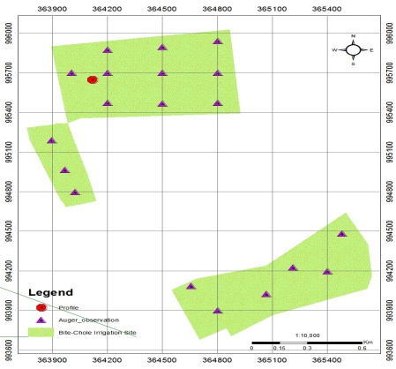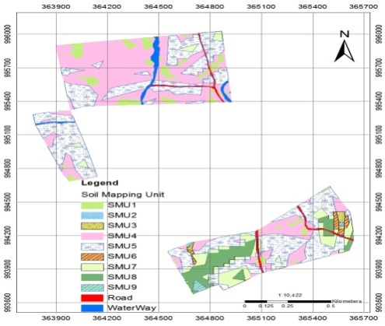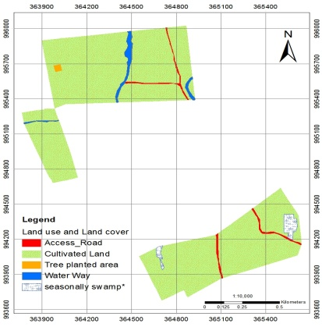
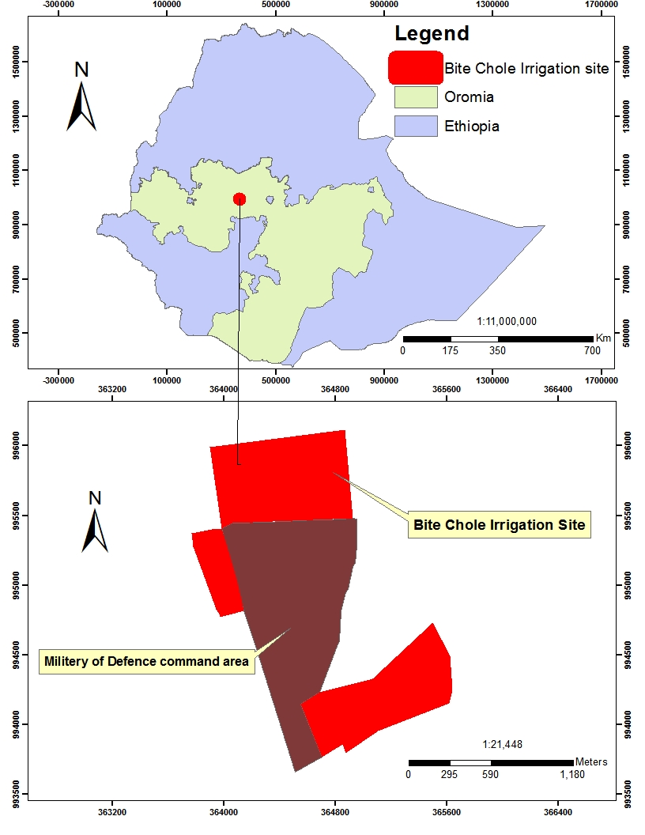
NAME OF PROJECT: BITE-CHOLE SMALL SCALE IRRIGATION

LOCATION: TOKE KUTAYE WOREDA, WEST SHOA ZONE, OROMIA REGIONAL STATE

CLIENT: OROMIA IRRIGATION DEVELOPMENT AUTHORITY

CONSULTANT: TERRACE ENGINEERING P.L.C
TABLE OF CONTENTS

LIST OF TABLES, Figures, and Appendices v
List of Tables v
List of Figures v
List of Appendices v
LIST OF ABBREVIATIONS AND ACRONYMS vi
1. INTRODUCTION 1
1.1. General 1
1.2. Objective of the Study 1
1.3. Scope of the Study 2
2. SOIL SURVEY METHODOLOGY 3
2.1. General 3
2.2. Review of Previous Studies 3
2.3. Pre-field Work 4
2.4. Field Work 4
2.5. Laboratory Analysis of Soil Samples 5
2.6. On – site Physical Tests 6
2.7. Post Field Work 6
2.7.1. Data Compilation and Analysis 6
2.7.2. Soil Classification and Mapping 7
3. DESCRIPTION OF THE PROJECT AREA 8
3.1. Location 8
3.2. Topography 8
3.3. Land Use and Land Cover 9
4. SOILS OF THE PROJECT AREA 11
4.1. General 11
4.2. Site Description and Morphological Characterization of Dominant Soil Types 11
4.3. Major Soil Types of the Project Area 11
4.3.1. Vertisols 11
5. SOIL CHARACTERISTICS OF THE PROJECT AREA 15
5.1. Morphological Characteristics 15
5.1.1. Soil Color 15
5.1.2. Soil Structure 15
5.1.3. Soil Consistence 15
5.1.4. Horizon Boundary 16
5.1.5. Plant Roots 16
5.1.6. Drainage 16
5.1.7. Erosion Status 16
5.1.8. Effective Soil Depth 17
5.2. Physical Characteristics 17
5.2.1. Soil Texture 17
5.2.2. Infiltration Rate 17
5.2.3. Hydraulic Conductivity 19
5.2.4. Soil Moisture Characteristics 21
5.2.5. Bulk Density 22
5.2.6. Surface Coarse Fragments 22
5.3. Chemical Characteristics 23
5.3.1. Soil Reaction 23
5.3.2. Electrical Conductivity (EC) 23
5.3.3. Organic Carbon (OC) 23
5.3.4. Total Nitrogen (TN) 24
5.3.5. Available Phosphorus (P) 24
5.3.6. Available potassium (K) 24
5.3.7. Cation Exchange Capacity (CEC) 25
5.3.8. Exchangeable Sodium Percentage (ESP) 25
5.3.9. Calcium Carbonate (CaCO₃) 25
5.3.10. Exchangeable Cations 25
6. SOIL MAPPING UNITS 27
6.1. Soil Mapping Unit Description 27
6.2. Soil Maps 31
7. LAND SUITABILITY EVALUATION 33
7.1. Introduction 33
7.2. Land Suitability Classes and Sub-classes 34
7.3. Land Use Requirements, Land Characteristics and Land Qualities 35
7.3.1. Land Use Requirements 35
7.3.2. Land Characteristics 36
7.3.3. Land Qualities 36
7.4. Results of Land Suitability Evaluation 38
7.5. Land Evaluation for Selected Crops 41
7.5.1. Proposed Crops 41
7.5.2. Crop Requirements 41
7.5.3. Results of Crop Suitability Evaluation 41
8. CONCLUSIONS 43
9. REFERENCES 44
APPENDICES 46

LIST OF TABLES, Figures, and Appendices

List of Tables
Table 2-1: Field activities performed during the field work 5
Table 3-1: Major Land use and Land cover types in Bite Chole irrigation site 9
Table 5-1 Infiltration test results clay textured soils of Bite-Chole irrigation site 18
Table 5-2 Hydraulic conductivity ratings 19
Table 5-3 Hydraulic Conductivity measurements, inverse-auger hole method in Bite-Chole irrigation site 20
Table 5-4 Field capacity along soil depth of clay textured soil 21
Table 5-5: Permanent wilting point along soil depth of clay textured soil 21
Table 5-6: Available Water Capacity (AWC) 22
Table 6-1 Distribution of Soil Mapping units in Bite Chole irrigation site 31
Table 7-1 FAO recommended land class definitions 35
Table 7-2: Land use requirement and critical class limits for surface irrigation 36
Table 7-3 Land characteristics and land qualities of soil mapping units 38
Table 7-4: Results of surface irrigation suitability evaluation 39
Table 7-5: Results of crop suitability evaluation under irrigation 42

List of Figures
Figure 2-1: Locations of Auger observations and Profile pits 7
Figure 3-1 Location map of Bite-Chole irrigation site 8
Figure 3-2 Land use and Land cover types of Bite Chole irrigation site 10
Figure 4-1 Morphological features of Vertisols in Bite-Chole irrigation site 12
Figure 4-2 Bite-Chole Soil series 14
Figure 5-1 Infiltration rate versus cumulative intake on clay-textured soils of Bite Chole 18
Figure 6-1 Soil map showing the distribution of the soil-mapping units 32
Figure 7-1: Irrigation Land Suitability Map 40

List of Appendices
Appendix Table: 1 Soil Laboratory results 46
Appendix Table 2: Soil Profiles Description 51

LIST OF ABBREVIATIONS AND ACRONYMS

AAS | Atomic Absorption Spectrometer
AWC | Available Water Capacity
BD | Bulk Density
CEC | Cation exchange capacity
DEM | Digital Elevation Model
EC | Electrical Conductivity
ECe | Electrical conductivity of the saturated extract
ESP | Exchangeable Sodium Percentage
ETM+ | Enhanced Thematic Mapper plus
FAO | Food and Agriculture Organization
FC | Field Capacity
GIS | Geographical Information System
GPS | Geographic Positioning System
HC | Hydraulic Conductivity
IR | Infiltration Rate
LCs | Land Characteristics
LQ | Land Qualities
LURs | Land Use Requirements
LUTs | Land Utilization Types
OIDA | Oromia Irrigation Development Authority

INTRODUCTION

General
The soil survey and land suitability evaluation of the Bite Chole small-scale irrigation based development Project was conducted at feasibility level at scale of 1:10,000 to assess the physical and chemical characteristics of the soils in the study area and to evaluate the suitability of the area for surface irrigation and selected crops. One of the studies being undertaken Oromia Irrigation Development Authority is a feasibility study of the Bite Chole Irrigation scheme in West Shoa Zone, Oromia regional state.
The intended project area covers about 109 ha which is proposed to use the Bite River as water source for surface irrigation, which supplies water of good quality. Currently the study area produces a good proportion of Maize and Teff production and contributes substantially to local food security by producing a substantial surplus of grain. Moreover, in and around the project area produces Cabbage, Pepper, onion, Garlic, Sweet Potato, Beetroot, Tomato and Carrot under irrigation and Wheat, sorghum, Noug, Beans, Chick Peas, Flax, Lentils and Haricot beans under rain fed.
As part of the feasibility study, a detailed soil survey has been carried out for the command area with an auger observation density of about 1 per 10 ha due to variability of soil and land characteristics. Feasibility level survey with intentional increased observation density has enabled to identify and map areas of constraints due to high pH value, clay textured, slow infiltration rate and hydraulic conductivity. Contrary to those limitations, most of the lands were found to be suitable in terms of their nutrient content and physical characteristics of the land.
This report is prepared to provide the findings of the soil survey and land suitability evaluation of the project. It gives detail information on the physical and chemical properties of soil of the area, soil mapping units, and evaluation of suitability of the area for the selected crops.

Objective of the Study
The major objectives of the soil survey are to:
- Define, map, characterize (physically and chemically) and classify the soils of Bite Chole irrigation site following the standard detailed soil survey method of FAO 2006 guideline. A survey intensity of one soil observation per 10 ha is to be achieved at minimum.
- Identify and map or delineate soil factors which restrict optimum production and recommend relevant ameliorative strategies and
- To identify and map suitable area for irrigation development in the survey area

Scope of the Study
The study was performed at feasibility level using standard methods and procedures. Hence, the scope of the soil survey is to characterize the physical and chemical properties of the soil and thereby determine the suitability of the soil and land conditions of the project area. In doing so, different field investigations and observations, In-situ and laboratory tests, and consultation of different available secondary information have been implemented in order to meet the stipulated overall objectives of the study. Generally, the scope of the study includes the following:
- Investigate, identify, analyze and describe the distribution of different soil and land mapping units;
- Survey to a depth of 1.20 cm (as the rooting depth of most crops is about 1m) and profile pit at a depth of 2 m, except obstructed by lithic contact and shallower depth;
- Conduct standard soil physical and chemical analyses in the accepted laboratories;
- Determination of the permeability of the soils employing inverse auger hole method (to infer the drainage class) in triplicate at representative sites as the soil conditions permit;
- Measurement of infiltration tests using double ring Infiltrometer, in triplicate at representative sites as soil condition permit;
- Collect undisturbed core samples for determination bulk density at representative sites for which core samples will be taken from each representative site at different depth;
- Prepare land use/land cover maps and soil mapping units of observation points for the site;

SOIL SURVEY METHODOLOGY

General
In order to achieve the specific objectives the methodology has followed the interpretation of satellite imagery and topographic maps, preparation of a base map from overlays of slope generated from 30m DEM. Moreover, reconnaissance and pre-feasibility studies that are pertinent to this study were fully reviewed and incorporated. The methodology to be followed for the soil survey is designed to conform to the scope of the study. The overall survey procedure consisted of three stages, namely pre-field stage, fieldwork, and post-field work. The data collected and activities undertaken in each stage, and the soil parameters analyzed were listed in the subsequent sections.

Review of Previous Studies
BCEOM-French Engineering Consultants conducted Abbay River Basin Master Plan Project in 1999 in association with ISL and BRGM. The Abbay Basin is by most criteria the most important river basin in Ethiopia. Accordingly, the topography of Bite-Chole irrigation site is characterized by plain to gently sloping landform. The overall objective of the soil survey was to identify, characterize, and map the soils of the basin. The major soils of the study area are Vertisols developed on flat to undulating plains and side slopes of the alluvial landform (0-5%). The soils are moderately well to well drained, deep to very deep, very dark brown to yellowish brown, weakly to moderately developed, granular and sub-angular blocky structure, fine to coarse textured.
Similarly, Geomorphology and soils map of Ethiopia, 1984 under Land use planning and regulatory department (LUPRD) of the ministry of agriculture has conducted soil survey. The land use planning and regulatory department of ministry of agriculture made a good effort in producing geomorphology and soil map of Ethiopia that shows the landforms and soils types at scale of 1:1,000, 000. This basic landform and soil mapping was carried out at national level covering the entire areas of Ethiopia as part of the assistance to land use planning Project.
To prepare geomorphology and soils map of Ethiopia LUPRD, (1984) used readily observable and relatively stable properties that are unlikely to change rapidly in response to management practice. The mapping units were achieved by delineating geomorphic units (group of land system or individual land system) from interpretation panchromatic Land sat MSS imagery. However compared to the current TM or SPOT imagery, the resolution is poor. The basic assumption in the preparation of the map is that geomorphic units delineated by manual interpretation of the land sat contain recurrent patterns of landforms, soils and vegetation. The study has identified one major soil types in Bite Chole irrigation site named Pellic Vertisols.

Pre-field Work
The pre-fieldwork stage is activities incorporating the survey planning stage and collection of other related studies such as collection of secondary data, and then reviewing and planning for the actual field data collection. The review concentrated on the evaluation of their objectives and methodologies, their outputs in terms of data, maps and findings and the means of using them. Moreover, topographic maps at 1:50,000 scale, LANDSAT ETM+ image of 30 m resolution color composite and digital elevation models (DEM) having spatial resolution of 30 m were interpreted by the GIS team. As a result, a base map was prepared at a scale of 1:10,000.
Satellite imagery interpretation has been carried out following the recommended false color composite band combination for soil survey. A Preliminary soil observation transects and approximate location of profile pits, infiltration and hydraulic conductivity testing sites were laid on the base map. However, they were subjected to change depending on the situation in the field. Soil survey staffs with previous and necessary experiences have been recruited for the field work and the proforma which is used to record and ensures all the data are collected systematically in a standardized format easily entered to an MS Excel worksheet that facilitates the sorting, analysis, classification and mapping, and as well equipment were made available.

Field Work
During the field work, all field soil investigations, soil sampling, and verification of aerial photo/satellite imagery and interpretation of unit boundaries were carried out. Mainly we adopted grid (300m x 300m) as a survey methodology to provide an optimal coverage for the description of the land units and soils of the command area by producing one auger observation per 10 ha. However, because of the variability of the soils and complexity of soil water interaction and constraints it was very difficult to fallow only the fixed grid survey. Most merging, splitting and correction of unit boundaries were carried out during auger observation data interpretation and boundary delineation.
Profile descriptions on representative sites and soil sampling for laboratory analysis were undertaken. Field-testing of infiltration rates and hydraulic conductivity were also conducted through routine field check. All descriptions and observations have been recorded according to the FAO guidelines for soil description (FAO, 2006). Soil color notations have been made according to Munsell Color Chart (1975). Dilute HCl test was made to check the presence of carbonates. The locations of profile pits, infiltration and hydraulic conductivity testing sites were recorded by GPS.
Disturbed soil samples (about 1 kg each) have been collected in polythene bag from generic horizons depth wise from freshly dug 2 m deep pits, if not restricted by lithic contact. At selected sites, infiltration test using double ring infiltrometer and permeability test in triplicates using an inverse-auger-hole method have been conducted; undisturbed soil cores from the major horizons of the soil profile were also collected. These cores were tested by the NSTC to produce soil bulk density values and to generate soil available water content based on moisture content at wilting point and field capacity, using pressure plate apparatus. Results are given in Appendix table. A total of two cores samples from one-soil profiles were analyzed. Similarly, a total of 19 auger observation, 1 profile description, 1 infiltration measurements (3 replicate) and 1 hydraulic conductivity measurement (3 replicate) has been taken during field work.
Table 2-1: Field activities performed during the field work
Status | Number of observations
Total augers observation points | 19
Soil profile sampled | 4 soil samples
Infiltration, hydraulic conductivity test sites | 1 (3 replication)
Sites of undisturbed core samples | 2

Laboratory Analysis of Soil Samples
The main horizons of all soil profile pits were sampled and samples were analyzed in the Horticoop Ethiopia, Soil and Water Analysis Laboratory in DebreZeit. The laboratory follows the Procedures for Soil and Plant Analysis ed. Sahlemedhin Sertsu and Taye Bekele, NSRC, EARO (2000). Four samples from one profile were analyzed for:
- Particle size (Bouyoucos hydrometer, sieving)
- Sand (0.10 – 2.00 mm) %
- Very fine sand (0.06 – 0.10 mm) %
- Silt, (0.06 – 0.002mm)%
- Clay, (<0.002mm)%
- Organic carbon, OC (Walkley and Black)
- Total nitrogen, N (Kjeldahl)
- pH (1:2.5 soil suspension, water and KCl) (pH electrode)
- Cation exchange capacity, CEC (pH 7.0 ammonium acetate extraction, filtration).
- Exchangeable cations, Ca, Mg (pH 7.0 ammonium acetate extraction, EDTA titration)
- Exchangeable cations Na, K (pH 7.0 ammonium acetate extraction, flame photometer)
- Available phosphorus, P (Olsen)
- Available potash, K (Mehlich-3)
- Free calcium carbonate, CaCO₃ (filtration and titration with NaOH)
- Electrical conductivity, ECe (saturated paste, conductivity meter)
- Bulk density on dry weight basis from core samples.
- Moisture content (FC and PWP) by pressure plate extraction.
From the above data, other soil attributes have been derived, namely: base saturation (BS), Organic Matter (OM) content, Exchangeable Sodium Percentage (ESP). All the laboratory results are presented in Appendix 1.

On – site Physical Tests
Three replicate site tests of infiltration rates and hydraulic conductivity were made at selected sites using a standard double ring infiltrometer and inverse auger hole method respectively on representative profile pit of major soil types; both are required for irrigation planning, including selection of irrigation methods and irrigation scheduling.
For measurement of water content at various bars to determine, soil available water capacity (AWC) two undisturbed soil cores were sent to the Horticoop Ethiopia Soil and Water Analysis Laboratory in DebreZeit for pressure-plate testing. Cores were taken within the topsoil and within the subsoil up to 100 cm. Soil water content is influenced by several factors, primarily soil texture, stoniness and organic content but also by bulk density which is determined on the basis of dry weight, porosity and structure. It is not feasible to isolate the contributions of each of these parameters. Consequently, it is the general order of AWC values that is most valid to indicate irrigation needs. Infiltration, hydraulic conductivity and soil moisture data should always be interpreted with caution. All are potentially very variable. Data provide indications of soil conditions rather than precise values.

Post Field Work

Data Compilation and Analysis
All the physical data collected in the field and the results from laboratory analysis were compiled and entered in the computer database using Microsoft Access, Excel and GIS by GIS expert. This facilitated the preparation of data collection points and their distribution in the command area using GIS.

Soil Classification and Mapping
Based on information obtained from field auger observations, profile descriptions and laboratory results, the classification and identification of the soils were made following the World Reference Base for soil Resources (WRB, 2014). Identification of diagnostic horizons, diagnostic properties and materials were used to characterize of the soils of the study area. For this, the morphological characteristics, physical and chemical properties of the soils were used.
Linking of the encoded database with the GIS was made for the ease of interpretation and final report compilation and Arc GIS manipulation of the shape files and spatial attributes. Analysis of the field and laboratory data for each soil-mapping unit, description of each soil mapping units, report writing and map production were among the major activities done at this stage. Mapping of the major soils identified and the individual soil-mapping units were produced at scale of 1:10,000. Location of auger observation and soil profile pits for the study areas are presented in Figure below.
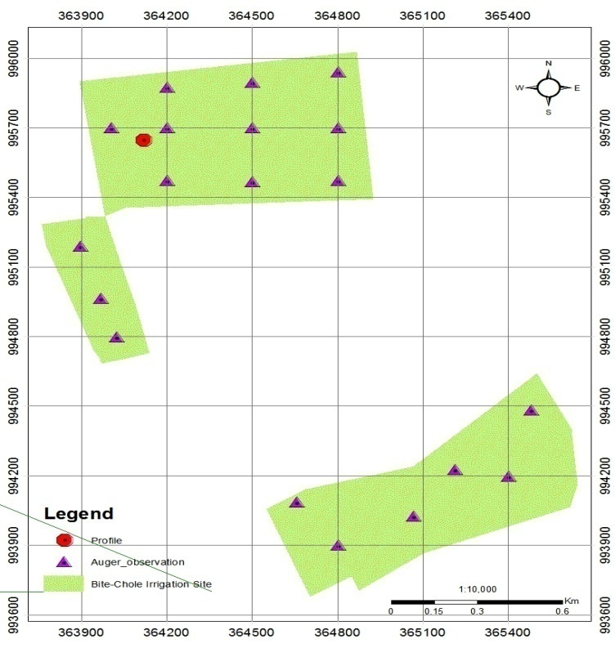
Figure 2-1: Locations of Auger observations and Profile pits

DESCRIPTION OF THE PROJECT AREA

Location
The intended project area is one of the 34 kebeles of Toko Kutaye wereda, which is located in the Oromia regional state at about 127 km from Addis Ababa, and it covers an area of 119 hectares. It extends from 8⁰ 59’14’’ to 9⁰ 00’34’’N latitude and 37⁰ 45’38’’ to 37⁰46’39’’E longitude. The study area is accessible from the wereda capital Guder town, which is found at the upper lying part of the project kebeles characterized by different types of landform.
Figure 3-1 Location map of Bite-Chole irrigation site

Topography
The project site is part of highland plains of Abay basin having straight shape draining towards Bite River. Majorly the slope of the study area is made up of uniform landforms from flat to very gently sloping (0-2%) and gently sloping (2-5%) while the southern part is characterized by sloping and moderately steep topography of 5-10 and 15-30% slope topography.

Land Use and Land Cover
The major land use and land cover of the area is characterized by intensive annual crop production. Smallholders practice irrigated crop production in and around the project area such as Cabbage, Pepper, onion, Garlic, Sweet Potato, Beetroot, Tomato and Carrot crops as the main cultivation under irrigated conditions. Whereas under rainfed condition the major crops produced in and around the project area are Teff, Wheat, Maize, sorghum, Noug, Beans, Chick Peas, Flax, Lentils and Haricot beans. The dominant vegetation covers in the project area are Acacia sp, Eucalyptus, Cordia Africana and some Ficus sp. Bite-Chole irrigation site majorly under cultivation which cover about 112.7 ha (94.9%) of the study area (Table 1).
Table 3-1: Major Land use and Land cover types in Bite Chole irrigation site
Land use/Land cover types | Area coverage (ha) | Area coverage (%)
Cultivated Land | 112.7 | 94.9
seasonally swamp* | 1.8 | 1.6
Tree planted area | 0.5 | 0.2
River bank | 2.0 | 1.7
Road | 1.9 | 1.6
Total | 119.0 | 100.0

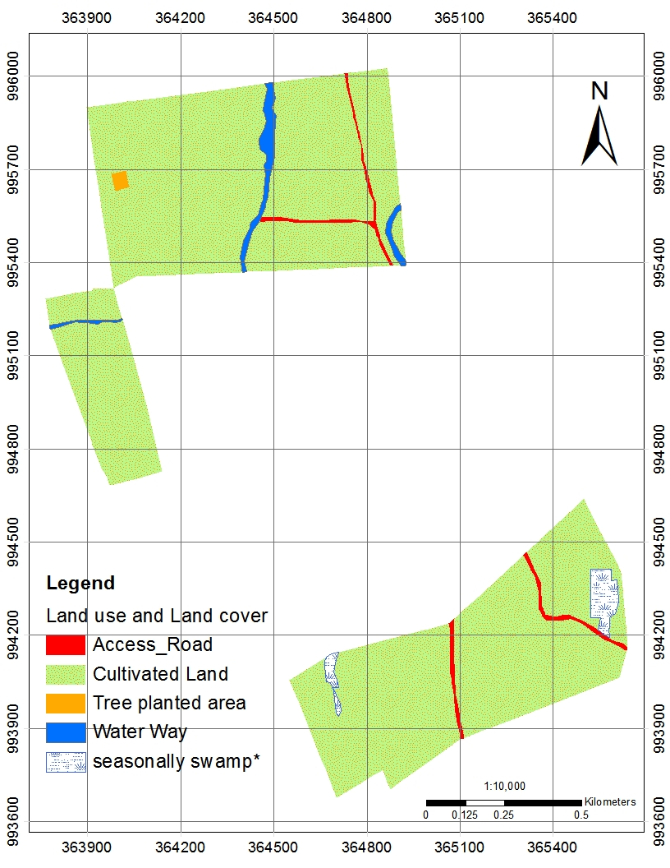
Figure 3-2 Land use and Land cover types of Bite Chole irrigation site

SOILS OF THE PROJECT AREA

General
Soil types have been defined based on soil physical properties (such as texture, depth, color, coarse material, etc…), soil chemical characteristics (CEC, pH, etc…). Although there was some variability in soil physical properties such as in soil color, texture and coarse fragments over short distance, they are very limited in their area extents, meaning it is not always possible to map individual soil types. Sometimes several soil types or phases occur in a small area and cannot be delineated as separate map unit i.e. it is not map-able at scale this study.

Site Description and Morphological Characterization of Dominant Soil Types
Vr1, Vr2 and Vr3 (Alluvial, deep, fine textured soils): Vr2 soil type has showed a significant variability in its color compared with Vr1 and Vr3. Vr1 and Vr3 soil is a very dark grayish brown/very dark grey over very dark brown/very dark grayish brown clay where as Vr2 is dark reddish brown or brown over reddish brown or dark reddish brown clay (see table below). They are all found in the slope range of 0-5 % on flat topography and originate from alluvial deposits and to some extent from colluvial. Generally Vr1 and Vr2 soil types are very deep, moderate soil drainage condition having clay to clay loam texture, moderately to strongly developed medium to prismatic structure; distinct slickenside on the profiles; non-calcareous. Whereas, Vr3 soil types showed some variation only in terms of poor drainage and some mottle on the soil profiles.

Major Soil Types of the Project Area
Based on the procedures and methods of soil classification, one major soil type was identified in the study area having varying areal extent and distribution and is briefly discussed below.

Vertisols
Vertisols occur extensively throughout the Study Area. They are cracking clay soils developed in-situ or from old alluvium that has weathered to montimorillonite clay with distinct shrink-swell properties. Three soil types having different characteristics have been identified. Vr1 and Vr3 are all black or very dark grey up to 200 cm. Vr2 is Dark reddish or brown over reddish brown or dark reddish brown clay loam, moderate drainage.
The Vertisols of the study area are the most widely distributed soil type and classified as Pellic Vertisols (Mollic), Pellic Vertisols (Stagnic) and Chromic Vertisols (Mollic). The surface textures of the Vertisols are clay and clay loam and the effective depth range is greater than 200 cm. accordingly, the soils series of Vertisols of the study area is briefly discussed below.
- Mollic Pellic Vertisols
Mollic Pellic Vertisols are soils having a typical expression of Swelling and shrinkage properties with distinct slickenside (Figure below). Where, the suffix qualifier Mollic refers to soils having structure sufficiently strong that it is not both massive and hard or very hard when dry (prisms larger than 30 cm in diameter are included in the meaning of massive if there is no structure further subdividing the prisms) and having greater than equale 0.6% soil organic carbon. Moreover, it is characterized by slightly crushed samples having a Munsell color value of ≤ 3 moist, and ≤ 5 dry, and a chroma of ≤ 3 moist. Pellic referes to soils having in the upper 30 cm of the soil a Munsell colour value of ≤ 3 and a chroma of ≤ 2, both moist (in Vertisols only). Pellic Vertisols have area coverage of 104 ha occupying 87% of the Vertisols of the study area.
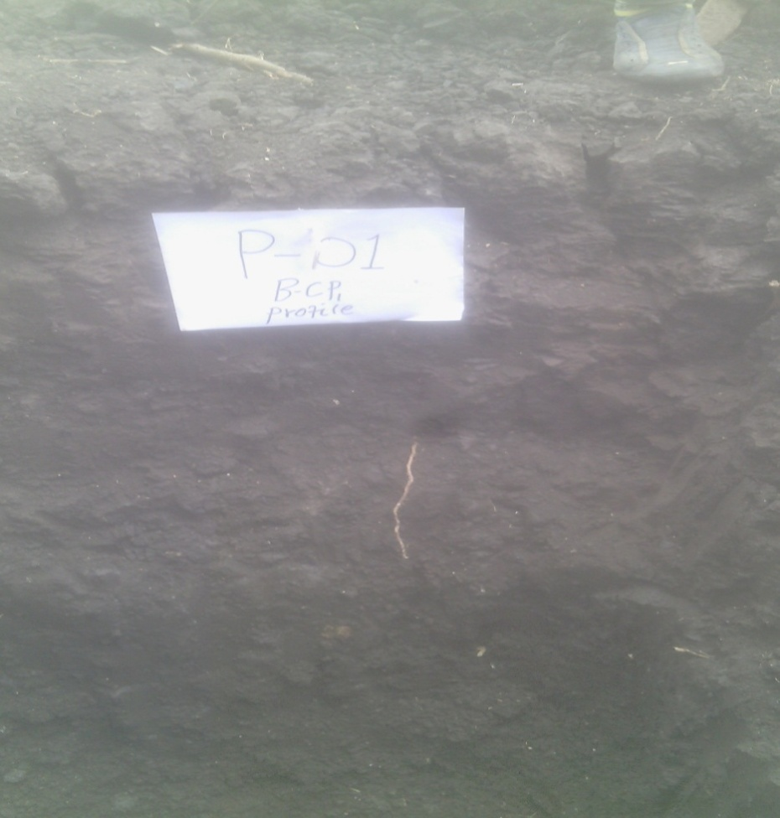
Figure 4-1 Morphological features of Vertisols in Bite-Chole irrigation site

- Stagnic Pellic Vertisols
Stagnic Pellic Vertisols are soils having a typical expression of Swelling and shrinkage properties with distinct slickenside. Where, the suffix qualifier Stagnic refers to soils having reductimorphic colours plus the area of oximorphic colours is ≥ 25% of the total area, and reducing conditions for some time during the year in the major part of the soil volume that has the reductimorphic colours. Pellic referes to soils having in the upper 30 cm of the soil a Munsell colour value of ≤ 3 and a chroma of ≤ 2, both moist (in Vertisols only). Pellic Vertisols have area coverage of 2 ha occupying 2% of the Vertisols of the study area.
- Mollic Chromic Vertisols
Mollic Chromic Vertisols are soils having a typical expression of Swelling and shrinkage properties with distinct slickenside. Where, the suffix qualifier Mollic refers to soils having structure sufficiently strong that it is not both massive and hard or very hard when dry (prisms larger than 30 cm in diameter are included in the meaning of massive if there is no structure further subdividing the prisms) and having greater than equal 0.6% soil organic carbon. Moreover, it is characterized by slightly crushed samples having a Munsell color value of ≤ 3 moist, and ≤ 5 dry, and a chroma of ≤ 3 moist. Chromic refers to soils having within ≤ 150 cm of the soil surface, a subsurface layer ≥ 30 cm thick, that has a Munsell colour hue redder than 7.5YR, moist. Chromic Vertisols have area coverage of 13 ha occupying 11% of the Vertisols of the study area.
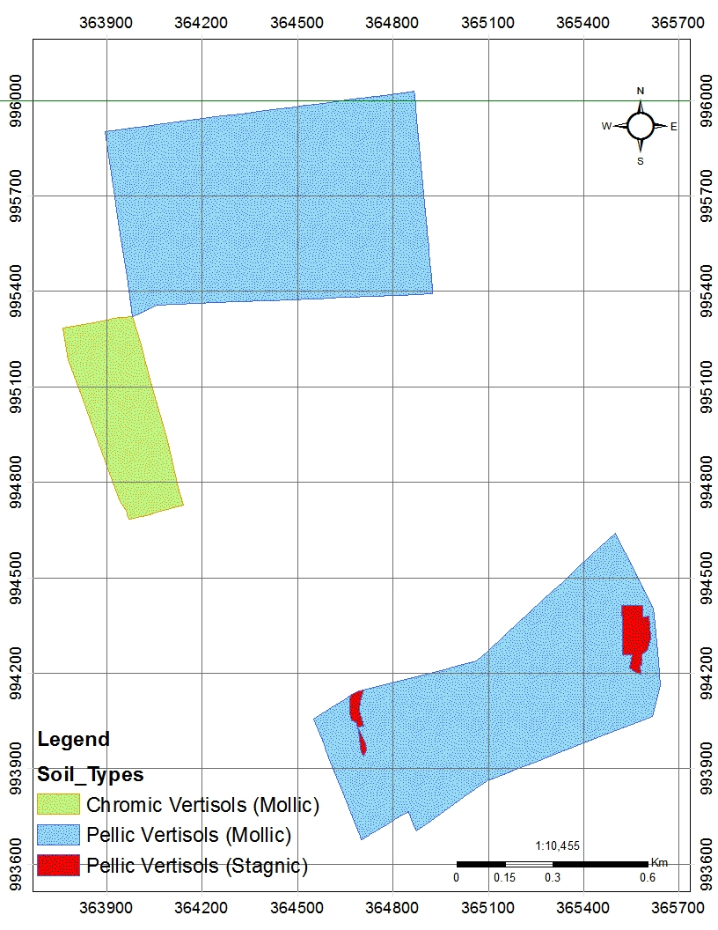
Figure 4-2 Bite-Chole Soil series

SOIL CHARACTERISTICS OF THE PROJECT AREA

Morphological Characteristics

Soil Color
The morphological description of the profiles showed some variations in the patterns of soil color both among the horizons within a profile and among the soil profiles. Accordingly, the soil color patterns ranged from black (10YR 2/1) in Profile 1 to dark brown (7.5YR 3/3) in Auger 5 when moist on their surface horizons. The observed variation in soil color pattern among the soil profiles appears to be associated more with the difference in oxidation-reduction processes that have taken place within the soils as well as the OM contents.
Compared to its surface horizon, the subsurface horizon of the Profiles described at the Bite Chole irrigation site showed variation in soil color pattern. Accordingly, the sub surface soil colors vary from dark reddish brown (5YR 3/3), reddish brown (5 YR 4/4) in Auger 5 to very dark grayish brown (10YR3/1) in Profile 1.

Soil Structure
Soil structure refers to the natural organization of soil particles into discrete soil units (aggregates or peds) that result from pedogenic processes. Pores or voids separate the aggregates from each other. It is preferred to describe the structure when the soil is dry or slightly moist. Soil structure is described in terms of grade, size and type of aggregates (FAO, 2006).
There are also variations in soil structure within a profile with depth and among profiles described at the Bite Chole irrigation site. Accordingly, the structure of the surface layers of the profiles varied from moderate, medium sub angular in Auger 5 to strong, coarse angular structure in Profile 1. Similarly, the structure of the subsurface layers of the profiles ranged from strong, medium angular to strong, coarse prismatic structure.

Soil Consistence
Similar to the above-described morphological properties, soil consistence within horizons and among profiles also showed variability under moist and wet conditions. Accordingly, the moist consistence of the topsoil’s of the soil profiles varied from very firm in Profile 1 to friable in Auger 5.
Furthermore, the wet consistence is sticky and plastic in all observation. Contrary to the consistence of the surface layers of the profiles, the subsurface layers showed variations in their consistence at different soil wetness conditions. Accordingly, the moist consistence varied from very firm in Profile 1 to friable in Auger 5. The wet consistence, on the other hand, varied from very sticky and very plastic in Profile 1 to sticky and plastic in Auger 5.

Horizon Boundary
Profiles 1 showed clear in distinctness and smooth topography in the horizon boundary between their surface and subsurface horizons whereas the third horizon showed gradual distinctness and smooth topography horizon boundary. Similarly, the horizon boundary between the second and third horizons of the profile showed clear distinctness and smooth to smooth-in topography.

Plant Roots
The study area is majorly cultivated lands and to some extent open woodland mixed with open bush and shrubs and thus the vegetation cover is moderate and the roots of the plants are observed deep up to greater than 1.0 m down the profile. Similar to the above-described morphological properties, plant roots within horizons and among profiles also showed variability in terms of their abundance and size. Plant roots in the surface horizon of soils showed fine to medium roots size, and few to many roots abundance. The variation in the size of plant roots in the profiles were attributed to the presence different types of plant roots where the profiles were taken, which in turn affect other morphological properties of the soil. Similar to the plant roots of the surface layers of the profiles, the subsurface layers also showed variations in their abundance and size. The plant root abundance varied from few to common in most of the profile while the size ranged from fine to medium.

Drainage
The Pellic Vertisols (Mollic) and Chromic Vertisols (Chromic) have moderate drainage condition whereas the Pellic Vertisols (Stagnic) have poor soil drainage condition based on their varying properties affecting drainage such as water transmission, soil depth, soil chemistry, slope gradient, etc.

Erosion Status
The erosion status of the command area is slight to moderate for the level lands where the slope of the study area ranges from 0 to 5%. Those erosion degrees in the command area have shown different characteristics with different types of erosion such as sheet and rills on the respective lands. On the cultivated lands, the erosion is majorly sheet type, and on the road and water ways the erosion is both the sheet and rill type; there is no soil and water conservation practices observed on the lands.

Effective Soil Depth
The soils identified on the study area with three soil series Pellic Vertisols (Mollic), Chromic Vertisols (Chromic) and Pellic Vertisols (Stagnic) are very deep (>2m) in their depths. As a result, soil depth is not a limiting factor in soils of the study area.

Physical Characteristics

Soil Texture
Soil textural class in the study area does not have variability within the horizons in the soil Profiles studied. Soil texture in both the surface and subsurface horizons of Profiles is clay. Generally, the soils of the study are finer in texture that is clay throughout the horizons of all profiles. The soil textural classes are used to characterize soil physical make-up, having a bearing on such soil behaviors as nutrient and water holding capacity, OM level and decomposition, aeration, infiltration rate, drainage and/or permeability and workability (Brady and Weil, 2002).
The sand fraction of the soils of the study area ranged from 8% in the 62-125 cm depth of Profile 1 to 12% in the 0-25 cm depth of Profile. Not all the Profiles followed any regular pattern with soil depth. In general, sand is the lowest fraction found next to silt fraction in the surface and sub-surface horizons of the profile.
In contrary, the silt proportion of the soil profiles does not showed any variation in all horizons (Appendix table 1). Similarly, the silt fraction did not follow consistent trend with soil depth in profile. The clay fraction ranged from 76% in depth 0-25 to 80% in depth 62-125 among the surface and sub-surface horizons (Appendix table 1). Down the horizons of Profiles clay fraction did not follow any consistent trend with soil depth.

Infiltration Rate
Infiltration refers to the vertical intake of water into a soil, usually at the soil surface, and measurements rate form a vital part many survey involving irrigation development or soil conservation (Landon, 1991). Texture of the soil and other properties of the soil such as organic matter content and structure of the soil mainly affect infiltration rate. Soils are considered non-arable if the IR is less than 0.1cm/hr. Infiltration rates between 0.1 and 0.2cm/hr are undesirable as surface waste becomes excessive or ponding reduces crop yield. The optimum rates for gravity irrigation are between 0.7 and 3.5 cm/hr. Infiltration rates in excess of 12.5cm/hr is generally mean that gravity irrigation is not practicable due to water distribution problems and excessive deep percolation. The following table and figure shows the results of infiltration tests of the soils.

Table 5-1 Infiltration test results clay textured soils of Bite-Chole irrigation site
Time |  |  | Depth to water |  | Water intake, cm |  | Infiltration
Interval | min. | hr. | cm |  | Immediate | cumulative | Rate, cm/hr
0 | 0 | 0.0 | 80.0 | 80.0 | 0.0 | 0.0 | 0.0
5 | 5 | 0.1 | 79.9 | 79.9 | 0.1 | 0.1 | 1.2
5 | 10 | 0.2 | 79.9 | 79.9 | 0.0 | 0.1 | 0.6
15 | 25 | 0.4 | 79.8 | 79.8 | 0.1 | 0.2 | 0.5
15 | 40 | 0.7 | 79.2 | 79.2 | 0.6 | 0.8 | 1.2
20 | 60 | 1.0 | 78.0 | 78.0 | 1.2 | 2.0 | 2.0
20 | 80 | 1.3 | 77.9 | 77.9 | 0.1 | 2.1 | 1.6
20 | 100 | 1.7 | 77.7 | 77.7 | 0.2 | 2.3 | 1.4
25 | 125 | 2.1 | 77.4 | 80.2 | 0.3 | 2.6 | 1.2
25 | 150 | 2.5 | 80.1 | 80.1 | 0.1 | 2.7 | 1.1
25 | 175 | 2.9 | 79.9 | 79.6 | 0.2 | 2.9 | 1.0
25 | 200 | 3.3 | 79.4 | 79.4 | 0.2 | 3.1 | 0.9
30 | 230 | 3.8 | 79.3 | 79.3 | 0.1 | 3.2 | 0.8
30 | 260 | 4.3 | 79.2 | 79.2 | 0.1 | 3.3 | 0.8
30 | 290 | 4.8 | 79.1 | 79.1 | 0.1 | 3.4 | 0.7

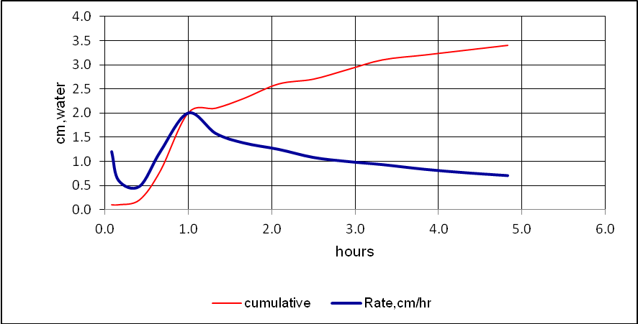
Figure 5-1 Infiltration rate versus cumulative intake on clay-textured soils of Bite Chole

Hydraulic Conductivity
Hydraulic conductivity (permeability) is the property of the soil to transmit water downwards through a unit cross-section of area in unit time. Field measurements recorded a wide range of values from 0.05 to 0.26 m/d. The lowest values were associated with fine textured subsoil and the highest value with relatively better fraction of coarse textured subsoil.
Table 5-2 Hydraulic conductivity ratings
< 0.2 m/day | very slow
0.2 – 0.5 m/day | Slow
0.5 – 1.4 m/day | Moderate
>1.4 m/day | moderately rapid to rapid
Source: Landon, 1990

Table 5-3 Hydraulic Conductivity measurements, inverse-auger hole method in Bite-Chole irrigation site
Profile No. | Repli-cate | Section | Field | Soil type | Depth cm |  |  |  |  |  | A |  |  | B | C | E | F | G | K, m/day
 |  |  |  |  |  | r | 1.15r | h(ti) | r/2 | h(ti)+r/2 | log (h(ti)+r/2) | h(tn) | h(tn)+r/2 | log (h(tn)+r/2 | A-B | tn-ti | C/E | 1.15r*F | G*864
P1 | 1 | B | BCP1 | VR | 90 | 4 | 4.6 | 65 | 2 | 67 | 1.83 | 64.3 | 66.3 | 1.82 | 0.005 | 1800 | 0.000003 | 0.000012 | 0.01
P1 | 2 | B | BCP1 | VR | 90 | 4 | 4.6 | 65 | 2 | 67 | 1.83 | 64 | 66 | 1.82 | 0.007 | 1800 | 0.000004 | 0.000017 | 0.01
P1 | 3 | B | BCP1 | VR | 90 | 4 | 4.6 | 65 | 2 | 67 | 1.83 | 61.1 | 63.1 | 1.80 | 0.026 | 1800 | 0.000014 | 0.000067 | 0.06

Soil Moisture Characteristics
Undisturbed soil samples from representative sites were taken to the laboratory to determine bulk density, permanent wilting point and field capacity for the determination of available water capacity and readily available water capacity of the soils.

Field Capacity (FC)
Field capacity (FC) of a soil is the maximum water content the soil will hold following free drainage. FC is the upper limit of available soil moisture under irrigation. It does not therefore correspond to a fixed soil-water potential, but instead represents the condition of each individual soil after the larger pores have drained freely under gravity (Landon, 1991). The field capacity of the soils of the study area falls in the range of 0.57 to 0.58--cm³ water/cm³ soil. The following table shows the field capacity results of the study area along the soil depth.
Table 5-4 Field capacity along soil depth of clay textured soil
No | Soil depth (cm) | Field capacity (cm³ water/cm³ soil)
1 | 0-25 | 0.57
2 | 25-62 | 0.58

Permanent Wilting Point (PWP)
Permanent wilting point (PWP) is the soil moisture content at which plants can no longer obtain enough moisture to meet evapo-transpiration requirements and remain wilted unless water is added to the soil. In other way round, the permanent wilting point (PWP) is arbitrary defined as the soil moisture content at which the leaves of sunflower plants wilts permanently, i.e. when they do not recover their turgor if subsequently placed in a saturated atmosphere. The permanent wilting point is taken as the lower limit of available water so that water in drier soil is assumed to be not available to plants (Landon, 1991). The PWP of the soils of the project area varies from 0.45 to 0.46 cm³ water/cm³ soil and is given in the following table along the soil depth.
Table 5-5: Permanent wilting point along soil depth of clay textured soil
No | Soil depth (cm) | Permanent wilting point(cm³ water/cm³ soil)
1 | 0-25 | 0.45
2 | 25-62 | 0.46

Available Water Capacity and Readily Available Water Capacity
Soil Available Water Capacity (AWC) is the volume of water held between field capacity (FC; pF 2.5) and wilting point (WP; pF4.2) for a specified soil depth, usually the main root zone that for most crops is 0.6 m. We recommend that to avoid over-watering, crop water requirements (e.g. using Cropwat) should adopt 0.6 m soil depth rather than the conventional 1.0 m. Available Water Capacity (AWC) data for various topsoil and subsoil horizons (to 0.6 m depth) are shown in table below. In general principle results of AWC <120mm/m, 120-180 mm/m and >180 mm/m has low, medium and high rate for irrigation suitability respectively. Readily available moisture is considered 60% of total available water as a rule. Calculation of AWC is done by the following formula.
AWC =

Table 5-6: Available Water Capacity (AWC)
No | Soil depth (cm) | Available Water Capacity (AWC) (mm/m)
1 | 0-25 | 160.8
2 | 25-62 | 156.72

The above values were derived from the representative samples for the study area. The higher values of the available water capacity may be because of the higher clay content of the soils, good structure etc.

Bulk Density
Bulk density is the overall density of soil (i.e. the mass of mineral soil divided by the overall volume occupied by soil, water and air); it should be distinguished from the density of the solid soil constituents. The bulk density of the soils in the study area varies between 1.306 and 1.34 g/cm³. The higher bulk density was registered for clay textured surface soils of Pellic Vertisols and the lower bulk density was observed on the clay sub surface. The surface soils of Vertisol have bulk density of 1.34g/cm³ while the sub-surface horizons have 1.31 g/cm³ (Appendix Table 1).

Surface Coarse Fragments
The surface coarse fragment in the soils of the study area is characterized by very few to common coarse gravels abundance and less stone abundance in some parts of the area. Generally, surface coarse fragments are not limiting factor in soils of the study area.

Chemical Characteristics

Soil Reaction
Soil reaction (pH) is one of the chemical properties that govern the availability of nutrients such as available P, exchangeable bases and the micronutrients in soils (Buol et al., 1997). Generally, the pH in the soils of the profiles studied showed slight variation within horizons and among profiles. The surface soil pH-H₂O values of the Bite-Chole irrigation site is 7.91 in Profile 1 described at the Teff cultivated land. Similarly, the subsurface soil pH-H₂O values of the soils in the study area ranged from 8.15 at 25-62 cm soil depth to 8.35 in Profile 1 at 125-200 cm soil depth (Appendix table 1). pH-H₂O values in the Profiles showed consistent decrement down the horizon.
Generally, the surface and subsurface soil pH values in the study area ranged from 7.94 in Profile 1 at 0-25 cm depth to 8.35 in Profile 1 at 125-200 cm depth, indicating that the soils of the Bite-Chole area could be rated under high in soil reaction as per the rating recommended by Landon (1991). Soil pH value between 7 and 8.5 could be an indication of low available P to deficiencies at higher pH.

Electrical Conductivity (EC)
As indicated in Appendix table 1, the EC values in the soils of the study area varied with depth within a profile. The surface soil EC values of the Bite-Chole project site is 0.16 in Profile 1 described at the Teff (Appendix table 1). Similarly, the subsurface soil EC values of the soils in the study area ranged from 0.17 at depth 25-62 cm to 0.28 at 125 cm depth in Profile 1.
The results indicate that the EC values in the study area were below 4 dS m⁻¹ indicating that the concentration of soluble salts in the soils of the Bite-Chole site are below the levels at which growth and productivity of most agricultural crops are affected due to soil salinity as these were non-saline (Richards, 1954).

Organic Carbon (OC)
The organic carbon content of the surface soils of the study area is 1.65% and rated as low level. The organic matter content can be obtained by multiplying the value of organic carbon by 1.72% and can be used to as a measure of fertility status of the soil. Using the above conversion method, the surface organic matter content of the surface soils of the study area is 2.84% and is rated as medium level (Tekalign, 1991). Generally, in the profile, the OM content decreased consistently with increase in soil depth. This may indicate a relatively better accumulation of decomposable organic materials in the surface horizons than in the subsurface ones.

Total Nitrogen (TN)
Similar to most of the other soil properties discussed above, total nitrogen content also differed with soil depth within a profile (Appendix table 1). Accordingly, in Profile the total N content does not showed consistency with soil depth and not followed the trend observed in OM. The Profile had their relatively highest total N in their sub-surface horizons at 62-125 cm depth and the lowest in their extreme bottom horizons. Furthermore, the variations down the horizon indicate that the total N content varied from 54.3 mg/kg at 125-200 cm depth to 148 mg/kg at 62-125 cm depth in Profile 1 in the sub-surface horizons. Generally, soil TN contents within horizons and between profiles in study area were rated as very low based on the ratings made by Landon (1991).

Available Phosphorus (P)
Variable distributions of available P with depth within a profile were observed in soils of the Bite Chole irrigation site (Appendix table 1). Available P decreased with soil depth in the Profile. Largely, the available P distribution with soil depth closely followed that of the OM trend. Available P ranged from 2.08 mg kg⁻¹ at 125-200 cm depth to 3.83 mg kg⁻¹ 0-25 cm depth in Profile 1.
According to the ratings by Landon (1991), the available P contents of the study area were generally very low throughout the horizons. Those low levels of available P recorded in most of the horizons profiles could be associated, among others, with the low OM content. This may indicate that OM content of the soil determines the amount of available P present in the soil of Bite-Chole project area.
This low availability of P in the soils of the study is could be one of the major low soil fertility status indicating factors. However, high available P content in the surface horizons of Profile 1, and relatively the lowest available P was obtained in their sub-surface horizon when compared to surface horizons of the Profiles. The sources of available P could be animal manure, plant residues, or due to the nature of soil parent materials.

Available potassium (K)
Variable distributions of available K with depth within a profile were observed in soils of the Bite Chole irrigation site (Appendix table 1). Available K in profile 1 showed unsystematic variation with depth. Available K ranged from 515.36 mg kg⁻¹ at depth 125-200 cm to 703.88 mg kg⁻¹ at depth 25-62 cm. The results indicate that available K in the soils of Bite-Chole irrigation site is not limiting factors but rather present in appreciable amounts in soil horizons, which could be due to the nature of parent material from which, the soils developed.

Cation Exchange Capacity (CEC)
As depicted in Appendix table 1, CEC of the soil of the study area was variable within horizons. Accordingly, in the soils of the study area, CEC ranged from 57.7cmol (+) kg⁻¹ at 125-200 cm depth to 61.5cmol (+) kg⁻¹ at depth of 0-25 cm in Profile 1. According to Landon (1991) ratings, the CEC value in the soils of the study area is very high. Thus, the value of CEC in the soil of the study area is an important indicator for both soil fertility/nutrition studies and for soil genesis and thus widely used in soil classification (Buol et al., 1997). The levels of CEC recorded in most of the horizons could be associated, among others, with the level of both clay and OM content. This may indicate that clay and OM content of the soil determines the amount of CEC present in the soil of Bite-Chole irrigation site. Generally, CEC in the soils of the study area has indicated a decreasing trend with depth; which could be due to the strong association between organic carbon and clay.

Exchangeable Sodium Percentage (ESP)
Exchangeable sodium percentage indicates the degree of sodicity or alkalinity of the soils. Soils with ESP <15% are generally considered as non-sodic whereas soils with ESP >15% are sodic soils and require amendment. The surface ESP status of the soils of the project area is 0.26%. The results of the ESP in soils of the study area are free from sodicity problem.

Calcium Carbonate (CaCO₃)
Carbonates in the soil profiles may be derived from carbonate rich rocks (calcite CaC0₃, dolomite CaC0₃ + MgC0₃) but are more commonly encountered as a secondary deposition from groundwater. The horizons of the soils of the study area have Carbonates ranged from 7.5% at 0-25 cm depth to 13.7% at 125-200 cm depth in Profile 1. According to Landon (1991) ratings, the Carbonates value in the soils of the study area is medium. Thus, medium levels of carbonate (<15%) do not affect the physical as well as the chemical properties of soils (Landon, 1991) which affect the available moisture capacity to be remains high irrespective of the measured clay content when there is low level of carbonate in the soils. Generally, the soils of the study area are slightly calcareous in reaction.

Exchangeable Cations

Exchangeable Sodium (Na⁺)
The exchangeable Na of the soils of the study area falls in the range of 2.37 – 17.44 cmol (+) kg⁻¹. These levels of exchangeable sodium in the soils profile indicate that the soils of the study area are free from adverse effects of high sodium levels on soil physical properties and crop growth; this is because the exchangeable sodium percentage derived from these levels is so low that (<15%) there is no problem of sodicity of the soils.

Exchangeable Potassium (K⁺)
Exchangeable K in the soil horizons of the soils varied from 46.9 cmol(+) kg⁻¹at 125-200 cm soil depth to 63.9 cmol (+) kg⁻¹ at 25-62 cm soil depth; Depth wise, the exchangeable K in profile showed unsystematic variation with depth. According to the ratings by Landon (1991), exchangeable K contents of the soils of the study area are in the range of high.
In general, the exchangeable K contents in most of the soil horizons were higher than exchangeable Na (Appendix table 1). This could be due to the type of parent material from which the soil developed. Because, K content of a soil depends primarily upon the parent material and degree of weathering (Hesse, 1972). The overall exchangeable cations in most of the Profiles showed a content gradient of Ca > Mg > K > Na. According to Halvin et al. (1999), the prevalence of Ca followed by Mg, K and Na in the exchange site of soils is favorable for crop production.

Exchangeable Calcium (Ca⁺⁺)
Exchangeable calcium (Ca) followed by exchangeable magnesium (Mg) formed the dominant cations within soil horizons of the study area. The exchangeable Ca in the soil horizons varied from 760.5 cmol(+) kg⁻¹ at 0-25 cm soil depth to 864.8 cmol(+) kg⁻¹ at 125-200 cm soil depth. Exchangeable Ca in the surface and subsurface horizons of the profiles was very high in its content.

Exchangeable Magnesium (Mg⁺⁺)
Exchangeable Ca accompanied by exchangeable Mg dominated the exchange sites of the soils in the study area. Accordingly, the exchangeable Mg in the soil horizons varied from 95.14 cmol(+) kg⁻¹ at 0-25 cm soil depth to 129.9 cmol(+) kg⁻ at 125-200 cm soil depth. Similarly, to the exchangeable Ca, the highest exchangeable Mg content which was also found in the surface and subsurface horizons. According to Landon (1991) ratings, these soils were rated under very high exchangeable Mg content.

SOIL MAPPING UNITS

Soil Mapping Unit Description
The soils of the project area are mapped and described based on their similar soil characteristics and constraints. The soils of the study area have been classified in to 3 soils series and 9 soil mapping unit out of which two soil mapping units are river courses. The soil-mapping units were classified based on soil phase’s criteria. The dominant characteristics considered in mapping the soil unit are like soil type, soil drainage, depth to water table, soil texture and soil physical and chemical properties. Based on this, the following soil mapping units were identified which can be easily evaluated for the proposed irrigation development because of their similar soil land quality and constraints. After evaluating the land their respective management options for each mapping unit can be also given based on their soil and land constraints and level of its severity.
SMU 1
The soil type in this mapping unit is Vertisols characterized by a very deep, darkish (10YR 3/2, 2/2, 3/1, dark brown (7.5YR 3/3)) over dark brown to dark reddish brown soil color. The soil unit has clay to loam soil texture. They have strong, medium angular blocky to strong, coarse prismatic structure. The consistency of this soil unit is very firm to firm when moist, sticky to very sticky and plastic to very plastic during wet condition. The total extent of the unit is 7 ha or 6% of the total mapping units. This mapping unit is distributed on level alluvial plains, which were characterized by moderate soil drainage condition and lie on 0-2% slope range.
The soil reaction ranges from 7.94 to 8.35. The organic carbon content ranges from 0.97-1.65%, indicating low of organic carbon. The total nitrogen varies from 0.0054-0.0148%, indicating very low level of nitrogen content. The available P of this soil-mapping unit is found to be low to high in its content, which ranges from 2.08-3.83%. The value of CEC ranges from 57.7 to 61.5 cmol(+) kg⁻¹ and the exchangeable sodium percentage ranges below 15% showing high level of CEC and low level of exchangeable sodium percentage ranges. Thus, the soils are non-saline, non-sodic, and calcareous.
SMU 2
The soil type in this mapping unit is Vertisols characterized by a very deep, darkish (10YR 3/2, 2/2, 3/1) over dark brown soil color. The soil unit has clay to loam soil texture. This soil-mapping unit is characterized by poor drainage condition due to seasonally water logging in the area. They have strong, medium angular blocky to strong, coarse prismatic structure. The consistency of this soil unit is very firm to firm when moist, sticky to very sticky and plastic to very plastic during wet condition. The total extent of the unit is 0.19 ha or 0.16% of the total mapping units. This mapping unit is distributed on level alluvial plains, which were characterized by moderate soil drainage condition and lie on 0-2% slope range.
The soil reaction ranges from 7.94 to 8.35. The organic carbon content ranges from 0.97-1.65%, indicating low of organic carbon. The total nitrogen varies from 0.0054-0.0148%, indicating very low level of nitrogen content. The available P of this soil-mapping unit is found to be low to high in its content, which ranges from 2.08-3.83%. The value of CEC ranges from 57.7 to 61.5 cmol(+) kg⁻¹ and the exchangeable sodium percentage ranges below 15% showing high level of CEC and low level of exchangeable sodium percentage ranges. Thus, the soils are non-saline, non-sodic, and calcareous.
SMU 3
The soil type in this mapping unit is Vertisols characterized by a very deep, darkish (10YR 3/2, 2/2, 3/1) over dark brown soil color. The soil unit has clay to loam soil texture. This soil-mapping unit is characterized by poor drainage condition due to seasonally water logging in the area. They have strong, medium angular blocky to strong, coarse prismatic structure. The consistency of this soil unit is very firm to firm when moist, sticky to very sticky and plastic to very plastic during wet condition. The total extent of the unit is 0.6 ha or 0.5% of the total mapping units. This mapping unit is distributed on level alluvial plains, which were characterized by moderate soil drainage condition and lie on 2-5% slope range.
The soil reaction ranges from 7.94 to 8.35. The organic carbon content ranges from 0.97-1.65%, indicating low of organic carbon. The total nitrogen varies from 0.0054-0.0148%, indicating very low level of nitrogen content. The available P of this soil-mapping unit is found to be low to high in its content, which ranges from 2.08-3.83%. The value of CEC ranges from 57.7 to 61.5 cmol (+) kg⁻¹ and the exchangeable sodium percentage ranges below 15% showing high level of CEC and low level of exchangeable sodium percentage ranges. Thus, the soils are non-saline, non-sodic, and calcareous.
SMU 4
The soil type in this mapping unit is Vertisols characterized by a very deep, darkish (10YR 3/2, 2/2, 3/1, dark brown (7.5YR 3/3)) over dark brown to dark reddish brown soil color. The soil unit has clay to loam soil texture. They have strong, medium angular blocky to strong, coarse prismatic structure. The consistency of this soil unit is very firm to firm when moist, sticky to very sticky and plastic to very plastic during wet condition. The total extent of the unit is 43 ha or 36% of the total mapping units. This mapping unit is distributed on level alluvial plains, which were characterized by moderate soil drainage condition and lie on 2-5% slope range.
The soil reaction ranges from 7.94 to 8.35. The organic carbon content ranges from 0.97-1.65%, indicating low of organic carbon. The total nitrogen varies from 0.0054-0.0148%, indicating very low level of nitrogen content. The available P of this soil-mapping unit is found to be low to high in its content, which ranges from 2.08-3.83%. The value of CEC ranges from 57.7 to 61.5 cmol(+) kg⁻¹ and the exchangeable sodium percentage ranges below 15% showing high level of CEC and low level of exchangeable sodium percentage ranges. Thus, the soils are non-saline, non-sodic, and calcareous.
SMU 5
The soil type in this mapping unit is Vertisols characterized by a very deep, darkish (10YR 3/2, 2/2, 3/1, dark brown (7.5YR 3/3)) over dark brown to dark reddish brown soil color. The soil unit has clay to loam soil texture. They have strong, medium angular blocky to strong, coarse prismatic structure. The consistency of this soil unit is very firm to firm when moist, sticky to very sticky and plastic to very plastic during wet condition. The total extent of the unit is 46 ha or 39% of the total mapping units. This mapping unit is distributed on level alluvial plains, which were characterized by moderate soil drainage condition and lie on 5-10% slope range.
The soil reaction ranges from 7.94 to 8.35. The organic carbon content ranges from 0.97-1.65%, indicating low of organic carbon. The total nitrogen varies from 0.0054-0.0148%, indicating very low level of nitrogen content. The available P of this soil-mapping unit is found to be low to high in its content, which ranges from 2.08-3.83%. The value of CEC ranges from 57.7 to 61.5 cmol(+) kg⁻¹ and the exchangeable sodium percentage ranges below 15% showing high level of CEC and low level of exchangeable sodium percentage ranges. Thus, the soils are non-saline, non-sodic, and calcareous.
SMU 6
The soil type in this mapping unit is Vertisols characterized by a very deep, darkish (10YR 3/2, 2/2, 3/1) over dark brown soil color. The soil unit has clay to loam soil texture. This soil-mapping unit is characterized by poor drainage condition due to seasonally water logging in the area. They have strong, medium angular blocky to strong, coarse prismatic structure. The consistency of this soil unit is very firm to firm when moist, sticky to very sticky and plastic to very plastic during wet condition. The total extent of the unit is 1 ha or 0.8% of the total mapping units. This mapping unit is distributed on level alluvial plains, which were characterized by moderate soil drainage condition and lie on 5-10% slope range.
The soil reaction ranges from 7.94 to 8.35. The organic carbon content ranges from 0.97-1.65%, indicating low of organic carbon. The total nitrogen varies from 0.0054-0.0148%, indicating very low level of nitrogen content. The available P of this soil-mapping unit is found to be low to high in its content, which ranges from 2.08-3.83%. The value of CEC ranges from 57.7 to 61.5 cmol(+) kg⁻¹ and the exchangeable sodium percentage ranges below 15% showing high level of CEC and low level of exchangeable sodium percentage ranges. Thus, the soils are non-saline, non-sodic, and calcareous.
SMU 7
The soil type in this mapping unit is Vertisols characterized by a very deep, darkish (10YR 3/2, 2/2, 3/1) over dark brown to dark reddish brown soil color. The soil unit has clay to loam soil texture. They have strong, medium angular blocky to strong, coarse prismatic structure. The consistency of this soil unit is very firm to firm when moist, sticky to very sticky and plastic to very plastic during wet condition. The total extent of the unit is 9 ha or 8% of the total mapping units. This mapping unit is distributed on level alluvial plains, which were characterized by moderate soil drainage condition and lie on 10-15% slope range.
The soil reaction ranges from 7.94 to 8.35. The organic carbon content ranges from 0.97-1.65%, indicating low of organic carbon. The total nitrogen varies from 0.0054-0.0148%, indicating very low level of nitrogen content. The available P of this soil-mapping unit is found to be low to high in its content, which ranges from 2.08-3.83%. The value of CEC ranges from 57.7 to 61.5 cmol(+) kg⁻¹ and the exchangeable sodium percentage ranges below 15% showing high level of CEC and low level of exchangeable sodium percentage ranges. Thus, the soils are non-saline, non-sodic, and calcareous.
SMU 8
The soil type in this mapping unit is Vertisols characterized by a very deep, darkish (10YR 3/2, 2/2, 3/1) over dark brown soil color. The soil unit has clay soil texture. This soil-mapping unit is characterized by poor drainage condition due to seasonally water logging in the area. They have strong, medium angular blocky to strong, coarse prismatic structure. The consistency of this soil unit is very firm to firm when moist, sticky to very sticky and plastic to very plastic during wet condition. The total extent of the unit is 8 ha or 6% of the total mapping units. This mapping unit is distributed on level alluvial plains, which were characterized by moderate soil drainage condition and lie on 15-30% slope range.
The soil reaction ranges from 7.94 to 8.35. The organic carbon content ranges from 0.97-1.65%, indicating low of organic carbon. The total nitrogen varies from 0.0054-0.0148%, indicating very low level of nitrogen content. The available P of this soil-mapping unit is found to be low to high in its content, which ranges from 2.08-3.83%. The value of CEC ranges from 57.7 to 61.5 cmol(+) kg⁻¹ and the exchangeable sodium percentage ranges below 15% showing high level of CEC and low level of exchangeable sodium percentage ranges. Thus, the soils are non-saline, non-sodic, and calcareous.
SMU 9
The soil type in this mapping unit is Vertisols characterized by a very deep, darkish (10YR 3/2, 2/2, 3/1) over dark brown soil color. The soil unit has clay to loam soil texture. This soil-mapping unit is characterized by poor drainage condition due to seasonally water logging in the area. They have strong, medium angular blocky to strong, coarse prismatic structure. The consistency of this soil unit is very firm to firm when moist, sticky to very sticky and plastic to very plastic during wet condition. The total extent of the unit is 0.5 ha or 0.4% of the total mapping units. This mapping unit is distributed on level alluvial plains, which were characterized by moderate soil drainage condition and lie on 30-50% slope range.
The soil reaction ranges from 7.94 to 8.35. The organic carbon content ranges from 0.97-1.65%, indicating low of organic carbon. The total nitrogen varies from 0.0054-0.0148%, indicating very low level of nitrogen content. The available P of this soil-mapping unit is found to be low to high in its content, which ranges from 2.08-3.83%. The value of CEC ranges from 57.7 to 61.5 cmol(+) kg⁻¹ and the exchangeable sodium percentage ranges below 15% showing high level of CEC and low level of exchangeable sodium percentage ranges. Thus, the soils are non-saline, non-sodic, and calcareous.

Soil Maps
The soil mapping of the study area showing the distribution of the soil-mapping units is included in the following maps at scale of 1:10, 000 and also depicted in table below.
Table 6-1 Distribution of Soil Mapping units in Bite Chole irrigation site
SMU | Area (ha) | Area (%)
SMU1 | 6.8 | 5.7
SMU2 | 0.19 | 0.16
SMU3 | 0.62 | 0.52
SMU4 | 42.56 | 35.92
SMU5 | 46.21 | 38.99
SMU6 | 1.04 | 0.86
SMU7 | 9.17 | 7.74
SMU8 | 7.49 | 6.32
SMU9 | 0.48 | 0.41

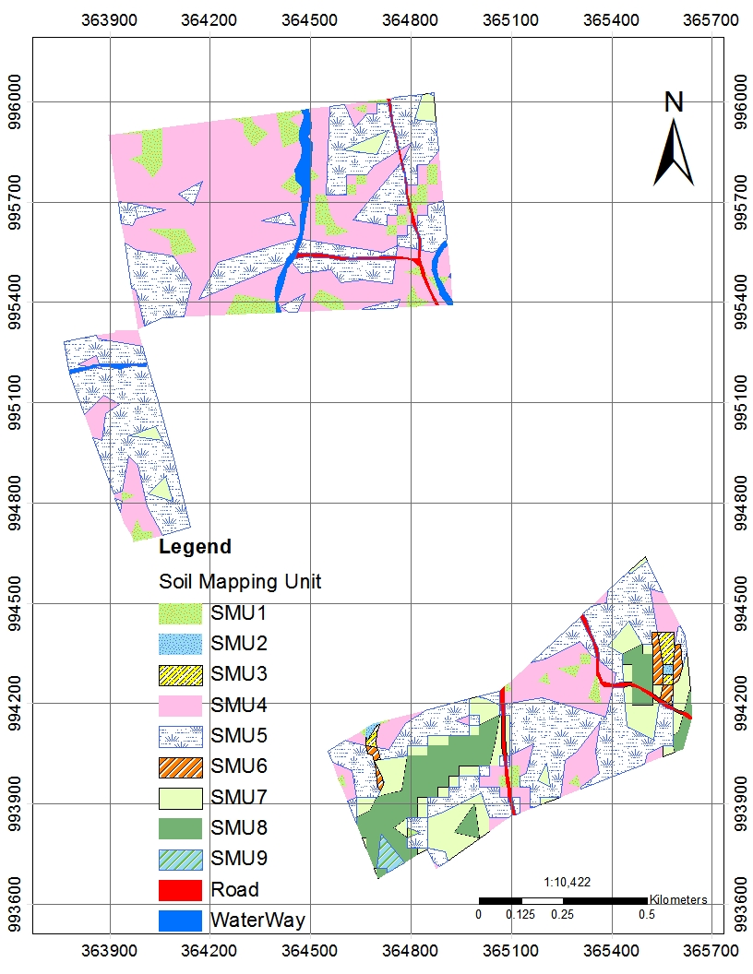
Figure 6-1 Soil map showing the distribution of the soil-mapping units

LAND SUITABILITY EVALUATION

Introduction
The methodology for land suitability assessment is based upon the FAO Framework for Land Evaluation (FAO, 1976), where evaluation is the process of matching different environments against possible land use options. Land suitability is then defined as the fitness of a specific area of land for a specified kind of land use a so-called land utilization type (LUT) under a stated system of management. Simply, to what extent is the land in questionable to support the LUT being considered? If the LUT appears profitable, the land is deemed suitable for it.
Land is assessed for its suitability for a LUT by a consideration of soil properties and site factors as they might affect the practicality and cost of development and maintenance, and the productivity of the land. The classification is implicitly or explicitly based on the economics of land development, although physical features are used as a basis for the economic rating. Classification is intended to reflect the payment capacity of the land, where different classes indicate decreasing payment capacity relative to increasing requirements for development and continued production. There is a cut-off point beyond which limitations of soil and/or site are so severe as to preclude any possibilities of successful sustained use at reasonable cost.
In semi-arid zones the concept of land suitable for irrigation being linked with positive economic benefits is problematical because the cost of supplying water, however good the land and the soil, usually outweighs the potential benefits to be derived from the range of possible enterprises. In simple terms, all land in the strict economic sense is hardly suitable for irrigated agriculture. This difficulty is usually circumvented by arguing that in semi-arid regions having a predominantly rural economy, soil and water are both scarce commodities and even if they are of poor quality, their coexistence frequently justifies agricultural production, regardless of purely economic considerations. However, a realistic assessment should be provided of the ability of the project to satisfactorily develop land for irrigation because if such development cannot be properly achieved the livelihood of the local beneficiaries will be seriously jeopardized, this is not a risk that should be entertained.
Notwithstanding the above argument one can say that in the FAO system of land evaluation suitable land (S) is that on which sustained use in the defined manner is expected to yield benefits acceptable for the required capital and recurrent inputs (costs), without causing unacceptable risk to the environment. Unsuitable land (N) has characteristics that preclude its sustained use in the defined manner because of an unacceptable requirement of development or recurrent inputs.

Land Suitability Classes and Sub-classes
The land suitability classes, S1 to S3, indicate relative suitability, to reflect decreasing benefits relative to increasing requirements for continued production; either a greater cost is required to achieve the same yield or yields will be lower under the same costs.
A truly quantitative land suitability evaluation based on real economic assessment is difficult to make, due to scarcity or unreliability of data, uncertain pricing and marketing policies and highly fluctuating marketing conditions. Moreover, in areas where transport and infrastructure are poorly developed the proximity of an all-weather asphalt road or a large town (market) can make the surrounding land highly suitable in economic terms, far more suitable than the quality of land might indicate. More distant land might be far better physically for a defined use but less attractive economically simply because of its remoteness. Likewise, it may be preferable or more cost-effective to irrigate relatively poorer quality land close to a water source rather than pump and pipe water to better but more distant land. These considerations are not embodied in the FAO land classification but must be considered by the developer.
For each suitability class there are a number of sub-classes that reflect the type of limitations restricting the suitability of the soil-mapping unit. Note that S1 has no specific limitations.
Limiting factors governing land suitability evaluation for irrigation in project area are:
- t - Topography (micro topography, dissection)
- r - Restricted root ability; limited depth to bedrock and coarse material
- s - Salinity
- dw - Poor drainage and shallow water table
- p - Soil pH
- st - Stoniness
- x - Texture
- i - Infiltration rate
- h - Hydraulic conductivity

Table 7-1 FAO recommended land class definitions
Class | Designation | Definition
S1 | Highly suitable | Land having no significant limitations to sustained application of a given use, or only minor limitations that will not significantly reduce productivity or benefits and will not raise inputs above an acceptable level.
S2 | Moderately suitable | Land having limitations which in aggregate are moderately severe for sustained application of a given use. The limitations will reduce productivity or benefits and increase required inputs to the extent that the overall advantage to be gained from the use, although still attractive, will be appreciably inferior to that expected on Class S1 land.
S3 | Marginally suitable | Land having limitations which, in aggregate, are severe for sustained application of a given use and will so reduce productivity or benefits, or increase required inputs, that this expenditure will be only marginally justified.
N1 | Currently not suitable | Land otherwise suitable (S1 to S3) for sustained application of a given use but having a limitation(s) which, although possibly surmountable in time, cannot be corrected with existing knowledge at currently acceptable cost. The limitation(s) is so severe as to preclude successful sustained use of the land in the given manner at present.
N2 | Permanently not suitable | Land having limitations that appear so severe as to preclude any possibilities of successful sustained use of the land in the given manner.

Land Use Requirements, Land Characteristics and Land Qualities

Land Use Requirements
Having described the land use type, which is surface irrigated agriculture, the next step is to define the land requirements for successful soil, crop and irrigation water management. It is the necessary or desirable conditions of the land for successful and sustained practice of a given land use such as agronomic management, land development, conservation requirements or limitations. In other words, land use requirements refer to the set of land qualities that determine the production and management conditions.

Land Characteristics
These are measurable properties of the physical, socioeconomic, and environmental conditions directly related to land use. Land characteristics are made available through soil and land use surveys, socioeconomic and farming system surveys and environmental assessment. Some of the land characteristics and qualities are climate, topography, soil physical and chemical properties, soil fertility, salinity and alkalinity, etc.

Land Qualities
They are an attribute of land or their expressions as a diagnostic criterion, which limits the potential of land for a specified kind of use. They are derived from measured land characteristics.
Land characteristics, land qualities and class determining/limiting factors have been obtained from detail soil survey (feasibility level) and have been evaluated on how they affect the land for irrigation development. Critical limits have been given a suffix in suitability evaluation as discussed in Section 7.2 above to denote the main limiting factor or factors that affect the management of the soil-mapping units.
Land use requirement for surface irrigation and land characteristics, land qualities and class determining/ limiting factors governing land suitability evaluation for irrigation are given in table below.
Table 7-2: Land use requirement and critical class limits for surface irrigation
Limiting factors | Suitability Classes
Limiting factors | S1 | S2 | S3 | N1 | N2
Slopes (%) | 0-2 | 2-5 | 5-10 | 10-15 | >15
Drainage | Well | Moderately well | imperfect | poor & excessive | very poor
Depth ( cm ) | >200 | 120-200 | 60-120 | 30-60 | <30
Soil texture | Silty loam - clay loam | Sandy loam – clay | Loamy sand & heavy clay | Sand | very coarse sand
Coarse material (%) | <1 | 1-3 | 3-15 | 15-50 | >50
Structure | SAB, AB | SAB, AB | Platy, prismatic | Massive
Salinity (mS/cm) | <4 | 4-8 | 8-12 | 12-16 | >16
ESP (%) | <10 | 10-15 | 15-20 | >20 | >20
CEC (meq/100g of soils) | >20 | 5-20 | 1-5 | <1 | <1
OM (%) | 3-5 | 1-3 | <1 | <1
Total N (%) | >0.5 | 0.2-0.5 | 0.1-0.2 |  | <0.1
Available P (ppm) | >15 | 5-15 | <5 |  | <2
pH | 5.5-7.0 | 5.0-5.5 & 7.0-8.0 | 4.5-5.0 & 8.0-8.5 | 8.5-9.0 | <4.5&>9.0
IR (Cm/hr) | 0.5-3.5 | 0.1-0.5 | 6.5-10.0 | 10_25 | <0.1 or >25
IR (Cm/hr) |  | 3.5-6.5
HC (m/day) | >1.5 | 1.5-0.5 | 0.4-0.2 | <0.2
AWC (mm/m) | >150 | >100 | >75 | >50 | <50

Table 7-3 Land characteristics and land qualities of soil mapping units
Class limiting factors | SMU1 | SMU2 | SMU3 | SMU4 | SMU5 | SMU6 | SMU7 | SMU8 | SMU9
Slope % | 0-2 | 0-2 | 2-5 | 2-5 | 5-10 | 5-10 | 10-15 | 15-30 | 30-50
Drainage | Moderate | Poor | Poor | Moderate | Moderate | Poor | Moderate | Moderate | Moderate
Depth (cm) | >200 | >200 | >200 | >200 | >150 | >100 | >200 | >200 | >200
Texture | C | C | C | C | C | C | CL | CL | CL
Coarse material (%) | None | None | None | None | Very Few | Few | None | None | None
Structure | SAB,P & G | SAB,P & G | SAB & G | SAB &G | SAB &G | SAB &G | SAB,P &G | SAB &G | SAB &G
Salinity (mS/cm) | 0.16 | 0.16 | 0.16 | 0.16 | 0.16 | 0.16 | 0.16 | 0.16 | 0.16
CEC (meq/100 gm of soils) | 61.5 | 61.5 | 61.5 | 61.5 | 61.5 | 61.5 | 61.5 | 61.5 | 61.5
OC (%) | 1.65 | 1.65 | 1.65 | 1.65 | 1.65 | 1.65 | 1.65 | 1.65 | 1.65
Nitrogen (%) | 0.013 | 0.013 | 0.013 | 0.013 | 0.013 | 0.013 | 0.013 | 0.013 | 0.013
Available P (mg P2O5/kg soil) | 3.83 | 3.83 | 3.83 | 3.83 | 3.83 | 3.83 | 3.83 | 3.83 | 3.83
pH | 7.91 | 7.91 | 7.91 | 7.91 | 7.91 | 7.91 | 7.91 | 7.91 | 7.91
IR (cm/hr) | 0.7 | 0.5 | 0.5 | 0.7 | 0.7 | 0.5 | 0.7 | 1.1 | 1.1
HC (m/day) | 0.06 | 0.01 | 0.01 | 0.06 | 0.06 | 0.01 | 0.06 | 0.06 | 0.06
AWC (mm/m) | 160.8 | 160.8 | 160.8 | 160.8 | 160.8 | 160.8 | 156.72 | 156.72 | 156.72

Results of Land Suitability Evaluation
Matching and super imposing of the land use requirements and critical class limits with the soil and land characteristics and limiting factors of the SMU has resulted in suitability classes. Initially matching proceeds for each land quality for each soil-mapping units. These individual ratings are then combined to give an overall suitability for the soil-mapping units. To arrive at the final land suitability classification for proposed irrigation of the command area, possible remedial measures have to be considered relevant to soil fertility and socioeconomic conditions.
Evaluation of land use requirements for irrigated agriculture with soil and land characteristics, land qualities and limitations of each soil-mapping unit in Bite-Chole command area has given the irrigation land suitability class with its specific limitations requiring remedial measures for up grading the land and soil suitability of each soil-mapping unit. The result of suitability evaluation for surface irrigation is shown in Table 13 below.
Table 7-4: Results of surface irrigation suitability evaluation
SMU | Suitability under proposed irrigation | Area (ha) | Area (%)
SMU1 | S2 (p,x) | 6.8 | 5.7
SMU2 | N1 (dw) | 0.19 | 0.16
SMU3 | N1 (dw) | 0.62 | 0.52
SMU4 | S2 (t,p,x) | 42.56 | 35.92
SMU5 | S3 (t) | 46.21 | 38.99
SMU6 | N1 (dw) | 1.04 | 0.86
SMU7 | N1 (t) | 9.17 | 7.74
SMU8 | N2 (t) | 7.49 | 6.32
SMU9 | N2 (t) | 0.48 | 0.41

According to the result given in the table above the main limiting factors of the soils of Bite-Chole command area are topography, pH, texture and. Those limiting factors mentioned have brought the soils majorly to be moderately to marginally suitable under intermediate level of management. Some of the limitations can be corrected at different level of intervention; for example, fertility status of the soil can be easily improved by adding fertilizer relative to other remedial measures. The moderately suitable mapping units (SMU1 and SMU4) limited by high pH, texture and low nutrient status can be improved to highly suitable class (S1) with irrigation water management and application of fertilizer.
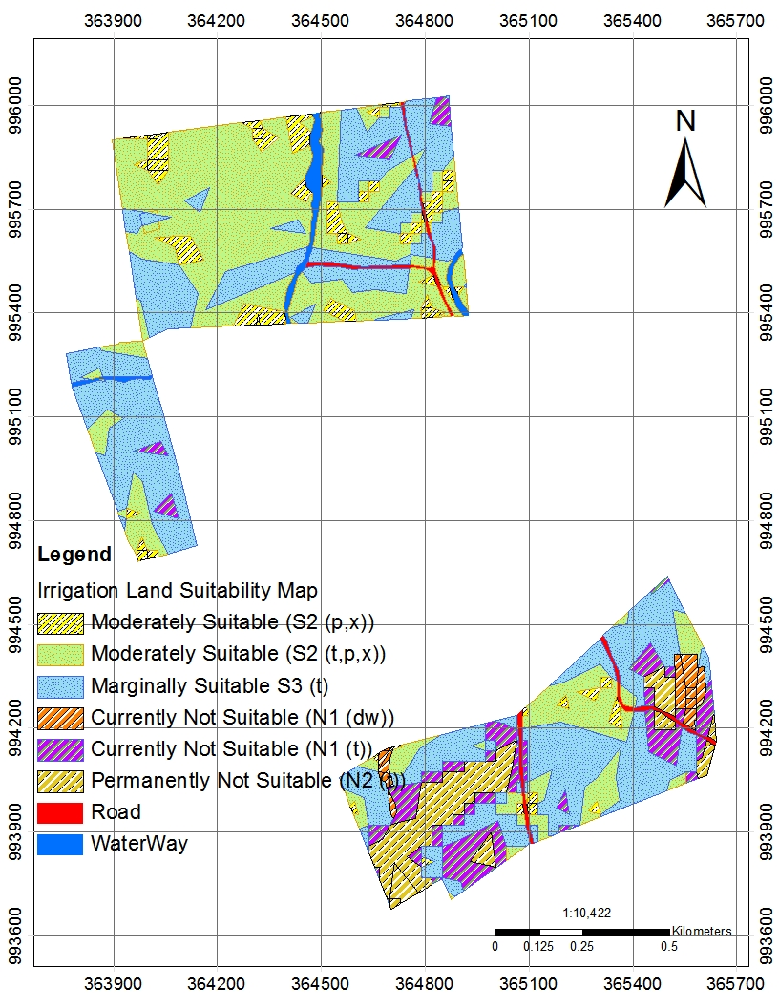
Figure 7-1: Irrigation Land Suitability Map

Land Evaluation for Selected Crops

Proposed Crops
Crops and cropping patterns have been selected based on existing conditions, climate, and requirement of individual crops for daily consumption and income generation for the community. The major proposed crops are Cabbage, Pepper, onion, Garlic, Sweet Potato, Beet root, Tomato and Carrot crops.

Crop Requirements
A crop requirement is an optimum land and soil characteristics and qualities required to achieve average and high yield plus a potential for improvement in the future as more experience and management capacity is gained. Crop requirements for proposed and selected crops for the project have been reviewed and analyzed for surface irrigation under medium input level.

Results of Crop Suitability Evaluation
Crop suitability evaluation for the proposed crops has been done to investigate alternative viable cropping pattern. It enables planners and managers including farmers, to consider all practicable alternative-cropping patterns. Crop suitability evaluation for the proposed crops under a medium level of management has been considered.
Matching and superimposing crop requirements under irrigation with soil and land characteristics, land qualities and limitations of each soil mapping unit has given the irrigated crop suitability class. Hence, all proposed crops, which are: Cabbage, Pepper, onion, Garlic, Sweet Potato, Beet root, Tomato and Carrot crops are found to be moderately to marginally suitable under irrigation with different extent of suitable area. However, Garlic, Onion, Sweet potato in SMU 2, SMU 3, SMU 6, and SMU 9 have been found to be unsuitable due to drainage and topography (Table 7-5).

Table 7-5: Results of crop suitability evaluation under irrigation
SMU | Proposed Crops
SMU | Cabbage | Tomato | Pepper | Garlic | Onion | Sweet Potato | Beet root | Carrot | Area ha | Area %
SMU1 | S2 (p,x) | S3 (p,x) | S2 (p,x) | S3 (p,x) | S3 (x) | S3 (p,x) | S3 (p) | S3 (p,x) | 6.8 | 5.7
SMU2 | S3 (dw) | S3 (dw,p,x) | S3 (dw) | N1 (dw) | N1 (dw) | N1 (dw) | S3 (dw,p,x) | S3 (dw,p,x) | 0.19 | 0.16
SMU3 | S3 (dw) | S3 (dw,p,x) | S3 (dw) | N1 (dw) | N1 (dw) | N1 (dw) | S3 (dw,p,x) | S3 (dw,p,x) | 0.62 | 0.52
SMU4 | S2 (p,x) | S3 (p,x) | S2 (p) | S3 (p,x) | S3 (x) | S3 (p) | S3 (p,x) | S3 (p,x) | 42.56 | 35.92
SMU5 | S2 (t,p,x) | S3 (p,x) | S2 (p) | S3 (t,p,x) | S2 (t,x) | S3 (t,p,x) | S3 (p,x) | S3 (p) | 46.21 | 38.99
SMU6 | S3 (dw) | S3 (dw,p,x) | S3 (dw) | N1 (dw) | N1 (dw) | N1 (dw) | S3 (dw,p,x) | S3 (dw,p,x) | 1.04 | 0.86
SMU7 | S2 (p,x) | S3 (p,x) | S2 (p) | S3 (p,x) | S2 (t,p,x) | S3 (p) | S3 (p) | S3 (p) | 9.17 | 7.74
SMU8 | S2 (p,x) | S3 (t,p,x) | S2 (p,x) | S3 (t,p) | S3 (t) | S2 (t,p) | S3 (t,p) | S3 (t,p,x) | 7.49 | 6.32
SMU9 | S2 (t,p,x) | S3 (t,p,x) | S3 (t,p,x) | N1 (t) | N1 (t) | S3 (t,p) | N1 (t) | N1 (t) | 0.48 | 0.41

CONCLUSIONS
The soil survey of Bite-Chole irrigation project was conducted at feasibility (detailed) level to evaluate and map suitable area for irrigation and to assess the soil and land constraints so that the constraint free and problematic area are identified and managed according to the problem and its extent.
Standard and recommended detailed level of soil survey methodology was followed including review of previous studies, interpretation of satellite imageries and topographic maps. Field auger observations and profile descriptions was conducted. The soil survey was done at 19 observations density based on the problem of the survey area. Finally one FAO major soil types and 3 sub units were identified and mapped at 1: 10,000 scales.
Nine-soil mapping units were established which have more or less similar soil, land characteristic, and constraints. Soil and land suitability have been evaluated based on the soil mapping units hence the majority of land units found to be moderately to marginally suitable under intermediate level of management. However, there some soil-mapping units, which are not suitable to crops such as SMU 2, SMU3, SMU6 and SMU 9 due to drainage problem and topography, this soil mapping unit takes smaller area coverage. In contrary, all the limiting factors related to nutrient status are correctable through the application of fertilizers and other natural manures such as cow dung, crop residues and compost making according to area problem.

REFERENCES
- BCEOM (1999) Data Collection, Site Investigation, Survey and Analysis, Abbay River Basin Integrated Development Master Plan Project, Vol. XIII, Part 1, MoWR, Addis Ababa.
- Bray R.H & Kurtz, L.T., 1945. Determination of total organic and available phosphorus in soils. Soil. Sci, 59: 39-45.
- Bohn, H.L., B.L. McNeal, and G.A. O'Connor, 2001. Soil Chemistry. 3rd ed. John Wiley and Sons, Inc., USA.
- Buol, S.W., F.D. Hole and R.J. McCracken, 1997. Soil Genesis and Classification (Fourth Edition). The Iowa State University Press, Inc., Iowa, USA. 527p.
- Food and Agriculture Organization of the United Nations (FAO), 1976. A framework for land evaluation. FAO Soils Bulletin 32, FAO, Rome
- Food and Agricultural Organization of the United Nations (FAO), 1979. Yield response to water. FAO irrigation and drainage paper 33, FAO, Rome.
- Food and Agricultural Organization of the United Nations (FAO), 1983. Guidelines: Land evaluation for rain fed agriculture. Soils Bulletin 52, Rome.
- FAO (Food and Agriculture Organization), 2006. Guidelines for soil description (Fourth Edition). FAO, Rome.
- FAO/WRB (Food and Agriculture Organization/World Reference Base), 2006. A framework for international classification, correlation and communication. World Soil Resources Reports 103. International Union of Soil Sciences, FAO, Rome.
- Food and Agriculture Organization of the United Nations (FAO), 2007, Land evaluation towards a revised framework, Land and water discussion paper 6. FAO, Rome.
- Geomorphology and soils map of Ethiopia, 1984. Land use planning and regulatory department (LUPRD) of the ministry of agriculture. Landforms and soils types at scale of 1:1,000, 000.
- Hesse, P.R., 1972. A textbook of soil chemical analysis. John Murry Limited., London, Great Britain. 470p.
- Landon J.R., 1991. Booker tropical soil manual, Hand book for soil survey and agricultural land evaluation in the tropics and sub tropics.
- Munsell Color Company, 1975, Munsell soil color charts. Munsell Color Company Press, Inc., Baltimore 18, Maryland, USA.
- Olsen, S.R & Dean, L. A., 1965. Phosphorus. In: C. A. Black (ed.) Methods of soil analysis. Agronomy No. 9. American society of Agronomy, Madison.
- Sys I., C., Van Ranst, E and Debaveye, I.J., 1991a.Land evaluations part I: Principles in land evaluation and crop production calculations. Agricultural Pub. No.7, ITC, University of Ghent, Ghent.
- Tekalign Tadese, 1991. Soil, plant, water, fertilizer, animal manure and compost analysis. Working Document No. 13. International Livestock Research Center for Africa, Addis Ababa, Ethiopia.
- Walkley. A & Black, I. A., 1934. An examination of the Degtiareff method for determining soil organic matter, and a proposed modification of the chromic acid titration method. Soil. Sci. 34: 29-38.

APPENDICES
Appendix Table: 1 Soil Laboratory results
Sample Information
Laboratory Code | M0153 | Date Sampled | 27-Mar-15
Report Date | 9-May-15 | Date Received | 28-Mar-15
Sampling Depth | 0-25cm | Sampled By | Client
Description | Field Number B-CP1,Sample Number- 1
Analytical Result Applied Standard
Parameter Result Unit for Measurement
Conductivity | EC | 0.16 | mS/cm | ISO 11265
Acidity | pH-H 2 O | 7.91 | - | ISO 10390
Total Nitrogen | N | 130.90 | mg/kg | Kjeldahl Method ISO 1261
Organic Carbon | OC | 1.65 | % | Walkey and Black Method
Cation Exchange Capacity | CEC | 61.5 | Meq/100g soil | Ammonium Acetate Method
Available Phosphorous | P | 3.83 | mg/l | Olsens Method
Boron | B | 1.04 | mg/l
Exchangeable Calcium (Ca) | Ca | 760.5 | Meq/100g soil
Copper | Cu | 4.81 | mg/l
Iron | Fe | 202.97 | mg/l
Exchangeable Potassium (K) | K | 62.9 | Meq/100g soil | Ammonium Acetate Method
Exchangeable Magnesium (Mg) | Mg | 95.14 | Meq/100g soil | Ammonium Acetate Method
Manganese | Mn | 169.05 | mg/l | Ammonium Acetate Method
Exchangeable Sodium (Na) | Na | 2.37 | Meq/100g soil | Ammonium Acetate Method
Phosphorus | P | 2.76 | mg/l
Sulfur | S | 5.35 | mg/l
Zinc | Zn | 1.89 | mg/l
Aluminum | Al | 962.69 | mg/l
% CaCo3 |  | 7.50 | % | Acid Neutralization
% Sand(50um-2mm) |  | 12.00 | % | Bouyoucos Hydrometer Method
% Clay(0-2um) |  | 76.00 | % | Bouyoucos Hydrometer Method
% Silt(2um-50um) |  | 12.00 | % | Bouyoucos Hydrometer Method
Textural Class |  | Clay |  | Textural Triangle
Bulk density | BD | 1.34 | gm/cm 3
Field Capacity | FC | 0.57 | cm 3 water/cm 3 soil
Permanent Wilting Point | PWP | 0.45 | cm 3 water/cm 3 soil

Sample Information
Laboratory Code | M0154 |  |  | Date Sampled | 27-Mar-15
Report Date | 9-May-15 |  |  | Date Received | 28-Mar-15
Sampling Depth | 25-62cm |  |  | Sampled By | Client
Description | Field Number B-CP1, Sample Number -2
Analytical Result Applied Standard
Parameter Result Unit for Measurement
Conductivity | EC | 0.17 | mS/cm | ISO 11265
Acidity | pH-H 2 O | 8.15 | - | ISO 10390
Total Nitrogen | N | 102.50 | mg/kg | Kjeldahl Method ISO 1261
Organic Carbon | OC | 1.18 | % | Walkey and Black Method
Cation Exchange Capacity | CEC | 58.58 | Meq/100g soil | Ammonium Acetate Method
Available Phosphorous | P | 3.43 | mg/l | Olsens Method
Boron | B | 1.24 | mg/l | Ammonium Acetate Method
Exchangeable Calcium (Ca) | Ca | 806.8 | Meq/100g soil
Copper | Cu | 5.07 | mg/l
Iron | Fe | 187.93 | mg/l
Exchangeable Potassium (K) | K | 63.9 | Meq/100g soil
Exchangeable Magnesium (Mg) | Mg | 98.5 | Meq/100g soil
Manganese | Mn | 157.44 | mg/l
Exchangeable Sodium (Na) | Na | 4.07 | Meq/100g soil
Phosphorus | P | 1.86 | mg/l
Sulfur | S | 5.25 | mg/l
Zinc | Zn | 1.91 | mg/l
Aluminum | Al | 934.25 | mg/l
% CaCo3 |  | 8.90 | % | Acid Neutralization
% Sand(50um-2mm) |  | 10.00 | % | Bouyoucos Hydrometer Method
% Clay(0-2um) |  | 78.00 | % | Bouyoucos Hydrometer Method
% Silt(2um-50um) |  | 12.00 | % | Bouyoucos Hydrometer Method
Textural Class |  | Clay |  | Textural Triangle
Bulk density | BD | 1.306 | gm/cm 3
Field Capacity | FC | 0.58 | cm 3 water/cm 3 soil
Permanent Wilting Point | PWP | 0.46 | cm 3 water/cm 3 soil

 | Sample Information
 | Laboratory Code |  | M0156 |  |  |  | Date Sampled | 27-Mar-15
 | Report Date |  | 9-May-15 |  |  |  | Date Received | 28-Mar-15
 | Sampling Depth |  | 62-125cm |  |  |  | Sampled By | Client
 | Description |  | Field Number B-CP1, Sample Number-3
Analytical Result Applied Standard
Parameter Result Unit for Measurement
Conductivity |  | EC |  | 0.22 | mS/cm | ISO 11265
Acidity |  | pH-H 2 O |  | 8.24 | - | ISO 10390
Total Nitrogen |  | N |  | 148.00 | mg/kg | Kjeldahl Method ISO 1261
Organic Carbon |  | OC |  | 1.08 | % | Walkey and Black Method
Cation Exchange Capacity |  | CEC |  | 59.3 | Meq/100g soil | Ammonium Acetate Method
Available Phosphorous |  | p |  | 2.30 | mg/l | Olsens / Bray Method
Boron |  | B |  | 1.10 | mg/l | Ammonium Acetate Method
Exchangeable Calcium (Ca) |  | Ca |  | 850.2 | Meq/100g soil
Copper |  | Cu |  | 4.89 | mg/l
Iron |  | Fe |  | 210.83 | mg/l
Exchangeable Potassium (K) |  | K |  | 56.7 | Meq/100g soil
Exchangeable Magnesium (Mn) |  | Mg |  | 113.9 | Meq/100g soil
Manganese |  | Mn |  | 137.29 | mg/l
Exchangeable Sodium (Na) |  | Na |  | 7.1 | Meq/100g soil
Phosphorus |  | P |  | 2.32 | mg/l
Sulfur |  | S |  | 8.10 | mg/l
Zinc |  | Zn |  | 2.13 | mg/l
Aluminum |  | Al |  | 938.75 | mg/l
% CaCo3 |  |  |  | 7.80 | % | Acid Neutralization
% Sand(50um-2mm) |  |  |  | 8.00 | % | Bouyoucos Hydrometer Method
% Clay(0-2um) |  |  |  | 80.00 | % | Bouyoucos Hydrometer Method
% Silt(2um-50um) |  |  |  | 12.00 | % | Bouyoucos Hydrometer Method
Textural Class |  |  |  | Clay |  | Textural Triangle

 | Sample Information
 | Laboratory Code |  | M0158 |  |  |  | Date Sampled | 27-Mar-15
 | Report Date |  | 9-May-15 |  |  |  | Date Received | 28-Mar-15
 | Sampling Depth |  | 125-200cm |  |  |  | Sampled By | Client
 | Description |  | Field Number B-CP1, Sample Number- 4
Analytical Result Applied Standard
Parameter Result Unit for Measurement
Conductivity |  | EC |  | 0.28 | mS/cm | ISO 11265
Acidity |  | pH-H 2 O |  | 8.35 | - | ISO 10390
Total Nitrogen |  | N |  | 54.30 | mg/kg | Kjeldahl Method ISO 1261
Organic Carbon |  | OC |  | 0.97 | % | Walkey and Black Method
Cation Exchange Capacity |  | CEC |  | 57.7 | Meq/100g soil | Ammonium Acetate Method
Available Phosphorous |  | p |  | 2.08 | mg/l | Olsens / Bray Method
Boron |  | B |  | 0.81 | mg/l | Ammonium Acetate Method
Exchangeable Calcium (Ca) |  | Ca |  | 864.80 | Meq/100g soil
Copper |  | Cu |  | 4.05 | mg/l
Iron |  | Fe |  | 136.34 | mg/l
Exchangeable Potassium (K) |  | K |  | 46.9 | Meq/100g soil
Exchangeable Magnesium (Mg) |  | Mg |  | 129.90 | Meq/100g soil
Manganese |  | Mn |  | 103.81 | mg/l
Exchangeable Sodium (Na) |  | Na |  | 17.44 | Meq/100g soil
Phosphorus |  | P |  | 1.53 | mg/l
Sulfur |  | S |  | 20.34 | mg/l
Zinc |  | Zn |  | 1.76 | mg/l
Aluminum |  | Al |  | 649.93 | mg/l
% CaCo3 |  |  |  | 13.70 | % | Acid Neutralization
% Sand(50um-2mm) |  |  |  | 12.00 | % | Bouyoucos Hydrometer Method
% Clay(0-2um) |  |  |  | 76.00 | % | Bouyoucos Hydrometer Method
% Silt(2um-50um) |  |  |  | 12.00 | % | Bouyoucos Hydrometer Method
Textural Class |  |  |  | Clay |  | Textural Triangle

Appendix Table 2: Soil Profiles Description
Field No: B-CP1 Author Yitbarek Wolde Status: Sampled
Project name Bite-Chole SSIP Date 28/03/2015
Observation site location: Ras Mesfin GPS N: 995646 E: 364118
Surface crust: None Erosion
Cracking: Wide A) At site: Sheet/Rill (Slight) Land use: Cultivated
Elevation: 1879 B) At surrounding: S/R/G (Moderate) Crop grown: Teff
Drainage Class/Ext: Moderate/Slow Micro topography: Gilgai (common)
Land Form: Plain Range Land
Flooding F/D: None SMU: 1 Over grazing: None
Position: Low Slope Class: 4% Bush encroachment: None
GWTD (cm): None Slope aspect/direction: South to North
Vegetation type: Open Woodland Slope form: Rolling
Permeability: Slow Rock out crop: None Dominant species: Acacia species, Eucalyptus
Parent material: Basalt Surface Stone/gravel: Very Few/ Very Few

Horizon symbol |  | A | B1 | B2 | B3
Depth(cm) |  | 0-25 | 25-62 | 62-125 | 125-200
Boundary |  | C/S | C/S | C/G
Moisture Status | D/T | D | SM | SM | SM
Color | Dry | 10YR 3/1 | - | - | -
Color | Moist | 10YR 2/1 | 10YR 3/1 | 10YR 2/1 | 10YR 2/2
Mottles | Abundance | None | None | None | None
Mottles | Size | - | - | - | -
Mottles | Contrast | - | - | - | -
Texture |  | clay | Clay | Clay | clay
Coarse Fragment | Abundance | Very Few | None | Few | None
Coarse Fragment | Size | Fine | - | Fine | -
Structure | Grade | Strong | Strong | Strong | Strong
Structure | Size | Medium | Course | Course | Course
Structure | Type | Sub-angular | Prismatic | Prismatic | Angular
Crack |  | Wide | Wide | Wide | None
Consistency | Dry | Very Hard | - | - | -
Consistency | Moist | Very firm | Very firm | Very firm | Firm
Consistency | Wet | Sticky/Plastic | V.Sticky/V.Plastic | V.Sticky/V.Plastic | V.Sticky/V.Plastic
Cutans | Abundance | None | Abundant | Abundant | Abundant
Cutans | Size | - | Distinct | Distinct | Distinct
Cutans | Nature | - | Slickenside | Slickenside | Slickenside
Cementation | Grade | None | Compact | Compact | Moderate
Mineral nodules | Abundance | None | None | None | Common
Mineral nodules | Color | - | - | - | White
Mineral nodules | Hardiness | - | - | - | Soft
Mineral nodules | Nature | - | - | - | Carbonate
Mineral nodules | Kind | - | - | - | Segregation
Root | Abundance | Few | Few | None | None
Root | Size | fine | fine | - | -
Pores | Abundance | Common | Common | None | Common
Pores | Size | Fine/Medium | Fine/Medium | - | Fine/Medium
Sample |  | 1 | 2 | 3 | 4

Diagnostic horizon (surface) Mollic Sub surface Vertic
Diagnostic property Argic Depth to paralithic contact: > 200 cm
FAO field classification: Vertisols Final Classification: Pellic Vertisols

Field No: B-CP2 Author Yitbarek Wolde Status: Not-Sampled
Project name Bite-Chole SSIP Date 28/03/2015
Observation site location: - GPS N: 995281 E: 363897
Surface crust: None Erosion
Cracking: Wide A) At site: Sheet/Rill (Slight) Land use: Cultivated
Elevation: 1906 B) At surrounding: S/R/G (Moderate) Crop grown: Teff
Drainage Class/Ext: Moderate/Slow Micro topography: Gilgai (common)
Land Form: Plain Range Land
Flooding F/D: None SMU: 2 Over grazing: None
Position: Low Slope Class: 5% Bush encroachment: None
GWTD (cm): None Slope aspect/direction: South to North
Vegetation type: Open Woodland Slope form: Rolling
Permeability: Slow Rock out crop: None Dominant species: Acacia species, Eucalyptus
Parent material: Basalt Surface Stone/gravel: Very Few/ Very Few

Horizon symbol |  | A | B1 | B2 | B3
Depth(cm) |  | 0-20 | 20-60 | 60-120 | 120-200
Boundary |  | C/S | C/S | C/G
Moisture Status | D/T | Dry | D | D | D
Color | Dry | 7.5YR 4/4 | 5YR 4/4 | 7.5YR 3/4 | 5YR 4/4
Color | Moist | 7.5YR 3/3 | 5YR 3/3 | 7.5YR 3/3 | 5YR 3/3
Mottles | Abundance | None | None | None | None
Mottles | Size | - | - | - | -
Mottles | Contrast | - | - | - | -
Texture |  | clay | Clay | Clay | clay
Coarse Fragment | Abundance | Very Few | None | Few | None
Coarse Fragment | Size | Fine | - | Fine | -
Structure | Grade | Strong | Strong | Strong | Strong
Structure | Size | Medium | Course | Course | Course
Structure | Type | Sub-angular | Prismatic | Prismatic | Angular
Crack |  | Wide | Wide | Wide | None
Consistency | Dry | Very Hard | - | - | -
Consistency | Moist | Very firm | Very firm | Very firm | Firm
Consistency | Wet | Sticky/Plastic | V.Sticky/V.Plastic | V.Sticky/V.Plastic | V.Sticky/V.Plastic
Cutans | Abundance | None | Abundant | Abundant | Abundant
Cutans | Size | - | Distinct | Distinct | Distinct
Cutans | Nature | - | Clay | Clay | Clay
Cementation | Grade | None | Compact | Compact | Moderate
Mineral nodules | Abundance | None | None | None | Common
Mineral nodules | Color | - | - | - | White
Mineral nodules | Hardiness | - | - | - | Soft
Mineral nodules | Nature | - | - | - | Carbonate
Mineral nodules | Kind | - | - | - | Segregation
Root | Abundance | Few | Few | None | None
Root | Size | fine | fine | - | -
Pores | Abundance | Common | Common | None | Common
Pores | Size | Fine/Medium | Fine/Medium | - | Fine/Medium
Sample |  | 1 | 2 | 3 | 4

Diagnostic horizon (surface) Mollic Sub surface Vertic
Diagnostic property Argic Depth to paralithic contact: > 200 cm
FAO field classification: Vertisols Final Classification: Chromic Vertisols

