OROMIA IRRIGATION DEVELOPMENT AUTORITY
ALENTU SMALL SCALE IRRIGATION PROJECT
IN
DODOLLA WOREDA OF WEST ARSI ZONE

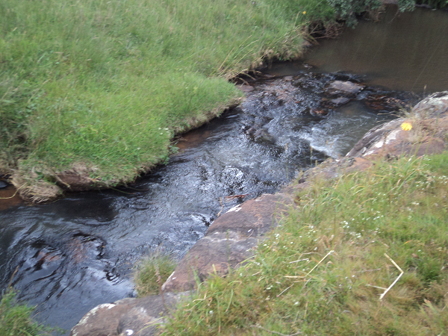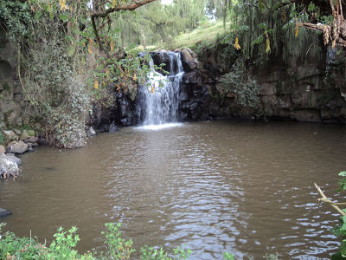
FINAL FEASIBILITY STUDY

BY
VIRGINIA CONSULTANTS IN ASSOCIATION WITH BERUH CONSULTING ENGINEERS AND HYDRO GEOLOGISTS
SOIL SURVEY

STUDY & DESIGN REVIEWED BY OIDA-AGP TEAM IN CONSULTATION WITH WEST ARSI ZONE IRRIGATION DEVELOPMENT AUTHORITY

NOVEMBER, 2016

Table of Contents
SOIL SURVEY 5
SUMMARY 6
1. Inventory of Soil Properties 7
1.1. Data presentation 7
2. General Information on the Site 7
2.1. Location and Accessibility 7
2.2. Climate 8
2.3. Vegetation and Land Use 8
2.4. Geology and Geomorphology 9
2.5. Hydrology 10
3. Field Procedures 10
3.1. Scope of the Survey 10
3.2. Soil Survey Methodology 11
3.2.1. Pre-Field Work 11
3.2.2. Field Work Stage 12
3.2.3. Laboratory Analysis 12
3.2.4. Post Field Work (office) Stage 13
4. Chemical Characteristics 14
4.1. Soil Reaction (P^{H}) 14
4.2. Organic Carbon and Organic Matter 14
4.3. Total Nitrogen 14
4.4. Salinity and Soluble Salts 14
4.5. Exchangeable Cations 14
4.5.1. Exchangeable Calcium (Ca²⁺) 14
4.5.2. Exchangeable Magnesium (Mg²⁺) 14
4.5.3. Exchangeable Potassium (K⁺) 14
4.6. Cat ion Exchange Capacity (CEC) 15
4.7. Base Saturation Percentage (BSP) 15
4.8. Exchangeable Sodium Percentage (ESP) 15
4.9. Available Phosphorus (P) 15
4.10. Available Potassium (K) 15
5. Physical Properties 17
5.1. Effective Soil Depth 17
5.2. Soil texture 17
5.3. Soil Structure 17
5.4. Available Water holding Capacity 17
5.5. Bulk Density 17
5.6. Permanent Wilting Point (PWP) 17
5.7. Field Capacity (FC) 17
5.8. Hydraulic Conductivity 18
6. Soils 18
6.1. Soil Classification 18
6.2. Description of Major Reference Soil Groups 19
6.3. Description of Soil Mapping Unit 19
6.3.1. SMU 1a 19
6.3.2. SMU 2a 21
7. Land suitability Evaluation for Surface Irrigation 24
7.1. Results of Land Suitability Evaluation for surface Irrigation 24
8. Land Capability Classification 25
8.1. Objectives of Land Capability Classification 25
8.2. Approach to Land Capability Classification 25
8.3. Result of Land Capability Classification 26
9. Conclusion and Recommendation 26
9.1. Soil Fertility Management 26
9.2. Managing the problem of seasonal water logging 26
10. Reference 27

Table 1: Land Use/Land Cover Map of the Command Area and Area close to the Command Area 9
Table 2: The Type of Soil Chemical Analysis and Their Respective Methodology 13
Table 3: Summarized Soil Chemical and Physical Characteristics of the Soil Mapping Unit 16
Table 4: Summarized Physical Properties of the Soil Mapping Units 18
Table 5: Summarized Land Quality and Characteristics of the Soil Mapping Units 22
Table 6: Description of Land Requirement and Land Qualities of Surface Irrigation 24

Figure 1: Location map of the study area 8
Figure 2: Land Use/Land Map of the Command Area 9
Figure 3: Soil Map of Alentu SSIP 23

Annex1: Soil Testing……………………………………………………………………..................................28

ABBREVIATIONS

ASSIP Alentu Small Scale Irrigation Project
BSP Base Saturation Percentage
CEC Cat ion exchange capacity
EC Electrical Conductivity
ESP Exchangeable Sodium Percentage
FC Field Capacity
FAO Food and Agricultural Organization
GPS Global Positioning System
GIS Geographic Information System
HCL Hydrochloric acid
ISSS International Soil Science Society
PWP Permanent Wilting Point
SMU Soil Mapping Unit
TM Thematic Mapper
TOR Terms of Reference
UTM Universal Transverse Mercator
USDA United State Department of Agriculture
WRB World Reference Base for Soil Resources

SOIL SURVEY

SUMMARY

Soil survey and land evaluation study of Alentu Small Scale Irrigation Project (ASSIP) was carried out to investigate, interpret and map the distribution of the soil at feasibility level (1:10000 mapping scale). The information obtained was used in the assessment of irrigation potential, crop selections, irrigation designs and can be used for future agricultural development planning of the study area.

The command area is situated in the southwestern end of Wabi Shebele River basin approximately 331 km southeast of Finfinne and about 57 km south of Dodola town. It is bounded in the west by Serofta Mountain and in the South East and East direction Koro Mountain. The total size of command area surveyed, as computed on GIS it is about 70 hectares.

By and large, the survey procedure consists of three stages, that is: pre-field, fieldwork, and post-field stage, which included review of previous studies, satellite image interpretation and the actual field survey and sampling. The auger observation sites are regularly spaced out 250 by 250 meters grid. As a whole, eleven disturbed soil samples, three deep boring samples for salinity and sod city determination were collected and analyzed. Besides, a total of two in situ infiltration and hydraulic conductivity test in triplicate were executed.

The survey result ascertained one major reference soil group, which are classified in to two soil-mapping units. In line with, land capability classification, the entire area of land categorized in to class II.

In conclusion, appropriate land management options are given in detail.

Inventory of Soil Properties

Data presentation
This report is presented in four main sections. The first section describes general information on site characteristics and soil of the study area, the second section of the report deals with description of the physical environmental condition of the study area and survey methodology, the third section discuss result of the detail soil survey, and the last section discuss the results of land capability classification, Irrigation suitability and recommended land management and reclamation options.

Moreover, important soil data are presented in annexes and is supported by a number of maps at 1:10000 and smaller scales, which incorporate the soil distribution, land capability and irrigation suitability maps.

General Information on the Site

Location and Accessibility
The study area is situated in the south end of the wabishebele River basin approximately 331 km southeast of Finfinne and about 57 km from Adaba town. It is bounded in the west by Serofta Mountain and in the South East and East direction by Koro Mountain.

The area can be reached by Finfine-Shashemene-Dodola-Goba asphalt road or via Finfine-Asella-Dodola-Goba asphalt road. The command area can be accessed by Edo-Alentu-Werka all weather gravel road.

The project area lies within the geographic extent of 6⁰ 85’N to 6⁰ 87’N longitude and 39⁰ 04’ to 39⁰ 06’E latitude. The altitude is varying from 2780 masl in the northern edge to 3460 masl in southern tip.
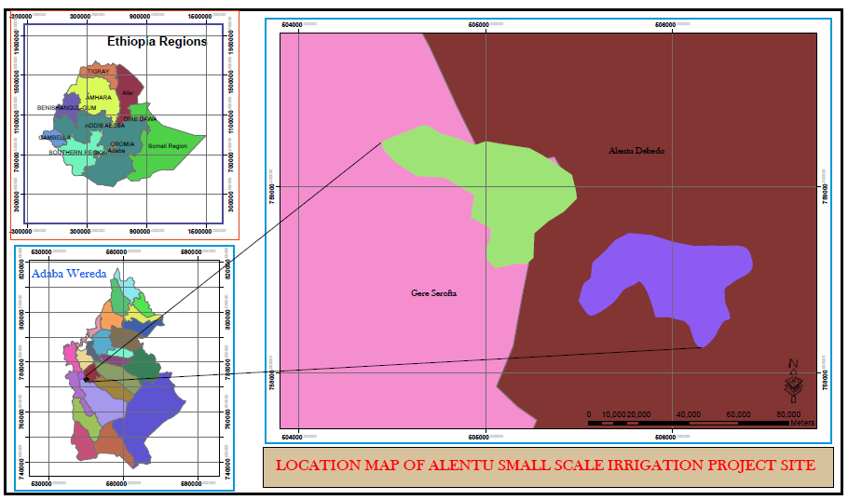
Figure 1: Location map of the study area

Climate
According to the data collected from Dodola weather station, the average mean annual rainfall for the area is ranging from a maximum of 1165.9mm to a minimum of 706.2mm.The maximum temperature ranges between 19⁰C and 29 ⁰C and the minimum temperature is ranging between -1.1⁰C and 10.2⁰C.

Climate is characterized by a long dry season and two consecutive rainy seasons, where small rains in spring and big rainy season in summer merge together.

Vegetation and Land Use
Around the project area, about three major groups of land use roughly out lined. These are:

- Cultivated land with scattered trees used mainly for cereal crop production mainly wheat.
- Flood area mainly used for livestock grazing.
- Open and dense forest area, used for fire and construction wood collection.
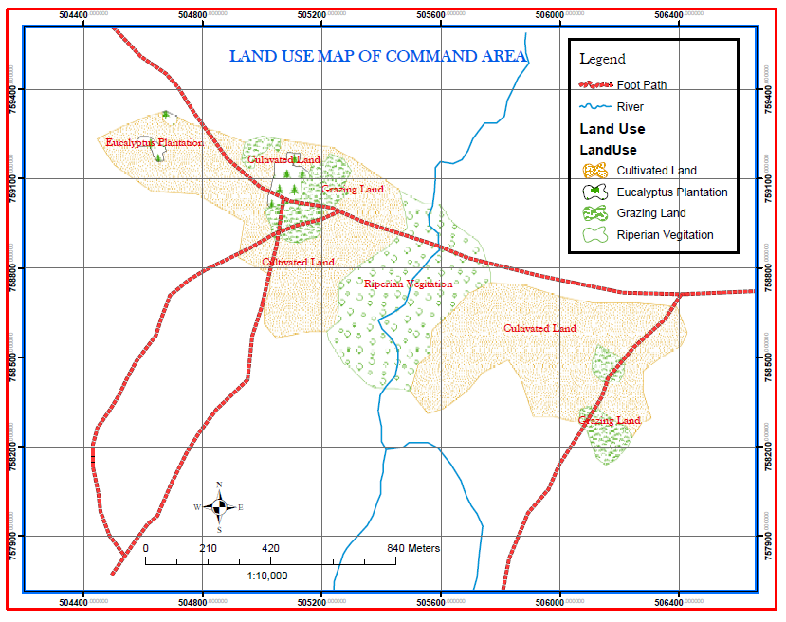
Figure 2: Land Use/Land Map of the Command Area

Table 1: Land Use/Land Cover Map of the Command Area and Area close to the Command Area
No | Land use/land cover | Area in Hectare | %age
1 | Cultivated Land | 57.36 | 81.94
2 | Eucalyptus Plantation | 3.40 | 4.85
3 | Grazing Land | 9.24 | 13.21
Total area |  | 70 | 100
3 | Riparian Vegetations outside of the command area | 19.6

Total area

Geology and Geomorphology
The geological formation of the study area belongs to Chilalo Formation. The Chilalo Formation is a group of Early Pliocene complex shield volcanoes. The lower unit comprises intercalation of peralkaline ignimbrite and trachytes, which show clear flow structure. The dominant rock type is a strongly porphyritic dark grey trachyte with sanidine phenocrysts.
Lava flow of predominantly trachytic volcanoes interfinger with the upper part of the Nazret Series and in volcano-sedimentary sequence.

Hydrology
The main river that governs the drainage nature of the study area is represented by Alentu River, supplied by a numbers of minor intermittent streams.

Alentu River has a shallow depth river bed; showing gently sloping River side’s covered by open riparian vegetation and thicket. The watershed area above the command area can be characterized by high drainage density & show a signs of erosion at the riversides.

Field Procedures
The survey methodology is designed to be consistent with standard soil survey methods and procedures. On top of these, it sticks to the attainment of the intended scope of the study. In general, the survey procedure consists of three stages, namely: pre-field stage, fieldwork, and post-field stage. Detail of the procedures and methods employed will be thoroughly discussed in the subsequent section.

Scope of the Survey
The TOR calls for Alentu SSIP include soil survey of the project area, which is intended for feasibility level soil and land evaluation study. In due course, the interpretation and analysis of the survey data for irrigation suitability and identify limitation related to soils of the project area will be uncovered.

Hence, the study adheres to the following standards: -

- Investigate, analyze and map the distribution of soil type for an area of about 70 ha.
- Stick to overall density of one observation pre 10 ha.
- Follow a grid survey technique for the whole command area.
- Standard soil observations will be made to a depth of 2 m unless restricted by lithic contact. Auger observations will be to 1.2 m unless restricted by barrier layers.
- Deep boring to 3 to 5 m depth to an average density of one per every two square kilometer should be carried out to determine the presence of barrier layers, depth to ground water table and ascertain salinity/sodicity problem.
- The exact locations of each observation must be precisely laid down on the map.
- Disturbed Soil samples will be collected from genetic horizons for the analysis of the chemical and physical properties.
- Undisturbed soil samples will be collected for soil moisture characterization.
- Standard infiltration and hydraulic conductivity tests on representative sites will be carried out as the soil conditions permit.
- Soil and land characteristics description will be made according to FAO/ISSS/WRB guidelines (2006).
- Soil management problems associated with salinity, sodicity, drainage, workability etc, should be discussed.

Soil Survey Methodology

Pre-Field Work
The pre-field works such as acquiring and interpretation of LANDSAT TM color composite satellite image(dated January, 2006) at the resolution of 30m covering the project area, plotting preliminary traverses (transect) lines, preparation of field working procedures, administration of the field survey, and other organizational issues were handled together with the reconnaissance field assessment. Moreover, review of existing relevant previous soil studies was carried out.

Satellite imagery interpretation has been carried out following the land system approach and demarcation of the project boundary was made on the image.

Size of the project area, as computed through GIS estimated to be about 70 ha. As a result, three major units: flat plain, plain, and undulating side slope were identified. Further subdivisions of the three geomorphic units into different soil groups, types and series were left for the proceeding stage.

On the base map, preliminary soil observation transects, approximate location of profile pits, and infiltration and hydraulic conductivity testing sites were placed. However, these initial allocations were controlled by the reality on the field and subjected to amendment.

Field Work Stage
Under this stage execution of all field soil investigations, in situ testing and sampling were carried out. The survey applied grid survey technique with survey intensity of one observation per ten hectare. Hence, the observation sites are regularly spaced out 250 meters by 250 meters grid. In spite of this rule, the distance between auger observations was adjusted to catch those geomorphic dissimilarities failed to spot by the grid.

Following the auger observation, delineation of the soil-mapping unit for further assertion and classification of the major soil-mapping units in to different soil unit and series was carried out.

Location of soil profile pits, deep boring, infiltration and hydraulic conductivity testing sites were amended and reallocated on representative sites based on the result of field observation. As a result, best representation of the study area via fair distribution of soil observation, sampling and in situ testing were achieved.

All descriptions and observations are recorded according to the FAO guidelines (1990). Soil color notations were made according to Munsell Color Chart (KIC, 1990). The presence or absence of carbonates confirmed with 10% HCl test. The exact locations and slope gradients of profile pits, deep boring, infiltration and hydraulic conductivity testing sites were recorded by GPS.

Disturbed soil samples collected from each genetic horizons depth wise from freshly dug 2 m deep pits, if not restricted by lithic contact. Undisturbed core samples collected from representative pits for measurement of bulk density and water retention characteristics and soil samples for salinity and sodicity determination were collected from selected sites at 3-5m depth (deep boring).

In situ infiltration and permeability (hydraulic conductivity) tests by means of double ring infiltrometer and an inverse-auger-hole method in triplicates respectively, were performed.

Laboratory Analysis
The soil samples analysis are carried out by the Federal Water Works Design and Supervision Soil and Water laboratory Services Sub Process.

The soil samples submitted to the laboratory were air dried and crashed to pass through a 2mm size sieve. Further analysis were made on air dried fine earth fraction (<2mm) as outlined by the standard procedure (Vaan Reeuwijik, 1993). The test method include: hydrometer, acid neutralization, Olsen, Kjeldahl, Walklay Black, Ammonium Acetate and other instruments.
The types of parameters and their respective methods of analysis are described in table 2

Table 2: The Type of Soil Chemical Analysis and Their Respective Methodology
No | Types of chemical analysis | Laboratory Method of analysis
- Chemical Properties
1.1 | Particle size distribution | hydrometer method
1.2 | Electrical conductivity and soil pH | EC meter in 1:2.5 soil to water suspension
1.3 | Cation exchange capacity (CEC) | ammonium acetate (pH 7) method
1.4 | Exchangeable basic Cations (Ca, Mg, K, Na) | ammonium acetate at pH 7 in the leachate
1.5 | CaCO₃ content | HCl dissolution method
1.6 | Total nitrogen | Kjeldahl method
1.7 | Available phosphorus & Potassium | Olsen method
1.8 | Organic carbon | Walkley and Black method
1.9 | Bulk density | on dry weight basis from pF-ring samples
1.10 | Moisture content (FC and PWP) | pressure plate extraction
1.11 | Organic matter | computed
12 | Base saturation | computed
- Physical Properties
2.1 | Bulk density | Oven dry weight
2.2 | Field Capacity (at 0.33MPa) | Pressure plate
2.3 | Permanent Wilting Point (at 1.5MPa) | Pressure plate
2.4 | Available water holding | computed

Post Field Work (office) Stage
The post field stage includes field and laboratory data interpretation, analysis, compilation of the report, land capability assessment and mapping activities. Data encoding, relating the database in to Geographic Information System and data processing are also carried out at the post fieldwork stage. Preparation of thematic soil map and finalizing the extended soil map legends were conducted in the early post fieldwork stage. Compilations of all the necessary soil data and write up of the draft report are prepared shortly after the acquisition of the laboratory results.

The soil classification is made according to the ISSS/ISRIC/FAO and WRB (2006) system.

Chemical Characteristics

Soil Reaction (P^{H})
The P^{H} values recorded in soils of the study area are strongly acid (5.05-5.07). The value influences the availability and mobility of many plant nutrients. Hence, the recorded P^{H} values indicate that under this range the availability of manganese, boron and iron will be increased.

Organic Carbon and Organic Matter
The value of organic carbon in soils of the study area ranges between 4.5 and 8.95 %. It can be categorized in to medium level.
Concerning the mean value of soil organic matter contents it varies from a minimum of 7.76% to a maximum of 15.43%. Hence, these values are showing very high level of organic matter of the soils in the study area.

Total Nitrogen
The level of total nitrogen content of the soils is in the range of 0.40% and 0.60%, which is considered as medium to high. It is one of the indicators of soil fertility status.

Salinity and Soluble Salts
The electrical conductivity (EC) measurement of the soil solution is an indicator of the amount of soluble salts in the soil. Excess amount of soluble salts in soils will cause moisture stress and nutrient imbalance to plants. The EC values of the soils in the area ranges from 0.05 to 0.29 ds/m and it shows that the soil is free of soluble salt.

Exchangeable Cations

Exchangeable Calcium (Ca²⁺)
The level of exchangeable Calcium content of the surface soil is moderate; while in sub surface horizon the value became high. On surface soil the value ranges from 7.54meq/100g soil to 8.37meq/100g soil.

Exchangeable Magnesium (Mg²⁺)
The exchangeable Magnesium level of the soil varies from 6.70 meq/100g soil to 7.54 meq/100g soil. This value indicates that the soils of the study area have high level of exchangeable magnesium. The uptake of exchangeable magnesium is affected by high level of Potassium (K⁺).

Exchangeable Potassium (K⁺)
The exchangeable Potassium level of the soil is high. The value varies from a minimum of 1.21meq/100g soils to a maximum of 1.35 meq/100g soils.

Cat ion Exchange Capacity (CEC)
This value shows the capacity of the soil to retain and supply plant nutrients. Besides, it is an indicator of potential fertility of the soil. Thus, the measured value of CEC in the soils of the study area is high to very high, varying from 29.57% to 57.10%, indicating that the nutrient retention capacity of the soil is high.

Base Saturation Percentage (BSP)
Base saturation is the proportion of the CEC accounted by the basic exchangeable cations (Ca,Mg,K and Na) and is considered as an index of soil fertility. Soils with base saturation of greater than 50% are considered to be fertile. In line with this, BSP of the study area is medium; it ranges between 29.39% and 56.75%.

Exchangeable Sodium Percentage (ESP)
The ESP value varies from minimum values of 1.23% to a maximum value of 1.86% within 100cm from the surface and from 0.89% to 1.32% on the subsurface horizon. The ESP of the soil both on surface and sub surface horizon falls in to very low category.

Available Phosphorus (P)
Phosphorous is one of the most important elements to plant growth. The available P content less than 10mg/kg is considered low. In this regard, the level of available P content of the soil in the study area is very high. The value varies from 724.30mgP₂O₅/kg soils to 769.0mgP₂O₅/kg soils.

Available Potassium (K)
The level of potassium in soils of the study area is also very high. The value ranges from 492.24 mgK₂O/kg soils to 549.71mgK₂O/kg soils.

SMU | Field  Code | Depth  Cm | P^{H} Water  (1:2.5) | P^{H}-KCL  (1:2:5) | E.C ds/m | O.C % | T.N % | O.M % | Na me/100g soil | k me/100g soil | Ca me/100g soil | Mg me/100g soil | SUM me/100g soil | CEC me/100g soil | BS %
1a | DO-1 | 0-30 | 5.05 | 4.11 | 0.08 | 8.95 | 0.60 | 14.92 | 15.43 | 0.49 | 1.21 | 7.54 | 7.54 | 16.78 | 57.10
 |  | 30-63 | 4.68 | 3.82 | 0.03 | 2.13 | 0.25 | 8.52 | 3.67 | 0.53 | 0.46 | 15.23 | 8.46 | 24.68 | 57.70
 |  | 63-120 | 4.96 | 4.06 | 0.03 | 0.79 | 0.07 | 11.29 | 1.36 | 0.39 | 0.53 | 15.37 | 8.54 | 24.83 | 59.30
 |  | 120-180+ | 4.61 | 4.61 | 0.12 | 0.63 | 0.08 | 7.88 | 1.09 | 0.49 | 0.55 | 15.62 | 10.41 | 27.07 | 66.04
2a | DO-2 | 0-20 | 5.07 | 5.07 | 0.06 | 4.50 | 0.40 | 11.25 | 7.76 | 0.36 | 1.35 | 8.37 | 6.70 | 16.78 | 29.57
 |  | 20-60 | 5.02 | 5.02 | 0.03 | 2.14 | 0.12 | 17.83 | 3.69 | 0.42 | 0.70 | 12.58 | 9.23 | 22.93 | 44.68
 |  | 60-118 | 4.83 | 4.83 | 0.02 | 1.34 | 0.07 | 19.14 | 2.31 | 0.44 | 0.56 | 10.10 | 11.79 | 22.89 | 38.43
 |  | 118-150 | 4.57 | 3.68 | 0.02 | 0.77 | 0.07 | 11.00 | 1.33 | 0.39 | 0.76 | 12.76 | 7.66 | 21.57 | 42.08
 |  | 150-180+ | 4.84 | 4.18 | 0.03 | 0.62 | 0.04 | 15.50 | 1.07 | 0.46 | 0.81 | 8.43 | 15.17 | 24.87 | 40.31
Table 3: Summarized Soil Chemical and Physical Characteristics of the Soil Mapping Unit

Table2: continued
SMU | Field Code | Depth Cm | ESP % | Av.P (mgP₂O₅Kg soil) | Av.K (mgK₂OKg soil) | Sand % | SILT % | CLAY % | Textural Class
1a | DO-1 | 0-30 | 1.86 | 769.0 | 492.24 | 43.31 | 35.69 | 21.00 | Loam
 |  | 30-63 | 1.32 | 210.7 | 178.37 | 31.05 | 22.28 | 46.68 | Clay
 |  | 63-120 | 0.89 | 190.3 | 190.26 | 22.82 | 12.86 | 64.31 | Clay
 |  | 120-180+ | 1.05 | 159.3 | 159.28 | 14.78 | 6.56 | 78.67 | Clay
2a | DO-2 | 0-20 | 1.23 | 724.30 | 549.71 | 28.70 | 36.70 | 34.60 | Clay Loam
 |  | 20-60 | 0.94 | 428.91 | 305.76 | 32.74 | 25.22 | 42.04 | Clay
 |  | 60-118 | 1.14 | 860.87 | 240.92 | 26.14 | 23.21 | 50.65 | Clay
 |  | 118-150 | 0.92 | 1126.66 | 294.76 | 44.47 | 12.81 | 42.71 | Clay
 |  | 150-180+ | 1.14 | 895.11 | 319.94 | 30.26 | 16.91 | 52.83 | Clay

Physical Properties

Effective Soil Depth
This depth refers to the depth of soil that can be effectively exploited by plant roots and it is an important criterion for soil suitability evaluation. Largely, the soil depth of the area is very deep, which is greater than150cm.

Soil texture
It refers to the proportion of fine earth fraction less than 2mm. In general, about 100% of top soil of the area has clay loam to loam texture. Soil texture influences such complex soil qualities as infiltration, moisture and nutrient retention, drainage, tilth and susceptibility to erosion.

Soil Structure
Soil structure refers to the nature and degree of aggregation of soil particles. The majority of the soil mapping unit is dominated by moderate medium to coarse granular and sub angular blocky structure.

Available Water holding Capacity
The available water holding capacity of the soils on horizon basis ranges from 249.29mm/m to 284.18mm/m, which is categorized as high class. It means that the soils requires relatively longer irrigation interval.

Bulk Density
The value of bulk density is used as an indicator of problem of root penetration and soil aeration in different soil horizons. Accordingly, the value of bulk density range between 1.30g/m³ to 1.41g/m³.

Permanent Wilting Point (PWP)
Permanent wilting point is taken as the lower limit of available water in order soil is assumed to be not available to plant. PWP of the soils of the study area is in the range of 13.8% and 20.55%

Field Capacity (FC)
The Field capacity refers to the maximum water content that the soil will hold following free drainage. The value of FC in the study area ranges from 35.73% to 38.23%.

Hydraulic Conductivity
The hydraulic conductivity of the soils in the study area fall in acceptable rate for surface irrigation; it ranges between 3.37 10⁻⁵ and 8.83 10⁻⁶ cm/s.

Table 4: Summarized Physical Properties of the Soil Mapping Units

SMU | Field Code | Depth Cm | FC  (0.33bar) | PWP (15bar) | Bulk Density (cm3) | AWC  mm/m | K  (cm /s) | IR  Cm/hr
1a | DO-1 | 0-30 | 38.23 | 20.55 | 1.41 | 249.29 | 8.83 10⁻⁶ | 2.5
 |  | 30-63 | 30.84 | 16.44 | 1.27
 |  | 63-120 | 35.72 | 21.73 | 1.26
 |  | 120-180+ | 39.91 | 29.33 | 1.87
2a | DO-2 | 0-20 | 35.73 | 13.87 | 1.30 | 284.18 | 3.73 10⁻⁵ | 1.4
 |  | 20-60 | 31.86 | 15.21 | 1.29
 |  | 60-118 | 30.63 | 16.30 | 1.24
 |  | 118-150 | 30.24 | 16.80 | 1.25
 |  | 150-180+ | 32.79 | 18.31 | 1.28

Soils

Soil Classification
FAO-ISRIC-WRB, (2006) classification system was employed in the classification of the soils of the study area. The criteria related to soil properties, which are thought to be relevant at lower levels, are used. The use of phases as differentiating criteria of the lower classification levels has also been well considered.

Based on the broad principles which govern the World Reference Base for Soil Resources (WRB) class differentiation, at the higher category level, classes were differentiated mainly according to the primary pedogenetic process that has produced the characteristic of soil features, except where 'special’ soil parent materials are of overriding importance. Subsequently, at the lower category levels, classes are differentiated according to any predominant secondary soil forming process that has significantly affected the primary soil features. In certain cases, soil characteristics that have a significant effect on use may be taken into account.

Moreover, a single name was used to define each lower level, however, the names can be used in combination with indicators of depth, thickness or intensity, and definitions of the lower level units should not overlap or conflict with other soil subunits or with reference soil group definitions.

Description of Major Reference Soil Groups
The dominant soil unit of the area is categorized in to one reference soil group. This reference soil group represents Luvisols that holds soils whose dominant characteristics is influenced by translocation of clay from the surface soil to the depth of accumulation forming “Argic” horizon. For an argic horizon to form, the (coagulated) clay must disperse in the horizon of eluviations before it is transported to the depth of accumulation by percolating water (WRB, 2006).

By and large, clay in soil is not present as individual particles but is clustered to aggregates that consist wholly of clay or of a mixture of clay and other mineral and/or organic soil material.

Description of Soil Mapping Unit
The soil-mapping units have been established based on similarities or dissimilarities of the most influencing and observable land characteristics such as slope, depth, and texture. The characteristics of each soil component is separately determined and recorded for each specific map unit. Correspondingly, symbol of the soil mapping unit is expressed by a combination of two symbols. The first symbol represent slope and the second symbol represent the soil depth, because the units are similar in other characteristics. In the naming of the soil mapping unit expression of the soil phase will be included.

Attainment of a defined standard or level of confidence in the interpretative purity of map unit delineations was reached by fulfilling the intended intensity of field investigations. According to the scale of the survey, a minimum delineation of the soil-mapping unit is about 0.4 ha, it represents the size of an area that is the smallest area manageable for an intended level of survey.
Generally, the soil survey identified two soil mapping units.
- Soil Mapping Unit- SMU 1a: very deep, loam, ponded, on 0-8% slope
- Soil Mapping Unit- SMU 2a: very deep, clay loam texture, 2-8 % slope
The following section deals with detail description of the soil mapping units.

SMU 1a
This mapping unit consists of very deep, loam texture, ponded, on 0-8% slope soils, which have a brown to dark brown surface horizon over a (grayish).

The unit is designated on the soil map by the symbol 1a and it spreads over 32.45 hectare of land. Soils in this group are occurring on nearly flat to level plain landform, with slope range of 0-8%. The soils are very deep that is deeper than 150cm and characteristically a brown to dark brown surface horizon dry color, brown to strong brown argic subsurface horizon.

The soils in this group have strongly acid soil reaction, the pH value vary from 4.68 to 5.05, high to very high cation exchange capacity (CEC) which is above 40%, the base saturation percentage (BSP%) values are moderate. The soils in the group have high level of organic carbon and total nitrogen. Correspondingly, they have high level of organic matter contents, which is reaching about 15%.

The average infiltration rate (IR values) varies from 1.4 to 2.5 cm/hr and the hydraulic conductivity (K) value varies from -----m/sec to ---m/sec. Both values are in the range of suitable for surface irrigation.
Profile ID DO-1 | Mapping unit: 1a
Site Description | Moisture condition: moist after 25cm
Date of Description:7/12/2012 | Drainage Class: Moderately well
Location: Alentu area | Permeability:good
Author (S): | Climate: Sub-Humid
Coordinate UTM: E: 505502 | Flooding Ponding: seasonally ponded
N:758812 | Seepage: none
Elevation:2784 | Erosion Status: slight
Soil Classification FAO-WRB | Slope gradient: 4%
Surrounding Land form: undulating Plan | Parent Material: basalt
Micro topography: none | Rock Outcrops:none
Physiographic position undulating plain | Surface stoniness/gravel: moderate to coarse gravel
Land use/cover: Farm land | Surface crusting/capping:none
Diagnostic Horizons | Diagnostic Property
Surface
Subsurface: Argic
Representative Profile for SMU-1a

Soil profile description
0-30 Brown (10YR4/3) dry, Clay loam, strong,medium granular structure, slightly hard, friable dry, Friable moist, Slightly sticky & Slightly plastic wet, Many Fine to Medium and Few Coarse roots, Few Fine gravel, smooth and clear boundary.
30-63 Dark brown (7.5YR3/2) moist, clay, strong coarse to medium sub-angular blocky structure, hard when dry, firm moist, sticky & slightly plastic wet, few fine gravel, common fine to medium roots, gradual & smooth boundary
63-120 Brown(7.5YR4/4) moist, Clay, moderate fine to medium sub-angular blocky structure, friable moist, sticky & plastic wet, few fine pores, common fine to medium & few coarse gravel, few fine roots, gradual & smooth boundary.
120-180+ Strong brown (7.5YR4/6) dry, Clay, weak fine to medium sub-angular blocky structure, slightly hard dry, Friable moist, sticky & slightly plastic wet, very few fine pores, common fine to medium & few Coarse gravel, very few fine roots

SMU 2a
This unit consists of very deep, clay loam texture, 2-8 % slope, soils and spread over 37.55 hectare of land.

Soils in the unit have brown to dark brown dry surface color and are usually strong brown at depth. The sub surface texture is clay throughout the solum. The soils structure is generally moderate, well-developed granular structures. Surface horizons are slightly hard when dry, friable moist, non sticky & non plastic wet consistency, and about 30 cm thick on average.

The organic matter content of the soil of the study area is very high (7.76%), while the level of total nitrogen content is varying from 0.12 % below the surface horizon to 0.40 % on the surface that is categorized in to moderate class. The soils have strongly acid soil reaction. The base saturation percentage is generally high and the unit is characterized by high to very high content of its cation exchange capacity (CEC).

The bulk density is ranging between 1.29 and 1.30 g/cm³ and the permanent wilting point value vary from 13.87 to 15.21%

Representative Profile for SMU-2a
Profile ID: DO-2 | Mapping unit:2a
Site Description | Moisture condition: dry through out
Date of Description 7/12/2012 | Drainage Class: well
Location:Alentu area | Permeability: good
Author (S): | Climate:Sub-Humid
Coordinate UTM: E:505230 | Flooding Ponding: none
N:758922 | Seepage:
Elevation:2783m.a.s.l | Erosion Status: slight rill and sheet
Soil Classification FAO-WRB | Slope gradient: 5%
Surrounding Land form: undulating plain | Parent Material: Basalt
Micro topography: | Rock Outcrops:none
Physiographic position: undulating plain | Surface stoniness/gravel: few
Land use/cover: farm land | Surface crusting/capping:
Diagnostic Horizons | Diagnostic Property
Surface
Subsurface: Argic

Soil profile description

0-20 Brown (7.5YR5/4) dry, Clay loam, strong medium sub angular blocky structure, slightly hard, friable dry, friable moist, slightly sticky & slightly plastic wet, fine crack, many, fineto medium and few coarse roots, few fine gravel, slightly calcareous, many fine to medium & few coarse roots, smooth and clear boundary.

20-60 Dark brown (7.5YR3/3) dry, Clay, strong coarse to medium sub-angular blocky structure, hard when dry, Firm moist, Sticky & plastic wet, medium cracks, common fine to medium, few fine gravel, common fine to medium roots, smooth and clear boundary

60-115 Dark brown (7.5YR3/4)dry, Clay, moderate fine to medium sub-angular blocky structure, slightly hard dry, friable moist, sticky & slightly plastic wet, few fine pores, common fine to medium & few coarse gravel, strongly calcareous, few fine roots, gradual & smooth boundary.

115-150 Brown (7.5YR4/4) dry, Clay, weak fine to medium sub-angular blocky structure, slightly hard dry, firm moist, sticky & plastic wet, very few fine pores, common fine to medium & few coarse gravel, very few fine roots, diffused boundary

150-180+ Brown (7.5YR4/4) dry, dark yellowish brown (7.5YR5/4) moist, Clay, weak fine to medium sub-angular blocky structure, hard dry, Friable moist, Sticky & Slightly plastic wet, very few fine pores, common fine to medium & few coarse gravel.

Table 5: Summarized Land Quality and Characteristics of the Soil Mapping Units
Land Quality/Land Characteristics | Soil Mapping Units
Land Quality/Land Characteristics | 1a | 2a
Depth | Cm | >150 | >150
PH Water(1:2.5) |  | 4.87 | 5.05
Ph-KCL(1:2:5) |  | 3.97 | 5.05
E.C | ds/m | 0.06 | 0.05
O.C | % | 0.12 | 0.10
T.N | % | 5.54 | 3.32
O.M | % | 0.43 | 0.26
Na+ | Cmol(+)Kg-1 | 9.55 | 5.72
k + | Cmol(+)Kg-1 | 0.51 | 0.39
Ca++ | Cmol(+)Kg-1 | 0.84 | 1.03
Mg++ | Cmol(+)Kg-1 | 11.39 | 10.48
SUM | Cmol(+)Kg-1 | 8.00 | 7.97
CEC | Cmol(+)Kg-1 | 20.73 | 19.86
BS % | % | 57.40 | 37.13
ESP % | % | 36.08 | 54.03
Available P | mgP₂O₅Kg-1 soil | 1.59 | 1.09
Available K | mgK₂OKg-1 soil | 489.86 | 576.61
Textural Class |  | CL-L | L-CL
Field Capacity (0.33bar) | % | 33.80 | 34.54
Permanent Wilting Point (15bar) | % | 14.54 | 18.50
Bulk Density (cm3) | g/m3 | 1.30 | 1.34
Infiltration Rate | cm/hr
Permeability | m/day
Slope Gradient |  | 0-8% | 2-8%
Drainage class |  | Moderately Well | Well
Structure |  | Moderate angular blocky | Moderate medium granular
Consistency |  | Slightly sticky &Slightly plastic | Slightly sticky &Slightly plastic
Source: Result of Soil Survey, 2013
Figure 3: Soil Map of Alentu SSIP

Land suitability Evaluation for Surface Irrigation
As the methodology suggests, detail specifications for each factor in terms of their requirements and limitations for assessment of surface irrigation suitability are compiled. The specifications are represented by appropriate land qualities, or their representative land characteristics. The land quality against the land use requirement and suitability classes are described in the table 6.

Table 6: Description of Land Requirement and Land Qualities of Surface Irrigation
Land quality | Unit | Land use requirement and suitability classes
Land quality | Unit | S₁ | S₂ | S₃ | N₁ | N₂
Slope | % | 0-2 | 2-4 | 4-6 | 6-10 | >10
Drainage |  | Well | Moderately well | Imperfect | Excessive, poor | V. poor
Depth | Cm | >120 | 80-120 | 50-80 | 30-50 | <30
Soil texture |  | SIL, CL | CL,SCL | LS, clay | Coarse LS | Sand
Salinity | ds/m | <4 | 4-8 | 8-15 | 12-16 | >16
ESP | % | <10 | 10-15 | 15-20 | >20 | >20
Salinity & Sodicity (EC/ESP) | ds/m&% | 0-8/0-15,  8-16 | 0-8/>15, 8-16/15-30  16-30/0-15  >30/0-8 | 8-16/>30,  16-30/15-30  >30/8-15 | 16-30/>30  >30/>15
CEC | Meq/100g | >20 | 5-20 | <5
OM | % | 3-5 | 1-3 | <1 | <1
N | % | >0.5 | 0.2-0.5 | 0.1-0.2 | <0.1
P | mg/kg | >15 | 5-15 | <5 | <2
C/N |  | 10-12 | 6-10 | <6 | <6
Structure |  | SAB | SAB | PLATY | MASSIVE
Consistency |  | Sl. sticky Sl. plastic | Sticky & plastic | V. Sticky & V. plastic | V. Sticky & V. plastic
infiltration | cm/hr | 3.5-6.5 | 6.5-12.5 | 12.5-2.5 or  0.2-0.5 | >12.5 or <0.2
Permeability | m/day | 0.5-1.4 | 0.2-0.5 | <0.2
Erosion status |  | None | Medium/slight | Severe | Very severe | Extreme
Stoniness | % | <0.1 | 1-3 | 3-15 | 15-50 | >50

Results of Land Suitability Evaluation for surface Irrigation
In general, the result of suitability assessment for surface irrigation shows that the study area is suitable for surface irrigation. As a result, the entire command area is grouped in to “S2” that is moderately suitable. Hence, flooding and flood created drainage problem and slope are the prevailing limiting factors that determined the suitability of the unit to be came grouped in to S2.

Land Capability Classification
The land capability assessment has been carried out using Land Capability Classification System developed by USDA, which was also used to classify and map land according to its ability to support a range of crops on a long term sustainable basis. The assessment is based on the degree of limitation imposed on that land by a variety of physical factors including erosion, soils, wetness and climate. Land is evaluated on the basis of the range of land uses, productivity level, and ease of management and risk of degradation.

As with all interpretive groupings, the capability classification begins with the individual soil-mapping units, which are the basis of the system. The capability classification provided three major categories of soil groupings; namely capability unit, capability subclass, and capability class.

Objectives of Land Capability Classification
Apart from interpreting and introducing the soil map to different users; the main objectives of capability grouping of soils are:
- To make possible broad generalizations based on soil potentialities, limitations in use, and management problems;
- Identifying areas for specific land uses;
- Defining management options;
- Providing information for detailed planning and strategy for development; and
- Identifying areas at risk of degradation.

Approach to Land Capability Classification
The approach followed in this classification relied on grouping of arable soils according to their potentialities and limitations for sustained production of the common cultivated crops that do not require specialized site conditioning or site treatment. Non-arable soils (soils unsuitable for long-term sustained use of cultivated crops) are grouped according to their potentialities and limitations for the production of permanent vegetation and their risks of soil damage if mismanaged.

The classification system comprises eight land capability classes ranked in the order of increasing degree of limitation in relation to agricultural use, and decreasing order of agricultural versatility. Class I is the best land and Class VIII the poorest. Class IV is considered marginal for cropping activities.

Capability classes are groups of capability subclasses or capability units that have the same relative degree of hazard or limitation. The classes show the location, amount, and general suitability of the soils for agricultural use.

Result of Land Capability Classification
Generally, the study area classed in to class II. Accordingly they are nearly level, have deep rooting zones, favorable permeability and water-holding capacity, and the problem of flooding will be easily corrected.

Conclusion and Recommendation

Soil Fertility Management
Generally, soils of the study area have shown high level of organic matter, and organic carbon and medium level of total nitrogen contents. Soil organic matter is crucial to the maintenance of soil fertility and the soils ability to hold nutrients, structural stability and water holding capacity are all affected by organic matter content. Hence, maintaining and improving the organic matter status in the soil will be the major task in relation to soil fertility management.

Managing the problem of seasonal water logging
Soil mapping unit 1a is well drained but soil mapping unit 2a has Stagnic properties, which are found below a dense illuviation horizon obstructs downward percolation and the surface soil becomes saturated with water for some periods of time so the unit requires protection from seasonal flood water, which is coming from the upper hilly area and proper management of irrigation water.

Reference
- FAO. 1990. Guidelines for Soil Profile Description. Third edition (revised). Soil Resources, Management and Conservation Service, Land and Water Development Division, FAO, Rome.
- Food and Agriculture Organization of the United Nations. 1976. A framework for land evaluation. Soils Bulletin 32, Rome, Italy: FAO.
- Food and Agriculture Organization of the United Nations. 1985. Guidelines: land evaluation for irrigated agriculture. Soils Bulletin 55, Rome, Italy: FAO.
- HEBEL, A. 1994 Unpublished. Soil Characterization and Evaluation System (SCE) With Emphasis on Top soils and Their Fertility-Related Characteristics. Food and Agriculture Organization of the United Nations, Rome.
- ISSS-ISRIC-FAO. 1994. World Reference Base for Soil Resources. Rome.
- Food and Agriculture Organization of the United Nations.2006. Guidelines for soil description. Rome, Italy: FAO

