OROMIA IRRIGATION DEVELOPENT AUTHORITY
ALENTU SMALL SCALE IRRIGATION PROJECT
IN
DODOLLA WOREDA OF WEST ARSI ZONE
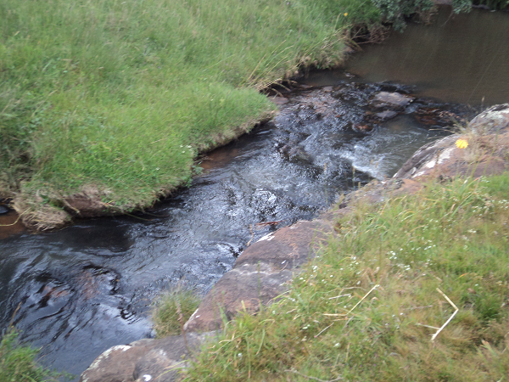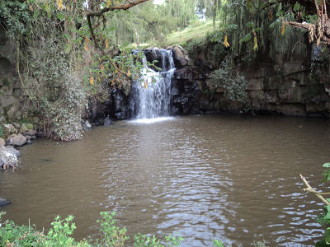
FINAL FEASIBILITY STUDY

BY

VIRGINIA CONSULTANTS IN ASSOCIATION WITH BERUH CONSULTING ENGINEERS AND HYDRO GEOLOGISTS

WATERSHED DEVELOPMENT
NOVEMBER, 2016

Table of Contents
WATERSHED DEVELOPMENT 5
SUMMARY 6
1. Background 7
2. Objectives 7
3. Justification 7
4. Materials, Methods and Period of Investigation 8
4.1. Materials 8
4.2. Methods 9
5. The Watershed Area 10
5.1. General Description of the Watershed Area 10
5.1.1. Location 10
5.1.2. Topography 10
5.1.3. Slope 11
5.1.4. Climate 13
6. Land Capability Classification 19
6.1. Objectives of Land Capability Classification 19
6.2. Approach 19
6.3. Description of Land Capability Classes 19
7. Major Problems of the Watershed Area 22
7.1. Analysis of Soil Erosion Potential of the watershed 22
7.2. Soil Erosion Hazard 22
7.3. Gully erosion 23
8. Conservation Effort Made in the Watershed Area 23
8.1. Types of Conservation Measures Carried Out 23
8.2. Availability of Infrastructure and Manpower 23
9. Watershed Development Strategy 24
10. Previous Experiences on Natural Resources Management 26
11. Implementation Schedule 27
12. Manpower and Equipment Requirement 27
12.1. Manpower Requirement 27
12.2. Equipment Requirement 28
13. The Plan Frameworks: Goal, Purpose, Indicators and Assumptions 28
13.1. Activity Plan for Alentu Watershed Management Plan 35
13.2. Estimated Financial Requirements 36
14. Identification of Research Priority 37
15. Conclusion and Recommendation 37
16. Reference 38

Table 1: Distribution of major topographic of Alentu watershed 11
Table 2: Slope classes and their distribution in Alentu watershed 12
Table 3: Thermal zone of Alentu watershed 13
Table 4: Distribution of agro-ecological zones across the watershed is shown in the table 14
Table 5: Distribution and major properties of Alentu watershed 15
Table 6: Land use/land cover type of Alentu watershed area 16
Table 7: Population size of watershed kebeles 17
Table 8: Livestock Population in Alentu Watershed 18
Table 9: Land Capability Class of Alentu Watershed 21
Table 10: Soil Loss of Alentu Watershed 22
Table 11: Soil loss and their severity classes in Alentu watershed 23
Table 12: Major soil conservation activities carried out in the year 2012 23
Table 13: Implementation Phases of Alentu Watershed 27

Figure 1: Location map of Alentu watershed 10
Figure 2: Digital elevation model of Alentu watershed 11
Figure 3: Slope map of Alentu watershed 12
Figure 4: Thermal zone map of Alentu watershed 13
Figure 5: Agro-ecological Zones of Alentu Watershed 14
Figure 6: Major Soils of Alentu Watershed 15
Figure 7: Land Use/Cover Map of Alentu Watershed 16
Figure 8: Kebeles of Alentu Watershed 18
Figure 9: Land Capability Class Map of Alentu Watershed 20
Figure 10: Sub Watersheds of Alentu Watershed 25
Figure 11: Watershed Management Plan for Alentu Watershed 26

ABBREVIATIONS

ACZ Agro-climatic Zone
CSA Central Statistical Agency
DEM Digital Elevation Model
GCP Ground Control Points
GPS Global Positioning System
Ha Hectare
FAO Food and Agricultural Organization of the United Nations
ISSS International Soil Science Society
m.a.s.l meter above sea level
PET Potential Evapo transpiration
TM Thematic Mapper
WRB World Resources Base

WATERSHED DEVELOPMENT

SUMMARY

Alentu watershed is located in Dodola wereda, West Arsi Zone of Oromia Rigional State. Geographically, the watershed falls in between 6.81⁰ and 6.86⁰ N latitude and 39.10⁰ and 39.04⁰ E longitude.

The terrain shape include ridge, saddle, flat summit, ravine and hillside relief form. Elevation of the area ranges from 2800 meters at the northern end of the watershed and reaches up to 3460 meters at southern tip of the watershed. Alentu River is the major river of the watershed. It has different intermittent tributary Rivers.

The study areas fall within the cool sub humid mid dega, cool sub-humid upper dega and cold sub-humid wurch agro-ecological zones. According to the Ethiopian growing season classification, the watershed is characterized as no crop failure risk, total Length of Growing period (LGP) is estimated to be about 169 days and the potential evapotranspiration (PET) is about 1300-1800 mm.

The major land use identified includes: Dense forest occupy 906.69 ha, open forest cover about 558.43 ha, cultivated land comprised about 337.26 ha, and Grass/grazing land area covers about 213.18 ha.

According to the soil loss analysis made by FAO about 94% of the watershed grouped to soil loss class I and about 6 percent grouped in to soil loss class II, where the annual soil loss rate range from 0 to 5 and 16 to 30 T/ha/yr respectively.

The analysis made under this study also show that, the quantity of estimated soil loss, which indicates the amount of soil detached from its original location, deposited within the Watershed area or transported to the hydrographic system, is about 30,033 T/ha/yr.

Background
Watershed management plan is a process of implementing land and water management practices to protect and improve the quality of the water and other natural resources within a watershed by managing the use of those land and water resources in a sustainable manner. In Alentu watershed, agricultural land expansion on the expense of the existing natural forest and grazing land, predominantly seen as clearance of indigenous trees such as Ficus capensis, podocarpus,Carrisa edulis, Aningeria altissimo, etc. Consequently, the extensive clearance of vegetation cover of the watershed caused soil erosion, which is the major component of land degradation that affects land productivity.

Proper management of on-site effect of soil erosion reduces the risks and negative impacts of downstream water resources due to water erosion. Tackling the on-site effects of soil erosion requires an understanding of the rates of erosion processes as well as identification of the major controlling factors that enhance or retard these processes. So this particular study will distinguish the potential causes and the associated reasons behind the respective causes and prepare Watershed management plan.

Objectives
The overall aim of the Watershed management is to:
- To establish long lasting irrigation water supply system by minimizing deforestation, soil erosion, and land degradation.
- Facilitate sustainable management and utilization of natural resources.
- To reduce sedimentation
The watershed study is part of the overall irrigation development study and is aimed to prepare integrated watershed management plan of the watershed.

Justification
A sound watershed management plan will provide the frame for harmonizing economic development and natural resources conservation. It will also integrate socio-economic and cultural realities, institutional structures and the biological aspects into upland protection and conservation in order to attain sustainable development.
A watershed management plan provides actions to
- protect a watershed or prevent damage to it
- mitigate the effects of land use to an acceptable level
- restore degraded environments
- optimize the availability of water resources

In this regards, this particular integrated watershed management plan will be based on a complete inventory of the Watershed bio-physical and human resources. The objectives of the plan will not be limited to prevention of watershed degradation but also attaining increased production from the land on a sustained basis and a general improvement of the standard of living for the people living in the Watersheds must be an integral part.

Moreover, the watershed management plan will be a comprehensive development of a watershed so as to make productive use of all its natural resources and protect them from further degradation. This includes land improvements, rehabilitation and other technical works as well as the human considerations.

Materials, Methods and Period of Investigation

Materials

The physical features study of Alentu watershed involved the collection, structuring, digitizing and encoding of basic datasets such as:

- Administrative boundaries (Regional, Zonal, Wereda and Kebele);
- Watershed boundary;
- Topographic maps at 20 meters intervals;
- Drainage systems;
- Land use and land cover based on Land Sat TM of 2006, respectively;
- Soils data;
- Population data;
- Climatic data (rainfall, temperature, etc); and
- Agro-climatic Zone (ACZ).

The kebele administrative boundary layers of the watersheds were extracted from the spatial data recently prepared by the Central Statistical Agency (CSA). The watershed boundary, which followed the natural hydrological system, and the drainage systems of the sub-watershed were generated from the larger spatial resolution (20mx20m) Digital Elevation Model (DEM) of the study area.

Topographic information was produced from EMA’s analog topographic maps of 1:50,000 scales. The data sets helped to generate DEM, altitude ranges, slope gradients, slope length, relief types, analytical hill shading, etc. In all respects, such information products had added values to further substantiate the land use and land cover change analysis and erosion hazard assessment in the study area. The population figures were collected from the 2007 census of the CSA.

The land use and land cover map layers were generated from the Landsat TM of 2006. The classification involved both supervised and unsupervised methods. About 20 representative training areas were selected based on the pixels demonstrating regular patterns. The training samples were used for the classification of Landsat TM data. While the actual samples collected using the GPS receiver were utilized to classify the data.

The soil data, which mainly consisted of dominant soils, textures and depth and management constraints, were collected from secondary information and verified through intensive field survey. Apart from their use for land evaluation, the data layer prepared was employed for modeling the potential erosion hazard by computing soil erodibility factor based on the soil map produced from SOTER map (prepared according to FAO/ISSS/WRB guideline, 1988).

The climate and agro-ecological zone data were collected from the available secondary sources of the National Meteorological Service Agency and the Ministry of Agriculture and Rural Development. The volume, quality and completeness of the datasets particularly referring to climate were limited by the problems of recording and documenting at the provider agency.

Methods
In the process of preparing land use and land cover data, image pre-processing tasks were performed. The work involved correction of image data to create a more faithful representation by correcting the geometric and radiometric distortions.

The geometric registration process involved identification of geographic features on the image known as ground control points (GCPs), whose position were known such as intersection of streams, roads, etc., in the image, and matching them to their true position in ground coordinates. The geometric correction of the separate scenes was conducted using ground control points of known co-ordinate from a topographic map of 1:50,000 mapping scale with the method called image-to-map registration. Several well-distributed GCP pairs were identified and the coordinate information was processed to determine the proper transformation.

After performing desktop preliminary classifications, ground truthing was done covering almost 65.0 percent of the entire area, which is almost homogenous in the rugged and flat parts of the watersheds. At that stage, the work mainly focused on areas somehow reflecting heterogeneous green patterns and steeper slopes. In order to have fuller views, the study paid particular attention to visiting the vegetation in the mountainous areas.

The methodologies used to analyze the physical features of the study area was mainly based on the GIS and Remote Sensing method of spatial data input, structuring, integrating, transforming and producing outputs. For this purpose, ArcGIS 10.0 and Idrisi 32 software were used.

Interviews were made with farmers especially in areas that demonstrated significant changes over the last three decades. In this regard, there was no sampling technique applied for interviewing purposes, as more emphasis was primarily made on group discussions than individual responses. In addition, the distribution of the latter was fairly even with regard to the changes that have taken place during the decades. During group discussions, elders provided adequate analytical view on their accumulated observations and experiences of the areas they lived in since their childhood.

In general, the interviews and group discussions dwelled on:
- Land cover types before 30 years;
- Categories of land use/land cover and sizes before the decades;
- Crop production, productivity trends and related reasons;
- Measures practiced to improve land productivity;
- Existence of fallowing practice;
- Existence of tree planting practice;
- Alternative household energy sources;
- Understanding on the existence of and experiences with soil erosion;
- Local and institutional practice of protecting soil erosion.

The Watershed Area

General Description of the Watershed Area

Location
The Alentu watershed is entirely located in Dodola wereda (Figure -1). Geographically, the Alentu watershed falls in between 6.81⁰ and 6.86⁰ N latitude and 39.10⁰ and 39.04⁰ E longitude.

The project area is accessed by all-weather and rough road which provide additional access to the interiors of the project area.
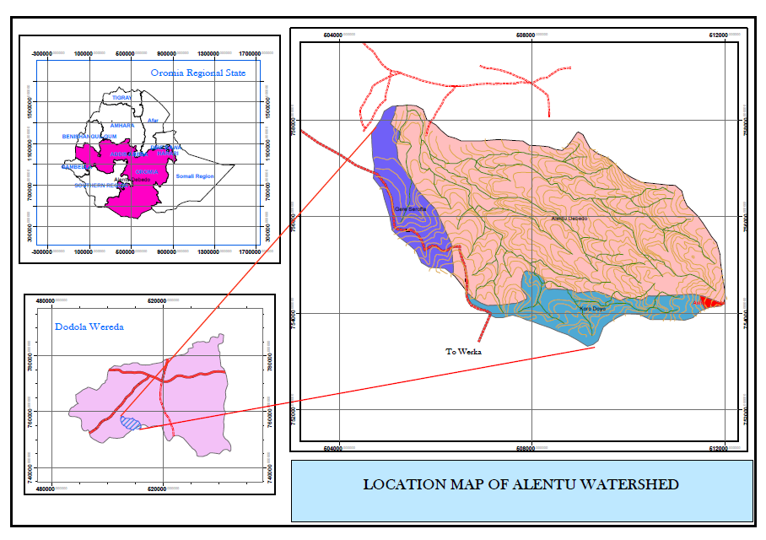
Figure 1: Location map of Alentu watershed

Topography
The Alentu watershed is a medium to high relief area with different types of land forms. The terrain shape include ridge, saddle, flat summit, ravine and hillside relief form. Elevation of the area ranges from 2800 meters at the northern end of the watershed and reaches up to 3460 meters at southern tip of the watershed. Alentu River is the major river of the watershed. It has different intermittent tributary Rivers.

Table 1: Distribution of major topographic of Alentu watershed
No | Topographic form | Area (Ha.) | percent
1 | Ridge | 451.61 | 20.38
2 | Saddle | 88.18 | 3.98
3 | Flat area | 195.13 | 8.80
4 | Ravine | 363.12 | 16.38
5 | Different Types of Hillside | 1118.34 | 50.46
 |  | 2216.38 | 100

The sub-watersheds have a common conical shape with its narrow width at the downstream and wider at the upstream. With a computed area of 2216.38 hectare, the flow paths of the watersheds reach 7.5 km.
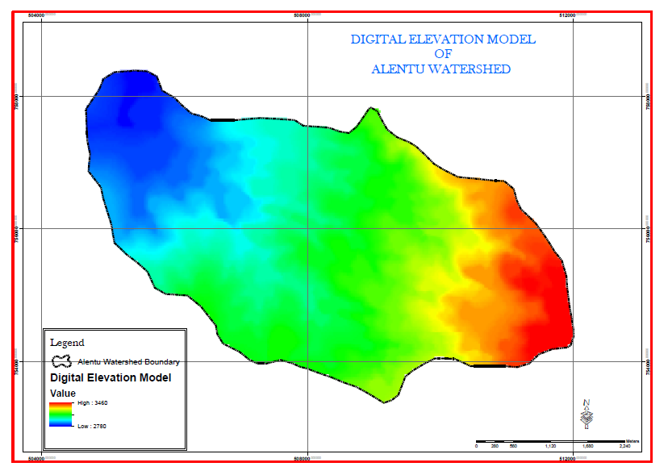
Figure 2: Digital elevation model of Alentu watershed

Slope
Based on the national guideline of Community Based Watershed Development, slope computation had also been made with six classes. The Guideline suggests the use of such classification for soil and water conservation and other land management recommendations. In most cases, slopes over 8.0 percent are generally recommended for relevant conservation interventions according to the landscape and physical human activities. Accordingly, 73.16 percent of the sub-watersheds area (Table. 2) could be designated for various natural resources management programs under the existing conditions of the watershed.

Table 2: Slope classes and their distribution in Alentu watershed
No | Slope Gradient (%) | Slope class | Area (Ha.) | percent
1 | 0 to 3 | Flat or almost flat | 338.63 | 15.28
2 | 3 to 8 | Gently sloping | 256.27 | 11.56
3 | 8 to 15 | Sloping | 605.43 | 27.27
4 | 15 to 30 | Moderately steep | 846.88 | 38.21
5 | 30 to 50 | Steep | 157.49 | 7.11
6 | >50 | Very steep | 12.67 | 0.57
Total |  |  | 2216.38 | 100
Source: Computed in GIS

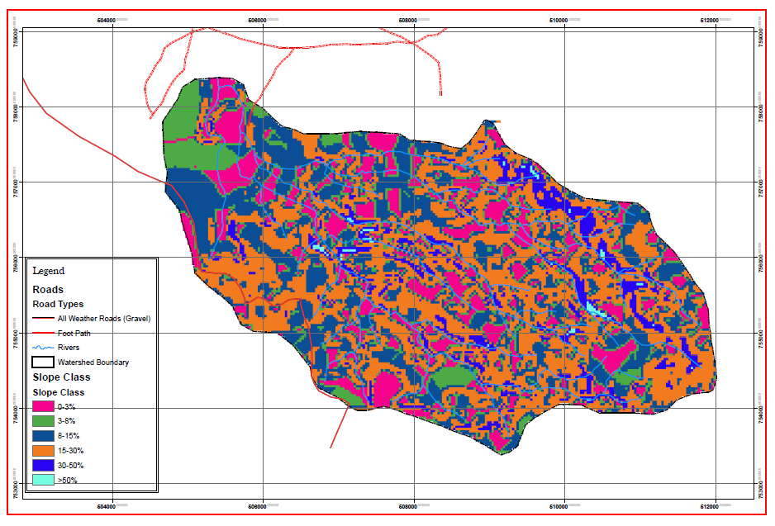
Figure 3: Slope map of Alentu watershed

Climate

Rainfall Distribution
According to the Dodola weather station, the watershed area receives an annual rainfall ranging from the minimum of 523 mm in low rainfall year and the maximum of 1165 mm in the high rainfall year. It has a bimodal rainfall pattern where the two season merging together.

Thermal Zones
Temperature during growing period, which refers to the amount of temperature available for plant growth and development during the growing period, usually defined by the mean daily temperature during the growing period (Berhanu, 1999). Accordingly, the maximum temperature registered in the station is ranging between 19⁰c and 29 ⁰c, while the minimum temperature is ranging between -1.1 ⁰c and 10.2⁰c. The watershed area classified in to a Cool and Cold thermal zone.

Table 3: Thermal zone of Alentu watershed
No | Thermal Zone | Altitude (m a.s.l.) | Temperature (ºC) | Area in ha | % age
1 | Cool | 2800-3200 | 11.3-15.1 | 1781.43 | 80.38
2 | Cold | 3200-3460 | 11.3-7.5 | 434.95 | 19.62
Total |  |  |  | 2216.38 | 100
Source: Computed in GIS

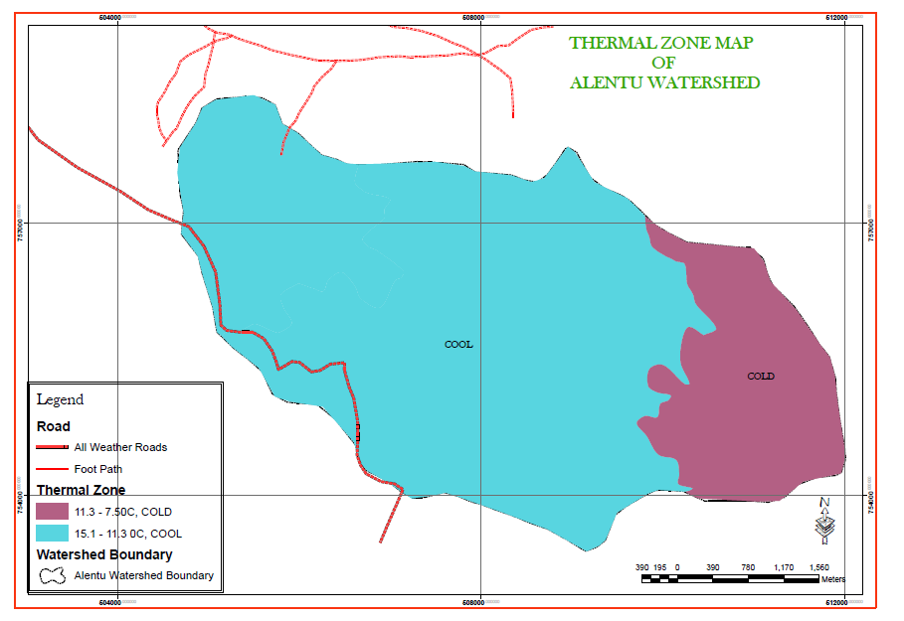
Figure 4: Thermal zone map of Alentu watershed

Agro ecological Zone (AEZ)
The study areas fall within the cool sub humid mid dega, cool sub-humid upper dega and cold sub-humid wurch agro-ecological zones. According to the Ethiopian growing season classification, the watershed is characterized as no crop failure risk, total Length of Growing period (LGP) is estimated to be about 169 days and the potential evapotranspiration (PET) is about 1300-1800 mm.

Table 4: Distribution of agro-ecological zones across the watershed is shown in the table
No | AEZ | Altitude  (m.a.s.l.) | Temperature (ºC) | Area  in ha | % age
1 | Cool Sub Humid Mid Dega | 2600 - 2900 | 15.1 - 13.2 | 409.17 | 18.46
2 | Cool Sub-Humid Upper Dega | 2900 - 3200 | 13.2 - 11.3 | 1372.27 | 61.92
3 | Cold Sub-Humid Wurch | 3200 - 3700 | 11.3 - 7.5 | 434.94 | 19.62
Total |  |  |  | 2216.38 | 100
Source: Computed in GIS

Figure 5: Agro-ecological Zones of Alentu Watershed

Soils
Soil map of the watershed is produced from SOTER revised map with intensive field survey (FAO/ISSS/WRB, 2006). Chromic Luvisols, Pellic Vertisols and Eutric Leptosols are the dominant soil types occurred in the area. Vertisols are mainly distributed over flatter slope areas. Luvisols are occurred on moderate to steep slope, while Leptosols are occurred on very steep and escarpment area. In terms of area coverage Luvisols cover about 65 percent of the watershed. Major soils of the watershed are described in the following section in detail (Table 5).

Table 5: Distribution and major properties of Alentu watershed
Soil type | depth | Colour | Texture | Drainage | Area in  Ha | %age
C.Luvisols | Very deep | Reddish brown to dark reddish brown | Clay to clay loam | Moderate to well | 1451.09 | 65.47
P.Vertisols | Very deep | Very dark clay to black | Clay to clay loam | Moderate to imperfect | 575.34 | 25.96
E.Letosols | Shallow | Dark brown to dark reddish brown | Sandy clay loam to clay loam | well | 189.95 | 8.57
Total |  |  |  |  | 2216.38 | 100
Source: Result of Field Survey & SOTER revised map (FAO/ISSS/WRB, 2006)

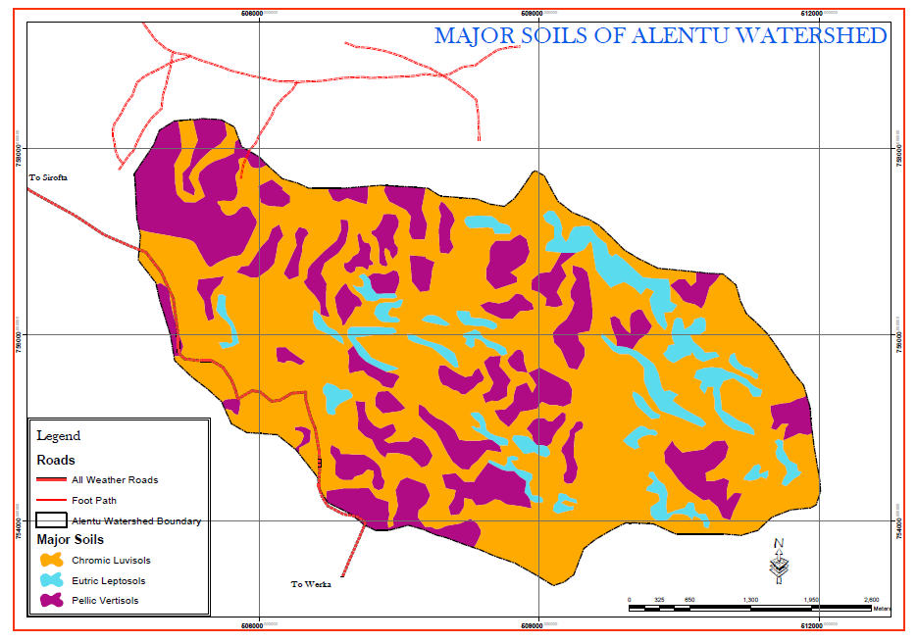Figure 6: Major Soils of Alentu Watershed

Vegetation
The vegetation assessment of the area revealed that the watershed is endowed with a variety of both indigenous and exotic species. The dominant indigenous tree species include: hypericum revolutun, erythrina abyssininca,discopodum penninervum, hygienic abyssinica , etc. The forest of the watershed area is part of the Koro Forest.

Present Land Use/land cover
The major land use identified includes: Dense forest occupy 906.69 ha, open forest cover about 558.43 ha, cultivated land comprised about 337.26 ha, and Grass/grazing land area covers about 213.18 ha.
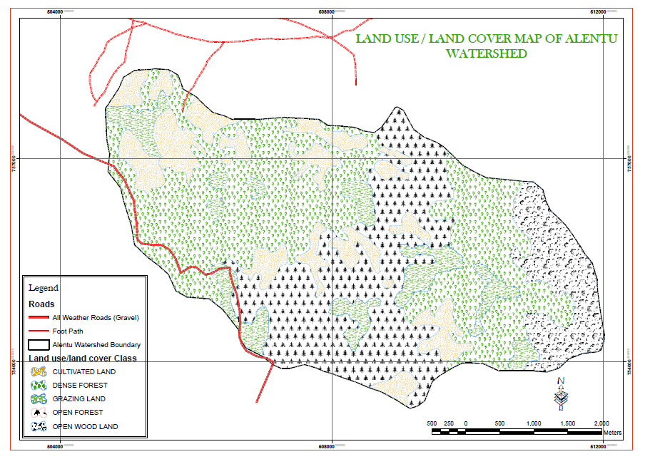
Figure 7: Land Use/Cover Map of Alentu Watershed

The land use/land cover types and their extents are depicted on the table below.

Table 6: Land use/land cover type of Alentu watershed area
No | Land use/land cover | Area in Ha | % age
1 | Cultivated Land | 337.26 | 15.22
2 | Dense forest | 906.69 | 40.90
3 | Grazing land/Grass land | 213.18 | 9.62
4 | Open High forest | 558.43 | 25.20
5 | Open Wood land | 200.82 | 9.06
Total |  | 2216.38 | 100

Source: Field survey (LandSat TM, 2006)

The Land use System
The land use system is a major cereal surplus producing area of the region. It is distinguished by the lack of trees in the landscape. Wood fuel consumption rates at 90-280kgs/capita/year are some of the lowest in the Oromia Regional State, whilst dung consumption rates at 450-1100kgs/capita/year are some of the highest (WBSPP). Settlements are within walking distance of the forest area obtaining fuel and construction wood supplies from the Adoba-Dodola Priority Forest Area (PFA). Crop residues are too valuable as livestock feed and used as fuel.

The land use system experiences a double rain season, both of which are adequate for crop production, and thus for tree establishment.

Human Population Distributions
According to the population data collected from of the Central Statistical Agency, the total number of people living in the watershed kebeles reaches 29,110 persons and about 5384 households.

Table 7: Population size of watershed kebeles
 | Kebele Name | Area  in Ha | % | Total  population | No House  Holds
1 | Alentu Debedo | 1701.39 | 76.76 | 9,621 | 1,751
2 | Gere Serofta | 232.55 | 10.94 | 10,974 | 2,004
3 | Koro Doyo | 275.68 | 12.44 | 4,773 | 899
4 | Ashena Robe | 6.77 | 0.31 | 3,742 | 730
Total |  | 2216.39 | 100 | 29,110 | 5,384
Source: CSA, Population Census, 2007.
Figure 8: Kebeles of Alentu Watershed

Livestock Population Distribution
The distribution of livestock: sheep, goats, horse, donkeys, and mule each constitutes 65.6 percent, 15.3 percent, 11.4 percent , 7.3 percent, and 0.4percent, respectively.

Table 8: Livestock Population in Alentu Watershed
No | Types of Livestock | Total No of Livestock | Livestock (%) | TLU in WS
2 | Sheep | 21443 | 65.6 | 2144.3
3 | Goats | 5003 | 15.3 | 500.3
4 | Horses | 3732 | 11.4 | 2463.12
5 | Donkeys | 2401 | 7.3 | 77.22
6 | Mules | 117 | 0.4 | 1584.66
 | Grazing Animals( Total) | 32696 | 100 | 6769.6
7 | Poultry |  |  | 123.22

Land Capability Classification

Objectives of Land Capability Classification

The main objectives of capability grouping of soils are:
- To make possible broad generalizations based on soil potentialities, limitations in use, and management problems;
- Identifying areas for specific land uses;
- Defining management options;
- Providing information for detailed planning and strategy for development; and
- Identifying areas at risk of degradation.

Approach
The approach followed in this classification relied on grouping of arable soils according to their potentialities and limitations for sustained production of the common cultivated crops that do not require specialized site conditioning or site treatment. Non-arable soils (soils unsuitable for long-term sustained use of cultivated crops) are grouped according to their potentialities and limitations for the production of permanent vegetation and their risks of soil damage if mismanaged.

The classification system based on USDA land capability classification comprises eight land capability classes ranked in the order of increasing degree of limitation in relation to agricultural use, and decreasing order of agricultural versatility. Class I is the best land and Class VIII the poorest. Class IV is considered marginal for cropping activities.

Description of Land Capability Classes
The result of land capability classification is shown that about 13.87 percent of the watershed is classified from class I to class IV, covering an area of 307.31 hectare of land. Moreover, lands categorized from Class V to class VII are covering about 86.13 percent of the watershed, which is about 1909.07 hectare of land. Detail description of the land capability classes are presented below.

Class I: Soils in this class are suited to a wide range of plants and can be used safely for cultivated crops, pasture, range, woodland, and wildlife. The soils are nearly level and erosion hazard is low. They are deep, generally well drained, and easily worked. The area grouped in to class I covers a total of 00hectare, which is about 00 percent of the watershed

Class II: Soils in this class have some limitations that reduce the choice of plants or require careful soil management, including conservation practices, to prevent deterioration or to improve air and water relations when the soils are cultivated. Limitations of soils in class II include singly or in combination the effects of gentle slopes, moderate susceptibility to water erosion and moderate adverse effects of past erosion, less than ideal soil depth, somewhat unfavorable soil structure and workability, The soils may be used for cultivated crops, pasture, range, woodland, or wildlife food and cover. Area under class II occupies about 85.35 hectares of land.

Class III: Soils in this class have severe limitations that reduce the choice of plants and require special conservation practices. Moderately steep slopes; high susceptibility to water or wind erosion or severe adverse effects of past erosion; frequent overflow, very slow permeability of the subsoil
Class IV: Soils in this class have very severe limitations that restrict the choice of plants, require very careful management. Steep slopes, severe susceptibility to water or wind erosion, severe effects of past erosion, shallow soils, low moisture-holding capacity, frequent overflows.

Class V: Soils in this class have little or no erosion hazard but have other limitations like wetness that limit their use largely to pasture, range, woodland, or wildlife food and cover. It is level to nearly level land, which is frequently ponded and soils of the bottom lands subject to frequent overflow that prevents the normal production of cultivated crops but where soils are suitable for grasses or trees.

Class VI: Soils in class VI have severe limitations that make them generally unsuited to cultivation and limit their use largely to pasture or range, woodland, or wildlife habitat. Major limitation include: Steep slope, severe erosion hazard, effects of past erosion, stoniness, and shallow rooting zone.

Class VII: Soils in class VII have very severe limitations that make them unsuited to cultivation and that restrict their use largely to grazing, woodland, or wildlife. The major limitations identified are: very steep slopes, erosion, and shallow soil, stones.

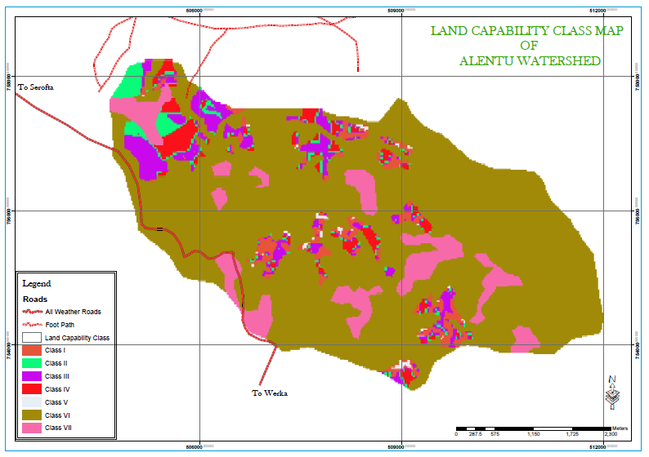
Figure 9: Land Capability Class Map of Alentu Watershed

Table 9: Land Capability Class of Alentu Watershed
No | Land Capability Class | Area in ha | % age
1 | Class I | 53.07 | 2.39
2 | Class II | 93.84 | 4.23
 | Class III | 61.47 | 2.77
 | Class IV | 98.93 | 4.46
4 | Class V | 233.60 | 10.54
 | Class VI | 29.05 | 1.31
5 | Class VII | 1646.42 | 74.30
Total |  | 2216.38 | 100
Source: Computed in GIS

Major Problems of the Watershed Area
Soil erosion comprises all accelerated soil removal processes performed by wind and water, most of which are induced by human activities (Bennett, 1939). It is manifested by the deterioration or the destruction of soil surface induced by exogenous forces, especially water, wind, and human activities as the significant anthropogenic factor (Holý, 1980), which reduce the vegetation cover and increase the risk of soil erosion.

With extensive cultivation, deforestation, overgrazing and use of land having steeper slope for agriculture, deterioration and even complete destruction of soil will result.

The effect of soil erosion by water is multifold. It results in soil compaction, low organic matter, loss of soil structure, poor internal drainage, soil salinity and acidity problems. Soil particles detached and transported by the effect of runoff can silt artificial and natural waterways, water storages and clog structures on water flows. This reduces the carrying capacity of canals and watercourses and reduces storage capacity of water reservoirs. Silt raises the level of riverbeds, the beds of water reservoirs and hence increases the danger of inundating adjoining area and also results in water logging.

Analysis of Soil Erosion Potential of the watershed
According to the soil loss analysis made by FAO about 94% of the watershed grouped to soil loss class I and about 6 percent grouped in to soil loss class II, where the annual soil loss rate range from 0 to 5 and 16 to 30 T/ha/yr respectively.

The analysis made under this study also show that, the quantity of estimated soil loss, which indicates the amount of soil detached from its original location, deposited within the Watershed area or transported to the hydrographic system, is about 30,033 T/ha/yr.

Table 10: Soil Loss of Alentu Watershed

No | Soil loss classes | Soil loss rate  T/ha/yr | Area in ha | %age
1 | I | 0 - 5 | 2089.55 | 94.28
2 | II | 16 - 30 | 126.84 | 5.72
Total |  |  | 2216.39 | 100

Soil Erosion Hazard
Categorization of different erosion potentials was made following the FAO basic classification of desertification (FAO 1986). In line with this, the study area classified in to two classes (Table10). Soil loss tolerance (SLT) denotes the maximum allowable soil loss that will sustain an economic and a high level of productivity (Wischmeier & Smith, 1978; FAO & UNEP., 1984).The normal SLT values range from 5 to 11 tons/ ha/yr (Renard, Foster, Weesies, McCool and Yoder, 1996) The total area with a soil loss potential higher than the SLT was 859.37ha, comprising 38.77% of the total study area.

Table 11: Soil loss and their severity classes in Alentu watershed
Soil loss(T/ha/yr) | Severity Class | Priority Class | Area in ha | %age | Annual soil loss (T/ha/Yr)
0 – 5 | None to slight | II | 1357.01 | 61.23 | 3392.525
16 – 30 | Moderate | I | 859.37 | 38.77 | 26640.47
Total |  |  | 2216.38 | 100 | 30,033
Source: Computed in GIS

Gully erosion
Gullies of various sizes of width and depth have been identified in the watershed. Beside its negative effects on soil resources, consuming crop and grazing lands in areas between the gullies and reducing grazing land available for livestock, gully erosion is observed in different land use but their intensity is high in cultivated land. Assessment of gully development and its intensity is intended to design reliable conservation measures for already existed gullies and controlling strategies for those areas susceptible to gully formation. Due to the mapping scale factor, one can not map every gullies observed in the watershed at 1:50,000 mapping scale, nevertheless, the survey outlined major gullies observed in the watershed. Additionally, it is recommended that further mapping of gullies at very larger workable scale is required.

Conservation Effort Made in the Watershed Area
Based on the data collected from Woreda Office for Agriculture and Rural Development, the key effort made by the office in soil conservation activities are summarized in the next section of the report.

Types of Conservation Measures Carried Out
The Wereda Agriculture and Rural development office under its Natural Resources Development, Conservation and Utilization key process owner carried out the following major soil and water conservation activities.

Table 12: Major soil conservation activities carried out in the year 2012
No | Kebeles | Planned Soil and water conservation activities
No | Kebeles | Area Closure | Bund  Construction(km) | Cutoff drain(km) | Gully Treatment(m3) | Delineated Watershed Area
1 | Alentu Debedo | 80 | 398 | 52 | 3600 | 592
2 | Gere Serofta | 77 | 100 | 13 | 34 | 428
3 | Koro Doyo | 87 | 66 | 11 | 26 | 428
4 | Ashena Robe | 70 | 60 | 11 | 9 | 429
Source: Dodola Wereda Agriculture and Rural Development Office Report, 2012

Availability of Infrastructure and Manpower

Natural Resources Development, Conservation and Utilization key process owner has three soil and water conservation staff. The owner under it authority manage three seedling nurseries. The watershed can be crossed only on foot, so it requires building all weather gravel road that can serve throughout the year.

Watershed Development Strategy

Since watersheds are shaped by complex ecological relationships and diverse social systems that are continually responding to dynamic economic, social and cultural forces, watershed planning must first and foremost be an interdisciplinary process. It will require technical expertise in geology, hydrology, biology, ecology, engineering, environmental science, resource management, social science and rural development planning.

It must also strive to relate these processes to the human factor. It should address linkages between land use and water management, upland watershed issues and downstream concerns, public values and economic natural resource use, community well-being and sustainable watersheds, short term activities and long term sustainability issue.

Consideration of these issues requires participation not only by different agencies but also by farmers, businesses, environmental groups, and technical specialists from the profit and non-profit sectors, disadvantaged communities and the general public.

Having in mind all these factors, the anticipated integrated watershed management plan will consider the following bench mark issues:

- Recognize and address multiple perspectives, issues, and objectives, including local, regional, and federal concerns of environmental, economic, and social nature.
- Integrate and coordinate planning, management, monitoring, and community activities across agencies, and nongovernmental entities.
- Provide for inclusive and participatory involvement by all agencies and all stakeholders to ensure meaningful input, including disadvantaged or hard to reach communities and stakeholders.
- Use or provide at least a minimum level of assessment early in the process to provide a scientific foundation for moving forward.
- Allow for a long-term, phased implementation strategy while managing for shorter term project delivery.
- Develop a monitoring strategy for projects to provide scientifically valid information about effectiveness and to determine if overall plan is meeting stated objectives.
- Establish a process for ongoing, informed decision-making through adaptive planning, management, and monitoring.

A watershed plan does not need to offer all the answers. Instead, it can lay out a long-term process towards finding answers and improving solutions and a long-term system of acquiring new information on key issues and trends to modify the management program. Moreover, watershed as a complex dynamic system will require time, information, and resources to manage. Hence, the study suggest to follow the program approach of watershed plan and management, in short term the study identified major programs that could give instant effect to the rehabilitation endeavor and pave the way to future sustainable management of the watershed. Accordingly, the planned land management programs will include:

- Soil and Water Conservation program
- Agro Forestry and Forestry Program
- Livestock development Program
- Capacity Development Program

In order to realize the planned programs, sustainable funding strategies will be explored by the leading offices, identifying additional sources, opportunities for leveraging resources, and long-term strategies for generating funds. A long-term perspective will also focus on conflict resolution and make the implementation less discouraging.

In order to ease implementation of the development plan; the watershed need to be divided into smaller sub-watersheds. Each sub-watershed as a hydrological unit is connected, and any modification of the land use in watershed or sub-watershed will reflect on the water as well as sediment yield of the overall watershed. Watershed can be classified as micro-watershed, sub-watershed, broader or critical watershed, major watershed, sub-basin and basin.

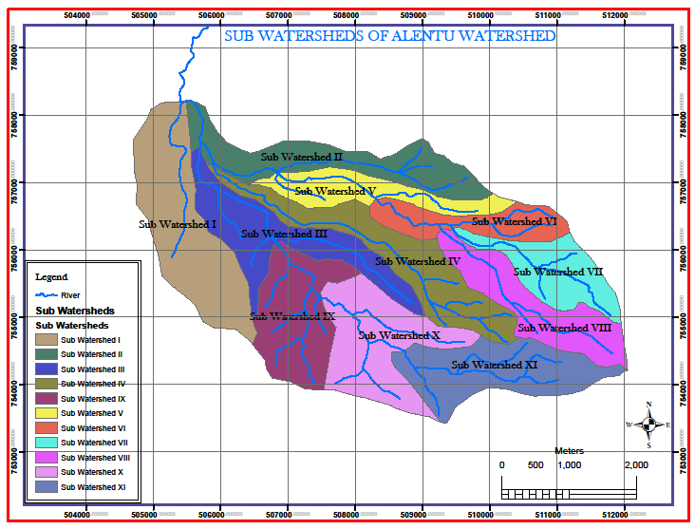
Figure 10: Sub Watersheds of Alentu Watershed

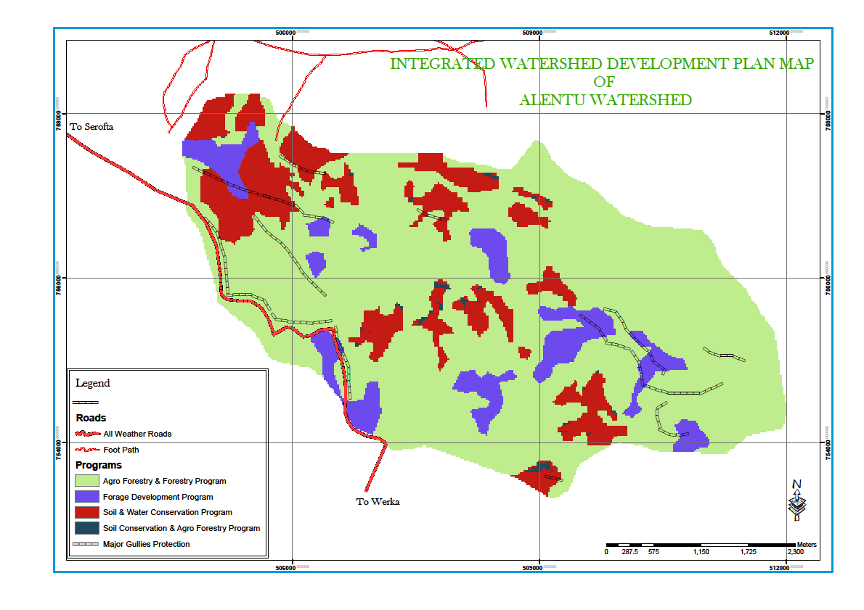
Figure 11: Watershed Management Plan for Alentu Watershed

Previous Experiences on Natural Resources Management

Integrated forest management project initiated in 1995 by local stakeholders in cooperation with GTZ. The overall goal of the IFMP was to protect the remaining natural forest in the Bale Mountain from further destruction and to develop, use and manage them sustainably. The project followed a community based approach, which was named the WAJIB – approach. The idea of WAJIB is that local inhabitants, organized in forest dwellers’’ association, receive exclusive right to use forest products and generate income through forest related activities. In return the WAJIB groups have to guarantee the maintenance of tree cover and to implement rehabilitation measures. Supplementary measures of IFMP included the introduction of non wood based income generating activities for all people of the area. The most recognized non wood based activity is the ecotourism project. In order to apply this approach to the recommended forestry and agro forestry program, the approach should be revised and studied in detail.

The wildlife of the Adaba-Dodola PFA includes various kinds of birds and Colobus Monkey. Adaba-Dodola Priority forest area has an area of about 10,800ha of dense forest (woody biomass study, 2002). It has also the smallest area extent of cultivation. The forest is designated as protection forest.

Implementation Schedule
Recognizing the fact that watershed management is a Long-term perspective, which can provide a more realistic basis for sustainable management of the natural resources. The planned implementation schedule will accommodate the physical and monetary challenges of the planning process. Implementation will be based on smaller (micro) watershed in a nested fashion, accompanied by monitoring and evaluation.

The major activities planned to develop the watershed are sequenced into three successive phases, namely: preparatory and inception phase, implementation phase and consolidation phase. In view of the benchmark, magnitude of land degradation and the scope of the planned measures, the study suggests five years timelines for watershed plans implementation. The implementers should align their time horizons with regional and local development plan to increase the chance of integration with those plans.

Table 13: Implementation Phases of Alentu Watershed
Phase | Name | Duration
I. | preparatory and inception phase | 1year
II | Implementation Phase | 3years
III | Consolidation Phase | 1 years
Total Implementation Year |  | 5 Years

Manpower and Equipment Requirement

Manpower Requirement
Implementation of the proposed program will be according to the national community based participatory watershed development guideline. The responsibility to plan and implement the Watershed development program will be accord to the Dodola wereda office for Agriculture and Rural Development.

Within the context of this guideline and taking into account practical factors, there should be a group of “Core Wereda Watershed Team” (WWT) experts assigned to support and follow-up Participatory Watershed Development work and technical issues. Additional experts can be assigned by the wereda to further strengthen the WWT as per the expansion of watershed planning in various kebeles, the range of activities and integration required. Under ideal conditions, the wereda core team is composed of 10 experts as follows:

Composition of the wereda core team:
- Soil Conservation Expert,
- Forestry/Agro-forestry Expert,
- Agronomist,
- Irrigation Expert,
- Home Agent,
- Livestock Expert,
- Land Use and Administration Expert,
- Food Security Expert (Economist/Socio-economist/Agro-economist),
- Cooperative/Marketing and Inputs Expert, and
- Rural Road Construction Expert
In addition to this, appropriate institutional arrangements should be made ranging from the region to the village level.
Moreover, participatory monitoring and evaluation of the program will be part and parcel of the program implementation.

Equipment Requirement
The planned land management programs require technical equipments and hand tools that would be able to accomplish the programs. Technical equipments include: GPS, line level, clinometers, measuring tapes etc. The hand tools consist of spade; pick axe, and other complete nursery equipments.

The Plan Frameworks: Goal, Purpose, Indicators and Assumptions
Logical Framework Analysis (LFA)
Description: Integrated Watershed Management Plan (IWSMP) for Alentu Watershade
Area: Oromia Regional State, Dodola Wereda
Program: Overall Watershed Development Program
Summary of Objectives/Activities | Objectively Verifiable Indicators (OVIs) | Means of Verification (MoV) | Important  Assumption
Overall goal:  Integrated Watershed Management Plan developed, implemented and land degradation reduced by 90 percent at the end the program. | - By the end of the program 80 percent of the watershed treated by biological and physical conservation measures.  - By the end of the program 70 percent of the existing vegetation cover rehabilitated.  - By the end of the program the Tsetse flies impact reduced by 60%. | - Reports/results of hydrological assessment.  - Report on river flow measurement  - Report on sediment monitoring. | - Almost all of the proposed programs of IWMP effectively implemented and evaluated.  - Stakeholders’ cooperation and coordination put in place.
Purpose  Sustainable Watershed management system is introduced and developed | - By the end of the program sustainable land management practices implemented by 90% of the target household. | - Report on annual sediment monitoring.  - Report on river flow measurement and sediment monitoring | - Planned programs fully implemented and intended impacts seen in the watershed

Logical Framework Analysis (LFA)
Description: Integrated Watershed Management Plan for Alentu Watershed
Area: Oromia Regional state, Dodola Wereda
Program: Forestry and Agro forestry Development
Summary of Objectives/Activities | Objectively Verifiable Indicators (OVIs) | Means of verification (MoV) | Important Assumption
Program goal:  Forestry and agro forestry practices improved and vegetation destruction reduced in Alentu watershed. | - Land cover maintained to the level of 1970 by the end of the program.  - Fuel wood shortage is reduced by 40 percent, by the end of the program. | - WoARD progress reports on forestry and agro forestry.  - Monitoring & Evaluation reports  - Reports on land use/cover change analysis. | - Technical capability and financial capacity of the WoARD offices are built  - Donors’ support is ensured.
Purpose  - Deforestation and forest degradation reduced  - Agro forestry practice promoted and disseminated in the sub-watersheds  - Alternative household energy technologies introduced and promoted. | - Forest cover is increased to the level of 1970 by the end of the program.  - At least 50% of households integrated agro forestry system in to the farming system, by end of the program  - A minimum of 60 % of the households utilized energy saving stoves, by the end of the program. | - WoARD progress reports on forest coverage  - Physical observation of household farms.  - Monitoring and evaluation report.  - Reports on land use/cover change analysis. | - Willingness and participation of target households in SWC activities.  - The same with the above  - Improved household energy saving technologies is easy to get to the target household on local market.  - Household energy saving technologies is affordable and replicable by the target households.
Result/Output 2.1:  Natural and plantation forest cover is increased | - Different tree species planted and managed, by the end of the program.  - Natural forest area demarcated and protected by the end of the program.  - Bamboo plantation established and managed, by the end of the program. | - WoARDs’ progress reports on plantation forest.  - WoARD progress reports on protection forest areas.  - WoARD progress reports on bamboo plantation.  - Field observation | - Availability and on time allocation of fund  - Willingness and participation of target households are ensured.  - Bamboo trees are adopted.
Result/Output 2.2:  Agro forestry practice enhanced and adopted. | - Agro forestry trees planted for alley and inter cropping by 60% the target households, by the end of the program.  - Fruit trees planted by 50 % of the target households by the end of the program. | - WoARDs’ progress reports on alley cropping & agro-forestry trees planted.  - Monitoring and evaluation reports on agro-forestry.  - WoARDs’ progress reports on fruit trees.  - Field observation. | - Allocation of adequate fund is guaranteed.  - Willingness and participation of households to plant agro forestry and fruit trees are guaranteed.
Result/Output 2.3:  Improved and efficient energy saving stoves disseminated and adopted. | - Improved energy saving stoves distributed and utilized by 50 % of the target households by the end of the program. | - WoARDs’ progress report on improved household energy saving stoves.  - Monitoring and evaluation report on the use of fuel saving stoves. | - Fuel saving stoves is accessible in the local market.  - The uses of fuel saving stoves by the target households are realized.
Result/Output 2. 4:  Agro forestry demonstration plots (on highland fruits) established and promoted by farmers in the watershed | - At least 4 Agro forestry demonstration plots are established, by the end of the program. | - WoARDs’ progress reports on the establishment of agro-forestry plots/sites.  - Field observation | - Allocation of adequate fund for running demonstration plots is guaranteed.  - Availability of labour force to work on the demonstration plots.
Result/Output 2.5:  Tree nurseries established and managed | - About 3 nursery sites selected, established and became functional, by the end of the program.  - Different tree seedlings produced and distributed for the target households by the end of the program. | - WoARDs’ progress reports on nursery sites established and managed.  - WoARDs’ progress reports on distributed seedling and trees planted.  - Field observation | - Allocation of adequate fund is guaranteed.  - Continuous capacity building of SWC experts and farmers is ensured.  - Willingness and participation of target households

Logical Framework Analysis (LFA)
Description: Integrated Watershed Management Plan (IWSMP) for Alentu Watershed
Program: Livestock Development Program
Area: Oromia Regional state, Dodola Wereda
Summary of Objectives/Activities | Objectively Verifiable Indicators (OVIs) | Means of Verification (MoV) | Important Assumption
Program Goal  - Livestock production and management intensified and livestock triggered land degradation reduced in Alentu watershed. | - By the end of the program year, Livestock production and products increased by 50%, by the target households.  - Livestock feeds production (Dry matter Tons) from all feed resources increased by 40 percent, by the end of 2021. | - WoARDs’ Progress reports on livestock development in the watershed.  - Quarterly & annual project reports.  - Midterm review and terminal evaluation reports  - Government office reports | - Policy & strategies that support the livestock sector are realized.  - Willingness and participation of target households in livestock development activities.  - Optimal coordination among all stake holders is ensured.  - Strong community awareness and participation is guaranteed.  - No major drought risks during the implementation periods
Purpose  - Livestock management and productivity intensified.  - Free grazing reduced | - Farmers’ income from livestock and livestock products increased by 20 percent, by the end of the program.  - Free grazing reduced by 40 percent of household, by the end the program. | - WoARD Progress reports on livestock development.  - Quarterly & annual reports.  - Midterm review and terminal evaluation reports | - No major drought risks during the implementation period.
Result /output 3.1:  Natural pasture/grazing land rehabilitated. | - By the end of the program complete restriction of free grazing systems on slope above 45 percent attained.  - Browsing of shrub/bush land area established, by the end of the program. | - WoARD Progress reports on livestock development.  - Quarterly & annual reports.  - Midterm review and terminal evaluation reports | - Strong community awareness and participation is ensured.  - No major drought risks during the implementation period.
Result/output 3. 2:  Community grazing land management groups established and strengthened. | - Community grazing land management groups of farmers established and their capacity enhanced, by the end of the program.  - Communal and private grazing land maintained with proper grazing land management system, by the end of the program. | - Periodic field visits and progress reports.  - field evaluation of vegetations and their utilization | - Optimal coordination among all stake holders is ensured.  - Strong Community awareness and participation is guaranteed  - No major drought risks during implementation period.
Result/output 3.4:  Conservation based forage development intensified. | - Back yard forage developed, by the end of the program.  - Forage strips/alley cropping established, by the end of the program.  - By the end of the program, annual forage crops/mixed pasture established on private farm land. | - Periodic field visits and progress reports.  - field evaluation of vegetations and their utilization | -   Allocation of adequate fund is guaranteed.  - Technical capability and financial capacity of the WoARD offices are built.
Result/output 3.5:  Forage seed production and seedling multiplications practices are improved. | - Tree legumes seedlings produced and planted, by the end of the program.  - Elephant grass cuttings/splits and local grass splits planted, by the end of the program.  - Forage seeds production & forage seedlings multiplication sites/centers established and become operational, by the end of the program | - Periodic field visits and progress reports.  - field evaluation on fodder bank vegetations and utilization | - Availability of seeds and seedlings are guaranteed.
Result/output 3.6:  Modern bee-keeping strengthened and promoted | - At least 40% of the target farmers run small scale bee-keeping, by the end of the program.  - 50 % of honey produced is sold in local market, by the end of the program.  - Modern beehives distributed and properly managed by the target household, by the end of the program. | - WoARD progress reports  - Midterm review and terminal evaluation reports.  - Field visits  - Special study report. | - Willingness and participation of target households in modern bee-keeping is ensured.  - Availability of improved beehives and there proper management by the target household is attained.  - Efficient coordination and cooperation of stakeholders are ensured.  - No major drought risks occurred during implementation of the program.

Logical Framework Analysis (LFA)
Description: Integrated Watershed Management Plan (IWSMP) for Alentu Watershed
Program: Capacity Building Program
Area: Oromia Regional State, Dodola Wereda.
Summary of Purposes, Results/Outputs | Objectively Verifiable Indicators (OVIs) | Means of  Verification (MoV) | Important  Assumption
Program Goal  Plan implementation and sustainable management of the watershed development ensured by the target households by the end of the program. | - Knowledge of conservation concepts and principles are acquired by majority of farmers and Wereda practitioners by the end of the program. | - Wereda ARDOs annual reports.  - M & E Reports | - Appropriate fund by WoARD is allocated.  - Donors’ participation is ensured.
 | - Multidisciplinary skills of 40 percent of regional and Wereda level watershed management experts are improved and applied in integrated watershed assessment and M & E of the watershed. | Training reports of regional Bureaus and Wereda Offices (BoARD, BoWE, EPLA, ARDOs) in Oromia region.
Purpose:  - Knowledge and skills of farmers (men and women) and Watershed management experts; improved.  - Follow up and coordination capacity of Wereda ARDOs is enhanced. | - 60 percent of the biological and physical conservation structures are to acceptable standards  - At least 85 percent of the performed sub-watersheds development activities are monitored and coordinated by the Wereda ARDOs. | - Monitoring reports of regional BoARDs and Wereda ARDOs.  - Semi-annual and annual reports of Weredas,  - Project M & E reports. | - Appropriate fund by WoARD is allocated.  - Donors’ support is ensured.
Result 4.1:  - Skill improvement for farmers and Wereda Watershed management team on integrated SWC practices achieved. | - At least 70 percent of target households have gained and applied integrated knowledge and skill of SWC | - Wereda internal monitoring reports,  - WoARDs progress reports. | - Appropriate fund by WoARD is allocated.  - Donors’ support is ensured.
Result 4.2:  Wereda, Kebele and Village Watershed Management teams/committees in Concepts and Practices of Integrated Watershed Development and Management are trained. | - At least 75 percent of the performed activities accord annual implementation plans. | - Annual and review reports | - Appropriate fund by WoARD is allocated.  - Donors’ support is ensured.
Result 4.3:  Experts and farmers group training in agro-forestry practices and nursery management are trained | - Appropriate agro-forestry knowledge are gained and applied by a minimum of 50 percent of the households in the sub-watersheds;  - Seedling performance rate on all nursery sites reaches a minimum of 90 percent by the end of the program. | - Program review reports of the sub-watersheds.  - M&E reports  - Wereda Annual reports | - Appropriate fund by WoARD is allocated.  - Donors’ support is ensured.
Result 4.4:  Capacities of Kebeles and village committees, Wereda ARDOs and regional BoARDs and EPLA are strengthened. | - Annual action plans are implemented at least by 75 percent at the end of the program. | - Program review reports of the sub-watersheds.  - M&E reports  - Wereda Annual reports | - Appropriate fund by WoARD is allocated.  - Donors’ support is ensured.

Activity Plan for Alentu Watershed Management Plan
No | Type of Measures | Unit | Work amount | Phase I | Phase II | Phase III
- SWC Program
1 | Soil bund (50%) | km | 285 | 85 | 171 | 28
2 | Fanyajuu bund (50%) | km | 285 | 85 | 171 | 28
3 | Grass plantation on bunds | km | 3101 | 930 | 1861 | 310
4 | Cutoff drain construction | km | 28 | 9 | 17 | 3
5 | Waterway construction with grass | km | 14 | 4 | 9 | 1
6 | Wooden check dam | m3 | 3000 | 900 | 1800 | 300
7 | Trench construction | No | 5000 | 1500 | 3000 | 500
8 | Microbasin construction | No | 5000 | 1500 | 3000 | 500
9 | Eyebrow basin construction | No | 15000 | 4500 | 9000 | 1500
10 | Grass plantation on bunds | km | 285 | 930 | 1861 | 310
11 | Gully re-vegetation | km | 9 | 3 | 3 | 3
12 | Running nursery site | no | 1 | 1
13 | Establishment of grass multiplication center | no | 1 | 1
14 | Running grass multiplication center | no | 1 | 1
15 | Grass seed collection | kg | 1000 | 300 | 600 | 100
16 | Tree seed collection | kg | 1000 | 300 | 600 | 100
II. Agro forestry and Forest Development Program
No | Activities |  | Work amount | Phase I | Phase II | Phase III
1 | Seedling Production | No | 10,000,000 | 3,000,000.0 | 6,000,000.0 | 1,000,000.0
2 | Pitting and Planting | No | 10,000,000 | 3,000,000.0 | 6,000,000.0 | 1,000,000.0
3 | Agro forestry tree planting –Alley cropping | No | 1,000,000 | 300,000.0 | 600,000.0 | 100,000.0
4 | Agro forestry tree planting -intercropping | No | 1,000,000 | 300,000.0 | 600,000.0 | 100,000.0
5 | Highland Fruit tree planting | No | 5000000 | 1,500,000.0 | 3,000,000.0 | 500,000.0
6 | Introduction energy saving stoves | No | 10000 | 3,000.0 | 6,000.0 | 1,000.0
7 | Natural forest demarcation | ha | 1646.42 | 493.9 | 987.9 | 164.6
8 | Natural forest protection | ha | 1646.42 | 493.9 | 987.9 | 164.6
III. Livestock Development Program
No | Activities |  | Work amount | Phase I | Phase II | Phase III
1 | Grazing land management | ha | 3000 | 900 | 1800 | 300
2 | Forage seed multiplication | No | 3 | 0.9 | 1.8 | 0.3
3 | Bee-keeping | No | 20000 | 6000 | 12000 | 2000
IV. Capacity Building Program
No | Activities |  | Work amount | Phase I | Phase II | Phase III
4 | Expert training on participatory methods | No | 15 | 5 | 9 | 1
5 | Farmers training on Agro forestry | No | 15 | 5 | 9 | 1
6 | Skill improvement on SWC | No | 15 | 5 | 9 | 1
7 | Experts training on participatory M&E system | No | 6 | 2 | 2 | 2
8 | Experience exchange workshops and seminars | No | 15 | 5 | 9 | 1

Estimated Financial Requirements
The total estimated costs of the planned programs are listed below. The program implementation cost estimated for phase I, II and III having duration of 3, 5, and 2 years respectively.

Estimated cost for Alentu Watershed management Plan
No | Type of Measures | Unit | Total Cost | Community Contribution | Project Contribution | Phase I | Phase II | Phase III
I SWC Program
1 | Soil bund (50%) | Birr | 1282410 | 1025928 | 256482 | 76944.6 | 153889.2 | 25648.2
2 | Fanyajuu bund (50%) | Birr | 1709880 | 1367904 | 341976 | 102592.8 | 205185.6 | 34197.6
3 | Grass plantation on bunds | Birr | 1488460.8 | 1190768.64 | 297692.16 | 89307.648 | 178615.296 | 29769.216
4 | Cutoff drain construction | Birr | 170988 | 136790.4 | 34197.6 | 10259.28 | 20518.56 | 3419.76
5 | Waterway construction with grass | Birr | 85494 | 68395.2 | 17098.8 | 5129.64 | 10259.28 | 1709.88
6 | Wooden check dam | Birr | 18000 | 14400 | 3600 | 1080 | 2160 | 360
7 | Trench construction | Birr | 50000 | 40000 | 10000 | 3000 | 6000 | 1000
8 | Micro basin construction | Birr | 50000 | 40000 | 10000 | 3000 | 6000 | 1000
9 | Eyebrow basin construction | Birr | 150000 | 120000 | 30000 | 9000 | 18000 | 3000
10 | Grass plantation on bunds | Birr | 136800 | 109440 | 27360 | 8208 | 16416 | 2736
11 | Gully re-vegetation | Birr | 14880 | 11904 | 2976 | 892.8 | 1785.6 | 297.6
12 | Running nursery site | Birr | 21000 | 16800 | 4200 | 1260 | 2520 | 420
13 | Establishment of grass multiplication center | Birr | 21000 | 16800 | 4200 | 1260 | 2520 | 420
14 | Running grass multiplication center | Birr | 21000 | 16800 | 4200 | 1260 | 2520 | 420
15 | Grass seed collection | Birr | 300000 | 240000 | 60000 | 18000 | 36000 | 6000
16 | Tree seed collection | Birr | 600000 | 480000 | 120000 | 36000 | 72000 | 12000
 | Total | Birr | 6,119,912.80 | 4,895,930.24 | 1,223,982.5 | 367,194.7 | 734,389.5 | 122,398.26
II | Agro forestry and Forest Development Program |  | Total Cost | Community Contribution | Project Contribution | Phase I | Phase II | Phase III
1 | Seedling Production | Birr | 450,000 | - | 450,000 | 135,000 | 270,000.0 | 45,000.0
2 | Pitting and Planting | Birr | 2,000,000 | 200,000.0 | 1,800,000.0 | 600,000 | 1,200,000.0 | 200,000.0
3 | Agro-forestry tree planting –Alley cropping | Birr | 1,000,000 | 100,000.0 | 900,000.0 | 300,000 | 600,000.0 | 100,000.0
4 | Agro-forestry tree planting -intercropping | Birr | 1,000,000 | 100,000.0 | 900,000.0 | 300,000 | 600,000.0 | 100,000.0
5 | Highland Fruit tree planting | Birr | 1,600,000 | 160,000.0 | 1,440,000.0 | 480,000 | 960,000.0 | 160,000.0
6 | Introduction energy saving stoves | Birr | 2,500,000 | 250,000.0 | 2,250,000.0 | 750,000 | 1,500,000.0 | 250,000.0
7 | Natural forest demarcation | Birr | 82,321 | 8,232.1 | 74,088.9 | 24,696 | 49,392.6 | 8,232.1
8 | Natural forest protection | Birr | 987,852 | 98,785.2 | 889,066.8 | 296,356 | 592,711.2 | 98,785.2
 | Total | Birr | 9,620,173 | 917,017.3 | 8,703,155.7 | 2,886,052 | 5,772,103.8 | 962,017.3
III | Livestock Development Program |  | Total Cost | Community Contribution | Project Contribution | Phase I | Phase II | Phase III
1 | Grazing land management | Birr | 1200000 | 120000 | 1080000 | 360000 | 720000 | 120000
2 | Forage seed multiplication | Birr | 63000 | 6300 | 56700 | 18900 | 37800 | 6300
3 | Bee-keeping | Birr | 4000000 | 400000 | 3600000 | 1200000 | 2400000 | 400000
 | Total | Birr | 5263000 | 526300 | 4736700 | 1,578,900.00 | 3,157,800.0 | 526,300.0
IV | Capacity Building Program |  | Total Cost | Community Contribution | Project Contribution | Phase I | Phase II | Phase III
1 | Expert training on participatory methods | Birr | 600000 | 60000 | 540000 | 180000 | 360000 | 60000
2 | Farmers training on Agro forestry | Birr | 600000 | 60000 | 540000 | 180000 | 360000 | 60000
3 | Skill improvement on SWC | Birr | 240000 | 24000 | 216000 | 72000 | 144000 | 24000
4 | Experts training on participatory M&E system | Birr | 600000 | 60000 | 540000 | 180000 | 360000 | 60000
5 | Experience exchange workshops and seminars | Birr | 2040000 | 204000 | 1836000 | 612000 | 1224000 | 204000
 | Total |  | 4,080,000.00 | 408,000.00 | 3,672,000.0 | 1,224,000.0 | 2,448,000.0 | 408,000.0

Identification of Research Priority

Identification of reliable and demand driven research priority requires a holistic study on the social, economic and natural resources assessment of the target area and it should be based on participatory approach. Nevertheless, as a prior indicator the research priority might focus on: high land fruit production, natural resource management, and appropriate land management practice that can be able to enhance the agricultural productivity etc.

Conclusion and Recommendation

Soil erosion is identified as one of the growing land management problem resulting in both on-site and off-site effects. Soil erosion is generally a growing and more expanding problem in the watershed, where rainfall is more intense and soils are highly erodible due to the relatively erodible top soil and low structural stability.

In line with this, the Alentu watershed is under gradual clearing of the existing forest resources, which is directly affecting and exposing the soil resource of the watershed to erosion. Those practices reduce the protective plant cover, thereby exposing the soil surface to the destructive impact of high-intensity rainfall.

Considering the mounting problem of soil erosion and its impacts, it is necessary that appropriate management measures be undertaken. To achieve this, a sound knowledge of spatial variations in soil erosion is necessary. Because of the high cost of conservation and the competing production objectives such as population increase, infrastructure development, and land degradation, there is a need to target responses and resources to areas of high risk rather than spreading them equally across the landscape. Different land management program can then be implemented to deal with the various land degradation problems. These attempts must take into consideration the biophysical and socioeconomic conditions of the respective sites. Generally, about 61percent of the watershed is falling under tolerable soil loss rate and only 39 percent of the watershed is above tolerable soil loss rate, which need a prior attention.

Reference

FAO.1984. Ethiopian Highland reclamation Study (EHRS). Final Report, Vol 1-2.Rome.
FAO. 1986. Ethiopian Hihgland Reclamation Study: Report prepared for the government of Ethiopia by FAo, Rome .Vol.I
FAO and UNEP. 1984. Provisional Methodology for Assessment and Mapping of desertification. FAO, Rome, Italy.
Fistikoglu, O., and Harmancioglu, N.B. 2002. Integration of GIS with USLE in assessment of soil erosion. Water Resources Management, 16: 447-469.
Gachene, C.C.K. 1995. Evaluation and mapping of soil erosion susceptibility: an example from Kenya. Soil Use and Management 11: 1-4.
Gebreyesus, B. and Kirubel, M. 2009. Estimating Soil Loss Using Universal Soil Loss Equation (USLE) for Soil Conservation planning at Medego Watershed, Northern
Ethiopia .Journal of American Science 2009: 5(1), 58-69. Marsland Press
Hellden, U. 1987. An Assessment of Woody Biomass, Community Forests, Land Use and Soil Erosion in Ethiopia, Lund University Press,Lund.
Hudson N. 1995. Soil Conservation, 3rd edn. Batsford: London, 391 pp.
Hurni H. 1985a. Soil Conservation Manual for Ethiopia. Ministry of Agriculture: Addis Ababa. Hurni H. 1985b.
Erosion–productivity–conservation systems in Ethiopia. Paper Presented at the 4th International Conference on Soil Conservation, 3–9 November 1985, Maracacy, Venezuela.
Hurni, H. 1988. Degradation and conservation of the resources in the Ethiopian highlands. Mountain Research and Development, 8 (2/3): 123-130.
Hurni H. 1993. Land degradation, famine, and land resource scenarios in Ethiopia. In World Soil
Erosion and Conservation, Pimentel D (ed.).Cambridge University Press: Cambridge; 27–62.
Hurni H, Cook MG, Sombatpanit S. 1996. Soil conservation extension—Aworld perspective. In
Jenson, S.K. and J.O. Domingue, 1988. Extracting topographic structure from digital elevation data for geographic information system analysis. Photogrammetric Engineering and Remote Sensing. 54.11: 1593-1600.
Kinnell, P.I.A. 2001. Slope length factor for applying the USLE-M to erosion in grid cells. Soil and Tillage Research. 58:11-17.
Morgan R.P.C. 1986. Soil Erosion and Conservation. Longman Scientific and Technical Group Ltd: Hongkong; 111–210.
RUSLE (Revised Universal Soil Loss Equation) Using ArcView. Unpublished. ESRI , 2005c.
ArcView. [GIS software]. Version 3.3. Help Files: Flow Direction Description and Flow Accumulation Description.
Rehabilitation of degraded and degrading areas of Tigray, Ethiopia. Research Report, Wageningen Agricultural University, Wageningen.

