Amhara National Regional State
North Shoa Zone
Irrigation and Lowland Area Development Department

Burka –spring Development Project

Engineering Design Report

Feb, 2024

Ensaro,Lemi

Table of Contents
1. INTRODUCTION AND BACKGOUND 4
1.1 Background 4
1.2 Description of the Project Area 5
1.2.1 Location of Bersina Watershed 5
1.3 Accessibility of all watershed 6
1.4 Previous Irrigation Practices 6
1.5 Objectives of the Study 6
1.5.1 Major Objective 6
1.5.2 Specific Objectives 7
1.6 Scope of the Study 9
1.7 Methodology 9
1.8 Hydrology Introduction 11
2. HEADWORK STRUCTURES MAINTENANCES DESIGN 14
2.1 Headwork Site 14
2.2 Spring Bank condition 15
2.3 Sources of construction materials 16
2.3.1 Rock for Masonry and Crushed Coarse Aggregate 16
2.3.2 Fine Aggregates 17
2.3.3 Water 17
2.4 Head work site selection 17
2.4.1 Head work Design and Canal root selection 17
3. IRRIGATION AND DRAINAGE SYSTEMS DESIGN 23
3.1 Irrigable Area Description 23
3.2 Existing Irrigation Practices in the Project Area 24
3.3 Irrigation Water Requirement 24
3.4 Irrigation methods 27
33
4. CONCLUSION AND RECOMMENDATION 35
4.1 OPERATION AND MAINTENANCE 36
REFERENCE 38

List of figure
fig 1- 1 Location map of the project area 5

Fig 2- 1 spring reservoir 15

Fig 3- 1 retaining wall stability checking 31
Fig 3- 2 Gabion Work cross- section 32
Fig 3- 3 plan view of retaining wall 33
Fig 3- 4 Cross-section of retaining wall 34

SAILENT FEATURE

- Project name: Burka – Weir, Canal and Canal Crossing Irrigation Project
- Name of the stream: Burka Spring
- Location of the Weir site using UTM
- North: 494145
- South: 1093459
- Average Altitude: 1334 masl
- Zone:- North Shoa
- Woreda:- Ensaro
- Kebele:- Salayish
- Hydrology for Spring
- Canal capacity: 1.079 m3 /sec
- Reservoir catchment area: 953.1912 m2
- Spring Phreatic Lane : 1.15 m take from the previous construction
- Under sluices capacity: 2.487358 m3/sec
5. Name of the stream that the canal crosed :
5.1 Fewiswiha River
5.2 Gedi River
- Location of the intake site using UTM
6.1 Fewiswiha River
- North: 1094052
- East: 493467
- Average Altitude: 1336 masl
- Zone:- North Shoa
- Woreda:- Ensaro
- Kebele:- Salayish

6.2 Gedi River
- North: 1093916
- South: 493851
- Average Altitude: 1339 masl
- Zone:- North Shoa
- Woreda:- Ensaro
- Kebele:- Salayish

Hydrology

7.1 Fewis Wiha Watershed
- Design rainfall: 128.32 mm
- Catchment area: 23.1212 Km2
- Longest flow path length: 14765.5 m
- Design flood: 301.2116 m3 /sec
- AMC CN II: 86
- AMC CN III: - 93.87
7.2 Gedi Watershed
- Design rainfall: 128.32 mm
- Catchment area: 14.412 Km2
- Longest flow path length: 14208.5 m
- Design flood: 301.21 m3 /sec
- AMC CN II: 81
- AMC CN III: 91.25

- Hydrology Estimation Methiod:
- For Fewiswiha Watershed: SCS by ARF
- For Gedi Watershed: SCS by ARF

- Rainfall Data
- Types of Rainfall Data: DHRF
- Amount of data: 33
- Maximum data: 130.3428 mm
- Minimum data: 56.275 mm
- Highest outlier: 138.042 mm
- Lower outlier: 50.809 mm
- Return Period: 50 Years

- Diversion Weir
- Intake type: Broad crested Weir (Glacis type)
- Height of weir: 1.70 m
- Gross crest length: 12.05 ≈ 12.10 m
- Bed level (minimum bed) level = 1332.32
- Top crest level: 1334.02 m.a.s.l

Irrigation and drainage systems Infrastructure

- Command area size: 88 ha
- Type of soil of the command area is dominantly Sandy Loam Soil
- Design discharge of the main canal = 1078.639 l/sec
- Irrigation system layout consists of one lined main canal, the other canal will be earthen
- Main irrigation structures designed are;
- Two River crossing structures
- Two Road Crossing
- Washing basin
- Cattle through

1. INTRODUCTION AND BACKGOUND

1.1 Background

In Ethiopia, under the prevalent rain-fed agricultural production system, the progressive degradation of the natural resource base, especially in highly vulnerable areas of the highlands coupled with climate variability have aggravated the incidence of poverty and food insecurity. The major source of growth for Ethiopia is still conceived to be the agriculture sector. Hence, this sector has to be insulated from drought shocks through enhanced utilization of the water resource potential of the country, (through development of small-scale irrigation, water harvesting, and on-farm diversification) coupled with strengthened linkages between agriculture and industry (agro-industry), thereby creating a demand for agricultural output. In line with the above, efforts have been made by the government to improve the situation in the country in areas of domestic water supply provision, irrigation, watershed management, etc.

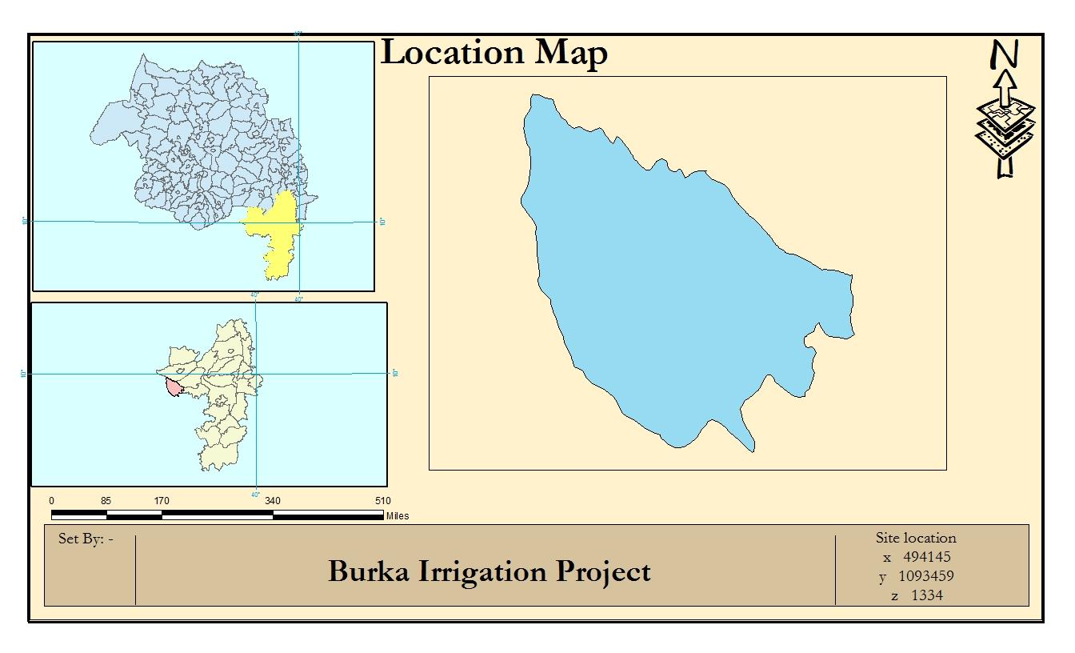

fig 1- 1 Location map of the project area

1.2 Description of the Project Area

1.2.1 Location of Bersina Watershed

This project is located mainly at Salayish kebele, Ensaro Wereda of North Shoa Zone in the Amhara Region. The proposed hydrology project is to be undertaken on Burka spring and the headwork structures are specifically located at an altitude of about 1333.80 masl and geographical coordinates of North: 1093459N (UTM) and 494145 E (UTM).

The first proposed hydrology project is to be undertaken on Fewiwiha River and the headwork structures are specifically located at an altitude of about 1336 masl and geographical coordinates of
North: 1094052 N (UTM) and 493467 E (UTM).

The second proposed hydrology project is to be undertaken on Gedi River and the headwork structures are specifically located at an altitude of about 1336 masl and geographical coordinates of
North: 1093916 N (UTM) and 493851 E (UTM).

1.3 Accessibility of all watershed

The project area is accessed through Burka project is around 15km from Ensaro wereda and 500 m from Salayish Kebele center to the Southern and western direction respectively. Along to the u/s Belbelit Eyesus Gedam or via Salayish kebele to the North west direction.

Head work site is 500 m from Belbelit Eyasus Gedan earthen road and 150 m from left side of Bersina River. From Debere Birhan town only 2 km are asphalt all other remaining distances are 128 km are weathered road it maintain on summer season.

1.4 Previous Irrigation Practices

There are modern diversions on the site which constructed by Ortogodox Tewahido Development
Program on 2001 E.C only the head work structure on Burka Spring. In addition to that all of the
Canal is earthen and on road crossing and two rivers are crossed by only local material. By using Burka spring using different irrigation practices but as the hydrology and Hydrogeology study and respondent farmers indicated, the river has capacity of recharging as it stretches down from the source area of the river. As a result there will not be a marked reduction or fluctuation of water flows both for the already existing and the newly proposed irrigation schemes.

The traditional irrigation practices (if any) are under taken by individual farmers that use the river flow to the extreme left side is with hardship not only irrigation it’s hard for both side protection work. So, the farmers in the project area are very much interested to upgrading the traditional scheme to modern scheme.

At the time of study, It use 65 ha command area for 103 male, 47 female totally 150 households. This is without Beliblit Eyesus Gedam Irrigation land.

1.5 Objectives of the Study

1.5.1 Major Objective
The project area faces variability of rainfall distribution though the overall rainfall generally suffices the rain-fed agriculture. Accordingly, the rain-fed agriculture needs means of supplementing during distribution failures and further full irrigation is required to maximize the use of the potential land and water resources.

Hence the objective of this project is to contribute a substantial share in the effort to reduce the risk of production decrease due to rainfall variability and increase the productivity of the resource in the project specific area. Specifically, the project is targeted for the following.
To make sustainable the rain-fed crop production and make extra production in the dry season possible for 88 ha of land through irrigation. By this project add 23 ha new command area.
There is a general consensus that irrigation investments will achieve broader food security and poverty reduction impacts and if efforts are also geared towards up-grading existing traditional farming practices with support to enhance access to input supply, output marketing and extension to facilitate access to information and innovations.
This objective is to be realized by constructing head work maintenances, canal and canal crossing structures.
- Because of the embankment is shorter than the Weir height.
Due to this we ask /request/ for zone and regional agricultural bureau for additional works but it didn’t solved.
Activates and works that we need for full application of the structure
- Embankment works more than 2meter heights and more than 5 meter thickness/width/.
- gabion works to support the embankment outside of the embankment 23 meter and 5 meter width
- bulk excavation of the surrounding for embankment compaction
- strengthening the internal part of the embankment either with riprap or vitbe grass

1.5.2 Specific Objectives
Other benefits that can be expected to appear with the launching of the project are: Efficiency of water use improvement;
Improved local nutrition/food security gains;
Improved management of scarce natural resources (land and water); Resilience against drought risk;
Rationale for the intensification and modernization of small-holder agriculture and rural lifestyles.
The engineering study and design enables the realization of the project by the provision of engineering structures that will allow the appropriate abstraction of the river water for delivery in to the identified irrigation fields of the study area. Hence, this engineering design is specifically targeted to:
Analyze hydrologic requirements of the project and engineering structures; The formulation of sound and stable structure, with necessary provisions that allow safe, easy and low-maintenance operation in the service life of the project;
Estimation peak flood for river crossing structure

1.6 Scope of the Study
The hydrology design shall ensure reliability, equity and flexibility of watershed study and all of soil and water conservation work to farmers. It will aim at reducing conflicts among land use and land degradation.
Updating the existing, if available, computation of the actual Evapo-transpiration, crop water requirement, irrigation demand/duty using the existing and recent agronomic, climatologic and soil data using more appropriate methodologies.
Establish flood protection measures for the command area and canal structures and design the respective drainage system accordingly,
Planning and layout of the irrigation system, which include irrigation canals, drainage channels, inspection roads and alignments, canal spacing, canal length, location of structures, and water profiles along canal and drains at specified reaches, which is most economical easily manageable and aligned with topographic feature and geological investigation.

1.7 Methodology
In the study and design procedure, Designers used the following steps.
Specific Site identification for canal and canal crossing:
o Review of the reconnaissance survey conducted by the woreda expert
o GIS information, Google Earth and database system
o Local farmers interview and discussion
o Wereda and Zone expert section expertise
o Previous studies and construction
o On foot travel along the river channel and farm areas.
o GPS (global poisoning system)
o Civil 3D

SECTION I: Hydrology Design

1.8 Hydrology Introduction
Hydrology is broadly defined as the geosciences that describes and predicts the occurrence, circulation, and distribution of water of the earth and its atmosphere.

The study of hydrology helps us to know
(i) the maximum probable flood that may occur at a given site and its frequency; this is required
for the safe design of drains and culverts, dams and reservoirs, channels and other flood control structures.
(ii) The water yield from a basin - its occurrence, quantity and frequency, etc; this is necessary
for the design of dams, municipal water supply, water power, river navigation, etc.
(iii) the ground water development for which a knowledge of the hydrogeology of the area, i.e.,
of the formation soil, recharge facilities like streams and reservoirs, rainfall pattern, climate, cropping pattern, etc. are required.
(iv) The maximum intensity of storm and its frequency for the design of a drainage project in
the area.
Runoff is that balance of rain water, which flows or runs over the natural ground surface after losses
by evaporation, interception and infiltration.

The yield of a catchment is the net quantity of water available for storage, after all losses, for the
purposes of water resources utilization and planning, like irrigation, water supply, etc.

Maximum flood discharge is the discharge in times of flooding of the catchment area, i.e., when the intensity of rainfall is greatest and the condition of the catchment regarding humidity is also favorable for an appreciable runoff.

The maximum flood that any structure can safely pass is called the ‘ design flood’ and is selected after consideration of economic and hydrologic factors.

The design flood is related to the project feature; for example, the spillway design flood may be much higher than the flood control reservoir design flood or the design flood adopted for the temporary coffer dams

One of the principal applications of hydrology is the forecasting and predicting of flood peaks and runoff volume due to large rainfall event. For the purpose of this manual, hydrology will deal with

estimating flood magnitudes as the result of rainfall. In the design of hydraulic structure like weir, floods are usually considered in terms of peak runoff or discharge in cubic meters per second (m3 /s) and hydrographs as discharge per time.

The collection of relevant data, test of the appropriateness of data’s and analysis of data by applying the principles of applied hydrology to obtain the required values are the first and most important task to be conducted before the design of any hydraulic and irrigation structure commences. Errors in the estimates of peak flood will result in a structure that is either undersized or oversized, which costs than necessary.

For all hydrologic analysis, the following factors which affect the runoff shall be evaluated and included when they will have a significant effect on the final results:
Drainage basin characteristics including: size, shape, slope, land use, geology, soil type, surface infiltration, and storage
Size of watershed: Generally, runoff rates and volumes increase with increasing drainage area.
Watershed shape: The watershed shape will affect rainfall runoff rates. For example, a long, narrow watershed is likely to experience lower runoff rates than a short, wide watershed of the same size and other characteristics.
Slope: The rate of runoff increases with increasing slope. Furthermore, rates of runoff decrease with increasing depression storage and detention storage volumes.
- Stream channel characteristics including geometry and configuration, natural and artificial controls, channel modification, aggradation - degradation, and debris
- Flood plain characteristics and
- Meteorological characteristics such as rainfall amounts and type, time rate of rainfall
(Hyetograph)

SECTION II: HEADWORK DESIGN

2. HEADWORK STRUCTURES MAINTENANCES DESIGN

2.1 Headwork Site

The headwork site is situated at 10933454 m N, 494131m E and river bed elevation of 1334m a.s.l. above sea level. At this site the spring course is well defined, matured with fixed width and forms nearly a U-shaped valley and by other project all head work are done. At this specific site, the spring back water fetch length including shape length is above 140.5233 m and total water ponding area cover 953.1921 m2 with 1.10 m depth. In this ponding area there is no any sediment at all. Total spring ponding volume estimated 1048.53 m3 .

2.2 Spring Bank condition

The bank is assigned facing downstream. It is embankment compacted clay soil with 1.20 m height
and all bank condition or all embankment condition are no any seepage and other problem on back.

But on diversion structure all diversion weir are fully cracked and the water flow in to the weir body. In addition to that the under sluices get are not operated because the problem. In summery season the spring capacity are over the weir and it over flow through the weir.

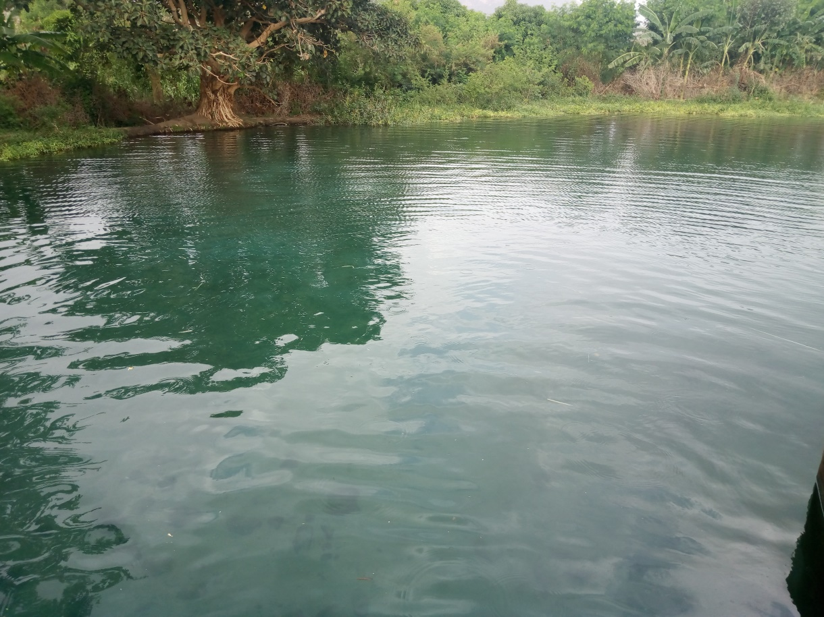
Fig 2- 1 spring reservoir

2.3 Sources of construction materials

During site investigation, natural construction materials required for the construction of the various proposed engineering structures at the headwork and within the farmland have been assessed, and possible quarry sites and borrow areas have been identified within the vicinity of the study area as close to the project site as possible. In addition to identifying the quality, quantity and accessibility conditions of the construction materials, ownerships of each proposed production sites have also been studied and described in this report, on separate sub-sections below. The materials needed for the construction of the structures include rock for masonry stones, aggregates (both coarse and fine), and water.

2.3.1 Rock for Masonry and Crushed Coarse Aggregate

Slightly weathered ignimbrite has been identified for masonry works of the project at 11.5 km distance away from the headwork site. It is located in Salayish Kebele the head of Fewis wiha the masonry stone are available for this construction. On Bersina and Jama River have enough sand.

Aggregates are inlet materials which when bound together by cement will form concrete. Generally, aggregates occupy 70 to 75% of concrete volume. Aggregates are classified as fine and coarse grained depending on their sizes. The size of fine aggregates shall not exceed 4.75mm.

Aggregates of bigger size are called coarse aggregate. The type of the work to be built governs the maximum size of aggregate. For most of the common reinforced concrete works, a maximum of size of 20mm is generally suitable.

Coarse aggregate for the construction of the project can be obtained by collecting fresh basaltic river boulders and crushing it to the desired size. Boulders deposited in the riverbed can satisfy the coarse aggregate demand of the project.

2.3.2 Fine Aggregates

Borrow areas for fine aggregate or natural sand have been assessed starting from the project stream itself.

2.3.3 Water

Water for construction purposes can be found from the project stream, Burka spring itself. The spring’s perennial throughout the year that there is some amount of flow along its course during this field time the spring flow was more than 186 litt/second

2.4 Head work site selection
Looking the availability of natural construction materials and considering
- Spring features and expected flood amount,
- Head different from maximum command area to spring site
- Water divert to command to irrigate all command area
- Availability of spring water capacity
- Duration of the head work site
- Simple for construction
- There is no significant bed load (boulder effect) in the spring.

2.4.1 Head work Design and Canal root selection

Looking the availability of natural construction materials and considering the spring features and expected water amount, only maintenances and canal construction only is chosen. As it is:
Spring diversion (weir)
Excluder get
Canal and canal crossing structure

Hydraulic Design

Diversion Structure Determination

The following major factors have been seen in determining the spring diversion Seepage amount on the weir body
Excluder without operation
Main canal slope
Loss
Lowest Point of spring center

Base flow or storage of the spring

The study team has not assessed that there are irrigation project at u/s. but the water can be execs and flow over the existing weir. Similarly by nature the spring can have good recharge of water. According to study team has calculated flow of the spring during dry season of the local at the Diversion site storage site by using Manning’s equation by taking canal width and depth

Table 30 canal volume calculation
Symbol Value unit
0.025
n =
0.650
D = m
0.800
W = m
0.520
A = m2
2.100
R =
1.079
Q in canal = m3/se
1078.639
Q in canal = lit/sec
Dimensions of diversion weir Height

The crest elevation (pond level in the case of gated structures) is determined primarily by: The level of the area to be commanded,
The length of feeder canal and its gradient, and
Any head required for sediment control and other purposes

For weirs, the crest level will also have to take account of the afflux caused at high flows, and the impact this has on upstream flood protection.
The pond level, upstream of the canal head regulator will generally be obtained by adding the working head to the designed full supply level in the canal. The working head will include the head required for passing the design discharge (full supply discharge) into the canal and head losses in the regulator.
Pond level = FSL of the canal + Working head

Weir Height 1.950 m

Length of the weir
The weir length has to be designed to allow the design flood to safely discharge over the weir and is governed by the physical feature of the site. Width of the weir could be the natural river channel width, or it could be widened or contracted depending on the flow condition of the river flood. The length of the weir for deep and confined river with stable banks should be approximately equal to the actual width of the river at the design discharge.

However for shallow and meandering river, the minimum stable width of the river should be taken as
The Lacey’s perimeter
√ Where Q is the design discharge (m3 /s) and P is width of the weir (m).

Weir Length
2.1 Lacey’s perimeter
P = 4.75*squ(Q)
Q 3.566 m3/s

P = 8.970 m
Actual Length of the weir site 12.50 Flood mark
Measured L = 12.500

SECTION III: - SYSTEM INFRASTRUCTURE AND AGRONOMY ANALYSIS

3. IRRIGATION AND DRAINAGE SYSTEMS DESIGN

3.1 Irrigable Area Description

Topography

Topography is an important factor for the planning of any irrigation project as it influences method of irrigation, drainage, erosion, mechanization, and cost of land development, labor requirement and choice of crops.

The topographic feature of the project command area lies between flat to gently sloping (i.e., 0 to 2%) slopes. Its elevation range is from 1332m to 1333 meters above sea level. However, it has
identified to be suitable for surface irrigation. Nevertheless, it requires soil and water conservation
measures or structures (i.e. constructing bunds, bio-physicals, check dams, artificial water ways, etc).
The project command area is situated at the right side of Burk spring (to the South side of the river). The natural topographic feature of the command area has inclined from the North-South, from West - East south to North direction.

Climate

As per the hydrological analysis and on the basis of the traditional Ethiopian Agro-Ecological Zones (MOA, 2001), the UGDWIP area is basically classified as moist warm (sub-moist cool) agro- ecological zone, indicating better moisture condition in the area in wet seasons. There is no belg rain
season in the project area. Despite the fact that the Meher rains are considered adequate, there is
notable variation in terms of onset, distribution and withdrawal from year to year affecting crop production in general and crop productivity in particular.

As the project site has no its own meteorological station, Alem Ketema(for rainfall and minimum
and maximum temperature) and Alem Ketema (for relative humidity, wind speed and sunshine
hour) meteorological stations data were used for the project study as long as these stations are relatively near to the proposed command area. In general, the sources of meteorological data are the National Meteorology Service Agency (NMSA).

Soil characteristics

Soil properties (physical, chemical, etc.) greatly influence the growth and thereby yield of crops which is grown. The command area have black clay soils, and deep soil characteristics Soil properties (physical, chemical, etc.) greatly influence the growth and thereby yield of crops which is grown. The command area has heavy clay textured soils which is a workable soil depth for crop production; and have nil to slight erosion hazards.

3.2 Existing Irrigation Practices in the Project Area

The pressure of survival and the need for additional food supplies to meet the demands of the increasing population is necessitating a rapid expansion of irrigation schemes. Thus, irrigation is becoming a basic part of well-developed agriculture wherever there is water and irrigable land potential. Accordingly, Pump and small irrigation practices are under taken by individual farmers that use the river flow to the Right side is with laborious very small temporary diversions not greater than 1ha. So, the farmers in the project area are very much interested in the idea of upgrading the Pump scheme and sample traditional to modern scheme.

3.3 Irrigation Water Requirement

Crop Water Requirement (CWR)

The calculation of crop water requirement is a very important aspect for planning of any irrigation project. Several methods and procedures are available for this. The Food and Agriculture Organization (FAO) of the United Nations has also made available several publications on this subject and other issues related with this. The computer program available in FAO Irrigation and Drainage Paper No. 56 “CROPWAT” has been used for the calculation of Crop Water requirement. This program is based on Penman-Monteith approach and procedures for calculation of crop water requirements and irrigation requirements are mainly based on methodologies presented in FAO Irrigation and Drainage Paper No. 24 “Crop Water Requirements” and No. 33 “Yield Response to Water”.

The corresponding values of the crop water requirements of the proposed crops of the project are presented in the Agronomy Study of the same project.

Irrigation efficiency (Ep)

To complete the evaluation of the demand, the efficiency of the water distribution system and of application must be known.

The gross requirement of water for irrigation system is very much dependent on the overall efficiency of the irrigation system, which in turn is dependent on several factors: Method of irrigation, type of canal (Lined and/or Unlined), method of operations (simultaneously and continuous or Rotational water supply), and availability of structures (for controlling and distribution and measuring and monitoring).

Irrigation duty

Irrigation duty is the volume of water required per hectare for the full flange of the crops. Moreover, it helps in designing an efficient irrigation canal system.

The area, which will be irrigated, can be calculated by knowing the total available water at the source and the overall duty for all crops required to be irrigated in different seasons of the years.

The proposed cropping pattern of irrigation project has showed a maximum net irrigation water requirement (NIWR) in the month of March with the amount of 24.51 mm/day for 24 working hours (for overall proposed crops).

However, for the designing of the irrigation water application and the flows in the entire canal systems, from the overall proposed crops the one that has maximum NIWR was used for irrigation duty calculation. Accordingly, Maize has showed the maximum NIWR (i.e. 15.83 mm/day); and hence taken for the irrigation project duty calculation as indicated here below:

Irrigation Project, it decided to adopt 85% field application efficiency, 90% distribution efficiency, and 90% conveyance efficiency as the soil is clay textured and the canal systems are estimated to be lined of the main canal can be provided. Hence, the overall/project efficiency for the selected surface irrigation method has been estimated to be 68.9% (85/100*90/100*90/100) which is rounded to 68.9%.

- Crop water requirement
Et0 from FAO Table 16.67

Average Kc Average ET Average seasonal ET
Crop type (mm) growing (mm/day)
period
KC mm Day mm/day

Onion(dry) 0.85 450.00 180.00 2.50
Banana (tropical 0.75 1,700.00 135.00 12.59
Cabbage 0.75 440.00 130.00 3.38
Maize (grin ) 0.83 650.00 153.00 4.25
Sorghum 0.80 550.00 135.00 4.07
Sugarcane 0.95 2,000.00 120.00 16.67
Maximum Value 0.95 2,000.00 180.00 16.67

NIWR = GIWR*IE 15.83 mm/day
Where; GIWR- Gross irrigation water requirement [mm/day]
NIWR- Net irrigation water requirement [mm/day]
IE- Irrigation efficiency [%]

Field Application efficiency 85%
Distribution Efficiency 90%
Coveyance Efficiency 90%
IE- Irrigation efficiency [%] 0.689
GIWR 23.00 mm/day
1.00 ha

The duty is calculated by: Command 10,000.00 (m2 )
Area
IWR = GIWR *CA/(1000 × Ef) 229.97 m3/day
IWR 24 hr = IWR*1,000/86,400 second 2.66 litr/sec
Duty (for selected crop) = IWR/Command Area in ha 2.66 l/s/ha

- Command Determination
Duty = 2.66 l/s/h
Irrigation hour duty 3.99 l/s/h
Irrigation hour duty 3.99 l/s/h
Net Base flow = 395.40 l/se
Command Area = 99.04
ha
The previous canal flow is 395.40 lit/sec this flow is irrigating 99.04 ha. Our command area is 88.0 ha so there is no any new canal. But there is a new canal root and extension construction.

After road crossing there is no any modern canal so 1500 m canal can be constructed in anew canal root.

3.4 Irrigation methods

Among the different irrigation systems will be used for the project area; and the irrigation water will be obtained from head work site and by constructing diversion weir/intake and conveying the water commonly through earthen canals (SC, SC, and TC) and then leading to field canals; and finally irrigation takes place mostly in furrows.

For this project, among the various irrigation methods, surface irrigation method has been selected. Of the surface irrigation methods furrow, border and basin irrigation methods can be used to supply irrigation water to the plants/crops. However, each method has its own advantages and disadvantages. Care should be taken when choosing the method which is best suited to the local circumstances, i.e., depending on slopes, soil types, selected crop types, amount of water available, etc. of the command area.

Based on the above factors surface irrigation method has been proposed for the proposed crops in this project. The method allows applying light irrigation and can be laid out in sloping fields along the contour. Furrow irrigation method is best suited for most of the proposed and row planted crops. In general, furrow irrigation method is simple, manageable and widely practiced irrigation method. This method is suitable for row crops that cannot stand in water for long periods. The only thing required to use this method is row planting of crops. Besides, basin and border irrigation method would be used for the non-row planted crops. Rotational flow water distribution is also recommended for the project area.

Irrigation and Drainage System Layout

The irrigation system layout for the project is prepared taking the following points into consideration besides other factors.

- A primary concern in the layout of the system is that it serves the purpose of conveying and distributing water to the command area.

- The excavation and earth fill volumes not be excessive, otherwise the construction costs can be tremendous.

- The selection of longitudinal bed slope is made taking into account the existing slopes of the terrain, so as to minimize deviations in canal routing.

- Curves in canals should not be too sharp.

Conveyance System

The conveyance system consists of One (1) Main canal to irrigate total command area of 88 ha. The
main canal starts from Water abstraction site on right side and conveys water for a length of 1500 m.

Main canal is aligned along contours and supplies to two secondary unit and one tertiary canals also both SC supplies for TC and finally they distributed to the many field canal.

Design of the Canal System

Flow Depth and Section Capacity

The earthen canals have been designed with a trapezoidal shape and the lined ones with rectangular x-section using Manning's Formula:

Where Q= discharge (m3 /s)

- Hydraulic radius (Flow area/wetted perimeter)

- Hydraulic gradient

- Manning's roughness coefficient, n=0.024 is adopted for the earth channels and n=0.018 for the masonry lined part of the main canal

Main Canal

The main canal is designed for a discharge of 0.3954 m3 /s and depending on the site specific condition, appropriate slope is provided. Hydraulic parameters of the main canal are shown below.

SECTION IV: - Drawing

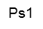            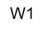  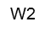  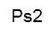     |  | 0.40
 | 1335.5200
 |  |  | H
 |  |  | V
3.20
1332.3200
1331.9200 |  |  |  | 0.40
bt |  |  | 1.60 | bh
 |  | 2.00

Fig 3- 1 retaining wall stability checking

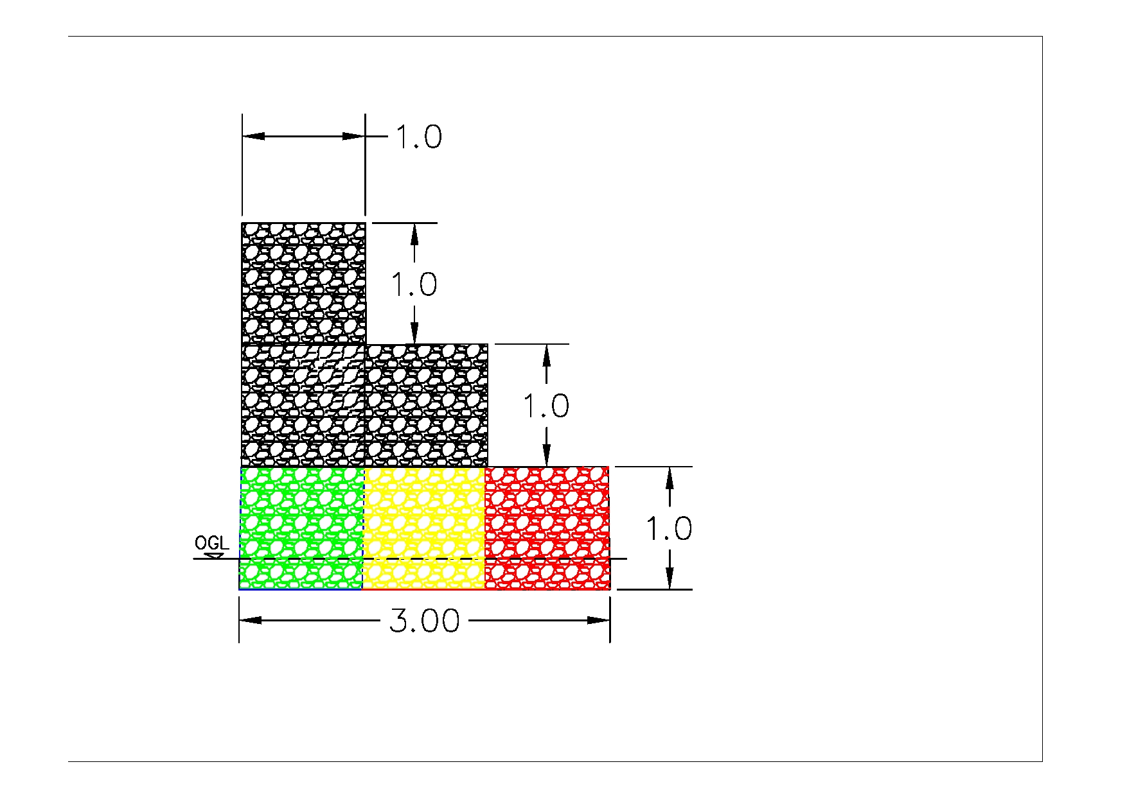

Fig 3- 2 Gabion Work cross- section

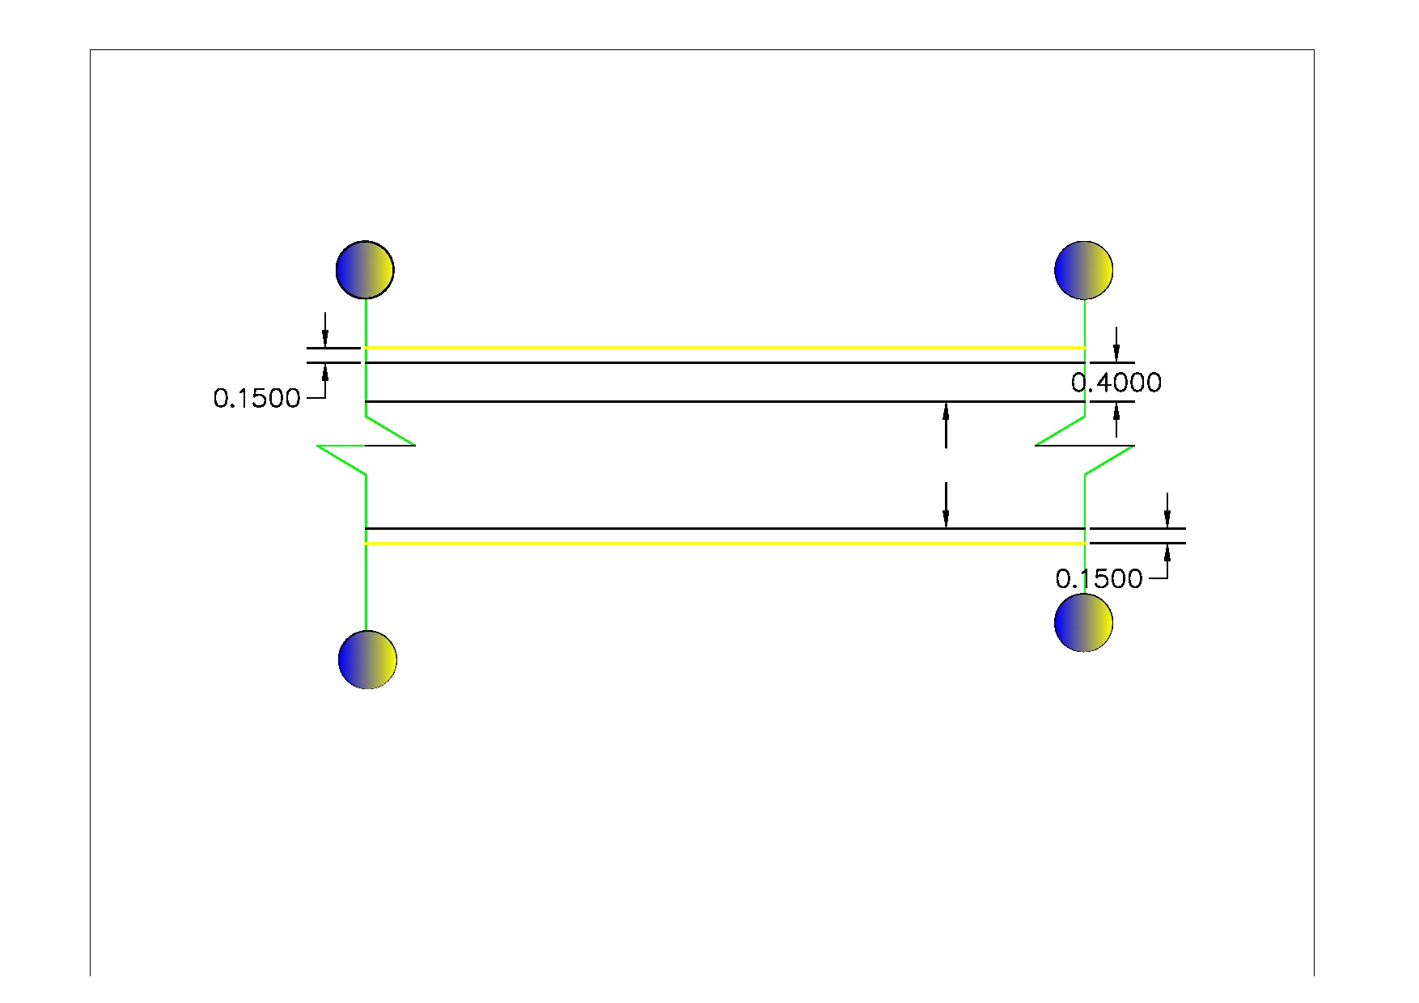

Fig 3- 3 plan view of retaining wall

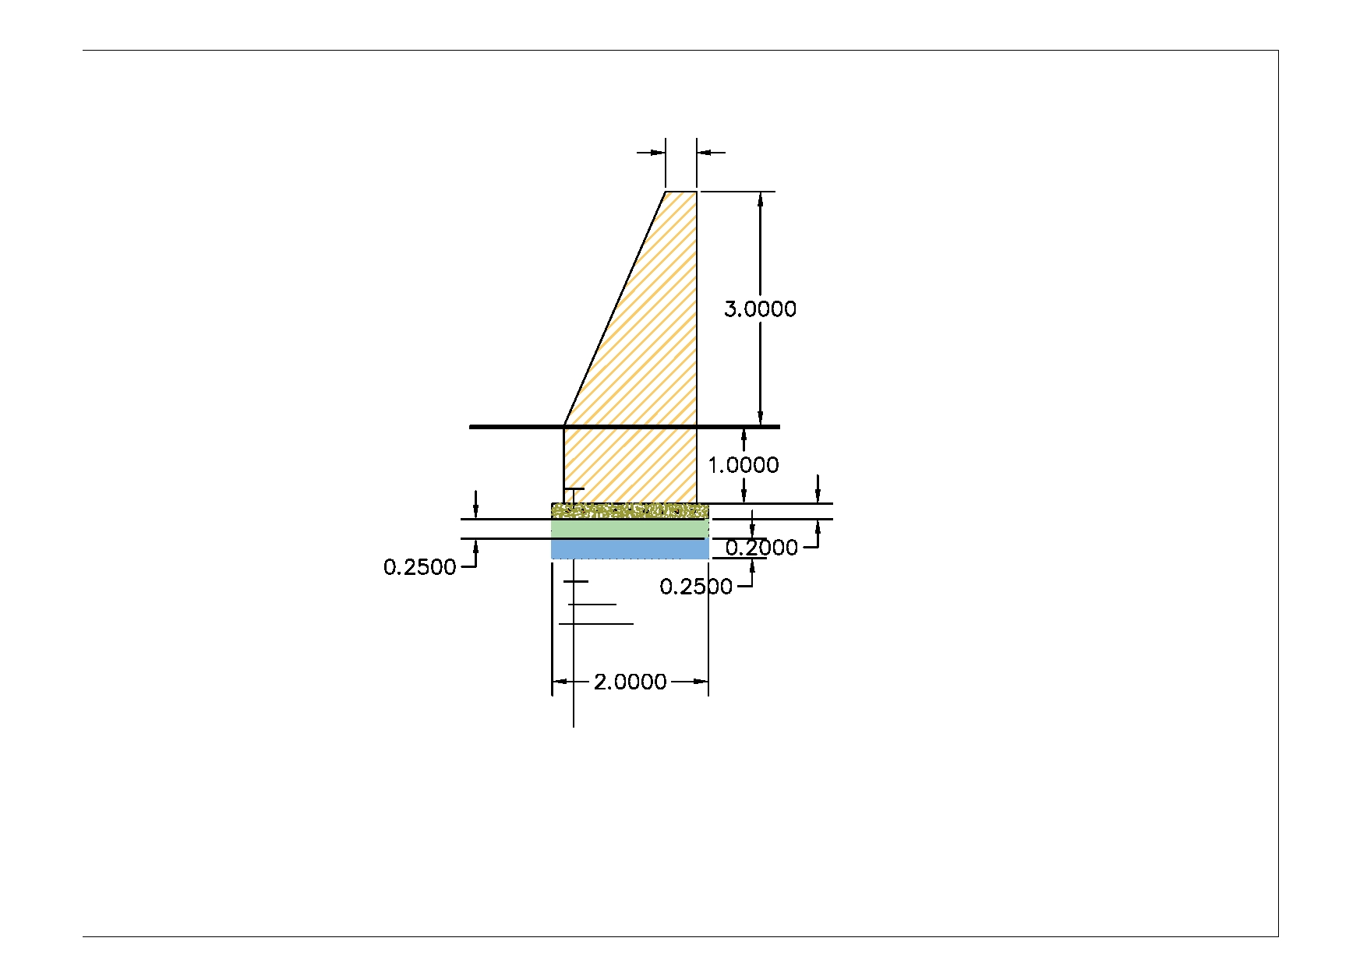

Fig 3- 4 Cross-section of retaining wall

4. CONCLUSION AND RECOMMENDATION

- The infrastructure of this project area is designed to irrigate about 88ha of land by taking its supply
from the irrigation project. The maximum duty of the command area for 16 hours per day irrigation with overall project efficiency of 68.9%. The method of irrigation of the project area is furrow surface irrigation in which the Main and Secondary canals are working continuously whereas the field canals within a tertiary block are working rotational system.
- As the dominant soil type is black cotton soil, the main canal system is designed to be masonry.
- The reason why the main canal is to be lined up to the end is to avoid the siltation problem, time saving to reach at the tail part, reduce maintenance cost and use water properly.
- On the secondary unit of the irrigation systems, some are associated with far as possible to be very small filled and almost total cut.
- The design of the canal dimensions of the irrigation canal is done by applying the manning’s uniform flow equation. The variable of the hydraulic parameters are calculated using iteration or flow master program.
- The design discharge of the drainage canals are determined using Rational formula and Gamble Powell method.
- As soils of the command area are predominantly black cotten(clay) textured; and hence water and soil management measures should be undertaken; and optimum moisture content should be maintained to improve workability of the soil during land preparation and planting time.

The following recommendations are drown:

- For better performance and long service year of the project regular inspection and maintenance is highly required.

- Farmers training, how to operate and maintain the project structures as a whole and available and water resources has a paramount important.

- The irrigation hours per day and per week should be flexible based on base flow amount of each week or month.

- Close supervision of the construction should be made to modify (if need be) each Components of irrigation system based on specific site conditions.

4.1 OPERATION AND MAINTENANCE

General

The main objective of the operation and maintenance aspect of an irrigation scheme is to facilitate the timely delivery of the required irrigation water to farms and to keep the irrigation system in an optimum operating condition. This section therefore, discusses the main functions of the subject matter under consideration for the scheme.

Operation of the Head Works

Operation at the diversion weir mainly focuses on the diversion of a controlled flow of river water, timely cleaning of floating debris in front of intake and removal of sediment deposits in front of the weir and intake structures.

Irrigation System Operation

The operation of the irrigation system depends mainly on the method of water delivery at farm level. Surface irrigation method is the recommended type of water distribution and application method for Aderkayna diversion irrigation scheme.

The farmers would organize themselves and form groups in order to handle the water management. Since flow is low Rotational water distribution would be applied within the group. The rotational distribution is then to distribute water by turn to the whole scheme according to the timely need of crop water requirement. For better and efficient water management, crop diversification should be avoided within a group. This would reduce the complexity of water distribution system of the scheme during one irrigation season. At farmers’ level of operation, a constant flow and variable irrigation time is advisable.

The operation of the irrigation system is continuous for 14 hours per day in main, secondary and tertiary canals whereas field canals within a tertiary block are operating in rotational system with each other for irrigation hours proportional to their size. Since the tertiary canal discharges are within the manageable range and the irrigation canal structures are accordingly designed for simple operation, the farmers can open and close easily whenever they required.

Maintenance Requirement

The canal system of the project is earthen canal except main canal and secondary canal, which is susceptible to siltation, erosion, growth of weeds and or breaching problems. Though the canal sections are designed for non- silting and non-scouring conditions, the above mentioned problems are unavoidable and hence periodical and yearly inspection and maintenance of canals and structures are obligatory in order to fulfill the design objective of the project area.

The maintenance tasks are categorized into two types: - routine activities, and repairs. The routine maintenance activities that are carried out periodically include:-

- Regular cleaning of sediments and weeds from canals and drains;
- Inspection and lubrication of gates; and
- Maintenance of cracked lined canals, regulating and control structures.

Repair works include task carried out more frequently and quickly, and include those tasks that are generally unpredictable. They also include emergency works. The activities included in this category are:-

- Repairing overtopped or breached canals, drains, and flood protection dykes;
- Repairing jammed gates;
- Filling holes made by wild animals; and
- Reduced free board due to walking over by people and livestock.

Regular inspection of the irrigation facilities should be carried out as part of the maintenance activities. These tasks could be carried out immediately after the end of the main rains in September and during the rainy season. This could concentrate on the interceptor drains and the flood protection dykes, the main canal and the field drains. The inspection of the other works like the tertiary canals, field drains, and the water control and regulating structures could be carried out as part of routine operation activities.

- Beneficiaries of the project need to have operation and maintenance budget, For O&M cost incurring
entity area:
- Purchase sing of gate lubricate (grease)
- Replacing and maintenance of Stolen and damaged gates
- Repair Damages on the cross drainage structures.
The expense for O&M should be collected from the beneficiaries. Of course, much of the task is done by the labor and skill of the community. For cost incurring activities beneficiaries have to collect money based on the proportion of the command area they owned.

REFERENCE

- ARORA, K.R., Irrigation Water Power and Water Resources Engineering, Professor of Civil
Engineering, Engineering College, Kota (Raj.)
- Design of small Canal structures , USBR
- Ethiopian Ministry of irrigation department manual(IDD).
- Hydraulic structural design guide line for small scale irrigation project.
- Irrigation Engineering And Hydraulic Structure (Garge)
- PART 1-3F design guide lines on diversion structure
- Soft copies of hydraulic structure publishing FAO (1977) guidelines for predicting crop water
requirements. No 24, Rome Italy

