Table of content
Table of content i
List of Figures iv
List of Tables v
ACRONYMS 1
Sample Salient Features 2
1. INTRODUCTION 3
1.1 Background 3
1.2 Objectives 3
1.3 Scope, methodology and procedures 3
1.3.1 Scope 3
1.3.2 Methodology and procedures 4
1.4 The Project Area 5
1.4.1 Project Location and Accessibility 5
2. Topography 6
3. Local Geological condition 7
4. Hydrology 9
4.1 Watershed Characteristics 9
4.2 Hydro-Metrological Data Availability 10
4.2.1. Climate 10
4.3 Dependable Rainfall 10
4.4 Water Resources Potential 11
4.4.1 Hydrological data 11
4.4.2 Design flow and flood estimation 11
4.4.3 Watershed Erosion and Sediment 13
4.5 Water Demand 14
4.5.1 Irrigation water demand 14
4.5.2 Livestock water demand (LWD) 15
4.5.3 Environmental flow requirement (EFR) 15
5. Head Work Design 15
5.1 Components of Headwork 16
5.2 Site Selection 16
5.3 Design Consideration of Surplus Weir 17
5.3.1 Elevation of Weir Crest 17
5.3.2 Length of Weir 17
5.3.3 Forces acting on Weir 17
5.3.3.1 Water Pressure 18
5.3.3.2 Uplift Pressure 18
5.3.3.3 Silt Pressure 18
5.3.4 Weight of Weir 19
5.3.5 Modes of Failure & Criteria for Structural Stability of Weir 19
5.3.5.1 Overturning about the toe 19
5.3.5.2 Compression or Crushing 19
5.3.5.3 Sliding 20
5.3.6 Protection Work for Weir Structure 20
5.4 River Geomorphology 20
5.4.1 River Bed condition 21
5.4.2 River Bank condition 22
5.4.2.1 Right Bank 22
5.4.2.2 Left Bank 22
5.5 Sources of construction materials 22
5.5.1 Rock for Masonry and Crushed Coarse Aggregate 22
5.5.2 Burrow (filling material) Area 23
5.5.3 Water for Construction 23
5.6 Headwork Type Selection 23
5.6.1 Base flow of the River 23
5.6.2 Under Sluice, and Canal outlet 23
5.6.2.1 under sluice 23
5.4.2.2 Canal outlet level 24
6. Spring Development 25
6.1 Introduction 25
6.2 Purpose and Scope 26
6.3 Type of spring 26
6.4 Design Considerations 27
6.4.1 Spring Box 27
6.4.2 Artesian springs 27
6.4.3 Gravity Springs 27
6.4.4 Seepage Springs 28
6.5 Spring Yield Determination 28
6.6 Water Demand Estimation 29
6.6.1. Irrigation water Requirements 29
6.6.2 Domestic and Livestock Water Use 30
6.6.3 Total water demand 30
6.6.4 Computation of Gross water demand 31
6.7 Reservoir 32
6.8 Spring Design 33
7. Irrigation Distribution System Design 34
7.1 Command Area 34
7.2 Irrigation Canal Systems 34
7.2.1 Description of Water Distribution System 34
7.2.2 Canal Alignment (Canal Layout) 35
7.2.3 Canal Design 36
7.2.3.1 Fixing Canal Capacities 36
7.2.3.2 Canal Cross-Sections 36
7.3 Design of Related Structures 38
7.3.1 Drop Structures 38
7.3.2 Crossing Structures 40
7.3.2.1 Aqueduct 41
7.3.3 Design of Pond 42
7.3.4 Design of Division Structures 44
i. Division Boxes 45
8. Drainage System 49
8.1 General 49
8.1.1 Field Drains 49
8.1.2 Tertiary drain 50
9. Bill of Quantity & Contract Cost 51
9.1 Bill of Quantity 51

List of Figures
Figure 1 Google Map of the headwork site 8
Figure 2 the Study Area 9
Figure 3 Site plan of the storage Dam 10
Figure 4 Geological cross section along the intended dam axis 11
Figure 5 the geological cross section along this spring developing structure 12
Figure 6Drainage map of Hidha Sombo watershed 13
Figure 7 Forces on the Weir 21
Figure 8 Photo image at the proposed intake site 24
Figure 9 Spring location map 29
Figure 10 Typical feature of artisan spring box 30
Figure 11 typical feature of a gravity spring box 31
Figure 12 typical feature of a seepage spring box 31
Figure 13 Measuring spring discharge (volumetric method) 32
Figure 14 Cattle trough 33
Figure 15 Plan and section of Trapezoidal Reservoir 36
Figure 16 (HSSSIP) command Area of the project 37
Figure 17 X -section of Masonry Lined & earth canals 41
Figure 18 Drop longitudinal x Section 43
Figure 19 Plan of typical aqueduct Structure 44
Figure 20 Plan section of pond 47
Figure 21 Longitudinal X-section of division boxes 50

List of Tables
Table 1 Design rainfall of Hidha Sombo Irrigation Project 10
Table 2 Dependable Rainfall of Hidha Sombo Irrigation Project Area 11
Table 3 Monthly Run off and Flow Estimation of Hidha Sombo Irrigation Project by SCS 11
Table 4 Design Rainfall and design discharge for Hidha Sombo River at Dam site 13
Table 5 Irrigation water requirement of Hidha Sombo Irrigation Project 14
Table 6 Live Stock Water Demand of Hidha Sombo Irrigation Project Area 15
Table 7 Environmental Flow Requirement of Hidha Sombo Irrigation Project Area 15
Table 8 Dimensions of the drop structures in TC 41
Table 9 Location, type and number of drain crossings 42
Table 10 Dimensions of the Box culvert structures in TC 43
Table 11 Dimensions of the Pond structures in TC 44
Table 12 Dimensions of the Division box structures in River as a Main canal 47
Table 13 Hydraulic characteristics of the canals 48
Table. 14 BILLS OF QUANTITIES AND COST SUMMARY 53

ACRONYMS
T = Return period
A = Catchments area
C = Runoff coefficient
I = Intensity of rainfall
D = Rainfall duration
Tc = Time of concentration
Tb = Time to base
Tp = Time to peak
U/S = Upstream
D/S = Downstream
Q = Discharge
V = Velocity
R = Hydraulic radius
S = Slope of the canal
n = Manning’s coefficient
P = Wetted perimeter
HFL = High flood level
TEL = Total energy level
T = Weir top width
B = Weir bottom width
Fr = Fraud Number
KN/m3 = Kilo Newton per meter cube
RCC = Reinforced cement concrete

Sample Salient Features
1. Project-name: Hidha Sombo SSIP
2. River basin- Wabishebele
3. Name of the Lake: - Haro Korma Kasir
4. Name of spring: - Hidha Sombo
4. Location dam site,
a) Zone: - East Harerghe
b) Woreda: - Jarso
c) Kebele/ Got: - Bedhaasaa
d) Accessibility: - 16km from woreda town
5. Grid location:
a) Longitudes: - 205908.2637mE,
b) Latitude: - 1046142.54mN and
c) Altitude: - 2440m.a.s.l.
6. Hydrology:
a) Catchment area:- 85.42ha
b) Design peak discharge:-62.05m3/sec
c) Gross Command area: - 182 ha
d) Net Command Area: - 160 ha
c) Duty: - 2.12lit/sec/ha
7. Design life:-50Years
8. Date and year of design:-
9. Number of HH: - 160*0.25 = 640

INTRODUCTION

1.1 Background
The Engineering study has been conducted as part of Haro Korma Kasir Lake and Hidha Sombo spring development small scale irrigation development project as per the requirement of the TOR which has been signed between OWWDSE (Consultant) and OIDA (Client) in June, 2018. The project site is found in East Hararghe Zone, Jarso Woreda and Badhasa Kebele. The project is a Small scale irrigation that covers about 182 ha and 160 ha gross & net command area respectively. It is based on Haro Korma Kasir Lake as source of water as well as Hidha Sombo spring. The Lake discharges down to the command area. Its discharge increases during wet season and decreases during dry season. The spring is situated at about 150m distance downstream of the Lake. It is a perennial spring that flows across the Badhasa PA with minimum estimated flow rate of 25 lit/sec. So, the local farmers are well experienced in irrigation practice as well as they constructed small ponds throughout the command area at different places to store the required irrigation water during rainy season for practice irrigation in dry season when the lake water level is decline, and including the Hidha Sombo Spring for rural water supply and irrigation as observed during the feasibility study. The design of a scheme is considered the feasibility study (all sectorial studies) and based on the physical condition of the site we recommend that Tank weir or surplus escape weir in front of the lake and protection dyke at both side of the bank; on other hand the dyke and surplus weir height is limited up to 1.50m, 1.00m respectively due to the farm area developed by the local resident around the reservoir area; so the next task is preparing the design of the scheme. At this level, type of structures, specifications, working drawings, and design reports, operation and maintenance manual, etc. are made ready for latter uses (i.e. construction and operation and management of schemes.)

1.2 Objectives
The main objectives of the engineering design of the scheme are as follow:-
- To design structures that is matching to the natural ground condition
- To prepare detailed hydraulic and structural design of the Dam, main, secondary, tertiary, feeder ditch, drainage canal and the associated structures (e.g. Culverts, division boxes, flow measuring structures on main canal, etc.) and Spring Development.
- To prepare the detailed specification and cost estimate of the structures to be designed as a component of a scheme.
- To prepare the operation and maintenance manual after the design work is completed.

1.3 Scope, methodology and procedures

1.3.1 Scope
The project design carried out starting from the very head of the project up to the point where the tail water (drainage water is finally guided out of the project area and made to join natural gullies or the river course). Therefore, the design work includes every hydraulic and structural design of the different components of the project under consideration.

1.3.2 Methodology and procedures
In the study and design procedure, Designers used the following steps.
- Specific Site identification:
Review of the reconnaissance survey conducted by the Client
- 50,000 scale top map and GIS information
- Local farmers interview and discussion
- District and Zone Agriculture section expertise
- Previous studies
- On foot travel along the river channel and farm areas

- Topographic survey:
- Surveying the headwork site and the Command area with sufficient radius, using Total station

- Flow estimation
- Physical observation on flood mark indications and local information about high flood and critical flow condition of the river
- Analyzing the recorded river flow data and use watershed inputs for further analysis.
- Base flow estimated during the reconnaissance field visit by floating method.

- Irrigable area identification:
- Using local information
- 50,000 Topographic map, and GIS information, GPS to see elevation
The design report is organized in three sections. In Section I the Hydrology study is presented and in Sections II and III the Headwork and Irrigation and Drainage Systems designs are discussed respectively. In Section III, planning and design of the irrigation system after diverting the water using the intake will be dealt. The following are major areas of concern in this part.
- Study and design of the irrigation method to be adopted,
- Study and design of the irrigation system layout and associated structures,
- Design of the different conveyance canals,
- Planning and design of the different irrigation and drainage structures,
- Preparation of the longitudinal profiles of the different irrigation and drainage canals.

1.4 The Project Area

1.4.1 Project Location and Accessibility
Hidha Sombo Small scale irrigation development project is located in East Hararghe Zone of the Oromia National Regional State. It is located in Jarso district and Badhasa Kebele. The UTM coordinate location of the site where the spring eye located which should be developed is 205908.2637mE, 1046142.54mN and elevation of 2440m.a.s.l. It is found at a distance of about 581km from Finfinee to the east direction. It is accessed by about 525km asphalt road from Finfinee to Harar Town; by 56km all-weather road from Harar Town to the project site.
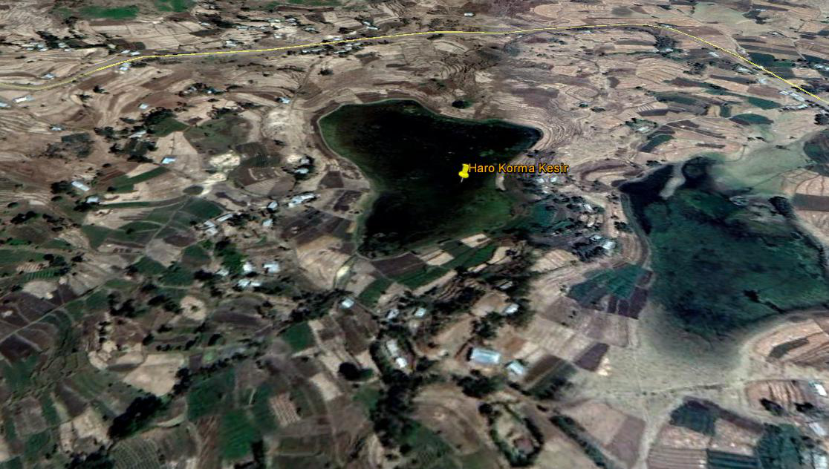
Figure 1 Google Map of the headwork site
Figure 2 the Study Area

Topography
- Mapping is made based on addendum and UTM projection system
- Topographic survey of the Dam site carried out after establishing a minimum of two benchmarks on each sides of the weir and at least one in the range to be able to seen from the Dam. The benchmarks should be prepared pre-cast concrete with pin point at center to size of 10cm x10cm at top, 20cm x20cm at bottom and the depth of 60cm strongly fixed to the ground so that it will not be dismantled by any other interference.
- At least two permanent benchmarks established in the command area along the main canal routes.
- All natural, artificial features, and bench marks are shown on the topographic map of the Dam to be prepared at an appropriate scale depending on the information needed (area coverage).(i.e. 1:1000,1:500, 1:200 scale). Coverage of weir site is a minimum of 50m on all the four direction from the axis of the proposed weir. Refer to Technical Guideline for design of Dam.
- The topographic survey of the command area carried out and a topographic map will be prepared at a scale of 1:2000 or larger with contour internal of 1m and /or 0.5m.
- Longitudinal profile of canal and water conveyance system surveyed and plotted on appropriate scale: Preferably 1:1000 H and 1:100 V and at an interval of 20 to 50m. More over strip contour plan of 10 to 12m on either side of centerline of the canal should be surveyed and plotted at 1:1000 and 0.5 m counter interval.
- Longitudinal and cross section survey of river channel gully and natural drain conducted and plotted to an appropriate scale. If the project is a storage Dam, the topographic survey of the reservoir site should be prepared at a scale of 1:2000 or large and contour interval of 1m up to an elevation of maximum water level (MWL) plus certain meters above the water level (5m) shall be prepared. So that area Vs elevation relationship is established to determined storage capacities shall be made.
- Night storage topographic survey of 1:500 scales prepared.
- For the above surveying activities the surveyor can use different instruments such as Total Station, GPS, Leveling and other software that minimize time and cost without compromising data quality.
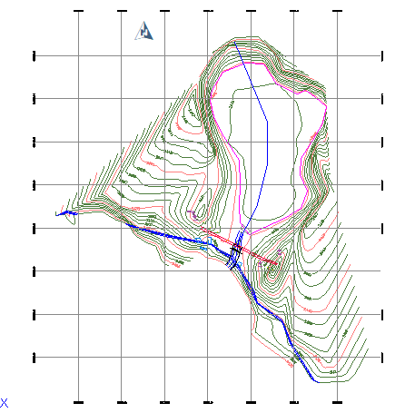
Figure 3 Site plan of the storage Dam

3. Local Geological condition
The Lake site is characterized by fractured basaltic rock formation. It is situated at lake forming topography under the cliff forming and chain of basaltic ridges surrounding the lake. Along the dam axis thick sediments of black silty clay deposited with more than 2m thickness. This lake collects water from the surrounding basaltic and limestone recharging areas and discharges through its outlet at the dam axis. The bedrock geology underlying the Hidha Sombo headwork site is basaltic rock formation. It is well exposed at upstream, downstream; the right and left banks of the head work site (Figure 3). This sandstone rock is hard and massive to faintly joint faces in structure. The outcrops at the right and left bank of the stream makes generally stable slope. But the stream bed has about 2.5m thick overburden sedimentation of loose unconsolidated clay deposits at the center of the dam axis. These types of loose transported sediments of thick clay need to be excavated in the streambed to get the firm foundation material.
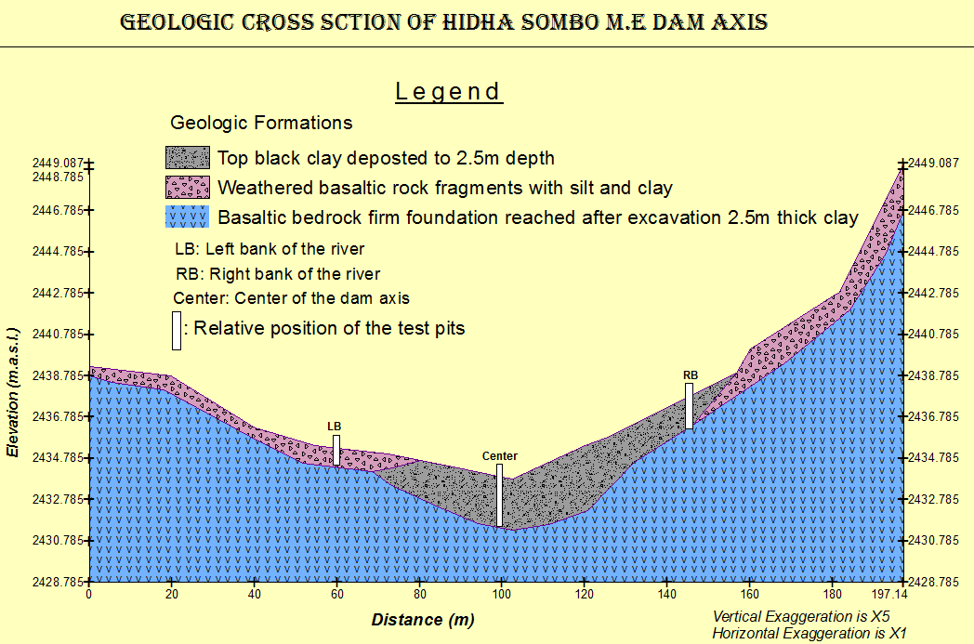
Figure 4 Geological cross section along the intended dam axis

In addition to the M.E dam, there is also spring named Hidha Sombo at about 150m distance downstream of the proposed dam site. This spring has been observed to be used as supplementary irrigation water. Because, it is a perennial spring that flows across the Badhasa PA with minimum estimated flow rate of 25 l/s. therefore, this spring strongly recommended to be developed and join the canal system. The geological cross section along this spring developing structure (submerged box or diversion weir) constructed from the test pits and underrating geological set up of this locality (Figure 9). This spring is with two eyes and discharge from fractured basaltic rock.

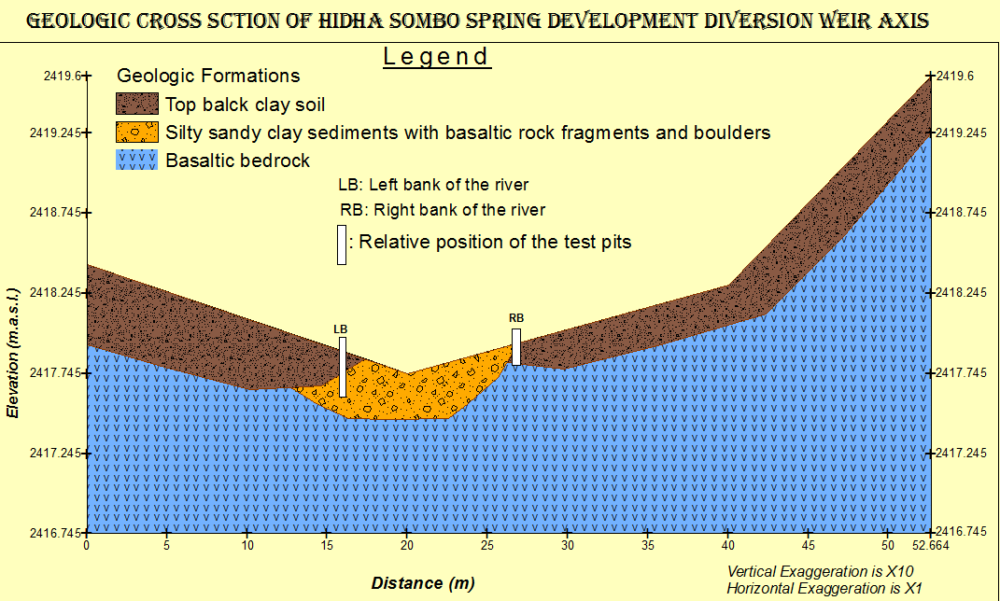
Figure 5 the geological cross section along this spring developing structure

4. Hydrology

4.1 Watershed Characteristics
The watershed characteristics are analyzed and presented in the Watershed Feasibility Study Report of the same project. In summary: Certain physical properties of watersheds significantly affect the characteristics of the runoff and sediment yield and are of great interest in hydrologic analyses. The rate and volume of runoff, and sediment yield from the watershed have much to do with shape, size, slope and other parameters of the landscape. These suggest that there should be some important relations between basin form and hydrologic performance. If the basin and hydrologic characteristics are to be related, the basin form must also be represented by quantitative descriptors. These parameters can be measured from maps.
- Catchment Area = 85.42 ha
- Stream Length = 1.325km
(Extracted from the Watershed Study Report of the same project) At the selected reference point, the area of catchment is 85.42ha and consists of a network of tributaries as shown in Figure 2 below. Hidha Sombo River at the headwork site is characterized by well-defined channel system and considerable flows. It looks that the gradient of the river is getting low and hence there exists significant deposition of sediment black silty clay.
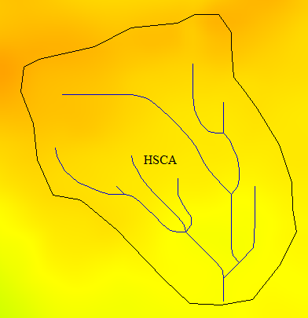
Figure 6Drainage map of Hidha Sombo watershed

4.2 Hydro-Metrological Data Availability

4.2.1. Climate
The proposed project area has an average altitude of 2420 meters above sea level. The Monthly max., min. and average temperatures are 22.30c, 138.30c & 17.80c, respectively. The hottest month is March, and the coldest one is August. And has an average annual rainfall of 890mm with effective rain being 475mm, seems bi-modal type, erratically distributed over more than four months. From this the highest rainfall is recorded in the month of April, and the lowest is recorded in the month of December.
Source (National Meteorological Agency (NMA)
Table 1 Design rainfall of Hidha Sombo Irrigation Project
Return T | 2 | 5 | 10 | 25 | 50 | 100 | 200 | 500 | 1000 | 10000
Log Pearson III | 53.1 | 69.98 | 81.1 | 91.77 | 105.63 | 116.14 | 127 | 141 | 150 | 182
GEV-Max | 53.13 | 69.13 | 79.71 | 93.09 | 103.02 | 112.87 | 132 | 136 | 145 | 178

4.3 Dependable Rainfall
There are different approaches to determine the dependable rainfall (normally it is effective rainfall) which is a rainfall remain for plants after a percolation, evaporation +dependable rainfall method, Empirical formula and USDA soil conservation services methods. But, we used effective rainfall 80% dependable rainfall.
Table 2 Dependable Rainfall of Hidha Sombo Irrigation Project Area
Months | Jan | Feb | Mar | Apr | May | Jun | Jul | Aug | Sep | Oct | Nov | Dec
80% Rainfall | 0.00 | 0.00 | 6.50 | 19.00 | 13.80 | 9.60 | 14.60 | 22.00 | 14.20 | 8.52 | 0.00 | 0.00

4.4 Water Resources Potential
The main surface water source for the irrigation demand of this area is Hidha Sombo River near Ejersa Goro rural town, which is a tributary of Erer Sub basin which finally joins Wabe Shebele River Basin.

4.4.1 Hydrological data
Daily flow data at dam site is necessary for design of dam and its appurtenant structures to estimate maximum design flood for a given return periods, dependable flow to estimate the reservoir capacity and low flow to estimate the base flow and decide environmental flow for the downstream environment.

Table 3 Monthly Run off and Flow Estimation of Hidha Sombo Irrigation Project by SCS
Month | Jan | Feb | Mar | Apr | May | Jun | Jul | Aug | Sep | Oct | Nov | Dec
Runoff (mm) | 2.37 | 2.43 | 2.16 | 2.44 | 2.12 | 2.04 | 2.19 | 2.00 | 1.89 | 2.27 | 2.31 | 2.35
Flow (m³/s) | 0.53 | 0.52 | 0.48 | 0.54 | 0.47 | 0.45 | 0.49 | 0.44 | 0.42 | 0.50 | 0.51 | 0.52
Flow (Mm³) | 1.41 | 1.30 | 1.28 | 1.40 | 1.26 | 1.17 | 1.30 | 1.19 | 1.09 | 1.35 | 1.33 | 1.40

4.4.2 Design flow and flood estimation
The most popular deterministic approaches area
- Rational Method
Where,
Q _{p} is peak runoff in m3/s
C is runoff coefficient (dimensionless)
i is rainfall intensity in mm/hr
A is Catchment’s area in km²
The rational method is applicable to a watershed area less than 60 ha and we can't apply this method for larger watershed area.
- SCS method
The SCS Runoff Curve Number (CN) method is described runoff equation is:
Where, Q = runoff (mm),
P = rainfall (mm),
S = potential maximum retention after runoff begins (mm), and
I_{a} = initial abstraction (mm).
From SCS equation the initial abstraction, Ia was estimated from:
I_{a} = 0.2S
Substituting equation Ia into equation Q gives:
Where,
Q (or r_{d}) is the runoff depth in mm corresponding to peak rainfall depth (R_{day}),
S is the surface retention
CN is curve number is equal to 76 for Gololcha watershed,
S and CN depend on antecedent rainfall conditions
- Normal conditions, AMC(II): CN(II)
- Dry conditions, AMC(I)
- Wet conditions, AMC (III)
Curve number at saturated soil condition, CN₃ was estimated to be 84.3 for Hidha Sombo watershed,
The corresponding peak discharge for the computed effective rainfall depth was estimated as:
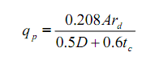
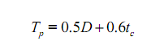
t_{c} = 0.0195 * L^{0.77} * S^{-0.385}
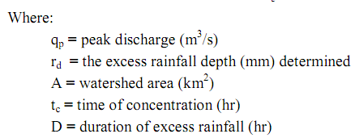
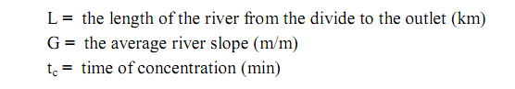
Based on the Ethiopian Committee of Large Dams (ETCOLD) Recommendation, the Design Flood for the Hidha Sombo Dam spillway will was estimated from 2 years return period to 10,000 years as shown below.
Table 4 Design Rainfall and design discharge for Hidha Sombo River at Dam site
Return Period (Years) | 2 | 5 | 10 | 20 | 25 | 50
Design Rainfall (mm) | 53.135 | 69.129 | 79.718 | 89.889 | 93.097 | 103.023
Design Discharge (m³/s) | 19.76 | 28.83 | 37.7 | 47.72 | 53.14 | 62.05
Return Period (Years) | 100 | 200 | 500 | 1000 | 2000 | 5000
Design Rainfall (mm) | 112.87 | 132 | 136 | 145 | 155.26 | 168.199
Design Discharge (m³/s) | 73.47 | 91.54 | 97.42 | 111.47 | 123.76 | 139.29
Return Period (Years) | 10000
Design Rainfall (mm) | 178
Design Discharge (m³/s) | 146

4.4.3 Watershed Erosion and Sediment
There is no sediment measurment on the river or at the proposed dam sites. The sediment data is crucial to determine the sediment transport in the river, sediment load at the dam sites and storage at the back of the dam in the reservoir after construction of the dam. Hence, it is important to decide the bottom outlet size and position for environmental flow, flashing suspended sediment and release of flood flow. It also important to design the life span of the dam and dam size (dead load).
Sediment load in tributary rivers are varying from location to location depending on their sediment source area and steepness of the watershed. No generalization is possible, and local study should be undertaken when the need arises. Based on small number of sediment – discharge data (see Table 10), a preliminary estimate of sediment transport rate of different Tributary River emanating from western upper course (above Melka Wakana dam) and eastern upper courses (over Harar highlands including Jijiga area) have been developed.
The equation form used is:
Q_{s} = a Q_{w} ^{b}
Where:
Q_{s} = the sediment load tons/day,
Q_{w} = daily discharge in m³/s,
a and b = parameters varying depending on the hydro-Climatologically characteristics of the watershed and estimated through regression analysis. Using the parameter a = 33.697 and b =1.7416 for upper Erer sub basin which depend on discharge data and estimated on wabe shabele master plane integrated study, suspended sediment load has been estimated and it is 0.319 ton/km2/year.

4.5 Water Demand
In order to efficiently utilize the available surface water resources of Hidha Sombo River the water balance study of the river along its route to Wabe Shebelle River confluence has to be made. The water demand for irrigation, environmental release and livestock use have been analyzed to balance the supply and the demand on time based. We used excel sheet for the water balance analysis of the project site and to estimate the potential irrigable area, irrigation coverage and reliability. Similarly, we have analyzed the environmental flow requirement, supplied, coverage and reliability at the downstream of head work site.

4.5.1 Irrigation water demand
The result of gross irrigation water demands was given as follows from cropping patterns, effective rainfall and crop evaporation calculation (Reference agronomy part).
Table 5 Irrigation water requirement of Hidha Sombo Irrigation Project
Month | Jan | Feb | Mar | Apr | May | Jun | Jul | Aug | Sep | Oct | Nov | Dec
Flow (m³/s) | 0.53 | 0.52 | 0.48 | 0.5 | 0.5 | 0.5 | 0.5 | 0.4 | 0.4 | 0.5 | 0.51 | 0.52
IWR (m³/s) | 0.19 | 0.17 | 0.02 | 0 | 0 | 0 | 0 | 0 | 0 | 0 | 0.08 | 0.14

The annual net irrigation requirement was calculated as 10613.376m³/ha/year or average of 0.122/s/ha for 24 hr operation and 0.244 l/s/ha for 12 hr operations, and we have taken annual water requirement as10613.376 m³/ha/year for the analysis of water balance in excel sheet.

4.5.2 Livestock water demand (LWD)
Livestock water demand estimation is based on demography of the local number and types of livestock and standard water consumption rate per day per capita of the livestock. Such information was obtained from socio-economic study part and the livestock water demand was estimated as 0.37731MMC/year.
Table 6 Live Stock Water Demand of Hidha Sombo Irrigation Project Area
Month | Jan | Feb | Mar | Apr | May | Jun | Jul | Aug | Sep | Oct | Nov | Dec
Livestock demand (MMC) | 0.032 | 0.032 | 0.036 | 0.03 | 0.03 | 0.03 | 0.03 | 0.03 | 0.03 | 0 | 0.03 | 0.031

4.5.3 Environmental flow requirement (EFR)
The environmental flow water requirement is one of the water demands to be relased from the reservoir or to be allowed to flow in the river systems to conserve the enviornment, the ecosystems and fauna and flora for the current and future genearion to achive suistainable developments. There are different international standards to estimate the environmental flow requirement (EFR) (traditionally known as minimium flow requiremenet). The most common one was hydrological approach to estimate stream flow based on historical flow data either some fixed percent of stream flow or flexibale percentage of stream flow based on seasons and ecosystems downstream. The other method is hydraulic method, to estimate EFR based on the hydraulic depeth of the stream flow to meet some flow depth requirement for fishing, wetlands, flooding of flood plain etc.
We are going to use the EFR based on Ethiopian enviornmetal reclamation and experience after accessing the downstream environment and ecosystems in the basin to decide the percent of stream flow. Due to the lack of the environment and hydrology characteristic of the stream, 20% of stream flow was allocated for the environmental flow in Hidha Sombo River.
Table 7 Environmental Flow Requirement of Hidha Sombo Irrigation Project Area
Month | Jan | Feb | Mar | Apr | May | Jun | Jul | Aug | Sep | Oct | Nov | Dec
EFR | 0.11 | 0.10 | 0.10 | 0.11 | 0.10 | 0.10 | 0.10 | 0.10 | 0.10 | 0.10 | 0.10 | 0.10

5. Head Work Design
As the engineering point of view for the proposed project area the selected/recommended headwork structure is small tank (homogeneous bund) with surplus weir type, to protect the vicinity of farm lands from possible inundation during wet season, due to that the Key components of the Works which will be covered under this feasibility are those stated here under with further components will be included during the detailed design.

5.1 Components of Headwork
- Marginal Bund (incorporating clay soil, shoulders (rock fill));
- Surplus Weir (incorporating weir, Stilling basin and Downstream transition Channel);
- Irrigation intakes, conduits and outlets
- Marginal Bund
The marginal bund is designed with homogeneous clay soil), drainage zone and transitions are provided to protect migration of soil to drain seepage water and smooth transition from fine to coarse textured dam fill materials. And the right abatement is characterized by organic soil material of bad engineering property hence, deep excavation is necessary to remove some areas of alluvial deposit the valley having weak shear strength. Appropriate foundation treatment measures such as back fill by sound bed rock fragments were also proposed to ensure foundation stability and curtail seepage through dam foundation.
- Surplus Weir
Surplus Weir is provided to this specific site and designed to discharge a maximum of 62.05m3/s for 50 years return period routed outflow. However, the crest level is fixed to be over topped with probable maximum flood. The nominal crest length of the surplus weir is 12m. The crest level (full supply level) is at 2435.00m and the maximum water level corresponding to 50 years routed flood is 2435.50m i.e. with flood lift height of 0.50m. The structure is 12m long, comprising an approach channel, broad crest, d/s inclined terminal structure. The spilled water leaving the terminal structure will join the natural river channel which will be serving as exit channel.
- Irrigation outlet
The main purpose of the Hidha Sombo project is for irrigation. It is planned to develop the command area estimated to around 160ha downstream of the dam. Therefore, during dry months of the year regulated water will be released as per the downstream demand. Accordingly Intake tower, conduit and intake structure is provided for this purpose.

5.2 Site Selection
The headwork site is situated at 1046159.79 m N, 205908.28 m E and riverbed elevation of 2434.00 m above sea level. For this project, a simple riverbed level intake structure has been proposed for diverting the water to the main canal. The headwork site geological surface and subsurface conditions have been investigated based on the nature of the proposed structure. At the site and immediate vicinity, the stream flows along genteel slope course and its bed is mainly covered with recently deposited alluvial sediments. These sediments are dominated sand with some unconsolidated clay soil. On the other hand, the banks of the stream at the headwork site are made up of different geologic materials; most part of the right bank is made up of basaltic bedrock materials. It is loss by nature that the river morphology is still unfinished. The left bank, on the contrary, has no clear difference with streambed that had made from thin layer of basaltic bedrock. Detail geologic nature of the banks, and bed of the stream along the headwork axis and immediate vicinity are described and their potential geotechnical influence on the proposed structures discerned/detected below, with remedial measures. The different sections of the stream at the proposed headwork site are described separately below-

5.3 Design Consideration of Surplus Weir
The design of weir includes computing the elevation of weir crest, length of weir, computing the forces acting on the weir and checking the safety of the weir from all aspects like overturning, sliding, crushing etc. They all are explained in the following articles.

5.3.1 Elevation of Weir Crest
There are various factors that affect the elevation of the crest, but in our case, diversion of water is the purpose and the height should be sufficient to pond the water at a level that can facilitate design flow in the intake. The height of the weir is governed by the height of intake sill, depth of intake orifice and depth of the river at the intake site.

5.3.2 Length of Weir
The length of the weir depends upon the width of the waterway at the intake site. Crest length should be taken as the average wetted width during the flood. The upstream and downstream should be properly examined for the protection consideration. Rise in water level on the upstream of the structures after construction of the weir is called afflux. Fixation of afflux depends on the topographic and geomorphologic factors. A high afflux shortens the length of the weir but increases the cost of the river training and river protection works. For alluvial reaches it is generally restricted to 1m but for mountainous region it may be high. The water way must be sufficient to pass high floods with desired afflux. A weir with crest length smaller than the natural river width can severely interfere the natural regime of flow thus altering the hydraulic as well as the sediment carrying characteristics of the river.

5.3.3 Forces acting on Weir
The main forces which are acting on the weir when it will be operation are: Water Pressure, Uplift Pressure, Slit Pressure and Weight of the weir.
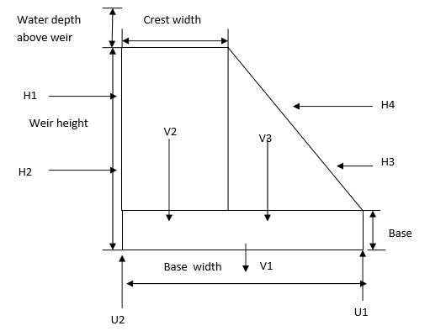
Figure 7 Forces on the Weir

5.3.3.1 Water Pressure
It is the major external force acting on the weir. This is called hydrostatic pressure force and acts perpendicular on the surface of the weir and its magnitude is given by:
P = 0.5× γ× H²×b
Where, γ = Unit weight of water,
H = Depth of water,
b = Width of
The Weir surface, this pressure force acts on H/3 from the base.

5.3.3.2 Uplift Pressure
Water seeping through the pores, cracks and fissures of the foundation material, seeping through the weir body itself and seepage from the bottom joint between the weir and its foundation exerts an uplift pressure on the base of the weir. The uplift pressure virtually reduces the downward weight of the weir hence acts against the dam stability. The analysis of seepage is done using Khosla's Theory. Khosla's Theory is the mathematical solution of the Laplacian equation and it is easy and accurate method for seepage analysis.

5.3.3.3 Silt Pressure
The silt gets deposited on the upstream of the weir and exerts the horizontal and vertical pressure as exerted by the water. So, flushing of the silt should be done regularly to reduce its effect of destabilizing the weir. It is done by the use of under sluice gate. The silt pressure is given by the relation:
P _{silt} = 0.5× γsub×H²×K _{a}
Where, γ sub = Submerged unit weight of silt;
H= Depth of silt deposited and
K _{a}= Coefficient of Active earth pressure and is given by,
Where, ϴ = Angle of internal friction of silt
The silt pressure force also acts at a height of H/3 from the base.

5.3.4 Weight of Weir
The weight of weir and its foundation is the major stabilizing/ resisting force. While calculating the weight, the cross section is split into rectangle and triangle. The weight of each along with their center of gravity is determined. The resultant of all these forces will represent the total weight of weir acting at the C.G. of weir. Simply, when the sectional area of each part is multiplied by unit weight of concrete, weight of that part is obtained. The weir is designed with ogee profile for spilling over its length. Hence weight is calculated by knowing its section and multiplying by its unit weight.

5.3.5 Modes of Failure & Criteria for Structural Stability of Weir

5.3.5.1 Overturning about the toe
If resultant of all the forces acting in the weir passes outside, the weir shall rotate and overturn about the toe. Practically, this condition will not arise because the weir will fail much earlier by compression. The ratio of resisting moment to the overturning moment about the toe is the factor of safety against overturning and it should greater than1.5 for safety.

5.3.5.2 Compression or Crushing
While designing the weir section it should be so design that the resultant should pass through middle 3 rd part of the section to avoid the possible tension on the weir section. The section should be totally in compression. So, weir should be checked against the failure by crushing of its material. If the actual compressive stress may exceed the allowable stress, the structure material may get crushed. The vertical combine stress at the base is given by
Where e = eccentricity of the resultant force from the center of the base.

5.3.5.3 Sliding
Sliding will occur when the net horizontal force above any plane in the weir or at the base of the weir exceed the frictional resistance developed at that level. Factor of safety against the sliding is measured as Shear Stability Factor (SSF) and is given by:
Where, µ= Coefficient of friction;
q= Average shear strength of the joint.
For safety against sliding, SSF should be greater than 3.5. To increase the value of SSF, attempts are always made to increase the magnitude of q, which is achieved by providing the stepped foundation, ensuring the better bond between the dam base and rock foundation etc.

5.3.6 Protection Work for Weir Structure
The weir should be well protected from the flowing river to avoid creep effect. For this, the wing wall is essential to construct. It should be well anchored into the bed. Similarly, to protect the channel bed from being eroded, launching apron is used. To protect the weir body riprap (rock or other material used to armor shorelines, streambeds or other shoreline structures against scour water or ice erosion) is usually placed. If both of the banks are rocky no especial protection shall be introduced. Some sorts of works to protect banks and to confine the river at upstream may be required. Gabion walls are used as protection works for the banks which ultimately protect the degradation of the weir. To prevent the seepage effect, sheet piles are inserted at the upstream and downstream.

5.4 River Geomorphology
It is a common fact that the river development tends to accommodate itself to the local geology that develops along the structurally weak zones like faults, joints, folds, etc. The drainage system of the study area is strongly influenced by alluvial-deposited features .The nature of geological formations and structures has also strong influence on the development of the channel.
The present morphology of the Hidha Sombo River channel is a function of a number of processes and environmental conditions, including the composition of the bed and the banks (moderately weathered, fractured and jointed basalt along right side whereas loose silt clay soils and recent coarser deposit at the left bank and bed); the size and composition of the sediment moving through the channel; the rate of sediment transport through the channel and deposition on the banks and beds; and the regional degradation due to erosion processes. Both left bank and the bed are composed of loose silt clay soil and coarser alluvial sediment as the result the stream shows less meandering nature both up and downstream from the proposed site but at the particular intake site it shows nearly straight river channel. The river has wider section in upstream direction whereas to downstream side the river section somewhat become narrower.

5.4.1 River Bed condition
At the proposed headwork site, the streambed or course is well defined, irregular, and shows rough surface due to recent sediment accumulations. Along the intake axis, the bed is made up of one geologic material, as seen from surface observation. These are recently deposited alluvial coarse-grained sediments,
The streambed is totally covered with the alluvial deposits, which extend to the bottom of both ends of the bank. The bedrock is totally covered with the sediments at the central areas of the streambed. To know the thickness of the sediments or depth to bedrock, three manual test pits has been dug to 1m. Due to excessive surface and subsurface water inflow to the pit, the excavation has been interrupted before encountering the required bedrock; it is difficult to found bedrock in shallow depth.
The alluvial sediments filling of the streambed are dominantly composed of sand and gravel mixtures, but some boulders and cobbles are also found especially on top and surface areas, having maximum size of 0.8cm diameter. From the test pit log, the sediment becomes rich in sand, with some gravel to depth. At the surface, it is loose, but gets denser to depth.
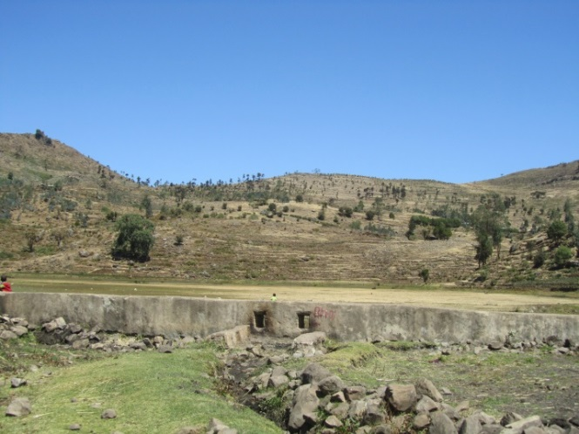
Figure 8 Photo image at the proposed intake site

5.4.2 River Bank condition

5.4.2.1 Right Bank
From geotechnical observation of the test pits at the headwork site the bank, there are two distinct geological materials of wethered basalt rock fragments with silt and clay and basalt rock. And the right side abutment is safe from stability point of view. No engineering treatment should be designed to prevent removal of materials from up slopes because it is competent material

5.4.2.2 Left Bank
The left bank is the same as right bank. From geotechnical point of view No engineering treatment should be designed to prevent removal of materials from up slopes because it is competent material

5.5 Sources of construction materials
During site investigation, natural construction materials required for the construction of the various proposed engineering structures at the headwork and within the farmland have been assessed, and possible quarry sites and borrow areas have been identified within the vicinity of the study area as close to the project site as possible. In addition to identifying the quality, quantity and accessibility conditions of the construction materials, ownerships of each proposed production sites have also been studied and described in this report, on separate subsections below. The materials needed for the construction of the structures include rock for masonry stones, aggregates (both coarse and fine), and water.

5.5.1 Rock for Masonry and Crushed Coarse Aggregate
Two potential quarry sites have been identified as source for building stones for masonry and aggregates. The first quarry site is located nearby the headwork site about 100m downstream. The source of this quarry site is from basaltic rock outcrops with well-formed columnar jointed basalt (Figure 12). The other is found at Adada locality at about 1k distance downstream of the head work site. This location is accessible by dry weather road. Access road preparation will be required for the 1km distance. The source of this second quarry site is observed to be well bedded fresh limestone that indicates good in quality and enough volume of the rock is available in the selected site. The rock is massive and strong when fresh at block level so that it will make a good construction material. The rock is workable and can be shaped to required size for rock aggregate without difficulty. It is owned by local MSE with current price is 300Birr per cubic meter. The GPS coordinate location of this quart site is UTM 38P 204953mE, 1046412mN and elevation of 2407m.a.s.l. Rocks required for coarse aggregate production can also be obtained from masonry rock source sites as mentioned above. The coarse aggregates can be produced by crushing and grinding of the boulder rocks in to appropriate size and shape that can fit the required specification. Secondary rock source site for coarse aggregate purpose can also get from the project stream bed for some amount.

5.5.2 Burrow (filling material) Area
Good quality and quantity clay for borrowing or filling material is available at Badhadha locality. It is accessible by all-weather road of 1km upstream from the project site. It is formed from the altered parent shale rock formation reddish clay formation available in sufficient quantity. Its’ texture is identified by feel right in the field and the soil is a result of in situ alteration and deep weathering accumulated from limestone, shale, siltstone and mudstone rock that can easily be excavated. Therefore, it can be easily and economically extracted from the nearest site and used for construction purpose. The coordinate location is at UTM 38P 206539mE, 1046986mN and elevation of 2500m.a.s.l.

5.5.3 Water for Construction
For engineering structure construction of the project water can be used from Hidha Sombo spring and Haro Korma Lake. These sources of water yields enough amount of water flowing perennially and can be used for construction at any season of the year.

5.6 Headwork Type Selection
Looking the availability of natural construction materials and considering the river features and expected flood amount, cyclopean reinforced concrete intake is chosen. Intake Height Determination the following major factors have been seen in determining the intake crest level:
- Maximum command area elevation
- Deriving head of the intake structure
- Main canal slope
- Head Loss
- Lowest Point of river center

5.6.1 Base flow of the River
The study team has assessed that the stream is used for irrigation along its entire at the proposed intake site where farmers are using the stream for traditional SSI (Irrigation Infrastructure Report). Study team hasn’t calculated the baseflow of the river at the intake site because the river flow were desapired. At 150m downstream of proposed scheme there, is natural spring that is perennial in good flow condition used for traditional irrigation purpose and released for downstream. The purpose of releasing the 25l/s to downstream is for the sake of downstream users.

5.6.2 Under Sluice, and Canal outlet

5.6.2.1 under sluice
The under sluice is mainly provided here to remove silt deposition at a result of barrier structure. Hence the sill level of the under sluice is fixed to facilitate this deposited silt to increase the efficiency of water abstracting to the main canal through the head regulator from the pocket. The sill level of this sluice is fixed to be 0.50m above the minimum bed level. Hence the sill level of the under sluice level is 2434.50. Even if the position of the under sluice is on concave side that is on scouring side, there might be boulders that may come into the pocket of the under sluice due to the barrier structure. Hence, in addition to the supply of water to the intake and the removal of silt, this acts to remove the boulder that comes to wards it. Considering this, the opening size of the gate is 0.6m*0.6m with spindle type operating from the operation slab. Considering rectangular notch profile of flow of water at the under sluice, the discharge passing is computed using the following formula.
- During construction, it should be able to pass the prevailing (at least base flow)
- Discharge of the river. But the practical application of those values is not sound so the discharging capacity of under sluice is determined by using orifice flow formula for maximum flood condition. i.e.
,
Where, Cd = Discharge coefficient = 0.80
A = under sluice opening area (m2)
g = 9.81m/s2
Hence the size of the under sluice is 1.00m (height *width)

5.4.2.2 Canal outlet level
The head regulator is provided on the left side .The sill level of this head regulator is fixed from different angle observations. The main conveyance system is more than 2.04km that passes more gullies and undulating alignment. Hence, this level is fixed based on the optimum route alignment and the maximum irrigated command level including minor and major losses criteria. Based on this condition, the sill level is fixed to be 2434.50m.
- Outlet capacity
The minimum command area is determined by the minimum flow of the river. But the canal capacity should be determined for maximum command area and the corresponding discharge. In this case the outlet capacity is fixed considering maximum duty and command area and applying correction factors are considered to account the variation of duty.
Outlet capacity = Duty x command area x correction factor
Where, maximum duty for 24 hr irrigation = 1.06 Lit/s/ha
Command area = 160ha.
Outlet capacity =1.06Lit/s/ha x 160ha = 196 Lit/sec 0.196m3/sec

- Outlet size
a) Sill Level Determination
The sill level of intake out let is based on the following criteria:-
- Maximum elevation of command area =2433.00m
- Maximum distance between the elevated command area and diversion site, =250 m
- Main canal alignment;-Taking into consideration the farmers irrigation practice in the area and cost effectiveness of alignment, main canal alignment has been made on the river course.
- The capacity of main canal
- The capacity of main canal which is based on the duty, command area, irrigation efficiency & operation hours in a day. And the design discharge for irrigation which the canal has to carry is as;
,
Where, A=wetted cross sectional area (m^2)
V= velocity of flow in canal (m/s) and it is given by:-
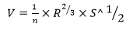
Where n= Manning’s roughness coefficient
R= hydraulic radius = A/P, P= Wetted perimeter &
S= longitudinal slope of main canal.

6. Spring Development

6.1 Introduction
A spring is a place where groundwater surfaces naturally. The water source of most springs is rainfall that seeps into the ground up hill from the spring outlet. While springs may seem like an ideal water supply, they need to be selected with care, developed properly, and tested periodically for contamination. Spring water moves downhill through soil or cracks in rock until it is forced out of the ground by natural pressure. The amount, or yield, of available water from springs may vary with time of year and rainfall. Groundwater obtained from springs is similar to water pumped from shallow wells, Like shallow wells, springs may be contaminated by surface water or other sources on or below the ground surface. Springs are susceptible to contamination because the water feeding them typically flows through the ground for only a short distance, limiting the amount of natural filtering that can occur. Springs may not be a good choice for a water supply if the area uphill where the water collects is used for industry, agriculture, or other potential sources of pollution.
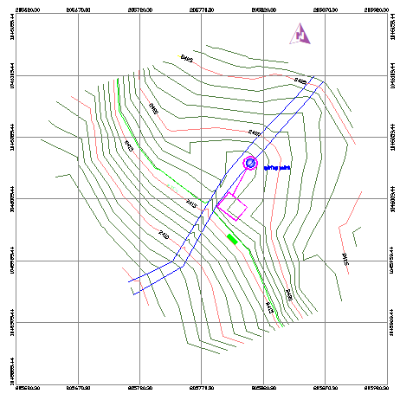
Figure 9 Spring location map

6.2 Purpose and Scope
Proper spring development helps protect the water supply from contamination. The objective of spring development is to collect the flowing water underground to protect it from surface contamination and store it in a sanitary spring box.

6.3 Type of spring
Springs can be classified in a number of ways. The classification can be based on magnitude of discharge, type of aquifer, chemical characteristics, water temperature, direction of water migration, relation to topography, and associated geological structures. It is important to note that the topographical basin and the system of surface drainage through streams or rivulets does not necessarily correspond with the hydrological underground spring water system
- Artesian Springs
- Gravity Springs
- Seepage Springs

6.4 Design Considerations

6.4.1 Spring Box
Both the type of spring and its location will determine the type of spring box to be built. There are three basic design types, related to the three types of springs. These are described below.

6.4.2 Artesian springs
Spring, which is naturally occurring on relatively flat ground, is likely to be an artesian spring. Water flows vertically out of the ground due to the pressure that is accumulated within a confined aquifer. For this type of spring, a spring box with an open bottom is used, as illustrated in Figure 6-1
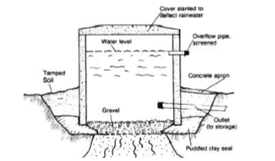
Figure 10 Typical feature of artisan spring box

6.4.3 Gravity Springs
For the spring occurs at the base of a slope or hillside, the flow is likely to be gravity driven. Unlike an artesian spring, a gravity spring will most likely have just one impermeable layer at the bottom. In this case, much less pressure will exist in the system. Due to the nature of the horizontal flow, and low water pressure, a gravity spring in a hillside will require a spring box with a side entrance for the water. The design will most likely be similar to the structure presented in Figure 6-2 below.
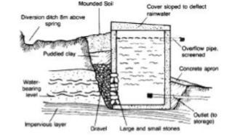
Figure 11 typical feature of a gravity spring box

6.4.4 Seepage Springs
A spring box for a seepage spring may be constructed in two ways, depending on the spring characteristics. The ideal design is to dig far enough back into the hill to reach the single source of all of the spring flow. In this case, the seepage spring would simply be a gravity spring covered by a small amount of porous media. If a single line of water flow cannot be found, it may still be possible to dig far enough back to ensure all of the water flows into the side opening of the spring box. However, if the lines of spring flow are too separated and cannot be channeled into one spring box structure, then a different approach is needed. Rather than a spring box, one should construct what is known as a Seep Collection System as shown in Figure 6-3.
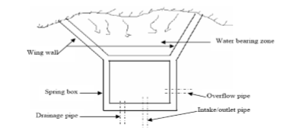
Figure 12 typical feature of a seepage spring box

6.5 Spring Yield Determination
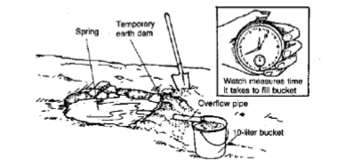
Figure 13 Measuring spring discharge (volumetric method)
Flow rate (discharge) is the volume of water coming out from the spring per unit of time. It should be measured during a low flow period, usually in the early fall (ending of dry season). For small springs, the flow rate can be measured by damming the spring’s flow, inserting a pipe to collect the water, and measuring the time it takes to fill a container of known volume (i.e. jar, bucket, etc…) as shown in Figure 6-4, the procedure stated under 5.2 will be adapted.

6.6 Water Demand Estimation

6.6.1. Irrigation water Requirements
Step 1: Reference Evapo-transpiration (ETo)
Methods to estimate reference evapo-transpiration (ETo) are Blane-criddle, Pan Evaporation, Penman, and FAO-Penman-monteith. Out of these methods Pan Evaporation (ETo = E _{pan} × K _{pan}) is the easiest, which needs pan evaporation (E _{pan}) and pan coefficient (K _{pan)} data only.
FAO-Penman-monteith (recommended) as the sole method to determine ETo (see FAO Irrigation and Drainage Paper No. 24 and FAO Irrigation and drainage paper 56). Basic Data required are monthly mean rainfall (mm), monthly mean temperature (^{O}c), relative humidity (%), daily sunshine hour (h/day) and wind speed (Km/hr). Though this method gives reliable estimate of ETo, it is not widely utilized because of its data intensive nature except in fewer research areas.
Step 2: Crop Evapo-transpiration (ETc) or Crop Water Requirement
ETc = ETo x Kc
Where, Kc = crop coefficient, which varies for different crops, with growing stages and climate. For details on how to estimate ETc, Woreda experts can review FAO Paper 24.
Step 3: Irrigation Water Requirement
Crop water needs can be fully or partly met by rainfall and therefore reliable rainfall of the area should be deducted from the calculated crop water requirement.
Where Ir - Irrigation water requirements in cubic meters for the whole dry period.
ETcrop - Crop water requirement in mm during the dry period.
C_{a} - Area irrigated in ha
Ef - Overall water application efficiency

6.6.2 Domestic and Livestock Water Use
It can be calculated using the expression:
W _{d} = N × q × t
Where, W _{d} - is the volume of water required for domestic purposes
N - is number of people and livestock
q - is daily water consumption and
t - is number of days’ water consumed
Note that 20 % of the total water demand is considered as various losses.
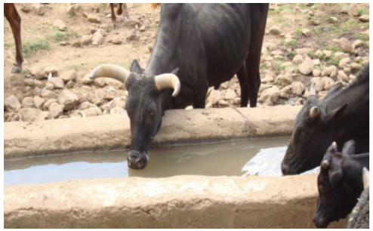
Figure 14 Cattle trough

6.6.3 Total water demand
It includes all water requirements depending on the area required for irrigation, livestock and human water supply. Hence,
Total water demand = Irrigation requirement + domestic water use + water for livestock + losses

6.6.4 Computation of Gross water demand
Crop data: Selected crop is Sorghum; Average Kc is 0.7 (from FAO books)
- Livestock data:
Total livestock number (N_{L}) 500, water consumption (Ac) is 50 l/day/animal.
- Population data:
Number of users (Po) is 400, water consumption (Dc) 40 l/day/person
- General data:
Average reference crop evapo-transpiration during the dry period is 6mm/d,
Irrigated area (C a) is 2ha; overall water application efficiency is 40%,
Dry period (t) is 90 days,
Rainfall is 78mm per total growing season of 120 days,
Seepage loss is assumed to be equal to ETo losses; reservoir surface area is 1000 m²,
Bottom and side walls area is 1500 m²
Estimate irrigation water demand: ET _{crop} = K _{c} x E _{to} = 0.7 x 6mm/d = 4.2mm/d
ET _{crop} (dry period) = ET _{crop} (day) x dry period = 4.2mm/d x 90d = 378mm
Irrigation water requirement = ET crop – rainfall = 378 – 78 = 300 mm. Finally, it will be calculated for the proposed crop area
Estimate livestock water demand:
Estimate domestic water demand
Total water demand = Irr. + W_{L} + W_{D} = 15,000 + 2,250 + 1,440 = 18,690m3
Losses = Evaporation losses + Seepage losses
Evaporation losses = ETO × Surface area of reservoir = 6mm/d ×1000 m² = 6 m³ /d
Seepage losses assumed equal to 6mm/d
Total seepage losses = Seepage loss × Bottom and side wall areas = 6mm/d × 1500 m² = 9 m³ /d
Total losses = (Evaporation losses + Seepage losses) × Dry period
Total losses = (6 + 9 m³ /d) × 90d = 1350 m³
Estimate Gross water demand = Total water demand + Losses
= 18,690 + 1,350 = 20,040m3 for 90 days
= (20,040 m3 *1000 liters/m3)/ 90 days
= 222,667 liters/day

6.7 Reservoir
Reservoir in irrigation or rural water supply is required when the yield of the spring is very low and causes excessive queuing time. Overnight spring flows can be easily collected, stored and made ready for day time use that would otherwise have drained down the drainage in the absence of reservoir.
- To determine how big, the storage reservoir should be, calculate how much water will flow into the reservoir during the night or non-irrigation hours.
- Volume (liters) = flow rate (liters per minute) x number of minutes
- Volume (cubic meters) = Volume (liters) ÷ 1000
- It is generally a good idea to have some extra capacity in the tank, so multiply the volume calculated by 1.2.
- Storage Reservoir volume = Volume (cubic meters) x 1.2
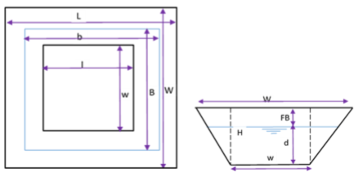
Figure 15 Plan and section of Trapezoidal Reservoir
The following trapezium equation can be used for uniform height.
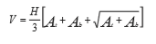
Where, V = Total storage capacity including free board, m3
d = Water storage depth at height, d, m
H = Total tank depth = d + FB, m
At = Top surface area of storage = Lx W, m2
Ab = Base area of storage = lx w, m2
For water volume calculation, the top surface area (At) will be reduced to level d and H=d Shape, dimensions, slopes and other factors of storage area is fixed based on the actual site condition. Depending on the construction method and site condition, the shape of the chamber can be trapezoidal, square, circular or rectangular.

6.8 Spring Design
Flow rate = 3 liters per minute
Spring closed at 7pm and opened at 6am
Number of hours closed overnight is 11 hours and number of minutes closed is 11 x 60 = 660 min.
Volume (liters) = 660 x 3 = 1980 liters or 1.98 cubic meters
Storage Reservoir Volume = 1.98 x 1.2 = 2.4 cubic meters
Once you know the volume, you can calculate the dimension of the reservoir using the formula Volume = width x breadth x height
For instance, a trapezoidal shape below ground reservoir with 8m x 8m top width, 5m x 5m bottom width and 3m depth can store 129 m3 of water and can be constructed with available low cost construction materials i.e. geo membrane plastic sheet for lining; grass for roof cover; local wood for fencing and above ground tanks constructed with masonry.

7. Irrigation Distribution System Design

7.1 Command Area
The river flow indicates that the water potential of the scheme can irrigate more than 160 ha of land in dry season and wet season by supplementary irrigation if the lake adjusted the storage capacity. According to the topographic map the command area on the left and right side of the river can be described as steep and undulating terrain towards to the main river. The topography is also illustrated that the main river valley Sombo about two gullies are found in right side. For detail refer the topo map of the scheme.
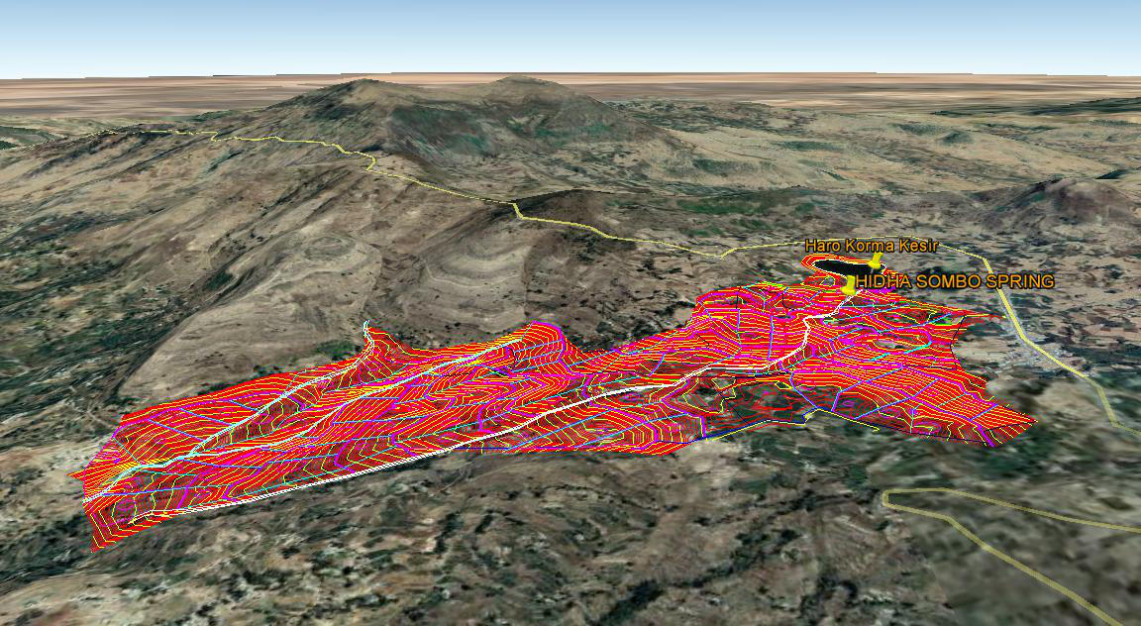
Figure 16 (HSSSIP) command Area of the project

7.2 Irrigation Canal Systems

7.2.1 Description of Water Distribution System
The stored water & is to be distributed to the farm through a network of canals by gravity flow. The purpose of irrigation is to satisfy the demands of crop water requirement by increasing the moisture content of the soil in the root zone of the crop. For this canal distribution system should be planned to convey the required amount of water from the outlet as described above. In the case of Hidha Sombo small scale irrigation scheme since gravity led irrigation practice is designed and furrow irrigation method is selected. Each command area with small channels (furrow) water reaches over the soil surface.

7.2.2 Canal Alignment (Canal Layout)
Hidha sombo Small scale Irrigation Project has sufficient and suitable irrigable area on both right and left sides of the river, but irrigation water is insufficient during dry season so the main canal rout follows along the main river course (see Fig. 5.1 for the layout of the command area). The larger proportion of the command area of this Irrigation project is stretched along the right and left side of the main river course. The proposed canal system of the scheme consists of Left and Right side Tertiary canals (LTC-3358.61m) long and (RTC –9434.57m) long goes to irrigate 50.3ha and 109.95 ha of the land) through Bedhasa and Ejersa districts side respectively,
The following points are considered while preparing the canal layout:
- The layout is done based on block areas to be irrigated by taking drains and ridges into consideration.
- Deep cutting and high banking is tried to be avoided
- The alignment of secondary canal follows almost on the periphery of the command area as a contour canal.
- To be economical, detour alignment is considered when steep ground slope is encountered.
- Most of the tertiary canals run perpendicular to the secondary canal along the natural slope.
- Field channels, field and collector drains are left to be constructed by farmers
- Catchment drains leading to the main drain is also designed.

One road is available that crosses each left and right side command, can serve farmers to transport their produce to market. Box culvert is designed to be placed at on the canal to serve as footbridge and vesicle pass. As the landscape on the sides of the Tertiary canals is very sleep, runoff from the catchment may damage them. Therefore, to protect the canals from the surface runoff, cutoff drains and drain crossing are provided. In the whole canal system crossing and number of small drains are designed. Topographic map showing general layout of the canal systems given in Figure (3.1) whereas the detail drawing of these various structure and their locations is shown in part three of the engineering re

7.2.3 Canal Design

7.2.3.1 Fixing Canal Capacities
The farmers adopt total project efficiency of 50 % for design of canals considering Awareness of irrigation experience. However, this irrigation efficiency is expected to increase with time as they get well acquainted with the irrigation operation.
Water application efficiency adopted = 80%
Conveyance efficiency = 85%
Storage efficiency in root zone = 75%
Total = 0.75 * 0.85 * 0.80 = 51%
Hence, as agronomy report for the design purpose 50% project efficiency is proposed to be used.
Considering the above efficiency, the crop water requirement (duty) calculated is 2.12 liters per second per hectare. Canal capacity is fixed based on the command area that is delivered by the canal.
Canal discharge = duty* irrigated area.
Q = 2.12*A
The area irrigated by one tertiary canal is between 1 to 20 ha and the discharge between 2.5 to 40 lit/sec. The whole command area is divided in to 22 tertiary units (farm blocks). 22 tertiary units at Bedhasa of Ejersa district

7.2.3.2 Canal Cross-Sections
The design of open canals is concerned with the determination of the cross sectional dimensions of the canal to convey the required amount of discharge intended to meet the peak requirement of crops grown in the entire command area during the supplementary case and dry season cases. The dimension of the channel can be calculated using the general formula of Manning’s, which is given by:
$$Q=\frac{1}{n}*AR^{2/3}s^{1/2}$$
Where, Q = discharge of the channel
R = Hydraulic radius = A/p
A = Wetted cross-sectional area
p = wetted perimeter
s = bed slope
n = Manning’s roughness coefficient
Normally the solution for b and d are obtained by trial and error. Also various monographs, tables and computer program are available to find the area. According to the recommended value of the open channel design, canals that have a discharge value less than 200lit/sec, the bed width to depth of flow ratio shall be in the range 1 to 1.5 for clay and up to 1.6-2.0 for masonry. Therefore, taking b/d ratio, which will lead as to attain the permissible non-scouring and non-silting velocity, the bed width and depth of canals have been computed by using the computer program's the geological formation along the canal routes is pervious, a rectangular masonry section is provided for Tertiary canals , (it is to construct sustainable structure) which does not involve any formwork and the beneficiaries can easily maintain it The thickness of the masonry lining depends on the height of the wall to retain the saturated earth pressure and available size of boulders. For the Tertiary canal of the Hidha Sombo small scale irrigation scheme, the thickness of wall is tertiary is 0.15 m in a mortar mix of 1:3. There are twenty two tertiary canals in the project called Right & Left side tertiary canals. The design of the Tertiary canal capacity is based on the maximum command area to be irrigated measured after the wet season to fulfill the need of water for supplementary irrigation. The longitudinal section along the canals is prepared with levels at intervals based on the natural topographic changes indicating the following details:
- Chainage, (Ch.)
- Original ground level, (OGL)
- Design bed level, (CBL)
- Full supply level (FSL)
- Bank top level, (BTL)
- Canal Bed slope, (S)
- Canal Bed width, (B)
- Flow Discharge, (Q)
- Flow Velocity, (V)
For more details please refer the longitudinal profile of the tertiary canals are shown in the drawings with canal section details.
Design of Left & Right Tertiary Canals
- Rectangular Lined Canal
Design Parameters
Command Area, A -20.5ha
Duty, q -0.00212m3/sec/ha
Design Discharge, Q_{d} -0.043m3/sec
Canal bed width, b - 0.19m
Water depth, d -0.15 m
Cross sectional area, A -0.02m²
Wetted Perimeter, P - 0.06m
Hydraulic Radius, R -0.5m
Roughness Coefficient, n -0.018
Canal bed slope, I -0.002
Velocity of Flow, V - 1.57m/sec
Calc. Design Discharge, Q_{d} - 0.045m3/sec
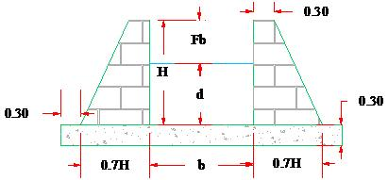
Figure 17 X -section of Masonry Lined

7.3 Design of Related Structures
The flow of irrigation water in the canals must always be under control. For this purpose, canal structures are required. They help regulate the flow and deliver the correct amount of water to the different branches of the system and onward to the irrigated fields. There are four main types of structures: erosion control structures, distribution control structures, crossing structures and water measurement structures. In this particular scheme which the canal route goes through steep ground, crosses a numbers of drains and footpaths, which needs different types of structures. These structures include:-
- Drop Structures
- Cross Drainage Structures(flumes)
- Road crossing
- Ponds
- Cattle troughs
Design is made based on their design parameters and detail drawings are shown in the working drawing i.e. part 3 engineering report of this site

7.3.1 Drop Structures
Whenever the natural ground profile is steeper than the design canal bed slope, drops have to be provided to avoid high filling. The ground slope along the canals rout in both left and right side of the project area at different places is generally steeper than the water surface slope (1:500), which is required to limit the flow velocity. Hence, providing a fall or chute is imminent to secure lowering of the water surface in the canal and to dissipate the energy liberated, fall is located at a point upstream where the full supply level exceeds the natural ground level such that the drop structure is positioned in cutting than in fill. Vertical and chute drop type is selected since the discharge through the canal system is Vary i.e. less than 1.69m3/sec. Only 0.50m, 1.00m, 2.00m and 2.50m vertical drop height is provided for ease of construction in most part of the canal. The design has been carried out at both the Left & Right side main, secondary and tertiary canals by the procedures shown below using computer programme; the computation of volume of masonry work is done as shown below.

i) Vertical Drop H = 1m LTC at Ch.0+250

1. Canal flow Hydraulic
Design Discharge, Q =0.009m³/sec
Water Depth, h =0.1 m
Free Board, F_{b} =0.15 m
U/S bed Level =2381.48m
D/S bed Level = 2380.48 m
Height of Drop, H = U/S bed Level - D/S bed Level
Height of Drop, H = 1m
Width of Drop, b_{c} = (0.734*Q)/d3/2)
Width of Drop, b _{c} =( 0.734*0.009)/0.032^{3/2}=1.15m
Unit Discharge, q = Q / bc
Unit Discharge, q =0.0078m³/sec/m
Critical Depth, dc = [q²/g] ^{1/3}, g = 9.81
Critical Depth, dc =0.18m

2. Stilling Basin
Lip Height, a = dc / 2
Lip Height, a = 0.009m
Length, L = [2.5 + 1.1*(dc/H) + 0.7*(dc/H) ³]*√H*dc
Length, L = 2.69 Say 2.7m
Protection of Upstream Canal, I = 1.2 + 3/2*Q 1/2
Protection of Upstream Canal, I = 1.34 use 1.5 m
The dimensions of the drops in the remain tertiary canals are determined in the same way and tabulated in table below.
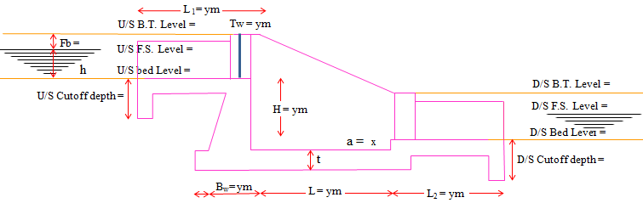
Figure 18 Drop longitudinal x Section
Dimensions of the drop structures in TC
Table 8 Dimensions of the drop structures in TC
Canal Name | Chainage | h (Drop) | Q | V (canal) | b | d | He | L | B | X
LTC-1 | 150.00 | 0.50 | 0.003 | 1.357 | 0.14 | 0.10 | 0.140 | 1.118 | 0.140 | 0.100
LTC-4 | 250.00 | 1.00 | 0.006 | 1.069 | 0.13 | 0.10 | 0.130 | 1.581 | 0.130 | 0.100
RTC-8 | 477.85 | 0.50 | 0.025 | 1.098 | 0.11 | 0.06 | 0.111 | 0.866 | 0.110 | 0.100
RTC-8 | 577.44 | 1.00 | 0.013 | 1.098 | 0.10 | 0.06 | 0.101 | 1.225 | 0.100 | 0.100
RTC-11 | 50 | 0.50 | 0.019 | 1.565 | 0.18 | 0.12 | 0.181 | 1.225 | 0.180 | 0.100
RTC-12 | 25 | 0.50 | 0.033 | 1.565 | 0.18 | 0.14 | 0.182 | 1.323 | 0.180 | 0.100

7.3.2 Crossing Structures
General
Starting from the headwork up to the end of the Tertiary Canal at Left and Right side of the command area the alignment of the canal crosses different Intermittent or permanent streams and cattle foot paths, natural drainages which include small dry gullies. To manage the traffic and sustainable conveyance, suitable crossing structures are considered in the design like Aqueduct, Super passage, level crossing, Drainage Culvert, Road Culvert and etc) To reduce numbers of cross drainage structures along the Tertiary canals, cutoff drains (ditch) with protection dykes are proposed to combine / intersect different stream. And in the whole canal system of the (HSSIP), there are a number of gully crossing.

7.3.2.1 Aqueduct
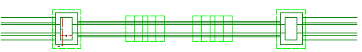
Figure 19 Plan of typical aqueduct Structure
Gully Crossing at CH 0+971 (Left Tertiary Canal)
Canal Section; Rectangular
Canal parameter
Discharge, Q =0.018cumecs
Bed Width, b = 0.17m
Water depth, d =0.12 m
Side Slope, m =0
Canal Bed Level, DBL =2170.33m
Canal Full Supply Level, FSL =2170.43m
Canal Top of the bank Level, BTL = 2170.63m
Original Ground Level, OGL = 2171m
Drain Parameter
High flood discharge, Q of 1in 10 years =5.68cumecs (From Hydrology Report)
High flood level =2164.10m
High flood depth =0.53m
Drain Bed level of the drain =2163.70m
General Ground level = 2171m
Since the FSL of the canal is above the bed of the drain, aqueduct will be provided.
Table 9 Location, type and number of drain crossings
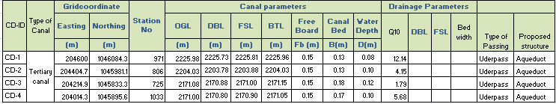
Stream Crossing at 0+93 (Left Tertiary Canal)
Canal Section: Rectangular
i) Road crossing Pipe culvert
Table 10 Dimensions of the Box culvert structures in TC
Canal Name | Gridcoordinate |  | Chainage(m) | Canal parameters |  |  |  |  | Box Culvert Dimension
Canal Name | Easting | Northing | Chainage(m) | Q  (m³/sec) | v  (m/sec) | b(m) | d(m) | Free Board | D(m) | L(m) | V(m/sec) | d | B
Canal Name | (m) | (m)
LTC-4 | 205795.3 | 1045514.3 | 380 | 0.01 | 1.13 | 0.17 | 0.12 | 0.15 | 0.27 | 7 | 0.35 | 0.12 | 0.32
LTC-6 | 205506.3 | 1045595.6 | 93 | 0.03 | 1.15 | 0.21 | 0.16 | 0.15 | 0.31 | 7 | 0.52 | 0.16 | 0.36
RTC-8 | 204925.0 | 1045718.1 | 199 | 0.02 | 1.13 | 0.20 | 0.14 | 0.15 | 0.29 | 7 | 0.44 | 0.14 | 0.35

7.3.3 Design of Pond
Basic design data
Assuming water depth =2m
Free board, FB=0.3m
Dead Storage =0.5m, and
Total depth =0.3+2+0.5=2.3m
Inflow Q mc=0.03m³/sec
Area to irrigate =14.11ha, considering supplementary irrigation
Water duty, q=2.12 lit/sec/ha
Irrigation Time=12hr
Storing Time, Ts=12hr
Pond Center OGL=2343.00
Pond center DBL=2341.00
Geometry of the Pond
Total water depth in the pond =2.3m
Spillway height = 0.5m
Volume of accounts for dead storage =327.31m³ for depth of d=0.5m
Side slopes inside 1:3, and outside 1:2
Top Bund = 3m~5m
The dimensions of the drops in the remain ponds are determined in the same way and tabulated in table below.
Table 11 Dimensions of the Pond structures in TC
Canal Type | Struc. | Grid Coordinate |  | Station | Elevation
 |  |  |  |  | OGL | DBL | FSL | BTL
RTC-2 | Pond1 | 205766 | 1046011 | No 1 | 2415.9 | 2413.94 | 2416.94 | 2417.44
LTC-2 | Pond2 | 205798 | 1045979 | No 2 | 2415.9 | 2413.93 | 2416.93 | 2417.43
RTC-3 | Pond3 | 205697 | 1045954 | No 3 | 2404.0 | 2401.97 | 2404.97 | 2405.47
LTC-3 | Pond4 | 205698 | 1045922 | No 4 | 2404.0 | 2401.98 | 2404.98 | 2405.48
RTC-6 | Pond5 | 205472 | 1045684 | No 5 | 2343.0 | 2340.98 | 2343.98 | 2344.48
LTC-6 | Pond6 | 205494 | 1045661 | No 6 | 2343.0 | 2341 | 2344 | 2344.5
LTC-7 | Pond7 | 205207 | 1045582 | No 7 | 2321.0 | 2318.97 | 2321.97 | 2322.47
RTC-8 | Pond8 | 204911 | 1045569 | No 8 | 2302.0 | 2299.95 | 2302.95 | 2303.45

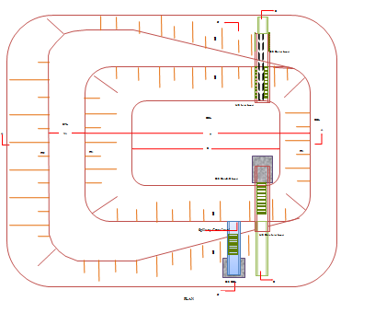
Figure 20 Plan section of pond

7.3.4 Design of Division Structures
In small systems, the entire flow in the channel is often conveyed to one field, sometimes in to two fields on either side of the channel or in to three, in this case box like structure is usually applied. This structure must divert exactly the amount of water, which has to flow in the branching out flow channel and the water, which is continuing its direction. Division structures are provided at the canal system, which are used to divide the flow from the main canal between two secondary canals and from these secondary canals to several traditional tertiary canals. The division boxes are designed to divert flow to each canal on proportional bases during the maximum flow and on rotational bases during the low flow (when the flow is less than the design flow of the canal). In Hidha Sombo Scale Small Irrigation Division boxes Proposed along the Main River directly supply water to Tertiary canals in right and left. Geology report show that the river bed of materials are rocky formation its good for foundation condition. There are 14 number of division boxes along the main river of water course and they are designed proportionally according to Peak discharges in river .Hydrology report shows that the peak discharge of the river is 62.05m³/sec. The flow at each Tertiary canal is controlled by gate operation.

Division Boxes
Let the throat width in the direction of RTC₁ be B₁ and the throat width in the direction of LTC₂ be B₂
Let the throat width B₂ = 0.50m from the broad crested weir formula, the head over crest can be fixed as follows:
h₂= (Q/C*B₂)^{2/3}
= (0.009/1.70*0.5) ^{2/3} = 0.048m
Figure 4.4 Sections A-A of the Turnouts
Height (above bed), h_{s} = U/S FSL - Driving head
= H - h₂
= 0.53 - 0.048= 0.48≈ 0.48m
Thickness of sill, t = 2/3*height of sill
= 2/3*0.5 = 0.33≈ 0.35m
Throat length, L_{d} = 3*water depth d/s (d₂)
= 3*2.4 = 7.2m
For the condition when the d/s of the weir is higher than that of weir crest, the submerged weir formula is used:
Q = 1.7W*√H₂ (H₂+ 2.082X)
For the above case:
W = 0.50m
H₂ = 0.53 - 0.33 = 0.12m
X =D₂ - hs
= 0.33 - 0.25 = 0.08
Q ≅ 0.230m³/sec Ok!
Throat length (Inlet Length):
The inlet length is fixed such that flow along the sill is parallel straight. It is determined from the relationship:
0.08 ≤ h/L_{in}≤ 0.5
Where: h₂ = driving head (m)
L_{in} = inlet length (m)
i.e L_{in}≤ h₂/0.08 and L_{in}≥ h/0.5
L_{in}≤ 0.20/0.08 and L_{in}≥ 0.20/0.5
L_{in}≤ 2.5m and L_{in}≥ 0.4m
Take L_{in} = 0.50m
Table 12 Dimensions of the Division box structures in River as a Main canal
Division Box | Parent and originating canals | Chainage(m) | L₁(m) | L₂(m) | L₃(m) | L₄(m) | D(m) | B(m) | B₀(m)
HSDB-1 | RTC-1 & LTC-1 | 32.5 | 0.90 | 0.80 | 0.10 | 0.10 | 0.65 | 2.40 | 4.48
HSDB -2 | RTC-1 & LTC-2 | 202.4 | 0.90 | 0.80 | 0.10 | 0.10 | 0.65 | 2.40 | 4.50
HSDB-3 | RTC-1 & LTC-3 | 306.7 | 0.30 | 0.30 | 0.30 | 0.30 | 0.65 | 2.40 | 4.50
HSDB -4 | RTC-1 & LTC-4 | 500.0 | 0.30 | 0.30 | 0.10 | 0.10 | 0.65 | 2.40 | 6.60
HSDB -5 | RTC-1 & LTC-5 | 575.0 | 0.10 | 0.10 | 0.10 | 0.10 | 0.65 | 2.40 | 6.60
HSDB -6 | RTC-1 & LTC-6 | 700.0 | 0.10 | 0.10 | 0.10 | 0.10 | 0.65 | 2.40 | 6.60
HSDB -7 | RTC-1 & LTC-7 | 1025.0 | 0.10 | 0.10 | 0.10 | 0.10 | 0.65 | 2.40 | 6.60
HSDB -8 | RTC-1 & LTC-8 | 1350.0 | 0.10 | 0.10 | 0.10 | 0.10 | 0.65 | 2.40 | 6.60
HSDB -9 | to RTC-9 | 1475.0 | 0.10 | 0.10 | 0.00 | 0.10 | 0.65 | 2.40 | 6.70
HSDB -10 | to RTC-10 | 1626.1 | 0.10 | 0.00 | 0.00 | 0.10 | 0.65 | 2.40 | 6.70
HSDB -11 | to RTC-11 | 1838.3 | 0.10 | 0.00 | 0.00 | 0.10 | 0.65 | 2.40 | 6.70
HSDB -12 | to RTC-12 | 1993.8 | 0.10 | 0.00 | 0.00 | 0.10 | 0.65 | 2.40 | 6.70
HSDB -13 | to RTC-13 | 2271.4 | 0.10 | 0.00 | 0.00 | 0.10 | 0.65 | 2.40 | 6.70
HSDB -14 | to RTC-14 | 2413.3 | 0.10 | 0.00 | 0.00 | 0.10 | 0.65 | 2.40 | 8.70

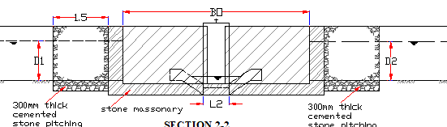
Figure 21 Longitudinal X-section of division boxes
Table 13 Hydraulic characteristics of the canals
Canal Reach | D | B | Top width | Wetted Cross-sec,A | Wetted Perimeter | R_{hyd rad} | n | S | Velocity | FB | Q_{cal} | Q tc | Q_{actFC}
m | m | m | m | m² | m | m |  | m/m | m/s | m | m³/s | m³/s | m³/s
RTC-1 | 0.08 | 0.11 | 0.27 | 0.01 | 0.02 | 0.50 | 0.03 | 0.0037 | 1.53 | 0.15 | 0.013 | 0.009
Reach-1 | 0.08 | 0.10 | 0.260 | 0.01 | 0.02 | 0.50 | 0.025 | 0.0037 | 1.53 | 0.15 | 0.012 | 0.006 | 0.0033
Reach-2 | 0.07 | 0.10 | 0.240 | 0.01 | 0.01 | 0.50 | 0.025 | 0.0035 | 1.49 | 0.15 | 0.010 | 0.004 | 0.0017
 |  |  |  |  |  |  |  |  |  |  |  | 0.000 | 0.0039
RTC-2 | 0.10 | 0.15 | 0.35 | 0.02 | 0.03 | 0.50 | 0.02 | 0.0025 | 1.75 | 0.15 | 0.026 | 0.011
Reach-1 | 0.10 | 0.13 | 0.330 | 0.01 | 0.03 | 0.50 | 0.020 | 0.0024 | 1.54 | 0.15 | 0.020 | 0.008 | 0.0033
Reach-2 | 0.08 | 0.12 | 0.280 | 0.01 | 0.02 | 0.50 | 0.020 | 0.0023 | 1.51 | 0.15 | 0.015 | 0.003 | 0.0052
 |  |  |  |  |  |  |  |  |  |  |  | 0.000 | 0.0028
RTC-3 | 0.07 | 0.09 | 0.23 | 0.01 | 0.01 | 0.50 | 0.02 | 0.0020 | 1.57 | 0.15 | 0.010 | 0.008
Reach-1 | 0.07 | 0.09 | 0.230 | 0.01 | 0.01 | 0.50 | 0.020 | 0.0020 | 1.41 | 0.15 | 0.009 | 0.005 | 0.0029
Reach-2 | 0.06 | 0.08 | 0.200 | 0.00 | 0.01 | 0.50 | 0.020 | 0.0019 | 1.37 | 0.15 | 0.007 | 0.003 | 0.0027
Reach-3 | 0.06 | 0.08 | 0.200 | 0.00 | 0.01 | 0.50 | 0.020 | 0.0019 | 1.37 | 0.15 | 0.007 | 0.001 | 0.0018
 |  |  |  |  |  |  |  |  |  |  |  | 0.000 | 0.0008
RTC-4 | 0.08 | 0.12 | 0.28 | 0.01 | 0.02 | 0.50 | 0.03 | 0.0018 | 1.07 | 0.15 | 0.010 | 0.007
Reach-1 | 0.07 | 0.12 | 0.260 | 0.01 | 0.02 | 0.50 | 0.025 | 0.0017 | 1.04 | 0.15 | 0.009 | 0.005 | 0.0017
Reach-2 | 0.07 | 0.11 | 0.250 | 0.01 | 0.02 | 0.50 | 0.025 | 0.0017 | 1.04 | 0.15 | 0.008 | 0.002 | 0.0036
 |  |  |  |  |  |  |  |  |  |  |  | 0.000 | 0.0015
RTC-5 | 0.08 | 0.12 | 0.28 | 0.01 | 0.02 | 0.50 | 0.03 | 0.0018 | 1.07 | 0.15 | 0.010 | 0.008
Reach-1 | 0.07 | 0.11 | 0.250 | 0.01 | 0.02 | 0.50 | 0.025 | 0.0017 | 1.04 | 0.15 | 0.008 | 0.007 | 0.0009
Reach-2 | 0.06 | 0.11 | 0.230 | 0.01 | 0.01 | 0.50 | 0.025 | 0.0017 | 1.04 | 0.15 | 0.007 | 0.004 | 0.0033
 |  |  |  |  |  |  |  |  |  |  |  | 0.000 | 0.0040
RTC-6 | 0.09 | 0.12 | 0.30 | 0.01 | 0.02 | 0.50 | 0.02 | 0.0020 | 1.57 | 0.15 | 0.017 | 0.016
Reach-1 | 0.09 | 0.12 | 0.300 | 0.01 | 0.02 | 0.50 | 0.020 | 0.0020 | 1.41 | 0.15 | 0.015 | 0.015 | 0.0013
Reach-2 | 0.08 | 0.10 | 0.260 | 0.01 | 0.02 | 0.50 | 0.018 | 0.0019 | 1.53 | 0.15 | 0.012 | 0.009 | 0.0056
Reach-3 | 0.08 | 0.11 | 0.270 | 0.01 | 0.02 | 0.50 | 0.017 | 0.0018 | 1.57 | 0.15 | 0.014 | 0.003 | 0.0065
 |  |  |  |  |  |  |  |  |  |  |  | 0.000 | 0.0027
RTC-7 | 0.06 | 0.09 | 0.21 | 0.01 | 0.01 | 0.50 | 0.02 | 0.0015 | 1.36 | 0.15 | 0.007 | 0.005
 |  |  |  |  |  |  |  |  |  |  |  | 0.000 | 0.0053
RTC-8 | 0.14 | 0.20 | 0.480 | 0.03 | 0.06 | 0.50 | 0.025 | 0.0020 | 1.13 | 0.15 | 0.032 | 0.022
Reach-1 | 0.11 | 0.16 | 0.380 | 0.02 | 0.04 | 0.50 | 0.025 | 0.0019 | 1.10 | 0.15 | 0.019 | 0.012 | 0.0092
Reach-2 | 0.08 | 0.12 | 0.280 | 0.01 | 0.02 | 0.50 | 0.025 | 0.0019 | 1.10 | 0.15 | 0.011 | 0.010 | 0.0025
Reach-3 | 0.06 | 0.11 | 0.230 | 0.01 | 0.01 | 0.50 | 0.025 | 0.0019 | 1.10 | 0.15 | 0.007 | 0.007 | 0.0029
Reach-4 | 0.06 | 0.10 | 0.22 | 0.01 | 0.01 | 0.50 | 0.03 | 0.0019 | 1.10 | 0.15 | 0.007 | 0.004 | 0.0030
 |  |  |  |  |  |  |  |  |  |  |  | 0.000 | 0.0040
RTC-9 | 0.10 | 0.14 | 0.340 | 0.01 | 0.03 | 0.50 | 0.018 | 0.0020 | 1.57 | 0.15 | 0.022 | 0.012
Reach-2 | 0.07 | 0.09 | 0.230 | 0.01 | 0.01 | 0.50 | 0.018 | 0.0020 | 1.57 | 0.15 | 0.010 | 0.010 | 0.0026
Reach-3 | 0.06 | 0.08 | 0.200 | 0.00 | 0.01 | 0.50 | 0.018 | 0.0020 | 1.57 | 0.15 | 0.008 | 0.007 | 0.0021
Reach-3 | 0.06 | 0.08 | 0.20 | 0.00 | 0.01 | 0.50 | 0.018 | 0.0020 | 1.57 | 0.15 | 0.008 | 0.006 | 0.0018
Reach-4 | 0.06 | 0.08 | 0.200 | 0.00 | 0.01 | 0.50 | 0.018 | 0.0019 | 1.53 | 0.15 | 0.007 | 0.002 | 0.0036
 |  |  |  |  |  |  |  |  |  |  |  | 0.000 | 0.0020
RTC-10 | 0.15 | 0.20 | 0.50 | 0.03 | 0.06 | 0.50 | 0.03 | 0.0020 | 1.13 | 0.15 | 0.034 | 0.025
Reach-1 | 0.12 | 0.16 | 0.400 | 0.02 | 0.04 | 0.50 | 0.025 | 0.0019 | 1.10 | 0.15 | 0.021 | 0.013 | 0.0118
Reach-2 | 0.11 | 0.16 | 0.380 | 0.02 | 0.04 | 0.50 | 0.025 | 0.0019 | 1.10 | 0.15 | 0.019 | 0.010 | 0.0035
Reach-3 | 0.08 | 0.11 | 0.27 | 0.01 | 0.02 | 0.50 | 0.03 | 0.0019 | 1.10 | 0.15 | 0.010 | 0.004 | 0.0058
 |  |  |  |  |  |  |  |  |  |  |  | 0.000 | 0.0039
RTC-11 | 0.12 | 0.18 | 0.42 | 0.02 | 0.04 | 0.50 | 0.02 | 0.0020 | 1.57 | 0.15 | 0.034 | 0.025
Reach-1 | 0.12 | 0.17 | 0.410 | 0.02 | 0.04 | 0.50 | 0.02 | 0.0020 | 1.57 | 0.15 | 0.032 | 0.021 | 0.0040
Reach-2 | 0.10 | 0.16 | 0.360 | 0.02 | 0.03 | 0.50 | 0.02 | 0.0018 | 1.48 | 0.15 | 0.024 | 0.017 | 0.0038
Reach-3 | 0.10 | 0.15 | 0.35 | 0.02 | 0.03 | 0.50 | 0.02 | 0.0016 | 1.40 | 0.15 | 0.021 | 0.012 | 0.0051
Reach-4 | 0.08 | 0.13 | 0.290 | 0.01 | 0.02 | 0.50 | 0.02 | 0.0012 | 1.21 | 0.15 | 0.013 | 0.010 | 0.0018
Reach-5 | 0.08 | 0.13 | 0.290 | 0.01 | 0.02 | 0.50 | 0.02 | 0.0010 | 1.11 | 0.15 | 0.012 | 0.009 | 0.0013
Reach-6 | 0.08 | 0.13 | 0.29 | 0.01 | 0.02 | 0.50 | 0.02 | 0.0008 | 0.99 | 0.15 | 0.010 | 0.008 | 0.0013
 |  |  |  |  |  |  |  |  |  |  |  | 0.000 | 0.0079
RTC-12 | 0.14 | 0.18 | 0.46 | 0.03 | 0.05 | 0.50 | 0.02 | 0.0020 | 1.57 | 0.15 | 0.039 | 0.030
Reach-1 | 0.12 | 0.17 | 0.410 | 0.02 | 0.04 | 0.50 | 0.02 | 0.0020 | 1.57 | 0.15 | 0.032 | 0.022 | 0.0076
Reach-2 | 0.10 | 0.13 | 0.330 | 0.01 | 0.03 | 0.50 | 0.02 | 0.0020 | 1.57 | 0.15 | 0.020 | 0.019 | 0.0033
Reach-3 | 0.10 | 0.13 | 0.33 | 0.01 | 0.03 | 0.50 | 0.02 | 0.0018 | 1.48 | 0.15 | 0.019 | 0.015 | 0.0038
Reach-4 | 0.10 | 0.13 | 0.330 | 0.01 | 0.03 | 0.50 | 0.02 | 0.0018 | 1.48 | 0.15 | 0.019 | 0.010 | 0.0050
Reach-5 | 0.09 | 0.13 | 0.310 | 0.01 | 0.02 | 0.50 | 0.02 | 0.0018 | 1.48 | 0.15 | 0.017 | 0.008 | 0.0016
 |  |  |  |  |  |  |  |  |  |  |  | 0.000 | 0.0085
RTC-13 | 0.15 | 0.19 | 0.490 | 0.03 | 0.06 | 0.50 | 0.018 | 0.0020 | 1.57 | 0.15 | 0.045 | 0.043
Reach-1 | 0.15 | 0.19 | 0.490 | 0.03 | 0.06 | 0.50 | 0.018 | 0.0019 | 1.53 | 0.15 | 0.043 | 0.037 | 0.0059
Reach-2 | 0.13 | 0.18 | 0.440 | 0.02 | 0.05 | 0.50 | 0.018 | 0.0018 | 1.48 | 0.15 | 0.035 | 0.034 | 0.0023
Reach-3 | 0.13 | 0.18 | 0.44 | 0.02 | 0.05 | 0.50 | 0.018 | 0.0018 | 1.48 | 0.15 | 0.035 | 0.033 | 0.0016
Reach-4 | 0.12 | 0.18 | 0.420 | 0.02 | 0.04 | 0.50 | 0.018 | 0.0018 | 1.48 | 0.15 | 0.032 | 0.031 | 0.0017
Reach-5 | 0.12 | 0.17 | 0.410 | 0.02 | 0.04 | 0.50 | 0.018 | 0.0017 | 1.44 | 0.15 | 0.029 | 0.019 | 0.0120
Reach-6 | 0.12 | 0.17 | 0.410 | 0.02 | 0.04 | 0.50 | 0.018 | 0.0017 | 1.44 | 0.15 | 0.029 | 0.018 | 0.0017
Reach-7 | 0.10 | 0.14 | 0.34 | 0.01 | 0.03 | 0.50 | 0.018 | 0.0017 | 1.44 | 0.15 | 0.020 | 0.014 | 0.0035
Reach-8 | 0.10 | 0.13 | 0.330 | 0.01 | 0.03 | 0.50 | 0.018 | 0.0017 | 1.44 | 0.15 | 0.019 | 0.010 | 0.0042
 |  |  |  |  |  |  |  |  |  |  |  | 0.000 | 0.0099
RTC-14 | 0.12 | 0.16 | 0.40 | 0.02 | 0.04 | 0.50 | 0.03 | 0.0020 | 1.13 | 0.15 | 0.022 | 0.013
Reach-1 | 0.10 | 0.14 | 0.340 | 0.01 | 0.03 | 0.50 | 0.025 | 0.0019 | 1.10 | 0.15 | 0.015 | 0.008 | 0.0055
Reach-2 | 0.08 | 0.12 | 0.280 | 0.01 | 0.02 | 0.50 | 0.025 | 0.0019 | 1.10 | 0.15 | 0.011 | 0.002 | 0.0060
 | 0.08 | 0.12 | 0.280 | 0.01 | 0.02 | 0.50 | 0.025 | 0.0019 | 1.10 | 1.15 | 0.011 | 0.000 | 0.0018
LTC-1 | 0.12 | 0.16 | 0.40 | 0.02 | 0.04 | 0.50 | 0.03 | 0.0030 | 1.38 | 0.15 | 0.026 | 0.015
Reach-1 | 0.10 | 0.14 | 0.340 | 0.01 | 0.03 | 0.50 | 0.025 | 0.0029 | 1.36 | 0.15 | 0.019 | 0.010 | 0.0052
Reach-2 | 0.10 | 0.13 | 0.330 | 0.01 | 0.03 | 0.50 | 0.025 | 0.0029 | 1.36 | 0.15 | 0.018 | 0.004 | 0.0059
 |  |  |  |  |  |  |  |  |  |  |  | 0.000 | 0.0042
LTC-2 | 0.10 | 0.14 | 0.34 | 0.01 | 0.03 | 0.50 | 0.02 | 0.0020 | 1.57 | 0.15 | 0.022 | 0.011
Reach-1 | 0.10 | 0.14 | 0.340 | 0.01 | 0.03 | 0.50 | 0.020 | 0.0019 | 1.37 | 0.15 | 0.019 | 0.007 | 0.0045
Reach-2 | 0.08 | 0.12 | 0.280 | 0.01 | 0.02 | 0.50 | 0.020 | 0.0019 | 1.37 | 0.15 | 0.013 | 0.002 | 0.0049
 |  |  |  |  |  |  |  |  |  |  |  | 0.000 | 0.0019
LTC-3 | 0.07 | 0.11 | 0.250 | 0.01 | 0.02 | 0.50 | 0.018 | 0.0020 | 1.57 | 0.15 | 0.012 | 0.008
Reach-1 | 0.07 | 0.11 | 0.250 | 0.01 | 0.02 | 0.50 | 0.025 | 0.0019 | 1.10 | 0.15 | 0.008 | 0.005 | 0.0027
Reach-2 | 0.06 | 0.10 | 0.220 | 0.01 | 0.01 | 0.50 | 0.025 | 0.0018 | 1.07 | 0.15 | 0.006 | 0.003 | 0.0017
Reach-3 | 0.06 | 0.10 | 0.22 | 0.01 | 0.01 | 0.50 | 0.03 | 0.0018 | 1.07 | 0.15 | 0.006 | 0.002 | 0.0014
 |  |  |  |  |  |  |  |  |  |  |  | 0.000 | 0.0021
LTC-4 | 0.12 | 0.17 | 0.410 | 0.02 | 0.04 | 0.50 | 0.025 | 0.0020 | 1.13 | 0.15 | 0.023 | 0.014
Reach-1 | 0.12 | 0.16 | 0.400 | 0.02 | 0.04 | 0.50 | 0.025 | 0.0020 | 1.13 | 0.15 | 0.022 | 0.011 | 0.0029
Reach-2 | 0.10 | 0.13 | 0.33 | 0.01 | 0.03 | 0.50 | 0.03 | 0.0018 | 1.07 | 0.15 | 0.014 | 0.009 | 0.0019
Reach-3 | 0.09 | 0.12 | 0.300 | 0.01 | 0.02 | 0.50 | 0.025 | 0.0018 | 1.07 | 0.15 | 0.012 | 0.006 | 0.0027
Reach-4 | 0.09 | 0.12 | 0.300 | 0.01 | 0.02 | 0.50 | 0.025 | 0.0018 | 1.07 | 0.15 | 0.012 | 0.002 | 0.0042
 |  |  |  |  |  |  |  |  |  |  |  | 0.000 | 0.0020
LTC-5 | 0.05 | 0.08 | 0.180 | 0.00 | 0.01 | 0.50 | 0.025 | 0.0018 | 1.07 | 0.15 | 0.004 | 0.002
 |  |  |  |  |  |  |  |  |  |  |  | 0.000 | 0.0025
LTC-6 | 0.16 | 0.21 | 0.530 | 0.03 | 0.07 | 0.50 | 0.025 | 0.0021 | 1.15 | 0.15 | 0.039 | 0.030
Reach-1 | 0.15 | 0.20 | 0.500 | 0.03 | 0.06 | 0.50 | 0.025 | 0.0021 | 1.15 | 0.15 | 0.035 | 0.028 | 0.0020
Reach-2 | 0.14 | 0.19 | 0.47 | 0.03 | 0.05 | 0.50 | 0.03 | 0.0021 | 1.15 | 0.15 | 0.031 | 0.017 | 0.0110
Reach-3 | 0.12 | 0.16 | 0.400 | 0.02 | 0.04 | 0.50 | 0.025 | 0.0020 | 1.13 | 0.15 | 0.022 | 0.012 | 0.0053
Reach-4 | 0.10 | 0.15 | 0.350 | 0.02 | 0.03 | 0.50 | 0.025 | 0.0019 | 1.10 | 0.15 | 0.016 | 0.006 | 0.0053
 |  |  |  |  |  |  |  |  |  |  |  | 0.000 | 0.0063
LTC-7 | 0.10 | 0.14 | 0.34 | 0.01 | 0.03 | 0.50 | 0.03 | 0.0016 | 1.01 | 0.15 | 0.014 | 0.011
Reach-1 | 0.09 | 0.12 | 0.300 | 0.01 | 0.02 | 0.50 | 0.025 | 0.0015 | 0.98 | 0.15 | 0.011 | 0.004 | 0.0071
 |  |  |  |  |  |  |  |  |  |  |  | 0.00 | 0.0038
LTC-8 | 0.10 | 0.13 | 0.330 | 0.01 | 0.03 | 0.50 | 0.020 | 0.0020 | 1.41 | 0.15 | 0.018 | 0.015
Reach-1 | 0.09 | 0.12 | 0.300 | 0.01 | 0.02 | 0.50 | 0.025 | 0.0018 | 1.07 | 0.15 | 0.012 | 0.008 | 0.0070
Reach-2 | 0.08 | 0.11 | 0.27 | 0.01 | 0.02 | 0.50 | 0.03 | 0.0017 | 1.04 | 0.15 | 0.009 | 0.003 | 0.0053
 |  |  |  |  |  |  |  |  |  |  |  | 0.000 | 0.0030

8. Drainage System

8.1 General
Following points that may be taken into consideration to determine the capacity of the drains by the surface and sub–surface flow which vary between command areas the discharge capacity is fixed.
- Intensity and frequency of rainfall of different durations.
- Infiltration losses.
- Blocks area general slope.
- Economics of the drainage system.

8.1.1 Field Drains
According to the curve number (CN) method taking into account, results in a runoff of 30mm per day. It is assumed that evaporation is estimated to be 5mm for the 24 hours and 10mm for the 48hours. If 7mm runoff is considered stored in field ditches, then 5mm will reach drains. Drainage of 5mm in 24- hour yields a drainage duty of 3.78lit/s/ha. Since the area covered by each field drain is about 1 ha, therefore full drainage duty has been taken. The drainage duties at different levels should be determined as follows:

8.1.2 Tertiary drain
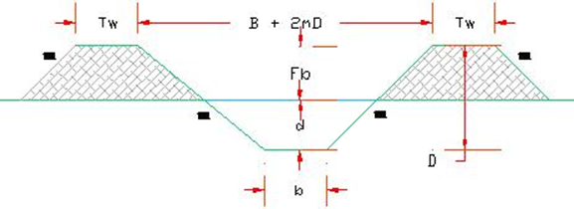
The tertiary drains have to accommodate besides the rainfall runoff also the irrigation water runoff of 1/5 of the fields (1/5 of the fields is simultaneously irrigated).The sub-surface drainage system also discharges into the tertiary drains. Hence, this flow should also be accommodated. As precaution for mismanagement, which can occur especially if a heavy rainstorm starts, operational losses of the tertiary canal should also be taken care of. The hydrology report show that the drainage design duty: 3.78 l/s/ha
Open or Surface Drains are Provided to collect the excess water from the land surface and remove it to the lateral or collecting drains, thence in to main drains which out fall in to a stream or gullies . The networks of the open drains that are established in the left, Right side of Bedhasa and Ejersa areas follow the Path of natural drainage as far as Possible. The location of an outfall may need adjustment to obtain necessary slopes in the drains. The Design of an open drainage system needs consideration of the following aspects. The network of surface drains is designed to drain out excess water (due to rainfall or irrigation or leaching) from fields and to convey it safely to natural drains, by integrating it in the conveyance network.

9. Bill of Quantity & Contract Cost

9.1 Bill of Quantity
Quantity of canals drains and other structures are calculated based on the provided layout and geometry of the structures. The norm adopted for the various activities is taken from the norms used by different contractors for similar works. The unit price also is estimated referring cost estimates of similar works. For some materials, this unit price is taken according to current market price. Quantity determining and cost estimate for various activities and material purchase is summarized in the tables. The grand total cost of the project is x Birr.

Table. 14 BILLS OF QUANTITIES AND COST SUMMARY
S/No | Description of Activities | Total cost(Br)
1 | Preparatory Work | 160,000.00
2 | Camp construction | 469,080.84
2 | Headwork (Surplus Weir) | 5,598,141.72
3 | Lined Tertiary Canals | 1,448,204.32
4 | Drainage canal and Outfall | 111,045.02
5 | Farm Related Structures in the System | 8,309,831.58
6 | Total Cost of Road Works | 18,250.00
 | Sub Total | 16,114,553.5
 | Management & Construction Supervision (7.5%) | 1,208,591.5
 | Total | 17,323,145.0
 | Physical Contingency (10%) | 1,732,314.5
 | S.Total | 19,055,459.5
 | VAT (15%) | 2,858,318.9
 | Grand Total | 21,913,778.4

Item | Description of work | Unit | Qty | Unit cost | Total cost
1 | Access Road Construction
1.1 | Access Road Maintenance cutting . | km | 2.50 | 2,500.00 | 6,250.00
1.1 | to an average depth of 0.2m,
1.1 | with 6m width including Box Culvert on River
1.2 | Field Road construction cutting | km | 12.00 | 1,000.00 | 12,000.00
1.2 | to an average depth of 0.15m,
1.2 | with 6m width.
2 | Preparatory Work for Camp construction
2.1 | Mobilization and Demobilization | LS | 1 | 75,000.00 | 75,000.00
2.2 | Engineering surveying and preparation of as built drawings | LS | 1 | 85,000.00 | 85,000.00
 | Total Carried Summary Birr |  |  |  | 160,000.00
 | Grand Total Birr |  |  |  | 160,000.00
3.3 | CAMPING
3.3.1 | Residential rooms & office
3.3.1.1 | Earth Work
3.3.1.1a | Clearing of site to remove top soil to a depth of 200 mm. | m2 | 92.00 | 8.00 | 736.00
3.3.1.1b | Excavation for stone masonry foundation; 0.5m width and 0.4 m depth | m3 | 27.24 | 54.00 | 1,470.96
3.3.1.1c | Cart away and deposit excavated surplus material to a distance not exceeding 1km | m3 | 42.24 | 42.00 | 1,774.08
3.3.1.1d | Provide and fill hard core with hard basaltic or equivalent stone, well compacted and blinded with crushed stone to a finished thickness of 25 cm | m2 | 52.20 | 107.00 | 5,585.40
 | Total Carried Summary Birr |  |  |  | 9,566.44
3.3.1.2 | Concrete and Block Work
3.3.1.2a | Supply and raise 500mm thick and 200mm high trachytic or equivalent stone masonry foundation wall below ground level bedded in cement mortar mix 1:3 | m3 | 6.46 | 1,689.00 | 10,910.94
3.3.1.2b | Supply and raise 500mm thick and 200mm high trachytic or equivalent stone masonry foundation wall above ground level bedded in cement mortar mix 1:3 | m3 | 6.46 | 1,843.00 | 11,905.78
3.3.1.2c | Mass concrete fill on floor slab (100mm) C-15 | m3 | 6.16 | 2,118.00 | 13,046.88
 | Total Carried Summary Birr |  |  |  | 35,863.60
3.3.1.3 | Carpentry and Walling |  | -
3.3.1.3a | Supply, assemble and fix in position eucalyptus wall post of length 3 m with span length of 1.2m | No | 66.00 | 50.00 | 3,300.00
3.3.1.3b | Supply and fix purlin in Eucalyptus wood size 50 x 70 mm nailed into eucalyptus truss | m | 586.00 | 100.00 | 58,600.00
3.3.1.3c | Supply and fix roof cover in G-35 mm corrugated galvanized iron sheet fixed into zigba wood purlin with dome headed galvanized nails (purlin and ridge cover measured separately) | m2 | 149.16 | 325.00 | 48,477.00
3.3.1.3d | Chip wood wall cilling | m2 | 255.84 | 180.00 | 46,051.20
3.3.1.3e | Supply and fix 4x5 mm cilling buttons | m | 214.00 | 75.00 | 16,050.00
 | Total Carried Summary Birr |  |  |  | 172,478.20
3.3.1.4 | Carpentry and Roofing |  | -
3.3.1.4a | Supply, assemble and fix in position eucalyptus roof truss of length 3m span price shall include the application of three coats and external anti-termite treatment as per the drawing | No | 21.00 | 210.00 | 4,410.00
3.3.1.4b | Supply and fix purlin in eucalyptus wood size 50 x 70 mm nailed into eucalyptus truss including three coats of anti - termite external treatment | m | 81.00 | 120.00 | 9,720.00
3.3.1.4c | Supply and fix roof cover in G-35 mm corrugated galvanized iron sheet fixed into zigba wood purlin with dome headed galvanized nails (purlin and ridge cover measured separately) | m2 | 99.50 | 280.00 | 27,860.00
3.3.1.4d | Supply and fix CIS windows size 1x1.2m | No | 7.00 | 600.00 | 4,200.00
3.3.1.4e | Supply and fix CIS doors size 1.0x2.10m | No | 6.00 | 1,100.00 | 6,600.00
 | Total Carried Summary Birr |  |  |  | 52,790.00
3.3.1.5 | Finishing |  | -
3.3.1.5a | Floor screed in cement mortar 20 mm thick (1:3 mortar) | m2 | 79.00 | 185.00 | 14,615.00
 | Total Carried Summary Birr |  |  |  | 14,615.00
3.3.2 | Store
3.3.2.1 | Earth Work
3.3.2.1a | Clearing of site to remove top soil to a depth of 200 mm | m2 | 36.00 | 8.00 | 288.00
3.3.2.1b | Excavation for stone masonry foundation; 0.5m width and 0.4 m depth | m3 | 3.92 | 54.00 | 211.68
3.3.2.1c | Cart away and deposit excavated surplus material to a distance not exceeding 1km. | m3 | 4.70 | 42 | 197.57
3.3.2.1d | Provide and fill hard core with hard basaltic or equivalent stone, well compacted and blinded with crushed stone to a finished thickness of 25 cm | m2 | 25.00 | 107 | 2,675.00
 | Total Carried Summary Birr |  |  |  | 3,372.25
3.3.2.2 | Concrete and Block Work
3.3.2.2a | Supply and raise 500mm thick and 200mm high trachitic or equivalent stone masonry foundation wall below ground level bedded in cement mortar mix 1:3 | m3 | 2.20 | 1,689.00 | 3,715.80
3.3.2.2b | Supply and raise 500mm thick and 200mm high trachitic or equivalent stone masonry foundation wall above ground level bedded in cement mortar mix 1:3 | m3 | 2.20 | 1,843.00 | 4,054.60
3.3.2.2c | Mass concrete fill on floor slab (100mm), C-15 | m3 | 2.50 | 2,118.00 | 5,295.00
 | Total Carried Summary Birr |  |  |  | 13,065.40
3.3.2.3 | Carpentry and Walling
3.3.2.3a | Supply, assemble and fix in position eucalyptus wall post of length 3 m span | No | 20.00 | 60.00 | 1,200.00
3.3.2.3b | Supply and fix wall cover in G-35 mm corrugated galvanized iron sheet fixed into eucalyptus wood purlin with dome headed galvanized nails | m2 | 80.00 | 280.00 | 22,400.00
 | Total Carried Summary Birr |  |  |  | 23,600.00
3.3.2.4 | Carpentry and Roofing
3.3.2.4a | Supply, assemble and fix in position eucalyptus roof truss | No | 5.00 | 210.00 | 1,050.00
3.3.2.4b | Supply and fix purlin in zigba wood size 50 x 70 mm nailed into eucalyptus truss | m | 56.00 | 120.00 | 6,720.00
3.3.2.4c | Supply and fix roof cover in G-35 mm corrugated galvanized iron sheet fixed into zigba wood purlin with dome headed galvanized nails | m2 | 49.00 | 280.00 | 13,720.00
3.3.2.4d | Supply and fix CIS windows size 1x1.2m | No | 1.00 | 600.00 | 600.00
3.3.2.4e | Supply and fix CIS doors size 2.0x2.10m | No | 1.00 | 1,100.00 | 1,100.00
 | Total Carried Summary Birr |  |  |  | 23,190.00
3.3.3 | Caffe, Kitchen and Workers living room
3.3.3.1 | Earth Work
3.3.3.1a | Clearing of site to remove top soil to a depth of 200 mm | m2 | 23.00 | 8.00 | 184.00
3.3.3.1b | Excavation for stone masonry foundation; 0.5m width and .4 m depth | m3 | 2.18 | 54.00 | 117.50
3.3.3.1c | Cart away and deposit excavated surplus material to a distance not exceeding 1km. | m3 | 6.78 | 42 | 284.59
3.3.3.1d | Provide and fill hard core with hard basaltic or equivalent stone, well compacted and blinded with crushed stone to a finished thickness of 25 cm | m2 | 12.50 | 107 | 1,337.50
 | Total Carried Summary Birr |  |  |  | 1,923.60
3.3.3.2 | Concrete and Block Work
3.3.3.2a | Supply and raise 500 mm thick and 200mm high trachitic or equivalent stone masonry foundation wall below ground level bedded in cement mortar mix 1:3 | m3 | 0.54 | 1,689.00 | 918.82
3.3.3.2b | Supply and raise 500 mm thick and 200mm high trachitic or equivalent stone masonry foundation wall above ground level bedded in cement mortar mix 1:3 | m3 | 0.54 | 2,118.00 | 1,143.72
3.3.3.2c | Mass concrete fill on floor slab (100mm), C-15 | m3 | 1.25 | 2,118.00 | 2,647.50
 | Total Carried Summary Birr |  |  |  | 4,710.04
3.3.3.3 | Carpentry and Walling
3.3.3.3a | Supply, assemble and fix in position eucalyptus wall post of length 3 m span price shall include the external anti-termite treatment as per the drawing | No | 23.00 | 60.00 | 1,380.00
3.3.3.3b | Supply and fix roof cover in G-35 mm corrugated galvanized iron sheet fixed into zigba wood purlin with dome headed galvanized nails (purlin and ridge cover measured separately) | m2 | 56.00 | 280.00 | 15,680.00
 | Total Carried Summary Birr |  |  |  | 17,060.00
3.3.3.4 | Carpentry and Roofing
3.3.3.4a | Supply, assemble and fix in position eucalyptus roof truss of length 3m span price shall include the application of three coats and external anti-termite treatment as per the drawing | No | 5.00 | 210.00 | 1,050.00
3.3.3.4b | Supply and fix purlin in zigba wood size 50 x 70 mm nailed into eucalyptus truss including three coats of anti - termite external treatment | m | 32.00 | 120.00 | 3,840.00
3.3.3.4c | Supply and fix roof cover in G-35 mm corrugated galvanized iron sheet fixed into zigba wood purlin with dome headed galvanized nails (purlin and ridge cover measured separately) | m2 | 28.00 | 280.00 | 7,840.00
3.3.3.4d | Supply and fix CIS windows size 1x1.2m | No | 1.00 | 600.00 | 600.00
3.3.3.4e | Supply and fix CIS doors size 1.0x2.10m | No | 3.00 | 1,100.00 | 3,300.00
 | Total Carried Summary Birr |  |  |  | 16,630.00
3.3.3.5 | Finishing
3.6.5.1a | Floor screed in cement mortar 20 mm thick, (1:3 mortar) | m2 | 12.00 | 185.00 | 2,220.00
3.6.5.1.b | Total Carried Summary Birr |  |  |  | 2,041.92
3.3.4 | Shower and Toilet
3.3.4.1 | Earth Work
3.3.4.1a | Clearing of site to remove top soil to a depth of 200 mm | m2 | 24.00 | 8.00 | 192.00
3.3.4.1b | Excavation for stone masonry foundation; 0.5m width and .4 m depth | m3 | 30.00 | 54.00 | 1,620.00
3.3.4.1c | Cart away and deposit excavated surplus material to a distance not exceeding 1km. | m3 | 34.80 | 42 | 1,461.60
 | Total Carried Summary Birr |  |  |  | 3,273.60
3.3.4.2 | Concrete and Block Work
3.3.4.2a | Supply and raise 500mm thick high trachitic or equivalent stone masonry foundation wall below ground level bedded in cement mortar mix 1:3 | m3 | 20.00 | 1,689.00 | 33,780.00
3.3.4.2b | Slab for the toilet including reinforcement bar , form work and concrete C-20 with 150mm thick | LS | 1.00 | 2,961.00 | 2,961.00
3.3.4.2c | Mass concrete fill on floor slab (200mm) for shower, C-15 | m3 | 1.80 | 2,961.00 | 5,329.80
 | Total Carried Summary Birr |  |  |  | 42,070.80
3.3.4.3 | Carpentry and Walling
3.3.4.3a | Supply, assemble and fix in position eucalyptus wall post of length 3.5 m span price shall include the external anti-termite treatment as per the drawing | No | 16.00 | 60.00 | 960.00
3.3.4.3b | Supply and fix roof cover in G-35 mm corrugated galvanized iron sheet fixed into zigba wood purlin with dome headed galvanized nails (purlin and ridge cover measured separately) | m2 | 52.00 | 280.00 | 14,560.00
 | Total Carried Summary Birr |  |  |  | 15,520.00
3.3.4.4 | Carpentry and Roofing
3.3.4.4a | Supply, assemble and fix in position eucalyptus roof truss price shall include the application of three coats and external anti-termite treatment as per the drawing | No | 5.00 | 210.00 | 1,050.00
3.3.4.4b | Supply and fix purlin in zigba wood size 50 x 70 mm nailed into eucalyptus truss including three coats of anti - termite external treatment | m | 21.00 | 120.00 | 2,520.00
3.3.4.4c | Supply and fix roof cover in G-35 mm corrugated galvanized iron sheet fixed into zigba wood purlin with dome headed galvanized nails (purlin and ridge cover measured separately) | m2 | 18.00 | 280.00 | 5,040.00
3.3.4.4d | Supply and fix CIS doors size 1.0x2.10m | No | 4.00 | 1,100.00 | 4,400.00
3.3.4.4e | Fence work with 1.5m spacing rotated by barbed wire fixed 2m height eculaptus post | LS | 1.00 | 4,300.00 | 4,300.00
 | Total Carried Summary Birr |  |  |  | 17,310.00
 | Grand Total Birr |  |  |  | 469,080.84
4 | HEAD WORK
4.1 | Left & Right Side Retaining Walls
4.1.1 | Site Clearing | m2 | 7,200.00 | 8.54 | 61,488.00
4.1.3 | Excavation | m3 | 479.39 | 54.00 | 25,887.17
4.1.4 | Masonry work | m3 | 722.12 | 2,195.00 | 1,585,053.40
4.1.6 | Plastering work | m2 | 432.24 | 196.77 | 85,051.86
4.1.7 | Back Fill & Compaction | m3 | 79.77 | 143.44 | 11,442.20
 | Total Carried Summary Birr |  |  |  | 1,768,922.63
4.2 | Wier & Stilling Basin Including Piles
4.2.1 | Site Clearing | m2 | 6,500.00 | 8.54 | 55,510.00
4.2.3 | Excavation | m3 | 624.00 | 54.00 | 33,696.00
4.2.5 | Masonry | m3 | 567.00 | 2,195.00 | 1,244,565.00
4.2.7 | Plastering work | m2 | 330.00 | 196.77 | 64,934.10
 | Total Carried Summary Birr |  |  |  | 1,398,705.10
4.5 | Side Intake Gates |  | 1.00
4.5.1 | Excavation | m3 | 215.00 | 54.00 | 11,610.00
4.5.3 | Masonry | m3 | 442.54 | 3,113.00 | 1,377,627.02
4.5.4 | Concrete work C-15 | m3 | 21.65 | 750.00 | 16,237.50
4.5.5 | Back Fill & Compaction | m3 | 55.00 | 143.44 | 7,889.20
4.5.6 | Fix Intake gate 0.60mX0.60m with 6mm thick sheet plate | pcs | 1.00 | 25,000.00 | 25,000.00
 | Total Carried Summary Birr |  |  |  | 1,438,363.72
4.6 | Under sluice Gate | pcs | 1.00
4.6.5 | Fix under sluice gate 1.50m X 1.50m with 6mm thick sheet plate | pcs | 1.00 | 50,000.00 | 50,000.00
 | Total Carried Summary Birr |  |  |  | 50,000.00
4.7 | U/S & D/S aprons
4.7.1 | Bulk excavation in ordinary Soil up to 2.00m | m3 | 2,475.00 | 54.00 | 133,650.00
4.7.2 | Place 0.75 thick Packed stone | m2 | 253.13 | 25.00 | 6,328.25
4.7.3 | Place 6 rows 1.2x1.2x0.75 cc thick blocks with 10 cm thick filter | m2 | 652.50 | 35.00 | 22,837.50
4.7.4 | 1.5 thick stone apron | m3 | 877.50 | 56.00 | 49,140.00
4.7.5 | 0.50 thick toe masonry walls | m3 | 225.00 | 2,195.00 | 493,875.00
4.7.6 | Plastering work | m2 | 90.00 | 196.77 | 17,709.30
 | Total Carried Summary Birr |  |  |  | 723,540.05
4.8 | Left & Right Side Protection Dyke
4.8.1 | Soil excavation & Silt Removal | m3 | 104.80 | 54.00 | 5,659.20
4.8.5 | Clay Soil filling & compaction for Dyke Protection construction | m3 | 1,484.60 | 143.44 | 212,951.02
 | Total Carried Summary Birr |  |  |  | 218,610.22
 | Grand Total Birr |  |  |  | 5,598,141.72
5 | Canal Conveyance & Related Structures
5.1 | Tertiary Canals | m | 4,045.000
5.1.1 | Lined | m | 925.00
5.1.1.1 | Site Clearing | m2 | 2,558.64 | 8.54 | 138,166.35
5.1.1.2 | Excavation | m3 | 6,470.76 | 54.00 | 349,420.82
5.1.1.3 | Masonry Work | m3 | 2,557.17 | 2,195.00 | 503,174.34
5.1.1.4 | Concrete | m3 | 55.50 | 3,113.00 | 172,771.50
5.1.1.5 | Plastering work | m2 | 1,295.00 | 196.77 | 254,817.15
5.1.1.6 | Backfill & Compaction | m3 | 208.13 | 143.44 | 29,854.17
 | Total Carried Summary Birr |  |  |  | 1,448,204.32
5.2 | Drainage Canal | km | 2.65
5.2.1 | Excavation | m3 | 876.00 | 54.00 | 47,304.00
5.2.2 | Canal Embankment fill and compaction | m3 | 88.10 | 171.00 | 15,064.26
5.2.3 | Drain Outfall
5.2.3.1 | Excavation | m3 | 52.01 | 132.44 | 6,887.69
5.2.3.2 | Lean Concrete C-10 | m3 | 6.95 | 1,878.23 | 13,051.67
5.2.3.3 | Masonry work with Cement Mortar (1:3) ratio | m3 | 2.69 | 1,577.99 | 4,240.92
5.2.3.4 | Wet Rip Rap (1:4) | m3 | 26.45 | 926.08 | 24,496.48
 | Total Carried Summary Birr |  |  |  | 111,045.02
 | Grand Total Birr |  |  |  | 111,045.02
5.3 | Pond | Pcs | 8.00
5.3.1 | Excavation for foundation | m3 | 2,193.63 | 54.00 | 118,455.75
5.3.2 | Backfill & Compaction | m3 | 2,193.63 | 143.44 | 314,653.57
5.3.3 | Gate
5.3.4 | Single Spindle Flat Gate dia 300mm | No | 16.00 | 1,800.00 | 28,800.00
 | Total Carried Summary Birr |  |  |  | 461,909.32
5.4 | Farm Related Structures
5.4.1 | Drop Structure H= 0.50 | Pcs | 2.00
5.4.1.1 | Excavation | m3 | 17.06 | 54.00 | 921.24
5.4.1.2 | Masonry | m3 | 15.18 | 2,195.00 | 33,320.10
5.4.1.3 | Concrete | m3 | 2.56 | 3,113.00 | 7,969.28
5.4.1.4 | U/s & D/S aprons Rip rap including Cutoff | m3 | 0.58 | 104.00 | 60.32
5.4.1.5 | Plastering | m2 | 10.50 | 196.77 | 2,066.09
5.4.1.6 | Backfill & Compaction | m3 | 8.56 | 143.44 | 1,227.85
 | Total Carried Summary Birr |  |  |  | 45,564.87
5.4.3 | Drop Structure H= 1.00 | Pcs | 2.00
5.4.3.1 | Excavation | m3 | 34.12 | 54.00 | 1,842.48
5.4.3.2 | Masonry | m3 | 30.36 | 2,195.00 | 66,640.20
5.4.3.3 | Concrete | m3 | 5.12 | 3,113.00 | 15,938.56
5.4.3.4 | U/s & D/S aprons Rip rap including Cutoff | m3 | 1.16 | 104.00 | 120.64
5.4.3.5 | Plastering | m2 | 21.00 | 196.77 | 4,132.17
5.4.3.6 | Backfill & Compaction | m3 | 17.12 | 143.44 | 2,455.69
 | Total Carried Summary Birr |  |  |  | 91,129.74
5.4.4 | Drop Structure H= 1.50 | Pcs | 2.00
5.4.4.1 | Excavation | m3 | 51.18 | 54.00 | 2,763.72
5.4.4.2 | Masonry | m3 | 45.54 | 2,195.00 | 99,960.30
5.4.4.3 | Concrete | m3 | 7.68 | 3,113.00 | 23,907.84
5.4.4.4 | U/s & D/S aprons Rip rap including Cutoff | m3 | 1.74 | 104.00 | 180.96
5.4.4.5 | Plastering | m2 | 31.50 | 196.77 | 6,198.26
5.4.4.6 | Backfill & Compaction | m3 | 25.68 | 143.44 | 3,683.54
 | Total Carried Summary Birr |  |  |  | 136,694.61
5.4.6 | Flume | Pcs | 4.00
5.4.6.1 | Excavation | m3 | 420.00 | 54.00 | 22,680.00
5.4.6.2 | Masonry | m3 | 300.00 | 2,195.00 | 658,500.00
5.4.6.3 | Concrete C-20 | m3 | 380.00 | 3,623.00 | 1,376,740.00
5.4.6.4 | Concrete C-25 | m3 | 340.00 | 3,855.00 | 1,310,700.00
5.4.6.5 | Mild steel reinforcement bars dia. 8 | kg | 225.48 | 60.00 | 13,528.80
5.4.6.6 | Mild steel reinforcement bars dia. 10 | kg | 2,777.40 | 60.00 | 166,644.00
5.4.6.7 | Mild steel reinforcement bars dia. 12 | kg | 23,349.12 | 60.00 | 1,400,947.20
5.4.6.8 | Mild steel reinforcement bars dia. 25 | kg | 11,823.84 | 60.00 | 709,430.40
5.4.6.9 | Mild steel reinforcement bars dia. 28 | kg | 16,086.92 | 60.00 | 965,215.20
5.4.6.10 | Plastering | m2 | 70.00 | 196.77 | 13,773.90
5.4.6.11 | Backfill & Compaction | m3 | 248.40 | 143.44 | 35,630.50
 | Total Carried Summary Birr |  |  |  | 6,673,790.00
5.4.7 | Pipe Culvert | Pcs | 3.00
5.4.7.1 | Excavation | m3 | 21.60 | 54.00 | 1,166.40
5.4.7.2 | Masonry | m3 | 7.59 | 2,195.00 | 16,653.47
5.4.7.3 | Concrete | m3 | 3.78 | 3,113.00 | 11,767.14
5.4.7.4 | Pipe Placing ϴ = 50cm | pcs | 18.00 | 550.00 | 9,900.00
 | U/s & D/S aprons Rip rap including Cutoff | m3 | 3.75 | 104.00 | 390.00
5.4.7.5 | Plastering | m2 | 37.80 | 196.77 | 7,437.91
5.4.7.6 | Backfill & Compaction | m3 | 19.44 | 143.44 | 2,788.47
 | Total Carried Summary Birr |  |  |  | 50,103.38
5.4.9 | Division Box | m3 | 14.00
5.4.9.1 | Excavation | m3 | 79.38 | 54.00 | 4,286.52
5.4.9.2 | Masonry | m3 | 61.96 | 2,195.00 | 136,003.30
5.4.9.3 | Concrete | m3 | 6.17 | 3,113.00 | 19,219.66
5.4.9.4 | U/s & D/S aprons Rip rap including Cutoff | m3 | 30.63 | 104.00 | 3,185.00
5.4.9.5 | Plastering | m2 | 231.53 | 196.77 | 45,557.17
5.4.9.6 | Backfill & Compaction | m3 | 39.61 | 143.44 | 5,681.42
 | Total Carried Summary Birr |  |  |  | 213,933.07
5.4.9.5 | Backfill & Compaction | m3
5.4.10 | Turnouts on TC | pcs | 68.00
5.4.10.1 | Excavation | m3 | 244.80 | 54.00 | 13,219.20
5.4.10.2 | Masonry Work | m3 | 114.92 | 2,195.00 | 252,249.40
5.4.10.3 | Concrete Work | m3 | 42.84 | 3,113.00 | 133,360.92
5.4.10.4 | Plastering | m2 | 856.80 | 250.00 | 214,200.00
5.4.10.5 | Pipe Placing Dia.100mm. | pcs | 136.00 | 45.00 | 6,120.00
5.4.10.6 | Backfill & Compaction | m3 | 122.40 | 143.44 | 17,557.06
 | Total Carried Summary Birr |  |  |  | 636,706.58
 | Grand Total Birr |  |  |  | 8,309,831.58

