Table of Contents
1 Water shed management on Damakash River, Woliso Woreda 1
1.1 Executive summary 1
2 Methodology 1
3 Area description 1
3.1 Sub water shed (Catchment) area. 1
3.2 Shape & size 2
3.3 Climate 2
3.4 Slope 2
3.5 Surface Drainage 2
3.6 Physiographic 3
4 Land Use 3
4.1 Cultivation System 4
4.2 Forts Development 4
4.3 Soil & Soil Conservation Activates 5
5 Watershed Problem 5
5.1 Heath 6
5.2 Road Accessibility 6
5.3 Development Skill (Capacity) 6
5.4 Topographic Condition 6
5.5 Special Problem 6
6 The possible management practices 7
7 Effect of Work 7
8 Gully Treatment. 7
9 Conclusion & Recommendation 8

Water shed management on Damakash River, Woliso Woreda

Executive summary
All the possible preliminary water shed condition of the climate and the existing farming systems are seen. Forest grazing land, community intervention activity the cultivation Process are shortly provided in the study paper. Surface drainage status, physiographic and project nature for development are also seen in the report.

Methodology
As specific area observation a transect walk and an interval observation is made during the investigation period. observation from the topographic Map ( 1,50000) and comparing the real situation on the field (area) making an interview with farmers , experts of the district, agricultural office are considered .The previous OIDA guideline is referred as one part in the utilized methodology.

Area description
The study area is within the high land forms mainly seen as rugged formation. Different features such as cliffs, undulating, and hills are widely seen. Agriculture (Cultivation) is conducted almost in all landforms except on cliffs and difficult riverbanks and rocky area .The river divides the area travels to the west parts as perennial source.
The cultivation land is mostly seen dissected and small water canals, naturally flow to the river and the valley bottoms. The weir site is located at the lower part of the sub water area and the site both side are forest lend.

Sub water shed (Catchment) area.
This is considered from the town of Waliso and to the upper parts (south) about 35 Km. Commonly different land form seen is without specific difference .Rock fragments and newly formed gullies are quite seen in this area, near or within the project area. Only one irrigation site present. This area is 30he of land .The potato, avocado, mango & cabbage and the cereal Crop are wheat, teff & barley are the major crops in the site. The soil which is red in color is dominant. (Red loam)

Shape & size
It is somehow wider in the upper (east south) & narrow to the lower catchment area .This is seen as visual observation, because only the sub water shed condition is studies at this level of investigation. Since both side of the river are observed the wide area is not assumed. Water Shed as self-study takes time and asks multi-disciplinary participation. Thus the possible sub water shed areas in both sides of the river are considered at the study time and hence the wider ( to north east ) and narrow in the south with in about 65.2 km² ( 6520he).

Climate
- Generally one long rain season starts in the month of late May and ends in the month of half September. But sometimes a short period rain condition is occurred from March to April, however it is not expect to give full time cultivation due to its short time occurrence.
As specification the rain fall condition (nature) is monomial but still conditional (unexpected) rain full could be occurred in the study area. From computer reference of Walliso condition (since Walliso representative station) about 1203 mm of annual distribution is estimated.
The max & min of rain full 900-1300 mm. respectively. An average month temperature is 27 ⁰c3 10 ‘c in the months respectively

Slope
Generally plain slope conditions, which are greater than 1-2% is not seen. Since slopes are different in different areas with the watershed area, specific generalization is not possible at this study level. However, considering the cultivable area near the river (including) that would be command area mostly undulating to moderate and gentle slope nature is simply observed.

Surface Drainage
The slope or topography and the existing soil nature determine the condition of surface drainage.
Topography
Following the flow of the river direction the land topography also drops its slope. And in both direction from the river natural waterway (gullies small water channels etc.) are seen forwarding to the river banks dissecting the existing cultivable lands. At this level of surface drainage, water can simple drains and erode the soil and contributes a lot to the formation of gullies and hence, drainage in the sense, is moderate with no value to development aspects.

Soil Nature
In the condition of soil nature an in perfect subsurface drainage is happened. The soil existing soil in the watershed area is red loam & high water holding capacity. Adequate drainage system is needed. In some case due to the presence of rock fragments the condition is same how not serious problem but in most cases especially at the development parts (cultivable lands). Surface drainage problem is quite seen the condition at soli nature is moderate & fertile soil especially at command area.

Physiographic
As indicated in the earlier part, different land forms are presented in the sub- watershed area. Different slope conditions are also ideal based on the nature of this topography .Hence, even land productivity also limited, because of these facts for instance, crops of the upper catchment and at the lower catchment is quite different . The upper one is with shallow soil depth & with rock fragment and the lower is with sufficient agricultural soil depth and with no rock fragment. And bushes, shrubs and trees are seen at the river banks and Mach seen in the hill tops and high lands. Home stead trees (eucalyptus), Villages, etc. are concentrates on the rocky & on used parts. Thus such & such conditions are practical as a physiographic nature of the water shed area. Erosion is high in the upper catchment & normal to moderate in the lower parts. Soil degradation is due to topography (serious) but not more in commend land.

Land Use
Main activities and land use program (pattern) are considered as farming, village or construction are grazing land, forestland & other land forms such as hill valleys, & water bodies. People (the existing community) use the resources as the advantage and possibilities based on their present economic & skill capacity. As the district and the concerned peasant association parts, the following land use pattern is practiced in the specific watershed area

Land use |  | Area ( he)
 |  | werde | PA(kabele) |  | PA %
Cultivated land |  | 43,874 | 4,072.7 |  | 62.46
Grazing land |  | 3,565 | 330.9 |  | 5
Villages ( constriction) |  | 15,820 | 1,468.5 |  | 22.52
forest area |  | 5,513 | 511.75 |  | 7.84
Other |  | 1,466 | 136 |  | 2
 |  |  | 6,520 |  | 100
Total | 70,238 |  |  |  | 100

- Source:- agricultural & Rural development office of the waliso district.

Cultivation System
In the water shed area, mixed farming is practiced. Different agricultural crop are cultivated in rain fed system. Irrigation as a traditional is also exercised.
Wheat, burly teff are the major crop of catchment area & potato, avocado, mango & cubage from vegetable are widely cultivated in rain fed. Tillage is totally conducted by ox-drawn power and small hand tools.
In put utilization is known. The area is some time fertile and productivity is also high, but the tillage is local & the soil is not fully workable. Pests & weeds are common and wild animals like monkey, an ape & others such as wild birds contribute to crop yield reduction.

Forts Development
Naturally the development of forest condition in the watershed area is not well protected. The community simply cut and reduces the existing volume for the sake of fuel & cropland expansion without re-planting activities, this is may be due to lack of adequate extension work and the concerned bodies. Tree plantation & nursery site is not seen in the catchment area due to topography the soil is simply degraded so concerned bodies give attention

Soil & Soil Conservation Activates
By nature over cultivation is not yet serious, and degradation by this means is not considered as major case. But due to deforestation and existing topographic nature especially at any upper parts of the land forms. Soil degradation (as eroded) is practical. The absence of replanting & a proper cultivation (on the hill side) the soil development condition under risk.
On the other hand the community does not fully participate to soil conservation activities, this is may be due to the absence land problem or skill to do that as an eye observation during fieldwork. Any considerable soil conservation work is not seen.

Watershed Problem
This can be seen from different point of view. Most of the canal alignment meanders through forests and there is the leakage of water along the canal which requires treatment along the main canal at specified location given on the map at 3.5km chain ages. The treatment is solved by Gabion with wire mesh properly tied to the right and left of the fractured land.
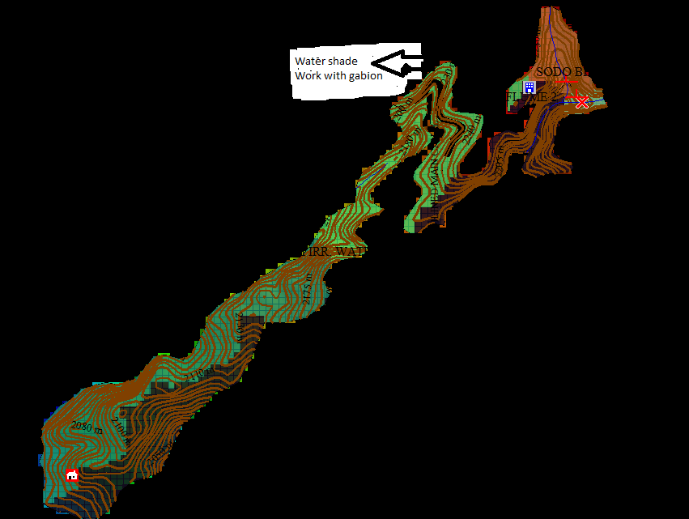
Fig.1. The water shade work on the main canal

Heath
There is no serious problem in case of health. Because the whether condition is Wayina Daga . There are some health centers and clinics. But due to transport in accessibility, a lot are un- able to go the health centers. Drinking water is not available and thus sanitation case also could be considered.

Road Accessibility
- Communication , especially for villages that are fur from the main road are without adequate communication farm roads are not adequate constructed and even they are highly eroded and not simple for some area 4-wheel and soon thus lock of sufficient infrastructures is main problem in the area.

Development Skill (Capacity)
As it is told in the earlier parts no adequate extension was given to the users.

Topographic Condition
Erosion is a serious problem of the upper of any land form in the catchment. Thus gullies are developing rapidly to words the plane (cultivated lands) that might be difficult in the near future.

Special Problem
- As field observation a special attention was given to the weir site and the command area.
*weir site
- The site (weir site) is proposed under or at the foot at the catchment & the upper (top) part is not wall covered by grass or trees and thus there might be siltation on the diversion. Therefore this part should be replanted or grassed of for as possible .This may reduce the risk.

*Command area.
- There are already existed (formed) small gullies and are also signs of waterways. These create a negative condition to the future development, especially in the implement period again this part should be considered adequately and conservation work should be planned together with other activities, since stones (fragments) one available in the area, stone bunds are the possible conservation methods, on long with agronomical measures.

The possible management practices
- Agronomic specific cropping pattern, variety selection and crop rotation are considered. Timing in tillage practice and good water management during the development phase is very essential proper ploughing along the hillside
(Contour farming) and tree planting are an effective erosion controlling measures.
- Drainage:- considering the red loam nature of exiting soil, adequate drainage should be planned and effective water management practice should conducted, use on appropriate schedule and water during irrigation time.

Effect of Work
Considering the actual and effective work in all possible and required activities it is happed to achieved better irrigation development in the proposed area. This can be practical through on integrated watershed management besides irrigation practices. But the level of the work, depends on the project nature and the capacity of the community.

Gully Treatment.
For the specific command area there is no special gully problem. But simply gullies, are seen and it will be treated. With biological mated. For the specific catchment area special gully problems are observed and this problem is treated
- Material (stone) Availability
- Within the project area not more than 1km at the start of the main canal catchment area stone fragment is available. An another hand, there is a possibility to stop or reduce the gully tops by means of forestation here gullies are stopped natural vegetation will grow naturally . A gradual succession of plant species eventually will protect the gully areas with grasses, shrubs or trees. This is planned to be undertaken by the community and not assumed as immediate cost based activity. As an additional treatment we have proposed Gabion with wire mesh for critical and needs cost for the construction implementation. The cost breakdown is included in the engineering Bill of Quantities.

Conclusion & Recommendation
The watershed study is based on the sub- catchment condition and considered only the first preliminary situations around project area. As observed in the field visit, complicated conditions that affect the planned irrigated agriculture are not visualized. But forest degradation absence extension service & lack skilled farmers is observed. These are simply corrected by re-organized ideas and extension packages among the beneficiaries and for this purpose experts and related organs development practices, such as agriculturalists and administrative members should be involved in the future.

