Table of Contents
8. Engineering Aspects 1
8.1 General 1
8.2 Methodology 1
8.3 Irrigable area 1
8.4 Water Availability 1
8.5 Major Components of the project 1
8.6 Selection of Headwork site 2
8.7 Geology of weir site 2
8.8 Design of weir 3
8.9 Design of Headwork 3
8.9.1 Basic Design Criteria 3
8.9.2 Design Conditions 3
8.9.3 Basic Design Input Data 4
8.9.4 River Bed Slope 5
8.9.5 Design Water Intake Discharge 6
8.9.6 Design Water Intake Level 6
8.9.7 Design Flood Discharge 9
8.9.8 Design flood level 10
8.9.9 Design Flood Level (EL. of weir crest + H_{d}) 12
8.9.10 Elevation of Crest Height and Length of Weir 13
8.9.11 Possible Effect on the River control of upstream 14
8.9.12 Detail Design 15
8.9.13 Foundation work 25
8.9.14 Upstream and downstream cut-off walls 27
8.9.15 Inlet 27
8.9.16 Scouring Sluice Size 28
8.9.17 Gate 28
8.9.18 Settling Basin 30
8.9.19 Protection of River bank and major bed 30
8.9.20 Basic Data for design of canal 34
8.9.21 8.9.15 Classification of canals by System 36
8.9.22 Canal Shape 36
8.9.23 Hydraulic design of canals 36
8.9.17 Design of inner space width and opening height of gate 47
8.9.18 Earth Retaining Structures 48
8.10 Load Assessment and for Design of Girder Beam 49
8.11 Design for Flexural Resistance 50
8.12 Design for Shear Resistance 51
8.13 Design of Flume Wall and Bottom Slab 52
8.9.14 Flume Base Slab Design 53

Engineering Aspects

8.1 General

Engineering aspects related to project study and designs are addressed under this section. All influential factors that determine project sustainability are accounted to come up with reasonable results of study. In so doing, idea from different disciplines was given due attention to make the scheme smart. The project is gravity diversion system on Demekash River that delineates a catchment including Qanyira Labu upstream of head work and Soddo Garbo Kebele at the Head work and moves in limalimo forest and mountainous area to arrive at the command area stretched to Derare Ebicha Kebele Farmer Association. The head work Canal system supplies to only the right side of the River and downstream water users are also found after 500m traditional diversion for southern Nation Nationalities and people. Manageable systematic layouts were adopted to minimize costs and to enable easier application of water. A total of 105 ha of land were surveyed and net irrigable area of 60 ha of land was planned for development. The rest area were identified as forest and chat in the garden.

8.2 Methodology
The methodologies adopted are:

- Existing localities and community experiences and information.
- Using Mosaic contour maps, Dem 30, Excel format Guides from OIDA and JICA, Global mapper15 , Eaglepoint software, Autocad, Zprofile and SAP 2014.
- Site survey and investigations with Garmin GPS 62,Sokia Total Station and Sokia leveling.
- Secondary data from concerned areas in the kebele.
- Hydro-meteorological data from Wolisso Station, crop data, soil data etc. collecting and organizing for this study.
- Using OIDA guidelines and manuals.
- FAO Standards and other reference materials.

8.3 Irrigable area

The irrigable area is sloppy with slope ranging between 4-7% away from Right side of Demekash River. The soil of the area is brown reddish soil and thick in depth. As a result, it is good to use excavated soils for foundation fill of structures. The proposed crops under irrigation have duty of 1.57l/s/ha with irrigation ifficiency of 50%. And the net irrigable area is 60 ha.

8.4 Water Availability

It could have been good if monthly flow data were available; but at this level of study it was not possible to have reliable data. Hence dry season flow was estimated and reasonably safer flow was taken as lean flow available for design. The lean flow as reported under hydrology section is 134 l/s.

8.5 Major Components of the project

- Diversion Head work (Cyclopian Concrete)
- Lined Main Canal at Right side of the river (5440m)
- Earthen main conveyance canal after 5440m lined canal which is 3000m. And Canal water escape on main canals (5 in No).
- Aqueducts 6(in No)
- Foot Paths (5 in No
- Flumes 6m span 1 in number
- Turnouts 17 in number and Field off take 94 in number
- Cut off drain along MC 5440 m and Other Drainage canals
- Access road clearance 3km and Camping
- Drops 20 in No, and check structure 4 in number

8.6 Selection of Headwork site
The headwork site was selected under the following factors:

- Possibility to command the anticipated area.
- Geological formation of the site.
- Relative cost of weir.
- Possibility to protect flooding of off taking canal
- Relatively area convenient for construction and less flood heights & effects.
- Access to the site
- Area simpler for temporary diversion during construction.

8.7 Geology of weir site

The weir site is selected by considering the topography, command area, stability of the river banks, engineering geological properties of the materials and canal routes. At the weir axis, the river bed is approximately 20m wide flat and wide valley. The bed rock of weir axis, the right and left abutment is moderately to slightly externally weathered ignimbrite rock. Based on field investigations, there is no overburden at the river bed and the weir foundation has no soil formation deposit, instead it is bedded ignimbrite rock along and across river flow having more than 200m of vertical depth. The ignimbrite rock is formed by pyroclatic fall and flow.

The river banks above the weir axis are characterized by bed rock in the river bed and the banks are also covered with moderately weathered ignimbrite and trachy basalt with occasional thin soil coverage. It covers upstream banks of the river for more than 1000m and downstream of at least 5km, forming the river banks very stable. This rock formation is found solid and compact, with some columnar like jointing near to the surface. This rock, according to the field observations has been grouped in the class of moderately strong to very strong with unified compressive strength of 12.5 to 200 MN/M² strength Based on BSI 10-1990, 126.

In general, the proposed Headwork Site is on Bedrock River, a river that typically has little to no alluvium mantling the bedrock over which it flows. At the proposed weir site it is a medium river gradient and the bed is exposed bed rock. The prominent rock type present in the head works site is thick bedded moderately jointed light gray to white and hard ignimbrite rock. The spacing of the joints varies from 10-15m in the river bed and 5-30 cm in river banks. Hence the foundation has to be considered as relatively impervious (if the joints are grouted and weathered part at least 50cm is removed ) welded ignimbrite bed rock of strong, weathering resistant and with good bearing capacity.

Since the proposed weir is located on bed rock, there is no stability problem on banks and river bed and also enables to prevent flow of water beneath the weir or leakage. The pond storage above head work have a long period duration of time shows as the bed rock formation on which water flows is impermeable, free from leakage and water tight and Erosion and weathering resistant. In addition, this pond storage is used to kill high energy flood during maximum flood time not to harm the weir axis.
The combination of the trachy basaltic and ignimbrite rock competency and no overburden at the river center and the weir site river banks leads to the conclusion that the weir structure will be founded on the competent bed rock.

8.8 Design of weir
Weir type: Cyclopian type weir: Simple intake design anchored to the existing natural bed rock.
Length or span of the weir flow width was taken 20m from the existing situation of the river perpendicular section.

8.9 Design of Headwork

Head works are systems of integrated structures constructed across the river to raise water level in the river so as to take usable water for irrigation. The designs of these structures are conducted to ensure their stability associated with the topography and hydrogeology of the area and so that they perform the intended function.

Here under is a crucial data and calculation of basic design of simple intake head works on Demekash River, Woliso Woreda, and South West Shoa Zone of Oromia Regional State for small scale irrigation project serving 60ha.

Basic Design Criteria

The basic design criteria consists of the pre-feasibility stage as the first criterion which identifies the availability of usable water, command area, soil type beneficiaries, type of crops dominantly grown and applicability for the future plan.
Secondly, detail study of different disciplines are applied together with the secondary data and primary survey data which later implemented to the design criteria.

Design Conditions
- Design water intake discharge
- Design intake water levels
- Design flood discharge and
- Design Flood Levels must be known for the design of head works.
The height of fixed structures and the future level at which the riverbed will be stable must be studied in order to set appropriate design conditions (for this particular river, the river bed is stable with ignimbrite Rock River bed).

Basic Design Input Data

8.9.3.1 Getting Discharge Data through Actual Measurement
According to the river discharge measurement data, it is difficult to use float measurement in the river because of the flowing is turbulent within the steep slope stone existence in the river bed. The river is thoroughly checked both upstream and downstream and the method of discharge measuring in the river is decided to use after diverting into the existing traditional main canal using floating method in the open channel. Time is recorded to reach the floating material cover a distance of 8m along the canal.
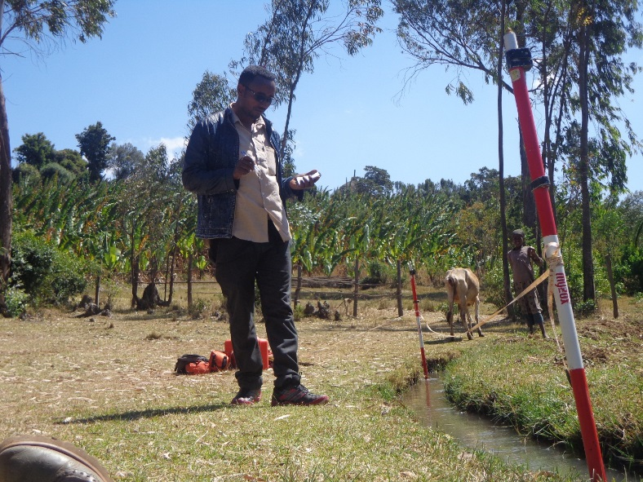
Fig 8.1Direct volume measurement through floating method.

Time(sec.) | t1 | t2 | t3 | t4 | t5 | t6 | Remarks
Length(m) | 22 | 21 | 22 | 22 | 22 | 21 | Seconds
Average Time
$Σt$ 1-6/6 | 21.66667 |  |  |  |  |  | l/s
  =130/6
Channel parameters |  | Depth | Width | Length
 |  | 0.61 | 0.6 | 8 |  |  | Meters
Discharge (m3/s) | W*D*L/Avgt |  | 0.134 | m3/s |  | 134 | l/s
Water Balance | 70% is taken for the project and the 30% is released for downstream
 | traditional diversion and environmental river ecosystem
 | 94l/s | usable water

River Bed Slope
According to the river bed slope survey data, the calculation table can be made as follow.

Points | Staff Reading | Chainage (m) | Elevation(m) | HI | Chainage (m) | Opening Elevations (m) |  | Flod Mark Level
A | 3.415 | 0 | 2225 | 2228.415 | 0 | 2227.065
1 | 4.045 | 2 | 2224.37 |  | 2 | 2226.885
2 | 4.01 | 4 | 2224.405 |  | 4 | 2226.665
3 | 4.03 | 6 | 2224.385 |  | 6 | 2226.265
4 | 4.045 | 8 | 2224.37 |  | 8 | 2225.575 |  | 2225.575
5 | 4.7 | 10 | 2223.715 |  | 10 | 2225 |  | 2225.575
6 | 4.4 | 12 | 2224.015 |  | 12 | 2224.37 |  | 2225.575
7 | 4.8 | 14 | 2223.615 |  | 14 | 2224.405 |  | 2225.575
8 | 4.6 | 16 | 2223.815 |  | 16 | 2224.385 |  | 2225.575
9 | 4.115 | 18 | 2224.3 |  | 18 | 2224.37 |  | 2225.575
B | 3.85 | 20 | 2224.565 |  | 20 | 2223.715 |  | 2225.575
FM | 2.84 | 22 | 2225.575 |  | 22 | 2224.015 |  | 2225.575
 | 2.15 | 24 | 2226.265 |  | 24 | 2223.615 |  | 2225.575
 | 1.75 | 26 | 2226.665 |  | 26 | 2223.815 |  | 2225.575
 | 1.53 | 28 | 2226.885 |  | 28 | 2224.3 |  | 2225.575
 | 1.35 | 30 | 2227.065 |  | 30 | 2224.565 |  | 2225.575
 |  |  |  |  | 32 | 2225.575 |  | 2225.58
 |  |  |  |  | 34 | 2226.265
 |  |  |  |  | 36 | 2226.665
 |  |  |  |  | 38 | 2226.885
 |  |  |  |  | 40 | 2227.065

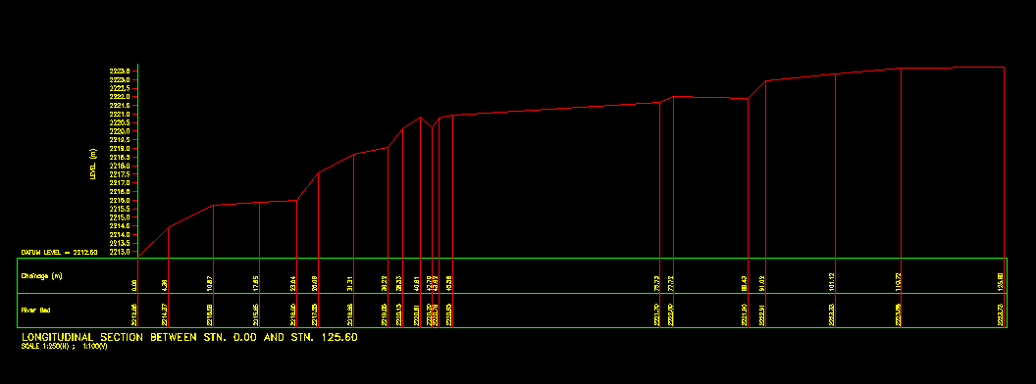
Fig. River Longitudinal Profile Over 115m

Design Water Intake Discharge
There is no recorded Gauge to get discharge data in or near river basin of the project site from Ministry of Water and Energy. Base flow water Data collection is conducted directly on project site by direct measurement of flow in the river during detail study of the project only as explained in section 8.10.1 (i.e. The base flow obtained here is 134l/s).
The water balance should be done for the river so that avoid conflicts on irrigation water use. Previously, there is only culturally developed water intakes downstream of the river. For this project there is one traditional intake which locally administered by releasing 1/3rd of the river flow and also we adopted the design by 70% usable water for the modern system.
Hence, the downstream intake is taken 1/3rdl and 30% is assumed to be released in the river.
WU=D*0.7-Qdw
=134*0.7-0=94l/s
Where, WU is usable water
D is Base flow discharge and
Q_{dw} is previous designed intake discharge downstream of the river.

Design Water Intake Level
This is the water level required to be secured at the start of the canal set in the irrigation plan. In case of intake on weir, the intake water level must be the greater of the following:
- ① The total of the water level required to be secured at the canal start plus the total of the head loss between the intake and the canal start; or
- ② The total of the intake threshold height from the bottom the silt scouring sluice to prevent sediment inflow and the intake depth.

Assuming that this base level flow coincides with the timing when the design intake volume is required, final design intake level is then determined so as to satisfy the requirements of ① and ② mentioned previously as stated earlier, the choice of design intake level is not only related to the location of the head works, but it is also affected by loss of head that varies depending on the distance between the intake and the canal start, existence of a slit basin and the flow velocity of the intake (size of the intake). Therefore, the final decision must be made after a series of trial calculations and reviews of various factors. At the preliminary design stage, it is recommended to take 1.8 to 2.3 times of the intake velocity head (V²/2g) as the loss of head at the intake.

< Supplementary explanation >
Design intake water level is used for consideration of the head works position. The head works position has to be located upper than this level.

- Water level of the field at the highest elevation of the irrigation area.
The field level at the highest elevation of the irrigation area+furrow irrigation water depth on the farmland=El.2198m+0.05m=2198.05m.
- Water Level at the Starting point of the Main Canal
- Canal length from the starting point of the main canal to the starting point of the irrigation area (the highest elevation of the irrigation area).
- Canal slope (assumption) =1/1000. It can be changed after decided canal slope if necessary. And it must be calculated again as everything below.
- Necessary water head=5440*1/1000=5.44m
- Water Level at the starting point of the Main Canal=Water Level of the field at the highest elevation of the irrigation area+Necessary water head
=
EL. 2198.05m+5.44m=EL.2203.49m<<2220m river bed level at the diversion. Hence we are going to use simple diversion i.e simple weir.
- The hydraulic loss between the intake and the starting point of the main canal
There is no structure in this design but this loss assumes 0.1m for safety.

- Other Structural losses at the Intake (Hydraulic loss of entrance)- Δh_{e}
- Inlet Sill
The inlet elevation prefers to be 1.0m higher than scouring sluice sill and also prefers to be more than 1/6 of maximum flood depth of the river from the river bed for prevention of sand. But in case of small head weir, a minimum inlet elevation is at least 0.5m higher than scouring sluice sill. If the height from scouring sluice sill to inlet elevation is lower than 1.0m, settling basin should be considered.
- Scouring Sluice Sill
It adopts the elevation of river bed level as the elevation of scouring sluice sill (2220m).
Inlet sill ≥ scouring sluice sill (2220m) + 0.5m =more than 2220.5m assuming small weir.

- Maximum flood depth of the river
Maximum flood depth of the river=Design flood level - River bed level
=EL.2221.01-EL.2220=1.01m.
Therefore, Inlet sill ≥ 1/6 of maximum flood depth of the river
=River bed level+1.01m*1/6=El.2400+0.17=El.2220.17m
As the comparison of ( i) and( ii), inlet sill is ≥ El.2220..5m
- Intake size and hydraulic loss of entrance
B=Q/h₁*V
At the time, 0.6 ≤ Intake velocity (V) ≤ 1.0m/s
Δh_{e}=he+V₂²/2g-V₁²/2g=f_{e}* V₂²/2g+ V₂²/2g- V₁²/2g (this case V₁²=0
By using the above two formula, it calculates Δh_{e} , B and h1 by trial and error calculation.

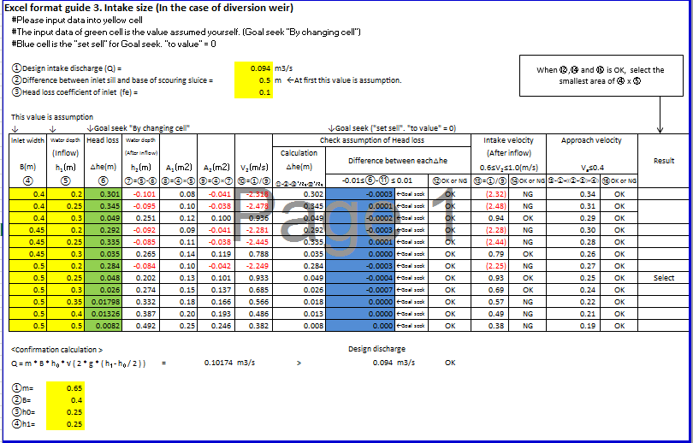
The result of calculation intake size is B=0.25m, H=0.20m. So, hydraulic loss of entrance (Δh_{e})=0.035m.
- Confirmation Calculation
Q_{c}=m*B*ho*$\sqrt{(2*g*\left(h1-\frac{ho}{2}\right))}$
=0.65*0.25*0.20*$\sqrt{(2*9.8*\left(0.25-\frac{0.15}{2}\right))}$=0.032m³/s > 0.028m³/s Ok!
- Calculation Result of Design Water Intake Level
The result of above calculations, design water intake level is decided as follows.
Design intake water level (DIWL) =(2) + (3) +(4)=water level at the starting point of the main canal (WLASPMC) + Hydraulic Loss between the intake and the starting point of the main canal + Hydraulic Loss of Entrance (HLOE)=EL.2203.49m+0.1m+ 0.049m
=EL.2203.64m < 2220.5m existing bed canal assumed as starting point of the main canal.
Take 2220.5m as the starting point of the main canal and reserve 2220.5m-2203.64m=16.86 ~ 17m for the head loss between the start of MC and End of MC.(5440m)and use vertical drops at required sections to avoid bulk excavation and control flow between design standards.
According to (4) (a) (i) in this chapter.
Inlet Sill= EL.2220.5-0.25m=EL.2220.25m OK!
So, the difference between the inlet sill and base of the scouring sluice=Inlet sill (EL.2220.25m)-Scouring sluice sill (EL.2220m)=0.25m
Based on this value, the approach velocity can be calculated using excel format guide 3.
And the result is 0.93=~0.9m/s > 0.60m/s
The result of calculation shows the approach velocity is OK!

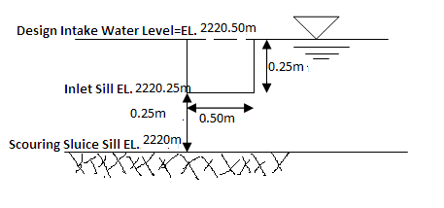
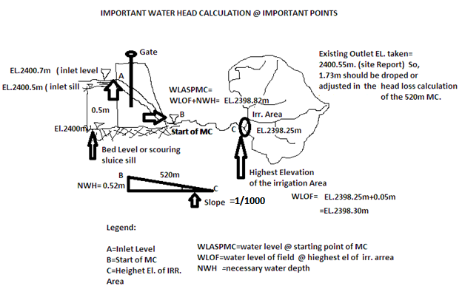

Design Flood Discharge

The design flood discharge is decided in accordance with the river control plan. In other cases, the design flood discharge is decided on the basis of the known discharge capacity of the target river. The design flood discharge and the design flood level explained in the following sections are the basic values for calculations stability of external force and stress. They are also basic values in deciding the features of the structure.

Design flood discharge has to be decided from the following:
- past flood discharge data,
- the maximum flood in the past based on flood mark or discharge capacity of the river by slope area method or
- flood (1/50 probability year) by run-off analysis.
- In case of getting past flood discharge data in or near river basin of project side
There is no yearly recorded past flood discharge data in or near river basin of the project side from Ministry of Water, Irrigation and Energy to know the maximum flood discharge used for the design. Instead, it is adapted to approach using slope area method explained here under.
(2) In case of using the maximum flood in the past based on flood mark or discharge capacity of the river by slope area method
According to the river cross- section survey data, the calculation table and drawing of cross-section can be made.
Cross-Section Survey Data
Point ID | X (East) | Y (North) | Distance (m) | Accumulated Distance (width) (m) |  | Elevation (m) | Depth (m) | Remark
RFM | 376920.047 | 959169.163 | 0.00 | 0 |  | 2402.093 | 2.093 | Right Side
X-S(K.S) | 376919.946 | 959168.274 | 0.89 | 0.89 |  | 2401.276 | 1.276
X-S(K.S) | 376919.529 | 959167.409 | 1.00 | 1.89 |  | 2401.121 | 1.121
X-S(K.S) | 376919.304 | 959166.494 | 0.94 | 2.84 |  | 2400.260 | 0.26
X-S(K.S) | 376919.158 | 959165.212 | 1.29 | 4.13 |  | 2399.818 | -0.182 | River Bed
X-S(K.S) | 376918.469 | 959164.481 | 1.00 | 5.13 |  | 2399.915 | -0.085
X-S(K.S) | 376918.307 | 959163.679 | 0.82 | 5.95 |  | 2399.899 | -0.101
X-S(K.S) | 376918.054 | 959162.595 | 1.11 | 7.06 |  | 2400.445 | 0.445
X-S(K.S) | 376917.732 | 959161.729 | 0.92 | 7.99 |  | 2401.930 | 1.93
LFM | 376918.010 | 959161.869 | 0.31 | 8.30 |  | 2401.865 | 1.865 | Left Side
Based on the above data, rating curve bay Manning formula can be made. Slope=0.074, Coefficient of Roughness=0.04

Design flood level

If the target river is under a river control plan or it is likely to be incorporated in such plan in the near future, then the design flood level is set in accordance with the target plan. In other cases, the design flood level should be the level at the proposed site when the design flood discharge flows.
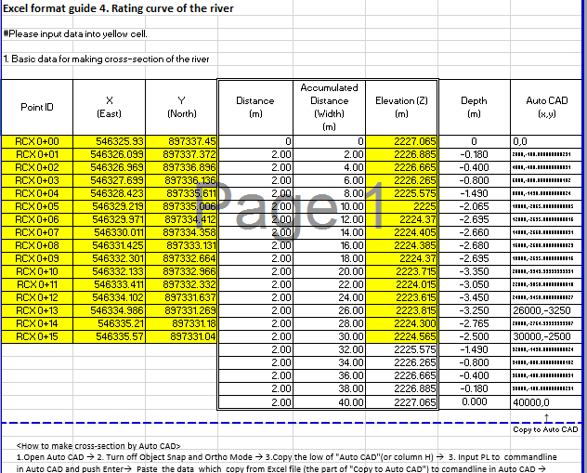

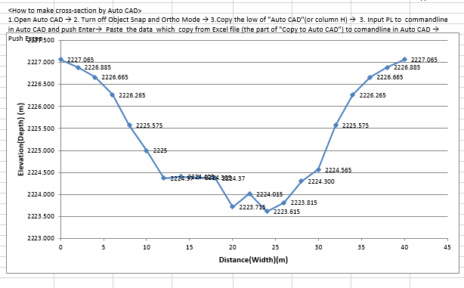

Auto Cad Result of the River Cross -section

2. Discharge of the river
Slope |  | 0.029
Coefficient of Roughness |  | 0.04
Elevation  (m) | Depth  (m) | Water area  (m2) | Wetted  Perimeter  (m) | Hydraulic radius  (m) | velocity  (m/s) | Discharge  (m3/s) | Note ; Water area and Wetted  Perimeter calculated by Auto CAD
2219.12 | 0 | 0 | 0 | 0 | 0 | 0
2219.54 | 0.42 | 0.46 | 3.44 | 0.13 | 1.11 | 0.51
2220 | 0.88 | 5.99 | 7.70 | 0.78 | 3.60 | 21.57
2220.45 | 1.33 | 9.5 | 11.37 | 0.84 | 3.78 | 35.88
2220.56 | 1.44 | 12.6 | 11.84 | 1.06 | 4.44 | 55.91
2221.01 | 1.89 | 16 | 14.71 | 1.09 | 4.50 | 72.04 | Flood mark

According to rating curve of the river, the river discharges at the flood mark (EL.2221.01m) is 72m3/s. In this case, peak flood should be multiplied by 1.04 for safety not as such required due to safe foundation on anchored rock bed..
Design flood discharge (Q_{d})=Peak flood discharge is1.04* 72m3/s say =75m³/s
(Refer to excel format guide 4 for the detail).

Design Flood Level (EL. of weir crest + H_{d})
If the target river is under a river control plan or it is likely to be incorporated in such plan in the near future, then the design flood level is set in accordance with the target plan. In other cases, the design flood level should be the level at the proposed site when the design flood discharge flows.
< Supplementary explanation >

Design flood level is an input for design of stability, safety and consideration for influence to upstream in the absence of river control plan. Design flood level is calculated from design discharge on condition of after head works is constructed.

The Total Energy, H_{e} = (Q_{d}/CL)^{2/3} from Q_{d}= CL H_{e} 3/2
H_{e}= H_{d}+H_{av}
H_{av}= V_{a}²/2g
V_{a}= Q_{d} / L (h+H_{d})
H_{e} = H_{d} +(Q_{d})²/[L(h+H_{d})]² /(2g),
Design flood level at weir = H_{d} + Elevation of weir crest
Where,
H_{e}: Total energy head (m)
H_{d}: Design head (Water depth on the crest) (m)
H_{av}: Approach velocity head (m)
V_{a}: Approach velocity (m/s)
Q_{d} : Design flood discharge (m3/s)
C : 1.7 Discharge coefficient
L : Length of weir (m)
h: weir height (m)
g: 9.8m/s2 gravity acceleration
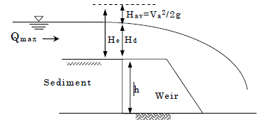
Design flood levels at other place are calculated by Manning formula. However, it is possible to take some cross section and use non-uniform flow equation.
$i+\frac{dh}{dx}+α\frac{Q^2}{2g}*\frac{d}{dx}(\frac{1}{A^{2}})+\frac{n^2V^2}{R^{4}/3}=0$

Where, i: Bed slope
h: Water depth (m)
x: Length towards the downstream along the canal bed (m)
Q: Discharge (m³/ s)
A: Cross-section area (m²)
g: Acceleration due to gravity (m/ s²)
α: Coefficient of energy correction (α = 1.1, is used in general but
α = 1.0 may be used for simple calculation)
n: Coefficient of Manning roughness
V: Mean velocity (m/s)
R: Hydraulic Mean Radius (m)

Elevation of Crest Height and Length of Weir
The calculation of crest height of weir is as follows
- Design water intake level + (freeboard say 10cm) for this case
=EL.2220.5+0.1m=EL.2220.6m
- Crest Height of weir (h)=EL.2220.6m-EL.2220 of Average River Bed Level
h=2220.60-2220.0m=0.60m.
And the length of weir can be decided from cross section survey data and geological data of the bank around weir site and it is 20m wide.

Weir Line Cross Section
Based on the river cross-section on weir site and geological data of the bank around weir site (up to the hard rock), the weir position selected is not the perpendicular direction to the river flow rather cross-section inclined to the river flow.
The length of weir=19.87m, Say 20m.

Possible Effect on the River control of upstream
Calculation of possible effect on the river control of upstream is as follow.
- Water depth of the River where the place of head works before construction as design flood discharge (tail water depth)
The depth of the river at design flood discharge (Q_{max}=75m³/s)=EL.2221.01m (reading from the rating curve. So, Tail water depth=El.2221.01-220=1.01m=d₃.
- Water depth on the crest as design flood discharge
- Total energy as design flood discharge H_{e}=(Q/CL)^{2/3}=(100m³/s/(1.7*15m))^{2/3}=1.7m
- Water depth on the crest
H_{e}=(H_{d}+Q_{d}²/((L(h+H_{d}))²*2g)
0= H_{d}+ Q_{d}²(( L(h+H_{d}))²*2g)- H_{e}
- = H_{d}+75/((15*(0.60+Hd))²*2*9.8)-1.7
Excel format guide 5. Water depth on the crest
 | 1. Design head
 | #Please input data into yellow cell
 | #The input data of green cell is the value assumed yourself. (Goal seek "By changing cell")
 | #Blue cell is the "set sell" for Goal seek. "to value" = 0
 | ①Total energy head (He) = |  |  |  | 1.7 | m | He=Q/(CL)^2/3 |  | 1.694551
 | ②Design flood discharge (Q_{d}) = |  |  |  | 75 | m3/s
 | ③Length of weir (L)= |  |  |  | 20 | m
 | ④Weir height (h) = |  |  |  | 0.6 | m
 | ⑤Design head (H_{d}) = |  |  |  | 0.061 | m | ← Goal seek ("By changing cell")
 | ⑥The result of calculation |  |  |  | 0.000 |  | ← Goal seek ("set cell". "to value" = 0)

The result of calculation is H_{d}=0.181m, say H_{d}=0.20m
If upstream of weir is filled up until crest, because of siltation
He=H_{d}+Q_{d}²/((L(0+H_{d}))²-2g)
0= H_{d}+ Q_{d}²( L(0+H_{d}))²*2g)- H_{e}
= H_{d}+ Q_{d}² ((L*H_{d})²*2g)- H_{e}
= H_{d}+1=75*(20*(0.6+Hd))²*2*9.8)-1.7

The result of calculation is H_{d}=0.061m, say H_{d} =1.70m,
Siltation increases H_{d}
H_{av}=H_{e}-H_{d}=1.7-0.061=1.64m
H_{d} value should adopt the biggest one from the result of above calculation.
So, H_{d}=1.70m
Design flood level at weir (DFL)=H_{d}+ Elevation of weir crest
DFL =1.70+EL.2220.6m=EL.2222.30m.
NB: It is recalled that the design flood level is EL.2221.01m before construction of weir and it will be increased to EL.2222.3m after construction of the weir (EL.2222.30m - EL.2221.01m =1.3m is increased as a result of the obstacle weir).
Study of possible effect on the river control of upstream
At this point it is time for upstream check not overtops the river bank.
According to the design flood level at weir (EL.2222.30m), river slope (0.074) and cross-section data, possible effect on the river control of upstream can be assumed or modeled. For this case,Demekash River has a deep valley and there is no such problem. (i.e the back water can be easily with holed in the valley shape (even Natural Pond Behind).

Detail Design
Fixed Weir
(1) Section Shape
a) The crest height of weir=0.6m
b) The top width of weir (supposition of section dimension)
- Bligh’s method; B=(H_{d}+H_{av})/$\sqrt{Ƴ}$
= (1.70+1.6)/$\sqrt{2.35}$=2.15m
- Etcheverry’s method; B=0.552 $\sqrt{h}$+$\sqrt{(Hd+Hav)}$
=0.552 $\sqrt{0.60}$+$\sqrt{(1.7+1.6)}$ =1.42m

So, it selects average between Bligh’s method and Etcheverry’s method.
$\frac{\left(2.15+1.42\right)}{2}=$1.78m Say B=1.8m.
c) The bottom width of the weir (supposition of section dimension)
Bligh’s formula: L=(h+H_{d}+H_{av})/$\sqrt{Ƴ}$
=(0.60+1.70+1.6)/$\sqrt{2.35}$
=2.54m, Say L=2.60m.
(After calculate stability analysis L is to be 2.20m finally).

(2) Determination of Section (stability Analysis)
Section shape of weir has to check the stability by stability analysis. The calculation is different whether downstream water height is higher than crest height (refer to excel 6 for the details).

Excel format guide 6. HW Stability Analysis (Summary)
【Case1 : H_{downstream} < Hw】
#Please input data into yellow cell
1.Basic data for calculation
Item | Value
Unit weight of plane concrete | γc＝ | 23 | kN/m³
Unit weight of wet soil | γwse＝ | 18 | kN/m³
Unit weight of water | W₀＝ | 9.8 | kN/m³
Unit weight of submerged soil | γwe＝ | 8.2 | kN/m³（γwse－w0）
Coefficient of earth pressure | C₀＝ | 0.45
Uplift coefficient | μ＝ | 0.4
Seismic horizontal acceleration | kh＝ | 0.15
Friction coefficient | f＝ | 0.7
Allowable stress of the graund | qa＝ | 1000 | kN/m²
2.Mesurement of structure
Item | Value
Slope of front body m = 1 : | 1.33
B1 | 1.80 | m
B2 | 0.80 | m
B (B1+B2) | 2.60 | m
H_{w} | 0.60 | m
H_{d} | 0.06 | m
H_{downstream} | 1.01 | m
H_{e} | 1.70 | m

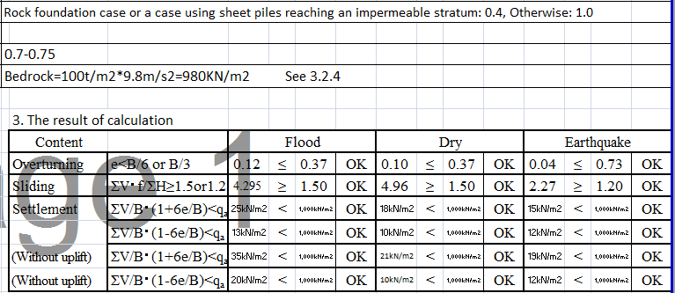

B1
H_{dd}
B
H_{w}
H_{e}
H_{d}
H_{downstream}
B2
1:m

①Stability analysis (The case of flood)
1.Basic calculation
(1 )Area
External force |  |  |  |  |  | Area
Dead load; |  |  |  |  | W1 | 1.20m2= |  |  | 1.50m× |  |  | 0.80m
 |  |  |  |  | W2 | 0.28m2= |  |  | 0.70m× |  |  | 0.80m× |  |  | 1/2
Static water |  |  |  |  | P1 | 1.97m2= |  |  | 2.46m× |  |  | 0.80m
pressure; |  |  |  |  | P2 | 0.32m2= |  |  | 0.80m× |  |  | 0.80m× |  |  | 1/2
 |  |  |  |  | P3 | 1.20m2= |  |  | 1.60m× |  |  | 1.50m× |  |  | 1/2
 |  |  |  |  | P4 | 1.50m2= |  |  | 1.85m× |  |  | 1.62m× |  |  | 1/2
 |  |  |  |  | P5 | 1.71m2= |  |  | 1.85m× |  |  | 1.85m× |  |  | 1/2
Earth pressure; |  |  |  |  | Pe | 0.32m2= |  |  | 0.80m× |  |  | 0.80m× |  |  | 1/2
Uplift; |  |  |  |  | U1 | 2.64m2= |  |  | 2.20m× |  |  | (1.60m+ |  |  | 0.80m) |  |  | × 1/2
 |  |  |  |  | U2 | 2.04m2= |  |  | 2.20m× |  |  | 1.85m× |  |  | 1/2
(2)Distance
External force |  |  |  |  |  | Distance
Dead load; |  |  |  |  | W1 | 0.75m= |  |  | 1.50m× |  |  | 1/2
 |  |  |  |  | W2 | 1.73m= |  |  | 1.50m+ |  |  | 0.70m× |  |  | 1/3
Static water |  |  |  |  | P1 | 0.40m= |  |  | 0.80m× |  |  | 1/2
pressure; |  |  |  |  | P2 | 0.27m= |  |  | 0.80m× |  |  | 1/3
 |  |  |  |  | P3 | 0.50m= |  |  | 1.50m× |  |  | 1/3
 |  |  |  |  | P4 | 1.66m= |  |  | 0.58m+ |  |  | 1.62m× |  |  | 2/3
 |  |  |  |  | P5 | 0.62m= |  |  | 1.85m× |  |  | 1/3
Earth pressure; |  |  |  |  | Pe | 0.27m= |  |  | 0.80m× |  |  | 1/3
Uplift; |  |  |  |  | U1 | 0.73m= |  |  | 2.20m× |  |  | 1/3
 |  |  |  |  | U2 | 1.47m= |  |  | 2.20m× |  |  | 2/3
2.Calculation table
(Unit Width)
 |  |  | Vertical |  |  |  | Distance |  |  | Resistance |  |  | Horizontal |  |  | Distance |  |  | Turning
 |  |  | Force |  |  |  |  |  |  | moment |  |  | force |  |  |  |  |  | moment
 |  |  | Ｖ(kN) |  |  |  | ｘ(m) |  |  | V*x(kN･m) |  |  | Ｈ(kN) |  |  | ｙ(m) |  |  | H*y(kN･m)
Dead load | W1 |  | 27.60 |  |  |  | 0.75 |  |  | 20.70
 | W2 |  | 6.44 |  |  |  | 1.73 |  |  | 11.14
water pressure | P1 |  |  |  |  |  |  |  |  |  |  |  | 19.31 |  |  | 0.40 |  |  | 7.72
 | P2 |  |  |  |  |  |  |  |  |  |  |  | 3.14 |  |  | 0.27 |  |  | 0.85
 | P3 |  | 11.76 |  |  |  | 0.50 |  |  | 5.88
 | P4 |  | 14.70 |  |  |  | 1.66 |  |  | 24.40
 | P5 |  |  |  |  |  |  |  |  |  |  |  | -16.76 |  |  | 0.62 |  |  | -10.39
Earth pressure | Pe |  |  |  |  |  |  |  |  |  |  |  | 1.18 |  |  | 0.27 |  |  | 0.32
Uplift | U1 |  | -10.35 |  |  |  | 0.73 |  |  | -7.56
 | U2 |  | -8.00 |  |  |  | 1.47 |  |  | -11.76
Total |  |  | 42.15 |  |  |  |  |  |  | 42.80 |  |  | 6.87 |  |  |  |  |  | -1.50
(3)External force by unit width
External force |  |  |  | External force by unit width
Dead load; |  | W1 |  | 27.60kN= |  |  |  | 1.20m2× |  |  | 23.00kN/m2
 |  | W2 |  | 6.44kN= |  |  |  | 0.28m2× |  |  | 23.00kN/m2
Static water |  | P1 |  | 19.31kN= |  |  |  | 1.97m2× |  |  | 9.80kN/m2
pressure; |  | P2 |  | 3.14kN= |  |  |  | 0.32m2× |  |  | 9.80kN/m2
 |  | P3 |  | 11.76kN= |  |  |  | 1.20m2× |  |  | 9.80kN/m2
 |  | P4 |  | 14.70kN= |  |  |  | 1.50m2× |  |  | 9.80kN/m2
 |  | P5 |  | -16.76kN= |  |  |  | 1.71m2× |  |  | -9.80kN/m2
Earth pressure; |  | Pe |  | 1.18kN= |  |  |  | 0.32m2× |  |  | 8.20kN/m2 |  |  | ×0.45
Uplift; |  | U1 |  | -10.35kN= |  |  |  | 2.64m2× |  |  | -9.80kN/m2 |  |  | ×0.4
 |  | U2 |  | -8.00kN= |  |  |  | 2.04m2× |  |  | -9.80kN/m2 |  |  | ×0.4
B1
↓w2
↓w1
P5→
P4↓
P3↓
P1←
P2←
Pe←
U1↑
U2↑
H_{dd}
B
H_{w}
H_{e}
H_{d}
H_{downstream}
B2
②Stability analysis (The case of dry)
1.Basic calculation
(1 )Area
External force |  |  |  |  |  | Area
Dead load; |  |  | W1 |  |  | 1.20m2= |  |  | 1.50m× |  | 0.80m
 |  |  | W2 |  |  | 0.28m2= |  |  | 0.70m× |  | 0.80m× |  |  | 1/2
Static water |  |  | P1
pressure; |  |  | P2 |  |  | 0.32m2= |  |  | 0.80m× |  | 0.80m× |  |  | 1/2
 |  |  | P3
 |  |  | P4
 |  |  | P5
Earth pressure; |  |  | Pe |  |  | 0.32m2= |  |  | 0.80m× |  | 0.80m× |  |  | 1/2
Uplift; |  |  | U1 |  |  | 0.88m2= |  |  | 2.20m× |  | 0.80m |  |  |  |  |  | × 1/2
 |  |  | U2
(2)Distance
 |  |  |  |  | Distance
Dead load; | W1 |  |  |  | 0.75m= |  |  | 1.50m× |  |  |  | 1/2
 | W2 |  |  |  | 1.73m= |  |  | 1.50m+ |  |  |  | 0.70m× |  |  | 1/3
Static water | P1
pressure; | P2 |  |  |  | 0.27m= |  |  | 0.80m× |  |  |  | 1/3
 | P3
 | P4
 | P5
Earth pressure; | Pe |  |  |  | 0.27m= |  |  | 0.80m× |  |  |  | 1/3
Uplift; | U1 |  |  |  | 0.73m= |  |  | 2.20m× |  |  |  | 1/3
 | U2
Seismic load | S1
 | S2
(3)External force by unit width
External force |  |  |  | External force by unit width
Dead load; |  | W1 |  | 27.60kN= |  |  | 1.20m2× |  |  | 23.00kN/m2
 |  | W2 |  | 6.44kN= |  |  | 0.28m2× |  |  | 23.00kN/m2
Static water |  | P1
pressure; |  | P2 |  | 3.14kN= |  |  | 0.32m2× |  |  | 9.80kN/m2
 |  | P3
 |  | P4
 |  | P5
Earth pressure; |  | Pe |  | 1.18kN= |  |  | 0.32m2× |  |  | 8.20kN/m2 |  |  | ×0.45
Uplift; |  | U1 |  | -3.45kN= |  |  | 0.88m2× |  |  | -9.80kN/m2 |  |  | ×0.4
 |  | U2
Seismic load |  | S1
 |  | S2

2. Calculation table

(Unit Width)
 |  | Vertical | Distance | Resistance | Horizontal | Distance | Turning
 |  | Force |  | moment | force |  | moment
 |  | Ｖ(kN) | ｘ(m) | V*x(kN･m) | Ｈ(kN) | ｙ(m) | H*y(kN･m)
Dead load | W1 | 27.60 | 0.75 | 20.70
 | W2 | 6.44 | 1.73 | 11.14
water pressure | P1 |  |  |  | 0.00 | 0.00 | 0.00
 | P2 |  |  |  | 3.14 | 0.27 | 0.85
 | P3 | 0.00 | 0.00 | 0.00
 | P4 | 0.00 | 0.00 | 0.00
 | P5 |  |  |  | 0.00 | 0.00 | 0.00
Earth pressure | Pe |  |  |  | 1.18 | 0.27 | 0.32
Uplift | U1 | -3.45 | 0.73 | -2.52
 | U2 | 0.00 | 0.00 | 0.00
Seismic load | S1
 | S2
Total | 30.59 |  | 29.32 | 4.32 |  | 1.17
B1
↓w2
↓w1
P2←
Pe←
U1↑
B
H_{w}
B2

③Stability analysis (the case of earthquake )
1.Basic calculation
(1 )Area
External force |  |  |  | Area
Dead load; |  | W1 |  | 1.20m2= |  | 1.50m× |  | 0.80m
 |  | W2 |  | 0.28m2= |  | 0.70m× |  | 0.80m× | 1/2
Static water |  | P1
pressure; |  | P2 |  | 0.32m2= |  | 0.80m× |  | 0.80m× | 1/2
 |  | P3
 |  | P4
 |  | P5
Earth pressure; |  | Pe |  | 0.32m2= |  | 0.80m× |  | 0.80m× | 1/2
Uplift; |  | U1 |  | 0.88m2= |  | 2.20m× |  | 0.80m |  |  | × 1/2
 |  | U2
(2)Distance
External force |  |  | Distance
Dead load; | W1 |  | 0.75m= |  | 1.50m× |  | 1/2
 | W2 |  | 1.73m= |  | 1.50m+ |  | 0.70m× |  |  | 1/3
Static water | P1
pressure; | P2 |  | 0.27m= |  | 0.80m× |  | 1/3
 | P3
 | P4
 | P5
Earth pressure; | Pe |  | 0.27m= |  | 0.80m× |  | 1/3
Uplift; | U1 |  | 0.73m= |  | 2.20m× |  | 1/3
 | U2
Seismic load | S1 |  | 0.40m= |  | 0.80m× |  | 1/2
 | S2 |  | 0.27m= |  | 0.80m× |  | 1/3

(3)External force by unit width
External force |  | External force by unit width
Dead load; | W1 | 27.60kN= | 1.20m2× | 23.00kN/m2
 | W2 | 6.44kN= | 0.28m2× | 23.00kN/m2
Static water | P1
pressure; | P2 | 3.14kN= | 0.32m2× | 9.80kN/m2
 | P3
 | P4
 | P5
Earth pressure; | Pe | 1.18kN= | 0.32m2× | 8.20kN/m2 | ×0.45
Uplift; | U1 | -3.45kN= | 0.88m2× | -9.80kN/m2 | ×0.4
 | U2
Seismic load | S1 | 4.14kN= | 27.60kN× | 0.15
 | S2 | 0.97kN= | 6.44kN× | 0.15

2.Calculation table
 |  |  |  |  |  | （unit width）
 |  | Vertical | Distance | Resistance | Horizontal | Distance | Turning
 |  | force |  | moment | force |  | moment
 |  | Ｖ(kN) | ｘ(m) | V*x(kN･m) | Ｈ(kN) | ｙ(m) | H*y(kN･m)
Dead load | W1 | 27.60 | 0.75 | 20.70
 | W2 | 6.44 | 1.73 | 11.14
water pressure | P1 |  |  |  | 0.00 | 0.00 | 0.00
 | P2 |  |  |  | 3.14 | 0.27 | 0.85
 | P3 | 0.00 | 0.00 | 0.00
 | P4 | 0.00 | 0.00 | 0.00
 | P5 |  |  |  | 0.00 | 0.00 | 0.00
Earth pressure | Pe |  |  |  | 1.18 | 0.27 | 0.32
Uplift | U1 | -3.45 | 0.73 | -2.52
 | U2 | 0.00 | 0.00 | 0.00
Seismic load | S1 |  |  |  | 4.14 | 0.40 | 1.66
 | S2 |  |  |  | 0.97 | 0.27 | 0.26
Total | 30.59 |  | 29.32 | 9.43 |  | 3.09

B1
↓w2
↓w1
P2←
Pe←
U1↑
B
H_{w}
B2
(3). Apron and Riprap
In the case of Bede River, the River Bed of downstream of weir is hard rock. And the place of upstream of weir is also expected sedimentation in the future. Hence, Apron and Riprap are not required downstream of the weir for this particular project.

- Calculation of water depth at the weir toe as design flood discharge

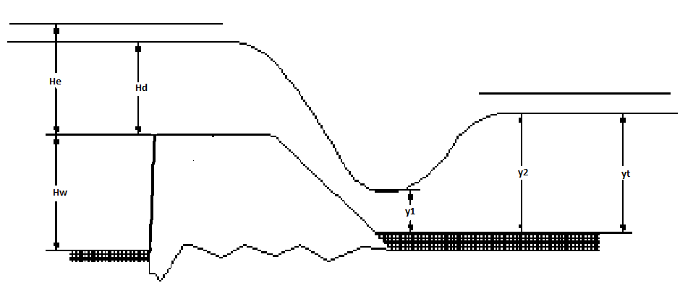

$$\frac{Vc^2}{2g}+Δz+hc=\frac{Va1^2}{2g}+h1a$$
Where, Q_{d}=98.40m³/s
W=15m
$$Δz=h=0.80m$$
q=Q/w=98.40/15=6.56m³/s/m
h_{c}=$\sqrt[3]{\left(\frac{6.56^2}{9.8}\right)}$=1.6m
V_{c}=$\frac{q}{hc}$ =6.56/1.6=4m/s
V_{c}²/2g+h+h_{c}=h_{1a}+V_{1a}/2g=h_{1a}+q²/(2g*h_{1a}²)
4²/(2*9.8)+0.8+1.6=h_{1a}+6.56²/(2*9.8*h_{1a}²)
0=h_{1a}+43.034/(19.6*h_{1a}²)-3.22
The value of h_{1a} is calculated by trial and error calculation. Refer to Excel format 7 for calculation.
The result of calculation, h_{1a}=0.98m.
1. Water depth (h_{1a})
#Please input data into yellow cell
#The input data of green cell is the value assumed yourself. (Goal seek "By changing cell")
#Blue cell is the "set sell" for Goal seek. "to value" = 0
①Design flood discharge (Qd) = |  |  |  |  | 75 | m3/s
②Length of weir (W) = |  |  |  |  | 20 | m
③Flow per unit width of design flood discharge (q) |  |  |  |  | 3.75 | m3/s/m
④Weir height (h) = |  |  |  |  | 0.6 | m
⑤Critical depth (hc) = |  |  |  |  | 1.13 | m
⑥Velocity of critical depth (Vc) = |  |  |  |  | 3.32 | m
⑦Water depth at the weir toe (h1a) = |  |  |  |  | 0.664 | m | ← Goal seek ("By changing cell")
⑧The result of calculation |  |  |  |  | 0.000 |  | ← Goal seek ("set cell". "to value" = 0)

- Calculation of water depth at the beginning point of hydraulic jump (d₂=h_{1b})
$\frac{h1b}{h2}$ =1/2*($√((1+8F2^2))$-1)=$\frac{d2}{d3}$
Where, h₂=d₃=1.85m (tail water depth from rating curve)
F₂=V₂/$\sqrt{(gh2})$=q/(h₂*$\sqrt{(gh2})$= 6.56/(1.85*$\sqrt{(9.8*1.85})$=0.83
h_{1b}=d₂=h₂/2*($\sqrt{(1+8F2^{2})}$ -1)=1.85/2*($\sqrt{(1+8*0.83^2)}$ -1)=1.44m
- Comparison with h_{1a} and h_{1b}
h_{1a}=0.98m<h_{1b}=1.44m (i.e. h_{1a}<d₂) => It needs riprap.
In the case of Bede River Weir site, there is existing natural bed rock which can serve as riprap and hence, no need of additional riprap.
- Calculation of supercritical length
=> q²x/C²+a=h⁴/4-h_{c}³*h
Where, C=h^{1/6}/n
=>h_{1a} is substituted for this equation (h=h_{1a},x=0)
=>a=h_{1a}⁴/4-h_{c}³h_{1a}=0.98⁴/4-1.64³*0.98= -4.09
=>h_{1b} is substituted for this equation (h=h_{1b})
n=0.04
C=h_{1b}^{1/6}/n=1.44^{1/6}/0.04=26.56
X=L₁=-C²/q²(h_{1b}⁴/4-h_{c}³h_{1b}-a)=-26.56²/6.56²(1.44⁴/4-1.64³*1.44-(-4.09))=54.70m.
- The length of hydraulic jump
L₂= (4.5$\sim$6)*h₂=(4.5$\sim$6)*1.85=8.33m$\sim$11.10m

- Length of upstream Riprap
The length of upstream riprap is desirably longer than water depth at the flood time (H_{d}=1.60m). In consideration of water depth, upstream length is designed as follows.
Length of upstream riprap is therefore, say L= 2m.

Foundation work
The foundations of a weir must transmit the loads of pier, weir body, etc. safely to the bedrock below or in subsoil stratum having sufficient bearing capacity. .In addition it reduces the ground water flow below the weir body owing to difference in water level between upstream and downstream. It serves as a cut-off wall to secure required creep length preventing the piping of the gravel layer.
Therefore, in the design of the foundation of the head works, care must be taken to understand the objective thoroughly, adopt the construction method that is suitable for the site, make design choices be economical and durable, and thoroughly execute said construction method.

- Types of foundation work
Based on geological data, this weir foundation selects spread foundation because there is hard rock (hard brown ignimbrite rock) at proposed head works site excavated around 0.5m to 1.5m from the surface.
The design of footing is performed by the following procedure:
- Calculate the load on the base of the footing.
- Obtain the allowable bearing capacity of the supporting ground.
- Determine the configuration and sizes of footings so that the maximum contact pressure acting on the base of the footing is less than the allowable bearing capacity.
- Determine the section and arrangement of reinforcing bar for the footings.
Allowable Bearing Capacity of ground
To obtain the allowable bearing capacity of the ground there are the following methods:
① Allowable bearing capacity is determined from the ultimate bearing capacity formula using the results of soil test.
② Allowable bearing capacity is determined directly from the results of a plate bearing test.
③ Allowable bearing capacity is determined from the conventionally adopted table of bearing capacity of ground.
Using method 3 above and since our foundation is on bed rock it is adopted the bearing capacity of 1000kN/m².
(a) Contact pressure
Considering when the vertical load from the superstructure acts on the center of the base of the footing, the contact pressure is distributed uniformly over the entire base area, the following formula is applied.
$σα=\frac{P}{A}≥qa$ Where$, σα$ .: contact pressure (KN/m²)
P : vertical load acting on footing (including dead load of footing) (KN)
A : base area of footing (m²)
q_{a} is allowable bearing pressure, here q_{a}=1000kN/m² for bed rock)
$$σα=\frac{(dead loadl+External load)}{15*2.20}=\frac{((27.6+6.4)+23(15*2.20))}{33}$$

$\frac{(34.04+759)}{33}$=793.04kN/m²$≤$ 1000kN/m² OK!

When an eccentric load acts on the base of the footing as shown in one end of the footing is lifted up as the eccentricity of the load exceeds a certain value and the contact pressure at that portion becomes zero. Assuming that the contact pressure is distributed linearly, the maximum contact pressure is examined by the formula
$$σmax=\frac{αP}{A}$$
Where,: maximum contact pressure (KN/m²)
$α$ : Coefficient determined by eccentricity of load and configuration of bottom. It is 1 where there is no eccentricity. Generally, the extent of eccentricity in an independent footing should be limited to e /L = 1/3.
Fig. bellow shows the value of$α$ in the range of
0…e /L … 1/3.
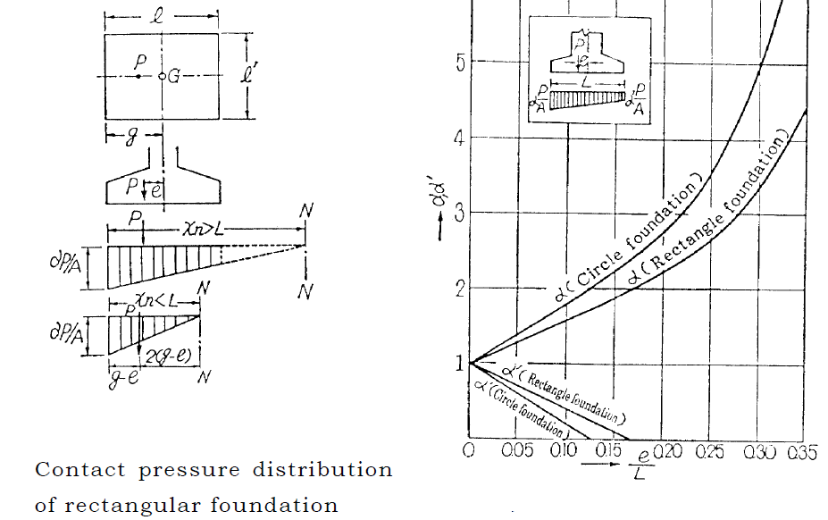
When an eccentric load and moment act on the base simultaneously as shown in Fig. here under, the equivalent eccentric load indicated by the broken line is substituted, and using
$e$＝ $\frac{\sum{MG}}{P}$=$\frac{M+Pε}{P}$=$\frac{M}{P}+ε$

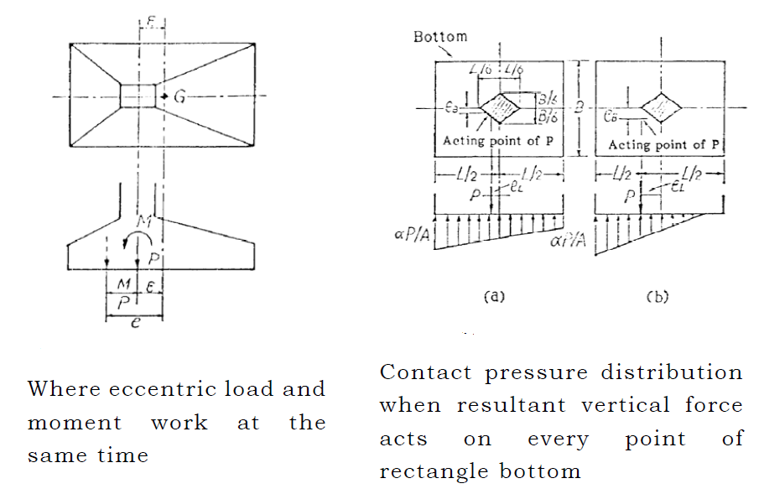

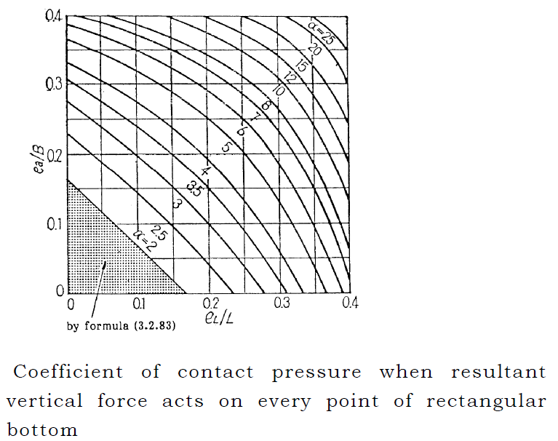

When the vertical load is acting on the outside of the shaded portion, the compressive stress becomes zero at a part of the base. The value $∝$ in this case can be obtained from the Figure above.

Average River Bed Level =EL.2400m
Foundation=EL.2400-0.60m=EL.2399.40m (until hard rock)
The long term allowable bearing capacity is adopted 1000kN/m² for bed rock.

Upstream and downstream cut-off walls
A cut-off wall must be an impermeable structure with sufficient depth.
In the case of Bede River Weir Site, foundation is non-permeable foundation (River bed is hard rock).So, it is unnecessary to consider cut-off walls both upstream and downstream.

Inlet
An inlet must be designed to prevent soil, sand and floating material, which are undesirable in irrigation water, from entering the canals.
Inlets must allow the designed flow-rate and be safe from external forces. The principle of inlet design is to ensure the consistent intake of water and prevent inflow of sand. Stability of the river course, river meandering condition and runoff condition should be studied to fulfill the principles.
- Function of Inlet

Inlet must have sufficient capacity to draw the design discharge from a river and transfer the flow to the irrigation canal. Generally, discharges in rivers are subject to change and at the time of flood, large amount of soil, sand, and floating debris materials are carried by the river flow. Thus, the inlet is expected to enable easy control of intake discharge and prevention of the materials carried by flood waters from flowing into the canal. For these purposes discharge control gate, gate pillar, screen (trash rack), conduit (bank crossing culvert etc), intake apron sand drain may have to be installed.
Minimization of maintenance and operation costs for these facilities is important.

Scouring Sluice Size
For scouring sluice in case of rapid stream (river slope $≥\frac{1}{800}is as follow$.(i.e. 0.074 $≥0.00125)$
- Diameter of River bed material
- Maximum grain size (90% by weight), de=0.5m
- Average grain size (60% by weight), dm=0.15m
- Design of Scouring Sluice intake
In the condition that the flow within the scouring sluice should be supercritical, the critical flow will be caused at the intake. And the design should be so made as to transport the maximum size particles of the river bed materials with this critical flow. The critical velocity required to transport sediment V_{e} can be given by the following formula experimentally.
V_{e}=$\sqrt{(20*de)}$=$\sqrt{(20*0.5)}$=3.16m/s
h_{c}=20*de/g=20*0.5/9.8=1.02m
q_{e}=${\sqrt{\left(20*de\right)}}^{3}/g^2)= {\sqrt{\left(20*0.5\right)}}^{3}/9.8^2$=3.23m³/s/m.
The height of the guide wall H required to forma channel for the scouring sluice is made 1.5hc at the point of intake.
H=1.5*hc=1.5*1.02 $≥1.5m$.
So, the height of the guide wall: H=1.53m $>$ weir height h=0.8m Not Ok!
Use average grain size (60% by weight) de=0.15m
V_{e}=$\sqrt{(20*de)}$=$\sqrt{(20*0.15)}$=1.73m/s
h_{c}=20*de/g=20*0.15/9.8=0.31m
q_{e}=${\sqrt{\left(20*de\right)}}^{3}/g^2)= {\sqrt{\left(20*0.15\right)}}^{3}/9.8^2$=0.054m³/s/m.
H=1.5*0.31=1.5*0.31 $=0.465≅0.50m$. (i.e 0.5m below weir crest=EL.2400.80m-0.50m=EL.2220.30m.
This is below the intake design bed level 2400+0.5+0.2=EL.2220.70m Not Ok!
Use The Weir height h=0.80m as sluice guide wall (H).
The critical water depth: hc=H/1.5=0.53m
So, qe=$\sqrt{\left(ghc^{3}\right)}$ =$\sqrt{\left(9.8*0.53{^}^{3}\right)}$=1.22m³/s/m. Use the width of the scouring sluice Bs=0.50m.

Gate
The gate structure must be watertight to ensure stable water intake and firm enough against several external forces like flowing water.
Steady and smooth operational workability is also required for its function.
A gate is one of the most important facilities to control both water utilization and floods. The following conditions are to be fulfilled for the purpose of water use and flood control. Conditions required from the view point of Water use are:
- to keep a constant required water level and to control intake level and discharge and
- to have water tightness
According to the result obtained from the scouring sluice gate, H=0.60m, B_{s}=1m
So, skin plate area=0.60*1=0.10m².
This gate will be opened during rainy season, so the upstream water height of gate assumes height of gate plus half of design flood height for safety.
H_{upstream}=0.60m+1.60m/2=0.80+0.60m=1.40m.

According to table below the upstream water height is 1.60m, Area=0.8*1m and thickness will be 7mm.
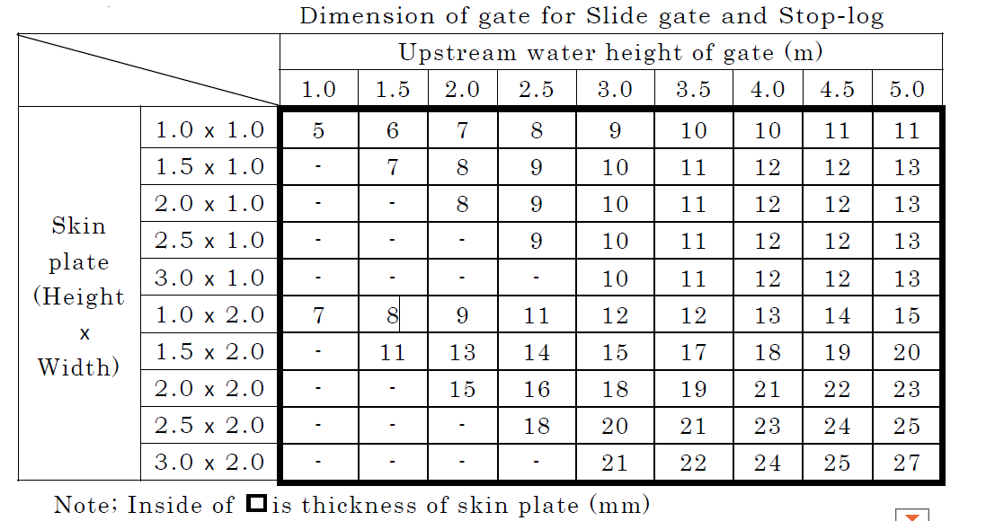
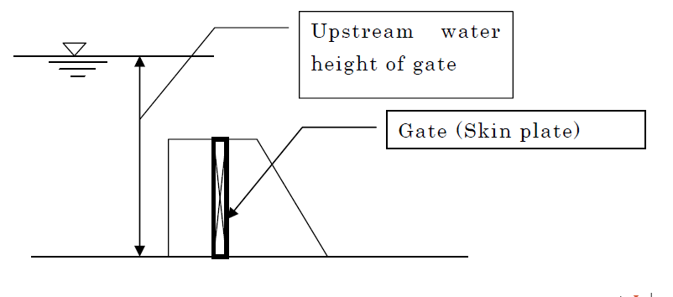

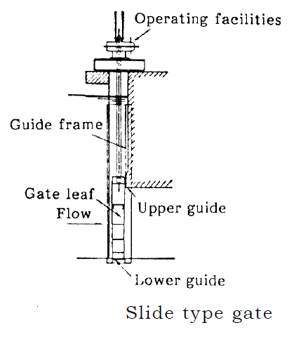

Settling Basin

Settling basin is used to settle and exclude sand which may flow into an intake facility under certain river conditions and which may obstruct canals and degrade their functions.
For the case of Bede River, the prevention of sediment inflow into the canal is secured by installation of intake gate and scouring sluice for this particular project, hence, settling basin is not required.

Protection of River bank and major bed
In constructing a weir, bank protection may be required to prevent erosion of the banks or dikes for a certain section of the river. Major bed (Flood plane) protection may also be required to prevent erosion.
1) Protection of transition and dike
Discharge and flow direction may change due to construction of a weir. Protection works of riverbed, minor bed, major bed and river bank may be necessary against these changes. In the place of head works, if there is low elevation land than design flood level (EL. 2221.01m), it is necessary to protect this part from flood.

Further protection of up- and down-stream river bank in this section may be necessary.
When a weir is designed at a curved section of the river, transition protection should be extended further than the distances mentioned above at the downstream side. Bank protection height is higher than design flood level (freeboard 0.5～0.6m) or as high as original river bank height.
Hence crest elevation of guide bank’s are EL.2220.0m+0.50m+0.6m=EL.2221.01m.
For the length 10m bottom width is 1m and top width is 0.5m.

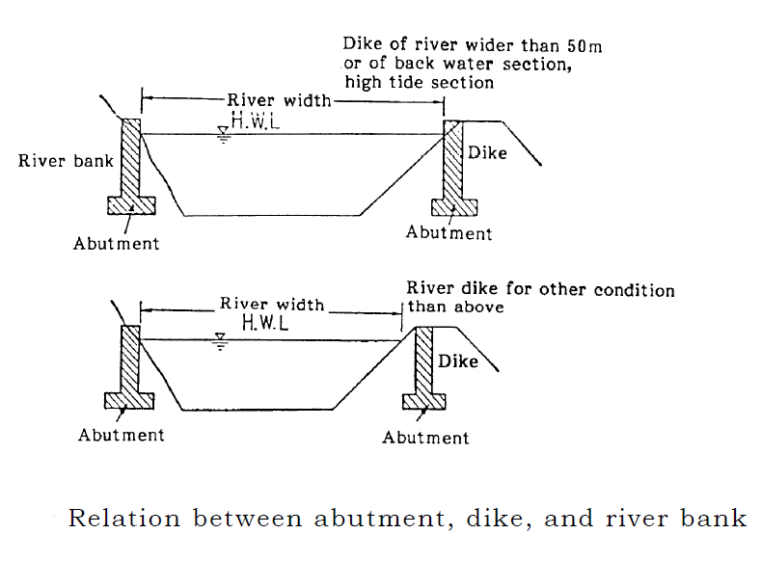
- Design of upstream slope of channel

In assuming the water depth at the downstream end of the supercritical flow, canal h and then value of the canal, following table can be obtained. Refer to excel format 8 for the detail.
Formula: n²g/h_{c}^{1/3}<n²gh_{c}³/h_{m}^{10/3}<8.25*10⁻²d_{m}/h_{m}
Where, n=0.018, h_{c}=1.64(m),h_{m}:(hc+h)/2(m),dm=0.15(m)

Excel format 8. Scouring sluice
1.Test calculation table of water depth
#Please input data into yellow cell
#The input data of green cell is the value assumed yourself. (Goal seek "By changing cell")
#Blue cell is the "set sell" for Goal seek. "to value" = Q value
<Formula>
n²g/h_{c}^{1/3} < n²gh_{c}³/h_{m}^{10/3} < 8.25*10⁻²d_{m}/h_{m}
n = | 0.018
g = | 9.8 | m/s²
h_{c} = | 1.64 | m
h_{m} = | (h_{c}+h)/2 | m
d_{m} = | 0.15 | m
↓This value is assumption
h(m) | h_{m} | n²g/h_{c}^{1/3} |  |  | n²gh_{c}³/h_{m}^{10/3} |  |  |  |  | 8.25*10⁻²d_{m}/h_{m}
0.3 | 0.97 | 0.0026925 | = | 1/371 | 0.0155023 |  | = | 1/65 |  | 0.0127577 |  |  | = | 1/78 |  |  | NG
0.35 | 0.995 | 0.0026925 | = | 1/371 | 0.0142416 |  | = | 1/70 |  | 0.0124372 |  |  | = | 1/80 |  |  | NG
0.4 | 1.02 | 0.0026925 | = | 1/371 | 0.0131110 |  | = | 1/76 |  | 0.0121324 |  |  | = | 1/82 |  |  | NG
0.45 | 1.045 | 0.0026925 | = | 1/371 | 0.0120943 |  | = | 1/83 |  | 0.0118421 |  |  | = | 1/84 |  |  | NG
0.5 | 1.07 | 0.0026925 | = | 1/371 | 0.0111778 |  | = | 1/89 |  | 0.0115654 |  |  | = | 1/86 |  |  | OK
0.55 | 1.095 | 0.0026925 | = | 1/371 | 0.0103496 |  | = | 1/97 |  | 0.0113014 |  |  | = | 1/88 |  |  | OK
0.6 | 1.12 | 0.0026925 | = | 1/371 | 0.0095994 |  | = | 1/104 |  | 0.0110491 |  |  | = | 1/91 |  |  | OK
0.65 | 1.145 | 0.0026925 | = | 1/371 | 0.0089183 |  | = | 1/112 |  | 0.0108079 |  |  | = | 1/93 |  |  | OK
0.7 | 1.17 | 0.0026925 | = | 1/371 | 0.0082988 |  | = | 1/120 |  | 0.0105769 |  |  | = | 1/95 |  |  | OK
0.8 | 1.22 | 0.0026925 | = | 1/371 | 0.0072183 |  | = | 1/139 |  | 0.0101434 |  |  | = | 1/99 |  |  | OK
0.9 | 1.27 | 0.0026925 | = | 1/371 | 0.0063138 |  | = | 1/158 |  | 0.0097441 |  |  | = | 1/103 |  |  | OK
1 | 1.32 | 0.0026925 | = | 1/371 | 0.0055512 |  | = | 1/180 |  | 0.0093750 |  |  | = | 1/107 |  |  | OK
1.1 | 1.37 | 0.0026925 | = | 1/371 | 0.0049042 |  | = | 1/204 |  | 0.0090328 |  |  | = | 1/111 |  |  | OK
1.2 | 1.42 | 0.0026925 | = | 1/371 | 0.0043519 |  | = | 1/230 |  | 0.0087148 |  |  | = | 1/115 |  |  | OK
1.3 | 1.47 | 0.0026925 | = | 1/371 | 0.0038777 |  | = | 1/258 |  | 0.0084184 |  |  | = | 1/119 |  |  | OK
1.4 | 1.52 | 0.0026925 | = | 1/371 | 0.0034686 |  | = | 1/288 |  | 0.0081414 |  |  | = | 1/123 |  |  | OK

2.Test calculation of upstream slope
1 = | 3.7 | m
h = | 1 | m
h_{m} = | 1.035
 |  |  |  |  | = | 0.213967165 | = | 1/5
3.Confirming a calculation
<Formula>
Q = B*h* I^{1/2} * (Bh/(B+2h))^{2/3} / n
n = | 0.015
Q = | 0.012 | m3/s
B = | 1 | m
I = | 0.074
de = | 0.5 | m
 | ↓ Goal seek ("By changing cell")
h = | 1.21 | m | > | 0.5 |  | OK
The result of calculation
 | 0.012 | ← Goal seek ("set cell". "to value" = Q value)

2. Design of Canals and Related Structures

This part shows the crucial data and calculation for basic design of canal and related structures.
The design and construction of each canal in different conditions, technical and economic criteria must be considered depending on the canal function, network, system, scale and other field conditions such as topography, etc.

Canals are broadly divided into canals for conveying water (such as main canals and lateral canals) and canals for distributing or collecting water (such as farm ditches and farm drains), according to their functions and hydraulic characteristics.

Basic Data for design of canal

(1) Data from surveyor
- Topographic map, cross-sections, longitudinal section (canal profile)
- The highest elevation of the irrigation area (starting point of irrigation area)=EL.2198m.
- Canal length from starting point of irrigation area (the highest elevation of the irrigation area) =5440m.
- This data is an assumption value at first.
- Canal slope=1/1000(Lined Canal), (1/2000(Earthen Canal).
- This data is an assumption value at first.
- Data from Hydrologist
- The amount of usable water for irrigation=94l/s
(Comparison with agronomist data)
- Data from Agronomist
- The Crop Water Requirement, duty=1.57l/s/ha
(Comparison with hydrologist data)
- Data from geologist
- The geological condition on canal route

Lth | Chain age |  | Detail Geological description | General properties | Remark
Lth | From | To | Detail Geological description | General properties | Remark
80 | 0+000 | 0+080 | Massive ignimbrite rock | Sealing its cracks or joints is needed, no need of masonry wall, instead removing its upper weathered part and closing openings | Lined
120 | 0+080 | 0+200 | Moderately weathered ignimbrite | Easily excavated with hand tools, should be removed | Lined
10 | 0+200 | 0+210 | Flume 1 | Has 10m width span and foundation at 2m depth | Flume
184 | 0+0210 | 0+394 | Silty clay soil | Holds water properly | Earthen
160 | 0+394 | 0+554 | Marshy Area | Pervious formation diverting water to be percolated | Lined
10 | 0+554 | 0+564 | Flume 2 | Has 8m width span and 11m depth with rocky abutments | Flume
170 | 0+564 | 0+734 | Silty clay soil with sands | Partially transfer water | Lined
30 | 0+734 | 0+764 | Marshy area | Pervious formations | Lined
280 | 0+764 | 0+1044 | Red silty clay | Holds water | Earthen
90 | 0+1044 | 0+1134 | Weathered tuff with sandy silty clay | Poor in holding water lined
60 | 0+1134 | 1194 | Boulders of ignimbrite rock | Poor in holding water | Lined
10 | 0+1154 | 0+1164 | Aqueduct 1 | 5m width with 2m depth and rocky foundation | Aqueduct
56 | 0+1194 | 0+1250 | Top rooted soil overlying sandy clay | Slightly transfer water | Lined
40 | 0+1250 | 0+1290 | Boulders of ignimbrite rock dominated with silty clay soil | Poor in holding water and ignimbrite can be used for masonry canal lining | Lined
360 | 0+1290 | 0+1650 | Weathered tuff +silty clay | Moderately transfer water | Lined
410 | 0+1650 | 0+2060 | Ignimbrite bed + Forest | Its joints doesn't hold water properly and plant root enhances percolation | Lined
70 | 0+2060 | 0+2130 | Sand + silty clay | Highly permeable | Lined
10 | 0+2060 | 0+2070 | Flume 3 | 5m width on unstable loose soil formation | Masonry guide wall
70 | 0+2130 | 0+2200 | Red silty clay + sand + weathered tuff | Highly permeable and enhanced percolation | Lined
10 | 0+2200 | 0+2210 | Aqueduct 2 | 6m width on sandy soil | Aqueduct with gabion
410 | 0+2210 | 0+2620 | Forest + land slide | Unstable for canal sustainability | Gabion + lined
10 | 0+2270 | 0+2280 | Foot Path | 3m width on red sany silty clay | Closed canal
10 | 0+2280 | 0+2290 | Aqueduct 3 | 3m x 3m x 0.5m needs gabion wall | Aqueduct
410 | 0+2290 | 0+2700 | Erosion and slide land | Needs sustainable land management | Linig
140 | 0+2700 | 0+2840 | Boulders + Forest | Plant root increases water percolation | Lining
250 | 0+2840 | 0+3090 | Red silty clay soil | Good water holding capacity | Earthen
60 | 0+3090 | 0+3150 | Forest + boulders $ bed of ignimbrite | Joint and plant root plays great role in water percolation | Lining
350 | 0+3150 | 0+3500 | Loom soil + Forest | Poor water holding capacity | Lining
610 | 0+3500 | 0+4110 | Boulders and ignimbrite bed | Dark grey slightly weathered ignimbrite rock with insitu soil. | Lining
10 | 0+4060 | 0+4070 | Flume 4 | Its bed is rocky foundation 4m width | Flume
110 | 0+4090 | 0+4100 | Aqueduct 4 | Soil foundation with 2m span | Aqueduct
440 | 0+4110 | 0+4550 | Forest + Rock+sol | Thick forest with boulders and silty clay | lining
10 | 0+4210 | 0+4220 | Aqueduct 5 | Aqueduct of 2m width | lining
10 | 0+4240 | 0+4250 | Aqueduct 6 | Aqueduct of 2m width | lining
10 | 0+4320 | 0+4330 | Flume 5 | Flume of 5m width | Lining
10 | 0+4400 | 0+4410 | Aqueduct 7 | Aqueduct of 2m width | lining
520 | 0+4550 | 0+5070 | Silty clay | Red silty clay of 1.5m av depth | Earthen
50 | 0+5070 | 0+5120 | Forested | Thick forest of loom soil (plant rooted) | lining
10 | 0+5090 | 0+5100 | Aqueduct 8 | Aqueduct of 5m width | Aqueduct
10 | 0+5140 | 0+5150 | Aqueduct 9 | Aqueduct of 2m width | Aqueduct
5.3km | 5350 |  |  | Command area starts

8.9.15 Classification of canals by System
The irrigation canal is classified into the main canal that conveys irrigation water from the intake point to the irrigation areas (here it is 520m long MC), and into the lateral canal, which is branched off from the main canal to distribute water into individual irrigation blocks (here secondary canals- SC) and Tertiary canal TC, which supplies from irrigation blocks to farm furrow field canal FC. The drainage canal DC is also classified into the main canal and lateral canal from the drainage outlet to the upstream.

The main irrigation canals, canals which convey irrigation water from the intake points to the regulating reservoirs, major division works, etc. are often called head races. Lateral canals are also divided into secondary (SC) and tertiary canals (TC).

Canal Shape
Canal shapes affect the flow of water in open canals and hence should be designed for mean allowable velocity.
Allowable Flow Velocity
The design velocity of canal must be determined within the limits of two factors: the minimum allowable velocity which produces neither deposit of sand and earth nor growth of water weeds, nor the maximum allowable velocity which produces no erosion if canal component materials by the flow not hydraulically unsafe conditions of flow in the canal. (Minimum is from 0.45m/s-0.9m/s and maximum is 1.5 times 0.45-0.9)
Tunnel, Culvert – more than 1.3 times the velocity in open channel
Siphon – more than 1.5 times the velocity in open channel

Hydraulic design of canals
The hydraulic design of canals must be made for the design discharge and to secure hydraulically purposed designed level, and the design of respective facilities in the canal system must be made for not only the design discharge but also other discharges so that their purposes and functions can fully be fulfilled. Discharges other than the design discharge are the most-frequent discharge and the minimum discharge for an irrigation canal, and in a drainage canal, discharge to study low water revetment, and discharges that may make troubles to important canal facilities.
1) Irrigation canal
(a) Most-frequent discharge
This discharge is used to confirm the flow condition in examining the minimum allowable velocity in the canal facilities.
(b) Minimum discharge
This discharge is used to examine the functions of diversion works and related facilities for water level regulation when the discharge decreases.
2) Drainage canal
(a) Discharge to study low water revetment etc.
Probable discharge with a return period of one year or two is usually applied for the revetment planning of drainage canals. The water level related with this discharge is used for the structural design of the drainage canal such as the determination of the revetment height, etc. This discharge is also used to check the function of a drop. In addition, the minimum allowable velocity in the drainage canal is usually examined by use of the probable discharge with a return period of one year or two.
(b) Discharges that may make troubles to important canal facilities
When corresponding damages are expected from the scale of facilities, discharges, which flow the full section of a canal, should be studies to examine flow conditions and capacity of a canal and be used to study structural conditions, alignment of facilities and countermeasures for expected troubles.

Canal Cross Section
Cross-sections of canals differ depending on the respective canal size, but generally in cases of canals where quantity of flow is small, bottom width/depth ratio of around 2:1 is adopted. Where quantity of flow is large, width/depth ratio of up to around 8:1 is applied. Inner gradient of slopes of canals often takes values of around 1:1.5 to 1:2.5, and in cases where soil character is especially of good quality and the canal size is small, inner gradient of slopes shall be able to be steeper within a range where no trouble occurs on the slope stability. In such cases, inner gradient of slopes are sometimes as steep as around 1:0.8 to 1:1.1.

Hydraulically favorable cross section is decided by the following formula.

B=2H*tan ($θ/2)$
But in the case of unlined canal, the slope of the canal is decided as table below.

Thickness of linings
Thickness of linings shall be determined through studying the canal size, purposes, degree of importance, and conditions of future maintenance, etc.
Generally, the value shall be around 10 cm as a standard. In cases of including reinforced concrete lining canals or cold climates, or where canal size is extraordinarily large, it shall be studied to increase the thickness, or others.

Design of unlined canals
Unlined canals are generally applied to drainage canals or the like where it
is not necessary to consider leakage prevention.

(a) Alignment of curves
Maximum degree of curvature θ = around 60 degrees
Minimum radius of curve R = around 10B
Where B is Canal width (m)
(b) In cases where curves are adopted, continuous curves shall be avoided and a straight section with length of six times or more canal width shall be placed in between curved sections.
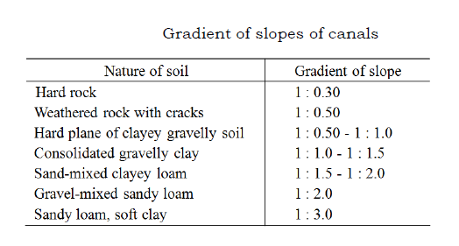
Determination of the design velocity
Determination of the design velocity is one of the important factors for the design of canals and the cross sections of canal structures. The design velocity is determined between the minimum and maximum allowable velocity taking into consideration the functions and structure of a canal.

Considerations for determination of design velocity

Hydraulic conditions in a canal must be carefully examined in determining the design velocity of an irrigation canal. Under the nearly critical flow conditions, the water surface in the canal tends to become unstable, producing waves which do not vanish quickly. These cause a lowering in the efficiency of the canal function. It is generally recognized that the stability of flow in the canal is controlled by the velocity, though it can vary owing to many factors such as discharge, velocity, change of cross-section area, bends, etc. A velocity of less than two-thirds of the critical velocity (Froude number: 0.54) may be expected to stabilize the water surface in the canal.

Fr=v/$\sqrt{(g*h)}$ < 0.54

Accordingly, the above velocity must be applied to conditions under subcritical flow in the irrigation canal.
Calculation of Mean Velocity

Dimensions of the cross section of a canal are determined, in principle, from the design discharge calculated by mean of velocity formula. The calculation of the uniform flow velocity must in principle be made according to the
Manning’s mean velocity formula for an open channel type canal and Hazen William’s formula for a pipe line type canal.

Discharge of canal
The discharge of the canal is calculated using the following formula:
Q = A · V
Where, Q: Discharge (m³/s)
A: Cross-section area (m²)
V: Mean velocity (m/s)
(2) Mean velocity formula of open channel type canal
The mean velocity of an open channel type canal in the above formula is calculated according to the Manning formula as a rule.
V= $\frac{1}{n}*$R2/ 3 *I^{1 /2}
Where, V: Mean velocity (m/s)
n: Coefficient of roughness
R: Hydraulic radius (m) (R=Cross-section area (A)/Wetted perimeter (P))
P: Wetted perimeter (m)
I: Hydraulic gradient (canal bed slope)
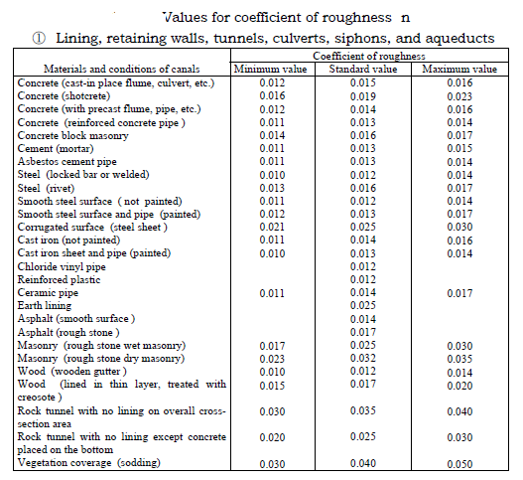
Effects of bends, sedimentation and vegetation on coefficient of roughness
The following factors have an effect on the coefficient of roughness.
- Canal bends: The coefficient of roughness (n) increases when a canal meanders because such meandering produce losses and sand deposits in the canal. In the case of low velocity, increases of n may be neglected. In general, n increases about 0,002 as an allowance for canal bend losses when the canal has curves, and n in a natural meandering channel increases by 30%.

Determination of cross-section area of a uniform flow canal
The water depth of a uniform flow canal can be obtained by trial calculations using the Manning formula. Alternatively, other various calculation methods may be suggested for convenience’ sake such as:
A · R^{2/3}= n · Q.I, obtained by Manning’s mean velocity formula. The graphic solution method is also useful for obtaining answers easily for a complicated cross-section area. The most appropriate method must be selected after taking into consideration factors, which affects the determination of the cross-section area of the canal. For a canal with a relatively gentle slope from the topographic point of view, the maximum possible canal slope may be an important factor for determination of the cross-section area of the canal. Whereas when topographic slope becomes steep and velocity high speed, it is necessary to modify the canal slope by providing drops for the prevention of high velocity in the canal.

Head losses and change of water level
1) Head losses (which should be) considered in hydraulic design
The following head loss must be considered in principle in the canal design.
① Head loss due to friction,
② Head loss due to inflow or outflow,
③ Head loss due to change of canal section,
④ Head loss due to trash rack, and
⑤ Head loss due to pier.
Head loss due to friction
The calculation of head loss due to friction is made by using the Manning formula as shown below:

Hf=Q²/2*l(n₁²/R₁^{4/3}*A₁+ n₂²/R₂^{4/3}*A₂)= 1/2*l(n₁²*v₁²/R₁^{4/3}+ n₂²* v₁²/R₂^{4/3}

Where Q: Discharge (m3/s)
Hf : Head loss due to friction (m)
R: Hydraulic radius (m)
V: Mean Velocity (m/s)
A: Cross section area of flow (m2)
l: Distance calculated (m)
n: Coefficient roughness

Canal free Board
(1) In case of normal canal (Fr=$\sqrt{\frac{v}{(gh}}$ $≤1$), canal free board is decided by the following formula.
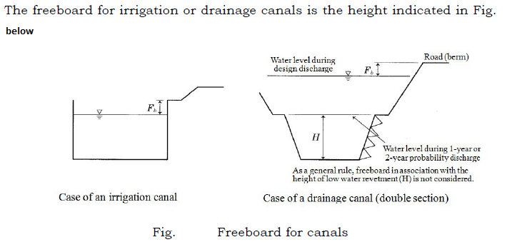
- Retaining wall canals
(Flumes, retaining wall canals (masonry), box, culverts, readymade product canals, etc.)
- Fb=0.07d+$β*hv+hw----------subcritical flow$
- Non-lining canals by concrete
- Fb=0.05d+$β*hv+hw$
- In case of super critical or rapid flow canals (Fr=$\sqrt{\frac{v}{(gh}}$ $>1$)
Canal freeboard is decided by the following formula
- Fb=C*Vh^{1/2}
Fb=0.6+0.037*Vh^{1/3}
There is a range at the length of freeboard calculated above formula, so free board is decided on actual site condition.
Calculation on Canal shape
Based on (i)$\sim$(ii) above, canal shape is decided. The check points are as follow.
- Minimum and maximum allowable velocity
- Froude number
- Cross Section Form
- Canal Free Board

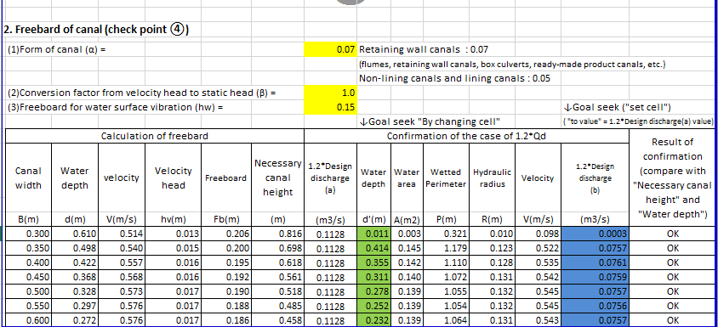

Take freeboard of 20cm.
Therefore, Use Masonry Main Canal MC conveying Q=94l/s with the following parameters:
Canal width (B) =0.50m
Canal Depth (D)=0.32m+0.20m=0.52m. Say, D=0.5m Canal slope (S)=1/1000=0.001,
Top width say (tw)=0.30m and
Bottom thickness= 0.25m hardcore+0.04m lean concrete +0.01m cement screed=0.30m( Finally these parameters should be checked in the overall canal stability analysis).

From previous calculation of water level at MC start, Canal slope was assumed S=1/1000. After detail canal design it became 1/500 and adjustments should be made at chute sections.

Earthen Canal

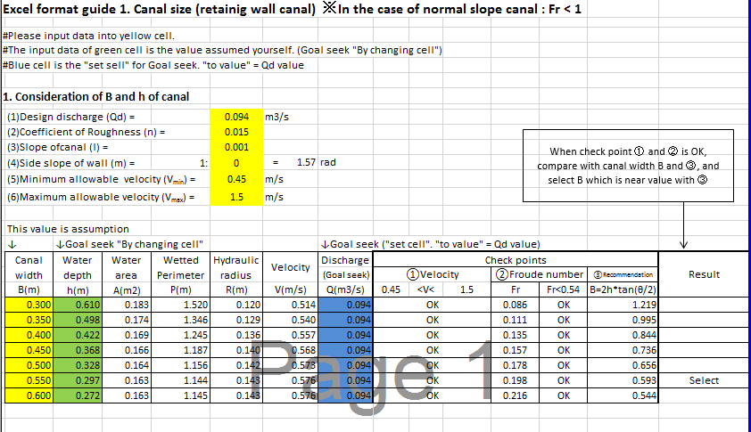

B=500mm, D=200mm+200mm=400mm, side slope 1:1 , slope of canal=1/250

Design of open Channel(Trapezoidal) |  |  |  |  | Project: Bede
1.Given Values | Earthen MC | Type- Earthen |  | Soil- Loamy sand
Particular | Designation | Unit | Value | Remarks
Discharge | Q | m3/s | 0.028 | use n, 0.025 for earth canal
Manning's Co-eff. | n | _ | 0.025 | n, 0.015 for lined canal
Side slope, inner | m | _ | 1.5 | n, 0.02 for pitched canal
Canal bed slope | s | _ | 0.004 | use m, 1.0-1.2 for clayey soils
 |  |  |  | m,up to 1.5 other types
 |  |  |  | use s, 1/800 to 1/900 for MC,Check V at end
 |  |  |  | s, 1/700 to 1/800 for SC, "
 |  |  |  | s, 1/500 to 1/700 for TC, "
 |  |  |  | s, 1/300 to 1/500 for FC, check Perm.Veloc.
2.Trial Value
Water Depth | y | m | 0.1 | Remarks
Canal bed width | B | m | 0.50 | It shall be economical
 |  |  |  | s,B and Y are: | Variable Elements
 |  |  |  |  | Use B=0.50m
3. Computed Values
Particular | Designation | Unit | Value | Formula used | Remarks
Wetted perimeter | P | m | 0.860 | B+2Y(1+m²)^{1/2}
Area of water | A | m² | 0.065 | By+my2
Hydraulic Radius | R | m | 0.075 | A/P | Economical Section
Discharge | Q | m³/s | 0.029 | (A*R^{2/3}*s1/2)/n | Check with above value
Velocity | V | m/s | 0.452 | Q/A | Check with Max. Perm. value
Maximum Permissible values of V
Channel Type | Velocity(m/s) | W  T  Y  1:z  1:m  F  B  Typical Canal Cross section
Sandy soil | 0.45
Sandy loam | 0.6
Loam | 0.7
Clayey loam | 0.9
Clayes | 1
clay with sand | 1.2
soft rock | 2.5
Moderately hard rock | 2.5
hard rock | 3 |  | B- Canal Bed Width
Thick conc.(>18cm) | 3.5 |  | Y- Canal Water depth
Thin conc.(<10ch) | 1.5 |  | F- Canal Free Board, Shall not be less than 0.3m
Asphalt | 1 |  | for earthen canals except for field canals and TC .
Conc.block dry masonry |  |  | of little flow rate.
(Stay< 30 cm) | 1.5 |  | T- Canal top width
(Stay > 30 cm) | 2 |  | W- Canal embankment top width
Conc.Block wet masonry | 2.5 |  | z- Canal side slope(external)
pre-cast conc. Pipe | 2.5 |  | m- Canal side slope( inner)
Steel pipe | 5

Take B=0.5m,W=0.3m,F=0.3m, m=1, z=1.5 for Earthen main canal and SC-1.
Stability analysis of retaining wall Canal
- Loads Acting on Open Channels

Loads to be considered in structural design of the canal are, in general, dead weight, water pressure (internal and external), buoyancy/uplift pressure, earth pressure, vehicle load, impact load, and crowd load and ground reaction.

- Load combination
Common combinations acting on canals built on common ground are described in Fig.below. Calculations shall be performed based on an appropriate load combination selected in consideration of the site conditions of the canal, construction condition, soil condition, etc.
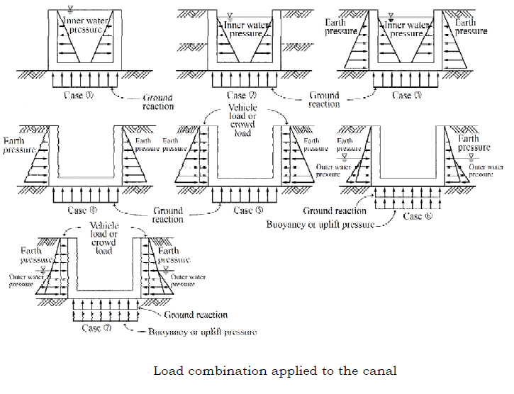
There are three types of calculations for stability analysis according to the ground condition of back side of canal.

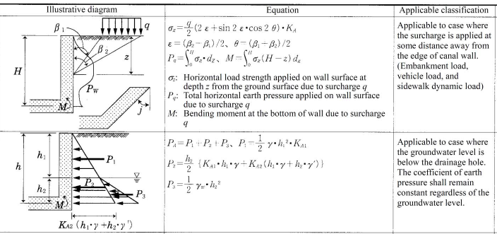

For this project the majority of the main canal passes through inclined ground surface and better to adopt earth pressure on canal wall by inclined ground surface stated on the third figure above. See excel format guide 2 on canal stability analysis below.

Excel format 2. Wall Stability Analysis Type2 (Summary)
#Please input data into yellow cell
1.Basic data for calculation
Item | Value
Unit weight of plane concrete | γc＝ | 23 | kN/m³
Unit weight of soil | γs＝ | 20 | kN/m³
internal friction angle | ϕ＝ | 25 | ° | =0.436rad
Angle between wall's back surface and vertical plane | α＝ | 0.0 | ° | =0.000rad
Inclination angle of wall's backside ground | β＝ | 15 | ° | =0.262rad
Angle of wall friction (normal condition) | δ＝ | 16.7 | ° | =0.291rad
Angle of wall friction (seismic condition) | δ＝ | 12.5 | ° | =0.218rad
Crowd load | q＝ | 3.00 | kN/m²
Unit weight of water | W₀＝ | 9.8 | kN/m³
Coefficient of earth pressure | C₀＝ | 0.45
Uplift coefficient | μ＝ | 1.0
Seismic horizontal acceleration | kh＝ | 0
Seismic vertical acceleration | kv＝ | 0
Seismic compound angle | θ＝ | 0.00 | ° | =0.000rad
Friction coefficient | f＝ | 0.7
Allowable stress of the graund | qa＝ | 50 | kN/m²

Reference
Reinforced concrete: 24.5KN/m3, Plain concrete: 23KN/m3, Cement mortar: 21KN/m3
Rock foundation case or a case using sheet piles reaching an impermeable stratum: 0.4, Otherwise: 1.0
Bedrock=1000KN/m2 See blow.
B1
H
1:m1
1:m2
ω
α
B2
B3
B4
Hd
β

3. The result of calculation
Content |  | Dynamic |  |  |  | Static |  |  |  | Earthquake
Overturning | e<B/6 or B/3 | 0.01 | ≤ | 0.03 | OK | 0.02 | ≤ | 0.03 | OK | 0.02 | ≤ | 0.07 | OK
Sliding | ΣV・f/ΣH≥1.5or1.2 | 1.75 | ≥ | 1.50 | OK | 1.57 | ≥ | 1.50 | OK | 1.47 | ≥ | 1.20 | OK
Settlement | ΣV/B・(1+6e/B)<q_{a} | 8kN/m2 | < | 50kN/m2 | OK | 10kN/m2 | < | 50kN/m2 | OK | 11kN/m2 | < | 50kN/m2 | OK
 | ΣV/B・(1-6e/B)<q_{a} | 4kN/m2 | < | 50kN/m2 | OK | 3kN/m2 | < | 50kN/m2 | OK | 2kN/m2 | < | 50kN/m2 | OK
(Without uplift) | ΣV/B・(1+6e/B)<q_{a} | 9kN/m2 | < | 50kN/m2 | OK
(Without uplift) | ΣV/B・(1-6e/B)<q_{a} | 5kN/m2 | < | 50kN/m2 | OK

Design of inner space width and opening height of gate
Based on the assumed value of inner space width and opening height of gate space width and opening height of gate can be calculated by trial and error calculation. Refer to Excel format guide 3 for the calculation. In case of free out flow (Fr=V/$\sqrt{(g*h)}≥$1)

Q=Ca*b*d*$\sqrt{(2g*h1)}$

Division Box |  | Gate |  |  | h1(m) |  |  | h2(m) | b(m) | D(m) | h1/d | h2/d | Ca |  | Q(m3/s) |  | Design max d(m) |  | d$≤$Design d
DB1 |  | Retaining wall canal ->Secondary Canal |  |  | 0.10 |  |  | 0.10 | 0.20 | 0.10 | 0.45 | 0.45 | 0.45 |  | 0.028 |  | 0.45 |  | Ok
DB2 |  | Retaining wall canal ->Earthen Canal |  |  | 0.10 |  |  | 0.10 | 0.20 | 0.10 | 0.45 | 0.45 | 0.45 |  | 0.028 |  | 0.50 |  | Ok
Excel format guide 3. Opening height of gate (Division box)
 | 1. Opening height of gate (d)
 | #Please input data into yellow cell
 | #The input data of green cell is the value assumed yourself. (Goal seek "By changing cell")
 | #Blue cell is the "set sell" for Goal seek. "to value" = Qd value
 | ①Water depth upstream of gate (h1) |  |  |  |  |  | 0.1 |  |  |  | m
 | ②Water depth downstream of gate (h2) |  |  |  |  |  | 0.1 |  |  |  | m
 | ③Inner space width (b) = |  |  |  |  |  | 0.2 |  |  |  | m
 | ④Opening height of gate (d) = |  |  |  |  |  | 0.222 |  |  |  | m |  |  | ← Goal seek ("By changing cell")
 | ⑤h1 / d = |  |  |  |  |  | 0.45
 | ⑥h2 / d = |  |  |  |  |  | 0.45
 | ⑦Coefficient of discharge (Ca) |  |  |  |  |  | 0.45
 | ⑧Discharge |  |  |  |  |  | 0.028 |  |  |  | m3/s
 | ⑨The result of calculation of discharge |  |  |  |  |  | 0.028 |  |  |  |  |  |  | ← Goal seek
 |  |  |  |  |  |  |  |  |  |  |  |  |  | ( "set cell". "to value" = ⑧ value)

Earth Retaining Structures
By and large most of the load bearing structural components in the weir and its abutments will be made up of stone masonry in mortar. All earth retaining structures will be made to sustain by their self-weight (gravity retaining walls). For the general structural analysis and design of the scheme the Figure is shown below. The stability analysis for side and wing walls of Bede Weir has been also shown.

Demekash River weir guide bank general calculation of free standing rationing wall

q2
t
W₄

 | 8.10 Load Assessment and for Design of Girder Beam
 | Span Length |  |  | 9 | m
 | Flume Dimension (Internal)
 |  | Width |  | 1 | m
 |  | Depth |  | 0.8 | m
 | Wall and slab thichness |  |  | 0.2 | m
 | Water Depth |  |  | 0.8 | m
 | Girder Beams Depth |  |  | 0.5 | m
 | Girder Width |  |  | 0.38 | m
 | Loads
 | Dead Loads
 |  | Water Load |  | 8 | KN/m | (Unit weight of water
 |  |  |  |  |  | = 10KN/m3)
 |  | Flume Load |  | 14.4 | KN/m | (Unit weight of Concrete
 |  |  |  |  |  | = 24KN/m3)
 |  | Girder Load |  | 9.12 | KN/m
 | Total Dead Loads |  |  | 31.52 | KN/m
 | Factored Dead Load |  |  | 42.552 | KN/m | (Dead Load Factor=1.35)
 | Factored Dead Load for a girder |  |  | 21.28 | KN/m
 | Max. BM | =wl^2/8 |  | 215.4195 | KNm
 | Max. Shear Force |  | =wl/2 | 95.742 | KN
 |  |  |  |  |  |  | 394
 | 8.11 Design for Flexural Resistance
 |  | M u= | 215.42 | KNm/m | (ultimate Moment)
 |  | As = | 12309 | mm2/m | , 5*4No. , Dia. 28
 |  | b= | 833 | mm
 |  | c = | Asfy/(0.85fcbb) |  | 327 | mm
 |  | a= | 278 | mm
 |  | D= | 700 | (Girder over all depth)
 |  | dc= | 210 | (Cover and bar center)
 |  | d'= | 490 | mm | (Effective depth)
 |  | c/d'= | 0.668 | < 0.42 Ok! For ductility requirement
 |  | Maximum reinforcement is limited by ductility requirement, which is given by
 |  | a = | βc
 |  | c/d=< | 0.42 | a=<0.42βd | β= | 0.85 | for f'c<=28 Mpa
 |  |  |  |  |  |  | Art.5.7.2.2
 |  | Φ= | 0.9 | For Flexure
 |  | Reinforcement
 |  |  | ρ = | As/bd | 0.0301
 |  |  | ρ_{min}= | 0.03*(fck/fy) | 0.0019 | <ρ ok!
 |  | Moment Carrying Capacity of the section = Mn = |  |  |  | As*fy(d'-a/2) | 1728.07 | KNm
 |  | Factored Resistance |  | 0.9* | Mn |  | 1555.26 | KNm
 |  |  |  |  |  | >Mu | 215.42 | KNm
 |  | Moment at span @ 8.0m from support |  |  |  |  | 85.104 | KNm
 |  | M u= | 85.10 | KNm/m
 |  | As = | 9847 | mm2/m | , 4*4No. , Dia. 28
 |  | b= | 667 | mm
 |  | c = | Asfy/(0.85fcbb) |  | 327 | mm
 |  | a= | 278 | mm
 |  | d= | 700
 |  | dc= | 140
 |  | d'= | 560 | mm
 |  | c/d'= | 0.584 | < 0.42 Ok! For ductility requirement
 |  | Maximum reinforcement is limited by ductility requirement, which is given by
 |  | a = | βc
 |  | c/d=< | 0.42 | a=<0.42βd | β= | 0.85 | for f'c<=28 Mpa
 |  |  |  |  |  |  | Art.5.7.2.2
 |  | Φ= | 0.9 | For Flexure
 |  | Reinforcement
 |  |  | ρ = | As/bd | 0.0264
 |  |  | ρ_{min}= | 0.03*(fck/fy) | 0.0019 | <ρ ok!
 |  | Moment Carrying Capacity of the section = Mn = |  |  |  | As*fy(d'-a/2) | 1658.17 | KNm
 |  | Factored Resistance |  | 0.9* | Mn |  | 1492.36 | KNm
 |  |  |  |  |  | >Mu | 85.10 | KNm
 |  | Moment at span @4m from support |  |  |  |  | 212.76 | KNm
 |  | M u= | 212.76 | KNm/m
 |  | As = | 7385 | mm2/m | , 3*4No. , Dia. 28
 |  | b= | 667 | mm
 |  | c = | Asfy/(0.85fcbb) |  | 245 | mm
 |  | a= | 209 | mm
 |  | d= | 950
 |  | dc= | 105
 |  | d'= | 845 | mm
 |  | c/d'= | 0.290 | < 0.42 Ok! For ductility requirement
 |  | Maximum reinforcement is limited by ductility requirement, which is given by
 |  | a = | βc
 |  | c/d=< | 0.42 | a=<0.42βd | β= | 0.85 | for f'c<=28 Mpa
 |  |  |  |  |  |  | Art.5.7.2.2
 |  | Φ= | 0.9 | For Flexure
 |  | Reinforcement
 |  |  | ρ = | As/bd | 0.0131
 |  |  | ρ_{min}= | 0.03*(fck/fy) | 0.0019 | <ρ ok!
 |  | Moment Carrying Capacity of the section = Mn = |  |  |  | As*fy(d'-a/2) | 2188.22 | KNm
 |  | Factored Resistance |  | 0.9* | Mn |  | 1969.40 | KNm
 |  |  |  |  |  | >Mu | 212.76 | KNm
 | 8.12 Design for Shear Resistance
 |  | Member Dim.
 |  | d(mm) |  |  |  | 700
 |  | b_{w}(mm) |  |  |  | 380
 |  | f_{ck(N/mm2)} |  |  |  | 25
 |  | v=0.7-fck/200 not < 0.5 |  |  |  | 0.575
 |  | Shear (V_{sd})- Design shear |  |  |  | 95.742
 |  | A_{s(mm2)} |  |  |  | 9847
 |  | V_{RD2(Max. Sh. Cap.)} |  |  |  | 1147.125
 |  | V_{RD1}= Shear Capacity of Concrete |  |  |  | 213.92
 |  | Asw/s |  |  |  | -0.5403
 |  | providing Dia 10mm |  |  |  | 10.00
 |  | spacing of stirrups |  |  |  | -290.60 | mm
 |  | Provided | Stirrups Spacing @ |  |  | 180 | mm c/c
 |  | 8.13 Design of Flume Wall and Bottom Slab
 |  | Flume Wall Design
 | Flume Wall Height |  |  |  |  | = 1.6m | 0.8m
 | Flume Wall and bottom slab thickness |  |  |  | = 0.20m
 | Bending Moment due to static water pleasure = 1/6*γ_{w}*h³ = 1/6*10*0.8^3 |  |  |  |  |  | 0.85 | KNm
 | Using Load factor 1.35, ultimate moment is |  |  |  | 1.2 | KNm
 | Ultimate shear = 1.35*1/2* γ_{w}*h² | 16.21688 |  |  | 4.32 | KN
 | M u= | 1.15 | KNm/m | (ultimate Moment)
 | As = | 565 | mm2/m | , Dia. 12@200mm
 | b= | 1000 | mm
 | c = | Asfy/(0.85fcbb) |  | 13 | mm
 | a= | 11 | mm
 | D= | 200 | (Girder over all depth)
 | dc= | 36 | (Cover and bar center)
 | d'= | 164 | mm | (Effective depth)
 | c/d'= | 0.076 | < 0.42 Ok! For ductility requirement
 | Maximum reinforcement is limited by ductility requirement, which is given by
 | a = | βc
 | c/d=< | 0.42 | a=<0.42βd | β= | 0.85 | for f'c<=28 Mpa
 |  |  |  |  |  | Art.5.7.2.2
 | Φ= | 0.9 | For Flexure
 | Reinforcement
 |  | ρ = | As/bd | 0.0034
 |  | ρ_{min}= | 0.03*(fck/fy) | 0.0019 | <ρ ok!
 | Moment Carrying Capacity of the section = Mn = |  |  |  | As*fy(d'-a/2) | 35.87 | KNm
 | Factored Resistance |  | 0.9* | Mn |  | 32.29 | KNm
 |  |  |  |  | >Mu | 1.15 | KNm
 |  | 8.9.14 Flume Base Slab Design
 |  | Base Slab Load = 0.3*24 |  |  |  | 7.2 | KN/m
 |  | Water Load = 1.6*10 |  |  |  | 8 | KN/m
 |  |  | Total |  |  | 15.2 | KN/m
 |  | Factored Load (With load factor=1.35) |  |  |  | 20.52 | KN/m
 |  | Ultimate Moments at support = wl2/12 |  |  |  | 4.94 | KN/m
 |  | Ultimate Moments at Span = wl2/24 |  |  |  | 2.47 | KN/m
 |  | Provision of Da. 12 @ 200mm c/c would be safe as seen from wall design

