OROMIA NATIONAL REGIONAL
STATE
OROMIA IRRIGATION DEVELOPMENT AUTHORITY

Aleltu Negade SSIP Soil Survey and Land Evaluation for Irrigation Development Feasibility Study Final Report
PREPARED BY BONEYA CONSULTING PLC

October, 2016
Batu

Table Of Contents

Table Of Contents I
List of Tables I
1. 1
1.1 Introduction 1
1.2 General information on the site 1
1.3 Methodologies used for the study 2
1.4 Study Results 4
1.5 Interpretation of analytical data 6
1.6. Soil profile description and other associated studies 7
1.7 Interpretation of soil survey information for land capability and 9
Irrigability classification 9
1.8 Recommendations 10
1.9 conclusions 10
PHASE 1.1 11
PHASE 1.2 12
PHASE 1.3 13
PHASE 1.4 14

List of Tables

Table 1: summary of land and soil characteristic of the command area 4
Table 2: physical and chemical analytical results of the soil samples 4
Table 3: Soil Fertility Lab Test Results 5
Table 4: SOIL PROFILE DESCRIPION SHEET 11
Table 5: SOIL PROFILE DESCRIPION SHEET 12
Table 6: SOIL PROFILE DESCRIPION SHEET 13
Table 7: SOIL PROFILE DESCRIPION SHEET 14

1. SOIL SURVEY AND LAND EVALUATION FOR IRRIGATION DEVELOPMENT

1.1 Introduction

Soil is an essential component of the terrestrial ecosystems of the earth and is a media for plant growth. It provides the necessary primary and secondary nutrients for plant. Hence, the management and conservation of soil is unquestionable for maximum utilization of this essential component of natural resource.

Soil related problems such as acidification, nutrient depletion and accumulation of salts each of which is capable of being reversed. But the most serious problem is erosion because of that it cannot be reversed. These problems are the main reason for the decline of agricultural production of our county. The local subsistent farmers have almost no scientific information about their soil fertility and productivity conditions. They mostly use their traditional knowledge and a very small scientific assistance given to them by the concerned bodies to evaluate their soil fertility and productivity. However, soils need continues follow up for the management, for sustainable production for this the field and laboratory studies of agricultural soils are very crucial.

It is based on the above facts that soil studies of this irrigation project have been conducted both in the field and laboratory. It is hoped that the studies result will remarkably help for the good soil management practices of the irrigation project for sustainable and maximum production.

1.2 General information on the site

Aleltu Nagade SSIP is found in Oromiya regional state E/Wollega zone W/Tuqa district and Gidda abaloo peasant association. Aleltu Nagade SSIP command area is presented both to the right and to left of the river. The entire command area has two soil mapping unit called soil mapping unit 1 and soil mapping unit 2. The command area which is described under soil mapping unit 1 is physically located both to the right and to the left of the river and it is under traditional irrigation on which Maze, Potato, Tomato & pepper is cultivated but Maze cultivation covers about 98% of this soil unit.

Topographically the site is gently undulating of slope 2-5% with residual type of soil which comes from the weathering of basalt rock. It is affected by very severe ponding during rainy season especially from the month of June up to the beginning of October. This accumulation of water comes from the rain water, flooding which comes from the surrounding land form which increases the discharge of the river and over tops the embankment and the less permeability condition of the soil. This soil unit is clay & fine from textural and structural point of view.

Soil unit 1 covers about 85% of the entire command area.
Soil unit 2 it is part of the command area which is only found to the right side of the river and to the lower part of the entire command area next to soil mapping unit 1. It covers about 15% of the entire command area having gently undulating micro topography of 2-5% slope and affected by common flooding. Very sever ponding. The soil classification of this soil unit is vertisole which is cracked during dry season & swell during rainy seasons having clay texture and fine structure for the surface & coarse structure for the sub-surface presently the site is only cultivated by rain fed on which teff, Millet & Noug crops are cultivated.

Methodologies used for the study
General field visit and reconnaissance had been made and auger observation had been taken to find the soil variation existing and to classify the command area in to different soil mapping units. Based on the texture, soil depth, slope and land use point of view the entire command area was divided in to two soil units, which are soil unit 1 and soil unit 2.

Diagonal sampling technique was used to collect the composite samples for the chemical and physical laboratory studies of the soils. A number of samples were collected from the soil units and mixed together to form the composite samples from the desired depth. Soil profile descriptions and other associated studies were made using representative test pits, General Field visit and farmers interviews.

The soil units are described as follows:-

Soil Unit 1:- This soil unit 1 of the command area has got loam to silt loam surface texture and loam composition of sub-surface texture. Very deep effective soil depth (>150cm), gently undulating micro topography of slope 2-5% shallow ground water table of <2m, well drainage of class IV. The soil reaction of the command area lies in a range of moderately acidic soil reaction of PH 5.82 very high organic matter content and very high total nitrogen content of 8.58% and 0.43% respectively. And low available phosphorus of 4.76ppm. It is residual type of soil.

Soil unit 2:- This unit is part of the command area it is only found to the right side of the river and to the down part of the entire command area next to soil mapping unit 1. It is gently undulating topography of slope 2-5%, loam surface texture, very deep effective soil depth (>150cm), most parts of this soil unit has seasonally deep (1-2m) ground water table.
It has got moderately well drainage class (IV) during rainy season and well drainage class (V) during dry season. The soil reaction of the command area lies in a range of moderately acidic soil reaction of PH 5.98, high organic matter content and high total nitrogen content of 4.308% and 0.215% respectively and also has medium available phosphorus of 14.567PPM. It is verti soill type of soil. Refer Soil MaP units on the attachment part

Table 1: summary of land and soil characteristic of the command area

Mapping  Unit | Soil unit  (FAO) | Slope rang (%) | Eff. Soil depth(cm) | Drainage class | CEC  Meq/100 | O.M%  (TopSoil) | T. N(%)  Topsoil | PH  (Top soil) | Texture  (top soil) | Area
 |  |  |  |  |  |  |  |  |  | Ha | %
1 | Residual | 2.5 | >150 | Well | 40.444 | 8.587 | 0.429 | 5.82 | Loam to silt loam | 62.9 | 85
2 | Vertisoil | 2.5 | >150 | Moderately well | 40.191 | 4.308 | 0.216 | 5.98 | loam | 11.1 | 15

  - Study Results

Table 2: physical and chemical analytical results of the soil samples

Soil  unit | Sample No | Depth  (cm) | PH  H₂o  1:5 | E.C  mm  Hos/cm | CEC  Meq/100g | O.C  % | O.M  % | T.N  % | Av. p  Ppm | Clay  % | Silt  % | Sand  % | Texture
1 | 1 | 0-25 | 5.65 | 0.034 | 42.536 | 7.062 | 12.176 | 0.609 | 0.000 | 26 | 41 | 33 | Loam
1 | 1 | 25-50 | 5.75 | 0.037 | 41.232 | 1.371 | 2.364 | 0.118 | 7.109 | 18 | 45 | 37 | Loam
1 | 2 | 0-25 | 5.99 | 0.096 | 38.352 | 2.899 | 4.998 | 0.250 | 9.528 | 20 | 59 | 21 | silt loam
1 | 2 | 25-50 | 5.86 | 0.034 | 36.351 | 2.797 | 4.821 | 0.241 | 9.503 | 24 | 37 | 39 | Loam
2 | 1 | 0-25 | 5.67 | 0.138 | 39.556 | 2.839 | 4.894 | 0.245 | 19.296 | 22 | 43 | 35 | Loam
2 | 1 | 25-50 | 6.14 | 0.065 | 34.904 | 2.045 | 3.526 | 0.176 | 29.290 | 26 | 33 | 41 | Loam
2 | 2 | 0-25 | 6.28 | 0.124 | 40.826 | 2.159 | 3.722 | 0.186 | 9.838 | 20 | 35 | 45 | Loam
2 | 2 | 25-50 | 6.12 | 0.123 | 38.902 | 3.722 | 6.416 | 0.321 | 0.744 | 18 | 43 | 39 | Loam

Table 3: Soil Fertility Lab Test Results

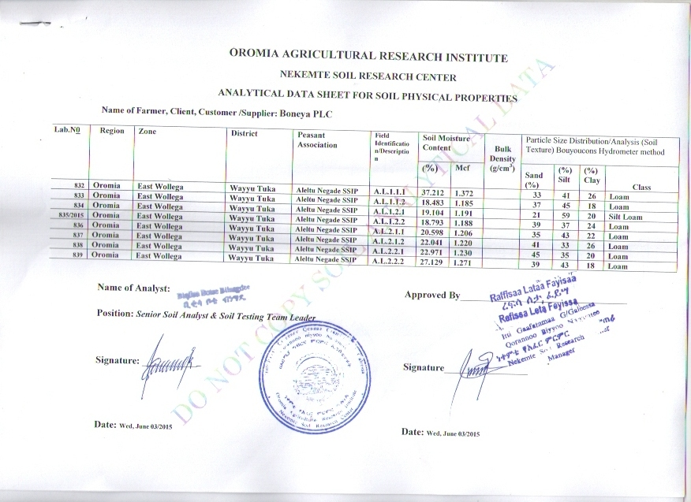

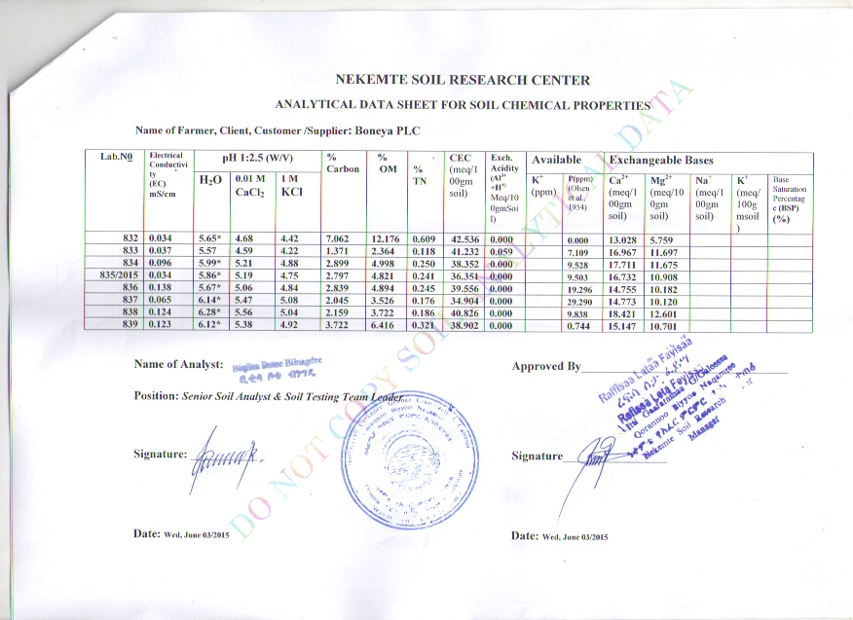

Interpretation of analytical data

a, Soil reaction (PH):- soil unit 1 has got moderately acidic soil reaction of PH 5.82. Soil unit 2 has got moderately acidic soil reaction of PH 5.98.

b, Total Nitrogen:- soil unit 1 has very high total nitrogen content which is 0.43% and soil unit 2 has high total nitrogen content of 0.215%.

c, Available phosphorus:- soil unit 1 has low available phosphorus of (4.76ppm) in its top soil. Soil unit 2 has got medium available phosphorus of (14.567ppm) in its top soil.

d, Organic matter content:- Soil unit 1 has got very high organic matter content which is 8.58% and that of soil unit 2 is high organic matter content which is 4.308%.

e, Texture:- soil unit 1 has got loam to silt loam textural composition and that of soil unit 2 has got loam textural composition.

1.6. Soil profile description and other associated studies

1. Landform: - The land form of soil unit 1 and soil unit 2 is mainly gently undulating topography of slope 2-5%.

2. Altitude range: - The altitude of the two soil-mapping units and/or the entire command area is lies in b/n 1925-1898m above sea level.

3. Micro-relief: - No dominant micro-relief is observed in both the soil-mapping units.

4. Slope shape: - Both soil units has got even slope shape.

5. Permeability: - The permeability of soil unit 1 is moderate and that of soil units 2 is in perfect.

6. Run off: - There is no problem of runoff with in the entire command area.

7. Flooding: - The entire command area is affected by common flooding.

8. Ground water table: - The entire command area has shallow ground water table.

9. Ponding (accumulation of water): - Both soil unit 1 and 2 have problem of sever ponding.

10. Erosion status: - Both soil unit has no problem of erosion.

11. Rockiness: - There is no rockiness with in soil map unit 1 but there is a measllanious surface rock observed at the end of soil mapping unit 2 nearer to the river, which is fresh protrude basalt rock.

12. Vegetation: - Soil unit 1 is cultivated both by traditional irrigation and rain fed. But soil unit 2 is only cultivated by rain fed except very few part of the right side is under grazing land.

13. Effective soil depth: - Both units have got very deep effective soil depth.

14. Drainage class: - Soil unit 1 has got well drainage (class V) in all seasons. But soil unit 2 has got moderately well (IV) drainage class.

15. Color:- Soil unit 1 has got brown (7.5YR4/4) when dry and soil unit 2 has got yellowish red (Hue 5YR 4/6).

16. Structure: - Both Soil units have fine structure on its top soil.

17. Consistence: - Soil unit 1 has hard, friable slightly sticky and slightly plastic when dry, moist and wet respectively and it is none cemented. But soil unit 2 has very hard very firm, very sticky and very plastic respectively and weakly cemented.

18. Cracks: - No cracks with in soil unit 1 but cracks of depth 150cm, width 10-25cm and by the frequency of 5-10m with in soil mapping unit 2.

19. Pores: - Soil unit 1 has got medium sized pores, which are many in number. But soil unit 2 has got fine sized pores.

20. Roots: - The two soil units have few roots of medium size.

21. Parent material: - the parent material of the command area is basalt.

1.7 Interpretation of soil survey information for land capability and

Irrigability classification

Based on the combined field and laboratory studies made, soil unit 1 has been classified under capability class II and irrigability class II with the following characteristic.

Loam surface texture.
Very deep effective soil depth (>100cm)
Fine structure
Well drainage in dry seasons.
No erosion problem.
Flat micro topography of slope 0-2%
Moderately acidic soil reaction of PH 5.82
Very high total nitrogen content of 0.43%
Low available phosphorus of 4.76ppm
There is no problem of erosion.

The limitation of soil unit 1 is low available phosphorus.
Based on the field and laboratory studies of the soils made soil unit 2 has been classified under capability class III and irrigability class II with the following characteristics.

Loam surface texture.
Very deep effective soil depth (>150cm)
Fine structure
Moderately well drainage class during rainy season and well drainage
Class during dry season
Gently sloping micro topography
Moderately acidic soil reaction of PH 5.98
High Organic matter content and high total nitrogen content of 4.308% and
0.215% respectively
Medium available phosphorus of 14.567ppm
Exposed to flooding exceptionally when river fills up and move out of
the embankment.

The limitation of this unit is the exceptionally flooding during rainy season and medium available phosphorus.

1.8 Recommendations

From the study point of view soil unit 1 should have to be treated by an application of full rate of phosphorus fertilizer for all type of crops which is going to be selected by an agronomist. From one of its sources such as Triple super phosphate (ca(H₂po₄)₂) , mono ammonium phosphate ((NH₄)H₂ po₄) and /or Diammonium phosphate ((NH₄)₂H₂po₄) which is commonly used in our country, Each of those mentioned phosphorus fertilizers has phosphorous content of 20%, 26%, and 23% respectively must be applied.

As discussed above soil unit 2 of command area has got moderately acidic soil reaction, high total nitrogen content and high organic matter content and medium available phosphorus. Thus those crops recommended for this soil unit need an application of half rate of phosphorus fertilizer from any of its sources. Since this part of the command area is verity sole it need deep cultivation to make up its structure for horticultural crops.

1.9 conclusions

Based on the studied and described properties of the soil, the necessary irrigation soil and water management should be made for maximum and sustainable production.

Table 4: SOIL PROFILE DESCRIPION SHEET

LOCATION Aleltu Negede |  | MAPSHEET |  |  |  |  |  |  | Filed No 1
 | MAPPING UNIT 1 |  |  |  |  |  |  | GRIDREF
SUTORCS) |  |  | DATE 30/07/2007 |  |  |  |  | COORDINATES
SOIL CLASSIFCATION(FAO) Residual  ST |  |  |  |  |  |  |  | PHASE 1.1
SURROUNDING LAND FORM undulating |  |  |  |  | Rock out crops None
PHYSIOGRAPHIC POSITION SLOPE 5-8% |  |  |  |  |  |  | ELEVATION
MICROTOPOGRAPY gently undulating |  |  |  |  |  | Slope 2-5%
VEGETATION /LAND USE traditional irrigation
PARENT MATERIAL Basalt
FLOODING none |  |  |  | Pounding v. severe |  |  |  |  |  | SEEPAG None
PERMEABLTY moderate DRAINAGE CLASSL well MOIS COND Moist
SURFACESTNINESS/GRAVEL None
EROSION A, AT SITE None B. SURROUNDING Slight
CRACK A, DEPTH - B, WIDTH – C, FUEQUENCY

HORIZONE DESCRIPTION
HORIZON SYMBOL | 1 | 2
DEPTHC CM | 0-75 | 75->150
COLOR MOIST  DRY | Dark brown (7.5YR3/4)  brown (7.5YR 4/4) | Brown (7.5YR4/2)  Dark gray (7.5YR 4/1)
MOTL/NG | none | none
TEXTURE | clay | Clay
STRUCTURE/CRACKS | Fine | Fine
CONSIS TENCE  DRY  MOIST  WET | hard  Friable  Slightly sticky & slightly plastic | Very hard  Very firm  Slightly sticky & V. Plastic
CLTAMS/SUKEN SLDES | none | none
CEMENTATION | None | W. Cemented
PORES/BURROWS | medium | Medium
ROCK FBAGMENT | None | None
MINERAL NODULES | - | “
CAC0₃ | none | present
BOUNDARY | none | -
PH(FLELD) | - | -

Table 5: SOIL PROFILE DESCRIPION SHEET

LOCATION Aleltu Negede |  | MAPSHEET |  |  |  |  |  |  | Filed No 2
 | MAPPING UNIT 1 |  |  |  |  |  |  | GRIDREF
SUTORCS) |  |  | DATE 30/07/2007 |  |  |  |  | COORDINATES
SOIL CLASSIFCATION(FAO) Residual  ST |  |  |  |  |  |  |  | PHASE 1.2
SURROUNDING LAND FORM undulating |  |  |  |  | Rock out crops None
PHYSIOGRAPHIC POSITION SLOPE 5-8% |  |  |  |  |  |  | ELEVATION
MICROTOPOGRAPY gently undulating |  |  |  |  |  | Slope 2-5%
VEGETATION /LAND USE traditional irrigation
PARENT MATERIAL Basalt
FLOODING none |  |  |  | Pounding v. severe |  |  |  |  |  | SEEPAG None
PERMEABLTY moderate DRAINAGE CLASSL well MOIS COND Moist
SURFACESTNINESS/GRAVEL None
EROSION A, AT SITE None B. SURROUNDING Slight
CRACK A, DEPTH - B, WIDTH – C, FUEQUENCY

HORIZONE DESCRIPTION
HORIZON SYMBOL | 1 | 2
DEPTHC CM | 0-58 | 58->150
COLOR MOIST  DRY | Dark brown (7.5YR3/4)  brown (7.5YR 4/4) | Brown (7.5YR4/2)  Dark gray (7.5YR 4/1)
MOTL/NG | none | none
TEXTURE | clay | Clay
STRUCTURE/CRACKS | Fine | Fine
CONSIS TENCE  DRY  MOIST  WET | hard  Friable  Slightly sticky & slightly plastic | Very hard  Very firm  Slightly sticky & V. Plastic
CLTAMS/SUKEN SLDES | none | none
CEMENTATION | None | W. Cemented
PORES/BURROWS | medium | Medium
ROCK FBAGMENT | None | None
MINERAL NODULES | - | “
CAC0₃ | none | present
BOUNDARY | none | -
PH(FLELD) | - | -

Table 6: SOIL PROFILE DESCRIPION SHEET

LOCATION Aleltu Negede |  | MAPSHEET |  |  |  |  |  |  | Filed No 1
 | MAPPING UNIT 2 |  |  |  |  |  |  | GRIDREF
SUTORCS) |  |  | DATE 01/08/2007 |  |  |  |  | COORDINATES
SOIL CLASSIFCATION(FAO) Vertisoil  ST |  |  |  |  |  |  |  | PHASE 1.3
SURROUNDING LAND FORM undulating |  |  |  |  | Rock out crops None
PHYSIOGRAPHIC POSITION SLOPE 5-8% |  |  |  |  |  |  | ELEVATION
MICROTOPOGRAPY Flat |  |  |  |  |  | Slope 2-5%
VEGETATION /LAND USE Annual cultivate land and grazing land
PARENT MATERIAL Basalt
FLOODING none |  |  |  | Pounding v. severe |  |  |  |  |  | SEEPAG common
PERMEABLTY moderately rapid DRAINAGE CLASSL M. well MOIS COND Dry
SURFACESTONINESS/GRAVEL None
EROSION A, AT SITE None B. SURROUNDING Slight
CRACK A, DEPTH 150cm - B, WIDTH – 10-25cm C, FUEQUENCY 5-10m

HORIZONE DESCRIPTION
HORIZON SYMBOL | 1 | 2 | 3
DEPTHC CM | 0-25 | 25->60 | 60-150
COLOR MOIST  DRY | Yellowish red (HUE 5YR4/6)  Yellowish red (HUE 5YR 5/8) | Dark gray (HUE 5YR 4/1)  Gray (HUE 5YR 6/1) | Dark gray (10YR 4/1)  v. dark gray (10YR 3/1)
MOTL/NG | Many | Few | Few
TEXTURE | Clay | Clay | Clay
STRUCTURE/CRACKS | Fine | Coarse | V. coarse
CONSIS TENCE  DRY  MOIST  WET | Very hard  Very firm  v. sticky & V. plastic | V. hard  Extremely firm  v. sticky & v. plastic | V. hard  Extremely firm  V.S.& V.P
CLTAMS/SUKEN SLDES | None | None | None
CEMENTATION | S. cemented | Strongly cemented | W. cemented
PORES/BURROWS | Medium | Common | -
ROCK FBAGMENT | None | None | None
MINERAL NODULES | Roots | - | -
CAC0₃ | - | Observed | -
BOUNDARY | - | - | -
PH(FLELD) | - | - | -

Table 7: SOIL PROFILE DESCRIPION SHEET

LOCATION Aleltu Negede |  | MAPSHEET |  |  |  |  |  |  | Filed No 2
 | MAPPING UNIT 2 |  |  |  |  |  |  | GRIDREF
SUTORCS) |  |  | DATE 01/08/2007 |  |  |  |  | COORDINATES
SOIL CLASSIFCATION(FAO) Vertisoil  ST |  |  |  |  |  |  |  | PHASE 1.4
SURROUNDING LAND FORM undulating |  |  |  |  | Rock out crops None
PHYSIOGRAPHIC POSITION SLOPE 5-8% |  |  |  |  |  |  | ELEVATION
MICROTOPOGRAPY Flat |  |  |  |  |  | Slope 2-5%
VEGETATION /LAND USE Annual cultivate land and grazing land
PARENT MATERIAL Basalt
FLOODING none |  |  |  | Pounding v. severe |  |  |  |  |  | SEEPAG common
PERMEABLTY moderately rapid DRAINAGE CLASSL M. well MOIS COND Dry
SURFACESTONINESS/GRAVEL None
EROSION A, AT SITE None B. SURROUNDING Slight
CRACK A, DEPTH 150cm - B, WIDTH – 10-25cm C, FUEQUENCY 5-10m

HORIZONE DESCRIPTION
HORIZON SYMBOL | 1 | 2 | 3
DEPTHC CM | 0-37 | 37->91 | 91-150
COLOR MOIST  DRY | Yellowish red (HUE 5YR4/6)  Yellowish red (HUE 5YR 5/8) | Dark gray (HUE 5YR 4/1)  Gray (HUE 5YR 6/1) | Dark gray (10YR 4/1)  v. dark gray (10YR 3/1)
MOTL/NG | Many | Few | Few
TEXTURE | Clay | Clay | Clay
STRUCTURE/CRACKS | Fine | Coarse | V. coarse
CONSIS TENCE  DRY  MOIST  WET | Very hard  Very firm  v. sticky & V. plastic | V. hard  Extremely firm  v. sticky & v. plastic | V. hard  Extremely firm  V.S.& V.P
CLTAMS/SUKEN SLDES | None | None | None
CEMENTATION | S. cemented | Strongly cemented | W. cemented
PORES/BURROWS | Medium | Common | -
ROCK FBAGMENT | None | None | None
MINERAL NODULES | Roots | - | -
CAC0₃ | - | Observed | -
BOUNDARY | - | - | -
PH(FLELD) | - | - | -

