HORO GUDURU WOLEGA ZONE IRRIGATION DEVELOPMENT AUTHORITY OFFICE


ADAMI SSI REHABILITATION PROJECT

ENGINEERING REPORT

BY: TAYE H. SEPTEMBER, 2016

Rehabilitation
of
Adami Small-Scale Irrigation Project

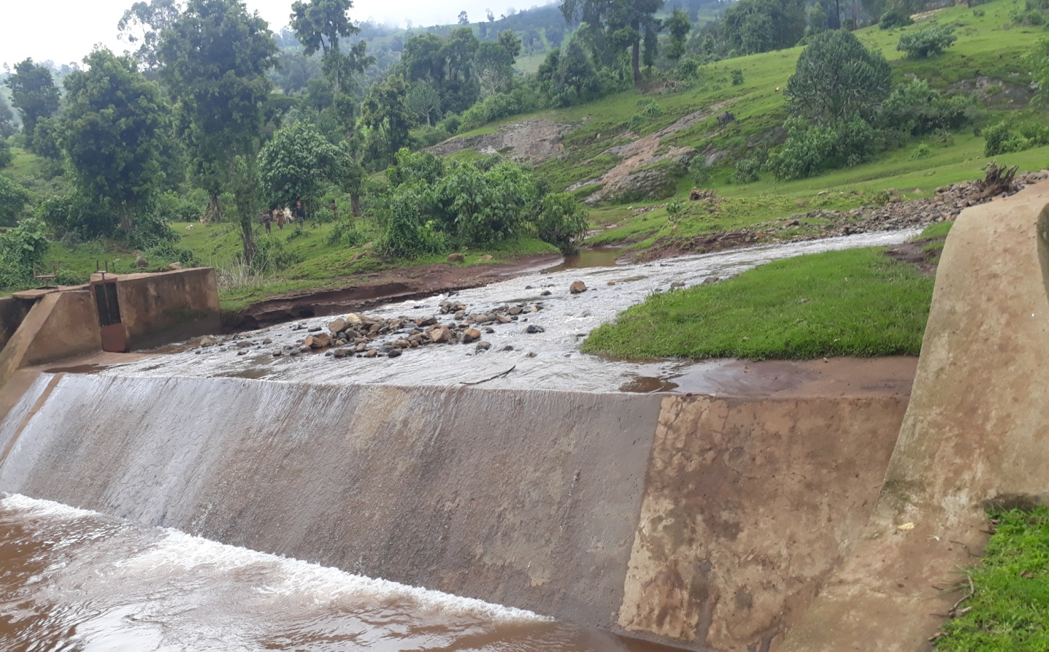

Shambo, Ethiopia

Table of Contents Page Nr
SAILENT FEATURE vi
1 INTRODUCTION 1
1.1 Background 1
1.1.1 Description of the Project Area 1
1.2 Objectives of the Study 3
1.2.1 Major Objective 3
1.2.2 Specific Objectives 3
1.3 Scope of the Study 4
2 HEADWORK STRUCTURES DESIGN 5
2.1 Headwork Site Selection 5
2.1 Operation of Head Work 5
3 IRRIGATION AND DRAINAGE SYSTEMS DESIGN 11
3.1.1 Irrigable Area Description 11
3.1.2 Topography 11
3.1.3 Climate 11
3.1.4 Existing Irrigation Practices in the Project Area 12
3.1.5 Irrigation efficiency (Ep) 13
3.1.6 Irrigation methods 14
3.1.7 Conveyance System 15
3.2 Design of the Canal System 15
3.2.1 Main Canal 15
3.3 Irrigation System Operation and Maintenance 19
3.3.1 Operation 19
3.4 Canal Structures Design 28
3.4.1 Rehabilitation Of Typical Flume 28
3.4.2 Rehabilitation of Main Drainage Culvert 29
3.4.3 Rehabilitation Of Night Storage 30
3.4.4 Bill of Quantities and Cost Estimate 33
4 CONCLUSION AND RECOMMENDATION 35
5 REFERENCE 36

LIST OF FIGURES
Figure 1 Location map of the project area 2
Figure 2 EXISTING STRUCTURES ON THE DIVERSION WEIR 5
Figure 3 SEDIMENT AND DEBRIS DEPOSIT AROUND CONTROL GATE 6
Figure 4THE CURRENT PERFORMANE OF ADAMI DIVERSION WEIR 8
Figure 5 CANAL PASSED THROUGH EARTH WITH PROBLEM OF SILTING 12
Figure 6 CANAL WITH SILTATION PROBLEM 13
Figure 7 CURRENT PHYSICAL PERFORMANCE OF ADAMI MAIN CANAL 16
Figure 8 CAUSE FOR ADAMI SSIP CANAL FAILURE 18
Figure 9 THE MAIN CANAL PROFILE AND TYPICALSECTION OF MAIN CANAL 26
Figure 10TYPICAL SECTION OF SC AND TC CANAL 27
Figure 11 ADAMI EXISTING FLUME 28
Figure 12 CHISELING INLET CANAL ON THE EXISTING CANAL 30
Figure 13 THE NIGHT STORAGE OF ADAMI WHICH IS DISILTED AND NEED RESHAPING 31
Figure 14 CURRENT PERFORMANCE OF NIGHT STORAGE 32

SAILENT FEATURE
- Project name: Adami Rehabilitation Irrigation Project
- Name of the stream: Adami river
- Location of the weir/intake site using
- North: 1333868.4 UTM
- South: 567480 UTM
- Zone: H/G/W/Zone
- Wereda: Horo
- Average Altitude: 2390 masl

- Outlet
- Sill level: 2399.18.a.s.l at weir crest
- Opening dim: 0.4*0.6 m² at control gat Source: Feasibility Study of Adami SSIP
- Discharge capacity: 54 lit/sec.
Irrigation and drainage systems Infrastructure
- Command area size: 52 ha
- Type of soil of the command area is dominantly loam soil
- Design discharge of the main canal = 54 l/sec
- Main irrigation structures needed to maintain are; 1 main canal,1 culvert and 1 flume.
- All main canals must need to lined.
Project cost
- Irrigation infrastructure cost = 1,789,887.50 Birr
- Total project cost without vat = 268,483.10 Birr
- Cost per hectare = 2,05,370.6 Birr

INTRODUCTION

Background
In Ethiopia, under the prevalent rain-fed agricultural production system, the progressive degradation of the natural resource base, especially in highly vulnerable areas of the highlands coupled with climate variability have aggravated the incidence of poverty and food insecurity. The major source of growth for Ethiopia is still conceived to be the agriculture sector. Hence, this sector has to be insulated from drought shocks through enhanced utilization of the water resource potential of the country, (through development of small-scale irrigation, water harvesting, and on-farm diversification) coupled with strengthened linkages between agriculture and industry (agro-industry), thereby creating a demand for agricultural output. In line with the above, efforts have been made by the government to improve the situation in the country in areas of domestic water supply provision, irrigation, watershed management, etc. The Oromia Irrigation development Authority is playing its role in the development of small scale irrigation projects in the region. Accordingly, as part of the water sector development program, the office has initiated the study and design of a small scale irrigation scheme on Adami River at Abe dulecha Kebele and an agreement with Letinsa Share Campany for the study and design of the project checked by GIRD Consultant and the project construction is completed in 2008 by Private Contractor ( Bikila WWGC).

Description of the Project Area

Location
This irrigation project is located mainly at Abe Dulecha Kebele, Horo Wereda of Horo Guduru Wolega Zone in the Oromia Region. The proposed irrigation project is to be undertaken on Adami River and the headwork structures are specifically located at an altitude of about 2390 masl and geographical coordinates of 1052450N (UTM) and 285635 E (UTM).
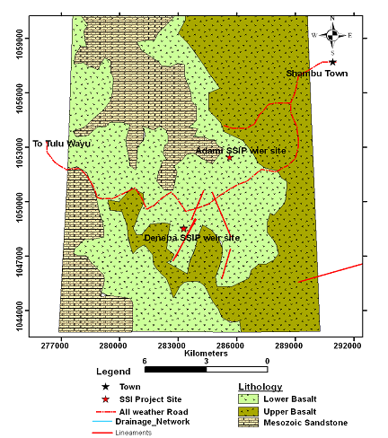
Figure 1 Location map of the project area. Source: Geological map of the area during feasibility Study

Accessibility
The project area is accessed through weathered road that pass from Shambu city Zonal place to Abe Dongoro Woreda and the project is at about 5km to the right side of the road.

Previous Irrigation Practices
There is modern diversion weir on the head work project area of this river using different irrigation practices but the existing diversion weir structure outlet and irrigation systems are designed only for the earth canal to the end. The farmers whose farm land is in the project of the river refuse to operate the earthen canal regularly mostly in the main canal. Due to this there are no sufficient irrigation practices on the command area of the project.

Objectives of the Study

Major Objective of Rehabilitation
The project area faces variability of rainfall distribution though the overall rainfall generally suffices the rain-fed agriculture. Accordingly, the rain-fed agriculture needs means of supplementing during distribution failures and further full irrigation is required to maximize the use of the potential land and water resources.
Hence the objective of this project is to contribute a substantial share in the effort to reduce the risk of production decrease due to rainfall variability and increase the productivity of the resource in the project specific area.
The main objective of the operation and maintenance aspect of an irrigation scheme is to facilitate the timely delivery of the required irrigation water to farms and to keep the irrigation system in an optimum operating condition. Specifically, the project is targeted for the following
- To make sustainable the rain-fed crop production and make extra production in the dry season possible for 52 ha of land through irrigation.
- There is a general consensus that irrigation investments will achieve broader food security and poverty reduction impacts and if efforts are also geared towards rehabilitate existing structures farming practices with support to enhance access to input supply, output marketing and extension to facilitate access to information and innovations.
- This objective is to be realized by operating the demolished structures across the Adami small scale irrigation project and diverting the river flow.

Specific Objectives
Other benefits that can be expected to appear with the launching of the project are:
- Efficiency of water use improvement;
- To improve local nutrition/food security gains through maintaining the canal.
- To improve management of scarce natural resources (land and water);
- Resilience against drought risk;
- Rationale for erosion control and watershed management;
The engineering study and design enables the realization of the project by the provision of engineering structures that will allow the appropriate abstraction of the river water for delivery in to the identified irrigation fields of the study area. Hence, this engineering design is specifically targeted to:
- Rehabilitation requirements of the project and engineering structures;
- The formulation of sound and stable structure, with necessary provisions that allow safe, easy and low-maintenance operation in the service life of the project;
- Develop working drawings;
- Estimation of rehabilitation costs.

Scope of the Study
- The irrigation design shall ensure reliability, equity and flexibility of water delivery to farmers. It will aim at reducing conflicts among water users and will lead to lower operation and maintenance costs.
- Updating the existing main canal to make it lined.
- Design proper irrigation system compatible with local conditions and management capabilities,
- Check and test hydraulic and structural designs of main canal considering total demand and the required capacity and the base flow availability
- Prepare general plans and drawings for those irrigation infrastructure and irrigation systems demolished,

HEADWORK STRUCTURES DESIGN

Headwork Site Selection
There is existing (constructed) diversion weir structure on the headwork site of Adami irrigation project. This headwork site is situated at 1333868.4 m N, 567480 m E and the weir crest elevation of 2390 m above sea level. The existing diversion weir structure was constructed only for the purpose of diverting water to the right side of the river. Main canal inlet, under sluice and gates are constructed at the right side of the diversion weir.
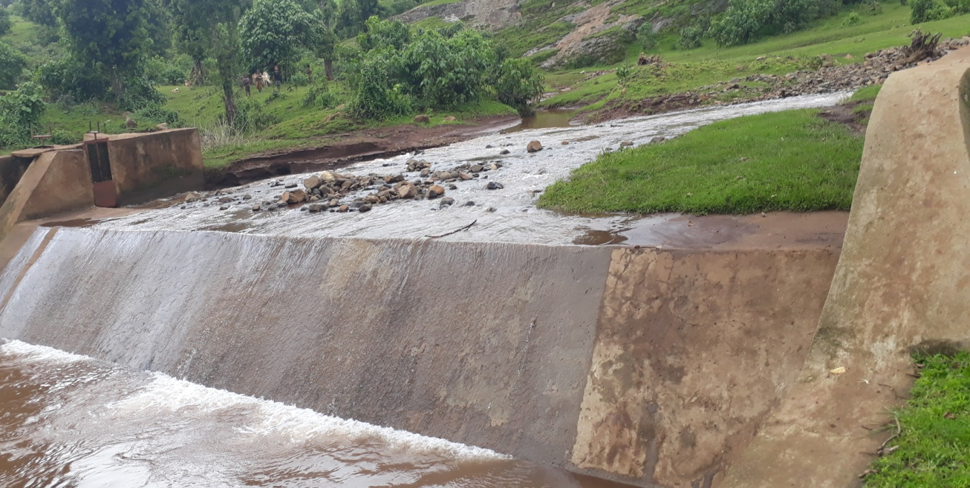
Existing structure
Figure 2 Existing structures on the Diversion weir

Operation of the Head Works
Operation at the diversion weir mainly focuses on the diversion of a controlled flow of river water, timely cleaning of floating debris in front of control gate and removal of sediment deposits in front of the gate structures.
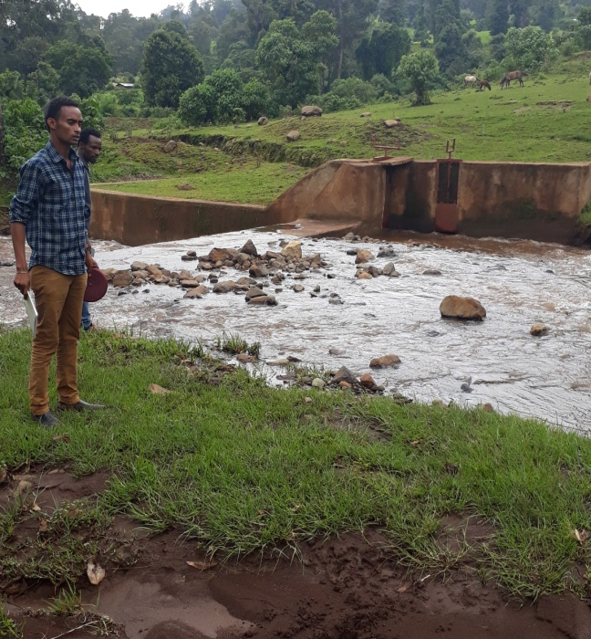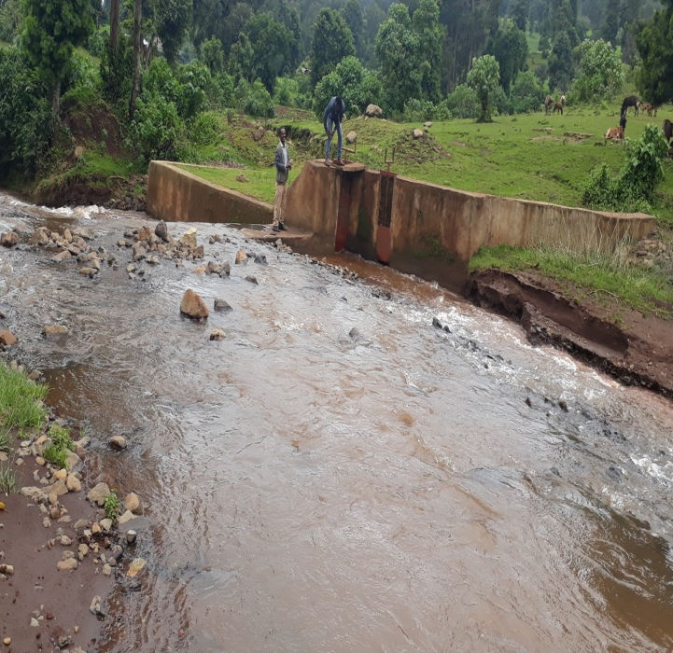
Table 3 Sediment and debris deposit around control gate
This irrigation schemes around the head regulator do not provide adequate service to farmers, for example
- because gates can no longer move due to rust or because parts are missing or broken, canal
- Sections have collapsed or are full of silt, water level gauges have disappeared, etc.
All of the above are the result of poor maintenance. A newly-built irrigation scheme is expected to function for 20-30 years or more. The efficiency and longevity of the scheme lies upon the nature of maintenance of the components involved in the irrigated agriculture and upkeep of the general ecology and environment. Maintenance includes repairs as well and is better to classify as “Repair and Maintenance”.
But at the right side of the river there are farmers with their irrigable farm land that were not considered during the time of existing headwork structure construction. At this time farmers have high interest to use the river water for irrigation and they construct traditional irrigation canal.
The operation of the irrigation system depends mainly on the method of water delivery at farm level. Surface irrigation method is the recommended type of water distribution and application method for Adami diversion irrigation scheme.
The farmers would organize themselves and form groups in order to handle the water management. Since flow is low Rotational water distribution would be applied within the group. The rotational distribution is then to distribute water by turn to the whole scheme according to the timely need of crop water requirement. For better and efficient water management, crop diversification should be avoided within a group. This would reduce the complexity of water distribution system of the scheme during one irrigation season. At farmers’ level of operation, a constant flow and variable irrigation time is advisable.
The operation of the irrigation system is continuous for 24 hours per day in main, secondary and tertiary canals where as field canals within a tertiary block are operating in rotational system with each other for irrigation hours proportional to their size. Since the tertiary canal discharges are within the manageable range and the irrigation canal structures are accordingly designed for simple operation, the farmers can open and close easily whenever they required.
The maintenance tasks are categorized into two types: - routine activities, and repairs. The routine maintenance activities that are carried out periodically include:-
- Regular cleaning of sediments and weeds from canals and drains;
- Inspection and lubrication of gates; and
- Maintenance of cracked earthen canals to lined, regulating and control structures.
Repair works include task carried out more frequently and quickly, and include those tasks that are generally unpredictable. They also include emergency works. The activities included in this category are:-
- Repairing overtopped or breached canals, drains, and flood protection dykes;
- Repairing jammed gates;
- Filling holes made by wild animals; and
- Reduced free board due to walking over by people and livestock.
Regular inspection of the irrigation facilities should be carried out as part of the maintenance activities. These tasks could be carried out immediately after the end of the main rains in September and during the rainy season. This could concentrate on the interceptor drains, the main canal and the field drains. The inspection of the other works like the tertiary canals, field drains, and the water control and regulating structures could be carried out as part of routine operation activities.
Beneficiaries of the project need to have operation and maintenance budget, For O&M cost incurring entity area:
- Purchase sing of gate lubricate (grease)
- Replacing and maintenance of Stolen and damaged gates
- Repair Damages on the cross drainage structures.
The expense for O&M should be collected from the beneficiaries. Of course, much of the task is done by the labor and skill of the community. For cost incurring activities beneficiaries have to collect money based on the proportion of the command area they owned.
In the off-season, both farmers and operators are not busy with irrigation and can therefore more easily be engaged in maintenance work. Sometimes, for very large or difficult jobs, it may be necessary to hire a contractor. But here there were somehow problems for taking a care by project users. Because the project beneficiaries must take away the gate of the main drainage during off season. But it is not applicable incase of Adami SSIP that may difficult to easily operable. So, it need greasing the during the on season ( start of irrigation).
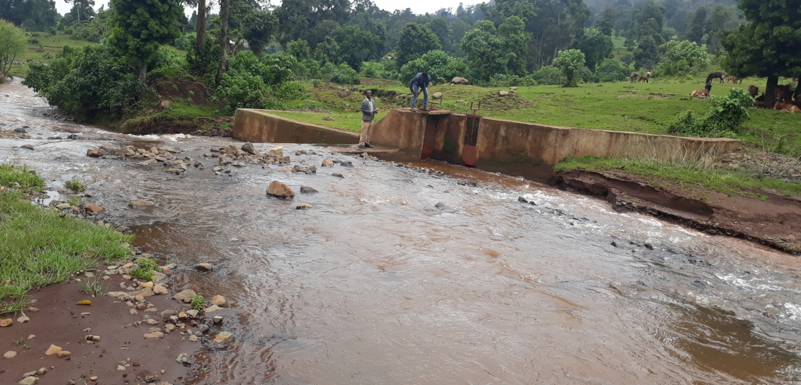
Need greasing of the gates during the start of Irrigation
Take away the gate of the main drainage during off season
Table 4 The Current Performance of Adami Diversion Weir
During the study period of this time we have seen that at about 150m canal has been lined and the other all are earthen that tried by the farmers in the to protect it and they have high interest to solve the canal problems and to use the river water for irrigation.
Even though the farmers construct traditional canal and starting to use the water for the irrigation purpose, they cannot irrigate their land by this constructed earthen canal because of the following problems:-
- There is no any control structure to protect the loss of water.
- The incoming water cannot flow properly to the main canal to end because of the presence of seepage through soil.
Therefore based on the above main problems, the farmers cannot be successful to develop their irrigable land using the river water.
To divert the river water and to supply the irrigation water to the right side the followings are the main solutions:-
- Make all main canal to be lined.
- To resist the flood problem, the chiseled surface walls should be reinforced.
- Control gate constructed should be operated timely on the diversion weir structure.

Control Gate and main channel gate design

Gate level
The bottom level of the main canal and the escaping channel outlet gates are within the same level of the main canal bed level at that location or at 0+50m chain age. Therefore both the gates bottom level is fixed which is the main canal bed level.
Outlet capacity of the gate
The gate outlet capacity should be determined for maximum command area and the corresponding discharge. In this case the outlet capacity is fixed considering maximum duty and command area.
Outlet capacity = Duty x command area
Where
Maximum duty for 24 hr irrigation = 2.4L/s/ha
Command area = 52ha.
Outlet capacity = 2.4 L/s/ha x 52ha = 124.8 L/sec
Outlet size
From the orifice discharge formula the outlet size is determined as follows
Q= 2/3*Cd*(2g)^(1/2)*B*H^(2/3)
Where
Opening width of the gate = Bed width of the main canal=B=0.4m
Q=maximum discharge=0.054m³/s
C_{d}=0.7 for rectangular orifice
Therefore from the above formula H can be calculated as
H= ((3*Q)/(2*B*C_{d}*(2g)^0.5))^3/2= ((3*0.054)/(2*0.4*0.7*(2*9.81)^0.5))^3/2
H= 0.25m
The dimensions of the gates are fixed based on the amount of water that should be passed through the gates. To discharge the maximum amount of incoming water through the main canal, the gates opening size should be equal to the main canal opening dimension including its free board. Therefore the gate height H is fixed to be 0.6m which is equal to the total depth of the main canal at the gate location. This structure was safely constructed with proportional dimension.

IRRIGATION AND DRAINAGE SYSTEMS DESIGN

Irrigable Area Description

Topography
Topography is an important factor for the planning of any irrigation project as it influences method of irrigation, drainage, erosion, mechanization, and cost of land development, labour requirement and choice of crops.
The topographic feature of the project command area is mainly sloping type. However, it has identified to be suitable for surface irrigation. Nevertheless, it requires soil and water conservation measures or structures (i.e. constructing bunds, bio-physicals, check dams, artificial water ways, etc) still on the up line of canal contour.
The project command area is situated at the right side of Adami River (to the south side of the river). The natural topographic feature of the command area has inclined from the west to the east direction.

Climate
As per the hydrological analysis and on the basis of the traditional Ethiopian Agro-Ecological Zones (MOA, 2001), the UGDWIP area is basically classified as Dry Woina Dega (dry-warm) agro-ecological zone, which is comparatively conducive to the production of tropical and sub-tropical lowland crops. There is belg rain season in the project area. Despite the fact that the Meher rains are considered adequate, there is notable variation in terms of onset, distribution and withdrawal from year to year affecting crop production in general and crop productivity in particular.
The meteorological stations, Shambu (for rainfall data’s), (for minimum and maximum temperature relative humidity, wind speed and sunshine hour) meteorological stations data were used for the project study as long as these stations are relatively near to the proposed command area. In general, the sources of meteorological data are the National Meteorology Service Agency (NMSA).

Existing Irrigation Practices in the Project Area
The pressure of survival and the need for additional food supplies to meet the demands of the increasing population is necessitating a rapid expansion of irrigation schemes. Thus, irrigation is becoming a basic part of well developed agriculture wherever there is water and irrigable land potential.
There is diversion weir, outlet structures and irrigation canals on the project area of this river. The existing diversion weir outlet structure and irrigation systems are constructed for the right side of the river. Using the existing structures, the farmers are developing small hectare of land using Adami river water for irrigation. Because, this constructed canal cannot be used for irrigation water supply to the right side by the causes of the following problems:-
- The main canal is passed through the earthen type and at this place the land is sliding in the left and right part of the canal. Therefore this earth canal is back filed by the sliding earth materials.
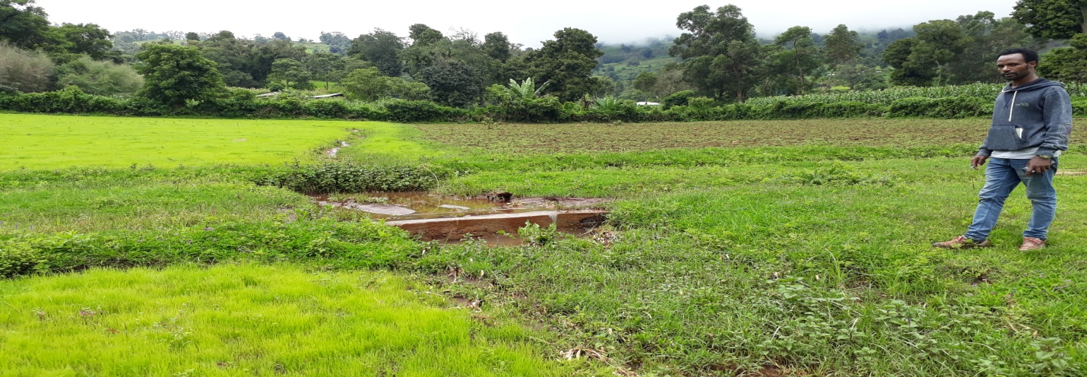
Back fill of earth surface
Figure 5 canal passed through earth with problem of sliding
- The earth canal is must properly designed and constructed to address the area of the non silting. At some places the canal faced siltation problem and the water cannot pass through it to address the proposed irrigation land.
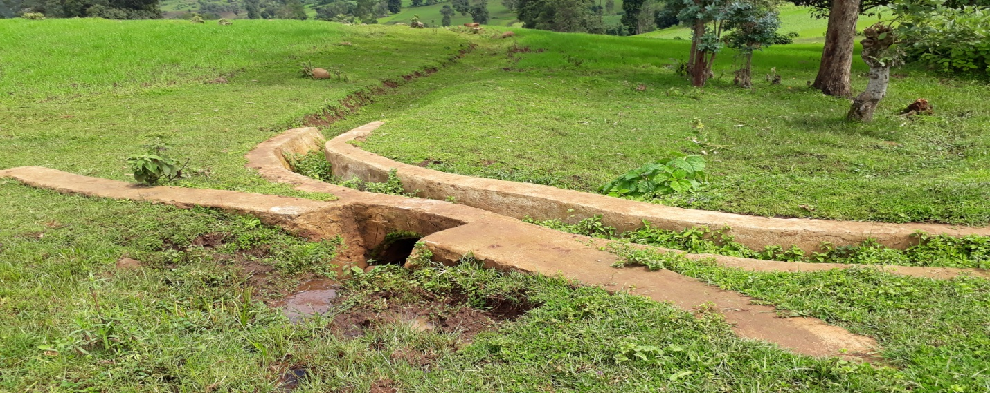
Siltation problem
Figure 6 canal with siltation problem
Therefore based on the above main problems, the farmers cannot be successful to develop their irrigable land using the river water.
To divert the river water and to supply the irrigation water to the right direction the followings are the main solutions:-
- On the back field earth material on the main canal should be excavated, removed and to protect the future of the sliding and back filing problems catch drain should be excavate by farmers.
- The main irrigation canal should be properly designed and constructed to lined keeping the slope with no scouring and non silting.

Irrigation efficiency (Ep)
To complete the evaluation of the demand, the efficiency of the water distribution system and of application must be known.
The gross requirement of water for irrigation system is very much dependent on the overall efficiency of the irrigation system, which in turn is dependent on several factors: Method of irrigation, type of canal (Lined and/or Unlined), method of operations (simultaneously and continuous or Rotational water supply), and availability of structures (for controlling and distribution and measuring and monitoring).
On the basis of these factors, the project has planned to impose surface irrigation method (using furrows). The canal system is lined other than SC, tertiary and field canals. Hence, the conveyance efficiency has been estimated to be 80%, distribution efficiency 80%, and field application efficiency 65%. As a result of these the overall irrigation efficiency has been estimated to be 52%.

Irrigation methods
Among the different irrigation systems furrow irrigation system will be used for the project area; and the irrigation water will be obtained from Adami River and by constructing diversion intake or head regulator and convoying the water commonly through masonry lined canals (Mc) and then leading to SC, Tc, and field earthen canals; and finally irrigation takes place mostly in furrows.
For this project, among the various irrigation methods, surface irrigation method has been selected. Of the surface irrigation methods furrow, border and basin irrigation methods can be used to supply irrigation water to the plants/crops. However, each method has its own advantages and disadvantages. Care should be taken when choosing the method which is best suited to the local circumstances, i.e. depending on slopes, soil types, selected crop types, amount of water available, etc. of the command area.
Based on the above factors surface irrigation method has been proposed for the proposed crops in this project. The method allows applying light irrigation and can be laid out in sloping fields along the contour. Furrow irrigation method is best suited for most of the proposed and row planted crops. In general, furrow irrigation method is simple, manageable and widely practiced irrigation method. This method is suitable for row crops that cannot stand in water for long periods. The only thing required to use this method is row planting of crops. Besides, basin and border irrigation method would be used for the non-row planted crops. Rotational flow water distribution is also recommended for the project area.

Conveyance System
The conveyance system consists of 1 Main canal to irrigate total command area of 52 ha. The main canal starts from Water abstraction site on right side and conveys water for a length of 2.727 Km.

Design of the Canal System
Flow Depth and Section Capacity
The earthen canals have been designed with a trapezoidal shape and the lined ones with rectangular x-section using Manning's Formula:
Where Q= discharge (m³/s)
R= Hydraulic radius (Flow area/wetted perimeter)
S= Hydraulic gradient
n= Manning's roughness coefficient, n=0.025 is adopted for the earth channels and n=0.018 for the masonry lined part of the main canal

Main Canal
The main canal is designed for a discharge of 54.8 l/s and depending on the site specific condition, appropriate slope is provided. Even though the soil condition of the canal route is poor from permeability condition at negligible reach, it have to be lined for the whole of the conveyance length (2.2km) because of the following factors:
- To avoid regular maintenance of the canal and difficulty to keep the original slope of the canal during maintenance period.
- To save the reach time at the tail part and to avoid social conflicts.
- To protect the head users from easy bank breaching during low flow periods and night time.
- Difficult land terrain and steep slope at some reaches of the main canal
- To increase the conveyance efficiency of the flowing water through this canal
- Its intensity of work period per day is high as it is 24 hours per day and seven days per week.
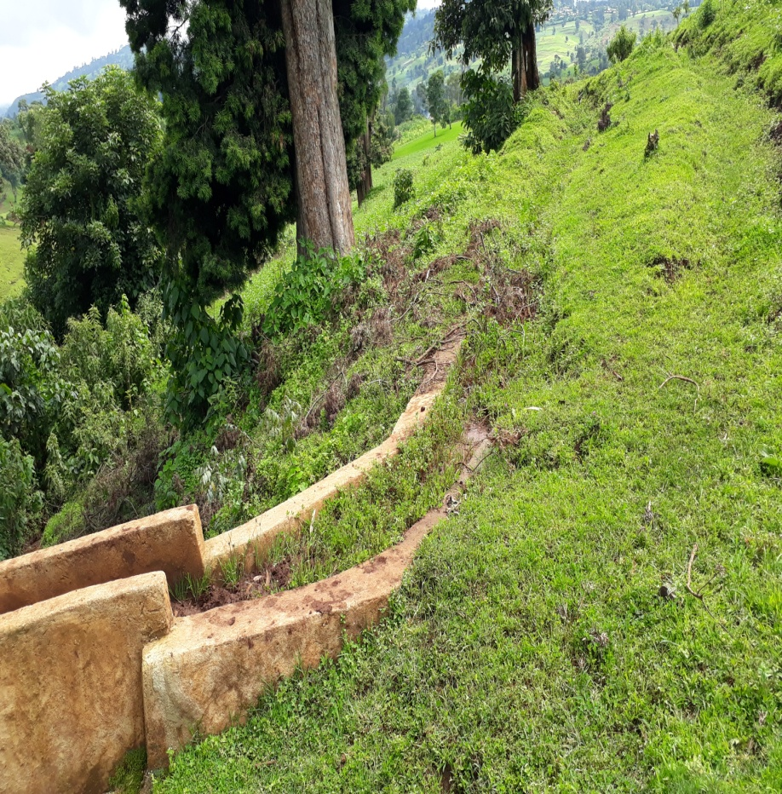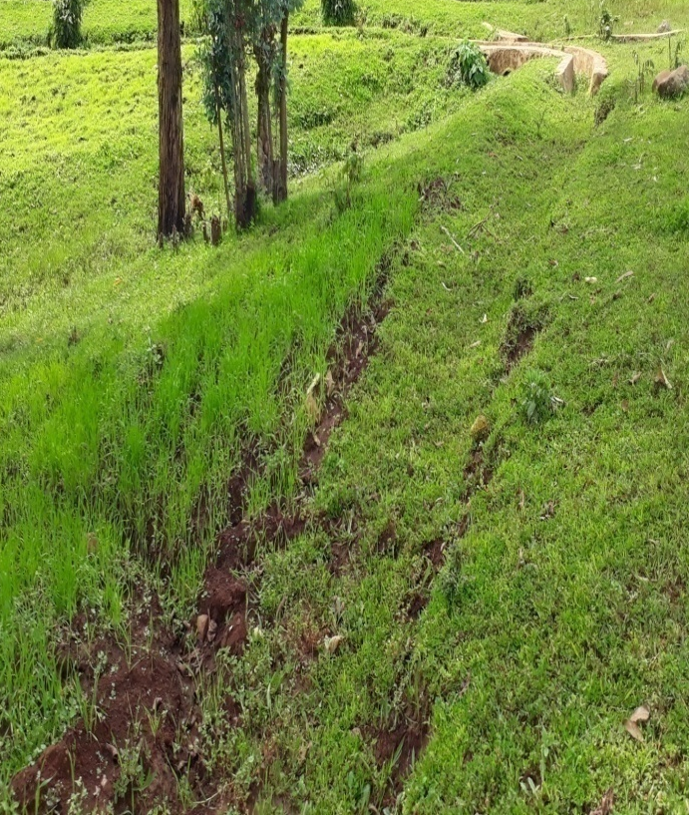
Siltation of all main canals and lack of regular maintenance due to it is earthen type canal.
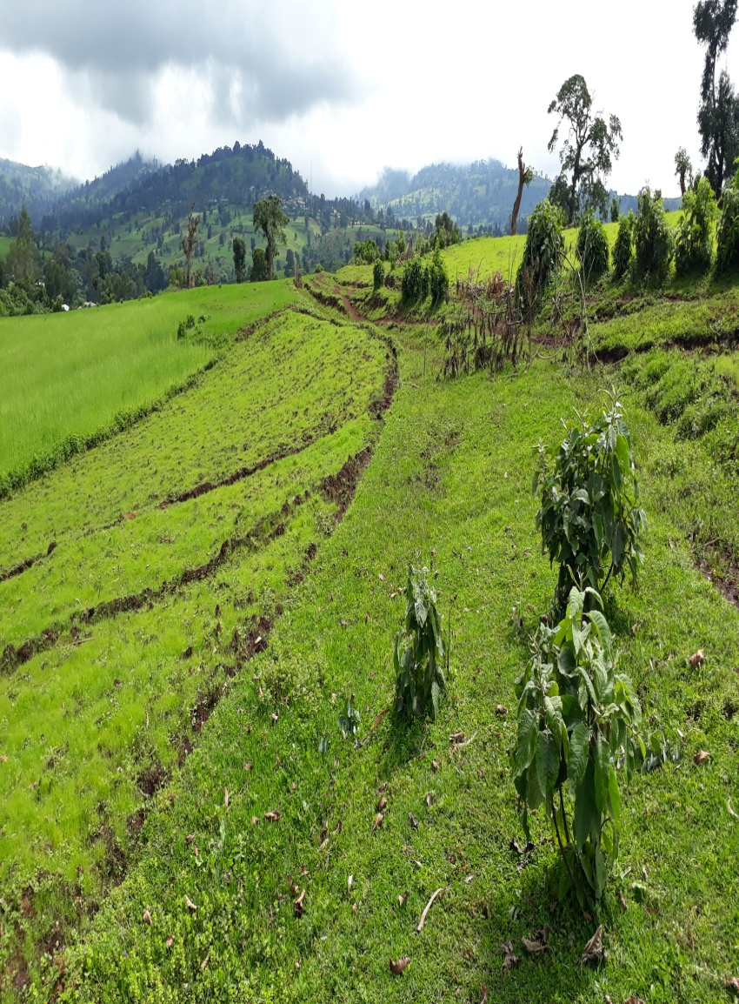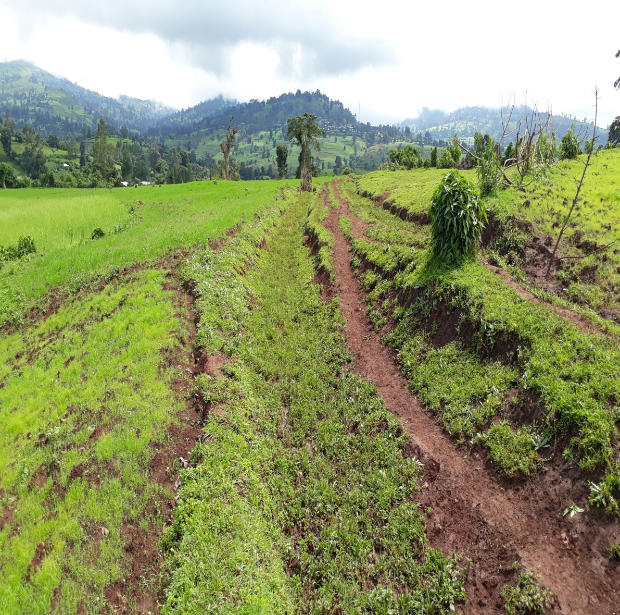 Figure 7 Current physical performance of Adami main canal. (@ august, 2017)
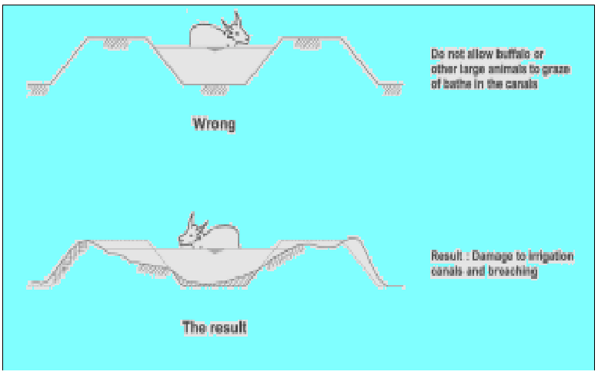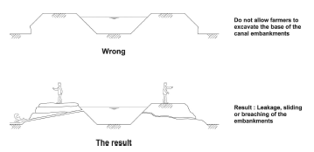
Animals Intruding into Canal
Farmers Encroaching on Canal banks
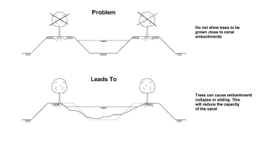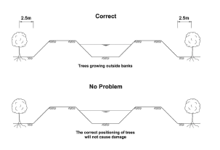
Trees Growing on Canal banks

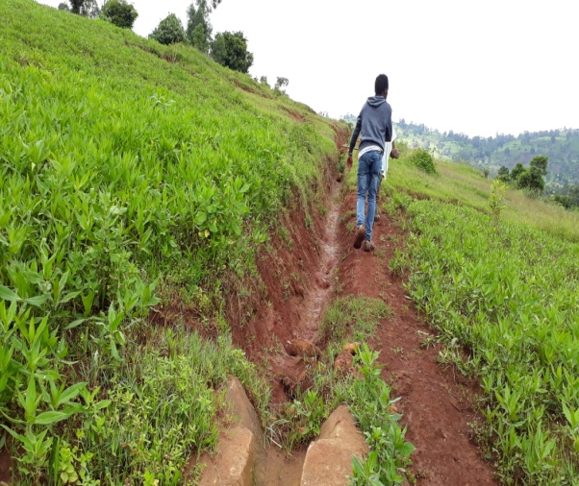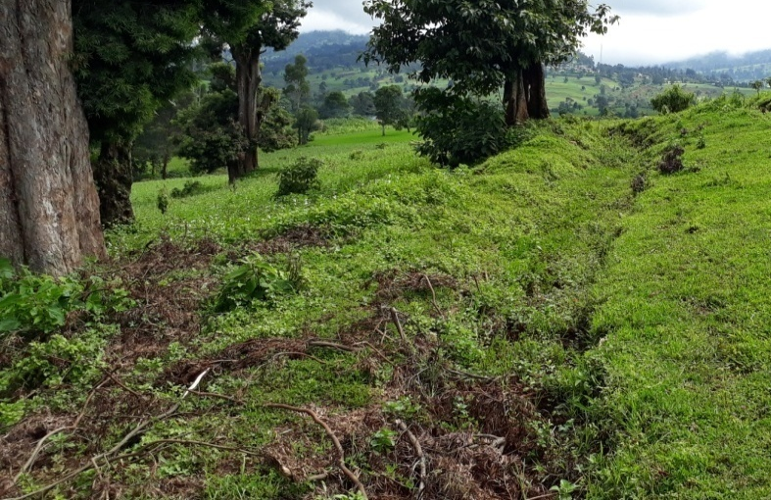
Table 8 Cause for Adami SSIP Canal failure
  - Irrigation and drainage system operation and maintenance
    - Operation
The operation of the irrigation system depends mainly on the method of water delivery at farm level. The farmers would organize themselves and form groups in order to handle the water management. For better and efficient water management, crop diversification should be avoided within a group. This would reduce the complexity of water distribution system of the scheme during one irrigation season.
To ensure equitable distribution of water the amount of water released through field canals should be proportional to the available command area.
- In order to minimize the water losses during conveyance and application:
  - Water users association (WUA) should assign gate keeper who is responsible to control unnecessary gate opening, damage and losses through gates.
  - Every damage on the canal system, crossing structure and gates should be followed by the WUA and immediate action should be undertaken.
  - For technical failure beyond the capacity of the local community should be informed to the Woreda irrigation and Drainage sector and immediate action should be taken.
  - Frequent supervision to the canal system is needed. Remove silt, weed, and any flow blocking objects from the canal system.
  - Land leveling of each farm block access uniform water distribution within the block.
  - Water application should be done by furrow rather than flooding.
  - Uniform cropping season and pattern within nearby blocks is good for irrigation water management.
    - Maintenance
The performance of an irrigation canal system depends not only on how the system is operated, But also on the condition of the canals. Irrigation canals function well so long as they are kept clean and if they are not leaking. If no attention is paid to the canal system, plants may grow and the problem of siltation may arise. Even worse, the canals may suffer from leakages. Plant growth and sedimentation not only impede the flow in a canal, they also diminish the area of the cross-section. As a consequence, the canal capacity may diminish A reduction in the capacity may result in overtopping and a limit on water supply to the fields. The available water will also be reduced when there are leakages in a canal.
To protect the system from these problems, the canals should be maintained on a regular basis. It is not just the smaller, tertiary irrigation canals that need to be maintained, it is the Primary and secondary canals as well. Sometimes these canals may be located far from the Farmers’ fields and this can be one reason why farmers show no interest in maintaining them. However, the smaller canals receive water from these canals and so maintenance of the larger Canals is of vital importance for the proper functioning of the whole system. Even when a canal is well maintained, serious technical problems may arise. These problems need to be solved by repair or improvement works.
A repair should usually be done as soon as possible, depending on the severity of the problem. Improvements, such as the lining of a canal section, may be postponed until the end of an irrigation season, when canals are dry and farmers have more time available.
After a serious problem is found on an inspection tour, a team of workers or farmers should be available for repair as soon as possible. Such a team should be formed at the beginning of the irrigation season in order to have it on call in case of emergencies. The same team may be asked to do the improvement works. If necessary, a contractor may be asked to do the job.
The canal system of the project is earthen canal except main canal, which is susceptible to siltation, erosion, growth of weeds and or breaching problems. Though the canal sections are designed for non- silting and non scouring conditions, the above mentioned problems are unavoidable and hence periodical and yearly inspection and maintenance of canals and structures are obligatory in order to fulfill the design objective of the project area.
A good maintenance programmed can prolong the life of canals. A routine, thorough programmed should be kept to. Maintenance of an irrigation canal system is usually carried out in between two irrigation seasons, or at times of low water demand. It consists of cleaning, weeding, de-silting, re-shaping, and executing minor repairs.
- Bushes or trees on canal embankments should be removed. They may obstruct the water flow and their roots will open the compacted soil in the banks and cause the development of leakages.
- Breaches and rat holes in the embankments should be filled with compacted soil, inside as well as outside of the embankment. For compacting, the soil should be wetted.
- Plants silt and debris in the canal should be removed. While cleaning the canal bed, care must be taken that the original shape of the cross-section is kept. For this, a wooden frame, or template, with the exact dimensions of the designed cross-section of the canal being cleaned, can be of great help.
- Weak sections and sections of canal embankments where people or animals cross the canal should be strengthened with compacted soil or with bricks.
- Eroded sections of a canal should be rebuilt to the original shape.
The expense for O&M should be collected from the beneficiaries. Of course, much of the task is done by the labor and skill of the community. For cost incurring activities beneficiaries have to collect money based on the proportion of the command area they owned. Households with more command area contribute more money. Farmers should contribute twice in a year unless special damage is happened to the system. The amount of money to be contributed by each Household shall be determined by the beneficiaries using the water users association.

Table 4 Hydraulic Parameters of main canal

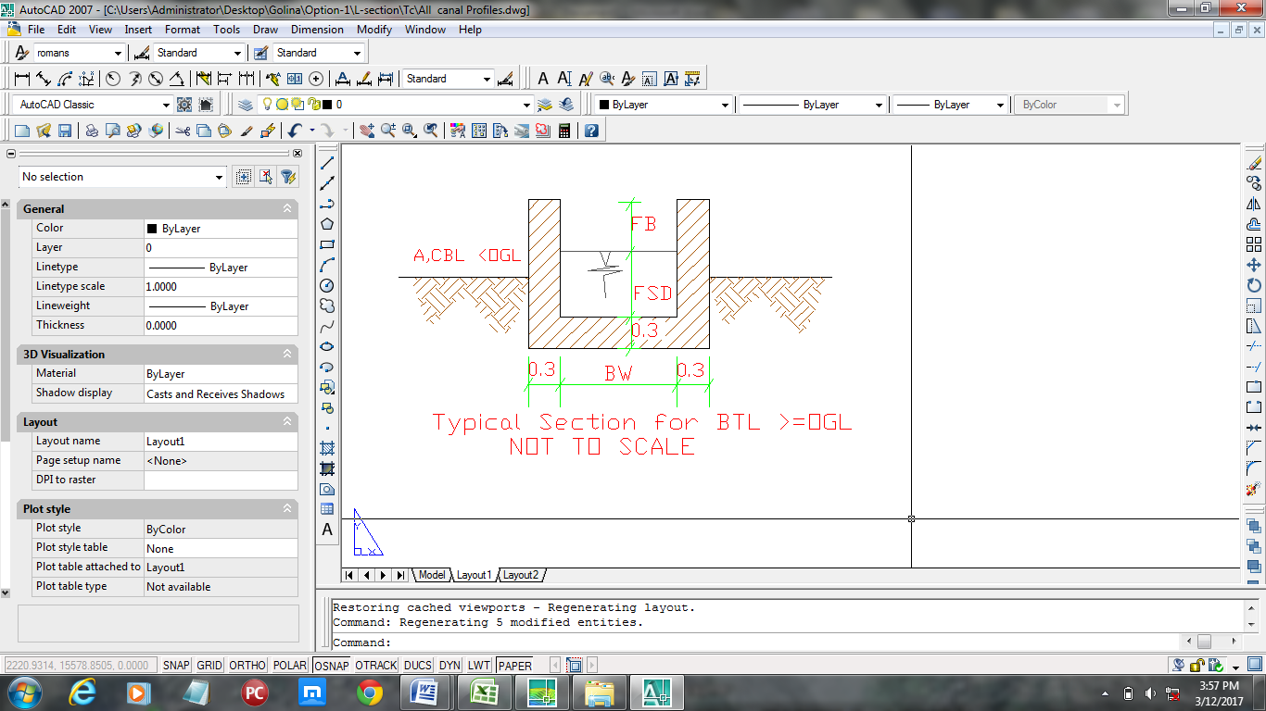
Figure 9 The main canal profile and Typical section of main canal

Figure 11 Typical section of main canal
BTL=Total bank label
BW= Canal bottom width SS= Side slope Q_{R}= Required discharge
FSD= Full supply depth V= Velocity Q_{D}= Designed Discharge
FB= Free board SS= Side slope

SC And Field Canals
As shown in the layout, field canals run across the contours and hence face relatively steeper gradient. The discharge of most of the field canals is very small and this is taken as an advantage to cope up with the relatively steeper gradient. Figure 18 below shows a typical field canal x-section. As much as possible field canals shall be made in fill in order to easily irrigate the adjacent command area. As can be seen from the layout, majority of the filed canals can be used to irrigate both sides of the command area depending on the condition of the individual plots of land owned by individual farmers. the designed discharge is determined based on the Catchment area, run off coefficient and rain fall intensity (Rational formula). The sections of the canals are determined by using manning’s formula, and they are trapezoidal section. The construction work of tertiary canals is considered to be done by individual farmers.
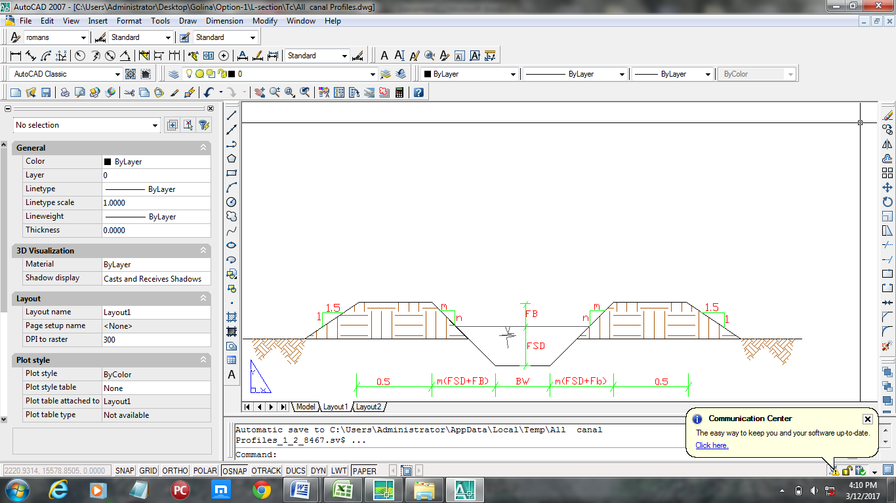
Figure 10 Typical section of Sc and Tc canal

Canal Structures Design

Rehabilitation of a typical flume
There are flumes constructed across the gullies. From those flumes the one which is designed and constructed will became crack on the start of its inlet because of the foundation situation that means the land problem. So, make the inlet canal lined than earth will solve the problem. Existing flume
Hydraulic Characteristics of the canal
Length of the flume: 8 m
Shape of the flume: Rectangular with concrete structure
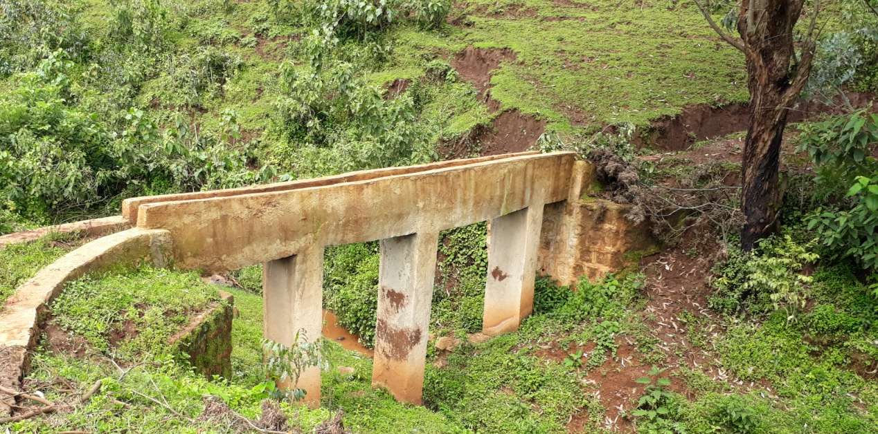
Table 11 Adami existing Flume
As another option, construct some distance guide wall on the right side of the canal to minimize the earth pressure. This is because of to protect the land slide around the flume inlet.

Flume | start Chainage (m) | Q(m3/s) | V(m/s) | L(m) | h(m) | t(m)
Existing Flume 1 | Mc1 | 0.054 | 1.58 | 8 | 2.45 | 0.1
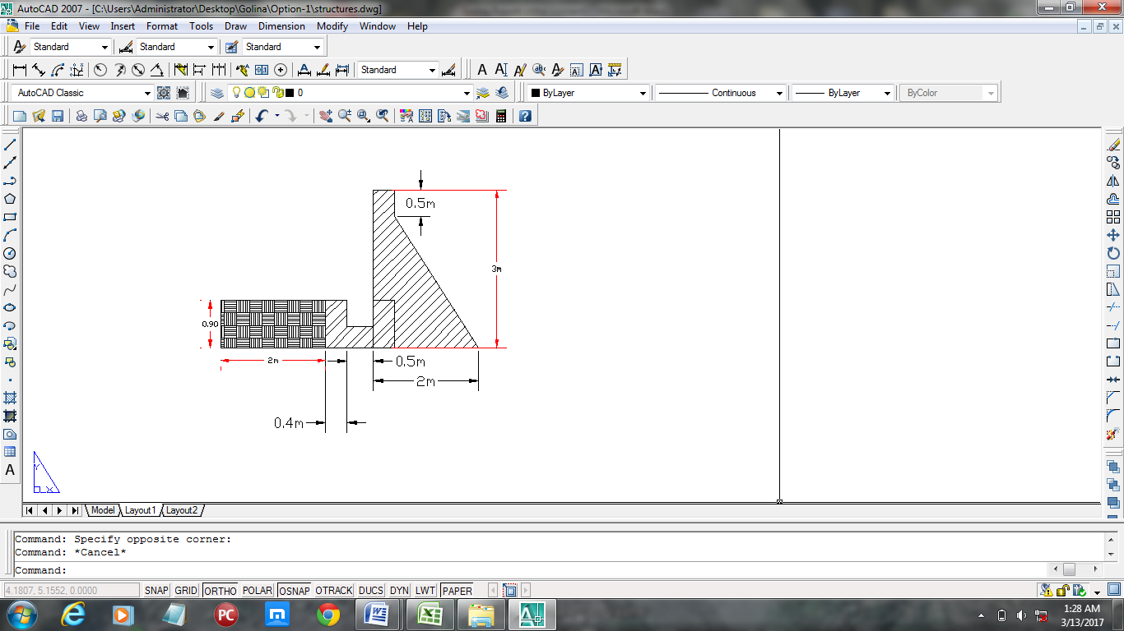

Main Drainage Culvert
Hydraulic Characteristics of the culvert
Length of the culvert: 12 m
Shape of the flume: Rectangular with concrete structure

To divert the river water come from the upstream, the existing super passage is out of work and is recommended to be reconstructing by reinforced concrete. The surface level of the demolished canal be chiseled and it will be lower than the bottom culvert crest and the water will be flow through this chiseled surface to the main canal inlet.
Existing weir
Water flow surface on chiseled canal

Reinforced surface after chiseling
Existing retaining wall
top crest
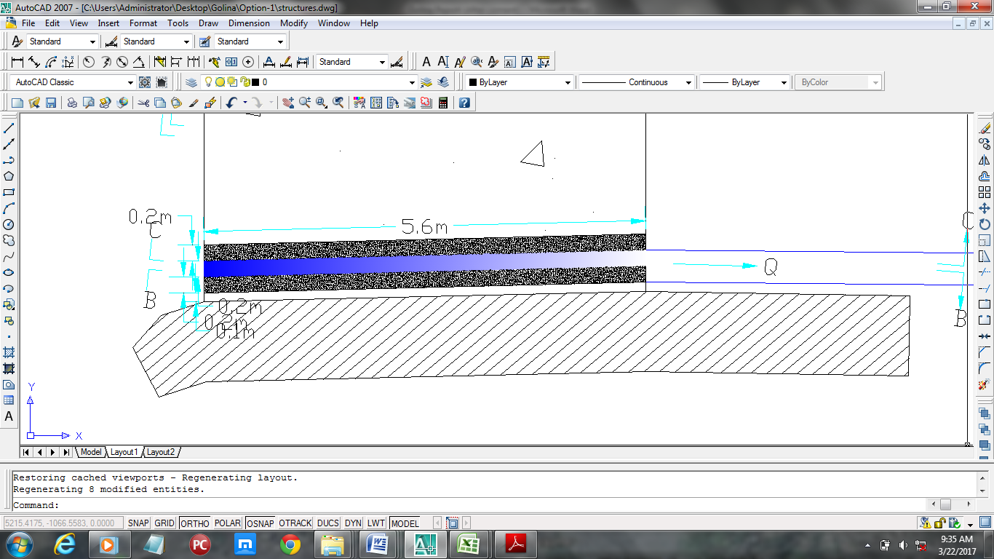

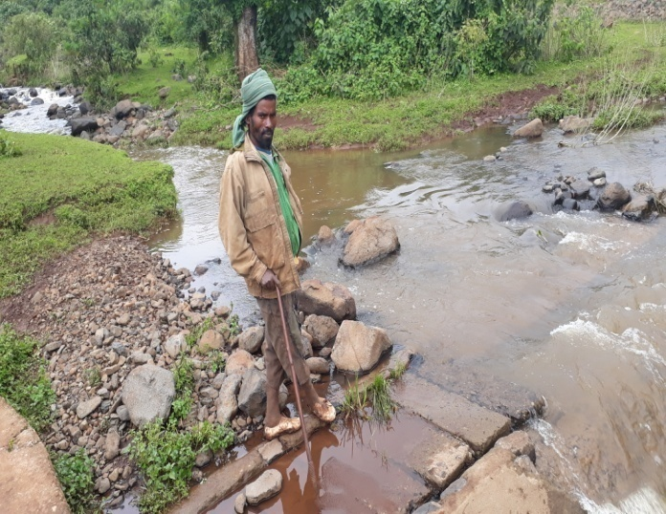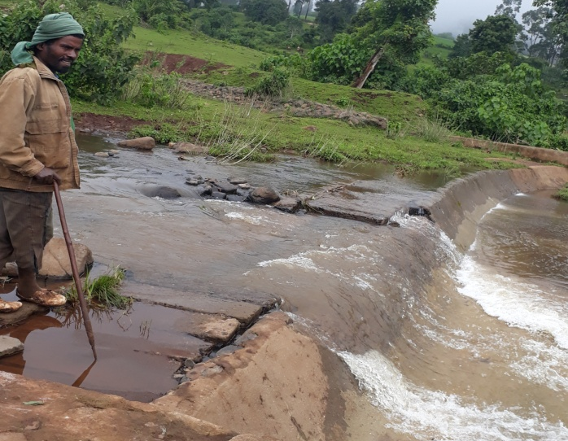
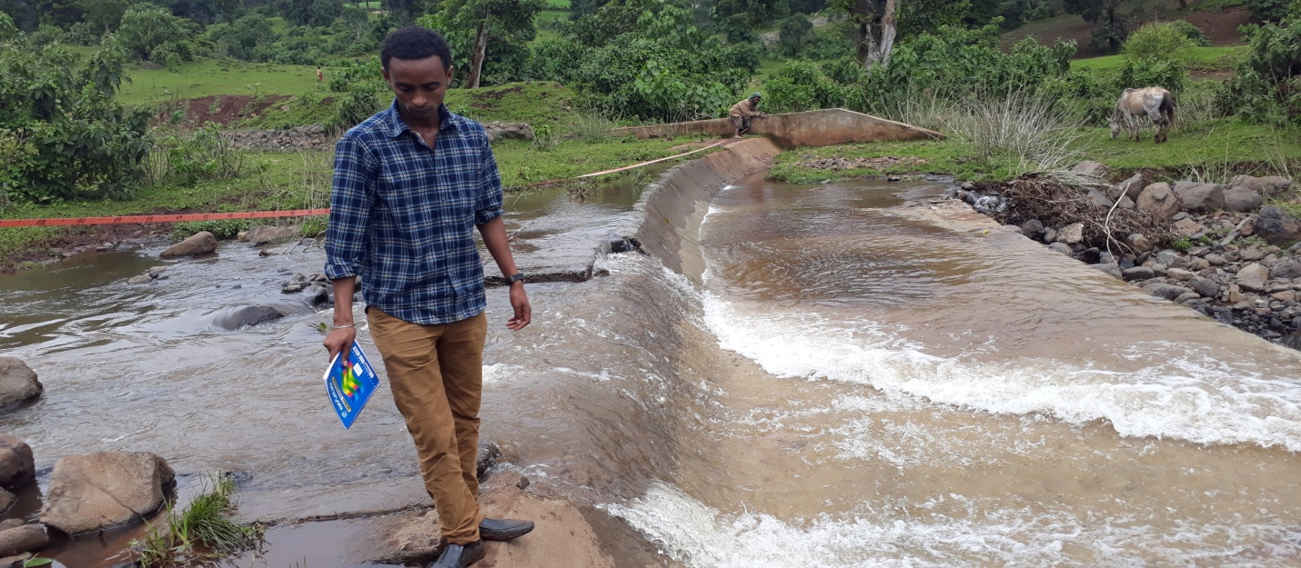
Figure 12 chiseled inlet canal on the existing canal
Super passage | start Chainage (m) | Q(m3/s) | V(m/s) | L(m) | h(m) | t(m)
Existing Culv. | Mc1 | 0.054 | 0.86 | 34 | 1.34 | 0.2

Rehabilitation Night Storage
The constructed Night storage of the Adami SSIP fail its service because of:
- The lack of irrigation water to reach to enter the Night storage through along distance of earthen canal due infiltration through soil strata.
- Even though the left some amount of water has get the pond, It is not stored in it because of seepage problem through the pond bed and through its embankment.
- Water User give less attention to the all structures. For instance the fence of the night storage is demolished by the owner of the land user around it.
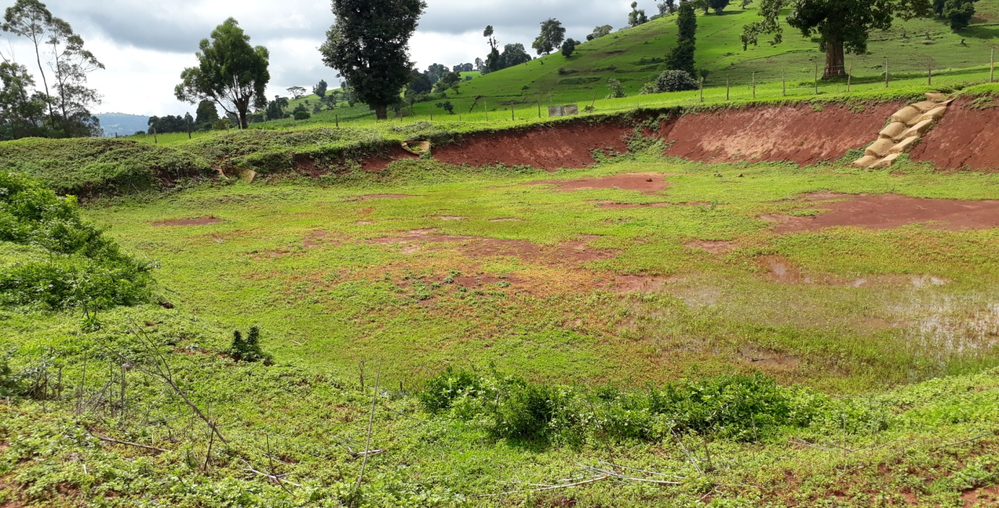
Table 13 The Night Storage Of Adami which is disilted and need reshaping
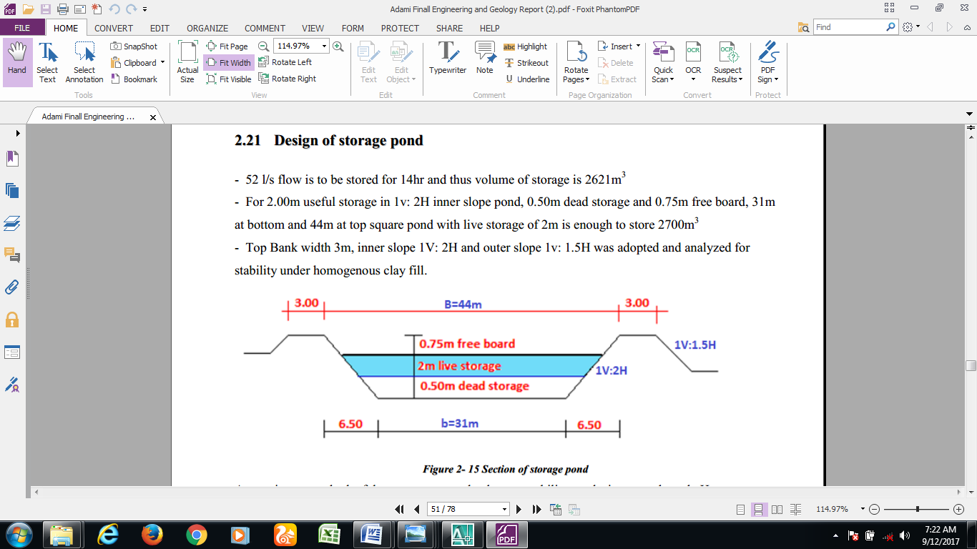
So, Reshaping and compaction of the Pond Embankments is mandatory to make the night storage function able according to the design and the plan during the study.
Second, I t is recommendable to make Plastic Geomembrane to minimize the seepage of irrigation water that is stored in it. And maintain the fence of the pond.
Finally, The Project users give attention and keep the structure safely for the future.

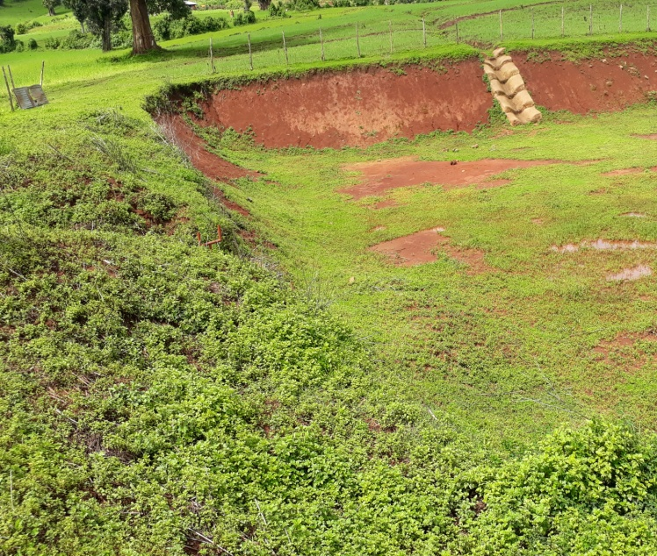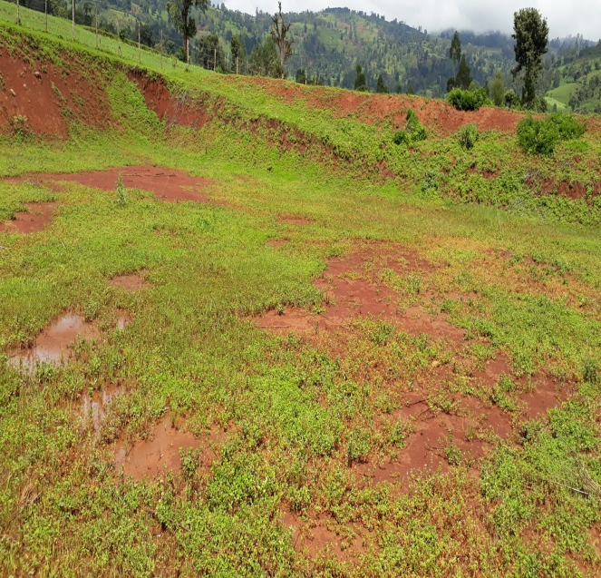
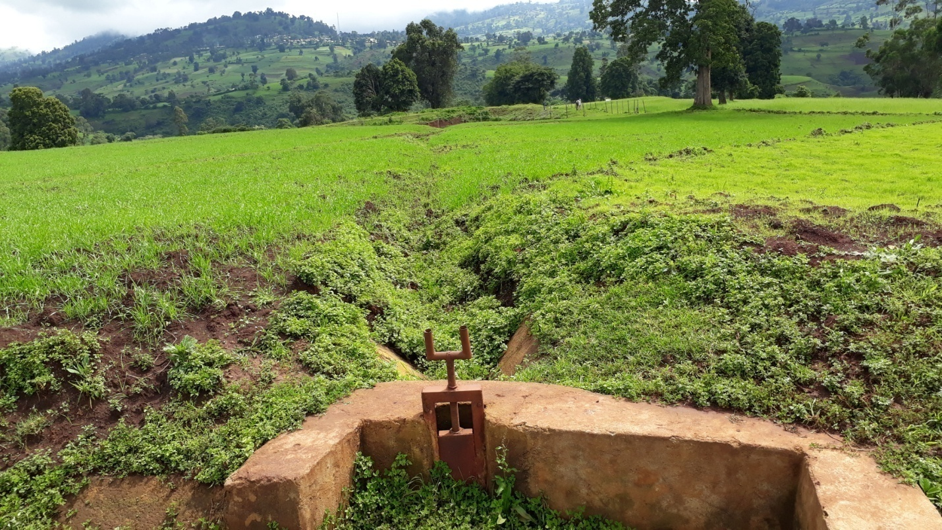
The canal inlet to the pond is totally not there and changed to farm land
Table 14 Current Performance Of Night Storage

Bill of Quantities and Cost Estimate

CONCLUSION AND RECOMMENDATION
- As the dominant soil type is loam soil, the main canal system is designed to be masonry lined.
- The reason why the main canal is to be lined up to the end is to avoid the seepage problem, time saving to reach at the tail part and reduce maintenance cost.
- The design of the canal dimensions of the irrigation canal is done by applying the manning’s uniform flow equation. The variable of the hydraulic parameters are calculated using iteration or flow master program.
- The design discharge of the drainage canals are determined using rational formula and ERA design manual rain fall intensity.
- As soils of the command area are predominantly loam textured; and hence water and soil management measures should be undertaken; and optimum moisture content should be maintained to improve workability of the soil during land preparation and planting time.
The following recommendations are drown:
- Water user association and all of the project users must get awareness on the way of using Irrigation water and how to protect the structures constructed carefully.
- Because of the command area is sloppy; the method of irrigation of the project area is recommended to be furrow surface irrigation method.
- For better performance and long service year of the project regular inspection and maintenance is highly required.
- For better performance and long service year of the project regular inspection and maintenance is highly required.
- Farmers training, how to operate and maintain the project structures as a whole and available and water resources has a paramount important.
- There should physical and biological soil and water conservation practice for the command area to mitigate erosion.
- Close supervision of the construction should be made to modify (if need be) each Components of irrigation system based on specific site conditions.

REFERENCE

- Design Guide line on Irrigation Structures Part I-B, Ministry of water Resources,(July,2002),Addis Ababa, Ethiopia.
- Irrigation Engineering and Hydraulic Structures ,Santosh Kumar Garg, Khanna Publisher,23rd edition 2009,Delhi
- Theory and Design of Irrigation Structures, V-II,SC Gupta,7th edition,2007NEM CHAND &BROS, Roorke, India.
- FAO (1977) guidelines for predicting crop water requirements. No 24, Rome Italy
- Design of small Canal structures , USBR
- Soft copies of hydraulic structure publishing
- IDD manual
- ERA drainage design manual
- E.F.D.R ministry of water resource irrigation system design manual (Part 1-A)

