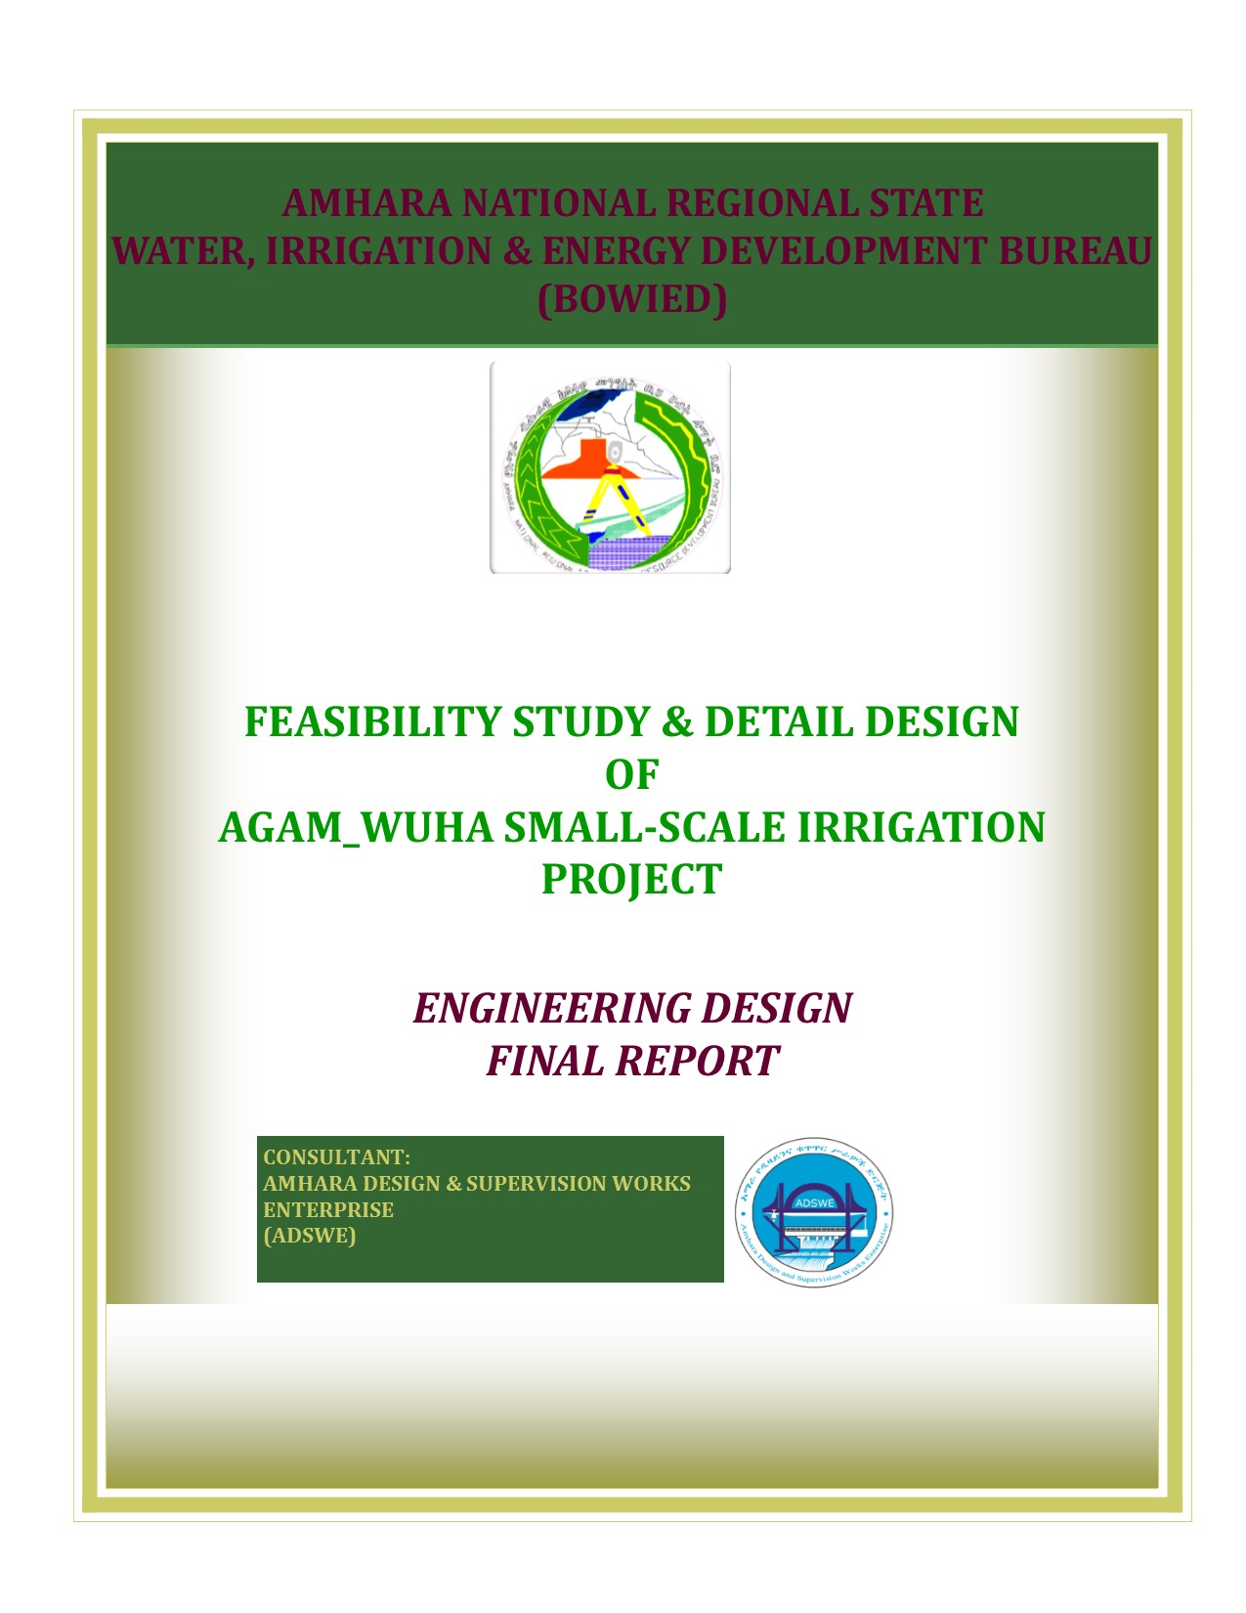
Amhara National Regional State
Water, Irrigation and Energy Development Bureau
(BoWIED)

Feasibility Study and Detail Design
of
Agam Wuha Small Scale Diversion Irrigation Project

Volume IV: Engineering Design
Final Report
Jan. 2018
Bahir Dar

Client: Water, Irrigation and Energy Development Bureau (BoWIED)
Address:
P. O .Box: 88
Telephone: 0528-200853/855
Fax: 251-08-20-65-68/204676/202040
Consultant:Amhara Design & Supervision Works Enterprise (ADSWE)
Address:
P. O. Box: 1921
Telephone: +251-582-181023/ 180638/181201/181254
Fax: (058) 2180550/ (058) 2180560
E-mail:amhara design@yahoo.com
Bahir Dar, Ethiopia

LIST OF TABELS
- VolumeI: Watershed Management
- VolumeII: Engineering Geology
- VolumeIII: Irrigation Agronomy
- Volume IV: Engineering Design
- VolumeV: Socio Economy
- Volume VI: Environmental Impact Assessment
- Volume VII: Economic and Financial Analysis

Table of Contents Page Nr
LIST OF TABLES ix
LISTS OF FIGURES x
ACRONYMS xi
SALIENT FEATURE xii
1. INTRODUCTION 1
1.1. General 1
1.2. Location and Accessibility 1
1.3. Objective of the Study 2
1.4. Scope of the Study 2
1.5. Methodology 3
SECTION-I: HYDROLOGY 5
2. HYDROLOGY 6
2.1. Watershed Characteristics 6
2.2. Metrological Data Availability 7
2.2.1. Hydrometric Data 7
2.2.2. Climate 7
2.3. Data Quality 10
2.3.1. Data Consistency Test 11
2.4. Design Rainfall Computation 14
2.4.1. Normal Distribution Method 14
2.4.2. Log Normal Distribution 14
2.4.3. Log Pearson type III Distribution Method 15
2.4.4. Pearson Type III Method 15
2.4.5. GumbelsEvi Distribution 15
2.4.6. Gumbels Distribution 16
2.5. Selection of Distribution 16
2.5.1. D-index 16
2.6. Design Flood Estimation 17
2.6.1. Peak Flood Analysis by SCS Method 17
2.6.2. Direct Run off Analysis 18
2.7. Flood mark Method 20
2.8. Selected Design flood 24
2.9. Basin Base flow, Demand and Water balance 25
2.9.1. Basin Base flows 25
2.9.2. Existing water use and Irrigation Practices 26
2.9.3. Upstream & Downstream utilization 27
SECTION-iI: Head work structure design 28
3. HEADWORK DESIGN 29
3.1. Headwork Site Selection 29
3.2. River Geomorphology 30
3.2.1. Left Bank Condition 30
3.2.2. Right Bank condition 31
3.2.3. River Bed Condition 32
3.3. Headwork Type Selection 33
3.4. Hydraulic Design of the Structure 33
3.4.1. Weir Height Determination 33
3.4.2. Weir Dimensioning 34
3.4.3. Determination of Upstream & Downstream High flood level (HFL) 35
3.5. Hydraulic Jump Computation 39
3.5.1. Cut off Depth Calculation 44
3.5.2. Impervious floor length design 45
2.1.1.1 D/S protection work 47
3.6. Stability Analysis of Weir 47
3.6.1. Hydraulic Stability 47
3.6.2. Structural stability 51
3.6.3. Resisting Load 51
3.6.4. Over Turning Load 52
3.7. Weir Appurtenance Structures 56
3.7.1. Divide Wall 56
3.7.2. Under sluice 56
2.1.2 Gate for the under sluice 57
3.7.3. Outlet Capacity 58
3.7.4. Design of operation Slab and Breast Wall 59
3.8. Design of Retaining Wall 60
3.8.1. Upstream Retaining Wall 60
3.8.2. Downstream Retaining Wall 62
3.9. Weir Cutoff, Under Sluice Bed, Offtake RCC Capping 63
3.10. Bill of Quantity and Cost Estimation 64
4. IRRIGATION INFRASTRUCTURE 72
4.1. Irrigable Area Description 72
4.1.1. Topography 72
4.1.2. Climate 72
4.2. Soil Characteristics 72
4.3. Existing Irrigation Practices in the Project Area 73
4.4. Irrigation Water Requirement 73
4.4.1. Irrigation Efficiency (Ep) 73
4.4.2. Irrigation Duty 74
4.5. Irrigation Methods 74
4.6. Irrigation and Drainage System Layout 75
4.6.1. Canal Layout 75
4.6.2. Canal Lining Option 76
4.7. Design of the Canal System 78
4.8. Design of Drainage Canal 81
4.9. Irrigation Structures 81
4.9.1. Design of Division Boxes and Turnouts 81
4.9.2. Crossing Structures 85
4.10. Bill of Quantity and Cost Estimation 86
Source of construction materials 92
4.11. Masonry Stones and Coarse Aggregates 92
4.12. Fine Aggregates 93
4.13. Water 94
5. PROVISION OF CAMP FACITLITY 95
6. OPERATION AND MAINTENANCE 96
6.1. General 96
6.2. Irrigation System Operation 96
6.3. Maintenance 97
7. CONCLUSION AND recommendation 99
7.1. Conclusion 99
7.2. Recommendation 99
8. REFERENCE 101

LIST OF TABLES Page Nr
Table 2-1: Data Availability and Adequacy Addis Zemen Station 8
Table 2-2: Maximum Daily Rain Fall for Addis ZemenStation 8
Table 2-3: Storm Analysis for Addis Zemen Rainfall Station 10
Table 2-4: D-index Test 17
Table 2-5: Design Rainfall Arrangement 18
Table 2-6: Direct Runoff analysis 19
Table 2-7: Hydrograph Coordinates 19
Table 2-8: River Discharge Computation at Different Stages of Flow 23
Table 3-1:Weir Height Determination 33
Table 3-2: Weir Top and Bottom Width Determination 38
Table 3-3: Jump and tail-water profile 42
Table 3-4: Broad crested weir thickness at key points for alluvial deposit 49
Table 3-5 : Hydraulic gradient at key points for no flow and flood condition 50
Table 3-6: Weir Stability Analysis at Pond Level 53
Table 3-7: stability analysis at high flood level 55
Table 3-8: Off take Sizing 59
Table 3-9: Upstream Retaining Wall Stability Analysis 62
Table 3-10: Downstream Retaining wall stability analysis 63
Table 3-11: Bill Nr. 1- General Item Cost 64
Table 3-12: Bill Nr. 2- Headwork Structure 65
Table 4-1: Hydraulic Parameters of Main Canal 78
Table 4-2: Hydraulic Parameter of Secondary Canal 1 (SC 1) 80
Table 4-3: Hydraulic Parameter of Secondary Canal 2 (SC-2) 80
Table 4-4: Hydraulic Parameter of the Tertiary Canal 81
Table 4-5: Hydraulic Parameters of Division Box 83
Table 4-6 : Off take hydraulic parameters from mC-1 and SC-1 83
Table 4-7 : Hydraulic parameters for turnout from SC-2 and TC1 84
Table 4-8: Bill Nr. 3- Irrigation Infrastructure 86
LISTS OF FIGURES Page Nr
Figure 1-1: Project Area Location Map 2
Figure 2-1: Drainage map of Agam__Wuha watershed 7
Figure 2-2: Trend Of Daily Heaviest Rainfall in Addis Zemen NMS 9
Figure 2-3: Trend Of Annual Rainfall in Addis Zemen NMS 10
Figure 2-4: Complex Hydrograph 20
Figure 2-5: The River Cross-Section for Agam Wuha Weir Axis 21
Figure 2-6: Stage Discharge Curve 24
Figure 3-1: Proposed Weir Axis 30
Figure 3-2: Geological Cross section of the Weir Axis 32
Figure 3-3 : Schematic drawing of the weir profile 36
Figure 3-4 : Schematic presentation of weir section 39
Figure 3-5: Hydraulic Jump Profile at the Proposed Weir Site 40
Figure 3-6: Jump Versus Tail Water Depth Curve 43
Figure 3-7 : Cut off depth Sketch 45
Figure 3-8 : Diversion Weir longitudinal section 46
Figure 3-9 : Uplift pressure distribution for no flow and flooding condition 49
Figure 3-10: Load Distribution during Minimum Water level 53
Figure 3-11 : Load Distribution after work completion 55
Figure 3-12 : Typical wing wall section and load distribution 61
Figure 4-1: Typical Division Box Drawing 84
Figure 0-1: source of masonry and coarse aggregate 92

ACRONYMS
- ADSWE : Amara Design and Supervision Enterprise
- BoWRD : Bureau of Water resource Development
- CN : Curve Number
- NMSA : National Meteorology Station Agency
- ETo :Evapotranspiration
- SCS : Soil Conservation Service
- IDD : Irrigation and Drainage Department
- U/S :Upstream stream
- D/S : Down stream
- HFL : High flood level
- TEL : Total energy level
- CBL : Canal bank level

SALIENT FEATURE
- Project name: Agam_WuhaSmall Scale Diversion Irrigation Project
- Name of the stream: Agam_Wuha River
- Location of the weir site
- North: 1361607.003
- East: 378345.806
- Average Altitude: 1866.23 m.a.s.l
- Accessibility: 37 km from Arbaya
- Zone: North Gonder
- Wereda: West Belesa
- Kebele: Bajja Ferfer
- Hydrology
- Selected Meteorology station for Watershed : Addis Zemen Metrological station
- Design rainfall: 89.49 mm
- Catchment area: 59.87 Km²
- Longest flow path length: 19.18 km
- Design flood: 158.74 m³/s
- Lean flow: 81l/s

- Diversion Weir
- Weir type: Broad crest
- Height: 2.70m
- Gross crest length: 23.00m
- Effective weir crest length: 22m
- Weir crest level: 1869.18m.a.s.l
- U/S HFL: 1871.45m.a.s.l
- D/s HFL: 1868.848m.a.s.l
- Afflux: 2.15m

- Under sluice
- Number of under sluice : 1
- Sill level: 1867.98m.a.s.l
- Dimension:1.00m x0.1.20m ( length x height)
- Discharge capacity: 2.406m³/sec
- Outlets
- Sill level:1868.58 m.a.s.l
- Opening dimension: 0.50m x 0.60m
- Discharge capacity: 0.162 m³/sec
- Irrigation and drainage systems Infrastructure
- Command area
- size: 100ha
- Design Discharge of Main Canal: 0.162m³/sec
- Canals
  - Nr of main canal: 1
  - Nr of secondary canals: 2
  - Nr of tertiary canal : 1
- Project cost
Agam Wuha SSIP SUMMARY OF BILLS
Bill No. | Description | Amount (Birr)
1 | General Items | 1,037,000.00
2 | Head work (intake body, Outlet structures) | 4,188,892.36
3 | Irrigation Infrastructures (MC,FC,Flumes,Culverts..) | 9,814,129.47
Total |  | 15,040,021.84
VAT(15%) |  | 2,256,003.28
Grand Total |  | 17,296,025.11
Per hectare Cost without VAT |  | 150,400.22

INTRODUCTION

General
In Ethiopia, under the prevalent rain-fed agricultural production system, the progressive degradation of the natural resource base, especially in highly vulnerable areas of the highlands coupled with climate variability have aggravated the incidence of poverty and food insecurity. The major source of growth for Ethiopia is still conceived to be the agriculture sector. Hence, this sector has to be insulated from drought shocks through enhanced utilization of the water resource potential of the country, (through development of small-scale irrigation, water harvesting, and on-farm diversification) coupled with strengthened linkages between agriculture and industry (agro-industry), thereby creating a demand for agricultural output. In line with the above, efforts have been made by the government and NGO’s to improve the situation in the country in areas of domestic water supply provision, irrigation, watershed management, etc. Amhara Water Resources Development Bureau is playing its role in the development of small scale irrigation projects in the region. Agam_Wuha small scale irrigation project is part of the development strategy carried out by the regional Bureau of Water Resource Development.
Accordingly, as part of the water sector development program, the owner of the project Amhara Region Bureau of Water Resource development has initiated the study and design of a small scale irrigation scheme on Agam_Wuha River at Baja Ferfer Kebele and signed an agreement with Amhara Design & Supervision Works Enterprise (ADSWE) for the study and design of the project.

Location and Accessibility
This irrigation project is located mainly at Baja Ferfer Kebele, West Belesa Wereda of North Gondar Zone in the Amhara Region. The proposed irrigation project is to be undertaken on Agam_WuhaRiver and the headwork structures are specifically located at an altitude of about 1866.267masl and geographical coordinates of 1361607.003N & 378345.806E (UTM ADINDAN).
The project Head work site is accessible by vehicle via 130km asphalt road from the regional city Bahir Dar to Maksegnit, 40km all weathered road to Arbaya Woreda capital town of West Belesa, 37 km all weathered road from woreda center, Arbaya to Bajja Ferfer Kebele. The main command area is accessible by this road. Almost all command areas are accessible in dry season.
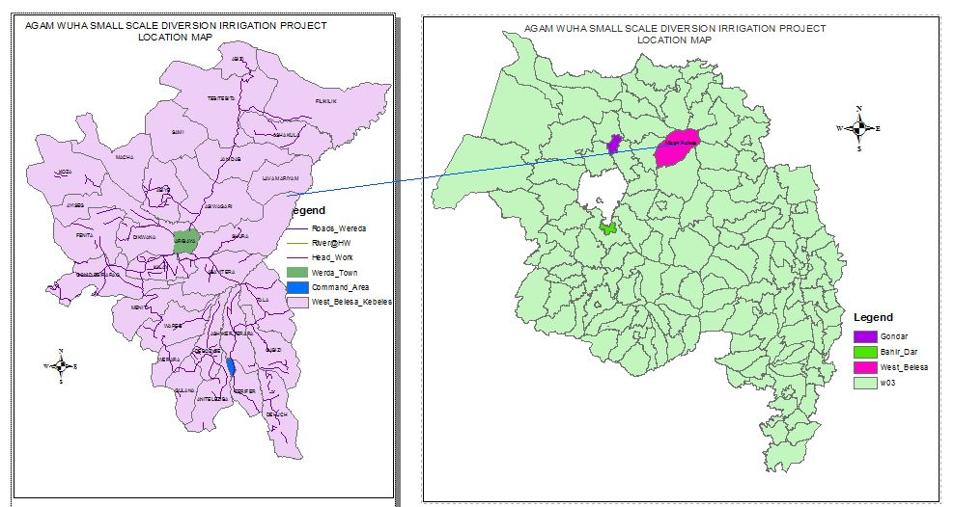
Figure 1-1: Project Area Location Map

Objective of the Study
The general objective of Agam Wuha irrigation based development study is to prepare the required design for utilizing the available water and land resources in the project area. The design focused on utilizing these resources for dry period and supplementing the rain fed agriculture during moisture stress in wet seasons. Particularly in this study it focuses the preparation of headwork and appurtenant structures and irrigation infrastructure design for the project.

Scope of the Study
- The irrigation design shall ensure reliability, equity and flexibility of water delivery to farmers. It will aim at reducing conflicts among water users and will lead to lower operation and maintenance costs.
- Computation of the actual evapotranspiration, crop water requirement, irrigation demand/duty using the existing and recent agronomic, climatologic and soil data using more appropriate methodologies.
- Design proper irrigation system compatible with local conditions and management capabilities,
- Establish flood protection measures for the command area and canal structures and design the respective drainage system accordingly,
- Planning and layout of the irrigation system, which include irrigation canals, drainage channels, inspection roads and alignments, canal spacing, canal length, location of structures, and water profiles along canal and drains at specified reaches, which is most economical easily manageable and aligned with topographic feature and geological investigation.
- Determination and estimation of water application conveyance and other losses and irrigation efficiencies and consideration of those parameters in design steps.
- Check and test hydraulic and structural designs of main canal considering total demand and the required capacity and the base flow availability,
- Prepare general plans and drawings for all irrigation infrastructure and irrigation systems designs,

Methodology
In the study and design procedure, designers used the following steps.
- Site identification:
  - DEM, Google Earth
  - Local farmers interview and discussions
  - Wereda Agriculture section expertise
  - Previous studies
  - On foot travel along the river channel and farm areas.
- Topographic survey:
  - Surveying the head work area with sufficient distance to u/s and d/s reaches, using Total station and GPS.
- Flow estimation
  - Physical observation on flood mark indications and local information about high flood level and base flow condition of the river.
  - Analyzing the recorded rainfall data and use watershed inputs for further analysis of peak flood determination.
  - The base flow is estimated using floating method
- Irrigable area identification:
  - Using local information
  - Site observation, topo map and GIS information
  - Google Earth to identify villages.

SECTION-I: HYDROLOGY

HYDROLOGY

Watershed Characteristics
In any small scale modern irrigation system, most of the headwork component structures are to be designed considering the magnitude of flood produced by a 50 (fifty) years return period design rainfall. In order to do hydrological analysis first it is important to understand/study the characteristics of the watershed.
All the watershed parameters have been determined by using a topographic map at a scale 1:50000 and Digital Elevation Model of 90x90m resolution. By using ArcSWAT and field ground truthing or data collection, the average Curve Number in Antecedent Moisture Condition II is found to be 83.49 and with time of concentration of 2.89hr. All the details of the watershed characterization and development plan is shown in the watershed report.
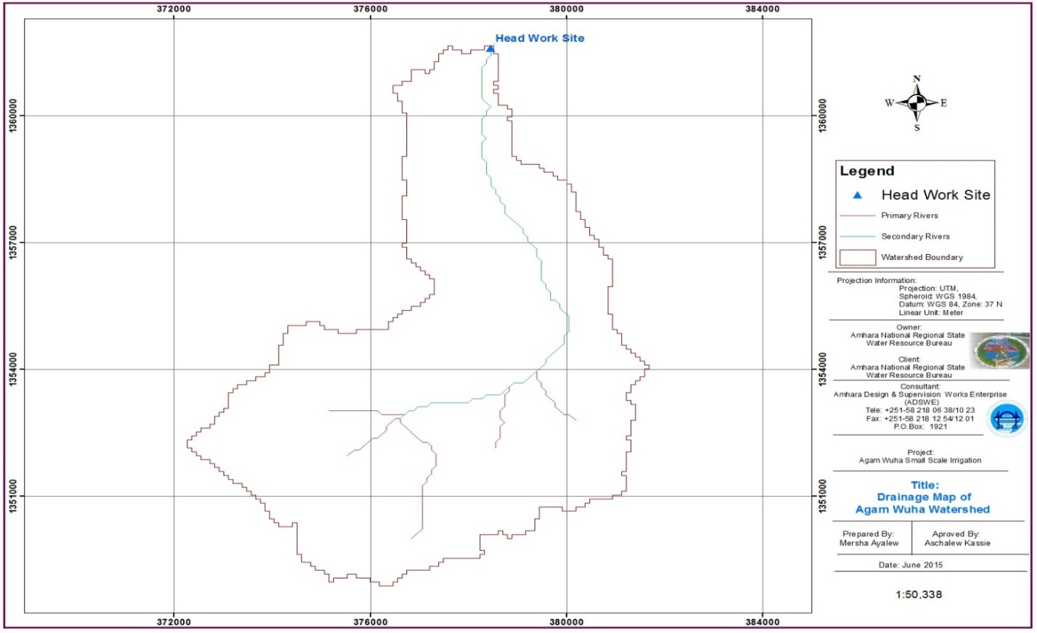
Figure 2-1: Drainage map of Agam__Wuha watershed

Metrological Data Availability

Hydrometric Data
Hydrologists and designers are faced with lack of good or non-recorded hydrometric data on the target stream/river and on local weather and climate conditions. Stream gauging stations are non-existent in remote rural areas of the region and even meteorological stations are almost rare near small rivers in the region. Likewise, at the watershed of Agam_Wuha River, there is neither gauged river nor meteorological station. Therefore investigating other stations near the project area is the primary step in hydrological analysis of the given Agam_Wuha watershed.

Climate
Rainfall and other related meteorological data availability is core for any projects that require hydrological analysis. However, sufficient availability of such data in a target position is a rarely happening phenomenon in developing countries like Ethiopia.
The nearest meteorological station for the headwork site is Arbaya meteorological but the watershed area is closest to Addis Zemen meteorological. Therefore, designer of the project has adopted Addis Zemen`s station heaviest daily rainfall data for the calculation of design rainfall and for peak flood analysis. Though interrupted a little, about 10 years rainfall data is used here under for analysis. The completeness of the selected station data is tabulated as shown in the following table.
Table 2-1: Data Availability and Adequacy Addis Zemen Station
Climate data Elements | Nr. Years | Range of Data Years | Adequacy | Remark
Minimum temperature | - | - | -
Maximum temperature | - | - | -
Daily Rainfall | 10 | 1997-2006 | Adequate
Wind speed | - | - | -
Sunshine hours | - | - | -
Relative humidity | - | - | -

Table 2-2: Maximum Daily Rain Fall for Addis ZemenStation
Nr. Data | Year | Max. RF
1 | 1997 | 42.5
2 | 1998 | 32.4
3 | 1999 | 42
4 | 2000 | 46.5
5 | 2001 | 27
6 | 2002 | 53.2
7 | 2003 | 38
8 | 2004 | 48.4
9 | 2005 | 57
10 | 2006 | 69

Figure 2-2: Trend Of Daily Heaviest Rainfall in Addis Zemen NMS

Figure 2-3: Trend Of Annual Rainfall in Addis Zemen NMS

Data Quality
Rainfall and other related meteorological data availability is core for any projects that require hydrological analysis. However, sufficient availability of such data in the target position is a rarely phenomenon in developing countries.
Maximum daily rainfall of each year is filtered out from the recorded data. There may be errors in data that affect its quality. These errors may be either instrumental or personal errors. Personal error may occur during reading, measuring, recording & etc. of the data. A data value registered by any error has to be rejected by various quality test methods, because, it may lead to uneconomical or unsustainable structures designing of the project. So, for this particular case, data consistency, adequacy and whether the existing data values lays between extreme outlier values should be checked for each station in 50 years return period.
Table 2-3: Storm Analysis for Addis Zemen Rainfall Station
Nr. | Year | Max. RF | Descending Order | Rank | Logarithmic Value/Yo/ | (Yo-Ym)² | (Yo-Ym)³
1 | 1997 | 42.5 | 69 | 1 | 1.8388 | 0.0377224 | 0.0073266
2 | 1998 | 32.4 | 57 | 2 | 1.7559 | 0.0123762 | 0.0013768
3 | 1999 | 42 | 53.2 | 3 | 1.7259 | 0.0066073 | 0.0005371
4 | 2000 | 46.5 | 48.4 | 4 | 1.6848 | 0.0016176 | 0.0000651
5 | 2001 | 27 | 46.5 | 5 | 1.6675 | 0.0005210 | 0.0000119
6 | 2002 | 53.2 | 42.5 | 6 | 1.6284 | 0.0002637 | -0.0000043
7 | 2003 | 38 | 42 | 7 | 1.6232 | 0.0004570 | -0.0000098
8 | 2004 | 48.4 | 38 | 8 | 1.5798 | 0.0042046 | -0.0002726
9 | 2005 | 57 | 32.4 | 9 | 1.5105 | 0.0179778 | -0.0024105
10 | 2006 | 69 | 27 | 10 | 1.4314 | 0.0454810 | -0.0096994
SUM |  |  | 456.00 |  | 16.4463 | 0.1272286 | -0.0030792
MEAN |  |  | 45.60 |  | 1.6446 | 0.0127229 | -0.0003079
STANDARD DEVATION |  |  | 12.22 |  | 0.1189
SKEWNESS COEFICIENT |  |  | 0.197 |  | -0.2544

Data Consistency Test
Ten years of daily heaviest rainfall records of Addis Zemen meteorological station, from 1997 to 2006, were used for the estimation of design rainfall. The number of this rainfall data is adequate to compute storm event that happens at every 50 years of return period, which is common for small scale irrigation projects like Agam_Wuhaweir. These data should be checked for their reliability and then by outlier test in order to assurance their adequacy.

Checking Data Reliability
Number of data = 10
Standard deviation,
Mean,
Standard error of mean, = 3.795
Relative standard, =
Hence, the data series is regarded as reliable and adequate since the value of relative standard is smaller than the maximum limit.

Data Outlier Test
This is done to check if the adopted data are within a limited range or Nrt. It is to mean, larger recorded values greater than the calculated higher value will be dropped as well as smaller recorded heaviest daily rainfall values less than the calculated lower value.
Input data:
Summation of the daily maximum rainfall data records of twenty years,
Arithmetic mean of the data, Ẍ

Summation of common logarithms of the data,
Mean value of common logarithms of the data,
  
Standard deviation of the common logarithms,
Skewness of the common logarithms of the daily maximum rainfall data, Cs
Tests for Outliers
Outliers are data points that depart from the trend of the remaining parent data. The detention or retention of these outliers can significantly affect the magnitude. As shown from the above calculation the Station Skew is between -0.4 than 0.4, test for higher and lower outliers is considered. However, if it were less than -0.4, then only the lower outlier would be considered and if it were greater than 0.4 the higher outlier would be checked.
Test for higher outlier
Higher outlier
Where: = mean of data in log unity
= From table for sample size N
From Table for data N=10,   and
Skewness coefficients,
Higher outlier
The highest recorded value (69mm) is less than the higher outlier (77.0686 mm). Therefore, there is no higher outlier.
Test for lower outlier
Lower outlier
The lowest recorded value (27 mm) is greater than lower outlier (25.2566 mm) and Nr lower outlier. Therefore, the recorded data is consistent for both outliers and it is possible to use it for analysis.

Design Rainfall Computation
After checking the consistency of the data for higher and lower outlier, the data is considered as representative for the analysis. The probability of occurrence of maximum probable rainfall is estimated as follow:

Normal Distribution Method
$$Xt=\overline{X}+K_{t}S_{y}$$
$$K_{t}=w-\frac{2.515517+0.80802853w+0.010328w^{2}}{(1+1.432788W+0.189269w^{2}+0.001308 w^{3}}$$
$$w= {\left[ln\left(\frac{1}{p^{2}}\right)\right]}^{1/2}$$
$${Where, K}_{t}=frequency Factor$$
The frequency factor can be expressed as, $y_{t}=\overline{y}+K_{t}S_{y}$

Log Normal Distribution
For log Normal distribution, the same procedure applies except that it is applied to the logarithms of the variables, and their mean and standard deviation are used for D-index test.
$$Xt=\overline{Y}+K_{t}S_{y}$$
$$K_{t}=w-\frac{2.515517+0.80802853w+0.010328w^{2}}{(1+1.432788W+0.189269w^{2}+0.001308 w^{3}}$$
$$w= {\left[ln\left(\frac{1}{p^{2}}\right)\right]}^{1/2}$$
$${Where, K}_{t}=frequency Factor$$
$$y_{t}=\overline{x}+K_{t}S_{y}$$

Log Pearson type III Distribution Method
For this distribution, the first step is to take the logarithms of the hydrologic data, $y=logx$. The mean, standard deviation and coefficient of Skewness are calculated for the logarithms of the data.
$$Yt=\overline{Y}+K_{t}S_{y}$$
$$K_{t}=Z+\left(Z^{2}-1\right)k+\frac{1}{3}\left(Z^{3}-6Z\right)K^{2}-\left(Z^{2}-1\right)K^{3}+ZK^{4}+\frac{1}{3}K^{5}, Where k=C_{s}/6$$
$$Z=w-\frac{2.515517+0.80802853w+0.010328w^{2}}{(1+1.432788W+0.189269w^{2}+0.001308 w^{3}}$$
$$w= {\left[ln\left(\frac{1}{p^{2}}\right)\right]}^{1/2}$$

Pearson Type III Method
$$x_{t}=\overline{x}+K_{t}S_{y}$$
$$K_{t}=Z+\left(Z^{2}-1\right)k+\frac{1}{3}\left(Z^{3}-6Z\right)K^{2}-\left(Z^{2}-1\right)K^{3}+ZK^{4}+\frac{1}{3}K^{5}=C_{s}/6$$
$$Z=w-\frac{2.515517+0.80802853w+0.010328w^{2}}{(1+1.432788W+0.189269w^{2}+0.001308 w^{3}}$$
$$w= {\left[ln\left(\frac{1}{p^{2}}\right)\right]}^{1/2}$$

GumbelsEvi Distribution
$$K_{t}=\frac{Y_{t}-Y_{n}}{S_{n}}$$
Y_{n}= Reduced mean in Gamble’s extreme value distribution for N sample size from table;
S_{n}= Reduced standard deviation in Gamble’s extreme value distribution for N sample size from table.
$$Xt=\overline{X}+K_{t}S_{y}$$
$$K_{t}= 0.7801\left\{0.5772+ln\left\lceil (ln(T/(T-1))\right\rceil \right\}$$

Gumbels Distribution
Using Gumbel's method the design storm is given as follows
QT = QMEAN +K*σ = 89.45mm
Where,
Where,
QT = Daily maximum design storm of 50 years return period
QMEAN = Mean of the daily maximum storm
K= Frequency factor and
σ= Standard deviation
Yn = Reduced mean
Sn = Reduced standard deviation

Selection of Distribution

D-index
The data shall be checked for goodness using D-Index Method for different distribution methods.
$$D-Index=\frac{1}{\overline{X}}\sum_{i}^{n}{(x_{i}-\overline{X}})$$
Where $x_{i}$ and $\overline{X}$ are the i^{th} highest observed and computed values for the distribution. The distribution giving the least D- index is considered to be the best fit distribution statically parameter.

Table 2-4: D-index Test
Rank | XI | Normal | Log Pearson Type III | Log Normal | Pearson Type III | Gumbel EVI | Gumbel
Rank | XI | XI -'XI' | XI -'XI' | XI -'XI' | XI -'XI' | XI -'XI' | XI -'XI'
1 | 69.00 | 7.078 | 5.408 | 5.408 | 6.898 | 6.500 | 3.457
2 | 57.00 | 0.298 | 0.425 | 0.425 | 0.348 | 1.595 | 13.776
3 | 53.20 | 0.215 | 1.144 | 1.144 | 0.374 | 2.196 | 42.522
4 | 48.40 | 1.457 | 0.133 | 0.133 | 1.241 | 0.733 | 35.058
5 | 46.50 | 0.492 | 0.983 | 0.983 | 0.252 | 1.629 | 51.481
Sum |  | 9.541 | 8.094 | 8.094 | 9.113 | 12.653 | 146.294
Sum/Mean |  | 0.209 | 0.177 | 0.177 | 0.200 | 0.277 | 3.208
Point Rainfall |  | 70.71 | 74.54 | 77.42 | 69.01 | 77.28 | 89.45
Design Point Rainfall = |  |  | 89.448
Though it relatively over estimates the design storm, Gumbell Probability Distribution is preferred for the design of hydraulic structures. This is because the computed design rainfall value passes through different processes that further reduce the expected design flood, like Rainfall Profile and Ariel to Point ratio, till the peak runoff is found, the standard error of the data approaches to its limit 10%, and also in our country the gauging stations data are not recorded and placed carefully. Thus, it is better to apply Gumbell distribution method to get a design storm of highest value.

Design Flood Estimation

Peak Flood Analysis by SCS Method
For ungagged rivers, the design flood can be simulated by using SCS unit hydrograph method. The computation is done using design rainfall. In the hydrologic analysis of flood using SCS method, rainfall amount, catchment area, shape, ground cover, type of soil, slopes of terrain and stream(S); antecedent moisture condition; storage potential (over bank, ponds, wetlands, reservoirs, channel, etc.) can be used and all such data shall be carefully determined before proceeding to SCS simulation. For detail, see watershed study report of the same project.
Generally, the following result is obtained from the watershed study report of the same project.
Time of concentration (Tc) = 2.89hr
Average Curve number (CN) = 83.49
Total Catchment area = 59.87 km²

Areal Rainfall
As the area of the catchment gets larger, coincidence of all hydrological incidences becomes less and less. This can be optimized by changing the calculated point rainfall to aerial rainfall. The conversion factor is taken from standard table or curves that relate directly with the size of watershed area and type of the gauging station (IDD manual). But in this project a table was used.

Rainfall Profile
Rainfall profile is the distribution of the proportion of design rainfall during every incremental time on the watershed area during the 24 hours duration. Well-developed models are needed to determine such an event for the selected basin area. But there are Nr sufficient modelling studies in the vicinity and adaptation of standard curves has been taken as the only option. Designer of this project has adopted the standard curve from Design Guidelines for Small Scale Irrigation Projects in Ethiopia. With the aid of rainfall profile versus duration curve the percentages of design rainfall distribution on the catchment area are computed for the first most intensive storm duration.
Table 2-5: Design Rainfall Arrangement
Duration (hr) | Design Rainfall  (mm) | Rainfall Profile |  | Area to Point Ratio  (%) | Areal Rainfall  (mm) | Incremental Rainfall  (mm) | Descending order  (mm) | Rank
Duration (hr) | Design Rainfall  (mm) | (%) | (mm)
0.50 |  | 30 | 26.8 | 59.42 | 15.9 | 15.95 | 15.95 | 1
1 |  | 45 | 40.3 | 69.42 | 27.9 | 12.00 | 12.00 | 2
1.5 | 89.49 | 52 | 46.5 | 73.32 | 34.1 | 6.16 | 6.16 | 3
2 |  | 59 | 52.8 | 77.21 | 40.7 | 6.64 | 6.64 | 4
2.5 |  | 63 | 56.4 | 79.02 | 44.5 | 3.78 | 3.91 | 5
3 |  | 67 | 59.9 | 80.82 | 48.4 | 3.91 | 3.78 | 6

Direct Run off Analysis
The maximum potential difference between rainfall and runoff, S, starting at the time the stormbegins is given by;
$$S=\frac{25400}{N}-254$$
The direct surface runoff, Q, in mm is given by,
- $Q=\frac{{(I-0.2S)}^{2}}{(I+0.8S)}$
- $S=\left(\frac{25400}{CN}\right)-254$
- $Q_{p}=0.21*\frac{(A*Q)}{T_{p}}$
- Where, I =cumulative Rainfall in mm
- S = Maximum run off potential difference,
- Q_{p} = Peak run-off for incremental, unit rainfall depth;
- A = Catchment area (Km2)
- Tp = Time to peak (hr)
- Q = Incremental run-off (mm)

Table 2-6: Direct Runoff analysis
Duration  (hr.) | Commutative RF  (mm) | Incremental RF  (mm) | Cumulative runoff  (mm) | Incremental runoff  (mm) | Runoff  (m³/s) | Unit hydrograph time |  |  | Remark
 |  |  |  |  |  | Beginning | Peak | End | Remark
0.50 | 3.78 | 3.78 | 0.00 | 0.00 | 0.00 | 0.50 | 1.99 | 5.30 | H1
1.00 | 9.94 | 6.16 | 1.13 | 1.13 | 7.17 | 1.00 | 2.49 | 5.80 | H2
1.50 | 16.59 | 6.64 | 4.38 | 3.25 | 20.56 | 1.50 | 2.99 | 6.30 | H3
2.00 | 32.53 | 15.95 | 15.86 | 11.48 | 72.65 | 2.00 | 3.49 | 6.80 | H4
2.50 | 44.53 | 12.00 | 26.01 | 10.15 | 64.25 | 2.50 | 3.99 | 7.30 | H5
3.00 | 48.44 | 3.91 | 29.46 | 3.45 | 21.84 | 3.00 | 4.49 | 7.80 | H6

Table 2-7: Hydrograph Coordinates
Hydrograph Time | H1 | H2 | H3 | H4 | H5 | H6 | HT
0.50 | 0.00 |  |  |  |  |  | 0.00
1.00 | 0.00 | 0.00 |  |  |  |  | 0.00
1.50 | 0.00 | 2.41 | 0.00 |  |  |  | 2.41
1.99 | 0.00 | 4.76 | 6.73 |  |  |  | 11.49
2.00 | 0.00 | 4.82 | 6.92 | 0.00 |  |  | 11.74
2.49 | 0.00 | 7.17 | 13.65 | 23.78 |  |  | 44.60
2.50 | 0.00 | 7.14 | 13.83 | 24.44 | 0.00 |  | 45.41
2.99 | 0.00 | 6.09 | 20.56 | 48.21 | 21.03 |  | 95.90
3.00 | 0.00 | 6.06 | 20.48 | 48.87 | 21.61 | 0.00 | 97.03
3.49 |  | 5.01 | 17.47 | 72.65 | 42.64 | 7.15 | 144.91
3.99 |  | 3.93 | 14.37 | 61.70 | 64.25 | 14.49 | 158.74
4.49 |  | 2.85 | 11.27 | 50.75 | 54.57 | 21.84 | 141.27
5.30 |  | 1.08 | 6.20 | 32.85 | 38.74 | 16.46 | 95.32
5.80 |  | 0.00 | 3.10 | 21.90 | 29.05 | 13.16 | 67.21
6.30 |  |  | 0.00 | 10.95 | 19.37 | 9.87 | 40.19
6.80 |  |  |  | 0.00 | 9.68 | 6.58 | 16.27
7.30 |  |  |  |  | 0.00 | 3.29 | 3.29
7.80 |  |  |  |  |  | 0.00 | 0.00
From the analysis, the 50 years return period design flood is 158.74 m³/s. This implies that for this watershed the peak flood rate per km² area of the watershed is about 2.65 m³/s/km². This value ensures that high rainfall of the area can generated higher rate of runoff per km2 of the generating catchment. Graphical plot of all the 6 hr synthetic hydrographs are shown below.

Figure 2-4: Complex Hydrograph

Flood mark Method
During field assessment and topographic survey, the flood characteristics have been requested from the local aged farmers and it has been concluded the flow would not overflow above bank of the river. This is just to check the design flood what we have determined using rough simulation methods such as SCS for ungagged catchments. That was the main purpose of taking flood marks information during field assessment and that will be checked using the stage discharge analysis in the following section.
Tail water depth of the river is equal to the flood depth and amount at the proposed weir site before construction of the weir. It is used to crosscheck peak flood estimated by the SCS unit hydrograph method with flood mark method and to see the flood feature after the hydraulic jump. During field visit, the flood mark of the river at the proposed diversion site was decided to be inside the river bank based on dwellers information and physical indicative marks. The data required to do stage discharge analysis has been discussed in the following section.

Figure 2-5: The River Cross-Section for Agam Wuha Weir Axis
- Average river bed slope
Average river bed slope of a River is estimated by two different techniques. One is by end area method and the other is by using best fit line method. Designers have adopted the end area method output for further analysis. Finally the average bed slope using end area method is 0.011 as shown below.
River slope estimation using partial area method
SN | Partial Distance (m) | Elevation H(m) | Accumulative Height(m) | Total Area A(M^2)
1 | 0.00 | 1866.9569 | 0 | 0
2 | 10.00 | 1866.7935 | 0.163 | 0.815
3 | 10.00 | 1866.5984 | 0.358 | 2.605
4 | 10.00 | 1866.5389 | 0.418 | 3.88
5 | 10.00 | 1866.5277 | 0.429 | 4.235
6 | 10.00 | 1866.4439 | 0.513 | 4.71
7 | 10.00 | 1866.359 | 0.598 | 5.555
8 | 10.00 | 1866.2744 | 0.682 | 6.4
9 | 10.00 | 1866.0791 | 0.878 | 7.8
10 | 10.00 | 1865.9111 | 1.046 | 9.62
11 | 10.00 | 1865.6506 | 1.306 | 11.76
12 | 10.00 | 1865.5901 | 1.367 | 13.365
13 | 10.00 | 1865.5328 | 1.424 | 13.955
14 | 10.00 | 1865.3029 | 1.654 | 15.39
15 | 10.00 | 1865.2409 | 1.716 | 16.85
16 | 10.00 | 1865.3736 | 1.583 | 16.495
17 | 10.00 | 1865.5097 | 1.447 | 15.15
18 | 10.00 | 1865.5671 | 1.39 | 14.185
19 | 10.00 | 1865.4633 | 1.494 | 14.42
20 | 10.00 | 1865.2629 | 1.694 | 15.94
21 | 10.00 | 1865.267 | 1.69 | 16.92
sum | 200.00 |  |  | 210.05
Havg | 2.10
Iavg | 0.011

The average vertical height ( H_{av}) in m,
Where A=summation of partial areas=210.05m2, L=summation of partial distance=200m
Compute average river slope in decimal = $Iavg=\frac{Havg}{L}=\frac{2.10}{200}=0.011$

- Manning’s Roughness coefficient for the river bed and banks (average)
The Manning’s roughness coefficient is taken from standard table based on the river nature. At this site the river course is well defined, with fixed width, length and excellent form of river shape The River banks are defined,rocky and relatively alluvial deposit river bed So, Manning’s roughness coefficient (n = 0.04) is adopted.
- Discharge of the river
Input data:
- Manning's roughness coefficient, n = 0.04
Average river bed slope, S = 0.011
,
- Where, R = Hydraulic radius = (Area/Perimeter)
- $Q=V*A$
Table 2-8: River Discharge Computation at Different Stages of Flow
Elevation (m) | Water Depth (m) | Area (m2) | Wetted Perimeter (m) | Hydraulics Radius (m) | Velocity (m/sec) | Discharge (m3/sec) | Remark
1866.480 | 0 | 0.000 | 0.000 | 0.000 | 0.00 | 0.00
1866.502 | 0.022 | 0.997 | 7.880 | 0.127 | 0.66 | 0.66
1866.777 | 0.297 | 1.902 | 9.597 | 0.198 | 0.89 | 1.70
1867.113 | 0.6333 | 6.362 | 17.473 | 0.364 | 1.34 | 8.51
1867.222 | 0.742 | 8.302 | 18.286 | 0.454 | 1.55 | 12.86
1867.722 | 1.2423 | 17.718 | 19.946 | 0.888 | 2.42 | 42.93
1868.222 | 1.7423 | 27.790 | 21.607 | 1.286 | 3.10 | 86.18
1868.969 | 2.4893 | 44.060 | 24.088 | 1.829 | 3.92 | 172.79

From the above stage discharge table the maximum flood estimated from the SCS design flood depth interpolated is 2.368m from the river bed.

Figure 2-6: Stage Discharge Curve

Selected Design flood
The computed flood amount using SCS method above and hence design flood is calculate as 158.74m³/s.
Based on the stage discharge analysis of the project at d/s of the weir section or design discharge capacity of the river channel before the construction or intervention, the downstream high (HFL) flood level can be fixed by the selected designed flood in the previous section. Therefore, the D/S HFL=river bed elevation + depth of Tail-water (as obtained from SCS flood at a depth of 2.368m). D/S HFL=1866.48+2.368=1868.848 m.a.s.l.

Basin Base flow, Demand and Water balance

Basin Base flows
Today the question of water right becomes a nationwide burning issue. Crop cultivation based on modern or semi-modern irrigation schemes becomes the solely alternative for developing countries like Ethiopia to feed their rapidly growing population. Though it is the bare fact, downstream water rights and ecological securities should be preserved to make the project environmental friendly whereby resolving social conflicts too.
Agam_WuhaRiver is the water source for the intended AgamWuha small scale irrigation project. The project has been named after the name of this river. The river is Perennial River and on April, 2015 during site investigation period, the base flow had been measured by using floating method and the discharge was found to be 102 l/s.
When we checked the base flow within the same technique on Dec.27, 2017, the stream flow was estimated to be 81.00 lit/sec at the proposed weir site. This difference might be raised due to erratic rainfall distribution, there might be occurred rainfall at the feasibility study period, however the river is perennial as we checked after around one month or at the middle of January 2018. When we checked the stream flow at the indicated date at the downstream of about 1.00 kilometer distant downstream of the first measuring location, the estimated stream flow was around 100lit/sec. This indicated that the stream flow increases downstream because of the following facts.
- Sub surface flow through alluvial deposits
- There are small side springs that contributes seepage flow to the river
- There is small natural perennial stream that joins the Agamwuha River.
There is one intermittent stream at the left side of the AgamWuha that joins at the downstream and has good flow up to end of November. This stream is also contributing subsurface flow at the extreme downstream part. When irrigation is also applied at the Agamwuha River, the proposed designed irrigated command area is running parallel to the stream for about 2.8km. The drainage system of this command area is to wards to the River that contributes flow increasing at the stream when the irrigation is initiated.
The elder inhabitants and site identification study in December confirmed that the stream flow estimated at the wet season to about 180 lit/sec can extend to end of November in most cases. This figure indicates that the river has good potential to irrigate even more than the target area at the first irrigation round. Therefore, this project has been designed to exploit the water potential effectively and efficiently in environmentally friendly manner so as to ensure food security and to increase the income of the farmers’ livelihood around the area.
The farmers can be benefited from the excess flow of wet season, because the river has good stream flows till the end of November, Moreover the project area is a highland area and many springs are seen developed along the river course .So, the proposed Agam_Wuha Diversion Irrigation project will not cause any environmental disturbances resulting from shortage of water during the 1st irrigation period and reduced in the second irrigation period.
During dry season, the abstracted flow for irrigation is about 81.00 lit/sec as there are about 19.00 lit /sec at the downstream of the weir section. This 19.00 lit/sec discharge is safe for downstream ecosystems which have the probability of increasing more than this figure when irrigation is launched. Hence, the base flow considered for dry season irrigated command area is about 81 lit/sec.
The command area irrigated at the 1st irrigation round and 2nd irrigation round will be different as there is limitation of base flow. The canal will be designed for critical case at the irrigation system according to the duty for first irrigation and second irrigation round figure.

Existing water use and Irrigation Practices
The watershed is currently covered with less populated trees and many springs along the banks of the rivers. The river water is also used for domestic water supply and irrigation uses downstream. People use the eyes of the springs along the stream for drinking purpose.
There is a traditional irrigation practice along the river, and especially on the proposed site, a small land on the right is being irrigated for vegetables and cash crops. There exists a traditional irrigation practice observed in the near downstream parts of the river. Generally in the late season up to the month of February there is No shortage of water and afterwards water decrease. The water resource becomes minimum in the driest months of March, April and May as of the interviewed aged people saying.

Upstream & Downstream utilization
Agam Wuha irrigation project will not affect the downstream eco-system since there are small springs around/and just downstream of the newly proposed weir that join the River and nearly 25% of the base flow is available at the downstream. These springs produce reliable discharge throughout the year. In addition to that, the downstream users are beneficiary of the irrigation scheme. So, there will not be conflict on downstream of the proposed site. The communities located at both upstream and downstream of the scheme are very delightful about the project as the stream is almost nonfunctional before this project planning.

SECTION-iI: Head work structure design

HEADWORK DESIGN

Headwork Site Selection
In selecting or comparing the best site, it was practically important to put criteria’s such as considering the economic considerations, the availability of enough command and other selection or comparison flood the channel has to accommodate, the length of the weir crest, topographic suitability, the relative criteria’s.
The headwork site is situated at1361607.003 m N 378345.806 m E and river bed elevation of 1866.27m above sea level. At this site the river course is well defined, with fixed width, length and excellent form of river shape and at this specific site, exposure of weathered aphanetic basaltic rocks are exposed in the right and left bank. The stream bed is covered by alluvial deposits with bolder which comes from the mountains. The different sections of the stream at the proposed headwork site are described separately below: -
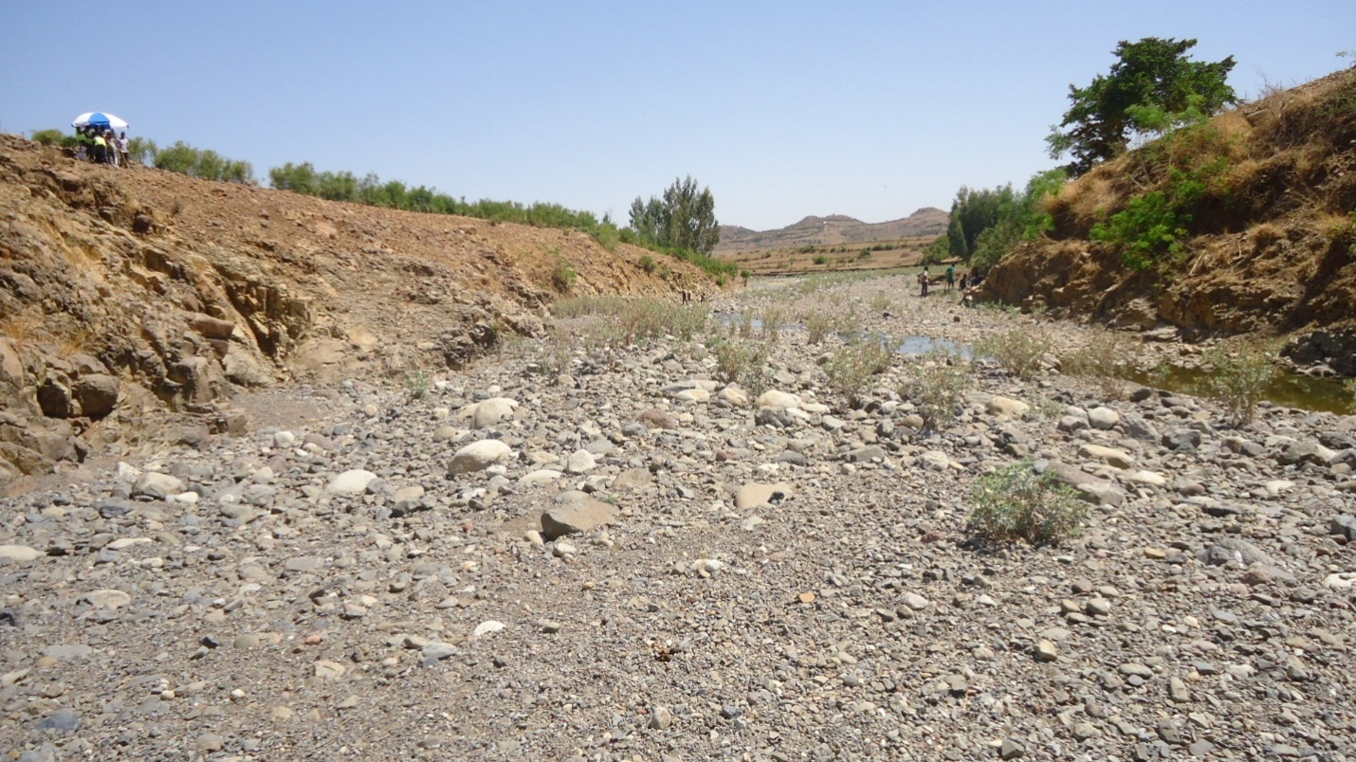
Figure 3-1: Proposed Weir Axis

River Geomorphology
Both surface and sub-surface investigations have been conducted at the proposed weir site and along the main canal route. A source area for required natural construction materials has also been studied by the geologist. The results of the investigations are presented in concise form in the geology report with appropriate recommendations based on findings and requirements of the proposed engineering structures in the respective parts of the project report.

Left Bank Condition
The left bank of the project headwork site geological formation is highly weathered and jointed aphanetic textural basaltic rock ,and the rock extends until 50m distance in the downstream direction. The upstream direction of this bank is mountain ridge extension due to this extension the bank geology is aphanetic basaltic rock. The aphanetic basaltic rock of this bank is highly jointed or broken mirror type joint structure is dominant along the weir axis direction. The area above the bank is farmland in both the upstream and downstream direction due to this farming activity the area shows tendency to erode. The bank along the weir axis has more than 3.2m height from the river bed to the farmland area.

Right Bank condition
The right bank of the project headwork site is weathered aphanetic basaltic rock with silt sand and granular soils. The bank has 4.5m height from the river bed to upper area, but all the bank height is not rocky. The bank until 2m height is highly weathered aphanetic and jointed rock formation, but the rest 2.5m height is silty sand and granular soil and the channel outlet of the diversion is part of this bank. The soil formation is corresponding to quaternary sediment such as boulder, gravel, sand and silt and the traditional channel existed in this bank, during in the study time the channel is not functional. The bank in the upper part is farmland area and dominated by soils which are characterized by fine grained silt, silty clay and granular soils with erosion fine grained aphanetic basalt rocks. This soil extends in both the upstream and downstream direction from this bank. In the upstream from proposed headwork axis the bank is fine grained silt and alluvial deposits and the area is highly affected by river flood in summer season before. The river in feature may change current flow direction out of the proposed headwork site, so that this area should have masonry structure until 30m distance from weir axis to reduce hydraulic structure problems.
To summarize the geological condition of the headwork, a geological X- section is prepared by combining the observed and interpreted surface and subsurface data.
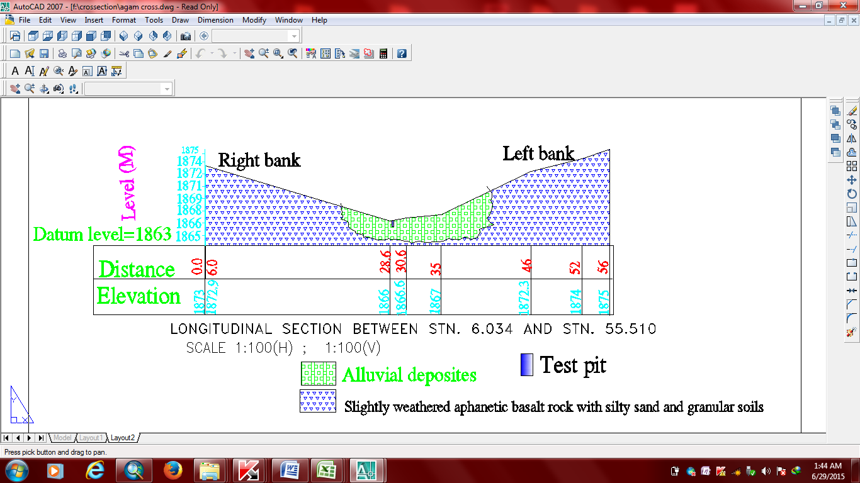
Figure 3-2: Geological Cross section of the Weir Axis

River Bed Condition
The stream bed at proposed headwork site is characterized by straight, well defined and uniform surface situations and formed with uniform geological materials, as seen from surface and subsurface observations. The whole surface of the bed is covered by alluvial soils, but both banks covered by weathered aphanetic basalt rock and from geological point of view the rock that exist in the banks should have extension from the left bank to right bank across the stream bed below the alluvial deposits. The alluvial deposits that cover all stream bed in both upstream and downstream direction including the weir axis. The deposit is characterized by boulder, cobble, gravel, sand and silt formations. The test pit is taken from this stream bed near the right bank with 1.7m height and from the observation of this subsurface investigation; the bed rock may extends up to 3m depth in the stream bed. The test pit material is characterized by silty sand and gravel soil until the end of pit depth with higher moisture content. The laboratory test has been done for this pit to characterize the gradation of the deposit .For more information about the material characteristics, it is better to refer the engineering geology feasibility study of the same scheme.

Headwork Type Selection
After detail observation of the available water balance, the target command area and the cost of future idle canal length, it is decided to design a diversion weir with commanding elevation. Weir type selected for the given height and flood amount is broad crest weir type which could be subjected to the expected hydrostatic and hydrodynamic forces that can be generated from peak flood. The weir is to be constructed with masonry material with a 200mm thickness RCC capping

Hydraulic Design of the Structure

Weir Height Determination
The following major factors have been reasonably assessed during the field study and the final topographic map whether the target area can be commanded at less weir height or not. Finally using necessary parameters, the weir crest elevation have been determined as follows:
- Maximum command area elevation
- Deriving head of the intake structure
- Main canal slope
- Turn out and head regulator loss
- Lowest Point of river centre
Table 3-1:Weir Height Determination
Description | Value | Unit | Remark
Command area level | 1868.50 | m
Idle Canal Length | 40.00 | m
slope | 0.0010 | -
depth of off take canal flow | 0.50 | m
Conveyance loss | 0.40 | m
Turn Out losses | 0.05 | m
Head regulator loss | 0.10 | m
weir crest level | 1869.19 | m
River bed elevation | 1866.48 | m
WEIR HEIGHT | 2.71 | m
The revised weir height is 2.70m and its crest level=2.70+1866.48=1869.18m

Weir Dimensioning

Weir Crest Length Determination

Flow over the Weir crest
- Crest Length

The crest length of the weir is fixed relative to the weir height and maximum flood condition. The estimated crest length of the weir with respect to the weir height is around 23.26m but considering the design flood level, it shrinks to 22.64 meter. Hence, considering the actual cross-section type and the foundation of the river formation as almost greater than 100% of the flow is confined within the crest length of 23.00m, it is better to extend the section to be 23.00m crest length.
Factor of contracting=actual crest length/natural width=23/22.64≈1.015. From this, the section is not contracted rather expanded, however the hydraulic performance may be changed as the result of rigid barrier structure and there should be protection works. As stated at the geology section, the right and left abutment is stable formation and weathered to hard rock formation.
Considering this principle, the design accounts the left and the right bank protection to make all the hydraulic performance safely. The left bank of the stream is not required any protection except at reinstate after the construction work. The right bank will be treated according to the site specific condition.
The weir section design is treated as alluvial-deposited materials as the bed formation of the stream are alluvial deposit.

Determination of Upstream & Downstream High flood level (HFL)
Determination of high flood level for both u/s and d/s case of the weir is essential in determining the retaining wall height as well as for initiation of weir section determination. The determination of the downstream and upstream high flood level as well as energy level is calculated as shown below
D/S high flood level=1868.848 m amsl………………………………. (a) From rating curve corresponding to the maximum flood.
U/S HFL=U/S bed level+ weir height +Hd…………………………… (b)
Where Hd=the depth of water over the weir crest.
The water depth is calculated using the following formula by considering broad crested weir formula. The velocity head (ha) is calculated as shown below. The following procedure is used for calculating the upstream high flood level.
$Q=C*L*{H_{e}}^{\frac{3}{2}}$, C=1.7 and L= 23.00m, Q=158.74 m3/sec
${ H}_{e}={\left(\frac{Q}{C*L}\right)}^{\frac{2}{3}}$= 2.545m.
$ha=\frac{{Va}^{2}}{2g}$ Where g: acceleration due to gravity = 9.81m/sec2
Va is Approach velocity determined by:
$\frac{{Va}^{2}}{2g}=He-Hd$.................... (c)
Where L=weir crest length (m), He=head over the weir crest and h=Hd as shown at the figure below
From practical case, it is assumed that the weir is to be free from silt about 0.70m to make silt free flow of water to the offtake.The remaining depth of about 2.0 m is silted due to deposition on the upstream reach as shown in the following rough sketch.
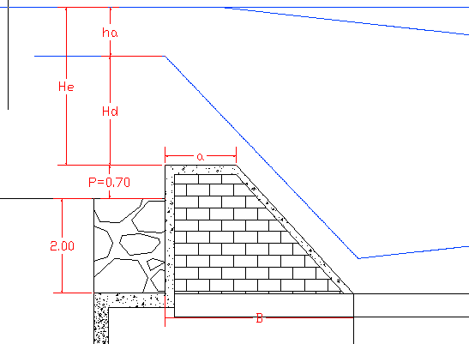
Figure 3-3 : Schematic drawing of the weir profile
The approach velocity, Va $=\frac{Q}{L(Hd+p)}$ ……………………………………………. (d). Hence, by combining equation (c) and equation (d)
He-Hd =${(\frac{Q}{L\left(Hd+P\right)})}^{2}$ ............... (e), p=0.70m
2.545-Hd =$\frac{2.427}{Hd+0.7}………………(f)$.Hence using equation (f), Hd is calculated using iteration and equals 2.27 m and ha=2.545-2.27=0.275m
Hd=2.27m and ha=0.275m
U/S high flood level=U/S bed level + weir height + water depth over the weir crest =1866.48+2.7+2.27=2279.886=1871.450
U/S TEL=U/S HFL + ha=1871.45+0.275=1871.725m asl
D/S TEL= D/S HFL + tail velocity head=+$\frac{3.79^2}{2*9.81}$=1868.848+0.731=1869.579
a. Afflux determination
Afflux is the level difference between the upstream and downstream energy level
Afflux = U/s TEL- D/s TEL = 1871.725m a.s.l – 1869.579 m a.s.l = 2.146m.
The afflux value is greater than the permissible values; however at this specific project, no more protection works required as the upstream river banks are stable both at the left and the right side. At the left side, river channelization will be essential after 150meter to make the stream flow on streamlined straight flow. The channelization work will include excavating of the left side and filling and compacting to the flood mark level.
b. Discharge over the weir section
- From the hydrological analysis, for 50 years return period the design discharge is 158.74 m³/s

Top and Bottom Width Determination
Bligh’s formula can be used to approximately estimate the top and bottom width of a broad crest weir. However, the dimension values obtained by using this formula should be checked structurally in the stability section.
Top width T in m,
Take T=1.50m
Bottom width B in m,
Take bottom width, B=4.00m which can be verified later by stability analysis.
Hence,
Top width
Bottom width,

Where, h is Height of weir (m), He is specific energy head (over flow depth + approaching velocity head (m)), ρ is specific weight of weir body (2.35 for cyclopean concrete, 2.2 for masonry and 2.4 for reinforced concrete). In selecting the specific weight of weir body, it is advisable to take lower values, since during construction the quality may be deteriorated and hydraulic parameters may be under estimated. For our case, masonry weir body capped with RCC is selected and the value of G =2.2
Therefore taking L=23.00m and h=2.70m as stated previously.
Table 3-2: Weir Top and Bottom Width Determination
Parameter | Unit | Values
Dischargecoeff., C | none | 1.70
Design discharge,Q | m³/s | 158.74
Specific Energy Head, He | m | 2.545
Water Depth U/S After Construction | m | 2.27m
Approach velocity head | m | 0.275m
Specific Gravity,G | none | 2.30
Top Width | m | 1.50
Bottom Width,B | m | 4.00m
This is an initial weir dimension which may undersize or oversize the structure. So, to design resistant from all forces and to make the structures economical, the dimensions are checked by stability analysis and finally the dimensions becomes.
Top width (m) | 1.50
Bottom width (m) | 4.00
Weir height (m) | 2.70
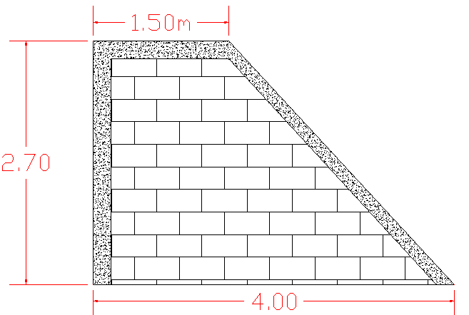
Figure 3-4 : Schematic presentation of weir section

Hydraulic Jump Computation
As discussed in the geology report, the river bed is alluvial deposit (as it is directly observed) and hence apron for energy dissipation is required. Left side bank is relatively sound so it doesn’t require protection but the right bank needs protection. Retaining wall at upstream right side is mainly needed to confine the peak flood within the bank. Hence bank protection work is needed upstream of the weir site to direct the flood in to the course. However protection works are required for the downstream case and a need of the jump profile is necessary.
The length of protection walls is determined based on the length of Jump as well as the nature of the foundation soil. Jump is calculated as shown below.
• Weir crest length = 23.00m
• Weir height = H = 2.70m
• Pre-jump depth = y₁
• Post -jump depth =y₂
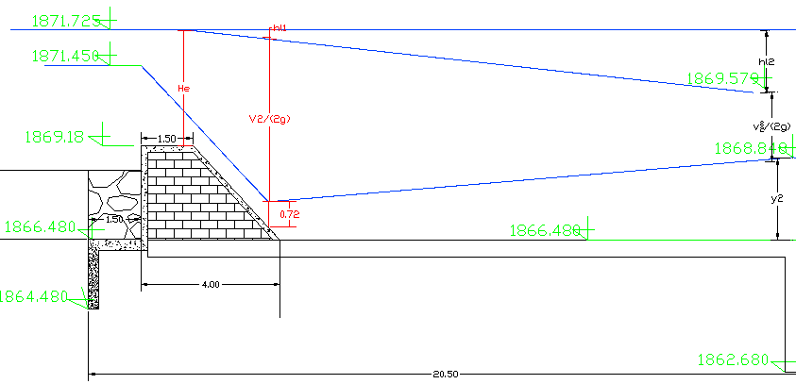
Figure 3-5: Hydraulic Jump Profile at the Proposed Weir Site
Neglecting losses between point U/s and D/s and considering similar datum
Z+ H_{e} = y₁ + h_{a…………………………..(x)}
But, He = 2.545m and Z=weir height=2.70m
By considering 30% retrogression effect, the above equation is rewrite as:
=0.3+2.70+2.545=y1+ (q₁/y1)²*1/(2g) where q1=Q/23=158.74/23=6.902m3/s/m
Considering 10% concentration for discharge intensity=1.1*6.902=7.59m3/s/m
5.545=y₁+2.938/y₁²
Y₁³ –5.545*y₁²+2.938=0.0
$Y2=\frac{y1}{2}*(\sqrt{8{f1}^{2}+1) }$-1) and${f1}^{2}=\frac{q^{2}}{g{y1}^{3}}$.
Ef1=U/STEL –CL and Cistern level (CL) =D/SHFL-y₂
Hence, using the above equation and iteration, the known parameters are computed until the cistern level becomes constant.
y1 (m) | f1² | y2 (m) | Y1^3-5.545*y1^2+2.938=0 (m) | Assumed CL (m) | CL=D/SHFL-CL (m) | Ef1=U/STEL-CL (m)
0.72 | 15.648 | 3.691 | 0.00 | 1865.358 | 1865.157 | 6.367
0.705 | 16.800 | 3.747 | 0.00 | 1865.1 | 1865.101 | 6.625
Hence, from the iteration value, y1=0.705m, f₁²=16.8, f1=4.10 and Y2=3.747 to obtain constant cistern level=1865.10m asl. This shows that the downstream river section is liable for scouring to this level as the energy is not easily dissipated.
If retrogression effect is not considered,y1=1.10m, y2=2.77m and Froude number, f =2.11 using the same above equation.
- The length of a hydraulic jump
The length of jump calculation for this specific site is mandatory as the bed materials are alluvial deposit. Hence, the calculation of the length of jump is used as a clue for estimation of the bank protection length at downstream part as well as to determine the stilling basin length.
From this, the bank protection length on the downstream of the right side extends at least up to 5*(3.747-0.705)=15.21m but considering the actual site condition, the protection work at both the stilling basin and the right bank can extends to 15.00m.
To compare the rating curves of the hydraulic jump and the tail water condition, different discharges which are less than or equal the maximum flood level are accounted as shown at the table 3-3.
- Location of jump
Tail water level plays a significant role in the formation of jump at a particular location. In most practical situation the tail water level depends upon the channel discharge Q.
Tail water rating curves for the regime of river below a diversion weir are fixed by the natural conditions along the stream and ordinarily cannot be altered by the diversion weir design or by the release characteristics. The basin floor/apron level must therefore be selected to provide jump depths that most nearly agree with the tail-water depths.
For the given basin/apron design, the tail-water depth for each discharge seldom corresponds to the conjugate depth needed to form a perfect jump. Thus, the relative shapes and relationships of the tail-water curve to the depth curve will determine the required minimum depth to the basin floor, and also to fix the d/s guide and wing walls.
Hence the jump and tail-water profiles are computed and put in tabular and graph as follow
Table 3-3: Jump and tail-water profile
Q (m3/sec) | Hd (m) | Ha (m) | He (m)) | U/s HFL (m) | U/s TEL (m) | V (m/sec) | h (m) | TWD (m) | D/s HFL (m) | D/S TEL (m)
0.66 | 0.03 | 0.04 | 0.03 | 1869.210 | 1869.246 | 0.661 | 0.022 | 0.02 | 1865.122 | 1865.14
1.70 | 0.07 | 0.05 | 0.07 | 1869.250 | 1869.303 | 0.891 | 0.040 | 0.30 | 1865.397 | 1865.44
8.51 | 0.35 | 0.01 | 0.36 | 1869.534 | 1869.542 | 1.337 | 0.091 | 0.63 | 1865.733 | 1865.82
12.86 | 0.47 | 0.01 | 0.48 | 1869.649 | 1869.656 | 1.549 | 0.122 | 0.74 | 1865.842 | 1865.96
42.93 | 1.00 | 0.07 | 1.06 | 1870.178 | 1870.244 | 2.423 | 0.299 | 1.24 | 1866.342 | 1866.64
86.18 | 1.55 | 0.15 | 1.69 | 1870.728 | 1870.874 | 3.101 | 0.490 | 1.74 | 1866.842 | 1867.33
158.74 | 2.26 | 0.28 | 2.54 | 1871.444 | 1871.725 | 3.92 | 0.783 | 2.37 | 1867.468 | 1868.25
Continued:
q(m3/s/m) | HL(m) | Ef1(m) | Ef₁(m) | F₁ | Y₁ (m) | V₁(m/s) | Y₂ (m) | v₂ (m/s)
0.03 | 4.101 | 4.016 | 4.146 | 51.071 | 0.003 | 9.016 | 0.228 | 0.126
0.07 | 3.866 | 4.040 | 4.203 | 32.135 | 0.008 | 9.072 | 0.365 | 0.202
0.37 | 3.717 | 4.080 | 4.442 | 14.875 | 0.040 | 9.294 | 0.817 | 0.452
0.56 | 3.692 | 4.205 | 4.556 | 12.292 | 0.060 | 9.393 | 1.005 | 0.556
1.87 | 3.603 | 4.288 | 5.144 | 7.235 | 0.189 | 9.860 | 1.845 | 1.012
3.75 | 3.541 | 4.309 | 5.774 | 5.455 | 0.364 | 10.303 | 2.629 | 1.425
6.90 | 3.474 | 4.536 | 6.625 | 4.337 | 0.637 | 10.839 | 3.600 | 1.917

Figure 3-6: Jump Versus Tail Water Depth Curve
As the TWRC is lower than HJC, hydraulic jump forms at a certain section downstream of the toe. For the formation of the jump, the horizontal apron depressed by excavating the river bed downstream of the toe of the weir and used the sill height to increase the tail water depth. The depth of depression may be equal to the difference between the tail water depth and post jump depth.
As it is calculated previously, the stilling basin will be depressed to 1.38m lower than the existing minimum river bed level. Hence, the energy will be dissipated at this level and sill height will be provided at the end of the stilling basin.

Cut off Depth Calculation
Since the materials at the river bed of the weir section is alluvial deposit, it is necessary to design both upstream and downstream cut off depth considering the retrogression effect at downstream.

U/s cut off
- Q = 158.74 m³/sec
- q = 6.90 m³/s/m
- Silt factor, f =1.76*(d₅₀)^{0.50} and d50=1.00mm for coarse sandy soil.
- f=1.76
${R=1.35*\sqrt[3]{(q^{2}/f)}}^{}$ Where: R=normal scour depth (m) and q=0.9m3/s/m
R=1.35*(q²/f)^{(1/3)} = 2.32
R=4.05m and take R=4.10m
Taking 25 % of concentration, the upstream scouring depth=1.25*4.1=5.125m and take 5.20m
Hence, bottom level of u/s cut off = U/S HFL –5.20=1871.45-5.20=1866.25m but considering the downstream retrogression level (1865.10m), it is better to adopt less than this value. Hence, take downstream cut off depth as 1864.48m asl.
U/S Cut off depth = RBL- bottom level of u/s cut off = 1866.48-1864.48 = 2.00m

D/s cut off
- Q =158.74m³/sec
- q =6.90m3/s/m
- Silt factor, f =1.76*(d₅₀)^{0.50}
Take f=1.76
- D₅₀=1mm for medium sandy soil
- R=1.35*(q²/f)^{(1/3)}
R=1.35*(q²/f)^{(1/3)} = 4.05m and take 4.10m
Considering 50% concentration, lackey’s scouring depth,R=1.5*4.1=6.15m and take 6.20m.
Hence bottom level of d/s cut off = D/S HFL – 6.20=1868.848-6.20=1862.648m and take 1862.68m
D/S Cut off depth=RBL- bottom level of d/s cut off=1866.48-1862.68=3.80m
Considering the upstream and downstream cut off depth, it is summarized as shown at Sketch
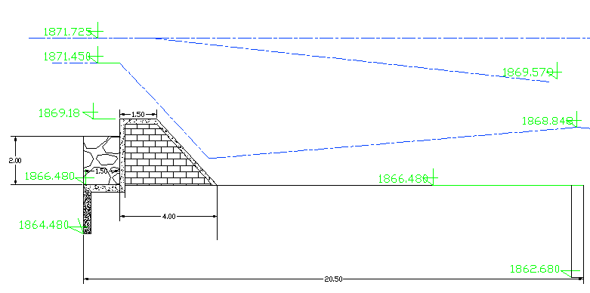
Figure 3-7 : Cut off depth Sketch

Impervious floor length design
From hydraulic jump design, the stilling basin is designed to be 15 meter. The weir section is also selected to be broad crested weir type with bottom width of 4.00 meter and 1.50-meter top width. The upstream floor length is calculated using principle of apparent soil formation called medium sand. The exit gradient, GE for this soil is to be 1/6 using principles of Kohsla’s.
GE=H/d*1/(3.142*λ) where H=static head=2.70 m and d=downstream cut off depth=3.80m
1/(3.142*λ)= 1/6*3.8/2.7=0.235. For this value, from the graph=b/d=4.5 where b=total impervious length (m)
b=d*3.5=3.8*4.5=17.10m
On the other hand, b=Lu+1.5+2.5+15 where Lu= upstream impervious floor length (m)
Lu=17.10-19=-1.90m. Hence, from this formula upstream impervious floor length is not required, however from direct impact of the weir and alluvial deposit disturbance because of turbulence flow, it is better to account nominal upstream impervious floor length which is 1.50m.

Impervious Floor thickness (t) Design
As initiation, the floor thickness is fixed for static case, as it is governing factor and can be checked later for high flood condition. The static case for this condition is 2.70m.Nominal thickness is provided for upstream floor as the uplift pressure is counter balanced by the weight of standing water or pool water. Hence, the provisional nominal thickness is 0.40m.
For the trough and the downstream sections, the thickness shown is provided. Checking for surface and subsurface flow condition shall be checked later using Khosla’s formula.
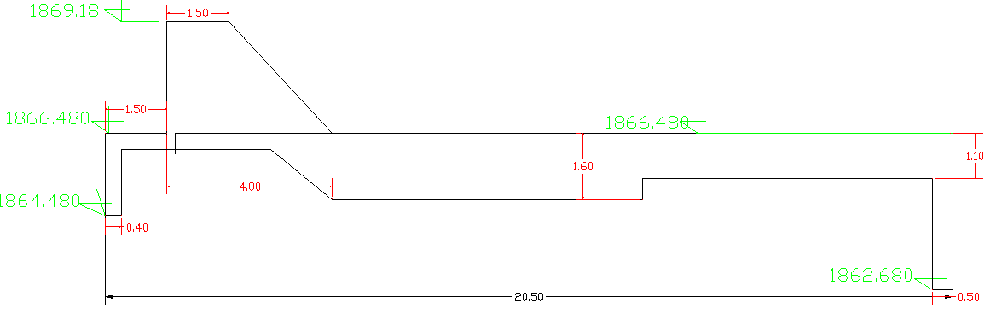
Figure 3-8 : Diversion Weir longitudinal section

Pervious Protection Work
- U/Stream Protection Work
Upstream launching apron is not recommended in most usual case, as it is area of sedimentation deposition, however, considering the weir height at initial fill period, it is better at least to provide nominal length of launching apron as energy dissipater. Launching apron length of 1.5D is provided where d=upstream cut of depth=2.00m. Hence, upstream apron length of 3.00meteris provided with a maximum thickness of 0.60m. This is simply reinstating of the upstream section after construction.
      - D/S protection work
Inverted filter and launching apron is provided at the downstream part of the impervious floor. This is used to relieve the uplift pressure and to protect piping of the underlying soil as well as dislocation of particles due to surface and subsurface flow.
The length of the inverted filter=1.5D2 where D2= d/S cut off depth= 3.80m
Lf=1.5*3.8=5.70m and take 6.00m.
Length of launching apron=1.5D2=1.5*3.8=5.70m and take 6.00m.The thickness of the protection work is provided from the dynamic load condition as well as construction point of view. Hence, it is better to provide at least one-meter thickness from both conditions. Please check the working drawing for more information.

Stability Analysis of Weir

Hydraulic Stability
As it is known that, the weir on permeable foundation is failed due to surface and subsurface flow condition. The subsurface flow due to piping as well as uplift pressure is the critical case for alluvial deposit formation. To alleviate this problem, the provision of impervious length, thickness and cut off is checked using Kohsla’s principle.
- Against piping

The bed materials of the foundation soil is sandy materials at which Exit Gradient, GE=1/6 and downstream cut of depth=3.80m.
α=b/d=20.5/3.8=5.395
λ= (1+ ((1+α^2)) ^.5)/2= (1+ ((1+5.395^2)^0.5)/2=3.243
GE= (H/d)*1/(3.142*l^.5) where H=static head=2.70 and d=D/S cut off depth=3.80m

GE=0.1255 <1/6=0.167 OK.

- Uplift Pressure
- U/S Cut off
b=20.50m, d=2.00m and α=b/d=20.50/2=10.25
λ= (1+ (1+α^2) ^.5)/2 and λ = (1+ (1+10.25)^0.5)/2=5.649
ФE1=100/pi ()*Cos⁻¹((λ-2)/λ) =27.645%
Hence ФE=100 - ФE1=100-27.645=72.355%

ФD1=100/3.142*Cos⁻¹((λ-1)/λ) =19.24
Hence ФD=100 – ФD1=100-19.24=80.76%

Corrections
- For point E

Thickness correction.tc = (80.76-72.645)*0.4/2=1.681%
Mutual Correction, tm=19(d+D)/b*(D/b') ^0.5
Where D=866.48-0.4-1862.68=3.40m
d=1866.48-0.4-1864.48=0.1.60m
b’=19.60
Mutual correction, tm=1.93% using the parameters listed.
Corrected ФE=72.355+1.681+1.93=75.966%
- D/S Cut off
b= 20.50 m, d=3.80 m and b/d=5.395
λ= (1+ ((1+α^2)) ^0.5)/2=3.243
ФE1=100/IICos⁻¹((λ-2)/λ) =37.50%

D1=100/IICos-1((-1)/) =25.70%

Corrections for point E1
Thickness correction, tc=(37.50-25.70)*1.1/3.8=3.415%
ФE1 corrected=37.50%-3.42%=34.08%

Based on the end pressure values, the estimation of pressure at the key points can be directly interpolated according to the following sketch.
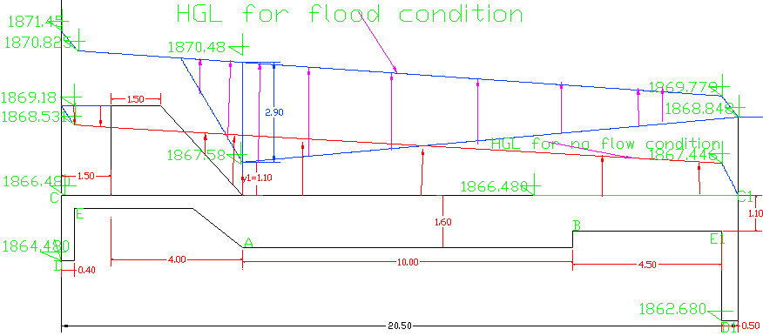
Figure 3-9 : Uplift pressure distribution for no flow and flooding condition
Base on pressure at points of E and E1, points at key points (A,B) can be easily determined using direct interpolation ,
Checking pressures and thickness at key points is shown at the next table. This thickness is provided for no flow condition or pool level condition. This provision thickness will be verified later for high flood condition.
Table 3-4: Broad crested weir thickness at key points for alluvial deposit
Points | P, Pressure (%) | H, Residual head=P*4/100 (m) | t, Floor thickness =h/(G-1) (m) | Actual thickness provided (m) | Remark
A | 65.07 | 1.757 | 1.46 | 1.60 | P is calculated by direct interpolation
B | 43.70 | 1.180 | 1.1 | 1.1 | P is calculated by direct interpolation
N.B: At the trough section of the weir (point “A”), the floor thickness shall be checked for dynamic case. As described previously, maximum static head=2.70m
Head difference during high flood condition=1871.45-1868.848=2.602m
Table 3-5 : Hydraulic gradient at key points for no flow and flood condition
Flow Condition | U/S water level (m) | D/s water level (m) | Seepage head (m) | Height and Elevation
 |  |  |  | U/S cut off |  |  | D/s Cut off
 |  |  |  | FC 100% | FD 80.76% | FE  75.966% | FE1 35.79% | FD1 25.70% | FC1 0%
No flow | 1869.18 | 1866.48 | 2.7 | 2.7 | 2.181 | 2.051 | 0.966 | 0.694 | 0
 |  |  |  | 1869.180 | 1868.661 | 1868.531 | 1867.446 | 1867.174 | 1866.480
High flood | 1871.450 | 1868.848 | 2.60 | 2.602 | 2.101 | 1.977 | 0.931 | 0.669 | 0.000
 |  |  |  | 1871.450 | 1870.949 | 1870.825 | 1869.779 | 1869.517 | 1868.848

As it is calculated previously, hydraulic jumping point for design discharge is located at elevation of 1867.58m with pre-jump depth of 1.10m and post jump depth of 2.77 meter for 10% concentration of design discharge.
Based on this principle, the hydraulic gradient of the maximum flood and no flow condition between ends of cutoff depth is determined by interpolation. For maximum flood condition, the maximum unbalanced head at the jump trough is 2.90m. The level of the hydraulic gradient at this point is2.9+1867.58 =1870.48m asl.
Hence. 2/3 of this head =2/3*2.90=1.93m.The required thickness for this head at the jump point=h/(G-1)=1.93/(2.2-1)=1.61m.
The maximum head for no flow condition at the cistern level=1.757m as shown at the above table. The required thickness for this head=h/ (G-1)
=1.757/(2.2-1)=1.46m
Hence, for this case, the critical section for hydraulic stability is flood flow condition or pool level. Hence, the provided thickness of 1.60m is sufficient as the masonry weight considered is the minimum figure (2.2). The sketch is shown previously.

Structural stability
In design of diversion weir relevant external forces acting on it must be calculated. Forces which include the soil and uplift pressures can be evaluated whenever the surface water profile at the weir location is drown. The critical discharge for the uplift pressure may be when there is no surface flow and no tail water ( dynamic case), while for the design of wing walls the high and low floods levels may be considered .
The designed weir should be enough to resist the piping effect, overturning moment, sliding effect and there should be No tension developed at the base of the dam. The stability analysis is carried out considering the effect of the following forces.
• Water pressure
• Weight of the over flow weir section
• Sediment load
Stability analysis is done for two critical conditions, the first case is minimum river flow case and the second case is at maximum flow of the river.
Case 1: When Water is at Pond Level
The extreme load combination is the case where the head is at crest level of the weir and there is no flow over the weir (static case).
Forces acting in base flow condition are Self-weight, Uplift pressure, silt load and upstream water load. The unit weight for RC concrete is 24KN/m³, for masonry=22KN/m3 and for water is 9.81KN/m³ .All pressures are estimated by assuming unit width

Resisting Load
Self-weight load (W): - It is determined with respect to an appropriate unit weight (γ_{m}) for the material. For simple elastic analysis the resultant is considered to operate through the centroid of the section.
Where A is the cross sectional area.

Over Turning Load
Water Load:-If the weir has a water height ‘H’, then the hydrostatic pressure distribution on the horizontal resultant force (P_{wh}) is given by:
Where P_{wh} in (KN/m) acting at P/3 from the base of the Weir..
Uplift pressure: The uplift pressure if No pressure relief are provided is given by:
Where Z₁ and Z₂ is the water heads at u/s and d/s respectively.
Sediment Load: The gradual deposition of sediments creates overturning force at the upper face of the weir. This force is a function of the submerged unit weight of the sediment ‘γ_{s}’ and depth of accumulation ‘Z’ (in this case equal to H). Mostly as the deposition is reached to crest level, it is normal to take depth of weir height as depth of accumulation. The force is given by:
Acting at $\frac{z}{3}$from the base of the weir.
Where Φ is the angle of shearing resistance of the sediment and the submerged unit weight=9KN/m3 and Φ=30º
The values are tabulated as in the following case
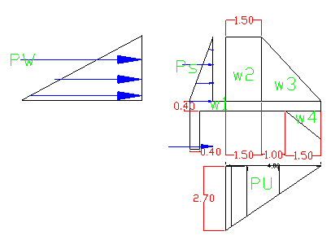
Figure 3-10: Load Distribution during Minimum Water level
Table 3-6: Weir Stability Analysis at Pond Level
Height, H | Triangle, B1 | Rectangle, B2 | Bottom width, B
2.70 | 1.5 | 2.50 | 4.00
Code | Load |  | Lever Arm, R | Moment (about toe)
 | Vertical | Horizontal |  | Positive | Negative
W1 | 35.20 |  | 2 | 70.40
W2 | 89.10 |  | 3.25 | 289.58
W3 | 74.25 |  | 1.67 | 123.75
W4 | 19.80 |  | 0.5 | 9.08
Ps |  | 10.92 | 0.9 |  | 9.83
P_{W} |  | 36.45 | 0.9 |  | 32.81
PU | -54.00 |  | 2.67 |  | 144.00
SUM | 164.35 | 47.37 |  | 493.63 | 186.64
- Factor of safety against overturning, F₀, in terms of moments about the toe of the weir
Where; and is summation of stabilizing moment and overturning moment respectively. F₀ should be greater than or equal to 1.5
- Stability against Sliding
The weir should be stable against sliding at the base for different conditions and it is the function of the shear strength of the construction materials. It is given by:

Where; and is summation of vertical and horizontal forces respectively and μ is coefficient of friction b/n the material and the horizontal section and its value varies b/n 0.60 to 0.75 up on the materials used ( here 0.70 is taken ) . F_{s} should be greater than or equal to 1.5.
- Safety against Tension
For No tension on the base of the head work structure, for critical section, the resultant (R) should act as the middle third part of the critical section. This implies that the eccentricity (e) should be less than or equal to one-sixth (1/6) of the base width (b) of the weir at the critical section.
And the eccentricity,
The resultant lies within the middle third implying that there is Nr tension developed at the weir body at the toe.
Case 2: When the weir is a monolithic structure and full of sediment
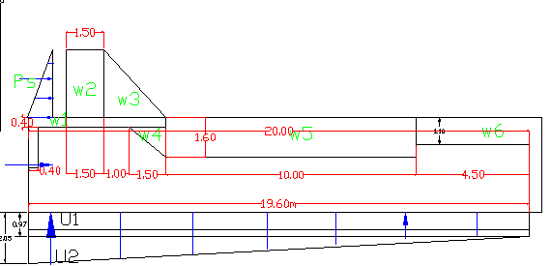
Figure 3-11 : Load Distribution after work completion

Table 3-7: stability analysis at high flood level
Forces |  |  | Leverarm (m) | Momentum about pt A
Designation | Vertical (kN/m) | Horizontal (KN/m) | Leverarm (m) | Mr | Mo
w1 | 38.72 |  | 17.25 | 667.92
W2 | 89.1 |  | 17.75 | 1581.53
W3 | 74.25 |  | 16.167 | 1200.38
W4 | 19.8 |  | 15 | 297.00
w5 | 352.00 |  | 9.50 | 3344.00
W6 | 108.90 |  | 2.25 | 245.03
U1 | -189.336 |  | 9.8 |  | 1855.49
U2 | -200.9 |  | 13.07 |  | 2625.09
Pa |  | 36.45 | 0.90 |  | 32.81
Ps |  | 10.924 | 0.90 |  | 9.83
Total | 292.53 | 47.374065 |  | 7335.85 | 4523.22
- Factor of safety against overturning,${ F}_{o}=\frac{ΣM (+)}{ΣM (-)}=\frac{7335.85}{4523.22}=1.62>1.5,$ the structure is safe against overturning.
- Factor of safety against sliding, $F_{s}=μ*\frac{ΣV}{ΣH}=0.70*\frac{47.374}{292.53}=3.70>1.5,$ the structure is safe against sliding.
- Tension for checking
X_{ave}= $X_{ave}=\frac{(ΣM(+)-ΣM(-)}{ΣV}=\frac{7335.85-4523.22}{292.53}=9.615$
The eccentricity, (e) =$e=\left(\frac{B}{2}-X_{ave}\right)=\frac{19.6}{2}-9.615=0.185$ B=19.6
But $\frac{B}{6}$=3.267, there for eccentricity (e) =0.185<$\frac{B}{6}$=3.267, shows the resultant lies within the middle third hence N0 tension developed.
Therefore, the stability analysis shows the section is structurally safe under both in base flow condition as the governing factor is static condition.

Weir Appurtenance Structures

Divide Wall
The divide wall is provided between the sluice gate and the weir body and the main function is to Separate the under sluice and the weir flow section and to support operation slab. Divide wall is designed in order to arrange an operation slab so that users can access easily during operation. This structure is not always necessary for all weir structures, the divide wall height may be shortened to as high as the weir height and sluicing mechanism can be done with a bed elevation lower than the canal off take elevation, especially for small flows and commands. Rejection of such walls will also reduce the costs of breast wall and operation slab and also a bigger spindle. However, such type of wall is necessary for practical operation. Such gates can be taken during sudden discharge and hence operation mechanism for gates is essential and also used as an operating slab support. So, the height of divide wall is equal to u/s wall height.
H _{wall} = U/S HFL - River Bed Level + Free board
= 1871.45 – 1866.48+ 0.40= 5.37, take 5.40m of divide wall

Under sluice
The under sluice is mainly provided here to remove silt deposition because of barrier structure/weir. Hence, the sill level of the under sluice is fixed to facilitate the disposal of this deposited silt away downstream to increase the off take efficiency. Therefore, considering the amount of incoming silts from the watershed, the sluice opening depth is fixed to be 1.50m above the minimum bed level.
Hence, the sill level of the under sluice elevation =1866.48+1.5=1867.98m.a s.l.
Hence the under sluice facilitates the supply of water to the off take and the removal of silt near the off take bed level.
The capacity of under sluice is determined by considering the following points:
- To effectively scouring purposes, hence the discharge capacity of the under sluice should be at least two times the main canal capacity
- Considering the maintenance purpose, the opening size of the under sluice should have the capacity equal to the dry weather flow of the river
- Considering the operation and management of the opening size of the gate
Having such above principle, the discharge passing through the under sluice is computed using the following equation for rectangular notch.
Q=$\frac{2}{3}*cd*\sqrt{2*g}*L*H^{\frac{3}{2}}$ where cd=0.62, L=1.00 m and H=1.20 m
Q=$2/3*0.62*\sqrt{2*9.81}$*$1.0*{1.2}^{\frac{3}{2}}=2.406m3/sec$.Hence this discharge satisfies the design criteria. It is ok.
The provision of the under sluice dimension of 1.0m*1.20 m is sufficient to keep the off take canal free of silt zone and easy remove of transported trashes, logs and boulders.
    - Gate for the under sluice

Considering this, the opening size of the gate is 1.00m*1.20m with spindle-operated gate.
The gate for under sluice is to be vertical sheet metal of the indicated size for the closure of the opening space providing some extra dimensions for the groove insertion (60mm on each grove total =2*60mm=120mm). The grooves are to be provided on the walls using angle iron frames at the two sides of the gate opening. Therefore, The gate of the opening sluice is to be vertical sheet metal of 1.12m x 1.56m with some 2.5mm clear spacing between the gate and the groove for easy opening and closing. Rubber seal materials of 2mm thickness shall be used to make watertight. For more information, please refer the working drawing. The under sluice gate is provided on the right side of the weir.

Outlet Capacity
The minimum command area is determined by the minimum flow of the river. But, the canal capacity should be determined for maximum command area and the corresponding discharge. In this case the outlet capacity is fixed considering maximum duty and command area of both 1st irrigation round and 2nd irrigation round.
Case-1: Design discharge for wet season
Maximum duty for 1st season irrigation round (supplement) =1.5 lit /sec for 20hrs irrigation duration and the stream flow at the wet season is more than 160 lit /sec. and flexibility factor for irrigation duration and crop proportion=8%
The surveying topographic net command area=100ha.
Q=1.5*100*1.08=162 lit /sec. More than this discharge is avail at the stream flow up to end of November after considering 25% flow at the downstream of the project area.
Case-2: Design Discharge for Dry Season
- Estimated duty at 20 hours irrigation duration per day=1.83 lit/sec
- Estimated base flow after releasing nearly 25% at the downstream=81 lit/sec
- Proposed net command area at dry season=50 ha
- Proposed crop at the dry season should be water tolerant crops
Estimated dry design discharge=1.83*50=91.50 lit/sec. This is nearly satisfied the dry season command area (50ha) with efficient irrigation efficiency and increasing irrigation duration to 23 hours per day at the maximum irrigation demand. When the irrigation hours increased for about 23 hours per day, the required crop demand=1.83*20/23*50=80lit /sec. Hence, this base flow is available after releasing 25lit/sec at the different available springs and natural perennial gullies to downstream ecosystems.
The canal outlet opening design discharge is fixed for supplemental case or 1st irrigation round as Q f=162lit/sec > Q d=80 lit/sec. Here, the limiting factor for both wet and dry season irrigation is stream flow but not command area. Hence, increasing the outlet capacity is profitable when there is good stream flow and rainfall distribution.
Outlet size
From the orifice discharge formula, the outlet size is determined as follows
$Q=CA\sqrt{2gh}$ ...... (a) Where A=area of the opening and, C=0.60, h=head difference b/n upstream and downstream of canal outlet
Depth of water at the canal=0.50m and opening dimension of the canal outlet is assumed 0.50m *0.60m (width and height respectively)
h=0.60m-0.50m=0.10m
L= Length of water way (m)
Table 3-8: Off take Sizing
Parameters | Amount | Remark
Stream flow for wet season, m³/s | 0.180
C | 0.60
Height of opening | 0.60
Width of Off take | 0.50
Gross opening Gate Size | 0.6x0.65
Thickness Of Iron Sheet, m | 0.006
Canal Bed Elevation | 1868.580
Gross area of sheet metals for the off take canal gate will be 0.6m x 0.65m (allowing 5cm insertion for grooves). The grooves are to be provided on the walls using angle iron frames at the two sides of the gate openings.

Design of operation Slab and Breast Wall
To avoid damage of under sluice gate, R.C.C wall is provided from the gate top level up to the river HFL plus freeboard (i.e. known as breast wall). More over to operate the gates operation slab is provided.
The operation slab is made to have dimensions of 1.5m x 1.5m and to make the operator free from risk during operation; the slab is enclosed with hand rails. Refer the drawing for detail.
The thickness of the slab and breast wall is simply determined from the recommendations.
The recommendation is
$$\frac{L}{t}=20 to 35$$
Where, L=length of greater span = 1.50m
t= thickness
$$\frac{L}{t}=20$$
t=0.15m
However, provide t = 0.20m = 20cm thickness for the slab and breast wall work. And provide the reinforcement bar of φ 12mm at 150mm c/c spacing in all directions with reinforcement cover depth of 50mm.

Design of Retaining Wall
At the end of the right side of diversion weir, walls have been provided to safeguard the structure from scour of banks and flooding at the ends .The walls are basically provided to keep the highest flood flow within the weir crest section and to safeguard areas out of the river bank from scouring and cavity.

Upstream Retaining Wall
Using stability analysis, wall dimensions are found for protection walls, a free board of 0.40m is selected for both u/s and d/s walls. The minimum fresh basaltic river bank elevation near the upstream bank is found to be 1867.20. Therefore the height of the upstream retaining wall is given by subtracting the bed elevation from the upstream HFL and then adding a Nominal freeboard of 0.50m.
H _{wall}=1871.45-1867.20+0.50=4.75m.Therefore we take 4.80m to be the height of upstream wall but the actual height is expected to be less than the stated depth as it is rock foundation and difficult to excavate up to the stated level. Hence, when the fresh basaltic rock is obtained during construction, it is not further continued and stopped at that level according to the side slope given at the drawing.
By checking all the factor of safeties using spread sheet analysis, the dimensions of the u/s protection wall are with top width of 0.50m and bottom width 3.50m. Stability is checked by considering surcharge load as there will be cultivation and cattle movement.
The wall foundation must be reinforced with a lean concrete (C-10) of thickness 0.10m at the bed for good bondage between the foundation and the wall material. The detail drawing will be shown at the drawing.
The expected load distribution is shown at the sketch below when there is no water at the river section.
Selected backfill unit weight=16KN/m3
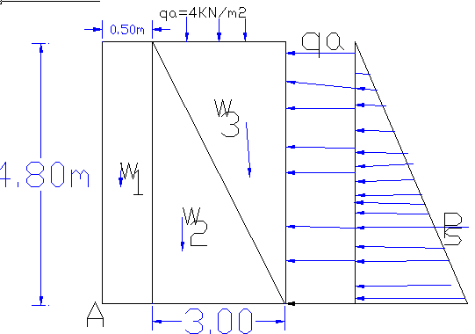
Figure 3-12 : Typical wing wall section and load distribution
Table 3-9: Upstream Retaining Wall Stability Analysis
Forces |  |  | Lever arm (m) | Momentum about pt A
Designation | Vertical (kN/m) | Horizontal (KN/m) |  | Mr | Mo
w1 | 52.8 |  | 0.25 | 13.20
W2 | 158.4 |  | 1.50 | 237.60
w3 | 107.52 |  | 2.50 | 268.80
qa |  | 19.2 | 2.4 |  | 46.08
Ps |  | 61.379 | 1.600 |  | 98.206
Total | 318.72 | 80.579 |  | 519.60 | 144.286
- Factor of safety against overturning,${ F}_{o}=\frac{ΣM (+)}{ΣM (-)}=\frac{519.60}{144.286}=3.6>1.5,$ the structure is safe against overturning.
- Factor of safety against sliding, $F_{s}=μ*\frac{ΣV}{ΣH}=0.65*\frac{318.72}{80.579}=2.57>1.5,$ the structure is safe against sliding.
- Tension for checking
X_{ave}= $X_{ave}=\frac{(ΣM(+)-ΣM(-)}{ΣV}=\frac{519.60-144.286}{318.72}=1.18$
The eccentricity, (e) =$e=\left(\frac{B}{2}-X_{ave}\right)=\frac{3.5}{2}-1.18=0.57,$ B=3.50
But $\frac{B}{6}$=0.583, there for eccentricity (e) =0.57<$\frac{B}{6}$=0.583, shows the resultant lies within the middle third hence Nr tension developed.

Downstream Retaining Wall
The bed elevation of the bank at downstream was found to be 1867.20 and the height of the right retaining wall is fixed by subtracting the bed elevation from the downstream HFL and then adding a nominal freeboard of 0.5m, or sequent depth; whichever is the higher.
H _{wall} =D/s HFL-River Bed+0.50
H _{wall} =1868.8485-1867.20+0.50=2.148m and considering retrogression effect and sequent depth at downstream as stated previously, it is better to consider additional depth of 1.00m if the formation of the bank is not fresh basaltic rock. Hence, it is better to consider the height of the retaining wall to be about 3.50m.
By checking all the factor of safeties using spread sheet analysis, the dimensions of the d/s protection wall are with top width of 0.50m and bottom width 2.25m for critical case.
Table 3-10: Downstream Retaining wall stability analysis
Forces |  |  | Lever arm (m) | Momentum about pt A
Designation | Vertical (kN/m) | Horizontal (KN/m) |  | Mr | Mo
w1 | 38.5 |  | 0.25 | 9.63
W2 | 67.375 |  | 1.30 | 87.59
W3 | 171.5 |  | 1.67 | 285.83
qa |  | 35 | 1.75 |  | 61.25
Ps |  | 32.634 | 1.167 |  | 38.073
Total | 277.375 | 67.634 |  | 383.05 | 99.323

- Factor of safety against overturning,${ F}_{o}=\frac{ΣM (+)}{ΣM (-)}=\frac{383.05}{99.323}=3.86>1.5,$ the structure is safe against overturning.
- Factor of safety against sliding, $F_{s}=μ*\frac{ΣV}{ΣH}=0.65*\frac{277.375}{67.634}=2.67>1.5,$ the structure is safe against sliding.
- Tension for checking
X_{ave}= $X_{ave}=\frac{(ΣM(+)-ΣM(-)}{ΣV}=\frac{383.05-99.323}{277.375}=1.02$
The eccentricity, (e) =$e=\left(\frac{B}{2}-X_{ave}\right)=\frac{2.25}{2}-1.02=0.23,$ B=2.25
But $\frac{B}{6}$=0.375, there for eccentricity (e) =0.23<$\frac{B}{6}$=0.375, shows the resultant lies within the middle third hence Nr tension developed.

Weir Cutoff, Under Sluice Bed, Offtake RCC Capping
In order to avoid cracking and shearing of the weir, divide wall, the cutoff, under sluice bed and off take slab during overflowing and incoming of boulders, RCC of thickness 200 mm is provided with proper anchoring and capping. The nominal reinforcement cross sectional area per meter width is taken as 0.20% of the concrete.
Hence, A_{steel}=0.002*1000*200=400mm², A_{steel}=400mm²
Provide Ǿ12mm@C/C 250mm.The spacing of the reinforcement bar should be less than three times the effective depth or 450mm, which is smaller of the two.
Considering cover thickness of 50mm, effective depth=50+12/2=56mm
Hence, our provision spacing is less than 3* (200-56)=3*144=432mm.Hence, it is better to adopt 250mm spacing as it is.
Actual A steal=3.142*12^2/4*1000/250=452.45mm2.Therefore the actual provided reinforcement area per meter width is 452.45mm2/m>400mm2/m. It is ok.

Bill of Quantity and Cost Estimation
In this basic topic three major tasks have been conducted. Th1st and the most important is the preparation of quantity take off sheet. The 2nd part of this topic shall be summarizing the take-off sheet and preparing the Bill of quantities for each work items in the headwork. The last activities to be performed here is estimation of the unit rate specific to the project area.
Finally the engineering cost estimate for the head work shall be computed and summed up for procurement specification. Take off sheet will be annexed or given in softcopy.
Table 3-11: Bill Nr. 1- General Item Cost
BILL No. 1 : Agam Wuha SSIP General Items
Item N. | Descriptions | Unit | Quantity | Unit Price (Birr) | Total Cost (Birr)
1 | General Items
1.1 | Allow for mobilization | Ls | 1.00 | 130,000.00 | 130,000.00
1.2 | Allow for demobilization | Ls | 1.00 | 104,000.00 | 104,000.00
1.3 | Allow for contractor's camp and facilities
1.3.1 | Allow for construction camp and facilities = 4*3 m², living rooms for construction & consultant key personnel, CIS and internally painted chip wood wall, masonry floor cement screened and well ventilated room complete with doors and windows., cafeteria, | Nr | 6.00 | 75,000.00 | 450,000.00
1.3.2 | 5*5 m2, store constructed from CIS with doors and windows, masonry floor cement screened. | Nr | 1.00 | 60,000.00 | 60,000.00
1.3.3 | Construction of toilet and shower for constructor and consultant staffs (2*1.5) | Nr | 2.00 | 20,000.00 | 40,000.00
1.3.4 | Cafeteria(4m*4m) and kitchen (3m*3m) | No | 1.00 | 85,000.00 | 85,000.00
1.3.5 | Barbed wire fence 50*20 m and 1.5m high treated timber post complete with 3m wide gate and a CIS guard house (1.5m*2m) | LS | 1.00 | 56,000.00 | 56,000.00
1.4 | Dewatering of open trenches and excavation of temporary diversion of the river flow and pumps. | Ls | 1.00 | 75,000.00 | 75,000.00
1.5 | Provide project indicator post starting from the construction time. | Ls | 1.00 | 9,000.00 | 9,000.00
1.6 | Provision of as built drawings for the project. | Ls | 1.00 | 28,000.00 | 28,000.00
Total amount for general items |  |  |  |  | 1,037,000.00

Table 3-12: Bill Nr. 2- Headwork Structure
Bill No.2 : Agam Wuha SSIP Head Work (weir, retaining wall, apron & gates)
I. Nr | Descriptions | Unit | Quantity | Unit Price (Birr) | Total Cost (Birr)
1 | Weir body including cutoff depth,previous and impervious floor
1.1 | Earth Work and Rock Excavation
1.1.1 | Common Soil Excavation | m³ | 850.87 | 90.00 | 76,578.30
1.1.2 | Ditto but Weathered Rock | m³ | 354.53 | 350.00 | 124,085.50
1.1.3 | Ditto but Hard Rock | m³ | 212.72 | 650.00 | 138,268.00
1.1.4 | Back filling from excavated material including compaction. | m³ | 75.93 | 120.00 | 9,111.60
1.2 | MASONARY
1.2.1 | Basaltic or equivalent stone masonry wall bedded in cement sand mortar 1:3. The thickness of masonry wall will be as indicated in the drawing. Price should include scaffolding. | m³ | 596.44 | 1,800.00 | 1,073,584.80
1.3 | CONCRETE WORK
1.3.1 | 50 mm thick C-10 Concrete bedding | m2 | 405.48 | 140.00 | 56,767.20
1.3.1 | Supply and cast reinforced concrete quality C-20 (minimum cement content of 320kg of cement/m³) for capping filled in to form work and vibrated | m³ | 157.63 | 2,900.00 | 457,115.40
1.4 | Provide and install mild steel reinforcement.
1.4.1 | B. Dia.12mm deformed bar of high strength | Kg | 4,416.41 | 80.00 | 353,313.07
1.5 | Supply and install Expansion Joint in 25mm thick Styrofoam between concrete blocks of the weir body | m² | 48.00 | 450.00 | 21,600.00
1.6 | Downstream launching apron
1.6.1 | Riprap placing and dumping to a maximum of 60mm diameter | m3 | 281.75 | 1,200.00 | 338,100.00
 | Downstream inverted filter
 | Filter placing and arranging according to working drawing | m3 | 261.30 | 1,050.00 | 274,368.15
Total Carried to Summary for Weir |  |  |  |  | 2,922,892.02
2 | DIVID WALL
2.1 | Earth Works and Rock Excavation
2.1.1 | Common Soil Excavation | m3 | 3.15 | 90 | 283.5
2.1.2 | Weathered Rock excavation in structures including haul to a distance not exceeding 200m. | m³ | 5.39 | 350 | 1886.5
2.1.3 | Ditto but Hard Rock | m³ | 8.99 | 650 | 5843.5
2.2 | CONCRETE WORK
2.2.1 | 50 mm thick C-10 Concrete bedding for masonry work | m2 | 12.07 | 140 | 1689.8
2.2.2 | Supply and cast reinforced concrete quality C-20 (minimum cement content of 320kg of cement/m³) filled in to form work and vibrated | m³ | 16.97 | 2,900.00 | 49213
2.3 | Provide and install mild steel reinforcement .
2.3.1 | Dia.12mm deformed bar | Kg | 728.42 | 80 | 58273.6
2.4 | MASONRY WORK
2.4.1 | Basaltic or equivalent stone masonry well bedded in cement sand mortar 1:3. The thickness of masonry wall will be as indicated in the drawing. Price should include scaffolding. | m³ | 51.29 | 1,800.00 | 92322
Total Carried to Summary for Divide Wall |  |  |  |  | 209,511.90
3 | UNDER SLUICE
3.1 | Earth Works and Rock Excavation
3.1.1 | Common Soil Excavation | m3 | 9.36 | 90 | 842.4
3.1.2 | Weathered Rock excavation in structures including haul to a distance not exceeding 200m. | m³ | 28.08 | 350 | 9828
3.1.3 | Ditto but Hard Rock | m³ | 56.17 | 650 | 36510.5
3.2 | CONCRETE WORK
3.2.1 | 50 mm thick C-10 Concrete bedding for masonry work | m3 | 20.2 | 140 | 2828
3.2.2 | Supply and cast reinforced concrete quality C-20(min. cement content of 320kg of cement/m³) filled in to form work and vibrated | m³ | 7.38 | 2,900.00 | 21402
3.3 | Provide and install mild steel reinforcement .
3.3.1 | . Dia.12mm deformed bar | Kg | 302.18 | 80 | 24174.4
3.4 | MASONRY WORK
3.4.1 | Basaltic or equivalent stone masonry well bedded in cement sand mortar 1:3. Price should include scaffolding. | m³ | 17.54 | 1,800.00 | 31572
Total Carried to Summary for Under Sluice |  |  |  |  | 127,157.30
4 | Right side retgaining Wall
4.1 | Earth Works and Rock Excavation
4.1.1 | Common Soil Excavation in structures including haul to a distance not exceeding 200m. | m³ | 133.05 | 90 | 11974.5
4.1.2 | Weathered Rock excavation in structures including haul to a distance not exceeding 200m. | m³ | 79.83 | 350 | 27940.5
4.1.3 | Ditto but Hard Rock | m³ | 266.11 | 650 | 172971.5
4.1.4 | Back filling with selected material from excavation including compaction. | m³ | 32.58 | 120 | 3909.6
4.2 | CONCRETE WORK
4.2.1 | 50 mm thick C-10 Concrete bedding for masonry work | m2 |  | 140 | 0
4.2.2 | Supply and cast reinforced concrete quality C-20 (minimum cement content of 360kg of cement/m³) filled in to form work and vibrated | m³ | 21.22 | 2,900.00 | 61538
4.3 | MASONRY WORK
4.3.1 | Basaltic or equivalent stone masonry well bedded in cement sand mortar 1:3. Price should include scaffolding. | m3 | 306.144 | 1,800.00 | 551,059.20
4.3.2 | Top & water face Plastering (ratio 1:2) | m2 | 188.011 | 140.00 | 26,321.54
4.3.3 | Pointing of external wall above the selected fill materials (ratio 1:2) | m2 | 82.59 | 110.00 | 9,084.90
Total Carried to Summary for Right side retaining wall |  |  |  |  | 864,799.74
5 | Left side Retaining Wall
5.1 | Earth Works and Rock Excavation
5.1.1 | Weathered Rock excavation in structures including haul to a distance not exceeding 200m. | m³ | 2.25 | 350 | 787.50
5.1.2 | Ditto but Hard Rock | m³ | 5.25 | 650 | 3,412.50
5.2 | CONCRETE WORK
5.2.1 | Supply and install lean concrete quality C-20 including cement slurry treatment in rock cracks and cavities | m³ | 1.16 | 2,900.00 | 3,364.00
5.3 | MASONRY WORK
5.3.1 | Basaltic or equivalent stone masonry well bedded in cement sand mortar 1:3. The thickness of masonry wall will be as indicated in the drawing. Price should include scaffolding. | m³ | 5.81 | 1,800.00 | 10,458.00
5.3.2 | Top & water face Plastering (ratio 1:2) | m2 | 6.98 | 140.00 | 977.20
Total Carried to Summary for left side retaining wall |  |  |  |  | 18,999.20
6 | River Training at upstream as shown at the drawing |  |  |  | -
6.1 | Excavation of ordinary soils and river deposit including cart away of excess materials | m³ | 210.48 | 90 | 18,943.20
6.2 | Back fill and compaction of excavated materials | m3 | 5.04 | 120 | 604.80
Total Carried to Summary for river training work |  |  |  |  | 19,548.00
7 | Breast wall and operation slab for undersluice and canal outlet
7.1 | Concrete work
7.1.1 | C-20 concrete | m3 | 2.17 | 2900 | 6,293.00
7.1.2 | Reinf. Φ12mm | Kg | 75.08 | 80 | 6,006.40
7.1.3 | Operation hand rail as per the drawing | m | 17.1 | 40 | 684.00
Total Carried to Summary for Breast wall and operation slab of under sluice and Canal outlet |  |  |  |  | 12,983.40
8 | Gate fabrication, Supply and Installation and painting
8.1 | Under sluice gate as per the drawing | No | 1 | 16000 | 16,000.00
8.2 | Canal outlet gate as per the drawing | No | 1 | 16000 | 16,000.00
Total Carried to Summary for gate fabrication, supply and installation |  |  |  |  | 32,000.00
Total Carried to Summary |  |  |  |  | 4,188,892.36

SECTION-III: IRRIGATION INFRASTRUCTURE

IRRIGATION INFRASTRUCTURE

Irrigable Area Description

Topography
Topography is an important factor for the planning of any irrigation project so long as it influences method of irrigation, drainage, erosion, costs of land development, mechanization, labour requirement and choice of crops.
The topographic feature of the command area ranges from moderately sloping to gentle slope and crossed by some moderate and small gullies. The slope gradient class is from 2% to 5% (moderately sloping). The slope gradient indicates that the proposed command area is suitable for surface irrigation.

Climate
According to the traditional Ethiopian agro-ecological zones classification (MOA, 2001) the proposed irrigation project area is basically categorized under Weinadeg aagro-ecology which is conducive to the production of tropical and sub-tropical crops. The elevation of the command area ranges 1866 meters above sea level (masl).
Climate has an important influence on the nature of the natural vegetation, the characteristics of the soil, the crops that can be grown and the type of farming that can be practiced in the region. The climate of an area is highly correlated with its vegetation and, by extension, the type of crop that can be cultivated.
The proposed project area has unimodal rainfall pattern, which extends from mid-June to Late August. The mean annual rainfall that the project area received according to the Addis Zemen station is 1351 mm.

Soil Characteristics
As to the surface characteristics (stoniness, rock out crops, water logging and flooding) of the command area, it has estimated that the command area has few to many stones and no rock out crops. Parts of command area having many stones may not suitable for full capacity of crop seedling emergence. Though soils of the command area are heavy clay, soils of the command area may not have seasonal water logging characteristics due to sloppy nature of the command area and low. Majority of the command area have black clay soils, and deep soil characteristics, which is a workable soil depth for crop production; and have slight to severe erosion hazards.

Existing Irrigation Practices in the Project Area
Rain-fed with mixed crop-livestock farming systems are the major farming systems in which cereals are dominant, mostly mono cropping and mixed farming where livestock production is undertaken complementary to crop production. This farming system, which accounts for the bulk of food production in the area, is characterized by subsistence farming with its typical feature of low input – low output productivity. Crop production is predominantly carried out under rain fed condition and is frequently vulnerable to natural hazards such as droughts/or erratic rainfall, crop pests, weeds, diseases, etc.
At present, the project area is being farmed, entirely, by small-holder farmers. Farmers use their land predominantly for rain fed subsistence cropping. Almost all of their staple food production comes from this system. Irrigated farming is not a new phenomenon in the project area; and it is practicing at small scales mainly by using traditional and modern river diversions.

Irrigation Water Requirement

Irrigation Efficiency (Ep)
To complete the evaluation of the demand, the efficiency of the water distribution system and efficiency of application must be known.
The gross requirement of water for irrigation system is very much dependent on the overall efficiency of the irrigation system, which in turn is dependent on several factors: Method of irrigation, type of canal (Lined and/or Unlined), method of operations (simultaneously and continuous or rotational water supply), and availability of structures (for controlling and distribution and measuring and monitoring).
Based on these factors, the project has planned to impose surface (furrow & basin) irrigation method. Based on engineering study results, concerning the canal systems, all canals are lined. Hence, the conveyance efficiency has estimated to be 85%;, distribution efficiency is 85% and the field application efficiency has estimated to be 60% seeing that the soil texture of the command area is predominantly clay type (according to ADSWE soil Lab result). Thus, the overall/project efficiency has estimated to be 43%.
The steps as enumerated above will be able to give the crop water requirement during its cropping period. The losses in the irrigation system have to be incorporated to arrive at the water requirement at the head of the irrigation system.

Irrigation Duty
Irrigation duty is the volume of water required per hectare for the full flange of the crops; and it is also the relationship between the volume of water and the area of the crop matures. Moreover, it helps in designing an efficient irrigation canal system. The area, which will be irrigated, can be calculated by knowing the total available water at the source and the overall duty for all crops required to be irrigated in different seasons of the years.
Based on this and the type of crops proposed for the project area, the design duty for Agam_Wuha irrigation project has been determined as 1.83 l/s/ha for full irrigation during dry season and 1.50 l/s/ha for supplementary irrigation during wet season at irrigation duration of 20 hours per day.To cover the dry season command area of about 50 ha, it is better to use water tolerant crop as well as increase the irrigation duration from 20 hrs. to 23 hours at the maximum crop water demand month. For more information, please refer the agronomist report of the same project.
The proposed scheme has designed for 100 ha and 50 ha net command area for first and second irrigation round respectively while the second irrigation round command area is successfully covered when the irrigation hours extended per day and water tolerant crops applied. Hence, the irrigation intensity of the scheme is 150% per year.

Irrigation Methods
Among the various irrigation methods, surface irrigation method has been selected for this project. Of the surface irrigation methods furrow, border and basin irrigation methods can be used to supply irrigation water to the plants/crops. However, each method has its own advantages and disadvantages. Care should be taken into account when choosing the method, which is best, suited to the local circumstances; that is, depending on the command area slopes, soil types, types of crops, the amount of water and irrigation equipment available. The irrigation water will be obtained from Agam_Wuha River, which is perennial, through canals and will be diverted to the command area in right sides of the river.
Based on the above factors furrow irrigation method has proposed for majority of the proposed crops for this project. The method allows applying light irrigation and can be laid out in sloping fields along the contour. Furrow irrigation method is best suited to the topography and soils of the command area and to the proposed row planted crops. In general, furrow irrigation method is simple, manageable and widely practiced irrigation method. This method is suitable for row crops that cannot stand in water for long periods. The only thing required to use this method is row planting of crops. Besides, basin and border irrigation method would be used for the non-row planted crops. Rotational flow water distribution is also recommended for the project area.
From economy, safety and easily operation criteria, the water distribution system of the project is as follow.
- The main, secondary and tertiary canals are designed to operate continuously and the field canals within a tertiary blocks are rotational for irrigation hours proportional to the area.
- To facilitate the rotation system, there should be water association in the project area. This association controls and manages the duration of each field canal within the block unit size.
- The position of each turn out of the field canal should be determined by beneficiaries unless it is not on the ridge line.

Irrigation and Drainage System Layout

Canal Layout
The irrigation scheme layout was prepared by considering the general topography of the land, the soil characteristics, minimizing crossing structure and slope of the canal. Several alternatives were considered for the conveyance and distribution system. The most promising and economical of these alternatives were recommended for more details. The irrigation system comprises four major components: the main canal, secondary canal, tertiary canal and field canal system.
The general layout system consists of one main canal, two secondary canals, one tertiary canal and more field canals. In order to facilitate the drainage system the natural drains along with catch drains has been used. The layout system covers a net command area of 102ha.
Water is conveyed through the main canals from the diversion weir. The flow through the main canal is continuous type and the flow through field canals can be rotational. For easy distribution, division boxes and turnouts are provided at the head of tertiary and filed canals respectively.
The main canal has a length of 2844m. Secondary and Tertiary canals are designated as distribution system. The Layout process of the distribution system has involved several steps and the parameters. Topographical, Field slope and its uniformity and Sizes of the canals are determined based on the requirement in the field unit.

Canal Lining Option
- Main Canal
From the head work section of this report the canal outlet capacity is fixed considering optimum design flow of the first season to irrigate the whole command area. Therefore, Outlet capacity for the main canal is sized based on the available command area and the governing irrigation duty.
The design discharge for 1st irrigation round ( net command area 100ha) is 162 lit/sec by accounting 8% flexibility factor while the design discharge for full irrigation (50ha net command area) is 99lit/sec with the same flexibility factor. Hence, the critical design discharge for the scheme is the first irrigation round. The main canal design discharge is 162lit/sec.
Geotechnical investigation of the canal route has been carried out in view of permeability, workability, seepage and instability. Accordingly, a number of traverses following the existing canal have been made to characterize the permeability nature of the soil in the area. The main canal has studied by considering index and engineering properties of the soil, like permeability, land sliding or stability, soil strength, grain size and lined canal weight carrying capacity.
Therefore, from permeability point of view the route is relatively thin impervious underlain by the pervious deposits and there will be significant amount of seepage if the canal is unlined (earthen). However, other canal systems other than the more length of main canal and secondary canal can be earthen as a geotechnical report but to save the base flow which is travelled to the command the main canal is recommended as lined the whole route.
This design is made with the intension of lining the main canal considering the pervious nature of the soil. The lined canal will save the limited water source available at the dry season. The topography is increasingly dropping the whole length of the canal and therefore the main canal is designed with the ground surface slope with total in cut and partial cut and partial fill. Main canal sections are designed by using Manning’s equation for masonry as shown below.
Where: - Q=design discharge, (m³/s)
R= hydraulic radius of the canal, (m)
A=wetted cross sectional area of the canal, (m²)
P=wetted perimeter, (m)
n= manning roughness coefficient,
- Secondary Canal
Considering the topography orientation the command area is large in size and there is secondary canal take water from the Main canal to tertiary canals distribute to field canals.
There are 2 secondary canals and their sections are proposed to be rectangular in shape which is lined all designed by using Manning’s equation. The topography of the area for secondary canals is steep so their section should be rectangular and lined.
Where: - Q=design discharge, (m³/s)
R= hydraulic radius of the canal, (m)
A=wetted cross sectional area of the canal, (m²)
P=wetted perimeter, (m)
n= manning roughness coefficient,
The hydraulic Parameters for each variable are calculated by Iteration method with MS-EXCEL program from main canal to tertiary canals.

Design of the Canal System
- Main Canal
Considering the length of the main canals, the slope of the land, the seepage of water, the scarcity of water and the costs during operation and maintenance, the main canal is proposed to have masonry lining so as to maximize the efficiency of the irrigation. The canal section is rectangular masonry lined and is designed using the manning’s formula.
$$Q=\frac{1}{n}*R^{\frac{2}{3}}*S^{\frac{1}{2}}$$
Using this formula for different design discharge, the canal section is determined and the result is shown in the table below. The canal design slope is probably the ground slope where there is zero fill and partial cut principle to convey water easily. There are four major ground slopes as shown in the following table. However, based on the information from main canal profile the slopes vary with the natural ground condition and the detail shall be shown in canal profile drawing.
Table 4-1: Hydraulic Parameters of Main Canal
A  (ha) | Chainage | Qr  (m3/s) | B  (m) | D  (m) | Fb  (m) | S | n | V  (m/s) | Qd  (m3/s) | Branched Canal | Branched chainage
100 | 0+000-0+780 | 0.162 | 0.60 | 0.47 | 0.23 | 0.0010 | 0.018 | 0.57 | 0.162 | FC-0 & SC-1 | 0+050 &0+780
68 | 0.780-1+100 | 0.11 | 0.40 | 0.56 | 0.23 | 0.0010 | 0.018 | 0.49 | 0.11 | FC-1 &2 | 0+830 & 0+930
68 | 1+100--1+250 | 0.11 | 0.40 | 0.24 | 0.19 | 0.0080 | 0.018 | 1.14 | 0.11
68 | 1+250- 1+781 | 0.11 | 0.40 | 0.56 | 0.21 | 0.0010 | 0.018 | 0.49 | 0.11 | FC-3,4 &5 | 1+380,1+560 & 1+740
68 | 1+781-1+911 | 0.11 | 0.40 | 0.29 | 0.19 | 0.0050 | 0.018 | 0.95 | 0.11
68 | 1+911-2+021 | 0.11 | 0.40 | 0.56 | 0.21 | 0.0010 | 0.018 | 0.49 | 0.11 | FC-6 | 1+960
68 | 2+021-2+361 | 0.11 | 0.40 | 0.42 | 0.19 | 0.0020 | 0.018 | 0.66 | 0.11 | FC-7 | 2+360
68 | 2+361-2+461 | 0.11 | 0.40 | 0.17 | 0.18 | 0.0200 | 0.018 | 1.60 | 0.11
68 | 2.461-2+844 | 0.11 | 0.40 | 0.56 | 0.28 | 0.0010 | 0.018 | 0.49 | 0.11 | SC-2 & TC-1 | 2+8441
Where,
A= Command Area (ha) Qr= Design Discharge (m³/s)
B= Bed Width (m) D= Flow Depth (m)
Fb= Free Board (m) Z= Side Slope
S= Longitudinal Slope N= Manning’s Roughness
V= Flow Velocity (m/s)
Typical X-section of the Masonry lined Canal
1
1
1
1
- Secondary Canals
There are two secondary canals and their sections are proposed to be rectangular in shape which is lined all designed by using Manning’s equation. The topography of the area for secondary canals is steep so their section should be rectangular and lined.
There are two secondary canals running across the main canals and the length of the secondary canal varies from place to place in the command area. Considering the capacity of an irrigator to handle the discharge and the existing natural land block, the design discharge of the secondary vary when it convey water. And based on such data the minimum canal section has been determined.
All secondary canals are rectangular canals which is lined and the section of the canals are determined using the manning’s formula. They are lined because slope of secondary canals are high and to minimize erosion masonry lined canal is recommended. Considering the siltation problems of canals manning’s 0.018 for masonry lined. Detail hydraulic characteristics of the secondary canals are shown on the table below.
Table 4-2: Hydraulic Parameter of Secondary Canal 1 (SC 1)
A(ha) | chainage | Qr (m3/s) | B (m) | D (m) | FB (m) | S | n | V (m/s) | Qd (M3/s)
32 | 0+000-0+100 | 0.052 | 0.3 | 0.18 | 0.22 | 0.01 | 0.018 | 1.04 | 0.055
32 | 0+100-0+200 | 0.052 | 0.3 | 0.14 | 0.26 | 0.02 | 0.018 | 1.35 | 0.055
32 | 0+200-0+300 | 0.052 | 0.3 | 0.18 | 0.22 | 0.01 | 0.018 | 1.04 | 0.055
32 | 0+300-0+400 | 0.052 | 0.3 | 0.12 | 0.28 | 0.028 | 0.018 | 1.53 | 0.055
32 | 0+400-0+500 | 0.052 | 0.3 | 0.13 | 0.27 | 0.025 | 0.018 | 1.47 | 0.055
32 | 0+500-0+650 | 0.052 | 0.3 | 0.14 | 0.26 | 0.018 | 0.018 | 1.30 | 0.055
32 | 0+650-0+880 | 0.052 | 0.30 | 0.14 | 0.26 | 0.02 | 0.018 | 1.35 | 0.055
32 | 0+880-0+980 | 0.052 | 0.30 | 0.13 | 0.27 | 0.025 | 0.018 | 1.47 | 0.055

Table 4-3: Hydraulic Parameter of Secondary Canal 2 (SC-2)
A | Chainage | Qr | B | D | FB | Z | S | n | V(m/s)
10 | 0+000-0+080 | 0.018 | 0.3 | 0.05 | 0.3 | 0 | 0.063 | 0.018 | 1.56
10 | 0+080-0+240 | 0.018 | 0.3 | 0.05 | 0.3 | 0 | 0.037 | 0.018 | 1.20
10 | 0+240-0+450 | 0.018 | 0.3 | 0.06 | 0.3 | 0 | 0.029 | 0.018 | 1.15
Where,
A= Command Area (ha) Qr= Design Discharge (m³/s)
W= Bed Width (m) D= Flow Depth (m)
FB= Free Board (m) Z= Side Slope
S= Longitudinal Slope N= Manning’s Roughness
V= Flow Velocity (m/s)
- Tertiary canals
In the layout system there is tertiary canal, the designed discharge is determined based on the duty of irrigation. The section of the canal is determined by using manning’s formula.
There is only one tertiary canal diverted from the main canal in the whole system. Field canals are designed based on the existing canal system and footpath system alignment and hence the length of field canals varies for ease of operation. Detail hydraulic characteristics of the tertiary canal is shown on the table below.
Table 4-4: Hydraulic Parameter of the Tertiary Canal
A | Chainage | Q | B | D | FB | Z | S | n | V
10 | 0+00-0+200 | 0.018 | 0.3 | 0.15 | 0.3 | 0 | 0.002 | 0.018 | 0.40
Where,
A= Command Area (ha) Q= Design Discharge (m³/s)
W= Bed Width (m)D= Flow Depth (m)
FB= Free Board (m)Z= Side Slope
S= Longitudinal Slope N= Manning’s Roughness
Ch= Chainage, V= Flow Velocity (m/s)

Design of Drainage Canal
The design of drain canal at this scheme is not necessary as there is natural gullies that act as tertiary drain and collector drains. The catch drain at the main canal can easily be guided by direct beneficiaries to the escape channels and easily join the natural gullies. Hence, the drain network design is not substantial at this scheme.
The field drain layout is designed to fix the furrow length of the field canal and indicate the direction of field irrigation. Based on the field drain layout, the furrow length should be fixed during irrigation operation.

Irrigation Structures

Design of Division Boxes and Turnouts
The proportional division of water among receiver and delivery canals is effected by providing division box and turn outs. Division boxes are junction points where secondary and/or tertiary canals emerge from main canal or tertiary canals arise from secondary canals. Whereas, turnouts are junction points on canal system layout where field canals are emerge from other canals like main, secondary or tertiary. The design principle of division boxes and turn outs in this proposed canal is taken as similar. The technique of determining the division opening width is computed based on the rectangular notch intake formula as following. Using broad crested formula,
Q= CL (h)^{3/2}
Where; Q= discharge over rectangular weir/intake (opening), m³/s
C= discharge coefficient, c= 1.7
L= effective length of crest form in m
h= over flow depth, m
Assuming equal discharge coefficient & sill height for two or three dividing canals, the proportion becomes.
Q₁/ Q₂= Q₂/ Q₃ =L₁/ L₂ = L₂/ L₃
Where, Q₁= is flow in canal 1
Q₂ = is flow in canal 2
Q₃ = is flow in canal 3
L₁= is effective crest length of division box/turnout sill across opening to canal 1
L₂= is effective crest length of division box/turnout sill across opening to canal 2
L₃ = is effective crest length of division box/turnout sill across opening to canal 3
Q₁= CL₁ (h)^{3/2},
L₁ = Q₁/Ch^{3/2}
L₂ = L₁*Q₂/ Q₁
L₃ = L₁*Q₃/ Q₁
The depth of (height of) the division box,
D= d+f_{b}
The width of the division box,
B= b+2*m*D
Where b= base width of the incoming canal
D= total canal depth of the incoming canal

Off takes from MC-1 and SC-1 is designed using orifice formula
.$Q=CA\sqrt{2gh}$
Table 4-5: Hydraulic Parameters of Division Box
Dividing canal | Chainage | Q(l/s) | Q1(l/S) | Q2(l/sec) | Bo(m) | FSD (m) | FB (m) | Do (m) | L1(m) | L2(m) | Lb (m) | D1 (m) | B1 (m) | D2 (m) | B2 (m) | Ldp (m) | Lup (m) | CBL1
MC -1 & SC-1 | 0+780 | 162 | 46.4778 | 115.5 | 0.6 | 0.47 | 0.23 | 0.70 | 0.40 | 0.30 | 0.80 | 0.75 | 0.4 | 0.5 | 0.3 | 0.00 |  | 1867.8
M.C1& SC-2 and TC-1 | 2+844 | 115.5 | 18.0 | 18.0 | 0.4 | 0.52 | 0.23 | 0.75 | 0.40 | 0.30 | 0.80 | 0.35 | 0.3 | 0.5 | 0.3 | 0.00 |  | 1861.79
Table 4-6 : Off take hydraulic parameters from MC-1 and SC-1
Parent canal | Q (l/s) | Q2 (l/S) | Q1 (l/sec) | B (m) | FSD (m) | FB (m) | D (m) | Dia. (m) | L2 (m) | L. pipe (m) | Lup. (m) | Ldp. (m) | Field canal Number | Remark
Off Take-zero to off take 5 from MC-1 | 115.5 | 21.0 | 94.5 | 0.6 | 0.47 | 0.23 | 0.70 | 0.13 | 0.33 | 1 | 0.00 | 1.30 | 5 | Off takes from zero to 4 operates rotational
Off take-5& 6 from MC-1 | 94.5 | 17.4 | 77.1 | 0.4 | 0.52 | 0.23 | 0.75 | 0.12 | 0.32 | 1 | 0.00 | 1.35 | 2 | Off takes from 5 to 6 operates rotational
Off take-7& 8 from MC-1 | 77.1 | 19.7 | 57.4 | 0.4 | 0.39 | 0.21 | 0.60 | 0.13 | 0.33 | 1 | 0.00 | 1.20 | 2 | Off takes from 7 to 8 operates rotational
Off takes 9,10,11 & 12 from MC-1 | 57.4 | 21.5 | 35.9 | 0.4 | 0.52 | 0.23 | 0.75 | 0.14 | 0.34 | 1 | 0.00 | 1.35 | 4 | Off takes from 9 to 12 operates rotational
Off takes from SC-1 | 52.1 | 18.0 | 34.1 | 0.30 | 0.20 | 0.2 | 0.40 | 0.12 | 0.32 | 1 | 0.00 | 1.00 | 4 | FCs from 1 to 3 and FC 1-8 operates rotational
Off takes from SC-1 | 34.1 | 17.3 | 16.9 | 0.30 | 0.20 | 0.2 | 0.40 | 0.12 | 0.32 | 1 | 0.00 | 1.00 | 4 | FCs 1-4 & 5 and Fcs 1-9 and 10 operates rotational
Off takes from SC-1 | 16.9 | 16.9 | 16.9 | 0.30 | 0.20 | 0.2 | 0.40 | 0.12 | 0.32 | 1 | 0.00 | 1.00 | 3 | The rest field canals from SC-1 operates rotationally

Table 4-7 : Hydraulic parameters for turnout from SC-2 and TC1
Hydraulic parameters for turnouts
Parent canal | Q (l/s) | Q2 (l/S) | Q1(l/sec) | B (m) | FSD (m) | FB (m) | D (m) | L1 (m) | L2 (m) | Lb (m) | Lup ( m) | Ldp (m)
T.C1 | 18 | 20 | 20 | 0.3 | 0.15 | 0.2 | 0.30 | 0.3 | 0.3 | 0.90 | 0.00 | 1.50
SC-2 | 16 | 16 | 16 | 0.3 | 0.06 | 0.29 | 0.30 | 0.3 | 0.3 | 0.90 | 0.00 | 1.50

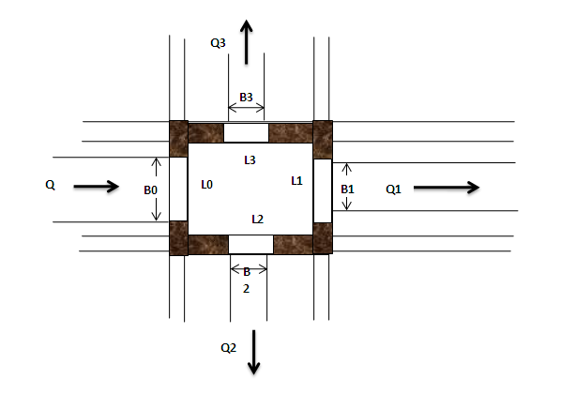
Figure 4-1: Typical Division Box Drawing

Crossing Structures

Drainage Crossing Structures
Super passage and flumes are most known irrigation structures that are used to convey water across depressed land and gully. In this project, one flume structure is designed to pass water. The flume on MC is located at a chainage of 0+100.
The length of the flume on the former canal is about 23m. The flumes are proposed to be constructed from R.C concrete. The concrete grade is proposed to be C-25, that is, 25MPa. Concrete structures are for base slab, supporting piers, footings and for water holding canal walls.
The R.C. concrete flume walls are to be well joined with a C-25 grade R.C. concrete base slab. Again the base slab of the flume structure will be supported by R.C. concrete piers at a clear span of 7.5m. The thickness of the base slab and vertical walls is 20cm. These walls are designed to be constructed from a diameter of 12mm and 10mm double reinforced C-25 concrete even they are carrying small depth of water they might be exposed to the impact of boulders. The total bed widths of the slabs of both flumes are controlled based on the internal widths of the incoming canals, the thickness of the walls at both sides needs extra 5cm for putting formworks to erect the walls.
Masonry retaining wall of top width 0.5m and bottom width of 2.5m, length equal to 5mdownstream and depths of about 2.6m is proposed for the right of the gully to enhance the stability of the bank.
Finally, to place the two ends of the flumes on strong formation abutment masonry walls were incorporated. These walls can properly support the earthen banks at both sides and further protect them from scouring.

Road Crossing Structures
There several dry weather major foot paths in the command area they run across the main canal and secondary canal. Pipe culvert which is the most common road crossing structure is preferred to pass water beneath major roads. Whereas, small box culverts are preferred to cross foot paths rather than pipe culverts. The road crossing structures will not be comfortable for operation and maintenance by virtue of its smaller design bed width and depth. Unlike other civil structures irrigation and hydraulic structures are hardly flexible to change their geometrical sizes. That is modifying their designed parameters result in malfunctioning of the proposed scheme. As result, the possible option is controlling the lengths of the culverts as much as possible for operation and maintenance purpose from outside. In addition to this, priority is given to box culverts with removable slab covers if the situation allows.
In this scheme two URAP road crossing structures considered at the main canal and two pedestrian bridge at which one is at the main canal and the other is at MC-1. The design of the road crossing structures fixed according to the URAP design road guide line as well as the site specific condition.

Bill of Quantity and Cost Estimation
Table 4-8: Bill Nr. 3- Irrigation Infrastructure
Bill No. 3: Agam Wuha SSIP Bill of Quantity For Irrigation System
Nr. | Descriptions | Unit | Quantity | Unit Price (Birr) | Amount (Birr)
1 | Main Canal
1.1 | Earth Work and Rock Excavation
1.1.1 | Common Soil Excavation | m³ | 3,326.88 | 90 | 299,419.20
1.1.2 | 20 cm thick Selected materials fill and compaction as masonry bedding over the clay foundation | m3 | 799.60 | 120 | 95,952.00
1.1.3 | Weathered rock excavation | m³ | 67.90 | 350 | 23,765.00
1.2 | Masonry Work
1.2.1 | Basaltic or equivalent stone masonry Canal well bedded in cement sand mortar of 1:3 mix ratio .The thickness of masonry wall will be as indicated in the drawing. | m³ | 2,967.04 | 1,800.00 | 5,340,672.00
1.2.2 | 25 mm thick plastering (ratio 1:2) of water face and top surface | m2 | 7,414.60 | 140.00 | 1,038,044.00
1.2.3 | Pointing of External wall above the ground level ( Ratio 1:2) | m2 | 935.34 | 110.00 | 102,887.77
1.3 | Flume Structures at chainage 0+100
1.3.1 | Excavation
1.3.1.1 | Excavation in loose soil in open to the lines and grades as shown in the drawing. | m³ | 78.50 | 90 | 7,065.00
1.3.1.2 | ditto but wathered rock | m³ | 2.50 | 350 | 875.00
1.3.1.3 | Back filling with selected material from excavation including compaction. | m³ | 36.20 | 120 | 4,344.00
1.3.2 | Concrete
1.3.2..1 | Providing and laying Plain cement concrete in C10 for masonry pad | m³ | 15.00 | 2,700.00 | 40,500.00
1.3.2..2 | Class C-20 reinforced mass concrete of thickness indicated on the drawing | m³ | 10.39 | 2,900.00 | 30,131.00
1.3.3 | Reinforcement
1.3.3.1 | Provide and install mild steel reinforcement.
 | A. Ø6 | kg | 2.80 | 80 | 224.00
 | B. Ø10 | kg | 119.41 | 80 | 9,552.80
 | C. Ø12 | kg | 749.49 | 80 | 59,959.20
 | D. Ø20 | kg | 379.20 | 80 | 30,336.00
1.3.4 | Basaltic or equivalent stone masonry wall bedded in cement sand mortar 1:3 | m³ | 29.25 | 1,800.00 | 52,650.00
1.3.5 | 25 mm thick water face plastering (ratio 1:2) of the guide wall | m2 | 27.00 | 140.00 | 3,780.00
1.4 | Main Cana Road Crossing (URAP road two times and one foot path)
1.4.1 | Excavation in loose soil . | m³ | 26.92 | 90 | 2,422.80
1.4.2 | Back filling with selected material from excavation including compaction. | m³ | 6.66 | 120 | 799.20
1.4.2 | Concrete
1.4.2.1 | Providing and laying Plain cement concrete in C10 for masonry pad of thickness 0.10 | m³ | 1.30 | 2,700.00 | 3,510.00
1.4.2.2 | Class C-20 reinforced concrete of thickness indicated on the drawing | m³ | 3.41 | 2,900.00 | 9,889.00
1.4.3 | Reinforcement
1.4.3.1 | Provide and install mild steel reinforcement.
 | A. Ø10 | kg | 36.13 | 80 | 2,890.40
 | B. Ø12 | kg | 66.65 | 80 | 5,332.00
1.4.5 | Basaltic or equivalent stone masonry wall bedded in cement sand mortar 1:3 | m³ | 14.40 | 1,800.00 | 25,920.00
1.4.6 | 25mm thck top and water face plastering (ratio 1:2) | m2 | 21.60 | 1,400.00 | 30,240.00
1.5 | Division box
1.5.1 | Earth works and excavation
1.5.1.1 | Ordinary Soil Excavation | m3 | 2.20 | 90 | 198.00
1.5.1.2 | Selected material bedding and compaction | m3 | 0.80 | 120 | 96.00
1.5.2 | Concrete
1.5.2.1 | Supply and cast of C-10 concrete bedding after compacting of the selected materials | m3 | 1.60 | 2,700.00 | 4,320.00
1.5.3 | Masonry Work
1.5.3.1 | Basaltic or equivalent stone masonry well bedded in cement sand mortar of 1:3 mix ratio . | m³ | 2.73 | 1,800.00 | 4,914.00
1.5.3.2 | Internal plastering for the masonry wall | m² | 3.47 | 140 | 485.80
1.5.4 | Gate fabriication, supply and installation as per the drawing installation | No | 4.00 | 6000 | 24,000.00
1.6 | Offtake from MC-1
1.6.1 | Ordinary soil excavation | m3 | 7.20 | 90 | 648.00
1.6.2 | Selected material back fill and compacted under and over the the uPVC pipe | m3 | 4.80 | 120 | 576.00
1.6.3 | UpVC pipe of diameter 140mm of 4 bar | m | 14.40 | 250 | 3,600.00
1.6.4 | Cemented Stone Pitching | m3 | 13.85 | 1250 | 17,312.50
1.6.5 | Offtake gate fibrecation, Supply and installation as per the drawing | No | 24.00 | 6000 | 144,000.00
1.7 | Escape structures at Main Canal ( five in quantity)
1.7.1 | Earth work & compaction
1.7.1.1 | Ordinary earth excavation including clearing and grubbing and cart away | m3 | 20.10 | 90 | 1,809.00
1.7.1.2 | Selected material back fill and compaction | m3 | 11.00 | 120 | 1,320.00
1.7.2 | Stone production,supplying ,dressing and constructing
1.7.2.1 | Masonry work | m3 | 37.50 | 1,800.00 | 67,500.00
1.7.2.2 | Dry stone pitching | m3 | 27.90 | 1250 | 34,875.00
1.7.2.3 | 2.5 cm plastering (ratio 1:2) | m2 | 75.00 | 140 | 10,500.00
1.7.3 | Steel gate supply, welding and installing according to the working drawing | No | 15.00 | 6000 | 90,000.00
Total carried to main canal |  |  |  |  | 7,627,314.67
2 | Secondary Canal (2 in Quantity)
2.1 | Earthworks
2.1.1 | Common Soil Excavation | m³ | 1,269.38 | 90 | 114,244.20
2.1.2 | Selected material filling and compaction for masonry bedding | m³ | 371.80 | 120 | 44,616.00
2.2 | Masonry Work
2.2.1 | Basaltic or equivalent stone masonry well bedded in cement sand mortar of 1:3 mix ratio . | m³ | 729.30 | 1,800.00 | 1,312,740.00
2.2.2 | 25 mm thick water and top surface plastering (ration 1:2) | m² | 2,431.00 | 140 | 340,340.00
2.2.3 | Pointing of External wall above the ground Ratio 1:2) | m2 | 493.05 | 110 | 54,235.50
2.3 | Turnout/ Division box
2.3.1 | Concrete
2.3.1.1 | Supply and cast of C-10 concrete bedding after compacting of the selected materials | m³ | 0.45 | 2,700.00 | 1,215.00
2.3.2 | Masonry Work
2.3.2.1 | Basaltic or equivalent stone masonry well bedded in cement sand mortar of 1:3 mix ratio .The thickness of masonry wall will be as indicated in the drawing. The work should be to the satisfaction of the Engineer | m³ | 2.00 | 1,800.00 | 3,600.00
2.3.2.2 | 25 mm thick water and top surface plastering (ration 1:2) | m² | 8.00 | 140 | 1,120.00
2.3.2.3 | Cemented Stone Pitching as per the drawing | m³ | 1.50 | 1250 | 1,875.00
2.3.3 | Gate fabriication, supply and installation as per the drawing installation | pcs | 2.00 | 6000 | 12,000.00
2.4 | Offtake from SC-1
2.4.1 | Ordinary soil excavation | m3 | 5.28 | 90 | 475.20
2.4.2 | Selected material back fill and compacted under and over the the uPVC pipe | m3 | 1.72 | 120 | 206.40
2.4.3 | UpVC pipe of diameter 140mm of 4 bar | m | 11.00 | 250 | 2,750.00
2.4.4 | Cemented Stone Pitching | m3 | 5.91 | 1250 | 7,387.50
2.4.5 | Offtake gate fibrecation, Supply and installation as per the drawing | No | 22.00 | 4000 | 88,000.00
2.5 | Pedestrian Bridge at SC-1
2.5.1 | Excavation in loose soil . | m³ | 3.60 | 90 | 324.00
2.5.2 | Back filling with selected material from excavation including compaction. | m³ | 1.28 | 120 | 153.60
2.5.3 | Concrete
2.5.4 | Providing and laying Plain cement concrete in C10 for masonry pad of thickness 0.10m | m³ | 0.43 | 2,700.00 | 1,161.00
2.5.5 | Class C-20 reinforced concrete of thickness indicated on the drawing | m³ | 1.14 | 2,900.00 | 3,306.00
2.5.6 | Reinforcement
2.5.7 | Provide and install mild steel reinforcement.
 | A. Ø10 | kg | 6.02 | 80 | 481.60
 | B. Ø12 | kg | 11.96 | 80 | 956.80
2.5.8 | Basaltic or equivalent stone masonry wall bedded in cement sand mortar 1:3 | m³ | 4.80 | 1,800.00 | 8,640.00
2.5.9 | 25mm thck top and water face plastering (ratio 1:2) | m2 | 7.20 | 1,400.00 | 10,080.00
Total Carried to Secondary Canals |  |  |  |  | 2,009,907.80
3 | Tertiary Canal (1 in quantity)
3.3 | Earth work and excavation
3.3.1 | Common Soil Excavation . | m² | 72.00 | 90 | 6,480.00
3.3.2 | Masonry Work
3.3.2.1 | Basaltic or equivalent stone masonry well bedded in cement sand mortar of 1:3 mix ratio .The thickness of masonry wall will be as indicated in the drawing. The work should be to the satisfaction of the Engineer | m³ | 54.00 | 1,800.00 | 97,200.00
3.3.2.2 | Internal plastering for the masonry wall | m² | 270.00 | 140 | 37,800.00
3.3.2.3 | 40cm Cemented Stone Pitching as per the engineers interest | m³ | 2.25 | 1250 | 2,812.50
3.4 | Turnout/ Division box
3.4.1 | Concrete
3.4.1.1 | Providing and laying Plain cement concrete in C10 for masonry pad of thickness 0.10m | m³ | 0.30 | 2,700.00 | 810.00
3.4.2 | Masonry Work
3.4.2.1 | Basaltic or equivalent stone masonry well bedded in cement sand mortar of 1:3 mix ratio . | m³ | 2.40 | 1,800.00 | 4,320.00
3.4.2.2 | Internal plastering for the masonry wall | m² | 4.80 | 140 | 672.00
3.4.2.3 | 40cm Cemented Stone Pitching as per the engineers interest | m³ | 2.25 | 1250 | 2,812.50
3.4.3 | Offtake gate fibrecation, Supply and installation as per the drawing | No | 6.00 | 4000 | 24,000.00
Total Carried to tertiary Canals |  |  |  |  | 176,907.00
Total sum of infrastructure |  |  |  |  | 9,814,129.47

Agam Wuha SSIP SUMMARY OF BILLS
Bill No. | Description | Amount (Birr)
1 | General Items | 1,037,000.00
2 | Head work (intake body, Outlet structures) | 4,188,892.36
3 | Irrigation Infrastractures (MC,FC,Flumes,Culverts..) | 9,814,129.47
Total |  | 15,040,021.84
VAT(15%) |  | 2,256,003.28
Grand Total |  | 17,296,025.11
Per hactare Cost with out VAT |  | 150,400.22

Source of construction materials
During site investigation, natural construction materials required for the construction of the varies proposed engineering structures at the project area, so that assessing and identifying possible quarry site and borrow areas near the site is necessary precondition in the feasibility study. In additional to identifying the quality, quantity and accessibility condition of the construction materials, ownerships of each proposed production sites have also studied and described.

Masonry Stones and Coarse Aggregates
Masonry stones are highly required during construction of the project for headwork structure, main canal route structure, cross drainage structure, and for many other purposes. The aggregates are another required construction material found during in the construction of the project. The aggregates required for constructions of the project in concrete work are fine aggregate and coarse aggregate that is sands and crushed stones respectively. Rocks use as masonry works incorporated in the engineering design and found in the downstream direction near mountain ridges, and in the command area at location of 377989 E, 1364069N and at elevation of 1850m above sea level (Nashoragote near villages), and at location of 378403E, 1363248N and at 1859m above sea level in the command area respectively, and also in the surface of river bed additional construction source, but the rocks occurred as boulders and coable size. The rock type that exists in the production quarry site is fine grained aphanetic basalt rock within higher quality and the abundance is more than required amount and which has 3km distance from headwork site. Both productive quarry sites have Nr ownerships and which is out of farmland area.
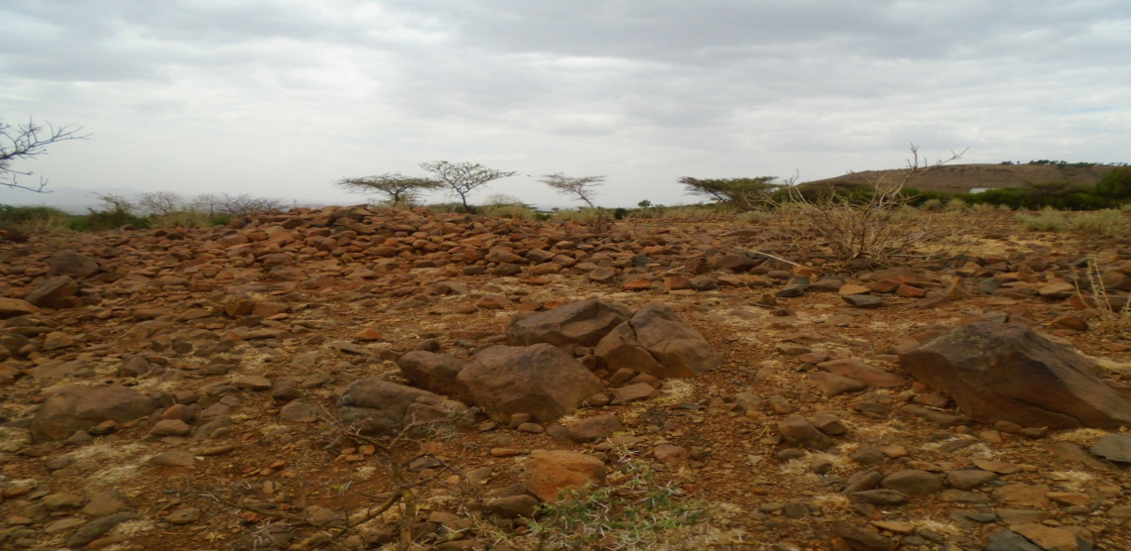

Figure 0-1: source of masonry and coarse aggregate

Fine Aggregates
During construction process, natural fine aggregate is required for concrete works and accessing this material in the surrounding area is another issue in the study. Natural deposits of these materials are found within the beds of Agam_Wuhastream itself and the quantity of sand is more than required amount. The sand deposits are higher in the downstream direction from headwork site and this natural deposit is used by local people for construction purpose in the surrounding. But the sand source until this study is not used by local contractors due to accessibility problem of the area. Both visual investigation and laboratory testing of the sand deposits that are found in the proposed area have been done. The secondary source also found nearby stream called Mena River and natural deposit of this sand is used by local contractors and also far from project area by15km distance towards word town called Arbaya.
The laboratory tests of the sand deposits that are found in the Agam_Wuhaand Mena River have been done. To characterize the gradation of the deposit, a sample has been taken for laboratory testing (especially for gradation test) the sand deposit from Agam_WuhaRiver itself has the following gradation:
Gravel (>4.75) = 37.15 %
Coarse Sand (4.75-0.425mm) = 40.25%
Fine Sand (0.425-0.075mm) =16.67%
Silt and Clay (<0.075mm) =5.93%
And the secondary sand source laboratory result also has the following gradation:
Gravel (>4.75mm) =26.90%
Coarse sand (4.75-0.425mm) =31.11%
Fine sand (0.425-0.075mm) = 38.01 %
Silt and Clay (<0.075mm) =3.99%
From observation the percentage of fines (Silt and clay) and gravel is higher, so that the sand deposit should be washed before using for construction to remove fines and in addition, the amount of oversize grains (gravels) are also considerable and sieving with sieve opening of about 4.75 to 5mm is required.

Water
Water source during in the construction of the project can be getting from the stream, Agam_Wuhaitself for construction purposes. The stream is perennial, so that, it flows throughout a year with in some amount along its course. During this study time the stream flow was more than 102 l/second.

PROVISION OF CAMP FACITLITY
Arranging camp facility for use during project construction according to the site condition and the society is a crucial issue which must be considered during feasibility and detail design study of a given scheme. Based on the suitability of the topography and the access conditions, a good camp site has been selected in Bajja_Ferfer Kebele. The proposed camp site is center for all activities to be done in the both the headwork and the infrastructure. The site is located in the communal grazing land and will not have any compensation problem.
The camp is place on the area of 25*30m². It contains contractor and consultant’s dormitory and offices with toilet and store.
There are two rooms for consultant and three rooms for contractor. The general location is shown in the drawing.

OPERATION AND MAINTENANCE

General
The main objective of the operation and maintenance aspect of an irrigation scheme is to facilitate the timely delivery of the required irrigation water to farms and to keep the irrigation system in an optimum operating condition. This section therefore discusses the main functions of the subject matter under consideration for the scheme.

Irrigation System Operation
The operation of the irrigation system depends mainly on the method of water delivery at farm level. Surface irrigation method is the recommended type of water distribution and application Method forAgam_WuhaSmall Scale irrigation project.
The farmers organize themselves and form groups in order to handle the water management. Rotational water distribution would be applied within the group. The rotational distribution is then to distribute water by turn to the whole scheme according to the timely need of crop water requirement. For better and efficient water management, crop diversification should be avoided within a group. This would reduce the complexity of water distribution system of the scheme during one irrigation season. At farmers’ level of operation, a constant flow and variable irrigation time is advisable.
To ensure equitable distribution of water the amount of water released through field canals should be proportional to the available command area.
- Due to the above reasons;
- Field canals rotational system has been arranged.
- Sill height of the division boxes above the bed of the division box is calculated.
- Required depth of water above sill level of the diving box is calculated and should be marked on the division boxes.
- In order to minimize water losses during conveyance and application:
  - Water users association (WUA) should assign gate keeper who is responsible to control unnecessary gate opening, damage and losses through gates.
  - Any damage on the canal system and gates should be followed by the Water Users Association and immediate action should be undertaken.
  - For technical failure beyond the capacity of the local community should be informed to the Wereda Irrigation and Drainage sector and immediate action should be taken.
  - Frequent supervision to the canal system is needed. Remove silt, weed, and any flow materials that can block the flow in the canal system.
  - Water application should be done by furrow rather than flooding.
  - Uniform cropping season and pattern within nearby blocks is good for irrigation water management.
  - Water application should be based on the proposed irrigation hour and rotation. This will reduce water application losses.
- Delivery system of water from field canal to the fields should be by bank breaching.
The proposed command area operated during irrigation is attached at the table below.
Command area Estimation
Parent Canal Name | Branched CN | FC- Name | Command area (ha)
MC-1 | SC-1 | FC1-1 | 3.63
MC-1 | SC-1 | FC1-2 | 2.34
MC-1 | SC-1 | FC1-8 | 2.48
MC-1 | SC-1 | FC1-3 | 2.66
MC-1 | SC-1 | FC1-9 | 3.51
MC-1 | SC-1 | FC1-4 | 1.74
MC-1 | SC-1 | FC1-5 | 2.68
MC-1 | SC-1 | FC1-10 | 2.73
MC-1 | SC-1 | FC1-6 | 4.62
MC-1 | SC-1 | FC1-7 | 2.57
MC-1 | SC-1 | FC1-11 | 3.22
MC-1 | SC-1 | Total | 32.18
MC-1 | FC-0 |  | 0.26
MC-1 | FC-1 |  | 4.82
MC-1 | FC-2 |  | 4.79
MC-1 | FC-3 |  | 1.4
MC-1 | FC-4 |  | 1.57
MC-1 | FC-5 |  | 4.19
MC-1 | FC-6 |  | 6.56
MC-1 | FC-7 |  | 6.19
MC-1 | FC-8 |  | 5.95
MC-1 | FC-9 |  | 3.31
MC-1 | FC-10 |  | 1.25
MC-1 | FC-11 |  | 3.44
MC-1 | FC-12 |  | 5.29
MC-1 | Total Off takes from MC-1 |  | 49.02
MC-1 | TC | FC1-1-1 | 4.18
MC-1 | TC | FC1-1-2 | 2.83
MC-1 | TC | FC1-1-3 | 4.32
MC-1 | TC | Total TC | 11.33
MC-1 | SC-2 | FC2-1 | 3.81
MC-1 | SC-2 | FC2-2 | 6.25
MC-1 |  |  | 10.06
Total command area |  |  | 102.59

Parent canal | Q  (l/s) | Q2 (l/S) | Q1 (l/sec) | B (m) | FSD (m) | FB (m) | D (m) | Dia. (m) | L2 (m) | L. pipe (m) | Lup. (m) | Ldp. (m) | Field canal Number | Remark
Off Take-zero to off take 5 from MC-1 | 115.5 | 21.0 | 94.5 | 0.6 | 0.47 | 0.23 | 0.70 | 0.13 | 0.33 | 1 | 0.00 | 1.30 | 5 | Off takes from zero to 4 operates rotational
Off take-5& 6 from MC-1 | 94.5 | 17.4 | 77.1 | 0.4 | 0.52 | 0.23 | 0.75 | 0.12 | 0.32 | 1 | 0.00 | 1.35 | 2 | Off takes from 5 to 6 operates rotational
Off take-7& 8 from MC-1 | 77.1 | 19.7 | 57.4 | 0.4 | 0.39 | 0.21 | 0.60 | 0.13 | 0.33 | 1 | 0.00 | 1.20 | 2 | Off takes from 7 to 8 operates rotational
Off takes 9,10,11 & 12 from MC-1 | 57.4 | 21.5 | 35.9 | 0.4 | 0.52 | 0.23 | 0.75 | 0.14 | 0.34 | 1 | 0.00 | 1.35 | 4 | Off takes from 9 to 12 operates rotational
Off takes from SC-1 | 52.1 | 18.0 | 34.1 | 0.30 | 0.20 | 0.2 | 0.40 | 0.12 | 0.32 | 1 | 0.00 | 1.00 | 4 | FCs from 1 to 3 and FC 1-8 operates rotational
Off takes from SC-1 | 34.1 | 17.3 | 16.9 | 0.30 | 0.20 | 0.2 | 0.40 | 0.12 | 0.32 | 1 | 0.00 | 1.00 | 4 | FCs 1-4 & 5 and Fcs 1-9 and 10 operates rotational
Off takes from SC-1 | 16.9 | 16.9 | 16.9 | 0.30 | 0.20 | 0.2 | 0.40 | 0.12 | 0.32 | 1 | 0.00 | 1.00 | 3 | The rest field canals from SC-1 operates rotationally

Maintenance
The maintenance tasks are categorized into two types: - routine activities and repairs.
The routine maintenance activities that are carried out periodically include:-
- Regular cleaning of sediments and weeds from canals and drains;
- Inspection and lubrication of gates; and
- Maintenance of cracked lined canals, regulating and control structures.
Repair works include task carried out more frequently and quickly and include those task that are generally unpredictable. They also include emergency works. The activities included in this category are:-
- Repairing overtopped or breached canals, drains and flood protection dykes:
- Repairing jammed gates:
Regular inspection of the irrigation facilities should be carried out as part of the maintenance activities. These tasks could be carried out immediately after the end of the main rains in September and during the rainy season. This could concentrate on the interceptor drains and the flood protection works, the main canal and the field drains. The inspection of the other works like the tertiary canals, field drains, and the water control and regulating structures could be carried out as part of routine operation activities.

CONCLUSION AND recommendation

Conclusion
- The command area is located at the right side of the river.
- Agam_WuhaSmall Scale Diversion Irrigation Project is planned to irrigate 100ha. The headwork is proposed to be made of masonry broad crested weir with 2.70m height and 24m crest length.
- Ten years of daily maximum rainfall data of Addis Zemen Meteorological Station had been used and the design point rainfall was computed.
- Since the headwork site of the river is made of thick alluvial deposit it is necessary to provide cut off depth as shown at the working drawing
- The proper implementation of this Diversion Irrigation Project as per the working drawings, the specifications and the recommendations forwarded will certainly change the lives of the beneficiaries.
- All canals are designed to be lined with masonry. MC and TC are lined to minimize seepage loss due to mild slope because the river has small flow.
- The layout of the main canal is designed as much as possible to be partially in fill and cut to give suitable bed slopes in order to avoid unnecessary head loss.
- At the end, implementation of this project undoubtedly increases the living standard of the local people.

Recommendation
- For better performance and long service year of the project regular inspection and maintenance is highly required.
- Farmers training, how to operate and maintain the project structures as a whole and available and water resources has a paramount important.
- The irrigation hours per day and per week should be flexible based on base flow amount of, each week or month.
- Constant supervision of the construction is crucial to prepare as built drawings of every component of irrigation system when necessary and prompt the timely accomplishment and durability of the scheme. Field canals and the drainage excavations are left for the beneficiaries. Therefore, costs due to these works are not considered in the bill of quantities. Whereby, community ownership and management should be declared by the farmers through their active participation in the wellbeing of the proposed irrigation development project.
- As soils of the command area are predominantly clay textured; and hence water and soil management measures should be undertaken; and optimum moisture content should be maintained to improve workability of the soil during land preparation and planting time.

REFERENCE
- FAO (1977) guidelines for predicting crop water requirements. Nr 24, Rome Italy
- Irrigation Engineering and Hydraulic Structures by Santosh Kumar Garg
- Design of small Canal structures , USBR
- IDD manual
- ESRDF manual
- Previously Designed report

