Table of Contents
Table of Contents i
List of Tables iii
List of Figures iv
AGRONOMY STUDY 1
1.1 Executive Summary 1
1.2 Background of the study 1
1.3 General Objective of the Study 2
1.3.1 Specific Objectives of the Study 3
1.4 Review of Sector Policies, Strategies and Related Previous Studies 3
1.4.1 Agriculture Policy 3
1.4.1.1 Food Security Strategy 4
1.4.1.2 Strategic Direction of Agriculture and Rural Development during the Growth and Transformation Plan Period 4
1.4.2 Irrigation Policy 5
1.5 Methodology 5
1.6 The Physical Features of the Project Area 6
1.6.1 Agro-climatic Zone of the Specific Area 8
1.6.1.1 Rainfall 9
1.6.1.2 Temperature and Relative Humidity 10
1.6.2 Land Use 10
1.6.2.1 Existing /Present Agricultural Conditions 11
1.6.2.2 Existing Crop Calendar (rain-fed agriculture) 12
1.6.2.3 Major Rain-fed Crops of the Area 12
1.6.2.4 Livestock Production 14
1.6.2.5 Existing Agricultural Techniques 15
a) Low Technology Input Utilization 16
b) Soil Erosion as a Result of Deforestation 16
c) The Prevalence of Animal Diseases & Low Livestock Productivity 17
d) Poor Access to Markets 17
e) Inadequate Infrastructures & Institutional Setups 17
f) Insufficient Expertise of Irrigation Farming 17
1.6.3 Labour Requirement 18
1.7 Proposed Irrigated Agriculture 18
1.7.1 Crop Selection 19
1.7.2 Cropping Pattern 19
1.7.3 Details of the Selected Crops 20
1.7.3.1 Cereals 20
1.7.3.2 Roots & Tubers 20
1.7.3.3 Vegetables 21
1.7.3.4 Industrial Crops 21
1.8 Irrigation Seasons 22
1.8.1 Proposed Management 23
1.8.2 Method of Irrigation 23
1.8.3 Cultivation Activities 24
1.8.4 Fertilizer Management 24
1.8.4.1 Method of Fertilizer Application 25
1.8.4.2 Plant Protection 26
1.8.4.3 Crop Rotation and Intercropping 27
1.8.4.4 Labor Requirement 28
1.8.4.5 Area Coverage/Intensity 29
1.8.4.6 Yield Projection 30
1.8.4.7 Postharvest Activities 30
1.9 Extension Service 31
1.9.1 Market 32
1.9.2 Input Supply 32
1.9.3 Credit Service 32
1.9.4 Technology Packages 32
1.10 Crop Water Requirement 33
1.11 Suggestion & Recommendation 34
Annex 1.1: AGRONOMY ANNEXES 35
A. Required climatic & other aerodynamic data collected from Bedele Station 35
B. Irrigation Efficiencies 35
C. Irrigation depth (d, mm) 35
D. Interval (days) 35
E. Detail Crop Water Requirement (Dry-Season Cultivation) 36
I. Structured Questionnaire for Agronomy and Other Data Collection 38
SOIL AND LAND SUITABILITY STUDY 41
2.1 General 41
2.2 Objective of the study 41
2.3 Description of the command soil 41
2.4 Methodology 42
2.4.1 Pre-field Work 43
2.4.2 Field Work 43
2.4.3 Post-field Work 43
2.4.4 Detail Procedures 43
2.5 Results of Physical Analyses 44
2.5.1 Soil Profile Description 45
2.5.2 Physical Properties 46
2.6 Chemical Analysis 48
2.6.1 Results of the laboratory Analysis 50
2.6.2 Result Interpretation 51
2.6.3 Result evaluation 53
2.7 Irrigable land Suitability 54
2.8 Production of soil Map Unit 55
2.9 Conclusion & Recommendation 56
Annex 2.1: Soil Study Annexes 57
A. Soil Profile Description Sheet 57
A. Table : 1Values/classes of most chemical properties 58
B. Table: 2 Values/classes of most chemical properties 59
C. Major soil Associations in Ethiopia 60
D. Basic Soil Survey (by Transect- Walk Method) 61
E. Soil Laboratory Test Result 62
WATERSHED MANAGENT STUDY 63
3.1. Executive Summary 63
3.2. Objective of the Study 63
3.3. Methodology 63
3.7.1. General Description of the Project Area 64
3.7.2.1. Location 64
3.7.2.2. Existing Climate 65
3.7.2. Specific Agro climatic Zonation 66
3.7.3. Existing Land use Pattern 66
3.4. Independent features (Physical Components) of the watershed area 68
3.7.1. Drainage & Stream Density 68
3.7.2. Physical Features of the Soil 70
3.7.3. Erosion Condition 71
3.7.4. Ponding 71
3.7.5. Rockiness 72
3.7.6. Forest Distribution 72
3.7.7. Surface Drainage 73
3.7.8. Major Socio- Economic Activities & Other Economic Data 73
3.5. Land Capability Classes (LCC) 74
3.6. Existing Problems of the Watershed Area 75
3.7.1. Low Technology Input Utilization 76
3.7.2. Deforestation & Absence of Replanting 76
3.7.3. The Prevalence of Animal Diseases & Low Livestock Productivity 76
3.7.4. Poor Access to Markets 77
3.7.5. Inadequate Infrastructures & Institutional Setups 77
3.7.6. Insufficient Expertise of Irrigation Farming 77
3.7. The Possible Solutions for the above Watershed Problems 77
3.7.1. Around the proposed Command Area 78
3.7.2. Solutions for Specific Problematic Areas of the Watershed 78
3.7.2.1. Gully control 78
3.7.2.2. Improved Cultivation Techniques 79
3.8. Implementation Schedule and Priority Setting 82
3.9. Conclusion & Opinions /Recommendations 89
Annex 3.1: Watershed Annexes 90
A. Climatic Data used as basic reference in the completion of the study report. 90
B. Possible Design of Micro-basins for tree planting in sloppy area nearby designed wear 91

List of Tables
Table 1. 1: Length of growing period as expressed in 0.5PET. 8
Table 1. 2: Land Use Pattern of Chora Woreda and Emboro Bonga kebele 11
Table 1. 3: Chemical Fertilizers, Improved Seeds (qt) and Agro-chemicals (lt) Used by Farmers of the Woreda 11
Table 1. 4: Existing Cropping Calendar of the Project Area 12
Table 1. 5: Major Staple Food Crops of Chora Woreda and the Project Kebele 13
Table 1. 6: Crops Harvested with rainfall in Chora Woreda in the last three years 13
Table 1. 7: Crops Harvested with Irrigation in Chora Woreda in the last three years 14
Table 1. 8: Livestock Types, Quantities and Common Diseases in Chora Woreda and the Project Kebele 15
Table 1. 9: A Hectare of Labor Requirement as a “without project” Condition 18
Table 1. 10: Crops Selected for Irrigation Development 19
Table 1. 11: Dry-season Irrigation time Schedules 22
Table 1. 12: Wet-season Irrigation time Schedules 23
Table 1. 13: Method of Irrigation and Spacing for the selected crops 23
Table 1. 14: Major cultivation activities in irrigated agriculture 24
Table 1. 15: Required fertilizers & other agrochemicals planned for each proposed crop 25
Table 1. 16: Methods of fertilizer application for the proposed crop types 25
Table 1. 17: Chemical & non-chemical plant protection methods for the proposed crops 26
Table 1. 18: A hectare of labor requirement as a “With-Project” condition 28
Table 1. 19: A 5-year cropping pattern/intensity plan 29
Table 1. 20: Yield Projection for five (5) year/season production period 30
Table 1. 21: Duty of Dry-season cultivation 33

Table 2: 1. Soil samples with their different horizon depths 44
Table 2: 2. Basic profile descriptions observed in the soil pit process 45
Table 2: 3. Details of the physical properties of the command area 46
Table 2: 4. Other non-basic physical structures of the proposed command soil 48
Table 2: 5. Basic chemical properties of the command soil examined in the Laboratory 48
Table 2: 6. Laboratory results of the sampled soil chemical properties of the command area 50
Table 2: 7. Result evaluation based on the upper & lower horizons of the sample analysis 53
Table 2: 8. Physical Properties as evaluated under the (5)-irrigability Classes 54
Table 2: 9. Chemical Properties as evaluated under the (5)-irrigability Classes 55

Table 3: 1. Land Use Pattern of the Watershed Area 67
Table 3: 2. Land use pattern of Chora Woreda and the project kebele 67
Table 3: 3. Major staple food crops of the woreda (Chora) and project kebele in percent 68
Table 3: 4. Some quantitative analysis of watershed morphology (by 3.3km x 2.0Km) =6.7Km² 69
Table 3: 5. Woreda & Project area’s livestock data & major diseases recorded in (2007 E.C) 74
Table 3: 6. General existing natural factors & topographic features of the project surroundings, & their places in standard land capability classes (as observed during the field assessment) 75
Table 3: 7. Strip width of erosion permitting & erosion resisting crops at various slopes 79
Table 3: 8. Recommended SWC Measures on Different Units 83
Table 3: 9. Yearly Work Plan for SWC Implementation Activity 84
Table 3: 10. Time Schedule for SWC Activities one Fiscal Year 85
Table 3: 11. Estimated Costs for Soil and Water Conservation Activities 86

List of Figures

Figure 1. 1: Partial view of the command area 7
Figure 1. 2: Partial view of Unkuso River at the proposed weir site 8
Figure 1. 3: Length of growing period (LGP) of the command area. 9
Figure 1. 4: Trend of mean monthly Rainfall and Effective Rainfall of the stud area 9
Figure 1. 5: Mean monthly max, and min temperatures with relative humidity of the stud area 10

Figure 2. 1: Soil Texture Map of the Command Area 42
Figure 2. 2: Location Map of the Study Area 44
Figure 2. 3: Slope Map of the Command Area 47
Figure 2. 4: Soil Map Unit (SMU) of the Command Soil 55

Figure 3: 1. Watershed with scattered distribution of indigenous trees and shrubs 64
Figure 3: 2. Location Map of Unkuso SSI Project’s Watershed 65
Figure 3: 3. Land use/Land Cover Map of Gewiso SSI Project Watershed 66
Figure 3: 4. Slope Gradients Map of the Watershed 70
Figure 3: 5. Some indigenous trees found in the Watershed 72

AGRONOMY STUDY

Executive Summary
Currently incompatibility of growth in food production and population coupled with periodic occurrence of drought has ascended the importance of irrigation development in the country. Oromia has a number of perennial rivers and wide landmass which can be great potential for irrigation development. In spite of such huge irrigation potential, dependency on rain-fed agriculture coupled with the erratic nature of rainfall is one of the causes of widespread food insecurity observed in some parts of the region. Thus, the irrigation study was conducted in Emboro Bonga kebele of Chora woreda, Buno Bedele zone of Oromia National Regional State to develop modern irrigation scheme for the local community. Primary and secondary data were generated through structured questionnaires, formal group discussions among the community and the study teams, and review of previous documents. In the document the major physical features of the study area, specific agroclimatic zone, land use pattern of the project area and the woreda were briefly discussed. The existing agricultural conditions including cropping pattern and calendar, major crops and livestock in the area with their existing problems were assessed. Based on these existing conditions new irrigated agriculture was proposed and crops to be developed with irrigation were selected depending on the climatic and physical factors of the study area. The agronomic study shows that the climate and soil of the command area is suitable for many cereals, vegetables and other fruit crops and has no any limitation for implementation of the proposed irrigation project. Therefore, production of crops two times in a year with irrigation is recommended as full irrigation (dry period irrigation) and supplementary irrigation (wet period irrigation) seasons.

Background of the study
Agriculture in Ethiopia accounts for almost 41 percent of GDP, 80 percent of exports, and 80 percent of the labour force. Many other economic activities depend on agriculture, including marketing, processing, and export of agricultural products. Crop production in our country is mainly dependent on natural rainfall. The current global climate change has altered seasonal occurrence of natural rainfall and greatly threatened food production for the ever increasing population of the world in general and that of our country in particular. Even though Ethiopia’s agriculture is plagued by periodic drought, soil degradation caused by overgrazing, deforestation, and high population density, yet agriculture is the country's most promising resource and will continue to be a major contributor to GDP in the coming years. Incompatibility of growth in food production and population coupled with periodic occurrence of drought has become a challenge to the livelihoods of millions of people in the country.

Oromia has a number of perennial rivers and wide landmass which can be great potential for irrigation development. Irrespective of the region’s endowment with potentially huge irrigable land and water resources, the area of land under irrigation so far is so little showing that water resources have made little contribution towards the development of irrigated agriculture sector. In spite of such huge irrigation potential in Oromia, dependency on rain-fed agriculture coupled with the erratic nature of rainfall is one of the causes of widespread food insecurity observed in some parts of the region. In the Agricultural Development Led Industrialization (ADLI) Policy, it was emphasized that small holder’s irrigation development is considered as the country’s main development strategy to mitigate the problem of food insecurity and to maintain the overall growth of the rural economy. The development of irrigated agriculture in our country can be categorized at four levels, traditional irrigation, modern small scale irrigation (less than 200 ha), modern medium scale irrigation (from 200 to 3000 ha), and modern large scale (larger than 3000 ha) irrigation. Thus, this fact directly touches the proposed study area (Unkuso Small Scale Irrigation Project) and needs irrigation development and advocating new technologies and improved farming practices that are easily manageable by the beneficiaries based on environmentally-friendly approaches. Generally, Agronomy study mainly focused on the assessment of existing agronomic conditions along with the identification of gaps and constraints, and proposed new irrigated agriculture based on the available land, soil, climate, water resources, potential crops and other socio economic conditions.

General Objective of the Study
The overall goal of the study is to increase production and productivity of the area through introduction of modern irrigated agriculture which is environmentally suitable, economically feasible and sustainable and identifying crops that are adaptable to the area and suitable for added food security/nutritional value and/or have market potential. Some 188 households (about 0.25ha/HH) which could be about 940 people (about 5 family sizes per household) will be direct beneficiaries of the irrigation development.

Specific Objectives of the Study
The specific objectives of Agronomy study of this irrigation project include:
- evaluation of the existing agricultural situation of the study area,
- investigation of the agricultural suitability of soils, climate, and water for the proposed irrigation project,
- identification of the existing physical environment of the study area,
- identification and evaluation of crop production constraints of the study area,
- selection of suitable crops, cropping pattern and cropping calendar for the project,
- estimation of input requirements for the selected crops,
- prediction of yield projection for the selected crops,
- recommendation of important agronomic practices and supporting services for the crops grown under irrigation, and
- analysis of crop-water requirement and irrigation scheduling for the proposed crops.

Review of Sector Policies, Strategies and Related Previous Studies

Agriculture Policy
The focus of agricultural policy has been to:
- Increase food security
- Increase the supply of agricultural raw materials to the local industry
- Expand the local manufacturing industries to supply the rural areas, and
- Increase foreign exchange earnings
As part of the agricultural development policy, Ethiopia’s food security strategy was first issued in 1996 and updated in 2001. It has been observed that food insecurity is one of the defining features of rural poverty affecting millions of people, particularly in moisture deficit areas. Both chronic and transitory problems of food insecurity exist. The government is tackling food deficit problem through the introduction of: i) small, medium and large-scale irrigation; ii) drought resistant and early maturing varieties and with water harvesting technology; iii) soil conservation and environmental protection; iv) improved harvesting, handling and storage facilities.

Food Security Strategy
Food security is manifested directly in three security components: adequacy of supply (production, reduction of post-harvest loses), stability of supply (production and price stability), and access to supply (increase purchasing power of households and access to employment).
The consequences of food insecurity are reflected in the high level of malnutrition. The first version of food security strategy (FSS) was prepared in 1996 and has been revised as required by the national government. For instance, the revised FSS (2002) targeted mainly to the chronically food insecure, moisture deficit and pastoral areas, water harvesting and introduction of high value crops, livestock development were key development issues in the revised strategy.
In 2004 the new coalition for food security prepared a food security program that was more comprehensive and detailed than the earlier ones. The goal of the food security program is to drastically reduce food insecurity faced by vulnerable households. Its objective is to attain food security of the chronically food insecure population and significantly improve and sustain overall food security of population within five years.

Strategic Direction of Agriculture and Rural Development during the Growth and Transformation Plan Period

During the GTP period, a key strategic direction is to ensure small holder agriculture becomes the main source of agricultural growth by scaling up intervention based on the experience gained, and identification of success achieved in the previous plan period. Experience to date has shown that it is possible to increase the productivity of small holder farmers within short period of time by better utilizing small holders labour, land and by using improved, but less capital intensive agricultural practices and technologies. It is also the case that there is a growing demand for agriculture products because of growth in population, growth in per capita GDP, increasing international demand and growing.

Irrigation Policy
1. Ensure the full integration of irrigation with the overall framework of the country's socio-economic development plans, and more particularly with the Agricultural Development Led Industrialization (ADLI) Strategy.
2. Promote the development of irrigation on two- pronged approaches of, i) strategic planning for achieving socio-economic goals, and ii) participatory-driven approach for promoting efficiency and sustainability.
3. Recognizing that irrigation is an integral part of the water sector and consequently develop irrigation within the domain and framework of overall water resources management.
4. Earmark on a reasonable percentage of the GDP as committed resource towards the development of irrigated agriculture, especially in capacity building and infrastructures.
5. Promote decentralization and users-based management of irrigation systems taking in to account the special needs of rural women in particular.
6. Develop a hierarchy of priority schemes based on food requirements, needs of the national economy and requirements of raw materials and other needs.
7. Support and enhance traditional irrigation schemes by improving water abstraction, transport systems and water use efficiency.
8. Ensure the prevention and mitigation of degradation of irrigated water and maintain acceptable water quality standards for irrigation.
9. Establish water allocation and priority setting criteria based on harmonization of social equity, economic efficiency and environmental sustainability requirements.
10. Integrate the provision of appropriate drainage facilities in all irrigated agriculture schemes.
11. Enhance greater participation by the Regional and Federal Governments in the development of large scale irrigated farms in high water potential basins, but with low population density (Ethiopian Water Sector Policy, 2001).

Methodology
The methods used in the study mainly focused on document review on related works and review of government policies and strategies on agriculture and irrigation as pre-field work, and direct field observation with full participation of the target community members of the proposed area as field work. Primary data were collected by employing quantitative and qualitative methods, generated through household survey that involves structured questionnaires, key informant interviews and focus group discussions. Secondary data were collected from different sectors of the woreda development structures such as Chora woreda agriculture office, irrigation development authority, cooperative office, livestock agency, market development office, land use office, and the development agents (DAs) office of the kebele in which the proposed irrigation scheme is located. Pertinent Agricultural Research Centers such as Bako and Jima Research Centers, and other stakeholders have also been consulted and have a great part in contributing and providing data during the consultation period. Discussion among the study crew members has also been made in the field assessment activities. In the post-field work the collected information was processed, analyzed and critically evaluated for developing the suitable agricultural production plan. For data analysis, simple statistical models such as means, coefficient of variations, and standard deviations were used. The water requirement of duly selected crops and cropping pattern was worked considering nearest station for representative meteorological parameters, crops and cropping factors, soil factors, etc. Meteorological elements for crop water assessment had been collected from pertinent stations and missing meteorological data had been filled by missing data models. In general, the water requirement was calculated following standard scientific procedures as suggested by FAO Irrigation and Drainage, Paper No. 56 and data processing and modeling for crop water requirement was undertaken by method of Penman Monteith using CropWat-8.0 software for windows.

The Physical Features of the Project Area
The specific command area is found at the hill bottom in rugged and undulating landform at slope range of 2-8% and an average altitude of 1840m.a.s.l at the assumed center of the command area. This area is almost surrounded by mountainous and hilltop areas, especially in the southern, northern and western parts. Some indigenous scattered big trees and more bushes and shrubs are observed in the command area as well as on the hill surfaces surrounding the command area. Crops such as maize, sorghum, teff, wheat, sugarcane, coffee, mango, and some other horticultural crops are cultivated on and around the command area with rainfall and traditional irrigation. The net command area is 47ha and the soil of the command area is dominantly clay loam in texture having pH value ranging from 4.4-5.0 with medium to high water holding capacity and low to fair infiltration rate. The upper horizon (25 to 30 cm) has almost partially granular structure and when goes downwards blocky to partially platy structures are observed. Red to brown color is dominant with sufficient agricultural depths. When wet is sticky and hard during it dries. As a general soil order, the area soil falls under alluvial Nithosols which are deposited from the highlands of the catchment for a certain period of years and seems rich in organic matter (humus) from the decomposition of grassy and bushy vegetation debris and other related materials. The primary clay mineral seems a mixture of micas and vermiculites which has a medium bondage between soil particles. This condition helps the soil structure to have a fair water movement during watering the soil. Generally, from physical condition and existing crop stand observation of the project area, the soil is suitable for most agricultural crops with minimum mitigation measures. Major soil types of the project area include sand 20.5%, clay 63.5%, and silt 16.0% (Data obtained from Lab. analysis). The detail chemical analysis can be referred on the soil study report of the project document.
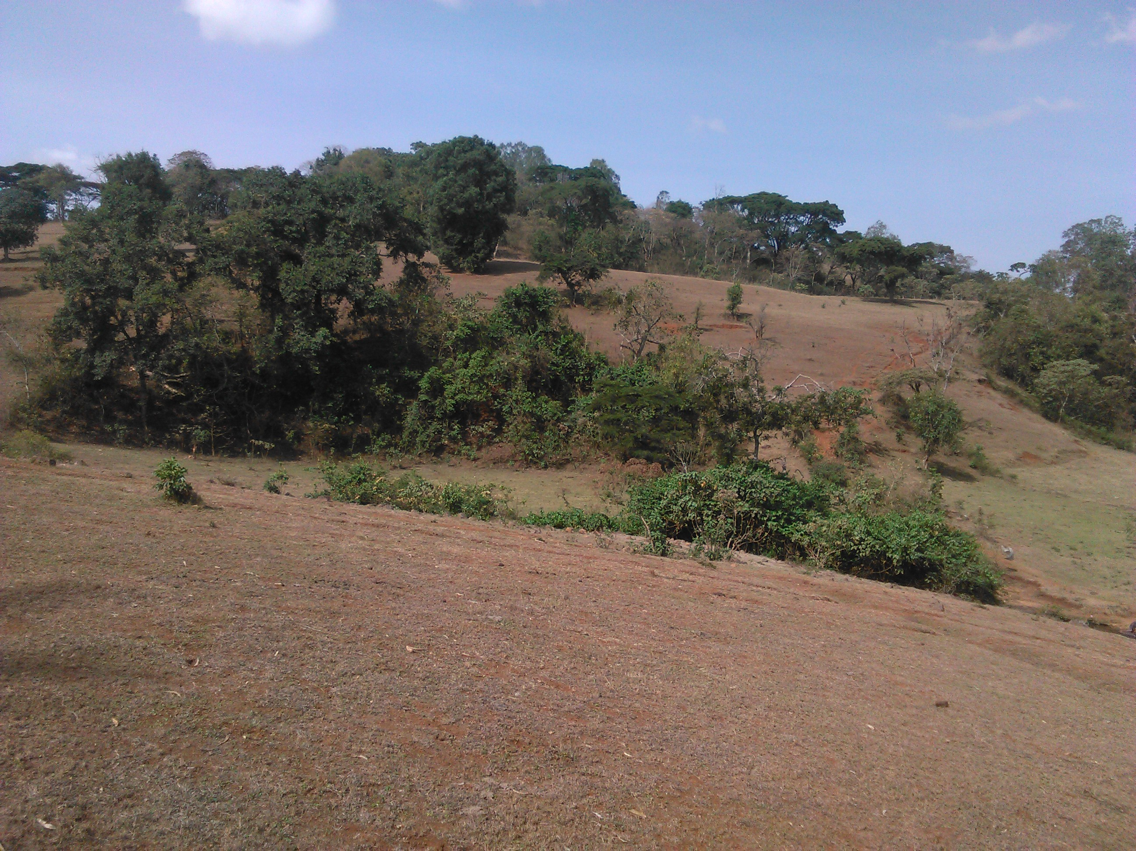
Figure 1. 1: Partial view of the command area

The water source of the future irrigation development is Unkuso River which emanates from the swampy area under Mountain, a bit far away at west direction from the command area, and it flows to east direction to join Dabana River and eventually joins the Abay River. During the assessment period the flow rate of the river is minimal and it can hardly supply the required amount of water to the irrigation development activity. The proposed water abstraction method is gravity (diversion) with furrow irrigation system. As it is observed during the field assessment and secondary data collected from the relevant parties, the area is suitable for small scale irrigation scheme development with some required amendment measures.
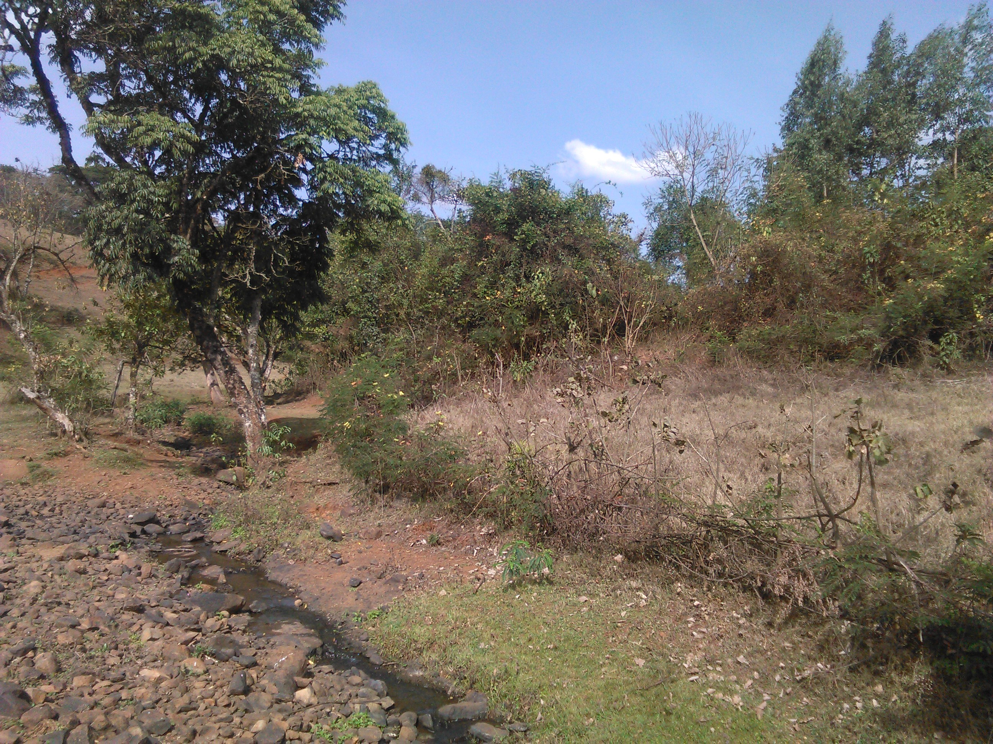
Figure 1. 2: Partial view of Unkuso River at the proposed weir site

Agro-climatic Zone of the Specific Area
The command area is located in Emboro Bonga kebele of Chora woreda, IluAbabora zone of Oromia National Regional State at about 546 km (assumed centre of command area) west of Finfinne (Addis Ababa) city, about 30 km north of Qumbabe town, the capital of this woreda, and about 30 km away from the main asphalt road that runs through Bedele to Mettu. The area is found in the cool sub-humid tropical mid highland agro-ecological zonation at an average altitude of 1840masl with crops having 180 to 240 days of growing period (LGP) based on type of crops and varieties to be produced. Meteorological data were obtained from Bedele National Meteorology Station which is found at an average altitude of 2011m.a.s.l and about 10km air distance from the command area. All necessary climatic data for crop water requirement computation were obtained from this station.

Table 1. 1: Length of growing period as expressed in 0.5PET.
Parameter | Unit | Jan | Feb | Mar | Apr | May | Jun | Jul | Aug | Sep | Oct | Nov | Dec
RF | Mm | 16.8 | 22.1 | 74.0 | 103.5 | 239.9 | 337.3 | 294.1 | 291.0 | 312.5 | 159.1 | 36.6 | 27.0
PET | Mm/M | 105.3 | 100.5 | 114.6 | 121.2 | 102.9 | 97.9 | 77.4 | 79.5 | 95.7 | 114.3 | 102.3 | 92.7
0.5PET | Mm/M | 52.65 | 50.25 | 57.3 | 60.6 | 51.45 | 48.95 | 38.7 | 39.75 | 47.85 | 57.15 | 51.15 | 46.35

Figure 1. 3: Length of growing period (LGP) of the command area.
There are about 180 days of humid period and about 60 days of moist period. Therefore, the area has about 240 days of growing period.

Rainfall
Rainfall needs to be examined in terms of its ability to satisfy crop requirements. By comparing the results with the potential evapo-transpiration the water available to crops could be determined. For example a positive difference between rainfall and potential evapo-transpiration for the greater part of a growing season would ensure good crop growth.
A negative result during the critical growing season would indicate insufficient moisture for that crop or the need for irrigation. On the other hand, an excess of precipitation over the potential evapo-transpiration during the wet season would indicates the need of drainage. A study of

Figure 1. 4: Trend of mean monthly Rainfall and Effective Rainfall of the stud area

the rainfall intensity (quantity over a given period of time) would give an indication of the potential water erosive or of the runoff to be expected and of the dimensions which would have to be given to surplus water disposal channels, etc. As the data collected from Bedele National Meteorology Station shows the project area (Chora woreda) has an average annual rainfall of 1913.9mm, mono-modal type, evenly distributed over more than six months. From this the highest rainfall is recorded in the month of June, and the lowest is recorded in the month of February.

Temperature and Relative Humidity
Air temperature and relative humidity are the most important climatic variables that affect plant life. Each species and variety of plants and each age group of plants has its own upper and lower temperature limits. Beyond these limits a plant becomes considerably damaged and may even be killed. Relative Humidity (RH), the water vapor contained in the atmosphere, is expressed as the percentage of the ratio of actual to saturation vapour pressure. This, together with wind, gives an indication of drying power of the air important for drying and storage of crops while fluctuations in values often affect the incidence of plant diseases as well as the safe storage of harvested crops. Therefore, temperature and relative humidity should be considered while dealing with agricultural planning of an area. Monthly max., min. and average temperatures are 25.8⁰c, 12.8⁰c & 19.3⁰c, respectively. The hottest month is February and the coldest one is July.
Figure 1. 5: Mean monthly max, and min temperatures with relative humidity of the stud area

Land Use
The land use pattern is mainly composed of an extensive grazing, subsistence type of agriculture and scattered settlement, situated within different landforms. The major land use types in the command area include cultivated land, bush land, grass (fallow) land, and riverine forests. Among the use types, cultivated land takes the largest proportion (65%) followed by fallow land (20%), bush lands (10%), and riverine forest land (5%). On the cultivated lands, crops such as maize, sorghum, wheat, barley, F. millet, teff, and other highland oil crops are cultivated under traditional way of farming practices. As the information obtained from the farmers and physical observation made in the field, about few of the command area is covered with crops such as maize, sugarcane, papaya, avocado, and other horticultural crops with traditional irrigation system during the field assessment period. According to the information obtained from the woreda agriculture and DA offices, the following land use patterns for the woreda and the project areas are identified.

Table 1. 2: Land Use Pattern of Chora Woreda and Emboro Bonga kebele
S/N | Types of Land Use | Chora Woreda |  | E/Bonga Kebele
S/N | Types of Land Use | (ha) | (%) | (ha) | (%)
1 | Arable land | 48,148 | 61.42 | 2111 | 93.74
2 | Cultivated | 48,050 | 99.8 of arable land | 2102 | 99.6 of arable land
3 | Grazing land | 5300 | 6.76 | 26 | 1.15
4 | Settlements | 1772 | 2.26 | --- | ---
5 | Forest lands (including bushes & shrubs) | 15,785 | 20.14 | 20 | 0.89
6 | Other land | 7383 | 9.42 | 95 | 4.22
 | Total | 78,388 | 100 | 2252 | 100
Source: Chora Woreda Agriculture Office and Emboro Bonga kebele DAs office

Existing /Present Agricultural Conditions
Agriculture is the mainstay of the community at the project area. Traditional crop-livestock mixed farming practices, subsistence type of farming and high dependence on natural rainfall dominate the sector. However, at a specific project area crops such as maize, sugarcane, onion, and cabbage are predominantly produced using small scale traditional irrigation on some part of the command area. As witnessed by the local farmers the use of improved agricultural technologies such as improved seeds and fertilizers is not adequately well practiced on both irrigated and rain-fed crops production. This might be because of inadequate supply, insufficient extension activities and inadequate awareness of the beneficiaries about the improved technologies. The following table shows the supply and distribution trend of these improved agricultural technologies for the last three years.

Table 1. 3: Chemical Fertilizers, Improved Seeds (qt) and Agro-chemicals (lt) Used by Farmers of the Woreda
S/N | Items | 2005 |  | 2006 |  | 2007
 |  | Supplied | Distributed | Supplied | Distributed | Supplied | Distributed
1 | Fertilizer
 | DAP | --- | 5372.5 | --- | 3055 | --- | ---
 | Urea | --- | 2017.5 | --- | 1952 | 2524 | 2241.5
 | NPS | --- | --- | --- | --- | 5829 | 5741.5
 | Total Fertilizer | --- | 7390 | --- | 5007 | 8353 | 7983
2 | Seed
 | Maize (d/t var.) | --- | --- | --- | 433 | 400.75 | 395
 | Wheat | --- | 111.5 | --- | 16 | 128 | 128
 | Teff | --- | 7 | --- | 7 | 7 | 3
 | Total Seeds | --- | 118.5 | --- | 456 | 535.75 | 526
Source: Chora Woreda Cooperative office

Existing Crop Calendar (rain-fed agriculture)
Length of growing period of the crops is mainly determined by the area agro climatic conditions. As indicated before, agro-climatic zonation for this particular area is cool sub- humid tropics (more of highland having mono-modal, but sufficient rainfall distribution with scattered trees, bushes and shrubs). Hence, generally crops growing with such type of climatic conditions have a longer LGP (Total Growing Period) of 120 to 180 days based on crop type and varieties. As the information obtained from woreda agriculture office, the project area development office, and from the interview of focal farmers indicated the following cropping calendar is presented for the rainy seasons.

Table 1. 4: Existing Cropping Calendar of the Project Area
S/N | Crops | Land preparation | Ploughing frequency | Sowing date | Harvesting date
1 | Maize | Feb - Apr | 4 | May 1 - 15 | Nov 20 - 30
2 | Sorghum | Feb - Apr | 3 | Apr 10 - 25 | Nov 25 - 30
3 | Teff | Mar - Apr | 4 | June 25 – July 10 | Oct 20 – Nov 15
4 | Wheat | Feb - Mar | 4 | June 25 - 30 | Nov 10 - 30
5 | Barley | Late July | 3 | June 25 - 30 | Nov 10 - 30
6 | F. bean | Mar - Apr | 2 | Jun 15 - 30 | Oct 20 - 30
7 | H. bean | Mar - Apr | 2 | Apr 25 - 30 | Sep 1- 10
8 | Noug | Apr - May | 2 | Jun 20 - 30 | Nov 10 - 20
*Source: Chora Woreda, Emboro Bonga Kebele & Farmers Interview.

Major Rain-fed Crops of the Area
As the soil and climate is suitable for a wider variety of crop types, different crops and varieties are growing by farmers of the kebele in the project area. However, improved technologies are not fully and adequately utilized, mainly because of inadequate extension services rendered to the farmers, inaccessibility of the area, insufficient supply, poor distribution and unaffordable price of the improved technologies. According to the data obtained from the woreda Agriculture Office and the nearby Development Agent Center, the information about the last cropping season has been compiled in the following table.

Table 1. 5: Major Staple Food Crops of Chora Woreda and the Project Kebele
S/N | Major crops of the Woreda (rain-fed) | Chora Woreda |  |  | E/Bonga Kebele
S/N | Major crops of the Woreda (rain-fed) | Area Coverage |  | Average Yield  (qt/ha) | Area Coverage |  | Average Yield  (qt/ha)
S/N | Major crops of the Woreda (rain-fed) | ha | (%) | Average Yield  (qt/ha) | ha | (%) | Average Yield  (qt/ha)
1 | Maize | 5133 | 25.41 | 34.6 | 370 | 30.25 | 34.37
2 | Sorghum | 1589 | 7.86 | 32.8 | 60 | 4.91 | 31.93
3 | Wheat | 2326 | 11.51 | 30.4 | 85 | 6.95 | 22.56
4 | Barley | 656 | 3.25 | 21.8 | 113 | 9.24 | 9.0
5 | Teff | 8909 | 44.10 | 12.8 | 475 | 38.84 | 10.61
6 | F. bean | 775 | 3.84 | 14.3 | 31 | 2.53 | 10
7 | H. bean | 621 | 3.07 | 13.7 | 89 | 7.28 | 11
8 | Potato | 192 | 0.95 | 200.0 | --- | --- | ---
Source: Chora Woreda Office of Agriculture and Development Agents Office of the project kebele

From the above tables, it can be understood that crops like maize, teff, and wheat are widely grown in the woreda and project area as well. The above condition is also confirmed by the Woreda Office of Agriculture and Development Agents Centers of the project kebele. As the information obtained from the Woreda Office of Agriculture indicated, almost all types of field crops are growing in the woreda. For instance the following rain-fed crops with their total production for the period of 2005 - 2007 E.C. production years are harvested in Chora woreda.
Table 1. 6: Crops Harvested with rainfall in Chora Woreda in the last three years
S/N | Crops harvested | 2005/6 |  | 2006/7 |  | 2007/8
1 | Cereals | Area (ha) | Total prod. (qt) | Area (ha) | Total prod. (qt) | Area (ha) | Total prod. (qt)
1.1 | Maize | 5368 | 197,511 | 5052 | 289,004 | 5133 | 177,799
1.2 | Sorghum | 1545 | 34,469 | 1582 | 47,166 | 1589 | 52,158
1.3 | Teff | 7690 | 89,186 | 8354 | 108,808 | 8909 | 113,893
1.4 | Wheat | 2151 | 58,229 | 2287 | 65,387 | 2326 | 70,813
1.5 | Barley | 618 | 7138 | 653 | 11,801 | 656 | 14,275
1.6 | F. millet | 152 | 1900 | 150 | 2182 | 102 | 1572
2 | Pulses
2.1 | F. bean | 689 | 10,056 | 760 | 12,104 | 775 | 11,025
2.2 | F. pea | 468 | 5616 | 448 | 4928 | 498 | 4481
2.3 | H. bean | 591 | 5910 | 328 | 3087 | 621 | 8496
2.4 | Soybean | 58 | 580 | --- | --- | --- | ---
3 | Oil Seeds
3.1 | Noug | 1271 | 11,439 | 1276 | 10,503 | 1036 | 7319
3.1 | Linseed | 98 | 804 | 78 | 546 | 78 | 546
3.2 | Rapeseed | 238 | 2630 | 139 | 1385 | 109 | 1199
4 | Roots & Tubers
 | Potato | 187 | 37,400 | 175 | 35,002 | 192 | 38,400
 | Sweet potato | 152 | 24,860 | 162 | 131,082 | 168 | 135,912
5 | Coffee | 22,862 | 62,188 | 23,839 | 159,390 | 25,350 | 128,324
 | Others | 460 | 45,905 | 419 | 59,489 | 521 | 62,190
6 | Total | 44,598 | 595,821 | 45,702 | 941,864 | 48,063 | 828,402
*Source: Chora Woreda Office of Agriculture.
According to the table above it can be concluded that maize, teff, and wheat are widely produced from cereal crops and cover the largest portion of arable land. Other crops such as F. bean, H. bean, and noug are largely harvested from the pulses and oil crops respectively. Coffee is largely produced in the woreda and share the highest portion of the production. The productivity of these crops is increasing from year to year from almost constant land unit. On the other hand, the following crops have been harvested with traditional irrigation development in Chora Woreda for the period of 2005 - 2007 cropping seasons, which could be used as baseline for the proposed irrigated agriculture.

Table 1. 7: Crops Harvested with Irrigation in Chora Woreda in the last three years
S/N | Crops harvested | 2005 |  | 2006 |  | 2007
1 | Cereals | Area (ha) | Total prod. (qt) | Area (ha) | Total prod. (qt) | Area (ha) | Total prod. (qt)
1.1 | Maize | --- | --- | 229.5 | 34,425 | 223 | 33,450
2 | Roots and Tubers
2.1 | Potato | --- | --- | 640 | 96,000 | 657 | 98,550
3 | Vegetables
3.1 | Tomato | --- | --- | 57 | 8,550 | 59.5 | 8,925
3.1 | Cabbage | --- | --- | 35 | 5250 | 35 | 5250
3.2 | Beetroot | --- | --- | 36 | 5400 | 39 | 5850
3.3 | Onion | --- | --- | 53 | 7950 | 59 | 8850
3.4 | Pepper | --- | --- | 94 | 14,100 | 103 | 15,450
3.5 | Carrot | --- | --- | 7 | 1050 | 13 | 1050
 | Total | --- | --- | 1,151.5 | 172,725 | 1,188.5 | 177,375
*Source: Chora woreda irrigation development authority.

Livestock Production
Livestock production is a major component of the farming system. It is also one of the economic activities for traction powers, provision of dairy products, transportation and for household income generation. Oxen are selected for speed and endurance in pulling traditional ploughs. Small ruminants and chickens are generating additional incomes for the community. Traditional beekeeping is also normally known in the area. Modern beekeeping is not as such significantly practiced, but small scale activities are there in few pocket areas. Equines serve as means of transport for human beings and agricultural products. The major type and quantities of livestock in Chora Woreda and the project Kebele (where the proposed irrigation project is located) are indicated in the table below.

Table 1. 8: Livestock Types, Quantities and Common Diseases in Chora Woreda and the Project Kebele
S/N | Chora Woreda |  | E/Bonga Kebele | Diseases of the area
S/N | Type of livestock | Qty | Qty | Diseases of the area
1 | Cattle | 125,522 | 2752 | Foot & Mouth disease (FMD), Anthrax, Lumpy Skin Disease, Black legs, Newcastle, fowl typhoid, Bovine and Ovine Pasturollosis, Senoryosis, Trypanosomiasis (Tryps), endo and ecto parasites (Faciolla), Coccidiosis, sheep pox, etc.
2 | Sheep | 60,450 | 836
3 | Goats | 36,492 | 362
4 | Horses | 7432 | 120
5 | Donkeys | 2117 | 136
6 | Mules | 2412 | 31
7 | Poultry | 68,200 | 1786
8 | Beehives
 | -Traditional | 61,803 | 1683
 | -Transitional | 4669 | 110
 | -Modern | 896 | 6
*Source: Chora Woreda Livestock Health Clinic and nearby Development Agents Office.

According to the information obtained from woreda livestock agency and health clinic, and the community, Anthrax, Blackleg, Tryps, FMD, Pasturollosis, Faciolla, Newcastle and Coccidiosis are the most prevalent diseases in the area. Vaccination and treatment is the major means of preventing these diseases and farmers use their traditional healing mechanisms practiced from generation. In the area natural grazing is the major sources of feed for livestock. In addition some improved forage grasses, multipurpose legume trees and few industrial byproducts are used for livestock feed in the area. Crop residues are largely consumed on the field and also collected, stored and fed during the season of feed shortage. Communal grazing land in some areas is the common means of grazing arrangements among the farmers of the area. Farmers allocate common grazing land at the bottom of the hill around river banks wetland to feed their animals in common. Individually, farmers in the command area allocate and fallow some part of their crop land for animal grazing. Zero grazing is also practiced by few farmers exercising animal fattening around homesteads.

Existing Agricultural Techniques
As observed from the field assessment and information obtained from the concerned institutions, the existing farming practice is traditional method of crop husbandry. As the project area is more of midland the sector is dominated by midland crops production and especially the farmers of the project area relatively produce wider range of crop types which are mainly used for their subsistence consumption and some more for additional household income generation. The supplying of agricultural inputs such as improved seeds and fertilizers for existing traditional rain-fed agriculture is low, not adequate for full potential use of the available resources. As information collected from the woreda cooperative office and local farmers the price of these agricultural inputs is increasing from time to time and get unaffordable. As a result, the farmers use few inputs, especially, fertilizers on large area of land, not according to the research recommendation. The credit service in the command area is not common and most farmers have little awareness of credit service rendering organizations. The basic agricultural techniques like crop rotation, crop diversification, double cropping, soil and water conservation and other related activities are not yet well practiced in the area. Most farmers use traditional oxen drawn plows to plough their crop land on sloppy farmland, and this plow is short and can cause the formation of a hard pan beneath the top soil. This lowers the water retention capacity of the soil and exposes the upper agricultural soil to water erosion. There are great variations among the farmers, depending on the different biographical conditions, skills, the availability of labor and access to resources outside the farm. Most are marginal subsistent farmers, cultivating basic food crops only. But the production of such crops is low, not enough to meet their requirements in most years. The number of livestock is higher, but the productivity of these livestock sector is very low mainly due to the poor feeding system and lack of improved breeds. The prevalence of livestock diseases, feed shortage, and low awareness of improved management practices has its own impact to low productivity.

Generally, the following major agricultural problems are identified in and around the project area.

Low Technology Input Utilization
There is no adequate provision of agricultural inputs, like improved seeds, agrochemicals, improved breeds of livestock, and other related technology packages in the proposed development area. The farmers produce relatively limited range of crop types due to low awareness of improved, environmentally-friendly agricultural technologies. Although the Woreda Agricultural Extension Office has been supplying few improved crops varieties, adoption of improved farm practices is hardly seen in the area. This might be because of continuous price increase of important agricultural inputs, especially fertilizers. The price of agricultural inputs as common is high and farmers could not afford to purchase. Crop rotation, diversification and intercropping and soil water conservation are not seen well practiced in the area.

Soil Erosion as a Result of Deforestation
Due to population increase which leads to horizontal expansion of agricultural lands, and the increasing fire wood consumption and other related human needs (construction, fencing timber etc.), deforestation is becoming a problem in the proposed project area. Moreover, replanting and other soil conservation activities are not yet well adopted by the community.

The Prevalence of Animal Diseases & Low Livestock Productivity
A free-type of grazing is extensively conducted on forest & bushy areas and post harvested lands. The production & productivity is below the expected condition (as informed by the development agents & other concerned workers). The occurrence of different animal diseases, lack of quality breeding, shortage of high nutritional feeding and the dominance of traditional way of raring system are some of the many factors which reduce livestock productivity.

Poor Access to Markets
Marketing of agricultural production in the area poses significant constraints for the producers. Poorly developed or lack of proper infrastructure and marketing facilities (roads, bridges, and warehouses) are major constraints. Limited opportunities to send products to market have hampered the production of micro-businesses and petty trading that could have provided alternative incomes.

Inadequate Infrastructures & Institutional Setups
This should be emphasized as one of the major problems in the proposed project area. For instance, there are no road networks among the kebeles surrounding the command area. No or little opportunities of local transportation available to the community. Basic Institutions such as large market opportunities, Shops, Credit Service giving sectors, Information providers and the likes are absent in the area.

Insufficient Expertise of Irrigation Farming
The expansion of small scale irrigation in the study area and in the Woreda as a whole is still insignificant. This has got its own impact on the introduction of different vegetables and other cash crops in the area. Although there are many potential rivers for irrigation development, the practice is not yet developed as required.

Labour Requirement
Labour requirement for the existing rain-fed agriculture system is calculated on the proposed command area. This is mainly based on the field assessment and secondary data gathered from the agriculture office of Chora woreda and the project Kebele. As per the “without project” condition, a hectare of labor requirement is specified under the following condition.
Table 1. 9: A Hectare of Labor Requirement as a “without project” Condition
S/N | Crops | Activities | Unit | Frequency | Qty | Total  Required | Remark
1 | Maize | Ploughing | OD | 4 | 4 | 16 | Has been harvested on and around the command area during 2007/08 cropping season
1 | Maize | Sowing | OD | 1 | 4 | 4
1 | Maize | Weeding/cultivation | MD | 2 | 30 | 60
1 | Maize | Fertilizer application | MD | 2 | 4 | 8
1 | Maize | Harvesting | MD | 1 | 30 | 30
1 | Maize | Threshing | MD | 1 | 40 | 40
1 | Maize | Transport | MD | 1 | 8 | 8
2 | Wheat | Ploughing | OD | 4 | 4 | 16 | Same
2 | Wheat | Sowing + fertilizer | OD | 1 | 4 | 4 | Same
2 | Wheat | Weeding | MD | 2 | 20 | 40 | Same
2 | Wheat | Harvesting | MD | 1 | 15 | 15 | Same
2 | Wheat | Threshing | MD | 1 | 10 | 10 | Same
2 | Wheat | Transport | MD | 1 | 5 | 5 | Same
3 | Teff | Ploughing | OD | 4 | 4 | 16
3 | Teff | Packing | OD | 1 | 20 | 20
3 | Teff | Sowing + fertilizer | MD | 1 | 2 | 2
3 | Teff | Weeding | MD | 2 | 25 | 50
3 | Teff | Harvesting | MD | 1 | 20 | 20
3 | Teff | Threshing | MD | 1 | 10 | 10
3 | Teff | Transport | MD | 1 | 4 | 4
4 | F. bean | Ploughing | OD | 3 | 4 | 12 | Same
4 | F. bean | Sowing | OD | 1 | 4 | 4 | Same
4 | F. bean | Weeding | MD | 1 | 20 | 20 | Same
4 | F. bean | Harvesting | MD | 1 | 15 | 15 | Same
4 | F. bean | Threshing | MD | 1 | 10 | 10 | Same
4 | F. bean | Transport | MD | 1 | 4 | 4 | Same

Proposed Irrigated Agriculture
Irrigated agriculture is proposed based on the objectives of the agronomic study indicated in earlier parts of this study report under the following conditions. Since assisting with installation of irrigation scheme is a key part of the proposed program and development strategy, it is essential that sound environmental, agronomic, social, economic and technical criteria are met at all stages of planning and design activities. Modern crop technology has the power to increase farm incomes and lower food prices simultaneously, thus benefiting everyone in society, especially the poor who spend a larger portion of their income on food. Thus, clearly irrigation can and should play an important role in raising and stabilizing food production, especially in areas of the proposed project, where there is relatively better land and water potential suitable for irrigation.

Crop Selection
Crops are selected based on the following major criteria:
- Climatic & soil suitability of the area,
- Yield potentiality and marketability,
- Multiple purposes such as food, fodder, fuel and other byproducts,
- Length of growing period (early maturing) and workability,
- Their places in rotation and contribution to soil fertility,
- As a basic staple food for existing community (farmers’ crop selection preference), and
- Existing farmers’ skill and level of technology utilization.
Accordingly, on the basis of the above criteria, the following crops are selected for the “would be” irrigated agriculture.
Table 1. 10: Crops Selected for Irrigation Development
S/N | Selected Crops | Variety | % | Remark
1 | Maize | BH-540, Shone, Shala | 30
2 | Potato | Jalane, Gudane, Belete | 20
3 | Pepper | Marekofana, Bako Local | 20
4 | Tomato | Marglobe, Melkashalo red | 25
5 | Sugarcane | Thick var. | 5

Cropping Pattern
After selection of the crops to be planted using irrigation, the seasonal cropping pattern and cropping calendar for each crop should be determined. This helps in establishing which crop will occupy what part of the available land area during each season, also taking into consideration the crop rotation requirement. Moreover, the cropping pattern is based on the following basic considerations.
- The objective of the project,
- Production of food crops, at least sufficient for the local population, improvement of the living standards of the community by producing an agricultural surplus,
- The proportion of land for different crops can be adjusted according to the farmers’ needs with the increase of their knowledge in raising the crop and preferences,
- Intensification of crop production from food crops to cash income generation,
- Immediate benefit in the form of more reliable harvest higher production per unit of labor.

Details of the Selected Crops
The essential climatic and soil needs, length of growing period, and their appropriate agronomic and other related requirements of the selected crops are identified below.

Cereals
Maize
- It is a food and cash crop at green harvest for the community
- Workable and relatively easy for management.
- Its crop residue is used for animal feeding and other economic purposes.
- It is a high potential crop among cereals
- It is a warm –weather crop and grows from the sea level up to altitudes 2500 m.
- It is tolerant to wind range of environmental conditions but should be free from frost.
- Optimum temperature for germination is 18⁰c to 25⁰c and for optimum growth 18⁰c to 31⁰c are preferable.
- It requires 800 to 1500 mm of water for optimum production.
- It grows on many type of soils, well drained and aerated
- Its pH ranges from 5.8 to 8.5

Roots & Tubers
a) Potato
- It is a food and cash crop for the poor community
- Workable and relatively easy for management.
- It is a high potential crop among root crops
- It is a cool weather crop; however, improved varieties grow from altitude ranges of 1200 up to 3000 m.a.s.l.
- It is tolerant to wide range of environmental conditions, but be free from frost & hail.
- Optimum temperature for germination and growth is 15⁰c to 25⁰c.
- It requires 800 to 1300 mm of water for optimum production.
- It grows on many types of soils well drained and aerated
- Its pH ranges from 5.5 to 7.5
- It is susceptible to blight diseases and proper management is essential.

Vegetables
a) Tomato
- Like onion it grows under a wide range of climates from temperate to tropical.
- It is a high value and demanded crop in the project area and surroundings.
- Preferable soil pH is 6.5 to7.5 and it grows in all soil types.
- For optimum growth a temperature of 16⁰c to 28⁰c is preferred.
- It has an economic demand in the project area.
- Has a good place in crop rotation.
b) Pepper
- It best grows on areas, between 1200 and 2000m.a.s.l. and is a plant of the humid tropics.
- The crop is highly demanded in the project area and its surroundings.
- It prefers a day temperature between 21⁰c and 29⁰c, for optimum growth. But tolerates a temperature range of 10⁰c to 40⁰c.
- High yield is obtained with rainfall of 600 – 1250 mm. However, heavy rainfall during the flowering period causes flower shedding and during the ripening period rotting of fruits.
- Light to medium textured soils with adequate water holding capacity and drainage are preferred.
- Optimum soil pH is 5.5 to 7.5.

Industrial Crops
a) Sugarcane
- It grows under a wide range of climates from temperate to tropical, (especially from 600 to 1800m.a.s.l).
- It is a high value industrial crop and plays a great role in the country’s economy.
- For a high yield of good quality, the crop needs controlled and frequent supply of water throughout the total growing period.
- Although the crop can be grown on various types of soils, it grows best on light soils, with a pH of 5.5 to 7.5
- Optimum temperatures are ranging between 18⁰c to 28⁰c
- Irrigation should be discontinued as the crop approaches maturity to allow the buildup of starch and to desiccate.

Irrigation Seasons
Irrigation seasons are decided based on the existing climatic condition, length of growing period (LGP) of the proposed crops and capacity (efficiency) of the beneficiaries of the project. As to the proposed project condition, two times irrigation seasons as a “Dry-season” and “Wet-season” irrigation development are possibly recommended. The “Dry-Season” is considered as “Full-Time” irrigation season and the “Wet-season” is as “supplementary” irrigation. The full time irrigation season is proposed immediately when most rain-fed crops are harvested. The month of October is assumed to be a starting Month. Even though all crops will not completely be harvested, this period (October) is a must considering the (LGP) of crops, appropriate marketing time and the time for first season rainfall agriculture practices. Accordingly, the following time schedule for both dry season and wet season irrigation is performed below.

Table 1. 11: Dry-season Irrigation time Schedules
S/N | Proposed Crops | Area |  | Selected varieties | Planting/ Sowing date | Harvesting Date | Base- period  (days)
S/N | Proposed Crops | (ha) | (%)
1 | Maize | 14.1 | 30 | BH-540, Shone, Shala | Oct. 1-15 | Jan. 20-30 | 120
2 | Potato | 9.4 | 20 | Jalane, Gudane, Belete | Oct. 10-20 | Jan. 20-25 | 95
3 | Pepper | 9.4 | 20 | Marekofana, Bako Local | Oct. 5-15 | Jan. 25-30 | 120
4 | Tomato | 11.8 | 25 | Marglobe, Melkashalo red | Oct. 1-10 | Jan. 20-30 | 110
5 | Sugarcane | 2.3 | 5 | Thick var. | Oct. 1-10 | Oct. 5-15 | 360+

Table 1. 12: Wet-season Irrigation time Schedules
S/N | Proposed Crops | Area |  | Selected varieties | Planting/ Sowing date | Harvesting Date | Base- period  (days)
S/N | Proposed Crops | (ha) | (%)
1 | Onion | 9.4 | 20 | Adama red, Bombe red | Feb. 1-10 | May 20-30 | 110
2 | Potato | 14.1 | 30 | Jalane, Gudane, Belete | Feb. 1-10 | May 20-30 | 120
3 | Beetroot | 7.05 | 15 | --- | Feb. 5-15 | May 20-30 | 105
4 | Cabbage | 9.4 | 20 | Duram Head | Feb. 10-20 | May 15-25 | 95
5 | Carrot | 7.05 | 15 | Scharwoode | Feb. 1-10 | May 20-30 | 110

Proposed Management
As a “With-Project” condition and modern farming system, all the required crop management approaches should be applied in the system. For instance crop spacing, method of irrigation, fertilizer application (type, amount, time and method) should be identified prior to the development phases. Accordingly, the following basic and integral parts of crop management approaches for the “would be” irrigated agriculture are identified below.

Method of Irrigation
The major method of water application during the cultivation seasons is furrow system for the selected crops. Farmers of the proposed irrigation area have the experience of furrow application on the traditional irrigation activities. The detail condition is indicated in the following table.
Table 1. 13: Method of Irrigation and Spacing for the selected crops
S/N | Selected Crops | Method of Irrigation | Recommended  Furrow Length (m) | Plant spacing (cm) |  | Remark
 |  |  |  | Intra-row | Inter-row | Remark
1 | Maize | Furrow | 25 | 30 | 75
2 | Potato | Furrow | 25 | 30 | 75 | Produced for food purpose
3 | Pepper | Furrow | 25 | 15 | 50
4 | Tomato | Furrow | 25 | 25 | 100
5 | Sugarcane | Furrow | 25 | 30 | 80
6 | Onion | Furrow | 25 | 10 | 25
7 | Beetroot | Furrow | 25 | 20 | 40
8 | Cabbage | Furrow | 25 | 20 | 40
9 | Carrot | Furrow | 25 | 5 | 20

Cultivation Activities
Different crops require different cultivation activities. Some crops require simple hoeing and some others require earthening up. Thus, it is advisable to understand these conditions prior to the development activities. Some of the major cultivation processes of crop production are summarized in the following table.

Table 1. 14: Major cultivation activities in irrigated agriculture
S/N | Proposed crops | Seed Rate (Kg/ha) | Soil depth during Seeding/ planting (cm) | Cultivation time/Weeding
1 | Maize | 25 | 5 | After 4-leaf stage
2 | Potato | 2000 | 5-10 | 1st 25 days and 2nd 45 days after planting
3 | Pepper | 0.5 to 0.6 | 4-6 (Transplanting from nursery site after 30 days) | After 20 days of transplanting
4 | Tomato | 0.5 | 4-6 (Transplanting from nursery site after 30 days) | After 20 days of planting
5 | Sugarcane | 44,444 cuttings | 5-10 | 40 - 45 days after planting
6 | Onion | 3-4 | 4-5 (Transplanting from nursery site after 30 days) | After 20 days of transplanting
7 | Beetroot | 0.5-1.0 | Same | Same
8 | Cabbage | 0.5-0.7 | Same | Same
9 | Carrot | 6-10 | 3-5 and drilling | 20 to 25 days after sowing

Fertilizer Management
Adequate fertilization programs supply plant nutrients needed to sustain maximum crop productivity and profitability while minimizing environmental impact from nutrient use. In essence, fertilizers are used so that soil fertility is not a limiting factor in crop production. The major factors influencing the quantity of nutrients to apply are crop and soil characteristics, fertilizer placement, climate especially moisture and temperature, yield goals and economics. Considering these main factors in proper fertilizer management activities, the required fertilizers (that can be synthetic or natural), are given to the proposed crops. However, it should be applied after careful chemical analysis of the command soil. As to the proposed project condition, the following fertilizer and other agrochemicals are averagely determined. (The total yearly input required for the command area is referred in Agronomy Annexes).

Table 1. 15: Required fertilizers & other agrochemicals planned for each proposed crop
S/N | Selected Crops | Fertilizers,(Kg/ha) |  | Pesticide s,(Lt, Kg/ha) |  |  | Remark
S/N | Selected Crops | DAP | Urea | Insecticides | Fungicide | Herbicide | Remark
1 | Maize | 100 | 200 | Cypermethrin, Akito 2.5% EC, Endosulfan | Tilt 250 EC | PrimgrmGold, Atrazine, Alazine, etc. | Amount of pesticides is determined on the type of crop, kind of pest outbreak and type of pesticides to be used.
2 | Potato | 150 | 100 | Dimethoate 40% EC, Diazinone, etc. | Mancozeb, Ridomil, etc. | -
3 | Pepper | 100 | 100 | Diazinone, etc. | Ardent 50 SC, Ridomil, etc. | -
4 | Tomato | 150 | 100 | Dimethoate 40% EC, Diazinone, etc. | Mancozeb, Ridomil, etc. | -
5 | Sugarcane | 100 | 50 | - | Noble 25 WP | -
6 | Onion | 100 | 100 | Nimbicidine, etc. | Ridomil, etc. | -
7 | Beetroot | 100 | 50 | Diazol 60 EC | Ridomil MZ 63.5 WP | -
8 | Cabbage | 100 | 50 | Dimethoate 40% EC. | - | -
9 | Carrot | 100 | 100 | Diazol 60 EC | Ridomil MZ 63.5 WP | -

Method of Fertilizer Application
There are a number of fertilizer application methods, based on the crop and its cultivation system. Among these, deep-banding, side/basal dressing, fertigation, foliar application and others are known. However, as to the level of irrigation and farmers awareness, the basal and top dressing are the most important application methods in farmer managed irrigation development activities. Accordingly, the following application experiences are designed for the proposed project.
Table 1. 16: Methods of fertilizer application for the proposed crop types
S/N | Proposed Crops | Fertilizers to be applied | Method of Application | Time of Application
1 | Maize | DAP | Top/Side dressing | At the time of sowing
1 | Maize | Urea | Basal dressing | At 4-leaf stage
2 | Potato | DAP | Top/Side dressing | At the time of sowing
2 | Potato | Urea | Basal dressing | During earthening up stage
3 | Pepper | DAP | Top/Side dressing | At the time of transplanting
3 | Pepper | Urea | Basal dressing | 3 to 4 weeks after transplanting
4 | Tomato | DAP | Top/Side dressing | At the time of transplanting
4 | Tomato | Urea | Basal dressing | 3 to 4 weeks after transplanting
5 | Sugarcane | DAP | Top/Side dressing | At the time of planting
5 | Sugarcane | Urea | Top/Side dressing | 6 weeks after planting
6 | Onion | DAP | Top/Side dressing | At the time of transplanting
6 | Onion | Urea | Basal dressing | 3 to 4 weeks after transplanting
7 | Beetroot | DAP | Top/Side dressing | Same
7 | Beetroot | Urea | Basal dressing | Same
8 | Cabbage | DAP | Top/Side dressing | At the time of transplanting
8 | Cabbage | Urea | Top/Side dressing | 3 to 4 weeks after transplanting
9 | Carrot | DAP | Top/Side dressing | At the time of sowing
9 | Carrot | Urea | Basal dressing | 3 to 4 weeks after sowing
In general the assigned agronomist can select one of the following fertilizer management practices during the implementation period.
- Excessive use of external inputs,
- Intensified use of local resources with few or no external inputs,
- Integrated use of external inputs and local resources.

Plant Protection
Controlling insect pests, diseases, and weeds is very essential for the achievement of optimum crop yield from irrigated agriculture. Pesticides may be expensive and may cause environmental problems on the area for both human beings and animals. They also kill other important pests which are enemies of the non-advantageous pests. Thus, during the cultivation period, non-chemical methods of pest control should be applied together with that of chemical ones (integrated method of pest management). Accordingly, the following protection methods are summarized to be used in the future plant protection activities of the proposed project.

Table 1. 17: Chemical & non-chemical plant protection methods for the proposed crops
S/N | Proposed Crops |  | The Possible Pests & Diseases | Chemical Prevention  Method | Non-chemical Prevention Method
1 | Maize | Pests | Stalk Borer, African Ball Worm, Aphids, Army Worms, Weevil | Use different Chemicals & pesticides | Field sanitation, Crop rotation, and Insect free var., proper crop and water management.
 |  | Diseases | GLS, TLB, Cob Rot, | Use different fungicides. | Field sanitation, Crop rotation, and Disease free var., proper crop and water management.
2 | Potato | Pests | Soil borne Worms, Aphids, Army Worms | Use different Chemicals & pesticides | Field sanitation, Crop rotation, use of Insect free var., proper crop and water management.
 |  | Diseases | Early and Late blight, Bacterial wilt, etc. | Use of different fungicides. | Field sanitation, Crop rotation, use of Disease free var., proper crop and water management.
3 | Pepper | Pests | Thrips, white fly, Different Worms | Use different chemicals | Field sanitation, Crop rotation, use of Disease free var., proper crop and water management.
 |  | Diseases | Fruit rot, Powdery Mildew, Bacterial wilt, etc. | Use different fungicides. | Field sanitation, Crop rotation, use of Disease free var., proper crop and water management.
4 | Tomato | Pests | Fruit sucking insects, Aphids, Worms | Same as potato | Same as potato
 |  | Diseases | Same as potato | Same as potato | Same as potato
5 | Sugarcane | Pests | Root cutters (worms)  Suckers, Scales, Aphids | Use different chemicals | Field sanitation, Crop rotation, and Disease free var., proper crop and water management.
 |  | Diseases | Smut, fungus spp. | Use different chemicals | Field sanitation, Crop rotation, and Disease free var., proper crop and water management.
6 | Onion | Pests | Onion trips, cut worms, Onion flies, | Use different Chemicals & pesticides | Field sanitation, Crop rotation, use of Disease free var., proper crop and water management.
 |  | Diseases | Root rot, Purple Bloch, Downey Mildew | Use different fungicides. | Field sanitation, Crop rotation, use of Disease free var., proper crop and water management.
7 | Beetroot | Pests | Aphids, Flea, Beetle, Diamond Back | Use different Chemicals & pesticides | Field sanitation, Crop rotation, and Insect free var., proper crop and water management.
 |  | Diseases | Black rot, Downy Mildew, Leaf Spot | Use of different fungicides. | Field sanitation, Crop rotation, and Disease free var., proper crop and water management.
8 | Cabbage | Pests | Aphids, Flea, Beetle, Diamond Back | Use different chemicals | Field sanitation, Crop rotation, and Disease free var., proper crop and water management.
 |  | Diseases | Black rot, Downy Mildew, Leaf Spot | Use different fungicides. | Field sanitation, Crop rotation, and Disease free var.
9 | Carrot | Pests | Ahids, Jassids, Beetles, Worms | Use different Chemicals & pesticides | Field sanitation, Crop rotation, and Insect free var., proper crop and water management.
 |  | Diseases | --- | Use of different fungicides. | Field sanitation, Crop rotation, and Disease free var., proper crop and water management.

Crop Rotation and Intercropping
Crop rotation is used to avoid the build-up of diseases and pests and to avoid or minimize loss of soil fertility. Intercropping allows efficient utilization of soil nutrients and increased harvest from limited land resource. It also enables to get minimum harvest in case of one component crop failure which is a common phenomenon in the proposed command area. The possible arrangements in crop rotations and intercropping can be the following.
- Maize ↔ potato/pepper/tomato ↔ maize which helps for avoidance especially of stalk borer, and rust.
- Maize ↔ cabbage used for avoidance, especially of nematode build up, blight and bacterial wilt; only Solanaceous crops should be avoided in the rotation system.
- Shallow rooted crops alternatively with deep rooted crops for efficient utilization of essential nutrient resources is also one of the rotational possibilities.
- Maize/H. bean intercropping used to improve the fertility status of soil and efficient utilization of limited land resources.

Labor Requirement
As a “With-Project “condition, labor is calculated for each selected crop, for a hectare of irrigable land. The required activities, frequency and amounts with their justification are specified in the next table.
Table 1. 18: A hectare of labor requirement as a “With-Project” condition
S/N | Crops | Activities | Unit | Frequency | Qty | Total | Remark
1 | Maize | Ploughing | OD | 4 | 4 | 16 | Irrigation requirement will be every 17 days for 24 hours.
 |  | Pre-Irrigation | MD | 1 | 4 | 4 | Irrigation requirement will be every 17 days for 24 hours.
 |  | Planting/Sowing | MD | 1 | 4 | 4 | Irrigation requirement will be every 17 days for 24 hours.
 |  | Irrigation | MD | 15 | 4 | 60 | Irrigation requirement will be every 17 days for 24 hours.
 |  | Cultivation/Weeding | MD | 2 | 20 | 40 | Irrigation requirement will be every 17 days for 24 hours.
 |  | Fertilizer application | MD | 2 | 4 | 8 | Irrigation requirement will be every 17 days for 24 hours.
 |  | Protection | MD | 2 | 4 | 8 | Irrigation requirement will be every 17 days for 24 hours.
 |  | Harvesting | MD | 1 | 15 | 15 | Irrigation requirement will be every 17 days for 24 hours.
 |  | Threshing | MD | 1 | 35 | 35 | Irrigation requirement will be every 17 days for 24 hours.
 |  | Transport | MD | 1 | 8 | 8 | Irrigation requirement will be every 17 days for 24 hours.
2 | Potato | Ploughing | OD | 4 | 4 | 16 | Irrigation requirement will be every 7 days for 24 hours.
 |  | Pre-Irrigation | MD | 1 | 4 | 4 | Irrigation requirement will be every 7 days for 24 hours.
 |  | Planting/Seeding | MD | 1 | 20 | 20 | Irrigation requirement will be every 7 days for 24 hours.
 |  | Irrigation | MD | 15 | 4 | 60 | Irrigation requirement will be every 7 days for 24 hours.
 |  | Cultivation/Weeding | MD | 2 | 20 | 40 | Irrigation requirement will be every 7 days for 24 hours.
 |  | Fertilizer application | MD | 2 | 4 | 8 | Irrigation requirement will be every 7 days for 24 hours.
 |  | Protection | MD | 2 | 4 | 8 | Irrigation requirement will be every 7 days for 24 hours.
 |  | Harvesting | MD | 1 | 30 | 30 | Irrigation requirement will be every 7 days for 24 hours.
 |  | Transport | MD | 1 | 20 | 20 | Irrigation requirement will be every 7 days for 24 hours.
3 | Pepper | Ploughing | OD | 4 | 4 | 16 | Irrigation requirement will be every 8 days for 24 hours.
 |  | Pre-Irrigation | MD | 1 | 4 | 4 | Irrigation requirement will be every 8 days for 24 hours.
 |  | Seedling nursery | MD | 1 | 5 | 5 | Irrigation requirement will be every 8 days for 24 hours.
 |  | Transplanting | MD | 1 | 30 | 30 | Irrigation requirement will be every 8 days for 24 hours.
 |  | Irrigation | MD | 15 | 4 | 60 | Irrigation requirement will be every 8 days for 24 hours.
 |  | Cultivation/Weeding | MD | 2 | 20 | 40 | Irrigation requirement will be every 8 days for 24 hours.
 |  | Fertilizer application | MD | 2 | 4 | 8 | Irrigation requirement will be every 8 days for 24 hours.
 |  | Protection | MD | 3 | 4 | 12 | Irrigation requirement will be every 8 days for 24 hours.
 |  | Harvesting | MD | 1 | 30 | 30 | Irrigation requirement will be every 8 days for 24 hours.
 |  | Transport | MD | 1 | 20 | 20 | Irrigation requirement will be every 8 days for 24 hours.
4 | Tomato | Ploughing | OD | 4 | 4 | 16 | Irrigation requirement will be every 8 days for 24 hours.
 |  | Pre-Irrigation | MD | 1 | 4 | 4 | Irrigation requirement will be every 8 days for 24 hours.
 |  | Seedling nursery | MD | 1 | 5 | 5 | Irrigation requirement will be every 8 days for 24 hours.
 |  | Transplanting | MD | 1 | 30 | 30 | Irrigation requirement will be every 8 days for 24 hours.
 |  | Irrigation | MD | 15 | 4 | 60 | Irrigation requirement will be every 8 days for 24 hours.
 |  | Cultivation/Weeding | MD | 2 | 20 | 40 | Irrigation requirement will be every 8 days for 24 hours.
 |  | Fertilizer application | MD | 2 | 4 | 8 | Irrigation requirement will be every 8 days for 24 hours.
 |  | Staking | MD | 1 | 15 | 15 | Irrigation requirement will be every 8 days for 24 hours.
 |  | Protection | MD | 3 | 4 | 12 | Irrigation requirement will be every 8 days for 24 hours.
 |  | Harvesting | MD | 1 | 30 | 30 | Irrigation requirement will be every 8 days for 24 hours.
 |  | Transport | MD | 1 | 20 | 20 | Irrigation requirement will be every 8 days for 24 hours.
5 | Sugarcane | Ploughing | OD | 4 | 4 | 16 | This is only for a one –harvest plan. There are many ratoon harvesting for sugarcane plant in its production life.
 |  | Pre-Irrigation | MD | 1 | 4 | 4
 |  | Cutting preparation | MD | 1 | 20 | 20
 |  | Planting | MD | 1 | 30 | 30
 |  | Irrigation | MD | 50 | 4 | 200
 |  | Cultivation/Weeding | MD | 2 | 20 | 40
 |  | Fertilizer application | MD | 2 | 4 | 8
 |  | Protection | MD | 2 | 4 | 8
 |  | Harvesting | MD | 1 | 40 | 40
 |  | Transport | MD | 1 | 50 | 50

Area Coverage/Intensity
For the irrigation project the development approach is assumed to double crop over one cropping season and the cropping intensity to approach 200%. The community of the command area has currently good experience in producing crops twice in a year using traditional irrigation system. This helps to increase the efficiency of the beneficiaries and adopt irrigated agriculture through a sequence of irrigation practices. Accordingly, the following cropping pattern/intensity is designed for the first 5-year crop production schedule.
Table 1. 19: A 5-year cropping pattern/intensity plan
S/N | Crops | Area coverage
S/N | Crops | 1st-Year/Season |  | 2nd-Year/Season |  | 3rd-Year/Season |  | 4th-Year/Season |  | 5th-Year/Season
S/N | Crops | ha | % | ha | % | ha | % | ha | % | ha | %
1 | Maize | 7.05 | 15.0 | 9.4 | 20.00 | 14.1 | 30.5 | 16.45 | 35.2 | 18.8 | 41.1
2 | Potato | 7.05 | 15.0 | 9.4 | 20.00 | 14.1 | 30.5 | 16.45 | 35.2 | 18.8 | 41.1
3 | Pepper | 3.52 | 7.5 | 4.7 | 10.00 | 7.05 | 15.2 | 8.23 | 17.6 | 9.4 | 20.5
4 | Tomato | 3.52 | 7.5 | 4.7 | 10.00 | 7.05 | 15.2 | 8.23 | 17.6 | 9.4 | 20.5
5 | Sugarcane | 1.76 | 3.7 | 2.35 | 5.00 | 2.35 | 5.1 | 2.35 | 5.2 | 2.35 | 5.0
6 | Onion | 3.52 | 7.5 | 4.7 | 10 | 7.05 | 15.2 | 8.23 | 17.6 | 9.4 | 20.5
7 | Beetroot | 2.47 | 5.25 | 3.29 | 7 | 4.94 | 10.68 | 5.75 | 12.2 | 6.58 | 14.4
8 | Cabbage | 3.52 | 7.5 | 4.7 | 10 | 7.05 | 15.2 | 8.23 | 17.6 | 9.4 | 20.5
9 | Carrot | 2.82 | 6.0 | 3.76 | 8 | 5.64 | 12.2 | 6.58 | 14.1 | 7.52 | 16.4
Intensity |  | 35.23 | 75.00 | 47 | 100.00 | 69.33 | 150.00 | 80.5 | 175.00 | 92.00 | 200.00

Yield Projection
Crop yield is mainly estimated based on the level of crop management required practices, availability of agricultural inputs, proper extension services, and existing climatic situations for crop production. Apart from these basic factors, other trends should be assessed. For instance, observation of previous yield condition from traditional (rain-fed) agriculture, anticipated research outputs, and other related sources are very important. Considering these parameters, the yield projection is forecasted as shown below.
Table 1. 20: Yield Projection for five (5) year/season production period
S/N | Crop | 1st-Year /season |  | 2nd-year /Season |  | 3rdYear /Season |  | 4th-year /Season |  | 5th-year /Season
S/N | Crop | Yield (qt/ha | Prodn (Qt) | Yield (qt/ha | Prodn (Qt) | Yield (qt/ha | Prodn (Qt) | Yield (qt/ha | Prodn (Qt) | Yield (qt/ha | Prodn (Qt)
1 | Maize | 60 | 846 | 65 | 916 | 68 | 959 | 70 | 987 | 70 | 987
2 | Potato | 80 | 752 | 90 | 846 | 100 | 940 | 120 | 1128 | 120 | 1128
3 | Pepper | 20 | 188 | 25 | 235 | 30 | 282 | 30 | 282 | 30 | 282
4 | Tomato | 150 | 1770 | 180 | 2124 | 200 | 2360 | 210 | 2478 | 220 | 2596
5 | Sugarcane* | 150 | 345 | 165 | 379 | 175 | 402 | 180 | 414 | 180 | 414
6 | Onion | 80 | 752 | 90 | 846 | 100 | 940 | 120 | 1128 | 120 | 1128
7 | Beetroot | 180 | 1269 | 200 | 1410 | 220 | 1551 | 240 | 1692 | 260 | 1833
8 | Cabbage | 70 | 658 | 80 | 752 | 90 | 846 | 95 | 893 | 95 | 893
9 | Carrot | 150 | 1057 | 165 | 1163 | 180 | 1269 | 200 | 1410 | 220 | 1551
Note: *indicates tone/ha for sugarcane

Postharvest Activities
a) Harvesting
Irrigated crops such as vegetables and fruits are highly perishable and subjected to chemical and physical changes and hence too rapid deterioration. Apart from some exceptions, most farm products are susceptible to damage, whether from mechanical shocks or climatic factors like atmospheric dryness, heat and cold. This sensitivity creates the need for a whole series of precautions in handling, storing, packing and transport. Therefore, care should be taken during harvesting and post-harvest activities. Recognition of the point of optimum maturity is important for the successful harvesting of certain fruits and vegetables. Correct handling is required during picking or lifting of crops manually. The grower must supervise the work and insists constantly that all rough handling is avoided. Every shock and small wound, even those not observable, will shorten the shelf life of the vegetable/seeds and deteriorates and reduces the quality and hence the profitability. Attention should be paid to the weather. Heat, rain, hail and dew may all damage the appearance of the crop after picking or lifting.
b) Storage
Storage under naturally ventilated conditions is the best. It is sometimes necessary to store produce for a considerable period, so as to space out the sales and avoid glutting the market. The site for the storage facility should be relatively elevated and well-exposed to the dominant winds. It can be located under the shade of a tree, with light air condition. Generally, cold storage is preferable. The crop should be spread on well-aerated open racks in layers not exceeding about 20cm in depth. The store must be kept clean and baskets and boxes packed, so that they do not interfere with the free circulation of air. The material used to construct the building should be chosen from locally available material within the means of the irrigator.

c) Packing & Grading
Packing concerns the preservation of the produce in the best possible conditions of freshness, appearance, hygiene and general attractiveness, hence protecting its market values.

d) Transport
Available transport should be prepared, at least to the farm gate condition. In hot climate where the distances to be covered are long journeys that are undertaken in day light, special protection and proper packing for the produce is very necessary. Bad road conditions will inflict further damage on produce before it reaches the market. Frequency and reliability of transport as well as distances to the market should be assessed and planned before complete harvesting activities.

Extension Service
Farm management deals with the organization and operation of a farm with the objective of maximizing profits from the farm business on a continuing basis. And hence, proper extension activities should be applied for the fact stated above. All the concerned stakeholders have their own parts in the achievement of the project objectives. The following are to be basic factors in extension approach.

Market
Agricultural marketing in irrigation scheme is an integral and general understanding involved in the process of marketing from farm gate to final consumption of irrigation farm products. Adequate market information, shops in the market place for sale of their produces, access road from farm place to the market outlet and good bargaining power are basic issues for the proper development of the proposed irrigated agriculture. Therefore, the irrigators shall get current market information and technical assistance in determination of demand in different crops in their specific area or as a whole in the region. This should be done through market study information, feedback by irrigation extension agents at all levels of related development offices.

Input Supply
Adequate agricultural input provision is another important issue for good output from irrigation farming. Inputs, like vegetable seeds, agrochemicals and fertilizers should be supplied and this should be supported by the extension agents and other relevant stakeholders. The current supply of agricultural inputs is given a priority for rain-fed agriculture. Thus, the detail demand of irrigation in fertilizers, seeds, and chemicals shall be analyzed and quantified as per the calculated demand shall be provided on time.

Credit Service
Comparing to rain-fed farming irrigation development is labour and capital intensive. Specifically, vegetable and fruit production need capital for the purchase of the required inputs. However, these inputs need high financial cost, so the financial constraints of irrigators (beneficiaries), can tie back the enhancement of the irrigation development. Therefore, the concerned micro-finance and/or micro-financial institutions shall expand their short-term credit provisions to the irrigators; hence, the irrigators shall be encouraged to involve, and establish their own saving and credit association.

Technology Packages
Advocating new technologies and improved farming practices that are easily manageable by the beneficiaries, and organizing them into interest/special function groups will help to ensure sustainable agricultural outputs. Since, successful adoption of agriculture depends on the farmers’ capacity; they have to get trained about wise technology choices, for short & long-term implications. Farmers also need to have a good understanding of the role of agro-ecosystem functions, the wealth of traditional knowledge held by the farmers and local communities. Thus, the concerned institutions must also insure farmers’ access to relevant external knowledge and help link it to traditional knowledge.

Crop Water Requirement
The crop water requirement calculation is computed using Cropwat-8 software based on modified Penman-Monteith Method (conducted on FAO-Irrigation & Drainage Paper No. 56). Under this topic, the relevant parameters for proper irrigation water management, such as Irrigation Depth (d, mm), Interval (i, days) and frequencies of irrigation are calculated. Moreover, the design supply (duty) in (l/s/ha) for the maximum value of the project is computed in this part. As shown in water requirement analysis, the net water requirement of each crop is divided by the overall efficiency 45% to obtain the gross water requirement. The project supply of Unkuso irrigation project during full irrigation is indicated for 24 hour irrigation and becomes 0.87 l/s/ha. This can be determining at the outlet head or canal head regulator for calculating the discharge capacity of the main off taking canal. The detail climatic data used for computing the crop water requirement and other soil and crop data with detail calculation procedures are seen in the ANNEX part of this study report.

Table 1. 21: Duty of Dry-season cultivation
 | Jan | Feb | Mar | Apr | May | Jun | Jul | Aug | Sep | Oct | Nov | Dec
Precipitation deficit
1. Maize | 85.5 | 2.5 | 0 | 0 | 0 | 0 | 0 | 0 | 0 | 0 | 82.9 | 107.8
2. Potato | 110.8 | 29.5 | 0 | 0 | 0 | 0 | 0 | 0 | 0 | 0 | 75.6 | 104.2
3. Pepper | 104.4 | 6.0 | 0 | 0 | 0 | 0 | 0 | 0 | 0 | 1.4 | 69.5 | 94.1
4. Tomato | 119.3 | 79.8 | 0 | 0 | 0 | 0 | 0 | 0 | 0 | 1.4 | 66.0 | 101.1
5. Sugarcane | 127.1 | 110.6 | 105.3 | 82.3 | 0 | 0 | 0 | 0 | 0 | 0 | 51.0 | 94.3
Net scheme irr.req.
in mm/day | 3.4 | 1.2 | 0.2 | 0.1 | 0 | 0 | 0 | 0 | 0 | 0 | 2.4 | 3.3
in mm/month | 104.9 | 33.3 | 5.3 | 4.1 | 0 | 0 | 0 | 0 | 0 | 0.6 | 73.0 | 102
in l/s/ha | 0.39 | 0.14 | 0.02 | 0.02 | 0 | 0 | 0 | 0 | 0 | 0 | 0.28 | 0.38
Irrigated area (% of total area) | 100 | 100 | 5 | 5 | 0 | 0 | 0 | 0 | 0 | 45 | 100 | 100
Irr.req. for actual area (l/s/ha) | 0.87 | 0.31 | 0.8 | 0.71 | 0 | 0 | 0 | 0 | 0 | 0.02 | 0.62 | 0.84

Suggestion & Recommendation
Crop production using only natural rainfall is not sufficient to feed the ever increasing population in the region. Production of economically important crops more than twice in a year through irrigation development is highly encouraged. To fulfill the objectives of the project, irrigable crops which are suitable to the soil and climatic conditions of the command area, have short growing period and can give reasonable yield are proposed for the project area. As the project area is midland and the community has some more experience on irrigated agricultural crops production, frequent support and supervision by the extension activists for more irrigated crops production by these farmers is critically required. The agronomic study shows that the climate and soil of the command area is suitable for many cereals, vegetables and midland fruit crops and has no any limitation for implementation of the proposed irrigation project. The time of dry spell from the offset and onset of the natural rainfall is wider which can allow irrigation practices. Therefore, production of crops two times in a year using irrigation water is recommended as full irrigation (dry period irrigation) and supplementary irrigation (wet period irrigation) seasons. As physical observation made during the field visit the flow rate of Unkuso River is optimum and assumed that it can deliver the required amount of irrigation water for the proposed command land. However, irrigation is not an easy task. It needs an integrated extension work throughout the development practices. The major actors (beneficiaries & development agents and other concerned stakeholders) must work together for sustainable irrigation development in the proposed project area. Since livestock is an integral part of the development, animals should be kept healthier and well fed. Production of animal feeds using irrigation water is also much important in order to help the animals play a vital role in agricultural development. To scale up the existing knowledge of the farmers and Subject Matter Specialists (SMS) on increasing productivity for sustainable growth and development, patterned and continuous trainings, workshops, opinion exchanges, etc. should be exercised.

Annex 1.1: AGRONOMY ANNEXES

A. Required climatic & other aerodynamic data collected from Bedele Station
S/n | Climate Fac. | Unit | Moths
S/n | Climate Fac. | Unit | J | F | M | A | M | J | J | A | S | O | N | D
1 | Max. Mean tep. | ⁰C | 27.4 | 29.1 | 28.8 | 28.3 | 26.2 | 23.9 | 22.4 | 22.6 | 2.1 | 24.9 | 25.6 | 26.4
2 | Min .mean tem. | ⁰C | 11.9 | 12.9 | 14.0 | 14.4 | 13.7 | 13.0 | 12.8 | 12.8 | 12.7 | 12.4 | 11.9 | 11.6
3 | Re. humidity | % | 66 | 60 | 61 | 66 | 77 | 83 | 85 | 87 | 83 | 73 | 73 | 67
4 | W. speed | Km/day | 24 | 25 | 26 | 27 | 26 | 25 | 25 | 25 | 25 | 25 | 24 | 24
5 | Sunshine | Hrs/day | 8.5 | 5.9 | 6.8 | 7.3 | 5.4 | 5.6 | 2.8 | 3.0 | 5.1 | 8.6 | 7.9 | 7.0
6 | Radiation | MJ/m² | 20.2 | 17.5 | 19.8 | 20.7 | 17.4 | 17.3 | 13.3 | 13.9 | 17.1 | 21.7 | 19.5 | 17.6
7 | P.RF | mm/M | 16.8 | 22.1 | 74.0 | 103.5 | 239.9 | 337.3 | 294.1 | 291.0 | 312.5 | 159.1 | 36.6 | 27.0
8 | Eff. RF | mm/M | 0.1 | 3.3 | 35.2 | 58.8 | 167.9 | 245.8 | 211.3 | 208.8 | 226.0 | 103.3 | 12.0 | 6.2
9 | Eto | mm/day | 3.51 | 3.35 | 3.82 | 4.04 | 3.43 | 3.26 | 2.58 | 2.65 | 3.19 | 3.81 | 3.41 | 3.09
10 | Eto | mm/M | 105.3 | 100.5 | 114.6 | 121.2 | 102.9 | 97.9 | 77.4 | 79.5 | 95.7 | 114.3 | 102.3 | 92.7

B. Irrigation Efficiencies
Based on the type of irrigation, method of application and farmers’ capacity on the given soil type, the following efficiencies are given below.

Table 1: Project efficiencies
S/n | Type of Efficiencies |  | Suggested Values, in (%)
1 | Conveyance Eff. | Ec | 94 %
2 | Distribution Eff. | Ed | 80 %
3 | Application Eff. | Ea | 60 %
4 | Project Eff. | Ep | 45 %

C. Irrigation depth (d, mm)
This is calculated based on the depletion factor (p) of the crop, available soil moisture (Sa), application efficiency (Ea) of the project, and effective root zone (D) of the individual selected crop. The detail is shown in the following table.

Table 2: Irrigation depth, (d, mm)
S/n | Crops | p-value | Sa (mm/M) | p.Sa | D (mts) | Ea | d (mm) | Remark
1 | Maize | 0.56 | 200 | 112 | 0.60 | 0.6 | 112
2 | Potato | 0.35 | 200 | 70 | 0.45 | 0.6 | 52.5
3 | Pepper | 0.33 | 200 | 66 | 0.52 | 0.6 | 57.2
4 | Tomato | 0.42 | 200 | 84 | 0.42 | 0.6 | 58.8
5 | Sugarcane | 0.65 | 200 | 130 | 0.85 | 0.6 | 184.2

D. Interval (days)
The required interval for crop watering as to their requirement is calculated based on the following condition.
S/n | Crops | p-value | Sa (mm/M) | p.Sa | D (mts) | Etc (mm/day) | i, (days) | Remark
1 | Maize | 0.56 | 200 | 112 | 0.60 | 3.86 | 17 | Average watering days are to be from 8 to 9days.
2 | Potato | 0.35 | 200 | 70 | 0.45 | 4.32 | 7 | Average watering days are to be from 8 to 9days.
3 | Pepper | 0.33 | 200 | 66 | 0.52 | 4.11 | 8 | Average watering days are to be from 8 to 9days.
4 | Tomato | 0.42 | 200 | 84 | 0.42 | 4.18 | 8 | Average watering days are to be from 8 to 9days.
5 | Sugarcane | 0.65 | 200 | 130 | 0.85 | 5.23 | 21 | Average watering days are to be from 8 to 9days.

E. Detail Crop Water Requirement (Dry-Season Cultivation)
Crop: Maize
Sowing Date: Oct.01
Harvesting Date: Jan.30
Total area (ha): 14.1
S/n | Parameters | Months
S/n | Parameters | J | F | M | A | M | J | J | A | S | O | N | D
1 | Eto (mm/M) | 105.3 | 100.5 | 114.6 | 121.2 | 102.9 | 97.9 | 77.4 | 79.5 | 95.7 | 114.3 | 102.3 | 92.7
2 | Kc | 0.81 | 0.36 | - | - | - | - | - | - | - | - | 0.93 | 1.16
3 | Etc (mm/M) | 85.29 | 36.18 | - | - | - | - | - | - | - | - | 95.14 | 107.53
4 | PRF (mm/M) | 16.8 | 22.1 | 74.0 | 103.5 | 239.9 | 337.3 | 294.1 | 291.0 | 312.5 | 159.1 | 36.6 | 27.0
5 | Eff. RF (mm/M) | 0.1 | 3.3 | 35.2 | 58.8 | 167.9 | 245.8 | 211.3 | 208.8 | 226.0 | 103.3 | 12.0 | 6.2
6 | Net irr.req.(mm/M) | 85.19 | 32.88 | - | - | - | - | - | - | - | - | 83.14 | 101.33
7 | Project eff. | 0.45 | 0.45 | 0.45 | 0.45 | 0.45 | 0.45 | 0.45 | 0.45 | 0.45 | 0.45 | 0.45 | 0.45
8 | Gross irr. req.(mm/M) | 189.32 | 73.07 | - | - | - | - | - | - | - | - | 184.75 | 225.18
9 | Gross irr.req.(l/s/ha) for 12hrs | 0.73 | 0.28 | - | - | - | - | - | - | - | - | 0.71 | 0.87
10 | Project sup.(l/s) for total area | 10.29 | 3.94 | - | - | - | - | - | - | - | - | 10.01 | 12.26

Crop: Potato
Sowing Date: Oct.10
Harvesting Date: Jan.10
Total area (ha): 9.4
S/n | Parameters | Months
S/n | Parameters | J | F | M | A | M | J | J | A | S | O | N | D
1 | Eto (mm/M) | 105.3 | 100.5 | 114.6 | 121.2 | 102.9 | 97.9 | 77.4 | 79.5 | 95.7 | 114.3 | 102.3 | 92.7
2 | Kc | 1.01 | 0.76 | - | - | - | - | - | - | - | 0.51 | 0.93 | 1.12
3 | Etc (mm/M) | 106.35 | 76.38 | - | - | - | - | - | - | - | 58.14 | 95.14 | 103.82
4 | PRF (mm/M) | 16.8 | 22.1 | 74.0 | 103.5 | 239.9 | 337.3 | 294.1 | 291.0 | 312.5 | 159.1 | 36.6 | 27.0
5 | Eff. RF (mm/M) | 0.1 | 3.3 | 35.2 | 58.8 | 167.9 | 245.8 | 211.3 | 208.8 | 226.0 | 103.3 | 12.0 | 6.2
6 | Netirr.req.(mm/M) | 106.25 | 73.08 | - | - | - | - | - | - | - | - | 83.14 | 97.62
7 | Project eff. | 0.45 | 0.45 | 0.45 | 0.45 | 0.45 | 0.45 | 0.45 | 0.45 | 0.45 | 0.45 | 0.45 | 0.45
8 | Gross irr. req.(mm/M) | 236.12 | 162.4 | - | - | - | - | - | - | - | - | 184.75 | 216.94
9 | Gross irr.req.(l/s/ha) for 12hrs | 0.91 | 0.63 | - | - | - | - | - | - | - | - | 0.71 | 0.84
10 | Project sup.(l/s) for total area | 8.55 | 5.92 | - | - | - | - | - | - | - | - | 6.67 | 7.89

Crop: Pepper
Sowing Date: Oct.05
Harvesting Date: Jan.05
Total area (ha): 9.4
S/n | Parameters | Months
S/n | Parameters | J | F | M | A | M | J | J | A | S | O | N | D
1 | Eto (mm/M) | 105.3 | 100.5 | 114.6 | 121.2 | 102.9 | 97.9 | 77.4 | 79.5 | 95.7 | 114.3 | 102.3 | 92.7
2 | Kc | 0.98 | 0.88 | - | - | - | - | - | - | - | 0.60 | 0.80 | 1.02
3 | Etc (mm/M) | 103.19 | 88.44 | - | - | - | - | - | - | - | 68.58 | 81.84 | 94.55
4 | PRF (mm/M) | 16.8 | 22.1 | 74.0 | 103.5 | 239.9 | 337.3 | 294.1 | 291.0 | 312.5 | 159.1 | 36.6 | 27.0
5 | Eff. RF (mm/M) | 0.1 | 3.3 | 35.2 | 58.8 | 167.9 | 245.8 | 211.3 | 208.8 | 226.0 | 103.3 | 12.0 | 6.2
6 | Netirr.req.(mm/M) | 103.09 | 85.14 | - | - | - | - | - | - | - | - | 69.84 | 88.35
7 | Project eff. | 0.45 | 0.45 | 0.45 | 0.45 | 0.45 | 0.45 | 0.45 | 0.45 | 0.45 | 0.45 | 0.45 | 0.45
8 | Gross, irr. req.(mm/M) | 229.10 | 189.2 | - | - | - | - | - | - | - | - | 155.2 | 196.34
9 | Gross irr.req.(l/s/ha) for 12hrs | 0.88 | 0.73 | - | - | - | - | - | - | - | - | 0.60 | 0.76
10 | Project sup.(l/s) for total area | 8.27 | 6.86 | - | - | - | - | - | - | - | - | 5.64 | 7.14

Crop: Tomato
Sowing Date: Oct.10
Harvesting Date: Jan.10
Total area (ha): 11.8
S/n | Parameters | Months
S/n | Parameters | J | F | M | A | M | J | J | A | S | O | N | D
1 | Eto (mm/M) | 105.3 | 100.5 | 114.6 | 121.2 | 102.9 | 97.9 | 77.4 | 79.5 | 95.7 | 114.3 | 102.3 | 92.7
2 | Kc | 1.11 | 0.87 | - | - | - | - | - | - | - | 0.60 | 0.82 | 0.77
3 | Etc (mm/M) | 116.88 | 87.44 | - | - | - | - | - | - | - | 68.58 | 83.89 | 71.38
4 | PRF (mm/M) | 16.8 | 22.1 | 74.0 | 103.5 | 239.9 | 337.3 | 294.1 | 291.0 | 312.5 | 159.1 | 36.6 | 27.0
5 | Eff. RF (mm/M) | 0.1 | 3.3 | 35.2 | 58.8 | 167.9 | 245.8 | 211.3 | 208.8 | 226.0 | 103.3 | 12.0 | 6.2
6 | Netirr.req.(mm/M) | 116.78 | 84.14 | - | - | - | - | - | - | - | - | 71.89 | 65.18
7 | Project eff. | 0.45 | 0.45 | 0.45 | 0.45 | 0.45 | 0.45 | 0.45 | 0.45 | 0.45 | 0.45 | 0.45 | 0.45
8 | Gross, irr.req.(mm/M) | 259.5 | 186.97 | - | - | - | - | - | - | - | - | 159.75 | 144.84
9 | Gross irr.req.(l/s/ha) for 12hrs | 1.00 | 0.72 | - | - | - | - | - | - | - | - | 0.62 | 0.56
10 | Project sup.(l/s) for total area | 11.8 | 8.49 | - | - | - | - | - | - | - | - | 7.31 | 6.60
Crop: Sugarcane
Sowing Date: Oct.10
Harvesting Date: Dec.09
Total area (ha): 2.3
S/n | Parameters | Months
S/n | Parameters | J | F | M | A | M | J | J | A | S | O | N | D
1 | Eto (mm/M) | 105.3 | 100.5 | 114.6 | 121.2 | 102.9 | 97.9 | 77.4 | 79.5 | 95.7 | 114.3 | 102.3 | 92.7
2 | Kc | 1.19 | 1.19 | 1.19 | 1.19 | 1.19 | - | - | - | - | 0.40 | 0.62 | 1.01
3 | Etc (mm/M) | 125.31 | 119.60 | 136.37 | 144.23 | 122.45 | - | - | - | - | 45.72 | 63.43 | 93.63
4 | PRF (mm/M) | 16.8 | 22.1 | 74.0 | 103.5 | 239.9 | 337.3 | 294.1 | 291.0 | 312.5 | 159.1 | 36.6 | 27.0
5 | Eff. RF (mm/M) | 0.1 | 3.3 | 35.2 | 58.8 | 167.9 | 245.8 | 211.3 | 208.8 | 226.0 | 103.3 | 12.0 | 6.2
6 | Netirr.req.(mm/M) | 125.21 | 116.30 | 101.17 | 85.43 | - | - | - | - | - | - | 51.43 | 87.43
7 | Project eff. | 0.45 | 0.45 | 0.45 | 0.45 | 0.45 | 0.45 | 0.45 | 0.45 | 0.45 | 0.45 | 0.45 | 0.45
8 | Gross irr. req.(mm/M) | 278.24 | 258.43 | 224.83 | 189.84 | - | - | - | - | - | - | 114.28 | 194.28
9 | Gross irr.req.(l/s/ha) for 12hrs | 1.07 | 0.99 | 0.87 | 0.73 | - | - | - | - | - | - | 0.44 | 0.75
10 | Project sup.(l/s) for total area | 2.46 | 2.27 | 2.00 | 1.67 | - | - | - | - | - | - | 1.01 | 1.72

G. Inputs Required for Unkuso SSIP for one year

Crop | Dry Season
Crop | Area, ha | DAP, qt | Urea, qt | Seeds, qt | Fungicide, lt | Insecticide, kg | Herbicide, lt
Maize | 14.1 | 14.1 | 28.2 | 3.525 | 42.3 | 42.3 | 56.4
Potato | 9.4 | 14.1 | 9.4 | 188 | 28.2 | 28.2 | ---
Pepper | 9.4 | 9.4 | 9.4 | 0.0564 | 28.2 | 28.2 | ---
Tomato | 11.8 | 17.7 | 11.8 | 0.059 | 35.4 | 35.4 | ---
Sugarcane* | 2.3 | 2.3 | 2.3 | 44,444 cuttings | 6.9 | --- | ---
Total | 47 | 57.6 | 61.1 | 285.6404 | 141.0 | 134.1 | 56.4
Note: * indicates total cuttings as seed rate

Crop | Wet Season
Crop | Area, ha | DAP, qt | Urea, qt | Seeds, qt | Fungicide, lt | Insecticide, kg | Herbicide, lt
Onion | 9.4 | 9.4 | 9.4 | 0.376 | 28.2 | 28.2 | ---
Potato | 14.1 | 21.15 | 14.1 | 282 | 42.3 | 42.3 | ---
Beetroot | 7.05 | 7.05 | 3.525 | 0.0705 | --- | 21.15 | ---
Cabbage | 9.4 | 9.4 | 9.4 | 0.0658 | --- | 28.2 | ---
Carrot | 7.05 | 7.05 | 3.525 | 0.705 | --- | 28.2
Total | 47 | 54.05 | 39.95 | 283.2173 | 70.5 | 148.05 | ---

Crop | Dry Season + Wet Season
Crop | DAP, qt | Urea, qt | Seeds, qt | Fungicide, lt | Insecticide, kg | Herbicide, lt
Maize | 14.1 | 28.2 | 3.525 | 42.3 | 42.3 | 56.4
Potato | 35.25 | 23.5 | 470 | 70.5 | 70.5 | ---
Pepper | 9.4 | 9.4 | 0.0564 | 28.2 | 28.2 | ---
Tomato | 17.7 | 11.8 | 0.059 | 35.4 | 35.4 | ---
Onion | 9.4 | 9.4 | 0.376 | 28.2 | 28.2 | ---
Beetroot | 7.05 | 3.525 | 0.0705 | --- | 21.15 | ---
Cabbage | 9.4 | 9.4 | 0.0658 | --- | 28.2
Carrot | 7.05 | 3.525 | 0.705 | --- | 28.2
Sugarcane* | 2.3 | 2.3 | 44,444 cuttings | 6.9 | ---
Total | 111.65 | 101.05 | 474.8577 | 211.5 | 282.15 | 56.4

I. Structured Questionnaire for Agronomy and Other Data Collection

1. Agroclimatic Data of the woreda
- Temperature
  - Maximum ___________
  - Minimum ___________
  - Average _____________
- Rainfall (average) ____________
- Length of rainy season: Date start _______________ Date end _________________
- Altitude ________________
- Latitude ___________________
- Longitude ___________________
- Soil type ______________________________________________________________________
2. Land Use (ha)
- Arable Land ________________________
- Cultivated Land _____________________
- Grazing Land _______________________
- Forest Land ________________________
- Construction Land ___________________
- Wet Land __________________________
- Rock Land __________________________
- Others _____________________________

3. Existing Crop Calendar (rainfed crops)
Crop Type | Land Preparation | Sowing Date | Harvesting Date | Area Coverage | Average Yield qt/ha | Remark

4. Existing Crop Calendar (irrigated crops)
Crop Type | Land Preparation | Sowing Date | Harvesting Date | Area Coverage | Average Yield qt/ha | Remark

5. Crops harvested in the last three years with their area and total yield using rainfall
Crop Type | 2004 |  | 2005 |  | 2006
Crop Type | Area Coverage (ha) | Total Production (qt) | Area Coverage (ha) | Total Production (qt) | Area Coverage (ha) | Total Production (qt)

6. Crops harvested in the last three years with their area and total yield using irrigation
Crop Type | 2004 |  | 2005 |  | 2006
Crop Type | Area Coverage (ha) | Total Production (qt) | Area Coverage (ha) | Total Production (qt) | Area Coverage (ha) | Total Production (qt)

7. Crops Planned for Irrigation
Crop Type | Area Coverage | Expected Total Yield, qt | Remark

8. Livestock Production
Livestock Type | Total Number | Prevalent Diseases | Remark
Cattle
Sheep
Goat
Horse
Donkey
Mules
Chicken
Honeybee colony

9. Crop Selection for Irrigation
Crop Type | Variety | % Coverage | Remark

10. Mention the common cropping systems practiced in the woreda
_____________________________________________________________________________________________________________________________________________________________________________________________________________________________________________________________________________________________________________________________________________________________________________________________________________________________________________________________________________________________________________

11. Fertilizer Management
Crop Type | Fertilizer |  |  |  | Remark
 | Type | amount | time | method

12. Crop Protection
Crop Type | Possible Pests | Prevention Methods |  | Remark
 |  | Chemical | Non-chemical

13. Labor Requirement for Each Crop (rainfed crops)
Crop Type | Activities | Unit | Frequency | Quantity | Total | Remark

14. Labor Requirement for Each Crop (irrigated crops)
Crop Type | Activities | Unit | Frequency | Quantity | Total | Remark

15. What are the main sources of feed and grazing arrangements for animal production?
___________________________________________________________________________________________________________________________________________________________________________________________________________________________________________________________________________________________________________________________________________________________________________________________________________________________________________________________________________________________________________

16. What are the major agricultural problems and constraints in the area?
_____________________________________________________________________________________________________________________________________________________________________________________________________________________________________________________________________________________________________________________________________________________________________________________________________________________________________________________________________________________________________________

17. What possible solutions have been and to be given to these problems by the concerned bodies?
____________________________________________________________________________________________________________________________________________________________________________________________________________________________________________________________________________________________________________________________________________________________________________________________________________

SOIL AND LAND SUITABILITY STUDY

General
Basically soil is known to be the source of life. Every living thing depends on soil for its existence. Crop production requires sufficient supply of water either from rainfall or irrigation sources. And the major source of water for the plant root zone is soil water which firstly stored in the soil during rainfall or irrigation time. Apart from this, soil provides essential plant nutrients, support plants by holding down their root masses against wind action. Thus, detail physical and chemical investigation for an agricultural soil is found to be important for sustainable crop production. It is well known that, one of the chief factors responsible for obtaining satisfactory crop yields is the presence of essential plant nutrients in the soil in adequate quantities and in readily utilizable form. For maximum production and rational soil management, knowledge of the fertility status and physical properties of soil is crucial. Soil testing is also one of the methods for determining the fertility status of the soils so that recommendations in regard to nutrients or soil amendments can be made. Accordingly, the study has been investigated in Unkuso Small Scale Irrigation project (USSIP), for the purpose of irrigation activity. All the required parameters under physical & chemical assessment have been conducted through the methods and methodologies of soil investigation processes.

Objective of the study
The main objective of the study is to investigate & evaluate irrigation suitability of the soil of the proposed command area for future irrigation development and the achievement of sustainable crop production for the target beneficiaries of the concerned area.

Description of the command soil
The command area has rugged and undulating landform with gentle slope to somewhat sloppy (2-8%) situation in some pocket areas. Some dead water ways and gullies with short lengths and shallow depths are also observed in their naturally well conserved condition. The soil in the proposed command area has sufficient depth, for most of agricultural crops grown by irrigation. It is more of alluvial nature, with a deep self-mixed A horizons dominated by reddish brown to black color and high content of clays. It has medium to high water holding capacity and fair to medium infiltration rate especially in some pocket lands within the command area. Some cereals and horticultural crops (mainly barley, wheat, potato, carrot, garlic, and others) are well grown by rain-fed and irrigated agriculture. Still these crops are seen widely cultivated in the field during the assessment of the command area. No rock outcrops are observed in the command area and most parts are covered by annual crops. In overall conditions, the command land & its nearby surroundings are seen extensively utilized for annual crop production and livestock open grazing and conventional tillage practices exercised by the community.
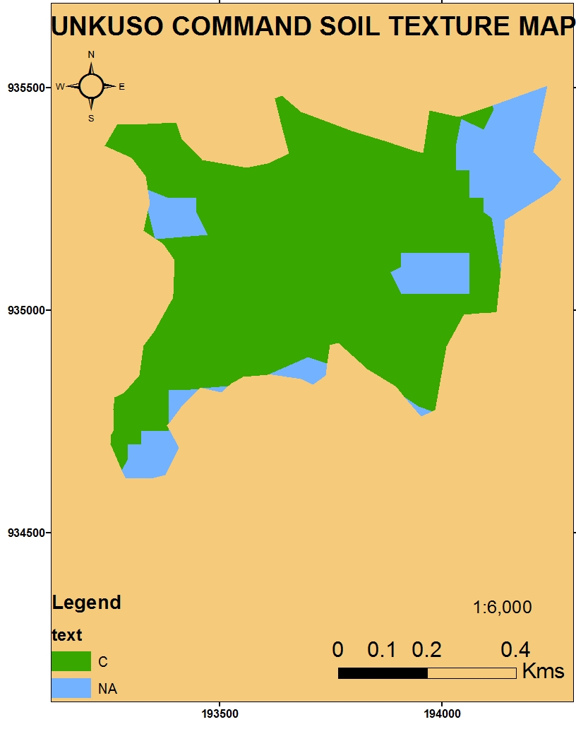
Figure 2. 1: Soil Texture Map of the Command Area

Methodology
A field survey has been made for its basic physical and chemical investigation using a “Transect-Walk” along the command longitudinal and cross-sectional directions to observe the existing soil physical features, such as color, slope, depth, texture, drainage status, and the likes. Discussion among the Team crew members and an interview with the farmers about agricultural development possibilities and its past cropping history of the project area has been conducted. Materials such as Topo-Map at 1:1,500 scale, GPS, Pick-axe, Spade, Augur and other small hand tools like, (Shovel, Hoe, Hand Meter, Plastic Bags, etc.), have been used in the assessment period. Soil survey works were performed in three phases. Summary of activities performed at each phase is as follows:

Pre-field Work
Previous study documents relevant to the project area were thoroughly reviewed and tentative field visit has been carried out. Before the actual field survey the necessary survey formats such as Field soil survey guidelines, standard description sheets for auger boring, profile pits, have been duplicated during this stage. And preliminary soil boundary larger than the actual size was delineated. .

Field Work
Survey approaches followed standard soil survey procedures and classified according to the FAO “guidelines for soil description” (2006) and “world Reference base for Soil Resources” (2006). The system is used because it provides detail information on soil qualities and soil characteristcs for the assessment of land performance when used for specific purpose. Soil profile pits were dug to 2 m depths at representative sites, following transect lines. Soil samples were taken from each significant natural horizon’s, for full physical and chemical determination.
Moreover, some internal characteristics such as soil depth and texture were further evalauted. During profile pit analysis more information was recorded (i.e., from each horizon stractural development and form, consistence, porosity, roots, etc.). All field observation points (auger holes and profile pits) had been plotted in the digitized soil map units, and observations within similar soil unit were used to characterize the mapping unit.

Post-field Work
Some of the major activities carried out were: detail scrutiny of field, laboratory and supporting documents; interpretation of obtained data, establishment of land suitability analysis and diagnostic criteria, preparation of soil and land suitability management units, etc.

Detail Procedures
After careful analysis of the physical investigation, soil pit allocation has been conducted by dividing the command area based on the major observed physical features like color, depth, and slope and texture variations. Accordingly, the proposed command area is divided in to three parts and about three (3) soil pits have been taken as the reference points (coordinates) indicated for all pits (UP1, X=193347, Y=934843, Z=1846; UP2, X=193546, Y=935259, Z=1840; UP3, X=194171, Y=935084, Z=1830).
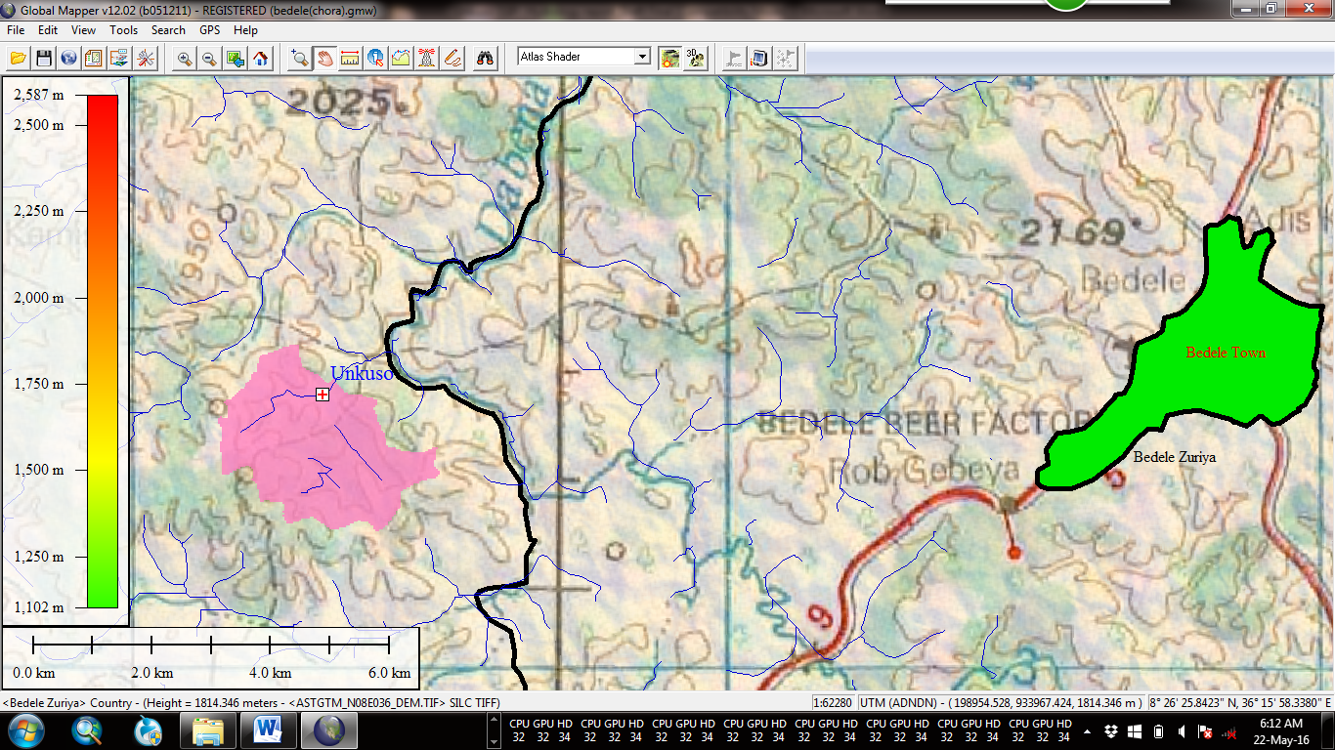
Figure 2. 2: Location Map of the Study Area

Based on the major physical soil characteristics observed along the soil profile of the pits, samples are collected and labeled for further laboratory analysis of chemical investigation. The observed physical characteristics and their physiographic condition around the pits are also determined.

Results of Physical Analyses
The detail soil profiles & quantities of samples for different depths are shown in the following table.

Table 2: 1. Soil samples with their different horizon depths
S/n | Pit Codes | Sample quantity | Profile depth (cm) | Remark
1 | UP₁ | 3 | 0 - 30 | The sample depth is taken as under the assumption of the longest effective root of the crop to be developed during the implementation period.
 |  |  | 30 - 75
 |  |  | 75 - 120
2 | UP₂ | 3 | 0 - 30
 |  |  | 30 - 75
 |  |  | 75 - 120
3 | UP₃ | 3 | 0 - 30
 |  |  | 30 - 75
 |  |  | 75 - 150

Soil Profile Description
In the soil profile description, basic physical soil properties are examined. Areas where the soil pits are taken, basic properties like color, depth, structure, slope, texture and the like are analyzed. Some of the major characteristics are shown in the table below.
Table 2: 2. Basic profile descriptions observed in the soil pit process
S/n | Pit Code | Depth  (cm) | Physiographic nature | Observed Physical Features
1 | UP₁ | 0 - 30 | - Gentle slope  - Less fertile soil  - F. millet harvested  - No rock outcrops & erosion hazards. | - Color is reddish brown  - Texture is to be clay  - Stable structure.  - Crop roots are abundant  - Medium infiltration rate  - Medium to high water holding capacity
1 | UP₁ | 30 - 75 | Same as the upper horizon | - Color reddish brown  - Clay part is dominant  - Partial blocky structure  - Low to fair infiltration rate  - High water holding capacity
 |  | 75 - 120 | Same as the upper horizon | - Color red brown  - Clay part is dominant  - Blocky structure  - Medium infiltration rate  - High water holding capacity
2 | UP₂ | 0 - 30 | - Fairly flat  - Low fertility  - Teff harvested  - No rock outcrops & erosion hazards. | - Color is red  - Texture is clay  - Stable structure  - Fair to medium infiltration rate  - Grass roots are abundant  - Medium to high water holding capacity
 |  | 30 - 75 | Same as the upper horizon | - Color is red  - Clay is dominant  - Crop roots are rare  - Medium infiltration rate  - High water holding capacity
 |  | 75 - 120 | Same as the upper horizon | - Color is reddish  - Clay is dominant  - Crop roots are rare  - Medium infiltration rate  - High water holding capacity
3 | UP₃ | 0 - 30 | - Fairly flat  - Maize harvested  - No rock outcrops & erosion hazards. | - Color is brown  - Texture is to be sandy clay  - Stable structure.  - Grass roots are abundant  - Medium infiltration rate  - High water holding capacity
 |  | 30 - 75 | Same as the upper horizon | - Color is red brown  - Sand is dominant  - Crop roots are rare  - Medium infiltration rate  - Medium water holding capacity

Physical Properties
Physical properties of a soil largely determine the manner in which it can be used. Properties like the water holding capacity, permeability to water, aeration, plasticity and nutrient supplying ability are influenced by the size, proportion, arrangements and mineral composition of the soil particles. More detail conditions about physical properties of the proposed command area are summarized below.

Table 2: 3. Details of the physical properties of the command area
S/n | Basic Physical Properties | Unit | Ranges rated as an average condition | Remark
1 | Slope | (%) | 2 to 8
2 | Depth | m | Very deep (>1.5m)
3 | Bulk Density | g/cm³ | Medium ( 1.03 to 1.19)
4 | Field Capacity | % | 28.98 to 68.01
5 | Available Moisture | mm/M | 200 | Calculated value
6 | Permanent W.P | % | 12.31 to 21.58
7 | Porosity | % | About 53 to 59
8 | Drainage status | Observation | Moderately high
9 | Texture | Observation | Clay
10 | Structure | Observation | Moderate
11 | Infiltration rate | Field/Soil condition (mm/hr) | Fair to moderate (5 to 10) | Clay soil condition
12 | Water-holding Capacity | (mm/M) | Moderate to High (190)
13 | Rock outcrops | % | Below 5
14 | Workability | Field, Observation/soil type | Moderately Workable/can easily be improved with improved tillage system.

Based on the basic physical characteristics of the command soil, the irrigable land falls under Class I and Class II which is suitable for irrigation development with certain amendments. However, as physical observation made during the field assessment most of the command land falls in slope ranges above 8% and requires certain conservation measures for sustainable irrigation utilization. Contour farming, strip cropping, stone mulching/bund, use of permanent crops on the upper slopes, and the likes could be some of the conservation measures to be taken during irrigated crops production.
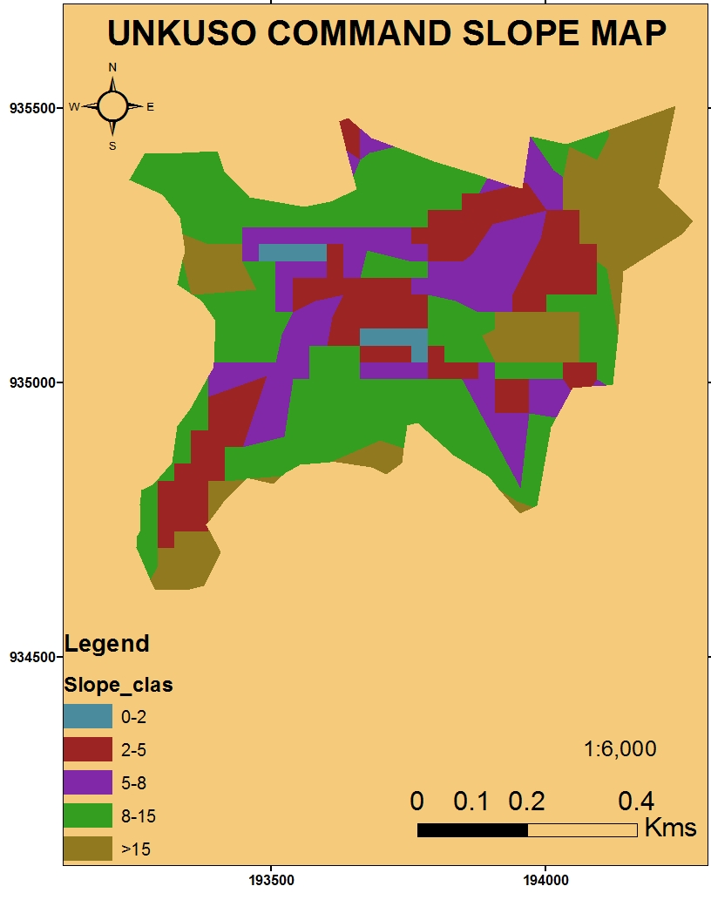
Figure 2. 3: Slope Map of the Command Area

The secondary (non-basic) physical characteristics observed during the sampling activities are indicated in the following table.

Table 2: 4. Other non-basic physical structures of the proposed command soil
S/n | Properties | Conditions/Appearance | Remark
A | Molting | Little down wards only | Preferable condition for crop production
B | Consistency (Wet) | Moderately sticky | Needs improved tillage practices
B-1 | Consistency (Dry) | Slightly hard to hard | Needs improved tillage practices
C | Cementation | Loose to Weakly cemented (almost below the effective root zoon/lower soil profile) | No problem for shallow root crops but needs improved practices for deep rooted crops.
D | Strongness (Wet) | Loose to friable (upper horizon) and Firm in the lower horizon. | Not difficult for most of medium rooted crops
D-1 | Strongness  (Dry) | Loose to soft (upper horizon and slightly hard to hard in the lower horizon). | Needs improved soil amendments for deep rooted crops.

Chemical Analysis
This method is supported by laboratory analysis of the soil samples collected from the proposed command area. The major objective of this soil sample examination is to understand the basic chemical characteristics of the soil and evaluate the existing naturally available mineral/nutrient proportions of the soil and make a balance during the development activities. Here the condition of salinity and acidity problems and their mitigation measures are also forecasted based on the result obtained from the laboratory analysis. The basic chemical properties, analyzed in the laboratory are compiled in the following table.

Table 2: 5. Basic chemical properties of the command soil examined in the Laboratory
S/n | Basic, Chemical characteristics analyzed in the Lab. | Unit | Remark
1 | C.E.C | (meq/100g of soil)
2 | Base sat. | (%)
3 | Total (N) | (%)
4 | O.M | (%)
5 | Av.P | ppm
6 | E.C | mmhos/cm⁻¹
7 | pH | -
8 | Exchange bases of
8 | Ma⁺⁺ | (meq/100g of soil)
8 | Na⁺ | (meq/100g of soil)
8 | Ca⁺⁺ | (meq/100g of soil)
8 | K⁺ | (meq/100g of soil)
9 | Textural Analysis

More likely the above properties are selected due to the following indications they have for the future development of irrigated agriculture.

C.E.C
- Is strongly affected by the nature and amount of mineral and organic colloid present in the soil.
- Soils with large amount of clay and organic matter will have higher exchange capacities.
- It is good indicator of good soil fertility when values are high.
- It indicates the charge characteristics of a soil in adsorption and release of cations.
- Under high weathered soils, where the dominant clay minerals are oxides of Al and Fe, its values are low.
- Its measurement allows an estimate of whether or not fertilizer needs to be added.
- The soils’ C.E.C change as the soil p^{H}, humus, and clay contents change, otherwise always same (does not change).
E.C
- Is the measure of concentration of free ions in soil solution
- Is a good indicator of soil salinity

pH
- It is the negative logarithms of the reciprocal of the hydrogen ion concentration.
- It determines and indicates the type of soil reactions.
- Most soil chemical properties and nutrient release and availability are predicted based on this taste.
- It is a measure of acidity or alkalinity.
Exchange Bases: (Ca⁺⁺, Mg⁺⁺, Na⁺, K⁺)
- These parameters show the base saturation of soils.
- Values are very low in acidic soils and very high in saline/alkaline soils.
- High base status in saline /alkaline soils is indicators of good soil fertility.
Texture
- It is extremely importance in determining the physical behaviors or soils mainly in relation to water and air movement.
- Is closely related to plant nutrient status and availability.
T.N
- Is related to soil organic matter accumulation.
- Values give indication of the potential for release of available nitrogen through mineralization.
O.M
- It shows the soil nutrients resource potential through decomposition.
- It influences both chemical and physical properties of soil such as adsorption and release of nutrients and water holding capacity and soil structure.
- Higher soil organic matter content is indicator of good soil fertility.
Base Saturation
- Phosphorus is the second most often limiting nutrient.
- It contained in plant cell nuclei and is part of energy storage and transfer chemicals in the plant.
- Soils have low total and low plant-available phosphate because mineral phosphate forms are not readily available. Thus, we have to select this parameter to be examined in the Lab. Because this helps us to determine the amount of Phosphorus during the project implementation period.

Results of the laboratory Analysis
As per the specified parameters given in the above conditions, the laboratory analysis has been made for each soil samples collected to the laboratory. And their rates of identification are summarized in the following table.

Table 2: 6. Laboratory results of the sampled soil chemical properties of the command area
S/n | Pit  Code | Depth  (cm) | pH (H₂O) | E.C  (m.h/  cm-²) | O.M  (%) | T.N  (%) | Av.P  (ppm) | ESP  (%) | C.E.C  (meq/  100gm) | Exchange bases |  |  |  | Textural  Analysis
 |  |  |  |  |  |  |  |  |  | Mg⁺⁺ | Ca⁺⁺ | Na⁺ | K⁺ | Textural  Analysis
1 | UP₁ | 0-30 | 4.4 | 0.08 | 3.28 | 0.18 | 0.56 |  | 27.5 | 1.79 | 6.83 | 1.31 | 0.35 | Clay
 |  | 30-75 | 5.0 | 0.04 | 1.49 | 0.07 | 13.40 |  | 26.0 | 1.63 | 5.98 | 1.53 | 0.23 | Clay
 |  | 75-120 | 4.6 | 0.08 | 1.62 | 0.08 | 1.42 |  | 25.6 | 2.46 | 6.53 | 1.31 | 0.20 | Clay
2 | UP₂ | 0-30 | 4.9 | 0.05 | 3.81 | 0.23 | 0.24 |  | 31.0 | 2.40 | 7.93 | 1.31 | 0.56 | Clay
 |  | 30-75 | 5.0 | 0.05 | 4.02 | 0.25 | 1.20 |  | 24.0 | 2.03 | 5.43 | 1.09 | 0.19 | Clay
 |  | 75-120 | 4.8 | 0.05 | 1.16 | 0.06 | 0.56 |  | 23.4 | 2.81 | 6.08 | 1.09 | 0.20 | Clay
3 | UP₃ | 0-30 | 4.6 | 0.10 | 4.02 | 0.22 | 0.34 |  | 30.4 | 3.27 | 10.52 | 1.53 | 0.72 | Clay
 |  | 30-75 | 4.6 | 0.05 | 2.51 | 0.16 | 0.02 |  | 26.3 | 3.36 | 7.93 | 1.31 | 0.32 | Clay

Result Interpretation
Based on the collected results from the laboratory analysis, both the upper and the lower soil horizons are identified as follows.

a) Soil Reaction (pH, H₂O(1:2.5))
Soil pH determines or influences the activities of the possible soil micro-organisms. It also determines the availability of nutrients like, Ca⁺⁺, Mg⁺⁺ and K⁺ (especially at lower pH, the value of these nutrients also becomes lower). As to the project soil condition, the range of soil pH is found from 4.4 to 5.0, which is moderately acidic soil reaction. This is conducive for the production of most agricultural crops, but some corrective soil amendment measures are required and appropriate water management with write application of lime and natural fertilizers is needed in the future cultivation processes.

b) Electrical Conductivity (E.C 1:2.5 Water)
Electrical Conductivity is one of the mechanisms to measure soil salinity. If its amount is greater than 4ds/m, the soil is to be saline and difficult for crop production. According to the laboratory result shown above, the values are between 0.04 and 0.10, which has a negligible effect on crop production. Thus, the soil of the project is free from salinity and suitable for crop production.

c) Cation Exchange Capacity (C.E.C)
The C.E.C of the project soil is ranging from 23.4 to 31.0 meq/100g soil. Values are decreasing downwards in soil profile of the first two pits indicating the upper soil profile is more suitable for crop production. As it is indicated in the earlier part of this report, high values of C.E.C indicates the soil fertility status. This also shows that other important soil nutrients such as K and Mg are adequately available in the soil.

d) Exchangeable Sodium (Na⁺)
The average content of exchangeable sodium of the study area is to be between 1.09 to 1.53 meq/100 g soil. This is a strong value and some mitigation measures should be done during the implementation program. This can be amended by applying natural fertilizers at the time of the cultivation (ploughing) processes.

e) Exchangeable Potassium (K⁺)
The values are ranging from 0.19 to 0.72 meq/100 g soil. This shows medium to very high content of natural K and there is no need of soil amendments be done during the cropping season. Ethiopian soils are naturally rich in K content and this soil analysis result also confirmed the earlier findings. Applying farmyard manure can be one of the ways to sustainably fix the available K during crop production activities.

f) Exchangeable Calcium (Ca⁺⁺)
The overall content of exchangeable calcium varies from 5.43 to 10.52 meq/100 g of soil. This shows that it is found in ‘high to very high’ ranges in the soil. This status is found to be good with the proportion of the rest cations found in the soil.

g) Exchangeable Magnesium (Mg⁺⁺)
Laboratory results indicate high values of exchangeable magnesium. The range is varied from 1.63 to 3.36 meq/ 100 g of soil. This may be a result of the existing soil structures of the project area. If no adequate leaching high accumulation of cations are usually found in the soil. This condition may be improved by proper water management and drainage system during the cropping season.

h) Total Nitrogen (T.N %)
The total nitrogen (TN) is one of the best parameters to indicate the natural fertility status of the soil. It naturally maintains the soil and available wherever naturally decomposed materials, such as crop residues, dried tree parts and in the growing area of acacia species. According to the results obtained from the laboratory, values are ranging from high to very high contents. The trend shows the decrease of total nitrogen towards the lower soil horizons (profile).The lowest value is to be 0.06% and that of the highest one is about 0.25%.

i) Available Phosphorus (Av.P)
The amount of available phosphorus (P) in the project soil ranges from 0.02 to 13.40 mg/Kg of soil. Normally, contents greater than 15 mg/kg of soil is considered as high value, however, the soil of the project area is somewhat acidic and may cause the availability and movement of P to be lower in the lower soil profile. The trend is decreasing downwards within the soil profile.

j) Organic Matter (OM)
The overall Organic Matter content of the soil indicates the fertility status of a given soil. High OM content indicates highly fertile soil, and OM content of soil in the project area ranges from 1.17 % to 4.02 % which is to be medium value. This condition can easily be maintained by applying adequate natural fertilizers like compost, manure, decomposition of crop residues, and the likes during the cultivation season.

k) Exchangeable Sodium Percentage (ESP)
Values of exchangeable sodium percentage (ESP) are ranging from 1.62 % to 5.43 % which are in their lower condition. This is very good situation for crop production (irrigation development) because values less than 15% are generally possible for irrigation with the required soil amendments.

Result evaluation
The chemical features of the sampled results are evaluated for both, upper and lower horizons of the selected pits within the command area. The rates are evaluated as Very low, Low, Normal, High and Very high as specified in the following table.

Table 2: 7. Result evaluation based on the upper & lower horizons of the sample analysis
S/n | Properties | Rates achieved |  |  |  |  |  |  |  |  |  | Remark
S/n | Properties | Very low |  | Low/moderate |  | Normal to medium |  | High |  | Very high |  | Remark
S/n | Properties | H1 | H2 | H1 | H2 | H1 | H2 | H1 | H2 | H1 | H2 | Remark
1 | pH
2 | E.C
3 | T.N
4 | O.M
5 | Av.P
6 | C.E.C |  |  |  |  |  |  |  |  |  |  | Decreasing
7 | Ex.bas.for
7 | Ma⁺⁺ |  |  |  |  |  |  |  |  |  |  | Decreasing
7 | Ca⁺⁺ |  |  |  |  |  |  |  |  |  |  | Indifferent
7 | K⁺ |  |  |  |  |  |  |  |  |  |  | Indifferent
7 | Na⁺

The above table shows the trend of increasing or decreasing of the evaluated parameters through the soil profiles. (H1) indicates upper horizon and (H2) indicates the lower soil profile or soil horizons. Thus, as it is shown in the above table, the upper horizons/profiles are relatively better for crop production.

Irrigable land Suitability
Based on the principles of Land Utilization, areas for irrigation development are divided into five (5) different irrigability classes. Based on Agriculture & Food Organization (FAO) classification method, the classes are symbolized as S₁, S₂, S₃, N₁ and N₂.The interpretations are shown in the annex part of this study report. The basic criteria for classifying a given soil study (including the proposed command area) are both the physical and chemical characteristics of the soil observed during the study period. After careful classification of the command area, Land Utilizations Type, (LUT) and the appropriate Soil Map Units, (SMU) are prepared by delineating areas of the same features within the proposed land. The following table shows, both the physical and chemical properties of the proposed area and their rating under the five (5) classes of land suitability.

Table 2: 8. Physical Properties as evaluated under the (5)-irrigability Classes
S/n | Physical & Chemical Properties |  | Land suitability Classes
S/n | Physical & Chemical Properties | S-I | S-II | S-III | N₁ | N₂ | Remark
1 | Physical
1.1 | Slope | 80 % | 20 %
1.2 | Depth | 100 %
1.3 | Bulk Density | 80 % | 20 % |  |  |  | Clay condition
1.4 | Field Capacity | 100 %
1.5 | Available Moisture | 100 %
1.6 | Permanent W.P | 100 %
1.7 | Porosity | 70 % | 30 % |  |  |  | Clay condition
1.8 | Drainage status | 100 %
1.9 | Texture | 100 %
1.10 | Structure | 70 % | 30 % |  |  |  | Clay condition
1.11 | Infiltration rate | 90 % | 10 %
1.12 | Water-holding Capacity | 100 % |  |  |  |  | Clay condition
1.13 | Rock out crops | 95 % | 5%
1.14 | Workability | 95 % | 5 %
1.14 | Average situation | 91.4 % | 8.6 %
*As the above interpretation, averagely, the physical properties of the command area are mostly classified under Class-I and only certain properties are classified under class-II.

Table 2: 9. Chemical Properties as evaluated under the (5)-irrigability Classes
S/n | Physical & Chemical Properties | Land suitability Classes
S/n | Physical & Chemical Properties | S-I | S-II | S-III | N₁ | N₂
1 | Chemical
1.1 | pH
1.2 | E.C
1.3 | O.M
1.4 | T.N
1.5 | Av.P
1.6 | C.E.C
1.7 | Ex.bas.for
1.8 | Mg⁺⁺
1.9 | Ca⁺⁺
1.10 | Na⁺
1.11 | K⁺
1.12 | ESP
* More or less the basic chemical soil properties are classified under Class-I land capability classes. However, there are some limitations that can be grouped under Class-II of the Classification system.

Production of soil Map Unit
More or less the command land lies in one soil unit, which is to be a red brown (Nithosol) soil. Thus, producing soil map unit due to this condition is not necessary. However, soils are different in different localities of the same area, both in their physical and chemical properties. Therefore, the command area is further, grouped based on slope gradients, depth, localized color differences and chemical variations based on field assessment and chemical laboratory results.
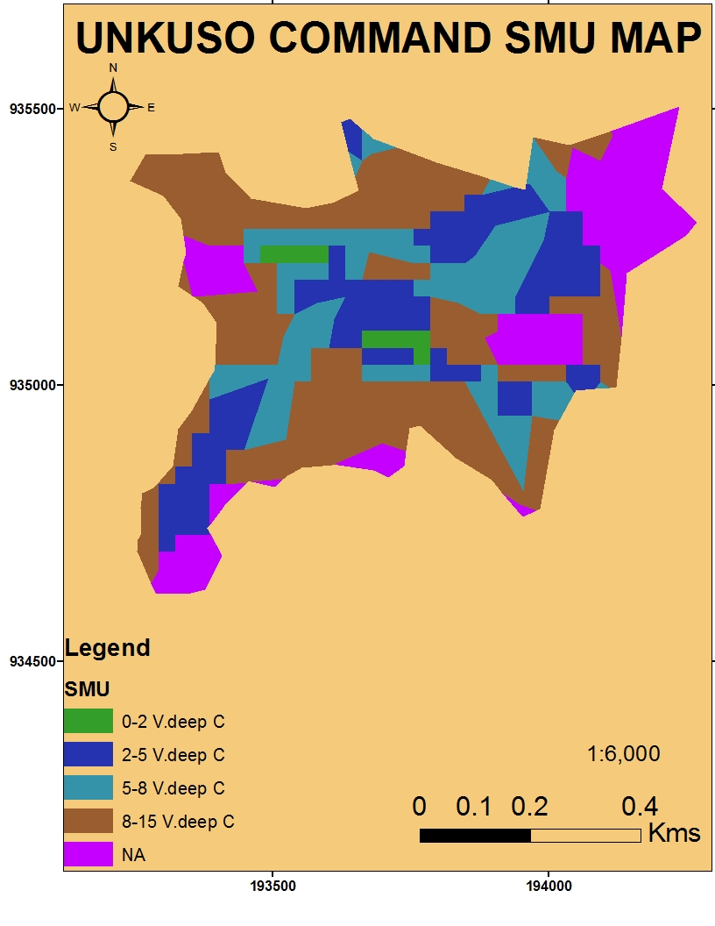
Figure 2. 4: Soil Map Unit (SMU) of the Command Soil

Conclusion & Recommendation
Generally, the project soil has sufficient depth with high water holding capacity. This is very suitable for most agricultural crops. The pH values of all sampled soils are somewhat lower, which is a common phenomenon for high rainfall environments. This low pH value indicates that the soils are of acidic nature and some soil amendments with basic cation containing materials and use of acid tolerant crops are very crucial. Most of the chemical properties are under normal conditions and those which are not in their normal conditions can be amended by different soil and crop management activities, during the cultivation season. Thus, all in all the project soil is possible for irrigation development with some amendment practices during the course of crop production.

Annex 2.1: Soil Study Annexes
Basic factors of the command soil are described in the provided sheet as shown below.

A. Soil Profile Description Sheet
Station :------------------------------------------------------------------------
Classification Base: FAO ,Coordinates, X:193546,Y:935259 and Z=1840m.a.s.l
Surrounding land Forms: Slightly flat plain to somehow undulating features.
Rock outcrops; almost nil.
Crops grown: Most of cereals, pulses and horticultural crops.
Physiographic Position:---------------------------------------------------------------------------------------
Land use type: Traditional agriculture with mixed farming.
Parent material:-------------------------------------------------------------------------------------------------
Vegetation density: Scattered big trees.
Flooding/Ponding: Not serious and damageable.
Surface stoniness: Very low.
Infiltration rate: Low to fair. Drainage class: C1 (good)
Agricultural Depth:------------------------------------------------------------
Mineral Nodules: Medium in the upper parts and lower in the downward profiles.
Erosion:-------------------------------------------------------------------------------------------------------------
Structure/Cracks: Loose to partial blocky. Platy when goes down.
Diagnostic Horizons: a) Surface:------------------------- b) Sub-surface---------------------------------
Horizon Symbol: UP1 to UP3
Consistency: Dry: Upper part only (about 25%)
Moist: 35%
Overall opinion about the command area: With some chemical amendments, it is suitable for crop production.--------------------------------------------------------------------------------------------------------------------------------------------------------------------------------------------------------------------------------------------------------------------------------------------------------------------------------------------------------------------------------------

The common values & classes for most chemical properties are specified in the following table.

Table : 1Values/classes of most chemical properties
S/n | Chemical Properties | Units | Classes | Rating
1 | pH | - | <4.5 | Extremely acidic
 |  |  | 4.5-5.5 | Very strongly to strongly acidic
 |  |  | 5.5-6.5 | Moderately to slightly acidic
 |  |  | 6.5 – 7.8 | Neutral
 |  |  | 7.4 – 8.0 | Moderately alkaline
 |  |  | > 8.0 | Strongly alkaline
2 | C.E.C | meq/100gm | < 5 | Very Low
 |  |  | 5 - 10 | Low
 |  |  | 10 - 20 | Medium
 |  |  | >20 | High
3 | Base Sat. | % | < 25 | Very Low
 |  |  | 25 - 50 | Low
4 | Total Nitrogen | % | < 0.03 | Low
 |  |  | 0.03 – 0.06 | Medium
 |  |  | >0.06 | High
5 | Av.P | ppm | < 1 | Very Low
 |  |  | 1 - 5 | Low
 |  |  | 6 - 15 | Medium
 |  |  | >15 | High
5 | O.M | % | < 1 | Low
 |  |  | 1 - 3 | Medium
 |  |  | 3 - 5 | High
 |  |  | >5 | Very High
6 | Na⁺ | % | <0.2 | Slightly Low
 |  |  | 0.2 – 0.5 | Moderate
 |  |  | >0.5 | Strong
7 | K⁺ | Meq/100gm | <0.1 | Low
 |  |  | 0.1 – 0.25 | Medium
 |  |  | 0.25 – 0.5 | High
 |  |  | >0.5 | Very High
8 | Ca⁺⁺ | Meq/100gm | <1 | Low
 |  |  | 1 - 4 | Medium
 |  |  | 4 - 10 | High
 |  |  | >10 | Very High
9 | Mg⁺⁺ | Meq/100gm | <0.3 | Low
 |  |  | 0.3 – 1.0 | Medium
 |  |  | 1 - 5 | High
 |  |  | >5 | Very High
10 | E.C | Mmhs/cm² | 0 -2 | Negligible
 |  |  | 2 -4 | Slight effect
 |  |  | 4 - 8 | Significant effect
 |  |  | 8 - 16 | Only salt tolerant
 |  |  | >16 | Only highly tolerant

The common values & classes for most physical properties are specified in the following table.

Table: 2 Values/classes of most chemical properties

S/n | Physical Properties | Unit | Rating | Classes | Remark
1 | Slope | % | 0.1 -0.2 | I | 0.2 Flat
 |  |  | 1 - 4 | II | 2 – 5 Gentle slope
 |  |  | 10 -15 | III | 5 -8 Undulating
 |  |  | 15 - 25 | IV | 15 – 30 Rolling
 |  |  | 25 - 33 | V or VI | 30 – 60 Steep
 |  |  | 33 - 50 | VII or VIII | > 60 Very steep
2 | Depth | M | >1.5 | I | Very deep
 |  |  | 1 – 1.5 | II | Deep
 |  |  | 0.5 – 1.00 | III | Moderately deep
 |  |  | 0.25 – 0.50 | IV | Shallow
 |  |  | <0.25 | V or VII | Very shallow
3 | Bulk Density | gm/c³ | <1 | Low
3 | Bulk Density | gm/c³ | 1 – 1.6 | Medium
3 | Bulk Density | gm/c³ | >1.6 | High
4 | Texture | Size | Medium | (Loam, Sandy loam,  Silt loam | I
4 | Texture | Size | Light | More of sand | III
4 | Texture | Size | Silt clay loam, sandy clay loam, Clay loam | Light-medium | II
4 | Texture | Size | Very light (sand), Very heavy (clay) | Heavy | III
5 | Infiltration rate | mm/hr | Sand | 30 | High
 |  |  | Sandy loam | 20-30 | Medium
 |  |  | Silt loam | 10-20 | low
 |  |  | Clay loam | 5-10 | Low
 |  |  | Clay | 1-5 | Low
6 | Drainage | 0-6 | Moderately Well | I | D4-D5
 |  |  | Imperfect | II | D2-D3
 |  |  | Poor | III | D1
 |  |  | Very poor | IV,V | D0

Major soil Associations in Ethiopia

The latest soil map of Ethiopia which covers the whole country is the one extracted from the FAO/UNESCO soil Map of the World at a scale of 1 : 2000,000.Nominclature commonly used is also the FAO/UNESCO. According to this classification there are eighteen (18) sol associations in the country. However, 87 % of the area is covered only by the following ten (10) associations.
Table: 12 Major soil associations in Ethiopia
S/n | Major Soil Associations | % of the Country | Remark
1 | Lithosols | 17.0
2 | Nithosols | 12.2
3 | Cambisols | 11.6
4 | Regosols | 10.9
5 | Vertisols | 10.0
6 | Fluvisols | 8.3
7 | Xerosols | 4.8
8 | Solonchaks | 4.8
9 | Aerisol | 4.5
10 | Yermosol | 2.8

Basic Soil Survey (by Transect- Walk Method)
From certain benchmark, equal distances of both left & right directions are used as observation method.

Walk down the slope of the land in this direction
Benchmark

Soil A Soil A
Follow the line of change of soil properties Follow the line of change of soil properties
Boundary between soils A and B Boundary between soils A and B
Soil B Soil B
Follow the line of change of soil properties Follow the line of change of soil properties
Boundary between B and C Boundary between B and C
Soil C Soil C
Follow the line of change of soil properties Follow the line of change of soil properties
Boundary between soils C and D Boundary between soils C and D
Soil D Soil D
Follow the line of change of soil properties Follow the line of change of soil properties
Boundary between soils D and E Boundary between soils D and E
Soil E Soil E

Soil Laboratory Test Result
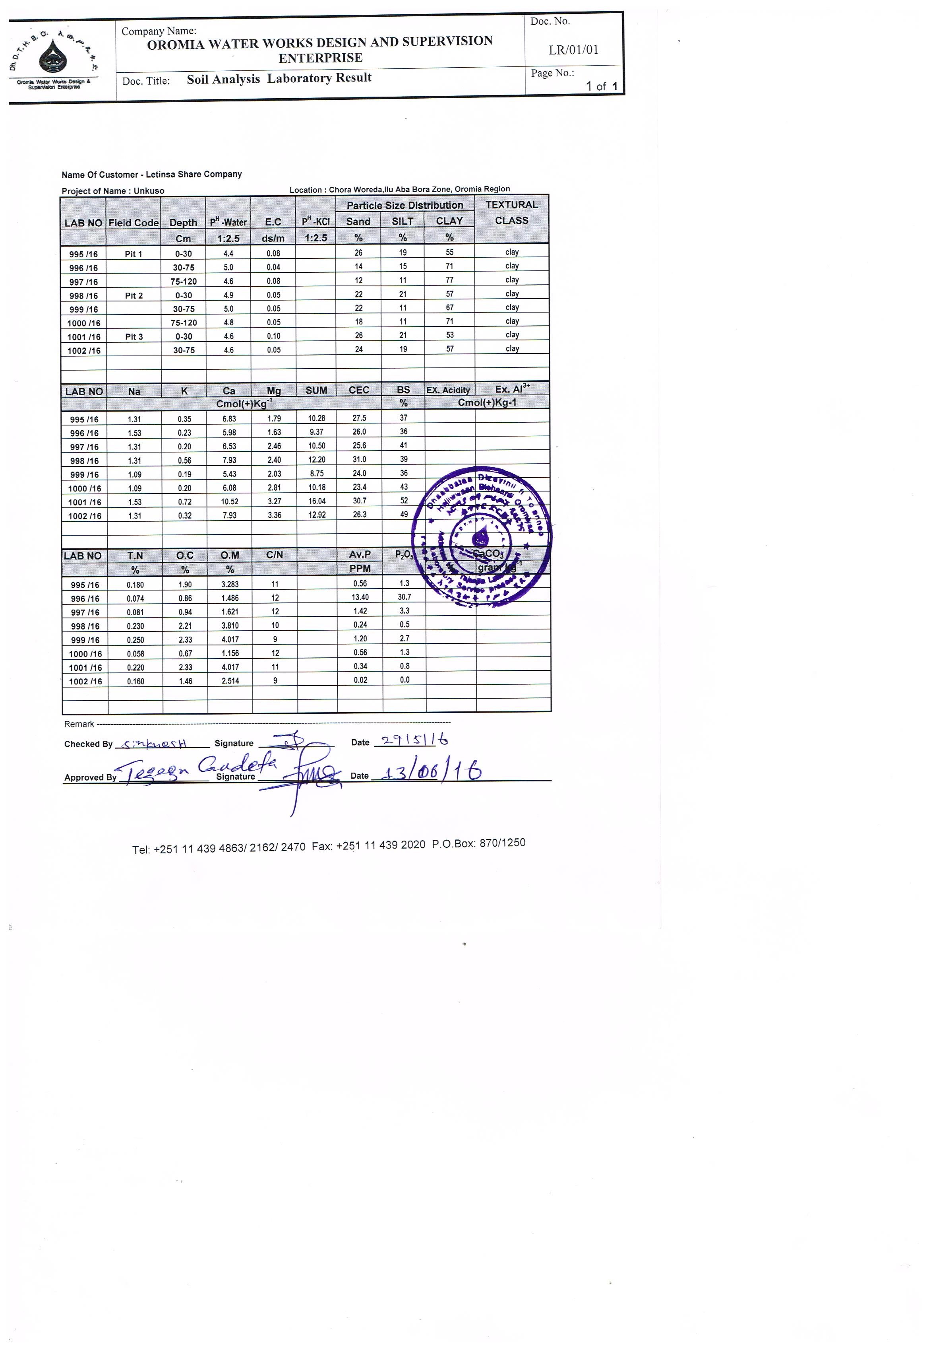

WATERSHED MANAGENT STUDY

Executive Summary
The report contains all the detail components of the existing watershed conditions of the specific study area as a micro-catchment level, especially focused on the command land and its nearby surroundings, methods, and objective of the study, its existing land use pattern. Climatic situation and the topographic features with the present state of vegetation cover are also stated out. More-over the soil type and major watershed problems with their relevant solutions are included in the study report. Potential for crop production, existing cropping pattern of the area, type of existing agriculture and its future plan are included in the study report. Strategies and professional responsibility for integrated watershed management are briefly expressed. Climatic data, figures and sketch maps with different soil conservation strategies for different land use pattern are stated out in the document.

Objective of the Study
Specifically, the objective of this watershed management study touches the proper unit for wise utilization and development of lands in the given catchment area. The land within the given watershed should be treated in accordance with its peculiar need and by methods that will control soil erosion, conserve water, encourage wild life, improve farm income and prevent flood damage to agricultural lands. Moreover, the objective mainly focuses on the prevention of the “would be” irrigation structures starting from the weir to the different canal networks within the command area and its drainage outlets, from unexpected flood and sediment damage. And it is also believed to improve the food security in Emboro Bonga kebele of Chora Woreda. The objective also includes interventions that address the livelihood constraints of target communities including improvement of social services (e.g. schools, health institutions and other infrastructures), provide biomass for economic use of communities and their animals, like fodder, timber, firewood, straw, fiber, and fruit.

Methodology
Design Engineer, Hydro-geologist, Socio-Economist, Environmentalist, Surveyors, and a certain focus group of the relevant community members have been consulted and discussed about the existing conditions of the watershed. The field assessment was done based on a “transect-walk” from the head to the tail of the project and from longitudinal to the cross sectional areas of the unit sub-watershed. The major features, topographic nature and other natural resources including the existing farming systems (the past & the present) have been recognized during this approach. Materials such as Topo-maps and other measurement tools like GPS, Hand Meters, Cameras and the like have been used during the observation period. A discussion with the community members was also conducted about the condition of the watershed before and at the present time. A consultation work has also been made with relevant parties such as Zone & Woreda Agriculture Offices and other stakeholders during the study period. The soil loss was computed using the most common method, Revised Universal Soil Loss Equation (RUSLE). Erosion hazard was estimated considering the results of soil loss based on slope gradients, intensity of rainfall and other factors.

General Description of the Project Area

Location
The target watershed area is located in Emboro Bonga kebeles, Chora Woreda, IluAbabora Zone of Oromia Regional State. The total area of the watershed is 6.7km² and it is found in different landforms ranging from plain lands to hill tops, rugged areas, allies and undulating lands. It is a landscape with a scattered distribution of indigenous trees, bushes and shrubs around the river bank lands. The land steps down from the east to the west direction and situated at an altitude of about 1850 to 2150m.a.s.l. The rug, hilly and mountainous areas some kilometers away from the command area still support some more diverse vegetation and give rise to important sources of fresh water.
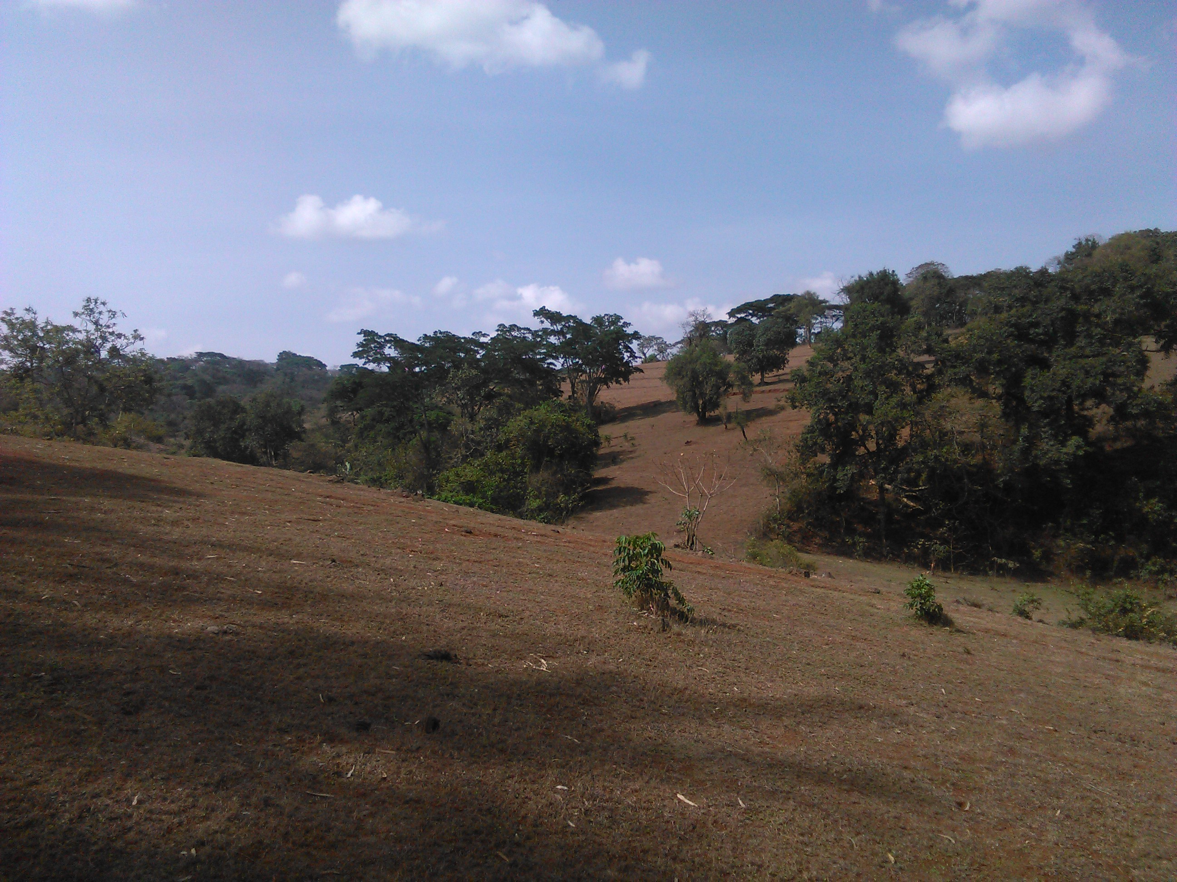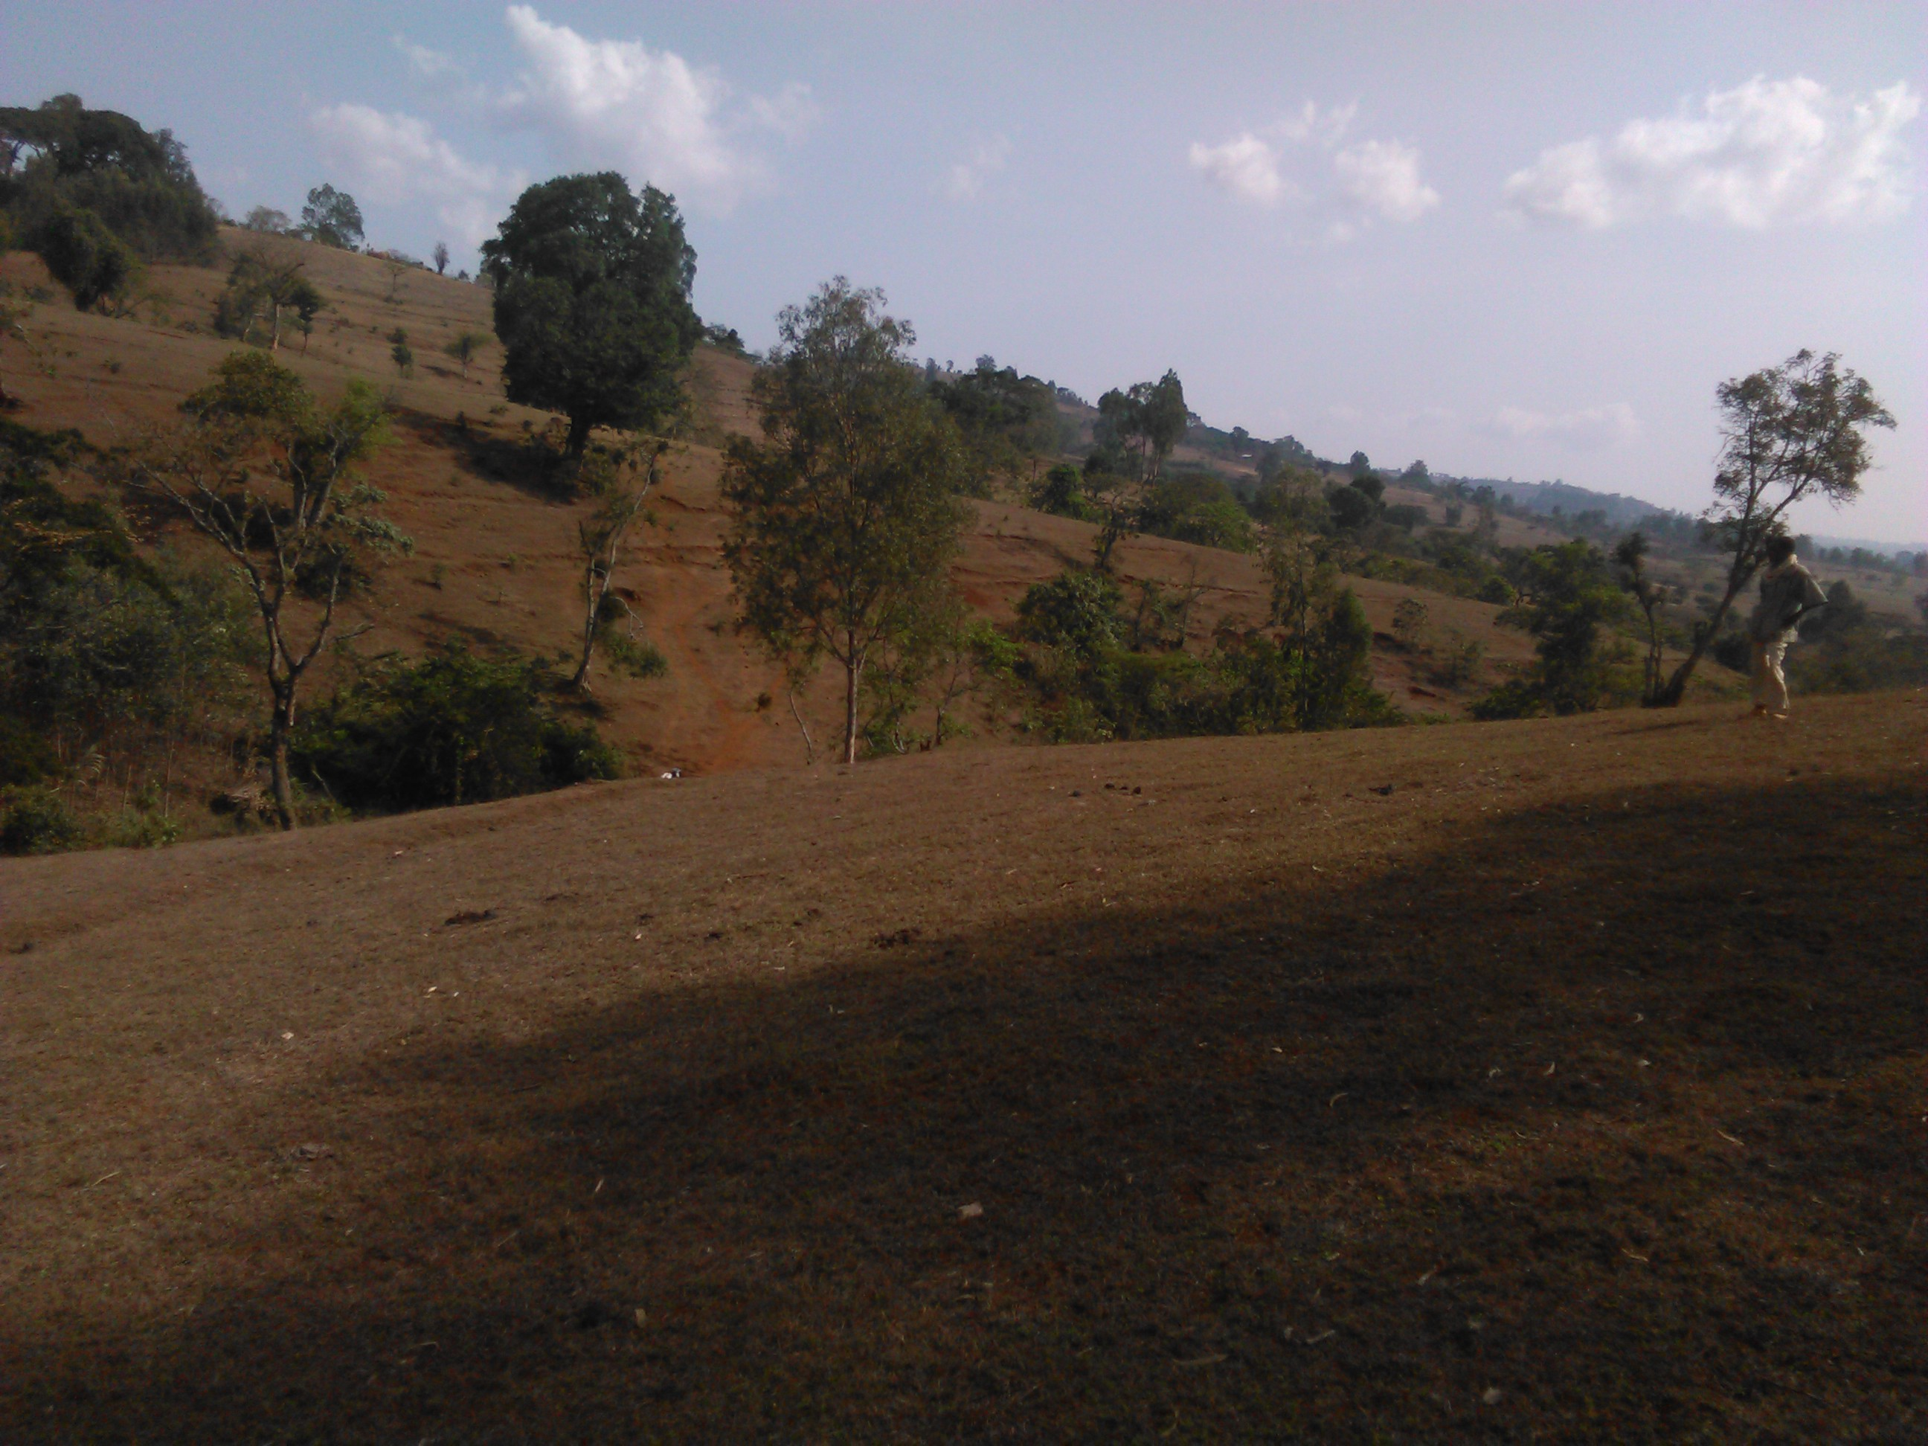
Figure 3: 1. Watershed with scattered distribution of indigenous trees and shrubs
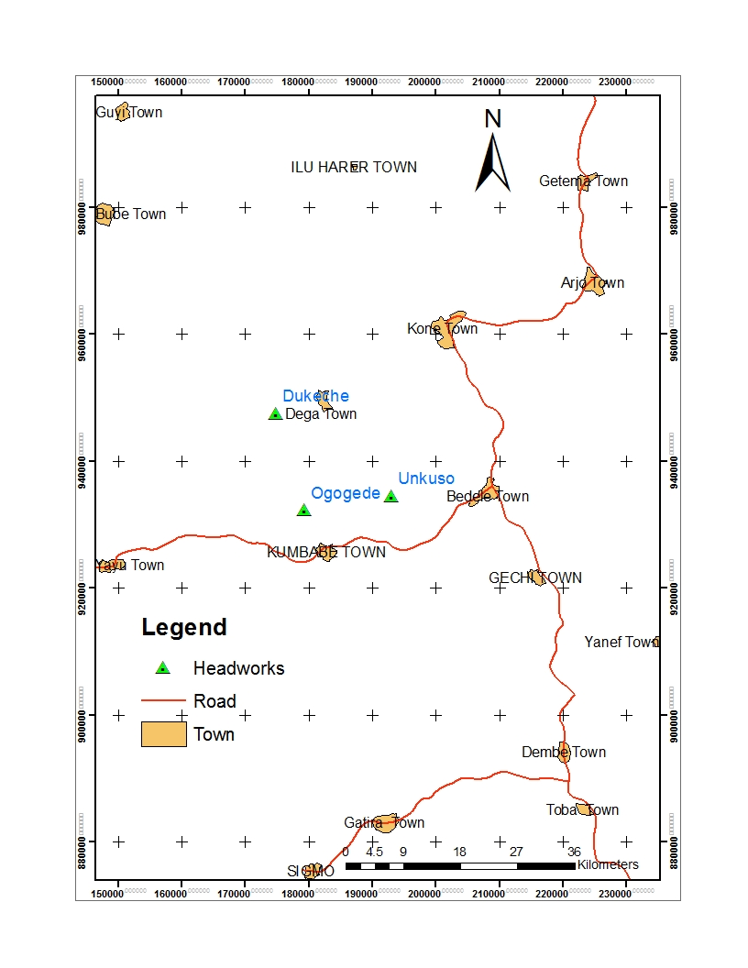
Figure 3: 2. Location Map of Unkuso SSI Project’s Watershed

Some dry streams and different sized localized water ways are observed in the study area. Stable rock fragments and boulders with different grass species and trees are situated together, without common erosion hazards are found in the undulating parts of existing hill tops.

Existing Climate
The climate of the specific watershed is classified under cool sub humid tropical climate with a monomodal distribution of rainfall condition. According to the information obtained from the Zonal & Woreda (district) Agriculture Offices, the major rainfall of the area occurs between the months of June to September. This fact is also confirmed from meteorology data collected from Bedele station, which is the nearest weather station to the project. The whole analysis is based on the historical data obtained from this station. This station is located at an altitude of 2011m.a.s.l and around 15 km from the project area. It is also estimated to have about 4 to 5 Km air distance up to the specific project area. According to this station’s information, total average annual rainfall is calculated to be 1913.9mm. Maximum rainfall occurred in the month of June which is 337.3mm. The Monthly Max & min Temperatures are 25.8⁰c & 12.8⁰c respectively. The highest temperature is recorded in the Month of February which is 29.1⁰c. The whole climatic data for the project area and its surrounding areas, which are used for project design parameters, are indicated in the Annex Part of this study document.

Specific Agro climatic Zonation
As indicated in the above climate condition of the specific study area, Cool Tropical Sub-Humid Climate (TSHC) is the most preferable term for this area. Rainfall occurs only in some months of the year (which commonly known as Kiremt). According to the climatic data collected from Bedele meteorology station, heavy rain occurs over longer periods, between the Months of May to September. Other aerodynamic factors such as average monthly relative humidity (%), sunshine (hrs/day) and potential evaporation ETo (mm/day) are basic indicators of this demarcated agro climatic condition of the project area. Basically the altitude of the project area falls between 1850 to 2150m.a.s.l. This shows that the area falls in the highland agro-climatic conditions. To this effect, the type of crops to be produced in this area is limited only to highland crops.

Existing Land use Pattern
The total landmass of the district (Chora) is about 78,388ha and from this 48,148ha (61.42%) is used for agriculture. The rest area is occupied by different land forms, such as mountainous area, hill tops rock lands, wet land and water bodies, forest areas, grazing lands, and construction areas (buildings, villages, towns & social services). Detail available data is indicated in the following table.
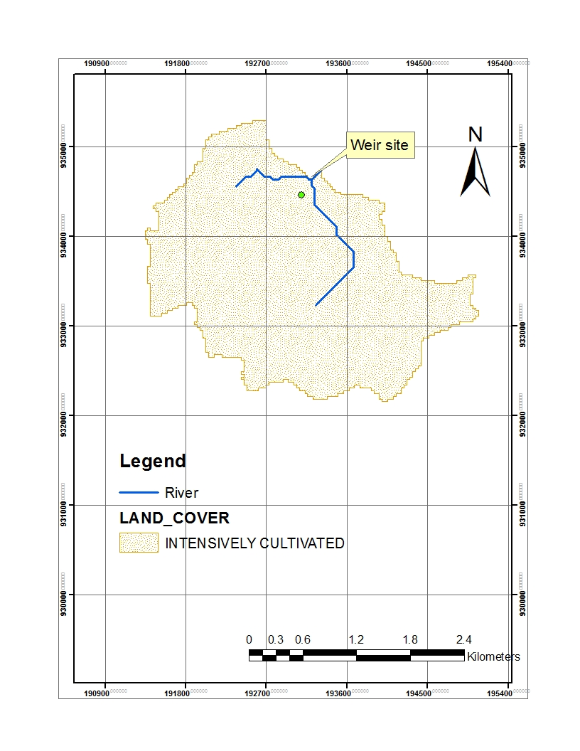
Figure 3: 3. Land use/Land Cover Map of Gewiso SSI Project Watershed
Table 3: 1. Land Use Pattern of the Watershed Area
S/N | Types of Land Use | Area
S/N | Types of Land Use | % | Km²
1 | Cultivated | 65 | 30.55
2 | Pasture | 20 | 9.4
3 | Forest | 10 | 4.7
4 | Farmstead | 5 | 2.35
 | Total | 100 | 6.7

Table 3: 2. Land use pattern of Chora Woreda and the project kebele
S/N | Types of Land Use | Chora Woreda |  | E/Bonga Kebele
S/N | Types of Land Use | (ha) | (%) | (ha) | (%)
1 | Arable land | 48,148 | 61.42 | 2111 | 93.74
2 | Cultivated | 48,050 | 99.8 of arable land | 2102 | 99.6 of arable land
3 | Grazing land | 5300 | 6.76 | 26 | 1.15
4 | Settlements | 1772 | 2.26 | --- | ---
5 | Forest lands (including bushes & shrubs) | 15,785 | 20.14 | 20 | 0.89
6 | Other land | 7383 | 9.42 | 95 | 4.22
 | Total | 78,388 | 100 | 2252 | 100
Source: Chora Woreda Agriculture Office and Emboro Bonga kebele DAs office

From the table above one can understand that crop husbandry has the largest portion in the project area and the second largest area is occupied by grazing land. Such type of land use classification is the typical characteristics of mixed farming system. Forest development in the area is weak and destruction of the naturally available forest is the common phenomenon during current days. This condition is roughly observed during the field assessment of the watershed area.

The major rain fed (staple) crops produced in the woreda are cereals like maize, sorghum, wheat, barley, teff, and others; pulses like faba bean, field pea, haricot bean, and others are produced in small quantities; and oil seeds like linseed, noug, rapeseed and others. According to the information obtained from the woreda agriculture office, these major crops have the following proportion in the cultivation system.

Table 3: 3. Major staple food crops of the woreda (Chora) and project kebele in percent
S/N | Major crops of the Woreda (rain-fed) | Chora Woreda |  |  | E/Bonga Kebele
S/N | Major crops of the Woreda (rain-fed) | Area Coverage |  | Average Yield  (qt/ha) | Area Coverage |  | Average Yield  (qt/ha)
S/N | Major crops of the Woreda (rain-fed) | ha | (%) | Average Yield  (qt/ha) | ha | (%) | Average Yield  (qt/ha)
1 | Maize | 5133 | 25.41 | 34.6 | 370 | 30.25 | 34.37
2 | Sorghum | 1589 | 7.86 | 32.8 | 60 | 4.91 | 31.93
3 | Wheat | 2326 | 11.51 | 30.4 | 85 | 6.95 | 22.56
4 | Barley | 656 | 3.25 | 21.8 | 113 | 9.24 | 9.0
5 | Teff | 8909 | 44.10 | 12.8 | 475 | 38.84 | 10.61
6 | F. bean | 775 | 3.84 | 14.3 | 31 | 2.53 | 10
7 | H. bean | 621 | 3.07 | 13.7 | 89 | 7.28 | 11
8 | Potato | 192 | 0.95 | 200.0 | --- | --- | ---
Source: Chora Woreda Office of Agriculture and Development Agents Office of the project kebele

From the table above, teff is the major source of staple food in the woreda followed by maize and wheat crops. As the project area is highland and suitable for production of different crops, potato is fairly produced both with natural rainfall and irrigation.

Independent features (Physical Components) of the watershed area

Drainage & Stream Density
Basically drainage is the removal of excess gravitational water from soils by natural or artificial means. Unless otherwise specified; drainage refers to artificial (anthropic) systems for removal of water in soils. Where drainage density is the length of streams within a watershed area per unit of area, or kilometer of canal per kilometer square, it is expressed as:
Drainage Density (Dd) = L/A, where L is the total length of streams and, A is the watershed area. It is the most important parameter in relation to hydrology of small watershed. A high drainage density reflects highly dissected watershed with response relatively rapidly to a rainfall input, while low drainage density reflects a poorly drained watershed with low hydrologic response. Low drainage densities are observed in the following conditions.
- Where soil materials are resistant to erosion, or
- Where the soil material is very permeable, or
- Where the relief is small.
Whilst, high values are expected in the following conditions,
- Where the soils are easily erodible, or
- When the soil mantle is relatively impermeable, or
- Where slopes are steep, or
- Where vegetable cover are scanty.
Drainage density can be influenced by other catchment morphologies such as relief (R), Relief Ratio (RR), Area of the watershed (A), Form Factor (F) and land Slope (%). For our watershed determination let the following observed (essential) parameters arranged as shown in the following table.

Table 3: 4. Some quantitative analysis of watershed morphology (by 3.3km x 2.0Km) =6.7Km²
S/n | Parameter | Equation | Remarks/Method | Measurements taken for the specific watershed area from field observation and topo-map. | Remark
1 | Area (A) | A = WXL | W= Watershed width  L= Watershed Length | 6.7 km² | The mini catchment  Area is to be about 6.7 km²  Length=3.3km & Width=2.0km  H=2550m.a.s.l  Lo=2350m.a.s.l
2 | Form factor | F = A/L² | A= Area  L= Watershed length | 0.61
3 | Stream Density | (D) =L/A | L =Total stream length  A = Area | 0.49
4 | Relief (R) | R = H - Lo | H = higher elevation  Lo = Lower elevation | 200 meters
5 | Relief ratio (RR) | RR = R/L | R= Relief  L= Watershed length | 0.061 meter

As it is observed from the above table, all values of the given parameters are in their small figures, especially, relief ratio is too small in which the potential sediment yield is low. Based on the above table the given watershed unit of the project area can be identified as a watershed with low to medium drainage density with minimum flood and silt damage that could be occurred due to the rainfall and irrigation water during the implementation period. This can be highly supported by the physical factors of the existing soil types, forest availability and the tillage practices in the past cultivation seasons. Some physical structures like terracing and conservation of existing forest are currently done by the community, and should be more strengthened in the future. The type and the detail condition of prevention mechanisms are given in recommendation part of this document. The following figure illustrates the detail condition of slope gradients of the watershed.
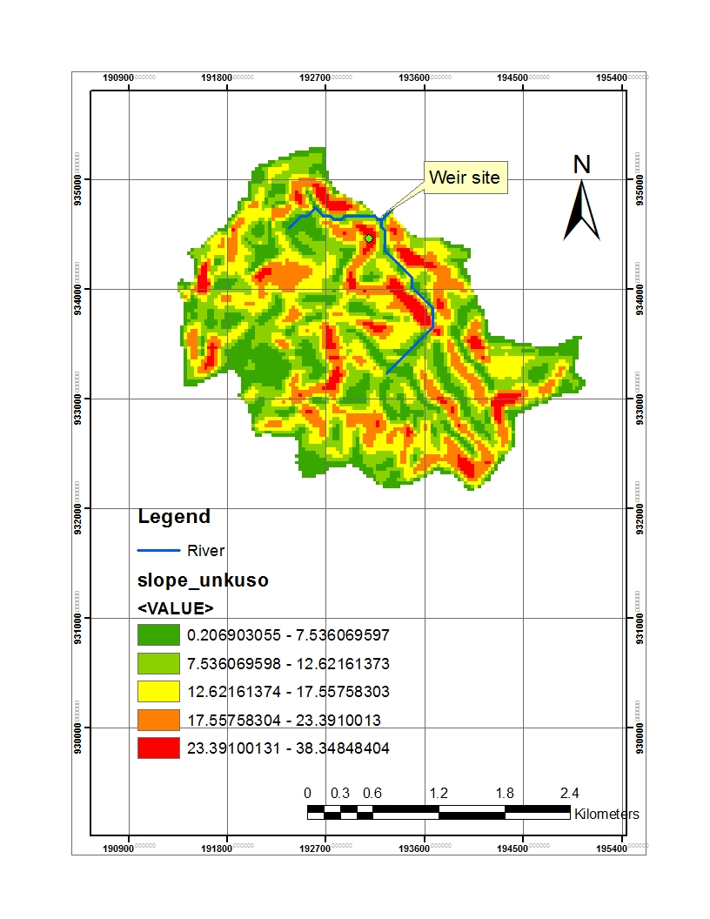
Figure 3: 4. Slope Gradients Map of the Watershed

Physical Features of the Soil
The soil of the sub-watershed area is dominantly clay to clay-loam in texture with medium to high water holding capacity and low to fair infiltration rate. The upper horizon (25 to 30 cm) has almost partially granular structure and when goes downwards, blocky to partially platy structures are observed. Red to reddish brown color is dominant with sufficient agricultural depths. Due to crop residues and decomposition of old parts from the trees, bushes and shrubs, the upper part of the soil (up to 25 to 30 cm) layer has almost brown to dark brown color. When wet is sticky and hard during it dries. As a general soil order, the area soil falls under Nithosols which are deposited from the high lands of the catchment for a certain period of years and seems rich in humus (organic matter) from the decomposition of old trees and other related parts. The A horizon (about 100 cm) is found to be deep and sufficient for cultivation purposes. The primary clay mineral seems a mixture of micas and vermiculites which have a medium bondage between soil particles. This condition helps the soil structure to have a fair water movement during watering the soil. Generally, from physical condition and existing crop stand observation of the project area, the soils are suitable for most agricultural crops with minimum mitigation measures. The detail chemical and physical analysis can be referred on the soil study report of this document.

Erosion Condition
Commonly speaking, soil erosion generally refers to detachment and transport of soil and soil materials by water, wind, ice or gravity-water and water being the major factors. As observed the condition during the field assessment period, it is tried to differentiate which type of erosion hazard is common in the watershed area. By consulting the community members and physical observation made, among many features of erosion, the study team focuses on only two major types of erosion in the project area. Those are accelerated erosion and gully and/or rill erosion. In the first type, there is a clear indication of human intervention to destroy and disturb the existing ecosystem, especially, the deforestation of existing natural forest for the different economic uses (e.g. fire wood, construction, etc.) and expansion of agricultural lands in the given watershed. Shifting cultivation is also an important cause of soil erosion in the hilly areas of the sub-catchment. Because this system, particularly on steep slopes without any protective measures and animal traffic destroys natural vegetation and exposes soil surface to direct action of raindrops and runoff water. The following figure illustrates the possible annual soil loss estimated.

The second type of erosion observed in the watershed is gully and/or rill erosion due to the topographic nature of the uplands of the watershed. As the volume of concentrated water increases and attains more velocity on slopes, it enlarges the rills into gullies. Here, rills become so deep that the ground cannot be smoothed out by ordinary tillage tools. However, in both cases (accelerated and gully erosion types) there are no severe damages observed on the crop lands. Generally as observed during the field survey, because of the soil nature and forest density of the surrounding area, severe erosion hazards are not widely seen. However, on the hill sides and sloppy areas of the watershed, gully erosion is observed due to the nature of existing topography. The required mitigation and future gully management approaches are indicated in the recommendation part of this study report.

Ponding
Pond is an accumulation of rain water on almost flat lands with slowly permeable soils. However, it is not a problem in the watershed area due to two major factors. The first is the existing topographic nature and the second is the good access of sufficient drainage in the surrounding area. Since the land is mostly undulating type, there is no any opportunity for the water to pond in the area. It simply drains to the lower part of the watershed and moves out through the runoff outlets. Thus, because of the slope differences of the area, water cannot be accumulated as a form of ponding in the crop lands.

Rockiness
This condition can be seen from two points of view in the specific command land and the surrounding watershed area. In the first case except some rock fragments and boulders at the upper part of the command area (the pass of the main canal route and the hill top) there are no any rock outcrops and rocky areas in the major parts of the “would be” irrigable land. However, in the upper and top parts of the surrounding watershed area, rocks are plenty but somewhat in stable formation. This is due to the existence of adequate forest coverage that stabilizes and holds together the existing rocks and its fragments. Thus, rockiness is not a problem in the developed command area.

Forest Distribution
The forest distribution in the sub-watershed area seems fair in the nearby areas of the command land and good in the upper catchment. More of indigenous trees like Abyssinia hygenia, Vernonia galamensis, Podocarpus falcutus, Cordia africana, Ficus sura, Acacia spp., and other species are grown mixed with bushes and shrubs. No dominant grass spp. is found as the command land and the watershed areas are used for crop production and grazed by domestic animals. As the information obtained from development workers of the specific Kebele (Emboro Bonga) where the project is located, there is also a nursery development site raising indigenous trees by the extension agents of the PA.
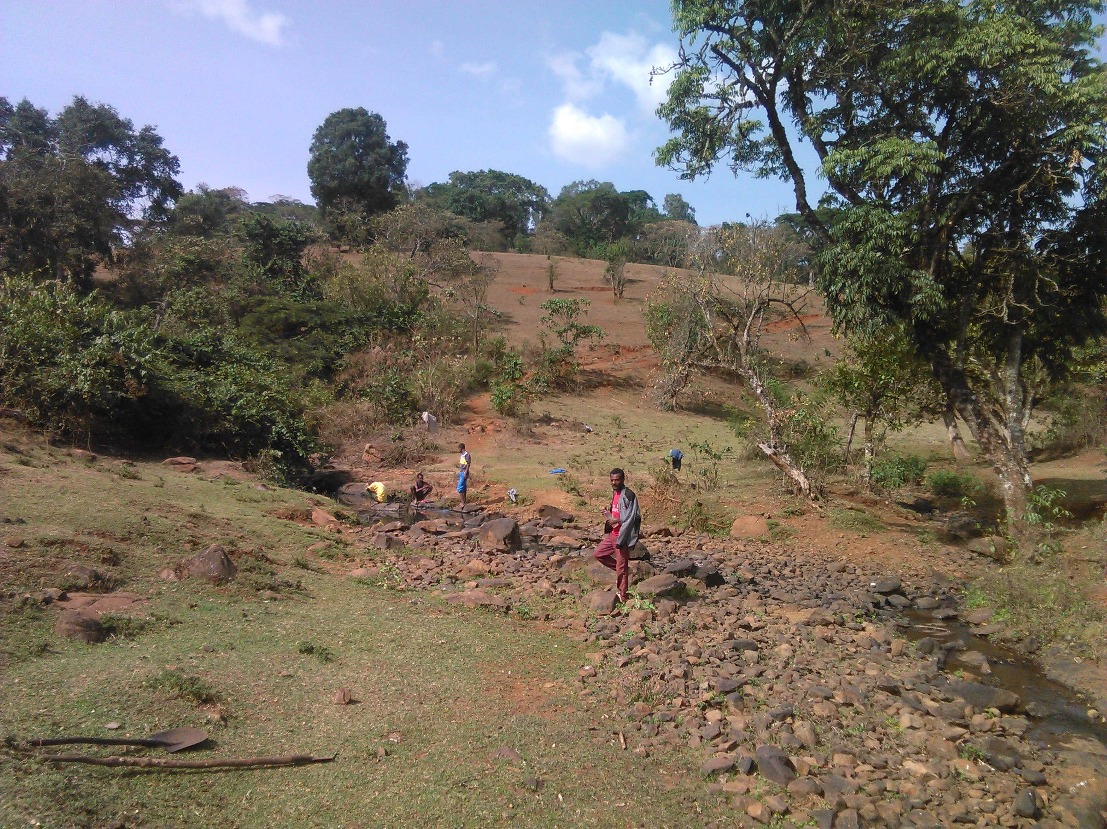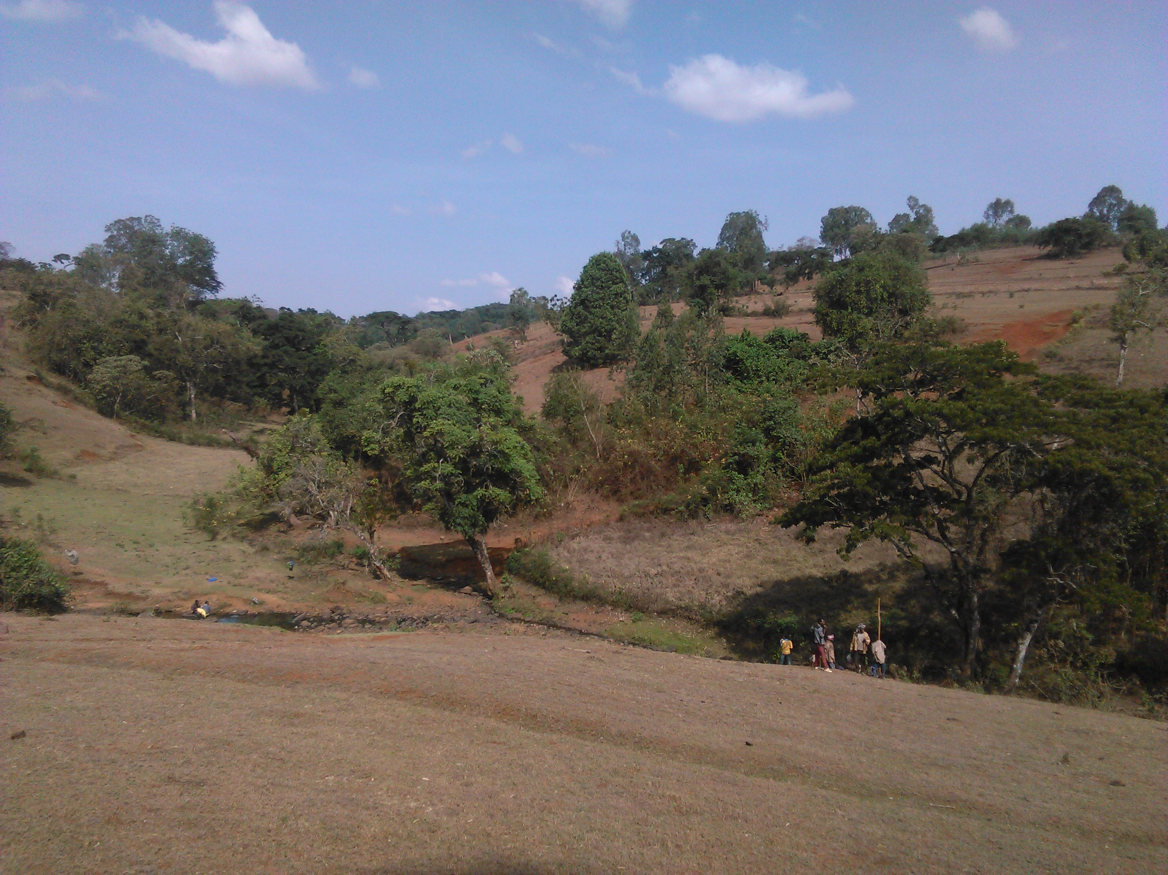
Figure 3: 5. Some indigenous trees found in the Watershed
The objective of this development is to assist the farmers in forest development and introduction of some fruit trees in the area. However, currently deforestation brings a considerable negative impact in the development activities. Due to the need of agricultural lands, fuel consumption and construction purposes, there is high forest destruction in the surrounding area. Presently, the government & other concerned stakeholders cordially work together for the minimization of existing deforestation by creating awareness for the community and producing other relevant mitigation measures for further forest development in the area.

Surface Drainage
This condition can be seen in two approaches. One is the vertical movement (vertical drainage) and the other one is horizontal movement (lateral drainage). In both cases, the determinant factors are mainly the soil properties and existing topographic nature of the command area and its surroundings. The soils are mainly dominated by clay parts in which excessive or adequate drainage is impossible unless and otherwise, sufficient drainage mitigation measures are applied. However, the undulating topography of this area helps to drain surplus water to the adjacent areas which have lower elevation than their surroundings. Thus, in the proposed command area, due to its undulating nature, drainage problem is not expected as severe in the cultivation process. More about drainage amendment measures are indicated in the recommendation part of this study document.

Major Socio- Economic Activities & Other Economic Data
As indicated in the land use system of the area (earlier parts of this report), almost about 99% of the livelihood of the community in the watershed is based on agriculture. Thus, agriculture is the main stay of the people. Traditional mixed crop-livestock farming practices and high dependence on production of food crops dominate the sector. Development potentials within the specific Kebele (Emboro Bonga) are good and include cooperative and willing people. Existing climate is also suitable to a wide range of crop types for both rain-fed and irrigated agriculture. Livestock production is also one of the economic activities, for oxen provide traction power and cows provide dairy products. Small ruminants & poultries are not only source of additional cash income, especially in case of crop failure, but also means of accumulating wealth. Equines serve as means of transport for agricultural products and humans. The sector is limited mainly on free grazing over post harvested lands and forest areas without shifting system. Other means of animal feeding such as cut & carry system of forage development and the likes are not yet applied or well exercised. The productivity of livestock is very low due to improper feeding system, lack of improved breeds, prevalence of livestock diseases, and low awareness of improved management. The type and quantity of livestock production including their main diseases are specified for the Woreda and specific Kebele in which the proposed projected is found, are listed in the following table.

Table 3: 5. Woreda & Project area’s livestock data & major diseases recorded in (2007 E.C)
S/N | Chora Woreda |  | E/Bonga Kebele | Diseases of the area
S/N | Type of livestock | Qty | Qty | Diseases of the area
1 | Cattle | 125,522 | 2752 | Foot & Mouth disease (FMD), Anthrax, Lumpy Skin Disease, Black legs, Newcastle, fowl typhoid, Bovine and Ovine Pasturollosis, Senoryosis, Trypanosomiasis (Tryps), endo and ecto parasites (Faciolla), Coccidiosis, sheep pox, etc.
2 | Sheep | 60,450 | 836
3 | Goats | 36,492 | 362
4 | Horses | 7432 | 120
5 | Donkeys | 2117 | 136
6 | Mules | 2412 | 31
7 | Poultry | 68,200 | 1786
8 | Beehives
 | -Traditional | 61,803 | 1683
 | -Transitional | 4669 | 110
 | -Modern | 896 | 6
*Source: Chora Woreda Livestock Health Clinic and nearby Development Agents Office.

Land Capability Classes (LCC)
Capability classes are the groups of capability subclasses or capability units that have the same relative degree of hazardous or limitations. These help to group our area and divide the units of lands for appropriate and suitable development approaches. Basically, there are eight (8) which is divided based on different natural features (topography) including soil condition, climate, forest, erosion and other related factors which best suit the area for development and which does not easily utilize for better development without applying great effort to it. In the watershed where the proposed irrigation project is situated, it can be classified under different land capability classes based on different natural characteristics and existing topographic features as shown in the following table.

Table 3: 6. General existing natural factors & topographic features of the project surroundings, & their places in standard land capability classes (as observed during the field assessment)
S/n | Observed Features | Land Capability Classes (occupies in %)
S/n | Observed Features | I | II | III | IV | V | VI | VII | VIII
1 | Soils used for crop production, used for pastures, grazing lands, wood lands, or even for wildlife preserves. | 100
1.1 | Soils are deep, having good water holding capacity well drained and but not level and fairly difficult for workability. | 90 | 10
1.2 | Soils are naturally fertile or possess such characteristics which encourage good response of crop to fertilizer application | 100
2 | Erosion (due to well plant distribution hazardous erosion is not observed) | 30 | 70
3 | Drainage (needs improvement) | 30 | 70
4 | Topography (slope, land existence etc.) |  | 100
5 | Forest Distribution | 90 | 10
6 | Climatic Condition, (faire rainfall distribution during the rainy season observed from the meteorology station in Bedele) & sufficient for crop production. | 100
7 | Availability of Water Sources, (a number of rivers are existing in the nearby surroundings (as the information obtained from Woreda agricultural staffs) rich in ground water resources from field observation. | 100
7 | Total out of 900 | 640 | 260
*Source: field Observation, discussion with relevant professionals & interview with target group farmers.

As observed in the above table, based on the major factors taken for land capability classes, the given watershed falls between Class I & Class II with interaction of some common characteristics shared by these Classes. More likely, the area is to be in the division of Class I Land Capability.

Existing Problems of the Watershed Area
It is expected that a number of natural and human made problems in the watershed area. To start with natural problems, the exiting topographic nature of the area exposes the soil somewhat to water
erosion in the Kebeles, around the project area. Due to the clayey nature of the soil in these areas, workability especially for cultivation purposes are remarkable. Secondly, the prevalence of animal diseases can be considered as some of the main natural problems observed during the field assessment program. Other man made and related watershed problems are numerous. The following are some of the many problems observed in the development area, as arranged in their order of importance.

Low Technology Input Utilization
There is no adequate provision of agricultural inputs, like improved seeds, agrochemicals, improved breeds of livestock, and other related technology packages in the proposed development area. The farmers produce relatively limited range of crop types due to low awareness of improved, environmentally-friendly agricultural technologies. Although the Woreda Agricultural Extension Office has been supplying few improved crops varieties, adoption of improved farm practices is hardly seen in the area. Crop rotation, diversification and intercropping and soil water conservation are not seen well practiced in the area.

Deforestation & Absence of Replanting
Due to population increase which leads to horizontal expansion of agricultural lands, and the increasing fire wood consumption and other related human needs (construction, fencing timber etc.), deforestation becomes a serious problem in the given watershed area. As the information obtained from both, Zonal & Woreda Subject Matter Specialists, the condition of forest degradation is recorded as one of the major watershed problems in the area. Moreover, replanting and other conservation activities are not yet well adopted by the community.

The Prevalence of Animal Diseases & Low Livestock Productivity
A free-type of grazing is extensively conducted on forest & bushy areas and post harvested lands. The production & productivity is below the expected condition (as informed by the development agents & other concerned workers). The occurrence of different animal diseases, lack of quality breeding, shortage of high nutritional feeding and the dominance of traditional way of raring system are some of the many factors which reduce livestock productivity.

Poor Access to Markets
Marketing of agricultural production in the area poses significant constraints for the producers. Poorly developed or lack of proper infrastructure and marketing facilities (roads, bridges, and warehouses) are major constraints. Limited opportunities to send products to market have hampered the production of micro-businesses and petty trading that could have provided alternative incomes.

Inadequate Infrastructures & Institutional Setups
More or less the absence or inadequate infrastructures is indicated in different parts of this report. However, this should be emphasized as one of the major problems in the watershed area. For instance, there are no road networks among the kebeles within the same regional areas. No or little opportunities of local transportation available to the community. Basic Institutions such as large market opportunities, Shops, Credit Service Giving Sectors, Information providers and the likes are absent in the area.

Insufficient Expertise of Irrigation Farming
The expansion of small scale irrigation in the study area and in the Woreda as a whole is still insignificant. This has got its own impact on the introduction of different vegetables and other cash crops in the area. Although there are many potential rivers for irrigation development, the practice is not yet developed as required.

The Possible Solutions for the above Watershed Problems
Solutions are found not only from one part, but from different stakeholders which are directly or indirectly involved in the development approaches. Based on the different approaches the following specific mitigation measures and solutions for specific problems observed in the watershed are found to be important for accelerated development in the particular areas.

Around the proposed Command Area
Although, the surrounding areas have some natural vegetation cover, some parts still need extra physical soil conservation activities for sustainable irrigation development. More likely, the proposed work is to be combination of different soil conservation practices like construction of micro basins combined with area closure and some graded stone bunds. These structures are possible in drier areas in slope ranges of all type except highly degraded land. Pits are dug in the center of the basin for optimum use of stored water. This mechanism can be combined with area closure and some hill side terrace conservation systems. Materials used for this system are simple, and includes line level, shovel, hoe and hand meters with strings. The detail condition is seen on figure in the annex part of this study report. Micro basins (MB) have to be carefully lined out on the slope with intermittent placements for runoff control and proper spacing. After tree planting, micro basins need little maintenance. Area Closure must be organized with some stone bund structures by the Peasant Association (concerned beneficiaries). As it is specified above, this area is not large and the community itself can maintain by the guidance of soil conservation workers of the specific area. Cost break down for this activity might not be important due to the minimum work volume of this approach.

Solutions for Specific Problematic Areas of the Watershed
As it is specified by the Woreda Staffs and concerned stakeholders, a participatory and integrated watershed management practices are relevant. The participation of the community in forest development is a mandatory approach. Planting of multipurpose trees and conservation of indigenous trees for multiple uses are necessary. Establishment of community and/or household level woodlots for fuel and timber, fodder plants to supplement animal diets and create income for the living community. The following are some specific management activities needed.

Gully control
The evaluation and prediction of gully development is often difficult because the factors are not well defined and field records of the gullying are inadequate. However, few stabilized gullies are observed within the command area. Most of them have dead ends in which no further extension is expected. They are almost in their healing stage where vegetation starts growing in them. Dry streams also observed nearby the command area, with stable gradient and their walls attain a stable slope, sufficient vegetation cover develops over the gully surface to anchor the soil and permit development of new soil. Therefore, preventing these gullies by biological means of conservation system is the duty of the “would be” beneficiaries. No cultivation is allowed at the edge of these gullies. Gully planting should always be made of both trees and shrubs with several different species used for animal feed. All gully plantings should be fenced from livestock unless they are in areas where it is definitely known that livestock will not damage.

Improved Cultivation Techniques
In the cultivable area, improved agricultural techniques should be applied. The following are some of the many techniques used for such areas.

a) Strip Cropping
In strip cropping crops are grown in strips or bands at right angles to the slope of the land. Row crops (erosion permitting crops) are alternatively planted with close growing crops (erosion resisting crop). Thus, alternate strips of erosion resisting and permitting crops reduce the speed of runoff water coming from erosion permuting strips as a consequence, the runoff water enters the next strip with reduced speed and its velocity is further reduced with its movement resulting in to less soil loss. Moreover, a large proportion of water becomes available to the crop as a strip cropping makes it possible water to remain for longer period of time in the field. More practical specification for the combination of erosion permitting and that of erosion resisting crops are shown in the following table.

Table 3: 7. Strip width of erosion permitting & erosion resisting crops at various slopes
S/n | Slope (%) | Width of erosion permitting crops (m) | Width of erosion resisting crops (m)
1 | Less than 1 % | 45 | 9.0
2 | 1.0 – 2.0 | 24.0 | 6.0
3 | 2.0 – 3.0 | 13.5 | 4.5

The arrangement of the two different types of crops (erosion permitting & erosion resisting) with their appropriate slope of cultivated land & the required width dimensions are shown on figure-2, in the Annex Part of this study report.

b) Mulching
The value of mulch in erosion control is well recognized and is of special value for the periods when the crop itself does not adequately protect the soil. Covering soil surface with crop residues can reduce soil loss by about 50 % or more depending up on the amount of rainfall and mulch, soil type and other characteristics. However, the amount of mulch added to the soil should not suppress the growth of most plants. If soil surface is bare at the time of seeding a crop, mulch should be applied immediately to protect the soil from erosion.

c) Crop rotation
Crop rotation is one of the most practical methods under biological means of conservation measures in a given watershed area. It provides high degree of protection to the soil thereby reducing soil erosion. Crops differ a great deal in their root activity and amount of crop residues added to the soil. The dense and fibrous root system of grasses holds soil aggregates together and creates good soil structure. So, cropping under the rotational system is the most important means of preservation of good soil structure, maintenance of organic matter and soil fertility. This practice is rarely found in the study area. Especially in the command area and its surroundings only certain crops such as wheat and barley are grown repeatedly. This trend should be stopped by teaching the farmers (beneficiaries) about the use of crop rotation based on pilot programs under small scale package technologies within the farmers themselves. Model farmers should be selected and initiated for further advancement in modern/improved agricultural practices. Extension workers with other relevant stakeholders have a lot to do on this issue.

d) Controlled Grazing System (CGS)
Excessive grazing deteriorates the condition of vegetation and promotes erosion. In the study area and the concerned Woreda as a whole free type of grazing is adopted. And specially grazing in forest area is expanded these days (as the information obtained from the development Workers of Emboro Bonga Kebele). And this type of grazing (grazing in the forest areas) is rarely controlled and regulated. It is therefore essential to stop at least minimize excessive grazing in the watershed area. There are many alternates to feed the animals. Cut & carry, shifting grazing, hay and straw as well as using crop residues in controlled and manageable way are some of the many options of animal feeding system which reduce excessive grazing in the area. Feed lot and fattening and other related practices should be adopted by the community.

e) Forest Development/Protection
Large scale unauthorized and indiscriminate destruction of available forests has been taking place by the community mainly for agricultural land expansion and consumption for household fire wood. Thus, the solution lies in educating people about the importance of forest and the dangerous consequences of such destructive activities. Alternative fuel consumption mechanisms such like biogas usage should be designed and provided to the community. The role played by forest is not known even to most of the educated people. It is, therefore necessary that forestry should be included in the syllabus of the school in the concerned area. Thus, it is advisable to motivate the local people in considering the existing forest as their own and to be more willing to participate in its further development and monitoring activities.

f) Adequate Market & Credit Service Possibilities
Agricultural marketing is a general understanding involving in the process of marketing from farm gate to final consumption of crop products. Thus, adequate market information, access roads from farm place to the market outlet and good bargaining power are basic issues for the development of improved farming system. On the other hand, agriculture is labor & capital intensive. Therefore, the community should be supported by credit-based input provision and other necessary materials on time, during the cultivation process. There should also be parties like agricultural Cooperatives and Unions that closely work with the farmers and assist them in the cultivation practices. Additional agricultural inputs like vegetable seeds, agrochemicals, fodder crops, and fertilizers should be provided to the farmers through the channel of these Cooperatives and Unions.

f) The professionals & Institutional responsibility
Present Agricultural and Rural Development Policies & Strategies have a direct relationship with the proposed programs. They also provide conducive working environment for implementation of the project. Thus, the concerned professionals & institutions should play a great role in the following basic issues;
- Encourage environmentally suitable, higher yielding agricultural production.
- Introduction of improved agricultural techniques and change the existing traditional way of cultivating system.
- Introduction of food/cash crops by conducting studies and training of farmers.
- Create community awareness of the relationship between human activities, agriculture and the environment, and the need for institutions of environmentally sensitive land management and farming methods.
- Preparing compatible development packages for agro-ecological zone including diversification and specialization where possible.
- Human capacity building and utilization, including ensuring the health of farmers, and
- Improving agricultural marketing systems are basic requirements to be conducted by all concerned professionals and institutions around the project area.

Implementation Schedule and Priority Setting
In this watershed management plan the first priority schedule is given to the upper sub watersheds, around the peaks, to minimize the downstream effects. Land use changes based on the recommendation should be done parallel to this action. Following this other physical soil conservation measures such as level terrace, soil and stone bund on cultivated land, over sowing of improved forage seeds on grazing land, group and private nursery establishment, cut of drain, water way, micro basin and small gully plugging activities should have been done.

Table 3: 8. Recommended SWC Measures on Different Units
Land Use | Recommended Measure | Unit | Quantity
Cultivated land | Contour farming | ha | 20
Cultivated land | Strip cropping | ha | 10
Cultivated land | Terraces | km | 7
Cultivated land | Stone bund | km | 3
Cultivated land | Soil bund | km | 4
Cultivated land | Cut of drain | km | 1
Cultivated land | Water way | km | 1
Cultivated land | Boundary and road side plantation | km | 2.5
Cultivated land | Bund stabilization | km | 1
Cultivated land | Terraces stabilization | km | 3
Cultivated land | Mulching | ha | 5
Grazing Land | Over Sowing of forage | ha | 5
Grazing Land | Hay Making | Tone | 8
Grazing Land | Cut and Carry | Tone | 6
Protected area and other land forms | Pit digging | No | 50
Protected area and other land forms | Area closure | ha | 10
Protected area and other land forms | Tree plantation | ha | 8
Forest land focused | Promote Group & Private nursery management and woodlot establishment
Forest land focused | Group nursery establishment | No | 2
Forest land focused | Group nursery management | No | 2
Forest land focused | Private nursery establishment | No | 10
Forest land focused | Private and group seedling production | Seedlings | 50,000
Forest land focused | Site preparation | ha | 5
Forest land focused | Private and group woodlot establishment and management | ha | 3
Forest land focused | Promote Homestead intensification practices
Forest land focused | Vegetable production | HHs | 30
Forest land focused | Dry and Live fencing | HHs | 30
Forest land focused | Integrated conservation measures | HHs | 30
Local Community focused | Local capacity building
Local Community focused | Farmers Training (men and women) | No | 30
Local Community focused | Local Experts Training | No | 5
Local Community focused | Initial supply of hand Tools for group nurseries | Set | 2
Local Community focused | Initial supply of hand Tools for private nurseries | Set | 10
Table 3: 9. Yearly Work Plan for SWC Implementation Activity
No. | Measures | Unit | Quantity | 1st Year | 2nd Year | 3rd Year | 4th Year
1 | Contour farming | ha | 20 | 6 | 6 | 6 | 2
2 | Strip cropping | ha | 10 | 3 | 3 | 2 | 2
3 | Terraces | km | 7 | 2 | 2 | 2 | 1
4 | Stone bund | km | 3 | 1 | 1 | 1 | -
5 | Soil bund | km | 4 | 1 | 1 | 1 | 1
6 | Cut of drain | km | 1 | 0.25 | 0.25 | 0.25 | 0.25
7 | Water way | km | 1 | 0.25 | 0.25 | 0.25 | 0.25
8 | Boundary and road side plantation | km | 2.5 | 1 | 0.5 | 0.5 | 0.5
9 | Bund stabilization | km | 0.8 | 0.2 | 0.2 | 0.2 | 0.2
10 | Terraces stabilization | km | 3 | - | 1 | 1 | 1
11 | Mulching | ha | 5 | 2 | 1 | 1 | 1
12 | Over Sowing of forage | ha | 5 | 2 | 1 | 1 | 1
13 | Pit digging | No | 50 | 10 | 15 | 15 | 10
14 | Area closure | ha | 10 | 2.5 | 2.5 | 2.5 | 2.5
15 | Tree plantation | ha | 8 | 2 | 2 | 2 | 2
16 | Group nursery establishment | No | 2 | - | 1 | 1 | -
17 | Group nursery management | No | 2 | - | 1 | 1 | -
18 | Private nursery establishment | No | 10 | 2.5 | 2.5 | 2.5 | 2.5
19 | Private and group seedling production | Seedlings | 50,000 | 10,000 | 15,000 | 15,000 | 10,000
20 | Site preparation | ha | 5 | 1 | 2 | 1 | 1
21 | Private and group wood lot establishment and management | ha | 3 | 1 | 1 | 1 | -
22 | Vegetable production | HHs | 30 | 10 | 10 | 5 | 5
23 | Dry and Live fencing | HHs | 30 | 10 | 10 | 5 | 5
24 | Integrated conservation measures | HHs | 30 | 10 | 10 | 5 | 5
25 | Farmers Training (man and women) | No | 30 | 10 | 10 | 5 | 5
26 | Local Experts Training | No | 5 | 2 | 2 | 1 | -
27 | Initial supply of hand Tools for group nurseries | Set | 2 | 1 | 1 | - | -
28 | Initial supply of hand Tools for private nurseries | Set | 10 | 4 | 4 | 1 | 1

Table 3: 10. Time Schedule for SWC Activities one Fiscal Year
S.No | Activity | Jan | Feb | Mar | Apr | May | Jun | Jul | Aug | Sep | Oct | Nov | Dec
1 | Contour farming |  |  |  | X | X
2 | Strip cropping |  |  |  | X | X
3 | Terraces | X | X
4 | Stone bund | X | X
5 | Soil bund | X | X
6 | Cut of drain |  |  |  |  | X | X
7 | Water way |  |  | X | X
8 | Boundary and road side plantation |  |  |  |  |  | X | X
9 | Bund stabilization | X | X | X
10 | Terraces stabilization | X | X | X
11 | Mulching |  |  |  |  |  |  |  |  |  | X | X
12 | Over Sowing of forage |  |  |  |  |  | X | X
13 | Pit digging |  |  | X | X
14 | Area closure |  |  |  |  |  |  |  |  |  |  | X | X
15 | Tree plantation |  |  |  |  |  | X | X
16 | Group nursery establishment |  |  | X | X | X | X | X | X | X | X | X | X
17 | Group nursery management | X | X | X | X | X | X | X | X | X | X | X | X
18 | Private nursery establishment |  |  | X | X | X | X | X | X | X | X | X | X
19 | Private and group seedling production |  |  |  | X | X | X | X | X | X | X | X | X
20 | Site preparation |  |  |  | X | X | X | X | X | X | X | X | X
21 | Private and group woodlot establishment and management |  |  |  |  |  |  | X | X | X | X | X | X
22 | Vegetable production |  |  |  |  |  |  |  |  |  | X | X | X
23 | Dry and Live fencing |  |  |  |  |  |  | X | X | X | X | X | X
24 | Integrated conservation measures | X | X | X | X | X | X | X | X | X | X | X | X
25 | Farmers Training (man and women) |  |  |  |  | X | X | X | X | X | X | X | X
26 | Local Experts Training |  |  |  |  | X | X | X | X | X | X | X | X
27 | Initial supply of hand Tools for group nurseries |  |  |  |  | X | X | X | X | X | X | X | X
28 | Initial supply of hand Tools for private nurseries |  |  |  |  | X | X | X | X | X | X | X | X

- Cost Estimation
Soil conservation costs are estimated based on the future land use plans; those lands which are proposed for future cultivation; physical, biological and agronomic measures are planned to be constructed. Bund costs are with the assumption that vertical interval is 1m.
They community were participated in sites, and need identification for improved agricultural intensification activities. Accordingly, the community contributes free unskilled labor and local materials and money to internalize part of the project cost.

Table 3: 11. Estimated Costs for Soil and Water Conservation Activities
S.N | Activity | Unit | Total Quantity | Work Norm | Total MD | Total Cost
 |  |  |  |  |  | Birr | Cent.
1 | Terraces construction | Km | 7 | 150Md/Km | 1050 | 52,500 | 0
2 | Terraces maintenance | Km | 5 | 15 Md/Km | 75 | 3,750 | 0
3 | Bund (Stone & Soil) construction | Km | 7 | 150Md/Km | 1050 | 52,500 | 0
4 | Bund stabilization | No | 20,000 | 15 Md/100 plants | 3000 | 150,000 | 0
5 | Cut of drain construction | Km | 1 | 400 Md/Km | 400 | 20,000 | 0
6 | Cut of drain maintenance | Km | 1 | 40 Md/Km | 40 | 2,000 | 0
7 | Water way construction | Km | 1 | 600 Md/Km | 600 | 30,000 | 0
8 | Water way maintenance | Km | 1 | 60 Md/Km | 60 | 3,000 | 0
9 | Forage seeds for Over Sowing | Kg | 100 | 25Birr/Kg | - | 2500 | 0
10 | Private and group seedling production | Seedlings | 50,000 | 1 Md/100 plants | 500 | 25,000 | 0
11 | Pitting | No | 50,000 | 1 Md/20pits | 2500 | 125,000 | 0
12 | Planting | No | 50,000 | 15 Md/100 plants | 7500 | 375,000 | 0
13 | Site preparation | Ha | 5 | 60 Md/Ha | 300 | 15,000 | 0
14 | Vegetable Seeds | Kg | 25 | 300Birr/Kg |  | 7,500 | 0
15 | Farmers Training | No | 30 | 3 days perdiem |  | 9,000 | 0
16 | Local Experts Training | No | 5 | 10 days perdium |  | 5,000 | 0
17 | Initial supply of hand Tools for group nurseries | Set | 2 | 1720 Birr/set |  | 3,440 | 0
18 | Initial supply of hand Tools for private nurseries | Set | 10 | 1000 Birr/set |  | 10,000 | 0
19 | Multi-purpose store | No | 1 | 150,000Br/store |  | 150,000 | 0
Total Cost |  |  |  |  |  | 1,041,190 | 0
Contingency cost (10%) |  |  |  |  |  | 104,119 | 0
Over All Cost |  |  |  |  |  | 1,145,309 | 0

- Benefits
The evaluation of the success of specific benefits of watershed management has rather difficulties; there are various factors which can hardly be measured. However, by conserving the soil from erosion and by covering the catchment with vegetation some socio-economic and environmental benefits can be obtained.

Environmental Rehabilitation
- Reduce production risks of annual crops by providing wind and erosion protection, shade and nutrient enrichment.
- Promotes the porosity of the soil by rooting, increases infiltration.
- By their production of organic matter and humus biological activity in the soil is promoted, which intern favors water retention capacity, soil stability and soil structure, i.e. increase fertility and productivity.
- Roots, stems, fallen leaves and brunches, check superficial runoff and help to strengthen soil conservation structures and keep soil from being washed by runoff and reduces sediment load of the discharged water.

- Soil conservation structures and vegetation cover generally play a vital role for environmental stability.

Socio –Economic Benefits:-
- Biological and physical conservation measures will guaranty and improve food supply for the population by promoting productivity of cultivated land.
- Trees can supply row materials such as building materials, tools, fencing materials, and by products like medicine, gum, day etc.
- Guaranteeing energy supply i.e. fuel wood and charcoal.
- Generally improving living condition of the community by generating an income i.e. by supplying row materials for sale, by improving productivity of crop and grass etc. Creating stability in the living condition of the community by creating job opportunity.
Qualitative Benefits
- With the assumption that conservation measures will be done according to the development plan, the following qualitative benefits are expected.
- Improved environment that is suitable for humans, animals and wild life.
- Higher base flow of rivers
- Aesthetic value of the environment
- Improvement of Microclimate of the area.

Project impacts: Long-term benefits expected
Expected impacts in general:
- Sustainable land management practices developed.
- Through integration of different economic activities, household food security attained.
Specific project impacts on women:
- Women workload reduced, accordingly their participation in socio-cultural, political and economic activities increased and.
- Women’s decision-making power at different levels improved.
Specific project impacts on the environment:
- On highly degraded and agriculturally marginal lands, private woodlots established so that these lands are efficiently rehabilitated and utilized based on their productive capacity and sustainability.
- By creating awareness both at individual and group levels, further environmental degradation mitigated.
- By adapting sustainable land management practices, the farming system improved; consequently, land productivity increased.

Conclusion & Opinions /Recommendations
As indicated in the earlier parts of this study report, the sub-watershed of the study area is naturally well protected except some man-made degradation problems and poor (traditional) way of agriculture in the area. The existence of shifting cultivation condition and deforestation problems seems the continuing situations, unless and otherwise fast measures are taken by the concerned parties. The existence of different landforms has its own impact on the development of modern agriculture. However, since the area is not highly degraded by erosion and other related natural factors, all the possible cultivation methods can be done through systematic extension approach in the future. As to the project condition, the objective of the watershed development is mainly focused on the command land and its nearby surroundings (mini-catchment) area, in order to protect the would be irrigation structures, starting from the head (weir site) to the tail of the project, including all canal networks (culverts, main & secondary canals, off takes & the likes) from unexpected damages by floods and sediments, etc. When the condition is observed, only in some places, (especially at the proposed weir site), some combined bio-physical structures are needed. In the rest part of the command area, due to the naturally well preservation condition, as such remarkable physical mitigation measures are not considered because mostly biological methods are found to be basic conservation approaches during the implementation activities and these are almost suggested in the early parts of this study report.

As part of the existing community (the “would be” project beneficiaries), they need sufficient training in basic agricultural trends, to avoid the existing shifting and traditional methods of cultivation. For further watershed development in the area, the first tasks to be done are changing/improving the present existing agricultural system and improve agro forestry systems with appropriate tillage practices.

Annex 3.1: Watershed Annexes

A. Climatic Data used as basic reference in the completion of the study report.

Table: 1 Basic climatic data for Bedele, long-term average

S/n | Months | Mean min.  monthly temp.(oC) | Mean max.  monthly temp.(oC) | Relative humidity  (Kpa). | Wind speed  (Km/Day) | Sunshine  (hrs/day) | Radiation  (J/m²/day) | ETO  (mm/day)
1 | Jan. | 11.9 | 27.4 | 66 | 24 | 8.5 | 20.2 | 3.51
2 | Feb. | 12.9 | 29.1 | 60 | 25 | 5.9 | 17.5 | 3.35
4 | Mar. | 14 | 28.8 | 61 | 26 | 6.8 | 19.8 | 3.82
5 | Apr. | 14.4 | 28.3 | 66 | 27 | 7.3 | 20.7 | 4.04
6 | May | 13.7 | 26.2 | 77 | 26 | 5.4 | 17.4 | 3.43
7 | June | 13 | 23.9 | 83 | 25 | 5.6 | 17.3 | 3.26
8 | July | 12.8 | 22.4 | 85 | 25 | 2.8 | 13.3 | 2.58
9 | August | 12.8 | 22.6 | 87 | 25 | 3 | 13.9 | 2.65
10 | Sep. | 12.7 | 24.1 | 83 | 25 | 5.1 | 17.1 | 3.19
11 | Oct. | 12.4 | 24.9 | 73 | 25 | 8.6 | 21.7 | 3.81
11 | Nov. | 11.9 | 25.6 | 73 | 24 | 7.9 | 19.5 | 3.41
12 | Dec. | 11.6 | 26.4 | 67 | 24 | 7 | 17.6 | 3.09
12 | Av. | 12.8 | 25.8 | 73 | 25 | 6.2 | 18 | 3.35

Table 2: Rainfall of Bedele Area (same source)
S/n | Moths | Potential rainfall (mm/Month) | Effective Rainfall (mm/Month) | Remark
1 | Jan. | 16.8 | 0.1 | Effective Rainfall is calculated based on dependable formula
2 | Feb. | 22.1 | 3.3 | Effective Rainfall is calculated based on dependable formula
3 | Mar. | 74 | 35.2 | Effective Rainfall is calculated based on dependable formula
4 | Apr. | 103.5 | 58.8 | Effective Rainfall is calculated based on dependable formula
5 | May | 239.9 | 167.9 | Effective Rainfall is calculated based on dependable formula
6 | June | 337.3 | 245.8 | Effective Rainfall is calculated based on dependable formula
7 | July | 294.1 | 211.3 | Effective Rainfall is calculated based on dependable formula
8 | August | 291 | 208.8 | Effective Rainfall is calculated based on dependable formula
9 | Sep. | 312.5 | 226 | Effective Rainfall is calculated based on dependable formula
10 | Oct. | 159.1 | 103.3 | Effective Rainfall is calculated based on dependable formula
11 | Nov. | 36.6 | 12 | Effective Rainfall is calculated based on dependable formula
12 | Dec. | 27 | 6.2 | Effective Rainfall is calculated based on dependable formula
12 | Total | 1913.9 | 1278.6 | Effective Rainfall is calculated based on dependable formula

B. Possible Design of Micro-basins for tree planting in sloppy area nearby designed wear
