THE NATIONAL REGIONAL STATE OF OROMIA
OROMIA IRRIGATION DEVELOPMENT AUTHORITY
DETAIL DESIGN OF
ALELTU SMALL SCALE IRRIGATION PROJECT

ENGINEERING DESIGN DRAFTFINAL REPORT

April, 2019
Finfinnee, Ethiopia

Table of content
Table of content ii
List of Tables iv
List of Figures v
List of Plat vi
Executive Summary vii
1. Introduction 1
2. Project Location and Back Ground 1
3. Objective 2
4. Methodology of the study and design 2
5. Hydrology 3
5.1 Tail water depth 3
6. Foundation condition at weir site 5
7. Construction material 5
8. Design of diversion weir 6
8.1. Shape of the weir crest 7
8.2 Hydraulic design 7
8.2.1. Fixing weir crest level 7
8.2.2. Determination of weir height based on flow data 8
8.2.3. Length of the weir 8
8.2.4. Flow depth over the weir crest 9
8.2.5. Determination of the bed level of the stilling basin 10
8.2.6. Freeboard 11
8.2.7. Depth of Scour 12
8.2.8. Basic section of the weir 12
8.2.9. Length of percolation 13
8.2.10. Apron length and its thickness 14
8.2.10.1. Apron length 14
8.2.10.2. Apron floor thickness 15
8.2.11. Protection Works 19
8.2.11.1. Down Stream loose protections 19
8.2.11.2 Downstream Launching Apron 19
8.2.11.3Up Stream loose protections 19
8.2.12. Exit Gradient 20
8.3 Design of head regulator 20
8.4 Design of Scouring Sluice 21
8.5. Divide wall 23
9. Structural design 24
9.1. Stability analysis of the weir 24
9.1.1 Normal Pond Level 25
9.1.2. Maximum Flood Level 29
9.2. Retaining wall and flood protection embankment 30
9.2.1. Retaining (wing) walls 30
9.2.2. Protection Embankment 32
10. Irrigation and drainage system design 33
10.1. Irrigation System Design 33
10.1.1 Canal Systems 33
10.1.2 Canal Alignment 33
10.1.3. Canal Design 34
10.1.3.1. Fixing Canal Capacities 34
10.1.3.2. Main canal 35
10.1.3.3. Field Canal 36
10.2. Drainage System Design 36
11. Irrigation Infrastructure 37
11.1. Drop Structures 37
11.2. Division Boxes 38
11.3. Turnouts 38
11.4. Access Road 39
12. Conclusion and Recommendation 40
12.1. Conclusion 40
12.2. Recommendation 40
13. REFERENCE 41
14. Bill of quantities 42

List of Tables
Table 1Values of Lane’s Safe Hydraulic Gradient for different types of Soils 15
Table 2Post jump flow profile computation 17
Table 3H.G.L of subsurface flow for high flood condition 18
Table 4Safe exit gradients for different types of soils 20
Table 5Input data for stability analysis of the weir 24
Table 6Types of load act on the weir in pond level condition 25
Table 7Types of load act on the weir in high flood condition 28
Table 8Load and moment on wing walls 31
Table 9Length and Area Irrigated by Secondary Canal 36
Table 10Lengths and Area Irrigated by tertiary Canals 36
Table 11Number of drop structures 39
Table 12 some of turn outs available on main and secondary canal 41

List of Figures
Figure 1 Stage discharge curve of Aleltu River 5
Figure 2 Aleltu River cross section at weir site. 6
Figure 3 River cross section at weir site for flood protection 32
Figure 4 Right side river embankment profile for dyke construction 32

List of Plat
Plat 1 Aleltu command area in photo 2
Plat 2Location of the project from Google Earth 2
Plat 3 Source location of construction material 6
Plat 4 Curves for plotting post jump profile 16

Executive Summary
Aleltu small scale irrigation project is located in Oromia regional state, North Shoa zone, Jida district, Siba-Sirti Kebele, which is target beneficiary. It is at 70 km and 3 km from Finfine and Jida town, which is the nearest town for the project, respectively.
The area is under temperate zone at an average altitude of 2646ma.s.l, with mono-modal rainfall distribution. The command area is located in high drainage problem area. The farmers have no irrigation experience on the area instead use grass as fodder for their cattle and market value. Irrigation is a key element to boost agricultural production and productivity and to diversify agricultural activities over the area. Looking to interest, efforts, trials and requests of the community, OIDA-North Shoa Zone office, district line office, administrative bodies and other stakeholders at district level have given due attention to the site to be studied and come up with this proposal.
The potential available command area is 266ha out of which 107.1 ha can be irrigated using 1.68 l/s/ha duty for twelve hours and 0.18m3/s base flow of the river which is after releasing twenty percent for downstream users.
The beneficiaries of the project are residents of Siba-Sirti Kebele which includes at least 214households benefit from irrigation activity so that equitable use of land and water resources could be established at the site under consideration as currently there exist water shortage to increase production and productivity on sustainable basis.
The component of this small scale irrigation project includes the weir, supply and drainage canal network with a total length of 5008m main canal, 937.3m secondary canal, 8159m tertiary canal and other related irrigation infrastructures.
The total project cost is 12,165,179.13 birr including VAT. The detail is explained in the bill of quantity of the project.

1. Introduction
Irrigation is an artificial application of water to the soil through various systems of canals, tubes, pumps, and sprays. It is normally used in areas where rainfall is inconsistent or dry conditions or drought is expected. It can also be defined as the process of supplying water, in addition to natural precipitation, to field crops, orchards, vineyard, or other cultivated plants. Irrigation water is applied to ensure that the water available in the soil is sufficient to meet crop water needs. The role of irrigation is to improve production and the effectiveness of other inputs.
Irrigation has the following purposes:
- Providing insurance against short duration droughts
- Reducing the hazard of frost (increase the temperature of the plant)
- Reducing the temperature during hot spells
- Washing or diluting salts in the soil Softening tillage pans and clods
- Delaying bud formation by evaporative cooling
- Promoting the function of some micro organisms
It has also been found to have the following benefits:
- Increase in Crop Yield
- Protection from famine
- Cultivation of superior crops
- Elimination of mixed cropping
- Economic development

2. Project Location and Back Ground
Aleltu small scale irrigation project is situated in Oromia regional state, North shoa zone, Jida district at 5km to the North direction from Jida town which is the town of the district. The beneficiary kebeles from this project are Siba-Sirti and Areya-Kelate kebeles which includes the total households of 214 holding 0.5ha of command area per house hold. The total proposed command area is266ha located at the right side of Aleltu River which is the source of water for irrigation. It records a maximum discharge of 64.53m³/s during rainy season and only 0.18m³/s base flow which is after twenty percent release for downstream users. The selected command area is highly drainage problem area where farmers are using grass as fodder for their cattle and market value once throughout the year.
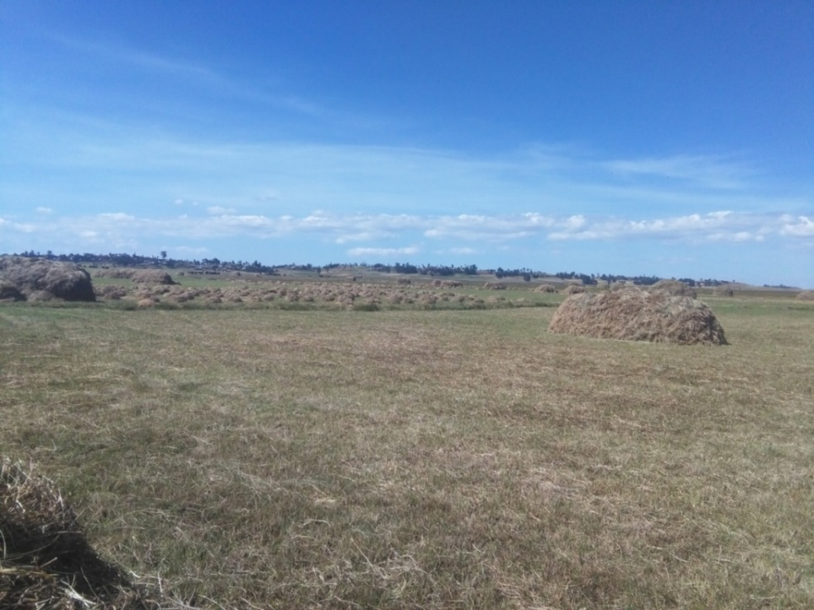
Plat 1Aleltu command area in photo
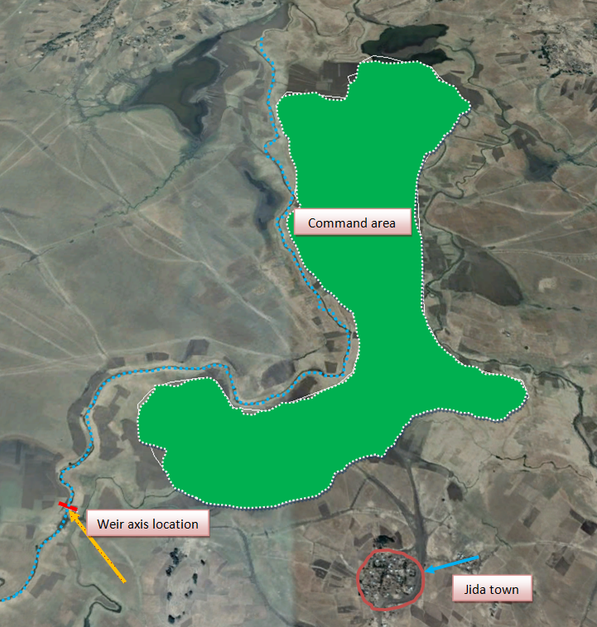
Plat 2Location of the project from Google Earth
The head work is located at the coordinate point of 502113 Easting and 1033471 Northing and at the distance of 2km and 5km from all-weather road and Jida town, respectively. The river embankment is at higher level relative to its surrounding that is why over flooding occur easily during rainy season.

3. Objective
Objective of this study is to undertake feasibility study and detailed designs of irrigation head works and their associated irrigation infrastructures to enhance the utilization of the available water resources for irrigation development and thus improve agricultural productivity of farmers.

4. Methodology of the study and design
- Feasibility study of the project
- Topography survey of the project site
- Exploration of weir site foundation
- Exploration of geologic formation of the main canal route
- Detail study of soil property in the command area
- Determination of crop water requirement
- Studying weather condition

5. Hydrology
A flood is commonly considered to be an unusual at high stage of a river. For a river in its natural state, occurrence of a flood usually fills up the stream up to its banks and often spills over to the adjoining flood plains. For a hydraulic structure planned within the river (like a dam or a barrage) or on an adjoining area (like flood control embankments), due consideration should be given to the design of the structure so as to prevent it from collapsing and causing further damage by the force of water released from behind the structure.
Hence, an estimate of extreme flood flow is required for the design of hydraulic structures, though the magnitude of such flood may be estimated in accordance with the importance of the structure. It must be remembered that proper selection of design flood value is of great importance. While a higher value would result in an increase in the cost of hydraulic structures, an under-estimated value is likely to place the structure and population involved at some risk. For designing small hydraulic structures such as weirs, aqueducts, cross-drainage works, etc., 50 year frequency flood is recommended. Hence, the proposed diversion weir was designed for 50 years return flood dischargeof64.53m³/s as explained in hydrology report.

5.1 Tail water depth
The determination of tail water elevation is one of the least emphasized components of hydraulic design. However, in area with flat, low lying terrain, there can significant consequences when tail water elevations are either over estimated or underestimated in the design of hydraulic structures. Overestimated tail water elevations can result in over-designed hydraulic structures which can increase the cost of the project. Overestimated tail water elevations can also result in actual project discharges that are greater than predicted, resulting in downstream flood problems. Underestimated tail water elevation can result in inadequately sized hydraulic structures and undersized storm water management facilities, which increase the potential for upstream flooding.
Based on the weir site topographic map, river cross-sectional and longitudinal profiles were produced. Using these profiles the stage discharge curve was computed and plotted as shown below. It helps for knowing the tail water depth after construction of weir and enables to decide the arrangement of the weir and protective structures. The corresponding tail water depth to design flood discharge is 3.43m from stage discharge curve taking the river bed elevation 2642.97m.
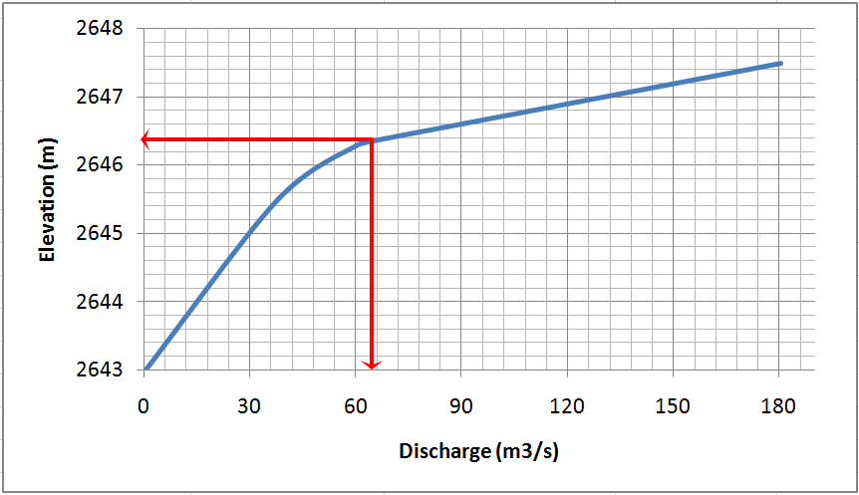
Figure 1 Stage discharge curve of AleltuRiver
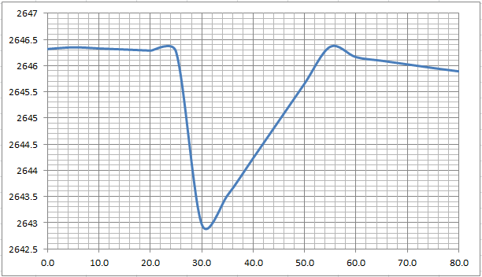
Figure-2.Aleltu River cross section at weir site.

6. Foundation condition at weir site
Soil profile under the foundation of structure is required to reveal the depth of impermeable and soft layers. In designing the foundation of heavy structures investigating the soil profile is necessary to assess the settlement of the construction and the allowable pressure on the soil layers. The depth to which the investigation is to be carried out depends on the load and dimensions of the foundation. Permeability of the foundation soil is of significant value in the determination value and uplift pressure under the foundation of hydraulic structures. Small hydraulic structures usually do not collapse because the pressure of the foundation is more than the bearing capacity of the soil. They collapse due to the scour of the foundation or the differential settlement.
According to the geology study reports for this specific project, the underlying diversion weir headwork site is basaltic rock. However, it does not exposed at the head work site, but it has been overlain by very thick as more than 5m unconsolidated residual soil sediments. These thick alluvial sediments composed of silty-clay deposits with organic matter which could be as thick as 5m that need cut-off and fill with in order to find firm foundation.

7. Construction material
Weirs can be constructed using deferent materials; the suitability of each material depends largely on the shape of the weir. For selecting construction material, among others the following factors are considered:
Type of construction materials available at or near by construction site.
- The type and size of bed materials transported by the river during its high flood.
- The hydrological characteristics of the river.
- Availability of skilled and unskilled labor.
- The foundation condition of the weir site.
The source for construction material is available at the nearby of the project site named Dhaga Dawataat the coordinate point of Easting 501059m, Northing 1045242m and Elevation of 2646m.a.s.l. It is around 13km far from the project site.
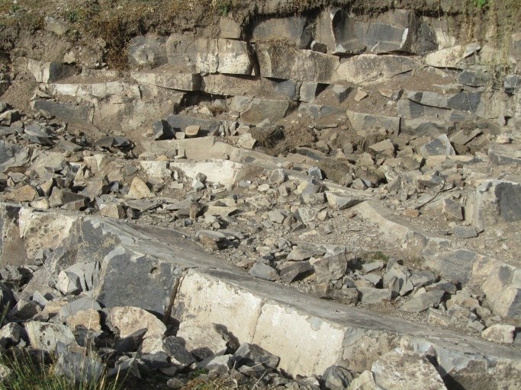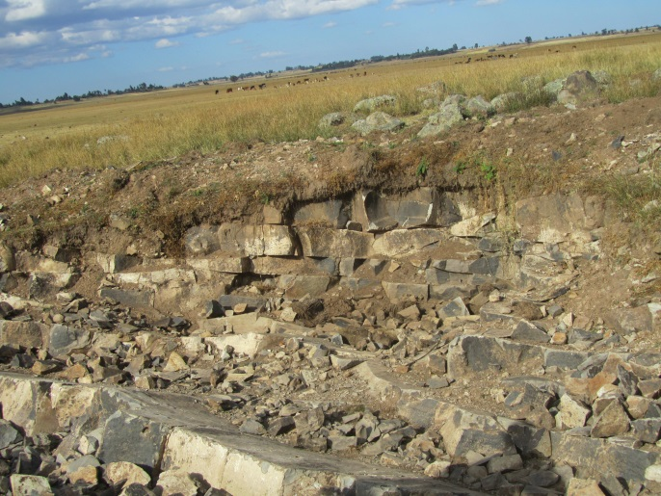
Plat 3Source location of construction material
Considering the above points and other factors, concrete weir constructed monolithically with foundation, wing walls and apron has to be adopted for this study.

8. Design of diversion weir
Diversion weir is designed to raise the level of water in the river sufficiently to the desired height for diverting the water in full or in part through regulator into the main supply canal for the development of irrigated agriculture. In engineering terms the design of a weir must satisfy three fundamental requirements:
- Hydraulic performance – the weir must provide the desired hydraulic performance throughout the full range of flow conditions, from low summer flow to flood.
- Structural integrity – the weir must be able to resist the onerous hydraulic and structural loading throughout its design life, without the need for excessive maintenance expenditure.
- Health and safety requirements – the weir must not pose any avoidable and unacceptable health and safety risks to members of the public or operational staff, both during construction and for the completed structure.
However, in addition to the basic need to get the design criteria, there is a parallel need to take into account the environmental impact of the weir, both during construction and throughout its design life. The general arrangement of the proposed weir and its main dimension was determined based on the results of hydraulic analysis and then after the structural design was carried out.
8.1. Shape of the weir crest
Weirs are differ in type and shape, but designed and constructed to serve the same purposes. The following points are considered to determine the type and shape of the weir suited to this specific site:
- A weir with a shape that cannot easily be constructed by local manpower should not be considered.
- Ogee shaped weir has higher coefficient of discharge than other weir shapes which results in lower overflow depth.
- The main disadvantage of the curved shape is the difficulty in constructing it accurately and soundly.
- The availability of the skilled manpower for implementing it.
- The skill of the local builders, to perform as per design and specification.
Taking into account the cited points and other factors, broad crested concrete weir type is recommended for this specific project.

8.2 Hydraulic design

8.2.1. Fixing weir crest level
At the location of the selected weir site, the river bed elevation is 2642.97mabove mean sea level. The weir crest elevation is fixed with reference of canal bed elevation considering the following factors.
- The crest level should be set at desired height or level to be able to obtain the required driving head to safely deliver the designed discharge to main canal.
- The weir crest should be set to allow a safely passage of maximum flood discharge within designed weir crest length.
- The bed level of the under sluice should be below sill level of canal head regulator.
- The main canal at the head reach should not be too deep in order to avoid large excavation work, to minimize construction cost and to reduce maintenance and side slopes stability problems.

8.2.2. Determination of weir height based on flow data
Bed level of the main canal at the first turnout 287.3m away from the weir = 2644.28
Slope of this canal up to the first turnout = 0.001 m/m
Head loss on the canal up to the first turnout = 0.29m
Canal bed level elevation at intake = 2644.57m
F.S.L elevation in the canal at head regulator = 2645.17m
Minimum driving head elevation for full supply discharge = 2645.17m
Elevation of free board = 2645.37m
Elevation of the weir Crest = 2644.57 + 0.6 + 0.1 + 0.2 = 2645.47m
Therefore, crest height of the weir = 2645.47 – 2642.97(upstream river bed level) = 2.5m

8.2.3. Length of the weir
The length of the weir crest depends on the physical features of the selected weir site. A weir with a long crest gives a small discharge per unit length and hence, the required energy dissipater per meter of the crest width is smaller than what is needed for a shorter crest length. A weir crests longer than maximum wetted river width causes formation of islands at upstream side of the weir. The formation of island upstream of the weir reduces the effective length of the crest. That is, part of the weir less effective in passing the flood. As a general rule, the crest length of the weir including scouring sluice should be taken as the average wetted width during the flood. Increasing the length of the weir crest to 1.2 times the river width is allowable. It should be adequate to pass the design flood safely. For alluvial river it is usually determined from the Lacey wetted perimeter (p).
P = 4.75 * $√Q$
Where, Q is maximum discharge
P = 4.75 * $√64.53$ = 38.2m
Considering clear water way of a single under sluice portion of 2m and 17m of weir body, clear length of weir waterway becomes 19m. But the effective length of the weir calculated as follows:
b_{effective}= b _{clear} - 2 (n K_{p} + K_{a}) H_{e}
Where;
b_{clear}= length of other weir body = 17m+ 1*2m =19m
n = number of piers
K_{p}= pier coefficient
Ka = abutment coefficient
He = water flow depth over the weir calculated using b_{clear}
b_{effective}= 19- 2 (0*0.01 + 0.1) *1.5 = 18.7m

8.2.4. Flow depth over the weir crest
Flow depth over the weir crest was computed by the following empirical formula, assuming that the estimated 50-years return period peak flood discharge passes over weir crest length of 18.7m which is effective length of the weir
Q = CL (H_{e}) ^{3/2}
H_{e} = (Q/C*L) ^{2/3}
Where,
Q = peak flood discharge in m³/s = 64.53 m³/s
L = length of weir crest in m = 18.7 m
H_{e} = over flow depth including approaching velocity head in m
C = discharge coefficient which varies = 1.70
H_{e} =$({\frac{64.53}{1.70*18.7})}^{\frac{2}{3}}$ = 1.603174m ≈ 1.6m
Approaching velocity
$V_{a}$ = $\sqrt{2g(H_{e}-h)}$
$V_{a}$ = $\frac{Q}{\left(P+h\right)*L}$
$\frac{Q}{\left(P+h\right)*L}$ = $\sqrt{2g(H_{e}-h)}$
Where,
h = depth of water over the weir crest in m
V_{a}= approaching velocity in meter per second
P = height of weir above river bed = 2.5 m, but this height may not be obtained in the future after the construction of the weir. It can be filled up by silt. Hence, it is preferred to reduce this height to 0.5m and u/s bed level becomes 2644.97m above mean sea level.
${( \frac{0.779059}{0.5+h} )}^{2}$ = 1.6 -h, by trial and error h = 1.44m
Velocity of approach, $\sqrt{2g(H_{e}-h)}$ = $\sqrt{2*9.8(1.6-1.44)}$ = 1.770875 m/s ≈ 1.77m/s
The corresponding velocity head, h_{a} = $\frac{V^{2}}{2*g}= \frac{{1.77}^{2}}{2*9.8}=$0.16m
Upstream water level = 2645.47+1.44 = 2646.91 m above mean sea level
Downstream tail water level = 2646.4m
Since the upstream water level is higher than tail water level the flow is free (modular) and it is not affected by submergence.
Upstream total energy level (u/s TEL) = 2646.91 + 0.16= 2647.07m
Downstream total energy level is (d/s TEL) = 2646.4 + 0.16= 2646.58m

8.2.5. Determination of the bed level of the stilling basin
Discharge per meter width$q=\frac{Q}{L}=\frac{64.53}{18.7}=$3.451 m²/s
Total head on the crest, H_{e} = 1.6m
Crest elevation = 2645.47m
It is necessary to find jump height and adjust the bottom level of the basin so that the water surface level of the jump is a little higher than the downstream water surface level (0.20-0.40m). The stilling basin floor level was determined by trial and error method. Assuming the floor level is lower than the river bed by 0.50m. Hence, assumed floor level elevation is 2642.97- 0.50 = 2642.47m.
Energy at upstream end of jump (E_{o}) = 2647.07– 2642.47= 4.6m
$${ E}_{o}= d_{1}+\frac{q^{2}}{{d_{1}}^{2}+2g }$$
4.6, by trial and error, d₁ = 0.379219m≈ 0.38m
$$V_{1}=\frac{q}{d_{1}}=\frac{3.451}{0.38}=9.1 m/s$$
$$h_{v1}=\frac{V_{1}^{2}}{2g}=\frac{{9.1}^{2}}{19.62}=4.2m$$
$$F_{1}= \frac{V_{1}}{\sqrt{gd_{1}}}=\frac{9.1}{\sqrt{9.81×0.38}}=4.71$$
Energy at downstream end of jump (E₂),
$$d_{2}=\frac{d_{1}}{2}×\left(\sqrt{1+8×F_{1}^{2}}-1\right)=\frac{0.38}{2}×\left(\sqrt{1+8×{4.71}^{2}}-1\right)=2.349991m$$
Floor level of the stilling basin is 2646.4+0.2 – 2.349991 = 2644.25m
Post jump water level = 2644.25 +2.349991 = 2646.6m, it is slightly higher than tail water level = 2646.4m and it requires longer apron.

8.2.6. Freeboard
Sufficient freeboard should be provided for u/s and d/s wing walls in order to protect the walls and embankments from being overtopped by surges, splash and spray, and wave action setup by the turbulence of hydraulic jump, and not to allow high flood water to bypass the diversion weir. The following empirical formula is used to determine the freeboard.
Freeboard (F_{b}) = 0.1(V₁ + d₂)* = 0.1(9.1 +2.349991) = 1.1449991m≈1.2m
Adopt 0.5m free board for both upstream and downstream retaining walls.
Therefore, top elevation of the downstream retaining walls = 2644.25+ 2.34991+ 0.5 = 2647.1m
Top elevation of upstream retaining walls and embankments = 2646.91 + 0.5 = 2647.41m

8.2.7. Depth of Scour
Properly designed the stilling basin dissipates the great majority of the turbulent energy in the flow. At the outflow from the basin, the remaining proportion of energy in the flow that scours the downstream of the basin. The scour holes so formed may progress towards the structure and results in structural failure. Such failures can be prevented by providing piles or cut-off at u/s and d/s ends of the impervious floor, much below the calculated scour level. The depth of scour can be calculated using Lacey’s equation.
Hydraulic mean depth(R),
Where,
R = hydraulic mean depth
q = discharge per meter length = 3.451m²/s
f = Lacey’s silt factor, f= 1
3.082931m ≈ 3.1m
Bottom level of u/s cut-off = u/s HFL – 1.5R = 2646.81 - 1.5*3.1= 2642.1856m
Depth of cut-off below river bed level = 2642.97m –2642.1856m= 0.7844m. Hence, provide 1.0m ≈ 1.2m (to be safe) cut-off wall at upstream is required.
Bottom level of d/s cut-off = u/s HFL – 2R = 2646.99 – 2*3.1= 2640.79m
Depth of cut-off below river bed level = 2642.97 – 2640.79 = 2.18m≈2.2m

8.2.8. Basic section of the weir
Gravity weir must be designed to resist, with sufficient factor of safety, the three tendencies to destruction: overturning, sliding and overstressing. The basic section of the weir can be determined using Bligh’s method as follows:
Top width of the weir (b),
Where,
b = Top width of the weir wall
He = overflow depth including approaching velocity head.
ρ = specific gravity of the weir body (ρ = 2.0 – 2.4)
Top width of the weir (b), 1.1m
Bottom width (B) of the weir should not be less than:
Where,
B = bottom width of the weir
P = weir height above apron floor = 2.5m
He = overflow depth including approaching velocity head
3.525773m ≈3.5m
However, to be safe more for all stability analysis use4.2m bottom width which will be checked for all critical case conditions.
8.2.9. Length of percolation
The water from the upstream side continuously percolates through the bottom of the foundation and emerges at the downstream end of the weir floor. The force of percolating water removes the soil particles by scouring at the point of emergence. As the process of removal of soil particles goes on continuously, a depression is formed which extends backwards towards the upstream through the bottom of the foundation. A hollow pipe like formation thus develops under the foundation due to which the weir may fail by subsiding. Unless adequate percolation length is provided, this progressive action may cause foundation failure. Safe length of percolation was determined by Lane’s method.
L = CH
Where, L = safe length of percolation = vertical creep distance + 0.333*horizontal creep distances
H = maximum head (difference between u/s and d/s water level).
= 0.51 & 2.5m for high flood and no over flow conditions respectively
C = Lane’s percolation coefficient
Table 1Values of Lane’s Safe Hydraulic Gradient for different types of Soils
S. No. | Type of Soil | Value of Lane’s  Coefficient C1 | Safe Lane’s Hydraulic gradient should be less than
1 | Very fine sand or silt | 8.5 | 1/8.5
2 | Fine sand | 7.0 | 1/7.0
3 | Coarse sand | 5.0 | 1/5.0
4 | Gravel and sand | 3.5 to 3 | 1/3.5 to 1/3
5 | Boulders, gravels and sand | 2.5 to 3 | 1/2.5 to 1/3.0
6 | Clayey soils | 3.0 to 1.6 | 1/3.0 to 1/1.6
Based on the characteristics of the river bed materials, the value of C for fine sand is equals to 7.
L>7*0.51 = 3.57m, for high flood condition
L >5*2.5 = 12.5m, for no over flow condition
= 2*1.2+2*2.5+1/3*19.2 = 13.8m > 12.5 m Ok!

8.2.10. Apron length and its thickness

8.2.10.1. Apron length
Apron may be placed both on the upstream and downstream of the weir in conjunction with cut-off wall depending on the specific site condition. The function of upstream apron is to increase the length of percolation path in order to prevent piping and reduce uplift pressure acting over the entire base area.
Downstream apron has two functions. One is to lengthen the path of the percolation and the other is to dissipate energy. Therefore, properly designed apron with stilling basin should be provided on the downstream of the weir.
The length of the downstream apron can be calculated using hydraulic jump method.
Downstream apron length, hydraulic jump method,
L = 5(d2-d1) = 5(2.349991-0.38) = 9.85 ≈ 10 m
As per Lane’s creep theory, total required creep length is 17.5m. To fulfill the requirement and reduce the thickness of the downstream apron and upstream apron in conjunction with 1.2 m depth of concrete cutoff walls has to be provided.

8.2.10.2. Apron floor thickness
The thickness of the downstream apron can be determined either by assuming that the apron consists of individual unit volumes which are structurally not linked, and the weight of each individual unit balances the uplift pressure or by considering the structure as unit and determining the bending moment and shear force at the critical section, which is at the toe of the weir.
Hydraulic grade lines (HGL) of the sub-surface flow were computed for the two conditions i.e. for high flood and no over flow conditions. To determine the thickness of the apron to be provided based on the first assumption post jump flow profile can be calculated with the help of graphs. The result of calculation of the post Jump flow profile, H.G.L of the subsurface flow and thickness of the apron are shown in table 2, 3 and 4.
The water surface profile after the jump can be plotted with the help of curves shown in the following plate. Values of $\frac{y}{y_{2}-y_{1}}$for known values of $\frac{x}{y_{2}-y_{1}}$can be read out for a given value of F_{1.}
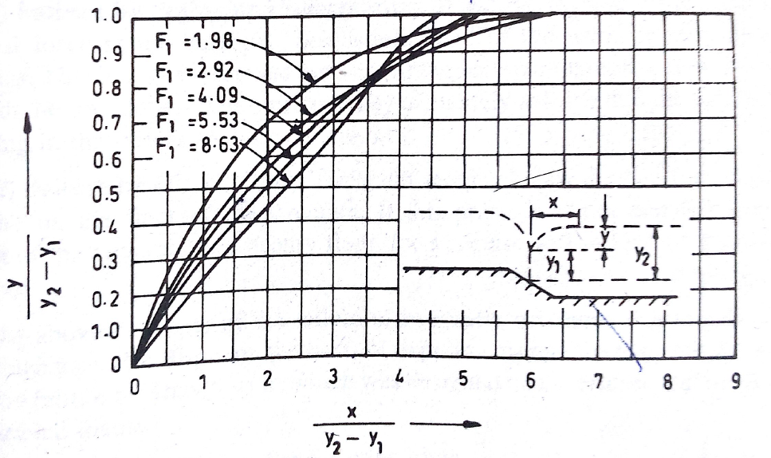
Plat 4Curves for plotting post jump profile
Table 2Post jump flow profile computation
Length(X) | $$\frac{X}{Y_{2}-Y_{1}}$$ | $$\frac{Y}{Y_{2}-Y_{1}}$$ | Y | Y+Y1 | Elevation | Remark
0 | 0.000 | 0.000 | 0.000 | 0.380 | 2642.37 | At u/s end of apron
  0.000
2 | 1.015 | 0.310 | 0.611 | 0.991 | 2642.981
4 | 2.030 | 0.520 | 1.024 | 1.404 | 2643.394
6 | 3.046 | 0.723 | 1.424 | 1.804 | 2643.794
8 | 4.061 | 0.890 | 1.753 | 2.133 | 2644.123
10 | 5.076 | 0.980 | 1.931 | 2.311 | 2644.301 | At d/s end of apron
Note: F1 =4.71, Y1 = 0.38 m, Y2= 2.349991m

Table 3H.G.L of subsurface flow for high flood condition
Lx | $$h_{x}=H\left(1-\frac{L_{x}}{L_{c}}\right)$$ | Head loss  (Lx*0.0265) | H.G.L elevation at each point | Water level  (From Table 2) | Difference in elevation (h) | Apron thickness  $$t=\frac{h}{\left(G-1\right)}$$ | Remark
1 | 2 | 3 | 4 | 5 | 6 |  | 8
0 | 0.51 | 0.00 | 2646.91 | 2646.91 | 0.00
2 | 0.46 | 0.05 | 2646.86
4 | 0.40 | 0.11 | 2646.8
6 | 0.35 | 0.16 | 2646.75
8 | 0.30 | 0.21 | 2646.7
9.2 | 0.27 | 0.24 | 2646.67 | 2642.37 | 4.3 | 1.25 | Toe of the weir
11.2 | 0.21 | 0.30 | 2646.61 | 2642.981 | 3.63 | 1.58
13.2 | 0.16 | 0.35 | 2646.56 | 2643.394 | 3.17 | 1.38
15.2 | 0.11 | 0.40 | 2646.51 | 2643.794 | 2.72 | 1.18
17.2 | 0.05 | 0.46 | 2646.45 | 2644.123 | 2.33 | 1.01
19.2 | 0.00 | 0.51 | 2646.4 | 2644.301 | 2.1 | 0.91 | end of apron
Note: H = 0.51 m, Lc= 19.2 m, head loss = H/Lc = 0.51/19.2 = 0.0265, G = 2.4 specific gravity of floor material
At the toe of the weir the calculated ‘h’ value is reduced by 2/3 and h becomes (2/3)*( 4.3) = 2.87m and the apron thickness is 1.25m and 0.9 at the end apron (this is according to Irrigation Engineering and Hydraulic structures, by Santosh Kumar Garg, 19th revised edition 2005, page 580-581).

8.2.11. Protection Works
Protection works are required on the upstream as well as on the downstream in order to prevent the possibility of scour hole travelling close to the pucca floor of the weir and to relieve any residual up lift pressure through the filter.

8.2.11.1. Down Stream loose protections
Just after the end of the concrete floor, an inverted filter 1.5D to 2D long is generally provided.
Where, D is the depth of scour below the original river bed.
Therefore, provide downstream loose protection of length
L = 2D =2*3 = 6.2m
The depth of inverted filter is kept equal to the depth of downstream launching apron. It generally consists of 1.0to 1.2m deep concrete blocks with open joints laid over 0.6m thick filter graded material. For Aleltu irrigation project 0.6m deep concrete block is recommended.

8.2.11.2 Downstream Launching Apron
After the inverted filter the launching apron is provided for a length generally equal to 1.5D.
Where, D is the depth of scour below the original river bed.
Therefore, provide downstream launching apron of length
L = 1.5*3 = 4.8m

8.2.11.3Up Stream loose protections
Just upstream of the concrete floor of the weir, block protection is provided. It generally consists of concrete blocks laid over packed stone, for a length equal to L.
L = xR – y
Where, x = 1.0 to 1.5, generally taken as 1.25
y = water depth above bed
L = 1.25*3.1- (2646.81-2642.97) = 0.035m
To be safe provide 1.0m length of upstream loose protections.

8.2.12. Exit Gradient
It is the slope or gradient of hydraulic grade line for subsoil seepage flow at the exit end of the structure where the seepage water comes out from subsoil.
For the standard form of structure with a floor length b, vertical cut-off depth d, the exit gradient at its downstream end is given by the equation below.
Where; H is depth of water up to crest of the weir
d: depth of cutoff
b: floor length
0.16 it is between 1/6 to 1/7
According to the table for safe exit gradient for different types of soils, the total provided depth of cut-off wall proves to be sufficient to safeguard against piping for the material of fine sand.
Table 4Safe exit gradients for different types of soils
Types of soils | Safe exit gradient
Shingle | 1/4 to 1/5 (0.25 to0.2)
Coarse sand | 1/5 to 1/6 (0.2 to 0.17)
Fine sand | 1/6 to 1/7 (0.17 to 0.14)

8.3 Design of head regulator

A suitably designed regulator at the head of a canal is provided to regulate the supplies entering the canal as well as to control silt entry into the canal. It can also be used as a calibrated meter for assessment of the discharge entering the canal. Head regulators are provided at the head of a canal off-taking from a river or a branch canal taking-off from a main canal.
Design principles for head regulators፡
- The crest level of the head regulator should be fixed higher than the crest of the under-sluices of the weir with or without the silt excluder by 1.25 to 2 m to avoid silt entry into the canal.(It is large scale irrigation project.)
- The crest level and the waterway required by the head regulator are interrelated because the discharge to be passed down into the canal and the pond level of the weir are already fixed.
- Generally for the head regulator broad crest with sloping downstream glacis are provided. So, the waterway required can be calculated by corresponding hydraulic formula.
The discharge formula applied is:
Q = 1.7*(L-knH) H^{3/2}
Where:
Q = design discharge of the canal in m³/s
L = length of waterway in m
H = head causing flow in m (0.21m)
k = a constant which varies from 0.01 to 0.03. It depends on the shape of pier nose or cut water,
n = number of end contractions.
According to agronomy study, duty of the project for twelve hour is 1.68l/s/ha. The command area proposed for the project is 266ha. Therefore, to irrigate the proposed area 0.4704m³/s net discharge is required at the entrance of command area. Though this, the base flow of the river is only 0.18m³/s after twenty percent release for downstream users according to hydrology report. Therefore, using the available discharge, the command area irrigated will be only 107.1ha using 1.681l/s/ha duty for twelve hours.
Hence, the length of waterway of the head regulator, L becomes:
L = $\frac{Q}{{1.7*H}^{\frac{3}{2}}}$ + KnH = $\frac{0.18}{{1.7*0.21}^{1.5}}$ + 0.02*1*0.21= 1.104458m≈ 1m

8.4 Design of Scouring Sluice
A weir or barrage normally requires deep pockets of under sluices portions in front of the head regulator of off taking canal and long divide walls to separate the remaining river bays portion from the under sluices portion. The arrangement is aimed for keeping the approach channel to the canal head regulator comparatively clear of the silt and to minimize the effect of main river current on the flow conditions in the regulator. Provision of intermediate divide wall to produce favorable flow condition may be decided on the basis of model studies and proposed operation of gates. The width of the under sluice portion shall be determined on the basis of the following considerations:
- It should be capable of passing at least double the canal discharge to ensure good scouring capacity.
- It should be capable of passing about 10 to 20 percent of the maximum flood discharge at high floods.
- It should be wide enough to keep the approach velocities sufficiently lower than critical velocities to ensure maximum settling of suspended silt load.
- In case of weirs, it should be capable of passing fair weather freshets and low mon-soon floods for obviating overtopping and/or operation of crest gates.
- Where silt excluders are provided, the width of the pocket should be determined by the velocity required in the pocket to induce siltation. Where the width of barrage is appreciable, river sluices adjoining the pockets can be provided to take care of low floods and freshets thereby economizing on the cost.
For Aleltu small scale irrigation project, it is designed to ensure sufficient scouring capacity at least to dispose of about 10~20% of the peak flood i.e.6.45m³/s, this value is at least greater than 10 times the intake capacity.
Using a broad crested weir formula, Q = C d* L* H _{d}^{3/2}
Where,
Q = discharge through the under sluice = 6.45m3/s
Cd, coefficient of discharge = 1.70
L = Length of under sluice section,
H d = h + hd
Where, h is weir height and h_{d} is design head
Hd = water depth above the crest of the under sluice during high flood = 3.44m
Under sluice crest level = 2643.47m
Upstream highest flood level = 2646.47 m
Hd = 3.44m
Hence L = $\frac{Q}{{CD*(Hd)}^{\frac{3}{2}}}$ = 0.595m≈ 1m
Therefore, provide 1m width to pass the required amount of discharge.

8.5. Divide wall
Divide wall is a masonry or concrete wall constructed at right angle to the axis of the weir. The divide wall extends on the upstream side beyond the beginning of the canal head regulator; and on the downstream side, it extends up to the end of the loose protection of the under-sluices. On the upstream side, the wall is extended just to cover the canal head regulator and on the downstream side, it is extended up to the launching apron.
The main functions of the divide walls:
- It separates the ‘under-sluices’ with lower crest level from the ‘weir proper’ with higher crest level.
- It helps in providing a comparatively less turbulent pocket near the canal head regulator, resulting in deposition of silt in this pocket and, thus, to help in the entry of silt-free water into the canal.
- It helps to keep cross-current, if any, away from the weir.
The divide wall is provided on upstream of the weir. The length of walls on upstream should extend beyond the upstream end of the head regulators. In this design the upstream divide wall of 5m long, 0.5 m thick and equal the crest level of the weir height above the river bed are proposed to be constructed.

9. Structural design

9.1. Stability analysis of the weir
For the design of the weir, it is necessary to determine the forces which may be expected to affect the stability of the structure. The forces which must be considered are those due to:
- external water pressure
- internal water pressure (pore pressure or uplift) in the weir and foundation,
- silt pressure
- weight of the structure
- earthquake
Besides satisfying the hydraulic requirements, the designed structure has to be safe against overturning, sliding, tension and such related structural parameters. Silt gets deposited against the upstream face of the weir. If h is the height of silt deposited, then the force exerted by this silt in addition to external water pressure, can be represented by Rankine's formula as: Ps = 1/2 x γsub x h² x Ka
Where, Ka is the coefficient of earth pressure of silt =$\frac{1-sinΦ}{1+sinΦ}$
Φ-is the angle of internal friction of soil.
γsub-the submerged unit weight of silt material h-height of silt deposited.
In the absence of any reliable data for the type of silt that is going to be deposited, U.S.B.R. recommendations may be adopted. In these recommendations, deposited silt may be taken as equivalent to a fluid exerting a force with a unit weight equal to 3.6KN/m³ in the horizontal direction and the vertical force with a unit weight of 9.2KN/m³.Hence; in this project case it is reasonable to accept the U.S.B.R. recommendation.
The horizontal and vertical silt pressure are given as
P_{sh}= ½*3.6*2/5*h²*1
Psv = ½*9.2*2/5*h²*1
Where, h - is height of silt deposited
Hence, the designed section is tested for stability requirement. The stability of the weir wall above upstream apron level was evaluated as below:

9.1.1 Normal Pond Level
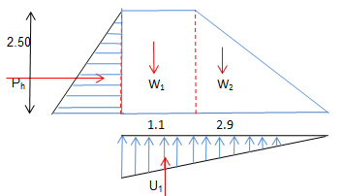
Figure 3Forces on the weir in pond level condition
Table 5Input data for stability analysis of the weir
INPUT DATA
Description | symbol | unit | value
Upstream bed level | Hu | m | 2642.97
Upstream side slope | m1 |  | 0.00
Downstream side slope | m2 |  | 0.86
Downstream bed level | Hd | m | 2642.97
Crest level of weir | Hcw | m | 2645.47
Head above weir | Ha | m | 1.52
Length of weir | Lw | m | 19
Width of weir | Bw | m | 4.0
Depth of Upstream pile | Dup | m | 0.56
Depth of Downstream pile | Ddp | m | 2.30
Level of u/s flow in flood | Hfd | m | 2646.99
Level of d/s flow in flood | Hfd | m | 2645.46
Gravity density of stone | Ws | KN/m3 | 20
Gravity density of concrete | Wc | KN/m3 | 24

Table 6Types of load act on the weir in pond level condition
Name of Load | V (KN) | H (KN) | Arm (L) | M (KN.m)
Horizontal water pressure (Ph) |  | -31.25 | 0.83 | -25.94
Horizontal silt pressure (Psh) |  | -1.8 | 0.33 | -0.59
Vertical silt pressure (Psv) | 4.6 |  | 0.33 | 1.52
Weight of the weir (Pw) | 153 |  | 2.63 | 402.39
Up lift pressure (U₁) | -3.53 |  | 1.33 | -4.69
Total | 154.07 | -33.05 |  | 372.68

- Over-Turning about the toe.
There is a tendency for a weir to overturn about the downstream toe at the foundation or about the downstream edge of any horizontal section. If the vertical stress at the upstream edge of any horizontal section computed without uplift exceeds the uplift pressure at that point the weir is considered safe against overturning.
For safe over turning moment the ratio of stabilizing moment to disturbing moment should be greater than two.
i.e${ F}_{s}=\frac{M_{s}}{M_{d}}>$ 2
${ F}_{s}=\frac{403.908}{31.2264}$= 12.93> 2
Therefore, the structure is safe against overturning.
- Sliding
The friction developed between two surfaces is equal to μΣv, where Σv is the algebraic sum of all the vertical forces whether upward or downward, and μ is the coefficient of friction between the two surfaces. In order that no sliding takes place, the external horizontal forces (ΣH) must be less than the shear resistance μ x ΣV.
Hence, ΣH < μ ΣV
Factor of safety against sliding (F.S.S) = μ ΣV/ΣH =2
The value of μ generally varies from 0.65 to 0.75, taking μ = 0.7
F.S.S = $\frac{0.7*154.07}{33.05}$ = 3>2
Therefore, the structure is safe against sliding.
- Compression or Crushing
The structure may fail by the failure of its materials. That is the compressive stress produced may exceed the allowable stress and the material get crushed which is the cause for failure. The vertical stress distribution at the base is given by the equation
$P_{\frac{max}{min}}$ = $\frac{\sum{V}}{B}\left[1 ± \frac{6e}{B}\right]$
Where e=eccentricity of the resultant force from the toe of the base
${}_{V}$ = total vertical force
B = Base width
e =$\frac{B}{2}-$= $\frac{4}{2}-\frac{372.68}{154.07}$= 2 – 2.42= 0.42
B= 4m
$P_{\frac{max}{min}}$ = $\frac{154.07}{4}\left[1±\frac{6*0.42}{4}\right]$
$P_{max}$ =14.3 KN/m²
$P_{min}$ = 62.8 KN/m²
For compressive strength of the concrete equals to 2500KN/m² the structure is safe against crushing.
- Tension
In order to ensure that no tension developed anywhere, we must ensure that the maximum value of eccentricity that can be permitted on either side of the center is equal to B/6.
B/6= 4/6 = 0.67> 0.42
Hence, the resultant force passes with in middle third of the bottom width of the structure which result in safe condition.
- Stress on foundation
Distance from toe to point acting moment
E= $\frac{{}_{M}}{{}_{V}}$ = $\frac{372.68}{154.07}$ = 2.42m
Distance of eccentricity, e = 0.42m
Maximum Stress on the foundation (at toe) = 14.3KN/m²
Minimum Stress of Foundation (at heel) = 62.8KN/m²
Coefficient of unbalanced settlement = $fu= \frac{S_{max}}{S_{min}} = \frac{14.3}{62.8}=0.23$
Since the coefficient of unbalanced settlement for very soft foundation, f=3 >fu=0.23 the structure is safe against stress on foundation.

9.1.2. Maximum Flood Level
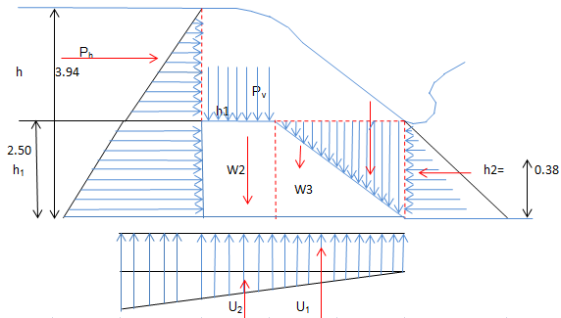

Figure 4Forces on the weir in maximum flood condition
Table 7Types of load act on the weir in high flood condition
Name of Load | V (KN) | H (KN) | Arm (L) | M (KN.m)
Horizontal water pressure (Ph) |  | -69.33 | 1.06 | -73.49
Horizontal silt pressure (Psh) |  | -1.8 | 0.33 | -0.59
Horizontal tail water pressure (Ph2) |  | 0.72 | 0.13 | 0.0936
Hydrodynamic pressure (Pm) |  | -5.13 | 3.01 | -15.4413
Vertical water pressure on  the width of the weir (Pv) | 7.62 |  | 3.25 | 24.765
Vertical water pressure on  upstream slope (Pv1) | 69.33 |  | 3.59 | 248.8947
Vertical water pressure on  downstream slope (Pv2) | 0.62 |  | 0.11 | 0.0682
Vertical silt pressure (Psv) | 4.6 |  | 0.33 | 1.518
Weight of the weir (Pw) | 153 |  | 2.63 | 402.39
Up lift pressure (U1) | -0.74 |  | 2 | -1.47323
Up lift pressure (U2) | -3.22 |  | 1.33 | -4.2826
Total | 231.21 | -75.54 |  | 582.45

- Over-Turning about the toe
$F_{s}=\frac{M_{s}}{M_{d}}>$ 2
$F_{s}=\frac{677.7295}{95.281}$= 7.11> 2
Therefore, the structure is safe against overturning
- Sliding
F.S.S = $\frac{0.7*231.21}{75.54}$= 2.14 >2
Therefore, the structure is safe against sliding.
- Stress on foundation
Distance from toe to the point acting moment
E= $\frac{{}_{M}}{{}_{V}}$ = $\frac{582.45}{231.21}$= 2.52m
Distance of eccentricity, e = 0.52m
Maximum Stress on the foundation (at toe) = 12.7 KN/m²
Minimum Stress of Foundation (at heel) = 102.9 KN/m²

Coefficient of unbalanced settlement = $fu= \frac{S_{max}}{S_{min}} = \frac{12.7}{102.9}=0.12$
Since the coefficient of unbalanced settlement for very soft foundation, f=3 >fu= 0.12 the structure is safe against stress on foundation.

9.2. Retaining wall and flood protection embankment

9.2.1. Retaining (wing) walls
To control the spillage of flood to the irrigation canal and to protect the scouring of banks due to the incoming high velocity wing walls are provided on both the right and left of upstream and downstream of the river. In this case, both upstream and downstream aprons serve as a long toe for the wing walls. For this reason, the length of upstream and downstream wing walls is extended towards up to the end of upstream and downstream apron.
Design Considerations:
- Analysis per meter span and moment about heel
- Earth pressure at rest was considered
- Drained selected clay back fill was considered
γ_{m} = 23 KN/m³. γ_{w} = 10KN/m³, γ_{soil} = 18kN/m³
- Drained angle of internal friction (Φ) was taken 30⁰ for the back fill material.
p_{s}= ½ k_{o}γ_{s} H²
Where;
K₀= $\frac{1-sinΦ}{1+sinΦ}$
H = 3.42m and hence
P_{s}= 69.86 KN/m
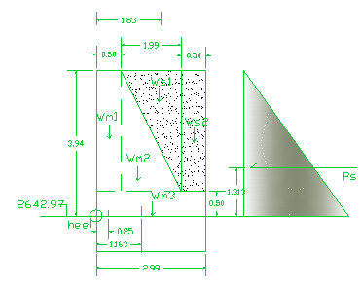
Figure 5Load distributions on wing wall

Table 8Load and moment on wing walls
Force (KN) | Sum of forces (KN) | Arm (m) | Moment (KN-m) | Sum of moments
Ps | 69.86 = H | 1.313 | - 91.72 | - 91.72
WS₁ = 61.61 | 245.24 = V | 1.83 | +112.75 | +350.43
WS₂ = 30.96 | 245.24 = V | 2.74 | +84.83 | +350.43
WM₁ = 39.56 | 245.24 = V | 0.25 | +9.89 | +350.43
WM₂ = 78.72 | 245.24 = V | 1.163 | +91.56 | +350.43
WM₃ = 34.39 | 245.24 = V | 1.495 | +51.41 | +350.43

- Safety against overturning = $\frac{350.43}{91.72}$= 3.82> 1.5 safe
- Safety against sliding= $\frac{69.86}{245.24}$ = 0.285< 0.65 safe
- Location of resultant (middle-third- rule)
X = ΣM/ΣV = 258.71/245.24 = 1.055
e = (b/2)-X =1.495- 1.055 = 0.44
e≤ B/6 = B/6 = 0.498m
0.44< 0.498, e<B/6 accepted!

9.2.2. Protection Embankment
Due to provision of weir across a river, the water level rises on upstream of structure. The structure is designed and provided in restricted width of the river. Raised water level may cause out flanking of riverbanks near structure if the banks are not above afflux level. To prevent out flanking, earthen protection embankments on flanks of weir are provided. The protection embankments are provided from abutment of weir structure and extended up to the point where required ground elevation corresponding with the top embankment elevation joins on the bank.
At the selected weir site, the embankment of the river is at higher level than the nearby environment. During high flood time because of the topography of the river as shown below, there is over flood of the area.
Figure 3River cross section at weir site for flood protection
In addition to this, at upstream of the selected weir site the embankment of the river is at lower elevation relative to the maximum flood level2646.81ma.s.l.for a length of 86malong the river direction on the right side as shown below.

Figure 4 Right side river embankment profile for dyke construction
Therefore, to protect over flooding the construction of dyke for 86 m long and a depth from 0.3m to 2m using 0.3m as free board is required.

10. Irrigation and drainage system design
Irrigation and drainage system design incorporates all engineering aspects related to project study and designs. This system design focuses on study and design of headwork, supply and drainage canals and all appurtenant structures related to diversion, conveyance, distribution and application of water to the farm lands. This design also gives attention to network of roads: main access road, farm roads and inspection roads. All influential factors that determine project sustainability are accounted to come up with reasonable results of study. In so doing, idea from different disciplines was given due attention.

10.1. Irrigation System Design
The design of irrigation canals is mainly concerned with the adoption of proper canal geometry to accommodate the design discharge within the specified limits and at the same time to allow gravitational flow of irrigation water to farm fields. This situation will call the close inquiry of the farm fields, which are to be irrigated, as the level of the farm field is the major parameter that would influence the relative vertical positioning of irrigation canals in the system.
Prior to the design of the longitudinal profile of irrigation canals, it would be necessary to define the design flow in each irrigation canal and to proportion the geometric parameters of the canal in such a way that it is capable to carry the design flow within acceptable tolerances.

10.1.1 Canal Systems
The diverted water is to be distributed to the farm through a network of canals by gravity flow. The physical purpose of irrigation is to satisfy the demands of crop water requirement by increasing the moisture content of the soil in the root zone of the crop. For this canal distribution system should be planned to convey the required amount of water from the outlet to the required area. For Aleltu small Scale irrigation furrow irrigation method is selected.

10.1.2 Canal Alignment
In order to prepare a realistic system layout it would be inevitable to study the local topographic condition of the area. For this purpose, detailed topographic survey has been done using total station. After generating contours using the collected topographic data, the alignment of canals are fixed either along or across the contour.
The following points are considered while preparing the canal layout:
- The layout is done based on block areas to be irrigated by taking drains and ridges into consideration.
- Deep cutting and high banking is tried to be avoided
- The alignment of secondary canal follows almost perpendicular to contour line.
- To be economical, changing alignment is considered when steep ground slope is encountered.
- Most of the tertiary canals run perpendicular to the secondary canal along the natural slope.
- Field channels, field and collector drains are left to be constructed by farmers
The command area of this small scale project is located on the right side of the river. It covers about 266 ha.
The layout of irrigation canals, furrows are made to run more or less parallel to contours and field canals are aligned perpendicular to contour lines, subsequent higher level canals were made to run perpendicular and/or near perpendicular to lower level canals that they discharge into.
The alignment procedure used for drainage canals is such that the positioning of higher-level drainage channels would more or less be along depressions. Accordingly, field ditches are placed at the foot of furrows and are aligned down the contour lines. Similarly, tertiary and secondary drains are made to run perpendicular to field ditches and to each other.

10.1.3. Canal Design

10.1.3.1. Fixing Canal Capacities
The design of canals is concerned with the determination of the cross sectional dimensions of the canal to convey the required amount of discharge intended to meet the peak requirement of crops grown in the entire command area during the supplementary case and dry season cases. The dimension of the channel can be calculated using the general formula of Manning’s, which is given by:
Where, Q = discharge of the channel
R = Hydraulic radius = A/p
A = Wetted cross-sectional area
m = side slope
p = wetted perimeter
s = bed slope
n = Manning’s roughness coefficient
The roughness coefficient recommended by USBR design standard No. 3 is used to derive the roughness coefficients to be used in the present project. USBR recommends a value of n 0.025 for earthen canals.

10.1.3.2. Main canal
The main canal which runs on the right side of the river is designed to irrigate 107.1ha of command area. It is recommended to be lined canal for the first 280 m since it is running in deep cut up to 2m.The source of water is Aleltu River which has the maximum discharge of 64.53m³/s and a base flow of 0.18m³/s after twenty percent release for downstream users.
Main canal design using Manning equation
Q = $\frac{1}{n}$A$R^{\frac{2}{3}}S^{\frac{1}{2}}$
For the first 280m rectangular lined canal to irrigate 107.1ha, discharge at the head = 0.18m³/s
Bed width, b = 0.5m
Water depth, d = 0.3m
Manning roughness coefficient, n = 0.018
Longitudinal slope S, = 0.01m/m
Calculated discharge, Q = 0.22m³/s
For the remaining trapezoidal earthen canal with 1:1 side slope
Bed width, b = 0.6m
Water depth, d = 0.35m
Manning roughness coefficient, n = 0.025
Longitudinal slope S, = 0.002m/m
Side slope = 1:1
Calculated discharge, Q = 0.21m³/s
Since the calculated discharge passes is more than required, the design is ok!

10.1.3.3 Secondary canal
Generally, secondary canals will flow for rotationally and flow will be distributed down each tertiary canal in proportion to the area they irrigate. The canal geometric design results for irrigation canals including related hydraulic particulars such as design discharge, flow depth, velocity etc. are given in the standard longitudinal profile drawings of each irrigation canal. Secondary canals comparatively run down steep slopes and in most cases, the flow regime in secondary canals is supercritical. To avoid the prevalence of super-critical flow in secondary canals it was inevitable to provide drop structures where conditions permit. There is only one secondary canal for this specific project as shown in the table below.
Table 9Length and Area Irrigated by Secondary Canal
S.No | Description | Length(m) | Area (ha)
1 | SC-1-1 | 937.3 | 38.63
Sample secondary canal design
Canal Parameters
Duty, q = 1.68lit/sec/ha
Canal name = SC-1
Command Area, A = 38.63 ha
Section of Channel = Trapezoidal
Design Discharge, Q _{d} = q*CA = 0.0649m³/s
Canal bed width, b = 0.35m
Water Depth, d = 0.33m
Canal Side Slope = 1:1
Water area, A = 0.22m²
Wetted Perimeter, P = 1.28m
Hydraulic Radius, R = 0.17m
Roughness Coefficient, n = 0.020
Canal bed slope, S = 0.0008m/m
Flow Velocity, V = 0.44m/s
Logically, calculated discharge should be greater than design discharge.
i.e0.0992m3/s >0.0649 m³/s …….Ok!

10.1.3.4. Tertiary Canal
Tertiary canals will flow for 12 hr/day and flow will be distributed down each off-taking field canals in proportion to the area they irrigate. The discharge released for each tertiary canal at its off take is different based on the area they irrigate. The canals are earthen open channels, which is generally laid along the contours. The canal geometric design results for irrigation canals including related hydraulic particulars such as design discharge, flow depth, velocity etc. are given in the standard longitudinal profile drawings of each irrigation canal. There is around 13 tertiary canals in number and a total length of 8125.89m which irrigates 232.83ha as shown below.
Table 10Lengths and Area Irrigated by tertiary Canals
S.No | Exist of TC | Description | Length(m) | Area (ha)
1 | On  Main Canal | TC-1 | 430.6 | 18.4
2 | On  Main Canal | TC-2 | 1194.97 | 32.8
3 | On  Main Canal | TC-3 | 2059.2 | 53.8
4 | On  Main Canal | TC-4 | 316.7 | 8.7
5 | On  Main Canal | TC-5 | 706.2 | 17.5
6 | On  Main Canal | TC-6 | 486.7 | 16.6
7 | On  Main Canal | TC-7 | 478.7 | 13.5
8 | On  Main Canal | TC-8 | 768.2 | 32.9
9 | On  Secondary canal | TC-1-1 | 703.1 | 15.8
10 | On  Secondary canal | TC-1-2 | 71.22 | 2.23
11 | On  Secondary canal | TC-1-3 | 384.5 | 7.5
12 | On  Secondary canal | TC-1-4 | 303.6 | 7.2
13 | On  Secondary canal | TC-1-5 | 222.2 | 5.9
Total |  |  |  | 232.83
Sample tertiary canal design
Canal Parameters
Duty, q = 1.68lit/sec/ha
Canal name = TC-1
Command Area, A = 18.4ha
Section of Channel = Trapezoidal
Design Discharge, Q d = q*CA = 0.03091m3/s
Canal bed width, b = 0.35m
Water Depth, d = 0.33m
Canal Side Slope = 1:1
Water area, A = 0.22m2
Wetted Perimeter, P = 1.28m
Hydraulic Radius, R = 0.1749m
Roughness Coefficient, n = 0.023
Canal bed slope, S = 0.0006m/m
Flow Velocity, V = 0.33m/s
T w – Top width (m) = 1.01m
F b, free board (m) = 0.25m

10.1.3.5. Field Canal
The field channels which are earthen open channels which takeoff water from the tertiary canals. The alignment of the field canals are across the contour on the ridge so that it can supply furrows on both sides. These canals are the last watercourses that directly supply irrigation water to the farm plots. While main canal, secondary canals and tertiary canals are designed as telescopic with successive reduction of discharge from head to tail, the design section of field channels are remain constant from head to tail.

10.2. Drainage System Design
For design of a drainage system, the drainage requirement or the drainable surplus has to be known. This is the amount of water that must be removed from an area within a certain period so as to avoid an unacceptable rise in the levels of the groundwater or surface water. Removing the drainable surplus has two advantages:
- It prevents water logging by artificially keeping the water table sufficiently deep
- It removes excess water from the root zone so that any salts brought in by irrigation cannot reach a concentration that would be harmful to crops.
Field drains for a surface drainage system have a different shape from field drains for subsurface drainage. Those for surface drainage have to allow farm equipment to cross them and should be easy to maintain with manual labor or ordinary mowers. Surface runoff reaches the field drains by flow through row furrows or by sheet flow. In the transition zone between drain and field, flow velocities should not induce erosion.

11. Irrigation Infrastructure
The flow of irrigation water in the canals must always be under control. For this purpose, canal structures are required. They help in regulating the flow and deliver the correct amount of water to the different branches of the system and onward to the irrigated fields. There are four main types of structures: erosion control structures, distribution control structures, crossing structures and water measurement structures. In this particular scheme the following structures have been provided.

11.1. Drop Structures
Whenever the natural ground profile is steeper than the design canal bed slope, drops have to be provided to avoid high fill. The ground slope along the canals in the project area is generally steeper than the water surface slope (1:500), which is required to limit the flow velocity. So that, providing a fall or chute is imminent to secure lowering of the water surface in a canal and to dissipate the energy liberated. Fall is located at a point upstream where the full supply level exceeds the natural ground level such that the drop structure is positioned in cutting than in fill. Vertical and chute drop type is selected since the discharge through the canal system is small i.e. less than 400 liters per second. Only 1.50m, 1.00m and 0.50m vertical drop height is provided for ease of construction in most part of the canal.
Table 11Number of drop structures
No | Change(m) | Drop height(m) | Discharge(m³/s
1 | 3775.00 | 0.75 | 0.33
2 | 4300.00 | 0.50 | 0.32
3 | 4475.00 | 0.50 | 0.32

Hydraulic Calculation for 0.75m drop on right main canal
Input Parameters:
Discharge, Q =0.33m³/s
Upstream water depth, h_{1,} =0.38m
Upstream water velocity, V₁ =0..37m/s
Downstream water depth h_{2,} =0.38m
Downstream water velocity, V₂= 0.37m/s
Drop height, Z =0.75m
Drop width = $b_{c}$=0.734 * $\frac{Q}{{h_{1}}^{\frac{3}{2}}}$ = 1.034m
Unit discharge= q =$\frac{Q}{b_{c}}$ = 0.319m
Critical depth = $y_{c}$= (${\frac{q^{2}}{g}) }^{\frac{1}{3}}$ = 0.218m
Stilling basin:
Basin width, B=18.46*$\frac{Q^{0.5}}{(Q+9.91)}$= 1.04m
Basin length = L= [2.5+1.1*($\frac{y_{c}}{Z})+0.70 ({\frac{y_{c}}{Z})}^{3}$]* $\sqrt{{z*y}_{c}}$ = 2.83m
Lip height a =$\frac{y_{c}}{2}$= 0.109m
Protection work at upstream and downstream=1.2+1.5*$\sqrt{Q}$ = 2.062m

11.2. Division Boxes
Division structures or boxes regulate the flow from one canal to another, or to several others. They usually consist of a box with vertical walls in which controllable openings are provided. Metal or wooden slide gates or stop-logs are usually installed to regulate the division of flow at all times and to shut off flow in any branch when desired.
The width of each outlet is generally proportional to the division of water to be made. In lined canals, a full gate opening at the intake to the box is made covering approximately the same area as the canal flow section since the canal is designed to carry water at relatively high velocities. In earth canals, gate openings can be dimensioned by assuming a velocity of about 1.5 m/ s in the opening section. Reinforced concrete transitions are provided below the gates on larger structures. Hydraulic losses through gate openings are seldom controlling factors in designing division boxes. When the gates are operated at full openings, entrance losses are simply transition losses. When operated at partial openings, available heads are not fully utilized so that increased losses due to gate contractions are not important.
The division box is constructed at the junction point where an irrigation sub-lateral branches into two or three farm ditches. The division box is not used to divide water carried in by the sub-lateral between farm ditches. It is used to turn the whole flow of water alternatively into one of the ditches according to a preset irrigation schedule.

11.3. Turnouts
Turnouts are needed to provide a quick and easy means off taking water from the head ditch to field ditches or border dikes. They can be made of wood, metal or concrete. For this specific project 81 numbers of turnouts have been installed on secondary canal, tertiary canal &main canals. Some of them are described in the following table below.

Table 12 some of turn outs available on main and secondary canal
No | Parental Canal | Name of canal | Chainage(m) | Discharge(m³/s) | Area(ha)
1 | MC | TC-1 | 287.3 | 0.0309 | 18.4
2 | MC | TC-2 | 2239.36 | 0.0551 | 32.8
3 | MC | TC-3 | 3701.616 | 0.0904 | 53.8
4 | MC | TC-4 | 3860.489 | 0.0146 | 8.7
5 | MC | TC-5 | 4227.39 | 0.0294 | 17.5
6 | MC | TC-6 | 4426.4 | 0.0279 | 16.6
7 | MC | TC-7 | 4758.34 | 0.0227 | 13.5
8 | MC | TC-8 | 5007.98 | 0.0553 | 32.9
9 | MC | FC-1 | 333.95 | 0.0064 | 3.8
10 | MC | FC-2 | 592.82 | 0.004 | 2.4
11 | MC | FC-3 | 1045.233 | 0.006 | 3.6
12 | MC | FC-4 | 1252.699 | 0.0044 | 2.6
13 | MC | FC-5 | 1495.35 | 0.0049 | 2.9
14 | MC | FC-6 | 1623.57 | 0.0018 | 1.1
15 | MC | FC-7 | 1739.56 | 0.0047 | 2.8
16 | MC | FC-8 | 1849.21 | 0.0044 | 2.6
17 | MC | FC-9 | 1977.71 | 0.0035 | 2.1
18 | MC | FC-10 | 2266.82 | 0.0074 | 4.4
19 | MC | FC-11 | 2371.85 | 0.0044 | 2.6
20 | MC | FC-12 | 2480.77 | 0.0032 | 1.9
21 | SC | TC-1-3 | 666.26 | 0.0126 | 7.5
Design of turnout / field off takes
The flow in turnouts and field off takes is governed by orifice formula given below. It basically depends on the pipe size and head creating flow.
Q=C_{d}A√(2gh)
h=y-(D/2) and A=πD²/4
Where;
C_{d} = is the coefficient of discharge equals to 0.80 for submerged out flow and 0.6 for free out flow
A = is the area of pipe
g = acceleration due to gravity (9.81 m/s) and
h = is the head creating flow in meter.
Sample turnout design on right main canal at a distance of 295m from headwork
Design data
- FC-1-1-1
Design discharge = 0.00521m³/s
Parent canal full supply level =2644.29m
Off- taking canal full supply level =2644.14m
Off-taking canal depth = 0.15m
Off-taking canal bed level =2643.95m
It is designed as submerged orifice flow.
Design of the intake pipe
Considering a pipe conduit intake diameter 0.15m the determined discharge using orifice weir formula Q=C_{d}A√(2gh)
Where; C_{d} = 0.6, A = 0.018m², h_{L}= 0.15m the calculated discharge is equals to 0.02m³/s.
Since the capacity of the designed intake pipe is greater than the required flow, it is ok
Each field off take and turn out has to be controlled with simple shutters with chain to lift to required level.

11.4. Access Road
An access road is a travel way included in conservation plan to provide a safe, fixed route of travel for moving livestock, equipment, products and supplies. The practice applies to roads that provide access for proper management of the activities including operation and maintenance. The roads also provide access to farms, ranches, specific fields and various kinds of structures.
For this specific project proved an access road of length 2km from the nearest available all weather road to the head work site.

12. Conclusion and Recommendation

12.1. Conclusion
- The project command area is totally located in highly drainage problem area where farmers growing grass for their cattle and market value (fodder) once per year.
- The main canal runs in a deep cut (maximum 2m) for the first 20 to 30m.
- Awareness about irrigation has been created in good manner for farmers.
- The area is affected not only by surface water but also subsurface.

12.2. Recommendation
- To make the project fruitful, since all the command areas are fall in drainage problem areas implementation all drainage system layout is mandatory.
- Since all the area including the river are flooded during rainy season, for the stability of the weir protection work should be implemented timely during construction.
- For the canal running in deep cut making it lined is recommended which is favorable for clearing slide soils.

13. REFERENCE
- Irrigation Engineering and Hydraulic structures by S.K.Garg
- Design of small canal structures
- Open Channel Hydraulics VEN TE CHOW, Ph.D.
- Hydraulic Structures by C.D. SMITH
- OIDA irrigation design manuals
- Different published irrigation engineering materials
- Hydraulic design of barrages and weirs - guidelines

14. Bill of quantities
Item No. | Description of works | Unit | Quantity | Unit cost | Total cost
1 | General works
1.1 | Mobilization (Manpower, machinery, material, work commencement to be paid on his work schedule submission) | Ls | 1 | 50000 | 50,000.00
1.2 | Demobilization is to be paid after taking over of the project | LS | 1 | 50000 | 50,000.00
1.3 | Engineering surveying and preparation of as built drawings | LS | 1 | 75000 | 75,000.00
 | Total |  |  |  | 175,000.00
2 | Camping (3m x 13.85m office & bed room, 4m x 6m kitchen & Cafeteria, 5m x 5m store, 4mx2m Toilet & Shower, 2m x 2m guard house
2.1 | Site clearing | m² | 175.00 | 8.54 | 1,494.50
2.2 | Excavation | m³ | 63.34 | 53.52 | 3,389.74
2.3 | Cart away all excess excavated material for safe place with a radius of more than 500m | m³ | 88.52 | 47.89 | 4,239.22
2.4 | 25cm thick hard core | m³ | 89.70 | 257.20 | 23,070.84
2.5 | Masonry work with 1:3 mortar mix | m³ | 38.40 | 2,114.27 | 81,196.43
2.6 | 5cm thick mass concrete (1:2:4 mix ratio) | m³ | 12.71 | 3,194.69 | 40,604.51
2.7 | 2cm cement screed | m² | 91.00 | 2,419.25 | 220,151.41
2.8 | CIS walling G-32 | m² | 337.00 | 200.00 | 67,400.00
2.9 | CIS roofing G-32 | m² | 194.50 | 100.00 | 19,450.00
2.10 | Chip wood wall ceiling | m² | 256.00 | 355.66 | 91,047.68
2.11 | Supply, assemble and fix in position eucalyptus wall post of length 3 m with span length of 1.2m | No | 161.00 | 365.66 | 58,870.46
2.12 | Supply and fix purling in Eucalyptus wood size 50 x 70 mm nailed into eucalyptus truss | m | 586.00 | 180.00 | 105,480.00
2.13 | Supply, assemble and fix in position eucalyptus roof truss | No | 36.00 | 75.00 | 2,700.00
2.14 | Supply and fix purling in zigba wood size 50 x 70 mm nailed into eucalyptus truss including three coats of anti - termite external treatment | m | 190.00 | 950.00 | 180,500.00
2.15 | Supply and fix CIS doors size 1.0x2.10m | No | 14.00 | 2,100.00 | 29,400.00
2.16 | Supply and fix CIS windows size 1x1.2m | No | 9.00 | 50000 | 450,000.00
2.17 | Fence 2.0m height & 15cm φ eucalyptus poles placed every 2m with barbed wire at 20cm vertical interval & erected in 0.6m depth embedded with concrete | LS | 1 | 550000 | 550,000.00
 | Total |  |  |  | 1,928,994.78
3 | Head Works
3.1 | Site clearance & grubbing | m² | 557.52 | 8.54 | 4,761.22
3.2 | Excavation of ordinary soil | m³ | 1035.86 | 53.52 | 55,439.01
3.3 | Placing compacted selected material | m³ | 48.92 | 171.87 | 8,408.16
3.4 | Backfill with compaction | m³ | 98.74 | 143.44 | 14,163.52
3.5 | C-10 Lean Concrete under the masonry walls (0.20m thick) | m³ | 97.84 | 2419.25 | 236,706.79
3.6 | Masonry works of the weir walls in 1:4 cement mortar | m³ | 379.02 | 2253.50 | 854,128.64
3.7 | C-25 Concrete work with 1:2:4 mix ratio | m³ | 484.45 | 3194.69 | 1,547,667.57
3.8 | Plastering (with 1:3 mortar) | m² | 438.75 | 187.93 | 82,454.49
3.9 | 5mm thick Sliding Gates (1.5*1m) including supply & installation | No | 2 | 10000 | 20,000.00
3.10 | 5mm thick Gates with Spindle (1.0 width* 0.5m height) including supply & installation | No | 2 | 17000 | 34,000.00
3.11 | Pointing of back side of wing walls | m² | 260.70 | 102.61 | 26,749.47
3.12 | Provide and place 0.50m thick stone Rip-Rap (with 1:3 mortar) | m³ | 187.41 | 673.39 | 126,200.02
 | Total |  |  |  | 3,010,678.89
4 | Canals
4.1 | Lined Main Canals (Total L= 138m) | No | 1
4.1.1 | Site clearance & grubbing | m² | 234.60 | 8.54 | 2,003.48
4.1.2 | Excavation of ordinary soil | m³ | 211.14 | 53.52 | 11,300.21
4.1.3 | Placing compacted selected material with compaction | m³ | 15.18 | 171.87 | 2,608.99
4.1.4 | Hardcore well blinded (30cm thick) | m² | 45.54 | 257.2 | 11,712.89
4.1.5 | Mass concrete, 5cm thick (1:2:4) for canal bed | m² | 69 | 3194.69 | 220,433.61
4.1.6 | Masonry work with 1:3 mortar mix | m³ | 41.4 | 2253.50 | 93,294.76
4.1.7 | Plastering with 1:3 mix ratio | m² | 151.8 | 187.93 | 28,527.85
4.1.8 | Backfill and compaction of normal soil | m³ | 37.26 | 143.44 | 5,344.57
 | Sub total |  |  |  | 375,226.36
4.2 | Earthen Main Canals (Total L=4870m ) | No | 1
4.2.1 | Site clearance to the depth of 15cm | m² | 22601.85 | 8.54 | 193,019.80
4.2.2 | Soil Excavation | m³ | 1589.40 | 48.39 | 76,911.07
4.2.3 | Fill and compaction (excavated or surrounding soil) | m³ | 6153.11 | 143.44 | 882,602.10
 | Sub total |  |  |  | 1,152,532.96
4.3 | Earthen Secondary Canals (Total L=937.297m ) | No | 1
4.3.1 | Site clearance to the depth of 15cm | m² | 3875.261 | 8.54 | 33,094.73
4.3.2 | Soil Excavation | m³ | 3.503425 | 48.39 | 169.53
4.3.3 | Fill and compaction (excavated or surrounding soil) | m³ | 1652.046 | 143.44 | 236,969.51
 | Sub total |  |  |  | 270,233.77
4.4 | Earthen Tertiary Canals (Total L=8152.959m ) | No | 13
4.4.1 | Site clearance to the depth of 15cm | m² | 31067.49 | 8.54 | 265,316.41
4.4.2 | Soil Excavation | m³ | 446.4776 | 48.39 | 21,605.05
4.4.3 | Fill and compaction (excavated or surrounding soil) | m³ | 10505.03 | 143.44 | 1,506,840.85
 | Sub total |  |  |  | 1,793,762.31
 | Total |  |  |  | 3,591,755.40
5 | Farm Structure
5.1 | Turn Outs on Main Canals | No | 21
5.1.1 | Excavation for foundation in all sorts of soil including depositing the excavated material as directed. | m³ | 144.480 | 8.54 | 1233.86
5.1.2 | Masonry work with Cement Mortar (1:4) ratio | m³ | 62.779 | 143.44 | 9005.09
5.1.4 | Plastering with Cement Mortar (1:4) mix thick complete for water exposed faces of masonry walls | m² | 149.592 | 53.52 | 8006.19
5.1.3 | selected material Backfill with selected material for structure support | m³ | 62.78 | 257.20 | 16146.88
 | Sub total |  |  |  | 34392.01
5.2 | Vertical drop structures on MC | No | 3.00
5.2.1 | Excavation for foundation in all sorts of soil including depositing the excavated stuff as directed. | m³ | 113.79 | 257.20 | 29,267.20
5.2.2 | Masonry work with Cement Mortar (1:4) ratio | m³ | 20.48 | 187.93 | 3,848.52
5.2.3 | Plastering with Cement Mortar (1:4) mix thick complete for water exposed faces of masonry walls | m² | 21.69 | 143.44 | 3,110.79
5.2.4 | Backfill with selected material for structure support | m³ | 59.28 | 3,194.69 | 189,365.25
5.2.5 | Cemented Stone Pitching | m³ | 8.09 | 2,253.50 | 18,223.85
 | Sub-Total |  |  |  | 243,815.60
5.3 | Turn out on Secondary Canal | No | 1.00
5.3.1 | Excavation for foundation in all sorts of soil including depositing the excavated material as directed. | m³ | 1.85 | 8.54 | 15.77
5.3.2 | Masonry work with Cement Mortar (1:4) ratio | m³ | 0.83 | 143.44 | 119.71
5.3.4 | Plastering with Cement Mortar (1:4) mix thick complete for water exposed faces of masonry walls | m² | 1.52 | 53.52 | 81.21
5.3.3 | selected material Backfill with selected material for structure support | m³ | 0.83 | 257.20 | 214.65
 | Sub-Total |  |  |  | 431.33
5.3.2 | Division Box on SC | No | 2.00
5.3.2.1 | Excavation for foundation in all sorts of soil including depositing the excavated material as directed. | m³ | 2.30 | 8.54 | 19.68
5.3.2.2 | Masonry work with Cement Mortar (1:4) ratio | m³ | 3.55 | 143.44 | 509.50
5.3.2.4 | Plastering with Cement Mortar (1:4) mix thick complete for water exposed faces of masonry walls | m² | 6.72 | 53.52 | 359.65
5.3.2.3 | selected material Backfill with selected material for structure support | m³ | 1.25 | 257.20 | 322.63
5.3.2.5 | Cemented Stone Pitching | m³ | 1.08 | 187.93 | 202.96
 | Sub-Total |  |  |  | 1,414.43
5.3.3 | Turn out on Tertiary Canal | No | 67.00
5.3.3.1 | Excavation for foundation in all sorts of soil including depositing the excavated material as directed. | m³ | 86.706 | 8.54 | 740.47
5.3.3.2 | Masonry work with Cement Mortar (1:4) ratio | m³ | 40.143 | 143.44 | 5,758.12
5.3.3.4 | Plastering with Cement Mortar (1:4) mix thick complete for water exposed faces of masonry walls | m² | 73.399 | 53.52 | 3,928.32
5.3.3.3 | selected material Backfill with selected material for structure support | m³ | 40.14 | 257.20 | 10,324.79
 | Sub total |  |  |  | 20,751.70
6 | Drainage Canals
6.1 | Secondary drainage canals(L= 1906.74m) | No | 1.00
6.1.1 | Site clearance to the depth of 15cm | m² | 5297.14 | 8.54 | 45,237.54
6.1.2 | Soil Excavation | m³ | 612.81 | 53.52 | 32,797.46
6.1.3 | Fill & compaction with excavated or surrounding soil | m³ | 1669.75 | 171.87 | 286,980.02
 | Sub-Total |  |  |  | 365,015.02
6.2 | Tertiary drainage canals(L= 6385.73m) | No | 10.00
6.2.1 | Site clearance to the depth of 15cm | m² | 19005.20 | 8.54 | 162,304.37
6.2.2 | Soil Excavation | m³ | 1544.81 | 53.52 | 82,678.27
6.2.3 | Fill & compaction with excavated or surrounding soil | m³ | 3946.62 | 171.87 | 678,304.92
 | Sub-total |  |  |  | 923,287.56
6.3 | Protection work
6.3.1 | Secondary Drainage
6.3.1.1 | Foundation excavation | m³ | 107.46 | 53.52 | 5,751.43
6.3.1.2 | Masonry Wet (1:3) | m³ | 5.41 | 2253.50 | 12,189.33
6.3.1.3 | Plain concrete C-10 | m³ | 15.74 | 3194.69 | 50,286.40
6.3.1.4 | Wet Rip Rap (1:4) | m³ | 60.26 | 2253.50 | 135,791.06
 | Sub Total |  |  |  | 204,018.21
6.3.2 | Tertiary Drainage
6.3.2.1 | Foundation excavation | m³ | 37.80 | 53.52 | 2,022.99
6.3.2.2 | Masonry Wet (1:3) | m³ | 1.89 | 2253.50 | 4,262.33
6.3.2.3 | Plain concrete C-10 | m³ | 6.10 | 3194.69 | 19,484.05
6.3.2.4 | Wet Rip Rap (1:4) | m³ | 23.56 | 2253.50 | 53,092.34
 | Sub-total |  |  |  | 78,861.71
Total |  |  |  |  | 1,871,987.56
Total Engineering Cost Estimate of the project |  |  |  |  | 10,578,416.64
15% VAT |  |  |  |  | 1,586,762.50
Grand Total |  |  |  |  | 12,165,179.13

