THE NATIONAL REGIONAL STATE OF OROMIA
OROMIA IRRIGATION DEVELOPMENT AUTHORITY

FEASIBILITY STUDY AND DETAIL DESIGN
OF
ALELTU MEDIUM SCALE IRRIGATION PROJECT

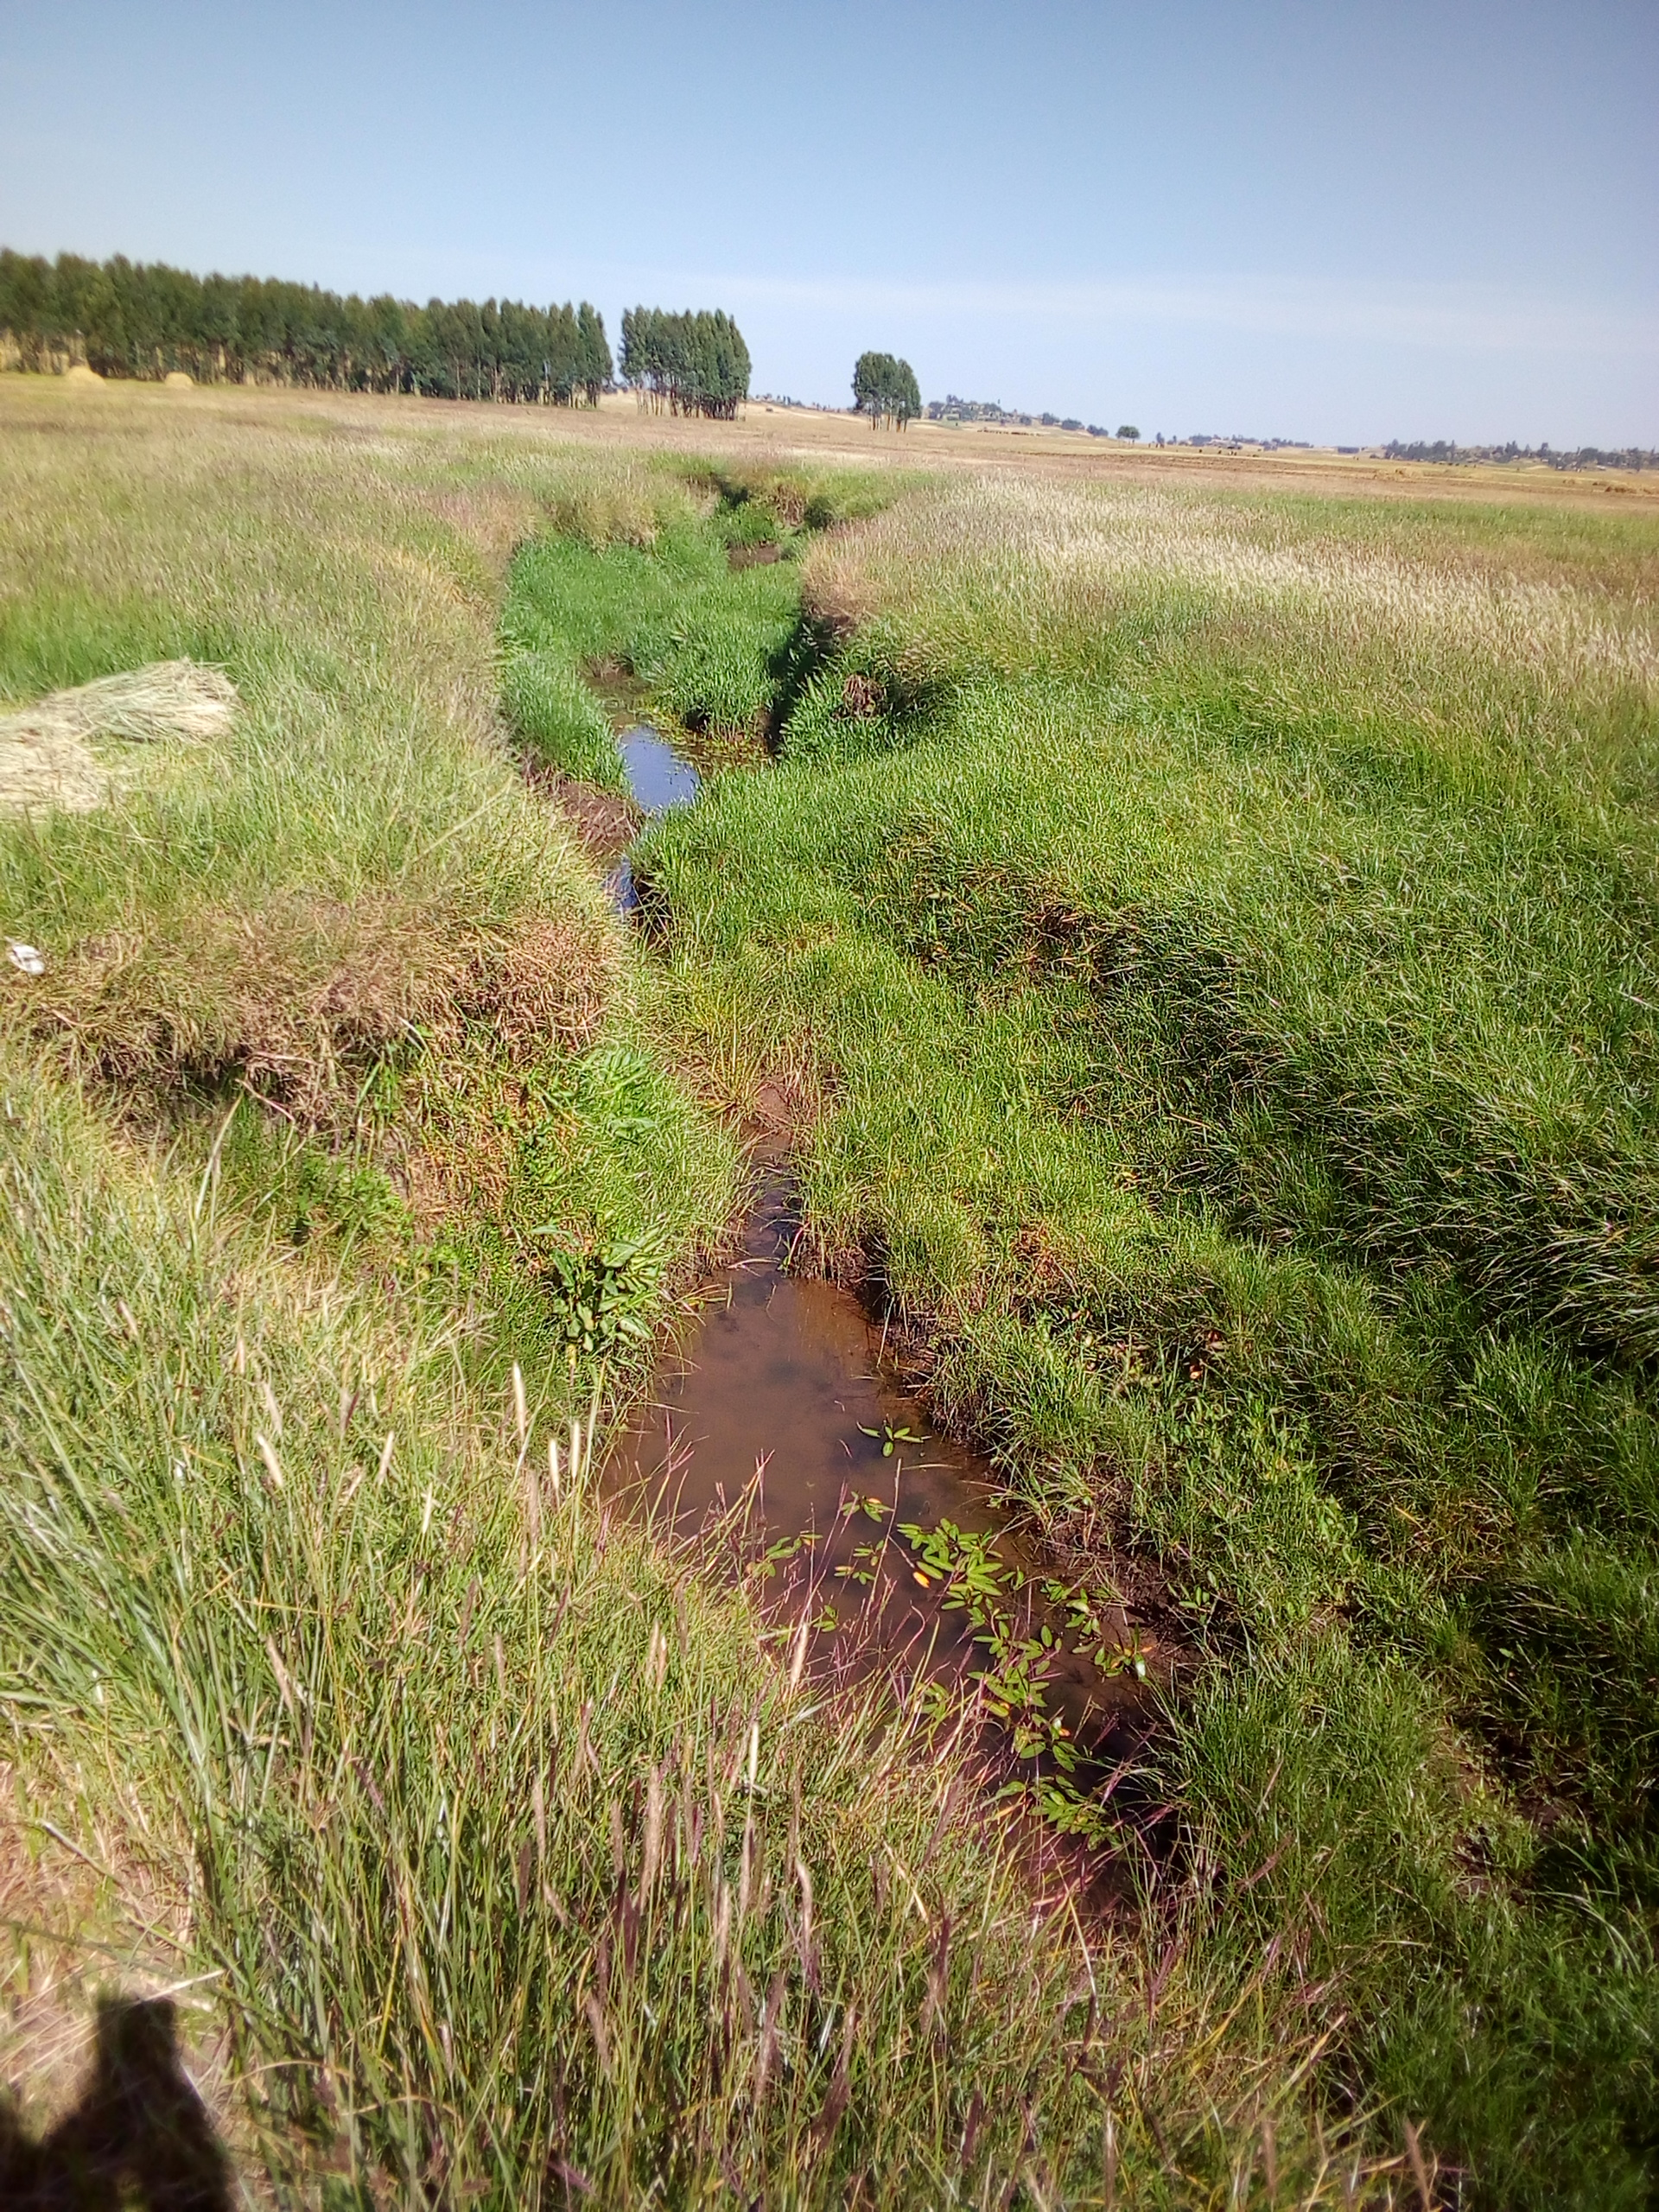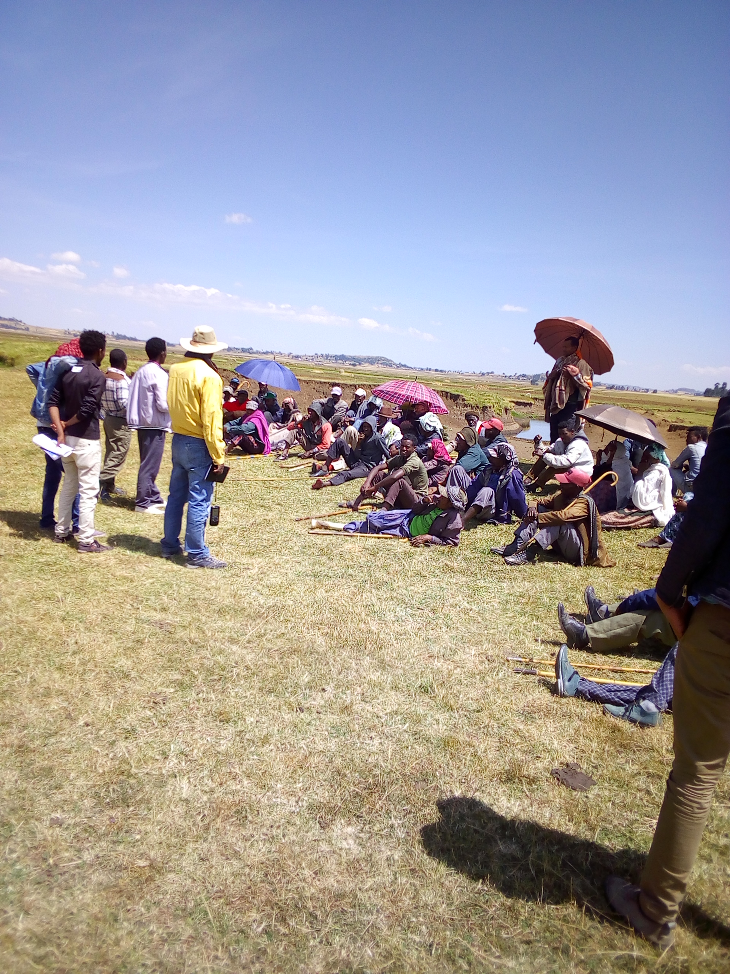

DRAFT IRRIGATION AGRONOMY STUDY REPORT

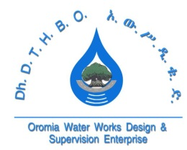
Oromia Water Works Design & Supervision Enterprise (OWWDSE)

TEL.: +251 11 439-21-62/24-7
FAX: 25111 439-20-08
E-mail: owwdse@telecom.net.et

March, 2019
Finfinne

Table of Contents
Table of Contents
List of Tables iii
List of Figures iii
Aleltu Medium Scale Irrigation Project 1
1 Agronomy Study 1
1.1 Background of the study 1
1.2 General Objective of the Study 2
1.2.1 Specific Objectives of the Study 2
1.3 Review of Sector Policies, Strategies and Plans 2
1.3.1 Agriculture Policy 2
1.3.1.1 Food Security Strategy 3
1.3.1.2 Growth and Transformation Plan (GTP II-2015/16-2019/20) 3
1.3.2 Irrigation Policy 4
1.4 Methodology 5
1.5 The Physical Features of the Project Area 6
1.5.1 Agro-climatic Zone of the Specific Area 8
1.5.1.1 Length of Growing Periods 9
1.5.1.2 Rainfall 9
1.5.1.3 Temperature, Relative Humidity and Wind Speed 10
1.5.2 Land Use 12
1.5.3 Existing /Present Agricultural Conditions 12
1.5.4 Existing Crop Calendar (rain-fed agriculture) 13
1.5.5 Major Rain-fed Crops of the Area 14
1.5.6 Livestock Production 16
1.5.7 Existing Agricultural Techniques 18
1.6 Existing Agricultural Problems 18
1.7 Labour Requirement 20
1.8 Irrigated Agriculture Development Plan 20
1.8.1 Crop Selection 21
1.8.2 Cropping Pattern 22
1.8.3 Details of the Selected Crops 22
1.8.3.1 Cereals 23
1.8.3.2 Vegetables 23
1.9 Irrigation Seasons 25
1.9.1 Proposed Management 25
1.9.2 Method of Irrigation 25
1.9.3 Cultivation Activities 26
1.9.4 Fertilizer Management 26
1.9.5 Method of Fertilizer Application 27
1.9.6 Plant Protection 28
1.9.7 Crop Rotation and Intercropping 29
1.9.8 Labor Requirement 29
1.9.9 Area Coverage/Intensity 29
1.9.10 Yield Projection 30
1.9.11 Postharvest Activities 31
1.10 Extension Service 32
1.10.1 Market 32
1.10.2 Timely Input Provision 32
1.11 Crop Water Requirement 32
1.11.1 Calculation procedure 33
1.11.2 Cropwat input data 34
1.11.3 Determination of Evapotranspiration (ETo) 34
1.11.3.1 Evapotranspiration (ETo) 35
1.11.3.2 Crop coefficient (Kc) 35
1.11.3.3 Effective Rainfall (Pe) 37
1.11.4 Irrigation Water Requirement 37
1.11.5 Net irrigation requirements 37
1.11.6 Irrigation Efficiency 38
1.11.7 Field Irrigation Schedules 38
1.11.7.1 Depth of irrigation application (d) 38
1.11.7.2 Irrigation application interval (i) 39
1.12 Suggestion & Recommendation 40
Annex 1.1: AGRONOMY ANNEXES 41

List of Tables
Table 1: Agro-climatological Data for Calculation of LGP 9
Table 2: Land Use Pattern of Jida Woreda and Wanya Dega Nasiri & Siba Sirxi Kebeles 12
Table 3: Fertilizers, Improved Seeds and Agro-chemicals Used by Farmers of the Woreda 13
Table 4: Existing Cropping Calendar of the Project Area (Belg Season) 13
Table 5: Existing Cropping Calendar of the Project Area (Meher Season) 14
Table 6: Major Staple Food Crops of Jida Woreda and the Project Kebeles 14
Table 7: Crops Harvested with rainfall in Jida Woreda in the last three years 15
Table 8: Crops Harvested with Irrigation in Jida Woreda in the last three years 15
Table 9: Livestock Types, Quantities and Diseases in Jida Woreda and the Project Kebeles 16
Table 10: A Hectare of Labor Requirement as a “Without Project” Condition for Major Crops 20
Table 11: General recommended crop mix for major agro-ecologies of Ethiopia 21
Table 12: Crops Selected for Dry Season Irrigation Development 22
Table 13: Method of Irrigation and Spacing for the selected crops 26
Table 14: Major cultivation activities in irrigated agriculture 26
Table 15: Required fertilizers & other agrochemicals planned for each proposed crop 27
Table 16: Methods of fertilizer application for the proposed crop types 27
Table 17: Chemical & non-chemical plant protection methods for the proposed crops 28
Table 18: A hectare of labor requirement as a “With-Project” condition 29
Table 19: A 5-year cropping pattern/intensity plan 30
Table 20: Yield Projection for five (5) year/season production period 30
Table 21: Duty of Dry-season cultivation 33
Table 22: Crop development stage and crop coefficient for proposed crops 37

List of Figures
Figure 1: Partial view of the command area 7
Figure 2: Aleltu River at proposed weir site 8
Figure 3: LGP graph of the project area 9
Figure 4: Trend of mean monthly Rainfall and Effective Rainfall of the stud area 10
Figure 5: Mean monthly max, and min temperatures of the stud area 11
Figure 6: Mean monthly relative humidity and wind speed of the project area 11
Figure 7: Land Preparation Process for Traditional Irrigation Activities 16
Figure 8: Livestock Production in the project area 17

Aleltu Medium Scale Irrigation Project

Agronomy Study

Background of the study
The Agriculture sector in the country plays the entire and dominant role in the food supply, job opportunity and income sources of the population; accounting for about 38.5 percent of GDP as compared to 15.1 percent from Industry, and 46.3 percent from Services (NPC, 2016); while contributing almost 80 percent of export earnings and employing 80 percent of the population (Irrigation Agronomy Guideline 2011, Ministry of Agriculture). Many other economic activities depend on agriculture, including marketing, processing, and export of agricultural products. Currently incompatibility of growth in food production and population coupled with periodic occurrence of drought has ascended the importance of irrigation development in the country. Even though, Oromia has a number of potential perennial rivers and wider landmass which can be used for irrigation development, dependency on rain-fed agriculture coupled with the erratic nature of rainfall is one of the causes of widespread food insecurity observed in some parts of the region. To this effect, the farmers in agriculture sector, which is featured by low input and low output production methodologies and low rainfall conditions, could not able to meet the food requirement of the ever increasing population. In other words, the available natural resources of the country have not been properly exploited so far to meet the increasingly high demand of the country for food, raw material for domestic agro-industries and for export market. Considering these facts, concerted efforts are being made at the moment both at national as well as regional levels to transform the prevailing subsistence production system to high value and market oriented production system. One of the efforts exerted in this line embarks on the judicious use of the available irrigation water potential found in different parts of the country. It is through irrigation and integrated crop development that sustainable crop production can be ensured. In this view, the feasibility study of Aleltu Medium Scale Irrigation Development Project was carried out in Jida district North Shewa Zone of Oromia National Regional State to develop 266 hectares of command area.

Irrigated agriculture plays an important role in sustainable crop production in areas where the climatic variation and poor distribution of rainfall exists. The predominant agricultural system is based on smallholder production and the crop production is entirely dependent on rainfed agriculture with limited areas currently developed under irrigation. The natural supply of water to the agricultural land for crop production purpose is usually received from natural sources such as precipitation/rain, other atmospheric water, ground water and flood water. The proposed command area is flat land and there is serious waterlogging problem during the rainy season. On this command land crop production activities during the wet-season is totally hardly possible. The only option that the community has for crop production purposes is the use of the available surface water resources for irrigation during the dry season.

General Objective of the Study
The overall goal of the study is to increase production and productivity of the area through introduction of modern irrigated agriculture which is environmentally suitable, economically feasible and sustainable and identifying crops that are adaptable to the area and suitable for added food security/nutritional value and/or have market potential. Some 1064 households (about 0.5ha/HH) which could be about 5320 people (about 5 family sizes per household) will be direct beneficiaries of the irrigation development.

Specific Objectives of the Study
The specific objectives of Agronomy study of this irrigation project include:
- evaluation of the existing agricultural situation of the study area,
- investigation of the agricultural suitability of soils, and climate for the proposed project,
- identification of the existing physical environment of the study area,
- identification and evaluation of crop production constraints of the study area,
- selection of suitable crops with important agronomic practices and supporting services for the crops grown under irrigation, and
- determination of crop-water requirement and irrigation scheduling for the proposed crops.

Review of Sector Policies, Strategies and Plans

Agriculture Policy
The focus of agricultural policy has been to:
- Increase food security
- Increase the supply of agricultural raw materials to the local industry
- Expand the local manufacturing industries to supply the rural areas, and
- Increase foreign exchange earnings
As part of the agricultural development policy, Ethiopia’s food security strategy was first issued in 1996 and updated in 2001. It has been observed that food insecurity is one of the defining features of rural poverty affecting millions of people, particularly in moisture deficit areas. Both chronic and transitory problems of food insecurity exist. The government is tackling food deficit problem through the introduction of: i) small, medium and large-scale irrigation; ii) drought resistant and early maturing varieties and with water harvesting technology; iii) soil conservation and environmental protection; iv) improved harvesting, handling and storage facilities.

Food Security Strategy
Food security is manifested directly in three security components: adequacy of supply (production, reduction of post-harvest loses), stability of supply (production and price stability), and access to supply (increase purchasing power of households and access to employment).
The consequences of food insecurity are reflected in the high level of malnutrition. The first version of food security strategy (FSS) was prepared in 1996 and has been revised as required by the national government. For instance, the revised FSS (2002) targeted mainly to the chronically food insecure, moisture deficit and pastoral areas, water harvesting and introduction of high value crops, livestock development were key development issues in the revised strategy.
In 2004 the new coalition for food security prepared a food security program that was more comprehensive and detailed than the earlier ones. The goal of the food security program is to drastically reduce food insecurity faced by vulnerable households. Its objective is to attain food security of the chronically food insecure population and significantly improve and sustain overall food security of population within five years.

Growth and Transformation Plan (GTP II-2015/16-2019/20)
The GTP II (2015/16-2019/20) has been formulated to carry forward the basis, objectives and strategic directions of GTP I. The achievements gained, challenges faced and lessons drawn from the implementation of GTP I was the bases for the formulation of GTP II. Nevertheless, with pertaining to irrigation development GTP II has its own distinguishing features. In GTP II period, agriculture will remain the main driver of the rapid and inclusive economic growth and development. It is also expected to be the main source of growth for the modern productive sectors. Therefore, besides promoting the productivity and quality of staple food crops production, special attention will also be given to high value crops, industrial inputs and export commodities. To this end irrigation based agriculture, horticulture, fruits and vegetables, livestock and Fisheries development will be promoted. Designing and providing support schemes to smallholder farmers where peasants and pastoralists are the main actors in the production process; and facilitating a joint participation of educated young farmers and private investors in the sector are strategic directions that will be pursued during the plan period. To this end, addressing constraints entrenched in the agricultural development and marketing systems will be given utmost emphasis and priority.
Fundamentals of the strategy include the shift to produce high value crops, a special focus on high-potential areas, facilitating the commercialization of agriculture, supporting the development of large-scale commercial agriculture where it is feasible. In addition, small, medium and large scale irrigation development and dam constructions were also targeted to be undertaken and strengthened by federal and regional government institutions. Increasing the area of land covered with irrigation from 2.34 million hectare in 2014/15 to 4.143 million hectares by the end of 2019/20 was set as the major targets with respect to irrigation development. As a result over 1,743,000 hectare additional irrigated land has been targeted to be developed during the plan period and providing access to at least one alternative water point for 80% of smallholder farmers (semi-pastoralists) of which 50% are users of the full irrigation farming package.

Irrigation Policy
1. Ensure the full integration of irrigation with the overall framework of the country's socio-economic development plans, and more particularly with the Agricultural Development Led Industrialization (ADLI) Strategy.
2. Promote the development of irrigation on two- pronged approaches of, i) strategic planning for achieving socio-economic goals, and ii) participatory-driven approach for promoting efficiency and sustainability.
3. Recognizing that irrigation is an integral part of the water sector and consequently develop irrigation within the domain and framework of overall water resources management.
4. Earmark on a reasonable percentage of the GDP as committed resource towards the development of irrigated agriculture, especially in capacity building and infrastructures.
5. Promote decentralization and users-based management of irrigation systems taking in to account the special needs of rural women in particular.
6. Develop a hierarchy of priority schemes based on food requirements, needs of the national economy and requirements of raw materials and other needs.
7. Support and enhance traditional irrigation schemes by improving water abstraction, transport systems and water use efficiency.
8. Ensure the prevention and mitigation of degradation of irrigated water and maintain acceptable water quality standards for irrigation.
9. Establish water allocation and priority setting criteria based on harmonization of social equity, economic efficiency and environmental sustainability requirements.
10. Integrate the provision of appropriate drainage facilities in all irrigated agriculture schemes.
11. Enhance greater participation by the Regional and Federal Governments in the development of large scale irrigated farms in high water potential basins, but with low population density (Ethiopian Water Sector Policy, 2001).

Methodology
The methods used in the study mainly focused on document review on related works and review of government policies and strategies on agriculture and irrigation as pre-field work, and direct field observation with full participation of the target community members of the proposed area as field work. Primary data were collected by employing quantitative and qualitative methods, generated through household survey that involves structured questionnaires, key informant interviews, focus group discussions and direct field visits. Secondary data were collected from different sectors of the district development structures such as Jida district agriculture office, Irrigation development office, cooperative office, livestock and fishery development office, market development office, land use and rural land administration office, and the development agents (DAs) offices of the kebeles in which the proposed irrigation scheme is located. Holeta and Debre Zeyit Agricultural Research Centers and other stakeholders have also been consulted and have a great part in contributing and providing data during the consultation period. Discussion among the study crew members has also been made in the field assessment activities. In the post-field work the collected information was processed, analyzed and critically evaluated for developing the suitable agricultural production development plan. For data analysis, simple statistical models such as means, coefficient of variations, and standard deviations were used which were computed using SPSS 16.0 for Windows software. The water requirement of duly selected crops and cropping pattern was worked out considering nearest station for representative meteorological parameters, crops and cropping factors, soil factors, etc. Meteorological elements for crop water assessment had been collected from pertinent stations and missing meteorological data had been in-filled by missing data models. In general, the water requirement was computed following standard scientific procedures as suggested by FAO Irrigation and Drainage, Paper No. 56 and data processing and modeling for crop water requirement was undertaken by modified method of Penman-Monteith using CropWat-8.0 software for windows.

The Physical Features of the Project Area
The specific command area is found at the hill bottom in flat and plain landforms at a slope range of 0-2% and an average altitude of 2647m.a.s.l at the assumed center of the command area. This area is surrounded by hilltop areas, especially in the southern, eastern and western parts. Few indigenous scattered big trees and some more eucalyptus plantations are observed in the command area as well as on the hill surfaces surrounding the command area. Crops such as barley, wheat, F. bean, lentil, linseed, oats and some other horticultural crops are cultivated on and around the command area with rainfall and traditional irrigation. The net command area is 266ha and the soil of the command area is dominantly heavy clay in texture having average pH values ranging from 5.3 to 6.7 with high water holding capacity and low to fair infiltration rate. The upper horizon (25 to 30 cm) has almost partially granular structure and when goes downwards blocky to partially platy structures are observed. Black to brown color is dominant with sufficient agricultural depths. When wet is sticky and hard during it dries. As a general soil order, the area soil falls under alluvial Vertisols which are deposited from the highlands of the catchment for a certain period of years and seems rich in organic matter (humus) from the decomposition of grassy and bushy vegetation debris and other related materials. The primary clay mineral seems a mixture of micas and vermiculites which has a medium bondage between soil particles. This condition helps the soil structure to have a fair water movement during watering the soil. Generally, from physical condition and existing crop stand observation of the project area, the soil is suitable for most agricultural crops with minimum mitigation measures during the dry season. The detail chemical and physical analyses can be referred on the soil study report of the project document.
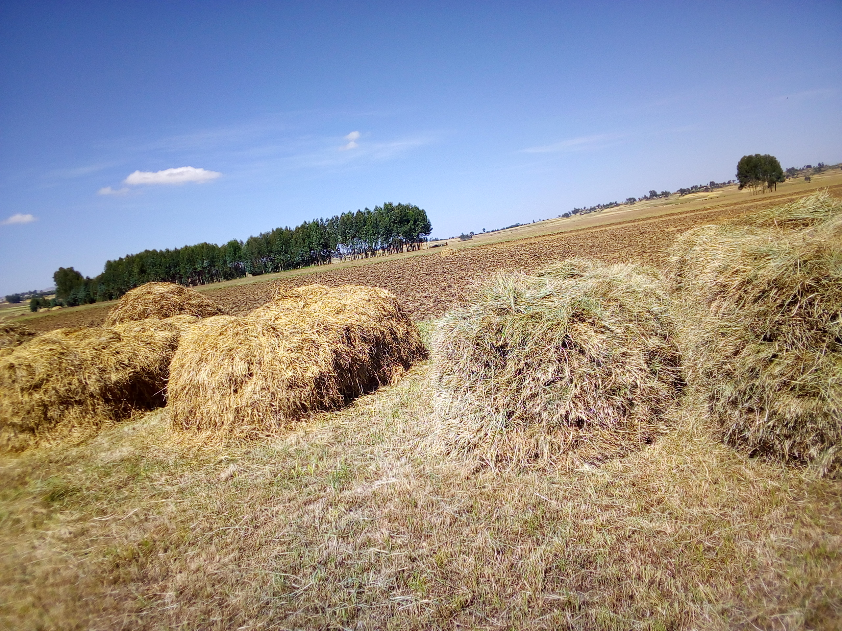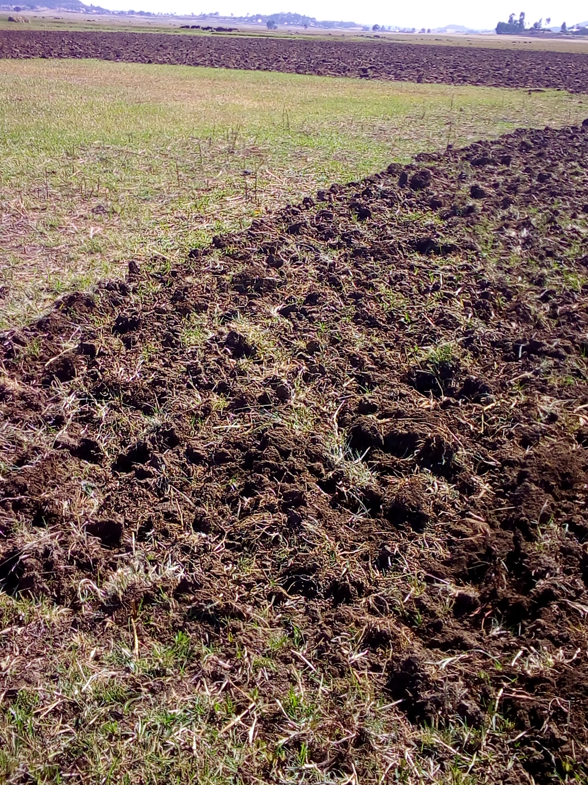
Figure 1: Partial view of the command area

The water source of the future irrigation development is Aleltu River which emanates from the swampy area under Mountain, a bit far away at south direction from the command area, and it flows to north direction to join Jema River, and eventually flows to the north to join the Abay River. During the assessment period the flow rate of the river is optimum and it can supply the required amount of water to the whole command areas of the proposed irrigation development project. The proposed water abstraction method is gravity (diversion) on both sides of the river with furrow irrigation system. As it is observed during the field assessment and secondary data collected from the relevant parties, the area is waterlogged during the wet-season and requires some sub-surface drainage for small scale irrigation scheme development.
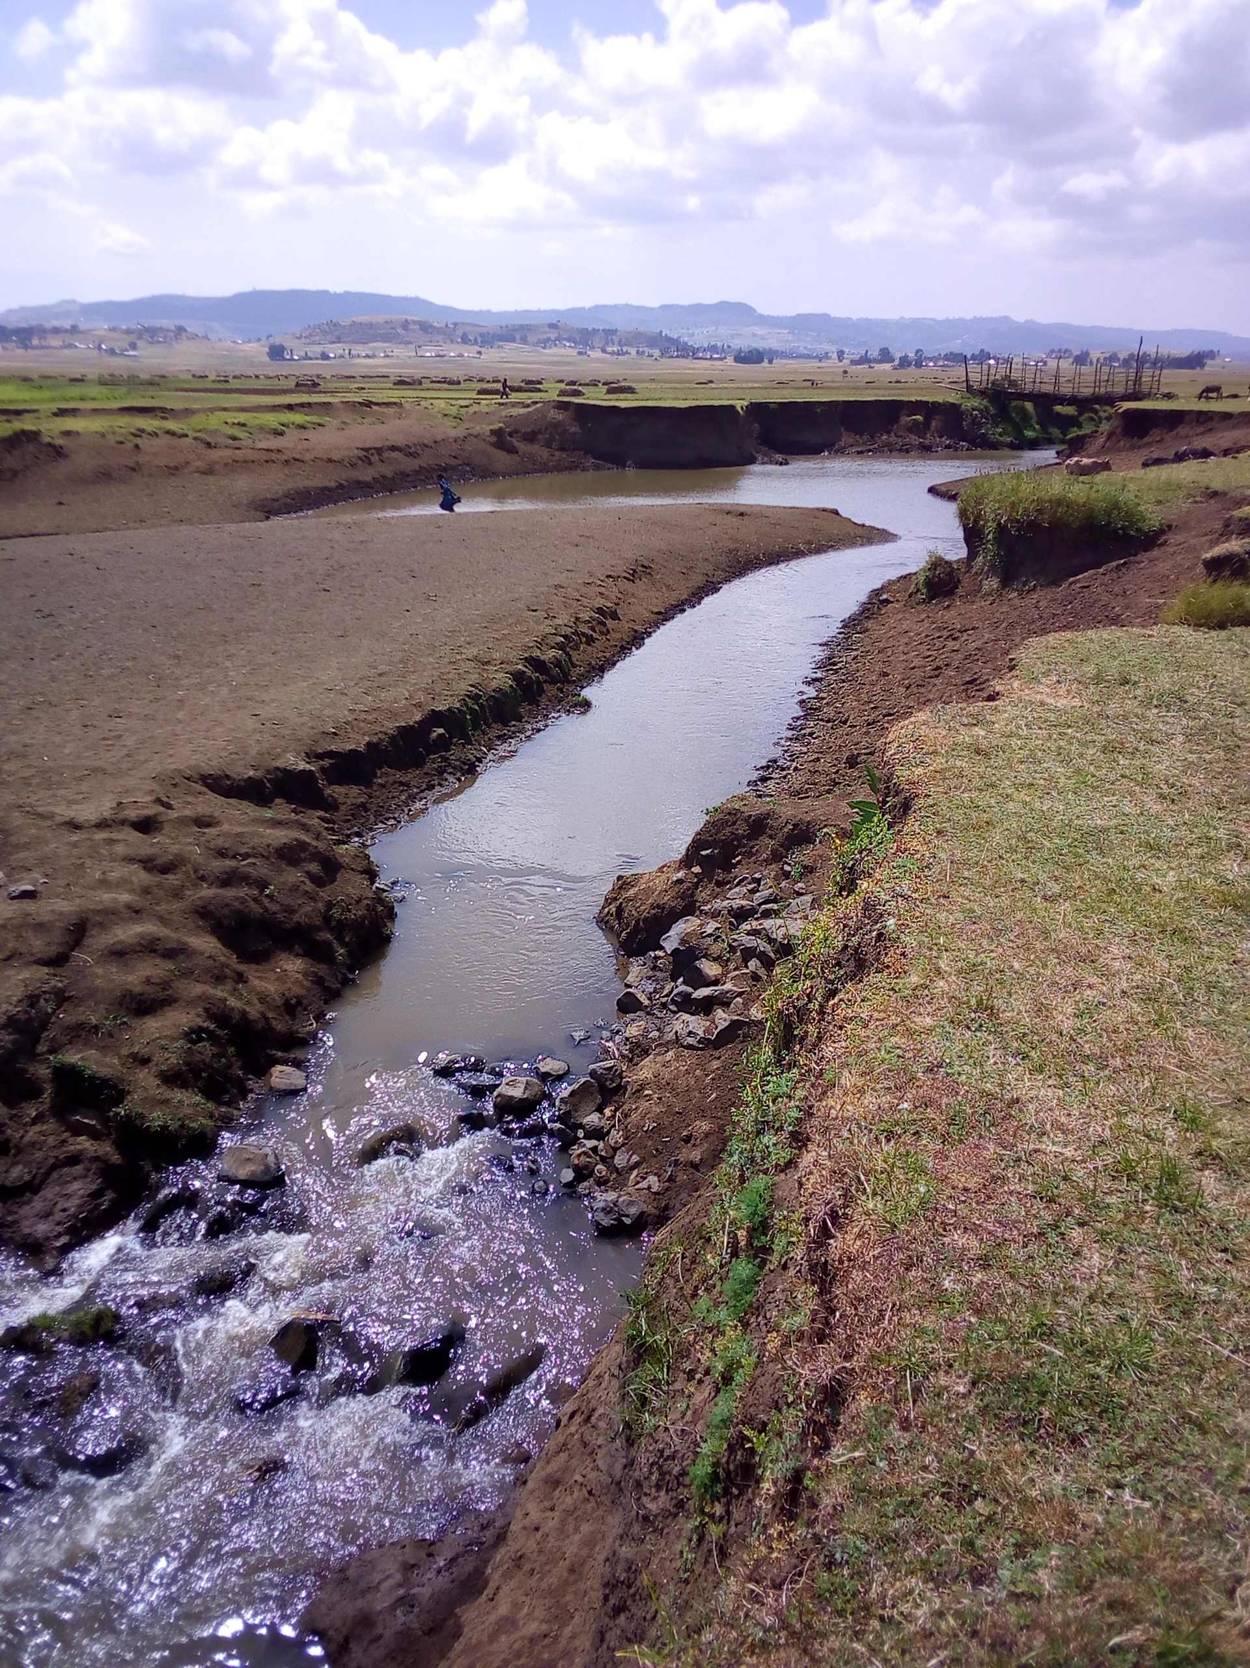
Figure 2: Aleltu River at proposed weir site

Agro-climatic Zone of the Specific Area
The command area is located in Wanya Dega Nasiri and Siba Sirxi kebeles of Jida woreda North Shewa Zone of Oromia Regional State at about 85km (at headwork site) north of Finfinne (Addis Ababa) city, about 58km from zone town (Fiche), about 1.5 km east of Sirxi town, the capital of this woreda, and about 36.5 km away from the main asphalt road that runs through Finfinne to Debre Birhan. The area is found in the temperate sub-humid highland agro-ecological zonation at an average altitude of 2647masl with crops having 120 to 180 days of growing period (LGP) based on type of crops and varieties to be produced. Meteorological data were obtained from Sendafa National Meteorology Station which is found at an average altitude of 2569m.a.s.l and at about 10km air distance from the command area. All necessary climatic data for crop water requirement computation were obtained from this station.

Length of Growing Periods
Growing period describes the period in which conditions for plant growth are adequate, in this case defined by the availability of soil moisture. It is estimated in days from the beginning to the end of crop growth. The length of this period is crucial to the satisfactory development and maturation of the crops. As can be observed from (Table 1 & Figure 3) below in the proposed project area the amount of rainfall below half of the potential evapotranspiration is more than four months in a year. In this area irrigation development is possible in larger months as dry-season or as supplementary in a year.
Table 1: Agro-climatological Data for Calculation of LGP
Climate Fac. | Unit | Months
Climate Fac. | Unit | Jan | Feb | Mar | Apr | May | Jun | Jul | Aug | Sep | Oct | Nov | Dec
P.RF | mm/M | 19 | 50 | 71 | 90 | 95 | 118 | 250 | 265 | 169 | 41 | 9 | 14
PET | mm/M | 108.9 | 116.1 | 123.9 | 118.2 | 119.4 | 100.2 | 85.5 | 88.5 | 100.8 | 118.8 | 118.2 | 111.9
0.5PET | mm/M | 54.45 | 58.05 | 61.95 | 59.1 | 59.7 | 50.1 | 42.75 | 44.25 | 50.4 | 59.4 | 59.1 | 55.95

Figure 3: LGP graph of the project area

Rainfall
Rainfall needs to be examined in terms of its ability to satisfy crop requirements. By comparing the results with the potential evapo-transpiration the water available to crops could be determined. For example a positive difference between rainfall and potential evapo-transpiration for the greater part of a growing season would ensure good crop growth. A negative result during the critical growing season would indicate insufficient moisture for that crop or the need for irrigation. On the other hand, an excess of precipitation over the potential evapo-transpiration during the wet season would indicate the importance of drainage. A study of the rainfall intensity (quantity over a given period of time) would give an indication of the potential water erosive or of the runoff to be expected and of the dimensions which would have to be given to surplus water disposal channels, etc. Some qualitative aspects of precipitation are also worthy of attention: for example, the duration and frequency of hail storms, in relation to the periods when the land is occupied by crops, or the occurrence of rain storms associated with strong winds, etc. As the data collected from Sendafa National Meteorology Station shows the project area (Aleltu project site) has an average annual rainfall of 1191mm, mono-modal type, evenly distributed over more than six months. From this the highest rainfall is recorded in the month of August, and the lowest is recorded in the month of November.

Figure 4: Trend of mean monthly Rainfall and Effective Rainfall of the stud area

Temperature, Relative Humidity and Wind Speed
Air temperature and relative humidity are the most important climatic variables that affect plant life. Each species and variety of plants and each age group of plants has its own upper and lower temperature limits. Beyond these limits, a plant becomes considerably damaged and may even be killed. Relative Humidity (RH), the water vapor contained in the atmosphere, is expressed as the percentage of the ratio of actual to saturation vapour pressure. This, together with wind, gives an indication of drying power of the air important for drying and storage of crops while fluctuations in values often affect the incidence of plant diseases as well as the safe storage of harvested crops. Therefore, temperature, relative humidity and wind speed should be considered while dealing with agricultural planning of an area. Monthly max., min. and average temperatures are 22.9⁰c, 10.7⁰c & 16.8⁰c, respectively. The hottest month is March and the coldest one is December.

Figure 5: Mean monthly max, and min temperatures of the stud area

Figure 6: Mean monthly relative humidity and wind speed of the project area

As can be seen from the above table the amount of wind speed is higher in almost nine months than the relative humidity, indicating there is high crop evapotranspiration and high crop water demand in these months.

Land Use
The land use pattern is mainly composed of an extensive grazing, subsistence type of agriculture and scattered settlement, situated within different landforms. The major land use types in and around the command area include cultivated land, and grazing (fallow) land. Among the use types, grazing land takes the largest proportion (85%) followed by cultivated land (15%). On the cultivated command lands about 90% is cropped to barley, and the remaining land is cropped to some vegetable crops such as garlic, potato, cabbage, and others with traditional farming system during the field assessment period. Average landholding size per household is about 1.5ha in the project kebeles. According to the information obtained from the woreda agriculture and DA offices, the following land use patterns for the woreda and the project areas are identified.
Table 2: Land Use Pattern of Jida Woreda and Wanya Dega Nasiri & Siba Sirxi Kebeles
S/N | Types of Land Use | Jida Woreda |  | Wanya Dega Nasiri Kebele |  | Siba Sirxi Kebele
S/N | Types of Land Use | (ha) | (%) | (ha) | (%) | (ha) | (%)
1 | Arable land | 21,114 | 43.26 | 2195 | 48.97 | 1267 | 58.20
2 | Cultivated | 16,048 | 76.0 of arable land | 1889 | 86.1 of arable land | 761 | 60.1 of arable land
3 | Grazing land | 24,602 | 50.41 | 2060 | 45.96 | 813 | 37.34
4 | Settlements | 2472 | 5.06 | 203 | 5.01 | 55 | 2.53
5 | Forest lands (including bushes & shrubs) | 576 | 1.18 | 11 | 0.25 | 42 | 1.93
6 | Other land | 40 | 0.08 | 13 | 0.29 | --- | ---
 | Total | 48,804 | 100 | 4482 | 100 | 2177 | 100
Source: Jida Woreda Agriculture Office, Wanya Dega Nasiri & Siba Sirxi Kebeles DAs offices

Existing /Present Agricultural Conditions
Agriculture is the mainstay of the community at the project area. Traditional crop-livestock mixed farming practices, subsistence type of farming and high dependence on natural rainfall dominate the sector. Even though the command area is swamp land during the rainy season traditional irrigation agriculture is well known by the community in and around the command area during the dry season. As information obtained from the farmers during community consultation and kebeles DA offices at a specific project area crops such as barley (major), garlic, cabbage, onion, beetroot and lettuce are produced using small scale traditional irrigation on some part of the command area.

As witnessed by the local farmers the use of improved agricultural technologies such as improved seeds and fertilizers is not adequately well practiced on both irrigated and rain-fed crops production. The supply and distribution of improved seeds and fertilizers to farmers in the woreda for rain-fed crop production shows negligible for the last three years. This might be mainly due to the weak extension activities given to the farmers to use improved agricultural inputs and most land is recently put under cultivation as the area is largely covered with natural grasses used for animal feed. Some of the kebeles are not easily accessible during the wet season, less road network and far away from the main asphalt road. The following table shows the supply and distribution trend of these improved agricultural technologies for the last three years.
Table 3: Fertilizers, Improved Seeds and Agro-chemicals Used by Farmers of the Woreda
S.N | Input Type | Unit | 2008 | 2009 | 2010
1 | Fertilizer
 | NPSB | Qt | 2423 | 1300 | 1489
 | Urea | Qt | 1340.5 | 1484 | 1577
 | Total Fertilizer |  | 3763.5 | 2784 | 3066
2 | Seed
 | Barley | Qt | 38.5 | --- | ---
 | Wheat | Qt | 263 | 45 | 47.5
 | F. bean | Qt | 10 | 5 | ---
 | Total Seed |  | 311.5 | 50 | 47.5
3 | Agro-chemicals
 | 2,4-D | Lt | 1000 | 500 | 469
 | Pallas 45 | Kg | 225 | 168 | 119
 | Natura | Lt | 30 | 270 | ---
 | Dimethoate | Lt | 180 | 110 | 130
 | Total Chemical |  | 1435 | 1048 | 718
Source: Jida Woreda Cooperative office

Existing Crop Calendar (rain-fed agriculture)
Length of growing period of the crops is mainly determined by the area agro climatic conditions. As indicated before, agro-climatic zonation for this particular area is humid tropics (more of cool highland) having mono-modal, but sufficient rainfall distribution with scattered trees, bushes and shrubs on and surrounding the command area. Hence, generally crops growing with such type of climatic conditions have relatively a longer LGP (Total Growing Period) of 130 to 180 days based on crop type and varieties. As the information obtained from woreda agriculture office, the project area development offices, and from the interview of focal farmers indicated the following cropping calendar is presented for the rainy season.
Table 4: Existing Cropping Calendar of the Project Area (Belg Season)
S/N | Crops | Time of Land preparation | Ploughing frequency | Sowing date | Harvesting date
1 | Barley | December | 2-3 | Late January | Mid May. to Mid June
2 | F. pea | January | 1-2 | Late January | Mid May. to Mid June
*Source: Jida Woreda, Wanya Dega Nasiri & Siba Sirxi Kebeles and Farmers Interview.
Table 5: Existing Cropping Calendar of the Project Area (Meher Season)
S/N | Crops | Land preparation | Ploughing frequency | Sowing date | Harvesting date
1 | Barley | Mar. to May | 3-4 | Mid May to Mid-June | Mid Oct. to Late Nov.
2 | Wheat | Mar. to May | 3-4 | Late May to Late June | Early Nov. to Dec.
3 | Teff | May – June | 4-5 | Early July | November
4 | E. Wheat | Mar. to May | 3-4 | June | November
5 | F. bean | May | 2-3 | June | November
6 | Lentil | May | 2-3 | June | October
7 | Linseed | May | 1-2 | Late May | Early December
*Source: Jida Woreda, Wanya Dega Nasiri & Siba Sirxi Kebeles and Farmers Interview.

Major Rain-fed Crops of the Area
As the soil and climate is suitable for a wider variety of crop types, different crops and varieties (dominantly barley) are growing by farmers of the kebele in the project area. However, improved technologies are not fully and adequately utilized, mainly because of inadequate extension services rendered to the farmers, weak interest of the farmers to use improved technologies, inaccessibility of the area during the wet season, insufficient supply, poor distribution and unaffordable price of the improved agricultural technologies. According to the data obtained from the woreda Agriculture Office and the nearby DA Centers, the information about the last cropping season (Meher and Belg) has been compiled in the following table.
Table 6: Major Staple Food Crops of Jida Woreda and the Project Kebeles
S/N | Major crops (rain-fed) | Jida Woreda |  |  | W. D. Nasiri Kebele |  |  | Siba Sirxi kebele
S/N | Major crops (rain-fed) | Area Coverage |  | Yield, | Area Coverage |  | Yield, | Area Coverage |  | Yield
S/N | Major crops (rain-fed) | (ha) | (%) | (qt/ha) | (ha) | (%) | (qt/ha) | (ha) | (%) | (Qt/ha)
1 | Teff | 902 | 8.02 | 12.9 | 82 | 6.93 | 7.0 | 53 | 6.92 | 17.0
2 | Wheat | 2177 | 19.35 | 29.9 | 373 | 31.53 | 9.1 | 192 | 25.06 | 21.4
3 | Barley | 6277 | 55.78 | 38.3 | 563 | 47.59 | 8.5 | 281 | 36.68 | 27.5
4 | F. bean | 839 | 7.45 | 16.6 | 109 | 9.21 | 7.1 | 59 | 7.70 | 8.0
5 | Lentil | 694 | 6.17 | 4.3 | 51 | 4.31 | 7.0 | 35 | 4.57 | 6.0
6 | Potato | 281 | 2.50 | 249.4 | 3 | 0.25 | 53.3 | 88 | 11.49 | 94.2
7 | Cabbage | 82 | 0.73 | 122.0 | 2 | 0.17 | 55.0 | 58 | 7.57 | 98.7
Source: Jida Woreda Office of Agriculture and Development Agents’ Offices of the project kebeles
From the above table, it can be understood that crops like barley, wheat, teff, potato, and F. bean are widely grown in the woreda and project areas as well. The above condition is also confirmed by the Woreda Office of Agriculture and Development Agents Centers of the project kebeles. As the information obtained from the Woreda indicated, almost all types of field crops are growing in the woreda and the project kebele.
Table 7: Crops Harvested with rainfall in Jida Woreda in the last three years
S/N | Crops harvested | 2008 |  | 2009 |  | 2010
1 | Cereals | Area (ha) | Total prod. (qt) | Area (ha) | Total prod. (qt) | Area (ha) | Total prod. (qt)
1.1 | Teff | 621 | 7560 | 858 | 12,012 | 902 | 11,648
1.2 | Wheat | 3086 | 75,307 | 3137 | 97,494 | 2177 | 65,150
1.3 | Barley | 2632 | 81,586 | 2888 | 76,704 | 2617 | 63,701
1.4 | E. Wheat | 369 | 5438 | 370 | 5550 | 299 | 4091
1.5 | Triticale | 280 | 4821 | 228 | 3879 | 115 | 2011
2 | Pulses
2.1 | F. bean | 965 | 17,392 | 1088 | 19,576 | 839 | 13,938
2.2 | F. pea | 713 | 9731 | 676 | 9464 | 971 | 11,411
2.3 | Lentil | 656 | 7520 | 656 | 7872 | 695 | 7984
3 | Oilseeds
3.1 | Linseed | 565 | 7381 | 556 | 5085 | 579 | 6519
*Source: Jida Woreda Office of Agriculture

According to the table above it can be concluded that wheat, barley, and teff are widely produced from cereal crops and cover the largest portion of arable land. Other crops such as F. bean, F. pea, lentil and linseed are largely harvested from the pulses and oilseed crops, respectively. The productivity of these crops is stagnant from year to year from almost constant land units. On the other hand, the following crops have been harvested with traditional irrigation development in Jida Woreda for the last three years, which could be used as baseline for the proposed irrigated agriculture development.
Table 8: Crops Harvested with Irrigation in Jida Woreda in the last three years
S/N | Crops harvested | 2007/8 |  | 2008/9 |  | 2009/10
1 | Cereals | Area (ha) | Total prod. (qt) | Area (ha) | Total prod. (qt) | Area (ha) | Total prod. (qt)
1.1 | Barley | 3257 | 157,295 | 3457 | 166,914 | 3660 | 176,758
2 | Roots & Tubers
2.1 | Potato | 214 | 21,396 | 277 | 27,652 | 281 | 69,686
2.2 | Carrot | 201 | 11,041 | 222 | 12,245 | 31 | 4881
2.3 | Beetroot | 66 | 6910 | 92 | 9119 | 40 | 4319
3 | Vegetables
2.1 | H. Cabbage | 86 | 10,494 | 84 | 10,149 | 82 | 10,002
2.2 | L. Cabbage (Kale) | 109 | 16,710 | 100 | 15,875 | 50 | 7005
2.3 | Lettuce | 46 | 6562 | 43 | 6221 | 26 | 3857
2.4 | Spinach | 29 | 2617 | 26 | 2069 | 1.25 | 127
2.5 | Garlic | 225 | 14,665 | 211 | 13,823 | 282 | 18,683
*Source: Jida woreda irrigation development office.

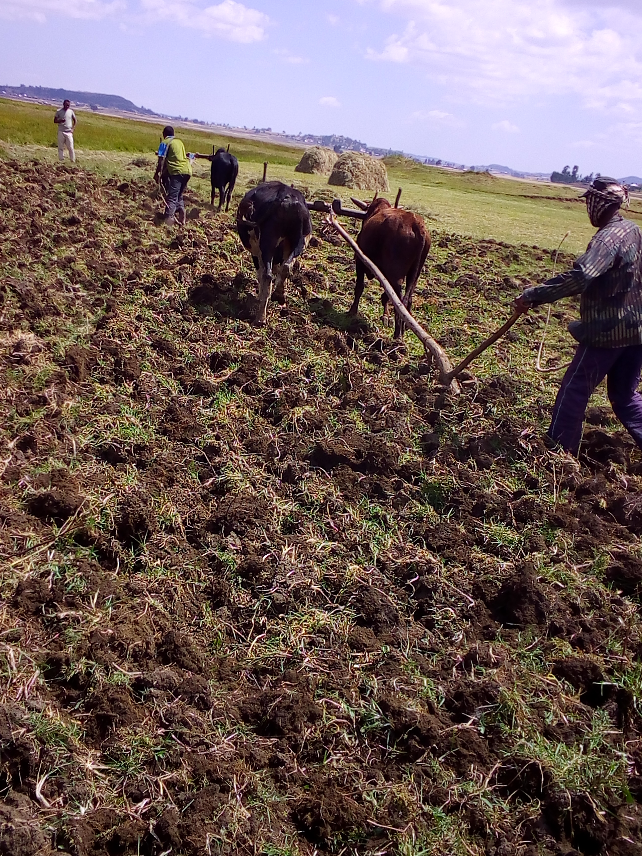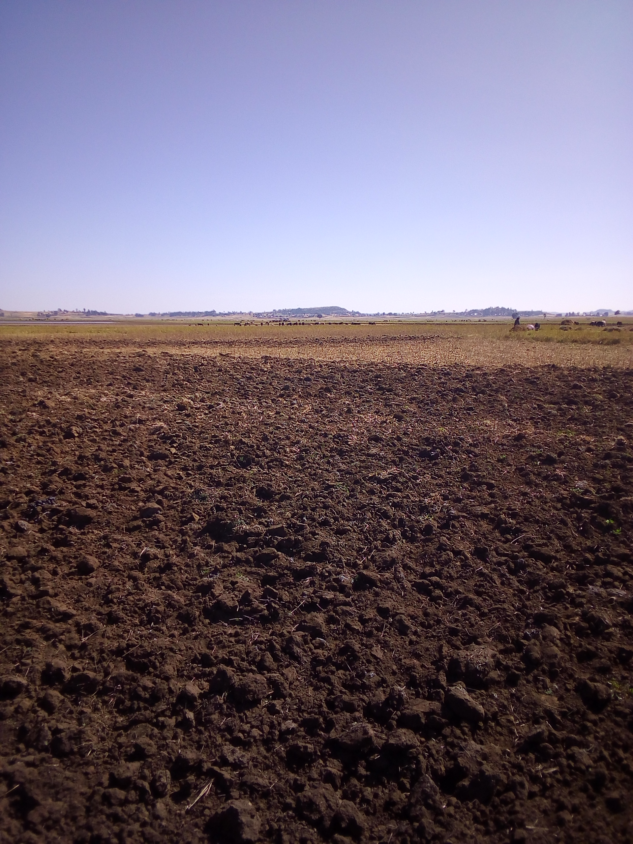
Figure 7: Land Preparation Process for Traditional Irrigation Activities

Livestock Production
Livestock production is a major component of the farming system. It is also one of the economic activities for traction powers, provision of dairy products, transportation and for household income generation. Oxen are selected for speed and endurance in pulling traditional ploughs. Small ruminants and chickens are generating additional incomes for the community. Beekeeping is not a common practice in the area; however, traditional beekeeping is exercised by few farmers. Modern beekeeping is not as such significantly practiced, but small scale activities are there in few pocket areas. Equines serve as means of transport for human beings and agricultural products. The major type and quantities of livestock in Jida Woreda and the project Kebeles are indicated below.
Table 9: Livestock Types, Quantities and Diseases in Jida Woreda and the Project Kebeles
S/N | Jida Woreda |  | W.D.Nasiri Kebele | Siba Sirxi Kebele | Livestock Diseases of the area
S/N | Livestock | Qty | Qty | Qty | Livestock Diseases of the area
1 | Cattle | 182,092 | 8407 | 4260 | Foot & Mouth disease (FMD), Anthrax, Blackleg, Bovine and Ovine Pasturollosis, sheep and goat pox, Senoryosis, AHS, endo and ecto parasites (Faciolla), Newcastle, Coccidiosis, fowl typhoid, etc.
2 | Sheep | 160,092 | 23,640 | 6220
3 | Goats | 2758 | 230 | 46
4 | Horses | 25,482 | 1301 | 320
5 | Donkeys | 22,936 | 1630 | 325
6 | Mules | 2999 | 223 | 77
7 | Poultry | 109,582 | 9696 | 5670
8 | Beehives
 | -Traditional | 1055 | 46 | 66
 | -Transitional | 217 | 3 | 40
 | -Modern | 132 | 10 | 8
*Source: Jida Woreda Livestock Health Clinic and nearby Development Agents Offices.
According to the information obtained from woreda livestock agency and health clinic, and the community, Anthrax, Blackleg, FMD, Pasturollosis, Faciolla, Newcastle and Coccidiosis are the most prevalent diseases in the area. Vaccination and treatment is the major means of preventing these diseases and farmers use their traditional healing mechanisms practiced from generation. In the area natural grazing is the major sources of feed for livestock. In addition some improved forage grasses, multipurpose legume trees and few industrial byproducts are used for livestock feed in the area. Crop residues are largely consumed on the field and also collected, stored and fed during the season of feed shortage. Communal grazing land in some areas is the common means of grazing arrangements among the farmers of the area. Farmers allocate common grazing land at the bottom of the hill around river banks wetland to feed their animals in common. Individually, farmers in the command area allocate and fallow some part of their crop land for animal grazing. Zero grazing is also practiced by few farmers exercising animal fattening around homesteads.
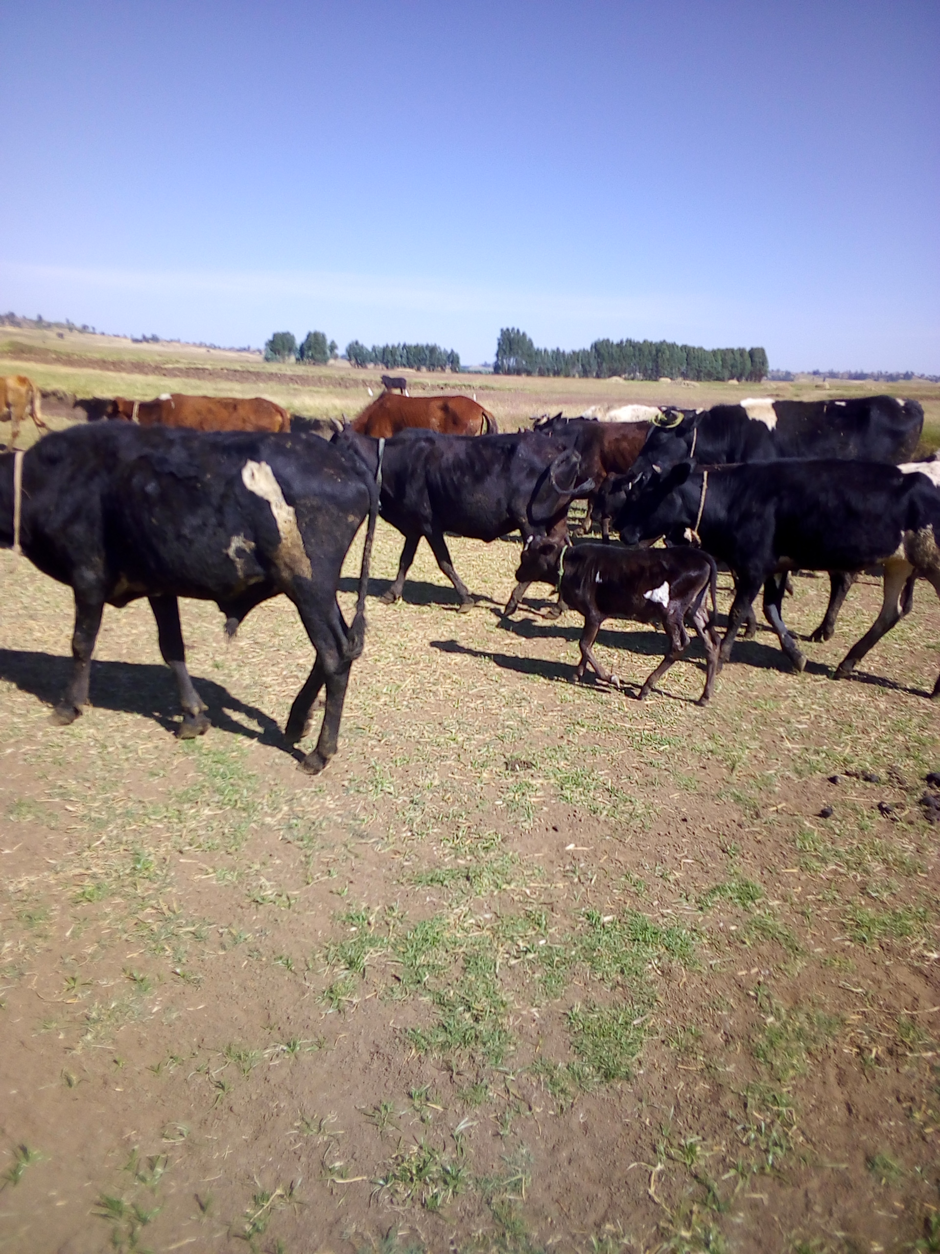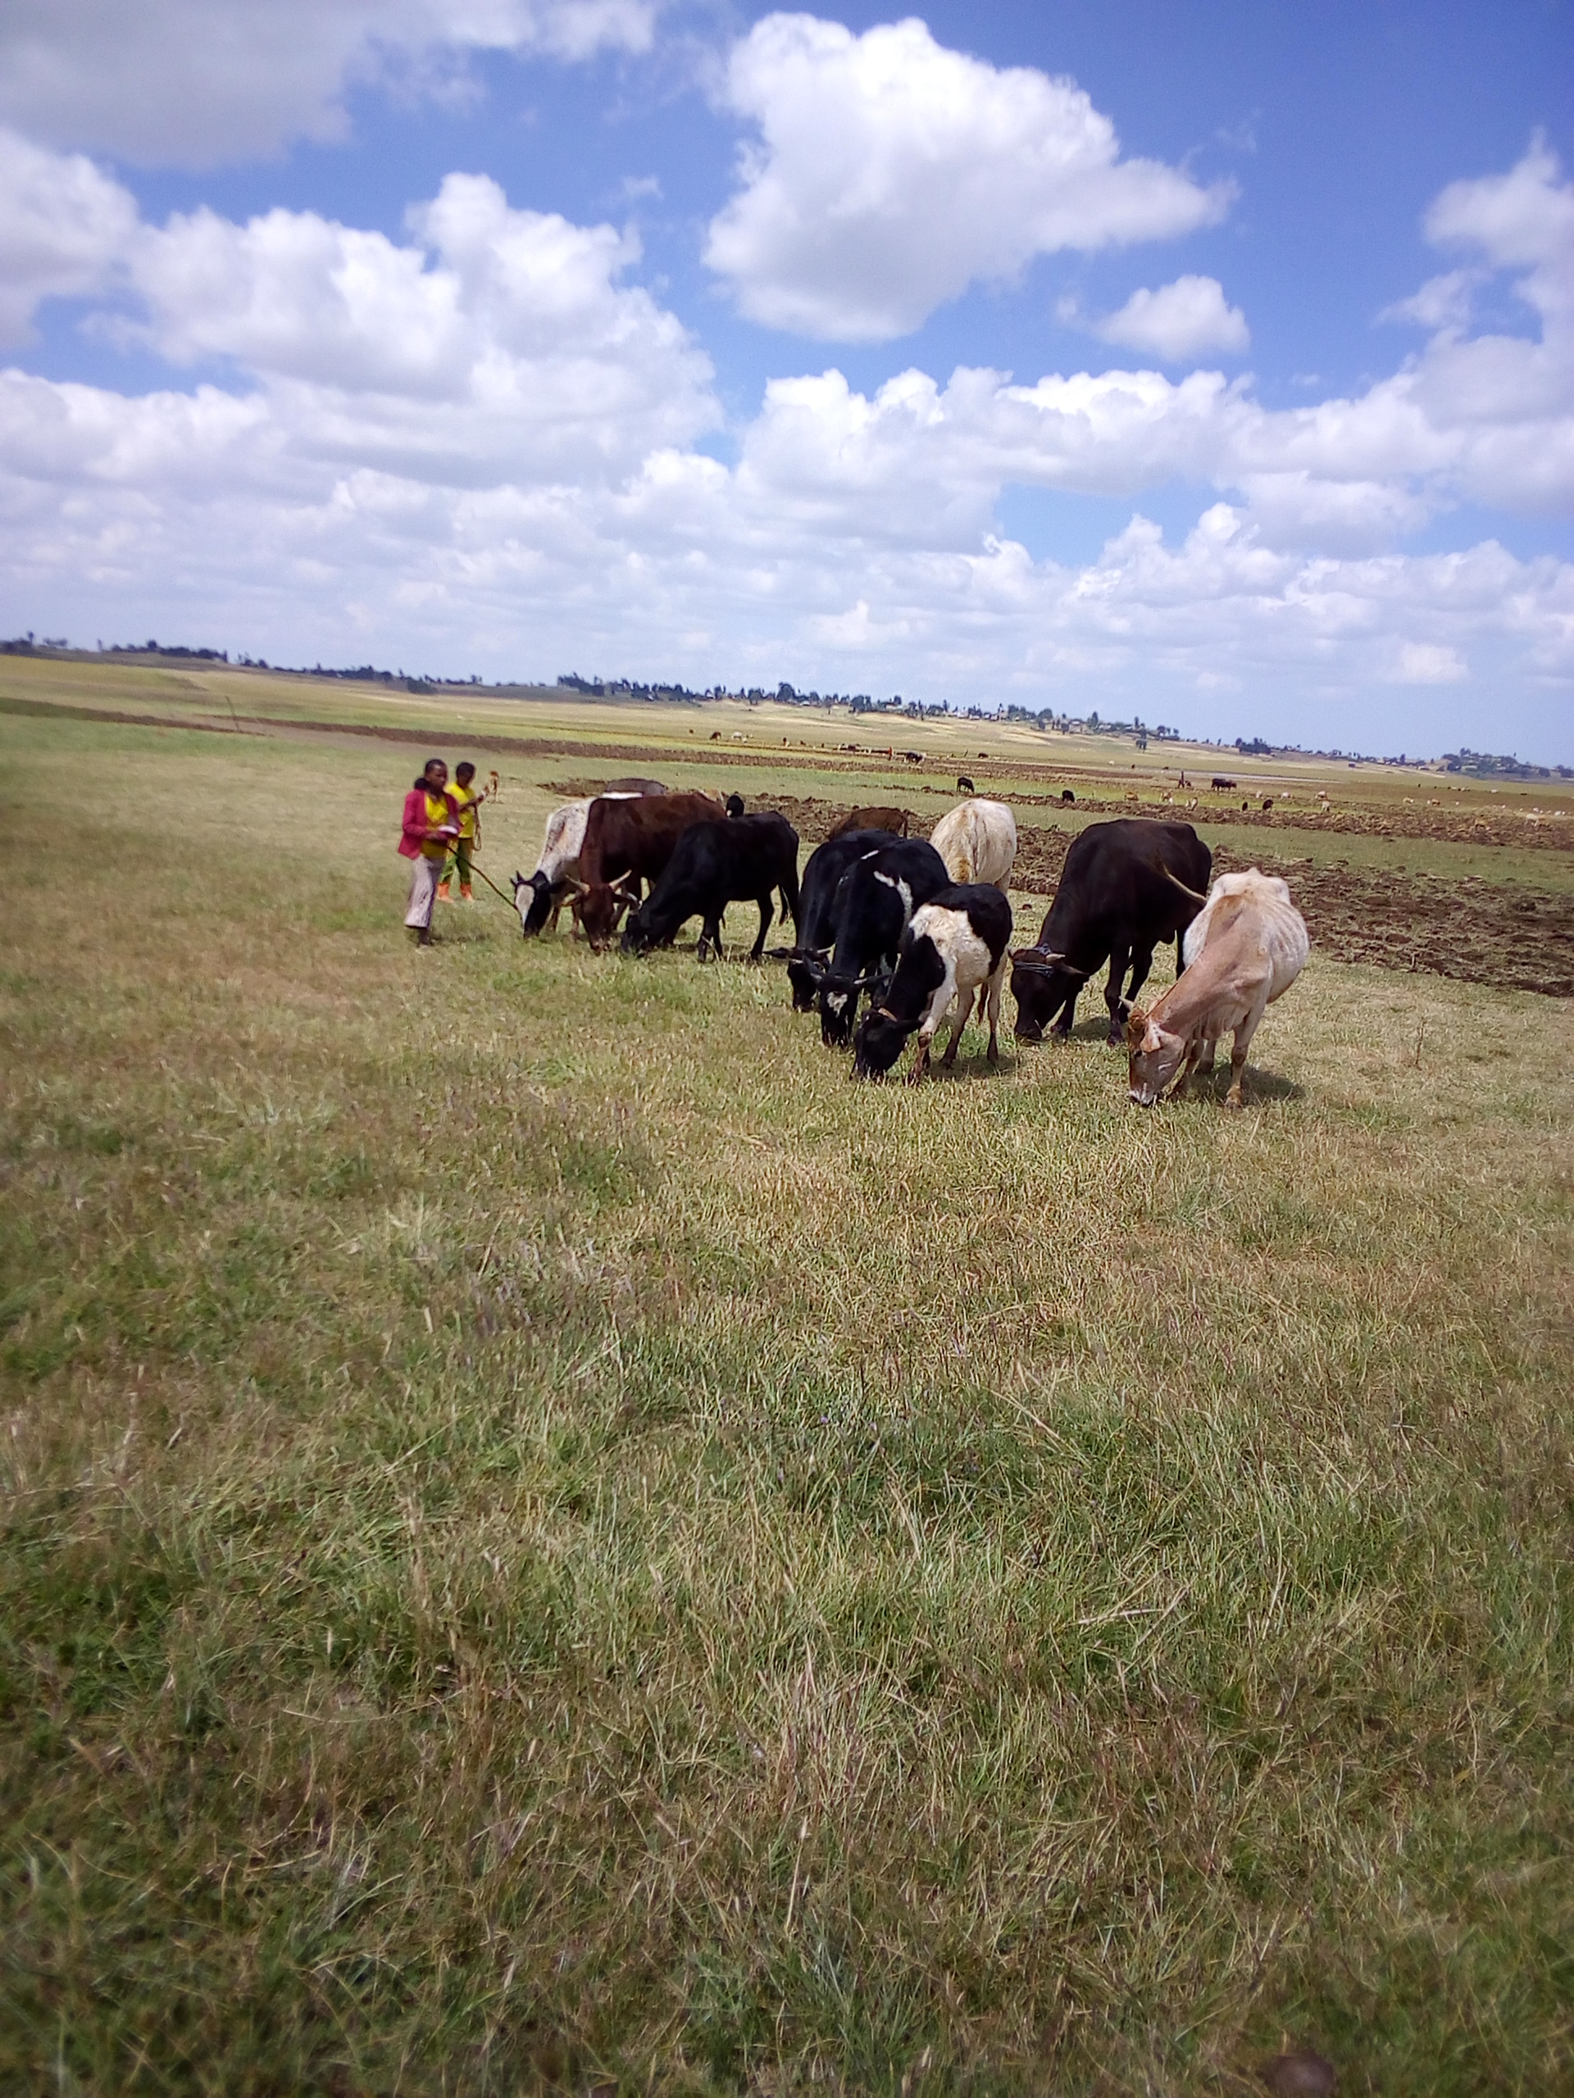
Figure 8: Livestock Production in the project area

Existing Agricultural Techniques
As observed from the field assessment and information obtained from the concerned institutions, the existing farming practice is traditional method of crop husbandry. As the project area is more of highland and swampy the sector is dominated by highland crops production and especially the farmers of the project area relatively produce narrower range of crop types which are mainly used for their subsistence consumption and some more for additional household income generation. The supplying of agricultural inputs such as improved seeds and fertilizers for existing traditional rain-fed agriculture is low, not adequate for full potential use of the available resources. As information collected from the woreda cooperative office and local farmers the price of these agricultural inputs is increasing from time to time and get unaffordable. As a result, the farmers use few inputs, especially, fertilizers on large area of land, not according to the research recommendation. The credit service in the command area is not common and most farmers have little awareness of credit service rendering organizations. The basic agricultural techniques like crop rotation, crop diversification, double cropping, soil and water conservation and other related activities are not yet well practiced in the area. Most farmers use traditional oxen drawn plows to plough their crop land on sloppy farmland, and this plow is short and can cause the formation of a hard pan beneath the top soil. This lowers the water retention capacity of the soil and exposes the upper agricultural soil to water erosion. There are great variations among the farmers, depending on the different biographical conditions, skills, the availability of labor and access to resources outside the farm. Most are marginal subsistent farmers, cultivating basic food crops only. But the production of such crops is low, not enough to meet their requirements in most years. The number of livestock is higher and there are many animals with exotic blood level, but the productivity of these livestock sector is low mainly due to the poor feeding system. The prevalence of livestock diseases, feed shortage, and low awareness of improved management practices has its own impact to low livestock productivity.

Existing Agricultural Problems
Generally, the following major agricultural problems are identified in and around the project area.

Low Technology Input Utilization
There is no adequate provision of agricultural inputs, like improved seeds, agrochemicals, chemical fertilizers, and other related technology packages in the proposed development area. The farmers produce relatively limited range of improved crop types due to low awareness of improved, environmentally-friendly agricultural technologies. Although the Woreda Agricultural Extension Office has been supplying few improved crops varieties, adoption of improved farm practices is hardly seen in the area. This might be because of continuous price increase of important agricultural inputs, especially fertilizers. The price of agricultural inputs as common is high and farmers could not afford to purchase. Crop rotation, diversification, intercropping and soil water conservation are not seen well practiced in the area.

Soil Erosion as a Result of Deforestation
Due to population increase which leads to horizontal expansion of agricultural lands, and the increasing fire wood consumption and other related human needs (construction, fencing timber etc.), deforestation is the major problem in and around the proposed project area. This leads to serious soil erosion problems on the uplands surrounding the command area. Moreover, replanting and other soil conservation activities are not yet well adopted by the community.

The Prevalence of Animal Diseases & Low Livestock Productivity
A free-type of grazing is extensively conducted on swampy areas and post harvested lands. The production & productivity is below the expected condition (as informed by the development agents & other concerned workers). The occurrence of different animal diseases, shortage of high nutritional feeding and the dominance of traditional way of raring system are some of the many factors which reduce livestock productivity.

Poor Access to Markets
Marketing of agricultural production in the area poses significant constraints for the producers. Poorly developed or lack of proper infrastructure and marketing facilities (roads, bridges, and warehouses) are major constraints. Limited opportunities to send products to market have hampered the production of micro-businesses and petty trading that could have provided alternative incomes.

Inadequate Institutional Setups
This should be emphasized as one of the major problems in the proposed project area. For instance, there are little opportunities of local transportation available to the community. Basic Institutions such as large market opportunities, Shops, Credit Service giving sectors, Information providers and the likes are absent in the area.

Insufficient Expertise of Irrigation Farming
The expansion of small scale irrigation in the study area and in the Woreda as a whole is still insignificant. This has got its own impact on the introduction of different vegetables and other cash crops in the area. Although there are many potential rivers for modern irrigation development, the practice is not yet developed as required and farmers try their best in developing traditional irrigation system.

Labour Requirement
Labour requirement for the existing rain-fed agriculture system is calculated on the proposed command area. This is mainly based on the field assessment and secondary data gathered from the agriculture office of Jida woreda and the project Kebeles. As per the “without project” condition, a hectare of labor requirement is specified under the following condition.
Table 10: A Hectare of Labor Requirement as a “Without Project” Condition for Major Crops
Activities | Unit | Wheat | Barley | Teff | F. bean
Land preparation | OD | 12 | 10 | 16 | 8
Pre planting operation | MD | 5 | 4 | 20 | 4
Planting | MD | 6 | 5 | 2 | 2
Fertilizer application | MD | 4 | 4 | 2 | 2
Weeding & hoeing | MD | 30 | 30 | 40 | 20
Crop protection | MD | 6 | 4 | 2 | 3
Harvesting | MD | 25 | 20 | 25 | 20
Post-harvest operation | MD | 25 | 25 | 25 | 10
Total | MD | 113 | 102 | 132 | 69
Production Cost | Birr | 6,720 | 6,080 | 7,920 | 4,140

Irrigated Agriculture Development Plan
Irrigated agriculture is proposed based on the objectives of the agronomic study indicated in earlier parts of this study report under the following conditions. Since assisting with installation of irrigation scheme is a key part of the proposed program and development strategy, it is essential that sound environmental, agronomic, social, economic and technical criteria are met at all stages of planning and design activities. Modern crop technology has the power to increase farm incomes and lower food prices simultaneously, thus benefiting everyone in society, especially the poor who spend a larger portion of their income on food. Thus, clearly irrigation can and should play an important role in raising and stabilizing food production, especially in areas of the proposed project, where there is relatively better land and water potential suitable for irrigation.

Crop Selection
Crops are selected based on the following major criteria:
- Climatic & soil suitability of the area,
- Yield potentiality and marketability,
- Multiple purposes such as food, fodder, export value,
- Length of growing period (early maturing) and workability,
- Their places in rotation and contribution to soil fertility,
- As a basic staple food for existing community (farmers’ crop selection preference), and
- Beneficiary’s existing skill and level of technology utilization.
Whenever the construction of an irrigation project is proposed, it is essential first to develop a cropping pattern for the command area to facilitate proper utilization of the project potential and to make the project economically viable. Considering the factors discussed above, the following general cropping patterns are recommended for major agro-ecologies of Ethiopia.
Table 11: General recommended crop mix for major agro-ecologies of Ethiopia
No. | Major agro-ecological zones | Altitude (m) | Average Temperature (ºC) | Annual Rainfall (mm) | Recommended crops
1 | Moist Dega | 2300-3200 | 12-18 | 900-1400 | Barley, wheat, highland pulses, potato, cabbage, carrot, Swiss chard
2 | Moist Weyna Dega | 1500-2300 | 18-25 | 900-1400 | Teff, maize, wheat, pulses, sorghum, Noug, potato, sweet potato, cabbage, carrot, Swiss chard, shallot, onion, pepper, tomato, garlic, coffee
3 | Dry Weyna Dega | 1500-2300 | 18-25 | 300-900 | Maize, wheat, groundnut, haricot beans, sweet potato, shallot, onion, pepper, tomato, Swiss chard, coffee, banana, papaya, citrus
4 | Moist Kolla | 500-1500 | >25 | 900-1400 | Maize, groundnut, haricot beans, sweet potato, shallot, onion, pepper, tomato, banana, papaya, citrus
5 | Dry Kolla | 500-1500 | >25 | 300-900 | Maize, sorghum, groundnut, haricot bean, cotton, sweet potato, shallot, onion, pepper, tomato, banana, papaya, citrus
Source: Irrigation Agronomy Guideline, Ministry of Agriculture (2011)
Accordingly, crops such as Barley, Potato, Cabbage, Beetroot, and Garlic are proposed for the project during the dry season. During the wet season crop production is not possible on the command area as the command area is swampy and totally covered with water during the rainy season. In selection of crops most attention was given to high value marketable vegetable crops. Vegetable crops provide steady income to producers besides using as a food, and make significant contribution to the economy of the beneficiary community in form of cash incomes. They are also the main source of vitamins, minerals, proteins, carbohydrates and fats.

Cropping Pattern
After selection of the crops to be planted using irrigation, the seasonal cropping pattern and cropping calendar for each crop should be determined. This helps in establishing which crop will occupy what part of the available land area during each season, also taking into consideration the crop rotation requirements other than perennial crops. Moreover, the cropping pattern is based on the following basic considerations.
- The objective of the project,
- Production of high value crops, at least to satisfy the local market demand, increase export needs by producing an agricultural surplus,
- The proportion of land for different crops can be adjusted according to the market needs with the increase of local and export demand in raising the crop and preferences,
- Intensification of crop production from food crops to cash income generation,
- Immediate benefit in the form of more reliable harvest higher production per unit of labor.
Table 12: Crops Selected for Dry Season Irrigation Development
S/N | Proposed Crops | Area |  | Selected varieties | Planting date | Harvesting Date | Base-period  (days)
S/N | Proposed Crops | (ha) | (%)
1 | Barley | 79.8 | 30 | HB 1307, HB 42, Dimtu | Dec. 25-30 | Apr. 25-30 | 120
2 | Potato | 66.5 | 25 | Jalene, Gudene, Menagesha | Dec. 20-30 | Apr. 20-30 | 120
3 | Cabbage | 53.2 | 20 | Copenhagen market, Drumhead | Dec. 25-30 | Apr. 20-25 | 115
4 | Beetroot | 39.9 | 15 | BORO F1 | Dec. 20-25 | Mar. 25-30 | 95
5 | Garlic | 26.6 | 10 | Tsedey, Bishoftu, Chelenko I | Dec. 25-30 | Apr. 05-10 | 110

Details of the Selected Crops
The essential climatic and soil needs, length of growing period, and their appropriate agronomic and other related requirements of the selected crops are identified below.

Cereals
a) Barley (Hordium vulgare)
Barley can adapt at an altitude between 1800- 3500 masl. However, it is best adapted between 2200 to 3000masl. The amount of rainfall suitable for barley production is between 500 to 1200mm in a given cropping season and crop stage. The best and suitable soil temperature is between 15-20 ⁰C for good crop seedlings. With regards to soil requirement barley can adapt to wide range of soil types, however fertile and light clay and loam soil with pH 6.5 to 7.5 suits best. Soil that holds water or water logged field is not suitable as barley is very sensitive to water logging. Barley has the potential to produce very high yields in excess of 12t/ha. In barley one of the key factors to achieving high yields is the production of a high number of grains per meter square. High number of grains is a result of high tillers production and survival, number of spikelets per ear and grains per spikelet. These critical crop characteristics are determined between plant establishment and flowering, and the amount of light intercepted by the crop during this period (GS21-GS59) is strongly related to grains/m2 and yield potential. This means that crop management to increase the green area of the crop during this period is very important for maximizing yield potential. Appropriate field preparation is essential for production of higher yield and grain quality. Proper tillage operations and time improve soil moisture conservation and physical property (aeration, infiltration); reduce weed and volunteer plant population; reduce disease and pest inoculum and enhance germination, emergence and crop establishment. The appropriate time of harvesting is crucial to ensure maximum yield and maintain the grain quality. A barley crop can be harvested manually or mechanically. In both cases care should be taken to avoid mechanical injury to grains and admixing during harvesting and threshing operations.

Vegetables

a) Potato (Solanum tuberosum)
Potato is grown in a three or more year rotation with other crops such as maize, beans and alfalfa, to maintain soil productivity, to check weeds, and to reduce crop lass from insect damage and disease particularly soil borne diseases. Potato requires a well-drained, porous soil with a pH of 5 to 6 and it grows on ridges or on the flat seedbed. For rainfed production in dry conditions, flat planting tends to give higher yield due to soil water conservation. Under irrigation the crop is mainly grown on ridges. The sowing depth is generally 5 to 10 cm, while plant spacing is 0.75 x 0.3m for seed potato and 1m x 0.5m for ware potato conditions. Cultivation during the growing period must avoid damage to roots and tubers, and the ridges are earthen up to avoid greening of tubers
Potato is relatively sensitive to soil water deficit. To optimize yields the total available soil water should not be depleted more than 30 to 50 percent. Water deficit during the period of stolanization and tuber initiation and yield formation has the greatest adverse effect on yield. Whereas, ripening and early vegetative period are less sensitive. Supply of water can be restricted during the early vegetative and ripening periods. Good yields under irrigation of a crop taking 120 days in tropic climates are 15 to 25 tons/ha.

b) Cabbage - (Brassica oleracea)
For high production, the crop requires a cool, humid climate. The length of the total growing period varies between 90 and 200 days. Depending on climate, variety and planting date, but for good production the growing period is about 120 to 140 days. Most varieties can withstand a short period of frost. Heavier loam soils are more suited to cabbage production. Under high rainfall conditions, sandy or sandy loam soils are preferable because of improved drainage. Cabbage is moderately sensitive to soil salinity. Water requirement vary from 380-500 mm depending on climate and length of growing season. The crop transpiration increases during the crop growing period with a peak towards the end of the season. The crop response to water supply increases with development of the crop. During the slow development in the vegetative period, the crop yield is little affected by water deficit. Once rapid growth during yield formation period is reached, the yield depressing effect of limited water supply becomes increasingly pronounced until the end of the growing period.

c) Beetroot (Beta vulgaris)
Beetroot grows under a wide range of climates (especially from 1700 to 2600m.a.s.l). It is a high value and demanded crop in the project area and surroundings. Preferable soil pH is 5.5 to 7.5 and it grows well in all soil types. For optimum growth a temperature of 10⁰c to 25⁰c is preferred. For a high yield of good quality, the crop needs controlled and frequent supply of water throughout the total growing period. It has an economic demand in the project area and has a good place in crop rotation.
d) Garlic (Allium sativum)
It grows under a wide range of climates from midland to highland (especially from 1700 to 2800m.a.s.l). It is a high value and demanded crop in the project area and surroundings. For a high yield of good quality, the crop needs controlled and frequent supply of water throughout the total growing period. Although the crop can be grown on various types of soils, it grows best on light soils, with a pH of 5.5 to 7.5. Optimum temperatures are ranging between 10⁰c to 23⁰c and low temperatures. So planting time adjustment for maximum yield is very much important. Irrigation should be discontinued as the crop approaches maturity to allow the tops to desiccate, and also to prevent a second flush of root growth. Has good economic and medicinal value at the community level. As it is easily attacked by diseases and insect pests careful crop protection measures should be employed during the growing period.

Irrigation Seasons
Irrigation seasons are decided based on the existing climatic condition, length of growing period of the proposed crops and capacity (efficiency) of the beneficiaries of the project. As to the proposed project condition, the command land is waterlogged and swampy during the rainy season so that only one time irrigation seasons as a “Dry-season” is possibly recommended. The “Dry-Season” is considered as “Full-Time” irrigation season and there is no second planting season or rainfed “Wet-season”. The full time irrigation season is proposed starting in late month of December. This period (December) is proposed to be a starting month considering the high frost occurrence in the area, length of growing period of the selected crops, and appropriate marketing time of the produce.

Proposed Management
As a “With-Project” condition and modern farming system, all the required crop management approaches should be applied in the system. For instance crop spacing, method of irrigation, fertilizer application (type, amount, time and method) should be identified prior to the development phases. Accordingly, the following basic and integral parts of crop management approaches for the “would be” irrigated agriculture are identified below.

Method of Irrigation
The major method of water application during the cultivation seasons is furrow system for the selected crops. Furrow application method is easy for the farmers of the proposed irrigation area who have no or little experience of traditional irrigation activities. The detail is indicated in the following table.

Table 13: Method of Irrigation and Spacing for the selected crops
S/N | Selected Crops | Method of Irrigation | Recommended Furrow Length | Plant spacing (cm)
 |  |  |  | Intra-row | Inter-row
1 | Barley | Furrow | 10 – 15 m | Broadcasting
2 | Potato | Furrow | 15 – 20 m | 30 | 75
3 | Cabbage | Furrow | 10 – 15 m | 40 | 60
4 | Beetroot | Furrow | 10 – 15 m | 10 | 35
5 | Garlic | Furrow | 10 – 15 m | 15 | 30

Cultivation Activities
Different crops require different cultivation activities. Some crops require simple hoeing and some others require earthening up. Thus, it is advisable to understand these conditions prior to the development activities. Some of the major cultivation processes of crop production are summarized in the following table.
Table 14: Major cultivation activities in irrigated agriculture
S/N | Proposed crops | Seed Rate (Kg/ha) | Soil depth during Seeding/ planting (cm) | Cultivation time/Weeding
1 | Barley | 125 | 4-5 (Broadcasting) | After 30 days of planting
2 | Potato | 2000 | 5-10 | After 20 days of planting
3 | Cabbage | 0.5 to 0.7 | 5-10 (Transplanting from nursery site after 30 days) | After 20 days of transplanting
4 | Beetroot | 0.5 to 1 | 5-10 (Transplanting from nursery site after 30 days) | After 20 days of transplanting
5 | Garlic | 600 to 800 | 5-10 (Direct planting) | After 20 days of planting

Fertilizer Management
Adequate fertilization programs supply plant nutrients needed to sustain maximum crop productivity and profitability while minimizing environmental impact from nutrient use. In essence, fertilizers are used so that soil fertility is not a limiting factor in crop production. The major factors influencing the quantity of nutrients to apply are crop and soil characteristics, fertilizer placement, climate especially moisture and temperature, yield goals and economics. Considering these main factors in proper fertilizer management activities, the required fertilizers (that can be synthetic or natural), are given to the proposed crops. However, it should be applied after careful chemical analysis of the command soil. As to the proposed project condition, the following fertilizer and other agrochemicals are averagely determined. (The total yearly input required for the command area is referred in Agronomy Annexes).

Table 15: Required fertilizers & other agrochemicals planned for each proposed crop
S/N | Selected Crops | Fertilizers,(Kg/ha) |  | Pesticide s,(Lt, Kg/ha) |  |  | Remark
S/N | Selected Crops | NPS | Urea | Insecticides | Fungicide | Herbicide | Remark
1 | Barley | 100 | 100 | Apron Star, Karate, Gaucho 70% WS, etc. | Rex Duo, Amistar extra, etc. | 2,4-D | Amount of pesticides is determined on the type of crop, kind of pest outbreak and type of pesticides to be used.
2 | Potato | 150 | 100 | Dimethoate 40% EC, Diazinone, etc. | Mancozeb, Ridomil, etc. | -
3 | Cabbage | 100 | 50 | Dimethoate 40% EC. | Ardent 50 SC, Ridomil, etc. | -
4 | Beetroot | 100 | 100 | Diazol 60 EC | Ridomil MZ 63.5 WP | -
5 | Garlic | 100 | 100 | Diazol 60 EC | Ridomil MZ 63.5 WP | -

Method of Fertilizer Application
There are a number of fertilizer application methods, based on the crop and its cultivation system. Among these, deep-banding, side/basal dressing, fertigation, foliar application and others are known. However, as to the level of irrigation and user’s awareness, the basal and top dressing are the most important application methods in farmer managed irrigation development activities. Accordingly, the following application experiences are designed for the proposed project.
Table 16: Methods of fertilizer application for the proposed crop types
S/N | Proposed Crops | Fertilizers to be applied | Method of Application | Time of Application
1 | Barley | NPS | Broadcasting | At the time of planting
1 | Barley | Urea | Top dressing | 3 to 4 weeks after planting
2 | Potato | NPS | Top/Side dressing | At the time of planting
2 | Potato | Urea | Basal dressing | 3 to 4 weeks after planting
3 | Cabbage | NPS | Top/Side dressing | At the time of transplanting
3 | Cabbage | Urea | Top/Side dressing | 3 to 4 weeks after transplanting
4 | Beetroot | NPS | Top/Side dressing | At the time of transplanting
4 | Beetroot | Urea | Basal dressing | 3 to 4 weeks after transplanting
5 | Garlic | NPS | Top/Side dressing | At the time of planting
5 | Garlic | Urea | Basal dressing | 3 to 4 weeks after planting

In general the assigned agronomist can select one of the following fertilizer management practices during the implementation period.
- Excessive use of external inputs,
- Intensified use of local resources with few or no external inputs,
- Integrated use of external inputs and local resources.

Plant Protection
Controlling insect pests, diseases, and weeds is very essential for the achievement of optimum crop yield from irrigated agriculture. Pesticides may be expensive and may cause environmental problems on the area for both human beings and animals. They also kill other important pests which are enemies of the non-advantageous pests. Thus, during the cultivation period, non-chemical methods of pest control should preferably be applied together with that of chemical ones (integrated method of pest management). Accordingly, the following protection methods are summarized to be used in the future plant protection activities of the proposed project.
Table 17: Chemical & non-chemical plant protection methods for the proposed crops
S/N | Proposed Crops |  | The Possible Pests & Diseases | Chemical Prevention  Method | Non-chemical Prevention Method
1 | Barley | Pests | Shoot fly, cut worms, Termite. | Use different Chemicals & pesticides | Field sanitation, Crop rotation, use of Disease free var., proper crop and water management.
 |  | Diseases | Scald, Net blotch, Rust | Use different fungicides. | Field sanitation, Crop rotation, use of Disease free var., proper crop and water management.
2 | Potato | Pests | Soil borne Worms, Aphids, Armyworms | Use different Chemicals & pesticides | Field sanitation, crop rotation, and insect free var., proper crop and water management.
 |  | Diseases | Late blight, Bacterial wilt, etc. | Use of different fungicides. | Field sanitation, crop rotation, and disease free var., proper crop and water management.
3 | Cabbage | Pests | Aphids, Flea, Beetle, Diamond Back | Use different chemicals | Field sanitation, Crop rotation, and Disease free var., proper crop and water management.
 |  | Diseases | Black rot, Downy Mildew, Leaf Spot | Use different fungicides. | Field sanitation, Crop rotation, and Disease free var., proper crop and water management.
4 | Beetroot | Pests | Aphids, Flea, Beetle, Diamond Back | Use different chemicals | Field sanitation, Crop rotation, and Disease free var., proper crop and water management.
 |  | Diseases | Black rot, Downy Mildew, Leaf Spot | Use different fungicides. | Field sanitation, Crop rotation, and Disease free var., proper crop and water management.
5 | Garlic | Pests | Onion thrips, cut worms, Onion flies, | Use different chemicals | Field sanitation, crop rotation, and disease free var., proper crop and water management.
 |  | Diseases | Root rot, Purple Bloch, Downey Mildew, rust spp. | Use different fungicides. | Field sanitation, crop rotation, and disease free var., proper crop and water management.

Crop Rotation and Intercropping
Crop rotation is used to avoid the build-up of diseases and pests and to avoid or minimize loss of soil fertility. Intercropping allows efficient utilization of soil nutrients and increased harvest from limited land resource. It also enables to get minimum harvest in case of one component crop failure, so intercropping of leguminous crops with the major component crop is advisable. The possible arrangements in crop rotations and intercropping can be the following.
- Barley ↔ potato/cabbage/beetroot/garlic ↔ barley which helps for avoidance, especially of rust.
- Barley ↔ cabbage used for avoidance, especially of nematode build up, blight and bacterial wilt; only Solanaceous crops should be avoided in the rotation system.
- Shallow rooted crops alternatively with deep rooted crops for efficient utilization of essential nutrient resources is also one of the rotational possibilities.

Labor Requirement
As a “With-Project “condition, labor is calculated for each selected crops, for a hectare of irrigable land. All the required activities, frequency and amounts are specified in the next table.
Table 18: A hectare of labor requirement as a “With-Project” condition
Activity | Unit | Proposed crops
Activity | Unit | Barley | Potato | Cabbage | Beetroot | Garlic
Nursery | MD | 0 | 0 | 60 | 60 | 0
Land preparation | OD | 12 | 12 | 12 | 12 | 12
Pre planting operation | MD | 8 | 10 | 10 | 10 | 10
Planting | MD | 6 | 12 | 15 | 15 | 12
Fertilizer application | MD | 4 | 4 | 5 | 4 | 4
Irrigation | MD | 15 | 20 | 20 | 20 | 20
Weeding & hoeing | MD | 20 | 40 | 20 | 30 | 30
Crop protection | MD | 4 | 4 | 5 | 5 | 5
Harvesting | MD | 20 | 20 | 15 | 20 | 20
Post-harvest operation | MD | 10 | 15 | 15 | 15 | 15
Total | MD | 99 | 137 | 177 | 191 | 128
Production Cost | Birr | 5,940 | 8,220 | 10,620 | 11,460 | 7,680

Area Coverage/Intensity
For the irrigation project the development approach is assumed to double crop over one cropping season and the cropping intensity to approach 200%. The climatic condition of the command area allows producing crops twice in a year using irrigation system. This helps to increase the time and resource use efficiency and allows adopting irrigated agriculture through a sequence of irrigation practices. However, the proposed command land is waterlogged and swampy during the rainy season and it is only possible producing crops one time during dry season in a year. Accordingly, the following cropping pattern/intensity is designed for the first 5-year crop production schedule.
Table 19: A 5-year cropping pattern/intensity plan
S/N | Crops | Area coverage
S/N | Crops | 1st-Year/Season |  | 2nd-Year/Season |  | 3rd-Year/Season |  | 4th-Year/Season |  | 5th-Year/Season
S/N | Crops | ha | % | ha | % | ha | % | ha | % | ha | %
1 | Barley | 59.85 | 22.5 | 79.8 | 30 | 79.8 | 30 | 79.8 | 30 | 79.8 | 30
2 | Potato | 49.87 | 18.75 | 66.5 | 25 | 66.5 | 25 | 66.5 | 25 | 66.5 | 25
3 | Cabbage | 39.9 | 15.0 | 53.2 | 20 | 53.2 | 20 | 53.2 | 20 | 53.2 | 20
4 | Beetroot | 29.93 | 11.25 | 39.9 | 15 | 39.9 | 15 | 39.9 | 15 | 39.9 | 15
5 | Garlic | 19.95 | 7.5 | 26.6 | 10 | 26.6 | 10 | 26.6 | 10 | 26.6 | 10
Intensity |  | 199.5 | 75 | 266 | 100 | 266 | 100 | 266 | 100 | 266 | 100

Yield Projection
Crop yield is mainly estimated based on the level of crop management required practices, availability of agricultural inputs, proper extension services, and existing climatic situations for crop production. Apart from these basic factors, other trends should be assessed. For instance, observation of previous yield condition from traditional (rainfed) agriculture, anticipated research outputs, and other related sources are very important. Considering these parameters, the following yield projection is forecasted.
Table 20: Yield Projection for five (5) year/season production period
S/N | Crop | 1st-Year /season |  | 2nd-year /Season |  | 3rdYear /Season |  | 4th-year /Season |  | 5th-year /Season
S/N | Crop | Yield (qt/ha | Prodn (Qt) | Yield (qt/ha | Prodn (Qt) | Yield (qt/ha | Prodn (Qt) | Yield (qt/ha | Prodn (Qt) | Yield (qt/ha | Prodn (Qt)
1 | Barley | 25 | 1496 | 30 | 2394 | 30 | 2394 | 30 | 2394 | 30 | 2394
2 | Potato | 140 | 6982 | 150 | 9975 | 160 | 10640 | 160 | 10640 | 160 | 10640
3 | Cabbage | 80 | 3192 | 85 | 4522 | 90 | 4788 | 90 | 4788 | 90 | 4788
4 | Beetroot | 75 | 2245 | 80 | 3192 | 82 | 3271 | 85 | 3392 | 85 | 3392
5 | Garlic | 45 | 898 | 50 | 1330 | 55 | 1463 | 60 | 1596 | 60 | 1596

Postharvest Activities
a) Harvesting
Irrigated crops such as vegetables and fruits are highly perishable and subjected to chemical and physical changes and hence too rapid deterioration. Apart from some exceptions, most farm products are susceptible to damage, whether from mechanical shocks or climatic factors like atmospheric dryness, heat and cold. This sensitivity creates the need for a whole series of precautions in handling, storing, packing and transport. Therefore, care should be taken during harvesting and post-harvest activities. Recognition of the point of optimum maturity is important for the successful harvesting of certain fruits and vegetables. Correct handling is required during picking or lifting of crops manually. The grower must supervise the work and insists constantly that all rough handling is avoided. Every shock and small wound, even those not observable, will shorten the shelf life of the vegetable/seeds and deteriorates and reduces the quality and hence the profitability. Attention should be paid to the weather. Heat, rain, hail and dew may all damage the appearance of the crop after picking or lifting.

b) Storage
Storage under naturally ventilated conditions is the best. It is sometimes necessary to store produce for a considerable period, so as to space out the sales and avoid glutting the market. The site for the storage facility should be relatively elevated and well-exposed to the dominant winds. It can be located under the shade of a tree, with light air condition. Generally, cold storage is preferable. The crop should be spread on well-aerated open racks in layers not exceeding about 20cm in depth. The store must be kept clean and baskets and boxes packed, so that they do not interfere with the free circulation of air.

c) Packing & Grading
Packing concerns the preservation of the produce in the best possible conditions of freshness, appearance, hygiene and general attractiveness, hence protecting its market values.

d) Transport
Available transport should be prepared, at least to the farm gate condition. In hot climate where the distances to be covered are long journeys that are undertaken in day light, special protection and proper packing for the produce is very necessary. Bad road conditions will inflict further damage on produce before it reaches the market. Frequency and reliability of transport as well as distances to the market should be assessed and planned before complete harvesting activities.

Extension Service
Farm management deals with the organization and operation of a farm with the objective of maximizing profits from the farm business on a continuing basis. And hence, proper extension activities should be applied for the fact stated above. All the concerned stakeholders have their own parts in the achievement of the project objectives. The following are to be basic factors in extension approach.

Market
Agricultural marketing in irrigation scheme is an integral and general understanding involved in the process of marketing from farm gate to final consumption of irrigation farm products. Adequate market information, shops in the market place for sale of the produces, access road from farm place to the market outlet and good bargaining power are basic issues for the proper development of the proposed irrigated agriculture. Therefore, the irrigators shall get current market information and technical assistance in determination of demand in different crops in their specific area or as a whole in the region.

Timely Input Provision
Adequate agricultural input provision is another important issue for good output from irrigation farming. Inputs, like vegetable seeds, agrochemicals and fertilizers should be supplied and this should be supported by the extension agents and other relevant stakeholders. The current supply of agricultural inputs is given a priority for rain-fed agriculture. Thus, the detail demand of irrigation in fertilizers, seeds, and chemicals shall be analyzed and quantified as per the calculated demand shall be provided on time.

Crop Water Requirement
Crop water requirement (CWR) is defined as the depth of water needed to meet the water loss through evapotranspiration of a disease free crop growing in large fields under non-restricting soil conditions including soil water and fertility and achieving full production under the given growing environment (FAO, 1977). The crop water requirement calculation is computed using Cropwat-8 software based on modified Penman-Monteith Method (conducted on FAO-Irrigation & Drainage Paper No. 56). The estimation of crop water requirement underlies effective planning of crop production at farm level. Water requirement (WR) is related to water from soil profile(s), rainfall and irrigation.
(IR):
Under this topic, the relevant parameters for proper irrigation water management, such as Irrigation Depth (d, mm), Interval (i, days) and frequencies of irrigation are calculated. Moreover, the design supply (duty) in (l/s/ha) for the maximum value of the project is computed in this part. As shown in water requirement analysis, the net water requirement of each crop is divided by the overall efficiency of 45% to obtain the gross water requirement. The project supply of the irrigation project during full irrigation is indicated for 24 hours irrigation and becomes 0.84 l/s/ha. This can be determining at the outlet head or canal head regulator for calculating the discharge capacity of the main off taking canal. The detail climatic data used for computing the crop water requirement and other soil and crop data with detail calculation procedures are seen in the ANNEX part of this study report.
Table 21: Duty of Dry-season cultivation

Calculation procedure
The calculation of reference evapotranspiration (ETo) is based on the FAO Penman-Monteith method (FAO, 1998). Input data include monthly and daily for temperature (maximum and minimum), humidity, sunshine, and wind-speed are collected from the station. Crop water requirements (ETcrop) over the growing season are determined from ETo and estimates of crop evaporation rates, expressed as crop coefficients (Kc), based on well-established procedures (FAO, 1977), according to the following equation:
ETcrop = Kc × ETo
FAO (1998) has presented updated values for crop coefficients. Through estimates of effective rainfall, crop irrigation requirements are calculated assuming optimal water supply. Inputs on the cropping pattern will allow estimates of scheme irrigation requirements. With inputs on soil water retention and infiltration characteristics and estimates of rooting depth, a daily soil water balance is calculated, predicting water content in the rooted soil by means of a water conservation equation, which takes into account the incoming and outgoing flow of water.

Stress conditions in the root zone are defined by the critical soil water content, expressed as the fraction of total available soil water between field capacity and wilting point that is readily available for crop transpiration, and characterizes a soil moisture condition in which crop transpiration is not limited by any flow restrictions in the root zone. The critical soil water content varies for different crops and different crop stages and is determined by the rooting density characteristics of the crop, evaporation rate and, to some extent, by the soil type.

Cropwat input data
Calculations of water and irrigation requirements utilize inputs of climatic, crop and soil data, as well as irrigation and rain data. The climatic input data required are reference evapotranspiration (monthly/decade) and rainfall (monthly/decade/daily). Reference evapotranspiration can be calculated from actual temperature, humidity, and sunshine/radiation and wind-speed data, according to the FAO Penman-Monteith method (FAO, 1998). The soil data include information on total available soil water content and the maximum infiltration rate for runoff estimates. In addition, the initial soil water content at the start of the season is needed.

The impact on yield of various levels of water supply is simulated by setting the dates and the application depths of the water from rain or irrigation. Through the soil moisture content and evapotranspiration rates, the soil water balance is determined on a daily basis.

Determination of Evapotranspiration (ETo)
CROPWAT is a computer program for irrigation planning and management, developed by the Land and Water Development Division of FAO (FAO, 1998). Its basic functions include the calculation of reference evapotranspiration, crop water requirements, and crop and scheme irrigation. Through a daily water balance, the user can simulate various water supply conditions and estimate yield reductions and irrigation and rainfall efficiencies. Typical applications of the water balance include the development of irrigation schedules for various crops and various water irrigation methods, the evaluation of irrigation practices, as well as rain fed production and drought effects.
The estimation of crop water requirement needs the analysis of climatic data and Agronomic practices of the project area. The effect of climate on crop water requirement is given by the reference crop evapotranspiration ETo which is analysed using the modified Penman method.

Evapotranspiration (ETo)
Evapotranspiration (ETo) includes transpiration of the crop as well as evaporation of water from the soil. During the study, Penman method of estimating ETo has been utilized.
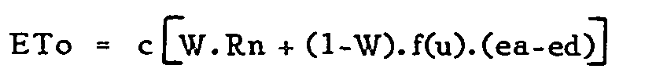
ETO = Reference crop evapotranspiration in mm/day
W = Temperature - related weighting factor
Rn = Net radiation in equivalent evaporation in mm/day
f (u) = Wind - related function
(ea-ed) = difference b/n the saturation vapor pressure at mean air temperature and the mean actual vapor pressure of the air, both in mbar
C = Adjustment factor to compensate for the effect of day and night weather conditions.
Pen-Man equation was used in ETo calculations.

Crop coefficient (Kc)
The effects of weather conditions are captured in the ETo estimate. Therefore, as ETo represents a factor of climatic demand, crop coefficient (Kc) varies mainly with the specific crop characteristics. The effects of crop transpiration and soil evaporation are combined into a single Kc coefficient. This coefficient combines differences in soil evaporation and crop transpiration rate between the crop and the grass reference surface. Crop coefficient (kc) is affected by many factors including crop type, climate, soil evaporation and crop growth stages.
Crop type: the large variation in Kc values between major groups of crops is due to the resistance to transpiration of different crops, such as closed stomata during the day (pineapple) and waxy leaves (citrus). Also, differences in crop height, crop roughness, reflection and groundcover produce different Kc values.
Climate: General climatic conditions, especially wind and humidity, affect crop coefficients. Variations in wind change the aerodynamic resistance of the crops and their crop coefficients, especially for those crops that are substantially taller than the grass reference crop. Crop aerodynamic properties also change with climate, in particular relative humidity. Kc for many crops increases as wind speed increases and as relative humidity decreases. More arid climates and conditions of greater wind speed will have higher values for Kc. More humid climates and conditions of lower wind speed will have lower values for Kc.
Soil Evaporation: Crop evapotranspiration is a combination of transpiration by the crop and evaporation from the soil surface. Differences in soil evaporation and crop transpiration between field crops and the reference surface are integrated within the crop coefficient. The Kc for full cover crops reflects differences in transpiration, as the contribution of soil evaporation is relatively small. After rainfall or irrigation, the contribution of soil evaporation is significant, especially if the crop is small and has small groundcover. For such low cover conditions Kc is largely determined by how frequent the soil is wetted.
Crop growth stages: the Kc for a given crop changes over the growing period as the groundcover, crop height and leaf area changes. Four growth stages are recognized for the selection of Kc: initial stage, crop development stage, mid-season stage and the late season stage.
Initial stage: the initial stage refers to the germination and early growth stage when the soil surface is not or is hardly covered by the crop (groundcover < 10%). The Kc during this initial stage (Kc ini) is large when the soil is wet from irrigation and rainfall and is low when the soil surface is dry.
Crop development stage: the crop development stage is the stage from the end of the initial stage to attainment of effective full groundcover (groundcover 70-80%). As the crop develops and shades more and more of the ground, soil evaporation becomes more restricted and transpiration becomes the dominant process. During the crop development stage, the Kc values correspond to amounts of groundcover and plant development and thus vary.
Late season stage: the late season stage runs from the start of maturity to harvest or full senescence. The calculation of Kc and ETo is presumed to end when the crop is harvested, dries out naturally, reaches full senescence, or experiences leaf drop. The Kc value at the end of the late season stage (Kc end) reflects crop and water management practices. The Kc end value is high if the crop is frequently irrigated until harvested fresh. If the crop is allowed to senescence and to dry out in the field before harvest, the Kc end value will be small.

Table 22: Crop development stage and crop coefficient for proposed crops
Crop | LGP | Growing stage |  |  |  | Crop coefficient
Crop | (Days) | D₁ | D₂ | D₃ | D₄ | Kc₁ | Kc₂ | Kc₃ | Kc4
Barley | 120 | 25 | 30 | 40 | 25 | 0.40 | 0.70 | 0.95 | 0.85
Potato | 120 | 25 | 30 | 40 | 25 | 0.40 | 0.70 | 1.05 | 0.85
Cabbage | 115 | 20 | 25 | 55 | 15 | 0.40 | 0.70 | 0.95 | 0.80
Beetroot | 95 | 15 | 25 | 35 | 20 | 0.40 | 0.70 | 0.95 | 0.80
Garlic | 110 | 25 | 30 | 35 | 20 | 0.40 | 0.70 | 0.95 | 0.85
Source: FAO Irrigation and drainage paper 24 (1977) and paper 33 (1979)

Effective Rainfall (Pe)
Not all dependable rainfall is effective and some may be lost through surface runoff, deep percolation or evaporation. Only a part of the rainfall can be effectively used by the crop, depending on its root zone depth and the soil storage capacity. Different methods exist to estimate the effective rainfall (FAO, 1992). But, for the proposed irrigation project, the effective rainfall is calculated using dependable rain (FAO/AGLW formula). Accordingly, Peff = 0.6*P-10 (P month ≤ 70mm) and Peff = 0.8*P-24 (P month > 70mm) where, Peff = effective rainfall (mm/month) and P = dependable rainfall (mm/month) respectively.

Irrigation Water Requirement
Irrigation water requirement is calculated using the crops requirements but takes into account the effective rainfall. It is derived from the formula ET_{CROP}-Pe (effective rainfall). Essentially effective rainfall is that proportion of the rain which is stored in the root zone and therefore available to the plants. Rainfall which percolates beyond the root zone or is lost to the plants through surface runoff is not effective in that it is unavailable for plant growth. The texture and structure of the soil are the two important factors which influence the portion of rainfall which may be considered as effective for plant growth. When the rainfall is high, a relatively higher proportion of the water is lost through runoff and deep percolation. In hilly areas, particularly where there is little vegetative cover, runoff can account for the higher losses.

Net irrigation requirements
The net irrigation requirement (net water depth application) is the depth of irrigation water needed to replenish the soil water deficit at the effective root zone to field capacity. Sometimes, the contribution of ground water and the available stored water at the beginning of irrigation period may not be significant. As a result, the net irrigation requirement (NIR) is determined by considering only the effective rainfall (i.e. NIR = ETc-Pe).

Irrigation Efficiency
To account for losses of water incurred during conveyance and application to the field, an efficiency factor was included while calculating the project irrigation requirements. Project efficiency is normally subdivided into conveyance efficiency, distribution efficiency and application efficiency. Accordingly, an overall project efficiency of 45% for farmer managed furrow irrigation has therefore been adopted as the design criteria for the irrigation project. This is at the lower end of efficiencies that could be achieved for farmer managed furrow irrigation. (See the detail calculation in Agronomy Annex)

Field Irrigation Schedules
Field irrigation schedules are based on field water balance and are expressed in depth (d, in mm) and interval of irrigation (i, in days).

Depth of irrigation application (d)
Depth of irrigation application is the depth of water that can be stored within the root zone between the so-called field capacity (sfc) and the allowable level the soil water can be depleted for the given crop, soil and climate. Some crops, such as, vegetables, potatoes, onions and strawberries, require relatively wet soils to produce acceptable yields; others such as cotton, wheat and safflowers will tolerate higher soil water depletion level. However, the tolerated depletion varies greatly with crop development stages; for most crops a reduced level of depletion should be allowed during changes from vegetative to reproductive growth or during heading and flowering to fruit setting.
Depth of irrigation application (d) is equal to the readily available soil water (p.sa) over the root zone (D). An application efficiency factor (Ea) is always added to account for the uneven application over the field or
d= (p.sa) .D = mm
Ea
Where –d=depth of application in mm
P=fraction of available soil water
Sa=available soil water in mm/m soil depth
D=Rooting depth of crops in m.
Ea=application efficiency

Irrigation application interval (i)
Correct time of irrigation application is over-riding importance. Delayed irrigations, particularly when the crop is sensitive to water stress, could affect yields, which cannot be compensated for by subsequent over watering. Timing of irrigation should confirm to soil water depletion requirement of the crops which are shown to vary considerably with evaporative demand, rooting depth and soil type as well as with stage of crop growth, therefore rather than basin irrigation interval on calendar or fixed schedules, considerably flexibility in time and depth of irrigation should be maintained to accommodate distinct difference needs during in crop’s growth cycle water. These detailed considerations are often not cover at design stage. Normally the irrigation interval given in FAO Irrigation and drainage paper number 24 is for dry irrigation season which is. The irrigation interval can be obtained from:
i= (p.sa).D
ET crop
The average days of irrigation intervals for the proposed crops were calculated as for Barley every 9 days, for Potato every 8 days, for Cabbage every 11 days, for Beetroot every 9 days and for Garlic every 8 days. These irrigation intervals are applied only when maximum soil water depletion percentage is kept higher for all crops and when ample water is applied in single irrigation. However, during critical water requirements of each crops, especially during flowering and seed or ball formation periods, frequent application (less irrigation intervals) of water is highly recommended, (see the calculation procedure table on annex part).

Suggestion & Recommendation
Production of economically important crops more than twice in a year through irrigation development is highly encouraged in Ethiopia at present days. To fulfill the objectives of the project, irrigable crops which are suitable to the soil and climatic conditions of the project area, have short growing period and can give reasonable economic yield are proposed in this document. The agronomic study shows that, though the climate of the project area is suitable for the production of most crops, the soil of the command area is swampy and waterlogged during the rainy season and has significant limitation for implementation of the proposed irrigation project during the wet season. Due to this limitation in command soil, sub-soil drainage is very crucial for effective utilization of the command land. The time of dry spell from the offset to the onset of the natural rainfall is wider and the amount and distribution of rainfall is insufficient in the project area. This situation allows the full utilization of irrigation practices throughout the growing season provided that the surface water for irrigation is not limiting. Therefore, production of crops one time in a year using only irrigation water application is recommended as full irrigation (dry period irrigation) season. However, irrigation is not an easy task. It needs an enormous capital investment and intensive workforce and requires integrated extension work throughout the development practices. The major actors (beneficiaries & development agents and other concerned stakeholders) must work together for sustainable irrigation development in the proposed project area. Since livestock is an integral part of the development, animals should be kept healthier and well fed. Production of animal feeds using irrigation water is also much important in order to help the animals play a vital role in agricultural development. To scale up the existing knowledge of the farmers and Subject Matter Specialists (SMS) on increasing productivity for sustainable growth and development, patterned and continuous trainings, workshops, opinion exchanges, etc. should be exercised.

Annex 1.1: AGRONOMY ANNEXES

A. Required climatic & other aerodynamic data collected from Sendafa Station
S/n | Climate Fac. | Unit | Moths
S/n | Climate Fac. | Unit | J | F | M | A | M | J | J | A | S | O | N | D
1 | Max. mean tep. | ⁰C | 23.3 | 24.1 | 24.8 | 24.1 | 24.3 | 22.8 | 20.8 | 20.8 | 21.6 | 22.3 | 23 | 22.7
2 | Min .mean tem. | ⁰C | 8.8 | 10 | 11.8 | 12.3 | 12.5 | 11.5 | 11.3 | 11.3 | 11.5 | 10.1 | 8.8 | 8.8
3 | Re. humidity | % | 56 | 60 | 63 | 66 | 66 | 68 | 69 | 70 | 68 | 62 | 58 | 60
4 | W. speed | Km/day | 104 | 112 | 112 | 104 | 112 | 69 | 69 | 69 | 86 | 138 | 130 | 130
5 | Sunshine | Hrs/day | 8 | 7.5 | 7.3 | 6.5 | 6.8 | 5.2 | 3.3 | 3.7 | 5.2 | 7.8 | 9 | 9
6 | Radiation | MJ/m² | 19.4 | 19.9 | 20.6 | 19.5 | 19.5 | 16.8 | 14 | 15 | 17.3 | 20.5 | 20.9 | 20.2
7 | P.RF | mm/M | 19 | 50 | 71 | 90 | 95 | 118 | 250 | 265 | 169 | 41 | 9 | 14
8 | Eff. RF | mm/M | 1.4 | 20 | 32.8 | 48 | 52 | 70.4 | 176 | 188 | 111.2 | 14.6 | 0 | 0
9 | Eto | mm/day | 3.63 | 3.87 | 4.13 | 3.94 | 3.98 | 3.34 | 2.85 | 2.95 | 3.36 | 3.96 | 3.94 | 3.73
10 | Eto | mm/M | 108.9 | 116.1 | 123.9 | 118.2 | 119.4 | 100.2 | 85.5 | 88.5 | 100.8 | 118.8 | 118.2 | 111.9

B. Irrigation Efficiencies
Based on the type of irrigation, method of application and farmers’ capacity on the given soil type, the following efficiencies are given below.

Table 1: Project efficiencies
S/n | Type of Efficiencies |  | Suggested Values, in (%)
1 | Conveyance Eff. | Ec | 94 %
2 | Distribution Eff. | Ed | 80 %
3 | Application Eff. | Ea | 60 %
4 | Project Eff. | Ep | 45 %

C. Irrigation depth (d, mm)
This is calculated based on the depletion factor (p) of the crop, available soil moisture (Sa), application efficiency (Ea) of the project, and effective root zone (D) of the individual selected crop. The detail is shown in the following table.

Table 2: Irrigation depth, (d, mm)
S/n | Crops | p-value | Sa (mm/M) | p.Sa | D (mts) | Ea | d (mm) | Remark
1 | Barley | 0.25 | 180 | 45 | 0.62 | 0.60 | 46
2 | Potato | 0.35 | 180 | 63 | 0.45 | 0.60 | 47
3 | Cabbage | 0.45 | 180 | 81 | 0.45 | 0.60 | 61
4 | Beetroot | 0.25 | 180 | 45 | 0.45 | 0.60 | 34
5 | Garlic | 0.42 | 180 | 75 | 0.35 | 0.60 | 44

D. Interval (days)
Table 3: The required interval for crop watering as to their requirement is calculated based on the following condition
S/n | Crops | p-value | Sa (mm/M) | p.Sa | D (mts) | Etc (mm/day) | i, (days) | Remark
1 | Barley | 0.25 | 180 | 45 | 0.62 | 2.32 | 9 | Average watering days are about 10 days.
2 | Potato | 0.35 | 180 | 63 | 0.45 | 3.54 | 8 | Average watering days are about 10 days.
3 | Cabbage | 0.45 | 180 | 81 | 0.45 | 3.19 | 11 | Average watering days are about 10 days.
4 | Beetroot | 0.25 | 180 | 45 | 0.45 | 2.25 | 9 | Average watering days are about 10 days.
5 | Garlic | 0.42 | 180 | 75 | 0.35 | 3.28 | 8 | Average watering days are about 10 days.

F. Inputs required for the Irrigation Project for one year

Crop | Dry Season (1st Irrigation)
Crop | Area, ha | NPS, qt | Urea, qt | Seeds, qt | Fungicide, lt | Insecticide, kg | Herbicide, lt
Barley | 79.8 | 80 | 40 | 100 | 150 | 150 | 200
Potato | 66.5 | 100 | 66 | 1330 | 180 | 180 | --
Cabbage | 53.2 | 53 | 26 | 0.58 | -- | 106 | --
Beetroot | 39.9 | 40 | 40 | 0.4 | -- | 78 | --
Garlic | 26.6 | 37 | 27 | 213 | 70 | 70 | --
Total | 266 | 310 | 199 | 1643.98 | 400 | 584 | 200

Table 23: Climatic, Soil and Water Requirements for Major Selected Irrigable Crops
Crop | Total Growing Period (days) | Temperature Requirements for Growth (⁰C) | Specific Climatic Requirements/ Constraints | Soil Requirements | Sensitivity to Salinity | Water Requirements (mm/growing period)
Barley | 100- 140  (+30-35 in  nursery) | 15- 20 (10- 25) | Tolerant to frost; low temp. (<14-16ºC) required for flower initiation, no extreme temp. or excessive rain | Medium-textured soil; pH= 6.0- 7.0 | Moderately  Sensitive | 350-550
Potato | 100- 140+ | 24- 30 (15- 35) | Sensitive to frost; for germination temp. >10 ºC; cool temp. causes problem of ripening | Well- drained and aerated soils with deep water table and without waterlogging; opt. pH =5.0- 7.0 | Moderately sensitive | 500- 800
Cabbage | 100-150 | 15-20 (10-24) | Short periods of frost (-6 to –10  oC) are not harmful; opt. RH =  60- 90 % | Well- drained; opt.  pH = 6.0- 6.5 | Moderately sensitive | 380-500

