OROMIA NATIONAL REGIONAL STATE
OROMIA IRRIGATION AUTHORITY

Aleltu Negede SSIP Final Feasibility Study and Detail Design Report, Catchment Management
PREPARED BY BONEYA CONSULTING PLC

October, 2016
Batu

Table of Content

1 INTRODUCTION 6
1.1 Background 7
1.2 Objectivesof the Study 8
1.3 Scope of the Study 8
1.4 Review of previous studies 9
1.4.1 Soil Erosion in Ethiopia 9
1.4.2 AbayRiver Basin Master Plan Study 9
1.5 Policy and Proclamation 10
1.5.1 Rural Land Use and Administration Proclamation of the FDRE 10
1.5.2 Rural Development Policy and Strategies 10
1.5.3 Food Security Strategy (2002) 10
1.5.4 New Coalition for Food Security Program 11
1.5.5 Natural Resources and Environment Policy 11
1.5.6 Land Administration and Use, Forest Conservation and Development Policies 11
2 MATERIALS AND METHODS 12
2.1 Materials 12
2.2 Methods 12
3 STUDY AREA 14
3.1 Location 14
3.2 Topography 16
3.3 Agro-Ecology 17
3.4 Land use/Land cover 18
3.4.1 Farmlands 19
3.4.2 Forestlands 20
3.4.3 Shrub lands 21
3.4.4 Settlements 21
3.4.5 Grazing lands 21
3.5 Major Soil types 21
3.5.1 Acrisols 22
3.5.2 Cambisols 22
3.5.3 Fluvisols 24
3.5.4 Lixisols 25
3.5.5 Nitosols 25
3.6 Soil Erosion and State of Natural Resources Management 26
3.6.1 RUSLE model 28
3.6.2 Major Factors Affecting Erosion 28
3.6.3 Estimating Soil Losses 30
4 SOCIO-ECONOMIC CONDITION 31
4.1 General 31
4.2 Population 31
4.3 Agricultural production 31
4.3.1 Crop Production 32
4.3.2 Livestock Production 32
4.3.3 Apiculture 34
4.3.4 Land Tenure System 34
4.3.5 Rural Energy 35
4.3.6 Gender Issues 35
4.3.7 Infrastructure Development 35
4.3.8 Institutions 36
4.3.8.1 Community based institutions 36
4.3.8.2 Government Institutions 36
5 PROBLEM ANALYSIS 37
5.1 General 37
5.2 Major Problems 37
5.2.1 Soil erosion 37
5.2.2 Deforestation 37
5.2.3 Low livestock production 38
5.2.4 Low diversification of crop production 38
5.2.5 Limited alternative income sources 39
5.2.6 Low Local Capacity 39
5.3 Opportunities 39
5.3.1 Bio-physical opportunities 39
5.3.2 Socio-Economic Opportunities 40
6 PROPOSED CATCHMENT MANAGEMENT INTERVENTIONS 40
6.1 Main Strategies 40
6.2 Catchment Management Interventions 41
6.2.1 Soil and Water Conservation 42
6.2.1.1 Physical Soil and Water Conservation 42
6.2.1.2 Biological Soil and Water Conservation Measures 44
6.2.2 Crop Production Management 49
6.2.3 Livestock Development interventions 50
6.2.4 Income Generating Activities 52
6.2.5 Supportive Strategies 52
6.2.6 Local Capacity Building 53
6.3 Planning and Implementation 53
7 IMPLEMENTATION STRATEGIES 64
8 ORGANIZATION & MANAGEMENT 65
9 MONITORING AND EVALUATION 66
9.1 Monitoring 67
9.2 Evaluation 67
10 CONCLUSION 68
11 References 69

List of Tables
Table 1: Sub-watersheds of Aleltu Negede catchment 15
Table 2: Slope class categories and landforms 17
Table 3: Land use/cover of AleltuNegede catchment 18
Table 4: Major soils of AleltuNegede catchment 22
Table 5: Livestock population in the catchment 33
Table 6: Physical target and therequired budget for AleltuNegedecatchment 57
Table 7: Three years physical target and the total budget required per year 60
Table 8: Total budget summary required by components and by year 63
Table 9: Community & Government contribution by component and year 63

List of Figures
Figure 1: Location Map of AleltuNegede Catchment 14
Figure 2: Sub-watersheds of AlaltuNegede catchment 15
Figure 3: Sub-watersheds of the micro-catchment 16
Figure 4: Land use/land cover map of AleltuNegede catchment 19
Figure 5: Land use/land cover map of the micro-catchment 20
Figure 6: Major soils of AleltuNegede Catchment 23
Figure 7: Major soils of the micro-catchment 24
Figure 8: Development map of AleltuNegede catchment 54
Figure 9: Development map of AleltuNegede catchment 55

ABBREVIATIONS

ARDO | Agriculture and Rural Development Office
ASTERBoARD | Advanced Space borne Thermal Emission and Reflection Radiometer  Bureau of Agriculture and Rural Development
cms | Cubic meter per second
CN  CBO  CBPWD  CWT  CM | Curve Numbers  Community Based Organization  Community Based Participatory Watershed Development  catchment management  Community Watershed Team
DA  DEM | Development Agents  Digital Elevation Model
ESRI | Environmental Systems Research Institute
ETM+ | Enhanced Thematic Mapper plus
FAO  FTC | Food and Agriculture Organization of the United Nations  Farmers Training Center
GDEM | Global Digital Elevation Model
GIS | Geographic Information System
GPS | Global Positioning System
ha  HH(s) | Hectare  Household(s)
Km  KWT | Kilometer  Kebele Watershed Team
LULC | Land use and land cover
m.a.s.l | Meter above sea level
mm  MoA  M&E | Millimeter  Ministry of Agriculture  Monitoring and Evaluation
MoARD | Ministry of Agriculture and Rural Development
MoWR | Ministry of Water Resources
NGO | Non-Governmental Organization
NMSA  NRM | National Meteorological Service Agency  Natural Resources Management
OADB  ONRS | Oromia Agriculture and Development Bureau  Oromia National Regional State
PA  P&ME | Peasant Association  Participatory Monitoring and Evaluation
PI  PWDP | Problem Identification  Participatory Watershed Development Planning
REVAPC  RUSLE | Re-evaporation coefficient for ground water  Revised Universal Soil Loss Equation
SWAT  SWC | Soil and Water Assessment Tool  Soil and Water Conservation
UTM | Universal Transverse Mercator Projection
WGS 84  WWT | World Geodetic System 84  Wereda Watershed Team

INTRODUCTION
A watershed or catchment area is defined as any surface area from which runoff resulting from rainfall is collected and drained through a common confluence point. The term is synonymous with a drainage basin or catchment area. Hydrological, watershed could be defined as an area from which the runoff drains through a particular point in the drainage system. Every stream, tributary, or river has an associated watershed, and small watersheds aggregate together to become larger watersheds. A watershed is made up of the natural resources in a basin, especially water, soil, and vegetative factors (CBPWD, 2005). People and livestock are the integral part of a watershed and their activities affect the productive status of watersheds and vice versa. From the hydrological point of view, the different phases of hydrological cycle in a watershed are dependent on the various natural features and human activities. Since the flow of water follows watershed boundaries, not political boundaries, any upstream activity on a watershed that people do to their land and water can significantly affect the productivity and sustainability of land downstream whether it is related to agriculture, livestock grazing, forestry or other uses. Among those influences are the effects on the rates of soil erosion and sediment movements, water flow patterns and water availability on the watershed. The management practices on upstream watersheds and the resulting effects of these practices are often part of a solution on the quantity, quality and delivery of water to downstream users.
In the past, Oromia National Regional State (ONRS) is known for its high agricultural potential area. Now a days, the region is highly affected due to sever land degradation due to many reasons. The rapidly growing number of population & rising demand for more food and agricultural land created pressure on land and its resources. These processes combined with poor farming system & the lack of appropriate soil and water conservation strategies caused the increase in the risk of floods and landslides, organic matter depletion, accelerated soil erosion, nutrient leaching and increased the amounts of sediment loads entering streams, rivers, reservoirs, and irrigation structures.
Land degradation is a serious problem in many developing countries like Ethiopia. WayuTuka woreda is one of those woredasof the EastWeleggaZone under immense or sever degradation.Thecatchment is highly affected from land degradation that resulted to the decline in the productivity of land, and, hence the existing natural resources need to be properly utilized and conserved. On the basis of this, a catchment management (CM) study was conducted on AleltuNegede catchment of WayuTuka woreda as part of AleltuNegede small Irrigation feasibility study and detail design project. The study, therefore, helps to identify the biophysical and Socio-Economic conditions and constraints in the watershed and propose appropriate management interventions as an integral part of the project to ensure its sustainability in ways that maintain the long-term productive capability of the available natural resources in the area.

Background
Commonly speaking ‘soil erosion’ generally refers to the removal of soil particles (including important soil nutrients) from its original place by soil moving agents (water and wind). Soil erosion by water is the result of rain drop splash, and flowing runoff water, usually when the land surface is left without vegetation cover. Erosion in a Catchment takes place in the form of sheet erosion, rills, and inter-rills and gullies leading to the decline of land productivity resulting from the decline of soil fertilityand fragmentation of land due to rills and dissected gullies. Besides, transportation of excessive sediment on downstream areas results in the loss of arable land and siltation on water courses, lower lying lands and irrigationinfrastructures.

In the past, conversion of forest, shrubs, and grass lands to agricultural land, cultivation of steep slopes and free grazing were commonly practiced activities observed in AleltuNegede catchment. Besides, the majority of the watershed is under intensive cultivation of cereal crops that accelerated soil erosion. Moreover, mixed farming (crop production and livestock production) is the main agricultural system in the area. Grazing lands were highly trampled by livestock due to overstocking and greatly affected the physical structure of the soil. In addition, the average annual rainfall of the area, its rugged topography, soil characteristics, scarce vegetation cover, and inappropriate management practices are the main factors that contributed to soil erosion process in the AleltuNegede catchment.

Because of the loss of protective vegetative cover and the gradual expansion of agricultural activities from gently sloping land onto the steeper slopes of the neighboring hills and mountainous areas, a large portion of the AleltuNegede catchment is severely degraded and soil erosion is observed in various land use types in the watersheds.

Therefore, to reverse the above situation, a catchment management (CM) studywas conductedonAleltuNegedecatchment aspart of AleltuNegedesmallscale irrigation feasibility study and detail design project. TheCatchment ispart of Gibe basin and is located in ONRS, East Welegga administrative zone, covering part of WayuTuka and Guto Gida woredas. Aleltu Negede catchment has a total area of about 4616.88ha.

The main objective of this study is to assess biophysical and socioeconomic conditionsof the area and propose appropriate intervention technologies that will reduce soil erosion and deforestation in the AleltuNegede catchment and thereby sustain optimum production in the area and minimize sediment inflow on to the proposed project schemes and command area.

Objectivesof the Study

The overall objective of the study is to improve the livelihood of the community living in the watershed through comprehensive and integrated natural resource development. It aims at productivity enhancement measures for improved income generation opportunities, enhanced livelihood support systems and to optimize the use of existing natural resources and untapped potentials in both already degraded areas and in the remaining potential areas in the watershed.
The specific objective is to:
- Reduce soil erosion, rehabilitate degraded areas and maintain existing natural forest and woodland vegetation cover of the area;
- Conserve rainwater effectively to create additional water sources for productive uses;
- Improve soil infiltration rate that maintains irrigation water supply for the command area;
- Improve the livelihood of the communities in the watershed through creating and sustaining improved agricultural production systems;
- Recommend appropriate conservation measures depending on the biophysical & socio-economic problems, potentials and constraints of the area;
- Prepare watershed management plan, and estimate the cost required for implementing the proposed management interventions.

Scope of the Study

Dependingon the biophysical and socio-economic conditions of the study area, the scope of catchmentmanagement (CM) can be broadening beyond the NRM interventions. As stipulated in the TOR, the study will give high emphasis to conservation, rehabilitation and development of natural resources that will primarily contribute to the reductionof soil erosion and deforestation problems in the Catchment and thereby reduce sediment inflow to the proposed scheme and the downstream command area. The study encompasses collecting and analyzing of biophysical and socio-economic situations of the Catchment area and proposesintegrated CM interventions and strategies. Generally, the scope of the study includes the flowing:
Review the available data, polices and proclamations related to natural resources management,
Delineate the Catchment boundary and interpret the physiographic features of the Catchment area,
Analyze and interpret drainage system , land use/land cover, soil, agro-ecology, and soil erosion and land degradation status,
Undertake land capability classification to identify soil conservation requirement classes to determine required SWC practices and techniques,
Analyse and syntheses the identified problems and opportunities, and then recommend integrated Catchment management measures and strategies,
Elaborate action plan and estimate project budget requirement to implement the planned activities

Review of previous studies

Soil Erosion in Ethiopia

Several Previous studies indicated that soil erosion and land degradation mainly caused by soil erosion and deforestation has been the chronic problems in Ethiopia (Hurni, 1988, Alemneh, 1990). Alemneh (1990) sated that the highlands of Ethiopia, which is the base of the nation economy, suffer from enormous land degradation due to soil erosion. It was estimated that 1.9million metric tons of soil is eroded annually in the high land part of the country. The Soil and conservation research program (SCRP) reported that the average annual soil loss in the country was estimated to be 42t /ha/year (Hurni, 1998). These studies showed that soil erosion and land degradation caused due to improper land use practices severely affecting ecological systems and resulted in low land productivity and progressive decline of agricultural production in most parts of the country. These studies also revealed that soil erosion also induces downstream sedimentation, which often adversely affect sustainability of dam/reservoirs and Irrigation schemes. The scholars further indicated that soil erosion and its impact on land productivity depends mainly on topographic factors, soils characteristics, vegetation cover, and rainfall and land management practices.

AbayRiver Basin Master Plan Study

In a more general way, the study of soil erosion situation and the efforts made so far in soil and water conservation were carried out by MoWR(2007)in Abay River Basin Master Plan study. This report would be relevant to the target area of this study. The study indicated that soil erosion in the basin as a whole is increasing under the combined pressures of increasing population and deforestation, improper land use practices, over livestock population, overgrazing and free grazing systems. In light of this, the study suggested that soil and water conservation strategy should focus to conserve productive lands.

Policy and Proclamation

Several strategies and policies refer and support the need for the conservation and development of natural resources, community participation and diversified agriculture. Among others, the very relevant policy and proclamation to this study are described below:

Rural Land Use and Administration Proclamation of the FDRE
The major land policy issues reflected in the proclamations are:
- Land is common property of the government and the people;
- Any citizen of the country or rural resident of the region of age 18 and above and wants to engage in agriculture shall have the right to use rural land;
- The rural land use right of farmers have no time limit;
- That land is the property of the government & the people and not subject to sale or exchange;
- Transfer of rural land use rights allowed through inheritance, gift and rent;

Rural Development Policy and Strategies
Proper use and management of agricultural land implies improving land productivity through encouraging different conservation and rehabilitation mechanisms and rational utilization of the country’s land resource. Enough emphasis should also be placed to conserve and rationally utilize water resources. Natural resource conservation is the base for sustainable agriculture. Conservation and management of natural resource that ensures real benefit to communities is envisaged.

Food Security Strategy (2002)
The strategy is targeted mainly to chronically food-insecure, moisture-deficit and pastoral areas. The focus is on environmental rehabilitation to reverse the current trend in land degradation, and as a source of income generation for food insecure households. Watershed based water harvesting and introduction of high value crops, livestock, and agro-forestry development are new elements in the revised strategy.

New Coalition for Food Security Program
In this program, Integrated Participatory Watershed Management Planning is suggested for planning and implementation of food-security interventions.

Natural Resources and Environment Policy
The overall policy goal is to improve and enhance the health and quality of life of all Ethiopians. The goal is to promote sustainable social and economic development through sound management and use of natural, human-made and cultural resources and the environment as a whole.

Land Administration and Use, Forest Conservation and Development Policies
The Land Administration and Use, Forest Conservation and Development Policies is also believed to strongly support the current participatory watershed development initiative.

These policies and strategies could be an excellent incentive to enable land users to feel ownership right and encourage them to encourage them to carryout natural resources management interventions.

MATERIALS AND METHODS

Materials
The following materials were used in conducting the study:
- Computer with its accessories;
- Field data collection formatsprepared for the study;
- GPS with Alkaline battery;
- Digital data like administrative maps, satellite imagery and topo-sheets;
- FAO digital soil map;
- FAO digital Land cover map and ASTER_DEM data.
- 4 wheel drive vehicle
- Software: Arc GIS, Arc Hydro, Arc Swat, Global Mapper, Remote sensing programs, USLE, etc.

Methods
This study was conducted following the approaches and methodologies outlined in the Community-Based Participatory Watershed Development (CBPWD) guideline of the Ministry of Agriculture and Rural Development (M0ARD) of Ethiopia. The steps listed in the guideline were followed to identify and prioritize the major problems of the study area based on biophysical and socio-economic survey and finally the most suitable development interventions were recommended for further actions. The study was conducted by dividing the entire work in to three stages:

Pre-field work
This stage includes preparation of formats and questionnaires, review of reports and existing documents, collection of spatial data, interpretation and preparation of maps. Detail activities performed at this stage includes:
- Preparation of check lists, formatsand questionnaires,
- Review of reports,records and important existing documents,
- Collecting ofspatial data (topo-maps, aerial photographs, satellite images, etc),
- Collection of secondary data and gathering information using structured formats,
- Discussion with relevant government office staffs and respective community members,
- Delineation of the catchment area from DEM data usingGIS techniques and interpretation of topographic and drainage patternof the catchment using 1: 50,000 scale topographic map, GPS etc.
- Interpretation of land use/cover of the catchment from remote sensing LANDSAT Digital images

Field work
The field work includes conducting biophysical and socio-economic survey for defining each mapping unit (land use/land cover, slope map, erosion map, etc); describing the type, magnitude, and status of soil erosion in the site; and collecting other pertinent data and information for the watershed development plan.
- Group discussion was made with selected community members, influential persons, DAs, and kebele officials.
- Collection of primary data by direct measurements and field observation,
- Conducting biophysical and socio-economic survey,
- Additional data were also collected through semi-structured questionnaire,

Post-field work
At this stage the collected relevant data were compiled and analyzed.
The present land use/land cover map with the existing features and detail development map of the watershed was prepared using GIS techniques,
Suitable development interventions that are most acceptable by the community and technically viable measures were recommended,
Preparing and submitting the final complete report.

STUDY AREA

Location
AleltuNegedeCatchment is located in ONRS, EastWelegga Zone, WayuTuka woreda (Figure 1).The altitude of the catchment ranges from 1759m to 2497masl and is located between 36º33'38.90''-36º37'55.97''E and 8º58'08.26''- 9º06'30.54''N. The catchment has a total area of 4616.88ha including the command area and covers part of the Gari and NegasaKebeles from GutoGida woreda; and part of DaloKomto, Gute and GidaAbaloKebeles from WayuTuka woreda. AleltuNegede Catchment originates from the mountain peak of Tulu Komto in the North. The stream finallydrains into the Gibe Basin to the south.

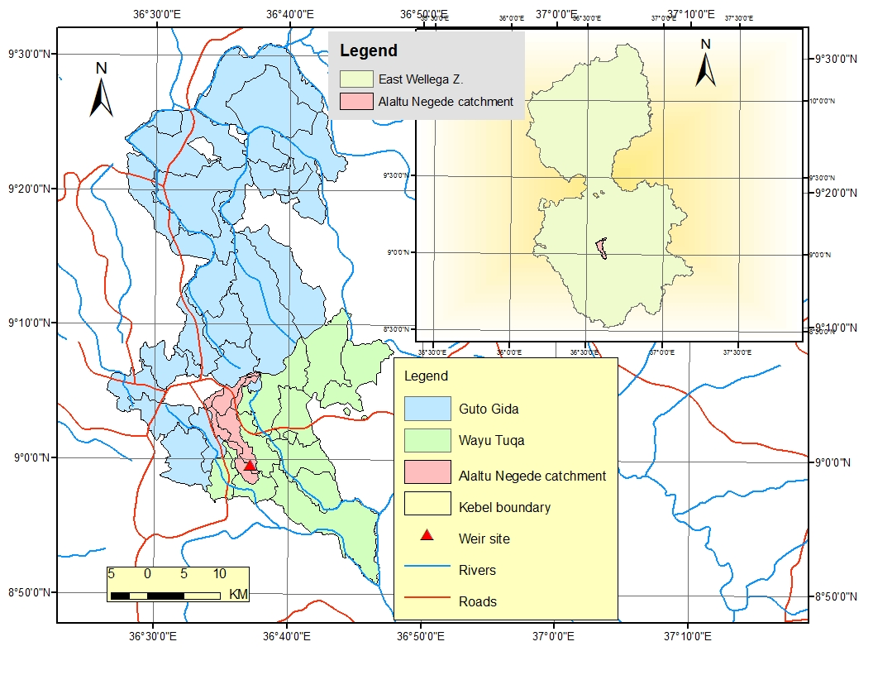
Figure 1: Location Map of AleltuNegede Catchment

AlaltuNegede major watershed is sub-divided in to nine micro-watersheds for the simplicity of implementation (Figure 2). The area of each micro-watershed is also shown on Table 1 below. The sub-watershed surrounding the SSIP is represented by CWS-8.
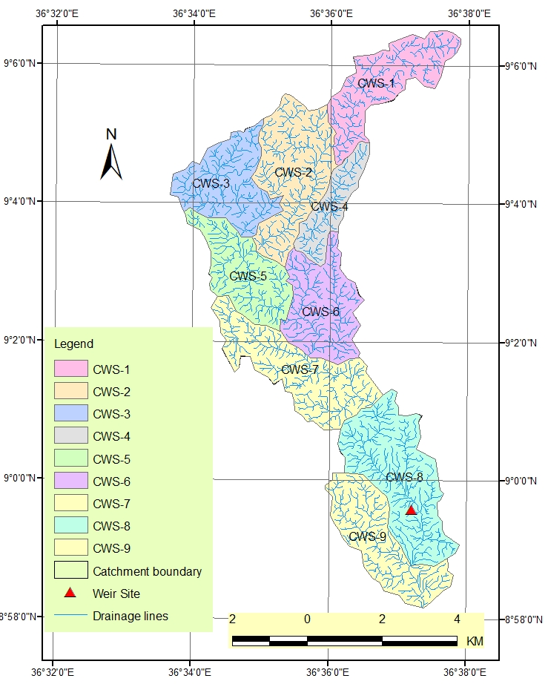
Figure 2: Sub-watersheds of AlaltuNegede catchment

In this catchment, although all the micro-watersheds need treatments for reducing the rate of soil erosion, increasing the productive capacity of the land, and improving the infiltration rate of the soil which then increase the ground water table, here we consider only the management of the micro-watershed surrounding the small scale irrigation.

Table 1: Sub-watersheds of Aleltu Negede catchment
S/No | Sub-watersheds | Area (ha) | % Cover
1 | CWS-1 | 497.3 | 10.77
2 | CWS-2 | 625.67 | 13.55
3 | CWS-3 | 473.76 | 10.26
4 | CWS-4 | 239.83 | 5.19
5 | CWS-5 | 440.64 | 9.54
6 | CWS-6 | 487.71 | 10.56
7 | CWS-7 | 612.52 | 13.27
8 | CWS-8 | 734.07 | 15.90
9 | CWS-9 | 505.38 | 10.95
 | Total | 4616.88 | 100.00
CWS-Community watershed
The map of the micro-watershed under consideration surrounding the SSIP is shown on Figure 3 below. It has an area of 734.07ha and accounts for about 10.95% of the total area of the whole catchment.
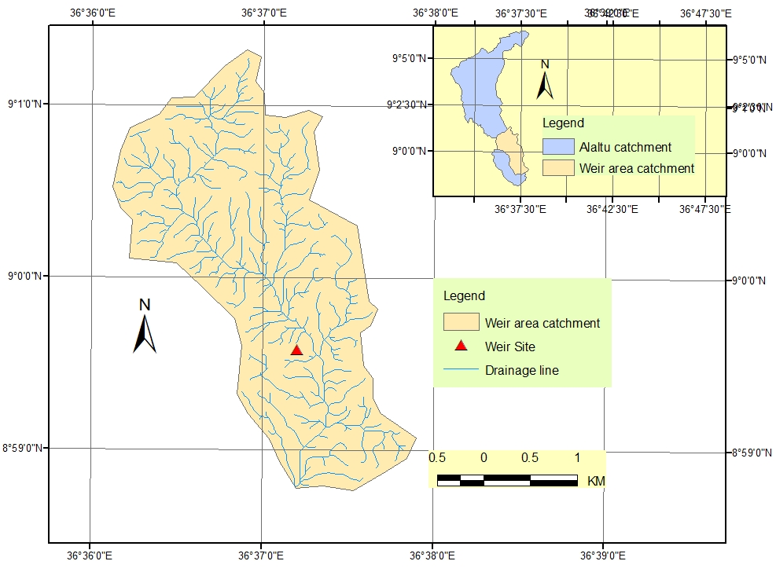
Figure 3: Sub-watersheds of the micro-catchment

Topography

Topography is one of the main factors affecting the rate of soil erosion in the watershed. Topographic features that influence erosion are degree of slope, shape and length of slope and size and shape of the watershed. On steep slopes, runoff water is more erosive and easily transport detached sediment down-slope. On longer slopes, an increased accumulation of overland flow tends to increase rill erosion. Therefore, slope steepness and its length have a major implication on soil erosion and subsequent sediment inflow to lower lying lands. It determines detachment and transportation of soil particles.
AleltuNegede catchment has a very narrow shape and is characterized with rolling and hilly rugged topography upstream of the diversion site. However, the catchment area below the proposed weir site has flat to gentle and undulating landscapes. The slope classes of the catchment area is categorized depending on the slope ranges indicated in Community Based Participatory Watershed Development guide line (CBPWSD) of the M0ARD and is given in Table 2 below.

Table 2: Slope class categories and landforms
Slope classes | Range (%) | Size (ha) | Coverage (%)
Flat or almost flat | 0 - 3 | 289.39 | 6.27
Gently sloping | 3 - 8 | 1417.6 | 30.70
Sloping | 8 - 15 | 1740.15 | 37.69
Moderately steep | 15 - 30 | 1090.18 | 23.61
Steep | 30 - 50 | 72.68 | 1.57
Very steep | > 50 | 6.88 | 0.15
Total |  | 4616.88 | 100.00

As indicated in the table above, the catchment area is mainly characterized by gently sloping, sloping, and moderately steep topography. About 31% of the catchment area falls under gently sloping topography; 38% sloping; 24% moderately steep; and the remaining 6% of the area falls under flat or almost flat land. Very steep topography covers about 6.88ha that accounts for only less than 1% of the total area.
About 92% of the watershed area characterized with slope categories greater than 8% are significantly susceptible to erosion as these areas are under intensive cultivation of annual crops and are not covered with natural or artificial vegetation and woodland that prevent the barren area from the forces of rain drops.

Agro-Ecology

The general purpose of an agro-ecological zoning is to provide a tool for assessing which areas are ecologically suitable for various land use alternatives and land management practices. Therefore, it is the delineation of land into certain categories based on bio-physical and socio-economic factors. Precipitation, soils, altitude, temperature, evaporation, farming systems and vegetation types are the usual classification components, singly or in combination.
The rainfall distribution of the area has been estimated from stations around the watershed area i.e.Nekemte rain gauge stations. Data processing includes the filling of the missed data. Accordingly, the mean annual rainfall of the watershed is estimated to be 1054 mm and receives from May to September. The erratic nature of the rainfall made farming unpredictable and generally put it at low level of productivity.

Land use/Land cover
Identification of the present land use/land cover of an area is essential part of watershed management study. The way a given land unit is used along with other physical features and socio-economic conditions determines the erosion process and the management interventions it receives. Based on this, the land use/land cover of the AleltuNegede catchment was processed from satellite remote sensing with the application of Geographical Information System (GIS) techniques. It was also confirmed with ground truth during field visit in the area and from Google earth images as well. Accordingly, six major land use/land cover classes were identified for the AleltuNegede catchment area (Table 3) - namely, farmlands (61.6%), forest land (11.4%), shrub/bush lands (10.9%), grazing lands (2.70%), and the remaining 13.5% is occupied by rural settlements and part of Nekemte Town. The catchment has a total area of about 4616.88ha including the proposed command area. The spatial distributionof each land use /land cover types isshown on Figure 4.

Table 3: Land use/cover of AleltuNegede catchment
Land use | Major Catchment |  | Micro-catchment
Land use | Area (ha) | Coverage (%) | Area (ha) | Coverage (%)
Farmlands | 2842.23 | 61.56 | 560.53 | 76.36
Forest lands | 525.98 | 11.39 | - | -
Shrub/Bush lands | 501.43 | 10.86 | 89.37 | 12.17
Settlements | 336.39 | 7.29 | 41.72 | 5.68
Grazing lands | 125.58 | 2.72 | 42.45 | 5.78
Town | 285.27 | 6.18 | - | -
Total | 4616.88 | 100 | 734.07 | 100

The land use/land cover map of the micro-catchment under consideration is shown on Figure 5 below. According to the land use/cover classification used four major land use/land cover classes were identified for the micro-catchment (Table 3) - namely, farmlands (76.36%), shrub/bush lands (12.17%), and grazing lands (5.78%). The total area occupied by rural settlements accounts for about 5.68% of the total micro-catchment area.

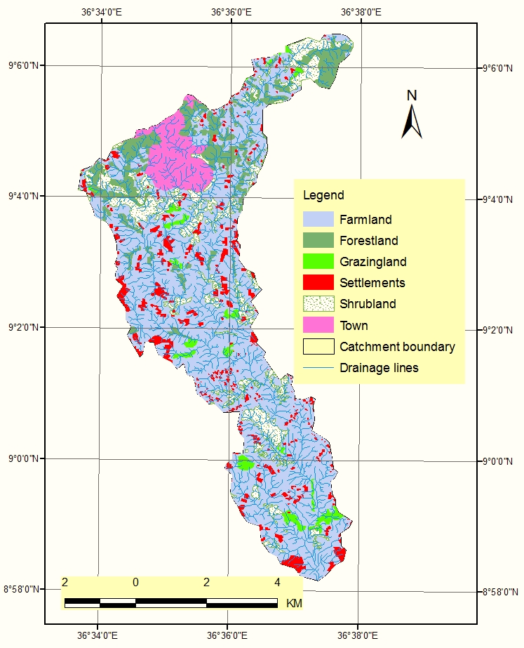
Figure 4: Land use/land cover map of AleltuNegede catchment

Farmlands

In AleltuNegede catchment, farmlands comprise the largest land use unit and covers about 2842.23ha which accounts for 61.56% of the total watershed area.The area covered by farmlands in the micro-catchment is about 560.53ha and is the largest portion of the micro-catchment area accounting for about 76.36% (Figure 5). It includes the command area and is found distributed throughout the watershed. The area is intensively cultivated mainly dominated with rain fed annual crops. The major crops grown in the area are cereal crops (maize, teff, barely, wheat, oats, etc), pulses (horse bean and field pea) and horticultural crops (potatoes, cabbages, carrots, onions, etc). In this catchment traditional irrigation locally known as ‘bone’ is widely practiced immediately after the harvest of the annual rain-fed crops starting from the month of December onwards mainly for the growth of Maize crop, potato and some vegetables like onions, carrots, cabbages, etc.
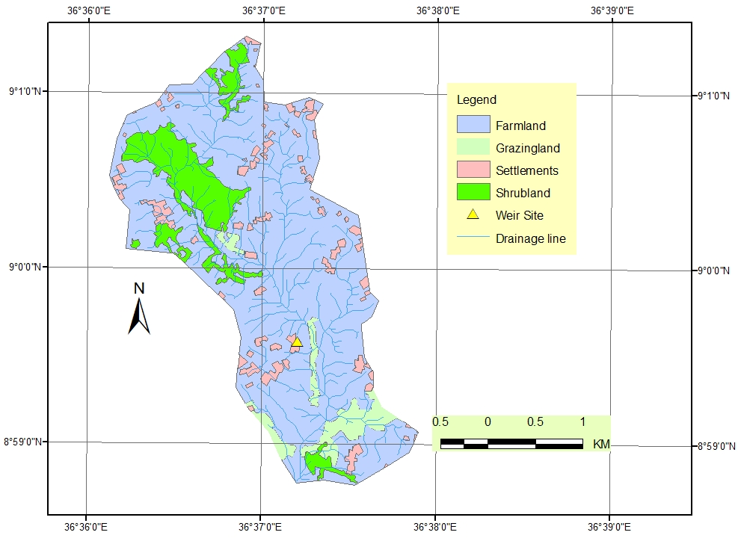
Figure 5: Land use/land cover map of the micro-catchment

Forestlands
In AleltuNegede catchment the area covered by forest lands is about 525.98ha and accounts for 11.39% of the total catchment area. This area includes natural forest, bush and shrubs, and scattered trees. Some of natural tree species are Juniperus-procera, Hageniaa-byssinica, Olea-africana, Erythrina, Euphorbia- candelabrum and Ekebergia-capensis and etc. In the upper part of the catchment, especially adjacent to Nekemte Town, the natural forests are mixed with plantations of various tree species such as eucalyptus, gravilea, jacaranda, Juniperus-procera etc. This land use unit is used as a source of construction materials, poles and posts, and fuel for the people living in the area. This land use unit is found mainly in the upper most extreme of the catchment. Some of these forests are artificial plantation and is located around Nekemte Town. In the rural area they are used as a source of fodder for livestock. Additionally, these forests play important roles in maintaining the delicate ecological balance of the area. The roots of trees hold soil in place and, as a result, control soil erosion and help to stabilize steep slopes. However, the encroachment of Nekemte Town in the upper catchment to this forest lands can dramatically increase runoff and soil erosion and degrade the water quality downstream.

Shrub lands
Shrub/bush lands cover about 501.43ha and accounts for 10.86% of the total AleltuNegede catchment area. It also covers about 89.37ha in the micro-catchment accounting for about 12.17% of the total area of the catchment. The coverage of the shrub land is the second largest land use unit in the micro-catchment (Table 3).This land use unit is found distributed in the catchment. It is used as the source for collecting fire woods, fencing material and also serves as a communal grazing area for the local farmers.

Settlements

The total settlement area in AleltuNegede catchment is about 621.66ha which accounts for 13.47% of the total catchment. The settlement area occupied by the rural community covers about 336.39ha which accounts for 7.29% of the total watershed area and the remaining 285.27ha (6.18% of the total catchment area) is occupied by part of the Nekemte Town dwellersin the north. Other settlements include various institutions such as schools, churches, health posts, kebele administration offices, etc.

Grazing lands

In AleltuNegede catchment grazing lands covers about 130.50ha which accounts for 2.58% of the total area. The area of grazing land in the micro-catchment is about 42.45ha and it accounts for about 5.78% of the area. In this catchment grazing land is the major source of livestock feed in addition to crop residues after the harvest of crops. Despite its low coverage in the catchment, grazing lands are owned communally and, therefore, used in common by the local communities living nearby. These grazing areas are highly overgrazed and trampled by livestock due to over stocking. Some of the areas are converted to degraded areas and highly susceptible to erosion.

Major Soil types
Soils have particular importance in CM study. The soils characteristics, which influence the erosion process in a Catchment, are soil texture, structure, organic matter content, soil fertility, soil chemical properties and stoniness. Therefore, Catchment planning process needs basic knowledge about major soils characteristics.
In this study the FAO/UNESCO soil classification system, which is the most suitable and acceptable classification method, is used to classify the major soil types of the AleltuNegede catchment. Accordingly, six major soil types have been identified in the study area (Table 4); namely Acrisols(26.84%), Cambisols (46.10%),Cambisols and Lixisols (6.611%),Lixisols (11.90%), Nitisols (6.85%) and Fluvisolsabout (1.70%) of the catchment area (Figure 6).
For the micro-catchment four major soil types have been identified (Table 4); namely Acrisols (41.20%), Cambisols (33.53%),Cambisols and Lixisols (21.45%), and Fluvisols (3.82%)(Figure 7).The detail descriptions of these major soils are given below:

Table 4: Major soils of AleltuNegede catchment
Major soils | Major Catchment |  | Micro-catchment
Major soils | Area (ha) | Coverage (%) | Area (ha) | Coverage (%)
Acrisols | 1238.94 | 26.84 | 302.46 | 41.20
Cambisols | 2128.16 | 46.10 | 246.15 | 33.53
Cambisols&Lixisols | 305.38 | 6.61 | 157.43 | 21.45
Fluvisols | 78.48 | 1.70 | 28.03 | 3.82
Lixisols | 549.58 | 11.90 | - | -
Nitisols | 316.34 | 6.85 | - | -
Total | 4616.88 | 100 | 734.07 | 100

Acrisols
Acrisols are soils that have a higher clay content in the subsoil than in the topsoil as a result of pedogenetic processes (especially clay migration) leading to an argicsubsoil horizon. Acrisols have in certain depths a low base saturation and low-activity clays.
Preservation of the surface soil with its all-important organic matter and preventing erosion are preconditions for farming on Acrisols. Adapted cropping systems with complete fertilization and careful management are required if sedentary farming is to be practiced on Acrisols. Agroforestry is recommended as a soil-protecting alternative to shifting cultivation to achieve higher yields without requiring expensive inputs.

Cambisols
A Cambisol is a young soil. Soil forming processes are evident from variations in colour and/or the development of structure below the surface horizon. This type of soil occurs in a wide variety of climates around the world and under all kinds of vegetation. The brown colour of the upper part of the soil is the result of a soil process known as brunification which involves the leaching of base cations and alteration of iron-oxides in iron-rich parent material.
Cambisols combine soils with at least an incipient subsurface soil formation. Transformation of parent material is evident from structure formation and mostly brownish discoloration, increasing clay percentage, and/or carbonate removal.

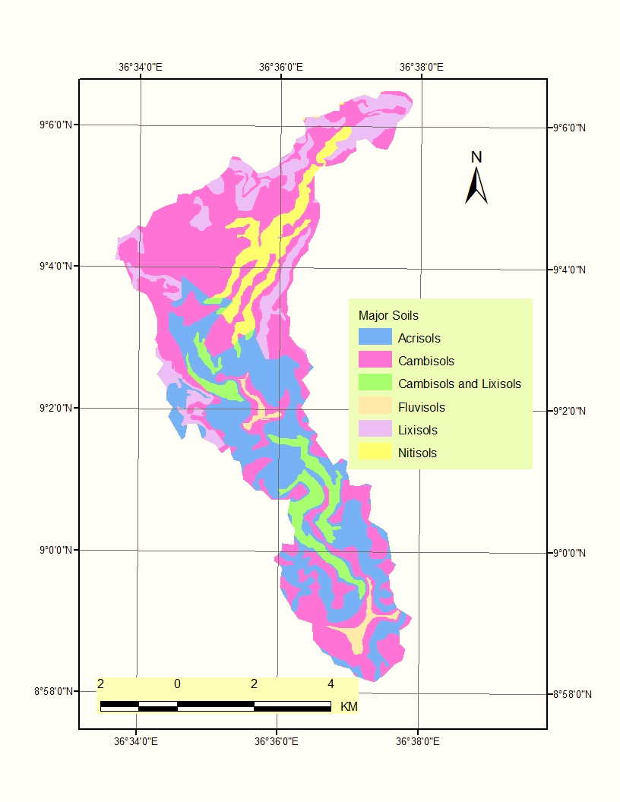
Figure 6: Major soils of AleltuNegede Catchment

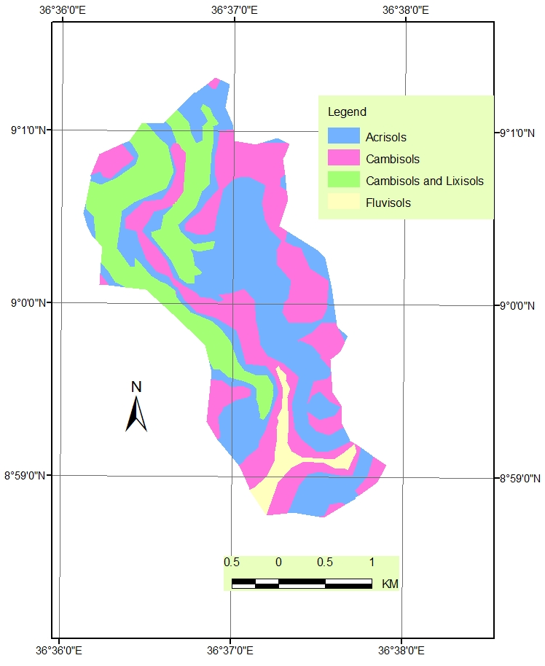
Figure 7: Major soils of the micro-catchment

Cambisols generally make good agricultural land and are used intensively. Cambisols with high base saturation in the temperate zone are among the most productive soils on earth. More acid Cambisols, although less fertile, are used for mixed arable farming and as grazing and forest land. Cambisols on steep slopes are best kept under forest; this is particularly true for Cambisols in highlands. Cambisols on irrigated alluvial plains in the dry zone are used intensively for production of food and oil crops. Cambisols in undulating or hilly terrain (mainly colluvial) are planted to a variety of annual and perennial crops or are used as grazing land.
It has strong brown or red soils and is found in the catchment following the mountain ridges. This soil has limited agricultural value due to on steep slopes and is often shallow or has stones or rock outcrop. The major limitation to agricultural use is their topographical position and stoniness in very steep slope areas and highly erodible soils.

Fluvisols
The Reference Soil Group of the Fluvisolsaccommodates generally very young soils with weak differentiation, azonal soils in alluvial deposits and, therefore, isyoung soils that have ‘fluvic soil properties’. This means they receive fresh sediment during regular floods and show stratification and/or an irregular organic matter profile. They are predominantly brown (aerated soils) and/or grey (water logged soils) in colour. Their texture can vary from coarse sand in levee soils to heavy clay in basin areas. Fluvisols are normally confined to narrow strips of land adjacent to the actual riverbed. Fluvisols are used for planting food crops and orchards and are also used for grazing. Flood control, drainage and/or irrigation is normally required.

Lixisols
Lixisols comprise soils that have a higher clay content in the subsoil than in the topsoil as a result of pedogenetic processes (especially clay migration) leading to an argicsubsoil horizon. Lixisols have a high base saturation and low-activity clays at certain depths.
Areas with Lixisols that are still under open woodland vegetation are widely used for low volume grazing. Preservation of the surface soil with its important organic matter is of utmost importance. Degraded surface soils have low aggregate stability and are prone to slaking and/or erosion where exposed to the direct impact of raindrops. Tillage of wet soil or use of excessively heavy machinery compact the soil and cause serious structure deterioration. Tillage and erosion control measures such as terracing, contour ploughing, mulching and use of cover crops help to conserve the soil. The low absolute level of plant nutrients and the low cation retention by Lixisols makes recurrent inputs of fertilizers and/or lime a precondition for continuous cultivation. Chemically and/or physically deteriorated Lixisols regenerate very slowly where not reclaimed actively.
Perennial crops are to be preferred to annual crops, particularly on sloping land. Cultivation of tuber crops (cassava and sweet potato) or groundnut increases the danger of soil deterioration and erosion. Rotation of annual crops with improved pasture has been recommended in order to maintain or improve the content of soil organic matter.

Nitosols

Nitisols are deep, well-drained, red, tropical soils with diffuse horizon boundaries and a subsurface horizon with more than 30 percent clay and moderate to strong angular blocky structure elements that easily fall apart into characteristic shiny, polyhedric (nutty) elements. Weathering is relatively advanced but Nitisols are far more productive than most other red, tropical soils.
Nitisols are among the most productive soils of the humid tropics. The deep and porous solum and the stable soil structure of Nitisols permit deep rooting and make these soils quite resistant to erosion. The good workability of Nitisols, their good internal drainage and fair water holding properties are complemented by chemical (fertility) properties that compare favourably with those of most other tropical soils. Nitisols have relatively high contents of weathering minerals, and surface soils may contain several percent of organic matter, in particular under forest or tree crops. Nitisols are planted to plantation crops such as cocoa, coffee, rubber and pineapple, and are also widely used for food crop production on smallholdings. High P sorption calls for application of P fertilizers, usually provided as slow-release, low-grade phosphate rock in combination with smaller applications of better soluble superphosphate for short-term response by the crop.
In general, these soils have good potential for agriculture as they are porous, well drained, stable structure and a high water storage capacity. Chemically these soils have a rather low CEC for their clay content and available phosphorus is very low.

Soil Erosion and State of Natural Resources Management

In the past, due to the decline of the fertility and productivity of land, farmers were forced to use shifting cultivation encroaching into vegetation, hillsides, and steep slope areas. The areas which were once covered with forests and bush lands before few decades ago were slowly converted to farmlands & settlements by clearing off the existing natural forests & shrubs. In this way, forest and grazing lands were diminishing and the natural resources of the watershed are gradually deteriorating from time to time resulting in land degradation. In this system, farmers cultivate their land for two consecutive years and left it again as a fallow for one or two years and the system repeat itself in this manner.
At present, unsustainable management of the natural resource is manifested by cultivation of fragile hillsides and steep slopes and changing grazing areas into cropland. River bank erosions are also a widely observed problem at the right and left banks of AleltuNegede River due to concentration of high run off coming from upstream of the catchment. Besides, the agricultural production system in the area is intensified with cultivation of rained crops. Because of this sheet and rill erosionare prevalent in the area, resulting to less water infiltration, organic matter depletion, enhanced gully formation, and overall loss of land productivity.
Despite the presences of high demand for forest/wood products in the area, artificial forest development is limited in the area. This has happened due to low extension services and limited access to tree seedlings in the vicinity of the area. On farm nursery activities is almost none. Moreover, the existing forest/shrub resources also lack joint forest management system. Traditional agro forestry practices are not applied in the area and fallowing is the only practice used to improve the soil fertility and most farmers use cow dung around their homestead.

The community has underlined that expansion of degradation is highly correlated with population growth and lack of alternative income source. The degree of degradation of natural resource base was explained by the farmers as follows:
- Crop cultivation expanded to steep and very steep slopes as well as to marginal areas,
- Soil fertility decreased due to the combined effect of frequent cultivation, lack of conservation measures, increased run-off and siltation problems,
- Currently, there is no natural forest in the area due to agricultural encroachment to forest areas,
- Very little communal grazing lands left in the area that leads to shortage of fodder & grasses for livestock resulting to overgrazing, poor vegetation cover and land degradation,
- With the increasing demand for agricultural production, the trend of traditional natural resources management is reduced,
- The discharge of existing springs decreased in the watershed due to the reduction of natural forest coverage,
- The existing traditional agro forestry system is under question if the current condition continues.

As discussed with various groups (FGD) of the community (community leaders, elders and youth groups), the major factors for soil erosion occurrence in the area include scarce vegetation cover, frequent cultivation of farmlands and limited use of SWC measures. The undulating and steep topography, fragile nature of the soils, and seasonally abundant rainfall distribution in the area are also other contributing factors for the severity of soil erosion in the Watershed.
Understanding of the soil erosion processes and degree of occurrence is important in order to arrive at proper catchment management interventions and put remedial measures. The degree of erosion differs from place to place depending on the land use type being used. Erosion generated from varies land uses also vary accordingly. This indicates that few areas of the watershed are critical and responsible for high amount of soil losses and sediment delivery. Therefore, it is necessary to identify high risk areas of the catchment to prioritize areas for specific soil conservation plans for reducing further degradation, reclaiming the degraded areas and improving the land productivity of the watershed through application of appropriate SWC technologies.

RUSLE model
The scientific planning for soil conservation and water management requires knowledge of the relations among those factors that cause losses of soil and water, methods for controlling those factors, and to reduce such losses. The rate of erosion for a given site results from the combination of many physical and management variables. Actual measurements of soil loss would not be feasible for each of these factors that occur under field conditions. Erosion and sedimentation by water involves the process of detachment, transport, and deposition of soil particles (Foster 1983). The major forces are from the impact of raindrops and from water flowing over the land surface. The Revised Universal Soil Loss Equation (RUSLE) is an empirically based model that has the ability to predict the long term average annual rate of soil erosion on a field slope based on rainfall pattern, soil type, topography, crop system and management practices (Renardet al., 1997). RUSLE is an erosion model designed to predict the longtime average annual soil loss carried by runoff from specific field slopes in specified cropping and management systems as well as from grazing lands. It retains the factors of the USLE by including improved means of computing soil erosion factors. The RUSLE model in GIS environment can predict erosion potential on a cell-by-cell basis, which is effective when attempting to identify the spatial pattern of soil loss present within a large watershed area (Shi et al., 2004). GIS can then be used to isolate and query these locations to identify the role of individual variables in contributing to the observed erosion potential value (Saavedra, 2005). In spite of this advantage, RUSLE does not estimate remote deposition and gully erosion.

RUSLE is given by the following equation:
A = R x K x L x S x C x P
Where: A = computed average annual soil loss in tons/ha/year;
R = rainfall-runoff erosivity factor;
K = soil erodibility factor;
LS = slope length and steepness factor;
C = cover management factor; and
P = support practice factor

Major Factors Affecting Erosion
RUSLE, an empirically based equation, derived from a large mass of field data, computes sheet and rill erosion using values representing the four major factors affecting erosion. These factors are climate soil conditions, topography and land use and management represented by R, K, LS and CP, respectively. These factors are described below:

Therainfall factor (R)
The rainfall factor (R), is the product of the energy contained in rain storms multiplied by their maximum 30-minute intensity for all storms of more than 12.5 mm; it is also called the EI30 index. It is a measure of the total annual erosive rainfall for a specific location, as well as the distribution of erosive rainfall throughout the year. The most important characteristics of rainfall are rainfall intensity (how hard it rains), rainfall amount (how much it rains), and runoff that occurs during different seasons of the year.
Rainfall drives inter-rill and rill erosion. Soil loss is high where much intense rainfall occurs, whereas soil loss is low where very little rainfall occurs. Thus, rainfall erosivity varies from area to area depending on the amount of rain it receives.

The Soil Erodibility Factor(K)
The Soil Erodibility Factor (K) is a quantitative measure of a soil's inherent susceptibility/resistance to erosion and the soil's influence on runoff amount and rate. It is affected by soil texture and structure, organic matter content, permeability, and season of the year. Erosion by raindrop impact is not easily seen, but varying degrees of rilling indicate differing erodibility among soils. Knowledge of basic soil properties such as texture provides an indication of erodibility. For example, soils high in clay and sand have low erodibilities while soils high in silt have high erodibilities.

The Topographic factor (LS)
In USLE, the slope factor (LS)is a measure of the effects of slope angle, length and complexity on erosion. Topography, especially steepness, affects soil loss. Intense rilling is evidence that steep slopes like road cuts and fills experience intense erosion when bare. Runoff that accumulates on long slopes (overland flow path lengths) is also highly erodible, especially when it flows onto steep slopes. Thus, slope steepness and overland flow path length are major indicators of how topography affects erosion. Slope shape (steepness along the overland flow path) also affects erosion and deposition as evidenced by both erosion and deposition on concave slopes.

The crop cover and management factor (C)
The crop cover and management factor (C)is a measure of the relative effectiveness of soil and crop management systems in preventing or reducing soil loss. Cultural practices include: vegetative cover, crop rotations, conservation tillage and mulching. It is affected by:
- crop canopy (leaves and branches of the crop, which intercept the raindrops and dissipate some of their erosive force),
- surface cover (crop residues and live vegetation on the soil surface),
- soil biomass (all vegetative matter within the soil; residue helps to improve the flow of water into the soil and the soil water-holding capacity),
- tillage (type, timing and frequency of tillage operations; has an effect on soil porosity,
- surface roughness and compaction),
- previous year's crop, and
- Distribution of erosive rainfall over the growing season.

The support practice factor (P)
The support practice factor (P)is defined as the ratio of soil loss with a given conservation practice to that under crops in rows running up and down the slope. It is a measure of the effects of practices designed to modify the flow pattern, grade, or direction of surface runoff and thus reduce the amount of erosion. Some of the most common support practices are: cross slope cultivation, contour farming, strip-cropping, terracing, and grassed waterways.

Estimating Soil Losses
RUSLE2 computes soil loss and other erosion values using inputs for climate, soil, topography, and use practices and conditions. These values stored in the RUSLE2 database under names for locations, which identify climatic variables; soil; cover management conditions and practices; and supporting practices. The user selects a name from a menu list for each of these factors to compute erosion. RUSLE2 “pulls” the values associated with each input name from the RUSLE2 database. The user changes values of particular variables from those stored in the database as needed to represent site-specific conditions related to topography, yield (production level), rock cover, and type and amount of applied materials like manure and mulch.

Accordingly, the average annual soil loss from AleltuNegede catchment is greater than 33 tones/ha /year, which is high based on the soil loss category. Therefore, conservation measures such as zero tillage, crop rotations, and terraces, contour strip cropping, and cover of permanent vegetation need to be employed.
The long term consequences of soil erosion problems are mainly associated with the decline in the productivity of land, loss of valuable forest resources, micro climate change, decline in the yield of streams and siltation of sediments inside watercourses and lower lying areas including the weir site and the proposed command area. Therefore, proper planning and implementation of watershed management measures are necessary in this watershed to maintain existing natural resources and ensure sustainability of the proposed small irrigation project.

SOCIO-ECONOMIC CONDITION

General
The study of the socio-economic situation of a catchment helps to have clear understanding of the area. The main interactions of the people with the various levels of the watershed will be described in detail. It provides useful information about land resources in the watershed and assess the opportunities (internal and externals available for development) and the major issues and limitation that may hinder proper watershed development.
In general, to identify the major problems, constraints and opportunities that help prioritize the main development interventions and choose locally acceptable and technically sound development options, assessment of the socio-economic situation of an area is very crucial.

Socio-economic conditions of the watershed were collected through predefined format, discussion with relevant GO staffs (experts, DAs etc.) and observation during field visiting in the area and discussion through informal and random interviews of community members during transect walk in the area. The findings are discussed in the following sections.

Population

The total population of AleltuNegede catchment is about 8476 (52% males and 48 % females) and comprises part of the two kebeles of GutoGida woreda (Gari and Negasakebeles) in the west, part of three kebeles from WayuTuka woreda (DaloKomto, GidaAbalo and Gutekebeles) in the east and a portion of Nekemte Town upstream end of the catchment in the North. The average number of families per household is found to be 5.3 people. The sex distribution in the study area shows that the numbers of male population are a bit greater than females. The catchment is densely populated and the settlement pattern is almost similar throughout the watershed except the Nekemte Town where many urban people resides closely in the urban area.

Agricultural production

Understanding the farming system of a watershed offers opportunities to accurately plan the most suitable approach to hasten the agricultural development of the area through optimized &sustainable use of the natural resources. In AleltuNegede Watershed, the agricultural production system is mixed farming system (crop & livestock production).

Crop Production

The area is intensively cultivated mainly dominated with rain fed annual crops. The major crops grown in the area are cereal crops (Maize, teff, Barley, Wheat, Oats, etc), pulses (field bean, field pea, and lentil), oil crops (Noug and flax) and horticultural crops (potatoes, vegetables, carrot, onions, etc). In spite of its significant potentials, the production of fruit trees is rarely observed in the area. Traditional irrigation practices are few and limited to small plot of land for growing vegetables.
In the study area, farmers practice crop rotation to improve the fertility of their farmland as well as to minimize weed and control various diseases. Among others, cereal –pulse – cereal, and cereal – cereal – cereal are the most commonly crop rotation practiced in the area. Out of these types, the cereal-cereal-cereal approach is widely practiced. However, such type of crop rotation contributes to soil fertility depletion.
As they have access to inputs, farmers apply chemical fertilizer (DAP and UREA) to their farmlands for the major crops grown in the watershed such as Maize, Barley, Wheat and teff). Improved varieties of these major crops are also used by the farmers. Because of this, the total annual crop production in the area is better as compared to those areas where farmers do not have access to inputs. It was reported that the productivity of the land per hectare with optimum rate of fertilizer application for the major crops grown in the area is 32qt, 35qt and 31qt for Maize, Barley and Wheat crops, respectively. Therefore, the farmers need to be encouraged through adequate access to better improved inputs and diversification of crop production systems in the area.

Livestock Production

The major livestock types found in the study area are Cattle, Sheep, Goats, Horse, Mules and donkeys. They kept livestock for multi-purpose i.e. for draught power, milk, meat, transport services, earning cash income, and risk aversion in time of crop failure and etc. The total population of livestock in the watershed is given in (Table 5).

Animals kept in the catchment include 23069 oxen, 28796 cattle, 29981 sheep, 9848 goats 5784 donkeys, and 7450 horses. The population of sheep dominated accounting for 29% of total livestock, followed by cattle and oxen which accounts for 27% and 22%, respectively. The average number of livestock per household is about 6. Traditional beekeeping is also practiced in the area by few farmers. The common animal products used by the residents are milk, cheese, meat, egg, hides &skin. Oxen are used to plough cropland, cows for milk, shoats for sale, and equines for transport. Animal manure is also used as a source of fuel. Further to these, animals are the sources of cash when farmers need money as well as during the time when they faced private problems.
Traditionally, the farmers are practicing free grazing in their own plot. The major sources of animal feed are natural pasture from the private fallow and grazing lands that contributes about 68% and about 14% of animal feed comes from crop residues. There is no any improved forage development activities in the area.

Table 5: Livestock population in the catchment
Descriptions | Quantity | %
Oxen | 23069 | 21.99
Cattle | 28796 | 27.44
Sheep | 29981 | 28.57
Goats | 9848 | 9.39
Donkey | 5784 | 5.51
Horse | 7450 | 7.10
Total | 3137 | 100

The total number of livestock population kept in the watershed is high compared to the available grazing lands. Additional sources of livestock feed comes from crop residues, mainly Wheat, Barley, teff, and other cereal crops. Free grazing is the commonly practiced grazing system in the area and, therefore, it greatly contributed to soil erosion and destruction of vegetation cover of the area due to overgrazing and trampling by livestock.
In general, the livestock management system followed in the community watershed area is very traditional. Livestock productivity also remained low due to inadequate supply of livestock feed throughout the year. In the study area, there is huge shortage of livestock feed during the dry season. Failure to provide adequate feed throughout the year certainly reduces the possible income from any livestock production. Thus, proper livestock development strategy should be devised as part of the watershed development to improve productivity as well as to minimize soil erosion.
Shortage of grazing land and lack of improved forages; prevalence of livestock diseases, poor quality of the existing local breed, absence of nearby AI and bull services; lack of awareness on livestock and grazing land management and feed quality enrichments and invasion of weeds are cited as the major problems.
As to curve all these drawbacks as well as to boost up the production and productivity of the livestock sector in the area, introducing and planting improved grass and fodders in physical structures, homestead areas, grazing fields and gullies are very crucial. As to improve the productivity and sustainability of communal areas, proper land use and management system need to be adopted. Proper feed reservation and quality improvement are also the focus areas which need attention. Regarding quality improvement of the existing breeds, partnerships should be strengthened along with those concerned offices which work on animal diseases prevention, AI and bull services, improved breeds and fodder providers.

Apiculture

Apiculture has a great contribution to rural economy as it promotes self-reliance and requires small land and investment. When beekeeping is integrated with forestry development activities, it conserves the natural resources and contributes to environmental protection. Honeybee has also a great role in economic balance by pollination of different trees and crops.
AleltuNegedecatchment has some potential for beekeeping due to favorable ecological factors. The area has also relatively good market access being found near the woreda town. In this study area, most farmers practice beekeeping using traditional beehives. Some farmers have also engaged in transforming from traditional beehives to modern or transitional beehives in the previous times. Productivity of Honey form a traditional beehive in the area is about 5kg /harvest. Therefore, there is a need to support the farmers to promote improved technology and practices to increase the productivity of honey in the area.

Land Tenure System

Land tenure security can influence land management, because it may affect communities’ encouragement or ability to invest on land improvement. Landholding under insecure tenure is less likely to be developed in SWC and planting trees. The current constitution of FDRE has given private rural land use right that allows the farmer to use, rent, transfer, debt and lease. Land certification is already issued to the farmers living in the study area. However, the tenure system on natural resources is still communal and open access with limited regulation on the use and management of the resources contained in it. These may contribute to the destruction of natural resources as the community may not fell sense of ownership on lands which are not certified. Under situation, it is also difficult to realize the newly issued land use policy and proclamation of the region.

Rural Energy

Types of biomass energy resources in use in the study area are wood, animal dung and crop residue in their order of importance and fuel demands. The cooking stove is traditional (open fire) that consumes more fuel wood as compared to improved fuel stoves. In this study area, the promotion of improved stoves is low. This remains one of the most important factors that have been aggravating deforestation of exiting natural forest resources. This happened due to lack of the technology in the locality, low awareness of the community on energy conservation and the need for it and poor extension on the promotion of fuel-saving stoves.
Thus, the use of fuel- saving stoves and alternative energy sources is crucial to reduce the current rates of deforestation and subsequently to overcome the problem of fuel wood shortages. This can also help to reduce workload on women and children.

Gender Issues

Although the National constitute gives access right to all community owned properties on equal basis to women and men, in Ethiopia women hardly access to and control over the family resources and have low social status in the community. Similarly in this study area, women and men have different access and control over family resources. Economic capacities and incentives are also strongly gender-differentiated in ways, which affect supply response, resource allocation within the household, labor productivity, and welfare. Due to unfair division of labor in the community, the workload of women is immense as they are responsible for all domestic activities.
Although Women may suffer more than men due to inadequate availability of various resources like water, fuel wood, food, etc, their participation on the management of land is limited, otherwise confined around homesteads areas. Therefore, women need to be involved in the CM activities and high emphasis should be given both to fulfill both strategic and practical needs of women through different interventions like extension services, family planning and etc.

Infrastructure Development

Basic infrastructures like all-weather rood, telecommunication, education, safe water supply services, etc are important for economic development of any society. There is one dry weather road connecting the project area to the woreda town.
The coverage of access to safe drinking water supply is very low, and the source of water supply for the majority of the community living in the watershed is streams, springs and hand dug wells. In the watershed, there is only one elementary School. High school and preparatory school are available in the woreda town.

Institutions

Community based institutions
Institutions are basically established by the community or a group of people to satisfy their religion, social and economic needs. Generally, Mosque, Church, Idir, and Debo, are most important community based institutions that have been providing various services. Kebele and farmer’s cooperatives are also community based institutions established for facilitating political, economic, and social and justice services to the rural community. The kebele is sub-divided in to Zones and goths consisting of 10 to 20 members, mainly composed of productive labor age groups and HH heads.
Generally, those types of community gatherings are most important to achieve genuine community participation in development activities. However, the capacity of the institutions needs to be strengthened to carry out their vested responsibilities appropriately.

Government Institutions

The DA and health extension promotion workers are the most important GO institutions based at Kebeles which are very relevant to this study. Three DAs are assigned at kebele level who are responsible in promoting, disseminating and adoption of improved technologies and practices on agriculture, forestry development, and SWC interventions. Two female health extension workers are assigned at a kebele level, which are responsible in facilitating awareness creation education on environmental and personal hygiene, HIV/AIDs, family planning, prevention of malaria, and related interventions. They also support home management activities for rural women.
At woreda level, several governmental institutions exist, whose joint effort is to satisfy the needs of rural community. These institutions are directly or indirectly responsible to environmental protection, agricultural development and sustainable natural resources management. In general, the existences of those institutions are highly important to support the rural community in improving their livelihoods.

PROBLEM ANALYSIS

General
The biophysical and socio-economic situations of the watershed are discussed in the previous sections. Therefore, these need to be analyzed to identify major problems and their root causes to put solutions on solving or mitigating the identified problems and constraints. In this case, the CM interventions shall be planned to address root causes of the problems instead of the consequences.

The analysis indicates that the major problems/constraints of the study area include soil erosion, deforestation, decline in crop production, low livestock production and productivity, low alternative income sources and inadequate local capacity. The main root causes of the identified problems include population pressure, inadequate extension services, improper land use practices and low diversification of income sources. Factors such as topography, soil conditions, agro-climate, and vegetation cover and inappropriate farming practices were also contributing for the present situation.

The major problems and opportunities identified in the watershed are described below:

Major Problems

Soil erosion
The erosion process by Water includes sheet, rills, and small gully forms. The causes of this process is invariably a combination of natural phenomena and human's actions such as destruction of vegetative cover, overgrazing and inappropriate agricultural practices that are not in harmony with the natural environment. It is human's actions, often as a result of increasing population pressurethat accelerate the processes of deforestation. Many factors cause these proximate or direct causes including population pressure, limited access to extension services, land tenure, and low awareness of farmers about conservation of the natural resources.

Deforestation

Deforestation is loss of vegetation resources which is both cause and consequences of soil erosion. Although active deforestation was not observed in the catchment area, the vegetation cover is scant where found only in the upper boundary of the catchment in the mountain escarpment.

This may lead to shortage of various wood resources, soil erosion, drying up or declining in yield of ground water sources and other environmental consequences. There is wide spread argument that deforestation causes a reduction of rainfall on a local and regional scale, because the recycling process of water vapor through forest transpiration will be reduced where there is deforestation.

These are the collective result of intuitional and policy constraints, social and economic factors prevailing in the area. Uncontrolled cutting of trees for various purposes, notably firewood, charcoal, construction and expansion of agriculture due to rapid population growth are the major causes. Low awareness of the community, land tenure security problems, lack of alternative rural energy technology and highly dependent on woody biomass for fuel wood are the other contributing factors.
In spite of the above problem, Forest development activityis limited in the area. As per information collected from the Woreda office, onlytwo centralnurseries exist in the woreda to supply tree seedlings for various plantation strategies. These have also lowcapacity about 0.7 million seedlings, mainly eucalyptus tree species. Thishas happened due to financial constraints to run nurseries.Therefore, adequate numbers of nurseries need to be established and run to produce multipurpose trees seedlings to the community in their locality. Moreover; existing natural vegetation need to be protected via community based management system through awareness raising education sessions.

Low livestock production

The main challenge in livestock productivity is inadequate supply of livestock feed and water resources. Shortage of livestock feed resources is a serious problem particularly in the dry seasons. Furthermore, overgrazing by large no of livestock must be looked upon as one of the causes for instability of natural vegetation and soil resources. Therefore, appropriate livestock husbandry and forage development strategies should be devised in the community to improve livestock productivity.

Low diversification of crop production

Although the area has potential for crop diversification, the dominant crops grown are mainly cereals which require large areas which areincomparable with ever increasing population pressure in the area. Thus, crop diversification and intensification is important both throughrain fed and irrigation development are necessary to improve crop production and increase availability of food crops on sustainable basis.

Limited alternative income sources

In the study area, most HHsoperates with low income because they have no diversified income generating sources. This could be associated with lack of working capital to engage in various IGAs, limited knowledge and skill on entrepreneur, weak institutional set up, and limited access to rural credit and saving services.

Therefore, providing financial and technical support to the poor rural community member is necessary to encourage them to involve in feasible IGAs. This in turn contributes to improve the income and consequently reduced unnecessary burdens on existing natural resources. In this regard, the area has significant potential for IGAs like fatting of small ruminants mainly goats, and apiculture and the like.

Low Local Capacity

The effectiveness of the regional and local efforts to improve the environment and livelihoods of the inhabitants through natural resource conservationis highly related to thelocal capacity. Lack of technical knows and skill in field staffs, budget constraint and shortage of trained work force at local level are the major problems related to capacityin the local government. They lack experiences on principles, approaches and techniques of CM interventions. As the result, the extension service to the communities is limited and gives low attention to conservation of natural resources. Low awareness and limited knowledge of the rural community on management of natural resources and adoption of improved production techniques and practices are also other major constraints.

Therefore, strengthening the local capacity through training and equipping with necessary equipment (tools) are highly important to achieve effective catchment management.

Opportunities

In a CM, all the existing opportunities in terms of bio-physical resources and socio-economic conditions need to be identified. The study has identified the following opportunities that will support to achieve development of the catchment in the future.

Bio-physical opportunities

- Suitable agro-ecology to introduce multipurpose trees and shrubs for livestock feed, soil fertility maintenance and ecosystem conservation, and to diversify productions,
- Adequate moisture in the soil for establishing planting materials,
- Possibility of carrying out fattening through controlled grazing and cut and carry system, thereby reducing pressure on existing vegetation cover,
- There is a potential for promoting apiculture in the area,
- The streams flow continuously throughout the year and will serve as a good source both for the development of small scale irrigation and for domestic supply.

Socio-Economic Opportunities

In this study area, there are many socio-economic opportunities to alleviate the problems and respond to the community’s felt needs: The following are among others:
- the existence of many laborers in the rural community and ample culture to work together is a good opportunity to carryout SWC activities,
- indigenous knowledge of the local community on traditional apiculture practices,
- the presence of land use policy in the country and enactment of rural land administration and land use proclamation by the regions,
- Some experiences in dairy farming with localand cross-breeds.

PROPOSED CATCHMENT MANAGEMENT INTERVENTIONS

Main Strategies
A watershed is a physiographic unit encompassing different land units such as hillsides, drainage lines, plains, grazing lands, farmland, and settlements. Watershed rehabilitation projects have first to understand the causes of degradation rather than trying to address the effects of it. Untreated and/or deforested hillsides are always sources of flooding and erosion for lower-lying farmlands and grazing lands; hence, treatment of hillsides should be carried out before starting gully treatment. Though construction of any physical structures is becoming a common practice in watershed management, they are only for a short-term solution, until the vegetation cover of the degraded area, whether from natural regeneration or artificial plantation, recovers.
The management of watersheds, therefore, requires the application of scientific methods and principles of welfare economics within a framework of public policy which can accommodate multiple objectives, the ultimate objective being improved people’s livelihood through restoring and enhancing land productivity. Careful management of watersheds is a core element of good agriculture and management because it can minimize land degradation, stabilize water stream flows, reduce sediment load, and recharge groundwater stores. In this way effective watershed development integrates the management of water resources, land, welfare, healthcare, and yet other aspect of development. Due to the nature of the project and limited scope the proposed interventions will give high emphasis to interventions that will reduce soil erosion and deforestation of the existing natural resources. The recommended measures will help conserve the available natural resources of the watershed which in turn increase the productivity of the land thereby improving the livelihood of the community living in the watershed area. The major intervention areas recommended for the watershed include:
- Soil and water conservation;
- Reforestation;
- Crop production management;
- Livestock management;
- Pasture/forage management;
- Income generating activities;
- Cross-cutting issues; and
- Capacity development.
- These proposed interventions will be implemented to suit a variety of land uses in the watershed as discussed below.

Catchment Management Interventions

Basically, CM interventions can be derived from identified potentials in terms of problems, constraints and opportunities as outlined in the previous sections. Accordingly, a broad range of possible interventions and strategies are proposed based on the biophysical and socio-economic conditions of study area. Their description is given below:

Soil and Water Conservation
In soil and water conservation, engineering and biological principles are applied to solve or address soil and water management problems. Accordingly, soil conservation measures are broadly classified into physical soil conservation measures and biological soil conservation measures. For effectiveness both measures are used in combination to reinforce one another. Biophysical measures, which are a combination of physical and biological treatment (planting trees, shrubs, legumes and grasses) are most important in the provision of immediate benefits to farmers. The guiding principle here is to have water infiltrate into the soil as much as possible where it falls, so as to increase the water-holding capacity for the benefit of crops and natural vegetation, as well as for groundwater replenishment. Any excess runoff must be safely disposed of from the land, but needs to be managed within the watershed by constructing sinkholes or percolation pits along the drainage canals. Soil in solution with water needs to be filtered out and re-deposited as close as possible to its original location.

Physical Soil and Water Conservation
Physical SWC measures are mechanical or structural engineering measures developed through soil cutting and earth moving to reshape the topography. They are mechanical barriers constructed across the slope to control the velocity of surface runoff and thereby reduce soil loss by erosion. The important principles to be kept in view while planning physical control measures are:
- Increasing the time of concentration of runoff thereby allowing more of it to be absorbed and held by the soil,
- Intercepting a long slope into several short ones so as to maintain less than a critical velocity for the runoff water,
- Protection against damage due to excessive runoff.
Usually such measures are not complete on their own and require the addition of a vegetative cover before becoming fully effective and permanent.
This category includes: bunds, terraces, moisture retention structures (like micro-basins, eye-brows, half-moons, trenches etc.), check dams, sediment storage dams (SS-dams), cutoff drains and waterways. Physical conservation structures, especially stone or soil bunds will be implemented based upon the local conditions and availability of construction materials. Stone bunds are aimed at dissipating the energy of the runoff and filtering the soil transported between the terraces. Stone bunds are recommended in upper catchments of dam sites, semi-water logged areas, poorly drained and shallow-profile soils. Soil bunds, meanwhile, are constructed in areas where there are not enough stones for terracing; where deep and well-drained soils exist, and in areas where moisture is much needed for crops to grow. Physical SWC structures, if not well constructed and maintained, can create more damage than good, indeed major disasters. Different biophysical structures need to be combined in a way which gives maximum benefits to the smallholder farmers.The main factors to be considered in the selection of physical SWC are climate, soil, topography and farming practice and other socio-economic situation of the area.

Some of the physical SWC interventions recommended for the catchment are described below:

Soil Bunds
Soil bunds are earth embankments constructed across the slope to act as a barrier to runoff, to form a water storage area on their upslope side and break up a slope into segments shorter in length than is required to generate overland flow. They are suitable on cultivated lands with slopes between 3 to 15%. Soil bunds need to be spaced at 15 to 20m and at vertical interval of between 1 to 2m. Above 15% hillside terraces are recommended. The bunds could be stone-faced in areas with high stoniness and stable soils. Planting of grasses and other multi-purpose agro-forestry species should be integrated with such measures. Moreover, they should be stabilized with legume shrubs such as pigeon peas, Sesbaniasesban, Acacia saligna and other grass species on the lower sides of the bunds.

Cutoff Drains
Cut-off drains are graded channel constructed to intercept surface run-off from higher ground/slopes and protect downstream areas. Its capacity can be estimated from runoff coming from upland watershed. The location of cut-off drain is determined after checking the outlet conditions. If it is intended to protect cropland against runoff from adjoining non-arable land, it should be constructed at the boundary between the two, while when needed to divert runoff from a gully head, it should be far 1.5 times the depth of the gully above the gully head so that stable slopes will exist. Cut-off drains are to be implemented in all types of mapping units wherever necessary and should be stabilized with grass splits and shrubs seedlings.

Waterways
A waterway is a natural or artificial drainage channel that leads water down a slope. Natural waterways are very efficient in safe disposing runoff for the reasons that being located in depressions usually approaches the required design slope, and the construction expenses are less than in artificially excavated channels. It takes runoff water from cut-off drains and carries it to rivers and streams. It is usually constructed one or two seasons ahead of the construction of these structures to make stabilized before runoff is entering to the ditches. Waterways are applicable in areas where natural waterways are not available. Technical specification of waterways depends on the volume of runoff envisaged to carry.

Check dams
In this study area, some small gullies were observed along road ditches, cattle trucks and following the river courses. Therefore, high emphasis should be given to addressing the root causes instead of tackling the effects. The techniques include diverting runoff (partially or wholly) plantation along the gully sides, and bed, and construction of check dams across gullies to hold backwater and trap sediments.
The type of check dam selected to treat gullies depends on the gully features (depth, width, gradient, gully formation stage, slope), availability of construction materials, and slope gradient of the gullies. To this end, live brush wood check dams and stone check dams, all integrated with plantations along the side of the gullies are proposed. These activities should be constructed in cost sharing systems in that the community will participate in the labor contribution in collection and provision of local available material such stones, while the project will cover the labor cost required for the implementation of the planned activities.

Stream Bank Protection
In AleltuNegede watershed stream bank erosion, land sliding and creation of deep gorges is one of the problems related to soil erosion close to stream banks. Due to the lack of appropriate SWC measures the continuous removal of soil by erosion from stream bank aggravated the problem. This stream bank erosion resulted to the loss of productive cropped lands from either side of the streams. Therefore, protecting of stream banks should be important part of the watershed management.

Biological Soil and Water Conservation Measures
Biological soil and water conservation measures are measures that include vegetative barriers, agronomic and soil fertility improving practices which help in controlling surface runoff, reduce soil loss and are often considered as reinforcement measures. They can stand alone, or in combination with physical SWC structures to reduce farmland degradation improve land productivity. Applications may vary depending on slope type and the agro-ecological zone. Biological SWC measures are sustainable and cheap and provide immediate and diversified benefits to the rural community.

Application of biological measures is based on the principle that:
- It protects the direct impact of raindrops through establishment of adequate ground cover and intercept the rainfall energy before reaching the ground,
- It reduces the concentration of runoff and consequently minimizes the surface flow velocity,
- It increases the soil resistance to erosion.
Vegetative barriers comprise grass strips and agro-forestry on cultivated lands, area closure and afforestation on non-cultivated lands. Agronomic practices include crop rotation, intercropping, strip cropping, alley cropping, mulching, vetiver hedge, contour cultivation, cash crops (chat, fruits, Gesho, pigeon pea) and tree plantations on bunds, soil fertility management, conservation tillage, improved seed production, grass hedge rows and compost making will be applied in the intervention area.
Some of the proposed interventions are presented below:

Nursery establishment
Nursery site is the place where multi-purpose tree seedlings and grasses are produced for various purposes like woodlot, backyard, homestead plantation and other strategies. In this watershed about three nurseries are planned with a capacity to produce about 1.2 million MPT seedlings, annually. The distribution of the nurseries will be based on the potentials and agro-ecological variation and the availability of access roads and many other factors. The investment and operation costs of these two nurseries are expected to be fully supported by the government, while the communities will contribute free labour and locally available materials. Produced seedlings will be distributed to the community through cost sharing mechanisms to sustain the nurseries.
Furthermore, effort has to develop to establish private nurseries to enable the farmers to satisfy their seedling demand by themselves through the provision of technical and material assistances to selected community members. In this case, it is planned that at least 10 % of the households living in the watershed will have their own nursery either in group or individually with a capacity to produce a minimum of 500 seedlings annually. The type of tree species to be produced in the nurseries depends up on the agro-ecological conditions of the area.

Afforestation/Reforestation
Trees and forest are critical resources for people’s livelihoods, environmental conservation and economic development. Majority of the population depends directly on wood for their energy needs (firewood and charcoal), materials for furniture and construction (timber and poles) as well as food and other non-timber forest products (including fruits, nuts, medicinal plants, fodder, etc.).
Many factors are directly influencing the loss of forest cover and the decline in the forest resource base. These include forest clearance for agriculture, wood fuels or charcoal production, the over-harvesting (poor planting and weak regulation, non-sustainable harvesting of forest products) and degradation of forests, the encroachment of government reserves and the degazetting of forest reserves for alternatives purposes, mainly cultivation of agricultural crops as a result of population pressure.
Consequently, it has become vital to identify appropriate land–use approaches for the production of multipurpose outputs, and to ensure the sustainability of the production base. Forests have a critical role to play in watershed development. They are essential to maintain the environment. This suggested the need for reforestation to restore the forests of the most degraded or deforested areas with multi-purpose tree seedlings.The diversification of tree species will initiate the future forest cover and ensure an ecological integration of the restored areas in the overall forest cover and provide habitats for wildlife.
Agroforestry activities also need to be practiced widely on farmlands and around homesteads. Plantation of multipurpose tree seedlings would be implemented primarily on steep and hillsides and degraded areas integrated with moisture retentions structures such as micro basins, trenches, and hillside terraces. From the time plantation is completed, the area need to be closed and free grazing and human interferences must be avoided.
Afforestation also helps as a source of income generating activities like: establishment of nurseries, sustainable supply of timber for future generations, increasing pasture outputs, developing small business relying on non-timber products such as honey, medicinal plants, wild fruit, handicraft…etc and ecotourism development.

Area Closure
Area closure is a protection system and saving mechanism of land against any external influences including erosion. Basically, slopes above 30% are recommended to be closed from day to day human and livestock interferences to give a way for the regeneration of natural trees and grass vegetation. The steep slope areas of the AleltuNegede catchment were highly degraded from continuous cultivation for decades. Such degraded areas (grazing, shrub/bush lands, gully banks, abandoned farmlands etc.) need to be closed for rehabilitation purposes. Gullies should be temporary closed at least for two years or so until the vegetation cover regenerate naturally. Such areas also need to be enriched with plantation of multipurpose trees.
Existing Forest protection and Management
AleltuNegede catchment area has scarce natural vegetation cover that accounts for 11% (526ha) of the catchment area. Shrubs cover about 501ha (about 10%) of the total catchment area. Therefore, high attention needs to be given to the protection and/or conservation of these resources to allow the natural regeneration of grasses and vegetation. Besides, enrichment plantation with multipurpose tree species should be made in scarce areas to convert to dense forest. Therefore, about 5418 ha of natural forest areas needs to be protected to maintain the existing once and allow natural regeneration of the existing trees species. In line with these strategies, panel discussion should be made with the local community especially with farmers on the wise utilization of these forest and shrub resources. Farmers should be convinced of the benefits they get from these valuable resources. It is also suggested that whenever possible cut-and-carry feeding system should be practiced in such areas. These processes have double advantages: better livestock development as-well as good conservation of the available natural resources and subsequent reductions of soil erosions and sediment inflow to downstream areas.

Compost Making and Utilization
Compost is an organic fertilizer that can be made on the farm at very low cost. The most important input is the farmer’s labour. Composting is a technology for recycling organic materials in order to achieve enhanced agricultural production. Biological and chemical processes accelerate the rate of decomposition and transform organic materials into a more stable humus form for application to the soil (Müller-Sämann, 1986). To improve soil fertility in the long term, it is necessary to improve the soil structure and to increase the organic matter content of the soil. Compost is a good fertilizer because it contains nutrients as well as organic matter. As a measure of improving soil fertility and enhancing crop production, compost making should be one of the interventions in this CM. Therefore, strengthening the ongoing extension service with respect to compost making through training and support to the community members need to be considered as important option for CM. Compost making is a natural process of turning organic material into valuable plant nutrients called humus. When properly made and applied, compost provides readily available plant nutrient. Compost is easily prepared using crop residues, garden weeds, kitchen and household wastes, and any other vegetative materials.
There are two basic methods of making compost: heap and pit method. The heap method is built above the ground, while the pit method requires digging a large pit. Both methods can be suitable for this area with proper management. Therefore, about 50% of the land holding HHs living in the watershed area will be expected to prepare at least about 5 m³ of compost per house hold annually and apply on their farmland to increase the productivity of the land, thereby increasing crop yield.

Crop residue management
Crop residues include any biomass left in the field after grains and other economic components have been harvested. Plant residues provide a renewable resource for incorporation into soil organic matter.
In a natural system, the production of plant residues is balanced by the return of dead plant material to the soil. In agricultural systems, however, as plants are harvested, only about 20 percent of production is accumulated in the soil as organic matter. Crop residues are usually the largest source of organic materials available to farmers. Residue return following harvest is important to improve soil biological, physical and chemical conditions.
Crop residue is a tremendous natural resource in crop production. About 25% of nitrogen (N) and phosphorus (P), 50% of the sulfur and 75% of potassium (K) uptake by cereal crops are retained in crop residue making them a valuable nutrient source. Leaving residues stubble after harvesting the grain and incorporating this stubble into the soil can increase grain yield. Crop residue is also a source of organic matter. Soils with high organic carbon retain more plant nutrients, increasing crop yields and, thus, food security.
In AleltuNegede watershed about 80% of the land holding HHs will be expected to practice crop residue management on their farmland to increase the productivity of the land, thereby increasing crop yield.
Grass Strips
Grass strips are vegetative barriers made out of grass planted in narrow strips of 0.5 to 1.5 meters width laid along the contour or along the physical conservation measures. While contributing to protect soils against erosion they also provide valuable biomass meant to increase animal feed or used for different purposes. Grass strips can be used alone on slopes ranging between 3-8% and integrated with physical measures alternatively between 8-15% slopes.
The strips will be laid out at 1m vertical interval; widths of strips could vary from 0.5 to 1m based on density of plants in the strip. Spacing between the seedlings/splits should not be wider than 5cm to guarantee effective grass strip. They can be integrated with lines of legume shrubs such as pigeon peas, Sesbania, Tree-Lucerne and Acacia-saligna planted in dense rows. Common grass species such as Elephant grass, Rhodes, Setaria, Phalaris and Vetiver grass could be used as grass strips.

Crop Production Management
Diversification and intensification of agricultural production should be considered as one of the main components of watershed management interventions. Improving diversity and production of food crops helps to increase availability of food crops and yield, consequently reduces pressure on natural resources by increasing income generating opportunities. To this end, the following interventions area proposed under this component:

Conservation agriculture
Integrated watershed management sees a high potential for increased agricultural productivity, on the basis of introduction of modern agricultural practices, use of high yielding and disease resistant varieties, development of irrigation infrastructure, reduction of post-harvest losses, agro-processing facilities, and marketing of agricultural products. Promotion of conservation agriculture is based on three key principles: i) minimum soil disturbance, ii) soil cover (with mulch, or cover crops, preferably legumes) and iii) crop rotation or association.
Conservation agriculture can reduce poverty directly by providing higher yields for most products, in a highly significant level, with progressive efficacy.Development of non-agricultural activities such as beekeeping or production of aromatic and medicinal plants will also act in favour of poverty reduction. The introduction of such approaches is most urgent in areas with highest erosion hazards or evidence. The combined production-protection oriented approach implies a much stronger emphasis on agro-forestry components and conservation farming. These are highly productive techniques providing a more continuous vegetative ground cover and a much better alternative for clean weeding land preparation before the onset of rainy seasons. Also, a well-established farming system along these lines would require less input of labour intensive terracing works.
Introduction of conservation agriculture practices aims at achieving better and more permanent soil cover in connection with improving soil fertility, providing protection from erosion and preventing outwash of agricultural chemicals. Conservation agriculture (CA) is seen as a more sustainable land-use practice that incorporates the essential elements of land preparation and planting, but eliminates the need to disturb the soil regularly. Besides reducing the cost of crop production, CA increases soil moisture and fertility significantly, leading to higher yields. These advantages indicate that for arable land, CA is a viable alternative to conventional soil conservation programs and traditional land preparation.
Conservation agriculture in the form of zero tillage, together with crop rotations and permanent cover, is more crucial in a landscape where repetitive tillage, downslope tillage and monocultures are prevalent. Where the traditional farming practices include perennial and annual species that already provide a good soil cover, improvements could focus on integrated soil fertility, water and biodiversity management for pest and disease control and added productivity and value.

Fruit Productions
Generally the Agro-ecological condition of the study area issuitable forgrowing of highland fruit trees. To this end,Apple fruit tree production is proposed for this catchment. This will be started through demonstrations on model farmers. The seedlings will be obtained from other part of the region and or it can be produced in the nursery by collecting cutting from other sources. Moreover, intensive training to participating farmers should be provided on agronomic aspects of apple fruit tree production as it needs great care than the lowland fruits. This can be carried out both through rain -fed and supplement irrigation water.
In this strategy about 150 HHs will be participated in growing of this fruit depending upon the availability of the land and willingness of the farmers’. The seedlingswill be distributed to through a cost sharing system to increase sense of ownership on the planted fruit seedlings.

Small scale irrigation development
In the watershed, farmers have been practicing traditional irrigation along the AleltuNegede streams individually for growing vegetables both for consumption and market purpose. However, the production is very low as there were no any supports. The proposed small scale irrigation development scheme will help to improve the livelihood of the farmers through increased production and ensure the sustainable availability of irrigation water throughout the year. Moreover, continuous training will be provided on irrigation agronomy to the community members and the woreda extension personnel. Accordingly, it is planned that the entire beneficiary will be trained on irrigation agronomy and at least 50 % of them will have access to improved seeds on revolving fund system.

Livestock Development interventions
Livestock cannot be regarded as the principle cause or the leading force in the process of soil erosion and deforestation; they certainly contribute to it owing to improper management practices. The livestock density in the study area is relatively high as compared to the available forages resources. Therefore, given the present situation, all lines of improvement must be for looked for and implemented to maintain the existing numbers of livestock. The proposed interventions are that of relevant to catchment management initiatives. The followings are some of the proposed options:

Utilization of crop residues
Crop residues feed stuffs are very low in nutrition value. Therefore, efficient management and utilization of straw should be developed and promoted. The proposed technique for this study area is addition of herbaceous forage and tree legumes in the farming system and mix with straws to improve the quality of crop residues. This practice can be carried out by every farmer that has been engaged in crop and livestock production activities.

Forage Development
Forage development is the introduction and growing of improved species that gives high quality of forages. This type of development will be more practicable for relatively smallholder dairy production and fattening activities integrated with cut and carry system. This strategy will be promoted at farmer's level using a wide range of forage species adapted to climatic conditions of the area. This helps farmers to fulfilled specific opportunity in the mixed farming systems. Accordingly, the following forage development strategies are proposed for this study area:

Forage development on bunds
Soil conservation structures must be sown or planted with improved forage species at the time that the physical erosion control structures are built. This strategy is very important to maximize production through compensating forage development and helps also to stabilize SWC structures that also reduce frequency of maintenances. It should also be closed from interference of livestock through the encouraging cut-and-carry feeding system. In this intervention at least 40 % of the proposed terraces should be planted or sown with best -bet, grass, shrubs and tree species. Among others, Elephant grasses, Sesbania, Tree lucerne are suitable for this intervention.

Back-yard forage development
Back-yard forage development involves the establishment of plots or hedges of high quality and biomass of forages. In this strategy, it is planned about 100model HHS will be participated through demonstration. The size of the plot depends on the available land and its requirement. However, it should not be below the minimum standard recommended by the extension packages of the country that is 1250m². Suitable species to this strategy are; Elephant grass, alfalfa, Sesbania, Cajuns Cajun, Tree Lucerne and fodder beet. To achieve this intervention, seedlings and splits will be raised in the tree nurseries proposed above.

Income Generating Activities
Despite its low productivity, the livelihood of the community living in the study area is largely dependent on both livestock and crop production. Thus, the highest financial income source of these people mostly comes from the sale of cereals crops, small ruminants and from petty trading activities. However, those poor rural farmers who had no other option have been creating pressures on existing natural resources.
Therefore, creating another income sources is highly necessary to increase income of the HHs thereby reducing pressure on natural resources. Possible income generating activities (IGAs) in this study area include fattening, apiculture, woodlots, etc. These schemes could be achieved through improving knowledge and skills on entrepreneurs and ensuring sustainable rural saving and credit services in the locality. Accordingly, large number of the community will participate in the proposed IGAs organized under different groups. In this watershed about 220 apiculture promotion will be performed either in group or at HH level during the project life. The number of participants in a group depends on the type of IGAs. For the planning purpose, it is assumed that a group will consists of 25 members.

Supportive Strategies
As it was indicated in the previous sections, lack of energy saving technologies, high population pressure, the increasing demand for farmland and various forest resources and poor awareness of the communities on environmental protection are the most contributing factors for the deforestation of exiting natural forest resources in the study area. Therefore, to reduce pressure on the available limited natural resources and bring about sustainability in the area, the following supportive strategies are proposed as part of this catchment management:

Fuel wood saving stove promotion
In order to restore the forest coverage in the catchment possible alternatives to fuel wood and energy saving technologies will be selected and introduced in the watershed. Promotion of fuel-wood saving stoves could reduce the pressure on forests. In this regard, Mirtstove will be provided to the community as it helps to reduce consumption of fuel wood by 50% compared to the open fire stove and thereby significantly reduces pressures on natural resources. It also helps to reduce workloads on women which might devote in collection of firewood and protects fire hazards on women and children. Under this strategy, it is planned that at least 30% women inhabiting in the watershed will have access to this technology.

Family Planning
Family planning (FP) could be considered as one of the interventions of watershed management because the ever increasing number of population greatly contributed directly or indirectly to the deterioration of the natural resources. Therefore, it is planned that about 50% of women in reproductive age groups will have access to family planning services including education and supply of contraceptive medicines. The family planning service and education will be provided through health extension workers.

Local Capacity Building
Capacity development is one of the most important components of watershed development. The capacity building will target institutional and community capacities. Hence, developing the capacity of the woreda technical staffs and community members is very important for the sustainability of the area. Continuous trainings will be given on various topics like SWC, improved forest rehabilitation and management practices,tree nursery establishment and management, Fruit production, Apiculture, etc. to improve their implementing capacity.
Moreover, the woreda technical staffs with their role of providing technical advice to the community need to have adequate knowledge and skills on the principles and techniques of technological interventions. Therefore, enough training will be also provided to the woreda staffs particularly to the technical staffs of Office of Agriculture, Irrigation Department, Water, Energy and Mineral offices as they will play the major role during the implementation of the planned activities.

Planning and Implementation
The plan includes major activities to be implemented, list of inputs and materials, required budget, and time to complete the work. Implementation strategies are based on the concepts and principles of integrated watershed development outlined in the participatory watershed development guide lines (PWDP) of the MoARD of Ethiopia. Implementation period is proposed to be three years. However, it is subjected to revision by the implementing agencies based on the specific local situations.

The development maps of the major AleltuNegede catchment and the micro-catchment are shown below on Figure 8 and Figure 9, respectively. The technologies include physical and biological conservation technologies both on degraded hilly areas and cultivated land; forestland management; grazing land management; IGA and livelihood improvement activities around homestead, etc.

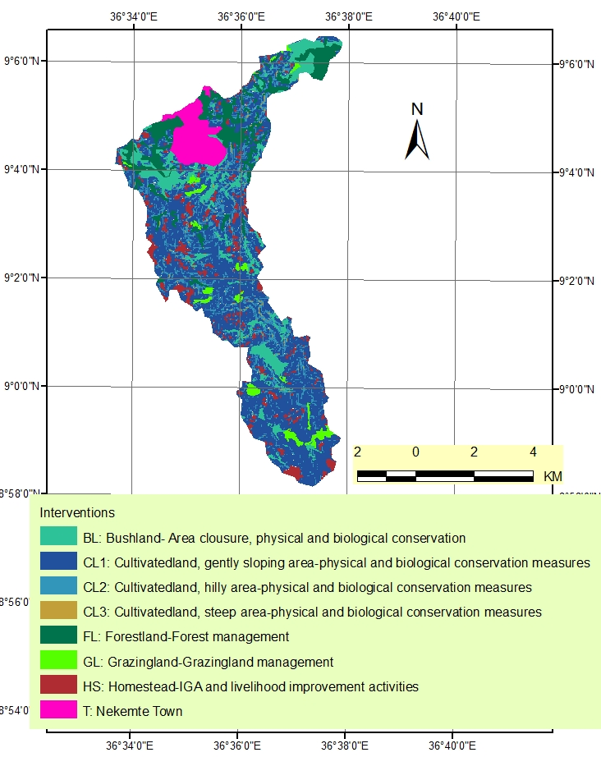
Figure 8: Development map of AleltuNegede catchment
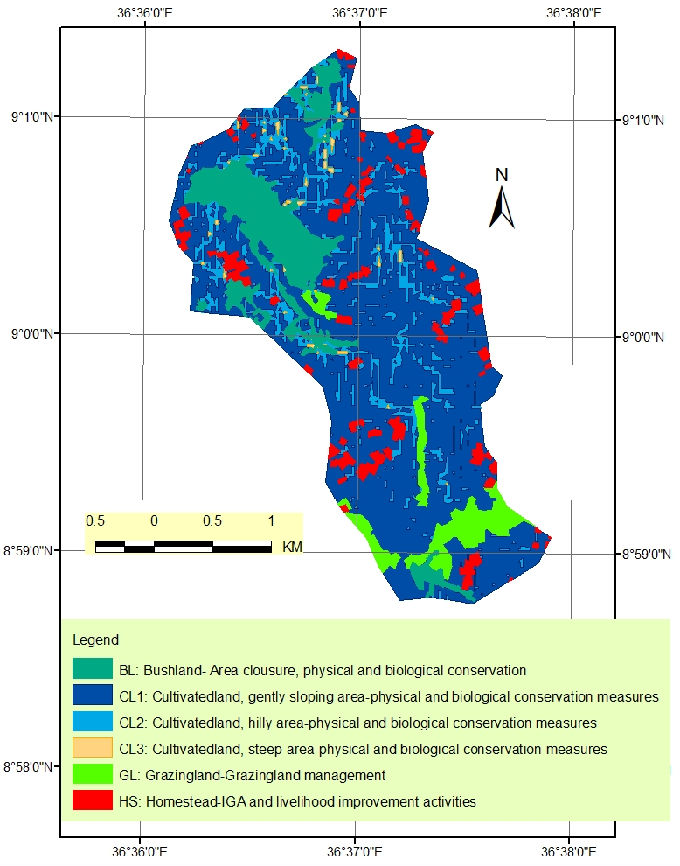
Figure 9: Development map of AleltuNegede catchment

Total Budget Summary
As shown on Table 6, the total estimated cost for AleltuNegede catchment for a period of three years is about 1,907,202.02 Birr. It is sub-divided in to two main categories: namely, labour and input costs. Labour costs are paid in cash form based on daily wage rate for the community for the equivalent of physical activities performed and input costs are the cost needed for the purchase required input materials such as SWC hand tools, motor-bikes, office equipment, high yielding varieties of crops, improved vegetable seeds, fruits etc. Accordingly, the budget required for labour and input costs are 917,661.02 Birr (48.12%) and 989,541.00 Birr (51.88%), respectively. The total input costs are fully covered by the Government, whereas 532,063.81 Birr which is about 57.98% of the total labour cost required will be contributed by the community living in the watershed either as free labour or in kind. The amount which will be contributed by the community accounts for about 27.90% of the total project cost required.
Budget allocated for the first, second and third year is about 658,642.54 Birr (34.53%), 747,416.93 Birr (39.19%) and about 501,142.54 Birr (26.28%), respectively.

The following Table indicates the major proposed measures and their corresponding required budget for AleltuNegedecatchment.

Table 6: Physical target and therequired budget for AleltuNegedecatchment
 | Interventions/Development strategies | Unit | Physical Target | Norm | Required labour (PD) | Input Costs (Birr) | Labour Cost (Birr) | Total Estimated Costs (Birr)
1 | Natural Resource Management
1.1 | Physical SWC
1.1.1 | Soil-bund construction | km | 30 | 150 | 4500 |  | 108000 | 108000
1.1.2 | Stone-faced soil-bund construction | km | 5 | 250 | 1250 |  | 30000 | 30000
1.1.3 | Gabion check-dam construction | m3 | 55 | 4 | 220 | 22000 | 5280 | 27280
1.1.4 | Loose-stone check-dam construction | m3 | 60 | 2 | 120 |  | 2880 | 2880
1.1.5 | Brushwood check-dam (double row) | m | 150 | 0.33 | 49.5 |  | 1188 | 1188
1.1.6 | Gully-wall reshaping | m3 | 65 | 1 | 65 |  | 1560 | 1560
1.1.7 | Gabion check-dam maintenance | m3 | 25 | 1 | 25 |  | 600 | 600
1.1.8 | Loose-stone check-dam maintenance | m3 | 75 | 0.5 | 37.5 |  | 900 | 900
1.1.9 | Waterway construction | m3 | 60 | 1.33 | 79.8 |  | 1915.2 | 1915.2
1.1.10 | Cut-off-drain construction | m3 | 82 | 0.7 | 57.4 |  | 1377.6 | 1377.6
1.1.11 | Maintenance of physical structures | km | 15 | 125 | 1875 |  | 45000 | 45000
1.2 | Biological SWC
1.2.1 | Central nursery establishment | set | 1 | 150000 | - | 150000 | 0 | 150000
1.2.2 | Area-closure | ha | 20 | 4 | 80 | 12040 | 1920 | 13960
1.2.3 | Bund stabilization (grasses and legumes) | km | 25 | 30 | 750 | 42075 | 18000 | 60075
1.2.4 | Grass-hedge establishment (vetiver, etc) | km | 12 | 30 | 360 |  | 8640 | 8640
1.2.5 | Agro-forestry promotion (gravelia, etc) | no | 1500 | 0.087 | 130.5 | 1500 | 3132 | 4632
1.2.6 | Gully-revegetation& live fencing | ha | 3 | 500 | 1500 | 15000 | 36000 | 51000
1.2.7 | Afforestation/reforestation of degraded-land (gravelia, etc) | ha | 32 | 62 | 1984 | 160000 | 47616 | 207616
1.2.8 | Shrub-land enrichment planting (gravelia, etc) | no | 5100 | 0.087 | 443.7 | 5100 | 10648.8 | 15748.8
1.2.9 | Woodlot establishment (energy source) | no | 2560 | 0.087 | 222.72 | 2560 | 5345.28 | 7905.28
2 | Homestead & Livelihood development
2.1 | Compost making (Pit: 4mL x 2mW x 1.5mD) | pit | 20 | 10 | - |  | 200 | 200
2.2 | Compost preparation (EM application) | m3 | 150 | 1 | - |  | 150 | 150
2.3 | Crop residue management (on-farm use) | ha | 24 | 10 | - |  | 240 | 240
2.4 | Green manuring (vetch application, etc) | qt | 12 | 10 | - | 5880 | 120 | 6000
2.5 | Fuel-wood saving stove promotion ('mirt', etc) | no | 42 | 1 | - | 6300 | 42 | 6342
3 | Community Infrastructure development
3.1 | Spring capping/development | no | 2 | 60000 | - |  | 120000 | 120000
3.2 | Feeder road construction | km | 2 | 3000 | 6000 |  | 144000 | 144000
3.3 | Road maintenance | km | 2 | 500 | 1000 |  | 24000 | 24000
4 | High value crop promotion
4.1 | Tropical fruit promotion (avocado, etc) | no | 150 | 5 | - | 21750 | 750 | 22500
4.2 | Root & tuber crop promotion (Enset, etc) | no | 38 | 2 | - | 5510 | 76 | 5586
4.3 | Vegetable promotion (carrot, tomato, etc) | kg | 18 | 5 | - | 1800 | 90 | 1890
4.4 | Potato promotion (Genet, Tolcha, etc) | qt | 36 | 5 | - | 3600 | 180 | 3780
4.5 | Cereal crop promotion (Triticale, Sorghum, etc) | qt | 12 | 30 | - | 10140 | 360 | 10500
4.6 | Pulse crop promotion (Haricoat-bean, etc) | qt | 6 | 30 | - | 6000 | 180 | 6180
4.7 | Oil crop promotion (sunflower, etc) | qt | 3 | 30 | - | 3000 | 90 | 3090
4.8 | Maize-haricotbean intercropping | qt | 8 | 30 | - | 9600 | 240 | 9840
5 | Livestock management
5.1 | Forage development along bund (sesbania, etc) | km | 12 | 16 | - | 20376 | 192 | 20568
5.2 | Grass land improvement | ha | 12 | 20 | - |  | 240 | 240
5.3 | Forage seed planting (vetch, etc) | qt | 3 | 500 | - | 1470 | 1500 | 2970
5.4 | Livestock feed conservation (crop-straw, hay, etc) | set | 28 | 10 | - | 6944 | 280 | 7224
5.5 | Poultry promotion (improved breed of egg/meat) | no | 250 | 125 | - | 31250 | 31250 | 62500
5.6 | Vet service provision | set | 120 | 1 | - |  | 120 | 120
5.7 | Apiculture promotion | set | 10 | 2 | - | 19720 | 20 | 19740
6 | Capacity Development & Knowledge
6.1 | Farmer training on improved methods | no | 90 | 124 | - | 1350 | 11160 | 12510
6.2 | Farmers training on CBPWD Guideline | no | 80 | 124 | - | 1200 | 9920 | 11120
6.3 | NRM technicians/foremen training on SWC | no | 15 | 124 | - | 225 | 1860 | 2085
6.4 | Horticulture/field crop dev (Apple, Triticale, etc) | no | 100 | 124 | - | 1500 | 12400 | 13900
6.5 | Forage dev, feed conservation & feeding strategy | no | 100 | 124 | - | 1500 | 12400 | 13900
6.6 | Poultry management (improved breeds) | no | 100 | 124 | - | 1500 | 12400 | 13900
6.7 | Apiculture management (improved tech) | no | 50 | 124 | - | 750 | 6200 | 6950
6.8 | Small-scale Irrigation water use management | no | 40 | 124 | - | 600 | 4960 | 5560
6.9 | Potable water-scheme management (spring, etc) | no | 60 | 124 | - | 900 | 7440 | 8340
610 | Farmers' field-day (experience exchange) | set | 2 | 50000 | - | 30 | 100000 | 100030
6.11 | Crosscutting issues (Gender, HIV, family planning) | no | 100 | 124 | - | 1500 | 12400 | 13900
7 | Project management
7.1 | Annual work plan & budget planning | pd | 6 | 190 | - | 270 | 1140 | 1410
7.2 | Technical and managerial support | pd | 72 | 190 | - | 3240 | 13680 | 16920
7.3 | Woreda support to community (watershed) | pd | 72 | 190 | - | 3240 | 13680 | 16920
7.4 | Woreda Logistic support (watershed dev) | set | 3 |  | - | 12000 |  | 12000
7.5 | Computer & printer with accessories | no | 1 |  | - | 25000 |  | 25000
7.6 | Stationery materials | set | 3 |  | - | 45000 |  | 45000
7.7 | SWC hand tools | gp | 3 |  | - | 12000 |  | 12000
7.8 | Motor bikes | no | 2 |  | - | 190000 |  | 190000
7.9 | Fuel & lubricants | lt | 3000 |  | - | 60000 |  | 60000
7.1 | Others (utilities, maintenance) | set | 3 |  | - | 15000 |  | 15000
7.11 | Filing-cabinet | no | 10 |  | - | 1000 |  | 1000
7.12 | Wooden-shelve with door | no | 1 |  | - | 1000 |  | 1000
 | Total |  |  |  |  | 942,420.00 | 873,962.88 | 1,816,382.88
 | Contingency (5%) |  |  |  |  | 47,121.00 | 43,698.14 | 90,819.14
 | Grand Total |  |  |  |  | 989,541.00 | 917,661.02 | 1,907,202.02
Table 7: Three years physical target and the total budget required per year
S/No | Interventions/Development strategies | Unit | Physical Target |  |  |  | Required Budget per year
S/No | Interventions/Development strategies | Unit | Total | Yr 1 (30%) | Yr 2 (40%) | Yr 3 (30%) | Year 1 (35%) | Year 2 (39%) | Year 3 (26%)
1 | Natural Resource Management
1.1 | Physical SWC
1.1.1 | Soil-bund construction | km | 30 | 9 | 12 | 9 | 32400 | 43200 | 32400
1.1.2 | Stone-faced soil-bund construction | km | 5 | 1.5 | 2 | 1.5 | 9000 | 12000 | 9000
1.1.3 | Gabion check-dam construction | m3 | 55 | 16.5 | 22 | 16.5 | 8184 | 10912 | 8184
1.1.4 | Loose-stone check-dam construction | m3 | 60 | 18 | 24 | 18 | 864 | 1152 | 864
1.1.5 | Brushwood check-dam (double row) | m | 150 | 45 | 60 | 45 | 356.4 | 475.2 | 356.4
1.1.6 | Gully-wall reshaping | m3 | 65 | 19.5 | 26 | 19.5 | 468 | 624 | 468
1.1.7 | Gabion check-dam maintenance | m3 | 25 | 7.5 | 10 | 7.5 | 180 | 240 | 180
1.1.8 | Loose-stone check-dam maintenance | m3 | 75 | 22.5 | 30 | 22.5 | 270 | 360 | 270
1.1.9 | Waterway construction | m3 | 60 | 18 | 24 | 18 | 574.56 | 766.08 | 574.56
1.1.10 | Cut-off-drain construction | m3 | 82 | 24.6 | 32.8 | 24.6 | 413.28 | 551.04 | 413.28
1.1.11 | Maintenance of physical structures | km | 15 | 4.5 | 6 | 4.5 | 13500 | 18000 | 13500
1.2 | Biological SWC
1.2.1 | Central nursery establishment | set | 1 | 1 |  |  | 150000
1.2.2 | Area-closure | ha | 20 | 6 | 8 | 6 | 4188 | 5584 | 4188
1.2.3 | Bund stabilization (grasses and legumes) | km | 25 | 7.5 | 10 | 7.5 | 18022.5 | 24030 | 18022.5
1.2.4 | Grass-hedge establishment (vetiver, etc) | km | 12 | 3.6 | 4.8 | 3.6 | 2592 | 3456 | 2592
1.2.5 | Agro-forestry promotion (gravelia, etc) | no | 1500 | 450 | 600 | 450 | 1389.6 | 1852.8 | 1389.6
1.2.6 | Gully-revegetation& live fencing | ha | 3 | 0.9 | 1.2 | 0.9 | 15300 | 20400 | 15300
1.2.7 | Afforestation/reforestation of degraded-land (gravelia, etc) | ha | 32 | 9.6 | 12.8 | 9.6 | 62284.8 | 83046.4 | 62284.8
1.2.8 | Shrub-land enrichment planting (gravelia, etc) | no | 5100 | 1530 | 2040 | 1530 | 4724.64 | 6299.52 | 4724.64
1.2.9 | Woodlot establishment (energy source) | no | 2560 | 768 | 1024 | 768 | 2371.584 | 3162.112 | 2371.584
2 | Homestead & Livelihood development
2.1 | Compost making (Pit: 4mL x 2mW x 1.5mD) | pit | 20 | 6 | 8 | 6 | 60 | 80 | 60
2.2 | Compost preparation (EM application) | m3 | 150 | 45 | 60 | 45 | 45 | 60 | 45
2.3 | Crop residue management (on-farm use) | ha | 24 | 7.2 | 9.6 | 7.2 | 72 | 96 | 72
2.4 | Green manuring (vetch application, etc) | qt | 12 | 3.6 | 4.8 | 3.6 | 1800 | 2400 | 1800
2.5 | Fuel-wood saving stove promotion ('mirt', etc) | no | 42 | 12.6 | 16.8 | 12.6 | 1902.6 | 2536.8 | 1902.6
3 | Community Infrastructure development
3.1 | Spring capping/development | no | 2 | 1 | 2 | 1 | 30000 | 60000 | 30000
3.2 | Feeder road construction | km | 2 | 0.6 | 0.8 | 0.6 | 43200 | 57600 | 43200
3.3 | Road maintenance | km | 2 | 0.6 | 0.8 | 0.6 | 7200 | 9600 | 7200
4 | High value crop promotion
4.1 | Tropical fruit promotion (avocado, etc) | no | 150 | 45 | 60 | 45 | 6750 | 9000 | 6750
4.2 | Root & tuber crop promotion (Enset, etc) | no | 38 | 11.4 | 15.2 | 11.4 | 1675.8 | 2234.4 | 1675.8
4.3 | Vegetable promotion (carrot, tomato, etc) | kg | 18 | 5.4 | 7.2 | 5.4 | 567 | 756 | 567
4.4 | Potato promotion (Genet, Tolcha, etc) | qt | 36 | 10.8 | 14.4 | 10.8 | 1134 | 1512 | 1134
4.5 | Cereal crop promotion (Triticale, Sorghum, etc) | qt | 12 | 3.6 | 4.8 | 3.6 | 3150 | 4200 | 3150
4.6 | Pulse crop promotion (Haricoat-bean, etc) | qt | 6 | 1.8 | 2.4 | 1.8 | 1854 | 2472 | 1854
4.7 | Oil crop promotion (sunflower, etc) | qt | 3 | 0.9 | 1.2 | 0.9 | 927 | 1236 | 927
4.8 | Maize-haricotbean intercropping | qt | 8 | 2.4 | 3.2 | 2.4 | 2952 | 3936 | 2952
5 | Livestock management
5.1 | Forage development along bund (sesbania, etc) | km | 12 | 3.6 | 4.8 | 3.6 | 6170.4 | 8227.2 | 6170.4
5.2 | Grass land improvement | ha | 12 | 3.6 | 4.8 | 3.6 | 72 | 96 | 72
5.3 | Forage seed planting (vetch, etc) | qt | 3 | 0.9 | 1.2 | 0.9 | 891 | 1188 | 891
5.4 | Livestock feed conservation (crop-straw, hay, etc) | set | 28 | 8.4 | 11.2 | 8.4 | 2167.2 | 2889.6 | 2167.2
5.5 | Poultry promotion (improved breed of egg/meat) | no | 250 | 75 | 100 | 75 | 18750 | 25000 | 18750
5.6 | Vet service provision | set | 120 | 36 | 48 | 36 | 36 | 48 | 36
5.7 | Apiculture promotion | set | 10 | 3 | 4 | 3 | 5922 | 7896 | 5922
6 | Capacity Development & Knowledge
6.1 | Farmer training on improved methods | no | 90 | 27 | 36 | 27 | 3753 | 5004 | 3753
6.2 | Farmers training on CBPWD Guideline | no | 80 | 24 | 32 | 24 | 3336 | 4448 | 3336
6.3 | NRM technicians/foremen training on SWC | no | 15 | 5 | 5 | 5 | 688.05 | 708.9 | 688.05
6.4 | Horticulture/field crop dev (Apple, Triticale, etc) | no | 100 | 30 | 40 | 30 | 4170 | 5560 | 4170
6.5 | Forage dev, feed conservation & feeding strategy | no | 100 | 30 | 40 | 30 | 4170 | 5560 | 4170
6.6 | Poultry management (improved breeds) | no | 100 | 30 | 40 | 30 | 4170 | 5560 | 4170
6.7 | Apiculture management (improved tech) | no | 50 | 15 | 20 | 15 | 2085 | 2780 | 2085
6.8 | Small-scale Irrigation water use management | no | 40 | 12 | 16 | 12 | 1668 | 2224 | 1668
6.9 | Potable water-scheme management (spring, etc) | no | 60 | 18 | 24 | 18 | 2502 | 3336 | 2502
610 | Farmers' field-day (experience exchange) | set | 2 | 1 | 1 | 1 | 33009.9 | 34010.2 | 33009.9
6.11 | Crosscutting issues (Gender, HIV, family planning) | no | 100 | 30 | 40 | 30 | 4170 | 5560 | 4170
7 | Project management
7.1 | Annual work plan & budget planning | pd | 6 | 2 | 2 | 2 | 465.3 | 479.4 | 465.3
7.2 | Technical and managerial support | pd | 72 | 18 | 36 | 18 | 4230 | 8460 | 4230
7.3 | Woreda support to community (watershed) | pd | 72 | 18 | 36 | 18 | 4230 | 8460 | 4230
7.4 | Woreda Logistic support (watershed dev) | set | 3 | 1 | 1 | 1 | 3000 | 6000 | 3000
7.5 | Computer & printer with accessories | no | 1 | 1 | 0 | 0 | 6250 | 12500 | 6250
7.6 | Stationery materials | set | 3 | 1 | 1 | 1 | 11250 | 22500 | 11250
7.7 | SWC hand tools | gp | 3 | 0.9 | 1.2 | 0.9 | 3000 | 6000 | 3000
7.8 | Motor bikes | no | 2 | 2 | 0 | 0 | 47500 | 95000 | 47500
7.9 | Fuel & lubricants | lt | 3000 | 900 | 1200 | 900 | 15000 | 30000 | 15000
7.1 | Others (utilities, maintenance) | set | 3 | 1 | 1 | 1 | 3750 | 7500 | 3750
7.11 | Filing-cabinet | no | 10 | 3 | 4 | 3 | 250 | 500 | 250
7.12 | Wooden-shelve with door | no | 1 | 1 | 0 | 0 | 250 | 500 | 250
 | Total |  |  |  |  |  | 627,278.61 | 711,825.65 | 477,278.61
 | Contingency (5%) |  |  |  |  |  | 31,363.93 | 35,591.28 | 23,863.93
 | Grand Total |  |  |  |  |  | 658,642.54 | 747,416.93 | 501,142.54
Table 8: Total budget summary required by components and by year
S/No | Descriptions | Total Budget (Birr) | Budget per year (Birr)
S/No | Descriptions | Total Budget (Birr) | 1st year | 2nd year | 3rd year
1 | Natural Resource Management | 740277.88 | 327083.36 | 236111.15 | 177083.36
2 | Homestead & Livelihood development | 12932.00 | 3879.60 | 5172.80 | 3879.60
3 | Community Infrastructure development | 288000.00 | 80400.00 | 127200.00 | 80400.00
4 | High value crop promotion | 63366.00 | 19009.80 | 25346.40 | 19009.80
5 | Livestock management improvement | 113362.00 | 34008.60 | 45344.80 | 34008.60
6 | Capacity & Knowledge Management | 202195.00 | 63721.95 | 74751.10 | 63721.95
7 | Project Management | 396250.00 | 99175.30 | 197899.40 | 99175.30
 | Grand total (with 5% contingency) | 1,907,202.02 | 658,642.54 | 747,416.93 | 501,142.54
Table 9: Community & Government contribution by component and year
S/No | Descriptions | Total Budget (Birr) | Community Contribution (Birr) |  |  | Government Contribution (Birr)
S/No | Descriptions | Total Budget (Birr) | 1st year | 2nd year | 3rd year | 1st year | 2nd year | 3rd year
1 | Natural Resource Management | 740277.88 | 65416.67 | 47222.23 | 35416.67 | 261666.69 | 188888.92 | 141666.69
2 | Homestead & Livelihood development | 12932.00 | 1939.80 | 2586.40 | 1939.80 | 1939.80 | 2586.40 | 1939.80
3 | Community Infrastructure development | 288000.00 | 16080.00 | 25440.00 | 16080.00 | 64320.00 | 101760.00 | 64320.00
4 | High value crop promotion | 63366.00 | 4752.45 | 6336.60 | 4752.45 | 14257.35 | 19009.80 | 14257.35
5 | Livestock management improvement | 113362.00 | 8502.15 | 11336.20 | 8502.15 | 25506.45 | 34008.60 | 25506.45
6 | Capacity & Knowledge Management | 202195.00 | 0.00 | 0.00 | 0.00 | 63721.95 | 74751.10 | 63721.95
7 | Project Management | 396250.00 | 0.00 | 0.00 | 0.00 | 99175.30 | 197899.40 | 99175.30
 | Grand total (with 5% contingency) | 1,907,202.02 | 101,525.63 | 97,567.50 | 70,025.63 | 557,116.92 | 649,849.43 | 431,116.92

IMPLEMENTATION STRATEGIES

The whole watershed development activities will be coordinated and guided by the woreda focal person (FP). The focal person is basically either SWC expert/specialist or natural resource management expert/specialist assigned from the Natural Resources Development Department of the woreda Office of Agriculture (ARDO). The woreda Steering Committee (WSC) and woreda watershed team (WWT) from various sector offices will be established at woreda level. At kebele level, community watershed team (CWT) and community facilitators will be established for the accomplishment of the implementation work. Notice that the selection of this committee follows the PWDP guideline.
The woreda watershed team (WWT) will facilitate the organization of technical backstopping from the woreda, zone, region, the aggregation and compilation of data generated from the planning work, the timely request of inputs to sector offices and donors as applicable, and their possible allocation before the period of the year set for implementation. Besides, DAs and the local CWT will play a major role in maintaining a high level of participation during implementation. They will coordinate the efforts provided by the community and those of single individuals or target groups. Implementation involves converting the agreed plans into the actual on the ground. This is primarily the task of farmers and DAs who have full support from woreda and Zonal extension staffs, regional experts and Administration staffs and other partner organizations. Generally, implementation of this watershed management plan will be realized based on the country’s participatory watershed development guidelines. The intervention should follow integrated approach and be able to support each other and produces positive environmental effect in the watershed area taking the watershed logics as main guiding principles in the implementation of the watershed management.

In general, during implementation:
1. Regional, zonal (if applicable), woreda experts and DAs are responsible to propose and arrange training for land users before and during implementation based on local conditions and specific needs. Therefore, training proposals should be developed and forwarded to woreda level which will provide the technical support.
2. DAs and woreda experts are responsible to follow-up trials and development of on-farm participatory technology for innovative measures to be tested in specific areas.
3. DAs and woreda experts will play a major role in strengthening the communication between the various sector agencies operating in the area by involving their experts and using their resources whenever required; for instance, education and health experts, resources, NGOs and others.
4. DAs and land users will also discuss the possible modifications that may occur to the plan during implementation.

ORGANIZATION & MANAGEMENT

The organizational arrangements required for the watershed management will coincide with the implementation strategies and institutional setups already defined in the Participatory Watershed Management Guide lines of the MoARD. Therefore, this plan will be integrated with current program as per the responsibility of existing government institutions. In this regard, the primary responsible body for watershed management activities is the BoA. This institution will create a networking that would enable other institutions to involve in the implementation of the watershed management activities as per their responsibilities. Therefore, the BoA at woreda level will mobilize professionals making them coordinate activities in their area of forming working groups, who will be technical expertise to help in NRM and agricultural activities. This will form a watershed management team that will be responsible in coordinating the planning, implementation and follow-up of the activities.

Furthermore, there should be integration among the various responsible institutions such as BoA, BWR&E, Land and Use Administration, Health and Education. These institutions will implement the planned activities as per their mandates and organizational responsibilities. For example, the bureau of Health will undertake family planning activities and so on. The DA who have already assigned by the BoA will be directly responsible in mobilizing the community, providing technical supports in the implementation of the planned activities.
At community level, a CM committee needs to be established to facilitate the implementations of the planned activities and ensure sustainability of the implemented activities. The committee should be composed of different community or social categories including kebele officials, youths, religion leaders, women and poor households. The main roles of the committee include working in collaboration with extension workers, mobilization and coordination of community to carry out planned activities and follow up of the activities.

MONITORING AND EVALUATION

Being an organized method, by which information is documented and available to all, planning is also an essential part of the monitoring and evaluation (M&E) system. The planned list of activities, targets, technical designs, reasons for selection, maps, & others, should be considered as benchmarks, which allow field staff to compare achievements and their impact against original purposes.
An effective PM&E thus requires a participatory planning approach. Participatory development is critical for achieving sound resource management in any watershed development or natural resources management. People, who participate, are investing time and effort in an activity from which they hope to benefit, will need to be part of a continuing process of investigating how things are going, whether changes are needed, whether expected results are still realistic, whether new alternatives have become available, and the like. P&ME is an essential tool for financiers, government, local leaders, beneficiaries and other stakeholders. Regular supervisionshould be made at all levels of implementing agencies of watershed development program.
Benefits of PM&E:
- Increases consensus on project goals, objectives and activities
- Creates ownership over evaluation results
- Increases cost-effectiveness of M&E information
- Provides timely and reliable information for decision making
- Enhances learning by local stakeholders
- Enhances skills and confidence of local people on management of development projects
- Utilizes local knowledge.
Monitoring and evaluation system with the following characteristics should be developed for effective implementation of watershed development:
- Simple to apply
- Fully involves communities
- Should be consistent with already existing government system
- It should be universally applicable in all woredas
- Promotes accountability
- Should use existing data to the extent possible
- Should assist in re-planning and correction of failed interventions; should also assist in introducing new innovative activities.

Monitoring
Monitoring is the collection of raw data or information for evaluation purposes. The monitoring system to be established will provide regular information on the use of inputs, participation and achievement on activities. Monitoring is a management tool which facilitates continuous learning and provides quality information on which to base evaluation.
Monitoring is the systematic recording and periodic analysis of information that has been chosen and recorded by insiders with the help of outsiders. The main purpose of monitoring is that it provides information during the life of the project, so that adjustments can be made if necessary.
Monitoring, to be successful, has to be participatory. This means that each stakeholder is involved in identifying the indicators and in measuring them. Participation will ensure that those indicators will be chosen which are meaningful to them. This means that the community, the experts and other stakeholders should undertake the review of the indicators jointly. Decision to make any modifications in the project being implemented must also be taken jointly based on review.

Evaluation

Evaluation is a process in which judgments on success and failures are made. Some evaluation can be made from regular result-based monitoring activities (process and outputs), but data can also be collected for evaluation purposes (outcomes and impact). Evaluation is where the learning occurs, questions answered, recommendations made and improvements suggested.
Evaluation measures the implementation of activities and how effectively this is done. It enables the stakeholders to develop a better understanding of the functioning of the program. In particular, it allows the stakeholders to understand the links between resource use, program activities, the intended and unintended immediate effects of those activities, the predetermined objectives, which are pursued, and the contribution of the program to some long-term vision.
Reporting: Regular reporting will be done on outputs achieved. The ‘foreman’ or community facilitator reports to the DA on outputs whenever there is an achievement. This could be daily or in longer intervals, depending on the season and the ongoing activities.
- The DA reports monthly on output achievement to Woreda Focal Person at the monthly Woreda meeting. The Woreda Focal Person will check on regular basis.
- The Woreda Focal Person summarizes output achievement on Woreda level and sends monthly, quarterly and annual reports to the Regional level.

CONCLUSION

Conversion of forest, shrubs, and grass lands to agricultural land, cultivation of steep slopes and free grazing were commonly practiced activities observed in AeltuNegede watershed. Besides, the majority of the watershed is under intensive cultivation of cereal crops that accelerated soil erosion. Grazing lands were highly trampled by livestock due to overstocking and greatly affected the physical structure of the soil. In addition, the average annual rainfall of the area, its rugged topography, soil characteristics, scarce vegetation cover, and inappropriate management practices are the main factors that contributed to soil erosion process in the AeltuNegede watershed.
The rapidly growing number of population & rising demand for more food and agricultural land created pressure on land and its resources. These processes combined with poor farming system & the lack of appropriate soil and water conservation strategies caused the increase in the risk of floods and landslides, organic matter depletion, accelerated soil erosion, nutrient leaching and increased the amounts of sediment loads entering streams, rivers, reservoirs, and irrigation structures.
Because of the loss of protective vegetative cover and the gradual expansion of agricultural activities from gently sloping land onto the steeper slopes of the neighboring hills and mountainous areas, a large portion of the AeltuNegede watershed is severely degraded and soil erosion is observed in various land use types in the watersheds.
Therefore, appropriate watershed management interventions are crucial in this study area to maintain and improve existing natural resources and thereby improve the livelihood of the community living in the watershed.

References
Abdi B. Desalegn C. &Ekasit K. 2012. Simulation of sediment yield using SWAT model in Fincha watershed, Ethiopia.Kasetsart J. Nat. Sci. 46: 1 – 15, Thailand.
Bezuayehu, T. 2006. People and dams: environmental and socio-economic impacts of Fincha’a hydropower dam, western Ethiopia. Tropical Res. Manag.Kebeleper 75.Wageningen University and Research Center, Wageningen, The Netherlands.
BirhanuFenataw .2003 .Integrated watershed management Training manual, Ethiopia, Addis Ababa
Blaikie P.1985. Political economy of Soil Erosion in Developing Countries.Longman Development Studies, New York.
E.K. Biamha and K.Fahlston. 1997. Soil and water conservation manual for Kenya, Nairobi, Kenya
EHRS. 1988. Ethiopia High Land Reclamation Study
Escobedo, J.U. (1988). Land classification for Use in soil Conservation, Communities forests and soil conservation Department, MoA, Assistance to Soil and Water Conservation Programme phase II, Addis Ababa, Ethiopia.
Foster, G.R., and R.E. Highfill. 1983. Effect of terraces on soil loss: USLE P-factor values for terraces. J. Soil Water Conserv. 38:48-51.
Hilko years, Ann Mollema and Egger Topper .2002 .Erosion Control in the Tropics, Wageningen, The Netherlands
Gizachew .A .2003. Integrated Watershed Management Training Manual, Ethiopia Addis Ababa
Javier Escobedo. 1990 .Soil and Land Classification guidelines
HanspeterLinjger& William Critchely.2007. Case studies and analysis of soil and water conservation initiatives world wide
Hudson N. 1981.Soil conservation.B.T. Batsford Limited, London, UK.324 pp.
Hurni, H. 1990. Degradation and conservation of soil resources in the Ethiopian highlands. Mountain research and development 8 (2-3): 123-130, University of Bern, Switzerland.
Hurni, H. 1993. Land degradation, famine, and land resource scenarios in Ethiopia. In: Pimental D. (ed) World soil erosion and conservation. Cambridge Univ. Press.
Javier Escobedo. 1990 .Soil and Land Classification guidelines
Lakew Desta.2006 .Soil and Water conservation training Manual, Ethiopia, Addis Ababa
MoWR (1999). Data Collection, Site Investigation, Survey and Analysis, AbayDawa River Basin Integrated Development Master Plan Project, Vol. XIII, Part 1, MoWR, Addis Ababa.
MoARD.2000. Participatory Watershed Management Planning Guideline Part I and II, Ethiopia, Addis Ababa
MoARD (2004). Woody Biomass Inventory and Strategic Planning Project, A national strategic plan for Biomass energy sector, final report, Addis Ababa, Ethiopia.
MoARD (2005). Communities Based Participatory Watershed Development: A Guideline. Part 1, first edition, Addis Ababa, Ethiopia
Prof. Tuffa. 2000. Soil and Water Conservation for Sustainable Agriculture
Renard, K.G., Foster, G.R., Weesies, G.A., McCool, D.K. and Yoder, D.C., (1997). Predicting soil erosion by water: a guide to conservation planning with the Revised Universal Soil Loss Equation (RUSLE). Agriculture Handbook No. 703. Agricultural Res. Service, Washington, DC
Saavedra, C., (2005). Estimating spatial patterns of soil erosion and deposition in the Andean region using geo-information techniques: a case study in Cochabamba, Bolivia Ph.D. dissertation, Wageningen University, The Netherlands.
Shi, Z.H., Cali, C.F., Ding, S.W., Wang, T.W. and Chow, T.L., (2003). Soil conservation planning at the small watershed level using RUSLE with GIS: a case study in the Three Gorge Area of China. Catena 55, 33–48.
Sileshi Getahun.2005. Integrated Watershed Management Training Manual, Ethiopia, Addis Ababa
S.K.GARG.2005. Hydrology and water Resources Engineering
Sutcliffe JP. 1993. Economic assessment of land degradation in the Ethiopian highlands: A case study. National Conservation Strategy Secretariat, Ministry of Planning and Economic Development, Addis Ababa.
T.C. Sheng.1990. The FAO Watershed Management Field Manual conservation guideline 13
V. Caruchi .2000. Guideline for SWC and Water Harvesting for moisture deficit areas in Ethiopia
Universal Soil Loss Equation (RUSLE). Agriculture Handbook No. 703. Agricultural Research Service, Washington, DC.
WWDSE (2011). Welmel Irrigation project feasibility study, Addis Ababa

