OROMIA IRRIGATION DEVELOPMENT AUTHORITY

ALENTU SMALL SCALE IRRIGATION PROJECT
IN
DODOLLA WOREDA OF WEST ARSI ZONE

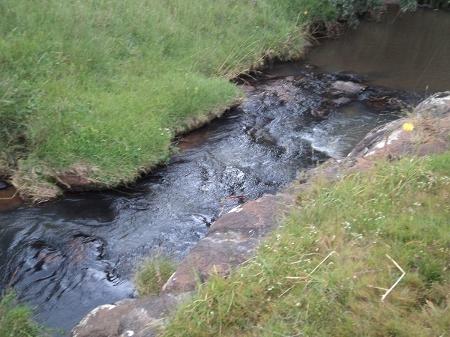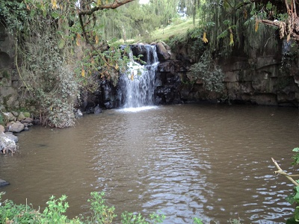

FINAL FEASIBILITY STUDY

BY

VIRGINIA CONSULTANTS IN ASSOCIATION WITH BERUH CONSULTING ENGINEERS AND HYDRO GEOLOGISTS

IRRIGATION AGRONOMY

NOVEMBER, 2016
TABLE OF CONTENTS PAGE
EXCUTIVE SUMMARY 2
1. INTRODUCTION 3
1.1. Background and Justification 3
1.2. Specific Objectives 4
1.3. Scope of Study 4
2. DESCRIPTION OF THE STUDY AREA 5
2.1. LOCATION 5
2.2. CLIMATE 5
2.3. SOIL 6
3. METHODOLOGIES 7
3.1. Collection of primary and secondary data 7
3.2. Selection of Crops for the command area 7
3.3. Computing crop water requirement of the selected crops 8
4. ASSESSMENT OF GOVERNMENT POLICIES 10
4.1. National Agricultural Policies 10
4.1.1. Regional Development Program and Strategy 10
4.2. Irrigation Policy of Ethiopia 10
4.2.1. National Irrigation Development Strategy 11
4.2.2. Irrigation Development Programs 11
5. EXISTING AGRONOMIC SITUATION 12
5.1. Existing Farming System 12
5.2. Land Tenure System and Agricultural Land Holding 12
5.3. Existing Land Use Land Cover of the study area 13
5.4. Existing Cropping Pattern in Alentu Kebelle and the study area 13
5.5. Existing Farming Practices and Cropping Calendar in and Around Command Areas. 14
5.6. Existing Crop Diseases, Insects and Weeds 19
5.7. Status of Irrigation Practices in the study area 19
5.8. Status of Agricultural Extension Packages in the study area 19
5.8.1. Fertilizers Utilization in Alentu Kebelle and the study area 19
5.8.2. Agro- Chemicals 20
5.8.3. Utilization of Improved Seeds 20
5.9. Agricultural Support Services in study area 22
5.9.1. Credit facility 22
5.9.2. Input supply 22
5.9.3. Training Facility 22
5.9.4. Research Institution 22
5.10. Major Constraints of Crop Production in the Project Area 22
6. PROPOSED CROPPING PRACTICES 23
6.1. Selection of Crops for Command Areas 23
6.2. Proposed cropping pattern of the study area 23
6.3. Growing period and cropping calendar 24
6.4. Proposed Crop Rotation 24
6.5. Input Requirements and their cost 24
6.6. Yield Build-Up Patterns 28
6.7. Crop Budget and Seasonal Input for the Study Area 28
7. CROP WATER REQUIREMENT FOR ALENTU SMALL SCALE IRRIGATION PROJECT 32
7.1. Proposed crops and cropping calendar. 32
7.2. Crop Water Requirement (ETcr) 32
7.3. Crop Irrigation Water Requirement 32
7.4. Reference crop evapo-transpiration (ETO) 33
7.5. Length of crop growing stage 33
7.6. Crop Coefficient (Kc) 34
7.7. Effective rain fall 35
7.8. Irrigation efficiency (E) 35
7.9. Leaching requirements 35
7.10. Net and Gross irrigation requirements 36
7.11. Irrigation scheduling 37
8. BENEFITS OF THE SMALL SCALE IRRIGATION SCHEMES 40
9. ORGANIZATION AND MANAGEMENT NEEDS 41
9.1. Establishment of Water Users Association (WUA) 41
9.2. Identification of Training Needs 41
9.3. Re-Distribution of land 42
9.4. Strengthening the Extension Services 42
9.5. The Role of Bylaw in Water and Land Use 42
9.6. Legal framework 43
9.7. Legislative Policy 43
9.8. Agricultural Research 43
9.9. Setting Effective Monitoring and Evaluation systems 44
9.10. Support Institutions 45
10. PROPOSED CROP VARIETIES AND THEIR IMPROVED MANAGMENT PRACTICE 46
10.1. Pulse Crops Production 46
10.1.1. FABA BEAN 46
10.2. Cereal Crops Production 47
10.2.1. WHEAT 47
10.2.2. BARLEY- FOOD AND MALTING 50
10.3. Vegetable Crops Production 52
10.3.1. GARLIC 52
10.3.2. POTATO 53
11. CONCLUSION AND RECOMMENDATIONS 56
11.1. Conclusion 56
11.2. Recommendation 56
12. REFERENCES 58
13. ANNEX 64

LIST OF TABLES
Table 1: Land use land cover of the study area 13
Table 2: Cropping pattern in Alentu Kebele 13
Table 3: Cropping pattern in the study area 14
Table 4: Type and rate of herbicides used in the study area 15
Table 5.Existing Crop Management Practice and Cropping Calendar during summer season in the study area 18
Table 6: Existing crop pests and their prevalence in the study area 19
Table 7: Fertilizer rate in Alentu Kebele and the study area 20
Table 8: Yearly input supply distribution in Alentu Kebele and the command area 20
Table 9: Improved seed and their respective yield with and without fertilizer in the study area 21
Table 10: Local Crop Cultivars and their Attributes as Perceived by Farmers 21
Table 11: Improved Varieties/Cultivars and their Attributes as Perceived by Farmers 21
Table 12: Yield response of local and improved varieties of the following crops of the study area 21
Table 13: Selected crop varieties for the command area 23
Table 14: Cropping pattern of the proposed crop 24
Table 15: Proposed crop rotation 24
Table 16.Proposed Cost of Materials /Farm tools required for Hectare 25
Table 17: Production cost for the proposed crops under rainfed on the irrigation command areas per hectare 26
Table 18: Production cost for the proposed crops under irrigation on the irrigation command areas per hectare 27
Table 19: Input requirement of cultivated crops with project condition 28
Table 20: Proposed Yield build up Pattern and Average Crop yields Project Command areas (qtl/ha) 28
Table 21: Crop budget for the first growing season 29
Table 22Crop Budget for the second growing season 30
Table 23: Cropping calendar for the proposed crops on the project 32
Table 24: Reference evapotranspiration of the study area 33
Table 25: Length of growing stages and crop coefficients of potato 34
Table 26: Length of growing stages and crop coefficients of garlic 34
Table 27: Effective rainfall of the study area 35
Table 28: Crop water requirement of Potato 36
Table 29: Crop water requirement of Garlic 36
Table 30: Irrigation schedule of Potato 37
Table 31: Irrigation schedule of Garlic 38
Table 32: Scheme Irrigation Water Supply of the Study Area 38
Table 33: List of improved faba bean varieties 46
Table 34: Agronomic practices recommended for faba bean 47
Table 35: Major diseases of faba bean 47
Table 36: Major insects of faba bean 47
Table 37: Agronomic characteristics and recommended production domains of released bread wheat varieties. 50
Table 38 : Recommended improved barely varieties by EIAR: 51
Table 39: Recommended variety of potato 53

LIST OF FIGURES
Figure 1: LGP of the study area 6
Figure 2: Agro climate of the study area 6
Figure 3: Group discussion with the command area representatives 7
Figure 4: Existing land use land cover of the study area 13
Figure 5: Wheat farm infested by various weed species particularly avena spp as compared to weed free farm. 15
Figure 6: Manual harvesting of crops in the study area 16
Figure 7: Threshing of crops using domestic animals in the study area 16
Figure 8: Storage system of the study area 17

LIST OF APPENDIX TABLE
Appendix Table 1: Alentu minimum temperature 64
Appendix Table 2: Alentu maximum temperature 65
Appendix Table 3: Alentu mean yearly pricipitation 66

ABBREVIATIONS

ADLI Agricultural Development Led Industrialization
WSDP Water Sector Development Program
WWDSE Water Works Design and Supervision Enterprise
EC Ethiopian calendar
⁰c Degree centigrade
qtl/ha quintal per hectare
a.i Active ingredient
mm millimetres
Ec Emulsfiable concentrates
Lt/ha Litres per hectare
Masl Meter above sea level
GDP Gross Domestic Product
PA Peasant Association
DAP Di Ammonium Phosphate
FAO Food and Agricultural Organization of the United Nations
MOA Ministry of Agriculture
IR Irrigation Requirement
WR Water Requirement

IRRIGATION AGRONOMY

EXECUTIVE SUMMARY

The study was conducted in 2012/2013 to ensure food security at local level and to produce food and vegetable crops through development of sustainable irrigation systems using the Aletu River at Alentu Dobado kebele of Dodola Wereda, West Arsi Zone, Oromia Regional State, Ethiopia. This spring water is supposed to irrigate 50ha of the project area.

To undertake the study intensive field survey was conducted to collect primary and secondary agronomy data in the command area. Primary data collection by interviewing different social groups namely, groups of men, women and young people were undertaken. On site observation of the actual crop production practices was also undertaken. Secondary data were collected from pertinent government offices (district and kebele government offices).

Existing agronomic condition of the study area like existing farming system, land use land cover, land tenure system, cropping pattern, cropping calendar, status of support service (inputs), yield response and major production constraints were thoroughly assessed.

Crop selection criteria were set to select the appropriate crops to the study area. Based on these criteria, the strategic crops are selected and include faba bean, wheat and barley for 1st growing season, vegetable crops like potato and garlic for 2nd growing season. For the selected crop varieties improved management practices were also forwarded. Related softwares such as New-LoClim-1.10, CLIMWAT version 2, and CROPWAT-8 were used to calculate the climate and crop water requirements, respectively.

Moreover, for the selected crops proper cropping patterns, crop rotation, cropping calendar, input requirements and yield projection were also proposed. Appropriate recommendations were also set for observed limitations.

INTRODUCTION

Background and Justification

All plants require water, air, light and media to survive, grow and reproduce. The soil acts as a media and gives stability to the plant, stores water and nutrients that the plants can take up through their roots. The sunlight (light) provides the energy which is necessary for plant growth and photosynthesis. The air allows the plants to "breath". Water is needed for photosynthesis, respiration, absorption, translocation and utilization of mineral nutrients. Therefore, adequate water supply is important for plant growth. The most well-known source of water for plant growth is rain water. When the rainfall is not sufficient, the plants must receive additional water from other sources. It may be provided partially or entirely by artificial means called Irrigation.

Agriculture in Ethiopia is the foundation of the country's economy. Despite the fact that agriculture playing such an important role in the economy and the availability of abundant water resource in the country ,the facility of irrigation has so far been only minimal leaving agriculture to be mainly dependent on the unreliable rainfall. Out of the estimated aggregate irrigation potential of Ethiopia (Small, medium and large) of 3.5 million hectares, the medium and large scale irrigation potential together comprise about 81.4% of the aggregate and the remaining is the small scale irrigation potential.

Oromia Regional State is endowed with huge natural resources such as land and water that are not utilized effectively. Alentu watershed is among the natural resources rich areas of the region. In spite of these ample natural resources, the region is highly affected by recurrent drought due to unreliability, shortage and erratic nature of rainfall. The efficient use of these natural resource is therefore of prior important to ensure the regional and nation food security and attain the millennium development goals.

To restrain theses problems, the government of Oromia has initiated Alentu small scale irrigation projects at Dodola area. The project area is located in West Arsi zone, Dodola Wereda and Alentu Kebeles. The proposed irrigation project is used to enhance the all round development in the agro-economic, social and cultural conditions of the targeted populations and the surrounding areas. It improves the general livelihoods and living standards of the people in the project area.
The main livelihoods of the communities in the project areas depend on mixed farming. That is crop production (mainly cereal crops) and livestock rearing. The major crops grown in the project areas are wheat and barley. Faba bean, peas, linseed, potatos, garlic are also the commonly growing crops in the study area.

The implementation of the project will provide irrigation water to an area of 50 hectares of land. This entails incremental production and diversification of crops by the beneficiary. Increased crop production and cash income will improve the diet and nutrition of the population. The practice of irrigation will create additional employment opportunities for the beneficiaries as well as for the people outside the command area. Apart from the scheme's beneficiaries, many other families in the surroundings will benefit from increased food crop production and possible labor opportunities in the irrigation fields. The high cropping intensity requires additional labor and provides employment opportunities throughout the year, which would have been idle otherwise. Crop yields will increase and problem of food shortage will be reduced. The project will also encourage crop diversification based on market demands in and around the districts. New farming practices and improved technology will be provided through the extension services. As a result, apart from the benefits that it provides to the beneficiaries, the project will also serve as demonstration of irrigation practice to the surrounding farmers.

Specific Objectives
- To assess the existing situation of the farming practices of crops under the prevailing conditions
- To asses and identify crop production constraints and potentials
- To calculate crop water requirements
- To propose crops and better production conditions in irrigation command areas

Scope of Study
The overarching concerns of the study would be of nutritional and livelihood security, poverty alleviation, gender equity, ecology and environment, and competitiveness in terms of cost and quality. This will include the following broad aspects:
- Study of existing farming systems and agricultural development pattern of project command areas
- Selection of most suitable crops and their most appropriate integration with suitable economic return for different size of irrigated farm holdings.
- System approach having economically dynamic and efficient cropping pattern involving selected food and cash crops and other enterprises appropriate under the prevailing climate, soils and added irrigation conditions.
- Identification of most appropriate agro-techniques and input support services for the farmers for increased farm productivity.
- Identification of the existing potential in crop production with respect to irrigation facilities and recommendation of crop requirements
- Calculation of crop water requirements

DESCRIPTION OF THE STUDY AREA

LOCATION

The project area lies in the eastern part of Ethiopia, Oromia Regional State, and West Arsi Zone, Alentu Dobedo Kebelle) in the Wabe Shebele River basin covering a total area of 50ha. One can get Dodola, which is the nearest town of the study area, via two main ways both are currently asphalted road. The first one is through Finfine, Bishoftu, Mojo, Batu, Shashemene, Kofele, Dodola which is 312km far away from Finfinne towards the south direction. The second one is the shortcut one through Finfine, Bishoftu, Mojo, Adama, Huruta, Asela, Bekoji, Asasa, Dodola which is 288km far from Finfine. The command area (Alentu Dobado Kebele) can be accessed by Edo-Alentu-Werka all weather gravel road.
The project area lies within the geographic extent of 6⁰ 85’N to 6⁰ 87’N latitude and 39⁰ 04’ to 39⁰ 06’E longitude. The highest altitude of the study area is 2780 masl in the northern edge to 3460 masl in southern tip.

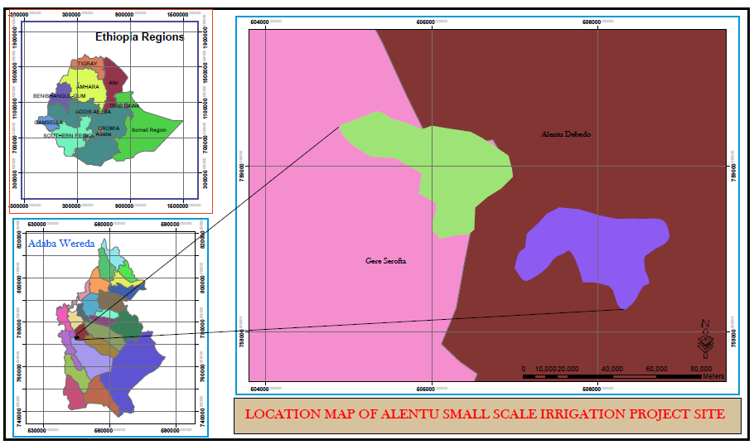

CLIMATE
Based on the traditional agro-climate classification of the country, the study area is classified as dega agro ecological zone. The rainfall is uni-modal with strong summer rainy season takes place during the months of July and August. As can be seen from the figure one, the study area is characterized as sub humid agro climatic zone.
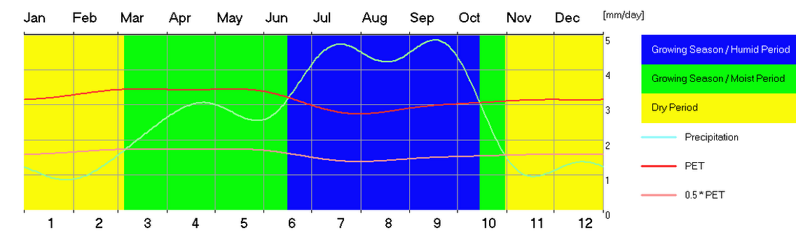
Figure 1: LGP of the study area
Figure 2: Agro climate of the study area

SOIL
The texture of the plow layer (0-30cm) ranges from loam to clay loam while the deeper one belongs to black clay soil. The pH (H₂O) of water ranges from 5.05 (upper 37cm) to 4.61 (deeper from the surface). The top soil of the study area is also highly rich in available phosphorus (769.01P₂O₅), total nitrogen (0.6%), organic carbon (8.95%), CEC (24Cmol+/kg of soil), and sum of exchangeable basis (>16.79 Cmol+/kg of soil). The available water holding capacity of the soils on horizon basis ranges from 249.29mm/m to 284.18mm/m, which is categorized as high class. This indicates that the soils requires relatively longer irrigation interval. The hydraulic conductivity of the soils in the study area also falls in acceptable rate. Detailed data about the soil of the study area can easily be obtained from the soil report of this study.

METHODOLOGIES
In general, the following methodological approaches were followed to undertake the study.
- Primary data collection by interviewing different social groups namely, groups of men, women and young people.
- On site observation of the actual crop failures due to late and low rain fall
- Secondary data collection from pertinent government offices (district and kebele government offices)
- Using software such as LOCLIM, CLIMWAT version 2, and CROPWAT 8 to calculate climate and crop water requirements respectively.

Collection of primary and secondary data
Primary data were collected by site observation, interviewing of focal group and district experts, and discussion with focal groups of the beneficiaries (Figure 3). Secondary data were also collected from pertinent government offices.

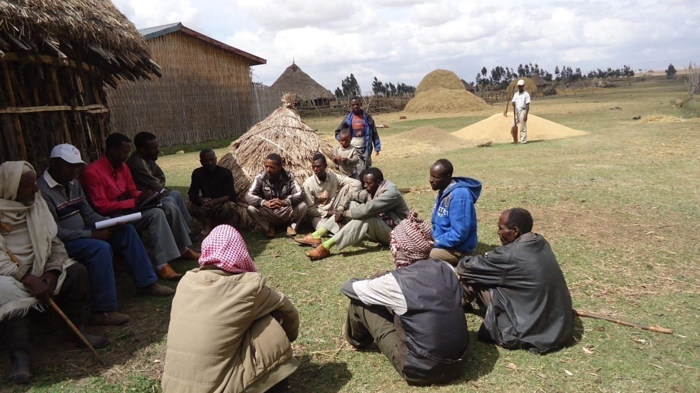
Figure 3: Group discussion with the command area representatives

Selection of Crops for the command area
Various bio-physical and socio-economic criteria were used to select the appropriate crops to the study area.

Computing crop water requirement of the selected crops
To calculate the crop water requirement the following steps were followed.

A. Calculation of Reference Evapotranspiration (ETo)
The crop water requirement is dependent on the meteorological factors, and Reference Evapotranspiration (ET_{o}) presents the effect of meteorological factors. The following Meteorological factors are taken into consideration for calculation of Reference Evapotranspiration by Modified Penmam Method (FAO I & D paper No. 24) &Penmam Montieth Approach (FAO I & D paper No. 46 and 56):
  - Temperature
  - Relative Humidity
  - Wind velocity
  - Sunshine hours
CROPWAT software Version 8 (FAO,) was employed to determine the net irrigation requirement.

B. Selection of values for crop coefficient:
The effect of crop on its water requirement is represented by crop co-efficient (K_{c}). This is presented by the relationship between reference Evapotranspiration (ET_{o}) and crop evapotranspiration ET_{crop} or ET_{c} as ET_{crop} = K_{c}ET_{o}. The values for crop coefficient vary with the crop, its stage of growth, growing season and prevailing water condition. The second step is required to select suitable values for crop coefficient.

C. Effect of agricultural practice and local conditions
This requires evaluation of the effect of climate and its variability over time and space. This also needs to evaluate the effect of soil water availability and agricultural and irrigation practices.

The three steps as enumerated above used to give the crop water requirement during its crop period at monthly interval. Therefore, the losses in the irrigation system have to be incorporated to arrive at the water requirement at the head of the irrigation system.

Sources of Climatic Data
The climate data used to calculate the reference evapotranspiration, effective rainfall and the overall crop water requirement was the nearby meteorological station (Dodola) and the FAO ClimWat2.0 for CropWat and NewLocClim_1.10.

Crop water requirement computation
The modified Penman method was used for analysing the reference potential evapotranspiration (PET). The crop coefficient (kc) developed for each selected crop was applied to the PET to compute the crop evapotranspiration. CROPWAT software Version 8 (FAO,) was used to compute the net project crop water requirement using the following data.
- The PET data,
- Cropping pattern,
- Areas allocated to each crop,
- Crop coefficients for each stage of crop growth,
- Planting and harvesting dates of each crop and
- Mean monthly rainfall data.

ASSESSMENT OF GOVERNMENT POLICIES

National Agricultural Policies

The federal government of Ethiopia have initiated and introduced a number of reforms aimed at transforming the previously centralized economic policy to new and free marketing economy. The agricultural strategy currently in use was formulated based on characterizing of agricultural sectors and outlining the major issues and constraints hindering the production and productivity of the sector in the country. The strategy formulated is called “Agricultural Development Led Industrialization (ADLI)” the main objectives of the strategy are:

- Improving quality of life of rural people,
- Increasing production of food supply in order to feed not only the population of the sector but also the population of other sectors,
- Increase and diversify the production of raw materials for industry,
- Increase and diversify the production for export and
- To make agriculture the driving force for economic development.

The objectives have been aimed to be met through the improvement of productivity of smallholder farming and commercial extensive and intensive agricultural development.

Regional Development Program and Strategy
The regional state of Oromia has also adopted the federal agricultural development strategy and formulated a five year regional development program (FYRDP), which currently serves as a basis for regional development policy. This program gives more emphasis to the development of agricultural sector particularly irrigation agriculture .The main objective is to improve the income and living condition of the farming communities through increased agricultural production and productivity. Other strategic measures recognized by the program includes appropriately designed settlement pattern , improved agricultural extension service and creation of off farm alternative means of income .The program recognizes that its objective require also other parallel development measures involving improvement of rural road network , education , health service and water supply .

Irrigation Policy of Ethiopia

Overall Objective
The overall objective of irrigation policy is to develop the huge irrigated agriculture potential for the production of food crops and raw materials needed for agro industries, on efficient and sustainable basis and without degrading the fertility of the production fields and water resources base.

Detail Objectives
- Development and enhancement of small scale irrigated agriculture and grazing lands for food self-sufficiency at the household level.
- Development and enhancement of small-, medium- and large - scale irrigated agriculture for food security and food self – sufficiency at national level including export earnings and to satisfy local agro-industrial demands.
- Promotion of irrigation study, planning and implementation on economically viable, socially equitable, technically efficient, environmentally sound basis as well as development of sustainable, productive and affordable irrigation farms.
- Promotion of water use efficiency, control of wastage, protection of irrigation structures and appropriate drainage systems.
- Ensuring that small-, medium- and large-scale irrigation potential projects are studied and designed to a stage ready for immediate implementation by private and/or the government at any time.

National Irrigation Development Strategy

Objectives
The principal objective of the irrigation development strategy is to exploit the agricultural production potential of the country to achieve food self sufficiency at the national level, including export earnings, and to satisfy the raw material demand of local industries, but without degrading the fertility and productivity of country's land and water resources base. More specific objectives of the strategy are to: expand irrigated agriculture, improve irrigation water-use efficiency and thus the agricultural production efficiency, develop irrigation systems that are technically and financially sustainable, and address water logging problems in irrigated areas.

Irrigation Development Programs

- Irrigated Agriculture is very important in stimulating sustainable economic growth and rural employment and is the corner stone of food security and poverty reduction.
- In recognition to this Irrigation Development program is one of the major sub-sectoral component of WSDP.
- Accordingly different development targets are set on the different planning horizons and totally at the end of 2016, a total area of 274,612hectares of irrigation land has to be developed.

EXISTING AGRONOMIC SITUATION

Existing Farming System

The existing farming system in the area is mixed farming where production of crops and livestock for the market and own production is commonly practiced. The livelihood system in the project area is integrated in such a way that the oxen are used as traction power, the livestock as a whole contribute farmyard manures by feeding on the crop residues and stubbles. Plowing of land in the project area takes place by use of ox power. Harvesting and threshing of crops also practiced by man power (cutting by sickle) and by draft animals, respectively. This is due to the undulating form of land which makes the use of farm machineries difficult. However, the majority of farming practices in the surrounding kebelle commonly use farm machineries for plowing, harvesting, threshing and even transportation of threshed crops. Major crops grown in the study area are wheat, barley, faba beans, linseed, and the like. Farmers use sole cropping system. There are also some very scattered enset farms at homestead level.

There is no intercropping, strip cropping and other practice in the area. The use of agroforestry is also not significant based on the data obtained from the wereda and the study area farmers.

Land Tenure System and Agricultural Land Holding

Land tenure system is a relationship between individuals and groups of individuals by which rights and use of land resource are determined. The traditional land use and land management practices that used to sustain the welfare of human population under low population pressure with little or no technical inputs is no longer able to support the growing population due to increasing population density and degradation of natural resource base, declining per capital food production results in deteriorating human welfare conditions.

In and around the command area, land tenure system is privately owned and the farmers have the right to use the land under the administration of government. Significantly large areas of lands are also covered by state farms. According to the present study, most of the farmers (about 80%) hold more than three hectares while the minorities hold a minimum of0.5ha in the district.

Existing Land Use Land Cover of the study area

Table 1: Land use land cover of the study area
No | Land use/land cover | Area in Hectare | %age
1 | Cultivated Land | 57.36 | 81.94
2 | Eucalyptus Plantation | 3.4 | 4.85
3 | Grazing Land | 9.24 | 13.21
Total area |  | 70 | 100
3 | Riparian Vegetations out side of the command area | 19.6 | 100
Total area

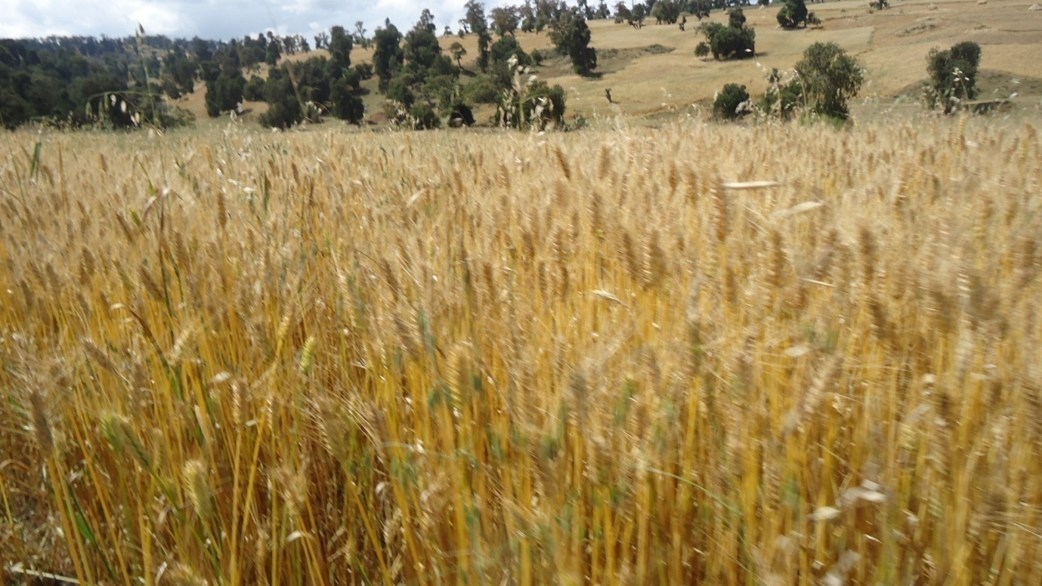
Figure 4: Existing land use land cover of the study area

Existing Cropping Pattern in Alentu Kebelle and the study area

The study area is endowed with favourable climate, soil and topography for cultivation of diverse highland crops. Wheat is the most widely grown crops in the study area. Barleey and pulse crops like faba bean and field pea, are also commonly grown crops. However, farmers in the study area are not commonly growing highland fruits and vegetable. Perennial crops are not commonly grown in the area mainly due to the agro-climatic limitation except enset in very limited area (at homestead level).

Table 2: Cropping pattern in Alentu Kebele
Crop type | Area (ha) | Percentage
Wheat | 854 | 47.3
Barley | 768 | 42.59
Faba bean | 16 | 0.89
Potato | 165 | 9.15
Table 3: Cropping pattern in the study area
Crop type | Area (ha) | Percentage
Wheat | 33.06 | 66.12
Barley | 10.45 | 20.9
Faba bean | 3.2 | 6.4
Potato | 3.2 | 6.4

Existing Farming Practices and Cropping Calendar in and Around Command Areas.

Land Preparation and Sowing
Time and method of land preparation affects seedling emergence, stand establishment and thus crop yield. Early ploughing has a distinct advantage over late ploughing; because it gives more opportunity to kill weeds. Early ploughing may help in getting the soil granulated at the time of sowing. Land preparation is practiced in the study area from March to May for most cereal crops such as wheat, barley.

Sowing /Planting
In general, the time of planting/sowing depends on the onset of rainy season, availability of human labour, farming tools, seeds, etc.

Planting /sowing of most field crops is planted in June (Table 5). Early sowing is an important factor that contributes to efficient water use, and generally, earlier sowing gives higher yields. French and Schultz (1984) reported that for each weeks delay in sowing after the optimum time, grain yield was reduced by 200-250 kg/ha. The majority of cereal, pulse and other crops are broadcasted, while vegetable crops area planted in raw planting method.

Crop Weed Competition and Weeding Practices: Crops and weeds compete for light, water and nutrients. Weeds benefit from crop management practices such as irrigation, fertilization, and pest control that are intended to benefit the crops. Competition begins when crops and weeds grow in close proximity and supply of any necessary growth factor falls below the demand of both. Competitiveness in both crops and weeds is related to their ability to exploit and sequester the environmental resources upon which plant growth depends. Competition is important only during the crop growth season. Therefore, relative crop /weed competitiveness generally depends on plant performance during only a part of each year.
The critical period of crop weed competition is the period from the time of sowing to the time to which the crop is to be maintained in a weed free environment to get the highest yield. Many studies have shown that the critical period for crop weed competition occurs only during the early part of the growing season .Generally; early one third of crop period should be maintained weed free. The critical period of weed competition varies with crop, cultivars and growing conditions. Vigorously growing plants with rapidly expanding leaf canopies and root systems are more efficient in utilizing the resources that are essential for plant growth.
The majority of farmers use different chemicals for weed control. They also use hand weeding though it is very difficult for them to manage vast area of land hold by one house hold. Different weed species such as Cynodon dactylon, Cyprus esculentus ,Cyperus rotundas ,Digitaria velutina ,Elucinia indica ,Guizotia scabera , Orobanche , loranthus ,parthinium Andropogoncn abyssinicus, avena spp etc are commonly occurring in the command area.

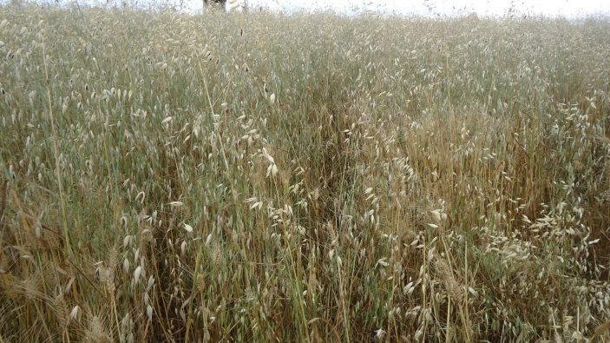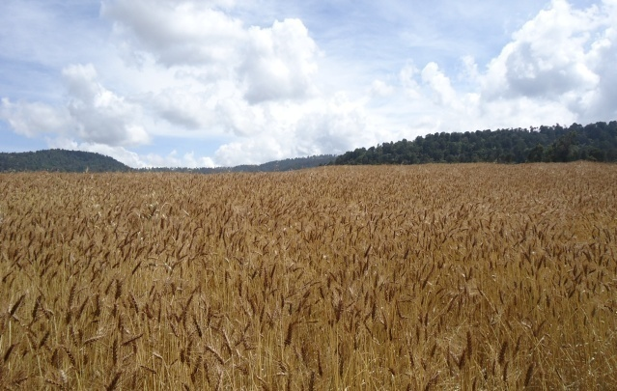
Figure 5: Wheat farm infested by various weed species particularly avena spp as compared to weed free farm.

Herbicides such as 2, 4-D and Topics are utilized to control weeds in addition to the effort of manual weeding. In the intended command area, most of the crops are weeded not more than one times except for some vegetable crops such as garlic which the farmers used to weed 3-5 times or sometimes as per required. The main reason is that each farmer holds at least three hectares resulting in the scarcity of manpower. The other problem regarding weeding efficiency is the problem of herbicide supply particularly Topic. Due to this reason most crop farms are infested by various types of weeds as observed during survey time (Fig 6). Therefore; a lot needs to be done regarding frequency of weeding particularly at critical time of crop growth.

Table 4: Type and rate of herbicides used in the study area
Crop type | Herbicide type | Rate
Wheat | 2-4.D, Topic | 1lit/ha
Barley | 2-4.D | 1lit/ha

Harvesting and Post Harvest Management: Proper time and method of harvesting are important to avoid yield loses in the field. Both early and late harvests are detrimental with respect to yield and quality. It has been estimated that about 10% of durable commodities and 40% of perishable commodities are lost due to improper harvest and post harvest practices. It is necessary to adopt improved post harvest practices starting from the harvest to consumption to reduce such lose. The harvested produce should be properly threshed, cleaned, graded and stored.

The major crop produced in Dodola wereda in general and the study area in particular is wheat of various cultivars. With respect to the study area, wheat crops are properly harvested at physiological maturity stage and harvesting is done manually. Other crops like barley, faba bean pea, linseed and partially wheat crops are cut by sickle and the manually cut crops are threshed by using domestic animals (Fig 7). A remarkable amount of yield loss occurs during harvesting of wheat especially by shattering as observed during field survey. On some crops, delayance in harvesting is observed due to scarcity of labour resulting in yield and quality loses.

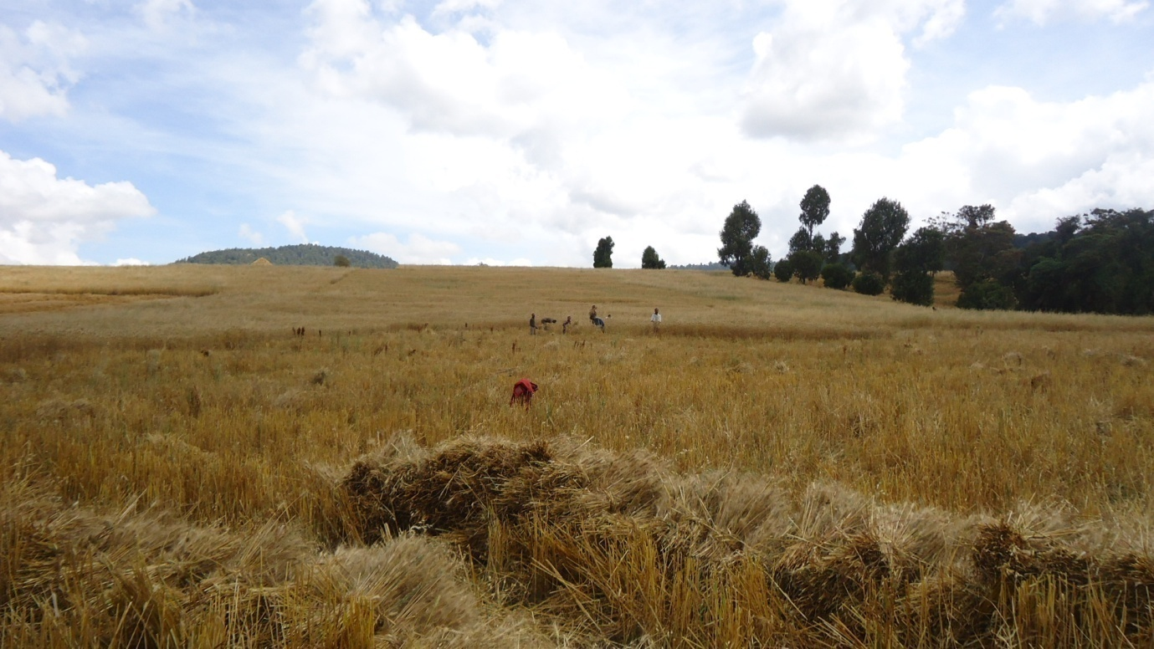
Figure 6: Manual harvesting of crops in the study area
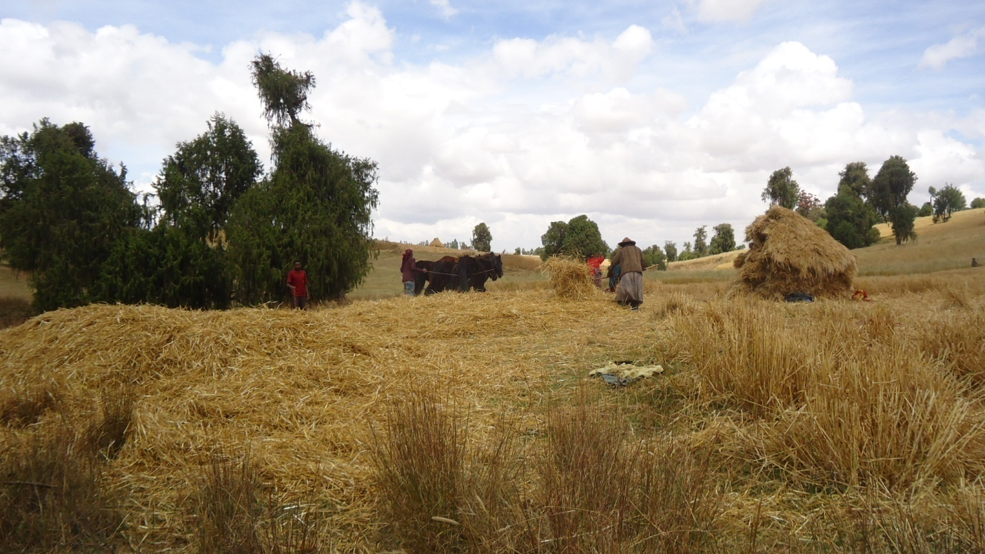
Figure 7: Threshing of crops using domestic animals in the study area

Storage: Food grains are physiologically stable after harvesting and this stability as well as viability should be preserved in a good storage method. Under natural conditions, stored grains undergo chemical changes within themselves and are subjected to pest infestation and product deterioration. Most agricultural commodities are produced seasonally. Harvesting is normally done during a short period of time while their consumption is spread all through the year. Hence proper storage of agricultural produce is essential.
In the study area , with the context of small holder farmers, since the grain crops are harvested at its physiological maturity and the farmers used to store properly, considerable storage problem was not observed as farmers report during focus group discussion. Most of the farmers use storage bags (sacks) to store their crops in well protected house. Some farmers also used to store in locally made “gotera” around homesteads for short period of time (Fig 9).

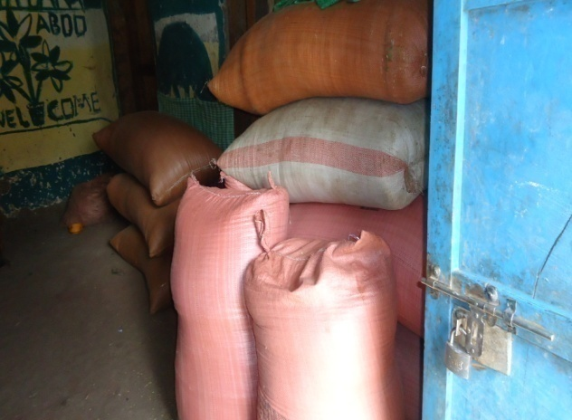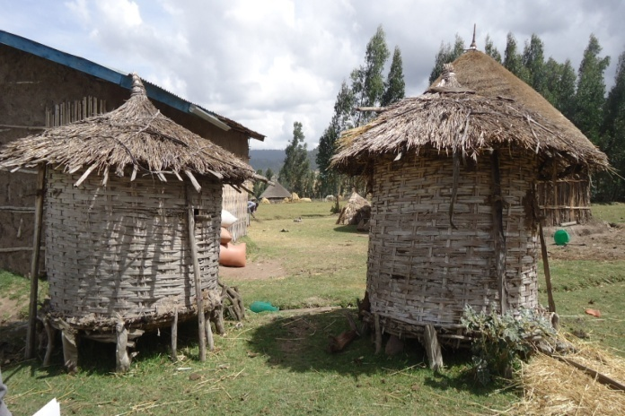
Figure 8: Storage system of the study area
Table 5.Existing Crop Management Practice and Cropping Calendar during summer season in the study area
S.n | Crop type | Management Practices |  |  |  |  |  | Remark
S.n | Crop type | Land Preparation |  | Sowing/ planting | Weeding |  | Harvesting
S.n | Crop type | Time | Freq. | Time | Time | Freq. | Time
I | Cereals
 | Barley | Mar-May | 3 | June | July-August | 2 | Oct-Nov
 | Wheat | Mar-May | 3 | June | July-August | 2 | Oct-Dec
II | Pulses
 | Faba bean | Mar-May | 3-5 | June | July-August | 2 | Oct-Nov
 | Field pea | Mar-May | 1-2 | June | August | 1 | Oct-Nov
III | Oil Crops
 | Linseed | - | - | June | August | 1 | Oct- November
IV | Vegetable
 | Garlic | May | 4-5 | June | Any time | 5-6 | December

Existing Crop Diseases, Insects and Weeds

In and around the project area, crop diseases such as smut, wheat rust, and septoria are periodically attacking crops. On the other hand insect pests such as aphids, cut worm and chaffer grups etc are known to be the most prominent crop production constraints in the district and around the project areas. Chemical and cultural control measures are employed to minimize the problem of diseases and insect pests. However, due to less availability and high cost of pesticides, reasonable yield lose was reported. Hence, IPM techniques should be employed. Weeds are also commonly seriously attacking almost all crops in the study area. Weed species such as, chinopodium, avena spp, guizoria, etc, are observed on farmers’ fields

Table 6: Existing crop pests and their prevalence in the study area
Major pests  ( Local/Common/Scientific Name) | Prevalence |  |  | Control method
Major pests  ( Local/Common/Scientific Name) | High | Medium | Low | Control method
Major Insects
Aphids |  |  |  | Chemical
Cut Warm |  |  |  | Chemical
Major Diseases
Rust (strip, stem and leaf rust) |  |  |  | Chemical
Septoria |  |  |  | Chemical
Smut |  |  |  | Chemical
Major Weeds
Chinopodium |  |  |  | Chemical
Avena spp |  |  |  | Chemical
Guizotia |  |  |  | Chemical

Status of Irrigation Practices in the study area
Though ample amount of water is flowing, irrigation agriculture and the development of modern irrigation is not common in the study area.

Status of Agricultural Extension Packages in the study area
In and around the command area, the crop yields had been remained low due to several problems. Among which, low awareness creation and low level of technologies utilized by the farmers as a result of poor agriculture support services are the major. To alleviate these problems, the government has built farmers training centers and recruited development agents. Currently, the development agents in collaboration with other experts have created awareness to initiate the farmers to involve in different agricultural extension packages. According to the data obtained from the district (Table 8), the involvement of the farmers in extension packages is increasing from year to year.

Fertilizers Utilization in Alentu Kebelle and the study area
Fundamentally, farmers in the study area are using DAP at the rate of 100kg/ha for wheat crop and less for barely (Table 7). The yearly DAP fertilizer utilization of farmers is also increasing from year to year (Table 8). On the other hand, the distribution and utilization of Urea in the district is negligible. According to the data obtained from the district and the study kebelle, there is no shortage of fertilizers in the districts in general and the study area in particular. Farmers in the study area not commonly use fertilizer for other crops.

Table 7: Fertilizer rate in Alentu Kebele and the study area
Crop type | Fertilizer rate (kg/ha)
Crop type | DAP | Urea | Compost (qt/ha)
Wheat | 100 | 100 | 40
Barley | 75 | 50 | 15

Agro- Chemicals
During survey, the farmers indicated the high incidence of weeds, insect-pests and diseases as one of the production constraints. This is due to inability of the farmers to recognize the pests and disease of crops and lack of knowledge regarding the control measures. In addition, due to high cost and non-availability of insecticides at the closest reach of the farmers, the utilization of agrochemicals to control disease and insect pest is very rare except high utilization of herbicides such as 2, 4-D and Topics and now a day’s Palas.

Table 8: Yearly input supply distribution in Alentu Kebele and the command area
Input type | Unit | 2000/2001 | 2001/2002 | 2002/2003 | 2003/2004 | 2004/2005
Fertilizer
DAP | Qt | 457 | 461.5 | 465 | 570 | 965
Urea | Qt | - | 1 | 1.5 | 1.5 | 4.5
Improved seed
Wheat | Qt | 205 | 307 | 355 | 412 | 460
Barley | Qt | - | 27 | 31 | 40 | 40
Faba Bean | Qt | - | 3.5 | 3.5 | 4 | 6
Linseed | Qt | - | 3.5 | 3.5 | 3 | 4
Agro-chemical
2.4D | Lit | 309 | 504 | 559 | 605 | 630
Topic | Lit | - | - | 9 | 18 | 35
Tilt | lit | - | - | - | 8 | 10
Source: Alentu PA

Utilization of Improved Seeds
Seed is a basic input for crop production. The quality of seed has the most profound influence on crop yields. The farmers have been using their own seed saved from the previous crops. Farmers in the study area have historical trends to use improved seed particularly for wheat and barley. However, they are facing the shortage of these improved seeds in all crop types. Therefore, lots are expected from research institution and seed enterprises at all level.

Table 9: Improved seed and their respective yield with and without fertilizer in the study area
CropType( Variety) | Local/Improved | Fertilizer Application rate in kg/ Ha |  | Yield With Fertilizer | Yield W/o Fertilizer
CropType( Variety) | Local/Improved | DAP | UREA | Yield With Fertilizer
Wheat (HAR-3116)  HAR-1407 | Improved | 100 | 50 | 38 | 15
Wheat (HAR-3116)  HAR-1407 | Improved | 100 | 50 | 37 | 14
Malting Barley | Improved | 100 | 50 | 28 | 10

Table 10: Local Crop Cultivars and their Attributes as Perceived by Farmers
Crop Type | Crop/Cultivar | Months to Mature | Relative drought Tolerance | Relative Yield Potential | Remark
Wheat | K62954A | 4-5 | high | low
Barley | Aruso | 3 | high | medium

Table 11: Improved Varieties/Cultivars and their Attributes as Perceived by Farmers
Crop Type | Crop/  Cultivar | Months to Mature | Relative drought tolerance | Relative Yield Potential | Remark
Wheat | HAR-3116 | 4-5 | Low | Medium
Wheat | HAR-1407 | 4 | high | high
Malting Barley | Misical | 4 | medium | high
Malting Barley | Savini | 4 | medium | high

Table 12: Yield response of local and improved varieties of the following crops of the study area
S.No | Crop type | Average yield in quintal/hectare |  | remark
S.No | Crop type | local | improved
 | Cereal
1 | Barley | 12 | 30
2 | Wheat | 15 | 50
4 | Oat | 10 | -
 | Pulse
5 | Faba bean | 7 | 10
6 | Field pea | 7 | 12
 | Oil crops
7 | Linseed | 4 | 8

Agricultural Support Services in study area

Credit facility
Though the credit facilities are not satisfactory there are some micro-finances like walka, busa gonfa and peace that support farmers in credit.

Input supply
There is farmers cooperative dominated by government that supply agricultural inputs like fertilizer, pesticides, improved seeds and some agricultural machineries for community farmers. However, only fertilizer is supplied with satisfactory manner. Others particularly herbicides against grass family weeds are at critical shortage. Also there is shortage of fungicides.

Training Facility
There are farmers training center in the study area. Development agents are training farmers on improved technologies. However, capacity building for the development agent is mandatory. Awareness creation on the recent agricultural technologies is also required.

Research Institution
Currently, agriculture research center are very far from command area. The nearby research center is found at sinana agricultural research center. To this effect, there is less site-specific research out-puts on various components of crop production.

Major Constraints of Crop Production in the Project Area
This Section describes some of the existing major production constraints in the project area.
- Poor pest control practices, particularly weed.
- Inadequate soil fertility and conservation management practices.
- Agriculture inputs availability and utilization, particularly, herbicides and improved seeds of various crops.
- Shortage of draught power.
- Shortage of farm implements.
- Lack of credit services.
- Use of low yielding local crop varieties
- Inadequate rural infrastructure

PROPOSED CROPPING PRACTICES

Selection of Crops for Command Areas

Based on the selection criteria described below the strategic crops are selected and includes barley, faba bean, wheat for 1st season , potato, garlic for 2nd season shown below. Table 10 shows the crop varieties selected for the command area. Table 11 shows the cropping pattern and area coverage of proposed crop of the project area.

The selection of potential crops has been done based on the following selection criteria.

- Climatic condition of the project area such as rainfall amount and distribution, temperature (max., min., optimum), humidity etc.
- The expected irrigation scheme development programs
- Altitude and topography of the project areas.
- Soil condition
- Adaptability of crops to the growing conditions of the project areas
- The farming standard of the local people
- Availability of Labor and farm tools
- Food habit of the community
- Resistance and tolerance of the crops to the prevailing production constraints
- The socio economic condition of the project areas
- Yield potential and availability of market out lets.
- Food security attainment goals.
- Length of growing period
- Market value
- Availability of suitable crops

Table 13: Selected crop varieties for the command area
Crop Type | Variety
Faba bean | CS-20_DK, Bolga,-70, Holeta2, Degaga, Moti, Gebelech, Wayo, selale,
Wheat | Kubsa, Galama, Pavon-76, Tusie, Foka, Kilinto
Barley | HB1370, IARH485, abdu1260B, HB42, Bontu
Garlic | TedayG-493, bishoftu white
Potato | Chiro, Bedesa, Zemen

Proposed cropping pattern of the study area
Cropping pattern is the yearly sequence of crops grown and the spatial arrangement of them and follows in a given area. The proposed cropping pattern of the crops selected for the study area is presented on Table 14.

Table 14: Cropping pattern of the proposed crop
Alentu Small Scale Irrigation Project Year One Cropping pattern
No. |  | Crop name | Planting date | Harvest date | Area%
1 |  | Barley | 02/06 | 29/09 | 30
2 |  | Wheat | 20/06 | 27/10 | 50
3 |  | Faba bean | 02/06 | 19/09 | 20
 | Total | 100
1 |  | Potato | 28/12 | 06/05 | 60
2 |  | Garlic | 01/01 | 10/05 | 40
 | Total | 100

Growing period and cropping calendar
Taking the time required for land preparation, planting and harvesting of the crop, the length of the growing period is estimated. The growing period and operational calendar of proposed crops are described on Table 14.

Proposed Crop Rotation
Growing of one crop repeatedly on the same land will cause poor growing environment and finally resulted in poor quality and low yield. In order to avoid this deleterious effect of single cropping, appropriate crop rotations are proposed by considering crop diversification, efficient labour distribution, disease prevention, soil fertility maintenance and crop characteristics as depicted in Table 15.

Table 15: Proposed crop rotation
Year one |  | Year two |  | Year three
Barley | Potato | Faba bean | Garlic | Wheat | Potato
Wheat | Garlic | Barley | Potato | Faba bean | Garlic
Faba bean | Garlic | Wheat | Potato | Barley | Potato

Input Requirements and their cost
Crops' input requirements in terms of labour, draught power, seeds, fertilizers and agro-chemicals have been estimated based on current practices in the country. Adequate and timely supply of inputs, particularly improved seeds and fertilizer, is very important to the sustainability and productivity of the project. The full application or use of these inputs may not be attainable during the early years of the project life but should be implemented in a gradual manner through vigorous extension work, farmers' active participation, on-farm demonstration and trials (pilot project).

While the available labour of the household may be adequate for the conventional rain fed farming system, introduction of irrigation during the dry season requires increased work force and will exert higher demand on family level. Consequently, it will not be possible for a family of average size to manage more than 0.5 ha of land holding.

Table 16.Proposed Cost of Materials /Farm tools required for Hectare
Type of farm tool | Amount required for a hectare | Unit cost of farm tool (Birr) | Total cost (Birr)
Shovel | 5 | 100 | 500
Fork | 5 | 120 | 600
Spade | 5 | 80 | 400
Slasher | 6 | 80 | 480
Plow and its accessories | 1 | 300 | 300
Chemical Sprayer | 1 | 500 | 500
Rake | 6 | 60 | 360
Sub total |  |  | 3140

Table 17: Production cost for the proposed crops under rainfed on the irrigation command areas per hectare
Type of crop | Type of activity | Frequency/season |  | Man day required per hectare | Man day/season/ha | Labour cost per head | Total labour cost
Wheat | Land preparation and sowing | 3 |  | 4 | 12 | 60 | 720
Wheat | Weeding | 1 |  | 16 | 16 | 60 | 960
Wheat | Chemical application (fertilizers, pesticides etc.) | 3 |  | 1 | 3 | 60 | 180
Wheat | Harvesting and storing | 1 |  | 15 | 15 | 60 | 900
Sub Total 2760
Faba bean | Land preparation and sowing |  | 3 | 4 | 12 | 60 | 720
Faba bean | Weeding |  | 1 | 16 | 16 | 60 | 960
Faba bean | Chemical application (fertilizers, pesticides etc.) |  | 2 | 1 | 2 | 60 | 120
Faba bean | Harvesting and storing |  | 1 | 15 | 15 | 60 | 900
Total 2700
Barley | Land preparation and sowing |  | 3 | 4 | 12 | 60 | 720
Barley | Weeding |  | 1 | 16 | 16 | 60 | 960
Barley | Chemical application (fertilizers, pesticides etc.) |  | 2 | 1 | 2 | 60 | 120
Barley | Harvesting and storing |  | 1 | 15 | 15 | 60 | 900
Total 2700

Table 18: Production cost for the proposed crops under irrigation on the irrigation command areas per hectare
Type of crop | Type of activity | Freq | Man day/per hectare | Man day required per hectare | Labour cost per head | Total labour cost
Potato | Land preparation and sowing | 3 | 4 | 12 | 60 | 720
Potato | Weeding/inter cultivation | 3 | 16 | 48 | 60 | 2880
Potato | Irrigation and Chemical application (fertilizers, pesticides etc.) | 9 | 1 | 9 | 60 | 540
Potato | Harvesting and storing | 1 | 15 | 15 | 60 | 900
Total 5040
Garlic | Land preparation and sowing | 3 | 4 | 12 | 60 | 720
Garlic | Weeding | 3 | 16 | 48 | 60 | 2880
Garlic | Irrigation and Chemical application (fertilizers, pesticides etc.) | 8 | 1 | 8 | 60 | 480
Garlic | Harvesting and storing | 1 | 15 | 15 | 60 | 900
Total 4980

Table 19: Input requirement of cultivated crops with project condition
No | Crops type | Seed Rate (qtl/ha) | Fertilizer (kg/ha) |  | Agro-chemicals
No | Crops type | Seed Rate (qtl/ha) | DAP | UREA | Insecticide orFungicide (lit/ha)
1 | Wheat | 150 | 130 | 80 | 1lit topic and 1lit2-4D
2 | Barley | 100 | 300 | - | 1lit2-4D
3 | Faba bean | 200kg/ha | 100 | - | 1lit topic and 150g a.i. of Cypermethrin
4 | Potato | 18-20 | 195 | 165 | 2-2.5 endosulfan
6 | Garlic | 8-12 | 200 | 150 | 2-2.5 endosulfan

Yield Build-Up Patterns
Estimation of ultimate yield was made based on previous experiences of research, on farm and demonstration results. The consensus is that a shift from rain fed to irrigated agriculture could allow peasants to at least double their yields with time. Moreover, peasant could also get about 10-20% of ultimate yields during the first few years. However, the on-going national extension experiences show that there is even a possibility to triple and even further increase crop yields. Although site-specific database, which can fit to this project area are lacking, the national average yield could allow preparing fair and achievable yield projection for the area. These databases are collected the training manuals compiled by Ethiopian Agricultural Research Institute and the data collected from the study area during survey time.

Table 20: Proposed Yield build up Pattern and Average Crop yields Project Command areas (qtl/ha)
No | Crops | Projected yield (qtl/ha) in years
No | Crops | 0 | 1 | 2 | 3
1 | Faba bean | 20 | 29 | 39 | 51
2 | Wheat | 28 | 38 | 51 | 70
3 | Barley | 20 | 32 | 45 | 60
5 | Garlic | 50 | 76 | 110 | 130
6 | Potato | 250 | 320 | 370 | 430

Crop Budget and Seasonal Input for the Study Area
Season crop budget of the crops selected are present on separate tables. Table 21 for the first growing season crop which are proposed to be produced by rainfed production system. Similarly Table 22 is crop budget prepared for the second growing season which is supposed to be produced by irrigation project.

Table 21: Crop budget for the first growing season
Crop | Input type | Unit | Required/ha |  | Total area (ha) | Required for the project area | Cost/ha | Cost for the project area (birr)
Wheat | 1. Fertilizer
Wheat | DAP | Kg | 130 |  | 25 | 3250 | 2034.5 | 50862.5
Wheat | Urea | Kg | 80 |  | 25 | 2000 | 995.2 | 24880
Wheat | 2. Agro-chemical |  |  |  | 25 | 0 |  | 0
Wheat | 2-4D | lit | 1 |  | 25 | 25 | 85 | 2125
Wheat | Topic | Lit | 1 |  | 25 | 25 | 450 | 11250
Wheat | Funjicide | lit | 1 |  | 25 | 25 | 750 | 18750
Wheat | 3. Ox | Pair | 12 |  | 25 | 300 | 1200 | 30000
Wheat | 4. Tools |  |  |  | 25 | 0 |  | 0
Wheat | Plow and its accessories | No | 1 |  | 25 | 25 | 300 | 7500
Wheat | Chemical Sprayer | No | 1 |  | 25 | 25 | 500 | 12500
 | 5. Planting Material (seed) | kg | 150 |  | 25 | 3750 | 1650 | 41250
 | 6. Labor | No | 46 |  | 25 | 1150 | 2760 | 69000
Barley | 1. Fertilizer |  |  |  |  |  |  | 0
Barley | DAP | Kg | 300 |  | 15 | 4500 | 2034.5 | 30517.5
Barley | 2. Agro-chemical |  |  |  | 15 | 0 |  | 0
Barley | 2-4D | lit | 1 |  | 15 | 15 | 85 | 1275
Barley | Funjicide | lit | 1 |  | 15 | 15 | 750 | 11250
Barley | 3. Ox | Pair | 12 |  | 15 | 180 | 1200 | 18000
Barley | 4. Tools |  |  |  | 15 | 0 |  | 0
Barley | Plow and its accessories | No | 1 |  | 15 | 15 | 300 | 4500
Barley | Chemical Sprayer | No | 1 |  | 15 | 15 | 500 | 7500
Barley | 5. Planting Material | kg | 100 |  | 15 | 1500 | 1200 | 18000
Barley | 6. Labor | No | 46 |  | 15 | 690 | 2760 | 41400
Faba bean | 1. Fertilizer |  |  |  |  | 0 |  | 0
Faba bean | DAP | Kg | 100 |  | 10 | 1000 | 1565 | 15650
Faba bean | 2. Agro-chemical |  |  |  | 10 | 0 |  | 0
Faba bean | Funjicide | lit | 1 |  | 10 | 10 | 750 | 7500
Faba bean | Insecticide | lit | 1 |  | 10 | 10 | 185 | 1850
Faba bean | Topic | Lit | 1 |  | 10 | 10 | 85 | 850
Faba bean | 3. Ox | Pair | 12 |  | 10 | 120 | 1200 | 12000
Faba bean | 4. Tools |  |  |  | 10 | 0 |  | 0
Faba bean | Plow and its accessories | No | 1 |  | 10 | 10 | 300 | 3000
Faba bean | Chemical Sprayer | No | 1 |  | 10 | 10 | 500 | 5000
Faba bean | 5. Planting Material | kg | 200 |  | 10 | 2000 | 3000 | 30000
Faba bean | 6. Labor | No | 45 |  | 10 | 450 | 2700 | 27000
Faba bean | Sub total |  |  |  |  |  |  | 503410
Faba bean | Training | Unit |  | required/season |  | Perdiem(birr/day) | No of days | Total cost
Faba bean | Training of farmers | Person |  | 10 |  | 150 | 2 | 3000
Faba bean | Training of DA | Person |  | 1 |  | 200 | 3 | 600
Faba bean | Trainers | Person |  | 2 |  | 300 | 3 | 1800
Faba bean | Coordinator | Person |  | 1 |  | 300 | 3 | 900
Faba bean | Sub total |  |  |  |  |  |  | 6300
Faba bean | Grand total |  |  |  |  |  |  | 509710
Faba bean | Contingency (5%) |  |  |  |  |  |  | 25485.5
Total cost |  |  |  |  |  |  |  | 535196

Table 22Crop Budget for the second growing season
Crop  Type | Input type | Unit | Required/ha | Total area (ha) | Required for the project area | Cost/ha | Cost for the project area
Potato | Fertilizer
Potato | DAP | Kg | 200 | 30 | 6000 | 3130 | 93900
Potato | Urea | Kg | 170 | 30 | 5100 | 2115 | 63450
Potato | Agro-chemical |  |  | 30 | 0 |  | 0
Potato | Funjicide | Lit | 1 | 30 | 30 | 750 | 22500
Potato | Insecticide | Lit | 1 | 30 | 30 | 185 | 5550
Potato | Ox | Pair | 12 | 30 | 360 | 1200 | 36000
Potato | Tools |  |  | 30 | 0 |  | 0
Potato | Shovel | No | 5 | 30 | 150 | 500 | 15000
Potato | Fork | No | 5 | 30 | 150 | 600 | 18000
Potato | Spade | No | 5 | 30 | 150 | 400 | 12000
Potato | Slasher | No | 6 | 30 | 180 | 480 | 14400
Potato | Plow and its accessories | No | 1 | 30 | 30 | 300 | 9000
Potato | Planting Material | qt | 18 | 30 | 540 | 5400 | 162000
Potato | Labor | No | 86 | 30 | 2580 | 5160 | 154800
Garlic | Fertilizer |  |  | 20 | 0 |  | 0
Garlic | DAP | Kg | 200 | 20 | 4000 | 3130 | 62600
Garlic | Urea | Kg | 150 | 20 | 3000 | 1866 | 37320
Garlic | Agro-chemical |  |  | 20 | 0 |  | 0
Garlic | Funjicide | Lit | 1 | 20 | 20 | 750 | 15000
Garlic | Insecticide | Lit | 1 | 20 | 20 | 185 | 3700
Garlic | Endosulfan | Lit | 1 | 20 | 20 |  | 0
Garlic | Ox | Pair | 12 | 20 | 240 | 1200 | 24000
Garlic | Tools |  |  | 20 | 0 |  | 0
Garlic | Shovel | No | 5 | 20 | 100 | 500 | 10000
Garlic | Fork | No | 5 | 20 | 100 | 600 | 12000
Garlic | Spade | No | 5 | 20 | 100 | 400 | 8000
Garlic | Slasher | No | 6 | 20 | 120 | 480 | 9600
Garlic | Plow and its accessories | No | 1 | 20 | 20 | 300 | 6000
Garlic | Chemical Sprayer | No | 1 | 20 | 20 | 500 | 10000
Garlic | Rake | No | 6 | 20 | 120 | 360 | 7200
Garlic | Planting Material | qt | 10 | 20 | 200 | 20000 | 400000
Garlic | Labor | No | 88 | 20 | 1760 | 5280 | 105600
Garlic | Sub total |  |  |  |  |  | 1317620
Garlic | Training Requirement | Unit | required/season |  | Perdiem(birr/day) | No of days | Total cost
Garlic | Training of farmers | Person | 10 |  | 150 | 2 | 3000
Garlic | Training of DA | Person | 1 |  | 200 | 3 | 600
Garlic | Trainers | Person | 2 |  | 300 | 3 | 1800
Garlic | Coordinator | Person | 1 |  | 300 | 3 | 900
Garlic | Sub total |  |  |  |  |  | 6300
Garlic | Grand total |  |  |  |  |  | 1323920
Garlic | Contingency (5%) |  |  |  |  |  | 66196
 | Total |  |  |  |  |  | 1390116

CROP WATER REQUIREMENT FOR ALENTU SMALL SCALE IRRIGATION PROJECT

Proposed crops and cropping calendar.

Cropping calendar is the times in which the agricultural activities are performed sequentially starting from land preparation until harvesting time. Different crops need different cropping calendar based on the climatic conditions they need and the length of growing period. The right and an optimum cropping calendar are needed to get an optimum yield. Thus, the following cropping calendar has been prepared for the proposed crops on the project.

Table 23: Cropping calendar for the proposed crops on the project
S.no | Crop Type | Sowing Date | Harvesting date | Percentage
1 | Potato | 28/12 | 06/05 | 60
2 | Garlic | 01.01 | 10/05 | 40
Total | 100

Crop Water Requirement (ETcr)
Crop water requirement is the depth of water needed to meet the loss through evapo-transpiration of diseases free, growing in large fields under non restricting soil conditions including soil water and fertility and achieving full production potential under the given growing environment.

Crop Irrigation Water Requirement
Crops require water for their growth. In areas where there is evenly distributed rainfall, irrigation may not be required. However, if the rainfall is not adequate or erratic, irrigation becomes crucial for crop production.

The irrigation water requirements of a particular crop plant for a certain period of time can be estimated by calculating a water balance for the root zone area of the crop plant. To determine the irrigation water requirement the following general equation can be applied:-
IWR = ET₀ x Kc - (Pe+Wb+Ge)
Where, ET₀ - Reference evapotranspiration (mm/day)
IWR - Irrigation Water Requirement (mm)
Kc - Crop Coefficient
Pe - Effective rainfall (mm)
Wb - Soil moisture at the beginning of irrigation (%), and
Ge - Recharge water from the nearby ground
The values of Ge, Wb are negligible in case of the project area, particularly in dry seasons.
ETcr = ETo * kc

Reference crop evapo-transpiration (ETO)
Reference crop evapo-transpiration is the rate of evaporation from an extensive surface of 8 to 15 cm tall green grass cover of uniform height, actively growing, completely shading the ground and with no shortage of water.

It is calculated by using the pen man method. The ETO used for the purpose of calculating ETcr is calculated using CROPWAT 8 and climatic parameters are taken from the monthly given for Adaba station from the manual of.FAO climwat for cowpat version 2.

The form of equation used in pen man method is:
ET_{O} = [W.Rn+(1-w). f(u), (ea-ed)]
Where; ET_{O}= reference crop evapo-transpiration in mm/day.
W = temperature related weighting factor
Rn = net radiation on equivalent evaporation in mm/day
F(u) = wind related function
(ea-ed) = difference between the saturation Vapour pressure at mean air temperature and the mean actual vapour pressure of the air, both in bar
C = adjustment factor to compensate for the effect of day and night weather conditions.

Table 24: Reference evapotranspiration of the study area
Month | Min Temp | Max Temp | Humidity | Wind | Sun | Rad | ETo
 | °C | °C | % | km/day | hours | MJ/m²/day | mm/day
January | 3.2 | 24.6 | 83 | 130 | 7.5 | 19.1 | 3.51
February | 3.2 | 24.1 | 78 | 138 | 7.6 | 20.3 | 3.8
March | 3 | 25.2 | 81 | 138 | 6.9 | 20.1 | 3.88
April | 4.9 | 25.1 | 93 | 147 | 6.4 | 19.3 | 3.59
May | 5.1 | 25.8 | 91 | 130 | 6.7 | 19.2 | 3.66
June | 3 | 25.7 | 92 | 112 | 6.7 | 18.7 | 3.56
July | 5 | 22.8 | 96 | 112 | 4.4 | 15.5 | 2.84
August | 5 | 22.6 | 100 | 104 | 4.8 | 16.5 | 2.93
September | 4.9 | 21.7 | 96 | 104 | 5.8 | 18.2 | 3.15
October | 4.1 | 22.2 | 89 | 112 | 6.3 | 18.5 | 3.25
November | 2 | 24 | 86 | 130 | 7.7 | 19.5 | 3.51
December | 2 | 23.6 | 80 | 130 | 8.3 | 19.8 | 3.51
Average | 3.8 | 23.9 | 89 | 124 | 6.6 | 18.7 | 3.43

Length of crop growing stage
There are four main growing stages of a crop during its growth period where water requirements vary. i.e. the seasonal use of water by plants is determined by their stage of growth.

The initial stage:-germination and early crop growth, where the ground cover is less than 10%.
Crop development stage: - from the end of initial stage to full ground cover usually between 70-80% of the land surface.
Mid season stage: - from the attainment of full ground cover to the start of maturity indicated by leaf senescence or loss.
Late season stage: - from the end of the mid season stage until harvest.
During the vegetative stage consumptive use continues to increase. Flowering occurs near and the peak of consumptive use of water. The fruiting stage is accompanied by a decrease in consumptive use until the transpiration essentially ceases during the later part or the formation of dry fruits. The growing stages of the proposed crops for the project are shown on Table 25, 26, and 27.

Crop Coefficient (Kc)
The effect of crop characteristics on crop water requirement is given by the crop coefficient. It represents the relationship between reference (ETO) and crop evapo-transpiration (ETcrop) or ETcrop = Kc x ETO. Values of crop coefficient given are shown to vary with the crop, its stage of growth, growing season and the prevailing weather conditions. For the proposed crops the crop coefficients are shown on the Table 25 and 26.

Table 25: Length of growing stages and crop coefficients of potato
Crop=Potato
Planting date=28/12
Harvesting date=06/05
Growth Stage | Initial | Development | Middle | Late | Total
Length (day) | 20 | 35 | 40 | 30 | 130
Kc value | 0.5 | 0.7 | 1.05 | 0.9
Root depth (m) | 0.3 | 0.45 | 0.6
Critical depletion | 0.25 |  | 0.3 | 0.5
Yield response (fraction) | 0.45 | 0.80 | 0.8 | 0.3

Table 26: Length of growing stages and crop coefficients of garlic
Crop=Garlic
Planting date=01/01
Harvesting date=10/05
Growth Stage | Initial | Development | Middle | Late | Total
Length (day) | 25 | 35 | 40 | 30 | 130
Kc value | 0.5 | 0.7 | 1.15 | 0.75
Root depth (m) | 0.3 | 0.4 | 0.5 | 0.5
Critical depletion | 0.25 |  | 0.3 | 0.5
Yield response (fraction) | 0.45 | 0.80 | 0.8 | 0.3

Effective rain fall
Effective rain fall is the proportion of the rain, which is stored in the root zone and therefore available to the plants. Rain fall which percolates beyond the root zone or is lost to the plants through surface run off is not effective, in that it is unavailable for plant growth.
It is calculated with USDA method using the formula;
P_{eff} = P_{total} (125-0.2 P_{total})/125, for P_{total} <250 mm per
P_{eff} = 125+0.1 P_{tota}l, for P_{total} > 250mm per month
Where, p_{eff} = effective rain fall
P_{total} = total rainfall in a month (mm per month)

Table 27: Effective rainfall of the study area
Month | Mean Monthly Rain | Eff rain
 | mm | mm
January | 24 | 26.7
February | 23.8 | 28.6
March | 66.3 | 59.8
April | 73.9 | 79.2
May | 55.2 | 74.2
June | 91.1 | 72
July | 202.7 | 123.3
August | 197.1 | 88
September | 89 | 121
October | 49.2 | 71.2
November | 10.8 | 21.2
December | 22.4 | 48.5
Total | 905.50 | 813.7

Irrigation efficiency (E)
It is the percentage of applied irrigation water stored in the soil and available for consumptive use by the crop. Field losses consist of surface run off and deep percolation. For small schemes estimates of 70% losses during application and another 70 % during conveyance and distribution is assumed. Hence an overall system irrigation efficiency of 49% is used for the calculation of the irrigation water requirement.

Leaching requirements
It is the proportion of the irrigation water that must be leached through the root zone in order to maintain the salinity of the soil at a specified limit. This means applying a greater quantity of water than required to satisfy the water requirements of the crop in order to leach out the excessive salts or if the irrigation water itself saline (salty) to avoid the accumulation of salts in the soil through dissolving the salts and move them down wards beyond the root zone where they can do no harm the plants. In this project case, both the soil and water have no the problem of salinity and thus no need of leaching requirements.

Net and Gross irrigation requirements
- Net irrigation requirement (N.I.R).

It is a depth of water needed to bring the soil moisture level in the effective root zone to field capacity from the soil moisture. It is calculated by using the relationship between crop water requirement (ETcr) and effective rain fall.
i.e. Net irrigation requirement = ETcr - Effective rain fall

b) Gross irrigation requirement.
It is the net irrigation requirement plus water application losses in the conveyance system due to seepage, evaporation etc.

Table 28: Crop water requirement of Potato
Month | Decade | Stage | Kc | ETc | ETc | Eff rain | Irr. Req.
 |  |  | coeff | mm/day | mm/dec | mm/dec | mm/dec
Dec | 3 | Init | 0.5 | 1.75 | 7 | 5.6 | 7
Jan | 1 | Init | 0.5 | 1.76 | 17.6 | 10.6 | 7
Jan | 2 | Init | 0.5 | 1.76 | 17.6 | 7.8 | 9.7
Jan | 3 | Deve | 0.62 | 2.22 | 24.4 | 8.4 | 16
Feb | 1 | Deve | 0.86 | 3.17 | 31.7 | 8.4 | 23.3
Feb | 2 | Deve | 1.09 | 4.13 | 41.3 | 8.2 | 33.2
Feb | 3 | Mid | 1.19 | 4.56 | 36.5 | 12.1 | 24.4
Mar | 1 | Mid | 1.19 | 4.59 | 45.9 | 16.8 | 29
Mar | 2 | Mid | 1.19 | 4.62 | 46.2 | 20.5 | 25.7
Mar | 3 | Mid | 1.19 | 4.5 | 49.5 | 22.5 | 27.1
Apr | 1 | Late | 1.18 | 4.34 | 43.4 | 25 | 18.4
Apr | 2 | Late | 1.06 | 3.81 | 38.1 | 27.5 | 10.6
Apr | 3 | Late | 0.93 | 3.35 | 33.5 | 26.6 | 6.9
May | 1 | Late | 0.82 | 2.98 | 17.9 | 15.1 | 5.3
Total |  |  |  |  | 450.6 | 215 | 243.7

Table 29: Crop water requirement of Garlic
Month | Decade | Stage | Kc | ETc | ETc | Eff rain | Irr. Req.
 |  |  | coeff | mm/day | mm/dec | mm/dec | mm/dec
Jan | 1 | Init | 0.5 | 1.76 | 17.6 | 10.6 | 7
Jan | 2 | Init | 0.5 | 1.76 | 17.6 | 7.8 | 9.7
Jan | 3 | Deve | 0.54 | 1.96 | 21.6 | 8.4 | 13.2
Feb | 1 | Deve | 0.76 | 2.83 | 28.3 | 8.4 | 19.9
Feb | 2 | Deve | 1 | 3.78 | 37.8 | 8.2 | 29.6
Feb | 3 | Mid | 1.17 | 4.49 | 35.9 | 12.1 | 23.8
Mar | 1 | Mid | 1.19 | 4.59 | 45.9 | 16.8 | 29
Mar | 2 | Mid | 1.19 | 4.62 | 46.2 | 20.5 | 25.7
Mar | 3 | Mid | 1.19 | 4.5 | 49.5 | 22.5 | 27.1
Apr | 1 | Mid | 1.19 | 4.39 | 43.9 | 25 | 18.9
Apr | 2 | Late | 1.12 | 4.01 | 40.1 | 27.5 | 12.6
Apr | 3 | Late | 0.98 | 3.55 | 35.5 | 26.6 | 8.9
May | 1 | Late | 0.85 | 3.08 | 30.8 | 25.2 | 5.6
 |  |  |  |  | 450.5 | 219.5 | 231

Irrigation scheduling
Irrigation scheduling is a systematic method by which a producer can decide on when to irrigate and how much water to apply. The goal of an effective scheduling program is to supply the plants with sufficient water while minimizing loss to deep percolation or runoff. Irrigation scheduling depends on soil, crop, atmospheric temperature, irrigation system and operational factors. Proper irrigation scheduling requires a sound basis for making irrigation decisions. Accordingly for all crops fixed interval at various stages of the crop development is selected yielding minimum yield reduction. Thus, an irrigation interval of 15, 18, 12, 10, 10, 10, 10, 11 for the crop potato and 18, 14, 11, 11, 13, 12, 11 days for the crop garlic is required after first irrigation (Table 30 and 31 respectively).

Table 30: Irrigation schedule of Potato
Date | Day | Stage | Rain | Ks | Eta | Depl | Net Irr | Deficit | Loss | Gr. Irr | Flow
 |  |  | mm | fract. | % | % | mm | mm | mm | mm | l/s/ha
28-Dec | 1 | Init | 0 | 1 | 100 | 28 | 15.5 | 0 | 0 | 22.1 | 2.56
12-Jan | 16 | Init | 0 | 1 | 100 | 27 | 18.8 | 0 | 0 | 26.9 | 0.21
29-Jan | 33 | Dev | 0 | 1 | 100 | 27 | 23.7 | 0 | 0 | 33.9 | 0.23
10-Feb | 45 | Dev | 0 | 1 | 100 | 30 | 29.2 | 0 | 0 | 41.8 | 0.4
20-Feb | 55 | Dev | 0 | 1 | 100 | 32 | 34.3 | 0 | 0 | 48.9 | 0.57
2-Mar | 65 | Mid | 0 | 1 | 100 | 30 | 32.6 | 0 | 0 | 46.6 | 0.54
12-Mar | 75 | Mid | 0 | 1 | 100 | 34 | 36.7 | 0 | 0 | 52.4 | 0.61
22-Mar | 85 | Mid | 0 | 1 | 100 | 32 | 34.5 | 0 | 0 | 49.3 | 0.57
2-Apr | 96 | Mid | 0 | 1 | 100 | 34 | 36.4 | 0 | 0 | 52 | 0.55
6-May | End | End | 0 | 1 | 0 | 26
Totals
Total gros irrigation=373.9mm | Total rain fall=232.7mm
Total net irrigation=261.8mm | Effective rain fall=184.7mm
Total irrigation loss=0mm | Total rain loss=48mm
Actual water use by crop=438mm | Moist deficit at harvest=28.2mm
Potential water use by crop=438mm | Actual irrigation requirement=263mm
Efficiency irrigation schedule=100% | Efficiency rain=79.4%
Deficiency irrigation schedule=0.1% | Efficiency rain=79.4%

Table 31: Irrigation schedule of Garlic
Date | Day | Stage | Rain | Ks | Eta | Depl | Net Irr | Deficit | Loss | Gr. Irr | Flow
 |  |  | mm | fract. | % | % | mm | mm | mm | mm | l/s/ha
1-Jan | 1 | Init | 0 | 1 | 100 | 28 | 15.5 | 0 | 0 | 22.1 | 2.56
19-Jan | 19 | Init | 0 | 1 | 100 | 26 | 19.2 | 0 | 0 | 27.4 | 0.18
2-Feb | 33 | Dev | 0 | 1 | 100 | 26 | 22.8 | 0 | 0 | 32.6 | 0.27
14-Feb | 45 | Dev | 0 | 1 | 100 | 30 | 29.3 | 0 | 0 | 41.8 | 0.4
25-Feb | 56 | Mid | 0 | 1 | 100 | 32 | 34.5 | 0 | 0 | 49.2 | 0.52
10-Mar | 69 | Mid | 0 | 1 | 100 | 34 | 36.3 | 0 | 0 | 51.9 | 0.46
22-Mar | 81 | Mid | 0 | 1 | 100 | 32 | 34.5 | 0 | 0 | 49.3 | 0.48
2-Apr | 92 | Mid | 0 | 1 | 100 | 34 | 36.5 | 0 | 0 | 52.2 | 0.55
10-May | End | End | 0 | 1 | 0 | 28
Totals
Total gross irrigation=326.6mm | Total rain fall=247.4mm
Total net irrigation=228.6mm | Effective rain fall=215.3mm
Total irrigation loss=0mm | Total rain loss=32.1mm
Actual water use by crop=447.5mm | Moist deficit at harvest=30.6mm
Potential water use by crop=447.5mm | Actual irrigation requirement=232.2mm
Efficiency irrigation schedule=100% | Efficiency rain=87%
Deficiency irrigation schedule=0.1% | Efficiency rain=87%

Depth of Application
The net maximum scheme irrigation requirement of 0.33l/s/h or 2.9mm/day in the month of February is required (Table 32). With overall system irrigation efficiency of 49% and with the assumption of a daily irrigation cycle of 24 hours an irrigation duty of 0.65lit/sec/ha is the required amount of irrigation water. With the assumption of rotational flow in the main canals the total irrigation water required to satisfy 50 ha of land will be calculated from the formula,
Q= Duty*area
Where Q is discharge in lit/sec
Duty= flow in lit.sec/ha=0.65 lit/sec/ha*50ha
A=area in ha=50ha
Q=0.65 lit/sec/ha*50ha=32.5lit/sec

Table 32: Scheme Irrigation Water Supply of the Study Area
 | Dec | Jan | Feb | Mar | Apr | May
Precipitation deficit
1. Garlic | 0 | 29.9 | 73.4 | 81.8 | 40.4 | 5.6
2. Potata | 7 | 32.7 | 80.8 | 81.8 | 36 | 5.3
Net scheme irr.req.
in mm/day | 0.1 | 1 | 2.8 | 2.6 | 1.3 | 0.2
in mm/month | 3.5 | 31.3 | 77.1 | 81.8 | 38.2 | 5.4
in l/s/h | 0.01 | 0.12 | 0.32 | 0.31 | 0.15 | 0.02
Irrigated area | 60 | 100 | 100 | 100 | 100 | 100
(% of total area)
Irr.req. for actual area | 0.03 | 0.12 | 0.32 | 0.31 | 0.15 | 0.02
(l/s/h)

BENEFITS OF THE SMALL SCALE IRRIGATION SCHEMES

The implementation of the project will provide irrigation water to an area of 70 hectares of land. This entails incremental production and diversification of crops by the beneficiary. Increased crop production and cash income will improve the diet and nutrition of the population.

The practice of irrigation will create additional employment opportunities for the beneficiaries as well as for the people outside the command area. Apart from the scheme's beneficiaries, many other families in the surroundings will benefit from increased food crop production and possible labor opportunities in the irrigation fields. The high cropping intensity requires additional labor and provides employment opportunities throughout the year, which would have been idle otherwise. Crop yields will increase and problem of food shortage will be reduced.

The project will also encourage crop diversification based on market demands in and around the districts. New farming practices and improved technology will be provided through the extension services. As a result, apart from the benefits that it provides to the beneficiaries, the project will also serve as demonstration of irrigation practice to the surrounding farmers.

ORGANIZATION AND MANAGEMENT NEEDS

In the course of its period of implementation, the project will undertake the following major tasks in order to fulfil the presented objectives and targets of irrigation agronomy.

Establishment of Water Users Association (WUA)
Peasant farmers who will join the proposed irrigation scheme will be identified and selected right the beginning period of the project. Peasant associations, community leaders, the project, Woreda and Zonal agricultural offices and Wereda and Zonal administrative councils will participate jointly in undertaking the duty of farmer’s selection. During selection of farmers, the willingness of each farmer, priority to farmers in the command area and additional farmers from outside the command area will be used as possible parameters to select potential beneficiaries .Particular attention could be given to adequately participate female farmers in the project scheme.

In view of the critical need to get equitable distribution of irrigation land to the existing farmers in the area and in view of the fact that each and every selected farmer is getting technically manageable and feasible holding of the irrigable land it is proposed that about 0.5 hectare irrigable land will be distributed to each selected house hold farmers. Accordingly, the total number of beneficiaries from the intended project will eventually be about 140 house hold.

The water use association also helps in resolving the use conflicts. This will enable the farmers to participate in the construction/implementation stage and a sense of ownership will be flourished. The committee shall be elected from the beneficiaries to organize, manage, co-ordinate and operate the scheme in accordance with established by laws of the association. The committee shall be composed of 5-7 elected members among whom 1-2 members shall be women.

The function of the committee would be:

- Establishment and operation of irrigation water schedules,
- Distribution of irrigation water to members on set schedules,
- Organize and co-ordinate maintenance and cleaning of the canal and structure, and
- Taking measures on not abiding by WUA's laws and regulations.

Identification of Training Needs

Training the Development Agents and subject matter specialists
Development agents, supervisors and subject matter specialists from the project area from main office will be trained by the project. The training programmes will give emphasis to improved irrigation practices, integrated land management, integrated pest control, and other related topics to the envisaged project. Moreover, study tours within the country where successful small-scale irrigation schemes are found could be organized in order to upgrade the extension skills of these development staff.

Training of farmers
The project will organized training programs to farmers on improved crop husbandry system, Vegetable and fruit production, improved land management, irrigation practices, pest control, livestock husbandry and improved nutrition systems. Every year 2 training sessions each for 2-3 days could be organized with annual training plan of participating. The extension service with external technical assistance should undertake the intended activity.

Demonstration and field days
On farm demonstration on improved production package and technologies could be conducted by the extension services in the project area. Demonstrations could focus on improved crop husbandry practice, improved irrigation practices, use of improve seeds and fertilizers and production systems of vegetables and fruits.

About 10 field days per season could be organized on demonstration sites in order to expose farmers to new technologies. With 10-15 farmers participating in each field day it is possible to cover all of the farmers in the project during the entire sessions of field days.

Re-Distribution of land
Land re-distribution in the command area is proposed based on the following issues
A- To provide technically manageable holding of irrigable land (0.5 hectare) to each farmer in the command area who are currently owing over 1 hectare land each from the command area;
B- To allow farmers who currently owe land outside the command area get and cultivate land from the proposed irrigable land
C- To give fair and equitable share of rural investment opportunities to all peasants living in the project area

Strengthening the Extension Services
The extension service will be provided with motor cycles, office supplies and adequate field equipment. The development center will be established and strengthen including the constriction of office and living house for the development agent

The Role of Bylaw in Water and Land Use
Law is an essential component of land use and land development. It is the body of rules, customs or practices that determines how the members of a group behave toward each other. Law creates both social order and defines the management framework within which a group uses natural resources to create life-sustaining enterprises.

Laws establish rules and procedures through which stakeholders can resolve conflict and reach agreement while implementing the plan or policy. The institutions, for example public meetings and task forces such as government boards, legislatures and technical departments, enable the stakeholders to analyse information constantly, debate issues and make decisions, and create a body of land law and regulation.
Incentives for compliance may be written into the law itself, or sanctions for non-compliance imposed by an outside source such as the state or village council. A court or tribunal can be used to settle a dispute or determine a remedy. In summary, law comprises agreements and institutions and is a land resource management tool.

Legal framework
A legal framework is necessary for controlling as well as ensuring incentives and compensations. The legal frame should be kept as simple and transparent as possible. It contributes to achieving the sustainability of the land resources protection measures. Any existing legal framework should be used and taken into consideration during the implementation of a land use plan. This makes it generally easier to achieve a consensus and to support it.

Legislative Policy
Integrated water and land use law has four main policy objectives:
- the protection of the environment
- ecological stability of the farming systems
- meeting long-term basic needs of the population for self-sufficiency in food and other agriculture products
- contribution to economic growth at the national and local levels

Agricultural Research
It is evident that agricultural researches have immense potential in promoting peasant sector crop production by developing appropriate crop production technologies and packages. Unless the peasant efforts are fully supported by utilizing variable research finding and technologies, the success and sustainability of the envisaged development efforts will certainly far from a reality. Currently, agriculture research center are very far from command area. The nearby research center is found at sinana. To this effect, there is less a readymade site-specific research out-puts on various components of crop production.

The various production technologies and packages which are presented for immediate use by this study are certainly developed outside the study area. It is the belief and interest of the project that these extrapolated technologies need to be farther rainfed and accordingly adjusted based on the results of future site and commodity specific agricultural researchers.

Accordingly, the project understands the need and importance of establishing a one –hectare field trial site in the study area in the future. Within this trail site both rain fed and irrigated trials could be carried out each on half hectare area.

Some of the priority researchable areas
I. Variety adaptation Researchable Areas
Development of adaptive, superiors, high yielding crop varieties both under rain fed and irrigated conditions

II. Fertilizer trial
Establishing economic optimum rates (EOR) of fertilizer mainly N and P2O5 for various under rain fed and irrigation

III. Irrigation trials
Established actual and site specific crop water requirement, time and method of irrigations
IV. Tillage trials
Establish the most effective time, method, frequency of ploughing and seed bed preparation.
V. Seed rates trials
Established optimum seed rates and plant population for various crops and varieties.
VI. Post-harvest crop loss Assessment studies.
- Identity the target crops liable to post harvest losses
- Identity the stage of losses and kind of losses
- Identify the causes of post-harvest crop losses
VII. Weeding trials
Establish time method, frequency of weed control practices
VIII. Impact Assessment studies on the project
Surveys on the positive and negative impacts of the project on environment, social, economic and cultural situations and condition of the project area, peasants, and nearby population.

Setting Effective Monitoring and Evaluation systems
Both the project as an independent structure in terms of organization and administration, and the partner organizations participating as well as all other groups which work in planning and implementation need functioning tools of control. They must be able to accompany, check, evaluate and, if necessary, correct the implementation process of the planned measures. Monitoring and evaluation requires attention and causes costs as well as work.

There should be continuity between the completion of the projec and the implementation of its various components. A well designed and effective monitoring and evaluation plan should be established which clearly indicates when recommended measures are being implemented and if they are having the desired impacts.

Typically, monitoring and evaluation should be done throughout the implementation process and stakeholders should review and retest the indicators they have already identified and ask:

- Is the implementation keeping to the time schedule? Do adjustments have to be made?
- Are the activities proceeding successfully (criteria for success)?
- What is proving to be less than successful?
- Is there new information or are there influencing factors (threats, opportunities) that need to be taken into account?
- What actions and strategies need to be taken to address the new conditions and reform unsuccessful aspects?

Support Institutions
The sustainability of the irrigation scheme is very much dependent upon the strength of the provision of the support services. These services include:
- Agriculture extension service: Thorough and continuous orientation regarding crop production in general and irrigation agriculture in particular should be given to the peasant farmers. The recommendation is to assign development agents for the scheme. The development agents will also be responsible to the rain fed activities during the wet season.
- Strong linkage with irrigation research: A strong link should be formed with research establishments to carry out adaptive trials in the scheme. The most important aspects include irrigation methods, irrigation interval, water and fertilizer use efficiency, crops adaptive trial, water consumption and irrigation water management.
- Agricultural inputs: Fertilizers, improved seed and agro- chemicals are very important to the success of any irrigation project undertakings. These inputs must be provided adequately and timely. In addition, credit requirements of the farmers should also be fulfilled.
- Product marketing: Marketing of agricultural products in general and vegetables in particular require a well-organized marketing infrastructure. These include all-weather roads, efficient transport system, market centres and networks and storage facilities.

PROPOSED CROP VARIETIES AND THEIR IMPROVED MANAGEMENT PRACTICE

The agronomic data discussed below are collected from the training manuals compiled by the Ethiopian Agricultural Research Institute, organized by Rural Capacity Building Project, and Funded by World Bank and Canada in 2001 E.C held at Melkasa Agricultural Research Center.

Pulse Crops Production

FABA BEAN
Environmental Requirements
Faba bean grows on clay, silt or heavy deep, fertile and well-drained soils with adequate reserves of organic matter and a P^{H} range of 6.0-7.0 for high seed yield.

PRODUCTION PROBLEMS
- Inherently low grain yielding potential by the indigenous cultivars
- Biotic stresses (diseases, insects and weeds)
- Abiotic stresses (waterlogging, frost and moisture stress)
- Problems related to the soil environment (poor fertility, low P^{H} or acidity, shallowness).
- Poor cultural practices (marginal lands, minimum tillage, low seed rates, minimum or no weeding, no fertilizers).

PRODUCTION PACKAGE
- Improved Variety
- Crop management practices
- Crop protection practices

Table 33: List of improved faba bean varieties
Variety | Altitude  (m.a.s.l.) | Year released | 1000  SW(g) | Yield (qt ha^{–1})
 |  |  |  | On-station | On-farm
CS-20-DK | 2300-3000 | 1977 | 476 | 20-40 | 15-30
Bulga-70 | 2300-3000 | 1994 | 440 | 20-45 | 15-35
Holetta 2 | 2300-3000 | 2001 | 525 | 20-50 | 15-35
Degaga | 2300-3000 | 2002 | 517 | 25-50 | 20-45
Moti* | 2300-3000 | 2006 | 781 | 28-51 | 23-35
Gebelcho* | 2300-3000 | 2006 | 797 | 25-44 | 20-30
* & ** released for export market and waterlogging and root rot resistance, respectively

Table 34: Agronomic practices recommended for faba bean
Ploughing Frequency |  | 2-3
Sowing Date |  | Mid June To Early July
Seed Rate (Kg/Ha) | Row Planting | 180-200
Seed Rate (Kg/Ha) | Broad Casting | 200-250
Spacing (Cm) |  | 40br & 5bp
Fertilizer (DAP) Rate (Kg/Ha) |  | 100
Weeding Frequency |  | Twice 25-30 Dae & 40-45 Dae

Table 35: Major diseases of faba bean
MAJOR DISEASES | CONTROL MEASURES
Chocolate spot  (Botrytis fabae) | - Debris management  - Resistant varieties
Rust (Uromyces viciae-fabae) | 1. Resistant varieties
Black root rot(Fusarium solani) | - Drainage  2. Resistant varieties

Table 36: Major insects of faba bean
MAJOR INSECTS | CONTROL MEASURES
African bollworm(Helicoverpa armigera) | 1. Single spray with 150g a.i. of Cypermethrin
Bean Bruchids (Callosobruchus chinensis) | 1. Pirimiphos-methyl 40g/qt (6-8 ppm)

Cereal Crops Production

WHEAT

Environmental requirements
- Wheat requires 500 - 1200 mm of rainfall with fairly good seasonal distribution.
- Cool temperatures and sufficient moisture are necessary during the first half of the growing period.
- After heading, wheat requires a reasonably warmer climate.

Soil requirements
Wheat performs well on black clay, red clay and brown clay soils. The soil P^{H} should be higher than 5.5. Waterlogged vertisols are not generally suitable for wheat production. But with special soil management practices (broad bed and furrow or BBF), such soils can become more productive. Ridge and furrow (RF) can also give good results.

Agronomic practices
The combined use of appropriate cultivars in their recommended agro-ecology and improved farm management practices could result in the exploitation of their maximum yield potential.
It is essential to strictly grow a variety by applying a good farm management practice in order to get the maximum benefit.

Land preparation and tillage
- Depending on the type of soil, rainfall and cropping systems, 2-4 passes with a local plow (Maresha) is necessary prior to seeding.
- On light soils in order to reduce erosion, using total weed killer herbicides can minimize frequency of tillage.
- Glyphosate at product rate of 2 litres/ha can be applied 1-2 times during fallow period depending on weed infestation level.
- A broad bed maker (BBM) having 8-12 cm width and which allows a drainage furrow of 15-20 cm between beds have been found to increase wheat grain yield by 50-144% in vertisol areas.
- The ridge and furrow method of land preparation by local plow facilitates drainage of excess water from a field through the furrows and can increase wheat grain yield by 33%. Camber beds of 7-11 meter width made by tractor could facilitate drainage of waterlogged fields and enhance wheat grain yield two to three times relative to traditional land preparation.

Sowing date: Sowing dates generally depend on location, soil type, onset and distribution of rainfall and the variety to be used. It should be noted that untimely planting (early or late) is likely to result in reduced yield. Late maturing varieties require early planting relative to early varieties.

Seeding rate: 175 kg/ha for semi-dwarf varieties with low tillering capacity, broadcast seeding and covering by local plow. 150 kg/ha for intermediate and semi-dwarf varieties with good tillering capability broadcast seeding and as low as 125 kg/ha for row planting with proper seed drilling machine.

Fertilizer rate: Fertilizer rates should be based on recommendations for specific areas. Fertilizer rates vary from location to location depending on the fertility status of the soil, cropping sequence and varieties used. The whole amount of DAP should be applied at sowing, whereas the nitrogen rate is split applied, 1/3 at sowing and 2/3 at mid-tillering (35-40 days after emergence).

Crop rotation
- Rotation of wheat with non-cereal crops could provide several benefits to the subsequent wheat crop.
- Improved soil-structure, added organic matter and reduced weed, disease and insect pest problems are some of the advantages of crop rotation.
- The soil fertility level could also be enhanced if the preceding crop is a nodulating leguminous crop, which could make a symbiotic association with Rhizobium bacteria that fix atmospheric nitrogen.

Wheat grain yield after faba bean has increased compared to continuous wheat. Experiments also showed that a precursor oil crop, mustard, increased wheat grain yield substantially as a result of certain rotation advantage provided by the oil crop.

Weed management:
In wheat-based cropping systems, weeds can be managed in several ways. Seedbed should be free of weed seedlings at seeding. This can be facilitated by uprooting the weeds, plowing or harrowing, or by applying total weed killer herbicides before seeding. Practicing crop rotation with non-cereals would facilitate the control of grass weeds such as Bromus spp., Phalaris spp., Setaria spp. and Avena spp. Use of clean seed reduces emerging weed population in wheat fields. Twice hand weeding (25-30 and 55-60 days after emergence) is recommended if labour is available.

Herbicides
If labour is limiting, a number of herbicides are recommended to use in wheat. 0.8-1 litre Puma Super or 0.75-1 litre Topic per ha are recommended against grass weeds in wheat.1 litre 2,4-D, 100 ml Derby or 1 litre Starane-M per ha are recommended against broadleaf weeds.

Compatibility
Depending on the growth stage of the weed and the prevailing weather conditions half product rates of tank mixed Puma Super and Starane-M can be used to control both grass and broadleaf weeds. These chemicals could be sprayed with a spray volume of 200-400 litres of water per ha. Derby and Starane-M are compatible with Puma Super and Topic to be sprayed tank mixed but 2,4-D does not. This minimizes repeated entry to the field.

Harvesting and threshing
It is advisable to harvest the wheat crop soon after maturity to avoid or minimize loses from shattering and sprouting, in case of unexpected strong wind and showers of rain. Traditionally, wheat is harvested manually and threshed on the ground using animal power. Farmers use the force of wind for winnowing and cleaning. Modern harvesting and threshing methods, however, involve use of combine harvesters and/or motor mounted threshers for stationary threshing.

Storage: Different storage pests can attack the wheat grain in the store. Proper drying of grains to about 12.5% moisture level is necessary before putting grains in storage facilities. Grain store should be constructed in a way that it is rodent and bird proof and must be free of weevils before storing grain. It is advisable that the storage facility is placed in a well-ventilated area.
Table 37: Agronomic characteristics and recommended production domains of released bread wheat varieties.
Variety | Height (cm) | DM | RF(mm) | Altitude (m) | Yield (q/ha)
ET-13A2 | 105-120 | 127-149 | >600 | 2200-2900 | 30-60
Galama | 100-125 | 120-155 | >600 | 2200-2800 | 45-70
Mada-Walabu | 95-110 | 100-125 | >600 | 2300-2800 | 35-45
Sofumar | 90-100 | 125-150 | >600 | 2300-2800 | 40-50
Meraro | 70-90 | 110-120 | >500 | 1800-2800 | 30-50

BARLEY- FOOD AND MALTING

Environmental Requirement
Climate
Mean temperatures of 14-20⁰c during the growing season are optimal, the tolerance range being 8-28⁰c. Although barley is more resistant than wheat, excessively hot or dry weather after heading will prevent normal maturation and produce grains which are lighter but high in nitrogen content, and which have reduced value for malting. During the growing season, it requires 400-to850 mm rainfall, the range being from 200to1200mm. Rainfall in excess of about 1200mm during the growing season may result in lodging and yield loss due to diseases. Growing season rainfall of below 200mm is unsuitable for barley cultivation.
In Ethiopia, local barley landraces are rapidly maturing types, with a growth cycle of 90-120 days, where as improved varieties require more than 120days mainly in the highland areas. According to a three years research of the MOA, across Ethiopia, an increase in length of growing period from 135days to over 155days has shown a decline in mean barley yield from 1270kg/ha to 688 kg/ha.
Soil
Barley is a deep rooting plant (1-2meters) with a lateral spread extending to more than 30cm in the upper soil layer. Soil depth over 50cm is optimal; below 25cm are considered to be marginal. It requires a well drained loamy and clay loam soil and performs poorly on heavy textured and poorly drained soils, particularly in regions of frequent rainfall.
Barley has moderate to high nutrient needs, requiring an optimum pH of 5.3-8.0, CEC of more than 12cmol(+) kg⁻¹soil, sum of exchangeable bases (SEB) of over 10cmol(+) kg⁻¹ soil and organic matter content of more than 1%. In some parts of Ethiopia, however, local barley landraces performs well in soils with pH below 5.5 showing some degree of tolerance to low pH and probably to aluminum toxicity. Barley has a reasonable tolerance to both saline and alkaline conditions. The crop is considered as one of the most salinity tolerant of small grain cereals, both during germination and at later stages of growth, with variations among cultivars. However, it may be sensitive to salinity at seedling stage. During germination and seedling stages salinity (Ec) should not exceed 4 or 5 ds m⁻¹. Salinity levels below 12ds m⁻¹and alkalinity levels below 25%ESP are considered optimal. A CaCO₃ content of less than 30% is considered optimal; it becomes marginal when this content is more than 40%. Under rained farming condition, the optimum topographic situation for barley cultivation corresponds to slopes of less than 8%, marginal condition differ depending mainly on the level of management and use of machines.
Cultural Practices
Recommended Varieties: -

Table 38 : Recommended improved barely varieties by EIAR:
Name | Rainfall  during the  growing season(mm) | Length of  growing  cycle(days) | Yield q/ha
Name | Rainfall  during the  growing season(mm) | Length of  growing  cycle(days) | On research  plot | On farmer  field
H B 1370 | 700-1000 | 137 | 47.8 | 35.4
AHOR 880/61 | 700-1000 | 129-135 | 29-44 | 20-25
ARDU 12 60B | 700-1000 | 133-135 | 36-63 | 18-30
H B 42 | 700-1000 | 129-134 | 32-55 | 20-33
Misirach | 700-1000 | 138-168 | 25-35 | 23-34
Source: EIAR, 2007

Land Preparation: It requires a well-prepared, firm seed bed, thus two to three Ploughing are required to achieve the desired seed bed depending on the cultivation system.

Fertilizer Application: - The doses of fertilizer vary depending on the climatic and soil condition of the area. It also vary depending on the purpose for which the barely is grown. When barley is grown for food it is desirable to apply fertilizer at higher rates than when barely is grown for malting. A dose of 60kgN/ha and 60kgP/ha for red soils and 25kgN/ha and 30kgP/ha for brown soil are recommended for food barely cultivation. For malting barley on red soils it is required to apply 46 kg/ha nitrogen and 60 kg/ha Phosphorus.
Sowing: - The recommended sowing rate by broadcasting for food barely is 125kg, while, for malting barley will be 100 kg/ha. During row sowing 85 kg for food barely and 75 kg per hectare are considered to be enough.

Crop Protection Practices
Diseases and Insect Pests: Barley flies, aphids and armyworms are the major pests of barely. control measures include; seed dressing with Gauch/ or Promate 185-250 gm and 272-1000 gm with 125 kg seed respectively for the control of barely fly is recommended. For the control of aphids use of resistant variety, chemical control and seed dressing show promising result. Barley is susceptible to a wide range of fungal diseases, smut being very common. The best control for diseases are use of resistant variety, use of clean seed and seed dressing.

Weeding: At least two hand weeding, first at about thirty days after emergence and the second at heading are essential. Chemicals can be used to control broad leaved weeds like mike prop 2.5lit/ha and 2.4D 1lit/ha.
Crops Grown In Association: Barley does well when grown in rotation with maize or any leguminous crop. Where barley can be grown maize, sorghum, groundnut, cowpeas, or beans can be grown as a preceding crop.

Products and Uses
Seed is the main product that is used for various types of flat and fermented breads, porridge, gruel; whole roasted grain or boiled grain. Barley also used for industrial use in brewing of beer, also malt for local breweries. Grain barely is a highly satisfactory livestock feed. Straws are also another product, which is used for mattresses, fuel, bedding and feed for livestock and supplementary thatching material.

Yields: - The national average yields for barley is around 1200kg/ha. With improved varieties and practices it is reported to obtain yields between 2000-3000kg/ha.

Vegetable Crops Production

GARLIC

Environmental Requirement
Climate: Garlic is adapted to cool climates and should not generally be planted at altitude below 2,000 m. a.s.l. Amount of rainfall during the growing period (4.5 to 6 months) should be 600 mm to 700 mm. The optimum temperature for growing garlic lies between 12°C and 24°C. Garlic withstands moderate frost.

Soils: Garlic can be produced in a wide range of soils provided they are deeper than 50cm. well drained sandy loam or clay loam soils that have enough OM give the best results, heavy soils restrict normal bulb expansion. Optimum soil PH 5.5-6.5 but it can grow from 5 to 7 PH.

Cultural Practices
Recommended varieties:
Variety Name | Suitable Elevation Range (M) | Yield (qt/Ha)
Variety Name | Suitable Elevation Range (M) | On Farmers Field | On Research Field
Qoricho (W-027) | 1900-3350 | 15-20 | 61

Land Preparation: The crop is directly planted in the field as a result well prepared seed bed/ field is essential normally 3 to 4 ploughing is required the last one together with planting

Planting
Seed Amount: Plant single cloves approximately 800 to 1200kg/ha of sets is required
Spacing: 40cm between the rows and 10-15cm within the row, also 30cm by 10cm or 30cmby 15cm depending on variety and fertility level of the soil.

Planting Date: when the rain starts in June or early July
Planting Depth: depth of planting will be 3 to 4cm to cover the seed/bulb
Fertilizer Application: It is recommended to apply 200kg/ha of DAP
Weed Control: weeding is essential to avoid competition, thus two times weeding is recommended.

Crop Protection
Diseases: garlic is susceptible to Rust Rot, Downy Mildew and Purple Blotch diseases mainly. To control these diseases spraying of fungicides, use of disease-free planting materials and planting time arrangement are recommended.

Insect Pest: Thrips is one of the major economical insect pests in Ethiopia to control use of Endosulfan (2 to 2.5 liter with 200 liter of water) per hectare is recommended.
Use: Condiment, food flavoring, spice and medicinal use.

Yield: local varieties with traditional practices gives 5000 kg/ha, while improved cultivars with improved management practices gives 10000 to 13000 kg/ha.

POTATO
Environmental Requirement
Climate: Potato is cultivated under different growing conditions. However, the best results are obtained in regions where the climate is tempered by altitude (1800 -2300 m) or at low altitude, during the coolest season (the dry season). Mean optimum temperatures for tuber production are 15⁰ -18⁰ C. Temperatures from 20⁰ to 29⁰ C lead to small tubers. Tubers are not produced if temperatures are high at the critical time of tuber initiation (>30⁰ C). Potato is sensitive to frost and the mean minimum temperature must be above 10⁰ C. The amount of rainfall for rainfed production must be more than 500 mm during the growing period. For high yields, the crop water requirements for a 120 to 150 day crop are 500 to 700 mm, depending on climate.

Soil: Potato can grow in a wide range of soils, but the best soils are medium- textured loamy soils with good organic matter content, well drained and soil pH range of 4.5 to 7.5 with optimum pH between 5.5 and 6.7. The crop is moderately sensitive to soil salinity with yield decrease at different levels of ECe: 0% at 1.7, 10% at 2.5, 25% at 3.8, 50% at 5.9 and 100% at ECe 10 mmhos/cm.

Cultural Practices
Recommended Varieties: The following varieties are recommended for the study area
Table 39: Recommended variety of potato
Variety Name | Suitable Elevation Range (M) | Yield (ton/Ha)
Variety Name | Suitable Elevation Range (M) | On Farmers Field | On Research Field
Hunde | 2400-3350 | 21-51 | 28-54
Ararso | 2400-3350 | 20.6-42.39 | 37.57-50.22

Land preparation: Before planting twice plough the field to a depth of about 25cm. Ridge the land with parallel ridges 75cm apart and plant on the ridges, this practice is very seldom carried out by peasant farmers, who alternatively heap soil around the stems of the crop during weeding. However, ridges conserve soil and water and provide ideal conditions for tuber expansion.

Planting practices: As an annual crop potatoes are planted each year. Tubers, either whole or cut, are used for planting. 18 to 20 quintal/ha seed amount is enough. Planting is normally done by hand on small scale farms. The tubers are placed 10cm deep in ridges, or at bottom of 15cm deep holes when planted on the flat. Spacing is 75 cm between the rows, 30 cm within the rows for tuber production. Heaping soil around the plant stem should be encouraged because only when the lower nodes are covered with soil can they produce tubers, therefore the more nodes covered, the higher the yields.

Fertilizer application: An adequate supply of organic matter in the form of well-rotted compost green manure or artificial fertilizer is essential for good growth, since potatoes are a shallow rooted, gross feeding crop. Adequate fertilization is particularly important in the tropics, since here there is a shorter growing period and more intense sunlight available to the crop, encouraging more rapid growth. Generally basal application of 165 kg/ha urea and 195 kg/ha DAP are recommended.

Crop protection practices
Weeding: If potatoes are spaced out correctly they will rapidly cover the ground and suppress weeds. Weeding should not be necessary after the first six weeks of there is a good crop stand. On a large scale use ridging bodies to control weeds, which heap soil around the stems and at the same time kill weeds. Potato will be weeded 2 to 3 times, this is together with riding

Diseases and Insect Pest Control: Potatoes are subject to a large number of pests and diseases, but their occurrence varies widely with the area of cultivation. The most efficient way of preventing pests, such as root nematodes, and diseases, such as potato blight, wilt and virus is by growing resistant varieties. Chemical protection is expensive and normally beyond the means of the small farmer. In the absence of resistant varieties EIAR recommends the following control measures to limit the damage caused by pests and diseases. Destroy wild host plants growing near cultivated areas, use clean planting material, plant new crops as far as possible from non-infested crops and use strict crop rotations. For detail consult EIAR publications.

Harvesting: If potatoes are a main crop they should not be harvested until they are fully mature, when the skins have set and there is less likelihood of damage during harvesting. The harvesting, usually done by hand, is carried out about one week after the vines have been cut, which is done to harden the skin and prevent further growth. Tubers must be exposed to the minimum of direct sunlight during harvesting. Otherwise they can turn green and mildly toxic.
Crops Grown in Association: Only recently has potatoes been grown on a larger scale in Ethiopia, and then mainly as a cash crop. More frequently potatoes are grown as a garden crop, mixed with many other vegetables. Commonly associated crops include barley, oats, horse been, field pea, linseed and wheat.

Main Product And Uses: - Tubers used as a stable food, after processing or cooking by one of many methods.

Other Products and Uses: - Used as stock feed and for production of starch, flour, alcohol, etc. None of these uses are at present known in Ethiopia.

Yields: Under normal conditions, the yields are in the region of 40 to 60 ton/ha. In actual situation, however, was below this, as the national average is about 98.65 quintals/ha (MOARD, 2006).

CONCLUSION AND RECOMMENDATIONS

Conclusion
- The proposed project areas have great agricultural potential because of its vast areas of fertile land, potential water resources, suitable climate and large labor pool. Despite these potentials, however, agricultural productivity remain below the potential because of poor economic base (low productivity, poor agricultural extension system, weak infrastructure, and low level of technology), and over population. The potential for increasing crop production and income from traditional rain fed cropping is very limited.
- The proposed projects conform to the objectives of achieving food security as well as income generation for the rural people in the areas where the project are located
- Farmers are well aware of the prevailing problems of the area (low crop productivity, etc.) and their attitudes are favourable towards the implementation of the project.

Recommendation
- The sustai1nability of the project is very much dependent on the full participation of the beneficiaries in all aspects of the project stages. Hence due attention should be given to involve the local community in problem identification, planning, prioritizing, implementation, monitoring and supervision processes.
- The beneficiaries should be encouraged to organize themselves for operation and marketing of products,
- The government should facilitate easily availability and distribution of sufficient inputs such as improved seeds, chemicals such as pesticides, herbicides, fertilizers etc in order to attain projected yields
- Farmers support systems such as credit schemes should be organized for existing social groups
- Agricultural extension systems should be effectively established and staffed with professionals.
- Periodical training and awareness creation has to be given to the farmers and field staffs.
- Research has to be conducted on these irrigation areas regarding irrigation methods and frequency, fertilizer and pesticide usage, variety development and other agronomic practices.
- The cropping pattern proposed for the scheme are based on the current knowledge and the production of vegetables and other cash crops need to have priority over other crops
- Marketing channels have to be established locally and regionally for the farmers in order to earn good income from crop production
- Indigenous knowledge such as crop rotation, biological soil conservation, farm yard manure and compost making practices have to be encouraged
- Due attention has to be given to the local cattle population in allocating the land use systems
- Any development endeavours in the locality should be environmentally soundly.

REFERENCES

CLIMWAT version 2 for CROPWAT .Water Resources,Development and Management Service .Land and water development Division FAO , Viale delle Terme di Carcalla , 00153 Rome , Italy .
Crop water requirements .FAO IRRIGATION AND DRAINAGE PAPER 24. Crop water requirements , FAO, 1998.
CROPWAT 8.Viale delle Terme di Caracalla, 00100 ,Rome , Italy .FAO(2009).
D.L.Smith , C.Hamel (Eds),Crop Yield , Physiology and Processes, Heidelberg ,Germany 1999.
“Ethiopian Institute of Agricultural Research ,”Usage of Crop Technologies ,2007.
Hurni H., 1986b. Guidelines for development agents on soil conservation in Ethiopia, CFSCDD/MOA, AA.
Juergen Griesser .Environment and Natural Resources Services .LocClim, Local Climate Estimator .Ver,1. FAO, 2002.
Luo Er-Mou,”Fruit Crops Production,” Training Manual , Alage Agricultural Technical and Vocational Training College , 2003.
“Ministry of Agriculture and Rural Development,” Crop Development Department ,Crop Variety Register issue No.9 ,2006,Addis Ababa ,Ethiopia .
“The Federal Democratic Republic of Ethiopia Central Stastical Agency, “Report on Area and Production of Major Crops , Vol-1, No.505,April 2010/2011.

ANNEX
Appendix Table 1: Alentu minimum temperature
MONTH | DODOLA MIN TEMP
MONTH | 1954 | 1955 | 1956 | 1957 | 1958 | 1959 | 1960 | 1961 | 1962 | 1965 | 1966 | 1968 | 1975 | 1976 | 1977 | SUM | Mean
JAN |  | 5.9 | 6.3 | 3.9 | 7.5 | 6.8 | 0.0 | -1.1 | 0.0 |  | 3.0 | 5.2 |  |  | 9.6 | 47.21 | 4.29
FEB |  | 5.6 | 5.1 |  | 7.1 | 5.9 | 1.5 | -0.9 | 0.4 | 3.3 | 1.4 |  |  |  | 7.4 | 36.89 | 3.69
MAR |  | 6.5 | 5.9 |  | 7.6 | 6.7 | 3.5 | 0.5 | 1.8 | 4.4 | 0.9 |  |  |  | 7.7 | 45.75 | 4.16
APR |  | 8.0 |  | 7.9 | 8.4 |  | 3.1 | 2.3 | 2.8 | 5.2 | 7.4 |  |  |  |  | 45.11 | 5.64
MAY |  | 8.0 |  | 8.1 | 9.1 |  | 3.4 | 2.2 | 2.6 | 5.4 | 5.6 |  |  |  |  | 44.38 | 5.55
JUN |  | 8.0 | 4.2 | 7.6 |  |  | 1.5 | 1.2 | 1.3 | 5.5 | 5.9 | 6.6 |  |  |  | 41.81 | 4.18
JUL |  | 7.8 | 7.0 | 7.8 | 10.2 |  | 2.5 | 1.5 | 1.0 | 5.9 | 6.0 |  |  |  |  | 49.86 | 4.99
AUG | 9.2 | 8.2 | 6.7 | 7.9 | 8.8 | 3.9 | 2.3 | 2.1 | 1.9 | 5.1 | 6.7 | 8.2 |  |  |  | 71.09 | 5.92
SEPT | 9.7 | 8.4 | 4.8 | 7.2 | 8.8 | 4.0 | 2.0 | 0.6 |  | 5.1 |  | 6.7 |  |  |  | 57.10 | 5.71
OCT | 7.5 |  |  | 5.1 | 7.2 | 2.5 | 1.2 | 0.8 |  | 4.5 |  | 6.1 |  |  |  | 34.67 | 4.33
NOV | 4.2 |  |  | 6.0 | 4.7 | 0.4 | 0.0 |  |  | 3.0 |  | 3.5 | 3.8 |  |  | 25.58 | 3.20
NOV | 4.8 | 5.7 | 2.7 | 3.6 | 6.3 | 0.2 | 0.0 | 0.8 |  | 3.1 |  | 3.8 |  | 6.0 |  | 36.83 | 3.35
TOTAL | 35.31 | 72.1 | 42.7 | 65.1 | 85.6 | 30.4 | 21.2 | 10.1 | 11.8 | 50.4 | 37.0 | 40.1 | 3.8 | 6.0 | 24.7 | 536.27

Appendix Table 2: Alentu maximum temperature
MONTHS | DODOLA TEMPERATURE MAX
MONTHS | 1,956 | 1957 | 1958 | 1959 | 1960 | 1961 | 1962 | 1965 | 1966 | 1968 | 1975 | 1976 | 1977 | SUM | Mean
JAN |  | 28.5 | 26.0 | 24.8 | 25.0 | 25.0 | 19.0 |  | 23.7 | 21.7 |  |  | 22.2 | 215.93 | 23.99
FEB |  |  | 22.9 | 25.1 | 27.3 | 26.3 | 19.9 | 24.1 | 22.1 |  |  |  |  | 167.69 | 23.96
MAR |  |  | 26.4 | 25.7 | 23.8 | 27.2 | 25.5 | 25.4 | 23.3 |  |  |  |  | 177.22 | 25.32
APR |  | 23.7 | 26.0 |  | 25.0 | 26.6 | 28.8 | 24.0 | 22.9 |  |  |  |  | 176.97 | 25.28
MAY |  | 24.6 | 26.2 |  | 24.1 | 27.1 | 29.0 | 25.1 | 25.2 |  |  |  |  | 181.38 | 25.91
JUN |  | 25.0 |  |  | 24.6 | 26.2 | 28.4 | 25.8 | 23.3 | 21.8 |  |  |  | 175.15 | 25.02
JUL |  |  | 20.4 |  | 21.4 | 22.2 | 26.6 | 24.6 | 22.5 |  |  |  |  | 137.78 | 22.96
AUG | 22.77 |  | 20.2 | 20.4 | 25.3 | 19.2 | 27.6 | 23.5 | 21.3 | 20.5 |  |  |  | 200.73 | 22.30
SEPT | 24.93 |  | 21.4 | 20.0 | 22.2 | 19.6 |  | 22.7 |  | 20.6 |  |  |  | 151.43 | 18.93
OCT |  |  | 20.7 | 21.8 | 22.4 |  |  | 23.4 |  | 21.9 |  |  |  | 110.20 | 22.04
NOV |  |  | 24.1 | 26.0 | 22.3 |  |  | 23.4 |  | 22.0 | 22.9 |  |  | 140.72 | 23.45
DEC | 26.71 | 23.5 | 22.3 | 26.5 | 23.7 | 19.0 |  | 23.3 |  | 22.3 |  | 22.9 |  | 210.17 | 23.35
TOTAL | 74.42 | 125.4 | 256.4 | 190.3 | 287.1 | 238.4 | 204.8 | 265.3 | 184.4 | 150.8 | 22.9 | 22.9 | 22.2 | 2,045.37

Appendix Table 3: Alentu mean yearly precipitation
MONTH | DODOLA PRECIPITATION
MONTH | 1956 | 1957 | 1958 | 1959 | 1960 | 1961 | 1962 | 1965 | 1966 | 1968 | 1972 | 1975 | 1976 | 1977 | 1978 | 1979 | 2007 | 2008 | 2009 | 2010 | Sum | mean
JAN | 37.8 | 8.5 | 53.0 | 65.0 | 4.0 | 59.5 | 0.0 |  | 27.0 | 14.1 |  |  | 0.0 | 135.3 | 11.1 | 67.4 |  |  | 28.0 | 0.0 | 510.7 | 34.05
FEB | 11.6 |  | 93.0 | 23.0 | 18.0 | 7.0 | 3.0 | 0.0 | 131.9 |  | 32.9 | 0.0 | 0.0 | 111.1 | 63.4 | 24.9 |  | 0.0 | 0.0 | 0.0 | 519.8 | 30.58
MAR | 3.2 |  | 17.0 | 24.0 | 119.0 | 79.0 | 78.0 | 41.1 | 53.1 |  | 62.2 | 20.2 | 7.0 | 40.4 | 46.9 | 78.6 |  | 0.3 | 41.9 | 139.0 | 850.9 | 50.05
APR | 68.4 | 127.4 | 26.0 |  | 33.0 | 145.0 | 81.0 | 29.4 | 142.5 |  | 144.9 | 48.0 | 75.8 | 127.0 | 7.3 | 40.4 | 10.3 | 21.4 | 35.9 | 150.9 | 1314.6 | 73.03
MAY | 6.5 | 85.0 | 19.0 |  | 115.0 | 46.0 | 46.0 | 5.7 | 8.8 |  | 43.8 | 27.3 | 91.4 | 81.1 | 4.8 | 78.2 |  | 54.2 | 25.4 | 87.5 | 825.7 | 48.57
JUN | 82.0 | 57.3 |  |  | 68.0 | 82.0 | 136.0 | 13.3 | 82.0 | 98.7 | 81.4 | 96.2 |  | 79.5 | 37.8 | 110.6 | 101.9 | 107.5 | 41.5 | 81.4 | 1357.1 | 79.83
JUL | 154.0 | 112.3 | 167.0 |  | 166.0 | 247.0 | 197.6 | 163.5 | 327.4 |  | 105.9 | 156.1 |  | 191.2 | 11.2 |  | 116.9 | 197.8 | 183.2 | 71.9 | 2569.0 | 160.57
AUG | 101.5 | 109.0 | 188.0 | 227.0 | 222.0 | 230.0 | 221.0 | 175.9 | 179.6 |  | 51.5 | 126.1 |  | 135.3 | 129.2 |  |  | 0.0 | 0.0 | 174.6 | 2270.7 | 141.92
SEPT | 128.5 | 29.0 | 73.5 | 194.0 | 98.0 | 127.0 |  | 98.8 |  | 60.0 |  | 118.9 |  | 99.7 | 99.5 |  |  | 0.0 | 62.5 | 161.4 | 1350.8 | 96.49
OCT | 131.0 | 30.0 | 59.0 | 63.0 | 0.0 |  |  | 79.3 |  | 15.9 |  | 38.1 |  | 98.5 | 54.4 |  | 10.3 | 28.2 | 114.4 | 5.5 | 727.6 | 51.97
NOV |  | 32.0 | 17.0 | 31.5 | 12.5 |  |  | 27.2 |  | 5.6 |  | 0.0 |  | 66.0 | 6.4 |  | 2.0 | 123.9 | 0.0 | 0.0 | 324.1 | 24.93
DEC | 30.0 | 3.0 | 21.0 | 13.5 | 23.0 | 21.0 |  | 31.3 |  | 4.6 |  |  | 6.2 | 0.8 | 12.2 |  |  | 1.2 | 71.5 | 46.2 | 285.5 | 20.39
TOTAL | 754.5 | 593.5 | 733.5 | 641.0 | 878.5 | 1043.5 | 762.6 | 665.5 | 952.3 | 198.9 | 522.6 | 630.9 | 180.4 | 1165.9 | 484.2 | 400.1 | 241.4 | 534.5 | 604.3 | 918.4 | 12906.5

