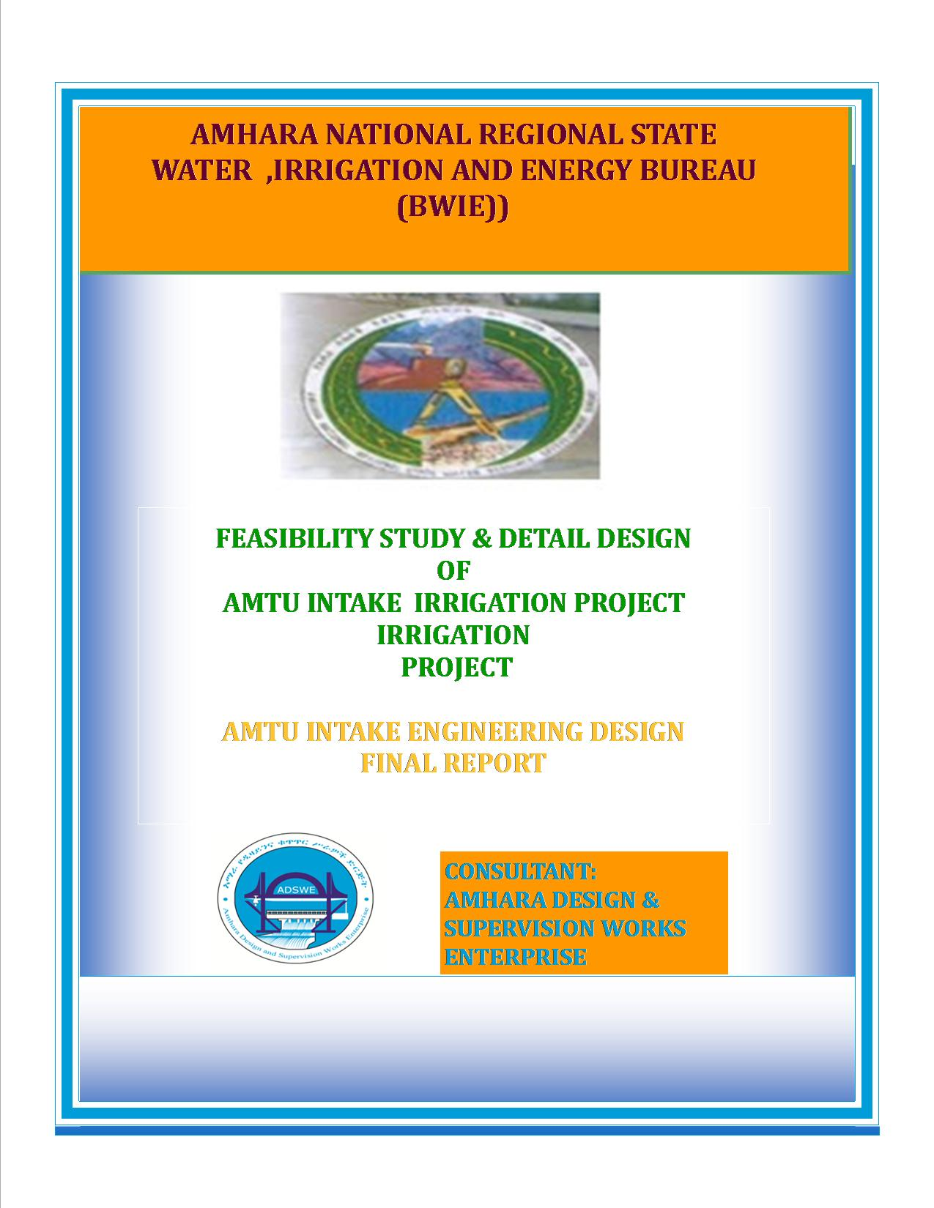
Amhara National Regional State
Water Resources Development Bureau
(BOWRD)

Detail Design
Of
Amtu Intake Small-Scale Irrigation Project

Volume IV: Engineering Design Final Report
(Revised 2016)
Bahir Dar

CliClient: Bureau of Water Resource Development
(BoWRD)
AdAddress:
P. O. Box: 88
Telephone: 0528-200853/855
Fax: 251-08-20-65-68/204676/202040
CoConsultant: Amhara Design & Supervision Works Enterprise
(ADSWE)
AdAddress:
P. O. Box: 1921
Telephone: +251-582-181023/ 180638/181201/181254
Fax: (058) 2180550/ (058) 2180560
E-mail: amhara design@yahoo.com
BaBahir Dar, Ethiopia

FEASIBILITY STUDY & DETAIL DESIGN REPORT STRUCTURE
- VolumeI: Watershed Management
- VolumeII: Engineering Geology
- VolumeIII: Irrigation Agronomy
- Volume IV: Engineering Design
- VolumeV: Socio Economy
- Volume VI: Environmental Impact Assessment

Table of Contents Page
Contents
SAILENT FEATURE vii
1 INTRODUCTION 9
1.1 Background 9
1.2 Description of the Project Area 9
1.2.1 Location 9
1.2.2 Accessibility 10
1.3 Objectives of the study 10
1.3.1 Specific Objectives 10
1.4 Scope of the study 11
1.5 Methodology 11
2 HYDROLOGY 14
2.1 Watershed characteristics 14
2.2 Hydro-metrological data availability 15
2.2.1 Climate 15
2.2.2 Daily Heaviest Rainfall Data 15
2.2.3 River flow data 15
2.2.4 Upstream & Downstream utilization 16
2.3 Design Flood Analysis 17
2.3.1 Design Rainfall computation 17
2.3.2 Outlier Test 17
2.3.3 Check for variance 17
2.3.4 Peak Discharge Determination 19
2.3.5 Flood mark Method 24
2.3.6 Tail Water Depth Computation 24
2.3.7 Selected Design flood 26
SECTION-II: HEADWORK DESIGN 30
3 HEADWORK STRUCTURES DESIGN 31
3.1 Headwork site selection 31
3.2 River Geomorphology 32
3.2.1 River Bed condition 32
3.2.2 River Bank condition 33
3.3 Sources of construction materials 34
3.3.1 Rock for Masonry and Crushed Coarse Aggregate 35
3.3.2 Fine Aggregates 35
3.3.3 Water 36
3.4 Headwork type selection 36
3.4.1 Hydraulic design of headwork structure 36
3.4.2 U/S and D/S HFL Calculation & Determination 37
3.4.3 Design of Divide wall, and Canal outlet 38
3.4.4 Design of Retaining Walls 41
3.5 Bill of Quantity and cost estimation 42
SECTION-III: IRRIGATION AND DRAINAGE SYSTEMS INFRASTRUCTURE 46
4 IRRIGATION AND DRAINAGE SYSTEMS DESIGN 47
4.1 Irrigable Area Description 47
4.1.1 Topography 47
4.1.2 Climate 47
4.1.3 Soil characteristics 48
4.1.4 Existing Irrigation Practices in the Project Area 48
4.2 Irrigation Water Requirement 48
4.2.1 Crop Water Requirement (CWR) 48
4.2.2 Irrigation efficiency (Ep) 49
4.2.3 Irrigation duty 49
4.2.4 Irrigation methods 51
4.3 Irrigation and Drainage System Layout 51
4.3.1 Conveyance System 52
4.4 Design of the Canal System 52
4.4.1 Main Canal 53
4.4.2 Secondary Canals 54
4.4.3 Tertiary canals 55
4.4.4 Field Canals 56
4.5 Design of Drainage System 57
4.6 Canal Structures Design 57
4.6.1 Design of a typical flume 57
4.6.2 Design of Division box 58
4.6.3 Road crossing structure 60
4.6.4 Design of Drops 61
4.7 Irrigation Infrastructure Bill of Quantities and Cost Estimate 62
5 CONCLUSION AND RECOMMENDATION 68
6 OPERATION AND MAINTENANCE 69
6.1 General 69
6.2 Operation of the Head Works 69
6.3 Irrigation System Operation 69
6.4 Maintenance Requirement 69
REFERENCE 70

TABLE OF CONTENT
Table 2-1: Outlier test analysis 17
Table 2-2: Test for goodness to fit using D-index 18
Table 2-3: Determination of Time of Concentration 20
Table 2-4: Runoff analysis 23
Table 2-5: Hydrograph coordinates 23
Table 2-6: Intake Site River Cross section Coordinate Data 25
Table 2-7: Stage discharge analysis 25
Table 2-8: River discharge computation at different stages of flow 28
Table 3-3: Upstream Retaining wall stability analysis 41
Table 3-5: Bill No. 1- General Items 42
Table 3-6: Bill No. 2- Head Work Structure 43
Table 4-1: Hydraulic Parameters of main canal 53
Table 4-2: Hydraulic Parameters of secondary canals 54
Table 4-3: Hydraulic Parameters of tertiary canals 55
Table 4-4: Hydraulic Parameters of Flume 58
Table 4-5: Hydraulic parameters of Division Boxes 59
Table 4-6: Hydraulic characteristics of drops 61
Table 4-7: Cost summary 62
Table 4-8: Bill No. 3- Engineering cost estimation for Infrastructure 62

FIGURES
Figure 1-1: Location map of the project area 10
Figure 2-1: Drainage map of Amtu watershed 15
Figure 2-2: Base flow of Amtu River (April 28/2007E.C) 16
Figure 2-3: Complex Hydrograph 24
Figure 2-4: River Cross Section Profile 25
Figure 2-5: Rating Curve 26
Figure 2-6: River profile 27
Figure 3-1: photo showing proposed Intake axis 31
Figure 3-1: River bed at the proposed Intake site 33
Figure 3-6: Rock Quarry Site for Masonry Stone and Crushed Aggregates 35
Figure 4-1: lined canal section view 52
Figure 4-2: Typical Cross Section of secondary canals 54
Figure 4-3: Typical Cross Section of tertiary canals 55
Figure 4-4: Typical Field Canal X-section 57
Figure 4-5: Typical Division Box plan 58
Figure 4-6: typical drops section 61

SAILENT FEATURE
- Project name: Amtu Intake Intake Irrigation Project
- Name of the stream: Amtu river
- Location of the Intake site using
- North: 1035600.822 (UTM)
- East:563958 (UTM)
- Zone: (N/Shewa)
- Wereda: Asagirt
- Kebele: Tamo
- Accessibility from woreda town: 8km
- Average Altitude: 2341.8527ma.m.s.l
- Hydrology
- Design Point rainfall:131.9mm
- Catchment area:11.75km²
- Longest flow path length:7.17Km
- Design flood: 119.77m³/sec
- Design base flow: 350 lit/s

- Intake:-
- Intake type, Rcc Concrete
- Bad Bar Depth:2.0m
- Bad Bar length:30m
- Bad Bar crest level:2340.7m.a.s.l
- U/S HFL:2343.2m.a.s.l
- D/s HFL:2343.2m.a.s.l
- Scour Depth:3.76m

- Outlet
- Sill level:2340m.a.s.l
- Opening dimension: 0.70*0.70 m²
- Discharge capacity: 272 lit/sec
Irrigation and drainage systems Infrastructure
- Command area size: 180ha
- Design discharge of the main canal:
  - Right canal (MC-R: 217.5l/sec
- Canals
  - No of main canal: 1
  - No of secondary canal:5
  - No of Tertiary canal: 25
- Main irrigation structures designed are;
- Gully Crossing Structures
- Road Crossing Structures
- Foot Path
Project cost (without VAT)

INTRODUCTION

Background

In Ethiopia, under the prevalent rain-fed agricultural production system, the progressive degradation of the natural resource base, especially in highly vulnerable areas of the highlands coupled with climate variability have aggravated the incidence of poverty and food insecurity. The major source of growth for Ethiopia is still conceived to be the agriculture sector. Hence, this sector has to be insulated from drought shocks through enhanced utilization of the water resource potential of the country through development of small-scale irrigation.
In line with the above, in the area of irrigation efforts have been made by the government to improve the situation in the country. Amhara Water Resources Development Bureau is playing its role in the development of small scale irrigation projects in the region.
Accordingly, as part of the water sector development program, the bureau has initiated the study and design of a small scale irrigation scheme on Amtu River at Tamo Kebele and signed an agreement with Amhara Design & Supervision Works Enterprise (ADSWE) for the study and design of the project.

Description of the Project Area

Location

This irrigation project is located mainly at Tamo Kebele, Asagirt Wereda of N/Shewa Zone in the Amhara Region. The proposed irrigation project is to be undertaken on Amtu River and the headwork structures are specifically located at an altitude of about 2341.8527masl and geographical coordinates of 1035600.822N(UTM)& 563958E(UTM).

Figure 1-1: Location map of the project area

Accessibility
The project area is located in Asagirt Wereda, Tamo Kebele in a specific location of Tamo. It can be accessed along 8km Dray Weather road from woreda town Ginager and 3km Asphalted road and 70km all weather road from the zone capital town Debrebrihan. the specific site is accessed 3 km on foot.

Objectives of the study
The Enterprise is required to make a complete feasibility and or detail design study by conducting a complete assessment and investigation of all available water and land resources all along the Amtu River. The service is also mainly focused in searching and selecting the best intervention /Intake in this case/ technology and tries to locate it together with local users. All the process of the service is purely bounded by the terms of reference and other guidelines and formats as per the client’s interest.

Specific Objectives
Other benefits that can be expected to appear with the launching of the project are:
- Efficiency of water use improvement;
- Improved local nutrition/food security gains;
- Improved management of scarce natural resources (land and water);
- Resilience against drought risk;
- Rationale for erosion control and watershed management;
- Rationale for the intensification and modernization of small-holder agriculture and rural lifestyles.
The engineering study and design enables the realization of the project by the provision of engineering structures that will allow the appropriate abstraction of the river water for delivery in to the identified irrigation fields of the study area. Hence, this engineering design is specifically targeted to:
- Analyze hydrologic requirements of the project and engineering structures;
- The formulation of sound and stable structure, with necessary provisions that allow safe, easy and low-maintenance operation in the service life of the project;
- Develop working drawings;
- Estimation of construction costs.

Scope of the study
- The irrigation design shall ensure reliability, equity and flexibility of water delivery to farmers. It will aim at reducing conflicts among water users and will lead to lower operation and maintenance costs.
- Updating the existing, if available, computation of the actual evapo-transpiration, crop water requirement, irrigation demand/duty using the existing and recent agronomic, climatologic and soil data using more appropriate methodologies.
- Establish design criteria for irrigations structures to be approved by the client and to be used in the final design stage,
- Design proper irrigation system compatible with local conditions and management capabilities,
- Establish flood protection measures for the command area and canal structures and design the respective drainage system accordingly,
- Planning and layout of the irrigation system, which include irrigation canals, drainage channels, inspection roads and alignments, canal spacing, canal length, location of structures, and water profiles along canal and drains at specified reaches, which is most economical easily manageable and aligned with topographic feature and geological investigation.
- Determination and estimation of water application conveyance and other losses and irrigation efficiencies and consideration of those parameters in design steps.
- Check and test hydraulic and structural designs of main canal considering total demand and the required capacity and the base flow availability,
- Prepare general plans and drawings for all irrigation infrastructure and irrigation systems designs,

Methodology
In the study and design procedure, Designers used the following steps.
- Specific Site identification:
  - Review of the reconnaissance survey conducted by the Client
  - 50,000 scale top map and GIS information
  - Local farmers interview and discussion
  - Woreda and Zone Agriculture section expertise
  - Previous studies
  - On foot travel along the river channel and farm areas.
- Topographic survey:
  - Surveying the headwork site and the Command area with sufficient radius, using Total station
- Flow estimation
  - Physical observation on flood mark indications and local information about high flood and critical flow condition of the river
  - Analyzing the recorded river flow data and use watershed inputs for further analysis.
  - Base flow estimated during the reconnaissance field visit by floating method.
- Irrigable area identification:
  - Using local information
  - 50,000 Topographic map, and GIS information, GPS to see elevation
The design report is organized in three sections. In Section I the Hydrology study is presented and in Sections II and III the Headwork and Irrigation and Drainage Systems designs are discussed respectively. In Section III, planning and design of the irrigation system after diverting the water using the Intake will be dealt. The following are major areas of concern in this part.
- Study and design of the irrigation method to be adopted,
- Study and design of the irrigation system layout and associated structures,
- Design of the different conveyance canals,
- Planning and design of the different irrigation and drainage structures,
- Preparation of the longitudinal profiles of the different irrigation and drainage canals.

SECTION-I: HYDROLOGY

HYDROLOGY

Watershed characteristics
The Watershed has marked topographic variation. All types of slopes are present. The dominant slope class is 15-30% which covers 42.62% of the total area followed by 8-15% which is 29.1%. Flat and almost Flat and Gentle Slopping accounts 1.92 and 12.58 percent respectively, very steep slopes also cover about 12.95% of the total area. Table 1 of the watershed feasibility study report shows the slope classes and proportion of the watershed.
Certain physical properties of watersheds significantly affect the characteristics of the runoff and sediment yield and are of great interest in hydrologic analyses. The rate and volume of runoff, and sediment yield from the watershed have much to do with shape, size, slope and other parameters of the landscape. These suggest that there should be some important relations between basin form and hydrologic performance. If the basin and hydrologic characteristics are to be related, the basin form must also be represented by quantitative descriptors. These parameters can be measured from maps.
The watershed characteristics are analyzed and presented in Table 2 of the Watershed Feasibility Study Report of the same project. In summary:
- Catchment Area = 11.75km²
- Stream Length = 17.17Km
- CN(II) = 77.68
(Extracted from the Watershed Study Report of the same project)
At the selected reference point, the area of Amtu Intake Irrigation Project catchment is 11.75km² and consists of a network of tributaries as shown in Figure 2 below.
Amtu River/stream at the headwork site is characterized by well-defined channel system and considerable flows. It looks that the gradient of the river/stream is getting low and hence there exists significant deposition of sediment mainly cobbles and boulders.

Figure 2-1: Drainage map of Amtu watershed

Hydro-metrological data availability

Climate
Small scale irrigation project designers and planners are faced with lack of good data on the hydrology of the stream/river system that will be their water source and on local weather and climate conditions. Stream gauging stations are virtually non-existent in remote rural areas of Ethiopia; meteorological stations are almost rare. Likewise, at Tamo Kebele (Project area location) and in the catchment area of this project, there is no meteorological station of any level. Moreover, there are no flow data for the river/stream near the project. Therefore, data for the hydro-meteorological analysis is taken from the nearby station and similar areas. Rainfall & temperature data are considered from Ginager Meteorological station. In fact, this station is very close to the project area.
As per the data of the station, March – April are identified as high temperature periods whereas December–January are low temperature periods. The mean annual rainfall amount is 1739.84mm (1998 - 2006 data) and most of it occurs from June to August.

Daily Heaviest Rainfall Data
In order to compute the design flood for the Intake structure, the daily maximum rainfall is collected from Ginager Metrological stations with a record of 9 years. Debrebrhan Metrological station nearest one as compared to Ginager station but it is not selected b/c the recorded rainfall minimum and also most of the year not record.
    - River flow data
Amtu River is perennial and on April 28/2007 E.C during site investigation period, the base flow had been measured by using floating method and the discharge was found to be 350 l/s. The elder inhabitants confirmed that the base flow decreases less than this figure in the month of March and also increases on the month of May by the reason of rainfall. On the other hand the river flow increases more till the month of December. The figure indicates that the river has good potential to irrigate even more than the target area. Therefore, this project has been designed to exploit the water potential effectively and efficiently in environmentally friendly manner so as to ensure food security and to increase the income of the farmers living around the area.
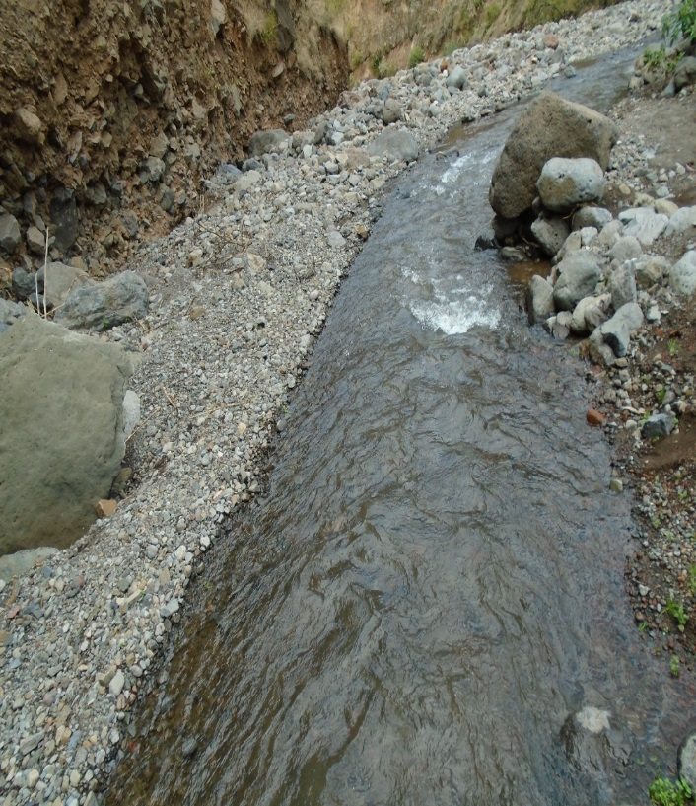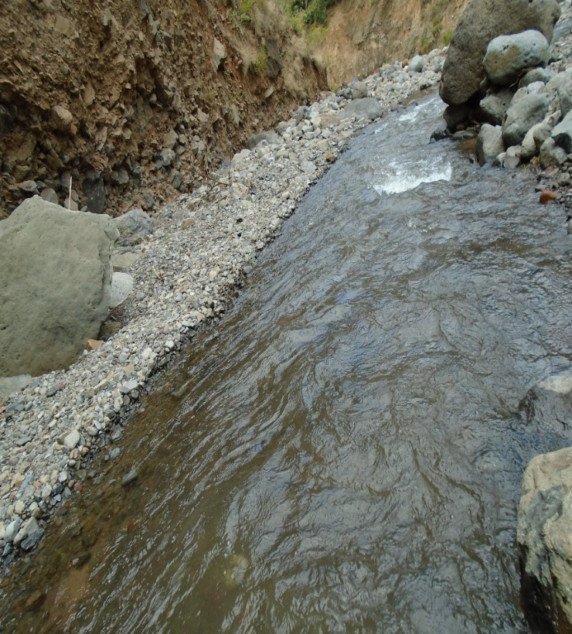
Figure 2-2: Base flow of Amtu River (April 28/2007E.C)
    - Upstream & Downstream utilization
During the time of base flow measuring, all traditional Intake head works were not operating because there was enough rainfall supply. In the development of modern irrigation practices, the concept of downstream water rights takes higher attention. Here in case of Amtu River Intake Irrigation Project water scarcity will not be faced according to the discussion made in the title “Source of the Irrigation Water and Its Potential”. There are several springs that feed water to the river to afford the downstream water consumption including the ecological requirements. Therefore, at least 23% of the minimum flow has to be released for downstream requirements.
For the sake of planning and design, however, the outlet for the Intake is designed for a discharge of 270l/s for this project and the project is to be developed for 180 ha of land, which is most of the time achievable as the flow for most of the time is significant to support this size of command area.
  - Design Flood Analysis
For the design and analysis of structures to be constructed on the river, estimation of flood magnitude is an important task. This can be done using different techniques depending on the data available. For this particular case, there are no river flow data and hence the flood estimation is done using the rainfall data and applying SCS Curve Method.
    - Design Rainfall computation
Based on the data of 24hr peak rainfall given in Table 1 the design rainfall, Rf is computed using Gumble’s Value Method.
    - Outlier Test
Higher Limit, $Y_{H}=Ymean+Kn*Sy$, Kn = 1.98 for 9 Years of data.
Lower Limit, $Y_{H}=Ymean-Kn*Sy$, Kn = 1.98 for 9 Years of data.
Table 2-1: Outlier test analysis
Higher Limit, YH = 2.05
Lower Limit, YL = 1.73
Therefore,
Upper limit of rainfall = 10^2.05 = 112.37mm
Lower Limit of rainfall = 10^1.73 = 53.77mm
Conclusion: The rainfall values are within the limits.

Year | Max. RF | Descending Order | Logarithmic Value/Yo/
1998 | 109 | 109 | 2.0374
1999 | 72.5 | 98 | 1.9912
2000 | 98 | 84.1 | 1.9248
2001 | 66.2 | 76 | 1.8808
2002 | 60.8 | 72.6 | 1.8609
2003 | 84.1 | 72.5 | 1.8603
2004 | 76 | 71.6 | 1.8549
2005 | 71.6 | 66.2 | 1.8209
2006 | 72.6 | 60.8 | 1.7839
SUM |  | 710.80 | 17.0152
MEAN |  | 78.98 | 1.8906
STANDARD DEVATION |  | 15.53 | 0.0808
SKEWNESS COEFICIENT |  | 1.074 | 0.7832
NUMBER OF DATA |  | 9.000
    - Check for variance
After checking the outliers, the data should be checked for variability. For variability the formula used is
$α=\left(\frac{δ_{∩-1}}{\sqrt{N}*Mean}\right)*100\%$
Where, δ_{n-1 =} Standard deviation =15.53
N = Nr of recorded data =9

M_{ean} = 78.98
$α$ = Standard error
$α=\left(\frac{15.53}{\sqrt{9}*78.98}\right)*100\%=6.55<10\%$ Acceptable
Therefore the data shows no variability.

      - D-Index test
After checking the consistency of the data for higher and lower outlier, the 9 years data is obtained as representative for the analysis using D-index. The D-Index test is believed to be the better goodness to fitness in many literatures. Hence in this study it was used to determine the best statistical distribution to estimate the peak rainfall. The D-index for the comparison of the fit of various distributions is summarized as follows.
$D_{-Index}=(\frac{1}{X_{m}})*\sum_{i=1}^{6}{Abs(Xi-{Xi}^{'})}$
Where Xi and Xi’ are the i^{th} highest observed and computed values for the distribution respectively
Table 2-2: Test for goodness to fit using D-index
Rank | XI | Normal | Log Pearson Type III | Log Normal | Pearson Type III | Gumbel
Rank | XI | XI -'XI' | XI -'XI' | XI -'XI' | XI -'XI' | XI -'XI'
1 | 109.00 | 10.119 | 9.388 | 10.331 | 9.325 | 9.764
2 | 98.00 | 5.956 | 8.145 | 7.094 | 6.021 | 7.850
3 | 84.10 | 3.015 | 0.145 | 1.591 | 2.860 | 0.371
4 | 76.00 | 6.905 | 3.549 | 5.475 | 6.708 | 4.122
5 | 72.60 | 6.378 | 3.294 | 5.128 | 6.169 | 3.827
6 | 72.50 | 2.564 | 0.140 | 1.666 | 2.369 | 0.548
Sum |  | 34.936 | 24.661 | 31.285 | 33.452 | 26.483
Sum/Mean |  | 0.442 | 0.312 | 0.396 | 0.424 | 0.335
Point Rainfall |  | 122.57 | 122.57 | 113.92 | 116.98 | 131.90
Design Point Rainfall = |  |  | 131.903
All the candidate distributions give almost identical correlation coefficients. However, the smallest D-index value was found to be for the Log Pearson typeIII. Accordingly, the design rainfall was found to be 122.57mm but to avoid risky & safe design structures Gumble is selected for this particular design with a design rainfall of 131.9mm.
Therefore, the design point rainfall for 50 years return period is found to be 131.9 mm.
The design rainfall using Gumble Method is given as
Where R_{f} = Design rainfall
R_{mean} = average of all values of annual heaviest fall = 78.98 mm
σ_{n-1} = standard deviation of the series = 15.53 mm
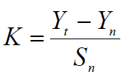
, T= Return period = 50 years
Yn, Sn = constant found from Gumble’s extreme value distribution table for N= 9 Years
- Yn = 0.5 and Sn = 1.0
- Point Design Rainfall = 131.9 mm
The design rainfall at points for 50 years return period is 131.9 mm and the areal design rainfall is calculated in the following section.
    - Peak Discharge Determination
      - General
The River is not gauged river. The design flood is calculated by using SCS unit hydrograph method. Thus, it is preferred to base the flood analysis on rainfall data, which are better both in quantity and quality of data. In the hydrologic analysis for drainage structures, it must be recognized that there are many variable factors that affect floods. Some of the factors that need be recognized and considered on an individual site by site basis are; rainfall amount and storm distribution; catchment area, shape and orientation; ground cover; type of soil; slopes of terrain and stream(S); antecedent moisture condition; Storage potential (over bank, ponds, wetlands, reservoirs, channel, etc.)
      - Peak flood analysis by SCS unit hydrograph method
Design flood is calculated SCS (The United States Soil Conservation Service). This method is widely adopted and more reliable method for flood estimation. The approach considers, watershed parameters, like Area, Curve number, and time of concentration.
      - Time of concentration (Tc)
Time of concentration has been calculated by taking the stream profile of the longest streamline and dividing it in to different elevation. Kirpich formula is adopted for computation.
Table 2-3: Determination of Time of Concentration
Reach | length (km) | Vertical Distance | slope | Time of concentration (hr)
0 | 0 | 0 | 0 | 0.00
1 | 0.17 | 20.00 | 0.12 | 0.04
2 | 0.12 | 20.00 | 0.17 | 0.03
3 | 0.04 | 20.00 | 0.48 | 0.01
4 | 0.07 | 20.00 | 0.31 | 0.01
5 | 0.04 | 20.00 | 0.45 | 0.01
6 | 0.07 | 20.00 | 0.28 | 0.01
7 | 0.08 | 20.00 | 0.26 | 0.02
8 | 0.06 | 20.00 | 0.33 | 0.01
9 | 0.10 | 20.00 | 0.20 | 0.02
10 | 0.06 | 20.00 | 0.34 | 0.01
11 | 0.06 | 20.00 | 0.31 | 0.01
12 | 0.30 | 20.00 | 0.07 | 0.08
13 | 0.22 | 20.00 | 0.09 | 0.05
14 | 0.09 | 20.00 | 0.21 | 0.02
15 | 0.13 | 40.00 | 0.30 | 0.02
16 | 0.09 | 20.00 | 0.23 | 0.02
17 | 0.10 | 20.00 | 0.20 | 0.02
18 | 0.11 | 20.00 | 0.18 | 0.02
19 | 0.09 | 20.00 | 0.23 | 0.02
20 | 0.05 | 20.00 | 0.36 | 0.01
21 | 0.11 | 20.00 | 0.18 | 0.02
22 | 0.13 | 20.00 | 0.15 | 0.03
23 | 0.05 | 20.00 | 0.44 | 0.01
24 | 0.06 | 20.00 | 0.33 | 0.01
25 | 0.07 | 20.00 | 0.30 | 0.01
26 | 0.04 | 20.00 | 0.49 | 0.01
27 | 0.02 | 20.00 | 0.81 | 0.00
28 | 0.02 | 20.00 | 0.88 | 0.00
29 | 0.02 | 20.00 | 0.89 | 0.00
30 | 0.02 | 20.00 | 0.84 | 0.00
31 | 0.04 | 20.00 | 0.46 | 0.01
32 | 0.10 | 20.00 | 0.20 | 0.02
33 | 0.11 | 20.00 | 0.18 | 0.02
34 | 0.38 | 20.00 | 0.05 | 0.10
35 | 1.40 | 20.00 | 0.01 | 0.44
36 | 0.40 | 20.00 | 0.05 | 0.10
37 | 0.09 | 20.00 | 0.23 | 0.02
38 | 0.28 | 20.00 | 0.07 | 0.07
39 | 0.75 | 20.00 | 0.03 | 0.22
40 | 0.28 | 20.00 | 0.07 | 0.07
41 | 0.40 | 20.00 | 0.05 | 0.10
42 | 0.32 | 20.00 | 0.06 | 0.08
Total | 7.16817 | 860 |  | 0.68
The formula is,
$Tc=\sum{0.948\left\{{\left(\frac{{L_{1}}^{3}}{H_{1}}\right)}^{0.385}+{\left(\frac{{L_{2}}^{3}}{H_{2}}\right)}^{0.385}+…+{\left(\frac{{L_{n}}^{3}}{H_{n}}\right)}^{0.385}\right\}}$
- Tc = 0.68 Since Tc < 3hr., duration of excess rainfall difference, D = 0.5hr.
- Time to peak,
$T_{p=}\frac{D}{2}+0.6*T_{c}$ = 0.66hr
- Base time,
$T_{b}=2.67*T_{p}$ = 1.76
- Recession time,
$T_{r}=1.67*T_{p}$ = 1.1hr.
      - Curve number (CN)
Curve number (CN) is achieved based on USSCS method by watershed characterization in terms of land cover, treatment, hydrologic condition and soil group. From the watershed analysis curve number at condition II =77.68. Since peak rainfall is found at an antecedent moisture condition III state, this value has to be changed to antecedent moisture condition III.

- Conversion factor = 1.144
- CN Condition (III) = (Factor from Table x CN condition II) =77.68*1.144 = 88.89. For detail analysis of the computation, Refer Excel file, attached here with.
      - Area Rainfall
As the area of the catchment gets larger, coincidence of all hydrological incidences becomes less and less. This can be optimized by changing the calculated point rainfall to aerial rainfall. The conversion factor is taken from standard table that relate directly with the size of watershed area and type of the gauging station. (IDD manual)
For the case of Amtu Intake irrigation project,
- Total watershed area = 11.75 Km²
- Type of gauging station = Daily rainfall (24 hr.)
- Aerial Rainfall = (Point Rainfall) x (Conversion factor)
      - Run off Analysis
Input data:
Design Point Rainfall = 131.9mm
Curve number at antecedent moisture condition III = 88.89
Catchment Area, A = 11.75 Km²
Tc = 0.68hr, D = 0.5hr., Tp = 0.66 hr; Tb = 1.76 hr; Tr = 1.1 hr.
Direct run-off,
$Q=\frac{{(I-0.2*S)}^{2}}{(I+0.8*S)}$
Where, I = Rearranged cumulative run-off depth (mm
S = Maximum run off potential difference,
$S=\left(\frac{25400}{CN}\right)-254$
Peak run-off for incremental;
$Q_{p}=0.21*\frac{(A*Q)}{T_{p}}$
Where, A = Catchment area = 11.75 Km²
T_{p} = Time to peak (hr)
Q = Incremental run-off (mm)
Table 2-4: Runoff analysis
Duration time(hr) | Cumulative run off(mm) | Incremental runoff(mm) | Peak runoff incremental runoff (m3/s) | Incremental Hydrograph
 |  |  |  | Begin time(hr) | peak time(hr) | End time(hr)
0.50 | 0.00 | 0.00 | 0.00 | 0 | 0.7 | 1.8
1.00 | 0.13 | 0.13 | 0.48 | 0.50 | 1.2 | 2.3
1.50 | 3.74 | 3.61 | 13.50 | 1.00 | 1.7 | 2.8
2.00 | 29.80 | 26.06 | 97.36 | 1.50 | 2.2 | 3.3
2.50 | 45.60 | 15.79 | 59.01 | 2.00 | 2.7 | 3.8
3.00 | 52.13 | 6.53 | 24.41 | 2.50 | 3.2 | 4.3
Table 2-5: Hydrograph coordinates

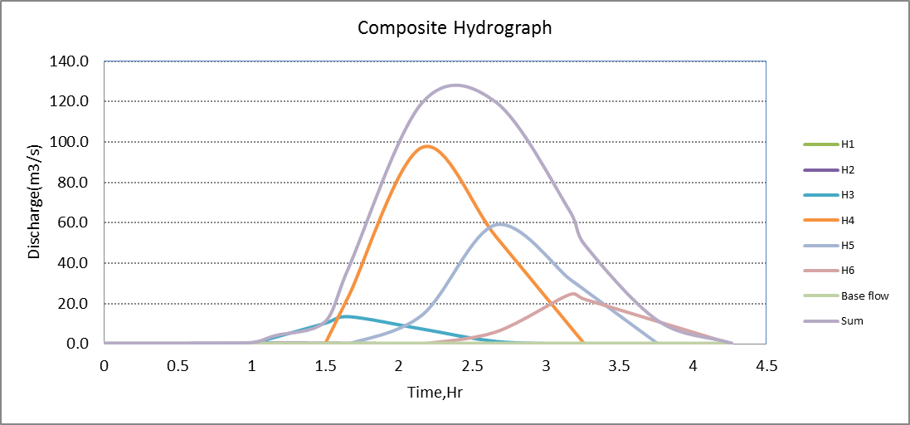
Figure 2-3: Complex Hydrograph
From the analysis, the 50 year return period design run off is 119.77 m ³/s

Flood mark Method

During field assessment and topographic survey, the normal and maximum flood mark points has been selected by interviewing the local aged farmers and marked in cross section of selected river geometry. This is just to check the design flood what we have determined using rough simulation methods such as SCS for engaged catchments. That was the main purpose of taking flood marks during field assessment and that will be checked using the stage discharge analysis in the following section.
    - Tail Water Depth Computation
Tail water depth of the river is equal to the flood depth and amount at the proposed Intake site before construction of the Intake. It is used to crosscheck peak flood estimated by the SCS unit hydrograph method with flood mark method and to see the flood feature after the hydraulic jump. During field visit, the flood mark of the river at the proposed Intake site was marked based on dwellers information and physical indicative marks. The data required to do stage discharge analysis has been discussed in the following river cross-section was surveyed.

Figure 2-4: River Cross Section Profile
Table 2-6: Intake Site River Cross section Coordinate Data
East | North | Elevation | Code | Par.dis | Com.dis
563935.6065 | 1035587.081 | 2343.5938 | River Center | 0.00 | 0.00
563938.4561 | 1035589.888 | 2342.9691 | River Center | 4.00 | 4.00
563941.3056 | 1035592.695 | 2342.2996 | River Center | 4.00 | 8.00
563944.1551 | 1035595.503 | 2341.823 | River Center | 4.00 | 12.00
563947.0047 | 1035598.31 | 2341.6344 | River Center | 4.00 | 16.00
563949.8542 | 1035601.117 | 2341.4458 | River Center | 4.00 | 20.00
563952.7037 | 1035603.924 | 2341.2572 | River Center | 4.00 | 24.00
563955.5532 | 1035606.731 | 2340.5427 | River Center | 4.00 | 28.00
563958.4028 | 1035609.538 | 2339.6377 | River Center | 4.00 | 32.00
563961.2523 | 1035612.346 | 2338.7553 | River Center | 4.00 | 36.00
563964.1018 | 1035615.153 | 2338.3953 | River Center | 4.00 | 40.00
563966.9514 | 1035617.96 | 2338.0353 | River Center | 4.00 | 44.00
563969.8009 | 1035620.767 | 2337.6753 | River Center | 4.00 | 48.00
563972.6504 | 1035623.574 | 2337.3153 | River Center | 4.00 | 52.00
563975.5 | 1035626.381 | 2337.0008 | River Center | 4.00 | 56.00
563978.3495 | 1035629.188 | 2336.6117 | River Center | 4.00 | 60.00

Table 2-7: Stage discharge analysis
S.N | Elevation | Depth(m) | Wet Area(m^2) | Perim(m) | Hydrulic radius(m) | Velocity V (m/sec.) | Discharge Q (m^3/sec.) | Remark
1 | 2340.7 | 0 | 0 | 0 | 0 | 0 | 0
2 | 2341 | 0.3 | 0.55 | 3.68 | 0.15 | 2.81 | 1.55
3 | 2341.3 | 0.6 | 2.07 | 6.54 | 0.32 | 4.64 | 9.60
4 | 2341.6 | 0.9 | 4.4 | 9.25 | 0.48 | 6.09 | 26.78
5 | 2341.9 | 1.2 | 7.7 | 13.8 | 0.56 | 6.77 | 52.13
6 | 2342.2 | 1.5 | 12.6 | 19.95 | 0.63 | 7.35 | 92.65
7 | 2342.33 | 1.63 | 15.50 | 22.88 | 0.67 | 7.65 | 119.77 | SCS FLOOD
8 | 2342.5 | 1.8 | 19.39 | 26.8 | 0.72 | 8.05 | 156.10
9 | 2342.8 | 2.1 | 27.5 | 27.98 | 0.98 | 9.88 | 271.58 | DESIGN FLOOD MARK
10 | 2343.1 | 2.4 | 35.62 | 29.1 | 1.22 | 11.43 | 407.22
11 | 2343.4 | 2.7 | 44.18 | 30.25 | 1.46 | 12.86 | 568.23
From the above stage discharge table the maximum flood estimated from the flood mark level is 271.58m3/s (at a depth of 2.1 m from the river bed) but the SCS design flood depth interpolated in the above table is 1.63m.

Figure 2-5: Rating Curve

Selected Design flood
Based on the stage analysis result of the flood mark elevation, the amount of flood computed in that elevation has been found to be 271.58m3/s which is higher to the computed Design flood amount using SCS method in that value 119.77m3/s seen above table. So that design flood is taken as 271.58m3/s.
From the above stage discharge table and curve the maximum flood level corresponding to the computed design peak discharge is 2342.8 (2.1 m from the river bed) and it is considered as the d/s & U/s high flood level i.e. expected at the Intake axis before construction of the Intake.
D/S HFL = 2342.8+FB =2342.8+0.4=2343.2masl.
- Average river bed slope
Average river bed slope of River is estimated by two different techniques. One is by end area method and the other is by using best fit line method. Designers have adopted the end area method output for further analysis.
The water level of the river is taken at different points along the river channel around the head work site. Surveying work done for 60m length. And then, average water surface slope is considered as the river bed slope. For comparison of the two procedures, refer the attached Excel file.

Figure 2-6: River profile
- Manning’s Roughness coefficient
The Manning’s roughness coefficient is taken from standard table based on the river nature. The river at the headwork site has got relatively U-shape feature and straight nature. The Manning roughness coefficient take as the average value of river banks and bed whence Manning’s roughness coefficient (n = 0.035) is adopted.

- Discharge of the river
Input data:
- Manning's roughness coefficient, n = 0.035
- Average river bed slope, S = 0.122
- , Where, R = Hydraulic radius = (Area/Perimeter)
- $Q=V*A$
Table 2-8: River discharge computation at different stages of flow
S.N | Elevation | Depth(m) | Wet Area(m^2) | Perim(m) | Hydrulic radius(m) | Velocity V (m/sec.) | Discharge Q (m^3/sec.) | Remark
1 | 2340.7 | 0 | 0 | 0 | 0 | 0 | 0
2 | 2341 | 0.3 | 0.55 | 3.68 | 0.15 | 2.81 | 1.55
3 | 2341.3 | 0.6 | 2.07 | 6.54 | 0.32 | 4.64 | 9.60
4 | 2341.6 | 0.9 | 4.4 | 9.25 | 0.48 | 6.09 | 26.78
5 | 2341.9 | 1.2 | 7.7 | 13.8 | 0.56 | 6.77 | 52.13
6 | 2342.2 | 1.5 | 12.6 | 19.95 | 0.63 | 7.35 | 92.65
7 | 2342.33 | 1.63 | 15.50 | 22.88 | 0.67 | 7.65 | 119.77 | SCS FLOOD
8 | 2342.5 | 1.8 | 19.39 | 26.8 | 0.72 | 8.05 | 156.10
9 | 2342.8 | 2.1 | 27.5 | 27.98 | 0.98 | 9.88 | 271.58 | DESIGN FLOOD MARK
10 | 2343.1 | 2.4 | 35.62 | 29.1 | 1.22 | 11.43 | 407.22
11 | 2343.4 | 2.7 | 44.18 | 30.25 | 1.46 | 12.86 | 568.23

SECTION-II: HEADWORK DESIGN

HEADWORK STRUCTURES DESIGN

Headwork site selection
In selecting or comparing the best site, it was practically important to put criteria’s such as considering the flood the channel has to accommodate, the length of the Intake crest, topographically suitability, the relative economic considerations, the availability of enough command and other selection or comparison criteria’s.
New headwork site was selected a little upstream side of the one proposed during site identification period. It is proposed to have one outlet due to the existence of irrigable command area largely on the Right side of Amtu River.
At this specific site, covered by recent alluvial deposit sediment and boulder at the river bed whereas the left bank is also active erosion made from silt clay soil but the right bank is joint massive rock. The river is flowing through a defined channel and its scouring effect on the river course is significant as its bed covered by loose, big boulder, alluvial deposit which is easily erodible and transported by running water.
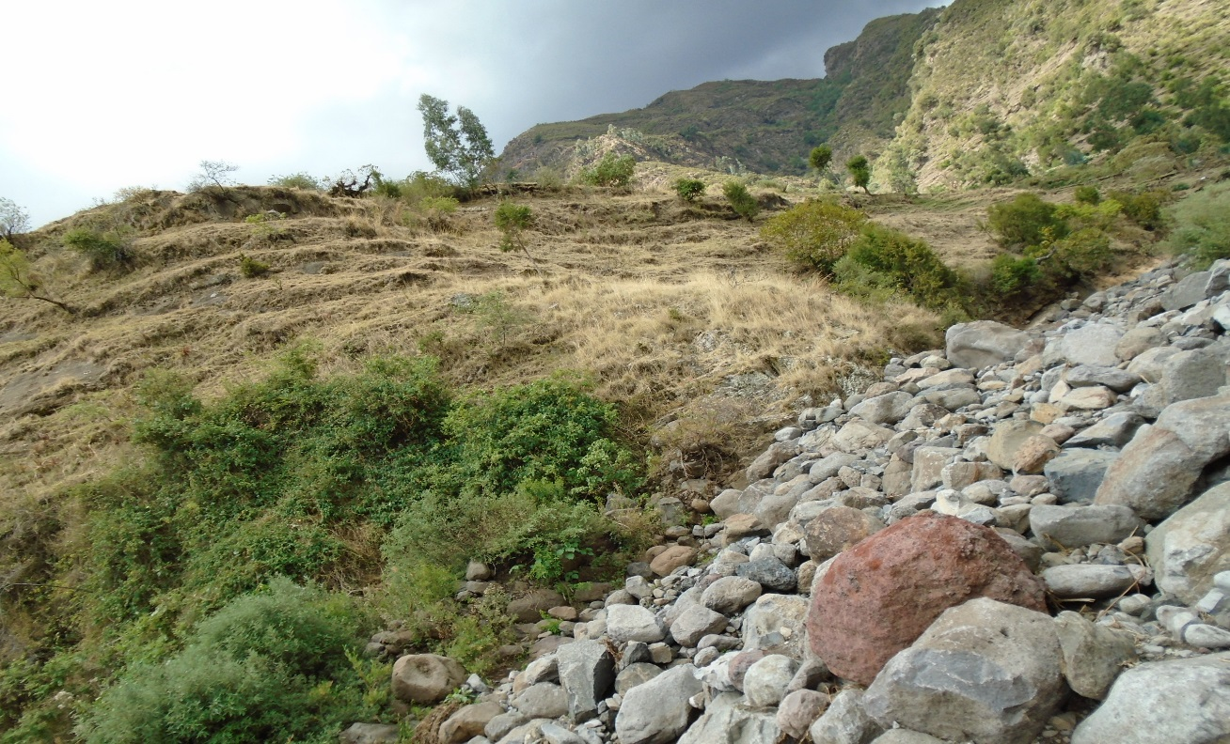
Proposed and selected Intake axis
Figure 3-1: photo showing proposed Intake axis
Therefore, the headwork site is situated at 1035600.822N, 563958E and river bed elevation of 2341.85(river bed) m above sea level. At this site the river course is well defined, stable and forms nearly a U-shaped cross section. The different sections of the stream at the proposed headwork site are described separately below:-
  - River Geomorphology
It is a common fact that the river development tends to accommodate itself to the local geology that develops along the structurally weak zones like faults, joints, folds, etc. The drainage system of the study area is strongly influenced by geological structures and formations, the nature of the vegetation cover and climate. The nature of geological formations and structures has also strong influence on the development of the channel.
The present morphology of the Amtu River channel is a function of a number of processes and environmental conditions, including the composition of the bed and the banks (alluvial deposit, cover by big boulder and fracture jointed rock along right side whereas loose silt clay soils at top of right bank and recent loose clay soils at the left bank and bed); the size and composition of the sediment moving through the channel; the rate of sediment transport through the channel and deposition on the banks and beds; and the regional degradation due to erosion processes. Both left bank and the bed are composed of loose silt clay soil and coarser alluvial sediment and big boulder as the result the stream shows highly meandering nature both up and downstream from the proposed site but at the particular Intake site it shows nearly straight river channel. The river has wider section in upstream direction whereas to downstream side the river section become narrower.
    - River Bed condition
At the proposed headwork site the stream bed is well defined, with having straight channel, and shows rough and smooth surface due to its appearance of alluvial deposit and hard boulder. Along the Intake axis, the bed is med up of alluvial sediment deposit and at the all bed covered by large boulders. Even if the right foot of the bank is covered by massive basaltic rock, the enter bed is made up of alluvial deposits of transported boulder soils. From the deposit the large boulders are dominated. Therefore, all the bearing capacity and shear strength is not the problem of this foundation.
Therefore, it is recommended that the foundation of the Intake structure be put at a depth of 2meters from minimum river bed of the bed rock. Given the size of the structure is small; the foundation can be laid at a shallow depth. (See figure 3.1).
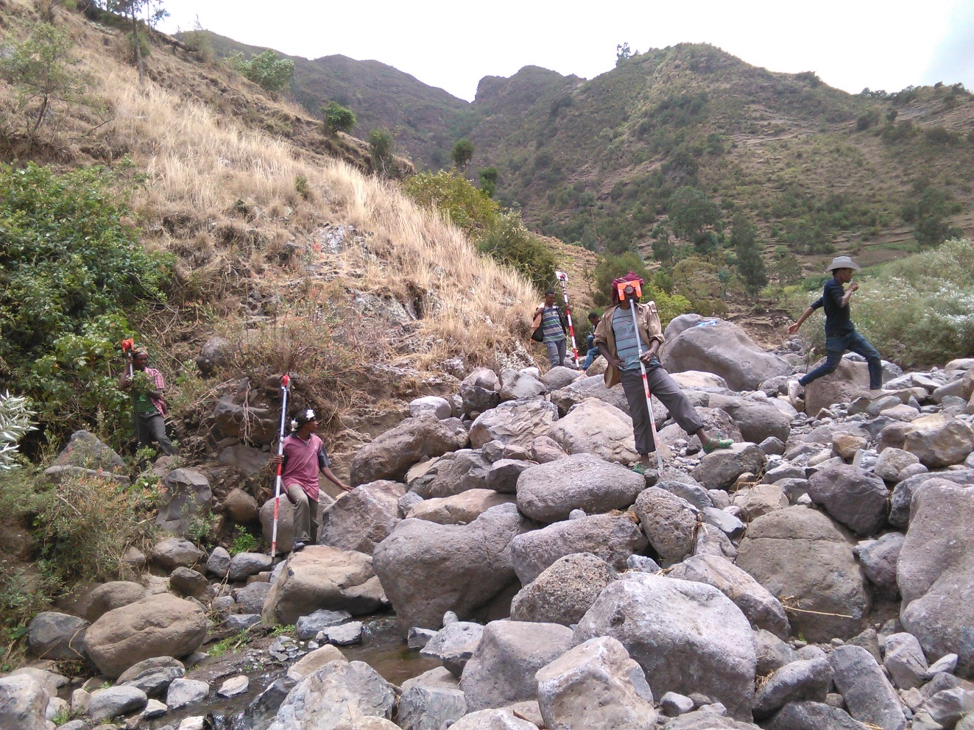

Figure 3-2: River bed at the proposed Intake site
    - River Bank condition
      - Right Bank
This abutment forms nearly small ridge. It is characterized by moderately to highly weathered, jointed and fractured rock. It is covered by dark brown silt clay soil with few centimeter thicknesses on the top part of this bank. This rock is extending in downstream direction and upstream. At the proposed Intake site the height of this bank is above 4m with steeply slope but to up and downstream direction and become zero about 80m length downstream from proposed Intake site. But in upstream side the bank has same height as the proposed Intake site. This rock is good for anchoring the proposed Intake structure at upstream protection work and the recommended retaining wall along this side with it.
Furthermore, for this project bank protection works are necessary in both up-and down-stream directions for about 2 to 3m length by anchoring with hard rock at upstream direction but at downstream 80m protection work provided b/c the main canal rout up to 80m distance length on the right side bank bed so that to prevent from flood. if it is possible to get hard rock within shallow depth, to prevent further widening of the stream course at the headwork site due to the stream flood and construction of the proposed Intake structure.
      - Left Bank
The left bank of the river is covered by loose, dark brown silt clay soil with some sand and gravel sediment layer near the bottom of the bank. It is transported, silt clay soil with steeply slope feature and it has about some height at the particular Intake site. Its height increase to some extends in the downstream side. But in upstream side the bank has same height as the proposed Intake site. The top surface of the bank is covered with grasses, whereas the slope and its bottom are bare and liable or prone to bank erosion that some part of it is actively affected during flood times, both up- and down-stream of the headwork axis. During the field work, the bank soil has been classified according to the Unified Soil Classification System (USCS) based on visual method. The soil shows moderate dry strength, moderately dilatancy, low toughness and low plasticity. From these field test results, the soil horizon is classified as low Plastic CLAY (CL) soil group. It is stiff, dry to moist, moderately to low plastic, and impermeable.
Furthermore, for this project bank protection works are not necessary in left side b/c the proposed intake side at right side.
  - Sources of construction materials
During site investigation, natural construction materials required for the construction of the various proposed engineering structures at the headwork and within the farmland have been assessed, and possible quarry sites and borrow areas have been identified within the vicinity of the study area as close to the project site as possible. In addition to identifying the quality, quantity and accessibility conditions of the construction materials, ownerships of each proposed production sites have also been studied and described in this report, on separate sub-sections below. The materials needed for the construction of the structures include rock for masonry stones, aggregates (both coarse and fine), and water.

Rock for Masonry and Crushed Coarse Aggregate
Quarry site that can be used for production of rock for masonry stone and crushed coarse aggregates for concrete has been assessed during the field work investigation within the vicinity of the project area at near distance. The main possible quarry site for this project is found at the right and left side of the head work area at the radius of 20m to 50m distance.
The second possible quarry site has been identified within the Amtu river bed itself. Within the beds of proposed Intake axis there is large boulder of fresh and hard basaltic rock having the diameter of 20cm to 80cm. therefore, the rock for masonry and coarse aggregate is found within the same kebele and woreda with Head work area. That is the name of kebele is Tamo and the name of woreda is Asagirt. The rock which has selected is the formation of tertiary volcanic rock which is Aphanitic Basalt. The selected quarry site is not belongs to anyone. It is free land.
The composition of this basaltic rock is olivine, pyroxene and some coarse grained quartzite minerals.
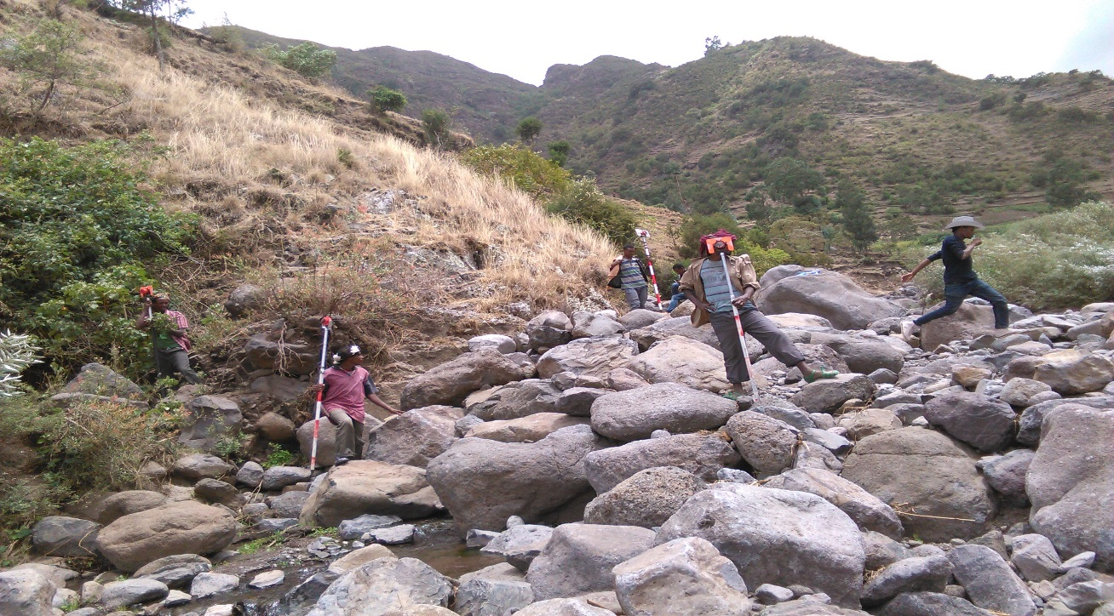
Boulder rocks for construction materials
Figure 3-6: Rock Quarry Site for Masonry Stone and Crushed Aggregates

Fine Aggregates
The natural sand for fine aggregate and cement mixing for concrete works has been assessed within the bed of the river Amtu River itself in the downstream side of the headwork area. Therefore, this Natural deposit of sand martial is found within the same kebele and woreda as with the headwork site.
The source area is located at about 160m from the head work site in the downstream side of the river. The 160m road from headwork to the sand source is not accessible. This material is not belongs to anyone. It is free of anyone.
Both visual investigation and laboratory testing of the sand deposit found in the proposed area have been done. In the area good quantity, which suffices the need of this project, is available. The deposit is dominated by sand sized transported alluvial sediments, though some amount of fines and very few over sizes are also observed. Therefore, the soil is grouped under nearly well graded SAND soil (SW). The individual grains of sand are mainly originated from physical weathering or degradation of basaltic rock and reveals high crushing resistant that the sand has good quality in this respect.
    - Water
Water for construction purposes can be found from the project stream, Amtu River, itself. The stream is perennial throughout the year that there is some amount of flow along its course. During this field time the stream flow was more than 300L/second.

Headwork type selection

After detail observation of the available water balance, the target command area and the cost of future idle canal length, it is decided to design an Intake with commanding elevation. Intake type selected for the given height and flood amount is Rcc-Concrete Intake type which could be subjected to the expected hydrostatic and hydrodynamic forces that can be generated from peak flood. The Intake is to be constructed with Reinforcement concrete with a 30cm thickness bed bar.

Hydraulic design of headwork structure

Intake Height Determination

The following major factors have been seen in determining the Intake crest level:
- Maximum command area elevation
- Deriving head of the intake structure
- Main canal slope
- Loss
- Lowest Point of river center.

Design Base flow of the River
Based on the water balance analysis, the minimum flow of April month measurements have been used. On April 28/2007E.C, the value of the discharge was measured to be 350 l/considering 80 l/s for downstream users and for environmental purpose a design flow 271.875 l/s is used for canal sizing.

Intake Dimensioning

Intake crest length determination
a. Crest Length
- Lacey’s regime width, $L=4.75*\sqrt{Q},$ $=4.75*\sqrt{271.58}$ = 78.28 m.
- Actual river section width of the over flow section of the river is = 30m
b. Discharge over the Intake section
- Design discharge, Q = 271.58 m³/s
Therefore Intake crest length used for designing other Intake hydraulic parameters is taken as the average river width of 30m.

U/S and D/S HFL Calculation & Determination
Determination of high flood level for u/s and d/s is similar that is used is essential in determining the wall heights. D/s high flood level is required because, the flood after passing the Intake, will join the natural channel section and therefore From the stage –discharge curve prepared in hydrology Section, the high flood level before construction (i.e. D/s HFL) corresponding to the design flood is found to be 2342.8m a.s.l.
D/s HFL=U/s HFL = Avg River Bed Level+ Tail water Depth + Free board =2340.7+2.1+0.4 =2343.2m amsl ------------------------------------- (a)

The velocity head, h_{a} is computed from the approach velocity as shown below
Where g: acceleration due to gravity = 9.81m/sec^{2,}
Va is Approach velocity determined by

Design of Divide wall, and Canal outlet
Divide wall is designed in order to prevent D/s retaining wall and Brest wall from large bolder. The divide wall allows safe and stable base flow to the canal outlet. Flow turbidity created by current flow impact over the intake body is reduced.
      - Wall height fixation of Divide Wall
The existing topographical condition at the weir/intake axis and HFL are considered to be most governing parameters for fixing the wall height.
After construction of the intake (u/s HFL) = 2342.8m.a.s.l
Hence the level of divide wall and weir/intake body foundation should be the same and is 2340.7m
U/s wall height = U/s HFL - foundation level + free board.
Adapt 0.4m free board
U/s wall height = 2342.8m.a.s.l – 2340.7m + 0.4m =2.5 m
⇒ Provide 2.5 m wall height and the top level of the divide wall =2340.7m + 2.5m =2343.2

Design of Canal outlet level
The head regulator is provided on the right side .The sill level of this head regulator is fixed from different angle observations. The main conveyance system is more than 4 km which passes more gullies and undulating alignment. Hence this level is fixed based on the optimum route alignment and the maximum irrigated command level including minor and major losses criteria. Based on this condition, the sill level is fixed to be 2340m.
• Outlet capacity
The minimum command area is determined by the minimum flow of the river. But the canal capacity should be determined for maximum command area and the corresponding discharge. In this case the outlet capacity is fixed considering maximum duty and command area and 1.25 correction factors are considered to account the variation of duty.
- Outlet capacity = Duty x command area x correction factor
Where, maximum duty for 18 hr irrigation = 1.45L/s/ha
Command area = 180ha
- Outlet capacity = 1.45 L/s/ha x 180ha x 1.25 = 272 L/sec, Say 272 L/s
• Outlet size
The regulator dimension is computed using rectangular notch formula given by
Q= 2/3*Cd*(2g) ^ (1/2)*B*H^ (2/3)
Where: Q=diverted discharge, 0.272m^{3/s}
Cd=Coefficient of discharge, 0.6
B=Width of intake, 0.7
H=Height of the intake,
g=Acceleration due to gravity, 9.81
FOR width 0.7m H will be calculated
h= (Q*3/ (2*Cd*(2*g) 1/2*B)) 2/3 = 0.364
Flow depth, H =0.36m
Free board, FB=0.30
Total depth, H=0.36+0.30=0.66m It is take, 0.7m
Therefore provide intake dimension 0.7X0.7m width and height respectively. The gate of the off take canal is to be vertical sheet metal of 0.7m x 0.7m for the closure of the opening space. Provide some extra dimensions for groove insertion. Gross area of sheet metals for the off take canal gate will be 0.75m x 0.750m (allowing 5cm insertion for grooves and above the Intake crest level). The grooves are to be provided on the walls using angle iron frames at the two sides of the gate openings.
Trash racks of diameter 24mm with c/c spacing of 180cm has to be provided u/s of the gate to prevent entry of debris to the canal.

Breast Wall and Operation Slab
A vertical raised gate is designed for the head regulator. These gates slide over the breast wall using spindle during opening and closing.
For easy operation of these gates, operation slab is provided. The size of the operation slab is fixed from the point of construction and free movement. The size of the operation slab is shown in the drawing for head regulator with thickness 0.15m.
The thickness of the breast wall is also 0.2m. The nominal thickness is fixed from the point of construction rather than the imposed load. The thickness required for the imposed load is less than the nominal value and treated as cantilever retaining wall. For the breast wall, the minimum reinforcement area is taken as 25% along the respective direction.
To avoid spilling of water during HFL over offtake gate, a R.C.C wall is provided from the gate top level up to the river HFL (i.e. known as breast wall). More over to operate the gates operation slab is provided.
For off take, Minimum cover to reinforcement shall be 50mm for all structures in contact with water or earth, BS 8007.
Where, Minimum steel ratio for crack distribution in immature concrete
Direct tensile strength of immature concrete (1N/mm2, 1.15N/mm2, 1.3N/mm2 for, Class C20, C25 & C-30 respectively [Anchor, Table 5.1, 1992])
Characteristics strength of reinforcement (400N/m)
=0.0025 for class C20 therefore As= 0.25% of Gross area of the section to calculate the area of the breast wall
Width =0.72 m
Length =2.50 m
Slab thickness =0.20
Gross area =0.36 m2
As= 0.25% of Gross area of the section =0.000900 m2
=900.00mm2
For Bar diam=16mm as =200.96mm2
Spacing’s = 223.29mm
Provide 16mm diam bar @180mm c/c along the length and minimum reinforcement along the width with minimum reinforcement cover of 50mm
The actual arrangement of angle irons, spindles, shafts and operation slab including other components is shown on the design drawing.
For each arrangement and further information, refer to the design drawing.

Design of Retaining Walls
At the right side ends of the Intake, walls have been provided to safeguard the structure from scour of banks at the ends .The walls are basically provided to keep the highest flood flow within the Intake crest section and to safeguard areas out of the river bank from scouring and cavity. But as discussed in the geology report the U/S right side bank of Amtu proposed Intake site is stable hard joint rock so that there are 2m protection work provide. But the wall is link on the bank.

Right side Retaining walls Design
Using stability analysis, wall dimensions are found for protection walls. A free board of 0.40m is selected for u/s and d/s walls. The bed elevation of the Right side retaining wall is found to be 2340.7. Therefore the height of the Right side retaining wall is given by subtracting the bed elevation from the upstream HFL and then adding a nominal freeboard of 0.4m.
H _{wall=} 2342.8-2340.7+0.4=2.5m
By checking all the factor of safeties using spread sheet analysis, the dimensions of the Right side protection wall are with top width of 0.5m and bottom width 1.5m. Stability is checked in submerged lateral earth pressure condition which is the critical case. The stability checks are tabulated below.
The wall foundation must be reinforced with a lean concrete (c-10) of thickness 0.05m at the bed for good bondage between the foundation and the wall material.
Table 3-3: Upstream Retaining wall stability analysis

Bill of Quantity and cost estimation
In this basic topic three major tasks have been conducted. The 1st and the most important is the preparation of quantity take off sheet. The 2nd part of this topic shall be summarizing the take-off sheet and preparing the Bill of quantities for each work items in the headwork. The last activities to be performed here is estimation of the unit rate specific to the project area.
Finally the engineering cost estimate for the head work shall be computed and summed up for procurement specification. Take off sheet will be annexed or given in softcopy.
Table 3-5: Bill No. 1- General Items

Table 3-6: Bill No. 2- Head Work Structure

SECTION-III: IRRIGATION AND DRAINAGE SYSTEMS INFRASTRUCTURE

IRRIGATION AND DRAINAGE SYSTEMS DESIGN

Irrigable Area Description

Topography
Topography is an important factor for the planning of any irrigation project so long as it influences method of irrigation, drainage, erosion, costs of land development, mechanization, labor requirement and choice of crops.
Topography is also the major limiting factor in setting the layout of an irrigation system. Topographically most of the available command area is characterized by sloping land. There is also undulating slope land near the edges of the river. The average slope of the command area is about 1-5%. It is characterized by dominated clay soil where wheat, sorghum and teff crops are dominantly grown. This slope of the command area has been identified to be more suitable for surface irrigation. The command area has a soil depth of 75-180cm below which is a permeable weathered soil material. There are about 2 major gullies dissecting the command area. All the gullies have been formed due to the road drainage networks which have no mitigating mechanisms. By recommending gully rehabilitation activities to be undertaken in the future, it is planned to use such dissecting gullies as future waters or tertiary drains for good irrigation practice in the command area.
    - Climate
As per the hydrological analysis and on the basis of the traditional Ethiopian Agro-Ecological Zones (MOA, 2001), the UGDWIP area is basically classified as Moist Woina Dega (sub-moist cool) agro-ecological zone, indicating better moisture condition in the area in wet seasons. There is no belg rain season in the project area. Despite the fact that the Meher rains are considered adequate, there is notable variation in terms of onset, distribution and withdrawal from year to year affecting crop production in general and crop productivity in particular.
As the project site has no its own meteorological station, Ginager metrological station (for rainfall and minimum and maximum temperature) and Ginager metrological station (for relative humidity, wind speed and sunshine hour) meteorological stations data were used for the project study as long as these stations are relatively near to the proposed command area. In general, the sources of meteorological data are the National Meteorology Service Agency (NMSA).
    - Soil characteristics
Soil properties (physical, chemical, etc.) greatly influence the growth and thereby yield of crops which is grown. The command area has predominantly clay textured soils which can be classified as moderately drained soil. Most of the study area soils are categorized as deep soil (0.75-1.5 meter depth). Soils of the command area are suitable for most of the selected crops to be grown (for further detail see the Agronomy Study of the same project.
    - Existing Irrigation Practices in the Project Area
The pressure of survival and the need for additional food supplies to meet the demands of the increasing population is necessitating a rapid expansion of irrigation schemes. Thus, irrigation is becoming a basic part of well-developed agriculture wherever there is water and irrigable land potential. Accordingly, traditional irrigation practices are under taken by individual farmers that use the river flow to the right side is with laborious temporary diversions. So, the farmers in the project area are very much interested in the idea of upgrading the traditional scheme to modern scheme.
  - Irrigation Water Requirement
    - Crop Water Requirement (CWR)
The calculation of crop water requirement is a very important aspect for planning of any irrigation project. Several methods and procedures are available for this. The Food and Agriculture Organization (FAO) of the United Nations has also made available several publications on this subject and other issues related with this. The computer program available in FAO Irrigation and Drainage Paper No. 56 “CROPWAT” has been used for the calculation of Crop Water requirement. This program is based on Penman-Monteith approach and procedures for calculation of crop water requirements and irrigation requirements are mainly based on methodologies presented in FAO Irrigation and Drainage Paper No. 24 “Crop Water Requirements” and No. 33 “Yield Response to Water”.
The corresponding values of the crop water requirements of the proposed crops of the project are presented in the Agronomy Study of the same project.
    - Irrigation efficiency (Ep)
To complete the evaluation of the demand, the efficiency of the water distribution system and of application must be known.
The gross requirement of water for irrigation system is very much dependent on the overall efficiency of the irrigation system, which in turn is dependent on several factors: Method of irrigation, type of canal (Lined and/or Unlined), method of operations (simultaneously and continuous or Rotational water supply), and availability of structures (for controlling and distribution and measuring and monitoring).
On the basis of these factors, the project has planned to impose surface irrigation method (using furrows). The canal system is lined. Hence, the conveyance efficiency has been estimated to be 95%, and field application efficiency 60%. As a result of these the overall irrigation efficiency has been estimated to be 52%. According to soil Lab result, soils of the command area are predominantly characterized as clay texture soils.
    - Irrigation duty
Irrigation duty is the volume of water required per hectare for the full flange of the crops. Moreover, it helps in designing an efficient irrigation canal system.
The area, which will be irrigated, can be calculated by knowing the total available water at the source and the overall duty for all crops required to be irrigated in different seasons of the years.
The proposed cropping pattern of Amtu Intake irrigation project has showed a maximum net irrigation water requirement (NIWR) in the month of March with the amount of mm/day for 17 working hours (for overall proposed crops).
For Amtu Intake Irrigation Project, it has estimated to adopt 65% field application efficiency (ea) and 95% conveyance efficiency (ec) as the soil is dominantly Clay textured soils and the canal systems are estimated to be lined. Once the conveyance and field application efficiencies are determined or estimated, the scheme irrigation efficiency (e) for the selected surface irrigation method can be calculated using the following formula:

For Amtu Intake Irrigation Project, it decided to adopt 60% field application efficiency, 80% distribution efficiency and 95% conveyance efficiency as the soil is clay textured and the canal systems are estimated to be lined except small Terialy canal. Once the conveyance and field application efficiencies are determined or estimated, the scheme irrigation efficiency (e) for the selected surface irrigation method can be calculated using the following formula:
e = ec * ea *ed =60/100*95/100*85/100 = 48%.
100
Where, e = scheme irrigation efficiency (%)
ec = conveyance efficiency (%)
ea = field application efficiency (%)
ed=distribution efficiency(%)
For the designing of the project, the GIWR is given as follows:
GIWR = NIWR/e = 4.49/0.48 = 9.354 [mm/day] for full irrigation
The GIWR, 9.354 mm/day, represents the daily quantity of water that is required to be applied. This water quantity is also used for the determination of the canal discharge in consideration of the time of flow and is defined as the duty, expressed as l/s/ha.
The duty is calculated by:
Duty (D) = GIWR × 1000 × 10 / (t × 60×60)
Where; Duty – the duty [l/s/ha]
GIWR – Gross Irrigation Requirement [mm/day]
t – Daily irrigation or flow hours [hrs]
The duty for the GIWR of 9.354mm/day and 18 hours of daily irrigation time (t = 18), is supported to be used with furrow irrigation method. Hence, Duty for 18 working hours, as the site is nearer to farmers’ village and local farmers have experiences in irrigation, is computed as follows:
D = (9.354 x 1000 x 10) / (18 x 3600) = 1.45l/s/h (for full irrigation)
    - Irrigation methods
Among the different irrigation systems Furrow irrigation system will be used for the project area; and the irrigation water will be obtained from Amtu River and by constructing diversion Intake and convoying the water commonly through earthen canals (PC, SC, and TC) and then leading to field canals; and finally irrigation takes place mostly in furrows.
For this project, among the various irrigation methods, surface irrigation method has been selected. Of the surface irrigation methods furrow, border and basin irrigation methods can be used to supply irrigation water to the plants/crops. However, each method has its own advantages and disadvantages. Care should be taken when choosing the method which is best suited to the local circumstances, i.e., depending on slopes, soil types, selected crop types, amount of water available, etc. of the command area.
Based on the above factors surface irrigation method has been proposed for the proposed crops in this project. The method allows applying light irrigation and can be laid out in sloping fields along the contour. Furrow irrigation method is best suited for most of the proposed and row planted crops. In general, furrow irrigation method is simple, manageable and widely practiced irrigation method. This method is suitable for row crops that cannot stand in water for long periods. The only thing required to use this method is row planting of crops. Besides, basin and border irrigation method would be used for the non-row planted crops. Rotational flow water distribution is also recommended for the project area.
  - Irrigation and Drainage System Layout
The irrigation system layout for the project is prepared taking the following points into consideration besides other factors.
- A primary concern in the layout of the system is that it serves the purpose of conveying and distributing water to the command area.
- The excavation and earth fill volumes not be excessive, otherwise the construction costs can be tremendous.
- The selection of longitudinal bed slope is made taking into account the existing slopes of the terrain, so as to minimize deviations in canal routing.
- Curves in canals should not be too sharp.
The proposed irrigation system layout comprises one main canal, five secondary canals and twenty five tertiary canals as shown on the layout Drawings. The main canal runs for most of its length parallel to the contours and several changes of direction are necessary to follow the topography. It crosses two main gullies, eight foot path and two road cross structure. The main canal is masonry lined for a length of 4424metersas as the geological reports recommendation starting from the Intake outlet to make maintenance easier since this part of the canal may be subjected to flooding during high flood flows.
    - Conveyance System
The conveyance system consists of one Main canal to irrigate total command area of 180 ha. The main canal starts from Water abstraction site on right side and conveys water for a length of 4.4 Km.
Main canal is aligned most along contours and some length cross the contours and supplies to five secondary unit and twenty five tertiary canals.
  - Design of the Canal System
Flow Depth and Section Capacity
The earthen canals have been designed with a trapezoidal shape and the lined ones with rectangular x-section using Manning's Formula:
, R=A/P
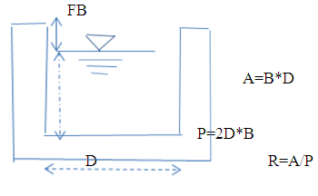
Where Q = Design discharge, m³/s
R= Hydraulic radius of the canal, m
A= Wetted cross sectional area of canal, m²
P=Hydraulic radius (Flow area/wetted perimeter)
n = Manning's roughness coefficient, n=0.03 is adopted for the earth channels and n=0.018 for the masonry lined part of the main canal
S = Bed slope of the canal
Figure 4-1: lined canal section view

    - Main Canal
The main canal is designed for a discharge of 270 l/sec.and depending on the site specific condition, appropriate slope is provided. Hydraulic parameters of the main canal are shown below.
At a chainage of (2030-2050m), 2694-2697), two are Flume structures.
Table 4-1: Hydraulic Parameters of main canal
BW= Canal bottom width QR= Required discharge
FSD= Full supply depth QD= Designed Discharge
FB= Free board
SS= Side slope
Vel= Velocity
    - Secondary Canals
Table 4-2: Hydraulic Parameters of secondary canals
Figure 4-2: Typical Cross Section of secondary canals
    - Tertiary canals
In the layout system there are Twenty five tertiary canals, the designed discharge is determined based on the duty of irrigation. The sections of the canals are determined by using manning’s formula, and they are trapezoidal section. The hydraulic characteristics is Presented in Table 4.3 below.
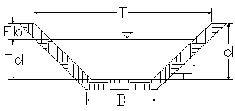
Figure 4-3: Typical Cross Section of tertiary canals
Table 4-3: Hydraulic Parameters of tertiary canals
    - Field Canals
As shown in the layout, field canals run across the contours and hence face relatively steeper gradient. The discharge of most of the field canals is very small and this is taken as an advantage to cope up with the relatively steeper gradient. Figure 4-3 below shows a typical field canal x-section. As much as possible field canals shall be made in fill in order to easily irrigate the adjacent command area. As can be seen from the layout, majority of the filed canals can be used to irrigate both sides of the command area depending on the condition of the individual plots of land owned by individual farmers.
Figure 4-4: Typical Field Canal X-section

Design of Drainage System
The main purpose of the drainage system in the command area is to remove the flood during rain Season and surplus irrigation water from the entire system. As discussed earlier, all the drains are natural ones. Collector drains takes from each field drains and empties to the natural waterways. The field drains will be constructed by the farmers and remove while they plough the irrigation field. For the next irrigation, they can easily construct again. Field canals are constructed with the same sections of the respective field canals.
  - Canal Structures Design
    - Design of a typical flume
There are two gullies and whose width various from 29.47m to 10.34m. All cross gullies sustainability purpose depending on the site condition, an RCC cross gully structure is designed.
Hydraulic Characteristics of the canal
Length of the flume: 29.47m
Shape of the flume: RCC cross gully structure
From the canal longitudinal profiles, u/s canal bed level (CBL) = 2275.615m
D/s Canal bed level (CBL) =2275.573m
U/s full supply level (FSL) = 2275-996m
D/s Full Supply Level = 2275.953m
Total head loss between the inlet & Outlet =0.043m
Table 4-4: Hydraulic Parameters of Flume
Flume on | start Chain age | Q | V | L | h | t
Flume 1 | 2024-2057 | 0.145 | 0.64 | 29.47 | 3.9 | 0.4
Flume 2 | 2691-2706 | 0.122 | 0.53 | 10.34 | 2.4 | 0.4
    - Design of Division box
At different points of the main and secondary canals division boxes are provided which divert the flow to the secondary canal and tertiary canals. Gate should be provided at the outlet of the boxes. For detail refer the drawing.
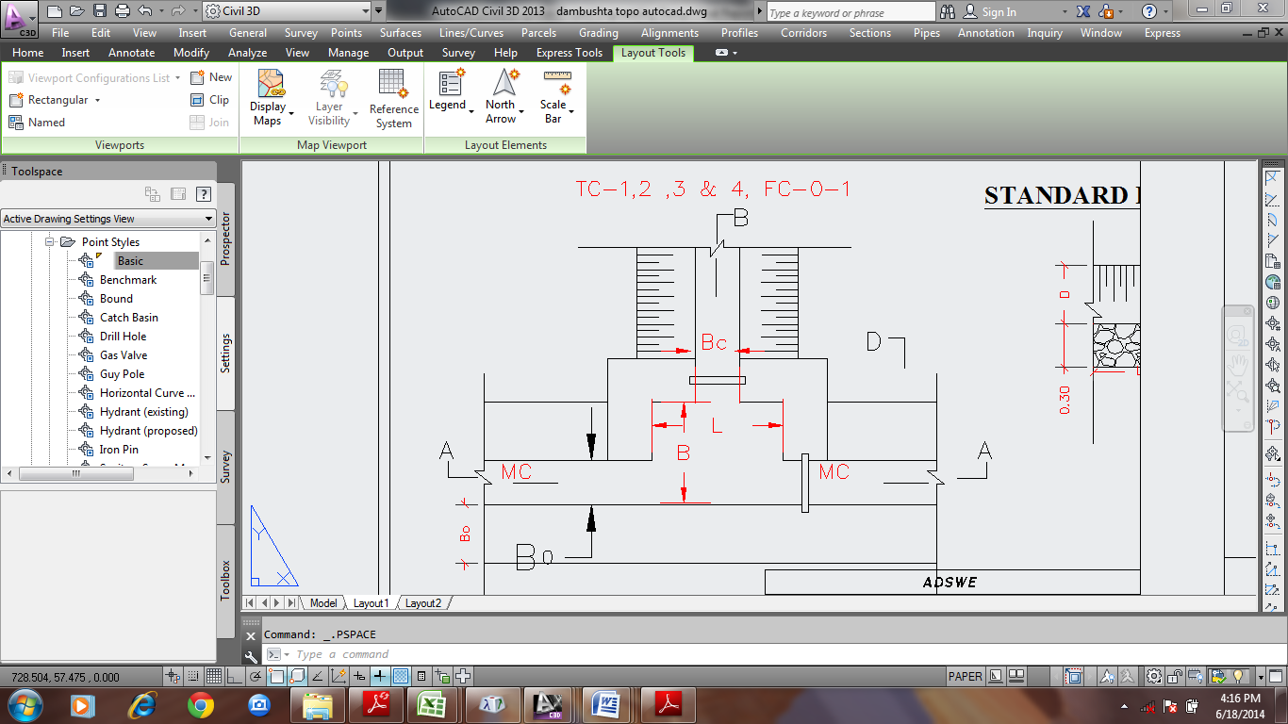
Figure 4-5: Typical Division Box plan
Using broad crested formula,
Q= CL (h)^{3/2}
Where; Q= discharge over rectangular weir/intake (opening), m³/s
C = discharge coefficient, c= 1.7
L= effective length of crest form in m
h= over flow depth, m
Assuming equal discharge coefficient & sill height for two or three dividing canals, the proportion becomes.
Q₁/ Q₂= Q₂/ Q₃ =L₁/ L₂ = L₂/ L₃
Where Q₁= is flow in canal 1
Q₂ = is flow in canal 2
Q₃ = is flow in canal 3
L₁= is effective crest length of weir/intake sill across opening to canal 1
L₂= is effective crest length of weir/intake sill across opening to canal 2
L₃ = is effective crest length of weir/intake sill across opening to canal 3
Q₁= CL₁ (h)^{3/2},
L₁ = Q₁/Ch^{3/2}
L₂ = L₁*Q₂/ Q₁
L₃ = L₁*Q₃/ Q₁
The depth of (height of) the division box,
D = d + f_{b}
The width of the division box,
B = b + 2*m*D
Where b= base width of the incoming canal
D = total canal depth of the incoming canal
Table 4-5: Hydraulic parameters of Division Boxes
Division box | Incoming flow(m3/s) | Design Discharge to Tc or Sc | Ongoing discharge | MC bed width for ongoing discharge(m) | TC/SC outlet width (m) | Top width of division | Depth of division box (m)
MC & TC-1 & TC-2 | 217.50 | 5.10 | 212.40 | 0.7 | 0.3 | 1.5 | 0.51
MC & SC-1 | 212.40 | 33.68 | 178.72 | 0.7 | 0.3 | 1.5 | 0.51
MC & SC-2 | 178.72 | 23.76 | 154.96 | 0.6 | 0.3 | 1.4 | 0.50
MC & SC-3 | 154.96 | 26.76 | 128.20 | 0.6 | 0.3 | 1.4 | 0.15
MC & TC-3 | 128.20 | 6.82 | 121.38 | 0.6 | 0.3 | 1.4 | 0.38
MC & SC-4 | 121.38 | 12.79 | 108.59 | 0.6 | 0.3 | 1.4 | 0.33
MC1 & SC-5 | 108.59 | 14.40 | 94.19 | 0.6 | 0.3 | 1.4 | 0.33
    - Road crossing structure
Two road crossing structures (if any) are provided on the main canal, at the existing foot paths. The road crossing structures are rectangular double reinforced concrete slab. The slab is reinforced with 16mm @200mmc/c and 14mm @ 200mm c/c the length of the slab is 20m both crossing, its width and thickness is 1.5m and 20mm respective.

Design of Drops

Well, the design of drops may be necessary in steep slope commands like Amtu the length of tertiary canals is higher than that of the main canal. When looking the general topography of the Amtu site, all the length the secondary canal is running in high drops in order to find a steep command area. Therefore, secondary canal requires have threaten droop structures but tertiary canals have eight drop structures. Critical flow hydraulics has been made in excel spread sheet analysis and the result is attached here in the following table.
Table 4-6: Hydraulic characteristics of drops
Standard drawing of drop structures is given below
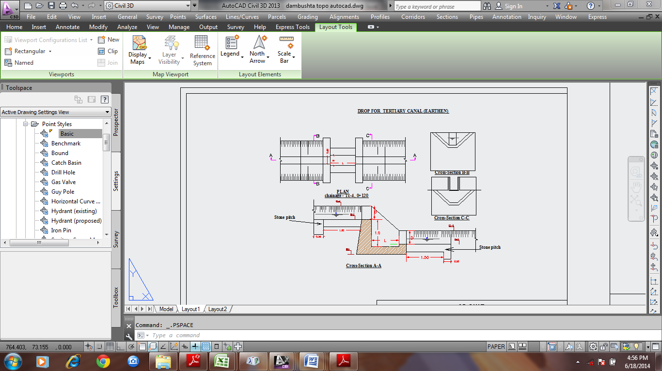
Figure 4-6: typical drops section

Irrigation Infrastructure Bill of Quantities and Cost Estimate
In this basic topic three major tasks have been conducted. Th1st and the most important is the preparation of quantity take off sheet. The 2nd part of this topic shall be summarizing the take-off sheet and preparing the Bill of quantities for each work items in the headwork. The last activities to be performed here is estimation of the unit rate specific to the project area.
Finally the engineering cost estimate for the infrastructure shall be computed and summed up for procurement specification. Take off sheet will be annexed or given in softcopy.
Table 4-7: Cost summary

Table 4-8: Bill No. 3- Engineering cost estimation for Infrastructure

- CONCLUSION AND RECOMMENDATION
- The infrastructure of this project area is designed to irrigate about 180 ha of land by taking its supply from the Amtu Intake irrigation project. The maximum duty of the command area for 18 hours per day irrigation with overall project efficiency of 60%. The method of irrigation of the project area is furrow surface irrigation in which the main and tertiary canals are working continuously whereas the field canals within a tertiary block are working rotational system.
- As the dominant soil type is clay soil, the main canal system is designed to be masonry.
- The reason why the main canal is to be lined up to the end is to avoid the siltation problem, time saving to reach at the tail part, reduce maintenance cost.
- On the secondary unit of the irrigation systems, some are associated with chute. They are designed as far as possible to be partially filled and cut. The layout is designed as far as possible to avoid cross-structures within them.
- The design of the canal dimensions of the irrigation canal is done by applying the manning’s uniform flow equation. The variable of the hydraulic parameters are calculated using iteration or flow master program.
- The design discharge of the drainage canals are determined using rational formula and Gamble Powell method.
- As soils of the command area are predominantly clay textured; and hence water and soil management measures should be undertaken; and optimum moisture content should be maintained to improve workability of the soil during land preparation and planting time.
The following recommendations are drown:
- For better performance and long service year of the project regular inspection and maintenance is highly required.
- Farmers training, how to operate and maintain the project structures as a whole and available and water resources has a paramount important.
- The irrigation hours per day and per week should be flexible based on base flow amount of each week or month.
- Close supervision of the construction should be made to modify (if need be) each Components of irrigation system based on specific site conditions.

- OPERATION AND MAINTENANCE

General
The main objective of the operation and maintenance aspect of an irrigation scheme is to facilitate the timely delivery of the required irrigation water to farms and to keep the irrigation system in an optimum operating condition. This section therefore, discusses the main functions of the subject matter under consideration for the scheme.

Operation of the Head Works
Operation at the diversion weir mainly focuses on the diversion of a controlled flow of river water, timely cleaning of floating debris in front of intake and removal of sediment deposits in front of the weir and intake structures.

Irrigation System Operation
The operation of the irrigation system depends mainly on the method of water delivery at farm level. Surface irrigation method is the recommended type of water distribution and application method for Amtu Intake irrigation scheme.
The farmers would organize themselves and form groups in order to handle the water management. Since flow is low Rotational water distribution would be applied within the group. The rotational distribution is then to distribute water by turn to the whole scheme according to the timely need of crop water requirement. For better and efficient water management, crop diversification should be avoided within a group. This would reduce the complexity of water distribution system of the scheme during one irrigation season. At farmers’ level of operation, a constant flow and variable irrigation time is advisable.
The operation of the irrigation system is continuous for 14 hours per day in main, secondary and tertiary canals whereas field canals within a tertiary block are operating in rotational system with each other for irrigation hours proportional to their size. Since the tertiary canal discharges are within the manageable range and the irrigation canal structures are accordingly designed for simple operation, the farmers can open and close easily whenever they required.

Maintenance Requirement
The canal system of the project is earthen canal except main canal and secondary canal, which is susceptible to siltation, erosion, growth of weeds and or breaching problems. Though the canal sections are designed for non- silting and non-scouring conditions, the above mentioned problems are unavoidable and hence periodical and yearly inspection and maintenance of canals and structures are obligatory in order to fulfill the design objective of the project area.
The maintenance tasks are categorized into two types: - routine activities, and repairs. The routine maintenance activities that are carried out periodically include:-
- Regular cleaning of sediments and weeds from canals and drains;
- Inspection and lubrication of gates; and
- Maintenance of cracked lined canals, regulating and control structures.
Repair works include task carried out more frequently and quickly, and include those tasks that are generally unpredictable. They also include emergency works. The activities included in this category are:-
- Repairing overtopped or breached canals, drains, and flood protection dykes;
- Repairing jammed gates;
- Filling holes made by wild animals; and
- Reduced free board due to walking over by people and livestock.
Regular inspection of the irrigation facilities should be carried out as part of the maintenance activities. These tasks could be carried out immediately after the end of the main rains in September and during the rainy season. This could concentrate on the interceptor drains and the flood protection dykes, the main canal and the field drains. The inspection of the other works like the tertiary canals, field drains, and the water control and regulating structures could be carried out as part of routine operation activities.
- Beneficiaries of the project need to have operation and maintenance budget, For O&M cost incurring entity area:
- Purchase sing of gate lubricate (grease)
- Replacing and maintenance of Stolen and damaged gates
- Repair Damages on the cross drainage structures.
The expense for O&M should be collected from the beneficiaries. Of course, much of the task is done by the labor and skill of the community. For cost incurring activities beneficiaries have to collect money based on the proportion of the command area they owned.

REFERENCE
- FAO (1977) guidelines for predicting crop water requirements. No 24, Rome Italy
- Design of small Canal structures , USBR
- Soft copies of hydraulic structure publishing
- IDD manual
- ESRDF manual

