ANNEX D
HEADWORKS AND IRRIGATION INFRASTRUCTURE

OROMIYA NATIONAL REGIONAL STATE

OROMIA IRRIGATION DEVELOPMENT AGENCY (OIDA)
SORIYA SMALL SCALE IRRIGATION PROJECT
Feasibility Study and Detail Design (Final)

ANNEX D:
HEADWORKS & IRRIGATION INFRASTRUCTURE
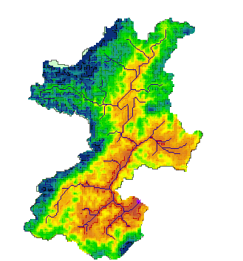
AWE Consultants plc
NOVEMBER, 2016

TABLE OF CONTENTS
1 INTRODUCTION 3
1.1 General 3
1.2 Background 3
1.3 Scheme location 3
1.4 Project Goal 3
1.5 Purpose of the project 3
1.6 Scheme Objectives 4
2 Irrigation Design 5
2.1 Head work site selection 5
2.1.1 General Description 5
2.1.2 Head work Site Selection 5
2.1.3 Head work (Weir) alignment 6
2.1.4 Hydrological study of the design flood 7
2.1.5 Tail water rating curve 8
2.1.6 Hydraulic design of the weir section 9
2.1.6.1 Selection of the type of structure 9
2.1.6.2 General Description of the Weir 10
2.1.6.3 Hydraulic design of the Weir and appurtenant 10
2.1.7 Structural design of the weir and guide walls 20
2.1.8 Structural design of gates 29
2.1.9 Design Criteria for the On-farm Works 35
2.1.9.1 Crop water demand 35
2.1.9.2 Irrigation efficiency 36
2.1.9.3 Irrigation duty 37
2.1.10 Design Criteria for Structures 38
2.2 On Farm Works Design 38
2.2.1 Summary of Resource Base and Irrigation Development 38
2.2.1.1 Land Resource 38
2.2.1.2 Water Resource 38
2.2.2 Layout of irrigation system 38
2.2.2.1 Topographic survey 39
2.2.2.2 Layout of the Command Area 39
2.2.3 Alignment of main Canal 40
2.2.4 Alignment of Secondary Canal 40
2.2.5 Alignment of Tertiary canal 40
2.2.6 Alignment of Field canal 41
2.3 Irrigation System Design 41
2.3.1 Design of Main Canal system 42
2.3.2 Design of Secondary Tertiary Canals 43
2.3.3 Design of field channels 43
2.3.4 Design of furrow irrigation methods 43
2.3.4.1 Selection of irrigation methods 43
2.4 Drainage canals 44
2.5 Hydraulic Design of Irrigation Structures 44
2.5.1 Design of cross drainage structure/aqueduct 44
2.5.2 Division Boxes and Turnouts Structures 45
2.5.3 Farm Roads and road culvert Design 45
2.5.4 Washing basin and cattle trough 45
2.6 Water Delivery Rotation 46
2.7 Supply Head 46
2.8 Operation and Maintenance 46
2.8.1 General 46
2.8.2 Irrigation System Operation 46
2.8.3 Maintenance Activities 46
2.9 Engineering Cost Estimate 47
2.10 APPENDIX A 48

List of Table
Table 1 Flow parameters of the off-taking canals 14
Table 2 Force and momentum computation under flow State-1. 23
Table 3 Force and momentum computation under flow State-2. 24
Table 4 Stability analysis under the two flow conditions. 24
Table 5 Force and momentum computation under flow State-1. 26
Table 6 Force and momentum computation under flow State-2. 27
Table 7 Stability analysis under the two flow conditions. 28
Table 8 Summary of Irrigation and drainage System Design Criteria 37
Table 9 Command statement of the canals. 40
Table 10 Hydraulic parameters of the main canal. 43
Table 11 Hydraulic parameters of the secondary and main canals. 43
Table 12 Summary of cost of irrigation system and infrastructure 47

List of Figures
Figure 1 Head work site and the demarcated command area 5
Figure 2 Photographi view of proposed Soriya head work site 6
Figure 3 Head work alignment. 7
Figure 4 River cross section at Soriya weir axis 8
Figure 5 Longitudinal profile of Soriya River at weir axis. 9
Figure 6 Stage - discharge curve 9
Figure 7 Hydraulic Jump profile 13
Figure 8 Section of the proposed Head work design 18
Figure 9 Free Body Diagram of the Weir body (no tail water condition). 22
Figure 10 Free body diagram of forces on retaining wall under flow State-1. 26
Figure 11 Free body diagram of forces on retaining wall under flow state-2. 27
Figure 12 Pressure diagram on flat submerged gates with water on one side. 30
Figure 13 Surface parameters of typical screw. 31

INTRODUCTION

General
The Oromia National Regional State initiated Soriya Irrigation Project as part of its on-going programmes to develop small- scale irrigation works in the Region with a view to enhance food security and improve the living standard of farmers. The World Bank through Agricultural Growth Program is financing the project.

Background
The project envisaged the development of about 83ha of farmer managed small-scale irrigation, whereas due to the topography of the project site the command area is estimated to be about 24 ha. The source of water is the Soriya River. Soriya’s flow increases during the rainy season, reducing to its base flow during dry season. In view of the foregoing, the reconnaissance report had recommended the construction of a diversion weir for the irrigation. The envisaged project components include the construction of a diversion weir, conveyance main canal, secondary canal, distribution canals and drainage system. AWE’s consultancy assignment has the objective of preparing the project documentation in two phases, namely feasibility and detail design phases. This was preceded by a site survey and investigation that included topography, soils geo-technical, hydrology, agronomy, socio economy, watershed and environmental studies.

Scheme location
The proposed Soriya irrigation project is located in Didessaa district in Illuababora zone Oromia regional national state at about 460km from Addis Ababa and 70 km east of Bedele town. The command area stretches from west to east along both sides of the Soriya River. Its geographic extent in UTM ranges from 677590 m to 682596 m east and 1121308 to 1123195 m north. It has an elevation of 1440 masl at head work site and 1400 masl at the end of north east of the command area.

Project Goal
The project goal is making effective contributions to:
- Successful implementation of Growth and Transformation plan (GTP) of the region for improved income of and the livelihood of the community
- Increased social, economical, environmental and political benefits
In fulfillment of these goals, the possibilities for secured and strengthened economic access to food and improved way of life (food security) for rural beneficiary communities become a reality.

Purpose of the project
The contract agreement stipulates that the project feasibility report will be submitted following the completion of the feasibility study phase. This report is prepared in fulfillment of the requirements of the Contract. The objective of this Report is to present the result of analysis of the land, water, and climatic resources, as well and the socio-economic, environmental impacts, and the technical and financial viability of the planned project.

Scheme Objectives
The specific objectives of the project studies are:
- To conduct feasibility study of the project and investigation for optimum use of land and water resources of the area under sustainable, technical, social, financial, and environmental condition.
- To prepare detail design, cost estimate and tender documents of the most feasible option for implementing the project, and
- To develop operation and maintenance manual guideline for the smooth and efficient running of the irrigation farms.

Irrigation Design

Head work site selection

General Description
Soriya Irrigation project has been initially planned to irrigate 83ha of land. However, as it could be exhaustively assessed during the field work, the maximum command area to be brought under irrigation from the proposed diversion site is only 26ha, of which the designed irrigable net area is of about 24ha. The planned water delivery system includes diversion of water directly from Soriya River and delivery of the water by the main canal that runs along the left side of the project area along the contour line.

Head work Site Selection
Selection of the site for head work is very important and was done considering various factors. By following the general diversion structure design guidelines, the location and alignment of the weir axis and that of the canal headwork has been decided. Prior to final selection of the best possible candidate site, a general survey to determine the Feasibility of the project, topographical features of the area, possible sites for locating the proposed weir and which can command the available irrigable area were carried out. The survey works were done by the use of precise Power set surveying instrument.
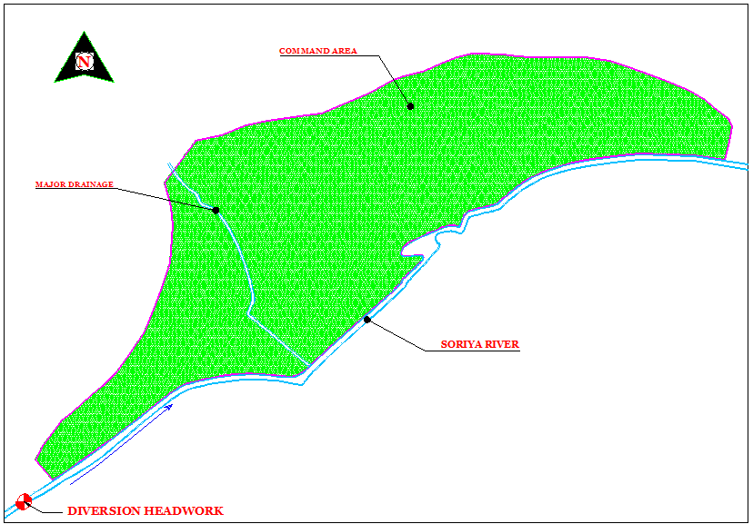
Figure 1 Head work site and the demarcated command area
Generally, the selected diversion site is ideal from the structure point of view as well as economical and the overall water management perspective. Therefore, this location is selected for the detail feasibility design work. The following photographic view shows proposed head work site for Soriya irrigation scheme.

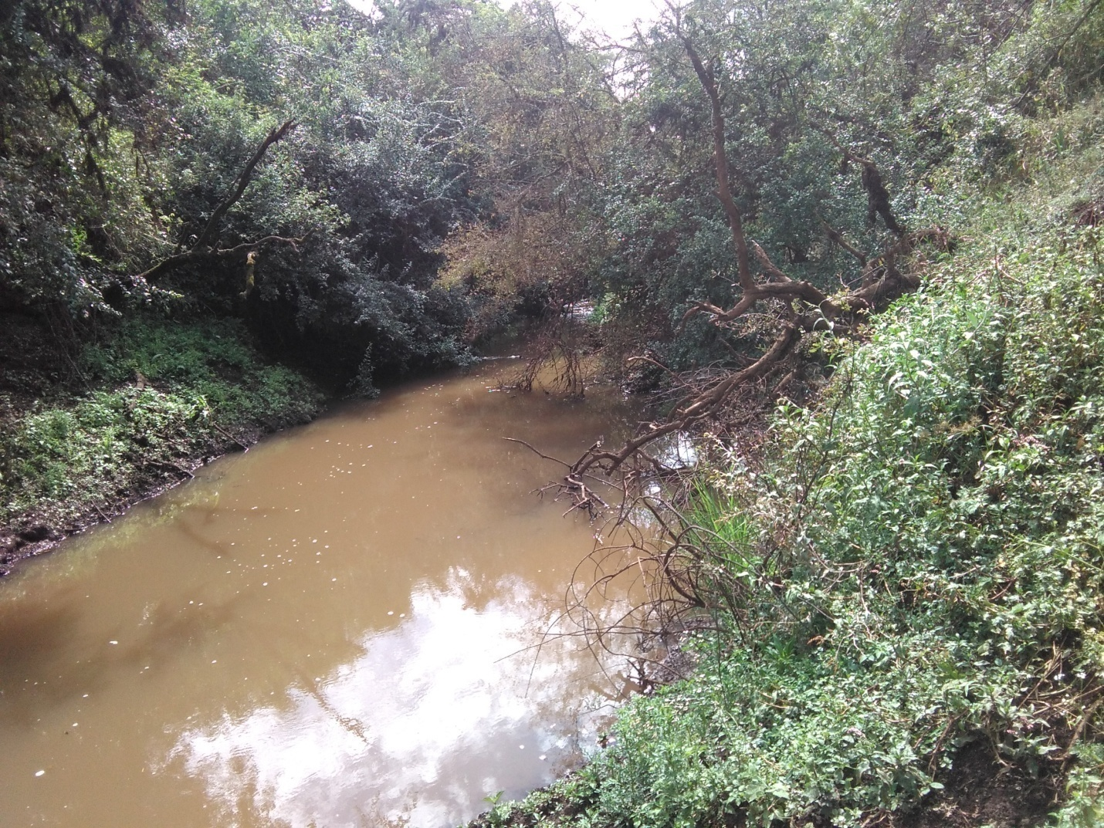
Figure 2 Photographi view of proposed Soriya head work site

Head work (Weir) alignment
The alignment of the weir is laid on the location proposed by the client. The weir is aligned considering its technical, operational and economic implications. The alignment is performed by considering also the off take arrangement. An off-take at 90° to the main flow is the least desirable one. The structure should be aligned to produce a suitable curvature of flow into the intake, and a diversion angle of around 30°–45° is usually recommended to produce this effect (Novak, 2002). Therefore, the off take structure is aligned 40° out of the main weir axis .The weir axis and its alignment is shown in the diagram, below.

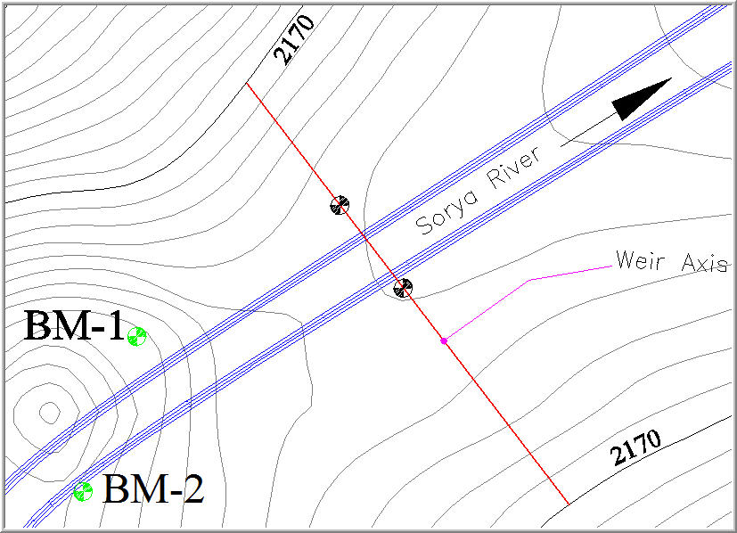
Figure 3 Head work alignment.

Hydrological study of the design flood
The hydrological computation provides the design floods for different return periods. The river at proposed weir site is not a gauged river. In the absence of data where a hydraulic structure is intended to be built using a rainfall-runoff model or transferring data from hydrologically homogeneous area is among the methods to generate data at a diversion weir site for this particular project. The long term monthly maximum, minimum and average flow data at Dabana River near Buno Bedele hydrological gauging station has been used.
The design flood of the river has been estimated applying flood frequency analysis method. The design flood computed for different return periods using Gumbel distribution has been adopted for this design as per the recommendation by the hydrologist. The result of the frequency analysis is presented in the table below.
Return period (years) | 2 | 5 | 10 | 50 | 100
Q,m³/sec | 23.55 | 27.47 | 30.07 | 35.78 | 38.19

Apparently, considering the physical site condition and the high flood mark observed in the area, the hydrological model result of design discharge 38.19m³/s for 100 years return period has been considered for the design as recommended by the hydrologist.

Tail water rating curve
As it was shown in the hydrological report, the design flood for 100 years return period is 38.19m³/s. This flow is used to design the weir body and appurtenant structures of the project. The level of this and other discharges on the tail water curve is determined to investigate the flow hydraulics of the stream downstream of the proposed weir before and after construction of the weir. It also helps in analyzing critical flow and condition where the weir body will be critically influenced not to be structurally unstable in any cases of the destabilizing forces.
River cross section was taken at 10 meter downstream from the center of the weir axis for the preparation of the tail water curve. As ungauged stream, the rating curve has been developed by Manning’s equation estimating the input data. The flow cross sectional area, perimeter, and hydraulic radius were estimated from downstream cross-section data. The longitudinal slope of the river was calculated from its longitudinal profile. The output curve will serve to evaluate the influence of the downstream water on the nature of flows at toe of the weir axis. The river cross section at tail water position, the river profile and the corresponding rating curve are shown in Figures 4, 5 and 6.
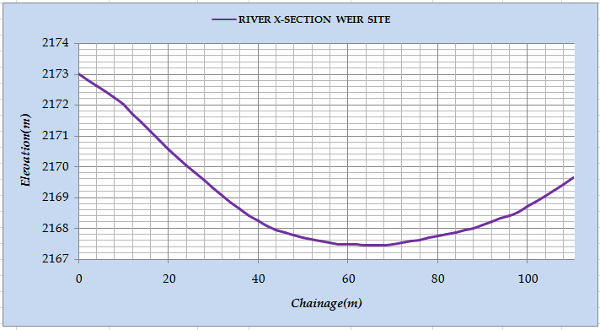
Figure 4 River cross section at Soriya weir axis

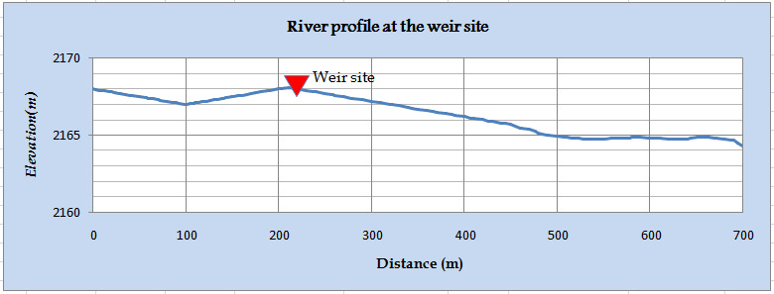
Figure 5 Longitudinal profile of Soriya River at weir axis.

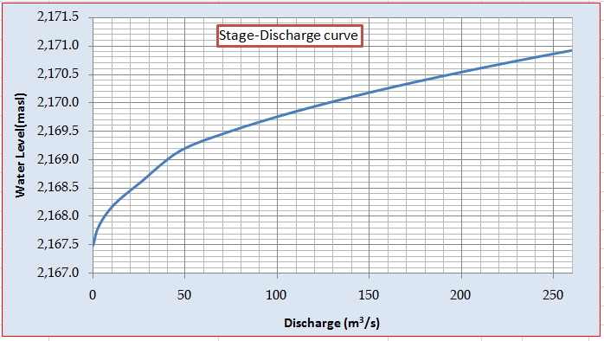
Figure 6 Stage - discharge curve
As it could be observed from the rating curve developed, the tail water elevation at design flood (38.19m³/s) is 2168.90masl or 1.4m above apron level.

Hydraulic design of the weir section

Selection of the type of structure
The type of structure selected for diversion of the required flow is masonry weir. It is vertical drop weir with vertical upstream and sloping (1H: 1V) downstream face. The selection of the type of structure has been made taking in to consideration availability of construction materials, foundation condition, and flow magnitude, nature of the river, workmanship, available technology and construction condition.

General Description of the Weir
The diversion weir proposed for the given scheme comprises the following components:-
- Broad crested weir (over flow section),
- Upstream and downstream apron,
- Intake facility (head regulator gate and trash rack),
- Under sluice (scouring sluice gate),
- Divide wall,
- Retaining walls,
- Stilling basin,

Hydraulic design of the Weir and appurtenant
weir crest level and height
Height of weir has been fixed from consideration of silting, canal FSL and bed elevation, driving head, and allowance for pondage. The minimum height of weir has been evaluated with following assumptions.
Water way
The diversion structure has to be designed in such a way that it may be able to pass a high flood of sufficient magnitude called the design flood safely. The clear opening of a weir to allow flood flow to pass has a bearing on the afflux. Hence, a maximum limit placed on the afflux also limits the minimum waterway. Many a times, the Lacey’s stable perimeter for the highest flood discharge is taken as the basis of calculating the waterway. However, it should be remembered that Lacey’s formula is based on studies of canals in the alluvial regime and may not be quite correct for large rivers, and also for rivers in boulder or clayey reaches.
The size of the water way has been fixed based on known and assumed parameters applying energy equations and broad crested formula. The assumed and the known parameters used are:
- River bed level at the weir site…………………………………….2167.50 masl
- The crest level of the weir (pool level)……………………………..2168.80 masl
- D/S HFL……………………………………………………….........2168.90 masl
- Assumed afflux………………………………………………….......1.5m
- U/S HFL (D/s HFL + Afflux)…………………….………….…… 2170.40 masl
- The top width of crest is kept………………………………….…….1.2m
- Assumed divide wall thickness…………………………………………….0.5m
- Width of the under sluice portion…………………………………………..1.0m
As the size of afflux and length of water way have inverse relation, the optimum magnitude of afflux is fixed after many trials. Accordingly, the afflux magnitude adopted is 1.5m and the corresponding overall waterway of the weir between abutments is 17m. The effective crest length of the weir will be 15.5m. The head over the crest is 1.68m which is less than 1.5 times the width of crest, hence acceptable.
As of the analysis result, the total discharge passing over weir is 57.55m³/s and that passing through the under sluice is 3.21m³/s. Thus, total discharge passing over weir and through under sluice is 60.75 m³/s which is more than the 100 year flood, 38.19 m³/s. Hence, the assumed waterway of under sluices and weir has been adopted.
In order to evaluate the looseness factor of the water, the length of the water way has been also computed using Lacey’s formula. The regime width shall be arrived as:
Where: Pw = Lacey’s minimum waterway (m)
Q = Total maximum flood discharge (m³/s).
This is worked out to 29.85m. The actual waterway of 17.00 m is provided from which Looseness factor is evaluated as 0.57. A looseness factor of value less than one is acceptable.
Surface flow Analysis
The surface flow analyses of a diversion weir involve determination of flow profile over the weir and apartments that may occur under different flow conditions. It mainly involves computation of hydraulic jump which will result in estimates of the flow depths before and after the jump formation on the downstream reach of the diversion structure. The pre and post jump flow depths of the stream reach downstream of the proposed structure enable determination of the type and size of the energy dissipating structure to be provided so as to avoid erosion of river bed material.
As there is only one irrigation intake on the left flank of the river, in order to allow silt free water to the irrigation intake an under sluice has been provided. Surface flow analysis has been made for the effective crest length of the weir and the under sluice portions of the weir separately. The hydraulic analysis has been made for the maximum flow condition (flood of 100 years return period) and water at pond level. The hydraulic jump analysis has been made based on flow energy curves developed by Blench and Montague; and combination of momentum equation.
For the given discharge, the depth of water on the downstream can be obtained from the developed tail water rating curve. This fixes the TEL on the downstream. The difference between levels of upstream TEL and downstream TEL gives H_{L}.
Knowing flow intensity, (q) and HL, the specific energy, Ef₂ can be obtained from Blech Curves. Subtracting from downstream TEL, the level at which the jump will form can be obtained.
Knowing Ef₂, and Ef₁ can also be calculated by using Ef₁-Ef₂ = H_{L}. The corresponding values of D₁ and D₂ for the known Ef₁ and Ef₂ can be directly read from the ‘Energy of flow Curves’ developed by Montague.
Alternatively, the flow depths before and after the hydraulic jump can be estimated based on direct energy equations. The flow depth, D₁ at the downstream toe of the weir body before the hydraulic jump, is determined by equating the energy level at upstream and downstream toe of the weir body, neglecting energy losses over the crest and downstream slope of the weir body.
The sequent depth of flow, D₂, at further downstream after the hydraulic jump is determined by the equation:

Where: F₁ is the incoming
Froude Number and is given by

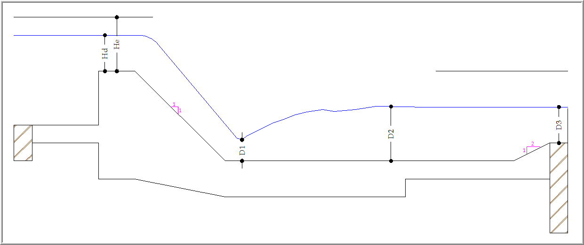
Figure 7 Hydraulic Jump profile
The hydraulic jump parameters estimation has been made following the two approaches stated above. Accordingly, the following results have been obtained:
- Hydraulic jump occurs at level 2166.88 masl,
- The depth of flow before the jump, D₁ = 0.38m,
- The depth of flow after the jump, D₂ = 2.16m,
The hydraulic analysis for different discharges over the weir body was made using Microsoft Excel application.
Sub-surface flow analysis
The geotechnical report reveals that the foundation condition for the head work site is pervious alluvial deposit. Detail investigation of the weir site has been undertaken. Based on the analyses and interpretations made so far, the geotechnical parameters have been presented. As a whole the formation in the study area is clay soil. Taking all the parameters in to account, the foundation depth has to be kept at 2m below the river bed level. Furthermore, it has been recommended that at least 450mm low plasticity selected material with sub base quality just between the foundation soil and footing has to be placed and compact the selected material at to at least 95% of the laboratory density. Accordingly, selected material of 450mm thickness has been provided under the masonry foundation. Keeping the foundation depth of the weir body at 2m below the river bed, subsurface analysis has been done.
Head Regulator
The head regulator is located on the left side of the weir body. It has sufficient capacity to deliver the maximum irrigation water need for the available command area with possible expansion. The designed irrigable area for this project is found to be 24ha. Hence, the main canals are designed to serve an area of 24 hectares of land. The off-taking canal parameters are as given in Table 1 below.
The intakes are located within the guide walls and are aligned at 90⁰ to the guide walls. The off-taking main canal is open canal. The intake is sized in such a way that the ponded water is diverted to the off-taking canal under any flow condition.
Table 1 Flow parameters of the off-taking canals
The flow through the canal head regulator is supposed to be orifice flow, and hence the flow is treated by orifice formula:
Where:
- Q_{d} is the flow through the intake(m³/s),
- Cd is coefficient of discharge and is assumed to be 0.6,
- A is flow cross sectional area(m²),
- h_{L} water level difference between pond level and center half of intake slot (m).
The water level (pond level) of the canal head regulator to the weir side is assumed equal to the weir crest level. Consider the left main canal intake for illustrating the design approach.
Thus, the known variables are:
- Pond level = 2168.80 masl,
- Canal FSL = 2168.50 masl,
- Intake level = 2168.00 masl,
- Provided intake slot size = 0.4mx0.4m,
- Driving head, h_{L} = 2168.80 – 2168.50 = 0.3m
Hence, substituting the known and assumed values in to the orifice equation above and solving gives:
The maximum flow through the opening will be 0.09m3/s and this flow magnitude is greater than the largest irrigation diversion requirement. Hence, the assumed opening size is adopted for the irrigation outlet.
For the designed irrigation outlet opening, the head regulator has been provided with simple operating gates of 0.5mx0.5m size. The intake gate has been mounted to the retaining walls at the upstream face (weir pond side) of the wall with RCC beam supporting the masonry part. Trash rack screen has been provided in front of the intake structure in order to avoid the entry of floating debris. Trash rack is provided with bars of 12mm diameter at 100mm center to center as per recommendations.
Scouring Sluice Design
Scouring or under sluice is provided on the weir body at the side of head regulator mainly to give the following functions:
- Maintain a clear and well defined river channel towards the canal head regulator,
- To enable the canal to draw silt free water from surface only as much as possible,
- To scour the silt deposited in front of the head regulator.
The crest level of the scouring sluice is kept at the deepest bed level of the river so that the deep channel develops towards the pocket, which helps in bringing dry season flow towards this pocket, thereby, ensuring easy diversion of water in to the canal. It should be capable of passing about 10 to 20 percent of the maximum flood discharge at high floods.
As of the hydraulic analysis made to fix the water way for the weir, the under sluice crest length has been designed to be 1.0m. The adequacy of the opening to pass the maximum flow has been evaluated using drowned weir formula.
The flow passing through the under sluice, during high flood flow condition, has been computed using drowned weir formula:
Q = C_{d} x L_{e} x d x (√2g (H₁-H₂) + V_{a})………………………..Eqn 1
Where:
- C_{d} is the coefficient of discharge and is taken as 0.62,
- L_{e} is the effective length of the sluice, 1.0m,
- d is the orifice height and fixed at 1.0m(the roof level of under sluice orifice is kept 0.50 m below pool level),
- g is acceleration due to gravity, 9.81m/s²,
- H1 is upstream TEL, H1 = 2170.48 masl,
- H₂ is downstream TEL, H₂ = 2168.98masl,
- V_{a} is approach velocity, V_{a} = 1.25m/s
Substituting the above values in Eqn-1 will result in a flow magnitude of 3.21m3/s.
The scouring sluice has been provided with gate sizes of 1.0mx1.0m which are operated by spindles on the head. RCC operating platforms have been provided with the breast walls, the divide walls and the guide walls functioning as supports.
The rail for operation of the gate slot has been mounted in the divide walls and the guide walls. The detail of the structure and components could be referred from the respective drawings. The structural design of the gates provided is detailed in the subsequent section of the report.
Apron length and depth
The primary task in designing apron or downstream floor of a diversion weir is hydraulic sizing of the stilling basin. This mainly deals with fixing the length as well as the depth of the stilling basin for different flow conditions so that complete energy dissipation will occur within the length of the apron. Accordingly, the length of the basin has been fixed based on the pre and post jump depths calculated and estimated by the formula:
L = 5*(D₂-D₁)
Substituting the pre jump and post jump flow depths, the minimum stilling basin length will be 9.52m.
The depth of the basin has been determined based on the following approach:
For maximum flow over the weir and the sunder sluice, the discharge intensity ‘q’ and head loss ‘H_{L}’ is worked out.
And
H_{L} = upstream TEL – downstream TEL
Knowing q and H_{L} corresponding value of Ef₂ (specific energy after jump) is read from Blench Curves. Then, the level at which the jump occurs can be known and will be at Downstream TEL – Ef₂
The specific energy before jump is computed as:
But E_{f1} = U/S TEL – Assumed Cistern level. The above equation used for estimation of E_{f1} will be iterated against D₁ until the assumed cistern level becomes equal to:
Assumed cistern level = D/S water elevation – the sequent depth (D₂).
Accordingly, the computation made for the worst flow condition results in the following outputs:
- Downstream HFL = 2168.90masl
- River bed level = 2167.50 masl
- Cistern level(D/S HFL – D₂) = 2166.74 masl
- Tail water depth(D₃) = 1.40m
- Depth of Cistern = 0.96m
The implication of the depressed stilling basin is that the energy dissipation is completed in the basin and the high sequent depth D₂ level will not exceed the predetermined tail water level of 2168.90masl. Thus, the estimated tail water depth (D₃) will be maintained at 1.40m.
Providing inverse slope (at the end of the jump 2:1), the total length of the downstream impervious floor based up on energy dissipation requirements is of 10m.
Cut-off walls
For diversion structures founded on pervious foundation, masonry or concrete cut-off walls have to be provided below the floor of the weir both at the upstream and the downstream ends of the impervious floor. The depth of upstream and downstream cut-off walls is dependent on the scouring depth, R.
These structures are provided to function under both low flow and high flood conditions. During low-flow periods in rivers, when the sluice gates are closed in order to maintain a pond level, the differential pressure head between upstream and downstream may cause uplift of river bed particles. A cutoff increases the flow path and reduces the uplift pressure, ensuring stability to the structure.
The computation of the vertical cut-off walls has been made through the following procedures:
The scour depth, R = 1.35 (q²/f)^{1/3}
Where:
- q = discharge intensity (m³/s/m),
- f = Lacey's silt factor(f = 1.76√m, m = Average size of erodible river material=1.5mm)
Accordingly, the upstream cut-off wall is 1.25*R = 3.13m and the downstream cut-off wall is 1.5*R = 3.76m. However, as the magnitudes of the computed values are exaggerated, the recommended values have been adopted. Accordingly, the upstream cut-off wall is 1.5m and the downstream depth is 2m.
Total Floor Length and thickness
The weir floor is subjected to the maximum static head when the river is closed and the full supply level is maintained in the upstream at pool level.
The length of the impervious material to be provided over the previous foundation should be sufficient to provide a safe hydraulic gradient. Hence, based on Bligh's theory, the safe creep length is given by:
L=CH_{L}
Where:
H_{L} : The total head loss (1.3m),
C : Bligh's coefficient ,for clay material the value is 7,
L= 1.3*7=9.1m.
Thus, the floor length provided for the surface flow hydraulics (10m) is sufficient and hence, this length has been adopted.
The safety against the uplift pressure is ensured through provision of the required thickness of impervious material at salient points along the provided length. The floor thickness, t at the selected salient points is computed using the following equation.
The thickness of the impervious material has been calculated using Bligh's method as:
Where:
t: thickness of the floor at the point
h : Ordinate of the hydraulic gradient line measured above the top of the floor (1.3m),
ρ : Specific gravity of the floor material
Accordingly, the floor thickness provided at three salient points is as shown in the figure below:
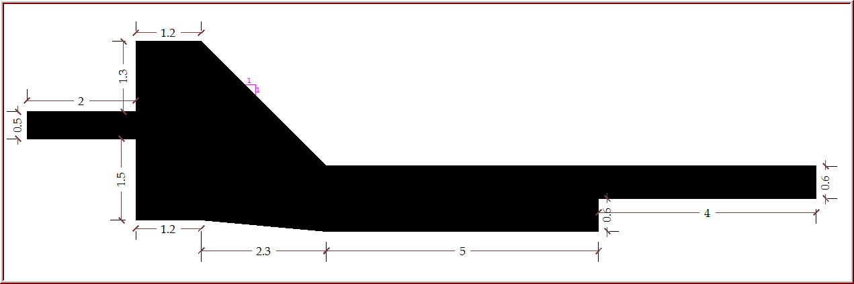
Figure 8 Section of the proposed Head work design
Divide Wall
Divide wall is provided to separate the main weir body portion from the under sluice to reduce the disturbance of flow in the canal head regulator side. A divide wall is masonry or concrete wall constructed at the right angle to the axis of the weir. This structure extends on the upstream side beyond the beginning of the canal head regulator; and on the downstream side, it extends up to the end of loose protection of the under sluice. Its length is twice the width of the scouring sluice. Accordingly, the length of the divide wall is kept in the order of 3.0m which is twice the width of the sluice.
For the project under consideration, masonry divide walls of 0.5m thickness have been provided. The height of the divide wall is fixed in such a way that at weir top and upstream weir flank its height equals height of upstream retaining wall, on the downstream flank of the weir it follows the same slope and elevation as down slopping weir body. The assumed thickness of the divide wall will be adopted after it has been confirmed following structural analysis.
The retaining walls
Retaining walls or river training works for weir are required to achieve the following functions:
- Prevent out flanking of the structure,
- Minimize cross flows through the weir,
- Prevent flooding by the river lands upstream,
- Provide favorable curvature of flow at the head regulator from the point of Sediment entry into the canal, and
- Guide the river to flow axially through the weir.
The height of the retaining walls is fixed based on the maximum possible flood level which corresponds to the design flood (100 years return period). For the project under consideration, the height of the retaining walls at upstream of the weir has been fixed based on the upstream HFL of 2170.40 masl and the downstream retaining walls based on downstream HFL of 2168.90 masl. Providing a freeboard of 0.5m on the wall heights, the top level of the upstream retaining wall will be 2170.90 masl and that of the downstream 2169.40 masl. Accordingly, the height of the upstream retaining wall is 2.90m and the downstream wall height will be 1.90m above the river bed level.
The walls are made of masonry structure and the top and bottom thickness of the structure will be fixed based on the structural analysis result to be carried out in the subsequent section.
The FLOOD PROTECTION DYKE
Flood protection dykes are provided on the upstream side of the headwork in continuation to the masonry retaining walls in order to protect the area from submergence due to rise in HFL caused by the afflux. These bunds are continued till they join contours higher than the new HFL. The top level of the bunds is kept equal to top level of the retaining wall.
Soriya diversion weir site is situated in such a way that the ponded water shall over flank during high flood time. Hence provision of embankment walls or dykes is of importance. The maximum height of the embankment is 2.75m. The length of the dyke provided at the right bank is 57m and that of the left bank is 33.5m. The top width is kept 2m and the side slope 2:1. As the height, top width and bottom width of the guide bund are considerably small, the structure has been treated as simple embankment and no detail stability analysis has been carried out. The source and type of material for the embankment would be as recommended by the geological and geotechnical report of this study.

Structural design of the weir and guide walls
Structural design of diversion weir and appurtenants involves proportioning of each structural member so as to secure its stability against possible critical load combinations and in extension to guarantee the safety, serviceability and sustainability of the structure with in its life time.
A masonry wall imbedded in cement mortar for the weir body, retaining wall and divide wall is recommended where there is sufficient quantity of rock suitable for mason work. Accordingly, all solid structures of the diversion weir have been made of masonry, except the RCC beam for the head regulator and the scouring sluice roofs and the operating platform. The stability analyses have been made for each component of the structure according to the overwhelming loads acting. The major structures for which the structural stability analyses have been made are discussed in the subsequent sections.
Conditions of safety
All the structural components of the diversion weir should be safe against any disturbing force acting on them. The major forces acting on the weir body, the divide wall and the retaining walls considered for Soriya diversion structure are:
- Static water pressure,
- Uplift pressure(considering that the rock foundation may have fissures),
- Friction force at the base(contact of masonry and rock foundation),
- Self-weight and,
- Water wedge.
The conditions of stability of the structural components are:
- The ratio of balancing moment to the overturning moment should be greater than 2 such that the structure is safe against overturning,
- The ratio of summation of the vertical forces multiplied with coefficient of friction to summation of the horizontal force should be greater than 1.5 such that the structure is safe against sliding,
- The maximum compression stress is within the limit of 700KN/m² such that structure is safe against compression stress,
- The minimum tensile stress in the body of the structure is greater than -100KN/m² such that the structure is safe against tension.
Accordingly, the structural components of the weir and appurtenants have been analyzed under different loading conditions. The details are presented in the next sections.
Weir body stability analysis
The weir body is designed to be safe at prevailed critical conditions of its disturbing forces. The various discharges were taken to investigate the critical flow condition that can make the weir body at minimum stable. The prevailing forces and moments by the weight of the weir body and the water from these discharges were determined, the safety factors for each force was estimated. The weir section that can be economical and stable for all prevailing forces was taken.
The force distribution on the weir body and its own weight is shown below and the structural stability analyses for safety of structure were done.
The condition of maximum pressure on the work is that in which the head water is at the level of the crest of the weir and no water is passing over the weir. However, the condition of maximum stress on the weir may be different in certain cases. Hence, it is necessary to check the stability under two flow conditions:
- When the upstream water of head water is at crest level and there is no flow to the downstream[Static condition],
- When the water is passing over the weir crest and the weir is submerged [Dynamic condition].

- Case1: The stability analysis of the main weir body during no tail water condition.
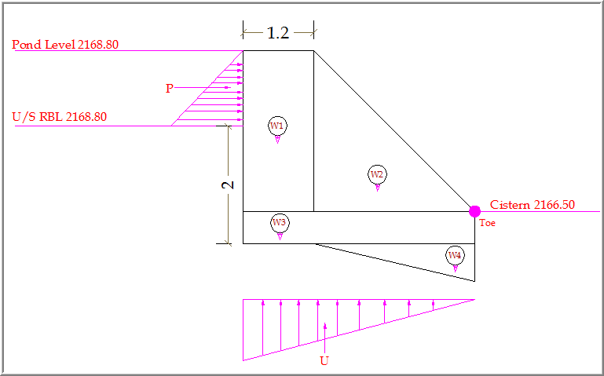 Figure 9 Free Body Diagram of the Weir body (no tail water condition).
DESIGN CONSTANTS
- Specific weight of water (γ_{w})……………………....10KN/m³
- Specific weight of masonry (γ_{m})…………………..24KN/m³.

Table 2 Force and momentum computation under flow State-1.
Item | Calculations | Force (KN/m) |  | Lever arm | Moments (KN-m)
Item | Calculations | Vertical | Horizontal | (m) | (+ve) | (-ve)
W₁ | W₁ = A-1* γ_{m}* 1 | 95.040 |  | 3.350 | 318.384
W₂ | W₂ = A-2* γ_{m}*1 | 90.750 |  | 1.833 | 166.375
W₃ | W₃= A-3* γ_{m}* 1 | 36.300 |  | 1.375 | 49.913
W₄ | W₄ = A-4* γ_{m}* 1 | 21.450 |  | 0.917 | 19.663
P | P = 1/2*γ_{w}*h² |  | 8.450 | 1.883 |  | 15.91
U | U = 1/2*γ_{w}*h*B | 8.450 |  | 2.633 |  | 22.25
 |  | ∑V₁ | ∑H₁ |  | ∑M₁(+) | ∑M₁(-)
 |  | 251.990 | 8.450 |  | 554.334 | 38.166

- CASE-2: The stability analysis of the main weir body during over flow condition.
The force distribution on the weir body, the magnitude of forces, and the analytical analysis of the safety factors are shown in the following figure and the table below.
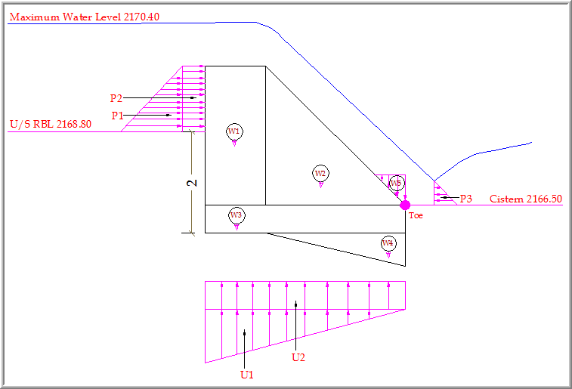
Table 3 Force and momentum computation under flow State-2.
Table 4 Stability analysis under the two flow conditions.
Adopted stable size of the weir body
As it could be read from the stability analyses result computed in Table 4 above, the structure is safe under any of the disturbing force combinations for the assumed dimensions. Apparently, the assumed dimensions of the weir body would be adopted. These will be summarized as:
- The weir crest width is 1.2m,
- The upstream face of the weir is vertical and the downstream face is kept at a slope of 1:1 and,
- The bottom width of the weir is 3.95m.
Retaining wall Stability analysis
The condition of maximum pressure on the work is that in which the river is empty. Although the river is not expected to be empty under normal circumstance, this condition has been considered as critical. However, the condition of maximum stress on the weir may be different in certain cases. Hence, it is necessary to check the stability under two flow conditions:
- State 1: When the river is empty,
- State 2: When the upstream head water is at HFL.
The basic data for computation of the prevailing loads and moments are as presented below:
Retaining wall dimensions:
- Assumed top width of Wing wall, b = 0.65m,
- Base width of Wing wall, B = 2.0m,
- Maximum height of the wall above the river bed level = 2.90m.
Computation of active earth pressure coefficient, K_{a}:
Parameters used to determine K_{a}:
Cos(Ф - Ɵ) | = | 1.0000 | Cos(δ + Ɵ) | = | 0.608
Cos(Ɵ - α) | = | 0.8653 | Sin(Ф - α) | = | 0.500
CosƟ | = | 0.8653 | Sin(α + Ɵ) | = | 0.501
Sin(δ + Ф) | = | 0.6091

Active earth pressure coefficient, K_{a} is evaluated by Coulomb's formula
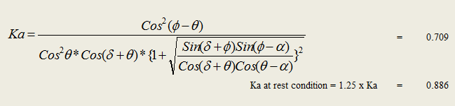
Design constants and assumed parameters
- For the given parameters Active earth pressure, Pa = Ka*γ_{s}*h²/2 = 78.24KN/m²/m
- State 1: When the river is empty
Under this condition, the river is considered to be empty and saturated backfill force acting adversely. Moment is considered about left side of toe.
Figure 10 Free body diagram of forces on retaining wall under flow State-1.
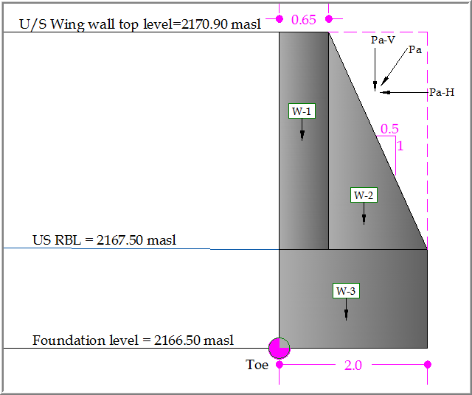
Table 5 Force and momentum computation under flow State-1.
Item | Calculations | Force (KN) |  | Lever arm | Moments (KN-m/m)
Item | Calculations | Vertical | Horizontal | (m) | (+ ve) | (- ve)
W₁ | b* h₁ * γ_{m} | 43.355 |  | 0.825 | 35.768
W₂ | 0.5*h₁*(B-b)*γ_{m} | 45.023 |  | 1.600 | 72.036
W₃ | B*h₂*γ_{m} | 46.000 |  | 1.250 | 57.500
Pah | Pa * Cos(δ + Ɵ) |  | 47.548 | 2.433 |  | 115.700
Pav | Pa * Sin(α + Ɵ) | 39.218 |  | 2.310 | 90.594
 |  | ∑V₁ | ∑H₁ |  | ∑M₁(+) | ∑M₁(-)
 |  | 173.596 | 47.548 |  | 255.898 | 115.700
Figure 11 Free body diagram of forces on retaining wall under flow state-2.
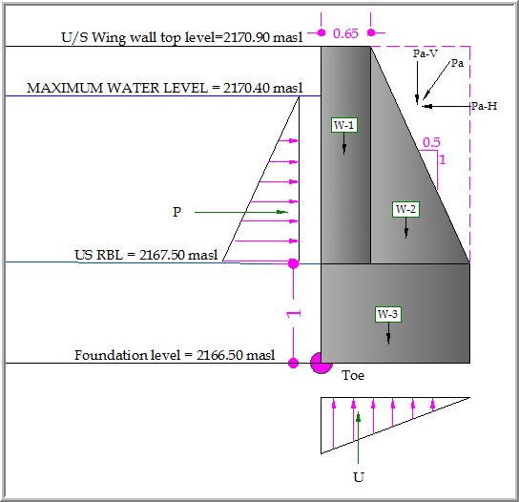
Table 6 Force and momentum computation under flow State-2.
Table 7 Stability analysis under the two flow conditions.
Adopted stable size of the weir body
As it could be read from the stability analyses result computed in Table 7 above, the structure is safe under any of the disturbing force combinations for the assumed dimensions. Apparently, the assumed dimensions of the upstream guide wall body would be adopted. These will be summarized as:
- The wall crest width is 0.65m,
- The water front face of the wall is kept vertical and the other face is kept at a slope of 0.5:1,
- The bottom width of the weir is 2.0m and
- The part of the foundation depth is 1m.
Following similar structural analysis method, the dimensions of the walls at the downstream have been fixed. Accordingly, the crest width has been kept 0.5m and the bottom thickness 1.5m.

Structural design of gates
The type of gate selected for both the under sluice and the intake is a vertical lift. Structural design of the gate involves fixing the thickness of the skin plate and the stem or screw diameter that can withstand the load imposed on them. When dimensioning a gate, the first step is to calculate the water thrust acting on the skin plate for the various gate opening-positions. Its maximum value occurs with the gate closed and subjected to the maximum head water level. The water thrust acting on the plate depends on the water level condition. For submerged gates with only one side of the skin plate in contact with water (Figure 12), as in case of the gates under consideration, the water thrust is calculated by:
Where:
- γ=specific weight of water=9.81KN/m³,
- B = span of side seals,
- H = Maximum headwater on sill,
- h= gate sealing height.
Figure 12 Pressure diagram on flat submerged gates with water on one side.
The pressure diagram above has a trapezoidal shape. In this case, the position of the resultant water thrust is given by:
The thickness of the skin plate is determined based on the stress that occurs in the plate. The plate stress is a function of the water pressure and the thickness of the plate. It is given by the relation:
Where:
- k = non-dimensional factor obtainable from table,
- P = Water pressure relative to the module center,
- a = minor support length,
- t = plate thickness.
The maximum deflection occurs at the center of the plate and is given by:
The stem or screw jack of a gate is the element that attaches directly to the gate and applies the lifting force (Figure 13). The stem is simply a long threaded shaft. The stem can be a rising stem, i.e. the bottom of the stem is attached directly to the gate. Rising stem or screw jack is widely recommended type of gates.
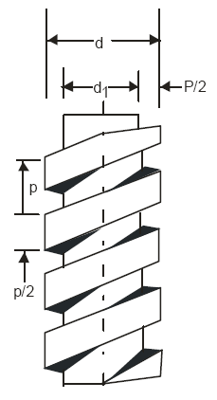
Figure 13 Surface parameters of typical screw.
The stem or screw is designed in such a way that it resists the possible shear and compressive stresses that occur as a result of the load acting. Thus, the shear and compressive stresses computed based on the estimated diameter of the thread should be checked against the allowable corresponding stresses.
The magnitude of the compressive stress depends on the weight of the gate and the screw and is given by:
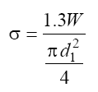
The shear stress is also determined as:
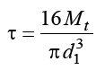 Where: The torque, Mt = 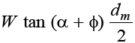
The terms W and d₁ correspond to the weight of the gate that should be lifted and the core diameter of the screw. The terms ɸ and α are the angle of friction and the angle of the threads.
Design of the under sluice gate
- Determination of skin plate thickness
Given and assumed data:
- Maximum headwater (H) = 2.15m,
- Specific weight of water(γ) =9.81KN/m³,
- Span of side seals(B) = 1.0m,
- Gate sealing height (h) = 1.0m,
- Assumed plate thickness (t) = 8mm.
The water load is, W = γBh(H-h/2) =9.81*1.0*1.0*(2.15-1/2) = 16.19KN
The water pressure relative to the module center is computed as:
P = γ(H-h/2) = 9.81*(2.15-1/2) = 16.19KN/m² = 0.0162MPa
For the assumed thickness of the plate, the plate stress will be:
Where:
- K is read from table and for b/a=1.0/1.0=1 and fixed four edges of the plate as
K1x = 13.7, K1y = 13.7, K4y = 30.9, K3x = 30.9
- a is the smaller edge of the plate and equals to 1.0m,
Hence,
- = 39.82MPa
- = 39.82MPa
- = 89.80MPa
- = 89.80MPa
The allowable tensile stress for steel elements as obtained from standard tables is equal to 0.4 times the yield stress. This will be equal to 96MPa. Hence, the assumed plate thickness is adequate to withstand the possible stress occurring. However, to adopt the assumed skin plate thickness, it should be checked against allowable deflection.
The maximum deflection of the plate is given by:
Where α is coefficient and equals to 0.0138 for b/a = 1,
And E is modulus of elasticity of the plate and equals to 20.6GPa. Hence, substituting the known values:
= = 0.265mm
The computed deflection of the plate is very small and insignificant. Thus, the assumed thickness of the plate has been adopted. Accordingly, the thickness of the plate adopted is of 8mm. Only diagonal stiffeners are provided as the plate size is small.
- Determination of the screw diameter
The magnitude of the compressive stress is given by:
Where:
- W is the weight of the gate and screw,
- d₁ is core diameter of the screw
Assuming core diameter of the screw as 50mm, the estimated weight of the gate and the screw will be 145.11Kg (1451.10 N) and compressive stress will be:
= 0.961MPa
The compressive stress created in the stem or screw is by much less than the allowable bearing pressure value of 14MPa. Hence, the assumed core diameter could be adopted based on the capacity of the screw to resist the shear stress.
The magnitude of the shear stress is determined based on the following approach:
M_{t} is the torque created during operation and is given by:
Where: W = Weight of the screw and gate and is 1451.10 N, as calculated in the previous section,
d_{m} is the average diameter and is calculated as:
Assuming that external diameter, d = 60mm,
=55mm
Considering efficiency of the screw to be equal to 50%, α = ɸ =2⁰
Hence,
=3.767MPa
The maximum shear stress is computed using the following equation:
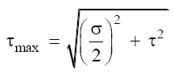
Substituting the calculated parameters in the formula will result in maximum shear stress of 2.00MPa. The permissible shear stress for steel screw is 20MPa. Hence, the screw with the assumed diameter is safe against shear.
- Adopted gate dimensions
Based on the structural design analyses made in the above sections, the following dimensions of the gate and screw for the sluice have been adopted:
- Gate size: 1000mmx1000mm,
- Skin plate thickness(t) = 8mm,
- Screw or stem external diameter(d) = 60mm,
- Diagonal stiffeners of appropriate size.
Following the same procedures as that of the sluice gate, structural design has been carried out for the intake gate. Accordingly, gate having the following dimensions have been adopted:
- Gate size: 500mmx500mm,
- Skin plate thickness(t) = 8mm,
- Screw external diameter(d) = 60mm and
- Diagonal stiffeners of appropriate size.

Design Criteria for the On-farm Works

Crop water demand
Crop water requirements (CWR) encompass the total amount of water used in evapotranspiration. Irrigation requirements (IR) refer to the water that must be supplied through the irrigation system to ensure that the crop receives its full crop water requirements. As per the Irrigation Agronomy report, the following four steps are involved in the calculation of crop water and irrigation water requirements:
- Calculation of reference evapotranspiration (ETo) based on meteorological parameters collected from the near-by meteorological stations.
- Crop coefficients for five annual crops (Green Maize, Onion, Tomato, pepper and potato) for full-fledged irrigation and one perennial crop (Mango) as supplementary irrigation.
- Determination of monthly crop water requirements (ETc) depending upon the cropping patterns and local conditions.
- Determination of Irrigation water requirements/demand using calculated effective rainfall of the area.
The crop water requirement and Irrigation water demand for six crops have been estimated using 75% dependable rainfall on a monthly basis and the FAO’s CropWat computer model (FAO, 1996). The scheme water requirements are computed as aggregate of the crop water requirement. The irrigation schedules for each crop are computed based on the type of soils and the crop growth stage A detailed methodology, calculations, analysis and summary of the crop and irrigation water demand is given in agronomy report of this study.
The estimation of crop water requirement normally needs the analysis of climatic data and agronomic practice of the proposed project area. The effect of climate on crop water requirement is given by the reference crop Evapotranspiration (ETo) that is analyzed using the Modified Penman Method.
In most cases the method of the determination of the net irrigation water requirements includes the additional quality of water needed to satisfy the leaching requirement of the soil (leaching of accumulated salts from the root zone) in every application. In Soriya case, however, according to the soils report, the soils of the command area are of good permeability, well drained and clay texture with moderate and medium structure and no potential saline and sodic nature of the soils. The source of irrigation water is also good quality, which is suitable for irrigation. This being the case, no provision has been made for additional water supply for the leaching requirement.
Therefore, the net and gross irrigation water requirements are calculated using crop evapotranspiration, ETcrop, and effective rainfall as presented in the Agronomy report.

Irrigation efficiency
The amount of water stored in the root zone is estimated as the net irrigation dose. However, during the irrigation process, considerable water loss occurs through seepage, deep percolation, etc. The amount lost depends on the efficiency of the system.
Gross irrigation water demand is dependent on the overall efficiency of the irrigation system, which it turn is dependent on several factors such as method of irrigation, type of conveyance system, method of operation and the availability of structures for controlling water. Irrigation efficiency is the efficiency of the total process of irrigation from the source of the water to the point where the water becomes available in the root zone of the plant. To account for losses of water incurred during conveyance and application to the field, an efficiency factor should be included when calculating the gross irrigation requirements.
For small schemes, the overall efficiency can be divided into two; conveyance and field application efficiency. Conveyance efficiency is the efficiency of transportation and distribution of water from the source to the point where it leaves the point of distribution. Therefore, conveyance efficiency accounts for all the losses from primary to farm channel level. Besides the losses in the conveyance and distribution system, loss also takes place in the field where water is actually applied to the crops which is known as field application efficiency. The field application efficiency is very much dependant on the method of irrigation and characteristics of soil and land.
The farmers of the project area have limited knowledge in water management. Water management in the area needs proper and thorough training and this should be disseminated throughout the scheme so as to effectively transform the training into reality. The development agents should also be included in the training program. Taking into consideration this scenario, irrigation efficiencies have been determined as follows:-
Conveyance efficiency 90%
Distribution efficiency 80%
Application efficiency 70%
Overall irrigation efficiency 50%

Irrigation duty
The peak requirement in terms of duty in liters/sec/ha was calculated to determine the command area and system capacity of the canal system based on the estimated monthly gross irrigation demand. Details of irrigation duty calculations are given in Agronomy report.
The irrigation water duty was calculated on monthly basis and the peak duty selected for the design purposes is 0.616 l/s/ha in the month of June. This is based on 24 hours running of the system. However, due to practical limitations only 12 hours of irrigation is assumed in a day. Therefore, the capacities of the canals, for which hydraulic designs have been made, are based on 12 hour running of the system.
In order to meet any changes in demand in the future as well as for providing flexibility in operation, it is proposed to increase the design discharges of all components of irrigation system by 10%. Thus the main canal is supposed to be designed with a peak duty of 1.36 liter per second per hectare at head work to satisfy the critical irrigation water demand of the crops during five critical months (June and July) on 12 hours running time in a day. Furthermore, the design discharge for each of tertiary and field canals is determined by multiplying the peak duty by the respective cultivated areas served by each canal. Hence, canal system capacity is determined and designed using the Manning’s Formula and the design criterion is shown in Table 8.
Table 8 Summary of Irrigation and drainage System Design Criteria
Canals and drains | N | b/d | Minimum Velocity  m/s | Maximum Velocity | Side Slopes | Free Board
 |  |  |  | (m/s) | Side Slopes | (cm)
Main canal (Lined) | 0.024 | 1-2 | 0.3 | 0.85 | 1:1.5 | 0.20
Secondary Canal(earthen) | 0.024 | 1-2 | 0.3 | 0.85 | `1:1.5 | 0.20
Tertiary canal (earthen) | 0.024 | 1-2 | 0.3 | 0.85 | 1:1.5 | 0.20
Field canals (earthen) | 0.024 | 1-2 | 0.3 | 0.85 | 1:1.5 | 0.20
Field drain | 0.024 | 1-2 | 0.3 | 0.85 | 1:1.5 | 0.20

Design Criteria for Structures
Type II division boxes have been selected as water control structures to facilitate operation by the farmers. Standard main canal cross drainage culverts have been provided at identified locations along the main canals to carry small natural drainage flows under the canal. These culverts are made standardized and have been designed for 1-in-10 year flood estimates for the catchment areas concerned (see design flood of each culvert in the drawing dimension table). Moreover, standard stone masonry drop and turn out structures are designed

On Farm Works Design
This section deals with the design of the irrigation system of the scheme that includes the analysis of crop water requirement, irrigation water requirement, irrigation planning, water distribution system, and hydraulic structures required for on-farm works. The operation and maintenance arrangement of the scheme is also presented.

Summary of Resource Base and Irrigation Development

Land Resource
It is noted that, the project was aimed at designing the command area of 83 ha, and improving the water resource utilization by increasing irrigation efficiency. However, as it could be assessed during field work, the potential command area obtained is only a net of 24ha. As the topographic feature of the area is characterized by hilly and undulating topography as well as vegetation cover, the proposed command area was not found due to topographic limitations. Thus, with 1.36l/s irrigation duty at the headwork, the gross scheme irrigation requirement is only 32.2 l/s. The hydrologic analysis of the Soriya River shows that the 80% dependable monthly flow is in the order of 214l/s. Thus, the available water source is adequate.

Water Resource
The water resource has been discussed in the hydrology report of this document. The source of water for the scheme is the Soriya River. The river is perennial and ungauged. As the Soriya catchment is located adjacent and nearby to the Dabena river near Buno Bedele and it is assumed hydrologically homogeneous with this station, the data from this hydrological gauging station is used to generate flow data of Soriya River.

Layout of irrigation system
Irrigation network has been planned for commanding the entire cultural area with the available head and irrigation water for the critical crop–water periods. The main objective of the irrigation system is to provide the River to the field units with efficient method. The irrigation system proposed consists of an open main canal (MC) serving a number of tertiary canals (TC) and secondary canal (SC). The Tertiary canals transport the water to the turn out points where it will be conveyed by open field channels to the irrigated fields.
Canal categories and Nomenclature in this study is given starting from the head work working toward the end of the command area (i.e. from upstream to downstream). Irrigation canal categories could be identified using the following codes:

Main Canal – MC
Tertiary Canal- TC i.e. TC1-2 is the second tertiary canal on the main canal 1.
Field Canal –FC: FC1-2 is the second field canal on Tertiary canal 1
Furrows- F
Tertiary Off take (TO) i.e. TO 1-2 is second division box on the main canal 1

Topographic survey
A topographic survey has been carried out for the entire and potential command areas. These maps are prepared using software, CAD system Terra model and Eagle point. Based on the field survey data, major and minor contours are constructed in 1m and 0.5m vertical intervals respectively for detailed planning of irrigation system.
The topographic maps also show physical features, spot levels, benchmarks and natural drainage etc. on the command area. The command area has undulating topography with elevation varying from 2183 m to 2163 m. The slopes of the command area vary from 2% to 10 %. Moreover, main, secondary, tertiary and field canals are aligned on the contour map.

Layout of the Command Area
The irrigation system at the project site is designed to use the available water as efficient as possible by minimizing the losses in conveyance, distribution and application. The layout of irrigation at the project site has been done on the contour map prepared from the detailed survey data.
The main factors considered in determining system layout for this irrigation scheme are;
- Topography
- Farm size
- Possible length of furrow
- Tertiary unit size
- Furrow length
The topographic feature of the area is such that the maximum are to be irrigated is limited to only 24ha. The proposed command area is located at the left bank of the river. The right command area is divided into 6 tertiary units, having field units or blocks each served by field canals and bounded by the drainage lines in between each field canals. The farm size of each irrigation blocks is ranged as 0.29 to 2.50 ha. The partitioning of the command area into smaller units is done by considering the topography, furrow length and the length of field channels. The layout of the irrigation system is shown in the respective drawing.

Alignment of main Canal
As shown on the system layout, the Main Canal (MC) is the largest size of the canal network, capable of conveying the flow of the system under favorable hydraulic conditions of flow velocity with minimum losses. The main canal is aligned along the contour. It takes off from the head regulator located at the diversion weir to the end of the turnout of the last tertiary canal. The design discharges of the main canal at 12 hrs and with 10% flexibility in operation is0.032m3 /s and has a total length of 961m. The main canal is aligned at 2168.5 m.a.s.l contour and goes along with some longitudinal drops of .001 (1: 1000 longitudinal slopes).
Table 9 Command statement of the canals.

There are 2 division boxes on the main canal for, diverting the irrigation water to the respective secondary and tertiary canals which is laid out parallel to the main canals. Main canal is designed reach by reach. Tertiary canal are designed to supply water to all field plots in rotation during peak demand.

Alignment of Secondary Canal
There is also a secondary canal in the irrigation system. It delivers water to five Tertiaries in the system. It is aligned along the ridge and its total length is 194m.

Alignment of Tertiary canal
Tertiary canal alignment indicated that 6 Tertiary canals are laid out off-taking from the main and secondary canals parallel to both the contour and the main canal. Hence, the entire project command area is covered by 6 tertiary and 17 field canals taking water from tertiary canals. Each tertiary canal is connected with turnouts to release water to the field canals laid out along the natural slope. The Tertiary canals are prefixed as TC1-1, TC1-1-1, TC1-1-2, 3 etc. The length of each Tertiary canal is ranged from 257 to 458m with a total length of 2224 m.

Alignment of Field canal

Field canals take-off from the tertiary canals laid out parallel to the main canal taking each tertiary as farm units. The number of field canals found at each tertiary is varied depending on the land configuration. Each Field canal is planned and designed as to irrigate those farm lands on both right and left directions of the field canals known as the herringbone layout system. (OIDA/SORIYA/FL/01).
Furrows are designed to run along the contour lines with its suitable bed slope gradient for water flow. The distance between two field canals is designed based on the optimum furrow length of 50 m. Field drains are aligned opposite to the field canal on either side of the canals. Hence, irrigation is to be taking place on contour furrow on both right and left direction of each field canals. Division structures have been provided at the bifurcation of the field canals to control and divide the water.
Considering the topography of the command, the main canal is aligned along the contour and the field canal along the natural slope. Under this condition, it is recommended that the alignment of the field canal with several drops should be substantiated with bench terrace. Hence, the construction of the required bench terraces is planned to be handled by the farming community under the guidance of development agents in the Kebele and Woreda.

Irrigation System Design
The planning and layout of an irrigation system design is dictated by the area to be irrigated and the source of water supply. The data considered for designing irrigation system are:
- The water resources to be used, including source of water, flow rates/ availability and water quality
- Topography of the land surface
- The physical and chemical characteristics of the soil, including infiltration rates, soil moisture holding capacities, salinity
- Expected cropping pattern
- Economic and marketing situation in the area and the availability of services, including the availability of labor (family labor), maintenance services by the farmers themselves
Before commencement of design of entire irrigation structure, the detailed irrigation and drainage system layout were prepared. This layout contains information on field configuration, canal networks, natural drainage channels network, field drains, access roads and service roads, etc. Key dimensions for all layout components and irrigation and drainage infrastructure are determined.
Ground level profiles of canal systems are also taken and analyzed in accordance with the acceptable field layout. The detail levels are then used for the longitudinal and cross section of the canals and drains and to determine the levels of canal control and regulating structures.
The design of the main canal is concerned with the determination of the cross sectional dimension of the canal to convey the required discharge needed to meet the peak requirement of crops grown in the entire command area. The whole section of the canal is designed for adequate capacity, to provide sufficient capacity.
All conveyance and distribution systems are designed as unlined section, based on the criteria such that the canal is non-silting when conveying sediment-laden water, and non-scouring when conveying silt-free water. The canal flows were classified as steady and uniform and were designed using the Manning’s equation for open canals.
$Q = A * V$
Where: Q = Discharge (m³/s)
A = Average of cross-section (m²)
V = Average velocity (m/s)
The velocity of flow was computed using Manning Formula as follows.
$V=\frac{1}{n}*R^{2/3}*S^{\frac{1}{2}}$
Where: V = Average velocity (m/s)
n = Rugosity coefficient depending on the roughness of the canal material
R = Hydraulic mean radius (m)
S = Bed slope of canal

Design of Main Canal system
The purpose of canal system design is to provide water, adequate in quantity and command to all farms within the area serviced. The system should be convenient to operate and should blend with the pattern of farming. Canals are normally designed to properly distribute water to a system that will make irrigation easy and efficient.
The conveyance and distribution systems include the main, secondary and tertiary canals that distribute water to the field canals. The main, secondary and tertiary canals will have a constant volume of water in each reach. Flows in the field canals are distributed among farmers according to the size of land holding on a time sharing basis i.e. a farmer will take the full field flow for a scheduled period of time. This allocation is managed by the farmers themselves, through their Water Users’ Association.
As it was discussed in the previous sections of this report, the calculated 12 hours irrigation water duty is 1.36 l/s/ha is for growing the selected crop types in the project area. The main canal has been designed to carry the design flow throughout its length so as to serve the future expansion. Hence, the canal section will be made uniform. As the canal is of shorter length and small capacity, maintaining the canal section uniform will not affect the economy. The detail hydraulic computation is shown in Table 10. The longitudinal profile and cross section of the main canal is shown on the respective drawing.

Table 10 Hydraulic parameters of the main canal.

Design of Secondary Tertiary Canals
The secondary and tertiary canals are also designed based on the respective irrigation water duty and the irrigated area by each tertiary line. There is only one secondary canal in the scheme. The design discharges of the Tertiary canals vary according to the area that they serve. It varies from 3.66 l/sec to 7.82 l/sec. The Tertiary canals are laid along the contour as shown on the layout.
Each tertiary canal is planned to allocate irrigation water among 2 to 5 field canals depending on its location. The block formed by each tertiary canal is having the unit of 3 to 6 ha, which will be irrigated at time by a single turnout. For this feasibility level study, a typical tertiary canal TC-1-1 is intended to irrigate a net area of 5.77 ha. Irrigation water is designed to distribute to all field canals in a tertiary unit simultaneously. Each field canal then supplies water to a group of furrows at a time on a 7-21 days rotation base depending on the crop development stage. The values of the design parameters for all the secondary and tertiary canals are shown in 5.
Table 11 Hydraulic parameters of the secondary and main canals.

Design of field channels
Field channel is designed as an open channel aligned along the natural slope. The bed width, water depth and side slopes of 1:5 Vertical: Horizontal of the field channel designed is to be used for distributing the required discharge is varied. The channel is designed using Manning’s equation.

Design of furrow irrigation methods

Selection of irrigation methods
The selection of irrigation method/system is largely influenced by the topographic nature of the command area, soil and crop type that is planned to be grown. Farmers experience and level of technology being used in the ploughing system are also other important factors, which have got considerable impact on the selection of irrigation methods.
The morphological feature of the area is characterized by undulating valley bottom flanked by valley slopes 2 to 12% slopes and it is suitable for contour furrow. Furrow method of application is quite suitable for row crops like maize, potatoes, and vegetables and adaptable to most soils of different textures.
The actual irrigation operation will be carried out according to irrigation schedule to be worked out on the basis of the stage of crop development, prevailing climatic data and water management practices to be adopted during operation of the system.
In this project, with the help of the development agents supported with necessary trainings, the farmers are supposed to construct the contour furrow on their own farm lands.

Drainage canals
The internal as well as external drainage systems have been provided for the farm. External runoff is diverted and combined with the Soriya road drainage ditch. The internal drainage system includes field drains and collector drains. The field drains collect water from the farm plots and drain to collector drains which disposes the drainage to the nearest natural water courses. The network of drainage system provided is shown in the layout.
Drainage module:
To dispose excess water that can be resulted from either excess rainfall or excess irrigation or both from the command area, it is necessary to estimate rate of drainage depending on capability of the command area to be drain. As per the hydrology report , based on the 24 hrs runoff flow of 65 mm at 2 years recurrence interval, the duty used for design of field drainage is 3.75 l/s/ha.
The different types of drains in the scheme include field drains which drain field blocks of about 3 ha. Hence the drainage flow is in the order of 12 l/sec. The secondary drains collect from field drains and dispose it off to the natural drain, Soriya River or the major drainage line dissecting the command area. No major drainage structures are required for the system

Hydraulic Design of Irrigation Structures
The irrigation and drainage structures required for the scheme have been determined based on the scheme layout. The types of structures selected for the main and Tertiary canals regulating and control structures are division boxes, and drops structures where the topography required. These are standard small structures that are generally designed using standard procedures for regulation of canal flows.

Design of cross drainage structure/aqueduct
There is one natural drain which crosses the main canal. The main canal crosses the drainage line Design at 576m distance from the intake. The cross drainage structures are designed for 10 years return period design flood and checked with 25 years recurrence interval. The structure is made as reinforced concrete box (Flume) supported by RCC piers. The length of the flume is 82m. The RCC support is spaced at 6m interval.
The trough size is so chosen that the head loss is within the cut off specified. For this discharge level the trough shape is most suitable. The vertical walls will function as two sides of the duct and function as longitudinal beams as well.
The transverse design: The bottom slab is designed for the hydraulic load and self weight. The side slabs are designed as cantilevers for hydraulic load. For the hydraulic load it is assumed that the trough is filled to top since such condition is not ruled out.
Longitudinal Design: The trough walls are designed as simply supported beams. Horizontal flange stiffeners and vertical web stiffeners are provided to ensure safety. The detail can be referred from the respective drawing.

Division Boxes and Turnouts Structures
A diversion structure regulates the flow from one canal to the second canal system. It normally consists of a box with vertical walls in which controllable openings are provided. The minimum dimensions of the structure depend on its performance in the fully open position. The width of the outlet is usually proportional to the division of water flow to be made. These structures are constructed of stone masonry. Tertiary canals are planned to take off from the Main canals, running parallel to the contours and serving to turnouts to the field canals. There are a total of 6 division boxes on the main canal and secondary canal at different chainages for the scheme. The structure is designed according to FAO standard designs for small canal structures.
Turnout structures could be used for off-taking the flow from the tertiary canal to the field canals. There are 17 turnouts designed for this scheme.

Farm Roads and road culvert Design
The road proposed parallel to the main canal is a service road, used for operation and maintenance of the canal. Foot paths have been provided within the project area for operation and maintenance of the canals, and for transport of inputs and farm products. The paths connect the different part of the scheme to the road along the main canal. The paths are located alongside the canal systems or following existing footpaths. There are also road culverts to cross over the canals. These are made of RCC slab supported by masonry structure. There are five road culverts proposed on the main canal. The detail can be referred from the respective drawing.
The farm roads will be built by the community using labor-intensive method in collaboration with Wereda Road Development Office.

Washing basin and cattle trough
Though Soriya river is within easy reach to the local community, the client has preferred provision of washing basins and cattle troughs. Accordingly, three washing basins and three cattle troughs have been provided. Appropriate types of these structures have been adopted. The details could be referred from the respective drawing produced.

Water Delivery Rotation
Scheduling (rotation) system of distribution is selected for this scheme. It uses forms of rotation between farmers or group of farmers. Water will be available in the main canals and released to the field canals as per the requirement of the Water Users’ Associations and/or group of Water Users’ Associations of individual field canals.
The main and Tertiary canals will have a constant volume of water in each reach. The water flowing in the field canal (depending on the size of the command to be irrigated) will be diverted to group of furrows at a time during the time allowed for the field canal.

Supply Head
Water will be supplied to the plots with the head required for gravity flow. The canal system is designed to ensure this head. It is considered that furrow irrigation will be possible for this scheme. The furrow lengths planned with an average length of 50 m have been adopted for row crops including vegetables planted on clay soils and loamy soils. However, practically where the micro topography of the land does not permit, the maximum length of the furrow has to be up to 50m. A furrow irrigation system consists of furrows and ridges, of which the shape, spacing and length depend mainly on the crops to be grown and the types of soils. Furrows are supposed to be constructed by the farmers. The furrow slopes would be 0.2% for clay soils where as in sandy/silt soils it varies from 0.1 to 0.4 %, but must not be so steep that the soil erosion occurs

Operation and Maintenance

General
The main objective of the operation and maintenance plan of an irrigation scheme is to facilitate the timely delivery of the required irrigation water to farms and to keep the irrigation system in an optimum operating condition. This section therefore, discusses the main functions of the operation and maintenance plan of the irrigation scheme.

Irrigation System Operation
The operation of the irrigation system depends directly on the method of water delivery at farm level. The main and secondary canals have to be operated at full design discharge and continuous supply over 12 hours per day.
Field canal off takes are designed as proportional turnout structures and abstract water the proportional to water needed by the respective field canals. Therefore, was no need of measurement at the off takes points and measuring facilities were not provided. The respective off take structures should be closed by gates when irrigation is not required.

Maintenance Activities
Structures and all canals are subject to deterioration due to wear and tear through the life of the project. Regular maintenance is, therefore, required to reduce early deterioration. Problems of weed growth and siltation will damage the proper operation of the scheme. Therefore frequent inspection followed by regular maintenance and weeding must be carried out by the Water Users Association.
The scope of the maintenance works for Soriya Irrigation Scheme consists of:
- Maintenance of structures including head work,
- De-silting of canals,
- Maintenance of canal embankments and side slope, and
- Control of grass and weeds
Lubrication of head regulators, scour sluices and off take gates at the beginning and end of the irrigation season

Engineering Cost Estimate
The total supply and construction cost for Soriya small-scale irrigation system along with all structures is ETB 7,818,281.04 Table 12, shows the summary of the engineers cost estimate for different components of the irrigation system and structures.
Table 12 Summary of cost of irrigation system and infrastructure
 | SORIYA SMALL SCALE IRRIGATION SCHEME
 | BILLS OF QUANTITIES SUMMARY SHEET
ITEM | DESCRIPTION | AMOUNT (BIRR)
Bill No.1 | SORIYA HEADWORK AND CAMPING | 2,893,762.42
Bill No.2 | SORIYA SMALL SCALE IRRIGATION SCHEME CANALS, LINING AND EARTHWORKS | 2,856,641.21
Bill No.3 | SORIYA SMALE SCALE IRRIGATION SCHEME ON-FARM STRUCTURES | 1,048,101.62
Bill No.4 | SORIYA SMALL-SCALE IRRIGATION SCHEME GENERAL ITEMS | -
 | TOTAL BEFORE VAT | 6,798,505.25
 | VAT (15%) | 1,019,775.79
 | GRAND SUM | 7,818,281.04

APPENDIX A

DETAILS OF BILL OF QUANTITIES AND ENGINEERING COST ESTIMATES
DETAILS OF BILL OF QUANTITIES AND ENGINEERING COST ESTIMATES

 |  |  |  | SORIYA SMALL SCALE IRRIGATION SCHEME
 |  |  |  | BILLS OF QUANTITIES SUMMARY SHEET
ITEM |  |  |  | DESCRIPTION |  |  |  |  |  |  |  |  |  |  | AMOUNT (BIRR)
Bill No.1 |  |  |  | SORIYA HEADWORK AND CAMPING |  |  |  |  |  |  |  |  |  |  | 2,636,096.82
Bill No.2 |  |  |  | SORIYA SMALL SCALE IRRIGATION SCHEME CANALS, LINING AND EARTHWORKS |  |  |  |  |  |  |  |  |  |  | 2,856,641.21
Bill No.3 |  |  |  | SORIYA SMALE SCALE IRRIGATION SCHEME ON-FARM STRUCTURES |  |  |  |  |  |  |  |  |  |  | 952,969.62
Bill No.4 |  |  |  | SORIYA SMALL-SCALE IRRIGATION SCHEME GENERAL ITEMS |  |  |  |  |  |  |  |  |  |  | 352,000.00
 |  |  |  | TOTAL BEFORE VAT |  |  |  |  |  |  |  |  |  |  | 6,797,707.64
 |  |  |  | VAT (15%) |  |  |  |  |  |  |  |  |  |  | 1,019,656.15
 |  |  |  | GRAND SUM |  |  |  |  |  |  |  |  |  |  | 7,817,363.79
BILL 1-DIVERSION HEADWORK
ITEM | DESCRIPTION |  |  |  | UNIT |  | QUANTITY |  |  |  | RATE (BIRR) |  |  |  |  |  | AMOUNT (BIRR)
1 | Headwork (Intake)
1.1 | Earthworks
1.1.1 | Site clearance |  |  |  | m² |  | 557 |  |  |  | 10 |  |  |  |  |  | 5,570
1.1.2 | Excavation in normal soil/soft material |  |  |  | m³ |  | 878 |  |  |  | 200 |  |  |  |  |  | 175,506
1.1.3 | Placing compacted selected material under the main weir body |  |  |  | m³ |  | 65 |  |  |  | 150 |  |  |  |  |  | 9,754
1.1.4 | Backfill to structure with granular/murram material including compaction as specified |  |  |  | m³ |  | 38 |  |  |  | 100 |  |  |  |  |  | 3,835
1.1.5 | Fill and compact flood protection embankment and shaping |  |  |  | m³ |  | 787 |  |  |  | 200 |  |  |  |  |  | 157,497
1.2 | Concrete and masonry work
1.2.1 | Class C15/ Blinding concrete, 50mm thick |  |  |  | m² |  | 153 |  |  |  | 175 |  |  |  |  |  | 26,852
1.2.2 | Class C20/ reinforced concrete to breast walls, operating deck slab as shown on the drawings. The cost includes supply and erection of formworks. |  |  |  | m³ |  | 1.11 |  |  |  | 3,900 |  |  |  |  |  | 4,310
1.2.3 | Masonry to head work structure and abutment walls complete as shown on the drawings |  |  |  | m³ |  | 589 |  |  |  | 2,800 |  |  |  |  |  | 1,649,848
1.2.4 | Plastering for the water surface areas of the weir, stilling basin and guide walls |  |  |  | m² |  | 477 |  |  |  | 150 |  |  |  |  |  | 71,583
1.2.5 | High yield steel reinforcement for the under sluice, intake and operating deck (The size and arrangement as shown in the drawings) |  |  |  | kg |  | 25 |  |  |  | 39 |  |  |  |  |  | 975
1.2.6 | Supply, erect enameled gauge u/s and d/s of the off-take gate |  |  |  | No |  | 2 |  |  |  | 500 |  |  |  |  |  | 1,000
1.3 | Miscellaneous |  |  |  |  |  |  |  |  |  |  |  |  |  |  |  | 0
1.3.1 | Supply, install galvanized off-take gate complete with all fixing iron mongery and screw size as per drawings |  |  |  | No |  | 1 |  |  |  | 10,000 |  |  |  |  |  | 10,000
1.3.2 | Supply, install galvanized sluice gate complete with all fixing iron mongery and screw size as per drawings |  |  |  | No |  | 1 |  |  |  | 15,000 |  |  |  |  |  | 15,000
1.3.3 | Supply and install galvanized steel trash rack complete with all fixing iron mongery to the canal off-take as per the drawings |  |  |  | No |  | 1 |  |  |  | 5,000 |  |  |  |  |  | 5,000
1.3.4 | Supply and install galvanized steel hand railing |  |  |  | kg |  | 10 |  |  |  | 150 |  |  |  |  |  | 1,500
 | SUB TOTAL |  |  |  |  |  |  |  |  |  |  |  |  |  |  |  | 2,138,228
2 | Construction of temporary diversion work and access road
2.1 | Allow for diversion of Soriya river including Temporary coffer dam work U/S and D/S |  |  |  | sum |  | 1 |  |  |  | 100,000 |  |  |  |  |  | 100,000
2.2 | Supply and installation of dewatering pump |  |  |  | No |  | 1 |  |  |  | 10,000 |  |  |  |  |  | 10,000
2.3 | Allow for construction of access road to the diversion site |  |  |  | Sum |  | 1 |  |  |  | 150,000 |  |  |  |  |  | 150,000
 | SUB TOTAL |  |  |  |  |  |  |  |  |  |  |  |  |  |  |  | 110,000
3.0 | Camping
 | A. Living rooms 4(3mx3m)
 | B. Store 1(5mx5m)
 | C.Kitchen1 (3mx3m)
 | D. Guard house1 (2.5x 2m)
 | E. Toilet house1 (2.5x 2m)
 | F.Office1 (3x3)
 | G. Fencing
3.1 | Site clearance |  |  |  | m² |  | 134 |  |  |  | 10 |  |  |  |  |  | 1,335
3.2 | Trench and other excavations |  |  |  | m³ |  | 68 |  |  |  | 150 |  |  |  |  |  | 10,125
3.3 | Cart away surplus excavations |  |  |  | m³ |  | 23 |  |  |  | 100 |  |  |  |  |  | 2,250
3.4 | Stone masonry |  |  |  | m³ |  | 53 |  |  |  | 2,500 |  |  |  |  |  | 132,813
3.5 | 25cm hard core |  |  |  | m² |  | 66 |  |  |  | 1,500 |  |  |  |  |  | 98,250
3.6 | 10 cm lean concrete |  |  |  | m² |  | 66 |  |  |  | 200 |  |  |  |  |  | 13,100
3.7 | C-20 for toilet cover slab |  |  |  | m³ |  | 0.63 |  |  |  | 3,500 |  |  |  |  |  | 2,196
3.8 | CIS walling, doors and windows (G-32) |  |  |  | m² |  | 310 |  |  |  | 250 |  |  |  |  |  | 77,550
3.9 | CIS roofing (G-32) |  |  |  | m² |  | 118 |  |  |  | 300 |  |  |  |  |  | 35,250
3.10 | Fencing |  |  |  | m |  | 300 |  |  |  | 50 |  |  |  |  |  | 15,000
 | SUB TOTAL |  |  |  |  |  |  |  |  |  |  |  |  |  |  |  | 387,869
 | TOTAL CARRIED OVER TO SORIYA SMALL SCALE IRRIGATION SUMMARY SHEET |  |  |  |  |  |  |  |  |  |  |  |  |  |  |  | 2,636,097
Bill No. 2 |  | SORIYA SMALL SCALE IRRIGATION SCHEME CANALS, LINING AND EARTHWORKS
ITEM |  | DESCRIPTION |  |  |  |  |  | UNIT |  | QUANTITY |  |  |  | RATE |  |  | AMOUNT
 |  |  |  |  |  |  |  |  |  |  |  |  |  | (BIRR) |  |  | (BIRR)
2.1 |  | Soriya Primary Canal - Lined ( 961m )
 |  | Chainage 0 to 961
2.1.1 |  | Site clearance |  |  |  |  |  | m² |  | 1,922 |  |  |  | 10.00 |  |  | 19,220.00
2.1.3 |  | Excavation in soft material |  |  |  |  |  | m³ |  | 1,691 |  |  |  | 150.00 |  |  | 253,704.00
2.1.4 |  | Backfill around the masonry walls |  |  |  |  |  | m³ |  | 369 |  |  |  | 100.00 |  |  | 36,902.40
2.1.4 |  | Stone masonry greater than 300 mm thick plastered with 1:3 cement mortar mix |  |  |  |  |  | m³ |  | 554 |  |  |  | 2,500.00 |  |  | 1,383,840.00
2.1.5 |  | Plastering to the bed and internal surface of masonry wall of the canal |  |  |  |  |  | m² |  | 1,230 |  |  |  | 150 |  |  | 184,512.00
2.2 |  | Soriya Secondary Canal (SC1_1) Earthen (94m ) |  |  |  |  |  |  |  |  |  |  |  |  |  |  | -
2.2.1 |  | Site clearance |  |  |  |  |  | m² |  | 188 |  |  |  | 10.00 |  |  | 1,880.00
2.2.2 |  | Strip 150 mm top soil as specified |  |  |  |  |  | m² |  | 141 |  |  |  | 12.00 |  |  | 1,692.00
2.2.3 |  | Excavation in soft material |  |  |  |  |  | m³ |  | 32 |  |  |  | 150.00 |  |  | 4,751.41
2.2.4 |  | Fill and compact canal embankment and shaping |  |  |  |  |  | m³ |  | 43 |  |  |  | 200.00 |  |  | 8,606.32
2.3 |  | Soriya Tertiary Canals (TC1_1 on MC and other 5 Tertiary canals on SC-1-1 Earthen (2097m ) |  |  |  |  |  |  |  |  |  |  |  |  |  |  | -
2.3.1 |  | Site clearance |  |  |  |  |  | m² |  | 3,146 |  |  |  | 10.00 |  |  | 31,455.00
2.3.2 |  | Strip 150 mm top soil as specified |  |  |  |  |  | m² |  | 2,097 |  |  |  | 12.00 |  |  | 25,164.00
2.3.3 |  | Excavation in soft material |  |  |  |  |  | m³ |  | 237 |  |  |  | 150.00 |  |  | 35,597.71
2.3.4 |  | Fill and compact canal embankment and shaping |  |  |  |  |  | m³ |  | 241 |  |  |  | 200.00 |  |  | 48,248.62
2.5 |  | Soriya Catch Drain (1.635km) |  |  |  |  |  |  |  |  |  |  |  |  |  |  | -
2.5.1 |  | Site clearance |  |  |  |  |  | m² |  | 3,270 |  |  |  | 10.00 |  |  | 32,700.00
2.5.2 |  | Strip 150 mm top soil as specified |  |  |  |  |  | m² |  | 2,453 |  |  |  | 12.00 |  |  | 29,430.00
2.5.3 |  | Excavation in soft material |  |  |  |  |  | m³ |  | 269 |  |  |  | 150.00 |  |  | 40,392.00
2.5.4 |  | Fill and compact canal embankment and shaping |  |  |  |  |  | m³ |  | 90 |  |  |  | 200.00 |  |  | 17,952.00
2.6 |  | Soriya Tertiary Drains Earthen (1.125km ) |  |  |  |  |  |  |  |  |  |  |  |  |  |  | -
2.6.1 |  | Site clearance |  |  |  |  |  | m² |  | 2,250 |  |  |  | 10.00 |  |  | 22,500.00
2.6.2 |  | Strip 150 mm top soil as specified |  |  |  |  |  | m² |  | 1,688 |  |  |  | 12.00 |  |  | 20,250.00
2.6.3 |  | Excavation in soft material |  |  |  |  |  | m³ |  | 186 |  |  |  | 150.00 |  |  | 27,843.75
3.00 |  | Other Earthwork Activities |  |  |  |  |  |  |  |  |  |  |  |  |  |  | -
3.1 |  | Construction of roads along the main canal, secondary and Tertiaries |  |  |  |  |  |  |  |  |  |  |  |  |  |  | -
3.1.1 |  | Along the main canal for a length of 1.0 Km |  |  |  |  |  | m |  | 1,000 |  |  |  | 250.00 |  |  | 250,000.00
3.1.2 |  | Along the Secondary and Tertiaries for a length of 1.9 Km |  |  |  |  |  | m |  | 1,900 |  |  |  | 200.00 |  |  | 380,000.00
 |  | TOTAL CARRIED OVER TO SORIYA SUMMARY SHEET |  |  |  |  |  |  |  |  |  |  |  |  |  |  | 2,856,641.21
BILL No.3 |  |  | SORIYA SMALE SCALE IRRIGATION SCHEME ON-FARM STRUCTURES
ITEM |  |  | DESCRIPTION |  |  | UNIT |  |  | QUANTITY |  |  | RATE |  |  |  | AMOUNT
 |  |  |  |  |  |  |  |  |  |  |  | (BIRR) |  |  |  | (BIRR)
3.1 |  |  | STANDARD DIVISION BOXES (One way and two-way)
 |  |  | (On MC @ 0+140 and 0+961 and on SC-1-1 @ 0+000, 0+040, 0+060 and 0+194)
3.1.1 |  |  | Foundation excavation for structure in soft material |  |  | m³ |  |  | 14.1 |  |  | 150.00 |  |  |  | 2,116.95
3.1.2 |  |  | Backfilling and compaction with selected fill to structure |  |  | m³ |  |  | 1.2 |  |  | 100.00 |  |  |  | 117.10
3.1.3 |  |  | Wet stone masonry, thickness greater than 250 mm to walls and bed |  |  | m³ |  |  | 13.8 |  |  | 2,500.00 |  |  |  | 34,560.00
3.1.4 |  |  | Plastering to the internal surface of masonry wall |  |  | m² |  |  | 35.1 |  |  | 150.00 |  |  |  | 5,269.50
3.1.5 |  |  | Supply, install galvanized slide gates complete with all fixing iron mongery as per drawings |  |  | No |  |  | 19.0 |  |  | 1,000.00 |  |  |  | 19,000.00
3.1.6 |  |  | Provide and install staff gage (0.60 m) |  |  | No |  |  | 6.0 |  |  | 300.00 |  |  |  | 1,800.00
 |  |  | SUB-TOTAL |  |  |  |  |  |  |  |  |  |  |  |  | 62,863.55
3.2 |  |  | DROP STRUCTURE
 |  |  | (vertical drop, 0.5m height & 1 N.o) At Chainage 0+100 onSC-1-1(see canal profile)
3.2.1 |  |  | Foundation excavation for structure in soft material |  |  | m³ |  |  | 4.4 |  |  | 150.00 |  |  |  | 654.08
3.2.2 |  |  | Stone Masonry bedded with 1:3 cement mortar mix |  |  | m³ |  |  | 4.3 |  |  | 2,500.00 |  |  |  | 10,650.00
3.2.3 |  |  | Plastering to the external surface of masonry wall |  |  | m² |  |  | 5.5 |  |  | 150.00 |  |  |  | 831.94
3.2.4 |  |  | Structural back fill and compact |  |  | m³ |  |  | 3.9 |  |  | 100.00 |  |  |  | 388.80
3.2.5 |  |  | Cemented stone pitching |  |  | m³ |  |  | 1.9 |  |  | 850.00 |  |  |  | 1,580.18
 |  |  | SUB-TOTAL |  |  |  |  |  |  |  |  |  |  |  |  | 14,105.00
3.3 |  |  | ROAD CULVERTS_BOX CULVERT (5No.)
 |  |  | On Main Canal and Tertiaries as shown in the drawings
3.3.1 |  |  | Excavation for structure in soft material |  |  | m³ |  |  | 31.5 |  |  | 150.00 |  |  |  | 4,722.30
3.3.2 |  |  | Compacted backfill with selected fill to structure |  |  | m³ |  |  | 20.1 |  |  | 100.00 |  |  |  | 2,006.40
3.3.3 |  |  | Class C20/ Reinforced concrete to cover slab |  |  | m³ |  |  | 1.7 |  |  | 3,800.00 |  |  |  | 6,270.00
3.3.4 |  |  | High yield steel reinforcement |  |  | kg |  |  | 409.0 |  |  | 39.00 |  |  |  | 15,950.88
3.3.5 |  |  | Masonry abutments |  |  | m³ |  |  | 13.00 |  |  | 2,500.00 |  |  |  | 32,505.00
 |  |  | SUB-TOTAL |  |  |  |  |  |  |  |  |  |  |  |  | 61,454.58
3.4 |  |  | TURN OUT STRUCTURES
3.4.1 |  |  | Turn out structures on the Tertiary canals (17 No.)
3.4.2 |  |  | Excavation for structure in soft material |  |  | m³ |  |  | 6.1 |  |  | 150.00 |  |  |  | 918.00
3.4.3 |  |  | Backfilling and compaction with selected fill to structure |  |  | m³ |  |  | 2.0 |  |  | 100.00 |  |  |  | 204.00
3.4.4 |  |  | Wet stone masonry, thickness greater than 250 mm to walls |  |  | m³ |  |  | 4.1 |  |  | 2,500.00 |  |  |  | 10,200.00
3.4.5 |  |  | Supply, install galvanized slide gates complete with all fixing iron mongery as per drawings |  |  | No |  |  | 17.0 |  |  | 1,000.00 |  |  |  | 17,000.00
 |  |  | SUB-TOTAL |  |  |  |  |  |  |  |  |  |  |  |  | 28,322.00
3.5 |  |  | Elevated Flume
3.5.1 |  |  | Diversion works
3.5.1.1 |  |  | Allow for diversion/Pumping of Soriya River including dewatering pump rental cost |  |  | Sum |  |  | 1.0 |  |  | 10,000 |  |  |  | 10,000.00
3.5.2 |  |  | Earthworks |  |  |  |  |  |  |  |  |  |  |  |  | -
3.5.2.1 |  |  | Site clearance |  |  | m² |  |  | 288.35 |  |  | 10 |  |  |  | 2,883.45
3.5.2.2 |  |  | Excavation in soft material |  |  | m³ |  |  | 14.28 |  |  | 150 |  |  |  | 2,141.64
3.5.2.3 |  |  | Backfill to structure with granular/murram material including compaction as specified |  |  | m³ |  |  | 4.76 |  |  | 100 |  |  |  | 475.92
3.5.3 |  |  | Concrete and Stonework |  |  |  |  |  |  |  |  |  |  |  |  | -
3.5.3.1 |  |  | Class C15/ Blinding concrete, 50mm thick |  |  | m² |  |  | 1.75 |  |  | 200 |  |  |  | 350.00
3.5.3.2 |  |  | Class C20/ reinforced concrete to flume supporting pier, pier foundation and flume supporting slab, pedestrian crossing deck and supports and stair case as shown on the drawings |  |  | m³ |  |  | 47.29 |  |  | 3,900 |  |  |  | 184,440.73
3.5.3.3 |  |  | Masonry around the pier foundation to protect scouring around the pier as shown on the drawings |  |  | m³ |  |  | 2.66 |  |  | 2,500 |  |  |  | 6,641.00
3.5.3.4 |  |  | High yield steel reinforcement (The size and arrangement as shown in the drawings) |  |  | kg |  |  | 1,055.56 |  |  | 39 |  |  |  | 41,166.84
3.5.3.5 |  |  | Corrugated steel pipe (ID=0.05m and L=6m) for hand rail |  |  | Pc |  |  | 15.00 |  |  | 150 |  |  |  | 2,250.00
 |  |  | SUB TOTAL |  |  |  |  |  |  |  |  |  |  |  |  | 250,349.58
3.6 |  |  | CHUTE STRUCTURES ON SC_1_1 (2 in No.)
3.6.1 |  |  | Earthworks
3.6.1.1 |  |  | Site clearance |  |  | m² |  |  | 100 |  |  |  | 10 |  |  | 1,000.00
3.6.1.2 |  |  | Foundation excavation for structure in soft material |  |  | m³ |  |  | 59 |  |  |  | 150 |  |  | 8,823.12
3.6.1.3 |  |  | Backfill to structure with granular/murram material including compaction as specified |  |  | m³ |  |  | 28 |  |  |  | 100 |  |  | 2,771.20
3.6.2 |  |  | Concrete and Stonework |  |  |  |  |  |  |  |  |  |  |  |  | -
3.6.2.1 |  |  | Class C15/ Blinding concrete, 50mm thick |  |  | m² |  |  | 10 |  |  |  | 200 |  |  | 2,012.44
3.6.2.2 |  |  | Masonry walls, stilling basin and key walls as shown on the drawings |  |  | m³ |  |  | 24 |  |  |  | 2,500 |  |  | 60,289.49
3.6.2.3 |  |  | Plastering to the internal surface of masonry wall |  |  | m² |  |  | 44 |  |  |  | 150 |  |  | 6,528.18
 |  |  | SUB TOTAL |  |  |  |  |  |  |  |  |  |  |  |  | 81,424
3.7 |  |  | CATTLE TROUGH (3 in No.)
3.7.1 |  |  | Earthworks
3.7.1.1 |  |  | Site clearance |  |  | m² |  |  | 90 |  |  |  | 10 |  |  | 900.00
3.7.1.2 |  |  | Foundation excavation for structure in soft material |  |  | m³ |  |  | 78 |  |  |  | 150 |  |  | 11,700.00
3.7.1.3 |  |  | Backfill to structure with granular/murram material including compaction as specified |  |  | m³ |  |  | 30 |  |  |  | 100 |  |  | 3,000.00
3.7.2 |  |  | Concrete and Stonework |  |  |  |  |  |  |  |  |  |  |  |  | -
3.7.2.1 |  |  | Graded gravel bed with average depth of 300mm and particle size ranging from 3 to 6mm |  |  | m³ |  |  | 18 |  |  |  | 230 |  |  | 4,140.00
3.7.2.2 |  |  | Supply and place 250 mm thick hard trachyte stone hard core |  |  | m² |  |  | 15 |  |  |  | 1,500 |  |  | 22,500.00
3.7.2.3 |  |  | 50 mm thick C10 lean concrete under the cattle trough |  |  | m² |  |  | 11 |  |  |  | 2,000 |  |  | 22,380.00
3.7.2.4 |  |  | Supply and raise 350 mm high C20 concrete side walls above the ground level as shown in the drawing, price includes reinforcement bar bending, cutting and fixing, and formwork |  |  | m² |  |  | 4 |  |  |  | 2,300 |  |  | 10,120.00
3.7.2.5 |  |  | Supply C20 concrete base slab extended for 400 mm below the ground level as shown in the drawing, price includes reinforcement bar bending, cutting and fixing, and formwork |  |  | m² |  |  | 11 |  |  |  | 2,500 |  |  | 28,000.00
3.7.2.6 |  |  | Cement screeding of internal and external faces of troughs with a cement mortar mix of 1:3 to 20mm thickness |  |  | m² |  |  | 3 |  |  |  | 1,500 |  |  | 4,995.00
3.7.3 |  |  | Pipe works |  |  |  |  |  |  |  |  |  |  |  |  | -
3.7.3.1 |  |  | Supply and Install 40 mm GS threaded pipes and required fittings |  |  | m |  |  | 50 |  |  |  | 150 |  |  | 7,500.00
 |  |  | Subtotal for One cattle trough |  |  |  |  |  |  |  |  |  |  |  |  | 115,235
 |  |  | Subtotal for three cattle troughs |  |  |  |  |  |  |  |  |  |  |  |  | 345,705
3.8 |  |  | WASHING BASIN (3 in No.)
3.8.1 |  |  | Earthworks
3.8.1.1 |  |  | Site clearance |  |  | m² |  |  | 45.0 |  |  |  | 10 |  |  | 450.00
3.8.1.2 |  |  | Foundation excavation for structure in soft material |  |  | m³ |  |  | 13.7 |  |  |  | 150 |  |  | 2,052.00
3.8.1.3 |  |  | Backfill to structure with granular/murram material including compaction as specified |  |  | m³ |  |  | 4.6 |  |  |  | 100 |  |  | 456.00
3.8.2 |  |  | Concrete and Stonework |  |  |  |  |  |  |  |  |  |  |  |  | -
3.8.2.1 |  |  | Class C15/ Blinding concrete, 50mm thick |  |  | m² |  |  | 30 |  |  |  | 1,000 |  |  | 30,000.00
3.8.2.2 |  |  | Masonry walls washing basin as shown on the drawings |  |  | m³ |  |  | 28 |  |  |  | 2,500 |  |  | 70,537.50
3.8.2.3 |  |  | Plastering to the internal surface of masonry wall |  |  | m² |  |  | 35 |  |  |  | 150 |  |  | 5,250.00
 |  |  | SUB TOTAL |  |  |  |  |  |  |  |  |  |  |  |  | 108,746
 |  |  | TOTAL CARRIED OVER TO SORIYA SUMMARY SHEET |  |  |  |  |  |  |  |  |  |  |  |  | 952,969.62

Bill No.4 | SORIYA SMALL-SCALE IRRIGATION SCHEME GENERAL ITEMS
ITEM | DESCRIPTION | UNIT | QUANTITY | RATE | AMOUNT
 |  |  |  | (BIRR) | (BIRR)
4.1 | Allow for costs of tests to be conducted elsewhere | LS | 1 | 30,000.00 | 30,000.00
4.2 | Allow for measures against nuisance from dust etc. | Month | 6 | 10,000.00 | 60,000.00
4.3 | Allow for Contractors offices and labor and staff accommodation :fixed cost | LS | 1 | 60,000.00 | 60,000.00
4.4 | Ditto : running cost | Month | 6 | 3,500.00 | 21,000.00
4.5 | Allow for Contractors plant yard workshop and stores: fixed cost | LS | 1 | 75,000.00 | 75,000.00
4.6 | Ditto : running cost | Month | 6 | 2,000.00 | 12,000.00
4.7 | Allow for medical arrangements : fixed cost | LS | 1 | 25,000.00 | 25,000.00
4.8 | Ditto : running cost | Month | 6 | 3,000.00 | 18,000.00
4.9 | Progress photographs : Sets of negatives and 5 titled prints | Set | 10 | 500.00 | 5,000.00
4.10 | Provide for Variation in Price of labor and Materials | PS | 1 | 15,000.00 | 15,000.00
4.11 | Sign boards: Provisional | PS | 1 | 1,000.00 | 1,000.00
4.12 | Demobilization | LS | 1 | 30,000.00 | 30,000.00
 | TOTAL OF BILL NO.4
 | Carried to Summary |  |  |  | 352,000.00

CropWat: software for computing crop water requirement.

