ANNEX G
WATERSHED MANAGEMENT

THE FEDERAL DEMOCRATIC REPUBLIC OF ETHIOPIA
OROMIYA NATIONAL REGIONAL STATE
OROMIA IRRIGATION DEVELOPMENT AGENCY (OIDA)

SOTA SMALL SCALE IRRIGATION PROJECT
FEASIBILITY STUDY AND DETAIL DESIGN REPORT

ANNEX G:
WATERSHED MANAGEMENT (FINAL)

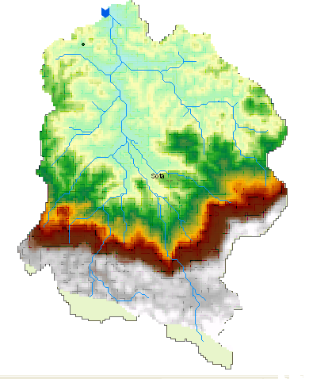

AWE Consultants PlC
November, 2016

Contents
Executive Summary 7
1. Background 8
2. Objectives 8
3. Justification 9
4. Materials, Methods and Period of Investigation 9
4.1 Materials employed 9
4.2 Methods 9
4.2.1 Boundary Delineation: 10
4.2.2 Land form study: 10
4.2.3 Land Use/Cover: 10
4.2.4 Soil data Collection: 10
4.2.5 Climatic and agro ecological zoning 12
4.2.6 Social and Economic Situation Assessment 12
5. The Watershed Area 12
5.1 General Description of the Watershed Area 12
5.1.1 Location 12
5.1.2 Topography 13
5.1.3 Drainage Pattern 14
5.1.4 Slope 16
5.1.5 Climate 17
6. Land Capability Classification 24
6.1 Objectives of Land Capability Classification 24
6.2 Approach 24
6.3 Description of Land Capability Classes 24
7. Major Problems of the Watershed Area 26
7.1 Analysis of Soil Erosion Potential of the watershed 26
7.2 Soil Erosion Hazard 27
7.3 Gully and Stream Bank erosion 27
7.4 Population Pressure on Land Resources of the Watershed 28
8. Conservation Effort Made in the Watershed Area 28
8.1 Types of Conservation Measures Carried Out 28
8.2 Availability of Infrastructure and Manpower in the woreda 29
9. Watershed Development Strategy 29
10. Implementation Schedule 31
11. Integrated Watershed Management Plan 31
12. Manpower and Equipment Requirement 32
12.1 Manpower Requirement 32
12.2 Equipment Requirement 33
12.3. Participatory Monitoring and Evaluation System of the Watershed 33
12.3.1 Mechanism 34
12.3.2 Follow-up 35
12.3.3 Evaluation 35
13. The Plan Frameworks: Goal, Purpose, Indicators and Assumptions 36
13.1 Activity Plan for Sota Watershed Management Plan 44
13.2 Estimated Financial Expense 45
14. Identification of Research Priority 47
15. Conclusion and Recommendation 47

List of Tables
Table 1: Slope classes and their distribution in Sota watershed 16
Table 2: Thermal zone of Sota watershed 18
Table 3: Distribution of agro-climatic zones across the watershed is shown in the table 19
Table 4: Distribution and major properties of Sota watershed 20
Table 5: Land use/land cover type of Sota watershed area 22
Table 6: Land capability class of Sota watershed 25
Table 7: Soil loss of Sota watershed 26
Table 8: Population size of the watershed 28
Table 9: Soil and Water Conservation activities Carried out from 2006 – 2007 e.c 29
Table 10: Implementation phase of Sota watershed 31
Table 11: Estimated cost for Sota Watershed management Plan 45

List of Figure
Figure 1: Location map of Sota watershed 13
Figure 2: Digital elevation model and Hill shed of Sota watershed 14
Figure 3: Drainage Network Map of Sota Watershed 15
Figure 4: Slope map of Sota watershed 17
Figure 5: Thermal zone map of Sota watershed 18
Figure 6: Agro-ecological Zones of Sota Watershed 19
Figure 7: Major soils of Sota watershed 21
Figure 8: Land use/cover map of Sota watershed 22
Figure 9: Watershed Kebeles of Sota Watershed 23
Figure 10: Land capability class map of Sota watershed 25
Figure 11: Soil Loss class map of Sota watershed 27
Figure 12: Watershed management plan for Sota watershed 32

ABBREVIATIONS
ACZ Agro-climatic Zone
CSA Central Statistical Agency
DEM Digital Elevation Model
GCP Ground Control Points
GPS Global Positioning System
Ha Hectare
FAO Food and Agricultural Organization of the United Nations
ISSS International Soil Science Society
M.a.s.l meter above sea level
TM Thematic Mapper
WRB World Resources Base

Executive Summary
Sota watershed is situated in Bedele district, Buno Bedele Zone, in Oromia Regional State. The watershed geographically lies between 8⁰.14’ and 8⁰.22’ N latitude and 36⁰.13’ and 36⁰.19’ E longitude. It covers a total area of 156.29 square kilometer of land.
The watershed has a regular dendriatic shape with its narrow width at the downstream and wider at the upstream. It is also have a computed area of about 10,005.78 hectare; the longest flow length of the watersheds reaches about 14.2 km.
Dystric Gleysols and Dystric Nitisols are the dominant soil types occurred in the area. Nitisols are mainly distributed over sloppy areas covering an area of about 5543.24 hectare, constituting about 55% of the watershed. The second dominant soils of the watershed is Dystric Gleysols, which are occurred on flat land and occupied about 45% of the watershed or 4462.54, while Leptosols are occurred on very steep and escarpment area.
The major farming system in the study area is composed of cereal, and enset farming system, which is characterized by cultivation of cereal and livestock raring. High rainfall and relatively fertile soils provide excellent environmental conditions for on-farm tree production.
In areas near the forest edge there are many fragments of remnant natural forest. These patches are often only a few hundred hectares in extent. However, these forest fragments can and do provide a number very important goods and services to households and to communities:
According to the soil loss analysis made about 86 percent of the watershed grouped to high soil loss class and about 14 percent of the watershed grouped in to moderate soil loss class.
The analysis made under the study show that, the total quantity of estimated soil loss, which indicates the amount of soil detached from its original location and deposited within the Watershed area or transported to the surrounding hydrologic system, is about 710,957 ton /ha/yr. The mean annual soil loss of the watershed is about 71/ha/yr. the most sever loss is occurred in stream channels and the general trends of the finding indicate that soil loss increases as the slope steepness increases in the watershed.

1. Background

Soil erosion is one of the major factors affecting sustainability of agricultural production and it is a common phenomenon in the highlands of Ethiopia, which is mainly favored by human activities, is the major elicit factor for the loss of soil and caused widespread land degradation. Rapid population growth, cultivation on steep slopes, clearing of vegetation and overgrazing are the main factors that accelerate soil erosion.
Studies indicate that clearing of forests for agriculture and inadequate erosion prevention measures in the previous years have been the main causes of soil degradation in the densely populated highlands of Ethiopia (Feoli et al., 2002). Hurni (1988) from plot measurements reported a mean annual soil erosion rate of 42 t/ha/1yr or an equivalent loss of a soil depth of 4 mm/yr from cultivated fields in the central and northern highlands.
In this regard, proper management of on-site effect of soil erosion reduces the risks and negative impacts of downstream water resources due to water erosion. Tackling the on-site effects of soil erosion requires an understanding of the rates of erosion processes as well as identification of the major controlling factors that aggravate or reverse the processes.
So this particular study will distinguish the potential causes and the associated reasons behind the respective causes and prepare Watershed management plan. Integrated watershed management plan is the process of evaluating, planning, restoring, and organizing land and other resource use within a watershed to provide desired goods and services while maintaining a sustainable ecosystem. This process provides a chance for agencies and stakeholders to balance diverse goals and uses for environmental resources, and to consider how their cumulative actions may affect long-term sustainability of these resources.

2. Objectives

The specific objectives of the project include:
- To propose appropriate interventions in order to reduce soil erosion on the upstream and the sediment deposition on the downstream will be controlled.
- To undertake integrated watershed development activities in the sub-watershed and formulate an implementable project designs which will contribute to the livelihood improvement in the watershed.
- To propose different activities to improve vegetation cover and increase availability of various tree resources in the watershed areas by promoting plantation of tree species to enhance appropriate conservation.
- To assess the root causes of land degradation in the watersheds and identify proper conservation techniques that contribute to reduce soil erosion and improve infiltration rate to enhance the ground water recharge.
- To assess the previous activities on soil and water conservation and identify the gaps and incorporate to the project components for implementation.
The watershed study is part of the overall irrigation development study and is aimed to prepare integrated watershed management plan of the watershed.

3. Justification

A sound watershed management plan will provide the frame for harmonizing economic development and natural resources conservation. It will also integrate socio-economic and cultural realities, institutional structures and the biological aspects into upland protection and conservation in order to attain sustainable development.
A watershed management plan provides actions to
- protect a watershed or prevent damage to it
- mitigate the effects of land use to an acceptable level
- restore degraded environments
- optimize the availability of water resources
In this regards, this particular integrated watershed management plan will be based on a complete inventory of the Watershed bio-physical social, economic and human resources. The objectives of the plan will not be limited to prevention of watershed degradation but also attaining increased production from the land on a sustained basis and a general improvement of the standard of living for the people living in the Watersheds must be an integral part.
Moreover, the watershed management plan will be a comprehensive development of a watershed so as to make productive use of all its natural resources and protect them from further degradation. This includes land improvements, rehabilitation and other technical works as well as the human considerations.

4. Materials, Methods and Period of Investigation

4.1 Materials employed
The methodologies used to analyze the physical features of the study area was mainly based on the GIS and Remote Sensing method of spatial data input, structuring, integrating, transforming and producing outputs. For this purpose, ArcGIS 10.0, Idrisi 32 and ERDAS IMAGIN 9.1 and PC ArcInfo software were used.

4.2 Methods
The bio-physical features of Sota watershed involved the main steps include but not limited to the collection, structuring, digitizing, encoding of basic geo-datasets and generating the new data sets such as:
- Administrative boundaries (Regional, Zonal, Wereda and Kebele);
- Delimit the watershed and sub watershed boundaries;
- Generate contour map at 20 meters intervals;
- Develop digital elevation model of the watershed;
- Drainage systems;
- Land use and land cover based on Land sat imagery of 2015, respectively;
- Soils data;
- Population data;
- Climatic data (rainfall, temperature, etc); and
- Agro-climatic and ecological Zoning.

4.2.1 Boundary Delineation:
The kebele administrative boundary layers of the watersheds will be extracted from the spatial data recently updated by the Central Statistical Agency (CSA) and confirmed by Oromia regional state. The watershed boundary, which followed the natural hydrological system, and the drainage systems of the sub-watershed were generated from the larger spatial resolution (20mx20m) Digital Elevation Model (DEM) of the study area.

4.2.2 Land form study:
Topographic information will be produced from EMA’s analog topographic maps of 1:50,000 scales. The data sets helped to generate DEM, altitude ranges, slope gradients, slope length, relief types, analytical hill shading, etc. In all respects, such information will have added values for subsequent study of soil loss assessment. The population figures will be collected from the census of the CSA.

4.2.3 Land Use/Cover:
The land use and land cover map layers were generated from the Landsat image of 2015. The classification will involve both supervised and unsupervised methods. Appropriate size of representative training areas will be selected based on the pixels demonstrating regular patterns. The training samples will be used for the classification of Landsat TM image data. While the actual samples will be collected using the GPS receiver and the data will be utilized to classify the image.
The geometric registration process entail identification of geographic features on the image known as ground control points (GCPs), whose position were known such as intersection of streams, roads, and other easily recognizable natural and artificial features etc., in the image, and matching them to their true position in ground coordinates. The geometric correction of the separate scenes was conducted using ground control points of known co-ordinate from a topographic map of 1:50,000 mapping scale with the method called image-to-map registration. Several well-distributed GCP pairs were identified and the coordinate information was processed to determine the proper transformation.
After performing desktop preliminary classifications, ground truthing was done covering almost 70 percent of the entire area, which is almost homogenous in the rugged and flat parts of the watersheds. At that stage, the work mainly focused on areas somehow reflecting heterogeneous green patterns and steeper slopes. In order to have fuller views, the study paid particular attention to visiting the vegetation in the mountainous areas.

4.2.4 Soil data Collection:
The soil data, which will consist of the major soil property include: dominant soils, textures and depth and management constraints, will be generated from secondary information and consequently verified through intensive field survey and will be classified according to FAO/ISSS/WRB guideline, 1988.
In association with, the land capability assessments, the data layer will be employed for modeling and assessment of potential erosion hazard via computing soil erodibility factor.
To determine the areas currently suffering from soil erosion, the Revised Universal Soil Loss Equation (USLE) adapted for Ethiopia was used. The RUSLE uses six sets of factors to calculate soil loss in tons per hectare per year:
- Erosivity of rainfall – R factor
- Erodibility of soil –K factor
- Slope gradient - S factor
- Slope length – L factor
- land cover – C factor
- land management – P factor

The study will obtain these values for the factors from data sets to be established with in GIS environment. The rainfall erosivity factor of the Revised USLE will be applied to 90s DEM map of mean annual rainfall and the soil erodibility factors will be applied to FAO soil units identified on the upgraded soil map of the watershed.
The universal soil loss equation as empirical model was developed by Wischmeir and Smith (1978) to estimate soil erosion from fields. Mathematically the equation is denoted as:
A = R * K * L * S * C * P
Where A is the mean annual soil loss (tons/ha/year), R is the rainfall erosivity factor, K is the soil erodability factor, L is the slope length factor, S is the slope steepness factor, C is the crop management factor and P is the erosion control practice or land management factor.
R = 0.5 * P (in US unit) and R = 0.5 * P *1.73 (in Metric unit). [Roose (1975) cited in Morgan (1994)]
K = ranges from 0 to 1. Hellden (1987) developed a USLE for Ethiopian condition by adapting different sources and proposed the K values of the soil based on their color.
LS = (X/22.1) ^{m} (0.065 + 0.045 S + 0.0065 S²)
Where X = slope length (meters) and S = slope gradient (%), and m = slope coefficient (0.2 – 0.5).
C = an average C value of 0.25 was used for intensively cultivated cropland, 0.20 for moderately cultivated and 0.05 for open grassland.
P = the value of P ranges from 1.0 for up and down cultivation to 0.25 for contour strip cropping of gentle slope.

Soil Loss Rate Map
A=LS*R*K*C*P (t/ha/yr)
Reclassify
RUSLE Input values
DEM data
Annual Rainfall data
Soil Data
Land Use/Cover Data
Land Management data
Slope ppe
Flow Direction
Flow Accumulation
LS factor
R factor
K factor
C factor
P factor

Figure1. Flow chart showing analysis of soil loss based on GIS application

4.2.5 Climatic and agro ecological zoning
The climate and agro-ecological zone data will be collected from the available secondary sources of the National Meteorological Service Agency together with 90s DEM. The zoning process will be conducted through GIS environment.

4.2.6 Social and Economic Situation Assessment
Semi structured Interviews and group discussions will be made with farmers especially in areas that demonstrated significant changes over the last three decades. In this regard, there was no sampling technique applied for interviewing purposes, as more emphasis was primarily made on group discussions than individual responses. During group discussions, elders provided adequate analytical view on their accumulated observations and experiences of the areas they lived in since their childhood.
In general, the interviews and group discussions paying attention on:
- Land cover pattern;
- Categories of land use/land cover and their extent before the decades;
- Crop production, productivity trends and related reasons;
- Measures practiced to improve land productivity;
- Existing farm management practice;
- Existence of tree planting and management practice;
- Alternative household energy sources;
- Understanding on the existence of and experiences with soil erosion;
- Local and institutional practice of protecting soil erosion.

5. The Watershed Area

5.1 General Description of the Watershed Area

5.1.1 Location
Sota watershed is situated in Bedele district, Ilu Aba Bora Zone, in Oromia Regional State. The watershed geographically lies between 8⁰.14’ and 8⁰.22’ N latitude and 36⁰.13’ and 36⁰.19’ E longitude. It covers a total area of 156.29 square kilometer of land.
The project area is accessed by all-weather rough road which provide access to the interiors of the project area.
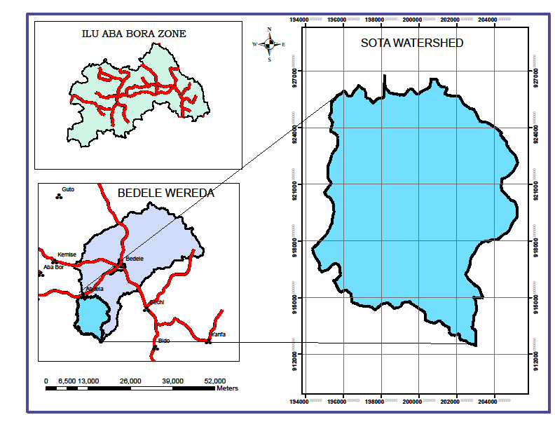
Figure 1: Location map of Sota watershed

5.1.2 Topography
The Sota watershed is a medium to high relief area with different types of land forms. Elevation of the area ranges from 1972 meters at the northern tip of the watershed and at the bottom of the watershed reaches up to 2423 meters. Sota River is the major river of the watershed. It has different intermittent tributary Rivers.

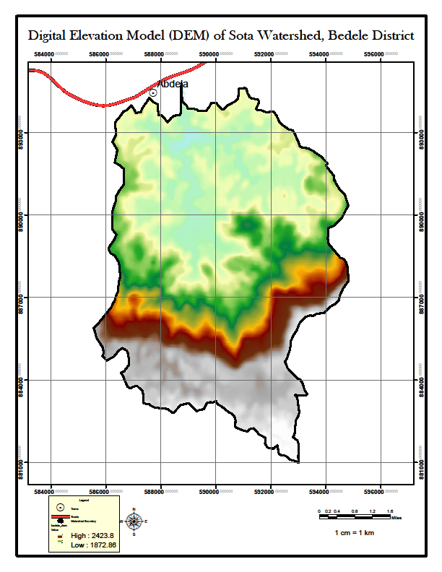
Figure 2: Digital elevation model and Hill shed of Sota watershed

5.1.3 Drainage Pattern
The watershed has a regular dendriatic shape with its narrow width at the downstream and wider at the upstream. It is also have a computed area of about 10005.78 hectare; the longest flow length of the watersheds reaches about 14.2 km.
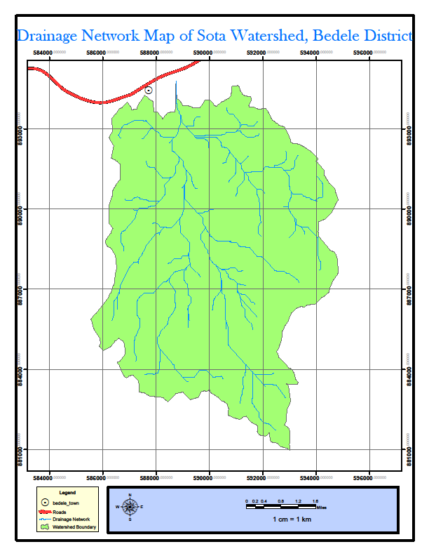
Figure 3: Drainage Network Map of Sota Watershed

5.1.4 Slope
Based on the national guideline of Community Based Watershed Development, slope computation had also been made with six classes. The Guideline suggests the use of such classification for soil and water conservation and other land management recommendations. In most cases, slopes over 8.0 percent are generally recommended for relevant conservation interventions according to the landscape and physical human activities. Accordingly, 81.28 percent of the sub-watersheds area (Table. 2) could be designated for various natural resources management programs under the existing conditions of the watershed.
Table 1: Slope classes and their distribution in Sota watershed
No | Slope Gradient (%) | Slope Class | Area in Hectare | Percentage
1 | 0 to 3 | Flat or almost flat | 4368.13 | 44
2 | 3 to 8 | Gently sloping | 3451.13 | 34
3 | 8 to 15 | Sloping | 1903.13 | 19
4 | 15 to 30 | Moderately steep | 268.13 | 3
5 | 30 to 50 | Steep | 15.26 | 0.15
 |  |  | 10005.78 | 100
Source: Computed in GIS, 2016.
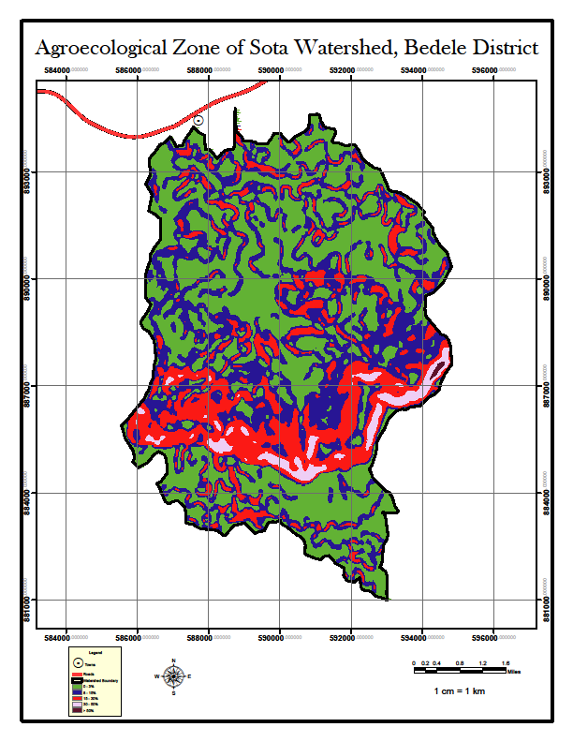
Figure 4: Slope map of Sota watershed

5.1.5 Climate

5.1.5.1 Rainfall Distribution
According to the Bedele weather station, the watershed area receives an annual rainfall ranging from the minimum of 1700 mm in low rainfall year and the maximum of 2100 mm in the high rainfall year. It has a bimodal rainfall pattern where the two season merging together.

5.1.4.2 Thermal Zones
Temperature during growing period, which refers to the amount of temperature available for plant growth and development during the growing period, usually defined by the mean daily temperature during the growing period (Berhanu, 1999). Accordingly, the maximum temperature registered in the station is ranging between 20.0ºc and 15.0 0c, while the minimum temperature is ranging between 15 0c and 11.30c. The watershed area classified in to a Tepid, and Cool zone. About 71% of the watershed area belongs to tepid thermal zone with altitude range between 1872 and 2400m.as.l. On the other hand about 29% of the area belongs to cold thermal zone.

Table 2: Thermal zone of Sota watershed
No | Thermal Zone | TEMPRATURE | %age | Area in Hectare
1 | Cool | 15-17.5 | 29 | 2928.29
2 | Tepid | 17.5-20 | 71 | 7077.49
 |  |  | 100 | 10005.78
Source: Computed in GIS, 2016.

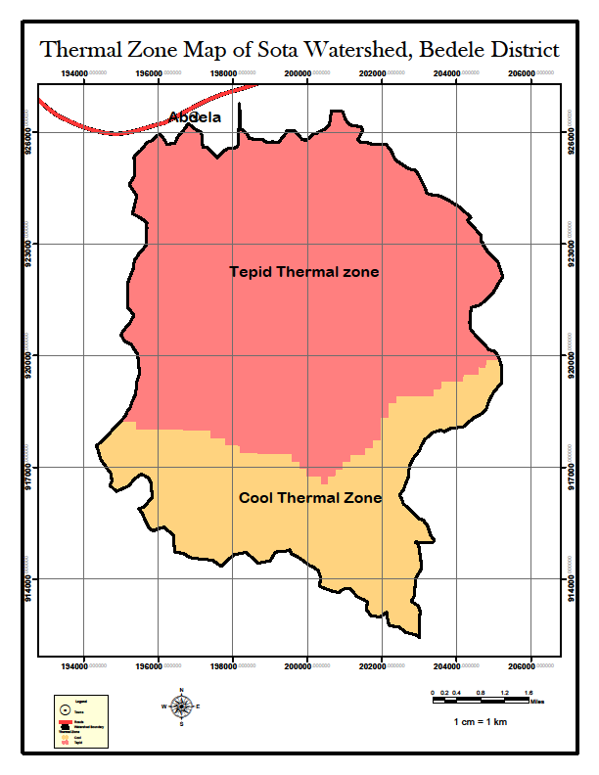
Figure 5: Thermal zone map of Sota watershed

5.1.4.3 Traditional Agro ecological Zone (TAEZ)

The study areas fall within the wet lower dega and wet Weyna dega traditional agro-ecological zones. According to the Ethiopian growing season classification, the watershed is characterized by its longest length of growing period (LGP), which is above 210 days with no drought risk. The mean potential evapo-transpiration is about 1430mm

Table 3: Distribution of agro-climatic zones across the watershed is shown in the table
No | Agro ecological Zone | Altitude Range (m.a.s.l) | Percentage | Area in Hectare
1 | Wet Lower Dega | 2300 - 2423 | 18 | 1831.01
2 | Wet Weyna Dega | 1872 - 2300 | 82 | 8174.76
 |  |  | 100 | 10005.77
Source: Computed in GIS, 2016
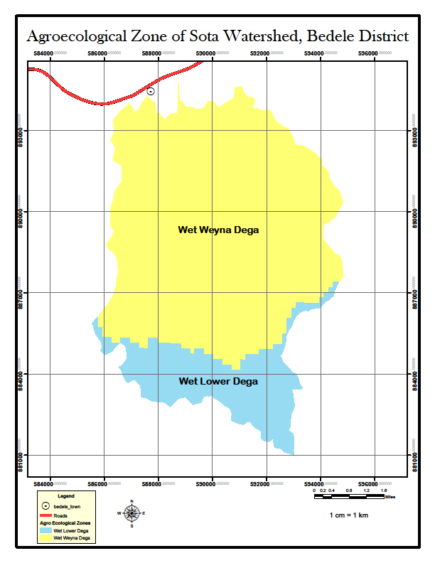
Figure 6: Agro-ecological Zones of Sota Watershed

5.1.4.4 Soils
Soil map of the watershed is produced based on existing soil maps (WBISPP AND SOTER) through intensive reconnaissance field survey (FAO/ISSS/WRB, 2006). Accordingly, Dystric Gleysols and Dystric Nitisols are the dominant soil types occurred in the area. Nitisols are mainly distributed over sloppy areas covering an area of about 5543.24 hectare, which is about 55% of the watershed. The second dominant soils of the watershed is Dystric Gleysols, which are occurred on flat land and occupied about 45% of the watershed or 4462.54, while Leptosols are occurred on very steep and escarpment area. The distributions of major soils of the watershed are described in the following table (Table 5).
Table 4: Distribution and major properties of Sota watershed
No | Major Soils | %age | Area in Hectare
1 | Dystric Gleysols | 45 | 4462.54
2 | Dystric Nitisols | 55 | 5543.24
 |  | 100 | 10005.78
Source: Result of Field Survey & SOTER revised map (FAO/ISSS/WRB, 2006), 2016

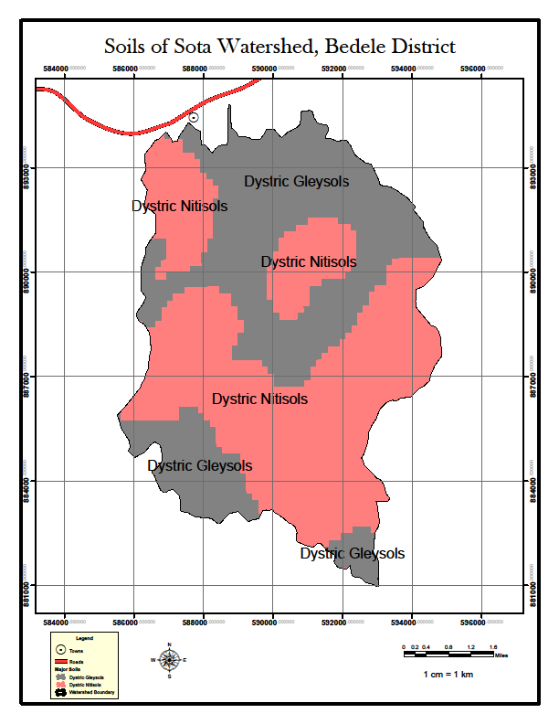
Figure 7: Major soils of Sota watershed

5.1.4.5 Vegetation
The vegetation assessment of the area revealed that the watershed is endowed with a variety of both indigenous and exotic species. The dominant indigenous tree species include: podocarpus falacatus, cordial africana eur, croton macrostachyus, Oliea europaea, Borassus aethiopum, ricinus communis, rhombus prinoides, eucalyptus spp, etc. Vegetation and land use assessment was carried out using Landsat ETM+

5.1.4.6 Present Land Use/land cover
The major land use identified includes: open forest occupy 3361.18ha, moderately stocked woody plants about 6127.33 hectare, and moderately cultivated land comprised about 512.67 hectare. Detail descriptions of the major land use/cover of the watershed area are given here below:

Table 5: Land use/land cover type of Sota watershed area
No | Major Land Use | %age | Area in Hectare
1 | Moderately stocked woody plants | 61 | 6127.33
2 | Moderately Cultivated Land | 5 | 517.27
3 | Open forest cover | 34 | 3361.18
 |  | 100 | 10005.78
Source: Field interpretation of Landsat ETM+, 2015
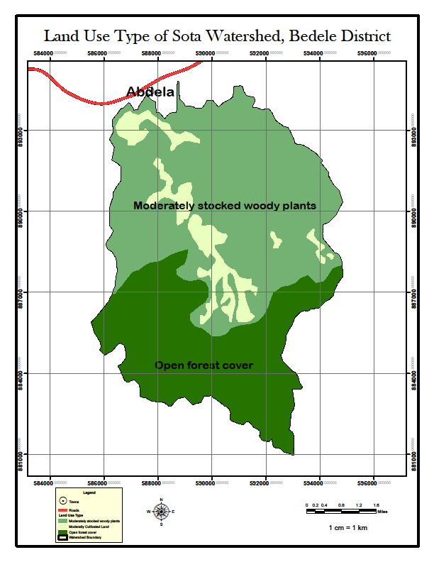
Figure 8: Land use/cover map of Sota watershed

5.1.4.7 The Land use System
The major farming system in the study area is composed of enset and forest farming system, which is characterized by cultivation of cereal and livestock raring. High rainfall and relatively fertile soils provide excellent environmental conditions for on-farm tree production.
In areas near the forest edge there are many fragments of remnant natural forest. These patches are often only a few hundred hectares in extent. However, these forest fragments can and do provide a number very important goods and services to households and to communities:
However, if these fragments are to continue providing these important goods and services then effective community management systems need to be established.

5.1.4.8 Human Population Distributions
According to the projected population data, the total number of people living in 12 watershed kebeles reaches about39, 389 persons and about 6996 households.
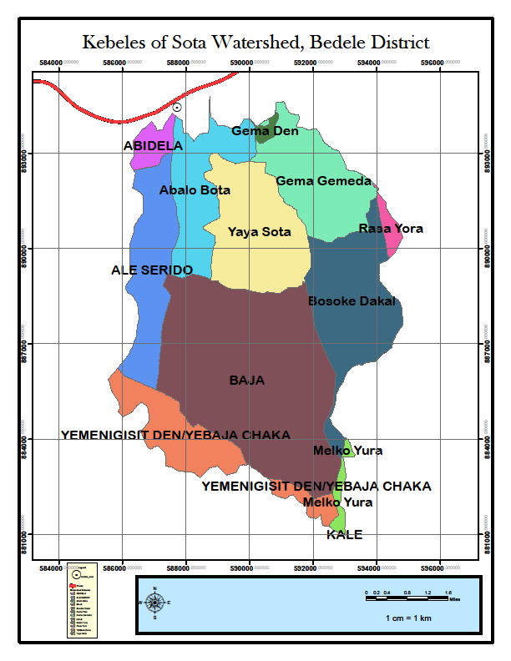
Figure 9: Watershed Kebeles of Sota Watershed

5.1.4.9 Livestock Population Distribution
The livestock population distribution of the watershed includes: cattle, sheep, goats, horse, donkeys, and mule each constitutes 56.9 percent, 27.93 percent, 6.03 percent, 5.43 percent, 2.07 percent and 0.4percent, respectively ( wereda livestock population data).

6. Land Capability Classification

6.1 Objectives of Land Capability Classification
The main objectives of capability grouping of soils are:
- To make possible broad generalizations based on soil potentialities, limitations in use, and management problems;
- Identifying areas for specific land uses;
- Defining management options;
- Providing information for detailed planning and strategy for development; and
- Identifying areas at risk of degradation.

6.2 Approach
The approach followed in land capability classification based on grouping of arable soils according to their potentialities and limitations for sustained production of the common cultivated crops that do not require specialized site conditioning or site treatment. Non-arable soils (soils unsuitable for long-term sustained use of cultivated crops) are grouped according to their potentialities and limitations for the production of permanent vegetation and their risks of soil damage if mismanaged.
The classification system based on USDA land capability classification comprises eight land capability classes ranked in the order of increasing degree of limitation in relation to agricultural use, and decreasing order of agricultural versatility. Class I is the best land and Class VIII the poorest. Class IV is considered marginal for cropping activities.

6.3 Description of Land Capability Classes
The result of land capability classification is shown that about 33 percent of the watershed is classified to class I, covering an area of 3282.59hectare of land. Detail description of the land capability classes are presented here below.
Class I: Soils in this class are suited to a wide range of plants and can be used safely for cultivated crops, pasture, range, woodland, and wildlife. The soils are nearly level and erosion hazard is low. They are deep, generally well drained, and easily worked. The area grouped in to class I covers a total of 3282.59 hectare, which is about 33 percent of the watershed
Class III: Soils in this class have severe limitations that reduce the choice of plants and require special conservation practices. The unit characterized by: Moderately steep slopes; high susceptibility to water erosion or severe adverse effects of past erosion; frequent overflow, very slow permeability of the subsoil. The total area of the class covers about 3032.45 hectare of land.
Class IV: Soils in this class have very severe limitations that restrict the choice of plants, require very careful management. Steep slopes, severe susceptibility to water or wind erosion, severe effects of past erosion, shallow soils, low moisture-holding capacity, frequent overflows. The total area of the class covers about 1847.23 hectare of land.

Class VI: Soils in class VI have severe limitations that make them generally unsuited to cultivation and limit their use largely to pasture or range, woodland, or wildlife habitat. Major limitation include: Steep slope, severe erosion hazard, effects of past erosion, stoniness, and shallow rooting zone. The total area of the class encompass about 1843.51hectare of land.
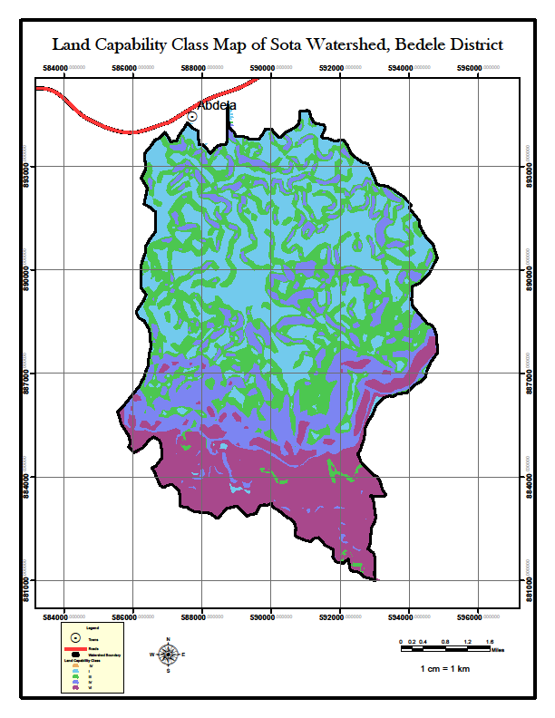
Figure 10: Land capability class map of Sota watershed
Distribution of land capability classification of the watershed area is shown here below.
Table 6: Land capability class of Sota watershed
No | Land Capability Class | Area in Hectare | Percentage
1 | I | 3282.59 | 33
2 | III | 3032.45 | 30
3 | IV | 1847.23 | 18
4 | VI | 1843.51 | 19
 | Total | 10005.78 | 100
Source: Computed in GIS, 2016

7. Major Problems of the Watershed Area
Major problems of the area are summarized in to soil erosion and consequent land degradation, loss of vegetation cover, poor soil fertility, high population pressure and other socio economic problems. Soil erosion is generally more acute problem in the watershed area due to high rainfall intensity and soils are highly erodible attributable to the relatively shallow depth and low structural stability.
In this particular incidence, soil erosion is a common phenomenon in the area, where it causes widespread soil degradation. Rapid population growth, cultivation on steep slopes, clearing of vegetation and overgrazing are the main factors that accelerate soil erosion in watershed. Such unsustainable and exploitative land use practices due to an increasing demand for food and fodder by the growing human and livestock populations are responsible for accelerated soil erosion in many parts of the watershed area. Those practices reduce the protective plant cover, thereby exposing the soil surface to the destructive impact of high-intensity rainfall.

7.1 Analysis of Soil Erosion Potential of the watershed
According to the soil loss analysis made about 86 percent of the watershed grouped to high soil loss class and about 14 percent of the watershed grouped in to moderate soil loss class.
The analysis made under the study show that, the total quantity of estimated soil loss, which indicates the amount of soil detached from its original location and deposited within the Watershed area or transported to the surrounding hydrologic system, is about 710957 ton /ha/yr. The mean annual soil loss of the watershed is about 71/ha/yr. the most sever loss is occurred in stream channels and the general trends of the finding indicate that soil loss increases as the slope steepness increases in the watershed.
Table 7: Soil loss of Sota watershed
No | Erosion Class | Area in Hectare | Soil loss (t/ha/yr) | Percentage | Total annual Soil loss
1 | Moderate | 1413.25 | 31-50 | 14 | 57,943.25
2 | High | 8592.53 | 51-100 | 86 | 653,032.28
 |  | 10005.78 |  | 100 | 710,975.53
Source: soil loss computation in GIS, 2016
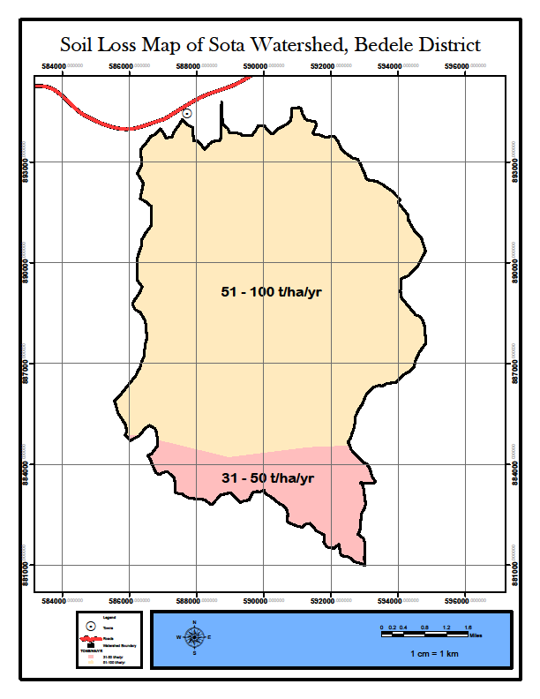
Figure 11: Soil Loss class map of Sota watershed

7.2 Soil Erosion Hazard
Categorization of different erosion potentials was made following the FAO basic classification of desertification (FAO 1986). In line with this, the study area classified in to eight severity classes (Table11). Soil loss tolerance (SLT) denotes the maximum allowable soil loss that will sustain an economic and a high level of productivity (Wischmeier & Smith, 1978; FAO & UNEP., 1984), in this regard, the normal SLT values range from 5 to 11 tons/ ha/yr (Renard, Foster, Weesies, McCool and Yoder, 1996) The entire area of the watershed is higher than the SLT.

7.3 Gully and Stream Bank erosion
Gullies of various sizes of width and depth have been identified in the watershed. Beside its negative effects on soil resources, consuming crop and grazing lands in areas between the gullies and reducing grazing land available for livestock. Gully erosion is observed in different land use but their intensity is high in cultivated land. Assessment of gully development and its intensity is intended to design reliable conservation measures for already existed gullies and controlling strategies for those areas susceptible to gully formation. Due to the mapping scale factor, the survey outlined the buffer area around streams of varies level where gully and stream bank erosion occurred in the watershed. Additionally, it is recommended that further mapping of gullies at very larger and workable scale is required.

7.4 Population Pressure on Land Resources of the Watershed

The study carried out projection of the watershed population employing the CSA, 2007 census data as a base year. Consequently, the watershed inhabited with a total population of about !The Formula Not In Table of which is distinguished as rural dwellers. Average farm family size in the study area ranges from 4.9 to 5.9, the average being 5.0 members. The crude population density of the watershed in the year 2016 is approximately about 129.3 persons per sq km, while in the projected year 2025 the population density will grow to be 144.4 persons per sq km. The population data analysis show that the current average land holding of the watershed, which is 0.5 hectare, will be reduced to 0.23 hectare in the projected year 2025.The total number of household in the watershed area is estimated to be 6996.
Table 8: Population size of the watershed
Name of Kebeles | No of House holds | Average Family Size | Population Size for the year 2016 |  |  | Population Size for the year 2025 |  |  | Area km2 | Dens 2016  per/km² | Dens 2025 per/km²
Name of Kebeles | No of House holds | Average Family Size | Both sex | Male | Female | Both sex | Male | Female | Area km2 | Dens 2016  per/km² | Dens 2025 per/km²
Abdela | 1045 | 5.2 | 5461 | 2731 | 2730 | 6194 | 3098 | 3096 | 21.3 | 256 | 290
Ale Serdo | 540 | 5.4 | 2937 | 1459 | 1420 | 3266 | 1655 | 1611 | 17.3 | 170 | 189
Baja | 757 | 5.2 | 3901 | 1954 | 1870 | 4337 | 2216 | 2121 | 33.5 | 117 | 130
Baja forest | 50 | 5.5 | 274 | 133 | 135 | 304 | 151 | 153 | 0.0 | 0 | 0
Kale | 685 | 5.3 | 3607 | 1734 | 1802 | 4010 | 1966 | 2044 | 37.4 | 96 | 107
Abalo Sota | 506 | 5.8 | 2944 | 1471 | 1414 | 3273 | 1669 | 1604 | 14.1 | 208 | 232
Yaya sota | 375 | 5.9 | 2200 | 1083 | 1073 | 2446 | 1229 | 1217 | 12.7 | 173 | 192
Gema Gemeda | 777 | 4.9 | 3770 | 1849 | 1847 | 4192 | 2097 | 2095 | 18.9 | 200 | 222
Raso Yora | 343 | 5.6 | 1909 | 931 | 940 | 2123 | 1057 | 1066 | 19.0 | 100 | 112
Bosoke Dakal | 598 | 5.5 | 3290 | 1620 | 1605 | 3658 | 1837 | 1821 | 0.0 | 0 | 0
Melko Yura | 409 | 5.3 | 2179 | 1075 | 1061 | 2423 | 1219 | 1203 | 21.3 | 102 | 114
 | 6086 | 5.0 | 32472 | 16040 | 15897 | 36226 | 18194 | 18031 |  | 118.5 | 132.33
Source: population projection

8. Conservation Effort Made in the Watershed Area
Based on the data collected from Woreda Office for Agriculture and Rural Development, the key effort made by the office in soil conservation activities are summarized in the next section of the report.

8.1 Types of Conservation Measures Carried Out
The Wereda Agriculture and Rural development office under its Natural Resources Development, Conservation and Utilization key process owner carried out the following major soil and water conservation activities for the last three years.

Table 9: Soil and Water Conservation activities Carried out from 2006 – 2007 e.c
No | Activities | Unit | Year of Achievement
No | Activities | Unit | 2006 | 2007 | 2008
1 | Terrace Construction |  | 7956 | 7698 | 7736
2 | Cut off drain |  | 216 | 148 | 26843
3 | water way |  | 96 | 150.8 | 16,650
4 | Micro basin |  | - |  | 8962
5 | Check dam |  | 9741 |  | 2126
6 | Trench |  |  |  | 1543
7 | Vitiver grass planting |  | 3563 | 2359
8 | Forest seedling plantation |  | 4,714,000 | 5,290,000 | 4,296,500
9 | Conservation tree planting |  | 635,000 | 1,512,000 | 1,260,500
10 | Fodder tree planting |  | 1,827,000 | 5,604,000 | 3,335,000
11 | Fruit tree planting |  | 136,500 | 233,800 | 353,500
Source: Bedele Wereda Agriculture and Rural Development Office Report, 2008 E.C

8.2 Availability of Infrastructure and Manpower in the woreda
Natural Resources Development, Conservation and Utilization key process owner has four soil and water conservation staff. The owner under its authority has managed two seedling nurseries. The nurseries have the capacity to produce about 2,000,000 seedlings each. The watershed can be crossed only on foot, so it requires building all weather gravel road that can serve throughout the year.

9. Watershed Development Strategy
Since watersheds are shaped by complex ecological relationships and diverse social systems that are continually responding to dynamic economic, social and cultural forces, watershed planning must first and foremost be an interdisciplinary process. It will require technical expertise in geology, hydrology, biology, ecology, engineering, environmental science, resource management, social science and rural development planning.
It must also strive to relate these processes to the human factor. It should address linkages between land use and water management, upland watershed issues and downstream concerns, public values and economic natural resource use, community well-being and sustainable watersheds, short term activities and long term sustainability issue.
Consideration of these issues requires participation not only by different agencies but also by farmers, businesses, environmental groups, and technical specialists from the profit and non-profit sectors, disadvantaged communities and the general public.
Having in mind all these factors, the anticipated integrated watershed management plan will consider the following bench mark issues:
Recognize and address multiple perspectives, issues, and objectives, including local, regional, and federal concerns of environmental, economic, and social nature.
Integrate and coordinate planning, management, monitoring, and community activities across agencies, and nongovernmental entities.
Provide for inclusive and participatory involvement by all agencies and all stakeholders to ensure meaningful input, including disadvantaged or hard to reach communities and stakeholders.
Use or provide at least a minimum level of assessment early in the process to provide a scientific foundation for moving forward.
Allow for a long-term, phased implementation strategy while managing for shorter term project delivery.
Develop a monitoring strategy for projects to provide scientifically valid information about effectiveness and to determine if overall plan is meeting stated objectives.
Establish a process for ongoing, informed decision-making through adaptive planning, management, and monitoring.
A watershed plan does not need to offer all the answers. Instead, it can lay out a long-term process towards finding answers and improving solutions and a long-term system of acquiring new information on key issues and trends to modify the management program. Moreover, watershed as a complex dynamic system will require time, information, and resources to manage. Hence, the study suggest to follow the program approach of watershed plan and management, in short term the study identified major programs that could give instant effect to the rehabilitation endeavor and that would pave the way to future sustainable management of the watershed.
In order to realize the planned programs, sustainable funding strategies will be explored by the leading offices, identifying additional sources, opportunities for leveraging resources, and long-term strategies for generating funds. A long-term perspective will also focus on conflict resolution and make the implementation less discouraging.
In order to ease implementation of the watershed development plan; the watershed need to be divided into smaller sub-watersheds. Each sub-watershed as a hydrological unit is connected, and any modification of the land use in watershed or sub-watershed will reflect on the water as well as sediment yield of the overall watershed. Accordingly, the Sota watershed will classified in to micro-watershed or sub-watershed, in concurrence with Ethiopian Soil and Water Conservation Manual, which recommend the minimum area to be treated as micro watershed is about 500 hectare of land; as a matter of fact it depends on particular site condition.

10. Implementation Schedule
Recognizing the fact that watershed management is a Long-term perspective, which can provide a more realistic basis for sustainable management of the natural resources. The planned implementation schedule will accommodate the physical and monetary challenges of the planning process. Implementation will be based on micro watersheds in a nested fashion, accompanied by monitoring and evaluation.
The major activities planned to develop the watershed are sequenced into three successive phases, namely: preparatory and inception phase, implementation phase and consolidation phase. In view of the benchmark, magnitude of land degradation and the scope of the planned measures, the study suggests five years timelines for watershed plans implementation. The implementers should align their time horizons with regional and local development plan to increase the chance of integration with those plans.
Table 10: Implementation phase of Sota watershed
Phase | Name | Duration
I. | preparatory and inception phase | 1year
II | Implementation Phase | 3years
III | Consolidation Phase | 1 years
Total Implementation Year |  | 5 Years

11. Integrated Watershed Management Plan
Based on the finding of study the watershed management plan incorporated the following programs. It includes:
- Soil and Water Conservation program
- Agro Forestry and Forestry Program
- Livestock development Program
- Capacity Development Program
The spatial distribution of the program is depicted on the map here below

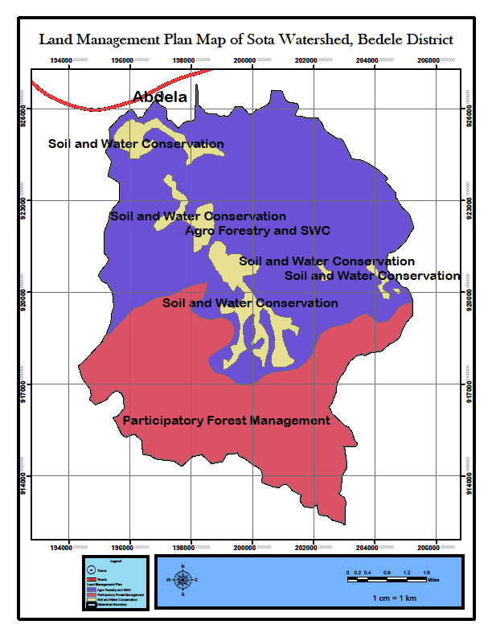
Figure 12: Watershed management plan for Sota watershed
In order to give much emphasis to gully erosion the survey outlined the buffer area around streams of varies level where gully and stream bank erosion occurred in the watershed.

12. Manpower and Equipment Requirement

12.1 Manpower Requirement
Implementation of the proposed program will be according to the national community based participatory watershed development guideline. The responsibility to plan and implement the Watershed development program will be accord to the Bedele wereda office for Agriculture and Rural Development.

Within the context of this guideline and taking into account practical factors, there should be a group of “Core Wereda Watershed Team” (WWT) experts assigned to support and follow-up Participatory Watershed Development work and technical issues. Additional experts can be assigned by the wereda to further strengthen the WWT as per the expansion of watershed planning in various kebeles, the range of activities and integration required. Under ideal conditions, the wereda core team is composed of 10 experts as follows:
Composition of the wereda core team:
- Soil Conservation Expert,
- Forestry/Agro-forestry Expert,
- Agronomist,
- Irrigation Expert,
- Home Agent,
- Livestock Expert,
- Land Use and Administration Expert,
- Food Security Expert (Economist/Socio-economist/Agro-economist),
- Cooperative/Marketing and Inputs Expert, and
- Rural Road Construction Expert
In addition to this, appropriate institutional arrangements should be made ranging from the region to the village level.
Moreover, participatory monitoring and evaluation of the program will be part and parcel of the program implementation.

12.2 Equipment Requirement
The planned land management programs require technical equipments as well as hand tools that would be able to accomplish the programs. Inventory of technical equipments and hand tools, which is existed and requested by the WARD office, are described in the table (Tab 15) here below.

12.3. Participatory Monitoring and Evaluation System of the Watershed

For the watershed in consideration, a monitoring and evaluation system will be built into the programs; in order to enable periodic appraisal of the project's performance, physical outputs, benefits, expenditures and impacts. There will be both internal and external M & E interventions. Monitoring activities will be periodic and more frequent and the program evaluation will take place once after every phase completed in the form of reviewing the performance of the phase. In view of the nature of the watershed program, the participation of community-based committees, technical experts of key stakeholders, a multidisciplinary team from the BoARD and the Wereda ARDOs will be involved.

12.3.1 Mechanism
The M&E mechanism will be based on the watershed management objectives. The monitoring system will include process and outcome monitoring.
Accordingly, the mechanisms should include the following:
A data base and monitoring sub-unit should be established within the Watershed Management Unit at the Wereda ARDOs to collect, collate and analyze data for the use of evaluations, which can be done by using computers;
The project's annual and final reports will incorporate M & E results; in which achievements should be clearly set out and compared to the bench mark.
Independent evaluations will be carried out after the project is completed. Because of the long-term effects of watershed works, these evaluations though difficult, are often useful. Depending upon the availability of data and resources, the whole or part of the watershed implementation will be evaluated periodically.
The general methodology will include the following major indicators of the watershed program(s):

12.3.1.2 Erosion and Sediment Reduction:
Setting hydro-meteorological measuring points to collect and monitor rainfall, stream flow and sediment data for long-term analysis and comparison;
Making sediment trap reservoir profile surveys to obtain data on sedimentation rates and volumes;
Establishing small plots on major soils and cropping systems with and without conservation measures to monitor and evaluate differences in soil erosion and runoff;
Conducting sample surveys for special purposes or for needed information.

12.3.1.3 Land Use/Cover Monitoring (it includes forest monitoring):
For monitoring changes in land use and vegetative cover, it would be necessary to obtain satellite remote sensing data and make studies on periodic changes during the life of the watershed implementation programs.

13.3.1.4 Farm Improvement Benefits:
Keeping farm records from properly selected farms for monitoring purpose;
Making periodic farm management surveys for comparison with the baseline survey data; and
Conducting specially designed surveys on farm production and income.

12.3.1.4 Livelihood Improvement:
To some selected scale, repeating the baseline socio-economic surveys to compare the results;
Making special surveys, as may be required; and
The database established at the Wereda ARDOs should assist in the various stages of the evaluation work. Desktop computers can help to facilitate data storage; analysis and comparison

12.3.2 Follow-up
Regular follow-up of projects activities will have to be carried out in order to take corrective actions and implementation gaps likely occurring at any stage of the projects. The Wereda ARDOs should submit quarterly progress reports to the Wereda Administrative Council, the BoARD and the Steering Committees to be officially formed by region.
The role of the Wereda ARDOs and the Steering Committee will be critical in ensuring that the following systems are properly followed:
- Internal monitoring by the ARDOs and key stakeholders;
- Progress and process monitoring;
- GIS-based Implementation monitoring;
- Self monitoring by Watershed Management Committees;
- Sustainability monitoring;
- Social Audits (against socio-economic supports and confidence building activities); and
- External monitoring by independent agencies;

12.3.3 Evaluation
Each evaluation should include physical, financial and social audit of the work done. Evaluators should be seen not as inspectors but as facilitators. The Terms of Reference (ToR) to be developed for them should be strict in order to ensure that the plans are being realized, inputs are adequately provided and properly utilized, and stakeholders’ involvement and community participation are satisfactory. It has to be considered that fund releases for the programs and projects under implementation will depend on favorable reports of evaluation. Furthermore, concurrent and post-project evaluation should be conducted to assess the status of interventions related to the sub-watersheds.

13. The Plan Frameworks: Goal, Purpose, Indicators and Assumptions
Logical Framework Analysis (LFA)
Description: Integrated Watershed Management Plan (IWSMP) for Sota Watershed
Area: OROMIA Regional State, Bedele Wereda
Program: Overall Watershed Development Program
Summary of Objectives/Activities | Objectively Verifiable Indicators (OVIs) | Means of Verification (MoV) | Important  Assumption
Overall goal:  Integrated Watershed Management Plan developed, implemented and land degradation reduced by 90 percent at the end the program. | By the end of the program 80 percent of the watershed treated by biological and physical conservation measures.  By the end of the program 70 percent of the existing vegetation cover rehabilitated.  By the end of the program the Tsetse flies impact reduced by 60%. | Reports/results of hydrological assessment.  Report on river flow measurement  Report on sediment monitoring. | Almost all of the proposed programs of IWMP effectively implemented and evaluated.  Stakeholders’ cooperation and coordination put in place.
Purpose  Sustainable Watershed management system is introduced and developed | By the end of the program sustainable land management practices implemented by 90% of the target household. | Report on annual sediment monitoring.  Report on river flow measurement and sediment monitoring | Planned programs fully implemented and intended impacts seen in the watershed

Logical Framework Analysis (LFA)
Description: Integrated Watershed Management Plan for Sota Watershed
Area: Oromia Regional state, Bedele Wereda
Program: Forestry and Agro forestry Development
Summary of Objectives/Activities | Objectively Verifiable Indicators (OVIs) | Means of verification (MoV) | Important Assumption
Program goal:  Forestry and agro forestry practices improved and vegetation destruction reduced in Sota watershed. | Land cover maintained to the level of 1970 by the end of the program.  Fuel wood shortage is reduced by 40 percent, by the end of the program. | WoARD progress reports on forestry and agro forestry.  Monitoring & Evaluation reports  Reports on land use/cover change analysis. | Technical capability and financial capacity of the WoARD offices are built  Donors’ support is ensured.
Purpose  - Deforestation and forest degradation reduced  - Agro forestry practice promoted and disseminated in the sub-watersheds  - Alternative household energy technologies introduced and promoted. | - Forest cover is increased to the level of 1970 by the end of the program.  - At least 50% of households integrated agro forestry system in to the farming system, by end of the program  - A minimum of 60 % of the households utilized energy saving stoves, by the end of the program. | - WoARD progress reports on forest coverage  - Physical observation of household farms.  - Monitoring and evaluation report.  - Reports on land use/cover change analysis. | - Willingness and participation of target households in SWC activities.  - The same with the above  - Improved household energy saving technologies is easy to get to the target household on local market.  - Household energy saving technologies is affordable and replicable by the target households.
Result/Output 2.1:  Natural and plantation forest cover is increased | - Different tree species planted and managed, by the end of the program.  - Natural forest area demarcated and protected by the end of the program.  - Bamboo plantation established and managed, by the end of the program. | - WoARDs’ progress reports on plantation forest.  - WoARD progress reports on protection forest areas.  - WoARD progress reports on bamboo plantation.  - Field observation | - Availability and on time allocation of fund  - Willingness and participation of target households are ensured.  - Bamboo trees are adopted.
Result/Output 2.2:  Agro forestry practice enhanced and adopted. | - Agro forestry trees planted for alley and inter cropping by 60% the target households, by the end of the program.  - Fruit trees planted by 50 % of the target households by the end of the program. | - WoARDs’ progress reports on alley cropping & agro-forestry trees planted.  - Monitoring and evaluation reports on agro-forestry.  - WoARDs’ progress reports on fruit trees.  - Field observation. | - Allocation of adequate fund is guaranteed.  - Willingness and participation of households to plant agro forestry and fruit trees are guaranteed.
Result/Output 2.3:  Improved and efficient energy saving stoves disseminated and adopted. | Improved energy saving stoves distributed and utilized by 50 % of the target households by the end of the program. | - WoARDs’ progress report on improved household energy saving stoves.  - Monitoring and evaluation report on the use of fuel saving stoves. | - Fuel saving stoves is accessible in the local market.  - The uses of fuel saving stoves by the target households are realized.
Result/Output 2. 4:  Agro forestry demonstration plots (on highland fruits) established and promoted by farmers in the watershed. | At least 4 Agro forestry demonstration plots are established, by the end of the program. | - WoARDs’ progress reports on the establishment of agro-forestry plots/sites.  - Field observation | - Allocation of adequate fund for running demonstration plots is guaranteed.  - Availability of labour force to work on the demonstration plots.
Result/Output 2.5:  Tree nurseries established and managed | About 3 nursery sites selected, established and became functional, by the end of the program.  Different tree seedlings produced and distributed for the target households by the end of the program. | - WoARDs’ progress reports on nursery sites established and managed.  - WoARDs’ progress reports on distributed seedling and trees planted.  - Field observation | - Allocation of adequate fund is guaranteed.  - Continuous capacity building of SWC experts and farmers is ensured.  - Willingness and participation of target households

Logical Framework Analysis (LFA)
Description: Integrated Watershed Management Plan (IWSMP) for Sota Watershed
Program: Livestock Development Program
Area: OROMIA Regional state, Bedele Wereda
Summary of Objectives/Activities | Objectively Verifiable Indicators (OVIs) | Means of Verification (MoV) | Important Assumption
Program Goal  Livestock production and management intensified and livestock triggered land degradation reduced in Sota watershed. | By the end of the program year, Livestock production and products increased by 50%, by the target households.  Livestock feeds production (Dry matter Tons) from all feed resources increased by 40 percent, by the end of 2021. | WoARDs’ Progress reports on livestock development in the watershed.  Quarterly & annual project reports.  Midterm review and terminal evaluation reports  Government office reports | Policy & strategies that support the livestock sector are realized.  Willingness and participation of target households in livestock development activities.  Optimal coordination among all stake holders is ensured.  Strong community awareness and participation is guaranteed.  No major drought risks during the implementation periods
Purpose  Livestock management and productivity intensified.  Free grazing reduced | Farmers’ income from livestock and livestock products increased by 20 percent, by the end of the program.  Free grazing reduced by 40 percent of household, by the end the program. | WoARD Progress reports on livestock development.  Quarterly & annual reports.  Midterm review and terminal evaluation reports | No major drought risks during the implementation period.
Result /output 3.1:  Natural pasture/grazing land rehabilitated. | By the end of the program complete restriction of free grazing systems on slope above 45 percent attained.  Browsing of shrub/bush land area established, by the end of the program. | WoARD Progress reports on livestock development.  Quarterly & annual reports.  Midterm review and terminal evaluation reports | Strong community awareness and participation is ensured.  No major drought risks during the implementation period.
Result/output 3. 2:  Community grazing land management groups established and strengthened. | - Community grazing land management groups of farmers established and their capacity enhanced, by the end of the program.  - Communal and private grazing land maintained with proper grazing land management system, by the end of the program. | - Periodic field visits and progress reports.  - field evaluation of vegetations and their utilization | - Optimal coordination among all stake holders is ensured.  - Strong Community awareness and participation is guaranteed  - No major drought risks during implementation period.
Result/output 3.4:  Conservation based forage development intensified. | - Back yard forage developed, by the end of the program.  - Forage strips/alley cropping established, by the end of the program.  - By the end of the program, annual forage crops/mixed pasture established on private farm land. | - Periodic field visits and progress reports.  - field evaluation of vegetations and their utilization | - Allocation of adequate fund is guaranteed.  - Technical capability and financial capacity of the WoARD offices are built.
Result/output 3.5:  Forage seed production and seedling multiplications practices are improved. | - Tree legumes seedlings produced and planted, by the end of the program.  - Elephant grass cuttings/splits and local grass splits planted, by the end of the program.  - Forage seeds production & forage seedlings multiplication sites/centers established and become operational, by the end of the program | - Periodic field visits and progress reports.  - field evaluation on fodder bank vegetations and utilization | - Availability of seeds and seedlings are guaranteed.
Result/output 3.6:  Modern bee-keeping strengthened and promoted | - At least 40% of the target farmers run small scale bee-keeping, by the end of the program.  - 50 % of honey produced is sold in local market, by the end of the program.  - Modern beehives distributed and properly managed by the target household, by the end of the program. | - WoARD progress reports  - Midterm review and terminal evaluation reports.  - Field visits  - Special study report. | - Willingness and participation of target households in modern bee-keeping is ensured.  - Availability of improved beehives and there proper management by the target household is attained.  - Efficient coordination and cooperation of stakeholders are ensured.  - No major drought risks occurred during implementation of the program.

Logical Framework Analysis (LFA)
Description: Integrated Watershed Management Plan (IWSMP) for Sota Watershed
Program: Capacity Building Program
Area: Oromia Regional State, Bedele Wereda.
Summary of Purposes, Results/Outputs | Objectively Verifiable Indicators (OVIs) | Means of  Verification (MoV) | Important  Assumption
Program Goal  Plan implementation and sustainable management of the watershed development ensured by the target households by the end of the program. | Knowledge of conservation concepts and principles are acquired by majority of farmers and Wereda practitioners by the end of the program. | Wereda ARDOs annual reports.  M & E Reports | Appropriate fund by WoARD is allocated.  Donors’ participation is ensured.
 | Multidisciplinary skills of 40 percent of regional and Wereda level watershed management experts are improved and applied in integrated watershed assessment and M & E of the watershed. | Training reports of regional Bureaus and Wereda Offices (BoARD, BoWR, EPLA, ARDOs) in OROMIA region.
Purpose:  Knowledge and skills of farmers (men and women) and Watershed management experts; improved.  Follow up and coordination capacity of Wereda ARDOs is enhanced. | - 60 percent of the biological and physical conservation structures are to acceptable standards  - At least 85 percent of the performed sub-watersheds development activities are monitored and coordinated by the Wereda ARDOs. | - Monitoring reports of regional BoARDs and Wereda ARDOs.  - Semi-annual and annual reports of Weredas,  - Project M & E reports. | - Appropriate fund by WoARD is allocated.  - Donors’ support is ensured.
Result 4.1:  Skill improvement for farmers and Wereda Watershed management team on integrated SWC practices achieved. | At least 70 percent of target households have gained and applied integrated knowledge and skill of SWC | - Wereda internal monitoring reports,  - WoARDs progress reports. | - Appropriate fund by WoARD is allocated.  - Donors’ support is ensured.
Result 4.2:  Wereda, Kebele and Village Watershed Management teams/committees in Concepts and Practices of Integrated Watershed Development and Management are trained. | At least 75 percent of the performed activities accord annual implementation plans. | Annual and review reports | - Appropriate fund by WoARD is allocated.  - Donors’ support is ensured.
Result 4.3:  Experts and farmers group training in agro-forestry practices and nursery management are trained | - Appropriate agro-forestry knowledge are gained and applied by a minimum of 50 percent of the households in the sub-watersheds;  - Seedling performance rate on all nursery sites reaches a minimum of 90 percent by the end of the program. | - Program review reports of the sub-watersheds.  - M&E reports  - Wereda Annual reports | - Appropriate fund by WoARD is allocated.  - Donors’ support is ensured.
Result 4.4:  Capacities of Kebeles and village committees, Wereda ARDOs and regional BoARDs and EPLA are strengthened. | Annual action plans are implemented at least by 75 percent at the end of the program. | - Program review reports of the sub-watersheds.  - M&E reports  - Wereda Annual reports | - Appropriate fund by WoARD is allocated.  - Donors’ support is ensured.

13.1 Activity Plan for Sota Watershed Management Plan
Type of Measures | Unit |  | Work amount | Phase I | Phase II | Phase III
Soil and Water Conservation Program
Soil bund (50%) | km | 2702 |  | 811 | 1621 | 270
Fanyajuu bund (50%) | km | 2702 |  | 811 | 1621 | 270
Grass plantation on bunds | km | 20644 |  | 6193 | 12386 | 2064
Cutoff drain construction | km | 270 |  | 81 | 162 | 27
Waterway construction with grass | km | 135 |  | 41 | 81 | 14
Wooden check dam | km | 1000 |  | 300 | 600 | 100
Trench construction | No | 2000 |  | 600 | 1200 | 200
Micro-basin construction | No | 8000 |  | 2400 | 4800 | 800
Eyebrow basin construction | No | 30000 |  | 9000 | 18000 | 3000
Grass plantation on bunds | km | 20644 |  | 930 | 1861 | 310
Gully revegitation | km | 1000 |  | 300 | 600 | 0
Running nursery site | no | 2 |  | 2 | 2 | 2
Establishment of grass multiplication center | no | 1 |  | 1 | 0 | 0
Running grass multiplication center | no | 1 |  | 1 | 0 | 0
Grass seed collection | kg | 4000 |  | 300 | 600 | 100
Tree seed collection | kg | 4000 |  | 300 | 600 | 100
Agro forestry and Forest Development Program
Activities | unit | Work amount |  | Phase I | Phase II | Phase III
Seedling Production | No | 2,500,000 |  | 750,000.0 | 1,500,000.0 | 250,000.0
Pitting and Planting | No | 2,500,000 |  | 750,000.0 | 1,500,000.0 | 250,000.0
Agro-forestry tree planting - Alley cropping | No | 2,500,000 |  | 750,000.0 | 1,500,000.0 | 250,000.0
Agro-forestry tree planting - intercropping | No | 2,500,000 |  | 750,000.0 | 1,500,000.0 | 250,000.0
lowland Fruit tree planting | No | 1,000,000 |  | 300,000.0 | 600,000.0 | 100,000.0
Introduction energy saving stoves | No | 20,000 |  | 6,000.0 | 12,000.0 | 2,000.0
Participatory Forest Management | Ha | 20,000 |  | 6,000.0 | 12,000.0 | 2,000.0
Livestock Development Program
Activities | unit | Work amount |  | Phase I | Phase II | Phase III
Grazing land management | ha | 2,000.00 |  | 600 | 1200 | 200
Establishment of Forage seed multiplication Center | No | 1 |  | 0 | 0 | 0
Running of Forage seed multiplication Center | No | 1 |  | 1 | 1 | 1
Introduction and Promotion of Apiculture | No | 40,000 |  | 12000 | 24000 | 4000
Capacity Building Program
Activities | unit | Work amount |  | Phase I | Phase II | Phase III
Expert training on participatory methods | No of training session | 2 |  | 1 | 1 | 0
Farmers training on Agro-forestry | No of training session | 4 |  | 2 | 1 | 1
Skill improvement on SWC | No of training session | 4 |  | 1 | 1 | 1
Experts training on participatory M&E system | No of training session | 1 |  | 1 | 0 | 0
Experience exchange workshops and seminars | No of training session | 6 |  | 2 | 2 | 2

13.2 Estimated Financial Expense
The total estimated costs of the planned programs are listed below. The program implementation cost estimated for phase I, II and III having duration of 3, 5, and 2 years respectively.
Table 11: Estimated cost for Sota Watershed management Plan
Type of Measures | Total Cost |  | community Contribution | total cost | Phase I | Phase II | Phase III
Soil and Water Conservation Program
Soil bund (50%) |  | 11256502.5 | 1125650.25 | 10130852.25 | 3039255.675 | 6078511.35 | 1013085.23
Fanyajuu bund (50%) |  | 15008670 | 1500867 | 13507803 | 4052340.9 | 8104681.8 | 1350780.3
Grass plantation on bunds |  | 9909199.2 | 990919.92 | 8918279.28 | 2675483.78 | 5350967.57 | 891827.93
Cutoff drain construction |  | 1500867 | 150086.7 | 1350780.3 | 405234.09 | 810468.18 | 135078.03
Waterway construction with grass |  | 750433.5 | 75043.35 | 675390.15 | 202617.045 | 405234.09 | 67539.02
Wooden check dam |  | 6000000 | 600000 | 5400000 | 1620000 | 3240000 | 540000
Trench construction |  | 20000 | 2000 | 18000 | 5400 | 10800 | 1800
Micro basin construction |  | 80000 | 8000 | 72000 | 21600 | 43200 | 7200
Eyebrow basin construction |  | 300000 | 30000 | 270000 | 81000 | 162000 | 27000
Grass plantation on bunds |  | 9909199.2 | 990919.92 | 8918279.28 | 2675483.78 | 5350967.57 | 891827.93
Gully re-vegetation |  | 480000 | 48000 | 432000 | 129600 | 259200 | 43200
Running nursery site |  | 42000 | 4200 | 37800 | 11340 | 22680 | 3780
Establishment of grass multiplication center |  | 21000 | 2100 | 18900 | 5670 | 11340 | 1890
Running grass multiplication center |  | 21000 | 2100 | 18900 | 5670 | 11340 | 1890
Grass seed collection |  | 1200000 | 120000 | 1080000 | 324000 | 648000 | 108000
Tree seed collection |  | 2400000 | 240000 | 2160000 | 648000 | 1296000 | 216000
 |  | 58,898,871.4 | 5,889,887.14 | 53,008,984.3 | 15,902,695.3 | 31,805,390.6 | 5,300,898.4
Agro forestry and Forest Development Program

Type of Measures |  | Total Cost | community Contribution | total cost | Phase I | Phase II | Phase III
Seedling Production |  | 1,125,000 | 1,125,000 | 1,125,000.0 | 337,500 | 675,000.0 | 112,500.0
Pitting and Planting |  | 5,000,000 | 5,000,000 | 5,000,000.0 | 1,500,000 | 3,000,000.0 | 500,000.0
Agro-forestry tree planting - Alley cropping |  | 5,000,000 | 5,000,000 | 5,000,000.0 | 1,500,000 | 3,000,000.0 | 500,000.0
Agro-forestry tree planting - intercropping |  | 5,000,000 | 5,000,000 | 5,000,000.0 | 1,500,000 | 3,000,000.0 | 500,000.0
lowland Fruit tree planting |  | 2,000,000 | 2,000,000 | 2,000,000.0 | 600,000 | 1,200,000.0 | 200,000.0
Introduction energy saving stoves |  | 5,000,000 | 5,000,000 | 5,000,000.0 | 1,500,000 | 3,000,000.0 | 500,000.0
Participatory Forest Management |  | 4,000,000 | 4,000,000 | 4,000,000.0 | 1,200,000 | 2,400,000.0 | 400,000.0
 |  | 27,125,000 | 27,125,000 | 27,125,000.0 | 8137500 | 16275000 | 2712500
Livestock Development Program
Type of Measures |  | Total Cost | community Contribution | total cost | Phase I | Phase II | Phase III
Grazing land management |  | 800000 | 800000 | 800000 | 240000 | 480000 | 80000
Establishment of Forage seed multiplication Center |  | 21000 | 21000 | 21000 | 6300 | 12600 | 2100
Running of Forage seed multiplication Center |  | 15000 | 15000 | 45000 | 15000 | 15000 | 15000
Introduction and Promotion of Apiculture |  | 8000000 | 836000 | 8000000 | 2400000 | 4800000 | 800000
 |  | 8836000 | 1672000 | 8866000 | 2650800 | 5301600 | 883600
 |  | 17672000 | 1672000 | 8866000 | 5312100 | 10609200 | 1780700
Capacity Building Program
Type of Activities |  | Total Cost | community Contribution | total cost | Phase I | Phase II | Phase III
Expert training on participatory methods |  | 80000 | 80000 | 120000 | 40000 | 40000 | 40000
Farmers training on Agro-forestry |  | 80000 | 80000 | 60000 | 20000 | 20000 | 20000
Skill improvement on SWC |  | 120000 | 120000 | 90000 | 30000 | 30000 | 30000
Experts training on participatory M&E system |  | 50000 | 50000 | 100000 | 50000 | 50000 | 0
Experience exchange workshops and seminars |  | 240000 | 240000 | 120000 | 40000 | 40000 | 40000
 |  | 490000 | 570000 | 490000 | 180000 | 180000 | 130000

14. Identification of Research Priority

Identification of reliable and demand driven research priority requires a holistic study on the social, economic and natural resources assessment of the target area and it should be based on participatory approach. Nevertheless, as a prior indication for the research priority to be set might focus on: high land fruit production, participatory forest management, and appropriate land management practice that can be able to enhance the agricultural productivity and sustain the production etc.

15. Conclusion and Recommendation

Soil erosion is identified as one of the growing land management problem resulting in both on-site and off-site effects. Soil erosion is generally a growing and more expanding problem in the watershed, where rainfall is more intense and soils are highly erodible due to the relatively erodible top soil and low structural stability.
In line with this, the Sota watershed is under gradual clearing of the existing forest resources, which is directly affecting and exposing the soil resource of the watershed to erosion. Those practices reduce the protective plant cover, thereby exposing the soil surface to the destructive impact of high-intensity rainfall.
Considering the mounting problem of soil erosion and its impacts, it is necessary that appropriate management measures be undertaken. To achieve this, a sound knowledge of spatial variations in soil erosion is necessary. Because of the high cost of conservation and the competing production objectives such as population increase, infrastructure development, and land degradation, there is a need to target responses and resources to areas of high risk rather than spreading them equally across the landscape. Different land management program can then be implemented to deal with the various land degradation problems. These attempts must take into consideration the biophysical and socioeconomic conditions of the respective sites. Generally, the entire watershed is falling above tolerable soil loss rate, which need a prior attention. Therefore, this study has placed the following key recommendations:
Because of accelerated land degradation, there must be sustainable soil conservation strategies in the area. The vegetation cover of the land should be improved to reduce the removal of soil organic matter. The water-holding capacity and nutrient availability of the soil should be increased by applying biological and agronomic conservation schemes to increase agricultural productivity and minimize biodiversity loss in the area. Farmers should be included in all such schemes as active participants.

Reference
FAO.1984. Ethiopian Highland reclamation Study (EHRS), Final Report, Vol 1-2.Rome,
FAO. 1986. Ethiopian Highland Reclamation Study: Report prepared for the government of Ethiopia by FAo, Rome .Vol.I
FAO and UNEP. 1984. Provisional Methodology for Assessment and Mapping of desertification. FAO, Rome, Italy.
Fistikoglu, O., and Harmancioglu, N.B. 2002. Integration of GIS with USLE in assessment of soil erosion, Water Resources Management, 16: 447-469.
Gachene, C.C.K. 1995. Evaluation and mapping of soil erosion susceptibility: an example from Kenya. Soil Use and Management 11: 1-4.
Gebreyesus, B. and Kirubel, M. 2009. Estimating Soil Loss Using Universal Soil Loss Equation (USLE) for Soil Conservation planning at Medego Watershed, Northern
Ethiopia .Journal of American Science 2009: 5(1), 58-69. Marshland Press
Hellden, U. 1987. An Assessment of Woody Biomass, Community Forests, Land Use and Soil Erosion in Ethiopia, Lund University Press, Lund
Hudson N. 1995. Soil Conservation, 3rd edn, Batsford: London, 391 pp
Hurni H. 1985a. Soil Conservation Manual for Ethiopia, Ministry of Agriculture: Addis Ababa. Hurni H. 1985b.
Erosion–productivity–conservation systems in Ethiopia, Paper Presented at the 4th International Conference on Soil Conservation, 3–9 November 1985, Maracacy, Venezuela.
Hurni, H. 1988. Degradation and conservation of the resources in the Ethiopian highlands, Mountain Research and Development, 8 (2/3): 123-130.
Hurni H. 1993. Land degradation, famine, and land resource scenarios in Ethiopia. In World Soil
Erosion and Conservation, Pimentel D (ed.).Cambridge University Press: Cambridge; 27–62.
Hurni H, Cook MG, Sombatpanit S. 1996. Soil conservation extension-A world perspective, In
Jenson, S.K. and J.O. Dominguez, 1988, extracting topographic structure from digital elevation data for geographic information system analysis, Photogrammetric Engineering and Remote Sensing, 54.11: 1593-1600.
Kinnell, P.I.A. 2001. Slope length factor for applying the USLE-M to erosion in grid cells, Soil and Tillage Research. 58:11-17.
Morgan R.P.C. 1986. Soil Erosion and Conservation, Longman Scientific and Technical Group Ltd: Hongkong; 111–210.
RUSLE (Revised Universal Soil Loss Equation) Using ArcView, Unpublished, ESRI, 2005c
ArcView. [GIS software]. Version 3.3, Help Files: Flow Direction Description and Flow Accumulation Description.
Rehabilitation of degraded and degrading areas of Tigray, Ethiopia-Research Report, Wageningen Agricultural University, Wageningen

Hurni, H (1988) Degradation and conservation of the resources in the Ethiopian Highlands, Mountain Research and Development, Vol. 8, No. 2/3, pp. 123-130.

