AMHARA NATIONAL REGIONAL STATE
IRRIGATION AND LOWLAND DEVELOPMENT BEURO

IN NORTH GOJJAM ZONE
BAHIR DAR ZURIA WOREDA ESALA KEBELE

FEASIBILITY STUDY AND DETAIL DESIGN OF ANSHELA

SEPTEMBER-2017
BAHIR DAR- ETHIOPIA

TABLE OF CONTENT PAGE NO
Table of CONTENT………………………………………………………………………………………………i
LIST OF TABLE…………………………………………………………………………………………………vi
LIST FIGURE……………………………………………………………………………………………………vii
ACRONYMS…………………………………………………………………………………………………... viii
1 Introduction…………………………………………………………………………………………………………1
1.1 Back Ground 1
1.2 Location And Accessibility 2
1.3 Previous Irrigation Practices 2
1.4.1 Specific Objective 3
1.6 Scope Of The Study 3
1.7 Methodology 4
Section 1: Hydrology 6
2 Hydrology 7
2.1 Watershed Characteristics 7
2.2 Available Hydrologic Data 9
2.3 Meteorological Data Availability 9
2.4 Catchment Balance 9
2.5 Rain Fall Analysis 11
2.6 Element Of Statistics For Hydrological Data 11
2.6.1 Sample Mean 11
2.6.2 Sample Standard Deviation 11
2.6.3 Sample Coefficient Of Variation 12
2.6.4 Sample Skew Coefficient 12
2.7 Data Quality Test 15
2.7.1 Data Consistency 15
2.7.2 Checking Data Reliability 15
2.8 Probability Distribution 18 2.8.1Extreme Value Type I Distribution 19
2.9 Peak Flood Analysis By Scs Unit Hydrograph Method 21
2.9 Tail Water Depth 35
3. Headwork Structures Design 43
3.1headwork Site Selection 43
3.2 River Geomorphology 44
3.3 River Morphology 44
3.4 Sources Of Construction Materials 45
3.4 Headwork Type Selection 45
3.5 Weir Height Determination 46
3.6 Flow Over The Weir Crest Length 48
3.7 Discharge Over The Weir Section 48
3.8 Top And Bottom Width Determination 50
3.9 Upstream And Downstream Hfl Calculation & Determination 51
3.10 Hydraulic Jump Determination 53
3.11 Upstream Impervious Floor Length 58
3.12 Scour Depth Determination 58
3.13 Determination Of Length And Thickness Of Impervious Floor 60
3.14 Stability Analysis Of Weir 63
3.14 Design of, Under Sluice, And Canal Outlet 68
3.16 Design Of Under Sluice 70
3.17 Design Of Canal Outlet 71
3.18 Breast Wall And Operation Slab 75
3.19 Design Of Retaining Walls 76
3.19.1 Design Of U/S Retaining Walls 76
3.20 Stability Analysis Of Upstream Masonry Retaining Wall 77
3.21 D/S Retaining Wall 79
3.21.1 Stability Analysis Of D/S Retaining Wall 80
4 Irrigation Infrastructure 83
4.1 Irrigation Water Requirement 83
4.2 Irrigation Efficiency 84
4.3 Irrigation Duty 85
4.4 Layout 87
4.5 Water Distribution System 88
4.6 Hydraulic Design Of Main Canal 88
4.7 Design Of Division Box 92
5. Conclusions And Recommendations 92
7 Reference 94

LIST OF TABLES
Table 2.1 slope class of water shade……………………………………………………………………………..….14
Table 2.3 rain fall analysis b/dar meteorological station………………………………………...……………….....13
Table 2.4 out layer test result……………………………………………………………………………………. ...16
Table 2.5 coordinates of hydrograph………………………………………………………………………………..24
Table 2.6 river cross section coordinate data……………………………………………………………………….31
Table 3.1 weir height computation………………………………………………………………………….……....35
Table 3.2 hydraulic jump computation……………………………………………………………………………...47
Table 3.3 gate detail………………………………………………………………………………….……………...56
Table 4.1main canal parameter……………………………………………………………………………….….....74 Table 4.2 flume parameter………………………………………………………………………………………......90

LIST OF FIGURE
Fig 2.2 unit hydrograph……………………………………………………………………………………….……..32
Fig 2.3 composite hydrograph………………………………………………………………………………….…...34
Fig 2.4 cross section of river…………………………………………………………………………………….…..36
Fig 2.5 river profile…………………………………………………………………………………………...…..…38
Fig 3.1 diagram of weir…………………………………………………………………………………..……..…...52
Fig 3.2 tail water and hydraulic jump……………………………………………………………………………….57
Fig 3,3force diagram……………………………………………………………………………………………..….64
Fig 4.1 main canal cross section…………………………………………………………………………………….90

ACRONYMS
CN Curve Number
D/S Down Stream
ERA Ethiopian Road Authority
FAO Food Agricultural Organization
FTC Farmer Training Center
GIS Geographical Information System
GIWR Gross Irrigation Water Requirement
GPS Geographical Positioning System
HFL High Flood Level
IE Irrigation Efficiency
m.a.s.l Above Mean Sea Level
U/S Up Stream
USSCS United States Soil Conservation Service
UTM Universal Transfer Mercato
SALIENT FEATURE

1. Project name: Anshela diversion weir irrigation project

2. Name of the river: Anshela River

3. Location of the weir site using
- Northing: 1264326 UTM
- Easting: 313713UTM
- Zone: west gojjam
- Woreda: Bahir dar zuria
- Kebele: Esala
- Average Altitude: 2019.73 m.a.s.l
- Accessibility: 20km accessibility from B/dar town (weathered gravel road) and 1.5 km is not accessibility

4. Hydrology
- Catchment area: 7.043 km^2
- Longest flow path length: 6.324 km
- Design flood: 55.08m 3 /sec
- Design base flow: 71.5 l/s

5. Diversion weir
- Weir type: Broad Crest Weir
- Height: 1.4m
- Gross crest length: 13.00m
- Weir crest level: 2021.215
- U/S HFL: 2022.295
- U/S TEL: 2023.058
- D/S HFL: 2021.8
- D/S TEL: 2023.07

Under sluice
- Sill level: 2019.91
- Dimension: 1m*1.3m

Out let
- Out let Sill level: 2020.526
- Dimension: 0.4m*0.4m
- Discharge capacity: 0.121m3/s

Irrigation and drainage system infrastructure
- Command area size: 30ha
- Type of soil of the command area is dominantly loam soil
- Design discharge of the main canal = 0.0432m 3 /s

Main irrigation structures designed are
- One Flumes (Gully crossing structure)
- Masonry rectangular canal
- One secondary canal
- Six turn outs

Project cost
- General Item cost = 110,000
- Headwork item cost =4,136,818.314
- Irrigation infrastructure cost including =13,112,660.89
- Total project cost without = 17,359,479.2
- Vat(15%) =2,603,921.881
- Total project cost with vat(15%) = 19,963,401.08 birr

Executive summary
Anshela irrigation project found in amhara region west gojjam zone bahir dar zuria woreda esala kebele and its geo graphical loction3137130N, 1264326 E and 2019.73amsl.
The main objective of the project is to review current practices and identifying ways for expanding access to irrigation to Esala Kebeles. The overall approach and methodology which has been designed to undertake the present project is based on careful collection of data at field and desk level.
At present time the farmers cultivate 15ha land though tradional diversion and motor pump system .to adder’s 30ha land we need to construct diversion weir on anshela river. It will participate 94farmers though irrigation. the lean flow of the river during driest season were 71.5l/sec. the peak flood determined by using different methods .the largest rain fall comes in gaumble distribution method and it was 136.09mm which is our design rain fall. The area of the watershed determined using Gis soft ware which is 7.043km^2and its time of concentration was 3.58hr.
We calculate design flood using SCS method which was 55.08m^3/sec. The height of the weir is1.48m and the top and bottom width to be 1m&2.6m. D/s& U/S apron length is 8.5m&1m respectively .the length of main canal is about 1300m.along main canal there is one gully crossing. The total cost of the project is about 19,963,401.08 birr.

1. Introduction

1.1 Back ground
Most of Ethiopian’s cultivated land is under rain feed agriculture. Due to uneven rainfall distribution challenges and lack of water storage, there is not enough water for most farmers both for supplementary irrigation as well as to produce more than one times per year and hence there are frequent crop failures. So that it leads for poverty. Irrigation is vital solution for agricultural leading economy to ensure sustainable food security. Due to these Ethiopia categorized under reach poor country. To change these naming we have to participate hardly.
The study and design of Anshela diversion weir small scale irrigation project is under modern irrigation scheme will enable the farmers to use the available water and land resources efficiently. In addition to this, they will save time, power and money for which they will lose for temporary diversion of the project every irrigation period. And also, the farmers use their farming land throughout the year. Anshela Diversion weir small scale irrigation project will enable the irrigation water users of the project area to positive economic change and improve their life standard by producing excess production and livestock feed for their live stokes using advanced irrigation.

1.2 Location and accessibility
The Anshela diversion weir Irrigation project headwork site is located in the Amhara National Region State, west gojjam zone, B/Ddar zuria woreda, Esala kebele . The headwork site is located at the geographic co-ordinate which defined by the UTM location of 1264326N, 313712E and elevation of 2019.73a.m.s.l within 6km distance from the meshenty town and 18kms from Bahir dar town. The location map of the Anshela Diversion weir Irrigation project is shown in the figure below.
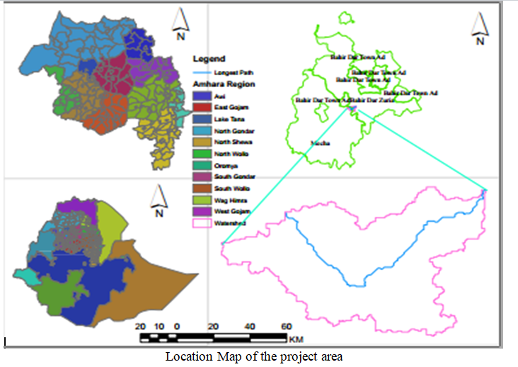
1.3 Previous irrigation Practices
Local farmers of the project site have an interest in irrigation development as observed at the time of site visit. Some farmers use ‘traditional diversion by stone & mud along the weir site. Their intention for irrigation is so impressive the way they tried to pass the gully crossing. Selected and irrigate the right side of the command area. They cultivate different types of crops .among these maize, potato, tomato, onion, barely e.t.c. are the most common products at the project site. Totally they irrigate20haof land using traditional irrigation practice and now we are intended to irrigate30ha of land.
1.4 The general Objective of the study
The woreda small scale irrigation development team is required to make a complete quality feasibility and/or detail design of anshela Diversion weir and tries to locate it together with local users and finally to increase production and productivity thought irrigation.

1.4.1 Specific objective
- The engineering study and design enables the realization of the project by the provision of engineering structures that will allow the appropriate abstraction of the river water for delivery in to the identified irrigation fields of the study area.
- To achieve sustainable food security.
- To safely and easily use water for production.
- Develop working drawings.
- Estimation of construction costs.
- To increasing command area from 20ha to 30ha
- To reduced or avoid reputed maintenance cost.
- To minimize water loss due to seepage
- To save time and energy in each irrigation season
1.6 Scope of the study
- Studying and adaptation of the river watershed parameters for hydrological analysis and Watershed rehabilitation purpose.
- Collect, analyze and interpretation of daily rainfall from nearby meteorological station and use for design flood estimation of the project.
- Measuring and interpretation of base flow of river.
- Planning and layout of the irrigation system, which include irrigation canals, drainage.

1.7 Methodology
In the study and design procedure, Designers used the following steps ϖ
Site identification:
- GPS and GIS information.
- Local farmer’s interview, Kebele agriculture expert, and zone small scale irrigation development.
- On foot travel along the river channel and farm areas.
Topographic survey:
Surveying the head work area with sufficient radius to u/s and d/s reaches, by using total station.
Flow estimation;
- Physical observation on flood mark indications and local information about high flood and base flow condition of the river
- Analyzing the recorded meteorological data nearby station and use watershed inputs for further analysis.
- Base flow estimated during the reconnaissance field visit by floating method.
The design report is organized in three sections. In Section I the Hydrology study is presented and in Sections II and III the Headwork and Irrigation and Drainage Systems designs are discussed respectively. In Section III, planning and design of the irrigation system after diverting the water using the diversion weir will be dealt.

SECTION ONE: HYDROLOGY
2. HYDROLOGY
2.1 Watershed Characteristics
The watershed is found within 2026 to 2106.25 meters above sea level altitudinal range. As to the high lands of Ethiopia, the land escape of the watershed is characterized by gentle slope, almost flat plains and slopping which are thoroughly cultivated for annual food crops. The topographic feature of anshela watershed encompasses all types of slop classes from flat to very steep slope. The dominant slope classes flat or almost flat are (0%-3%) and moderately steep sloping (50%-30%), they are sharing 55.37% and 15.82% respectively of a total area of a watershed. The rest flat almost flat( 3-8%), Gentle sloped( 8-15%), slopping (30-50%) and very steep sloped area greater than 50% are sharing 14.1%, 4.8%, 7.8% and 1.9% of the total area of the watershed respectively.

Table 2.1: Slope class of anshela watershed
 | Slope |  | Area coverage
No | Description | Class | Area(km^2) | Proportion
1 | Flat or almost flat | 0-3% | 3.9 | 55.37
2 | Gently sloping | 3-8% | 1 | 14.19
3 | Sloping | 8-15% | 0.34 | 4.82
4 | 4 Moderately steep | 15-30% | 1.113 | 15.8
5 | Steep | 30-50% | 0.55 | 7.8
6 | Very steeply | >50% | 0.14 | 1.98
 |  |  | 7.043 | 100
- Stream Length = 6.34Km
- CN(III) = 95.23
- Maximum elevation=2109
- Minimum elevation=2026
- At the selected reference point, the area of catchment is 7.043km²

2.2 Available Hydrologic Data
The availability of data is an important aspect in frequency analysis.The estimation of probability of occurrence of extreme floods is an extrapolation based on limited data. Thus the larger the database, the more accurate the estimates will be. The meteorological data required for the design of the project are obtained from the nearby station which Bahir Dar, meteorological station. Bahir Dar has the some agro ecological conditions for the proposed site and have 22 years consecutively recorded daily heaviest rainfall data.
2.3 Meteorological Data Availability
A. Rainfall
The project area is described by Uniondale rainfall pattern. The area experiences a uni modal rain fall pattern. The rainy season (kiremt) starts from May and extends through end of September month. But sometimes some irregular (little) rains occur in April month. Daily rainfall data of Bahir Dar station has been adopted and analyzed to compute design peak rainfall of the project.

B. Climate and Hydrology
Climate data has been adopted from the nearby meteorological station of Bahir Dar and used for the estimation of crop evapo-transpiration of the project. The climatic data are; temperature, wind speed, sunshine hour, and relative humidity. The prevailing temperature considerably influences selection of crops and their growing periods. Optimum temperature plays an important role on the growth period and the production of crops. In the project area, the mean daily maximum air temperature ranges between 25^{O}C and 26.7^{O}C; whereas the mean daily minimum air temperatures not lower than 5⁰c.

2.4 Catchment Balance
During field work in april 2021 the study team measured the base flow as 71.5 l/s and the project is designed to use this potential of water effectively and efficiently to increase the income of the farmers living around the area .the u/s users of the river uses for traditional irrigation and cattle drinking and also the d/s users of the river also used for the same purpose but the users of d/s are very limited both for irrigation and cattle drinking because they have another source of water and we released above 20% of flow. The amount of water that we diverted covers command area and the rest flow used for d/s users then the irrigation system is fine and accepted.
- Maximum duty value = 1.2 lt/sec/ha
- Irrigation hour, = 16hr
- Over all irrigation efficiency = 48%
- Command area=30ha
Upstream & Downstream utilization
Downstream of the proposed site, appreciable need for water is anticipated for locals and cattle as well as traditional irrigation provisions. Therefore, at least 10% of the minimum flow has to be released for downstream requirements. But in our site we released above 20% of lean flow.so that it is enough for that purpose e. and they have another source of water for their irrigation and cattle drinking. The linkages are relative to the physical hydrologic system in nature. Understanding of this upstream and downstream linkage in hydrological processes is essential for water resources planning in river basins. The activities in upstream areas have both beneficial and adverse effects on downstream communities. Good watershed management practices provide better opportunities to downstream communities; however, bad watershed management practices do not only degrade upstream environmental conditions, but also adversely affect the opportunities in downstream areas. Hence, as the ‗opportunities ‘and threats ‘flow from upstream to downstream areas, the users in downstream areas often have great ‗concerns ‘about upstream land-use and water management practice.
The selection of design flood return period is generally based of safety, economy and size and category of the scheme and should be greater than the design period of the structure. For small diversion structures return period flood can be used from 25 to 50 years.
Design flood frequency is expressed by return period, i.e., the probability (expressed in years) where a flood of a target size/magnitude is likely to occur. The probability of occurrence of a flood (having a recurrence interval T-yr) in any year, i.e., the probability of exceedance, is P=1/T or the percent chance of its occurrence in any one year, i.e., frequency (F) is, F=1/T*100.
The meteorological data is adopted from Bahir Dar meteorological station. The station has 22 years of rainfall recorded data.

2.6 Element of statistics for hydrological data
The following are the sample statistics that are commonly used in fitting distributions for hydrological analysis.

2.6.1 Sample mean
Sample mean is generally used to represent measures of central tendency.
Xm= ∑xi/n Where n is the number of sample size
2.6.2 Sample standard deviation
Sample standard deviation is the measure of the spread of the distribution around the central value/mean.
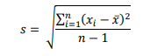
The square of the sample standard deviation is the variance,s².

2.6.3 Sample coefficient of variation
The standard deviation divided by the mean is called the coefficient of variation. It is a dimensionless desperation parameter.
Cv = S/X
Cv (%) =S/X*100%

2.6.4 Sample Skew coefficient
Skew measure the symmetry of a distribution. The lack of symmetry of a distribution is called skewness or asymmetry.
The sample skew is given by
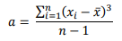
The degree of the skewness of the distribution is usually measured by the coefficient of skewness‘(Cs) and is given by:
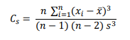
2.6.7 Kurtosis: Kurtosis provides information about the peakdness of the central portion of the distribution & is given by:
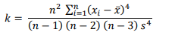

Table 2.2 Rain Fall Analysis from Bahir Dar Meteorological Station
s.no | Year | Max Rf(xi) | descending order | Rank | (xi-x')2  | y=log(xi) | (y-y')2 | (y-y')3
1 | 1987 | 70 | 114.1 | 1 | 154 | 1.845 | 0.0185 | 0.0025
2 | 1988 | 85 | 90.5 | 2 | 752.95 | 1.929 | 0.048 | 0.0107
3 | 1989 | 61.1 | 86.9 | 3 | 12.53 | 1.786 | 0.059 | 0.000457
4 | 1990 | 114.1 | 85.7 | 4 | 3196.7 | 2.057 | 0.121 | 0.0422
5 | 1991 | 90.5 | 85 | 5 | 1085.04 | 1.956 | 0.613 | 0.0151
6 | 1992 | 53.8 | 71.3 | 6 | 14.13 | 1.73 | 0.00047 | 9.261E
7 | 1993 | 71.3 | 70 | 7 | 188.78 | 1.85309 | 0.0185 | 0.0029
8 | 1994 | 39 | 61.1 | 8 | 344.47 | 1.591065 | 0.0059 | -0.00045
9 | 1995 | 27.8 | 58.3 | 9 | 885.65 | 1.765669 | 0.0032 | 0.000181
10 | 1996 | 37.4 | 57.3 | 10 | 406.42 | 1.572872 | 0.0185 | -0.0025
11 | 1997 | 86.9 | 57.1 | 11 | 860.83 | 1.93902 | 0.0529 | 0.01217
12 | 1998 | 34.5 | 53.8 | 12 | 531.76 | 1.537819 | 0.029 | -0.005
13 | 1999 | 35.9 | 50.7 | 13 | 469.15 | 1.555 | 0.023 | -0.0036
14 | 2000 | 57.3 | 39 | 14 | 0.067 | 1.758155 | 0.0024 | 0.000118
15 | 2001 | 85.7 | 38.7 | 15 | 791.85 | 1.932981 | 0.05 | 0.011
16 | 2002 | 50.7 | 38 | 16 | 47.05 | 1.705 | 0.000016 | 6.40E-08
17 | 2003 | 57.1 | 37.4 | 17 | 0.211 | 1.572872 | 0.0185 | -0.0025
18 | 2004 | 58.3 | 37.3 | 18 | 0.547 | 1.571709 | 0.0188 | -0.0025
191 | 2005 | 38.7 | 36 | 19 | 355.69 | 1.556303 | 0.0233 | -0.0035
20 | 2006 | 38 | 35.9 | 20 | 382.59 | 1.555094 | 0.0236 | -0.00364
21 | 2007 | 37.3 | 34.5 | 21 | 20.26 | 1.537819 | 0.0293 | -0.005
22 | 2008 | 36 | 27.8 | 22 | 410.46 | 1.55 | 0.025 | -0.004
 | Sum | 1266.4 | 1266.4 |  | 10,911.14 | 37.85747 | 1.201886 | 0.064636
 | Mean | 57.56 | 57.56 |  | 496 | 1.709 | 0.546 | 0.00029
 | St.dev | 23.25 | 23.25493384 |  | 689 | 0.169906
 | Cv | 0.409 | 0.409 |  | 1.3 | 0.099418
 | Max | 114.1
 | Min | 27.8
 | Cs |  |  |  |  | 0.233

2.7 Data Quality Test

2.7.1 Data Consistency
Test Twenty two years of daily heaviest rainfall records of B/Dar town meteorological station, from 1987 to 2008, had been used for the estimation of design rainfall. These data should be checked for their consistency by outlier test following the assurance of the reliability of the data.

2.7.2 Checking Data Reliability
Number of data=22
Standard deviation, δ n−1 = 23.25
Mean, Xm=57.56 mm
Standard error of mean, = 4.95
Relative standard, = (4.95/57.59)*100= 8.6 %< 10%
Hence the data series could be regarded as reliable and adequate
2.7.3. Test for Outliers
Outliers are data points which depart significantly from the trend of the remaining data. The observed annual daily maximum rainfall series was subjected to tests for high and low outliers.
The procedure followed for detection and treatment of high and low outliers are summarized below:
- If the station skew is greater than +0.4, test for high outliers are considered first;
- If the station skew is less than -0.4, tests for low outliers are considered first;
- Where the station skew is between ±0.4, test for both high and low outlier should be applied before eliminating any outliers from the data set. In our case cs =0.233 Check for Both Higher and Lower Outliers
So we are going to check both lower and higher outlier test
This is done to check whether the adopted data is within the limited range or not.
Table 2.3: Outlier test result for B/Dar meteorological stations
No | Description | Result
1 | Kn | 2.429
2 | Ym Mean logarithmic | 1.709
3 | σY standard deviation | 0.169
4 | YH =Ym+Kn*σ y | 2.11
5 | YL = Ym- Kn* Σσy | 1.636
6 | Higher outlier limit | 128.8
7 | Lower outlier | 19.8
Test for higher outlier test
Higher outlier Yh = Ym + K S
Where: − Yh = higher outlier
Ym= mean data in log unit
Kn = From table for sample size N
S= standard deviation of logarithm X‘s
From Table for data N=22, ym=1.709, sy = 0.169 KN, = 2.429 and
Skewness coefficients Cs =0.233
Higher outlier (YH) = ym+kn*sy=
=1.709+2.429*0.169=2.11
=10) ^2.11=128.8mm
The highest recorded value is (114.1mm) is less than high outlier (128.8mm). Therefore, there is no higher outlier.
Test for Lower Outlier
Lower outlier (YL)= Ym − Kn Sy
Where YL=lower outlier
Ym=mean data in log unit
S =standard deviation
Kn = From table for sample size N
=1.709-2.429*0.169=1.636
= Lower outlier = (10) ^1.29 = 19.8mm
The Lowest recorded value is (27.8mm) which is greater than lower outlier (19.8mm). Hence, no lower outlier. Therefore, the recorded data is consistent for both outliers and it is possible to use it for analysis.

2.8 Probability distribution
Since most hydrologic events are represented by continuous random variables, their density functions denote the probability distribution of the magnitudes. Some of the frequently used density functions in hydrologic analysis are given below:

- Normal distribution
- Lognormal distribution
- Extreme value distribution
- Extreme value type I distribution (Gumbel distribution, 1941)
- Pearson‘s Type-III distribution
- Logarithmic Pearson Type-III distribution
Extreme value type I distribution and Log Pearson Type III distribution which are commonly used for used extreme hydrological series.
The values of design rain fall using different methods
NO | Method | Formulas | Result
1 | Normal distribution | X50=X_{mean} + KT*σx | 109.6
2 | log normal | Y=Y_{mean} + Z*σy  Design Rainfall, X₅₀ ₌ 10^{Y} | 118
3 | Log Pearson Type III | Y=Y_{mean} + Z*Y_{Standared deviation} | 114.25
4 | pearson type iii |  | 111.2
5 | gumbel evi | Y=Xmean + Z*XStandared deviation | 130.9

D- Index test
Rank | xi | normal | log normal | log person type three | person type three | gumbleEVI | remark
 | xi | xi-xi' | xi-xi' | xi-xi' | xi-xi' | xi-xi'
1 | 114.1 | 8.827153655 | 14.1267006 | 15.81812 | 19.1385 | 10.537839
2 | 90.5 | 6.573733357 | 3.39116947 | 5.772705 | 3.355204 | 0.07334
3 | 86.9 | 4.659806022 | 7.459852093 | 10.01127 | 4.967861 | 4.1145913
4 | 85.7 | 5.689541234 | 11.82568452 | 14.38886 | 7.86725 | 8.5846623
5 | 85 | 7.8964512 | 15.55142427 | 18.0579 | 10.64754 | 12.404354
6 | 71.3 | 8.83379655 | 5.565141806 | 7.979572 | 0.039064 | 2.5058765
Sum |  | 42.48048202 | 57.91997276 | 72.02843 | 46.01541 | 38.220664
sum/mean |  | 0.750936575 | 1.00625387 | 1.251363 | 0.799434 | 0.6756349
point rain fall |  | 109.6 | 118 | 114.25 | 111.25 | 130.9 | designe rain fall

2.8.1 Extreme value type I distribution
Extreme value type I distribution is applicable to the extreme hydrological events such as the minimum daily rainfall, rainfall intensity and flood peak flow.
Storm rainfalls are most commonly modeled by the Extreme Value Type I distribution (Gumbel Method) and drought flows by the Weibull distribution, that is, the EVI II distribution (Ven. Te. Chow, Applied Hydrology).
EVI is expressed using the following equation:
Xt= xm+kt*s where
xt= the design storm for a certain return period (mm)
xm= the mean of the observed daily highest rainfall (mm)
s = the standard deviation of observed daily highest rainfall (mm)
kt =the frequency factor for a return period
kt=(Y_{T}-Y_{n})/S_{n}
𝑌𝑡 = − ln (𝑙𝑛 (/ (− 1)) From the above table xm=57.56, S=23.25

T=50years, 𝑌𝑡 = − ln (𝑙𝑛 ( /(𝑇 − 1 ))=3.906
From table and using interpolation
Yn =0.528, sn =1.07272
Kt= (3.906-0.528)/1.07272=3.378
X50=57.56+3.378*23.25
=136.09mm
The Probable maximum Storm of 22 years rainfall data of B/Dar metrological station is136.09mm.
Peak flood analysis by SCS unit hydrograph method
Design flood is calculated by SCS (The United States Soil Conservation Service). This method is widely adopted and more reliable method for flood estimation. The approach considers, watershed parameters, like Area, Curve number, and time of concentration.
2.9 Peak flood analysis by SCS unit hydrograph method
Design flood is calculated by SCS (The United States Soil Conservation Service). This method is widely adopted and more reliable method for flood estimation. The approach considers, watershed parameters, like Area, Curve number, and time of concentration.
Time of concentration (Tc); the time of concentration Tc is defined as the time required for a drop of water falling on the most remote part of the drainage basin to reach the basin outlet. It is calculated by Kirpich formula. It determines the peak time, lag time of the maximum discharge the basin contributes from all corners.
Tc=1/3000*(L/$\sqrt{s}$) ^0.7
Where; L = Length of the main water course (m) = 6340
S = slope of the main water course (m/m) = (hmax-hmin)/L
Table 2.4 Determination of Time of Concentration
 | Elevation
longest flow path | Max(m) | Min(m) | Difference | TC(hr)
6340 | 2109.25 | 2026 | 83.25 | 1.48
2220 | 2041 | 2024 | 17 | 0.81
1551.3 | 2062 | 2041 | 21 | 0.45
1559.7 | 2082 | 2067 | 15 | 0.56
1010.8 | 2106 | 2082 | 24 | 0.28

Total TC=3.58hr
TC=3.58hr since TC>3hr D=1hr from IDD manual
Time to peak; Tp=.6TC+.5D=2.64hr
Base time; TB=2.67TP=7.04hr
From this peak unit rate of discharge; QP= (.21*A)/Tp))=.21*7.043/2.79=0.56mm
The lag (TL) of a watershed is defined as the time from the center mass of unit excess rainfall (D) to the time to peak (Tp) of a unit hydrograph
TL=0.6*TC
=0.6*3.58=2.14hr
Retention time (TR) =1.67*TP
=1.67*2.64=4.408hr
But the Hydrology Study Guideline of the Ministry of water resources, (MoWR, 2001) recommend the following relationship for the duration of excess rainfall:
D=TC/6 if TC <3hr
D=1h if TC= >3hr
D=2hr if TC>10hr
D = duration of excess rainfall (hr), In our case D=1hr

Runoff Curve number (CN)
The SCS uses a combination of soil conditions and land-use (ground cover) to assign a runoff factor to an area. These runoff factors, called runoff curve numbers (CN), indicate the potential of an area. CN has a range of 0 to 100. The higher the CN, the higher is the runoff potential.
Curve number (CN) is achieved based on USSCS method by watershed characterization in terms of land cover, treatment, hydrologic condition and soil group. From the watershed analysis curve number at condition II = 88.72 since peak rainfall is found at an antecedent moisture condition III state, this value has to be changed to antecedent moisture condition III.
Table2.5 determination of CN
 |  | Area coverage
No | Description | area(km^2) | Proportion | Hydro soil group | texture | CN | weighed CN | Sum Weighted CN II | Sum of Weighted CN III
1 | cropland-vegetable | 6.8 | 0.97 | B/poor | loam | 86 | 83.42 | 88.72 | 95.23
2 | Shrub land | 0.184 | 0.02 | B/poor | loam | 67 | 1.34 | =c1*a1+c2*a2+c3*a3  AT
3 | Grassland | 0.058 | 0.06 | B/poor | loam | 73 | 4.38 | =c1*a1+c2*a2+c3*a3  AT
 |  | 7.043 | 100% |  |  |  |  | =c1*a1+c2*a2+c3*a3  AT

CN Condition (III) = (43.8 x Ln (CN condition II)-101.23) = 95.23
Areal Rainfall
As the area of the catchment gets larger, coincidence of all hydrological incidences becomes less and less. This can be optimized by changing the calculated point rainfall to aerial rainfall. The conversion factor is taken from standard table that relate directly with the size of watershed area and type of the gauging station (IDD manual).
Rainfall Profile
Rainfall profile is the distribution of the proportion of design rainfall during every incremental time on the watershed area during the 24 hours duration. Well-developed models are needed to determine such an event for the selected basin area. But there are no sufficient modeling studies in the vicinity and adaptation of standard curves has been taken as the only option. Designer of this project has adopted the standard curve from Design Guidelines for Small Scale Irrigation Projects in Ethiopia. With the aid of rainfall profile versus duration curve the percentages of design rainfall distribution on the catchment area are computed for the first most intensive storm duration.
For the case of anshela irrigation project
Total watershed area = 7.043 Km2
Aerial Rainfall = (Point Rainfall) x (Conversion factor)
Type of gauging station = Daily rainfall (24 hr.).
ARF = 1 - 0.044 A^{0.275 .}A in km² for small catchment.

Runoff Analysis
Design Point Rainfall = 130.9 mm
Curve number at antecedent moisture condition III = 95.23
Catchment Area, A =7.04 K m ²
Time of concentration TC= 3.58hr
D= 1hr, if, Tc > 3hr
Peak time, Tp = D/2 + 0.6*Tc=2.64hr
Base time, Tb = 2.67xTp=7.04hr
Retention time, Tr= 1.67xTp=1.92hr
Table 2.3 Input data
Design rain fall(mm) | Water shade area in km² | Tc (hr) | AMC III | Runoff potential difference, (S) | D | TP | TB | TR
136.09mm | 7.04 | 3.58 | 95.23 | 12.72 | 1 | 2.64 | 7.04 | 1.92

Direct runoff
$Q=\frac{{(I-0.2*S)}^{2}}{(I+0.8*S)}$
Where, I=Rearranged cumulative run-off depth (mm)
S=Maximum run off potential difference,
$S=\left(\frac{25400}{CN}\right)-254$
=12.72
Peak run-off for incremental; 𝑄𝑝 = 0.208 ∗ (𝐴 ∗ 𝑄) /𝑇P
Where; A=Catchment area=7.04km²
Tp=Time to peak (hr) and
Q=incremental run-off (mm)
The following steps are used to get design flood

parameter | Unit | Value
Catchment Area | Km² | 7.04
Length of main river water course | M | 6340
Time of concentration, Tc | Hr | 3.58
Rain fall excess duration(D) | Hr | 1
Time to peak,  Tp = 0.6 Tc + 0.5 D | Hr | 2.64
Time base of hydrograph, TB = 2.67TP | Hr | 7.04
Lag time, TL= 0.6 Tc | Hr | 2.14
Peak rate of discharge created by 1mm RF excess on whole of the catchment qp=(0.208*A)/Tp | m³/s/mm | 0.74

Duration | Daily point rainfall | Rainfall Profile |  | Areal to point rainfall ratio | Areal-rainfall | Incremental rainfall | Descending order | Descending order
Hr | mm | % | mm | % | mm | mm | mm | No
0-1 | 136.09 | 44 | 59.87 | 39 | 93.4 | 23.34 | 40.05 | 1
1-2 | 136.09 | 58 | 78.93 | 79 | 93.4 | 39.01 | 39.01 | 2
2-3 | 136.09 | 66 | 89.8 | 83.5 | 93.4 | 12.55 | 12.55 | 3
3-4 | 136.09 | 72 | 97.98 | 86 | 93.4 | 9.36 | 9.36 | 4
4-5 | 136.09 | 76 | 103.42 | 87.5 | 93.4 | 6.23 | 6.23 | 5
5-6 | 136.09 | 79 | 107.51 | 88 | 93.4 | 4.11 | 4.11 | 6
6-7 | 136.09 | 81 | 110.23 | 89.5 | 93.4 | 4 | 4 | 7

rearranged order; | rearranged incremental order | cumulative order | times of incremental hydrograph
 |  |  | time of begging | time to peak | time to end
6 | 4.11 | 4.11 | 0 | 2.64 | 7.04
4 | 9.36 | 13.47 | 1 | 3.64 | 8.04
2 | 39.01 | 52.48 | 2 | 4.64 | 9.04
1 | 40.05 | 92.53 | 3 | 5.64 | 10.4
3 | 12.5 | 104.83 | 4 | 6.64 | 11.04
5 | 6.23 | 111.06 | 5 | 7.64 | 12.04
7 | 4 | 115.06 | 6 | 8.64 | 13.04

The maximum potential difference b/n Rainfall (p) and direct runoff (Q), S = (25400/CN) - 254, CN=Value corresponding to AMC III | Mm
 | Mm | P(mm) | Q(mm)
 | Mm | 4.11 | 0.17
 | Mm | 13.47 | 5.04
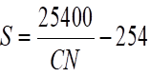  (p-0.2*S)^2/(p+0.8S) |  | 52.48 | 39.77
 |  | 92.53 | 78.8
 |  | 104.83 | 90.98
 |  | 111.06 | 97.14
 |  | 115.06 | 100.13
 |  | 12.72

 | Duration | Cumulative run off | Incremental run off | Peak run off for increment | Time of beginning | Time to peak | Time to end
No | Hr | Mm | Mm | m³/sec | Hr | hr | Hr
1 | 1 | 0 | 0 | 0 | 0 | 2.64 | 7.64
2 | 2 | 5.04 | 4.83 | 3.57 | 1 | 3.64 | 8.64
3 | 3 | 39.17 | 34.13 | 25.25 | 2 | 4.64 | 9.64
4 | 4 | 78.8 | 39.63 | 29.32 | 3 | 5.64 | 10.64
5 | 5 | 90.98 | 12.18 | 9.013 | 4 | 6.64 | 11.64
6 | 6 | 97.14 | 6.16 | 4.55 | 5 | 7.64 | 12.64
 | 3.5 | 100.13 | 2.99 | 2.21 | 6 | 8.64 | 13.64

Table2.5 coordinates of hydrograph
Time | Ordinate of Hydrograph (m^3/Sec)
Hr | H1 | H2 | H3 | H4 | H5 | H6 | H7 | Sum | Remark
0 | 0.00 |  |  |  |  |  |  | 0
1 | 0.00 | 0.00 |  |  |  |  |  | 0
2 | 0.00 | 0.86 | 0.00 |  |  |  |  | 0.86
2.64 | 0.00 | 2.21 | 6.12 | 0.00 |  |  |  | 8.33
3.64 | 0.00 | 3.57 | 15.68 | 7.1 | 0.00 |  |  | 26.35
4.64 | 0.00 | 2.85 | 25.25 | 18.21 | 2.18 | 0.00 |  | 46.31
5.64 | 0.00 | 2.14 | 20.2 | 29.32 | 5.56 | 1.10 |  | 55.08 | Peak flood
6.64 | 0.00 | 1.42 | 15.15 | 23.45 | 9.013 | 2.82 | 0.53 | 50.433
7.64 | 0.00 | 0.714 | 10.1 | 17.59 | 7.21 | 4.55 | 1.37 | 30.72
8.64 |  | 0.00 | 5.05 | 11.72 | 5.4 | 3.64 | 2.21 | 28.02
9.64 |  |  | 0.00 | 5.86 | 3.6 | 2.73 | 1.76 | 12.19
10.64 |  |  |  | 0.00 | 1.8 | 1.82 | 1.32 | 4.79
11.46 |  |  |  |  | 0.00 | 0.91 | 0.88 | 1.79
12.46 |  |  |  |  |  | 0.00 | 0.44 | 0.44
13.46 |  |  |  |  |  |  | 0.00 | 0

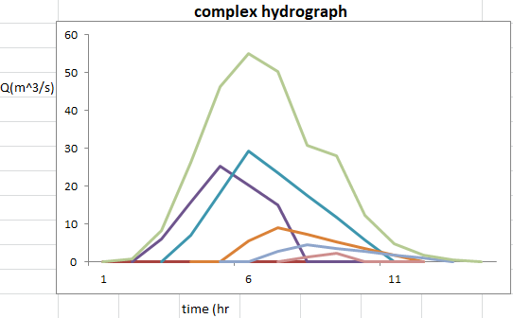

Fig2.3 complex hydrograph
From the analysis, the 50 year return period design runoff is 55.08m3 /s

2.9 Tail water depth
Tail water depth of the river is equal to the flood depth and amount at the proposed weir site before construction of the weir. It is used to cross check the peak flood estimated by the SCS unit hydrograph method with flood mark method and to see the flood feature after the hydraulic jump. During field visit, the flood mark of the river at the proposed diversion site was marked based on indigenous information and physical indicative marks. The river cross-section was surveyed using total station instrument.
partial distance | Cumulative distance | Elevation | Remark
0 | 0 | 2021.105
1.7841079 | 1.7841079 | 2021.062
1.952581112 | 3.736689013 | 2021.069
2.386425779 | 6.123114792 | 2021.079
2.06381443 | 8.186929221 | 2021.039
2.360143216 | 10.54707244 | 2020.729
2.255909794 | 12.80298223 | 2020
2.280730146 | 15.08371238 | 2019.67
2.153554504 | 17.23726688 | 2019.674
1.8145217 | 19.05178858 | 2019.615
1.907040901 | 20.95882948 | 2019.73 | RCA
2.040718011 | 22.99954749 | 2020.085
2.156977515 | 25.15652501 | 2020.616
2.208075406 | 27.36460042 | 2021.059
2.511078852 | 29.87567927 | 2021.276
2.380124787 | 32.25580405 | 2021.395
2.024245538 | 34.28004959 | 2021.535
2.478193899 | 36.75824349 | 2021.647
2.176048253 | 38.93429174 | 2021.895
2.122924634 | 41.05721638 | 2021.966
1.720201442 | 42.77741782 | 2022.085

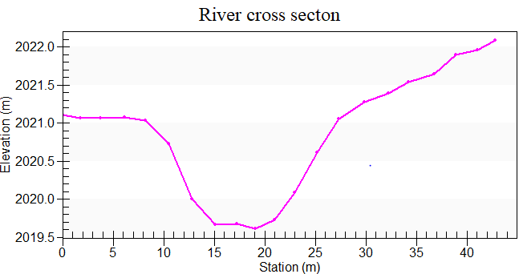
Fig2.4 cross section of river

Average river bed slope
Average bed slope of River is estimated by two different techniques. One is by end area method and the other is by using best fit line method. In this particular case end area method the is adopted for further analysis. The water level of the river is taken at different points along the river channel around the headwork site. This is surveyed for 137.11m length and plotted on below figure then, average water surface slope is considered as the river bed slope which is 0.011
Determination of longitudinal slope of river (using end area method)

No | Pd | elevation(m) | H partial (m) | Hcum(m | area(m^2)
1 | 0 | 2020.65 | 0 | 0 | 0
2 | 7.92014 | 2020.489 | 0.161 | 0.161 | 0.637571186
3 | 5.79792 | 2020.325 | 0.164 | 0.325 | 0.942161393
4 | 7.28352 | 2020.427 | -0.102 | 0.223 | 0.812113034
5 | 7.14292 | 2020.482 | -0.055 | 0.168 | 0.600005656
6 | 10.4662 | 2019.725 | 0.757 | 0.925 | 4.84063742
7 | 9.06799 | 2019.671 | 0.054 | 0.979 | 4.438778902
8 | 7.04366 | 2019.672 | -0.001 | 0.978 | 3.44435008
9 | 9.61009 | 2019.601 | 0.071 | 1.049 | 5.040494803
10 | 6.89795 | 2019.785 | -0.184 | 0.865 | 2.983363118
11 | 6.21208 | 2019.596 | 0.189 | 1.054 | 3.273765273
12 | 5.92988 | 2019.416 | 0.18 | 1.234 | 3.658733733
13 | 7.69797 | 2019.164 | 0.252 | 1.486 | 5.719592669
14 | 7.54863 | 2018.713 | 0.451 | 1.937 | 7.310851114
15 | 6.70848 | 2018.554 | 0.159 | 2.096 | 7.030485953
16 | 8.30442 | 2018.196 | 0.358 | 2.454 | 10.18952116
17 | 6.85772 | 2017.917 | 0.279 | 2.733 | 9.371080598
18 | 7.00288 | 2017.594 | 0.323 | 3.056 | 10.70039646
19 | 9.62011 | 2016.64 | 0.954 | 4.01 | 19.28831394
Sum | 137.113 |  |  |  | 100.2822165
 | Havg | 2*ΣA/ΣL = |  | 1.46
 | Slope | H_{avg}/ΣL = |  | 0.011

Fig2.5 River profile
Manning’s Roughness coefficient
The Manning’s roughness coefficient is taken from standard table based on the river nature. The river banks are defined, clean straight, relatively and smooth. Manning’s roughness coefficient (n = 0.04) is adopted in our design analysis.

Discharge of the river

- Manning's roughness coefficient, n = 0.04
- Average river bed slope, S =0.029
- , Where, R = Hydraulic radius = (Area/Perimeter)
- $Q =V*A$
Stage discharge curve analysis (rating curve)
no | manning | water depth | area(m^2) | perimeter(m) | H/radius | slope | velocity(m^3/s) | charge(m^3/s)
1 | 0.04 | 0 | 0
2 | 0.04 | 0.5 | 1.16 | 5.16 | 0.225 | 0.011 | 0.969 | 1.124
3 | 0.04 | 1 | 4.65 | 10.71 | 0.43 | 0.011 | 1.53 | 6.96
4 | 0.04 | 1.5 | 11.66 | 19.89 | 0.54 | 0.011 | 1.89 | 21
5 | 0.04 | 2.07 | 25.04 | 32.068 | 0.78 | 0.011 | 2.224 | 55.08
6 | 0.04 | 2 | 38.87 | 36.7 | 1.05 | 0.011 | 2.71 | 105.41

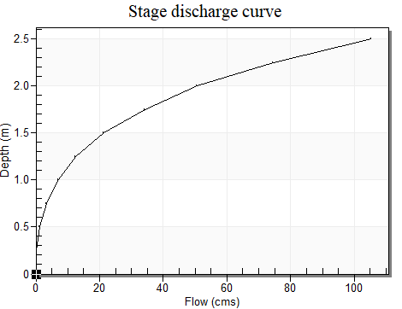
D=2.07m

Fig 2.6 stage discharge curve

3. HEADWORK STRUCTURES DESIGN
3.1 Headwork site selection
The headwork is located at an altitude of about 2019.73m.a.s.l and geographical coordinates of 1264325N (UTM) &313711.2E (UTM). The designer team have assessed possible alternative site for diversion site but we can’t got site which is better than the place that we selected from social, economic and technical point of view. The weir site has been selected to satisfy the following requirements.
- It is located in the narrowest valley.
- It is located in straight reach of the river i.e. not meandering channel at the site. However, in sediment laden river meandering might be considered as a potential site.
- it have impervious and strong foundation condition, if not it requires especial foundation treatment;
- It should be possible to align off taking canal in such a way that command area is obtained without excessive digging;
- It shall be environmentally friendly, socially and culturally acceptable, and economically feasible;
- All of the traditionally irrigated land is included.
- Community interest on the site selection was also included.
- And also from economic, social, and technical point of view it is advisable site.
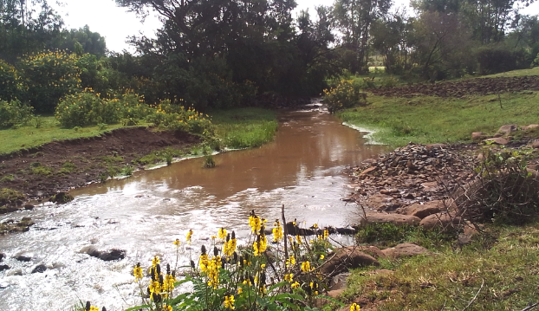

Weir site plan
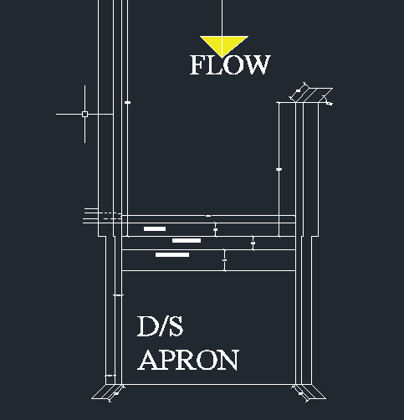

Fig weir site plan
3.2 River Geomorphology
3.3 River Morphology
The river has no meandering behavior in nature. And its direction does not changes some distance at u/s and d/s of the proposed weir axis. The river bank at the proposed weir site, upstream and downstream of the weir site seems stabilized and covered with soil.
River Bed condition
Due to unavailability or shortage of test pit couldn’t know excavating thickness of the weathered rock so by simple observation up and down stream bed covered by fractured, jointed, weathered basaltic rock with continuity.
River Bank condition
A. Right Bank
At the headwork site/axis, the right bank is characterized by relatively moderate to gentle covered by alluvial soils, weathered bed rock. It is covered with red loam soil.
B. Left Bank
At the proposed site head work axis and immediate vicinities, the left bank forms relatively moderate to flat slope topography. From surface observation, the bank is made up of red loam soil and soils. Generally on both sides some bank protection work is needed on the right and left side of bank to protect over flooding of cultivated land especially on the left side.
C. Canal route
The canal rout was investigated during the preliminary study stage of our project. The design team tries to investigate different routes of the canal with the following points & finally we decided which is economical one.
- Material subject to high seepage rates are traversed by lined canals.
- The lining may consists of compacted earth, concrete, , masonry blocks, earth and any combination of these.
- For investigation of canal alignment, engineering geological survey are similar to roadways.
- Care should be taken that there should be no detrimental settlement of the canal into the underlying material.
- Side slopes should be stable.
- Bottom and side slopes should be sufficiently impervious with regard to permissible water loss.
- Longitudinal and transverse profiles along the chosen alignment are prepared and depths of cut and height of embankments determined.
- Canals on strong rocks are the most stable even though, cutting through the rock require most work.

3.4 Sources of construction materials
During the site investigation, natural construction materials required for the construction of the various proposed engineering structures are not found near the headwork and the farmland. In addition to the identification, the quality, quantity, accessibility condition and ownership of each proposed production sites have also been studied and described in this report; on separate sub-sections below. The natural materials required for the construction of the proposed hydraulic structures include rock for masonry stones, aggregates (both coarse and fine), impervious soil for fill and/or lining, backfill soil, and water.
Rock for Masonry and Crushed Coarse Aggregate
Quarry site that can be used for production of rock for masonry stone and crushed coarse aggregates has been assessed during the field work session near from the project area. One possible quarry site has been identified at a d/s of river and on some part of command area.
At the quarry site, fresh slightly weathered basalt rock units are found in large quantity that satisfies the requirement of the project. From this site, rock of different sizes can be produced; ranging from large boulders to coarse gravels that masonry stone and coarse aggregate can be produced easily.

Water
Water for construction purposes can be get from the project stream, anshela itself. The stream is perennial that throughout the year there is enough amount of water flow along its course. The stream water originates from mainly fractured basaltic rock aquifer, which is apportioned of good quality potable water.
3.5 Headwork type selection
Looking the availability of natural construction materials and considering the river features and expected flood amount, broad crest masonry weir type is chosen. As it is:
- Simple for construction and can be done local skilled man power
- There is no some significant bed load in the river
- The flood is small in amount.
- Low construction cost.
3.6 Weir Height Determination
The weir height is determined based on the maximum command area elevation which is required to irrigate the maximum possible irrigable area.
By referring from the survey data of B/dar zuria woreda, Esala kebele, head work x-section and existing traditional canal profile of irrigable land the following data are obtained.
Maximum (optimum) command area elevation of the 1st Turn out of main canal=2020.344masl
- River bed level at the weir cross-section =2019.73
- Expected head loss along the irrigation canal = proposed canal route length *designed canal bed slope = 170* (1/1000) = 0.17m
- Head loss expected at the head regulator = 0.1m
- Head loss the turnout = 0.05m
- Water depth =0.30m
- Driving head=0.15m
- Weir crest level = Maximum (optimum) command area elevation of the first turnout +main canal length*canal bed slope + head regulator loss+ head loss at turnout + Water depth +driving head
Weir crest level = 2020.344+0.170+0.1+0.05+0.30+0.15=2021.114
Maximum height = Weir crest level -river bed level at the intake cross-section
=2021.114m -2019.73m = 1.38m but take 1.4m
The full analysis is shown in the following table
Required data |  | Value | Unit | Remark
minimum river bed level |  | 2019.73
 |  | 2019.73 | m .a. s. l
Maximum command. Area |  | 2020.344 | m. a. s. l | From topo survey
water depth |  | 0.30 | M | From main canal design
head loss at at head regulator |  | 0.1 | M | Assumed
head loss at at turn out |  | 0.05 | M
head loss at canal to the max. command a |  | 0.17 | M
design discharge |  | 55.08 | m3/s
actual river width |  | 13 | M
laceys regime |  | 35.25 | M
crest level of weir |  | 2021.114 | m.a.s.l
weir height |  | 1.4 | M
total loss |  | 0.245 | M
tail water depth |  | 2.07 | M
bottom intake level |  | 2020.564 | m.a.s.l

3.6 Length of Waterway

The weir length has to be designed to allow the design flood to safely discharge over the weir.
Depending on the flow condition of the river flood, width of the weir could be:
- the natural river channel width, or
- it could be widened
- The length of the weir for deep and confined river with stable banks should be approximately equal to the actual width of the river at the design discharge.
- Peak discharge=55.08m3 /sec
- Lacey’s regime width, 𝐿 = 4.75 ∗ √𝑄, = 4.75 ∗ √55.08 =35.25m.
- Actual river section width of the over flow section of the river is = 13mso, I decided to take the actual river length for further detail design purpose which is 13m.
3.7 Discharge over the weir
Hd is the depth of water over the weir crest. This is calculated by assuming broad crested weir formula
Taking the crest length of the weir to be 13m, Q=55.08m3 /s and C= 1.7 the water depth on the crest can be estimated as follows for broad crested weir shape.
Total head over the crust = Q_{D} = CLHe^{^3/2} From Which
He = (Q_{D}/CL) ^{^2/3}
= (55.08/1.7*13)^^{2/3}
He =1.84
The approach velocity head Ha = 1.84- Hd…………………equ(1)

=……………………………egu(2)

H_{d} & H_{a} by trial & error from eqn…….. …….1 & 2
Hd= 1.76 and
Ha=He-Hd=1.84-1.76
Ha=0.083
3.8 Upstream and Downstream HFL Calculation
From the stage –discharge curve prepared in Section I (Hydrology Part) the high flood level before construction (i.e. D/s HFL) corresponding to the design flood is 2021.8m.a.s.l.

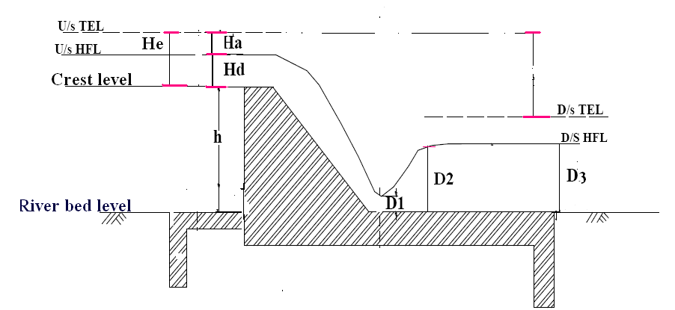
Fig3.1 Schematic Diagram of weir Section

U/s HFL=WCL + hd= 2021.114+1.76=2022.975
D/s HFL=RBL+TWD=2019.73+2.07=2021.8
U/s TEL=U/s HFL +Ha=2022.975+0.083=2023.058
D/s TEL=D/s HFL+ Ha2= Ha2=v2^2/2g=V2=1.89,/sec=Ha=0.18,2021.8+0.18=2021.983
3.5 Afflux
It is the rise in the maximum flood level of the river u/s of the weir with barrage after construction
The amount of afflux will determine the top levels of guide banks.
Afflux = U/s HFL – D/s HFL=2022.975m -2021.8m =1.175m
Providing higher afflux: Can reduce the waterway and the length of the weir with barrage, will increase the discharge intensity and the consequent scour.
3.8 Top and bottom width determination of weir
According to the Bligh’s formula, top and bottom width of the weir body is determined as follows.
Input Data:
H: Height of weir (m) = 1.4m
He: specific energy head (over flow depth + velocity head (m) =1.84
ρ : Specific weight of weir body (2.3 for masonry)
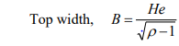
=1.61m

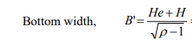
=2.91m

To make economical Provide 1.0m and 2.6m top and bottom width respectively, this will be tested for adequacy during stability analysis.
3.9 Hydraulic Jump computation
Hydraulic jump is the sudden and turbulent rise of water that takes place when a supercritical flow (water moving with high velocity and low depth strikes a sub critical flow (water moving with low velocity and relatively larger depth with).
It occurs frequently at the foot of a spillway/weir from practical viewpoint; hydraulic jump is useful means of dissipating excess energy in supercritical flow.
Input data for the analysis:
Using Bernoulli's equation and neglecting losses between U/S and D/S is applied to determine y1 at the weir toe

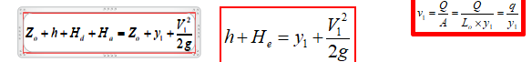
Finally we have the following equation

1.4+1.84=y1+18/19.62* (y1)²
3.32=y1+0.92/ (y1)²
Critical depth yc= (q²/g)^{1/3}
=1.225
y₁ <y_{c} since the flow is supercritical start the iteration with y1<1

H + He | Y1 | Y1+0.92/y1²
3.32 | 0.9 | 2.03
3.32 | 0.8 | 2.23
3.32 | 0.7 | 2.57
3.32 | 0.6 | 3.15
3.32 | 0.57 | 3.32

Hence y1=0.57m
V1=q/Y1=4.23/0.57=7.42m/s
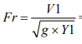
=7.42/2.38=3.12
The conjugate depths y₁ and y₂ of the jump on the horizontal apron d/s of the weir are determined by adopting the following equation.

$y2=\frac{y1}{2}(\sqrt{1+8{Fr}^{2}}-1$)
=2.23m
Where y1=Pre-jump depth
y2=Post -jump depth
Dissipated energy due to jump, E = $\frac{ {(y2-y1)}^{3}}{4*y2*y1}$= 0.89
For the design discharge, y1= 0.57m &y2=2.23m Hydraulic Jump length (L) for Fr= 3.12
Jump Length 5x (Y2- Y1) =5*(2.23-0.57) =8.3m.The foundation of the downstream the river is weak during filed observation so it needs apron length for the protection of weir body then we use the minimum length of downstream apron length is 8.3m.
3.12 Scour Depth Determination
Irrigation structures should be designed against scour which occurs due to Surface flow. According to Lacey, the normal depth of scour ‘R’ in alluvial soils is given by:
R = 1.35(q ²/ f )^{1/3}
Where: R= the scour depth measured below the highest flood level,
q= the discharge intensity
=55.08/13
=4.23m^3/sec
f =1.25 for medium sandy soil. From SSIGL page84
R=3.24m.
Depth of upstream cutoff below the river bed.
d1 = 1.25R-(h+Hd) =0.85m since the geological condition is not considered to be rock provide 1.5mdepth
Depth of downstream cutoff below the river bed,
d2 = 1.5R-y3 = 2.8m
Where y3=D/SHFL–River bed=2.07
Provide 1.5m and 2.8m concrete cutoff having each 50cm thickness at the upstream and downstream of the weir respectively.
NB; this value may be theoretical to provide, practical condition of the site should be adopted value based on the geological.
3.13 Determination of length and thickness of impervious floor
Creep length is the length of seepage path traversed by water
According to Bligh, safety against piping can be ensured by providing sufficient creep length, given by
L= C*HL
Where L= total creep length,
C=creep coefficient=7 for most design and
HL= the seepage head (H)
=7*1.48
=10.36m
Length of D/S impervious floor (Ld):- According to Bligh's;

Where, C = Bligh's creep constant = 7 for most design
H_{L} = seepage head = weir height
=2.21*7*0.38=5.95m
Since the hydraulic jump length is 8.3m, the D/S apron length should be 8.3m

Length of U/S impervious floor

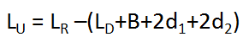
Where, d1 and d2 are the US and DS sheet piles (cut-off) respectively.
LU=10.36-(2*1.5+1+2.6+8.5+3.2*2)
=10.36-21.6=-11.24m which means no need of u/s impervious floor .adopt 1m
Floor thickness determination for the upstream, as the upward and downward forces are balanced, nominal thickness (0.5cm) concrete may be enough. For the downstream, the floor should be thick enough to resist the uplift pressure developed due to the seepage water. Hence, using Bligh’s theory, the thickness of the floor can be computed as shown the table below. The unbalanced pressure head at any point is given by:

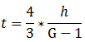
Where, residual head for static or dynamic case
(Different from weir height h).
G = Specific gravity of material of weir body.
= 2.25KN/m³ for masonry wall.
Actual creep length (L_{R})
L_{R} = 2d1+2d2+LD+B+LU
=2*1.5+2*3.3+8.5+2.6+1=21.5m
Seepage head = crest level-bed level
= weir height (h) = 1.4m
Residual head (h) at the toe (A) of the weir wall
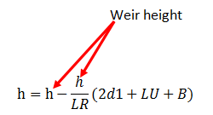
h = h-h/LR (2d1+LU+B) in these case h=weir height actual creep length
=1.4-1.4/21.5 (1.5*2+1+2.6) =
=1.4-0.068(6.5) = 0.97
t=4/3*1.03/ (2.25-1)=1.03
Residual head (h) at 2.5m from toe

=1.4-1.4/21.6 (1.5*2+1+2.5+2.5)
=0.86m
t=4/3*0.86/ (2.25-1)
=0.91m
Residual head (h) at5m from toe
=1.4-1.4/21.6 (11.5)
=0.69m
t=4/3*0.69/ (2.25-1)
=0.73m
Residual head (h) at 8.5m from toe
=1.4-1.4/21.6 (15)
=0.45
t=4/3*0.45/ (2.25-1)
=0.48m, but for uniformity of D/S apron and workability for construction we used average thickness of apron
The average thickness of the entire d/s apron is to be 0.5m since residual head (lr) is greater than creep length our site is free from piping effect
3.14 Stability Analysis of weir
Stability analysis is carried out to see whether the already determined weir dimension is safe against overturning, sliding and tension forces. The stability analysis is carried out considering the effect of Water Pressure, Self-weight of structure and Sediment load. The extreme load combination is the case where the head is at crest level of the weir and there is no flow over the weir (Static case).
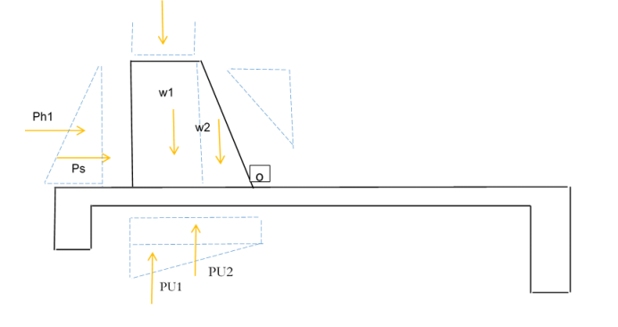
Fig 3.3 Direction of force acting on weir
Where ph=hydrostatic pressure
Ps=sediment load, W1= self-weight and Pu= uplift pressure
Table forces acting on the weir and their determination.
Considering the following unit weight value Ka= (1-sinφ)/ (1+sinφ) =0.33;φ=30 for small structure

Table3.2 Static case for weir stability analysis
No | Description | symbol | Unit | Trial value
1 | Height of weir | H | m | 1.4
2 | Top width of weir | B | m | 1
3 | Bottom width of weir | B | m | 2.6
4 | Unit weight of water | Rw | KN/m^3 | 9.81
5 | Unit weight of silt | Rs | KN/m^4 | 17
6 | Unit weight of masonry | Rm | KN/m^5 | 23

forces and moments acting on the weir
Description | vertical force(KN) | horizontal force(KN) | lever arm from toe(N) | moment about toe KN-M
 |  |  |  | +ve moment | -ve moment
water pressure (ph) |  | -10.74 | 0.46 |  | -4.94
self-weight 1 | 34.04 |  | 2.1 | 71.48
self-weight 2 | 27.23 |  | 1.06 | 28.86
Uplift pressure | -18.87 |  | 1.73 |  | -32.708
Silt load |  | -6.1 | 0.46 |  | -2.8
Sum | 42.4 | -16.88 |  | ∑ M+=100.344 | ∑ M- =40.5
Net moment |  |  |  | 59.35

Factor of safety against
1. Stability against overturning: -For the weir to be stable the factor of safety should be greater than 1.5
∑M+/∑M-=100.344/40.99= 2.47>1.5 so, it is safe against overturning!
2. Stability against sliding: - The factor of safety against sliding
∑ Fv/∑Fh > 1=42.4/16.88=2.5 >1 so, it is safe against Sliding
3. Existence of the tension in weir body: -
For no tension anywhere in the weir body, the eccentricity (e) must be less than one sixth of base width of the weir.
e=| (B/2)-X|
Where; x= (∑M+ - ∑M-)/∑FV=1.32
Therefore e=| (2.5/2)-1.32 |= 0.07
B/6 =2.5/6=0.416
e =0.07< B/6 = 0.416 safe
The resultant passes through the middle third of the base which ensures the non-development of tension in any cross-section of the weir body!
4. The contact pressure (stress) at the toe or heel of the weir body should be less than the allowable bearing
Pressure of the foundation material.
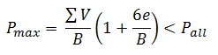
=47.02/2.5 (1+6*0.07/2.5)=19.2KN/m^2 which is less than allowable bearing pressure
21.4KN/m^2<100KN/m^2 safe
3.14 Design of Under Sluice and Canal outlet
3.16 Design Of Under Sluice
The under sluice is mainly provided to remove silt deposition at the result of deposited silt to increase the efficiency of water abstracting to the main canal through the head regulator.
- Under Sluice Level
Since the position of the under sluice is on concave side, that is on scouring side, there is little deposition of silt. So crest level of under sluice is fixed to be 0.2m higher than the minimum bed level. Hence the crest level of the under sluice = river bed level + 0.18m. Under sluice level = 2019.73m +0.18m =2019.98m
B .Capacity Of under Sluice

The capacity of the under sluice can be seen from the general guide which is lines given below: - The
- Capacity should be at least five times the canal discharge to ensure proper scouring.
- Capacity of passing about 10% to 20% of the maximum flood discharge at high flood.
Q=C*L*H^3/2, but H=?
h= net head/residual head, U/SHFL-sill level of under sluice=2022.975-2020.02
=2.955
Let L=0.9m and C=1.7 for broad crested weir
Q=1.7*0.9*2.95^1.5
=7.77m^3/s which is 14.43% designe discharge and it is safe
Provide an under sluice size (Width*Depth) of 0.9m*1.15m Hence. The gate of the under sluice is to be vertical sheet metal of 0.9*m x1.15m for the closure of the opening space. Provide some extra dimensions for groove insertion. Gross area of sheet metals for the under sluice gate will be 1m x 1.2m (allowing 5cm insertion for groove) and with 6mmthickness sheet metal. The grooves are to be provided on the walls using angle iron.so the under sluice gate is manageable by local farmer’s easily. The main reason that we don’t design spindle gate is that from our previous practical case which is very brittle when the farmer’s rotates it.so that divide wall, breast wall and operation slap are not part of document.it can be operated with two farmers easily.
3.17 Design of Canal Outlet
The head regulator (off-take) is a structure at the head of a canal taking off water from a reservoir behind a dam or a weir. It is provided to
- regulate supply in the canal control
- the entry of silt in the canal and
- shut out river floods
Outlet canal bed level = max. Command area elevation + Expected head loss along the irrigation canal + Head loss expected at the turn out.
= 2020.344+ 0.17+ 0.05= 2020.564 m.a.s.l the canal out let bed level is 2020.564m.a.s.l.
A. Capacity of the Outlet Canal
The minimum command area is determined by the minimum flow of the river. But the canal capacity should be determined for maximum command area and the corresponding discharge. In this case the outlet capacity is fixed considering maximum duty and command area.
The full supply discharge of the canal =Duty*command area*correction factor
=1.2 l/s/ha*30ha* 1.2= 34.56l/s =0.0432m3 /sec.
Duty of crop 12 hour irrigation time per day is 1.2 l/s/ha from agronomy report
- Maximum Command area = 30ha.
- Outlet capacity = 1.2L/s/ha x 30 ha* 1.3=43.2L/sec
B .Outlet Size determination
The opening size is fixed using orifice formula.
Q= C_{d} A$\sqrt{2gh}$
Where:
C_{d} = discharge coefficient, 0.6
A = Area of the gate opening
h = head over the opening
Q = diverted discharge,
g = Acceleration due to gravity; 9.81
Where h =water depth/2+working head=0.4/2+0.15=0.35m
Q= 0.6*0.4*0.$3\sqrt{\begin{aligned}2*9.81*0.35 \\ \end{aligned}}$=0.121m^3/sec

Q= 0.121m³/sec >0.0432 m³/sec then it is acceptable
NB For true orifice flow to occur the u/s WL must always be above the top opening. If the u/s WL level drops below the top of opening, act as a weir it is difficult for construction and maintenance of the canal, then the adopt value L=0.4m,
Provide an outlet size of 0.4m*0.40m (Depth & Width) for canal outlets.
Flow depth = 0.3m
Total depth, h = 0.4 m including 0.1m free board
Therefore provide weir opening dimension 0.4 m x 0.4m width and height. Hence, provide an outlet size of 0.4m x 0.4m (length x height) .The gate of the off take canal is to be vertical sheet metal of 0.5 x 0.45m for the closure of the opening space. Provide some extra dimensions for groove insertion. Gross area of sheet metals for the off take canal gate will be (allowing 5 cm insertion for grooves and above the weir with barrage crest level). The grooves are to be provided on the walls using angle iron frames at the two sides of the gate openings.

3.19 Design of Retaining Walls
At the ends of the diversion weir, walls have been provided to safeguard the structure from scouring &it is designed by masonry and it covers a length of 11m and 20m left side and right side respectively. The wing wall is used to protect the upstream and downstream banks and prevent over toping of water during high flood time.
3.19.1 Design of u/s Retaining Walls
At the ends of the diversion weir, walls have been provided to safeguard the structure from scouring &it is designed by masonry and it covers a length of 11m and 20m Right side and Left side respectively. The wing wall is used to protect the upstream and downstream banks and prevent over toping of water during high flood time.
River bed level=2019.73
Data available for the design U/S HFL=2022.975
γ m = 23KN / m^3 ,γw = 9.81KN / m3 ,γsoil = 19KN / m^3
Free board (FB) =0.3m (assumed)
Anchored depth below river bed =0.3m
Therefore, height of wing wall H= (U/S HFL- river bed level) + Fb, H= (2022.975-2019.73) +0.3 = 3.5m,
Top width, b = H/6 to H/12=3.5/6= 0.58m take0.60m
Bottom width, B = ½ H to 2/3 H=3.5/2=1.75m take1.75m
u/S HFL | 2022.29
River bed level | 2019.73
Free board | 0.3
Height | 3.5
Top width | 0.6
Bottom width | 1.75
Specific weight of Stone masonry | 23
Specific weight of Soil KN/m3 | 17
Φ = for dry condition | 30
Active pressure coefficient(Ka), Ka = (1 -sin Φ /1+sin Φ ) | 0.33

Forces acting on U/S &D/S retaining wall
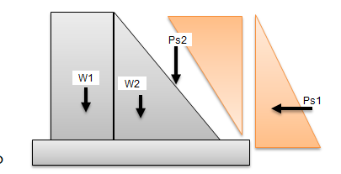
Where =w1&w2 self- weight of retaining wall
ps2 =inclined over burden soil pressure
ps1=vertical overburden soil pressure

3.20 Stability analysis of upstream masonry retaining wall
 |  | Force |  |  | Moment
No | Description | Horizontal | Vertical | lever arm | Positive | Negative
1 | Ps1=0.5*Ka*h ^2*γs | -34.36 |  | 1.16 |  | 39.85
2 | W1=rm*b*H |  | 48.3 | 1.45 | 70.03
3 | W2=0.5 * γm*(B-b)*H |  | 46.28 | 0.76 | 35.17
 | Ps2=1/2*3.5*1.15*17*0.33 |  | 11.29 | 0.98 | 11.06
 | Sum | 34.36 | 104.39 |  | 116.26 | 39.85
 | Net moment | 74.95

Factor of safety against sliding | FS | 3.3 | 3.3>1 safe
Factor of softy against overturning | FO | 2.9 | 2.9>1.5 safe
Centroid distance | X | 0.71
Eccentricity | E | 0.16 | e< B/6 safe
3.21 D/S Retaining Wall
Generally wall height governed by maximum design flood level and the flood jump level, even though, the maximum u/s right flood protection wall height is determined as shown below
Wall height = D/s HFL- bed level of wall foundation + freeboard. The bed level of flood protection wall foundation = 2019.73m a.m.s.l.
D/s HFL = 2021.8m a.m.s.l.
Wall height = 2021.8m a.m.s.l– 2019.73m a.m.s.l +0.3m = 2.4m
Top width, b = H/6 to H/12=2.4/6= 0.48m take 0.50m
Bottom width, B = ½ H to 2/3 H=2.4/2=1.2m

D/s HFL | 2021.8
Free board | 0.3
River Bed level | 2019.73
Height | 2.4
Bottom Width | 1.2
Top width | 0.5
Φ = for dry condition | 30
Active earth pressure | 0.33

3.21.1 Stability analysis of d/s retaining wall
 |  | Force |  |  | Moment
No | Description | Horizontal | Vertical | lever arm | positive | Negative
2 | Ps1=0.5*Ka*rs*hs^2 | -16.15 |  | 0.8 |  | -12.92
3 | W1=rm*b*H |  | 27.6 | 0.95 | 26.22
4 | W2=0.5 * rm*(B-b)h |  | 19.32 | 0.46 | 9.01
 | Ps2=1/2*2.4*1.1*17*0.33 |  | 7.44 | 0.73 | 5.46
 | Sum | -16.15 | 54.36 |  | 40.69 | -12.92

Factor of safety against sliding | FS | 3.36 | 3.36>1 safe
Factor of safety against overturning | FO | 3.14 | 3.14>1.5 safe
Centroid distance | X | 0.51
Eccentricity | E | 0.09 | e< B/6 safe

SECTION THREE: IRRIGATION INFRASTRUCTURE
4. IRRIGATION INFRASTRUCTURE
4.1 Irrigation water requirement
The irrigation water requirement is the amount of water required to irrigate new command area. Irrigation water requirement compared to the net available water helps to decide whether the existing water resources are enough for the project or additional water resources is required for development. For calculating the irrigation water requirement, the crop water requirement and the effective rainfall are important elements in the irrigation planning. These parameters are decided by the soil properties and the meteorological properties of the command area and consumptive water used during the growth of field crops. Moreover, the amount of water loss during the transportation from water source of the river to the field and spraying on the field needs to be considered in addition to these. The calculation of crop water requirement is a very important aspect for planning of any irrigation project. Several methods and procedures are available for this. The Food and Agriculture Organization (FAO) of the United Nations has also made available several publications on this subject and other issues related with this. The computer program available in FAO Irrigation and Drainage Paper No. 56 “CROPWAT” has been used for the calculation of Crop Water requirement.
The determination of irrigation water requirement therefore, need the study and analysis of cropping pattern, estimation of crop water requirement, estimation of effective rainfall and estimation of irrigation efficiency.
Effective Rainfall (Peff)
The proportion of rainfall that enters and support plant evapo transpiration is said to be effective rainfall (Peff). Of the various methods used for CWR calculation, the USDA soil conservation service method has been used to estimate the effective rainfall for this project, that is:
Peff = (P* (125 - 0.2 * 3 * P))/125 ………………for P ≤ 250/3mm
Peff = 125/3 + 0.1 * P …………………………….for P ≤ 250/3mm
Where, Peff is effective rainfall, and P is total rainfall.
As the rainfall amount in the project area is somewhat good the effective rainfall has been accounted for the present irrigation scheme crop water requirement’s calculation. And hence, bahir dar meteorological station rainfall data was directly used to calculate Irrigation Water Requirements (IWR) and dependable rainfall computation for anshela diversion weir Irrigation Scheme.
4.2 Irrigation efficiency
The irrigation efficiency expresses the percentage of the quantity of water used efficiently for the growth of the crop in the field to the quantity of intake water from the water source. A part of the intake water is lost during transport through the canals and in the fields by the evaporation, the infiltration and so on. The remaining part is stored in the root zone and used by the crop. The irrigation efficiency is computed by the following formula.
e = ec * ea / 100 where
e: Irrigation efficiency (%)
ec: Conveyance efficiency (%)
The conveyance efficiency is the ratio of the quantity of water supplied to the fields out of the quantity of intake water from the water source. It represents the efficiency of water transport in the canals. The conveyance
Efficiency mainly depends on the length, the soil type or permeability of the canal banks and the condition of the canals.
The field application efficiency is the ratio of the quantity of water used for the growth of the crop out of the quantity of water supplied to the fields. It represents the efficiency of water application in the field. The field application efficiency mainly depends on the irrigation method and the level of farmer practice. The values of the field application efficiency are given by FAO as follows.
Conveyance efficiency (Ec) =80%
Application efficiency (Ea) = 60%
Overall irrigation efficiency (Ep) = 48%
Community participation
The local community and the beneficiary of the project have been asked the office to study the river many times .so that the office order us to study that site and then we made twice meeting with the community about awareness creation of irrigation .at that time many beneficiary raise the question and give ideas and suggestions about the the project. Finally they make sure that the will protect any damage of building though their signature that attached at the socio economic portion of study.
4.3 Irrigation Duty
Duty (d) is defined as the area of the land which can be irrigated if one cumsec (m³/sec) of water was applied to the land continuously for the entire base period of the crop. In other words it means the area of land that can be irrigated with unit volume of irrigation water.
Moreover, it helps in designing an efficient irrigation canal system.The peak crop irrigation requirement occurs in the month of March with the amount of 1.2lit/sec/ha for the continuous flow of 12 hours each day. Duty for 12 hours is computed as follows :the Maximum net irrigation water requirement (NIWR) for overall proposed crops is in the Month of March with the amount of 2.5mm/day for 12 working hours.
NIWR = GIWR*IE
Where; GIWR- Gross irrigation water requirement [mm/day]
NIWR- Net irrigation water requirement [mm/day]
Field Application efficiency ea 60%
Conveyance Efficiency ec 80%
IE- Irrigation efficiency 48%
GIWR=NIWR/IE
=2.5mm/48
=5.20mm/day
The duty is calculated by:
Duty (D) = GIWR × 1000 × 10 / (t × 60×60)
Where; Duty – the duty [l/s/ha]
t – Daily irrigation hours (12hr)
duty=1.2l/s/ha

4.4 Layout of canal
The irrigation system layout for the project is prepared taking the following points into consideration besides other factors.
- A primary concern in the layout of the system is that it serves the purpose of conveying and distributing water to the command area.
- The excavation and earth fill volumes not be excessive, otherwise the construction costs can be tremendous.
- The selection of longitudinal bed slope is made taking into account the existing slopes of the terrain, so as to minimize deviations in canal routing.
- Curves in canals should not be too sharp. The proposed irrigation system layout comprises only one main canal as shown on the layout Drawings. The main canal runs for most of its length parallel to the contours and several changes of direction are necessary to follow the topography. It crosses one large gully. The main canal is masonry lined for a length of 1850meters starting from the off take. There is no need of designing drainage lay out system and it is not part of document.

4.5 Water Distribution System
Water is conveyed through the main canal from the diversion weir. The flow through the main canal continuous type and the flow through field canals are on rotational base.
4.6 Hydraulic Design of main Canal
The hydraulic design of canals must be made for the design discharge and to secure hydraulically purposed designed level, and the design of respective facilities in the canal system must be made for not only the design discharge but also other discharges so that their purposes and functions can fully be fulfilled. Discharges other than the design discharge are the most-frequent discharge and the minimum discharge for an irrigation canal, and in a drainage canal, discharge to study low water revetment, and discharges that may make troubles to important canal facilities.
The main canal is contour canal and the condition that should be taken in to account during the canal alignment are; Minimum number of falls, cross drainage structures, etc. Minimum length of canal per hectare So as to minimize seepage loss, the alignment is done in canals with less cutting.
The total length of the main canal on the right side is about1850m starting from the head work site. The canal capacity was determined based on crop water requirements prepared for the proposed cropping pattern. The main canal is designed for a discharge of 71.5l/s and depending on the site specific condition, appropriate slope is
Provided. Hydraulic parameters of the main canal are shown below. For rectangular canal we have to calculate hydraulic parameters as follows
A=b*d, P=d+2b, R=A/P Where; b=bottom width of flow, d= depth of flow A=area, P=perimeter, R=radius
Let b/d=1, for discharge below 0.1, therefore A=b*d=d², P=d+2d=3d
R=A/P=d2/3d, R=0.34d
Q=A/n*R^{2/3}*S^{1/2} where n=manning coefficient
R=hydraulic radius
S=bed slope the canal
Q= design discharge
0.0436=66.67d²*(0.34d)^{2/3}*(0.001)^{0.5}
0.0436=66.67d*0.48*d^{2/3}*0.031
0.0436=32*d^{8/3} *0.031
1.406=32d^{8/3}
d=0.35m hence b =0.3m
Table 4.1 Hydraulic Parameters of main canal
c.area(ha) | b(m) |  | d(m) |  | Fb | A(m2) |  | P(m) |  | R(m) |  | S | M |  | n |  | V(m/sec |  | QD(m³/sec
30 | 0.3 |  | 0.3 |  | 0.1 | 0.102 |  | 0.96 |  | 0.106 |  | 0.001 | 1 |  | 0.015 |  | 0.507 |  | 0.0436

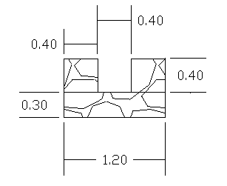

Design of secondary canal
Secondary canal
Conveys water from the main canal to the tertiary units or, in small schemes, directly to the farmers' fields through an outlet structure .there is one masonry rectangular secondary canal with length of 350m. The dimensions and design is the same as main canal for workability.
Hydraulic Parameters of secondary canal
c.area(ha) | b(m) |  | d(m) |  | Fb | A(m2) |  | P(m) |  | R(m) |  | S | M |  | n |  | V(m/sec |  | QD(m³/sec
30 | 0.3 |  | 0.3 |  | 0.1 | 0.102 |  | 0.96 |  | 0.106 |  | 0.001 | 1 |  | 0.015 |  | 0.507 |  | 0.028

Design of turn out
Turnouts are used to direct water from the supply canals into the laterals and farm ditches.
We can calculate the dimensions of turn out using continuity equation.
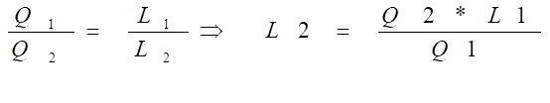
Where Q1=main canal design discharge
Q2= discharge of turn out (2/3of main canal discharge)
L2= the width of turn out
L1= the width of main canal
L1 = 0.028*0.4/0.0423=0.26=0.3m for workability.
Broad crested weir formula adopted to calculate the height of the crest
Q=CLh^{3/2} where
h= the depth of flow
C=flow coefficient
h=0.15m which is over flow depth

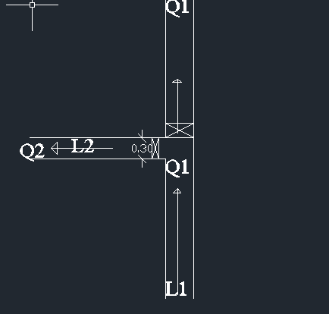
Fig section of turn out

Field canal
In the layout system there are two field canals, the designed discharge is determined based on the duty of irrigation. The sections of the canals are determined by using manning’s formula, and they are trapezoidal section. There is no need of designing, tertiary canal and drainage canal and are not parts of the document.
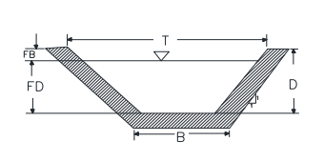
Typical cross section of field canal

4.8 Design of Cross Drainage Works /Flume structure/
One gully crossing structure is provided on the primary canal, the gully crossing structures are rectangular reinforced concrete flume. The dimension of the flume is the same as the primary canal. The flume is reinforced with 12 and 12 mm bar @150mmc/c and its length is 19m which is 0.4m internal canal bed width and 1 m total canal bed width. The vertical section of the flume is 60 cm thick. And also we provide two pier at the center of gully.
Table4.2 flume parameter
Hydrological analysis of flume
 | Parameter
 | gully depth of flume | 4.5
 | span length of flume | 19
 | flow rate | 0.00733m^3/s
 | Top width of guide bank | 1
 | bottom width of guide bank | 2.3
The flow rate of flume can be calculated using rational method where A=0.1km^2 from gis flume water shade
Max elevation=2086
Min elevation=2017
L==386m
Q=CIA/3.6
where A=catchment area, I=intensity of rain fall and C=run off coefficient
=0.00733m^3/s

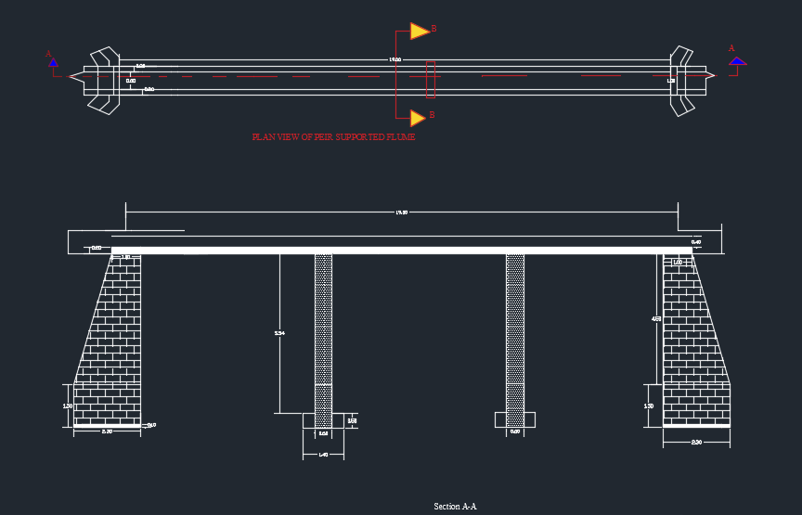

Stability analysis of guide bank of flume
 |  | Force |  |  | Moment
No | Description | Horizontal | Vertical | lever arm | positive | Negative
2 | Ps1=0.5*rs*h*h*0.33 | 56.8 |  | 1.5 |  | 85.2
3 | W1=rm*b*H |  | 82.5 | 0.4 | 33
4 | W2=0.5 * rm*(B-b)h |  | 77.62 | 1.56 | 121.56
 | Ps2=1/2*h(B-b)*rs |  | 18.9 | 1.3 | 24.57
 | Sum | 56.8 | 179.02 |  | 179.14 | 85.2

Factor of safety against sliding | FS | 3.15 | 3.15>1 safe
Factor of safety against overturning | FO | 2 | 2 >1.5 safe
Centroid distance | X | 1.18
Eccentricity | E | 0.03 | e< B/6 safe

6 .Bill of Quantity
 | zone | N/Gojjam
 | Woreda | Bahir dar zuria
 | site | Esala
 | name of the river | anshela
 | scheme type | diversion weir
 | User's M | 89
 | F | 5
 | sum | 94
 | command area | 30ha
 | Location | X | 313713
 |  | Y | 1264326
 |  | Z | 1973
 | Bill of Quantity for diversion weir and main canal
item | descripition | unit | quantity | unite price | total price
1 | general item
1.1 | allow for mobalization | LS | 1 | 40000.00 | 40000.00
1.2 | allow for demobalization | LS | 1 | 40000.00 | 40000.00
1.3 | erecting sign board at site | ls | 1 | 10000.00 | 10000.00
1.5 | dewatering during construction of head work and construction
 | temporary diversion of river flow | LS | 1 | 20000.00 | 20000.00
 | sub total |  |  |  | 110000.00
2 | weir body
2.1 | site clearing 20cm up depth | m^2 | 33.8 | 44.10 | 1490.58
2.2 | ordinary soil excavation | m^3 | 19.5 | 306.25 | 5971.88
2.3 | weathered rock excavation | m^3 | 7.8 | 864.71 | 6744.71
2.4 | hard rock excavation | m^3 | 3.38 | 1260.00 | 4258.80
2.5 | concrete(c-20) (1:2:3) ratio | m^3 | 16.9 | 12330.89 | 208392.07
2.6 | masonary work with cemeny mortar mix(1:3)(65%stone &35% mortar) | m^3 | 47.32 | 8360.22 | 395605.61
2.9 | plasterig with2.5cm thickeness(1:2) all faces of wall | m^2 | 58.89 | 716.43 | 42190.56
 | sub total |  |  |  | 664654.21
3 | U/S cut off
3.1 | site clearing up to 20cm depth | m^2 | 26 | 44.10 | 1146.60
3.2 | ordinary soil excavation | m^3 | 31.2 | 628.21 | 19600.00
3.3 | weathered rock excavation | m^3 | 5.2 | 864.71 | 4496.47
3.4 | hard rock excavation | m^3 | 2.6 | 1260.00 | 3276.00
3.5 | form work with timber | m^2 | 39 | 913.50 | 35626.50
3.6 | Reinforced concrete workc-20(1:2:3)ratio | m^3 | 9.75 | 12330.89 | 120226.20
3.7 | Rienforcemnt bar φ12mmand 15cm spacing | kg | 245.1 | 187.93
3.8 | back fill and compaction with selected material | m^3 | 14.63 | 300.00 | 4387.50
 | sub total |  |  |  | 188759.27
3 | D/S cut off
3.1 | site clearing up to 20cm depth | m^2 | 39 | 44.10 | 1719.90
3.2 | ordinary soil excavation | m^3 | 78 | 942.31 | 73500.00
3.3 | weathered rock excavation | m^3 | 15.6 | 864.71 | 13489.41
3.4 | hard rock excavation | m^3 | 15.6 | 1260.00 | 19656.00
3.5 | form work with timber | m^2 | 72.8 | 913.50 | 66502.80
3.6 | Reinforced concrete workc-20(1:2:3)ratio | m^3 | 18.2 | 12330.89 | 224422.23
3.7 | Rienforcemnt bar φ12mmand 15cm spacing | kg | 448 | 187.93
3.8 | back fill and compaction with selected material | m^3 | 27.3 | 300.00 | 8190.00
 | sub total |  |  |  | 407480.34
3.2 | U/S apron
3.2.1 | site clearing up to 20cm depth | m^2 | 19.5 | 44.10 | 859.95
3.2.2 | ordinary soil excavation | m^3 | 5.85 | 306.25 | 1791.56
3.2.3 | weathered rock excavation | m^3 | 3.9 | 864.71 | 3372.35
3.2.5 | conrete work c-20(1:2:3) | m^3 | 6.5 | 12330.89 | 80150.80
 | sub total |  |  |  | 86174.66
3.3 | D/S apron
3.3.1 | site clearing upto depth of 20cm | m^2 | 1105 | 44.10 | 48730.50
3.3.2 | ordinary soil excavation | m^3 | 33.15 | 306.25 | 10152.19
3.3.3 | weathered rock excavation | m^3 | 22.1 | 864.71 | 19110.00
3.3.4 | concrete work c-20(1:2:3)ratio | m^3 | 53.95 | 12330.89 | 665251.62
 | sub total |  |  |  | 743244.30
4 | masonary support slap above offtake
4.1 | Rienforcemnt bar φ12mm and 150mm spacing | kg | 18.12 | 187.93 | 3405.21
4.2 | Rienforced concret work c-20(1:2:3) | m^3 | 0.36 | 12330.89 | 4439.12
4.3 | form work with timber,30cm thick | m^2 | 1.2 | 913.50 | 1096.20
 | sub total |  |  |  | 8940.53
5 | U/S left side retaining wall
5.1 | site clearing upto 20cm depth | m^2 | 40 | 44.10 | 1764.00
5.2 | ordinary soil excavation | m^3 | 22.5 | 306.25 | 6890.63
5.3 | weathered rock excavation | m^3 | 9 | 864.71 | 7782.35
5.4 | concrete(1:2:3)for wall foundation | m^3 | 3.5 | 12330.89 | 43158.12
5.5 | masonary work with cement mortar mix(1:3) | m^3 | 96.25 | 8360.22 | 804671.18
5.6 | plasterig with2.5cm thickeness(1:2)ratio including all faces | m^2 | 82 | 716.43 | 58747.26
5.7 | pointing external part of retainig wall | m^3 | 30 | 724.47
5.8 | back fill and compaction with selected material | m^3 | 10.5 | 300.00 | 3150.00
 | sub total |  |  |  | 926163.53
6 | U/s right side retaining wall
6.1 | site clearing upto depth of 20cm | m^2 | 22 | 44.10 | 970.20
6.2 | ordinary soil excavation | m^3 | 12.38 | 306.25 | 3789.84
6.3 | weathered rock excavation | m^3 | 4.95 | 864.71 | 4280.29
6.4 | concretec-20(1:2:3)for wall foundation | m^3 | 1.925 | 12330.89 | 23736.97
6.5 | masonary work with cement mortar mix(1:3)(65%stone&35%mortar) | m^3 | 52.94 | 8360.22 | 442569.15
6.6 | plasterig with2.5cm thickeness(1:2) all faces | m^2 | 45.1 | 716.43 | 32310.99
6.7 | pointing external part of retainig wall | m^2 | 19.25 | 724.47
6.8 | back fill and compaction with selected material | m^3 | 16.5 | 300.00 | 4950.00
 | sub total |  |  |  | 512607.44
7 | D/S left side retaing wall
7.1 | site clearing with 20cm depth | m^2 | 14 | 44.10 | 617.40
7.2 | ordinary soil excavation | m^3 | 8.5 | 306.25 | 2603.13
7.3 | weathered rock excavation | m^3 | 3.4 | 864.71 | 2940.00
7.4 | concretec-20(1:2:3)for wall foundation | m^3 | 1.2 | 12330.89 | 14797.07
7.5 | masonary work with cement mortar mix(1:3) | m^3 | 25.2 | 8360.22 | 210677.54
7.6 | plasterig with2.5cm thickeness(1:2) all faces | m^2 | 30 | 716.43 | 21492.90
7.7 | pointing external part of retainig wall | m^2 | 14 | 724.47
7.8 | back fill and compaction with selected material | m^3 | 3.6 | 300.00 | 1080.00
 | sub total |  |  |  | 254208.04
8 | D/S right side retaing wall
8.1 | site clearing with 20cm depth | m^2 | 14 | 44.10 | 617.40
8.2 | ordinary soil excavation | m^3 | 8.5 | 306.25 | 2603.13
8.3 | weathered rock excavation | m^3 | 3.4 | 864.71 | 2940.00
8.4 | concrete work (1:2:3)for wall foundation | m^3 | 1.2 | 12330.89 | 14797.07
8.5 | masonary work with cement mortar mix(1:3)(65%stone&35%mortar) | m^3 | 34.8 | 8360.22 | 290935.66
8.6 | plasterig with2.5cm thickeness(1:2) all faces | m^2 | 29 | 716.43 | 20776.47
8.7 | pointing external part of retainig wall | m^2 | 14 | 724.47
8.8 | back fill and compaction with selected material | m^3 | 3.6 | 300.00 | 1080.00
 | sub total |  |  |  | 333749.72
7 | Gates(scouring sluice and trash rack)
7.1 | off take canal gate consists
 | 4mmthick sheet metal 0.5m*0.45 | no | 2 | 5000.00 | 10000.00
 | 50mm*50mm*4mm angle iron
 | Φ-12mm for stiffing
 | Φ-12mm bar for handling,1m length
7.2 | under sluice gate consists
 | 4mm thickness sheet metal 1m*1.2m | kg | 0.89 | 187.93 | 167.25
 | 50mm*50mm*4mm angle iron
 | Φ12mm for stiffinng
 | Φ-12mm bar for handling,1m length
7.3 | trash rack for off take(0.4m*0.4m)Φ-12mm bar with 10cmc/c spacing | kg | 3.56 | 187.93 | 669.01
 | sub total |  |  |  | 10836.27
 | total coast for head work item |  |  |  | 4136818.31
8 | main canal
8.1 | site clearing | m^2 | 2080 | 44.10 | 91728.00
8.2 | ordinary soil excavation | m^3 | 1664 | 306.25 | 509600.00
8.3 | weathered rock excavation | m^3 | 624 | 864.71 | 539576.47
8.4 | foundation of canal masonery work by crushed stones for 30cm depth | m^3 | 468 | 8360.22 | 3912582.96
8.5 | masonary work with cemeny mortar for canal wall mix(1:3)(65%stone&35%mortar) | m^3 | 416 | 8360.22 | 3477851.52
8.6 | plasterig with2.5cm thickeness(1:2) all faces | m^2 | 4070 | 716.43 | 2915870.10
8.7 | back fill and compaction with selected material | m^3 | 546 | 300.00 | 163800.00
 | sub total |  |  |  | 11611009.05
8.2 | secondary canal
8.2.1 | site clearing | m^2 | 150 | 44.10 | 6615.00
8.2.2 | ordinary soil excavation | m^3 | 75 | 306.25 | 22968.75
8.2.3 | weathered rock excavation | m^3 | 45 | 864.71 | 38911.76
8.2.4 | foundation of canal masonery work by crushed stones for 30cm depth | m^3 | 33 | 8360.22 | 275887.26
8.2.6 | masonary work with cement mortar for canalwall mix(1:3)(65%stone&35%mortar) | m^3 | 24 | 8360.22 | 200645.28
8.2.7 | plasteringwith 2.5cmthickeness(1:2)ratio all faces | m^2 | 170 | 716.43 | 121793.10
8.2.8 | back fill and compaction with selected material | m^2 | 39 | 300.00 | 11700.00
 | sub total |  |  |  | 678521.15
9 | turn out
9.1 | ordinary soil excavation | m^3 | 4.5 | 306.25 | 1378.13
9.2 | foundation of canal masonery work by crushed stones for 30cm depth | m^3 | 0.33 | 8360.22 | 2758.87
9.4 | masonary work with cemeny mortar mix(1:3)(65%stone&35%mortar) | m^3 | 1.2 | 8360.22 | 10032.26
9.5 | plasterig with2.5cm thickeness(1:2) | m^2 | 8.5 | 716.43 | 6089.66
9.6 | gates -4mm thickness sheet metal(0.45m*0.4m)
 | 50mm*50mm*4mm angle iron | no | 5 | 5000.00 | 25000.00
 | Φ-12mm bar for handling with 0.5m length | kg | 2.67 | 187.93 | 501.76
 | subtotal |  |  |  | 45760.68
10 | gully crossing( aquduct)(19m span and 4.5m gully depth)
10.1 | sit clearing up depth of 20cm | m^2 | 7.5 | 44.10 | 330.75
10.2 | ordinary soil excavation for left side guide wall | m^3 | 6.3 | 306.25 | 1929.38
10.3 | ordinary soil excavation for right side guide wall | m^3 | 6.3 | 306.25 | 1929.38
10.4 | ordinary excavation for peir foundation | m^3 | 2.43 | 306.25 | 744.19
10.5 | weathered rock excavation for left side guid wall | m^3 | 1.26 | 864.71 | 1089.53
10.6 | weathered rock excavation for right side guid wall | m^3 | 1.26 | 864.71 | 1089.53
10.7 | weathered rock excavation for peir foundation | m^3 | 1.62 | 864.71 | 1400.82
10.8 | concrete for guide wall fondation (1:2:3) | m^3 | 0.69 | 12330.89 | 8508.32
10.9 | concrete for peir foundation(1:2:3) | m^3 | 1.08 | 12330.89 | 13317.36
10.1 | masonary work with mortar mix ratio(1:3) for guide wall(65% stone&35%mortar) | m^3 | 41.4 | 8360.22 | 346113.11
10.12 | plastering with 2.5cm thickneess(1:2) | m^2 | 95.2 | 716.43 | 68204.14
10.13 | concretec-20(1:2:3)ratio for flume peir wall | m^3 | 4.32 | 12330.89 | 53269.45
10.14 | concretec-20(1:2:3)ratio for flume canal bed | m^3 | 5.7 | 12330.89 | 70286.08
10.15 | Concretec-20(1:2:3)ratio for flume Canal wall | m^3 | 3.92 | 12330.89 | 48337.10
10.16 | rainforcemnt bar,φ12mmbar with 150c/c spacing for canal bed | kg | 134.3 | 187.93 | 25230.84
10.17 | rainforcemnt bar,φ16mm bar with 150c/c spacing for pier | kg | 212 | 313.60 | 66483.39
10.18 | rainforcemnt bar,φ12mmbar with 150c/c spacing for canal wall | kg | 339 | 187.93 | 63706.65
10.22 | back fill and compaction with selected material | m^3 | 18 | 300.00 | 5400.00
 | subtotal |  |  |  | 777370.01
 | total coast for irrigation infrastructure item |  |  |  | 13112660.89
 | total project cost with out vat |  |  |  | 17359479.20
 | vat(15%) |  |  |  | 2603921.88
 | total project cost including vat15% |  |  |  | 19963401.08

5. Conclusions and Recommendations
Generally, anshela diversion irrigation project is planned to irrigate 30ha. By the proposed irrigation project, 94 houses -holds are expected to be benefited. Overall project cost with vat15% for the head work is estimated to 19,963,401.08 birr
- The method of irrigation of the project area is furrow surface irrigation in which the main and tertiary canals are working continuously whereas the field canals within a tertiary block are working rotational system.
- The infrastructure of this project area is designed to irrigate about 30ha of land by taking its supply from the anshela diversion weir irrigation project. The maximum duty of the command area for 18hours per day irrigation with overall project efficiency of 48%
- The reason why the main canal is to be lined up to the end is to avoid the scouring and siltation problem, time saving to reach at the tail part, reduce maintenance cost.

6. Reference
- Drainage Design Manual, Hydrology
- DD Manual N
- Design Guide Line on Hydraulic Structures, Ministry of Water Resource.
- Previous design Report
- Irrigation Engineering and Hydraulics structure Santosh kumargarga
- Soft copies of hydraulic structure publishing
- Small scale irrigation guide line in ministry of agriculture

.

