AMHARA NATIONAL REGIONAL STATE
BEAUREU OF ILADO
DEBAY TILATGEN WORDA
ASENDABO KEBELE CANAL EXTENDED WORK

MARCH 2017 E.C
DEBAYTILAT GEN

Table of Contents
1. INTRODUCTION 2
1.1background 2
1.2 Irrigation area description 2
1.2.1 Location 2
1.2.2 Accessibility 2
1.2.3 Topografy 2
1.2.4 Soil characterstics 3
1.2.5 Climate 3
1.2.6 Previous Irrigation practices 3
1.3 Objectives of the study 3
1.3.1 main objective 3
1.4 Scope of the study 3
1.5 Study methodology 4
1.6 Water resources and base flow measurement 4
1.7 Determination of duty 4
1.8 Design of canal system 4
1.9 Bill Of Quantity Bechet Canal Work 10

1. INTRODUCTION

1.1background
Our country Ethiopia is gifted with different natural resources among these Amhara region is the one. The economy of the region largely depends on subsistence Agriculture which is tradional &rainfall dependant .Irrigation has to be considered not only as engine for agricultural development but also as acrucial factor for the overall economic growth .about 85% of the total population directly depend on agriculture for their livelihood.
It is known that Ethiopian government running to alleviate the impact of recurrent drought in the whole country.this can be achieved by working together with the community, local and international NGOS and the government organizations to use all the available resources efficiently and bring significant change.
Farmers of of the woreda in general and the project aera in particular have good interest and practice to utilize their land and water resources.During the study of the project,we have seen the farmers attempt to use traditionally way.Thus,the development of this iirigation project will have agreat role to increase their incomes and improve their irrigation practices.

1.2 Irrigation area description

1.2.1 Location
Bechet small scale irrigation project is found in Amhara National regional state,East Gojjam zone,Debaytilat gen woreda particularly Asendabo kebele.It is located about 12km far from kuy town,the proposed irrigation project is to be under taken on Bechet river and the canal work is specifically located at an altitude of about2592 masl and geograficall coordinates of 385977E 115881N

1.2.2 Accessibility
The project is accessible by vehicle from the worda town, debaytilat gen,which is 12km.

1.2.3 Topografy
Topografy is an important factor for the planning of any irrigation project thereby the topographic feature of the project command area is mainly gently slope type.its elevation range is from 2616 to 2611m meters above sea level.How ever, it is identified to be suitable for surface irrigation.

1.2.4 Soil characterstics
Soil properties (physical,chemical) greatly influence the growth and thereby yield of crops which is grown.The command area has predominantly clay textured of black cotton soils which can be classified as moderately drained soil.soils of the command area are suitable for most of the selected crops to be grown.

1.2.5 Climate
As per the hydrological analysis and on the basis of the traditional Agro-ecological zones(MOA,2001),theUGDWIP areais basically classifiedas Moist woina dega(sub-moist cool agro-ecologicalzone,indicatingbetter moisture condition in the area in wet seasons.

1.2.6 Previous Irrigation practices
The farmers in the project area are very much interested in up grading the traditional scheme to modern scheme .in the traditional practice 18 ha was irrigated upgrading to modern 31hawill be irrigated.The beneficiaries in this project are male=52&female=4 with total of 56 people benefited.But after construction of the project the project the beneficiaries will be male=172&female=22 with total of 194 people will be benefited. 65 + 28= 93 is found from the previous document.But 194 where is coming??

1.3 Objectives of the study

1.3.1 main objective
The main objective of the study is preparation of detail design document for canal work at bechet river, so that traditional canal system can be improved into modern canal system,and more area can be developed under irrigation.

1.4 Scope of the study
- Planning and layout of the irrigation system that includeirrigation canals, drainage structures canal length ,location of the structure
- Structural desin of main canal considering total demand &the required capacity and the base flow availability
- Prepare general plans and drawings for all irrigation infrastructures
- Establish flood protection measures for the command area and canal structures

1.5 Study methodology
- Collecting the data at field level with different materials like meter,Gps
- Local farmers interview
- Previous studies

1.6 Water resources and base flow measurement
The study project water source bring from bechet river.this river perennial through out the year.the base flow which is measured during march.the base flow has 39l/s by our measurement but from preveious study the base flow is 33l/s from this our measurement is more than preveious but in our case the time was rainy time so we take the base flow 33l/s.

1.7 Determination of duty
Duty the capacity of the water to irrigate the land.it is the ratio of the area of the landto be irrigated to the quantity of water required
crop | potato | cabbage
Base period B(days) | 90 | 90

Duty= (8.64*B)/Δ
B | delta | duty
day | mm | l/sec/ha
90 | 700 | 1.11085714
1.11
39 | 7.8
43.29 | 31.2
 | 34.632
Command area based on your flow data 39 l/s(43.3 or 34.63///31)
The duty of the crop is1.11l/s/ha

1.8 Design of canal system
The conveyance system consists of one main canal to irrigate total command area of 31ha.Bechet irrigation project irrigates 31ha in the base flow.the main canal runs for 900m from this 610 is constructed in 2014 now we need to extend up to 900m .The maximum design design capacity the left canal for 31ha is 33l/s based on the duty of 1.1l/sec/hafor 18hr daily irrigation cycle. The main canal starting from the river is masonry lined canal with rectangular section.
The basic requirements to design the main canal are:
- Duty of the area1.1l/s/ha
- Maximum command area.31ha
- Mannigs roughness coefficient,0.018
- Canal gradient or slope for the given soil.1/1000
- b/d ratio,2m
- the type of canal section is rectangular
the lined canals with rectangular section is designed by mannings formula
Q=(A*R^2/3*S^1/2)/n
Where,
- Q=discharge m^3/s
- R=hydraulic radius
- S=hydraulic gradient
- n=mannigs roughness co eficiant(n=0.018 for masonary lined part of the canal)
canal capacity is fixed based on the command area that could be irrigated with in one irrigation period for the given block of land to be delivering by the canal.
Canal discharge using gross command area=duty*irrigated area
Qd=D*A
=1.1*31
Qd=0.034m^3/s
Canal design discharge using base flow of the river 33l/s/hasince the base flow of the river is less thanQd,i.e 0.033≤0.034 the canal section parameter is fixed by base flow.
So,discharge=33l/s
Ssiplinnig freeboard=0.15m
Bed slope=0.001
Mannigs roughness=0.018
0.033=(1/0.018)*2y^2(y/2)^2/3 *0.001^0.5
Y=0.2m,take20cm
B=2Y=2*20=40cm
A=2Y^2=2*20^2=0.08M^2
R=y/2=0.25/2=0.08
P=b+2y=0.4m+0.4=0.8
Total depth of canal=D=Y+FB=35CM
Dimension of the canal
Total canal length 290m
Bottom width 40cm
Thickness 30cm
Depth 35cm
Depth=35cm+canal bottom thickness
D=35+30=65cm
Width=40cm+2*(thickness of canal)
W=40+2*30=100cm=1M
Bechet canal cross section

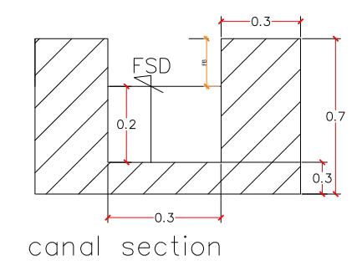
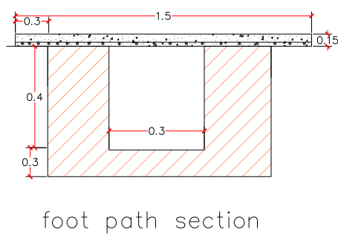
Figure-2
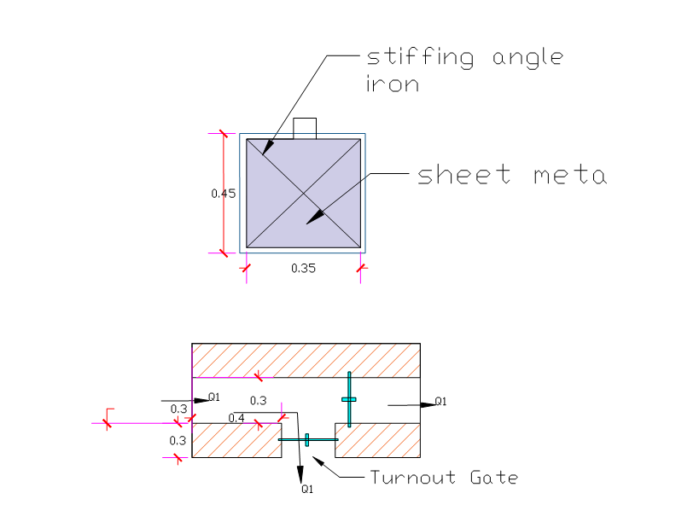
Figure-3 Turn out cross section

1.9 Bill Of Quantity Bechet Canal Work
ZONE:EAST GOJJAM
WOREDA:DEBAY TILAT GIN
KEBEELE:ASENDABO
PROJECT:BECHET SMALL SCALE IRRIGATION PROJECT
Bill of quantity BECHET CANAL WORK
No | work Item |  | bill of quantity
 | General Item | unit | unit price | quantity | amount
 | Irrigation Infrastructure Work
1.0 | canal work
1.1 | Clearing, grabing and cutting of trees for 200mm | m2 | 63.000 | 377 | 23,751.00
1.2 | Ordinary earth excavation including clearing and grubbing | m³ | 437.500 | 263.9 | 115,456.25
1.3 | backfill and compaction with selected materials | m3 | 420.000 | 40.6 | 17,052.00
1.4 | Masonry work ratio 1:3(Abay sand) | m3 | 10210.89 | 208.8 | 2,132,032.98
1.5 | pointing for external part with ratio 1:3 mortar | m3 | 669.49 | 29 | 19,415.09
1.6 | All gates Supply and installation according to the working drawing including stiffening bars and angle irons tunouts in both side of water surface | No | 9000.00 | 4 | 36,000.00
1.7 | 20 (two coat) mm thick Plastering of (ratio 1:2) abay sand | m2 | 740.448 | 261 | 193,256.93
 | SUBTOTAL |  |  |  | 2,536,964.25
2.0 | Superpassage work
2.1 | ordinary soil excavation | m2 | 437.500 | 7.2 | 3,150.00
2.2 | Concrete mixing ,pouring ,vibrating and curing with Concrete ratio 1:2:3.Gravel (02)(Abay sand) | m3 | 15495.800 | 1.2 | 18,594.96
2.3 | masonry work with ratio 1:3 aby sand | m3 | 10210.886 | 2.88 | 29,407.35
2.4 | poining for external part with ratio 1:3 mortar | m3 | 669.486 | 0.72 | 482.03
2.5 | Reinforcement supplying ,Cutting ,bending and installing ,Bar ø 12c/c 20cm | kg | 270.000 | 316.128 | 85,354.56
 | SUBTOTAL |  |  |  | 136,988.90
3.00 | foot path work
3.1 | Ordinary earth excavation including clearing and grubbing | m3 | 437.500 | 6 | 2,625.00
3.2 | Stone production, supplying ,dressing and constructing , Concrete mixing ,pouring ,vibrating and curing, Concrete with ratio 1:2:3.Gravel (02)(Abay sand) | m3 | 15495.800 | 1.8 | 27,892.44
3.3 | 20 (two coat) mm thick Plastering of (ratio 1:2) abay sand | m2 | 740.448 | 6 | 4,442.69
3.4 | Reinforcement supplying ,Cutting ,bending and installing ,Bar ø 12c/c 20cm | kg | 270.000 | 115.44 | 31,168.80
3.5 | black wier with installing RCC | kg | 150.000 | 1 | 150.00
3.6 | formwork (4mx0.3mx0.04m) for concrete placement | m2 | 500.000 | 4.8 | 2,400.00
 | SUBTOTAL |  |  |  | 68,678.93
 | Total with out Vat |  |  |  | 2,742,632.08
 | Vat(15%) |  |  |  | 411,394.81
 | Total with Vat |  |  |  | 3,154,026.89
 | prepared by:Bereket Yinesu Signatuer-----------------------

