

THE NATIONAL REGIONAL STATE OF OROMIA
OROMIA AGRICULTURE AND NATURAL RESOURCES BUREAU

AGRICULTURAL GROWTH PROGRAM (AGP II)

Lot Nine of Eighty Small Scale Irrigation Projects Feasibility Study and Detail Design

Volume VIII: Detail Engineering Design Report of Birbirsa Small Scale irrigation project

December 2019
Finfinne
 AYJEF Water Woks and P.O.Box: 43329 Tele: +251 911 304019
Business Service PLC E-mail: ayconsult1@gmail.com

table of content
table of content 2
LIST OF TABLES 4
Executive Summary 4
1 introduction 7
1.1 General 7
1.2 Objective and Scope of the Study 7
1.3 Outline of the report 8
2 Description of Project 9
2.1 Location and Accessibility of the project area 9
2.2 Soil and Land suitability 9
2.3 Hydrology and Water Availability 10
2.4 Crop water requirement 10
3 Methodology of project study and design 12
4 Definitions 12
4.1 Irrigation System 13
4.2 Drainage system 13
4.3 Irrigation Units 14
4.4 Canal / Drain Numbering System 15
4.5 Nomenclature and Symbols 16
4.6 Standards 16
5 IRRIGATION AND DRAINAGE SYSTEM 17
5.1 Irrigation tradition 17
5.2 Planned irrigable area 17
5.3 Water Availability 18
5.4 Water distribution scenario 18
5.5 System Layout Plan 18
5.6 Major Components of the project 19
6 HEAD WORK 19
6.1 Objective/ General 20
6.2 Selection of Headwork site 20
6.3 Geology of weir site and the canal route 20
6.3.1 Weir site Geology 21
6.3.2 Geotechnical Characteristics of Main Canal Route 22
6.4 Base Flow & Design Flood Estimation 23
6.5 Selection of Weir Type 27
6.6 Design of weir 28
6.6.1 General Description of the Weir 28
6.6.2 Stability analysis of the weir 38
6.6.3 Stability Analysis of Retaining Wall 47
6.6.4 Stability of Wing Wall 48
6.6.5 Weir cross section 51
6.7 Design of Intake 52
6.8 Silt Gate 53
6.9 Coffer dam 53
7 DESIGN OF SUPPLY CANALS 54
7.1 Main Canal 54
7.2 Design of drainage canals 59
7.3 Design of Hydraulic Structures 59
7.3.1 General 59
7.3.2 Design of Division Boxes/ off take / Gated outlet 60
7.3.3 Design of Culvert (cross drainage) Structures 63
7.3.4 Design of Flume (cross drainage) Structures 64
8 BILL OF QUANTITY 66
9 Summary cost of the project 73
10 Project Duration and Work Plan 74
11 Conclusion and Recommendations 75
12 Annex 75

LIST OF TABLES

Table 1. summary of climate data 11
Table 2. Naming used in system layout plan 17
Table 3. Geotechnical description of test pit dug at Right river bank 22
Table 4. Geotechnical description of geological pits along the main canal route 23
Table 5. Drainage Duty, in Litter per Second per Hectare (l/s/ha) 28
Table 7. Stability analysis at high flood level condition 47
Table 8. Calculation of forces and moments of the D/s wing walls 51
Table 9. Summary 54
Table 10. Calculation of Cross Drainage Culvert Structure 68
Table 11. Calculation of Flume Drainage Culvert Structure 69
Table 12. Bill of Quantity, specification and cost estimates 71

LIST OF FIGURES

Figure 1. Location of Birbirsa small scale irrigation Project area 9
Figure 2. Traditional Irrigation Practice in Birbirsa Area 18
Figure 3. Geological units observed along the proposed diversion weir axis 22
Figure 4. Geological cross section along the proposed diversion weir axis 23
Figure 5. SCS based Peak Discharge Hydrograph 27
Figure 6. Birbirsa river headwork site 29
Figure 7schamatic view of weir 29
Figure 8. Flow condition over the weir and its detail part 55
Figure 9. View of the weir from the u/s 56
Figure 10. Main Canal 59
Figure 11. Basic section of drainage canal 64
Figure 12. Gated outlet structures plan and section views 67
Figure 13. Section of the CD 1 structure 69

Executive Summary

Birbirsa small scale irrigation project is located in Nagasa Kebele of Guto Gida Wereda in East Wollega zone of Oromia National Regional State. It is situated at a distance of 5km south east of the woreda and zonal capital, Nekemte. The proposed project site is located at geographical grid coordinate of 230446m easting and 1000323m northing, in zone 37, UTM-Adindan projection with average altitude of 1959masl.The project site is accessed by 5km dry weather road.

The main objective of this project is to design an efficient and suitable irrigation system which ensures reliable delivery of required amount of irrigation water at the right time and to the command area as well as to design an efficient drainage system that ensures removal of excess moisture on and within the surface of the field. Accordingly, the agreement was signed between Oromia Irrigation development Authority (OIDA) and AYJEF Water Works and Business Service Plc to deliver consultancy service for feasibility study and detail design of Lot 9 (Birbirsa, Basaka, Kolasa, Chiracha, Maqa and Ukke) Small Scale Irrigation Projects.

The beneficiaries of the project are residents of Negasa kebele. From this proposed project, at least 76 households benefit from irrigation activity so that equitable use of land and water resources could be established at the site under consideration as currently there exist water shortage to increase production and productivity on sustainable basis. The target communities are experienced in irrigation development activities from the existing traditional scheme owned by them.

The water availability analysis shows that, the river has more than a 20% excess flow during dry time for downstream release as compared with the irrigation requirement of the project. Irrigation water will be supplied from the Birbirsa River using the main canal system aligned on Right side of the River. The total net command area is 51.82 ha. The main canal, Right Bank Main Canal is off taking from the weir and delivers water to tertiary and field canals. The main canal route is 3170 length.
As a subsequent task of the feasibility study the following design parameters have been considered for the detail designs of the irrigation and drainage canals and hydraulic structures.
- Based on the Agronomical report, 2.08 l/s/ha for 12 hr irrigation period is taken as a gross duty of the area for the design purpose by assuming 50% overall irrigation efficiency and 10% flexibility factor.
- A deep U-shape furrow with depth 0.3m, width 0.15m, average length 50m, spacing 1m, slope 0.005m/m and furrow stream size 5 l/s is adopted as a furrow characteristics of the project.
- The Field unit would have a NIA of 2ha (up to). A group of the field units that will be irrigated during one rotation cycle is considered as Tertiary Units with average stream flow of 16 l/s which is taken as optimum. It has been adopted a 14-day irrigation interval at the time of peak demand.
- The minimum FSL at the field level of the project is fixed to 0.20 m and all the canal head losses are considered in canal design.
The components of this project scheme include the weir, supply and drainage canal network and other related irrigation infrastructures. The total project upgrading cost is 7,847,036.64 Birr. The project is designed for 20 years life.

introduction

General
Irrigation and drainage system design incorporates all engineering aspects related to irrigation and drainage. The system design focuses on study and design of headwork, supply and drainage canals and all appurtenant structures related to diversion, conveyance, distribution and application of water to the farm lands. It also gives attention to network of roads (access to main road, farm roads and inspection roads). All influential factors that determine project sustainability are accounted to come up with reasonable results of study. In so doing, idea from different disciplines was given due attention. The project is gravity diversion system on Birbirsa River. Right side intake is suggested based on available suitable irrigable farm land with available discharge. Reasonable systematic layouts were adopted to minimize costs and to enable easier application of water and easy management of the project. A total of 74.15 ha of land were surveyed of which 51.82 ha net irrigable area planned for development based on topographic condition.

Objective and Scope of the Study
The purpose of the project is to achieve food security in the area in particular and in the country in general, and to improve income generation for the local and regional population through the development of improved irrigated agriculture.
With this overall project objective, the specific objectives have been listed below.
- To review and update all the available studies made concerning the project,
- To implement series of study steps to determine whether the project appears technically, economically, socially and environmentally feasible,
- To design suitable irrigation and drainage systems for the selected area.
- To study and design infrastructure requirement of the project (Road network within the perimeter and Water supply system upon the delivery point),
- To prepare Tender/ Contract documents for the execution of the project.
Within the umbrella of the above project objective, the irrigation and drainage system aimed to design appropriate, efficient, cost effective and sustainable irrigation and drainage system network in detail.
The scope of work on irrigation and drainage design includes:
- Desk work (review of relevant reports and documents);
- Field reconnaissance study;
- Data and information synthesis: this will result from combining the information and data collected on Topographic Map, hydrological study report (including meteorological data), soil property and land suitability report, environmental impact assessment report, geotechnical investigation report, crop agronomy study report, etc.;
- Determination of crop water requirement (daily and seasonal water demand);
- Delineation of the command area;
- Planning of the irrigation and drainage system;
- Preparation of the irrigation and drainage system layout (including road and flood protection work layout);
- Design of canals (primary, secondary, tertiary);
- Design of drains (main, secondary, tertiary);
- Design of flood protection work;
- Design of irrigation and drainage structures: this includes flumes, siphons, culverts, cross regulators, head regulators, drops, chutes, outfalls, escape, gates, etc. (if any);
- Preparation of working drawing;
- Bill of quantities and cost estimation;
- Preparation of technical specification and tender document;
- Preparation of technical report: progress (status) report, draft report, final report;
- Preparation of irrigation and drainage operation and maintenance manual.

Outline of the report
The report is structured to have brief introduction in the first chapter. Chapter 2 provides the general description of the project, i.e. location, topography and agro-climate, soil and land suitability, hydrology and water availability, Chapter 3 Methodology of project study, Chapter 4 Defines the major technical words used in the document. Chapter 5 describes irrigation and drainage in detail. Chapter 6 is devoted to headwork design, which includes those required for headwork design like geotechnical studies and hydrological studies. Chapter 7 deals with design of supply canals and related hydraulic structures. The last part of the report is Bill of quantity, Work plan and conclusion.

Description of Project

Location and Accessibility of the project area
Birbirsa small scale irrigation project is located in Nagasa Kebele of Guto Gida Wereda in East Wollega zone of Oromia National Regional State. It is situated at a distance of 5km south east of the woreda and zonal capital, Nekemte. The proposed project site is located at geographical grid coordinate of 230446m easting and 1000323m northing, in zone 37, UTM-Adindan projection with average altitude of 1959masl.The project site is accessed by 5km dry weather road.

Figure 1. Location of Birbirsa small scale irrigation Project area

Soil and Land suitability

The major soil is divided in to two (2) soil units Fluvisol and Haplic Fluvisol having area coverage of 80% and 20% respectively. The study identified two soil units based on those parameters of the soils important for use and management such as slope percent, effective depth and texture.
The soils of the study area have got considerable potential for irrigated agriculture with surface irrigation methods. Accordingly, the intended project area is found to be moderately suitable for surface irrigation. Similarly, the outcomes of crop suitability assessment indicate that the command area is moderately suitable for Onion, Pepper, Cabbage, Sweet potato, Potato, Tomato and Maize production. The suitability result showed that most of the correctable limiting constraints of the land units are poor drainage class mainly caused by existence of ground water at shallower depth which could be amended through irrigation interval adjustment and the application of considerable management practices.
Detail descriptions and necessary maps were prepared and presented in the Soils and Land suitability study report of the project.
The soil parameters are important for calculating the irrigation scheduling and for this study we have selected clay soil which is the dominant soil of the project area. But in the actual calculations of scheduling both heavy and medium textured soil types will be considered based on the results of both physical and chemical characteristics of the soils of the project area. The effective depth of soil is restricted by existence of ground water at a depth of 100cm all over the command area. .The available water holding capacity (AWC) of the soils ranges from low to high within the top 100 cm layer. The wider range of AWC (low to high) in the study area is related to textural variation.
The optimum infiltration rate of the soils in the Project Command ranges from 1.7 cm/hr to 2 cm/hr. The hydraulic conductivity of the soils ranges from 0.08 to 0.31 m/d m/day (slow). The average infiltration and hydraulic conductivity values of the soils appear to be acceptable with various degree of suitability.

Hydrology and Water Availability

As per conducted preliminary study of the water resource potential during the current dry season, the river has got adequate water reaching to a discharge of 620 lit/sec so as to develop the intended command area. As per the information obtained from woreda and zonal irrigation development offices, besides to the current study to be conducted on Birbirsa river, a project is underway on Aleltu river capable of irrigating 74ha of land. As a result, detail evaluation of water resource potential for all the intended projects implementation. On the other hand farmers having command area upstream of the current diversion site are diverting the water traditionally to irrigate their dispatched farms. During evaluating the water balance of this project detail evaluation will be conducted after this inception report.

Crop water requirement
Estimation of crop water requirement (CWR), which is directly related to irrigation system design and determination of the extent/size of field units, are essential for planning irrigation and thereby increasing the yield of the irrigated crop.

Climate Data and Reference ETo
Reference crop evapotranspiration (ET0) has been estimated using the CROPWAT 8.0 computer program by Penman Montieth Approach (FAO I & D Paper No.56). And as there is no metrological stations located inside the project command boundary the Climatic data are transferred from nearby Nekemt meteorological station (For detail information refer hydrological study of the project).
The summery of Climatic data and the resulting ETo values are provided in Table 2 below. The maximum ETo value occur in the month of February (4.32 mm/day), while the minimum ETo values occur in the months of August (2.55 mm/day).
Table 1. summary of climate data
Month | Min Temp | Max Temp | Humidity | Wind | Sun | Rad | ETo | ETo
Month | °C | °C | % | km/day | hours | MJ/m²/day | mm/day | mm/mon
January | 12.2 | 26.1 | 59 | 95 | 8.4 | 20 | 3.81 | 118.11
February | 13.5 | 28 | 53 | 104 | 8.2 | 20.8 | 4.32 | 120.96
March | 14.3 | 28.1 | 51 | 112 | 7.8 | 21.4 | 4.65 | 144.15
April | 14.5 | 27.4 | 64 | 103 | 7.7 | 21.3 | 4.47 | 134.1
May | 13.9 | 24.9 | 75 | 69 | 6.5 | 19.1 | 3.76 | 116.56
June | 12.9 | 22.5 | 85 | 69 | 5.3 | 16.9 | 3.18 | 95.4
July | 12.8 | 21.1 | 88 | 104 | 4.1 | 15.3 | 2.82 | 87.42
August | 12.9 | 21.1 | 90 | 69 | 2.8 | 13.6 | 2.55 | 79.05
September | 12.8 | 22.5 | 87 | 69 | 3.7 | 14.9 | 2.82 | 84.6
October | 12.9 | 24 | 79 | 103 | 6.6 | 18.7 | 3.49 | 108.19
November | 12.7 | 24.5 | 71 | 103 | 7.5 | 18.9 | 3.56 | 106.8
December | 12.1 | 25 | 65 | 104 | 7.7 | 18.4 | 3.53 | 109.43
Average | 13.1 | 24.6 | 72 | 92 | 6.4 | 18.3 | 3.58 | 108.67
Annual total (mm) |  |  |  |  |  |  |  | 1,304.77

Based on the Agronomical report, 2.08 l/s/ha for 12 hr irrigation period is taken as a gross duty of the area for the design purpose by assuming 50% overall irrigation efficiency and 10% flexibility factor. For the total command area of 51.82ha a discharge of 115 lit/sec discharge is needed.

Methodology of project study and design

The following brief methodologies are adopted:
- Existing localities and community experiences and information.
- Using hand held GPS and 1:50,000 contour maps in initial geo-referencing and in selection of appropriate headwork site.
- Detail site survey and investigations
- Secondary data from concerned areas.
- Hydro-meteorological data, crop data, soil data etc. collecting and organizing for this study.
- Using guidelines manuals and other reference materials.
- Use of different software like;
- Cropwat 8.0,
- Arc GIS 9.3
- Global Maper 13
- Google Earth

Definitions

Irrigation System
The irrigation system comprises a network of irrigation canals (main, secondary, tertiary and field canals) of different sizes and capacities to deliver the required amount of irrigation water from the source to the field.
Ridge and contour canal: | A ridge canal is a section that runs down the contours (with a comparatively steep gradient), whereas a contour canal is a section of a canal running approximately parallel to the contours (with a comparatively shallow gradient).
Main Canal: | Main canal is the principal channel of the system off-taking from the weir site delivering the required amount of flow to all the project command areas. The canal is mostly contour canal and in some cases ridge canal.
Secondary Canals: | Secondary canals off-take from main canal and deliver water to the secondary blocks. There are as many secondary canals as topographic situation dictates In most cases They are unlined canals in balanced cut and fill.
Tertiary Canals: | Tertiary canals off-take from secondary canals and delivers irrigation water to tertiary units.. Tertiary canals are generally unlined canals in fill.
Quaternary Canals:- | The field canals will be unlined fill canals or flexi flume that off-take from tertiary canals. These canals normally run down the major slope in such a way to feed furrows that are aligned perpendicular to them.
Irrigation | The flow of provided to each field unit. This will be dictated by the size of area under each field.
Night storage:- | It is a pond to store water during night time from the main canals and supply to the secondary canals during day time to satisfy the total required amount of water in time. Their capacity/sizes are varied according to the blocks sizes that are commanded by a secondary canal. Making the operation ease by reducing the water travel time, reducing the size of the main canal and the operational loss in the main canal could be mentioned as benefits from ponds.

Drainage system
Field Drains: | Field drains run parallel to field canals and collect water from field directly from furrows and field channel escapes. Disposal can be into a higher order drain or into a natural/artificial depression on the border of the command area.
Tertiary Drain: | Tertiary drains collect water from lower order drains (field drains). Disposal can be into a natural gully or into a natural depression on the border of the command area.
Main Drain: | Main drains are generally aligned following the path of existing drainage gullies and collect water from a number of lower order drains.
Interceptor Drain: | The drain running adjacent to the Main Canals and some Secondary Canals, on their right/Right bank. This intercepts sheet flow and minor gully flow from area above them. These will generally have cross drainage structures to discharge collected flows under the canals to natural gullies.

Irrigation Units
 | Field Unit: |  | The field is the smallest unit considered in the design of the project. It is the area irrigated using furrows every scheduled day, at maximum crop demand, by a field channel in 12hr per day with the estimated irrigation stream proportion to the field size. The minimum field size determination will be discussed in section 4.11.
 | Tertiary unit: |  | Groups of field sizes form a tertiary unit. All fields within a tertiary unit will be irrigated during one rotation cycle. Where there are areas less than field unit size in a tertiary unit the irrigation cycle will be reduced and the irrigation stream might be diverted elsewhere in the block.
 | Block: |  | The area irrigated by a tertiary canal off-taking from a secondary canal. Blocks are variable in size being built up from groups of field units.
Command Area: |  | The area irrigated by a secondary canal off-taking from the Main Canal. Individual command areas consist of a number of blocks which vary in size as they are dictated by topography.

Canal / Drain Numbering System
Main Canal : | The project has one main canal, Denotes as LBMC
Secondary Canal : | Secondary canals are named in the order of their off taking chainage from the main canals, for example the first secondary canal in the LBMC command is named SC-1.
Tertiary Canal : | Tertiary canals are labelled sequentially in the order they off-take from the Right or right side of the secondary canal, using the two-letter abbreviation.  Canals off-taking on the Right side use odd numbers and canals off-taking on the right side use even numbers. For example, the first tertiary off-taking on the Right side of the first Secondary Canal on the Right side main canal will be named TC-1-1  In the rare occasions where tertiary canals bifurcate they would be given suffixes as used for the secondary canal, for example TC-1-1 or TC-1-1 (0)
Field Canal : | A similar numbering system is adopted for the quaternary canals/flexi flumes. They are also labelled sequentially in the order they off-take with odd numbers used on the Right side and even numbers used on the right side. Examples would be FC-1-3, which is the second off-take on the Right side of tertiary canal TC1.
Drain Canals : | A similar numbering system is adopted for all drain canals as adopted for irrigation canals. Drains will be numbered starting from the outfall and working upstream. The drainage channel categories will be identified using the following codes:  Main Drain: MD;  Catch Drain: ID  Secondary Drain: SD; Tertiary Drain: TD and Field Drain: FD.

Nomenclature and Symbols

The following designations were used in naming various irrigation infrastructures in the project area.
Table 2. Naming used in system layout plan
Designation | Representation
MC | Main canal
SC | Secondary canal
TC | Tertiary canal
FC | Field canal
TC-1-1 | First tertiary canal on SC-1
OT | Field off take (tertiary canal to field canal)
TO | Turn out (secondary/main canal to tertiary canal)
C-1 | Culvert -1
TD | Tertiary drain
FD | Field drain
FU | Field unit
TU | Tertiary unit
b | Bottom width of abutment/ wing wall

Standards

The following standards were adopted in preparation of the project document. Weir site topographic map was prepared on 1:500 scale and field system layout is prepared on 1:1000 scale map indicating all features. Longitudinal profiles are prepared in scale of 1:100 in vertical and 1:1000 in horizontal. Working drawings are prepared to scales of 1:10, 1:50 or 1:100 based on appropriate visibility scale and all drawings are prepared on standard sheets of A₀(1080x810), A₁(810x540), A₂(540x410), A₃(410x297) and A₄(297x210) in millimeter units.

IRRIGATION AND DRAINAGE SYSTEM

Irrigation tradition

Farmers have been diverting Birbirsa river traditionally to irrigation their land. They have been doing so for years back. Farmers use local materials like wood, and others. Sample of famer’s effort is shown in the following picture.

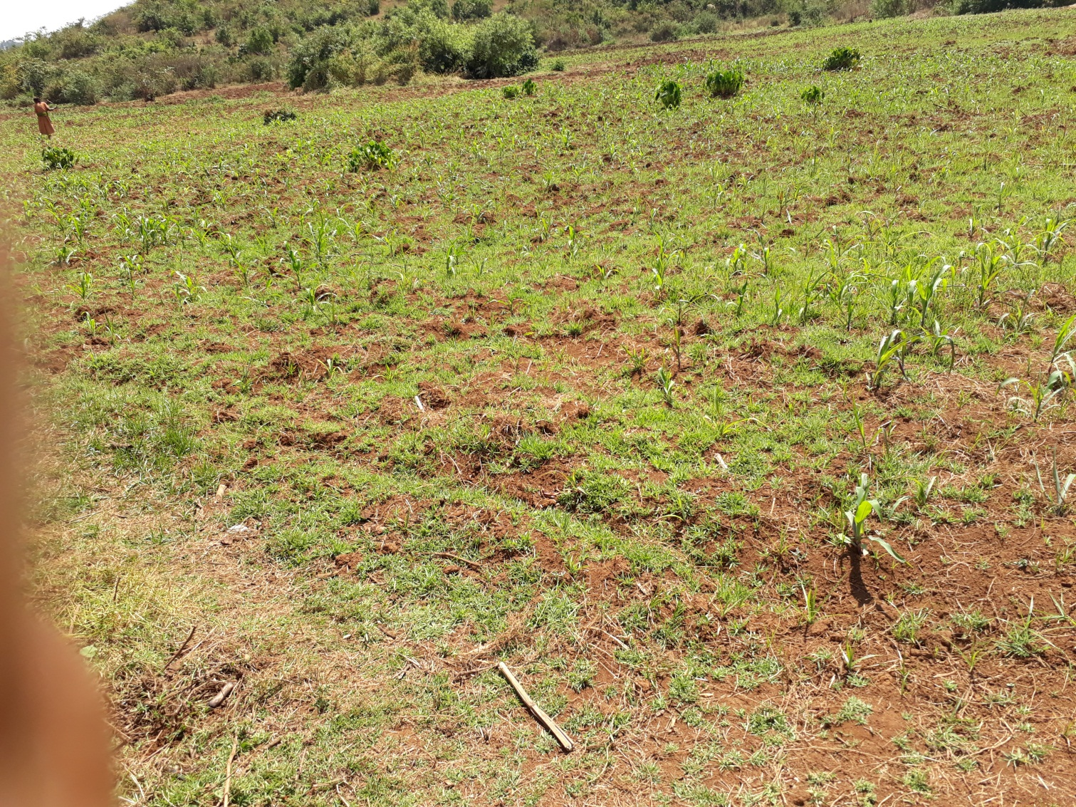
Figure 2. Traditional Irrigation Practice in Birbirsa Area
With the above shown diversion they have been irrigating significant command area, producing different vegetables.

Planned irrigable area

The irrigable area has moderate surface slope ranging from 3 - 10% towards the Birbirsa River. The soil of the area is loam dominated texture. The soil is workable type and easily susceptible to runoff. Proper soil and water conservation practices shall be adopted by the community to avoid and minimize the effect of runoff due to the introduced scheme. The proposed crops for this project are Maize, Onion, Potato, Pepper, Cabbage and Tomato. These crops under irrigation have maximum dry period duty of 2.08 l/s per ha for 12 hr irrigation per day and the net irrigable area of 51.82 ha was planned for 107.79l/s design discharge.

Water Availability

The source of water is Birbirsa River. It could have been good if monthly flow data were available; but the river is not gauged. Hence Lean flow was estimated after taking dry period measurements using floating technique. The lean flow as reported under hydrology section is 152 l/s. As mentioned above only 115 l/s was planned for this development, and the rest will be released for downstream. There is intense rainfall over the area and the catchment is mild to steep ranges with loam soil cover resulting in generation of high runoff, thus the peak design flood obtained is 125 m³/s.

Water distribution scenario

Water application to the field is based on irrigation interval set for each crop. In so doing continuous flow in main and secondary canals and rotated flow in tertiary and field canals will be adopted. The soil of the area is dense loam and its water holding property is moderate. The interval of water application is generally expected to be medium till next irrigation is applied when the readily available soil moisture is depleted. At each field unit level; the unit discharge is applied based on stream size required for that unit of field within irrigation time set per day to attain the required irrigation depth (FC of the soil).

System Layout Plan

The system layout plan was prepared based on irrigation and drainage design criteria for small scale community managed schemes. This layout is prepared on 1:1000 maps with 0.5m contour interval. The field units are up to 2.0 ha on average bases in size and tertiary units are kept below 10ha for the scheme to be manageable with an average 5ha the lower value for the tertiary unit is due to the topographic nature of the area. Continuous flow in main and secondary canals and rotated flow in tertiary canals is adopted regarding water distribution. The irrigation application method is furrow which has been locally practiced by the farmers. Thus the furrow direction is set along the contour lines. Furrow length is selected based on soil, crop type and topography of the area, but as per local farmers practice 30 - 70 m is adopted in stretching the layout plan. With average furrow length of 50m and field canal length 200m. Almost all field canals are aligned to irrigate on both sides so that each can cover up to 2 ha.

Major Components of the project

- Diversion Head work Broad crested weir and temporary channel and diversion for construction by part.
- Lined Main Canal 3.17 km long after intake structure
- Turnout/DB 29 fot both on MC and TC
- Three cross drainage culverts (CDs)
- Total of Tertiary Canals with total length 799.73m
- Total length of SC 206.2m

HEAD WORK

Objective/ General

The main objective of the diversion head work is to divert sufficient irrigation water from the natural course of the river towards the supply canal that provides irrigation water to the command area. This ensures a regulated continuous supply of silt-free water with a certain minimum head in to the canal.

Selection of Headwork site

The headwork site was selected under the following factors:
- Easy access to the site during construction and operation
- Possibility to command the anticipated area with reasonably less weir height.
- Convenience for intake and head regulators
- Better geological formation at the bed and side banks.
- Possibility to protect flooding of off taking canal
- Relatively area convenient for construction
- Area with less flood heights and effects.
- Area with less effect of transported materials specially boulders
- Area with easier temporary diversion during construction.
- Relative less cost of weir.

Based on these selection criteria Birbirsa headwork site was selected downstream of the confluence of the two rivers as mentioned in the hydrology report. The weir axis is located at relatively narrowest site of Birbirsa River. Fortunately at the selected site the foundation is found to fluvial soil which will the protection work at will needed for foundation. Hence, for the design of head work protection all data was collected.

The exact position has been fixed after carefully consideration of each of the following factors:-
- Characteristics of Foundation,
- Topography of the earth and rock surfaces at the site and its effect on the dimension of the weir,
- Quantity of Material to be excavated and other factors,
- Requirements as to coffers,
- necessary for unwavering of the site
- Availability and character of materials for Construction

Geology of weir site and the canal route

The site is located at the river where the river valley has constricted cross sectional dimension that has about 8m active channel width and gently sloping longitudinal and transverse valley profile .The river channel has fluvial soil with fractured rock covered by thin alluvial sediment deposit at both right and Right banks.

Weir site Geology
River bed and both river banks are composed of isolated basaltic boulders derived from under laying columnar basalt. It has size ranging from 20cm to 40cm diameter. The Right river bank has 65cm alluvial sediment ranging in size from clay to boulder size while the right bank has 20cm cover. The river bed is mainly covered by insitu angular basaltic boulder like braccia. Plate 4.1.depicts geologic units observed at the proposed diversion weir site.

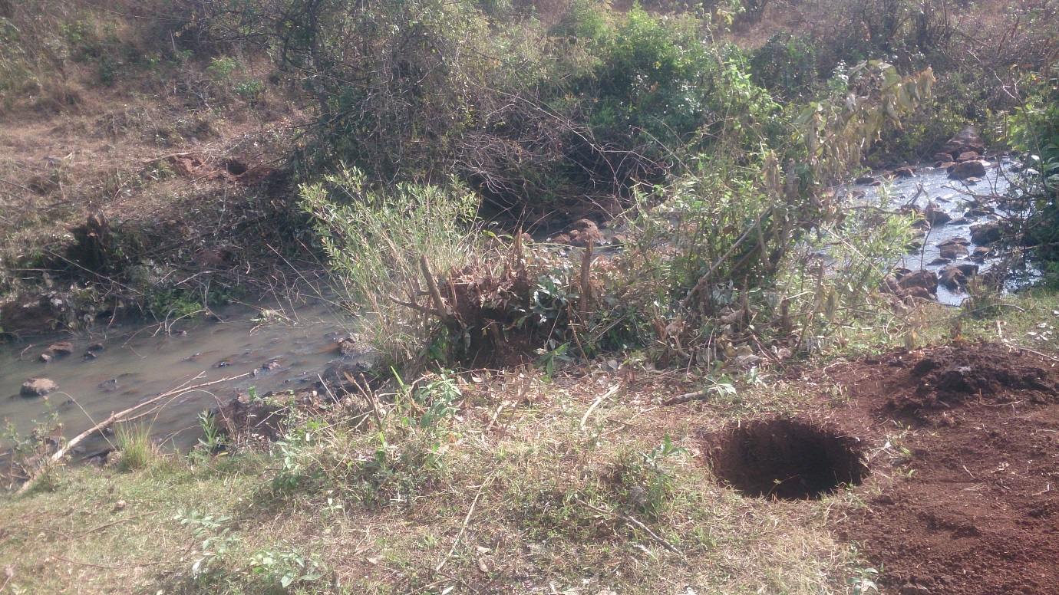

Figure 3. Geological units observed along the proposed diversion weir axis

The Right bank is covered by silty clay sediment underlain by basaltic unit. In the test pit dug 5m from the river bank fractured basalt similar to river bed and right bank appears at a depth of 120 cm b.g.s.
Table 3. Geotechnical description of test pit dug at Right river bank
Geo pit location | Depth (m) |  | Description
Geo pit location | From | To | Description
Left river bank  (230452mE, 1000335mN) | 0 | 65 | Silty alluvial sediment with weathered rock fragment
Left river bank  (230452mE, 1000335mN) | 65 | --- | Angular, non- intact basaltic boulder (30cm average diameter)
Right river bank  (230443mE, 1000326mN) | 0 | 25 | Silty alluvial sediment with weathered rock fragment
Right river bank  (230443mE, 1000326mN) | 25 | --- | Angular, non- intact basaltic boulder (30cm average diameter)
River center  (230450mE, 1000332mN) | 0 | 30+ | Angular, non- intact basaltic boulder (30cm average diameter)
50m upstream :River center  (230410mE, 1000344mN) | 0 | 30+ | Angular, non- intact basaltic boulder (30cm average diameter)
50m downstream: River center  (230490mE, 1000304mN) | 0 | 30+ | Angular, non- intact basaltic boulder (30cm average diameter)

In addition to the proposed diversion weir axis, geological characteristics of upstream and downstream shows that similar basaltic unit is observed along the river bed while the river banks are mostly composed of residual sediment.
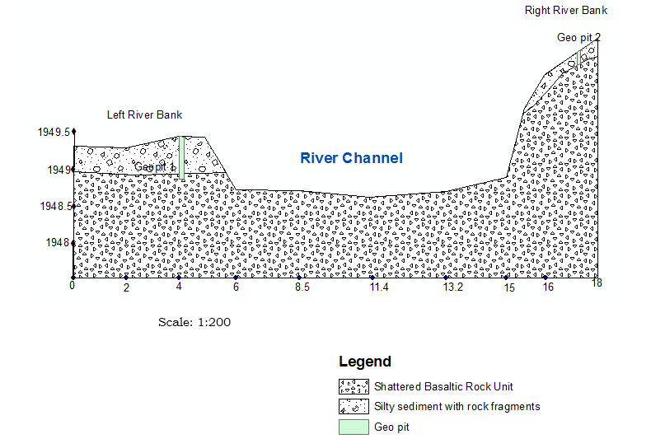
Figure 4. Geological cross section along the proposed diversion weir axis

Geotechnical Characteristics of Main Canal Route
The main canal route is generally underlain thin silty sediment mixed with rock fragment having thickness range of 0.0 to 40cm up to 500m followed silty to silty clay sediment up to the end of the canal. Table 4 shows the overall canal route geotechnical characteristics.

Table 4. Geotechnical description of geological pits along the main canal route
Pit location | Depth (m) |  | Description
Pit location | From | To | Description
100m from Headwork (2300527mE, 1000273mN) | 0.0 | 0.3 | Light friable gray silty sediment with weathered basaltic rock fragments
100m from Headwork (2300527mE, 1000273mN) | 0.3+ | -- | Angular, non- intact basaltic boulder (30cm average diameter)
500m from Headwork (230849mE, 1000223mN) | 0.0 | 0.5 | Light gray friable silty sediment with weathered basaltic rock fragments
500m from Headwork (230849mE, 1000223mN) | 0. 5+ | -- | Angular, non- intact basaltic boulder (30cm average diameter)

Base Flow & Design Flood Estimation

In the design of hydraulic and irrigation structures, the peak flow that can be expected from computed rainfall frequency analysis is important. Under estimation of peak flow would result inadequate capacity of structures and failure as a consequence.

The peak design discharge (Q_{max}) is used in the design of diversion structure, its appurtenant works and to determine the back water curve results from constructing the diversion structure, in order to predict the highest water level that occurs, on average once every (T) years, where T is the selected return period of the discharge. The Q_{max} determines the water afflux on the diversion structure and hence the height of wing walls and crossing bridges if any.

On the other hand computation of base flow and formulation of stage vs discharge relation by utilizing various approaches has a paramount importance in designing various structures and determining extent of irrigation command area.

The stream selected for the intended irrigation project has no recorded data of stream flow. As un gauged river, three methods have been implemented to estimate the expected flood from the existing rainfall condition and catchment characteristics described in detail previously.

The rational method is mostly applied to small catchments not exceeding 12.8Km² at most (Gray, 1971). The consequence of applying the rational method to larger catchments mostly produces an overestimate of discharge and a conservative design. Nevertheless, the method is frequently used in standard or modified form for much larger catchments.
The rational Method is based on the following formula:
Q_{m} = C.I.A. Fr
Where
Q_{m} = peak flow corresponding to return period of T- years (m³/sec)
C = a runoff coefficient expressing the ratio of rate of runoff to rate of rainfall

Coefficient of run off C for the formula is given by many soil and water conservation texts. The selection of the correct value of 'C' presents some difficulty. It represents a parameter that can influence runoff including soil type, antecedent soil conditions, land use, vegetation and seasonal growth. Therefore the value of 'C' can vary from one moment to another according to changes, especially soil moisture condition.
I = average maximum intensity of rainfall in mm/hr, for a duration equal to the time of concentration
Information on rainfall intensity I is the amount of rainfall measured over the catchment per hour duration. This value was taken from an intensity curve (annex-A4) based on the time of concentration and selected return period.
A= drainage area in KM²
Fr= is the real reduction factor (this factors improves the catchment limitations imposed on use of rational method).
The area reduction factor (fr) is introduced to account for the spatial of point rainfall over the catchment. The relationship adopted for Fr is based on the developed formula for east African condition (Fiddes, 1997). The relationship can be expressed as
Fr= 1-0.02D^{-0.33}*A^{0.5}
Where
D= Duration in hours
A= Drainage area
This equation applies for storms of up to 8 hours duration. For longer durations and large catchments, the value of D can be taken as 8hours in the above formula.
Time of concentration (time required for flow to reach the outlet from the most remote point in the catchment) is required and can be estimated by the following formula. Tc=(1/3080)*L ^{1.155} * H^{-0.385} Kirpich Equation
where
Tc= time of concentration (in hours)
L= maximum length of main stream (in meters)
H= Elevation difference of upper and outlet catchment (Meters)
Based on existing climatic and physiographic nature of the river morphology, the above procedural approaches and using developed tables and curves, the result of Rational method flood estimation has been tabulated as follows for 50 years return period.

The other method was developed from A relationship between accumulated rainfall and accumulated runoff by SCS (Soil Conservation Service). SCS runoff equation is therefore a method of estimating direct runoff from 24 hour or 1-day storm rainfall by the equations:
Q = (P-Ia)² /(P-Ia)+S
Where,
Q= accumulated direct runoff, mm
P= accumulated Rainfall (potential maximum runoff)mm
Ia= initial abstraction including surface storage, inception and infiltration prior to runoff, mm
S= Potential Maximum retention, mm.
The relationship between Ia and S was developed from experimental catchment read data. it removes the necessity for estimating Ia for common usage. The empirical relationship used in SCS runoff equation is:
Ia=0.2*S
Substituting 0.2*S for Ia in equation above , the SCs rainfall - Runoff equation becomes:-
Q=(P-0.2s)^2/(P+0.8S)
S is related to soil and cover conditions of the catchment area through CN. CN has a range of 0 to 100 (Can be obtained from Annex A₃) and S is related to CN by
S=254*((100/CN)-1)
Conversion from average antecedent moisture condition to wet conditions can be done by multiplying the average CN values by Cf [where Cf = (CN/100) ^{-0.4}]
Through utilizing the above equations and one to forty steps formulated for developing composite hydrograph, SCS method 50 years return period flood hydrograph has been developed as shown below. As indicated on the underneath graph, the river generates a peak runoff of 123.45m3/sec for 50 years return period.

Figure 5. SCS based Peak Discharge Hydrograph

In general, the Rational Method, SCS method and transferring gauged data are recommended for relatively small, medium, and large catchments respectively. However it is very important to establish a smooth pattern of transition from small to medium and from medium to large catchments.

Accordingly, the recommended weighted average estimate of peak flood can be given as:-
Qw=W1.Q1+W2.Q2+W3.Q3
where:-
Q1,Q2,Q3 are mean annual momentary peaks by Rational, SCS, and Transferring gauged data methods respectively
W1,W2, and W3 are weighing factors of mean momentary peak estimates by rational, SCS and transferring gauged data methods respectively.
W1=12.5/(12.5+Au)=12.5/56.5=0.22
W3= (Au/Ag)^0.7=(44/5278)^0.7=0.035
W2=1-(W1+W3)=1-(0.22+0.035)=0.74
where AG and Au are gauged and un gauged catchment areas, respectively
Qw= 0.22*130+0.74*123.45+0.035*33.01=122m3/sec
Take 125m³/sec for designing purpose
Regarding base flow, estimation of flow can be conducted based on many years river gauge data if available or by undertaking direct measurement at the area selected for development. From conducted evaluation, the stream selected for this project has no river gauge data that can be utilized for base flow estimation. As a result, flow measurement was conducted directly during the driest period of the year. The measurement was done in February before the beginning of the belg rainy season and end of the winter dry season. This implies, the period selected for the measurement was an ideal time so as to quantify the dry season flow of the stream.

Taking the average of the cross sectional areas and the velocity, discharge of the river was calculated. Accordingly the discharge in the river course of Birbirsa stream during the specified dry season period has been obtained as 152 liter/sec. While estimating this flow, discharge coefficient has been considered pertinent to existing condition and as per recommendation of study manuals so as to optimize measurement accuracy and avoid unwanted overestimation.

Regarding drainage duty the following table adopted.

Drainage Duty, in Litter per Second per Hectare (l/s/ha)

Table 5. Drainage Duty, in Litter per Second per Hectare (l/s/ha)

Selection of Weir Type

Broad Crested Weir will be provided so as to have minimum possible head loss. The minimum top width as per IS 6531-1994 is 2/3 He. Hence crest width of the weir was determined to be1.0m length
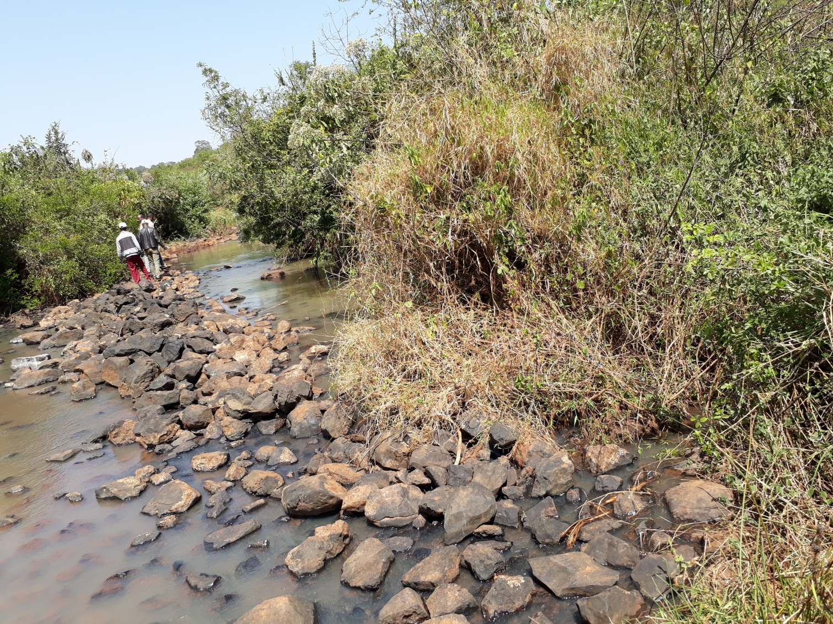
Figure 6. Birbirsa river headwork site

Design of weir

General Description of the Weir
Even though an ogee weir has a high hydraulic performance (discharge coefficient is higher than for other weir shapes), because it is difficult to accurately construct in the field, and considering foundation condition broad crested weir is suggested. Broad crested weir is also more economical than ogee weir cost wise

Components of Weir: -
-Weir proper (main weir),
Figure 7schamatic view of weir
-Scouring sluice

-Head regulator
-Guide wall

Design of weir (Main Weir)
The weir is designed under two main aspects:
1. Hydraulic design
2. Structural design
Weir type: broad crested masonry weir.
Weir design considered here is Birbirsa river having the following characteristics:-
Location of the Proposed Weir (Centre Co-ordinates) | Easting | 991434.737 | Northing | 238518.1 | UTM
SN Particulars Unit
(i) Maximum flood Discharge (Q) =125.00 cumecs
(ii) River Bed Level (RBL)
(Average bed level) =1948.650 m
(iii) Maximum Water Level of river =1950.287 m
(iv) Permissible afflux = 1.30 m
(v) River bed Width (RW) =12.00 m
(vi) Gravitational Acceleration (g) =9.81 m/sec2
(Vii) Lacey's silt factor = 1.00
Q(T=50year) over weir =112.500 m/sec2
Q(T=50year) under sluice pass 10% to 20% of Maximum Discharge assume 10%= 12.500 m/sec2
The following design procedures are considered:-
Step 1
Fixing of Crest Level and Water Way :
 | Retrogression = | 0.2 | m, safe exit gradient for Shingle (1/4 to 1/5)
 | Crest elevation of weir bay is generally kept 1.00 to 1.50 meters higher than the |  |  |  |  | 1.00 |  | m
 | crest level of the under sluice. |  |  |  |  | 0.20 |  | m
 |  |  |  | Under sluice bed level |  | = | 1948.850 | m
 |  |  | Crest elevation = 1948.85 + 1 = 1949.05 masl |  |  | = | 1949.85 | m
 | Crest height, H = 1949.85 - 1948.65 = 1.2 m above river bed level. |  |  |  |  | = | 1.20 | m
Fixing of Crest Level and Water Way :
Retrogression = 0.2 m, safe exit gradient for Shingle (1/4 to 1/5)
Crest elevation of weir bay is generally kept 1.00 to 1.50 meters higher than the crest level of the under sluice.
River bed Level=1948.65
Under sluice bed level 1948.65+0.2=1948.85
Crest elevation = 1948.85 + 1 = 1949.00 masl
Crest height, H = 1949.85 - 1948.65 = 1.2 m above river bed level.
Step 2
Crest Length (water way)
The length of water way should be adequate to pass the design flood safely. For alluvial river it is usually determined from the Lacey wetted perimeter (P).
P=4.75 √Q
P=53.1m3/s

a) Under sluice portion = 1.0 Bays of 1.6 =1.6m

=Overall waterway 1.6.00m
b) Other weir bays portion 1.0 Bays of 26.0m =26.00m

Width of weir portion =26+1.6 =27.6m
Length of weir waterway Provide clear length of crest (L)
L = 27.6.00m
Distance between Inner faces of Abutments Water_Way_Total =27.6m
Looseness factor = Actual length/ theoretical length = 27.6/53.1 = 0.52
Looseness factor (B/n 0.50-1.00) =0.52 OK!

Step 3
Discharge and Head over the Weir
Q = CLHe3/2 , H=(Q/CL)2/3
C = 2.14
He = 1.65 m
where ; q=Q/L q = 4.53 m3/s/m
Now R=Lacey′s regime scoured depth R= 1.35 x ( q2/f )1/3
Lacey's silt factor f = 1.00
R = 3.70 m
Regime velocity, v = q/R = 4.53/3.7 =1.23m/s
v = 1.23 m/s
Velocity head, ha = v2/2g =1.23^2/2*9.81 =0.08m.
ha =0.08m
∴ Level of u/s T.E.L =u/s H.F.L + Velocity head
u/s T.E.L = 1951.50 m
∴ Level of u/s H.F.L =u/s T.E.L -Velocity head
u/s H.F.L = 1951.42 m
length Clear waterway L = 27.60
b effective = 27.60
Q = CLHe3/2 , H=(Q/CL)2/3,H = 1.65 m

Hence the RL of weir crest = TEL - H , 1949.85 m
Since the allowable afflux is 1.30 m
Downstream HFL = 1951.42 - 1.3 = 1950.12m.
= 1950.122 m
∴ Level of d/s T.E.L =d/s H.F.L + Velocity head =1950.20

For the flow to be modular, i.e. not affected by submergence, the ratio H2/H1, where H1
and H2 are the upstream and downstream heads above the weir crest, is less than 0.75 (BSI, 1969; Bos, 1976):
Upstream head, H1 = 1951.42 - 1948.65 = 2.77 m, and
=2.77
Downstream head, H2 = 1950.12 - 1948.65 = 1.47 m
H2/H1 = 1.47/2.77 = 0.53 (<0.75) = 0.53 < 0.75 modular OK
Hence the flow is modular, and the weir discharges the design flow with the desired upstream and downstream water levels.
The approach velocity, V a = (Q/L (h + p))
Where, h = H – V a 2/2g
Va2/2g = H - h H =1.65
But, V a = ((Q/L (h + p)
(Q2/ [L (h + p)] 2 * 1/2g) = 1.65 -h
The Value of h can be calculated by trial and error method as follows.
h Left Site Right Site Remark
1.65 0.09 0.00
1.55 0.10 0.10 OK
1.45 0.10 0.20
Therefore h =1.55 Design Discharge to pass over weir 125.00 m3/s Q = CLHe3/2 =125.00 OK Check: Design Discharge to pass over weir
d/s HFL = 1950.287 m
afflux = 1.3 m
u/s HFL = 1951.587 m
Intensity of Discharge = q = 4.53 m
Scour Depth = R =1.35x (q*q / f)1/3 = 3.7
Silt Factor = f = 1.76√mr = 1
Velocity of Approach(V) = q/R = 1.23 m/s
Velocity Head = V2/2g = 0.077 m
u/s TEL = 1951.66 m
H2/H1 < 0.75 0.56 < 0.75 , Modular OK
Discharge Through Under Sluice (Q1) = 1.705 x (L -k*n*H)*H3/2) = 12.87 cumecs
Where:- OK
Total head (H) = 2.81 m
coefficient of end contraction(k) = 0.00
no of bays (n) = 1.00
Length of Clear Water Way (L) = 1.60 m

Discharge Through other weir bays (Q2) = 1.84 x (L -k*n*H)*H3/2) = 116.84 cumecs
Where:- OK
Total head (H) = 1.81 m
coefficient of end contraction(k) = 0.00
no of bays (n) = 1.00
Length of Clear Water Way (L) = 26.00 m

Total Discharge Pass Through Weir(Q1+Q2) =129.71cumecs > 125 ,OK cumecs
Step 4
Stilling Basin
a. Energy method
Velocity head in the approach channel
h v o = H - h h v o = 0.08 m
Hydraulic Jump 1.000 . In case of Rock foundation.
River bed Elevation = 1948.65m = 1948.650 m
D/S Water level = 1950.12m = 1950.12 m
Weir crest level = 1949.85m = 1949.85 m
Height of the crest, P = 1.2m (The Possible silt Height = 0.20 m assumed) = 1.20 m

b. Determination of the bed level of the stilling basin
by Trial and Error Method
It is necessary to fine the jump height and to adjust the bottom level of the basin so that the water surface level of the jump is a little higher than the D/S water surface level say 20 ~ 40cm.Therefore, the floor level of the stilling basin must be found by trial and error method. Assuming the floor level is 0.50 m lower than the river bed.
Assumed EL.1 = EL.3 - 0.50
Assumed EL.1 = 1948.65 - 0.5 = 1948.15
=1948.15 m
H = E0 =E1
Z = EL.0 - Assumed EL.1
Z = 1949.85 - 1948.15 = 1.7 m Z = 1.70 m
E0 = H + Z E0 = 3.25 m
q = Q/b q = 4.53 m3/sec/m
From the energy rule E0 = E1 =d1 + hv1
Where, d1 -Critical depth (m) , hv1 - critical velocity head (m)
Hence, E1 = d1 + hv1 = (d1 + v12/2g)*1/2g
E1 = d1 + hv1 = (d1 +q2/2gd12)
Z = E0 +E1 Therefore, d1 +q2/2gd12

d1 +q2/2gd1² = | 3.25 | m
d₁ | d₁+q²/2gd₁²= | 3.25 | Remark
0.6217 | 3.33 |  | OK

So from this result d1 = 0.62 m d1 = 0.62 m
Critical velocity, V1 = q/d1 = 4.53 / 0.62 = 7.3 m/sec V1 = 7.30 m/sec
Fraud number, Fr = V1/√ (gd1) = 7.3 / ( 9.81 x 0.62 = 2.96 = 2.96
Post conjugate depth, d2
d2 = d1/2[(√1+8Fr2) -1] = 2.31
If the water surface of the jump is assumed to be 0.09 m higher the downstream water level.
EL.1 = (WL.3 + 0.09) - d2 WL3 = 1950.12 m = 1947.91
EL.1 = 1948.65 m < assumed EL.1 = 1947.91 m
Therefore, the bottom level of the stilling basin will be EL.1 = 1947.91 m
Check for the difference (d) between d3 & d2
If d = d2 - d3 = -0.744m OK! For 0<=d<=0.09 m, NO NEED of depressing the downstream stilling basin level by depth d.

Step 5
LEVEL AND LENGTH OF D/S FLOOR :-
Q= 125.0cumecs
Discharge in Primary Main canal L = 27.60 m
Total clear waterway q = 4.53 cumec/m
Discharge per meter length HL= 1.30 m
Head loss
From Blench Curve, Dc = 1.28 m
Critical Depth, Dc = (q2/g)1/3 D1 = 0.62 m
Pre jump depth corresponding to Ef1 D2 = 2.31 m
Post jump depth corresponding to Ef2 Ef1= 2.85 m
Upstream specific energy level Ef2= 1.55 m
Downstream specific energy level F = 2.96
Froude no., F = q / √ g x D13 = 1948.65 m
∆ cistern level = D/S TEL - Ef2 ∆ Cistern depth will be equal to d/s bed level minus cistern level or in case d/s bed level is higher than calculated cistern level then depth be kept equal to FSD/4=0.58 m
∆ Provided Cistern Depth =0.60 m
∆ Provided Cistern level =1948.05 m
The length of the stilling basin is:-

L = 4*d2 = 4 x 2.31 = 9.224m take 9.2 m L = 9.22
L = 10.00
＊ Cistern Length required (Fr<4.5) = 5 x ( D2 - D1 ) = 8.43

Free Board:
Free Board for the side walls of stilling basin: 0.10 *(v 1 + d2)
Incoming velocity to the basin in m/s v 1 = 7.30 m/s
D/S Conjugate Water Depth in m d 2 = 2.31 m
Free Board for the side walls of stilling basin= 0.96
Say = 1.00

Step 6
TOP WIDTH OF CREST:
Broad Crested Weir will be provided so as to have minimum possible head loss. The minimum top width as per IS 6531-1994 is 2/3 He

Where He = U/S FSL - Crest Level = 1.65 m
∆ min. top width of crest = 1.1 m
Provide top width of crest for accommodating Gates and Stop log = 1.10 m
Step 7

VERTICAL CUT-OFFS
(i) Provide U/S Cut-off of 2.77 m depth below U/S bed level = 2.77 m
Bottom elevation of upstream pile = 1945.882 m
(ii) Provide D/S cut-off of 3.8 m depth for safe exit gradient= 3.80 m
Bottom elevation of downstream pile = 1944.106 m
Step 8

FLOOR LENGTH
From Khosla's theory, the exit gradient can be expressed by the relation as
Exit gradient = 1 / p x sqrt ( l ) X (H / d )
Where, GE ( Exit gradient ) = 1 / 5
d = Depth of d/s cutoff = 3.80 m
H = Maximum static head = U/S FSL - D/S bed level = 2.77 m
Substituting the values 1 / 5 = 1 / p x sqrt ( l ) X (H / d )
or 1 / p x sqrt ( l ) = d / (5 x H) = 0.274
From Khosla curve for 1 / p x sqrt ( l ) a = 1.37
Floor length = a x d = 5.22 m
The Total length will be provided as below :-
(i) D/S Floor length = 10.00 m
(ii) D/S Glacis length ( 2:1 slope) = 3.89 m
(iii) Length for Gates & Crest = 1.10 m
(iv) U/S Glacis length ( 1:1 slope) = 1.20 m
(v) U/S floor length = 3.40 m
(vi) Total length of floor = 19.59 m
(vii) Provided Floor length = 20.00 m
(viii) U/s Provided Floor length =4.00 m

Step 9
PRESSURE VARIATION CALCULATIONS

( i ) At U/S cut off wall
Total floor length (b) = 20.00 m
Depth of U/S cut off wall (d) = 2.77 m
From Khosla's equation1/a = d/b = 0.138
a = b/d = 7.225
l = (1 + √ (1 + a2))/2 = 4.147
fE = Cos-1((l - 2)/l) = 33
fD = Cos-1((l - 1)/l) = 23
fC1 = 100 - fE = 67
fD1 = 100 - fD = 77
Assuming floor thickness at U/S end as = 0.700 m
Correction for floor thickness at U/S end = (77 - 67) X 0.70 / 2.77 = 2.53 %
fC1 (Corrected) = 67.00 + 2.53 = 69.53 %

( ii ) At D/S cut off wall
Total floor length (b) = 20.00 m
Depth of D/S curtain wall (d) = 3.80 m
From Khosla's equation 1/a = d/b = 0.190
a = b/d = 5.263
l = (1 + √ (1 + a2))/2 = 3.179
fE = Cos-1((l - 2)/l) = 38
fD = Cos-1((l - 1)/l) = 26
Assuming floor thickness at D/S end as = 0.700 m
Correction for floor thickness at D/S end = (20 - 14) X 0.750 / 1.50 = 2.21 %
fE (Corrected) = 38.00 - 2.21 = 35.79 %
Pressure variation = (69.53 - 35.79) / 20.00 = 1.687 %

Hydraulic Jump over the weir crest

Hydraulic jump

The calculation for the hydraulic jump is by considering step 9 above and using the equation for hydraulic jump.

Step 10
FLOOR THICKNESS
(i) D/S FLOOR
Floor thickness from D/S face of D/S cut off wall at = 5.00 m
r = 35.79 + 5.00 * 1.687 = 44.225 %
Floor thickness = (r x H) / ((sp,gr.-1) X 100) = 0.428 m
Provide minimum as = 0.700 m
Floor thickness of D/S slope varies from 0.700 m to 0.700 m from d/s floor to cistern. Floor thickness from D/S face of D/S cut off wall at = 10.00 m
35.79 + 10.00 X 1.687 = 52.660 %
Floor thickness = (r x H) / ((sp.gr.-1) X 100) = 0.510 m
Provide minimum as = 0.700 m
Floor thickness of under cistern 0.700 m from start of cistern to end of cistern. Provide floor thickness under crest = 1.900 m
Floor thickness of D/S Glacis varies from 1.900 m to 0.700 m from crest to cistern
(ii) U/S FLOOR
Provide thickness of upstream floor = 0.700 m

Step 11

Protection Works beyond Impervious Floor
(i) Upstream protection :
Depth of scour R = 1.35 x (q2/f)1/3 = 3.70 m
Anticipated scour = 1.5 X R = 5.54 m
Upstream scour level = 1,951.50 - 5.54 = 1945.88m
Scour depth 'D' below u/s floor = 1,948.65 - 1,945.88 = 2.77 m
(a) Block protection :
Hence 'D' = = 2.77 cu.m/m
Block protection shall be provided minimum equal to 'D' in length & minimum 4 rows of blocks,
Provide 4 rows of 0.80 m x 1.25 m x 0.60 m
0.60 m thick gravel , gravel apron in a length of =3.35
No. of rows required across the bed width =22.08
Provide the no. of rows across the bed width =23
※gravel apron in a length= 2.77 / ( 0.60 + 0.60 ) = 2.31
rows of above blocks in a length of 2.40
(b) Launching apron :
Quantity of launching apron should be 2.25 X D = 6.23 cu.m/m
Thickness of launching apron = 1.20 m
The length required = 2.25 x D / thickness = 5.19 m
Provide length of launching apron = 5.00 m

(ii) Downstream protection :
Anticipated scour = 2.0 X R = 7.39 m
Downstream scour level = 1,951.50 - 7.39 = 1944.11 m
Scour depth 'D' below u/s floor = 1,948.65 - 1,944.11= 3.80 m

(a) Block protection
Block protection shall be provided in a minimum length equal to '2D' which comes
Provide 8 rows of 0.8 m X 0.8 X 0.60 m
C.C. blocks with 5 cm gap filled with 'bajri' (Sand) over 0.60 m thick
graded filter in a length of 6.75 m

(b) Inverted filter:
AS per Code of Practice, Just at the end of concrete floor on the downstream an inverted filter
1.5 to 2 D long (D being the depth of scour below bed ), is provided below the concrete block
The length of the inverted filter should be equal to 1.5D = 5.70 m
Providing 1.25m x 1.25m x 0.60m CC blocks with 10cm gap filled with 'bajri' over 0.60m.
0.60 m thick graded filter. No of rows required = 5.7 /1.35 = 4.22
Hence, provide 4 rows of blocks in the direction of flow.
Provide length of inverted filter in the direction of flow = 5.30 m
No. of rows required across the bed width = 20.52
Provide the no. of rows across the bed width = 21 N0.
(c) Launching apron:
Downstream of the inverted filter, loose apron 1.5 D in length consisting of either boulders of not
less than 40 kg or wire boulder crates should be provided so as to ensure a minimum thickness
of 1 m in launched position.

Thickness of launching apron (Sum of thickness of blocks & Filter) = 1.20 m
Quantity of launching apron required = 2.25 X D = 8.55 cu.m/m
Length required = 8.55 / 1.20 = 7.13 m
Provide launching apron 1.20 m deep in a length of , say = 7.20 m

Toe wall:
Also provide a 0.90 m thick and 1.20m deep masonry toe wall between the filter and the launching apron

Under sluice:

Provide the Crest of under Sluice at 1948.85m near the canal Head Regulator, which is 0.20m above the river bed level.

Step 12

Stability analysis of the weir
For the structure to be remained stable the following conditions must be fulfilled.
- The structure must safe against sliding, overturning and resultant force must lie within middle third.
- There should not be tension under the base
- The maximum toe and heel pressures on foundations should not exceed the prescribed safe limits.
The weir have to be checked against externals forces to decide whether the dimensions adopted from design based on hydraulic criteria is sufficient from structural stability point of view or not. The stability of the weir was checked for of high flood level conditions.

The weir wall constructed of cyclopean concrete was designed. As described in the above sub section. All the forces and moments that act on weir are calculated separately and tabulated in the following Tables. The external forces considered on stability of the weir body analysis are:
- The hydrostatic pressure up stream of weir,
- Uplift water pressure
- Tail water pressure,
- Self weight of the weir,
- The weight of water wedges and
- The silt pressure.
For the analysis of stability the following parameters value and symbols are adopted:
- Unit Weight of cyclopean concrete, γc = 2.4 t/m3 (for weir body and u/s & d/s cut off walls)
- Unit Weight of water,γw = 1.0t/m3
- Unit Weight of bed material (fine sand submerged), γs = 1.8t/m3
- INPUT DATA
Upstream bed level Hu =1948.65 m
Upstream side slop m1 =1.00
Downstream side slop m2 =2.00
Downstream bed level Hd =1948.65 m
Crest level of weir Hcw =1949.85 m
Head above weir Ha =1.57 m
Length of weir Lw =27.60 m
Width of weir Bw =4.7 m
Depth of Upstream pile Dup =2.77 m
Depth of Downstream pile Ddp =3.80 m
Level of u/s flow in flood Hfd =1951.42 m
Level of d/s flow in flood Hfd =1950.12 m
Gravity density of stone Ws =20 KN/m3
Gravity density of concrete Wc =24 KN/m3

 |  |  | Pv |  |  |  |  |  | B
 |  |  |  |  |  |  | h= | 0.7
 |  |  |  |  |  |  | h1= | 1.2 | 1.2
 |  |  |  |  |  |  | h2= | 2.31 | 1.1
 |  |  |  |  |  |  | h3= | 0.5 | 2.4
 |  |  | 0.00 |  |  |  | h4=
 |  |  |  |  |  |  | h5=
 |  |  |  |  |  |  | h6=
1.20 |  |  |  | 1: | 2 | h2 | h7=
1: | 1 |  |  |  |  |  | h8=
Ph |  | W1 | W2 | W3 |  |  |  |  | 4.70
 |  |  |  |  |  | h3
 |  | 1.2 | 1.1 | 2.4 |  | h4

Figure 8 Weir cross –section and all forces on the weir

Normal Pond Level
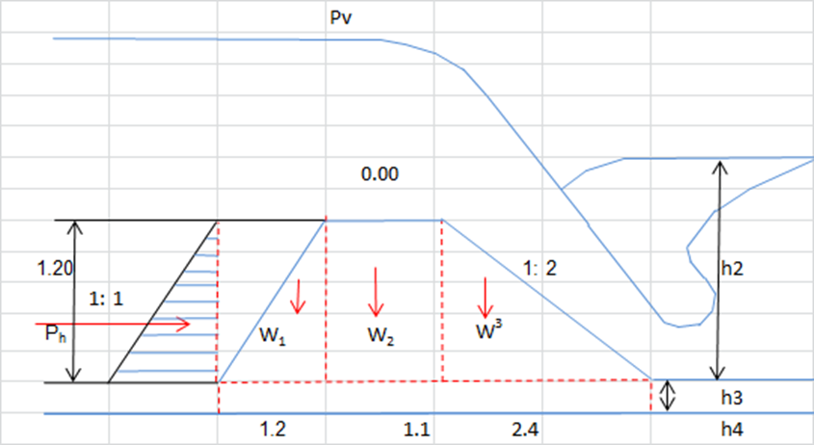
Figure 9 Forces on weir in normal pond level
(1 ) Horizontal forces

- : Water pressure Ph=γw x(Hcw - Hu)2 x1 x 0.5 = 7.20 KN
γw= 10 KN/m3 : Point acting force Lh1=1/3 x (Hcw - Hu) =above d/s bed level 0.4 m

② : Silt pressure
Silt gets deposited against the upstream face of weir. If h is the height of silt deposited, then the force exerted by this silt in addition to external water pressure, can be represented by Rankine's formula as :Ps = 1/2 x γsub x h2 x Ka
where :
Ka is the coefficient of earth pressure of silt = (1 - sinΦ) /( 1 + sinΦ).
Φ is the angle of internal friction of soil.
:γsub is the submerged unit weight of silt material.
: h is height of silt deposited.
In the absence of any reliable data for the type of silt that is going to be deposited, U.S.B.R. recommendations may be adopted. In these recommendations, deposited silt may be taken as equivalent to a fluid exerting a force with a unit wt. equal to 3.6KN/m3 in the horizontal direction and a vertical force with a unit wt. of 9.2KN /m3.Hence; in this project case it is reasonable to accept the U.S.B.R. recommendation.
PSh=1/2 x 3.6 x( 2/5 x (Hcw - Hu))² x 1=0.415 KN
: Point acting force Lh2=(2/5x (Hcw - Hd)) x 1/3= 0.16 m
( 2) Vertical forces
- : Water pressure Pv=γw x(Hcw - Hu)2x 1 x0.5 = 14.450 KN
: Point acting force LV1=1/3 x (Hcw - Hu) =0.57 m
- : Silt pressure
Psv=1/2 x 9.2 x (2/5 x (Hcw - Hu) )2 x 1 = 1.06 KN
: Point acting force LV2=(2/5 x (Hcw - Hu)) x 1/3 =0.16 m
- : Weight of weir
To calculate this one, body of weir should be divided as part of three.
△ Area and center of parts
① Area ((Dup+(Dup+0.5 / m1))/2) x 0.5 = 0.72 ㎡
C.G = 3.90 m
② Area = 1.32 ㎡
C.G = 2.95 m
③ Area = 1.44 ㎡
C.G = 1.600 m △Total area Aw = 3.48 ㎡
Centre of gravity for weir section from toe Cwv = 2.59 m
△ Weight W = Wc x 1 x Aw = 69.6kn
④ :Uplift pressure
U1= E3 x 1 x b 0.61 KN
: Point acting force 2.35 m
U2=1/2x(E1- E3)x 1xb 2.73 KN
: Point acting force 1.57 m
`

 |  |  |  | E₃
E₁
E₂
 | U₂ | U₁

Figure 10 Uplift pressure
( 1 ) Structural stability of Weir
- Stability against overturning:
Factor of safety against overturning
Table 6 Structural stability of Weir

Name of Load | V (kn) | H (kn) | Arm (L) | M (KN.m)
Ph |  | -7.2 | 0.40 | -2.88
Psh |  | -0.41472 | 0.16 | -0.0663552
Pv | 7.200 |  | 0.4 | 2.88
Psv | 1.06 |  | 0.16 | 0.1696
Pw | 69.6 |  | 2.59 | 180.264
U1 | -0.61 |  | 2.35 | -1.42292001
U2 | -2.73 |  | 1.57 | -4.2861
Total | 74.520 | -7.61472 |  | 174.66

Ft =Ms / Mt supporting Ms= 183.31

Overturning Mt = 8.66
Ft =21.18>Fs=2, 21.18 SAFE
- Check for Sliding
Factor of safety against sliding
Sliding
The friction developed between two surface is equal to μΣv, where Σv is the algebraic sum of all the vertical forces whether upward or downward, and μ is the coefficient of friction between the two surfaces. In order that no sliding takes place, the external horizontal forces (ΣH) must be less than the shear resistance μ x ΣV. From above Table Hence, ΣH<μΣv. F.S.S(factor of safety against sliding)=The value of μ generally varies from 0.65 to 0.75 .say , μ=0.7
Fs.s=2.0 =7
F.s.s.=2.0<7 SAFE
Stress on the foundation

① | Distance from toe to Point acting Moment
 | E=Σ174.66/Σ 74.52 |  |  | = | 2.34 | m
② | Distance of eccentricity
 | E0 = E - B/2 =2.34- 4.7/2 |  |  | = | -12.87 | m
 |  | B=Total Length of Weir |  | = | 4.70 | m
③ | Maximum Stress on the foundation (At toe)
 | Smax =ΣV/B(1 + 6xE0/B) |  |  | ₌ | -244.6 | KN/m2
④ | Minimum Stress of Foundation (at heel)
 | Smin =ΣV/B(1 - 6xE0/B) |  |  | ₌ | 276.4 | KN/m2
⑤ | Cefficienc of Unbalanced Sttlement
 | fu = Smax / Smin |  |  | ₌ | -0.88
⑥ | fu=-0.88 < f= 〔 3 〕 |  |  | ₌ | SAFETY
 | For | Very Soft | compressive strength |  | 10–250 tsf | kn/m2 ( See table )
 | Thus , | Smax = 276.4> 250–500 tsf |  |  | SAFETY

Maximum Flood Water Level

- Calculations of the force acting on the weir

Figure 11 Stability analysis at high flood level condition
- Horizontal forces
① | : Water pressure |  | Ph=γw x(h2-(h- h1)²) x1 x 0.5 |  |  | = | 26.06 | KN
 |  | γw= | 10 | _{KN/m3}
 | : Point acting force |  | Lh1=1/3 x h1(((h+2(h-h1))/((h +(h-h1))) |  |  |  | 0.54 | m
② | : Water pressure |  | Ph2=γw x h22 x 1 x 0.5 |  |  | = | 1.92 | KN
 | : Point acting force |  | Lh1=1/3 x h2= |  |  |  | 0.21 | m
③ | : Silt pressure
 |  | Silt gets depositted against the upstream face of weir.
 |  | Psh=1/2 x 3.6 x( 2/5 x (Hcw - Hu))² x 1= |  |  |  |  | 0.41 | KN
 | : Point acting force |  | Lh2=(2/5x (Hcw - Hu)) x 1/3= |  |  |  | 0.16 | m
④ | : Hydrodynamic pressure Pm
 |  | Pm=K x γw x Q /g x v
 |  | k is coefficienc as |  | 0.035
 |  | Q is discharge |  | 125.00 | m3/s
 |  | v is velocity when water is flowing over weir
 |  | v=q/(h-h1) | = | 2.88 | m/s
 |  | Thus | Pm= |  |  |  | 12.84 | KN
 | : Point acting force |  | Lm=(h - h1)/3 +h1 |  |  |  | 1.72 | m

① | : Water pressure |  | P_{v1}=γ_{w} x((h+(h-h1))/2)xh₁xm₁x Lw = |  |  |  | 26.06 | KN
 | : Point acting force |  | Lv₁=(2.5/3) x ((h+ 2x(h-h₁)/(h+(h-h₁)) |  |  |  | 2.7 | m
② | : Water pressure |  | P_{v}=γ_{w} x(h-h₁)x0.5x 1 = |  |  |  | 7.86 | KN
 | : Point acting force |  | Lv=3.8 -h₁xm₁-1.1 |  |  |  | 2.05 | m
③ | : Water pressure |  | P_{v2}=γ_{w} xh²₂m₂x0.5x 1 = |  |  |  | 3.84 | KN
 | : Point acting force |  | Lv₂=h₂xm₂/3 |  |  |  | 0.41 | m
④ | : Silt pressure
 |  | P_{sv}=1/2 x 9.2 x (2/5 x (H_{cw} - H_{u}) )² x 1= |  |  |  |  | 1.06 | KN
 | : Point acting force |  | L_{V2}=3.8-(2/5 x m₁ x (H_{cw} - H_{u})) x 1/3 = |  |  |  | 0.33 | m
⑤ | : Weight of weir

- Vertical forces

① | : Water pressure | Pv1=γw x((h+(h-h1))/2)xh1xm1x Lw = |  |  |  | 26.06 | KN
 | : Point acting force | Lv1=(2.5/3) x ((h+ 2x(h-h1)/(h+(h-h1)) |  |  |  | 2.7 | m
② | : Water pressure | Pv=γw x(h-h1)x0.5x 1 = |  |  |  | 7.86 | KN
 | : Point acting force | Lv=3.8 -h1xm1-1.1 |  |  |  | 2.05 | m
③ | : Water pressure | Pv2=γw xh22m2x0.5x 1 = |  |  |  | 3.84 | KN
 | : Point acting force | Lv2=h2xm2/3 |  |  |  | 0.41 | m
④ | : Silt pressure
 |  | Psv=1/2 x 9.2 x (2/5 x (Hcw - Hu) )² x 1= |  |  |  | 1.06 | KN
 | : Point acting force | LV2=3.8-(2/5 x m1 x (Hcw - Hu)) x 1/3 = |  |  |  | 0.33 | m
⑤ | : Weight of weir

 |  | To calculate this one,body of weir should be divided as part of five.
△ | Area and centre of parts
 |  | ① | Area | ((Dup+(Dup+0.5 / m1))/2) x 0.5 = |  |  | 0.72 | ㎡
 |  |  | C.G | (0.5/3) x ((Dup+2x(Dup+0.5/m1))/(Dup+(Dup+0.5/m1)) |  |  | 3.90 | m
 |  | ② | Area |  |  |  | 1.32 | ㎡
 |  |  | C.G |  |  |  | 2.95 | m
 |  | ③ | Area |  |  |  | 1.44 | ㎡
 |  |  | C.G |  |  |  | 1.600 | m
△ |  | Total area |  |  |  | Aw | 3.48 | ㎡
 |  | Centre of gravity for weir section from toe |  |  |  | Cwv | 2.59 | m
△ |  | Weight |  | W = Wc x 1x Aw = |  |  | 83.52 | kn

④ | :Uplift pressure
 |  | U1= E3 x 1x (m1x(Hcw- Hu)+0.5 m2 x(Hcw-Hd) |  |  |  |  | 2.20 | KN
 | : Point acting force |  |  |  |  |  | 2.35 | m
 |  | U2=1/2x(E1- E3)x 1x(m1x(Hcw- Hu)+0.5 m2 x(Hcw-Hd) |  |  |  |  | 2.53 | KN
 | : Point acting force |  |  |  |  |  | 1.57 | m
Table 7 Load & Moment about Toe
Name of Load | V (kn) | H (kn) | Arm (L) | M (KN.m)
Ph |  | -26.06 | 0.54 | -14.07
Psh |  | -0.41472 | 0.16 | -0.07
Ph2 |  | 1.92 | 0.21 | 0.4032
Pm |  | -12.84 | 1.72 | -22.0848
Pv | 7.86 |  | 2.05 | 16.113
Pv1 | 26.06 |  | 2.7 | 70.362
Pv2 | 3.84 |  | 0.41 | 1.5744
Psv | 1.06 |  | 0.33 | 0.3498
Pw | 83.52 |  | 2.59 | 216.32
U1 | -2.20 |  | 2.35 | -5.18041426
U2 | -2.53 |  | 1.57 | -3.9721
Total | 117.61 | -37.39472 |  | 259.74

Ft = | Ms / Mt | supporting | Ms= | 305.1192
 |  | overtuening | Mt = | 45.37606946
 | Ft =6.72>Fs=2 |  |  | 6.72
- Sliding
The friction developed between two suface is equal to μΣv,
where Σv is the algebraic sum of all the vertical forces whether upward or downward,
and μ is the coefficient of friction between the two surfaces. In order that no sliding takes place,
the external horizontal forces (ΣH) must be less than the shear resistance μ x ΣV.
 | From above Table
Hence, | ΣH<μΣv. |  | F.S.S(factor of safety against sliding)=
 | The value of μ generally varies from 0.65 to 0.75 . |  |  |  | say , μ= | 0.7
 | Fs.s=2.0 | 2.20 |  | F.s.s.=<2.2 |  | SAFETY
The friction developed between two surface is equal to μΣv, where Σv is the algebraic sum of all the vertical forces whether upward or downward, and μ is the coefficient of friction between the two surfaces. In order that no sliding takes place, the external horizontal forces (ΣH) must be less than the shear resistance μ x ΣV. From above Table Hence, ΣH<μΣv. F.S.S(factor of safety against sliding)=The value of μ generally varies from 0.65 to 0.75 .say , μ=0.7
Fs.s=2.0 =2.2
F.s.s.=2.0<2.2 SAFE
- Stress on the foundation

① | Distance from toe to Point acting Moment
 | E=Σ259.74/Σ117.61 |  |  | = | 2.21 | m
② | Distance of eccentricity
 | E0 = E - B/2 =2.21 - 4.7/2 |  |  | = | -0.14 | m
 |  | B=Total Length of Weir |  | = | 4.70 | m
③ | Maximum Stress on the foundation (At toe)
 | Smax =ΣV/B(1 + 6xE0/B) |  |  | = | 20.6 | KN/m2

 | Smax =ΣV/B(1 + 6xE0/B) |  |  | = | 20.6 | KN/m2
④ | Minimum Stress of Foundation (at heel)
 | Smin =ΣV/B(1 - 6xE0/B) |  |  | = | 29.5 | KN/m2
⑤ | Cefficienc of Unbalanced Settlement
 | fu = Smax / Smin |  |  | = | 0.7

fu=0.7< f= 〔 3 〕 |  | = | SAFE

fu=0.7< f= 〔 3 〕 |  | = | SAFE

For very soft compressive strength 10-250 kn/m2
For | Very Soft | compressive strength | 10–250 tsf | kn/m2 ( See table )
Thus , Smax = 29.5> Sf =250 SAFE
- Check for Overstress/Tension
Factor of safety against over stress F.S, e = |B_{b}/2 -X average | < B/6
X average=∑Mnet/∑V =2.53
e = |B_{b}/2 -X average | = 0.53
B/6 = 0.67
e = 0.45< B/6 = 0.67, safe against over stress!
- Factor of Safety against Contact Pressure
The contact pressure (Stress) on the foundation at the toe or heel of the weir body should be less than the allowable bearing capacity of the foundation material. Maximum and minimum compressive stress developed at toe of the weir is given by:
Both &< the stress allowable limit described in Geological report. So tension will not develop at the toe. Therefore, the weir stable against sliding, overturning, over stress and against contact pressure in high flood level condition.

Stability Analysis of Retaining Wall
The heights of upstream and downstream wing walls were determined in the hydraulic design work. Based on availability of material in site gravity stone masonry wall are proposed to be constructed.

The critical condition for u/s & d/s wing walls is no flow condition, because during high flood condition the structures are on safer side since soil pressure and water pressure balance each other. But in no flow condition wing walls are subjected to critical side soil pressure. This type of condition may occur during maintenance when under sluice gate is open & the coming flow of the river passes through under sluice. For the structures to be safe:
- the masonry section of the retaining (wing) walls must have enough weight to resist the thrust due to earth pressure from its rear without overturning
- The resultant force of entire weight of the wall and the external forces acting on it are required to cut the base within middle third.
When these conditions are satisfied, the nature of the stress acting on the masonry wall at its base will be compression only. Thus stability is checked under these critical conditions based on the following assumption:

Stability of Wing Wall
^{ASSUMPTIONS}

[1] | Stability is checked at rest condition wing wall being stiff
[2] | Passive earth pressure is considered as applicable
[3] | Stability of wing wall is checked at River Bed, Footing Top and at Foundation Level
[4] | Permissible Stress for Masonry in CM 1:3
 | (i) For compression = |  | 70.00 | t/m2
 | (ii) For tension = |  | 10.00 | t/m2
 | Safe Bearing Capacity at Foundation Level |  |  |  | 10763.9151 | t/m2
 | In Eathquke Condition limit of Permissible Stresses is increased by 33%
[5] | Batters for Wing wall
 | Canal side |  | (A) Canal Side |  |  | = | 0.00
 |  |  | (B) Bank Side |  |  | = | 0.70
[6] | Top width of Wing wall |  |  |  |  | = | 0.50
[7} | Angle of repose of soil, φ |  |  |  |  | = | 30.00
[8} | The horizontal seismic coefficient "a" is taken as |  |  |  |  |  | 0.100
[9} | Importance factor |  |  |  |  |  | 1.000
[10} | Concrete |  |  |  |  |  | 2.40
[11} | Stone Masonry |  |  |  |  |  | 2.30
[12} | Dry soil |  |  |  |  |  | 1.80
[13} | Saturated soil |  |  |  |  |  | 2.10
[14} | Water density |  |  |  |  |  | 1.00

Figure 12 Considering moments about toe (Left Side) of wing wall

Canal full, dry backfill and earthquake forces acting adversely

FORCES DUE TO WEIGHT
:. Active earth pressure, Pa = 6.260 t/m
Table 8 Calculation of forces the D/s wing walls

Item | Calculations |  |  | Force (tonnes) |  | Lever arm | Moments (t-m)
Item |  |  |  | Vertical | Horizontal | (m) | (+ ive) | (- ive)
W₁ | 0.500 x 0.500 x 2.30 |  |  | 0.575 |  | 0.250 | 0.144
W₂ | 0.500 x 2.772 x 2.30 |  |  | 3.188 |  | 0.250 | 0.797
W₃ | 1/2 x 1.940 x 2.772 x 2.30 |  |  | 6.185 |  | 1.147 | 7.094
Pah | Pa x Cos(d + q) |  |  |  | 3.364 | 1.164 |  | 3.916
Pav | Pa x Sin(d + q) |  |  | 5.279 |  | 1.625 | 8.578
Pw | 1/2 x 1.00 x 2.772 ^ 2 |  |  |  | -3.842 | 0.924 | 3.550
 |  |  |  | ∑V₁ | ∑H₁ |  | ∑M₁(+) | ∑M₁(-)
 |  |  |  | 15.227 | -0.478 |  | 20.163 | 3.916
EARTHQUAKE FORCES
Table 9 Calculation of forces due to earthquake the D/s wing walls
STABILITY CALCULATIONS
Table 10 Stability calculation with case of Canal full, dry and Canal empty, saturated backfill earthquake forces acting adversely
Note:- Coefficient of Friction, tan f = 0.75 for Masonry - Masonry
Therefore, the upstream and downstream wing wall is stable against sliding, overturning, over stress and against contact pressure.

Weir cross section

Figure 13. Flow condition over the weir and its detail part
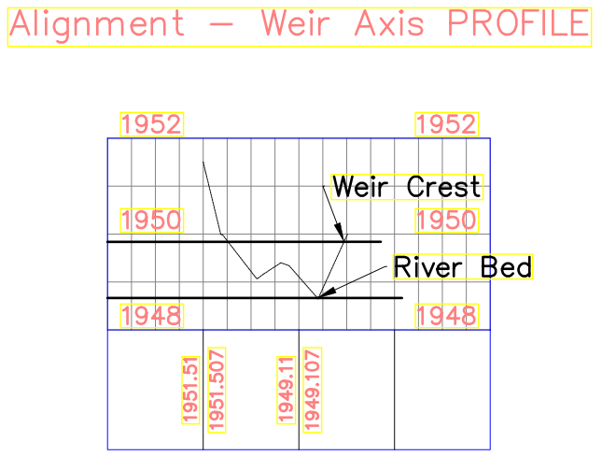
Figure 14. View of the weir from the u/s

Design of Intake

Silt Gate

The silt gate is located adjacent to the intake gate. It is 0.30m lower than the intake level i.e. 1949.55m and 1.6m wide. Hence depth below crest level is 1.2m and 1.6m wide; this gate is to be operated manually during the rainy season. The plate thickness shall be 5mm.

Coffer dam

Coffer dam is one the important to be constructed prior to the construction of the main weir. This is to make the weir site free from water and suitable for construction work. For Birbirsa weir, as shown on head work topo about 138 m³ u/s of the headwork selected for coffer dam. About 137m temporary canal on the right side of the weir is aligned. This is to minimize excess excavation works.

DESIGN OF SUPPLY CANALS

Main Canal

The design discharge of the main canal is 115 l/s. General formula adopted for designing of the distribution canals including main canal is Manning's formula. General formula Adopted is Manning's.
Q = A/n R ^{3/2} s ½ n = 0.015 for lined section
Economical lined Rectangular section criteria;
B = bed width of canal
y = water depth Side slope m=0.0 (inner and outer) for lined

R = y/2 , B/y = 2 R = Hydraulic radius
Figure 15. Main Canal
a) Design of Main canal
From Chainage 0+000 to 1+380m

Table: Detail of supply canal

b) Design of Main canal
From Chainage 1+380 to 2+420

C) Design of Main Canal
From Chainage 2+420 to 3+170

D) Design of Secondary Canal

E) Design of Tertiary Canal
- Tertiary Canal (TC-1-0-4)
- Tertiary Canal (TC-1-1-1)

- Tertiary Canal (TC-1-1-2)
- Tertiary Canal (TC-1-1-2)

Design of drainage canals

As stated under the hydrology report, the design storm resulted in drainage modulus of 1.5 l/s per ha. Thus based on area draining towards each drainage canal the discharge was calculated. Thus it was designed for this flow manning roughness co-efficient of 0.03 was adopted. And based General Manning’s formula stated below both irrigation and drainage canals are designed so as economic section of trapezoidal canal was take in to consideration.
The design formula and design parameters are as follows:
Q = A/n R ^{2/3} S ^{1/2}(general Manning’s formula)
Manning’s roughness coefficient for channel with moderate weeds, n = 0.03
Channel side slope to be adopted is 1V:1.5H
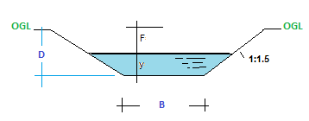
Figure 16. Basic section of drainage canal
Majority of the area drain to natural drainage routes and thus it was not essential to consider flow hydraulics of these natural water courses, but it is obvious that the local community has to take care of these drainage courses not to develop gullies. Main drain along main canal is to be considered on the layout plan. Design parameters were summarized as follows. As there is no secondary and tertiary drain in Birbirsa, Field canals and field drains are to be prepared by the user community under the guidance of district irrigation technicians. But farm drain is included in the Drop structures are provided on drainage canals to control the bed slope in this drawing irrigation system design report in detail.

Design of Hydraulic Structures

General
Type and number of different structures required for the scheme have been determined based on the scheme layout. The structures to be designed should be designed as per standard design criteria for small scale irrigation schemes and local situation so that it’s hydraulically and structurally safe. To achieve this, we focus on many parameters like foundation condition, topographic situation, type & availability of construction materials, purpose/function of structures, selection type of structures, construction materials selection, fixing design criteria, selection of construction method being adopted….etc so that economical and structurally safe structures that will perform efficiently and competently with minimum head/amount loss, easy operation, less Maintain ace cost, easily accessible…etc. will be implemented. There are different hydraulic structures proposed and designed for Birbirsa Irrigation system including:
- Regulating Structures: Division Box / Off take
- Protective Structures: Box Culvert
The design of structures were prepared using standard procedures and presented in the following sections and using drawing presented in drawing album.

Design of Division Boxes/ off take / Gated outlet
A diversion structure regulates the flow from one canal to the second canal system. It normally consists of a box with vertical walls in which controllable openings are provided. The minimum dimensions of the structure depend on its performance in the fully open position. The width of the outlet is usually proportional to the division of water flow to be made. These structures are constructed of plastered masonry to make the similar with canal. This type of structures incorporated in Birbirsa project to divide the flow from main canal and tertiary canals directly to field canals. A total of 24 division boxes or off take in the main canal and 4 on tertiary canals are proposed in the system.

Design of Division Box/ off take / gated outlet: (Sample design)
Out let must fulfill following requirements:
- It shall be structurally strong and shall have no moving parts so that
- It does not require periodic attention
- It is not tampered by farmers or unauthorized persons
- It shall draw its fair share of silt carried out by parent channel.
- It shall work efficiently with small working head.
- It shall be economical.
There are three types of outlets practiced in the world. These are Modular Outlets, Non-modular Outlets and Semi-modular Outlets. In Modular Outlets, the discharge remains constant and does not depend on the water head in the canal and water course. This type of outlets is either with moving parts or without moving parts. The latter type is called rigid module. The Modular Outlets with moving parts are very complicated and difficult to design. These are liable to be tampered by farmers or disturbed by floating materials.
Gated outlets of circular or rectangular cross section fall in Non-modular Outlet category if the discharging end is submerged. If the discharging ends discharges freely in the watercourse it falls in Semi Modular category. Open Flume Outlets or Adjustable Proportional Module (APM) outlets are other types of semi-modular outlets.
In the present case gated rectangular Outlets are proposed to be provided for supplying water to field channels. The discharge formula for non-modular pipe outlet is as under:
Where g= acceleration due to gravity
A= cross-sectional areas of pipe in cm²
C= Coefficient of discharge ( which is about 0.8 )
h= working head ( which is difference of U/S and D/S water levels )

The available sizes of gate shall be used which are near to the size as worked out above.
It is common practice to place the gated outlet at the bed of the distributing canal so that the outlet draws its share of silt.
Sample hydraulic calculation of the outlet structures (DB1, DB2, DB3 to DB24) is given below, the calculation for all outlets is given in the design calculation spread sheets of the division boxes or outlets.
Figure below shows the gated outlet structures plan and section views.
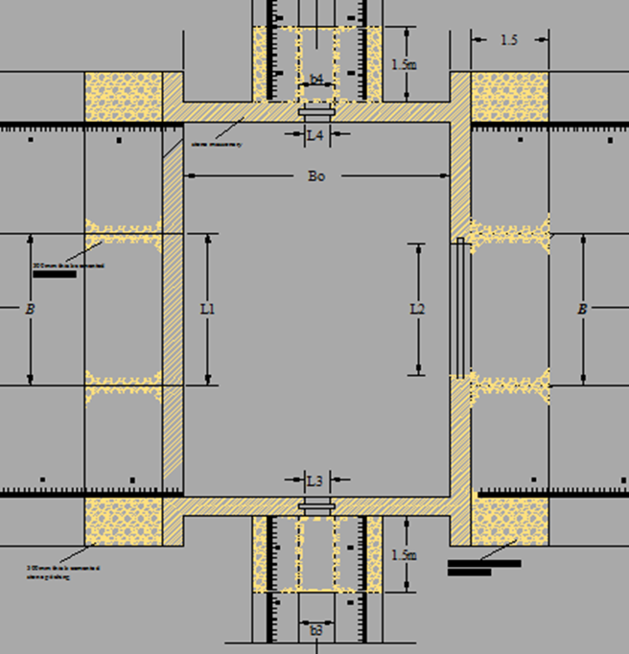
Figure 17. Gated outlet structures plan and section views

Design of Culvert (cross drainage) Structures
Three cross drainage culverts(CD 1, CD2 and CD3 at chainages 0 + 120, 0 + 660 and 2 + 087 respectively) underneath the main canal are provided to cross the canal across drainage lines or rivers. The culverts are box culverts. The culverts provide crossing of the main canal and the canal side road. The design capacities and type of these structures have been outlined in the table below for CD 1. (See the Drawing Album).
Table 12. Calculation of Cross Drainage Culvert Structure

Figure 18. Section of the CD 1 structure

Design of Flume (cross drainage) Structures
Table 13. Calculation of Flume Drainage Culvert Structure

BILL OF QUANTITY
Table 14. Bill of Quantity, specification and cost estimates
Typical Bill of Quantities for the construction of SSIP
Item No. | Description of works | Unit | Quantity | Unit cost | Total cost
1 | General Item
1.1 | Mobilization (Manpower, machinery, material, work commencement to be paid on his work schedule submission) | Ls | 1 | 55000 | 55,000.00
1.2 | Demobilization is to be paid after taking over of the project | LS | 1 | 25000 | 25,000.00
1.3 | Camping office & bed room,bed room & kitchen, store, Toilet & Shower and guard house as spacified on drawing |  | 2.7 | 2.1
1.3.1 | Site clearing | m² | 177.5 | 20 | 3,550.00
1.3.2 | Excavation the epth no exceed 1m | m³ | 106.4 | 90 | 9,576.00
1.3.3 | 20cm thick hard core | m² | 142 | 125 | 17,750.00
1.3.4 | Masonry work with 1:3 mortar mix | m³ | 55.05 | 1300 | 71,565.00
1.3.5 | 5cm thick mass concrete (1:2:4 mix ratio) | m³ | 7.1 | 2950 | 20,945.00
1.3.6 | 5cm cement screed | m² | 142 | 145 | 20,590.00
1.3.7 | CIS walling G-32 with all required materials for wall | m² | 185.67 | 225 | 41,775.75
1.3.8 | CIS Roofing G-32 with all required materials for roof | m² | 1051.38 | 225 | 236,560.50
1.3.9 | Fence 2.0m height & LTZ black steel profile 38mm*1.5mm. Price includes all necessary iron mongery ,one coat primer, two coats of synthetic enamel paint placed every 2m with barbed wire at 20cm vertical interval & erected in 0.6m depth embedded with concrete | ml | 300 | 180 | 54,000.00
1.4 | Access Road with average width of 5m and as per required depth of cut & fill to let vehicle access to it. | Ls | 1 | 250000 | 250,000.00
1.5 | Headwork site and main canal profile set out surveying works & check any logical contradiction whether headwork hydraulics consistent with designed canal profile & approved by engineer | Ls | 1 | 5000 | 5,000.00
1.6 | Dewatering | Ls | 1 | 2500 | 2,500.00
1.7 | Coffer dam work (temporary diversion) to be paid 50% for construction, 50% for demolition or returning to natural condition. | Ls | 1 | 250000 | 250,000.00
1.8 | Sign post at junction and camp office, with dimension of 1m *1.5m of 2mm thick with 2.5m height angle iron pole founded on C-10 (1:3:6) mass concrete of 0.5m minimum depth | Ls | 3 | 5000 | 15,000.00
1.9 | Preparation of as-built drawings and site plan including operation and maintenance manual | Ls | 1 | 15500 | 15,500.00
1.10 | Motor Cycle KTM RC Diesel motor with automatic starter and aproved by Engineer | No. | 1 | 75238 | 75,238.00
 | Sub Total |  |  |  | 1,169,550.25
2 | Head Works
2.1 | Earthworks | 752.77
2.1.1 | Site clearance of the weir base to the root zone of vegetation cover ,Bush and Shrubs | m² | 1716.00 | 50 | 85,800.00
2.1.2 | Excavation
2.1.3 | Excavation in weir (4690.6 m3) | 4875.7
2.1.4 | Excavation in overburden (75%) | m3 | 3656.8 | 80.0 | 292,542.54
2.1.5 | Excavation in soft rock (10%) | m3 | 487.6 | 108.0 | 52,647.91
2.1.6 | Excavation in hard rock (15%) | m3 | 731.4 | 206.6 | 151,105.54
2.1.7 | Selectl material in masonry wall downstream of back fill from 5 km quarry area | m3 | 48.8 | 90.39 | 4,407.15
2.1.8 | Cart away extra excavated materials to distance of 5km | m3 | 97.5 | 35.5 | 3,457.85
2.2 | Reinforcement weir slab and protection including concrete c-25 for protecrion under weir required vibraion
2.2.1 | Lean/plain concrete ,10cm C-10 (1:3:6) | m3 | 55.7 | 240.0 | 13,372.80
2.2.2 | Mass concrete 60cm depth C-15 (1:2:4) | m3 | 334.3 | 2400.0 | 802,368.00
2.2.3 | Reinforced Concrete C-20 (1:1.5:3) for cut off and Capping of the weir for 0.35m | m3 | 76.5 | 2900.0 | 221,960.20
2.2.4 | U/s Launching Aproun woth River gravel filter | m3 | 61.3 | 52.0 | 3,186.56
2.2.5 | D/s LaunchingAproun 8 Rows of 0*0.8x0.8*0.6 with 5cm gap Concrete bloch filled with sand over 0.6m thick graded filter | No. | 35.0 | 1075.2 | 37,632.00
2.2.6 | D/s Launching Aproun woth River gravel filter | m3 | 58.8 | 52.0 | 3,057.60
2.2.7 | Metal sheet Form work | m² | 67.2 | 120 | 8,064.00
2.3 | Masonry Works |  |  |  | -
2.3.1 | Masonry work with 1:3 mortar mix | m³ | 109.2 | 1500.0 | 163,800.00
2.3.2 | Stone masonry in 1:5 cement mortar for weir for wing wall | m³ | 55.2 | 800.0 | 44,160.00
2.3.3 | Pointing, mix ratio 1:3 of wing wall | m³ | 41.4 | 20 | 828.00
2.4 | Steel Reinforcement |  |  |  | -
2.4.1 | Reinforcement bar Ø10mm | kg | 15 | 51 | 765.00
2.4.2 | Reinforcement bar Ø12mm | kg | 11.56 | 61 | 705.16
2.5 | Gate Structures |  |  |  | -
2.5.1 | Supply & installation of steel intake gate, 5mm thick (1cm*1cm) including steel works, angle iron, sliding shaft as shown in the Drawing | pcs | 1 | 10000 | 10,000.00
2.5.2 | Supply & installation of steel sluice gate, 7mm thick (2m*2m) including steel works, angle iron, sliding shaft as shown in the Drawing | pcs | 2 | 15000 | 30,000.00
2.5.3 | Metal Ladder & safety protection for gates operation | No | 1 | 1000 | 1,000.00
2.5.4 | Purchasing, transporting, and laying of plain concrete pipes(Ø100cm) | m | 20 | 250 | 5,000.00
2.6 | Miscellaneous Works |  |  |  | -
2.6.1 | Purchasing, transporting & laying of plastic pipes (wheep holes) | pcs | 2 | 350 | 700.00
2.6.2 | River train works (Placement of selected material with shaping & compaction) | m³ | 20 | 50 | 1,000.00
2.6.3 | Handrail (ф=50mm) | m | 20.0 | 80.0 | 1600.0
 | Sub Total |  |  |  | 1,939,160.31
3 | Canals
3.1 | Lined Main Canal (s) (Chainage 0+000 upto 1+380=(70*80)cm ,L1=1380m (Chainage 1+380 upto 2+420 =(60*60)cm,L2=1040m (Chainage 2+420 upto 3+170=(60*50)cm,L2=750m Total L=3170m) | 1514.88
3.1.1 | Site clearance & grubbing of bush along the main canal | m² | 10212 | 20 | 204,240.00
3.1.2 | Excavation of ordinary soil | m³ | 1514.88 | 90 | 136,339.20
3.1.3 | Excavation of soft rock | m³ | 227.232 | 215 | 48,854.88
3.1.4 | Excavation of hard rock | m³ | 75.744 | 280 | 21,208.32
3.1.5 | Placing compacted selected material | m³ | 15 | 120 | 1,800.00
3.1.6 | Hardcore well blinded (25cm thick) | m² | 2178 | 105 | 228,690.00
3.1.7 | Mass concrete, 5cm thick (1:2:4) for canal bed | m² | 102 | 450 | 45,900.00
3.1.8 | Masonry work with 1:3 mortar mix | m³ | 1572 | 1200 | 1,886,400.00
3.1.9 | Plastering with 1:3 mix ratio, 3 coats | m² | 3930 | 35 | 137,550.00
3.1.10 | Backfill and compaction of normal soil | m³ | 25.77 | 25 | 644.25
 | Sub Total |  |  |  | 2,711,626.65
3.2 | Lined Secondary Canal(s) ((45cmx50cm) Total L 206m)
3.2.1 | Site clearance & grubbing | m² | 700 | 20 | 14,000.00
3.2.2 | Excavation of ordinary soil | m³ | 586.1 | 90 | 52,749.00
3.2.3 | Placing compacted selected material | m³ | 58.61 | 120 | 7,033.20
3.2.4 | Hardcore well blinded (25cm thick) | m² | 103 | 105 | 10,815.00
3.2.5 | Mass concrete, 5cm thick (1:2:4) for canal bed | m² | 5.15 | 450 | 2,317.50
3.2.6 | Masonry work with 1:3 mortar mix | m³ | 111.24 | 1200 | 133,488.00
3.2.7 | Plastering with 1:3 mix ratio, 3 coats | m² | 278.1 | 35 | 9,733.50
3.2.8 | Backfill and compaction of normal soil | m³ | 172.2 | 45 | 7,749.00
 | Sub Total |  |  |  | 237,885.20
3.3 | Earthen Tertiary Canals ((70*100)cmTotal L455m )
3.3.1 | Site clearance & grubbing | m² | 1800 | 20 | 36,000.00
3.3.2 | Excavation of ordinary soil | m³ | 225.4 | 90 | 20,286.00
3.3.3 | Fill and compaction of normal soil | m³ | 574.2 | 45 | 25,839.00
 | Sub Total |  |  |  | 82,125.00
3.4 | Earthen Catch Drain (Total L 4905m )
3.4.1 | Site clearance & grubbing | m² | 2453 | 2 | 4,906.00
3.4.2 | Excavation of ordinary soil | m³ | 604.5375 | 40 | 24,181.50
3.4.3 | Fill and compaction of normal soil | m³ | 120.9075 | 25 | 3,022.69
 | Sub Total |  |  |  | 32,110.19
 | Farm Infrastructures | 24
3.5 | Flume, F1 (L= 27.1m)
3.5.1 | Site clearance & grubbing | m² | 104 | 30 | 3,120.00
3.5.2 | Excavation of ordinary soil | m³ | 19.2 | 90 | 1,728.00
3.5.3 | Excavation of soft rock | m³ | 3.6 | 105 | 378.00
3.6 | Excavation of hard rock | m³ | 1.2 | 120 | 144.00
3.6.1 | Hardcore well blinded (25cm thick) | m² | 3 | 115 | 345.00
3.6.2 | Reinforced Concrete C-20 (1:1.5:3) | m³ | 19.5 | 2800 | 54,600.00
3.6.3 | Masonry work with 1:3 mortar mix | m³ | 2.856 | 1200 | 3,427.20
3.6.4 | Plastering with 1:3 mix ratio, 3 coats | m² | 2.72 | 80 | 217.60
3.6.5 | supply & preparing of 50mm thick timber for form working |  |  |  | -
3.6.6 | Purchasing, transporting, and cutting of Eucalyptus pole of Ø10cm at each 10m length for form working | pcs | 30 | 100 | 3,000.00
3.6.8 | Supply, cutting, bending, placing, & any other fixing of reinforcement bar :
3.6.8.1 | -Ø6 | kg | 10 | 26 | 260.00
3.6.8.2 | -Ø8 | " | 5 | 35 | 175.00
3.6.8.3 | -Ø10 | " | 615.82 | 41 | 25,248.62
3.6.8.4 | -Ø12 | " | 386.41 | 43 | 16,615.63
 | Sub Total |  |  |  | 109,259.05
4 | Turnouts (#) 5
4.1 | Ordinary soil excavation | m³ | 2 | 90 | 180.00
4.1.1 | Hardcore well blinded (25cm thick) | m² | 10.08 | 105 | 1,058.40
4.1.2 | Mass concrete, 5cm thick (1:2:4) | m² | 5.76 | 450 | 2,592.00
4.1.3 | Masonry work with 1:3 mortar mix | m³ | 8.064 | 1200 | 9,676.80
4.1.4 | Plastering with 1:3 mix ratio, 3 coats | m² | 20.16 | 110 | 2,217.60
4.1.5 | Steel gates (Sheet 2.5cm thick height & width may vary with 4cm angle iron | pcs | 18 | 400 | 7,200.00
4.1.6 | Backfill and compaction of normal soil | m³ | 0.9 | 35 | 31.50
 | Sub Total |  |  |  | 22,956.30
4.2 | Division Box (#) 24 |  |  |  | -
4.2.1 | Ordinary soil excavation | m³ | 22.03 | 50 | 1,101.60
4.2.2 | Hardcore well blinded (25cm thick) | m² | 9.72 | 115 | 1,117.80
4.2.3 | Mass concrete, 5cm thick (1:2:4) | m² | 3.24 | 2500 | 8,100.00
4.2.4 | Masonry work with 1:3 mortar mix | m³ | 31.97 | 1200 | 38,361.60
5 | Plastering with 1:3 mix ratio, 3 coats | m² | 64.80 | 86 | 5,572.80
5.1.1 | Cemented stone pitching (thickness 30cm) | m² | 9.72 | 60 | 583.20
5.1.2 | Purchasing, transporting, and laying of plain concrete/DCI/DN pipes | pcs | 24 | 300 | 7,200.00
 | Sub Total |  |  |  | 62,037.00
 | Culvert
6 | Box Culvert
6.1 | Ordinary soil excavation | m³ | 36 | 90 | 3,240.00
6.2 | Hardcore well blinded (25cm thick) | m² | 14.29 | 115 | 1,643.54
6.3 | Mass concrete, 5cm thick (1:2:4) | m³ | 88.29 | 2800 | 247,222.53
6.4 | Masonry work with 1:3 mortar mix | m³ | 0.736 | 1200 | 883.20
6.5 | Plastering with 1:3 mix ratio, 3 coats | m² | 2.08 | 86 | 178.88
6.6 | Cemented stone pitching (thickness 30cm) | m³ | 47.56 | 105 | 4,993.64
6.7 | Supply and preparing of 50mm thick timber for form working | m² | 11.76 | 120 | 1,411.20
6.8 | Purchasing, transporting, and cutting of Eucalyptus pole of Ø10cm at each 10m length for form working | pcs | 8 | 115 | 920.00
6.9 | Supply, cutting, bending, placing, &any other fixing of reinforcement bar :
6.9.1 | -Ø18 | kg | 826.17978 | 41 | 33,873.37
6.9.2 | -Ø12 | kg | 367.19101 | 39 | 14,320.45
6.9.3 | -Ø8 | kg | 390.9312 | 35 | 13,682.59
6.9.4 | -Soft Wire | kg | 150 | 35 | 5,250.00
6.9.5 | - Nails | kg | 75 | 45 | 3,375.00
 | Sub Total |  |  |  | 330,994.41
7 | Drops
7.1 | Ordinary soil excavation | m³ | 122.26 | 90 | 11,003.64
7.2 | Hardcore well blinded (25cm thick) | m² | 6.750 | 105 | 708.75
7.3 | Mass concrete, 5cm thick (1:2:4) | m² | 0.34 | 450 | 151.88
7.4 | Masonry work with 1:3 mortar mix | m³ | 22.91 | 1200 | 27,486.24
7.5 | Plastering with 1:3 mix ratio, 3 coats | m² | 23.87 | 110 | 2,626.07
7.6 | Cemented stone pitching (thickness 30cm) | m² | 12.56 | 85 | 1,067.20
 | Sub Total |  |  |  | 43,043.77
8 | Social Structures The system
8.1 | Social Structures
8.1.1 | Washing Basin as per the drawing | LS | 1 | 9000 | 9,000.00
8.1.2 | Cattle Trough/Water Point for animal as per the drawing | LS | 1 | 130000 | 130,000.00
8.1.3 | Foot Bridge and cattle cross as per Drawing | LS | 3 | 18000 | 54,000.00
 | Sub Total |  |  |  | 193,000.00
 | Total |  |  |  | 6,933,748.12
 | VAT (15%) |  |  |  | 1,040,062.22
 | Grand Total |  |  |  | 7,973,810.34

Summary cost of the project
Item | Description | Amount  (Birr)
PART I |  | 1,059,312.25
PART II | HEAD WORK SYSTEM | 1,939,160.31
1 | Diversion Weir | 1,939,160.31
PART III | IRRIGATION SYSTEM | 3,825,037.56
1 | Main Canal | 2,711,626.65
2 | Secondary Canal | 237,885.20
3 | Canal Structures
3.1 | Earthen Tertiary Canals ((70*100)cmTotal L455m ) | 82,125.00
3.2 | Earthen Catch Drain (Total L 4905m ) | 32,110.19
3.3 | Flume, F1 (L= 27.1m) | 109,259.05
3.4 | Division Box | 62,037.00
3.5 | Turnouts | 22,956.30
3.6 | Box Culvert | 330,994.41
3.7 | Drops | 43,043.77
3.8 | Social Structures The system | 193,000.00

COMMUNITY PARTICIPITION ON THE PROJECT

The community participation on the project is nearly covers 10.4% of the project cost.

Project Duration and Work Plan
The project is to be completed in 1 fiscal year under ideal conditions of financing, material availability and manpower allocation.
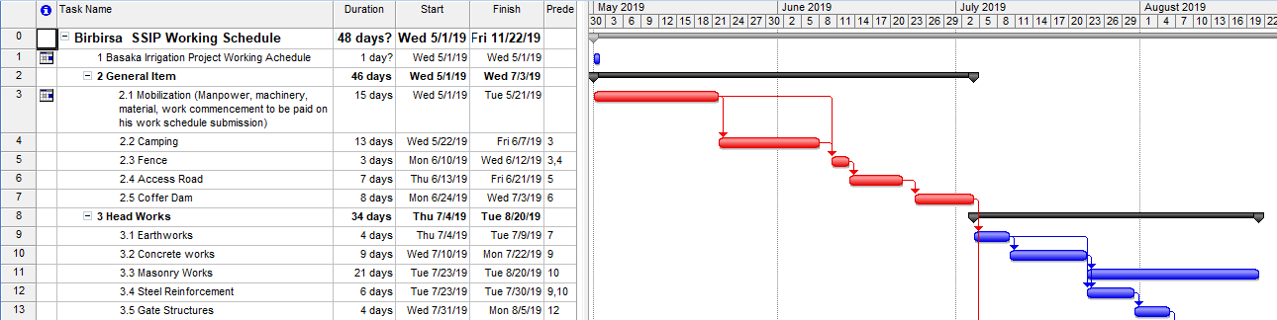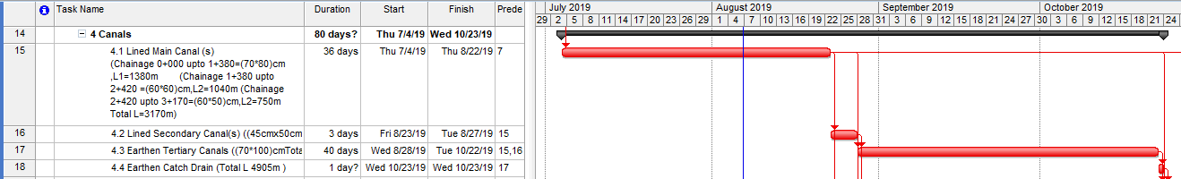
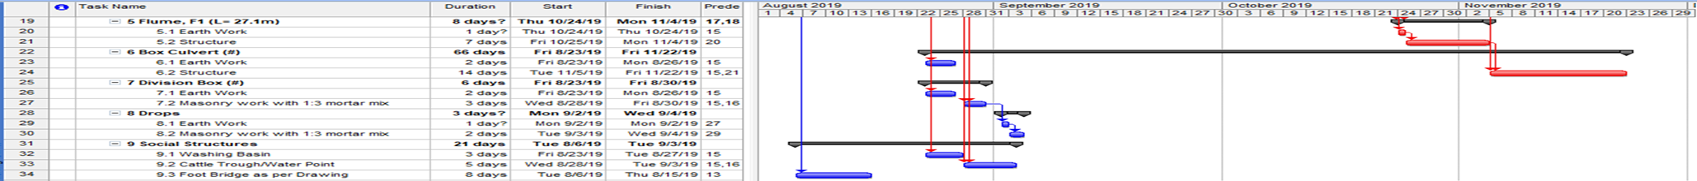

Conclusion and Recommendations

- The foundation and apron for weir may be modified under inspection of an engineer during construction if the weathered rock formation is not found sound or any fractures appear after excavation level of foundation.

- The soil of the locality is Vertisol with prolonged settlement period and adverse condition of swelling and shrinking so as cresting difficult condition structure being constructed. Thus it is necessary to use selected fill material under inspection and approval of engineers and geologists for all structures.

- The engineering cost estimate of the project with 10% contingency, 5% supervision and 15% VAT is 8,194,711.08 Birr. Of this, 10.3% of the investment cost is assumed to be covered through community participation.

- The headwork axis shall be carefully set and guide walls at upstream shall attain the highest design level to both sides of the bank and well anchored.

- Soil conservation works and good and managed farming practices are mandatory to avoid soil erosions.

- Wise use of water in the system is necessary for sustainability of the project.

Annex

- Main Canal Center line
- Secondary Canal Center line
- Tertiary Canal Center line(TC-1-0-4)

- Tertiary Canal Center line (TC-1-1-1)
- Tertiary Canal Center line (TC-1-1-2)
Tertiary Canal Center line (TC-1-1-3)

