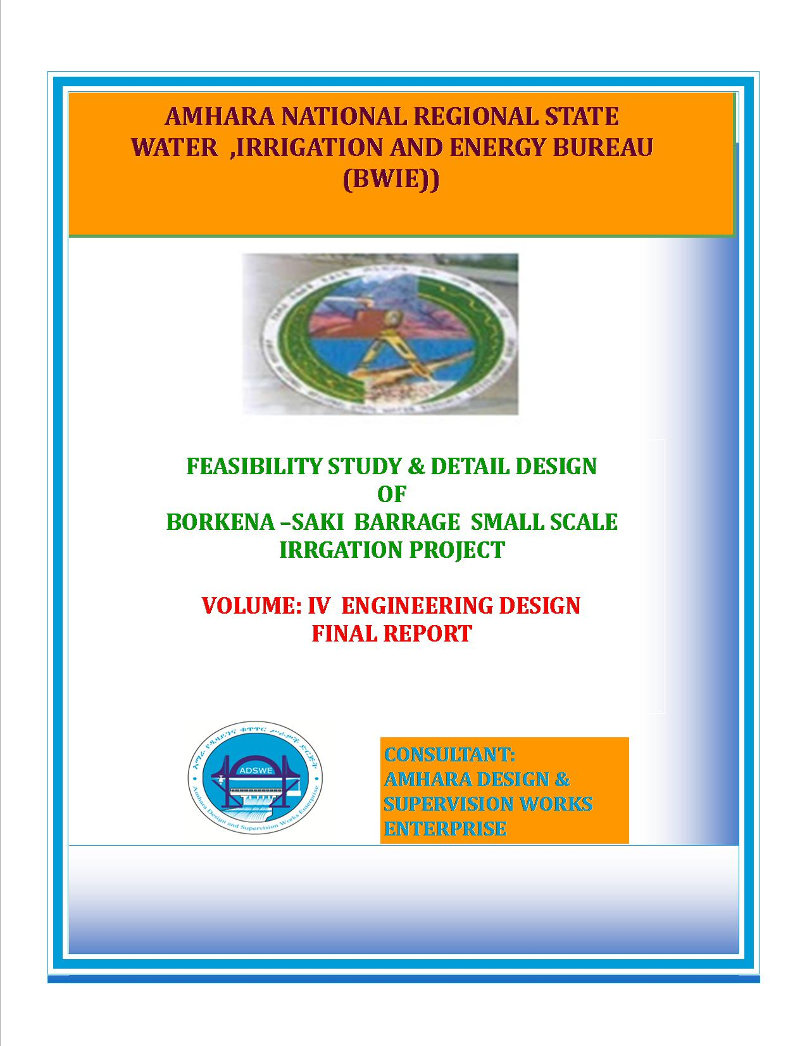
Amhara National Regional State
Water Resources Development Bureau
(BOWRD)

Feasibility Study and Detail Design
Of
Borkena Saki Barrage Small-Scale Irrigation Project

Volume IV: Engineering Design
Final Report
Feb, 2018
Dessie, Ethiopia
Client: Bureau of Water Resource Development
(BoWRD)
Address:
P. O. Box: 88
Telephone: 0528-200853/855
Fax: 251-08-20-65-68/204676/202040
Consultant: Amhara Design & Supervision Works Enterprise Eastern Amhara Branch Office
(E/ADSWE)
Address:
P. O. Box: 4921
Telephone: +251-333-124954
Fax: (033) 3124954
E-mail: amhara design@yahoo.com
Dessie, Ethiopia

FEASIBILITY STUDY & DETAIL DESIGN REPORT STRUCTURE
- Volume I: Watershed Management
- Volume II: Engineering Geology
- Volume III: Irrigation Agronomy
- Volume IV: Engineering Design
- Volume V: Socio Economy
- Volume VI: Environmental Impact Assessment
Table of Contents Page Nr
FEASIBILITY STUDY & DETAIL DESIGN REPORT STRUCTURE i
LIST OF TABLES v
LIST OF FIGURES vi
SAILENT FEATURE vii
1 INTRODUCTION 1
1.1 Background 1
1.1.1 Description of the Project Area 1
1.2 Objectives of the Study 2
1.2.1 Major Objective 2
1.2.2 Specific Objectives 3
1.3 Scope of the Study 3
1.4 Methodology 4
SECTION-I: HYDROLOGY 6
2 HYDROLOGY 7
2.1 Watershed Characteristics 7
2.2 Hydro-Metrological Data Availability 8
2.2.1 Climate 8
2.2.2 Rainfall Data 9
2.2.3 River flow data 9
2.2.4 Upstream & Downstream utilization 9
2.3 Design Flood Analysis 9
2.3.1 Design Rainfall computation 10
2.3.2 Outlier Test 10
2.3.3 Check for variance 11
2.3.4 Peak Discharge Determination 12
2.3.5 Tail Water Depth Computation 17
SECTION-II: HEADWORK DESIGN 21
3 HEADWORK STRUCTURES DESIGN 22
3.1 Headwork Site Selection 22
3.2 River Geomorphology 23
3.2.1 River Bed condition 23
3.2.2 River Bank condition 24
3.3 Sources of construction materials 25
3.3.1 Rock for Masonry and Crushed Coarse Aggregate 25
3.3.2 Fine Aggregates 26
3.3.3 Water 26
3.4 Headwork Type Selection 26
3.4.1 Hydraulic Design of Headwork Structure 26
3.4.2 Weir Dimensions 27
3.5 Top and bottom width 28
3.6 U/S and D/S HFL Calculation & Determination 28
3.7 Hydraulic Jump Calculation 29
3.8 Impervious floor 30
3.8.1 D/s impervious floor (Ld) 30
3.8.2 U/S Impervious Floor Length, (Lu) 30
3.9 Cut off Depth Calculation 32
3.9.1 U/s cut off 32
3.9.2 D/s cut off 32
3.10 Canal outlet level 33
3.11 Bill of Quantity and Cost Estimation 35
SECTION-III: IRRIGATION AND DRAINAGE SYSTEMS INFRASTRUCT 38
4 IRRIGATION AND DRAINAGE SYSTEMS DESIGN 39
4.1 Irrigable Area Description 39
4.1.1 Topography 39
4.1.2 Climate 40
4.1.3 Soil characteristics 40
4.1.4 Existing Irrigation Practices in the Project Area 40
4.2 Irrigation Water Requirement 41
4.2.1 Crop Water Requirement (CWR) 41
4.2.2 Irrigation efficiency (Ep) 41
4.2.3 Irrigation duty 42
4.2.4 Irrigation methods 43
4.3 Irrigation and Drainage System Layout 44
4.3.1 Conveyance System 44
4.4 Design of the Canal System 44
4.4.1 Main Canal 45
4.4.2 Secondary Canals 45
4.4.3 Tertiary canals 46
4.4.4 Field Canals 47
4.5 Drainage Canals 48
4.5.1 Escape canals 48
4.5.2 Catch drainage canals 48
4.5.3 Tertiary canal and drainage canals 48
5 Canal Structures Design 52
5.1.1 Design of a typical supper passage and Flume 52
5.1.2 Design of Division box 52
5.2 Irrigation Infrastructure Bill of Quantities and Cost Estimate 55
6 CONCLUSION AND RECOMMENDATION 59
7 OPERATION AND MAINTENANCE 60
7.1 General 60
7.2 Operation of the Head Works 60
7.3 Irrigation System Operation 60
7.4 Maintenance Requirement 61
REFERENCE 62

LIST OF TABLES

Table 2-1: Outlier test analysis 10
Table 2-2: Determination of Time of Concentration 13
Table 2-3: Runoff analysis 15
Table 2-4: Hydrograph coordinates 16
Table 2-5: Barrage Site River Cross section Coordinate Data 17
Table 2-6: River discharge computation at different stages of flow 20
Table 4-1: Hydraulic Parameters of main canal 45
Table 4-2: Hydraulic Parameters of secondary canals 46
Table 4-3: Hydraulic Parameters of tertiary canals 47
Table 4-4: Hydraulic Parameters of tertiary canals 51
Table 5-1: Hydraulic Parameters of supper passage 52
Table 5-2: Hydraulic parameters of Division Boxes 54

LIST OF FIGURES

Figure 2-1: Drainage map of Borkena Sakei watershed 8
Figure 2-2: Complex Hydrograph 16
Figure 2-3: River profile 18
Figure 2-4: River profile 19
Figure 3-1: River bed at the proposed Barrage site 22
Figure 3-2: River bed geological x-section 24
Figure 3-3: left and right bank 25
Figure 4-1: partial view of Borkena Sakei command area 39
Figure 4-2: Typical Cross Section of secondary canals 46
Figure 4-3: Typical Cross Section of tertiary canals 46
Figure 4-4: Typical Field Canal X-section 48

SAILENT FEATURE

- Project name: Borkena Sakei Barrage Irrigation Project
- Name of the stream: Borkena Sakei river
- Location of the Barrage site using
- East:3597251
- North: 1179879
- Zone: kemise oromia zone
- Wereda: Artuma Fursi
- Kebele: Bishae Eideda
- Average Altitude: 1403 masl
- Hydrology
- Design rainfall: 88.363 mm
- Catchment area: 1681.33 Km²
- Longest flow path length: 122.15 Km
- Design flood: 4192.5 m³/sec
- Design base flow: 350 lit/se.

- Barrage
Barrage type: barrage weir with reinforcement
- Weir type: Broad crest Weir with Cyclopean Concrete
- Height: 1.2m
- Gross crest length: 20.6 m
- Weir crest level: 1401.981 m.a.s.l
- U/S HFL: 1403.13m.a.s.l
- U/S TEL: 1403.51 m.a.s.l
- D/s TEL: 1402.78.a.s.l.
- D/s HFL: 1402.78 m.a.s.l
- Afflux: 0.72
- Barrage gate
- Sill level: 1401.981 m.a.s.l
- Dimension: 1.2*1.34m²

- Outlet
- Sill level: 1402.6 m.a.s.l
- Opening dimension: 1.6*0.5 m²
- Discharge capacity: 380.36 lit/sec.
Irrigation and drainage systems Infrastructure
- Command area size: 192 ha by gravity
- Type of soil of the command area is dominantly clay soil
- Design discharge of the main canal = 380.16l/sec
- Irrigation system layout consists of 1 Rcc lined main canal, 10 Earthen secondary canals,11 Earthen tertiary canals, main drain and 11 field drain
- Main irrigation structures designed are;
- Super passage
- Flume
- Division box
- Turn out
Project cost
BILL NO 1 GENERAL ITEM 1 | 1,436,548.858
BILL NO 2 HEAD WORK | 2,158,774.83
BILL NO 3 INFRASTRUCTURE | 8,093,556.56
Total cost | 11,688,880.24
VAT(15)% | 1,753,332.036
OVER ALL COST | 13,442,212.28
cost per hectare | 70011.52228

INTRODUCTION

Background
In Ethiopia, under the prevalent rain-fed agricultural production system, the progressive degradation of the natural resource base, especially in highly vulnerable areas of the highlands coupled with climate variability have aggravated the incidence of poverty and food insecurity. The major source of growth for Ethiopia is still conceived to be the agriculture sector. Hence, this sector has to be insulated from drought shocks through enhanced utilization of the water resource potential of the country, (through development of small-scale irrigation, water harvesting, and on-farm diversification) coupled with strengthened linkages between agriculture and industry (agro-industry), thereby creating a demand for agricultural output. In line with the above, efforts have been made by the government to improve the situation in the country in areas of domestic water supply provision, irrigation, watershed management, etc. The Amhara Water Resources Development Bureau is playing its role in the development of small scale irrigation projects in the region. Accordingly, as part of the water sector development program, the office has initiated the study and design of a small scale irrigation scheme on Borkena Sakei River at Bishae Eideda Kebele and signed an agreement with Amhara Design & Supervision Works Enterprise (ADSWE) for the study and design of the project.

Description of the Project Area

Location
This irrigation project is located mainly at Bishae Eideda Kebele, Artuma Fursi Wereda of oromiya Zone in the Amhara Region. The proposed irrigation project is to be undertaken on Borkena Sakei River and the headwork structures are specifically located at an altitude of about 1403 m a.s.l and geographical coordinates of 1179879 N (UTM) and 3597251E (UTM).

Accessibility
The Borkena Sakei Barrage project is located in the amhara national regional state, kemise oromia zone, artuma fursi woreda. The Barrage site is located at 577220E, 1179872N (UTM) and at 1042m above sea level. The irrigation of water is proposed by Barrage with barrage weir structure. The project can be accessed form kemise town; the asphalt road which goes to Addis Ababa 2km, turn to the right remain 1.5km dry weathered and need access road up to the head work site.

Previous Irrigation Practices
There is traditional pump system on the upstream and downstream of this river using different irrigation practices (dewatering pump), but as the hydrology and Hydrogeology study and respondent farmers indicated, the river has capacity of recharging as it stretches down from the source area of the river. As a result there will not be a marked reduction or fluctuation of water flows both for the already existing and the newly proposed irrigation schemes. The farmers are used two and above dewatering pump is use hence to minimize the challenge night storage structures are provided in some part of main canal. So, the farmers in the project area are very much interested to upgrading the traditional scheme to modern scheme.

Objectives of the Study

Major Objective
The project area faces variability of rainfall distribution though the overall rainfall generally suffices the rain-fed agriculture. Accordingly, the rain-fed agriculture needs means of supplementing during distribution failures and further full irrigation is required to maximize the use of the potential land and water resources.
Hence the objective of this project is to contribute a substantial share in the effort to reduce the risk of production decrease due to rainfall variability and increase the productivity of the resource in the project specific area. Specifically, the project is targeted for the following.
- To make sustainable the rain-fed crop production and make extra production in the dry season possible for 192 ha of land through gravity irrigation system and in addition 121 ha by dewatering pump system from pond storage provided at main canal.
- There is a general consensus that irrigation investments will achieve broader food security and poverty reduction impacts and if efforts are also geared towards up-grading existing traditional farming practices with support to enhance access to input supply, output marketing and extension to facilitate access to information and innovations.
- This objective is to be realized by constructing Barrage structures across the Borkena Sakei River and diverting the river flow.

Specific Objectives
Other benefits that can be expected to appear with the launching of the project are:
- Efficiency of water use improvement;
- Improved local nutrition/food security gains;
- Improved management of scarce natural resources (land and water);
- Resilience against drought risk;
- Rationale for erosion control and watershed management;
- Rationale for the intensification and modernization of small-holder agriculture and rural lifestyles.
The engineering study and design enables the realization of the project by the provision of engineering structures that will allow the appropriate abstraction of the river water for delivery in to the identified irrigation fields of the study area. Hence, this engineering design is specifically targeted to:
- Analyze hydrologic requirements of the project and engineering structures;
- The formulation of sound and stable structure, with necessary provisions that allow safe, easy and low-maintenance operation in the service life of the project;
- Develop working drawings;
- Estimation of construction costs.

Scope of the Study
- The irrigation design shall ensure reliability, equity and flexibility of water delivery to farmers. It will aim at reducing conflicts among water users and will lead to lower operation and maintenance costs.
- Updating the existing, if available, computation of the actual evapo-transpiration, crop water requirement, irrigation demand/duty using the existing and recent agronomic, climatologic and soil data using more appropriate methodologies.
- Establish design criteria for irrigations structures to be approved by the client and to be used in the final design stage,
- Design proper irrigation system compatible with local conditions and management capabilities,
- Establish flood protection measures for the command area and canal structures and design the respective drainage system accordingly,
- Planning and layout of the irrigation system, which include irrigation canals, drainage channels, inspection roads and alignments, canal spacing, canal length, location of structures, and water profiles along canal and drains at specified reaches, which is most economical easily manageable and aligned with topographic feature and geological investigation.
- Determination and estimation of water application conveyance and other losses and irrigation efficiencies and consideration of those parameters in design steps.
- Check and test hydraulic and structural designs of main canal considering total demand and the required capacity and the base flow availability,
- Prepare general plans and drawings for all irrigation infrastructure and irrigation systems designs,

Methodology
In the study and design procedure, Designers used the following steps.
- Specific Site identification:
  - Review of the reconnaissance survey conducted by the Client
  - 50,000 scale top map and GIS information
  - Local farmers interview and discussion
  - Wereda and Zone Agriculture section expertise
  - Previous studies
  - On foot travel along the river channel and farm areas.
- Topographic survey:
  - Surveying the headwork site and the Command area with sufficient radius, using Total station
- Flow estimation
  - Physical observation on flood mark indications and local information about high flood and critical flow condition of the river
  - Analyzing the recorded river flow data and use watershed inputs for further analysis.
  - Base flow estimated during the reconnaissance field visit by floating method.
- Irrigable area identification:
  - Using local information
  - 50,000 Topographic map, and GIS information, GPS to see elevation
The design report is organized in three sections. In Section I the Hydrology study is presented and in Sections II and III the Headwork and Irrigation and Drainage Systems designs are discussed respectively. In Section III, planning and design of the irrigation system after diverting the water using the Barrage will be dealt. The following are major areas of concern in this part.
- Study and design of the irrigation method to be adopted,
- Study and design of the irrigation system layout and associated structures,
- Design of the different conveyance canals,
- Planning and design of the different irrigation and drainage structures,
- Preparation of the longitudinal profiles of the different irrigation and drainage canals.

SECTION-I: HYDROLOGY

HYDROLOGY

Watershed Characteristics
The Watershed has marked topographic variation. All types of slopes are present. Especially the mountainous part is very steep with the slope range up to 244 %. The dominant slope class is moderately steep (15-30%) which covers 21.83 % of the total area followed Sloping (30-50 %) which is 21.38 %. Gentle slope (3-8%) covers 16.33%. Mountainous area, Very steeply (>50%) covers about 16.06 % , undulating slope (8-15%), covers about 12.93% and Flat or almost flat (0-3%) accounts about 11.47%, respectively. Table 3 shows the slope classes and proportion of the watershed report.
Certain physical properties of watersheds significantly affect the characteristics of the runoff and sediment yield and are of great interest in hydrologic analyses. The rate and volume of runoff, and sediment yield from the watershed have much to do with shape, size, slope and other parameters of the landscape. These suggest that there should be some important relations between basin form and hydrologic performance. If the basin and hydrologic characteristics are to be related, the basin form must also be represented by quantitative descriptors. These parameters can be measured from maps.
The watershed characteristics are analyzed and presented in Table 2 Morphologic feature of Borkena Sakei watershed Report of the same project. In summary:
- Catchment Area = 1681.33km²
- Stream Length = 122.15 Km
- CN(II) = 90.01
(Extracted from the Watershed Study Report of the same project)
At the selected reference point, the area of Borkena Sakei catchment is 1681.33km² and consists of a network of tributaries as shown in Figure 4 below.
Borkena Sakei River at the headwork site is characterized by well-defined channel system and considerable flows. It looks that the gradient of the river is getting low and hence there exists significant deposition of sediment mainly clay black cotton soil.

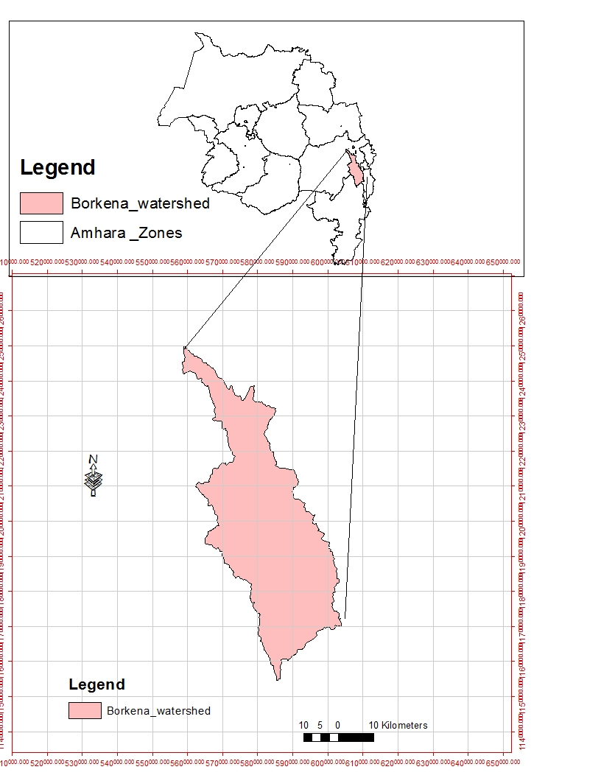
Figure 2-1: Drainage map of Borkena Sakei watershed

Hydro-Metrological Data Availability

Climate
Small scale irrigation project designers and planners are faced with lack of good data on the hydrology of the stream/river system that will be their water source and on local weather and climate conditions. Stream gauging stations are virtually non-existent in remote rural areas of Ethiopia; meteorological stations are almost rare. Likewise, at Bishae Eideda Kebele and in the catchment area of this project, there is no meteorological station of any level. Moreover, there are no flow data for the river/stream near the project. Therefore, data for the hydro-meteorological analysis is taken from the nearby station kombolicha. Rainfall & temperature data are considered from kombolicha meteorological station data. In fact, this station is very close to the project area.
As per the data of the station, December – June are identified as high temperature periods whereas November r - December are low temperature periods. The mean annual rainfall amount is more than 70.5mm (1991 - 2014data) and most of it occurs from June to August.

Rainfall Data
In order to compute the design flood for the Barrage structure, the daily maximum rainfall is collected from kombolicha Metrological stations with a record of 24 years.

River flow data
The base flow which is measured on May 2015 is 350 l/s. Since this base flow is measured during the dry months of the year, this figure is adopted for design.

Upstream & Downstream utilization
Downstream of the proposed site, appreciable need for water is anticipated for locals and cattle provisions. Therefore, at least 10% of the minimum flow has to be released for downstream requirements.
For the sake of planning and design, however, the outlet for the Barrage is designed for a discharge of 176l/s for this project and the project is to be developed for 192 ha of land using gravity system in the main canal, which is most of the time achievable as the flow for most of the time is significant to support this size of command area.

Design Flood Analysis
For the design and analysis of structures to be constructed on the river, estimation of flood magnitude is an important task. This can be done using different techniques depending on the data available. For this particular case, there are no river flow data and hence the flood estimation is done using the rainfall data and applying SCS Curve Method.

Design Rainfall computation
Based on the data of 24hr peak rainfall the design rainfall, Rf is computed using Gumble’s Powel’s Method.

Outlier Test
At first trial we have checked the 24 years of data for its outliers and higher and lower outlier is of range. After removing the higher record at the year of 2014, 106mm and lower outlier rainfall 30.5mm at the year of 2008, the data has been again checked for higher and lower outlier and no data is found outlier. There for the computation of design rainfall is done by using 22 years of data. Rejecting this two data and rechecking for its quality shows the following results.
22 years of daily heaviest rainfall records of kombolicha meteorological station, from 1991 to 2013, were used for the estimation of point design rainfall. In spite of less number of rainfall data, the designer selected an event that recurs in every 50 years of return period to compute the design rainfall, which is adopted for small scale irrigation projects like Borkena Sakei Barrage. These data should be checked for their consistency or outlier test to assure the reliability of data for further design flood simulation.
Table 2-1: Outlier test analysis
No | year | Max rain fall of year(X) | Descending order (x) | Y=logx | cumulative rainfall
1 | 1991 | 42.2 | 73.2 | 1.865 | 42.2
2 | 1992 | 52.4 | 192.6 | 1.855 | 94.6
3 | 1993 | 50.7 | 70.4 | 1.848 | 145.3
4 | 1994 | 46 | 68.4 | 1.835 | 191.3
5 | 1995 | 38.7 | 64.8 | 1.812 | 230
6 | 1996 | 42.7 | 64.5 | 1.810 | 272.7
7 | 1997 | 54.3 | 64.4 | 1.809 | 327
8 | 1998 | 68.4 | 61.2 | 1.787 | 395.4
9 | 1999 | 61.2 | 60.9 | 1.785 | 456.6
10 | 2000 | 50.6 | 60.4 | 1.781 | 507.2
11 | 2001 | 192.6 | 54.3 | 1.735 | 578.8
12 | 2002 | 64.4 | 54.3 | 1.735 | 643.2
13 | 2003 | 60.9 | 52.4 | 1.1929 | 704.1
14 | 2004 | 46.8 | 50.7 | 1.705 | 750.9
15 | 2005 | 70.4 | 50.6 | 1.704 | 821.3
16 | 2006 | 64.8 | 49.8 | 1.697 | 886.1
17 | 2007 | 54.3 | 49.6 | 1.695 | 940.4
18 | 2009 | 73.2 | 46.8 | 1.670 | 1013.6
19 | 2010 | 64.5 | 46 | 1.663 | 1078.1
20 | 2011 | 49.8 | 42.7 | 1.630 | 1127.9
21 | 2012 | 49.6 | 42.2 | 1.625 | 1177.5
22 | 2013 | 60.4 | 38.7 | 1.588 | 1237.9
sum |  | 1237.9 |  | 38.352
mean/µ/ |  | 56.268 |  | 1.743
stdv/αn-1/ |  | 10.226 |  | 0.080
skew/g/ |  | 0.0192 |  | -0.192

Higher Limit, YH=Ymean+Kn*Sy, Kn = 2.249 for22 Years of data.
Lower Limit,YL=Ymean-Kn*Sy, Kn = 2.249 for 22Years of data.
 |  | kn = | 2.249
 |  | YL= | 1.563
 |  | YH= | 1.924
Th  , | RL= | 36.19
 | RH= | 83.97
 | RL= | 36.519 | <= | 38.7
 | RH= | 83.947 | >= | 73.2
there for, there is no lower or higher outlier

Check for variance
After checking the outliers, the data should be checked for variability. For variability the formula used is
$α=\left(\frac{δ_{∩-1}}{\sqrt{N}*Mean}\right)*100\%$
Where, δ_{n-1 =} Standard deviation = 10.226
N = Nr of recorded data = 22
M_{ean} = 56.268
10.226$α$ = Standard error
$α=\left(\frac{10.226}{\sqrt{22}*56.268}\right)*100\%=0.98<10\%$ Acceptable
Therefore the data shows no variability.
The design rainfall using Gamble Powel’s Method is given as
Where R_{f} = Design rainfall
R_{mean} = average of all values of annual heaviest fall = 56.26 mm
σ_{n-1} = standard deviation of the series = 10.226mm
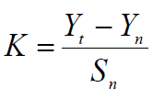
, T= Return period = 50 years
Yn, Sn = constant found from Gumble’s extreme value distribution table for N= 22 Years
- Yn = 0.5268 and Sn = 1.0754
- Point Design Rainfall = 88.363 mm
The design rainfall at points for 50 years return period is 88.363 mm and the areal design rainfall is calculated in the following section.

Peak Discharge Determination

General
The River is not gauged river. The design flood is calculated by using SCS unit hydrograph method. Thus, it is preferred to base the flood analysis on rainfall data, which are better both in quantity and quality of data. In the hydrologic analysis for drainage structures, it must be recognized that there are many variable factors that affect floods. Some of the factors that need be recognized and considered on an individual site by site basis are; rainfall amount and storm distribution; catchment area, shape and orientation; ground cover; type of soil; slopes of terrain and stream(S); antecedent moisture condition; Storage potential (over bank, ponds, wetlands, reservoirs, channel, etc.)

Peak flood analysis by SCS unit hydrograph method
Design flood is calculated SCS (The United States Soil Conservation Service). This method is widely adopted and more reliable method for flood estimation. The approach considers, watershed parameters, like Area, Curve number, and time of concentration.

Time of concentration (Tc)
Time of concentration has been calculated by taking the stream profile of the longest streamline and dividing it in to different elevation. Kirpich formula is adopted for computation.
Table 2-2: Determination of Time of Concentration
S/n | Distance b/n elevation _m | Elevation | Vertical distance | Horizontal dist_m | Slope (m/m) | slope*dist | Tc(Kirpich)minutes for each segment
1 | 0 | 3000 |  | 0.00 |  | 0 | Tc=0.0195*((L^0.77)*(S^-0.385))
2 | 1607.114169 | 2800 | 200.00 | 1607.11 | 0.124 | 200 | 12.80
3 | 3031.947305 | 2680 | 120.00 | 3031.95 | 0.040 | 120 | 32.43
4 | 23240.08249 | 2600 | 80.00 | 23240.08 | 0.003 | 80 | 398.43
5 | 5658.267924 | 2480 | 120.00 | 5658.27 | 0.021 | 120 | 66.67
6 | 2406.090597 | 2400 | 80.00 | 2406.09 | 0.033 | 80 | 29.02
7 | 2104.693591 | 2080 | 320.00 | 2104.69 | 0.152 | 320 | 14.58
8 | 1548.851775 | 2000 | 80.00 | 1548.85 | 0.052 | 80 | 17.45
9 | 6845.863743 | 1840 | 160.00 | 6845.86 | 0.023 | 160 | 74.36
10 | 6989.220361 | 1760 | 80.00 | 6989.22 | 0.011 | 80 | 99.46
11 | 6259.832767 | 1680 | 80.00 | 6259.83 | 0.013 | 80 | 87.57
12 | 1995.233901 | 1640 | 40.00 | 1995.23 | 0.020 | 40 | 30.53
13 | 54579.5336 | 1400 | 240.00 | 54579.53 | 0.004 | 240 | 699.72
14 | 5882.500846 | 1376 | 24.00 | 5882.50 | 0.004 | 24 | 129.57
 | Total | 1624 | 1624.00 | 122149.23 | 0.502 | 1624 | 1692.59
 |  |  |  | Weighted slope(%) = | 0.0133 |  | 28.21
 |  |  |  | Main stream length_m | 122149 |  | tc

The formula is,
$Tc=\sum{0.948\left\{{\left(\frac{{L_{1}}^{3}}{H_{1}}\right)}^{0.385}+{\left(\frac{{L_{2}}^{3}}{H_{2}}\right)}^{0.385}+…+{\left(\frac{{L_{n}}^{3}}{H_{n}}\right)}^{0.385}\right\}}$
- Tc = 28.1 Since Tc > 3hr., duration of excess rainfall difference, D = 1hr.
- Time to peak,
$T_{p=}\frac{D}{2}+0.6*T_{c}$ = 17.43hr
- Base time,
$T_{b}=2.67*T_{p}$ = 46.53 hr
- Recession time,
$T_{r}=1.67*T_{p}$ = 29.10hr.

Curve number (CN)
Curve number (CN) is achieved based on USSCS method by watershed characterization in terms of land cover, treatment, hydrologic condition and soil group. From the watershed analysis curve number at condition II =79.7 since peak rainfall is found at an antecedent moisture condition III state, this value has to be changed to antecedent moisture condition III.
- Conversion factor = 1.13
- CN Condition (III) = (Factor from Table x CN condition II) =79.7 *1.13 = 90.01. For detail analysis of the computation, Refer Excel file, attached here with.

Area Rainfall
As the area of the catchment gets larger, coincidence of all hydrological incidences becomes less and less. This can be optimized by changing the calculated point rainfall to aerial rainfall. The conversion factor is taken from standard table that relate directly with the size of watershed area and type of the gauging station. (IDD manual) .The area reduction factor (Fr) is introduced to account for the spatial variability of point rainfall over the catchments.
For the case of Borkena Sakei irrigation project, its have large catchment area
Therefore, Area rain fall conversion factor =1-(0.044*A^{0.275}) =66.076
For large>750km²
Where, A = drainage area in km²; 1681.33 Km²
- Type of gauging station = Daily rainfall (24 hr.)
- Aerial Rainfall = (Point Rainfall) x (Conversion factor)

Run off Analysis
Input data:
- Design Point Rainfall = 88.363 mm
- Curve number at antecedent moisture condition III =90.01
- Catchment Area, A = 1681.33 Km²
- Tc = 28.1, D = 1hr., Tp = 17.43hr; Tb = 46.53 hr; Tr = 29.10 hr.
- Direct run-off,
$Q=\frac{{(I-0.2*S)}^{2}}{(I+0.8*S)}$
Where, I = Rearranged cumulative run-off depth (mm
- S = Maximum run off potential difference,
$S=\left(\frac{25400}{CN}\right)-254$
- Peak run-off for incremental;
$Q_{p}=0.21*\frac{(A*Q)}{T_{p}}$
Where, A = Catchment area = 1681.33 Km²
T_{p} = Time to peak (hr)
Q = Incremental run-off (mm)
Table 2-3: Runoff analysis
Rainfall Duration(D) | Direct runoff increment, Ri(mm) | qp for 1mm runoff /m3/s/mm | qp for incremental run off m3/s/ | begin time, hour | peak time, hour | end time, hour | remarks
0-1 | 0.00 | 20.26 | 0.00 | 0 | 17.43 | 46.53
1-2 | 0.00 | 20.26 | 0.00 | 1 | 18.43 | 47.53
2-3 | 0.56 | 20.26 | 11.4 | 2 | 19.43 | 48.53
3-4 | 15.33 | 20.26 | 310.6 | 3 | 20.43 | 49.53
4-5 | 6.04 | 20.26 | 122.4 | 4 | 21.43 | 50.53
5-6 | 1.93 | 20.26 | 39.1 | 5 | 22.43 | 51.53

Table 2-4: Hydrograph coordinates
Time | Q1 | Q2 | Q3 | Q4 | Q5 | Q6 | base flow(m^3/se) | Qtotal
0 | 0.00 |  |  |  |  |  | 0.35 | 0.35
1 | 0.00 | 0.00 |  |  |  |  | 0.35 | 0.35
2 | 0.00 | 0.00 | 0.00 |  |  |  | 0.35 | 0.35
3 | 0.00 | 0.00 | 0.65 | 0.00 |  |  | 0.35 | 1.00
4 | 0.00 | 0.00 | 1.30 | 17.82 | 0.00 |  | 0.35 | 19.48
5 | 0.00 | 0.00 | 1.95 | 35.65 | 7.03 | 0.000 | 0.35 | 44.98
17.43 | 0.00 | 0.00 | 10.05 | 257.13 | 94.32 | 27.856 | 0.35 | 389.71
18.43 | 0.00 | 0.00 | 10.70 | 274.95 | 101.35 | 30.097 | 0.35 | 417.45
19.43 | 0.00 | 0.00 | 11.35 | 292.77 | 108.38 | 32.339 | 0.35 | 445.19
20.43 | 0.00 | 0.00 | 10.96 | 310.60 | 115.40 | 34.581 | 0.35 | 471.89
21.43 | 0.00 | 0.00 | 10.57 | 299.92 | 122.43 | 36.823 | 0.35 | 470.10
22.43 | 0.00 | 0.00 | 10.18 | 289.25 | 118.22 | 39.064 | 0.35 | 457.07
46.53 | 0.00 | 0.00 | 0.78 | 32.02 | 16.83 | 6.71 | 0.35 | 56.69
47.53 |  | 0.00 | 0.39 | 21.35 | 12.62 | 5.37 | 0.35 | 40.08
48.53 |  |  | 0.00 | 10.67 | 8.41 | 4.03 | 0.35 | 23.46
49.53 |  |  |  | 0.00 | 4.21 | 2.68 | 0.35 | 7.24
50.53 |  |  |  |  | 0.00 | 1.34 | 0.35 | 1.69
51.53 |  |  |  |  |  | 0.00 | 0.35 | 0.35

Figure 2-2: Complex Hydrograph
From the analysis, the 50 year return period design run off is 471.89 m ³/s

Tail Water Depth Computation
Tail water depth of the river is equal to the flood depth and amount at the proposed Barrage site before construction of the Barrage. It is used to crosscheck peak flood estimated by the SCS unit hydrograph method with flood mark method and to see the flood feature after the hydraulic jump. During field visit, the flood mark of the river at the proposed Barrage site was marked based on dwellers information and physical indicative marks. The river cross-section was surveyed. Since, in this project the flood mark is the highest elevation of the proposed site and the flow of water is over all command area and bank of the river, therefore it cannot determine tail water depth of river. It is difficult to protect the flood entering in to main canal and command area, for to safe the right bank of river small in height d/s and u/s retaining wall is recommended to stabilize the nature of bank and in order to minimize back water barrage with 1.2m height broad crest weir structure is recommended. To safe and easily remove sediment and peak discharge sheet metal gate provided in the crest of Broad crest weir.
Table 2-5: Barrage Site River Cross section Coordinate Data
A) Average river bed slope computation (End area method)
S.N | Easting | Northing | Elevation | Partial Height, (H), m | Partial Distance(L) m | Cumulative Distance, (m) | Area (m²)
1 | 597270.251 | 1179978.587 | 1400.696 | 0 | 0 | 0 | 0
2 | 597267.671 | 1179966.792 | 1400.677 | 0.019 | 12.074 | 12.074 | 0.1147
3 | 597262.907 | 1179956.464 | 1400.692 | 0.015 | 11.374 | 23.448 | 0.1934
4 | 597257.246 | 1179942.032 | 1400.768 | 0.076 | 15.503 | 38.950 | 0.7054
5 | 597251.061 | 1179926.656 | 1400.760 | 0.008 | 16.573 | 55.524 | 0.6961
6 | 597239.210 | 1179907.799 | 1400.890 | 0.13 | 22.272 | 77.795 | 1.5368
7 | 597231.594 | 1179891.047 | 1400.709 | 0.181 | 18.402 | 96.197 | 2.8615
8 | 597230.485 | 1179865.660 | 1400.805 | 0.096 | 25.411 | 121.609 | 3.5195
9 | 597240.223 | 1179848.908 | 1400.796 | 0.009 | 19.377 | 140.985 | 1.0173
10 | 597254.775 | 1179832.082 | 1400.854 | 0.058 | 22.246 | 163.231 | 0.7452
11 | 597271.978 | 1179817.781 | 1400.873 | 0.019 | 22.371 | 185.602 | 0.8613
12 | 597285.533 | 1179804.235 | 1400.59 | 0.283 | 19.163 | 204.765 | 2.8937
13 | 597298.565 | 1179792.164 | 1400.810 | 0.22 | 17.764 | 222.529 | 4.4675
Summation |  |  |  | 1.114 | 222.529 |  | 19.612
Average Height , H = |  |  |  | 2*A/L |  | 0.176
Average Slope , S = |  |  |  | H/L |  | 0.001
Adapted Slope, S = |  |  |  | 1:1262

- Average river bed slope(best fit method)
Average river bed slope of River is estimated by two different techniques. One is by end area method and the other is by using best fit line method. End area method adopted the method output for further analysis.
The water level of the river is taken at different points along the river channel around the head work site. Surveying work done for 222.53m length. And then, average water surface slope is considered as the river bed slope. For comparison of the two procedures, refer the attached Excel file. As you see the river profile below the river slope is Zigzag, it indicates the river by its nature is some depression and elevated have presented.

Figure 2-3: River profile
- Manning’s Roughness coefficient
The Manning’s roughness coefficient is taken from standard table based on the river nature. The river at the headwork site has got braded feature and curving nature. The river banks are defined have no sufficient bank I.e. flow of river is over the command area and relatively smooth. Manning’s roughness coefficient (n = 0.04) is adopted.

- Discharge of the river
Input data:
- Manning's roughness coefficient, n = 0.04
- Average river bed slope, S = 0.006
- , Where, R = Hydraulic radius = (Area/Perimeter)
- $Q=V*A$

In generally the slope of river and manning coefficient used to determine the river discharge computation at different stage flow. But in the above states have no sufficient bank in both sides since it cannot determine at what reach the maximum river discharge. But the scour depth can be recommended as the geology report two test pit is taken up to 2m in depth; the soil is the same property black cotton, then take 2.5m is for design barrage weir depth.

Figure 2-4: River profile
From the above stage discharge curve the maximum flood level corresponding to the computed design peak discharge is 1402.78 (2 m from the river bed) and it is considered as the d/s high flood level i.e. expected at the Weir Diversion axis before construction of the Weir Diversion.
D/S HFL = 1402.78 m.a.s.l. All hydraulics analysis is computed by flood mark because of the tail water depth of peak flood is very small; hence to protect overtopping flood tail water depth by flood mark elevation is safe for design
D/S HFL = 1402.78masl,

Table 2-6: River discharge computation at different stages of flow
Elevation discharge curve table for the Defined river section
S.Nr | Elevation/m/ | Water depth /m/ | Wetted Area (A), m^2 | Perimeter /m/ | Hydrualic radius/R/ | Velocity /m/s/ | Discharge /m^3/s/
1 | 1400.78 | 0.00 | 0.00 | 0.00 | 0.00 | 0.00 | 0.00
2 | 1401.178 | 0.400 | 1.910 | 9.610 | 0.199 | 0.383 | 0.732
3 | 1401.578 | 0.800 | 8.090 | 22.950 | 0.353 | 0.562 | 4.545
4 | 1401.978 | 1.200 | 19.020 | 30.570 | 0.622 | 0.820 | 15.605
5 | 1402.378 | 1.600 | 32.390 | 36.590 | 0.885 | 1.038 | 33.617
6 | 1402.778 | 2.000 | 56.440 | 94.470 | 0.597 | 0.799 | 45.071
7 | 1403.078 | 2.300 | 244.000 | 303.000 | 0.805 | 0.974 | 237.760
8 | 1403.13 | 2.300 | 244.000 | 303.000 | 0.805 | 0.974 | 471.89
9 | 1403.178 | 2.400 | 470.000 | 434.700 | 1.081 | 1.186 | 557.385
10 | 1403.378 | 2.600 | 557.090 | 437.810 | 1.272 | 1.322 | 736.439
11 | 1403.578 | 2.800 | 644.750 | 440.950 | 1.462 | 1.450 | 935.070
12 | 1403.978 | 3.200 | 821.840 | 446.000 | 1.843 | 1.692 | 1390.616
13 | 1404.378 | 3.600 | 1000.000 | 448.000 | 2.232 | 1.923 | 1922.795
14 | 1404.778 | 4.000 | 1179.280 | 450.360 | 2.619 | 2.139 | 2522.164

SECTION-II: HEADWORK DESIGN

HEADWORK STRUCTURES DESIGN

Headwork Site Selection
The headwork site is situated at 1179879N, 3597251E and river bed elevation of 1403 m above sea level.
The stream bed or course at the proposed headwork site is nearly straight, well defined, and shows almost uniform surface and straight rich from one bank to another bank. In selecting or comparing the best site, it was practically important to put criteria’s such as considering the flood the channel has to accommodate, the length of the Barrage crest, the topographically suitability, the relative economic considerations , the availability of enough command and other selection or comparison criteria’s.

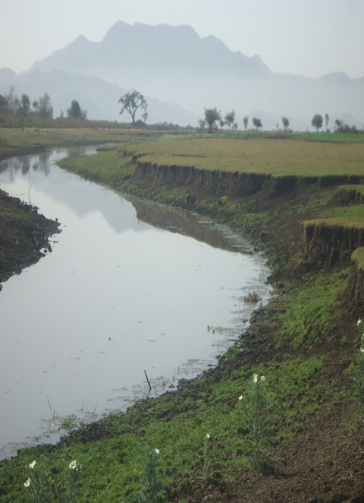
Weir axis
Figure 3-1: River bed at the proposed Barrage site

River Geomorphology
The geomorphology of the project area is characterized by jointed and weathered bed rock, and gentle to moderate slope landform respectively. These conditions are suitable for the infiltration, percolation and consequent storage as groundwater of significant amount of the precipitation. Close observation and estimation of the discharge (base flow) of the stream at the project area and surrounding areas both up- and down-streams indicates that the recharge of the groundwater to the stream flow is significant. It increases to downstream direction. This observation can also be confirmed by the existence of some swampy areas and springs around the periphery of the stream floodplain. The area's groundwater is stored mainly within weathered section and jointed part of the bedrock, which are overlain by fine- grained soils at many places. Some amount of groundwater also observed in thin layers of older alluvial sediments deposited along the floodplains of the stream.
From this study, groundwater observed from shallow depths along the Barrage-axis, shallow at the valley floor.
This observed groundwater would pose different problems on the proposed project especially on the Barrage and during construction time unless precautions are taken. Some of the anticipated problems are decrease in the shear strength of the foundation soil if the foundation material is soil; impose uplift pressure to the wire.
In this project area, the main recharging areas are the weathered and fractured unit on elevated areas of the catchment including the two right and left ridge segments.

River Bed condition
For this project a simple river Barrage structure has been proposed for diverting the water to the main canal. The headwork site geological surface and subsurface at conditions have been investigated the nature of the proposed structure. At the site, stream flows along the gentle slope course and its bed is almost the same type of the valley floor which gentle slopes. Mainly covered with the top and in bottom section is show the same soil which is black cotton. Geotechnical investigation of the head work axis is mainly contains according to the surface and subsurface investigation is the same type of clay soil is dominant. In the right and left bank of river two test pit each 2m depth are taken. Form those pit the soil have the same properties which is moist.

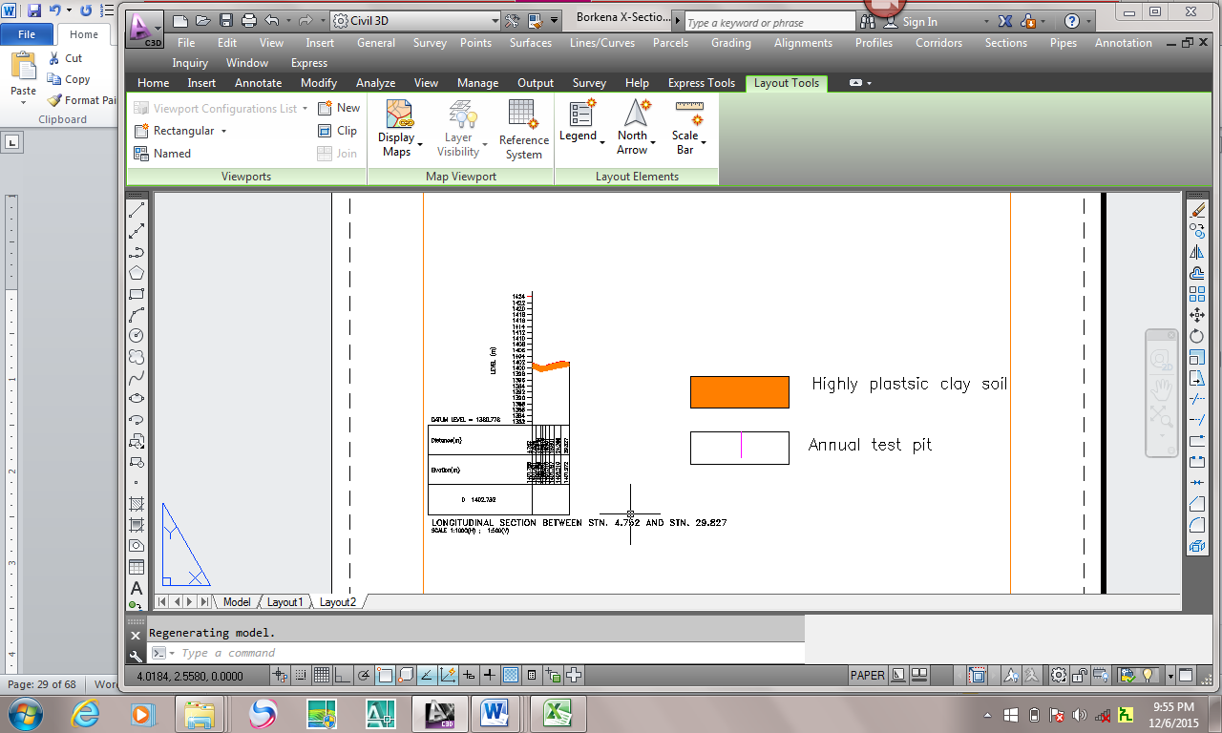
Figure 3-2: River bed geological x-section

River Bank condition
The project area of Borkena Sakei Barrage is volcanic lava flow and quaternary sediments are dominated. These areas are contains two type of land form:
The ridge which is the right and left side of Borkena Sakei river N-S orientation with moderately slope which is dominantly a volcanic rock which is weathered and jointed .
Around the river valley floor there is gentle area which is covered by quaternary sediments. Those moderately slope ridges are separated may be rifting due to the area are active. Consequently river which is form gentled valley floor inferred that the area are easily weathered, transported and eroded. And the local geology of the project area embraces the surrounding ridges and valley floor that is different geological formation one in the other. The continuous ridge segment is covered by highly fractured, jointed Rhyolite, welled tuff and UN welled tuff, valley floor is covered with clay formation. General volcanic rock such Rhyolite, welled tuff, upwelled tuff and quaternary sediments are dominant in the project area

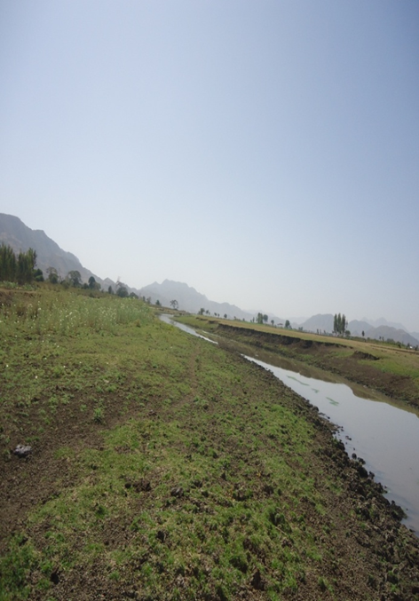
Figure 3-3: left and right bank

Sources of construction materials
During site investigation, natural construction materials required for the construction of the various proposed engineering structures at the headwork and within the farmland have been assessed, and possible quarry sites and borrow areas have been identified within the study area as close to the project site as possible. In addition to identifying the quality, quantity and accessibility conditions of the construction materials, ownerships of each proposed production sites have also been studied and described in this report, on separate sub-sections below. The materials needed for the construction of the structures include rock for masonry stones, aggregates (both coarse and fine), and water.

Rock for Masonry and Crushed Coarse Aggregate
During site investigation rocks required for masonry works were identified Quarry site that can be used production of rock for masonry stone and crushed coarse aggregates has been assessed during the field around the project area. One of the possible quarry sites has been identified form the head work to about 2km at the east direction of n-s orientations of the ridge within the asphaltic road which is goes to Addis Ababa to the left direction between kemise and chefa robit. With the specific location 0598250E, 1181357N (UTM), 1441m above sea level and 0598102E, 1181646N (UTM), 1430m above sea level respectively.

Fine Aggregates
Borrow area of fine aggregate or natural sand have been assessed 27km far from the project area. The natural deposits of such materials could found within the Jara River which is found the main asphalt road goes to Addis Ababa and turn to the right before passing of river. The source of such materials which are existed in the river with sufficient amount and it can be used by washing to remove the silt content.

Water
Water for construction purposes can be found from the project stream, Borkena Sakei, itself. The stream is perennial throughout the year that there is some amount of flow along its course. During this field time the stream flow was more than 300L/second.

Headwork Type Selection
Looking the availability of natural construction materials and considering the river features and expected flood amount, Barrage with Weir Diversion is chosen. As it is:
- Simple for construction
- Stability of resisting score depth since the foundation is more safe up 2m
- At proposed head work it’s have Economical section
- To minimize submergence or back water (hence the proposed head work gentle slope )

Hydraulic Design of Headwork Structure

Weir Height Determination
The following major factors have been reasonably assessed during the field study and the final topographic map has been investigated whether the target area can be commanded at less weir height or not. By using necessary parameters, the weir crest elevation has been determined on both sides of the river as follows:
- Maximum command area elevation
- Deriving head of the Weir Diversion structure
- Main canal slope Sill level of off take canal
- Main canal idle Length
- Loss

Base flow of the River
The study team has assessed that the stream is used for irrigation along it’s the river at the proposed diversion site by using two and above dewatering pump system. Where, the farmers are using the stream for traditional SSI (Irrigation Infrastructure Report). Study team has calculated flow of the river at the Barrage site as 350 l/s. Out of this 381.16 l/s will be required for the proposed scheme 192 ha by gravity system and 10% will be released for downstream. The purpose of releasing the 35l/s to downstream is for the sake of downstream users. The base flow is too much enough; because, of method of irrigation is rotational system

Weir Dimensions

Flow over the Weir crest
a. Crest Length
- Lacey’s regime width, $L=4.75*\sqrt{Q},$ $=4.75*\sqrt{471.89}$ = 103.184 m.
- Actual river section width of the over flow section of the river is = 20.63m
b. Discharge over the weir section
- Design discharge, Q = 471.89m³/s , C=1.7 & L=20.63m
- From ,$Q=C*L*{H_{e}}^{\frac{3}{2}}$
$H_{e}={\left(\frac{Q}{C*L}\right)}^{\frac{2}{3}} ={\left(\frac{471.89}{1.7*20.63}\right)}^{\frac{2}{3}}=$5.68m
The velocity head, h_{a} is computed from the approach velocity as shown below
Where g: acceleration due to gravity = 9.81m/sec²
Va is Approach velocity determined by
L is Weir crest length = 20.63 m,
h_{d} is flow depth over the weir and also,
By trial and error method, h_{d} is found to be 1. Velocity head, h_{a} = 0.358m 183m
- h_{a} = H_{e}-h_{d} = 1.52m-1.52m = 0.001m
- Design discharge, Q = 471.89 m³/s by flood mark

Top and bottom width
According to the Bligh’s formula, top and bottom width of the weir body is determined as follows
Input Data:
P: Height of weir (m) = 1.2 m
He: specific energy head (over flow depth + approaching velocity head (m))
: Specific weight of weir body (2.4 for cyclopean concrete) He=3.54
Top width, 1.2 m
Bottom width, say ------2.4m
Provide 1 m and 2.1 m top and bottom width respectively, which will be tested for adequacy during stability
Provide 2.1m bottom width and 1m top width respectively, which will be tested for adequacy during stability analysis.

U/S and D/S HFL Calculation & Determination
From the stage –discharge curve prepared the high flood level before construction (i.e. D/s HFL) corresponding to the design flood is 1402.78m a.s.l.
D/s HFL = 1402.78m amsl ------------------------------------- (a)
U/s HFL = U/s bed level + weir height + H_{d} -------- (b)
H_{d} is the depth of water over the weir crest. This is calculated by assuming broad crested weir formula.
$Q=C*L*{H_{e}}^{\frac{3}{2}}$ Whereas Q=471.89m3/s, L=20.63m & c=1.7
$H_{e}={\left(\frac{Q}{C*L}\right)}^{\frac{2}{3}}$=1.53
U/s HFL =U/s TEL –velocity head =1403.51m a.s.l – 0.001m = 1403.13m a.s.l

-  Afflux
⇒ Afflux = U/s HFL- D/s HFL = 1403.13m a.s.l –1402.78 m a.s.l = 0.72m.
From the flood level analysis, it is seen that the flood overtops the banks of the river u/s of the structure. This condition is allowed to take place as it doesn’t bring pronounced negative impacts on the structures, rather than constructing bulky structures to confine it.

Hydraulic Jump Calculation
As discussed in the geologic report, the river bed is alluvial deposit and hence stilling basin for energy dissipation is required. Both left and right side banks are joint rock, a wing walls are required at u/s and D/s sides for the left side of the river, so as to protect flood entering to the canal in high flood cases.
The length of wing walls is determined based on the length of Jump, and it is calculated as shown below.
• Weir crest length =20.63m
• Weir height = z = 1.2m
• Pre-jump depth = y₁
• Post -jump depth =y₂

Neglecting losses between point A and B and considering similar datum
z + H_{e} = y₁ + h_{a}
But, He = 1.53m,
$q=\frac{Q}{l}=\frac{59.58.m3/s}{20.63m}=2.88m$²$/s$
$$h_{a}=\frac{q2}{2*g*y^{2}}=\frac{{22.87}^{2}}{2*g*{y_{1}}^{2}}$$
1.2m + 1.53m=y₁+6.543/y₁²
After iterations Y₁ = 0.48m
V₁=q/y₁=2.88/0.48=6.01
$$F_{r}=\frac{V_{1}}{\sqrt{gy_{1}}}=\frac{6.01}{\sqrt{9.81*0.48}}=2.78$$
$$y_{2}=\frac{y_{1}}{2}\left(\sqrt{1+8*{F_{r}}^{2}}-1\right) y_{2}=\frac{1.43}{2}\left(\sqrt{1+8*{2.78}^{2}}-1\right) =1.854m$$
Hydraulic jump length (L) for Fr=2.12from the graph L=5*(y_{2-y1)} =5*(1.854-0.48) = 7m

Impervious floor

D/s impervious floor (Ld)
For under seepage the worst condition would be when the water on the upstream side is at the level of the weir crest & there is no tail water. Seepage head loss at
- Pond level case:
Hs = crest level –bed level
= 1.2m
- Maximum flood case:
Hs = U/s HFL- D/s HFL
= 1403.13-1402.78
= 0.72m
Therefore maximum seepage head occurs when water is stored up to the pond level and there is no water on the d/s.
= Bligh’s constant, C_{b} is depending on the type of the foundation.
$$L_{d}=2.2*C_{b}*\sqrt{\frac{H_{s}}{10}} L_{d}=2.2*9*\sqrt{\frac{1.2}{10}} =6.86 m$$
The jump length is 11m, Therefore D/s impervious floor is taken to be 11m long, the maximum.

U/S Impervious Floor Length, (Lu)
The u/s impervious floor, (L_{u}) = LT- (Ld +2*d1+2*d2+B) = -3.2m take nominal distance=1m Therefore total length of the u/s impervious floor is taken 1m nominal long.
Whereas, LT=Hs*C =1.2*9=10.8m
Ld =length of D/S Impervious Floor Length=7m
D1=U/S cut off=1.5m
D2=d/s cut off=1.5m
B=bottom width of weir=2.4m

Floor thickness (t) by khosla’s & Bligh’s theory

Creep length (b) =2*1.5+1+2.4+7+2*1.5= 16.4m
Hydraulic head (d) =pond level -bed level
= 1401.98m a.s.l-1400.78m a.s.l
=1.2m
Hydraulic gradient (GE) =d/b=1.2/16.4=0.0732
Floor thickness at heel
Creep length up to point (L)
=2*d1+L2=2*1.5+1=4m
Up lift pressure (head) at heel (h) =HS-GE*L
h=1.2-0.0732*4=0.907m
Thickness (t) =4/3*h/(G-1)
t=4/3*0.907/ (2.4-1) =0.86m
Take 0.6m b/c there is counterbalance water load
Floor thickness at Toe
Creep length up to point (L)
=2*d1+L2+B=2*1.5+1+2.4=6.4m
Up lift pressure (head) at heel (h) =HS-GE*L
h=1.2-0.0732*6.4=0.732m
Thickness (t)=4/3*h/(G-1)
t=4/3*0.732(2.4-1) =0.69m
Take 1.5m calculated by Bligh’s theory
Floor thickness at 4m from Toe
Creep length up to point (L)
=2*d1+L2+B+3.5=2*1.5+1+2.4+3.5=9.9m
Up lift pressure (head) at heel (h) =HS-GE*L
h=1.2-0.0732*9.9=0.475m
Thickness (t)=4/3*h(G-1)
t=4/3*0.475(2.4-1) =0.45m
Take 1m calculated by Bligh’s theory
Floor thickness at 8m from Toe
Creep length up to point (L)
=2*d1+L2+B+7=2*1.5+1+2.4+7=16.4m
Up lift pressure (head) at heel (h) =HS-GE*L
h=1.2-0.0732*16.4=0.001m, thickness (t) =4/3*h (G-1)
t=4/3*0.001(2.4-1) =0.00095m
Take 0.6m calculated by Bligh’s theory
The floor is constructed with cyclopean C-20 concrete & capping 30cm with c-20 concrete.
- For detail analysis of the computation, Refer Excel file.

Cut off Depth Calculation

U/s cut off
- Q = 59.58 m³/sec
- q =3.2 m³/s/m
- Silt factor, f =1.76*(d₅₀)^{0.50}
f= 3.7
- D₅₀=4.5mm for fine gravel & boulder
- R =1.35*(q²/f)^{(1/3)}
R=1.35*(q²/f)^{(1/3)} = 6.09m take R = 1.8m
Hence bottom level of u/s cut off = U/S HFL – 1.25*R
=1403.13-1.25*1.8=1400.88m
Take the bottom level of the u/s cut off as 1400.88m considering the floor thickness
U/S Cut off depth=river bed level- bottom level of u/s cut off
=1400.78-1400.88=-0.1 take 1.5m

D/s cut off
- Q =59.58m³/sec
- q =3.2 m³/s/m
- Silt factor, f =1.76*(d₅₀)^{0.50}
f= 3.71 take f=4.32
- D₅₀=4.5mm for fine gravel & boulder
- R=1.35*(q²/f)^{(1/3)}
R=1.35*(q²/f)^{(1/3)} =1.8 take
Hence bottom level of D/s cut off = U/S HFL – 1.5*R
=1403.13-1.5*1.8=1400.43m
Take the bottom level of the D/s cut off as 1400.43m considering the floor thickness
D/S Cut off depth=river bed level- bottom level of d/s cut off
=1400.78-1400.43=0.35 take 1.5m from geological report
For each arrangement and further information, refer to the design drawing.

Canal outlet level
The sill level of outlet is fixed by give pick up weir plus shatter gate from river bed level. Hence the proposed head work gentle slope and have no defined bank, therefore, by allowing free gate when high flood becomes. The main conveyance system is more than 2.985km which passes more gentle area alignment. Hence this level is fixed based on the optimum route alignment and the maximum irrigated command level including minor and major losses criteria. Based on this condition, the sill level is fixed to be 1402.6m
• Outlet capacity
The canal capacity should be determined for maximum command area and the corresponding discharge. In this case the outlet capacity is fixed considering maximum duty and command area and 1.25 correction factors are considered to account the variation of duty.
Outlet capacity = Duty x command area x correction factor
Where, maximum duty for 15 hr irrigation = 1.98 L/s/ha, Command area = 192ha.
Outlet capacity =1.98 l/s/ha x 192ha*1.25 = 380.16L/sec, Take 380.16 L/s for design.
• Outlet size
From the Barrage discharge formula the outlet size is determined as follows
From Orifice formula, Qd=cd*A*(2*gh)^0.5,where ,cd=0.65
A=B*H
B = Canal width (m) =1.6m, Qd=380.16lit/sec
Hence, provide an outlet size of 1.6 m x 0.5m (length x height) .The gate of the off take canal is to be vertical sheet metal of 1.6m x 0.50m for the closure of the opening space. Provide some extra dimensions for groove insertion. Gross area of sheet metals for the off take canal gate will be 1.7m x 0.60m (allowing 5cm insertion for grooves). The grooves are to be provided on the walls using angle iron frames at the two sides of the gate openings. In this project there is no bolder geologically and it’s have gentle slope at the proposed site , hence by considering of those Brest wall, operation slab, trash track is not necessary, only simply sliding gate provided.

Bill of Quantity and Cost Estimation
The quantities of the various items have been worked out as per the final design and final drawings prepared for the scheme. The unit rates analysis has been carried out based on the data available in the vicinity of the project area.
Bill No. 1- General Items
 | BILL No. 1. GENERAL | UNIT | QUANTITY | UNITE PRICE | AMOUNT (ETH. BIRR)
1.1 | Allow for mobilization | L.S | 1 | 200,000.00 | 200,000.00
1.2 | Allow for demobilization | L.S | 1 | 180,000.00 | 180,000.00
1.3 | Allow for contractor’s camping facilities 4*5m2, Living room for contractors key personnel, CIS and internally painted clip wood wall, Masonry floor cement screened and well ventilated room complete with doors and windows. | No | 5 | 62,037.29 | 310,186.44
1.3 | Allow for Consultant’s camping facilities 4*5m2, Living room for contractors key personnel, CIS and internally painted clip wood wall, Masonry floor cement screened and well ventilated room complete with doors and windows. | No | 2 | 62,037.29 | 124,074.58
1.3 | 5*5m2, Store and dining room constructed from CIS with doors and windows, Masonry floor cement screened | No | 1 | 69,157.0 | 69,157.03
1.3 | Barbed wire fence 60*20m and 1.5m high treated timber post complete with 3m wide gate and a CIS guard house (1.5*2m) | No | 1 | 70,368.42 | 70,368.42
1.4 | Allow for temporary access road to the project site by leveling the existing foot path using daily laborer (2km) | km | 2 | 152,017.27 | 304,034.54
1.5 | Dewatering of open trenches and excavations, pumps | LS | 1 | 118,700.77 | 118,700.77
1.6 | Provide project indicator post starting from the construction time | LS | 1 | 7,807.68 | 7,807.68
1.7 | Provision of as built drawings for the project | LS | 1 | 52,219.39 | 52,219.39
 | Sub Total |  |  |  | 1,436,548.86

 | Bill No2 Head work
Item No | Description | Unit | Quantity | Rate Birr | Amount Birr
1 | Weir Body
1.1 | Earth Work
1.1.1 | Bulk Excavation in ordinary soil | m³ | 28.51 | 78.00 | 2,223.94
1.1.2 | Bulk Excavation in alluvial deposit | m³ | 95.04 | 97.00 | 9,218.88
1.2 | concrete works
1.2.1 | Cyclopean concrete(60% C-20,40% graded stone) | m³ | 42.43 | 1864.03 | 79,098.25
1.2.2 | Reinforced C-20 concrete capping | m³ | 22.68 | 2761.54 | 62,633.38
1.3 | Reinforcement bars including cutting bending and placing
1.3.1 | Ф12mm bar | kg | 522.40 | 48.72 | 25,451.20
 | Sub total |  |  |  | 178,625.65
2 | Upstream and Downstream Apron
2.1 | Earth Work
2.1.1 | Bulk Excavation in ordinary soil | m³ | 54.52 | 78.00 | 4,252.25
2.1.2 | Bulk Excavation in alluvial deposit | m³ | 181.72 | 97.00 | 17,626.84
2.2 | concrete works
2.2.1 | Cyclopean concrete(60% C-20,40% graded stone) | m³ | 123.06 | 1864.03 | 229,387.53
2.2.2 | Reinforced C-20 concrete capping | m³ | 47.59 | 2761.54 | 131,410.64
2.3 | Reinforcement bars including cutting bending and placing
2.3.1 | Ф12mm bar | Kg | 993.17 | 48.72 | 48,387.14
 | Sub total |  |  |  | 431,064.41
3 | Upstream and Downstream Cut off
3.1 | Earth Work
3.1.1 | Bulk Excavation in alluvial deposit | m³ | 290.40 | 77.94 | 22,633.78
3.1.2 | Back fill and Compact with excavated material | m3 | 247.20 | 67.41 | 16,663.75
3.2 | concrete works
3.2.1 | C-20 Reinforced concrete | m³ | 24.72 | 2761.54 | 68,265.27
3.3 | Reinforcement bars including cutting bending and placing
3.3.1 | Ф12mm bar | Kg | 528.59 | 48.72 | 25,752.74
 | Sub total |  |  |  | 133,315.54
4 | Access Bridge for Barrage operation
4.1 | Earth Work
4.1.1 | Bulk Excavation in alluvial deposit | m3 | 23.12 | 77.94 | 1,801.97
4.1.2 | Back fill and Compact with excavated material | m3 | 0.32 | 67.41 | 21.57
4.2 | concrete works
4.2.1 | Reinforced C-20 concrete including (footing pad,peir,caping &slab) | m3 | 35.26 | 2761.54 | 97,371.90
4.3 | Reinforcement bars including cutting bending and placing
4.3.1 | Ф24mm bar | Kg | 2602.85 | 48.72 | 126,810.94
4.3.2 | Ф20mm bar | Kg | 1779.67 | 48.72 | 86,705.55
4.3.3 | Ф16mm bar | Kg | 853.04 | 48.72 | 41,560.34
4.3.4 | Ф14mm bar | Kg | 323.40 | 48.72 | 15,756.05
4.3.5 | Ф12mm bar | Kg | 215.55 | 48.72 | 10,501.64
4.3.6 | Ф10mm bar | Kg | 53.98 | 48.72 | 2,629.98
4.3.7 | Ф8mm bar | Kg | 180.47 | 48.72 | 8,792.45
4.4 | Safety Hand rail
4.4.1 | Hand rail vertical RHS (50mm*50mm*5mm) | m | 70.00 | 95.00 | 6,650.00
4.4.2 | Hand rail horizontal 3inch GS pipe properly welded for each vertical | m | 356.00 | 130.00 | 46,280.00
4.5 | Pier for groves
4.5.1 | C-20 Reinforced concrete | m3 | 3.18 | 2761.54 | 8,779.63
4.5.2 | Ф14mm bar | Kg | 323.40 | 48.72 | 15,756.05
4.5.3 | Ф8mm bar | Kg | 76.88 | 48.72 | 3,745.44
 | Sub total |  |  |  | 473,163.52
5 | Gabion works |  |  |  | -
5.1 | Bulk Excavation in alluvial deposit | m3 | 441.00 | 77.94 | 34,371.54
5.2 | Gabion works | m3 | 420.00 | 1300.00 | 546,000.00
 | Sub total |  |  |  | 580,371.54
6 | Off take operation slab and piers
6.1 | concrete works
6.1.1 | C-20 Reinforced concrete | m3 | 2.55 | 2761.54 | 7,041.93
6.1.2 | Ф14mm bar | Kg | 85.42 | 48.72 | 4,161.66
6.1.3 | Trash racks with Ф16mm bar | kg | 28.32 | 48.72 | 1,379.58
 | Sub total |  |  |  | 12,583.17
7 | Gates | No | 12.00 | 28451.59 | 341,419.08
7.1 | Barrage gate installation consisting of:
7.1 | 8mm thickness sheet metal,1.2m X1.34m
7.1 | 50x50x10mm angle iron, 10.8m length
7.1 | 60 x 60 x 10mm stiffing angle iron, 3m length
7.1 | Φ12mm bar for anchorage, 20Kg
7.1 | Spindle of 40mm dia ,3.95m length
7.2 | Off take canal gate installation consist of: | No | 1.00 | 8231.93 | 8,231.93
7.2 | 4mm thickness sheet metal, 1.6m X0.5m. With 1.8m length
7.2 | 40x40x10mm staffing angle iron, 2.5m length
7.2 | 50x50x10mm angle iron, 2.5mm length
7.2 | Φ12mm bar for anchorage, 3Kg
7.2 | handle made of 20mm dia steel bar of length as per the drawings
 | Sub total |  |  |  | 349,651.01
 | Total cost for Head Work |  |  |  | 2,158,774.83

SECTION-III: IRRIGATION AND DRAINAGE SYSTEMS INFRASTRUCT

IRRIGATION AND DRAINAGE SYSTEMS DESIGN

Irrigable Area Description

Topography
Topography is an important factor for the planning of any irrigation project as it influences method of irrigation, drainage, erosion, mechanization, and cost of land development, labor requirement and choice of crops.
Topography is an important factor for the planning of any irrigation project as it influences method of irrigation, drainage, erosion, mechanization, and cost of land development, labor requirement and choice of crops.
The topographic feature of the far surroundings of the project area, especially in the –North and South a directions, is dominated by chains of mountainous escarpments. Nonetheless, the topographic feature of the command area slope is ranging from 2-5 %. The slope gradient class also ranges from nearly level (2%)). Hence, it has identified to be almost suitable for surface irrigation.
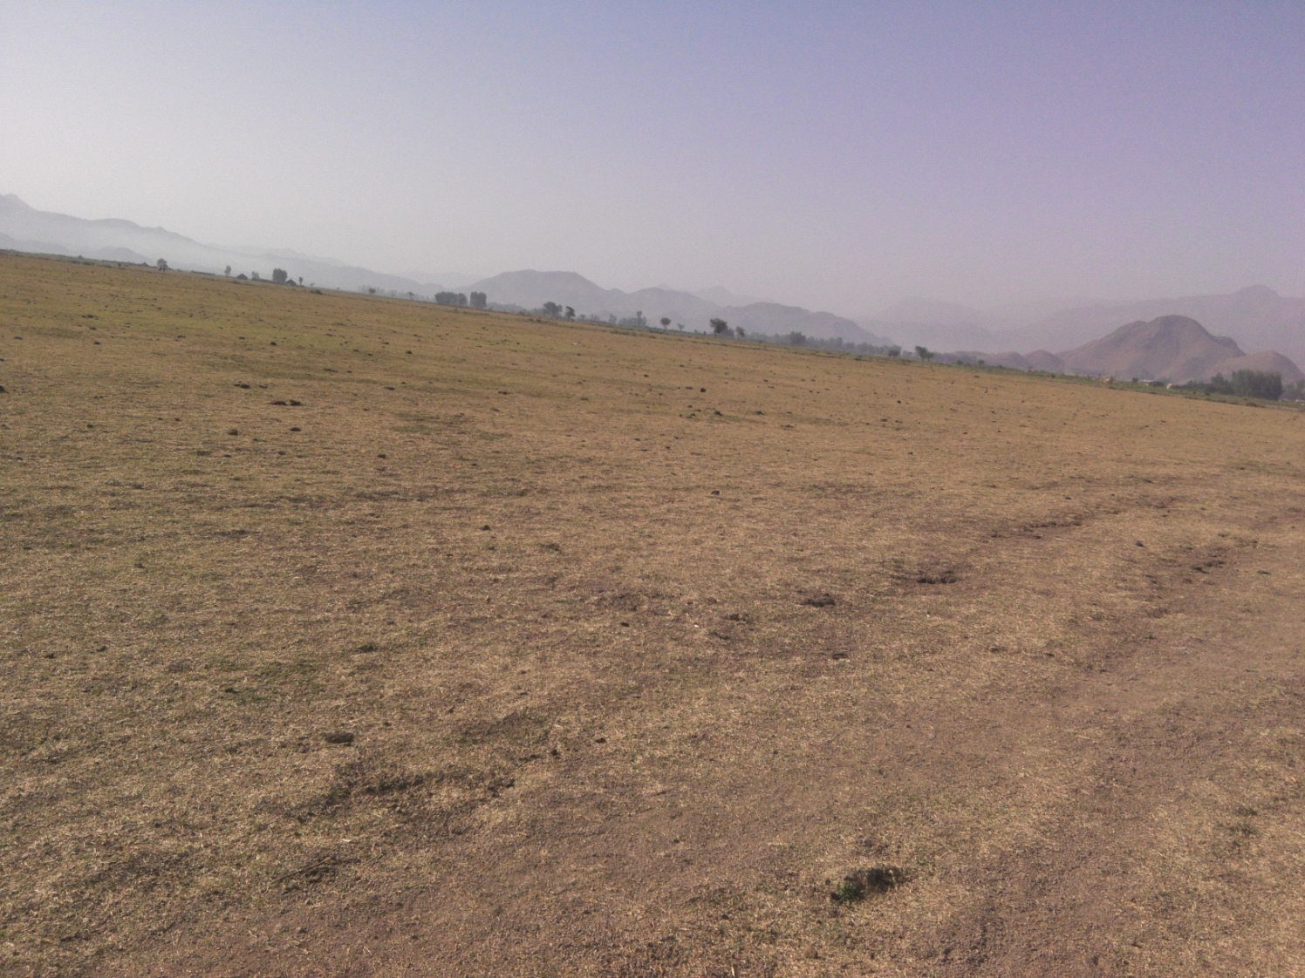
Figure 4-1: partial view of Borkena Sakei command area

The project command area is situated at the right side of Borkena Sakei River from its natural flow direction; and the natural topographic feature has also inclined from South-West to North-East direction.

Climate
On the basis of the traditional Ethiopian Agro-Ecological Zones (MOA, 2001), Borkena Sakei Barrage Irrigation Project, which is located at the vicinity of , Artuma Fursi town, is basically classified as Kola ( warm) agro-ecological zone that indicates rainfall distribution problem and poor moisture condition in the area. There is belg rain season in the project area but not adequate. Although meher rain is considered adequate, there is notable variation in terms of onset, distribution and withdrawal of rain season from year to year affecting crop production and productivity.
Chefa robit Meteorological station data (rainfall, temperature, relative humidity, wind speed and sunshine hour) were used for the project study as long as this station is relatively nearer to the proposed command area. In general, the source of meteorological data is the National Meteorology Service Agency (NMSA).

Soil characteristics
Soil properties (physical, chemical, etc.) greatly influence the growth and thereby yield of crops which is grown. Based on field observations and soil laboratory results, from soil samples collected from command area and submitted to ADSWE soil lab, the command area has predominantly sand textured. Most of the study area soils are categorized as deep soil ((≥ 1 meter depth). Soils of the command area are suitable for most of the selected crops to be grown (for further detail see the Agronomy Study of the same project.

Existing Irrigation Practices in the Project Area
The pressure of survival and the need for additional food supplies to meet the demands of the increasing population is necessitating a rapid expansion of irrigation schemes. Thus, irrigation is becoming a basic part of well-developed agriculture wherever there is water and irrigable land potential. Accordingly, traditional irrigation practices are under taken by individual farmers that use the river flow to the right side is with laborious dewatering pump system using two and above dewatering pump, so, the farmers in the project area are very much interested in the idea of upgrading the traditional scheme to modern scheme.

Irrigation Water Requirement

Crop Water Requirement (CWR)
The calculation of crop water requirement is a very important aspect for planning of any irrigation project. Several methods and procedures are available for this. The Food and Agriculture Organization (FAO) of the United Nations has also made available several publications on this subject and other issues related with this. The computer program available in FAO Irrigation and Drainage Paper No. 56 “CROPWAT” has been used for the calculation of Crop Water requirement. This program is based on Penman-Monteith approach and procedures for calculation of crop water requirements and irrigation requirements are mainly based on methodologies presented in FAO Irrigation and Drainage Paper No. 24 “Crop Water Requirements” and No. 33 “Yield Response to Water”.
The corresponding values of the crop water requirements of the proposed crops of the project are presented in the Agronomy Study of the same project.

Irrigation efficiency (Ep)
To complete the evaluation of the demand, the efficiency of the water distribution system and of application must be known.
The gross requirement of water for irrigation system is very much dependent on the overall efficiency of the irrigation system, which in turn is dependent on several factors: Method of irrigation, type of canal (Lined and/or Unlined), method of operations (simultaneously and continuous or Rotational water supply), and availability of structures (for controlling and distribution and measuring and monitoring).
On the basis of these factors, the project has planned to impose surface irrigation method (using furrows). The canal system is lined. Hence, the conveyance efficiency has estimated to be 95%, distribution efficiency to be 85% and field application efficiency 60%. As a result of these the overall irrigation efficiency has estimated to be about 48%. According to the soil Lab result, soils of the command area are predominantly characterized as clay textured soil.

Irrigation duty
Irrigation duty is the volume of water required per hectare for the full flange of the crops. Moreover, it helps in designing an efficient irrigation canal system.
The area, which will be irrigated, can be calculated by knowing the total available water at the source and the overall duty for all crops required to be irrigated in different seasons of the years.
The proposed cropping pattern of Borkena Sakei Barrage Irrigation project has showed maximum net irrigation water requirement (NIWR) for overall proposed crops is in the month of March with the amount of mm/day for 15 working or irrigation hours.
For Borkena Sakei Barrage Irrigation Project, it has estimated to adopt 60% field application efficiency (ea) and 95% conveyance efficiency (ec) as the soil is dominantly clay textured soils and the canal systems are estimated to be lined. Once the conveyance and field application efficiencies are determined or estimated, the scheme irrigation efficiency (e) for the selected surface irrigation method can be calculated using the following formula:
e = ec * ea *ed =60/100*95/100*85/100 = 48%.
Where, e = scheme irrigation efficiency (%)
ec = conveyance efficiency (%)
ea = field application efficiency (%)
ed=distribution efficiency(%)
For the designing of the project, the GIWR is given as follows:
GIWR = NIWR/e = 5.14/0.48 = 10.70833[mm/day] for full irrigation
The GIWR (10.70833 mm/day) represents the daily quantity of water that is required to be applied. This water quantity is also used for the determination of the canal discharge in consideration of the time of flow and is defined as the duty, expressed as l/s/ha.
The duty is calculated by:
Duty (D) = GIWR × 1000 × 10 / (t × 60×60)
Where; Duty – the duty [l/s/ha]
GIWR – Gross Irrigation Requirement [mm/day]
t – Daily irrigation or flow hours [hrs.]
The duty for the GIWR of 10.70833mm/day and 15 hours of daily irrigation time (t = 15), is supported to be used with furrow irrigation method. Hence, Duty for 15 working hours, as the site is nearer to farmers’ village and local farmers have experiences in irrigation, is computed as follows:
D = (10.70833 x 10 x 1000) / (15 x 60*60) = 1.98 l/s/h (for full irrigation)

Irrigation methods
Among the different irrigation systems perennial irrigation system will be used for the project area; and the irrigation water will be obtained from Borkena Sakei river and by constructing Barrage structure through lined canals (PC, SC, and TC) and then leading to field canals; and finally irrigation takes place mostly in furrows.
For this project, among the various irrigation methods, surface irrigation method has selected. Of the surface irrigation methods furrow, border and basin irrigation methods can be used to supply irrigation water to the plants/crops. However, each method has its own advantages and disadvantages. Care should be taken when choosing the method which is best suited to the local circumstances, i.e., depending on slopes, soil types, selected crop types, amount of water available, etc. of the command area.
Based on the above factors surface irrigation method has proposed for the proposed crops in this project. The method allows applying light irrigation and can be laid out in sloping fields along the contour. Furrow irrigation method is best suited for most of the proposed and row planted crops. In general, furrow irrigation method is simple, manageable and widely practiced irrigation method. This method is suitable for row crops that cannot stand in water for long periods. The only thing required to use this method is row planting of crops. Besides, basin and border irrigation method would be used for the non-row planted crops. Rotational flow water distribution is also recommended for the project area.

Irrigation and Drainage System Layout
The irrigation system layout for the project is prepared taking the following points into consideration besides other factors.
- A primary concern in the layout of the system is that it serves the purpose of conveying and distributing water to the command area.
- The excavation and earth fill volumes not be excessive, otherwise the construction costs can be tremendous.
- The selection of longitudinal bed slope is made taking into account the existing slopes of the terrain, so as to minimize deviations in canal routing.
- Curves in canals should not be too sharp.
The proposed irrigation system layout comprises one main canal, four secondary canals and elven tertiary canals as shown on the layout Drawings. The main canal runs for most of its length across to the contours and several changes of direction are necessary to follow the topography. It crosses three main gullies. The main canal is masonry lined for a length of 3000 meters starting from the Barrage outlet and the secondary canal also masonry lined to make maintenance easier since this part of the canal may be subjected to flooding during high flood flows.

Conveyance System
The conveyance system consists of one Main canal to irrigate total command area of 192 ha by gravity system and 121ha by dewatering pump system by providing of night storage in the main canal. The main canal starts from Water abstraction site on right side and conveys water for a length of 3 Km.
Main canal is aligned across contours and supplies to four secondary unit and eleven tertiary canals.

Design of the Canal System
Flow Depth and Section Capacity
The earthen canals have been designed with a trapezoidal shape and the lined ones with rectangular x-section using Manning's Formula:
Where Q= discharge (m³/s)
R= Hydraulic radius (Flow area/wetted perimeter)
S= Hydraulic gradient
n= Manning's roughness coefficient, n= 0.025 is adopted for the earth channels and n= 0.016 for the masonry lined part of the main canal

Main Canal
The main canal is designed for a discharge of 380.16l/s and depending on the site specific condition, appropriate slope is provided. Hydraulic parameters of the lined main canal are shown below. For detail analysis show excels.
The route of main canal is highly black cotton and pervious and the bearing capacity of the soil is less. There for It is advisable the below bed of canal fill by selected material then RCC lined canal is possible to resist tension, rather than masonry work.
Table 4-1: Hydraulic Parameters of main canal
B= Canal bottom width Qreq= Required discharge
D= Full supply depth Qdes= Designed Discharge
fb= Free board V= Velocity
S= longitudinal slope

Secondary Canals
In the layout system there are ten secondary canals, the designed discharge is determined based on the duty of irrigation. The sections of the canals are determined by using manning’s formula, and they are trapezoidal earthen section. The reason why the secondary canal route is along the contour gentle slope which is not affect by erosion, reduce cost. The hydraulic characteristics is Presented in below. For detail analysis show excel
Table 4-2: Hydraulic Parameters of secondary canals
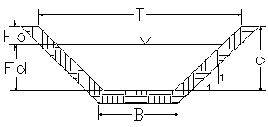
Figure 4-2: Typical Cross Section of secondary canals

Tertiary canals
In the layout system there are eleven tertiary canals, the designed discharge is determined based on the duty of irrigation. The sections of the canals are determined by using manning’s formula, and they are trapezoidal sectional almost the alignment of tertiary canal is across contours. The hydraulic characteristics is Presented in Table 4.3 below. For detail analysis show excel
Figure 4-3: Typical Cross Section of tertiary canals

Table 4-3: Hydraulic Parameters of tertiary canals
canal name | chain age | Length (m) | Comm. Area (ha) | Q req (m3/s) | m (H:V) | n | s | B (m) | D (m) | Fb (m) | V(m/s) | Qdes (m3/s) | QD-QR
TC-1sc7 | 0+0-0+187.879 | 188 | 4.53 | 0.0112 | 1:1 | 0.025 | 0.0008 | 0.3 | 0.12 | 0.18 | 0.21 | 0.01 | 0.00
TC-2 sc7 | 0+0-0+258.91 | 258.9 | 8.17 | 0.0202 | 1:1 | 0.025 | 0.0010 | 0.3 | 0.15 | 0.15 | 0.26 | 0.02 | 0.00
TC-1sc8 | 0+0-0+149 | 149 | 1.73 | 0.0043 | 1:1 | 0.025 | 0.0020 | 0.3 | 0.05 | 0.25 | 0.21 | 0.00 | 0.00
TC-2sc8 | 0+0-0+186.26 | 186 | 2.44 | 0.0060 | 1:1 | 0.025 | 0.0013 | 0.3 | 0.06 | 0.24 | 0.19 | 0.00 | 0.00
TC-3sc8 | 0+0-0+246.13 | 246.13 | 6.3 | 0.0156 | 1:1 | 0.025 | 0.0017 | 0.3 | 0.12 | 0.18 | 0.31 | 0.02 | 0.00
TC-4sc2 | 0+0-0+110 | 110.05 | 6.43 | 0.0159 | 1:1 | 0.025 | 0.0013 | 0.3 | 0.13 | 0.17 | 0.27 | 0.02 | 0.00
TC-5sc8 | 0+0-0+285.46 | 285.46 | 8.8 | 0.0218 | 1:1 | 0.025 | 0.0010 | 0.3 | 0.17 | 0.13 | 0.28 | 0.02 | 0.00
TC-1sc9 | 0+0-0+224.29 | 224.29 | 5.4 | 0.0134 | 1:1 | 0.025 | 0.0020 | 0.3 | 0.11 | 0.19 | 0.31 | 0.01 | 0.00
TC-2sc9 | 0+0-0+197.67 | 197.67 | 5.3 | 0.0131 | 1:1 | 0.025 | 0.0020 | 0.3 | 0.11 | 0.19 | 0.31 | 0.01 | 0.00
TC-1sc10 | 0+0-0+476.44 | 476.44 | 9.14 | 0.0226 | 1:1 | 0.025 | 0.0017 | 0.3 | 0.15 | 0.15 | 0.34 | 0.02 | 0.00
TC-2sc10 | 0+0-0+279.66 | 279.66 | 8.43 | 0.0209 | 1:1 | 0.025 | 0.0017 | 0.3 | 0.14 | 0.16 | 0.33 | 0.02 | 0.00

Field Canals
As shown in the layout, field canals run across the contours but, in such command area the irrigation system is directly from territory canal to furrow line, since the territory canal is align across the contour and hence face relatively steeper gradient. The discharge of most of the field canals is very small and this is taken as an advantage to cope up with the relatively steeper gradient. There for the work activity of field canal is done by beneficiary Figure 4.3 below shows a typical field canal x-section is if necessary. As much as possible field canals shall be made in fill in order to easily irrigate the adjacent command area. As can be seen from the layout, majority of the filed canals can be used to irrigate both sides of the command area depending on the condition of the individual plots of land owned by individual farmers. Since, for sake of good awareness the purpose of the project field canal work activity is done by the beneficiary.
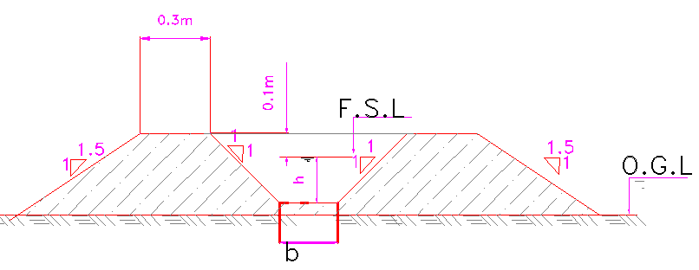
Figure 4-4: Typical Field Canal X-section

Drainage Canals

Escape canals
In the layout system there are 6 escape canals, since Borkena Sakei Barrage irrigation project is flat topography and both side the river bank is flat area due to that the flow of water is over all command area, hence in order to remove excess amount of water and UN wanted sediment incoming to main canal escape canal is recommended. The sediment and excess water is removing to gullies and at the out fall of escape canal no problem is occur since the canal is lined. The dimension of canal is based on the main canal dimension and gate is provided in the diverting escape canal and parent canal.
    - Catch drainage canals
As the study team observed during field investigation no catch drain is needed since the land future becomes flat there is no natural drain on the command area. Rather than catch drain field drain is necessary in the project, since the topography is so flat and it may be happen water logging. The designer of this project recommended doing surface field drainage and main drainage is necessary at the irrigated area.

Tertiary canal and drainage canals
In our project, surface drainage system has been found to be very suitable due to its lesser cost and easy construction and feasible management condition
Drainage Canals provided for the Tertiary canals, because Borkena Sakei irrigation project is very gentle slope since to protect water logging sufficient drainage canal is recommended. It is assumed that there is no excess irrigation water during dry season. For the rainy season the water that comes through the tertiary canals directly entered to gullies and swamp. So, Gully protection is necessary at the tertiary canal out fall. For protection gabion is recommended, since the gabion work is done by beneficiaries and the beneficiary should be good treatment the irrigation system.
Drainage coefficient (DC)
The drainage coefficient is the amount of water that must be removed from soil surface in order to have sustainable agriculture
There are different methods for estimating drainage coefficient. Those are:
a) 1 %MAR method
Where: MAR= mean annual rainfall
`` For Borkena Sakei irrigable area, MAR = 996.9mm.taken from agronomy report page 6
DC = 1 %* 996.9mm , DC=9.969mm
b) Hudson 1983 ‟s method
In this method the following two conditions are considered
If MAR <1000 mm, DC = 10 mm/day
If MAR >1000 mm, DC = MAR/100 mm/day
Since MAR= 10 mm, for hudson 1983method is the maximum is used for design DC = 10mm/day
C) Muzumdars (1983’s) method.
Table 29: Amuzumdar’s for drainage coefficient.

MAR(mm) | <750 | 750-1000 | 1000-1250 | 1250-1500 | >1500
DC(mm/day) | 5-7.5 | 7.5-9.0 | 9.0-12 | 12-25 | >25

From the above two methods the value of the drainage coefficient (Dc) for the maximum one is taken for design of the drainage canal. DC=10mm/day
In order to prevent our command area from water logging, we design field drainage canal on each tertiary unit and furrow on the left side & right side the command area.
The capacity of the drainage canal is determined based on the area coverage of tertiary canals.
Data available: for left side drain canal
For trapezoidal earthen drainage canal
* Drainage coefficient (Dc) =10mm/day
* Drainage area (A, total) =
* Drainage dis charge (Qdr) =DC*A
* Longitudinal slope, S= H/V
* Manning’s roughness coefficient
Take, n =0.0225, for earthen canal and, m=V/H= 1⁄1 =1
Q=1/n*AR2/3S1/2

The hydraulic parameter is summarize below
Table 4-4: Hydraulic Parameters of tertiary canals
Canal drainage Name | Chain age |  | Length (m) |  | Comm. Area (ha) |  |  | Q req (m3/s) |  | m (H:V) |  | n |  | s |  | B (m) |  | D (m) |  | A(m2) | P(m) | Fb (m) | V(m/s) | Qdes (m3/s)
MD 1 | 0+0-0+440 |  | 440.0 |  | 12.7 |  |  | 0.0018 |  | 1:1 |  | 0.025 |  | 0.0010 |  | 0.35 |  | 0.03 |  | 0.012 | 0.442 | 0.32 | 0.12 | 0.0015
MD2 | 0+0-0+675 |  | 675.2 |  | 23.53 |  |  | 0.0034 |  | 1:1 |  | 0.025 |  | 0.0011 |  | 0.35 |  | 0.06 |  | 0.024 | 0.516 | 0.29 | 0.17 | 0.0041
FD1 | 0+0-0+309.43 |  | 309.4 |  | 3.88 |  |  | 0.0006 |  | 1:1 |  | 0.025 |  | 0.0013 |  | 0.3 |  | 0.03 |  | 0.009 | 0.377 | 0.27 | 0.12 | 0.0010
FD2 | 0+0-0+209.7 |  | 209.9 |  | 5.1 |  |  | 0.0007 |  | 1:1 |  | 0.025 |  | 0.0011 |  | 0.3 |  | 0.03 |  | 0.011 | 0.394 | 0.27 | 0.12 | 0.0014
FD3 | 0+0-0+110 |  | 87.62 |  | 3.72 |  |  | 0.0005 |  | 1:1 |  | 0.025 |  | 0.0013 |  | 0.3 |  | 0.03 |  | 0.010 | 0.388 | 0.27 | 0.13 | 0.0013
FD4 | 0+0-0+197.79 |  | 197.8 |  | 2.53 |  |  | 0.0004 |  | 1:1 |  | 0.025 |  | 0.0013 |  | 0.3 |  | 0.03 |  | 0.010 | 0.383 | 0.27 | 0.12 | 0.0012
FD5 | 0+0-0+180 |  | 181 |  | 3.192 |  |  | 0.0005 |  | 1:1 |  | 0.025 |  | 0.0013 |  | 0.3 |  | 0.03 |  | 0.010 | 0.388 | 0.27 | 0.13 | 0.0013
FD6 | 0+0-0+265 |  | 265.2 |  | 4.36 |  |  | 0.0006 |  | 1:1 |  | 0.025 |  | 0.0020 |  | 0.3 |  | 0.03 |  | 0.010 | 0.387 | 0.27 | 0.16 | 0.0016
FD7 | 0+0-0+182 |  | 181.6 |  | 2.43 |  |  | 0.0004 |  | 1:1 |  | 0.025 |  | 0.0010 |  | 0.3 |  | 0.03 |  | 0.010 | 0.384 | 0.27 | 0.11 | 0.0011
FD8 | 0+0-0+315 |  | 315.3 |  | 8.22 |  |  | 0.0012 |  | 1:1 |  | 0.025 |  | 0.0013 |  | 0.3 |  | 0.04 |  | 0.013 | 0.406 | 0.26 | 0.14 | 0.0018
FD9 | 0+0-0+381.5 |  | 381.5 |  | 15.83 |  |  | 0.0023 |  | 1:1 |  | 0.025 |  | 0.0013 |  | 0.3 |  | 0.05 |  | 0.016 | 0.434 | 0.25 | 0.16 | 0.0026
FD10 | 0+0-0+313 |  | 313.2 |  | 8.7 |  |  | 0.0013 |  | 1:1 |  | 0.025 |  | 0.0013 |  | 0.3 |  | 0.04 |  | 0.013 | 0.407 | 0.26 | 0.14 | 0.0018
FD11 | 0+0-0+182 |  | 181.7 |  | 4.5 |  |  | 0.0007 |  | 1:1 |  | 0.025 |  | 0.0013 |  | 0.3 |  | 0.03 |  | 0.011 | 0.391 | 0.27 | 0.13 | 0.0014

Canal Structures Design

Design of a typical supper passage and Flume
At different point of main canal and secondary canal are found supper passage and flume structure when the canal and gully is crossing. The supper passage is constructed with enough wing walls, Slab thickness 20cm and stone pitching both in d/s and u/s for safely flow of water. As the same time two flume structure is designed safely on main canal. For more briefly Show in the drawing
Table 5-1: Hydraulic Parameters of supper passage

Design of Division box
At different points of the main and secondary canals division boxes are provided which divert the flow to the secondary canal and tertiary canals. Gate should be provided at the outlet of the boxes. For detail refer the drawing.
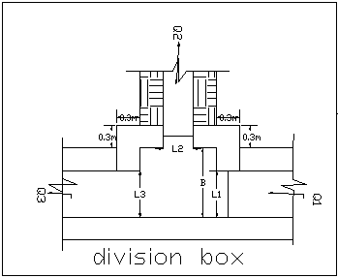
Figure 5-5: Typical Division Box plan
Using broad crested formula,
Q= CL (h) ^{3/2}
Where; Q= discharge over rectangular weir/Barrage (opening), m³/s
C = discharge coefficient, c= 1.7
L= effective length of crest form in m
h= over flow depth, m
Assuming equal discharge coefficient & sill height for two or three dividing canals, the proportion becomes.
Q₁/ Q₂= Q₂/ Q₃ =L₁/ L₂ = L₂/ L₃
Where Q₁= is flow in canal 1
Q₂ = is flow in canal 2
Q₃ = is flow in canal 3
L₁= is effective crest length of weir/Barrage sill across opening to canal 1
L₂= is effective crest length of weir/Barrage sill across opening to canal 2
L₃ = is effective crest length of weir/Barrage sill across opening to canal 3
Q₁= CL₁ (h)^{3/2},
L₁ = Q₁/Ch^{3/2}
L₂ = L₁*Q₂/ Q₁
L₃ = L₁*Q₃/ Q₁
The depth of (height of) the division box,
D = d + f_{b}
The width of the division box,
B = b + 2*m*D
Where b= base width of the incoming canal
D = total canal depth of the incoming canal
Table 5-2: Hydraulic parameters of Division Boxes

Irrigation Infrastructure Bill of Quantities and Cost Estimate
 | BILL NO.3 INFRASTRUCTURE
Item  No | Description | Unit | Quantity | Rate Birr | Amount Birr
1 | Main canal(MC-0+00 - 2+982)
1.1 | Excavation and Fill (Earth work)
1.1.1 | Bulk Excavation in ordinary soil | m³ | 6860.627 | 90.391 | 620141.558
1.1.2 | Fill around foundation of masonry with selected materials & compacted in 20cm layers | m³ | 1308.438 | 67.414 | 88207.118
 | sub total |  |  |  | 708348.676
1.2 | Concrete works
1.2.1 | Reinforced C-20 concrete(1:2:3) including form work | m3 | 1197.063 | 2761.538 | 3305736.602
1.2.2 | ф8mm bar | kg | 22497.868 | 48.725 | 1096207.207
1.2.3 | water stopper construction joint at every 24m | m | 125.000 | 520.000 | 65000.000
 | sub total |  |  |  | 4466943.810
2 | Flume on MC from 0+190-0+19.5 & 0+953-960
2.1 | Excavation of loose soil | m3 | 108.800 | 90.391 | 9834.582
2.2 | Back fill with Excavated material | m3 | 38.400 | 67.414 | 2588.699
2.3 | Masonry work with 1:3 cement sand ratio | m3 | 37.800 | 1669.637 | 63112.273
2.4 | Pointing (1:2) | m2 | 42.000 | 132.100 | 5548.210
2.5 | concrete work C-20 including form work | m3 | 9.360 | 2761.538 | 25848.000
2.6 | Lean concrete C10 (1:3:6)with 10cm thick | m3 | 6.840 | 2519.787 | 17235.343
2.7 | Reinforcement
 | bar 14 Diam | kg | 240.354 | 48.720 | 11710.050
 | bar 12 Diam | kg | 156.200 | 48.720 | 7610.064
 | bar 10 Diam | kg | 102.667 | 48.720 | 5001.920
 | sub total |  |  |  | 148489.143
3 | Super passages Mc (1+300-1+310 & 2+290-2+295.6)
3.1 | Excavation and Fill (Earth work)
3.1.1 | Bulk Excavation in ordinary soil | m³ | 225.260 | 90.391 | 20361.563
3.1.2 | Fill around foundation with selected materials & compacted in 20cm layers with hand compactor |  | 34.500 | 67.414 | 2325.785
 | sub total |  |  |  | 22687.347
3.2 | Masonry
3.2.1 | Stone masonry bedded in cement sand mortar (1:3) Price includes mortar bed | m³ | 58.320 | 1669.637 | 97373.222
3.2.2 | Pointing (1:2) | m2 | 64.800 | 132.100 | 8560.096
3.2.3 | Stone Riprap | m³ | 49.880 | 387.289 | 19317.955
3.2.4 | 20cm thick C-20 reinforced concrete | m³ | 6.750 | 2761.538 | 18640.385
3.2.5 | Reinforcement bar ф12mm | kg | 268.531 | 48.725 | 13084.166
 | sub total |  |  |  | 156975.823
4 | Division Box, Mc
4.1 | Excavation normal loose soil | m3 | 46.963 | 90.391 | 4245.005
4.2 | Back fill with Excavated material | m3 | 22.100 | 67.414 | 1489.850
4.3 | Reinforced C-20 concrete(1:2:3) | m3 | 10.200 | 2761.538 | 28167.693
4.4 | ф8mm bar | kg | 223.539 | 48.725 | 10891.933
4.5 | Gate consists of | Pcs | 8.000 | 2741.150 | 21929.200
 | 4mm thick sheet metal(1.6m*0.5m)
 | Stiffening angle iron (50x50x4)
 | Angle iron for groove (1.6x0.5x10)
 | 16mm reinforcement bar for handling
 | sub total |  |  |  | 66723.682
5 | Turn out for MC
5.1 | Excavation normal loose soil | m3 | 37.570 | 90.391 | 3396.004
5.2 | Back fill with Excavated material | m3 | 17.680 | 67.414 | 1191.880
5.3 | Reinforced C-20 concrete(1:2:3) including form work | m3 | 8.160 | 2761.538 | 22534.154
5.4 | ф8mm bar | kg | 223.539 | 48.725 | 10891.933
5.5 | Gate supply, cutting, welding and installation (1.6mx0.5m, 4mm thick sheet metal, 4m long angle iron for groove (30x30x3), 1m long, 12mm reinforcement. Bar for handle) | Pcs | 7.000 | 2090.080 | 14630.560
 | sub total |  |  |  | 52644.532
 | Total |  |  |  | 5,622,813.01
6 | Secondary canal (SC -1, SC-2,SC-3SC-4, SC-5, SC-6, SC-7, SC-8, SC-9, & SC-10)
6.1 | Excavation and Fill(Earth work)
6.1.1 | Bulk Excavation in ordinary soil | m³ | 3066.201 | 90.391 | 277158.101
6.1.2 | Fill around foundation of masonry with selected materials & compacted in 20cm layers | m³ | 1625.157 | 67.414 | 109558.376
 | sub total |  |  |  | 386716.477
7 | Super passages on Secondary canals
7.1 | Excavation and Fill(Earth work)
7.1.1 | Bulk Excavation in ordinary soil | m³ | 388.800 | 90.391 | 35144.169
7.1.2 | Fill around foundation with selected materials & compacted in 20cm layers with hand compactor |  | 194.400 | 67.414 | 13105.291
 | sub total |  |  |  | 48249.460
7.2 | Masonry
7.2.1 | Stone masonry bedded in cement sand mortar (1:3) Price includes mortar bed | m³ | 72.900 | 1669.637 | 121716.527
7.2.2 | Pointing (1:2) | m2 | 81.000 | 132.100 | 10700.120
7.2.3 | Stone Riprap | m³ | 74.880 | 387.289 | 29000.169
7.2.4 | 20cm thick C-20 reinforced concrete | m³ | 18.000 | 2761.538 | 49707.693
7.2.5 | Reinforcement bar ф12mm | kg | 556.243 | 48.725 | 27102.915
 | sub total |  |  |  | 238227.424
8 | Division Box
8.1 | Excavation normal loose soil | m3 | 17.875 | 90.391 | 1615.746
8.2 | Back fill with Excavated material | m3 | 7.150 | 67.414 | 482.010
8.3 | Reinforced C-20 concrete(1:2:3) | m3 | 9.000 | 2761.538 | 24853.846
8.4 | ф8mm bar | kg | 223.539 | 48.725 | 10891.933
8.5 | Gate consists of | Pcs | 11.000 | 2741.150 | 30152.650
 | 4mm thick sheet metal(0.5m*0.5m)
 | Stiffening angle iron (50x50x4)
 | Angle iron for groove (0.8x0.8x10)
 | 16mm reinforcement bar for handling
 | sub total |  |  |  | 67996.186
9 | Escape canal
9.1 | Excavation and Fill(Earth work)
9.1.1 | Bulk Excavation in ordinary soil | m3 | 1187.890 | 90.391 | 107375.019
9.1.2 | Fill around foundation with selected materials & compacted in 20cm layers with hand compactor | m3 | 113.330 | 67.414 | 7640.034
9.2 | Masonry |  |  |  | 0.000
9.2.1 | Hard trachytic or equivalent stone masonry bedded in cement sand mortar (1:3) for the guiding wall. Price includes mortar bed | m³ | 220.880 | 1669.637 | 368789.390
9.2.2 | Three coat plastering the internal sides, and bottom the canal with mortar of mix ratio (1:3) | m² | 617.984 | 132.100 | 81635.836
9.2.3 | Gate: With 3mm thick sheet metal, 100*50*4mm angle iron, ф10mm bar for handling | No | 12.000 | 500.000 | 6000.000
 | Sub total |  |  |  | 571440.279
 | Total |  |  |  | 1,312,629.83
10 | Tertiary canal
10.1 | Tertiary canal(all)
10.1.1 | Excavation and Fill(Earth work)
10.1.2 | Bulk Excavation in ordinary soil | m³ | 1119.338 | 90.391 | 101178.528
10.1.3 | Fill and Compact around the Embankment | m³ | 18.600 | 67.414 | 1253.901
 | sub total |  |  |  | 102,432.43
TOTAL |  |  |  |  | 7,037,875.27

CONCLUSION AND RECOMMENDATION
- The infrastructure of this project area is designed to irrigate about 192 ha of land by taking its supply from the Borkena Sakei Barrage
- irrigation project. The maximum duty of the command area for 15 hours per day irrigation is 1.98l/s with overall project efficiency of 48%. The method of irrigation of the project area is furrow surface irrigation in which the main, secondary and tertiary canals are working continuously whereas the field canals within a tertiary block are working rotational system.
- As the dominant soil type is clay soil, the main canal system is designed to be masonry.
- The reason why the main canal is to be lined up to the end is to avoid the siltation problem, time saving to reach at the tail part, reduce maintenance cost.
- The secondary canal also to be lined since the first irrigation start from secondary canal and the main network to irrigate 192 ha is by secondary lined canal and also in order to minimize frequently maintenance and to increase flow speed.
- The design of the canal dimensions of the irrigation canal is done by applying the manning’s uniform flow equation. The variable of the hydraulic parameters are calculated using iteration or flow master program.
- The design discharge of the peak flood is determined using Gamble Powell method.
- As soils of the command area are predominantly black cotton clay textured; and hence water and soil management measures should be undertaken; and optimum moisture content should be maintained to improve workability of the soil during land preparation and planting time.

The following recommendations are drown:
- For better performance and long service year of the project regular inspection and maintenance is highly required.
- Farmers training, how to operate and maintain the project structures as a whole and available and water resources has a paramount important.
- The irrigation hours per day and per week should be flexible based on base flow amount of each week or month.
- Close supervision of the construction should be made to modify (if need be) each Components of irrigation system based on specific site conditions.

OPERATION AND MAINTENANCE

General
The main objective of the operation and maintenance aspect of an irrigation scheme is to facilitate the timely delivery of the required irrigation water to farms and to keep the irrigation system in an optimum operating condition. This section therefore, discusses the main functions of the subject matter under consideration for the scheme.

Operation of the Head Works
Operation at the diversion Barrage mainly focuses on the diversion of a controlled flow of river water, timely cleaning of floating debris in front of Barrage and removal of sediment deposits in front of the weir and Barrage structures.

Irrigation System Operation
The operation of the irrigation system depends mainly on the method of water delivery at farm level. Surface irrigation method is the recommended type of water distribution and application method for Borkena Sakei Barrage irrigation scheme.
The farmers would organize themselves and form groups in order to handle the water management. Since flow is low Rotational water distribution would be applied within the group. The rotational distribution is then to distribute water by turn to the whole scheme according to the timely need of crop water requirement. For better and efficient water management, crop diversification should be avoided within a group. This would reduce the complexity of water distribution system of the scheme during one irrigation season. At farmers’ level of operation, a constant flow and variable irrigation time is advisable.
The operation of the irrigation system is continuous for 14 hours per day in main, secondary and tertiary canals where as field canals within a tertiary block are operating in rotational system with each other for irrigation hours proportional to their size. Since the tertiary canal discharges are within the manageable range and the irrigation canal structures are accordingly designed for simple operation, the farmers can open and close easily whenever they required.

Maintenance Requirement
The canal system of the project is earthen canal except main canal and secondary canal, which is susceptible to siltation, erosion, growth of weeds and or breaching problems. Though the canal sections are designed for non- silting and non scouring conditions, the above mentioned problems are unavoidable and hence periodical and yearly inspection and maintenance of canals and structures are obligatory in order to fulfill the design objective of the project area.
The maintenance tasks are categorized into two types: - routine activities, and repairs. The routine maintenance activities that are carried out periodically include:-
- Regular cleaning of sediments and weeds from canals and drains;
- Inspection and lubrication of gates; and
- Maintenance of cracked lined canals, regulating and control structures.
Repair works include task carried out more frequently and quickly, and include those tasks that are generally unpredictable. They also include emergency works. The activities included in this category are:-
- Repairing overtopped or breached canals, drains, and flood protection dykes;
- Repairing jammed gates;
- Filling holes made by wild animals; and
- Reduced free board due to walking over by people and livestock.
Regular inspection of the irrigation facilities should be carried out as part of the maintenance activities. These tasks could be carried out immediately after the end of the main rains in September and during the rainy season. This could concentrate on the interceptor drains and the flood protection dykes, the main canal and the field drains. The inspection of the other works like the tertiary canals, field drains, and the water control and regulating structures could be carried out as part of routine operation activities.
- Beneficiaries of the project need to have operation and maintenance budget, For O&M cost incurring entity area:
- Purchase sing of gate lubricate (grease)
- Replacing and maintenance of Stolen and damaged gates
- Repair Damages on the cross drainage structures.
The expense for O&M should be collected from the beneficiaries. Of course, much of the task is done by the labor and skill of the community. For cost incurring activities beneficiaries have to collect money based on the proportion of the command area they owned.

REFERENCE
- FAO (1977) guidelines for predicting crop water requirements. No 24, Rome Italy
- Design of small Canal structures , USBR
- Soft copies of hydraulic structure publishing
- IDD manual

