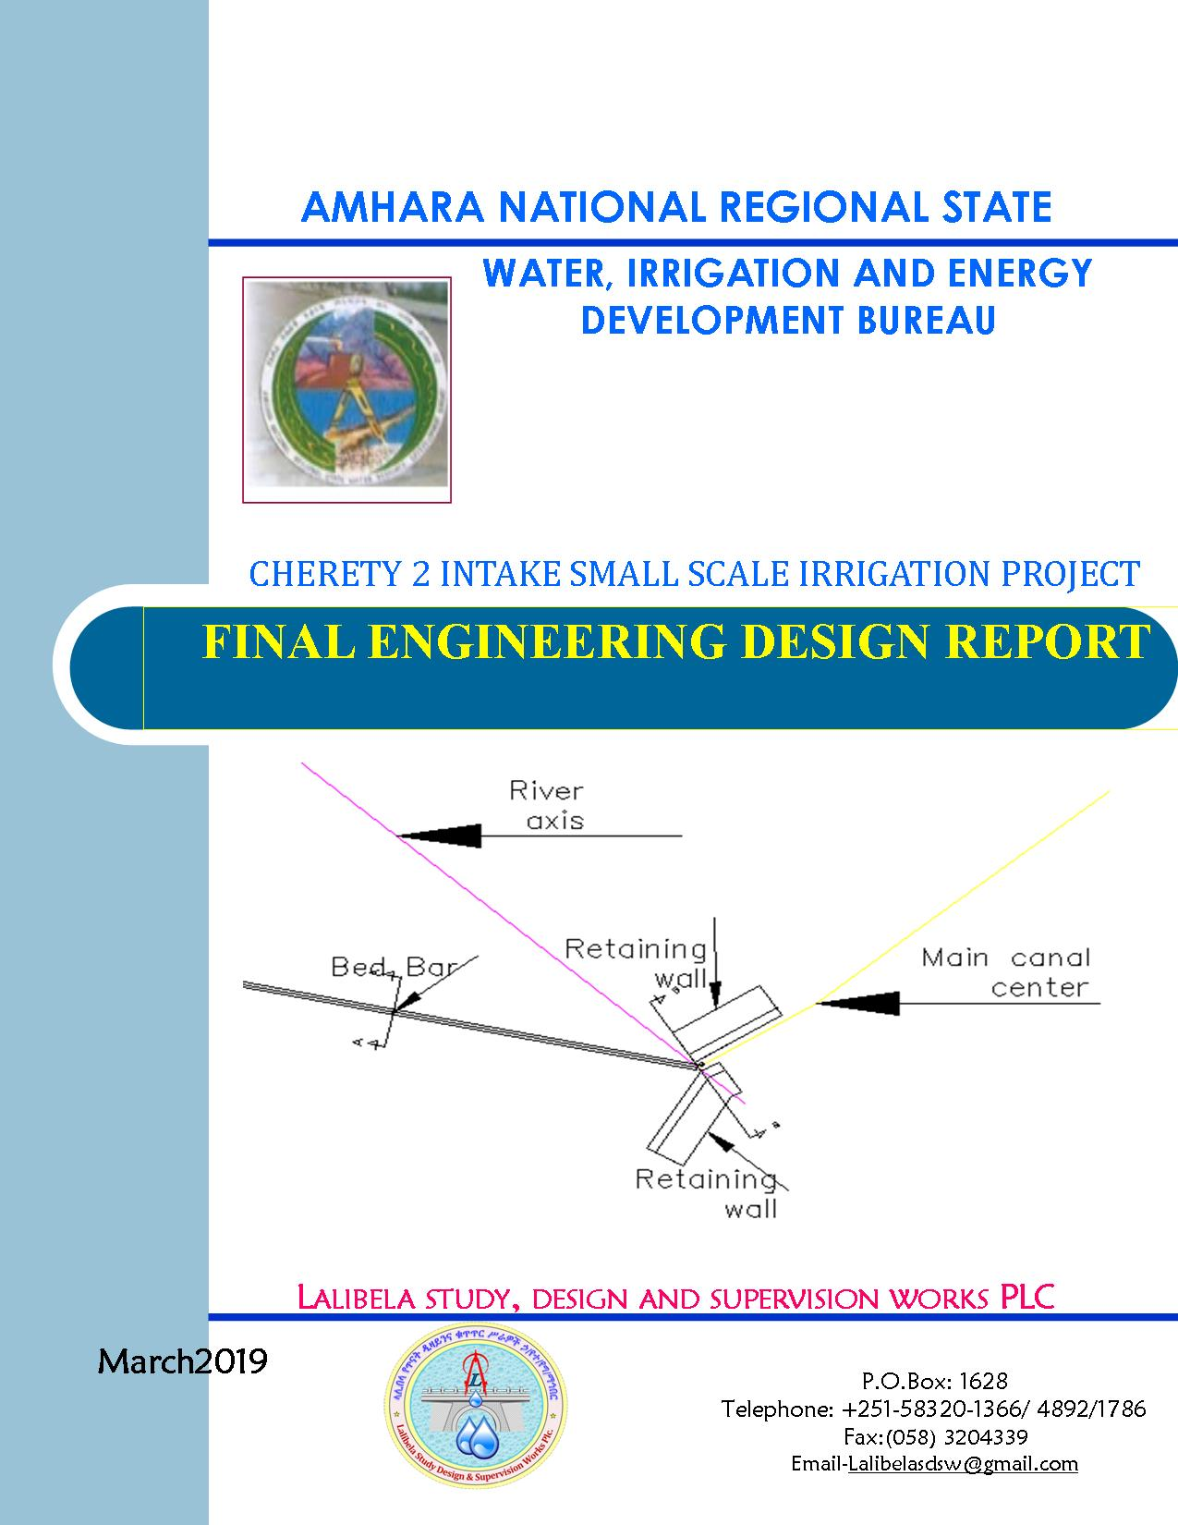

AMHARA NATIONAL REGIONAL STATE
WATER, IRRIGATION AND ENERGY DEVELOPMENT
BUREAU (BOWRD)
Cherety Diversion Small Scale Irrigation Project Draft Report
Bahir Dar, March, 2019
Client: Bureau of Water, Irrigation and Energy Development
(BoWIED)
Address:
P.O.Box: 88
Telephone: 0528-200853/855
Fax: 251-08-20-65-68/204676/202040
Consultant: Lalibela Study, Design and Supervision Works PLC
(LSDSW)
Address:
P.O.Box: 1628
Telephone: +251-58320-1366/ 4892/1786
Fax :( 058) 3204339
E-mail:Lalibelasdsw@gmail.com
Bahir Dar, Ethiopia

FEASIBILITY STUDY & DETAIL DESIGN REPORT STRUCTURE
- Volume I: Watershed Management
- Volume II: Engineering Geology
- Volume III: Irrigation Agronomy
- Volume IV: Engineering Design
- Volume V: Socio Economy
- Volume VI: Environmental Impact Assessment
Table of Contents Page No.
FEASIBILITY STUDY & DETAIL DESIGN REPORT STRUCTURE ii
SAILENT FEATURE viii
1 INTRODUCTION 1
1.1 Background 1
1.1.1 Description of the Project Area 1
1.2 Objectives of the Study 4
1.2.1 Major Objective 4
1.2.2 Specific Objectives 5
1.3 Scope of the Study 6
1.4 Methodology 7
2 HYDROLOGY 9
2.1 Watershed Characteristics 9
2.2 Hydro-Meteorological Data Availability 10
2.2.1 Climate 10
2.2.2 Rainfall Data 11
2.2.3 River flow data 11
2.2.4 Upstream & Downstream utilization 11
2.3 Design Flood Analysis 11
2.3.1 Design Rainfall computation 13
2.3.2 Peak Discharge Determination 16
2.3.3 Tail Water Depth Computation 20
SECTION-II: HEADWORK STRUCTURE DESIGN 21
3 HEADWORK STRUCTURES DESIGN 22
3.1 Headwork Site Selection 22
3.1.1 River Bank condition 23
3.2 Sources of construction materials 24
3.2.1 Rock for Masonry and Crushed Coarse Aggregate 25
3.2.2 Sand material 25
3.2.3 Water 25
3.3 Headwork Type Selection 25
3.4 Design of Intake 26
3.4.1 Design of operation slab and Breast wall 26
3.4.2 Hydraulic Gate Design 27
3.4.3 Trash Rack 29
3.4.4 Retaining Walls 29
3.5 Bill of Quantity and Cost Estimation 33
SECTION-III: IRRIGATION SYSTEMS INFRASTRUCTURE 35
4 IRRIGATION SYSTEMS DESIGN 36
4.1 Irrigable Area Description 36
4.1.1 Topography 36
4.1.2 Climate 36
4.1.3 Soil characteristics 37
4.1.4 Existing Irrigation Practices in the Project Area 37
4.2 Irrigation Water Requirement 38
4.2.1 Crop Water Requirement (CWR) 38
4.2.2 Irrigation efficiency (Ep) 39
4.2.3 Irrigation duty 39
4.2.4 Irrigation methods 41
4.3 Irrigation and Drainage System Layout 41
4.3.1 Conveyance System 42
4.4 Design of the Canal System 42
4.4.1 Main Canal 42
4.4.2 Secondary Canals 45
4.4.3 Tertiary canals 47
4.5 Irrigation Structures 48
4.5.1 Design of Division box 48
4.5.2 Flume Structure 51
4.5.3 Road crossing structure 52
4.6 Irrigation Infrastructure Bill of Quantities and Cost Estimate 53
5 CONCLUSION AND RECOMMENDATION 55
6 OPERATION AND MAINTENANCE 57
6.1 General 57
6.2 Operation of the Head Works 57
6.3 Irrigation System Operation 57
6.4 Maintenance Requirement 58
REFERENCE 60

LIST OF TABLES
Table 2-1: Rain fall Data 12
Table 2-2: Outlier test analysis 14
Table 2-3: Test for goodness to fit using D-index 15
Table 2-4: Determination of Time of Concentration 17
Table 2-5: Runoff analysis 19
Table 2-6: Hydrograph coordinates 19
Table 3-1: U/S Retaining Wall stability analysis 30
Table 3-2: Factor of safety 31
Table 3-3: D/S Retaining Wall stability analysis 32
Table 3-4: General item cost estimation 33
Table 3-5: Head work cost estimation 34
Table 4-1: (a) Hydraulic Parameters of main canal (0+000 to 4+730) 43
Table 4-2: Hydraulic Parameters of secondary canals 1 46
Table 4-3: a) Hydraulic Parameters of tertiary canals 47
Table 4-4: Hydraulic parameters of Division Boxes 50
Table 4-5: Hydraulic parameters of Flume 51
Table 4-6: Bill No.3 irrigation infrastructure 53

LIST OF FIGURES
Figure 1-1: Location map of the project area 2
Figure 1-2: Location map of the project area 3
Figure 1-3: Location map of the project area 4
Figure 2-1: Drainage map of Cherety watershed 10
Figure 2-2: Rain fall Data profile 12
Figure 2-3: Complex Hydrograph 20
Figure 3-1 Loads applied on Retaining wall 29
Figure 3-2: Loads applied on Retaining wall 31
Figure 4-1: Partial View of the existing traditional irrigation 38
Figure 4-2: Typical Cross Section of main canal 44
Figure 4-3: Part of command area (Photo) 45
Figure 4-4: Typical Cross Section of secondary canals 46
Figure 4-5: Typical Cross Section of tertiary canals 47
Figure 4-6: Typical Division Box plan 49
Figure 4-7: Typical Flume Cross-section 51

SAILENT FEATURE
- Project name: Cherety Intake Irrigation Project
- Name of the stream: Cherety River
- Location of the Head work site using UTM
- East: 579714.310
- North: 1302269.69
- Zone: North Wollo
- Wereda: Habru.
- Kebeele: Gola halo
- Accessibility from woreda town: 38 km
- Inaccessible distance: 3km
- Average Altitude: 1463 masl
- Hydrology
- Design rainfall: 167.96 mm
- Catchment area: 173.91 Km²
- Longest flow path length:28 Km
- Time of concentration: 4.52hr
- Design flood: 667.55 m³/sec
- Base flow: 618.93 lit/se.

- Intake
- Bed Bar Length : 30m
- River bank retaining structure
- Hydraulic Gate
- Outlet
- Sill level: 1463 m.a.s.l
- Opening dimension: 0.60x0.50 m2
- Discharge capacity: 262.69 lit/sec.

Irrigation and drainage systems Infrastructure
- Command area size: 175 ha
- Gross command area: 320 ha
- Type of soil of the command area is dominantly sandy clay loam soil
- Design discharge of the main canal = 262.69 l/sec
- Irrigation system layout consists of one lined main canal, 1 secondary lined canals and 9 tertiary canals
- Main irrigation structures designed are;
- 10 Foot path
- 16 division box
- 22 turnouts
Project cost
- General Items cost= 616,000.00 Birr
- Headwork cost = 202,644.417 Birr
- Irrigation infrastructure cost = 18,053,722.399 Birr
- Total project cost = 18,872,366.817 Birr
- Grand Total ( with vat) = 21,703,221.839 Birr
- Cost per hectare 124,018.410Birr

INTRODUCTION

Background
In Ethiopia, under the prevalent rain-fed agricultural production system, the progressive degradation of the natural resource base, especially in highly vulnerable areas of the highlands coupled with climate variability have aggravated the incidence of poverty and food insecurity. The major source of growth for Ethiopia is still conceived to be the agriculture sector. Hence, this sector has to be insulated from drought shocks through enhanced utilization of the water resource potential of the country, through development of small to large scale irrigation, water harvesting, and on-farm diversification coupled with strengthened linkages between agriculture and industry (agro-industry), thereby creating a demand for agricultural output.
In line with the above, efforts have been made by the government to improve the situation in the country in areas of domestic water supply provision, irrigation, watershed management, etc. The Amhara water, irrigation and energy development bureau is playing its role in the development of small to large scale irrigation projects in the region. Accordingly, as part of the water sector development program, the Bureau has initiated the study and design of a small scale irrigation scheme on Cherety River at Gola halo kebele and signed an agreement with Lalibela Study, Design and Supervision Works PLC (LSDSW) for the study and design of the project.

Description of the Project Area

Location
- This irrigation project is located at Gola halo kebeles, Habru Wereda of North Wello Zone in the Amhara Region. The proposed irrigation project is to be undertaken on Cherety River and the headwork structures are specifically located at an altitude of about 1463 m.a.s.l. and geographical coordinates of 1302269.69N (UTM) and 579714.31E (UTM). See Fig 1.1 for location of the project site.

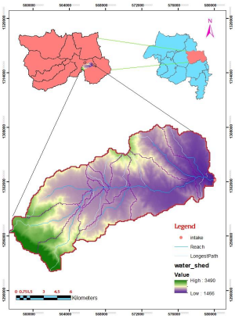
Figure 1-1: Location map of the project area

Accessibility
The project site is located at 38 km from Mersa, which is the capital town of Habru woreda. The first 15 km is along the main asphalt road from Dessie to Woldiya in the north direction. The next 20 km is all weathered road to the east and the remaining is walking on foot for about 3 km.

Previous Irrigation Practices
At the right side of the river where we proposed head work, intake structure was constructed, but not served more than a year based on the kebele chairperson and irrigation users.
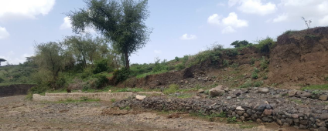
Figure 1-2: Location map of the project area
730 m upstream of this location there is an intake structure constructed by ORDA to irrigate the left side command area. But it is not functional due to the gate and canal slope problems base on we

learned from local farmers.
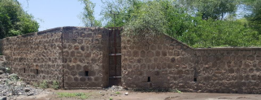
Figure 1-3: Location map of the project area

Objectives of the Study

Major Objective
The project area faces variability of rainfall distribution though the overall rainfall generally suffices the rain-fed agriculture. Accordingly, the rain-fed agriculture needs means of supplementing during distribution failures and further full irrigation is required to maximize the use of the potential land and water resources.
Hence the objective of this project is to contribute a substantial share in the effort to reduce the risk of production decrease due to rainfall variability and increase the productivity of the resource in the project specific area. Specifically, the project is targeted for the following.
- To make sustainable the rain-fed crop production and make extra production in the dry season possible for 175 ha of land through irrigation.
- There is a general consensus that irrigation investments will achieve broader food security and poverty reduction impacts and if efforts are also geared towards up-grading existing traditional farming practices with support to enhance access to input supply, output marketing and extension to facilitate access to information and innovations.
- This objective is to be realized by constructing intake structures across the Cherety River and diverting the river flow.

Specific Objectives
Other benefits that can be expected to appear with the launching of the project are:
- Efficiency of water use improvement;
- Improved local nutrition/food security gains;
- Improved management of scarce natural resources (land and water);
- Resilience against drought risk;
- Rationale for erosion control and watershed management;
- Rationale for the intensification and modernization of small-holder agriculture and rural lifestyles.
The engineering study and design enables the realization of the project by the provision of engineering structures that will allow the appropriate abstraction of the river water for delivery in to the identified irrigation fields of the study area. Hence, this engineering design is specifically targeted to:
- Analyze hydrologic requirements of the project and engineering structures;
- The formulation of sound and stable structure, with necessary provisions that allow safe, easy and low-maintenance operation in the service life of the project;
- Develop working drawings;
- Estimation of construction costs.

Scope of the Study
- The irrigation design shall ensure reliability, equity and flexibility of water delivery to farmers. It will aim at reducing conflicts among water users and will lead to lower operation and maintenance costs.
- Updating the existing, if available, computation of the actual evapo-transpiration, crop water requirement, irrigation demand/duty using the existing and recent agronomic, climatologic and soil data using more appropriate methodologies.
- Establish design criteria for irrigations structures to be approved by the client and to be used in the final design stage,
- Design proper irrigation system compatible with local conditions and management capabilities,
- Establish flood protection measures for the command area and canal structures and design the respective drainage system accordingly,
- Planning and layout of the irrigation system, which include irrigation canals, drainage channels, inspection roads and alignments, canal spacing, canal length, location of structures, and water profiles along canal and drains at specified reaches, which is most economical easily manageable and aligned with topographic feature and geological investigation.
- Determination and estimation of water application conveyance and other losses and irrigation efficiencies and consideration of those parameters in design steps.
- Check and test hydraulic and structural designs of main canal considering total demand and the required capacity and the base flow availability,
- Prepare general plans and drawings for all irrigation infrastructure and irrigation systems designs,

Methodology
In the study and design procedure, Designers used the following steps.
- Specific Site identification:
  - Review of the site identification reconnaissance survey conducted by the Client
  - 50,000 scale top map and GIS information
  - Local farmers interview and discussion
  - Wereda and Zone Agriculture section expertise
  - Previous studies
  - On foot travel along the river channel and farm areas.
- Topographic survey:
  - Surveying the headwork site and the Command area with sufficient radius, using total station
- Flow estimation
  - Physical observation on flood mark indications and local information about high flood and critical flow conditions of the river
  - Analyzing the recorded rainfall data and use watershed inputs for further analysis.
  - Base flow estimated during the field visit by floating method.
- Irrigable area identification:
  - Using local information
  - 50,000 Topographic map, and GIS information, GPS to see elevation
The design report is organized in three sections. In Section I the Hydrology study is presented and in Sections II and III the Headwork and Irrigation and Drainage Systems designs are discussed respectively. In Section III, planning and design of the irrigation system after diverting the water using the weir will be dealt. The following are major areas of concern in this part.
- Study and design of the irrigation method to be adopted,
- Study and design of the irrigation system layout and associated structures,
- Design of the different conveyance canals,
- Planning and design of the different irrigation and drainage structures,
- Preparation of the longitudinal profiles of the different irrigation and drainage canals.

SECTION-I: HYDROLOGY

HYDROLOGY

Watershed Characteristics
The watershed is studied with the objectives to characterize the existing conditions and future utilization and conservation of natural resources of the watershed which is the hydrologic unit or supply of the river. The study approaches and procedures followed different stages of study included pre-field work, fieldwork, and post fieldwork activities. All bio-physical conditions of the watershed are assessed with drainage pattern, sub watersheds, soil types, topographic condition, climate livestock condition and wild life with detail.
The main Watershed problems assessed in the study are land degradation and soil erosion with their cause population pressure, deforestation and overexploitation of vegetation, improper agricultural management. Soil erosion by water with its form of rain drop erosion, sheet erosion, rill erosion and gully erosion has adverse economic and environmental impacts. The process is initiated when soil particles are detached from its original configuration by erosive forces such as rainfall. A method was developed in this research which combines the Universal Soil Loss Equation (USLE) with the computer capabilities of GIS. The USLE calculates long-term average annual soil loss by multiplying six erosion factors, rainfall erosivity, soil erodibility, slope length and gradient, land cover and land management practices, which describe the watershed characteristics such as climate, soil types, topography, land cover and land management.
The watershed characteristics are analysed and presented in the Watershed Feasibility Study Report of the same project. In summary:
- Catchment Area = 173.91km²
- Stream Length = 28Km
- CN(II) = 73.45
- CN(II) = 86.96
(Extracted from the Watershed Study Report)
At the selected reference point, the area of Cherety catchment is 173.91km² and consists of a network of tributaries as shown in Figure 2.1 below. Cherety River at the headwork site is characterized by well-defined channel system and considerable flows.

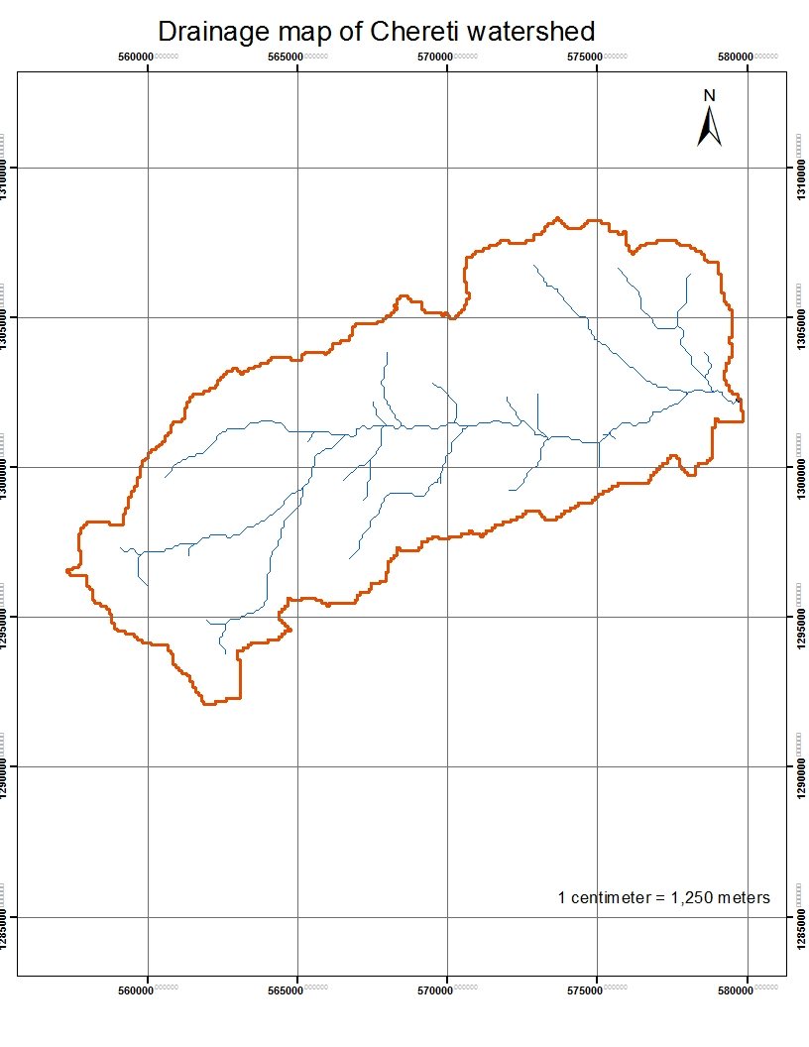
Figure 2-1: Drainage map of Cherety watershed

Hydro-Meteorological Data Availability

Climate
Irrigation project designers and planners are faced with lack of good data on the hydrology of the stream/river system that will be their water source and on local weather and climate conditions. Stream gauging stations are virtually non-existent in remote rural areas of Ethiopia; meteorological stations are almost rare. Likewise, at Gola halo Kebeles (Project area location) and in the catchment area of this project, there is no meteorological station of any level. Moreover, there is no flow data/Gauged for the river near the project. Therefore, data for the hydro-meteorological analysis is taken from the nearby station and similar areas. Rainfall data is considered from Bokeksa Meteorological station. As per the data of the station, May – June are identified as high temperature periods whereas December–January are low temperature periods.

Rainfall Data
In order to compute the design flood for the Intake structure, the daily maximum rainfall is collected from Bokeksa Metrological stations with a record of 16 years.

River flow data
Cherety River is the water source for the intended Cherety Intake irrigation project. The project has been named after the name of this river. The river is perennial as per the information of the local people. The base flow of river which is measured on 17/05/2011 E.C at the headwork site is 618.93l/s.

Upstream & Downstream utilization
Downstream of the proposed site, appreciable need for water is anticipated for locals and cattle provisions. Therefore, at least 57.5% of the minimum flow has to be released for downstream requirements.
For the sake of planning and design, however, the outlet for the Intake is designed for a discharge of 262.69 l/s for this project and the project is to be developed for 175 ha of land, which is most of the time achievable as the flow for most of the time is significant to support this size of command area.

Design Flood Analysis
For the design and analysis of structures to be constructed on the river, estimation of flood magnitude is an important task. This can be done using different techniques depending on the data available. For this particular case, there is no river flow data and hence the flood estimation is done using the rainfall data collected from Bokeksa Metrological stations.

Table 2-1: Rain fall Data
S.No. | Year | Daily Max. RF | Descending Order
1 | 2000 | 53.90 | 132.00
2 | 2001 | 63.70 | 114.00
3 | 2002 | 78.10 | 113.40
4 | 2003 | 57.20 | 108.60
5 | 2004 | 113.40 | 78.10
6 | 2005 | 25.36 | 74.00
7 | 2006 | 108.60 | 63.70
8 | 2007 | 132.00 | 62.50
9 | 2008 | 74.00 | 62.00
10 | 2009 | 52.00 | 57.20
11 | 2010 | 114.00 | 56.00
12 | 2011 | 51.70 | 53.90
13 | 2012 | 42.40 | 52.00
14 | 2013 | 62.00 | 51.70
15 | 2014 | 56.00 | 42.40
16 | 2015 | 62.50 | 25.36

Figure 2-2: Rain fall Data profile

Design Rainfall computation
Based on the data of 24hr peak rainfall given in Table 2-1 the design rainfall, RF is computed using Gumble’s Extreme Value Method.
The choice of a distribution is based on
  - experience with data of that type,
  - some understanding of the mechanisms giving rise to the data,
  - And /or examination of the observations themselves.

Outlier Test
From the selected rainfall station, daily heaviest daily rainfall data is selected for the whole historical data and checked for data quality. Outliers are data points that depart significantly from the trend of the remaining data. The retention or deletion of these outliers can significantly affect the magnitude of statistical parameters computed from the data, especially for small samples. Procedures for treating outliers require judgment involving both mathematical and hydrologic considerations. According to Chow (1989) recommendation, if the station skew is greater than +.0.4, tests for high outliers are considered first; if the station skew is less than -0.4, tests for low outlier are considered first. Where the station skew is between ±0.4, tests for both high and low outlier should be applied before eliminating any outliers from the data set.
Higher Limit,$Y_{H}=Ymean+Kn*Sy$, Kn = 2.28 for 16 Years of data.
Lower Limit, $Y_{H}=Ymean-Kn*Sy$

Table 2-2: Outlier test analysis
S.No. | Year | Monthly Max. RF | Descending Order | Logarithmic Value/Yo/
1 | 2000 | 53.90 | 132.00 | 2.12
2 | 2001 | 63.70 | 114.00 | 2.06
3 | 2002 | 78.10 | 113.40 | 2.05
4 | 2003 | 57.20 | 108.60 | 2.04
5 | 2004 | 113.40 | 78.10 | 1.89
6 | 2005 | 25.36 | 74.00 | 1.87
7 | 2006 | 108.60 | 63.70 | 1.80
8 | 2007 | 132.00 | 62.50 | 1.80
9 | 2008 | 74.00 | 62.00 | 1.79
10 | 2009 | 52.00 | 57.20 | 1.76
11 | 2010 | 114.00 | 56.00 | 1.75
12 | 2011 | 51.70 | 53.90 | 1.73
13 | 2012 | 42.40 | 52.00 | 1.72
14 | 2013 | 62.00 | 51.70 | 1.71
15 | 2014 | 56.00 | 42.40 | 1.63
16 | 2015 | 62.50 | 25.36 | 1.40
SUM |  |  | 1146.86 | 29.12
MEAN |  |  | 71.68 | 1.82
STANDARD DEVATION |  |  | 29.87 | 0.18
SKEWNESS COEFICIENT |  |  | 0.75 | -0.23

Higher Limit, YH = 2.24
Lower Limit, YL = 1.40
Therefore,
Upper limit of rainfall = 10^2.24= 173mm
Lower Limit of rainfall = 10^1.40 = 25.20mm
Conclusion: The rainfall values are within the limits i.e there is no data which is out of the outliers.

D-Index test
After checking the consistency of the data for higher and lower outlier, the 16 years data is obtained as representative for the analysis using D-index. The D-Index test is believed to be the better goodness to fitness in many literatures. Hence in this study it was used to determine the best statistical distribution to estimate the peak rainfall. The D-index for the comparison of the fit of various distributions is summarized as follows.
$D_{-Index}=(\frac{1}{X_{m}})*\sum_{i=1}^{6}{Abs(Xi-{Xi}^{'})}$
Table 2-3: Test for goodness to fit using D-index
Rank | XI | Normal | Log Normal | Log Pearson Type III | Pearson Type III | Gumbel EVI | Gumbel
 |  | XI -'XI' | XI -'XI' | XI -'XI' | XI -'XI' | XI -'XI' | XI -'XI'
1 | 132.00 | 13.57 | 3.88 | 7.02 | 15.33 | 8.48 | 4.69
2 | 114.00 | 6.87 | 4.82 | 5.67 | 7.42 | 7.37 | 2.06
3 | 113.40 | 13.98 | 15.52 | 15.40 | 13.89 | 16.99 | 9.84
4 | 108.60 | 15.38 | 18.95 | 18.32 | 14.88 | 19.72 | 14.24
5 | 78.10 | 9.74 | 4.97 | 5.88 | 10.51 | 4.70 | 8.83
6 | 74.00 | 8.94 | 3.50 | 4.55 | 9.89 | 3.61 | 6.58
Sum |  | 68.48 | 51.64 | 56.84 | 71.92 | 60.87 | 46.24
Sum/Mean |  | 0.96 | 0.72 | 0.79 | 1.00 | 0.85 | 0.65
Point Rainfall |  | 133.04 | 149.40 | 149.40 | 129.28 | 149.11 | 167.96
Design Point Rainfall = |  |  | 167.96

All the candidate distributions give almost identical correlation coefficients. However, the standard errors are insignificantly lower for Gumbel distribution Method which is 0.65. Accordingly, the design rainfall was found to be 167.96 mm for the Gumbel distribution which is relatively maximum.
Here xi and xi’ are the ith highest observed and computed values for the distribution. The distribution giving the least D-index is considered to be the best-fit distribution.
The design rainfall using Gumbel Method is given as
Where R_{f =} Design rainfall
R_{mean} = average of all values of daily heaviest rainfall = 71.68 mm
σ_{n-1} = standard deviation of the series = 29.87 mm
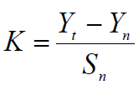
, T= Return period = 50 years
Yn, Sn = constant found from Gumble’s extreme value distribution table for N= 16 Years
- Yn = 0.52 and Sn = 1.05
$$K=\left(\frac{3.9-0.53}{1.10}\right)=3.22$$
- Point Design Rainfall = 167.96 mm
The design rainfall at points for 50 years return period is 167.96 mm.

Peak Discharge Determination

General
River is not gauged river. The design flood is calculated by using SCS unit hydrograph method. Thus, it is preferred to base the flood analysis on rainfall data, which are better both in quantity and quality of data. In the hydrologic analysis for drainage structures, it must be recognized that there are many variable factors that affect floods. Some of the factors that need be recognized and considered on an individual site by site basis are; rainfall amount and storm distribution; catchment area, shape and orientation; ground cover; type of soil; slopes of terrain and stream(S); antecedent moisture condition; Storage potential (over bank, ponds, wetlands, reservoirs, channel, etc.)

Peak flood analysis by SCS unit hydrograph method
Design flood is calculated using SCS (The United States Soil Conservation Service). This method is widely adopted and more reliable method for flood estimation. The approach considers, watershed parameters, like Area, Curve number, and time of concentration.

Time of concentration (Tc)
Time of concentration has been calculated by taking the stream profile of the longest streamline and dividing it in to different elevations. Kirpich formula is adopted for computation.
Table 2-4: Determination of Time of Concentration
FID | Partial Length,m | Elevation in m | Elevation Difference in m | Slope of river | TC
1 | 0 | 1470 | 0 | 0 | 0
2 | 6000 | 1620 | 150 | 2.5 | 1.12
3 | 9550 | 1800 | 180 | 1.88 | 1.78
4 | 5300 | 2000 | 200 | 3.77 | 0.87
5 | 4840 | 2580 | 580 | 11.98 | 0.52
6 | 2310 | 3110 | 530 | 22.94 | 0.23
Sum | 28000 |  |  |  | 4.52

The formula is,

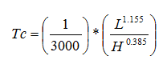
- Tc = 4.52 Since Tc < 3hr.,
- Since Tc > 3hr., duration of excess rainfall difference, D = 1hr.
- Time to peak,
$T_{p=}\frac{D}{2}+0.6*T_{c}$ = 3.21hr
- Base time,
$T_{b}=2.67*T_{p}$ = 8.57hr
- Recession time,
$T_{r}=1.67*T_{p}$ = 5.36hr.

Curve number (CN)
Curve number (CN) is achieved based on USSCS method by watershed characterization in terms of land cover, treatment, hydrologic condition and soil group. From the watershed analysis curve number at condition II = 73.45. Since peak rainfall is found at an antecedent moisture condition III state, this value has to be changed to antecedent moisture condition III.

- Conversion factor = 1.184
- CN Condition (III) = (Factor from Table x CN condition II) = 73.45*1.184 = 86.96.

Run off Analysis
Input data:
- Design Point Rainfall = 167.96mm
- Curve number at antecedent moisture condition III = 86.96
- Catchment Area, A = 173.91 Km2
- Tc = 4.52 hr, D = 1 hr., Tp = 3.21 hr; Tb = 8.57 hr; Tr = 5.36 hr.
- Direct run-off,
$Q=\frac{{(I-0.2*S)}^{2}}{(I+0.8*S)}$
Where, I = Rearranged cumulative run-off depth (mm)
S = Maximum run off potential difference,
$S=\left(\frac{25400}{CN}\right)-254$
Peak run-off for incremental;
$Q_{p}=0.21*\frac{(A*Q)}{T_{p}}$
Where, A = Catchment area = 173.91Km²
T_{p} = Time to peak (hr)
Q = Incremental run-off (mm)
Using the above input data See table 2.5 for runoff analysis result, work out runoff analysis using SCS-CN method.

Table 2-5: Runoff analysis
Duration | commulative RF | Incremental RF | acumulative runoff | incremental runoff | runoff | unit hydrograph time
hr | mm | mm | mm | mm | m3/s | Beginning | peak | End
1 | 5.27 | 5.27 | 0.00 | 0.00 | 0.00 | 0 | 3.21 | 8.57
2 | 16.36 | 11.09 | 1.63 | 1.63 | 18.57 | 1 | 4.21 | 9.57
3 | 31.17 | 14.81 | 9.00 | 7.37 | 83.83 | 2 | 5.21 | 10.57
4 | 75.77 | 44.59 | 43.72 | 34.72 | 394.85 | 3 | 6.21 | 11.57
5 | 98.39 | 22.62 | 63.95 | 20.23 | 230.05 | 4 | 7.21 | 12.57
6 | 106.12 | 7.73 | 71.04 | 7.09 | 80.63 | 5 | 8.21 | 13.57
Simple Triangular Hydrograph is developed for each peak runoff in order to interpret the runoff depth in every time intervals. The triangular hydrograph shall be developed considering the start, peak and end time of each hydrographs.
Table 2-6: Hydrograph coordinates
HYDROGRAPH TIME | H1 | H2 | H3 | H4 | H5 | H6 | HT
0.00 | 0.00
1.00 | 0.00 | 0.00 |  |  |  |  | 0.00
2.00 | 0.00 | 5.78 | 0.00 |  |  |  | 5.78
3.00 | 0.00 | 11.57 | 26.11 | 0.00 |  |  | 37.67
3.21 | 0.00 | 12.79 | 31.62 | 25.98 |  |  | 70.39
4.00 | 0.00 | 17.35 | 52.21 | 122.96 | 0.00 |  | 192.52
4.21 | 0.00 | 18.57 | 57.73 | 148.94 | 15.14 |  | 240.37
5.00 | 0.00 | 23.13 | 78.32 | 245.92 | 71.64 | 0.00 | 419.01
5.21 | 0.00 | 15.11 | 83.83 | 271.89 | 86.77 | 5.30 | 462.92
6.21 | 0.00 | 11.65 | 68.20 | 394.85 | 158.41 | 30.41 | 663.53
7.21 | 0.00 | 8.18 | 52.57 | 321.23 | 230.05 | 55.52 | 667.55
8.21 | 0.00 | 4.72 | 36.94 | 247.60 | 187.15 | 80.63 | 557.04
8.57 | 0.00 | 3.46 | 31.27 | 220.88 | 171.59 | 75.17 | 502.37
9.57 | 0.00 | 0.00 | 15.63 | 147.26 | 128.69 | 60.14 | 351.72
10.57 | 0.00 |  | 0.00 | 73.63 | 85.79 | 45.10 | 204.53
11.57 | 0.00 |  |  | 0.00 | 42.90 | 30.07 | 72.97
12.57 | 0.00 |  |  |  | 0.00 | 15.03 | 15.03
13.57 | 0.00 |  |  |  |  | 0.00 | 0.00
From the above table 2.6 Complex hydrograph figure is developed by making the hydrograph time in the x-axis and the discharge in the y-axis. See figure below.

Figure 2-3: Complex Hydrograph
From the analysis, the 50 year return period design run off is 667.55 m ³/s

Tail Water Depth Computation
For tail water depth computation we use physical observation on flood mark indications and local information about high flood and critical flow conditions of the river. Tail water depth of the river is equal to the flood depth and amount at the proposed intake site before construction. It is measured to be equal to 3m.

SECTION-II: HEADWORK STRUCTURE DESIGN

HEADWORK STRUCTURES DESIGN

Headwork Site Selection
The headwork site is situated at 1302269.69 m N, 579714.31m E and river bed elevation of 1463m above sea level. At this site the river course is well defined, with fixed width, length and excellent form of river shape. The head work of the river is mainly gentle to moderate slope. The stream bed is covered with mostly basaltic with some rhyolites in composition.
River Geomorphology
Surface and subsurface geological conditions of the headwork site have been investigated in relation to the nature of the proposed structure, which in this case is an intake structure. From the investigations carried out at the proposed intake site, the following engineering materials are observed having different depths.
These are:
- Brown and gray color low plastic silty soil around the right side of the intake and the main canal site.
b. Pebble and cobble layer on the river with sandy gravel
The various portions of the intake site are covered and underlain by the above formations in different extents. The following section describes the distribution, nature and geotechnical properties of the units found at the different portions of the intake site.

River Bank condition
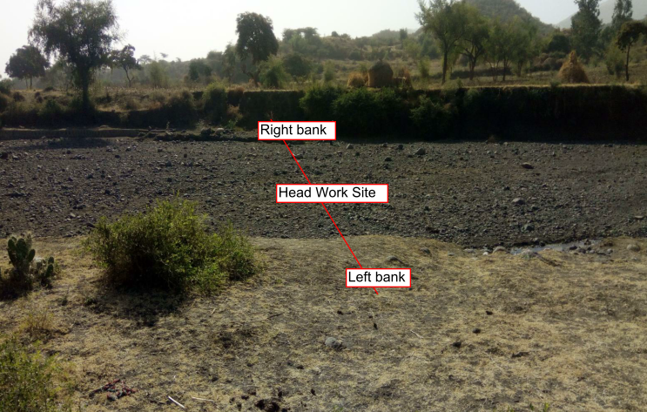
Figure 3-1: Right Bank at the proposed site

Right Bank
The river side section in this part is mostly silty soil material having a depth of 3 to 4 m and is very loose that can be affected by the flowing river. This is the case when we see the general conditions and has very steep slopes having no entrance.
The site which the selection of the site as intake structure is good as the level to raise the water is dangerous for the flowing water with its deposits. This site has no rocky layer which is depositional river materials like boulders, cobbles, pebbles, gravels and sands with silt.
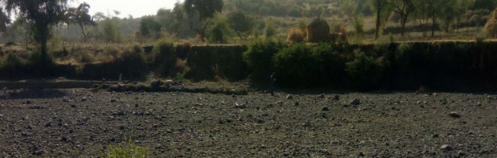
Figure 3-2: Right Bank at the proposed weir

Left Bank
In the left side, the bank of the river has some silty sand soil deposition under cobble and pebble layers with some sandy gravel. This can be assured as seen on some points of the banks; it is clearly cobble and cobble size with sandy gravel layers and has undergone slight consolidation processes. As seen on the small thickness layer, the base of the depositional material seems sandy gravel layer.

Sources of construction materials
During site investigation, natural construction materials required for the construction of the various proposed engineering structures at the headwork and within the farmland have been assessed, and possible quarry sites and borrow areas have been identified within the vicinity of the study area as close to the project site as possible. In addition to identifying the quality, quantity and accessibility conditions of the construction materials, ownerships of each proposed production sites have also been studied and described in this report, on separate sub-sections below. The materials needed for the construction of the structures include rock for masonry stones, aggregates (both coarse and fine), impervious soil for fill and/or lining, backfill soil, and water.

Rock for Masonry and Crushed Coarse Aggregate
Masonry stone site that can be used for production of rock has been assessed during the field work session within the vicinity of the project area at economic distance for hauling. For this project masonry sites have been proposed. These masonry sites are having very beautiful for their sizes (dimensions) and their workability. They can be well shaped and they have transporting distance from the weir site and the main canals. The distance is about 4 to 5 km far for the downstream structures and the main canal route.

Sand material
The sand material is found in the river Cherety from the head work to the downstream sides of the river. In addition, the dry stream found in the canal route is having very good sand which is clean and strong.

Water
Water for construction purposes can be getting from the project stream Cherety River itself. Water for construction purposes can be getting from the project perennial river that flows throughout the year used for local irrigation purpose.

Headwork Type Selection
At the selected head work site, it is possible to irrigate the command area by gravity, through only diverting water directly without raising the level of water considering reference to the highest point of the command area. Hence, intake structure has been recommended for Cherety small-scale irrigation project.
Along with intake structure other structures included are breast wall, operation slab, bed bar, trash rack & right side retaining structures are the main components of the head work structures. Breast wall & operation slab have been provided to aid the operation of gate & to prevent over flow of river flood into the main canal. Similarly, trash rack is provided at the river side of intake to exclude boulders, trees & etc from entering into outlet pocket that clog the gate. To retain river bed & banks, bed bar is buried within river bed and there is retaining structure to be constructed under the main canal as protection work.

Design of Intake
- Sill Level Determination
The sill level of intake out let is based on the required amount of water availability that can be easily diverted throughout the dry season.
- Capacity determination
The capacity of the intake outlet is the function of discharge required for the irrigation based on crop water requirements. Cherety project is intended for supplementary and full irrigation during driest season. So, the capacity of the main canal is determined based on the peak duty in January of the project area for full irrigation water supply i.e., 1.5 l/s/ha.
As indicated in water balance subtitle of hydrology section, the required discharge,
Full irrigation, Q_{req}= command area*duty=75*1.5= 262.69 l/s
So, the canal & intake capacity has to be fixed based on the required discharge of 0.263m^³/s.
The intake dimension is computed using rectangular notch formula given by:
Q = 2/3Cd*(2*g) ^{1/2}B*H ^{(3/2)}
Where: Q=diverted discharge= the required discharge, Q_{req} = 0.263m³/sec
Cd=Coefficient of discharge, C_{d}=0.62
B=Width of intake, 0.6 m
H=Height of the intake =flow depth above sill level
g=Acceleration due to gravity
Therefore for a width of 0.3 m,
H= (Q*3/ (2*C_{d}*(2*g)^{1/2}*B))^{2/3}=0.2m. Providing 0.05m clearance on both sides, then, 0.6m width & 0.5m height has to be provided by considering maintenance.

Design of operation slab and Breast wall

To avoid spilling of water during HFL over intake gate, a masonry wall is provided from the gate top level up to the HFL (i.e. known as breast wall). A vertical raised gate is designed for the head regulator. This gate is to be operated over the breast wall-using spindle during opening and closing. For the operation purposes, operation slab is also provided at the top of breast wall. The thickness of operation slab is simply judged from common sense small scale design provisions. The thickness required for the imposed load is taken at 20cm value.
For the operation slab, the minimum reinforcement area is taken as 0.15% in both directions unit width.
Hence, area of steel per one meter width,
A_{steel}=0.0015*W*t, where, w= width &t=thickness both in mm
A_{steel}=0.0015*1000*200 =300mm²
A_{steel}=300mm², Provide 12 @ c/c 150 mm
- Checking the appropriateness of spacing: Considering cover thickness of 50 mm, effective depth, d_{e}=t-(50+/2) =200-(50+12/2) =144. Hence spacing of reinforcement should be less of the following values:
- Five times the effective depth =5*144=720 mm
- 450mm
The spacing of bars, which is 150 mm, is less of the above listed values. Hence, it is acceptable!

- Checking adequacy of steel bar density: A_{steel} per meter length=3.14*12²/4*7= 791.68 mm²
Therefore, the actual provided steel area per meter width is 791.68 mm² > 300 mm² Ok!
Hence, thickness of 20cm for the operation slab is adequate.
Therefore, provide the reinforcement bar of φ12mm @150mm c/c spacing in both directions with reinforcement covers of 50mm for the operation slab.

Hydraulic Gate Design

The gate used for irrigation water control has to be water tight, with least leakage, straight, rigid, & capable of being raised or lowered by hoisting mechanism provided.
It is usually recommended to use slide gate for its simple, safe operation and less maintenance requirements. Generally the slide plate gate type consists of leaf (skin plate and seals), embedded part (sliding surface also called side guide, and sill beam, lintel, seal seats) and hoisting device.
Thickness & tensile strength determination: The gate skin has to have sufficient thickness and strength to resist hydraulic water pressure exerted by maximum highest flood. The minimum 6mm thickness of skin plate has to be considered including correction taken for corrosion. Based on this principle of designing, gate for this project is computed as follows.
Data required:
- Head of water above sill=3m
- Width of intake ,B=0.60m
- Height of leaf gate ,H=0.5m
The structural steel of 300N/mm² tensile yield strength with tension & bending moment at wet condition is selected for the gate design and installation.
The thickness of leaf/plate is given by;$t=√(\frac{K}{100}*\frac{P*H*B}{σ})$ where,$σ=bending stress in\frac{N}{mm^{2}}$
t=skin plate thickness in mm
K=coefficient factor based on H/B (from table)
H= longer dimension of leaf gate in mm
B= shorter dimension of intake in mm
P=Water pressure in N/mm² at the gate center.
Then, $aloowable stress,σ$=0.45*300N/mm²=135 N/mm²=13500 N/mm²
Head of 3.11m water exerts pressure at the bottom of the gate,
P_{b}=10KN/M^³*3m=30KN/m²
At the center of the gate, the pressure will be,
$$P=\frac{30KN}{m^{3}}*\left(1.3-\frac{0.2}{2}\right)=\frac{13KN}{m^{2}}=3*\frac{{10}^{-3}N}{mm^{2}}$$
For B/H= 1.6, K=51.54
The thickness of plate$,$
$$t=\sqrt{\frac{K}{100}*\frac{P*H*H}{σ}}=\sqrt{\frac{51.54}{100}*\frac{3*10^(-3)*40*40}{3*10^5}}=0.003mm$$
$S=\sqrt{\frac{K}{100}*\frac{P*H*B}{σ}}=\sqrt{\frac{28.7}{100}*\frac{2.8*47*47}{1.35*10^4}}=0.363cm≈4mm$But the computed value is below the minimum recommended value of 6mm; hence, for safety case 6mm gate leaf thickness is adopted.

Trash Rack
A trash rack screen is provided in front of the intake structure in order to prevent the entry of floating derbies, and logs into the off take. The trash rack has to cover the size of 0.60m*0.5m with 16mm diameter steel bar spaced at 100mm center to center horizontally and vertically.

Retaining Walls
Walls have been provided to safeguard the structure from scour at the ends and also as a facility to the canal outlet operation and maintenance at the canal outlet portion.
U/S Retaining Wall

Figure 3-1 Loads applied on Retaining wall
The overall stability of the retaining wall has been checked against overturning, sliding and also against tension. The detail calculation is conducted using excel and the result is as follows (Table 3.6).
Table 3-1: U/S Retaining Wall stability analysis
1 | Dimension
 | Height,H | Triangle ,B1 | Rectangle,B2 | Bed width, B
 | 4.00 | 2.00 | 0.50 | 2.50
2 | Stability analysis
 | Code | Load |  | Lever Arm, R | Moment
 |  | Vertical | Horizontal |  | Positive | Negative
 | W1 | 46.000 |  | 0.3 | 11.500
 | W2 | 92.000 |  | 1.2 | 107.3
 | W3 | 76.000 |  | 1.8 | 139.3
 | Ps |  | -50.160 | 1.3 |  | -66.880
 | ph |  |  |  |  | 0.000
 | SUM | 214.000 | -50.160 | 4.583 | 258.167 | -66.880

Factor of safety against
i) Factor of safety against overturning (Fo)
ii) Factor of safety against sliding (FS)
iii) Check for tension (i.e. whether the resultant lies within the middle third)
The location of the resultant force from the toe is given by
The eccentricity (e) = X – B/2
The eccentricity (e) should be less than B/6, So that the resultant lies within the middle third and no tension develops.

Table 3-2: Factor of safety
3 | Factor of safety against,
 | overturing test |  | Fo | 3.860 | >1.5 | OK
 | Sliding test |  | Fs | 3.200 | >1.50 | OK
 | Tension test |  | X | 1.519
 | B/6= | 0.417 | e | 0.269 | <B/6 | OK

Therefore the stability analysis shows that the section is structurally safe.
D/S Retaining Wall

Figure 3-2: Loads applied on Retaining wall

Table 3-3: D/S Retaining Wall stability analysis
1 | Dimension
 | Height,H | Triangle ,B1 | Rectangle,B2 | Bed width, B
 | 4.00 | 2.00 | 0.50 | 2.50
2 | Stability analysis
 | Code | Load |  | Lever Arm, R | Moment
 |  | Vertical | Horizontal |  | Positive | Negative
 | W1 | 46.000 |  | 0.3 | 11.500
 | W2 | 92.000 |  | 1.2 | 107.3
 | W3 | 76.000 |  | 1.8 | 139.3
 | Ps |  | -50.160 | 1.3 |  | -66.880
 | ph |  |  |  |  | 0.000
 | SUM | 214.000 | -50.160 | 4.583 | 258.167 | -66.880

3 | Factor of safety against,
 | overturing test |  | Fo | 3.860 | >1.5 | OK
 | Sliding test |  | Fs | 3.200 | >1.50 | OK
 | Tension test |  | X | 1.519
 | B/6= | 0.417 | e | 0.269 | <B/6 | OK
Therefore the stability analysis shows that the section is structurally safe.

Bill of Quantity and Cost Estimation
The quantities of the various items have been worked out as per the draft design and final drawings prepared for the scheme. The unit rates analysis has been carried out based on the data available in the vicinity of the project area.
Table 3-4: General item cost estimation
Sr No | Description | unit | Quantity | Rate | Amount Birr
Bill.No
 | 1.1 Mobilization and Camp Activities
1.1.1 | Allow for Mobilization (Machineries, material, labor, etc) | Ls | 1.00 | 90'000.00 | 90'000.00
1.1.2 | Allow for Demobilization | Ls | 1.00 | 70'000.00 | 70'000.00
1.1.3 | Construction of Consultants and contractor's camp and camp facilities (Living room & 0ffices for construction key personnel) size 3m*4m from CGIS for roof & wall and internally painted chip wood wall & ceilings, with hardcore filled cement screed floor. The rooms are well ventilated equipped with windows and doors | No | 5.00 | 30'000.00 | 150'000.00
1.1.4 | 4*5m2, cafe construction from from CGIS for roof & wall and internally painted chip wood wall & ceilings, with hardcore filled cement screed floor. | No | 1.00 | 35'000.00 | 35'000.00
1.1.5 | 4*6m2, store construction from CIS with doors and windows, Masonry floor cement screened (1 Block) | No | 1 | 40'000.00 | 40'000.00
1.1.6 | 3*4m2, Toilet and Shower construction from Masonry floor cement screened | No | 1 | 32'000.00 | 32'000.00
1.1.7 | Barded wire fence 60*20m and 1.5m high treated timber post complete with 3m wide gate and a CIS guard house (1.5*2m) | No | 1.00 | 15'000.00 | 15'000.00
1.1.8 | Dewatering of open trenches and excavations, pumps | LS | 1 | 30'000.00 | 30'000.00
1.1.9 | 2.5*2.5m2, Generator house construction | No | 1.00 | 5'000.00 | 5'000.00
1.1.10 | Construction of Access roads (Allow for temporary access road to site ) | km | 1.50 | 90'000.00 | 135'000.00
1.1.11 | As built drawing and site plan | Ls | 1.00 | 10'000.00 | 10'000.00
1.1.12 | Project indicator Post | No | 1.00 | 4'000.00 | 4'000.00
Total |  |  |  |  | 616,000.0

Table 3-5: Head work cost estimation
S/no | Item of work | Unit | Quantity | Unit rate (et.birr) | Total cost
 | B. Head Work
 | Bed bar
1.1 | Ordinary soil excavation | m3 | 75.00 | 95.00 | 7125.00
1.2 | Compacted Back fill | m3 | 100.00 | 85.88 | 8588.00
1.3 | C-20 concrete | m3 | 22.50 | 2899.83 | 65246.18
1.4 | Ø12mm & 10mm reinforcement bar | kg | 482.72 | 48.00 | 23170.37
 | Sub total |  |  |  | 104129.55
 | Operational slab & breast wall
1.1 | C-20 concrete | m3 | 5.00 | 2899.83 | 14499.15
1.2 | Ø12mm & 10mm reinforcement bar | kg | 44.96 | 48.00 | 2158.22
1.3 | plastering | m2 | 150.00 | 95.00 | 14250.00
 | Sub total |  |  |  | 30907.37
 | Retaining wall
1.1 | Masonry work with 1:3 mortar |  | 19.25 | 1850.00 | 35612.50
1.2 | plastering |  | 21.00 | 95.00 | 1995.00
 | Sub total |  |  |  | 37607.50
 | Gates
1.1 | Offtake gate | no | 1.00 | 22000.00 | 22000.00
1.2 | Escaping channel gate | no | 1.00 | 8000.00 | 8000.00
 | Sub total |  |  |  | 30000.00
 | Total |  |  |  | 202,644.42

SECTION-III: IRRIGATION SYSTEMS INFRASTRUCTURE

IRRIGATION SYSTEMS DESIGN

Irrigable Area Description

Topography
Topography is an important factor for the planning of any irrigation project as it influences method of irrigation, drainage, erosion, mechanization, and cost of land development, labor requirement and choice of crops.
The topographic feature of the project command area is mainly gentle slope type. Its elevation range is from 1467 to 1405 meters above sea level. Topography is an important factor for the planning of any irrigation project so long as it influences method of irrigation, drainage, erosion, costs of land development, mechanization, labor requirement and choice of crops. Topographically most of the cultivated lands of the project area are found between nearly levels to gently sloping lands. In general, the command area lies from almost flat to gently sloping (0 to 10%) slopes. The slope of the command area has identified to be suitable for surface irrigation.
The project command area is situated at the right side of Cherety River. The natural topographic feature of the command area has inclined from the South to the North direction.

Climate
According to the traditional Ethiopian agro-ecological zones classification (MOA, 2001) the proposed irrigation project area is basically categorized under Kola agro-ecology which is conducive to the production of tropical lowland and mid-land crops. Climate has an important influence on the nature of the natural vegetation, the characteristics of the soil, the crops that can be grown and the type of farming that can be practiced in any region. The climate of an area is highly correlated with its vegetation and by extension the type of crop that can be cultivated.
The proposed project area has unimodal rainfall pattern, which extends from early June to mid-September. The mean annual rainfall that the project area receives, according to Bokeksa metrological station is 892 mm. All rainfall, temperature, relative humidity, wind speed, and sunshine hour data were used for the project study, as long as this station is relatively near to the proposed command area, there is similarity in agro-ecology, and agronomic characteristics. The source of meteorological data is the National Meteorology Service Agency (NMSA).

Soil characteristics
Soil properties (physical, chemical, etc.) greatly influence the growth and thereby yield of crops which is grown. The command area has predominantly sandy clay loam textured soils. Most of the study area soils are categorized as deep soil (1.2-1.9 meter depth). Soils of the command area are suitable for most of the selected crops to be grown (for further detail see the Agronomy Study of the same project).

Existing Irrigation Practices in the Project Area
Irrigation enables smallholders to adopt more diversified cropping pattern, and to switch from low value subsistence production to high-value market-oriented production. It enables farmers to improve crop production and intensification thereby sustaining, improving livelihoods, and food security. Irrigation benefits the poor through higher production, higher yields, lower risks of crop failure, and higher and year round farm and non-farm employment. It is expected to contribute to the national economy in several ways. At the micro level, irrigation could lead to an increase in yield per hectare and subsequent increases in income, consumption and food security.
The existing low productivity/production capacity of crops, due to uneven distribution of rainfall and hail damage enforced farmers to develop traditional irrigation practices. Therefore, irrigated agriculture has gradually developed following rainfall abnormalities and scarcity. In the project area irrigation crop production has not been practiced.
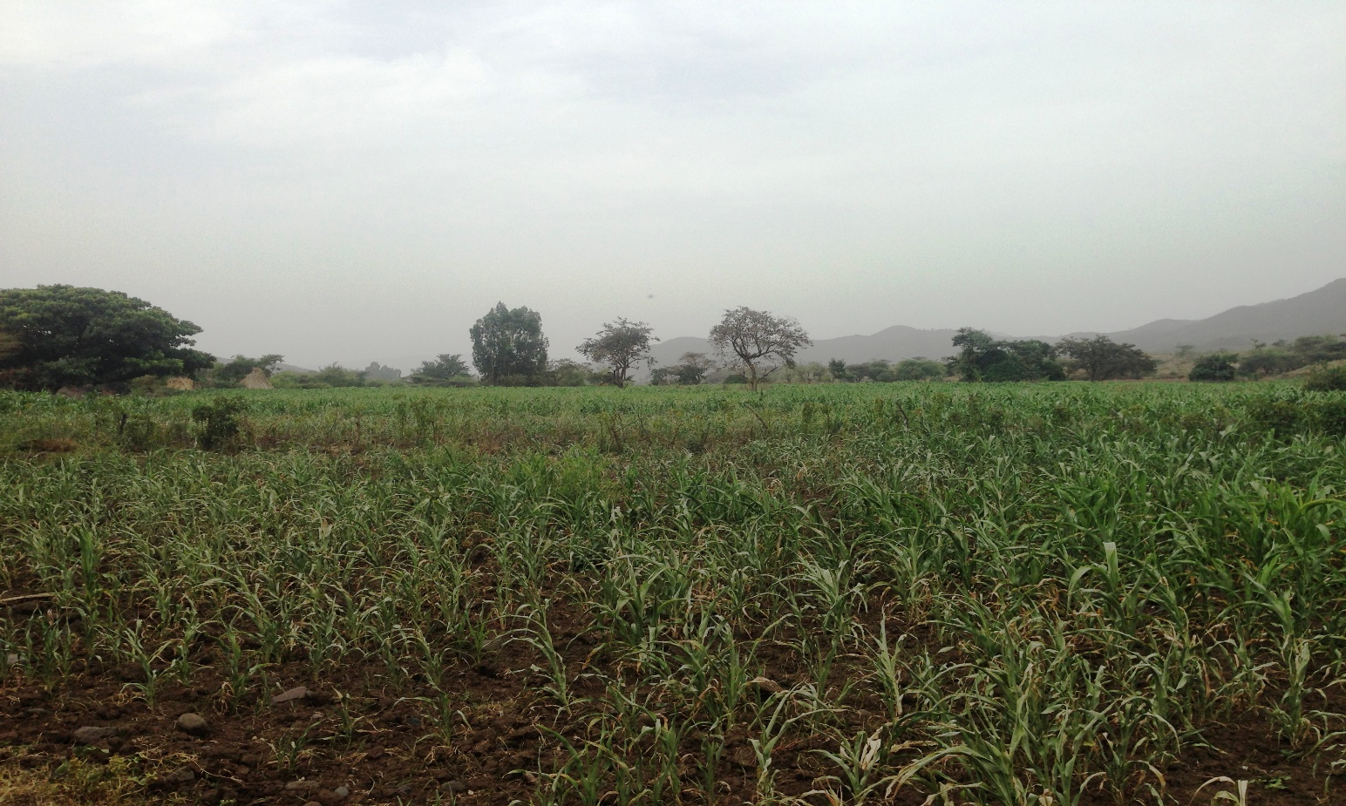
Figure 4-1: Partial View of the existing traditional irrigation

Irrigation Water Requirement

Crop Water Requirement (CWR)
The calculation of crop water requirement is a very important aspect for planning of any irrigation project. Several methods and procedures are available for this. The Food and Agriculture Organization (FAO) of the United Nations has also made available several publications on this subject and other issues related with this. The computer program available in FAO Irrigation and Drainage Paper No. 56 “CROPWAT” has been used for the calculation of Crop Water requirement. This program is based on Penman-Monteith approach and procedures for calculation of crop water requirements and irrigation requirements are mainly based on methodologies presented in FAO Irrigation and Drainage Paper No. 24 “Crop Water Requirements” and No. 33 “Yield Response to Water”.
As recommended in FAO Publications three steps (procedures) are involved in the calculation of the crop water requirement.

Irrigation efficiency (Ep)
To complete the evaluation of the demand, the efficiency of the water distribution system and of application must be known.
The gross requirement of water for irrigation system is very much dependent on the overall efficiency of the irrigation system, which in turn is dependent on several factors: Method of irrigation, type of canal (Lined and/or Unlined), method of operations (simultaneously and continuous or Rotational water supply), and availability of structures (for controlling and distribution and measuring and monitoring).
Based on these factors, for this project it is planned to impose surface irrigation method (using furrow). Based on Geology study results, concerning the canal systems, the main canal and secondary canal are lined. Hence, the conveyance efficiency is estimated to be 90%; distribution efficiency 85% and the field application efficiency is also estimated to be 60% seeing that the soil texture of the command area is predominantly clayey type (according to soil Lab result). Thus, the overall/project efficiency is estimated to be 46%.
The three steps as enumerated above will be able to give the crop water requirement during its cropping period. The losses in the irrigation system have to be incorporated to arrive at the water requirement at the head of the irrigation system.

Irrigation duty
Irrigation duty is the volume of water required per hectare for the full flange of the crops. It also helps in designing an efficient irrigation canal system. The irrigable area can be calculated by knowing the total available water at the source; and the overall duty for all crops required to be irrigated in the two seasons of the year.
The proposed cropping pattern of Chereti masonry irrigation project has showed all over crops average maximum net irrigation water requirement (NIWR) of 3 mm/day for dry season crops in the month of February and 1.9 mm/day for wet season in the month of October for all wet season crops. However, for the designing of the irrigation water application and flows in the entire canal system out of the proposed/selected crops the average that has maximum NIWR has been taken. Therefore, the overall crop has showed the maximum NIWR which is3mm/day in the month of February and taken for the irrigation project duty calculation for 12 irrigation hours and 1.9 mm/day in the month of October for wet season crops (see the calculation below).
For the designing of the project, the GIWR is given as follows:
GIWR = NIWR/e = 3/0.46 = 6.52 [mm/day] for full irrigation
GIWR = NIWR/e = 1.9/0.46= 4.13 [mm/day] for supplementary irrigation
The GIWR (6.52 and 4.13 mm/day) represents the daily quantity of water that is required to be applied for dry and wet season crops, respectively. This water quantity is also used for the determination of the canal discharge in consideration of the time of flow and also defined as the duty, expressed as l/s/ha.
The duty is calculated by:
Duty (D) = GIWR × 1000 × 10 / (t × 60×60)
Where; Duty – the duty [l/s/ha]
GIWR – Gross Irrigation Requirement [mm/day]
t – Daily irrigation or flow hours [hrs.]
The duty for GIWR of 6.52 mm/day (dry seasons) for daily irrigation time (t = 12 hrs.) and 4.13 mm/day (wet season) for daily irrigation time (12 hrs.). Thus, duty for 12 irrigation hours of dry and wet seasons’ full and supplementary irrigation has computed as follows, respectively:
D = (6.52 x10 x1000) / (12x3600) = 1.5 l/s/h (for full irrigation during dry season)
D = (4.13 x10 x1000) / (12x3600) = 0. 96 l/s/h (for supplementary irrigation during wet season)

Irrigation methods
Among the different irrigation systems furrow irrigation system will be used for this project area; and the irrigation water will be obtained from Cherety River and by constructing intake structure and convoying the water through lined main canal(MC), lined secondary canal (SC),earthen (TCs) and then leading to field canals; and finally irrigation takes place mostly in furrows. For this project, among the various irrigation methods, surface irrigation method has been selected. Of the surface irrigation methods furrow, border and basin irrigation methods can be used to supply irrigation water to the plants/crops. However, each method has its own advantages and disadvantages. Care should be taken when choosing the method which is best suited to the local circumstances, i.e., depending on slopes, soil types, selected crop types, amount of water available, etc. of the command area.
Based on the above factors surface irrigation method has been proposed for the proposed crops in this project. The method allows applying light irrigation and can be laid out in sloping fields along the contour. Furrow irrigation method is best suited for most of the proposed and row planted crops. In general, furrow irrigation method is simple, manageable and widely practiced irrigation method. This method is suitable for row crops that cannot stand in water for long periods. The only thing required to use this method is row planting of crops. Besides, basin and border irrigation method would be used for the non-row planted crops. Rotational flow water distribution is also recommended for the project area.

Irrigation and Drainage System Layout
The irrigation system layout for the project is prepared taking the following points into consideration besides other factors.
- A primary concern in the layout of the system is that it serves the purpose of conveying and distributing water to the command area.
- The excavation and earth fill volumes not be excessive, otherwise the construction costs can be tremendous.
- The selection of longitudinal bed slope is made taking into account the existing slopes of the terrain, so as to minimize deviations in canal routing.
- Curves in canals should not be too sharp.
The proposed irrigation system layout comprises one main canal, one secondary canals and eighteen (9) tertiary canals as shown on the layout Drawings. The main canal runs for most of its length parallel to the contours and changes of direction are necessary to follow the topography. The main canal is masonry lined for a length of 5720 meters starting from the weir outlet.

Conveyance System
The conveyance system consists of one Main canal to irrigate total command area of 175 ha. The main canal starts from Water abstraction site on right side and conveys water for a length of 5.72 Km.

Design of the Canal System
Flow Depth and Section Capacity
The earthen canals have been designed with a trapezoidal shape and the lined ones with rectangular cross-section using Manning's Formula:
Where Q= discharge (m³/s)
R= Hydraulic radius (Flow area/wetted perimeter)(m)
S= Hydraulic gradient (m/m)
n= Manning's roughness coefficient, n=0.025 is adopted for the earth channels and n=0.018 for the masonry lined part of the main canal

Main Canal
The design is made with the intension of lining the main canal considering the pervious nature of the soil. The lined canal will save the limited water source available there. The topography is moderate and rectangular section main canal is chosen for highly sandy clay loam soils of the area. The main canal is designed for a discharge of 262.69 l/s and depending on the site specific condition, appropriate slope is provided. Hydraulic parameters of the main canal are shown below.
Table 4-1: (a) Hydraulic Parameters of main canal (0+000 to 4+730)
Prameters | MC (0+000 -3+040) | MC (3+040-3+080) | MC (3+080-3+330) | MC (3+330-3+880) | MC (3+880-3+970) | MC (3+970-4+730)
Design discharge ,Q | 0.258 | 0.242 | 0.242 | 0.235 | 0.235 | 0.227
Bed width to depth ratio (b/d) | 1.250 | 1.250 | 1.250 | 1.250 | 1.250 | 1.250
Side slope ,Z | 0.000 | 0.000 | 0.000 | 0.000 | 0.000 | 0.000
Manning's roughness, n | 0.018 | 0.018 | 0.018 | 0.018 | 0.018 | 0.018
Longitudinal slope, S | 0.002 | 0.100 | 0.002 | 0.003 | 0.002 | 0.050
Water depth, d | 0.500 | 0.234 | 0.488 | 0.438 | 0.482 | 0.260
Bed width, b | 0.624 | 0.293 | 0.610 | 0.548 | 0.603 | 0.326
Area | 0.312 | 0.069 | 0.298 | 0.240 | 0.291 | 0.085
Wetted perimeter | 1.623 | 0.762 | 1.586 | 1.425 | 1.568 | 0.846
Hydraulic radius | 0.192 | 0.090 | 0.188 | 0.169 | 0.186 | 0.100
Velocity, v | 0.827 | 3.532 | 0.814 | 0.979 | 0.808 | 2.680
Canal Discharge capacity | 0.258 | 0.242 | 0.242 | 0.235 | 0.235 | 0.227
Free board | 0.300 | 0.300 | 0.300 | 0.300 | 0.300 | 0.300
Total depth | 0.800 | 0.534 | 0.788 | 0.738 | 0.782 | 0.560
Depth, d | 0.800 | 0.600 | 0.800 | 0.800 | 0.800 | 0.600
Bed width, b | 0.600 | 0.300 | 0.600 | 0.600 | 0.600 | 0.300

(b) Hydraulic Parameters of main canal (4+730 to 5+720)
Prameters | MC (4+730-4+790) | MC (4+790-4+960) | MC (4+960-5+230) | MC (5+230-5+280) | MC (5+280-5+460) | MC (5+460-5+720)
Design discharge ,Q | 0.191 | 0.116 | 0.116 | 0.067 | 0.067 | 0.067
Bed width to depth ratio (b/d) | 1.250 | 1.250 | 1.250 | 1.250 | 1.250 | 1.250
Side slope ,Z | 0.000 | 0.000 | 0.000 | 0.000 | 0.000 | 0.000
Manning's roughness, n | 0.018 | 0.018 | 0.018 | 0.018 | 0.018 | 0.018
Longitudinal slope, S | 0.002 | 0.050 | 0.002 | 0.100 | 0.033 | 0.003
Water depth, d | 0.446 | 0.202 | 0.370 | 0.144 | 0.177 | 0.273
Bed width, b | 0.558 | 0.253 | 0.463 | 0.180 | 0.222 | 0.341
Area | 0.249 | 0.051 | 0.171 | 0.026 | 0.039 | 0.093
Wetted perimeter | 1.450 | 0.658 | 1.203 | 0.469 | 0.576 | 0.888
Hydraulic radius | 0.172 | 0.078 | 0.142 | 0.056 | 0.068 | 0.105
Velocity, v | 0.767 | 2.266 | 0.678 | 2.557 | 1.693 | 0.714
Canal Discharge capacity | 0.191 | 0.116 | 0.116 | 0.067 | 0.067 | 0.067
Free board | 0.300 | 0.300 | 0.300 | 0.300 | 0.300 | 0.300
Total depth | 0.746 | 0.502 | 0.670 | 0.444 | 0.477 | 0.573
Depth, d | 0.750 | 0.500 | 0.700 | 0.500 | 0.500 | 0.600
Bed width, b | 0.550 | 0.300 | 0.500 | 0.300 | 0.300 | 0.300

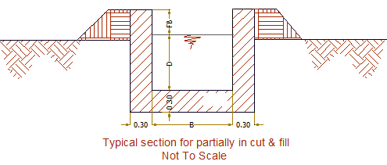
Figure 4-2: Typical Cross Section of main canal
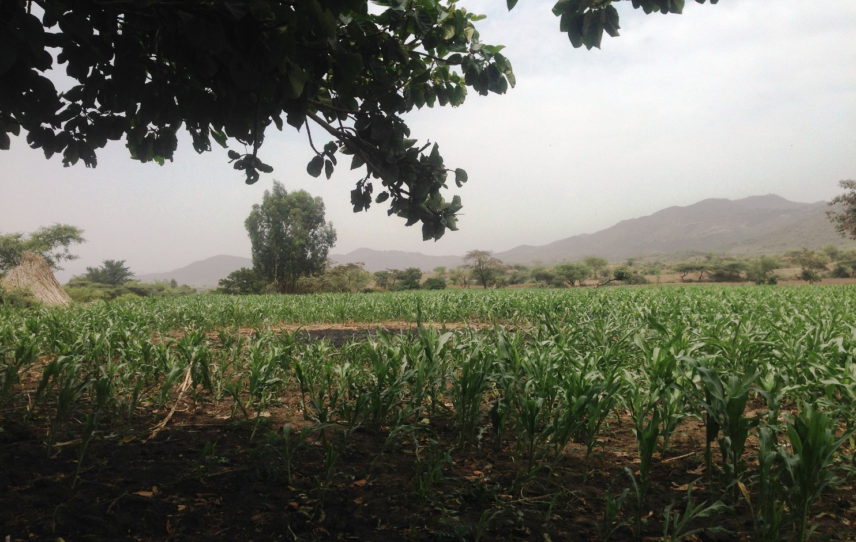
Figure 4-3: Part of command area (Photo)

Secondary Canals
Considering the topography soil type, the secondary canal is masonry lined in rectangular section. Secondary canal take water from the Main canal and distribute to tertiary canals. There is one secondary canals of the command area.

Table 4-2: Hydraulic Parameters of secondary canals 1
Prameters | SC 1-1 (0+000 -0+30) | SC 1-1 (0+30 -0+410)
Design discharge ,Q | 0.075 | 0.037
Bed width to depth ratio (b/d) | 1.500 | 1.500
Side slope ,Z | 0.000 | 0.000
Manning's roughness, n | 0.018 | 0.018
Longitudinal slope, S | 0.100 | 0.005
water depth, d | 0.137 | 0.185
bed width, b | 0.205 | 0.277
Area | 0.028 | 0.051
Wetted perimeter | 0.479 | 0.647
Hydraulic radius | 0.059 | 0.079
Velocity, v | 2.654 | 0.725
Canal Discharge capacity | 0.075 | 0.037
Free board | 0.300 | 0.250
Total depth | 0.437 | 0.435
Depth, d | 0.500 | 0.500
Bed width, b | 0.300 | 0.300

Figure 4-4: Typical Cross Section of secondary canals

Tertiary canals
In the layout system there are six tertiary canals, the designed discharge is determined based on the duty of irrigation and command area. The sections of the canals are determined by using Manning’s formula, and they are trapezoidal section. The computed hydraulic characteristics are presented in Table 4.4 below.
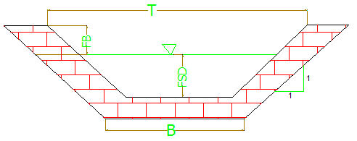
Figure 4-5: Typical Cross Section of tertiary canals
Table 4-3: a) Hydraulic Parameters of tertiary canals
Prameters | TC 1-0-1 | TC 1-0-2 | TC 1-0-3 | TC 1-0-4 | TC 1-0-5
Design discharge ,Q | 0.006 | 0.010 | 0.036 | 0.003 | 0.015
Bed width to depth ratio (b/d) | 1.000 | 1.000 | 1.000 | 1.000 | 1.000
Side slope ,Z | 1.000 | 1.000 | 1.000 | 1.000 | 1.000
Manning's roughness, n | 0.030 | 0.030 | 0.030 | 0.030 | 0.030
Longitudinal slope, S | 0.005 | 0.003 | 0.004 | 0.007 | 0.007
water depth, d | 0.094 | 0.126 | 0.198 | 0.070 | 0.129
bed width, b | 0.094 | 0.126 | 0.198 | 0.070 | 0.129
Area | 0.018 | 0.032 | 0.078 | 0.010 | 0.033
Wetted perimeter | 0.360 | 0.482 | 0.757 | 0.269 | 0.494
Hydraulic radius | 0.049 | 0.066 | 0.103 | 0.037 | 0.067
Velocity, v | 0.316 | 0.314 | 0.464 | 0.300 | 0.451
Canal Discharge capacity | 0.006 | 0.010 | 0.036 | 0.003 | 0.015
Free board | 0.300 | 0.300 | 0.300 | 0.300 | 0.300
Total depth | 0.394 | 0.426 | 0.498 | 0.370 | 0.429
Depth, d | 0.400 | 0.400 | 0.500 | 0.400 | 0.500
Bed width b | 0.300 | 0.300 | 0.300 | 0.300 | 0.300

b) Hydraulic Parameters of tertiary canals
Prameters | TC 1-0-6 | TC 1-0-7 | TC 1-0-8 | TC 1-1-1
Design discharge ,Q | 0.003 | 0.009 | 0.015 | 0.038
Bed width to depth ratio (b/d) | 1.000 | 1.000 | 1.000 | 1.000
Side slope ,Z | 1.000 | 1.000 | 1.000 | 1.000
Manning's roughness, n | 0.030 | 0.030 | 0.030 | 0.030
Longitudinal slope, S | 0.007 | 0.010 | 0.003 | 0.001
water depth, d | 0.070 | 0.099 | 0.155 | 0.249
bed width, b | 0.070 | 0.099 | 0.155 | 0.249
Area | 0.010 | 0.020 | 0.048 | 0.124
Wetted perimeter | 0.268 | 0.380 | 0.594 | 0.953
Hydraulic radius | 0.037 | 0.052 | 0.081 | 0.130
Velocity, v | 0.300 | 0.464 | 0.312 | 0.303
Canal Discharge capacity | 0.003 | 0.009 | 0.015 | 0.038
Free board | 0.300 | 0.300 | 0.300 | 0.300
Total depth | 0.370 | 0.399 | 0.455 | 0.549
Depth, d | 0.400 | 0.400 | 0.500 | 0.500
Bed width b | 0.300 | 0.300 | 0.300 | 0.300

Irrigation Structures
The types of structures, which are designed on this project, are division box, flume and foot path structures. Bligh theory is used to ensure against piping and uplifting pressure. All the structures are provided with sufficient depth of cutoffs as well as thickness to make structurally stable.

Design of Division box
At different points of the main canal division boxes are provided which divert the flow to the secondary canal and tertiary canals and directly to field canals. Gate should be provided at the outlet of the boxes. For detail refer the drawing.

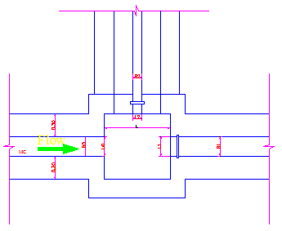
Figure 4-6: Typical Division Box plan
Using broad crested formula,
Q= CL (h) ^{3/2}
Where; Q= discharge over rectangular weir/intake (opening), m³/s
C = discharge coefficient, c= 1.7
L= effective length of crest form in m
h= over flow depth, m
Assuming equal discharge coefficient & sill height for two or three dividing canals, the proportion becomes.
Q₁/ Q₂= Q₂/ Q₃ =L₁/ L₂ = L₂/ L₃
Where Q₁= is flow in canal 1
Q₂ = is flow in canal 2
Q₃ = is flow in canal 3
L₁= is effective crest length of weir/intake sill across opening to canal 1
L₂= is effective crest length of weir/intake sill across opening to canal 2
L₃ = is effective crest length of weir/intake sill across opening to canal 3
Lo=Length of throat
B=Width of Division Box
D=Depth of Division Box
Bo=Width of the incoming canal
Do=Depth of the incoming canal
Lo=Q₀/(C*H₀^{3/2})
L₀/L₁=Q₀/Q₁
L₁=L₀*(Q₁/Q₀)
L₂=L₀*(Q₂/Q₀)
L₃=L₀*(Q₃/Q₀)
B=B₀+(2*m*Do)
Lp₁=Lp₂= 1.2+3/2Q ^{1/2}
H₀=(Q₀/(C*L₀))^(2/3)

Table 4-4: Hydraulic parameters of Division Boxes
Dividing Canal Name | Chainage @ | CBL | Parent canal bed width Bo | Parent canal depth,Do | FCS/TCS bed width, Bc | Width of the basin | Length of the basin | Depth of the basin
DB 1-0-1 | MC 0+520 | 1461.830 | 0.6 | 0.8 | 0.3 | 1 | 0.7 | 0.8
DB 1-0-0-1 | MC 1+000 | 1462.000 | 0.6 | 0.8 | 0.3 | 1 | 0.7 | 0.8
DB 1-0-0-2 | MC 1+670 | 1461.330 | 0.6 | 0.8 | 0.3 | 1 | 0.7 | 0.8
DB 1-0-0-3 | MC 1+980 | 1461.020 | 0.6 | 0.8 | 0.3 | 1 | 0.7 | 0.8
DB 1-0-0-4 | MC 2+340 | 1460.660 | 0.6 | 0.8 | 0.3 | 1 | 0.7 | 0.8
DB 1-0-2 | MC 2+640 | 1462.010 | 0.6 | 0.8 | 0.3 | 1 | 0.7 | 0.8
DB 1-0-3 | MC 3+050 | 1458.960 | 0.3 | 0.6 | 0.3 | 0.7 | 0.7 | 0.6
DB 1-1 | MC 3+340 | 1443.450 | 0.6 | 0.8 | 0.3 | 1 | 0.7 | 0.8
DB 1-1-1 | SC 0+040 | 1441.350 | 0.3 | 0.5 | 0.3 | 0.7 | 0.7 | 0.5
DB 1-0-0-5 | MC 4+300 | 1438.080 | 0.3 | 0.6 | 0.3 | 0.7 | 0.7 | 0.6
DB 1-0-4 | MC 5+220 | 1422.890 | 0.5 | 0.7 | 0.3 | 0.9 | 0.7 | 0.7
DB 1-0-5 | MC 5+300 | 1417.213 | 0.3 | 0.5 | 0.3 | 0.7 | 0.7 | 0.5
DB 1-0-6 | MC 5+380 | 1414.547 | 0.3 | 0.5 | 0.3 | 0.7 | 0.7 | 0.5
DB 1-0-7 | MC 5+560 | 1409.880 | 0.3 | 0.5 | 0.3 | 0.7 | 0.7 | 0.5
DB 1-0-0-6 | MC 5+580 | 1409.880 | 0.3 | 0.5 | 0.3 | 0.7 | 0.7 | 0.5
DB 1-0-8 | MC 5+630 | 1408.480 | 0.3 | 0.5 | 0.3 | 0.7 | 0.7 | 0.5

Flume Structure
As the route of the main canal and the irrigated command is dissected by number of gullies, there are 8 major flumes. Typical cross-section of flume is shown as follow.
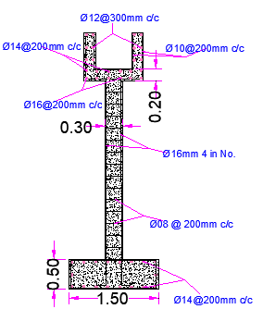
Figure 4-7: Typical Flume Cross-section
Table 4-5: Hydraulic parameters of Flume
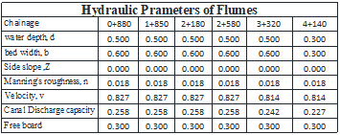

Road crossing structure
Ten road crossing structures (foot path) are provided on the main canal. The road crossing structures are rectangular reinforced concrete slab. The slab is reinforced with 10mm @200mmc/c the length of the slab is the same as the respective canal bed width, its width and thickness is 2m and 15mm respectively.

Irrigation Infrastructure Bill of Quantities and Cost Estimate
Table 4-6: Bill No.3 irrigation infrastructure
S/no | Item of work | Unit | Quantity | Unit rate (et.birr) | Total cost
 | C. Irrigation Infrastructure
 | Main Canal
1.1 | Ordinary soil excavation | m3 | 7501.418 | 95.000 | 712,634.73
1.2 | 30 cm depth clearing and grubbing | m2 | 5720.000 | 15.000 | 85,800.00
1.3 | Compacted Back fill | m3 | 4576.000 | 85.880 | 392,986.88
1.4 | Masonry work with 1:3 mortar | m3 | 5845.200 | 1850.000 | 10,813,620.00
1.5 | 25 mm thick Plastering ( mortar ratio1:2) | m3 | 11440.000 | 128.570 | 1,470,840.80
1.6 | C-20 concrete | m3 | 378.800 | 2899.830 | 1,098,455.60
 | Sub total |  |  |  | 14,574,338.01
 | Secondary Canal(1)
1.1 | Ordinary soil excavation | m3 | 659.604 | 95.000 | 62,662.37
1.2 | 30 cm depth clearing and grubbing | m2 | 287.000 | 15.000 | 4,305.00
1.3 | Compacted Back fill | m3 | 246.000 | 85.880 | 21,126.48
1.4 | Masonry work with 1:3 mortar | m3 | 270.600 | 1850.000 | 500,610.00
1.5 | 25 mm thick Plastering ( mortar ratio1:2) | m3 | 533.000 | 128.570 | 68,527.81
 | Sub total |  |  |  | 657,231.66
 | TC(9)
1.1 | Ordinary soil excavation | m3 | 2379.455 | 95.000 | 226048.245
 | Sub total |  |  |  | 226,048.24
 | FC(6)
1.1 | Ordinary soil excavation | m3 | 2379.455 | 95.000 | 226048.245
1.2 | Stone Piching (masonary work 20 % mortar to 80 % stone) | m3 | 486.000 | 925.000 | 449550.000
1.3 | Back fill | m3 | 486.000 | 45.000 | 21870.000
 | Sub total |  |  |  | 697,468.24
 | FLUMES(5)
1.1 | Ordinary soil excavation | m3 | 357.370 | 95.000 | 33950.15
S/no | Item of work | Unit | Quantity | Unit rate (et.birr) | Total cost
1.2 | Compacted Back fill | m3 | 169.074 | 85.880 | 14520.08
1.3 | Masonry work with 1:3 mortar | m3 | 137.640 | 1850.000 | 254634.00
1.4 | Plastering ( mortar ratio 1:2) | m3 | 118.420 | 128.570 | 15225.26
1.5 | Ø8mm, Ø10mm ,Ø12mm, Ø14 mm &Ø 16mm reinforcement bar | kg | 13733.432 | 48.000 | 659204.73
1.6 | Lean concrete | m3 | 57.200 | 900.000 | 51480.00
1.7 | C-25 concrete | m3 | 221.380 | 2980.000 | 659712.40
 | Sub total |  |  |  | 1,688,726.61
 | DRAINS(1)
1.1 | Ordinary soil excavation | m3 | 1023.000 | 95.000 | 97185.000
 | Sub total |  |  |  | 97,185.00
 | DIVISION BOX( 16)
1.1 | Ordinary soil excavation | m3 | 19.000 | 95.000 | 1805.000
1.2 | Masonry work with 1:3 mortar | m3 | 15.000 | 1850.000 | 27750.000
1.3 | 25 mm thick Plastering ( mortar ratio1:2) | m2 | 25.000 | 128.570 | 3214.250
1.4 | Compacted Back fill | m3 | 12.200 | 85.880 | 1047.736
 | Sub total |  |  |  | 33,816.99
1.1 | Division Box Gates (19) | No | 19.000 | 3500.000 | 66500.000
 | Sub total |  |  |  | 66,500.00
 | Foot Path
 | C-20 concrete | m3 | 2.160 | 2899.830 | 6263.633
 | Ø 10mm reinforcement bar | kg | 128.000 | 48.000 | 6144.000
 | Sub total |  |  |  | 12,407.63
 | Total |  |  |  | 18,053,722.40

CONCLUSION AND RECOMMENDATION
- At the selected head work site, it is possible to irrigate the command area by gravity, through only diverting water directly without raising the level of water considering reference to the highest point of the command area. Hence, intake structure has been recommended for Cherety small-scale irrigation project
- The design contains essential components of head works which are: breast wall, operation slab, bed bar, trash rack & right side retaining structures.
- This project needed great attention during construction stage to get the best results because the main canal topographic route is difficult for construction.
- The infrastructure of this project area is designed to irrigate about 175ha of land by taking its supply from the Cherety intake irrigation project. The maximum duty of the command area for 12 hours per day irrigation with overall project efficiency of 46%. The method of irrigation of the project area is furrow surface irrigation in which the main, secondary and tertiary canals are working continuously whereas the field canals within a tertiary block are working rotational system.
- As the dominant soil type is sandy clay loam soil, the main canal system is designed to be masonry.
- The reason why the main canal is to be lined up is to avoid the siltation problem and leakage, time saving to reach at the tail part, reduce maintenance cost.
- On the secondary unit of the irrigation systems are designed as far as possible to be partially filled and cut. The layout is designed as far as possible to avoid cross-structures within them.
- The design of the canal dimensions of the irrigation canal is done by applying the manning’s uniform flow equation. The variable of the hydraulic parameters are calculated using iteration or flow master program.
- As soils of the command area are predominantly sandy clay loam textured; and hence water and soil management measures should be undertaken; and optimum moisture content should be maintained to improve workability of the soil during land preparation and planting time.
- As confirmed in the survey the study area is comfortable for irrigation. However, lack of required modern irrigation infrastructure is core problem of the area. Additional problems are mentioned in the social part of this paper which affects subsistence agriculture, the main economic base of the people. However; traditional farming characterized by unscientific farming, low level of input and improved technologies application is the root cause for low productivity. Hence this small scale irrigation development is a master key to minimize those mentioned agricultural related problems and expect enhance the farmers’ production and productivity, and then improve their livelihood. Regard to beneficiary farmers, they are very interested and eager to see the project realization in the very near future.
- Therefore, in this study impacts on physical, biological and public are predicted and possible mitigation measures are proposed for negative impacts. In addition to this Environmental Management and Monitoring Plans are prepared for sustainable operation of the project.
- The development project meets its set objectives, socially acceptable, economically feasible, technically feasible and environmentally sound.
The following recommendations are drown:
- For better performance and long service year of the project regular inspection and maintenance is highly required.
- Farmers training, how to operate and maintain the project structures as a whole and available and water resources has a paramount important.
- The irrigation hours per day and per week should be flexible based on base flow amount of each week or month.
- Close supervision of the construction should be made to modify (if need be) each Components of irrigation system based on specific site conditions.

OPERATION AND MAINTENANCE

General
The main objective of the operation and maintenance aspect of an irrigation scheme is to facilitate the timely delivery of the required irrigation water to farms and to keep the irrigation system in an optimum operating condition. This section therefore, discusses the main functions of the subject matter under consideration for the scheme.

Operation of the Head Works
Operation at the diversion weir mainly focuses on the diversion of a controlled flow of river water, timely cleaning of floating debris in front of intake and removal of sediment deposits in front of the weir and intake structures, greasing of gates.

Irrigation System Operation
The operation of the irrigation system depends mainly on the method of water delivery at farm level. Surface irrigation method is the recommended type of water distribution and application method for Cherety diversion irrigation scheme.
The farmers would organize themselves and form groups in order to handle the water management. Since flow is low Rotational water distribution would be applied within the group. The rotational distribution is then to distribute water by turn to the whole scheme according to the timely need of crop water requirement. For better and efficient water management, crop diversification should be avoided within a group. This would reduce the complexity of water distribution system of the scheme during one irrigation season. At farmers’ level of operation, a constant flow and variable irrigation time is advisable.
The operation of the irrigation system is continuous for 12 hours per day in main, secondary and tertiary canals whereas field canals within a tertiary block are operating in rotational system with each other for irrigation hours proportional to their size. Since the tertiary canal discharges are within the manageable range and the irrigation canal structures are accordingly designed for simple operation, the farmers can open and close easily whenever they required.

Maintenance Requirement
The canal system of the project is lined canal except tertiary canal; the earthen canals are susceptible to siltation, erosion, growth of weeds and or breaching problems. Though the canal sections are designed for non- silting and non-scouring conditions, the above mentioned problems are unavoidable and hence periodical and yearly inspection and maintenance of canals and structures are obligatory in order to fulfill the design objective of the project area.
The maintenance tasks are categorized into two types: - routine activities, and repairs. The routine maintenance activities that are carried out periodically include:-
- Regular cleaning of sediments and weeds from canals and drains;
- Inspection and lubrication of gates; and
- Maintenance of cracked lined canals, regulating and control structures.
Repair works include task carried out more frequently and quickly, and include those tasks that are generally unpredictable. They also include emergency works. The activities included in this category are:-
- Repairing overtopped or breached canals, drains, and flood protection dykes;
- Repairing jammed gates;
- Filling holes made by wild animals; and
- Reduced free board due to walking over by people and livestock.
Regular inspection of the irrigation facilities should be carried out as part of the maintenance activities. These tasks could be carried out immediately after the end of the main rains in September and during the rainy season. This could concentrate on the interceptor drains and the flood protection dykes, the main canal and the field drains. The inspection of the other works like the tertiary canals, field drains, and the water control and regulating structures could be carried out as part of routine operation activities.
- Beneficiaries of the project need to have operation and maintenance budget, For O&M cost incurring entity area:
- Purchasing of gate lubricate (grease)
- Replacing and maintenance of Stolen and damaged gates
- Repair Damages on the cross drainage structures.
The expense for O&M should be collected from the beneficiaries. Of course, much of the task is done by the labor and skill of the community. For cost incurring activities beneficiaries have to collect money based on the proportion of the command area they owned.

REFERENCE
- Design of small Canal structures , USBR
- IDD manual
- Irrigation Engineering And Hydraulic Structure (Garge)
- Design Guide Line on Irrigation Structures, Ministry of Water Resource.
- Irrigation and Hydraulic Structures, ARORA

