TABLE OF CONTENTS
1. HEAD WORK……………………………………………………………………………………….1
1.1. General 1
1.1.1. Methodology 1
1.1.2. Irrigable area 1
1.1.3. Water Availability 1
1.1.4. Major Components of the project 1
1.1.5. Selection of Headwork site 2
1.1.6. Geology of weir site 2
1.2. Design of Headwork (weir) 2
1.2.1. Intake Design 3
1.2.2. Capacity of sluiceway 3
1.2.3. Water depth on the crest for broad crested weir 4
1.2.4. The approach Velocity 4
1.3. Stilling basin 5
1.3.1. Energy Method 5
1.3.2. Hydraulic Jump 5
1.3.3. Bed level of stilling basin: 5
1.3.4. Bernoulli’s energy equation between upstream & downstream of wire body 5
1.3.5. Froude number 5
1.3.6. Conjugate Depth 6
1.3.7. Tail water depth (d₃) 6
1.3.8. Length of the stilling 6
1.3.9. Conventional method 7
1.4. Determination of Detailed parts 8
1.4.1. Bottom width 8
1.4.2. Top width 8
1.5. Thickness of the floor 8
1.5.1. Foundation material: 9
1.5.2. Length of percolation: 9
1.5.3. Blight's method 9
1.5.4. Lane method 9
1.5.5. Maximum head on the structure 11
1.5.6. Exit gradient 12
1.6. Stability Analysis of weir 13
1.6.1. Dynamic Case 13
1.6.2. Foundation Reaction 14
1.6.3. Safety factors 14
1.6.4. Static case 14
1.6.5. Safety factors 15
1.7. Design of Wing walls 15
1.7.1. Safety against overturning 16
1.7.2. Safety against sliding 16
1.7.3. Location of resultant (middle-third- rule) 16
1.8. Backwater effect 16
1.9. Intake Gate 16
1.10. Silt Gate 16

2. IRRIGATION AND DRAINAGE………………………………………………………………..18
2.1. Design Criteria 18
2.2. Irrigation System Design 18
2.2.1. Design of Main Canal system 19
2.2.2. Design of Earthen Tertiary canals 20
2.2.3. Design of field channels 21
2.2.4. Design of furrow irrigation methods 21
2.3. Drainage Modulus 22
2.3.1. Rational method of flood determination 22
2.4. Design of Pipe Culverts 23
2.5. Design of Aqueducts 24
2.6. Design of turnout and Field off takes 25
2.7. Design of Vertical Drop (U.S.B.R.Type) 25

LIST OF TABLES
Table 1-1: Hydraulic Calculations of Sluice Capacity for 50 year flood 3
Table 1-2: Blign’s Coefficient and Lane’s Creep Ration 9
Table 1-3: Summery of downstream apron floor thickness 10
Table 1-4: Safe exit gradient against soil type 12
Table 2-1: Summary of canal dimension 21
Table 2-2: Summary of pipe culvert design 24
Table 2-3: Summary of Aqueduct 24
Table 2-4: Summary of turnout 25
Table 2-5: Summary of Vertical Drop Calculation 26

LIST OF FIGURES
Figure 1-1: Intake level of weir body 3
Figure 1-2: Water depth of broad crested weir 4
Figure 1-3: Discharge Vs Depth Curve of tail water depth 6
Figure 1-4: Energy profile of the weir 7
Figure 1-5: Weir section 10
Figure 1-6: Detail section of weir body 11
Figure 1-7: Details of guide wall 16
Figure 1-8: Section of intake and silt gates 17
Figure 2-1: Lined and Earthen canal section 20
Figure 2-2: Main drain section 23
Figure 2-3: Section of pipe culverts 23
Figure 2-4: Section of vertical drop design 25

LIST OF ANNEX
Annex 1: Bill of Quantity, Specification and Cost Estimate 28

HEAD WORK

General
Engineering aspects related to project study and design is addressed under this section. All influential factors that determine project sustainability are accounted to come up with reasonable results of study. In so doing, idea from different disciplines was given due attention to make the scheme smart. The project is gravity diversion system on Dalole River that delineates Bonaya boshe districts. One-way intake is suggested to serve the district. Manageable systematic layouts were adopted to minimize costs and to enable easier application of water. A total of 36 ha of land were surveyed and net irrigable area of 32 ha of land was planned for development.

Methodology
The methodologies adopted are:
- Existing localities and community experiences and information.
- Using 1:50,000 contour maps
- Site survey and investigations
- Secondary data from concerned areas
- Hydro-meteorological data, crop data, soil data etc. collecting and organizing for this study.
- Using guidelines manuals and other reference materials

Irrigable area
The irrigable area is moderately flat with slope ranging between 1-5% towards Dalole River. The soil of the area is silt clay soil and thick in depth. The radish clay soil is good for structures. The proposed crops under irrigation have duty of 0.53l/s/ha and net irrigable area is 32 ha.

Water Availability
It could have been good if monthly flow data were available; but at this level of study it was not possible to have reliable data. Hence dry season flow was estimated and reasonably safer flow was taken as lean flow available for design. The lean flow as reported under hydrology section is 16.96 l/s.

Major Components of the project
1. Diversion Head work (Broad crested weir) and temporary cofferdam
2. Lined main conveyance canal on one sides of the river 600m long, Secondary supply canals and Tertiary canals
3. Aqueducts
4. Culvers
5. Turnouts and Field off take (No)
6. Cut off drain along Main Canal (600m) and Other Drainage canals.
7. Access road clearance 5km and Camping.
9. Drops

Selection of Headwork site
The headwork site was selected under the following factors:
- Possibility to command the anticipated area.
- Geological formation of the site.
- Relative cost of weir.
- Possibility to protect flooding of off taking canal
- Relatively area convenient for construction and less flood heights & effects.
- Access to the site
- Area simpler for temporary diversion during construction.

Geology of weir site
The Dalole Riverbed at the diversion headwork site is formed of Rock blocks, boulders, cobbles and pebbles filled with gravel and fines. These fragmental deposits make the riverbed. A test pit (fig 3 a) dug at the central part of the riverbed at weir site revealed the dominant foundation material to be sands with gravel to about 1m depth underlain by coarse gravel with sand and clay. Trench excavation at both riverbanks showed the entire riverbanks are formed of unconsolidated silty clay soil (Illustrated in Geotechnics Section of the report Figure 4-2a) that has to be removed and provided with retaining structure to provide safety against slope failure due to saturation to be caused by the back-water effect.
Based on the data obtained from the excavated test pit and trench together with data from visual observation, thickness of the fragmental deposits making the riverbed is estimated to be more than 2mts (See Fig 4a Dalole River Valley Geological Cross Section along Weir Axis at Geotechnics Section of the report).
Both the upstream and downstream reaches around the headwork site are straight retch (See Fig 4b and 4c of Geotechnics Section of the report). The foundation material is in general taken as pervious foundation of loose gravel with sand and clay and it requires engineering provision of safety against piping, scouring and uplift effects. The bearing capacity of such material, as taken from literature, is 245KN/m².

Design of Headwork (weir)
Weir type: Broad crested masonry weir
Length or span of the weir overflow was taken 16m from the existing situation of the river section.
1) Determination of crest level
- Average level of the highest field = 1648.10m
- Water depth required = 0.30m
- Head loss across the field = 0.00m
- Head loss at turnout = 0.05m
- Slope of canal x distance from weir =(0.001x210) = 0.21m
- Head loss across head regulator = 0.10m
- Crest level of the weir = 1648.76m
- Upstream river bed level =1647.32m
i.e. Crest height = crest level - upstream river bed level
= 1648.76-1647.32 = 1.44m

Intake Design
Given: Q=16.961l/s
Formula adopted: Orifice (free outflow)
Q=C_{d}A√(2gh)……………………………………………….………………….Eq1.1
Where h=y-(D/2) and A=πD²/4
C_{d}=0.62 for free out flow condition
=0.8 for submerge out flow
Cd | D | y | A | h | Q
0.62 | 0.263 | 0.145 | 0.054 | 0.014 | 0.017

Since φ26 concrete pipes is not found on market and thus φ30cm concrete pipe was adopted and regulate by gate. The Intake level is 1648.46m.
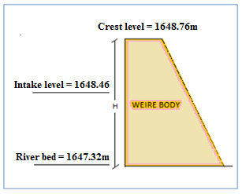
Figure 1-1: Intake level of weir body

Capacity of sluiceway
The capacity of the sluice decided based on the maximum of the values of discharge obtained by twice the intake capacity or the 20% of the design discharge.
- Intake capacity:0.01696 m³/s→ Sluiceway capacity: 2 x 0.6 = 1.2 m³/s
- 50 year design flood: 18.16 →Sluiceway capacity: 0.2 x 90.80 = 18.16 m³/s
Thus the minimum sluiceway capacity has to be 18.16m³/s.

Table 1-1: Hydraulic Calculations of Sluice Capacity for 50 year flood
Feature | Data | Formula | Calculation | Result
Width of sluiceway | 0.6 m
Flood discharge | 90.80 m³/s
Capacity of sluice |  | Section 1.3 | 0.2 x 90.80 | 18.16 m³/s
Crest elevation of sluiceway | 1804.74m
Using the formula for a broad crested weir |  | Q = 1.7LH^{1.5} | 1.7x 0.8 x (2.2 + 3.42)^{1.5} | 18.16 m³/s

Water depth on the crest for broad crested weir
Q = 1.7LH^{3/2}…………………………………………………………………..Eq1.2
Q = Design flood = 90.8m³/s (from Hydrology report)
L = Weir span = 16m
H = Total Head over crest = water ht + velocity head
Hence 90.80 = 1.7x16xH^{3/2}
H=2.23m
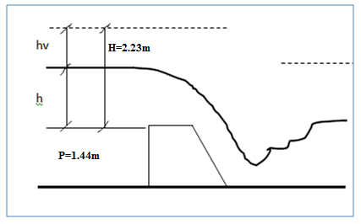
Figure 1-2: Water depth of broad crested weir

The approach Velocity
$Va=\frac{Q}{L(h+P)}$……………………………………………………………….Eq1.3
P was taken 0.50m after silt up

Where $h=\frac{Va^{2}}{2g}$
$$\frac{Va^{2}}{2g}=H-h=2.23-h$$
$$But Va=\frac{Q}{L(h+P)}=\frac{90.8}{16(h+0.5)}$$
$$\frac{{90.8}^{2}}{(16{\left(h+0.5\right))}^{2}}*\frac{1}{19.62}=2.23-h$$
$$\frac{1.64}{(h+{0.5)}^{2}}=2.23-h$$
By trial & error h = 2.09m

Stilling basin

Energy Method
Velocity head in approach channel
h_{va} = H-h ……………………………………………………………………Eq1.4
= 2.23 – 2.09 = 0.14m

Hydraulic Jump
For cobbles and pebbles filled with gravel and fines foundation:
River bed elevation = 1647.32m
Downstream water level (d₃) = 1647.32-1.6 =1645.72m
Weir crest level = 1648.76m
Height of crest, p = 0.50m (silt height assumed)

Bed level of stilling basin:
First find the jump height, D₂ or sequent depth.

First Trial:
Assuming the floor level is 0.00m lower than river bed,
Assumed EL1 = EL3-0.00 = 1647.32-0.00 = 1647.32m
H = E_{o} = E₁
Z = EL0- Assumed EL1 ……………………………………..………Eq5
= (+ 1648.76)-(+1647.32) = 1.44m
E0 = h+ hvo+Z…………………………………………………………Eq6
= H_{e}+Z = 2.23+1.44 = 3.67m
q = Q/L……………………………………………………….………...Eq7
= 90.8/16 = 5.67m³/s/m

Bernoulli’s energy equation between upstream & downstream of wire body
Z₀+ weir ht + h + h_{v}= Z₁+d₁+V₁²/2g…………………………..………………Eq8
0.00+1.44+2.09+0.14 = d₁+V₁²/2g
3.67 = d₁+ v₁²/2g
V₁= q/d₁ = 5.67/d₁ ………………………………………………….………….Eq9
Substituting 9 in 8:
3.67 = 5.67/ V₁+V₁²/19.62
By trial & Error V₁= 7.57m/s
Hence d₁ = 0.75m

Froude number
Fr = ………………………………………………………….……….Eq10
Where:
Fr= Froude number
V₁ = mean velocity of flow (m/s)
g = acceleration of gravity (m/s²)
d₁ = depth of flow (m)

Conjugate Depth
d₂ = …………………………………….………..Eq11
Where:
d₂ = conjugate depth (m)
d₁ = upstream depth (m)
Fr = Froude number

Tail water depth (d₃)

Figure 1-3: Discharge Vs Depth Curve of tail water depth

The tail water depth d₃=1.6m is less than the sequent depth, d₂ and thus the jump recedes downstream for downstream floor level that the same as upstream apron level. Hence the bottom level of stilling basin will be EL.1 = 1647.32m.

Length of the stilling
L = 4d₂…………………………………………………………….……………..Eq12
= 4x2.61 = 10.43m

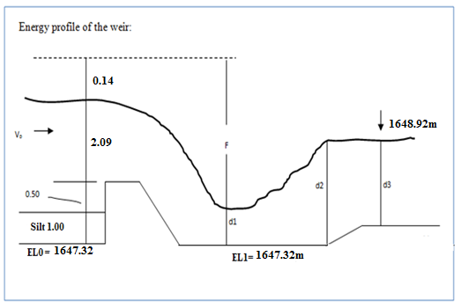
Figure 1-4: Energy profile of the weir

Conventional method
Experimental formula to determine the length and depth of stilling basin

Length of stilling basin
L = …………………………………………………………………………..Eq13

Depth of stilling basin
d = ≥d ≥ F/3…………………………………………………….Eq14
Where:
L = Length of basin (Horizontal length of weir glacis + length of downstream apron floor in m)
d = depth of basin (m)
h = over flow depth (m)
F = (upstream water level + velocity head) - (downstream water level)
h = 2.09m
F = (1650.85+0.14)-(1648.92) = 2.07m
L = L¹ =
d = = 1.04m it is fulfilled the criteria F/2 ≥d ≥ F/3.
Here the tail water depth is higher than the sequent depth and thus the flow gets submerged. Hence the stilling basin is so designed as to be equipped with the floor length of L = 6.24m and the depth of d= 1.03 m and the transition length of L¹= 6.00m.
From economic point of view this conventional method is selected in determining the length and depth of stilling basin. The detail design of the weir body and apron is as follows:

Determination of Detailed parts
According to Bligh’s formula, the basic section of weir body for the un submerged condition is determined as follows.

Bottom width
L = …………………………………………………………..Eq15

Top width
B = ……………………………………………………………..Eq16
Where:
H = height of weir = 1.44m
He = Specific energy head = 2.09m
ρ = Specific weight of weir body = 2.3
L = m
B =
L = 2.33m use L = 2.84 for the weir sloping surface (glacis) are 1V:1H.

Thickness of the floor
- Upstream apron thickness for leakage proof can be taken 0.50m.
- Downstream apron thickness can be determined for static & dynamic hydraulic condition. The larger thickness will be selected.
The thickness at any point (A) is calculated from:
t_{A} = {H_{max}[1- (La/ L_{c}) ]+ (TwL-wL_{A})}x (safety factor /(γ_{m}-1))……………….……….Eq17
Where:
t_{A =} Thickness of apron at the point A (m)
f = factor of safety = 1.30
H_{max}= upstream & downstream head differential (m)
L_{A} = Weighted creep length at the point A (m)
L_{c} = Weighted creep length total (m)
TwL = tail water level (m)
WLA = Water level at point A (m)
γ_{m}= Specific gravity of masonry (2.3)
Notes: -At the toe of weir the term (TWL-WLA) should be reduced by 50% for dynamic case.

Foundation material:
Foundation material is formed of Rock blocks, boulders, cobbles and pebbles filled with gravel and fines. For the sake of this design fine sand formation was taken.

Length of percolation:
Cut off walls of upstream & downstream besides the apron floor shall be installed with good anchorage with weir body to prevent piping & limit intensity of uplift pressure.

Blight's method
L> CH ………………………………………………………………………Eq18
Where L = total percolation distance (m) = Horizontal+ vertical
h = max head (m)
C= percolation co-efficient = 15

Lane method
L>CH………………………………………………………………………..Eq19
Where L = percolation distance = V+H/3
-For sloping surface > 45⁰ taken as vertical otherwise horizontal.
C = Percolation co-efficient = 7
H = max head (m)
* Adopt Lane's methods

Table 1-2: Blign’s Coefficient and Lane’s Creep Ration
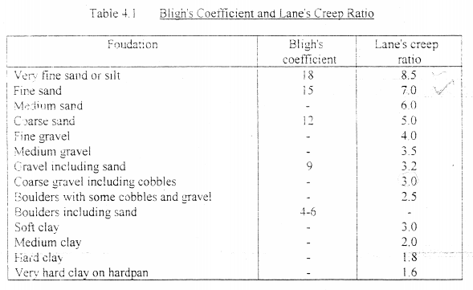
The weir section will be like the following:

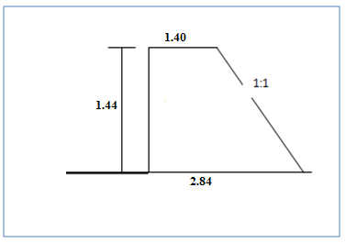
Figure 1-5: Weir section

Table 1-3: Summery of downstream apron floor thickness
Point | Weighted creep length |  |  | H_{max} [1-La/Lc] | TWL-WLA | (1.3)/ (2.3-1) | t | Remark
Point | H | V | L
Dynamic Case-H_{max} |  | 1.93 |  |  |  |  |  | Take reduced value of 1.375m instead of 2.75.
A | 5.34 | 6.5 | 8.28 | 0.72 | 2.03 | 1 | 2.75 | Take reduced value of 1.375m instead of 2.75.
B | 9.9 | 6.5 | 9.80 | 0.50 | 0 | 1 | 0.50 | Take reduced value of 1.375m instead of 2.75.
C | 15.4 | 6.5 | 11.63 | 0.23 | 0 | 1 | 0.23 | Take reduced value of 1.375m instead of 2.75.
Static case-Hmax |  | 1.44 |  |  |  |  |  | Take reduced value of 1.375m instead of 2.75.
A | 5.34 | 6.5 | 8.28 | 0.54 | 1.85 | 1 | 2.39 | Take reduced value of 1.375m instead of 2.75.
B | 9.9 | 6.5 | 9.80 | 0.37 | 0.4 | 1 | 0.77 | Take reduced value of 1.375m instead of 2.75.
C | 15.4 | 6.5 | 11.63 | 0.17 | 0.35 | 1 | 0.52 | Take reduced value of 1.375m instead of 2.75.

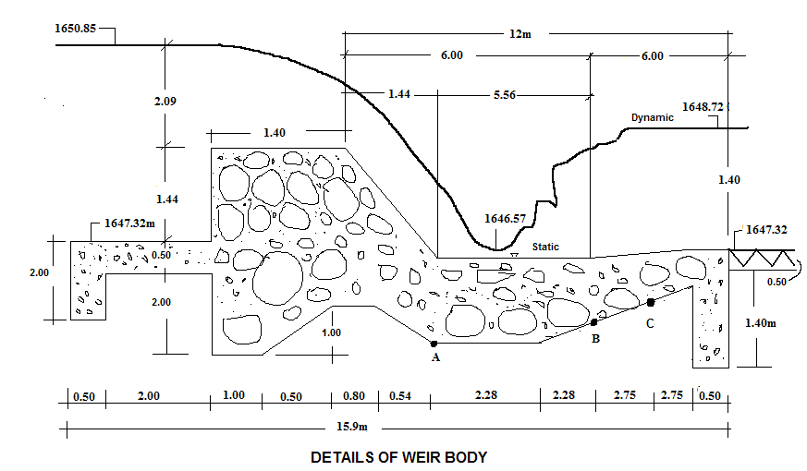
Figure 1-6: Detail section of weir body

Maximum head on the structure
* Dynamic case= Head water- tail water = 1650.85-1648.92 = 1.93m
* Static case = weir crest -river bed =1.44m
L_{c}= Σlv + 1/3 Σlh ………………………………………………………………………………………………………………..…… Eq20
L_{C} = (2+1.5 + 2.0+1.0+1.4) + 1/3 (15.9) = 7.90 + 5.30 = 13.20m
Hence thickness of each point will be:
Point A 1.38>1.375 (Dynamic case)
Point B 0.8>0.77 (static case)
Point C 0.6> 0.52 (static case)
Weighted creep ratio = L_{c}/ Head on structure = 13.2/2.09 = 6.32
According to Lane's recommended ratios, this structure would be safe from piping on either clay or on fine sand. The base material of the river consists of fine sand. Therefore the length of the apron is sufficient to prevent the piping,

Lane recommends; C = 7
L > CH → 7x1.44 = 10.08m
15.9 > 10.08 Safe!

Exit gradient
The final exit up ward thrust should not exceed certain value for the foundation material to avoid piping; safe exit gradient for course silt is 0.17-0.14.
Khosla formula to determine exit gradient at downstream side for structure with floor length (b) and vertical cut off (d)
G_{E} = H/d* …………………………………………………………..Eq21
Where 1= =1/2+ α=b/d
GE must be less than 0.17 to 0.14 for this case
Table 1-4: Safe exit gradient against soil type
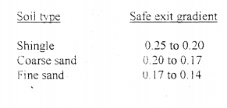
α = b/d =15.9/1.4 =11.36 …………………………………..………..Eq22
λ= 1+ ……………………………...…….Eq23
G_{E}= ………………………….…..…Eq24

Recommended G_{E} is 0.17 to 0.14 and 0.169 is fulfilled the critical values stated by Khosla thus it is safe to use 1.40 m cutoffs at downstream!
Note: - Use weep holes for guide walls, pressure relief holes for downstream apron and expansion joint for long masonry work
Use free board for guide wall of 0.50m and thus total height of wall is 1.44 + 2.09+0.50 = 4.03m at upstream. For downstream wall 1.6+0.50 = 2.10m, take 4.03m for typical stability analysis.

Stability Analysis of weir

Dynamic Case
Conditions:
- Up lift pressure was considered for the General weir section; p_{u} = _{gw}h_{t}²/2
- Downstream water pressure was considered; p_{d} = g_{w}h²/2
- Water wedge weight was considered for weir crest only; W_{w}= g_{w}A
- Upstream water pressure was considered; P_{u2} = g_{wh}²/2
- Dead weight also considered; W1 ₌ g_{c}A
Where:
g_{w}- Unit Wt of water which is 10kN/m³ and
g_{c} - unit Wt of masonry work that is 23kN/m³
Area in m²
h- Height that the pressure apply on it, in m
Moment is taken about the toe per meter width.

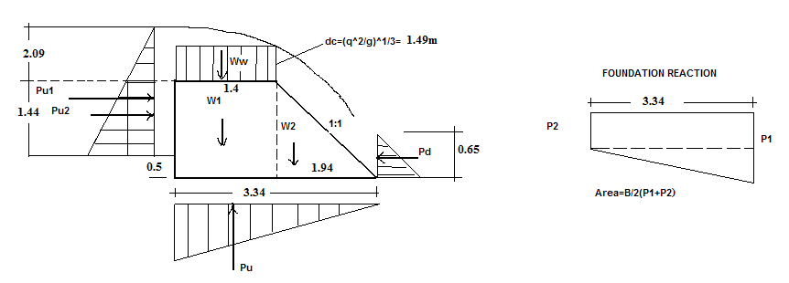
No | Item | Force (KN) | Arm (m) | Moment (KN.m) | Sum
1 | P_{u1} =(_{w}(2.31²/2) x 0.8 | 31.45 | 1.29 | -40.68 | -189.57
2 | P_{u2} = _{wh}²/2 | 10.37 | 0.98 | -10.16 | -189.57
3 | p_{u} = _{w}h_{t}²/2 | 62.30 | 2.23 | -138.73 | -189.57
4 | p_{d} = _{w}h²/2 | 2.09 | 0.22 | 0.45 | 285.88
5 | W_{w} ⁼ _{ w}A | 20.81 | 2.64 | 54.93 | 285.88
6 | W1 _{= c}A | 65.18 | 2.64 | 172.09 | 285.88
7 | W₂ = _{cA} | 45.16 | 1.29 | 58.41 | 285.88
8 | Foundation reaction | 1.67(P₁₊p₂) |  | B²(p₁+2p₂)/6 1.86(p1+2p2)

Foundation Reaction
1) 1.67(p₁+p₂) = ΣV = 68.85………………………………………………………...Eq25
2) 1.86(p₁+2p₂) = ΣM = 96.31………………………………………………………Eq26
p₁+p₂ = 41.23 p₁ = 10.55 KN
p₁+2p₂ = 51.78 p₂=30.68KN
Allowable bearing capacity of foundation material was taken 10 ton/m² for silt formation is (100KN/m2) and thus it is safe.

Safety factors

Over turning satiability
0 = Σm+/Σm- ……………………………………………………………..Eq27
= 285.88/189.57 = 1.51> 1.5 ok.

Sliding safety factor:
Ss = ΣH/ ΣV<f ………………………………………………………….….Eq28
Where f = 0.65 for this case
S_{s} = 39.73/68.85 < f
S_{s} = 0.58< 0.65 ok!

Check for tension:
x = Σm/ΣV ………………………………………………………………….Eq29
= 96.31/68.85 = 1.4m and eccentricity for no tension
e≤ B/6,……………………………………………………………………...Eq30
e = ⎢(B/2)-x⎢ ≤ B/6 that is =⎢1.67-1.4⎢ ≤ 3.34/6
= 0.27≤0.56 ok no tension!

Static case
S.N | Item | Force (KN) | Arm (m) | Moment (KN.m) | Sum
1 | PU1 | 10.37 | 0.98 | -10.16 | -33.25
2 | PU | 10.37 | 2.23 | -23.09 | -33.25
3 | W1 | 65.18 | 2.64 | 172.09 | 230.50
4 | W2 | 45.16 | 1.29 | 58.41 | 230.50

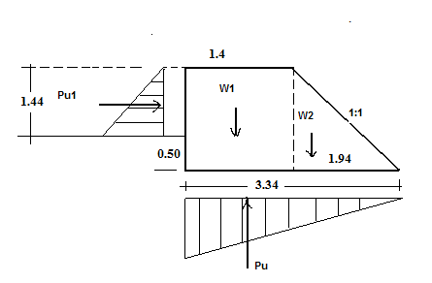

Safety factors

Over turning satiability
So = Σm+/Σm-…………………………………………………………….Eq31
= 230.5/33.25 = 6.93>1.5 ok!

Sliding safety factor:
Ss = ΣH/ΣV < f…………………………………………………………...Eq32
= 10.37/99.98= 0.10<0.65

Check for tension:
X = ΣM/ΣV………………………………………………………………..Eq33
=197.25/99.98 = 1.97
e = 0.30 < 0.56 ok no tension upstream.

Design of Wing walls
Considerations:
- Analysis per meter span and moment about heel.
- Earth pressure at rest was considered.
- Drained silty clay back fill was considered.
- γ_{m} = 23 KN/m³, γ_{w} = 10KN/m³, γ_{soil} = 18kN/m³
- Drained angle of internal friction was taken 28⁰
- p_{s}= ½ k_{o}γ_{s} H² where K₀= 1-sinϕ and hence p_{s} = 39.61KN/m
Force (KN) | Sum of forces | Arm (m) | Moment (KNm) | Sum of moments
P_{s =} | 39.61 | 1.34 | -53.21 | -53.21
Ws₁₌ | 27.27 | 1.56 | 42.64 | 174.11
WS₂₌ | 27.27 | 1.75 | 47.72 | 174.11
Wm₁₌ | 34.85 | 0.25 | 8.71 | 174.11
Wm₂₌ | 34.85 | 0.83 | 29.04 | 174.11
Wm₃₌ | 46.00 | 1.00 | 46.00 | 174.11

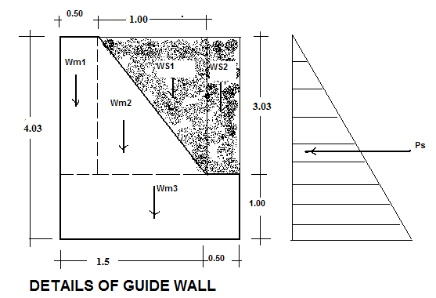
Figure 1-7: Details of guide wall

Safety against overturning
174.11/53.21 = 3.27 > 1.5 ok

Safety against sliding
39.61/170.23 = 0.23 < 0.65 OK

Location of resultant (middle-third- rule)
X = ΣM/ΣV = 120.9/170.23 = 0.71
e = ⏐(B/2)-X⏐ = ⏐1-0.71⏐ = 0.29
e ≤ B/6 = 0.33m →0.29 < 0.33 Ok!

Backwater effect
Due to the new barrier it is obvious that the raise in flood height will cover extra banks and this was considered in the design to protect effects by flood protection dyke and keep flood height of 2.09m above crest not to result any upstream damages.

Intake Gate
The intake level is fixed to 1648.46m. Opening diameter by general Orifice formula for free outflow is 30 cm concrete pipe. Here the head required above center of pipe to create flow of 16.69 l/s is 0.014m. It is to be operated by spindle gate. One-way intake was proposed.

Silt Gate
The silt gates are located adjacent to the intake gate. There is one flushing gates on intake side. They are 0.70m lower than the intake level i.e. 1647.46. It is 0.60m wide. Hence depth below crest level is 1.00m; this gate is to be operated (lifted) manually during the rainy season. The plate thickness shall be 5mm thick.

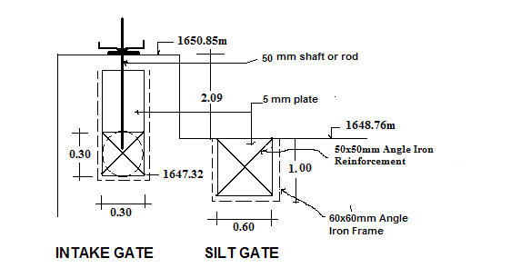
Figure 1-8: Section of intake and silt gates

IRRIGATION AND DRAINAGE

Design Criteria
The irrigation design project needs to be simple so that users can understand and participate in the operation and maintenance. Complex designs are avoided as much as possible. Designing cost effective structures is taken as one of the approaches in this study and design work. The irrigation system and structures are designed to use the water as efficient as possible by minimizing the losses in conveyance, distribution and application system. In this context, the criteria proposed to be adapted for the planning and design of Dalole small scale irrigation project is discussed below under various heads/sub heads.

Irrigation System Design
The planning and layout of an irrigation system design is dictated by the area to be irrigated and the source of water supply. The data considered for designing irrigation system are:
- The water resources to be used, including source of water, flow rates/ availability and water quality
- Topography of the land surface
- The physical and chemical characteristics of the soil, including infiltration rates, soil moisture holding capacities, salinity
- Expected cropping pattern
- Economic and marketing situation in the area and the availability of services, including the availability of labor (family labor), maintenance services by the farmers themselves

Before commencement of design of entire irrigation structure, the detailed irrigation and drainage system layout were prepared. This layout contains information on field configuration, canal networks, natural drainage channels network, field drains, access roads and service roads, etc. Key dimensions for all layout components and irrigation and drainage infrastructure are determined.

Ground level profiles of canal systems are also taken and analyzed in accordance with the acceptable field layout. The detail levels are then used for the longitudinal and cross section of the canals and drains and to determine the levels of canal control and regulating structures.

Dalole main canal that carries water directly from the diversion weir is divided into two, which are one secondary canal and one tertiary canal directly off taking from the main canal. The design of the canal is concerned with the determination of the cross sectional dimension of the canal to convey the required discharge needed to meet the peak requirement of crops grown in the entire command area. The whole section of the canal is designed for adequate capacity, to provide sufficient capacity.

The main conveyance canal is designed as lined and the other distribution systems are designed as unlined section, based on the criteria such that the canal is non-silting when conveying sediment-laden water, and non-scouring when conveying silt-free water.

The canal flows were classified as steady and uniform and were designed using the Manning’s equation for open canals.

$Q = A * V$………………………………………………………Eq34
Where: Q = Discharge (m³/s)
A = Average of cross-section (m²)
V = Average velocity (m/s)

The velocity of flow was computed using Manning Formula as follows.
$V=\frac{1}{n}*R^{2/3}*S^{\frac{1}{2}}$…………………………………………………….Eq35

Where: V = Average velocity (m/s)
n=Rugosity coefficient, depends on canal material roughness
R = Hydraulic mean radius (m)
S = Bed slope of canal

Design of Main Canal system
The purpose of canal system design is to provide water, adequate in quantity and command to all farms within the area serviced. The system should be convenient to operate and should blend with the pattern of farming. Canals are normally designed to properly distribute water to a system that will make irrigation easy and efficient.

The conveyance and distribution systems include the main and tertiary canals that distribute water to the field canals. The main and tertiary canals will have a constant volume of water in each reach. Flows in the field canals are distributed among farmers according to the size of land holding on a time sharing basis i.e. a farmer will take the full field flow for a scheduled period of time. This allocation is managed by the farmers themselves, through their Water Users’ Association.

It is designed to supply the irrigation water from the diversion weir. The detail hydraulic computation is shown in Table 2-1. The longitudinal profile and cross section of the main canal is shown on Figure 2-1.The values of the design parameters of the typical main canal are shown in Table 2-1.

Flow = 16.96 l/s
Bed slope of canal = 0.001
Velocity in earth canal for clayey soil = 0.60-0.70m/s,

Q = A/n R ^{3/2} s ½…………………………………………………..……….Eq36 n = 0.025 for earth
n = 0.014 for lined section

- Economical lined Rectangular section criteria;
B = 2y………………………………………………………………………….Eq37 R = y/2………………………………………………………………………..Eq38
Where
B = bed width of canal
y = water depth
R = Hydraulic radius
y = 0.13m B= 0.26m V =0.58m/s F=0.25m D= 0.38m

- Economical Earthen Trapezoidal section criteria:
B = 0.6y, m=1.5for canal inner side slope
R = y/2
$A= y(b+my)$……………………………………………………………..Eq39
$P=b+2y\sqrt{m^{2}+1}$…………………………………………….……………Eq40
y=0.12 B=0.2 V= 0.48m/s F=0.25 D= 0.37 w=0.50m

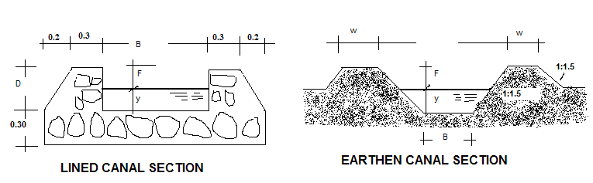
Figure 2-1: Lined and Earthen canal section

Design of Earthen Tertiary canals
The water budget for the condition that continuous flow in main, secondary and tertiary canal and rotated flow in field canals for duty of 0.53l/s/ha it could be seen that the flow that is required for each area when multiplied by the duty is less than the stream size required to irrigate 1ha of land per day in 10 hr irrigation. Unit flow or stream size q:
q_{t} =DA ……………………………………………..……………………….Eq41
Where q= unit flow (m3/s)
t= irrigation time per day (10 hr)
D= depth of application (168mm or 0.168m for this case)
A= Area to be irrigated (1ha)
Hence q=0.168m*(100mx100m)/(10*60*60)=0.047m3/s=47l/s

It is this stream size that was used to design each tertiary canal as Duty times Area is less than 47l/s for each tertiary canal in the system layout plan.
Q=16.96l/s n = 0.025 m=1.5
The condition B = 0.6y provides non practical Bed width & thus use B = 0.20 and determine y:
For slope 0.003 v=0.32m/s B=0.15m y=0.07m F=0.25 D=0.32m w=0.40m
For slope 0.002 v=0.24m/s B=0.15m y=0.06m F=0.25 D=0.31m w=0.40m
Here though the flow velocity is slightly smaller, it was accepted & silt clearance may be frequent.
 | Table 2-1: Summary of canal dimension
Canals |  | Q(m³/s) | V(m/s) | b(m) | y(m) | F | D(m) | m | slope | w(m)
Lined MC |  | 0.017 | 0.78 | 0.24 | 0.12 | 0.25 | 0.37 | 1 | 0.002
Earthen MC |  | 0.017 | 0.46 | 0.20 | 0.11 | 0.25 | 0.36 | 1.5 | 0.002 | 0.4
SC-1 |  | 0.007 | 0.340 | 0.150 | 0.100 | 0.25 | 0.35 | 1.5 | 0.002 | 0.4
TC-1 |  | 0.006 | 0.323 | 0.150 | 0.070 | 0.25 | 0.32 | 1.5 | 0.003 | 0.4
TC-2 |  | 0.003 | 0.236 | 0.150 | 0.06 | 0.25 | 0.31 | 1.5 | 0.002 | 0.4

Design of field channels
Field channel is designed as an open channel aligned along the natural slope. The bed width, water depth and side slopes of 1:5 Vertical: Horizontal of the field channel designed is to be used for distributing the required discharge is varied. The channel is designed using Manning’s equation. The Typical longitudinal section is shown on drawing.

Design of furrow irrigation methods

2.2.4.1 Selection of irrigation methods
The selection of irrigation method/system is largely influenced by the topographic nature of the command area, soil and crop type that is planned to be grown. Farmers experience and level of technology being used in ploughsystem are also other important factors, which have got considerable impact on the selection of irrigation methods.

The morphological feature of the area is characterized by undulating valley bottom flanked by valley slopes 1 to 5% slopes and it is suitable for contour furrow. Furrow method of application is quite suitable for row crops like maize, potatoes, and vegetables and adaptable to most soils of different textures. The actual irrigation operation will be carried out according to irrigation schedule to be worked out on the basis of the stage of crop development, prevailing climatic data and water management practices to be adopted during operation of the system.

In this project, with the help of development agents supported with necessary trainings, the farmers are supposed to construct the contour furrow on their own farm lands.

Drainage Modulus

Rational method of flood determination
Q = 2.78 CiA……………………………………………………………..Eq42
Where
C = 0.3, Constant that depend on catchment character,
i = Intensity of rainfall for time of concentration, in cm/hr
A = Area of catchment in km² = 5ha=0.05km²

Time of Concentration t_{c}
t_{c} = 1/3000 ………………………………………………..Eq43
Where
L= Length of remotes point in watercourse: 1400m
S= Slope of the water course for well managed irrigation farm = 0.002
t_{c} = 0.96hr

Intensity of rainfall, i for time of concentration t_{c} is then,
i = R₅₀/t_{c}…………………………………………………………………Eq44
= 89.86mm/0.96 hr= 93.12mm/hr = 9.312cm/hr
Q = 2.78CiA
Q = 2.78x0.30x9.312x0.055
Q =0.43m3/s for 5.5ha area and thus 21.36l/s/ha for 1 ha area.

As stated earlier the runoff expected from design storm results in 21.36l/s/ha. For the major cut off drain along the main canal maximum area draining towards the conveyance canal is 5.5ha between outlet points, which result in 427.16l/s flow to be intercepted at various points on the canal route and natural drains. Thus it was designed for this flow manning roughness co-efficient of 0.03 was adopted. And as per the IDD manual in design of drainage canals the following standard bed widths are to be adopted for the corresponding flows:
B=0.40m for Q<100l/s
B=0.50m for 100<Q<150l/s
B=0.60m for 150<Q<200l/s
B=0,80m for Q>200l/s

Hence for the main drain or cutoff drain the design parameters are as follows:
Q = 0.43m³/s m =1.5 S = 0.002 n = 0.03 B = 0.80m
Q = A/n R ^{2/3} S ^{1/2}…………………………………………………………….………Eq45
Thus for B = 0.80

B | Y | n | A | p | R | S | Q | V | F | D
0.80 | 0.70 | 0.03 | 1.30 | 15.59 | 0.083 | 0.002 | 0.43 | 0.33 | 0.2 | 0.90

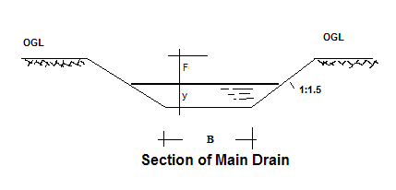
Figure 2-2: Main drain section

Majority of the area drain to natural drainage routes and thus it was not essential to consider flow hydraulics of these natural water courses, but it is obvious that the local community has take care of these drainage courses not to develop gullies.

Design of Pipe Culverts
Adopt velocity in pipe greater than 1m/s design under partial flow condition each culvert is designed to pass supply flow designed for each canal.

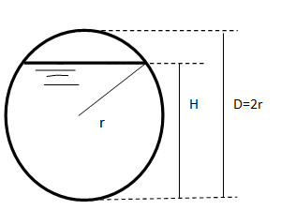

Figure 2-3: Section of pipe culverts

H= 0.8D
For table for H/r = 1.60 ∝ = A/r² = 2.694 p/r = 4.428 β= R/r = 0.608
For D = 0.10 → A = 0.006735 P = 0.2214 R = 0.0304
For D = 0.20 → A = 0.02694 P= 0.4428 R = 0.0608
For D = 0.25 → A = 0.0420 P = 0.5535 R = 0.0759
For D = 0.30 → A = 0.0606 P = 0.6642 R = 0.0912
For D = 0.40 → A = 0.1078 P = 0.8856 R = 0.1216
For D = 0.50 → A = 0.1684 P =1.107 R = 0.1520
For D = 0.60 → A = 0.2425 P = 1.328 R = 0.1824
For D = 0.80 → A = 0.4310 P = 1.1771 R = 0.2432
For D = 1.00 → A = 0.6735 P = 2.214 R = 0.3040

Downstream water level = u/s canal water level-Hydraulic losses
Hydraulic loss=1.2 (V₂²-V₁²)/2g + friction loss………………………………………..Eq67
Friction loss for canal bed slope, I =IL………………………………………………….Eq68

Table 2-2: Summary of pipe culvert design
For table for H/r = 1.60  = A/r² = 2.694 p/r = 4.428 = R/r = 0.608
Item | Flow (l/s) | Pipe Diameter (m) | Flow Area (m²) | V_{2 (m/s)} | V_{1 (m/S)} | Span, L | I | 1.2(V₂²-V₁²)/2g | IxL | Total Hydraulic loss | Level difference adopted (m)
Culvert (Typical) | 0.017 | 0.19 | 0.024 | 0.7 | 0.64 | 6 | 0.002 | 0.0048 | 0.012 | 0.017 | 0.1
Culvert (Typical) | 0.006 | 0.12 | 0.010 | 0.6 | 0.55 | 4 | 0.005 | 0.0049 | 0.02 | 0.025 | 0.1

Design of Aqueducts
Here since the pipe length is too short, total hydraulic loss is negligible, and hence it was designed to pass, the maximum drainage based on the drainage module previously stated.

The orifices formula governs the flow through the pipe under.

Q=CA √(2gh) ……………………………………-………………………….Eq69
Where C={1.1+0.026L/(D) ^{1.2} }^{-0.50} for concrete pipe of beveled lip entrance
h= level difference between upstream and downstream water surface.
A=0.1964 for diameter=0.50m
A=0.2827 for diameter=0.60m
A=0.5027 for diameter=0.80m

Table 2-3: Summary of Aqueduct
Particular | Canal Above | Canal below | Drainage flow (m³/s) | Pipe size(d) | Maximum length L (m) | C | Min. h(m) | Area | Flow for head h | Remark
Aqueduct (Typical) | MC | MD | 0.43 | 0.44 | 1.1 | 0.92 | 0.48 | 0.15 | 0.427 | Canal above is trapezoidal

Design of turnout and Field off takes
The flow in turnouts and field off takes is governed by the orifice formula. It basically depends on the pipe size and head creating flow.
Q=C_{d}A√(2gh)…………………………………………………………………Eq70

Where h=y-(D/2), Creating flow in meter
A=πD²/4, area of pipe
C_{d -}Coefficient of discharge,
0.80 - submerged out flow and
0.62 - free out flow,
g- Acceleration due to gravity 9.81 m/s
Each turn out is to be controlled with simple shutters with chain to lift to required level:

Table 2-4: Summary of turnout
Turnout | On canal | Q (m³/s) | Y(m) | (4Q/3.14C)²/  19.62 | Trial value of D (m) | D⁴(y - 0.5D) | Diameter Adopted (cm)
TO(Typical) | Mc | 0.017 | 0.13 | 0.00061 | 0.25 | 0.000020 | 25 controlled
FOT (Typical) | Sc | 0.01 | 0.09 | 0.00021 | 0.1 | 0.000004 | 15 controlled
FOT (Typical) | Tc | 0.006 | 0.087 | 0.00008 | 0.1 | 0.000004 | 15 controlled

Design of Vertical Drop (U.S.B.R.Type)
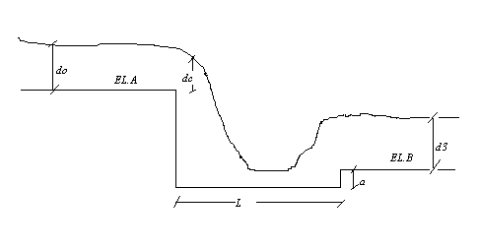
Figure 2-4: Section of vertical drop design

Input Parameters:
- Discharge - Q
- Upstream water depth - h₁
- Upstream water velocity - v₁
- Downstream water depth - h₂
- Downstream water velocity - v₂
- Drop - ht z

Drop width: bc=0.734 Q/(h1)1.5
Unit discharge=q=Q/bc
Critical depth: hc=(q2/g)1/3
Stilling basin:
Basin width: B=18.46(Q)½/(Q+9.91)
Basin length: L=[2.5+1.1(hc/z)+(hc/z)3](z*hc)0.5
Lip height: a =hc/2
U/s Transition Length: L = B + 3/2Q1/2
Dimensions that are not convenient during construction were changed reasonably.

Table 2-5: Summary of Vertical Drop Calculation
Drop on Canal | Q | Drop ht | Drop width(bc) | Basin width(B) | q | dc | Basin length(L) | Lip ht | U/s Transition
MC | 0.017 | 1.20 | 0.27 | 0.24 | 0.06 | 0.07 | 0.77 | 0.04 | 0.44
MC | 0.017 | 1.00 | 0.27 | 0.24 | 0.06 | 0.07 | 0.71 | 0.04 | 0.44
MC | 0.017 | 0.80 | 0.27 | 0.24 | 0.06 | 0.07 | 0.64 | 0.04 | 0.44
MC | 0.017 | 0.50 | 0.27 | 0.24 | 0.06 | 0.07 | 0.52 | 0.04 | 0.44
SC | 0.01 | 1.00 | 0.16 | 0.19 | 0.06 | 0.07 | 0.71 | 0.04 | 0.34
SC | 0.01 | 0.80 | 0.16 | 0.19 | 0.06 | 0.07 | 0.64 | 0.04 | 0.34
SC | 0.01 | 0.60 | 0.16 | 0.19 | 0.06 | 0.07 | 0.56 | 0.04 | 0.34
SC | 0.01 | 0.50 | 0.16 | 0.19 | 0.06 | 0.07 | 0.52 | 0.04 | 0.34
TC | 0.006 | 1.00 | 0.16 | 0.19 | 0.06 | 0.07 | 0.71 | 0.04 | 0.34
TC | 0.006 | 0.80 | 0.16 | 0.19 | 0.06 | 0.07 | 0.64 | 0.04 | 0.34
TC | 0.006 | 0.60 | 0.16 | 0.19 | 0.06 | 0.07 | 0.56 | 0.04 | 0.34
TC | 0.006 | 0.50 | 0.16 | 0.19 | 0.06 | 0.07 | 0.52 | 0.04 | 0.34

ANNEX
BILL OF QUANTITIY, SPECIFICATION
AND COST ESIMATE

Annex 1: Bill of Quantity, Specification and Cost Estimate
BILL OF QUANTITY, SPECIFCATION AND COST ESTIMATE
Project - Dalole SSIP
No | Item | Unit | Qty | Unit Rate | Amount
1 | Access road clearance ordinary soil | Km | 5.00 | 6,000.00 | 30,000.00
2 | Mobilization and Demobilization | Ls | 1.00 | 10,000.00 | 10,000.00
3 | Camping
 | A. Living rooms 4(3mx3m)
 | B. Store 1(5mx5m)
 | C.Kitchen1 (3mx3m)
 | D. Guard house1 (2.5x 2m)
 | E. Toilet house1 (2.5x 2m)
 | F.Office1 (3x3)
 | G. Fencing
3.1 | Site clearance | m² | 132.72 | 35.10 | 4,658.47
3.2 | Trench and other excavations | m³ | 38.00 | 128.70 | 4,890.60
3.3 | Stone masonry | m³ | 32.28 | 1,650.53 | 53,279.15
3.4 | 20 cm hard core | m³ | 49.05 | 1,359.82 | 66,702.61
3.5 | 10 cm lean concrete (1:2:4) mix | m³ | 24.53 | 2,442.51 | 59,905.65
3.6 | CIS walling (G-32) | m² | 249.20 | 324.00 | 80,740.80
3.7 | CIS roofing (G-32) | m² | 146.40 | 324.00 | 47,433.60
3.8 | Fencing | m | 160.00 | 80.00 | 12,800.00
 | Total Carried To Summary |  |  |  | 370,410.89
4 | Headwork (16m span Masonry Broad Crested Weir)
4.1 | Site clearance | m² | 418.00 | 35.10 | 14,671.80
4.2 | Coffer dam for temporary flow diversion with sand filled bags(dry time flow is estimated to 30 l/s and river span about 10m | m³ | 36.00 | 156.00 | 5,616.00
4.3 | Excavation for temporary diversion channel |  |  |  | -
4.3.1 | Soft soil formation | m³ | 30.00 | 128.70 | 3,861.00
4.4 | Excavation for foundations |  |  |  | -
4.4.1 | Soft soil formation | m³ | 569.29 | 128.70 | 73,268.23
4.4.2 | Rocky soil (Soil with cobbles) | m³ | 55.83 | 255.00 | 14,235.94
4.5 | Compacted rock fragments on loose foundation to avoid differential settlements | m³ | 25.38 | 117.00 | 2,968.99
4.6 | Lean concrete works for foundation (1:2:4 mix) | m³ | 329.89 | 2,442.51 | 805,755.33
4.7 | Lean concrete for Brest wall and Gate operating slab (1:2:4) mix | m³ | 3.96 | 2,442.51 | 9,669.42

No | Item | Unit | Qty | Unit Rate | Amount
4.8 | Masonry bedded in 1:3 mortar | m³ | 216.26 | 1,650.53 | 356,943.50
4.9 | Plastering in 1:3 mortar | m² | 237.10 | 119.00 | 28,214.58
4.10 | Manually lifted silt gate of size 60x50cm and 5mm thick plate in 60x60 mm angle iron slot well reinforced as per drawing, fixed in position | Pcs | 1 | 3,000.00 | 3,000.00
4.11 | Intake gate operated by spindle and shaft with square thread, plate size is 600x500x5mm as per drawing and specifications, fixed in position | Ls | 1 | 4,500.00 | 4,500.00
4.12 | Dia 30 cm concrete pipe supply and fix in position | Pcs | 6 | 2,500.00 | 15,000.00
4.13 | Fill and compactions with red clay | m³ | 242.915 | 156.00 | 37,894.71
4.14 | Rip raping | m³ | 15.00 | 252.17 | 3,782.48
 | Total Carried To Summary |  |  |  | 1,379,381.97
5 | Ford Structures for River crossing (1 No)
5.1 | Excavation for on ordinary soil | m³ | 82.26 | 128.70 | 10,586.86
5.2 | Lean concrete with 1:2:4 ratio | m³ | 9.36 | 1,650.53 | 15,448.97
5.3 | RCC in 1:2:4 mix as per reinforcement detail of drawing | m³ | 27.00 | 4,749.84 | 128,245.71
5.4 | Red clay back fill and compactions | m³ | 0.64 | 156.00 | 99.84
 | Total Carried To Summary |  |  |  | 154,381.38
6 | Lined Conveyance Canal(MC)-625m long
6.1 | Soil Excavations
6.1.1 | Soil excavation | m³ | 612.50 | 128.70 | 78,828.75
6.2 | Hard core well blinded with 1:3 mortar | m³ | 171.875 | 1,359.82 | 233,719.21
6.3 | Masonry bedded in 1:3 mortar | m³ | 200 | 1,650.53 | 330,106.28
6.4 | Lean concrete with 1:2:4 ratio | m³ | 18.75 | 2,442.51 | 45,797.10
6.5 | Plastering in 1:3 mortar | m² | 875 | 119.00 | 104,122.07
6.6 | Fill and compactions with red clay | m³ | 243.75 | 156.00 | 38,025.00
 | Total Carried To Summary |  |  |  | 830,598.40
7 | Secondary canals (790m)
7.1 | Soil Excavation | m³ | 165.9 | 128.70 | 21,351.33
7.2 | Fill and compaction | m³ | 47.4 | 156.00 | 7,394.40
 | Total Carried To Summary |  |  |  | 28,745.73
8 | Tertiary canals (1937m)
8.1 | Soil Excavation | m³ | 364.35 | 128.70 | 46,891.81
8.2 | Fill and compaction | m³ | 154.96 | 156.00 | 24,173.76
 | Total Carried To Summary |  |  |  | 71,065.57
9 | Drainage canals
9.1 | Main Drain (cutoff drain) excavation (625m) | m³ | 375 | 128.70 | 48,262.50
9.2 | Tertiary drain excavation (1500m) | m³ | 360 | 128.70 | 46,332.00
9.3 | Fill and compaction with red clay | m³ | 146 | 156.00 | 22,776.00
 | Total Carried To Summary |  |  |  | 117,370.50

No | Item | Unit | Qty | Unit Rate | Amount
10 | Drop structure(37No)
10.1 | Excavation on ordinary soil | m³ | 155.74 | 128.70 | 20,044.30
10.2 | Hard core well blinded with 1:3 mortar | m³ | 46.49 | 1,359.82 | 63,219.24
10.3 | Masonry bedded in 1:3mortar | m³ | 39.85 | 1,650.53 | 65,772.53
10.4 | Plastering in 1:3 mortar | m² | 132.83 | 119.00 | 15,806.45
10.5 | Lean concrete works(1:2:4 mix) | m³ | 0.40 | 2,442.51 | 978.92
10.6 | Fill and compaction with red clay | m³ | 3.65 | 156.00 | 569.85
 | Total Carried To Summary |  |  |  | 166,391.28
11 | Turnout (4No)
11.1 | Excavation on ordinary soil | m³ | 8.40 | 128.70 | 1,081.08
11.2 | Hard core well blinded with 1:3 mortar | m³ | 5.61 | 1,359.82 | 7,630.99
11.3 | Masonry bedded in 1:3 mortar | m³ | 5.46 | 1,650.53 | 9,009.96
11.4 | Plastering in 1:3 mortar | m² | 15.39 | 119.00 | 1,831.15
11.5 | Dia 15 cm concrete pipe supply and fix in position | Pcs | 4.00 | 2,000.00 | 8,000.00
11.6 | Gates of size 450x300x3mm in 40x40 mm angle iron slot(frame) and 1m long chain to control flow rates as per drawing | pcs | 4.00 | 2,500.00 | 10,000.00
11.7 | Red clay fill and compaction | m³ | 5.99 | 156.00 | 934.16
 | Total Carried To Summary |  |  |  | 38,487.35
12 | Field offtakes (22in No)
12.1 | Soil Excavation | m³ | 13.15 | 128.70 | 1,692.79
12.2 | Hard core well blinded with 1:3 mortar | m³ | 4.22 | 1,359.82 | 5,734.12
12.3 | Masonry bedded in 1:3mortar | m³ | 2.16 | 1,650.53 | 3,571.13
12.4 | Plastering in 1:2 mortar | m² | 22.60 | 119.00 | 2,689.05
12.5 | Supply and install Dia 15 cm concrete pipes | pcs | 10.00 | 500.00 | 5,000.00
12.6 | Steel Shutters(gates) as per drawing | lps | 10.00 | 800.00 | 8,000.00
12.7 | Red clay Fill and compaction | m³ | 1.20 | 156.00 | 187.94
 | Total Carried To Summary |  |  |  | 26,875.03
13 | Aquiducts(1No)
13.1 | Excavation on ordinary soil | m³ | 14.16 | 128.70 | 1,822.39
13.2 | Hard core well blinded with 1:4 mortar | m³ | 5.71 | 1,359.82 | 7,770.40
13.3 | Masonry bedded in 1:3 mortar | m³ | 0.25 | 1,650.53 | 412.63
13.4 | Lean concrete works(1:3:6 mix) |  | 4.90 |  | -
13.5 | Plastering in 1:3 mortar | m² | 19.32 | 119.00 | 2,299.02
13.6 | Concrete pipe of 50 cm diameter supply and install as per drawing | Pcs | 1.00 | 1,500.00 | 1,500.00
13.7 | Red clay fill and compaction | m³ | 6.24 | 156.00 | 973.89
 | Total Carried To Summary |  |  |  | 14,778.33

No | Item | Unit | Qty | Unit Rate | Amount
14 | Pipe Culverts (5No)
14.1 | Excavation on ordinary soil | m³ | 32.62 | 128.70 | 4,198.48
14.2 | Hard core well blinded with 1:4 mortar | m³ | 14.29 | 1,359.82 | 19,426.01
14.3 | Lean concrete works(1:2:4 mix) | m³ | 0.63 | 2,442.51 | 1,526.57
14.4 | Masonry bedded in 1:3 mortar | m³ | 12.25 | 1,650.53 | 20,219.01
14.5 | Plastering in 1:3 mortar | m² | 48.30 | 119.00 | 5,747.54
14.6 | Concrete pipe of 15 cm diameter supply and install | Pcs | 1.67 | 1,000.00 | 1,666.67
14.7 | Concrete pipe of 20 cm diameter supply and install | Pcs | 3.33 | 1,200.00 | 4,000.00
14.8 | Selected fill and compaction | m³ | 15.61 | 156.00 | 2,434.71
 | Total Carried To Summary |  |  |  | 59,218.99
 | Total Project Cost |  |  |  | 3,257,705.43
 | VAT (15%) |  |  |  | 488,655.81
 | Grand total |  |  |  | 3,746,361.24

