Table of Content
Table of Content i
LIST OF TABLES iii
LIST OF FIGURES iv
Executive summary 1
1. INTRODUCTION 4
1.1 Background 4
1.2 The Project Area 4
1.2.1 Project Location and Accessibility 4
2 DESCRIPTION OF WORKS 6
2.1 General Description 6
2.2 Dam Body 6
2.3 Spillway 6
2.4Irrigation outlet 7
3. HYDROLOGY 7
3.1 General 7
3.2 Project Area 7
3.3 Analysis of Climate Data 8
3.3.1 Rainfall 8
3.4 Flood Estimation 8
3.5 River flow Estimation for Water Harvesting 15
3.5.1 Estimating Total Flow Potential 15
3.5.2 Evaporation loss from Reservoir Area 20
3.6 River Morphology and Sediment Analysis 21
4. GEOLOGY AND GEOTECHNICAL INVESTIGATION 23
4.1 Regional Geology 23
4.2 Geologic Structures 23
4.3 Local Geology 24
4.3.1 Alluvial deposits 24
4.3.2 Volcanic rock units 24
4.4 Geological features of dam sites 25
4.4.1 Geological features along the dam axis 25
4.5 Geotechnical Investigation 26
4.5.1 Geophysical Investigation 26
4.6 Seismicity of the Study Area 27
4.7 Construction Materials Investigations 28
4.7.1 Background 28
4.7.2 Natural construction materials 29
5. Dam Site & type Selection 32
5.1 Location and Dam site 32
5.2 Type of Dam 32
5.2.1 Earth fill Dam 32
5.2.2 Gravity Dam 34
6. Dam Design 37
6.1 General 37
6.1.1 Topographic Features 37
6.1.2 Alignment 37
6.1.3 Dam Axis and Spillway Geologic Features 38
6.1.4 Available Construction Materials 38
6.2 Foundation Condition and Preparation 39
6.3 Seepage Control Measures through the Dam Foundation 39
6.3.1 Cutoff Trench 39
6.4 Dam Design Sectional Elements 41
6.4.1 General 41
6.4.2 Free Board 41
6.4.3 Dam Crest Elevation 42
6.4.4 Dam Crest Width 42
6.4.5 Dam Zoning 43
6.4.6 Slope Protection 45
7. Dam Slope Stability & Deformation Analyses 45
7.1 Upstream and downstream slopes 45
7.1.1 General 45
7.1.2 Slope Stability Analysis 46
7.1.2.1 Steady State Analysis 46
7.1.2.2 During/End of Construction 48
7.1.2.3 Upstream Drawdown 49
7.2 Slope stability analysis with earthquake loading 50
7.2.1 Pseudo static Analysis 50
7.3 Static Stress Deformation Analysis 52
8 SPILLWAY WORKS 53
8.1 General Design Considerations 53
8.2 Spillway inflow and outflow design flood 53
8.3 Type of spillway and selected scheme 53
8.4 Location and alignment of spillway 54
8.5 Hydraulic design of spillway 54
8.5.1 Discharge over the Chute Crest 54
9. Appurtenant Structures 61
9.1 Design of Outlet Works 61
9.1.1 Lay out of outlet conduit and related works 61
9.1.2 Irrigation Outlet 61
9.1.3 Irrigation Conduit Hydraulics 62
9.1.4 Type and sizes of Regulating Valves 64
9.1.5 Energy Dissipater Design 64
10. Cost Estimates 73
10.1 Cost estimation 73
11. CONCLUSIONS AND RECOMMENDATIONS 74
12. REFERENCES 75
13. APPENDIXS 76

LIST OF TABLES
Table 1 Summary of Bill off Quantity 2
Figure 1 Project location map 5
Figure 2 Project site Google earth image 5
Table 2 Values of Rational for50 years return period 10
Figure 3 Composite Hydrograph 12
Table 3 Computed Flood Discharge based on Area Slope Method 13
Figure 4 Stage vs. Discharge relation curve of Debobessa stream 15
Figure 5 Precipitation vs. output flow graph of stream Catchment (season1) 17
Figure 6 HEC-HMS Summary result of Debobessa Catchment (season1) 18
Figure 7 Precipitation and Soil Infiltration loss graphs of Debobessa (season1) 18
Figure 8 Precipitation vs. output flow graph of stream Catchment (season2) 19
Figure 9 HEC-HMS Summary result of Debobessa Catchment (season2) 19
Figure 10 Precipitation and Soil Infiltration loss graphs of Season2 20
Table 4 Monthly flow of the stream at different dependability 20
Table 5 Computed mean seasonal flow volume 21
Figure 11 Regional geological map of the project area (after OWWDSE 2008) 24
Figure 12 an outcrop of volcanic rock unit / Basalt 25
Figure 13 Geo-electric section map 26
Figure 14 Location map of the geophysical survey traverses and random points 27
Figure 15 Seismic hazard zonation map of Ethiopia 28
Table 6 Availability impervious materials 30
Table 7 Details can be referred from geology and geotechnical investigation of the same project. 30
Figure 16 Homogeneous dam 33
Figure 17 Core Dam 33
Figure 18 Zoned Dam 34
Table 8 Water Requirements for Various Uses 35
Table 9 Volume of storage at certain water level 36
Figure 19 Water level and storage capacity curves 37
Table 10 General foundation and trench excavation depths along the dam axis 40
Figure 20 Main Dam Longitudinal Cross Section 41
Figure 21 Dam zoning for rock fill with central clay core 44
Table 11 Loading condition and recommended minimum factor of safety 45
Table 12 Summary of embankment fill and foundation material characteristics used in seepage and stability analysis for (Zoned rock fill dam with central clay core) 46
Figure 22 Schematization for SEEP/W 47
Figure 23 Model output for steady seepage when the water level is at full reservoir level without earth quake loading condition 47
Table 13 Pore water pressure ratio Ru values for construction conditions 48
Figure 24 Slope stability analysis result for downstream slope during construction 48
Figure 25 Slope stability analysis result for upstream slope during construction 49
Table 14 Recommended and Computed Factor of Safety (FOS) for different Loading Conditions 50
Table 15 Range of soil parameters used for sensitivity analysis for the proposed Dam 51
Table 16 Parameters of Materials for Stress Deformation Calculation 52
Table 17 Computation of surface –water profile (Standard Step Method) 57
Table 18 Hydraulic properties at beginning and end of trajectory 58
Table 19 Debobesa dam BOQ and cost estimate summary 73

LIST OF FIGURES
Figure 1 Project location map 5
Figure 2 Project site Google earth image 5
Figure 3 Composite Hydrograph 12
Figure 4 Stage vs. Discharge relation curve of Debobessa stream 15
Figure 5 Precipitation vs. output flow graph of stream Catchment (season1) 17
Figure 6 HEC-HMS Summary result of Debobessa Catchment (season1) 18
Figure 7 Precipitation and Soil Infiltration loss graphs of Debobessa (season1) 18
Figure 8 Precipitation vs. output flow graph of stream Catchment (season2) 19
Figure 9 HEC-HMS Summary result of Debobessa Catchment (season2) 19
Figure 10 Precipitation and Soil Infiltration loss graphs of Season2 20
Figure 11 Regional geological map of the project area (after OWWDSE 2008) 24
Figure 12 an outcrop of volcanic rock unit / Basalt 25
Figure 13 Geo-electric section map 26
Figure 14 Location map of the geophysical survey traverses and random points 27
Figure 15 Seismic hazard zonation map of Ethiopia 28
Figure 16 Homogeneous dam 33
Figure 17 Core Dam 33
Figure 18 Zoned Dam 34
Figure 19 Water level and storage capacity curves 37
Figure 20 Main Dam Longitudinal Cross Section 41
Figure 21 Dam zoning for rock fill with central clay core 44
Figure 22 Schematization for SEEP/W 47
Figure 23 Model output for steady seepage when the water level is at full reservoir level without earth quake loading condition 47
Figure 24 Slope stability analysis result for downstream slope during construction 48
Figure 25 Slope stability analysis result for upstream slope during construction 49

Executive summary
The Regional Government, OIDA (Oromia Irrigation Development Authority) & Partners Consulting Office OWWDSE (Oromia Water Work Design & Supervision Enterprise) agreed undertakes the Engineering design and supervision of the Debobesa Small Scale Irrigation Project The proposed Debobessa Small Scale irrigation project (DSSIP) is located in Borena Zone, Teltele District. The project site is located at 23km from Teltele town on the way to the South direction on the dry weather road. The proposed micro dam irrigation site is located in two Gandhile kebele to benefit the community with in the kebele, especially, those around the project. It is almost found at a distance of 123km from Yabello (zonal town) and 688km from Finfinne, capital of Oromia regional state. From the Total distance from Finfinne to Yabello 565km are asphalt road and from Yabello to Teltele town 100km are all weather gravel road and the rest are 23km from Teltele town to the project site is dry weather road. At the entrance to the project site about 1.5 km needs maintenance for heavy track transportation during construction. The aim of the project is to improve the living standard of the farmer’s through the extension services by producing two or three times per year using modern irrigation systems.
As the Agronomy study result the major crops produced in the command area by rain fed agriculture are Teff, Maize, Sorghum, Haricot bean and Chickpea. These crops are produced mainly for food and as the people of the area are agro-pastoralists they sell animals and animal products to generate cash income. The area has been known for its livestock and apiculture resources. The rainfall pattern of the study area is bimodal. The total annual rainfall of the study area is about 793.9 mm. The climate in the project area is characterized by a bimodal rainfall and the main rainy season is from mid-March to mid-May and the short rainy season is from mid-September to early November. However the rainfall is highly erratic, late on the onset, less in amount and poor in distribution. The rainfall distribution and amounts vary from year to year. The moist months of the project area are mid-April to mid-May and beginning October to end October and the dry months are from end October to mid-April. The rainfall of the project area is shown on the table as follows. The mean maximum temperature in the area is recorded in the month of February (32.11ºC) and the highest mean minimum is recorded in the month of March (18.32ºC). The mean maximum temperature ranges between 27.12 ⁰C (July) and 32.11⁰C (February) and the mean minimum ranges from 16.12⁰C (September) to 18.32 ⁰C (March).
However, from hydrological point of view the Anga River is an intermittent stream which is one of the tributaries of Kukesa River. It originates from the toe of Mermero Mountains and flows down to the west lowland later join with Cheberti marshes near to Wata Wondo following a meandering flow line. River Anga runs on a relatively flat lying landscape. The catchment area 12 km² and mean elevation of the area is (1430m) and the area ecologically classified as low land and the expected loss of water by evaporation was computed as 1905mm per square meter of area. This means the average monthly evaporation becomes 160mm. This value is utilized for computing loss of water from the reservoir area during rainy season duration and the upcoming period when the water is utilized for irrigation purpose mostly 120 days (4 months). Based on the above classification the loss during season one is considered for 150 days (5 months) and for the second season a total of 135 days (four and half months) will be considered for determining the total loss from reservoir because of evaporation. The gross mean volume of irrigation water available from the rainfall and catchment during season one and two was 2,167,800m3 and 872,000m3 respectively. Hence, As calculated the net available volume of water utilizable for irrigation after deducting the evaporation loss, was estimated as 1,951,056m3 and 749,024m3 for season one and two respectively. For season one and two, computed average flow was 360 l/sec and185lit/sec) respectively. As per the above relation, the sediment load expected during the two seasons becomes 729 tones. As per conducted climatic and hydrologic study of the project, the river has got the required water quantity for proposed harvested water irrigation potential. Unless other study results hamper project implementation, there could be no limitation of river flow at normal and existing condition.
According to the regional geological map the Geology of the project area Yabello sheet N37-14, EIGS 2012, the area is characterised by the Pre Cambrian crystalline basement rocks, Cainozoic volcanic and quaternary superficial deposits. The crystalline basement rock comprises high grade gneiss, Schist, weakly to moderately metamorphosed volcano - sedimentary rocks. The crystalline basement rocks are invariably intruded by pre and post tectonic intrusive with elliptical and circular outcrop patterns respectively. The Pre-Cambrian rocks exhibit similar lithological association, structural features and grade of metamorphism. The Cainozoic volcanic rocks are broadly sub divided in to two based on eruption phase, -viz- that erupted weather before or after rifting (pre and post rifting volcanic). The Alluvial deposits occupy stream beds, flood plains and stream banks. It consists mainly sand, silt and clay in subordinate with pebble and cobble. The alluvial deposits consists residual and transported soils occupying flat laying and gentle topography. These are represented by sand, silt clay and gravel.
The project sub-watershed development studies have also been carried out for the sustainable development of the irrigation project. Problems of the water shed the extent of degradation, the erosion status, the present land uses, the soil, vegetation and other associated factors have been assessed. Based on the study results, the required development strategies have been designed. These development strategies are the recommendation of the integrated different soil and water conservation measures for the regeneration of the degraded resources of the area and for sustainability of the irrigation project. The environmental impact assessment and the water quality studies revealed that the project is environmentally feasible with controllable negative impacts which will occur during the project construction such as the removal of huge quantity of loos soil from around the dam site and along the main canal. The water quality is good or suitable for irrigation. The design work of the project does have two main components, the Storage dam and canals with its structures. The total project cost is summarized below out of which 10% is covered by community participations.
Table 1 Summary of Bill off Quantity
S/No | Item of Work | unit | Total Cost | Community share | Remark
1 | Main Access Road | Eth. Birr | 15,000,000.00
2 | Mobilization | " | 10,000,000.00
3 | Foundation Preparation and Treatment | " | 16,807,132.25
4 | Main Embankment Dam | " | 354,486,314.48
 | Saddle Dam | " | 12,505,188.82
8 | Canal Conveyance & Related Structure | " | 2,621,267.17
9 | Camp | " | 714,447.70
10 | Day Work | " | 10,000,000.00
Total Carried Summary Birr |  | " | 422,134,350.41
Overhead cost = 5% of Total Project Cost |  | " | 21,106,717.52
Total Carried Summary Birr |  | " | 443,241,067.93
For Supervision Cost = 5% of final Total Summary Birr |  | " | 22,162,053.40
Final Total Carried Summary Birr |  | " | 465,403,121.33
Vat 15% |  | " | 69,810,468.20
Grand Total |  | " | 535,213,589.53

In respect to Financial Analysis the project is financially sound, or as for the decision making criteria is used recommendable. But the project is sensitive to any change live reduction in price of output, reduction in service life and if it will give only for one season.

1. INTRODUCTION

1.1 Background
Debobessa Small Scale Irrigation Project was launched by Oromia Irrigation Development Authority (OIDA) with the aim of solving or mitigating the food self-sufficiency and rural unemployment problems of the people of Teltele Woreda by harnessing the Anga River at a suitable location and utilizing it for irrigated farming. Two optional sites were first selected by the reconnaissance field crew that was later reduced to one optional site having their own unique physiographic features, during latter field visits. The current study was conducted on the first option, envisaging of developing about 100 hectares of land at completion. Besides, a thorough computation of the catchment area and hydrological study is believed to increase the annual water flow estimate and hectares of developable land which will increase the number of beneficiaries of the project. Anga River is an intermittent stream which is one of the tributaries of Kukesa River. It originates from the toe of Mermero Mountains and flows down to the west lowland later join the Cheberti marshes near to Wata Wondo following a meandering flow line. River Anga runs on a relatively flat lying landscape, without developing deep gorge, this made the study work less difficult.

1.2 The Project Area

1.2.1 Project Location and Accessibility
Debobessa micro earth dam SSIP is located in Teltele district of Borena zone of Oromia Regional state. The selected dam has hand GPS based Zone 37 UTM location of 316073m east longitude, 539784m North Latitude and 1391m altitude. It is at about 690 km from the country’s capital, Addis Ababa (Finfinnee). The first 560km is accessible through an asphalted road that runs from Addis Ababa to Yabalo and the second 100km is accessible through a dry weathered road that runs from Yabalo to Teltele town. The remaining 30km is also accessible through a dry weathered road runs from Teltele town to site. The study area is bounded by geographic UTM coordinates of 315000m to 318000m east and 538400m to 540000m north. The average elevation of the site is 1401ma.s.l and it falls under climatic zone of Kola.
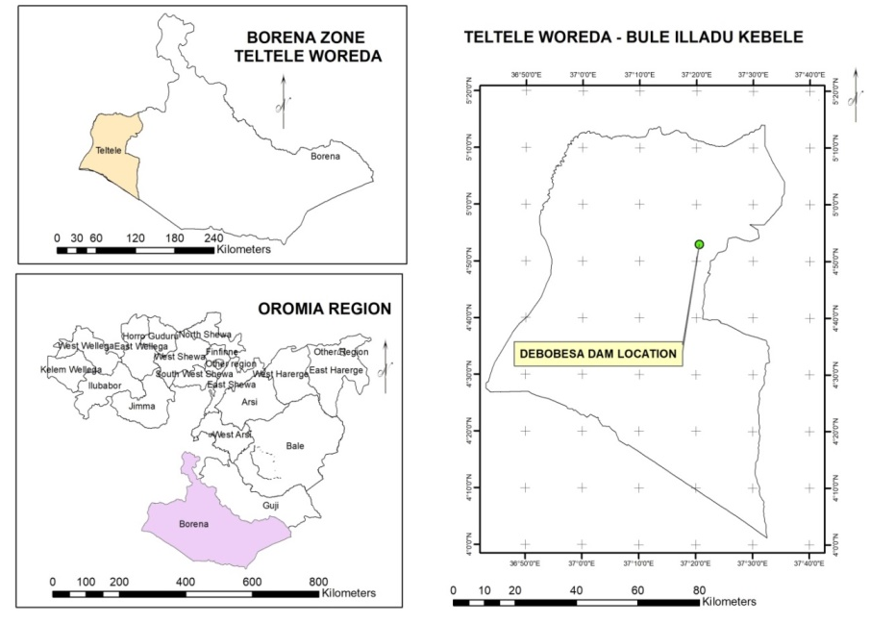
Figure 1 Project location map
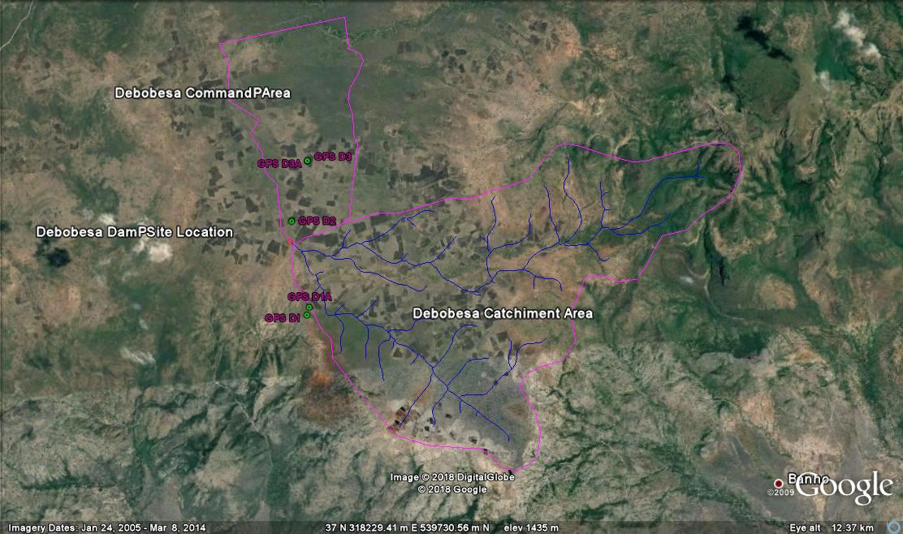
Figure 2 Project site Google earth image
Selection and Types of Earth fill Dams
The selection of type of dam is depends to the topographic and foundation conditions at the site and using available construction materials. So that in the proposed dam site a variety of soils are readily available, a zoned embankment will usually be chosen because it is generally superior for both stability and seepage performance. Zoned dams (as discussed later) also afford better ability to use material in the embankment section from required excavation. Materials that are closest to the dam and require the least processing should be used for the best economy.

2 DESCRIPTION OF WORKS

2.1 General Description
As the Geotechnical investigation in the proposed project area the selected/recommended dam type is zoned dam, due to that the Key components of the Works which will be covered under this feasibility are those stated here under but further components will be included during the detailed design.
- Main Dam (incorporating clay core, shoulders (rock fill), filters and drains);
- Spillway (incorporating Approach Channel, Chute and Stilling basin Spillway Road Bridge and Downstream Channel);
- River diversion works, including coffer dam and Intake Tower (incorporating Access Foot bridge with associated Steel work and approach Channel);
- Irrigation intakes, conduits and outlets

2.2 Dam Body
The main dam body is designed with Rock fill with central clay core, Downstream and upstream filter (medium to fine sand and coarse sand coarse gravel), drainage zone and transitions are provided to protect migration of soil to drain seepage water and smooth transition from fine to coarse textured dam fill materials. And the right abatement is characterized by organic soil material of bad engineering property hence, deep excavation is necessary to remove some areas of alluvial deposit the valley having weak shear strength. Appropriate foundation treatment measures such as back fill by sound bed rock fragments were also proposed to ensure foundation stability and curtail seepage through dam foundation.

2.3 Spillway
Chute spillway is provided to this specific site and designed to discharge a maximum of 68m3/s for 50 years return period routed outflow. However, the crest level is fixed not to be over topped with probable maximum flood. The nominal crest length of the spillway is 22m and clear waterway of 20m. The crest level (full supply level) is at 1404m and the maximum water level corresponding to 50 years routed flood is 1405.00m i.e. with flood lift height of 9m. The structure is 735m long, comprising an approach channel, broad crest, chute and terminal structure. The spilled water leaving the terminal structure will join the natural river channel which will be serving as exit channel.

2.4Irrigation outlet
The main purpose of the Debobesa project is for irrigation. It is planned to develop the command area estimated to around 100ha downstream of the dam. Therefore, during dry months of the year regulated water will be released as per the downstream demand. Accordingly Intake tower, conduit and intake structure is provided for this purpose.

3. HYDROLOGY

3.1 General
The hydrological analysis was undertaken to be primarily used for the design of the proposed dam. There is no flow data at the dam site, however to estimate the expected flood from the existing rainfall condition by the following different methods for ungagged catchments: Rational method, Empirical formulas, Unit hydrograph technique, flood frequency studies, Snyder’s, SCS methods and catchment characteristics.

3.2 Project Area
The hydrological investigation of this study includes;
- Review and utilization of findings obtained from previous studies on the stream or nearby catchment those related to Rift Valley Lakes Basin (RVLB) and neighboring and watershed divide line of Genale Dawa basin master plan studies.
- Collect relevant secondary data from all sources and scrutinizing their outputs
- Collect primary data from field and respective offices and relevant hydro meteorological data (i.e. rainfall, temperature, flow data etc.)
- Identify and amend gaps of available hydro and climatic data;
- Data organizing, pre-processing, analysis, producing relevant maps ( i.e. DEM, drainage system, sub-catchments area delineation from DEM data using Global Mapper 13 , Arc GIS 10 with extension Arc SWAT 2012 and SMADA 6.0 software);
- Evaluation of historical climate change related issues based on global and national perspectives
- Estimate the dependable flow of the river by utilizing appropriate method.
- Estimate the peak flood from the river catchment area based on long term monthly hydrological and climatic data and fixing the magnitude of design flood.
- Based on Laboratory analysis result, evaluating quality of water for the intended irrigation activity.

3.3 Analysis of Climate Data

3.3.1 Rainfall
Rainfall, Temperature and other essential hydro meteorological data were collected from different class NMSA stations around the project area. The record length, stations missing and outlier (often caused by encoding error) data has been evaluated before utilizing for analyses.
Based on proximity to project area and representation of the hydrologic and climatic features of the catchment area of the project, surrounding meteorological stations data have been requested from National Meteorological Agency (NMA). Through evaluating availability of recent and adequate data as per contract specification, among NMA submitted data of Teletele & Konso meteorological stations were mostly utilized. Other relatively close and compared stations were Yabelo, Aleweya and Arero. As per conducted evaluation on the data of each station, Teltele and Konso have got better quality of data in terms of diversity, adequacy and accuracy. Teltele station has got data of precipitation, minimum and maximum temperatures and that of Konso’s relative humidity, sunshine duration and wind speed have been adopted. In consideration to the stated stations, attempt has been made to develop Theisen polygon so as to determine areal rainfall. From developed Thesien Polygon in reference to those above stated nearby stations, the whole catchment area is located within Teltele station areal boundary.

3.4 Flood Estimation
In the design of hydraulic and irrigation structures, the peak flow that can be expected from computed rainfall frequency analysis is important. Under estimation of peak flow would result inadequate capacity of structures and failure as a consequence. The peak design discharge (Q _{max}) is used in the design of diversion structure, dam & its appurtenant works and to determine the back water curve that results from constructing dam/ diversion structure. It is crucial to predict the highest water level that occurs on average once every (T) years, where T is the selected return period of the discharge. The Q _{max} determines the water afflux on the diversion structure, spillway and hence the height of wing walls and crossing bridges if any.
On the other hand, computation of flow and formulation of stage vs discharge relation by utilizing various approaches has a paramount importance in designing various structures and determining extent of irrigation command area. For safety of structures, the magnitude of a peak flood may be estimated by the following different methods for un-gauged catchments:
- Rational method,
- Empirical formulas,
- Unit hydrograph technique,
- Flood frequency studies,
- Snyder’s and SCS methods
3.4.1 Flood Estimation for Un-gauged Catchment
The water course selected for the intended irrigation project has no recorded data of stream flow. As un-gauged river, three methods have been implemented to estimate the expected flood from the existing rainfall condition and catchment characteristics described in detail previously.

3.4.1.1 Rational Method
The rational method is mostly applied to small catchments not exceeding 12.8Km2 at most (Gray, 1971). The consequence of applying the rational method to larger catchments mostly produces an overestimate of discharge and a conservative design. Nevertheless, the method is frequently used in standard or modified form for much larger catchments too. The rational Method is based on the following formula:
Q _{m}=C.I.A. F _{r}
Where, Q _{m}= peak flow corresponding to return period of T- years (m³/sec)
C= a runoff coefficient expressing the ratio of rate of runoff to rate of rainfall
For the case of Debobessa, the slope range of the catchment was found to be 2% -6% which is rolling type with soil group D comprising Clay loam having a high runoff potential due to very slow infiltration rates. These soils primarily consist of clays with high swelling potential and shallow soils over nearly impervious parent material. Accordingly C value of 0.22 has been adopted.
I = average maximum intensity of rainfall in mm/hr, for a duration equal to the time of concentration
Information on rainfall intensity, I is the amount of rainfall measured over the catchment per hour duration. This value was taken from an intensity curve (annex-A4) based on the time of concentration and selected return period. As per deduction made on the graph, the intensity registered for 50 and 100 years return period was 37mm/hr and 45mm/hr respectively
A= drainage area in km²
F _{r} = is the real reduction factor (this factors improves the catchment limitations imposed on use of rational method).
The area reduction factor (F _{r}) is introduced to account for the spatial of point rainfall over the catchment. The relationship adopted for F _{r} is based on the developed formula for east African condition (Fiddes, 1997). The relationship can be expressed as
F _{r} = 1-0.02D-0.33*A0.5
Where, D = Duration in hours=0.18hr
A= Drainage area (km²) =12
This equation applies for storms of up to 8 hours duration. For longer durations and large catchments, the value of D can be taken as 8hours in the above formula.
Time of concentration (time required for a flow to reach the outlet from the most remote point in the catchment) is required and can be estimated by the following formula.
T _{c} = (1/3080)*L 1.155 * H- 0.385 Kirpich Equation
Where, T _{c}= time of concentration (in hours)
L= maximum length of main stream (in meters)
H= Elevation difference of upper and outlet catchment (meters)
Based on existing climatic and physiographic nature of the river morphology, the above procedural approaches and using developed tables and curves, the result of Rational method flood estimation has been tabulated as follows for 50 years return period.
Table 2 Values of Rational for50 years return period
C | I | A | F _{r} | Q ₅₀
0.22 | 37 | 12 | 0.87 | 85

3.4.1.2 SCS Method
A relationship between accumulated rainfall and accumulated runoff was developed by SCS (Soil Conservation Service). SCS runoff equation is therefore a method of estimating direct runoff from 24 hour or 1-day storm rainfall by the equations:
Q= (P-I _{a}) 2 / (P-I _{a}) +S
Where, Q = accumulated direct runoff, mm
P= accumulated Rainfall (potential maximum runoff) mm
I _{a}= initial abstraction including surface storage, inception and infiltration prior to runoff, mm
S = Potential Maximum retention, mm.
The relationship between I _{a} and S was developed from experimental catchment read data. It removes the necessity for estimating I _{a} for common usage. The empirical relationship used in SCS runoff equation is:
I _{a} = 0.2*S = 0.2*22.3 = 4.46
Substituting 0.2*S for I _{a} in equation above, the SCs rainfall - Runoff equation becomes:-
Q = (P-0.2s) ^2/ (P+0.8S)
S is related to soil and cover conditions of the catchment area through CN. CN has a range of 0 to 100 (Can be obtained from Annex A3) and S is related to CN by
S=254*((100/CN)-1)
Conversion from average antecedent moisture condition to wet conditions can be done by multiplying the average CN values by C _{f} [where C _{f} = (CN/100) -0.4]
Through utilizing the above equations and one to forty steps formulated for developing composite hydrograph, SCS method100 years return period flood hydrograph has been developed as shown below. As indicated on the underneath graph, the river generates a peak runoff of 59m³/sec for 100 years return period. (For the detail please see Annex B)

Figure 3 Composite Hydrograph
SCS based Peak Discharge Hydrograph

3.4.1.3 Transferring Gauged Data
Gauged data may be transferred to an un-gauged site of interest provided such data are nearby. (i.e within the same hydrologic region, and there are no major tributaries or diversions between the gauged and the site of interest). This procedure makes use of the constants obtained in developing the regression equations. These procedures are adopted from the works of Admasu (1989) given by:-
Q _{u} = Q _{g} (A _{u}/A _{g}) ^0.7
Where, Q _{u} = mean annual daily maximum flow at un gauged site (m³/sec)
Q _{g} = mean annual daily maximum flow at the nearby gauged site (m³/sec)
A _{u} = Un-gauged site catchment area (km²)
A _{g} = gauged site catchment area
However, as described in previous explanations and in review of previous studies, this river catchment is located at the periphery of Rift Valley Lakes Basin (RVLB) and at watershed divide of Genale Dawa River Basin (G-DRB). This implies the hydrologic region of Genale Dawa describes more than that of RVLB. From the study conducted, Dawa river rainfall and run off regression relation has been utilized as reference though it lacks the return period related output. In addition, there is no detail return period based discharge analysis made for Dawa sub basin in the master plan study except the stated regression equation as described in the evaluation of previous studies (chapter 2). At the presence of all these limitations, attempt has been made to derive the flow expected from the catchment at the rainfall intensity selected above for 50 and 100 years return period 37mm/hr and 45mm/hr.
The regression equation developed was described as:-
Runoff =1.93122*e^0.00366*rainfall* area
Q₅₀ = 27m3/sec
Q₁₀₀ =28m3/sec
6.2 Estimation of Weighted Average Flow
In general, the Rational Method, SCS method and transferring gauged data are recommended for relatively small, medium, and large catchments respectively. However it is very important to establish a smooth pattern of transition from small to medium and from medium to large catchments.
Accordingly, the recommended weighted average estimate of peak flood can be given as:-
Q _{w} =W₁.Q₁+W₂.Q₂+W₃.Q₃
Where:- Q₁, Q₂ and Q₃ are mean annual momentary peaks by Rational, SCS, and Transferring gauged data methods respectively
W₁, W₂ and W₃ are weighing factors of mean momentary peak estimates by rational, SCS and transferring gauged data methods respectively.
W₁=12.5/ (12.5+12) =12.5/24.5= 0.51
W₃= (A _{u}/A _{g}) ^0.7= (12/47935)^0.7=0.0006
W₂=1 - (W1+W3) =1-(0.36+0.022) = 0.4892
Where, A _{g} and A _{u} are gauged and un gauged catchment areas, respectively
Qw100= 0.51*85.76+0.4892*58.55+0.0006*28=72m³/sec
Take 75m³/sec as peak discharge for hydraulic structures requiring 100 years and similarly 68m³/sec for structures with 50 years return period. For 500 years return period, the peak discharge was computed as 105m³/sec by adopting similar procedure.

3.4.1.4 Area - Slope Method Discharge Estimation
This method is used to estimate the peak flood discharge using flood marks at locations where there are no records. The peak flow is estimated by using Manning’s equation and the resulted value was 52m³/s. This is computed by using field survey data of cross sectional area of headwork with respect to flood marks and longitudinal slope profile data of river.
Table 3 Computed Flood Discharge based on Area Slope Method
This method can give only an approximate estimate of unknown return period discharge due to the following limitations:-
- Difficulty in proper selection of flood time roughness coefficient (n);
- The cross-sectional area used in the current discharge equation may be different from the one existed during the time when the flood passed the reach;
- The current slope used in the discharge estimation cannot be precise as the water surface during the flood period
- For it is determined based on flood mark and information obtained from elderly local dwellers, the return period of that magnitude flood is not known unless compared with flood frequency analysis.
Stage vs Discharge Curve
For most of headwork sites, a simple plot of stage vs discharge is necessary, such a curve is approximately parabolic curve. It may show some irregularities if the cross-section is irregular. In most of the cases the discharge measurements are made within a limited range around the average stage in the river. Both at very low stages and at very high stages during floods there may be no measurements. it is, therefore, necessary to extend the curve downward for the low stages and upward for the high stages. By applying various steps to develop the curve, the result has been shown as below.
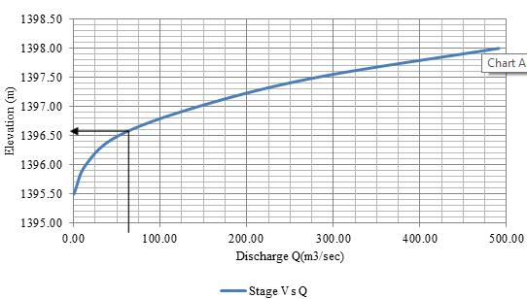
Figure 4 Stage vs. Discharge relation curve of Debobessa stream

3.5 River flow Estimation for Water Harvesting

3.5.1 Estimating Total Flow Potential
So as to utilize a given river for irrigation purpose, estimation of the dry season discharge should be conducted for perennial rivers and the utilizable runoff potential for intermittent streams. Besides to projects implemented to supplement rainfall shortage, most irrigation projects are designed for delivering water to potential command area crops during the dry season. As a result, estimating the available discharge during the dry or rainy season is among decisive factors to determine extent of command area, select method of irrigation system to be implemented, types of crops to be grown etc for effective use of available resources.
Estimation of flow can be conducted based on many years’ river gauge data if available or by undertaking direct measurement at the area selected for development. From conducted evaluation, the stream selected for this project has no river gauge data that can be utilized for base flow estimation.
As described earlier, the stream has no dry season discharge. As per the information obtained from the local community, there is flow only at the time of rainfall. In relation to narrowness of the catchment and scarcity of rainfall on the area, the runoff expected from the stream has shorter duration after onset of the rainy season. In other words the flow through the stream within the rainy season could be intermittent depending on rainfall availability, frequency, intensity amount, and soil initial moisture content.
As a result, the stream has flow when there is adequate rainfall capable of creating runoff. In order to estimate discharge of the stream during those rainy seasons of a year, daily rainfall of twenty years has been arranged in chronological order one to three hundred sixty five( three hundred sixty six during leap year) so as to determine the average daily rainfall.
Based on these average daily rainfall values computed from twenty years data, those better rainfall seasons of the area have been identified in comparison to the value of initial abstraction of the soil computed using SCS hydrograph. Those consecutive days with rainfall depths (mm) greater than the initial abstraction were considered to generate runoff over the catchment.
As per this classification, two relatively better rainy seasons have been identified from the computed mean daily rainfall and initial abstraction comparison. As shown on the monthly rainfall pattern description, the region has got bimodal type. That means the area has two rainfall increment seasons: the first and considered as the main rainy season is from March to May being peaked in April and the second season was found to be from Mid-September to November with the peak in October. Accordingly from the first season, those days having rainfall depth mostly more than initial abstraction were 70 days (from March 9th to 18th May. This doesn't imply each day has rainfall capable of generating runoff. As a natural and unpredicted circumstance, the trend shows both runoff bearing and dry conditions within the duration. However, considering wetness of the soil and the season's potential of rainfall, different magnitude of runoff or stream flow is expected in this time domain. The other potential runoff season having 55 days duration was found from 28th September to November 22nd during each year as average condition.
Having identified the potential rainfall periods of the catchment area, available and relatively reliable software’s have been investigated to convert computed average daily rainfall in to expected volumetric runoff. For conversion of the daily rainfall in to expected runoff, Hydrologic Engineering Center developed Hydrologic Modeling System (HEC-HMS) 4.2.1 has been utilized for its versatile applications and incorporating various study approaches.
As described on figure below, the program setting selected for the stated project utilizes SCS curve number and SCS unit hydrograph for evaluating sub basin loss and transformation respectively. For flow routing through the channel reaches, straddle stagger has been applied over the sub basins specified hyetograph precipitation. Computed mean daily flows generated from many years historical data has been fed as precipitation hyetograph data for the analysis.
As per the output obtained from the analysis, the following graphical and tabular data were generated.
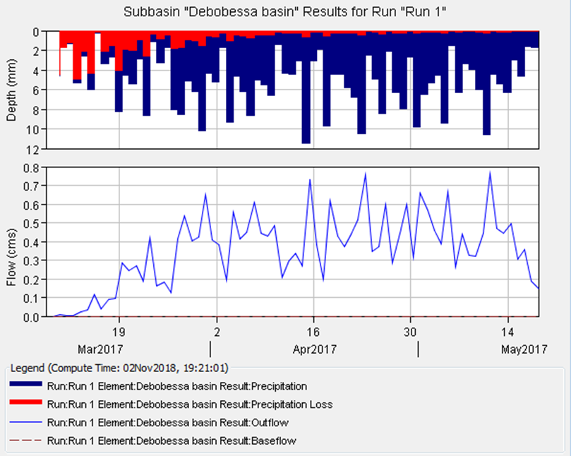
Figure 5 Precipitation vs. output flow graph of stream Catchment (season1)
The above graph shows, the out flow expected from the overall depth of precipitation of the catchment after deducting the loss because of seepage for season one.
As per output of the software summarized table on fig 17 below, the overall discharge volume of 2, 176,800 m3 is expected on average year for the specified season excluding the evaporation loss. As seen on the underneath summary output, the date of runoff peaking and the daily peak amount has been estimated based on the 20 years historical data.
The discharge volume expected during the second season (28th September to November 22nd) of every year was estimated as 872,000m3 excluding the loss due to evaporation from the reservoir area.
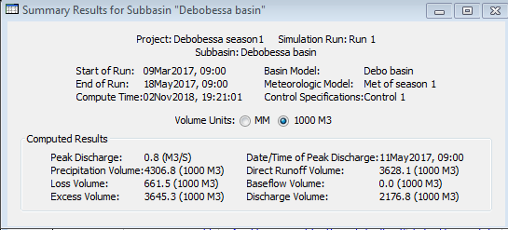
Figure 6 HEC-HMS Summary result of Debobessa Catchment (season1)
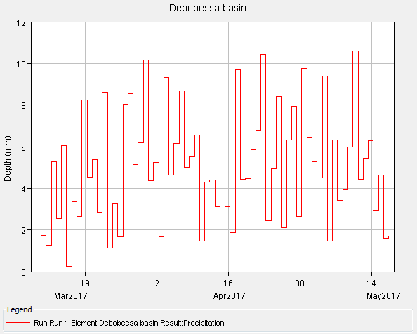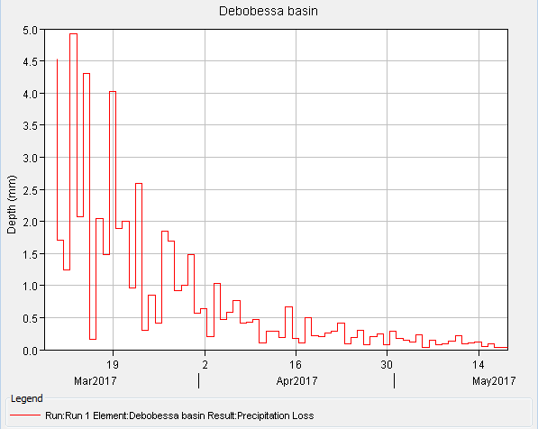
Season1 Precipitation graph Season1 Soil Infiltration graph
Figure 7 Precipitation and Soil Infiltration loss graphs of Debobessa (season1)
On the other hand the flow expected from season 2 has been tabulated and shown as below.
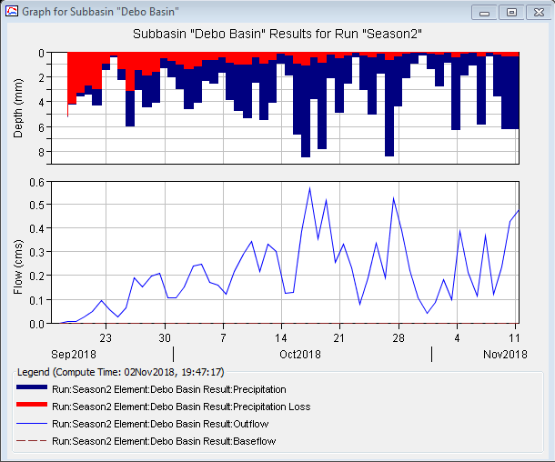
Figure 8 Precipitation vs. output flow graph of stream Catchment (season2)
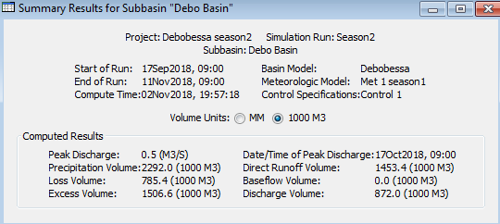
Figure 9 HEC-HMS Summary result of Debobessa Catchment (season2)

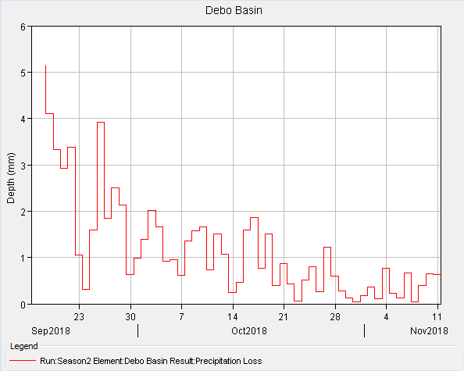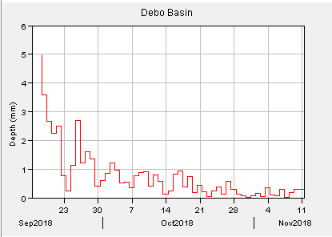
Season2 Precipitation graph Season2 Soil Infiltration graph
Figure 10 Precipitation and Soil Infiltration loss graphs of Season2
See Annex C for Time series Discharge estimate Output of HEC-HMS for Season 1& 2
From those estimated daily flows indicated on the above stated annex, monthly flow expected throughout the stream has been tabulated for different level of dependability as shown below.
Table 4 Monthly flow of the stream at different dependability
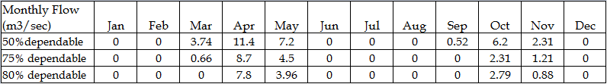

3.5.2 Evaporation loss from Reservoir Area
In relation to the loss because of evaporation from the reservoir area, those developed relation on Dawa sub basin has been utilized as reference. As per the equation shown on the discussion of previous studies evaporation and potential evapotranspiration was related to altitude of the catchment.
Equation of Evaporation, Y= -758.4Ln(X) +7418.4
Equation of Evapotranspiration, Y= -377.39Ln(X) + 4258.7
Where, Y = Evaporation/ evapotranspiration (mm) per annual
X = elevation (m.a.s.l)
While computing the runoff expected from the catchment area of the project, the loss of precipitation as seepage and evapotranspiration in HEC-HMS model as 40% ratio. As a result the evaporation from open surface of the reservoir has been considered for deducting the overall water loss. For mean catchment elevation of Debobessa (1430m), expected loss of water through evaporation was computed as 1905mm per square meter of area. This means the average monthly evaporation becomes 160mm. This value is utilized for computing loss of water from the reservoir area during rainy season duration and the upcoming period when the water is utilized for irrigation purpose mostly 120 days (4 months). Based on the above classification the loss during season one is considered for 150 days (5 months) and for the second season a total of 135 days(four and half months) will be considered for determining the total loss from reservoir because of evaporation.
Based on the above analysis approach, for estimated average reservoir area for both evaporation period determined for season one and two was 246,300m2 (24.63ha) and 170, 800m2 (17.08ha) respectively. From these reservoir areas, the loss expected for season one and season two, the overall evaporation was computed as 216,744m³ and 122,976m³ respectively. As estimated earlier with HEC-HMS summary (figure 18&21) , the gross mean volume of water available from the rainfall and catchment during season one and two was 2,167,800m³ and 872,000m³ respectively. Hence, As seen on underneath table the net available volume of water utilizable for irrigation after deducting the evaporation loss, was estimated as 1,951,056m³ and 749,024m³ for season one and two respectively.
Table 5 Computed mean seasonal flow volume
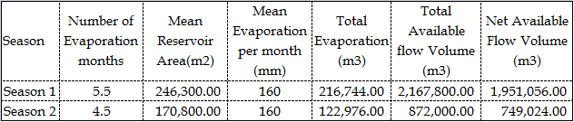

3.6 River Morphology and Sediment Analysis
From evaluation of the waterway sediment load during the study and from overall sub basin wise characteristics, the river course has stable bank on the left sides as compared to the right side which is loose black cotton soil at and upstream of the dam site. As described on catchment characteristics, presence of rolling slope of the catchment between 2%-6% and steep slope especially on the upper upstream river reach together with unsteady state flow, bank erosion and transportation of sediment from abroad is mostly common during the rainy season. However, as the river flows further downstream, there is grass, vegetation and scattered trees land over gentle slope that tend to reduce transported sediment from higher altitudes to the dam to some extent.
On the other hand, there are also dispatched places along the banks forming gulley that can contribute sediment from eroded mostly black cotton soil. As observed the sideway catchments at lower and middle have gentle slope that minimize sediment flow to the river. This gentle slope part of the river has also advantage of trapping sediment and gravel transported from the steep land as the flow velocity gets minimized before reaching current project headwork site. Generally, as a result of observed condition and indicators of sediment load at the dam site, practicing further soil conservation works and providing buffer zone shall get due concern for the sustainability of the dam.
For determining the quantity of sediment load of the river, getting recorded many years’ data or taking repeated samples at different period of the year/s would have been essential. However, neither the river has recorded sediment data nor conducted agreement has adequate time to take samples for sediment analysis. As a result, estimating the sediment load of the river from previously conducted basin wise studies and formulated equations becomes essential.
Hence, as discussed in review of previous studies part of this document, relationship between water discharge and sediment loads was developed for Dawa sub basin was estimated as 29.9 Tons of sediment per sq km per annum by the consultant performed the master plan of Genale Dawa Basin. Accordingly, the sediment expected as per this relation for our specific project would be 359 tons per annum.
On the other hand, from the Rift Valley Lakes Basin (RVLB) Integrated Resource Development Study conducted by Hal crow Group limited and Generation Integrated Rural Development (GIRD) Consultants (2008), sediment load and monthly mean discharge has been related as follows.
G _{s} = 0.078 Q^{^1.5}
Where, G _{s} = sediment load (in tons)
Q = monthly mean discharge (in lit/s/km²)
Based on the above developed relationship and computed mean seasonal flow of the intermittent stream especially during the two previously identified seasons has been generated from HEC-HMS analysis. For season one and two, computed average flow was 360 lit/sec and185lit/sec) respectively. As per the above relation, the sediment load expected during the two seasons becomes 729 tones.
Hence from the above two approaches' result and site level observation, the second result is more logical and descriptive to the existing condition. Taking 30% allowance for the seasonal based mean flow instead of monthly mean discharge as stated on the developed formula, it is advisable to use the annual sediment load 975 tons for design purpose. For expected 50 years design period the total sediment load could be 48,750 tons.

4. GEOLOGY AND GEOTECHNICAL INVESTIGATION

4.1 Regional Geology
According to the regional geological map Yabello sheet N37-14, EIGS 2012, the area is characterized by the Pre Cambrian crystalline basement rocks, Cainozoic volcanic and quaternary superficial deposits. The crystalline basement rock comprises high grade gneiss, Schist, weakly to moderately metamorphosed volcano - sedimentary rocks. The crystalline basement rocks are invariably intruded by pre and post tectonic intrusive with elliptical and circular outcrop patterns respectively.
The Pre Cambrian rocks exhibit similar lithological association, structural features and grade of metamorphism. The Cainozoic volcanic rocks are broadly sub divided in to two based on eruption phase, - viz - that erupted weather before or after rifting (pre and post rifting volcanic). The Alluvial deposits occupy stream beds, flood plains and stream banks. It consists mainly sand, silt and clay in subordinate with pebble and cobble. The elluvial deposits consist residual and transported soils occupying flat laying and gentle topography. These are represented by sand, silt clay and gravel.

4.2 Geologic Structures
Fractures and fault zones as well as the open faults and intersections of faults are significant in the basement metamorphic and basaltic rock units in the area. The crystalline basement have been subjected to several phases of organic deformation in the Precambrian time and subsequent extensional tectonics related to rift forming geodynamic processes during Phanerozoic Eon. The faults are running in the north-south direction in the metamorphic basement rock units. Main structural elements in the area consist of metamorphic foliation, folds, lineaments, primary igneous layering/structure, joints/fractures and faults. Besides, there are numerous lineaments concordant or across the main fabric elements of the different types of lithology’s. The basement rocks are subjected to three deformational events. These are D1 (folding), D2 (thrusting) and D3 (shearing)
The volcanic lava flow in the project area is found being affected by intense faulting, jointing and fracturing. Low and high scarp faults with NS, NW, SE and NE - SW trends are exhibited in the volcanic terrain. the volcanic terrain.
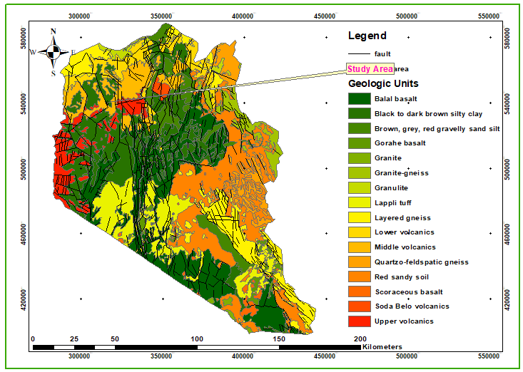
Figure 11 Regional geological map of the project area (after OWWDSE 2008)

4.3 Local Geology
The project area is characterized by alluvial soil overburden deposit and volcanic rock unit

4.3.1 Alluvial deposits
The deposit is found overlaying the volcanic rock units in the area. These are mainly organic soil material and River deposits. The organic soil material is found covering extensive part of the project area mainly covering the poorly drained plain land mass of the project area. Such a deposit is black to dark brown silty clay soil material of high plasticity. It shows desiccation cracks due to the constituent minerals and high degree of plasticity. As inferred from the geophysical survey done at the project site, thickness of the material is greater than 10mts. The river deposit is found along the course and banks of stream. It is commonly silty sandy gravel.

4.3.2 Volcanic rock units
The volcanic rock unit found exposed in the project site is the volcanic lava flow. It can be described as dark aphanatic / fine grained fresh to highly weathered jointed / fractured BASALT. The rock outcrop at places shows spheroidal weathering due to effect of differential weathering (see fig below where the hammer is displayed). This can be observed towards toe of the left abatement of the proposed dam site and at the proposed second spillway site option foundation. It is found observed forming prevailing ridges in the area. The Left abatement is found being characterized by an outcrop of such basaltic rock unit.
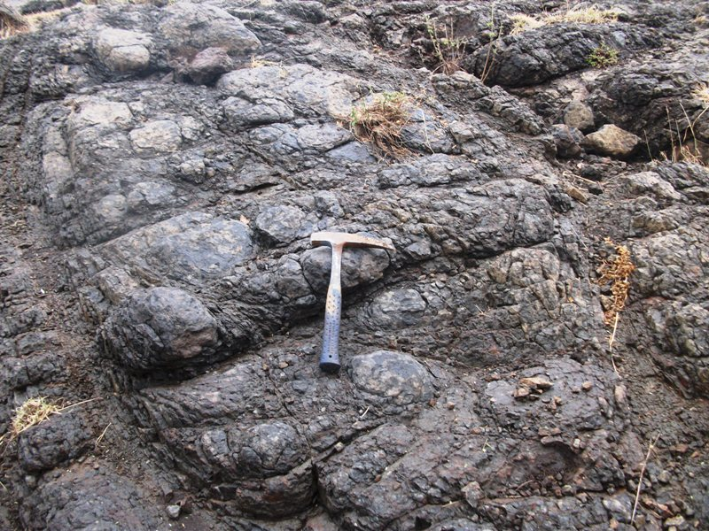
Figure 12 an outcrop of volcanic rock unit / Basalt

4.4 Geological features of dam sites

4.4.1 Geological features along the dam axis
a) Right Abutment
The layer mapped at the top of right abutment having a thickness of 1m has a resistivity value of 62 Ωm. This resistivity value is the response of the top soil. The second layer, which is over lain by the top soil, has resistivity value 9Ω-m is mapped as silty clay soil layer. This layer extends in depth up to 8m. The third layer 5Ωm resistivity formation is sand with silt and weathered basalt having a depth of 43m. The fourth bottom layer of this formation has lower resistivity values 14Ω-m. This low resistivity value is a response of highly fractured and weathered basalt or scoraceous basalt dominated by clay.
b) Left Abutment
The layer mapped at the top of left abutment having a thickness of 1m has a resistivity value of 72 Ωm. This resistivity value is the response of the top soil layer. The second layer, which is over lain by the top soil, has resistivity value 7Ω-m is mapped as black to dark brown silty clay layer. This layer extends in depth up to 7m. The third layer has a resistivity value of 25Ωm. This lower resistivity value is a response of the highly weathered and fractured basalt. This layer extends in depth up to 61m. The fourth bottom layer of this formation has higher resistivity values 300Ω-m. This high resistivity value is a response of slightly weathered to massive basalt.
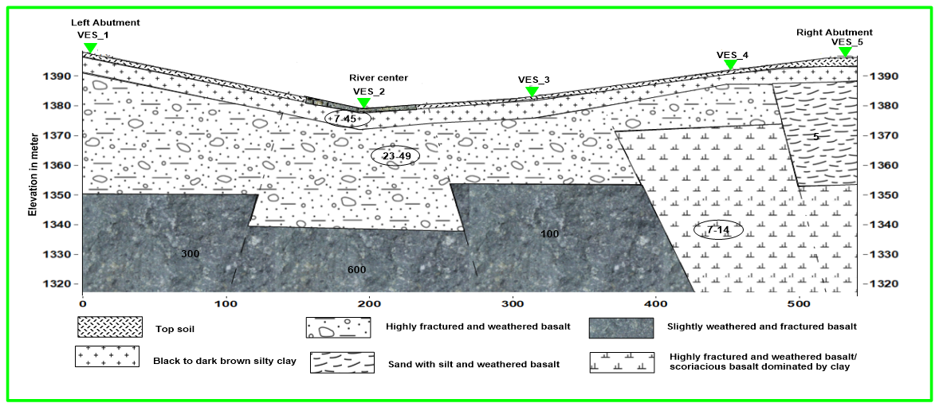
Figure 13 Geo-electric section map

4.5 Geotechnical Investigation
The geotechnical investigation of the current study is made based on observation of the surface exposures, test pit excavation and geophysical survey which is an indirect method of investigation. Field test on bored wells as well as sampling will be carried out during next phase of investigation which is the critical and major part of the geotechnical investigation.

4.5.1 Geophysical Investigation
The Vertical Electrical Sounding data were collected using Geo-electrical imaging system with Terrameter LS. This instrument runs both vertical electrical sounding and profiling simultaneously and it calculates the apparent resistivity of a point from the current, potential difference and electrode spacing at any four electrodes of the array. The Vertical Electrical Sounding data are acquired scientifically along traverses which were selected to collect a representative and detailed information about the area along the dam axis. Totally eight VES was surveyed. Five VES were collected across the dam axis and the rest three VES were collected along the spill way of the study area. The VES orientations of the dam axis were SW-NE and the VES orientation of spill way was N-S.
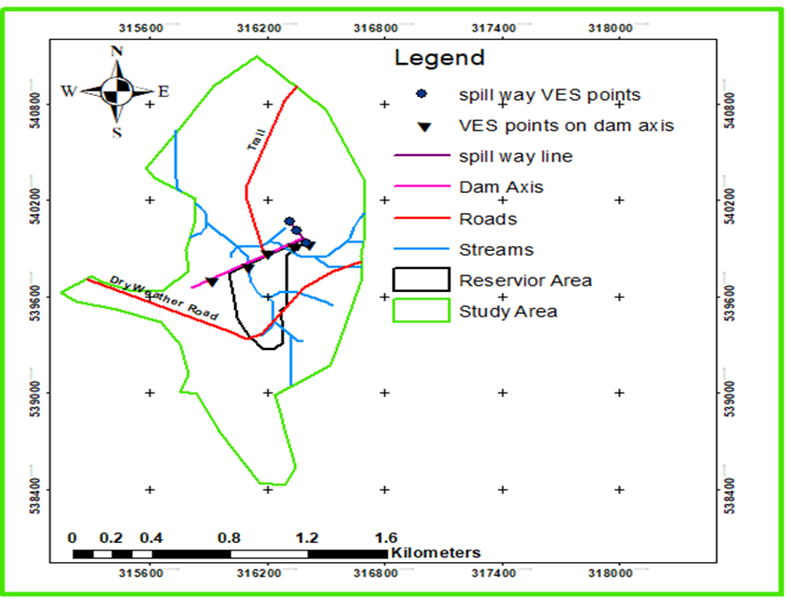
Figure 14 Location map of the geophysical survey traverses and random points

4.5.1.1 Geophysical Investigation along the dam axis
As mentioned in the earlier sections vertical electrical sounding data were collected at five sounding points all lying along the proposed dam axis (Figure 2.2). The VES points are spaced at about 200 m spacing and have been conducted with half current electrode spacing (AB/2) of 200m-350 m. The individual VES are interpreted to get the layer parameters (resistivity and thickness of the subsurface layers) as given in Figure 2.2. The VES data are presented in the form of apparent resistivity pseudo depth sections and geo-electric section and discussed separately in the following sections.

4.6 Seismicity of the Study Area
Seismic tremors occur at a rate of several hundred per day around the world. Small earthquakes occur and are recorded so frequently around tectonically active areas such as the Main Ethiopian Rift Valley. There occur earth quacks of different magnitude in several places within the rift and vicinity. Ground fissuring occurs in various parts of the rift, such as the site near Lake Ziway which is recent phenomenon. The complicated mechanisms of this fissuring are basically co – seismic in Afar and a seismic in the rift valley lakes region. The project area lies at the southern flank of the main Ethiopian Rift. Based on the Seismic zonation map of Ethiopia (see fig. below), the project site lies within the vertical ground acceleration of 100-cm/s2 equals to 0.1 of g. This would have certain impact on the proposed design related to earth movement. The volcanism is related to current development of a new rift referred as Ririba fault belt by Mohr (1974) in Davidson (1983).
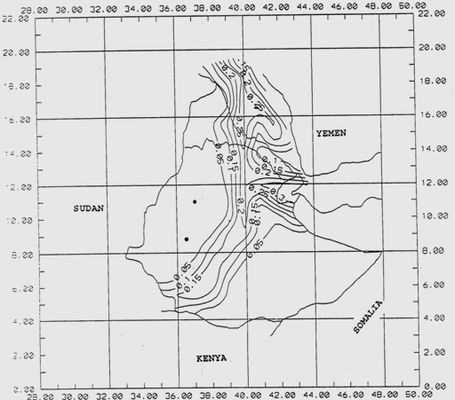
Figure 15 Seismic hazard zonation map of Ethiopia
Contours show peak vertical ground acceleration (After Kebede and Asfaw, 1996)

4.7 Construction Materials Investigations

4.7.1 Background
An investigation has been conducted to identify, evaluate and delineate potential sites of construction materials in the project area. During the investigation, major emphases for selection of potential sites for construction materials have been given by considering among others
- ease of excavation and extraction
- hydrologic condition
- overburden thickness
- soundness / durability
- Quality and volume of potential reserves with respect to the intended purpose
- hauling distance
- Social and environmental impacts that could hinder development of the quarry and borrow materials
The natural construction materials required for construction of the intended micro dam and appurtenant structures are:
- Borrow materials (clay) for impervious core and embankment
- Sand for chimney filter and chimney drain
- Sand and gravel for concrete
- River gravel as source of concrete, filter drain and blanket
- Quarry sites as sources for rock / mason, aggregate, shell and rip rap

4.7.2 Natural construction materials

4.7.2.1 Clay borrow material
Clay borrow material is extracted for use mainly as construction of the central impervious core membrane. In addition it is also needed as source of embankment fill and Canal Lining. The latter is meant for use to replace organic soil material of high swelling pressure in conjunction with rock fragments.
For central core dams, the primary water barrier (also called the core) will have low permeability but, as is typical for such materials, will have relatively low strength. Availability of suitable core material is limited at the project site. For these reasons, it may be desirable to limit the size of the zone. If abundant material is available, the entire dam can be made out of this single zone, which is known as a homogenous dam, but this is not recommended since the material is not found in excess relative to the intended purpose in the project area. As far as seepage through a central core dam, it is generally desirable to obtain full head loss near or just downstream of the dam centerline. Depending on the material used to construct the core, this may be achievable by the core itself. If not, and also to ensure that the head loss is achieved, drainage zones are provided on the downstream face of the core, also known as a chimney. The zone immediately against the core is termed the chimney filter and provides drainage and particle retention as described previously. If needed to provide adequate capacity, a second zone downstream of the chimney filter is included, known as a chimney drain. These two zones ensure that no excess head will be present downstream of their locations. These zones are included in the cross section
The most suitable material for clay core is that (USBR 2011):
- The soil should have low permeability in the range of 10-7 to 10-9 cm/sec.
- The soil should be non-dispersive i.e. the soil as part of the dam body should not exhibit erosion.
- The material must not consolidate excessively under the weight of superimposed embankments and must not soften upon saturation.
Accordingly, potential Clay borrows area that is assumed to comply the requirement has been identified and delineated close to the project area (see table below).
Table 6 Availability impervious materials
Sample ID | Location (UTM) |  | Estimated reserve | Remark
Sample ID | Easting | Northing | (m³) | Remark
TDCLB1 | 315964 | 539303 | 25,000 | · Found roughly 500mts South of dam site
 |  |  |  | · Accessible
 |  |  |  | · No overburden
 |  |  |  | · Farm land
TDCLB2 | 316137 | 538224 | 250,000 | · Found roughly 1600mts SW of dam site
 |  |  |  | · can be accessed upon construction of access road (some 400mts length) using excavator and dozer
 |  |  |  | · no overburden
 |  |  |  | · Jungle.
 |  |  |  | · no settlement and farming
 |  |  |  | · no environmental impact since there is excess deposit along valley cut/deposited by runoff that can be loaded using excavator/loader and human labor.
 |  |  |  | · available reserve in excess

Summary of the laboratory test results of samples collected from the proposed quarry are presented in
Table 7 Details can be referred from geology and geotechnical investigation of the same project.
PARAMETER | SAMPLE ID
PARAMETER | TCB2-1 | TCB2-2 | TDCB1-1 | TDCB1-2 | CB1 BULK
Grain size analysis
Clay (%) | 78 | 73 |  | 79 | 77
Silt (%) | 20 | 25 |  | 19 | 23
Sand (%) | 2 | 2 |  | 2 | 0
Gravel (%) | 0 | 0 |  | 0 | 0
Atterberg Limit
LL (%) | 64 | 60.5 | 65 | 65.2 | 87.8
PL (%) | 34.85 | 32.05 | 36.36 | 36.36 | 46.06
PI (%) | 29.15 | 28.45 | 28.84 | 28.84 | 19.14
Free Swell (%) | 50 | 50 |  |  | 75
Specific gravity | 2.32 | 2.33 | 2.4 |  | 2.33
Bulk Unit Weight (Kg/m³) |  |  |  |  | 1.88
Dispersion by pin hole
Proctor test
MDD(gm/cc) |  |  |  |  | 1405
OMC (%) |  |  |  |  | 33
Permeability(mm/s) |  |  |  |  | 6-Oct
Direct Shear
C(KN/m2) | 31 | 31
Phi (degree) | 18 | 19
Organic matter (%) | 4.8 | 4.7
Natural moisture cont.(%)
Consolidation

4.7.2.2 Rock Fill Material
Rock source for body of dam / Rip-rap, shell and rock-toe and also as source for mason and concrete works were assessed in the project area. Accordingly, potential source of Quarry site has been identified and delineated for use to the intended purpose. The site identified is located within the project site. It is located being centering at the geog. grid ref. 0315899E & 0539864N UTM.

4.7.2.3 Sand
Sand is required for concrete work of major structures to this requirement it is necessary to locate suitable sand borrow sites that could fulfill reasonable quality and quantity requirements. Accordingly, potential sand borrow site has been identified and delineated for use that is situated further away from the project area. It is located roughly 50kms NE of the project site at a locality of Eleweya, Mesgerdo River course and banks. Specifically it is located centering at the geog. grid ref 0357570E & 0556740N UTM.

4.7.2.4 Crushed Aggregate Material
The proposed site of Gravel source is from courses of prevailing River and tributaries draining in the dam site, reservoir and command area. As the other option, the rock quarry proposed in the project area being commonly well fractured and jointed fresh basalt, it can be used as source of crushed gravel.

4.7.2.5 Shell Material
Such shell material source considered and recommended for use is from the available quarry sites and river deposits consisting boulder, cobble and gravel material. It is found in excess for use to the intended purpose in the project site and close vicinity. The boulder and cobble rock fragments for use as shell material source is found in excess within the project site close to the left abatement and at the left abatement itself. It is found exposed on the slope and toe of prevailing ridge formed by volcanic lava flow / basaltic rock unit .Furthermore, during

5. Dam Site & type Selection

5.1 Location and Dam site
The following factors are considered in selecting the dam site:
- The dam site should be as nearer to the area to be served as possible;
- Foundation area should be reasonably impervious and it should be able to support the weight of the dam;
- The dam should be located at a relatively narrow part of the valley and it should back up into a sufficiently large storage pond;
- The ratio of the catchment area to the irrigable area should be reasonable. A too large catchment area above the dam site may require unduly expensive spill way and , on the other hand, a too smaller catchment area may not yield sufficient runoff to meet the storage requirement;
- The dam site and the reservoir rim should offer a reasonable configuration for provision of a spillway; and
- Construction materials should be available in sufficient quantity and good quality within a reasonable distance.

5.2 Type of Dam
There are mainly two different types of dams:
- Earth fill dam and
- Gravity dam

5.2.1 Earth fill Dam
There are three types of earth fill dams. They are
- Homogeneous dam,
- Core dam, and
- Zoned dam.
All the dams are the rolled fill type of earth fill in which the soil material should be spread in uniform layers and compacted at optimum moisture until maximum density is achieved.
- Homogeneous Dam
This is the simplest type which is constructed of relatively homogeneous soil material and is either keyed into an impervious foundation stratum. The material shall contain some amount of clay and silt and at best also some sand and gravel in order to provide sufficient strength.

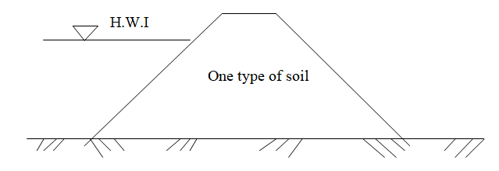
Figure 16 Homogeneous dam
- Core Dam
Core dams are constructed with the two different types of materials and are suitable for the sites where the available quantity of impervious material suitable for the dam is scarce. In such cases a central core of impervious material is embedded inside the previous material with a trench dug in to an impervious foundation.
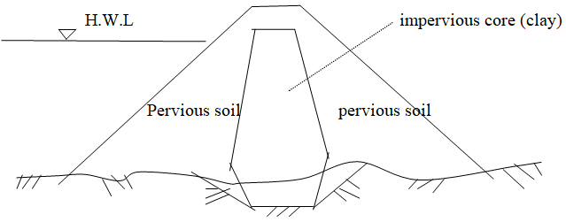
Figure 17 Core Dam
- Zoned dam
The dam with a core wall is called to be a “Zoned embankment type” if its horizontal thickness at any elevation is more than the height of embankment above any corresponding elevation in the dam. If the supply of pervious soil is so limited that the “Zoned embankment” type of dam cannot be constructed.
In the dam section, a central impervious core is flanked by zones of materials considerably more pervious, called shells. The upstream pervious zone affords stability against rapid drawdown and the downstream pervious zone acts as a drain to control the line of seepage. The pervious zones may consist of sand, gravel, cobbles or rock, or mixtures of these materials. This type of dam may have relatively steep outer slopes.
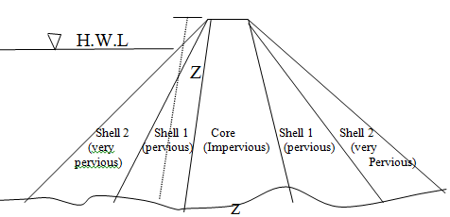
Figure 18 Zoned Dam

5.2.2 Gravity Dam
There are mainly two types of gravity dams:
  - concrete dam and
  - Stone masonry dam.
If the size of the dam is increased, concrete dam is preferable. If the foundation is adequate, and the site is located at the very narrow valley, a solid concrete dam is a permanent structure.
C. Determination of Storage Capacity
1. Storage Requirement
The storage capacity of a reservoir will depend on the water needs, evaporation from the water surface, seepage into the soil or through the dam, and storage for sedimentation. Water needs for irrigation, domestic uses, and livestock may be estimated from Table 2.1. Evaporation from the reservoir water surface can be estimated by multiplying local pan evaporation values by a factor of about 0.7.
Table 8 Water Requirements for Various Uses
Storage Requirements |  | (1000m³)
Irrigation |  | 1123.2
Human |  | 0.346
Domestic Animals |  | 0.756
Evaporation Loss |  | 1.754
Seepage Loss |  | 0.496
Total = |  | 1126.55

2. Computation of Storage
Once the required reservoir storage capacity is determined, it would be necessary to prepare a graph showing two curves:
  - Water level - storage capacity, and
  - Water level - surface water area at the dam site. These curves may be obtained by one of the following methods:
a. Contour method
A contour map would be prepared at the reservoir site. Contour should also be drawn on the upstream slope of the dam.
A₀, A₁, A ₂…… An = the area enclosing each contour
h = vertical distance between contours
v = storage capacity
- Prismoidal Formula
- End Area Formula
b. Longitudinal and Cross-sectional Method
Cross-sectional survey would be conducted along the longitudinal profile at certain distance. Based on these cross sections, either prismoidal or end area formula can be applied.
c. Accumulation Method
It is necessary' to calculate the volume of storage of each interval and to accumulate each of them to compute the sum of the volume of storage at certain water level. If the calculation of water level and storage capacity is completed, reservoir area and capacity relations can be drawn. The illustrative table is shown below.
Table 9 Volume of storage at certain water level
Water Level | Area | Average Area | Vertical Distance | Incremental Volume of storage | Accumulative Volume of Storage |  | Note
(m) | (ha) | (ha) | (m) | (ha-m) | (ha-m) | (1000m³) | Note
1395.50 | 0.00 | 0.00 | 0.00 | 0.00 | 0.00 | 0.00 | Empty
1396.00 | 0.20 | 0.10 | 0.50 | 0.05 | 0.05 | 0.50
1397.00 | 0.90 | 0.55 | 1.00 | 0.55 | 0.60 | 5.99
1398.00 | 2.69 | 1.79 | 1.00 | 1.79 | 2.39 | 23.91
1399.00 | 5.82 | 4.26 | 1.00 | 4.26 | 6.65 | 66.46
1400.00 | 10.79 | 8.31 | 1.00 | 8.31 | 14.95 | 149.53
1401.00 | 17.09 | 13.94 | 1.00 | 13.94 | 28.89 | 288.93
1402.00 | 24.63 | 20.86 | 1.00 | 20.86 | 49.75 | 497.54
1402.50 | 32.86 | 28.74 | 0.50 | 14.37 | 64.13 | 641.26
1403.00 | 41.08 | 32.86 | 1.00 | 32.86 | 82.61 | 826.10
1403.50 | 49.27 | 45.18 | 0.50 | 22.59 | 105.20 | 1051.97
1403.65 | 52.25 | 50.76 | 0.15 | 7.82 | 113.01 | 1130.14 | Normal Water Level
1404.00 | 57.46 | 49.27 | 1.00 | 49.27 | 131.88 | 1318.81
1405.00 | 60.94 | 55.11 | 1.00 | 55.11 | 160.30 | 1603.03 | High Flood Level
1406.00 | 67.83 | 62.65 | 1.00 | 62.65 | 194.53 | 1945.27 | Overtopping

Height Volume Area Curve

Figure 19 Water level and storage capacity curves
As shown in Figure, a water depth of 5.00m at stage of 1400.50m would have a storage volume of 210,000 m³ and a flooded area of 19 ha. Alternatively, if 1,130,000 m³ of storage is required, then the required water depth would be approximately 8.20 m and the flooded area would be approximately 620,000 m².

Dam Design

6.1 General

6.1.1 Topographic Features
The topographic maps produced for the present study shows that the river bed is as wide as 15m with average river bed level of around 1396masl, steep hilly escarpments on left abutment and regularly hilly at the right abutment.

6.1.2 Alignment
The dam axis has been aligned nearly perpendicular to Debobesa River considering the suitability of the abutments that ensure the stability of the dam. The final alignment of the dam is shown on Figure 6.1.

6.1.3 Dam Axis and Spillway Geologic Features

6.1.3.1 Left Abutment
The left abutment begins after long slightly inclined plain and is gently sloping with step forming rock outcrops and its tip is covered by yellowish residual soil. The slope of the left abutment is gentler compared to the right abutment with the order of 3~5%

6.1.3.2 River Channel and main river valley
It is represented by the bed rock unit is found being exposed in the left abatement of the proposed micro dam site. Such bed rock unit is the volcanic lava flow the rock unit can be described as: Dark aphanatic / fine grained fresh to slightly weathered and jointed / fractured BASALT.

6.1.3.3 Right Abutment
The proposed dam site right abatement is characterised by organic soil material of bad engineering property. This would have adverse impact that can cause movement upon swelling and instability. Consequently, it is recommended to remove such soil material to depth in the order of 6mts and back fill by sound bed rock fragments

6.1.3.4 Spillway alignment
The spillway is aligned on the left side by excavating the left abutment. The excess water passing over the spillway will be conveyed to the main river coarse with the necessary components of the spillway.

6.1.4 Available Construction Materials
As described in Section 4.7, the available materials at Debobesa project site include but not limited to the following:

6.1.4.1 Impervious material
Clay is one of the impervious materials for the dam design options. Accordingly, potential Clay borrow area that is assumed to comply the requirement has been identified and delineated close to the project area Found roughly 500mts South of dam site and 1600mts SW of the dam site.

6.1.4.2 Rock fill and riprap materials
The boulder and cobble rock fragments for use as shell material source is found in excess within the project site close to the left abatement and at the left abatement itself. It is found exposed on the slope and toe of prevailing ridge formed by volcanic lava flow / basaltic rock unit .Furthermore, during construction the materials to be excavated from cut off trench and spillway can also be used to the intended purpose / as source of shell material

6.1.4.3 Sand for filter and other purposes
The deposit is in excess that can meet more than the demand of required construction; the site is situated along the River crossed by the main Yabelleo - Teltele asphalt highway. Hence it is easily accessible from the project site to the borrow site

6.1.4.4 Water
The Ground water is the source of water for construction activities as described in Section 4.7, the available materials at Debobesa project site include but not limited to the following:

6.2 Foundation Condition and Preparation
The dominant lithological units around the foundation area are organic soil stiff to very stiff black to dark brown silt clay, dark aphanatic slightly wetherd/fracture basalt and cobbles and rock boulder deposits. Based on the developed preliminary engineering geological cross section the proposed general and trench excavation levels have been suggested as follows. The depth of the general foundation is proposed based on evaluation of the distribution of the soils/rocks and their engineering characterization.
General Foundation
- The dam general foundation on steep slope of the left abutment is made to rest on the basaltic flow rock after removing the top soil.
- The right abutment the dam general foundation is founded on organic soil material of bad engineering property. This would have adverse impact that can cause movement upon swelling and instability. Consequently, it is recommended to remove such soil material to depth in the order of 6mts and back fill by sound bed rock fragments
- The major portion of the dam which is the bottom valley is covered with top soil, alluvial deposit and weathered lime stone. The weathered limestone is found at deeper depth and thus at this stage the dam general foundation is planned to be founded on the alluvial deposit after removing variable depths along the dam axis. Accordingly the total depth of excavation from ground level can reach up to 6m which comprised removal of the top soil and the top layers of the alluvial deposit.

6.3 Seepage Control Measures through the Dam Foundation
In order to minimize seepage through the foundation, provision of seepage curtailing measures are necessary. From the Geotechnical evaluation of the dam foundation point of view the following seepage curtailing measures in the foundation has been considered.

6.3.1 Cutoff Trench
The cutoff trench is made to be founded on rock on the steep slopes of the right and left abutments i.e. (Chainage 0+00 to 0+160 and 0+606 to 0+735). However for the major portion of the dam the cutoff foundation is fixed on alluvial deposit. This is due to the fact that the alluvial deposit is thick and removing the whole thickness will be expensive. Besides, below the alluvial deposit, there is a very thick slightly weathered and fractured limestone with shell intercalation, which is expected to be highly permeable formation. Therefore it is impossible to achieve positive cutoff (with cutoff trench) and thus an alternative seepage curtailing design is proposed with combination of partial cutoff trench as discussed in subsequent sections. Given the site specific condition the proposed general and cutoff foundation depths are indicated in Table 6.1. The suggested depths are preliminary design concepts and thus will be further elaborated after core drilling.
Table 10 General foundation and trench excavation depths along the dam axis
Item No. | Chainage | General Foundation Excavation Depth | Trench depth below ground level | Trench Depth Below General Foundation
Item No. | (m) | (m) | (m) | (m)
1 | 0 | 1.31 | 2.31 | 1.00
2 | 45 | 1.67 | 2.67 | 1.00
3 | 95 | 1.90 | 2.90 | 1.00
4 | 145 | 1.83 | 2.83 | 1.00
5 | 160 | 5.03 | 7.03 | 2.00
6 | 195 | 6.51 | 8.51 | 2.00
7 | 245 | 6.96 | 8.96 | 2.00
8 | 295 | 6.91 | 8.91 | 2.00
9 | 345 | 7.08 | 9.08 | 2.00
10 | 395 | 7.83 | 9.83 | 2.00
11 | 445 | 7.65 | 9.65 | 2.00
12 | 495 | 7.78 | 9.78 | 2.00
13 | 545 | 7.84 | 9.84 | 2.00
14 | 595 | 7.54 | 9.54 | 2.00
15 | 645 | 7.46 | 9.46 | 2.00
16 | 695 | 8.04 | 10.04 | 2.00
17 | 735 | 8.42 | 10.42 | 2.00

The proposed general and cutoff foundation depth is shown in Figure 6.2. The width of trench is maintained nearly equal to the width of the core and specifically 2m less than the width of the core at dam section where the general foundation is maintained at rock foundation. However where the dam general foundation is at the alluvial deposit the core width will be tapered on both sides maintaining side slope of (H: V) 1.5:1.
Proposed general and cutoff foundation depths
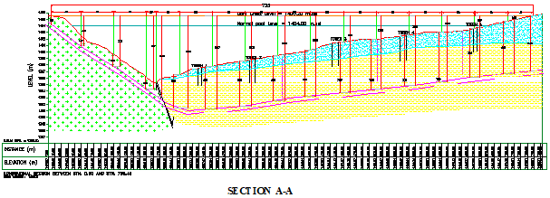
Figure 20 Main Dam Longitudinal Cross Section

6.4 Dam Design Sectional Elements

6.4.1 General
In most cases, central core type of dam can be most widely adopted. Therefore, standard sections will be based on the experience in design and construction of central core dams. This section describes the dam design procedures undertaken for Debobesa dam. The basic consideration in the design of Debobesa Dam has been to achieve safety consistent with economy. As indicated in Chapter 5, embankment dam with different zoning options has been considered for the feasibility study.
- Rock fill with central clay core
- Rock and shell fill with central clay core
Chute spillway on the right bank has been selected for Debobesa dam site. The following criteria have been considered in the Debobesa Dam design:
- Under all conditions of construction, reservoir operation, and seismic activity, the embankment, foundation, and abutments must remain stable.
- Seepage through the embankment, foundation, and abutments must be properly controlled and collected to prevent excessive uplift pressures, piping, sloughing and removal of material by solution or erosion of material by loss into cracks, joints, and cavities. In the design seepage control measures such as foundation cutoffs, grouting, slurry trench, concrete cutoff, adequate and non-brittle impervious zones, transition zones, and drainage blankets are incorporated.

6.4.2 Free Board
The distance between the flood peak level in the reservoir and the top of the settled dam constitutes the net freeboard. The net freeboard should be sufficient to prevent waves from overtopping the embankment. Wave height for moderate-size reservoir areas can be determined by Hawkslay's formula,
h = 0.014(D _{f}) ^{1/2}
Where, h: height of wave under maximum wind velocity (m)
D _{f}: fetch (m)
For the design of small dams with riprapped slopes, it is recommended that the freeboard be sufficient to prevent overtopping of the dam due to wave ride-up equal to 1.50 times the height of the wave and a safety of 0.05H. Therefore, the freeboard may be expressed as follows.
Net freeboard = 1.5h+0.05H (m)
Gross freeboard = D + 1.5h + 0.05H (m)
Where, D: depth of flow over the spillway (m)
h: height of wave (m)
H: the maximum height of dam (m)

6.4.3 Dam Crest Elevation
One of the basic requirements for design of dam is to fix the crest level of the dam which ensures safety against overtopping caused by wind induced waves and water by providing adequate free board. Freeboard is the vertical distance between the crest of the embankment (without camber) and the reservoir water surface. The more specific term “Normal Freeboard” is the difference in elevation between the crest of the dam and the top of active conservation, joint use, or exclusive flood control water level as fixed by design requirements. The term “Minimum Freeboard” is the difference in elevation between the crest of the dam and the maximum reservoir water surface that would result from a routing of the design flood with spillway operating as planned.

6.4.4 Dam Crest Width
The minimum top width for dams up to 5 m in height should be 2.4 m. If the top serves as a roadway, this minimum should be increased to 3.60m. Top widths for darns exceeding 5 m in height may be designed by the following formula:
B = 0.2H + 1.5 (m)
Where, B top width (m)
H height of dam above the stream (m)
ii. Trautwine's formula
B = 1.1 H ^{1/2} + 0.6 (m)
iii International Committee for Dams
B = 3.6*H^{1/3}+3.0 (m)
iv. US. Bureau of Reclamation
B = 3.6H^{1/3}+1.5 (m)

6.4.5 Dam Zoning
The main dam is designed with different materials zoning. Composed of Gravel, Cobble Boulder rock fragments in between the clay core and the outer rock fill zone. The remaining part of the dam will be rock fill materials. Detailed dam zoning will be made during detailed design stage, however the proposed zoning for dam design is:
Zone 1: Impervious clay core

Zone 1a: Fine Filter also refereed as F1
Zone 2a: u/s & d/s Shell Material
Zone 2c: Transition
Zone 3a: Clay Core
Zone 4a: Coarse Filter also refereed as F2
Zone 5: Horizontal U/S impervious Blanket
Zone 5a: Fine Filter also refereed as F1

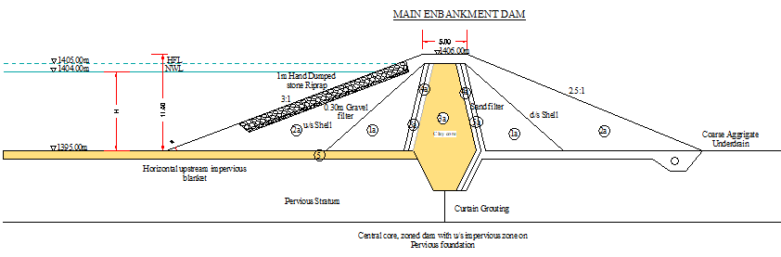
Figure 21 Dam zoning for rock fill with central clay core

6.4.6 Slope Protection
Experience has shown that in the majority of cases dumped riprap furnishes the best type of upstream slope protection. The thickness of the riprap should be sufficient to accommodate the weight and size of stone necessary to resist wave action. Experience has found 0.60 m riprap on 0.30 m bedding to be generally economical and satisfactory. Lesser thickness may be used on low dams. Downstream slopes of dams should be protected against erosion by wind and rainfall runoff by a layer of rock, cobbles, or sod. Because of the uncertainty of obtaining adequate protection by vegetative cover at many dam sites, protection by cobbles or rock is preferred. If grasses are planted, those suitable for a given locality should be selected.

7. Dam Slope Stability & Deformation Analyses

7.1 Upstream and downstream slopes

7.1.1 General
The existing laboratory facilities in the country do not support tests for rock fill materials. Therefore, the shear strength materials adapted for slope stability analysis are basically derived from similar project experience and commonly used literature data considering index and classification tests. Accordingly the parameters adapted for the analysis are shown in Table 11 and 12 for the proposed dam design.
The stability analysis has been conducted in order to determine the factors of safety for various slip surfaces of:
- Downstream under steady state seepage condition with and without earth quake;
- Upstream slope under sudden drawdown condition; and
- Upstream and downstream slopes during and end of construction.
Loading Conditions
Table below summarizes the loading conditions and corresponding minimum factor of safety (FOS _{min}) requirements proposed by USACE and used worldwide. The Debobesa Dam design shall meet these requirements.
Table 11 Loading condition and recommended minimum factor of safety
Case | Loading Condition | Slope | FSO _{min}
I | During Construction | Downstream/Upstream | 1.30
II | End of Construction | Downstream/Upstream | 1.30
III | Sudden drawdown | Upstream | 1.25
IV | Steady state seepage | Downstream | 1.50
V | Steady state seepage with earthquake | Downstream | 1.00

Table 12 Summary of embankment fill and foundation material characteristics used in seepage and stability analysis for (Zoned rock fill dam with central clay core)
Zone | Function | unit weight (kN/m³) | Permeability (m/s) | C' (kpa) | ϕ'(o)
3a | core | 18 | 1x10⁻⁸ | 10 | 20
5a | Fine Filter | 19 | 1x10⁻⁵ | 0 | 32
4a | Coarse Filter | 19 | 5x10⁻⁴ | 0 | 34
5 | Transition | 19 | 0.001 | 0 | 34
6 | Riprap | 22 | 0.01 | 0 | 42
3b | Foundation Alluvium | 18 | 5x10⁻⁵ | 5 | 28
1&2a | Fractured Rock | 20 | 1x10⁻⁵ | 5 | 38

7.1.2 Slope Stability Analysis
Typical slope stability analysis results of for both static and with earth quake loading are presented at end of respective sections. The minimum factor of safety is presented with four method of analysis i.e. Morgenstern-Price, Ordinary, Bishop and Janbu. However for comparison and reporting purposes the Morgenstern-Price method is selected which accounts both the force and moment equilibrium. The slope stability analysis discussion will be presented here only for the proposed dam design (rock fill dam with central clay core). However, the summary of stability analysis result will be presented in Tabular form whereas the model output will be annexed for further reference.

7.1.2.1 Steady State Analysis
The steady state slope stability analysis has been checked for the downstream slope which is expected to be the worst case compared to the upstream face. The hydraulic conductivity values indicated in Table 11 and 12 are used as input for SEEP/W of Geo studio 2012 to generate the water table and Pore-water pressure required for the slope stability analysis. The shear strength parameters shown in Table 11 and 12 are used for slope stability analysis using Slope/W of Geo studio 2012 package. The analysis is made when the water level is at Normal Pool level (1404.00m).
The minimum computed factor of safety for the downstream slope when the reservoir water is at normal pool level is found to 1.562 for no earthquake loading. The model schematization for Seep/W and Slope/W as well as the outputs of the Seep/W are indicated in Figure 22 considering option 1. Model output for steady state loading condition is presented in Figure 23 the reported factor of safety is 1.58 as the minimum factor of safety i.e. 2.38 is small for wedge for presentation.
Figure 22 Schematization for SEEP/W

Figure 23 Model output for steady seepage when the water level is at full reservoir level without earth quake loading condition

7.1.2.2 During/End of Construction
Computation of stability during and at the end of construction was performed using drained strengths in non-free-draining materials. For materials that drain slowly two alternatives are used:
- Total stress analysis with un-drained strengths and zero pore water pressure or
- Effective stress analysis modeling partially saturated condition with pore water pressure.
For Debobesa dam, the second alternative is used with pore water pressure during construction being higher than at the end of construction. Table 13 below summarizes the values of pore water pressure ratio Ru used for the stability analyses during and at the end of construction conditions.
Table 13 Pore water pressure ratio Ru values for construction conditions
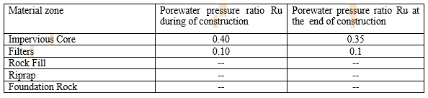
Accordingly the computed results during construction are presented in Figure 24 and Figure 25 for downstream and upstream slopes respectively. For downstream slope the minimum factor of safety obtained for end of construction and during construction are 1.48 and 2.38 respectively. The minimum factor of safety obtained for the upstream slope is 1.276 during construction case and 2.17 for end of construction case. The mentioned results are for the proposed dam design and values are indicated in Table 14.
Figure 24 Slope stability analysis result for downstream slope during construction
Figure 25 Slope stability analysis result for upstream slope during construction

7.1.2.3 Upstream Drawdown
Rapid drawdown stability computations were performed for the upstream slope for conditions occurring when the water level adjacent to the slope is lowered rapidly. For analysis purposes, it was assumed that the drawdown is very fast and no drainage occurs in materials with low permeability. It is proposed to provide outlet at two different levels. The outlet provided at 1400.00m is for irrigation purpose and the lower outlet proposed at 1398.55m is primarily for evacuation of flow below the irrigation outlet during maintenance as well as flow diversion during construction and silt removal where appropriate. Accordingly the combined drawdown time is estimated to be around 30days.
The computed factor of safety is 1.673 for the proposed dam design with Morgenstern-price method of analysis and the pore water is analyzed considering transient analysis.

Figure 7.5: Upstream drawdown analysis result

In summary the minimum factor of safety computed is presented in Table 7.5 in comparison to the recommended minimum factor.
Table 14 Recommended and Computed Factor of Safety (FOS) for different Loading Conditions 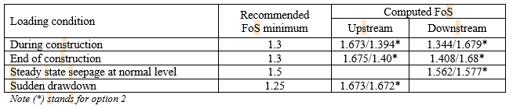

7.2 Slope stability analysis with earthquake loading
Jibson, R.W.(2011) reported that methods developed to date to assess the stability or performance of slopes during earthquakes thus falls into three general categories:
a) Pseudo static analysis,
b) Stress deformation analysis, and
c) Permanent-displacement analysis.
Each of these types of analysis has strengths and weaknesses, and each can be appropriately applied in different situations. Besides to this data availability is also another major hindrance to successfully undertake such kind of exercise.
Current methods of analysis generally use the Pseudo static method for reasonably well-built dams on stable soil or rock foundations and if estimated peak ground accelerations is less than 0.2g. USNRC (1985) stated that in areas where peak ground accelerations may exceed 0.2g and for dams involving embankment or foundation soils that may lose a significant fraction of their strengths under the effects of earthquake shaking; a dynamic analysis should be performed. The project area is located in less active seismic zone and the assumed ground acceleration is 0.1g as discussed in section 4.6. Therefore, for Debobesa Dam design Pseudo static analysis is sufficient and accordingly the analysis is discussed here under.

7.2.1 Pseudo static Analysis
Pseudo static analysis models the seismic shaking as a permanent body force that is added to the force body diagram of a conventional static limit-equilibrium analysis. The project area is located in less seismic active zone and hence PGA value of 0.1g is considered for SEE (Safety evaluation earthquake). It is usually common practice to consider the vertical acceleration as half of the horizontal acceleration i.e. 0.05g. Since there is no site specific seismic evaluation study it is considered that for operating earth quake (OBE) 0.05g is adapted. Accordingly, the slope stability analysis results considering the Pseudo static analysis for the steady seepage with earthquake loading for the downstream slope is presented in Figure 7.6 for SEE loading for the proposed option respectively.
Results of the analysis depicts that the minimum factor of safety for the SEE loading is 1.231 for the proposed dam design. Similarly for OBE loading the minimum factor of safety is 1.316.The output for the earthquake analysis is slightly greater than the minimum required which entails the need to slightly revise the slope. However, the materials property is mainly derived from literature and thus for the current design stage the proposed slopes for both upstream and downstream slopes are adapted.
To minimize the uncertainties in the material properties sensitivity and probability analysis has been done as presented below.
Figure 7.6: Pseudo static stability analysis result for SEE loading condition for the Dam

Probabilistic and sensitivity analysis has been also performed for the Pseudo static analysis for SEE loading condition considering some changes in the material properties. For the sensitivity analysis the material were made to be changed uniformly between the minimum and maximum ranges indicated in Table 7.6 and for the probabilistic analysis about 5000 Monte Carlo simulation were considered.
Table 15 Range of soil parameters used for sensitivity analysis for the proposed Dam
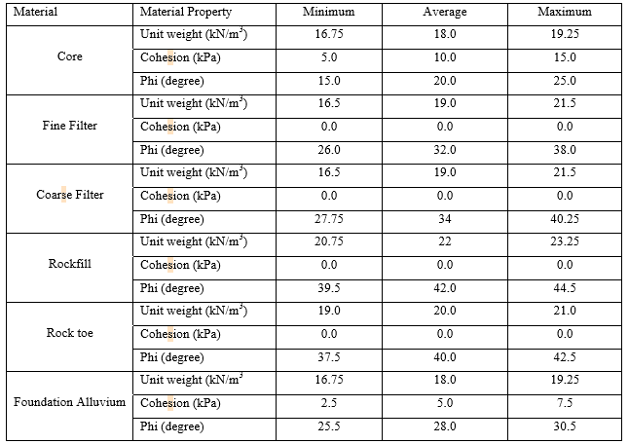

Figure 7.8: Probability distribution function of the 5000 Monte Carlo factor of safety showing probability failure

7.3 Static Stress Deformation Analysis
In order to achieve the expected behavior of the zoned fill dam, the rock fill materials constituting the shells have to exhibit sufficient strength, minimum reduction of strength parameters as strain progress and limited quantified settlement. Besides there should be adequate degree of permeability in order to effectively control any pore pressure build-up during embankment construction.
Non-linear elastic E－B model is adopted for the clay core and filter for the proposed dam design and linear elastic model is adopted for rock fill, riprap, rock toe, foundation alluvium, fractured rock and bed rock. Parameters of various materials are shown in Table16. The analysis is carried out by load deformation analysis of SIGMA/W. The results from this analysis are used to determine if the expected magnitude of settlement is acceptable and check the adequacy of the proposed camber.
Table 16 Parameters of Materials for Stress Deformation Calculation
Description |  | Strength Parameters |  |  |  | K | n | R _{f} | K(o)
 |  | C kPa | Unit Weight kN/m3 | ϕº degree | v
Non-linear elastic | Clay Core | 10 | 18 | 20 | 0.40 | 300 | 0.6 | 0.7 | 0.86
Non-linear elastic | Fine Filter transition | 0 | 19 | 32 | 0.33 | 600 | 0.4 | 0.7 | 0.47
Linear elastic | Transition/Coarse filter | 0 | 19 | 34 | 0.30 | 800 | 0.4 |  | 0.40
Linear elastic | Rock fill | 0 | 22 | 42 | 0.20 | 800 | 0.4 |  | 0.33
Linear elastic | Rock toe | 0 | 22 | 38 | 0.15 | 1000 | 0.4 |  | 0.33
Foundation Alluvium |  | 5 | 18 | 28 | 0.3 | 600 | 0.4 |  | 0.47
Fractured Rock |  | 5 | 20 | 38 | 0.15 | 400 | 0.6 |  | 0.8
Concrete cutoff |  | 10 | 22 | 38 | 0.3 | E = 0.5 Mpa
Bed Rock |  | 10 | 22 | 40 | 0.2 | E= 1.0 Gpa

Loading conditions the analysis is used to establish the stress conditions induced by the self-weight of the dam. The load/deformation analysis option in SIGMA/W is used for determining the stress conditions. The material properties used are those indicated in Table 7.7.
Analysis method and assumptions
A 2D stress-strain analysis on a vertical cross section with a unit length is conducted using SIGMA/W load-deformation analysis option. SIGMA/W is used for determining the stress conditions using nonlinear elastic and linear-elastic model (Mohr-Coulomb).

8 SPILLWAY WORKS

8.1 General Design Considerations
The proposed Dam is an embankment dam with central core. This type of dam needs sufficient spillway capacity. The safety of the dam cannot be secured only with provision of sufficient discharging capacity of the spillway; the hydraulic design of the spillway must also be adequate to convey and dissipate the energy associated with water passing over the spillway.
The spillway crest elevation is at 1404.00masl and the following main design criteria have been considered for the design of the spillway:
There should be complete dissipation of energy of spillway flow before it enters the river; The dimension of the control section (weir), have been fixed such that it could pass the maximum routed flood with a design discharge head (surcharge); The spillway must be hydraulically and structurally safe; The spillway and chute in general should be erosion resistant to withstand the high scouring velocities; and
The spillway design is accomplished in a manner that minimizes cost subject to the following:-
  - Sufficient crest length to convey the design discharge.
  - Acceptable minimum pressures acting on the crest boundary.
  - Acceptable maximum energy head on the spillway crest.
  - Acceptable velocities and flow characteristics through the spillway system.

8.2 Spillway inflow and outflow design flood
As indicated in section 3.4.1.3, the design discharge for the spillway is fixed based on the recommendation given in the Dam Safety Draft Guide of the Ethiopian Commission of Large Dams. Accordingly, the inflow hydrograph considered is 50 years return period and its peak discharge is 68m3/s. For the selected total crest length of 20m, the routed outflow discharge is 34.69m³/s.

8.3 Type of spillway and selected scheme
Spillway type selection can be governed mainly on type of dam, site condition (i.e. topography), and flood discharge, simplicity for construction and adaptability for foundation. Therefore, by considering all

8.4 Location and alignment of spillway
Primarily, location of the spillway is dictated by the safety of the dam, economic considerations, construction difficulties, and the possible interference with the layout of outlet and canal structures of the project. In addition to this, topography and geology of the area are among the main considerations guiding the choice of spillway location.
For Debobesa dam the spillway site is selected or proposed on the left abutment by excavating the top end of the abutment. Naturally, the spillway route has steep to moderate downstream slope starting from the control point, near the abutment, till it joins the stream bed. From surface observation and preliminary geophysical survey made along the proposed route shows that the dominant geologic features are topsoil, alluvial deposit, weathered and fractured limestone with shale intercalation and massive lime stone. At the beginning of the spillway i.e. approach channel and control section there is an exposed limestone, whereas on the steep slope and near to the river coarse the lime stone is deep and thus the chute floor might be founded on either the alluvial or fractured lime stone. As a result of this an extensive investigation and treatment design might be mandatory. Therefore, geotechnical investigation along the spillway is highly recommended and the preliminary proposed design will be further elaborated based on the investigation results. In addition to the hydraulic design stringent structural design of all components the spillway works is equally important.

8.5 Hydraulic design of spillway
The main components of the spillway include, approach channel, control section, chute section, terminal structure and exit channel. In this section the hydraulics aspects of the mentioned components will be presented.

8.5.1 Discharge over the Chute Crest
The control section of the spillway is designed as chute structure which has good hydraulic performance. Discharge over the crest is expressed as:
- Inlet section
Substituting in Eq. (3.4), the width of inlet section will be determined as follows:
L = Q/1.70*He^{3/2}
Where, Q = Discharge,
L = length of the weir,
He = height of energy line above the crest = Hd + V2/2g,
Hd = Design head excluding the velocity head of the approach flow,
C = Discharge Coefficient, N= Number pier,
Design parameters
- Spillway crest level: 1404.00m.
- Total Crest length: 20m, to support the truck bridge proposed on the top of spillway two piers each 1.0m thick is provided.
- Spillway design discharge: 68m3/s
- Flow depth over the spillway crest, Hd= 1.02m
Arbitrarily, assume a bed width of 20.00m for the control section. Then, the critical depth, dc for flow at the control is,
q = Q/b
d_{c} = (q²/g)^{1/3}
V_{c} = q/d_{c}
h_{vc} = V_{c}²/2g
For the Flow at the entrance,
q = Q/b
V = q/d
h = V²/2g
Substituting the values in Eq. (3.6)
Z₁ + d₁ + h_{v1} = Z_{c} + d_{c} + h_{vc} + 0.2(h_{vc} - h_{v})

2. Chute section
Water surface profile of the chute flume can be computed from the Bernoulli’s equation as shown in Eq.(3.8) and the trial and error computations are shown in the tabe.2. Chute section Water surface profile of the chute flume can be computed from the Bernoulli’s equation as shown in Eq. (3.8) and the trial and error computations are shown in the table.

Table 17 Computation of surface –water profile (Standard Step Method)
Station | Z | d | A | V = Q/A | h = ( V²/2g) | Z +d +h | P | R = (A/P) | S₁=(n²V²/R^{4/3}) | S, (avg.) | ΔL | h₁ = 11*12 | Z +d+ h_{v}+ h | Error | Remark
1 | 2 | 3 | 4 | 5 | 6 | 7 | 8 | 9 | 10 | 11 | 12 | 13 | 14 | 15 | 16
0 | 1402.92 | 1.339 | 26.788 | 2.538 | 0.328 | 1404.59 | 22.679 | 1.181 | 0.0017 | 0 | 0 | 0
5 | 1402.42 | 0.870 | 17.391 | 3.910 | 0.779 | 1404.07 | 21.739 | 0.800 | 0.0067 | 0.0042 | 5 | 0.0209 | 1404.09 | 0.498 | OK
20 | 1400.92 | 0.638 | 12.755 | 5.331 | 1.449 | 1403.01 | 21.276 | 0.600 | 0.0182 | 0.0124 | 15 | 0.1866 | 1403.19 | 0.876
 | 1400.92 | 0.684 | 13.670 | 4.974 | 1.261 | 1402.86 | 21.367 | 0.640 | 0.0145 | 0.0106 | 15 | 0.1591 | 1403.02 | -0.017 | OK
50 | 1397.92 | 0.535 | 10.700 | 6.355 | 2.059 | 1400.51 | 21.070 | 0.508 | 0.0323 | 0.0253 | 30 | 0.7575 | 1401.27 | 1.594
 | 1397.92 | 0.626 | 12.511 | 5.435 | 1.506 | 1400.05 | 21.251 | 0.589 | 0.0194 | 0.0170 | 30 | 0.5090 | 1400.56 | -0.047
 | 1397.92 | 0.749 | 14.980 | 4.539 | 1.050 | 1399.72 | 21.498 | 0.697 | 0.0108 | 0.0127 | 30 | 0.3802 | 1400.10 | -0.048 | OK

(3) Trajectory
(a) Convergence
The flow in the chute shows Froude number as follows:
F = V/√gd = (6.546/√9.81*0.742) = 2.43 at st. 50
It may be necessary to install a trajectory for a good hydraulic performance. The above velocity and depth is for the flow at the beginning of the transition. The velocity and depth at the end of the transition should be computed from the Bernoulli’s equation by using manning’s “n” = 0.008. Assume that the trajectory will have the horizontal distance of 10m and an average bed slope of 1:3 Assume d = 0.48m and b = 15.0 m at the end of trajectory and apply the Bernoulli’s equation.
The hydraulic properties at beginning and end of trajectory are as follows:
Table 18 Hydraulic properties at beginning and end of trajectory
st. | Z | d | A | V | hv | P | R | Sf
beginning | 1397.92 | 0.75 | 14.980 | 4.539 | 1.050 | 21.498 | 0.697 | 0.011
end | 1394.62 | 0.44 | 6.578 | 10.338 | 5.445 | 15.877 | 0.414 | 0.022

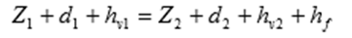
1397.92 + 0.74 + 2.143 = 1394.62 + 0.44 + 5.445 + 0.23
1399.719 = 1400.668 (Satisfactory)
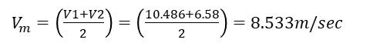
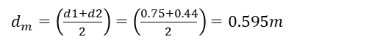
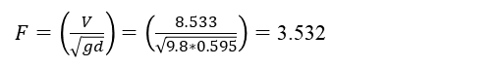
Substituting in Eq. (3.11)

b) Profile
The trajectory can be determined from Eqs. (3.9) and (3.10)
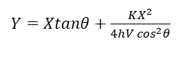
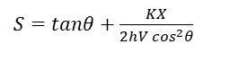
Where, X: horizontal length from origin to a point on the trajectory
Y: vertical fall from origin to X on the trajectory,
S: Slope of trajectory,
ϴ: Angle of inclination of chute channel at the origin of the trajectory
hv = V2/2g computed at origin of trajectory using n= 0.008 and K= 0.5
The trajectory should terminate at the crossing point or before the sidewalls of the chute and the stilling basin meet.
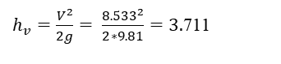
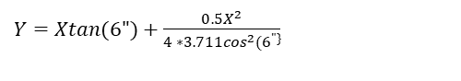
0.100335*x + 0.023048*x^2
Station | 52 | 54 | 56 | 58 | 60
x | 2 | 4 | 6 |  | 10
y | 0.293 | 0.770 | 1.432 | 0.000 | 3.308

(4) Stilling basin
V1 = 10.338 m/sec
d1 = 0.44m
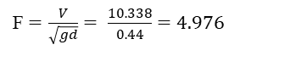
A stilling basin with incoming velocity, V1 =10.338m/sec and froude number F = 4.976 will have the best hydraulic performance for energy dissipation. Therefore, type III basin will be adopted and all basin dimensions can be read in appendix A-5
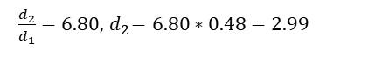
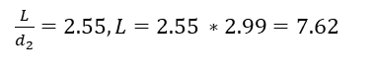
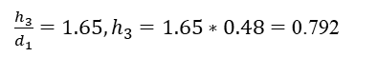
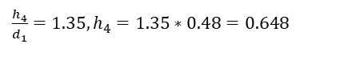
Details of shape and arrangement of chute blocks, baffle blocks and end sill are shown in Appendix A-5.
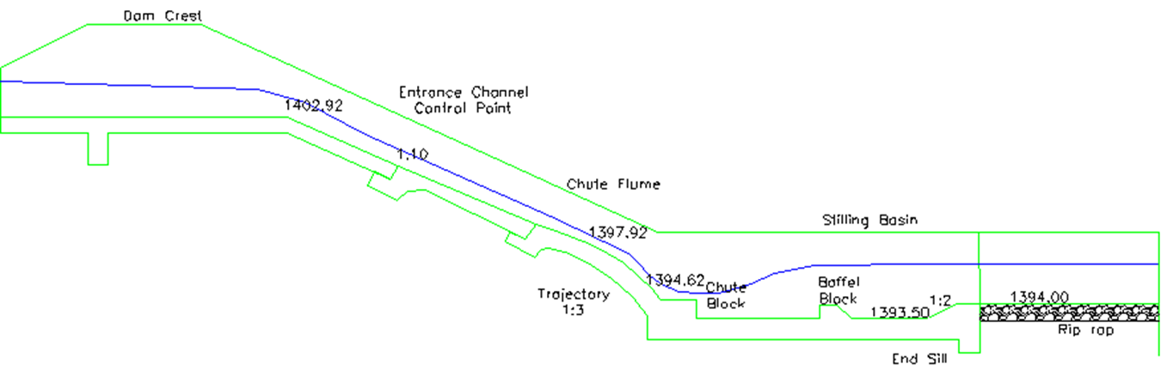

9. Appurtenant Structures

Design of Outlet Works

9.1.1 Lay out of outlet conduit and related works
The outlet work system covers mainly the irrigation outlet and provisions made to pass the dry season during construction. As it was discussed in section 2.4, the construction is planned to be finished in two years and hence during the first year of construction the wet season flow will pass with the existing river coarse; however foundation excavation of the main river coarse will be finished during the dry months of the first year construction. Therefore, simple temporary dry season outlet is proposed to pass the minimum flows during the dry months. The full supply level of the main canal is about 3.52m above the river bed level and hence it is mandatory to align the irrigation conduit corresponding to the irrigation demands. The total reservoir storage below the minimum drawdown level is relatively small and hence no separate bottom outlet is proposed to evacuate the flow below the irrigation conduit. However, if it is necessary to evacuate this volume water can be pumped into the outlet conduit and then into the Anga River.
The main purpose of this outlet system is for irrigation. However, during emergency cases it will be used to evacuate the volume of water above it. The control mechanism will be stop logs at upstream and downstream (valve). The water entering the small intake will be conveyed towards downstream with a conduit crossing the dam body. The current dam design concept did not encourage provision of conduits within the dam. Though locating conduit outside the dam is the safest approach, there are also several dams in which their outlet system crosses the dam body. For this project special consideration has been given in most part of the dam to be embedded in excavated trench and thus minimize potential failure. Water leaving the dam will be dissipated before it joins the main canal. The center line of the irrigation conduit is maintained to be at 1399.00m.

9.1.2 Irrigation Outlet
The proposed net command area for Debobesa project is about 100ha. The required design discharge considering the downstream release for environment cause is about 0.26m3/s. The main purpose of this outlet is for irrigation. However, the irrigation outlet is designed to have a small inlet, trash rack, circular conduit, flow regulation valves at the downstream end and an energy dissipater.

9.1.2.1 Hydraulic Design of Intake/Inlet
i. Intake/Inlet opening
The proposed design discharge is 0.26m³/s and an opening pipe diameter of 600mm ductile iron pipe is provided.

9.1.3 Irrigation Conduit Hydraulics
A. General
The conduit is designed to pass the irrigation flow and environmental release. Further the outlet will evacuate the reservoir water above irrigation outlet which is about 1.123MCM in volume. The size of an outlet conduit for a required discharge varies according to an inverse relationship with the available head for producing the discharge. This relationship is expressed by the following equation:
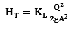
Where: H_{T} = total available head needed to overcome the various head losses to produce the discharge (m);
Q = required outlet works discharge (m³/s);
K_{L} = loss coefficients;
A = required area of the conduit (m²); and
g = acceleration due to gravity 9.81(m/s²). Head loss computation for various parts of the structure is discussed below.
B. Pressure flow in the irrigation conduit
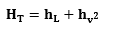
Where: H_{T} = total head needed to overcome the various head losses to produce discharge,
h _{L} = Cumulative losses of the systems, and
h _{v2} = Velocity head at the valve.
The above equation is expanded to include the system losses of the outlet structure as follows:
Where: h t = Trash rack losses,
h _{e} = entrance losses,
h _{f} = friction losses and
h _{g} = gate or valve losses. For the discharge at the outlet,
H_{T} is measured from the reservoir water surface to the centerline of the outlet gate.
C. Head loss computation
The control gate for the low level outlet conduit is located downstream of the conduit. Thus the conduit is always under pressure. The flow in a closed conduit pipe system follows Bernoulli’s equation which is written as:
Where: HT = total head needed to overcome the various head losses to produce discharge,
h _{L}= Cumulative losses of the systems, and
hv2 = Velocity head at the valve.
The above equation is expanded to include the system losses of the outlet structure as follows:
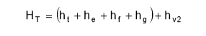
Where: ht= Trash rack losses,
he= entrance losses,
hf= friction losses and
hg= gate or valve losses
For the discharge at the outlet, HT is measured from the reservoir water surface to the centerline of the outlet gate.
D. Head loss computation
i. Trash rack Losses
The trash rack consists of 16mm thick mounted at the inlet and its head loss is almost negligible because the trash rack is placed on the top of the box horizontally.
ii. The other loss computation is shown in table 1 below (Entrance, Friction and Valve losses) in pipe size calculation

Intake Pipe size calculation
From the above table-1, the maximum discharge that can be withdrawn from the reservoir is 0.28m3/s, which is greater than the required discharge i.e.0.26m3/s. Therefore the proposed conduit diameter of 0.60m is satisfactory for the intended purpose.

9.1.4 Type and sizes of Regulating Valves
The selected types of valve at the outlet are two types; one is simple gate valve used for energy and the other is butterfly valve for operation purposes. The selected valve size is of diameter 27.56 inch to suit the 600mm conduit.

9.1.5 Energy Dissipater Design
Before water is conveyed to the main canal from the outlet, the flow energy should be dissipated so that downstream erosion will be avoided. Therefore at the end of the outlet pipe a stilling basin is needed for energy dissipation. It is designed to safely dissipate the maximum energy i.e. when the reservoir is full and discharging the maximum flow. So Based on the following data the irrigation outlet is designed as follow.
Topographic map Topographic map of the dam site and topographic map of irrigable area with the scale of 1:1000 is available
Geological information along the inlet/outlet route Surface observation and subsurface investigation have shown that the top 7.5m is covered by completely to moderately weathered aphanitic and fractured basalt and underlain by fresh aphanitic basalt. Therefore the foundation is good from settlement aspect.
Dead storage level
For 20 years sediment load = 1397.00masl
For 50 years sediment load =1400.00masl
Full supply level = 1400.60masl
Required: - Design all components of the outlet works
- Design of Intake structure
Intake sill level the sill-level is seen from two considerations
- Sedimentation analyses and
- Existing topographic condition
By analyzing the above factors the initial intake sill level is fixed at 1397.00masl for 20 years sediment distribution. And considering the experience on the economic life of the dam, to increase the service life of the dam the sill level rises to the level of 50 years sediment distribution (i.e 1400.00masl).Hence, to use the reservoir water effectively 3.00m heights submerged front entrance intake structure is provided.
- Intake shaft size
Considering the maximum required flows in the outlet pipe and the diameter of the pipe (i.e width/length = 1.3Do = 1.3x0.6m = 0.8m), 0.8m x 0.8m shaft size is provided.
- Intake wall thickness
The wall thickness is designed for the most critical loading (i.e the sediment deposited to the top level of the intake structure while inside is empty) using limit state design method. From experience for this loading condition and 3.00m height intake structure, the calculated rein forced wall thickness at the bottom of the wall is 31.5mm. But for practical condition adept 30cm wall thickness and reinforced with φ 12 mm bars at 150mm c/c spacing. →
Intake wall thickness = 30cm
- Stop log
So as to barrier the entrance of sediment in to the opening of the intake structure 0.1mx 0.25mx 1.0m (i.e. about 68kg) size reinforced concrete stop log is provided. And to operate the stop logs 12cm width grooves are provided on the wall of the intake
- Trash rack
To control the entrance of debris throughout the height of the intake structure 1.00m x 0.60m size movable trash rack is provided. And in addition to this on the top of the structure the trash rack also provided. Φ16mm reinforcement bar is used as the trash rack at the spacing of 10cm at c/c and to reinforce the trash rock from bending due to the water load 20mm x 20mm iron tube is welded to the edge of the trash rack at all four sides. And to operate the trash rock 24mm width grooves are provided on the intake tower wall. Note: A total of 14 stop logs (i.e. the size of one stop log is 0.1m x 0.25 x 1.0m) made from R.c.c should be prepared and kept at the site.
- Access footbridge
So as to operate the intake structure, 30.0m x1m (length x width) access footbridge is proposed. The footbridge slab is constructed from reinforced concrete with hand rails and the slab is supported by piers. To avoid the negative effect of the piers on the dams (i.e on which the pier is founded) the access footbridge pier is founded on the abutments.
- Slab Design
The total length of the slab is 30.0m considering the support condition (i.e all spans are simply supported), permissible deflection of the slabs and the length of each span, 15cm slab thickness reinforced with φ12mm bar at 110mm c/c spacing is provided.
- Pier Design
Eight piers are provided at the spacing of 3m (for the first two piers) and 4.0m (for the remaining piers) so as to support the foot bridge slab. The height of the pier varies from 1.0m to 3.0m, the 1.0m pier height is proposed to be constructed from masonry, and the rest piers are proposed to be constructed from reinforced concrete.
Considering the magnitude of acting loads on the pier and its height, 0.25m x 0.40m rectangular pier section reinforced with 6 x 14mmφ longitudinal bars and φ6mm bar lateral ties at the vertical spacing of 200mm is adapted.
- Conveyance structure
Pipe outlet level
As discussed earlier the intake sill level is fixed at 1399.50masl from sedimentation analysis but the command area to be irrigated is below 1399.50masl elevation and hence considering the peak elevation of the command area, the conduit level is drop by 0.29m from intake sill level and therefore the pipe outlet level is fixed at 1399.21masl
→Outlet level = 1399.21masl
Outlet capacity
The outlet is designed to release 2.60ℓ/s/ ha water demand for 100ha
→Outlet capacity = 2.60ℓ/s/ha x 100ha = 260 ℓ/s = 0.26m3/s
Pipe diameter fixation
- Full reservoir level = 1404.00masl
- Conduit outlet level = 1399.21masl
- Pipe length = 77.50m
- Steel pipe Manning's coefficient (n) = 0.012 (maximum value )
- Assumed pipe diameter = 0.60m
The diameter of the pipe can be calculated easily using the following equation
Where D = pipe diameter in (m)
Q = Discharge = 0.26 m3/s
HT = Total head between FRL and top level of the pipe (since the outlet is not free discharging) = 1.404.00masl - (1399.21m + 0.6m) = 5.19m
g = Acceleration due to gravity = 9.81m/sec2
KL= Constant which is obtained after considering all the losses in the system
K = all head loss excluding friction loss taken
L = pipe length = 77.50m
f = steel pipe friction loss
D = the assumed diameter in feet =1.969ft.
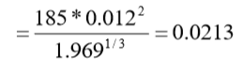
K = kt + ke + kb + kV + kex
Where kt = trash rack loss coefficient
Where Ag = the gross area of the trash racks = (3.5m x 0.8m) + (0.8m x 0.8m) = 3.44m2
An = the net area through the trash racks =
= Ag - (7 x 0.016 x3.5) + (34 x 0.016 x 0.8) + (2(0.8 x 7 x 0.016))
= Ag - 1.0064
= 3.44 - 1.0064 = 2.4336
ke = entrance loss = 0.70 (maximum value from the table)
kb = bending loss = 0.20 (from the graph)
kv = value loss = 0.15 (for butter fly values)
kex = exit loss coefficient = 1.0
→k = 0.6166312 + 0.70 + 0.20 + 0.15 + 1.00 = 2.666
→KL = 2.751 + 2.666 = 5.417
For minimum head of 1.40m (HT = 1.40m) (i.e. the elevation difference b/n the inlet and the outlet):
Diameter computed (0.383m) is less the assumed diameter (0.6m), hence it is okay. Therefore, to be able to utilize the minimum driving head by reducing friction loss through the pipe, a steel pipe of 0.60m diameters is adapted.
- Discharging capacity of the pipe at full reservoir
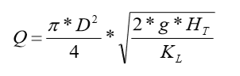
Where D = 0.60m, HT = 5.40m and KL = 5.912
- Check the velocity in the pipe
, acceptable
Pipe wall thickness
Since the location of the control valve is at the d/s of the dam, the pipe throughout its length is pressurized. Hence, at downstream portions of the pressure conduit, there may be an excess of internal pressure, which could cause leakage through joints or cracks in to the material surrounding the conduit barrel. To avoid this problem the conduit wall thickness should be greater than or equal to 4mm. And inside and outside of the pipe should be coated by bituminous or by some other rust - resisting treatment, so as to protect from corrosion to reinforce and to protect the pipe from any damage during compaction of the fill by the compactor and also to make suitable for compaction the pipe is covered by reinforced concrete as shown in the figure below.
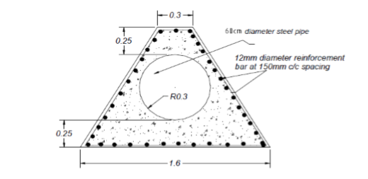
Reinforced concrete pipe cover
Controls
Considering its easiness to operate against unbalanced water pressure because of the partially balanced pressure against the disc, the advantages of being low cost and minimum head loss, abutter fly values are recommended. The values are provided at the downstream of the dam near to the outlet at two points. The first serve as a stand by and the other regulates the flow.
Energy dissipating device
An impact type of stilling basin that doesn't depend up on tail water is adapted. Impact basin consists of a rectangular box like structure with the long dimension parallel to the axis of the pipe. The discharge from the pipe is intercepted by a solid hanging baffle which extends over the full width of the structure. The basin width (w) recommended for the impact basin is a function of the discharge and calculated from:
W = 1.9*Q ^{0.4}
Where Q = 1.5 x discharge at maximum reservoir level
= 1.5 x 0.900m3/sec = 1.350m3/sec
All other dimensions are expressed in terms of “w” as indicated in the figure below
W = 1.9*1.350^0.4 = 2.142
c = 0.982 = 0.08 * 2.142m = 0.171m ≈ 0.20m
f = 0.37w = 0.37 * 2.142m =0.792m ≈ 0.80m
i = 0.17w = 0.17 * 2.142m = 0.364m ≈ 0.40m
j = 0.75w = 0.75 * 2.142 = 1.606m ≈ 1.70m
p = 1.33w = 1.33 * 2.142m = 2.848m ≈ 3.00m
y = 0.34w = 0.34 * 2.142m = 0.728m ≈ 0.75m
t = (wall thickness) = 0.20m (R.c.c)

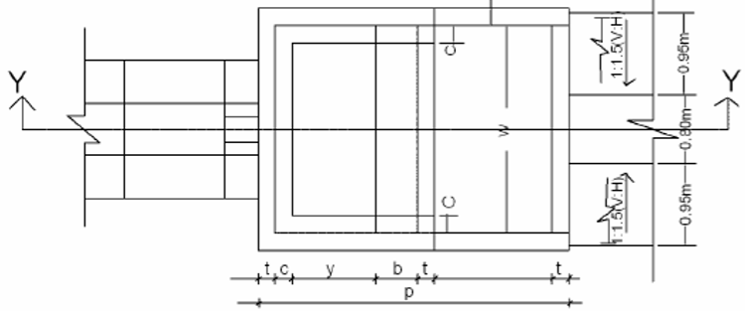
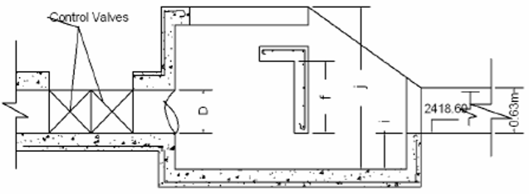
Plan and section y-y of USBR impact Basin

10. Cost Estimates

10.1 Cost estimation
The estimate of quantities presented at this draft feasibility design report considers the permanent works as set out in the feasibility level studies. The unit rate adapted for cost estimation is taken from other similar projects with some adjustments. All rates are presented in Ethiopian Birr (ETB) only. Accordingly the investment cost of the dam and its appurtenant structures is about Six hundred eighteen million one hundred one thousands four hundred ninety-six birr and ninty-nine cents 618,101,496.99 for option 1, Summary of the cost items and estimated costs are presented in Table 11.1below.
Table 19 Debobesa dam BOQ and cost estimate summary
S/No | Item of Work | unit | Total Cost | Community share | Remark
1 | Main Access Road | Eth. Birr | 15,000,000.00
2 | Mobilization | " | 10,000,000.00
3 | Foundation Preparation and Treatment | " | 16,807,132.25
4 | Main Embankment Dam | " | 354,486,314.48
 | Saddle Dam | " | 12,505,188.82
8 | Canal Conveyance & Related Structure | " | 2,621,267.17
9 | Camp | " | 714,447.70
10 | Day Work | " | 10,000,000.00
Total Carried Summary Birr |  | " | 422,134,350.41
Overhead cost =5% of Total Project Cost |  | " | 21,106,717.52
Total Carried Summary Birr |  | " | 443,241,067.93
For Supervision Cost = 5% of final Total Summary Birr |  | " | 22,162,053.40
Final Total Carried Summary Birr |  | " | 465,403,121.33
Vat 15% |  | " | 69,810,468.20
Grand Total |  | " | 535,213,589.53

11. CONCLUSIONS AND RECOMMENDATIONS
The catchment area at the dam site is about 12km². According to the reservoir simulation exercise the Debobesa reservoir can irrigate about 100ha with full storage capacity of 1.130 MCM. The proposed dam will have maximum dam height of 11m above river bed and 735 m crest length. The dam design option is carried out with two options considering the preliminary geological and geotechnical investigation made at the dam axis, spillway and partly the reservoir area. The geological features derived in this study phase are basically based on surface observation, geophysical survey along selected investigation routes and few laboratory test results with regards to construction materials. An attempt was made to extract as much as possible information required for design purposes from the limited investigation indicated above.
The project area is situated within the main Ethiopian Rift. Accordingly, it is found being characterized by volcanic rocks that are affected by closely sited faults associated to the rifting phenomenon. The lithological units are overlain by unconsolidated sediments of varying thickness. Accordingly to the geophysical survey the majority of the middle valley is overlain by a material with low resistivity value which interpreted as highly fractured and weathered basalt probably may contain ground water bearing aquifers. The exact property of this geologic feature is not clearly known and at this stage of study a conservative design with concrete cutoff has been proposed.
The construction material assessment was not sufficient and hence for the current design purpose experiences of other projects has been used to come up with an acceptable design. Given the investigation and study constraints in the geology and geotechnical investigation the feasibility design of the dam and appurtenant structures of the Debobesa Irrigation Project has been done following acceptable practices widely exercised within and outside the country. Accordingly, preliminary cost estimates were carried out two options and option - 1 is selected for detailed design stage with the approval of the client. For successful undertaking of the detailed design the geology and geotechnical investigation should be done with due consideration of:
- Detailed mapping of the reservoir and dam seat: the map should identify the weaker zones which are susceptible to leakage and erosion.
- The project area is situated within the main Ethiopian Rift and hence detailed analysis of the rock mass deformation is important and hence modulus of elasticity of the different rock formation should be estimated.
- Detailed engineering geological profile along the dam axis, spillway route and outlet works (irrigation and diversion during construction)
- Detailed construction material assessment by identifying the major construction material sources, location map of the construction materials, engineering properties as well as physical properties.
Therefore, the detailed dam and appurtenant structures design will be done immediately after the planned geology and geotechnical investigation is completed. Therefore it is strongly recommended to consolidate the ongoing efforts for the implementation of the investigation works and accordingly finalize the design works within short possible duration.

12. REFERENCES
- Advanced Dam Engineering for Design, Construction, & Rehabilitation, by R.B.Jansen, 1988;
- A Guideline for Community Based Participatory Watershed Development Part 1 &2 by MoARD, Jan. 2005.
- Criteria for Design of Small Embankment Dams, IS, 1999;
- General Design & Construction Considerations of Earth and Rock-Fill Dams, US Army Corps of Engineers, 2004;
- Design of Small Earth Dams, USBR, (1965);by J.T., 2014;
- Freeboard Requirement in Embankment Dams Guidelines, IS, 1993;
- Guidelines for Freeboard Requirement in Embankment Dams, IS, 1993;
- Hydraulic Structures, Novak, P., Moffat, A.I.B., Nalluri, C. and Narayanan, R. 1996;
- Irrigation Engineering and Hydraulic Structures, S.K. Garg, 2006;
- Irrigation and Water Resources Engineering, G.L. Asawa, 2005;
- Planning, Development, Monitoring & Evaluation of Irrigated Agriculture with Farmer Participation, FAO, 2006;
- Small Earth Dam Manual, FAO, 2010;
- Water Resources Engineering, by Linsley, R. K., Franzini, J. B., Freyberg, D. L., and Tchobanoglous, G.., 4th ed., McGraw-Hill, New York, 1992,

13. APPENDIXS

Appendix1. Dam Design

Freeboard computation procedures
This procedure explains the steps to be followed while fixing freeboard.
Effective fetch length (Fe)
The effective fetch length of the Debobesa Dam Reservoir has been calculated from the topographic map of the reservoir. Accordingly, the fetch lengths for the normal reservoir water level and maximum reservoir water level are found to be 1.45km and 1.5km, respectively.
Wind speed (V)
USBR recommends that normal freeboard should be based on a minimum wind speed of 100 mi/hr (160 km/h); and for the minimum freeboard the wind speed is taken as half to two third of the full wind velocity used in calculating the normal freeboard.
Wind setup
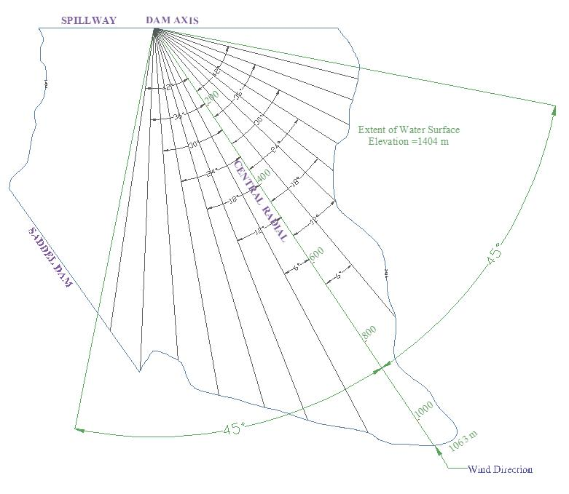
Significant wave height (H _{s})
The significant wave height H _{s} can be read from Figure 13.2 Fell et al (2005) adapted from Saville et al., 1962; USBR, 1981. From Figure 7.1A1 for fetch length 0.932mile and 0.963mile are 3.4feet and 2.2feet respectively corresponding to their wind speed.
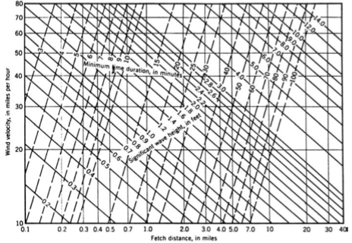
Figure 6.1A1: Wave heights and minimum duration wind (Fell et al. (2005)
Wave period (Ts)
The wave period can be read from Figure 6.1A2.
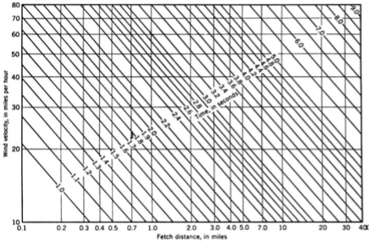
Figure 6.1A2: Wave periods (Saville et al., 1962; USBR, 1981)
The wind periods are 3.35sec and 2.75sec respectively.
Wave length (L _{s})
The deep water wave length in meters can then be computed from:
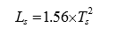
Accordingly the calculated wave length are 17.51and 11.80m for Ts = 3.35seconds and 2.75seconds respectively.
Design wave height (H0)
The design wave height is calculated by the following equation.
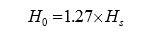
Accordingly the calculated design wave heights are 1.32m and 0.85m for Hs = 1.04m and Hs=0.67m
Steepness ratio
The steepness ratio is calculated by the following equation.
$Steepness ratio=\frac{H_{O}}{L_{S}}$
The steepness ratios for design wave heights of 0.08 and 0.07.
Relative run-up (R/Ho, rough surface)
Figure 6.1A3 is used to determine the relative run-up R/Ho, whose value depends on the upstream slope of the dam and the steepness ratio. An upstream slope of 1V:1.75H was used in this case. Considering rough placement of stones, accordingly, R/Ho for max steepness ration with Lo/H =0.01 is about 1.1 for both cases.
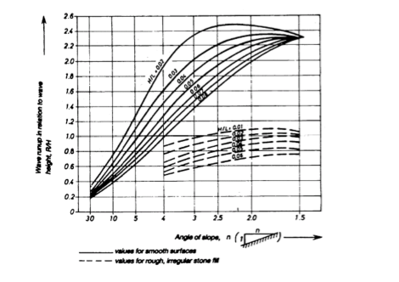
Figure 6.1A3: Graph showing relative wave run-up
Wave run-up (R)
The wave run-up is calculated by the following equation:
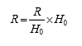
The calculated wave run-up are 1.45m and 0.94m.
Wind set up (S)
The wind set up is calculated by the following equation.
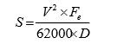
V= design wind velocity over water in km per hour; Fe wind fetch in km, D average water depth along the central radial in meters.
The calculated wind set up is 0.04m and 0.01m for normal and minimum freeboard cases.
Freeboard required
Freeboard = R + S
= R+S
Camber (settlement allowance)
Considering the complexity of the project and the existing foundation condition 1.5% of the dam height is consider as cumber and will be refined during detailed design where appropriate.
A summary of the freeboard calculations for Debobesa Dam based on the method described above is presented in the main report in respective sections.

Appendix2. Topographical Survey

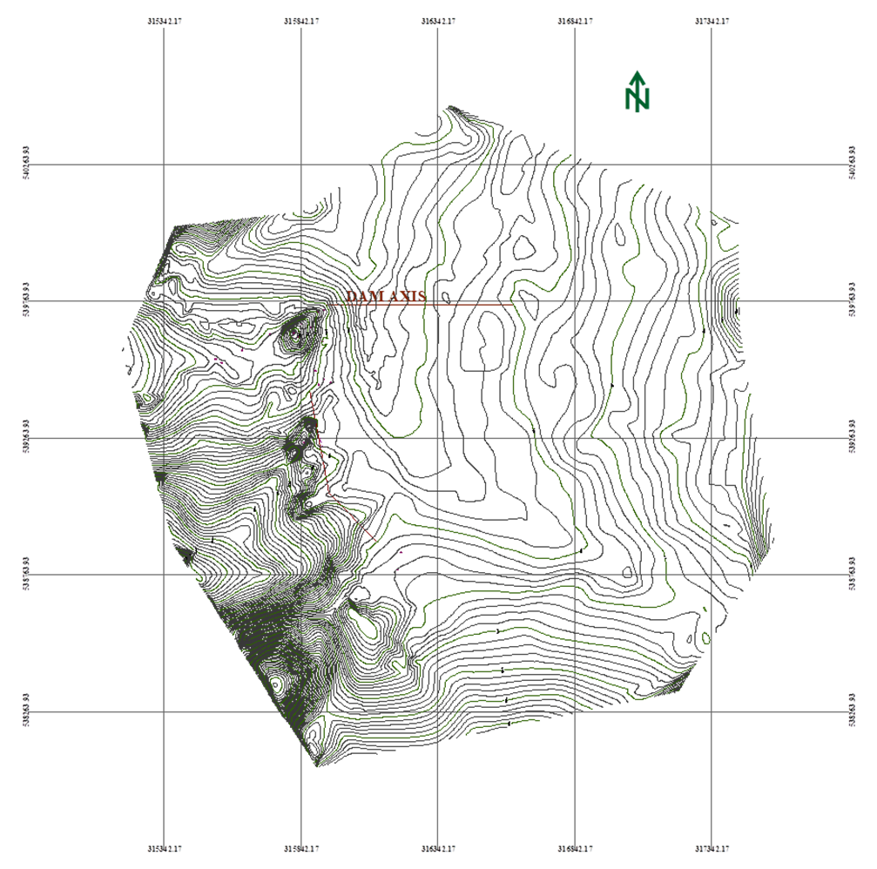

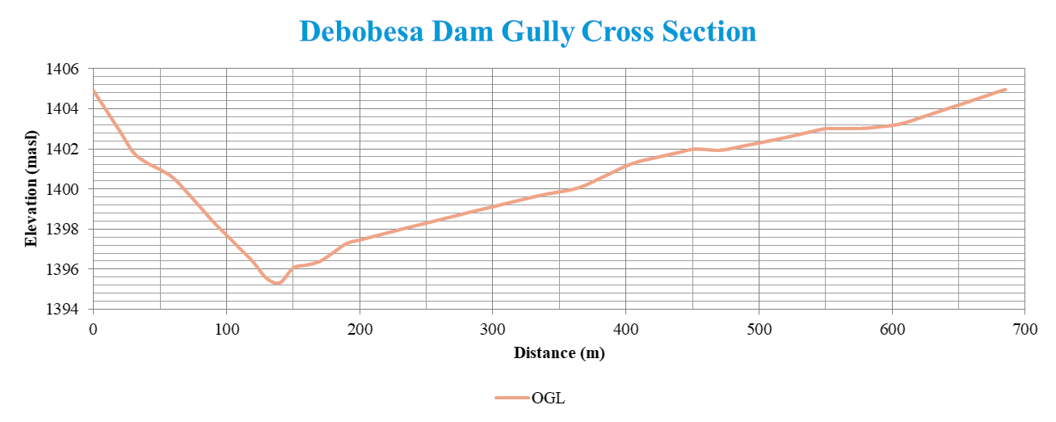

Appendix3. Map of Materials and Geotechnical
Investigation

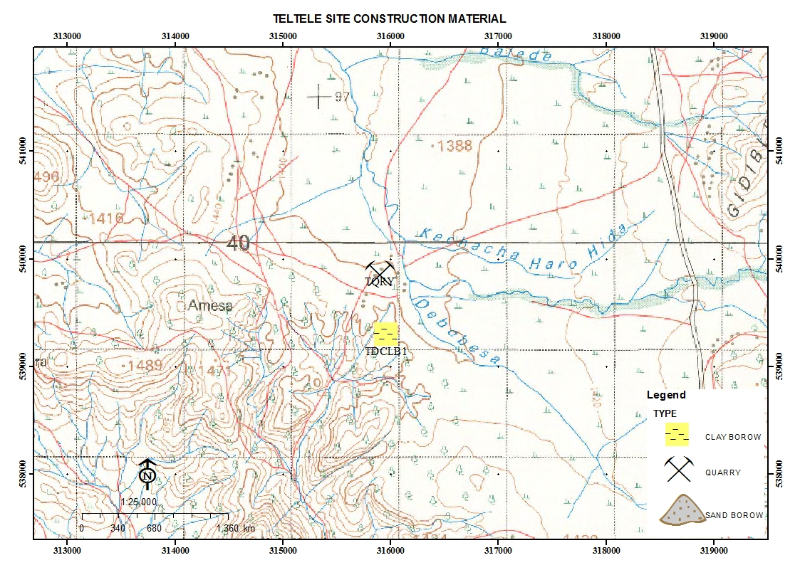
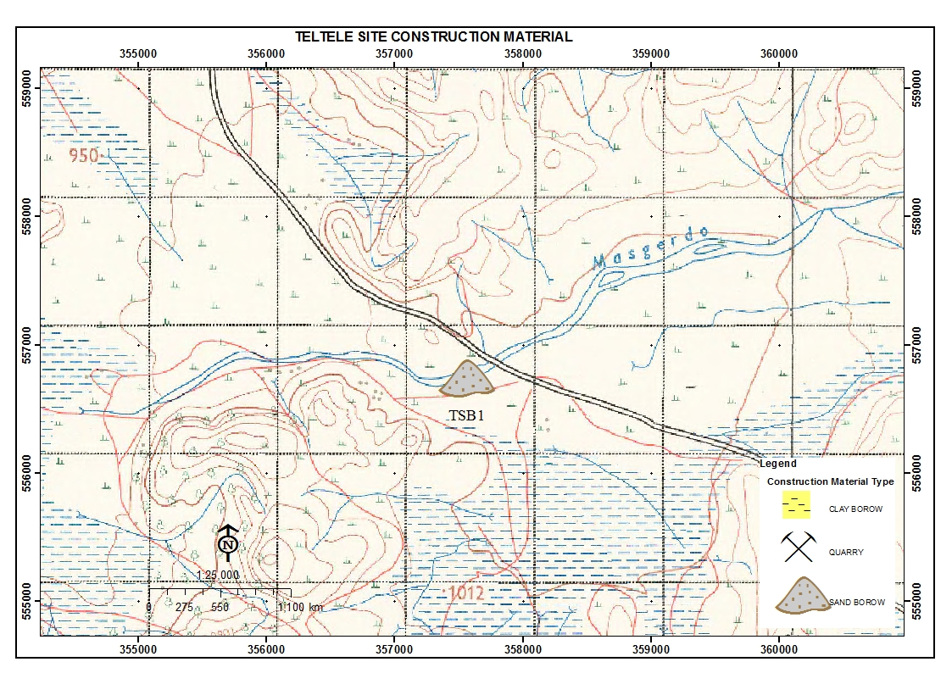

Appendix4. Cross Section of
Investigated Main Dam and Saddle dam

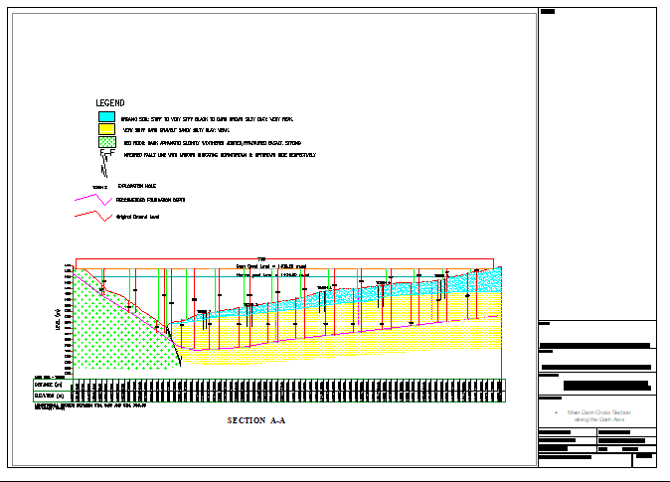

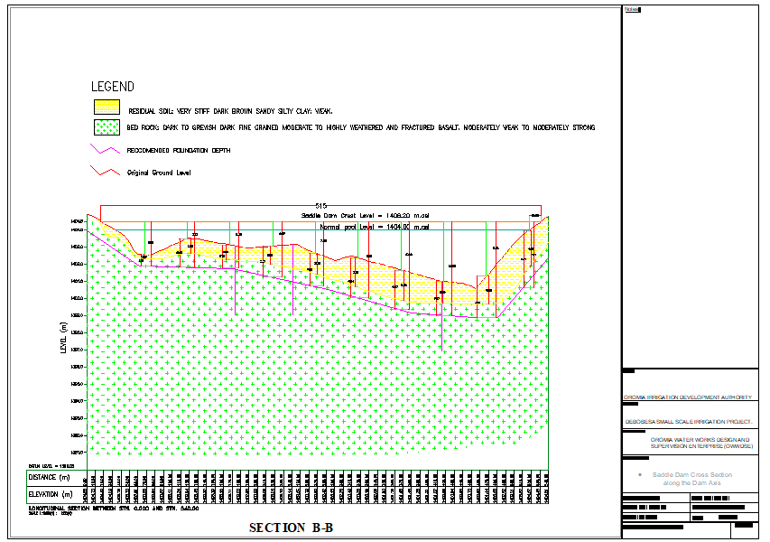

Appendix5. Layout of Investigated Dam site

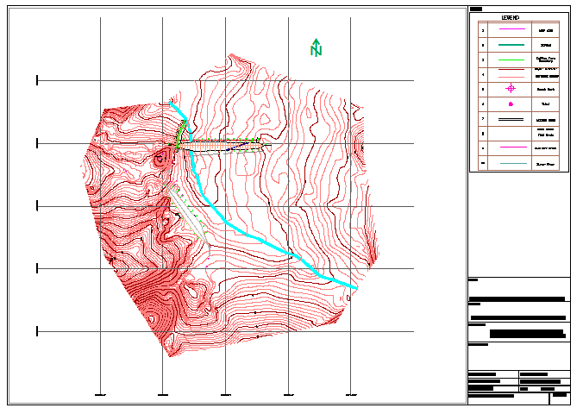

Appendix6. Flood Attenuation: Embankment Dam with side Spillway

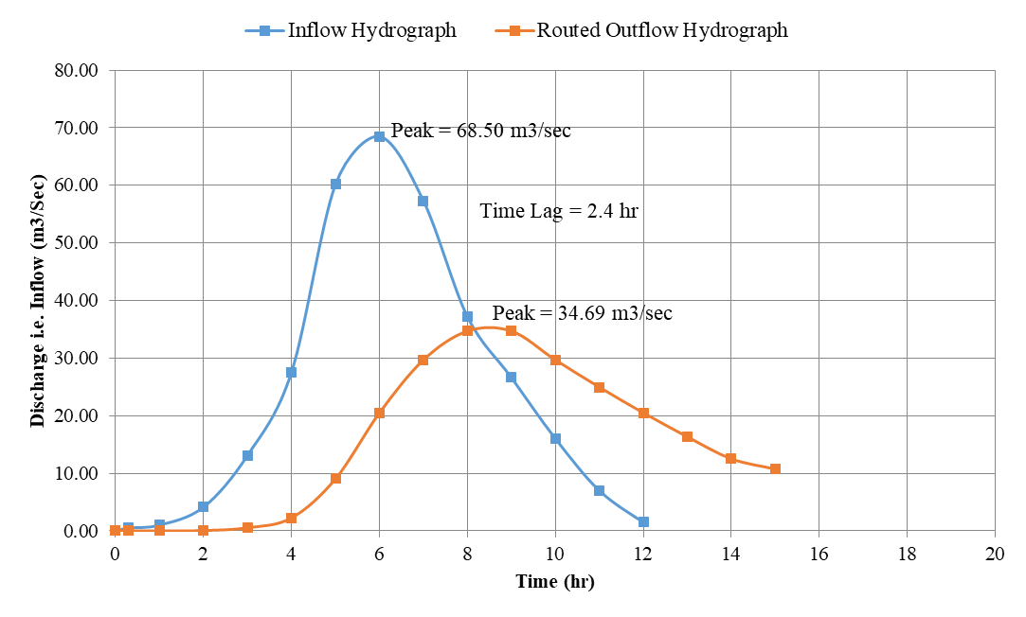

Appendix7. Project Cost Estimation

Main embankment Dam
S/No | Item of Work | unit | Qty | Unit rate (Eth. Birr) | Total Cost | Remark
1 | Dam Body
1.1 | Cut off
1.1.1 | Dam foundation top soil clearance | m2 | 40,726.60 | 12.00 | 488,719.20
1.1.2 | Trench excavation | m3 | 17,245.80 | 164.00 | 2,828,311.20
1.1.3 | Fill material production | m3 | 15,729.00 | 75.00 | 1,179,675.00
1.1.4 | Loading | m3 | 15,729.00 | 75.00 | 1,179,675.00
1.1.5 | Hauling | m3 | 15,729.00 | 75.00 | 1,179,675.00
1.1.6 | Spreading | m3 | 15,729.00 | 75.00 | 1,179,675.00
1.1.7 | Compaction | m3 | 15,729.00 | 200.00 | 3,145,800.00
 | Subtotal |  |  |  | 11,181,530.40
1.2 | Core material
1.2.1 | Production | m3 | 33,861.89 | 164.00 | 5,553,350.12
1.2.2 | Loading | m3 | 33,861.89 | 75.00 | 2,539,641.83
1.2.3 | Hauling | m3 | 33,861.89 | 75.00 | 2,539,641.83
1.2.4 | Spreading | m3 | 33,861.89 | 75.00 | 2,539,641.83
1.2.5 | Compaction | m3 | 33,861.89 | 200.00 | 6,772,378.20
 | Subtotal |  |  |  | 19,944,653.80
1.3 | Shell material
1.3.1 | Production | m3 | 188,895.00 | 395.00 | 74,613,525.00
1.3.2 | Loading | m3 | 188,895.00 | 75.00 | 14,167,125.00
1.3.3 | Hauling | m3 | 188,895.00 | 75.00 | 14,167,125.00
1.3.4 | Spreading | m3 | 188,895.00 | 75.00 | 14,167,125.00
1.3.5 | Compaction | m3 | 188,895.00 | 200.00 | 37,779,000.00
 | Subtotal |  |  |  | 154,893,900.00
1.4 | Others
1.4.1 | Riprap | m3 | 14,376.60 | 120.00 | 1,725,192.00
1.4.2 | Filter material | m3 | 15,023.40 | 65.00 | 976,521.00
 | Gravel (crashed) filter | m3 | 4,196.85 | 65.00 | 272,795.25
 | Subtotal |  |  |  | 2,974,508.25
1.5 | Drainage trench
1.5.1 | Excavation (man power) | m3 | 467.5 | 12.00 | 5,610.00
1.5.2 | Gravel (crushed) | m3 | 420.75 | 450.00 | 189,337.50
 | Subtotal |  |  |  | 194,947.50
2 | Spillway
2.1 | Excavation (machine), soil | m3 | 12,500.00 | 12.00 | 150,000.00
2.2 | Masonry work | m3 | 874.00 | 2195 | 1,918,430.00
2.3 | Concrete (C-20) | m3 | 3095.80 | 2,892.91 | 8,955,873.69
2.4.1 | Reinforcement bar
2.4.1.1 | Dia.12mm bar | ton | 23.54 | 42000.00 | 988,474.20
2.4.1.2 | Dia.14mm bar | ton | 275.65 | 42000.00 | 11,577,115.20
2.4.1.3 | Dia.6mm bar | ton | 7.37 | 42000.00 | 309,409.80
2.4.1.4 | Dia.16mm bar for trash rack | ton | 35.43 | 42000.00 | 1,488,081.00
2.5 | Plastering | m2 | 6440 | 135.00 | 869,400.00
2.6 | Backfill | m3 | 2,500.00 | 200.00 | 500,000.00
 | Subtotal |  |  |  | 26,756,783.89
3 | Inlet/outlet works Foot bridge
3.1 | R.C.C Concrete reinforced (C-20) | m3 | 150 | 2,892.91 | 433,936.64
3.2 | Reinforcement bar
3.2.1 | Dia.12mm bar | ton | 12.25 | 42000.00 | 514,500.00
3.2.2 | Dia.14mm bar | ton | 125.35 | 42000.00 | 5,264,700.00
3.2.3 | Dia.6mm bar | ton | 4.15 | 42000.00 | 174,300.00
3.2.4 | Dia.16mm bar for trash rack | ton | 17.56 | 42000.00 | 737,520.00
3.2.5 | Dia. 600mm steel pipe | m | 14 | 500000.00 | 7,000,000.00
3.2.6 | Valve (butter fly valve) | No | 2 | 400000.00 | 800,000.00
3.2.7 | Masonry work | m3 | 456 | 1500.00 | 684,000.00
3.2.8 | Form work | m2 | 245580 | 500.00 | 122,790,000.00
 | Subtotal |  |  |  | 138,398,956.64
 | Drainage trench
 | Excavation (man power) | m3 | 467 | 12 | 5,604.00
 | Gravel (crushed) | m3 | 93.4 | 450 | 42,030.00
 | Stone for pitching | m3 | 373.6 | 250 | 93,400.00
 | Subtotal |  |  |  | 141,034.00
 | Total |  |  |  | 354,486,314.48

Saddle Dam
S/No | Item of Work | unit | Qty | Unit rate (Eth. Birr) | Total Cost | Remark
1 | Saddle Dam Body
1.1 | Cut off
1.1.1 | Dam foundation top soil clearance | m2 | 28536.33 | 12.00 | 342,435.90
1.1.2 | Trench excavation | m3 | 12083.79 | 164.00 | 1,981,741.86
1.1.3 | Fill material production | m3 | 11021.00 | 75.00 | 826,575.00
1.1.4 | Loading | m3 | 11021.00 | 75.00 | 826,575.00
1.1.5 | Hauling | m3 | 11021.00 | 75.00 | 826,575.00
1.1.6 | Spreading | m3 | 11021.00 | 75.00 | 826,575.00
1.1.7 | Compaction | m3 | 11021.00 | 200.00 | 2,204,200.00
 | Subtotal |  |  |  | 7,834,677.76
1.2 | Core material
1.2.1 | Production | m3 | 23,726.36 | 164.00 | 3,891,122.88
1.2.2 | Loading | m3 | 23,726.36 | 75.00 | 1,779,476.93
1.2.3 | Hauling | m3 | 23,726.36 | 75.00 | 1,779,476.93
1.2.4 | Spreading | m3 | 23,726.36 | 75.00 | 1,779,476.93
1.2.5 | Compaction | m3 | 23,726.36 | 200.00 | 4,745,271.80
 | Subtotal |  |  |  | 13,974,825.45
1.3 | Shell material
1.3.1 | Production | m3 | 132,355.00 | 395.00 | 52,280,225.00
1.3.2 | Loading | m3 | 132,355.00 | 75.00 | 9,926,625.00
1.3.3 | Hauling | m3 | 132,355.00 | 75.00 | 9,926,625.00
1.3.4 | Spreading | m3 | 132,355.00 | 75.00 | 9,926,625.00
1.3.5 | Compaction | m3 | 132,355.00 | 200.00 | 26,471,000.00
 | Subtotal |  |  |  | 108,531,100.00
1.5 | Drainage tranch
1.5.1 | Excavation (man power) | m3 | 467 | 12 | 5,604.00
1.5.2 | Gravel (creshed) | m3 | 93.4 | 450 | 42,030.00
1.5.3 | Stone for pitching | m3 | 373.6 | 250 | 93,400.00
 | Subtotal |  |  |  | 141,034.00
 | Total |  |  |  | 130,481,637.21

Canal Conveyance & Related Structures
S/No | Item of Work | unit | Qty | Unit rate (Eth. Birr) | Total Cost | Remark
1 | CANAL CONVIYANCE
1.1 | Main Canal (earth canal) | m | 1820
1.1.1 | Excavation | m³ | 676.73 | 54 | 36,543.42
1.1.2 | Backfill & Compaction | m³ | 173.49 | 143.44 | 24,885.41
 | Total Carried Summary Birr |  |  |  | 61,428.83
1.2 | Secondary Canal (earth canal) | m | 1407.9
1.2.1 | Excavation | m³ | 715.01 | 54 | 38,610.54
1.2.2 | Backfill & Compaction | m³ | 162.1 | 143.44 | 23,251.62
 | Total Carried Summary Birr |  |  |  | 61,862.16
1.3 | Tertiary Canal - 1 (earth canal) | m | 1309.2
1.3.1 | Excavation | m³ | 152.26 | 54 | 8,222.04
1.3.2 | Backfill & Compaction | m³ | 100.74 | 143.44 | 14,450.15
 | Total Carried Summary Birr |  |  |  | 22,672.19
1.4 | Tertiary Canal - 2 (earth canal) | m | 1080.6
1.4.4 | Excavation | m³ | 105.56 | 54 | 5,700.24
1.4.2 | Backfill & Compaction | m³ | 50.71 | 143.44 | 7,273.84
 | Total Carried Summary Birr |  |  |  | 12,974.08
1.5 | Tertiary Canal - 3 (earth canal) | m | 860
1.5.1 | Excavation | m³ | 135.45 | 54 | 7,314.30
1.5.2 | Backfill & Compaction | m³ | 80.33 | 143.44 | 11,522.54
 | Total Carried Summary Birr |  |  |  | 18,836.84
1.6 | Tertiary Canal - 4 (earth canal) | m | 660
1.6.1 | Excavation | m³ | 305.56 | 54 | 16,500.24
1.6.2 | Backfill & Compaction | m³ | 8.36 | 143.44 | 1,199.16
 | Total Carried Summary Birr |  |  |  | 17,699.40
1.6 | Tertiary Canal - 5 (earth canal) | m | 260
1.6.1 | Excavation | m³ | 26.9 | 54 | 1,452.60
1.6.2 | Backfill & Compaction | m³ | 15.25 | 143.44 | 2,187.46
 | Total Carried Summary Birr |  |  |  | 3,640.06
1.6 | Tertiary Canal - 6 (earth canal) | m | 460
1.6.1 | Excavation | m³ | 127 | 54 | 6,858.00
1.6.2 | Backfill & Compaction | m³ | no back fill
 | Total Carried Summary Birr |  |  |  | 6,858.00
1.6 | Tertiary Canal - 7 (earth canal) | m | 580
1.6.1 | Excavation | m³ | 123.01 | 54 | 6,642.54
1.6.2 | Backfill & Compaction | m³ | 10.13 | 143.44 | 1,453.05
 | Total Carried Summary Birr |  |  |  | 8,095.59
 | Grand Total Birr
1.6 | Tertiary Canal - 8 (earth canal) | m | 814.62
1.6.1 | Excavation | m³ | 429 | 54 | 23,166.00
1.6.2 | Backfill & Compaction | m³ | 45.06 | 143.44 | 6,463.41
 | Total Carried Summary Birr |  |  |  | 29,629.41
 | Grand Total Birr |  |  |  | 243,696.54
1.3 | Drainage Collectors | m | 3427.3
1.3.1 | Excavation | m³ | 561.57 | 54 | 30324.78
 | Grand Total Birr |  |  |  | 30,324.78
2 | RELATED STRUCTURES
2.2 | Drop Structures H = 0.50m | Pcs | 2
2.2.1 | Excavation | m³ | 6.20 | 54 | 334.80
2.2.2 | Masonary Work | m³ | 30.38 | 2195 | 66,683.44
2.2.3 | Concrete | m³ | 5.10 | 3113 | 15,885.64
2.2.4 | Riprap | m³ | 1.17 | 103.21 | 120.76
2.2.5 | Plastering work | m² | 4.50 | 196.77 | 885.47
2.2.6 | Backfill & Compaction | m³ | 3.10 | 143.44 | 444.66
 | Total Carried Summary Birr |  |  |  | 84,354.77
2.3 | Drop Structures H = 1.00m | Pcs | 7
2.3.1 | Excavation | m³ | 43.40 | 54 | 2,343.60
2.3.2 | Masonry Work | m³ | 212.66 | 2195 | 466,784.09
2.3.3 | Concrete | m³ | 35.72 | 3113 | 111,199.47
2.3.4 | Riprap | m³ | 8.19 | 103.21 | 845.29
2.3.5 | Plastering work | m² | 31.50 | 196.77 | 6,198.26
2.3.6 | Backfill & Compaction | m³ | 21.70 | 143.44 | 3,112.65
 | Total Carried Summary Birr |  |  |  | 590,483.36
2.4 | Drop Structures H = 1.50m | Pcs | 9
2.4.1 | Excavation | m³ | 83.70 | 54 | 4,519.80
2.4.2 | Masonary Work | m³ | 410.13 | 2195 | 900,226.46
2.4.3 | Concrete | m³ | 68.89 | 3113 | 214,456.13
2.4.4 | Riprap | m³ | 15.80 | 103.21 | 1,630.20
2.4.5 | Plastering work | m² | 60.75 | 196.77 | 11,953.78
2.4.6 | Backfill & Compaction | m³ | 41.85 | 143.44 | 6,002.96
 | Total Carried Summary Birr |  |  |  | 1,138,789.33
2.8 | Division Box | Pcs | 5
2.8.1 | Excavation | m³ | 16.20 | 54 | 874.8
2.8.2 | Masonry Work | m³ | 12.65 | 2195 | 27,755.78
2.8.3 | Concrete | m³ | 1.26 | 3113 | 3,922.38
2.8.4 | Plastering work | m² | 47.25 | 196.77 | 9,297.38
2.8.5 | Backfill & Compaction | m³ | 8.10 | 143.44 | 1,161.86
 | Total Carried Summary Birr |  |  |  | 43,012.20
2.9 | Turnouts | Pcs | 40
2.9.1 | Excavation | m³ | 144.00 | 54 | 7,776.00
2.9.2 | Masonry Work | m³ | 67.60 | 2195 | 148,382.00
2.9.3 | Concrete Work | m³ | 25.20 | 3113 | 78,447.60
2.9.4 | Plastering | m² | 504.00 | 250 | 126,000.00
2.9.5 | Pipe Placing Dia.100mm. | pcs | 80.00 | 45 | 3,600.00
2.9.6 | Backfill & Compaction | m³ | 72.00 | 143.44 | 10,327.68
 | Total Carried Summary Birr |  |  |  | 374,533.28
2.10 | Water Supply system Installation | Pcs | 1
2.10.1 | Excavation | m³ | 12.50 | 54 | 675.00
2.10.2 | Masonry Work | m³ | 37.50 | 2195 | 82,312.50
2.10.3 | Concrete Work (R.C.C) | m³ | 51.84 | 3113 | 161,377.92
2.10.4 | Pipe Placing Dia.100mm. | pcs | 5.00 | 1500 | 7,500.00
2.10.5 | Plastering | m² | 45.00 | 250 | 11,250.00
2.10.6 | Backfill & Compaction | m³ | 6.25 | 143.44 | 896.50
 | Total Carried Summary Birr |  |  |  | 264,011.92
2.11 | Cattle Trough | pcs | 1
2.11.1 | Excavation | m³ | 21.84 | 54 | 1,179.36
2.11.2 | Masonry Work | m³ | 19.50 | 2195 | 42,802.50
2.11.3 | Concrete Work (R.C.C) | m³ | 12.72 | 3113 | 39,597.36
2.11.4 | Plastering | m² | 117.00 | 250 | 29,250.00
2.11.5 | Pipe Placing Dia.200mm. | pcs | 8.00 | 1500 | 12,000.00
2.11.6 | Backfill & Compaction | m³ | 8.74 | 143.44 | 1,253.09
 | Total Carried Summary Birr |  |  |  | 126,082.31
 | Grand Total Birr |  |  |  | 2,621,267.17

Camp (Staff residence, office, Café, Kichen, Sore,Toilet & Shower)
SN | Description | Unit | Qty | Unit rate (Eth. Birr) | Total Cost | Remark
1 | Preparatory Work
1.1 | Mobilization and Demobilization | LS | 1 | 75,000.00 | 75,000.00
1.2 | Engineering surveying and preparation of as built drawings | LS | 1 | 85,000.00 | 85,000.00
1.3 | Camp (Staff residence, office, Café, Kitchen, Store, Toilet & Shower)
1.3.1 | Residential rooms & office
1.3.1.1 | Earth Work
1.3.1.1a | Clearing of site to remove top soil to a depth of 200 mm. | m2 | 92.00 | 8.38 | 770.96
1.3.1.1b | Excavation for stone masonry foundation; 0.5m width and 0.4 m depth | m3 | 27.24 | 47.92 | 1,305.37
1.3.1.1c | Cart away and deposit excavated surplus material to a distance not exceeding 1km | m3 | 42.24 | 43.89 | 1,853.91
1.3.1.1d | Provide and fill hard core with hard basaltic or equivalent stone, well compacted and blinded with crushed stone to a finished thickness of 25 cm | m2 | 52.20 | 232.33 | 12,127.63
1.3.1.2 | Concrete and Block Work |  | -
1.3.1.2a | Supply and raise 500mm thick and 200mm high trachytic or equivalent stone masonry foundation wall below ground level bedded in cement mortar mix 1:3 | m3 | 6.46 | 1,964.66 | 12,691.70
1.3.1.2b | Supply and raise 500mm thick and 200mm high trachytic or equivalent stone masonry foundation wall above ground level bedded in cement mortar mix 1:3 | m3 | 6.46 | 1,964.66 | 12,691.70
1.3.1.2c | Mass concrete fill on floor slab (100mm) C-15 | m3 | 6.16 | 2,892.91 | 17,820.33
1.3.1.3 | Carpentry and Walling
1.3.1.3a | Supply, assemble and fix in position eucalyptus wall post of length 3 m with span length of 1.2m | No | 66.00 | 50.00 | 3,300.00
1.3.1.3b | Supply and fix purlin in Eucalyptus wood size 50 x 70 mm nailed into eucalyptus truss | m | 586.00 | 100.00 | 58,600.00
1.3.1.3c | Supply and fix roof cover in G-35 mm corrugated galvanized iron sheet fixed into zigba wood purlin with dome headed galvanized nails (purlin and ridge cover measured separately) | m2 | 149.16 | 325.00 | 48,477.00
1.3.1.3d | Chip wood wall celling | m2 | 255.84 | 180.00 | 46,051.20
1.3.1.3e | Supply and fix 4x5 mm celling buttons | m | 214.00 | 75.00 | 16,050.00
1.3.1.4 | Carpentry and Roofing |  | -
1.3.1.4a | Supply, assemble and fix in position eucalyptus roof truss of length 3m span price shall include the application of three coats and external anti-termite treatment as per the drawing | No | 21.00 | 200.00 | 4,200.00
1.3.1.4b | Supply and fix purlin in eucalyptus wood size 50 x 70 mm nailed into eucalyptus truss including three coats of anti - termite external treatment | m | 81.00 | 100.00 | 8,100.00
1.3.1.4c | Supply and fix roof cover in G-35 mm corrugated galvanized iron sheet fixed into zigba wood purlin with dome headed galvanized nails (purlin and ridge cover measured separately) | m2 | 99.50 | 325.00 | 32,337.50
1.3.1.4d | Supply and fix CIS windows size 1x1.2m | No | 7.00 | 500.00 | 3,500.00
1.3.1.4e | Supply and fix CIS doors size 1.0x2.10m | No | 6.00 | 1,000.00 | 6,000.00
1.3.1.5 | Finishing
1.3.1.5a | Floor screed in cement mortar 20 mm thick (1:3 mortar) | m2 | 79.00 | 149.79 | 11,833.08
 | Sub total |  |  |  | 297,710.39
1.3.2 | Store
1.3.2.1 | Earth Work
1.3.2.1a | Clearing of site to remove top soil to a depth of 200 mm | m2 | 36.00 | 8.38 | 301.68
1.3.2.1b | Excavation for stone masonry foundation; 0.5m width and 0.4 m depth | m3 | 3.92 | 47.92 | 187.85
1.3.2.1c | Cart away and deposit excavated surplus material to a distance not exceeding 1km. | m3 | 4.70 | 43.89 | 206.46
1.3.2.1d | Provide and fill hard core with hard basaltic or equivalent stone, well compacted and blinded with crushed stone to a finished thickness of 25 cm | m2 | 25.00 | 232.33 | 5,808.25
1.3.2.2 | Concrete and Block Work
1.3.2.2a | Supply and raise 500mm thick and 200mm high trachytic or equivalent stone masonry foundation wall below ground level bedded in cement mortar mix 1:3 | m3 | 2.20 | 1,964.66 | 4,322.25
1.3.2.2b | Supply and raise 500mm thick and 200mm high trachitic or equivalent stone masonry foundation wall above ground level bedded in cement mortar mix 1:3 | m3 | 2.20 | 1,964.66 | 4,322.25
1.3.2.2c | Mass concrete fill on floor slab (100mm), C-15 | m3 | 2.50 | 2,892.91 | 7,232.28
1.3.2.3 | Carpentry and Walling
1.3.2.3a | Supply, assemble and fix in position eucalyptus wall post of length 3 m span | No | 20.00 | 200.00 | 4,000.00
1.3.2.3b | Supply and fix wall cover in G-35 mm corrugated galvanized iron sheet fixed into euclaptus wood purlin with dome headed galvanized nails | m2 | 80.00 | 350.00 | 28,000.00
1.3.2.4 | Carpentry and Roofing
1.3.2.4a | Supply, assemble and fix in position eucalyptus roof truss | No | 5.00 | 300.00 | 1,500.00
1.3.2.4b | Supply and fix purlin in zigba wood size 50 x 70 mm nailed into eucalyptus truss | m | 56.00 | 75.00 | 4,200.00
1.3.2.4c | Supply and fix roof cover in G-35 mm corrugated galvanized iron sheet fixed into zigba wood purlin with dome headed galvanized nails | m2 | 49.00 | 325.00 | 15,925.00
1.3.2.4d | Supply and fix CIS windows size 1x1.2m | No | 1.00 | 500.00 | 500.00
1.3.2.4e | Supply and fix CIS doors size 2.0x2.10m | No | 1.00 | 1,000.00 | 1,000.00
 | Sub total |  |  |  | 77,506.02
1.3.3 | Cafe , Kitchen and Workers living room
1.3.3.1 | Earth Work
1.3.3.1a | Clearing of site to remove top soil to a depth of 200 mm | m2 | 23.00 | 8.38 | 192.74
1.3.3.1b | Excavation for stone masonry foundation; 0.5m width and .4 m depth | m3 | 2.18 | 47.92 | 104.28
1.3.3.1c | Cart away and deposit excavated surplus material to a distance not exceeding 1km. | m3 | 6.78 | 43.89 | 297.40
1.3.3.1d | Provide and fill hard core with hard basaltic or equivalent stone, well compacted and blinded with crushed stone to a finished thickness of 25 cm | m2 | 12.50 | 232.33 | 2,904.13
1.3.3.2 | Concrete and Block Work
1.3.3.2a | Supply and raise 500 mm thick and 200mm high trachitic or equivalent stone masonry foundation wall below ground level bedded in cement mortar mix 1:3 | m3 | 0.54 | 1,964.66 | 1,068.78
1.3.3.2b | Supply and raise 500 mm thick and 200mm high trachitic or equivalent stone masonry foundation wall above ground level bedded in cement mortar mix 1:3 | m3 | 0.54 | 1,964.66 | 1,060.92
1.3.3.2c | Mass concrete fill on floor slab (100mm), C-15 | m3 | 1.25 | 2,892.91 | 3,616.14
1.3.3.3 | Carpentry and Walling
1.3.3.3a | Supply, assemble and fix in position eucalyptus wall post of length 3 m span price shall include the external anti-termite treatment as per the drawing | No | 23.00 | 200.00 | 4,600.00
1.3.3.3b | Supply and fix roof cover in G-35 mm corrugated galvanized iron sheet fixed into zigba wood purlin with dome headed galvanized nails (purlin and ridge cover measured separately) | m2 | 56.00 | 325.00 | 18,200.00
1.3.3.4 | Carpentry and Roofing
1.3.3.4a | Supply, assemble and fix in position eucalyptus roof truss of length 3m span price shall include the application of three coats and external anti-termite treatment as per the drawing | No | 5.00 | 300.00 | 1,500.00
1.3.3.4b | Supply and fix purlin in zigba wood size 50 x 70 mm nailed into eucalyptus truss including three coats of anti - termite external treatment | m | 32.00 | 75.00 | 2,400.00
1.3.3.4c | Supply and fix roof cover in G-35 mm corrugated galvanized iron sheet fixed into zigba wood purlin with dome headed galvanized nails (purlin and ridge cover measured separately) | m2 | 28.00 | 325.00 | 9,100.00
1.3.3.4d | Supply and fix CIS windows size 1x1.2m | No | 1.00 | 500.00 | 500.00
1.3.3.4e | Supply and fix CIS doors size 1.0x2.10m | No | 3.00 | 1,000.00 | 3,000.00
1.6.5f | Finishing
1.6.5.1g | Floor screed in cement mortar 20 mm thick, (1:3 mortar) | m2 | 12.00 | 149.79 | 1,797.43
 | Sub total |  |  |  | 50,341.80
1.3.4 | Shower and Toilet
1.3.4.1 | Earth Work
1.3.4.1a | Clearing of site to remove top soil to a depth of 200 mm | m2 | 24.00 | 8.38 | 201.12
1.3.4.1b | Excavation for stone masonry foundation; 0.5m width and .4 m depth | m3 | 30.00 | 47.92 | 1,437.63
1.3.4.1c | Cart away and deposit excavated surplus material to a distance not exceeding 1km. | m3 | 34.80 | 43.89 | 1,527.37
1.3.4.2 | Concrete and Block Work
1.3.4.2a | Supply and raise 500mm thick high trachytic or equivalent stone masonry foundation wall below ground level bedded in cement mortar mix 1:3 | m3 | 20.00 | 1,964.66 | 39,293.20
1.3.4.2b | Slab for the toilet including reinforcement bar , form work and concrete C-20 with 150mm thick | LS | 1.00 | 3,197.94 | 3,197.94
1.3.4.2c | Mass concrete fill on floor slab (200mm) for shower, C-15 | m3 | 1.80 | 2,892.91 | 5,207.24
1.3.4.3 | Carpentry and Walling
1.3.4.3a | Supply, assemble and fix in position eucalyptus wall post of length 3.5 m span price shall include the external anti-termite treatment as per the drawing | No | 16.00 | 200.00 | 3,200.00
1.3.4.3b | Supply and fix roof cover in G-35 mm corrugated galvanized iron sheet fixed into zigba wood purlin with dome headed galvanized nails (purlin and ridge cover measured separately) | m2 | 52.00 | 325.00 | 16,900.00
1.3.4.4 | Carpentry and Roofing |  |  |  | 0.00
1.3.4.4a | Supply, assemble and fix in position eucalyptus roof truss price shall include the application of three coats and external anti-termite treatment as per the drawing | No | 5.00 | 300.00 | 1,500.00
1.3.4.4b | Supply and fix purlin in zigba wood size 50 x 70 mm nailed into eucalyptus truss including three coats of anti - termite external treatment | m | 21.00 | 75.00 | 1,575.00
1.3.4.4c | Supply and fix roof cover in G-35 mm corrugated galvanized iron sheet fixed into zigba wood purlin with dome headed galvanized nails (purlin and ridge cover measured separately) | m2 | 18.00 | 325.00 | 5,850.00
1.3.4.4d | Supply and fix CIS doors size 1.0x2.10m | No | 4.00 | 1,000.00 | 4,000.00
1.3.4.e | Fence work with 1.5m spacing rotated by barbed wire fixed 2m height eucalyptus post | LS | 1.00 | 45,000.00 | 45,000.00
 | Sub total |  |  |  | 128,889.50
 | Grand Total Birr |  |  |  | 714,447.70

Appendix8. Stability Analyses

Appendix9. Design Drawings

Left Abutment
Right Abutment

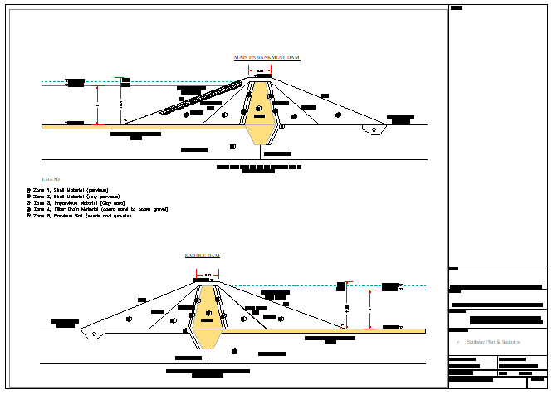
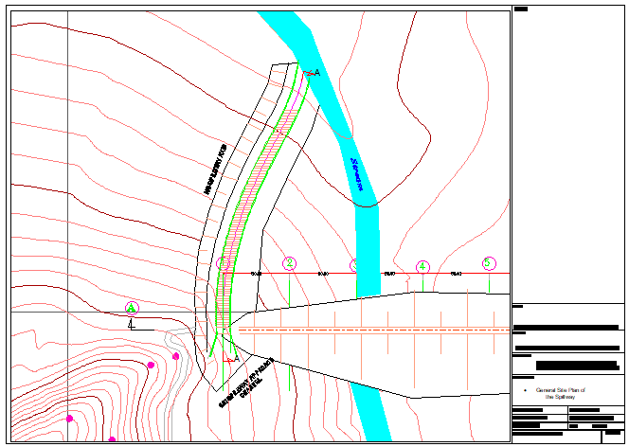
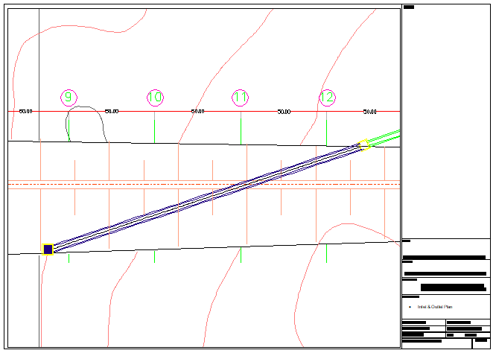
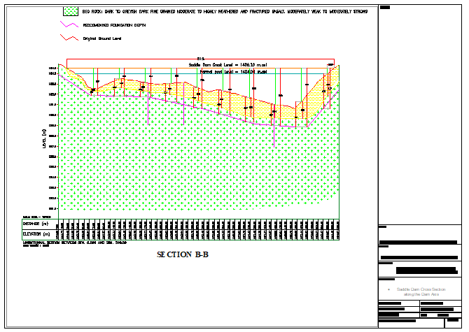

Appendix10. Final Summary Cost Estimate

Summary of BOQ
S/No | Item of Work | unit | Total Cost | Community share | Remark
1 | Main Access Road | Eth. Birr | 15,000,000.00
2 | Mobilization | " | 10,000,000.00
3 | Foundation Preparation and Treatment | " | 16,807,132.25
4 | Main Embankment Dam | " | 354,486,314.48
 | Saddle Dam | " | 12,505,188.82
8 | Canal Conveyance & Related Structure | " | 2,621,267.17
9 | Camp | " | 714,447.70
10 | Day Work | " | 10,000,000.00
Total Carried Summary Birr |  | " | 422,134,350.41
Overhead cost =5% of Total Project Cost |  | " | 21,106,717.52
Total Carried Summary Birr |  | " | 443,241,067.93
For Supervision Cost = 5% of final Total Summary Birr |  | " | 22,162,053.40
Final Total Carried Summary Birr |  | " | 465,403,121.33
Vat 15% |  | " | 69,810,468.20
Grand Total |  | " | 535,213,589.53

