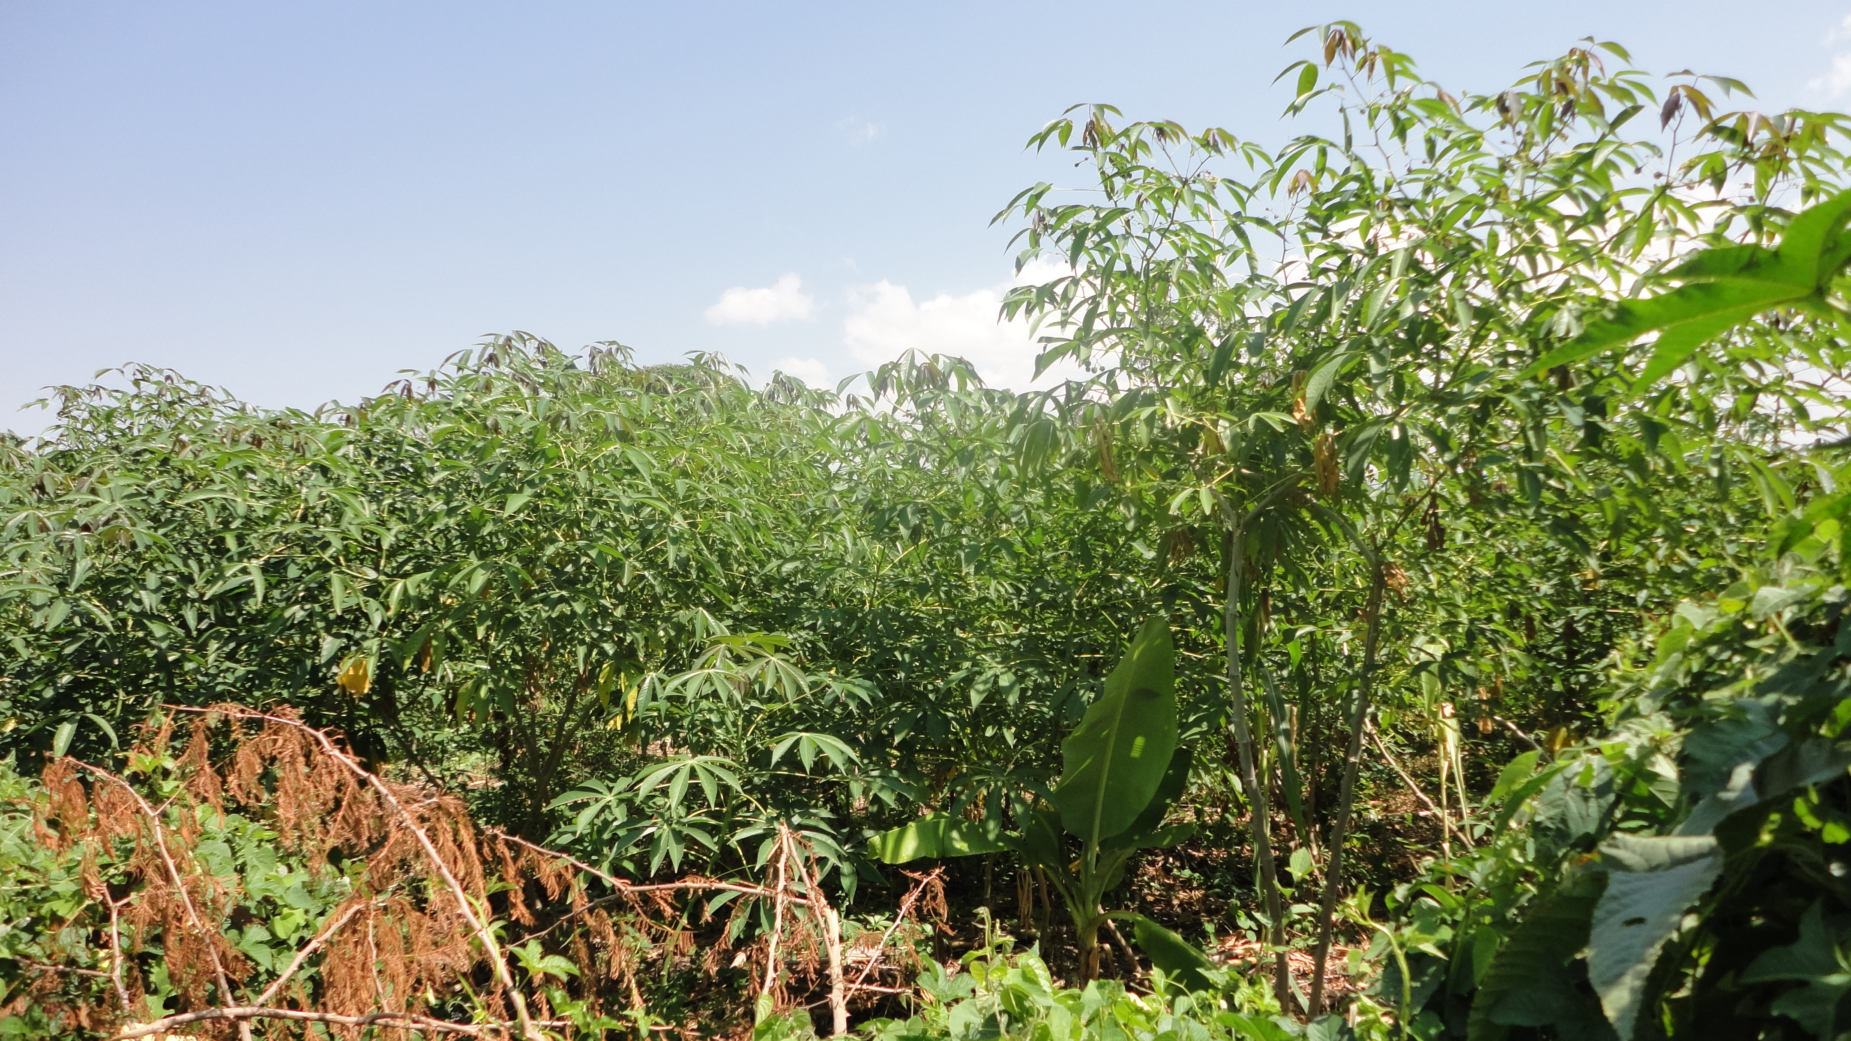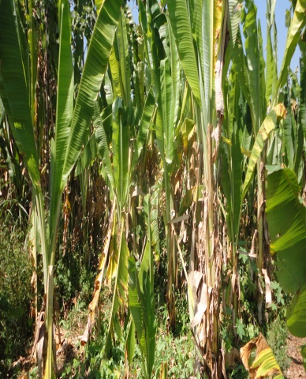

THE NATIONAL REGIONAL STATE OF OROMIA
DEBOBESA SMALL SCALE IRRIGATION PROJECT

WATERSHED MANAGEMENT STUDY DRAFT REPORT

CONSULTANT
Oromia Water Works Design & Supervision Enterprise
P.O.Box. 870/1250
Tel +251 11 4392162/2470
Email: owwdse@telecom.net.et
Finfine/Addis Ababa, Ethiopia

CLIENT
OROMIA IRRIGATION DEVELOPMENT AUTHORITY (OIDA)
P. O. Box
Tel +251
Email:
Finfine/Addis Ababa, Ethiopia



^{March, 2019}

Table of Contents
1 Table of Contents i
List of Maps i
List of Tables i
EXECUTIVE SUMMARY 1
2 INTRODUCTION 3
3 Description of the Debobessae watershed 6
3.1 Location 6
3.1 Soils of the watershed 6
3.2 Geomorphology and geology 7
3.3 Land use and land cover 8
4 OBJECTIVES & METHODOLOGY 9
4.1 Objectives 9
4.2 Methodology of the Study 10
4.2.1 Pre field Debobessa Activities 10
4.2.2 Field Survey 10
4.2.3 Post Field Activities 11
5 MAJOR PROBLEM OF THE WATERSHED 13
5.1 Soil Erosion and Land Degradation 13
5.2 Types and Forms of Water Erosion 14
5.3 Causes and Effects of Soil Erosion 17
5.3.1 Rainfall 17
5.3.2 Overgrazing 17
5.3.3 Erodible Nature of the soil 18
5.3.4 Deforestation 18
5.3.5 Steep Slopes, Undulating and Rugged Terrain 18
5.3.6 Change in Climate 18
6 SOIL EROSION HAZARD IN THE WATERSHED 20
6.1 Revised Universal Soil Loss Equation (RUSLE) 21
6.2 Rainfall Erosivity (R) 22
6.3 Soil Erodibility (K) 22
6.4 Topographic factors 23
6.5 Land Cover (C) 24
6.6 Land Management (P) 25
7 Annual Soil Erosion/soil loss 26
8 WATERSHED MANAGEMENT PLAN 27
8.1 Participatory Integrated Watershed Management 27
8.2 Rehabilitation of Gullies and Degraded lands 28
8.2.1 Stabilization of gullies 29
8.2.2 Structure for gully bed stabilization 30
8.2.3 Check dams 30
8.2.4 Reclamation of Large Gullies 31
8.2.5 Maintenance of Gully control structure 31
8.3 Recommended Biological Measures 32
8.3.1 Conservation Based Agriculture 32
8.3.2 Grass Strips 32
8.3.3 Agro- Forestry 32
8.3.4 Villages and Homestead Area Tree Plantation 33
8.3.5 River Bank and Water Ways Protection and Plantation 33
8.3.6 Plantation along Tracks and Paths 34
8.3.7 Live Fence Plantation 34
8.3.8 Wood lot Plantation: 34
8.3.9 Plantation on Soil Conservation Structures 35
8.4 Soil Management for Soil and Water Conservation 36
8.4.1 Addition of Organic Matter 36
8.4.2 Conservation tillage 36
8.5 Physical Soil Conservation System 37
8.5.1 Contour Ridges 37
8.5.2 Contour Bunds 37
8.5.2.Soil Bund 37
8.5.2.2 Stone bund 37
8.5.3 Terraces 37
8.5.4 Waterways 38
8.5.5 Embankment or road cut slope 38
9 Benefits of Soil & Water Conservation measures 39
10 REFERENCES 40
11 APPENDICES 41

List of Maps
Map 1: Location map of the Watershed 6
Map 2: Slope of the watershed 7
Map 3: Land use/Cover Map Error! Bookmark not defined.
Map 4; Topographic factor, LS 24

List of Tables
Table 1 Slope of the watershed 8
Table 2; Land use and land cover 8
Table 4: slope length exponent 23
Table 6: Size of Gully 29

EXECUTIVE SUMMARY
Watershed management is primarily a matter of gravity. Gravity makes rainwater flow at a speed − and with a power − that is directly proportional to the slope gradient. Rocks, soil, vegetation cover and human-made artifacts can slow the flow and divert part of it to the subsoil. Gravity makes it possible to distribute highland rainfall over downstream areas, create and renew surface and underground water resources, irrigate plants, water animals, enrich land with mineral and organic sediments, and transport biological materials such as seeds. Gravity makes watershed ecosystems highly dynamic and entropic.
Soil Erosion and conservation studies have been carried out in watershed with the purpose of providing information on the type and extent of soil erosion, sedimentation and land degradation, severity and rate of soil loss and soil loss tolerance/soil formation rates/, stakeholders perceptions of soil erosion, processes and factors involved in soil erosion, the Physical Erosion Hazard, the existing soil and water conservation effort, hindrances to sustainable soil management and proposals for mitigation measures.
The methodology pursued in undertaking the study consisted of field level investigation, measurements and assessment of biophysical conditions associated with soil erosion and land degradation. Reviewing of relevant literature, collecting of secondary information from various sources and interviewing of land users and technical staff are carried out at the woredas selected for the survey. The data and information collected are analyzed. The findings are presented as the rate of soil loss, soil formation rates and the soil physical erosion hazard index. This information is used for proposing intervention measures for erosion control and conservation.
Generally SWAT and RUSLE combined with GIS are adopted measure soil erosion and sedimentation yield.
The Revised Universal Soil Loss Equation (RUSLE) is used to estimate the soil loss rate and Erodibility of the soil estimates are made by the method suggested by Hurni (1981)using the soil colour and of the soil loss tolerance . Slope length and Gradient factors/LS-factors in the Universal Soil Loss equation are also calculated from a grid-based Digital elevation model using ArcMap10.40.
Participatory rapid Rural Appraisal methodology and physical measurements are used for collecting socioeconomic and biophysical information. This information have been analysed and interpreted for discussing the situations in the Sub - basin.
.A soil loss rate of 57.09 t/ha/yr with a total soil loss of 77705.09tons/year and a sediment yield of54500tons/year is estimated in the watershed..
Various forms of erosion and land degradation exist in the watershed with varying level of severity and extent. The types of land degradation observed in the watershed include water erosion, soil fertility decline, sedimentation/soil burial, devegetation and rock outcrop. The causes to these include poor farming practices, overgrazing in the range lands, clearing of forest for fuel selling , forest and bush burning and lack of awareness.
Based on the assessment on soil erosion rates and the past experience (indigenous and introduced), proposal for interventions in soil and water management is made. The programme aims primarily at reducing the current level of erosion and degradation to a tolerable level. The term ‘tolerable level’ describes maintaining the quality and productivity of land in a manner it is capable of supporting satisfactory level of crop and livestock production without further deterioration in yields and quality of land. To attain this, a range of techniques and technologies are recommended on the basis of agro-climatic zones in the basin.
Soil conservation activities planned on watershed basis are indispensable to improve hydrologic responses of rivers in the basin and minimizing sedimentation risk of reservoirs.

INTRODUCTION
A watershed is defined as any surface area from which runoff resulting from rainfall is collected and drained through a common confluence point. The term is synonymous with a drainage basin or catchment area. Hydrologically, watershed could be defined as an area from which the runoff drains through a particular point in the drainage system. A watershed is made up of the natural resources in a basin, especially water, soil, and vegetative factors. At the socio-economic level a watershed includes people, their farming system (including livestock) and interactions with land resources, coping strategies, social and economic activities and cultural aspects.
Watershed deterioration is caused by incorrect use of lands and poor management practices. The subsequent impacts of the problems of the watershed include decline in biomass production, low agricultural production, and the down site effects such as siltation of reservoirs, lakes, and channel, decline in water quality and quantity. Ultimately it results in lose of production potential of land which leads to indispensable famine the death.
The main causes of land degradation problems are very complex and attributed o both bio-physical and socio- economic factors. Many empirical studies have indicated that the main factors of land degradation such as deforestation, overgrazing, cultivation of marginal lands and soil fertility depletion can attributed to population pressure(Harrison 1987, FAO 1991, Hurni 1990, Hurni et.al. 1997, Ritler 1997). Furthermore, some of the researchers agree with the current trend of population growth there is a poor prospect for ecological sustainability and economic viability of the current agricultural practices unless an effort is made to integrated development in social, environmental rehabilitation and agriculture.
Soil erosion is one of the most important components of land degradation. Soil erosion and degradation is a reduction in soil depth and fertility. It is caused by erosion (soil removal, loss of nutrients), reduced soil water holding capacity and excessive exploitative use of the land (cultivation of steep slopes, shallow soils, tillage, overgrazing, encroachment of forests/closed areas, and others). If land and water resources are not protected and conserved against the forces of erosion, soil resources degradation occurs in various forms. In degraded watersheds, forms of degradations can be physical, biological and chemical.

Thus adopting watershed management approach is therefore, crucial in achieving maximum protection and enhances the resource of the watershed. It includes the treatment of land by agronomic management and structural measures, which also be economically feasible and socially acceptable in implement of the plan.
In terms of resource development, it starts from the most important one that is water and then extends to the resources of fuel, fodder, livestock and all associate components. Different measures are adopted and executed carefully in each of the top sequences according to its capability.
Thus in order to raise the agricultural productivity of the watershed, to protect, conserve and improve the natural vegetation, intensification of agriculture, to minimize soil erosion and to reduce the effect of sedimentation and other different purposes, identification of the extent and type of watershed problems and solutions accordingly are very indispensable.
The present study is therefore, deigned to address the deterioration of natural resources of the watershed, and cause of the problem. Furthermore to suggest strategies and proposal to manage watershed and there by to increase agricultural production, increase forest product and flood control and sedimentation the constructed irrigation scheme in the watershed.
Land degradation mainly caused by soil erosion has been one of the major problems in Debobessa watershed. Accelerated erosion is caused by the activities of man and is responsible for depleting soil productivity, destroying land and filling reservoirs with sediments.
The first area of technical facilitation required by sustainable development of a watershed resource is that of controlling soil loss by erosion and salinisation. It is the crudest paradox that in order to develop plenty we tend to squander sufficient and while erosion is a natural process we must come to understand it well enough to Debobessa in balance with it.
The erosion of soils by running water is not in itself a problem; soils are produced from a bed rock or drift mineral base by weathering (and the incorporation of organic material) and are then eroded as part of the long term evaluation of landscape. Soil erosion becomes a problem when its rate is accelerated above that of other landscape development processes-notably

weathering-because it becomes visible; it becomes a watershed management problem when it constraint agricultural production and ends to river, canal and reservoir sedimentation.
The report on Watershed management study of the Debobessae watershed describes the background information, findings of field assessment in biophysical measurements and socio-economic conditions governing watershed management in the watershed. It further describes the methodology pursued in the collection and analysis of data, interpretation of data and findings. In the situation analysis section, the watershed soil erosion status, description of factors involved in the process, effects of erosion, soil erosion rates, information on soil formation rates and the soil loss tolerances, beneficiaries perceptions of soil erosion problems and their views on the control measures and constraints to watershed management are discussed.
Watershed management studies have been carried out in Debobessae watershed with the purpose of providing information on the type and extent of soil erosion and land degradation, severity and rate of soil loss tolerance (soil formation rates), the Soil Physical Erosion Hazard, the existing watershed management; and/or soil and water conservation effort, hindrances to sustainable watershed management and proposals for mitigation measures. Methodologies pursued in the course of undertaking the study consisted of field survey and investigation of the physical parameters, interviewing and group discussions with the beneficiary population, analysis of the collected information and review of available project documents and relevant literature.

Description of the Debobessae watershed

Location
Debobessae watershed is located in South Ethiopia with in the basin of Genale Dawa and Dawa Sub basin of Yabello zone, Yabello Woreda and Huda Goro Kebele of the Oromia national regional state of Ethiopia The watershed covers a total area 1362.0 ha . It is bounded between the geographical coordinates of 315768.87 – 322136.20 UTM north; and 536640.68 – 541217.18 UTM East. The location of the study area is shown on map-1
The watershed is situated at an altitude of about 1316 to 1816 above m.s.l. The watershed exhibit Moist Kolla agro-ecological zones rate.
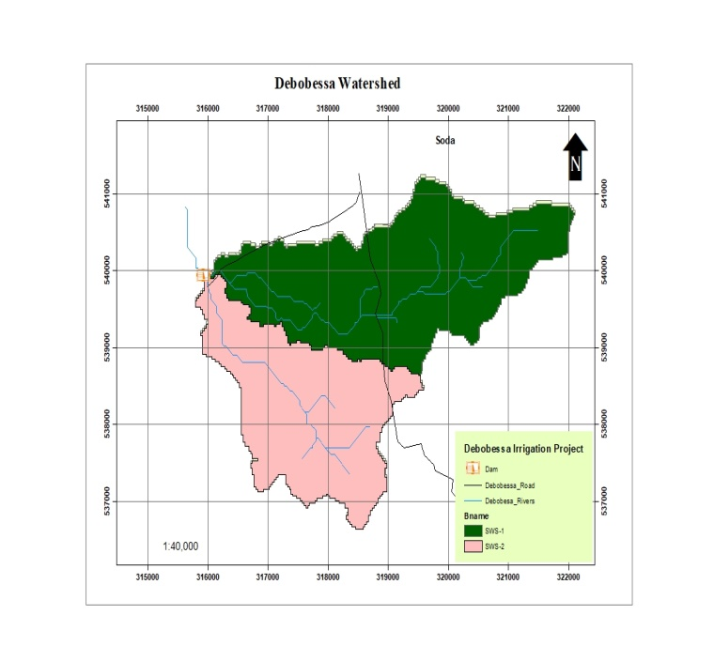
Map 1: Location map of the Watershed

Soils of the watershed
The major soils of the watershed are calcaric fluvisol, calcic vertisol, chromic cambisol eutric vertisol and leptosol. The texture of the soil are clay to Sandy clay loam, very deep to shallow sheet, rill and gully erosion exist and has good infiltration. The organic content is also The soil of the study area is shown on map-2

Map 2; Soil of the watershed
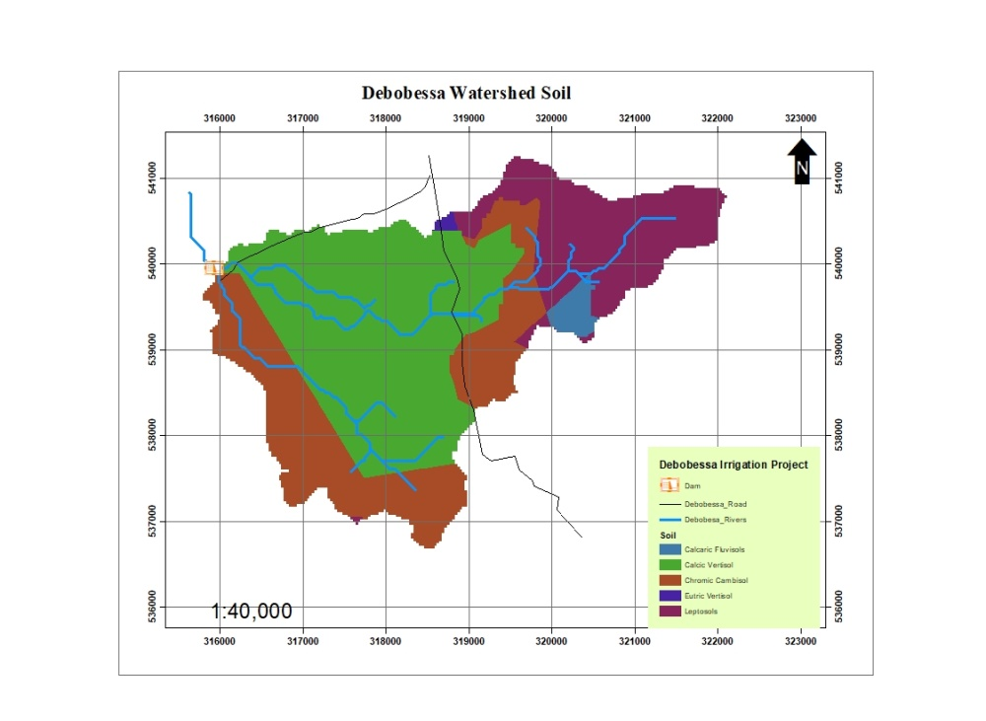

Geomorphology and geology
The geology and geomorphology of the watershed is assumed by the process occurred from Miocene to Pleistocene .The Physiographic feature of the watershed comprises various major land forms including hills, and undulating land form and dissected by many runoff drains towards common outlet of the River. Slopes ranges from plain to steep slopes characterize the Debobessae watershed. Of which, the gentle slopes comprises the largest proportion and found in the central mid and upper parts of the watershed. (Map 3 and Table 1)
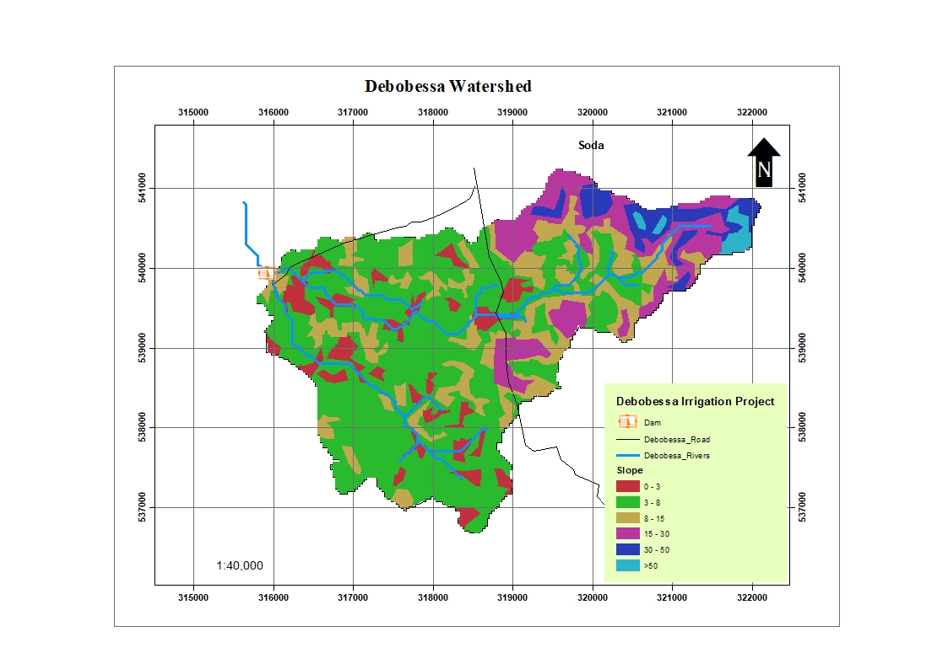
Map 3: Slope of the watershed
Table 1 Slope of the watershed
Slope | Slope Class | Area (ha) | Per cent
0 - 3 | plain | 117 | 8.60
3 - 8 | Gentle | 733.75 | 53.81
8 - 15 | Slopping | 258.73 | 18.94
15-30 | Moderately Steep | 167.30 | 12.26
30 – 50 | Very slopping | 66.45 | 4.80
>50 | Hill/mountain | 17.70 | 1.30
 |  | 1362 ha | 100

Land use and land cover
Based on the criteria of classification of landuse /land cover by FAO, the main land use /land cover units distngshed in the watershed are dense bush shrub land, open wood grass land, open shrub land, open shrub grass land and open bush shrub land. (Map 3 and Table 2)
Table 2; Land use/ land cover
Land Use/cover/ | Area (ha) | Per cent
Cultivated land | 421.19 | 30.98
Bush land | 828.47 | 60.83
Bare land | 112.14 | 8.23
 | 1362 | 100
Map 4; Land Use/ Land Cover
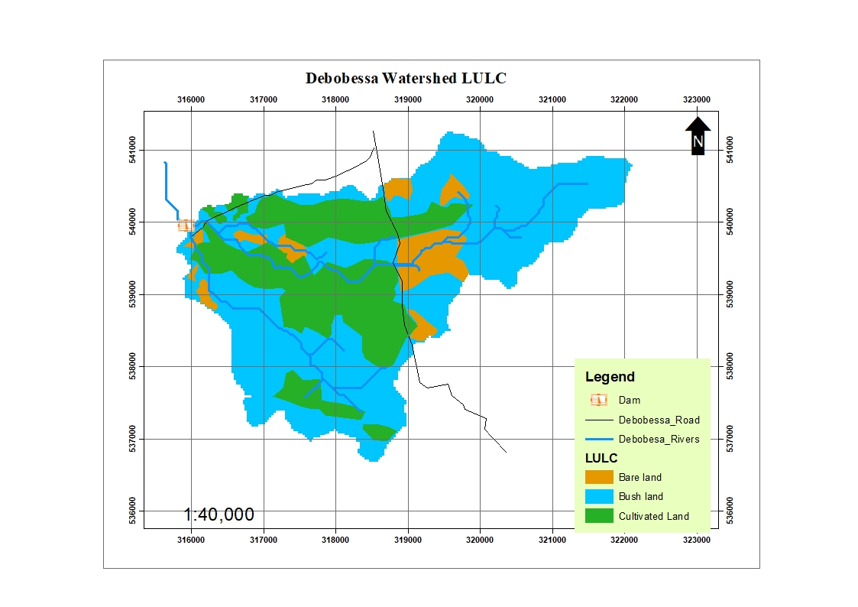

OBJECTIVES & METHODOLOGY

Objectives
Watershed management is necessary to protect, conserve and improve the land resources, for efficient and sustained production; to protect and enhance water resources, moderate floods and reduce silting of tanks and canals, increase irrigation and conserve rainwater for crops and thus mitigate droughts: watershed management is also required to utilize the natural local resources for improving agriculture and allied occupation or industries (Small and cottage industries) and to improve socioeconomic conditions of the local residents. Watershed management is an integrated and participatory approach, considering holistic development for the users of the entire watershed.
The present study is aimed at assessing the rate of land and soil degradation, analyzing the views of the land users on soil erosion and conservation, identifying factors involved in soil erosion and land degradation, evaluating existing mitigation measures (introduced and indigenous), assessing constraints to the watershed development.
In particular the objectives of the study are to:
- Asses the causes of natural resource degradation (types and causes of soil degradation, potentials and constraints of the watershed)/ Explore situations in land degradation and the perceptions of the people living in the watershed
- Estimate rate of soil losses and the erosion hazard
- Improve soil moisture availability to enable protective irrigation and enhance land productivity and water availability so as to minimize reliance on the irrigation canal.
- Control erosion and effect reduction in sediment production and deposition in the command area and irrigation structures.
- Propose measures to correct the natural resource degradation in different agro-ecological zones, slopes and farming systems and land uses
- Rehabilitating and reclaim marginal lands through appropriate conservation measures and mix of trees, shrubs and grasses, based on land potential;
- Develop action plan for the watershed.

Methodology of the Study
The methodology for the soil erosion hazard and land degradation study comprised field measurements, survey and investigation of the study area, interviewing key informants and households, group discussions with the communities in the basin, collection of relevant secondary data, review of literature and documents and analysis of data. The following is the details of the methodology pursued.

Pre field Debobessa Activities
Prior to fieldDebobessa, review of previous studies and interpretation of available spot and land sat image were made, and base map was prepared for field investigation and mapping of soil erosion and land degradation.
Collection of Data and Secondary Information
- Review of previous study reports;
- Reconnaissance survey undertaken by erosion control assistant;
- Collection of secondary data and information from government organizations, projects and nongovernmental organizations;
- Interpretation of topographic map (1:50,000) and (1:250,000)
- Collection of data on rainfall, soil physico-chemical properties, yield of various crops and growing period, land use and cover, farming systems
- Climate and hydrology from the sector report
- Socio-economic from sect oral report
- Moreover, data collection checklists were prepared (see Appendix I).

Field Survey
Field observation and investigation on the physical situation of the watershed, on the extent and degree of the soil and water erosion problems, land degradation, through extensive traveling to different parts of the watershed and spot checks were made. Specifically;on
- Land use /cover type, and density of coverage; Vegetative cover and farming system of the area were also observed.
- Information on various physical parameters of soils, color, texture, depth stoniness, structure,
- Direct measurements have been made on slope lengths and inclination, elevation of
`various sites, dimensions of rill, sheet and gully erosion and effective soil depths (Existing rills, sheet and gully erosion were evaluated ),
- Evaluating the technical aspects of the existing soil conservation measures
- Taking inventory of soil and water conservation measures undertaken by various organizations
- Taking inventory of indigenous conservation measures practised by land users
Discussion (on the basis of a checklist) with shirka woreda Agricultural office, Development agents, and PA leaders, regarding:
- Soil erosion/land degradation problems (type, extent, causes, symptoms, impacts);
- Community awareness, attitudes and reaction to the problem;
- Participation of other agencies such as NGOs, mass organizations etc.
Moreover, non formal interviews and group discussions were made with farmers, women, elders, youth, religious leaders, school children and teachers (on the basis of a checklist) regarding:
- Environmental patterns including population pressure (both human and livestock) related issues, patterns in the condition of the vegetation cover, rainfall pattern, economic and living conditions, livestock performance, etc and impact on natural resources.
- Issues that reflect on the community’s awareness and attitudes towards soil erosion and land degradation (major problems of the area, priority of problems, causes, measures considered appropriate, etc., areas considered to be severely affected by degradation and why so, etc.)
- Services or support obtained from government and other organizations in natural resources conservation in general and watershed management in particular.

Post Field Activities
The data and information's collected in the field was compiled and analyzed. Moreover, climate, soil, land use/land cover, slope, farming practice and other factors were analyzed and used in soil erosion and land degradation assessment.
The Universal Soil Loss Equation (USLE) is applied for estimating soil loss The original soil erosion model called Universal Soil Loss Equation (USLE) was empirically derived from more than 10,000 plots and years of runoff and soil loss data contributed from 49 locations in the United States (Renard, et al.1997). It is the most widely used erosion model to predict soil loss (Wischmeir and Smith, 1978). USLE was designed to provide a convenient tool for soil conservationists and can be used to any geographic region with its modified factors; RUSLE. It has been used in developing conservation plan and land use decisions. Therefore, revised/ modified USLE or RUSLE is to estimate the potential soil loss for the study.

MAJOR PROBLEM OF THE WATERSHED

Soil Erosion and Land Degradation
Soil erosion, land degradation and desertification are terminologies commonly employed in describing the condition of an environment that is in disequilibrium and mainly are the result of man’s interaction with his surroundings. They more or less have a cause and effect kind of relationship and it is often incomplete to investigate one without touching the other. Moreover, it is hardly possible to differentiate between the causes and effects of soil erosion and land degradation. An understanding of this relationship and distinction between these “different levels of environmental threats” is important in analyzing the degree of erosion and degradation problems as well as in planning corrective measures.
Accelerated soil erosion is often a problem where unsystematic or inappropriate land use prevails and can simply be defined as the process of removal or displacement of soil particles from one place to another by the forces of water and/or wind and mass slide. The process of removal involves detachment of soil particles from aggregates and transportation of the detached particles by flowing water or wind. The continues removal of soil particles from a given area often leads to the complete removal of the nutrient rich top soil, reduction of the soil depth and its water holding capacity and thus in turn lead to reduced productivity.
Land degradation, according to the United Nations’ Environmental Program’s (UNEP’s) definition of 1991, implies reduction of resource potential by one or a combination of processes acting on the land. These processes include water erosion, wind erosion and sedimentation by those agents, long-term reduction in the amount or diversity of natural vegetation, or decrease of crop yield.
Mechanism and Process of Erosion
Soil erosion is a two-phase process consisting of the detachment of individual particles from the soil mass and their transport by erosive agents. When sufficient energy is no longer available to transport the particles, a third phase deposition occurs. All three are resulting in harmful effects in one way or another. What needs to be emphasized here is that soil erosion starts with detachment and awareness has to be started here.
The severity of erosion depends up on the quantity of material supplied by detachment and the capacity of the eroding agents to transport it. In soil and water conservation investigation of the three mechanisms is important both for assessment of the effect and recommendations of remedial measures.
Heavy storms, high runoff, poor vegetation cover, friable/ loose soil structure and unstable nature of the materials in most areas of the watershed favors easy detachment. Steep slopes and roughness, overgrazed grass and poor vegetation cover encourages transport of detached materials to the flat topography of the watershed will favor deposion. The net effect is enormous soil loss in the watershed. Thus, every effort has to gear towards reversing the situation.

Types and Forms of Water Erosion
The following forms of water erosion are evident in all areas of the watershed.
Rain Drop and Sheet Erosions: The energy of falling rain drops when expended on bare soil surface is capable of breaking down aggregates as well as detaching and transporting particles. This process of detachment and transportation of soil particles is known as raindrop or splash erosion. The continuous detachment of soil particles by rain drop impact, particularly during high intensity and long duration rainfalls keeps the run-off water loaded with finer and more valuable particles. The run-off water also detaches and transports more and more soil particles as it flows down streams. That process of erosion resulting in the uniform removal of thin layers of soil from the land surface is commonly referred as sheet erosion.
The splash resulting from the impact of raindrops on bare soil also causes the sealing and compacting of the surface because the finer particles torn apart fill up the pore spaces between larger ones. The energy of the millions of rain drops bombarding the soil surface during a rainfall event also has a compaction effect which reduces the rate at which rain water enters into the soil and increases surface run-off further aggravating the process of erosion.
Sheet erosion often goes unnoticed because the total amount of soil removed in any storm is usually looks small. However, it has serious detrimental effects on soil fertility and land productivity since it removes the top lighter soil particles, organic matter, and soluble nutrients.
Sheet erosion is the dominant form of erosion occurring in all of the area in Debobessae watershed. However, it is more serious where the vegetation cover is severely depleted especially in overgrazed land. Erosion pedestals with grasses and leaves perched on them, deposition in relatively lower points within and at the boundaries of fields, and exposed roots of trees in all areas of the sub-basin indicate the severity of the sheet erosion problem.
Many areas experiencing heavy livestock grazing pressure turn into bare lands before the rainy seasons. Moreover, trampling by livestock throughout the dry season further pulverizes the soil and both exposes the land in to sheet wash during the rainy season. The major constraints of sheet erosion is that, its invisibility and lack of clear immediate effect makes the land users to under estimate its long term impact.
Rill Erosion: Rills are small gullies created as a result of concentration of run-off in small well defined channels with a potential to develop into gullies if left unchecked. Unlike sheet erosion where soil particles are primarily detached by raindrop impact, the energy of flowing water is the primary agent of detachment in rill erosion. Both detachability and transportability are more serious in rill erosion than in sheet because of higher velocities of concentrated flow. Physically, rills are small enough to be removed.
Rill erosion occurs in all areas of the Koji-kaka watershed and is also the important form of erosion. Infact, in almost all of the areas where sheet erosion is occurring one would find symptoms of rill formation. However, rill erosion is more conspicuous where the slope is relatively higher and the run-off faster. These often are areas where concentrated flow enters a natural water course such as a depression along the slope, a previously formed gully, or unstabilized road side drain.
Gully Erosion: is a kind of channel erosion that cuts deeply into the soil such that the ground can not be smoothed easily as is the case in rill erosion. Gullies often develop in natural depressions where run-off accumulates from the adjacent uplands. The process of gully development involves channel erosion by downward scour of top soil and upstream movement of the gully in width and depth.
Gully erosion is a serious problem in the Debobessae watershed. Gullies are created mainly as a result of either of the following:
- The concentration of the run-off in natural drainage lines from the surrounding slopping lands, which have very, little or no vegetation cover and that cuts into the watershed.
- Along footpaths, tracks, cattle roots that are regularly used by men, motor and livestock movement particularly to and from watering points, settlement areas and frequently used grazing fields;
- Inappropriate and unstabilized road embankments and road side drains and culverts disposing concentrated run-off onto unprotected and/or erosion prone unstabilized sloping areas were also observed in some parts of Debobessa watershed.
Gully formations have devastated most areas in the Debobessa watershed. There is very severe gully cutting Higher slopes. Most of the gullies are already developed to irreversible stages with over 10 meter depth and about 20 meter width. In some areas several chains of gully cuttings have formed gorges and hummocks.
Stream Bank Erosion: Stream bank erosion is the removal of the soil mass along the banks of rivers and streams. It is often causes damage to more productive bottom land soils and destroys the approaches to bridges and culverts. Stream bed erosion also causes bridge failure by removing materials that serve as footings. The stream bank erosion in many parts of the Koji-kaka watershed is causing tremendous damage to grazing and croplands lying adjacent to rivers. There is no economically feasible method for controlling bank erosion, and occurrence of ox-bows and meanders in many valley floors, shows that this process is very active. The most casual observation of the braided channels in the valley floors is clear indication that these mass movement processes are the source of the huge amounts of coarse bed load material.
Stream bank erosion is not only disastrous in terms of losing eroded land but also damage of downstream plain land due to sedimentation of coarse materials. Stream bank erosion is severe throughout the watershed. However, the wadies and river courses and its tributaries in the sub-basin are extremely eroding adjacent lands. Some of the streams are cutting the banks up to 500 meter width and about 10 meter depth and still expanding, thus have already reached irreversible stage.

Causes and Effects of Soil Erosion
The interaction of several factors accelerates the process of soil erosion, which in turn accelerates the process of land degradation. The following are among the major causes for accelerated soil erosion in Debobessa watershed.

Rainfall
Rainfall initiates soil erosion by kinetic energy of raindrop, which in turn is a function of raindrop size and terminal velocity. Raindrops reach their maximum (terminal) velocity in about 10 meter of fall, and therefore any un-intercepted rainfall will be at maximum velocity. It breaks a soil aggregation into smaller sizes or individual soil particles, making them more susceptible to transportation. Moreover, it may also form transportation function where a raindrop (splash) occurs on slopes and there is a movement of particles. The indirect effect of raindrops is that, splash drops may clog soil pores and form surface compaction there by reducing infiltration and increase runoff.

Overgrazing
The manner in which overgrazing is perceived by different groups may be different based on the particular interest. For the modern rancher, a given pasture land may be considered as overgrazed if it is not at the optimum level of plant productivity. To the traditional pastoralist it may be that when there is very little or nothing left for his livestock to feed on. To the nature conservationist it may be the loss of valued species from the pasture land. To the soils man it is the loss of vegetation and exposure of soils including disturbance of the soil material by trampling and compaction.
Moreover, as the grazing animal's moves around the field, it tends to exert a considerable pressure on the surface, which affect both the soil and grass (vegetation). The ILCA study demonstrates this fact as follow: The average weight of a mature sheep is about 60 - 80 kg that of a mature cow is about 500kg. Given the total hoof areas of 80 - 100 and 250 - 350 cm², respectively, indicates that the animals may exert a force of up to 1600gcm², In the case of the younger animals, the body weight is low but because the ratio between weight and hoof area remains fairly constant, the pressure exerted on the soil is much the same. The effect of compaction and deformation by trampling are wide ranging. Closure of the pore spaces inhibits root development and reduces plant growth. It increases moisture retention and causes a reduction in infiltration capacity. It destroys soil organism and thereby interferes with organic matter decomposition and nutrient cycling. Ultimately, it may lead to changes in grass composition and soil erosion. There is about 50 % loss of dry matter from trampling and soil detachment.
Overgrazing has resulted in soil erosion and land degradation in all areas of the watershed with more pronounced effects in the upper part of the watershed

Erodible Nature of the soil
The major soils in the Debobessa watershed is Rodic Nitisols. The natural characteristic; friable and loose /massive structure, low shear strength, poor water holding capacity coupled with shallowness and coarse texture (mainly sandy loam) makes the soils of the area to be susceptible to erosion and land degradation.

Deforestation
Although in limited areas, deforestation is considered to be one of the causes for the depletion of the vegetation cover and the exposure of the soil surface to the eroding forces of erosion. Moreover, the emergence of small towns mainly along the roads has increased the demand for forest products for purposes such as construction and fuel wood. Settlers some times set fire to the forest surrounding their settlement areas in fear of wild animals.
Fuel wood selling has significantly contributed to deforestation. All farmers interviewed were reported that they do not have alternative income than fuel wood selling for their daily expenses other than agriculture.

Steep Slopes, Undulating and Rugged Terrain
Some areas in the Debobessa watershed have undulating and rugged terrain with hills, hummocks, escarpments, mountains with steep slopes. All these favors erosion and land degradation by different agents including human interference.

Change in Climate
Major climatic elements such as rainfall (daily, mean monthly and mean annual rainfall), temperature (min. max. and average), humidity, wind speed, sunshine hours, Beqoji and Meraro station and other nearby stations have been reviewed. Review of the last 20 years rainfall data reveals that, the intensity of rainfall is decreasing from time to time, where as evapotraspiration is drastically increasing as a result of increase in temperature and relative humidity. Water balance calculation has shown moisture deficit throughout the year thus aggravate the problem of erosion by decreasing surface cover that obstruct erosion.
Even though soil erosion and land degradation by water is singled out as the most important factor, land degradation in the watershed is triggered by a combination of factors that are closely interlinked and whose causes and effects add up to further aggravate the process. Some of these factors include the following.
- Flooding and sedimentation
- Drought

SOIL EROSION HAZARD IN THE WATERSHED
The original soil erosion model called Universal Soil Loss Equation (USLE) was empirically derived from more than 10,000 plots and years of runoff and soil loss data contributed from 49 locations in the United States (Renard, et al.1997). It is the most widely used erosion model to predict soil loss (Wischmeir and Smith, 1978). USLE was designed to provide a convenient tool for soil conservationists and can be used to any geographic region with its modified factors. It has been used in developing conservation plan and land use decisions.
These factors have subsequently been updated and/or reassessed by the Abbay Master Plan (BCEOM-MoWR, 1998), the Woody Biomass Project (Tecsult, 2004 and Nyssen et al, 2004) who actually suggest that for several factors a return to the original USLE or the RUSLE would yield better results.
Calculation of the major factors contributing to soil loss, which constitute the main input for the RUSLE model for erosion assessment, were done using the normal procedures that are documented in different sources (Renard et al., 1997; Hurni, 1985; Wischmeier and Smith, 1978), as follows.
A=RKLSCP
Where; A = total soil loss (t/ha/yr),
R = Rainfall erosivity,
K = Soil erodibility ,
L = Slope length,
S = Slope gradient,
C = Cropping Management or land Management factor,
P = Erosion control/ conservation practice.
Renard et al. (1997) describe the Revised Universal Soil Loss Equation (RUSLE). It retains the same nomenclature of the original but has incorporated the following improvements. The ‘R’ term now incorporates more climatic information, making the equation more transportable to Debobessae watersheld. The ‘K’ term can be seasonally and includes soil containing rock fragments. ‘S’ has been improved to incorporate complex slope and plains. The conservation term ‘C’ has been extended to include surface soil roughness and ground cover plants as well as crop cover. These project has;
- updated the rainfall ‘R’ factor;
- used the most recent and detailed Digital Elevation Model (DEM) for the assessment of slope length ‘L’ and gradient ‘S’ factors; and
- used the most up to date land cover mapping available for the ‘C’ factor and also the management ‘P’ factor. The individual factors and the parameters used are discussed below.

Revised Universal Soil Loss Equation (RUSLE)
The Universal Soil Loss Equation (USLE) was first developed in the 1960s by Wischmeier and Smith of the United States Department of Agriculture as a field scale model It was later revised in 1997 in an effort to better estimate the values of the various parameters in the USLE [2]. There are five major factors that are used to calculate the soil loss for a given site. Each parameter is the arithmetic estimate of a specific condition that affects the severity of soil erosion at a particular location. The calculated erosion values reflected by this model can vary significantly due to fluctuating weather conditions. Thus, the erosion values obtained from the RUSLE (Revised Universal Soil Loss Equation) more accurately represents long-term averages. The RUSLE uses the simple equation (A = R x K x LS x C x P). Where ‘A’ is the average annual soil loss in tons/acre/year, ‘R’ is the rainfall-runoff erosivity factor, ‘K’ is the soil erodibility factor, ‘LS’ is the slope length and degree, ‘C’ is the land-cover management factor, and ‘P’ is the conservation practice factor. Each parameter will be described in more detail in this report. The erosion factors and the soil loss are calculated for each of the watershed.

Rainfall Erosivity (R)
The Rainfall erosivity factor (R) will be analyzed based on Tafa Tulu(2001) employing the equation R = -0.5P +-0.5 Where, R= Rainfall erosivity and P= mean annual rainfall (mm/yr)) for its simplicity and possibility of using only precipitation data.
The project has collected mean annual rainfall data for all stations within the basin into a MS Xl Database. The missing data was then interpolated using ArcMap GIS and analysis made by the procedures described above and rainfall erosivity of Debobessae watershed was calculated as 396.95.

Soil Erodibility (K)
In the USLE, the ‘K’ factor is determined from a monograph using values of:
- percent silt and very fine sand;
- percent sand;
- organic matter content;
- topsoil structure grade; and
- Permeability grade.
Soil Erodibility factor represents the soil susceptibility to detachment and transport of soil particles under an amount of runoff for specific rainfall. The K factor is rated mainly scale
from 0 to 1, where 0 is for least susceptibility soil for erosion and 1 is for High susceptibility soil for erosion by water.
The soil erodibility parameter is based on the soil texture, structure, organic matter, and even permeability. In present study consists of soil texture classes namely as clay, clay loam. Soil erodibility factor, K is calculated for watersheds of the sub basin as 0.24

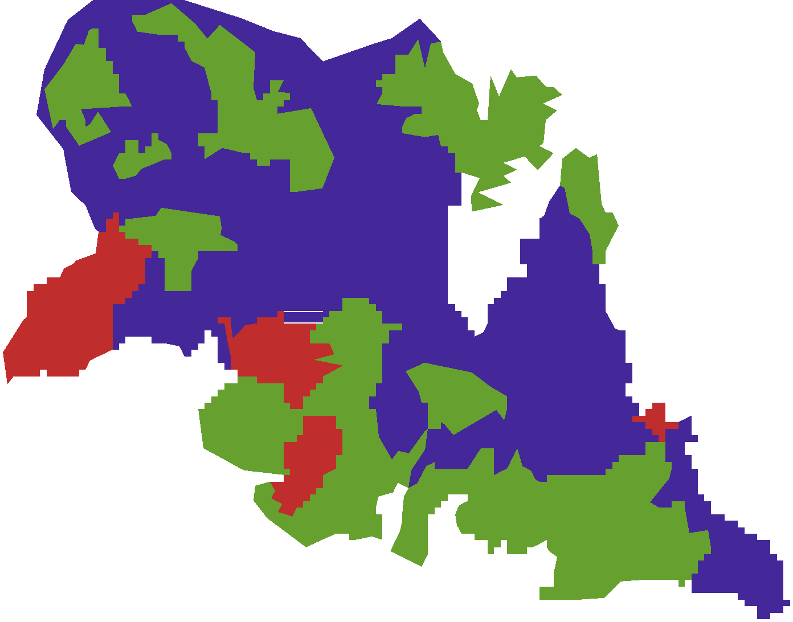
Topographic factors

The slope length and slope steepness can be used in a single index, which expresses the ratio of soil loss as defined by Wischmeier (1978). LS = (λ/22.1)^{m} * (0.065 + 0.045 S + 0.0065 S²)
λ = slope length (m or km); S = slope gradient (%)Slope value was derived from Digital Elevation Model(DEM) of Baro_subbasin The topographic factor ranges from 0.30 to 26.73 for the watersheds Calculated
$$LS={\left(\frac{λ}{22.13}\right)}^{m}\left(0.065+0.045S+0.0065S^{2}\right)$$
Where; L= Slope length factor
$λ=runoff forming slope length$, (meter)
m=is slope length exponent which is dependent on slope

Table 3: slope length exponent
Slope in per cent | m-value
≤ 0.50 |  | 0.15
0.5-1.0 |  | 0.20
1.1-3.4 |  | 0.30
3.4-4.9 |  | 0.40
≥ 5 |  | 0.50

The value of $λ$ and m were derived from DEM, to calculate the $λ$ value, flow of accumulation was derived from the DEM after conducting fill and flow direction in ArcMap 10.40 GIS, i.e.
$λ$=flow accumulation × cell value/resolution, then L=Pow([floacc]×resolution/22.13,m)
Accordingly the mean value of the topographic factor of the watershed is 4.61; 5.07 for sws1 and 1.89 for sws2.
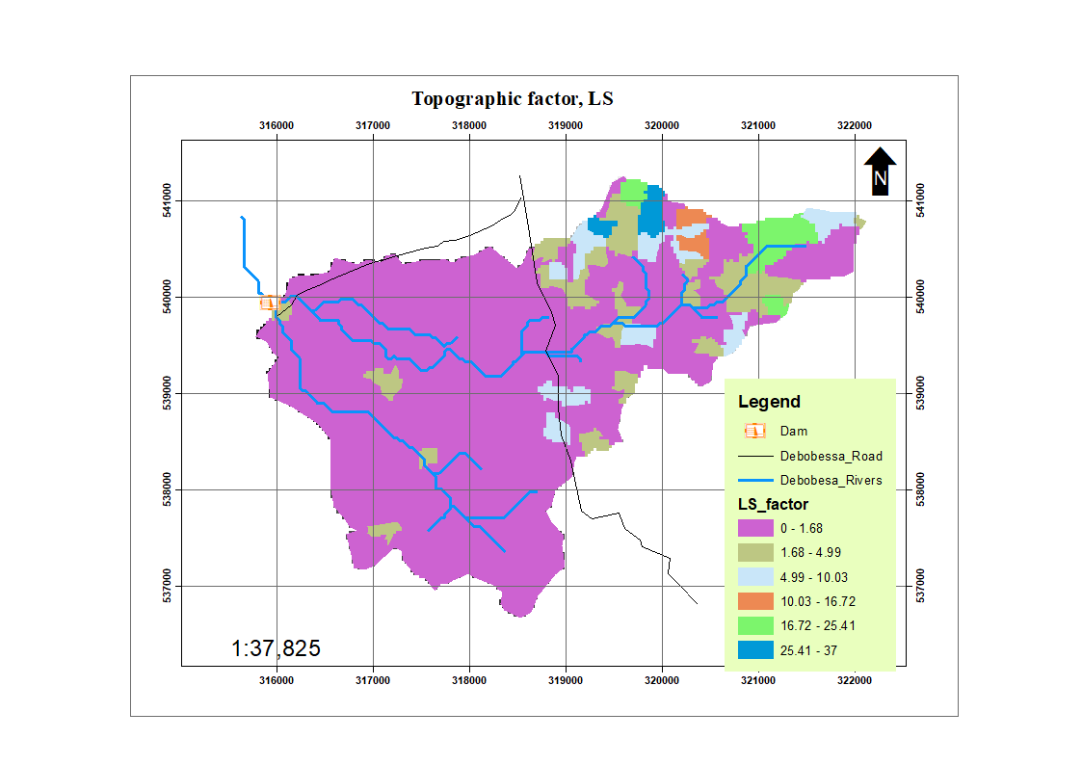
Map 5; Topographic factor, LS

Land Cover (C)
As Nyssen et al, (2004) commented, the land cover factor ‘C’, is of paramount importance in the determination of erosion hazard assessment because of the large difference between its minimum and maximum values and therefore slight mistakes in land cover mapping can easily result in large over- or under- estimations of soil loss. For this reason it was imperative that as accurate and up-to-date land cover data as possible is used and therefore Woody Biomass Project (Tecsult, 2004) data was used.
This data was compiled from satellite imagery mapping with a great deal of field ground-truthing and can therefore be considered to be appreciably more accurate than older data or more contemporary global data. Land Cover parameters were obtained from Halcrow (1989), FAO/LUPRD (1980s), SCRP and Hurni, and the WBISPP parameters were also derived using these historical data. The average/mean C-factor value is therefore 0.13.

Land Management (P)
The management factor P indicates reduced erosion potential, with a range between 0.0-1.0 because of farming practices or conservation measures. The only farming practice increasing erosion (P factor value > 1) instead of reducing it is ploughing in the direction of the slope. Studies conducted (Hurni, 1985 and CGIP, 1996) have found different P values for various management practices and land use and cover.
Depending on the qualities of terraces, erosion potential is estimated to be reduced by a factor P = 0.5 – 1.0. Table 8 gives P values for different management practices; and Debobessae watershed ranges 0.8 - 1.0 for different conservation and agricultural practice as shown below on map 10.
Accordingly the land management factor for the Debobessa watershed is 1.00.

Annual Soil Erosion/soil loss
Actual soil erosion is refers to the per cent jeopardize of soil erosion, taking in to account of land use/land cover and management practices that modifies the potential soil erosion.
The actual soil erosion assessment is based on the principles of RUSLE model, which multiplies the six parameters of rainfall erosivity, soil erodibility, slope gradient and length (LS factor), Land cover and management and conservation practice.
The application of model was by using raster calculation method of ArcGIS software, which enables the multiplication of the parameters cell by cell. The syntax given as follows:
Actual soil loss (A) = R factor*K factor*LS factor*C factor*P factor

The quantitative output of estimated soil loss as actual erosion/actual soil loss is57, 10 ton/ha/year that is high and needs serious soil conservation. The total actual soil loss from the watershed is 77705.09 ton/year.
The sediment yield of the watershed is 54500.94tons /year

WATERSHED MANAGEMENT PLAN
In many parts of the country reservoirs and other irrigation structures are silting up very rapidly. One of the major causes of the siltation is watershed degradation and deforestation. Deforestation is commonly the cause for enormous increase in the sediment load. Apart from silting, high sediment loads may change the nature of the river, particularly in the downstream parts. Increased flooding, blocking of irrigation intakes and so on can be resulted due to the upland erosion
Water shed management includes all practices applied to the land that are effective in reducing flood runoff and controlling erosion and soil loss. Proper land use and conservation practices are necessary for adequate water shed control. Conservation practices such as contouring, strip cropping, terracing, cheek dams, sediment trap dam, stone bunds, soil bunds, gully reclamation; etc will reduce floods and soil loss and siltation problems
Therefore, in order to maintain the existing land cover in the watershed, to avoid future risk of erosion and siltation, to mitigate increasing risk and damage to irrigation infrastructures, integrated watershed management should be mandatory.

Participatory Integrated Watershed Management
A watershed is a topographically delineated area that is drained by a stream system. The watershed is a hydrologic unit that has been described and used both as a physical-biological unit and as a socio-economic and sociopolitical unit for planning and implementing resource management activities (Easter and Hufschmidt 1985).
Integrated watershed management is the process of formulating and implementing a course of action involving natural and human resources in a watershed, taking into account the social, political, economic, and institutional factors operating within the watershed and the surrounding river basin and other relevant regions to achieve specific social objectives.
The watershed approach is the application of integrated watershed management in the planning and implementation of resource management and rural development projects or as part of planning for specific resource sectors such as agricultural, forestry, or mining. Imbedded in this approach is the linkage between uplands in both biophysical and socio-economic contexts. It is effective in land and water conservation as it integrates all the opportunities and constraints in the system.
Thus, the application of watershed management approach for soil and water conservation in the watershed is highly appropriate.
In integrated water management, the following activities would put us on the right track.
- Divide watershed in to manageable in terms of drainage (micro catchment) or land morphology such as up land, upper basin, valley bottom, flood plain, fluvial (riverine).
- Divide each watershed in to land use unit each with its set of potentials and constraints. Here soil erosion will be exposed as a major development constraint.
- Based on these, develop set of resource utilization and management practices for each operating unit with in each major resource (land use). E.g. in irrigated agriculture practice, types of soil, crops, quantity and timing of water, fertilizer, pesticides , labor , animal power , methods of land preparation , erosion and sedimentation. In all aspects their impact shall be assessed both in spatial and temporal terms.
- Set up stream and down stream management practice. For example conservation requirement such as check dams to protect gullies, contour terrace, stream bank protection , catchement treatment to reduce erosion and sedimentation.
- Ensure participation and awareness of the water shade system to the beneficiaries.
More specific water shed management practices for this particular water shed are described below:

Rehabilitation of Gullies and Degraded lands
It is discussed that gully formation is the major problem of soil erosion and land degradation in the sub-basin. Gullies are classified as small, medium and large depending up on the size of drainage area and depth of gully.
Table 4: Size of Gully
Size | Depth(m) | Drainage area(ha)
Small | < 1.5 | < 10
Medium | 1.5 – 3.0 | 10 - 30
Large | > 3.0 | > 3.0
Source: Teshome.A. /CRS-Water Action .2002
Small or shallow gullies can be reclaimed by check bunds 1.5 m² cross section spaced at horizontal intervals of 30 to 45 m bunds at a vertical interval of about 1m. Pipe out lets or grassed ramps are to be provided for draining the excess runoff water if any from the treated area. At the end of the small gully system, a small check dam is provided as a protective measure against any loss of soil.
Stabilization of small gully heads of less than 1.5 m deep, where the discharge is not more than 0.1m³/s, may be done by reshaping and the use of grass sod or brushwood carpet.

Stabilization of gullies
Grass sod: grass is carefully uprooted so that most of the soil remains attached to the roots. This will ensure that the grass established quickly. The gully head is reshaped and the sod laid in position to form a protective carpet that protects the soil from further erosion by the flowing water. Stakes can be used to anchor the sod to the ground. Its use is limited to small gullies with low discharge and head height less than 1 m.
Brushwood Layering (carpet): is formed by the use of tree branches that have leaves. It is particularly beneficial where grass sods cannot Debobessa because the flow is too much or the slope is too great. Brush wood layering reduces the waterfall erosion and safely discharges the water to the floor of the gully. Construction starts with reshaping of the gully head to reduce the slope.
About 10 cm of mulch or straw is laid, as foundation on the excavated and unfilled areas. This is required to prevent soil being washed out. It is very important that this layering reaches into the sides of the gully to protect them from collapsing. The brushwood carpet should be lower at the middle to form a spillway. To protect the brushwood from being washed away, wooden pegs or stakes are used to anchor it to the ground. As the brush wood layering is only temporary structures it should be born in mind that grass stabilization in due course will have to be thought.

Structure for gully bed stabilization
Scour checks: are known as stone or grass threshold depending on the material used in the establishment. Scour checks are stone or grass and stone barriers placed across a gully flour to prevent gully bed erosion by scour effect of runoff. Flat stones of medium sizes are best for scour checks. The placement of the stones should be in such a way that there are minimum voids within the structure to increase its stability. Before placing the checks, a trench 0.3m wide and 0.3m deep is excavated across the floor of the gully and extended 0.3m into the sides of the gully. Scour checks should be spaced 1- 4 m apart depending on the amount of flow and material availability. The middle section should be lowered to serve as spill way.

Check dams
Check dams: Check dams are gully plugging structures using rocks/stones, compacted soil or selected material, earth bank, wood racks, gabions and also planting trees and grass to stabilize the system. Each material has different sediment trapping and flood protection characteristic. Check dams can be easily applied in all gullies of less than 2m depth and 5m width. Vertical intervals between check dams are equal to the height of check dams.
A properly designed and constructed check dams acts as a detention dam, retention dam and as a drop structure. A check dam, even after it is filled with sediment will still function as a detention dam and a drop structure. Based on the type of construction material, check dams can be,
Loose rock/stone check dam: is usually built of loose stones and is most commonly used structure in gully control in Ethiopia.
Post stone check dam: is a type where stone or rock fills are reinforced by wooden post either downstream side or in both the upstream and downstream side.
Gabion check dams: gabions are rectangular boxes of varying sizes and are mostly made of galvanized steel wire woven in a mesh. The boxes are tied together with wire and then filled with stones and placed as building blocks. A good gabion check dam should have a proper key, adequate spillway, an apron and correct configuration.

Reclamation of Large Gullies
Large gullies of 3- 9 m depth are reclaimed by clearing and levelling the bed and constructing a serious of composite (earth and brick masonry) check dams at vertical intervals of 1.2 m. The side slopes of the gully are bench terraced. To justify the high cost of bench terracing, they are only made when the gully sides have a uniform slopes for a minimum length of 120 m. For gully side slopes of 8 to 15 % level terraces at 0.9 to 1.2 m vertical interval with inward gradient of 1 in 50 and longitudinal gradient of 1 in 200 is recommended.
During the process of terracing, the topsoil on the surface is covered with the poor sub soil. This requires a planned program to raise the fertility level of the soil, involving good crop rotations and heavy manuring. The terrace requires careful maintenance for the first two years in view of the unsettled conditions of the soil. The ridge bunds, terrace faces, graded cutlets and earthen check dams can be stabilized by sodding or growing with suitable grasses Reclamation of Very deep and narrow gullies
Very deep gullies over 10 meter can be maintained by constructing gully plugs with in the bed of the main and branch gullies. Gully heads and sides have to be stabilized by planting grass species like Dichanthium annulatum, gully plugging (with live hedges, brushwood, earth or composite) is done in the gully beds for conserving the soil moisture, controlling the soil loss and providing better growing conditions for the natural as well as planted grasses and forest species. Moreover, the best control measure for large and very deep irreversible gullies is to strictly abandon any interference and live to naturally stabilize itself.

Maintenance of Gully control structure
Treated gullies should be checked regularly and the healing process monitored closely. Structures built in the gully for stabilization purpose should be observed for damage especially during rainy seasons and after heavy storms. Damaged check dams should be repaired immediately to avoid further damage and the eventual collapse.

Recommended Biological Measures

Conservation Based Agriculture
It is proposed that, the current cultivated lands shall integrate conservation based agricultural practices. All agricultural practices in this area have to integrate with soil and water conservation activities focusing on the stability of the agro-ecology and on the rational and effective use of the land resources.
The conservation based agricultural management systems employs, among others physical structures and biological system such as, inter cropping, relay cropping and leguminous cover sowing, crop rotation, strip cropping, high density planting, multiple cropping, fallowing, Contour cultivation. etc. Contour cultivation reduces soil erosion from slope land by up to 50 % compared with cultivation up and down slope. Mono cropping of wheat and barley should be replaced with rotation of leguminous crops. These practices not only reduce soil erosion and land degradation but also sustain and increase the productivity and there by income of the farmers.

Grass Strips
Grass strips are narrow strips of 0.5 to 1 m width laid out on the contour level or graded. They have proven to be effective in controlling soil erosion up to 10% slope. Grass strips are less effective in reducing runoff than soil loss as they provide little storage capacity. However, they do retard the movement/velocity of water and encourage infiltration.

Agro- Forestry
Trees help preserve the fertility of the soil through the return of organic matter and fixation of nitrogen. Trees improve the soil structure and help maintain high infiltration rates and greater water holding capacity. As a result, less runoff generated and erosion is better controlled.
Trees can be used to supplement existing erosion control measures by being added to contour grass strips, on terraces, or on croplands. Research indicates that when trees are combined with grasses and crops on soil conservation structures, reduces erosion significantly. In Ibadan, Nigeria, erosion was reduced to 1.6 /ha/year, when compared to 8.7 t/ha/year with conventional cultivation.

Villages and Homestead Area Tree Plantation
It is a Practice of tree growing around individual home and villages, undertaken by individual farmers or the community. Areas and tree species have to be identified in consultation with farmers depending on the need of individual's and/or villagers as a whole. As trees are grown close to where people live it can be well looked after and the survival rate is high. The trees can have different purposes such as fodder, shelter and windbreaks, fruit for eating, live fence, ornamental, bee forage and creating better microenvironment.
Establishment of villages and homestead tree plantation reduce overgrazing, fuel wood cutting, charcoal making and in general reduce pressure on the natural resources in the area.

River Bank and Water Ways Protection and Plantation
The rivers flowing in and out from Debobessae watershed are loosing their earlier water course and increase width and depth because of clearing of riverine vegetation, river bank cultivation and improper exploration of construction material.
Trees have to be planted at least up to 3- 5 m away from the edge of the channel. Water Seepage from the water way will give an irrigation effect while boost production and also enable to grow many different tree species. As a rule tree strips should be maintained 20 - 40 m each side of perennial streams (Bosh and Hewlett 1980), although in some instances much narrow strips of 10 m have proven effective. Cultivation and any stream bank destablizing practice shall be avoided 50 meters along the major stream bank.
The most physically effective way to minimize the harmful effects of sedimentation and suspended sediment is to minimize erosion. Sediment trap structures and mechanical sediment removal are expensive “ after-the-fact” alternatives. Even if upland erosion could be halted by the conventional soil conservation measures, sediment would still be brought out of trapps by major storm and runoff events. Thus in addition to the standard soil and water conservation practices, establishment or protection of streamside “buffer” strips of largely undisturbed vegetation can reduce sediment input into streams. Human and livestock activity should be restricted in the critical stream bank area.

Plantation along Tracks and Paths
Growing trees on strips parallel to paths and tracks forming lines or hedges is essential. Trees can be planted on one or both side of the roads, in one or more rows depending on availability of the land minimum spacing of 1m between trees and 1 m between rows is acceptable. Along paths of animals it is advisable to plant species that are not browsed by animals. The trees stabilize the embankments and benefit the community as; trees growing in small strips are better productive than trees growing in closed areas.

Live Fence Plantation
Trees or shrubs are planted and grown in two or more rows to form a fence and protect a given area from external interference, while at the same time provide useful forestry products. Live fence substitute expensive wood and traditional fencing made of thorny branches, a practice which requires extensive cutting of trees and other natural vegetation. Based on selection of trees a systematic debranching of fenced trees will provide fodder, fuel wood and other products, if for example fruit trees are inserted in the fence.

Wood lot Plantation:
It is a traditional way of growing trees on a unit of land and is an effective way of producing construction and fuel wood. The enclosed areas in the watershed will be an ideal place for this type of intervention having multiple uses. The specific area can be selected with participation and consultation of the communities.
Distance between trees in planting for construction purposes should normally be spaced 2 x 2 m, while for fuel wood 0.5 - 1.0 m is acceptable.
Species to be selected should be able to give a good volume of production, multipurpose trees for soil conservation, cutting of grass and trees for feeding animals, shelterbelts and change of microenvironment.

Plantation on Soil Conservation Structures
Shrubs or small trees and fruit crops are grown on soil conservation structures on cultivated land i.e. bunds, bench terraces and grass strips. The trees will stabilize the structure and the use of leguminous species will improve soil fertility. Pruning of trees/shrubs will provide fodder and fruits for consumption. Planting of trees and shrub and grasses is often done in combination with grasses between the trees and will be used in cut and carry.

Soil Management for Soil and Water Conservation
The aim of soil management is to maintain the fertility and structure of the soil. Highly fertile soil results in high crop yields, good plant cover resulting in conditions, which minimize the erosive effects of raindrops, runoff and wind. The central theme inhere is that soil fertility must be seen as a key to soil and water conservation. Soil fertility can be maintained through the following methods.

Addition of Organic Matter
To increase the resistance of an erodible soil by building up organic matter is a lengthy process. The organic matter (O.M) content must be raised to more than 2% to bring any effect on soil & water conservation measures. On soils with less than 1% of organic content, a large supply of organic material is required. Ploughing under maize residues (5-10 t/ha) was found to increase the O.M of the soil in absolute terms by only 0.004- 0.017%, whilst application of farm yard manure at 10 t/ha was sufficient only to maintain but not increase an existing level of organic content (Jones, 1977). Grass materials are more effective in releasing better O.M. to the soil.
Organic matter can absorb considerable amount of water, often 5 to 6 times of its own weight. Under condition of heavy storms the elasticity of soil high organic matter content helps to absorb the energy of falling raindrops, so that surface damage is lessened and soil erosion by water on sloppy areas is very much reduced.

Conservation tillage
Conventional tillage harms the soil if used continuously over many years, especially if the fertile topsoil layer is thin. The tillage includes zero tillage, strip tillage, mulch tillage and minimum tillage. All conservation tillage operations are targeted at halting soil degradation and or restoration and improving soil productivity. They often involve crop residues management. In conservation tillage, crop residues cover at least 30 % of the soil surface.
Ridging/Listing: is the formation of alternate furrows and ridges on the land. When the furrow is tied at regular intervals across the slope, the practice is known as tied ridging. It increases contact time, infiltration and moisture conserved. The practice is more effective on gentle slope.

Physical Soil Conservation System

Contour Ridges
These are constructed on steep, rocky hills and mountainous terrain to protect heavy runoff and mass slides of soil materials. The ridges may be formed from rocks, boulders and old tree logs.

Contour Bunds
These are earth banks (1.5-2m wide) thrown across the slope to act as a barrier to runoff, to form a water storage area on the up slope side and to break up the slope into segments shorter in length than is required to generate over land flow. It can be formed from soil (soil bund) or stones (stone bund).

Soil Bund
Soil bunds are mostly practiced in deep soils and in areas where vegetation has been removed, recently. A construction height of 75 cm that can slump to 50 cm with a width of 1m is suitable. To restrict side way water movement, a tied ridge at interval of 6-10 m can be made. Soil bund can be stabilized with Couch, Star and Rhodes grass types and cut and feed livestock.

Stone bund
In areas where stones are, available stone bund is a good protection material. It is practiced in limited intense on watershed Mountains and hills and when combined with soil and grass strips are very successful.

Terraces
These are earth embankments constructed across the slope to intercept surface runoff, convey it to a stable outlet at a non-erosive velocity, and shorten slope length. They differ from contour ridges by being larger and designed to structure that is more stringent. The general recommendation includes diversion terraces on slopes of up to 7%, retention terraces on slopes of up to 4.5% and bench terraces on slope of 4.5 - 30%.

Waterways
These are channels designed to receive runoff from cutoff ditches, road drains and terraces and to carry out that runoff down a slope to a point where it can be safely discharged into a valley bottom or a stream. The constraint is shortage of land and the difficulty of finding an acceptable alignment.

Embankment or road cut slope
Construction of feeder roads and main roads exposes the embankment, cut slopes to mass slide, and run off erosion. Hence, rapid establishment of grass or legume cover is essential to minimize erosion and enhance slope stability. Planting natural turf over the slope is a standard practice. The turf should be up rooted with about 100-mm thickness of soil to serve as a seedbed. Once the soil has been stabilized, ornamental trees and shrubs may be planted or the land can be left to be colonized by native vegetation on roadsides.

Benefits of Soil & Water Conservation measures
As it seen in many part of the country the farmer's cooperation is achieved when conservation practices are associated with immediate and tangible benefit. The conservation practice must offer a quick pay. For crops we should be thinking in terms of one year or less growing types. Forestry trees require longer periods, but one could go for fast growing species. Proper type of trees has to be grown on selected sites. Moreover, conservation practices should offer a high financial return. A possible increase of 10 - 20 % income will not stimulate rapid uptake. There must be an increment of 50 - 100 % or more value to beneficiaries.
Soil conservation interventions provide adequate protection from erosion and avoid further decline of crop yield compared to that of untreated land. Conservation measures may not in the short time result in crop yield increases, they greatly control further decline of land productivity. The benefits accruing as an economic return is also satisfactory. Reports of the Ethiopian Highlands Reclamation study (1988), estimated yield reductions of 0.25 -1.5% per year as a result of land degradation. The estimated yield losses include:
Losses due to arable land going out of use and production as a result of the soil cover being reduced to a minimum declining yields due to loss of nutrients, soil structure and water retention capacity.
The protection of forests lead to a proper balance in the ecosystem, enhance the availability in the required amount of wood based and non wood based forest products such as honey, medicinal herbs, foodstuff and animal feed and conserve soil and water. Moreover, properly protected forests assure the existence of diversity in wildlife, the basis for boosting the smokeless industry. Ground water is replenished in the presence of sufficient vegetation cover, which increases the infiltration capacity of soils in improving the structure through decomposition of leaf litter and decayed wood.
Conservation activities contribute directly to the availability of livestock feed stuff. Planting bunds with legumes and grasses, establishment of grass strips, area closure and establishment of hedgerows with multi-purpose tree/shrub species are among the major area of soil and water conservation measures which promote livestock production.

REFERENCES
Barber G. R., 1984, Generalized soil physical erosion hazard index map. The Ethiopian Highlands Reclamation Study.
Constable M., 1986. Ethiopian highlands reclamation study, FAO. Rome volume I & II
Thomas D. B, et al, 1986 Soil and water Conservation in Kenya , Proceedings of the Third National Debobessashop. Nairobi.
Daniel G., 1968. “Aspects of climate and Water budget Ethiopia”. National Atlas of Ethiopia.
Escabedo J., and Volli C., 1990 land capability classification for soil conservation in Ethio pia, Assistance to soil conservation, A Field document.
Hurni H., and Kebede T., 1992 Erosion, conservation, and small scale farming: Proceedings of the 6th ISCO conference; Addis Abeba, volume I & II.
Hurni H. 1986., Soil formation and soil loss tolerance estimation model modified to Ethiopian conditions. Assistance to land use planning; Field document.
Master Plan for the Development of Surface Water Resources In the Awash Basin (1989), Final Report, Volume 6,EVDSA, HALCRO, Peoples Democratic Republic of Ethiopia
National Conservation Strategy of Ethiopia (1999)
SCRP (1982-1989) Research progress reports for the periods, 1982-1989.
Soil and water conservation Guideline for Ethiopia (2001) Natural Resources Management and Regulatory Department, Ministry of Agriculture.
USDA, 1978, Predicting Rainfall Erosion Losses, A guide to conservation planning.
USDA, 1979, Engineering field manual for conservation practices. USDA, Soil conservation service.
Woody Biomass Inventory and Strategic Planning Project (2001) Executive Summary Methodologies for Land use systems, Socio-economic Survey, MoA- Tecsult

APPENDICES

Appendix 1: Debobessae watershed Soil and Water Conservation
Field Data Collection Checklist:
Observation No.: ------------------------ Date: ------/-------/------
Name of P.A: ---------------------------- Local Name: ---------------
Location: N----------------------------- Altitude: ------------ (GPS)
E----------------------------- -------------- (altimeter)
1. Topography/Slope
A.
1.1 Flat 0-0.5%) ----------- 1.5 Rolling (10-15%) ----------
1.2 Almost Flat (0.5-2%) -------- 1.6 Hilly (15-30%) ------------
1.3 Gently Undulating (2-5%) ------ 1.7 Steeply Diss. >30%-------
1.4 Undulating (5-10%) ------------ 1.8-Measured Slope (%) -----------
1.9 Slope Length (m): --------
B. Surface Roughness
1.1 very rough---------- 1.4 fine/smooth ------------
1.2 Rough -------- 1.5 very smooth/almost even------------
1.3 mediums------

C. Slope Shape
Convex------------------------ Concave----------------------Linear------------------------------------Depression-------------------Irregular-----------------------
2. Land Use/Land Cover
2.1 Cultivated land: -------------- 2.4 Perennial Crops: ------
2.2 Grazing: ------------------------- 2.5 Bush: -------------
2.3 Forestry: ------------------------ 2.7 Shrubs: ------------
2.6 Vegetation type: --------------
2.8 Major Crops Cultivated/Activities: --------------------------------------------------------

3. Erosion by Water
2.1 Sheet: (Y)-------------------(N)---------- If yes extent (ha)--------------------------
2.2 Rill: (Y)------------(N)---------- If yes, gives dimensions
Depth (m)----------Length (m)---------- Width (m)---------------------------------------
Causes of sheet & rill erosions
- Heavy Rains
- Absence of control measures
- Loose soils
- Cultivation of steep slopes
- Other, specify
3.3 Gully Erosion: Causes of the gully:
- Deforestation
- Foot path, cattle track
- Inappropriate road drainage construction
- Cultivation of steep slopes
- Overgrazing/overstocking
- Others specify
Types of gullies formed
Size | Depth (m) | Remarks
Small | <1.5
Medium | 1.5 - 3
Large | >3

The gully being used, for grazing, tree planting, specify: --------------------- ---------
Stage of the gully: Active-------------------Non active-----------------------------------
Effects of the gully:
Flooding downstream-------------------------Dissection of farm land-------------------
Expansion into utilizable land----------------Silting up downstream water bodies----
Others specify: -------------------------------------------------------------------------------
Gully control measures taken:
Check dam----------runoff diversion--------closure& plantation-----------------------
Other specify------------------------------------------------------------------------

  - Stream Bank Erosion:
Active--------------------------non-active------------------------------------------------
Width (m)-------------Length (m)------------------------depth (m)-------------------
  - Mass Movement, if any: ------------------------------------------------------------------
Estimated area affected (ha): ----------------------------------------------------------------
- Soil Erosion by Wind
4.1 Water & wind erosion: -------------------- 4.4 Salt Deposition: ---------------------
4.2 Wind deposition: --------------------------- 4.5 wind storm occurrence ------------------
4.3 Shifting sands: ----------------------------- 4.6. Others specify
5.Type of Soil Degradation
5.1 Excess of salts:
Causes
- Aridity/rainfall shortage/inherent from soil--------------------------------------
- Improper land management, use of irrigation--------------------------------------
5.2 Biological Degradation (fertility loss):
Causes
- Erosion
- Continuous cultivation
- Luck of soil fertility management
- Arid climate
Slight---------------------medium--------------------sever----------------------------
Estimated area affected (ha): -------------------------------------------------------------
5.3 Chemical degradation:
Causes
- Leaching of bases
- Arid climatic condition
- Nature of soil
Estimated area affected (ha): ----------------------------------------------------------------

5.4 Physical degradation:
Causes: ---------------------------------------------------------------------------------
Estimated area affected (ha): --------------------------------------------------------
6. Soil Conservation Measures Applied & status
6.1 Physical: -----------------------ha 6.4 Indigenous: -----------------ha
6.2 Biological: ----------------------ha 6.5 Bio-Physical: --------------ha
6.3 Ago forestry: -------------------ha 6.6 others specify: ------------------------
6.7 Status of SWC measures: -------------------------------------------------------------
7 Proposed Soil Conservation Measures for that particular area
7.1 Physical: ------------------------ 7.5 Roof Water Collection: -----
7.2 Biological: ---------------------- 7.6 Water harvesting: ------------
7.3 Bio-Physical: ------------------- 7.7 Others: -------------------------7.4 Traditional/Indigenous: ---------------------
8. Traditional SWC measures under practice:
1---------------------------------- 2--------------------------------------
3---------------------------------- 4--------------------------------------
5---------------------------------- 6---------------------------------------
7 Area coverage of each:---------------------------------------------------------------------
9. Type of land Management: --------------------------------------------------------------
10 What type of SWC measure do you want to use in your farm? Farmers’opinion-------------------------------------------------------------------------------------------------------------------------------------
11. What is the major problem in your farmland that reduces production? ________________________________________________________________________________________________________________________________________________________________________
12. Collect data on conservation achievements, under different projects or NGO, office of agriculture
13. Soil types --------------------------------------Soil Depth (cm)--------------------------
Soil Texture----------------------------------------- Soil Drainage----------------------
14. Estimated soil loss per annum/ha( in tons)----------------------------------
15. Estimated Area affected----------------------------------------------------------
16. Sign of Desertification----------------------------------------------------------------
17. Remarks/comments: -------------------------------------------------------------------

Appendix 2: Land Resource Data Required For SCRS
Slope (L)
Slope % Code
Flat or almost flat 0 - 3 L-1
Gently sloping 3 - 8 L-2
Sloping 8 - 15 L-3
Moderately steep 15 - 30 L-3
Steep 30 - 50 L-4
Very steep >50 L-5
Soil Depth (D)
Soil Depth Cm Code
Very Deep >150 D1
Deep 100 - 150 D2
Moderately 50 - 100 D3
Shallow 25- 50 D4
Very shallow < 25 D5
Past Erosion (E)
Past erosion Definitions Code
Nil No erosion E0
Slight Some erosion E1
Moderate Rills occur E2
Severe Shallow gullies E3
Very severe Deep gullies E4
Texture (T)
Texture group Texture class Code
Coarse Sand T1
Medium Sandy loam T2
Loam T3
Silt loam T4
Clay loam T5
Fine Clay, silt clay T6
Heavy clay T7
Water logging (W)
Waterlogging Definitions Code
No water logging Well drained WO
Intermittently waterlogged Imperfectly drained W1
Regularly waterlogged Poorly drained W2
Swampy areas Very poorly drained W3
Infiltration (I)
Infiltration Definitions Code
Good Very permeable 10
Moderate Slowly permeable 11
Poor Impermeable 12
Stoniness classes or Rockiness classes( S)
Stoniness classes Rockiness classes Area cover Code
stones or few No rocks or few < 15 S0
Moderately stony Moderately rocky 15 - 30 S1
Stony Rocky 30 - 50 S2
Very stony Very rocky 50 - 85 S3
Rubble land Rock outcrops > 85 S4

Requirements for classification: the limitations will include one or more of the following
Class | Slope | Soil depth | Past erosion | Texture | Water logging | Infiltration | Stoniness
I | < 3 | > 150 | no | T3- T6 | no | good | <15
II | < 8 | >100 | no | T3 - T6 | no | good | <30
III | < 15 | >100 | nil | T3 - T6 | none- intermittently | none - moderate | <50
IV | < 30 | >50 | nil to slight | All texture except sand | nil- regularly | good - poor | <50
V | 15 - 30  30 - 50 | > 25  >50 | nil - moderate | all texture except sand | nil - regularly | good - poor | > 85 boulders included
VI | > 50 | > 25 | nil - severe | all texture except sand | nil - regularly | good - poor | < 85 boulders included
VII | all classes | < 25 | very severe | Sand | nil - regularly | good - poor | > 85 boulders included
Limiting factors (land class units)
IIL2: Slope 3 - 8
IID2: Soil depth 100 - 150 cm
IIT6: Clay, silty clay
IIS1: Stoniness 15 - 30
IIIL3: slope 8 - 15 %
IIIE1: slight past erosion
IIIW1: intermittently waterlogged
III I1: moderate infiltration
IVL4: Slope 8 - 15%
IVD3: Soil depth 50 - 100 cm
IVE2: Moderate past erosion
IVW2: Regularly water logged
IVI2: Poor infiltration
VW4: Swampy areas, soil always wet
VF: River beds or areas flooded every year
VIL5: Slope > 50 %
VID4: Soil depth 25 - 50 cm
VIs3: Stoniness 50 - 85 %boulders excluded
VIIID5: Soil depth > 25 cm
VIIIE4: Severe past erosion
VIIID5: Soil depth < 25 cm
VIIIE4: Very severe past erosion
VIIIT7: Heavy clay
VIIIS4: Stoniness or rockiness > 85 %
SOURCE: ESCOBEDO 1986

