oROMIA IRRIGATION DEVELOPMENT AUTHORITY
WILLIYO SMALL SCALE IRRIGATION PROJECT HYDROLOGICAL ANALYSIS, ENGINEERING FEASIBILITY STUDY AND DESIGN REPORT
PREPARED BY BONEYA PLC

JUNE 2016
NEKEMTE

TABLE OF CONTENTS

A. DESIGN OF WILIYO SMALL SCALE IRRIGATION PROJECT 4
1. Hydrologic Analysis 4
1.1 Flood Analysis 4
1.1.1 Factors Affecting Runoff 4
1.1.2 Physiographic (Catchment characteristic) factors 4
1.1.3 Climatic factors 4
1.2. Methods of determining Runoff 5
1.2.1. Unit- Hydrograph Method 5
1.2.3 Gumbles Composite Hydograph Methods 9
2. IRRIGATION AND DRAINAGE SYSTEM DESIGN 13
2.1 Headwork Design 13
2.1.1Location and description of the project area 13
2.1.2 Methodology 13
2.1.3 Water Resource 14
2.1.4 Planned Irrigable area 14
2.1.5 Water distribution scenario 14
2.1.6 System Layout Plan 14
2.1.9 Design of Headwork (weir) 16
3. FARM SYSTEM AND CANAL DESIGN 25
3.1 Secondary canal flow hydraulics (SC1, SC2, SC3 & SC4) 26
3.2 Design of typical Drops (at chainage 343 &1040) on main canal and at d/t chainages on secondary 27
3.3 Division Box 28
3.3 Design of Aqueducts (two in number) 30
4. Bill of Quantities and specifications 37

LIST OF TABLES
Table 1: computation of flood by Gumbles composite hydrographs 9
Table 2: Stability Analysis and Hydraulic Calculations 24
Table 3: Gross and Net Command Area by Supply Methods 25
Table 4: MC Hydraulic Design Parameters 26
Table 5: Sc Hydraulic Design Parameters 27
Table 6: Design of Box culvert 31
Table 7: Design of Night storage pond 32
Table 8: Pond inlet and out let design calculation table 34
Table 9: Summary of BOQ and Cost Estimate by Major Activities 41

LIST OF FIGURES

Figure 1: Wiliyo Drainage area 7
Figure 2: Williyo SSIP Topo and System layout view 15
Figure 3: Flow Conditions over the Weir 17
Figure 4: Canal Cross section 25
Figure 5: Typical Drop Structure 28
Figure 6: Division box typical plan view 30
Figure 7 : Schematic views of box culverts. See the detail on drawing 31
Figure 8: Night Storage plan and sectional views 34

A. DESIGN OF WILIYO SMALL SCALE IRRIGATION PROJECT

1. Hydrologic Analysis
The hydrological Analysis of the area focuses mainly on determining the peak (flood) discharges for hydraulic and structural design and the base flows for identifying the water balances of the river and irrigation system. The following methods were employed to determine the variables.

1.1 Flood Analysis
- Flood means the draining or flowing off of precipitation from catchment area through a surface channel or stream.
- Flood Analysis Used for designing proper structures such as Weir & Culvert in order to lie across the stream/Chanel as to minimize failure probability as low as possible.
- Probable maximum flood occurred expected to occur within certain return period of time is taken for design purpose.
- For small Diversion structures a 50 year return period is adopted. Whereas, for Small Dams, it can be designed for 100 years return period.

1.1.1 Factors Affecting Runoff

1.1.2 Physiographic (Catchment characteristic) factors
- Basin characteristics:
- Shape
- Size
- Slope
- Drainage density
- Infiltration characteristics:
- Land use & cover condition
- Soil types
- Lakes, swamps & other storage
- Channel/ Water way characteristics:
- Cross section
- Roughness

1.1.3 Climatic factors
- Storm characteristics
- Precipitation
- Intensity
- Duration
- Magnitude & movement of storm
- Initial loss
- Evapo – transpiration

1.2. Methods of determining Runoff

The portion of the precipitation which by a variety of paths above & below the surface of the earth reaches the stream channel is called runoff. Therefore, runoff is draining or flowing off precipitation from a catchment area through a surface channel. Once it inters a stream channel, runoff becomes stream flow.
There are so many ways of estimating stream channel flow:-
- Rational methods (<50km²)
- Empirical methods
- Unit Hydrograph methods (25<500km²)
- Flood frequency studies

1.2.1. Unit- Hydrograph Method
The problem of predicting a flood hydrograph resulting from a known storm in a catchment has received considerable attention.
Large numbers of methods are proposed to solve these problems & of them probably the most popular & widely used method is the unit hydrograph. It is defined as the hydrograph of direct runoff resulting from one unit depth (1cm) of rain fall excess occurring uniformly over the basin & at a uniform rate for a specified duration.
- Basic assumption

→ It relates only direct runoff to rainfall excess.
→ the distribution of rain fall is considered to be uniform all over the catchment.
→ the rainfall is considered to have an average intensity of excess rainfall of 1/D ch/h for the duration D-h of storm.
Flood-Frequency Analysis
The purpose of the frequency analysis of an annual series is to obtain a relation b/n the magnitude of the event & its probability of exceedance. The probability analysis may be either by empirical or by analytical methods.
A simple empirical technique is to arrange the given annual extreme series in a descending order of magnitude & to assign an order number.
The maximum one day rainfall data, obtained from the nearest available meteorology station of expressed in mm, is taken and the value is arranged in descending order for the design storm analysis
Pe (%)=m/(n+1)*100
m= order or rank number
n= number of years of record or observations
Pe= Position of Probability exceedance of the empirical points
Frequency analysis should not be adopted if the length of record is less than 10.

- Design Storm Analysis
To estimate the design flood for a project by the use of unit hydrograph, one needs the design storm. This can be the storm producing probable maximum precipitation for deriving standard project storm calculations.
Toward this, specific extreme –value distribution are assumed & the required statistical parameters calculate from available data.
Chow (1951) has show that most frequency –distribution function applicable in hydrologic studies can be expressed by the following equation known as the general equation of hydrologic frequency analysis:
X_{T} = x + kσ_{n-1}
Where, X_{T} = value of the variate X of a random hydrologic series with return period
T (50 years)
X= Mean of the variate
σ _{n-1} = standard deviation of the variate= √ (∑ (x_{i}- x¯) ²)
n – 1
K= Frequency factor which depend up on the return period, T
- From some of the commonly used frequency distribution function for prediction of extreme flood/storms value:

K= yT-y_{n → G}umbel's Extreme-Value Distribution
s_{n}
Where, Y_{T} = reduced variate, a function of T & is given by
-(o.834+2.303log.log(T/(T-1))) or=-(ln.ln(T/(T-1)))

y_{n} = reduced mean, a function of sample size (Table 7.3)
S_{n} = reduced standard deviation a function of sample size N

    - SNYDER`S UNIT HYDROGRAPH METHOD
In the absence of suitable discharge and rainfall data, set of emprirical equation for synthetic unit hydrographs could be used to estimate the peak discharge resulting from the drainage area. One of the synthetic unit hydrographs widely used is the snyder unit hydrograph. The most important charactersitic of a basin affecting a hydrograph due to a given storm is basin lag. Its value is determined essentially on the physical features of the catchment, such as size, length, stream density and vegetation. For its determination, however, only a few important catchment characterstics are considered. Figure below shows Williyo drainage area.
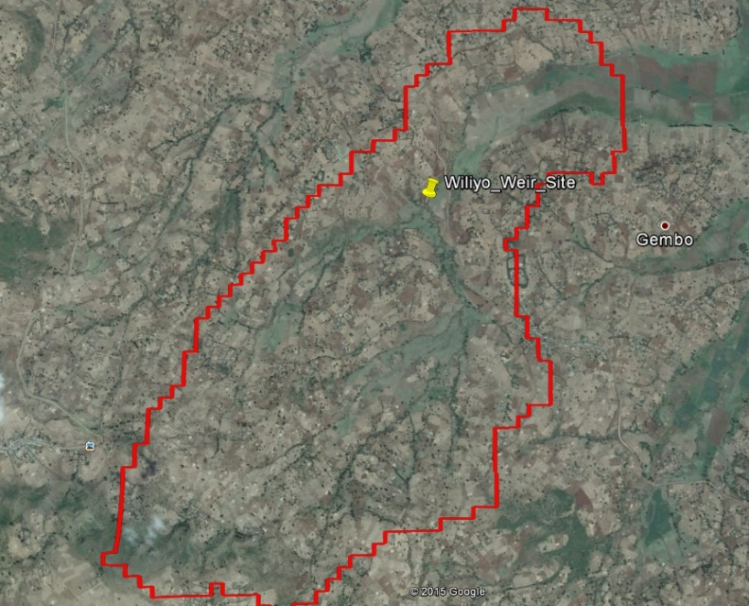
(1030571.944, 296625.7575) Exit point at weir axis
Figure 1: Wiliyo Drainage area
…………………………………………………………1
where tp is in hours.
L=basin length measured along the water course from the basin divide to the outlet
Lca= distance along the main water course from the outlet to a point opposite the watershed centroid in km.
From the delineated drainage area of Wiliyo, L=5.7km and Lca= 3.17Km was obtained in equation 1 above.
C_{t}= a regional constant representing watershed slope and storage.
the value of C_{t} in Snyder`s study ranged from 1.35 to 1.65.
For this case, C_{t} value of 1.35 is taken as the slope is considerably steep.
For Snyder adopted a standard duration t_{r} hours of effective rainfall given by:
…………………………………………………………………..2
The peak discharge Qps (m³/s) of a hydrograph of standard duration is given by Snyder as
---------------------------------------------------3
where A= catchment area in Km²
C_{p}= a regional constant (0.56 to 0.69)
using equation 1 above and the catchment characterstics as obtained from the delineated drainage area of Wiliyo:
Using equation 3 and the average value of C_{p}=0.625
. This is the discharge based on the assumption that the peak discharge is proportional to the average discharge of (1cmXcatchment area/duration of rainfall excess). If the rainfall intensity of 25mm/hr assumed to occur and effective for duraion of its occurrence, the design dischrge, Qd = 2.5*5.72=14.3m3/s.

- Rational Formula
The second method used to estimate the design discharge for Wiliyo SSIP is the rational method. For predominantly agricultural land and catchment slope greater than 6%, the runoff coefficient of 0.34 is used.
Q=0.00278*C*I*A
where C=Runoff coefficient = 0.34, I = 25mm/hr for return period of =50years for western highlands of Ethiopia, A= area of the catchment.
Using the rational formula, the design dischrge Qd estimated to be 18.8m³/s

1.2.3 Gumbles Composite Hydograph Methods

With Metorological data series available at the study site or nearby location,Gumbles composite hydrographs can be used to determine the maximum flood in the areas. The Metorological data used in this case is from bako stations.

Table 1: computation of flood by Gumbles composite hydrographs

A summarized catchment character
No | Designation /Formula/ | Symbol | Unit | Value
1 | Area of the catchment obtained by GIS delineation | A | Km² | 10.6
2 | Total length | L | m | 5,700
3 | Level of head of main water course | H₁ | m | 2800
 | Level of lower main water course (at Diversion) | H2 | m | 2253
 | Average Slope of main water course S= | S | m/m | 0.10
 | Time of Concentration ,TC=TC1+Tc2+TC3+TC4+TC5 | TC | hr | 0.64
6 | Rain fall excess duration, D= TC/6 | D | hr | 0.11
7 | Time to peak T_{p}=0.5D+0.6T_{C} | T_{p} | hr | 0.38
8 | Time of base of hydrograph T_{b}=2.67Tp | T_{b} | hr | 0.44
9 | Lag time of T_{l}=0.6TC | T_{l} | hr | 1.17
10 | Peak rate of discharge created by 1mm RF excess on whole of the catchment Qp=0.21*QA/Tp ,Qp=1mm(assumed) | Q_{p} | m³/s/mm | 5.08

11 | 12 | 13 | 14 | 15 | 16 | 17 | 18 | 19 | 20 | 21 | 22 | 23 | 24
Duration | Daily point Rainfall of Return period of 50 years | Rain Fall Profile | Rainfall Profile | Area to Point Rainfall Ratio | Areal Rainfall | Incremental Rainfall | Descending Order | Rearranged Order | Rearranged Incremental Rainfall | Cumulative Rain fall | Time of Incremental unit hydrograph
hr | mm | % | mm | % | mm | mm | No | No | mm | mm | hr | hr | hr
0.00-0.30 | 84 | 25 | 20.88 | 57 | 11.9 | 11.9 | 11.9 | 3 | 4.85 | 4.9 | 0.00 | 0.44 | 1.2
0.30-0.60 | 84 | 34 | 28.40 | 59 | 16.8 | 4.9 | 7.13 | 2 | 7.13 | 12.0 | 0.30 | 0.74 | 1.5
0.60-0.90 | 84 | 44 | 36.75 | 65 | 23.9 | 7.1 | 4.85 | 1 | 11.9 | 23.9 | 0.60 | 1.04 | 1.8
0.90-1.20 | 84 | 48 | 40.09 | 69 | 27.7 | 3.77 | 3.77 | 4 | 3.77 | 27.7 | 0.90 | 1.34 | 2.1
1.20-1.50 | 84 | 53 | 44.26 | 71 | 31.4 | 3.77 | 3.77 | 5 | 3.77 | 31.4 | 1.20 | 1.64 | 2.4
1.50-1.80 | 84 | 57 | 47.60 | 73 | 34.8 | 3.32 | 3.32 | 6 | 3.32 | 34.8 | 1.50 | 1.94 | 2.7
25 | 26 | 27 | 28 | 29 | 30
Land use Cover | Area Ratio % | Hydro soil group | Curve No ”CN” | Weighted “CN” | Sum Weighted “CN”
Wood Land | 0.1 | poor | 83 | 8 | AMC | CN
Meadow | 0.2 | good | 78 | 16 | II | 88
crop land | 0.7 | poor | 91 | 64 | III | 94

No | Designation /Formula/ | Symbol | Unit | Magnitude/Value/
31 | S is maximum potential difference between rainfall (P) and direct runoff(Q) which is S=(25400/CN)-254 | S | mm | 16.2
32 | Relation between direct Runoff( Q) and Rainfall (P), Q=(P-0.2*S) 2/P+0.8S | Q | mm | (P-0.2*S)/(p_{+0.8s)}
33 | Using Q= (P-0.2*S) ²/(P+0.8*S),it is possible to define the direct run off Q,(mm) | C=21 | C=33 | (P-0.2*S)/(p_{+0.8s)}
33 |  | P (mm) | Q (mm) | (P-0.2*S)/(p_{+0.8s)}
33 |  | 4.9 | 0.15
33 |  | 12.0 | 3.0887
33 |  | 23.9 | 11.60
33 |  | 27.7 | 14.72
33 |  | 31.4 | 17.93
33 |  | 34.8 | 20.85

34 | 35 | 36 | 37 | 38 |  |  | 39
Duration | Cumulative | Incremental | Peak Runoff | Time of beginning | Time to peak | Time to end | Composite Hydrograph
Hr | mm | mm | m³/s | Hr | Hr | Hr | f(t)=Q
0.00-0.30 | 0.15 | 0.0 | 0.0 | 0.00 | 0.44 | 1.2
0.30-0.60 | 3.09 | 2.9 | 14.9 | 0.30 | 0.74 | 1.5
0.60-0.90 | 11.60 | 8.5 | 45.3 | 0.60 | 1.04 | 1.8
0.90-1.20 | 14.72 | 3.1 | 15.8 | 0.90 | 1.34 | 2.1
1.20-1.50 | 17.93 | 3.2 | 16.4 | 1.20 | 1.64 | 2.4
1.50-1.80 | 20.85 | 2.9 | 14.8 | 1.50 | 1.94 | 2.7

As it can be seen above, the peak discharge found by composite hydrograph method is 45m³/s.
Therefore, we recommend, 45m³/s, for the design purpose.

2. IRRIGATION AND DRAINAGE SYSTEM DESIGN

2.1 Headwork Design

Engineering aspects related to project study and designs are addressed under this section. All influential factors that determine project sustainability are accounted to come up with reasonable results of study. This system design focuses on study and design of headwork, supply and drainage canals and all appurtenant structures related to diversion, storage, conveyance, distribution and application of water to the farm lands. This design also gives attention to network of roads (main access road, farm roads and inspection roads). In so doing, idea from different disciplines was given due attention to make the scheme smart.
The project is gravity diversion system on Wiliyo River. One-way intake is suggested based on available suitable irrigable farm land. Manageable systematic layouts were adopted to minimize costs and to enable easier application of water. A total of 95 ha of land were surveyed out of which gross project area of 90 ha and net irrigable area of 85 ha of land was planned for development based on available water sources and duty of irrigated crops.

2.1.1Location and description of the project area

The project is located in Oromia regional state, Horo guduru zone, Jimma Genati district in at about 34km from Shambu town (Zone and district capital). It is at 340 Km from Finfinne out of which 250Km is asphalt road and 88.8Km all weather Road and 1.2Km dry weather access that need clearance. The headwork can be located as (1030571.944, 296625.7575) with projection system UTM and datum ADINDAN. The area is categorized under tropical humid climate. Farm lands dominate the land use of the area and has fair in vegetation cover. The area has good water resource potential mainly springs emerging at various points. The soil of the area is clayey to silty clay in texture and red to reddish brown in color. It is deep, non- expansive, firm and with low infiltration rate and high water holding capacity. There are attempts made by local community to expand traditional irrigations around the project area. The area has good opportunity for diversification of crop production through modern irrigation.

2.1.2 Methodology

The methodologies adopted are: - Existing localities and community experiences and information. - Using 1:50,000 contour maps - Site survey and investigations - Secondary data from concerned areas. - Hydro-meteorological data, crop data, soil data etc. collecting and organizing for this study. - Using guidelines manuals and other reference materials.

2.1.3 Water Resource

Besides flat topography and fertile soils, water resource is one of the major important requirements for irrigated agriculture. The water source for the project is Wiliyo River which is perennial. The discharge of the river is 25 l/sec. The maximum water duty calculated for the project is 0.78 l/sec/ha for 24 hour. The proposed irrigation time is 16 hour. Thus, the water duty will be 2.34 l/sec/ha with 50% project efficiency for 16 hour irrigation. Accordingly, the water base flow (discharge) of the river is enough for 10.68 ha of land for the proposed 16 hour irrigation time. Hence, for the rest irrigable area (74.32 ha), night storage is required to develop the total command area.

2.1.4 Planned Irrigable area

The soil of the area is clayey, red to reddish brown in color and thick in depth. The soil is not expansive and not easily washed by runoff under proper management practice. Proper soil and water conservation practices shall be adopted by the community to avoid any ill effects due to the introduced modern scheme. Terracing, adoption of annual crops and fruit trees and intercropping practices may be useful as conservation measures. The proposed crops for this project are maize, sugar cane, onion, tomato, potato, carrot, pepper and cabbage. These crops under irrigation have maximum dry period duty of 2.34 l/s per ha and the net irrigable area of 85 ha was planned for 25 l/s lean flow available during the dry period.

2.1.5 Water distribution scenario

Water application to the field is based on irrigation interval set for each crop. In so doing continuous flow in main and secondary canals and rotated flow in tertiary will be adopted. The soil of the area is dense clay and its water holding property is good. On average it was obtained that the interval of water application is 10 days and generally next irrigation is applied when the readily available soil moisture is depleted. At each field unit level the unit discharge is applied based on stream size required for that unit of field within irrigation time set per day (10 hr irrigation) to attain the required irrigation depth (field capacity of the soil).

2.1.6 System Layout Plan

The system layout plan was prepared based on irrigation and drainage design criteria for small scale community managed schemes. This layout is prepared on 1:1000 maps with 1m contour interval. The field units are around 1ha in size and tertiary units are kept 5-7 ha for the scheme to be manageable. Continuous flow in main and secondary canals and rotated flow in tertiary canals is adopted regarding water distribution. The irrigation application method is furrow which is locally practiced by the farmers. Thus the furrow direction is set along the contour lines. Furrow length is selected based on soil, crop type and topography of the area, but as per local farmers practice 45-70 m is adopted in stretching the layout plan. With average furrow length of 50m and field canal length 200m a field unit of 10000m2 or 1 ha is generally adopted where the topography is convenient. Tertiary unit of 5-7 ha was adopted based on rotated flow in tertiary canals as per the irrigation interval of 10 days averagely obtained.

Figure 2: Williyo SSIP Topo and System layout view
2.1.7 Major Components of the project

1. Access road clearance 3km.
2. Camping
3. Diversion Head work and temporary cofferdam.
4. Lined MC-2000m,
5. Secondary canal SC-4
5. Canal water escape on main canals (1 in No).
6. Aqueducts (2in No)
7. Culvers 1 (in No)
8. Field off takes 30 in number and 4 division boxes
2.1.8 Selection of Headwork site

The headwork site was selected under the following factors:
- Easy access to the site during construction and operation
- Possibility to command the anticipated area with reasonably less weir height.
- Convenience for intake and head regulators
- Better geological formation at the bed and side banks.
- Possibility to protect flooding of off taking canal
- Relatively area convenient for construction
- Area with less flood heights and effects.
- Area with less effect of transported materials specially boulders
- Area with easier temporary diversion during construction.
- Relative cost of weir.

2.1.9 Design of Headwork (weir)

Length or span of the weir overflow was taken 20m from the existing situation of the river section. This span results in relatively less flood height and hence the anticipated weir would be economical. Maximum flood flow is 45m³/s and the normal flow depth from rating curve of the river at weir location is 1.70m.
- Determination of crest level
- Average level of the first intake level = 2254.00
- Water depth required = 0.520m
- Head loss across the field = 0.020m
- Head loss at turnout = 0.05m
- Slope of canal x distance from weir = (0.001x200) = 0.2m
- Loss across head regulator = 0.05m
- Intake level above RBL= 0.6m
- Crest level of the weir = 2254.64 i.e. Crest height = crest level - upstream river bed level = 2254.67-2253 = 1.67m
2) Water depth on the crest for broad crested weir, Q = 1.7LH^{3/2} Q = Design flood = 45m3/s (from Hydrology report) L = Weir span = 20m H = Total Head over crest = water ht + velocity head Hence 45 = 1.7x20xH3/2
H=1.21m

Figure 3: Flow Conditions over the Weir

Table 2: Stability Analysis and Hydraulic Calculations

3. FARM SYSTEM AND CANAL DESIGN

The canal system is designed both on continuous and rotational bases. Main canal on continuous bases and Secondary’s rotationally.
Table 3: Gross and Net Command Area by Supply Methods
Description | Area to be supplied |  |  | % form Total
Description | by pump | by Surface | Total | % form Total
Suitable | - | 85.00 | 85.00 | 89%
Not Suitable |  | 10.00 | 10.00 | 11%
Total | - | 95.00 | 95.00 | 100
Percentage | 0% | 100% | 100%
Net irrigable land | - | 82.45 | 82.45 | 97%
Infrastructure | - | 2.55 | 2.55 | 3%
Total | - | 85.00 | 85.00 | 100

Figure 4: Canal Cross section

Table 4: MC Hydraulic Design Parameters
 |  |  |  |  | NB: MCs are designed for 16 hours
Canal | Chainage (m) | A net (ha) | Duty (l/s/ha) | Q_{reqd} (m3/s) | n | s | b | m | d
MC | 000-152 | 14.20 | 2.34 | 0.0330 | 0.014 | 0.001 | 0.50 | 0 | 0.52
 | 152-290 | 14.20 | 2.34 | 0.0330 | 0.014 | 0.001 | 0.50 | 0 | 0.52
 | 290.49-1157 | 14.20 | 2.34 | 0.0330 | 0.014 | 0.000 | 0.50 | 0 | 0.52
 | 1157-1814 | 14.20 | 2.34 | 0.0330 | 0.014 | 0.000 | 0.50 | 0 | 0.52
 | 1814-1862 | 14.20 | 2.34 | 0.0330 | 0.014 | 0.000 | 0.50 | 0 | 0.52
 | 1862-2000 | 14.20 | 2.34 | 0.0330 | 0.014 | 0.000 | 0.50 | 0 | 0.52
 | Diverted percentage of the least of annual 80% dependable flow |  |  |  |  |  |  | 2000.0% | 20.000

b/d | A (m2) | P (m) | R (m) | V(m/s) | Q_{calcu} | Fb(m) | D(m) | T(m) | Remark
0.96 | 0.26 | 1.54 | 0.17 | 0.69 | 0.179 | 0.20 | 0.72 | 0.50 | Lined
0.96 | 0.26 | 1.54 | 0.17 | 0.69 | 0.179 | 0.20 | 0.72 | 0.50 | Lined
0.96 | 0.26 | 1.54 | 0.17 | 0.00 | 0.000 | 0.20 | 0.72 | 0.50 | Lined
0.96 | 0.26 | 1.54 | 0.17 | 0.00 | 0.000 | 0.20 | 0.72 | 0.50 | Lined
0.96 | 0.26 | 1.54 | 0.17 | 0.00 | 0.000 | 0.20 | 0.72 | 0.50 | Lined
0.96 | 0.26 | 1.54 | 0.17 | 0.00 | 0.000 | 0.20 | 0.72 | 0.50 | Lined

3.1 Secondary canal flow hydraulics (SC1, SC2, SC3 & SC4)

Table 5: Sc Hydraulic Design Parameters
Canal |  | Chainage (m) |  | Anet (ha) |  | Duty (l/s/ha) |  | Q_{reqd} (m3/s) |  |  | n |  | s |  | b |  | m | d | b/d
Sc1,2,3&4 |  | 0+000-0+667 |  | 21.25 |  | 2.34 |  | 0.0497 |  |  | 0.025 |  | 0.0050 |  | 0.30 |  | 1 | 0.40 | 0.75
AX(m2) | P(m) |  | R(m) |  | V(m/s) |  | Q_{calcu} |  | Q_{calc} -Q_{reqd} | fb(m) |  | D(m) |  | T(m) |  | Remark
0.28 | 1.43 |  | 0.20 |  | 0.95 |  | 0.267 |  | 0.217 | 0.30 |  | 0.70 |  | 1.70 |  | Earthen trapezoidal

3.2 Design of typical Drops (at chainage 343 &1040) on main canal and at d/t chainages on secondary

A Vertical type drop is proposed
Critical flow of hydraulics
Design discharge, Q = 0.033m3/sec
Drop height = 1m
Width of drop, $b_{c}=\frac{0.734Q}{{d_{1}}^{3/2}}=0.3m$
Unit discharge, $q=\frac{Q}{b_{c}}=0.08{m^{2}}/{sec}$
Critical depth, $d_{c}={\left({q^{2}}/g\right)}^{1/3}=0.144m$
U/s and D/s protection L1=L2=1.2+1.5Q1/2=1.30m
Stilling basin
Lip height,$a=\frac{d_{c}}{2}=0.072m, take a=0.15m$
Width, $B=\frac{18.46\sqrt{Q}}{Q+9.91}=0.454m$
Length, $L=3*\sqrt{H_{e}*h}=1.53m, where, H_{e}=d_{1}+\left(\frac{{v_{1}}^{2}}{2g}\right)=0.334m$
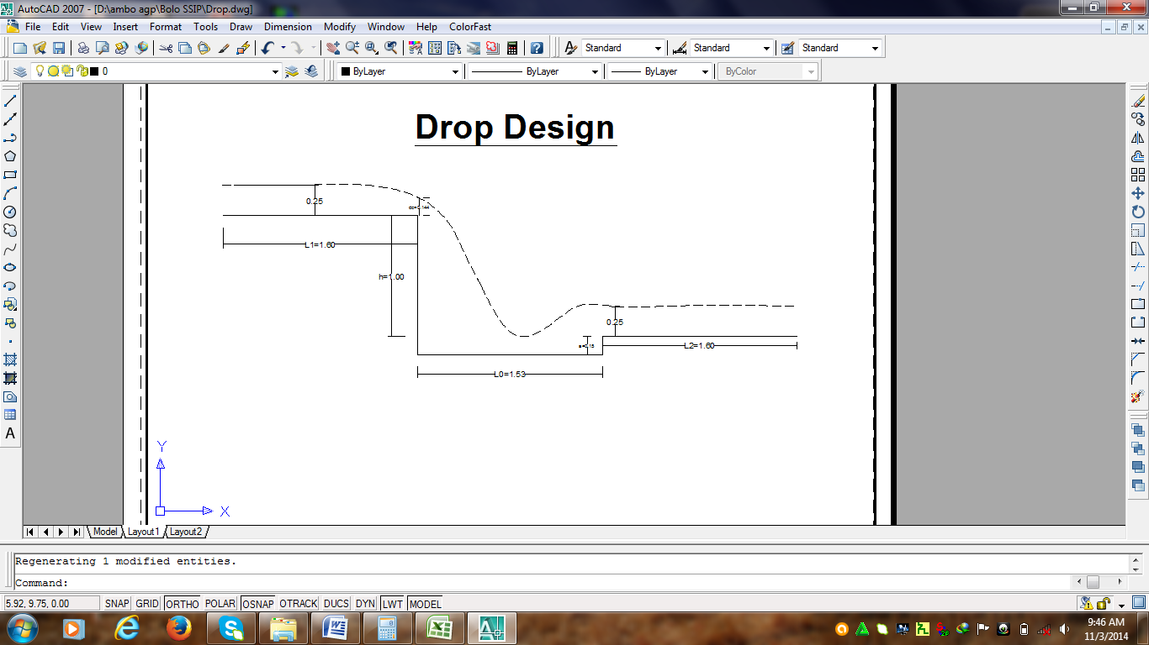
Figure 5: Typical Drop Structure

3.3 Division Box

Division box is structure to divide the irrigation flow in to defined parts for either a contractions or a rotational supply to tertiary, sub tertiary or quaternary canals in accordance with the custom of the local farmer.
Design consideration:
There are 4(four) division boxes on MC to secondary’s
All of them are gate operated.
The width of each out let is equally rotational method is used for each supply canal.
Equal head is considered.
Care should be taken to avoid submergence.
Approach velocity is negligible
Broad crested weir formula is used.
Q = CLh ^{3/2} where Q = 0.033 m3/s
C = Coefficient of discharge, C = 1.7
L = Span of opening in m
h = flow depth over the weir =0.25m
$$Q=CLh^{3/2}⟹L= \frac{Q}{Ch^{3/2}}=0.40m$$
The total depth of the DB is the total depth of the incoming canal plus free board (fb)
DDB= D + fb =0.52 + 0.2 =0.70m
The width of the DB is B = b+2xmxD
Where: b - bed width of incoming canal
m- Side slope of incoming canal
D - Depth of incoming canal
B = b+ 2xmxD = 0.50+ 2x0x0.50 = 0.5
The width of the DB is B = b+2xmxD
Where: b - bed width of incoming canal
m- Side slope of incoming canal
D - Depth of incoming canal
B = b+ 2xmxD = 0.20x 2x1.5x0.50 = 1.7, use 2.0m
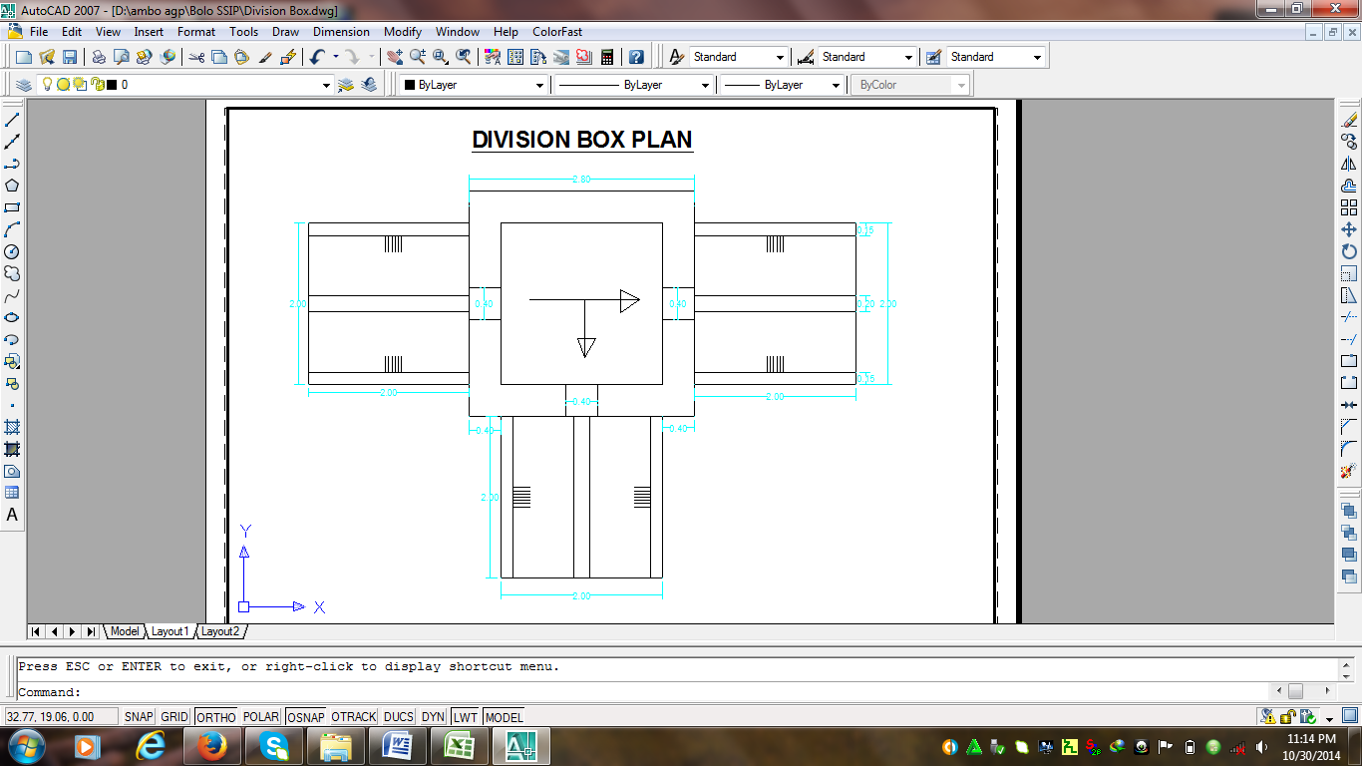

Figure 6: Division box typical plan view

3.3 Design of Aqueducts (two in number)

Here since the pipe length is too short, total hydraulic loss is negligible, and it was designed to pass the maximum drainage. And the orifice formula governs the flow of the pipe under.
$Q=C×A\sqrt{2gh} Where, C={\left(1.1+0.026\frac{L}{D^{1.2}}\right)}^{-0.5}$ For concrete pipe of beveled lip entrance and h= level difference b/n upstream and downstream water surface.
Summary of Aqueducts

Particulars | Canal above | Canal below | Drainage flow  (m³/sec) | Pipe size, D(m) | Maximum Length, L(m) | C | Minimum head  h(m) | Flow for head (lit /sec) | Remarked
AD | MC | - | 320 | 0.50 | 1.10 | 0.926 | 0.15 | 312 | Canal above is rectangular lined

Design of field off takes and turn out
The flow in field off takes is governed by the orifice formula. It basically depends on the pipe size and head creating flow. Q = Cd A(2gh) where h=y-(D/2) and A=D2/4 Where Cd is the coefficient of discharge, 0.80 for submerged out flow and 0.62 for free out flow, A is the area of pipe, g= Acceleration due to gravity (9.81 m/s), and h is the head creating flow in meter. Each field off take and turn out are to be controlled with simple shutters with chain to lift to required level. (About 14 Pipe off takes are proposed to take from secondary to tertiary).
Design of Box Culvert for Road crossings
Table 6: Design of Box culvert
Culvert on | Station (m) | OGL | CBE | Cut | D | b(m) | d(m) | Q(m³/s)
MC1 | 550 | 2255.000 | 2253.500 | 1.50 | 0.70 | 0.60 | 0.550 | 0.033

S | b*d | b+2d | [n*Q/b*d]^{3/2} | Left | Right | fb | V | D_{culv} (m)
0.005 | 0.33 | 1.70 | 5.24E-05 | 0.19 | 0.00 | 0.18 | 0.10 | 0.73

Figure 7 : Schematic views of box culverts. See the detail on drawing

Table 7: Design of Night storage pond
 | Parameter | Value | Unit | Description
 | MC1 works for | 24 | hours/day
 | Discharge in MC1, Q_{MC1} = | 0.0332 | m3/s
 | Discharge entering BSR from MC1 = | 0.0332 | m3/s
 | Maximum daily volume of water entering BSR= | 0.0029 | Mm3 | From MC1
 | Thus, storage times | 10 | hr
 | Effective Storage Required, Ve | 0.0012 | Mm3
 | Dead storage 20% | 0.0002 | Mm3
 | Thus, req'd daily storage in BSR-1= | 0.0014 | Mm3
 | Free Board, FB | 0.6 | (m) | To account for fluctuations
 | Full Water Depth in the reservoir, d | 2 | (m) | Assumed
 | Reservoir inner banks side slope | 2.5
 | Bed Width, b | 20 | (m)
 | Water surface Width, B= | 30 | (m) | B=b+2md
 | Assume Water surface Length, L2 | 36 | (m) | =B+20%*B
 | Bed Length, L1=L2-2md | 30 | (m)
 | Thus bed area, A1 | 600 | (m2) | A1=b*L1
 | Full water surface Area, A2 (m2) | 1080 | (m2) | A2=B*L2
 | Computed Volume of Storage, Vt (m3) | 0.0017 | Mm3 | Vc=(d/3)*(A1+A2+√(A1*A2))
 | Difference, Vt-Ve | 0.0002 | Mm3 | Vt > Ve, ok!
 | Thus top width of 25m by 40m and bottom width of 20 by 30 is ok!
 | Final total depth including FB, D | 2.6 | (m) | D=d+FB
 | Final water surface Width, B | 33 | (m)
 | Final water surface Length, L2 | 36 | (m)
 | Final bed Length, L1 | 30 | (m)
 | Final full water surface Area, A1 | 600 | (m2)
 | Final full water surface Area, A2 | 1188 | (m2)
 | Final total volume of storage, Vt | 0.0023 | Mm3
 | Final excess storage capacity, Vs | 0.0008 | Mm3 | The balance could be used for dead
 | MC1 inlet bed Level | 2253.7 | (m)
 | MC1 inlet FSL | 2255.7 | (m)
 | Allowed top width of embankment, T (m) | 3.0 | (m)
 | Width of land occupied, Wo(m) | 65 | (m)
 | Length of land occupied, Lo(m) | 49 | (m) | On command side, bank is not req'd as OGL is above EML
 | Total area of land occupied, Ao | 0.32 | (ha)
 | Reservoir Bed Level, RSBL (m) | 2251.1 | (m)
 | Bank Top Level, BTL (m) | 2253.7 | (m)
 | OGL on far d/s end | 2232.0 | (m)
 | OGL at most u/s side | 2253 | (m)
 | Average OGL | 2242.5 | (m)
 | Full Reservoir Level, FRL | 2253.1 | (m)

Figure 8: Night Storage plan and sectional views
Table 8: Pond inlet and out let design calculation table
Chute Inlet Design
Inclined Length, m |  |  |  |  |  | 7.00
Height, Z= |  |  |  |  |  | 2.6
Canal characteristics before the chute
Q= |  | 0.0332 |  | D= |  | 0.72 |  | d= |  | 0.52
V= |  | 0.00 |  | n= |  | 0.014 |  | S= |  | 0
b= |  | 0.50 |  | FB= |  | 0.2 |  | m= |  | 0
Critical flow hydraulics |  |  |  |  |  |  |  | n= |  | 0.014
Width of the notch, bc= 0.734Q/ d 3/2 |  |  |  |  |  |  |  | 0.07
q= Q/bc = |  |  |  |  |  |  |  | 0.51
dc= (q2/ q) ^{1/3} |  |  |  |  |  |  |  | 0.30
Dc= fbc+dc= |  |  |  |  |  |  |  | 0.50
Water Area, Ac= |  |  |  |  |  |  |  | 0.03
Vc= |  |  |  |  |  |  |  | 1.02
Hvc= |  |  |  |  |  |  |  | 0.0535
Pc= bc+2*dc= |  |  |  |  |  |  |  | 0.66
Rc= Ac / Pc |  |  |  |  |  |  |  | 0.049
Ic = (nVc/ Rc^{2/3}) ² |  |  |  |  |  |  |  | 0.0115
E_{c}= d_{c}+H_{vc}+Z= |  |  |  |  |  |  |  | 2.952
Energy at pre-Jump section
E1= d1+hv1+hf1 |  |  |  | Assume, d1= |  |  |  | 0.0893127
b1= bc= |  |  |  | 0.07
A1= d1xb1 |  |  |  | 0.006
V1= Q / A1= |  |  |  | 5.720
Hv1= v12/2*g= |  |  |  | 1.668
P1 = b1+2*d1= |  |  |  | 0.154
R1= A1/P1 = |  |  |  | 0.038
I1 = (n*v1/ R1 2/3) 2 |  |  |  | 0.5085
Im= [I1+Ic]/2 |  |  |  | 0.254234
hf1= Im*L = |  |  |  | 1.780
E1= |  |  |  | 3.537
Check |  |  |  | 0.5847
Conjugate depth, d2
Fr = V1 / (gd1)1/2 |  |  |  | 6.1109
q= Q/b = |  |  |  | 0.07
d2= d1 /2[(1+8*Fr₂)^{1/2}-1] |  |  |  | 0.728 |  |  |  | 2251.828
Stilling basin
Length L= 4*d2 = |  |  |  | 2.91 |  | Adopt |  | 3.00
B=18.46*(Q^{1/2})/ (Q+9.91)= |  |  |  | 0.338 |  | Adopt |  | 0.40
E2= d2+Hv2 = d2 +v2² /2g= d2 + [(q/d2)2 ]/2g= |  |  |  |  |  |  |  | 0.73
E3= d3+Hv3= d3+v32/2g= d3+(q/d3)2/2g |  |  |  |  |  |  |  | 0.52
Sill height, a = E2- E3 |  |  |  |  |  |  |  | 0.21
 |  |  |  |  |  |  |  |  |  |  | 0.72
 |  |  |  |  |  |  |  |  |  |  |  | 0.3
 |  |  |  |  |  |  |  |  |  |  | 1.0
 |  |  |  |  |  |  |  |  |  |  | 0.5
 |  |  |  |  |  |  | 7.00
 |  |  |  |  |  |  |  |  |  |  | 0.3
 |  |  |  |  | 0.72 |  |  |  | 0.5
0.3
0.3 |  |  |  |  |  |  | 0.3
 |  |  | 3.00 |  | 0.5
0.5
 | 0.3 |  |  |  | 0.3
0.2
0.40
0.2
 |  |  | 3.00
 |  |  |  |  |  |  |  |  |  |  | 1.0
Out let: The out let should be gated concrete pipe diameter 40cm for a length of 3 0m as indicated on lay out to SC1
Spillway Design
Rectangular box (chute) | length | depth | width
Inclined base | 7 | 0.3 | 0.4
Stilling basin | 3 | 0.3 | 0.4
Walls for basin | 3 | 0.7 | 0.3
Inclined side Walls | 7 | 0.7 | 0.3
End sill | 0.3 | 0.3 | 0.3
Cut-offs | 0.3 | 0.5 | 0.3

4. Bill of Quantities and specifications

SN | Description | Unit | Qty | Rate | Total Cost | Comm. Share
A | Preparatory Work
1 | Mobilization and Demobilization | LS | 1 | 100,000 | 100,000
2 | Engineering surveys and preparation of as built drawings and coffer Dam works | LS | 1 | 150,000 | 150,000
3 | Access and Service Road construction | km | 1.00 | 150,000 | 150,000
4 | Camping (3m x 12m office & bed room, 3m x 8m bed room & kitchen, 5m x 5m store, 3mx2m Toilet & Shower, 2m x 2m guard house |  |  |  | -
4.1 | Site clearing | m² | 160 | 15 | 2,400
4.2 | Excavation | m³ | 45 | 85 | 3,825
4.3 | Masonry works of mix ratio 1:4 | m³ | 60 | 1,300 | 78,000
4.4 | Hard core | m³ | 110 | 600 | 66,000
4.5 | 5cm Cement screed | m² | 110 | 150 | 16,500
4.6 | 10cm mass concrete | m3 | 120 | 1,800 | 216,000
4.7 | Walling(C.I.S) | m² | 295 | 240 | 70,800
4.8 | Roofing(C.I.S) | m² | 215 | 240 | 51,600
5 | Fence 2.0m height & 15cm φ eucalyptus poles placed every 2m with barbed wire at 20cm vertical interval & posted in 0.6m depth embedded with concrete | ml | 160 | 250 | 40,000
Subtotal of - A |  |  |  |  | 400,000
B | Diversion Head works
1 | Earth Works
2 | Site clearance | m2 | 20.00 | 15 | 300
3 | Excavation to the bed of each structure including working space | m3 | 229 | 55.8 | 12,795
4 | Rock excavation | m3 | 50 | 250 | 12,500
5 | Cart away for 500m distance | m3 | 46 | 21 | 963
6 | Masonry works | m3 | 595.0 | 1,300 | 773,515
7 | Concrete works | m3 | 241.5 | 2,500 | 603,625
8 | Hard core & compaction under HW | m3 | 111.60 | 600 | 66,960
9 | Back fill with selected material & compaction on outer face of wing walls | m3 | 105.49 | 21 | 2,215
10 | Stone pitching for u/s protection work |  | 55.00 | 300 | 16,500
11 | Gate Installation
a | Sliding intake gate supply and Installation for left side 1.2m wide by 0.80m height including runners within both grooves | Pcs | 1 | 21,300 | 21,300
b | Sliding sluice gates supply and Installation for both left & right side sluices, 1.2m by 1.2m including runners within both grooves | Pcs | 1 | 21,300 | 21,300
12 | Masonry Retain wall for the right bank along the canal for 15m as shown in the drawing (5m each at three critical places) | m³ | 90 | 1300 | 117,000
Subtotal of - B |  |  |  |  | 1,648,974
C | Main Canal Works
1 | Soil Excavation | m3 | 4,031 | 56 | 224,930
2 | Soil Fill and Compaction | m3 | 480.00 | 21 | 10,080
3 | Masonry works | m3 | 420.00 | 1,300 | 546,000
4 | Hard core | m3 | 660.00 | 600 | 396,000
5 | Mass concrete works | m3 | 100.00 | 2,500 | 250,000
6 | Plastering | m2 | 2400.00 | 130 | 312,000
 | Subtotal of C |  |  |  | 1,739,010
D | Division boxes(4 in no) | Nr
1 | Site clearance | m2 | 20.0 | 21 | 420.0
2 | Soil Excavation | m3 | 56.1 | 56 | 3,141.6
3 | Masonry works | m3 | 25 | 1,300 | 32,500.0
4 | Concrete | m3 | 1.2 | 2,500 | 3,000.0
5 | Plastering | m2 | 3.5 | 130 | 455.0
6 | Hardcore | m3 | 90 | 600 | 54,000.0
5 | Back fill | m3 | 20 | 21 | 420.0
6 | 5mm thick double framed with angle iron Gate works supply & Installation | Nr | 8 | 800 | 6,400.0
Subtotal of - D |  |  |  |  | 100,336.6
E | Cross Drain structures
1 | Earth Works |  |  |  | 2,765.0
2 | Site clearance | m2 | 15.00 | 21 | 315
3 | Soil Excavation | m3 | 40.00 | 56 | 2,240
4 | Backfill and compaction | m3 | 10.00 | 21 | 210
5 | Masonry works | m3 | 18.00 | 1,300 | 23,400
6 | Concrete works | m3 | 7.00 | 2,500 | 17,500
Subtotal of - E. |  |  |  |  | 43,665
Total of -E. |  | Nr | 2 |  | 87,330.0
F | Culverts on MC crossings
1 | Site clearance | m2 | 9.0 | 21 | 189
2 | Soil Excavation | m3 | 8.82 | 56 | 494
3 | Backfill and compaction | m3 | 4.41 | 21 | 93
4 | Reinforced concrete work | m3 | 7.14 | 2,500 | 17,840
5 | Form Work | m2 | 8.34 | 128 | 1,067
6 | Dry Stone pitching | m3 | 1.03 | 21 | 22
Subtotal of - F |  |  |  |  | 19,705
Total of -F |  | Nr | 1 |  | 19,704.6
G | Drop structures
1 | Site clearance | m2 | 6.0 | 21 | 126
2 | Soil Excavation | m3 | 8.60 | 56 | 481
3 | Backfill and compaction | m3 | 4.18 | 21 | 88
4 | Masonry works | m3 | 6.00 | 1,300 | 7,800
5 | Concrete | m3 | 3.00 | 2,500 | 7,500
6 | Plastering | m2 | 10.00 | 130 | 1,300
7 | Dry Stone pitching | m3 | 0.84 | 21 | 18
Subtotal of - G |  |  |  |  | 17,313
Total of - G |  | Nr | 2 |  | 34,625.6
H | Secondary Canal Works (Sc1,2,3,&4)
1 | Soil Excavation | m3 | 20,000.0 | 56 | 1,120,000
2 | Soil Fill and Compaction | m3 | 500.0 | 21 | 10,500
 | Total of H |  |  |  | 1,130,500
I | Drops
1 | Site clearance | m2 | 6.0000 | 21 | 126
2 | Soil Excavation | m3 | 8.60 | 56 | 481
3 | Backfill and compaction | m3 | 4.18 | 21 | 88
4 | Masonry works | m3 | 6.00 | 1,300 | 7,800
5 | Dry Stone pitching | m3 | 0.84 | 21 | 18
Subtotal of - H |  |  |  |  | 8,513
Total of - H |  | Nr | 40 |  | 340,511.9
J | Turnouts (Total Nr = 14) | Nr
1 | Site clearance | m2 | 5 | 21 | 105
2 | Soil Excavation | m3 | 14.69 | 56 | 823
3 | Backfill and compaction | m3 | 7.35 | 21 | 154
4 | Mass concrete works | m3 | 0.08 | 1,300 | 106
5 | Dry Stone pitching | m3 | 0.15 | 21 | 3
6 | Concrete Pipes of 200mm in diameter | Pcs | 2 | 858 | 1,716
7 | 5mm thick double framed with angle iron Gate works supply & Installation | Pcs | 2 | 700 | 1,400
Subtotal of - J |  |  |  |  | 4,307
Total of - J |  | Pcs | 14 |  | 30,152.4
K | Off takes
1 | Site clearance | m2 | 5 | 21 | 105
2 | Soil Excavation | m3 | 14.6944 | 56 | 823
3 | Backfill and compaction | m3 | 7.3472 | 21 | 154
4 | Masonry works | m3 | 0.08166 | 1,300 | 106
5 | Dry Stone pitching | m3 | 0.15 | 21 | 3
6 | Concrete Pipes of 200mm in diameter | Pcs | 20 | 858 | 17,160
Subtotal of - K |  |  |  |  | 18,351
L | Night storage ponds
1 | Earth Works
1.1 | Overall site clearance
1.1.1 | Site clearance | m2 | 3185 | 10 | 31,850
1.2 | Excavation works |  |  |  | -
1.2.1 | Excavation to depth of RSBL | m3 | 3120 | 85 | 265,200
1.2.2 | Fill and Cart away | m3 | 156 | 21 | 3,276
2 | Chute Inlet |  |  |  | -
2.1 | Masonry works |  |  |  | -
2.1.1 | Inclined base | m3 | 0.840086 | 1,300 | 1,092
2.1.2 | Stilling basin | m3 | 0.36 | 1,300 | 468
2.1.3 | Walls for basin | m3 | 0.864 | 1,300 | 1,123
2.1.4 | Inclined side Walls | m3 | 2.016206 | 1,300 | 2,621
2.1.5 | End sill | m3 | 0.036 | 1,300 | 47
2.1.6 | Cut-offs | m3 | 0.24 | 1,300 | 312
3 | D/s stone pitching of spill way | m3 | 0.15 | 0 | -
3 | Masonry work on spillway side | m3 | 3.372 | 1,300 | 4,384
4 | Fence | m | 160 | 200 | 32,000
5 | Inlet gate | Ls | 1 | 20000 | 20,000
6 | Outlet gate | Ls | 1 | 20000 | 20,000
2.1.7 | Geo-membrane (1.5mm) for all water touching surfaces | m² | 1454 | 150 | 218,100
 | Subtotal of L |  |  |  | 600,473
M | Catch Drain | M3 | 500 | 50 | 25000
O | Tertiary Canal Works(28 in no) | m3 | ___ | ___ | XXX | Community
Total |  | ETB |  |  | 6,174,969
VAT |  |  |  |  | 926,245.35
Grand Total |  | ETB |  |  | 7,101,214.35

Table: Summary of BOQ and Cost Estimate by Major Activities

SN | Item Description | Total Cost | Comm. Share
A | Preparatory Work | 400,000
B | Diversion Head works | 1,648,974
C | Main Canal Works | 1,739,010
D | Division Boxes | 100,337
E | Cross drain structures | 87,330
F | Culverts | 19,705
G | Drops | 34,626
H | Secondary Canal Works (Sc1,2,3,&4) | 1,130,500
I | Drops | 340,511.9
J | Turnout | 30,152.4
K | Off takes | 18,351
L | NSR | 600,473
M | Catch Drain along the MC | 25000
O | Tertiary’s | xxxxxx | xxx xxx
Total |  | 6,174,969
VAT |  | 926,245.35
G. Total |  | 7,101,214.35

