oromia REGIONAL national states
THE NATIONAL REGIONAL STATE OF
OROMIA
OROMIA IRRIGATION DEVELOPMENT AUTHORITY

FEASIBILITY STUDY AND DETAIL DESIGN
OF
LOT 1 OF 19 SSIPs [BUNO BEDELE ZONE]

UNKUSO SMALL SCALE IRRIGATION
PROJECT
FINAL SOCIO ECONOMY, ORGANIZATION AND MANAGEMENT, AND FINANCIAL ANALYSIS
REPORT
P.O.BOX: 40945
Tel: 0920724075/0911963757
E-mail: letinsasc@gmail.com

November, 2016
Addis Ababa, Ethiopia

THE NATIONAL REGIONAL STATE OF
OROMIA
OROMIA IRRIGATION DEVELOPMENT AUTHORITY

FEASIBILITY STUDY AND DETAIL DESIGN
OF
LOT 1 OF 19 SSIPs [BUNO BEDELE ZONE]

UNKUSO SMALL SCALE IRRIGATION
PROJECT
FINAL SOCIO ECONOMY, ORGANIZATION AND MANAGEMENT, AND FINANCIAL ANALYSIS
REPORT
P.O.BOX: 40945
Tel: 0920724075/0911963757
E-mail: letinsasc@gmail.com

November, 2016
Addis Ababa, Ethiopia
oromia irrigation development authority

FEASIBILITY STUDY AND DETAIL DESIGN
OF

bale zone gurra dhamole woreda awuchache SMALL SCALE IRRIGATION PROJECT
SOCIO ECONMIC
FEASIBILITY STUDY REPORT



P.O.Box:2929/1250
Tel.: +251-920724075/0911963757
Addis Ababa, Ethiopia
E-mail: letinsasc@gmail.com
March 2015
Addis Ababa, Ethiopia

TABLE OF CONTENTS
1 EXCUTIVE SUMMARY 9
2 INTRODUCTION AND BACKGROUND 12
2.1 INTRODUCTION 12
2.2 Rationale of the project 12
2.3 Review of policies and strategies 13
2.4 Objectives 14
2.4.1 General objective 14
2.4.2 Specific objective 14
2.5 Scope of the Study 15
2.6 limitation of the study 16
3 Methodology 17
4 SOCIO ECONoMiC Features 21
4.1 Location and access 21
4.2 Proposed Project Command area and Beneficiaries 21
4.3 Climate and topography 22
4.4 Water source 22
4.5 Project area and Settlement 23
5 Population And Demographic Characteristics 24
5.1 General 24
5.2 Population size of woreda 24
5.3 Urban and Rural Population of chora woreda 24
5.4 Population Density and Spatial Distribution 25
5.5 Project Area Population Size and Demographic Features 25
5.5.1 Population 25
5.5.2 Family size 25
5.5.3 Sex composition 26
5.5.4 Age structure and labour availability 26
5.5.5 Labour Availability 26
5.5.6 Ethnic Groups 27
5.5.7 Religion 27
5.5.8 Population Growth Projection 27
5.5.9 Factors contributing population growth 28
6 Land Use and land holding 30
6.1 Land use 30
6.2 Land holding size and land access 30
7 Economic and poverty situation 32
7.1 Economic and livelihood source 32
7.2 Wealth status and income distribution 33
7.3 Food Security Situation 33
8 Economic activities and production 34
8.1 Agriculture and Crop production 34
8.2 Livestock 35
8.3 Other off farm activities 36
8.4 Agro Processing Industries and Urban Economic Prospect 36
9 Market and roots 38
9.1 Market Institutions and stakeholders 38
9.2 Market and Market prospect at project area 38
9.3 Market Centre 38
9.4 Product destination 39
9.5 Product Demand and Supply 39
9.6 Product Price 40
9.7 Market problems and constraints 41
10 Agricultural support service 43
10.1 Agricultural Extension Service 43
10.2 Credit and saving 44
10.3 Cooperative and water users associations 45
11 Gender 48
12 Basic Social Service 50
12.1 Health service and health infrastructures 50
12.2 Education 52
12.3 water supply 52
12.4 Source of Energy 53
12.5 Development Potentials and Opportunities 54
13 Projects Social impact and Threats 55
13.1 Human Displacement 55
13.2 Health and related social impacts 56
13.3 Land Loss and land redistribution issues 56
14 Project Benefit and Contribution 58
14.1 Direct beneficiaries 58
14.2 Other Indirect economic benefit 58
15 Community Participation 60
15.1 Cost Sharing 60
15.2 Cost Recovery 61
15.3 Project Beneficiaries 62
16 Conclusion and Recommendation 63
17 Introduction and Background 66
17.1 Introduction 66
17.2 Objective 66
17.3 Policies and Legal framework 66
17.4 Role and responsibilities 67
18 Existing Organization and Management 69
18.1 Administration Status of the Project Area 69
18.2 Existing Community Organizations 69
18.3 Community Consultation and Participation 70
18.4 Local Administration Support to the Scheme 70
19 Proposed Organizational Structures 72
19.1 General 72
19.2 Proposed Organization arrangements 72
19.3 Water User Association (WUA) 72
19.4 Land issue and dispute settlement approach 74
19.5 Cost Recovery and Water Charge Approach 75
19.6 Training and capacity building 75
20 Monitoring and Evaluation 76
21 Conclusion 78
22 Introduction and Background 80
22.1 INTRODUCTION 80
22.2 OBJECTIVE 80
22.3 BASIC PRINCIPLES AND CONCEPTS 81
23 METHODOLOGY, ASSUMPTIONS AND CONCEPTUAL FRAMEWORK 82
23.1 General 82
23.2 Inputs and Outputs 82
23.3 Financial and Economic Viability Indicators and approach 83
23.4 Financial and Economic Viability Indicators and implications 84
23.5 THE PROJECT 86
23.5.1 TECHNOLOGY 86
23.5.2 COMMAND AREA AND BENEFICIARIES 86
23.6 PROJECT COST 86
23.6.1 General 86
23.6.2 23.Irrigation infrastructure and system Investment Cost 86
23.6.3 Other farm tools/implements investment cost 87
23.6.4 Replacement cost 88
23.6.5 Investment schedule 90
23.6.6 Operation & Maintenance Cost 90
23.6.7 Project Financing 90
24 FINANCIAL ANALYSIS 91
24.1 WITHOUT PROJECT 91
24.1.1 Cropping pattern and land allocation 91
24.1.2 Farm input and yield estimates 91
24.1.3 Farm cost and income 92
24.2 WITH THE PROJECT Situation 92
24.2.1 Cropping pattern 92
24.2.2 Land Development Plan 94
24.2.3 Input and farm cost 94
24.2.4 Yield build up 94
24.2.5 Price of input and output 95
24.2.6 Financial Analysis Results 95
24.2.7 Risk and Sensitivity Analysis 96
24.3 Comparison of the “without” and “With the Project” Situation Analysis of the project 97
25 ECONOMIC ANALYSIS 98
25.1 ESSENCE AND ISSUES 98
25.2 BASIC PRINCIPLES AND APPROACH 98
25.2.1 Economic Evaluation 98
25.2.2 Conversion Factor used for economic analysis 98
25.3 ECONOMIC ANALYSIS RESULT 99
26 CONCLUSION AND RECOMMENDATION 100
LIST OF TABLES
Table 4-1Distance of the Unkuso SSIP from towns 21
Table 6-1 : Land use pattern of Chora woreda and Imbro Bonga Kebele 30
Table 8-1: Shows major crops produced in Chora Woreda 2007/2008 34
Table 8-2: Major rain-fed crops of in Imbro Bonga kebele 2007/2008 34
Table 8-3: Livestock types & quantities in Chora Woreda and Imbro Bonga Kebele 35
Table 9-1: Market distance from the project kebele 38
Table 9-2: average costs of some products trend in Chora Woreda 40
Table 10-1: Agricultural input supply and distribution in Chora Woreda and Imbro Bonga kebele 43
Table 12-1: Ten top diseases of Chora Woreda report 50
Table 12-2: Health personnel of Chora woreda health office 51
Table 12-3: Chora Woreda Schools with their enrolment 52
Table 12-4: school and enrollment of the Imbro Bonga kebele 52
Table 19-1: Monitoring and Evaluation Framework 76
Table 22-1: Investment cost- Irrigation infrastructure and system development 87
Table 22-2: "With" the project other Investment costs and Overhead costs 89
Table 23-1: Without project/Existing cropping pattern (%) 91
Table 23-2: Cropping pattern with project 93
Table 23-3: Land development plan and cropping Pattern “with” the project 94
Table 23-4: Yield Build Up for "With" Project Situation 95
Table 23-5: Financial Analysis Result 95
   Table 23-6 Risk and sensitivity analysis 96
Table 24-1: Average Conversion Factor (ACF) of common items 99
Table 24-2: Economic analysis and sensitivity test result 99

LISTOF FIGURES

Figure 3-1: Discussion with woreda key stake holders 18
Figure 3-2: Methodological framework, Procedure and workflow 20
Figure 4-1: Partial views of the study team during head selection 22
Figure 4-2: Livestock around Unkuso river 23
Figure 5-1: Population growth trend of the Imbro Bonga kebele 28
Figure 6-1: Command area of Unkuso SSIP 31
Figure 7-1: Economic and livelihood source of the kebele 32
Figure 8-1: During House hold survey by kebele staffs 35
Figure 8-2: live stock in the command area 35
Figure 9-1: Market and Product destination flow 39
Figure 9-2: Population growth and Food demand projection of Imbro Bonga kebele 40
Figure 9-3: Newly accessed road towards Bedele town 41
Figure 11-1 Discussion with woreda women youth and children office experts 49
Figure 15-1: Discussion with the community 61
Figure 18-1: Proposed Organizational Structure for Irrigation Water User Cooperatives (WUC) 73
Figure 25-7 Minutes of woreda stake holders consultations 131

ANNEXES
Annex 1: Farm Gate prices of crop out puts 103
Annex 2: Farm-gate Prices of Inputs 103
Annex 3: Without project cropping pattern and land development 104
Annex 4: Yield Build up for "Without" the project situation 105
Annex 5: Quantity of crop production for with out project 105
Annex 6: Values of crop production for "Without" project situation 106
Annex 7: “Without" the project Inputs Requirement and costs of production per hectare 106
Annex 8: "Without" the project Production costs 107
Annex 9: "Without" the Project other Investment costs & overhead costs in Birr 107
Annex 10: "With" the project Cropping Pattern and Land Development 108
Annex 11: Yield Build Up for "With" Project Situation 109
Annex 12: Quantity of Crop production "With" the project 110
Annex 13: Value of Crop production "With" the Project Situation in Birr 111
Annex 14: Input cost per hec with project 112
Annex 15: "With" the project other Investment costs and Overhead costs 113
Annex 16: "With" the project Production Costs 114
Annex 17: "With" Project Irrigation Development Investment & O&M cost in Birr 115
Annex 18: Financial Analysis Results 116
Annex 19: Financial Sensitivity 117
Annex 20: Input cost Economic Analysis 118
Annex 21: "With" the project Production Costs 119
Annex 22: "With" the project Production Costs 120
Annex 23: Value of Crop production "With" the Project Situation in Birr 121
Annex 24: "With" Project Irrigation Development Investment & O&M cost in Birr 121
Annex 25: Economic Analysis Results 122
Annex 26: References 124
Annex 27: LIST OF CONTCATS IN CHORA WOREDA 125
Annex 28 : Community petition 126
Annex 29: Community/ committee applications 130
Annex 30: List of consulted stakeholders 134
Annex 31: 32 woreda OIDA request 135
Annex 33: Woreda and kebele level Questioners 136
Annex 34: Household Survey Questionnaires 147

Acronyms
BC: Benefit Cost
BOQ: Bill of Quantity
CF: Conversion Factors
CSA: Central Statistics Authority
DA: Developmental Agent
ECX: Ethiopian Commodity Exchange
FC: Farmers Cooperative
FDRE: Federal Democratic Republic of Ethiopia
FNPV: Financial Net present Value
GTP: Growth Transformation Plan
Ha: Hectare
IRR: Internal Rate of Return
IWMI: International Water Management Institute
IWUC: Irrigation Water User Cooperative
JICA: Japan International Cooperation Agency
MDG: Millennium Development Goal
MOWE: Ministry of water, energy and irrigation bureau
O&M: Operation and Maintenance
OIDA: Oromia irrigation authority
PASDEP: Plan for Accelerated and Sustained to End Poverty
Ql: Quintal
SSIP: Small Scale Irrigation Projects
VCT: Voluntary Counseling and Test
WAO: Woreda Agriculture Office
WAO: Woreda agriculture office
WCPO: Woreda Cooperation Promotion Office
WCPO: Woreda cooperative promotion office
WDC: Water Distributer Committee
WDC: Water distributor committee
WMC: Water Management Committee
WMC: Water management committee
WUA: Water User Association

EXCUTIVE SUMMARY
In the Ethiopian government development policy, agriculture is leading sector of the economy and given prime attention and considered as source of growth and drawn agriculture growth progrmme (AGP) to stimulate production and productivity in agriculture and thereby to bring reinforced development in industry and other sector of the economy.
Accordingly, Oromia Irrigation Development Authority initiatedfor study of several small scale irrigation projects of which Unkuso irrigation project is one among those project identified for feasibility study. The study was undertaken by Letinsa Share Company. Part I of this report deals with socio economic study report and Part IIis also organization and management aspect of the project.
Location:UnkusoSSIP is located in Oromia region Buno Bedelezone Chora woreda in Imbro Bonga kebele.Chora woreda is accessed through Addis Ababa Nekemte , Bedele then Chora woreda capital city Qumbabe is at 456 km from Addis Ababa and 35 km from zone town Bedele. After the arrival of woreda capital Unkuso SSIP also accessed through driving to the north direction or Dega way and by turning to the right or east direction at 7km or locally called Abba Bora village and then totally at 28 km you will get Unkuso river.
Agro ecology and climate: Ecologically the woreda is distributed in 1.5 % low land, 95.1% mid land and 3.4% is high land. They use the Meher season rain for crop production.
Population:Total Population of the Chora woreda is 136,455 and from this 65,221 is male and 71,234 are female. The project kebele, which the command area majorly lies in,Imbro Bongahas a total population of 6642 and from this 3253 is male and 3389 is female.
Economic Bases:Chora woreda and project kebele uses mixed economy and as estimate taken from the kebele DA office, in Imbro Bonga kebele crop production contributes about 80% of the household livelihood and income source and livestock supplement about 15% to household livelihood and others off farm like trading of cattle, crops and commodities, selling wood products etc which accounts about 5% which is less significant.
Proposed project and beneficiaries:The command area is 47 ha and about 188 households will be expected to be a beneficiary with considering 0.25 ha of land for a household. Total cost of the project is 6,872,711 Birr including 15% VAT which is 813650 and community participation which is 705459.
Community Participation: Community participation in planning, implementation and management is believed to ensure sustainable operation of development project.
The community contribution estimated to cover about 10 % of the project cost that expected to be covered in the form of labour, local material supply and to contribute some amount of money as community contribution.
Organization and Management: Functional community organization starts from clear understanding of the project area and existing community organization and administrative setup. The woreda agriculture office speaks as they have sufficient irrigation experts while the irrigation experts express as they need additional technical trainings and practical experiences on irrigation.
In general, proposed project is planned in potential and suitable agro ecology to produce diversified market based crops, but less experience in modern irrigation, and the project planned in consultation of community and community willing for participation and strong local responsiveness, suitable land and water resource available… etc. and socially feasible for implementation.

- PART I: SOCIO ECONOMY

INTRODUCTION AND BACKGROUND

INTRODUCTION
In line with government development strategic direction and policy focus for agriculture, Unkuso irrigation project was identified for feasibility and design study. The Unkuso SSIP project is located in Buno Bedele zone Chora Woreda in Imbro Bnga kebele. Feasibility study of the project included all sectorial studies and this socio-economic study conducted as one components of the feasibility study with aims to identify basic socio-economic features of the project area. The report preparation considered the requirements of the Terms of reference, field observation and, data collected at project sites and different stakeholder consultations to depict general socio-economic overview of the project area.

Rationale of the project
Agriculture is the dominant sector of the Ethiopian economy that contributes over 40% of GDP, 90% of export earnings and 85% of employment. However, the sector characterized largely rain fed dependent that cause severe damage in agriculture due to shortage of rainfall and others.
To overcome the effects of climate change and rainfall shortage, water centered development in agricultureis given prime importance more than ever in current agricultural development program with aims to improve the problem with food deficits in the country. Therefore, there is growing interest of government and other stakeholders towards promotion of water centered agricultural development.
The government policy support both private investment as well as small holders farm in agriculture development and small scale irrigation is believed to relief small holders rainfall dependence to increase agricultural production and one among the interventions options and one of the pillars in agriculture growth program ( AGP).
In a country like Ethiopia where over 85% of the population livelihood base is agriculture dependent, efficient and effective utilization of available land, water and laboris paramount important to bring sustained economic development. Irrigation Project believed to achieve increased livelihood bases, income improvement and generally to promotes socio economic development of the country. Thus technical support for development of the available water resources and irrigation is inevitable and necessary to bring sustainable food production and agricultural development.

Review of policies and strategies
The government of Ethiopia adopts development policies and strategies every five years. The Plan for Accelerated and Sustained Development to End Poverty (PASDEP) adopted for the period 2005/6-2009/10 has given prime importance for rural and agriculture development with aims for accelerated, sustained, and people-centered economic development to achieve the MDGs by 2015.
Following the PASDEP, Growth and Transformation Plan (GTP) adopted for the period (2009/10-2014/15) and is directed to achieve an economy which has a modern and productive agricultural sector with enhanced technology and an industrial sector that plays a leading role in the economy; to sustain economic development and secure social justice; and, increase per capita income of citizens so that it reaches at the level of those in middle-income countries.”
In policy direction of GTP 2, smallholder farming will continue to be the major source of agricultural growth with shift into commercialization. To complement this development objective, concerted policy support for private investment in large commercial farms Fundamentals of the strategy include the shift to produce high value crops, a special focus on high-potential areas, facilitating the commercialization of agriculture, supporting the development of small and large-scale commercial agriculture where it is feasible. In general, agriculture will direct on placing major effort to support the intensification of marketable farm products by small and large farmers for domestic and export market.
During the GTP 2 period, it is planned to transform agriculture sector to high growth path in order to ensure the food security challenge of the country and to curb inflationary pressure as well as broadening the export base of the country. The sector also serves as a spring board to bring about structural transformation in the long run through contribution to industrial growth. To promote multiple cropping and better cope with climate variability and insure food security, the Growth and Transformation Plan (GTP) 2 has adopted agricultural development and focus strategies include;
- Scaling up production and productivity of land, labor and available natural resource use based on agro ecological suitability.
- Specialization, diversification and strengthening agricultural production and marketing system.
- Strengthen extension service for majorities of smallholders
- Provide support for the private large scale commercial farms.
- Promotes appropriate use of rain water and other water source,
- Improve water use efficiency through expanding of irrigation schemes with special attention to small scale irrigation schemes development.
- Strengthen public participation in the planning and implementation and take affirmative action’s to enhance women participation at Woreda and kebele level; engaging and mobilizing the public in the construction of local infrastructure development activities (road, schools, health stations, irrigation and others).
In general, the agricultural Transformation Plan has adopted range of interventions and public investments directed to basic infrastructure development mainly road, market infrastructures and others to support and scale-up of the success in economic growth of the country. For conducting the socio economic study other policies like water policy, land use policy etc was referred and used to explain the issues.
Mostly the study of this document is prepared based on the guide line prepared by the Study and Design Technical guideline for irrigation projects by Japan International Cooperation Agency (IICA) and Oromia Irrigation Development Authority (OIDA) prepared in May 2014.
In line with the general development policy and strategic framework, several attempts underway in study and design of small scale irrigation project initiated by respective regions with vision towards water centered irrigated agriculture development for small holder benefit through efficient utilization of the existing water resource.

Objectives

General objective
The main objective of the socio economic study of the Unkuso irrigation project is to assess and identify the communities demand, social and health impact and financial and economic visibility.

Specific objective
The specific objective of the Unkuso SSIP is as the following
- The study is to reveal socio economic situation of existing conditions, economic activities, and income and livelihood source
- Identify socio economic constraints and priority problems and asses expected positive and adverse impacts as well as community attitude and social feasibility of the project.
- To assess the demographic features and characteristics of the community
- To assess the existing agricultural market practice, opportunities and challenges

Scope of the Study
The socio economic studyof theUnkuso SSIP deals with all about socio economic and demographic features of the project area. These includes assessment of existing economic activities, economic and livelihood basis, existing basic social infrastructure and social services, and identifying major economic and social problems, development priorities of the project area. Furthermore, the study gathers data on positive and adverse social impacts of the project, and stipulate how to intensify the positive aspect and mitigate the possible adverse social impacts due to the project.
In general, the report tried to verify the underlying socio economic and demographic situations and the scope of task includes, but not limited to;
- Asses and identify existing socio economic problems, constraints and social mitigation measures
- Asses gender relations and gender disaggregated data with respect to land access, control over resource, capital and income.
- Assess the status of house hold economy
- Asses conflicting and or competing demand if any
- Asses social impacts of the projects
- Asses and evaluate farmers attitude toward the project and
- Asses existing social structures and recommend social structure for sustainable use and operation of the irrigation system.
- Assess extent of farmers interest in the project and its implications for project planning

limitation of the study

Some socio economic data was not available as expected. For example the market data was not found for more than one year. The market share of the local product was also not available. Some data was also couldn’t be found specific to the project level.

Methodology
Both primary and secondary data gathered from relevant key informants, Sectoral offices, stakeholders and project beneficiaries and all directly or indirectly affected community groups. Moreover, woreda
Government offices, key informants, and other responsible partners at Woreda office and zone level contacted and discussed on the project under study. Relevant data and information required for the study was identified prior to field work and pre-prepared information checklist that used in gathering information and baseline data with respect to socioeconomic situation of the area and checked consistency of the data thorough discussion with farmers and development agents of the project kebele.
The general methodology approach used in data collection and descriptive analysis includes;
- Review of Reports and Secondary Data Source
Available secondary data and socio economic information were gathered in April 2016, at regional, zonal, Woreda, kebele and community level that expected to serve as input for the study. Pertinent documents on policy issues mainly land policy, irrigation policy of the region, and other national and regional development strategic policy direction accessible were also gathered and reviewed within the framework of the project objective.
- Key Informants and Discussion With Stakeholder institutions
Primary data required for this study were generated through field assessment and in office discussion in April, 2016.Site visits and discussion also held with different stakeholders and focal groups including interview with individual households. Representatives of sectoral office and other stakeholders and experts of these institutions have been contacted that includes;
- Woreda Administration
- Woreda irrigation authority office
- Woreda water resource development office
- Woreda agriculture and rural development office ,
- Kebele office, Development agents and Beneficiaries/community representatives,
- Health, Education and Other sector offices in the project areas
- Worreda Women, children and youth office
- Discussion and consultation meeting was held with, Woreda cooperative promotion office, trade and market development office and other concerned sectoral office.

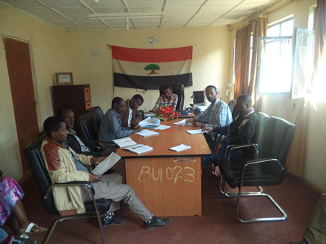

Figure 3-1: Discussion with woreda key stake holders
Key informants interview was made with key responsible individuals mainly woreda agriculture development office and other sectoral offices. Discussion was held with relevant sectoral office and communicated to provide information on specific and selected issues related to irrigation development and other relevant socio-economic issues. The key informants expressed their interest and also raised their doubts especially the quality of the construction and how to make the road access to the head wok sites.
- Public Consultation and Focal Group Discussion
In order to know attitudes, opinions and reactions of the community toward the proposed project, group discussion and consultative meeting was held with Kebele leaders, community representatives and different segments of the society. The public consultation was facilitated and pre-arranged by kebele leaders and participants were drawn from different groups of the society (opinion leaders & elders, Women, Youth, beneficiary farmers and Kebele councils) and where woreda administrator and other decision maker’srepresentatives attended the meeting on April 08, 2016 on the project site.
Furthermore, transect walks were made in the project area to grasp an overview of the existing socio economic situation and in the process discussions held with communities to explore opinion and attitudes towards the project.
- Household Survey
Household survey was also undertaken in order to assess some basic data on household’s economy and demographic structures based on purposely selected sample population. The household survey questionnaire included basic data content such as age, sex, family size, sex, education status. In addition to that it included social and economic issues like land ownership and management, irrigation experience, major income of the household, input supply availability and cost, accessibility of credit, market accessibility and problems, gender issues and related problems, irrigation management and etc.
In conducting the survey, enumerators were selected from the project sites, trained and assigned to conduct the household survey. The head site, command area is in Imbro Bonga kebele of Chora woreda and it covers about 47ha.As observed from household survey and discussion with key stakeholders the population of the kebele and beneficiary of the command area are fully an indigenous Oromo. They are almost homogeneous mainly with respect to ethnicity butreligion wise they are Muslims and Christian (Orthodox and protestant) culturally and socio economic characteristics of the society is almost similar. By considering the homogeneous ethnic characteristics of the society about 240 beneficiaries as a total population and 20 % or 45 in number of the household’s included in household survey. The sampling method used was simple purposive method which is on persons available and near to the command area. Age composition of sample household ranges from 23 years to 70years.
- Data collection tools
Different data collection tools had used on field and from the offices. Some of it was note book, different types of questioners for households, kebeles and sectors, camera for recording pictures and audios and etc.
- Data analysis
The socio economic report used descriptive and quantitative analysis approach. The report focuses on project area specific socio economic features, and also provides highlight on general overview of the region, zone and Woreda as required. Household survey analyzed using different software’s example Microsoft excels. The result found used as statistical description.
- Procedures and Process flow
The socio economic study followed the steps and procedure required in data collection and analysis. At the first glance to field work contact was made with Woreda administrative, woreda OIDA office, Agriculture. After preliminary discussion, with Woreda administrative Woreda OIDA person assigned to facilitate and to guide the study team to project area and kebeles to link with kebele administrative and development agents/DA’s on the project kebele where discussion and data collection continued at kebele level from development agents office and provided available data mainly on command area and beneficiaries. After the discussion at development office, site visit made at project sites and command area and identified the command areas and nature and characteristics of the beneficiary population and determined the sample size for the household survey. After the enumerators trained and assigned for household survey, key informants discussion and community consultation and other data collection continued at kebele and Woreda level and successfully completed the data collection at field and analysis of the report at office. The general approach, process flow and sequence of work are depicted as follows.
Figure 3-2: Methodological framework, Procedure and workflow

Study team
Woreda admin /woreda OIDA
Support staff from the woreda Office
Kebele administrative/ Development agents
Discussion and data collection from Development agents
Site visits & field observation and identification of command area and beneficiary population
Household survey, farmer’s consultation, key informants discussion and data collection at kebele and woreda level.

SOCIO ECONoMiC Features

Location and access
UnkusoSSIP is located in Oromia region Buno Bedele zone Choraworeda of Imbro Bonga kebele. The proposed SSIP can be accessed from Addis Ababa through two ways which is Nekemete and Jimma ways. One of the ways is along the asphalt road that runs from Addis Ababa through Jima way - Bedele then Chora woreda town called Qumbabe is located at 516km. The second \and shorter option is also through the asphalt road from Addis Ababa- in Nekemte way to Bedele then Chora woreda town called Qumbabe is located at 456 km from Addis Ababa. In both way the road Addis to Qumbabe town is asphalt and can be accessible throughout the year.
After the Chora woreda capital city Unkuso SSIP also accessed through driving in to the Dega way or to the north direction then on turning to the right or east direction at 7 km or at a village namely called Abba Bora then by driving about 19km Imbro Bonga will be arrived. Then after kebele office at about 2 km you will get Unkuso river. Totally it is 28km from Chora woreda capital city or Qumbabe. Totally the Unkuso SSIP is located at 484 km from Addis Ababa in Nekemete way. The road from Qumbabe to the Unkuso SSIP is gravel road constructed by Oromia road authority and URAP.
Table 4-1Distance of the Unkuso SSIP from towns
Name of SSIP | Distance from Qumbabe town | Distance from Bedele town | Distance from Addis Ababa through Nekemte way
Unkuso | 28 km | 63 kmif through Qumbabe  18 km if strait travelled from Bedele | 484km

Proposed Project Command area and Beneficiaries
The Unkuso irrigation head work site and command area bases in the same kebele called Imbro Bonga. The communities had an experience of using traditional irrigation for many years by gravity.But at this time they couldn’t continue. Because the head site they used for diversion of water was deepen by erosion and they couldn’t divert it by their labor. The community express as they have an interest for irrigation but couldn’t continue. During our visit most command area of the Unkuso command area is free of any crops however some areas occupied by irrigation crops. The proposed irrigation project is also using diversion irrigation system.
The command area is 47ha with a minimum land division of 0.25ha for the households188of household will going to be beneficiary from the project. From the expected 188 HHs beneficiary at least 5-10 % of the households have to be from the female headed households. The command head site and command area in the same kebele so there is no problem in community that they have an experience of using together the water and they know each other because of they are from the same kebele.
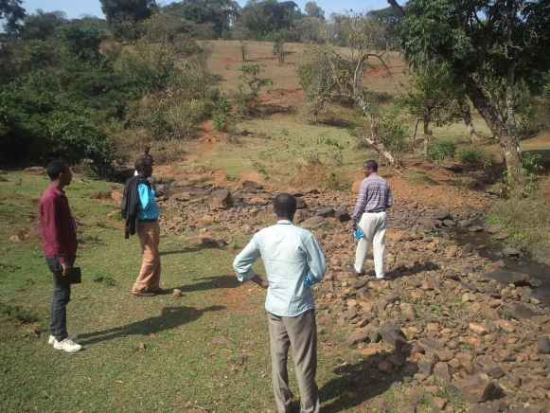
Figure 4-1: Partial views of the study team during head selection

Climate and topography
According to available data source, Chora woreda has an altitude range of 1450- 2300masl, an annual rainfall range of 1500- 2200mm distributed over late march to ends in October and atemperatures ranges a minim 9⁰c and with a maximum of 31⁰c. Ecologically the woreda is distributed in 1.5 % low land, 95.1% mid land and 3.4% is high land. They usethe Meher season rain for crop production.
The proposed project is characterized as mid landwhere temperature, sunshine, winds… etc is very moderate. Thus hot climate is suitable for crop production in short time.

Water source
The water source for crop production at the project area majorly depends on rain fall and in community view producing only in rainfall is not adequate to produce enough crops only at one time rain fall. The water source is the Unkuso river which originates and flows from the upper two streams namely called Mole stream and the other also called Unkuso stream and after they joined together they called by the name of Unkuso river. As it was observed during the field assessment and secondary data collected from the relevant sources, Unkuso River is Perennial which is not yet exploited by modern irrigation. The water flows throughout the year but no effective and efficient use because of it hadn’t constructed in modern way. The Ogode river flows to Debena river then flows to Nile river.
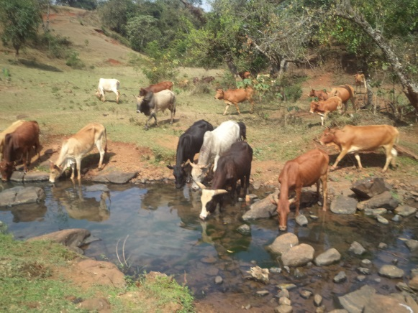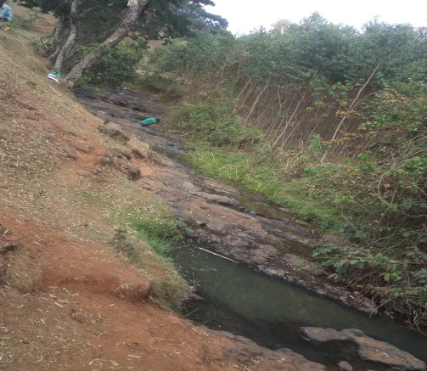
Figure 4-2: Livestock around Unkuso river

Project area and Settlement
The project area settlement pattern was assessed to understand the socio economic changes at the area and integrate expected changes with proposed project. The proposed project beneficiary of Unkso SSIP settlement was near to the head site and to the command area. Most community settlement is at near to the command area almost favorable to plough in short distance. The village is settled in scattered way in all direction in permanent. Their settlement is almost not in planned way, it is just in scattered and irregular way as they own the land. They use the river for different purposes in addition to irrigation such as drinking of livestock, cloth washing, bathing etc.
The community house structure was constructed from roof corrugated iron sheet and grass, the wall almost from wood and mud and the floor is from mud.

The society living in this area is fully an indigenous Ilu Abba Bora Oromo. The society was settled in permanent way in the area and their life depends on crop production and livestock breeding.

Population And Demographic Characteristics

General
Development project targets to see some gaps of existing population as well for future generation, for sustainable economic, social, and cultural development of the community in project area and expected added value and benefit to the society at large.
As a result development project planning needs to have data on existing population size and projected population growth, and understanding on social interaction and the overall situation in population characteristics like population density and land holding size, average family size/growth rate, age and sex composition, ethnicity and others including factors affecting production capacities like labor, age structures and availability, population movement/migration and spatial distribution are some of the issue discussed in this section of the report. In general, population and demographic data is relevant for market planning as well as other related issues and population data at regional, Woreda and kebele level indicted in section that follows for general overview of demographic features.

Population size of woreda
According to the data obtained from Woreda, the total populations of Chora woreda is about 136,455 of which 65221 are male and rest 71234 are female. From the total population urban populationis 11086. From this 5566 is male and 5520 is female. The urban population accounts about 8.12%. Data from the woreda administrative also shows that ethnically Oromo is about 80%, Amhara is about 10% and the remaining 10% is the other tribes like Tigre, Gurage, etc.The total kebele of Chora woreda is 33 from this 1 kebele is urban and the other is rural.

Urban and Rural Population of chora woreda
8.12 % of Chora woreda population lives in urban and 91.87 % lives in rural. The majority of rural living system depends on Agriculture which is crop production and livestock raring. The urban population income generating also depends on commercial and some also depends on agriculture. The Chora woreda office is located in Qumbabetown. The Unkusosociety’s exposure and traveling to the town islimited because of transportation was not available however the newly accessed road may improve it because of it linked with Bedele town. The Bedele town is almost 18 km but previously because of no transport and bridge on Debena river the community movement was limited. Beadle town have relatively good transportation, electric power and phone communication. The road is constructed by URAP last year. Before that the transportation was very difficult and almost all the society uses foot and animals for transportation.

Population Density and Spatial Distribution
Population density is one of the indicators for land holding size and other economic issues. Population density for Ethiopia is110.7 people/km² and forOromia region 95/km2 (250/sq mi) person /km2.Besides thatthe population density for Ilu Abba Bora zone is 76/ km2 and for Chora woreda is also 76.4 person/ km².
According to Woreda administrative and agriculture office, Population density is not that much high and the land holding size of the of the Imbro Bongakebele in average is 0.25 ha to 8ha per household while some of the youths have no land except their family given them for which serves only for house construction.

Project Area Population Size and Demographic Features

Population
Total Population of the Chora woredais 136,455 and from this 65,221 is male and 71,234 are female. The project kebele, which the command area majorly lies in, is Imbro Bongahas a total population of6642 and from this 3253 is male and 3389 is female.

Family size
Based on the available data gathered at health office and the results of the household survey the average family size for the project area was estimated. The minimum and maximum family size for the project kebeleranges from 2to the larger 13members of family size and the averages family size at the command area estimated to be 6family sizes which are greater to national average of 5 family sizes. According to the sample household survey result, household below and equal to 5 family member’saccounts29% andMajority of the household have family members which are between6-10 members and accounts about 60%.
Table 5-1: Family size range and % of householdsurvey conducted in project kebele
Family size | Frequency | Percent
Below or equal to 5 |  | 29%
6-10 |  | 60 %
11 and above |  | 11 %
Total |  | 100%

Source: Sample Household surveyduring the study

Sex composition
Sex composition of a population is important as it provides useful information like reproductive potential, gender mainstreaming, labor resource, education coverage, benefit share and participation by sex… etc. According to Woreda datafemaleaccounts 52.2 % and male’saccounts 47.80% the same to that at project kebele Imbro Bongamale accounts 49 % female accounts 51%.

Age structure and labour availability
Age is one of the basic demographic characteristics of a population and useful for demographic analysis, determine availability of productive age and other socio-economic developments planning. The age and sex structure of a population is usually the effects of past fertility, mortality and migration.
Though age data have many uses, it is usually found to be very difficult in obtaining reliable data on age. Effort was made in gathering secondary data from woreda health office and education office as well as computed the age structure from primary data source of household survey undertaken in project kebele. However, as majority of the respondent are farmer group and illiterate and lack knowledge and capacity of recording their children’s and their own age and therefore, the difficulty of obtaining reliable age information of a person in any surveys and censuses is a common phenomenon that encountered.
To mitigate this problem, enumerators are informed methods such as using list of historical events in order to assist primarily the respondents and then enumerators to estimate a person’s age.
According to CSA (2007), the proportion of young population in Ethiopia with age below 15 years indicated to be 46.3 % and the working age group (15-64) accounts to 51 % and population above 64 years age shares about 2.7 percent.
With regards to the project area the computed household survey analysis result indicates the broad base of population pyramid shows that significant proportions( 32.9%)is less than 15 years and 65.8 % are between 15-64 years and (2.4%) of the population at project area are above 64 years.

Labour Availability
Availability of labor is important during construction and operation as irrigation is labor intensive project. With regards to Labor availability existing situation assessed in terms of disguised unemployment and competing demand for labor at the area. At current condition due to land shortage many of the young age groups are land less as disguised unemployment/dependent with families.The project is expected to contribute additional temporary work and intensive use of family labor during operation and create opportunity for land access due to extensive use labor in irrigation farm. The community speaks as they have an experience to work by share cropping for those have land. If somebody has a land the other body will cover all labor works and they share other expenses and benefits gained. Currently the daily laborer costs60 birr per-day even though the community have no experience to employ for irrigation practices like coffee harvestingand it increases to 80- 100 birr per day during thecoffee harvesting time.
Regarding the working culture of the people, some key informants indicatethat working as daily laborer for other farm is looked as inferiority. There is bad views working as daily labor for private farm, particularly working on individual farm of their own ethnic considered as shame which needs to bring attitudinal change. On the other hand the people well accept working as contract or daily worker in construction activities like road and similar activities undertaken by government or other private investment ventures.

Ethnic Groups
The ethnic composition of the Chora woreda is almost an indigenous Ilu Abba Bora Oromo which accounts almost 80%, Amhara Wollo settlers is about 10 % and the other ethnic group is about 10%. But the ethnic composition of Imbro Bonga kebele is estimated about 100 % is an indigenous Oromo with the religion composition of Christian and Muslims estimated to be 80% and 20% respectively.

Religion
Religion composition assessed at country level and with respect to project area context. According to census 2007, existing religion in the country were categorized into six. The three major religion groups include Orthodox (43.6%), Muslim (33.9%) and Protestants (18.6%) traditional 2.6%, catholic, 0.7%, others 0.7%).
In same data source, religion composition indicated by region and in Oromia Muslim shares 47.6%, Orthodox shares (30.7 %), and Protestant (17.7 %), traditional religion 3.3% and others shares (1 %).
Religion aspect Cora woreda Christian accounts about 45% and Muslim accounts about 55%. The same to that the project kebele Imbro Bonga Christian accounts about 80% and Muslims accounts about 20%.

Population Growth Projection
The data on population size of the country as obtained from the successive population and housing censuses shows steady increments of significant proportions. For instance, comparison of the population size counted in the latest census conducted in 2007 with the 1994 census count shows that the population of a country has increased by more than 20 million persons in 12 years period of census 1994 and 2007. Population and Housing Census results showed population of Ethiopia grew at an average annual rate of 2.6 percent during the period 1994-2007 and total population of the country estimated 73.9 million at the base year 2007. The pattern in population growth determines food demand and agricultural product supply planning and population growth trendof the country indicated in figure that follows.
According to the 2007 Population and Housing Census results, the highest annual growth rate for the period (1994-2007) is observed for Gambella Region (4.1%) followed by Benishangul-Gumuz (3.0%), South nations nationalities and peoples regional state and Oromia (2.9 %) and the national average of 2.6%.
Therefore, based on the annual growth rate for the Oromia region which is 2.9 %total population at project area will be projected to increase from the current total of 6642 to 13570 at the end of project life in 25 Year’s period (2016 to 2041).

Figure 5-1: Population growth trend of the Imbro Bonga kebele

Factors contributing population growth
Population growth is accounted mainly due to fertility, mortality and population migration/ population movement and other factors. At existing condition family size atproject area is generally high and land fragmentation continued for the young and many landless groupsare created because of the land redistribution was not conducted after 1983 EC or 24years.
In general, based on the discussion with community some contributing factors identified to cause high population include;
- Low educational status and high social value for children
- Using family planning is working against God
- Using family planning affects human health
- Low health extension in effective family planning and attitudinal change
However, with health extension support and other intervention measures, family size and population growth at project area anticipated to decline and recommend strengthening the health extension service.The health extension program have to focus on family planning education, it should be integrated with other programs like nutrition.

Land Use and land holding

Land use
The land use pattern is mainly composed of an extensive grazing, subsistence type of agriculture and scattered settlement, situated within different land forms. Crops such as maize, sorghum, teff, and other lowland crops like red peper are cultivated under traditional way of farming practices. The land use pattern in Chora woreda is largelyarable land and about 48,148.04 ha.
Table 6-1 : Land use pattern of Chora woreda and Imbro BongaKebele

S/n | Types of Land Use | (ha)
1 | Arable land | 48,148.04
2 | Cultivated land | 48,050.04
3 | Grazing land | 5300
4 | Settlements | -
5 | Forest lands (including shrubs) | 15785.46
6 | Wet land | 1772
7 | Others | 7383
 | Total | 78,388.5 ha
Source: Chora woreda agricultural and rural development office ice

S/n | Types of Land Use | (ha)
1 | Cultivated land | 2101.9
2 | Cultivable land | 2110.9
3 | Grazing land | 25.7
4 | Bush and shrubs land | -
5 | Forest lands | 19.5
6 | Wet land | 90
7 | Others | 4.5
 | Total | 4352.50

The land use pattern at project area is mainly composed of extensive crop cultivation mainly maize, sorghum and teff scattered settlement, situated within different land forms. Asthe information obtained from development offices of kebele, about 2110.9 ha of the land inImbro Bongakebele is arable land and land use pattern of the kebele is as the above table.

Land holding size and land access
Land redistribution was not done in Oromia regional stateafter Dergue regime fail in 1983 EC whereas the certification was provided in this government system.The average land holding size of the Chora woreda is 1.5ha per householdwhereas according to the report from kebele DA office the range of land holding size for the project area is 0.5-8 ha. According to the woreda land administration department there was no land redistribution in the woreda as many of the land area occupied by households and investors. Even though the average land holding size shows as it is not bad the majority of the young family head has no land except they get small size of land for house construction from their family. In general, land holding size ranges from 0.5 ha to 8 ha.
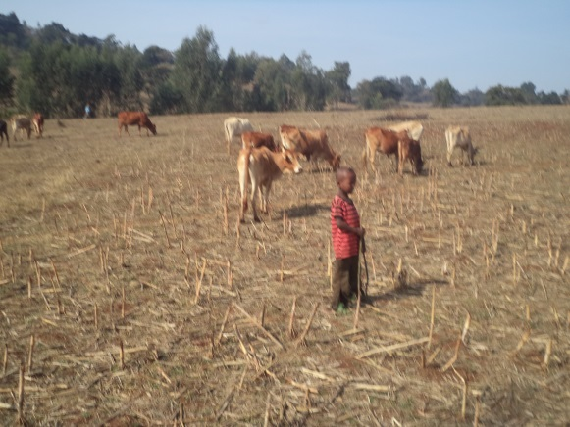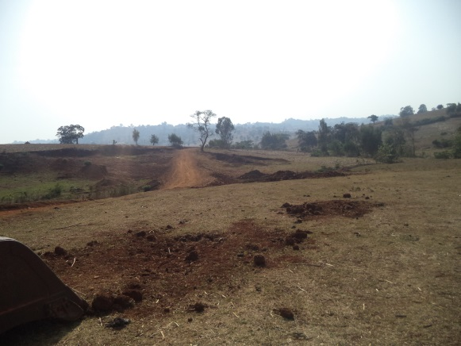

Figure 6-1: Command area of Unkuso SSIP

Economic and poverty situation

Economic and livelihood source
Chora Woredais a rural agricultural communityhowever they use mixed economy for house hold consumptions and income generating. Almost all households produces crop for their house hold consumption.The major Crops such as maize, sorghum, teff, and other lowland pulses are cultivated under traditional way of farming practices. As the information obtained from the farmers and physical observation made in the field, part of the command area was cultivated for traditional irrigation practices for maize during the assessment period. Even though some products produced in irrigation major production was using rain fed. In the area cereal crop used as traditional staple food.In Chora woreda as well in project kebele maize and sorghum is the dominant crop in order of land coverage and cultural importance.
Livestock provides/contributes supplementary food and household income and also used to cultivate farm land and means of farm activities. Majority of the household in both rural and urban have livestock as supplementary economic resource.
Economic activities outside agriculture is limited and few young groups engaged in off farm activities like tradingof coffee, cattle, crops and commodities, etc….
As estimate taken from the kebele DA office, crop production contributes about80% of the household livelihood and income source and livestock supplement about 15% to household livelihood and others off farm like trading of cattle, crops and commodities which accountsabout5% which is less significant.

Figure 7-1: Economic and livelihood source of the kebele

Wealth status and income distribution
Wealth and poverty status is a relative term and depends on the communities’ resource base and definition of community given to poor and rich and depends on once view and many others. In the context of the project area, community wealth ranking and wealth status primarily related to land holding size, coffee planted, number of farm ox and cattle possession, house structure (corrugated/thatch roof) as well as access to some basic services like mobile cell phone….etc.
Based on the household survey resultand focus group discussion ranking in command area, wealthstatus of the household indicated in terms of income classificationand about 77.77% of the household annual income is less thanor equal to birr 15,000 classified as poor household and 16.66 % of the household annual income ranges birr 15,000-35,000 categorizedas middle income and 5.55 %of the household annual income above 35,000-40,000 consideredas higher wealth group.

Food Security Situation
The midland and low land areas of Chora woreda are known by production of different cereals. Some of the cereal cropsproduced is maize, sorghum, teff, wheat, barely, bean, pea,nougetc… and coffee etc.
The Chora woreda are generally have sufficientrain and good climatic condition and can produce sufficient cereals for consumption and to supply for market.
The woreda have no safety net program because of the society is food secured.

Economic activities and production

Agriculture and Crop production
The area is known by rain fed cultivation of cereal crops. Because of the project area or Chora woreda is a mid and low land most of their production is maize and sorghum. Majority of their production is rain fed dependent.They use traditional ploughing using oxen. The traditional irrigation is started to practice in all rural kebeles while the production is not that much effective because of their agricultural input utilization and water using is in traditional way. The meher productions in the area have many problems. For example shortage of rainetccrop adoptable to grow in project area indicated in table that follows.
Table 8-1: Shows major crops produced inChora Woreda2007/2008

S/n | Major crops of the Woreda (rain-fed) | Area in Ha | Total production | Remark
1 | Maize | 5132.75 | 177,799.12
2 | Sorghum | 47166 | 52158.2
3 | Teff | 108808.34 | 113,892.92
4 | Wheat | 65387.2 | 70813
5 | Barely | 11800.9 | 14275
6 | Bean | 621 | 11025
Source: woreda agriculture and rural development office
Table 8-2: Major rain-fed crops of in Imbro Bonga kebele 2007/2008

S/n | Major crops of the Kebele (rain-fed) | Area Coverage  Ha | Average Yield  (qt/ha)
1 | Maize | 369 | 6476
2 | Sorghum | 60 | 1216
3 | Wheat | 84.5 | 1906
4 | Barely | 113 | 1017
5 | Teff | 475 | 5040
6 | Pea | 9 | 81
7 | Bean | 31 | 310
8 | Haricot bean | 89 | 979
Source: kebele DA office
The project area has fertile land and high production potential, but because of low agriculture input utilization andtraditional farming system agricultural production is low and possible to increase production much more than the current level with agriculture input utilization and minimum improvement in land and water management.
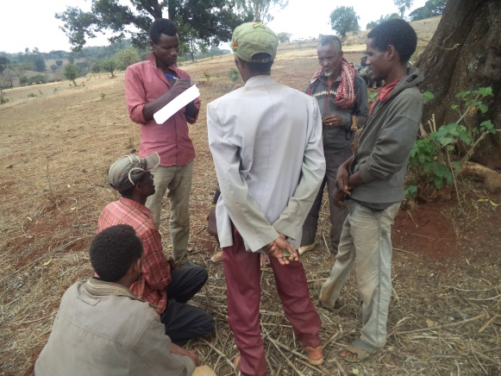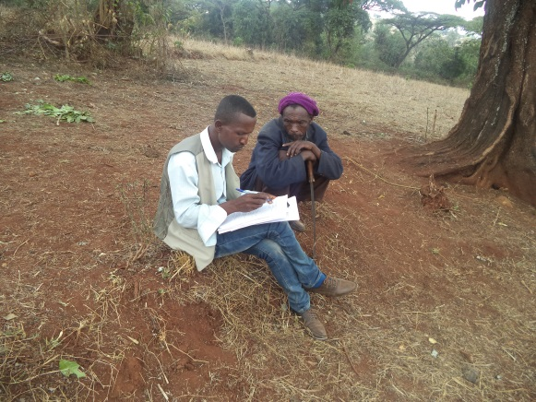
Figure 8-1: During House hold survey by kebele staffs
Crop storagesystem in the area
The community uses traditional storage system in house and in compound by constructing from by traditional way from wood and mud. They have no experience for use of chemicals and other storage systems for crop production. According to the community most of the time the production of crops from the area like maize and sorghum damages if stored for long time. Because of that and other purposes the storing practice of the society is decreasing from time to time. The community sells the crops as soon as harvesting if assumed as it is excess than their consumption.

Livestock
Livestock and by product mainly milk and milk by product is used to supplement family food and income. Livestock generate income and supplement food source and used in farm activities mainly ox for farm plough.
Cattle dominates the livestock population in project Woreda and kebele, as the data source from the area indicates cattle population amounts about 125,522 in Chora Woreda and 6898 in Imbro Bonga Kebele.
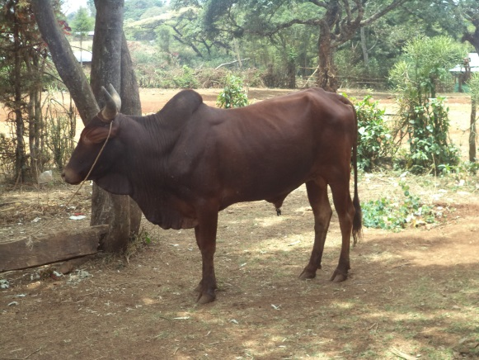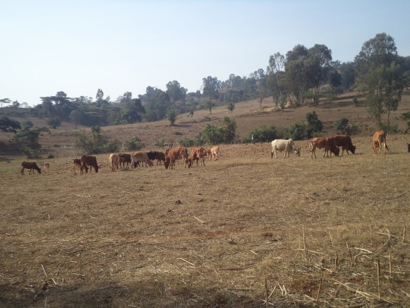
Figure 8-2: live stock in the command area

Table 8-3: Livestock types & quantities in Chora Woreda and Imbro Bonga Kebele
S/n | Chora Woreda |  | Imbro Bonga Kebele | Diseases of the area
S/n | Type of livestock | Qty | Qty | Diseases of the area
1 | Cattle | 125,122 | 6898 | Trypanosmosis, Lumpy skin, diseases,  African horse sickness  Tetanus  Internal parasites
2 | Sheep | 60,450 | 1150
3 | Goats | 36,492 | 271
4 | Horses | 7,432 | 72
5 | Donkeys | 2,117 | 67
6 | Mules | 2,412 | 50
7 | Camels | -
8 | Poultry | 68200 | 2172
9 | Beehives
 | Modern | 896 | -
 | Transitional | 4669 | 36
 | Traditional | 61803 | 1914
Source: Chora Woreda Livestock Health Clinic and kebele DA Office
The community livestock management is fully traditional. They use open feeding and uses koral for cattle. Most of the households share their houses with calves, oats and sheep’s. they don’t use any additional feeding for the livestock’s except from the field available water and traditional forage or grass.
Other activities like bee keeping and honey production is also a potential and contribute as an economic activities in the area.Modern type of behalves was not adopted in the kebele.
Veterinary clinic have not available in the project kebele but it located in adjacent kebele on about 9 km even at that clinic no doctor available and the service is by Para medical professionals.

Other off farm activities
In the projectareaall activities are directly or indirectly related to agricultural activities and other off farm activities are very limited. However, there are few local household groups engaged in some off farm activities like poultry, agricultural product and livestock buying and selling. This sector also includes marketing of consumable industrial products which has potential to contributes household income and advisable to promote rural marketing as it contributes in supply and demand for product marketing at the area. In order to support agricultural marketing and micro enterprise development at the project area, it is important to strengthen credit and saving to such group of the community.

Agro Processing Industries and Urban Economic Prospect
Currently the command area and as well the woreda is free of any agro processing or industries while it is good if linkage created for the future because of it has an advantage for purchasing the local product. For example because of no processing in the area the farmers forced to sellmaize in cheap price. The milk is also consumed by the community because of no processing and good market available in the area however some part sold as butter.

Market and roots

Market Institutions and stakeholders
The organizational structure for market management assessed and at woreda level, the task of market and cooperative activities were the job responsibility under agriculture office for long years. However, with organizational restructuring in Oromia region trade and market development officeis established and on follows the market activity of the woreda.

Market and Market prospect at project area
Maize and sorghum isthe major dominant crops producedfor home consumption in woreda andin project kebele as well. Some products like onion and tomato was also purchased for household consumption from other area.

Market Centre
Availability of primary, secondary and tertiary market centre and urban economic development tends to influence marketing of agricultural product. The project kebele have no market to sell their crop and livestock products. The irrigation project area or Imbro Bonga is located in area where no good accessibility and no public transport.
Table 9-1: Market distance from the project kebele
s/n | Site of market | Distance/time of walking from  Unkuso SSIP from market in time | Remark
1 | Bedele town | 4 hrs/18km
2 | Abdela town | 2 hrs
3 | Debeso soro | 1 hrs / 5km

Even though the market is not in short distance the market sites themselves were not accessible for transports both for public and loading, however this year the road constructed by URAP and the problem may be solved in the way of Bedele town. The community critically criticize the transport vehicles and discipline is not good. They requests high money, loads more than double on the vehicle. Thecommunity transports maize and other products by horse, mule and human force.

Product destination
Product destination for agricultural product from the project area including food crops like teff ismainly for supply to local market for local consumption. The market destination for surplus production of agricultural product from the area especially market is sold to the ECX (Ethiopian commodity exchange), chat also transported to Jima and Mettu towns. Maize also transported to Addis Ababa through merchants.
Other tertiary market root is open within the zone as well as neighbour regional town. The primary market is with low market price due to the public transportation problem and the local traders have no capacity to search the market when compared with the product. Private traders and even strong famers cooperative are not available in area.
The livestock’s also sold to the local market and also send to the near towns like Mettu and Gambella.
Figure 9-1: Market and Product destination flow
Zone & near towns like Gambella
Food crops
- Maize
- Sorghum
- Teff
- livestock

Market Destination
Local
Food crops
- Chat
- Maize
- Sorghum
- livestock
Addis Ababa
Cash crops
- coffee
- Salit

Product Demand and Supply
Considering the huge development potential of the area population expected to grow rapidly and predicted high food demand in the project kebele and domestic market at large.Based on the population growth rate and assuming the standard wheat equivalent food per capita consumption set 240kg (UNICEF), the total food demand for theprojectkebele orImbro Bonga is expected to increase from the current 15940.80quintal to 32,568quintal in 25 years period of year 2041.

Figure 9-2: Population growth and Food demand projection of Imbro Bonga kebele

Product Price
The project area major crops include maize, sorghum, wheat, teffand beans that producedfor household food consumption as well as cash crops to generate income. The retail price of these crops assessed at Woreda town and the trade and market development office experts speaks as the price of the product has on increasing trend from year to year.
Table 9-2: average costs of some products trend in ChoraWoreda

s/n | Agricultural product | Ql Price in Birr |  |  | Remark
s/n | Agricultural product | 2007 EC | 2008EC |  | Remark
1 | Maize | 300-450 |  | 400-500
2 | Teff | 1000-1550 |  | 1100-1650
3 | Sorghum | 250-300 |  | 300-350
4 | White onion | 60 |  | 45
5 | Red onion | 12 |  | 10
6 | Red peper | 70 birr per kg |  | 30 birr per kg
7 | Coffee |  |  |  | Delivered to ECX
Source: Chora Woreda trade and market office
Due to road and transportation problemand the demand for cash for different purposes farmers forced for excess supply to the market as soon as crops harvested and that cause price fall and unfavourable to trade.
As to farmers key informantsand marketing experts said farmers have low awareness in producing market based crops and vegetable. They produce similar products at the same time for house hold consumption.That forced the farmers to lose their products in cheap price.
The problem emanates due to market,transportation and awareness problem, some farmers forced to sale on farm or farmer traders assemble the product at farmer’s door at cheap price and marketing at the cost of the farmers.
With regards to agricultural input price farmers also indicated unfavourable terms of trade between cost of fertilizer and price of agricultural output. As farmers indicates fertilizer price escalates from year to year.

Market problems and constraints
During the consultation with community and key stakeholders, major market related problems in the study area were identified, itthat mainly includes;
- Lack of transportation
Due to lack of transport means market product transportation usually uses human labour and animal and marketing requires high energy and time for the producers.
Transportation and communication services are fundamental factors in determining development endeavours being undertaken in a given locality. Since they provide services to other sectors of the economy, it would be impossible to conceive of social and economic development in the absences of adequate transport and communication infrastructure and services.
Others Communication means with mobile network arealso not working well around the project areas. The project area has no electric supply;however the hydroelectric power is supplied some villages located at about 7km. Totally no hotels and rural based village and less urbanized to effect high demand for agricultural output.
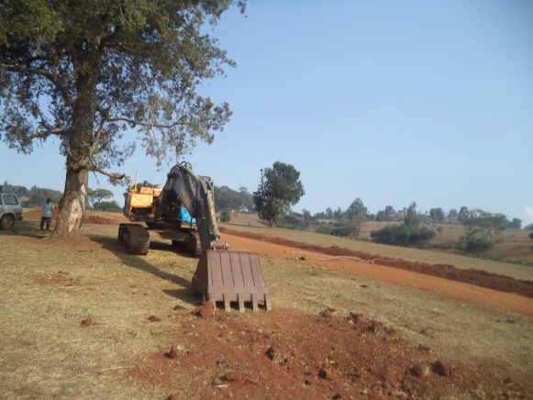

Figure 9-3: Newly accessed road towards Bedele town
- Market linkage and information is also a problem for farmers
The farmer produces what cost increased on a market in a time. All farmers production is almost similar and at the same time. Because of no market linkage the production will be excess on a local market for one time and a cost will decline at that time. According to trade and market office experts the market is not as expected for the farmers.
- Lack of saving awareness and exposure to crises
Banks and minimum rural financial institutions are required to meet farmer’s financial needs for agricultural input or others. Two banks are available in Qumbabe town. Oromia saving and sharing company and Wasasa credit and saving Share Company is available in woreda which located at Qumbabe town. Community speaks as many households received loan without clear understanding and preparation which resulted in crises for the family. The community over utilizes and miss uses it as soon as they sold their product than saving it. Some persons from the project kebele have an experience of receiving loan from Oromia credit and saving share company (WALQO) however not for irrigation.
- Product quality problem
The farmers have an experience of mixing good and bad quality products by focusing on the quantity. Mixing bad quality discourages the customer from buying and results in poor cost. The agriculture extension professionals and marketing professionals have to work hard to improve the community’s attitude to focus on quality. The community have to be aware the good and bad things of adulterating quality.
- Budget shortage
The marketing and trade office experts have no enough budgets to search and link the local producers and whole sellers with other areas. In addition to that almost all experts are fresh and lack technical practice and skill to search the market. They don’t have transporting materials like motor bicycle and fuel budget.

Agricultural support service

Agricultural Extension Service
The agricultural extension service of the Woreda is supplied by agricultural and rural development office. The agricultural extension service includes agricultural input supply and utilization, supply and use of different chemicals like herb sides and insect sidelivestock breeding and protection etc. Even though the service is not as expected Woreda agricultural office and kebele DA office express as they are conducting many efforts.
Agricultural input mainly fertilizer and improvedseed is provided to farmers by facilitations of different stakeholders. The agriculture and rural development office suggests and requests the item and amount of inputs needed. The cooperative promotion office supports the farmer’sprimary cooperatives in different capacity building beginning from establishment to training on different activities like recording, auditing etc. The primary farmers integrated cooperatives and unions also directly supplies and or sells to farmers the input needed. In Woreda different variety of seeds such as maize and fertilizers such as NPS and Urea are on supplying every year.
As a farmer indicates low purchasing powerand increasing input price trend was one of the constraints for limiting input application. Fertilizer and improved seeds distributed inlast year is was as follow.
Table 10-1: Agricultural input supply and distributionin Chora Woreda and Imbro Bonga kebele
Agricultural input | Unit | Allocated for woreda 2007/8 | Distributed for Woreda 2007/8 | Allocated for Imbro Bonga kebele 20007/8 | Distributed in Imbro Bonga 2007/8 | Price in ql
NPS | Ql | 5741.50 | 5741.50 | 124 | 124 | 1535
Dap | Ql | 2427 | 2241.50 | 260.5 | 260.5
Urea | Ql | 2524 | 2101 | 133.5 | 93 | 1134
Comp. | m³
Maize BH -661  BH-660 | Ql | 378.50 ql | 378.50 ql | 11.5 | 11.5 | 1600
Maize BH -661  BH-660 |  | 16.5 ql | 16.5 ql | - | - | 2218.46
Different chemicals herb side | packet Lit |  |  | 247 | 247 | 81
Source: Chora woreda cooperative promotion office and kebele DA office
As farmers and the agricultural officeindicated some of the constraints in agricultural input supply and application includes;
- Shortage of improved seeds
- Late delivery and distribution of inputs
- Credit is not facilitated by government
- Farmer is not ready to buy by cash
- Fertilizer selling cost is increasing from time to time
- Supply and demand is not as required
- The seed as well as fertilizer is very expensive example 1 ql of BH-61 price is 2218.46 birr
- Farmers have doubt on improved seeds

Credit and saving
Like any other business, rural farmer also in need of finance to meet immediate needs for agricultural inputs and others. Credit service providers in woreda is available through two bank and two micro finances however the availability for irrigation is better through Oromia credit and saving Share Company / WALQO. Credit disbursement is to serve farmers in productive activities and majority used for livestock development, fattening agricultural inputs like improved seeds.
The Oromia credit and saving share company speak as there is an option to give a loan for farmers for irrigation users through group and individual wise however currently no farmers received for irrigation.
Oromia credit and saving share companyhave different types of givingcredit for farmers. The system is individually and for group and also according to return system in instalment and in term.
The criteria to get credit from Oromia credit and saving Share Company/ WALQO isvary when it is group based, small business micro enterprises and individual
- Preparing business plan
- Recording owns property
- Kebele identification card and living in kebele
- Free from other loan
- Free from any criminal
- Free from any addiction
According to our analysis receiving credit from Oromia credit and saving share company/WALQO have many advantages than receiving from others micro finance.
Some of the advantages are
- No collateral needed for loan in team
- Credit is available for irrigation users
- Give priority for poor of poor and women
- The return uses declining system
- Monitors and train the clients every three month
- Uses less group member
- Oromia credit and saving Share Company uses less interest rate 13% - 18 % while others private micro finance uses 15% - 24 %.

Cooperative and water users associations
Farmer organized as cooperative in Woreda established on 8 categories. They have different activities and focus areas. Most cooperatives performance is not satisfactory.
Their categories are and members shown in the following table below.

s/n | Type of cooperatives | Quantity | Members by sex |  |  | Amount of capital
s/n | Type of cooperatives | Quantity | M | F | T | Amount of capital
1 | Multipurpose cooperatives | 32 | 5061 | 229 | 5290 | 7,105,087
2 | Forest cooperatives | 7 | 860 | 149 | 1009 | 81860
3 | Mining cooperatives | 2 | 27 | - | 27 | 12,475
4 | Irrigation cooperatives | 4 | 127 | 2 | 129 | 1,136,000
5 | Electrification cooperatives | 2 | 68 | - | 68 | 23,100
6 | Saving and credit cooperatives | 20 | 436 | 1256 | 1692 | 657,503
7 | Consumer cooperative cooperatives | 6 | 410 | 89 | 499 | 430,336
8 | Honey cooperatives | 2 | 35 | 37 | 72 | 79,900
9 | Spices producers cooperatives | 1 | 16 | - | 16 | 27,200
 | Total | 76 | 7040 | 1762 | 8802 | 9,553,461

Totally 8802 peoples are hold as members of cooperatives from this 1762 is female membersand 7040 are malemembers. Currently some cooperatives members like irrigation didn’t startedservice. Cooperativesestablished in the Woreda status and strength is varying from each other. According to woreda experts the farmers are volunteers to be established as cooperatives but they are not ready to contribute the needed capital.
Criteria to be established as a cooperative is
- Registration
- Committee establishment
- Feasibility study or analysis
- Forming general assembly
- Developing rules and regulations
- Pays their share
- Age minimum of 14 years and above
After that they will apply to Woreda cooperative office and certified as a cooperative.
According to the Woreda cooperation promotion office irrigation users tried to be established as cooperatives however it didn’t yet finalized. This is because of the misunderstanding of cooperative promotion office that organizing only irrigation users may not be allowed.
The irrigation user’s associations currently focuses on water use management and conflict resolution, but in the future they expands and focuses on seed producing and input supply.
Establishing irrigation water users as cooperative before construction have many advantages even for facilitation of participation during construction.
The problems and constraints indicated at Woreda and project kebele includes
- Cooperatives not start activity as soon as established
- Cooperative member have a doubt to contribute cash
- Control committee not works well
- Some members not willing to sell their products to cooperatives instead they sell to privates traders
- Less capital for operation or running business
- Some committee misuses or corrupts it
- Some employed staff and the committee not works in integration
- Educated members are less in number
- Woreda promotion office have no enough budget and resource to give satisfactory monitoring

Gender
Like many rural area of Ethiopia, women involve in household chores, food preparation, child care, marketing and farm activities and work burden than male counterpart. In addition to child care women engage in farm activities and marketing to support family income and livelihood source for the family. Child laboruse is also high and involve in food preparation and cooking, collecting fire woods, fetching water, livestock keeping and some other farm activities. The women participate in all agricultural activities.
Almost all in house and farm activity are women’s job, whereas the decision on different activity like resource cattle and camel selling and management is the husband’s duty.
Most male have a power and access to use on cash for alcohol drinking and even to enjoy with other ladies during travel to town for different purposes.
In general, women participation in agriculture and farming activity is very high while the major decision still made by the male counterpart.
Women at project area are economically male dependent and revolving fund and credit service highly recommended to reduce women economic vulnerability and alternative options identified to increase income for women for the benefit of the household. The proposed project also expected to support women through production of garden vegetables and as income source option.
According to women youth and children office irrigation improves family living standard and income and they will support by different activities if the project constructed in short period. Even they tried to organize different activities and youth on irrigation but the result is not satisfactory.
According to our discussion with woreda key stakeholders and with community women’s of the indigenous Oromo have high involvement in irrigation activities while the Wollo Amharas only men participate on irrigation activities.
Most girls in the project area stops school on around 7 and 8 grades. The indigenous Oromos have an experience of poly marriage, but the Wollos divorce and marry other body.
Female headed women’s gives their land sharing with youth’s have no land and but have labour. The female headed women also can get their share as male in the area no traditional influences to use irrigation land except difficulty of the work. Most of the female headed family gives their land for landless youths in crop sharing system. Even though many efforts are on-going on different stakeholders early marriage on women is not fully stopped.
Constraints on women and to perform womenrelated activities in the Woreda can be stated;
- Lack of allocated budget to resolve women immediate needs
- Lack of training and empowering to address women problem
- No strong integration to address the women’s issue while all running individually
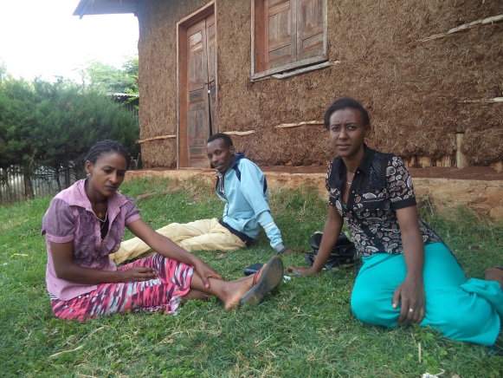
Figure 11-1 Discussion with woreda women youth and children office experts

Basic Social Service

Health service and health infrastructures
According to Chora Woreda health office health coverage in health centre and health post provision is 1000%. Latrine coverageis also 80%. Latrine utilization of the society is not good and it needs hard working. ChoraWoreda has different healthinstitutions such as 5 health centre, 32 health posts and 10 private clinics and 1 rural drug vender. 1 hospital is also on construction in Qumbabe town.
According to the Woreda health office different activities are on conducting in different levels for prevention and treatment of diseases. For example the health posts fully works on prevention which included vaccination, family planning and family health services, health education on sanitation etc. The health centre also performs different activities like diagnoses of different diseases, VCT for HIV/AIDS, admission for not more than five days, and also other prevention activities like vaccine, family planning services, supporting and monitoring health extension workers assigned in health post.
Table 12-1: Ten top diseases of Chora Woreda report

s/n | Disease type | No of cases
1 | Acute febrile illness | 5770
2 | Pneumonia | 3678
3 | Trauma | 2543
4 | UTI | 2817
5 | Skin infection | 2348
6 | Non bloody dehirrea | 2561
7 | Upper respiratory infections | 1725
8 | Diaspepsia | 2074
9 | Muscle skeleton system infections | 1934
10 | Other unspecified | 781
 | Total ten top diseases | 26231
 | Total Other cases | 7081
 | Total cases treated in woreda | 33312
Source: Chorawarada healthoffice 2007 year report

HIV/AIDS
At all health centreVoluntary council and test (VCT) andART service is available. Woreda health office informed as HIV/AIDS is series in the area and now the case is on declining. Currently 6 female and 4 male totally 10 person is on receiving ART.
Sanitation and hygiene
Regarding sanitation and hygiene situation health extension assigned in each kebele andthe health extension worker focus on it as their other health extension packages. Even though the report on latrine coverage indicates as 80 % status the real community practice on sanitation is not that much appreciable.The community assume as latrine is for those have no bush. No kebele is reported as open defecation free (ODF).
Health personnel
Chora Woreda has variety of health professionals which included health officer, nurses etc and with total health personnelexcluding health extension workers is52, health extension workers 57.
Table 12-2:Health personnel of Chora woreda health office

Health personnel | Quantity
Health officer | 8
Nurses (Clinical nurse, midwifery, public) | 39
Laboratory technicians | 4
Sanitarian | 1
Health extension workers | 57
Total | 109

Health problems and constraints includes
- Inaccessibility and transport problem
- Budget shortage
- The topographic area of the Woreda
- Traditional beliefs to discourage delivery at health institutions

Education
Education level of the household determines the level of community awareness and technology adoptability and other socio economic development status of a given community.
In Chora Woreda a total of 53 school facilities are on giving service at different levels. All the schools are government schools.But one KG is opened in Qumbabe town by private. Only 1 school is a preparatory.
Table 12-3: Chora Woreda Schools with their enrolment

Grade | Number of  schools | Student enrolment |  |  | Dropout
Grade | Number of  schools | M | F | T | M | F | T
1-4 | 23 | 10306 | 9491 | 19797 | 673 | 570 | 1243
5-8 | 25 | 4574 | 4237 | 8811 | 244 | 205 | 449
1-8 | 48 | 14880 | 13728 | 28608 | 917 | 775 | 1692
9-10 | 4 | 996 | 1012 | 2008 | 33 | 26 | 59
11-12 | 1 | 62 | 57 | 119 | 0 | 0 | 0
Total | 53 | 15938 | 14797 | 30735 | 950 | 801 | 1751
In Imbro Bonga kebele also there are 2 schools that teach 1-8 grades. And 1 school also teaches 1-4 grades. The school enrollment in Imbro Bongamale student accounts about 53.5 % and female student also accounts about 46.4 % of the entire students.

Grade | Number of  schools | Student enrolment |  |  | Dropout
Grade | Number of  schools | M | F | T | M | F | T
1-4 | 1 | 398 | 346 | 744 | 31 | 24 | 55
5-8 | 1 | 91 | 78 | 169 | 21 | 15 | 36
1-8 | 1 | 489 | 424 | 913 | 52 | 39 | 91

Table 12-4: school and enrollment of the Imbro Bonga kebele

Problems
- Traditional influences for girls education
- Female students migrate to Arab country
- Facility was not fulfilled for school, such as furniture, teaching materials, latrine, radio, plasma etc
- Budget shortage for school supervision and material supply

water supply
Chora woreda has different types of water supply system which included protected springs, hand pumps, motorized springs and deep wells. Currently the safe water supply coverage of the town is assumed as 100% and rural water supply coverage is 89%. The project kebele also have some protected springs and hand dug wells. Currently the functional schemes in woreda are 149 hands dug wells, 94 protected springs, 4 deep wells and 2 motorized systems. Totally there are 35 hand dug wells and 1 motorized spring system which makes the water supply coverage about 85 % of the kebele.

Source of Energy
The project area as majority of our country’s rural kebele has no electric supply and energy source.The area was known by its natural forest. The traditional practice of the society on conserving the natural society is very good. The Wollo settlers in adjacent kebele speak as there was a problem to construct a house during their settlement in 1977EC. At that time the forest was fully forest and the settlement was very scattered. But now even though the area has good forest coverage than other area there was an indicator fordeclining. The community uses wood for energy source, fencing of crops to protect livestock from their crops. In general, energy and livelihood depends on natural resource with increasing agricultural expansion at the expense of wood and shrubs, deforestation and less practice for forestation; the direct consequence of this in the long run inevitably to impact and ends up adverse impact on agro ecology of the area and influence food security situation unless proper water, land and natural resource management is in place.The community in Imbro Bonga kebele which is access able to transport started to sell fire wood.

Development Potentials and Opportunities
The project area has great agricultural potentials in terms of land slop, suitableagro ecology for production of diversified crops. The beginning of these irrigation projects will make an important contribution to the regional efforts to combat adequate marketable food and improved production and productivity of the project area and social infrastructure development. The main quantifiable opportunities will be the following.
- Existing institutional setup and government structure formed farmers in development zone and one to five farmer groups is good opportunity for community organization, labor mobilization, and formation of water users association and institutional arrangement of the project.
- The roads crosses the project kebele constructed and linked with Bedele town increases the market and flow of transport
- The upgrading of near village which is Abba bora to town administration may attract additional market to the area

Projects Social impact and Threats

Human Displacement
Expected displacement due to the project was assessed and analyzed at command area, upper and downstream. The proposed irrigation water source Unkusooriginates from thesame kebele and joined at the head site from two streams. The streams called Mole and Unkuso and after mixed together they called Unkuso river. By crossing the command area it mixed to the big river called Dabena river and then it flows to Nile river. Till command area the streams are freely flowing, no one tried to divert it and even the land is not favorable because of it is mountain.
Upper and lower command area:
Unkuso river have no problem on the upper side because of the river freely flows to the area without disturbance for irrigation and also other purposes. There are also different tributaries which added to the river on different sites after the weir and command area. Even though the community uses river water for different purposes such as livestock drinking, washing clothes, bathing and etc there are other options in the area. Even the Dabena river is not far and it can serve for livestock as an option.
So the upper side has no any problem if the river developed for the irrigation at assumed command area. Additional tributaries serve the community for different purposes like live stock and additional irrigation. Thelower command areas also have sufficient water because of different tributaries mixed to the river at different places. Already they have adapted system to use together without conflict.
The adverse impact of the irrigation construction which will beexpected to happen on upper and lower command area is assessed. As to the assessment study, proposed irrigation command area is near to the settlement and used under traditional irrigation and rainfed crop production. The technology option to use is diversion by gravity system. Some permanent plants may be in command area. The community was raised as that was not that much dangerous and the benefit from irrigation is better than the damage can happen due to irrigation construction. Those farmer groups whose land might be lost or damaged due to reservoir should be given awareness for willingness for the common benefit of the general community or compensated by equivalent farm land or other social system and conflict resolution committee, DAs and woreda stakeholders should take the lead role. As to the field observation and consultation with local communities, the proposed irrigation water source have sufficient capacity to serve all and less to anticipate other adverse social or people displacement due to the project.
Left and right side: The proposed irrigation project is one side canals on the left side. On both sides as we observed and discussed with community no adverse impacts can happen social and environmental impacton human beings due to the Unkso river irrigation constructions.

Health and related social impacts
The Proposed irrigation use diversion on the high area and free flows to the command area. Projectarea is a hot and marshy area; malariamay be expected because of irrigation water. According to discussion with Woreda health they are on working to prevent different communicable diseases. Currently the community awareness on malaria prevention is good community uses different methodologies to minimize malaria disease such as cleaning the environment and water area mosquito net use etc. so the irrigation water also not that much stored and creates favorable condition for breeding of mosquitoes. So we can minimize whatever causes can rise because of it. The expected health problem in the area is parasites and Amoebiases because of different vegetables and fruits eaten raw or without cooking.
According to health office the expected health impact from irrigation is less while the advantage by supplying additional income and improving nutrition is high. Woreda health office informed us that they have a health education program through health extension workers and also at health institutions by different staff, so therefore we can aware our community and control the expansion of such diseases.

Land Loss and land redistributionissues
In Oromia region land distribution didn’t conducted after Dergue regime. Most land of the command area is occupied by house hold farmers.Some farmers farmland included in command area is vast whereas most active farmers have no piece of land from the command area. Huge amount of money/cash will be invested for construction of the irrigation system and the irrigation is also naturally labor and capital intensive. So therefore land redistribution by considering different point is mandatory. For example some farmers have relatively vast land even though it was not in the command area, for such farmers replacing farm land in the command area is possible. Most command area is not the communal land, it occupied by private farmers while in the woreda the land near to river is not given for farmers by land ownership certificate. For those farmers who have land on rain fed and exchanging the land with irrigation is the best option depending on the region land and water use policy.
The issue will have to be well recognized and according to the land proclamation, irrigation land shall be redistributed with minimum of 0.25ha to ensure effective and efficient and equitable utilization of irrigable command area and water resource potential.
In general, irrigation development project has to meet efficient and social equity and land distribution has to be planned with consent & agreement of the community without worsening the other and should aims to maximize the overall benefit for local, regional and national economic development.

Project Benefit and Contribution

Direct beneficiaries
- Food Security and increased income at household level
Majority of the households in the project kebele able to meet family food demand and introduction of modern irrigation in the area will enable farmers to produce surplus crops and ensure sustainable food supply for local and regional market and contribute food security of the country by maximizing household income.
- Promotes women Income Generating Schemes
Women lack source of income generating scheme which is one of the major problems for women in the project area and development of irrigation scheme will enable women to participate in irrigated farming and garden vegetable production and generate income from development of the irrigation schemes. Particularly, widow and women household will benefit in generating adequate income for their family.
- Job Opportunity
Irrigated crop production is labor intensive activity and the landless and underemployed social groups will get opportunity and access for land through employment by cash during farming, share cropping and other in small holder farm expected to increase. Temporary employment also will be generated during construction and operation phase, as the project requires considerable working force from the nearby areas and it is expected that the implementation of the proposed project will contribute employment.
- It saves labor and time
The community especially the women can get variety of vegetables at nearby without travelling to distance area. This can help them by accessing the variety of vegetables and also saves women labor and time from travelling long distance.

Other Indirect economic benefit
Urban Development: The commencement of this small scale irrigation projects will contributes development of urbanization and market expansion through travelling to town for product sell and or the urban merchant travels to the area for product buying.

Skill, knowledge and Socio- cultural Improvement: The skill- knowledge and cultural diffusion created and farming system and work culture of the households will be greatly improved gradually through social interactions and skill transfer.

Community Participation

Cost Sharing
Community participation in planning, implementation and management is believed to ensure sustainable operation of development project. There is a need to establish and implement norms and procedures for financial sustainability and viability of irrigated schemes. Water resource development policy stipulates small scale irrigation project to be implemented on cost sharing and towards stage by stage cost recovery transition. Whereas Medium and large scale irrigation development schemes are to operate on full cost recovery principle.
The idea was clearly shared with community and the assessed community view and expected contribution from the community estimated. The community have traditional irrigation practice and their interest and commitment was very attractive. They have clear experience how irrigation benefits society and government. But they expressed their doubt that the irrigation land may be given to the investors not for the farmers. The community raised the experience of the adjacent kebele which the irrigation land given for the investors.
After extensive discussion on the government objective as to increase the farmers living standard not to give for investors then they accepted the idea. Discussionalso continued with possible contribution and cost sharing of the community to realize the project. Finally consensus was reached by the community group to contribute the required input (labour, material, money, etc,) for implementation of the project. Generally community is ready to contribute at least 10 % of the capital through different types such as labour, material and in cash.
Development project without community participation is less sustainable and highly recommended to promote community participation at all level and the estimated labour cost amount should be excluded from the total project cost if contracting the project to outside source for implementation.
At the end the community elected the entry committee which can serve to promote and facilitate the community during construction.
The elected committee name is
- Balcha Workneh chair person
- Alamu Fikadu secretory
- Kedir Birru casher
- Debela Biftu
- Nega Biftu
- Qanno Dhaba
- Dereje Yadeta

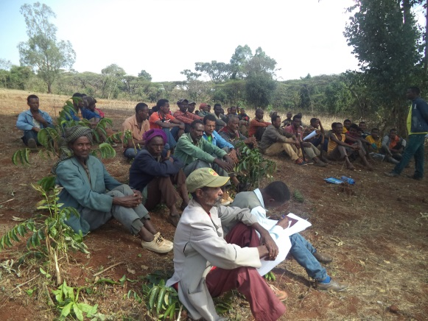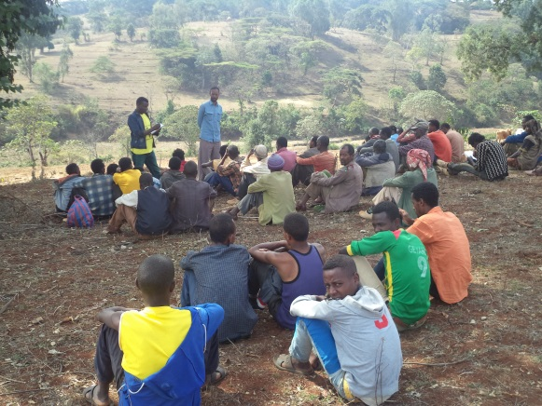
Figure 15-1: Discussion with the community
Camp site selection
During the community consultations the camp site issue was raised and discussed. The community agreed understood the importance of the camp and agreed to give the land for its construction. They promised to decide the camp site during the construction by considering different issues like accessibility, security and use for all beneficiaries.
Conflict resolution
Communities have been asked what other support to provide for project implementation and expressed their full willingness to provide local materials like stones, sand and land for camping and other project use and tolerate land loss due to canal or other; and if any conflict arises due to the project, community have agreed to settle and arrange land exchange for farmers whose land submerged due to the main canal, secondary and night storage.

Cost Recovery
As available review indicates local experience in irrigation cost recovery have not much performed or properly realized cost recovery. In area where water user associations or irrigation cooperatives formed, simply collect membership fees and share contributions in the case of irrigation water cooperatives and only some schemes cooperatives collect some money for system administration and management purpose.
The beneficiary community at Unkuso irrigation project currentlyhad traditional irrigation experience but not yet organized as water users associations (WUA)or Irrigation water user’s cooperatives (IWUC) but simply they established a committee which facilitates water use program. The existing committee is also just not formal but they says committee those volunteers who facilitates the water schedule and facilitates for water head diversion labour. But after intensive discussion with beneficiary community on the importance of the common committee as they are the beneficiary of one river they established the entry committee by making a representative from both kebeles. Totally seven committee members elected and shared a duty.
As stated in water resource development policy and strategies, medium and large scale irrigation development schemes are to operate on full cost recovery principle; whereas small scale irrigation project to be implemented on cost sharing and towards stage by stage cost recovery transition. Conceptually, the purpose of cost recovery is to provide sustainable irrigation services that improve irrigation performance through:
- More efficient O & M of irrigation facilities,
- Promoting more efficient use of water by framers,
- Support public investment project and ensure equitable and sustainable financial capital allocation
- Sustain the functioning of irrigation systems through their regular O & M and gradual upgrading of the O & M capacities of the local beneficiaries.
With these general understanding the idea of the cost recovery was discussed with the communities/beneficiaries and explored the opinion of beneficiaries and created awareness to the community and consensus reached to adopt water fee collection for sustainable operation and maintenance of the proposed schemes. In general, O & M with responsibilities and duties indicated in proposed organizational arrangement part II of this report.

Project Beneficiaries
The proposed project type is modern irrigation system for the benefit of small holder farmer and management system to operate at small holders’farmers’ level.
The proposed technology option of spring diversion irrigation is to cover 47 ha of command area and to make the beneficiaries effective and efficient in irrigation water utilization.
The selected technology type considered existing experience, knowledge and skills in the area to manage the irrigation schemes and the capacity of the existing water discharge. The technology type suitable and adopted is diversion of river and using by gravity system from Unkuso river majorly on left sideand some areas also on the right side of the river. The irrigable land area is expected to be 47 ha and expected to serve total beneficiaries of 188 households assuming 0.25 ha of irrigated land area perhousehold. From the above beneficiary households about 5% -10 % of the beneficiaries should include female headed households.

Conclusion and Recommendation
The proposed Unkuso SS irrigation project is a diversion from Unkusoriver and can serve a community of Imbro Bonga community.The design and planned irrigable command area is 47 ha and expected to serve a total ofabout 188household beneficiaries from this about 5%-10% household beneficiaries must be female headed. The project area has potential water source and suitable agro ecology for agriculture development. The command area is used under small holder farm and the project intended to develop for small holder’s farm and management with participation of the community.
The agricultural farming system use traditional system of ox pulled plough system and those who have no ox use share cropping and hand tools for farming and there is no effort for farm mechanization. Farmers at the area have no exposureto mechanized farm. The agro climate is almost mid land area that characterised hot and relatively good rain. Maize and sorghum are the major crops and people at project area are food securedand can produce excess supply for market provided improved farming inputs, efficient land and water utilization.
Among the constraints at the project area includes the ever increasing and unprecedented population growth and growing farming population, intensively and expanding cultivation, not using agricultural inputs like fertilizers and improved seeds, degrading natural environment and resources through traditional forest burning in dry season, rain fed dependence and lackof traditional irrigation and dependence on unreliable rainfall. Sustainable development, on the other hand, could be achieved with simultaneous efforts on all aspects of the socio-economic spheres that signify poverty to be fought in many directions. Therefore, some of the conclusion and recommendation with social aspect of the project highlighted as follows;
16.1 Conclusions
- Good traditional irrigation experience and traditional farming practice of the local communityin, positive attitude observed and consensus reached as it contributes livelihood improvement and positive for implementation of the project.
- Working towards the promotion of market linkage with traders which would have direct effect in strengthening the interaction between the urban and rural economy.
16.2: Recommendations
- Implementation and management of the project requires participatory approach where localpeople get job opportunity in the construction of the project and should not be limited to migrants from surrounding towns and distant places.
- Efforts should also be made to involve women in to the labor force and to be recruited in management committee,
- In consultant view, significant adverse social impact,people displacement or other adverse health impact is not expected and socially accepted and feasible for implementation.

- PART II: ORGANIZATION AND MANAGEMENT

Introduction and Background

Introduction
In addition to the social and other technical study, Institutional issues are equally important for success or failure of smallholder irrigation schemes. Therefore, required to assess existing institutional setup and with aims to rectify proposed organization and management arrangement in line with community managed irrigation scheme development, operation and management.
Furthermore, favorable legal framework for the enforcement of equitable water distribution and provision of efficient technical support for O & M and management of community organizations are among key factors for sustainable development of irrigation schemes to achieve the overall agricultural sector development objectives. As a result, the organization and management assessment included as main part of the feasibility study of the project.

Objective
The overall objective of the organization and management study is to depict existing institutional setup based on which to propose organization system and management options to overtake the responsibilities of sustainable operation and management of the irrigation Project and to assess the enabling environment, the policy and existing legal framework in the development of small scale irrigation projects.
Specific objectives
- To assess the existing management organization on SSIP
- To propose the appropriate management system for SSIPs
- To set monitoring and evaluation system for the projects

Policies and Legal framework
Assessment of the enabling environment, the policy and existing legal framework is one of the significant issues to understand the mandates, roles and responsibilities of the various stakeholders and local decision makers involved in the development of small scale irrigation projects.
In the current institutional and organizational arrangement of the federal government of Ethiopia, Ministry of Water Irrigation and Energy is responsible for managing and administering of large scale irrigation infrastructures of dams, main canals & roads, dikes and main drains and other major irrigation infrastructure development.
On the other hand, the administration, operation, management and maintenance of small-scale irrigation structures including the traditional schemes are the responsibility of community and local governments and sector stakeholders.
To achieve the intended objective of agriculture development policy, strategies and legal framework adoptedat national and regional level and some of the relevant and related documents reviewed includes;
- National Water Policy
- National Agricultural Development Policy
- Study & Design Technical Guide for Irrigation Projects by JICA & OIDA
- Agricultural Growth Program (AGP)
- Cooperative Society Proclamation
- Rural Land Proclamation, Administration and Use Regulation (Proclamation No 456/2005) and Regulation no 135/2007 and 455/2005, the expropriation of land holding for public purpose and payment of compensation

Role and responsibilities
Organization and management responsibility of water sector changes from time to time at federal and regional level. Still water resource management and responsible stakeholders varies from region to region. As per the organizational structures ofOromia National Regional State Oromia Irrigation Development Authority is responsible to undertake study, design and construction of small scale irrigation projects undertaken by participation of the community, transfer completed irrigation schemes to beneficiaries, and provide support for maintenance works beyond community level. Organizing farmer cooperatives mandate is also given for the cooperative promotion office. The agricultural extension work and promotion is also an agricultural bureau mandate. The irrigation extension is under agricultural office at Woreda level.
At Woreda level, Woreda OIDA office is responsible for small scale irrigationmanagement. The activity included small scale irrigation design, construction, and scheme management.In addition woreda agriculture and development office has given mandates for agronomicimprovement and schemes effective utilization.The Woreda agriculture office, articulates as they have sufficient experts for Irrigation development while the experts speaks as they need different technical trainings on practical irrigation.
Based on the discussion with key informants some gaps and constraints observed in organization and management of small scale irrigation schemes includes;
- Farmers less awareness and resistance
- Less input use
- Less acceptance for technology
- Shortage of budget
- Less technical experience of woreda experts
- Transport problem
- Shortage of manpower especially woreda OIDA office

Existing Organization and Management

Administration Status of the Project Area
Functional community organization starts from clear understanding of the project area and existing community organization and administrative setup
The kebele are divided into three development zones and administrative councils have established at kebele representing the legislative and executive bodies that also representextension workers and coordinated by kebele manager.
The command area beneficiaries of Unkuso SSIP are the community from the same kebele which is Imbro Bonga. The management of the schemehas to work with woreda administrative, kebele administrative, different stakeholders and with political administrative working in integration with community make the project more profitable and sustainable. This should be done from project planning, community mobilization, benefit sharing, community organization and institutional arrangement.The feeling of the community during community consultation wassimilar and attractive. Their initiative and doubt is similar. But after the discussion all the community agreed and decided to establish a common entry committee for facilitation of different activities in common and expressed as they can get more benefit if worked together.
However, the existing administrative structure is well organized and farmers formed into groups called (1 to 5) where one group leaderof five members as small unit of administrative and development unit expected to contributes active community participation in implementation and management of the project. Inaddition to kebele administration the cooperation and support of Woreda stake holders like agriculture and cooperative promotion office is mandatory.

Existing Community Organizations
The project scheme command area is anticipated to serve the Imbro Bonga community and irrigation infrastructure planned is diversion of the river irrigation system for the people living in the aforementioned kebeles.
Theirrigation experience is not that much satisfactory and in modern and organized way. Even though there is a traditional and modern irrigation schemesin Woreda and the woreda cooperative office registered as there is an irrigation beneficiary cooperative no cooperative started a job as cooperative or as an association. It needs intensive effort of concerned stakeholders tocreate awareness, capacity building towards irrigated farming practice and gradually establish strong irrigation management structure to operate & maintain irrigation system on sustainable basis.

Community Consultation and Participation
As the organization and management assessment prevails, the farmers in the project area have good knowledge and practice on the economic importance of irrigation. They informed us their awarenessincrement from time to time on irrigation use andknow they arenot only rain fall dependent for their livelihood source. But their productivity and income is not that much as expected. It requires continuousawareness creation and facilitation to bring in good attitude and productivity for improved benefit from irrigated agriculture. Consultation meeting and discussion was made as regards to importance of the project and implementation of the envisaged irrigation project as well as on their roles & responsibility during and after construction of the irrigation scheme.
During the consultation with farmers and community at project area major outstanding issues raised and discussed with conclusive remark given as follows;
- The beneficiaries are willing to fully participate in construction through cash, labor and material contribution at list 10% and to take responsibility of O & M of the scheme then after.
- They are willingly agreed to strengthen the established water users committee and promised to establish Water Users cooperatives to properly utilize the water and for sustainable operation and management of their irrigation scheme.
- Moreover, they decided to carry out required maintenance of irrigation structures, main & secondary canals and any in-farm structures by themselves and cooperatively manage the scheme through their community association or cooperatives.
As observed and in opinion of the consultant, better experience on irrigation but less experience in adopting modern irrigation system and management sointensive effort required in irrigation extension work to the target people.

Local Administration Support to the Scheme
Consultation was made withworeda administration,woreda irrigation development authority, Woredaagriculture office, woreda water, energy, mines office, woreda cooperative promotion office, woreda healthoffice, woreda trade and market development office, woreda education office, woreda women children and youth office.It was realized that the local decision makers and concerned stakeholders have positive attitude towards implementation of the project.
Finally, the local authorities indicated as it is a government and their interest and communities demand for irrigation development, even they had conducted different effort to increase irrigation use for food production and meet security at large and agreed to resolve any problems that will arise on land use, water distribution and management of command area throughout study, construction, operation and implementation of the project and planning for efficient and equitable land and water allocation.

Proposed Organizational Structures

General
The proposed institutional arrangement envisage irrigation project essentially is intended to be farmer-managed and the command area farmers are expected to be fully involved in the planning, design and construction of the scheme, after which they are to own and manage as well as operate and maintain the systems on sustainable manner. With this objective, the organizational structure based on water source, settlement pattern and irrigation system structures, explicitly to the intended user community based irrigation schemes proposed with available option as follows.

Proposed Organization arrangements
Water user association (WUA) and irrigation water user cooperatives (IWUC) are the two organizational options for consideration in this report. As the existing experience in the country shows, water users association (WUA) is much more community based and simple to establish, but its legal status not yet recognized and draft proclamation prepared to effect legal entity and proposed with expectation to get approval. Whereas, cooperative is already given legal entity and it is the higher stages of the farmers’ organizations below the union. Based on the management experience in the country, it is better to establish irrigation water user association (WUA) first and then promote to irrigation water user cooperatives (IWUCs).

Water User Association (WUA)
The expected project beneficiaries include smallholder farmers with very low traditional experience to manage the irrigation water and scheme management can start with simple Water Users Associations (WUAs) and gradually develop to IWUC. The organization setup of irrigation water user’s cooperatives and (IWUC) and water users associations (WUAs) are similar except legality and the function and role of credit and market committee under IWUC. The WUA is limited for the distribution of irrigation Water among the beneficiaries, cleaning of canals, collection of water fees and support in minor maintenance of the irrigation scheme and do not involve credit and market until given legal ground.
The structure and organizational setup of WUAs is follow farm blocks and groups of farm households for smooth flow of information and management of group activities. The control committees of WUAs are accountable to the General Assembly.
A general Assembly which is directly elected by all members will be the highest decision making body. The executive committee to be elected by the General Assembly will carry out routine activities of the Association. Major committee and subcommittee to be established under WUA and IWUC include;
- General Assembly
- Water Management Committee
- ControlCommittee
- Disputes and ConflictResolutions Committee
- Credit & Marketing Promotion Committee
- Water Distribution Committee
- Group Leader

The general assembly of irrigation water user association and Woreda offices like woreda OIDA, agricultural and cooperative and promotion office have an advisory and capacity building relationship while the General assembly and others have direct managerial relationship.
Woreda OIDA

Woreda agriculture office
Woreda cooperation promotion office

Figure 19-1: Proposed Organizational Structure for Irrigation Water User Cooperatives (WUC)

Water distribution committee is responsible to enable fair& equitable distribution of water, irrigation scheduling and coordinate labor mobilization and water fee collection… etc. Functions shall be devised by the management committee and must get the approval of the General Assembly before implementation.
During organization and establishment of proposed irrigation water users cooperatives’ the support from Woreda OIDA, woreda Agricultural office and cooperative promotion office, Kebele Administration and DAs as well as community leaders is crucially important as front line stakeholders in the process of providing management support.

Land issue and dispute settlement approach
Within the context of Unkuso small scale irrigation project area, the irrigation land holding size of some farmer is high and above the minimum requirement and for efficient and equitable land use land redistribution could be effected with consent and agreement of the user community. Land redistribution to be conducted should follow the procedure and strategies of land proclamation.
Rural land administration proclamation has explicitly and transparently indicated that except the irrigation land, farmers holding land shall not be redistributed. With regards to redistribution of irrigation land, procedure to be followed indicated on article 14.4 of the proclamation and explicitly states;
- A maximum holdings size of irrigation land of farmers households shall not exceed 0.5 hectare
- The distribution and redistribution of irrigation land shall be applicable to both traditional and modern irrigation lands, but not applicable to irrigation land used by individual or group of farmers by developing springs water, diverting small rivers or water harvesting on their own effort.
- In land redistribution, land holders whose land lied in the command area shall be given priority and retain the maximum holding size of 0.5 ha and the remaining land shall be distributed with minimum 0.25ha for farmers in the vicinity.
- Farmers whose irrigable land holding redistributed to others, shall be compensated with a reasonable rain fed land by the user of the scheme and if that not possible the land holder shall have the right to get additional o.5ha from the irrigable land area.
- Distribution and redistribution of irrigation land shall be made with the participation and decision of the community.
The management of the irrigation water user association/ cooperation expected to work signed by all beneficiaries and in consultation with kebele of the project area and Woreda administration when it found appropriate.

Cost Recovery and Water Charge Approach
The irrigation water users association/ cooperative to be established not only to maintain fair & equitable water distribution and scheduling, but also creates awareness of cost recovery, plan and implement water charging mechanisms with consensus of the general assembly. Awareness rising should be made to water management committee and subcommittee members and each user group should clear on the purpose and use of water charge and approved by the general assembly.
The following major tasks are proposed to be undertaken as a preparation to implement organization and management and thereby to achieve cost recovery on proposed irrigation schemes;
- Conduct wide coverage awareness creation on irrigation cost recovery for the sector offices at all level, irrigation water users and other stakeholders;
- Strengthen the management capacity of the community organization / irrigation user’s associations/ cooperatives to enable them to implement the cost recovery.
- Promote Woreda and Kebele level support to irrigation water users on irrigation agronomy, water management and marketing of perishable products.

Training and capacity building
It is highly important to facilitate the transfer and adaptation of modern institutional arrangement and management of small scale irrigation schemes to attain sustainable operation of the system. In this regards training and capacity building required at different level including Woreda staffs, development agents and farmers group that aims to
- Conduct public consultation and awareness raising for the community
- Special training on leadership and organization for water management committee and sub committees, team leaders
- Strengthen technical and management capacity of the woreda and DAs to improve and upgrade organization and management efficiency of the project
- In order to meet cost recovery, special attention needs to be given to understanding water charging methods, collection system, and cash spending and management, record keeping and reporting.

Monitoring and Evaluation
In the context of proposed irrigation project, evaluations adopts and focus on progress towards realizing sustainable organization and management system that ensure sustainable operation and management of the schemes which is the prime objective and goal. Therefore, periodical evaluation should be undertaken by relevant stakeholders and responsible sectoral office mainly woreda OIDA, woreda cooperatives promotion office and woreda agriculture and rural development office and others as required. Evaluation team should be organized from this office and undertake ongoing evaluation/Midterm evaluation, terminal and ex post evaluation of the irrigation schemes management. Implementation of cost recovery as liquidity/cash management requires special follow up and control and periodical evaluation and auditing the cash collected and expense and this should be made transparent for the community to maintain trust of the community. Evaluation framework model developed with due attention that at existing level of farmer’s awareness, education and organizational status, evaluation system considered that;
- The system should be simple to operate, and designed as to meet the specific requirements of the objective.
- It should concentrate on key indicators that measure the variables.
With the context of the proposed irrigation, some major issues evaluation and logical framework presented which could be modified as appropriate on application.
Table 20-1: Monitoring and Evaluation Framework
Expected Result | Indicators | Means of verification | Data source | Responsible*
Farmers trained with full understanding and awareness in establishing organization and management system (WUA) | % of farmers trained and given awareness | Reports from development gents | Development agents and kebele manager data | WAO  WCPO  DAs  WMC
subcommittee organized and provided capacity building training | Numbers of subcommittee formed and trained | Report from Development agents | Development agents and kebele manager data | “
WUA Established | Unkuso WUA in place for schemes management | Organizational setup, subcommittee and membership segregated by sex | Development agents and kebele manager data | “
Awareness and consultation workshop on cost recovery | % of members attended the consultation | Final consensus report | Woreda agriculture office, cooperative promotion office and DAs, | “
Cost recovery system in place | Number of members registered | List of members on register book | Woreda agriculture and Das | “
Bill and water fee collected | Amount of water fee collected | Registered book account | WMC  WDC  Team leaders | DA/Kebele manager

Conclusion
From the experience of small scale irrigation project in Ethiopia, organization and management is one of the challenging areas for sustainable operation of schemes and equally important to give due attention for organization and management aspect that ensure sustainable operation of the system. In this report, project area specific features, experience, community attitude were discussed and proposed most viable organization and management arrangement.
The proposed Unkuso SSIP planned to use river diversion irrigation system and net irrigablecommand area is 47 ha and expected beneficiaries of about 188 households. Modern irrigation experience of the community has not developed and existing local institutional setup for irrigation management is at low stage.
Based on the experience in other areas and taking the proclamation on cooperative society organization simple and farmers’ level organization and management system proposed to establish water user association (WUA) first and then promote to Irrigation water users Cooperatives (IWUC). Water management committee, and other Subcommittee like water distributor committee is required to establish under the general umbrella of one water user system.
In general, water centered agricultural development approach is government policy direction and responsible stakeholders should have in their annual plan, not only for the irrigation physical infrastructure development, but also equally for organization and management of the scheme.
The development agents and Woreda sector office should have to focus organization and management issues in their annual plan and monitored and evaluated in accordance of the set indicators by their report. Reports will be compiled and analyzed monthly, quarterly and yearly in the planning period to indicate the effectiveness of the performance and draw lesson for corrective measures and the future plan of action.

- PART III. FINANCIAL ANALYSIS

Introduction and Background

INTRODUCTION
This report refers to financial and economic analysis and feasibility test for Unkuso small scale irrigation project. The financial analysis is intended to assess the financial impacts on project participants and the economic benefits to the national economy. The analysis will, thus, seek to assess the financial effects of the project on the farm households as private business entity. It shows the rate of return on capital investment in implementing the project, and indicated the degree of financial viability of the project. The analysis also indicates the net returns, which will accrue to the farmers and project owners.
In making this analysis, all the relevant cost and benefit items with and without the project is identified, evaluated with appropriate prices and come up with reasonable incremental net returns and the financial Viability indicators updated accordingly.
Financial cost outflow and income inflow of the project estimated based on crop budget, farm cost and net returns under without and with project situation and based on the unit farm model computed gross and net incremental return of the project.

OBJECTIVE
Financial and economic analysis study aims to indicate project viability to assist investment decision. The specific objective is to test whether the project meets the basic feasibility criteria in both financial and economic terms and justify whether the project is a worthwhile for investment resources.
To meet the stated objective, the scope of task includes comprehensive financial and economic analysis prepared for the project. The report contained basic data and provided;
- Cost structure of the project
- Estimate financial and economic annual net returns from the existing and proposed crops in the command area and farm budgets,
- Financial analysis data base that are indicative of resource use and levels of returns,
- Evaluated the project in terms of financial return
- Tested financial Viability of the project including calculations of NPV, IRR and B/C ,
- Indicated source of finance and share of investments
- Economic analysis and economic return evaluated and
- Sensitivity analysis tested by using the financial and economic criteria by changing for all of the major variable factors.

BASIC PRINCIPLES AND CONCEPTS
Financial Analysis: The financial analysis is concerned with the individual financial entities participate in the project. In financial analysis outflow/cost and inflow/benefit primarily use market price. The financial analysis is more concerned investment financial profitability to farm operators as a business entity.
Economic analysis: The purpose of economic analysis of the proposed project is to measure its real contribution to the national income. The essence in economic analysis is that market prices as used in the financial analysis do not often reflect such opportunity cost values and the prices used in the economic analysis have to be real reflecting the true scarcity value or opportunity cost value. Therefore, the economy analysis requires for the adjustments of the financial benefits and the costs in to their respective real values in order to reflect their opportunity cost values. The purpose and aims in economic analysis is to test optimum allocation of scarce capital resources, and measure the extent to which investment to the project contributes additional economic value to the national economy based on the appropriate parameters as conversion factors. These parameters have been used in valuing the cost and benefit items for this project where Economic Price= Market Price * CF. Conversion factors are used based on the documents prepared as National Economic Parameters for Ethiopia (1998).

METHODOLOGY, ASSUMPTIONS AND CONCEPTUAL FRAMEWORK

General
Accumulated experience on the preparation of similar projects and the guidelines of project analysis technique was used. The analysis considered “without” and “with” project situations and identified involved cost and benefits, crop and farm budgets per models per hectare and developed the project cost and income flow and computed the analysis.

Inputs and Outputs
Engineering cost estimate provided by the irrigation engineer for the weir and irrigation infrastructure. The agronomist report used for cropping patterns, unit requirement of seed rates, fertilizers, pesticides, and labor days required for a hectare of land. Input and output price data is collected at project site that used in cost and benefit/Value projections.
- Farm Budget
Farm budget was developed from farm models by giving the inflows and outflows monetary values. In order to know the gross and net benefit of the “with” and “without” project conditions details of gross, net and incremental net benefit, farm budget was prepared per hectare basis first and transformed to the whole area of the proposed project
- Comparison Between “With” And “Without” Project
All the relevant cost and benefit items with and without the projects are identified, valued with appropriate prices and incremental net returns with the project computed. Cost inflow and outflow, crop budget, farm cost and net returns computed for with and without the project situation based on the unit farm model and arrived at gross and net incremental return of the project. In making the analysis, incremental project costs were calculated by deducting costs of the “without” project from the “with” project condition. Similarly incremental benefits were determined by deducting the gross benefits of the “without” project situation from the gross benefits of the “with” project condition. The comparison of the financial situation "without” project and “with” the project situation is clearly stated. Finally, net incremental benefits were calculated by deducting incremental costs from incremental benefits.
- Prices of Inputs and Outputs
Prices in the financial analysis for both cost and benefit streams are those, which are actually received and spent by the project at the farm site commonly called “farm-gate” prices. Prices information are one of the determinants in cost and benefit projection and used site specific as collected in and around the project area. Prices of output are that are actually received by farmers and are attributable to their crop production activities. Price information was collected for the existing and proposed crops and analyzed for appropriate price in the analysis.
Similarly input price information collected at project sites mainly cost of fertilizer, improved seeds, prices of tools, equipment and packing materials, wage for unskilled labour power cost assessed at the project area for consideration in the analysis.
- Project Period
One of the indicators for the length of the project period for which analysis has to be carried out is the technical life of the major capital assets. The project life of small scale irrigation with diversion estimated between 20-25 years. Therefore, project life is taken 25 years, which is acceptable determined by the technical life of the major capital items of the proposed project.
- Opportunity Cost Of Capital
The opportunity cost of capital is taken to be 10.23 %, which is recommended 10 % to 12 % by the Ministry of Finance and Economic Development of the Federal Democratic Republic of Ethiopia. In accordance with the findings of the study on Commercial Bank of Ethiopia this cut of discount rate is 10.23 % and this has been accepted for financial analysis of most projects.

Financial and Economic Viability Indicators and approach
Financial Net present value (FNPV), internal rate of return (IRR)and benefit cost (B-C) ratio are the parameters generally used to determine the financial viability of a project. In this study, the three measures of project viability were used to determine the viability of the project.
The three commonly used indicators of project viability were computed using the following formulae:

a. Net Present value
Where B_{t} = benefit in year t;
Ct = cost in year t;
t = 1, 2, 3, ...;
n = number of years;
i = interest (discount) rate

b. Benefit Cost Ratio
This indicator is equivalent to the ratio of the present value of benefits to the present value of costs. If there is no limitation of funds, the decision criterion is to accept any project having B/C ratio greater than 1.

c. Internal Rate of Return
Or
Where; LDR = lower discount rate at which its NPV is positive;
UDR = upper discount rate at which its NPV is negative;
NPV1 = Net Present value at the lower discount rate; and
NPV2 = Net Present value at the upper discount rate
The internal rate of return is a widely accepted criterion in project analysis and it is a very useful measure of project evaluation. The formal selection criterion for the internal rate of return measure of project worth is to accept all independent projects having an internal rate of return equal to or greater than the opportunity cost of capital (10.23%). The decision criterion in the Ethiopian context is to accept a project if it’s IRR is above the cutting edge of 10.23%, opportunity cost of capital.

Financial and Economic Viability Indicators and implications
Net present value (NPV), internal rate of return (IRR), and B/C ratio are used to determine the viability of the proposed project. Although, data base for the financial and economic viability test differs, the approach and implication of viability indicators are the same.
Net present value/NPV: The NPV measures the attractiveness of a project and the decision criteria is to accept all projects where NPV positive when discounted at the opportunity cost of capital. The NPV earns back all the capital and operating costs expended upon it and pay a given percent for the use of the money in the meantime.
Internal rate of return/IRR: The selection criterion with IRR is to accept where IRR result is greater than the opportunity cost of capital that justifies the project earns more than its opportunity cost and worth to implement.
Benefit -Cost ratio (B/C): It is defined as the ratio of the present worth of benefits to the present worth of costs. The selection criteria in financial B/C ratio are accepting all projects where the B/C ratio is greater than discounted at the opportunity cost of capital.

THE PROJECT

TECHNOLOGY
Depending on land topography and other considerations, project cost primarily depends on topographic nature of the area, system design and irrigation technology options (pumps, diversion, dam sprinkler, drip). Technology type is one factor determining for irrigation project cost and the project under study is diversion of the Unkuso river.

COMMAND AREA AND BENEFICIARIES
The benefits and cost flow depend on net irrigable land area and land development plan. The total potential irrigable area is over 47 ha to be effective under irrigation system. The project can support a maximum of 188 household beneficiaries under the existing land holding size of 0.25ha/household. However, irrigation is assumed labor intensive and recommended manageable land is 0.25ha/household and expected to serve total beneficiaries of about 188 households. Based on this basic ground, benefit and cost accruing estimated under “without” and “with” project.

PROJECT COST

General
Financial analysis requires data on capital cost of the project as well as the yearly ‘operation & maintenance cost’. The capital cost includes cost of construction of all engineering structures and developing infrastructure required for implementation of the project, including access road to project site from the main road.
Catchment development cost and others has not been loaded on the project for the purpose of financial analysis. Similarly, accruing benefits due to other economic effect have not been considered for financial analysis.

23.Irrigation infrastructure and system Investment Cost
The irrigation infrastructure and system development cost estimated to birr5,976,270.47. The total investment cost including VAT (15%) and 15% contingency estimated to birr 6,872,711.

Table 23-1: Investment cost- Irrigation infrastructure and system development

Description | Total Cost | Comm. Share
Preparatory Work | 815,518
Access Road construction | 75,000
Head Work Structure | 822,895
Construction of Flume structures on main canal | 887,891
Drainage Culvert on Right Main canal | 59,641
Night Storage (Capacity =1166m3) | 255,444
Division Boxes (at Night Storage) | 42,060
Turn Outs on Main, Secondary & Tertiary canals (Total No = 28) | 119,727
Road Crossing Culvert | 48,481
Foot Bridge | 22,531
Right Main Canal (MC-1) | 387,279
Left Main Canal (MC-2) | 422,410
Secondary Canals | 759,999
Drainage canals | 640,411 | 640,411
Field Canals (No=28) | 65,048 | 65,048
Total Engineering Cost Estimate of the project | 5,424,336 | 705,459
15% VAT | 813,650
Total Cost | 6,237,987
Community Contribution (%) |  | 13.01
Project Cost per Hectare | 132,723.12

Source: Engineering cost estimate/ BOQ

Other farm tools/implements investment cost
With development of the irrigation system, improved farm tools and implements required. Farm tools are estimated based on the area planned for development (sprayers -1/ha and others tools 2/ha and 1 motor cycle for management and supervision of the project in the period of project beginning of the project operation. Required list of farm tools and other investment cost estimated to birr 241120
in the first year and birr 40,400 and birr 130720 every two years alternatively of the project period.
The motor cycle is for management supervision by woreda OIDA office and this cost expected to be covered by the office from annual budget. With regards to other cost, farmers used to purchase farm tools for farm activities and this cost are assumed to be covered and financed by household beneficiaries.

Replacement cost
Major irrigation structure and equipment replacement are included in maintenance cost whereas farm tools are considered as replacement cost. Farm tools are estimated in ANNEX 9 and assumed to be replaced every two years, and the other cost is part of operation and maintenance and expected to cover directly or indirectly by target beneficiaries.
Table 23-2: "With" the project other Investment costs and Overhead costs

Investment schedule
In most case small scale irrigation project are planned to complete in one year period. Thus considering the land area of 47 ha planned for development, the project tends to small scale irrigation and taking the simplicity of the project structures we assumed to complete it in one year and investment cost assumed to be 100% utilized in zero year of the financial analysis.

Operation & Maintenance Cost
Irrigation project expected to wear and tear out and maintenance required ensuring sustainable operation of the system. This includes replacement cost for purchase and changing major irrigation equipment. Operation cost is the other cost intended for operation and running project as stipulated in project plan and this cost includes farmers and experts/staffs training as capacity building and other running cost. Training cost is assumed for the first two years as capacity building. Maintenance cost in most project analysis assumes 2-10% of investment cost and this project considered 3% of investment cost of irrigation infrastructure as maintenance cost. These costs are expected to incur annually and assumed to be financed by woredaOIDA office and community in the form of labor and financial contribution that requires establishing strong water users association for mobilization of financial and labor contribution for smooth and sustainable service of the business. Handing over of the project requires training/capacity building for woreda OIDA and concerned technical staffs of the woredas like agriculture offices and beneficiary community on roles and responsibility to administer the system of the irrigation scheme.

Project Financing
Farm tools and other replacement cost as well as operation and maintenance cost is to be covered from beneficiaries’ communities. In addition to this, the project investment is expected to be financed with participation of communities that willing to contribute labor and other local materials with total estimated amount to birr 705459 or about 13% of the total irrigation system investment cost in terms of labour by excavating tertiary canals, field and drainage canals. The remaining project and investment costs expected to be covered and financed either from government source or other external sources.

FINANCIAL ANALYSIS
The analysis considered two scenarios, with and without project. The financial analysis computed by considering cropping pattern, benefit and cost flow under the two scenarios.

WITHOUT PROJECT

Cropping pattern and land allocation
The existing cropping pattern dominates by maize and Sorghum which are the major cash and food crops growing in both agricultural production seasons.
The without project of existing cropping patterns as indicated by maize taking lion share of the cultivated land that accounts about 35% of the total irrigable land and wheat20%, Teff 15%, H.Bean 10% Chick pea10% and potato 10%. Crop production is rainfall dependent and there is no cropping in dry season and the most common cropping pattern at the project area is adopted for the financial analysis indicated in table below.
Table 24-1: Without project/Existing cropping pattern (%)
Annex 3 "Without" the project Cropping Pattern and Land Development

Ser.No | Crop Type |  | Cropping Pattern |  | Land Development by Project Years
Ser.No |  |  | % |  | 1 | 2 | 3 | 4 |  | 5 |  | 6 |  | 7 |  | 8 |  | 9 |  |  | 10 to 25
1 | Maize |  | 35 |  | 16.45 | 16.45 | 16.45 | 16.45 |  | 16.45 |  | 16.45 |  | 16.45 |  | 16.5 |  | 16.5 |  |  | 16.45
2 | Wheat |  | 20 |  | 9.4 | 9.4 | 9.4 | 9.4 |  | 9.4 |  | 9.4 |  | 9.4 |  | 9.4 |  | 9.4 |  |  | 9.4
3 | Teff |  | 20 |  | 9.4 | 9.4 | 9.4 | 9.4 |  | 9.4 |  | 9.4 |  | 9.4 |  | 9.4 |  | 9.4 |  |  | 9.4
4 | H.Bean |  | 10 |  | 4.7 | 4.7 | 4.7 | 4.7 |  | 4.7 |  | 4.7 |  | 4.7 |  | 4.7 |  | 4.7 |  |  | 4.7
5 | Potato |  | 15 |  | 7.05 | 7.05 | 7.05 | 7.05 |  | 7.05 |  | 7.05 |  | 7.05 |  | 7.05 |  | 7.05 |  |  | 7.05
TOTAL |  |  | 100 |  | 47 | 47 | 47 | 47 |  | 47 |  | 47 |  | 47 |  | 47 |  | 47 |  |  | 47
Source: Agronomy report

Farm input and yield estimates
At existing condition farmers at the project area use local seeds for all types crops under cultivation maize, Teff, wheat and H.bean and Chickpea, but apply commercial fertilizer and chemicals which are included in input cost. Farming system and technology is traditional hand tools and oxen-plough commonly and labor is used for land preparation.

Farm cost and income
In order to estimate the incremental income which will be obtained because of the project, it is necessary to estimate the benefit of the “without” project situations. Five crops dominate the cropping pattern in wet season and no crops in dry season. Without project production estimated and the total annual farm cost estimated to be birr 561781.6 and total farm income of birr 654308.15 and the annual net return amounts to birr 92527 constantly to the end of the project period.

WITH THE PROJECT Situation

Cropping pattern
Wet and dry season production considered and there are diversified crops proposed in addition to the existing crop under with project development.

Table 24-2: Cropping pattern with project
Sel.No | Crop Type | Cropping Pattern %
A Dry Season |  | 100
1 | Maize | 30
2 | Potato | 20
3 | Pepper | 20
4 | Tomato | 25
5 | Sugarcane | 5
B.Wet Season |  | 100
1 | Onion | 20
2 | Potato | 30
3 | Beetroot | 15
4 | Cabbage | 20
5 | Carrot | 15
Total |  | 200
Source: Agronomy report

Land Development Plan
The project as small scale project is possible to complete construction in one year period. It is to be assumed that all construction activities are to be completed in the zero year of investment, because the structures are not as such huge and farm structures are also not complex, so thatland use plan is to reach full capacity utilization in the 1styear’s period 100%. Based on this understanding, land area to be under irrigation will be expected fully 47 ha.
Table 24-3: Land development plan and cropping Pattern “with” the project
Sel.No | Crop Type |  | Cropping Pattern % | Land Development by Project Years
Sel.No |  |  | Cropping Pattern % | 1 | 2 | 3 | 4 | 5 | 6 | 7 | 8 | 9 | 10 to 25
A Dry Season |  |  | 100 | 47.00 | 47.00 | 47.00 | 47.00 | 47.00 | 47.00 | 47.00 | 47.00 | 47.00 | 47.00
1 | Maize |  | 30 | 14.30 | 14.30 | 14.30 | 14.30 | 14.30 | 14.30 | 14.30 | 14.30 | 14.30 | 14.30
2 | Potato |  | 20 | 9.40 | 9.40 | 9.40 | 9.40 | 9.40 | 9.40 | 9.40 | 9.40 | 9.40 | 9.40
3 | Pepper |  | 20 | 9.40 | 9.40 | 9.40 | 9.40 | 9.40 | 9.40 | 9.40 | 9.40 | 9.40 | 9.40
4 | Tomato |  | 25 | 11.75 | 11.75 | 11.75 | 11.75 | 11.75 | 11.75 | 11.75 | 11.75 | 11.75 | 11.75
5 | Sugarcane |  | 5 | 2.35 | 2.35 | 2.35 | 2.35 | 2.35 | 2.35 | 2.35 | 2.35 | 2.35 | 2.35
B.Wet Season |  |  | 100 | 47.00 | 47.00 | 47.00 | 47.00 | 47.00 | 47.00 | 47.00 | 47.00 | 47.00 | 47.00
1 | Onion |  | 20 | 9.4 | 9.4 | 9.4 | 9.4 | 9.4 | 9.4 | 9.4 | 9.4 | 9.4 | 9.4
2 | Potato |  | 30 | 14.5 | 14.5 | 14.5 | 14.5 | 14.5 | 14.5 | 14.5 | 14.5 | 14.5 | 14.5
3 | Beetroot |  | 15 | 7.05 | 7.05 | 7.05 | 7.05 | 7.05 | 7.05 | 7.05 | 7.05 | 7.05 | 7.05
4 | Cabbage |  | 20 | 9.4 | 9.4 | 9.4 | 9.4 | 9.4 | 9.4 | 9.4 | 9.4 | 9.4 | 9.4
5 | Carrot |  | 15 | 7.05 | 7.05 | 7.05 | 7.05 | 7.05 | 7.05 | 7.05 | 7.05 | 7.05 | 7.05
Total |  |  | 200 | 94 | 94 | 94 | 94 | 94 | 94 | 94 | 94 | 94 | 94
Source: computed based on cropping pattern proposed and land development plan in Agronomy

Input and farm cost
Development of the irrigation project expected to increase yield and productivity with optimum application of agricultural input. Farm input and cost as well as expected gross and net return under “with the project” situation computed.

Yield build up
Crop yield is mainly estimated based on the level of crop management, required practices, availability of agricultural inputs, proper extension activities, and existing climatic situations for crop production and other considerations like observation of existing yield condition, anticipated research out puts…etc. Considering these parameters, the following yield projection is given by the agronomist as shown in table below.

 | Table 24-4: Yield Build Up for "With" Project Situation
Sel.No |  | Crop Type | Yield With Project Condition (qt/ha)
 |  | Crop Type | 1 | 2 | 3 | 4 | 5 | 6 | 7 |  | 8 |  | 9 |  | 10 to 25
A Dry Season
1 |  | Maize | 70 | 75 | 78 | 80 | 80 | 80 | 80 |  | 80 |  | 80 |  | 80
2 |  | Potato | 80 | 90 | 100 | 120 | 120 | 120 | 120 |  | 120 |  | 120 |  | 120
3 |  | Pepper | 20 | 25 | 30 | 30 | 30 | 30 | 30 |  | 30 |  | 30 |  | 30
4 |  | Tomato | 250 | 280 | 300 | 310 | 320 | 320 | 320 |  | 320 |  | 320 |  | 320
5 |  | Sugarcane | 150 | 165 | 175 | 180 | 180 | 180 | 180 |  | 180 |  | 180 |  | 180
B.Wet Season
1 |  | Maize | 70 | 75 | 78 | 80 | 80 | 80 | 80 |  | 80 |  | 80 |  | 80
2 |  | Potato | 80 | 90 | 100 | 120 | 120 | 120 | 120 |  | 120 |  | 120 |  | 120
3 |  | Pepper | 20 | 25 | 30 | 30 | 30 | 30 | 30 |  | 30 |  | 30 |  | 30
4 |  | Tomato | 250 | 280 | 300 | 310 | 320 | 320 | 320 |  | 320 |  | 320 |  | 320
5 |  | Sugarcane | 150 | 165 | 175 | 180 | 180 | 180 | 180 |  | 180 |  | 180 |  | 180
Total

Price of input and output
Price used in the analysis is farm gate price that farmers receive as farm income and hence price of output used the farm gate price collected at project area. Sometimes price collected tends to reflect the retail price and in such case retail price changed to producer price by deducting 10% as market cost from the retail price.

Financial Analysis Results
The financial analysis was carried out after developing all the project cost and benefit flow and gross and net returns accruing to the farmers and/or project owners. Summary of the financial analysis results is shown in table below and the detail data table in Annex 18. The Net Present value is Birr 10,856,538.08 which is highly positive and based on the IRR criteria; the IRR results indicate 29% which is more than the opportunity cost of capital (1.61%), indicating the viability of the project. Based on the B/C ratio criterion, it result 1.61 which is much above one and meet the viability criteria in all yardstick indicators.
Table 24-5: Financial Analysis Result
viability indicators | Results
NPV | 10,856,538.08
IRR | 29%
B/C | 1.61

Looking the overall performance of the viability criteria, the project is highly Variable and worth for implementation.

Risk and Sensitivity Analysis
Risk and sensitivity analysis involves identifying the Variables that most influence a project’s net benefits and quantifying the extent of their influence, and assessing the probable effects of the result of uncertainties and risks associated with the project. The sensitivity analysis was thus carried out under the following major Variables, using financial values;-
- Increasing Investment cost by 10% maintaining other factors constant
- Decreasing Benefit of the project by 10% maintaining other factors constant
- Simultaneous increase of Investment cost by 10% and Benefit decreases by 10% maintaining other factors constant
The results show the project is still vale under all the sensitivity test scenarios and meet viability requirement as the summary of sensitivity test result indicated in Table below.

   Table 24-6Risk and sensitivity analysis

No | Scenarios | NPV | IRR | B/C
1 | Base case | 10,856,538.08 | 29% | 1.61
2 | Increasing investment cost by 10 % maintaining other factors constant | 6413216.16 | 20% | 1.34
3 | Decreasing benefit of the by 10 % and other variables constant | 6413216.16 | 20% | 1.34
4 | Simultaneous increase of investment and decrease of benefit by 10 % respectively maintaining other factors constant | 8059811 | 22% | 1.47

Comparison of the “without” and “With the Project” Situation Analysis of the project
The two production scenarios are made to compute the financial and economic benefits of the project investment. Accordingly 25years project period is assumed as to the technical recommendation and life year of the irrigation infrastructure for which the new investment is made. With two investment scenarios two cases are analyzed in terms of cost and return. The first case indicates that with very low investment capital and low water efficiency very low income (Revenues) has been attained, whereas in the second case “with the project” case the project analysis result shows that high investment cost, modern project infrastructure and high water use efficiency shall bring extreme high productivity of labour, material and high value of financial benefit for the community and high value of economic benefit for the nation. The figurative summary of the analysis result shown as follows: Therefore, according to the analysis made to compare and contrast the two scenarios the proposed project investment is much more beneficial to the beneficiary community in the project area and to the nation as whole.

ECONOMIC ANALYSIS

ESSENCE AND ISSUES
Irrigation project has a nature of public good as public investment capital expends with expectation return for the society and national income. The economic analysis therefore, aims to measure the real contribution of the project to the society/ national economy. Investment capital is also scarce and need efficient allocation and the economic analysis is to measure and evaluate the extent of project contribution to the national income justify worthiness to invest into the project from national economy point of view.

BASIC PRINCIPLES AND APPROACH
The essence in economic analysis is that, market prices as used in financial analysis sometimes do not often reflect the real cost/ values because of various imperfections may due to market distortion, policy intervention like fixed price of output and input or other factors. Such prices may not reflect true values and recommend price adjustment on cost and benefit streams to arrive the real value of each component. Accordingly, all the financial accounts on costs and benefits which have been estimated for making financial analysis have been adjusted to reflect the opportunity cost values by conversion factors given as standard, which are more or less described in table bellow.

Economic Evaluation
Economic costs and the economic returns determined by converting its financial costs and returns into economic terms through appropriate prices and conversion factors. The financial costs and returns converted into economic costs and evaluated to reflect real economic cost and return from the project.

Conversion Factor used for economic analysis

Conversion factors based on National Economic Parameters prepared for Ethiopia’ (1998) used in changing market price into economic price. I.e. Economic Price= Market Price * CF.
Table 25-1: Average Conversion Factor(ACF) of common items
No | Item | Average Conversion Factor(ACF)
1 | Unskilled Labour | 0.33
3 | Wheat | 1.28
4 | Fertilizer -Urea | 0.81
5 | Pulses | 1.17
6 | Construction: Irrigation & drainage | 0.623
7 | Operation & maintenance | 0.90
8 | Crop | Depends on type of crops
 | Spices | 1.06
9 | Discount rate | 10.23%
10 | Standard conversion factor | 0.90

ECONOMIC ANALYSIS RESULT
Financial and economic project’s viability measures/indicators are similar but differ in data input. Economic Internal rate of return (EIRR), net present value (ENPV), and economic benefit cost (EB-C) ratio are generally used to determine the economic viability of projects. The computed economic analysis result indicates viability of the project under all the viability indicators with positive economic net present value of birr 4813083.27, internal rate ofreturn 19% which is much above the cut point rate and economic benefit-cost ratio 1.44.
Table 25-2: Economic analysis and sensitivity test result
No | Scenarios | NPV | IRR | B/C
1 | Base case | 4,813,083.27 | 19% | 1.44
2 | Increasing Investment cost by 10% and Other things remaining constant | 6,345,115.19 | 24% | 1.68
3 | Gross return decreased by 10% | 135269503.81 | 73% | 16.01
4 | Increasing Investment cost and decreased gross return by 10% | 125453647.73 | 58% | 7.66

CONCLUSION AND RECOMMENDATION
Unkuso Irrigation project use diversion system from Unkusoriver source and expected to develop irrigable command area of 47 hectare. The irrigation infrastructure and system development cost estimated to birr 6,237987 including (Vat) 15% and community participation.
With and without project return and cost analysis computed and the results of financial the financial viability test result indicated Net Present value/NPV of birr$ The Net Present value is Birr 10,856,538.08 and IRR is 18 and B/C ratio is 1.31which is above one to bring added value for investment capital and under the financial viability indicators worth for implementation. The project is still viable assuming increase in investment cost by 10% and decrease in benefit by 10%. The project is still viable even assuming simultaneous adverse change in both Variables and advisable to implement in line with proposed development plan.
Economic viability also tested and the result much greater than the financial return. It also anticipated contributing other social and economical development for the area and implementing the proposed irrigation development project is tested worth full from financial and economic point of view.
With and without project return and cost analysis computed and the results of financial and economic analyses show viability of the project from financial & economic aspect and recommend for investment.
However, considering low level of traditional irrigation practice, low farmers organization in WUA, under developed market system of the area, even though the financial and economic analysis is done for full project command area, and the project infrastructure is relatively simple and it is possibly complete in one year to come to production at the beginning of next to the construction year.Since the command area is small as compared to the beneficiaries voluntarily use the whole command area at once in the first year of project operation.
Therefore, it is recommendable to design for the whole 60 ha to develop at one phaseand establish thefarmers WUA as immediately as possible to manage the scheme. In order to realize the anticipated outcome from the project, all the extension services (such as provision of inputs on time, technical support, provision of training and forming and strengthening (WUA) have to be undertaken to achieve the predicted benefits of the project.
Based on the findings in other report, this report ends with general conclusion and recommendation for decision makers. As discussed in different sectoral reports of feasibility study, the project is technically feasible, financial and economic return viable, but social awareness, farmers organization, road and market infrastructure at low stage and requires continued effort in basic infrastructure development to operate at small holder level. The national policy favors the establishment of such projects as a strategy to alleviate food shortage at local and national level and all round effort should be made to realize implementation and sustainable operation of the scheme.

ANNEXES

Annex 1:Farm Gate prices of crop out puts

Ser.No | Crop ype | Unit | Price/qt(Birr)
 | A.Wet Season
1 | Maize | Qt | 500.00
2 | Wheat | Qt | 600.00
3 | Teff | Qt | 1500.00
4 | H.Bean | Qt | 10.00
5 | Potato | Qt | 500.00
 | B.Dry Season
1 | Maize | Qt | 500.00
2 | Wheat | Qt | 600.00
3 | Teff | Qt | 1500.00
4 | H.Bean | Qt | 10.00
5 | Potato | Qt | 500.00

Annex 2: Farm-gate Prices of Inputs

Ser. No | Type Of Inputs | Unit | Price in Birr
1 | Labour | MD. | 80.00
2 | Oxen | OD | 85.00
3 | Fertilizer
3.1 | DAP | Qt | 1510.00
3.2 | Urea | Qt | 1212.00
4 | Seeds | Qt
4.1 | Maize | Kg | 6.00
4.2 | Onion | Kg | 300.00
4.3 | Tomato | Kg | 300.00
4.4 | Potato | Kg | 5.00
4.5 | Cabbage | Kg | 50.00

Annex 3: Without project cropping pattern and land development

Ser.No | Crop Type | Cropping Pattern | Land Development by Project Years
Ser.No | Crop Type | % | 1 | 2 | 3 | 4 | 5 | 6 | 7 | 8 | 9 | 10 to 25
1 | Maize | 35 | 16.45 | 16.45 | 16.45 | 16.45 | 16.45 | 16.45 | 16.45 | 16.5 | 16.5 | 16.45
2 | Wheat | 20 | 9.4 | 9.4 | 9.4 | 9.4 | 9.4 | 9.4 | 9.4 | 9.4 | 9.4 | 9.4
3 | Teff | 20 | 9.4 | 9.4 | 9.4 | 9.4 | 9.4 | 9.4 | 9.4 | 9.4 | 9.4 | 9.4
4 | H.Bean | 10 | 4.7 | 4.7 | 4.7 | 4.7 | 4.7 | 4.7 | 4.7 | 4.7 | 4.7 | 4.7
5 | Potato | 15 | 7.05 | 7.05 | 7.05 | 7.05 | 7.05 | 7.05 | 7.05 | 7.05 | 7.05 | 7.05
TOTAL |  | 100 | 47 | 47 | 47 | 47 | 47 | 47 | 47 | 47 | 47 | 47

Annex 4: Yield Build up for "Without" the project situation

Ser.No | Crop Type | Yield without the project condition(qt/ha)
1 |  | 1 | 2 | 3 | 4 | 5 | 6 | 7 | 8 | 9 | 10 to 25
1 | Maize | 31.43 | 31.43 | 31.43 | 31.43 | 31.43 | 31.43 | 31.43 | 31.43 | 31.43 | 31.43
2 | Wheat | 29.76 | 29.76 | 29.76 | 29.76 | 29.76 | 29.76 | 29.76 | 29.76 | 29.76 | 29.76
3 | Teff | 14 | 14 | 14 | 14 | 14 | 14 | 14 | 14 | 14 | 14
4 | H.Bean | 5 | 5 | 5 | 5 | 5 | 5 | 5 | 5 | 5 | 5
5 | Potato | 200 | 200 | 200 | 200 | 200 | 200 | 200 | 200 | 200 | 200

Annex 5: Quantity of crop production for without project

Ser.No. | Crop Type | Quantity of crop production with the "Without" the project
Ser.No. | Crop Type | 1 |  |  | 2 |  |  | 3 |  |  | 4 |  |  | 5 |  |  | 6 |  |  | 7 |  |  | 8 |  |  | 9 |  |  | 10 to 25
Ser.No. | Crop Type | yd/ha qt. | area/ha | prod. Qt | yd/ha qt. | area/ha | prod. Qt | yd/ha qt. | area/ha | prod. Qt | yd/ha qt. | area/ha | prod. Qt | yd/ha qt. | area/ha | prod. Qt | yd/ha qt. | area/ha | prod. Qt | yd/ha qt. | area/ha | prod. Qt | yd/ha qt. | area/ha | prod. Qt | yd/ha qt. | area/ha | prod. Qt | yd/ha qt. | area/ha | prod. Qt
1 | Maize | 31.43 | 16.45 | 517.02 | 31.43 | 16.45 | 517.02 | 31.43 | 16.45 | 517 | 31.43 | 16.45 | 517.02 | 31.43 | 16.45 | 517.02 | 31.43 | 16.45 | 517.02 | 31.43 | 16.45 | 517.02 | 31.43 | 16.45 | 517.024 | 31.43 | 16.45 | 517.02 | 31.43 | 16.45 | 517.0235
2 | Wheat | 29.76 | 9.4 | 279.74 | 29.76 | 9.4 | 279.74 | 29.76 | 9.4 | 279.7 | 29.76 | 9.4 | 279.74 | 29.76 | 9.4 | 279.74 | 29.76 | 9.4 | 279.74 | 29.76 | 9.4 | 279.74 | 29.76 | 9.4 | 279.744 | 29.76 | 9.4 | 279.74 | 29.76 | 9.4 | 279.744
3 | Teff | 14 | 9.4 | 131.6 | 14 | 9.4 | 131.6 | 14 | 9.4 | 131.6 | 14 | 9.4 | 131.6 | 14 | 9.4 | 131.6 | 14 | 9.4 | 131.6 | 14 | 9.4 | 131.6 | 14 | 9.4 | 131.6 | 14 | 9.4 | 131.6 | 14 | 9.4 | 131.6
4 | H.Bean | 5 | 4.7 | 23.5 | 5 | 4.7 | 23.5 | 5 | 4.7 | 23.5 | 5 | 4.7 | 23.5 | 5 | 4.7 | 23.5 | 5 | 4.7 | 23.5 | 5 | 4.7 | 23.5 | 5 | 4.7 | 23.5 | 5 | 4.7 | 23.5 | 5 | 4.7 | 23.5
5 | Potato | 200 | 7.05 | 1410 | 200 | 7.05 | 1410 | 200 | 7.05 | 1410 | 200 | 7.05 | 1410 | 200 | 7.05 | 1410 | 200 | 7.05 | 1410 | 200 | 7.05 | 1410 | 200 | 7.05 | 1410 | 200 | 7.05 | 1410 | 200 | 7.05 | 1410
TOTAL |  |  | 47 |  |  | 47 |  |  | 47 |  |  | 47 |  |  | 47 |  |  | 47 |  |  | 47 |  |  | 47 |  |  | 47 |  |  | 47

Annex 6:Values of crop production for "Without" project situation

Annex 7: “Without" the project Inputs Requirement and costs of production per hectare

Ser.No | Type of crop | Type of Inputs required |  |  |  |  |  |  |  |  |  |  |  |  |  |  | Total Cost of production/ha
Ser.No | Type of crop | SEED |  |  | LABOUR |  |  | OXEN |  |  | FERTILIZER |  |  | Packing materials |  |  | Total Cost of production/ha
Ser.No | Type of crop | rate(kg/ha) | price/kg | cost/ha | rate,MD/ha | Price/MD | cost/ha | rate(OD/ha) | price/OD | cost/ha | rate(qt/ha) | price/qt | cost/ha | rate(piece/ha) | price/pack | cost/ha | Total Cost of production/ha
1 | Maize | 50.00 | 12.00 | 600.00 | 146 | 70.00 | 10220.00 | 20 | 80.00 | 1600.00 | 1 | 1417.00 | 1417.00 | 30 | 15.00 | 450.00 | 14287.00
2 | Wheat | 50.00 | 7.00 | 350.00 | 70 | 70.00 | 4900.00 | 20 | 80.00 | 1600.00 | 1 | 1417.00 | 1417.00 | 30 | 15.00 | 450.00 | 8717.00
3 | Teff | 30.00 | 15.00 | 450.00 | 86 | 70.00 | 6020.00 | 40 | 80.00 | 3200.00 | 1 | 1417.00 | 1417.00 | 30 | 15.00 | 450.00 | 11537.00
4 | H.Bean | 50.00 | 9.00 | 450.00 | 49 | 70.00 | 3430.00 | 12 | 80.00 | 960.00 |  | 1417.00 | 0.00 | 30 | 15.00 | 450.00 | 5290.00
6 | Potato | 1600.00 | 4.00 | 6400.00 | 85 | 70.00 | 5950.00 | 20 | 80.00 | 1600.00 | 1 | 1417.00 | 1417.00 | 30 | 15.00 | 450.00 | 15817.00

Annex 8: "Without" the project Production costs

Annex 9: "Without" the Project other Investment costs & overhead costs in Birr

Ser.No | Cost Item | Unit | Quantity by Project Years |  |  |  |  |  |  |  |  |  |  | Unit Price (Birr) | Total Costs by Project Years
Ser.No | Cost Item | Unit | 1 | 2 | 3 | 4 | 5 | 6 | 7 | 8 | 9 | 10 | 11 to 25 | Unit Price (Birr) | 1 | 2 | 3 | 4 | 5 | 6 | 7 | 8 | 9 | 10 to 25
1 | Shovel | No | 47 |  | 47 |  | 47 |  | 47 |  | 47 |  | 47 | 70 | 3290 | 0 | 3290 | 0 | 3290 | 0 | 3290 | 0 | 3290 | 3290
2 | Hoe | No | 47 |  | 47 |  | 47 |  | 47 |  | 47 |  | 47 | 80 | 3760 | 0 | 3760 | 0 | 3760 | 0 | 3760 | 0 | 3760 | 3760
3 | Sickles | No | 47 |  | 47 |  | 47 |  | 47 |  | 47 |  | 47 | 70 | 3290 | 0 | 3290 | 0 | 3290 | 0 | 3290 | 0 | 3290 | 3290
4 | Axe | No | 47 |  | 47 |  | 47 |  | 47 |  | 47 |  | 47 | 80 | 3760 | 0 | 3760 | 0 | 3760 | 0 | 3760 | 0 | 3760 | 3760
5 | Gesso | No | 47 |  | 47 |  | 47 |  | 47 |  | 47 |  | 47 | 50 | 2350 | 0 | 2350 | 0 | 2350 | 0 | 2350 | 0 | 2350 | 2350
Total |  |  |  |  |  |  |  |  |  |  |  |  |  |  | 16450 | 0 | 16450 | 0 | 16450 | 0 | 16450 | 0 | 16450 | 16450

Annex 10: "With" the project Cropping Pattern and Land Development

Annex 11: Yield Build Up for "With" Project Situation

Annex 12: Quantity of Crop production"With" the project

Annex 13: Value of Crop production "With" the Project Situation in Birr

Annex 14: Input cost per hec with project

Annex 15: "With" the project other Investment costs and Overhead costs

Annex 16: "With" the project Production Costs

Annex 17: "With" Project Irrigation Development Investment & O&M cost in Birr

Ser. No | Description | Total cost 1-20 years | Period of Implementation (Years)
Ser. No | Description | Total cost 1-20 years | 1 | 2 | 3 | 4 | 5 | 6 | 7 | 8 | 9 | 10 to 25 years
1 | Design cost
2 | Construction Cost | 6237987
3 | Operation & Maint. |  | 187139 | 187139 | 187139 | 187139 | 187139 | 187139 | 187139 | 187139 | 187139 | 187139
4 | Other investment costs |  | 241,120.00 | 40,400.00 | 171,120.00 | 40,400.00 | 171,120.00 | 40,400.00 | 171,120.00 | 40,400.00 | 171,120.00 | 40,400.00
 | Total Base Cost | 6237987 | 428259 | 227539 | 358259 | 227539 | 358259 | 227539 | 358259 | 227539 | 358259 | 227539

Annex 18: Financial Analysis Results

Annex 19: Financial Sensitivity

Annex 20: Input cost Economic Analysis

Annex 21: "With" the project Production Costs

Annex 22: "With" the project Production Costs

Annex 23: Value of Crop production "With" the Project Situation in Birr

Annex 24: "With" Project Irrigation Development Investment & O&M cost in Birr

Annex 25: Economic Analysis Results

Appendix 25: Sensitivity Analysis Economic

Annex 26: References

- Best practice and technologies for small scale agricultural water management in Ethiopia, International Water Management Institute (IWMI), , Proceedings of MOARD/MoWRD/USAID/ symposium and exhibition , Addis Ababa, Published Colombo, Sri Lanka, March 2006
- Central statistics Agency (CSA), Annual Statistical Abstract, 2011
- Central statistics Agency (CSA), Household Income and Expenditure Survey, 1996
- Ethiopia Sustainable Development and poverty Reduction Program, Ministry of Finance and Economic Development (MoFED 2002, Addis Ababa , Ethiopia.
- Guide line for study of small scale irrigation projects in Ethiopia, Environment and social impact assessment, Continental consultant and Concert engineering (2002), August 2002.
- Guide to social analysis for Developing countries, ODA (1995), HMSO, London.
- Guideline for the preparation of public sector projects, Federal Democratic Republic of Ethiopia (FDRE 2006), Addis Ababa, Ethiopia.
- Ministry of Water Resource Development, Environment and social management framework and resettlement policy framework, Final Report, MoWRD, 2008
- Other unpublished secondary data from Chora Woreda sectoral office, kebele and development agent office
- Participation and social assessment : Tools and techniques , Rietbergen-Mccracken, J. and Narayan D. World bank, Washington, (1998),
- Proclamations on land and rural administration and others.
- Project Planning, Implementation, Monitoring And Evaluation, Training Materials And Manuals, Management Institute of Ethiopia (2002),
- Report on Ethiopian economy, Ethiopian Economic Association ( 20010/11), Addis Ababa.
- STUDY AND DESIGN TECHNICAL GUIDELINE FOR IRRIGATION PROJECTS by Japan International Cooperation Agency (JICA) and Oromia Irrigation Development Authority (OIDA) May, 2014

Annex 27: LIST OF CONTCATS IN CHORA WOREDA

No | Name | Organization/position | Contact address
1 | Betiglu Teshome | Woreda admin representative | 0935271614
2 | Asirat Ligidi | Chora woreda OIDA core process owner | 0917736871
3 | Atirsaw | Chora woreda OIDA head | 0917339928
4 | Bedhasa | Ilu Abba Bra zone Irrigation authority vice head | 0917158961
5 | Taju Abdu | Market development information expert | 0917218914
6 | Zerihun Hailu | Cooperative vice head | 0976064203
7 | Ayantu Taye | Youth office empowering youths | 091707866
8 | Fikadu Ebisa | Hinbiro Bonga kebele vce head | 0924438155
9 | Gashaw Mana | Hinbiro Bonga kebele DA | 0910479441
10 | Muluneh Amante | Hinbiro Bonga kebele committee | 0910679430

Annex 28 : Community petition
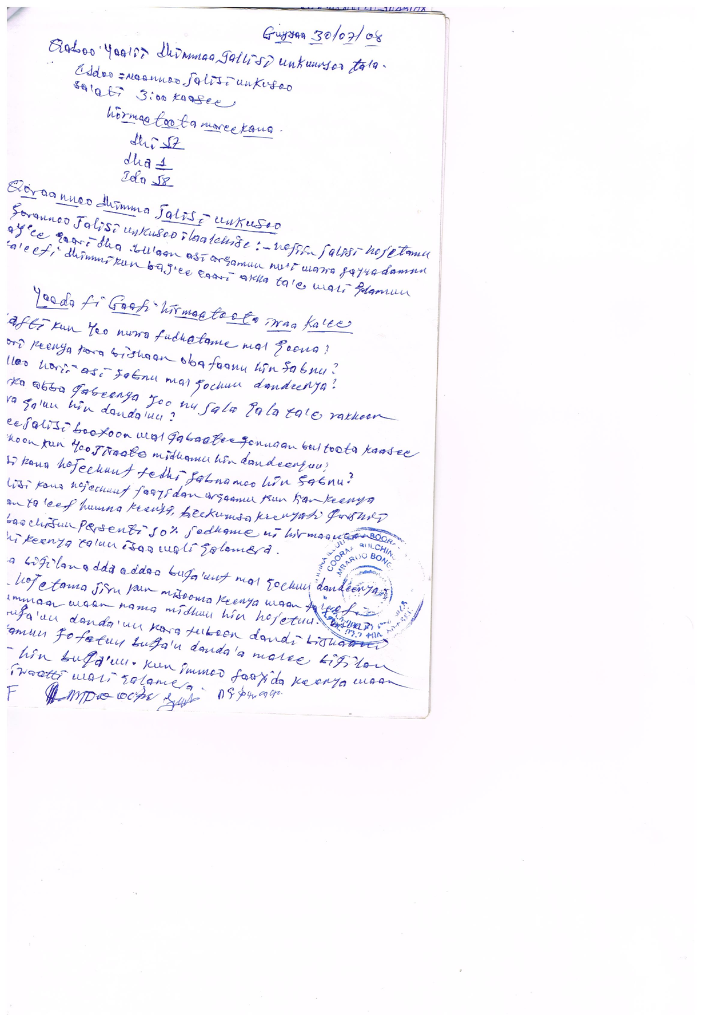
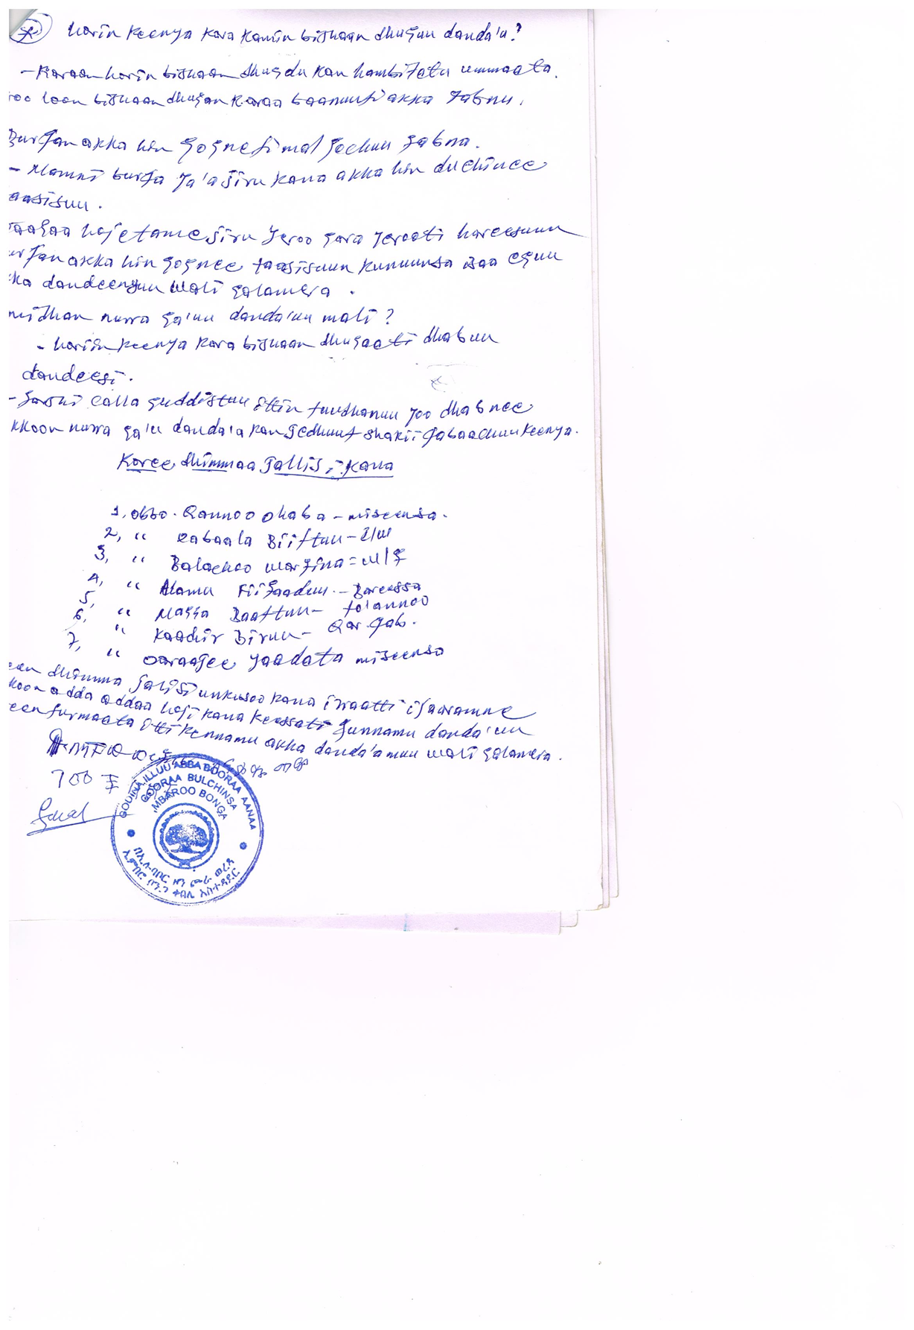
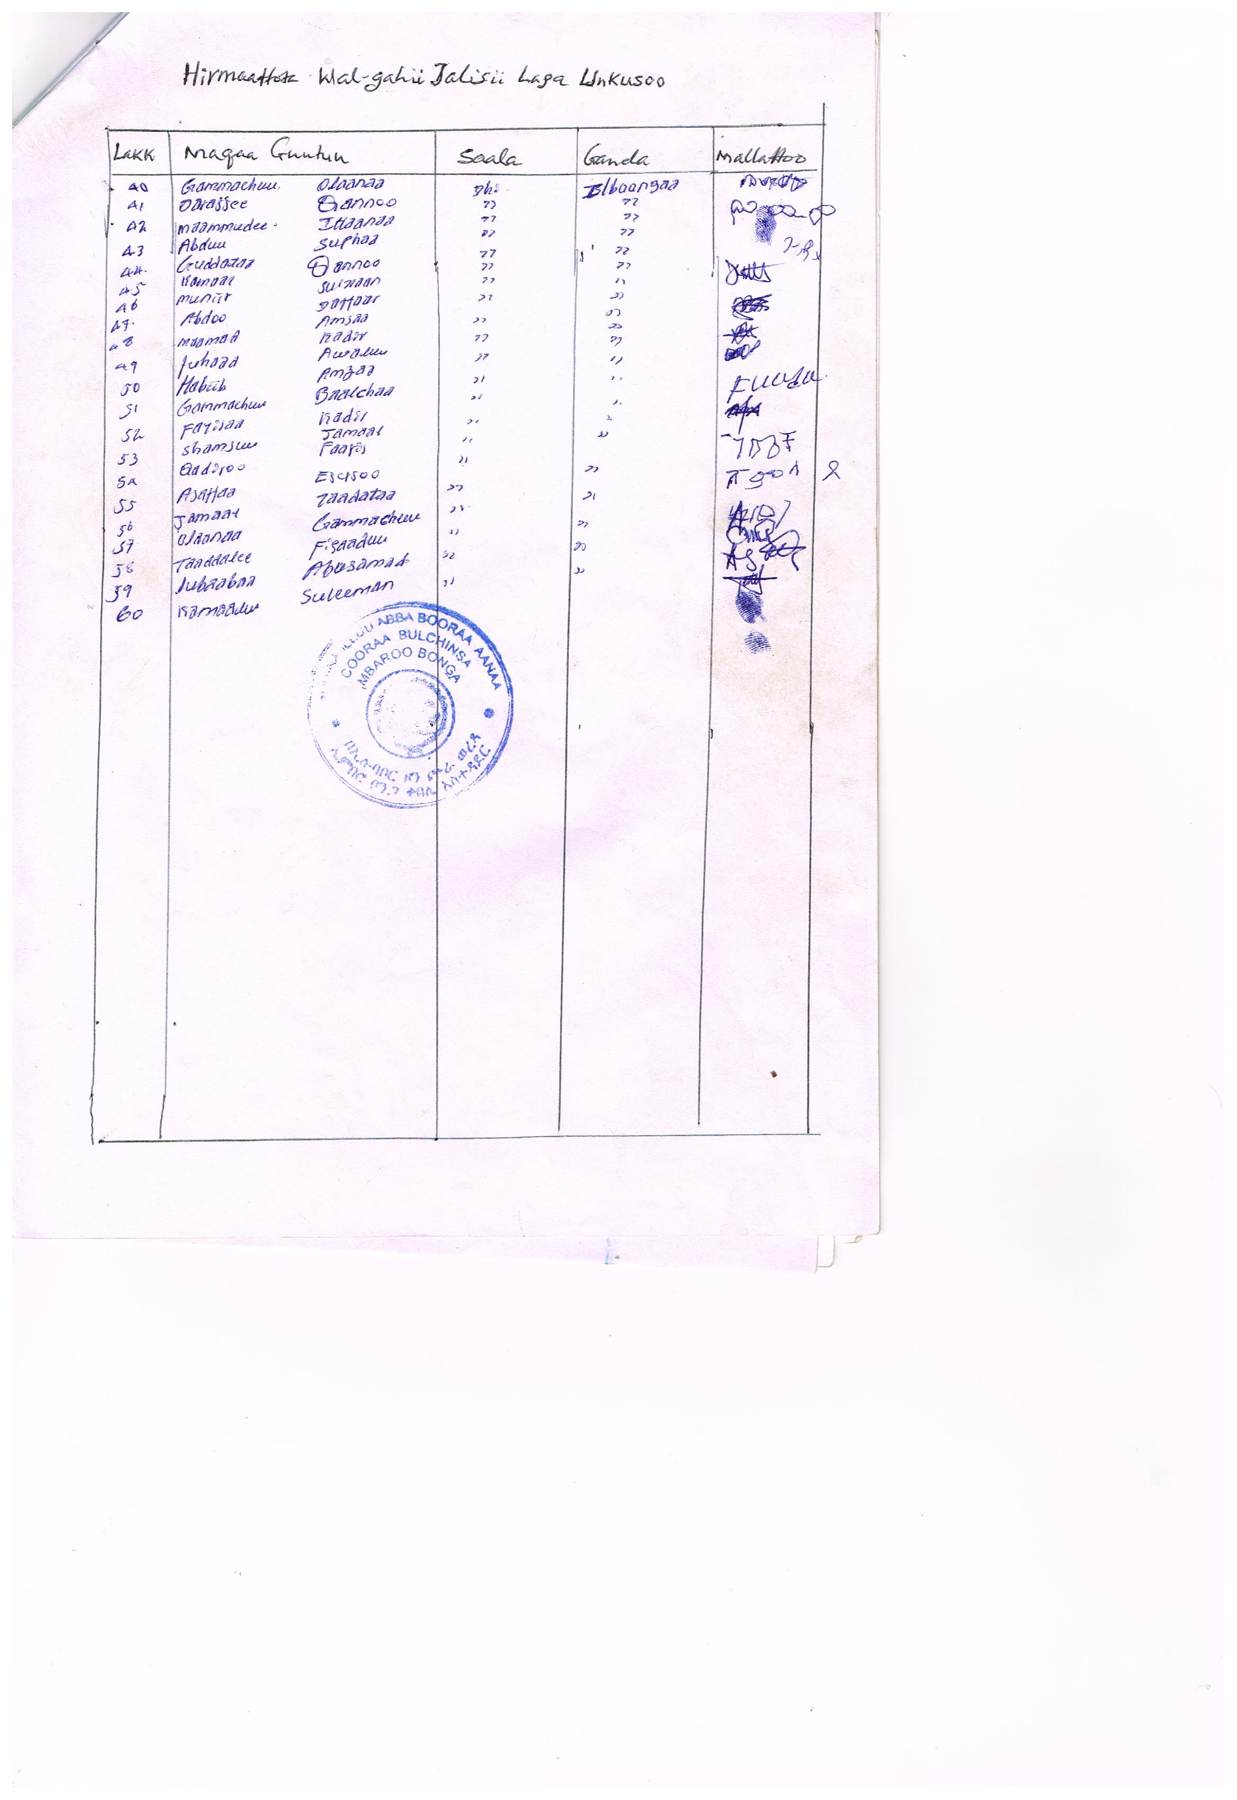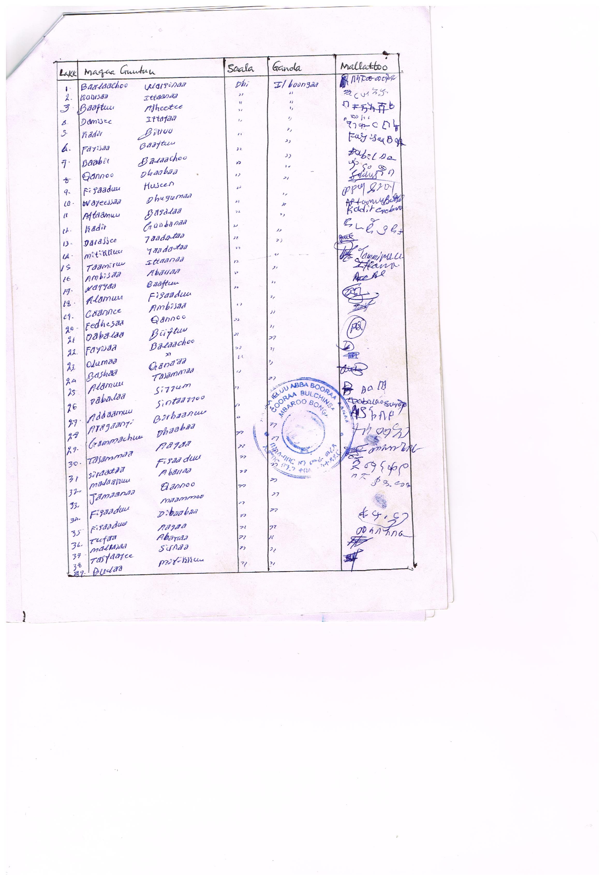
Annex 29: Community/ committee applications
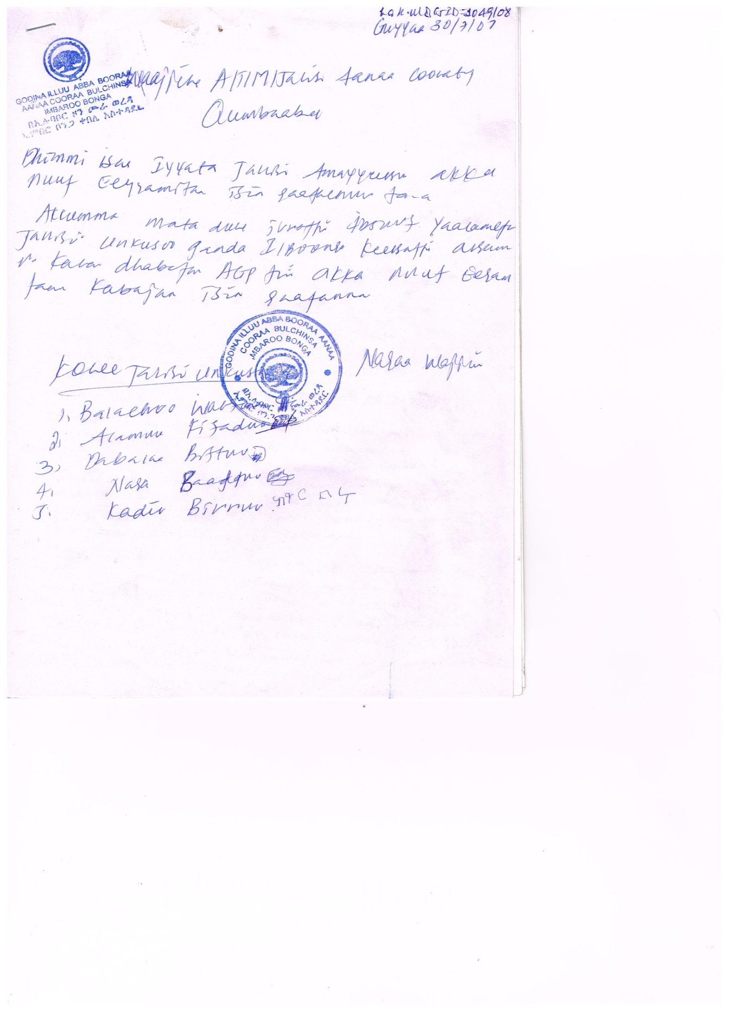

Figure26-1 Minutes of woreda stake holders consultations
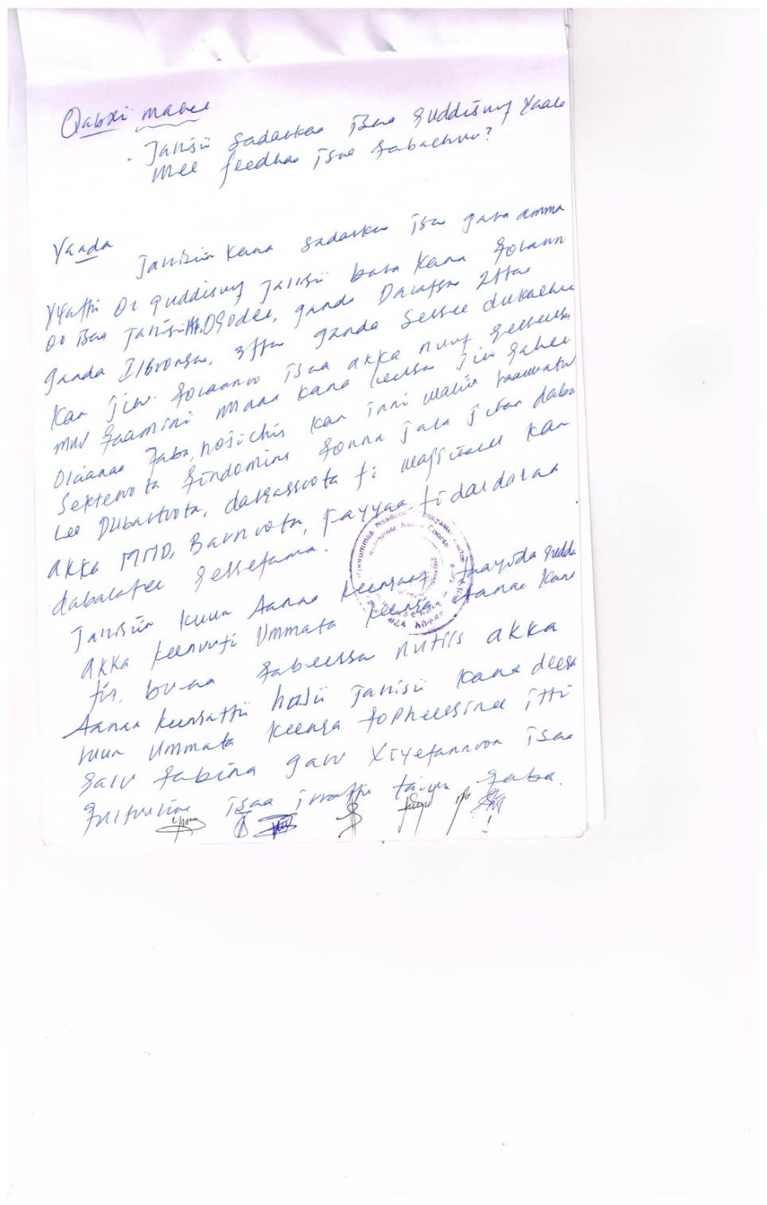
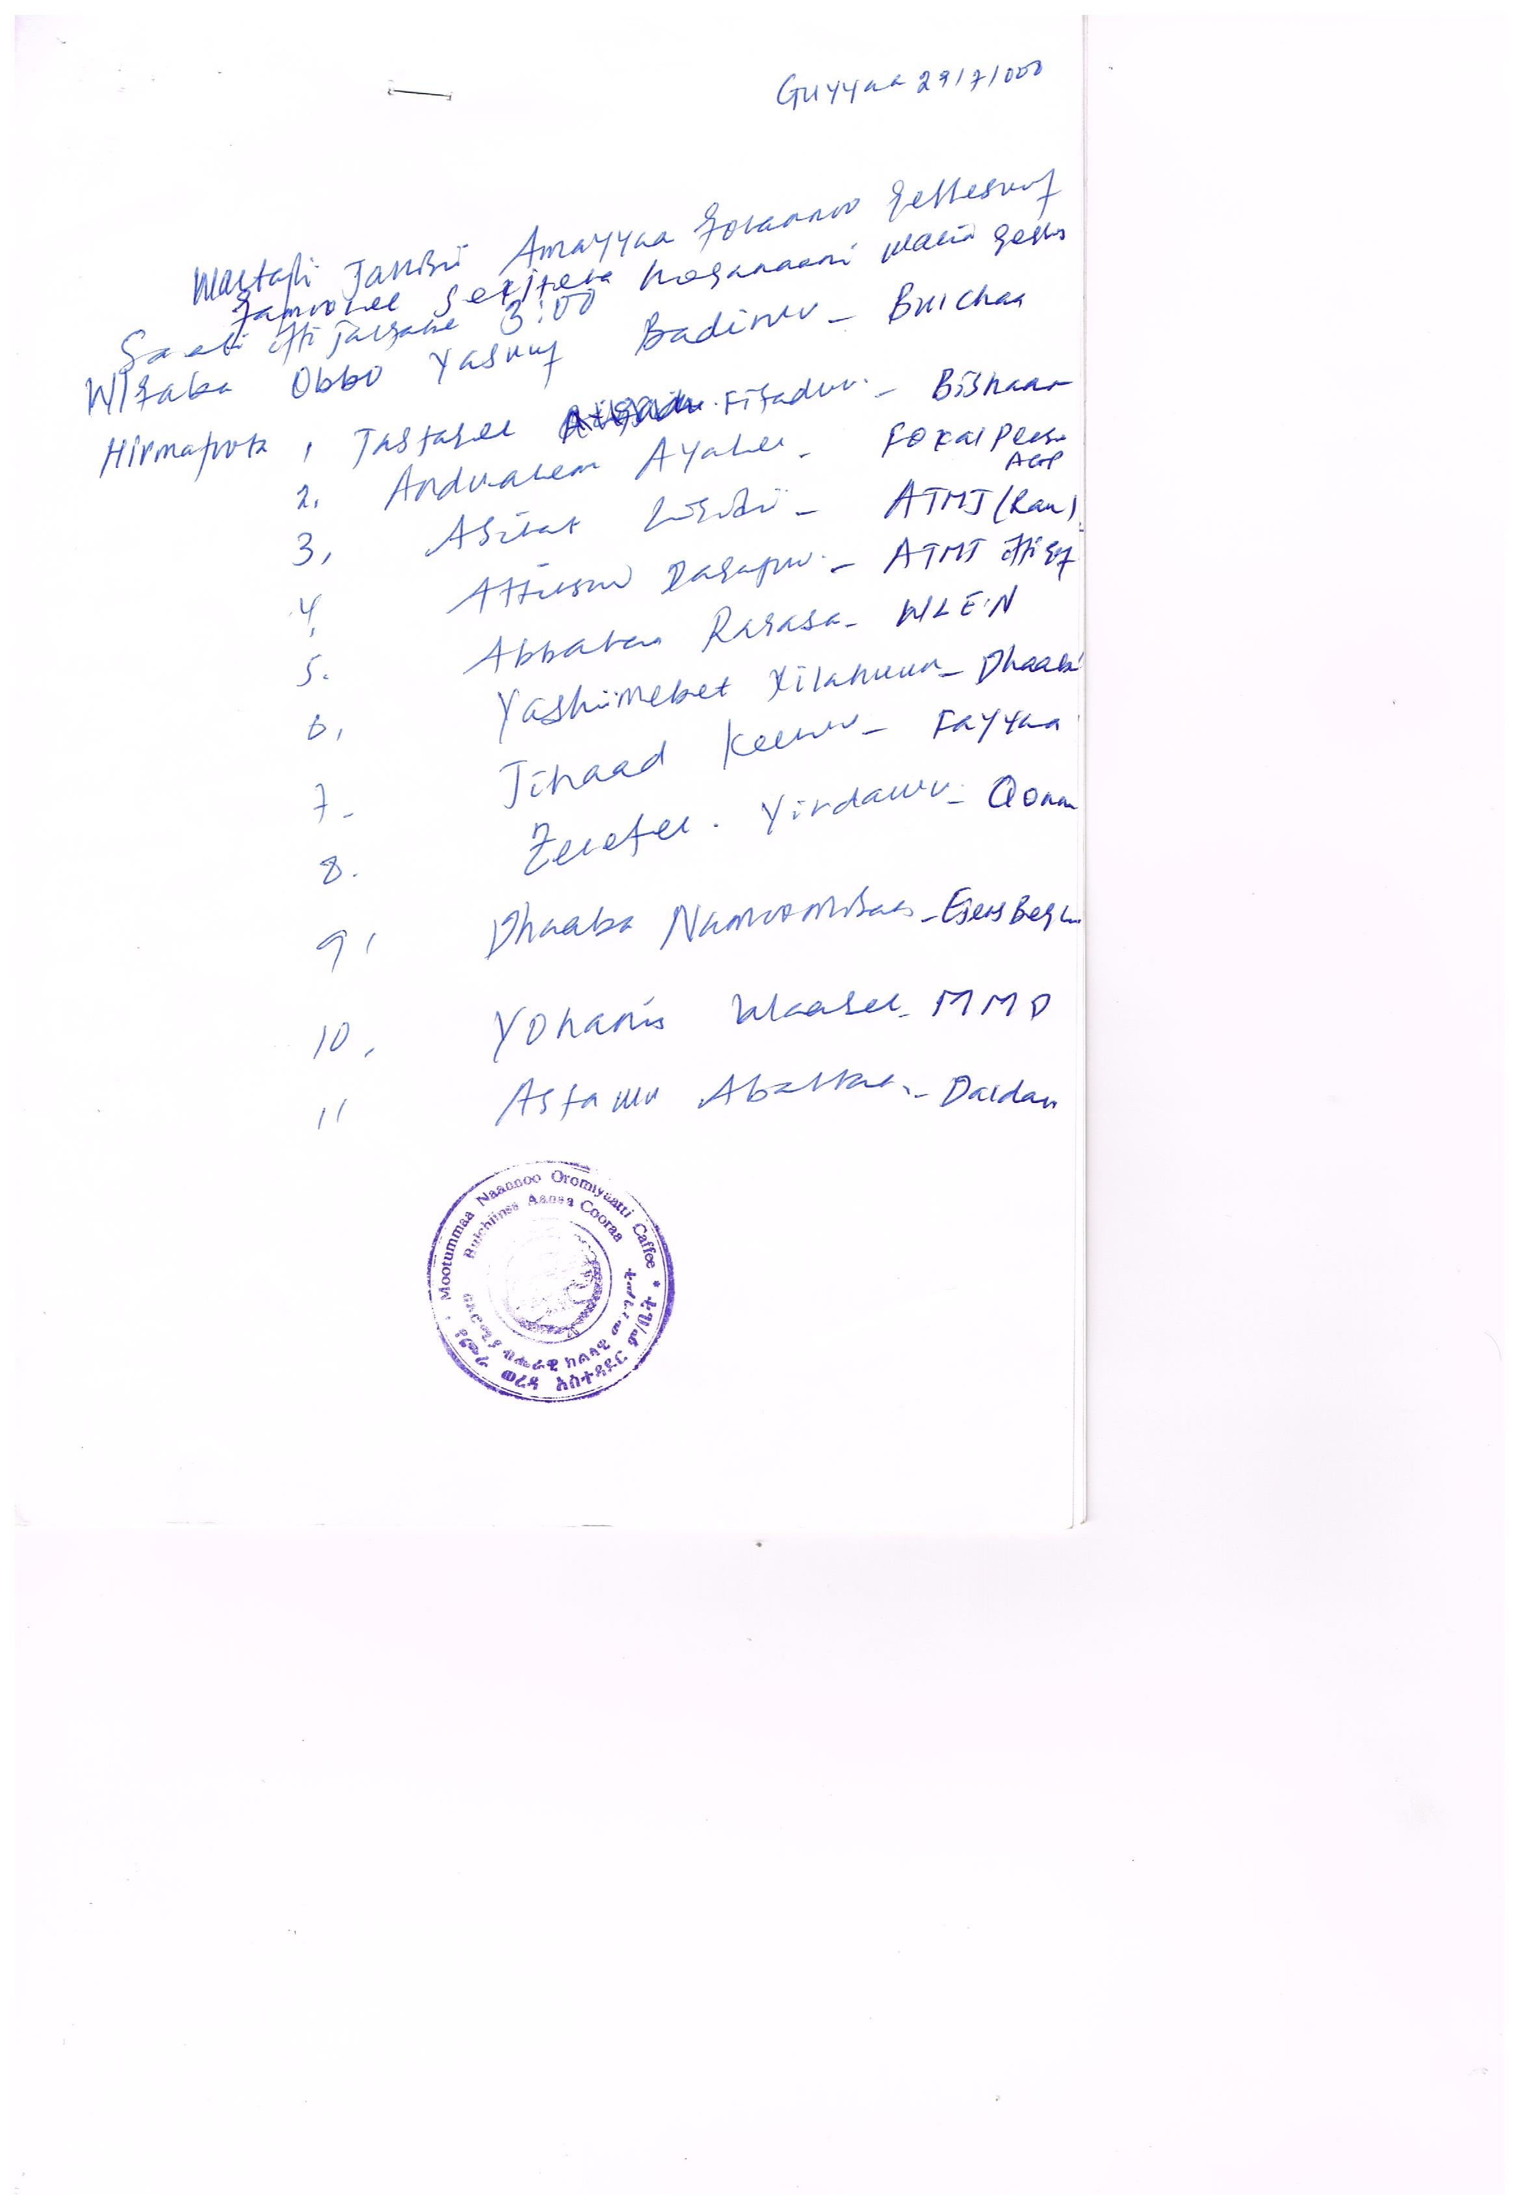

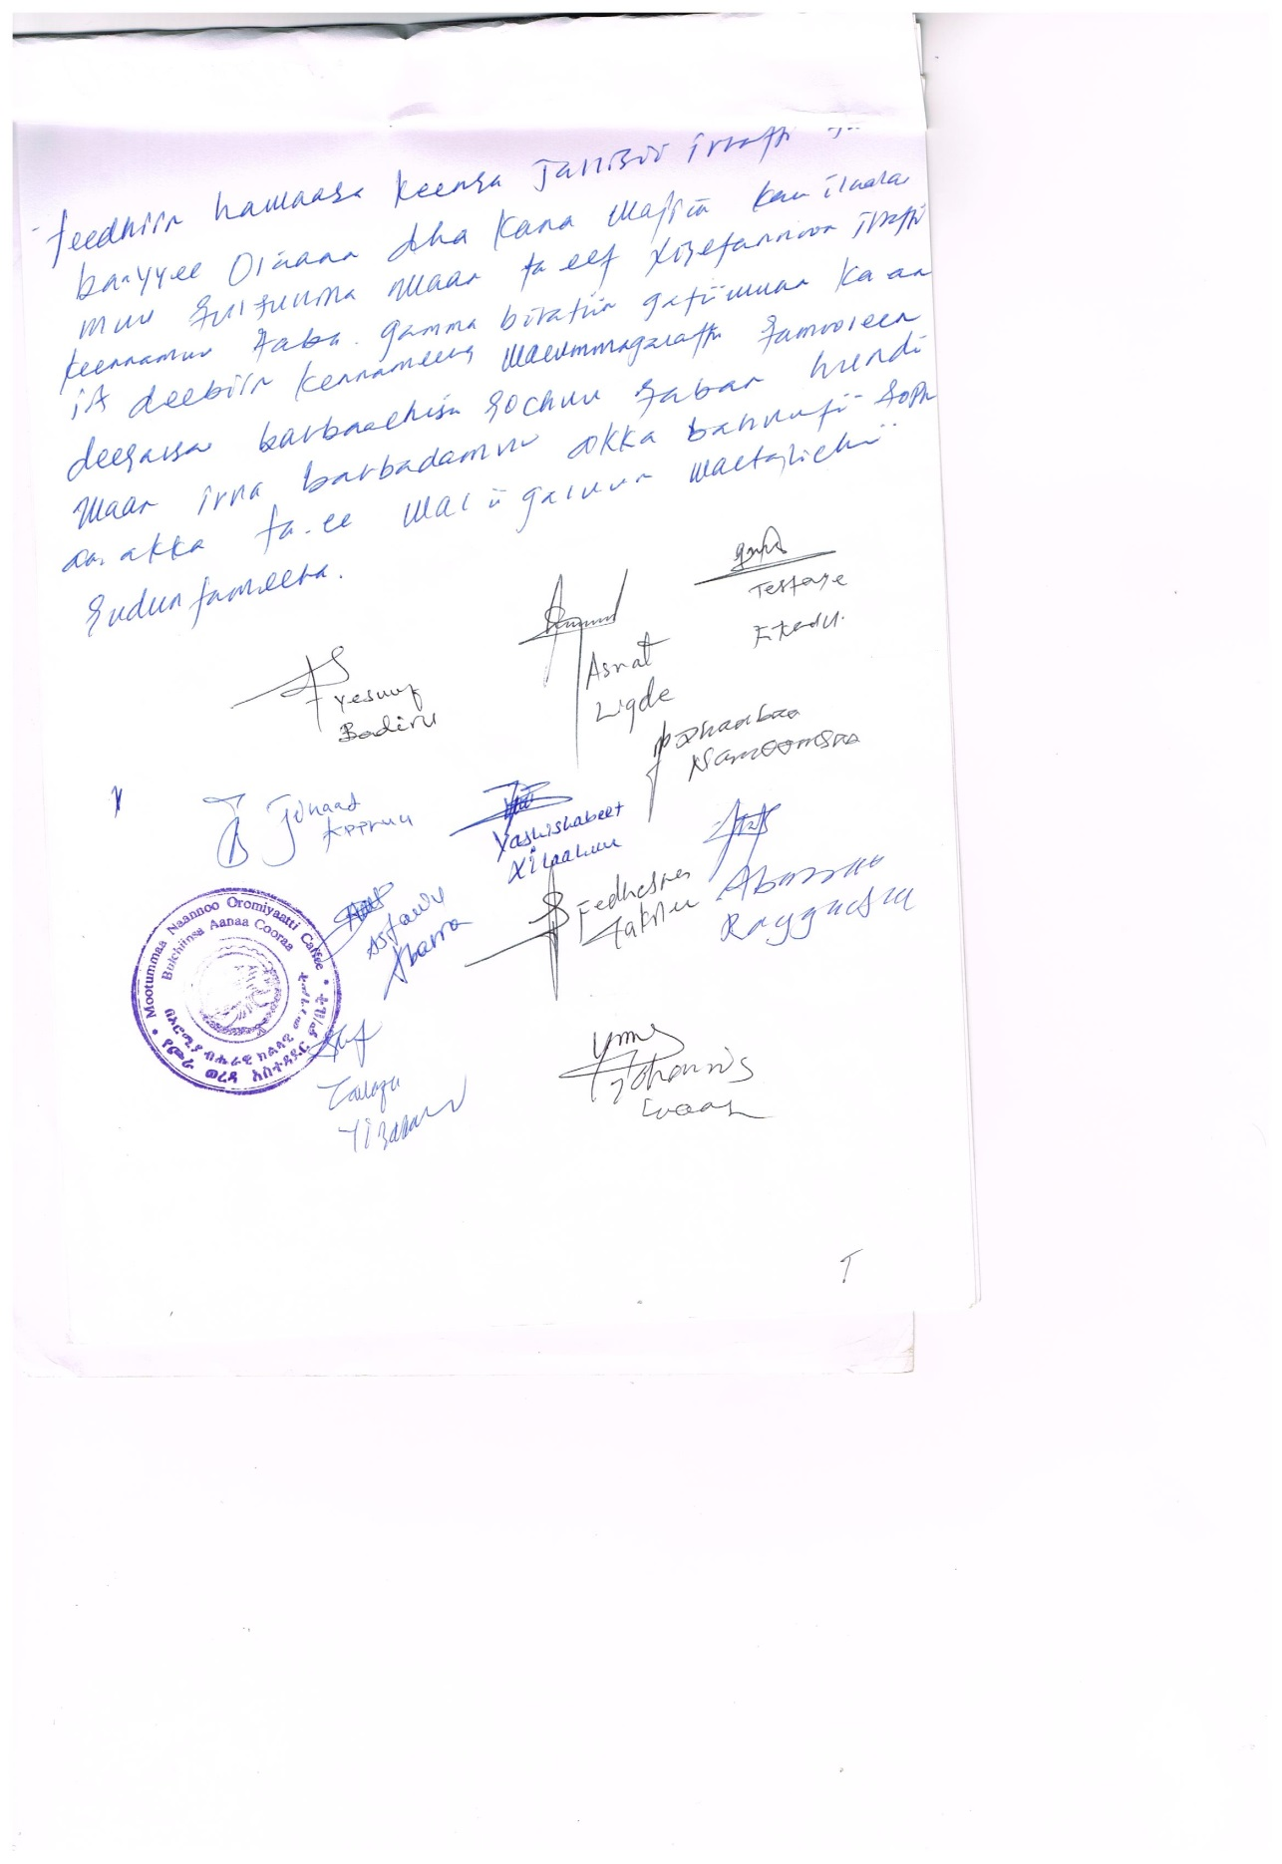

Annex 30: List of consulted stakeholders
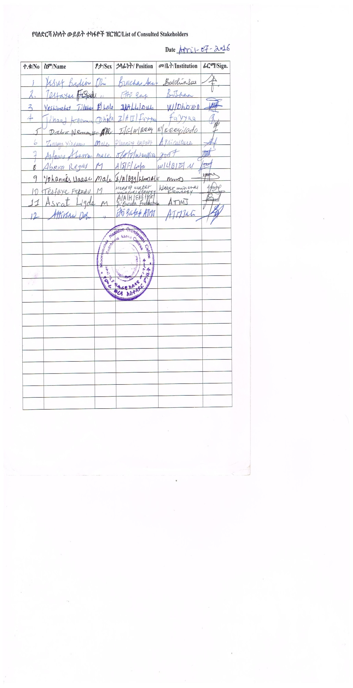

Annex 31: 32 woreda OIDA request

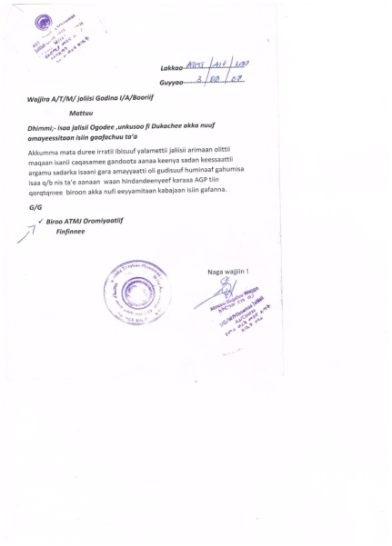

Annex 33: Woreda and kebele level Questioners

Woreda and Kebele Level Socio Economic Data Assessment
- Project Name _________________________________________________
- Location: Region ____________________Zone _________________Woreda ________________ Kebele________________
  - Name of towns and distance : Zone town _____________/____km; Woreda town _____/__KM; Rural village_________/____/km
  - Agro climates of the project kebele
Average altitude
Average rainfall
Average temperature
Rainfall seasons | Meher: From ________________ to _________________  Belg : From ________________to __________________
  - Agro-climate classification
%
High land
Mid high land
Low land
  - Land area, land use and land cover of the kebele
- Total land area: _____________ha;
Land Use | Area in ha. | % Share
Cultivated
Cultivable
Natural Forest
Waste land
Grazing and others
Total
  - Land holding size
Land Use | % Share
Landless
Below 0.5ha
0.5-1ha
1-2ha
2-3ha
3-5ha
>5ha
  - Population by kebele and sub village

Average family size:_____________
Number of kebeles ; Rural__________ Urban________ Total ______________

No | Kebele | Land area (ha) | HH | Population |  |  | Population Density
 |  |  |  | Male | Female | Total
  - Economic and livelihood base of the kebele
Sectors | % share contribution | Major crops and livestock type
Crop prod
Livestock
Mixed agriculture
Industry
Trade & commercial

  - What are major crops currently produced and potential to grow?
Major crops currently produced | Crops potential to grow | How is the crop use in terms of food and cash crops

  - Is the rainfall adequate for crop production? ___________
Does the community practice irrigation? ______________

  - Crop production and supply in the woreda
- Rain fed crop production
Crop type | 2003 | 2004
- Irrigated crop production
Crop type | 2003 | 2004

  - Irrigation experience
Is there traditional/modern irrigation practice? If yes give background information?
When constructed?
Who constructed?
What benefit?
Is there an organized water users association (WUA) in the kebele?

  - If yes, number of existing irrigation schemes in the woreda??
Name of irrigation schemes | kebele | Kebele | Command area (ha) | Remark (Traditional/Modern)

Water users associations (WUA) and membership
Name of irrigation water users associations | Number of members |  | Total
Name of irrigation water users associations | Male | Female | Total

  - Livestock
What are the major livestock: ________________ _____________________
What is the use value of holding livestock: _______________________________

Livestock type | Number of livestock | Average holding /household

What are the major livestock diseases? _____________________ _____________________
Where do livestock get fodder/feeding source? ________________ _____________________
Is there animal health clinic; ______________________________
What are the problems and constraints with livestock’s?
- _______________________________________________________
- _______________________________________________________
- _______________________________________________________
  - Food demand and Food security situation
- Is the kebele in food shortage/deficit?

- How is the overall food security situation?

- What copping mechanism in place to meet food security of the kebele/kebele?

- If there exist safety net as strategy indicate number kebele covered under safety net in the kebele ?

Number of households served safety net or other support?
Kebele | Indirect/food for work support  No of households |  | Total | Direct support |  |  | Remark
Kebele | Male | Female | Total | Male | Female | Total
  - What do you think are the factors that contributes food deficits in the kebele
- _______________________________________________________
- _______________________________________________________
- _______________________________________________________
- _______________________________________________________
  - Marketing
Major market place and distance from the project area within the kebele or neighbor kebele that serve as market outlet

Market place | Kebele | Distance from the project (KM)

Price trend (2000-2004) and current price
Crop type | Price trend by year |  |  |  | 2005  Current price
Crop type | 2000 | 2002 | 2003 | 2004 | 2005  Current price

- What are the product in excess of local market
- What product is in short supply for the local market?
- Can local market absorb increased production?
- Major market roots and product flow in the kebele as well as domestic and boarder trade if any. What product flow where and their market destinations?

  - Cooperative
- Existing agricultural cooperatives and Unions in the kebele
- Cooperative Membership by sex
Name of cooperatives /unions | Number of members |  | Total
Name of cooperatives /unions | Male | Female | Total
What are the constraints/problems in cooperatives management and weak performance?
- ______________________________________________________________________
- ______________________________________________________________________
- ______________________________________________________________________

  - Agricultural Extension and input supply
Name of kebele | Total number farmers households (both sex) | Number of farmers supported in extension service | Number of assigned development agents | No of health extension workers | FTC | No Nursery sites
- Give sex disaggregated data on farmers training and skill development in the last three years if any.

Distribution of input by kebele (2003 & 2004)
 | Unit | 2003 | 2004 | Remark
Fertilizer
DAP
UREA
Chemicals
-
-
Improved seeds
-

What do you think are the constraints in input supply
- ______________________________________________________________
- _____________________________________________________________
- _____________________________________________________________

  - Rural agricultural financing
How is the community attitude for credit & saving? Where do you get finance when in need?
Is there rural financing schemes (credit & saving) institutions in the kebele?
Who are the stakeholders providing credit & saving in the kebele?

For What purpose do the credit used ? | - ___________________________________  - ___________________________________  - ___________________________________

Credit beneficiaries and disbursement
 | Total |  |  | Amount of credit
Year | Male | Female | Total | Amount of credit
2001
2002
2003

  - Gender issues
What are the problems of women at the area mainly in ?
- Education
- Health
- Water supply
- Grinding mill
- Fuel

What are the traditional or cultural constraints hindering women equal decision making power

Availability of women organization in the project area
Do women participate in agricultural activities other development project work like daily work as off farm income?
What are the benefit this irrigation project for women?
Do you think any adverse/negative impacts?
Are women conceived equal to men counter parts? Who is the decision maker

Describe task assigned for men and women
No | Women | Men

  - Impact analysis Upper & lower stream users
Describe canal lay out (one side/two side) __________________________________________________________________
Are there beneficiaries on the other side of the canal, if yes describe estimated no of HH ______________________________

 | Estimated No of HH | Social impact | Environmental impact | Remark
Upper stream
Other side of the canal
- Dam, Diversion & wear structure
- Road and canal structure area
Command area
Down stream

  - Human Health and health service
What health service is available in the kebele: ____________ ___________________
Where do you served for other health care
Facilities | Location | Distance from project area
Hospital
Health center
Health post
No of health extension worker in the kebele
What are the three major health diseases?
- ____________________________
- ____________________________
- ___________________________
Ten top disease Year _______
No | Item | %
1
2
3
4
5
6
7
8
9
10
Ten top under five
No | Item | %
1
2
3
4
5
6
7
8
9
10

Health problems and constraints at project area/kebele
- _____________________________
- ___________________________
- _____________________________
  - Education
School & student enrolment
School | Number of schools in the kebele | School enrolment |  | Total | DROPOUT BY MALE & FEMALE
School | Number of schools in the kebele | Male | Female
1-4
4-8
1-8
8-10

Problems & constraints in education and school dropout
- _____________________________________________________________
- ____________________________________________________________
- _______________________________________________________________
  - Availability of other infrastructures and priority problem in basic social service
Road
Electricity
Telecommunications
Market
-
-
  - General issues
- Labour cost
- Labor availability
- community contribution
- Ethnic composition
- Attitude of the community towards the project
- Religion composition of the people and job culture
Marriage & cultural practice
Family size
Farming system and cultural practice
Irrigation practice
Existing cropping pattern
Proposed cropping pattern
Constraints to agricultural crop production | -
Attitude toward the projects | -

Annex 34: Household Survey Questionnaires
Gaaffin kun kan qophaahee jallisiiwan xixiqqaa hawaasaaf ijaramuuf qoratamaniif waan ta’eef isiiniins gaaffii kanarratti raga ykn odeefaanoo sirri ta’ee keennudhaan gumaacha akkataasiftan isin gaafanna
- Gaaffiwan bu’uraa
  - Ganda ----------------------------------------------------------
  - Maqaa abbaa maatii ------------------------------------ saala------------------ umurii-------------
  - Saba -------------------------------------
  - Sadarkaa barumsaa abbaa maatii -------------------------------------
  - Baayina maatii -------------------------------------
  - Baayina maatii umurii fi saalaan

Umurii | Dhira | Dubartii | Ida’ama
Waggaa 15 gadii
Waggaa 15- 64
Waggaa 64 ol

  - Barumsa karoora maatii argattanii beektuu?
a, eeyyanii --------------------- b, miti ---------------------------
  - karoora maatii isin nifayyadamtuu?
a, eeyyanii --------------------- b, miti ---------------------------
- Qabeenya Lafaa fi Haala Mala Qonnaa
  - Lafa qonnaa qbaduu?
a, eeyyanii --------------------- b, miti ---------------------------
  - Waligalatti lafti qonnaa keesan heektara hagam ta’a? ----------------
  - Lafa bishaanin misoomu qabduu? a, eeyyanii --------------------- b, miti --------------------
  - Eeyanii yoo ta’e lafa hagamtuu misoomaa jira? --------------------------------
  - Qotiyyoo qonnaa meeqa qabduu? -------------------------------------
  - Qonnaaf maal fayyadamtuu? a, qootiyyoo ------------------- b, farad ----------------- ------c, harree----------------------- d, sa’a -------------------------- e, gaangee ---------------------
- Sirna Koorniyaa fi Haala Qonnaa
  - Dubarttoonnii abbaa warraa ta’an qixxee dhiiraa lafa argatuu?
a, eeyyanii --------------------- b, miti ---------------------------
  - Naannoo kanatti hojii korniyaaf qoodamee dhiiraa fi dubartiin qoodamee jira?
a, eeyyanii --------------------- b, miti ---------------------------
  - Eyyanii hota’ee hojii dubartoonnii irratti hinhirmaannee kamfa’i?
- qonna qootuu 2, eeruu ykn maasaa qopheessuu 3, kotokotuu/ shuqunuu 4, bishaan jallisii obaasuu 5, aramaa buqqisuu 6, haamuu guuruu 7, gabaa fi gurguruu 8, kan biraa ---------------------------------------------------------------------------------------------------------------------------------------------------------------------------------------------------------------------------
  - Dubartoonni abbaa warraa ta’an baasii suphaa jallisiif ooluu dhira wajjin kaffaluu danda’uu jettaniti yaadduu?a , eeyyanii --------------------- b, miti ---------------------------
- Itti Fayyadama Bishaan Jallisi fi Oomishaa
  - Jallisiin fayyadamuu muxannoo qabduu? a, eeyyanii ----------------- b, miti ---------------
  - Jallisii oomishuu erga calabdanii waggaa meeqa ta’e?-------------------------
  - Waggaatti si’a meeqa oomishituu? ---------------------------------------------
  - Yeroo ammaa kana oomishini gurguddoon sadan isin omiishtan maalfa’i?
1,----------------------------------------
2,------------------------------------------
3,-----------------------------------------
  - Ijaarsi jaallisii kun xumuramee tajaajila yoo keenuu calqabee kan isin dursaan omishuu barbaadan maal fa’i? tarreen kaahii.
1.-------------------------------------------------
2,--------------------------------------------------
3,--------------------------------------------------
4.6 Omisha jallisiitiif humni maatii qoftii gahaa jeettuu?
a, eeyyanii ----------------- b, miti ---------------------
4.7 Qonnaa fi suphaa jallissiitiif meeshaa gahaa qabna jettuu?
a, eeyyanii ----------------- b, miti ---------------------
4.8 Hojjata dirree misoomaa irraa haala mala qonnaa fi kanfafakkaatan barumsaa fi deegarsa gara garaa yeroo yerootti argattu? a, eeyyanii ----------------- b, miti ---------------------
4.9 Waajjira qonnaa irraa deegrsi gara garaa isiniii taasifamee beekaa? a, eeyyanii ---- b, miti ----
5. Oomisha Roobaa fi Oomishituummaa Isaa
5.1 Waggaa keessatti rooba kan argattan ji’a meeqaaf?--------------- hagami haga yoomii?----------
5.2 Oomishitoota yeroo roobaa omishtan sadan ibsaa
1.------------------------------------------2,-----------------------------------------3,------------------------------------
6. Dhiiheessa Calla Guddiftuu fi Bittaa
6.1 Xaa’oo fi callaa gudiftuu biraa nifayyadamtuu? a, eeyyanii ------- b, miti ---------
6.2 Bara darbee calla guddiftuu hagaam fayyadamtanirtuu?
Gosa calla guddiftuu | Safartuu | Baayyana
Xaa’oo
Daappii
Uriyaa
Dikee/ kompostii
Farra aramaa
Farra ilbisootaa
Sanyii

6.3 Calla guddiftuu gabaadhuma naannoodhumaa argattuu? a, eeyyanii ---- b, miti -----
6.4 Deebinsaanii miti yoo ta’ee eessaa argattuu?
1, Waajjira qonnaa irraa 2, waldaa qonnaan bultootaa irraa 3, daldaaltootaa dhunfaa irraa 4, iddoo biroo ---------------------------------------
6.5 Gatiin calla guddiftuu madaalaamaadha jeettuu? a, eeyyanii ---- b, miti -----
-----------------------------------------------------------------------------------------------------------------------------------------------------------------------------------------------------------------------------------------------------------
7. Haala Liqii fi Qusannaa
7.1 Dhaabbatni liqiii fi qusannaa naannoo keessan jiruu beektuu? a, eeyyanii ---- b, miti -----
7.2 Eeyyanii yoo ta’ee liqii fudhattanii beektuu? a, eeyyanii ---- b, miti -----
7.3 Liqii fdhattan maal ittin hojjatanii? 1, loon horsiisuu ykn gabbisuuf 2, calla guddiftuu bituuf 3, daldaalaaf 4, dhimmaa biraaf
7.4 Hanqinnii maallaqaa/ qarshii ji’a kam keessa?-----------------------------------------------
8. Haala Gabaa
8.1 Oomisha keessan eessatti eenyuuf gurgurtuu? 1, waldaa qotee bultootaaf 2, daldaala dhunfaaf eruurratti 3, gabaa/ magaalaa naannooti 4, warshaaf 5, kan biraa yoo ta’ee ibsaa ------------------------------------------------------------------------------------------
8.2 Gabaan/ iddoon omisha keessan itti gurgurtan gidduu galeessaan sa’aati meeqa isiin deemsisa? -----------------------------------------
8.3 Oomisha keessan gabaatti kan geessitan geejjiba maaliin? 1, harree 2, farad/gaangee 3, konkolaataa 4, gaarii 5, human namaa baatee 6, kan biraa yoo ta’ee ibsaa -------------------------------------------------------------------------------------------------------------------------------------------
8.4 Waggaa sadii asitti hojii jallisii, calla guddiftuu akkasumas gabaan walqabatee rakkoo gurguddoon isin qunnamee isiin qunnamee kamidha? Tarreen kaahaa .
.Gatii taa’oo dabaluu . Gatii omishaa xiqqaachuu
. Rakkoo geejjibaa . Rakkoo karaa
. Gabaa naannoodha dhabamuu .qulqullina dhabuu oomishaa
. Kan biraa ----------------------------------------
-----------------------------------------------------------
--------------------------------------------------- ------
-------------------------------------------------------------
------------------------------------------------------------
-------------------------------------------------------- --
------------------------------------------------------------
-----------------------------------------------------------
----------------------------------------------------------
9. Haala Qabeenya Maatii Galii Fi Bahii
9.1 Maddii galii matii keessani guddoon maalirraahi?
1. qonnaa midhaanii 2. Loon horsiisuu 3.Meeshaalee harkaan hojjataman 4.Daldaalaa xixxiqqaa 5.Hojii humnaa guyyaan 6. Kan biro -----------------------------------------------------------------------------------------------------------------------------------------------------------------------------
9.2 Maddii galii matii keessani lammaffaan maalirraahi?
1. qonnaa midhaanii 2. Loon horsiisuu 3.Meeshaalee harkaan hojjataman 4.Daldaalaa xixxiqqaa 5.Hojii humnaa guyyaan 6. Kan biro -----------------------------------------------------------------------------------------------------------------------------------------------------------------------------
9.3 Bara darbee kana galiin maatii keessan walii galaa qarshii meeqa ta’a? -----------------------------------------------------------------------------------------------------------------------------------------------------------
9.4 Bara darbee kana baasiin maatii keessan walii galaa qarshii meeqa ta’a? --------------------------------------------------------------------------------------------------------------------------------------------------------
10. Hubannoo Kafaltii Tajaajilaa
10.1 Tajaajila jallisii kana itti fufinsaa amansiisaa taasisuuf gatii suphaa eenyuu haadanda’uu jettaniti amantuu?
1. Itti fayyadamtoota 2. Mootummaa 3.Miti mootummaa 4. Kan biroo yoo ta’ee ibsaa --------------------------------------------------------------------------------------------------------------------------------
10.2 Qaamnii haa kaffaluu jedhan sun maaliif haakaffaluu jedhan laataa?--------------------------------------------------------------------------------------------------------------------------------------------------------------------------------------------------------------------------------------------------------------------------------------------
11. Caasaa fi Bulchinsa Pirojeektii
11.1 Waldaan itti fayyadamtoota bishaan jallisii naannoo keessan jiraa? a, eeyyanii ---- b, miti ---
11.2 Miseensa waldaa itti fayyadamtoota jaallisiitii? a, eeyyanii ---- b, miti -----
11.3 Miseensa waldaa itti fayyadamtoota jallisii yoo ta’uu baattan maalii fi?
1. Miseensa waldaa ta’uu waan hinbarbaadneef 2. Waldichi cimaa waan hintaaneef
3. Qaamni qiindeessuu waan hinjirree fi waldichiis siirrii waan hin taaneef 4. Kan biro -----------------------------------------------------------------------------------------------------------------------------------
11.4 Fulduraaf miseensa waldaa ta’uf fedhii qabduu? a, eeyyanii ---- b, miti -----
12. Jallisii qoratamaa jiruu kanaan walqabatee wanti jeettan yoo jiraatee? -------------------------------------------------------------------------------------------------------------------------------------------------------------------------------------------------------------------------------------------------------------------------------------------Galatoomaa!!!!!!!

