
Amhara National Regional State
Water Resources Development Bureau
(BOWRD)

Detail Design
Of
Gulana Diversion Small-Scale Irrigation Project

Volume IV: Engineering Design Final Report
January, 2014(Revise 2016)
Bahir Dar

Client: Water Resource Development Bureau
(BoWRD)
Address:
P. O .Box: 88
Telephone: 0528-200853/855
Fax: 251-08-20-65-68/204676/202040
Consultant: Amhara Design & Supervision Works Enterprise
(ADSWE)
Address:
P. O. Box: 1921
Telephone: +251-582-181023/ 180638/181201/181254
Fax: (058) 2180550/ (058) 2180560
E-mail: amhara design@yahoo.com
Bahir Dar, Ethiopia

FEASIBILITY STUDY & DETAIL DESIGN REPORT STRUCTURE
- Volume I: Watershed Management
- Volume II: Engineering Geology
- Volume III: Irrigation Agronomy
- Volume IV: Engineering Design
- Volume V: Socio Economy
- Volume VI: Environmental Impact Assessment

Table of Content Page Nr
FEASIBILITY STUDY & DETAIL DESIGN REPORT STRUCTURE i
LIST OF TABLE vi
LIST OF FIGURE vii
SALIENT FEATURES viii
1. INTRODUCTION 1
1.1 General 1
1.2 Project Area Description 2
1.2.1 Location & accessibility 2
1.3 Objectives of the Study 3
1.4 Scope of study 3
1.5 Methodology of study 3
SETION I: HYDROLOGY 4
2. HYDROLOGY 5
2.1 Water Resources Availability and Balance 5
2.1.1 Water Resource & Base Flow Measurement 5
2.1.2 Water demand & Balance 5
2.2 Design Rainfall Computation 6
2.2.1 Location of Meteorological station 6
2.2.2 Rainfall data quality test 7
2.2.3 Checking the existence of outliers 8
2.2.4 Variability of the data series 9
2.2.5 Symmetric of the data series 9
2.3 Design Rain Fall Estimation 9
2.3.1 Determination of design period 9
2.3.2 Methods of Design Rain Fall Estimation 10
2.3.3 Estimation of flood (run-off) 11
2.4 Estimating Time of Concentration 11
2.5 Design Rainfall Arrangement 12
2.6 Determination of Hydrologic Soil –Cover Complex Number 13
2.7 Estimation of Direct Runoff 13
2.7.1 Computation of Hydrograph for Each increment of Runoff 14
2.7.2 Tail water depth determination 16
SECTION II: HEADWORK 19
3. DESIGN OF HEAD WORKS 1
3.1 Intake Site Geology 1
3.1.1 River bed 1
3.1.2 River Bank condition 2
3.1.2.1 Right Bank 2
3.1.2.2 Left Bank 2
3.2 Sources of construction materials 2
3.2.1 Masonry stone 2
3.2.2 Fine aggregate 2
3.3 Intake Dimension 3
3.3.1 Intake Design 3
3.3.2 Scour depth determination 3
3.4 Design of operation slab and Breast wall 5
3.5 Hydraulic Gate Design 6
3.6 Trash Rack 6
3.7 Highest Flood Level Determination 6
3.8 Bed bar provision 6
3.9 Wing walls and Protection wall Design 7
3.9.1 Determination of the dimensions of the u/s wing walls (left side) 7
3.9.2 Downstream retaining wall 10
SECTION III: IRRIGATION INFRASTRUCTURE 17
4. DESIGN IRRIGATION AND DRAINAGE SYSTEMS 18
4.1 The Project Command Area 18
4.1.1 Topography and soil 18
4.1.2 Climate 18
4.1.3 Village and settlement 19
4.1.4 Existing Cultivated Practice 19
4.2 Irrigation Agronomy 19
4.2.1 Crop selection cropping pattern & crop calendar 19
4.2.2 Irrigation efficiency 19
4.2.3 Crop and irrigation water requirement 20
4.2.4 Irrigation Duty: 20
4.3 Irrigation and Drainages Systems 22
4.3.1 Irrigation Canal 22
4.3.1.1 General Canal Layout 22
4.3.1.2 Hydraulic Design of Main Canal 22
4.3.1.3 Cross-section Design of Main Canal 22
4.3.1.4 Longitudinal Profile design of main Canals 24
4.3.1.5 Hydraulic Design of Secondary Canal 24
4.3.1.6 Cross-section Design of secondary Canal 24
4.3.1.7 Longitudinal profile Design of secondary Canal 26
4.3.1.8 Hydraulic Design of Tertiary Canal 26
4.3.1.9 Cross-section Design of Tertiary Canal 27
4.3.1.10 Hydraulic Design of Field Canal 28
4.3.2 Drainage canals 28
4.3.2.1 General Canal layout 28
4.3.2.2 Design of Drainage Canals 28
4.3.2.3 Peak discharge determination for catch drain 28
4.4 Hydraulic & Structural Design of Irrigation Structures 30
4.4.1 Drop structure 31
4.4.2 Division box 34
4.4.3 Turnouts 36
4.4.4 Crossing structure 36
4.4.5 Farm road and foot path 36
4.4.6 Crossing structure 36
4.4.6.1 Structural design of flume channel 36
4.4.6.2 c. Structural design 37
4.5 BILL OF QUANTITY AND COST ESTIMATION 43
5. OPERATION AND MAINTENANCE 46
6. CONCLUSION AND RECOMMENDATION 50
7. REFERENCES 51

LIST OF TABLE
Table 2-1: Addis Zemen Meteorological Station MRF data 7
Table 2-2: Safety factor for various return periods 10
Table 2-3: Time of concentration 11
Table 2-4: Design rainfall arrangements 12
Table 2-5: Direct runoff computation 13
Table 2-6: Computation of complex hydrograph 15
Table 2-7: River longitudinal slope computation 16
Table 2-8: Tail water-Discharge Computation 17
Table 3-1: Intake Hydraulic Parameters 4
. Table 3-2: Dimensions of the upstream left side wall 8
Table 3-3: stability analysis of upstream left side retaining wall 8
Table 3-4: Table stability analysis of retaining wall with canal 9
Table 3-5: Stability analysis for gabion retaining wall 11
Table 3-6: Bill No. 1. Work Quantity & cost estimation for General Item 13
Table 3-7: Bill No. 2 Work Quantity & cost estimation for Headwork 14
Table 4-1: Hydraulic parameters of main canals 24
Table 4-2: Hydraulic parameters of Secondary canals 26
Table 4-3: Hydraulic parameters of Tertiary canals 27
Table 4-4: Hydraulic parameters of the drop structure 30
Table 4-5: Particulars of the drop structure 32
Table 4-6: Hydraulic characteristics of the approach canal 36
Table 4-7: Total load carried by the flume and retaining walls 37
Table 4-8: Stability analysis of retaining wall that carrying the flume 39
Table 4-9: sample pier stability analysis 41
Table 4-10: Flume location and CBL and TBL elevation at Flume inlet and outlet 42
Table 4-11: Bill No.3 Summary of volume of work and cost estimation 43
Table 6-1: Irrigation time for rotation 46

LIST OF FIGURE
Figure 1-1: Location Map of the Project Area 2
Figure 2-1: Gulana river longest flow path profile 12
Figure 2-2: Composite hydrographs 15
Figure 2-3: Discharge rating curve 17
Figure 3-1: Geological Cross Section of the Headwork Site 1
Figure 3-2: River X-section at head work 6
Figure 3-3 upstream left side retaining wall 8
Figure 3-4 retaining wall with canal 10
Figure 3-5 Gabion Retaining Works 12
Figure 4-1 Partial view of the command area 18
Figure 4-2 Typical cross-section for main canal 23
Figure 4-3 Typical cross-section for secondary canal 25
Figure 4-4 Drop structures at MC 31
Figure 4-5 Division box plan 34
Figure 4-6: Typical three span flume 37
Figure 4-6: load distribution and bend diagram for flume 38
Figure 4-8: Typical abutment for the flume 38
Figure 4-8: Typical masonry pier for the flume 40

SALIENT FEATURES
- Project- Gulana Small Scale Irrigation project
- Location :-
- Admistratively ;- in Amhara Region, North Gonder zone, West Belesa wereda, Gulana kebele
- Geographically;
  - Northing: 1365347.42
  - Easting: 373484.05
  - Altitude: 1820 a.s.l
- Hydrology
- Catchment area: 68.83km2
- Design peak discharge: 160.3m³/s
- River water course length=19.7km
- River base flow =253.98l/s
- Command area: 200ha
- Addis Zemen Meteorological station with 26 years Number of data
- Head work
        - Type: Intake
        - River bank retaining structures and gabion
        - Hydraulic gate
- Engineering Cost Estimate Summary

GENERAL ITEMS | 3,768,526.38
HEAD WORKS | 7,080,798.41
INFRASTRUCTURE | 11,513,695.47
Total | 22,363,020.26
VAT 15% | -
Total | 22,363,020.26
Hectar | 200.00
Cost Per ha | 111,815.10

INTRODUCTION

General
Development of Irrigation contributes a valuable share in the production of agricultural products which enhances the removal of food security problem and leads the economic growth of a country where there are sufficient water resources for this purpose.
Different study documents show, in our country, there are sufficient resources of water that can be utilized for various irrigation purposes. But only few percent is underutilization. On other side there are a number of chronically food insecure families. This may be due to lack of good attitude, skill and budget. Nowadays, the degrees of these problems are slightly minimizing as attention is given to irrigation practices by Ethiopian government and other concerned bodies.
Similarly, Gulana irrigation project study and design was executed to increase the agricultural products with operations managed by farmers of the project area. This document contains study and design of Gulana intake project. It is a small scale project. The project is located Amhara regional state in North Gonder zone, West Belesa wereda in Gulana kebele, on Gulana River.
At the project area, agriculture is the main pillar of the economy, which depends on cultivation of annual crops. For the production of annual crops there is insufficient and non- uniform rainfall distribution at this project area. Therefore, the study found out that the existence of the promise of gathering additional agricultural product by irrigation. Again, supplementing yearly crops by irrigation can be undertaken. Hence, it is possible to gather crop yield twice and more per annum. As per this study, executing the irrigation practices during dry as well as wet seasons, the livelihood of population of the project can be improved due to the registered economic growth as a result of agriculture products increment. On average, Gulana small scale irrigation project can give benefits for 800 farmers on 200ha of command area by supplementary irrigation.
This design document comprises of three sections. Section one contains Hydrology study. Section two and section three deals with headwork structures design, and infrastructure respectively.

Project Area Description

Location & accessibility
- Location
Gulana Intake Irrigation Project is found in Amhara National Regional state (ANRS), North Gondar Administrative Zone of West Belesa Woreda in Gulana kebele. And the coordinates of geographic information system of the project site are:-
Geographically;-
- Northing: 1365347.42
- Easting: 373484.05
- Altitude: 1820. a.s.l.
- Accessibility
Gulana intake is about 93 km far from Gondar town to the project area is to the South-East direction; and also about 63 km far from the main Asphalt road (radiating Gondar to Bahir Dar) where the turning point is near Maksegnit town (at about 2 km far to the North) and going towards the East through the main gravel road to Arbaya town. After travelling about 17 km from Arbaya town to Maksegnit main gravel road there it is found a turning point to the South-East direction and seasonal road access to the project site and is about 20km far from turning point to Wareb Kebele. The rest 8km is inaccessible up to the project head work site.
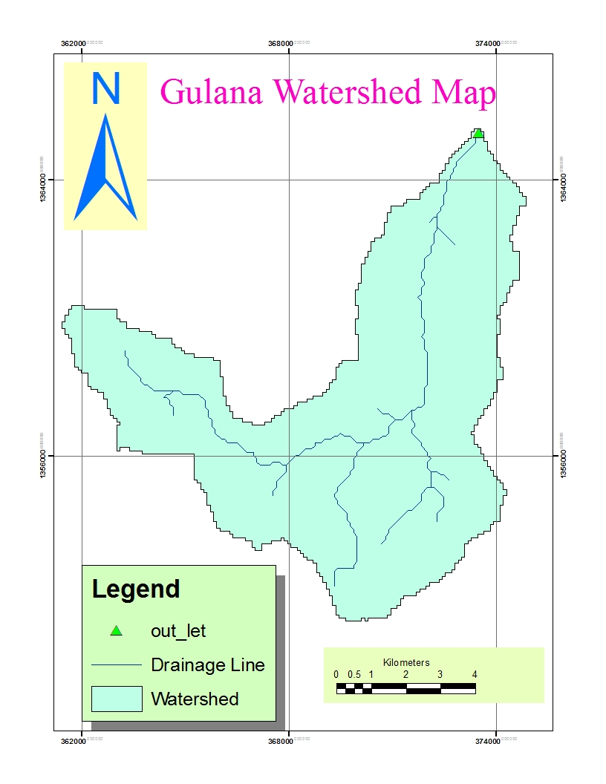
Figure 1-1: Location Map of the Project Area

Objectives of the Study
The main objective of the study is to conduct a detail study to upgrade the traditional irrigation schemes so as to increase the water utilization efficiency and reduce the labor resource required every year to construct a temporary diversion bunds and canal crossings by designing permanent structures. Moreover the project carried out has the following main objectives;
- Efficient utilization of the resources
- To minimize land degradation due to poor drainage system of the area.
- To promote easy & manageable irrigation operation system for the area.
- To mitigate problems of food shortage through irrigation development.
- To increase agricultural products through irrigation in dry and wet seasons.

The overall objectives of Gulana irrigation development project is to make farmers to be full benefited from Gulana river water resource, thereby to ensure sustainable food security, increased crop production and to increase income and sustainable livelihood to the community of the project area.

Scope of study
The study of this project mainly focuses on the Water availability, water balance, design, rainfall analysis , design flood determination, head work structure design, conveyance and distribution structure design, crossing structure, water measuring structures, energy dissipating structure, drainage structure, operation, maintenance and cost of the project .

Methodology of study
The methodology employed for the study is the conventional engineering study with integrated multidisciplinary approaches. Among These;
- Collecting relevant information and data useful for the study.
- Conduct fieldwork to collect all data required for the study in a multidisciplinary manner that include field investigation and surveying works.
- Conduct data analysis collected in the field by all disciplines participated in the study.
- Conduct the design and study work at office level using all inputs.

SETION I: HYDROLOGY

HYDROLOGY
Hydrological events, such as occurrence of peak floods and low flows, which have directly or indirectly impact on sustainability of the structures of the irrigation project, have to be analyzed and interpreted properly. The structures again have to be designed based on these events in a manner that they give proper functioning for which they are intended.
Gulana project’s headwork and drainage structures will be designed based on hydrologic events such as magnitude of peak flood of the given return period, base flow of the river. This portion of the study deals with events.

Water Resources Availability and Balance

Water Resource & Base Flow Measurement
The water source of Gulana irrigation project is spring besides, six perennial springs, namely Ambo, Minchit, Aynoye, Koha, Efesugn and Embila, are also found in the area. A spring Water flows to the nearby river which is called Gulana River. After the flows join the Gulana River at the downstream where traditionally water is diverted for irrigation by farmers, the study team fixed the head work position to be at this point.
The river is ungauged. That is, no data of flows of river at various seasons of years. Hence, base flow of the Gulana River is measured based on the local people’s information during driest season. The driest season is January-March. The base flow recorded in this critical season i.e. March, 1/2013, by using floating method is 253.98/sec.

Water demand & Balance
There is traditional irrigation structure at upstream of the proposed site. However, there is appreciable amount of water to be used for irrigation at the present proposed site downstream. There is 153ha of land being irrigated at upstream. The base flow from Gulana was measured two times in December 2013 found as 700l/s and on March 2/2013 found as 66l/s which have duty of 1.98 l/s/h and during December the base flow were 700l/s/ and duty of 1.27 l/s. the command area is estimated as 200ha so that the irrigation system designed for supplementary case because 66l/s only irrigates 27ha.. For downstream purpose this case 25% will have been released during the driest season for downstream ecology.

In this project, Gulana River is used as source of water by constructing intake structure at the selected head work site.
The rainfall condition in the project area is characterized by torrential distinctiveness which starts late and stops early. Normally, farmers use supplementary irrigation to overcome the problem. Therefore, the present engineering design is designed based on the present farmers practice considering the use of supplementary irrigation and for that reason the base flow is not used to determine the design outlet capacity.
At the downstream, no project is available at the time of field study at nearby distance. People don’t live at the downstream of the project area. The river goes to desert.
Water balance analysis:-
Gulana project; - amount of water required, QR=command area*Duty =200ha*1.27l/s/ha =254litre/second
Base flow measured at head work site= 700litre/second for supplementary case
Amount of water to be released to the downstream side=700-254=446itre/sec
Hence, with the addition of water emerges from springs, 446litre/second is to be released for downstream users but this discharge flows only for short term, at driest season the base flow decreases to 53 l/s/ha.

Design Rainfall Computation
Since the Gulana River, which is the water source for this project is not gauged, no recorded river flows data. Hence, it is impossible to forecast the design flood directly for a given return period. So, to design structures of the project at the headwork, conversion of other climatic data which has direct relation with flood has to be under taken by assuming the homogeneity of watershed of the project site and data source during the project life span. As it is known flood is a function of the rainfall. Hence, using the present parent rainfall data, design rain fall will be computed by various methods for the given return period. Finally, conversion of design rainfall to flood/runoff will be done.

Location of Meteorological station
Addis Zemen Meteorological station is preferred for this project from its proximity & homogeneity point of view. It is about 7 km air distance from project site. The station is more or less homogeneous with Gulana river basin and it has 26 years recorded rainfall data. The recorded data are considered to be sufficient in terms of quantity, if data quality is found to be acceptable, which will be proved in the next section.

Rainfall data quality test
Quality of the maximum daily rainfall data plays great role in the proper designing of the project structures, particularly in irrigation project for headwork and drainage structures. Quality of data may be poor due to personal error. Personal error may occur during reading, measuring, recording and etc. of the data. A data value registered by any error has to be rejected by various quality test methods, because, it may lead to designing of uneconomical or unsustainable structures for the project. So, for this particular case, data variability, reliable, symmetric and whether the existing data values lays between extreme outlier values are to be computed.
Table 2-1: Addis Zemen Meteorological Station MRF data
Sr. Nr | Year | Daily Max. rainfall (mm) | Descending order | Rank | Logarithmic value of X
1 | 1981 | 58.2 | 83.5 | 1 | 1.92169
2 | 1982 | 42.7 | 75 | 2 | 1.87506
3 | 1983 | 75.0 | 70.5 | 3 | 1.84819
4 | 1984 | 70.0 | 70 | 4 | 1.8451
5 | 1985 | 45.3 | 59 | 5 | 1.77085
6 | 1986 | 43.0 | 58.2 | 6 | 1.76492
7 | 1987 | 45.3 | 57 | 7 | 1.75587
8 | 1988 | 53.0 | 53.2 | 8 | 1.72591
9 | 1989 | 70.5 | 53 | 9 | 1.72428
10 | 1990 | 59.0 | 50.8 | 10 | 1.70586
11 | 1993 | 43.3 | 46.5 | 11 | 1.66745
12 | 1994 | 83.5 | 45.3 | 12 | 1.6561
13 | 1995 | 30.4 | 45.3 | 13 | 1.6561
14 | 1997 | 42.5 | 43.6 | 14 | 1.63949
15 | 1998 | 32.4 | 43.3 | 15 | 1.63649
16 | 1999 | 38.7 | 43 | 16 | 1.63347
17 | 2000 | 46.5 | 42.7 | 17 | 1.63043
18 | 2001 | 27.0 | 42.5 | 18 | 1.62839
19 | 2002 | 53.2 | 42 | 19 | 1.62325
20 | 2003 | 38 | 38.7 | 20 | 1.58771
21 | 2004 | 38.5 | 38.5 | 21 | 1.58546
22 | 2005 | 57.0 | 38 | 22 | 1.57978
23 | 2006 | 50.8 | 32.4 | 23 | 1.51055
24 | 2007 | 30.0 | 30.4 | 24 | 1.48287
25 | 2008 | 43.6 | 30 | 25 | 1.47712
26 | 2009 | 42.0 | 27 | 26 | 1.43136
Sum |  |  | 1259.4 |  | 43.3638
Standard deviation (Sy) |  |  | 14.3009 |  | 0.1245
mean(Ymean) |  |  | 48.4385 |  | 1.66784
Skewness |  |  | 0.81859 |  | 0.16568
Where, standard deviation,$αn-1=√( \frac{Σ(X-µ)^2}{n-1})$, n=number of data & µ= mean of data series
Skew (g) $= \frac{Σ(X-µ)^3}{n}$----------- (a)

Checking the existence of outliers
Outliers are data values which are quite different from the others in the data series. They exist both in extreme values i.e. there is lowest and largest values out of limits formulated. The Causes of the outliers may be errors of measurement or recording and etc. Since outliers have a significant effect on the results of the design rainfall computation, they have been discarded from the data set. As per U.S Water resources council (1981) recommended, it is possible to check for outliers based on skew value. If value of skew lies between +4 & -4 the outliers are checked for both lowest and highest values. In case of the particular Addis Zemen Meteorological station data values shown on table-1, the skew /g/=0.16564 found between -4 and 4.Hence the data series has be checked for both cases of extremes.
Higher Limit, YH = Ymean + Kn*Sy,
Yh =1.6678+2.502*0.124501
=1.979
Lower limit, Yl = 1.6678-2.502*0.124501= 1.35633
Upper limit of rainfall = 10^1.979 = 95.35mm
Lower Limit of rainfall = 10^1.356 = 22.716mm
Lowest and highest value in the given data series is 27 &83.5.So, all of the data values lies between the lowest and the highest calculated values. Hence, there is no any data that can be rejected. All of them will be used in the next design processes.

Variability of the data series
The variability of the data series has to be computed to see its variance. The variability of data series can be expressed in percentage and it should be is equal to or less than 10. The variability for Addis Zemen Meteorological station data for a given rain fall records are:-
Variability, α = αn-1/ (SQRT (N)* µ) *100 =5.934% < 10------- Acceptable.
Since, the data series values are within acceptable range, it is acceptable!

Symmetric of the data series
Skew measures the symmetric of the data series about their mean or median. As its value is near to zero it shows the symmetric of the data. And it is given by formula as shown in equation (a) above the skew of the above data series is calculated to be 0.1656. Which shows it is more or less the existence symmetry of data series among their mean.

Design Rain Fall Estimation

Determination of design period
Selection of the design return period, also called recurrence interval, depends on economic balance between the cost of periodic repair or replacement of the facility and the cost of providing additional capacity to reduce the frequency of repair or replacement vegetated control and temporary structures are usually designed for a runoff that may be excepted to occur once in 10 years; expensive permanent structures will be designed for runoffs expected only once in 50 or 100 years.
For the small – scale irrigation projects, the flood once in 50 years for design of diversion weirs, intake, and the flood once in 10-20 years for design of drainage structures is adopted. However, for the case that the downstream damage potential by resulting from failure of the structure may detect the choice of the design frequency, the flood once in 200 years should be selected. The following table shows safety factor for the different return period of the project design flood.

Table 2-2: Safety factor for various return periods
Type of  Structure | Project Life  (Years) | Return Period ( Years) | Safety Factor (Percent)
Storage dams | 30 | 200  100  50 | 86  74  54
Diversion weir and drainage structures | 15 | 50  20 | 74  54
Taking into consideration the above stated principles, for Gulana irrigation project, 50 years return period and 20 years project life for head work structures, 10 years for drainage structures has been recommended

Methods of Design Rain Fall Estimation
As per this study document design rainfall is to mean the amount of 24 hours rainfall that is computed based on the 50 years return periods recommended. There are various methods by which the estimation of design rainfall can be computed. For this particular irrigation project, Gumble probability distribution function method haven been used.
This is the most widely used method for the prediction of maximum annual rain falls, flood flows and others. It is applicable only to annual extreme values. For this particular case, this method is used to determine maximum rainfall for 50 years return periods.
Its formula is given by:-
$XT=µ+K_{T}*σ_{n-1}$
For sample size N=26, Yn =0.532, and Sn =1.096
$Yt=ln⁡(\ln\left(\frac{T}{T-1}\right))=\ln\left(ln\frac{50}{50-1}\right)=3.9$
Where $KT=\frac{YT-Yn}{Sn}=\frac{3.9-0.532}{1.096}=3.07$
$Xt=Xmean+Kt*σn-1=48.44+3.07*14.3=92.4mm$
Yn = Reduced mean in Gumble’s extreme value distribution for N sample size from table;
Sn= Reduced standard deviation in Gamble’s extreme value distribution for N sample size from table;
T= Return period, for intake diversion 50 years return periods;
$σn-1$ = Standard deviation of annual rain fall; and
µ = Mean of all values annual rain fall.
The design rainfall is determined using Gumble`s probability distribution method, it is computed as:

Estimation of flood (run-off)
The calculated design rainfall by Gamble- Powell method above is converted to runoff flow and its volume has to be determined at the irrigation headwork structure. This considers the natural characteristics of catchments (vegetation cover, soil type which has direct relationship with the infiltration or runoff) and its area, remoteness of stream flow.

Estimating Time of Concentration
It is the longest travel time taken by drops of water to reach the outlet location. To calculate the time of concentration the flood course is divided in to several segments based on slope .The longest water course is divided into different intervals and the time of concentration is computed using Kirpich formula.
$Tc=∑Tci , Where Tci=\frac{1}{3000}*{(\frac{L}{√S}) }^{0.77}$
Where;
L = water course (stream) length in m
S = Slope of each interval
T_{ci} = Time of concentration for each divided stream length
Tc = Total time of concentration
Table 2-3: Time of concentration
Partial Distance (km) | Cumulative distance (km) | Elevation (m) | Elevation diff. (m) | TC (hr)
0 | 0 | 3166 | 0
5.19 | 5.19 | 2660 | 506 | 0.58
3.1 | 8.29 | 2360 | 300 | 0.39
5.77 | 14.06 | 2060 | 300 | 0.80
5.71 | 19.77 | 1889 | 171 | 0.98
19.77 |  |  |  | 2.75
In the case of Gulana project the highest and remotest point from headwork, which is taken as outlet of the catchment area, has 3166m elevation at a distance of 19.77km. Area of the catchment that contribute runoff to the outlet (headwork site) throughout the length of water course is 68.83Km2.This water course is subdivided into five parts based their slope variability. Reaches of water courses that have nearly similar slope are considered as one reach with one out let and inlet as shown below.

Figure 2-1: Gulana river longest flow path profile
By using Kirpich formula at each segment, the time of concentration of the segment is first computed and then summation of them is taken as total concentration time.

Design Rainfall Arrangement
Since the time of concentration is 2.75 hours which is less than 3 hours, the rainfall duration/D/ or increments would be D/6 hour. The rainfall distribution profile within a day (24hrs), which is expressed in percentage, has been arranged based on the rainfall profile and increment hour curve developed. The obtained percentage for a given hour interval has been multiplied with the point design rainfall 92.4mm.
The point rainfall obtained per unit time increment interval has be distributed over the whole catchment area 68.83Km2. For this given area and each time interval, its percentage is read from Areal-time curve developed, and multiplied with earlier calculated values. After this it is called areal rainfall.
Based on the above principle, the obtained result is shown below in table.
Table 2-4: Design rainfall arrangements
D  (hr) | Daily point  Rain (mm) | Rainfall  Ratio (%) | Profile (mm) | Areal to  Point R. fall ratio (%) | Areal rainfall | Incremental rainfall  (mm) | Descending  Order (mm) | Descending  Order (Nr)
0-0.5 | 92.40 | 32.5 | 30.03 | 57.99 | 17.4 | 17.41 | 17.41 | 1
0.5-1 | 92.40 | 43.8 | 40.43 | 67.99 | 27.5 | 10.07 | 10.07 | 2
1-1.5 | 92.40 | 53.1 | 49.09 | 71.86 | 35.3 | 7.79 | 7.79 | 3
1.5-2 | 92.40 | 57.9 | 53.49 | 75.74 | 40.5 | 5.24 | 5.24 | 4
2-2.5 | 92.40 | 62.5 | 57.75 | 77.74 | 44.9 | 4.38 | 4.38 | 5
2.5-3 | 92.40 | 66.2 | 61.2 | 79.74 | 48.8 | 3.91 | 3.91 | 6

Determination of Hydrologic Soil –Cover Complex Number
Based on the water shade characteristics, the applicable runoff curve numbers is found to be 76.3 as water shade report indicates. Taking into account the importance of the structure, it would be necessary to apply the antecedent rainfall condition III. The calculated average curve number (N), 76.3 is for the antecedent rainfall condition II. The conversion factor of this value is 1.18. Then, when it is converted to condition III, it becomes N=76.3* 1.165= 88.98

Estimation of Direct Runoff
The maximum potential difference between rainfall and runoff (mm), starting at the time the storm begins is given by
$$S=\frac{25400}{N}-254=\frac{25400}{89}-254=31.46$$
Therefore, the direct surface runoff, Q, in mm is,
$Q=\frac{{\left(I-0.2*S\right)}^{2}}{I+0.8*S}$
Where, I = Cumulative Rainfall in mm
S = Potential difference between rainfall & runoff
$Q=\frac{{\left(I-0.2*S\right)}^{2}}{I+0.8*S} = \frac{{\left(I-0.2*31.46\right)}^{2}}{I+0.8*31.46}$
$Q=\frac{{\left(I-0.2*S\right)}^{2}}{I+0.8*S} = \frac{{\left(I-0.2*28.22\right)}^{2}}{I+0.8*28.22}$$Q=\frac{{\left(I-0.2*28.22\right)}^{2}}{I+0.8*28.22}$$Q=\frac{{\left(I-0.2*31.46\right)}^{2}}{I+0.8*31.46}$----------- (a)
Using the equation (a), it is possible to calculate the direct runoff equivalent to each incremental rainfall. The calculation can be tabulated as follows.
Table 2-5: Direct runoff computation
Duration  (hrs) | Cumulative run  off  (mm) | Incremental run off  (mm) | Peak run off  incremental  (m³/sec) | Time of  begin  (hrs) | Time to  peak | Time to  end  (hrs)
0-0.5 | 0.20 | 0 | 0.00 | 0 | 1.88 | 5.01
0.5-1 | 0.24 | 0.04 | 0.33 | 0.50 | 2.38 | 5.51
1-1.5 | 2.69 | 2.45 | 18.91 | 1.00 | 2.88 | 6.01
1.5-2 | 13.23 | 10.54 | 81.18 | 1.50 | 3.38 | 6.51
2-2.5 | 20.89 | 7.66 | 59.05 | 2.00 | 3.88 | 7.01
2.5-3 | 24.43 | 3.54 | 27.28 | 2.50 | 4.38 | 7.51

Computation of Hydrograph for Each increment of Runoff
For each time interval, D, Compute the time of peak T_{P,’} base time T_{b’ ,}and the peak discharge, q_{P’} for 1mm of runoff.
  - The time increment, D
For the first 3 hours, use D =0.5hour.
  - Calculation of T_{P’} T_{b’} and Q_{P}
$$A=68.83M^{2};Q=1mm$$
T_{p}=D/2+0.6*Tc, where Tc=time of concentration
Tc=2.75hr
T_{p}=0.5/2+0.6*2.85=1.88 hr

T_{b}=2.67* T_{p}=2.67*1.88= 5.01hr

$q=\frac{0.21*A*Q}{Tp}$ Where, A=area of the catchments in square km
T_{p} = time of peak in hour
$QP=\frac{0.21*A*Q}{Tp}=\frac{0.21*68.83*1}{5.1}=2.88m33/s/mm$
  - $Qp=\frac{0.21*A*Q}{Tp}=\frac{0.21*68.83*1}{1.96}=\frac{7.37m^{3}}{s}.mm$$Qp=\frac{0.21*A*Q}{Tp}=\frac{0.21*127.66*1}{2.9}=9.24m^{3}/s$Computation of the peak for each increment of runoff computed in the above.

Table 2-6: Computation of complex hydrograph
Time  (hr) | Ordinate of Hydrograph (m³/Sec)
Time  (hr) | 1 | 2 | 3 | 4 | 5 | 6 | Total
0 | 0 |  |  |  |  |  | 0.0
0.50 | 0 | 0 |  |  |  |  | 0.0
1.00 | 0 | 0.1 | 0 |  |  |  | 0.1
1.50 | 0 | 0.2 | 5.0 | 0 |  |  | 5.2
2.00 | 0.00 | 0.2 | 10.1 | 21.6 | 0 |  | 32.0
2.50 | 0 | 0.33 | 15.1 | 43.3 | 15.7 | 0 | 74.5
2.88 | 0 | 0.3 | 18.9 | 59.5 | 27.6 | 5.5 | 111.8
3.38 | 0 | 0.2 | 15.9 | 81.2 | 43.3 | 12.7 | 153.4
3.88 | 0 | 0.2 | 12.9 | 68.2 | 59.1 | 20.0 | 160.3
4.38 | 0 | 0.1 | 9.9 | 55.3 | 49.6 | 27.3 | 142.2
5.01 | 0 | 0.1 | 6.0 | 38.9 | 37.7 | 21.8 | 104.4
5.51 |  | 0 | 3.0 | 25.9 | 28.3 | 17.4 | 74.6
6.01 |  |  | 0 | 13.0 | 18.8 | 13.1 | 44.9
6.51 |  |  |  | 0 | 9.4 | 8.7 | 18.1
7.01 |  |  |  |  | 0 | 4.4 | 4.4
7.51 |  |  |  |  |  | 0 | 0.0

Hence, flood peak at the headwork position is 160.3m³/s. The composite hydrograph is shown below.

Figure 2-2: Composite hydrographs

Tail water depth determination
This is a normal flow depth of water in the river channel cross section during the occurrence of the design flood discharge particularly at headwork site. It is obtained by Manning’s formula taking into consideration the foundation of river, river cross sectional area and its longitudinal slope. Depth of flood flow is computed as follow:-
Slope of river (S): - it is the longitudinal slope of river at upstream and downstream for 200m length.
Accumulative height, H=EL.n – EL.0, where EL.n=elevation of nth point and EL.0=elevation of initial point. Individual area, =$A=\frac{\left(Hn+Hn-1\right)}{2}*Ln ,$where Ln= nth partial length
EL.4 EL.5
EL.3
EL.2
EL.1 A2 A3 A4 A5
EL.o A1 H1 H2 H3 H4 H5
No.0 No.1 No.2 No.3 No.5
EL
Hence, at each partial length, the partial or individual area can be calculated from the data obtained from field surveying taken along the longitudinal section of the river as shown below in Table 2-7.
Table 2-7: River longitudinal slope computation
Northing | Easting | Elevation | Partial Distance | Cumulative Distance | Elevation Difference | Area
1362265 | 372100.5 | 1888.78 | 0 | 0 | 0 | 0
1362250 | 372099 | 1889.4 | 15.00 | 15.00 | 0.62 | 4.65
1362235 | 372097.5 | 1890.15 | 15.00 | 30.00 | 1.37 | 14.92
1362220 | 372095.6 | 1890.9 | 15.00 | 45.00 | 2.12 | 26.17
1362205 | 372093.5 | 1891.47 | 15.00 | 60.00 | 2.69 | 36.08
1362190 | 372091.8 | 1891.64 | 15.00 | 75.00 | 2.86 | 41.63
1362175 | 372089.8 | 1891.82 | 15.00 | 90.00 | 3.04 | 44.25
1362160 | 372087.8 | 1892.01 | 15.00 | 105.00 | 3.23 | 47.03
1362157 | 372087.3 | 1892.05 | 3.69 | 108.69 | 3.27 | 11.99
Sum |  |  |  | 108.69 |  | 226.73

Then by end area method the longitudinal slope of the river can be obtained.
H_{avg} = 2_{Avg}*∑A/ L = 2(108.69)/ (226.73) = 4.172.Hence, Slope(S) =Hav/L=0.038m/m
Manning’s roughness coefficient (n):- based on foundation nature of river n=0.04 is adopted.
Area (A) & Perimeter (P):- the area and perimeter of the river at head work site is computed from the river cross section on the Auto cad software.
Then, the tail water depth is computed with 0.5m increment of depths which correspond to different discharges.
Table 2-8: Tail water-Discharge Computation
S.N | Elevation  /m/ | Water depth increment (m) | Wetted Area (m2) | Perimeter (m) | Hydraulic radius, R (m) | Slope (m/m) | Velocity (m/s) | Discharge (m3/s/)
1 | 1889.79 | 0 | 0 | 0 | 0 | 0.038 | 0 | 0.00
2 | 1890.29 | 0.5 | 9.55 | 101.51 | 0.09 | 0.038 | 1.01 | 9.63
3 | 1890.54 | 0.75 | 22.29 | 102.14 | 0.22 | 0.038 | 1.77 | 39.37
5 | 1891.04 | 1.25 | 75.54 | 108.67 | 0.70 | 0.038 | 3.82 | 288.88
6 | 1891.29 | 1.5 | 102.73 | 109.73 | 0.94 | 0.038 | 4.66 | 479.12
7 | 1891.54 | 1.75 | 130.16 | 110.78 | 1.17 | 0.038 | 5.43 | 706.30
8 | 1891.79 | 2 | 157.80 | 111.83 | 1.41 | 0.038 | 6.13 | 967.47
9 | 1892.04 | 2.25 | 185.60 | 112.79 | 1.65 | 0.038 | 6.79 | 1260.71

Figure 2-3: Discharge rating curve
As shown on table above, by interpolation, the tail water depth that corresponds to maximum food discharge is 1.01m.
Similarly, from the tail water depth rating curve developed, again it possible to get, for a given flood discharge, the corresponding flow depth.
Therefore, highest flood level (HFL) at headwork site = minimum river bed level + flow depth =1889.79m+1.01m = 1890.80m

SECTION II: HEADWORK

DESIGN OF HEAD WORKS

Intake Site Geology
This part deals on the geological aspects of the foundation condition of the intake site. The investigation at headwork site emphasizes on the bearing capacity, permeability, settlement problems and shear strength etc. The river bank condition should be described in order to design the structure according to the geological foundation condition. Therefore, when it is described according to the above parameters, the three layers found at the top middle and at the bottom are impermeable types and soils that have no settlement problem or compressibility problems.
Figure 3-1: Geological Cross Section of the Headwork Site

River bed
From the witnesses of the field investigation the proposed weir sites river beds have moderate to gentle slope. From surface examination of the site, the river bed, here, is covered by recently deposited alluvial, colluvial, alluvium sediments of coarser size of fanes, which are dominated by coarse Gravel, coarse grained Sand, with some cobbles and significant Boulders intermixed with little silt. Using visual classification method, this recent sediment layer is classified according to Unified Soil Classification System (USCS), it falls in Sandy gravel (SG) soil group having about 60% Gravel, 30% Sand and 10% Boulders and cobles by weight along the river bed. The shape of the main sediments fines (especially the gravels and cobbles) are sub-rounded to rounded; indicating long distance of transportation by the river action, whereas the shape of the boulders are angular to sub-angular that they are mainly came from shorter distances from nearby hills and ridges. The impact of boulders on any proposed engineering structure on the upstream direction is so significant. So the large boulders are dangerous for structures

River Bank condition

Right Bank
This bank has the same nature of formation with the left bank. Straight along the weir axis the banks are seems like stable along the weir axis but it is erodible at the upstream of the weir axis

Left Bank
This part is the bank where the out let of main canal is proposed. The top part of the bank is black cotton clay which is high plastic (CH) soil having 1meter thick, the middle one is the brownish medium plastic ML soil having 3meter thick impermeable soil and the lowest parts of this bank is highly consolidated tuff interbeded with the shell having 2m thick. Therefore, the total height of this bank is 6m. The bank of the river is erodible it has need the retaining wall on both the left and right side of the bank.

Sources of construction materials

Masonry stone
Most areas covered with basaltic rock that moderately to highly weathered so that it is not recommended to use it. Rather there is fresh masonry at the head work site so that due to freshness we can use for construction material.

Fine aggregate
Fine aggregate can be obtained 55km from head work site from Debary River

Intake Dimension

Intake Design
  - Sill Level Determination
The sill level of intake out let is based on the following criteria:-
- Maximum elevation of command area =1887.50m
- Maximum distance between the elevated command area and diversion site, = 891m
- Main canal alignment;-Taking into consideration the cost effectiveness of alignment, main canal alignment has been made on topo.
- The capacity of main canal; the capacity of main canal which is based on the duty, command area, irrigation efficiency.
And the design discharge for irrigation which the canal has to carry is;
$Qs ( duty × area)=200×1.27=254l/s$
Based on the above principles, the sill level of intake outlet is fixed to be at m above mean sea level1889.79m.

Scour depth determination
The river bed may be scoured during flood flow and large scour holes may develop progressively adjacent to the constructed head work structures, which may cause undermining of the structure. Finally, the structures become out of their functions. Hence, to provide proper cutoff, it is important to determine the scour depth. This depth can be computed by Lacey formula.
And the scour depth(R)) is given by;-
$R=1.35{\left(\frac{q^{2}}{f}\right)}^{\frac{1}{3}}$
Where;
$f=1.76*√d$, d = mean diameter of particle size in mm$upto possible scour depth.$
$$q=discharge intesity=\frac{maxumumflood}{river width(wetted)}$$
The mean particle size of the headwork site is found to be 0.32mm.
$f=1.76*\sqrt{d}=1.76*\sqrt{32}=9.95$
$q=\frac{Qpeak}{L}=\frac{160.3}{95}=\frac{1.68m^3}{s}/m$
Table 3-1: Intake Hydraulic Parameters
Sr. Nr | Parameters to be computed | Unit | Remarks
1 | Flood discharge (m³/s) | 160.30
2 | Clear width of the river (L) in m | 95.00
3 | Discharge intensity(q)in m³/s/m | 1.69
4 | River bed level(m) | 1889.80
5 | Tail water depth | 1.01
6 | HFL | 1890.81
7 | Cutoff depth -D | 2.25 | 2.3
8 | Bottom level of cut off-D | 1887.50
9 | Cutoff depth below river bed | 2.30
$R=1.35{\left(\frac{q^{2}}{f}\right)}^{\frac{1}{3}}=1.35{\left(\frac{q^{2}}{f}\right)}^{\frac{1}{3}}=0.745$
But 2.3m is taken since the river is made up of alluvial deposit and in addition to that the peak flood carries large boulders with higher intensity from nearest Mountain and the catchment area of the project is bare land due to this intense erosion exists in addition to this the bed rock exists below 3 meter depth to the river bed level so that the scour depth is exaggerated.
b) Capacity determination
The capacity of the intake outlet is the function of discharge required for the irrigation based on crop water requirements.
Generally, duty of the project area is 1.27l/s/ha taking into consideration the total efficiency, correction factor and irrigation hours within a day.
Then, the required discharge, Qr = command area*Duty = 200*1.27 = 0.254m³/s.
So, the canal and intake capacity has to be fixed in a manner that can convey the required discharge.
The intake dimension is computed using rectangular notch formula given by:-
Q = 2/3Cd*(2*g) ^{1/2}B*H ^{(3/2)}
Where: Q=diverted discharge = the required discharge, Q_{r}, 0.254m³/sec
Cd = Coefficient of discharge, Cd = 0.6
B = Width of intake, 0.6m
H = Height of the intake =flow depth above sill level free board
g = Acceleration due to gravity
Therefore for a width of 0.7m
H = (Q*3/ (2*Cd*(2*g) ^{1/2}*B)) ^{2/3} = 0.7m. Provide 0.6m*0.7m intake size.

Design of operation slab and Breast wall
To avoid spilling of water during HFL over intake gate, an R.C.C wall is provided from the gate top level up to the HFL (i.e. known as breast wall). A vertical raised gate is designed for the head regulator. This gate slides over the grooves using spindle during opening and closing. For the operation purposes, operation slab is also provided at the top of breast wall. The thickness of the breast wall and operation slab is simply determined from recommendations (point of construction) rather than the imposed load. The thickness required for the imposed load is less than this nominal value 20cm.
For the breast wall and operation slab, the minimum reinforcement area is taken as 0.15% in both directions per unit width.
Hence area of steel per one meter width,
A_{steel} = 0.0015*W*t, where, w = width & t = thickness both in cm
A_{steel}=0.0015*1000*200 = 300mm²
A_{steel}=300mm2, Provide 12 @ C/c 200 mm
- Checking the appropriateness of spacing :-Considering cover thickness of 50 mm, effective depth, de=t-(50+/2) =200-(50+12/2) =144 Hence spacing of reinforcement should be less of the following values:-
- Three times the effective depth =3*144=432mm
- 450mm
The spacing of bars, which is 200mm, is less of the above listed values. Hence, it is acceptable!
- Checking adequacy of steel bar thickness A_{steel}=3.14*12²/4*5= 678.24 mm²
Therefore the actual provided steel area per meter width is 678.24 mm²/m>300 mm²/m Ok!
Hence, thicknesses of 20cm for the breast wall & operation slab are adequate.
Therefore, provide the reinforcement bar of φ12mm @200mm c/c spacing in both directions with reinforcement covers of 50mm for the breast wall.

Hydraulic Gate Design
The gate used for irrigation water control has to be water tight, with least leakage, straight, rigid, and capable of being raised or lowered by hoisting mechanism provided.
Since the head of water for this particular case, that is the gate weight will be relatively heavy at head 0.7m height*0.6m width, slide plate gate type is selected.
Generally, the slide plate gate type consists of leaf, embedded part (sliding from & seals) & hoisting device.
Thickness and tensile strength determination: - plate gate has to have sufficient thickness and strength to resist hydraulic water pressure exerted by maximum flood. The minimum 6mm thickness of skin plate has to be provided including correction taken for corrosion.

Trash Rack
A trash rack screen is provided in front of the intake structure in order to prevent the entry of floating derbies, and logs into the off take. The trash rack has a height of 0.7m and width of 0.7m with 12mm diameter steel spaced at 100mm horizontally and vertically is provided.

Highest Flood Level Determination
The probable maximum flood discharge that may occur within the design period of the headwork structures, can cause damages to the built structures and destabilize, river bed, river banks that leads malfunctioning of the project. The river training works and some head structures have been properly designed based on the magnitude of flood depth at this particular point. That is at head work position.
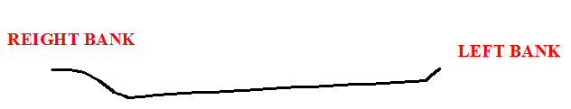
Figure 3-2: River X-section at head work

Bed bar provision
Since the river bed at the headwork site has a recent alluvial deposit, it is very important to provide bed bar up to a depth of scour depth of 2.3 m below river bed and thickness of 30cm. This structure will stabilize the bed of the river to keep or to maintain, the flow direction as much as possible throughout the design period of the project. It does not connect the two banks of river since the river cross section is very wide, the bed bar is provided up to the river center of 60m length inclined at 60 degree from the bank where the off take canal is proposed towards the upstream side. Series guiding of water and treating the right bank is very key issue specially.

Wing walls and Protection wall Design
Considering the geology of the abutment on both banks as it is indicated on the geology report, provision of masonry wing walls both u/s and d/s of the intake is required. The d/s again has to be protected by gabion works beginning from the end of wing wall. And, the right side of river bank should be protected by gabion works as shown on plan and cross sections drawings.
The general consideration in design of wing walls and gabion wall is that sections of the walls should have enough self-weight to resist the thrust due to soil pressure and water pressure without overturning, sliding, and tension developed within the body of the structure. The level of maximum design flood governs the height of the walls with some free board provision.

Determination of the dimensions of the u/s wing walls (left side)
Stability analysis of wing walls
For the wing walls to stable and give service for its design period, its stability has to be checked during the worst conditions. The worst condition for this particular case is during the absence of flow in the river. The main forces acting on the walls during this condition are weight of wing wall itself, soil pressure. Based on the following assumptions the stability analysis of wing wall has been checked as follow.
Data required:-
- Soil below two third its height is assumed to be saturated.
- Unit weight of dry soil =19KN/m³
- Unit weight of Saturated soil =12KN/m³
- Unit weight of masonry=22.4KN/m³
- Φ=30⁰ (for dry condition)
- Then , $Ka =\frac{\left(1 -\sin{Φ}\right)}{1+\sin{Φ}}=\frac{\left(1 -\sin{30}\right)}{1+\sin{30}}=0.3$3

Upstream left side retaining wall
The height of upstream retaining wall is 5.3m above the crest level of the intake; the bank height is 8.20m unstable saturated eroded bank so that to support the saturated unstable bank I take 5.3m retaining wall height
. Table 3-2: Dimensions of the upstream left side wall
h | b | c | scour depth | H | D | B | BF | BH
1.5 | 0.40 | 2 | 1.6 | 3.1 | 0.6 | 2.4 | 0.3 | 0.1

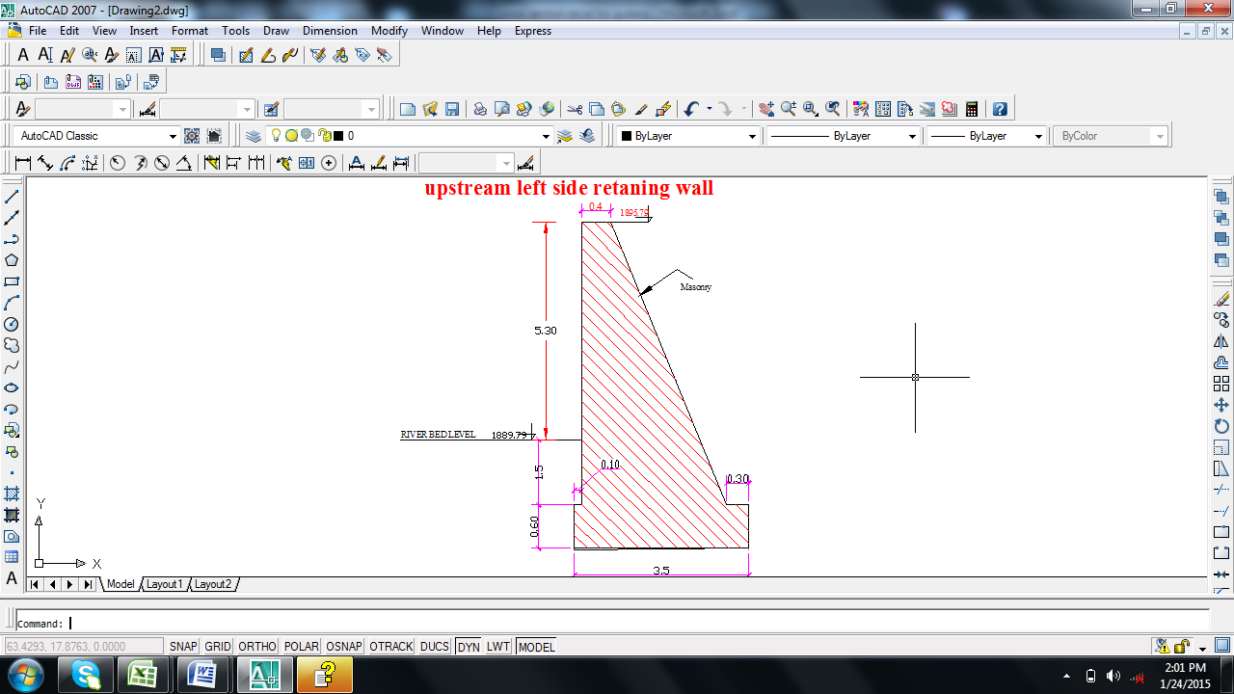
Figure 3-3 upstream left side retaining wall
Table 3-3: stability analysis of upstream left side retaining wall
Description | Horizontal forces (kN/m3) | Vertical forces (kN/m3) | Lever arm (m) | Restoring moment (kN-m) | Disturbing moment  (kN-m)
W1= weight of wall |  | 148.2 | 2.1 | 311.2
W2= weight of wall |  | 43.9 | 3.2 | 140.5
W3= weight of wall |  | 47.0 | 1.8 | 82.3
ps1= pressure of soil | 10.0 |  | 4.3 |  | 42.7
ps2= pressure of soil | 22.6 |  | 1.2 |  | 27.7
wv3= pressure of soil |  | 9.7 | 0.7 |  | 6.8
Water | 151.3 |  | 1.8 | 277.3
wv4= pressure of soil |  | 81.1 | 3.5 |  | 279.8
summation | 183.9 | 329.9 |  | 811.3 | 356.9
safety against;-
Overtiring(FSO) = | 2.3 | 1.5 | ok
Sliding( FSS) = | 0.6 | 0.8 | ok
Existence of tension | X= | 3.5
 | e= | -1.8 | <B/6=0.58 | ok

Table 3-4: Table stability analysis of retaining wall with canal
Description | Horizontal forces (kN/m3) | Vertical forces (kN/m3) | Lever arm (m) | Restoring moment (M+) | Disturbing moment (M-)
W1= weight of wall |  | 44.800 | 1.37 | 61.23
W2= weight of wall |  | 22.400 | 2.1 | 47.04
W3= weight of wall |  | 32.256 | 1.2 | 38.71
W3= weight of Canal |  | 6.272 | 3.2 | 20.07
ps1= pressure of soil | 9 |  | 0.34 |  | 3.1
ps2= pressure of soil | 1.683 |  | 1.03 |  | 1.7391
ps3= pressure of soil |  | 7.2 | 1 |  | 7.20
ps4= pressure of water
summation | 10.683 | 112.928 |  | 167.04 | 12.04
safety against;-
Overturning(FSO) = | 13.875 | >1.5 | so, it is safe
Sliding( FSS) = | 0.095 | <0.75 | Safe
Existence of tension | X= | 1.373
 | e= | -0.173 | <B/6=0.4

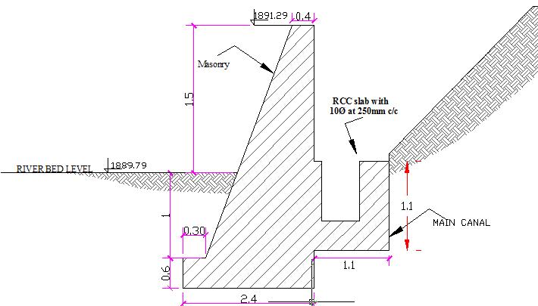
Figure 3-4 retaining wall with canal

Downstream retaining wall
- River Protection Works by Gabion
Though for some part of the river left banks masonry retaining wall have been designed, the rest left and right banks are being affected by intense erosion. So, to keep the base flow direction, there should be no erosion of the banks which may result in the change of flow direction, which in turn decreases or stops the irrigation water supply to the command area. Hence, the right and left banks should be protected from erosion by gabion materials.
- Gabion works design;-
- Gabion mattress size: - this is the gabion laid at the toe of the river left bank. It extends toward the river 1.5 times the anticipated maximum scour depth. As computed above the scour depth at head work is 0.7m. Hence, the mattress extends 2.25m in the river.
The thickness of the mattress is taken to be 0.5m.
The size of stone to be used is 180mm diameter within gabion mesh size of 60 *80mm.
- Gabion box size determination: - the gabion in box form is used as standing wall by over laying each other. Its height is equal to the bank height for this project, which is 2.5m. The thickness of the wall increases by 0.5m at 1m height interval from top to bottom of the gabion wall. The size of stone 200mm should be used with gabion mesh size of 80*100mm.
- Stability Analysis Gabion,
Data required
- Unit weight of dry soil =19KN/M^3
- Unit weight of Saturated soil =12KN/M^3
- Unit weight of stone=14-20KN/M^3( for 100-200mm diameter),
- take the average unit weight of stone to be17kN/m³
- Φ=30⁰ (for dry condition)
- Then , $Ka =\frac{\left(1 -\sin{Φ}\right)}{1+\sin{Φ}}=\frac{\left(1 -\sin{30}\right)}{1+\sin{30}}=0.33$
Table 3-5: Stability analysis for gabion retaining wall
Description | Horizontal forces (kN/m3) | Vertical forces (kN/m3) | Lever arm (m) | Restoring moment (kN-m) | Disturbing moment (kN-m)
W1= weight of gabion wall |  | 21.250 | 1.25 | 26.56
W2= weight of stonewall |  | 34.000 | 1.5 | 51.00
W3= weight of stonewall |  | 25.500 | 1 | 25.50
W4= weight of stonewall |  | 17.000 | 2 | 34.00
Ps1= pressure of soil | 2.97 |  | 0.500 | 1.49
Ps2= pressure of soil | 1.65 | 0.990 | 0.250 | 0.25
Ps3= pressure of soil | 38.404 |  | 1.167 |  | 44.80
Summation | 43.024 | 98.740 |  | 138.80 | 44.80
Safety against;-
Overturning(FSO) = | 3.098 | >1.5 | safe
Sliding( FSS) = | 0.436 | <0.75 | safe
Existence of tension | X= | 0.952
 | e= | 0.298 | <B/6=0.42 | no tension

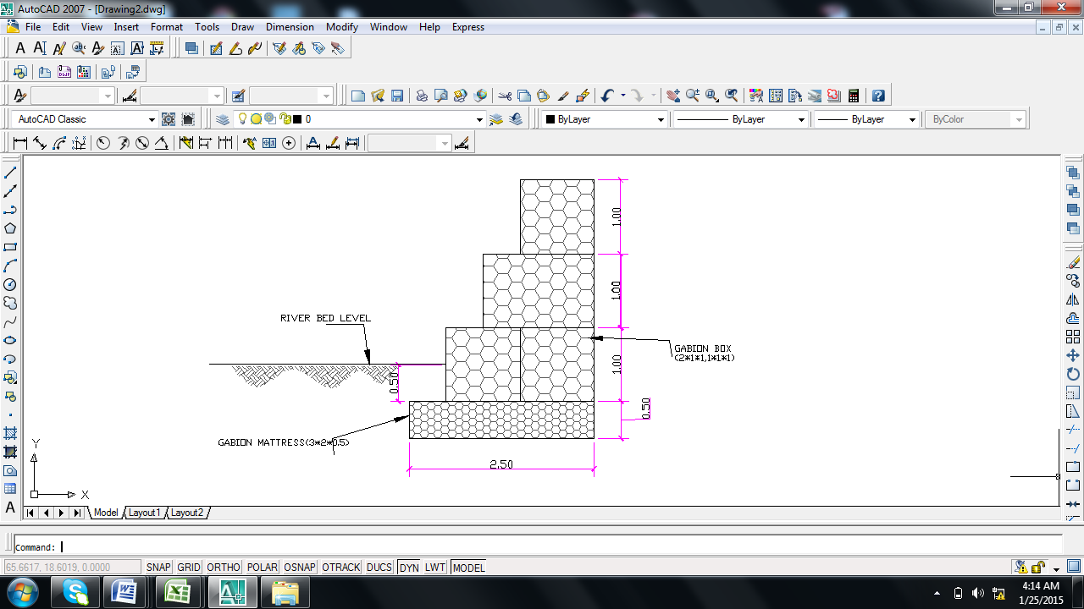
Figure 3-5 Gabion Retaining Works

Table 3-6: Bill No. 1. Work Quantity & cost estimation for General Item

Table 3-7: Bill No. 2 Work Quantity & cost estimation for Headwork

SECTION III: IRRIGATION INFRASTRUCTURE

DESIGN IRRIGATION AND DRAINAGE SYSTEMS

The Project Command Area

Topography and soil
The topographic characteristics of the command area have been identified to be flat to gentle sloping (2% to 12.25% slope). With these slope gradients, the command area has suitability for surface irrigation.

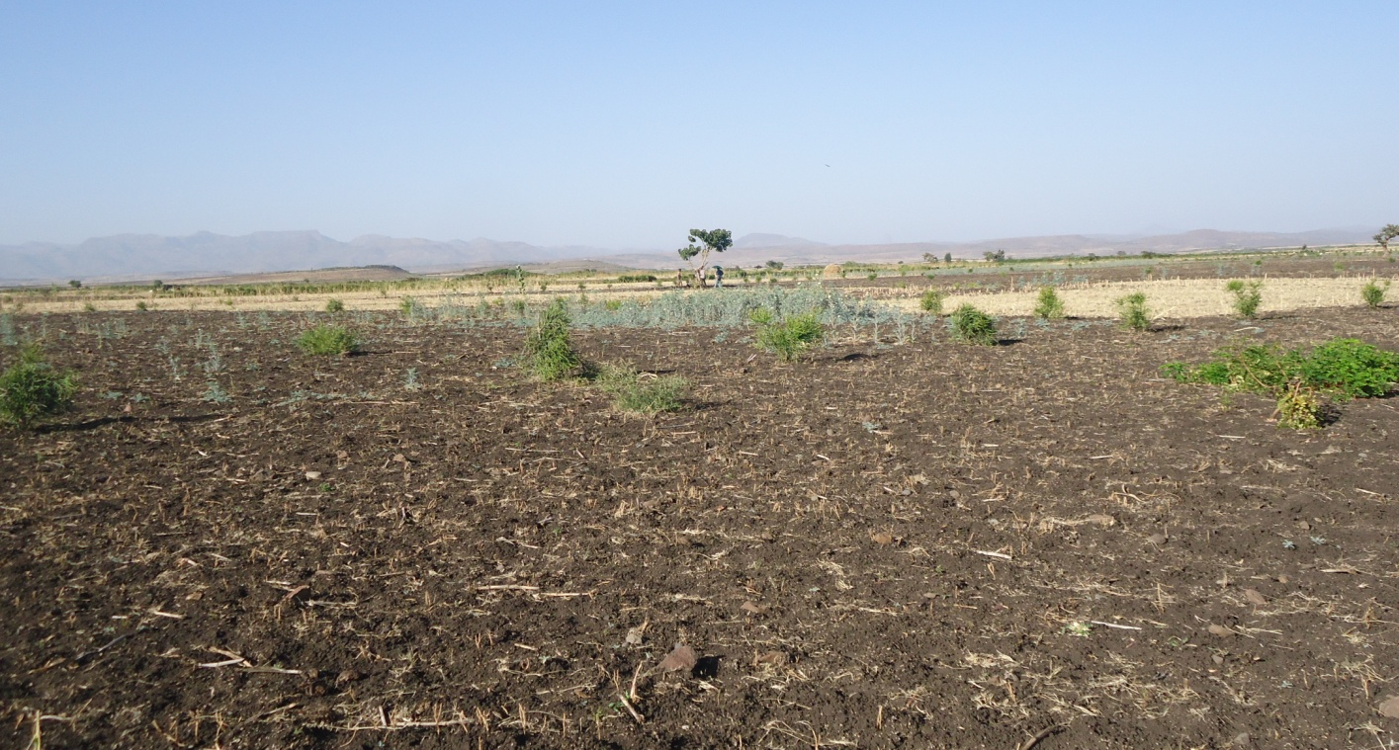
Figure 4-1 Partial view of the command area

Climate
The project area is classified as Dry Woina Dega (Dry warm) zone with an average altitude of 1880 m.a.s.l. The project area has unimodal pattern of rainfall. The main rainy season (Meher/Kiremt) occurs from Late June to End August.
The mean annual rainfall that the project area received is 768.7mm. In general, the rainfall of the project area is characterized by its high variability in distributions. Consequently, the main bottle neck for successful crop production in the area is the nature of uneven distribution of rain fall and relatively low amount of annual rainfall. Meher/Kiremt rainfall is largely received in the months of June, July, August and September. Had the annual amount of rainfall been well distributed throughout the rainy seasons, where Meher crops are grown, the amount of rainfall may have been sufficient for the crops grown in the wet seasons.
Five years rainfall data was used for the computation and analyses of irrigation water requirements. The monthly total rainfall data recorded from 2004-2005, 2009 and 2010-2011 was analyzed. The average annual rainfall at Arbaya station is about 768.7mm.

Village and settlement
Almost all the beneficiary of the project settles nearby the command area, this has an advantage to the farmers to spend more time on farming.

Existing Cultivated Practice
There is a traditional irrigation practice on the proposed command area and downstream of the river. So the farmers in the project area are very much interested to utilize the Gulana river flow at maximum for irrigation purpose.

Irrigation Agronomy

Crop selection cropping pattern & crop calendar
The selection of crops, cropping pattern and crop calendar has been done by the agronomist depending on food habit of the farmers and other agronomical criteria. The cropping pattern and calendar are designed to have enough time for land preparation and harvesting. The project has dry and wet season cropping calendars.

Irrigation efficiency
To account for losses of water incurred during conveyance and application to the irrigable land, a given factor of efficiency should be included while calculating the gross project irrigation requirement. The following efficiency factors are taken to determine the over all efficiency of the project for surface irrigation.
-Conveyance efficiency, Ec = 85%
-Field application efficiency, Ea = 60%
Overall project efficiency, Ep = Ec * Ea = 50%

Crop and irrigation water requirement
The crop water requirement of the crop varies as the crop coefficient varies. The crop coefficient again varies as the result of climatic condition, crop-planting date, stage of crops and varieties. Considering these factors the crop water requirement is obtained. The irrigation requirements for the proposed crops are determined by deducing the effective rainfall from the crop water requirement as:
NIR = ETc – Pe
ETc = Kc ETo
Peff = (P*(125-0.2*3*P))/125 ………………for P≤150/3 mm
Peff = 125/3+0.1*P) …………………………for P>150/3 mm
GIR = =NIR/E_{P}
Where,
ETc = crop water requirement
ETo = reference crop evapo-transpiration
Pe = Effective rainfall
p = mean monthly rainfall mm
NIR = Net irrigation requirement
GIR = gross irrigation requirement
E_{p} = Project efficiency
Arbaya station rainfall data was directly used to calculate Irrigation Water Requirement (IWR) for Gulana irrigation project. This calculated irrigation water requirement is the basis for determination of system capacity.

Irrigation Duty:
Irrigation duty is the volume of water required per hectare for the full flange of the crops; and it is also the relationship between the volume of water and the area of the crop matures. It helps in designing an efficient irrigation canal system. The area, which will be irrigated, can be calculated by knowing the total available water at the source and the overall duty for all crops required to be irrigated in different seasons of the years.
The proposed cropping pattern of Gulana Intake irrigation project has showed maximum net irrigation water requirement (NIWR) for overall proposed crops is in the month of February with the amount of 5.0 mm/day for 24 working or irrigation hours.
For Gulana Intake Irrigation Project, it has estimated to adopt 60% field application efficiency (ea) and 85% conveyance efficiency (ec) as the soil is dominantly clay loam textured soils and the canal systems are estimated to be unlined except small portion near head work site. Once the conveyance and field application efficiencies are determined or estimated, the scheme irrigation efficiency (e) for the selected surface irrigation method can be calculated using the following formula:
e = ec * ea = 60*85 = 51% which is rounded to 50%.
100 100
Where, e = scheme irrigation efficiency (%)
ec = conveyance efficiency (%)
ea = field application efficiency (%)
For the designing of the project, the GIWR is given as follows:
GIWR = NIWR/e = 5.0/0.50 = 10 [mm/day] for full irrigation
GIWR = NIWR/e = 3.2/0.50 = 6.4 [mm/day] for supplementary irrigation
The GIWR (10 mm/day) represents the daily quantity of water that is required to be applied. This water quantity is also used for the determination of the canal discharge in consideration of the time of flow and is defined as the duty, expressed as l/s/ha.
The duty is calculated by:
Duty (D) = GIWR × 1000 × 10 / (t × 60×60)
Where; Duty – the duty [l/s/ha]
GIWR – Gross Irrigation Requirement [mm/day]
t – Daily irrigation or flow hours [hrs]
The duty for the GIWR of 10 mm/day and 14 hours of daily irrigation time (t = 14), is supported to be used with furrow irrigation method. Hence, duty for 14 working hours, as the site is nearer to farmers’ village and local farmers have experiences in irrigation, is computed as follows:
D = (10 x 10 x 1000) / (14 x 3600) = 1.98 l/s/h (for full irrigation)
D = (6.4 x 10 x 1000) / (14 x 3600) = 1.27 l/s/h (for supplementary irrigation)

Irrigation and Drainages Systems

Irrigation Canal

General Canal Layout
The irrigation scheme layout was prepared taking into consideration the general topography of the land and the soil characteristics. Several alternatives were considered for the conveyance and distribution system. The most promising and economical of these alternatives were recommended. The irrigation system comprises four major components: the main canal, secondary canal, tertiary canal and the on-farm distribution system. The main canal starts from Water abstraction site on the left side and conveys water 2.5Km.
Main canal is aligned along contours and supplies one secondary unit and three tertiary canals. Secondary canal supplies eight tertiary units. Tertiary canals with their drainage system are designated as distribution system.

Hydraulic Design of Main Canal
The main canal runs along the left bank of the river. Mostly the main canal runs along contour for 2485m length starting from the diversion intake up to inlet of secondary canal SC. The flow throughout the length of the canal is subcritical flow, and all permissible flow parameters are achieved.

Cross-section Design of Main Canal
The canal capacity is determined based on crop water requirements prepared for the proposed cropping pattern. The maximum design capacity of the main canal adopted for 200 ha is 254 l/sec based on a duty of 1.27 l/sec/ha for 14 hour daily irrigation. The first 1000m length of canal (from intake to chainage 1+000) is masonry lined canal with rectangular section and the rest of the length of canal is earthen trapezoidal canal with bed width b (m) & side slope 1:1.
Figure 4-2 Typical cross-section for main canal
The canal section is designed using manning equation i.e. V=
Q =
Q = Design discharge, m³/s
R = Hydraulic radius of canal, m
A = Wetted cross sectional area of canal, m²
n = Manning’s roughness coefficient
S = Bed slope of the canal
R =
Where
b = Bed width of the canal, m
d = Water depth of the canal, m
F_{b} = free board of the canal, m
P = wetted perimeter of the canal, m
The hydraulic parameters for each variable are calculated using flow master version 4.3 or Iteration method with MS-EXL program. The hydraulic parameter for primary canal is shown below table 4.1.

Table 4-1: Hydraulic parameters of main canals
Chain age | Length (m) | Comm. Area (ha) | Qreq (m3/s) | m (H:V) | n | S | D (m) | B (m) | A (m2) | P(m) | R=A/P | Fb (m) | V (m/s) | Qdes (m3/s) | Remarks
0+000 - 1+000 | 1000 | 200 | 0.254 | (0:1) | 0.018 | 0.001 | 00.8 | 0.8 | 064 | 2.4 | 0.27 | 0.15 | 0.6 | 0.257 | Lined
1+000 -2+ 485 | 1485 | 200 | 0.254 | (0:1) | 0.018 | 0.001 | 0.8 | 0.8 | 0.64 | 2.4 | 0.27 | 0.15 | 0.6 | 0.277 | Lined

Longitudinal Profile design of main Canals
Mostly the main canal runs along contour and hence suitable longitudinal slope and bed fall is provided which optimizes flow parameters requirement and cut and fill volume. A vertical fall of 1m and less is provided (1m and less is recommended for Q<=15m³).

Hydraulic Design of Secondary Canal
The command area consists of one secondary canal that takes water from the main canal and supplies water to a command area of 143 ha through tertiary units with a design capacity of 51lit/s. The secondary canal is almost aligned across the contour which implies a need to provide chute and drop structures where they are needed.
The first 150m length of canal (from intake to chainage 0+150) is masonry lined canal with rectangular section and the rest of the length of canal is earthen trapezoidal canal with bed width b (m) and side slope 1:1. The flow throughout the length of the canal is subcritical flow, and all permissible flow parameters are achieved.

Cross-section Design of secondary Canal
The capacity of the secondary canal is determined by multiplying the irrigable area under specified canal and the duty of irrigation. The irrigation canal sections are designed according to manning’s formula as follow. The hydraulic variables are calculated by iteration

Figure 4-3 Typical cross-section for secondary canal

Q =
Where
Q = Design discharge, m³/s
R = Hydraulic radius of canal, m
A = Wetted cross sectional area of canal, m²
n = Manning’s roughness coefficient
S = Bed slope of the canal
R =
Where
b = Bed width of the canal, m
d = Water depth of the canal, m
F_{b}=freeboard of the canal, m
P = wetted perimeter of the canal, m
Using the above formula the hydraulic parameters of secondary canals are computed and tabulated in table 4.2 below.

Table 4-2: Hydraulic parameters of Secondary canals
Chainage | Length (m) | Comm. Area (ha) | Q req (m3/s) | m (H:V) | n | S | D (m) | B (m) | A(m2) | P(m) | R=A/P | Fb (m) | V(m/s) | Qdes (m3/s) | Remarks
0+000 - 0+050 | 50 | 143 | 0.18161 | (0:1) | 0.018 | 0.200 | 0.5 | 0.5 | 0.25 | 1.5 | 0.17 | 0.2 | 7.5 | 1.881 | LINED
0+050 - 0+150 | 100 | 143 | 0.18161 | (0:1) | 0.018 | 0.004 | 0.4 | 0.4 | 0.19 | 1.3 | 0.15 | 0.15 | 1.0 | 0.184 | LINED
0+150 -0+850 | 700 | 143 | 0.18161 | (1:1) | 0.027 | 0.025 | 0.4 | 0.4 | 0.13 | 1.1 | 0.12 | 0.2 | 1.4 | 0.184 | UN LINED
0+850 - 1+100 | 250 | 143 | 0.18161 | (1:1) | 0.027 | 0.017 | 0.4 | 0.4 | 0.15 | 1.2 | 0.13 | 0.1 | 1.2 | 0.184 | UN LINED
1+100 - 1+350 | 250 | 143 | 0.18161 | (1:1) | 0.027 | 0.025 | 0.4 | 0.4 | 0.13 | 1.1 | 0.12 | 0.2 | 1.4 | 0.184 | UN LINED
1+350 –  2+ 200 | 850 | 143 | 0.18161 | (1:1) | 0.027 | 0.017 | 0.4 | 0.4 | 0.15 | 1.2 | 0.13 | 0.1 | 1.2 | 0.184 | UN LINED

Longitudinal profile Design of secondary Canal
Mostly the secondary canal runs across contour and hence provision of consecutive falls and suitable slope is inevitable to optimize fill volume and flow parameters requirement. A chute stricture and vertical fall of 1m and less is provided (1m and less is recommended for Q<=15m³).

Hydraulic Design of Tertiary Canal
The tertiary irrigation system receives the water from the main and secondary canal systems. Tertiary canals are almost aligned along the contours and some tertiary canals run across the contour which implies a need to provide drop structures where it needs. All tertiary canals are proposed to be earthen canal. The flow throughout the length of the canal is subcritical flow, and all permissible flow parameters are achieved.

Cross-section Design of Tertiary Canal
The capacities of each TC is determined based on the areas they serve using the duty of 1.27 l/sec/ha. The canal section is designed according to manning’s formula; side slope of 1:1and bed width of b is proposed. The hydraulic variables are calculated either iteration or flow master version 4.3.
The hydraulic parameter for Tertiary canal are computed and tabulated in table 4.3 below

Table 4-3: Hydraulic parameters of Tertiary canals
Chainage | Length (m) | Comm. Area (ha) | Q req (m³/s) | m (H:V) | n | S | D (m) | B (m) | A(m2) | P(m) | R=A/P | Fb (m) | V(m/s) | Qdes (m³/s) | Remarks
(TC-1) 0+000 - 0+429 | 429 | 26.08 | 0.033122 | 1:01 | 0.025 | 0.001429 | 0.2 | 0.3 | 0.13 | 0.98 | 0.132 | 0.1 | 0.4 | 0.0507 | UN LINED
(TC-2 ) 0+000 - 0+182 | 182 | 11.1 | 0.014097 | 1:1 | 0.025 | 0.000667 | 0.2 | 0.3 | 0.10 | 0.87 | 0.116 | 0.1 | 0.2 | 0.0247 | UN LINED
(TC-3) 0+000 -0+587 | 587 | 30.69 | 0.038976 | 1:1 | 0.025 | 0.00125 | 0.2 | 0.3 | 0.11 | 0.92 | 0.124 | 0.1 | 0.4 | 0.0402 | UN LINED
(TC-4) 0+000 - 0+334 | 334 | 16.89 | 0.02145 | 1:1 | 0.025 | 0.000667 | 0.2 | 0.3 | 0.13 | 0.96 | 0.130 | 0.1 | 0.3 | 0.0333 | UN LINED
(TC-5) 0+000 - 0+129 | 129 | 7.5 | 0.009525 | 1:1 | 0.025 | 0.000667 | 0.2 | 0.3 | 0.08 | 0.79 | 0.104 | 0.1 | 0.2 | 0.0187 | UN LINED
(TC-6) 0+000 - 0+404 | 404 | 74.18 | 0.094209 | 1:1 | 0.025 | 0.001429 | 0.3 | 0.3 | 0.21 | 1.23 | 0.169 | 0.1 | 0.5 | 0.0959 | UN LINED
(TC-7) 0+000 - 0+172 | 172 | 66.94 | 0.085014 | 1:1 | 0.025 | 0.000833 | 0.4 | 0.3 | 0.24 | 1.32 | 0.180 | 0.1 | 0.4 | 0.0875 | UN LINED
(TC-8) 0+000 - 0+172 | 773 | 66.94 | 0.085014 | 1:1 | 0.025 | 0.000667 | 0.4 | 0.3 | 0.27 | 1.41 | 0.193 | 0.1 | 0.3 | 0.0942 | UN LINED
(TC-9) 0+000 - 0+050 | 287 | 66.94 | 0.085014 | 1:1 | 0.025 | 0.000833 | 0.4 | 0.3 | 0.26 | 1.37 | 0.187 | 0.1 | 0.4 | 0.0966 | UN LINED
(TC-10) 0+000 - 0+568 | 568 | 66.94 | 0.085014 | 1:1 | 0.025 | 0.000833 | 0.4 | 0.3 | 0.26 | 1.37 | 0.187 | 0.1 | 0.4 | 0.0966 | UN LINED
(TC-11) 0+000 - 0+460 | 460 | 66.94 | 0.085014 | 1:1 | 0.025 | 0.000667 | 0.4 | 0.3 | 0.27 | 1.41 | 0.193 | 0.1 | 0.3 | 0.0942 | UN LINED

Hydraulic Design of Field Canal
Field canals receive water from tertiary canal and supplies to the plots hence, it runs across the contour lines; this implies that it is necessary to construct drop structures where it is needed. The design capacity of the field canals is similar to the tertiary canal which feeds to it .This is suitable to rotation of field canals with in the tertiary canal. A farm block served by a field canal is bounded by field canal and tertiary drain. Almost a design furrow length not more than 100 meters was selected considering the ground slopes, soil types and infiltration rate and existing irrigation practices.
Apart from the discharge, velocity, and bed slope of the canal, all others design criteria’s are similar (side slope=1, bed width, b=0.3m, manning roughness coefficient, n= 0.025 and free board 0.15).

Drainage canals

General Canal layout
Field drains are provided within the system. In most cases aligned parallel to field canals & tertiary canals. They are designed considering drain within the irrigated command area; excess irrigation supply is simply collected from field and dispose to the river at the valley bottom. Catch drain along main canal (DC1) is proposed to intercept the runoff from the upper catchment.

Design of Drainage Canals
The rational method is applied in determining the peak discharge and ten years of recurrence interval is used to fix the drainage canal capacity. The ERA drainage design manual is used to calculate the time of concentration and in determining rain fall intensity.IDF curve developed by ERA drainage design manual is used to calculate the rainfall intensity. This is applied when at some chainage, drainage channel design is required.

Peak discharge determination for catch drain
The discharge is computed in rational formula as:
Where:
Q_{d} = Design discharge, m³/s
C = Runoff coefficient
I = Rainfall intensity, mm/hr
A_{C} = Catchment area in ha
C_{f} = frequency factor

Table 4-4: Hydraulic parameters of the drop structure
Drain Canal name | Length (m) | Comm. Area (ha) | Q req (m3/s) | m (H:V) | n | s | B (m) | D (m) | Fb (m) | A(m) | P(m) | R=A/P | V(m/s) | Q design (m3/s)
TD-1 | 803 | 10.77 | 0.17 | 1:1 | 0.025 | 0.001 | 0.4 | 0.4 | 0.3 | 0.367 | 1.639 | 0.224 | 0.466 | 0.171
TD-2 | 598 | 3.83 | 0.06 | 1:1 | 0.025 | 0.001 | 0.3 | 0.3 | 0.3 | 0.169 | 1.112 | 0.152 | 0.360 | 0.061
TD-3 | 416 | 28.38 | 0.45 | 1:1 | 0.025 | 0.001 | 0.6 | 0.6 | 0.3 | 0.758 | 2.357 | 0.322 | 0.594 | 0.450
TD-4 | 565 | 9.88 | 0.16 | 1:1 | 0.025 | 0.001 | 0.4 | 0.4 | 0.3 | 0.344 | 1.587 | 0.217 | 0.456 | 0.157
TD-5 | 497 | 30.66 | 0.49 | 1:1 | 0.025 | 0.001 | 0.6 | 0.6 | 0.3 | 0.804 | 2.427 | 0.331 | 0.605 | 0.486
TD-6 | 586 | 3.81 | 0.06 | 1:1 | 0.025 | 0.001 | 0.3 | 0.3 | 0.3 | 0.168 | 1.110 | 0.151 | 0.359 | 0.060
TD-7 | 550 | 20.9 | 0.33 | 1:1 | 0.025 | 0.001 | 0.5 | 0.5 | 0.3 | 0.603 | 2.102 | 0.287 | 0.550 | 0.332
TD-8 | 450 | 14.92 | 0.24 | 1:1 | 0.025 | 0.001 | 0.5 | 0.5 | 0.3 | 0.468 | 1.852 | 0.253 | 0.506 | 0.237
TD-9 | 550 | 19.62 | 0.31 | 1:1 | 0.025 | 0.001 | 0.5 | 0.5 | 0.3 | 0.575 | 2.053 | 0.280 | 0.541 | 0.311

Hydraulic & Structural Design of Irrigation Structures
The irrigation structures are provided to regulate and efficiently distribute the water to the farm the types of structures, which are provided on this project, are, regulating structure (division box), drop, and tertiary canal off takes. Bligh theory is used to ensure against piping, uplifting pressure and exit gradient. All the structures are provided with sufficient depth of cutoffs as well as thickness to make structurally stable.

Drop structure
Drop structure is provided where the slope of the ground is steeper than the canal bed slope. For irrigation canals vertical drop structure of U.S.B R type standard is selected to convey water from higher to lower elevation of the ground. The design procedures are shown below:
- Critical hydraulics
- Design discharge, Q (m³/s)
- Height of drop, h (m)
- Width of drop, b_{c} = , Where d = water depth of the canal, m
- Critical discharge, q = Q/bc
- Critical depth, d_{c} =
- Lip height, a = dc/2, a ≥ 0.15
- Stilling basin
Basin width, B = ≥ b_{c}
Basin length, L =
Figure 4-4 Drop structures at MC

Table 4-5: Particulars of the drop structure
Canal name | Chain age (m) | water depth,d1 (m) | Design discharge (m3/sec) | Drop H,(m) | width of drop, bc >=0.3m | unit discharge ,q=Q/bc (m3/s/m | Critical depth, dc=(q^2/g)^(1/3) (m | Lip height ,a=dc/2,>0.15m | Basin length ,L (m) | Basin width ,w >=bc | LU (m) | LD(m) | Lw (m) | Thickness (m) | FB(m) | TOP WIDTH (m)
MC | 0+849 | 0.640 | 0.257 | 0.75 | 0.37 | 0.697 | 0.367 | 0.18 | 1.64 | 0.92 | 2.0 | 2.0 | 0.5 | 0.4 | 0.15 | 0.640
MC | 1+305 | 0.800 | 0.274 | 0.50 | 0.30 | 0.913 | 0.440 | 0.22 | 1.85 | 0.95 | 2.0 | 2.0 | 0.5 | 0.4 | 0.15 | 0.800
SC | 0+200 | 0.359 | 0.184 | 0.70 | 0.63 | 0.293 | 0.206 | 0.15 | 1.08 | 0.78 | 1.8 | 1.8 | 0.4 | 0.3 | 0.2 | 0.359
SC | 0+500 | 0.359 | 0.184 | 0.50 | 0.63 | 0.293 | 0.206 | 0.15 | 0.96 | 0.78 | 1.8 | 1.8 | 0.4 | 0.3 | 0.2 | 0.359
SC | 1+100 | 0.388 | 0.184 | 0.50 | 0.56 | 0.329 | 0.222 | 0.15 | 1.02 | 0.78 | 1.8 | 1.8 | 0.4 | 0.3 | 0.1 | 0.388
SC | 1+200 | 0.359 | 0.184 | 1.00 | 0.63 | 0.293 | 0.206 | 0.15 | 1.24 | 0.78 | 1.8 | 1.8 | 0.4 | 0.3 | 0.2 | 0.359
SC | 1+812 | 0.388 | 0.184 | 0.50 | 0.56 | 0.329 | 0.222 | 0.15 | 1.02 | 0.78 | 1.8 | 1.8 | 0.4 | 0.3 | 0.1 | 0.388
SC | 2+000 | 0.388 | 0.184 | 0.50 | 0.56 | 0.329 | 0.222 | 0.15 | 1.02 | 0.78 | 1.8 | 1.8 | 0.4 | 0.3 | 0.1 | 0.388
TC-1 | 0+000 | 0.240 | 0.051 | 0.80 | 0.32 | 0.160 | 0.138 | 0.15 | 0.89 | 0.42 | 1.5 | 1.5 | 0.4 | 0.3 | 0.1 | 0.240
TC-3 | 0+000 | 0.220 | 0.040 | 1.00 | 0.30 | 0.134 | 0.122 | 0.15 | 0.92 | 0.37 | 1.5 | 1.5 | 0.4 | 0.3 | 0.1 | 0.220
TC-3 | 0+050 | 0.220 | 0.040 | 1.00 | 0.30 | 0.134 | 0.122 | 0.15 | 0.92 | 0.37 | 1.5 | 1.5 | 0.4 | 0.3 | 0.1 | 0.220
TC-3 | 0+053 | 0.220 | 0.040 | 1.00 | 0.30 | 0.134 | 0.122 | 0.15 | 0.92 | 0.37 | 1.5 | 1.5 | 0.4 | 0.3 | 0.1 | 0.220
TC-4 | 0+000 | 0.235 | 0.033 | 0.50 | 0.30 | 0.111 | 0.108 | 0.15 | 0.64 | 0.34 | 1.5 | 1.5 | 0.4 | 0.3 | 0.1 | 0.235
TC-5 | 0+000 | 0.173 | 0.019 | 1.20 | 0.30 | 0.062 | 0.073 | 0.15 | 0.76 | 0.30 | 1.4 | 1.4 | 0.4 | 0.3 | 0.1 | 0.173

Division box
The proportional division of water between receiver canal and delivery canal is controlled by providing cross regulator /division box. The principle of designing of the division opening width is computed based on the broad crested weir formula as follow and the weir have equal head and discharge coefficients; only the crest length vary.

Figure 4-5 Division box plan
Q=C_{d}Lh^3/2
Where, Q= discharge over rectangular weir (opening), m³/s
C_{d}= discharge coefficient, = 1.7
Q1/ Q2= Q2/ Q3 =L1/ L2 = L2/ L3
Where Q1= is flow in canal 1
Q2 = is flow in canal 2
Q3 = is flow in canal 3
L1= is effective crest length of weir sill across opening to canal 1
L2= is effective crest length of weir sill across opening to canal 2
L3 = is effective crest length of weir sill across opening to canal 3
Q1= CL1 (h) 3/2
L1 = Q1/Ch 3/2
L2 = L1*Q2/ Q1
L3 = L1*Q3/ Q1
The depth of (height of) the division box, D= h+fb
here h= depth of flow of the incoming canal
D= total canal depth of the incoming canal

Table 5: 2 Division box Sample calculation
Main Canal | Main canal downstream | Secondary Canal SC1 (branched)
Q1= 0.185 (m³/sec) | Q3 = 0.126 (m³/sec) | Q2 = 0.0504(m³/sec)
h = 0.35m | h = 0.29m | h = 0.15m
B = 0.5m | B = 0.5m | B = 0.4m

Let us calculate the length of the crest Main canal, L₁
L1 = Q1/C_{d}h^{3/2} = 0.180/ (1.7*0.35^3/2)=0.51m
L₂ = (Q₂/Q₁)*L₁= 0.143m
Taking, L2= 0.25m the required water depth over the crest
H_{crt2}= (Q₂/C_{d}L₂) ^ (2/3) = (0.0504/ (1.7*0.25)) ^ (2/3) =0.24m
The head on the division box is the same as the water depth on the incoming main canal i.e. h=0.35m.
Then, Height of the weir crest S = h- H_{crt} = 0.35-0.24= 0.11m
Width of weir crest = (2/3)* H_{crt} = 2/3*0.28=0.19m, take 0.2

Turnouts
All turnouts are found on the tertiary canals. Each field canal intake will divert the entire flow from tertiary canal to the field canal. At the end of each tertiary canal, there is no field canal intake since the discharge direct its path in to the field canal.

Crossing structure
The canals in the scheme layout cross major and minor streams or gullies, there is major crossing structure proposed in this project.

Farm road and foot path
In this project command area farm roads are not proposed as the existing footpaths within the command area are enough to serve as farm road and footpath.

Crossing structure
As the canals in the scheme layout cross major and minor streams or gullies, there is minor and major crossing structure, flume made of reinforced concrete, is proposed in this project.

Structural design of flume channel
- Hydraulic characteristics of the approach canal
Table 4-6: Hydraulic characteristics of the approach canal
Q | B(m) | d(m) | Fb(m) | S | n | V(m/s) | dc(m) | Vc(m/s)
0.254 | 0.64 | 0.64 | 0.15 | 0.001 | 0.0144 | 0.63 | 0.25073 | 1.96
Critical depth, dc =
d = 0.5 > dc = 0.105 = the flow is sub critical
Critical velocity, Vc =
V < Vc (0.69 < 1.2) = the flow is sub critical flow which is stable
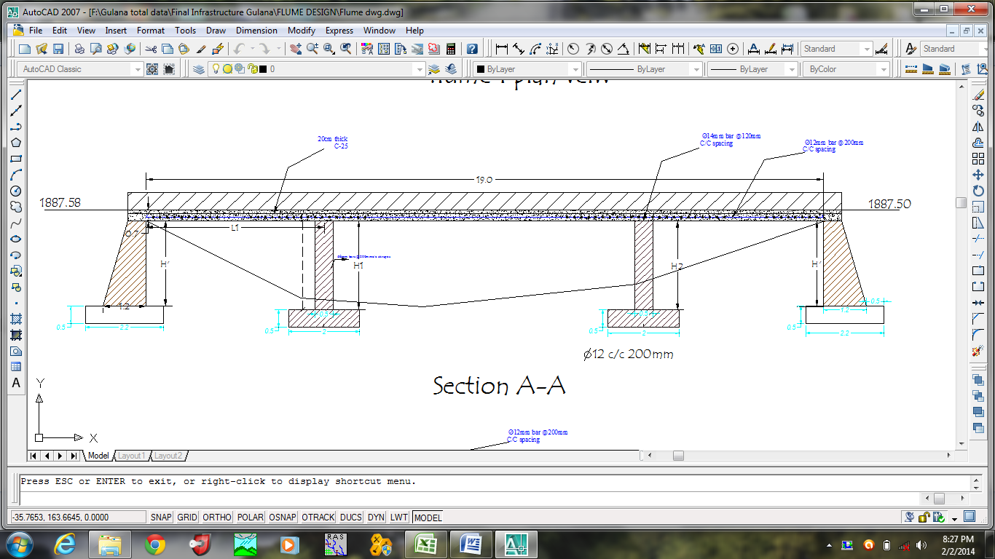
Figure 4-6: Typical three span flume

c. Structural design
Reinforced rectangular Flume cross section
Length of reinforced slab one span varies from 4.5m to 6.2m with its clearance.
- Load carried by the flume and retaining walls
Table 4-7: Total load carried by the flume and retaining walls
Code | slab width | slab thickness | load(kn/m) | remark
Load of concrete slab | 0.8 | 0.2 | 3.84 | ϒw (KN/m3) | 10
Load of canal wall | 0.5 | 0.15 | 1.8 | ϒc (KN/m3) | 24
Canal water load | 0.5 | 0.5 | 2.5 | ϒs (KN/m3) | 19
Total load, kN/m | wet condition |  | 8.14
Total load, kN/m | dry condition |  | 5.64 | critical condition
W_{con, dry} = 3.84 + 1.8 = 5.64KN/m
- Load of canal water
W_{w} =
Total uniformly distributed load on flume spans including retaining wall at both ends, W_{T} = W_{con} + ww
W_{T} = 8.14 KN/m… wet condition
Considering a one span uniformly distributed load, the reaction force is computed as shown below.
Distributed load =
8.14kn/m
B
RA

Figure 4-7: load distribution and bend diagram for flume
      - Wet condition
Taking moment about A, i.e. the clear spacing b/n piers and retaining wall & pier is 6m.Therefore the reaction force,
Ra=Rb
For easy analysis, we take
Rb=6*8.14/2=24.42 KN
      - During dry condition
W con=5.64 kN/m,
Rb=6*5.64/2=16.92 KN
Hence, the above forces are stabilized; we take the dry condition for analysis as this is critical ones.
Stability analysis of one of the bank of retaining wall that carrying the flume.
Figure 4-8: Typical abutment for the flume
Assume there is no water and soil in the inner side of the pier for critical condition. The support force at A is calculated above and is; RA=16.92 KN/m.
Ka =, for angle of repose, φ = 30⁰ (assumed)
r masonry = 22KN/m³
r concrete = 24KN/m³
r soil = 19KN/m³and r water = 10KN/m³
Taking moment of all forces about point A as shown in the table
Table 4-8: Stability analysis of retaining wall that carrying the flume
H | T' | B-T' | gM (kN/m3) | gs (kN/m3) | gW (kN/m3) | ka
1.1 | 0.4 | 0.2 | 22 | 20 | 10 | 0.3

Code |  | Fv | Fh | Lever |  | Resisting moment |  |  |  |  | Disturbing moment
W1 |  | 9.68 |  | 0.40 |  | 3.872
W2 |  | 2.42 |  | 0.067 |  | 0.16133
W3 |  | 2.2 |  | 0.13 |  | 0.29333
RA |  | 21.504 |  | 0.40 |  | 8.6016
Ps |  |  | 3.63 | 0.37 |  |  |  |  |  |  | 1.331
Sum |  | 35.804 | 3.63 |  |  | 12.9283 |  |  |  |  | 1.331
Factor of safety against,
 | Over turning = (M+ve/M-ve) >1.5 |  |  |  |  |  |  |  | Fo |  |  | 9.71 |  | >1.5 |  |  |  | safe
 | Sliding = (µxFv/Fh),---µ=0.75 >1.5 |  |  |  |  |  |  |  | Fs |  |  | 7.40 |  | >1.5 |  |  |  | safe
 | Tension: X= (Net Moment/Sum Fv), e=x-B/2, e<B/6 |  |  |  |  |  |  |  | X |  |  | 0.32
 |  |  |  |  | B/6= |  |  | 0.300 | e |  |  | 0.02 |  | <B/6 |  |  |  | safe

Where;
Fo =
Fs=
Checking bearing capacity of the footing
Maximum compression stresses
Since the allowable compression stress is about 200 kN/m² OK.
2. Stability analysis of one of the pillar wall that carrying the flume.

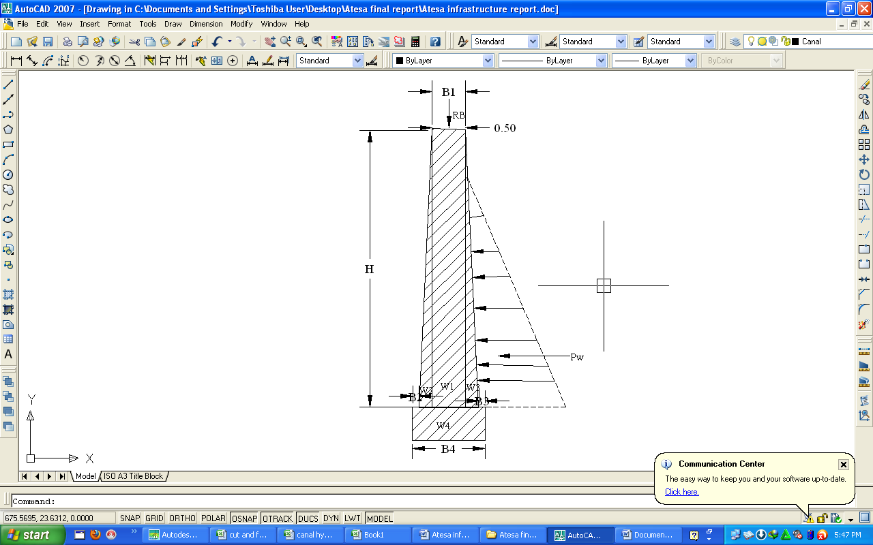
Figure 4-9: Typical masonry pier for the flume

Taking moment of all forces about point A as shown in the table
Table 4-9: sample pier stability analysis
H | B1 | B3 | B3 | B4 | h | g_{M} (kN/m³) | g_{w} (kN/m³)
3.0 | 0.50 | 0.20 | 0.20 | 1.30 | 0.50 | 22.0 | 10.0

Code | Fv | Fh | Lever | Resisting moment | Disturbing moment
W1 | 33 |  | 0.45 | 14.85
W2 | 6.6 |  | 0.067 | 0.44
W3 | 6.6 |  | 0.833 | 5.5
W4 | 14.3 |  | 0.650 | 9.295
Rb | 21.504 |  | 0.450 | 9.6768
pw |  | 2.25 | 1.300 |  | 2.925
UL | 19.5 |  | 0.433 |  | 8.4500
sum | 62.504 | 2.25 |  | 39.76 | 11.38
Factor of safety against,
Over turning = (M+ve/M-ve) >1.5 |  |  | Fo | 3.50 | >1.5 | safe
Sliding = (µxFv/Fh),---µ=0.75 >1.5 |  |  | Fs | 20.83 | >1.5 | safe
Tension: X= (Net Moment/Sum Fv), e=x-B/2, e<B/6 |  |  | X | 0.45
 | B/6= | 0.217 | e | 0.1958 | <B/6 | safe

D) Checking bearing capacity of the footing
Maximum compression stresses
Since the allowable compression stress is about 200 kN/m² OK.

Table 4-10: Flume location and CBL and TBL elevation at Flume inlet and outlet

BILL OF QUANTITY AND COST ESTIMATION
The cost estimate to construct the whole infrastructure system work is quantified as shown in table 4-6 below.

Table 4-11: Bill No.3 Summary of volume of work and cost estimation
General Item
Head work

Infrastructure

OPERATION AND MAINTENANCE
The operation of the irrigation system is continuous for 14 hours of irrigation a day in the main canal, secondary & tertiary canals whereas field canals within the tertiary block are operating in rotational system with each other for irrigation hours proportional to their command area. Since the field canal discharges are within the manageable range and the irrigation canal structures are accordingly designed for simple operation, the farmers can open and close easily whenever they required.

Table 5-1: Irrigation time for rotation
Gulana supply and branch canals identification
Rotation | ID | Command area | Duty | Required Q (L/sec) for 14 hr | Volume of water per day for 14hr irrigation in liter | Irrigation time for rotation (hr)
Supply canal
Supply canal | TC-1 | 26.08 | 1.27 | 33.1216 | 1669328.6 | 14
Rotation 1 | Fc-1-1 | 4.89 | 1.27 | 6.2103 | 312999.1 | 2.6
Rotation 2 | Fc-1-2 | 7.58 | 1.27 | 9.6266 | 485180.6 | 4.1
Rotation 3 | Fc-1-3 | 1.97 | 1.27 | 2.5019 | 126095.8 | 1.1
Rotation 4 | Fc-1-4 | 0.97 | 1.27 | 1.2319 | 62087.8 | 0.5
Rotation 5 | Fc-1-5 | 1.93 | 1.27 | 2.4511 | 123535.4 | 1.0
Rotation 6 | Fc-1-6 | 2 | 1.27 | 2.54 | 128016.0 | 1.1
Rotation 7 | Fc-1-7 | 3.9 | 1.27 | 4.953 | 249631.2 | 2.1
Rotation 8 | Fc-1-8 | 2.84 | 1.27 | 3.6068 | 181782.7 | 1.5
Supply canal | TC-2 | 8.34 | 1.27 | 10.5918 | 533826.7 | 14
Rotation 1 | FC-M-2-1 | 4.56 | 1.27 | 5.7912 | 291876.5 | 7.7
Rotation 2 | FC-M-2-2 | 1.59 | 1.27 | 2.0193 | 101772.7 | 2.7
Rotation 3 | FC-M-2-3 | 2.19 | 1.27 | 2.7813 | 140177.5 | 3.7
Supply canal | TC-3 | 22.91 | 1.27 | 29.0957 | 1466423.3 | 14
Rotation 1 | FC-M-3-1 | 6.44 | 1.27 | 8.1788 | 412211.5 | 3.9
Rotation 2 | FC-M-3-2 | 4.97 | 1.27 | 6.3119 | 318119.8 | 3.0
Rotation 3 | FC-M-3-3 | 4.17 | 1.27 | 5.2959 | 266913.4 | 2.5
Rotation 4 | FC-M-3-4 | 4.96 | 1.27 | 6.2992 | 317479.7 | 3.0
Rotation 5 | FC-M-3-5 | 2.37 | 1.27 | 3.0099 | 151699.0 | 1.4
Supply canal | TC-4 | 10.77 | 1.27 | 13.6779 | 689366.2 | 14
Rotation 1 | FC-S-4-1 | 1.81 | 1.27 | 2.2987 | 115854.5 | 2.4
Rotation 2 | FC-S-4-2 | 2.78 | 1.27 | 3.5306 | 177942.2 | 3.6
Rotation 3 | FC-S-4-3 | 1.95 | 1.27 | 2.4765 | 124815.6 | 2.5
Rotation 4 | FC-S-4-4 | 4.23 | 1.27 | 5.3721 | 270753.8 | 5.5
Supply canal | TC-5 | 3.83 | 1.27 | 4.8641 | 245150.6 | 14
Rotation 1 | FC-S-5-1 | 3.83 | 1.27 | 4.8641 | 245150.6 | 14.0
Supply canal | TC-6 | 28.38 | 1.27 | 36.0426 | 1816547.0 | 14
Rotation 1 | FC-S-6-1 | 6.18 | 1.27 | 7.8486 | 395569.4 | 3.0
Rotation 2 | FC-S-6-2 | 6.61 | 2.27 | 15.0047 | 756236.9 | 3.3
Rotation 3 | FC-S-6-3 | 5.96 | 3.27 | 19.4892 | 982255.7 | 2.9
Rotation 4 | FC-S-6-4 | 9.63 | 4.27 | 41.1201 | 2072453.0 | 4.8
Supply canal | TC-7 | 9.88 | 1.27 | 12.5476 | 632399.0 | 14
Rotation 1 | FC-S-7-1 | 9.88 | 1.27 | 12.5476 | 632399.0 | 14
Supply canal | TC-8 | 30.66 | 1.27 | 38.9382 | 1962485.3 | 14
Rotation 1 | FC-S-8-1 | 9.88 | 1.27 | 12.5476 | 632399.0 | 4.5
Rotation 2 | FC-S-8-2 | 7.51 | 2.27 | 17.0477 | 859204.1 | 3.4
Rotation 3 | FC-S-8-3 | 13.27 | 3.27 | 43.3929 | 2187002.2 | 6.1
Supply canal | TC-9 | 3.81 | 1.27 | 4.8387 | 243870.5 | 14
Rotation 1 | FC-S-9-1 | 1.27 | 1.27 | 1.6129 | 81290.2 | 4.7
Rotation 2 | FC-S-9-2 | 2.54 | 2.27 | 5.7658 | 290596.3 | 9.3
Supply canal | TC-10 | 14.92 | 1.27 | 18.9484 | 954999.4 | 14
Rotation 1 | FC-S-11-1 | 3.97 | 1.27 | 5.0419 | 254111.8 | 3.7
Rotation 2 | FC-S-11-2 | 3.38 | 1.27 | 4.2926 | 216347.0 | 3.2
Rotation 3 | FC-S-11-3 | 7.57 | 1.27 | 9.6139 | 484540.6 | 7.1
Supply canal | TC-11 | 19.62 | 1.27 | 24.9174 | 1255837.0 | 14
Rotation 1 | FC-S-1 | 19.62 | 1.27 | 24.9174 | 1255837.0 | 14

To ensure equitable distribution of water, the amount of water released through field canals should be proportional to the available command area. Rotational irrigation system within field canals is recommended for 14hrs of irrigation.
- By taking 14 hrs of irrigation hour a day,
- Field canals rotational system has been arranged.
- The required volume of water a day for each command area under each field canal is calculated. (Column 6)
- Irrigation hour (Duration) for each field canal and farm blocks is calculated (Column 7)
- In order to minimize the water losses during conveyance and application:-
  - Water users association should assign gate keeper who is responsible to control illegal gate opening, damage and losses through gates.
  - Damage on the canal system, structures and gates should be followed up by the WUA.
  - For technical failure beyond the capacity of the local community should be informed to the woreda irrigation and Drainage sector and immediate action should be taken.
  - Frequent supervision to the canal system is needed. Remove silt, weed, and any flow blocking objects from the canal system.
  - Land leveling of each farm block access uniform water distribution within the block.
  - Water application should be done by furrow rather than flooding.
  - Uniform cropping season and pattern within nearby blocks is good for irrigation water management.
  - Water application should be based on the proposed irrigation hour and rotation. This will reduce water application losses.
- Delivery system of water from field canal to the fields should be by bank breaching.
- Beneficiaries of the project need to have operation and maintenance budget, For O&M cost incurring entity area:
    - Purchase sing of gate lubricate (grease)
    - Replacing and maintenance of Stolen and damaged gates
    - Damages on the cross drainage structures.
The expense for O&M should be collected from the beneficiaries. Of course, much of the task is done by the labor and skill of the community. For cost incurring activities beneficiaries have to collect money based on the proportion of the command area they owned.
Farmers should contribute twice in a year unless special damage is happened to the system. The amount of money to be contributed by each Household shall be determined by the beneficiaries using the water users association.
The canal system of the project is earthen canal except main canal of the first 200m, which is susceptible to siltation, erosion, growth of weeds and or breaching problems. Though the canal sections are designed for non- silting and non-scouring conditions, the above mentioned problems are unavoidable and hence periodical and yearly inspection and maintenance of canals and structures are obligatory in order to fulfill the design objectivity of the project.

CONCLUSION AND RECOMMENDATION
The infrastructure of this project is designed to irrigate about 200 ha of land by taking its supply from Gulana stream diversion. The maximum duty of the command area is 1.27lit/sec/ha for 14 irrigation hours with overall project efficiency of 50 %. The method of irrigation of the project area is furrow surface irrigation. The project is designed to irrigate 200 hectares and 27 hectares of land both in wet and dry season respectively.
As the dominant soil type through which the main canal runs is heavy clay. The main canal system is designed to be masonry only for the first 1200m and the rest 1250m is designed to be earthen canal
The design of the canal dimensions of the irrigation canal is done by applying the manning’s uniform flow equation. The variable of the hydraulic parameters are calculated using iteration or flow master program.
The design discharge for the catch drain canal along main canal is determined using rational formula and following ERA Drainage Design manual.
Excavation of Field canals and field drains are left for the beneficiaries, hence the cost is not included in the bill of quantity.
The cost of operation and maintenance is going to be covered by the beneficiaries; hence the cost is not included in the bill of quantity.
The following recommendations are drown:
- The turnout is located on the layout, which shall be modified during actual work.
- To cover the proposed area, furrow irrigation method is highly recommended.
- For better performance and long service of the project regular inspection and maintenance is highly required.
- Farmers training how to operate and maintain the project as a whole and available land water resources has a paramount important
- The irrigation hours per day and per week should be flexible based on base flow amount of each week or month.
- During dry season the base flow amount is estimated to be 53l/s it is required to release 20% of the base flow to downstream user.

REFERENCES
- Irrigation Engineering and Hydraulic Structure (Garg)
- Design of small Canal structures, USBR
- Soft copies of hydraulic structure publishing
- IDD manual
- ERA (Ethiopian Roads Authority), 2002: Drainage Design Manual, Hydrology
- Theory & Design of Irrigation structure, Volume II (R.S. VARSHANEY)

