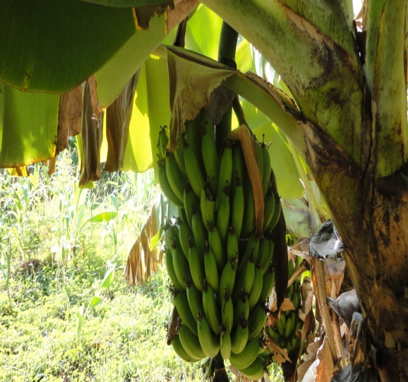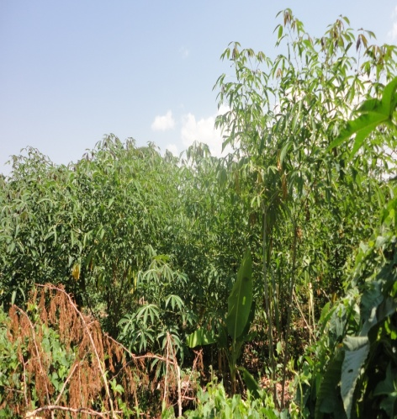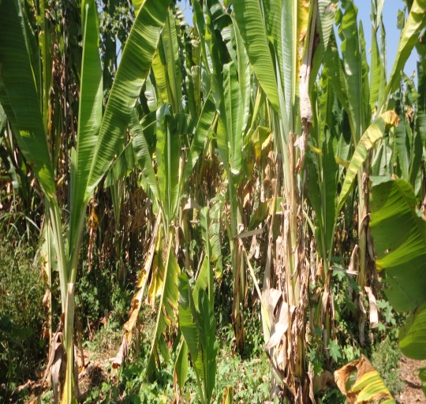
THE NATIONAL REGIONAL STATE OF OROMIA
HADHA-HURBU SMALL SCALE IRRIGATION PROJECT

ORGANIZATION MANAGEMENT DRAFT REPORT

CLIENT
OROMIA IRRIGATION DEVELOPMENT AUTHORITY (OIDA)
P. O. Box
Tel +251
Email:
Finfine/Addis Ababa, Ethiopia

CONSULTANT
Oromia Water Works DesignSupervision Enterprise
P.O.Box. 870/1250
Tel +251 11 4392162/2470
Email: owwdse@telecom.net.et
Finfine/Addis Ababa, Ethiopia



March, 2019

Table of Contents
Acronyms 6
1. Introduction 7
1.1 Objectives 7
2. General Methodology and Approaches 8
2.1 Consultation 8
2.2 Survey 8
2.3 Assessment of Existing Situation and Legal Environment 8
2.4 Community Participation 9
2.5 Identifying Institutions and their Capacity 10
2.6 Views of the community and stakeholders 11
2.7 Existing land Use policies and proclamations and their limitation 14
2.8 Conditions of Land ownership at the study area 14
3. Scheme Management 15
3.1 Main Duties of the scheme office 15
3.2 Manpower requirement of the Scheme office 17
3.3 Irrigation Water Users Association 18
3.4 Proposed Organizational Structure of Hadhaharbu WUA 19
3.5 Operation and Maintenance subcommittee: 20
3.6 Training and experience Sharing 22
3.7 Important stakeholders and their Responsibilities 23
3.8 Conclusions and recommendations 24
Bibliography 25

List of Tables
Table 1: Man power required at the Hadhagora scheme management office 16
Table 2: Equipment and facilities 17
Table 3: main stakeholders identified, their roles and responsibilities 22

Acronyms
FDRE MOWR: Federal Democratic Republic of Ethiopia Ministry of Water Resources
NGO: Non- Governmental Organizations
OIDA: Oromia Irrigation Development Authority
O&M: Operation and Maintenance
OWWDSE: Oromia Water Works Design and Supervision Enterprise
TVET: Technical and Vocational Education Training
WUA: Water Users Association
WUC: Water Users Cooperatives

Introduction
There are two central issues regarding irrigation scheme implementation and management. The first one is involvement of the users groups in identification, study, design and implementation of the irrigation scheme. This encompasses their needs and interest regarding the proposed action. Basically for sustainability of the scheme the user communities or groups need to be involved in all phases of project cycle. This is fundamental concern of irrigation development in which the idea of the project being community or user based is guaranteed so that ownership sentiment is established. The other concern is management of the scheme. An irrigation scheme is too often implemented for a group of people and hence how to manage and use the common resource and irrigation infrastructure for the life time of the project is another concern. This regards operating, maintaining and water distribution among the users.

Objectives
The general objectives of community organization, participation and management(institutional assessment) is to identify existing community and local level support institutions ,community and stakeholders willingness, their share of participation and propose future community organization or feasible institution.
The specific objectives include but not limited to:
- Identify existing community willingness and decision on the proposed project
- Assess existing institution, stakeholders and institutional arrangements including opportunities, issues and constraints
- Understand community perception, attitude and participation and demand driven of the project expressed in terms of demonstrable willingness of the user community to commit themselves in contributing resource and acceptance/ownership responsibility for operation and maintenance of the scheme.
- Identify modes of community participation or ways of maximizing communities participation
- Propose workable institutional systems that promote effective planning, design, construction and operation and maintenance.

- General Methodology and Approaches
To undertake community participation and organization study the methods and approaches include surveys, consultation and informal discussions.

Consultation
During the feasibility study of Hadhaharbu micro dam project consultation had been made with stakeholders found at various levels. They include zonal OIDA, district OIDA that participates fully with the study, district administration, district land administration and local administration consulted regarding the project and cross cutting issues in connection with its implementation. Informal discussions and general meeting with the user groups had been held and main issues had been discussed

Survey
The views of individual households regarding their interest for the proposed action and dam project and their contribution towards its implementation were assessed using household survey. The results and main findings are incorporated in this report.

Assessment of Existing Situation and Legal Environment
In line with the national irrigation policy to enhance the contribution of water to the national economy through the development of the country's water resources and expanding irrigation schemes so that agricultural production is improved by solving the problem of water shortage caused by the unpredictability of the rainfall, establishing irrigation institutions and regulations at various levels are some of the measures. One of the existing regulations in relation to irrigation development includes equitable distribution of land and water among users especially at public implemented irrigation schemes.
It was indicated on the policy document that Participatory- driven approach for promoting efficiency and sustainability was one of the two prolonged approaches for promoting irrigated agriculture. The following were also stipulated in the policy of irrigation development:
- Promote decentralization and users-based-management of irrigation systems taking account of the special needs of rural women in particular. (Ministry of Water Resources, 2001)
Furthermore in the strategic document that intends to translate the policies into actions one can find the following in relation to irrigation development. (FDREMOWR, 2001)
- Establish and strengthen the Water Users Associations (WUA) or Irrigation Co-operatives(WUC) in each scheme on a voluntary basis.
- Encourage and promote the role of women in these community based structures.
- Provide training to the women to assume greater role in the functioning of these community based structures.
- Make these structures focal point for development and management of irrigation schemes.
Towards this aim:
- promote partnership building between relevant government institutions, NGOs and local communities at different levels for the provision of bulk water storage, flood control and transfer schemes in particular;
- mobilize local community groups and assign them greater role in the planning, construction, and O&M of small scale irrigation schemes;
- involve local people in the project cycle of irrigation schemes, as well as the settlers in the decision-making process; and
Institute conflict resolution mechanisms based on traditional approaches and cultural Practices.

Community Participation
A distinction has to be made between the concepts of participatory and participation. (Narayan, 1993) defined participatory development as involving users and communities in all stages of the development process. On the other hand participation is voluntary or other forms of contribution by rural people to predetermined programs or project. On the other hand a participatory project has been described as one initiated and owned by beneficiaries.
According to WB, 1992 participation has been defined as a process by which people especially disadvantaged people influence decision that affects them. This is mainly to attain the objectives of empowering, developing beneficiary capacity, improve effectiveness and efficiency of activities and cost sharing. In general the principle of participation requires working or starting and finishing with the local people.

Participation is considered a voluntary contribution by the people to one or another of public programs supposed to contribute to national development, but the people are not expected to take part in shaping the program or criticizing its content.
With regard to rural development participation includes people’s involvement in decision making processes, implementing programs, their sharing in the benefits of development programs, and their involvement in efforts to evaluate such programs.
- Popular participation in development should broadly understand as the active involvement of people in decision-making process in so far as it affects them.
- Community involvement means that people, who have both the right and duty to participate in solving their own problems, have greater responsibilities in assessing their needs, mobilizing local resources and suggesting new solutions, as well as creating and maintaining local organizations.
- Participation is considered to be an active process, meaning that the person or group in question takes initiatives and asserts his/her or its autonomy to do so.
The target communities have an experience in participating in public development activities that include soil and water conservation activity, road construction and maintenance, construction of social service infrastructures such as school, domestic water supply and the like. Forms of participation include mainly free labor contribution. One of the agendas at the public meeting were the users had to participate in all phases of project cycle including during construction. They had been informed to cover a minimum of 10% total project cost as one of the modalities of project implementation.
About 65.4% of household survey respondents are willing to contribute free labor during construction.

Identifying Institutions and their Capacity
Identifying relevant institutions and stakeholders and assessing their capacity is crucial for effective implementation and management of any irrigation project. The main institutions in connection with irrigation development at the study area include irrigation sector, land administration, pastoralist development office. Except the pastoral development office that has staffs at local level the other sectoral offices are limited at district level. The pastoral development office was expected to have about three development office one working on crop production, the other on natural resources and one for supporting livestock husbandry activities. Currently there is only one female development worker at Hadhagora. The district irrigation development office had about ten staffs one of which is female. Four staffs are first degree holders and the others are TVET graduates. There is only one room for all staffs which is poorly furnished. Their main duty is promoting irrigation development in the whole district that includes extension, scheme management and study and design. Their experience in areas of scheme management and study and design is very limited. OIDA is initially structured at region, zone and wereda level. Currently there is rumor that the existing structure is demolished where irrigation department becomes one of the departments under bureau of agriculture and natural resources. Other structures involved in irrigation development in the region include private and public consultants in study and design, public and private contractors for construction of small, medium and large scale irrigation schemes. NGOs and international funding agencies are also involved in the development of irrigation activities in the region.
At the local level there are health extension workers and kebele manager. There is kebele office but the services of the local leaders was found in adequate including lack of keeping records that indicate the local administration profile. Geda system which is the Oromo Sociopolitical organization is one of the informal institutions operating in the area. Important decisions and conflicts are resolved by the prior consent of the ‘abagdas’.

Views of the community and stakeholders
Based on consultations made, the communities and local leaders do not have adequate information regarding the project. The site was proposed and selected by the district irrigation development office. Various alternatives along the stream was made with the engineering team of OWWDSE and the current site found best option in the area.
Various consultation procedures are undertaken. It was tried to consult the zonal irrigation sector initially and they are informed to some extent even though it found difficult getting the leaders due to ad hock assignments. A letter was submitted to zone and district administration office. All district level sectoral offices are introduced regarding the project. Before getting into the project community the local administration was consulted and introduced the project. Then they are informed to appoint a meeting after identifying the target communities. It was identified that one of the zones found in the kebele named Tadacha among three are found the main target beneficiaries. Few had appeared at the first day consultation and the meeting was postponed to other day. About one hundred fifty had appeared during the next day meeting. Facilitators and government officials include representatives of district administration essentially the district land administration management staff, district irrigation development head and staffs and OWWDSE experts including the socioeconomic team, agronomist and engineering team.

Figure 1:Public meeting with the community
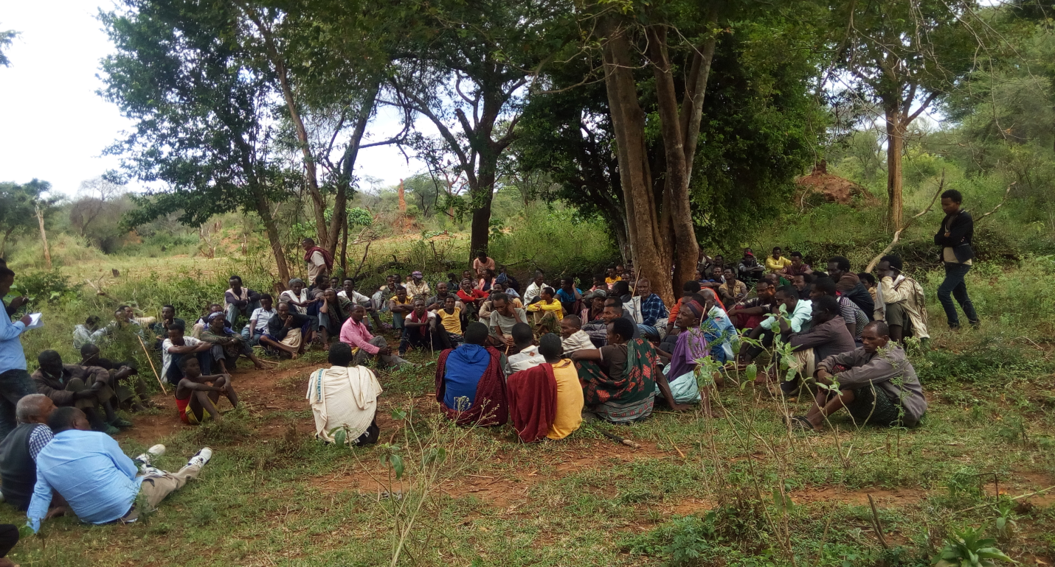

The meeting was started after thank giving by the ‘Abagadas’. After introducing the OWWDESE staff the irrigation office head explained and discussed the agendas for the participants. The points include the following:
- Importance of harvesting water in the area and irrigation technology in particular
- Existing policies and regulation in the region concerning irrigation development; These include utilization of irrigation land and water sources, compensation claim in case of loss of properties including land due irrigation infrastructures
- Cost sharing and community participation in the course of project implementation
- Establishing water users association and preparedness to cover various operational expenses during project development
- Awareness on Cost Recovery Principles due to increased income
Farther explanation and clarification was provided by OWWDSE socioeconomic experts. Then the participants are asked to raise their concerns and ask things found unclear. Unfortunately the meeting was contested by the influential groups who are supposed to be affected by the reservoir area. They raised the negative impact of the project and resisted its implementation. No possibility of getting alternative land for use by the losers was the main issue raised. Based on this the meeting was terminated. Feedback was provided for the district administration. Conflict between the current local administrator and the past administrator who mainly challenged the meeting was raised by the district administrator and he suggested the possibility to resolve the problem. The whole study crew had returned to Finfine and reported the progress and problems to the office on the basis of which the client/OIDA head quarter informed. After two weeks’ time OIDA through its down structure office preferably the district office said that the community had been convinced and it is possible to undertake the study. Based on this the study team was mobilized again to the area. Based on this the study crew tried to get the progress from local leaders and district administrators accordingly it was understood that an independent discussion had been made with the influential groups and other affected families and the main issues of agreement include the following.
- Cash compensation for the losers of land and other properties lost due to reservoir and others
- The study has to continue
Accordingly household survey and other studies including surveying, soil study and agronomic study had advanced peacefully and finalized. Asked for whether the respondents of the household heads heard of about the proposed project or not about 90.2% of the respondents have heard it and similarly asked for whether they accept the plan or not 86.7% of the respondents have a positive response mainly expecting sustainable crop production. Main reason for those who do not accept the plan was found to be loss of benefit from current land use.

Existing land Use policies and proclamations and their limitation
The constitution of the country asserts that land belongs to the government and people of Ethiopia. Land users have usufruct right not ownership right. It prohibits sale of land and exchange in terms of long term mortgaging. A land owner in case of farming communities can rent part of his holding in case of difficulty to cultivate may be because of health and labor shortage. The regional land policy which is more or less depend on the constitution as well as the federal governments land policy permits inheritance and renting of plots for not more than three years continuously. In the same policy document it was asserted that there should be land redistribution at all irrigation schemes among maximum number of beneficiaries. Land transfer in terms of inheritance and exchange of plots are the main strategies. However lack of regulations and enforcements are the main challenges that decreased efficiency and effectiveness of irrigation schemes implemented in the past. Since most land at pastoralist communities was expected to be communal it is relatively easier to implement the land relocation including at the study area.

Conditions of Land ownership at the study area
The study area was characterized by agro pastoralist livelihood system which was transformed from purely pastoralist livelihood system recently hence private holding were limited and most land was communal holding used mainly for grazing purpose. However recently due to population increase cultivation started. People started to fence plots for grazing and cultivation formally or informally. According to the district land administration office there is no land certification made in the district as a whole. The available land at the study area comprises individual holding and communal holding.
- Scheme Management
It was necessary establishing users group for effective performance of the scheme. Irrigation is not well known at the area since it is pastoralist setting where crop production itself is at infant stage. The project should be designed to be an integrated irrigation based project. Its purpose should be storing water for various uses. The stored water could be used for domestic purpose, livestock drinking, irrigation, fishing and also supplements bee keeping activities.
The total area targeted for irrigation development is about 500ha. This is categorized under medium scale irrigation project according to the existing directives and guidelines. According to recent guidelines and procedures small scale irrigation schemes that irrigate up to 200ha are to be managed by users themselves. Medium and large scale irrigation schemes need an independent scheme management office at scheme level in the context of Oromia region and there are experiences at Fentale, Tibila and Wedecha Belbela irrigation systems. This is based on experiences of managing large irrigation schemes in other countries. The success or failure of such management in our country is not well known. It may not be effective due to improper implementation. The scheme office is not well staffed and lack equipment and facilities. Farther more two schemes namely Fentale and Tibila are not completed yet that may complicate its management.

Main Duties of the scheme office
The main duty of the scheme office is in general is to run the scheme. It undertakes maintenance of the scheme infrastructures; distribute water for the users based on the schedule and collect fees from users of the scheme. The scheme office is accountable for the zone or region level irrigation authority. It could have the following organizational structure.

Figure 2: Organizational Structure Hadhaharbu Scheme
OIDA Head Quarters

Zone OIDA

District OIDA
Hadha hurbu Irrigation Scheme office

Project manager

O &M department
Agricultural department
Input supply and marketing
Administration & Finance

Manpower requirement of the Scheme office
The man power required for the scheme office was proposed below.
Table 1: Man power required at the Hadhagora scheme management office

S.No | Staffs required | Education level and type | Number required | Monthly salary(Birr) | Annual salary
I | Project Manager | BSc Irrigation/agricultural engineering | 1 | 8000 | 96000
II | Administration and finance |  |  |  | 0
1 | Personnel and property administrator | BA management related | 1 | 6000 | 72000
2 | Accountant | BA ,accounting | 1 | 5000 | 60000
3 | Fee collector and cashier | Diploma, accounting or book keeping | 1 | 2000 | 24000
4 | Store keeper | grade 10 grade 12 complete | 1 | 1500 | 18000
5 | janiter | Read and write | 1 | 1000 | 12000
6 | Guards | read and write | 2 | 1000 | 24000
7 | Driver | read and write | 1 | 1500 | 18000
III | O&M department |  |  |  | 0
1 | Construction expert | diploma vocational training | 1 | 4000 | 48000
2 | Operators | Vocational training | 3 | 3000 | 108000
IV | Agriculture |  |  |  | 0
1 | agronomist/horticulturalist | Bsc in agronomy or horticulture | 1 | 6000 | 72000
2 | Livestock expert | Bsc, animal science | 1 | 6000 | 72000
V | Input supply and marketing |  |  |  | 0
1 | Agricultural economist | BSc, agricultural economics or economics | 1 | 6000 | 72000
2 | Marketing expert | BA in marketing or cooperatives | 1 | 6000 | 72000
Total man power required |  |  | 17 |  | 768000

This way of scheme management over the traditional way of scheme management of WUA has the following advantages;
- The scheme could be used effectively due to higher responsibility
- Timely maintenance could be enabled
- Production could be based on recommendations and market oriented
- The sustainability of the scheme could be reliable
- Fees may be collected properly due to accountability
- Integration of other activities such as livestock and bee keeping practices could be enhanced
The disadvantage of such scheme management is clearly it entails additional budget from the government to run the scheme.
Equipment and facilities required
To operate the scheme properly the following facilities and equipment are proposed.
Table 2: Equipment and facilities
No | Item | Quantity | Remarks
1 | Office | 1 | one block, six rooms
2 | Field vehicle | 1
3 | Tractor | 1 | To be rented for cultivators
4 | Excavator | 1
5 | Table and chairs | as required
6 | Computers | 4

Another alternative to manage the scheme is by elected committees from the user communities which is mainly viable with small scale irrigation scheme. Since it may be challenging to collect fees from the users for the use of water it is preferred as far as the project area is concerned.

Irrigation Water Users Association
According to literature a Water User Association (WUA) is a non – profit organization that is initiated and managed by the group of water users along one or more hydrological sub systems regardless of the farms involved. In the past most WUAs have been established through a top down approach where the ordinary farmers have neither been consulted or nor been informed that they are members of WUA. For this reason such WUAs have failed or are unable to recover the costs of water and operation and maintenance of the irrigation and drainage facilities from the farmers because the ordinary farmers do not feel ownership and tend to avoid fee payment.
In general it is very crucial making WUA a viable and sustainable rural organization. The main functions of WUA are the following.
- Equitable distribution of water for their members
- Maintenance of irrigation infrastructures
- Resolving of conflicts
- Promoting better support among farmers and between farmers and officials
- Increase agricultural productivity

Regarding Hadha harbu project it was found difficult establishing WUA at this phase since the general meeting was departed without agreement because of some influential groups supposed to be negatively affected by the project. Hence it was agreed with local leaders and OIDA district office that organizational issues and others shall be considered after detail design and necessary compensation for the losers terms of payment agreed. Hence establishing users group seems the mandate of the client. The consultant’s responsibility in connection with community organization is providing general direction how to manage the scheme based on the existing local traditions, policies and regulation.
Based on this the consultant had undertaken drafting agendas for the public meeting, facilitates the meeting, provide farther explanations and clarification regarding the intervention not only for the community but for most stakeholders found at zone, wereda and local administration level.

Proposed Organizational Structure of Hadhaharbu WUA
Hadhaharbu is medium scale irrigation project expected to have many irrigation infrastructures including the reservoir area. It may be difficult to be managed by traditional way of irrigation water users association. The committee members may be sub divided into sub committees. They may include Operation and maintenance subcommittee, finance subcommittee, production & marketing subcommittee and women subcommittee.
General assembly:
This is the major decision making body of the WUA and it is the general meeting of at least two third of the members and has the power to assign and nominate various type of committees executive committee, control committee and block leaders.
Control committee: It could have three members and it has the responsibility and power to control the resources of association both material and financial resources. It should also control whether the scheme is going on the right track i.e serving the community as intended.
Executive committee: The executive committee could have about fifteen committees which could be sub divided into four sub committees with the following main activities.

Operation and Maintenance subcommittee:
Its main duty is take care of the various irrigation infrastructures and undertake on time maintenance. This committee could be also responsible for equitable distribution of water at the service area. Four members are adequate and block leaders are accountable to this subcommittee.
Finance subcommittee: this subcommittee as the name implies is accountable for the inflow and out flow of the association. It collects various fees from the members, open a bank account in the name of the users and deposit the money. It also effects payments due. It could have three members.
Production and Marketing subcommittee: This subcommittee is responsible to lead crop production activities including input supply and marketing and distribution of project output. It is proposed to have about three members.
Women subcommittee: Literature indicates that women had benefited little from past implemented irrigation schemes. So to take into account the gender balance and protect women right on access to irrigable land and water this subcommittee is found relevant. It could have three members of which two are female.
Additionally the executive committee had chairperson and secretary that could have following personal qualities.
Chairperson: this person should have the quality of respect by the society, responsive; possess some of the managerial skills that can be acquired in born. The main duty is to provide the overall leadership regarding the organization. If possible he could able to read and write. His main duty is to lead the general meetings, give general direction for other committee members and effect payments and decide and approve regarding matters on properties of the association.
Secretary: This individual should able to read and write in addition to other personalities. He is responsible for all documentations including record keeping. The records include list of beneficiaries with size of plots managed, internal bylaws, minutes of meetings and the like. The importance of having independent office is also crucial.
Control Committee: composed of three members to be nominated by the general assembly and it is responsible for the control of scheme performance and resources of the association including the physical infrastructures.
Block leaders: These are assigned based on the size of scheme and hydraulic structures mainly secondary and tertiary canals. Traditionally various names and connotations are given for these people such as ‘malaqaa’ in Harerghe and ‘yehuha abat’ around Amharic speaking people. These are responsible for distributing water properly for the members and very crucial at any irrigation scheme management.
Hadha harbu water Users Association is proposed to have the following organizational structure.

Figure 3: Organizational Structure of Hadhaharbu WUA
OIDA District office

Hadhaharbu WUA

General Assembly

Executive Committee
Control Committee

O & M subcommittee
Finance subcommittee
Women subcommittee
Production & marketing

Block leaders

Training and experience Sharing
The target communities are less experienced in irrigated agriculture in general.
Technologies may fail because of lack of experience and lacks of practical know how. For this reason there should be training and experience sharing of district level experts and farmers. The training should include irrigation technology and production of high value crops using irrigation. Particularly irrigation development using dam as water source is found critical. Farmers should get experience sharing from similar schemes at other zones in the region and other regions in the country in connection with using water harvesting structures for crop production and other purposes.

Important stakeholders and their Responsibilities
Important stakeholders identified for effective implementation and performance of the scheme are as summarized in the table that follows.

Table 3: main stakeholders identified, their roles and responsibilities
Identified Stakeholder | Main Duties and Responsibilities at various phases of the project
Identified Stakeholder | Project preparation | Implementation phase | Operation phase
Community/users | Contribute idea, provide information, organized as users association | Contribute towards construction, establish/strength WUA, involved in M&E | Use and protect irrigation infrastructure properly, relocate and cultivate plots, involved in terminal evaluation
OIDA District/  Zonal offices | Facilitate in establishing WUA, support in study and design process | Mobilize community and strength WUA, participate in M&E | Provide extension service and training, facilitate credit service
OIDA Head Quarter | Select consultant to conduct detail study, Evaluate and appraise design report and plan, secure fund for implementation, prepare implementation plan | Bid processing and selection of contractor,  Monitor and follow up of the progress | Undertake or cause to undertake terminal evaluation with users and others
Local administration | Involved in organization and mobilization of users, confirm the willingness and support, involved in establishing WUA | Mobilize community to participate at various activities, land redistribution, manage and resolve disputes and conflicts, involved in establishing WUA | Involved in various levels of project evaluation
Land administration | Provide data on existing land use, awareness creation on various rules and regulation in relation to irrigable land | Actively involved in relocating and distributing land for users, conflict resolution over use of land | Monitor land allocation issues, resolve conflicts in connection with land use
Environmental protection | Involved in ESIA process | Monitor environmental issues | Monitor the environmental performance of the scheme
Cooperative promotion Agency | Involved in establishment of WUA | Involved in strengthening WUA | Promote WUA to WUC, facilitate credit and input provision, facilitate product marketing
Bureau of Agriculture and other NGOS | Support at every stages of the project specially training and experience sharing among farmers, introduce new technologies and innovations ,agricultural practices particularly in areas of agricultural water use and crop selection

Conclusions and recommendations
Hadhaharbu micro earth dam project for the purpose of enhancing agricultural production with irrigation is proposed and planned in pastoralist and agro pastoralist setting. Crop production activity is at infant stage. The target community’s livelihood system is mainly based on animal husbandry practices. There are social services such as schools, domestic water supply and others that are communally under use. It was tried to have consultation with the target communities however few members had tried to resist the intervention mainly because of the fear that they are going to loss current benefits. It was found storing water in the area as crucial not only for irrigation development but for domestic use and more of for livestock drinking. The study was conducted under the condition that affected groups due to reservoir area are compensated in cash or in kind based on the existing rules and regulations. Farther consultation and discussion has to be made by the client regarding the compensation and organizational issues. At this this stage the consultant suggests alternative ways of managing the scheme which are establishing an independent scheme management office or establishing strong WUA fully responsive for the day to day activities of the scheme.

Bibliography
FDREMOWR. (2001). Water Sector Strategy. Addia Ababa: MOWR.
Ministry of Water Resources. (2001). Water Sector Policy. Addis Ababa: MOWR.

Annexed Materials
Agreement letters and Minutes of meetings
