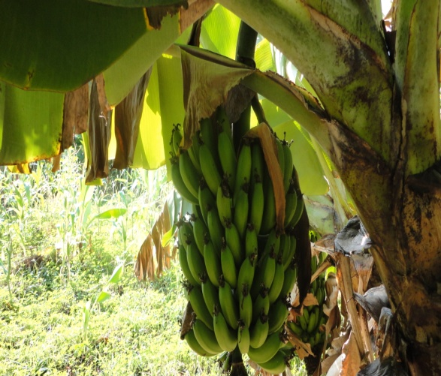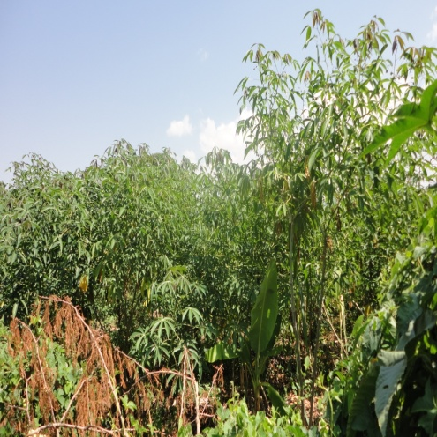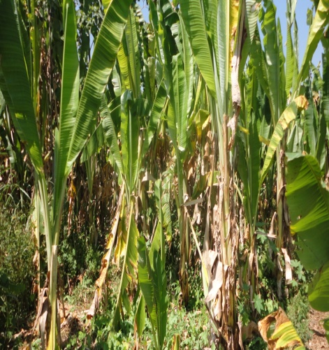

THE NATIONAL REGIONAL STATE OF OROMIA
HADHA-HURBU SMALL SCALE IRRIGATION PROJECT

SOCIO-ECONOMIC STUDY DRAFT REPORT

CONSULTANT
Oromia Water Works DesignSupervision Enterprise
P.O.Box. 870/1250
Tel +251 11 4392162/2470
Email: owwdse@telecom.net.et
Finfine/Addis Ababa, Ethiopia

CLIENT
OROMIA IRRIGATION DEVELOPMENT AUTHORITY (OIDA)
P. O. Box
Tel +251
Email:
Finfine/Addis Ababa, Ethiopia

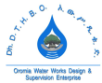
March, 2019

Acronym
ADLI: Agricultural Development Led Industrialization
AIDS: Acquired Immune Deficiency Syndrome
CBPP: Contagious Bovine Pleuropneumonia
CCPP: Contagious Caprine Pleuropneumonia
CSA: Central Statistical Agency
DA: Development Agent
DAP: Di ammonium Phosphate fertilizer
DRSLP: Drought Resilience Sustainable Livelihood Program
DVM: Doctorate of Veterinary Medicine
ESIA: Environmental and Social Impact Assessment
FDRE: Federal Democratic Republic of Ethiopia
FDRE MWR: Federal democratic Republic of Ethiopia Ministry of Water Resources
FMD: Foot and Mouth Disease
GDP: Gross Domestic Product
GOE: Government of Ethiopia
GTP: Growth and Transformation Plan
HIV: Human Immune Virus
IFAD: International Fund for Agricultural Development
Kg: Kilograms
LSD: Lysergic acid Diethylamide
MOWR: Ministry of Water Resources
NPC: National Planning Commission
NPS: Nitrogen Phosphorus Selphate fertilizer
OIDA: Oromia Irrigation Development Authority
OIPAP: Oromia Irrigation Potential Assessment Project
OWWDSE: Oromia Water Works Design and Supervision Enterprise
PASID: Participatory Small Scale Irrigation Development
PCDP: Pastoralist Community Development Project
PRA: Participatory Rural Appraisal
SPSS: Statistical Package for Social Sciences
UN: United Nations

Table of Contents
Acronym 3
List of tables 7
List of figures 8
1. Introduction and Background 9
1.1 Project Rationale 10
1.2 Project Objectives 10
1.3 Specific Objectives of the project 10
2.1 Stakeholder Consultation and Community Sensitization Meetings 11
2.2 Main issues include: 12
2.3 Methods of Data Collection 12
2.3.1 Household Survey 13
2.3.2 PRA (Participatory Rural Appraisal) 14
2.3.3 Collection of Secondary Data 14
2.3.4 Data Analysis 14
2.3.5 Irrigation and Existing Policies in General 15
3. Main Findings and Discussions 18
Administrative Location and Project Boundaries 18
3.1 Population and Households 19
3.2 Population Projection 20
3.3 Socio-Cultural Patterns 22
3.4 Migration 22
3.6 Land Tenure and Uses 23
Land Use Pattern 25
3.7 Irrigation Development in the District and Experiences of the target communities 28
4. Existing Conditions of the target communities 30
4.1. Settlement Patterns 30
4.2 Livelihood Systems 30
4.3 Livestock Husbandry and Pastoralism 34
4.4 Animal Health and Veterinary Services 37
5 Prices of major Agricultural Products 38
6 Cooperatives 40
7 Gender and Women affairs 41
9 Trends of Socioeconomic Variables and Rainfall 44
10.1 Investment 44
10.2 Tourism and Culture 44
10.3 Social and Physical Infrastructures 46
10.4 Education Performance in the District 46
10.6 Health Services and Facilities 49
10.7 Water Supply for Various Uses 52
10.7.1 Domestic Water Supply 52
10.7.2 Livestock drinking and other uses 53
10.7.3 Sanitation Facilities 53
11. Transportation and other Infrastructures 53
12.1 Existing Potentials and Opportunities: 54
12.2 Major Development Constraints 54
12.3 Benefits and Social Impacts of the proposed Action 55
12.4 Social Impacts/Negative Impacts 55
12.5 Compensation Claim and Mechanisms 56
13 Conclusions and Recommendations 57
Annex2: Household Survey Check List 62

List of tables
Table 14: Recent Education Performance in Melkasodda district 45
Table 15: Education Quality Indicating ratios for Melkasoda District,2010 E. C. 45
Table 16: Educational status of household heads 46
Table 17: Average distance of schools from home area 47
Table 18: Distribution of health staffs in Melkasoda district 48
TaTable 1: Projected population of Hadhagora kebele 21
Table 2: Land use and tenure system in Melkasoda District 23
Table 3: Land allocation by a typical household 25
Table 4: Land use Patterns in Melkasodda district 25
Table 5: Family Income from various sources 30
Table 6: Proportion of annual household expenditures by a typical household at the study area 31
Table 7 :Livestock resources 33
Table 8: Livestock husbandry related matters and responses 34
Table 9: Prices of agricultural products 37
Table 10: Status of cooperatives in Melkasodda district 38
Table 11: Daily activities of men, women and children at the project community 39
Table 12: Number of months on which households rely on own production 42
Table 13: Enrolment and educational status at Hadhagora local administration 44ble 19: Ten top disease documented Melkasodda district 48
Table 20: Health related matters assessed and results of household survey 49
Table 21: Possible Social impacts anticipated due to the project 55

List of figures
Figure 1: Physical features of the project area 12
Figure 2: Age Distribution of inhabitants in Melkasodda District 19
Figure 3: Vegetation and land use conditions 24
Figure 4 : Graph showing Area performance of main crops in Melkasodda district past five years 26
Figure 5: Agricultural output performance in Melkasodda district past five years 27
Figure 6:Graph Showing irrigation performance in Melkasodda district 28
Figure 7: Chart showing annual household expenditure at the study area 32
Figure 9: Distribution of teachers by education level and Sex in Melkasoda district 46
Figure 10: Graph showing trend of domestic water supply coverage in Melkasodda district 50
Figure 8: PRA Session 53

Introduction and Background
Hadha Hurbu Earth dam project is located in West Guji zone of Oromia region, Melkasodda district. The capital of this zone is named Bulehora. This town is located along Finfinne- Moyalle main highway just at about 475km from the center Finfinne. Westguji zone is established as a zone recently in which some districts including Melkasodda are administered under Borana zone and the others under Guji zone where the centers are at Yaballo and Negelle respectively. The capital of Melkasoda district is Melkasodda itself and it is located at about 59kms from Bulehora. The specific project is located at some ten kilometers from the district capital in a local administration called Hadhagora. According to Oromia Irrigation Potential Assessment Project (OIPAP) the district has a total surface area of 159,963.0545ha and a total population of 87,770. Hence a population density of 55 persons per square kilometers. West Guji zone is denser with a population density of 162 persons per square kilometres. This suggests the district being located in the low land settings in the zone where the settlement is expected to be sparse. The district as well as the project area is exclusively located in Dawa sub basin of Genale-dawa River basin in the region as well as the country at large.
The feasibility study of the project is undertaken by Oromia Water Works Design and Supervision Enterprise based on the contractual agreement made with the client (Owner) OIDA (Oromia Irrigation Development Authority) and Oromia Burea of Agriculture and Natural Resources (Funder).
The project was funded by IFAD (International Fund for Agricultural Development) where the country program evaluation of IFAD independent office recommended financing the second phase of Participatory Small Scale Irrigation Development (PASID II). PASID I lasted from year 2008 to 2015. The recommendation of PASID I is based on its impact on offering greater potential in reducing the impact of climate change and enhancing economic growth and poverty reduction aspirations of GOE. The purpose is to expand irrigation practice at those rain fall stressed areas and pastoralist communities so that livelihood systems could improve on sustainable basis.
The communities under consideration are involved in a kind of agro pastoralist livelihood system. The livestocks include cattle, goat and camels. Traditional bee keeping practice is also one of the livelihood systems in the area and income generated from sale of honey was significant. Friday honey market observation at Melkasoda town is a clue that indicates potential of the area in honey production and supply.

1.1 Project Rationale
Pastoralist and agro pastoralist communities are characterized by water stress conditions for various uses including domestic use, livestock drinking and crop production. As result moving from place to place in search of water and pasture characterizes their main livelihood system. Due to the dynamic nature of socioeconomic conditions this kind of livelihood results in conflict with those sedentary agriculturalists and others and hence found unsustainable. Border and tribal conflicts to often occur because of water and pasture land use. The proposed project area is categorized under agro pastoralist livelihood. Both crop production and livestock husbandry practices are constrained by availability of water. This intervention by the support of IFAD is intended to enhance crop production activity including fodder crop for livestock feed becomes the pervasive reason to initiate Hadhaharbu Micro Earth Dam project.

1.2 Project Objectives
The main Objective of the project is to enhance crop production at pastoralist communities that is otherwise negligible using annual precipitation.

1.3 Specific Objectives of the project
The project could have the following specific objectives;
- Provision of water for the local communities for domestic use at the spot in case of interruption of improved system
- Accessing of water for livestock use including apiculture activities
- Enhancing development of other social and physical infrastructures
- Skill development and creation of employment opportunity for some of the social groups mainly the youths
The feasibility study of the project follows a multidisciplinary approach of which the socioeconomic investigation is one of the components. The main objective of socioeconomic assessment is to identify the major constraints and needs of the target communities in connection with implementing the dam project. Prioritizing the problems and need of the target communities was the main focus area of the socioeconomic assessment particularly in connection with constructing water harvesting structure for various uses.
- Approaches and Methodologies Adopted
Blending of various approaches and tools was used in collecting relevant data and information to generate this detail level socioeconomic report.

Stakeholder Consultation and Community Sensitization Meetings
The study crew had met the district administration and sectoral offices at one place and introduced the project idea and its purpose. After detail description of the project the sectoral offices are requested to assign a representative expert that provides secondary data based on the supplied formats. Brief orientation for the experts was provided on the format to be filled at each sectoral office. Then sealed formats are collected after being checked. About fourteen sectoral offices are assessed in this way.
The main limiting factor observed was that there is no reliable data from most of the sectoral offices as required since data base creation and record keeping practices are negligible. Community Meetings
Public meeting was appointed for the first day however few had appeared and it was found necessary postponing the meeting the other day. About twenty two individuals excluding the youths had appeared at the first day. In the following day, as high as one hundred fifty members including ‘Abagadas’ found in the area had attended the meeting. The meeting was launched after thanks giving and opening speech by the ‘Abagadas’. The team had introduced the study crew and purpose of the project for the meeting attendants. The district irrigation department head had explained the agenda prepared for the meeting. Farther explanation on modalities of project implementation was provided by the socioeconomic team of the study crew.

Main issues include:
- Importance of harvesting water in the area and irrigation technology in particular
- Existing policies and regulation in the region concerning irrigation development; These include utilization of irrigation land and water sources, compensation claim in case of loss of properties including land due irrigation infrastructures
- Cost sharing and community participation in the course of project implementation
- Establishing water users association and preparedness to cover various operational expenses during project development
- Awareness on Cost Recovery Principles due to increased income

Methods of Data Collection
Primary Data collection
The following data collection instruments are employed to collect firsthand information or primary data.
Physical Observation and Transect Walk
Transect walk across the target community and project area was conducted with the team members and community members. The walk is systematic and the main tasks include observing, asking, recording and taking photograph important features and events were undertaken. The main objective is to understand the socioeconomic set up the community and identification potential resources in the area. Qualitative type of information is generated in such type data collection instrument.

Figure 1: Physical features of the project area
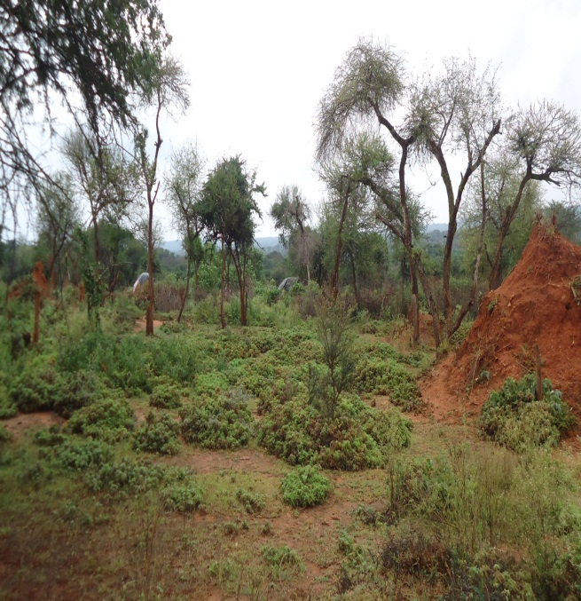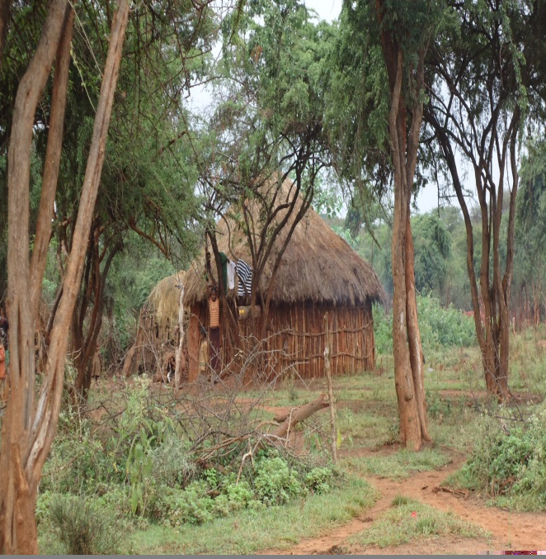

- Household Survey
This is one of the primary data collection instrument and most of the data collected are quantitative in nature. It involves drafting of survey questioners at desk level and pretesting of the questioners for their validity and applicability. The first task at field level is selection and training of enumerators. The criteria for selection of enumerators include university graduates who are not employed or others who can understand the concepts and good standing in English language and translate and ask the respondents in local languages preferably Oromiffa. Training was provided for the selected enumerators.
Before mobilizing the enumerators it was found necessary getting list of the possible beneficiaries. Accordingly there are about three sub villages in which the project affects one of these sub villages named Tadacha hora. It was estimated that about two hundred twenty households are included in this sub community and about sixty households being about 27.3% of the affected communities positively and negatively are systematically selected for household survey. In fact the number of beneficiaries is expected to be more if necessary land relocations made based on the existing rules and regulation of irrigation land use in the region. The questioners are filled by the trained enumerators and supervised by the chief socio-economist. The filled questioners are checked for consistency and accuracy after which they are coded, decoded and organized in the SPSS software and made ready for processing and analysis.
- PRA (Participatory Rural Appraisal)
It was tried to apply some of the PRA tools in generating some of the qualitative information concerning the condition of the inhabitants. The PRA team includes socioeconomic experts, agronomist, district level irrigation sector staff and about ten community members. The following PRA tools are adopted.
- Identification and ranking of major socioeconomic problems of the area
- Source of water for various uses in the study area
- Task by gender; daily duties of men and women in the study area
- Trend analysis, condition of various natural and socioeconomic factors in the study area past five and ten years that include rain fall pattern, availability of pasture land, population size
- Wealth ranking and criteria familiar in the area to indicate wealth status of community members.
- Collection of Secondary Data
Secondary data was collected from thirteen district level sectoral offices and local administration of the project area using formats developed for the purpose. The main limiting factor was lack of getting reliable data from most offices due to lack of keeping records and establishing data basis. The problem is immense at local level with in adequate public workers and office facilities. Other secondary sources of data include statistical publications concerning population matters and other socioeconomic variables. Similar studies in the area particularly data generated by Oromia Irrigation Potential Assessment Project was also utilized to augment current assessment.
- Data Analysis
The available data was analyzed using various computer utilities and programs. Household survey data was organized and analyzed using SPSS software. Frequencies and descriptive statistics are employed to determine values. Spread sheet mainly excel work sheet is used to organize secondary data collected from sectoral offices and local levels. Tables and graphs are widely used to present the available data. Qualitative information are logically analyzed and interpreted to augment the results of quantitative data.

- Irrigation and Existing Policies in General
In the development policy of the nation it was emphasized that food insecurity & poverty are as perverse and deep in pastoral communities across the country as they are in the traditionally drought prune locations where sedentary agriculture is being practiced. Irrigation becomes an absolute necessity for a successful settlement. Therefore, the availability of the surface and or underground water will dictate the choice of the site for a settlement in pastoral regions. (FDRE, 2003)
The water resource policy of the country which was issued by MOWR had the following multifaceted objectives:
- promote the development of water resources of the country for economic and social benefits of the people on equitable and sustainable basis;
- allocate and apportion the water based on comprehensive and integrated plans and optimum allocation principles that incorporate efficiency of use, equity of access and sustainability of resources;
- ensure the integration of water resources within Ethiopia’s overall socio-economic framework;
- manage and combat drought as well as other drought associated impacts and disasters through efficient allocation, redistribution, transfer, storage and efficient use of water resources;
- combat and regulate floods through sustainable mitigation, prevention, rehabilitation and other practical measures ;
- conserve, protect and enhance water resources and the overall aquatic environment on a sustainable basis and
- Build and strengthen the necessary capacity with regard to institutions, legislations, human resources, facilities, information system, research and studies.
The main elements of the strategies to change the policies into action include water resources studies, water resources management, creation of enabling environment, financial management, stakeholder participation, gender mainstreaming, disaster management and public safety and last but not least setting environmental health standards.

Similarly it was tried to review the country’s irrigation development policy that intends to achieve the objective of ‘Water can be made to contribute to the national economy through the development of the country's water resources and expanding irrigation schemes so that agricultural production is improved by solving the problem of water shortage caused by the unpredictability of the rainfall,’ (FDREMOWR, 2001).
According to the same policy document, sufficient food has to be produced to meet the requirements of the fast growing population and ensure food security for eventualities at household level. Furthermore, small, medium and large scale irrigation schemes will have to be developed in order to enhance reliable agricultural development in Ethiopia to cater for externally marketable surplus that would earn the country foreign exchange and at the same time provide raw material inputs for industries.
In general, it was stipulated that the overall objective of irrigation policy is to develop the huge irrigated agriculture potential for the production of food crops and raw materials needed for agro industries, on efficient and sustainable basis and without degrading the fertility of the production fields and water resources base and the policies are outlined below.
These are:
1. Ensure the full integration of irrigation with the overall framework of the country's socio-economic development plans, and more particularly with the Agricultural Development Led Industrialization (ADLI) Strategy,
2. Promote the development of irrigation on two- pronged approaches of:-
- Strategic planning for achieving socio-economic goals and
- Participatory- driven approach for promoting efficiency and sustainability,
3. Recognize that irrigation is an integral part of the water sector and consequently develop irrigation within the domain and framework of overall water resources management,
4. Earmark a reasonable percentage of the GDP as committed resource towards the development of irrigated agriculture, especially in capacity building and infrastructures,
5. Promote decentralization and users-based-management of irrigation systems taking account of the special needs of rural women in particular,
6. Develop a hierarchy of priority schemes based on food requirements, needs of the national economy and requirements of raw materials and other needs,
7. Support and enhance traditional irrigation schemes by improving water abstraction, transport systems and water use efficiency,
8. Ensure the prevention and mitigation of degradation of irrigated water and maintain acceptable water quality standards for irrigation,
9. Establish water allocation and priority setting criteria based on harmonization of social equity, economic efficiency and environmental sustainability requirements,
10. Integrate the provision of appropriate drainage facilities in all irrigated agriculture schemes,
11. Enhance greater participation by the Regional and Federal Governments in the development of large scale irrigated farms in high water potential basins but with low population density.
The issue of irrigation development has got great attention in the Second Growth and Transformation Plan (2nd GTP) in which the GTP is planned with an objective of gathering, analysis, compilation and updating of physical evaluation and socio economic resource information. The plan do have the objective of developing and expanding efficient, sustainable and indigenous technology based on medium and large scale irrigation farming primarily aimed at attaining food security, generating foreign exchange and supplying raw materials to industries (NPC, 2016).
In this comprehensive plan, it was stipulated that: ‘Ethiopia has high average rainfall per annum’. Nevertheless, its distribution in the country varies greatly in terms of location and time. Ground water reserves also vary from place to place. According to the information available, in places where the surface water is scarce, there is a great opportunity to exploit the available ground water. Thus, it is necessary to make use of both resources in a coordinated manner.

- Main Findings and Discussions

Administrative Location and Project Boundaries
As already mentioned in the background part of the study the project is located in Melkasoda district of West Guji zone at a local administration named Hadhagora. It is located at about seventy kilometer and ten kilometers from the zone capital Bulehora and district capital Melkasoda respectively. It is situated in low land settings agro ecologically in which reliable rainfall pattern is a limiting factor for all types of livelihood systems.
Westguji zone ie recently established by sharing districts from Borana zone and Guji zones. It is established having sseven rural districts and one urban administration which is essentially Bulehora town. Buletora town is recently growing at the fastest rate mainly due to the establishment of Bulehora University in the town. As a result improved hotel services and others are established to accommodate the incoming passengers and tourists. Farther it is thought to be one of the contraband centers in the southern part of the country. Foot wears and second hand clothing and electronic goods are supplied from the border areas both from Somali and Kenyan borders. Melkasoda district was also new having an age of not more than decade and previously included under Dugdadawa district. There are about twelve rural administrations namely ‘Kebeles’ in Melkasoda district and two urban centers namely Melkasodda the district capital and the other town named Bayyagandi.
This district is one of the districts located in low land part of the zone. Two districts namely Abaya and Gelana are fully located in Rift valley Lakes Basin,Dugdadawa and Bulehora district are partly located in RVLB and partly in Dawa sub basin while the remaining districts including Malkasoda are wholly located in Dawa sub basin of Genale Dawa River system.
There are about three sub villages in the Hadhagora local administration or Genda that are named ‘zoni’ namely they are Tadachahora, Kersa and Asile. Due to scattered settlement each sub village is too wide compared to local administrations found in the midland and high land settings. The project mainly affects Tadachahora sub community.

Population and Households
Administrative data suggested about 87770 human populations inhabiting in Malkasoda district. Of this total population about 51.5% are females. Similarly the total households in the district are about 18286. From this a household size of five was determined. The age distribution of the population in the district was as depicted in the graph that follows.
Figure 2: Age Distribution of inhabitants in Melkasodda District

It could be deducted that the working force being about 47.5% of the inhabitants and the rest 52.5% represent the dependent segment of the population mainly the children population. On the other hand age people exceeding 64 years comprise only about 4.9% of the inhabitants. This suggests that the life expectancy to be low caused by prevalence of diseases and the underlining poverty and vulnerable livelihood conditions. Similarly according to the socioeconomic profile of the district children account for about 40% of the inhabitants; economically active population account for about 55% of the population and the remaining 5% of the population account for aged people.
According to data generated from household survey regarding age distribution of the respondents aged people account only 2% of the inhabitants at the study area. The proportion of

children below fifteen year and work force ranging between fifteen and sixty four years of age is determined to be 48.7% and 49.3% respectively.
According to 2007 population and housing census of Ethiopia about 8077 human people comprising 48.8% females are enumerated in Hadhagora local administration. This population is currently projected to be about 11516 indicating sizable in the case of rural context particularly as far as pastoralist communities are concerned. In fact the settlement pattern is scattered and the inhabitants are distributed over wide area. The local administration had supplied even more being about 12654 of which 54.2% female inhabitants. However from the household survey it was estimated that about 51% of the household members are male and the remaining 49% are determined to be females. The same source suggested that about 1594 households of which 122 being only 7.6% are female headed households. The average household size was determined to be about eight individuals per family. However from household survey result a family size of nine individuals was determined. The average age of the household head was determined to be about 48 years. About 46.6% of the respondents are illiterate. Almost all respondents are married and there are no divorce and widowed cases suggested.

Population Projection
It was found relevant to project the current population during the project life in connection with food demand in the area. The rate of increase in food supply should meet the rate in population growth. To project future population the annual average growth rate determined by CSA for Oromia region which is 2.9% is adopted. The current population based on past census was used as a base population. The life span of this micro earth dam project was supposed to be thirty years. The total population is projected to be 27952. Almost it will become one of the medium towns currently found in the region at the end of project life.

Table 1: Projected population of Hadhagora kebele
year | Base Population and projected Population
year | Male | Female | Both
2018 | 5900 | 5616 | 11516
2019 | 6077 | 5785 | 11861
2020 | 6259 | 5958 | 12217
2021 | 6447 | 6137 | 12584
2022 | 6640 | 6321 | 12961
2023 | 6839 | 6511 | 13350
2024 | 7045 | 6706 | 13751
2025 | 7256 | 6907 | 14163
2026 | 7474 | 7114 | 14588
2027 | 7698 | 7328 | 15026
2028 | 7929 | 7548 | 15476
2029 | 8167 | 7774 | 15941
2030 | 8412 | 8007 | 16419
2031 | 8664 | 8247 | 16911
2032 | 8924 | 8495 | 17419
2033 | 9192 | 8750 | 17941
2034 | 9467 | 9012 | 18480
2035 | 9751 | 9283 | 19034
2036 | 10044 | 9561 | 19605
2037 | 10345 | 9848 | 20193
2038 | 10656 | 10143 | 20799
2039 | 10975 | 10448 | 21423
2040 | 11305 | 10761 | 22066
2041 | 11644 | 11084 | 22728
2042 | 11993 | 11416 | 23409
2043 | 12353 | 11759 | 24112
2044 | 12723 | 12112 | 24835
2045 | 13105 | 12475 | 25580
2046 | 13498 | 12849 | 26347
2047 | 13903 | 13235 | 27138
2048 | 14320 | 13632 | 27952

Socio-Cultural Patterns
The inhabitants are mainly Guji tribe Oromos that descended from Borana. Few others tribes from Oromo and other nation and nationalities inhabit urban centers essentially the district town and other town found in the district. Oromiffa language is spoken almost by all inhabitants in the district.
According to household survey result conducted at the study area about 98.9% of the respondents are Oromos and the remaining 1.1% was identified to be from Somale tribe. About 71.1% of the respondents are followers of protestant faith, 11% are Muslims and the rest stick to the Original Oromo Wakefata belief.

Migration
Inward migration was found limited based on the assessment made. About 14.5% of the respondents are found migrants. On the other hand outward migration and seasonal migration in search of pasture and water for livestock had been practiced for a long time. Few members of the community had migrated for education and searching better jobs at urban centers. Some members who demand better livelihood systems and better social services had migrated to the nearest Melkasodda town and had constructed home.

Land Resources and Potentials
The district in general and the project community in particular are categorized under agro pastoralist livelihood zone in the zone as well as the region as well. Hence the main livelihood of the inhabitants was mainly generated from livestock based economic activities. Crop production is negligible in the study area which was mainly limited by biophysical factors that include rainfall, edaphic and pest related matters. For these reasons livestock husbandry activities become basis of economic as well as socio cultural matters.

Land Tenure and Uses
Land and its resources are the main sources of livelihood in the project area or elsewhere. Particularly agricultural activities be it crop production or animal husbandry practices largely depend on access to land and its resources. According to data generated from the district pastoralist development office land use in the district was categorized as follow.
Table 2: Land use and tenure system in Melkasoda District

Type of Land ownership | Area in hectares unit | % of total | Remarks
Communal Holding | 34007.8 | 22.0
Private holdings | 119027 | 76.9
Public/government owned | 1700 | 1.1
Total | 154734.8 | 100.0
Source: Melkasodda District Pastoralist Development Office

The existing constitution of the country asserts that land is owned by the government and people of Ethiopia in general. Embedded in is an individual land user do have usufruct right and not ownership right. This implies inhibiting land sale and long term mortgaging for loan purpose.
It was suggested that more land is owned individually in the district and its trend is increasing compared to the past according to the consulted individuals. The major contributing factors are population rise and demand for various uses of land. Privately owned holdings mainly serve for individual grazing and limited crop production activity. Fallowing is practiced as observed at this particular project area. Average land holding in the district for various purposes was estimated to be about 1.5ha according to the district pastoralist development office. There is no land certification undertaken in the district so far. Traditional way of range land management prevails and conflicts between pasture land users and cultivators occur according to the views of subject matter specialists. Destruction of vegetation is main resulted from demand for biomass energy, construction material and farm land expansion.
Figure 3: Vegetation and land use conditions
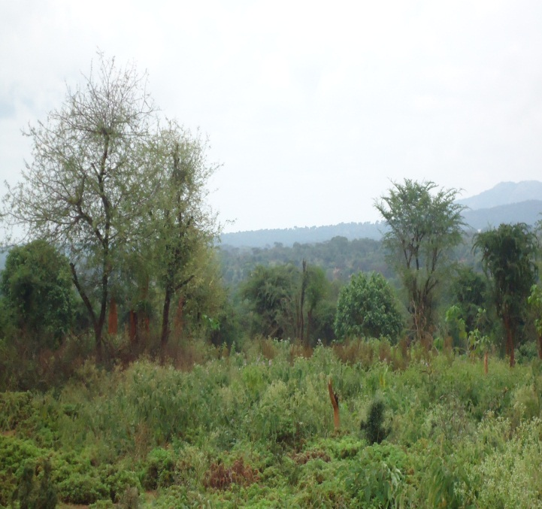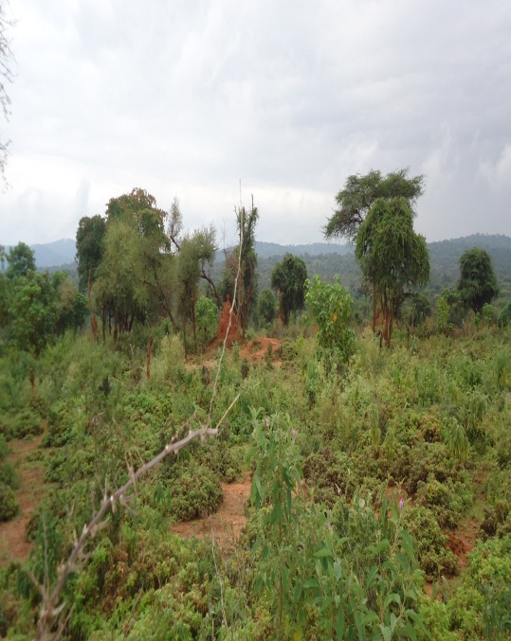
Communal holdings and individually owned grazing lands are mainly covered by bush and shrubs. The project area in particular is covered by such type of vegetation. Main species include acacia families and others. Their current main economic importance is holding traditional types of beehives, construction as well as means of firewood for cooking at household level. Cutting of trees in connection with project implementation was identified to be one of the limiting factors and hence thematic areas.
About 97% of respondents own land for various purposes. About 87.7% of the respondents do not rent in or out their holdings indicating limited land transaction at the study area.
Average land holding at the project community was estimated to be about 2.74ha based on the household survey result. A typical household at the project area allocates his holding in the following pattern based on the assessment made.

Table 3: Land allocation by a typical household
No | Type of use | Area allocated(Ha) | % of total
1 | Cultivation | 0.84 | 30.7
2 | Grazing | 0.87 | 31.8
3 | Backyard | 0.50 | 18.2
4 | Forest | 0.53 | 19.3
Total |  | 2.74 | 100
Source: household Survey

From the above data it could be inferred that more land is allocated for grazing land by the household at the study area.

- Land Use Pattern
According to the administrative data supplied from the district land administration office the land use pattern of Melkasodda district is as tabulated below.
Table 4: Land use Patterns in Melkasodda district
No | Type of use | Area in hectares unit | % of total | Remarks
1 | Cultivated land | 24000 | 15.4
2 | Forest land | 49 | 0.0
3 | Shrub | 42300 | 27.1
4 | wood | 46738 | 30.0
5 | Grazing | 40276 | 25.8
6 | wet land | 49.5 | 0.0
7 | water body | 102.5 | 0.1
8 | others | 2524 | 1.6
Total |  | 156039 | 100
According to the above statistics 57.1% of the total land in the district was covered by wood land that encompass bush and shrubs followed by land classified as grazing constituting about 25.8%
of the total land mass in the district. Similarly land brought under cultivation is low compared to regional and national figures.
According to data obtained from the district pastoralist development office total area covered by annual crops had increased at the rate of 10.5% on annual basis on average. Main crops produced in the district using annual precipitation include maize, haricot bean, teff and wheat. The performance of each crop was depicted in the following graph.

Figure 4 : Graph showing Area performance of main crops in Melkasodda district past five years

Similarly it was found that productivity of these crops was to low compared to national and regional levels that was mainly attributed to biophysical factors including rain fall. However the existing administrative data indicate average output growth rate to be 10.8% past five years. The growth is mainly attributed to expansion of area under production rather than productivity per unit area. Trend of agricultural output of major crops in the district was depicted in the graphs that follow.

Figure 5: Agricultural output performance in Melkasodda district past five years

Lack of adequate rain fall and low level of using modern agricultural technologies had contributed a lot for low level of output in the district. Additionally lack of experience in crop production activities among pastoralist communities has its own contribution.
The existing extension service is rated as low. There are a total of about 39 extension workers assigned at all rural administrations found in the district. Main focus areas include crop production, animal production and animal health and natural resources. At the current project area local administration there is only one female development worker currently working and the others are not available. It is possible to say that the existing extension service is not adequate so as to transform the existing traditional agricultural practices both crop production and animal raising.

Irrigation Development in the District and Experiences of the target communities
According to administrative data supplied from the district irrigation development office during the fiscal year 2009/2010 an area of land 392ha of land has been developed by irrigation in Melkasodda district. Close to 90% the irrigation practices are traditional systems along river banks mainly using flood recessions. Tomato, onion and cabbage are among the vegetables while banana is the main fruit irrigated in the district. Major source of water for irrigation in the district include Dawa, Afalata and Kajawa rivers. There are two modern irrigation schemes implemented in the district so far but found not effective mainly because of incomplete construction irrigation infrastructures and design defects. These issues become areas of lack of good governance in the district according to the district level officials and stakeholders. The following illustrates irrigation performance in the district past four years.
Figure 6: Graph Showing irrigation performance in Melkasodda district

Land brought under irrigation first shows an increasing trend and then decreased however exponential smoothening of the curve shows an increasing trend during the period. Data was available only for the past four years with the restructuring of OIDA before four years. Disease outbreak and limited use of agricultural inputs was suggested to be major challenges of the existing irrigation practice.
As far as the experiences of the project community is concerned no irrigation is known in the area which is mainly limited by availability of permanent water source close to the area. About 78.7% of the respondents of household survey are interested if they are accessed irrigation technology and about 20.1% of the respondents are not interested.
Part of the community members use Dawa and other rivers for livestock drinking. It may take an hour and more to reach these rivers.
Major constraints of the agricultural development sector according to the socioeconomic profile of the district recently undertaken include the following.
- Lack of sufficient rain fall
- Land degradation.
- The expansion of bush encroachment which has been reducing pasture for grazing
- Variability or dynamic nature of Agricultural policy
- Lack of supplying improved seed and other productivity enhancing farm inputs
- Shortage of technical manpower
- Existing Conditions of the target communities

Settlement Patterns
The inhabitants in Hadhagora local administration are not evenly distributed. Some villages are cluster forming while others settle sparsely. Parts of the sub community under consideration had settled along the main road that connects Bulehora and Shakiso towns. The housing units are corrugated iron sheet. The local administration office, DA offices and others are found in this village. Those settlements inside the command area and surroundings are located in bush and vegetative and they are far apart. The housing units are made from simple locally available materials sometimes covered with plastic geo membranes that may be provided for water harvesting structures in the area or somewhere.

Livelihood Systems
According to the household survey result the main livelihood of the target communities was agro-pastoralism as supported by 67.9% of the respondents. Based on similar assessment crop production activity had contributed for about 25% annual family income and livestock economy contributes for about 56.7% of annual family income at the study area.
Other sources of income include sale of forest products in terms of fire wood and charcoal making. Women and female children are mainly involved in sale of forest product. The income from various sources is as tabulated below.

Table 5: Family Income from various sources
Source of Income | Average annual Family income | % of total
Crop production | 10252.33 | 21.7
Livestock sale | 15118.41 | 32.0
Sale of Livestock products | 12213.20 | 25.9
Sale of vegetables and fruits | 3400.00 | 7.2
Sale of forest products | 6189.35 | 13.1
Total annual income | 47173.29 | 100.00
Source: Household Survey, September, 2018
As high as 57.9% family income was implied to be generated from sale of livestock and livestock products. Sale of honey from traditional bee keeping practices is one of the livestock products that contribute towards household income as the project area is identified to have potential in apiculture. The nearest Malkasodda Friday market is saturated with honey which is supplied from every direction surrounding the town including the project communities.
Based on the above household income about 5241.5 Birr or 194$ per capita income was determined on the basis of nine individuals per family. The figure is found to be below national figures determined for the nation recently indicating the prevalence of poverty in the study area. On the other hand a high dependency rate due to larger proportion of children is believed to cause low per capita income.
At PRA session it was tried to exercise wealth ranks in the community. Number of livestock owned was identified to be the main criteria to rank wealth status among community members. Accordingly households having more than ten heads of cattle, ten goats and two camels are categorized to be rich and those who own two heads of cattle, few goats and no camel are categorized as poor. Based on this classification the rich groups constitute only 2% and 75% are poor. The remaining 23% are in the middle.
Similarly it was tried to investigate family expenditure of the target communities based on household survey and accordingly the following data was generated.
Table 6: Proportion of annual household expenditures by a typical household (the study area)
Expenditure Item | Average annual expenditure per household(Birr) | % of total
Annual Expenditure on food | Birr14,693.28 | 29.9
Annual Expenditure on clothing | Birr10,922.62 | 22.2
Annual expenditure on fuel | Birr 3,040.81 | 6.2
Annual expenditure on salt, sugar and oil | Birr 7,202.33 | 14.6
Annual expenditure on soap and sanitation | Birr 2,008.72 | 4.1
Annual expenditure for treatment/health | Birr 4,795.12 | 9.7
Annual expenditure for education | Birr 4,811.47 | 9.8
Annual expenditure for inputs | Birr1,711.03 | 3.5
Total | Birr49,185.38 | 100
Source: Household Survey, September, 2018

De-saving of about birr 2012 was determined when comparing annual household income and expenditure. There are households who are included under the government’s productive safety net program. About 490 households having a total population 2600 are included by the program. Main activities include natural resources conservation and management, road maintenance and construction. The household expenditure is also depicted in the following pie diagram.
Figure 7: Chart showing annual household expenditure at the study area

Major household level expenditures in the study area include food and clothing. The lowest household expenditure in the study area was determined to be expenditure for procurement of agricultural productivity enhancing inputs that account only 3.5% of annual family expenditure. This indicates low farm input usage in the area due to various reasons.

Livestock Husbandry and Pastoralism
Pastoralism is a way of life characterized by moving with livestock from place to place mainly in search of pasture and water for their domesticated animals. Main livestock under pastoralist way of herd management include cattle and camels. The study area communities are not purely pastoralists as they started cultivating crops on few plot of land. There are also individual grazing plots fenced. There is fallowing where cultivated plots serve for grazing when not cultivated. Livestock holding per household had decreased with transformation from pastoralist way of life to agro-pastoralist way of life according to the consulted community members. Main reason suggested was increased human population and decreased grazing land. The livestock resources available at the district level and project kebele namely Hadhagora was as tabulated below.
Table 7 :Livestock resources
No | Type of Livestock | Number Found |  | Remarks
No | Type of Livestock | Malkasoda District | Hadhagora Local administration | Remarks
1 | Cattles | 149915 | 15841
2 | Sheep | 60818 | 7497
3 | Goats | 125114 | 13434
4 | Camels | 34675 | 7472
5 | Horse | 208 | 0
6 | Donkey | 13490 | 11
7 | Mule | 1200 | 13954
8 | Poultry | 137889
9 | Traditional Beehives | 61452 | No data supplied from local administration even though significant traditional beehives observed on bigger trees
10 | Modern beehives | 27
Source: Melkasodda Pastoralist development office and local administration

Based on the household survey result livestock ownership at the study area was as outlined below. About 98.9% of the respondents own livestock. A typical household at the study area owns six cattle, five goats and/or sheep, six chicken and about thirteen beehives. The following livestock related matters are assessed during the survey and the results are as follow.
Table 8: Livestock husbandry related matters and responses
Livestock related matter | Issue of concern | Result
Major problem related to animal husbandry | feed shortage | 37.7%
Source of water for livestock drinking | traditional wells or ‘Elas’ | 79%
Source of livestock feed | free grazing/pasturing | 64.5%
Providing supplementary feed | yes | 61.6%
Conserving feed for livestock | yes | 82.3%
Feed type conserved mostly | standing hey | 54.2%
whether feed shortage encountered recently | yes | 62%
Coping mechanism if feed shortage occurs | collect pods and leaves | 29.9%
Whether frequency of feed shortage is increasing | yes | 69.2%
Where livestock treated when sick | Private and black market cases | 62.6%
Whether the respondents pays for livestock treatment | yes | 64.9%
Amount of birr paid per year for livestock treatment | More than Birr 100 | 49.9%
Whether the respondent is interested to destock unproductive ones in favor of few productive ones | yes | 72.9%
Whether the respondent is interested to receive improved breeds | yes | 87.5%
Type of improved breed mostly preferred | Dairy | 54.9%
Access to training and extension regarding animal husbandry practices | positive response | 60.4%
Source: Household Survey,2018
The existing livestock species are local breeds that are adapted to the natural condition. They are capable of resisting diseases and feed shortage compared to the exotic breeds. The Boran breeds of the local breeds are dominant in the area. Their milk and meat production is better than other domestic breeds of cattle.
  - Animal Health and Veterinary Services
According to the district socioeconomic profile recently compiled there are about twenty four technical animal health assistances, one animal health technician and one animal health doctor (DVM). There are twelve veterinary health posts in the district distributed almost at all rural kebeles. Major livestock diseases in the district include internal and external parasites, black leg, FMD, CCPP, Anthrax ,LSD, CBPP, and Tryphanomisos.
  - Agribusiness and Agricultural Marketing
Demand for agricultural products to a larger extent determines its supply means the level of agricultural output. This in turn tends to promote agribusiness activities. There must be backward and forward linkages in the supply chain. Producers need to have reasonable prices. On the other hand there must be adequate marketing infrastructures that include transportation facilities, and storage facilities.
Agricultural products in the district as a whole including irrigation outputs are not beyond local consumption based on the existing administrative data, consultations made and physical observations as well. There is food aid as well as food for work activities widely observed in the district. As a result the district is net importer of mainly grains.
On the other hand the district had a potential for supply of livestock and livestock products including honey. The amount of honey supplied at Malkasodda Friday market was found considerable. Providing of modern honey storing and processing facilities are found areas of concern. Linking the producers with central markets and organizing the producers as cooperatives seems areas of intervention. On the other hand establishing honey and wax processing plants in the area is suggested.
There are two market centers in the district commonly known they are at Melkasodda (district capital) and Bayagundi.
Accessibility and transportation facilities are suggested to be the major marketing problems in the district.

Prices of major Agricultural Products
It was tried to generate price data during the study for the purpose of using similar information for analysis of proposed project financially and economically as well as to understand the supply and demand conditions at the study area.

Table 9: Prices of agricultural products
Item | Unit | unit price
Item | Unit | Minimum | Maximum | Average
Teff | Quintal | 2800 | 3000 | 2900
Maize | Quintal | 600 | 900 | 750
Wheat | Quintal | 1000 | 1200 | 1100
Haricot beans | Quintal | 1500 | 2200 | 1850
Coffee | Quintal | 3000 | 3500 | 3250
Pepper | Quintal | 20 | 25 | 22.5
Banana | Quintal | 600 | 900 | 750
Papaya | Quintal | 600 | 1000 | 800
Potato | kg | 7 | 10 | 8.5
Onion | Quintal | 1500 | 1800 | 1650
Milk | lit | 15 | 18 | 16.5
meat | kg |  |  | 120
Butter | kg | 180 | 200 | 190
Honey | kg | 30 | 35 | 32.5?
Egg | No | 4 | 5 | 4.5
ox | No | 7000 | 8500 | 7750
Cow | No | 6000 | 6500 | 6250
heifer | No | 4000 | 4500 | 4250
Bull | No | 9000 | 9500 | 9250
Calf | No | 600 | 6500 | 3550
Sheep | no |  |  | 750
Goat | no |  |  | 840
Camel | no |  |  | 7549
Donkey | no |  |  | 1600
Mule | no |  |  | 3500
Poultry | no |  |  | 95
Source: Malkasoda District, Pastoralist development office

About 40% of milk produced and 60% of butter produced are supplied to market for sale based on data obtained from the district concerned office.

Cooperatives
Cooperatives are associations established on voluntary basis to produce or distribute and supply goods or provide a sort of services so as to benefit their members. There are many types of cooperatives currently operating at the district and project area. They include multipurpose cooperatives, saving and credit and mining cooperatives. The following table summarizes the existing status of cooperatives in the district based on the socioeconomic profile of the district.
Table 10: Status of cooperatives in Melkasodda district
Particulars | No of cooperatives | Number of members by sex |  |  | Total capital
Particulars | No of cooperatives | Male | Female | Both | Total capital
Malkasodda district | 35 | 1139 | 1013 | 2152 | 2813830
Hadhagora | 2 | 73 | 45 | 118
Source: District cooperative promotion office and socioeconomic profile of the district
There is no irrigation water users association or cooperatives recognized particularly at the study area. One of the main activities of the cooperatives at the farming communities include distribution of agricultural inputs and accordingly the prices of NPS/DAP,UREA and improved variety of maize designated as BH-140 and BH-661 are Birr 1260,Birr 1190 and Birr 2366 per quintal respectively. The main benefit attained so far include improved livelihoods among members according to the views of the cooperative promotion office in the district. Major challenges and limiting factors that encounter the cooperative societies include less awareness on the cooperatives asset management, market problems and accessibility are too often mentioned.
- Gender and Women affairs
Gender does not mean biologically determined sex as male and female but it is the role and responsibility that the society assigns for male and female. In the past and developing countries gender issue is one of the cross cutting issues as there is sex discrimination. However due to advancement in human race and changes in attitude sex discrimination becomes under continuous improvement through time. There is sex discrimination at the study area according to 38% of the respondents.
One of the indicators of gender equality is decision regarding use and utilization of household level assets that include land and livestock in case of rural settings and found that it was decided by husband and wife in about 73.8% of the cases. Respondents were also asked whether men participate at household level duties such as cooking meal for the family and looking after children according to 52.8% of the respondents. Similarly they were also asked whether women participate at decisions regarding community development programs and it was supported by about 86.9% of the respondents. These clues suggest improved gender equality in the area and absence of sex discrimination. On the other hand estimated working hours for men and women are 6.2 hours and 7.6 hours per day respectively suggesting more work loads of women at the area. Based on PRA conducted within the community main daily activities of men, women and children are as summarized below.
Table 11: Daily activities of men, women and children at the project community
Men daily activities | Women daily activities | Children daily activities
Livestock tending | Fetching water | Tending livestock
Cultivation/farming | Collecting fire wood | Crop protection from wildlife attack
House and livestock shed construction | preparing food for family
construction of bee hive and bee management | Looking after children
Livestock watering | Feeding calves
Source: PRA Session at Hadhagora community, September, 2018

According to school enrolment condition assessed from household level more males are enrolled than female and the number of females attending higher level education decreases suggesting more have to be done in the area to minimize gender disparity in this regard. This might indicate termination of education among females because of marriage, household level duties such as collecting water for the family and the like.
Access to grinding mill services is identified to be the most pressing needs of women in the area according to 56.1% of the respondents.
- Food Security and Insecurity Issues
Food security is a wider concept that takes into account availability, access, utilization and stability that are identified as the four pillars of food security. It could be also analyzed at country level, household level and individual level. According to recent UN Committee on world food security food security is defined to be the condition in which all people, at all times have physical, social and economic access to sufficient, safe and nutritious food that meets their dietary needs and food preferences for an active and healthy life.
Food is secured not only by producing it but if people have adequate income to purchase it they could be food secured. This is explained in terms of access to food supply. According to consultations made at the study area the district is not food secured mainly in terms of not producing grain as there are humanitarian aids as well as productive safety net programs. In fact there is improper disaster risk management practices that prevail in the country including using resources for political aim and the like in the past expected to be changed with amazing reform ongoing in the country. There are government programs that work in areas of food security and other development activities. They include PCDP and DRSLPII. Plan international is an NGO operating in the district. Its main activities include human health and provision of domestic water supply.
According to data generated from the district food security office recently about 2247 people are provided with direct aid 20965 people are involved in productive safety net program for which they are provided grain or cash. A total of 2022.3 quintals of grain was disseminated and Birr 1752660 was paid as cash for work payment. About 1515 livestock species had been died due to the prevailing drought.
Similarly about 490 households including more than 2600 members are found to be beneficiaries of productive safety net programs at Hadhagora local administration.
It was determined that families require about 16 quintals of grain annually. Asked for performance of past five years crop production about 49.6% of the respondents suggested as it decreased, 26.2% said it increased and the rest 24.2% said it remained unchanged. Similarly asked for whether last year’s production is adequate for family consumption about 77.3% suggested as it is not. Based on this in sufficient levels of food production resulted from biophysical and sociocultural factors about 78.7% of the respondents have positive response in the introduction of irrigation development in the area.
Unfavorable weather condition including absence or shortage of rainfall was suggested to be the main cause for household level shortage as supported by 63.4% of the respondents. The coping mechanisms in case of food incidence circumstances include sale of livestock and their products, sale of fire wood and getting aid and borrowing from relatives are suggested.
Months of food shortage according to the responses of the respondents are as summarized in the table that follows.
Table 12: Number of months on which households rely on own production
Number of months |  | Frequency | Percent | Valid Percent | Cumulative Percent
Valid | Less than three months | 27 | 45.6 | 45.6 | 45.6
Valid | Three to six months | 25 | 41.3 | 41.3 | 87.0
Valid | Six to nine months | 3 | 4.9 | 4.9 | 91.8
Valid | nine to twelve months | 5 | 8.2 | 8.2 | 100.0
Valid | Total | 60 | 100.0 | 100.0
Source: Household Survey, 2018
This suggested that annual production in the area is too low to support families basic needs that calls for an intervention to enhance crop production activity in the area.

Trends of Socioeconomic Variables and Rainfall
During the PRA session it was tried to get the views of the communities regarding trends in human population and livestock density in the area. Accordingly it was suggested that human population had increased in the area in which the demand for natural resources such as land for cultivation increased. At the same time there is decreased grazing land for cultivation purpose and this in turn decreased livestock population in the area.
Regarding rain fall pattern past five and ten years an erratic rain fall pattern is detected which is not reliable for all types of livelihood system.
- Investment, Culture and Tourism Activities

10.1 Investment
Investment activities are limited in the district as a whole even though there are potentials especially in areas of mining. The district similar to adjacent districts was supposed to have deposits of precious metals such as gold and tantalum. According to the district investment office about 2894ha of land is provided for investment activity. It is hotel service investment. Currently its status was under construction. The trend of investment activities in the district was thought to decrease according to the same source. Main reasons suggested include less awareness made on investment potentials, unfavorable climate and lack of adequate physical infrastructures and social services are mentioned. Opportunities in the district include vast tracts of land with its resources and cheap labor as well according to the same source. Investment activities tend to increase job opportunities and hence decrease unemployment conditions, transfer skill and knowledge and increase outputs.

Tourism and Culture
About nine tourist attracting sites are identified. They include mainly natural features and cultural centers.
Culturally the inhabitants practice all Guji culture some of which are diets that compose mainly livestock products. Eating ‘Bunakala’ roasted coffee with butter at Geda ceremony could be mentioned. Men and women do have their own cultural wearing identified as Guji style.
One important unique culture at the study area and surroundings include burial places which is wider and circular or rectangular in shape. It is covered with ornamental stones widely found in the area. The burial site area depends on the social status, wealth and age of the individual.
  - Social and Physical Infrastructures
There are two towns in the district namely they are Melkasodda and Bayagundi. These towns do have access to power supply services though the service is not adequate. There is commercial Bank of Ethiopia at Melkasodda town. Oromia Saving and Credit association is operating in the district including for rural communities. A total of 198km road network of which 128km of it being all-weather road is found in the district.

Education Performance in the District
Education is a key factor for development. Educated people can understand better their environment and transform it as well. Educated people can adapt technologies than any one who is illiterate. Irrigation technology also needs adoption and adaptation of it. For this reason an assessment of educational activity at the local and district level was assessed and incorporated in this study.
There are three schools at Hadhagora local administration three of them being second cycle schools (1to 8). The number of students attended in the year 2010E.C. was as tabulated below.

Table 13: Enrolment and educational status at Hadhagora local administration
School level | Number of students by sex |  |  | % of females
School level | Male | Female | Both | % of females
First cycle(1 to 4) | 818 | 612 | 1430 | 42.8
Second cycle( 5 to 8) | 230 | 58 | 288 | 20.1
Both | 1048 | 670 | 1718 | 39
Source: District Education office

First cycle and second cycle school coverage was indicated to be about 90% and 80% respectively indicating more children schooled recently. A school dropout rate of 9.4% is documented of which 5.9% are males. The main reasons for school dropout suggested include drought and pastoralist mobility. About 29 individuals had attended informal education at the area. Similarly school performance in the district recently was tabulated as in the table below.

Table 14: Recent Education Performance in Melkasodda district
School level | Number of students by sex |  |  | % of females
School level | Male | Female | Both | % of females
First cycle(1 to 4) | 8867 | 6340 | 15207 | 41.7
Second cycle( 5 to 8) | 3910 | 1398 | 5308 | 26.3
Secondary school (9 to 10) | 870 | 213 | 1083 | 19.7
Preparatory(11 to 12) | 83 | 20 | 103 | 19.4
Total | 13730 | 7971 | 21701 | 36.7
Source: Melkasoda District Education office
From the above table the proportion of female students decreased at higher level of education indicating existence of female’s school dropout due to early marriage and other reasons such as wrong attitude towards female education. An assessment conducted few years ago by Oromia Irrigation potential assessment project indicate that there are about two kindle gardens, thirteen first cycle schools, forty seven second cycle schools, three secondary schools and one pre university school in Melkasodda district.
  - Quality of Education
Quality of education is the main determinant of education performance so as to attain the desired goal. The main education performance indicators include student class ratio, teacher student ratio and others. The following table summarizes these indicators.
Table 15: Education Quality Indicating ratios for Melkasoda District,2010 E. C.
Parameter | value by School level
Parameter | 1 to 4 | 5 to 8 | 9 to 10 | 11 to 12
Student-Class ratio | 53 to 1 | 38 to 1 | 61 to 1 | 25 to 1
Student-Teacher ratio | 58 to 1 | 33 to 1 | 19 to 1 | 8 to 1
Source: Melkasodda district education office

A total of sixty seven first degree holders six of which females; three hundred nineteen diploma holders seventy four of whom are females; one hundred thirteen certified teachers sixteen of whom female teachers are serving at the schools as depicted in the graph that follow.
Figure 8: Distribution of teachers by education level and Sex in Melkasoda district

Based on the household survey the educational status of the household heads was summarized in the following table.
Table 16: Educational status of household heads
Educational status | % of respondents | Remarks
Illiterate | 46.6
Read and write | 6.1 | Informal education
Attended grade 1 to 4 | 23.7
Attended grade 5 to 8 | 13.9
Attended grade 9 to 10 | 4.8
Unknown | 4.9
Total | 100
Source: Household Survey, 2018

About 84.7% of the respondents prefer formal education for their children rather than informal education such as religious and adult education.
It was also tried to estimate the average distance of various levels of schools from home area as summarized in the following table.
Table 17: Average distance of schools from home area
School level | Average Distance (kms) | Remarks
First cycle(1to4) | 2.2
Second cycle(1 to 8) | 2.5
Secondary school(9 to 10) | 7.2
Preparatory(Pre-university) | 7.2
Tertiary Education | 74.8
Source: Household Survey, 2018

About two males and three females are schooled on average from a household which indicates less number of girls enrolled to school at the study area. This may be caused by backward tradition towards girl education or cases of early marriage.
Difficulty to cover educational expenses and in accessibility of school centers particularly in connection with higher level education was mentioned as major constraints of education.

Health Services and Facilities
According to data generated from the district health sector there is one hospital newly established, four health centers two of which are under construction, thirteen clinics and seventeen health posts. Accordingly there are about 75 health staffs working in the district and their profession is summarized as follow.

Table 18: Distribution of health staffs in Melkasoda district
Profession/skill | Male | Female | Both
Physician | 0 | 0 | 0
health officer | 7 | 1 | 8
Nurse | 18 | 0 | 18
Pharmacist | 1 | 0 | 1
Laboratory technician | 1 | 0 | 1
sanitary | 1 | 1 | 2
Health extension workers | 2 | 37 | 39
others | 5 | 1 | 6
Total | 35 | 40 | 75
Source: Melkasodda District Health Office

The health coverage of the district had reached 92% according to the same source. About 52% of the health workers are extension workers that are assigned at health posts mainly located at rural communities. Their main duty is mainly aimed at disease prevention such as family planning, maternal and child health care and implementation of sanitation facilities mainly toilet service.
The ten top diseases recorded for the last consecutive year in the district area as summarized below.
Table 19: Ten top disease documented Melkasodda district
Ten top diseases | year in E.C |  |  |  | Average
Ten top diseases | 2008 |  | 2009 |  | Average
Ten top diseases | No of patients treated | % | No of patients treated | % | Average
Pneumonia | 1211 | 25.8 | 999 | 20.6 | 23.2
Typhoid fever | 304 | 6.5 | 357 | 7.4 | 6.9
Malaria with Falciparum | 453 | 9.7 | 1026 | 21.2 | 15.4
Non bloody diarrhea | 813 | 17.3 | 786 | 16.2 | 16.8
Malaria with other sps | 453 | 9.7 | 305 | 6.3 | 8.0
Acute Favorite illness | 367 | 7.8 | 275 | 5.7 | 6.8
Helmenthiasis | 364 | 7.8 | 212 | 4.4 | 6.1
Dyspepsia | 292 | 6.2 | 327 | 6.8 | 6.5
Anemia | 236 | 5.0 | 275 | 5.7 | 5.4
Urinary Tract infection | 201 | 4.3 | 276 | 5.7 | 5.0
Total patients | 4694 | 100.00 | 4838 | 100 | 100
Source: Melkasodda district health office

From the above table it could be understood that pneumonia is first ranking disease followed by non-bloody diarrhea and malaria with falciparum. Malaria with falciparum and other species account for 23.4% of all diseases occurred during the last two consecutive years. Therefore with implementation of dam project at the project area necessary prevention mechanism to combat the possible incidence is pivotal.
Major problem of the health service in the district include prolonged drought and hence malnutrition, lack of safe water supply and incidence of malaria and other cases according to the health sector officials.
Malaria, TB and typhoid are the major diseases commonly known at the study area according to the respondents of the household survey. Similarly most respondents visit the nearest health center when family members sick. Absence of health facility in the vicinity and lack of skilled staff and medicine are suggested to be major challenges in connection with health service according to respondents of the household survey.
About 64.6% of the respondents had received education regarding health prevention and control. The following health related matters are also assessed and the results are as tabulated below.
Table 20: Health related matters assessed and results of household survey

Health Related matter | Measurement | Value determined
Relevance of Immunization of women and children | Positive response | 87.4%
Importance of family planning | Positive response | 58.3%
Use family planning use | negative response | 58.7%
Favoring to have many children | Positive response | 70.7%
Knowledge on transmission of HIV/AIDS | Positive response | 92.9%
Knowledge how to prevent HIV/AIDS | Positive response | 85.2%
Source: Household Survey, 2018

Water Supply for Various Uses

Domestic Water Supply
This refers to use of water for drinking, cooking, washing and bathing purposes. According to the district water supply office the district had been supplied with modern water supply few years ago and currently there are about six motorized schemes in the district. Currently a total of 20976 human people are served by these improved supply systems. The trend of water supply coverage according to the same source was as depicted in the graph that follows.

Figure 9: Graph showing trend of domestic water supply coverage in Melkasodda district

The graph shows that the water supply coverage had shown an increasing trend. Poor quality water due to the geological formation and maintenance problems are suggested as thematic areas in connection with domestic water supply in the district. Some of the sub villages in the study area are one that provided with modern improved system. According to the household survey respondents about 24.4% get domestic water from improved system and about 40.6% of them get water from traditional wells known as ’Elas’. The others suggested from both sources.
The average time taken to fetch water was estimated to be about one hour. Housewife and female children are main collectors of water for all family needs in about 83.8%.

Livestock drinking and other uses
The main source of water for livestock drinking at the study area was identified to be traditional wells ‘Elas’ according to 79% of the respondents. There is no other use of water including for irrigation at the study area. In general there is no adequate water for various uses at the study area.
According to consultations made at PRA session with the community members it was suggested that main source of water for human drinking and livestock as well was traditional ‘Elas’. Improved system implemented in the area is not effective and its service was rated as low and it serves few communities found in the local administration.

Sanitation Facilities
Toilet facilities are negligible as only 6.7% of the respondents do have toilet facilities that are not improved. This indicates that most families use open defecation that may result in exposure to various diseases. Asked for the importance of having toilet facilities about 40% of the respondents suggested avoiding unsightly condition and control communicable diseases. About 62.4% of the respondents dispose their domestic waste at open field.

Transportation and other Infrastructures
Access to transportation facilities determines to a larger extent the quality of life of a certain community. For this reason road infrastructure and availability of transportation facilities are crucial. The total road network in the district was estimated to be about 265km. The main road that connects the main high way (asphalt road) from Finfine to Moyale and the other asphalted road that connects this main road to Negelle crosses Malkasodda district and town. It connects Bulehora town with Adola town crossing Shakiso town which is the main niche for mining activities in the country. Its total length is close to 180kms at Adola town Guji Zone of Oromia region.
Main means of transporting people include motor cycles including at the study area. Isuzu trucks transport materials and human beings additionally to bigger towns found in the area. There is transportation problem according to 95.5% of the respondents. In adequate road facility was suggested to be the most probable challenges in connection with transportation service at the area.
There is automatic telephone and mobile network service at the district capital Melkasodda. There is also internet service in the area particularly that could be used by individual mobile service owners. The use of postal service was limited particularly with availability of mobile phone service and internet service as well.
12. Existing Potentials, opportunities and Constraints
12.1 Existing Potentials and Opportunities: The study area has vast tracts of land covered with vegetation of low land species. The main limiting factor seems availability of water sources for various uses. The existing vegetation is used for construction, supply of energy and more for hanging traditional beehives. It was found that the amount of honey produced and supplied to local markets being substantial. It may be necessary to assist in terms of providing modern bee hives, improve honey collection and storage materials. It is known that water is one of the raw materials for honey making and storing water at the area do have positive impact for apiculture.

Major Development Constraints
Based on PRA conducted with the community groups major problems include the following:
- Shortage and erratic rain fall pattern
- Shortage of water for various uses
- Livestock diseases caused by recently invading weed in the area
- Malaria and other diseases affecting human health
- Problem of physical infrastructures such as access road and power supply
- Crop pests and diseases
- Lack of grinding mill services in the area

Figure 10: PRA Session
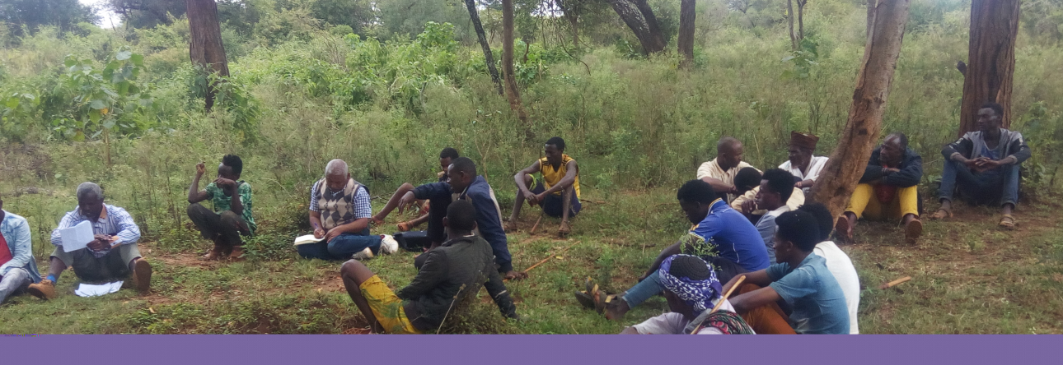

- Benefits and Social Impacts of the proposed Action
The proposed project was aimed to provide irrigation water for as high as 500ha of land by constructing micro earth dam whose surface area could extend as large as 85ha of land considering back water effects. It could be anticipated that due to water scarcity at the study area stored water could be used for domestic, livestock and for crop production as well according to their order of importance in the study area. Irrigation could be adopted gradually since crop production activity itself is recent livelihood system.
- Social Impacts/Negative Impacts
The detailed positive and negative impact of the project was expected to be addressed in ESIA report. However the bird side view could be explained here. The area both the command area and reservoir area constitutes bush land,, pasture land and few cultivated area to some extent. Main crops managed include maize and Teff. The bush land is used for grazing. Main bigger tree species include acacia families. It was estimated that about 80 trees are enumerated per hectare on average basis. Some bigger trees are used for hanging traditional bee hives. At least one tree per hectare are estimated to have bee hives. Annual production of honey from a single bee hive was suggested to be about 5kilograms. The following table summarizes the possible losses due to implementation of the project.

Table 21: Possible Social impacts anticipated due to the project
Typology | Area in ha | No of trees/ha | No of beehives per tree | No of trees having beehives/ha | Annual production/beehive(kg) | Total honey output | value of honey at Br 100/kg
Reservoir area | 85 | 80 | 2 | 1 | 5 | 68000 | 6800000
Command area | 500 | 80 | 2 | 1 | 5 | 400000 | 40000000
Other Losses due to reservoir area
Crop type | Area(ha) | Production/ha | Total production | Unit price | Total value
Maize
Teff
Number of households affected due to reservoir area |  |  |  |  |  |  | 56

Compensation Claim and Mechanisms
The target communities had strongly resisted the project idea mainly in connection with the possible losses that occur mainly due to the reservoir area. Difficult to get plot for land losers was suggested by the local leaders since most land is owned individually and serving for communal grazing and the like. Similarly results of household survey indicate that the losers need cash compensation and hence the compensation cost could be considered as project cost for smooth implementation of the project.

- Conclusions and Recommendations
The socioeconomic assessment of Hadhaharbu micro earth dam proposed project was undertaken using a set of methodological tools and approaches so as to generate reliable data and triangulate them so that their consistency and reliability shall be maintained. Based on the existing information it was tried to get incite the real conditions of the target communities in terms of livelihood, needs and constraints. The target community’s livelihood is basically under transformation form pastoralism to agro pastoralism in connection with population dynamics and other sociopolitical factors. For this reason crop production activity was evaluated to be at its infant stage, Factors include limited experience in crop production activities, problems related to moisture stress in connection with reliability and adequacy of rain fall. For these reason households are not in a position to produce adequate food crops and most families depend on governmental aid and other forms of food and livelihood enhancing programs such as productive safety net. The contribution of livestock subsector in supporting family was found substantial. Water sources for various uses are negligible in the study area and hence water based development programs are not only necessary but could also become a fact of life. However the future as well as multiple benefits of the proposed action the communities had tried to resist the proposed action by simply thinking value of the benefit of current use. Storing water at the study area is expected diversify livelihoods. It will be used not only to grow fodder for livestock and other crops but also for livestock drinking and fishing as well. The existing apiculture potential of the area could be more enhanced specially by providing modern beehives that need to be integrated with the proposed water harvesting project. More and more awareness creation is needed at the community level that includes experience sharing of similar schemes. Compensating the losers due to reservoir construction should be considered as one of the project implementation modalities. Cash compensation was suggested by the losers and others and this has to be included in the project cost.

Annexed Materials

Annex1: PRA Tools to Applied in irrigation Sector
- Problem identification and Ranking
No | Major problems | Rank | main causes | Effects | proposed solutions
1 |  |  | 1 | 1
1 |  |  | 2 | 2
1 |  |  | 3 | 3
2 |  |  | 1 | 1
2 |  |  | 2 | 2
2 |  |  | 3 | 3
3 |  |  | 1 | 1
3 |  |  | 2 | 2
3 |  |  | 3 | 3
4 |  |  | 1 | 1
4 |  |  | 2 | 2
4 |  |  | 3 | 3
5 |  |  | 1 | 1
5 |  |  | 2 | 2
5 |  |  | 3 | 3
6 |  |  | 1 | 1
6 |  |  | 2 | 2
6 |  |  | 3 | 3

- Task analysis by gender
No. | Men’s daily Activity | Female’s Daily Activity
1
2
3
4
5

3. Water use Matrix
3.1. Men group
Use type | Type of water source
Use type | Ela/traditional well | Pond | Improved system | Roof water harvesting
Domestic use
Livestock drinking
Irrigation

3.2. Women group
Use type | Type of water source
Use type | Ela/traditional well | Pond | Improved system | Roof water harvesting
Domestic use
Livestock drinking
Irrigation

4. Trend Analysis
- Human population
- Livestock population
- Availability of water sources
- Unemployment
- Prices
- Rainfall pattern
- Grazing land/pasture
5. Wealth ranking and scoring

Annex 2: Household Survey Check List
Household Survey data collection sheet
Identification:

Address of Household:
Region Oromia Zone ________ Wereda ________ Kebele/Town ______
Interviewing period:
Date /month/year :__________/____________/______________
Starting time:___________ Ending time:______________
Name of the Respondent_____________________________

PART I: Household characteristics
General direction: please, ask each question exactly as it is and circle or fill in the provided space as per response of the respondent.
1 |  |  |  | Sex of the respondent |  | Female  Male |  | 1  2
2 |  |  |  | Age |  | Write in full year |  | [____]
3 |  |  |  | Marital status? |  | Married  Single  Divorced  Separated  Widowed |  | 1  2  3  4  5
4 |  |  |  | Religion? |  | Orthodox Christian  Protestant  Catholic  Muslim  Others (specify)____________ |  | 1  2  3  4  5
5 |  |  |  | Total Size of the household |  | Male  Female  Total |  | [_____][____[____]  _____
6 |  |  |  | Household members age |  | Less than 15yrs  15-64 yrs  above 64 yrs  Total |  | [_____][_____]  ___  [_____] ______  ____
7 |  |  |  | Ethnic group |  | Oromo  Amara  Somali  Tigrai  Others specify |  | ___________  - _______
8 |  |  |  | Place of birth |  | Born in this area  Migrate from other surrounding |  | 1  2
9 |  |  |  | If you migrate from other area what is the main reason? |  | Job opportunity  Settlement  Farm land conflict  Other specify–––––––– |  | 1 ____  - ____  - ________4
10 |  |  |  | How long have you lived in this area? |  | Less than 10 Yrs,  10 - 20 years,  More than 20 years |  | 1  2  3
11 |  |  |  | What is your highest level of education attained? |  | Illiterate  Read and write  primary school (Grade 1-4)  primary school (grade 5-8)  Secondary school (Grade 9-10)  Secondary school (grade 11-12)  College and above |  | 1  2  3  4  5  6  7
12 |  |  |  | What is the main source of income? |  | Merchant  Farmer  Daily labourer  Government employee  Employee of private enterprise  Pension  Others (specify)____________ |  | 1  2  3  4  5  6  7
13 |  |  |  | What is the secondary occupation of the HH head? |  | Merchant  Farmer  Daily labourer  Government employee  Employee of private enterprise  Pension  Others (specify)____________ |  | 1  2  3  4  5  6  7
14 |  |  |  | Estimates of annual income of the HH from different sources? |  | Crop production  Sale of livestock  sale of livestock products (Milk, butter, cheese, egg, skin, honey etc)  Sale of vegetables and fruits  Sale of forest products  Off farm activities  Remittance  Others |  | [____  [____  [______]  [____  [____
15 |  |  |  | Estimates of annual expenditure of the HH for different purposes |  | Food  Clothing  Fuel  Salt, sugar, oil etc  Soap and other sanitation purpose  Treatment  Education  Farm inputs  Other  Total ______________ |  | [____  ____]  [____
Social service |  |  |  |  |  |  |  |  |  | Sale of forest products
 |  |  | Education
16 |  |  |  | What type of education do you prefer for your children? |  | Formal education  Non-formal education Religious education |  | 1  2  3
17 |  |  |  | How far is the nearby formal education institution for the household In km? |  | 1st cycle, 1-4  2nd cycle 1-8 (5-8)  High School (9-10)  Preparatory 11-12  Higher education |  | [____  __
18 |  |  |  | Number of Household members attending formal education. |  | Male  Female  Total |  | [______][______] [______]
 |  |  |  | What are the major problems of education in your community? |  | Absence of the school in the nearby  Unable to cover school expenses  HH demand of children labor |  | 1  2  3
 |  |  | Health
19 |  | What is the most common disease prevailing in your area? |  |  | Malaria  Diarrhea  TB  Intestinal parasite  Eye diseases  STD  Headache  Typhoid  Others (Specify) |  |  | 1  2  3  4  5  6  7  8  9
20 |  | Where do you go for treatment when one of your Household members gets sick? (More than one questions are possible) |  |  | Hospital,  Health center,  Private Clinic  Health post  Traditional healer  Self-treatment  Stay at home |  |  | 1  2  3  4  5  6  7
21 |  | . What is the major constraint in health services? More than one answer are possible by ranking |  |  | Absence of health service in the nearby Shortage of medicine  Lack of health personnel  High treatment and medicine cost  Reluctance of the health personnel  Lack of accessibility to reach the health services Other |  |  | 1  2  3  4  5  6  7
22 |  | Have you ever received health education on diseases prevention and control? |  |  | Yes  No |  |  | 1  2
23 |  | Do you agree that immunization for children and women are useful? |  |  | Yes  No |  |  | 1  2
24 |  | Do you agree that Household planning is useful? |  |  | Yes  No |  |  | 1  2
25 |  | Do you and/or your spouse use Household planning service? |  |  | Yes  No |  |  | 2
26 |  | Do you favor to have many children? |  |  | Yes  No |  |  | 1  2
27 |  | Do you know the mode of transmission of HIV/AIDS from Person to person? |  |  | Yes  No |  |  | 1  2
28 |  | Do you know what you should do to protect yourself and your Household from being infected with HIV/ AIDS? |  |  | Yes  No |  |  | 1  2
 |  | Drinking water supply
29 |  | Main sources of water used for drinking and food cooking? More than one question are possible by ranking |  |  | River  Pond  Lake  Hand Dug Well  Protected Spring  Not protected Spring  Piped Water  Others |  |  | 1  2  3  4  5  6  7  8
30 |  | How long does it take to go the house hold travel to fetch water (two ways)? |  |  | Time in minute |  |  | [_____]
31 |  | Who mainly collect water for the Household? |  |  | Wife  Female children  Male children  Husband  All HH members |  |  | 1  2  3  4  5
 |  | Sanitation and hygiene related information
32 |  | Does the household have a latrine/toilet facility? |  |  |  |  | Yes  No |  | 1  2
33 |  | If yes, what kinds of toilet facility do you have?  (OBSERE) |  |  |  |  | Improved pit latrine  Unimproved pit latrine  Improved flush toilet  Unimproved flush toilet  Others (specify)_________ |  | 1  2  3  4  5
34 |  | Does the household shares toilet facility with other household(s)? |  |  |  |  | Yes  No |  | 1  2
35 |  | Do all household members utilize the toilet facility (including children)? |  |  |  |  | Yes  No |  | 1  2
36 |  | To the best of your knowledge, what is the importance of having a latrine?  (Probe & Circle all that Apply) |  |  |  |  | To avoi d un s ightly condition  To have privacy  To control communicable diseases  Don’t know  Others (specify) __________ |  | 1  2  3  4  5
37 |  | Where do you usually dispose of your domestic liquid and solid waste? |  |  |  |  | Septic tank/sewer connection  Seepage pit/sock-away pit  Latrine  Open field  Open ditch to nearby water body  Others (specify) |  | 1  2  3  4  5  6
 |  | Transports and Communication
38 |  | Do you have transportation problems in this area? |  |  |  |  | Yes  No |  | 1  2
39 |  | If yes, what is the main problem? |  |  |  |  | There is no road at all  The fare is high  The road is not good  The road is too far  Other problem (Specify) |  | 1  2  3  4  5
40 |  | How far is the nearest postal service from you area? |  |  |  |  | KM |  | [___]
41 |  | How far is the nearest telephone service from your area? in KM |  |  |  |  | KM |  | [___]
42 |  | How far is the nearest Bank service from your area? |  |  |  |  | KM |  | [___]
 |  | Agriculture and Food Supply
 |  | Land Tenure
43 |  | Do you have your own land? |  |  |  |  | Yes  No |  | 1  2
44 |  | If yes, how much in ha? |  |  |  |  | Grazing  Cultivated  Backyard  Forestland  Total |  | [__  [__  [__  [__  [__
45 |  | Do you have rented Your own land for others? |  |  |  |  | Ys  No |  | 1  2

Crop Production
46 | How is the trend of your crop production for the last 5 years? |  |  |  |  |  | Increasing  Decreasing  No change |  | 1  2  3
47 | Do your last year's production is sufficient for your Household? |  |  |  |  |  | Yes  No |  | 1  2
48 | If no, what is the reason? |  |  |  |  |  | Shortage of farmland  Shortage of inputs (seed, fertilizers, farm power etc.  Bad weather  Other reasons |  | 1  2  3  4
49 | If no, how do you manage to fill the gap? |  |  |  |  |  | Household members sale labor  sale livestock  get remittance  Aid from Govt. and or NGO  Borrowing  Sale of forest products |  | 1  2  3  4  5  6
50 | For how many months of the year your households rely only on the yearly produced crops without external support or buying from market? |  |  |  |  |  | < 3 months  3-6 Months  6-9 months  9-12 Months |  | 1  2  3  4
51 | How many quintals of crops (all types) of food do your Household requires for 12 Months? |  |  |  |  |  | Quintals |  | [__
52 | Do you use any labor from outside other than your Household? |  |  |  |  |  | Yes  No |  | 1  2
53 | What is the share of crop production contribution of your annual income? |  |  |  |  |  | Estimate the percentage |  | [__
54 | Do you want to change from rain fed to irrigate farming? |  |  |  |  |  | Yes  No |  | 1  2
 | Livestock Production
55 | Do you have own livestock? |  |  |  |  |  | Yes  No |  | 1  2
56 | If yes, specify their type and number? |  |  |  |  |  | Cattle  Oxen  Equines  Goats and sheep  Poultry  Bee hives |  | [__  [__  [__  [__  [__ ]
57 | What are the main problems of livestock keeping? |  |  |  |  |  | Shortage of feed  Shortage of capital to buy animals  Livestock diseases |  | 1  2  3
58 | Do you have enough oxen for Ploughing? |  |  |  |  |  | Yes  No |  | 1  2
59 | What is the share of livestock contribution of your annual income? |  |  |  |  |  | Estimate the percentage |  | [__
60 | Source of water for livestock |  |  |  |  |  | River  Traditional well  Pond  Springs  Other |  | 1  4  5
61 | What is the source of feed for livestock? |  |  |  |  |  | Grazing  Crop residue  Grazing and Crop residue  Others (specify) |  | 1  2  3  4
62 | Did you provide your livestock any supplemental feed materials during the dry season or during the wet season? |  |  |  |  |  | Yes  No |  | 1  2
63 | Do you conserve feed for dry season and wet season (kiremt)? |  |  |  |  |  | Yes  No |  | 1  2
64 | If yes, state the type of feed you mostly conserve (only one) |  |  |  |  |  | Standing hay  Cut hay  Crop residues  Browse (pods, leaves, etc)  Other (Name) |  | 1  2  3  4  5
65 | Was there shortage of animal feed in the recent years? |  |  |  |  |  | Yes  No |  | 1  2
66 | what is the first measure you take during feed shortage? |  |  |  |  |  | Increase sale of livestock  Buy feed from other places  Collect pods & leaves  Borrowing and sharing with others  Aid from government and NGOs |  | 1  2  3  4  5
67 | Is the frequency of feed shortage increasing? |  |  |  |  |  | Yes  No |  | 1  2
68 | who treat your animals? |  |  |  |  |  | Community Animal Health Workers  Local veterinary service  Private  Black Market  Traditional healer |  | 1  2  3  4  5
69 | Do you pay for their service? |  |  |  |  |  | Yes  No |  | 1  2
70 | How much did you pay in the last 1-year? |  |  |  |  |  | Below 20 Birr  20-50Birr  60-80Birr  80-100Birr  above 100 Birr |  | 1  2  3  4  5
71 | You may be advised to reduce the number of livestock, but keep only productive ones under improved management and better feeding. Do  you agree to destock (reduce) the number of your livestock? |  |  |  |  |  | Yes  No |  | 1  2
72 | Are you willing to conserve livestock feed? If you are provided with the necessary training and material. |  |  |  |  |  | Yes  No |  | 1  2
73 | Do you like to carry out fattening and or dairy programs? |  |  |  |  |  | Yes  No |  | 1  2
74 | If yes, which one do you like most? |  |  |  |  |  | Fattening & dairy  Fattening  Dairy programs |  | 1  2  3
75 | Do you like to receive improved breeds? |  |  |  |  |  | Yes  No |  | 1  2
76 | If yes, which type’s livestock do you like most? |  |  |  |  |  | Dairy Cattle  Beef Cattle  Goat  Sheep  Poultry |  | 1  2  3  4  5
77 | Have you ever received any extension service, credit, and training for livestock Production? |  |  |  |  |  | Yes  No |  | 1  2
78 | How do people get together to discuss issues of community concerns? |  |  |  |  |  | Through formal community organization  Through Iddir and/or other related informal social organization  Through religious leaders  Through esteemed elders  Others |  | 1  2  3  4  5
 | Community Participation
79 | Have you taken part in any of the following community development programs? (more than one answers are possible) |  |  |  |  |  | A forestation  Soil and water conservation  Social services  Road construction |  | 1  2  3  4
80 | In what form do you participate? (more than one answers are possible) |  |  |  |  |  | Labor contribution  Material provision  Money contribution  Idea generation |  | 1  2  3  4
 | Community's attitude on the proposed irrigation development
81 | Have you heard of the proposed irrigation development? |  |  |  |  |  | Yes  No |  | 1  2
82 | Do you accept the proposed development plan? |  |  |  |  |  | Yes  No |  | 1  2
83 | If yes, what do you expected from it? |  |  |  |  |  | Sustainable production  Job opportunity will be created  Better infrastructure & social services  Other specify |  | 1  2  3  4
84 | In what way do you like to contribute or participate for the project in the future? |  |  |  |  |  | Labor  Material  Money  Labor & material  Material & money  Idea provision  Other |  | 1  2  3  4  5  6  7
85 | If your perception is negative towards the project, specify your reason: |  |  |  |  |  | Fear of losing land  Fear of losing house  Fear of losing trees  Reduction of income from crop production  Reduction of income from livestock  Fear of social disruption |  | 1  2  3  4  5  6
 | Gender Issues
86 | Is there sex discrimination in this area? |  |  |  |  |  | Yes  No |  | 1  2
87 | Who is the decision maker on the household assets (land, livestock) in your house hold? |  |  |  |  |  | Husband only  Wife  Both husbanded and wife  All house hold members |  | 1  2  3  4
88 | Estimate the average working hours for men and women per day: |  |  |  |  |  | Men  Women |  | [__  [__
89 | Do men/husbands participate in the house tasks? |  |  |  |  |  | Yes  No |  | 1  2
90 | Do women participate in the decision making of community affairs and development activities? |  |  |  |  |  | Yes  No |  | 1  2
91 | Is there Women association in your area? |  |  |  |  |  | Yes  No |  | 1  2
92 | What are the most pressing needs of women in this area? |  |  |  |  |  | Grinding mills  Safe water supply  Maternal and child health care servi  Credit and saving schemes |  | 1  2  3  4

93. Compensation claim: ---------------------------------------------------------------------------------------------------------------------------------------------------------------------------------------------------------------------------------------------------------------------------------------------------------------------------------------------------------------
94. Food security situation: ----------------------------------------------------------------------------------------------------------------------------------------------------------------------------------------------------------------------------------------------------------------------------------------------------------------------------------------------------------------------------------------------------------------------------------------------------------------------------------------
95. Conflict occurrence and resolution mechanism: ---------------------------------------------------------------------------------------------------------------------------------------------------------------------------------------------------------------------------------------------------------------------------------------------------------------------------------------------------------------------------------------------------------------------------------------------------------

Suggestion and comments to improve the situation
_____________________________________________________________________________________________________________________________________________________________________________________________________________________________________________________________________________________________________________________________________________________________________________________________________

Full name of enumerator ____________
Signature ____________ _____
Date ______________________

Full name of Supervisor__________________
Signature ________________________
Date ___________________________

