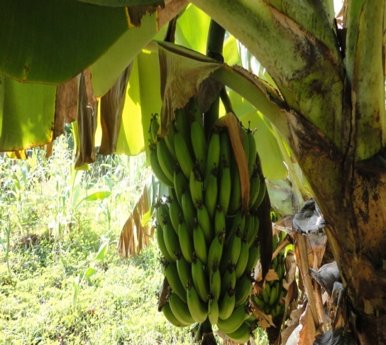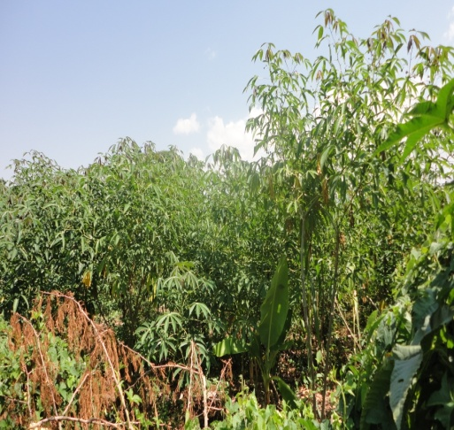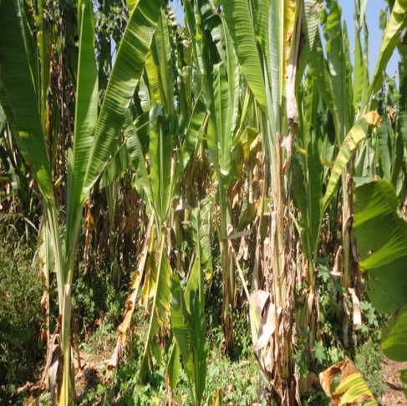

THE NATIONAL REGIONAL STATE OF OROMIA
HADHA-HURBU SMALL SCALE IRRIGATION PROJECT

SOIL AND LAND EVALUATION STUDY DRAFT REPORT

CONSULTANT
Oromia Water Works and DesignSupervision Enterprise
P.O.Box. 870/1250
Tel +251 11 4392162/2470
Email: owwdse@telecom.net.et
Finfine/Addis Ababa, Ethiopia

CLIENT
OROMIA IRRIGATION DEVELOPMENT AUTHORITY (OIDA)
P. O. Box
Tel +251
Email:
Finfine/Addis Ababa, Ethiopia



March, 2019

Tables of Contents
LIST OF TABLES iii
LIST OF TABLES IN APPENDIX vi
LIST OF ABBREVIATIONS AND ACRONYMS vii
SUMMARY 1
1. INTRODUCTION 3
1.1 Back Ground 3
1.2. General Objective 3
1.3 Specific objective 3
1.4 Structure of the Report 4
2. THE PHYSICAL ENVIRONMENT OF THE AREA 5
2.1. Location and Accessibility 5
2.2. Climate 6
2.4 Physiograpy and Geology 7
2.3.1 Landscape and Soils 7
2.3.2 Vegetation and Land Use 9
3. REVIEW OF PREVIOUS STUDIES 10
3.1. Genale Dawa River Basin Master Plan project 10
3.2. Borana Integrated Land Use Planning Soils of the Dawa Sub Basin Project 11
3.3. Soil and Geomorphology map of Ethiopia, 1984 11
4. METHODOLOGY OF INVESTIGATION 12
4.1. Scope of the survey 12
4.3. Fieldwork 13
4.3.1 Auger observation 13
4.3.2. Soil profile description 13
4.3.3 Physical tests 13
4.3.4. Post Fieldwork 15
4.4 Laboratory Analysis 17
5 SOILS OF THE PROJECT AREA 19
5.1. General 19
5.2. Major Soil Types in the Project Area 19
5.2.1. Luvisols 20
5.2.2. Cambisols (Chromic, and LepticCambisol, eutric) 24
5.2.3. Leptosols (Eskeletik Leptosol (eutric) 26
5.2.4. Lixisols (Rhodic and Chromic Lixisol (eutric) 27
5.2.5. Fluvisol (MollicFluvisol, eutric) 27
6. SOIL PHYSICAL AND CHEMICAL PROPERTIES 28
6.1 Soil Physical Properties 28
6.1.1 Effective Soil Depth 28
6.1.2. Soil Structure 29
6.1.3. Consistence 30
6.1.4. Texture 30
6.1.5. Soil Color 30
6.1.6. Soil Drainage 31
6.1.7 Infiltration rate 31
6.1.8. Hydraulic Conductivity 32
6.1.9. Bulk Density 32
6.1.10. Field capacity (FC) 33
6.1.11. Permanent wilting point (PWP) 33
6.1.12. Available water capacity (AWC) 33
6.1.13. Available water capacity (AWC) and readily available water Capacity (RAWC) 34
6.1.14 Porosity 35
6.1.16. Erosion Status 36
6.1.17. Flooding 36
6.1.18 Deep Boring 36
6.2. Soils Chemical Properties 36
6.2.1. Soil Reaction (pH) 36
6.2.2. Electrical Conductivity EC and (ECe) 37
6.2.3. Organic Carbon (OC) or Organic Matter (OM) 37
6.2.4. Total Nitrogen 38
6.2.5Carbon to Nitrogen Ratio (C: N) 38
6.2.6. Available Phosphorus 38
6.2.7. Cation Exchange Capacity (CEC) 39
6.2.8 Base Saturation Percentage (BSP) 39
6.2.9. Exchangeable Calcium (Ca) 39
6.2.10. Exchangeable Magnesium (Mg) 40
6.2.11. Exchangeable Potassium (K) 40
6.2.12. Exchangeable Sodium (Na) 40
6.2.13. Exchangeable Sodium Percentage (ESP) and Sodium Adsorpation Ratio 40
6.2.14 Calcium carbonete 41
6.2.15. Potassium to Magnesium Ratio (K: Mg) 41
6.2.16. Calcium to Magnesium Ratio (Ca: Mg) 41
6.2.17. Potassium to Cation Exchangeable Capacity Ratio (K: CEC) 41
7. DESCRIPTION OF SOIL MAPPING UNITS 44
7.1. General 44
7.2. Soil Mapping units Description: 46
8.0 CONCLUSIONS AND RECOMMENDATIONS 55
8.1. Conclusions 55
8.2.2. Recommendations 55
9. LAND EVALUATION 57
9.1. Introduction 57
9.3. Specific objectives: 57
9.4. Scope of work: 58
9.5. Procedures Followed 58
9.6. Land Use Requirement for Surface Irrigation 60
9.7. Land Utilization Types (LUTs) 62
9.8. Land Characteristics (LCs) andLand Qualities (LQs) 71
9.8.1. Temperature regime 71
9.8.2. Topography 72
9.8.3. Rooting conditions and workability 72
9.8.4. Nutrient availability and nutrient retention capacity 73
9.8.5. Conservation and water application management 74
9.8.6. Salinity/Sodicity 74
9.8.8. Water retention capacity 75
9.9. Matching of land use requirement with land qualities. 76
9.10 Results of Land Suitability Evaluation for Surface Irrigation 82
9.10.1. Existing Suitability for Surface Irrigation 82
9.10.2. Potential Suitability for Surface Irrigation 83
9.11. Results of Crop Suitability Evaluation 86
9.11.1. Potential Crop Suitabilty Evaluation. 86
10. SOIL MANAGEMENT AND RECLAMATION 95
10.1 Soil Physical Soil factors 95
10.1.4. Flooding 95
10.1.5 Erosion 96
10.2. Chemical Factores 96
10.2.1Soil Fertility 96
11. CONCLUSION AND RECOMMENDATIONS 97
11.1. Conclusion 97
11.2 Recommendations 97
12. REFERENCES 100
13. LIST OF APPENDICES 102

LIST OF TABLES
Table 1 Land form and Slope 9
Table 2 Land use land cover of Hadha Hurbu irrigation project 9
Table 3 Soil survey data collected during the field work 14
Table 4 Soil properties used for the definition of SMU 15
Table 5: Effective soil depth and area coverage of the area 28
Table 6 The following table shows the results of infiltration tests of the soils. 31
Table 7 : The hydraulic conductivity results of the soils are given below. 32
Table 8: Bulck density results versus soil textures of the study area 32
Table 9: permanent wilting point results versus soil textures of the study area 33
Table 10: Average available water capacity 34
Table 11 : Total porosity and Air-filled porosity 35
Table 12: Description of Soil physical and chemical properties by major soils 42
Table 13: Area or (distribution) percentage of major soil groups. 46
Table 14:FAO Land Suitability Classification Levels (FAO, 1983, After Ir.C.Sys 1991 & H.Huizing, ITC 1992) 59
Table 15: Land use requirement and critical class limits for surface irrigation 61
Table 16: Description of management levels 63
Table 17 : Low land Maize (Zea Mays)- Crop Environmental Requirements 65
Table 18: Onion (Allium Cepa)-Crop Environmental Requirements 66
Table 19: Tomato (Lycopersicum esculentum)-Crop Environmental Requirements 67
Table 20:Chilie Pepper (L)-Crop Environmental Requirements 68
Table 21 : Haricot Bean ( Spp)-Crop Environmental Requirements 69
Table 22 Cabbage (Brassica oleracea) - Crop Environmental Requirements 70
Table 23: Land suitability Limitations (sub-classes) 77
Table 24: LQ/LC and symbols assigned to evaluate suitability sub-class and unit. 79
Table 25: Summarized Land Quality and Characteristics of the SMU 80
Table 26: Existing Surface Irrigation Suitability by Area 82
Table 27 : Potential Surface Irrigation Suitability by Area 83
Table 28: Results of Existing and Potential Land Suitability Evaluation for surface Irrigation by SMU 84
Table 29:Potential Crop Suitability by Area for surface Irrigation 87
Table 30: Potential Crop Suitability by class and Area for surface Irrigation 87
Table 31Potential Crop Suitability by Sub Class 88
Table 32: The final proposed Crop Potential Suitability by SMU 94
Table 33: Final Proposed Overall Potential suitability map 95

LIST OF FIGURES
Figure 1 Location Map of Hadha Hurbu SSI project 5
Figure 2 Location Map of Hadha Hurbu SSI project Google earth 6
Figure 3: Location of Auger Observation Points 16
Figure 4 Location of Soil Profile Pits 17
Figure 5 major soil map 20
Figure 6 typical Luvisol profil 24
Figure 7 Depth map 29
Figure 8: Slope Map 44
Figure 9 Soil mapping unit (SMU Map) 45
Figure 10 Potential Surface Irrigation Suitability Map 83
Figure 11 Maize 89
Figure 12 Sorghum Potential Suitability Map 89
Figure 13 Haricot bean Potential Suitability Map 90
Figure 14 Tomato Potential Suitability Map 90
Figure 16 Onion potential suitability map 92
Figure 17 head cabbage potential suitability map 93
Figure 18 Final Proposed Overall Crop Potential Suitability map 94

LIST OF TABLES IN APPENDIX
Appendix Table 1: Summary of recommended criteria for soil chemical data interpretation 102
Appendix Table 2: Typical profile descriptions 105
Appendix Table 3: Format for auger observation and profile description sheet 126
Appendix table 4: Soil physical and chemical laboratory analysis results 130
Appendix table 5: Soil infiltration and permeability test 130
Appendix table 6: Soil physical test 135

LIST OF ABBREVIATIONS AND ACRONYMS
DEM | Digital Elevation Model
ECe | Electrical Conductivity
AAS | Atomic Absorption Spectrophotometer
FAO | Food and Agriculture Organization
GIS | Geographical Information System
GPS | Geographic Positioning System
ha | Hectare
masl | Meters above Sea Level
OC | Organic Carbon
OM | Organic Matter
IR | Infiltration Rate
SMU | Soil Mapping Unit
TN | Total Nitrogen
WRB | World Reference Base for Soil Resources
Na | Sodium
Ca | Calcium
K | Potassium
ESP | Exchangeable sodium Percentage
SSIP | Small Scale Irrigation Project
Mg | Magnesium
Al | Aluminum
LUT | Land utilization type
LUR | Land use requirements
LC | Land Characteristics
LQ | Land Qualities

SUMMARY
The soil Survey of the Hadha Hurbu Small Scale irrigation Project (Hadha Hurbu SSIP) conducted at feasibility level to use the information obtained as a basis for confirming/rejecting the irrigation potential, crop selections, irrigation designs and agricultural input requirements. Field auger observation, profile description and soil sampling for laboratory analysis (Both Physical and Chemical Properties), field setting of infiltration rate and hydraulic conductivity were conducted on representative sites.

On the basis of soil chemical characteristics (CEC, Ph, BS% .etc) and soil physical characteristics (depth, slope, soil texture and soil type) characteristics a total of 16 soil mapping units (SMU) were identified. On the basis of profile morphology and development, and nature of the soil material and profile phisical and chemical properites the soils of the study area are identified as Cambisols, Luvisols, Fluvisol, Lexisol and, Leptosol.

The targeted project has 864.19 ha of Gross area, and Net Irrigable area is 500 ha. Micro-dam is the source water to irrigate the area by canal using gravity. The proposed crops that can be cultivated by using surface irrigation are 7 (Low land Maize, Low Land Sorghum, Haricot bean, Tomato, Onion, Pepper, Cabbage,). The results of the suitability evaluation of the project area indicates that total area of 541.69ha of land is found to be (S2) Moderatly suitable for surface irrigation. An area amounting to 222.95 ha is found to be (S3) marginally suitable for surface irrigation development. The areas identified as moderately and marginally suitable for surface irrigation are constrained by slope, depth, texture and chemical reaction (Ph) and availability of nutrient (Avp and organic matter).
The result indicated that some, 228.64 moderatly Suitable (S2) ,528.16ha (S3) marginally suitable for Maize cultivation by surface irrigation. For Sorghum Some 446.14 ha Moderatly Suitable(S2) and 466.12 ha Marginally suitable (S3) Olso for Haricot bean some 375.61ha of land is moderately suitable (S2), 337.01ha marginally suitable(S3) respectively. For Tomato Some 133.53 (S2) moderatly suitable and 577.87 marginaly suitable (S3), For Pepper Some area of 130.32 ha moderatly suitable(S2) 681.83 ha marginaly Suitable (S3),for Onion ,some 209.11 ha moderatly suitable (S2), and some 491.81 ha marginaly suitable(S3),for Head Cabbage some 219.58 ha (S2) moderatly suitable, and 493.03(S3) marginaly suitable. The major limitations that downgraded the suitability level of the area to marginally subclass are Slope, Texture, Depth and Soil Chemical Reaction in the study area. Also low nutrient availability like organic matter availabile phosphorus (Av.p) are correctable constrients
Hadha hurbu irrigation soil survey report is presented in one volume that includes maps and information as:-
Physical environment;
Method of investigation and activities carried out;
Result of the soil survey and analysis of soils in the study area;
Description of the identified soil mapping unit; and relevant appendices are included. A total of observations (153 augers and 12 Profile pits) were described for the study area. The detail level soil survey study enabled the identification of 16.soil mapping units (SMU). It is hoped the information provided in this report helps in assembling and using data for the area of land suitability map.
To undertake the Land Evaluation, land utilization types (LUT) for surface irrigation methods were identified first. Accordingly, a total of nine LUTs for surface irrigation methods were identified. These LUTs include banana, cabbage, haricot bean, Lowland maize, onion, Sorghum, tomato, pepper, mango and papaya production for surface irrigation, For these LUT land use requirements (LURs) were then geared up. These land use requirements were carried out based on some critical land characteristics that strongly have an effect on the growth and development of crops. These are atmospheric temperature, slope, flooding, soil texture, soil depth, ECe, ESP, SAR, pH, Caco3, OCand CEC of the soil.

1. INTRODUCTION

1.1 Back Ground
The soil survey and land evaluation of the Hadha Hurbu Small Scale Irrigation Project conducted at feasibility level to assess in detail the physical and chemical characteristics of the soils in the project area and to evaluate the suitability of the area for surface irrigation and crop types.The project area is located in the Oromia Region, West Guji zone Melka Soda District. Residentes are dominantly pastoralists With food security Problem and sparcely Cultivation maize and Sorghum are cultivated crops in the project area with Livestock production (Cattle, Camels, Goats and Sheep) This report presents the results of detailed, soil survey carried out at feasibility level and the land evaluation exercise for the suitability of surface irrigation and selected crop types. The project area has food security problem

1.2. General Objective
The main objective of the soil survey is to provide detail information on land and soils of the study area (Hadha Hurbu SSIP) at feasibility level which may form as a basis for confirming/rejecting the irrigation potential (all or part of area), crop selections, irrigation designs, and agricultural input requirements such as fertilizer applications etc. suitability for irrigation. The study also focuses on identifying the various topographic forms, soil types, present land use assessment and evaluating the existing land use pattern and serve as a basis for assessment of land and crop

1.3 Specific objective
- To determine the distribution of different soil types over the project area
- To provide basic soil data to facilitate irrigation design work to be carried out in the project area.
- To offer detailed soil information of the command area as a ground for ratifying or rejecting the soils potential for surface irrigated agriculture.
- Produce soils and land suitability maps at scale of 1:10,000.

1.4 Structure of the Report
The results of the study is presented by standard narrative approaches, which include soil distribution and land suitability classification and other relevant information.
The report covers:
- Phyical environment ,
- Method of investigations and activities carried out,
- Result of the soil survey and analysis of soils present in the study area,
- Soil mapping units/soil management , etc.
- Land evaluation
And relevant appendix are included as follows:
- Appendix A: Soil physical and chemical analytical data for representative soil profiles
- Appendix B: typical profile pits explanation for each representative soil type,
- Appendix C: in situ soil physical test results for representative soil type
To make the report clear and readable the report on land suitability part is prepare in a separate volume as Part II.

2. THE PHYSICAL ENVIRONMENT OF THE AREA

2.1. Location and Accessibility
The study area, Hadha Hurbu Small Scale irrigation project, is Located in the Oromia Regional State, West Guji Zone Melka Soda wereda. Irrigation to be used from Hadha Rever Dam. More precisely it falls in between 601452 to 595820 UTM N and 456051 to 459465UTM E. The targeted area of the project is 864.19 ha. The altitude of the area ranges from 1145-1262masl. The project area is acceceble via Finfine-Bule-Hora-asphalt road and Bule Hora To Melka Soda allweather (Gravel) road 530Km, South East from Finfine.

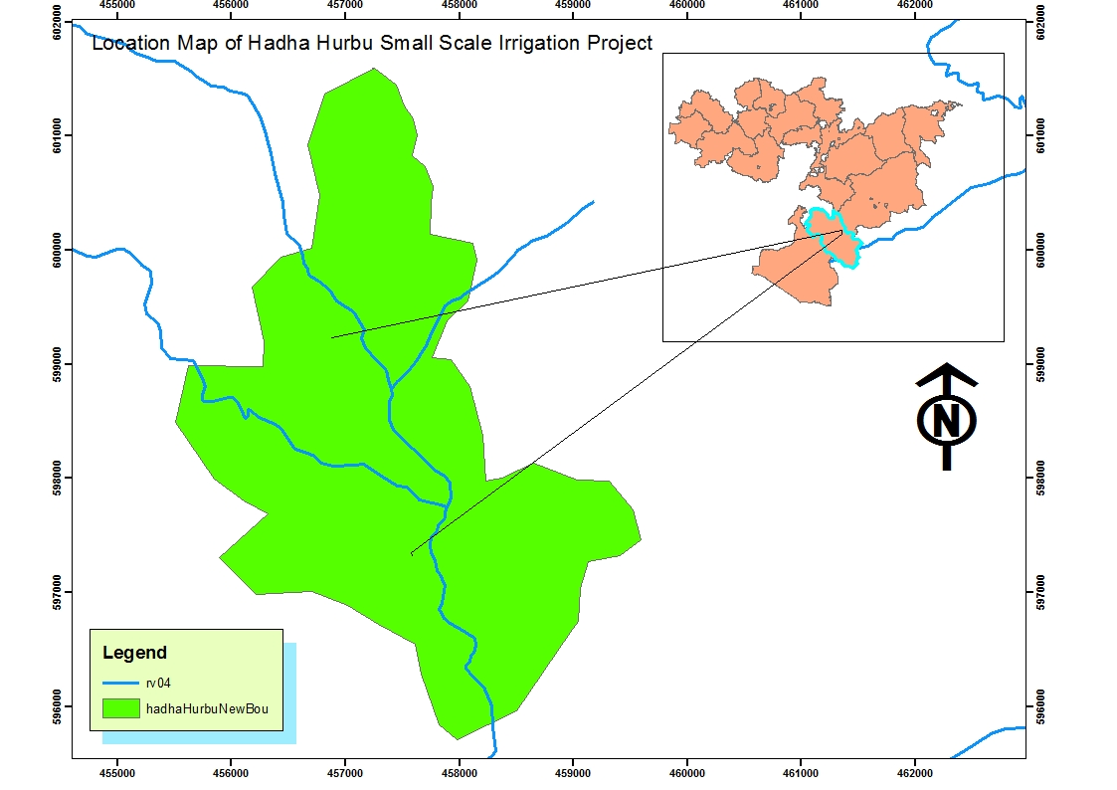
Figure 1 Location Map of Hadha Hurbu SSI project

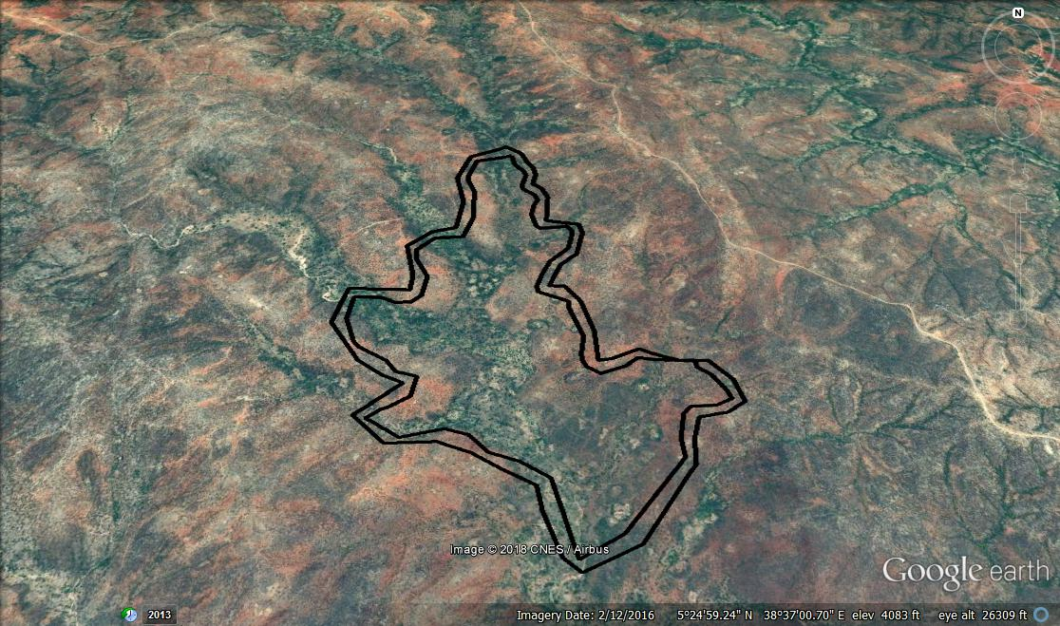
Figure 2 Location Map of Hadha Hurbu SSI project Google earth

2.2. Climate
Climate is one of the components of an environment that determines formation and characteristics of natural vegetation, soil formation and farming systems of a particular area. Based on the climatic factors, the length of the growing period (LGP) for the crops produced in the study area will be described. Climate and soils give information on the types of climate and soil that are best suited to the crop under consideration. Minimum tempreture 14.4-17.6⁰C, on average16.2⁰C, and maximum tempreture of 25.7⁰C-30.2⁰C, on average of 27.8⁰C,
The climate in the project area is characterized by a bimodal rainfall and the main rainy season is from mid March to mid May and the short rainy season is from mid September to early November. However the rainfall is highly erratic, late on the onset, less in amount and poor in distribution.
The nearest metreology station to the proposed command area is Finchuwa for rain fall data. For minimum temperature, maximum temperature, relative humidity, wind speed and sunshine hour data, Yabelo metreology station is used for the computation of reference evapotranspiration and then crop water requirement was computed for all the proposed crops.
2.3. Rainfall
The rainfall pattern of the study area is bimodal. The total annual rainfall of the study area is about 795.6 mm. The rainfall distribution and amounts vary from year to year. The moist months of the project area are mid September to end October, Mid March to beginning April and mid May to end May. The dry months are from end October to mid March and from end May to mid September. The rest of th months from mid April to mid May are humid period / growing seasons. The rainfall of the project area is shown on the table as follows.

2.4 Physiograpy and Geology
The geology of the study area is mainly composed of Based on the present study, the project area is found being characterised by alluvial soil overburden deposits of considerable thickness and the basement metamorphosed rock / GRANITE units
Alluvial deposits
The deposit is found overlaying the volcanic rock units in the area. These are mainly organic soil material and River deposits.
The organic soil material is found covering extensive part of the project area mainly covering the poorly drained plain land mass of the project area. Such a deposit is black to dark brown silty clay soil material of high plasticity. It shows desiccation cracks due to the constituent minerals and high degree of plasticity. As inferred from the geophysical survey done at the project site, thickness of the material is greater than 10mts.

2.3.1 Landscape and Soils
The properties of soil vary from place to place, but its variation is not random. Natural soil body are the result of climate and living organism (fauna and flora) acting on parentmaterials, with topography or local relief exerting a modifying influence and with time required for soil forming processes to act. For the most part soils are the same whenever all elements of the five factors are the same. Under similar environment in different place, soils are similar. Climate influences soil development by affecting the degree of weathering. Climate and time are related, in that climatic (weathering) effects are most pronounced on stable surfaces, while on such surfaces past rather than current climates may account for the soil conditions. Thus, in areas where the climate is wetter, weathering and decomposition are pronounced giving rise to deep and well developed soils such as Luvisols and cambisol. In areas where drier climates prevail, evaporation exceeds precipitation and accumulation rather than leaching occurs, so calcic and salt affected soils are dominant. Topography plays an important role in soil genesis, primarily through modification due to the impact of climate. Thus, on steeper slopes water runs off rapidly retarding soil development. Where topography is steeper, soils are shallower and at the initial stages of soil profile development, because erosion has not given them time to develop. Soils developed on recent alluvial and colluvial deposits are often only at an initial stage of development, or are not developed at all, as evidenced by their weak structure and stratification resulting in Fluvisols. In flat, nearly flat, and undulating topography in lower landscape positions, imperfect to poorly drained soils, such as Vertisols are formed.
The influence of organisms is manifested in the amount of organic matter in the soils. Organisms also have an appreciable impact on weathering, and are critical to the recycling and release of plant nutrients.
The Study Area comprises In flat, nearly flat, and undulating topography in lower landscape positions the middle and lower catchment of Hadha Hurbu River and its tributaries.Deep reddish brown Sandy clay loam textured soils (Luvisols, Cambisols and Fluvisols) are the most widespread soils developed on 0-8% slope mainly from Granite and Aluvium parent matterial , amounting to almost 78% of the Study Area.

Table 1 Land form and Slope
Slope% | Area (ha) | Area (%) | Remark
0-2 | 252.10 | 29.17
2-5 | 354 | 40.96
5-8 | 158.58 | 18.34
8-15 | 99.05 | 11.46
>15 | 0.48 | 0.05
Total | 864.19 | 100

2.3.2 Vegetation and Land Use
The major farming system of the study area is pastoralism and therefore, the land use of the study area is mainly for browsing and grazing purpose. A very few patchy areas of cultivated lands are also observed in the study area. The vegetation of the study area is open bush and shrubs dominated by acacia species.
Extensive Graizing and browsing with Cattles, camels,goat and sheeps are the dominant land use of the project area.(>90% of the Command area is open bush and shrub land There is sparsely cultivation in the project area maize Tef and sorghum are crops to be cultivated) .
(The vegetation cover is dense near to Dam site and Hadha Hurbu river).Sorghum, Maize and Teef are cultivated in the command area.)

Table 2 Land use land cover of Hadha Hurbu irrigation project
Land use | Area (ha) | Area(%)
Cultivated Land | 60 | 6.59
Shrub and Bush Land | 804.23 | 93.41
Total area | 864.23

3. REVIEW OF PREVIOUS STUDIES

3.1. Genale Dawa River Basin Master Plan project
A soil survey of Genale Dawa river basen master plan project was carried out by Lahmayer international (Germany) and Yeshiber Concelt (Ethiopia) at a recoinacence level and a soil unit association map prepared at 1:250,000 scale.The recoinacense soil surveys identified 13 Mayor Soil groups, 28 soil units and 61 soil mapping units.in the river basen.in the survey the majorsoil groups and soil units were classified bassed on the soil property observed in the field and from the laboratory results.Luvisol,cambisol,Calsisol,Fluvisol,Leptosol Nitosol,Acrisol, Gleysoland vertisol identified in the soil survey activity. Among many soil survey works carried out in Bale Zone in the past, the soil survey that included the proposed command area is the Genale-Dawa River basin master Plan Development Project. This study was conducted at reconnaissance level at a scale of 1:250, 000. In this study, previous studies at a pre-reconnaissance, reconnaissance, semi-detailed and detailed level were reviewed. The review concentrated on the evaluation of their objectives and methodology, their output in terms of data, maps and findings and the means to use them. Satellite imageries and national topographical maps were interpreted by GIS experts. A base map was compiled at 1:250, 000 scale from an overlay of national topographical maps, geomorphology and soils, land use and land cover, slope and geology.
A systematic verification survey was planned for the areas previously surveyed and mapped at different scales instead of repeating the conventional survey. The methodology of field survey was mainly through a network survey with additional free survey in different landform units depending on the complexity of the soil pattern, accessibility and potential of the area for development. Auger observations were carried out along the roads at 2 km intervals in most of the areas and at 1.5 km in potential areas to check and delineate soil types. Additional traverse auger observations were made in some complex soil patterns to check variability. About 1 to 2 pit were dug per mapping units/soil units and FAO pit description guidelines and FAO/UNESCO ISRIC classification method were used for description of the soil profiles and soil classification respectively. In heterogeneous areas additional mini pits of about 0.5 to 0.6 m were dug.
Based on the field and laboratory physical and chemical analysis of the soils, according to the study, identified soil types are Luvisol, and Eutric Nitisols

3.2. Borana Integrated Land Use Planning Soils of the Dawa Sub Basin Project
This project conducted by oromia water works design and suppervision enterprice
Based on soil genesis, morphology and other profile and surface characteristics such as effective soil depth, color, texture, structure, consistency, slope, micro topography, drainage, stoniness and flooding together with soil chemical properties the soil of Dawa Sub Basin is classified in to the following eight major soils i.e. Luvisols, Cambisols, Fluvisols, Leptosols, and Nitisols.
Soil auger field observation, profile description and laboratory results were compiled and analyzed using appropriate methods. The soils were identified, classified and characterized based on physical and chemical parameters following FAO/UNESCO/ISRIC/WRB methods. Potential and limiting factors have been identified to make land suitability evaluation. The report and soil map of the Dawa Sub Basin has been presented on 1:50,000 Scale map.in this study identifaid cambisol and Chromic Luvisol in the project area.

3.3. Soil and Geomorphology map of Ethiopia, 1984
Ethiopian soil and geomorphology map is presented at a scale of 1:1000, 000 and mostly used in the development of a master land use Plan for the country.Soils information was based on the interpretation of available surveys, field traverses; Land sat derived data and agro climatic information. These data were combined, as landscape units, in a Geomorphology and Soils map at 1:1,000,000 scale with extended legend. The FAO system of classification is used in the description of soi1types. Though the soil types were identified for the whole Ethiopian landscape, the scale level at which the soil was studied, doesn’t permit to evaluate and plan for a particular catchment at scale greater than 1:1,000,000.

4. METHODOLOGY OF INVESTIGATION

4.1. Scope of the survey
The TOR calls for soil survey (investigate, analyze and map the distribution of soil type) of the project area and use of the information obtained as a basis for confirming/rejecting the irrigation potential, crop selections, irrigation designs and agricultural input requirements. Therefore, the survey is designed to conform to the following standards in the TOR:-
Standard soil description is to a depth of 2m unless restricted by lithic contact. Auger observations are to 1.2 m unless restricted by barrier layers.
Soil samples (undisturbed and disturbed) be collected from generic horizons for the analysis of chemical and physical properties, and moisture characteristics.
Standard infiltration and hydraulic conductivity tests on representative sites be carried out as the soil conditions permit.
Soil and land characteristics description shall be according to FAO guidelines (1985; 1990).
The methodology to be followed for the soil survey is designed to conform to the scope of the study. The overall survey procedure will consist of three stages, namely pre-field stage, fieldwork, and post-field work. The data to be collected and activities undertaken in each stage, and the soil parameters to be analyzed are listed in the subsequent section.
4.2. Pre-fieldwork
The base map used in the field prepared from Land- sat image digitized/ interpreted by slope at a scale of 1:10,000. In addition the slope and contour map of the basin has been derived from ASTER Digital Elevation Model (DEM) of 30 m resolution created contour lines at 5m intervals.
Auger hole observations sites were predetermined on 200 m by 200 m grids and approximate location of profile pits, infiltration and hydraulic conductivity testing sites were laid on the base map and the necessary data recording sheets and equipment were made available.

4.3. Fieldwork

4.3.1 Auger observation
Auger observation was done to the depth of 1.2 m unless encounter by rock or water table. At each auger hole a mini-pit of 0.6 m deep was hand dug which enables identification of major soils on the bases of their physical appearance of the subsoil. Auger-hole observations made by fixed grid technique that transects laid at 200m apart and auger observations made along every 200 m each grid transects. A total of 153 auger holes observation has been made, All observation with their geographic coordinate for every Auger point is given in Appendix table3.

4.3.2. Soil profile description
Depending on soil mapping unit classified and defined from auger bores (mainly depth, texture and slope, 12 representative soil profiles were located and dug to the depth of 2.0 m and described in accordance with the FAO “Guidelines for Soil Description”. Data was recorded on a standardized profile description sheet to ensure completeness and uniformity of data collection. On-site, every profile pit description was preliminarily classified according to the “World Reference Base for Soil Resources” (2006) and (2014) final classification was made in the office after chemical analyses completed. A total of 12 soil profil pits were dug and sampled. These samples were sent to the Oromia Water Works Design and Supervision Enterprise Laboratory Service for further physical and chemical analysis. Profile description data with their coordinate are given appendix table2 and table 3.

4.3.3 Physical tests
For measurement of water content at various bars to determine soil available water capacity (AWC) 6 undisturbed soil core samples were collected from major horizons of representative soil profile and the samples were sent to Oromia Water Works Design and Supervision Enterprise Laboratory Service (OOWWDSELS).The core samples were analyzed for bulk density on dry weight basis and moisture content at (FC and PWP) by pressure plate extraction and the results are presented in appendix table 7.
Infiltration rate and Hydraulic conductivity test was determined in triplicates (8 to 10 m apart). A total of 2 representative sites by the double ring infiltrometer method and inverse Auger-hole Test method, respectively (FAO, 1979). Location of auger observation points and soil profile pits are presented in Figure 3 and 6. Observation of auger and profile pits descriptions are also presented in appendix table 2.
The soil survey data collected during field work is summarized in table 2 below and locations and distribution of the observations and description sites are shown in Figure 2 and 3 below.
Table 3: Soil survey data collected during the field work
S/N | Status | Number of observations
1 | Total augers observation points | 153
2 | Soil profile description | 12
3 | Soil samples | 34
4 | Infiltration and hydraulic conductivity | 2
5 | Undisturbed core samples | 6

All observations recorded on soil description sheets at each observation site, and the following surface/ external characteristics and information recorded.
- Steepness, length and direction of slopes;
- Land form and its use and/or land cover;
- Location of the site elevation using GPS;
- Soil color using Munsell soil color chart;
- Parent material, presence of micro-topography, surface features (E.g. cracks, crust, stoniness, etc,);
- Erosion hazard (by estimation), flooding problem, etc;
General pattern of drainage, Land use (i.e., the kind of crop grown and other plant species). Moreover, some internal characteristics such as soil depth, texture, nodules (such as iron, manganese, etc) mottling, etc, were further evaluated. During profile pit analysis more information was recorded (i.e. from each horizon structural development and form, consistence, porosity, roots cutans, slickenside, etc. From the analysis, it is noted that, textural class determination by hand fill method in the field is slightly underestimated than the clay content result in the laboratory. Under such condition where there are differences, values of the laboratory results have been considered.

4.3.4. Post Fieldwork
After completion of the fieldwork, field data compilation and encoding, field and laboratory data interpretation and report writing was conducted. The satellite image interpretation units were rectified on the basis of field observation and a legend was developed for the mapping units. Soil mapping units have been established based on slope, soil depth and soil unit. A total of 16 SMU were identified on the basis of the above three criteria.
Table 4 Soil properties used for the definition of SMU
Slope |  | Texture |  | Depth
% | Map Symbol | Class | Map Symbol | Cm | Map Symbol
0-1 | 1 | Clay loam | CL | >150 | a
1-2 | 2 | Sandy Clay Loam | SCL | 100-150 | b
2-4 | 3 | Clay | C
4-6 | 4 | Loam | L
6-8 | 5 | Silty loam | SIL
8-15 |  | Clay | C
Accordingly based on slope, top soil texture and soil depth of the study area 16 soil mapping units (SMU) were identified on the command area. Thus, SMU were represented by three symbols (e.g. 1SCL-a = Flat land (0-2% slope) with Clay loam texture and having very deep soil profile).

Soil Mapping Units
Example :
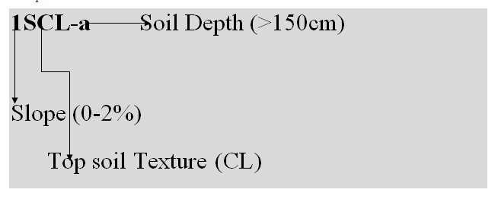

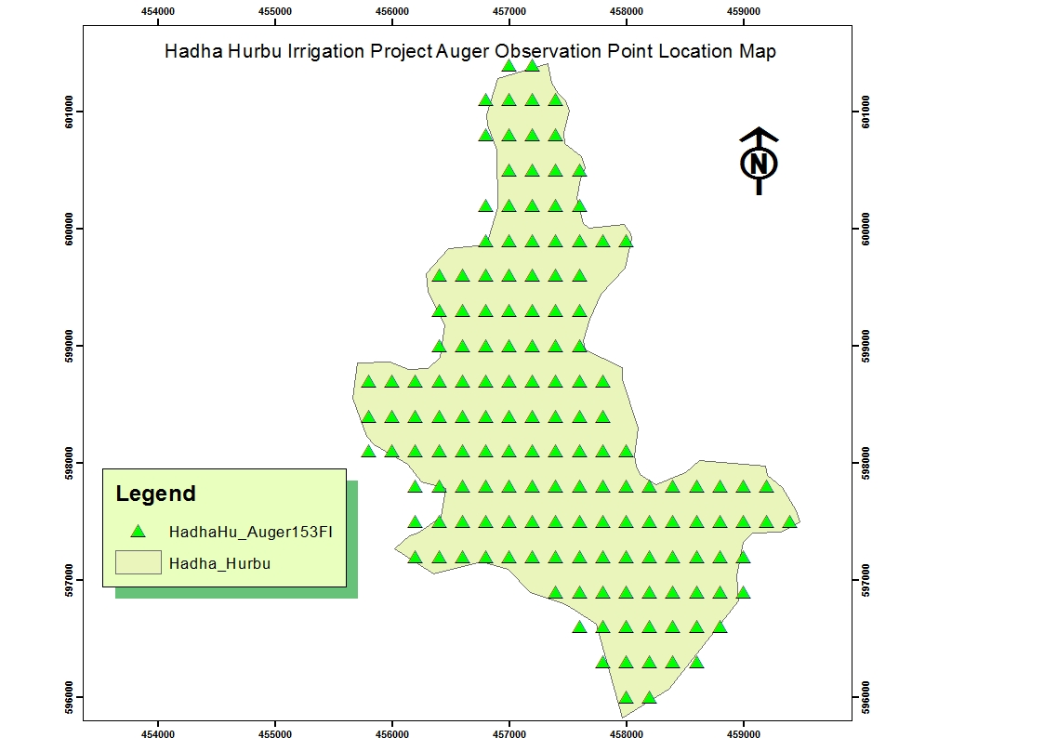
Figure 3: Location of Auger Observation Points

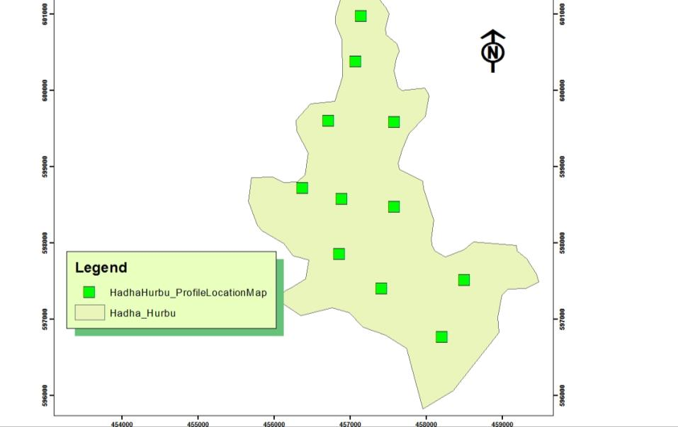
Figure 4 Location of Soil Profile Pits

4.4 Laboratory Analysis
The soil samples were air-dried, ground and sieved through a 2-mm sieve and analyzed for particle size distribution, pH (H2O), electrical conductivity(EC), organic carbon, total nitrogen, available phosphorus, exchangeable cations and cation exchange capacity (CEC). Soil analyses were performed in the OOWWDSE soil testing laboratory.
Soil pH was measured potentiometrically in 1:2.5 soils to water suspension (w/v) by using glass calomel combination electrode method (Van Reeuwijk, 1993). Electrical conductivity (EC) was determined at a soil/water ratio of 1:5. Organic carbon percentage was determined by the wet digestion method of Walkely and Black method (2000). Total nitrogen percentage was determined following the Kjeldahl method (Gupta, 2000). Available phosphorus was determined following the Olsen (sodium bicarbonate) method as described in Van Reeuwijk (1993). Cation exchange capacity (CEC) was determined by saturation with NH₄OAc at pH 7 and subsequent replacement of NH₄⁺ by NaCl extraction. Exchangeable basic cations (Na⁺, Ca²⁺, Mg²⁺, K⁺) from the ammonium leachate.Ca and Mg were read with the help of atomic absorption spectrophotometer (AAS), and K and Na by flame photometer.
Available potash, K (Morgan’s solution and flame photometer), Free calcium carbonate, CaCO₃ (filtration and titration with NaOH), Exchangeable Sodium Percentage (ESP
The percentage base saturation (PBS) was computed using the formula

PBS= (K+ Na+ Ca+ Mg) * 100 (Rowell, 1997)
CEC
The contributions of each exchangeable cation to the exchange site of soils were obtained by dividing value of each cation by value of CEC and multiplied by 100 for each horizon. Apparent CEC of clay was estimated by dividing CEC by percent clay expressed as percentages (Buol et al, 1997).Bulk density (BD) was determined on oven-dry weight basis of core samples. Water content at field capacity and permanent wilting point (0.33 and 1.5 MPa, respectively) was determined by pressure plate extractor. Soil analyses were performed in the OWWDSE soil testing laboratory.
The field data and laboratory analytical results as input for final findings of the study accordingly. Consequently based on the final interpreted data, particularly the laboratory analytical results, classification of major soil groups and soil units has been amended. The final soil map and report have been prepared based on data and sample test results obtained from laboratory. The prepared soil map is at the scale of 1:10,000 which contain the slope, soil unit comprising with the dominant soils. Profile pits and auger location points as shown on the map. The preparation of the soil maps was done by the use of GIS software. The soil data bases were generated are:
- Soil auger observation & profile description locations (geo-referenced)
- Soil profile &site description
- Soil auger & site description
- Soil laboratory analytical results
- Soil characteristics/land quality for land evaluation
- Soil maps (in GIS)

5 SOILS OF THE PROJECT AREA

5.1. General
Soil types have been defined on the basis of soil physical properties (such as texture, depth, color, slope etc…) and soil chemical characteristics (CEC, pH and BS% etc…). Although there was some variability in soil physical properties such as in soil color and texture over short distance, they are very limited in their area extents.

5.2. Major Soil Types in the Project Area
Based on soil genesis, morphological and other profile and surface characteristic such as effective soil depth, color, texture, structure, consistency, slope, micro topography, drainage, and stoniness, flooding together with soil chemical properties the soil of the Hadha Hurbu Irrigation Project is classified in to the following five major soils, i.e. Luvisols, Cambisols, Fluvisol Lixisol and Leptosol. Soil auger field observation, profile description and laboratory soil sample test results were compiled and analyzed using appropriate methods.
The soils were identified, classified and characterized based on physical and chemical parameters following FAO/UNESCO/ISRIC/1998(WRB 2014) methods. Potential and limiting factors have been identified to make land suitability evaluation. The report and soil map of the Hadha Hurbu Irrigation Project has been presented on 1:10,000 scale maps.

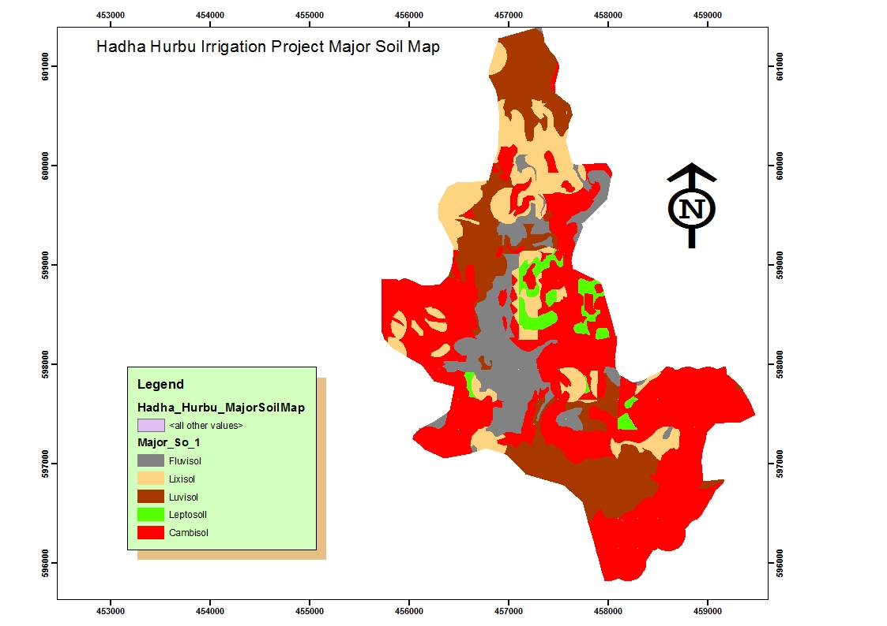
Figure 5 major soil map

5.2.1. Luvisols
Luvisols are soils that have a higher clay content in the subsoil than in the topsoil as a result of pedogenetic processes (especially clay migration) leading to an argic subsoil horizon. Luvisols have high-activity clays throughout the argic horizon and a high base saturation at certain depths. Luvisols are Soils having an argichorizon with a cation exchange capacity (in 1 M NH4OAc at pH 7.0) equal to or greater than 24 cmol (+) kg-1 clay, either starting within 100 cm from the soil
Surface or within 200 cm from the soil surface if the argic horizon is overlain by material that is loamy sand or coarser throughout (FAO, 2001, WRB, 2006).
The Luvisols of the study area classified as Chromic Luvisols.The color of the soils Redish brown (5YR4/4moist) to dark brown (5YR3/4Dray). The surface textures of the Luvisols are clay loam, and is very deep soil > 150 cm.
The Luvisols are with area coverage of 178.95 ha which constitutes 20.70% of the total area.and friable (moist), sticky and plastic (wet); moderate medium subangular blocky; Few fine coarse fragments;few fine and medium roots; few fine and medium pores; none cutanic features; non-cemented and non-compacted; none mineral nodules; clear smooth boundary; none calcareus
Mainly developed on gentely undulating to undulating slope (2-5 to 5-8) the soil is well drained, Shows evidence of clay elluvation (Argic B horizon).
The Luvisols in the Study area are strongly acid to very strongly acid with pH 5.2 to 5.4 in the topsoil and strongly acid in the sub soil or pH of 5.2-5.5 in the sub soils. The CEC values of the soils are very high ranging from 21.7-30.4 Cmol (+) kg⁻¹ in the topsoils and 21.4-33.7 Cmol (+) kg⁻¹ in the subsoil. Base saturation percent is high 71%percent and 67-72 percent in the topsoils and the subsoil respectively.
The electrical conductivity is 0.121-0.15 ds/min in the top and 0.046 ds/m and salinity would not impose any limitations throughout the soil types. The calcium carbonate content of the Luvisols is <15 percent in the topsoil and the result is trece sub soil. The presence of free carbonate normally indicates that the clay complex is dominated by calcium, which usually implies favorable physical condition but high level affects chemical characteristics of the soils in sub soils.
Organic carbon percent is low (2.41) in the topsoils and very low to low in the subsoil ranging from 0.69-0.84 %. The nitrogen percent is 0.23 rated as high in the topsoils and 0.04 % in the subsoil which is rated as low The available Phosphorus in these soils ranges from medium in the topsoils and subsoil and deficiency is very acute, even for crops with low demand for p fertilizer as adequate available p rates should be in excess of 8 ppm for low demanding crops and over 20 ppm for high demanding crops. Therefore, application of N P fertilizer in these Luvisols will respond positive.Representative Luvisol Profile Narration

Soil profile Profile code: HHP-1 Status: PS
Description.
Date: 29/09/18 Long. In utm (E): 457148
Author(s): Gadissa and Terefe Lat. in utm (N): 600986
Region Oromia Elevation: 1252m
Zone: West Guji Parent material: AL
Wereda: Melka Soda Rock
Types:
Soil classification FAO Luvisol Effective soil depth: very deep
Human influence: SC, VU Rock out C
Crops:
Land LP Depth to bed rock: none
Regional slope: Surface coarse few
Position: lower Micro topography: termite mound
Slope class: 0-2 Surface sealing: None
Slope aspect: North-Southu east Drainage class: W/W
Slope gradient:
Drainage external: well
Slope form: U
Drainage internal:
Slope length:
Ground water: none
Surface cracks: none
Flooding: none
Dissection:
Moisture condition: 0-30cm S/moist, 30- 200+cm moist
Erosion sheet and splash
Land cover:
Fertilizers: Unknown Land use: CL5, HE1
Existing crops: Maize Vegetation types: Mekenissa

0-30cm clear and smooth boundary; moist moisture status; dark brown (5YR3/4) Moist color, no mottling, Clay Loam, few fine coarse fragment, strong fine to medium Sub angular structure; No crack; very friable When moist, sticky and plastic when wet; no cutans; no cementation; no mineral nodules; common Fine medium, few medium to coarse roots; common fine medium fine coarse pores; non calcareous

30-110cm gradual and smooth boundary; slightly moist moisture status; dark red (2.5YR3/6) Moist, no Mottling, sandy clay , common fine coarse fragment, weak fine to medium granular structure; fine crack; Very friable when moist, slightly sticky and slightly plastic when wet; no cutans; no cementation; no mineral Nodules; few fine medium, few medium to coarse roots; common fine medium fine coarse pores; non Calcareous.
110-200cm; Moist moisture status; dark red (2.5YR3/4) when Moist, no mottling, sandy clay texture, few fine to medium coarse fragment, Strong medium Sub angular blocky structure; no crack; slightly hard when dry, friable to firm when moist, sticky and plastic When wet; no cutans; no cementation; few, white, both, concretion, calcium, mineral nodules; few fine roots; Common fine to medium pores; strongly calcareous.
0-30cm clear and smooth boundary; moist moisture status; dark brown (5YR3/4) Moist color, no mottling, sandy clay loam, few fine coarse fragment, strong fine to medium Sub angular structure; No crack; very friable When moist, sticky and plastic when wet; no cutans; no cementation; no mineral nodules; common Fine medium, few medium to coarse roots; common fine medium fine coarse pores; non calcareous

30-110cm gradual and smooth boundary; slightly moist moisture status; dark red (2.5YR3/6) Moist, no Mottling, sandy clay , common fine coarse fragment, weak fine to medium granular structure; fine crack; Very friable when moist, slightly sticky and slightly plastic when wet; no cutans; no cementation; no mineral Nodules; few fine medium, few medium to coarse roots; common fine medium fine coarse pores; non Calcareous.
110-200cm; Moist moisture status; dark red (2.5YR3/4) when Moist, no mottling, sandy clay texture, few fine to medium coarse fragment, Strong medium Sub angular blocky structure; no crack; slightly hard when dry, friable to firm when moist, sticky and plastic When wet; no cutans; no cementation; few, white, both, concretion, calcium, mineral nodules; few fine roots; Common fine to medium pores; strongly calcareous.
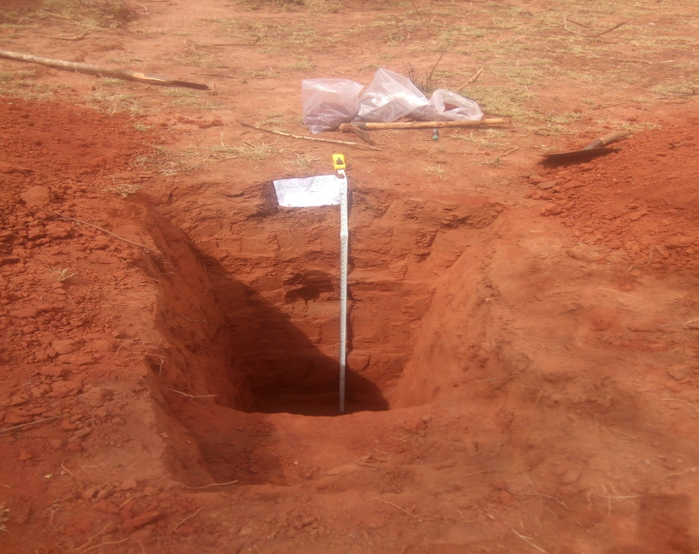
Figure 6 typical Luvisol profil

5.2.2. Cambisols (Chromic, and LepticCambisol, eutric)
Cambisols are moderately developed soils characterized by slight or moderate weathering of parent material and by the absence of appreciable quantities of accumulated clay, organic matter having moderately developed Cambic B horizon or a Mollic horizon overlying subsoil which has a base saturation (by 1M NH4OAc) of less than fifty percent (<50 per cent for dystric Cambisols and >50 per cent for Eutric Cambisols) Cambisols are soils those lacks hydromorphic and permafrost within 100 cm and 200 cm of the surface respectively. In the study area identified Eutric Cambisols. (See soil mapping unit description)
Cambisols of the study area are sub divided in to Leptic Cambisols (Aridic), Haplic Cambisols (Eutric)
The Cambisols in the study area are strongly acid with low pH ranging from 5.4-5.5 in the top soils and extremely acid to slightly acid ranging from 5.5 in the sub soils.
The CEC values of the soils are low to very high ranging from 4.5-11.2 Cmol (+) Kg⁻¹ in the top soils and very low to very high ranging from 7.5-11.2 Cmol (+) Kg⁻¹ in the sub soils. Base saturation percent is medium to high ranging from 45-85 and 46-74 percent in the top soils and the subsoil respectively.
The ESP of these soils is <15 and electrical conductivity is 0.061-0.21 ds/m indicating no salinity limitation. The calcium carbonate content of soils is trace en top soil and in sub soil. Organic carbon percent is very low ranging from 0.66-1.09 % in the top soils and 0.45-0.55 % in the sub soils rated as very low the total nitrogen percent is Low (0.07-0.08) in the top soils and 0.04-0.06 % rated as low in the sub soils. It requires No fertilizer application. The available P in the soils is low in the top soils and sub soils AvP<5.Cambisol en the Study area cover 415.18ha or 40.08% of the total area.
Soil profile Profile code: HHP-10 Mapping unit: Status: PS
Description
Date: 02/10/18 Long. In UTM (E): 457415
Author(s): Gadissa Lat. in UTM (N): 597411
Region Oromia Elevation: 1227m
Zone: Bale Parent material: BT
Wereda: Rayitu Rock
Types:
Soil classification FAO Cambisol Effective soil depth: Moderately Deep
Human influence: VU Rock out N
Crops:
Land LP Depth to bed rock: 75cm
Regional slope: Surface coarse N
Position: MEDIUM Micro topography: TM, AB, AT
Slope class: 8-15 Surface sealing:
Slope aspect: Drainage class: M/W
Slope gradient: Drainage external: well
Slope form: U Drainage internal:
Slope length: Ground water: none
Surface cracks: none Flooding: none
Dissection: Moisture condition: 0-110cm dry
Erosion sheet and splash

Fertilizers: Unknown Land cover:
Existing crops: N Land use: GL2
Vegetation types: HERER

0-25cm Clear smooth boundary; dry moisture status; (5YR4/6)dry colour;(5YR4/4)moist colour; none mottling; clay loam texture; none coarse fragement; weak,fine &,medium ,sub- angular blocky structure; none crack;slightly hard,friable (moist), sticky and plastic(wet) consistency; none cutanic features; non-cemented & non-compacted; none mineral nodules;many, fine to medium root;:many, fine to medium pores;none calcareous.

25-75cm dry moisture status; (2.5YR3/6) dry colour;red(2.5YR3/4) moist colour; none mottling; sand clay loam texture;common, fine to medium coarse fragement; moderate,fine & medium , sub- angular blocky structure; nonecrack;hard(dry)' friable (moist), sticky to sticky and plastic to plastic (wet) consistency; none cutanic features; non-cemented & non-compacted; none mineral nodules;common,fine & medium, root;many,fine to medium pores; nonecalcareous. >75 cm coarse and gravels. Argic diagnostic horizon (surface), Cambic (sub-surface

5.2.3. Leptosols (Eskeletik Leptosol (eutric)
Leptosols are soils having continuous hard rock within 25 cm from the soil surface; or a Ochric horizon with a thickness between 10 and 25 cm directly overlying material with a calcium carbonate equivalent of more than 40 percent, or less than 10 percent (by weight) fine earth from the soil surface down to a depth of 75 cm; and no diagnostic horizons other than a mollic, ochric, umbric or yermic horizon. Leptosols are very shallow soils over continuous rock and soils that are extremely gravelly and/or stony. Leptosols are azonal soils and particularly common in mountainous regions (FAO, 2001, WRB, 2006).
Leptosols of the study area are found as Ochric Leptosols (Eutric) having an area of 26.65 ha occupying 3.08% of the total area and occur in and HHP-9 representative profiles.

5.2.4. Lixisols (Rhodic and Chromic Lixisol (eutric)
Lixisols comprise soils that have a higher clay content in the subsoil than in the topsoil as a result of pedogenetic processes (especially clay migration) leading to an argic subsoil horizon. Lixisols have a high base saturation and low-activity clays at certain depths. Lixisols are soils with a pedogenetic clay differentiation (especially clay migration) between topsoil with a lower and subsoil with higher clay content, low-activity clays and a high base saturation at some depths; from Latin lixivia, washed-out substances. Lixisols occur in a wide variety of parent materials, notably in unconsolidated, strongly weathered and strongly leached, finely textured materials (WRB, 2014).
Lixisols of the study area are found from Plain land(0-2%) slope up to slope land 5-8% slope Well Draind and Deep soils Sandy clay loam textuer on the top Dark Redish brown (5YR 4/6 Dry); and Very Dark Redish Brown (5YR3/4) colored,high base saturation persentage(81% ) low CEC leve11.0Meq/100gm Low available Phosphorus. The total area of Lixisols is 131 ha covering 15.25% of the total area.HHP-5 are Representative Profiles

5.2.5. Fluvisol (MollicFluvisol, eutric)
Fluvisol accommodate genetically young, azonal soils in alluvial deposits, these soils are not only confined to river sediments, they are also occurring in lacustrine and marine deposits. Mainly Fluvisol are correlated with alluvial soils. Eutric Fluvisol having a base saturation (by N H4OAC) of 50 percent or more at least between 20 and 50 cm from the surface but which are not calcareous at the same depth, lacking a sulfuric horizon and sulfidic material with in 125 cm of the surface, lacking salic property,
Fluvisol with area coverage of 111.25 ha which constitutes 12.87% of the total area.Moderately well drained, very deep(>150cm), Redish Brown (5YR4/3Dray) and Dark Redish brown 5YR3/2moist); mainely developed on Flat slope(0-2per sent), none mottling; dominantly clay loam textured ,Slightly hard(dray) friable (moist), sitcky and plastic (wet); moderate and medium subangular blocky; Few fine coarse fragments; many fine and medium roots; many fine and medium pores; non-cemented and non-compacted; none mineral nodules; clear smooth boundary; slightly calcareous. Considering the above mentioned characteristics and other chemical properties they are identified as Eutric Fluvisol

6. SOIL PHYSICAL AND CHEMICAL PROPERTIES

6.1 Soil Physical Properties

6.1.1 Effective Soil Depth
The effective soil depth is that the thickness of the loose soil above a limiting layer which is impermeable for roots and/or percolating water. Deep well drained soil shows a root penetration until below 150 cm for most crops, however, root penetration might be stopped at shallower depth because of root restricting physical or chemical soil properties (presence of cemented, toxic, compacted or indurate layers, hard rock or gravel layers). The soil survey result shows that the dominant soils of Hadha Hurbu Irrigation Project are deep to very deep (100-150cm to >150 cm respectively), no limitation for normal rooting for most cultivated crops, grazing herbages, bushes and shrubs.
Table 5: Effective soil depth and area coverage of the area
Depth (cm) | Area (ha) | Ha (%)
>150cm | 666.26 | 76.64
50-100 | 114.97 | 13.22
25-50 | 56.61 | 8.67
0-25 | 26.65 | 1.40

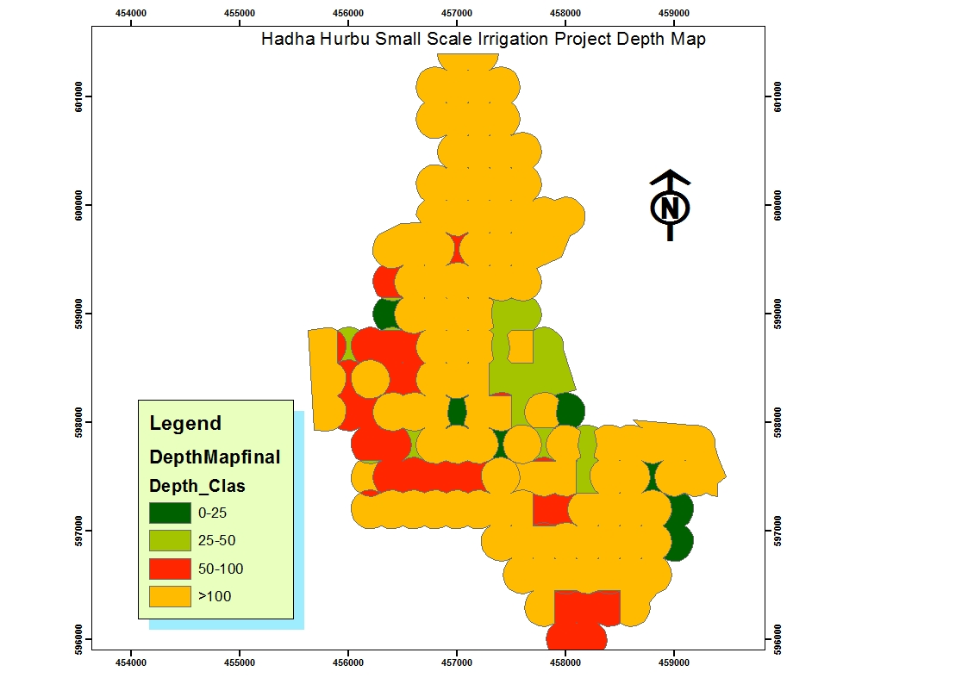
Figure 7 Depth map

6.1.2. Soil Structure
Soil structure is the natural arrangement of soil particles in discrete soil units (aggregates or peds) that result from the pedogenic process. Soil structure is described in terms of grade, size and types of aggregates.
Structure may be weak, moderate or strong and the aggregates may be platy, blocky, prismatic, granular etc…
Soil structures have been assessed from visual observation of soil peds taken from each horizon medium sub angular blocky type. Classification of structure follows the FAO Guidelines for Soil Description (2014).
This is a subjective system of assessment. The surface structure of Fluvisols is dominantly moderate to strong, medium angular blocky structure. The Luvisols (Mollic), moderate, medium sub angular blocky structure both in the surface and sub surface and Cambisols (Eutric) weak to medium moderate sub angular blocky structure and Lixisol have dominantly moderate to weak, fine to medium sub angular blocky structure in their surface soils and moderate to strong, medium to coarse sub angular block structure in their sub soils. Soil structure of almost all soil types is moderately developed medium size and sub-angular blocky.

6.1.3. Consistence
The Fluvisols soils with medium texture have hard consistence when dry, friable when moist and sticky and plastic consistence when wet. Luvisols friable when moist, sticky and plastic when wet, Cambisols have friable when moist, slighitly sticky and slightly plastic when wet, Lixisol friable to very friable when moist, slightly sticky and slightly plastic when wet. The consistence of other soils varies with their textural composition and accordingly the clay loam and sandy clay loam textures have dry consistence of slightly hard, friable consistence when moist and slightly stick and plastic when wet.

6.1.4. Texture
The proportions of sand, silt and clay are used to determine the textural class of the soil. It is important in that, it helps determine the capacity of the soil to retain moisture and air, both of which are necessary for plant growth.Top Soils texture of the Project area are dominantly Sandy Clay Lom and Sandy Loam for Fluvisol and Cambisol respectively, clay loam to clay for Molli-chromic Luvisols, and sandyclay loam and sandy loam for Cambisols and Leptosol. Laboratory analysis of soil texture show that clay percentage increases down soil profile especially in Luvisols and vertisols since the main characterization of Luvisols is migration of clay from to top soil and accumulated in the sub soil. However the clay percentage in Cambisols is not uniform in the soil profile.

6.1.5. Soil Color
Soil color was measured under dry and moist condition by determining the hue, value and chroma of the soil using Munsell color chart. The soil color of the survey area is mainly related to drainage and the parent material. Accordingly, well drained and moderately well drained soils of the project area Luvisol to dark redish brown (2.5YR3/3and 3/4) while modaretly drained.

6.1.6. Soil Drainage
Soil drainage relates the frequency and duration of periods when the soil is free of saturation or partially saturated. The soil drainage classes reflect the effect of climate, landscape and soil. Rainfall, seepage, internal vertical and lateral water movement and external surface run-off and run-on affect soil drainage. Based on this, soil drainage is classified as well drained, moderately well drained, imperfectly drained,
Soils of the study area have moderately well drained in fluvisols area and moderately drained to well-drained in Luvisols and Cambisols Soil condition which vary depending on their varying properties affecting drainage such as water transmission, soil depth, soil chemistry, slope gradient, etc.

6.1.7 Infiltration rate
Infiltration refers to the vertical intake of water into a soil, usually at the soil surface, and measurements rate form a vital part many survey involving irrigation development or soil conservation (Landon, 1991).
Infiltration rate is mainly affected by texture of the soil and other properties of the soil such as organic matter content and structure of the soil. Many challenges have been encountered during the test of infiltration on Vertisols and vertic soils because of the cracking nature of the soils that was not fully closed during pre-wetting time and consumed much more time and water. As a result of the unclosed hidden sub surface cracks, the effort of infiltration test on these soils frequently failed and finally achieved on the limited representative sits. All tests were performed close to representative soil profiles. The result of the test indicates that soils of the study area have a mean infiltration rate of 3.5cm/hr-3.8cm/hr and this implies that soils of the project area have a moderate infiltration rate.
Table 6 The results of infiltration tests of the soils.
No | Rep. Profile | Surface Texture | Rep1(cm/hr) | Rep2(cm/hr) | Rep3(cm/hr) | Infiltration rate (cm/hr)
1 | HHP-6 | SandyClayLoam | 3.5 | 3.2 | 4.2 | 3.2-4.2
2 | HHP-3 | Sandy loam | 3.8 | 3.5 | 3.6 | 3.5-3.8
 |  |  |  |  |  | 3.5cm/hr

6.1.8. Hydraulic Conductivity
The hydraulic conductivity or permeability of a soil defines the volume of water which will pass through unit cross sectional area of a soil in unit time given a unit difference in water potential. The measurement of hydraulic conductivity is done for comparison of hydraulic conductivity rates of different soil horizons, particularly as a guide to water movement and possible drainage problems within soil profiles (Landon, 1991). The tests were carried out by inverse auger-hole method, near/at the representative soil profile. The results indicate that hydraulic conductivity of 1.5 to 2.5 m/day for soils of the study area. The result indicates that, the water movement is to moderate to moderately rapid.this is because plant root penetration and crack formed down to the soil profile.Hydraulic conductivity is affected by texture and structure of the soils.

Table 7 : The hydraulic conductivity results of the soils are given below.
No | Rep. Profile | Surface Texture | Rep1  (m/day) | Rep2  (m/day) | Rep3  (m/day) | Hydraulic conductivity (m/day)
1 | HHP-6 | SandyClay Loam | 1.5 | 2.2 | 1.8 | 1.5-2.2
2 | HHP-3 | Sandy  Loam | 1.8 | 1.5 | 2.5 | 1.5-2.5

6.1.9. Bulk Density
Bulk density is the overall density of soil (i.e. the mass of mineral soil divided by the overall volume occupied by soil, water and air); it should be distinguished from the density of the solid soil constituents. Bulk density of clay, is 1.5 g/cm³, clay loam normally range from 1.42 to 1.44 g/cm³ depending on their conditions and bulk density of Silty loam is 1.54 g/cm3. The bulk density of the soils in the study area varies between 1.57and 1.72 g/cm³. The result shows that the bulk density of soils of the study area is in normal range and it is not causing hindrance to root penetration as such.
Table 8: Bulck density results versus soil textures of the study area
S/N | Rep.Profile | Surface Texture | Bulck density(gm/cm3)
1 | HHP-3 | Sandy Loam | 1.57
2 | HHP-6 | Sandy Clay loam | 1.63

6.1.10. Field capacity (FC)
Field capacity of a soil is the maximum water content the soil will hold following free draining by gravity force.Field capacity (FC) is the term used to describe the maximum water content that the soil will hold following free drainage. It does not therefore correspond to a fixed soil-water potential, but instead represents the condition of each individual soil after the larger pores have drained freely under gravity (Landon, 1991). The field capacity of the soils of the study area falls in the range of 20.5% in the top soil and 19.4% to23.7% in the sub soils.

6.1.11. Permanent wilting point (PWP)
Permanent wilting point is the soil moisture content at which plants can no longer obtain enough moisture to meet evapotranspiration requirements and remain wilted unless water is added to the soil. Permanent wilting pointis the moisture content level at which the plants are water stressed and irreversibly wilt. If water is continually taken-up by plants and no additional water is added to the soil in the form of precipitation or irrigation water, the medium and small soil pores will be emptied of water. With time, the plant will eventually wilt when it cannot extract more water. The soil is said to be at the permanent wilting point when plants can no longer exert enough force to extract the remaining soil water. At the permanent wilting point, water is held in the soil at about 1.5 MPa (15 bars). The permanent wilting points of the soils of the study area fall in the range of 13.6 % to 15.3% in the top soil and 12.9% to 18.6% in the sub soil.
Table 9: permanent wilting point results versus soil textures of the study area
S/N | Rep.Profile | Surface Texture | Permanent wilting point (%) (15 bar)
1 | HHP-3 | Sandy loam | 15.3
2 | HHP-6 | SandyClayloam | 13.6

6.1.12. Available water capacity (AWC)
Available water capacity is the volume of water retained between field capacity and permanent wilting point. However, not all available moisture is accessible to plants due to imperfect drainage, hydraulic conductivity of the soil, impenetrable depths, and root concentration at different depths and stage of plant growth. About 50-70% of available moisture is considered readily available water (RAW). Readily available moisture is considered 60% of total available water as a rule. In general principle results of AWC <120mm/m, 120-180 mm/m and >180 mm/m has low, medium and high rate for irrigation suitability respectively.
Based on laboratory analysis of FC, PWP and bulk density on undisturbed core samples, value of AWC was determined for the dominant major soil type of the command area. Calculation for the AWC is done as follows using the formula:

6.1.13. Available water capacity (AWC) and readily available water Capacity (RAWC)
Available water capacity (AWC) is the volume of water retained between field capacity and permanent wilting point. Not all the water held between the field capacity and permanent wilting point can be considered as equally available to plants. A rule of thumb is that the total readily available water capacity (TRAWC) value is half to two thirds of the total available water capacity of a profile (Landon, 1991). Calculation of AWC is done by the following formula.
AWC =

Table 10 below shows the average available water capacity (AWC) & readily available water capacity (RAWC) value for the Representative profile of the soils of the study area.
Table 10: Average available water capacity
Profile code | Depth (cm) | Field Capacity | Permanent Wilting Point | Bulk Density | FC-PWP | AWC | TAWC | Porosity (%)
HHP-3 | 0-25 | 20.6 | 15.3 | 1.57 | 5.3 | 20.8 |  | 40
 | 25-60 | 20.5 | 12.9 | 1.72 | 7.6 | 45.75 |  | 35
 | 60-90 | 19.4 | 13.9 | 1.72 | 5.5 | 28.38 | 94.93 | 35
HHP-6 | 0-30 | 20.5 | 13.6 | 1.63 | 6.9 | 33.74 |  | 38
 | 30-60 | 20.4 | 15 | 1.69 | 5.4 | 27.37 |  | 36
 | 60-90 | 23.7 | 18.6 | 1.7 | 5.1 | 26.01 | 87.12 | 37
The above values were derived from the representative samples for the study area. The higher values of the available water capacity may be because of the higher organic matter content of the soils, good structure etc.

6.1.14 Porosity
Total porosity gives a general indication of (dry) soil compaction. In clayey soils a total pore space of about 50% or less may indicate some compaction. The data confirm the field observations that, when dry, all the soils are hard. However, when moist (under irrigation) the Luvisols become very friable. The Fluvisols remain firm.The data indicate some compaction in the study area but not serious problem.
Air filled porosity is the total porosity minus the volume of moisture held at field capacity. Pores that are not filled by water contain air, and an estimate of their volume can give an indication of the aeration and drainage status of the soil. Very indicatively, a value of the study area indicates < 10% air capacity may indicate anaerobic conditions. In practice, though, the limit depends on soil temperature, continuity of pores, cracks, microbial activity and oxygen consumption by the plant; plants can receive oxygen through stems and roots.

As expected, the Luvisols .Lexisols and Cambisols are all well-aerated at field capacity, but the Fluvisols are not. However, even whenMedium cracks are filled and the Fluvisols have swelled, roots (those below about 20 cm) can extract sufficient oxygen from minor cracks that remain unsaturated
Table 11 : Total porosity and Air-filled porosity
profile No. | Soil units | Bulk density, g/cm³ |  |  | Total porosity, % |  |  | Air-filled  porosity, %
profile No. | Soil units | Top soil | 0.3–0.6m | 0.6–1.0m | Top soil | 0.3–0.6m | 0.6-1.0m | Top soil | 0.3–0.6m | 0.6-1.0m
HHP-3 | Lx | 1.57 | 1.72 | 1.73 | 41 | 40 | 41 | -30 | -27 | -20
HHP-6 | Cm | 1.63 | 1.69 | 1.70 | 38 | 36 | 36 | 30 | -26 | -30
Biological features such as krotovinas, termite burrows, insect nests, worm casts and borrows of large animals in terms of abundance and kinds. Biological features of the study area is common by animal borrows and few earth worm casts and many termite burrows on Redish brown soils according to profile description and surfce obsrvation.

6.1.16. Erosion Status
The erosion status of the command area is slight to moderate for the level lands up to 5% slope and moderate for Slopes >8%. This status of erosion of the command area is shown by the existence of some sheet and few rill and Gully erosion active in the comand area and not observed modern soil and water conservation practices.

6.1.17. Flooding
For the majority of the soil mapping units the flooding Status of the command area is generally none, there is no evidence of flooding hazareed, except Hadha River side (river buffer zone)

6.1.18 Deep Boring
To Check the depth of impervious layer/horizone, Soil salinity and the fluctuation of the water table of the study area two deep boring were made between 3.0m and 4.0m depth .Saline soils have an ECe of >4.0ds/m sodic or (alkali) soils have an ESP>15. The laboratory result of the study area indicates none of the soil profile or auger analysis even of deep horizons, indicate any
Soil salinity or sodicity problem,

6.2. Soils Chemical Properties

6.2.1. Soil Reaction (pH)
Soil pH is important, as it is an indicator of acidity, neutrality or alkalinity in the soil. PH helps to determine the availability of nutrients to plants and toxicity of macro and micronutrients in the soil that ultimately control plant growth. PH water values do not have precise significance but some generalizations can nevertheless be made for interpretation purposes. Generally the pH water tolerance limits for different plants vary, but for most commercial crops a neutral range (PH Water value 6.6-7.3.) is most suitable. The soil pH significantly affects the availability of most of the chemical elements important to plants and microbes.
The overall pH value of the project area in soil-water suspension varies from 5.1-5.6 with an average of 5.3 .which increase from top to sub soil. This range of soil pH is normally termed as Strongly acid to moderatly acid soil. In strong acid soils calcium and magnesium are deplated due to leaching Low calcium and magnesium can olso cause stock health problem melk fever and grass tetany but in the study area there is low almunium toxisity for soil of the study area Liming is recomended for neutralized the soil reaction or to increse the Low Ph with organic fertilizer application and crop rotation practices.

6.2.2. Electrical Conductivity EC and (ECe)
The Electrical conductivity (EC) measurement of a soil solution is an indicator of the amount of soluble salts in the soil. EC value of greater than 4 mmhos/ cm is considered not favorable for most crops. Electrical conductivity (EC) values of the study area varied from 0.039 to 0.21 dS m⁻¹ and in accordance with the EC rating, the soils of the study area were non-saline. Similarly, according to definition set by U.S. Salinity Laboratory Staff (1954) none of the samples were saline and the values were even lower than the suggested cut of point, 4 dS m⁻¹. This is due to rainfall that significantly exceeds evapotranspiration and results in leaching of soluble ions and prevents accumulation of salt. Plants growing in these areas do not have the problem of absorbing water because of the lower osmotic effect of dissolved salt contents.
The range of ECe measured for the soil of the study area is very low varying from 0.37 -2.95 dS/m with anaverage of 1.34 dS/m.Generally soil with EC value of less than 4dS/m is considered as salt free soil and hence soil of the project area is not affected by salinity and no effect on the growth of plant as the value observed is below the permissible limit.

6.2.3. Organic Carbon (OC) or Organic Matter (OM)
The organic carbon contents of soils of the study area are in the range of 0.53% to 2.41% with average of 1.50% which it is rated as very low level to low level of organic carbon content.The determination of organic matter (OM) is conducted to evaluate availability of plant nutrients and physical condition of the soil. Soil organic matter consists of plant, animal and microbial residues in various stage of decay. Organic matter contains about five present (5 per cent) of total nitrogen, so it serves as a store house for reserve nitrogen. But the nitrogen in organic matter is in inorganic form and not immediately available for plant use, since decomposition usually occurs slowly. Organic matter results to dark color of many soils, holds water 20 times of its weight, provides aggregation and has high CEC.
The organic matter content of the study area are in the range of 0.91%to 4.16%the average organic matter content of the soils of the study area is 2.59% and is rated as medium level. Generally, in all soils, organic carbon content decreases from top to sub soil indicating relatively better accumulation of decomposable organic materials in the surface horizons than in the subsurface.

6.2.4. Total Nitrogen
The total nitrogen is an indicator of the total amount of the different form of nitrogen such as organic nitrogen, NO₃, NO₂, and NH₄ ions. Apart from nitrogen fertilizer applications, the only other source of nitrogen in soil is the breakdown and humification of organic matter, and atmospheric nitrogen fixation by leguminous plants.
Results show that generally total nitrogen ranges from 0.04 to 0.23% percent with an average of 0.14% which indicate that the total nitrogen content is high in the study area.

6.2.5Carbon to Nitrogen Ratio (C: N)
C:N ratio is an indicator of the process of transformation of organic nitrogen to available nitrogen such as ammonium nitrite and nitrate. A minimum acceptable C: N ratio is a value less than 10:1 and C:N ratio of greater than 14:1 is considered as poor humification and low N. The C: N ratio of soils in the study area varies from 9 to 14

6.2.6. Available Phosphorus
Phosphorus is present in the soil in both organic and inorganic forms, the inorganic form is usually more important as a plant nutrient. The phosphorus availability to plants differs between different forms of phosphorus in the soil. Available phosphorus is the form of phosphorus, which is readily available to the plant. However, phosphorous is generally low in total amount in the soil and is low in solubility, because it is fixed by Aluminum and Iron at low PH and Calcium at high PH.
The available phosphorus content of the soils of the project area varies from 1.02 ppm to 15.18ppm with average of 4.53ppm where the value is low in top soil. Generally the available phosphorus of the soils of the soil mapping units is rated as lower.

6.2.7. Cation Exchange Capacity (CEC)
The Cation Exchange Capacity (CEC) measured as meq/100g soil is important indication or criteria in soil classification and can be used as an overall assessment of the potential fertility of the soils and possible response to fertilizer. CEC is often used as characteristics in determination of nutrient retention for land quality assessment in land evaluation. The higher the CEC, the greater will be the ability to retain cations. It should be noted that CEC values critically depend on pH. The overall values of CEC lie in the range of 4.5 meq/100g soil to 30.4 meq/100g. CEC on average 16.4meq/100g medium value, this value between these ranges is rated as low to very high which in turm mean is good agricultural soil in terms of plant nutrition.

6.2.8 Base Saturation Percentage (BSP)
Base saturation is frequently used as an indicator of soil fertility and it is also used in soil classification. Base saturation is the proportion of CEC accounted by exchangeable bases (Ca, Mg, K and Na) and is considered as an index of soil fertility. The soil with BSP value of less than 50 per cent is considered as Dystric (infertile) and those with above 50 per cent are considered as Eutric (fertile) in FAO classification.
The calculated BSP of the project area was found between45% to 87% average 65% indicating very high value. In other words, such higher levels of BSP mean that the exchangeable complex is saturated with exchangeable cations.

6.2.9. Exchangeable Calcium (Ca)
Normally calcium deficiency in a plant nutrient occurs only in soils of low CEC at PH of 5.5 or less, Calcium also effectively deficient at high PH level when there is excessive sodium content. Large input of potassium fertilizer or high natural potassium may however inhibit plant uptake of calcium in the soil having more neutral reaction. If other factors are conducive a level of 6 meq/100g soil of exchangeable calcium is generally sufficient to ensure crop production (FAO, 1979). The value of exchangeable calcium in the study area is 1.15cmol (+)/kg soil to 15.42cmol (+)/kg soil with average value of 6.68 cmol (+)/kg soil, which indicate that very high level

6.2.10. Exchangeable Magnesium (Mg)
Exchangeable magnesium which is greater than 3cmol (+)/kg soil is believed to be adequate for plant nutrition. The amount of exchangeable magnesium reported for the soils of the study area varies from 1.06 to 10.05cmol (+)/kg soil with average value of 3.32cmol(+)/kg soil. The result shows that the level of Mg is high to very high

6.2.11. Exchangeable Potassium (K)
Potassium is an important plant nutrient and a great deal of study has been made of the amounts believed necessary for adequate plant growth. Values less than 0.1cmol (+)/kg soil are considered deficient, from 0.1 to 0.2cmol (+)/kg intermediate and greater than 0.2cmol (+)/kg adequate.
Soils of the study area have exchangeable K value ranging from 0.14 to 2.28 cmol (+)/kg soil. Which indicates that the level of K is medium to high .the average value is 0.84 cmol (+)/kg

6.2.12. Exchangeable Sodium (Na)
Sodium is not an essential plant nutrient; but some plants for potassium substitute can utilize it. On the other hand, when sodium is present in the soil in significant quantities, particularly in proportion to the other cations present it can have an adverse effect to both plant nutrition and physical conditions of the soils; however, no structural degradation was observed during the present filed work.The value of the measured exchangeable Na falls in the range of 0.02 to 0.87cmol(+)/kg of soil, with mean value of 0.26 cmol(+)/kg of soil indicating lower Na content of the soil and have no any adverse effect on growth of crops and physical properties of soil.

6.2.13. Exchangeable Sodium Percentage (ESP) and Sodium Adsorpation Ratio
Exchangeable Sodium Percentage (ESP) indicates Sodicity in the soil. Soils with ESP<15 is generally non-Sodic requiring no amendments, whereas soil with ESP> 15 are Sodic and requires amelioration method.
The result of laboratory analysis and the derived ESP value for the soil of the command area showson the top soil 0.79% to 3.82% with avegage value of 1.58% it is below the allowable limit and there is no sodicity problem in the study area and no need of amendments. Sodic soils have an ESP >15, the ECe is <4 dS m^{–1}, and the lower limit of the saturation extract SAR is 13.

6.2.14 Calcium carbonete
The calcium carbonate equivalent of >15 per cent is used in the FAO definition of Calcic horizon. High level of calcium carbonate >15 per cent affect the physical and chemical characteristics of a soil besides normal root penetration. The term Calcaric which refers to soils which are calcareous (show strong effervescence with 10 per cent HCL), in most of the fine earth or which contain more than 2% carbonate equivalent. The calcium carbonate content of most of the soils in the study area is trace that the soils are free of Calcium Carbonate and not affect the soil conditions.

6.2.15. Potassium to Magnesium Ratio (K: Mg)
If the ratio of potassium to magnesium is more than 2:1, magnesium uptake may be inhibited. The ratio of K: Mg recorded for the project area is between 0.05 and 1.19(Average value is 0.18: 1, indicating an optimum situation for production of most field crops, vegetables and fruits.

6.2.16. Calcium to Magnesium Ratio (Ca: Mg)
The ratio of calcium to magnesium (Ca: Mg) in most soils of the project area is moderate 0.62 to 9.12 With Average of 2.0 Which indicate that the level is less favorable to high favorable.

6.2.17. Potassium to Cation Exchangeable Capacity Ratio (K: CEC)
If the ratio of K: CEC is less than two per cent, it suggests a minimum level to avoid K deficiency and soils with more than 25% ratio is considered to be potassium rich soil. The minimum K: CEC ratio of the soil units in project area is an average 0.03.

Table 12: Description of Soil physical and chemical properties by major soils
MAJOR SOIL
Soil Physical &chemical Properties | Horizon | LEXISOL | FLUVISOL | LUVISOL | CAMBISOL | LEPTOSOL
Ph | top  sub | 5.2  5.3 | 5.5  5.6 | 5.3  5.5 | 5.5  5.6 | 5.5  -
Ec | Top  sub | 0.04  0.06 | 0.05  0.06 | 0.13  0.05 | 0.16  0.15 | 0.14  -
Na | top  sub | 0.15  0.30 | 0.25  0.97 | 0.26  0.29 | 0.16  0.20 | 0.19  -
K | Top  sub | 0.42  0.9 | 0.70  0.44 | 0.38  1.08 | 0.78  0.77 | 0.44  -
Ca | top  sub | 5.94  7.4 | 5.12  3.3 | 4.77  9.56 | 2.75  3.2 | 4.15
Mg | top  sub | 2.7  2.3 | 4.07  5.49 | 4.77  3.53 | 2.41  3.39 | 2.61  -
CEC | Top  sub | 16.1  17 | 17.5  29.7 | 35  28 | 20  23.1 | 11.2  -
BS% | Top  sub | 75  77 | 52  70 | 71  65 | 67  64 | 66  -
ESP | top  sub | 1.1  2.2 | 1.5  1.78 | 1.04  1.1 | 1.23  1.50 | 1.70  -
TN | top  sub | 0.04  0.03 | 0.14  0.04 | 0.04  0.02 | 0.04  0.03 | 0.08  -
OC | top  sub | 0.44  0.2 | 1.52  0.42 | 0.52  0.18 | 0.5  0.27 | 1.0  -
OM | top  sub | 1.15  0.42 | 3.21  0.72 | 0.9  0.3 | 0.87  0.46 | 1.72  -
AvP | top  sub | 1.27  1.5 | 2.85  1.07 | 4.2  0.2 | 3.68  2.41 | 2.07  -
Caco3 | top  sub | 0.00  0.00 | 0.000  0.00 | -  0.00 | - | 0.00
Texture | top  sub | SL  SC | SCL  SCL | CL  C | SL  SL | SL  -
Depth |  | >150 | >150 | >150 | 50-100 &  25-50 | 0-25
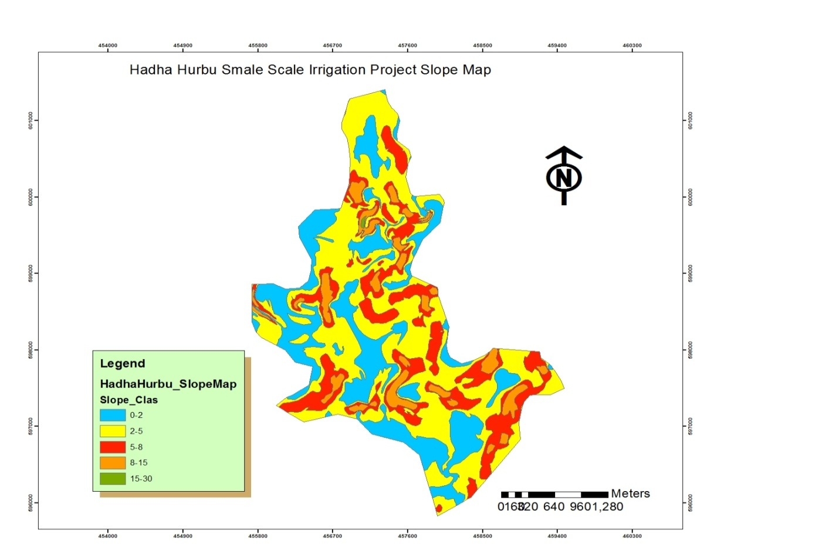
Figure 8: Slope Map

7. DESCRIPTION OF SOIL MAPPING UNITS

7.1. General
The soils of the project area are mapped and described based on their similar soil characteristics and constraints. The soils of the study area have been classified in to 16 soil mapping units. The soil mapping units were classified based on soil phase’s criteria. The dominant characteristics considered in mapping the soil unit are like slope, soil type, soil drainage, depth to water table, soil texture and soil physical and chemical properties. Based on this, the following soil mapping units were identified.

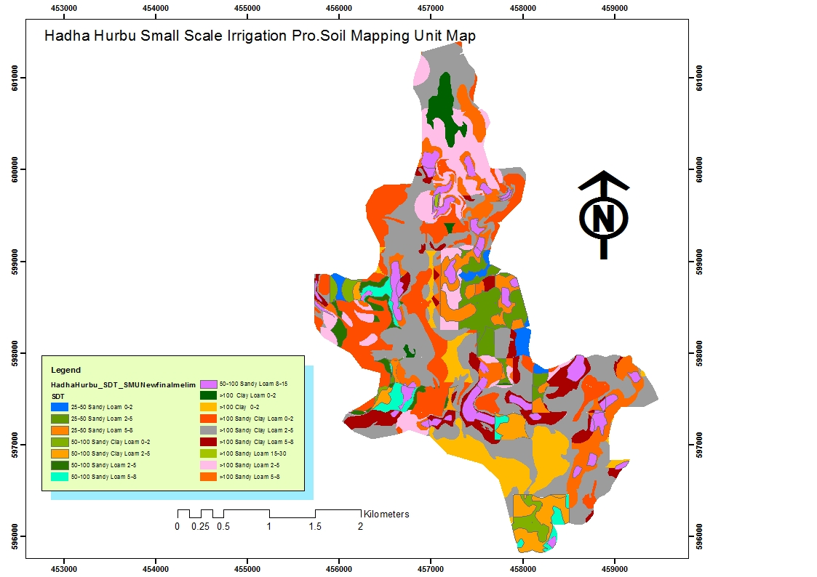
Figure 9 Soil mapping unit (SMU Map)

Table 13: Area or (distribution) percentage of major soil groups.
Major Soil Group(Fao,1988) | Identified soil | Area(ha) | Ha (%)
Fluvisol(river side) | Mollic,eutric | 111.25 | 12.87
Luvisol | Eutric and chromic | 178.95 | 20.70
Cambisol | Leptic,Mollic, eutric, fluvic, Cambisol | 415.58 | 48.08
Lexisol | Rhodic Lexisol eutric | 131.74 | 15.24
Leptosol | Eskeletic Eutric | 26.65 | 3.08
 |  | 864.19

7.2. Soil Mapping units Description:
1CL (Lv, eu) -a(SMU1)
This mapping unit refers to soils developed on 0-2% slope with very deep profile (>150cm). The soils are moderately well drained with moderate, medium sub angular blocky structure and have Clay L oam (CL) texture. This unit cover 16.44 ha 2.0% of the the total area.
The average infiltration rate (IR) of this unit is categorized as optimum (1 to 3.0cm/hr) and hydraulic conductivity (HC) ranges from 1.18 to 2.17 m/day.
The pH value is 5.4 in the top soil and 5.2 in the sub soil indicating that the soil is Strongly acid The over all organic carbone content of this soil unit is 1.5% in the top soil and 0.45% in sub soil, which indicates Low to Very Low level of organic matter content. Total nitrogen content ranges 0.13% in the top and 0.1 % in sub soil which shows high level status of the total nitrogen. This soil mapping unit has low available phosphores (0.65ppm in the top soil &1.02ppm in the sub soil), high CEC level (25.7&16.6Meq/100g of soil in top and sub soil respectively) and very high base saturation percentage (65% in the top soil and 67% in the sub soil. The soils in this mapping unit have high Ca2+ and are none calcareous. The soil unit is eutric Luvisol.The total extent of this mapping unit is 16.44ha or 2%.

1C (Lv, eu)-a(SMU2)
This mapping unit refers to soils developed on 0-2% slope with very deep profile (>150cm). The soils are moderately well drained with moderate, medium sub angular blocky structure and have Clay (C) texture.
The average infiltration rate (IR) of this unit is categorized as optimum (2.0 to 2.4cm/hr) and hydraulic conductivity (HC) ranges from 1.2 to 2.1m/day.
The pH value is 5.4 in the top and 5.8 in the sub soil indicating that the soil is strongly acid The overall organic carbon content of this soil unit is 2.41 % in the top soil and 0.65% in sub soil, which indicates low(topsoil) to very low(sub soil) level of organic matter content. Total nitrogen content ranges 0.22% in the top and 0.06% in sub soil which shows High level of the total nitrogen. This soil mapping unit has low lable available phosphorus (2.70ppm in the top soil &2.18ppm in the sub soil), CEC high level (30.4&27.18 Meq/100g of soil in top and sub soil respectively) and high base saturation percentage (71 in topand 80sub soil. The soil in this mapping unit have High Ca2+ and none calcareuse.The soil unit is eutric Luvisol The total extent of this mapping unit is 54.08 ha or 6.25%.Coverage.
1SC (Lv, eu)-a(SMU3)
This mapping unit refers to soils developed on 0-2 % slope with very deep profile (>150cm). The soils are Moderatly wel drain with moderate, medium sub angular blocky structure and have Sandy Clay Loam (SCL) texture.
The average infiltration rate (IR) of this unit is categorized as optimum (3.6cm/hr) and hydraulic conductivity (HC) ranges from 1.6 to 2.1m/day.
The pH value is 5.4 in the top soil and 5.8 in the sub soil, which indicating that the soil is Strongly acid. The over all organic carbone content of this soil unit is 2.36% in the top soil and 0.26% in sub soil, which indicates very Low level of organic matter content. Total nitrogen content ranges 0.22% in the top and 0.09 % in sub soil which shows highto medium level status of the total nitrogen. This soil mapping unit has very low available phosphorus (4.0ppm in the top soil &3.98ppm in the sub soil), medium CEC level (20.7&10.66Meq/100g of soil in top and sub soil respectively) and high base saturation percentage (57% in the topand 59 subsoil. The soils in this mapping unit have High Ca2+ and are none calcareous.The soil units is Fluvisol The total extent of this mapping unit is 156.02 ha or 18.05%.

1SCL (-a(SMU4)
This mapping unit refers to soils developed on 2-5 % slope with very deep profile (>150cm). The soils are well drained with fine & medium sub angular blocky structure and have Sandy Loam (SL) texture.
The average infiltration rate (IR) of this unit is categorized as optimum (2.5to 3.5cm/hr) and hydraulic conductivity (HC) ranges from 1.14 to 2.17 m/day.
The pH value is 5.2in the top and 4.9 in the sub soil, which indicating that the soil is strongly acid. The overall organic carbone content of this soil unit is 0.53% in the top soil and 0.33% in sub soil, which indicates very low level of organic matter content. Total nitrogen content ranges 0.04% in the top and 0.03 % in sub soil which shows medium level status of the total nitrogen. This soil mapping unit has low available phosphorus (2.02ppm in the top soil & 2.84ppm in the sub soil), medium CEC level (16.1&17.0Meq/100g of soil in top and sub soil respectively) and high base saturation percentage (65 inthe topand77 subsoil. The soils in this mapping unit have high Ca2+ and are none calcareous. The soil units is Lixisol.The total extent of this mapping unit is 80.83. ha or 9.35 %.
2SCL(Cm)-a(SMU5)
This mapping unit refers to soils developed on 2-5% slope with very deep profile (>150cm). The soils are imperfectely to moderately well drained with strong & medium sub angular blocky structure and have Sandy Clay Loam (SCL) texture.
The average infiltration rate (IR) of this unit is categorized as optimum (2.2to 3.5cm/hr) and hydraulic conductivity (HC) ranges from 1.36 to 2.5 m/day.
The pH value is 5.6 in the top soil and 4.1in the sub soil, which indicating that the soil is Strongly acid. The overall organic carbon content of this soil unit is 1.74% in the top soil and 0.50 % in sub soil, which indicates very low to low level of organic matter content. Total nitrogen content ranges 0.14% in the top and.0.06% in sub soil which shows high level status of the total nitrogen. This soil mapping unit have high available phosphorus in the top and medium in the sub soil (15.18 ppm in the top soil & 7.02 ppm in the sub soil), Medium CEC level 15.7 & 13.8 Meq/100g of soil in top and sub soil respectively) and high base saturation percentage (47%and 45% both in the top and subsoil. The total extent of this mapping unit is 188.31 and 21.79%.This soil mapping unit is Cambisol.
3SL (Lx, eu)-a(SMU6)
This mapping unit refers to soils developed on 5-8% slope with very deep profile (>150cm). The soils are moderately well drained with moderate & medium sub angular blocky structure and have Sandy loam (SL) texture.
The average infiltration rate (IR) of this unit is categorized as optimum (2.2 to 3.5cm/hr) and hydraulic conductivity (HC) ranges from 1.4 to 2.4 m/day.
The pH value is 4.8 in the top soil and 4.6 in the sub soil, which indicating that the soil is Very Strongly acid. The overall organic carbon content of this soil unit is 0.8% in the top soil and 0.49 % in sub soil, which indicates very high to high level of organic matter content. Total nitrogen content ranges 0.08% in the top and 0.04 % in sub soil which shows high level status of the total nitrogen. This soil mapping unit have low available phosphorus (1.02 ppm in the top soil & 0.12 ppm in the sub soil), medium CEC level (11 & 15 Meq/100g of soil in top and sub soil respectively) and high base saturation percentage (81% in the top and 75%subsoil. The soils in this mapping unit have high Ca2+ and are None calcareous. The soil units is eutric Lixisol. The total extent of this mapping unit is 36.06 ha or 4.01%.
3SCL (Cm,eu)-a(SMU7)
This mapping unit refers to soils developed on 2-5% slope with very deep profile (>150cm). The soils are well drained with stronge& medium sub angular blocky structure and have Sandy Clay Loam (SCL) texture.
The average infiltration rate (IR) of this unit is categorized as optimum (2.1 to 3.4cm/hr) and hydraulic conductivity (HC) ranges from 1.26 to 2.4 m/day.
The pH value is 5.6 in the top soil and 4.9 in the sub soil, which indicating that the soil is Strongly acidic. The overall organic carbon content of this soil unit is 1.74% in the top soil and 0.5% in sub soil, which indicates very Low level of organic matter content. Total nitrogen content ranges 0.14% in the top and 0.07 % in sub soil which shows high level status of the total nitrogen. This soil mapping unit have High level of available phosphorus in the top soil (15.18 ppm in the top soil &6.5ppm in the sub soil), mediumCEC level 14.01&24.1 Meq/100g of soil in top and in sub soil respectively) and Medium Level base saturation percentage (47% in the top and 42% subsoil. The soils in this mapping unit have high Ca2+ and are none calcareous. The soil units are Cambisol.The total extent of this mapping unit is 41.62 ha or 4.81 %.
1SCL (Cm, eu)-a(SMU8)
This mapping unit refers to soils developed on 0-2 % slope with very deep profile 50-100 cm). The soils are moderately well drained with medium subangular blocky structure and have Snndy Clay Loam (SCL) texture.
The average infiltration rate (IR) of this unit is categorized as optimum (2.2 to 4.6cm/hr) and hydraulic conductivity (HC) ranges from 1.26 to 2..4 m/day.
The pH value is 4.6 in the top soil and 6.2 in the sub soil, which indicating that the soil is Slightly acid. The over all organic carbone content of This soil unit is 4.05% in the top soil and 20.7 % in sub soil, which indicates very high to high level of organic matter content. Total nitrogen content ranges 0.46% in the top and 0.1 % in sub soil which shows high level status of the total nitrogen. This soil mapping unit have high to medium level of available phosphorus (24.4 ppm in the top soil & 1.2 ppm in the sub soil), very high CEC level (31.3 &21.8 Meq/100g of soil in top and sub soil respectively) and high base saturation percentage (83% in the top and 72% subsoil. The soils in this mapping unit have high Ca2+ and are none calcareous.The soil units is Cambisol.The total extent of this mapping unit is 15.96.ha or 1.84%.
2SCL (Cm, eu)-a(SMU9)
This mapping unit refers to soils developed on 2-5 % slope with moderatly deep profile (50-100 cm). The soils are well drained with moderate & medium sub angular blocky structure and have Sandy Clay Loam (SCL) texture.
The average infiltration rate (IR) of this unit is categorized as optimum (2.4 to 3.5cm/hr) and hydraulic conductivity (HC) ranges from 0.84 to 2.5 m/day.
The pH value is 5.4 in the top soil and 5.8 in the sub soil, which indicating that the soil is Strongly acid. The overall organic carbon content of this soil unit is 0.66% in the top soil and 0.65 % in sub soil, which indicates very low to high level of organic matter content. Total nitrogen content ranges 0.05% in the top and 0.03 % in sub soil which shows medium level status of the total nitrogen. This soil mapping unit have low level of available phosphorus (0.38 ppm in the top soil & 0.24 ppm in the sub soil), midum CEC level (11.2 & 15.3Meq/100g of soil in top and sub soil respectively) and high base saturation percentage (45% in the top and 46% subsoil. The soils in this mapping unit have high Ca2+(18) and are None calcareous.The soil units is Cambisol.The total extent of this mapping unit is 31.27ha or 3.61%.

2SL (Cm, eu)-a(SMU10)
This mapping unit refers to soils developed on 2-5 % slope with moderatly deep profile (50-100 cm). The soils are well drained with moderate & medium sub angular blocky structure and have Sandy Loam (SL) texture.
The average infiltration rate (IR) of this unit is categorized as optimum (2.4 to 3.5cm/hr) and hydraulic conductivity (HC) ranges from 0.84 to 2.5 m/day.
The pH value is 5.4 in the top soil and 5.8 in the sub soil, which indicating that the soil is Strongly acid. The overall organic carbon content of this soil unit is 0.66% in the top soil and 0.65 % in sub soil, which indicates very low to high level of organic matter content. Total nitrogen content ranges 0.05% in the top and 0.03 % in sub soil which shows medium level status of the total nitrogen. This soil mapping unit have low level of available phosphorus (0.38 ppm in the top soil & 0.24 ppm in the sub soil), very high CEC level (11.2 & 16.9Meq/100g of soil in top and sub soil respectively) and Medium base saturation percentage (45% in the top and 46% subsoil. The soils in this mapping unit have high Ca2+(18) and are Nonecalcareous.The soil units is Cambisol.The total extent of this mapping unit is 14.71ha or 1.70%.

3SL (Cm, eu)-a(SMU11)
This mapping unit refers to soils developed on 5-8 % slope with moderatly deep profile (50-100 cm). The soils are well drained with moderate & medium sub angular blocky structure and have Sandy Loam (SL) texture.
The average infiltration rate (IR) of this unit is categorized as optimum (2.4 to 3.5cm/hr) and hydraulic conductivity (HC) ranges from 0.84 to 2.5 m/day.
The pH value is 5.4 in the top soil and 5.6 in the sub soil, which indicating that the soil is Strongly acid. The overall organic carbon content of this soil unit is 0.66% in the top soil and 0.65 % in sub soil, which indicates very low to high level of organic matter content. Total nitrogen content ranges 0.05% in the top and 0.03 % in sub soil which shows medium level status of the total nitrogen. This soil mapping unit have low level of available phosphorus (0.38 ppm in the top soil & 0.24 ppm in the sub soil), very high CEC level (11.2 & 16.9Meq/100g of soil in top and sub soil respectively) and Medium base saturation percentage (45% in the top and 46% subsoil. The soils in this mapping unit have high Ca2+(18) and are Nonecalcareous.The soil units is Cambisol.The total extent of this mapping unit is 54.17ha or 6.26%.

2SL (Cm, eu)-a(SMU12)
This mapping unit refers to soils developed on 8-15 % slope with moderatly deep profile (50-100 cm). The soils are well drained with moderate & medium sub angular blocky structure and have Sandy Loam (SL) texture.
The average infiltration rate (IR) of this unit is categorized as optimum (2.4 to 3.5cm/hr) and hydraulic conductivity (HC) ranges from 0.84 to 2.5 m/day.
The pH value is 5.4 in the top soil and 5.8 in the sub soil, which indicating that the soil is Strongly acid. The overall organic carbon content of this soil unit is 0.66% in the top soil and 0.65 % in sub soil, which indicates very low to high level of organic matter content. Total nitrogen content ranges 0.05% in the top and 0.03 % in sub soil which shows medium level status of the total nitrogen. This soil mapping unit have low level of available phosphorus (0.38 ppm in the top soil & 0.24 ppm in the sub soil), very high CEC level (11.2 & 16.9Meq/100g of soil in top and sub soil respectively) and Medium base saturation percentage (45% in the top and 46% subsoil. The soils in this mapping unit have high Ca2+(18) and are Nonecalcareous.The soil units is Cambisol.The total extent of this mapping unit is 99.05ha or 11.46%.

1SL (Cm, eu)-a(SMU13)
This mapping unit refers to soils developed on 0-2 % slope with moderatly deep profile (25-50cm). The soils are well drained with moderate & medium sub angular blocky structure and have Sandy Loam (SL) texture.
The average infiltration rate (IR) of this unit is categorized as optimum (2.4 to 3.5cm/hr) and hydraulic conductivity (HC) ranges from 0.84 to 2.5 m/day.
The pH value is 5.5 in the top soil , which indicating that the soil is Strongly acid. The overall organic carbon content of this soil unit is 1.23% in the top soil l, which indicates very low to high level of organic matter content. Total nitrogen content ranges 0.12% in the top soil which shows medium level status of the total nitrogen. This soil mapping unit have low level of available phosphorus (2.84 ppm in the top soil, very high CEC level (11.12 of soil in top soil and High Level base saturation percentage (66% in the top). and are None calcareous.The soil units is Leptic Cambisol.The total extent of this mapping unit is 9.5ha or 1.1%.

2SL (Cm, eu)-a(SMU14)
This mapping unit refers to soils developed on 2-5 % slope with moderatly deep profile (25-50cm). The soils are well drained with moderate & medium sub angular blocky structure and have Sandy Loam (SL) texture.
The average infiltration rate (IR) of this unit is categorized as optimum (2.4 to 3.5cm/hr) and hydraulic conductivity (HC) ranges from 0.84 to 2.5 m/day.
The pH value is 5.5 in the top soil , which indicating that the soil is Strongly acid. The overall organic carbon content of this soil unit is 1.23% in the top soil l, which indicates very low to high level of organic matter content. Total nitrogen content ranges 0.12% in the top soil which shows medium level status of the total nitrogen. This soil mapping unit have low level of available phosphorus (2.84 ppm in the top soil, very high CEC level (11.12 of soil in top soil and High Level base saturation percentage (66% in the top). and are None calcareous.The soil units is Leptic Cambisol.The total extent of this mapping unit 38.8ha or 4.49% of the area

2SL (Cm, eu)-a(SMU15)
This mapping unit refers to soils developed on 5-8 % slope with moderatly deep profile (25-50cm). The soils are well drained with moderate & medium sub angular blocky structure and have Sandy Loam (SL) texture.
The average infiltration rate (IR) of this unit is categorized as optimum (2.4 to 3.5cm/hr) and hydraulic conductivity (HC) ranges from 0.84 to 2.5 m/day.
The pH value is 5.5 in the top soil , which indicating that the soil is Strongly acid. The overall organic carbon content of this soil unit is 1.23% in the top soil l, which indicates very low to high level of organic matter content. Total nitrogen content ranges 0.12% in the top soil which shows medium level status of the total nitrogen. This soil mapping unit have low level of available phosphorus (2.84 ppm in the top soil, very high CEC level (11.12 of soil in top soil and High Level base saturation percentage (66% in the top). and are None calcareous.The soil units is Leptic Cambisol.The total extent of this mapping unit 26.71ha or 3.09% of the area

5SL (Cm, eu)-a(SMU16)
This mapping unit refers to soils developed on >15 % slope with moderatly deep profile (50-100 cm). The soils are well drained with moderate & medium sub angular blocky structure and have Sandy Loam (SL) texture.
The average infiltration rate (IR) of this unit is categorized as optimum (2.4 to 3.5cm/hr) and hydraulic conductivity (HC) ranges from 0.84 to 2.5 m/day.
The pH value is 5.4 in the top soil and 5.8 in the sub soil, which indicating that the soil is Strongly acid. The overall organic carbon content of this soil unit is 0.66% in the top soil and 0.65 % in sub soil, which indicates very low to high level of organic matter content. Total nitrogen content ranges 0.05% in the top and 0.03 % in sub soil which shows medium level status of the total nitrogen. This soil mapping unit have low level of available phosphorus (0.38 ppm in the top soil & 0.24 ppm in the sub soil), very high CEC level (11.2 & 16.9Meq/100g of soil in top and sub soil respectively) and Medium base saturation percentage (45% in the top and 46% subsoil. The soils in this mapping unit have high Ca2+(18) and are Nonecalcareous.The soil units is Cambisol.The total extent of this mapping unit is 0.48 ha or 0.05%.

8.0 CONCLUSIONS AND RECOMMENDATIONS

8.1. Conclusions
The detailed survey of the soils of the study area, Hadha Hurbu irrigation project, has shown that the soils of the study area have good agricultural potential if properly managed and utilized. Most of the physical properties of the soils are very good for most agricultural production crops. Some of the ideal physical properties of the soils are Sandy Clay loam and sandy loam texture, moderate to weak, fine to medium sub angular blocky structures can be mentioned, high Level of Persentage base saturation.The soils also have no adverse chemical properties that can hinder the production of agricultural crops. The soils have problems of Acidity and fertility.
The limitations of the soils investigated are grouped into two as correctable and non-correctable. The correctable limitations are the low level of organic matter of most soils, the low level of plant nutrients such as available phosphorous, total nitrogen etc. One of the non-correctable limitations of the soils is strongly to Moderatly Acidity (Low Ph level) shallow to mderately deep effective depth of the soils and slopes greater than 8%.

8.2.2. Recommendations
Based the investigated potentials and limitations of the soils of the study area those crops that can be suitable should be selected through crop suitability evaluation. The non-correctable limitation for most of the soils is Low Ph level (Strongly acidity problem) for this Problem Recommended Lime Application and organic fertilizer (compost) use the effective depth of the soils varying from very shallow to moderately deep. Therefore, during crop selection for suitability evaluation, those crops which are shallow to medium rooted should be selected.
The low fertility condition of the soils reflected by the low levels of organic matter for most of the soil mapping units, total nitrogen, and available phosphorous should be avoided by modern practices. This can be done through addition of organic matter (compost) and artifial fertilizers (nitrogeneous and phosphate fertilizers) and by carrying out the overall intgrated nutrient management to alleviate the fertility constraints of the soils.
The correctable physical and chemical constraints which will be identified during evaluation of the selected crops should be corrected for optimum production of the crops. The suitability evaluation of those crops which may fit into the existing situation of the soils can minimize the limitations of the soils (proper crop selection).
There is 2-4 termite mund per hectar in the command area traditional or biological and chemical control of termite exspantion needed.
- Liming to improve the soil PH
- Application of organic fertilzer like compost, and/or chemical fertilzer improves the availability of phousphrous and improve the not suitable land for surface irrigation to highly and moderately suitability class.
Some of the soil mapping units can be affected by sheet, rill and gully erosion. This can be controlled through careful planning and implementation and integrated Watershed Development. Technologies such as proper erosion control mechanism, such as afforestation, plantation of cover grasses, contouring and conservation structures can be incorporated specific to site condition

9. LAND EVALUATION

9.1. Introduction
Land evaluation is the process of the assessment of land performance when used for specified purpose (FAO, 1984). Although its precise role varies in different circumstances, it is always an integral part of the process of land use planning. Land evaluation involves the interpretation of basic surveys of climates, soils, vegetation and other aspects of land in terms of the requirements of alternative kinds of land use. These may be major kinds of land use such as irrigation agriculture, rainfed agriculture, livestock production, forestry, etc., or land utilization types described in more detail.
The suitability of the land is assessed, classified and presented for each kind of use. Land evaluation occupies a central and coordinating position within the project. It provides the means by which the basic surveys of natural resources geomorphology, climate, soils and vegetation are assessed with respect to their potential for different kinds of land use, both actual and potential.
Thus the land evaluation has been the process through which the basic surveys of resources have been translated into potential for development. The output from the evaluation provides a major basis for land use planning at the regional and national level.
The study area, Hadha Hurbu Large scale irrigation project, is one of the selected area for the irrigation developements. This project area is one of the most important potential areas for all developmental activities, especially for crop development.
9.2. General objective
The general objective of the study is to assess and delineate potentially suitable from non suitable land units for irrigation indicating constraints for use of the land.

9.3. Specific objectives:
The specific objective of this part of the land evaluations includes;
- To identify area of land suitable for irrigation agriculture development that is simultaneously confirmed to be technically feasible, economically viable, and socially acceptable
- Identification of the study area resource potentials and constraints for irrigated agriculture.
- Classification of land into suitability classes and subclasses according to limitations;
Suggesting alternative suitable uses.

9.4. Scope of work:
- Prepare land unit maps
- Compare the major land quality of the study area with land use environmental requirement of LUTs considered.
- Land suitability assessment of the study area for irrigation agriculture development based on LUTs considered.
- Prepare land suitability map at 1:10,000 scales for the LUTs considered

9.5. Procedures Followed
First, identification of land utilization types (LUTs): surface irrigation Based on these land utilization types, full data on land mapping units in terms of their land characteristics and land qualities (FAO, 1976, 1983; Dent & Young, 1981) were collected. This phase is concerned with surveys to collect data on land resources. The collected information on land resources is used to demarcate land mapping units. These land mapping units, whose land characteristics and qualities are described and are known, form the area of land units in the suitability evaluation (FAO, 1983, 1984, 1985).
In the second step the land use requirements for each land utilization type were defined (FAO, 1983; 1984; 1985). The land use requirements of each land utilization type were defined in terms of all forms of their requirements.
In the third step, matching of land qualities and/or land characteristics, with the requirements of land utilization types (FAO, 1983; 1984; 1985) were made. In determining the suitability classes the maximum limitation method was employed to combine individual ratings. The maximum limitation method is based on the law of the minimum, which considers the least favourable land characteristics and/or qualities limit the land use. This implies that any other amendments of the land would not improve its quality unless the most severe limiting factor is eliminated or at least reduced. Then, it distinguishes land suitability classes on the basis of the most severe limiting land characteristic (FAO, 1983).
In the fourth stage combining individual class determining factor ratings to obtain a tentative land suitability classification for each LUT on each land unit through the maximum limitation method was executed.
Finally, mapping of provisionally irrigable and non irrigable area were made as the final outcome.
Table 14:FAO Land Suitability Classification Levels (FAO, 1983, After Ir.C.Sys 1991 & H.Huizing, ITC 1992)
Class | Designation | Definition
S1 | Highly suitable | Land having no significant limitations to sustained application of a given use, or only minor limitations that will not significantly reduce productivity or benefits and will not raise inputs above an acceptable level. The potential yield level expected is 85% or more of optimum yield.
S2 | Moderately suitable | Land having limitations which in aggregate are moderately severe for sustained application of a given use. The limitations will reduce productivity or benefits and increase required inputs to the extent that the overall advantage to be gained from the use, although still attractive, will be appreciably inferior to that expected on Class S1 land. The potential yield level expected is 60-85% of the optimum yield.
S3 | Marginally suitable | Land having limitations which, in aggregate, are severe for sustained application of a given use and will so reduce productivity or benefits, or increase required inputs, that this expenditure will be only marginally justified. The potential yield level expected is 40-60% of the unsuitable optimum yield.
N1(S4) | Currently not suitable | Land otherwise suitable (S1 to S3) for sustained application of a given use but having a limitation(s) which, although possibly surmountable in time, cannot be corrected with existing knowledge at currently acceptable cost. The limitation(s) is so severe as to preclude successful sustained use of the land in the given manner at present.
N2 | Permanently not suitable | Land having limitations that appear so severe as to preclude any possibilities of successful sustained use of the land in the given manner.

9.6. Land Use Requirement for Surface Irrigation
Surface irrigation is the most common method of irrigation and accounts for 95% of irrigation in the world. Soils with high infiltration rate are commonly not suitable to surface irrigation, because even distribution of irrigation water is difficult to maintain without short furrows. As a result the loamy soils may be considered as marginally suitable, despite the potential optimum nutrient and moisture holding capacity. High bulk density hinders root penetration in fine textured soils, if compacted.
In general soils of the area are occurring on very gentle slope and the soils are clay to Sandy loam in texture and prone to water logging (for clay soil). Thus the land is Moderately to marginally suitable for surface irrigation. See Table 18 below

Table 15: Land use requirement and critical class limits for surface irrigation
S/N | Limiting factors | Suitability Classes
 |  | S1 | S2 | S3 | S4 | N
1 | Slopes (%) | 0 - 2 | 2-5 | 5-8 | 8-15 | >15
2 | Drainage | W | MW | I | P&E | VP
3 | Depth ( cm ) | >120 | 60-120 | 30-60 | 30-60 | <30
4 | Soil texture | SL-CL | CL-C | LS & HC | S | VCS
5 | Structure | SAB | AB | Platy | Massive | -
6 | Salinity (ds/m) | <4 | 4-8 | 8-12 | 12-16 | >16
7 | ESP (%) | <10 | 10-15 | 15-20 | >20 | >20
8 | CEC (meq/100g) | >20 | 5-20 | 1-5 | <1 | <1
9 | OM (%) | 3-5 | 2.5-3 | 2-2.5 | 1-2 | -
10 | Total N (%) | >0.5 | 0.2-0.5 | 0.1-0.2 | - | <0.1
11 | Av.P (ppm) | >15 | 10-15 | 8-10 | 2-8 | <2
12 | C/N | 10-12 | 6-10 | <6 | <6 | -
13 | pH | 5.5-7 | 5-5.5 & 7-8 | 4.5-5 & 8-8.5 | 8.5-9 | <4.5 &>9
14 | Fertility index | High | Moderate | Low | Very low | -
15 | IR (Cm/hr) | 0.5-3.5 | 0.1-0.5 | 6.5-10.0 | 10-25 | <0.1, >25
16 |  | - | 3.5-6.5 | - | - | -
17 | HC (m/day) | >1.5 | 1.5-0.5 | 0.5-0.2 | <0.2 | -
18 | AWC (mm/m) | >150 | 100-150 | 75-100 | 50-75 | <50

9.7. Land Utilization Types (LUTs)
The main objective of this land evaluation study is to select optimum land use type for each land units(SMU) identified in the study area. Land evaluation defines the suitability of a specific area of land (land unit) for specific LUT under stated system of management and input level.
The major kind of land use considered for the evaluation is irrigated agricultural development in the command area, using surface irrigation systems. A number of land utilization types (LUTs) were identified and defined in terms of their produce.
The present land evaluation thus has been providing a systematic overview of the physical limitations of these land uses. This intern provides a useful indication on opportunity and type of improvements required to improve the systems. The purpose of the present land evaluation is to assess in qualitative terms, the biophysical suitability of the land for the land utilization types. The results of the physical analysis will be used in the subsequent planning phase to identify constraints, opportunities and assess the economic viability of changes in management and input levels.
The major kind of land use considered for the land cultivation is irrigated agriculture development in the study area particularly in the command area using surface irrigation system. A number of LUTs were identified and defined interims of their response to irrigation, socio-economic situation, marketavailability, expected advantage of the government for national and regional agricultural development.Furthermore, in defining and describing the LUTs for irrigated crop production the main management level selected is intermediate management levels were considered:
An intermediate level of management involves the use of improved hand tools and/or draught animals. If accessible, it employs some fertilizer and pesticide applications and simple conservation methods to reduce productivity losses from land degradation. It includes cultivation of a combination of presently grown and improved cultivars of crops on permanently arable rainfed lands and use of supplementary irrigation in the form of spate/ runoff flood farming.
The following potential LUTs have been considered in the command area under the prepared project area:
- Irrigated Low land sorghum cultivation
- Irrigated Low land maize cultivation
- Irrigated vegetable cultivation (Cabbage, Tomato, Pepper, Onion)
- Irrigated Haricot bean cultivation
The evaluation has been carried out assuming moderately inputs management levels, moderate capital investment and high labor intensity. Thus, the LUTs can be defined, as medium input level of fertilizer and herbicide, moderate capital investment, medium to high labor intensity, 100% private property, with moderate management level by using surface irrigation and improved agronomic cultural practices, for local consumption and market orientation.
Table 16: Description of management levels
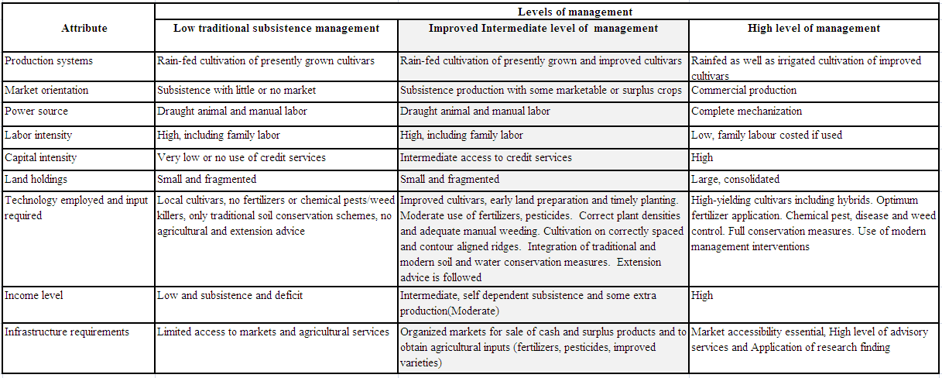
Source: Modified after UNEP and FAO (1999)

Table 17 : Low land Maize (Zea Mays)- Crop Environmental Requirements
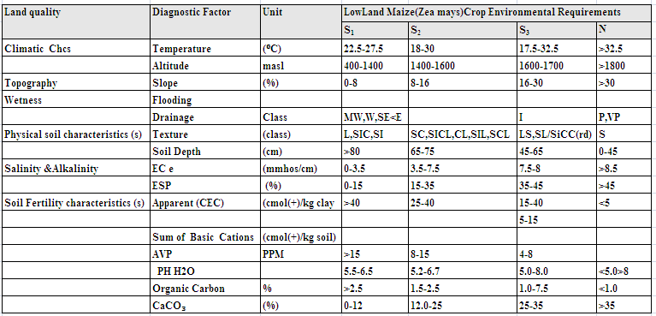

Table 18: Onion (Allium Cepa)-Crop Environmental Requirements
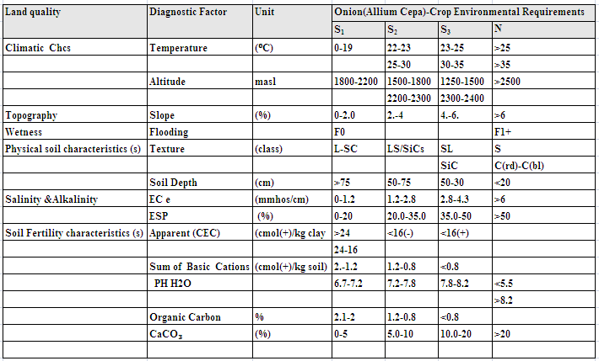

Table 19: Tomato (Lycopersicum esculentum)-Crop Environmental Requirements
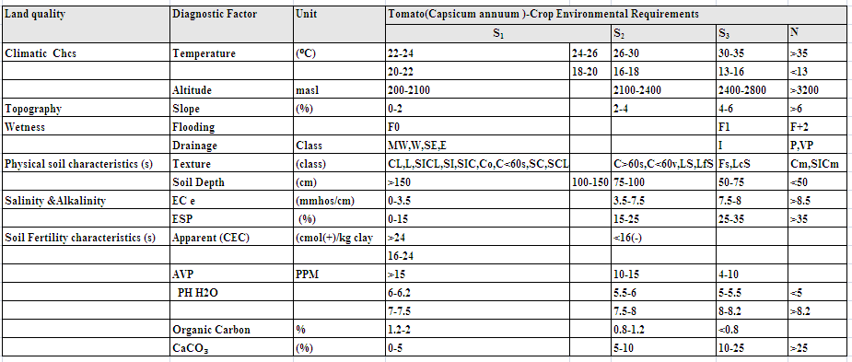

Table 20:Chilie Pepper (L)-Crop Environmental Requirements
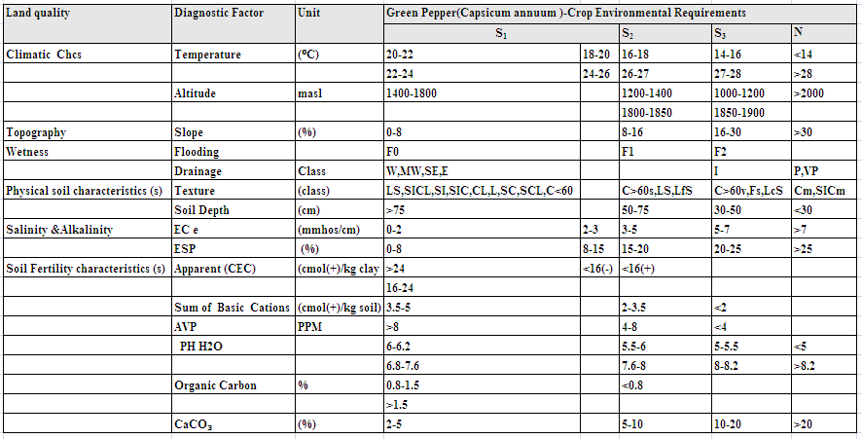

Table 21 : Haricot Bean ( Spp)-Crop Environmental Requirements
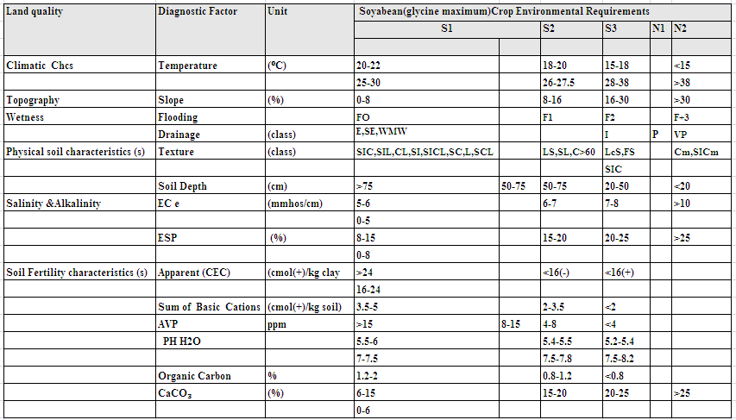

Table 22 Cabbage (Brassica oleracea) - Crop Environmental Requirements
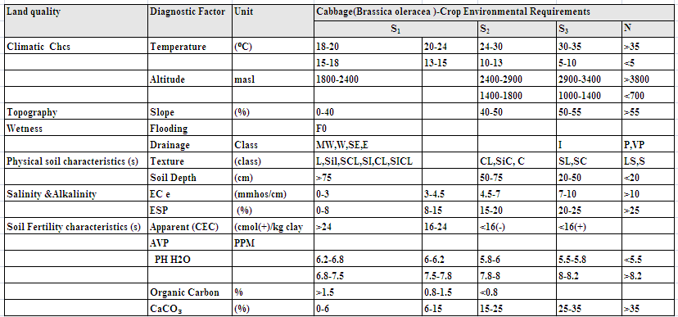

9.8. Land Characteristics (LCs) andLand Qualities (LQs)
These are measurable properties of the physical and socioeconomic and environmental conditions directly related to land use. Land characteristics are made available through soil and land use surveys, socioeconomic and farming system surveys and environmental assessment. Some of the land characteristics and qualities are climate, topography, soil physical and chemical properties, soil fertility, salinity and alkalinity, etc.
Land quality is an attribute of land which acts in a distinct manner in its influence on the suitability of the land for specific kind of land use. Examples of land qualities that are widely applicable to Rainfed cropping are temperature regime, moisture availability, drainage, and nutrient supply, rooting condition, potential for mechanization and erosion hazard (FAO, 1983). See more table : 27 below
Land qualities and land characteristics selected for influencing irrigated agriculture are listed below. The field survey data comprising each land qualities and land characteristics of the study area are however displayed in detail on Table 29. These survey data were used for matching of land qualities and land characteristic with land use requirements.

9.8.1. Temperature regime
There are three main effects of temperature on plant growth
- Growth ceases below critical temperature, varying with the plant, but typically6.5⁰C
- The rate of growth varies with temperature
- Very high temperature have adverse effect
Crops are divided into five adaptability groups on the basis of their photosynthetic carbon assimilation and response of photosynthesis to radiation and temperature. Between the minimum temperature for growth and the optimum temperature for photosynthesis, the rate of growth rises more or less linearly with temperature; growth rate then reaches a plateau within the optimum temperature range before falling off at higher temperature. This relationship interacts with radiation; that is the highest potential for growth is achieved with temperature in the optimal range and high amounts of radiation.
Adverse effects of high temperatures only occur for most crops above 30⁰C. In temperate and subtropical latitude, soil temperature can be substantially affected by slope aspects: this in turn affects rate of growth.

9.8.2. Topography
Topography is often a major factor in irrigation evaluation as it influences the choice of irrigation method, drainage, erosion, irrigation efficiency, costs of land development, etc. Of all the most important parameter of topography that has special bearing on irrigation suitability is slope.
Slope may affect the following factors: intended methods of irrigation, erosion, mechanization, etc. The acceptable degree of slope depends on factors such as: intended method of irrigation, risk of erosion and planned cropping pattern. Gravity irrigation is rarely suited to slopes exceeding 15 per cent. Sprinkler irrigation of arable crops is acceptable on slopes not exceeding 20 per cent, but tree crops are commonly grown on slopes of 45 per cent and occasionally greater than 45 per cent (FAO, 1979).
Irrigation of extremely gentle slopes (0-0.5 per cent), where the soil is slowly permeable and heavy rain is frequent, may lead to scalding by ponded water and water logging, particularly in a hot climate. However, if infiltration rates are moderately good and large flows of water are available to push the water across the field; such slopes are conducive to high irrigation efficiency. Smooth slopes of 0.1 to 2 per cent are usually regarded as ideal for gravity irrigation under average topographic conditions.

9.8.3. Rooting conditions and workability
Rooting conditions signifies root room and mechanical impedance. Soil temperature, soil aeration, soil nutrients and the chemical environment including salinity, Sodicity, pH and toxicities, mechanical impedance to root penetration and pest and disease all these factors affect root growth and root system development or function. However, because of their separate importance in land evaluation and for convenience some of these factors were assessed under different headings. Example, soil aeration was discussed under LQ oxygen availability. Rooting conditions is assessed by critical limits of effective soil depth and soil strength defined by consistence class, sub soil texture and sub soil structure.
The depth of soil that can be effectively exploited by the plant roots is an important criterion in selecting land for irrigation. A depth of 150 cm is ideal in a well drained friable soil; however, experience has shown that many irrigated annual and perennial crops produce excellent yields with a well drained effective root zone depth of 90 cm. When close attention is given to irrigation and crop management, most crops give well to excellent yields with effective soil depth of only 45 cm, while well managed grass give good response with depths of 30 cm. A soil depth of 90 cm is often chosen as the minimum for class 1 (highest level) production under average management. Lesser depths are commonly assigned a lower rating because of a smaller range of suitable crops (FAO, 1979; 1985).

9.8.4. Nutrient availability and nutrient retention capacity
The land quality nutrient availability and retention capacity is used as a measure of the ability of soils to supply the amounts needed for maximum crop yield under the system of agriculture being practiced. In dry land areas soil fertility is usually the second most limiting production factor after moisture stress. The improvement in the supply of water available to plants under any form of irrigation can lead to depletion of soil nutrients.
Most of the time areas in semi-arid and arid areas were limited by low soil fertility as much as by lack of moisture. Nitrogen and phosphorus are usually the elements most deficient in these area soils. Nitrogen is second only to water in importance as a factor affecting the yield of most irrigated crops. Nitrogen deficiency is especially common on sandy and well-weathered soils in areas of high rainfall and on soils low in organic matter. Total nitrogen content of soils gives some indication of nutrient N availability. Total soil nitrogen is low if it is less than 0.1 per cent and high if it is more than 0.3 per cent. Phosphorus deficiency most commonly occurs on highly weathered tropical soils, calcareous soils and peat and muck soils. Level of available phosphorus in the soil indicates the fertility status of the soil with regard to phosphorus. Nutrient availability and retention capacity is assessed in relation to pH of the soil.

9.8.5. Conservation and water application management
Several land characteristics affect the water application management of the different irrigation methods. Amongst those characteristics, slope gradient, soil texture, and structure are found to be relevant and class-determining factors for water application management. The suitability of these land characteristics is determined by considering their effect or influence on uniformity and/or rate of water application in the field.
- Slope gradient is the dominant topographic factor that influences irrigation suitability in The study area. It affects occurrence of erosion due to faulty irrigation water alignment in surface irrigation. As slope gradient increases, surface water irrigation may induce erosion. Furrow irrigation method requires a slight slope gradient. A slope gradient up to 2 per cent can be levelled for furrow irrigation and is optimal under low input management level. Slopes gradient of 6 per cent are considered as marginal for furrow irrigation. Levelling and grading are considered as ordinary management practices up to 6 per cent slopes In farming areas improved agronomic practices specific to the site condition is recommended, because it is essential for controlling soil productivity, increases its water holing capacity, provide take full advantage of fertilizer, prevent the unbalanced depletion of plant nutrients improving soil condition, cover, soil and water conservation, plant protection, yields and counter acts developments of the toxic substance, if any. (FAO, 1979).

9.8.6. Salinity/Sodicity
Sodic soils, which have a high exchangeable sodium percentage and saline soil which have excess soluble salts, should be avoided for irrigated agriculture. These soils can reduce moisture availability directly, or indirectly, as well as exerting direct harmful influence on plant growth. Sodicity is determined as the exchangeable sodium percentage (ESP). It is a good indicator of the structural stability of a soil and of the physical response that may be anticipated when water is applied. Most soils exhibit unfavourable physical properties at levels of ESP greater than 15 per cent. In general, physical properties become increasingly adverse with increasing levels of exchangeable sodium. In addition to the possible deleterious effects that high ESP levels may have on the physical properties of soil, some crops have a low tolerance for exchangeable sodium.
As a general guidance the ratings s1, s2, s3 and n reflect non-sodic, slightly sodic, moderately sodic and strongly sodic soils with respective values of < 10, 10 - 20, 20 - 35 and > 35 ESP per cent (FAO, 1985; 1996).
Salinity - an excess of soluble salts - is probably the most widespread soil quality adverse to crop growth in arid areas. The primary deleterious effect of excessive salinity is to raise the concentration of the soil solution. In consequence, the flow of water into the plant by osmosis is reduced or reversed and the plant is starved of water even though the soil is moist. Electrical conductivity (EC) measurements are used as indicators of total soluble salts in soil. General interpretation of EC values in soil mapping and land evaluation is as follows:

9.8.8. Water retention capacity
The capacity of a soil to retain water available to plants is important in judging the suitability of a soil for irrigation as this soil property determines the availability of soil water for crop requirements. Soil depth and texture are some of the major soil physical characteristics determining the capacity of a soil to retain available water to plants (FAO, 1979).
Soil texture is evaluated to 1m depth with regard to its capacity to retain water as most crops draw their major water requirements within this depth. Coarse textured soils such as sandy soils typically have high infiltration rates and very low soil moisture storage capacities; medium textured soils show medium storage capacities while those of fine textured soils with low infiltration or permeability rates show high water holding capacity, particularly the expandable type of clay (FAO, 1979).
9.8.9. Mechanization
This assessment concerns conditions of the land that specifically affect mechanized agricultural operations. The conditions which act as limitations to mechanization are slope angle, rock hindrances, stoniness or extreme shallowness of the soil, and the presence of heavy clays.

9.9. Matching of land use requirement with land qualities.
The term matching has both a broader and a more specific meaning. In its broader sense it refers to the process in which land utilization types and land units are progressively and mutually adapted as the evaluation proceeds. The more specific meaning of matching refers to the comparison of the requirements of land utilization types with the qualities of specified land use. It is in this specific sense that the term matching employed in this report.
Matching answers the question “How well the qualities of the land satisfy the requirement of land use?”
A land utilization types have requirements related to the crop or crops produced, the system of management, and conservation. Factor ratings are sets of values which indicate how well each land use requirement is satisfied by particular conditions of the corresponding land quality. In other words it is the suitability of the land quality for the specific land use. Because the land-use requirements are different, factor ratings vary from one crop to another and from one land utilization type to another. Therefore, factor ratings were made in terms of five classes (s1, s2, s3, n1, n2) where s1 stands for highly suitable, s2 for moderately suitable, s3 for marginally suitable n1 currently non-suitable and n2 permanently not-suitable.
The procedure used for suitability assessment here is that assessments were first made for the individual crop, assessments which are necessarily confined to the ecological and technological aspects of the crop; these are then combined with considerations deriving from the farming system itself. In general, the stages used in suitability assessments were:
- First suitability assessments for the individual crops were made.
- Then suitability assessments related to managements were taken in to consideration
- Thirdly, suitability assessments related to erosion and suitability hazards were considered (Intermediate and high management levels were considered)
- Finally, the above steps were combined for the overall suitability classes for each specific land utilization types.

Table 23: Land suitability Limitations (sub-classes)
Sub- class/suffixes | Description
c | Climate (Temperature regime) : Land units having either very low or very high temperatures below or above the critical temperatures, which may cease the plant growth and may have adverse effect on rate of plant growth, depending on the type of plants and varieties to be grown. Thus adaptable crops should be carefully selected for evaluation.
m | Moisture availability: Land units having soil moisture deficiencies, there is a need for an increased amount and frequency of irrigation and/or selection of draught-resistant crop varieties. Overhead irrigation may be more cost effective.
d | Oxygen availability: Land units having soil drainage deficiencies, ascribed to poor soil drainage that may be due to high ground water table, flooding, slow infiltration, slow permeability, slow surface drainage (low physiographic position) or some combination of these. Sub-soiling, diversion ditches and under drainage may be required. Selection of more tolerant crops like rice can be another solution.
n | Nutrient retention: Land units having poor capacity of soil to retain added nutrients as against loses caused by leaching, ascribed to low CEC, and these by organic matter. Thus, additional input is required to conserve organic matter and improve soil structure and require fertilizer application.
z | Nutrient availability:Land having poor capacity to supply crop with nutrients, ascribed to pH, nutrient availability is lower in pH <6.0 and >7.5 by fixation.
r | Rooting condition: Land units with limited effective soil depth (effective depth is a depth to a limiting horizon having high amount of gravels, hard pan or toxic layers) and restrictive root penetration having massive, columnar or coarse sized structure coupled with very firm consistence and high amount of stones or gravels. Land having restrictive effective soil depth and/or penetrability, which impairs germination and hinders mechanical cultivation.
w | Workability: Land units with poor workability, ascribed to massive clays, poor organic matter content, very firm consistence and occurrence of high amount of stones and gravels in the surface layers.
k | Potential for mechanization: Land units having unfavorable slope steepness, rock hindrances, presence of large amount of surface stones and plastic heavy clays, which affects mechanized agricultural operations by any kind of implements.
t | Land preparation and clearance: Land having topographic limitations ascribed to unfavorable slope angel, micro-relief coupled with excess rock out crops and denser vegetation covers, which needs a higher initial land development cost, requiring land leveling (or short channel lengths and drop structures), grading, terracing, clearances of rock hindrances and vegetation clearances.
e | Erosion hazard: Land having an increased water erosion risk under irrigation. Conservation practices and surface drainage control are required.

Table 24: LQ/LC and symbols assigned to evaluate suitability sub-class and unit.
Land quality | Symbol | Diagnostic factors
Temperature regime | t1 | Mean growing season temperature (ºC)
Water availability | m1 | Length of growing season (days)
Water availability | m2 | Growing season rainfall (mm)
 | m3 | IR
 | m4 | HC
 | m5 | AWC
Nutrient availability | n1 | Topsoil organic matter content ( per cent)
Nutrient availability | n2 | Topsoil phosphorus (Olsen, ppm)
Nutrient availability | n3 | soil reaction ( pH)
Nutrient availability | n4 | Top soil Texture (class)
Nutrient availability | n5 | Cation exchange capacity (CEC) (Cmol+/kg of soil
Oxygen availability | d | Land units having soil drainage deficiencies,
Rooting conditions and workability | r1 | Effective soil depth (mm)
Rooting conditions and workability | r2 | Top soil texture (class)
Rooting conditions and workability | r3 | Calcium carbonate (%)
Rooting conditions and workability | r4 | Soil structure
Mechanization Potential | p1 | Slope angle ( per cent)
Mechanization Potential | p2 | stoniness (class)
Erosion hazard | e | Slope steepness ( per cent)
Limitations /Toxicities | i1 | salinity (mmhos/cm)
Limitations /Toxicities | i2 | Alkalinity(ESP)

Table 25: Summarized Land Quality and Characteristics of the SMU
SMU | Horizone | Depth | Texture | Major Soil | Rainfall(mm) | Altitude (m) | Dranage | Flooding | Hydrouli con | Infiltration | Surface.C.F | FC | PWP | AWC | TAWC | RAWC | BD | PH | Ece | EC
1CL-a(SMU1) | T | >150 | CL | Luvisol | 789 | 1230 | MW | N | 1.18 | 3.1 | few fine | 20.5 | 13.6 | 185.51 | 185.51 | 122.38 | 1.63 | 5.4 | 1.35 | 0.15
1C-a(SMU2) | T | >150 | C | Luvisol | 789 | 1235 | MW | A/2 | 0.89 | 3.1 | few fine | 20.5 | 13.6 | 185.51 | 185.51 | 122.38 | 1.63 | 5.4 | 0.75 | 0.12
1C-a(SMU3) | T | >150 | SCL | Fluvisol | 789 | 1225 | MW | N | 2.1 | 3.3 | few fine | 20.5 | 13.6 | 331.64 | 331.64 | 287.38 | 1.63 | 5.4 | 1.23 | 0.16
2SL-a(SMU4) | T | >150 | SL | Fluvisol/Lixi | 789 | 1232 | MW | N | 2.1 | 3.5 | few fine | 20.6 | 15.3 | 210.64 | 210.64 | 139.98 | 1.63 | 5.2 | 0.6 | 0.05
2C-a(SMU5) | T | >150 | SCL | fluvisol | 789 | 1230 | MW | N | 2.1 | 3.2 | Few fine | 23.7 | 15.3 | 156.77 | 156.77 | 104.29 | 1.57 | 5.6 | 0.7 | 0.06
3SL-a(SMU6) | T | >150 | SL | fluvisol | 789 | 1274 | MW | N | 2.3 | 3.2 | few fine & medium | 19.41 | 15.3 | 331.64 | 331.64 | 287.38 | 1.57 | 5.4 | 0.4 | 0.039
3SCL-a(SMU7) | T | >150 | SCL | Luvisol | 789 | 1226 | WW | N | 2.2 | 2.7 | common medium& c | 20.6 | 15.3 | 193.80 | 193.8 | 129.28 | 1.63 | 5.6 | 0.7 | 0.06
1SCL-b(SMU8) | T | 50-100 | SCL | Cambisol | 789 | 1230 | MW | N | 2.3 | 2 | few fine & medium | 20.6 | 15.3 | 193.93 | 193.93 | 129.28 | 1.63 | 5.4 | 0.85 | 0.21
1SCL-b(SMU9) | T | 50-100 | LS | Cambisol | 789 | 1264 | MW | N | 2.5 | 2.4 | few fine | 19.41 | 15.3 | 218.40 | 388.1 | 258.73 | 1.57 | 5.2 | 0.85 | 0.07
2SL-b(SMU10) | T | 50-100 | SL | Cambisol | 789 | 1250 | WW | N | 2.5 | 2.7 | few fine & medium | 19.41 | 15.3 | 193.80 | 193.8 | 129.28 | 1.57 | 6..0 | 085 | 0.10
3SL-b(SMU11) | T | 50-100 | SL | Cambisol | 789 | 1229 | WD | N | 2.5 | 2 | few fine & medium | 19.41 | 15.3 | 193.93 | 193.93 | 129.28 | 1.57 | 5.5 | 0.85 | 0.06
4CL-b(SMU12) | T | 50-100 | SL | Cambisol | 789 | 1220 | WD | N | 2.5 | 2.5 | few fine | 19.41 | 15.3 | 156.77 | 156.77 | 104.29 | 1.57 | 5.8 | 1.23 | 0.11
1SL-c(SMU13) | T | 25-50 | SL | Leptic Cambisol | 789 | 1320 | WD | N | 2.5 | 2.8 | few fine & medium | 19.41 | 15.3 | 193.80 | 193.8 | 129.28 | 1.57 | 5.5 | 1.97 | 0.16
2SL-c(SMU14) | T | 25-50 | SL | Leptic Cambisol | 789 | 1265 | WD | N | 2.5 | 3.5 | few fine & medium &c | 19.41 | 15.3 | 203.64 | 226.26 | 135.76 | 1.57 | 5.5 | 1.97 | 0.14
3SL-c(SMU15) | T | 25-50 | SL | Leptic Cambisol | 789 | 1152 | WD | N | 2.5 | 3.5 | common medium& c | 19.41 | 16.35 | 203.64 | 226.26 | 135.76 | 1.57 | 5.5 | 1.97 | 0.14
4SCL(SMU16) | T | 50-100 | SL | Cambisol | 789 | 1220 | WD | N | 2.5 | 3.5 | common medium& c | 20.6 | 16.35 | 203.64 | 226.26 | 135.76 | 1.57 | 5.5 | 0.85 | 0.06
Na | K | Ca | Mg | EX .Acidity | SUM | CEC | BS | ESP | T.N | C/N | OC | OM | A.V.P | Caco3 | Soil units
0.28 | 0.85 | 10.15 | 4.11 | 0.40 | 15.39 | 21.7 | 71 | 0.375 | 0.23 | 10 | 2.41 | 4.16 | 6.22 | 0 | Lv (Luvisol)
0.24 | 0.61 | 15.42 | 5.44 | 0.54 | 21.70 | 30.4 | 71.0 | 0.16 | 0.35 | 11.00 | 2.41 | 4.16 | 2.74 | 0.00 | Lv (Luvisol)
0.20 | 1.40 | 6.11 | 4.13 | 0.40 | 11.83 | 20.7 | 57.0 | 0.99 | 0.22 | 11.00 | 2.36 | 4.07 | 4.00 | 0 | Fl (Fluvisol)
0.17 | 0.53 | 5.90 | 3.88 | 0.40 | 10.48 | 16.1 | 65.0 | 0.6 | 0.04 | 9.00 | 0.53 | 0.91 | 2.02 | 0 | Lx(Lixisol)
0.17 | 0.78 | 3.69 | 2.75 | 0.40 | 7.39 | 17.7 | 47.0 | 0.42 | 0.14 | 12.00 | 1.74 | 3.00 | 15.18 | 0 | Cm (cambisol)
0.12 | 0.31 | 5.96 | 2.53 | 0.48 | 8.93 | 11 | 81 | 0.32 | 0.08 | 10 | 0.8 | 1.37 | 1.02 | 0 | Lexisol(Cambisol
0.17 | 0.78 | 3.69 | 2.75 | 0.40 | 7.39 | 17.7 | 47.0 | 0.42 | 0.14 | 12.00 | 1.74 | 3.00 | 15.18 | 0 | Cm (cambisol)
0.17 | 0.81 | 1.15 | 1.79 | 0.48 | 3.91 | 4.5 | 87.0 | 0.34 | 0.07 | 9.00 | 0.66 | 1.13 | 2.72 | 0 | Cambisol
0.04 | 0.62 | 18.00 | 3.40 | 0.08 | 22.05 | 28.6 | 77.0 | 0.13 | 0.42 | 9.00 | 3.30 | 5.69 | 0.74 | 0.00 | Cambisol
0.10 | 0.19 | 17.22 | 5.13 | 0.12 | 22.63 | 31.6 | 72.0 | 0.32 | 0.33 | 9.00 | 2.86 | 4.94 | 6.00 | 0 | Cambisol
0.14 | 0.18 | 2.75 | 1.95 | 0.4 | 5.03 | 11.2 | 48 | 0.68 | 0.08 | 14 | 1.09 | 1.89 | 1.14 | 0 | Cambisol
0.13 | 0.26 | 14.37 | 4.58 | 0.12 | 19.34 | 27.2 | 71 | 0.48 | 0.35 | 9 | 0.66 | 5.52 | 1.14 | 0 | Cambisol
0.19 | 0.44 | 4.15 | 2.61 | 0.4 | 7.39 | 11.2 | 66 | 0.48 | 0.12 | 10 | 1.23 | 2.12 | 2.84 | 0 | Cambisol
0.19 | 0.44 | 4.15 | 2.61 | 0.24 | 7.39 | 11.2 | 66 | 0.47 | 0.12 | 10 | 1.23 | 2.12 | 2.84 | 0 | LP
0.19 | 0.44 | 4.15 | 2.61 | 0.24 | 7.39 | 11.2 | 66 | 0.47 | 0.12 | 10 | 1.23 | 2.12 | 2.84 | 0 | LP
0.14 | 0.18 | 2.75 | 1.95 | 0.12 | 5.03 | 11.2 | 48 | 0.48 | 0.08 | 14 | 1.09 | 1.89 | 1.14 | 0.00 | Cambisol

9.10 Results of Land Suitability Evaluation for Surface Irrigation

9.10.1. Existing Suitability for Surface Irrigation
The results of the suitability evaluation of the project area for surface irrigation are shown in Tables 34. The result indicates that a total area amounting to 300.47 ha(S3) is found to be marginally suitable for surface irrigation, 464.21 ha of land is (N1) currently not Suitable suitable for Irrigation development, and some 99.55 (N2) ha of land is Permanently not suitable for surface irrigation development. The areas identified as not suitable for surface irrigation are constrained by slope. The area identified as marginally suitable for surface irrigation is constrained by slope, drainage, Available phosphorous, and texture problem. The marginally suitable areas require careful land management, application of good quality of water and application of organic fertilizer, this improve the suitability level to moderately suitable.
Table 26: Existing Surface Irrigation Suitability by Area
 | S3 | (N1) | N2
 | Marginally Suitable | Currently not Suitable | Not Suitable
 | Area, ha | Area, ha | Area, ha
 | 300.47 | 464.2 | 99.55

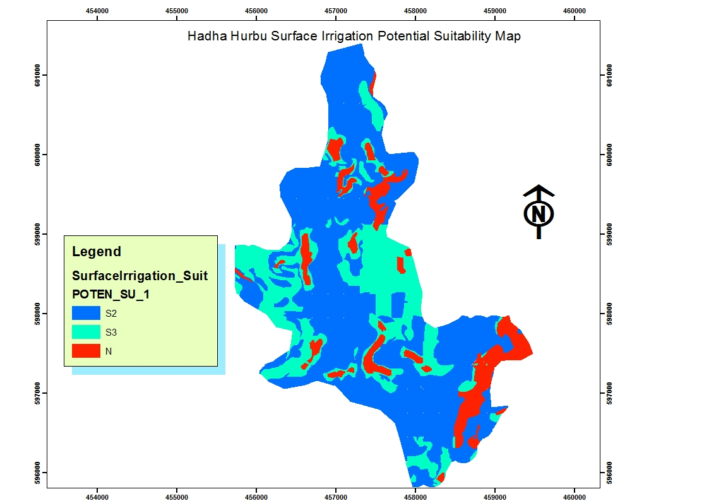
Figure 10 Potential Surface Irrigation Suitability Map

9.10.2. Potential Suitability for Surface Irrigation
The results of the suitability evaluation of the project area for surface irrigation are shown in Tables 33. The result indicates that a total of 541.69 ha of land Moderatly suitable(S2) for surface irrigation. An area amounting to 222.95 ha is found to be (S3) Marginally suitable for surface irrigation development and some 99.53ha of land is (N) Not suitable for surface irrigation development. The areas identified as Moderately and marginally suitable for surface irrigation are constrained by Low Ph (Stronly acid), Slope (>8%,) and depth .The total area not included, Cannal Area and town.
Table 27 : Potential Surface Irrigation Suitability by Area
S2 | S3 | N
Moderatly Suitable | Marginally Suitable | Permanently Not Suitable
Area,ha | Area,ha | Area,ha
541.69 | 222.95 | 99.53

Table 28: Results of Existing and Potential Land Suitability Evaluation for surface Irrigation by SMU
SMU | Area-ha | Existing suit Class | Existing Subclass | Class | Limitation | Potential Class | Potential Sub Class | Not Correctable Limitation
SMU1 | 16.44 | S3 | S3, n | Marginally Suitable | A.v.p, Organic matter | S2 | S2, | Soil Ph
SMU2 | 54 | S3 | S3, n | Marginally Suitable | Avp, OC, Om | S2 | S2, rt, n | Soil, Ph, Texture
SMU3 | 156.02 | N | N, n | Not Suitable | Nutrient availability | S2 | S2 | Soil Ph,
SMU4 | 80.83 | N | N, n | Not Suitable | Nutrient availablity | S2 | S2 | Slope, soil Ph
SMU5 | 188.31 | S3 | S3, n, | Marginally Suitable | Nutrient Availablity | S2 | S2, e, nr | Slope, Soil Ph, Texture
SMU6 | 36.06 | N | N, n | Not Suitable | Nutrient availability | S3 | S3, e | Slope
SMU7 | 41.62 | S3 | S3, n, | Marginal Suitable | Availa-Phosphor | S3 | S3, e | slope
SMU8 | 15.96 | N | N, n | Not Suitable | Nutrient availabilty | S3 | S3, nr | Soil Reaction (Ph)
SMU | Area-ha | Existing suit Class | Existing Subclass | Class | Limitation | Potential Class | Potential Sub Class | Permanenet Limitation
SMU9 | 31.27 | N | N,n | Not Suitable | Nutrient availability | S2 | S2, e | slope
SMU10 | 14.71 | N | N, n | Not Suitable | Nutrient availability | S2 | S2, r, e | Slope, depth
SMU11 | 29.93 | N | N, n | Not Suitable | Nutrient availability |  | S3, e, r | Depth, slope
SMU12 | 304.09 | N | N | Not Suitable | Nutrient availability | N | N, e, r | Slope,
SMU13 | 105.71 | N | N, n | Not Suitable | Nutrient availability | S2 | S3, rd | depth
SMU14 | 9.48 | N | N, n | Not Suitable | Nutrient availability | S3 | S3, rd | Depth
SMU15 | 12.35 | N | N, n | Not Suitable Suitable | Nutrient availability | S3 | S3, rd | Depth
SMU16 | 13.82 | N | N, e | Not suitabile | Slope | N | N, e | slope

9.11. Results of Crop Suitability Evaluation
The crops were selected based on existing condition, climate and requirement of individual crop to the daily diet and the cash value of the crop to generate for the community. The major proposed crops are: Lowland Maize, Sorghum, Pepper, Cabbage, Tomato, Onion, Haricot bean., The results of the crop suitability evaluation are shown in Table 37 and maps.
The suitability evaluation under irrigated condition was considered for the current land and soil condition and for future (potential) suitability after improvement of some correctable soil limitations.

9.11.1. Potential Crop Suitabilty Evaluation.
The result indicated that a total of 228.64 moderatly (S2) ,528.16 ha (S3) marginally for Low Land Maize cultivation by surface irrigation. For Sorghum Some, 446.14 ha Moderatly Suitable(S2) and 302.02 ha Marginally suitable(S3),. Olso for Haricot bean some 375.61ha of land is moderately suitable (S2), 337.01 ha marginally suitable(S3). For Tomato Some 133.53 (S2) moderatly suitable and 577.87 marginaly suitable (S3), For Pepper Some 130.32 ha moderatly suitable(S2) 681.83 ha marginaly Suitable (S3), for Onion Some 209.11 ha moderatly suitable (S2), some 491.81 ha marginaly suitable(S3), for HeadCabbage, some 219.58 ha moderatly suitable, and Some 493.03 marginaly suitable(S3). The major limitations that downgraded the suitability level of the area are Soil Ph (Low PH) Slope, Texture, Depth in the study area.
The result indicated Table : 39 below with tha applicatin of fertilizers and good quality of irrigation water and integrated neutrient management some part of the command area will be improved to moderatly suitable land for intended crop production.

Table 29:Potential Crop Suitability by Area for surface Irrigation
Crops | S2 | S3 | N1 | N2
Crops | Moderatly Suitable | Marginally  Suitable | Currently Not suitable | Not Suitable
Crops | Area,ha | Area,ha | Area,ha | Area,ha
Low Land Maize | 228.64 | 528.16 |  | 107.38
Sorghum | 446.14 | 302.02 |  | 116.03
Haricot bean | 375.61 | 337.05 |  | 151.57
Tomato | 133.53 | 577.87 |  | 152.28
Onion | 209.11 | 491.81 |  | 163.26
Pepper | 130.32 | 681.83 |  | 52.03
Head Cabbage | 219.58 | 493.05- |  | 151.57

Table 30: Potential Crop Suitability by class and Area for surface Irrigation
SMU | Low L/Maize | L/  Sorghum | Haricot Bean | Onion | Tomato | H/  Cabbage | Pepper | Area/Ha
SMU1 | S3 | S2 | S3 | S2 | S2 | S3 | S3 | 16.4489
SMU2 | S3 | S2 | S3 | S3 | S3 | S3 | S3 | 54.089
SMU3 | S2 | S2 | S2 | S3 | S3 | S3 | S3 | 156.023
SMU4 | S3 | S3 | S3 | N | S3 | S3 | S3 | 80.8371
SMU5 | S2 | S2 | S2 | S2 | S3 | S3 | S3 | 188.311
SMU6 | S3 | S3 | S3 | S3 | N | S3 | N | 36.0668
SMU7 | S3 | S3 | S3 | S3 | S3 | S3 | S3 | 41.6253
SMU8 | S3 | S3 | S3 | S3 | S3 | S3 | S3 | 15.9680
SMU9 | S2 | S2 | S2 | S2 | S2 | S2 | S2 | 31.2750
SMU10 | S3 | S3 | S3 | S3 | S3 | S3 | S3 | 14.7107
SMU11 | S3 | S3 | S3 | S3 | S3 | S3 | S3 | 54.1732
SMU12 | N | N | N | N | N | N | N | 99.05183
SMU13 | S3 | S3 | S3 | S3 | S3 | S3 | S3 | 9.5756
SMU14 | S3 | S3 | S3 | S3 | S3 | S3 | S3 | 38.8324
SMU15 | S3 | S3 | S3 | S3 | S3 | S3 | S3 | 26.7178
SMU16 | N | N | N | N | N | N | N | 0.4872

Table 31Potential Crop Suitability by Sub Class
Crops | Potential Crop Suitability by subclass | Sub Class  S2 | Sub Class  S3 | Sub Class  Not correctable
Low Land Maize | Potential Subclass | S2, e, rd, rt | S3, e, rd, rt | Soil Ph, Slope, depth, Texture
 | Area(ha) | 228.64 | 528.16 | 107.38
Sorghum | Potential Subclass | S2,e,rt.rd | S3, e, rt, rd | Soil Ph, Slope, depth, texture
 | Area(ha) | 446.14 | 302.02 | 116.03
Haricot bean | Potential Subclass | S2, e, rt, rd | S3, e, rt, rd | Slope depth texture
 | Area(ha) | 375.61 | 337.01 | 151.57
Tomato | Potential Subclass | S2, e, rt, rd | S3, e, rt, rd | Slope depth, texture
 | Area(ha) | 133.53 | 577.87 | 152
Pepper | Potential Subclass | S2, e, rt, rd | S3, e, rt, rd | Slope depth texture
 | Area(ha) | 130.32 | 681.83 | 52.03
Crops | Potential Crop Suitability by subclass | Sub Class | Sub Class | Sub Class
Onion | Potential Subclass | S2, e, n, rt, rd | S3, e,rt, rd | Slope depth texture
 | Area (ha) | 209.11 | 491.81 | 163.05
Head cabbage | Potential Subclass | S2, e, n, rt, rd | - | Slope, texture, depth
 | Area(ha) | 219.58 | 493.03 | 151.57

Potential Suitability Map
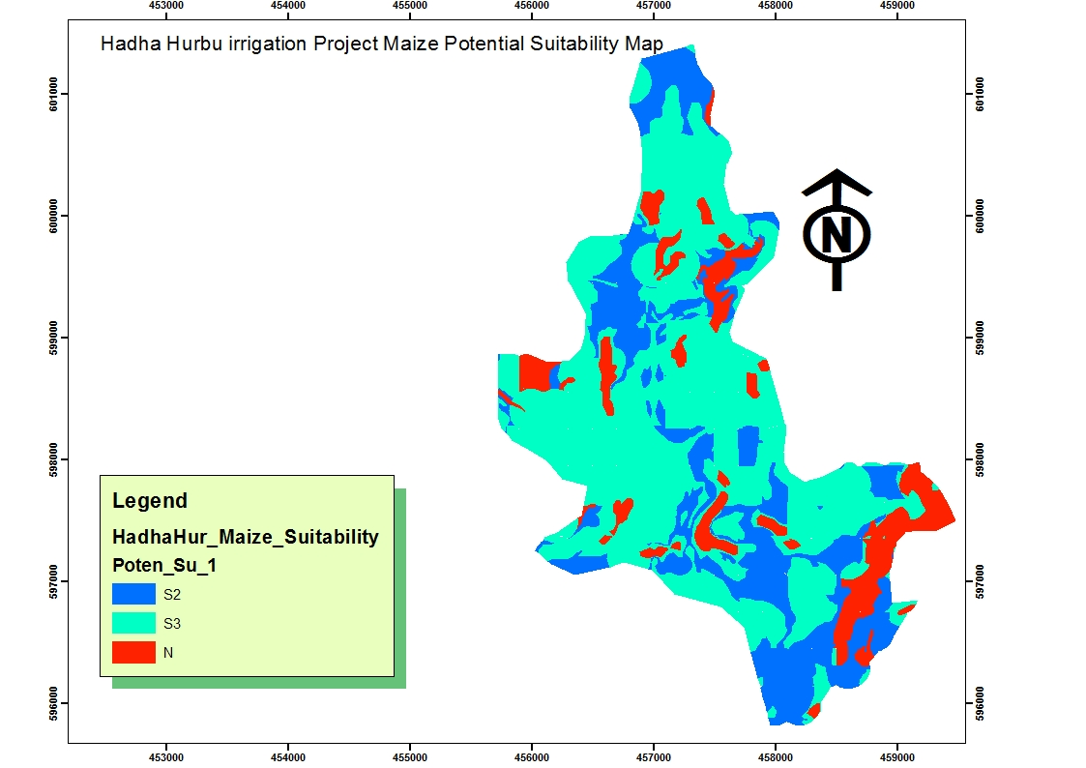
Figure 11 Maize

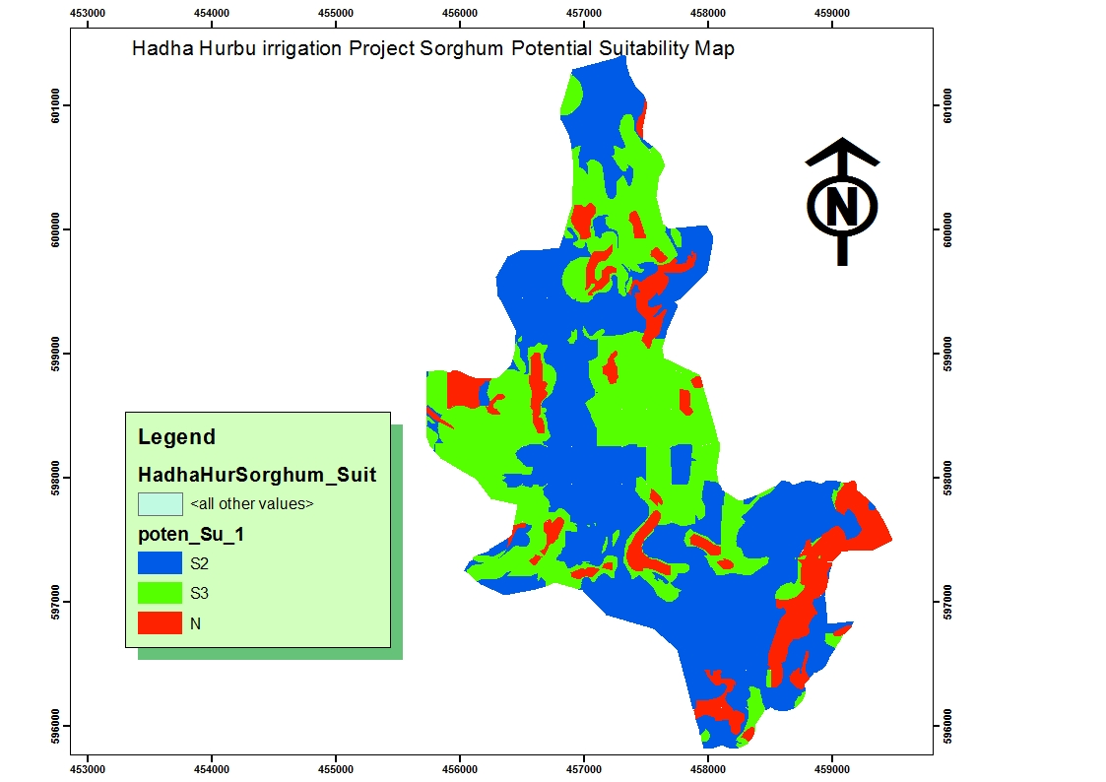
Figure 12 Sorghum Potential Suitability Map

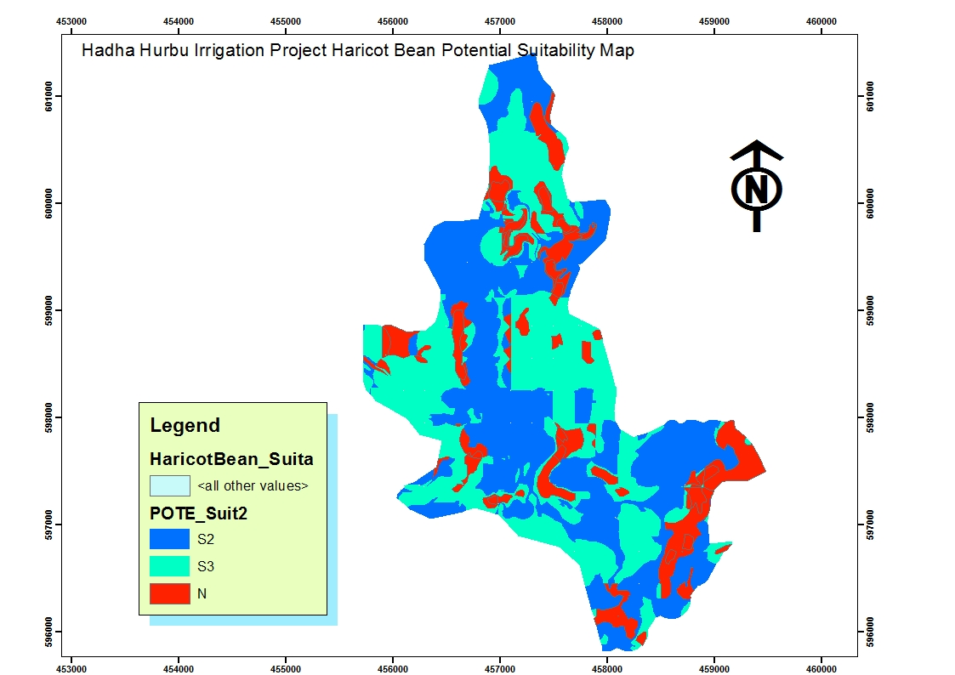
Figure 13 Haricot bean Potential Suitability Map

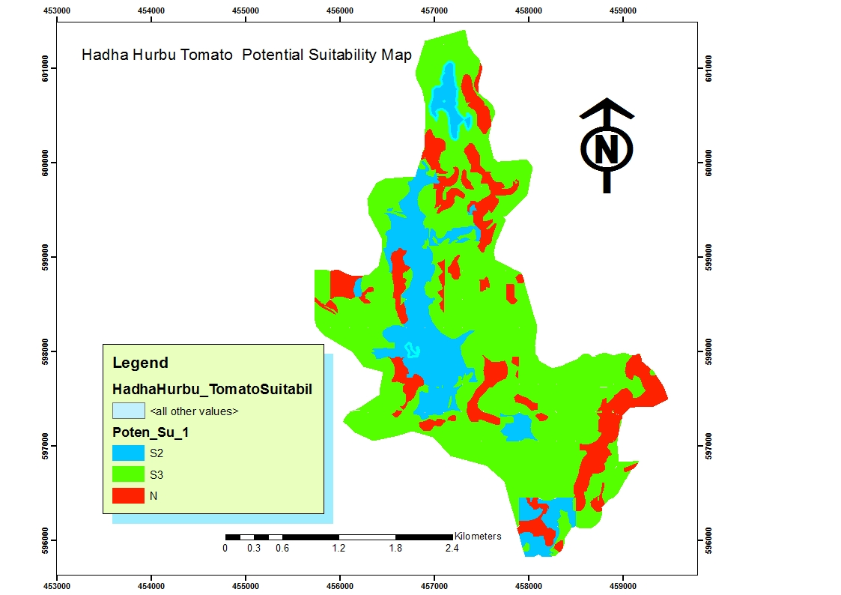
Figure 14 Tomato Potential Suitability Map
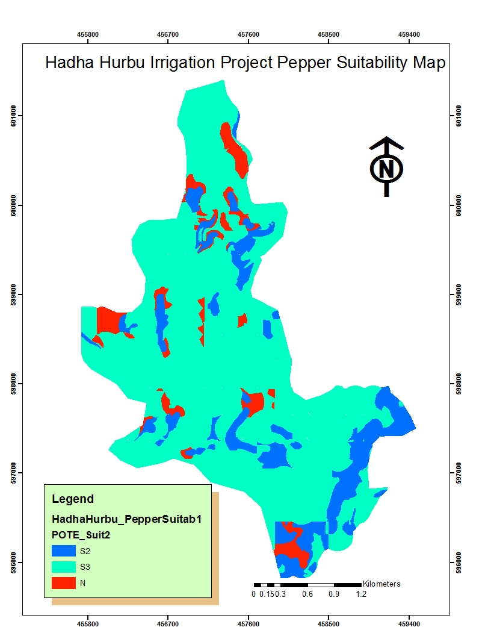
Figure 15: Pepper Potential Suitability Map
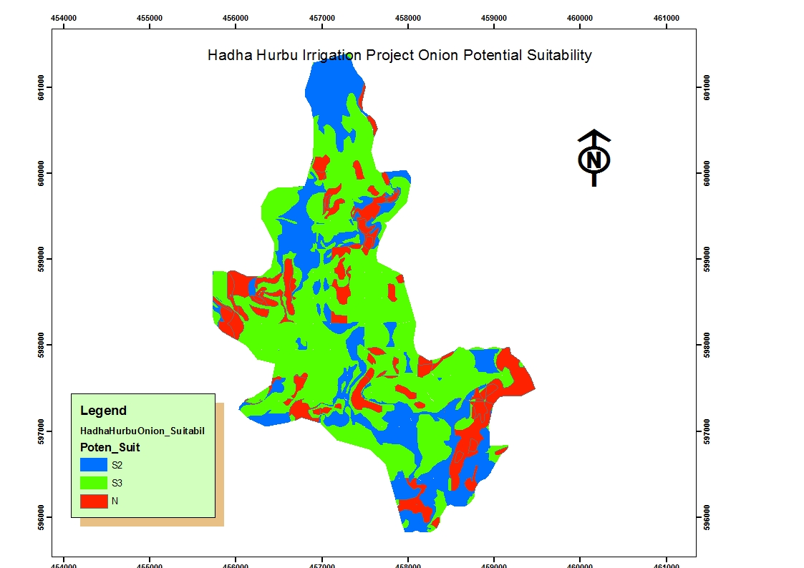
Figure 15 Onion potential suitability map
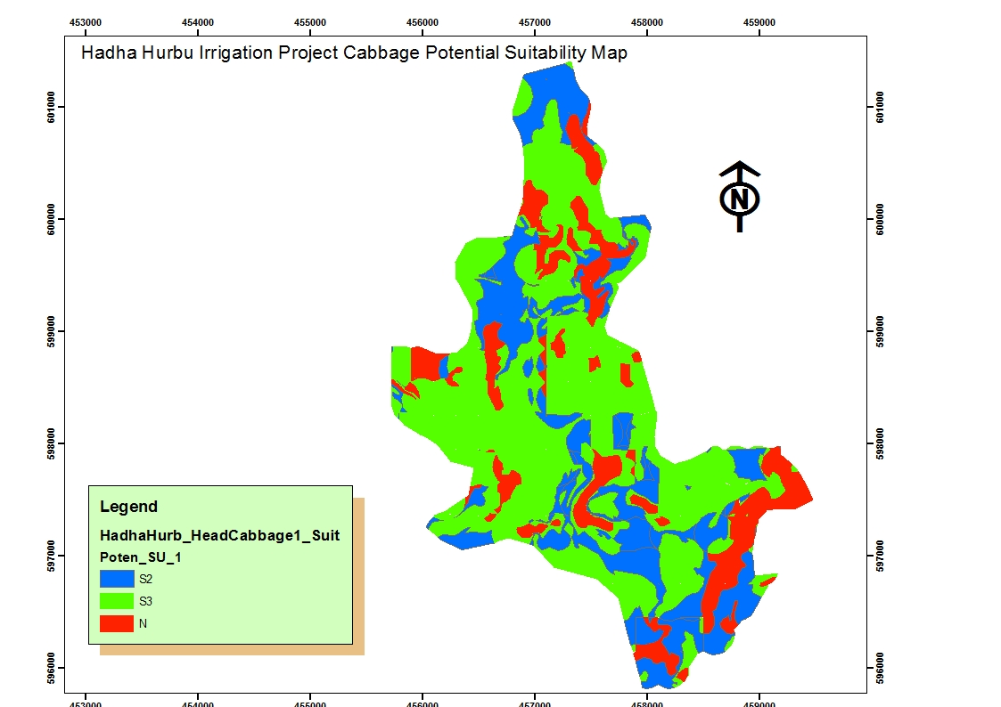
Figure 16 head cabbage potential suitability map

Table 32: The final proposed Crop Potential Suitability by SMU
SMU | Low L/Maize | L/  Sorghum | Haricot Bean | Onion | Tomato | H/  Cabbage | Pepper | Area/Ha
SMU1 | S3 | S2 | S3 | S2 | S2 | S3 | S3 | 16.4489
SMU2 | S3 | S2 | S3 | S3 | S3 | S3 | S3 | 54.089
SMU3 | S2 | S2 | S2 | S3 | S3 | S3 | S3 | 156.023
SMU4 | S3 | S3 | S3 | N | S3 | S3 | S3 | 80.8371
SMU5 | S2 | S2 | S2 | S2 | S3 | S3 | S3 | 188.311
SMU6 | S3 | S3 | S3 | S3 | N | S3 | N | 36.0668
SMU7 | S3 | S3 | S3 | S3 | S3 | S3 | S3 | 41.6253
SMU8 | S3 | S3 | S3 | S3 | S3 | S3 | S3 | 15.9680
SMU9 | S2 | S2 | S2 | S2 | S2 | S2 | S2 | 31.2750
SMU10 | S3 | S3 | S3 | S3 | S3 | S3 | S3 | 14.7107
SMU11 | S3 | S3 | S3 | S3 | S3 | S3 | S3 | 54.1732
SMU12 | N | N | N | N | N | N | N | 99.05183
SMU13 | S3 | S3 | S3 | S3 | S3 | S3 | S3 | 9.5756
SMU14 | S3 | S3 | S3 | S3 | S3 | S3 | S3 | 38.8324
SMU15 | S3 | S3 | S3 | S3 | S3 | S3 | S3 | 26.7178
SMU16 | N | N | N | N | N | N | N | 0.4872

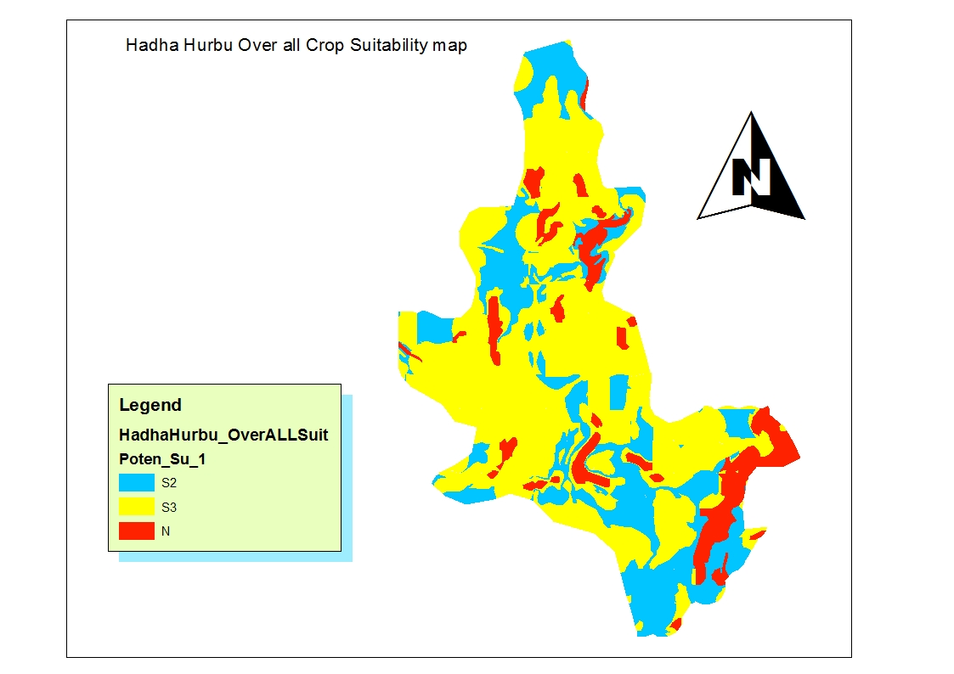
Figure 17 Final Proposed Overall Crop Potential Suitability map

Table 33: Final Proposed Overall Potential suitability map
Crops | S2 | S3 | N
Crops | Moderately Suitable | Marginally  Suitable | Not Suitable
Crops | Area, ha | Area, ha | Area, ha
Low Land Maize | 228.64 | 528.16 | 107.38
Sorghum | 446.14 | 302.02 | 116.03
Haricot bean | 375.61 | 337.05 | 151.57
Tomato | 133.53 | 577.87 | 152.28
Onion | 209.11 | 491.81 | 163.26
Pepper | 130.32 | 681.83 | 52.03
Head Cabbage | 219.58 | 493.05- | 151.57

10. SOIL MANAGEMENT AND RECLAMATION

10.1 Soil Physical Soil factors
. 10.1.1. Surface coarse fragements
Surface coarse fragements is one of the limiting factors observed during the field survey. During soil survey observed from few fine to common fine and medium fragements ,but this fragements cause no limitation for irrigation development in the study area .Surface coarse fragements less than 2 per cent in abundance considered as very low.

10.1.4. Flooding
The flooding problem in the study area is not Significant except in the Hadha Hurbu river buffer zone or river side and Fluvisols with flat or palain land; flooding will not be as such difficult and expensive to control. To prevent the flooding problem and subsequent water movement across the areas Watershed Development Measurements should be applied. The technology should be site specific. Among the measures to be applied construction of structures along the major water courses is required. Ridging, field leveling and furrows will also effectively prevent the wide spread movement of water over the surrounding area.

10.1.5 Erosion
The project area is on plain land dominanatly 0-8% of slope but there is some rill and sheet erosion evidences.soils of the soil mapping units smu11 smu12, smu 16 are affected by sheet and rill erosion ,the rest of the soil mapping units are none to silgtely sheet and splash erosion The main types of erosion in the study area are sheet ,splash and rill erosion
The risk of erosion can be effectively controlled by applying site specific technologies of Integrated Watershed Development practices. Constructing of cut of drains along the perimeter in order to intercept the runoff water from the surrounding to reservoirs (water harvesting), if any for feature use is very important, besides terracing, contour construction and plantation of tress and cover grasses are important measures to be considered.

10.2. Chemical Factores

10.2.1Soil Fertility
The distributions of nutrients in the entire study area are uniform. The exchangeable Ca, K and Mg are midium to high in soils of the soil mapping units Vertisols, Luvisols, Cambisols and Lexisol. Dominantly the available phosphorous content is low. All soils of the soil mapping units are medium to high level of CEC and high level of BSP%.
The PH value for most of the soils in the study area 5.1 up to5.6 with average of 5.3 on the top soil, which is Strongly acid at this PH level there is a possibility of Lime application (Limming) organic fertilizer application for plants up take, low level of organic carbone content description has been observed by the laboratory result .As indicated in Land evaluation result the major limitation for most crop is (acidity problem or low Ph level) Phosphorous availability may reduced, where as.The AVP content for soils of the majority soil mapping units are low it needs application of organic and inorganic(phosphorus fertilizer) fertilizer like compost is to considered. The total Nitrogen contents of the soil mapping unit is uniform across the entire units (medium to high level of T.N). To be more efficient in crop production, site specific soil test based fertilizer recommendations study has to be conducted. . The over all Integrated Nutrient Management (INM) activities should be adopted for the study area for optimum and sustainable crop production .

11. CONCLUSION AND RECOMMENDATIONS

11.1. Conclusion
Surface Irrigatin Suitability : The result indicates that a total of 541.69 of land is found to be (S2) Moderatly suitable for surface irrigation. An area amounting to 222.95ha is found to be (S3) Marginally suitable for surface irrigation development. The areas identified as Moderately and marginally suitable for surface irrigation are constrained by soil reaction (Low Ph), Depth and slope.
Crop Suitability : The result indicated that a total of 228.64 moderatly (S2) ,528.16 ha (S3) marginally for Maize cultivation by surface irrigation. For Sorghum Some, 446.14 ha Moderatly Suitable(S2) and 302.02 ha Marginally suitable(S3),for Haricot bean some 375.61 ha of land is moderately suitable (S2), 337.01 ha marginally suitable(S3) respectively. For Tomato Some 133.53 ha (S2) moderatly suitable and 577.87 ha marginaly suitable (S3}, For Pepper 130.32. ha moderatly suitable(S2) 681.83 ha marginaly Suitable (S3), for Onion,some 209.11 ha moderatly suitable (S2), some 491.81 ha marginaly suitable (S3) , Head Cabbage 219.58 ha moderatly suitable, and 493.03 ha marginaly suitable,
The dominant suitability subclass for all the considered crops is marginally suitable. The major limitations that downgraded the suitability level of the area to marginally subclass are Slope, Soil reaction (Low Ph), in the study area. This indicates that with high level of management practices Application of lime for low ph problems to correct the limitations, the suitability and expected crop yield be increased except uncorrecteble Limitations (slope). Special attention should be given on land management practicies, specifically ; applications of locally available sourcess of organic fertilizers and watershed level integrated soil fertility management options for susteinable productivity of soils.

11.2 Recommendations
In general the soil conditions of most identified soils by the present soil surve are suitable for irrigation agricultural development. The limitations of most soils in Hadha Hurbu Irrigation Project are Low PH level or soil Reaction, Nutrient deficency (Low Level of availabile phosphorus, organic matter), Depth and slope
The most limiting land characteristic in soils of Hadha Hurbu Surface Irrigation Project development is Soil Reaction (Low Ph Level). Concerning topography, although lands having slope gradient greater than 8% is not suitable theoretically under surface irrigation, the farmers experience in different areas show that this lands are developed under irrigation using different irrigation techniques like adequate conservation practice. Considering those indigenous knowledge of the farmers and by integrating conservation measures with the agricultural irrigation practice, the suitability evaluation was done for lands have slope up to 8%. However, there is a need to apply more and efficient conservation measures to use those sloping land for surface irrigation.water conservation in crop production, seepage control, water management and irrigation scheduling for water availability to crop and fertilizer need are important facters to apply in the project area.
Possible soil and water conservation interventions such as bench terracing need to be applied in lands with slope >8% which helps to converts a steep slope into a series of steps, with nearly horizontal benches to reduce velocity of runoff, reduce soil erosion and the decline in crop yields. Moreover, level soil bund as an alternative conservation measure can also be applied for those cultivated lands with a slope of 3-15% which further helps to reduce and stops the velocity of runoff and consequently reduces soil erosion. As a result, those soil mapping units that are not suitable for surface irrigation due to slope gradient will be amended accordingly.
Based on the investigated potentials and limitations of the soils of the study area, the soils and agronomic management and other activities should be carried out to maintain the already exisiting good conditions of the soils and to ammend or correct the correctable limitations. This can be application of organic fertilizers and liming to raise the pH of the soils to near neutrality where most of the plant nutrients are available for plant up take. The over all Integrated Nutrient Management (INM) activities should be adopted for the study area for optimum and sustainable crop production .
The following recommendations are suggested:
- Application of organic fertilizer and ISFM (integrated soil fertility management) to maintain/increase pH to neutral level, and to improve physical and chemical properity of soils.
- Application of organic fertilizers and liming to raise the pH of the soils to near neutrality where most of the plant nutrients are available for plant up take. The over all Integrated Nutrient Management (INM) activities should be adopted for the study area for optimum and sustainable crop production .

- some of the soil mapping units can be affected by sheet, rill and gully erosion. This can be controlled through careful planning and implementation Integrated Watershed Development. Technologies such as proper erosion control mechanism, such as afforestation, plantation of cover grasses, contouring and conservation structures can be incorporated specific to site condition and irrigation water quality management.
- In farming areas improved agronomic practices specific to the site condition is recommended, because it is essential for controlling soil productivity, increases its water holing capacity, provide take full advantage of fertilizer, prevent the unbalanced depletion of plant nutrients improving soil condition, cover, soil and water conservation, plant protection, yields and counter acts developments of the toxic substance, if any.
- Careful planning and implementation Integrated Watershed Management Development,Crop rotation,Application of organic fertilzer like compost,good quality of irrigation water for irrigation can improves the suitability of the land for crop production and the quality of the land can improve from not suitable to marginally suitable,marginally suitable land to moderately suitable, and moderately suitable land to highly suitable
- Biological and chemical Control of Termite: - care full biological (traditional) and chemical control of termite is needed there is many termite mundes in the project area

12. REFERENCES
- Assistance to Land Use Planning, Geomorphology and soil map Legend (1:1,000,000), 1984, Ethiopia.
- Brady, N.C., 1988. The Nature and Properties of Soils. Ninth Edition, Eurasia Publishing House (reprinted), New Delhi.
- Davide G. Rossiter, Lecture notes “Land Evaluation” Cornell University, 1994.
- Dent, D and A Young., 1981. Soil Survey and Land Evaluation, Allen and Unwin, London.
- FAO., 1979. Soil Survey Investigation for Irrigation. Soils Bulletin, No. 42, FAO, Rome.
- FAO – UNDP –ALUP., 1984, Geomorphology and Soils of Ethiopia, Technical Report No. 3 DT/ETH/78/003, Rome.
- FAO – UNESCO – ISRIC., 1988, FAO –UNESCO Soil Map of the World, Revised Legend, World Soil Resources report 60, FAO, Rome.
- FAO., 1989, FAO – ISRIC Soil Database, World Soil Resources Report 64, FAO, Rome
- FAO., 1990, Guidelines for Soil Description, Third Edition (revised) FAO, Rome.
- Food and Agriculture Organization (FAO), guideline for Soil description, fourth edition, 2006.
- JR Landon, Booker Tropical Soil manual. A hand book for soil survey and agricultural land evaluation in the tropics and sub tropics, 1991.
- Key to soil Taxonomy United States Department of Agriculture (USDA)
- World reference base for soil resources (WRB), a framework for international classification, correlation and communication, 2006
- Nyle C. Brady, the Nature and Property of Soils, 10th edition, New Delhi, 2002.
15. WRB 2014

- Study Guide Line on soil survey and Land Evaluation, “procedural Guide Line for study of small and medium scale irrigation projects in Ethiopia “by federal democratic republic Ethiopia ministry of water resource, 2002.
- WRB2014

13. LIST OF APPENDICES
Appendix Table 1: Summary of recommended criteria for soil chemical data interpretation
DESCRIPTION | UNIT | RANGE | RATING
PH | Water | <4.5 | Extremely acid
PH | Water | 4.5-5.0 | Very Strongly acid
PH | Water | 5.1-5.5 | Strongly acid
PH | Water | 5.6-6.0 | Moderately acid
PH | Water | 6.1-6.5 | Slightly acid
PH | Water | 6.6-7.3 | Neutral
PH | Water | 7.4-8.0 | Slightly alkaline
PH | Water | 8.1-9.0 | Strongly alkaline
PH | Water | > 9.0 | Very strangely alkaline
Electrical conductivity (EC) | mmhos/ cm | <2 | Salt free
Electrical conductivity (EC) | mmhos/ cm | 2-4 | Slightly saline
Electrical conductivity (EC) | mmhos/ cm | 4-8 | Moderately saline
Electrical conductivity (EC) | mmhos/ cm | 8-15 | Strongly saline
CEC | meq/100gm | >40 | Very high
CEC | meq/100gm | 25-40 | High
CEC | meq/100gm | 15-25 | Medium
CEC | meq/100gm | 5-15 | Low
CEC | meq/100gm | <5 | Very low
Base saturation (BS), | per cent | <20 | Low
Base saturation (BS), | per cent | 20-60 | Medium
Base saturation (BS), | per cent | >60 | High

Appendix Table 1. Continued
Exchangeable Cations
Ca | meq/100g of soil | >20 | High
Ca | meq/100g of soil | 10-20 | High
Ca | meq/100g of soil | 1-10 | Medium
Ca | meq/100g of soil | 2-5 | Low
Ca | meq/100g of soil | <2 | Very Low
Mg | meq/100g of soil | >8 | Very High
Mg | meq/100g of soil | 3-8 | High
Mg | meq/100g of soil | 1.5-3 | Medium
Mg | meq/100g of soil | 0.5-1.5 | Low
Mg | meq/100g of soil | <0.5 | Very Low
K | meq/100g of soil | >1.2 | Very High
K | meq/100g of soil | 0.6-1.2 | High
K | meq/100g of soil | 0.3-0.6 | Medium
K | meq/100g of soil | 0.1-0.3 | Low
K | meq/100g of soil | <0.1 | Very Low
Na | meq/100g of soil | >2 | Very High
Na | meq/100g of soil | 0.7-2 | High
Na | meq/100g of soil | 0.3-0.7 | Medium
Na | meq/100g of soil | 0.1-0.3 | Low
Na | meq/100g of soil | <0.1 | Very low
Organic matter (OM) | per cent | >5 | Very high
Organic matter (OM) | per cent | 3-5 | High
Organic matter (OM) | per cent | 1-3 | Medium
Organic matter (OM) | per cent | <1 | Low
Total (T.N) | per cent | <0.03 | Low
Total (T.N) | per cent | 0.03-0.06 | Medium
Total (T.N) | per cent | >0.06 | High
Appendix Table 1. Continued
Available phosphorous (A.V.P) | ppm | >15 | High
Available phosphorous (A.V.P) | ppm | 5-15 | Medium
Available phosphorous (A.V.P) | ppm | <5 | Low
Caco3 | meq/100gm | <1 | Low
Caco3 | meq/100gm | 1-4 | Medium
Caco3 | meq/100gm | 4-10 | High
Caco3 | meq/100gm | >10 | Very high
Organic carbon (OC) | per cent | >20 | Very high
Organic carbon (OC) | per cent | 10-20 | High
Organic carbon (OC) | per cent | 4-10 | Medium
Organic carbon (OC) | per cent | 2-4 | Low
Organic carbon (OC) | per cent | <2 | Very low
Exchangeable Sodium Percentage (ESP) | per cent | <2 | Low
Exchangeable Sodium Percentage (ESP) | per cent | 2-8 | Medium
Exchangeable Sodium Percentage (ESP) | per cent | 8-15 | High
Exchangeable Sodium Percentage (ESP) | per cent | 15-27 | Very high
Exchangeable Sodium Percentage (ESP) | per cent | >27 | Extremely high
Ca: Mg Ratio | Ratio | >40 | Extremely high
Ca: Mg Ratio | Ratio | 12-40 | Very high
Ca: Mg Ratio | Ratio | 6-12 | High
Ca: Mg Ratio | Ratio | 3.5-6 | Moderately high
Ca: Mg Ratio | Ratio | 2.5-3.5 | Moderately low
Ca: Mg Ratio | Ratio | 1.5-2.5 | Low
Ca: Mg Ratio | Ratio | <1.5 | Very low
Source: 1- Booker Tropical soil manual (1991).

Appendix Table 2: Typical profile descriptions
Hadha HurbuSmall Scale Irrigation Project Soil Profile Description
Soil profile Profile code: HHP-1 Mapping unit: Status: PS
Description.
Date: 29/09/18 Long. In utm (E): 457148
Author(s): Gadissa and Terefe Lat. in utm (N): 600986
Region Oromia Elevation: 1252m
Zone: West Guji Parent material: AL
Wereda: Melka Soda Rock
Types:
Soil classification FAO Luvisol/cambisol Effective soil depth: very deep
Human influence: SC, VU Rock out C
Crops:
Land LP Depth to bed rock: none
Regional slope: Surface coarse few
Position: lower Micro topography: termite mound
Slope class: 0-2 Surface sealing: None
Slope aspect: North-Southu east Drainage class: W/W
Slope gradient:
Drainage external: well
Slope form: U
Drainage internal:
Slope length:
Ground water: none
Surface cracks: none
Flooding: none
Dissection:
Moisture condition: 0-30cm S/moist, 30- 200+cm moist
Erosion sheet and splash
Land cover:
Fertilizers: Unknown Land use: CL5, HE1
Existing crops: Maize Vegetation types: Mekenissa,

0-30cm clear and smooth boundary; moist moisture status; dark brown (5YR3/4) Moist color, no mottling, sandy clay loam, few fine coarse fragment, strong fine to medium Sub angular structure; No crack; very friable When moist, sticky and plastic when wet; no cutans; no cementation; no mineral nodules; common Fine medium, few medium to coarse roots; common fine medium fine coarse pores; non calcareous

30-110cm gradual and smooth boundary; slightly moist moisture status; dark red (2.5YR3/6) Moist, no Mottling, sandy clay , common fine coarse fragment, weak fine to medium granular structure; fine crack; Very friable when moist, slightly sticky and slightly plastic when wet; no cutans; no cementation; no mineral Nodules; few fine medium, few medium to coarse roots; common fine medium fine coarse pores; non Calcareous.
110-200cm; Moist moisture status; dark red (2.5YR3/4) when Moist, no mottling, sandy clay texture, few fine to medium coarse fragment, Strong medium Sub angular blocky structure; no crack; slightly hard when dry, friable to firm when moist, sticky and plastic When wet; no cutans; no cementation; few, white, both, concretion, calcium, mineral nodules; few fine roots; Common fine to medium pores; strongly calcareous.
Soil profile Profile code: HHP-2 Mapping unit: Status: PS
Description.
Date: 27/06/16 Long. In utm (E):457070
Author(s): Gadissa Lat. in utm (N): 600384
Region Oromia Elevation: 1250m
Zone: West Guji Parent material: LI
Wereda:Melka Soda Rock
Types:
Soil classification FAO FLUVISOL Effective soil depth: deep
Human influence: SC, VU Rock out F
Crops:
Land plain Depth to bed rock: 140cm
Regional slope: Surface coarse few
Position: MEDIUM Micro topography: TM, AB
Slope class: 2-5 Surface sealing:
Slope aspect: WEST TO EAST Drainage class: M/W
Slope gradient:
Drainage external: well
Slope form: U
Drainage internal:
Slope length:
Ground water: none
Surface cracks: none
Flooding: none
Dissection:
Moisture condition: 0-25cm moist, 25-140cm dry
Erosion sheet and splash
Land cover:
Fertilizers: Unknown Land use: HE2
Existing crops: N Vegetation types: ACCACIOU SSP

0-35 cm clear and smooth boundary; moist moisture status; dark Reddish brown (2.5YR3/4) Moist, no Mottling, sandy clay loam, few fine, coarse fragments, weak, fine to medium sub angular blocky structure; no crack; very Friable when moist, slightly sticky and slightly plastic when wet; no cutans; no cementation; no mineral Nodules; many fine to medium, few medium to coarse, roots; many fine medium, few medium to coarse pores; Non calcareous.
35-100cm diffuse and smooth boundary; dry moisture status; Red (2.5YR4/6) when dry; dark Red (2.5YR3/6) When Moist, no mottling, sandy clay loam texture, no coarse fragment, moderate, medium sub angular blocky structure; No crack; slightly hard when dry, very friable when moist, sticky and plastic when wet; no cutans; no Cementation; no mineral nodules; common fine medium, few medium to coarse roots; common fine medium, few Medium to coarse pores; slightly calcareous.

100-160cm dry moisture status; Red (2.5YR4/6) when dry; dark Red (2.5YR4/3) when Moist, no mottling, sandy clay Loam texture, no coarse fragment, moderate, medium sub angular blocky structure; no crack; hard when dry, Friable when moist, sticky and plastic when wet; no cutans; no cemented; no mineral nodules; few fine roots; Common fine medium pores; none calcareous.

Soil profile Profile code: HHP-3 Mapping unit: Status: PS
Description.
Date: 29/09/18 Long. In utm (E): 456716
Author(s): Abdulahi/Busa Lat. in utm (N): 599600
Region Oromia Elevation: 1253
Zone: West Guji Parent material: LI
Wereda: Melka Soda Rock
Types:
Soil classification FAO LUVISOL Effective soil depth: deep
Human influence: SC, BR, VU Rock out N
Crops: N
Land LP Depth to bed rock: 170cm
Regional slope: Surface coarse few
Position: M Micro topography: TM, AB
Slope class: 2-4 Surface sealing:
Slope aspect: WEAST TO EAST Drainage class: M/W
Slope gradient:
Drainage external: M
Slope form: U
Drainage internal:
Slope length:
Ground water: none
Surface cracks: N
Flooding: none
Dissection:
Moisture condition: 0-170cm dry.
Erosion sheet and splash
Land cover:
Fertilizers: Unknown Land use: HE1, EV2
Existing crops: N Vegetation types: HERER

0-25cm Clear smooth boundary;dry moisture status;Brown(5YR4/4)dry colour;Dark brown(5YR3/3), moist colour; none mottling; sand clay loam texture; none mottling;common,fine to medium coarse fragement; strong,
medium, sub-angular blocky structure; fine crack; hard(dry); friable (moist), slightly sticky and slighty plastic(wet) consistency; none cutanic features; none cemented; none mineral nodules; ,many,fine to medium, root;common fine to medium pores, none calcareous
25-80cm gradual smooth boundary; slightly moist moisture status;dark brown (5YR 3/2,moist)colour; none mottling; clay loam texture; common; fine to medium coarse fragement;moderate, medium, subangular blocky Structure; none Crack;very friable(moist), sticky and plastic(wet) Consistency; none cutanic features;none cemented; none mineral nodules;few,fine to,medium,root; common,fine to medium pores; calcareous
80-120cm slightly Moist moisture status;dark brown(5YR3/4)moist colour;none mottling;clay texture;few,fine coarse fragment;moderate,fine & medium ,sub angular blocky structure;none cracks;very friable(moist),sticky & plastic(wet)consistency;none cutanic feature;none cemented;none mineral nodules;very few, fine root;few,fine pores; none calcareous.
120-200cm moist moisture status, (2.5YR3/6) moist colour; none mottling;sand clay texture; none coarse fragements;weak, fine to medium, sub-angular blocky structure;none crack;none cutans; none minarelas nodulas;none root;few, fine pore; none calcareous; Umbric diagnostic horizon(surface);Argic sub surface.

Soil profile Profile code: HHP-4 Mapping unit: Status: PS
description.
Date: 28/06/16 Long. In utm (E):458241
Author(s): Gadiss/Terrefe Lat. in utm (N):596672
Region Oromia Elevation: 1216m
Zone: West Guji Parent material: Al
Wereda: Melka Soda Rock
Types:
Soil classification FAO Luvisol Effective soil depth: v/deep
Human influence: SC, VU Rock out N
Crops:
Land LP Depth to bed rock: 120cm
Regional slope: Surface coarse few
Position: M Micro topography: TM, AB
Slope class: 0-2 Surface sealing:
Slope aspect: East-West Drainage class’M
Slope gradient:
Drainage external: W
Slope form: U
Drainage internal:
Slope length:
Ground water: none
Surface cracks: N
Flooding: none
Dissection:
Moisture condition: Dray
Erosion sheet and splash
Land cover:
Fertilizers: Unknown Land use: GL2
Existing crops: None Vegetation types: xadacha

0-30cm Clear and smooth boundary; dry moisture status; grayish brown(7.5YR3/2) dry colour, black
(7.5YR2.5/1)moist colour; none mottling; silt clay texture;few,fine & medium coarse fragement; moderate,medium sub-angular blocky structure; none crack; slightly hard (dry) , friable (moist),sticky and plastic(wet) consistency; none cutanic features;none cemented; none mineral nodules;many, fine,common, medium to coarse root: many,fine to coarse pores; none calcareous.
30-105cm clear and smooth boundary;dry moisture status;(10YR3/1)dry colour,dark grayish brown(10YR 2/2) moist colour; none mottling; clay texture; none coarse fragement; strong ,medium and sub-angular blocky structure; medium crack;very hard(dry),very firm (moist), very sticky and very plastic(wet) consistency; none cutanic features;none cemented ; none mineral nodules;many fine to medium root: common,fine to medium
pores; none calcareous.105-200cm,dry moisture status ;dark reddish(5YR3/4)dry colour, grayish brown(5YR332) moist colour ;none motles; clay loam texture ;none coarse fragment ;moderate ,fine and medium,sub-angular blocky stucture; none crack; slightly hard(dry),friable(moist); sticky and plastic (wet);none cutanic feature;none cemented; none mineral nodules;few, fine root;many, fine to medium pores; none calcareuos.
Umbric diagnostic horizon (surface), argic(sub-surface).

Soil profile Profile code: HHP-5 Mapping unit: Status: PS
description.
Date: 09/08/16 Long. In utm (E):457580
Author(s): Terefe/Gadissa Lat. in utm (N):599590
Region Oromia Elevation: 1252
Zone: West Guji Parent material: GR
Wereda: Melka Soda Rock
Types:
Soil classification FAO Luvisol Effective soil depth: deep
Human influence: SC, VU Rock out N
Crops:
Land LP Depth to bed rock:200cm
Regional slope: Surface coarse few
Position: m Micro topography: TM, AB, AT
Slope class: 5-8% Surface sealing:
Slope aspect SOUTH Drainage class: I/S
Slope gradient:
Drainage external: S
Slope form: U
Drainage internal:
Slope length:
Ground water: none
Surface cracks: N
Flooding: none
Dissection: N
Moisture condition: 100-200cm moist.
Erosion sheet and splash
Land cover:
Fertilizers: Unknown Land use: HE2
Existing crops: N Vegetation types: GL2

0-30cm Clear smooth boundary; dry moisture status; brown(5YR 4/6)dry colour,dark grayish brown (5YR3/2)moist colour; none mottling; sand clay loam texture; none coarse fragement; weak,fine &,medium ,sub- angular blocky structure; none crack;loose (dry), very friable (moist), slightly sticky and slightly plastic(wet) consistency; none cutanic features; non-cemented & non-compacted; none mineral nodules;many, fine to coarse root: common,fine to coarse pores;none calcareous.
30-100cm Clear smooth boundary ;dry moisture status; dark redish(2.5YR3/6) dry colour;(2.5YR 2.5/4) moist colour; none mottling; sand clay texture;none coarse fragement; moderate,fine & medium , sub- angular blocky structure; none crack;slightly hard,friable (moist),slightly sticky and slightly plastic(wet) consistency; none cutanic features; non-cemented & non-compacted; none mineral nodules;common,fine & medium, root: few,fine to medium pores; none calcareous.
100-200cm, Slighitly moist moisture status; dark red(2.5YR4/4) moist colour; none mottling ;sand clay texture; none coarse fragement; moderate , fine & medium , sub- angular blocky structure; none crack; friable (moist), sticky and plastic(wet) consistency; none cutanic features; non-cemented & non-compacted; none mineral nodules; few,fine root: many , few,fine pores; none calcareous.
Umbric diagnostic horizon (surface),Argic(sub-surface)

Soil profile Profile code: HHP-6 Mapping unit: Status: PS
Description.
Date: 01/10/18 Long. In utm (E):456919
Author(s): Abdulahi and Busa Lat. in utm (N):598581
Region Oromia Elevation: 1233m
Zone: West Guji Parent material: LI
Wereda: Melka Soda Rock
Types:
Soil classification FAO Fluvisol Effective soil depth: deep
Human influence: SC, VU Lockout N
Crops:
Land LP Depth to bed rock: 180+cm
Regional slope: Surface coarse few
Position: M Micro topography: TM, AB
Slope class: 0-2 Surface sealing:
Slope aspect: South-North Drainage class: I/S
Slope gradient:
Drainage external: M
Slope form: U
Drainage internal:
Slope length:
Ground water: none
Surface cracks: F
Flooding: none
Dissection:
Moisture condition: 0-180cm moist
Erosion sheet and splash
Land cover:
Fertilizers: Unknown Land use: HE2
Existing crops:Maize Vegetation types:, BL2 AccatiaSPP

0-30cm Clear and smooth boundary; slightly moist moisture status; brown (5YR3/2) moist colour; none mottling;clay loam texture; common,fine medium coarse fragement; moderate,medium,sub-angular blocky structure;none crack; friable (moist), slighitly sticky and slightly plastic(wet) consistency; none cutanic features; non-cemented & non-compacted; none mineral nodules;many, fine,medium,few,coarse root:common,fine to medium, pores; none calcareous.

30-70cm Gradully and smooth boundary ; slightly moist moisture status; brown (5YR4/2) moist colour; none mottling; clay loam texture; common, fine to medium coarse fragement; moderate,medium,sub-angular structure; none crack; friable(moist), sticky and plastic(wet) consistency; none cutanic features; none cemented; none mineral nodules;common,fine to medium root: common,fine to medium, pores; none calcareous.
70-110cm slightly moist moisture status; dark brown(5YR 4/3) moist colour; none mottling ;sandy clay texture;few,fine coarse fragement; moderate, fine to medium, sub-angular blocky structure; none crack; friable to firm (moist), sticky and plastic(wet) consistency;none cutanic features; non-cemented & non-compacted; none mineral nodules; few, fine root:common,fine to medium pores;none calcareous.
110-180cm moist moisture status; dark brown(5YR 5/8) moist colour; none mottling ;sandy clay texture;few,fine coarse fragement; moderate, fine to medium, sub-angular blocky structure; none crack; friable tofirm (moist), sticky and plastic(wet) consistency;none cutanic features; non-cemented & non-compacted; none mineral nodules; none root:common,fine to medium pores;none calcareous.
Greater than 180cm there is Sand deposited.Umbric surface horizon,Argic/Fluvic sub surface horizon
Soil profile Profile code: HHP--7 Mapping unit: Status: PS
Description.
Date: 01/10/18 Long. In utm (E): 456394
Author(s): Abdulahi and Busa Lat. in utm (N): 598730
Region : Oromia Elevation: 1242m
Zone: West Guji Parent material: GR, AL
Wereda: : Melka Soda Rock
Types:
Soil classification FAO Cambisol Effective soil depth: Very deep
Human influence: VU Rock out N
Crops:
Land LP Depth to bed rock: 110cm
Regional slope: Surface coarse N
Position: M Micro topography: TM
Slope class: 5-8% Surface sealing:N
Slope aspect: WEST TO EAST Drainage class: W/W
Slope gradient:
Drainage external: W
Slope form: U
Drainage internal:
Slope length:
Ground water: none
Surface cracks: N
Flooding: none
Dissection:
Moisture condition: 0-25cm dry, 25-200cm moist.
Erosion sheet and splash
Land cover:
Fertilizers: Unknown Land use: HE2
Existing crops: N Vegetation types: SL2, BL2

0-25cm Clear and smooth boundary; slightly moist moisture status; brown (5YR4/3) moist colour ; none mottling;sandy clay loam texture; Few,fine medium coarse fragement; moderate,medium,sub-angular blocky structure;fine crack; friable (moist), slighitly sticky and slightly plastic(wet) consistency; none cutanic features; non-cemented & non-compacted; none mineral nodules;common, fine,medium root:common,fine to medium, pores; none calcareous.
25-75cm Gradully and smooth boundary ;dry moist moisture status;(5YR5/8)dry color ,brown (5YR4/6) moist colour; none mottling; clay loam texture; Few, fine coarse fragement; moderate,fine to medium,sub-angular structure; fine crack;very friable(moist), slightly sticky and slightly plastic(wet) consistency; none cutanic features; none cemented; none mineral nodules;few,fine to medium root: common,fine to medium, pores; none calcareous.
75-110cm slightly moist moisture status; dark brown(5YR 5/8) moist colour; none mottling ;sandy clay texture;common,fine to medium coarse fragement; moderate, fine to medium, sub-angular blocky structure; nonecrack;very friable (moist), sticky to sticky and plastic to plastic(wet) consistency;none cutanic features; non-cemented & non-compacted; none mineral nodules; few, fine root:common,fine to medium pores;none calcareous.
Greater than 110cm gravels & stone.Ochric surface horizon, Cambic subsurface horizon.

Soil profile Profile code: HHP-8 Mapping unit: Status: PS
Description.
Date: 02/10/18 Long. In utm (E): 456856
Author(s): Terefe Lat. in utm (N): 597864
Region Oromia Elevation: 1234m
Zone: West Guji Parent material: GR
Wereda:Melka Soda Rock
Types:
Soil classification FAO LUVISOL Effective soil depth: deep
Human influence: PL, SC Rock out N
Crops:
Land LP Depth to bed rock:
Regional slope: Surface coarse N
Positional Micro topography: AT, AB, TM
Slope class:2-5 Surface sealing:
Slope aspect: Drainage class: W/W
Slope gradient:
Drainage external: W
Slope form: U
Drainage internal:
Slope length:
Ground water: none
Surface cracks: F
Flooding: none
Dissection:
Moisture condition: 0-90cm dry.
Erosion sheet and splash
Land cover:
Fertilizers: Unknown Land use: HE2, GL2
Existing crops: N Vegetation types: BL1, SL1

0-30cm Clear and smooth boundary;dry moisture status; brown (7.5YR4/4) dry color,(7.5YR3/3)moist colour;none mottling;sandy loam texture;none coarse fragement; moderate,fine to medium,sub-angular blocky structure;none crack;sligthly hard(dry),very friable (moist), none sticky and none plastic(wet) consistency; none cutanic features; non-cemented & non-compacted; none mineral nodules;common, fine to medium root:common,fine to coarse,pores; none calcareous.

30-90cm Gradully and smooth boundary ;dry moist moisture status;(5YR4/6)dry color ,brown (5YR3/4) moist colour; none mottling;sandy clay texture;none coarse fragement;strong,fine to medium,sub-angular structure;none crack; friable(moist), slightly sticky and slightly plastic(wet) consistency; none cutanic features; none cemented; none mineral nodules;common,fine to coarse root:few,fine to coarse, pores; none calcareous.
90-140cm Gradully and smooth boundary, slightly moist moisture status; dark brown(5YR3/3) moist colour; none mottling ;sandy clay texture;none coarse fragement; moderate, fine to medium, sub-angular blocky structure; none crack;friable to firm (moist), sticky to sticky and plastic to plastic(wet) consistency;none cutanic features; non-cemented & non-compacted; none mineral nodules; few, fine root:few,fine pores;none calcareous.
140-200cm slightly moist moisture status;dark brown(2.5YR3/6) moist colour; none mottling ;sandy clay texture; none coarse fragement; moderate, fine to medium, sub-angular blocky structure; none crack;friable to firm (moist), sticky to sticky and plastic to plastic(wet) consistency;none cutanic features; non-cemented & non-compacted; none mineral nodules;none root:few,fine pores;none calcareous.Umbric surface horizon,Argic subsurface horizon.

Soil profile Profile code: HHP-9 Mapping unit: Status: PS
description.
Date: 03/10/18 Long. In utm (E): 457583
Author(s): ABDULAHI AND BUSA Lat. in utm (N): 598478
Region Oromia Elevation: 1238m
Zone: West Guji Parent material: Gr
Wereda: Melka Soda Rock
Types:
Soil classification FAO Leptosol Effective soil depth: Very Shallow
Human influence: VU Rock out N
Crops:
Land LP Depth to bed rock 30cm
Regional slope: Surface coarse N
Position: M Micro topography: TM
Slope class: 2-5 Surface sealing:
Slope aspect: Drainage class: W/W
Slope gradient:
Drainage external: W
Slope form: U
Drainage internal:
Slope length:
Ground water: none
Surface cracks: N
Flooding: none
Dissection:
Moisture condition: 0-30cm dry.
Erosion sheet, rill
Land cover:
Fertilizers: Unknown Land use: HE2, EV2
Existing crops: N Vegetation types: WL2, SL2

0-30cm dry moisture status; brown (5YR4/4) dry color,(5YR3/3)moist colour;none mottling;sandy clay loam texture;common,fine medium coarse fragement; moderate,medium,sub-angular blocky structure;none crack; hard(dry), friable (moist),slightly sticky and sligthly plastic(wet) consistency; none cutanic features; non-cemented & non-compacted; none mineral nodules;common, fine to medium root:common,fine to medium,pores; none calcareous.
Greater than 30cm stone and gravel.Ochric surface horizon, Cambic subsurface horizon
Soil profile Profile code: HHP-10 Mapping unit: Status: PS
Description
Date: 02/10/18 Long. In utm (E): 457415
Author(s): Gadissa Lat. in utm (N): 597411
Region Oromia Elevation: 1227m
Zone: Bale Parent material: BT
Wereda: Rayitu Rock
Types:
Soil classification FAO Cambisol Effective soil depth: Moderatly Deep
Human influence: VU Rock out N
Crops:
Land LP Depth to bed rock: 75cm
Regional slope: Surface coarse N
Position: MEDIUM Micro topography: TM, AB, AT
Slope class: 8-15 Surface sealing:
Slope aspect: Drainage class: M/W
Slope gradient:
Drainage external: well
Slope form: U
Drainage internal:
Slope length:
Ground water: none
Surface cracks: none
Flooding: none
Dissection:
Moisture condition: 0-110cm dry
Erosion sheet and splash
Land cover:
Fertilizers: Unknown Land use: GL2
Existing crops: N Vegetation types: HERER

0-25cm Clear smooth boundary; dry moisture status; (5YR4/6)dry colour;(5YR4/4)moist colour; none mottling; clay loam texture; none coarse fragement; weak,fine &,medium ,sub- angular blocky structure; none crack;slightly hard,friable (moist), sticky and plastic(wet) consistency; none cutanic features; non-cemented & non-compacted; none mineral nodules;many, fine to medium root;:many, fine to medium pores;none calcareous.

25-75cm dry moisture status; (2.5YR3/6) dry colour;red(2.5YR3/4) moist colour; none mottling; sand clay loam texture;common, fine to medium coarse fragement; moderate,fine & medium , sub- angular blocky structure; nonecrack;hard(dry)' friable (moist), sticky to sticky and plastic to plastic (wet) consistency; none cutanic features; non-cemented & non-compacted; none mineral nodules;common,fine & medium, root;many,fine to medium pores; nonecalcareous. >75cm coarse and gravels. Argic diagnostic horizon (surface),Cambic(sub-surface)
Soil profile Profile code: HHP-11 Mapping unit: Status: PS
description.
Date: 03/10/18 Long. UTM (E): 458506
Author(s): Gadissa Lat. UTM (N): 597525
Region Oromia Elevation: 1232m
Zone: West Guji Parent material: LI
Wereda: Melka Soda Rock
Types:
Soil classification FAO Cambisol/
Effective soil depth: moderately deep
Human influence: VU
Rock out N
Crops:
Land LT Depth to bed rock: 200+
Regional slope: Surface coarse N
Position: M Micro topography: AT, TM
Slope class: 0-2 Surface sealing:
Slope aspect: NE-SW Drainage class: M/W
Slope gradient:
Drainage external: M
Slope form: U
Drainage internal:
Slope length:
Ground water: none
Surface cracks: none Flooding: none
Dissection:
Moisture condition: 0-200cm moist.
Erosion sheet and splash
Land cover:
Fertilizers: Unknown Land use: FL2
Existing crops: N Vegetation types: Mekenisa

0-35cm Clear smooth boundary; slightly moist moisture status; (5YR2.5/3)moist colour; none mottling; clay loam texture; none coarse fragement; moderate,fine &,medium ,sub- angular blocky structure; none crack;friable (moist), sticky and plastic(wet) consistency; none cutanic features; non-cemented & non-compacted; none mineral nodules;many, fine tomedium,fine to coarse root:many, fine to medium pores;none calcareous.
35-85cm Clear smooth boundary ;slightly moist moisture status; red(10R3/6) moist colour; none mottling; sand clay loam texture;none coarse fragement; moderate,fine & medium , sub- angular blocky structure; none crack; friable (moist), sticky and plastic(wet) consistency; none cutanic features; non-cemented & non-compacted; none mineral nodules;common,fine & medium, root:many,fine to medium pores; nonecalcareous.
85-130cm, Slighitly moist moisture status; dark red(10R4/6) moist colour; none mottling ;sand clay loam texture; none coarse fragement; weak , fine & medium , sub- angular blocky structure; none crack; friable (moist), sticky and plastic(wet) consistency; none cutanic features; non-cemented & non-compacted; none mineral nodules; few,fine root: many,,fine to medium pores; none calcareous.130-200cm, slightly moist moisture status;red(10R4/6) moist colour;none mottling;sand loam texture;common,fine to medium coarse fragements;weak, fine sub-angular blocky structure;none crack;none sticky and none plastic(wet) consistency;none cutans;none cementation and compacted;none minerals nodulas;very few, fine root; abundant, fine to medium pores;
Ochric diagnostic horizon (surface),Nitic(sub-surface)

Soil profile description and Auger observation
Profile No |  | X | Y
HHP_1 |  | 457148 | 600986
HHP_2 |  | 457071 | 600384
HHP_3 |  | 456716 | 599610
HHP_4 |  | 458212 | 596775
HHP_5 |  | 457581 | 599590
HHP_6 |  | 456889 | 598581
HHP_7 |  | 456374 | 598730
HHP_8 |  | 456856 | 597864
HHP_9 |  | 457583 | 598478
HHP_10 |  | 457415 | 597411
HHP_11 |  | 458506 | 597525
HHP-12 |  | 457179 | 601270

Auger No | N | E | Auger No | N | E
HHA-1 | 601100 | 456800 | HHA-81 | 597800 | 457000
HHA-2 | 601100 | 457000 | HHA-82 | 597800 | 457200
HHA-3 | 601100 | 457200 | HHA-83 | 597800 | 457400
HHA-4 | 601100 | 457400 | HHA-84 | 597800 | 457600
HHA-5 | 600800 | 457400 | HHA-85 | 597800 | 457800
HHA-6 | 600800 | 457200 | HHA-86 | 597800 | 458000
HHA-7 | 600800 | 457000 | HHA-87 | 597800 | 458200
HHA-8 | 600800 | 456800 | HHA-88 | 597800 | 458400
HHA-9 | 600500 | 457600 | HHA-89 | 597800 | 458600
HHA-10 | 600500 | 457400 | HHA-90 | 597800 | 458800
HHA-11 | 600500 | 457200 | HHA-91 | 597800 | 459000
HHA-12 | 600200 | 456800 | HHA-92 | 597800 | 459200
HHA-13 | 600200 | 457000 | HHA-93 | 597500 | 458200
HHA-14 | 600200 | 457200 | HHA-94 | 597500 | 458400
HHA-15 | 600200 | 457400 | HHA-95 | 597500 | 458600
HHA-16 | 600200 | 457600 | HHA-96 | 597500 | 458800
HHA-17 | 600500 | 457000 | HHA-97 | 597500 | 459000
HHA-18 | 599900 | 456800 | HHA-98 | 597500 | 459200
HHA-19 | 599900 | 457000 | HHA-99 | 597500 | 459400
HHA-20 | 599900 | 457200 | HHA-100 | 597200 | 456200
HHA-21 | 599900 | 457400 | HHA-101 | 597200 | 456400
HHA-22 | 599900 | 457600 | HHA-102 | 597200 | 456600
HHA-23 | 599900 | 457800 | HHA-103 | 597200 | 456800
HHA-24 | 599900 | 458000 | HHA-104 | 597200 | 457000
HHA-25 | 599600 | 457400 | HHA-105 | 597200 | 457200
HHA-26 | 599300 | 457400 | HHA-106 | 597200 | 457400
HHA-27 | 599000 | 457400 | HHA-107 | 597200 | 457600
HHA-28 | 598700 | 457400 | HHA-108 | 597200 | 457800
HHA-29 | 598400 | 457400 | HHA-109 | 597200 | 458000
HHA-30 | 598400 | 457600 | HHA-110 | 597200 | 458200
HHA-31 | 598700 | 457600 | HHA-111 | 597200 | 458400
HHA-32 | 599000 | 457600 | HHA-112 | 597200 | 458600
HHA-33 | 599300 | 457600 | HHA-113 | 597200 | 458800
HHA-34 | 599600 | 457600 | HHA-114 | 597200 | 459000
HHA-35 | 599600 | 457000 | HHA-115 | 598400 | 456800
HHA-36 | 599300 | 457000 | HHA-116 | 598700 | 456800
HHA-37 | 599000 | 457000 | HHA-117 | 599000 | 456800
HHA-38 | 598700 | 457000 | HHA-118 | 599300 | 456800
HHA-39 | 598400 | 457000 | HHA-119 | 599600 | 456800
HHA-40 | 598400 | 457200 | HHA-120 | 596900 | 459000
HHA-41 | 598700 | 457200 | HHA-121 | 596900 | 458800
HHA-42 | 599000 | 457200 | HHA-122 | 596900 | 458600
HHA-43 | 599300 | 457200 | HHA-123 | 596900 | 458400
HHA-44 | 599600 | 457200 | HHA-124 | 596900 | 458200
HHA-45 | 599600 | 456400 | HHA-125 | 596900 | 458000
HHA-46 | 599300 | 456400 | HHA-126 | 596900 | 457800
HHA-47 | 599000 | 456400 | HHA-127 | 596900 | 457600
HHA-48 | 598700 | 456400 | HHA-128 | 596900 | 457400
HHA-49 | 598400 | 456400 | HHA-129 | 598700 | 455800
HHA-50 | 598400 | 456600 | HHA-130 | 598700 | 456000
HHA-51 | 598700 | 456600 | HHA-131 | 598700 | 456200
HHA-52 | 599000 | 456600 | HHA-132 | 598400 | 455800
HHA-53 | 599300 | 456600 | HHA-133 | 598400 | 456000
HHA-54 | 599600 | 456600 | HHA-134 | 598400 | 456200
HHA-55 | 597500 | 456200 | HHA-135 | 596600 | 457600
HHA-56 | 597500 | 456400 | HHA-136 | 596600 | 457800
HHA-57 | 597500 | 456600 | HHA-137 | 596600 | 458000
HHA-58 | 597500 | 456800 | HHA-138 | 596600 | 458200
HHA-59 | 597500 | 457000 | HHA-139 | 596600 | 458400
HHA-60 | 597500 | 457200 | HHA-140 | 596600 | 458600
HHA-61 | 597500 | 457400 | HHA-141 | 596600 | 458800
HHA-62 | 597500 | 457600 | HHA-142 | 596300 | 457800
HHA-63 | 597500 | 457800 | HHA-143 | 596300 | 458000
HHA-64 | 597500 | 458000 | HHA-144 | 596300 | 458200
HHA-65 | 598100 | 455800 | HHA-145 | 596300 | 458400
HHA-66 | 598100 | 456000 | HHA-146 | 596300 | 458600
HHA-67 | 598100 | 456200 | HHA-147 | 596000 | 458000
HHA-68 | 598100 | 456400 | HHA-148 | 596000 | 458200
HHA-69 | 598100 | 456600 | HHA-149 | 601400 | 457000
HHA-70 | 598100 | 456800 | HHA-150 | 601400 | 457200
HHA-71 | 598100 | 457000 | HHA-151 | 566600 | 459000
HHA-72 | 598100 | 457200 | HHA-152 | 598400 | 457800
HHA-73 | 598100 | 457400 | HHA-153 | 598700 | 457800
HHA-74 | 598100 | 457600
HHA-75 | 598100 | 457800
HHA-76 | 598100 | 458000
HHA-77 | 597800 | 456200
HHA-78 | 597800 | 456400
HHA-79 | 597800 | 456600
HHA-80 | 597800 | 456800

Appendix Table 3: Format for auger observation and profile description sheet

Oromia Water Works Design and Supervision Enterprise
Soil Survey Format for Soil auger observation
Field No. _______________ Author_________________Status_________
Project site_______________ Date_______________
Observation site location _________ GPS N: _________ E: ____________
Surface crust__________ Erosion
Cracking ____________ A) At site__________ Land use ___________
Elevation____________ B) At surrounding_____ Crop grown_______
Drainage Class/Ext_______ Micro topography______ Crop grown since when__
Land Form__________ _ Seepage______________ -Range Land
Flooding F/D__________ SMU________________ Over grazing__________
Position______________ Slope Class___________ Bush encroachment____
GWTD ( cm) _________ Slope aspect/direction____ -Vegetation type_________
Permeability_________ Rock out crop___________ Dominant species______
Parent material________ Surface Stone/gravel______ Invasive species_______
Human Influence__________
Depth( cm)
Moisture Status | D/T
Color | Dry
Color | Moist
Mottles | Abundance
Mottles | Size
Mottles | Contrast
Texture
Coarse Fragment | Abundance
Coarse Fragment | Size
Topsoil Structure | Grade
Topsoil Structure | Size
Topsoil Structure | Type
Consistency | Dry
Consistency | Moist
Consistency | Wet
Cementation | Grade
Mineral nodules | Abundance
Mineral nodules | Color
Mineral nodules | Hardiness
Mineral nodules | Nature
Mineral nodules | Kind
Carbonate
Field PH
Field EC
Diagram and/or comment of the site |  |  | Diagram and/or comments between sites
Appendix Table 4. Continued.

Oromia Water Works Design and Supervision Enterprise
Soil Survey Format for Soil Profile Observation
Field No. _______________ Author_________________Status_________
Project site_______________ Date_______________
Observation site location _________ GPS N: _________ E: ____________
Surface crust__________ Erosion
Cracking ____________ A) At site__________ Land use ___________
Elevation____________ B) At surrounding_____ Crop grown_______
Drainage Class/Ext_______ Micro topography______ Crop grown since when__
Land Form__________ _ Seepage______________ -Range Land
Flooding F/D__________ SMU________________ Over grazing__________
Position______________ Slope Class___________ Bush encroachment____
GWTD ( cm) _________ Slope aspect/direction_____ -Vegetation type_________
Permeability_________ Rock out crop___________ Dominant species______
Parent material________ Surface Stone/gravel______ Invasive species_______
Human Influence__________
Horizon symbol
Depth( cm)
Boundary
Moisture Status | D/T
Color | Dry
Color | Moist
Mottles | Abundance
Mottles | Size
Mottles | Contrast
Texture
Coarse Fragment | Abundance
Coarse Fragment | Size
Structure | Grade
Structure | Size
Structure | Type
Crack
Consistency | Dry
Consistency | Moist
Consistency | Wet
Cutans | Abundance
Cutans | Size
Cutans | Nature
Cementation | Grade
Mineral nodules | Abundance
Mineral nodules | Color
Mineral nodules | Hardiness
Mineral nodules | Nature
Mineral nodules | Kind
Root | Abundance
Root | Size
Pores | Abundance
Pores | Size
Carbonate
Sample

Diagnostic horizon (surface) ______________ Sub surface _________________
Diagnostic property _____________________ Depth to paralitic contact_____
FAO field classification___________________Final Classification______
Remark/Comment, Diagram________________

Appendix table 4: Soil physical and chemical laboratory analysis results
See the excel Hadha HurbuLab result on sheet-1
Appendix table 5: Soil infiltration and permeability test
I-Infiltration
Profile number: |  | HHP6 |  |  |  |  | Replicate:
Time |  |  | Depth to water |  | Water intake, cm |  | Infiltration
interval | min. | hr. | cm |  | Immediate | cumulative | Rate,cm/hr
0 | 0 | 0.0 | 14.0 | 14.0 | 0.0 | 0.0 | 0.0
3 | 3 | 0.1 | 13.9 | 13.9 | 0.1 | 0.1 | 2.0
3 | 6 | 0.1 | 13.8 | 13.8 | 0.1 | 0.2 | 2.0
3 | 9 | 0.2 | 13.7 | 13.7 | 0.1 | 0.3 | 2.0
3 | 12 | 0.2 | 13.4 | 13.4 | 0.3 | 0.6 | 3.0
5 | 17 | 0.3 | 12.8 | 12.8 | 0.6 | 1.2 | 4.2
5 | 22 | 0.4 | 12.2 | 12.2 | 0.6 | 1.8 | 4.9
5 | 45 | 0.8 | 11.6 | 11.6 | 0.6 | 2.4 | 3.2
10 | 55 | 0.9 | 10.4 | 10.4 | 1.2 | 3.6 | 3.9
10 | 65 | 1.1 | 9.5 | 9.5 | 0.9 | 4.5 | 4.2
10 | 75 | 1.3 | 8.5 | 8.5 | 1.0 | 5.5 | 4.4
10 | 85 | 1.4 | 7.4 | 7.4 | 1.1 | 6.6 | 4.7
10 | 95 | 1.6 | 6.5 | 6.5 | 0.9 | 7.5 | 4.7
10 | 105 | 1.8 | 5.4 | 5.4 | 1.1 | 8.6 | 4.9
15 | 155 | 2.6 | 14.0 | 14.0 | 0.0 | 10.8 | 4.2
15 | 175 | 2.9 | 13.9 | 13.6 | 0.4 | 11.2 | 3.8
15 | 195 | 3.3 | 13.2 | 13.0 | 0.4 | 11.6 | 3.6
15 | 215 | 3.6 | 12.4 | 12.5 | 0.5 | 12.1 | 3.4
15 | 235 | 3.9 | 11.9 | 11.9 | 0.4 | 12.5 | 3.0
20 | 255 | 4.3 | 11.4 | 11.4 | 0.5 | 13.0 | 3.0
20 | 275 | 4.6 | 11.0 | 11.0 | 0.4 | 13.4 | 3.0
20 | 295 | 4.9 | 10.5 | 10.5 | 0.3 | 13.7 | 3.0

INFILTRATION TEST MEASUREMENTS ( double-ring infiltrometer test)
Profile number: |  | HHP- 6 |  |  |  |  | Replicate:
Time |  |  | Depth to water |  | Water intake, cm |  | Infiltration
interval | min. | hr. | cm |  | Immediate | cumulative | Rate,cm/hr
0 | 0 | 0.0 | 12.0 | 12.0 | 0.0 | 0.0 | 0.0
5 | 5 | 0.1 | 10.9 | 10.9 | 1.1 | 1.1 | 13.2
5 | 10 | 0.2 | 9.9 | 9.9 | 1.0 | 2.1 | 12.6
5 | 15 | 0.3 | 9.0 | 9.0 | 0.9 | 3.0 | 12.0
5 | 20 | 0.3 | 8.5 | 8.5 | 0.5 | 3.5 | 10.5
5 | 25 | 0.4 | 7.6 | 7.6 | 0.9 | 4.4 | 10.6
5 | 30 | 0.5 | 6.8 | 6.8 | 0.8 | 5.2 | 10.4
5 | 35 | 0.6 | 6.0 | 6.0 | 0.8 | 6.0 | 10.3
5 | 40 | 0.7 | 5.6 | 5.6 | 0.4 | 6.4 | 9.6
5 | 45 | 0.8 | 4.7 | 4.7 | 0.9 | 7.3 | 9.7
5 | 50 | 0.8 | 4.4 | 4.4 | 0.3 | 7.6 | 9.1
5 | 55 | 0.9 | 11.5 | 11.5 | 0.5 | 8.1 | 8.8
5 | 60 | 1.0 | 10.7 | 10.7 | 0.8 | 8.9 | 8.9
5 | 65 | 1.1 | 9.9 | 9.9 | 0.8 | 9.7 | 9.0
5 | 70 | 1.2 | 9.1 | 9.1 | 0.8 | 10.5 | 9.0
5 | 75 | 1.3 | 8.6 | 8.6 | 0.5 | 11.0 | 8.8
5 | 80 | 1.3 | 7.9 | 7.9 | 0.7 | 11.7 | 8.8
5 | 85 | 1.4 | 7.2 | 7.2 | 0.7 | 12.4 | 8.8
5 | 90 | 1.5 | 6.6 | 6.6 | 0.6 | 13.0 | 8.7
10 | 100 | 1.7 | 11.5 | 11.5 | 0.5 | 13.5 | 8.1
10 | 110 | 1.8 | 11.0 | 11.0 | 0.5 | 14.0 | 7.6
10 | 120 | 2.0 | 10.5 | 10.5 | 0.5 | 14.5 | 7.3
10 | 130 | 2.2 | 10.0 | 10.0 | 0.5 | 15.0 | 6.9
10 | 140 | 2.3 | 9.3 | 9.3 | 0.7 | 15.7 | 6.7
10 | 150 | 2.5 | 8.7 | 8.7 | 0.6 | 16.3 | 6.5
10 | 160 | 2.7 | 11.5 | 11.5 | 0.5 | 16.8 | 6.3
10 | 170 | 2.8 | 11.0 | 11.0 | 0.5 | 17.3 | 6.1
10 | 180 | 3.0 | 10.6 | 10.6 | 0.4 | 17.7 | 5.9
10 | 190 | 3.2 | 10.0 | 10.0 | 0.6 | 18.3 | 5.7
10 | 200 | 3.3 | 9.5 | 9.5 | 0.5 | 18.9 | 5.6
15 | 215 | 3.6 | 11.5 | 11.5 | 0.5 | 19.4 | 5.3
15 | 230 | 3.8 | 11.1 | 11.1 | 0.4 | 19.8 | 5.1
15 | 245 | 4.1 | 10.6 | 10.8 | 0.3 | 20.1 | 4.9
15 | 260 | 4.3 | 10.2 | 10.5 | 0.3 | 20.4 | 4.8

INFILTRATION TEST MEASUREMENTS ( double-ring infiltrometer test)
Profile number: |  | HHP-6 |  | Soil | FL(Fluvisol) |  | Replicate:
Time |  |  | Depth to water |  | Water intake, cm |  | Infiltration
interval | min. | hr. | cm |  | immediate | cumulative | Rate,cm/hr
0 | 0 | 0.0 | 10.5 | 10.5 | 0.0 | 0.0 | 0.0
5 | 5 | 0.1 | 10.0 | 10.0 | 0.5 | 0.5 | 6.0
5 | 10 | 0.2 | 9.8 | 9.8 | 0.2 | 0.7 | 4.2
5 | 15 | 0.3 | 9.6 | 9.6 | 0.2 | 0.9 | 3.6
5 | 20 | 0.3 | 9.4 | 9.4 | 0.2 | 1.1 | 3.3
5 | 25 | 0.4 | 9.0 | 9.0 | 0.4 | 1.5 | 3.6
5 | 30 | 0.5 | 8.7 | 8.7 | 0.3 | 1.8 | 3.6
5 | 35 | 0.6 | 8.4 | 8.4 | 0.3 | 2.1 | 2.6
5 | 40 | 0.7 | 8.1 | 8.1 | 0.3 | 2.4 | 3.6
5 | 45 | 0.8 | 7.8 | 7.8 | 0.3 | 2.7 | 3.6
5 | 50 | 0.8 | 7.6 | 7.6 | 0.2 | 2.9 | 3.5
5 | 55 | 0.9 | 7.3 | 7.3 | 0.3 | 3.2 | 3.5
5 | 60 | 1.0 | 7.1 | 7.1 | 0.2 | 3.4 | 3.4
5 | 65 | 1.1 | 6.8 | 6.8 | 0.3 | 3.7 | 3.4
5 | 70 | 1.2 | 6.6 | 6.6 | 0.2 | 3.9 | 3.3
5 | 75 | 1.3 | 6.4 | 6.4 | 0.2 | 4.1 | 3.3
5 | 80 | 1.3 | 6.1 | 6.1 | 0.3 | 4.4 | 3.3
10 | 90 | 1.5 | 9.4 | 9.4 | 1.1 | 5.5 | 3.7
10 | 100 | 1.7 | 9.0 | 9.0 | 0.4 | 5.9 | 3.5
10 | 110 | 1.8 | 8.6 | 8.6 | 0.4 | 6.3 | 3.4
10 | 120 | 2.0 | 7.9 | 7.9 | 0.7 | 7.0 | 3.5
10 | 130 | 2.2 | 7.4 | 7.4 | 0.7 | 7.7 | 3.6
10 | 140 | 2.3 | 6.7 | 6.7 | 0.7 | 8.4 | 3.6
10 | 150 | 2.5 | 6.2 | 6.2 | 0.5 | 8.9 | 3.6
10 | 160 | 2.7 | 5.7 | 5.7 | 0.5 | 10.4 | 3.9
10 | 170 | 2.8 | 5.2 | 5.2 | 0.5 | 10.9 | 3.8
15 | 185 | 3.1 | 10.0 | 10.0 | 0.5 | 11.4 | 3.7
15 | 200 | 3.3 | 9.6 | 9.6 | 0.4 | 11.8 | 3.5
15 | 215 | 3.6 | 9.0 | 9.0 | 0.6 | 12.4 | 3.6
15 | 230 | 3.8 | 8.4 | 8.4 | 0.6 | 13.0 | 3.6
15 | 245 | 4.1 | 8.0 | 8.0 | 0.4 | 13.4 | 3.6

Appendix table 6: Soil physical test
LAB No | Field Code | Depth | BD | FC | PWP | Remark
 | (Profile No.) | Cm | g/cm³ | % | %
2294 /18 | HHP - 3 | 0-25 | 1.57 | 20.6 | 15.3
2295 /18 |  | 25-60 | 1.72 | 20.5 | 12.9
2296 /18 |  | 60-90 | 1.72 | 19.4 | 13.9
2297 /18 | HHP - 6 | 0-30 | 1.63 | 20.5 | 13.6
2298 /18 |  | 30-60 | 1.69 | 20.4 | 15.0
2299 /18 |  | 60-90 | 1.70 | 23.7 | 18.6

