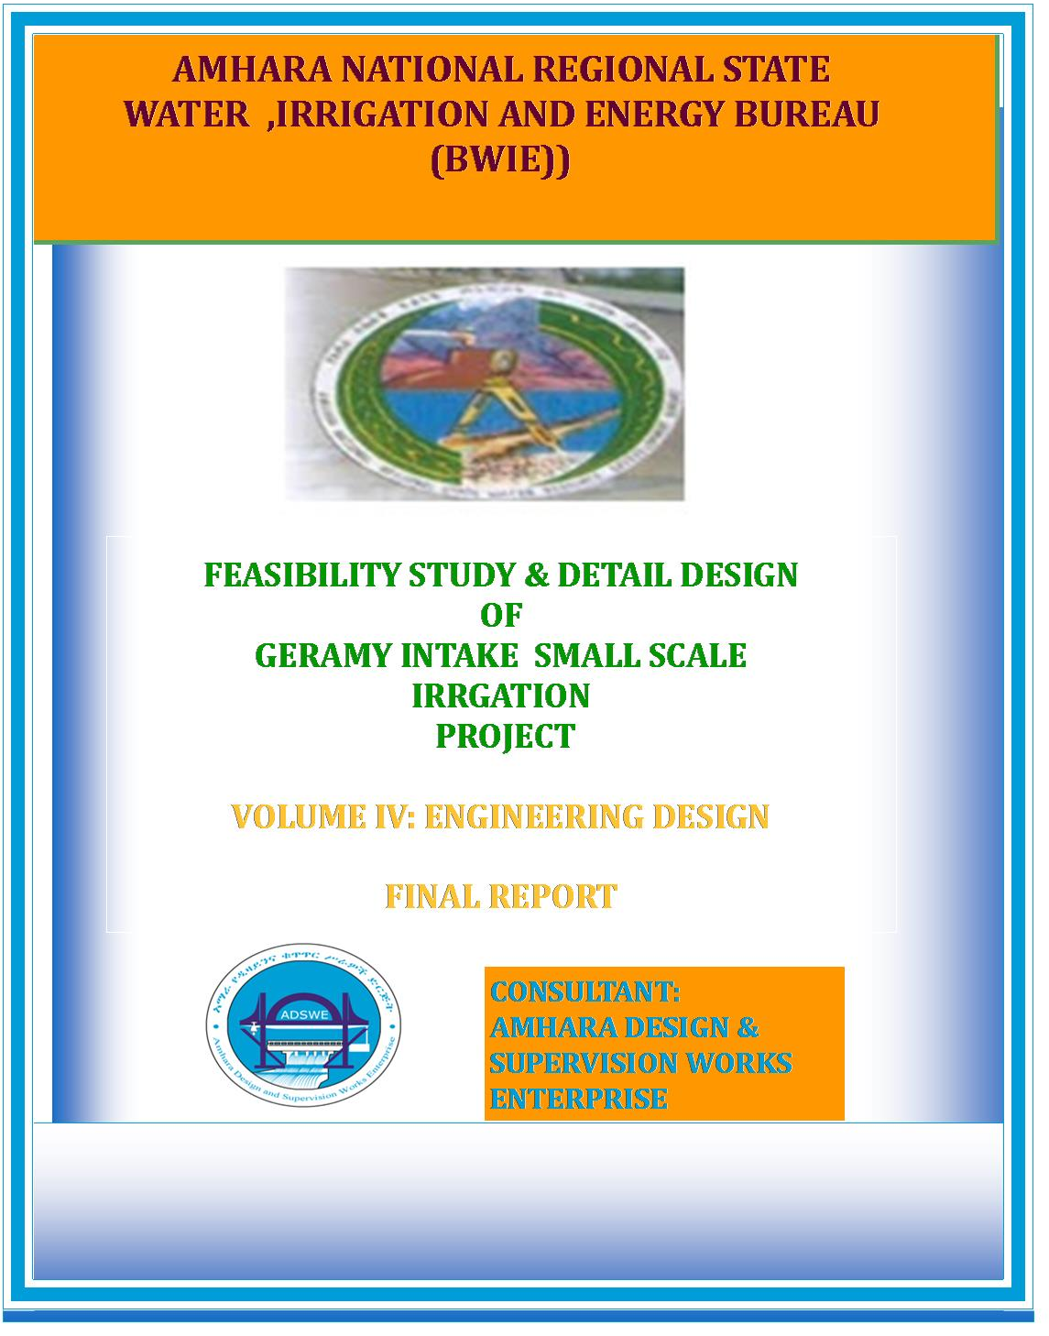
Amhara National Regional State
Water, Irrigation and Energy Bureau
(BWIE)
Detail Design
Of
Jerame Intake Small-Scale Irrigation Project
Volume IV: Engineering Design Final Report
Nov, 2017
Dessie
Client: Bureau of Water Resource Development
(BoWRD)
Address:
P. O. Box: 88
Telephone: 0528-200853/855
Fax: 251-08-20-65-68/204676/202040
Consultant: Amhara Design & Supervision Works Enterprise Eastern Amhara branch office
(E/ADSWE)
Address:
P. O. Box: 491
Telephone: +251-333-124954
Fax: (033) 3124954
E-mail: amhara design@yahoo.com
Dessie , Ethiopia

FEASIBILITY STUDY & DETAIL DESIGN REPORT STRUCTURE
- Volume I: Watershed Management
- Volume II: Engineering Geology
- Volume III: Irrigation Agronomy
- Volume IV: Engineering Design
- Volume V: Socio Economy
- Volume VI: Environmental Impact Assessment
Table of Contents Page No
FEASIBILITY STUDY & DETAIL DESIGN REPORT STRUCTURE i
LIST OF TABLES iv
LIST OF FIGURES iv
SAILENT FEATURE vi
1 INTRODUCTION 1
1.1 Background 1
1.1.1 Description of the Project Area 1
1.2 Objectives of the Study 3
1.2.1 Major Objective 3
1.2.2 Specific Objectives 3
1.3 Scope of the Study 4
1.4 Methodology 5
SECTION-I: HYDROLOGY 7
2 HYDROLOGY 8
2.1 Watershed Characteristics 8
2.2 Hydro-Metrological Data Availability 9
2.2.1 Climate 9
2.2.2 Rainfall Data 10
2.2.3 River flow data 10
2.2.4 Upstream & Downstream utilization 11
2.3 Design Flood Analysis 11
2.3.1 Design Rainfall computation 11
2.3.2 Outlier Test 11
2.3.3 Check for variance 12
2.3.4 Peak Discharge Determination 14
2.3.5 Tail Water Depth Computation 18
SECTION-II: HEADWORK DESIG 22
3 HEADWORK STRUCTURES DESIGN 1
3.1 Headwork Site Selection 1
3.2 River Geomorphology 1
3.2.1 River Bed condition 1
3.2.2 River Bank condition 2
3.3 Sources of construction materials 4
3.3.1 Rock Quarry 4
3.3.2 Fine Aggregates 5
3.3.3 Water 6
3.4 Hydraulic design of the head work 6
3.4.1 Headwork Site selection 6
3.4.2 Headwork Type selection 7
3.4.3 Intake Dimensions 10
3.4.4 Regime Scour Depth 11
3.4.5 Trash Rack 11
3.4.6 Design of Guide Wall and Protection Works 12
3.5 Bill of Quantity and Cost Estimation 14
SECTION-III: IRRIGATION AND DRAINAGE SYSTEMS INFRASTRUCTURE 16
4 IRRIGATION AND DRAINAGE SYSTEMS DESIGN 17
4.1 Irrigable Area Description 17
4.1.1 Topography 17
4.1.2 Climate 17
4.1.3 Soil characteristics 18
4.1.4 Existing Irrigation Practices in the Project Area 18
4.2 Irrigation Water Requirement 18
4.2.1 Crop Water Requirement (CWR) 18
4.2.2 Irrigation efficiency (Ep) 19
4.2.3 Irrigation duty 19
4.2.4 Irrigation methods 20
4.3 Irrigation and Drainage System Layout 21
4.3.1 Conveyance System 23
4.4 Design of the Canal System 24
4.5 Flow Depth and Section Capacity 24
4.5.1 Main Canal 24
4.4.2 Secondary Canals 27
4.4.3 Tertiary canals 31
4.5.2 Field Canals 34
4.6 Drainage Canals 34
4.7 Canal Structures Design 35
4.7.1 Design of a typical flume 35
6.2.1 Super passage 36
4.7.2 Design of Division box 36
4.7.3 Road crossing structure 40
4.8 Irrigation Infrastructure Bill of Quantities and Cost Estimate 41
5 CONCLUSION AND RECOMMENDATION 52
6 OPERATION AND MAINTENANCE 53
6.1 General 53
6.2 Operation of the Head Works 53
6.3 Irrigation System Operation 53
6.4 Maintenance Requirement 54
REFERENCE 56

LIST OF TABLES
Table 2-1: Outlier test analysis 11
Table 2-2: Test for goodness to fit using D-index 13
Table 2-3: Determination of Time of Concentration 15
Table 2-4: Runoff analysis 17
Table 2-5: Hydrograph coordinates 17
Table 2-6: intake Site River Cross section Coordinate Data 19
Table 2-7: Stage discharge analysis 21
Table 3-1 Stability analysis of upstream masonry retaining wall 13
Table 4-1: Hydraulic Parameters of main canal 25
Table 4-2: Hydraulic Parameters of secondary canals 27
Table 4-3: Hydraulic Parameters of tertiary canals 32
Table 4-4: Hydraulic parameters of Division Boxes 38

LIST OF FIGURES
Figure 1-1: Location map of the project area 2
Figure 2-1: Drainage map of jerame watershed 9
Figure 2-2: Drainage map of jerame watershed 9
Figure 2-3: Complex Hydrograph 18
Figure 2-4: River profile 20
Figure 2-5: Rating Curve 21
Figure 3-1: River bed at the proposed intake site 2
Figure 3-2: River bank at the proposed intake site 3
Figure 3-3: Left bank at the proposed intake site 4
Figure 3-4: Quarry site 5
Figure 3-5: Intake location 7
Figure 3-6 Different option locations 9
Figure 4-1 Typical cross section of Main canal 24
Figure 4-2: Typical Cross Section of secondary canals 30
Figure 4-3: Typical Cross Section of tertiary canals 31
Figure 4-4: Typical Field Canal X-section 34
Figure 4-5: Typical plan & longitudinal section of flume structure 35
Figure 4-6: Typical plan & cross section of super passage structure 36
Figure 4-7: Typical Division Box plan 37
Figure 4-8: Typical road crossing structures for cattle and peoples. 40

SAILENT FEATURE
- Project name: Jerame Intake small scale Irrigation Project
- Name of the stream: Jerame river
- Location of intake site using
- North: 1198234.5
- East: 55741
- Zone: south welo
- Wereda: werilu
- Average Altitude: 2923.5 m.a.s.l
- Hydrology
- Design rainfall: 78.15 mm
- Catchment area: 15.21 Km²
- Longest flow path length: 7.44 Km
- Design flood: 37.33m³/sec
- Design base flow: 150 lit/sec

- Intake
- Intake crest level: 2922 m.a.s.l
- Bottom level :2919.9 m.a.s.l

- Outlet
- Sill level: 2921.6 m.a.s.l
- Opening dimension: 0.4*0.6 m²
- Discharge capacity: 273 lit/sec
Irrigation and drainage systems Infrastructure
- Command area size: 140 ha
- Type of soil of the command area is dominantly clay soil
- Design discharge of the main canal =144.4 l/sec
- Irrigation system layout consists of two lined main canal, 7 secondary canals and 45 tertiary canals
- Main irrigation structures designed are;
- Gully crossing structures
- Foot path
- Division box
- Turn out

Project cost

Jeram Irrigation Project
Summary of Bills
Bill No | Description | Amount (Birr)
I | General items | 1,183,973.24
II | Head work | 28,101.03
III | Infrastructure | 15,392,759.63
 | Total | 16,604,833.90
 | 15 % VAT | 2,490,725.09
 | Grand Total | 19,095,558.99
 | Command area, ha | 140.00
 | Cost per ha befor VAT | 118,605.96

INTRODUCTION

Background
In Ethiopia, under the prevalent rain-fed agricultural production system, the progressive degradation of the natural resource base, especially in highly vulnerable areas of the highlands coupled with climate variability have aggravated the incidence of poverty and food insecurity. The major source of growth for Ethiopia is still conceived to be the agriculture sector. Hence, this sector has to be insulated from drought shocks through enhanced utilization of the water resource potential of the country, (through development of small-scale irrigation, water harvesting, and on-farm diversification) coupled with strengthened linkages between agriculture and industry (agro-industry), thereby creating a demand for agricultural output. In line with the above, efforts have been made by the government to improve the situation in the country in areas of domestic water supply provision, irrigation, watershed management, etc. The Amhara Water Resources Development Bureau is playing its role in the development of small scale irrigation projects in the region. Accordingly, as part of the water sector development program, the office has initiated the study and design of a small scale irrigation scheme on Jerame River at dolo Kebele and signed an agreement with Amhara Design & Supervision Works Enterprise (ADSWE) for the study and design of the project.

Description of the Project Area

Location
This irrigation project is located mainly at dolo Kebele, werilu Wereda of S/welo Zone in the Amhara Region. The proposed irrigation project is to be undertaken on jerame River and the INTAKE structures are specifically located at an altitude of about 2923.5 masl and geographical coordinates of 1198234.5N (UTM) and 557441E (UTM).
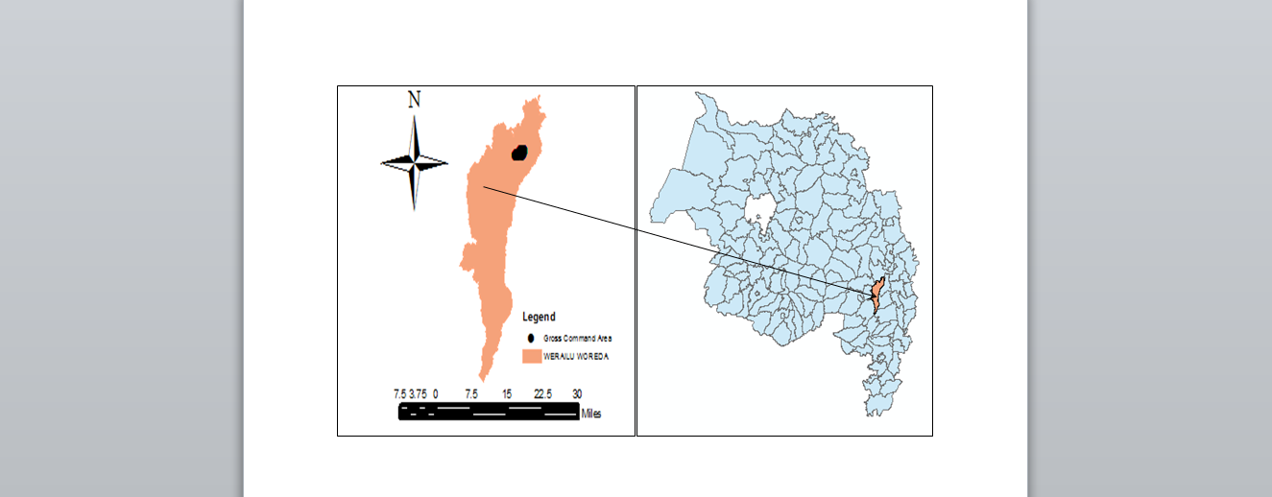
Figure 1-1: Location map of the project area

Accessibility
The project area is accessed through Asphalted road 44Km from Dessie to Guguftu, and 12Km dry weather road to the Project area and needs 3km access road up to the head work site.

Previous Irrigation Practices
There is traditional diversion on the downstream of this river using different irrigation practices but as the hydrology and Hydrogeology study and respondent farmers indicated, the river has capacity of recharging as it stretches down from the source area of the river. As a result there will not be a marked reduction or fluctuation of water flows both for the already existing and the newly proposed irrigation schemes. The traditional irrigation practices are under taken by individual farmers that use the river flow to the extreme right side is with hardship. So, the farmers in the project area are very much interested to upgrading the traditional scheme to modern scheme.

Objectives of the Study

Major Objective
The project area faces variability of rainfall distribution though the overall rainfall generally suffices the rain-fed agriculture. Accordingly, the rain-fed agriculture needs means of supplementing during distribution failures and further full irrigation is required to maximize the use of the potential land and water resources.
Hence the objective of this project is to contribute a substantial share in the effort to reduce the risk of production decrease due to rainfall variability and increase the productivity of the resource in the project specific area. Specifically, the project is targeted for the following.
- To make sustainable the rain-fed crop production and make extra production in the dry season possible for 150 ha of land through irrigation.
- There is a general consensus that irrigation investments will achieve broader food security and poverty reduction impacts and if efforts are also geared towards up-grading existing traditional farming practices with support to enhance access to input supply, output marketing and extension to facilitate access to information and innovations.
- This objective is to be realized by constructing intake structures across the jerame River and diverting the river flow.

Specific Objectives
Other benefits that can be expected to appear with the launching of the project are:
- Efficiency of water use improvement;
- Improved local nutrition/food security gains;
- Improved management of scarce natural resources (land and water);
- Resilience against drought risk;
- Rationale for erosion control and watershed management;
- Rationale for the intensification and modernization of small-holder agriculture and rural lifestyles.
The engineering study and design enables the realization of the project by the provision of engineering structures that will allow the appropriate abstraction of the river water for delivery in to the identified irrigation fields of the study area. Hence, this engineering design is specifically targeted to:
- Analyze hydrologic requirements of the project and engineering structures;
- The formulation of sound and stable structure, with necessary provisions that allow safe, easy and low-maintenance operation in the service life of the project;
- Develop working drawings;
- Estimation of construction costs.

Scope of the Study
- The irrigation design shall ensure reliability, equity and flexibility of water delivery to farmers. It will aim at reducing conflicts among water users and will lead to lower operation and maintenance costs.
- Updating the existing, if available, computation of the actual evapo-transpiration, crop water requirement, irrigation demand/duty using the existing and recent agronomic, climatologic and soil data using more appropriate methodologies.
- Establish design criteria for irrigations structures to be approved by the client and to be used in the final design stage,
- Design proper irrigation system compatible with local conditions and management capabilities,
- Establish flood protection measures for the command area and canal structures and design the respective drainage system accordingly,
- Planning and layout of the irrigation system, which include irrigation canals, drainage channels, inspection roads and alignments, canal spacing, canal length, location of structures, and water profiles along canal and drains at specified reaches, which is most economical easily manageable and aligned with topographic feature and geological investigation.
- Determination and estimation of water application conveyance and other losses and irrigation efficiencies and consideration of those parameters in design steps.
- Check and test hydraulic and structural designs of main canal considering total demand and the required capacity and the base flow availability,
- Prepare general plans and drawings for all irrigation infrastructure and irrigation systems designs,

Methodology
In the study and design procedure, Designers used the following steps.
- Specific Site identification:
  - Review of the reconnaissance survey conducted by the Client
  - 50,000 scale top map and GIS information
  - Local farmers interview and discussion
  - Wereda and Zone Agriculture section expertise
  - Previous studies
  - On foot travel along the river channel and farm areas.
- Topographic survey:
  - Surveying the headwork site and the Command area with sufficient radius, using Total station
- Flow estimation
  - Physical observation on flood mark indications and local information about high flood and critical flow condition of the river
  - Analyzing the recorded river flow data and use watershed inputs for further analysis.
  - Base flow estimated during the reconnaissance field visit by floating method.
- Irrigable area identification:
  - Using local information
  - 50,000 Topographic map, and GIS information, GPS to see elevation
The design report is organized in three sections. In Section I the Hydrology study is presented and in Sections II and III the Headwork and Irrigation and Drainage Systems designs are discussed respectively. In Section III, planning and design of the irrigation system after diverting the water using the intake will be dealt. The following are major areas of concern in this part.
- Study and design of the irrigation method to be adopted,
- Study and design of the irrigation system layout and associated structures,
- Design of the different conveyance canals,
- Planning and design of the different irrigation and drainage structures,
- Preparation of the longitudinal profiles of the different irrigation and drainage canals.

SECTION-I: HYDROLOGY

HYDROLOGY

Watershed Characteristics
The Watershed has marked topographic variation. All types of slopes are present. The dominant slope class is moderately steep (15-30%) which covers 38.60% of the total area followed by sloping (8-15%), which is 34.09%. Gently sloping (3-8%), steep slope (30-50%) and flat (0-3% and which accounts 20.73%, 3.51% and 3.06% respectively. Table 1 of the watershed feasibility study report shows the slope classes and proportion of the watershed.
Certain physical properties of watersheds significantly affect the characteristics of the runoff and sediment yield and are of great interest in hydrologic analyses. The rate and volume of runoff, and sediment yield from the watershed have much to do with shape, size, slope and other parameters of the landscape. These suggest that there should be some important relations between basin form and hydrologic performance. If the basin and hydrologic characteristics are to be related, the basin form must also be represented by quantitative descriptors. These parameters can be measured from maps.
The watershed characteristics are analyzed and presented in Table 2 of the Watershed Feasibility Study Report of the same project. In summary:
- Catchment Area = 15.21km²
- Stream Length = 7.44Km
- CN(II) = 76.42
(Extracted from the Watershed Study Report of the same project)
At the selected reference point, the area of jerame catchment is 15.21km² and consists of a network of tributaries as shown in Figure 2.1 below.

Figure 2-1: Drainage map of jerame watershed
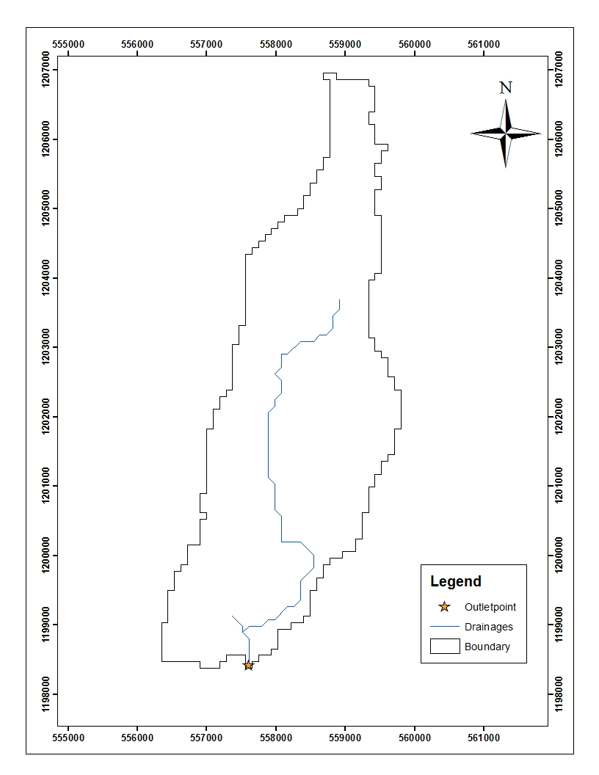
Figure 2-2: Drainage map of jerame watershed
Jerame River at the headwork site is characterized by well-defined channel system and considerable flows. It looks that the gradient of the river is getting low and hence there exists significant deposition of sediment mainly cobbles and boulders.

Hydro-Metrological Data Availability

Climate
Small scale irrigation project designers and planners are faced with lack of good data on the hydrology of the river system that will be their water source and on local weather and climate conditions. Stream gauging stations are virtually non-existent in remote rural areas of Ethiopia; meteorological stations are almost rare. Likewise, at dolo Kebele and in the catchment area of this project, there is no meteorological station of any level. Moreover, there are no flow data for the river near the project. Therefore, data for the hydro-meteorological analysis is taken from the nearby station and similar areas. Rainfall & temperature data are considered from kabie Meteorological station. In fact, this station is very close to the project area. As per the data of the station, March – April are identified as high temperature periods whereas December–January are low temperature periods. The mean annual rainfall amount is more than 892 mm (1994 - 2011data). The area is characterized with two rainfall seasons: the main rain fall season (summer) which supplies 75 % of the annual rainfall occurs mainly on the months of June to September and the Belg rainfall season which contributes lower amount of rainfall occurs in the months of February to April.

Rainfall Data
In order to compute the design flood for the intake structure, the daily maximum rainfall is collected from Kabie Metrological stations with a record of 18 years.

River flow data
The base flow which is measured on January 2016 is 150 l/s. But during the ground verification work on December 2017 the flow of water was measured to be 50 l/s. The rain fall pattern of the site is bimodal. The small rain season (Belg) occurs mostly on the months of February to May which supplies up to 50 mm monthly average rainfall. The local dwellers of the area state that once in 4 years the Belg rain will not happen. The main rain season (summer) occurs in the months of June to September.
The flow of the river is proportional to the mean monthly rainfall of the area. i.e it gets its maximum flow during the summer month then reduces in the months of October to December and again begins to increase from February to May due to the Belg rain.

Upstream & Downstream utilization
Downstream of the proposed site, appreciable need for water is anticipated for locals and cattle provisions. Therefore, at least 10% of the minimum flow has to be released for downstream requirements.
For this specific project it has been observed that the river is recharging type which is verified by the emergence of frequent springs and tributaries at downstream of the head work which will be used for environmental purpose and for downstream users.
For the sake of planning and design, however, the outlet for the intake is designed for a discharge of 144.4l/s for this project and the project is to be developed for 152 ha of land, which is most of the time achievable as the flow for most of the time is significant to support this size of command area.

Design Flood Analysis
For the design and analysis of structures to be constructed on the river, estimation of flood magnitude is an important task. This can be done using different techniques depending on the data available. For this particular case, there are no river flow data and hence the flood estimation is done using the rainfall data and applying SCS Curve Number Method.

Design Rainfall computation
Based on the data of 24hr peak rainfall given in Table 2-1 the design rainfall, Rf is computed using Gumble Method.

Outlier Test
From kabie meteorological station 18 years of daily heaviest rainfall records from 1994 to 2011, were used for estimation of point design rain fall. In spite of less number of rain fall data, the design selected an event that recurs in every 50 years of return period to compute the design rain fall, which is adopted for small scale irrigation projects like jerame intake. These data should be checked for their consistency or outlier test to assure the reliability of data for further design flood simulation.
Table 2-1: Outlier test analysis
S.No. | Year | Max. RF | Descending Order | Rank | Logarithmic Value/Yo/ | (Yo-Ym)² | (Yo-Ym)³
1 | 1994 | 43.20 | 94.00 | 1 | 1.9731 | 0.0898314 | 0.0269242
2 | 1995 | 41.30 | 73.70 | 2 | 1.8675 | 0.0376587 | 0.0073080
3 | 1996 | 45.00 | 64.00 | 3 | 1.8062 | 0.0176281 | 0.0023405
4 | 1997 | 25.90 | 61.60 | 4 | 1.7896 | 0.0134959 | 0.0015678
5 | 1998 | 50.90 | 56.30 | 5 | 1.7505 | 0.0059443 | 0.0004583
6 | 1999 | 50.60 | 50.90 | 6 | 1.7067 | 0.0011095 | 0.0000370
7 | 2000 | 56.30 | 50.60 | 7 | 1.7042 | 0.0009450 | 0.0000291
8 | 2001 | 73.70 | 45.30 | 8 | 1.6561 | 0.0002997 | -0.0000052
9 | 2002 | 44.00 | 45.00 | 9 | 1.6532 | 0.0004079 | -0.0000082
10 | 2003 | 94.00 | 44.40 | 10 | 1.6474 | 0.0006774 | -0.0000176
11 | 2004 | 28.70 | 44.00 | 11 | 1.6435 | 0.0008974 | -0.0000269
12 | 2005 | 45.30 | 43.20 | 12 | 1.6355 | 0.0014383 | -0.0000545
13 | 2006 | 61.60 | 42.20 | 13 | 1.6253 | 0.0023133 | -0.0001113
14 | 2007 | 41.50 | 41.50 | 14 | 1.6180 | 0.0030648 | -0.0001697
15 | 2008 | 44.40 | 41.30 | 15 | 1.6160 | 0.0033015 | -0.0001897
16 | 2009 | 36.10 | 36.10 | 16 | 1.5575 | 0.0134332 | -0.0015569
17 | 2010 | 64.00 | 28.70 | 17 | 1.4579 | 0.0464519 | -0.0100117
18 | 2011 | 42.20 | 25.90 | 18 | 1.4133 | 0.0676568 | -0.0175982
SUM |  |  | 888.70 |  | 30.1214 | 0.3065552 | 0.0089149
MEAN |  |  | 49.37 |  | 1.6734 | 0.0170308 | 0.0004953
STANDARD DEVATION |  |  | 16.20 |  | 0.1343
SKEWNESS COEFICIENT |  |  | 1.284 |  | 0.2436

Description | Value
N (Number of data) | 18
Kn | 2.3351
Mean | 49.37
Standard Deviation | 16.20
High outlier, X_{H} | 87.19
Low outlier, X_{L} | 11.55
Conclusion: | 94 mm rf in 2003 is a high outlier, No low outlier

The highest data value 94>87.19 implies that 94 is a high outlier. The lowest data 25.9 > 11.55 shows that there is no lower outlier. Hence the higher outlier shall be removed from the data set and the analysis should be done with the rest of 17 data.

Check for variance
After checking the outliers, the data should be checked for variability. For variability the formula used is
$α=\left(\frac{δ_{∩-1}}{\sqrt{N}*Mean}\right)*100\%$
Where, δ_{n-1 =} Standard deviation =16.2
N = Nr of recorded data =17
M_{ean} = 46.75
$α$ = Standard error
$α=\left(\frac{16.2}{\sqrt{17}*46.75}\right)*100\%=6.29<10\%$ Acceptable
Therefore the data shows no variability.

D-Index test
After checking the consistency of the data for higher and lower outlier, the 6 years data is obtained as representative for the analysis using D-index. The D-Index test is believed to be the better goodness to fitness in many literatures. Hence in this study it was used to determine the best statistical distribution to estimate the peak rainfall. The D-index for the comparison of the fit of various distributions is summarized as follows.
$D_{-Index}=(\frac{1}{X_{m}})*\sum_{i=1}^{6}{Abs(Xi-{Xi}^{'})}$
Where Xi and Xi’ are the i^{th} highest observed and computed values for the distribution respectively
Table 2-2: Test for goodness to fit using D-index
Rank | XI | Normal | Log Pearson Type III | Log Normal | Pearson Type III | Gumbel EVI | Gumbel
Rank | XI | XI -'XI' | XI -'XI' | XI -'XI' | XI -'XI' | XI -'XI' | XI -'XI'
1 | 94.00 | 18.387 | 14.673 | 16.200 | 17.369 | 15.074 | 8.032
2 | 73.70 | 4.046 | 3.836 | 4.266 | 3.722 | 3.883 | 1.250
3 | 64.00 | 1.619 | 0.236 | 0.286 | 1.578 | 0.323 | 4.304
4 | 61.60 | 0.800 | 1.456 | 1.146 | 0.530 | 1.304 | 1.834
5 | 56.30 | 3.329 | 0.576 | 1.039 | 2.904 | 0.762 | 3.223
6 | 50.90 | 6.231 | 3.218 | 3.769 | 5.701 | 3.419 | 5.304
Sum |  | 34.413 | 23.995 | 26.706 | 31.805 | 23.995 | 23.948
Sum/Mean |  | 0.697 | 0.486 | 0.541 | 0.644 | 0.486 | 0.485
Point Rainfall |  | 82.64 | 92.58 | 88.97 | 84.72 | 91.36 | 101.00
Design Point Rainfal = |  |  | 101.004

All the candidate distributions give almost identical correlation coefficients. However, the standard errors are significantly lower for the GUMBEL Method which is 101. Accordingly, The Gumbell Extreme Value Type I probability distribution method was selected for the analysis. The design rainfall for a return period T is estimated with the equation as shown below.

Where X_{T =} Design rainfall for a return period T
$Xbar$ = average of all values of annual heaviest fall = 46.75 mm
S = Standard deviation of the series = 12.12 mm
K_{T} = Frequency factor for a return period T
K_{T} value is a function of the return period which can be determined with the following formula set by Chow.
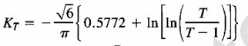
Using this formula for the return period of 50 years the frequency factor is determined as 2.591.
Hence the point design rainfall for a return period of 50 years is estimated as:
X₅₀ = 46.75 + 2.591 * 12.12 = 78.15 mm
- Point Design Rainfall = 78.15 mm
The design rainfall at points for 50 years return period is 78.15 mm and the areal design rainfall is calculated in the following section.

Peak Discharge Determination

General
The River is not gauged river. The design flood is calculated by using SCS unit hydrograph method. Thus, it is preferred to base the flood analysis on rainfall data, which are better both in quantity and quality of data. In the hydrologic analysis for drainage structures, it must be recognized that there are many variable factors that affect floods. Some of the factors that need be recognized and considered on an individual site by site basis are; rainfall amount and storm distribution; catchment area, shape and orientation; ground cover; type of soil; slopes of terrain and stream(S); antecedent moisture condition; Storage potential (over bank, ponds, wetlands, reservoirs, channel, etc.)

Peak flood analysis by SCS unit hydrograph method
Design flood is calculated SCS (The United States Soil Conservation Service). This method is widely adopted and more reliable method for flood estimation. The approach considers, watershed parameters, like Area, Curve number, and time of concentration.

Time of concentration (Tc)
Time of concentration has been calculated by taking the stream profile of the longest streamline and dividing it in to different elevation. Kirpich formula is adopted for computation.

Table 2-3: Determination of Time of Concentration
Time of concentration | Tc
Partial Distance/km/ | cumulative distance/km/ | Elevation/m/ | Elevation diff./meter | TC/hr
0 | 0 | 3540 | 0
2.22 | 2.22 | 3280 | 260 | 0.29
2.74 | 4.96 | 3160 | 120 | 0.50
2.76 | 7.72 | 3040 | 120 | 0.50
3.16 | 10.88 | 2980 | 60 | 0.77
10.88
 |  |  | TC | 2.06
The formula is,
$Tc=\sum{0.948\left\{{\left(\frac{{L_{1}}^{3}}{H_{1}}\right)}^{0.385}+{\left(\frac{{L_{2}}^{3}}{H_{2}}\right)}^{0.385}+…+{\left(\frac{{L_{n}}^{3}}{H_{n}}\right)}^{0.385}\right\}}$
- Tc = 2.06 Since Tc <3hr., duration of excess rainfall difference, D = 0.5hr.
- Time to peak,
$T_{p=}\frac{D}{2}+0.6*T_{c}$ = 1.487hr
- Base time,
$T_{b}=2.67*T_{p}$ = 3.97hr
Recession time,
$T_{r}=1.67*T_{p}$ = 2.48hr.

Curve number (CN)
Curve number (CN) is achieved based on USSCS method by watershed characterization in terms of land cover, treatment, hydrologic condition and soil group. From the watershed analysis curve number at condition II =76.42. Since peak rainfall is found at an antecedent moisture condition III state, this value has to be changed to antecedent moisture condition III.
- Conversion factor = 1.160
- CN Condition (III) = (Factor from Table x CN condition II) =76.42*1.160 = 88.64. For detail analysis of the computation, Refer Excel file, attached here with.

Area Rainfall
As the area of the catchment gets larger, coincidence of all hydrological incidences becomes less and less. This can be optimized by changing the calculated point rainfall to aerial rainfall. The conversion factor is taken from standard table that relate directly with the size of watershed area and type of the gauging station. (IDD manual)
For the case of jerame irrigation project,
- Total watershed area = 15.21 Km²
- Type of gauging station = Daily rainfall (24 hr.)
- Aerial Rainfall = (Point Rainfall) x (Conversion factor)

Run off Analysis
Input data:
- Design Point Rainfall = 78.15 mm
- Curve number at antecedent moisture condition III = 88.64
- Catchment Area, A = 15.21 Km²
- Tc = 2.06hr, D = 0.5hr., Tp =1.48 hr; Tb = 3.97 hr; Tr = 2.48hr.
- Direct run-off,
$Q=\frac{{(I-0.2*S)}^{2}}{(I+0.8*S)}$
Where, I = Rearranged cumulative run-off depth (mm
- S = Maximum run off potential difference,
$S=\left(\frac{25400}{CN}\right)-254$
- Peak run-off for incremental;
$Q_{p}=0.21*\frac{(A*Q)}{T_{p}}$
Where, A = Catchment area = 15.21 Km²
T_{p} = Time to peak (hr)
Q = Incremental run-off (mm)
Table 2-4: Runoff analysis
Time/hr/ | Incremental Runoff (mm) | q_{p} for 1mm Runoff (m3/sec/mm) | q_{p} for Incremental Runoff(m3/sec) | Incremental Hydrograph
 |  |  |  | Beginning time(hr) | Peak time(hr) | End time(hr)
0 - 0.5 | 0.12 | 1.84 | 0.22 | 0 | 1.49 | 3.97
0.5-1 | 0.20 | 1.84 | 0.37 | 0.5 | 1.99 | 4.47
1-1.5 | 1.49 | 1.84 | 2.75 | 1 | 2.49 | 4.97
1.5-2 | 12.10 | 1.84 | 22.27 | 1.5 | 2.99 | 5.47
2-2.5 | 8.22 | 1.84 | 15.13 | 2 | 3.49 | 5.97
2.5-3 | 2.12 | 1.84 | 3.91 | 2.5 | 3.99 | 6.47

Table 2-5: Hydrograph coordinates
Time(hr) | Ordinate of Hydrograph(m³/s) |  |  |  |  |  | Total
Time(hr) | H1 | H2 | H3 | H4 | H5 | H6 | Total
0 | 0.00 |  |  |  |  |  | 0.00
0.50 | 0.07 | 0.00 |  |  |  |  | 0.07
1.00 | 0.15 | 0.12 | 0.00 |  |  |  | 0.27
1.50 | 0.22 | 0.25 | 0.92 | 0.00 |  |  | 1.40
1.49 | 0.22 | 0.25 | 0.90 | -0.21 |  |  | 1.16
1.99 | 0.18 | 0.37 | 1.83 | 7.34 |  |  | 9.72
2.00 | 0.18 | 0.37 | 1.85 | 7.49 | 0.00 |  | 9.89
2.49 | 0.13 | 0.30 | 2.75 | 14.78 | 4.95 |  | 22.90
2.50 | 0.13 | 0.29 | 2.73 | 14.99 | 5.09 | 0.00 | 23.23
2.99 | 0.09 | 0.22 | 2.19 | 22.27 | 10.04 | 1.28 | 36.09
3.49 | 0.04 | 0.15 | 1.64 | 17.78 | 15.13 | 2.59 | 37.33
3.97 | 0.00 | 0.07 | 1.10 | 13.44 | 12.18 | 3.87 | 30.66
3.99 |  | 0.07 | 1.08 | 13.26 | 12.06 | 3.90 | 30.37
4.47 |  | 0.00 | 0.55 | 8.97 | 9.15 | 3.15 | 21.82
4.97 |  |  | 0.00 | 4.49 | 6.10 | 2.36 | 12.95
5.47 |  |  |  | 0.00 | 3.05 | 1.57 | 4.62
5.97 |  |  |  |  | 0.00 | 0.79 | 0.79
6.47 |  |  |  |  |  | 0.00 | 0.00

Figure 2-3: Complex Hydrograph
From the analysis, the 50 year return period design run off is 37.33 m ³/s

Tail Water Depth Computation
Tail water depth of the river is equal to the flood depth and amount at the proposed intake site before construction of the intake. It is used to crosscheck peak flood estimated by the SCS unit hydrograph method with flood mark method and to see the flood feature after the hydraulic jump. During field visit, the flood mark of the river at the proposed intake site was marked based on dwellers information and physical indicative marks. The river cross-section was surveyed.
Table 2-6: intake Site River Cross section Coordinate Data
- Average river bed slope computation (End area method)
s no | X-COORDINATE | Y-COORDINATE | ELEVATION |  | Accumulative Height(m) | PARTIAL DISTANCE | COMULATIVE DISTANCE | Total Area A(M^2)
1 | 557441.1 | 1198295 | 2931.002 |  | 0 | 0 | 0 | 0
2 | 557444.1 | 1198291 | 2927.91 |  | 3 | 5 | 5 | 7
3 | 557446 | 1198285 | 2926.149 |  | 5 | 7 | 11 | 26
4 | 557446.4 | 1198278 | 2924.63 |  | 6 | 7 | 18 | 38
5 | 557440.8 | 1198258 | 2923.722 |  | 7 | 20 | 38 | 139
6 | 557440.1 | 1198246 | 2922.194 |  | 9 | 13 | 51 | 103
7 | 557431 | 1198227 | 2920.585 |  | 10 | 21 | 72 | 199
8 | 557421.6 | 1198211 | 2920.133 |  | 11 | 19 | 91 | 200
9 | 557416.2 | 1198185 | 2918.313 |  | 13 | 26 | 117 | 309
10 | 557416.6 | 1198163 | 2917.136 |  | 14 | 22 | 139 | 294
11 | 557419.3 | 1198140 | 2915.788 |  | 15 | 23 | 162 | 337
12 | 557429.6 | 1198128 | 2915.166 |  | 16 | 16 | 178 | 251
13 | 557462.4 | 1198082 | 2910.945 |  | 20 | 56 | 234 | 1005
14 | 557462.8 | 1198066 | 2910.186 |  | 21 | 16 | 251 | 332
15 | 557451.4 | 1198036 | 2908.437 |  | 23 | 32 | 283 | 705
16 | 557428.2 | 1197999 | 2906.92 |  | 24 | 44 | 327 | 1015
 |  | Summation
 | AVERAGE | HEIGHT ,H |  |  | =2*A/L |  | 30.37
 | AVERAGE | SLOPE,S |  | =H/L |  |  | 0.93
- Average river bed slope
Average river bed slope of River is estimated by two different techniques. One is by end area method and the other is by using best fit line method. Designers have adopted the best fit method output for further analysis.
The water level of the river is taken at different points along the river channel around the head work site. Surveying work done for 327m length. And then, average water surface slope is considered as the river bed slope. For comparison of the two procedures, refer the attached Excel file.

Figure 2-4: River profile
- Manning’s Roughness coefficient
The Manning’s roughness coefficient is taken from standard table based on the river nature. The river at the headwork site has got braded feature and curving nature. The river banks are defined and relatively smooth. Manning’s roughness coefficient (n = 0.04) is adopted.

- Discharge of the river
Input data:
- Manning's roughness coefficient, n =0.045
- Average river bed slope, S = 0.06
- , Where, R = Hydraulic radius = (Area/Perimeter)
- $Q=V*A$

Table 2-7: Stage discharge analysis
Elevation EL(m) | Depth d(m) | Wetted area A(m^2) | Wetted perimeter P(m) | Hydraulic radius R(m) | Velocity V(m/sec.) | Discharge Q(m^3/sec.) | Remark
2922.12 | 0 | 0 | 0 | 0 | 0 | 0.0 | River bed
2922.37 | 0.25 | 0.389 | 3.170 | 0.123 | 1.674 | 0.7
2922.62 | 0.5 | 1.532 | 6.240 | 0.245 | 2.657 | 4.1
2922.87 | 0.75 | 3.279 | 8.917 | 0.368 | 3.479 | 11.4
2923.12 | 1 | 5.850 | 10.998 | 0.532 | 4.449 | 26.0
2923.37 | 1.25 | 8.780 | 13.063 | 0.672 | 5.200 | 45.7
2923.62 | 1.5 | 12.166 | 14.646 | 0.831 | 5.988 | 72.9

Figure 2-5: Rating Curve
From the above stage discharge table and curve the maximum flood level corresponding to the computed design peak discharge is 37.33 m³/s (1.2 m from the river bed) and it is considered as the d/s high flood level i.e. expected at the intake axis before construction of the intake. Therefore the tail water depth at the intake site is determined to be 1.3 m. River bed level = 2922.1m
D/S HFL = 2923.3 masl.

SECTION-II: HEADWORK DESIGN

HEADWORK STRUCTURES DESIGN

Headwork Site Selection
The headwork site is situated at 1198240 m N, 557439m E and river bed elevation of 2922 m above sea level. At this site the river course is well defined, matured with fixed width and forms nearly a U-shaped valley. In selecting or comparing the best site, it was practically important to put criteria’s such as considering the flood the channel has to accommodate, the length of the intake crest, the topographically suitability, the relative economic considerations, the availability of enough command and other selection or comparison criteria’s

River Geomorphology
The headwork site geological surface and subsurface conditions have been investigated based on the nature of the proposed structure. At the site and immediate vicinity, the stream flows along steep slope course. The right bed and bank at intake site are made up boulders (if the top boulders units are removed fresh rock will be expected) and also the active stream beds are covered with boulders. On the other hand, left bank is covered with the flood plain deposit dominated by bedrocks (basalt). The detail geologic nature of the banks, and bed of the stream along the headwork axis and immediate vicinity are described and their potential geotechnical influence on the proposed structures also discerned/detected below, with remedial measures.

River Bed condition
At the proposed headwork site the stream bed or course is well defined, nearly straight, and shows rough surface due to recent sediment(center and left bed) accumulations and undulating appearance of bedrock outcrops(at right bed). Along the intake axis, the bed is made up of two basically different geologic materials, as seen from surface observation. These are recently deposited alluvial coarse grained sediments, and underling bedrock.
The central and left areas of the bed are totally covered with the alluvial deposits, while the right bed is made up of basaltic bedrock. Some parts of the bedrock are covered with the recent sediments at the central and left areas of the stream bed. The alluvial sediment observed at the center and right beds are composed dominantly of Gravel with significant amount of boulders and cobbles. It is loose, dry (at the time of study) and not easily workable (to dig test pit). From surface geological understanding of the area, the thickness of this sediment is expected in the range 0.5to 1m. This coarser sediment is believed to be underlain by the bedrock extension that exposed at the right bed, left beds and bank. On the other hand, the bedrock found at head work axis is affected by slight degree of weathering and erratically oriented joints. The joints are not persistence that most of them penetrate to shallow depth or affecting the top 0.5 to 1m thickness of the rock. The foundation of the proposed intake structure; therefore, can be lie on the bedrock after removing the top 0.5 to 1m jointed portion of the bedrock at the both side of the bank. In addition to this, the foundation of the bed bar (if proposed), along the axis should lie on the bedrock, after excavating the top alluvial deposit covering the center, and left bed of the river.
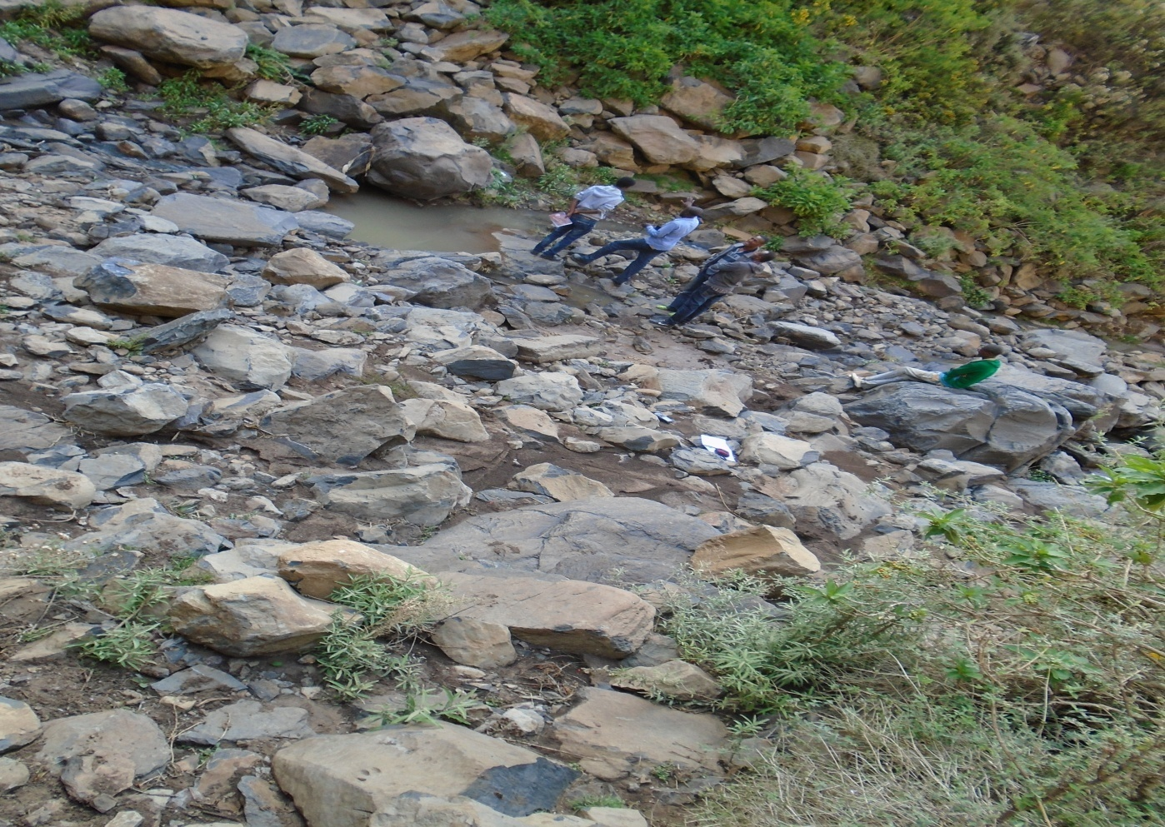
Stream beds
Figure 3-1: River bed at the proposed intake site

River Bank condition

Right Bank
At the proposed headwork axis and immediate vicinities, the right bank forms steep slope topography, having about more than 3m height from stream bed. From surface observation, the bank is covered entirely with two type’s geological material such as the top 2m of banks covered with low plastic clay material intermixed with gravel and boulders it is stiff, moist and dry while the lower
Section covered with boulders and it is flood plain deposit having dark brown color. The bank is now affected by flood erosion that active eroded surfaces are visible (see plate 4.1). So, it is necessary to provide some bank protection structures to prevent ongoing bank erosion.
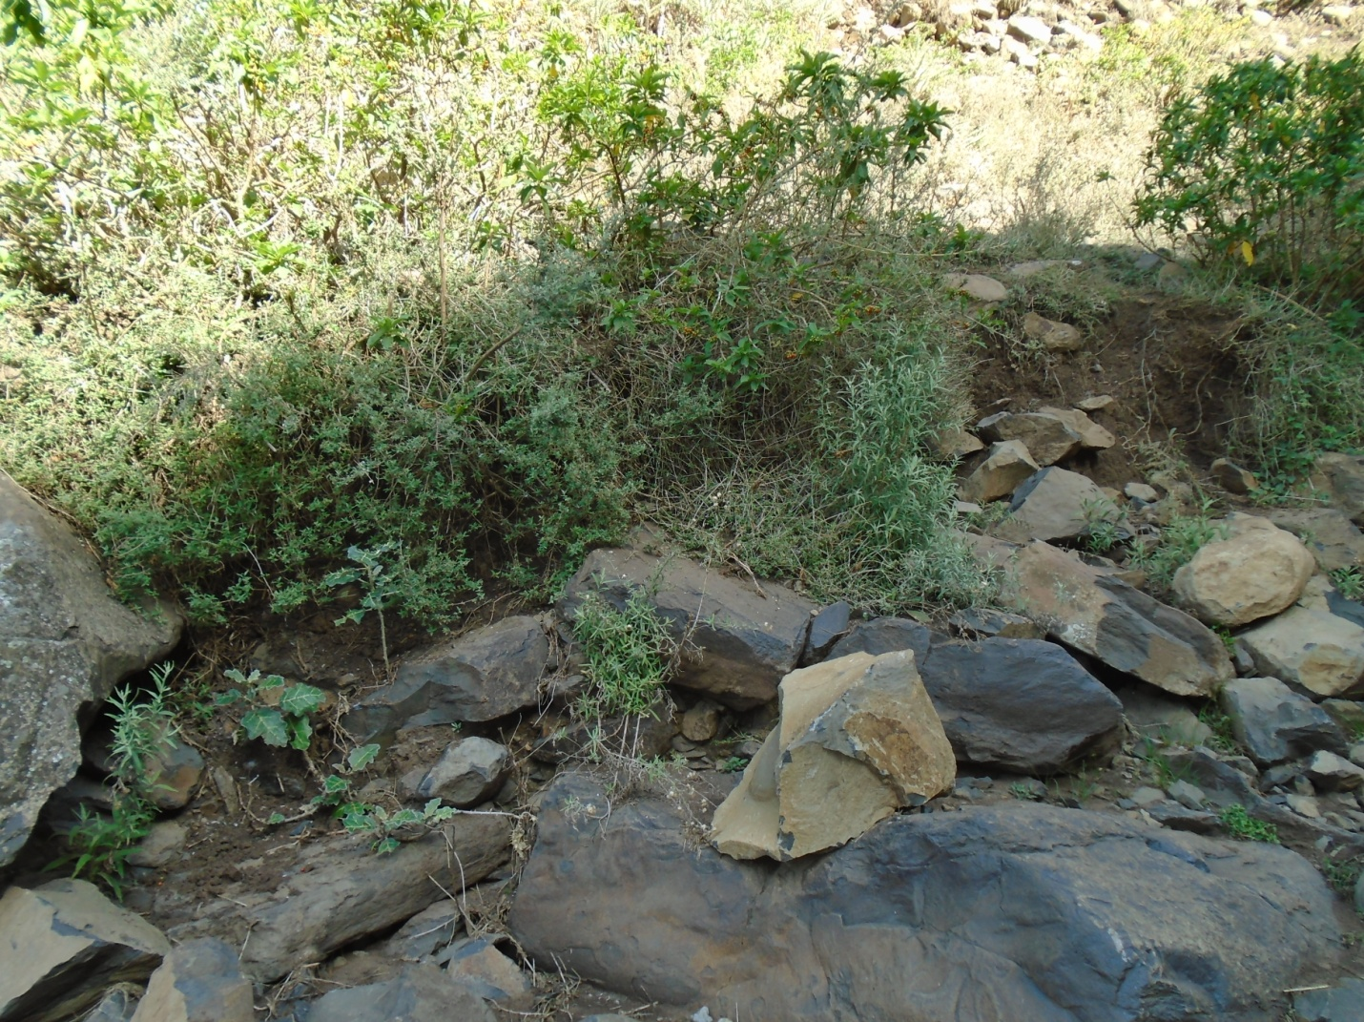
Right banks at top loose material
Figure 3-2: River bank at the proposed intake site

Left Bank
At the proposed headwork axis and immediate vicinities, the left bank forms steep slope topography, having about more than 5m height from stream bed. From surface observation, the bank is covered entirely with boulders. The boulders are intermixed with gravel and cobbles. It has 2 to 4m exposed thickness. It is flood plain deposit having dark brown color. It has weak strength and deposited sources form nearby ridges. But this loose material lies on the top parts of the bed rocks (basalts).This portion bank is dominantly covered with large size of boulders which is fall from nearby ridges’ and it needs cutting by slope to be stable the bank . The bank is now affected by flood erosion that active eroded surfaces are visible (see plate 4.1). So, it is necessary to provide some bank protection structures to prevent ongoing bank erosion
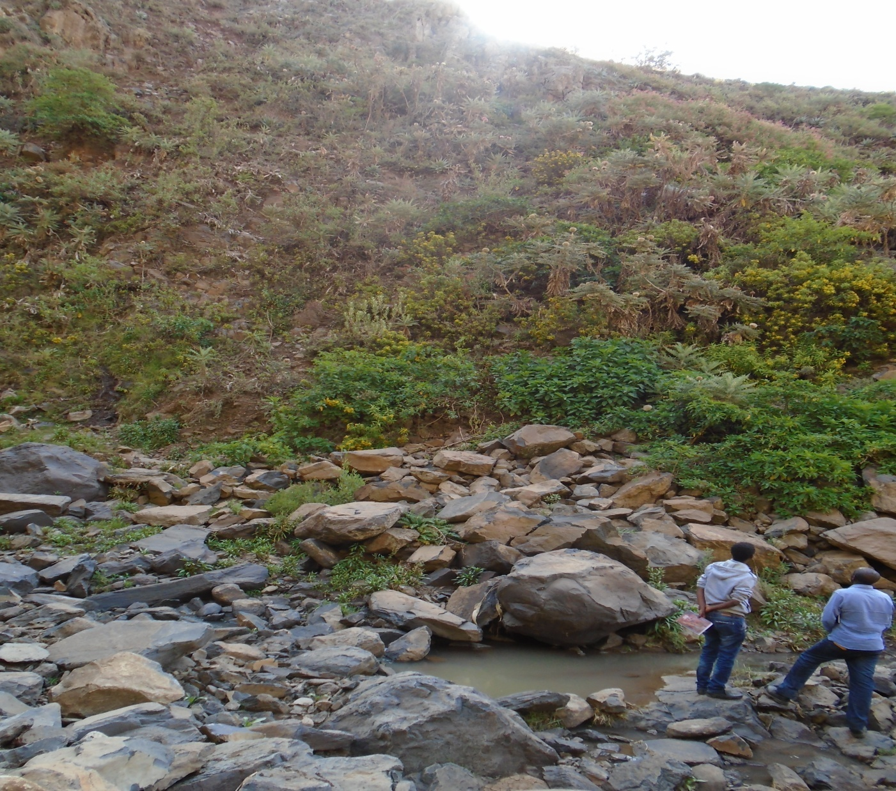
Left banks
Figure 3-3: Left bank at the proposed intake site

Sources of construction materials
During the site investigation, natural construction materials required for the construction of the various proposed engineering structures at the headwork and within the farmland have been assessed, and possible quarry sites and borrow areas have been identified within the vicinity of the area as much as possible. In addition to the identification, the quality, quantity, accessibility condition and ownership of each proposed production sites have also been studied and described in this report; on separate sub-sections below. The natural materials required for the construction of the proposed hydraulic structures include rock for masonry stones, aggregates (both coarse and fine), impervious soil for fill and/or lining, backfill soil, and water.

Rock Quarry
Quarry site that can be used for production of rock for masonry stone and crushed coarse aggregates has been assessed during the field work session within the vicinity of the project area at economic distance for hauling.
One possible quarry site has been identified along the right side ridge following the main canal route at co-ordinates of about 557573mE and 1197342mEwith elevation1635m. Here slightly weathered basaltic rock exposed and forms a continuous ridge parallel to the main canal. It is believed that below this weathered rock, fresh portion of the rock is found and can be used for the intended purpose. This quarry site has good potential and an economic distance from the head work site. It has about 300m form the head site downstream direction at the right banks (with continues ridge segments) jerame rivers.
In this field study, another sources for rock also proposed. The first one is Jerame stream itself and has good potential of rocks for an intended purpose.
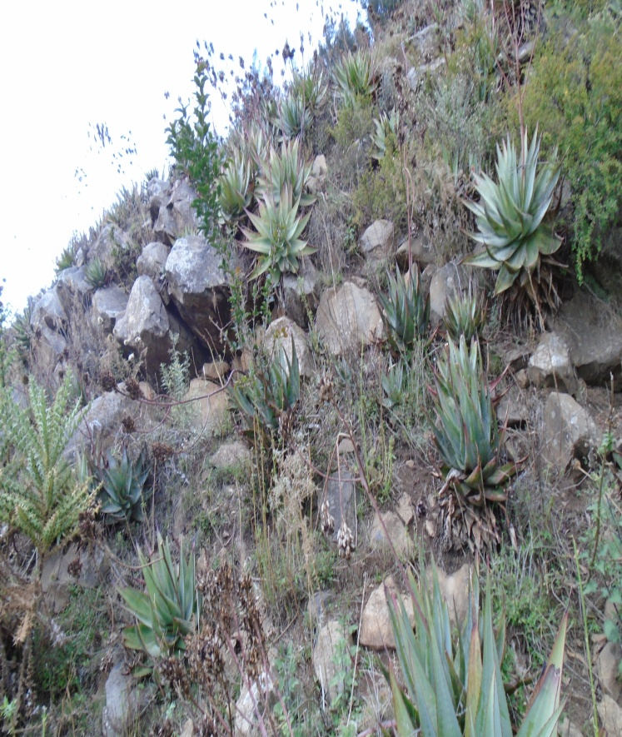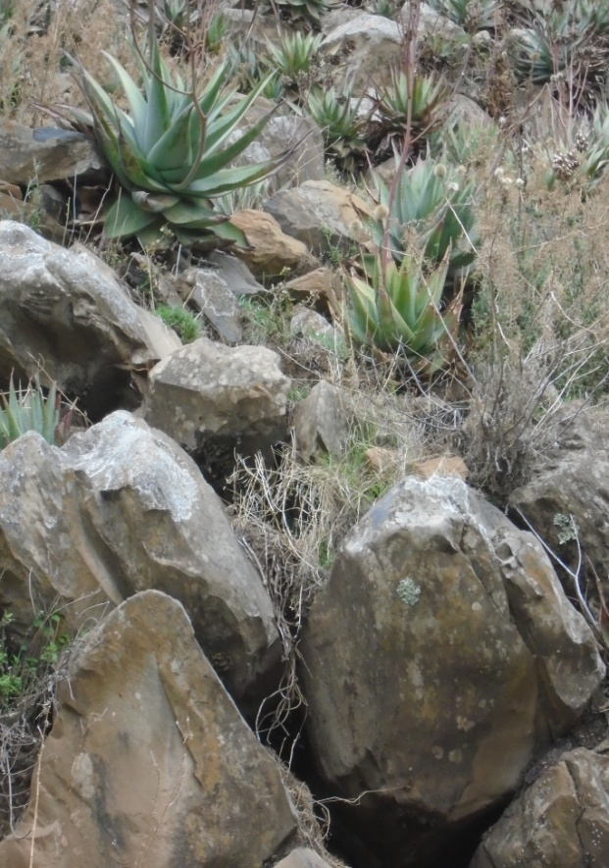
It has good potential for all intended purpose
Figure 3-4: Quarry site

Fine Aggregates
Borrow areas for fine aggregate or natural sand have been assessed starting from the project stream itself. Natural deposits of such materials couldn’t be found when assessed within the beds of the stream in the project area; rather very coarser sediments and rock exposures are found covering almost the entire bed of the workie stream. Seeing to this nature of the stream, other distant streams have been explored to identify the best source areas for fine aggregate or natural sand that can be used for this particular project. During exploration of this natural sand, at a distant one stream was identified as a possible source of fine sand. The stream is known as ‘jara’. It is located at about 40km from the project site, within chefa Robit woreda. A potential source area within the jara stream bed is located alongside the main kemise Robit-Ataye Asphalt road, near to a small village of chefa Robit. Here, there are local legalized sand miners associations, and the sand is acquired from them through negotiation and agreement.
The samples have been analyzed at Amhara Design and Supervision material testing laboratory to characterize the gradation of the sand deposit. According to these laboratory test results (See Annexture-2), the sand deposits from various portion of the jeram stream have grading as indicated in Figure 4.3 (Annexture-1). As the sand will be used as fine aggregate in the construction of concrete and as mortar ingredient for masonry works, its quality has been evaluated based on ASTM C33 specification, especially its grading. The result of the grading evaluation is indicated in Figure4.

Water
Water for construction purposes can be found from the project stream, jerame, itself. The stream is perennial throughout the year that there is some amount of flow along its course. During this field time the stream flow was more than 150L/second.

Hydraulic design of the head work

Headwork Site selection
The headwork site is selected primarily for intake site. Traditionally farmers divert channel from this point and irrigate an estimated amount of 20 ha. The study team tried to see possible sites more upstream and downstream and decided to put the headwork in this location because of the following reasons:-
- Due to the outside curvature it is an ideal site for intake.
- It has enough head to convey the water to the command and upgrading taken as the best solution.
- During low flood coming from the catchment, the river flows close to the left bank that allows water to divert

Headwork Type selection
The headwork type proposed for abstraction of water to the command area is an intake structure at the point where farmers use to divert the river traditionally.
The intake site has been investigated that it is located some 50 m downstream of a natural water fall having 10-15 m height. Around the fall there is an exposed hard rhyolitic rock on the surface while the intake axis is covered with interconnected transported boulders having small to big size up to 1.5m diameter on the surface. The right and left abutments at the head work site are too steep covered with big boulder which moves to the river channel during high flood. Therefore, the study team decided to design an intake structure at the off taking point together with river bank protection, Escape channel and slab cover.
Due to the difficult nature of the intake axis there will be no bed bar or weir recommended at the headwork. Therefore the beneficiaries will be consulted to operate the project in such a way that they will guide the river flow to the intake point to convey the water to the main canal and regularly follow up to avoid the damage of the intake due to boulder transport.
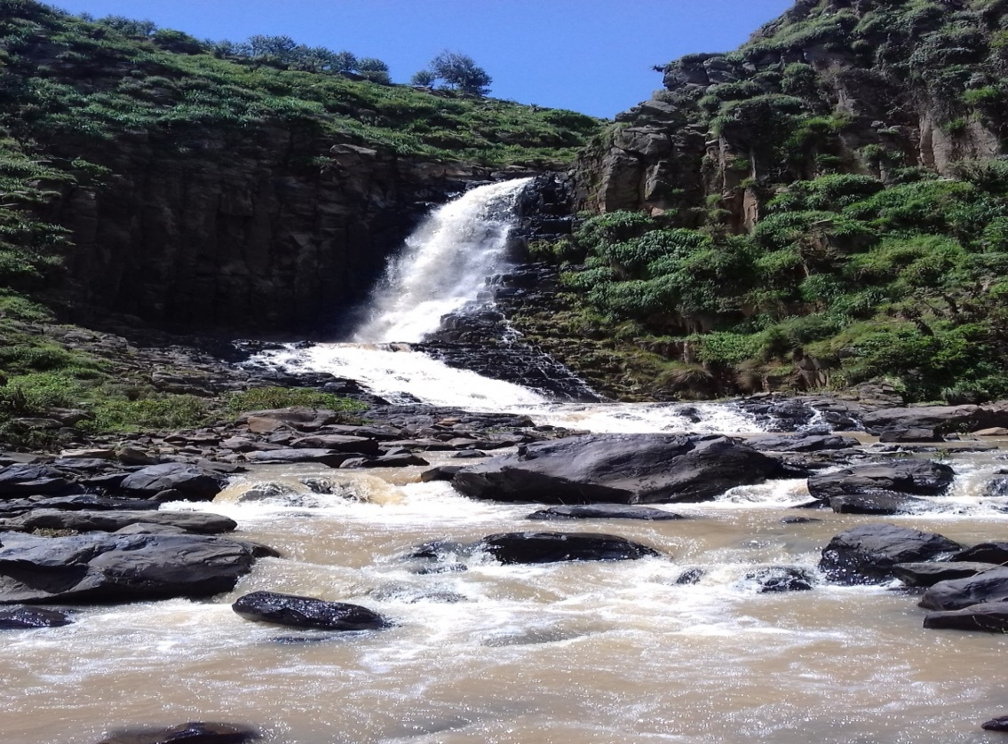
INTAKE LOCATION
Figure 3-5: Intake location
The intake sill level is fixed for the maximum abstraction of water when there is low flow and provided to be on the riverbed level at 2922 m.a.s.l. Since there is no structure to head up the water it is necessary to put the out let sill level on the riverbed possibly at the lowest level.
Option 2 head work type selection and location
An option for ogee weir axis is proposed during ground truthing with the client, but the axis is not selected due to the following reasons
  - The axis is not straight rich and hydraulically not recommended
  - It needs longest crest length and it is uneconomical
  - Unstable bank and bed formation which it geologically not recommended
  - To irrigate the command area it needs very high weir height
So due to this reasons our design team select option 1 head work site (intake site)
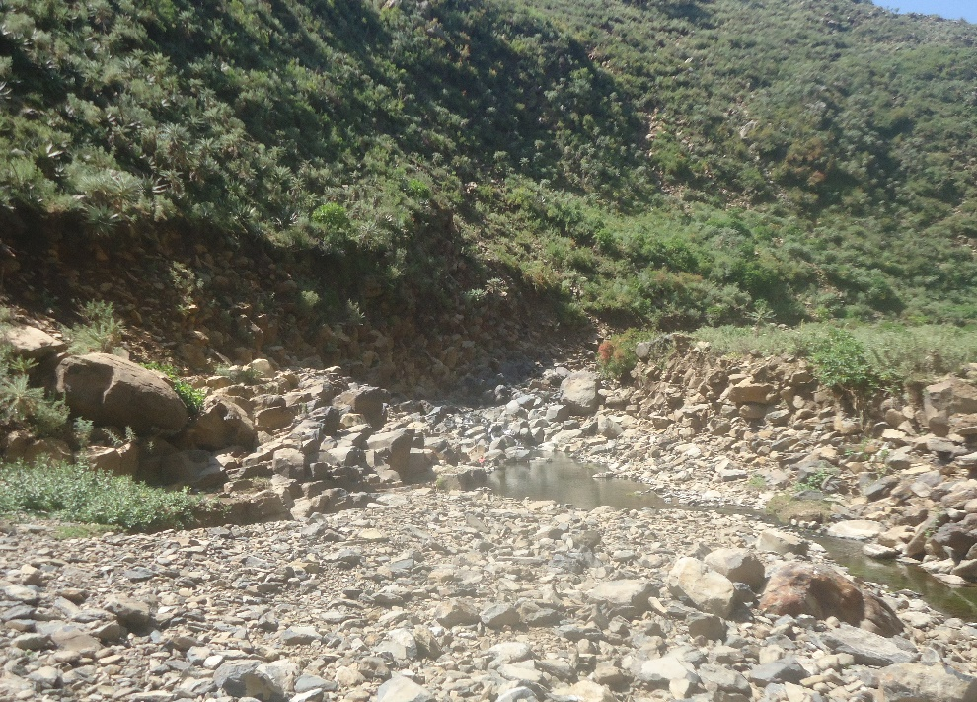
Option 2 head work site
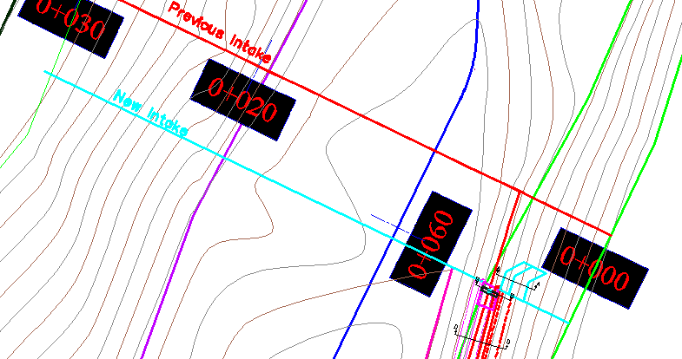

Option 1 lay out
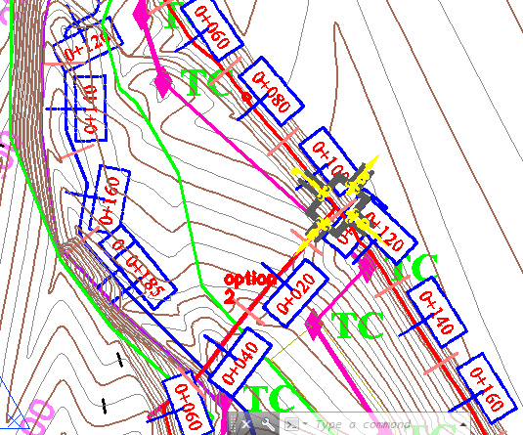
Option 2 lay out
Figure 3-6 Different option locations

Intake Dimensions
As the area is characterized with bimodal rainfall pattern and the flow of the river varies with respect to the rainfall variation the project is designed based on the supplementary irrigation principle during which the flow of the river is good. There will be two supplementary irrigation seasons: The summer and the Belg supplementary irrigation seasons.
Therefore the off take size is fixed taking in to consideration the maximum Duty of the command area and the maximum command area to be irrigated which is 152 ha.
Q = Max.Duty * factor of safety * Command area
Where, maximum duty of 0.95 l/s/ha is taken from agronomy report for an irrigation hour of 17 hr
Q=0.95 l/s/ha*1*152ha
Q=0.144 m3/sec.
Hence our canal capacity and off take size is fixed to convey and pass 0.144 m3/sec of discharge.
The regulator dimension is computed using rectangular notch formula given by:-
Where: Q=diverted discharge, 0.3m3/sec
Cd=Coefficient of discharge, Cd=0.6
B=Width of intake, 0.6m
H=Height of the intake
g=Acceleration due to gravity
Therefore for a width of 0.6m
h= 0.26m,
Total height (H) = h + FB = 0.26+0.14 = 0.4m
Therefore provide intake dimension 0.6X0.4m width and height respectively including easiness of maintenance.

Regime Scour Depth
The intake and guide walls will be provided cutoff underneath based on the scour depth of the river to protect from scouring and uplift. Therefore the regime scour depth is computed using the following Lacey formula:
=24.18
q = 3.11

R=1.35((3.11^2/24.18)^1/3 = 1 m this value is representative for this site
Therefore provide a cutoff to the intake and guide walls with 1m depth

Trash Rack
A trash rack screen is provided in front of the intake structure in order to prevent the entry of floating derbies, and logs enter into the off take. For this project trash rack as height as the get level 0.4m with free board 0.2 height and a width of 0.6 m with free board 0.2m trash rack with 16mm diameter steel spaced at 100mm horizontally and vertically is provided.
The final dimension will be H=0.6m, B=0.8m dia=16mm steel spaced100mm horizontally and vertically

Design of Guide Wall and Protection Works
Masonry guide walls are provided on left side for the purpose of containing the flood flows within the river channel and to reduce bank erosion and maintain the position of an existing riverbank.
The walls were designed to resist the hydraulic conditions that occur at the flood probable maximum of 50-year return period.
The general consideration in design of retaining wall is that the section of the retaining wall must have enough self-weight to resist the thrust due to earth pressure and water pressure for its rear without overturning, sliding, tension and compressive stress developed within the body of the structure.
The height of Maximum design flood governs the height of the retaining wall with some free board provided. The determination of the dimensions of the retaining wall on the upstream and downstream sides of the intake is shown below.

Upstream Wing wall
It’s designed by masonry and it covers only a length of 3m this wing wall is used to protect the upstream bank and it also used to protect the intake from direct hammering of boulders
      - U/S HFL=2923.3 m.a.s.l.
      - U/S bed level=2922.1 m.a.s.l
      - The Retaining wall height should at least reach the u/s HFL to protect over flow and allow gate operating during floods. The top elevation of the retaining wall is 2923.8 m
      - Maximum wall height =2923.3-2922+free board(0.6)=1.7m
Wall height of 1.7m is taken
Table 3-1 Stability analysis of upstream masonry retaining wall
U/S retaining wall dimensions
H | FB | HT |  | B1 | B2 | B
1.20 | 0.50 | 1.70 |  | 0.5 | 0.7 | 1.2

Stability analysis
Code | Load |  | Lever Arm, R | Moment
Code | Vertical | Horizontal | Lever Arm, R | Positive | Negative
W1 | 19.1 |  | 0.3 | 4.8
W2 | 13.4 |  | 0.7 | 9.8
W Soil | 11.3 |  | 1.0 | 10.9
P Soil |  | 9.1 | 0.6 |  | 5.1
SUM | 43.8 | 9.1 |  | 25.5 | 5.1

Factor of safety against,
Over turning = (M+ve/M-ve) >1.5 |  |  |  | Fo | 4.97 | >1.5 | OK
Sliding = (µxFv/Fh),---µ=0.75 >1.5 |  |  |  | Fs | 3.63 | >1.50 | OK
Tension: X= (Net Moment/Sum Fv), e=x-B/2, e<B/6 |  |  |  | X | 0.47
 |  | B/6= | 0.20 | e | 0.13 | <B/6 | OK

The above table (12) shows that the upstream masonry retaining wall is safe against overturning, sliding and tension with height 1.7, bottom width 1.2 and top width 0.5m

Bill of Quantity and Cost Estimation
The quantities of the various items have been worked out as per the final design and final drawings prepared for the scheme. The unit rates analysis has been carried out based on the data available in the vicinity of the project area.
Bill No.1 General Items
S/N | Description | Unit | Quantity | Unit Price (Birr) | Amount (Birr)
1.1 | Allow for mobilization | L.S | 1.0 | 158567.42 | 158,567.4
1.2 | Allow for demobilization | L.S | 1.0 | 142710.68 | 142,710.7
1.3 | Allow for contractor’s camping facilities 3*4m2, Living room for contractors key personnel, CIS G32 and internally painted clip wood wall, Masonry floor cement screened and well ventilated room complete with doors and windows. | No | 4.0 | 58741.8 | 234,967.2
 | Allow for Consultant’s camping facilities 3*4m2, Living room for contractors key personnel, CIS G32 and internally painted clip wood wall, Masonry floor cement screened and well ventilated room complete with doors and windows. | No | 2.0 | 58741.8 | 117,483.6
 | 5*5m2, Store and dining room constructed from CIS G32 with doors and windows, Masonry floor cement screened | No | 1.0 | 65561.9 | 65,561.9
 | Barbed wire fence 60*20m and 1.5m high treated timber post complete with 3m wide gate and a CIS guard house (1.5*2m) | No | 1.0 | 64580.08 | 64,580.1
 | Construction of Toilet and shower for the comap facility as per drawing(2*1.5) | No | 2.0 | 20,000.0 | 40,000.0
1.4 | Allow for temporary access road (in km) to site including clearing and ditch constraction | km | 2.0 | 125253.68 | 250,507.4
1.5 | Dewatering of open trenches and excavations, pumps | LS | 1.0 | 63850 | 63,850.0
1.6 | Provide project indicator post starting from the construction time | LS | 1.0 | 9500 | 9,500.0
1.7 | Provision of as built drawings for the project | LS | 1.0 | 36245 | 36,245.0
 | Sub Total |  |  |  | 1,183,973.24

Bill No.2 - Head work
S/N | Description | Unit | Quantity | Unit Price | Amount (Birr)
1 | Left Side of Intake Masonary Guide Wall U/S
1.1 | Ordinady soil excavation | m³ | 11.39 | 110 | 1,252.35
1.2 | Boulder excavation | m³ | 7.97 | 650 | 5,180.18
1.3 | Back fill | m³ | 5.87 | 75 | 439.88
1.4 | Masonry | m³ | 5.08 | 1600 | 8,132.80
1.5 | Lean concrete (C-10) | m² | 2.99 | 1902.3 | 5,687.88
1.6 | Pointing | m² | 3.91 | 78 | 304.98
1.7 | Reinforced concrete for cutoff |  |  |  | -
1.7.1 | Concrete C-20 | m³ | 0.69 | 2700 | 1,863.00
1.7.2 | Iron bar ꬷ 14mm | kg | 80.62 | 65 | 5,239.98
 | Sub Total |  |  |  | 28,101.03

SECTION-III: IRRIGATION AND DRAINAGE SYSTEMS INFRASTRUCTURE

IRRIGATION AND DRAINAGE SYSTEMS DESIGN

4.1 Irrigable Area Description

Topography
Topography is an important factor for the planning of any irrigation project as it influences method of irrigation, drainage, erosion, mechanization, and cost of land development, labor requirement and choice of crops.
The topographic feature of the project command area is mainly sloping type. Its elevation range is from 2810 to 2920 meters above sea level. The slope gradient also ranges from gently sloping (3%) to strongly sloping (13%). However, it has identified to be suitable for surface irrigation. Nevertheless, it requires soil and water conservation measures or structures (i.e. constructing bunds, bio-physicals, check dams, artificial water ways, etc.).
The project command area is situated at the left and right side of Jerami River/stream (to the East and west side of the river). The natural topographic feature of the command area has inclined from the West-North to the South-East direction.

Climate
As per the hydrological analysis and on the basis of the traditional Ethiopian Agro-Ecological Zones (MOA, 2001), the UGDWIP area is basically classified as Dega agro-ecology which is conducive to the production of tropical lowland crops. The project area has Bimodal and uneven distribution pattern of rainfall. The main rain season, locally known as Keremt, occurs from end of June to end of August with about 55% share of annual rainfall; and about 45% of the annual rainfall occurs during the dry season from October to May.
As the project site has no its own meteorological station. Generally, the project area is represented by Dessie Zuria (for rainfall and minimum and maximum temperature) and (for relative humidity, wind speed and sunshine hour) meteorological stations data were used for the project study as long as these stations are relatively near to the proposed command area. In general, the sources of meteorological data are the National Meteorology Service Agency (NMSA).

Soil characteristics
Soil properties (physical, chemical, etc.) greatly influence the growth and thereby yield of crops which is grown. The command area has predominantly clay loam textured soils. Most of the study area soils are categorized as deep soil (60-100cm depth). Soils of the command area are suitable for most of the selected crops to be grown (for further detail see the Agronomy Study of the same project.

Existing Irrigation Practices in the Project Area
The pressure of survival and the need for additional food supplies to meet the demands of the increasing population is necessitating a rapid expansion of irrigation schemes. Thus, irrigation is becoming a basic part of well-developed agriculture wherever there is water and irrigable land potential. Accordingly, traditional irrigation practices are under taken by individual farmers that use the river flow to the Right and Left side is with laborious temporary diversions. So, the farmers in the project area are very much interested in the idea of upgrading the traditional scheme to modern scheme.

Irrigation Water Requirement

Crop Water Requirement (CWR)
The calculation of crop water requirement is a very important aspect for planning of any irrigation project. Several methods and procedures are available for this. The Food and Agriculture Organization (FAO) of the United Nations has also made available several publications on this subject and other issues related with this. The computer program available in FAO Irrigation and Drainage Paper No. 56 “CROPWAT” has been used for the calculation of Crop Water requirement. This program is based on Penman-Monteith approach and procedures for calculation of crop water requirements and irrigation requirements are mainly based on methodologies presented in FAO Irrigation and Drainage Paper No. 24 “Crop Water Requirements” and No. 33 “Yield Response to Water”.
The corresponding values of the crop water requirements of the proposed crops of the project are presented in the Agronomy Study of the same project.

Irrigation efficiency (Ep)
To complete the evaluation of the demand, the efficiency of the water distribution system and of application must be known.
The gross requirement of water for irrigation system is very much dependent on the overall efficiency of the irrigation system, which in turn is dependent on several factors: Method of irrigation, type of canal (Lined and/or Unlined), method of operations (simultaneously and continuous or Rotational water supply), and availability of structures (for controlling and distribution and measuring and monitoring).
On the basis of these factors, the project has planned to impose surface irrigation method (using furrows). The canal system is lined. Hence, the conveyance efficiency has been estimated to be 95%, and field application efficiency 60%. As a result of these the overall irrigation efficiency has been estimated to be 55%. According to soil Lab result, soils of the command area are predominantly characterized as clay loam soils.

Irrigation duty
Irrigation duty is the volume of water required per hectare for the full flange of the crops. Moreover, it helps in designing an efficient irrigation canal system.
The area, which will be irrigated, can be calculated by knowing the total available water at the source and the overall duty for all crops required to be irrigated in different seasons of the years.
The proposed cropping pattern of Jeram intake irrigation project has showed average net irrigation water requirement (NIWR) in the month of February with the amount of 3.2 mm/day for 17 working hours (for overall proposed crops).
For Jeram River Intake Irrigation Project, it decided to adopt 60% field application efficiency, and 95% conveyance efficiency as the soil is clay loam textured and the main and secondary canal systems are estimated to be lined. Hence, the overall/project efficiency for the selected surface irrigation method has been estimated to be 57% (60/100*95/100) which is rounded to 55%.
For the designing of the project, the GIWR is given as follows:
GIWR = NIWR/e = 3.2/0.55 = 5.82 [mm/day]
The GIWR, 5.82 mm/day, represents the daily quantity of water that is required to be applied. This water quantity is also used for the determination of the canal discharge in consideration of the time of flow and is defined as the duty, expressed as l/s/ha.
The duty is calculated by:
Duty (D) = GIWR × 1000 × 10 / (t × 60×60)
Where; Duty – the duty [l/s/ha]
GIWR – Gross Irrigation Requirement [mm/day]
t – Daily irrigation or flow hours [hrs]
The duty for the GIWR of 5.82 mm/day and 17 hours of daily irrigation time (t = 17), is supported to be used with furrow irrigation method. Hence, Duty for 17 working hours, as the site is nearer to farmers’ village and local farmers have experiences in irrigation, is computed as follows:
D = (5.82x10x1000) / (17x3600) = 0.95l/s/ha

Irrigation methods
Among the different irrigation systems Surface irrigation system i.e furrow irrigation method will be used for the project area; and the irrigation water will be obtained from Jeram River and by constructing diversion intake and conveying the water commonly through lined main and secondary canals and earthen tertiary canal and then leading to field canals; and finally irrigation takes place mostly in furrows.
For this project, among the various irrigation methods, surface irrigation method has been selected. Of the surface irrigation methods furrow, border and basin irrigation methods can be used to supply irrigation water to the plants/crops. However, each method has its own advantages and disadvantages. Care should be taken when choosing the method which is best suited to the local circumstances, i.e., depending on slopes, soil types, selected crop types, amount of water available, etc. of the command area.
Based on the above factors surface irrigation method has been proposed for the proposed crops in this project. The method allows applying light irrigation and can be laid out in sloping fields along the contour. Furrow irrigation method is best suited for most of the proposed and row planted crops. In general, furrow irrigation method is simple, manageable and widely practiced irrigation method. This method is suitable for row crops that cannot stand in water for long periods. The only thing required to use this method is row planting of crops. Besides, basin and border irrigation method would be used for the non-row planted crops. Rotational flow water distribution is also recommended for the project area.

Irrigation and Drainage System Layout
The irrigation system layout for the project is prepared taking the following points into consideration besides other factors.
- A primary concern in the layout of the system is that it serves the purpose of conveying and distributing water to the command area.
- The excavation and earth fill volumes not be excessive, otherwise the construction costs can be tremendous.
- The selection of longitudinal bed slope is made taking into account the existing slopes of the terrain, so as to minimize deviations in canal routing.
- Curves in canals should not be too sharp.
The proposed irrigation system layout comprises two main canal (LMC and RMC), seven secondary canals and forty five tertiary canals as shown on the layout Drawings. The main canals run for most of their lengths are parallel to the contours and several changes of direction are necessary to follow the topography. RMC crosses two main gullies and two foot path structures. LMC crosses one main, two small gullies and one foot path structures.

The project is designed to irrigate command area of 151 ha using the irrigation system layout. The area of land irrigated by each canal system of the main, secondary and tertiary canals has been tabulated and shown below.

No | Name of the canal | Command area, ha
1 | RMC | 84.60
 | TC-1 | 1.40
 | TC-2 | 3.70
 | TC-3 | 1.66
1.1 | RSC1 | 33.94
 | TC-1 | 8.96
 | TC-2 | 4.84
 | TC-3 | 7.40
 | TC-4 | 7.02
 | TC-5 | 5.72
1.2 | RSC2 | 36.03
 | TC-1 | 7.51
 | TC-2 | 2.94
 | TC-3 | 5.09
 | TC-4 | 5.58
 | TC-5 | 5.37
 | TC-6 | 4.08
 | TC-7 | 5.46
1.3 | RSC3 | 7.87
 | TC-1 | 1.73
 | TC-2 | 3.36
 | TC-3 | 2.78
2 | LMC | 67.13
 | TC-1 | 3.21
 | TC-2 | 1.12
 | TC-3 | 0.60
 | TC-4 | 0.61
 | TC-5 | 0.17
 | TC-6 | 1.73
 | TC-7 | 2.45
 | TC-8 | 1.43
 | TC-9 | 4.25
2.1 | LSC1 | 20.60
 | TC-1 | 1.47
 | TC-2 | 5.01
 | TC-3 | 4.12
 | TC-4 | 6.82
 | TC-5 | 3.18
2.2 | LSC2 | 8.01
 | TC-1 | 2.25
 | TC-2 | 1.31
 | TC-3 | 1.32
 | TC-4 | 3.13
2.3 | LSC3 | 5.11
 | TC-1 | 0.90
 | TC-2 | 1.66
 | TC-3 | 1.41
 | TC-4 | 0.77
 | TC-5 | 0.37
2.4 | LSC4 | 17.84
 | TC-1 | 4.24
 | TC-2 | 6.06
 | TC-3 | 1.37
 | TC-4 | 3.25
 | TC-5 | 2.92
 | Total area, ha | 151.73

Conveyance System
The conveyance system consists of two Main canals to irrigate total command area of 152 ha. The main conveyor canal serving all the project command areas, starting at the intake outlet. The beneficiary farmers will guide the flow of water from the first proposed intake site to the newly modified intake site some 5.5 m downstream as it has been verified that constructing bed bar at the intake site will not be effective. The Main Canals are designed for 17 hr. continuous supply when irrigation is required and is provided with Reinforced Concrete rectangular canal at Chainage (0+005 – 0+033). The rest of the chainages of the main canal are designed to be constructed from masonry. The main canal alignment align from the left side and branched into two i.e Right Main Canal and Left Main Canal which length of 2.14km and 3.054 km each respectively. The left main canal is designed to irrigate 84ha of land and the right main canal is designed to irrigate 67 ha of land.
Main canals are aligned along contours and supplies to seven secondary unit and forty-five tertiary canals. The seven secondary canals are aligned on steep slope routs which are exposed for scouring of the structure. Therefore it has been designed to be reinforced concrete (C-20) with reinforcement iron bar of diameter 8mm to withstand the scouring effect of the flow of water. The tertiary canals are aligned along the contours and the dominant soil type of the command area is clay soil. Therefore the tertiary canals are designed to be earthen trapezoidal shape canals.

Design of the Canal System

Flow Depth and Section Capacity
The earthen canals have been designed with a trapezoidal shape and the lined ones with rectangular x-section using Manning's Formula:
Where Q= discharge (m³/s)
R= Hydraulic radius (Flow area/wetted perimeter) S= Hydraulic gradient
n= Manning's roughness coefficient, n=0.03 is adopted for the earth channels and n=0.018 for the masonry lined part of the main canal

Main Canal
The main canals are designed for a discharge of 145l/s and depending on the site specific condition, appropriate slope is provided. Hydraulic parameters of the main canal are shown below.

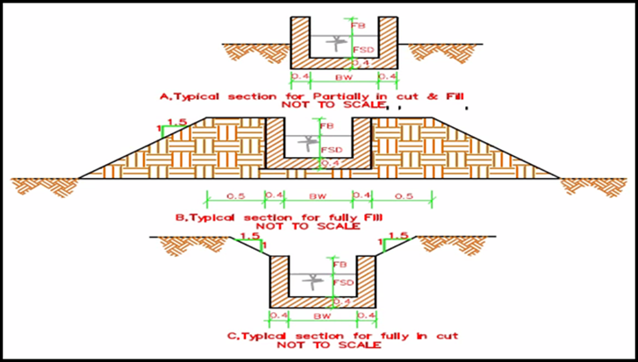
Figure 4-1 Typical cross section of Main canal

Table 4-1: Hydraulic Parameters of main canal
Canal | Chainage (m) | Anet (ha) | Duty (l/s/ha) | Q_{reqd} (m3/s) | n | s | b | m | d | A(m2) | P(m) | R(m) | V(m/s) | Q_{calcu} | fb(m) | D(m) | T(m) | Remark
LMC | 0 + 000 - 0+05 | 152.00 | 0.95 | 0.1444 | 0.03 | 0.001 | 0.6 | 1 | 0.40 | 0.40 | 1.73 | 0.23 | 0.40 | 0.159 | 0.3 | 0.70 | 2.00 | Earthen
LMC | 0 + 005 - 0+033 | 152.00 | 0.95 | 0.1444 | 0.013 | 0.0010 | 0.60 | 0 | 0.34 | 0.20 | 1.28 | 0.16 | 0.71 | 0.145 | 0.26 | 0.60 | 0.60 | Reinforced concrete
LMC | 0 + 033 - 0+109 | 152.00 | 0.95 | 0.1444 | 0.018 | 0.0010 | 0.70 | 0 | 0.37 | 0.26 | 1.44 | 0.18 | 0.56 | 0.145 | 0.30 | 0.67 | 0.70 | Masonry rectangular
LMC | 0+109 - 0+359 | 67.30 | 0.95 | 0.0639 | 0.018 | 0.0010 | 0.50 | 0 | 0.28 | 0.14 | 1.06 | 0.13 | 0.46 | 0.064 | 0.30 | 0.58 | 0.50 | Masonry rectangular
LMC | 0+359 - 0+560 | 67.30 | 0.95 | 0.0639 | 0.018 | 0.0040 | 0.40 | 0 | 0.21 | 0.08 | 0.82 | 0.10 | 0.77 | 0.064 | 0.30 | 0.51 | 0.40 | Masonry rectangular
LMC | 0+560 - 0+750 | 62.98 | 0.95 | 0.0598 | 0.018 | 0.0040 | 0.40 | 0 | 0.20 | 0.08 | 0.80 | 0.10 | 0.75 | 0.060 | 0.30 | 0.50 | 0.40 | Masonry rectangular
LMC | 0+750 - 0+933 | 42.39 | 0.95 | 0.0403 | 0.018 | 0.0040 | 0.40 | 0 | 0.15 | 0.06 | 0.70 | 0.09 | 0.68 | 0.040 | 0.30 | 0.45 | 0.40 | Masonry rectangular
LMC | 0+933 - 1+112 | 42.39 | 0.95 | 0.0403 | 0.018 | 0.0014 | 0.40 | 0 | 0.22 | 0.09 | 0.83 | 0.10 | 0.46 | 0.040 | 0.28 | 0.50 | 0.40 | Masonry rectangular
LMC | 1+112 - 1+180 | 42.39 | 0.95 | 0.0403 | 0.018 | 0.0050 | 0.40 | 0 | 0.14 | 0.05 | 0.67 | 0.08 | 0.74 | 0.041 | 0.28 | 0.42 | 0.40 | Masonry rectangular
LMC | 1+180 - 1+260 | 42.39 | 0.95 | 0.0403 | 0.018 | 0.0020 | 0.40 | 0 | 0.19 | 0.08 | 0.78 | 0.10 | 0.53 | 0.040 | 0.28 | 0.47 | 0.40 | Masonry rectangular
LMC | 1+260 - 1+449 | 34.39 | 0.95 | 0.0327 | 0.018 | 0.0020 | 0.40 | 0 | 0.16 | 0.07 | 0.73 | 0.09 | 0.50 | 0.033 | 0.29 | 0.45 | 0.40 | Masonry rectangular
LMC | 1+449 - 1+640 | 34.39 | 0.95 | 0.0327 | 0.018 | 0.0014 | 0.40 | 0 | 0.19 | 0.07 | 0.77 | 0.10 | 0.44 | 0.033 | 0.28 | 0.47 | 0.40 | Masonry rectangular
LMC | 1+640 - 1+883 | 33.18 | 0.95 | 0.0315 | 0.018 | 0.0014 | 0.40 | 0 | 0.18 | 0.07 | 0.77 | 0.10 | 0.44 | 0.033 | 0.28 | 0.46 | 0.40 | Masonry rectangular
LMC | 1+883 - 1+933 | 33.18 | 0.95 | 0.0315 | 0.018 | 0.0025 | 0.40 | 0 | 0.15 | 0.06 | 0.69 | 0.08 | 0.54 | 0.032 | 0.29 | 0.44 | 0.40 | Masonry rectangular
LMC | 1+933 - 2+291 | 31.28 | 0.95 | 0.0297 | 0.018 | 0.0025 | 0.40 | 0 | 0.14 | 0.06 | 0.68 | 0.08 | 0.53 | 0.030 | 0.28 | 0.42 | 0.40 | Masonry rectangular
LMC | 2+291 - 2+754 | 26.17 | 0.95 | 0.0249 | 0.018 | 0.0025 | 0.40 | 0 | 0.13 | 0.05 | 0.65 | 0.08 | 0.50 | 0.025 | 0.25 | 0.38 | 0.40 | Masonry rectangular
LMC | 2+754 - 2+922 | 22.29 | 0.95 | 0.0212 | 0.018 | 0.0025 | 0.40 | 0 | 0.11 | 0.04 | 0.62 | 0.07 | 0.48 | 0.021 | 0.25 | 0.36 | 0.40 | Masonry rectangular
LMC | 2+922 - 3+052 | 22.29 | 0.95 | 0.0212 | 0.018 | 0.0040 | 0.35 | 0 | 0.11 | 0.04 | 0.56 | 0.07 | 0.57 | 0.021 | 0.25 | 0.36 | 0.35 | Masonry rectangular
RMC | 0+000 - 0+168 | 84.7 | 0.95 | 0.0805 | 0.018 | 0.0014 | 0.55 | 0 | 0.27 | 0.15 | 1.08 | 0.13 | 0.55 | 0.081 | 0.35 | 0.62 | 0.55 | Masonry rectangular
RMC | 0 + 168 - 0+380 | 84.70 | 0.95 | 0.0805 | 0.018 | 0.0040 | 0.40 | 0 | 0.25 | 0.10 | 0.90 | 0.11 | 0.81 | 0.081 | 0.30 | 0.55 | 0.40 | Masonry rectangular
RMC | 0+380 - 656 | 79.60 | 0.95 | 0.0756 | 0.018 | 0.0040 | 0.40 | 0 | 0.24 | 0.09 | 0.87 | 0.11 | 0.80 | 0.076 | 0.28 | 0.52 | 0.40 | Masonry rectangular
RMC | 0+656 - 0+800 | 79.60 | 0.95 | 0.0756 | 0.018 | 0.0025 | 0.40 | 0 | 0.28 | 0.11 | 0.97 | 0.12 | 0.67 | 0.076 | 0.28 | 0.56 | 0.40 | Masonry rectangular
RMC | 0+800 - 1+055 | 45.66 | 0.95 | 0.0434 | 0.018 | 0.0025 | 0.40 | 0 | 0.19 | 0.07 | 0.77 | 0.10 | 0.58 | 0.044 | 0.28 | 0.47 | 0.40 | Masonry rectangular
RMC | 1+055 - 1+420 | 45.66 | 0.95 | 0.0434 | 0.018 | 0.0075 | 0.40 | 0 | 0.13 | 0.05 | 0.65 | 0.08 | 0.87 | 0.044 | 0.27 | 0.40 | 0.40 | Masonry rectangular
RMC | 1+420 - 1+474 | 9.64 | 0.95 | 0.0092 | 0.018 | 0.0075 | 0.40 | 0 | 0.05 | 0.02 | 0.49 | 0.04 | 0.53 | 0.010 | 0.27 | 0.32 | 0.40 | Masonry rectangular
RMC | 1+474 - 1+614 | 9.64 | 0.95 | 0.0092 | 0.018 | 0.0020 | 0.40 | 0 | 0.07 | 0.03 | 0.54 | 0.05 | 0.34 | 0.009 | 0.25 | 0.32 | 0.40 | Masonry rectangular
RMC | 1+614 - 1+774 | 9.64 | 0.95 | 0.0092 | 0.018 | 0.0909 | 0.40 | 0 | 0.02 | 0.01 | 0.44 | 0.02 | 1.16 | 0.009 | 0.28 | 0.30 | 0.40 | Masonry rectangular
RMC | 1+774 - 1+814 | 9.64 | 0.95 | 0.0092 | 0.018 | 0.1250 | 0.40 | 0 | 0.02 | 0.01 | 0.44 | 0.02 | 1.29 | 0.009 | 0.28 | 0.30 | 0.40 | Masonry rectangular
RMC | 1+814 - 1+914 | 9.64 | 0.95 | 0.0092 | 0.018 | 0.1429 | 0.40 | 0 | 0.02 | 0.01 | 0.44 | 0.02 | 1.34 | 0.009 | 0.28 | 0.30 | 0.40 | Masonry rectangular
RMC | 1+914 - 1+944 | 9.64 | 0.95 | 0.0092 | 0.018 | 0.1000 | 0.40 | 0 | 0.02 | 0.01 | 0.44 | 0.02 | 1.20 | 0.009 | 0.28 | 0.30 | 0.40 | Masonry rectangular
RMC | 1+944 - 2+052 | 9.64 | 0.95 | 0.0092 | 0.018 | 0.0182 | 0.40 | 0 | 0.03 | 0.01 | 0.47 | 0.03 | 0.70 | 0.009 | 0.28 | 0.31 | 0.40 | Masonry rectangular
RMC | 2+052 - 2+140 | 9.64 | 0.95 | 0.0092 | 0.018 | 0.0083 | 0.40 | 0 | 0.04 | 0.02 | 0.49 | 0.04 | 0.54 | 0.009 | 0.28 | 0.32 | 0.40 | Masonry rectangular

b = Canal bottom width Q_{reqd}= Required discharge
d = Full supply depth Q_{calcu} = Designed Discharge
Fb= Free board P = Wetted Perimeter
m = Side slope T = Top width of the canal
V = Velocity D = Total depth of the canal (d+Fb)

4.4.2 Secondary Canals
Table 4-2: Hydraulic Parameters of secondary canals
Canal | Chainage (m) | Anet (ha) | Duty (l/s/ha) | Q_{reqd} (m3/s) | n | s | b | m | d | A(m2) | P(m) | R(m) | V(m/s) | Q_{calcu} | fb(m) | D(m) | T(m) | Remark
LMC_SC-1 | 0 + 000 -0+010 | 20.58 | 0.95 | 0.0196 | 0.013 | 0.2083 | 0.30 | 0 | 0.02 | 0.01 | 0.34 | 0.02 | 2.38 | 0.014 | 0.28 | 0.30 | 0.30 | Reinforced concrete
LMC_SC-1 | 0+010 - 0+029 | 14.11 | 0.95 | 0.0134 | 0.013 | 0.2083 | 0.30 | 0 | 0.02 | 0.01 | 0.35 | 0.02 | 2.64 | 0.019 | 0.28 | 0.30 | 0.30 | Reinforced concrete
LMC_SC-1 | 0+029 - 0+039 | 14.11 | 0.95 | 0.0134 | 0.013 | 0.0100 | 0.30 | 0 | 0.06 | 0.02 | 0.43 | 0.05 | 0.98 | 0.019 | 0.28 | 0.34 | 0.30 | Reinforced concrete
LMC_SC-1 | 0+039 - 0+048 | 14.11 | 0.95 | 0.0134 | 0.013 | 0.2083 | 0.30 | 0 | 0.02 | 0.01 | 0.35 | 0.02 | 2.64 | 0.019 | 0.28 | 0.30 | 0.30 | Reinforced concrete
LMC_SC-1 | 0+048 - 0+068 | 14.11 | 0.95 | 0.0134 | 0.013 | 0.2500 | 0.30 | 0 | 0.02 | 0.01 | 0.35 | 0.02 | 2.80 | 0.019 | 0.28 | 0.30 | 0.30 | Reinforced concrete
LMC_SC-1 | 0+068 - 0+087 | 14.11 | 0.95 | 0.0134 | 0.013 | 0.4000 | 0.30 | 0 | 0.02 | 0.01 | 0.34 | 0.02 | 3.24 | 0.019 | 0.28 | 0.30 | 0.30 | Reinforced concrete
LMC_SC-1 | 0+087 - 0+107 | 14.11 | 0.95 | 0.0134 | 0.013 | 0.3571 | 0.30 | 0 | 0.02 | 0.01 | 0.34 | 0.02 | 3.12 | 0.019 | 0.28 | 0.30 | 0.30 | Reinforced concrete
LMC_SC-1 | 0+107 - 0+116 | 14.11 | 0.95 | 0.0134 | 0.013 | 0.3125 | 0.30 | 0 | 0.02 | 0.01 | 0.34 | 0.02 | 3.03 | 0.019 | 0.28 | 0.30 | 0.30 | Reinforced concrete
LMC_SC-1 | 0 + 116 - 0+126 | 3.18 | 0.95 | 0.0030 | 0.013 | 0.2000 | 0.30 | 0 | 0.01 | 0.00 | 0.32 | 0.01 | 1.56 | 0.005 | 0.29 | 0.30 | 0.30 | Reinforced concrete
LMC_SC-1 | 0 + 126 -0+136 | 3.18 | 0.95 | 0.0030 | 0.013 | 0.1000 | 0.30 | 0 | 0.01 | 0.00 | 0.32 | 0.01 | 1.03 | 0.003 | 0.29 | 0.30 | 0.30 | Reinforced concrete
LMC_SC-1 | 0+136 - 0+145 | 3.18 | 0.95 | 0.0030 | 0.013 | 0.0067 | 0.30 | 0 | 0.02 | 0.01 | 0.35 | 0.02 | 0.47 | 0.003 | 0.29 | 0.31 | 0.30 | Reinforced concrete
LMC_SC-1 | 0+145 - 0+165 | 3.18 | 0.95 | 0.0030 | 0.013 | 0.1333 | 0.30 | 0 | 0.01 | 0.00 | 0.32 | 0.01 | 1.19 | 0.003 | 0.29 | 0.30 | 0.30 | Reinforced concrete
LMC_SC-1 | 0+165 - 0+184 | 3.18 | 0.95 | 0.0030 | 0.013 | 0.0100 | 0.30 | 0 | 0.02 | 0.01 | 0.35 | 0.02 | 0.57 | 0.004 | 0.29 | 0.31 | 0.30 | Reinforced concrete
LMC_SC-1 | 0+184 - 0+194 | 3.18 | 0.95 | 0.0030 | 0.013 | 0.0667 | 0.30 | 0 | 0.01 | 0.00 | 0.32 | 0.01 | 1.00 | 0.004 | 0.29 | 0.30 | 0.30 | Reinforced concrete
LMC_SC-1 | 0+194 - 0+222 | 3.18 | 0.95 | 0.0030 | 0.013 | 0.0100 | 0.30 | 0 | 0.02 | 0.01 | 0.35 | 0.02 | 0.57 | 0.004 | 0.29 | 0.31 | 0.30 | Reinforced concrete
LMC_SC-1 | 0+222 - 0+251 | 3.18 | 0.95 | 0.0030 | 0.013 | 0.1000 | 0.30 | 0 | 0.01 | 0.00 | 0.32 | 0.01 | 1.03 | 0.003 | 0.29 | 0.30 | 0.30 | Reinforced concrete
LMC_SC-1 | 0+251 - 0+271 | 3.18 | 0.95 | 0.0030 | 0.013 | 0.1176 | 0.30 | 0 | 0.01 | 0.00 | 0.32 | 0.01 | 1.12 | 0.003 | 0.29 | 0.30 | 0.30 | Reinforced concrete
LMC_SC-1 | 0+271 -0+290 | 3.18 | 0.95 | 0.0030 | 0.013 | 0.1333 | 0.30 | 0 | 0.01 | 0.00 | 0.32 | 0.01 | 1.19 | 0.003 | 0.29 | 0.30 | 0.30 | Reinforced concrete
LMC_SC-1 | 0+290 - 0+319 | 3.18 | 0.95 | 0.0030 | 0.013 | 0.1111 | 0.30 | 0 | 0.01 | 0.00 | 0.32 | 0.01 | 1.09 | 0.003 | 0.29 | 0.30 | 0.30 | Reinforced concrete
LMC_SC-1 | 0+319 - 0+387 | 3.18 | 0.95 | 0.0030 | 0.013 | 0.0500 | 0.30 | 0 | 0.01 | 0.00 | 0.32 | 0.01 | 0.86 | 0.003 | 0.29 | 0.30 | 0.30 | Reinforced concrete
LMC_SC-1 | 0+387 - 0+445 | 3.18 | 0.95 | 0.0030 | 0.013 | 0.0870 | 0.30 | 0 | 0.01 | 0.00 | 0.32 | 0.01 | 1.03 | 0.003 | 0.29 | 0.30 | 0.30 | Reinforced concrete
LMC_SC-2 | 0 + 000 -0+008 | 8.00 | 0.95 | 0.0076 | 0.013 | 0.0667 | 0.30 | 0 | 0.03 | 0.01 | 0.35 | 0.02 | 1.55 | 0.012 | 0.27 | 0.30 | 0.30 | Reinforced concrete
LMC_SC-2 | 0+008 -0+048 | 4.44 | 0.95 | 0.0042 | 0.013 | 0.0667 | 0.30 | 0 | 0.02 | 0.01 | 0.33 | 0.02 | 1.21 | 0.006 | 0.28 | 0.30 | 0.30 | Reinforced concrete
LMC_SC-2 | 0+048 - 0+057 | 4.44 | 0.95 | 0.0042 | 0.013 | 0.1667 | 0.30 | 0 | 0.01 | 0.00 | 0.33 | 0.01 | 1.69 | 0.007 | 0.28 | 0.29 | 0.30 | Reinforced concrete
LMC_SC-2 | 0+057 - 0+067 | 4.44 | 0.95 | 0.0042 | 0.013 | 0.1250 | 0.30 | 0 | 0.01 | 0.00 | 0.33 | 0.01 | 1.52 | 0.007 | 0.28 | 0.29 | 0.30 | Reinforced concrete
LMC_SC-2 | 0+067 - 0+115 | 4.44 | 0.95 | 0.0042 | 0.013 | 0.0833 | 0.30 | 0 | 0.02 | 0.00 | 0.33 | 0.01 | 1.31 | 0.006 | 0.28 | 0.30 | 0.30 | Reinforced concrete
LMC_SC-2 | 0+115 - 0+124 | 3.13 | 0.95 | 0.0030 | 0.013 | 0.0833 | 0.30 | 0 | 0.01 | 0.00 | 0.33 | 0.01 | 1.19 | 0.005 | 0.28 | 0.29 | 0.30 | Reinforced concrete
LMC_SC-2 | 0+124 - 0+181 | 3.13 | 0.95 | 0.0030 | 0.013 | 0.0625 | 0.30 | 0 | 0.01 | 0.00 | 0.33 | 0.01 | 1.07 | 0.005 | 0.28 | 0.29 | 0.30 | Reinforced concrete
LMC_SC-2 | 0+181 - 0+200 | 3.13 | 0.95 | 0.0030 | 0.013 | 0.0909 | 0.30 | 0 | 0.01 | 0.00 | 0.33 | 0.01 | 1.23 | 0.005 | 0.28 | 0.29 | 0.30 | Reinforced concrete
LMC_SC-3 | 0 + 000 - 0+008.5 | 5.11 | 0.95 | 0.0049 | 0.013 | 0.1667 | 0.30 | 0 | 0.01 | 0.00 | 0.33 | 0.01 | 1.72 | 0.007 | 0.29 | 0.30 | 0.30 | Reinforced concrete
LMC_SC-3 | 0+008.5 - 0+020 | 2.55 | 0.95 | 0.0024 | 0.013 | 0.1667 | 0.30 | 0 | 0.01 | 0.00 | 0.32 | 0.01 | 1.41 | 0.004 | 0.29 | 0.30 | 0.30 | Reinforced concrete
LMC_SC-3 | 0+020 - 0+049 | 2.55 | 0.95 | 0.0024 | 0.013 | 0.1923 | 0.30 | 0 | 0.01 | 0.00 | 0.32 | 0.01 | 1.49 | 0.004 | 0.29 | 0.30 | 0.30 | Reinforced concrete
LMC_SC-3 | 0+049 - 0+069 | 2.55 | 0.95 | 0.0024 | 0.013 | 0.0952 | 0.30 | 0 | 0.01 | 0.00 | 0.32 | 0.01 | 1.15 | 0.004 | 0.29 | 0.30 | 0.30 | Reinforced concrete
LMC_SC-3 | 0+069 - 0+098 | 2.55 | 0.95 | 0.0024 | 0.013 | 0.0333 | 0.30 | 0 | 0.02 | 0.01 | 0.33 | 0.02 | 0.86 | 0.004 | 0.29 | 0.31 | 0.30 | Reinforced concrete
LMC_SC-3 | 0+098 - 0+137 | 1.14 | 0.95 | 0.0011 | 0.013 | 0.0833 | 0.30 | 0 | 0.01 | 0.00 | 0.32 | 0.01 | 0.91 | 0.002 | 0.29 | 0.30 | 0.30 | Reinforced concrete
LMC_SC-3 | 0+137 - 0+186 | 1.14 | 0.95 | 0.0011 | 0.013 | 0.0488 | 0.30 | 0 | 0.01 | 0.00 | 0.32 | 0.01 | 0.73 | 0.002 | 0.29 | 0.30 | 0.30 | Reinforced concrete
LMC_SC-3 | 0+186 - 0+203 | 1.14 | 0.95 | 0.0011 | 0.013 | 0.1000 | 0.30 | 0 | 0.01 | 0.00 | 0.32 | 0.01 | 0.99 | 0.003 | 0.29 | 0.30 | 0.30 | Reinforced concrete
LMC_SC-3 | 0+203 - 0+206 | 0.37 | 0.95 | 0.0004 | 0.013 | 0.1000 | 0.30 | 0 | 0.00 | 0.00 | 0.31 | 0.00 | 0.67 | 0.001 | 0.29 | 0.29 | 0.30 | Reinforced concrete
LMC_SC-3 | 0+206 - 0+235 | 0.37 | 0.95 | 0.0004 | 0.013 | 0.1220 | 0.30 | 0 | 0.00 | 0.00 | 0.31 | 0.00 | 0.73 | 0.001 | 0.29 | 0.29 | 0.30 | Reinforced concrete
LMC_SC-3 | 0+235 - 0+254 | 0.37 | 0.95 | 0.0004 | 0.013 | 0.0667 | 0.30 | 0 | 0.01 | 0.00 | 0.31 | 0.01 | 0.74 | 0.002 | 0.29 | 0.30 | 0.30 | Reinforced concrete
LMC_SC-3 | 0+254 - 0+284 | 0.37 | 0.95 | 0.0004 | 0.013 | 0.0250 | 0.30 | 0 | 0.01 | 0.00 | 0.32 | 0.01 | 0.47 | 0.001 | 0.29 | 0.30 | 0.30 | Reinforced concrete
LMC_SC-3 | 0+284 - 0+303 | 0.37 | 0.95 | 0.0004 | 0.013 | 0.0714 | 0.30 | 0 | 0.01 | 0.00 | 0.31 | 0.01 | 0.76 | 0.002 | 0.29 | 0.30 | 0.30 | Reinforced concrete
LMC_SC-4 | 0 + 000 -0+007 | 17.85 | 0.95 | 0.0170 | 0.013 | 0.2500 | 0.30 | 0 | 0.03 | 0.01 | 0.35 | 0.02 | 3.09 | 0.0249 | 0.27 | 0.30 | 0.30 | Reinforced concrete
LMC_SC-4 | 0+007 - 0+040 | 13.61 | 0.95 | 0.0129 | 0.013 | 0.2500 | 0.30 | 0 | 0.02 | 0.01 | 0.35 | 0.02 | 2.80 | 0.0190 | 0.27 | 0.29 | 0.30 | Reinforced concrete
LMC_SC-4 | 0+040 - 0+060 | 13.61 | 0.95 | 0.0129 | 0.013 | 0.1667 | 0.30 | 0 | 0.02 | 0.01 | 0.35 | 0.02 | 2.41 | 0.0180 | 0.27 | 0.29 | 0.30 | Reinforced concrete
LMC_SC-4 | 0+060 - 0+109 | 13.61 | 0.95 | 0.0129 | 0.013 | 0.0556 | 0.30 | 0 | 0.03 | 0.01 | 0.37 | 0.03 | 1.68 | 0.0174 | 0.27 | 0.30 | 0.30 | Reinforced concrete
LMC_SC-4 | 0+109 - 0+139 | 13.61 | 0.95 | 0.0129 | 0.013 | 0.0909 | 0.30 | 0 | 0.03 | 0.01 | 0.36 | 0.03 | 1.99 | 0.0180 | 0.27 | 0.30 | 0.30 | Reinforced concrete
LMC_SC-4 | 0+139 - 0+247 | 13.61 | 0.95 | 0.0129 | 0.013 | 0.0250 | 0.30 | 0 | 0.05 | 0.01 | 0.39 | 0.04 | 1.30 | 0.0179 | 0.27 | 0.32 | 0.30 | Reinforced concrete
LMC_SC-4 | 0+247 - 0+307 | 13.61 | 0.95 | 0.0129 | 0.013 | 0.0833 | 0.30 | 0 | 0.03 | 0.01 | 0.36 | 0.03 | 1.93 | 0.0180 | 0.27 | 0.30 | 0.30 | Reinforced concrete
LMC_SC-4 | 0+307 -0+337 | 13.61 | 0.95 | 0.0129 | 0.013 | 0.0500 | 0.30 | 0 | 0.04 | 0.01 | 0.37 | 0.03 | 1.64 | 0.0180 | 0.27 | 0.31 | 0.30 | Reinforced concrete
LMC_SC-4 | 0+337 - 0+339 | 13.61 | 0.95 | 0.0129 | 0.013 | 0.1053 | 0.30 | 0 | 0.03 | 0.01 | 0.36 | 0.02 | 2.08 | 0.0179 | 0.27 | 0.30 | 0.30 | Reinforced concrete
LMC_SC-4 | 0+339 - 0+376 | 6.18 | 0.95 | 0.0059 | 0.013 | 0.1053 | 0.30 | 0 | 0.02 | 0.01 | 0.34 | 0.02 | 1.56 | 0.0082 | 0.27 | 0.29 | 0.30 | Reinforced concrete
LMC_SC-4 | 0+376 - 0+436 | 6.18 | 0.95 | 0.0059 | 0.013 | 0.0282 | 0.30 | 0 | 0.03 | 0.01 | 0.35 | 0.02 | 1.03 | 0.0081 | 0.27 | 0.30 | 0.30 | Reinforced concrete
LMC_SC-4 | 0+436 - 0+476 | 6.18 | 0.95 | 0.0059 | 0.013 | 0.0500 | 0.30 | 0 | 0.02 | 0.01 | 0.34 | 0.02 | 1.23 | 0.0081 | 0.27 | 0.29 | 0.30 | Reinforced concrete
LMC_SC-4 | 0+476 - 0+525 | 6.18 | 0.95 | 0.0059 | 0.013 | 0.0855 | 0.30 | 0 | 0.02 | 0.01 | 0.34 | 0.02 | 1.46 | 0.0082 | 0.27 | 0.29 | 0.30 | Reinforced concrete
LMC_SC-4 | 0+525 - 0+575 | 6.18 | 0.95 | 0.0059 | 0.013 | 0.0714 | 0.30 | 0 | 0.02 | 0.01 | 0.34 | 0.02 | 1.38 | 0.0082 | 0.27 | 0.29 | 0.30 | Reinforced concrete
LMC_SC-4 | 0+575 - 0+577 | 6.18 | 0.95 | 0.0059 | 0.013 | 0.0909 | 0.30 | 0 | 0.02 | 0.01 | 0.34 | 0.02 | 1.49 | 0.0082 | 0.27 | 0.29 | 0.30 | Reinforced concrete
LMC_SC-4 | 0+577 - 0+605 | 2.93 | 0.95 | 0.0028 | 0.013 | 0.0909 | 0.30 | 0 | 0.01 | 0.00 | 0.32 | 0.01 | 1.12 | 0.0039 | 0.27 | 0.28 | 0.30 | Reinforced concrete
LMC_SC-4 | 0+605 - 0+714 | 2.93 | 0.95 | 0.0028 | 0.013 | 0.0164 | 0.30 | 0 | 0.02 | 0.01 | 0.34 | 0.02 | 0.66 | 0.0039 | 0.25 | 0.27 | 0.30 | Reinforced concrete

Canal | Chainage (m) | Anet (ha) | Duty (l/s/ha) | Q_{reqd} (m3/s) | n | s | b | m | d | A(m2) | P(m) | R(m) | V(m/s) | Q_{calcu} | fb(m) | D(m) | T(m) | Remark
RMC_SC-1 | 0 + 000 -0+006 | 33.94 | 0.95 | 0.0322 | 0.013 | 0.0855 | 0.30 | 0 | 0.06 | 0.02 | 0.41 | 0.04 | 2.66 | 0.0446 | 0.26 | 0.32 | 0.30 | Reinforced concrete
RMC_SC-1 | 0+006 - 0+040 | 20.14 | 0.95 | 0.0191 | 0.013 | 0.0855 | 0.30 | 0 | 0.04 | 0.01 | 0.38 | 0.03 | 2.23 | 0.0265 | 0.26 | 0.30 | 0.30 | Reinforced concrete
RMC_SC-1 | 0+040 - 0+080 | 20.14 | 0.95 | 0.0191 | 0.013 | 0.0153 | 0.30 | 0 | 0.07 | 0.02 | 0.44 | 0.05 | 1.25 | 0.0265 | 0.26 | 0.33 | 0.30 | Reinforced concrete
RMC_SC-1 | 0+080 - 0+119 | 20.14 | 0.95 | 0.0191 | 0.013 | 0.1667 | 0.30 | 0 | 0.03 | 0.01 | 0.36 | 0.03 | 2.78 | 0.0265 | 0.26 | 0.29 | 0.30 | Reinforced concrete
RMC_SC-1 | 0+119 - 0+169 | 20.14 | 0.95 | 0.0191 | 0.013 | 0.2273 | 0.30 | 0 | 0.03 | 0.01 | 0.36 | 0.02 | 3.07 | 0.0265 | 0.26 | 0.29 | 0.30 | Reinforced concrete
RMC_SC-1 | 0+169 - 0+179 | 20.14 | 0.95 | 0.0191 | 0.013 | 0.0952 | 0.30 | 0 | 0.04 | 0.01 | 0.38 | 0.03 | 2.31 | 0.0265 | 0.26 | 0.30 | 0.30 | Reinforced concrete
RMC_SC-1 | 0+179 - 0+199 | 20.14 | 0.95 | 0.0191 | 0.013 | 0.1111 | 0.30 | 0 | 0.04 | 0.01 | 0.37 | 0.03 | 2.43 | 0.0265 | 0.26 | 0.30 | 0.30 | Reinforced concrete
RMC_SC-1 | 0+199 - 0+219 | 20.14 | 0.95 | 0.0191 | 0.013 | 0.1667 | 0.30 | 0 | 0.03 | 0.01 | 0.36 | 0.03 | 2.78 | 0.0265 | 0.26 | 0.29 | 0.30 | Reinforced concrete
RMC_SC-1 | 0+219 - 240 | 20.14 | 0.95 | 0.0191 | 0.013 | 0.2000 | 0.30 | 0 | 0.03 | 0.01 | 0.36 | 0.03 | 2.94 | 0.0265 | 0.26 | 0.29 | 0.30 | Reinforced concrete
RMC_SC-1 | 0+240 - 0+268 | 5.72 | 0.95 | 0.0054 | 0.013 | 0.2000 | 0.30 | 0 | 0.01 | 0.00 | 0.33 | 0.01 | 1.85 | 0.0075 | 0.26 | 0.27 | 0.30 | Reinforced concrete
RMC_SC-1 | 0+268 - 0+318 | 5.72 | 0.95 | 0.0054 | 0.013 | 0.1250 | 0.30 | 0 | 0.02 | 0.00 | 0.33 | 0.01 | 1.60 | 0.0075 | 0.26 | 0.28 | 0.30 | Reinforced concrete
RMC_SC-1 | 0+318 - 0+328 | 5.72 | 0.95 | 0.0054 | 0.013 | 0.2222 | 0.30 | 0 | 0.01 | 0.00 | 0.33 | 0.01 | 1.91 | 0.0075 | 0.26 | 0.27 | 0.30 | Reinforced concrete
RMC_SC-1 | 0+328 - 0+368 | 5.72 | 0.95 | 0.0054 | 0.013 | 0.0741 | 0.30 | 0 | 0.02 | 0.01 | 0.34 | 0.02 | 1.36 | 0.0076 | 0.26 | 0.28 | 0.30 | Reinforced concrete
RMC_SC-1 | 0+368 - 0+398 | 5.72 | 0.95 | 0.0054 | 0.013 | 0.2000 | 0.30 | 0 | 0.01 | 0.00 | 0.33 | 0.01 | 1.85 | 0.0075 | 0.26 | 0.27 | 0.30 | Reinforced concrete
RMC_SC-1 | 0+398 - 0+452 | 5.72 | 0.95 | 0.0054 | 0.013 | 0.1429 | 0.30 | 0 | 0.02 | 0.00 | 0.33 | 0.01 | 1.66 | 0.0075 | 0.26 | 0.28 | 0.30 | Reinforced concrete
RMC_SC-2 | 0 + 000 -0+005 | 36.02 | 0.95 | 0.0342 | 0.018 | 0.1639 | 0.30 | 0 | 0.05 | 0.01 | 0.39 | 0.04 | 2.44 | 0.0342 | 0.27 | 0.32 | 0.30 | Reinforced concrete
RMC_SC-2 | 0+005 - 0+090 | 25.58 | 0.95 | 0.0243 | 0.018 | 0.1639 | 0.30 | 0 | 0.04 | 0.01 | 0.37 | 0.03 | 2.17 | 0.0243 | 0.27 | 0.31 | 0.30 | Reinforced concrete
RMC_SC-2 | 0+090 - 0+154 | 25.58 | 0.95 | 0.0243 | 0.018 | 0.1250 | 0.30 | 0 | 0.04 | 0.01 | 0.38 | 0.03 | 1.99 | 0.0244 | 0.27 | 0.31 | 0.30 | Reinforced concrete
RMC_SC-2 | 0+154 - 0+160 | 20.49 | 0.95 | 0.0195 | 0.018 | 0.1250 | 0.30 | 0 | 0.04 | 0.01 | 0.37 | 0.03 | 1.84 | 0.0195 | 0.27 | 0.31 | 0.30 | Reinforced concrete
RMC_SC-2 | 0+160 - 0+190 | 20.49 | 0.95 | 0.0195 | 0.018 | 0.2174 | 0.30 | 0 | 0.03 | 0.01 | 0.36 | 0.02 | 2.20 | 0.0195 | 0.27 | 0.30 | 0.30 | Reinforced concrete
RMC_SC-2 | 0+190 - 0+220 | 20.49 | 0.95 | 0.0195 | 0.018 | 0.1667 | 0.30 | 0 | 0.03 | 0.01 | 0.36 | 0.03 | 2.02 | 0.0195 | 0.27 | 0.30 | 0.30 | Reinforced concrete
RMC_SC-2 | 0+220 - 0+271 | 20.49 | 0.95 | 0.0195 | 0.018 | 0.2463 | 0.30 | 0 | 0.03 | 0.01 | 0.36 | 0.02 | 2.29 | 0.0195 | 0.27 | 0.30 | 0.30 | Reinforced concrete
RMC_SC-2 | 0+271 - 0+279 | 9.54 | 0.95 | 0.0091 | 0.018 | 0.2463 | 0.30 | 0 | 0.02 | 0.01 | 0.33 | 0.02 | 1.73 | 0.0091 | 0.27 | 0.29 | 0.30 | Reinforced concrete
RMC_SC-2 | 0+279 - 0+309 | 9.54 | 0.95 | 0.0091 | 0.018 | 0.2778 | 0.30 | 0 | 0.02 | 0.01 | 0.33 | 0.02 | 1.79 | 0.0091 | 0.27 | 0.29 | 0.30 | Reinforced concrete
RMC_SC-2 | 0+309 - 0+319 | 9.54 | 0.95 | 0.0091 | 0.018 | 0.1613 | 0.30 | 0 | 0.02 | 0.01 | 0.34 | 0.02 | 1.51 | 0.0091 | 0.27 | 0.29 | 0.30 | Reinforced concrete
RMC_SC-2 | 0+319 - 0+359 | 9.54 | 0.95 | 0.0091 | 0.018 | 0.1667 | 0.30 | 0 | 0.02 | 0.01 | 0.34 | 0.02 | 1.53 | 0.0091 | 0.27 | 0.29 | 0.30 | Reinforced concrete
RMC_SC-2 | 0+359 - 0+462 | 9.54 | 0.95 | 0.0091 | 0.018 | 0.1200 | 0.30 | 0 | 0.02 | 0.01 | 0.34 | 0.02 | 1.38 | 0.0091 | 0.27 | 0.29 | 0.30 | Reinforced concrete
RMC_SC-3 | 0 + 000 -0+007 | 7.87 | 0.95 | 0.0075 | 0.013 | 0.1205 | 0.30 | 0 | 0.02 | 0.01 | 0.34 | 0.02 | 1.78 | 0.0104 | 0.26 | 0.28 | 0.30 | Reinforced concrete
RMC_SC-3 | 0+007 - 0+040 | 6.14 | 0.95 | 0.0058 | 0.013 | 0.1205 | 0.30 | 0 | 0.02 | 0.01 | 0.33 | 0.02 | 1.63 | 0.0082 | 0.26 | 0.28 | 0.30 | Reinforced concrete
RMC_SC-3 | 0+040 - 0+100 | 6.14 | 0.95 | 0.0058 | 0.013 | 0.1667 | 0.30 | 0 | 0.02 | 0.00 | 0.33 | 0.01 | 1.79 | 0.0081 | 0.25 | 0.27 | 0.30 | Reinforced concrete
RMC_SC-3 | 0 + 100 -0+151 | 6.14 | 0.95 | 0.0058 | 0.013 | 0.1299 | 0.30 | 0 | 0.02 | 0.00 | 0.33 | 0.01 | 1.66 | 0.0081 | 0.25 | 0.27 | 0.30 | Reinforced concrete

Figure 4-2: Typical Cross Section of secondary canals

4.4.3 Tertiary canals
In the layout system there are forty-five tertiary canals, the designed discharge is determined based on the duty of irrigation. The sections of the canals are determined by using manning’s formula, and they are trapezoidal section. The hydraulic characteristics is Presented in Table 4-3 below.
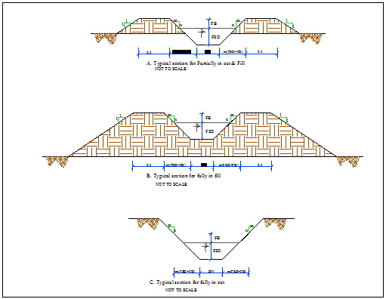
Figure 4-3: Typical Cross Section of tertiary canals

Table 4-3: Hydraulic Parameters of tertiary canals

Canal Name | Chainage (m) | Anet (ha) | Duty (l/s/ha) | Qreqd (m3/s) | n | s | b | m | d | V(m/s) | Qcalcu | fb(m) | D(m) | T(m)
LMC_TC-1 | 0 + 000 -0+324 | 3.206 | 0.950 | 0.003 | 0.03 | 0.010 | 0.3 | 1 | 0.032 | 0.304 | 0.003 | 0.27 | 0.30 | 0.90
LMC_TC-2 | 0 + 000 -0+101 | 1.116 | 0.950 | 0.001 | 0.03 | 0.014 | 0.3 | 1 | 0.023 | 0.295 | 0.002 | 0.28 | 0.30 | 0.91
LMC_SC-1_TC-1 | 0 + 000 -0+100 | 1.465 | 0.950 | 0.001 | 0.03 | 0.010 | 0.3 | 1 | 0.030 | 0.290 | 0.003 | 0.27 | 0.30 | 0.90
LMC_SC-1_TC-2 | 0 + 000 -0+278 | 5.011 | 0.950 | 0.005 | 0.03 | 0.011 | 0.3 | 1 | 0.043 | 0.378 | 0.006 | 0.26 | 0.30 | 0.91
LMC_SC-1_TC-3 | 0 + 000 -0+095 | 4.117 | 0.950 | 0.004 | 0.03 | 0.015 | 0.3 | 1 | 0.036 | 0.398 | 0.005 | 0.26 | 0.30 | 0.89
LMC_SC-1_TC-4 | 0 + 000 -0+464 | 6.815 | 0.950 | 0.006 | 0.03 | 0.008 | 0.3 | 1 | 0.063 | 0.401 | 0.009 | 0.24 | 0.30 | 0.91
LMC_SC-1_TC-5 | 0 + 000 -0+181 | 3.175 | 0.950 | 0.003 | 0.03 | 0.013 | 0.3 | 1 | 0.041 | 0.388 | 0.005 | 0.26 | 0.30 | 0.90
LMC_SC-1_TC-5 | 0+072-0+181 | 3.180 | 0.950 | 0.003 | 0.03 | 0.004 | 0.3 | 1 | 0.036 | 0.203 | 0.002 | 0.26 | 0.30 | 0.89
LMC_SC-1_TC-1 | 0 + 000 -0+239 | 2.252 | 0.950 | 0.002 | 0.03 | 0.006 | 0.3 | 1 | 0.032 | 0.223 | 0.002 | 0.27 | 0.30 | 0.90
LMC_SC-2_TC-2 | 0 + 000 -0+217 | 1.309 | 0.950 | 0.001 | 0.03 | 0.002 | 0.3 | 1 | 0.029 | 0.135 | 0.001 | 0.27 | 0.30 | 0.90
LMC_SC-2_TC-3 | 0 + 000 -0+247 | 1.315 | 0.950 | 0.001 | 0.03 | 0.006 | 0.3 | 1 | 0.023 | 0.183 | 0.001 | 0.28 | 0.30 | 0.91
LMC_SC-2_TC-4 | 0 + 000 -0+369 | 3.127 | 0.950 | 0.003 | 0.03 | 0.004 | 0.3 | 1 | 0.041 | 0.220 | 0.003 | 0.26 | 0.30 | 0.90
LMC_TC-3 | 0 + 000 -0+95 | 0.600 | 0.950 | 0.001 | 0.03 | 0.011 | 0.3 | 1 | 0.021 | 0.251 | 0.002 | 0.28 | 0.30 | 0.90
LMC_TC-4 | 0 + 000 -0+142 | 0.613 | 0.950 | 0.001 | 0.03 | 0.008 | 0.3 | 1 | 0.017 | 0.188 | 0.001 | 0.28 | 0.30 | 0.89
LMC_TC-5 | 0 + 000 -0+73 | 0.167 | 0.950 | 0.000 | 0.03 | 0.083 | 0.3 | 1 | 0.008 | 0.365 | 0.001 | 0.29 | 0.30 | 0.90
LMC_TC-6 | 0 + 000 -0+173 | 1.732 | 0.950 | 0.002 | 0.03 | 0.067 | 0.3 | 1 | 0.026 | 0.690 | 0.006 | 0.27 | 0.30 | 0.89
LMC_SC-3_TC-1 | 0 + 000 -0+149 | 0.898 | 0.950 | 0.001 | 0.03 | 0.007 | 0.3 | 1 | 0.027 | 0.230 | 0.002 | 0.27 | 0.30 | 0.89
LMC_SC-3_TC-2 | 0 + 000 -0+247 | 1.656 | 0.950 | 0.002 | 0.03 | 0.009 | 0.3 | 1 | 0.027 | 0.253 | 0.002 | 0.27 | 0.30 | 0.89
LMC_SC-3_TC-3 | 0 + 000 -0+196 | 1.411 | 0.950 | 0.001 | 0.03 | 0.008 | 0.3 | 1 | 0.027 | 0.243 | 0.002 | 0.27 | 0.30 | 0.89
LMC_SC-3_TC-4 | 0 + 000 -0+131 | 0.772 | 0.950 | 0.001 | 0.03 | 0.006 | 0.3 | 1 | 0.022 | 0.178 | 0.001 | 0.28 | 0.30 | 0.90
LMC_SC-3_TC-5 | 0 + 000 -0+144 | 0.368 | 0.950 | 0.000 | 0.03 | 0.011 | 0.3 | 1 | 0.017 | 0.220 | 0.001 | 0.28 | 0.30 | 0.89
LMC_TC-7 | 0 + 000 -0+136 | 2.453 | 0.950 | 0.002 | 0.03 | 0.022 | 0.3 | 1 | 0.029 | 0.425 | 0.004 | 0.27 | 0.30 | 0.90
LMC_TC-8 | 0 + 000 -0+098 | 1.426 | 0.950 | 0.002 | 0.03 | 0.040 | 0.3 | 1 | 0.023 | 0.495 | 0.004 | 0.28 | 0.30 | 0.91
LMC_SC-4_TC-1 | 0 + 000 -0+191 | 4.239 | 0.950 | 0.004 | 0.03 | 0.010 | 0.3 | 1 | 0.040 | 0.341 | 0.005 | 0.26 | 0.30 | 0.90
LMC_SC-4_TC-2 | 0 + 000 -0+375 | 6.059 | 0.950 | 0.006 | 0.03 | 0.005 | 0.3 | 1 | 0.056 | 0.304 | 0.006 | 0.24 | 0.30 | 0.89
LMC_SC-4_TC-3 | 0 + 000 -0+255 | 1.367 | 0.950 | 0.001 | 0.03 | 0.007 | 0.3 | 1 | 0.023 | 0.216 | 0.002 | 0.28 | 0.30 | 0.91
LMC_SC-4_TC-4 | 0 + 000 -0+291 | 3.254 | 0.950 | 0.003 | 0.03 | 0.017 | 0.3 | 1 | 0.038 | 0.431 | 0.006 | 0.26 | 0.30 | 0.90
RMC_TC-1 | 0 + 000 -0+207 | 1.405 | 0.950 | 0.001 | 0.03 | 0.017 | 0.3 | 1 | 0.022 | 0.309 | 0.002 | 0.28 | 0.30 | 0.90
RMC_TC-2 | 0 + 000 -0+209 | 3.696 | 0.950 | 0.004 | 0.03 | 0.013 | 0.3 | 1 | 0.040 | 0.394 | 0.005 | 0.26 | 0.30 | 0.90
RMC_SC-1_TC-1 | 0 + 000 -0+178 | 8.961 | 0.950 | 0.009 | 0.03 | 0.003 | 0.3 | 1 | 0.081 | 0.258 | 0.008 | 0.22 | 0.30 | 0.90
RMC_SC-1_TC-2 | 0 + 000 -0+275 | 4.839 | 0.950 | 0.005 | 0.03 | 0.006 | 0.3 | 1 | 0.051 | 0.291 | 0.005 | 0.25 | 0.30 | 0.90
RMC_SC-1_TC-3 | 0 + 000 -0+392 | 7.395 | 0.950 | 0.007 | 0.03 | 0.020 | 0.3 | 1 | 0.056 | 0.585 | 0.012 | 0.24 | 0.30 | 0.89
RMC_SC-1_TC-4 | 0 + 000 -0+331 | 7.020 | 0.950 | 0.007 | 0.03 | 0.013 | 0.3 | 1 | 0.059 | 0.488 | 0.010 | 0.24 | 0.30 | 0.90
RMC_SC-1_TC-5 | 0 + 000 -0+417 | 5.717 | 0.950 | 0.005 | 0.03 | 0.003 | 0.3 | 1 | 0.065 | 0.260 | 0.006 | 0.23 | 0.30 | 0.89
RMC_SC-2_TC-1 | 0 + 000 -0+338 | 7.508 | 0.950 | 0.007 | 0.03 | 0.013 | 0.3 | 1 | 0.051 | 0.453 | 0.008 | 0.25 | 0.30 | 0.90
RMC_SC-2_TC-2 | 0 + 000 -0+194 | 2.936 | 0.950 | 0.003 | 0.03 | 0.012 | 0.3 | 1 | 0.033 | 0.332 | 0.004 | 0.27 | 0.30 | 0.91
RMC_SC-2_TC-3 | 0 + 000 -0+358 | 5.085 | 0.950 | 0.005 | 0.03 | 0.010 | 0.3 | 1 | 0.051 | 0.390 | 0.007 | 0.25 | 0.30 | 0.90
RMC_SC-2_TC-4 | 0 + 000 -0+400 | 5.579 | 0.950 | 0.005 | 0.03 | 0.018 | 0.3 | 1 | 0.051 | 0.526 | 0.009 | 0.25 | 0.30 | 0.90
RMC_SC-2_TC-5 | 0 + 000 -0+395 | 5.374 | 0.950 | 0.005 | 0.03 | 0.022 | 0.3 | 1 | 0.045 | 0.548 | 0.009 | 0.25 | 0.30 | 0.89
RMC_SC-2_TC-6 | 0 + 000 -0+278 | 4.076 | 0.950 | 0.004 | 0.03 | 0.010 | 0.3 | 1 | 0.045 | 0.366 | 0.006 | 0.26 | 0.30 | 0.91
RMC_SC-2_TC-7 | 0 + 000 -0+249 | 5.463 | 0.950 | 0.005 | 0.03 | 0.007 | 0.3 | 1 | 0.056 | 0.335 | 0.007 | 0.24 | 0.30 | 0.89
RMC_SC-3_TC-1 | 0 + 000 -0+132 | 1.729 | 0.950 | 0.002 | 0.03 | 0.017 | 0.3 | 1 | 0.022 | 0.310 | 0.002 | 0.28 | 0.30 | 0.90
RMC_SC-3_TC-2 | 0 + 000 -0+189 | 3.359 | 0.950 | 0.003 | 0.03 | 0.020 | 0.3 | 1 | 0.038 | 0.470 | 0.006 | 0.26 | 0.30 | 0.90
RMC_SC-3_TC-3 | 0 + 000 -0+235 | 2.777 | 0.950 | 0.004 | 0.03 | 0.013 | 0.3 | 1 | 0.041 | 0.400 | 0.006 | 0.26 | 0.30 | 0.90
RMC_TC-3 | 0 + 000 -0+162 | 1.662 | 0.950 | 0.002 | 0.03 | 0.003 | 0.3 | 1 | 0.034 | 0.181 | 0.002 | 0.27 | 0.30 | 0.73
LMC_TC-9 | 0 + 000 -0+417 | 4.254 | 0.950 | 0.004 | 0.03 | 0.004 | 0.3 | 1 | 0.065 | 0.295 | 0.007 | 0.23 | 0.30 | 0.89

Field Canals
As shown in the layout, field canals run across the contours and hence face relatively steeper gradient. The discharge of most of the field canals is very small and this is taken as an advantage to cope up with the relatively steeper gradient. Figure 4-3 below shows a typical field canal x-section. As much as possible field canals shall be made in fill in order to easily irrigate the adjacent command area. As can be seen from the layout, majority of the filed canals can be used to irrigate both sides of the command area depending on the condition of the individual plots of land owned by individual farmers.
Figure 4-4: Typical Field Canal X-section

Drainage Canals
The main purpose of the drainage system in the command area is to remove the flood during rainy Season and surplus irrigation water from the entire system. As discussed earlier, all the drains are natural ones. Collector drains takes from each field drains and empties to the natural waterways. The field drains will be constructed by the farmers and remove while they plough the irrigation field. For the next irrigation, they can easily construct again. Field canals are constructed with the same sections of the respective field canals.

Canal Structures Design

Design of a typical flume
If the catchment area of drainage is large, also the coming discharge would be large. And from topography point of view when the canal CBL above the drainage OGL with height length above 3m provide a slab culvert and large piers flume.
Hydraulic Characteristics of the canal
FLUMES
Flume Name | Chain age(m) |  | Length(m) | Max. Pier Height(m) | B(m) | D=d+fb(m) | Slope(m/m)
RMC-FLUME1 | 0+000 | 0+052 | 52 | 8.17 | 0.95 | 0.6 | 0.0014
RMC-FLUME2 | 1+922.72 | 1+939.37 | 18.77 | 2.6 | 0.8 | 0.3 | 0.1
lMC-FLUME | 1+786.37 | 1+808.5 | 22.43 | 5.09 | 0.8 | 0.46 | 0.0014

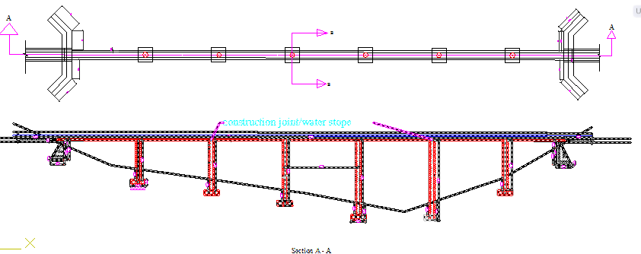
Figure 4-5: Typical plan & longitudinal section of flume structure

6.2.1 Super passage
The super passage is just the opposite of the aqueduct. In this cause the bed level of the drainage (BDL) is above the full supply levels of the canals (FSL). The drainage is taken through a rectangular or trapezoidal trough of channel which is constructed on the deck supported by pier or bare pier. According to our design Jeram Project has been designed by trapezoidal shape.
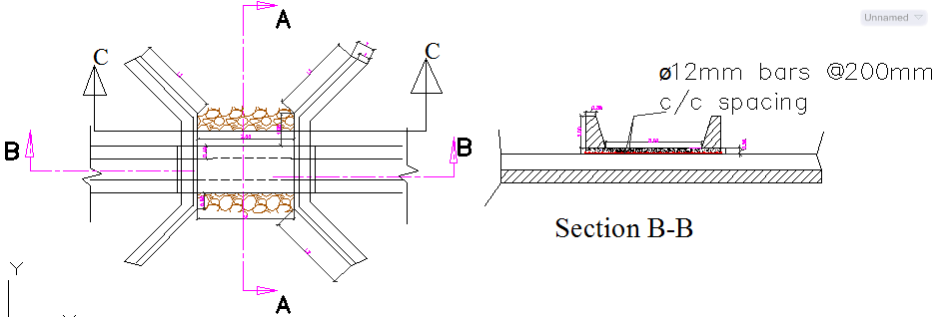
Figure 4-6: Typical plan & cross section of super passage structure

Design of Division box
At different points of the main and secondary canals division boxes are provided which divert the flow to the secondary canal and tertiary canals. Gate should be provided at the outlet of the boxes. For detail refer the drawing.
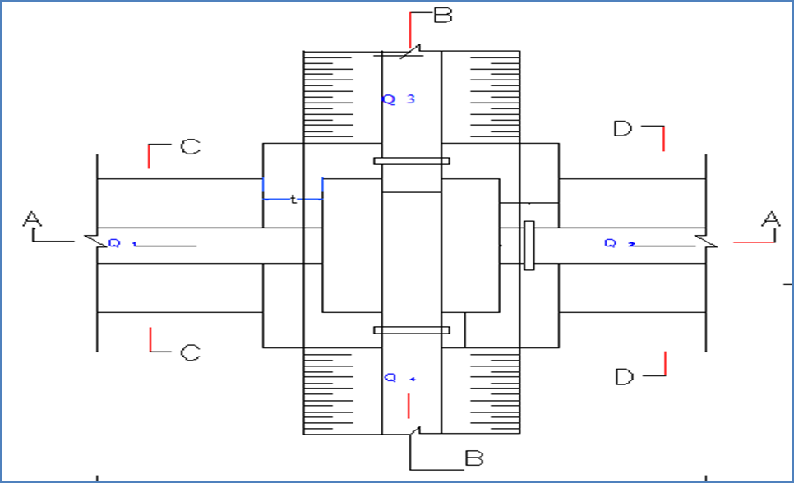
Figure 4-7: Typical Division Box plan
Using broad crested formula,
Q= CL (h)^{3/2}
Where; Q= discharge over rectangular weir/intake (opening), m³/s
C = discharge coefficient, c= 1.7
L= effective length of crest form in m
h= over flow depth, m
Assuming equal discharge coefficient & sill height for two or three dividing canals, the proportion becomes.
Q₁/ Q₂= Q₂/ Q₃ =L₁/ L₂ = L₂/ L₃
Where Q₁= is flow in canal 1
Q₂ = is flow in canal 2

Table 4-4: Hydraulic parameters of Division Boxes
Dividing canal Name | Chainage | Q0 (lit/sec) | Q1 (lit/sec) | Q2 (lit/sec) | Q3 (lit/sec) | B0 (m) | D0 (m) | D (D0+FB) (m) | B (m) | L1 (m) | L2 (m) | L3 (m) | No. of Gates
LMC & SC-1 | 0+750 | 0.060 | 0.040 | 0.020 | 0.000 | 0.4 | 0.20 | 0.5 | 1.20 | 0.400 | 0.300 | 0.000 | 2
LMC & SC-2 | 1+260 | 0.040 | 0.033 | 0.008 | 0.000 | 0.4 | 0.19 | 0.49 | 1.20 | 0.400 | 0.300 | 0.000 | 2
LMC & SC-3 | 2+295 | 0.030 | 0.025 | 0.005 | 0.000 | 0.4 | 0.14 | 0.44 | 1.20 | 0.400 | 0.300 | 0.000 | 2
LMC & SC-4 | 3+054 | 0.021 | 0.004 | 0.017 | 0.000 | 0.35 | 0.11 | 0.41 | 1.15 | 0.300 | 0.300 | 0.000 | 2
LMC_ SC-1 & TC-1& TC-2 | 0+010 | 0.020 | 0.013 | 0.001 | 0.005 | 0.3 | 0.03 | 0.33 | 1.10 | 0.300 | 0.300 | 0.300 | 3
LMC_ SC-1 & TC-3 &TC-4 | 0+116 | 0.013 | 0.003 | 0.004 | 0.007 | 0.3 | 0.02 | 0.32 | 1.10 | 0.300 | 0.300 | 0.300 | 3
LMC_ SC-1 & TC-5 | 0+435 | 0.003 | 0.000 | 0.003 | 0.000 | 0.3 | 0.01 | 0.31 | 1.10 | 0.000 | 0.300 | 0.000 | 2
LMC_ SC-2 & TC-1& TC-2 | 0+010 | 0.008 | 0.004 | 0.002 | 0.001 | 0.3 | 0.03 | 0.33 | 1.10 | 0.300 | 0.300 | 0.300 | 3
LMC_ SC-2 & TC-3 | 0+114 | 0.004 | 0.003 | 0.001 | 0.000 | 0.3 | 0.02 | 0.32 | 1.10 | 0.300 | 0.300 | 0.000 | 2
LMC_ SC-2 & TC-4 | 0+200 | 0.003 | 0.000 | 0.003 | 0.000 | 0.3 | 0.01 | 0.31 | 1.10 | 0.000 | 0.300 | 0.000 | 2
LMC_ SC-3 & TC-1& TC-2 | 0+010 | 0.005 | 0.002 | 0.001 | 0.002 | 0.3 | 0.01 | 0.31 | 1.10 | 0.300 | 0.300 | 0.300 | 3
LMC_ SC-3 & TC-3 | 0+098 | 0.002 | 0.001 | 0.001 | 0.000 | 0.3 | 0.02 | 0.32 | 1.10 | 0.300 | 0.300 | 0.000 | 2
LMC_ SC-3 & TC-4 | 0+206 | 0.001 | 0.000 | 0.001 | 0.000 | 0.3 | 0.01 | 0.31 | 1.10 | 0.300 | 0.300 | 0.000 | 2
LMC_ SC-3 & TC-5 | 0+284 | 0.000 | 0.000 | 0.000 | 0.000 | 0.3 | 0.01 | 0.31 | 1.10 | 0.075 | 0.300 | 0.000 | 2
LMC_ SC-4 & TC-1 | 0+010 | 0.017 | 0.013 | 0.004 | 0.000 | 0.3 | 0.03 | 0.33 | 1.10 | 0.300 | 0.300 | 0.000 | 2
LMC_ SC-4 & TC-2& TC-3 | 0+340 | 0.013 | 0.006 | 0.006 | 0.001 | 0.3 | 0.03 | 0.33 | 1.10 | 0.300 | 0.300 | 0.300 | 3
LMC_ SC-4 & TC-4 | 0+575 | 0.006 | 0.003 | 0.003 | 0.000 | 0.3 | 0.02 | 0.32 | 1.10 | 0.300 | 0.300 | 0.000 | 2
RMC & SC-1 | 0+800 | 0.076 | 0.043 | 0.032 | 0.000 | 0.4 | 0.28 | 0.58 | 1.20 | 0.400 | 0.300 | 0.000 | 2
RMC & SC-2 | 1+420 | 0.043 | 0.009 | 0.034 | 0.000 | 0.4 | 0.13 | 0.43 | 1.20 | 0.400 | 0.315 | 0.000 | 2
RMC & SC-3 | 2+132 | 0.009 | 0.002 | 0.008 | 0.000 | 0.4 | 0.04 | 0.34 | 1.20 | 0.300 | 0.326 | 0.000 | 2
RMC_ SC-1& TC-1&TC-2 | 0+010 | 0.032 | 0.019 | 0.009 | 0.005 | 0.3 | 0.06 | 0.36 | 1.10 | 0.300 | 0.300 | 0.300 | 3
RMC_ SC-1 &TC-3&TC-4 | 0+239 | 0.019 | 0.005 | 0.007 | 0.007 | 0.3 | 0.03 | 0.33 | 1.10 | 0.300 | 0.300 | 0.300 | 3
RMC_ SC-1 & TC-5 | 0+447 | 0.005 | 0.000 | 0.005 | 0.000 | 0.3 | 0.02 | 0.32 | 1.10 | 0.000 | 0.300 | 0.000 | 2
RMC_ SC-2& TC-1&TC-2 | 0+010 | 0.034 | 0.024 | 0.007 | 0.003 | 0.3 | 0.05 | 0.35 | 1.10 | 0.300 | 0.300 | 0.025 | 3
RMC_ SC-2 & TC-3 | 0+150 | 0.024 | 0.020 | 0.005 | 0.000 | 0.3 | 0.04 | 0.34 | 1.10 | 0.300 | 0.300 | 0.000 | 2
RMC_ SC-2& TC-4&TC-5 | 0+269 | 0.020 | 0.009 | 0.005 | 0.005 | 0.3 | 0.03 | 0.33 | 1.10 | 0.300 | 0.300 | 0.300 | 3
RMC_ SC-2& TC-6&TC-7 | 0+460 | 0.009 | 0.000 | 0.004 | 0.005 | 0.3 | 0.02 | 0.32 | 1.10 | 0.300 | 0.300 | 0.300 | 3
RMC_ SC-3 & TC-1 | 0+010 | 0.008 | 0.006 | 0.002 | 0.000 | 0.3 | 0.02 | 0.32 | 1.10 | 0.300 | 0.300 | 0.000 | 2
RMC_ SC-3 &TC-2&TC-3 | 0+150 | 0.006 | 0.000 | 0.003 | 0.004 | 0.3 | 0.02 | 0.32 | 1.10 | 0.000 | 0.300 | 0.300 | 3
RMC & LMC | 0+109 | 0.144 | 0.064 | 0.081 | 0.000 | 0.7 | 0.37 | 0.97 | 1.50 | 0.500 | 0.550 | 0.000 | 2

Road crossing structure
Two road crossing structures are provided on the main and secondary canals, at the existing foot paths. The road crossing structures are rectangular reinforced concrete slab. The slab is reinforced with 12mm @150mmc/c the length of the slab is the same as the respective canal bed width, its width and thickness is 1.5m and 20mm respectively.
Four road crossing structures for cattle and peoples are provided on the main and secondary canals, at the existing foot paths. The road crossing structures are rectangular reinforced concrete slab and also it has a masonry fence at both side and additional masonry support with canal masonry wall. The slab is reinforced with 12mm @150mmc/c the length of the slab is the same as the respective canal bed width, its width and thickness is 3m and 20mm respectively.

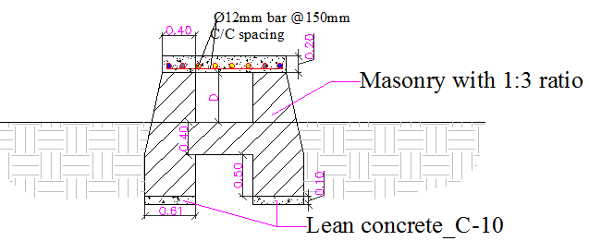

Figure 4-8: Typical road crossing structures for cattle and peoples.

Irrigation Infrastructure Bill of Quantities and Cost Estimate

Bill No.3 - Infrastructure
S/N | Description | Unit | Quantity | Unit Cost (Birr) | Amount (Birr)
 | RIGHT MAIN CANAL LINED
1.00 | Earth work & compaction
1.1 | Top soil Clearing and grubbing to a maximum depth of 20cm as per the design and to the satisfaction of the Engineer. | m2 | 4,400.0 | 14.5 | 63,976.0
1.2 | Excavation of loose soil | m3 | 1,380.0 | 110.0 | 151,800.0
1.3 | Excavation of soft rock/ weathered rock | m3 | 700.0 | 550.0 | 385,000.0
1.4 | Hard rock Excavation | m3 | 230.0 | 856.0 | 196,880.0
1.5 | Back filling with selected material from excavation including compaction. | m3 | 2,925.0 | 75.0 | 219,375.0
1.6 | Masonry lining and wall construction using 1:3 ratio of mortar at any height with dimensions as indicated in the drawing. Price should include scaffolding. | m3 | 1,765.0 | 1,600.0 | 2,824,000.0
1.7 | Plastering ( two coats ) with 1:2 cement mortar ratio of 25mm thickness | m2 | 4,435.0 | 110.0 | 487,850.0
 | Sub Total-1 |  |  |  | 4,328,881.0
2.00 | Flume from 0+000-0+052 &1+922.72-1+939.37
2.1 | Excavation of loose soil | m3 | 104.0 | 110.0 | 11,435.8
2.2 | Weathered rock excavation | m3 | 30.4 | 550.0 | 16,739.4
 | Hard rock Excavation | m3 | 15.1 | 856.3 | 12,970.1
2.4 | Back filling with selected material from excavation including compaction. | m3 | 55.1 | 75.0 | 4,134.9
2.5 | Masonry lining and wall construction using 1:3 ratio of mortar at any height with dimensions as indicated in the drawing. Price should include scaffolding. | m3 | 68.3 | 1,600.0 | 109,261.4
2.6 | Pointing (1:2) | m2 | 18.3 | 78.0 | 1,425.1
2.7 | Class C-25(1:1.5:3) reinforced mass concrete of thickness indicated on the drawing.Price should include formwork. | m3 | 40.5 | 3,300.0 | 133,517.7
2.8 | Lean Concrete Class of C-15 (1:2:4) as dimensions are specified on the drawing | m3 | 7.0 | 2,100.0 | 14,713.7
2.9 | Reinforcement |  |  |  | -
2.10 | Reinforcement bars ø16mm @ 200mm c/c spacing (bending, cutting , placing & tying with construction wire) | kg | 971.2 | 65.0 | 63,129.8
2.11 | Reinforcement bars ø14mm @ 150mm c/c spacing (bending, cutting , placing & tying with construction wire) | kg | 1,330.0 | 65.0 | 86,447.9
2.12 | Reinforcement bars ø12mm @ 150mm c/c spacing (bending, cutting , placing & tying with construction wire) | kg | 1,053.0 | 65.0 | 68,445.5
2.13 | Reinforcement bars ø10mm @ 200mm c/c spacing (bending, cutting , placing & tying with construction wire) | kg | 1,438.6 | 65.0 | 93,509.4
 | Sub Total-2 |  |  |  | 615,730.8
3 | Road for Cattle Crossing on Right Main canal(0+690 & 1+080)
3.1 | Excavation of loose soil | m3 | 9.1 | 110.0 | 1,001.9
3.2 | Back filling with selected material from excavation including compaction. | m3 | 4.1 | 75.0 | 310.5
3.3 | Masonry lining and wall construction using 1:3 ratio of mortar at any height with dimensions as indicated in the drawing. Price should include scaffolding. | m3 | 5.0 | 1,600.0 | 7,948.8
3.4 | (20cm tick,C-20, single reinforcement precast slab with area 1.2mx3m) | m3 | 1.7 | 2,700.0 | 4,471.2
3.5 | Reinforcement bars ø12mm @ 150mm c/c spacing (bending, cutting , placing & tying with construction wire) | kg | 112.7 | 65.0 | 7,328.1
3.6 | Lean Concrete Class of (C-10 ) as dimensions are specified on the drawing | m3 | 0.8 | 1,902.3 | 1,575.1
3.7 | Plastering ( two coats ) with 1:2 cement mortar ratio of 25mm thickness | m2 | 2.8 | 110.0 | 303.6
3.8 | Pointing (1:2) | m2 | 2.8 | 78.0 | 215.3
 | sub total_3 |  |  |  | 23,154.5
4 | LEFT MAIN CANAL LINED
4.1 | Earth work & compaction
4.3 | Excavation of loose soil | m3 | 2,955.0 | 110.0 | 325,050.0
4.4 | Excavation soft rock/ weathered rock | m3 | 1,500.0 | 550.0 | 825,000.0
4.5 | Hard rock Excavation | m3 | 500.0 | 856.3 | 428,125.0
4.7 | Back filling with selected material from excavation including compaction. | m3 | 2,950.0 | 75.0 | 221,250.0
4.8 | Masonry lining and wall construction using 1:3 ratio of mortar at any height with dimensions as indicated in the drawing. Price should include scaffolding. | m3 | 2,600.0 | 1,600.0 | 4,160,000.0
4.9 | Plastering ( two coats ) with 1:2 cement mortar ratio of 25mm thickness | m2 | 6,500.0 | 110.0 | 715,000.0
4.10 | Class C-20(1:2:3) reinforced concrete of thickness indicated on the drawing for approach canal.Price should include formwork. | m3 | 13.0 | 2,700.0 | 35,024.4
4.11 | Reinforcement bars ø12mm @ 150mm c/c spacing (bending, cutting , placing & tying with construction wire) | kg | 871.1 | 65.0 | 56,623.1
4.12 | Reinforcement bars ø10mm @ 200mm c/c spacing (bending, cutting , placing & tying with construction wire) | kg | 342.7 | 65.0 | 22,273.5
 | Sub Total-4 |  |  |  | 6,788,346.0
5 | Canal Empiting and Escape structurs on LMC
5.2 | Ordinary soil excavation in open to the lines and grades as shown in the drawing . | m3 | 11.6 | 110.0 | 1,281.5
5.3 | Filling with selected material from excavation including compaction. | m³ | 8.8 | 75.0 | 661.9
5.4 | Masonry wall construction using 1:3 mortart .The thickness of masonary wall will be as indicated in the darwing. | m³ | 6.4 | 1,600.0 | 10,160.0
5.5 | Plastering ( two coats ) with 1:2 cement mortar ratio of 25mm thickness | m2 | 15.9 | 110.0 | 1,746.3
 | Sub Total |  |  |  | 13,849.6
6 | Gates For Escape Canal and Left Main Canal | Pcs
6.1 | Trash rack Reinforcing bars Of Ø12 for Left Main Canal | kg | 28.2 | 65.0 | 1,834.7
6.2 | Supply & fixing of gate opening 0.6m*0.6m, 4mm thick sheet metal, 60*60*4mm angle iron ꬷ 10mm bar for handling as per the drawing | no | 2.0 | 6,000.0 | 12,000.0
 | Sub total |  |  |  | 13,834.7
7 | Drop for Escape canal
7.1 | Soil excavation in open to the lines and grades as shown in the drawing to any depth; | m3 | 3.0 | 110.0 | 334.7
7.2 | Masonry Lining and wall construction using 1:3 mortar for canals of any hight .The thickness of masonary wall will be as indicated in the darwing. | m3 | 1.3 | 1,600.0 | 2,028.8
7.3 | Plastering ( two coats ) with 1:2 cement mortar ratio of 25mm thickness | m2 | 3.2 | 110.0 | 351.6
7.4 | Provide C-10 Lean concrete for masonery footing linning of thickness as per the drawing and the direction of the engineer. | m2 | 3.1 | 1,902.3 | 5,915.6
7.5 | Cemented Stone Piching | m3 | 3.0 | 1,126.0 | 3,323.7
 | Sub total |  |  |  | 11,954.3
8 | LMC_Flume ( 1+786.37 - 1+808.5)
8.1 | Excavation of loose soil | m3 | 41.4 | 110.0 | 4,552.4
8.2 | Weathered rock excavation | m3 | 11.8 | 550.0 | 6,503.4
8.3 | Hard rock Excavation | m3 | 5.9 | 856.3 | 5,062.3
8.4 | Back filling with selected material from excavation including compaction. | m3 | 23.9 | 75.0 | 1,795.1
8.5 | Masonry lining and wall construction using 1:3 ratio of mortar at any height with dimensions as indicated in the drawing. Price should include scaffolding. | m3 | 29.5 | 1,600.0 | 47,278.8
8.6 | Pointing (1:2) | m2 | 6.6 | 78.0 | 516.7
8.7 | Class C-25(1:1.5:3) reinforced mass concrete of thickness indicated on the drawing.Price should include formwork. | m3 | 10.9 | 3,300.0 | 36,044.4
8.8 | Lean Concrete Class of C-15 (1:2:4) as dimensions are specified on the drawing | m3 | 3.1 | 2,100.0 | 6,520.5
8.9 | Reinforcement bars ø16mm @ 200mm c/c spacing (bending, cutting , placing & tying with construction wire) | kg | 188.8 | 65.0 | 12,269.0
8.10 | Reinforcement bars ø14mm @ 150mm c/c spacing (bending, cutting , placing & tying with construction wire) | kg | 440.4 | 65.0 | 28,624.0
8.11 | Reinforcement bars ø12mm @ 150mm c/c spacing (bending, cutting , placing & tying with construction wire) | kg | 369.8 | 65.0 | 24,034.1
8.12 | Reinforcement bars ø10mm @ 200mm c/c spacing (bending, cutting , placing & tying with construction wire) | kg | 421.1 | 65.0 | 27,371.2
 | Sub Total-5 |  |  |  | 200,571.9
9 | Super passage for ( LMC ,2+130 & 2+850)
9.1 | Class C-20(1:2:3) reinforced mass concrete slab of thickness indicated on the drawing.Price should include formwork. | m3 | 1.7 | 2,700.0 | 4,471.2
9.2 | Lean Concrete Class of (C-10 ) as dimensions are specified on the drawing | m3 | 1.5 | 1,900.0 | 2,897.3
9.3 | Reinforcement bars ø12mm @ 150mm c/c spacing (bending, cutting , placing & tying with construction wire) | kg | 183.0 | 65.0 | 11,894.9
9.4 | Masonry lining and wall construction using 1:3 ratio of mortar at any height with dimensions as indicated in the drawing. Price should include scaffolding. | m3 | 18.4 | 1,600.0 | 29,487.8
9.5 | Pointing (1:2) | m2 | 35.4 | 75.0 | 2,656.5
9.6 | Cemented Stone Piching | m3 | 14.5 | 1,126.0 | 16,316.0
9.7 | Excavation of loose soil | m3 | 18.2 | 110.0 | 1,999.7
9.8 | Back filling with selected material from excavation including compaction. | m3 | 6.0 | 75.0 | 448.5
 | Sub Total-6 |  |  |  | 70,172.0
10 | Foot path on LMC (2+920)
10.1 | (20cm tick,C-20, single reinforcement precast slab with area 1.2mx1.5m) | m3 | 0.4 | 2,700.0 | 1,117.8
10.2 | Reinforcement bars ø12mm @ 150mm c/c spacing (bending, cutting , placing & tying with construction wire) | kg | 29.3 | 65.0 | 1,905.0
 | sub total-7 |  |  |  | 3,022.8
11 | Division Box
1.1 | Masonry lining and wall construction using 1:3 ratio of mortar at any height with dimensions as indicated in the drawing. Price should include scaffolding. | m3 | 18.4 | 1,600.0 | 29,380.0
11.2 | Plastering ( two coats ) with 1:2 cement mortar ratio of 25mm thickness | m2 | 25.8 | 110.0 | 2,838.4
11.3 | Gate consists of | Pcs | 16.0 |  | -
 | Trash rack Reinforcing bars Of Ø12 for RMC-flume -1 | kg | 25.0 | 65.0 | 1,626.3
 | Supply & fixing of gate opening 0.4m*0.5m, 3mm thick sheet metal, Stiffning angle iron 40*40*4mm , 40*40*4mm angle iron for groove, ꬷ 16mm bar for handling | no | 31.0 | 2,700.0 | 83,700.0
 | Sub Total-8 |  |  |  | 117,544.7
12 | Turn out for MC
12.1 | Masonry lining and wall construction using 1:3 ratio of mortar at any height with dimensions as indicated in the drawing. Price should include scaffolding. | m3 | 6.9 | 1,600.0 | 11,061.0
12.2 | Cemented stone pitching | m3 | 11.0 | 1,126.0 | 12,359.4
12.3 | Plastering ( two coats ) with 1:2 cement mortar ratio of 25mm thickness | m2 | 38.8 | 110.0 | 4,269.6
12.4 | Gate supply, cutting ,welding and installation(50mmx50mm, 3mm thick sheet metal, 4m long angle iron for groove (40x40x4), 1m long, 14mm reinforcement.bar for handle) | Pcs | 5.0 | 2,600.0 | 13,000.0
 | Sub total |  |  |  | 40,689.9
13 | 1. SECONDARY CANALS
13.2 | Excavation in normal loose soil | m3 | 3,229.6 | 110.0 | 355,253.7
13.3 | Back filling with selected material from excavation including compaction. | m3 | 3,112.8 | 75.0 | 233,463.2
13.4 | Reinforced concrete rectangular canal including form work |  | - |  | -
13.4.1 | C-20 concrete | m3 | 600.1 | 2,700.0 | 1,620,344.3
13.4.2 | Reinforcement bars ø 8mm @ 30mm c/c spacing (bending, cutting , placing & tying with construction wire) | kg | 6,984.5 | 65.0 | 453,990.1
 | Sub total -10 |  |  |  | 2,663,051.3
14 | Division Box
14.1 | Masonry lining and wall construction using 1:3 ratio of mortar at any height with dimensions as indicated in the drawing. Price should include scaffolding. | m3 | 32.0 | 1,600.0 | 51,122.6
14.2 | Cemented Stone pitching | m3 | 10.6 | 1,126.0 | 11,899.0
14.3 | Plastering ( two coats ) with 1:2 cement mortar ratio of 25mm thickness | m2 | 52.4 | 110.0 | 5,759.3
14.4 | Gate |  |  |  | -
 | Supply & fixing of gate opening 0.4m*0.5m, 3mm thick sheet metal, Stiffning angle iron 40*40*4mm , 40*40*4mm angle iron for groove, ꬷ 16mm bar for handling | no | 30.0 | 2,700.0 | 81,000.0
 | Sub Total - 11 |  |  |  | 149,780.8
15 | Road for Cattle Crossing LMC_SC-1 (0+084) & RMC_SC-1(0+440)
15.1 | Excavation of loose soil | m3 | 9.1 | 110.0 | 1,001.9
15.2 | Back filling with selected material from excavation including compaction. | m3 | 4.1 | 75.0 | 310.5
15.3 | Masonry lining and wall construction using 1:3 ratio of mortar at any height with dimensions as indicated in the drawing. Price should include scaffolding. | m3 | 4.9 | 1,600.0 | 7,838.4
15.4 | (20cm tick,C-20, single reinforcement precast slab with area 1.1mx3m) | m3 | 1.5 | 2,700.0 | 4,098.6
15.5 | Reinforcement bars ø12mm @ 150mm c/c spacing (bending, cutting , placing & tying with construction wire) | kg | 108.5 | 65.0 | 7,049.3
15.6 | Lean Concrete Class of (C-10 ) as dimensions are specified on the drawing | m3 | 0.8 | 1,900.0 | 1,573.2
15.7 | Plastering ( two coats ) with 1:2 cement mortar ratio of 25mm thickness | m2 | 2.5 | 110.0 | 278.3
15.8 | Pointing (1:2) | m2 | 2.5 | 78.0 | 197.3
 | sub total -12 |  |  |  | 22,347.6
16 | Foot path on Secondary canal(LMC_SC-4)(0+367)
16.1 | (20cm tick,C-20, single reinforcement precast slab with area 1.1mx1.5m) | m3 | 0.4 | 2,700.0 | 1,024.7
16.2 | Reinforcement bars ø12mm @ 150mm c/c spacing (bending, cutting , placing & tying with construction wire) | kg | 28.2 | 65.0 | 1,832.0
 | sub total -13 |  |  |  | 2,856.7
17 | Tertiary canal
17.1 | Excavation and Fill (Earth work)
17.2 | Excavation in normal loose soil | m3 | 2,469.6 | 110.0 | 271,652.7
17.3 | Back filling with selected material from excavation including compaction. | m3 | 737.6 | 75.0 | 55,318.3
 | sub total -14 |  |  |  | 326,970.9
 | Total for Infrastructure |  |  |  | 15,392,759.6

CONCLUSION AND RECOMMENDATION
- The infrastructure of this project area is designed to irrigate about 152 ha of land by taking its supply from the Jeram diversion intake irrigation project. The maximum duty of the command area for 17hours per day irrigation with overall project efficiency of 55%. The method of irrigation of the project area is furrow surface irrigation in which the main and secondary canals are working continuously whereas the field canals within a tertiary block are working rotational system.
- As the dominant soil type is clay loam soil, the main canal system is designed to be masonry.
- The reason why the main canal is to be lined up to the end is to avoid the siltation problem, time saving to reach at the tail part, reduce maintenance cost.
- The design of the canal dimensions of the irrigation canal is done by applying the manning’s uniform flow equation. The variable of the hydraulic parameters are calculated using iteration or flow master program.
- The drainage canal will be constructed by the farmers and remove while they plough the irrigation field.
- As soils of the command area are predominantly clay loam textured; and hence water and soil management measures should be undertaken; and optimum moisture content should be maintained to improve workability of the soil during land preparation and planting time.

The following recommendations are drown:
- For better performance and long service year of the project regular inspection and maintenance is highly required.
- Farmers training, how to operate and maintain the project structures as a whole and available and water resources has a paramount important.
- The irrigation hours per day and per week should be flexible based on base flow amount of each week or month.
- Close supervision of the construction should be made to modify (if need be) each Components of irrigation system based on specific site conditions.

OPERATION AND MAINTENANCE

General
The main objective of the operation and maintenance aspect of an irrigation scheme is to facilitate the timely delivery of the required irrigation water to farms and to keep the irrigation system in an optimum operating condition. This section therefore, discusses the main functions of the subject matter under consideration for the scheme.

Operation of the Head Works
Operation at the diversion weir mainly focuses on the diversion of a controlled flow of river water, timely cleaning of floating debris in front of intake and removal of sediment deposits in front of the weir and intake structures.

Irrigation System Operation
The operation of the irrigation system depends mainly on the method of water delivery at farm level. Surface irrigation method is the recommended type of water distribution and application method for Aderkayna diversion irrigation scheme.
The farmers would organize themselves and form groups in order to handle the water management. Since flow is low Rotational water distribution would be applied within the group. The rotational distribution is then to distribute water by turn to the whole scheme according to the timely need of crop water requirement. For better and efficient water management, crop diversification should be avoided within a group. This would reduce the complexity of water distribution system of the scheme during one irrigation season. At farmers’ level of operation, a constant flow and variable irrigation time is advisable.
The operation of the irrigation system is continuous for 14 hours per day in main, secondary and tertiary canals whereas field canals within a tertiary block are operating in rotational system with each other for irrigation hours proportional to their size. Since the tertiary canal discharges are within the manageable range and the irrigation canal structures are accordingly designed for simple operation, the farmers can open and close easily whenever they required.

Maintenance Requirement
The canal system of the project is earthen canal except main canal and secondary canal, which is susceptible to siltation, erosion, growth of weeds and or breaching problems. Though the canal sections are designed for non- silting and no scouring conditions, the above mentioned problems are unavoidable and hence periodical and yearly inspection and maintenance of canals and structures are obligatory in order to fulfill the design objective of the project area.
The maintenance tasks are categorized into two types: - routine activities, and repairs. The routine maintenance activities that are carried out periodically include:-
- Regular cleaning of sediments and weeds from canals and drains;
- Inspection and lubrication of gates; and
- Maintenance of cracked lined canals, regulating and control structures.
Repair works include task carried out more frequently and quickly, and include those tasks that are generally unpredictable. They also include emergency works. The activities included in this category are:-
- Repairing overtopped or breached canals, drains, and flood protection dykes;
- Repairing jammed gates;
- Filling holes made by wild animals; and
- Reduced free board due to walking over by people and livestock.
Regular inspection of the irrigation facilities should be carried out as part of the maintenance activities. These tasks could be carried out immediately after the end of the main rains in September and during the rainy season. This could concentrate on the interceptor drains and the flood protection dykes, the main canal and the field drains. The inspection of the other works like the tertiary canals, field drains, and the water control and regulating structures could be carried out as part of routine operation activities.
- Beneficiaries of the project need to have operation and maintenance budget, For O&M cost incurring entity area:
- Purchase sing of gate lubricate (grease)
- Replacing and maintenance of Stolen and damaged gates
- Repair Damages on the cross drainage structures.
The expense for O&M should be collected from the beneficiaries. Of course, much of the task is done by the labor and skill of the community. For cost incurring activities beneficiaries have to collect money based on the proportion of the command area they owned.

REFERENCE
- FAO (1977) guidelines for predicting crop water requirements. No 24, Rome Italy
- Design of small Canal structures , USBR
- IDD manual
- The Federal Democratic Republic of Ethiopia Ministry of water Resources.

