THE NATIONAL REGIONAL STATE OF OROMIA

OROMIA IRRIGATION DEVELOPMENT AUTHORITY

AGRICULTURAL GROWTH PROGRAM (AGP)
Consultancy Services for Nineteen (19) Small Scale Irrigation Projects Study and Detail Design
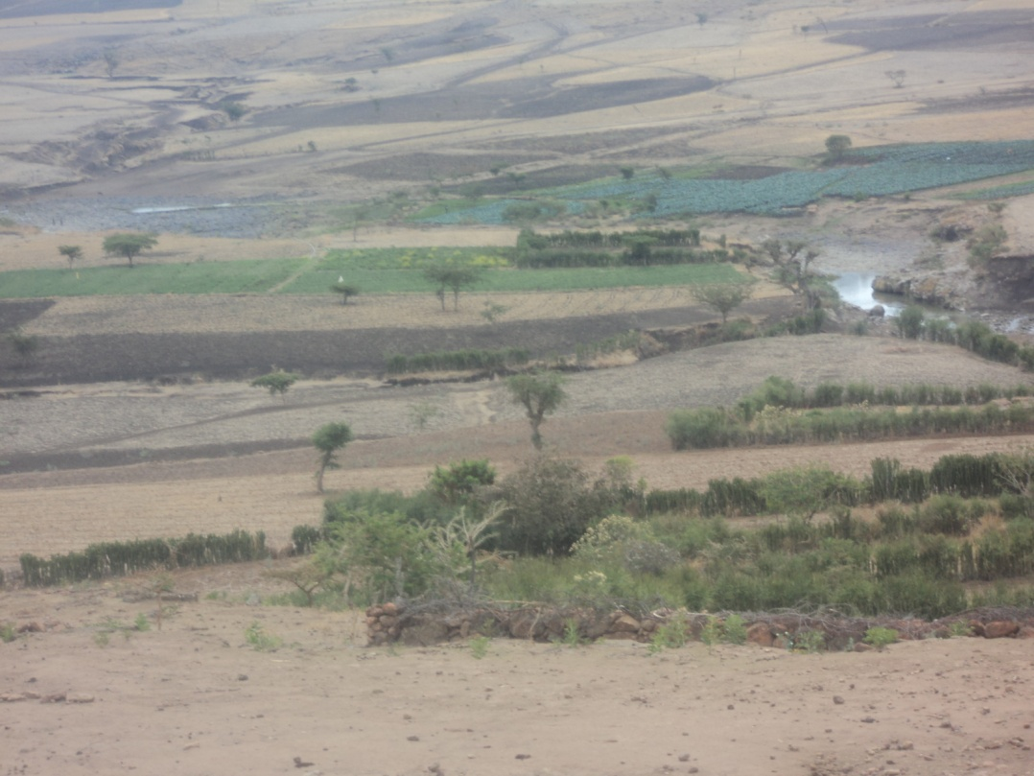
Volume VII: Watershed Development Study of Kerfe Small Scale Irrigation Project
November 2016
 AYJEF Water Woks and P.O.Box: 43329 Tele: +251 911 304019
Business Service PLC E-mail: ayconsult1@gmail.com

Finfinne

Table of Contents

Table of Contents 2
List of Tables 4
List of Figures 4
Acronyms 5
Executive Summary 6
1. Introduction 8
1.1. Background 8
1.2. Objectives 8
1.3. Methodology 9
1.4. Location 9
1.5. Brief Description of the project components 11
1.6. Population 11
2. Natural Features 12
2.1. Climate and Hydrology 12
2.1.1. Climate 12
2.1.2. Hydrology 12
2.1.3. Length of Growing Period 13
2.2. Physiography 15
2.3. Drainage 15
2.4. Catchment Morphology 16
2.5. Geology 17
2.6. Soil 19
2.7. Land use and land cover 20
2.8. Socioeconomic Profile of the project area 21
3. Problem Identification 32
3.1. Soil Erosion 32
3.2. Vegetation Degradation 32
3.3. Weed invasive 33
3.4. Improper Land Utilization System 33
3.5. Consequences of Land degradation in the catchment 33
3.5.1. Decline of Soil Fertility 33
3.5.2. Decline of Crop Production 33
3.5.3. Decline of Livestock Production 34
4. Land Capability Classification 35
4.1. USDA Land Capability Classification 35
4.2. Land Capability Classification, Principles 35
4.3. Categories of the System 35
5. Soil and Water Conservation Experience 39
6. Soil and Water Conservation Development Plan 41
6.1. General 41
6.2. Physical Soil and Water Conservation Measures 41
6.3. Biological Soil and Water Conservation Measures 42
7. Implementation Strategy 44
7.1. Preparation for implementation 44
7.2. Institutional organization and terms of reference 44
7.3. Resource identification and mobilization 44
7.4. Organizational arrangement at watershed/community level 45
7.5. Training and experience sharing 46
8. Implementation Plan 48
8.1. General schedule 48
8.2. Time schedule and phasing 48
8.3. Inputs Requirement 49
9. Estimation of Cost for Watershed Development 51
10. Monitoring and Evaluation 52
11. Conclusion and Recommendation 53
References 55

List of Tables
Table 2.1. Length of Growin Period for Bishoftu Station 14
Table 2.2. The most common diseases prevail in the areas 26
Table 4.1: Degree of Limitation of the Characteristics for the Different Capability Classes 37
Table 4.2: Suitable land use for SCRC 38
Table 4.3: Current land use/land cover vs land suitability with respect to SCRC 38
Table 8.1. Implementation schedule and total labor requirement by phase and years 49
Table 8.2. Inputs required for implementation of watershed development activities 50

List of Figures
Figure 1.1. Location map of the project area 10
Figure 2. 1. Altitude distribution of Upper Mojo River catchment at Kerfe project area. 15
Figure 2. 2. Drainage density of Upper Mojo River at Kerfe village 16
Figure 2. 3. Landform distribution of the study area 17
Figure 2. 4. Geological map of the study area (Adapted from Geological map of Ethiopia, 2006) 18
Figure 2. 5. Soil distribution in the study area (Adapted from Upper Awash Land use Study Project, Soil Survey). 20

Acronyms

CBO Community Based Organization
DA Development Agent
GTP Growth and Development Plan
HH Household
ITCZ Inter Tropical Convergence Zone
LCU Land Class Unit
LGP Length of Growing Period
ME Monitoring and Evaluation
MOFED Ministry of Finance and Economic Development
NGO Nongovernmental Organization
NRM Natural Resource Management
PWDP Participatory Watershed Development Program
SCRC Soil Conservation Requirement Class
SWC Soil and Water Conservation

Executive Summary
Kerfe small scale irrigation project is located in Kerefe kebele of Ada’a Woreda in East shewa zone of Oromia National Regional State. The proposed command area is located at geographical location of 8050.270N and 39008.948E at about 18km northeast Bushoftu town. It could be accessible from Bishoftu town to the project area through passing Gabaya Robi (Hidi town) all weathered road.
The study has been undertaken with the objectives: to implement natural resource conservation & development program; to protect and conserve land resources for efficient and sustainable production; to prevent irrigation command area from runoff accumulation and to protect the land from water logging; to prevent irrigation structures from siltation; to prevent soil erosion by water by establishing the necessary structures in the catchment area; to improve land productivity for high production ultimately.
The consultant has followed the methodologies and approaches consisting of Review of previous studies done by different researchers, relevant Government policies, strategies, proclamations and guidelines; and field surveys to gather primary data.
The mean annual rainfall is ranges from 850mm to 950mm at the project area. Mean monthly maximum air temperature is about 26.9⁰c while the mean minimum monthly is about 8.8⁰c.
The project area is endowed with different sources of water. The major water source for the area is upper Mojo River. Mojo River catchment is intensively cultivated land with rugged slope, while the lower part of the drainage area is flat and flows to Koka dam which is located in Awash River Basin. The length of drainage area is about 32.4 km and the overall slope is around 1.4% at proposed weir site.
The present physiographic setting of the catchment is the result of volcano-tectonic activity that forms the plateau and the rift in general. Later erosion and river dissection has contributed to the existing rugged landform. Accordingly, the catchment has altitude and drainage density variation of 2009 – 3050m.a.m.s.l and 0.48 – 6.96 km/km2. Catchment morphology of the area consists of level and undulated land, rolling plains and plateaus and hilly plains with overall slope ranges of 0-30%. Soil cover of the catchment consists of cambisol (75%), vertisol (20%) and liptosol (5%). More than 90% of the land in the catchment is employed cultivation. The remaining 10% is covered by shrubs, grass, rocks, etc.
Major observed problems in the catchment are: soil degradation, vegetation degradation, weed invasi ve, improper land utilization; and the resulting decline of soil fertility, crop production and livestock production.
Population in the catchment have soil and water conservation experiences consisting of making: Traditional cut-off drains, traditional water ways, soil bund, compost and stone terraces.
Soil and water conservation development plan consisting of physical measures (stone faced bunds, cutoff drains, micro basins, hillside terraces and soil fertility management); and biological measures (grass strips, green manuring, organic matter application, mulching, crop rotation, hedge row plantation, area closure, river bank protection, cut and carry etc.) have been proposed for the basin.
Implementation strategy incorporating: institutional organization and terms of reference; resource identification and mobilization; outstanding arrangement at watershed/community level; training and experience sharing have been devised for success of the project.

Introduction

Background
Ethiopia in general and parts of Oromia Region in particular have been faced with recurrent draught caused by the erratic nature and high spatial and temporal variability as well as low total amount of rainfall. Backward agricultural practices also contribute to low productivity and accelerated land degradation, which aggravates the impact of the draughts.
Due attention was given by government of Ethiopia to small and medium scale irrigation development project in GTP I and II growth and development program with higher priorities given for farmer managed small scale irrigation project.
In order to get Feasibility study and detail design consultancy service of Kerfe Small Scale Irrigation Project, Oromia Irrigation Development Authority has employed AYJEF Water Works and Business Service PLC.
Among the major deliverables of the Feasibility study and detail design works, Watershed Management Study is one of the Major component that this report pertains to.
A watershed is made up of the natural resources in a basin, especially water, soil, and vegetative factors. (CBPWD, 2005). Environmental problems in least developed countries like Ethiopia are manifested in the form of deforestation, soil erosion, and depletion of biodiversity. These are the results of century cultivation, rapid population growth rate, and abuse of the natural resources (Berhanu, 2003). The population pressure, which is alarmingly increased, contributes a great share in expanding cultivation of marginal lands. Increasing human and livestock population on one hand, and diminishing (small holding size or fragmentation) of the existing arable lands on the other hand could help to increase the proportion of waste lands.

Objectives
The main objectives of Watershed Development Study are:
- To implement natural resource conservation & development program.
- To protect and conserve land resources for efficient and sustainable production.
- To prevent irrigation command area from runoff accumulation and to protect the land from water logging.
- To prevent irrigation structures from siltation.
- To prevent soil erosion by water by establishing the necessary structures in the catchment area.
- To improve land productivity for high production ultimately

Methodology
The following activities have been carried out to achieve the above mentioned objectives:
- Identification of the watershed area locations (Altitude, Latitude, longitude and distance from a major reference point/say town, road etc)
- Assessment of the major features of the catchments, climate condition, soil condition and types, vegetation , present land use of the catchments, and major problems of the watershed.
- Assessment of present land use of watershed : cultivated, grazing, forest land, homestead and miscellaneous land
- Assessment of major problems of the watershed area
- Examination and analysis of all soil conservation activities and future plan in relation to social and economic environment of the watershed.
- Preparation of erosion potential, erosion hazard and soil degradation maps at appropriate scale.
- Identification and prioritization of activities for soil and water conservations and formulation of suitable intervention strategy (such as biological soil conservation measures).
- Preparation of effective watershed management plan and its contribution for ground water to be developed.
- Investigation and discussion of the effects of social and institutional factors inhibiting conservation measures.

Location
Kerfe small scale irrigation project is located in Kerefe kebele of Ada’a Wereda in East shewa zone of Oromia National Regional State. The proposed command area is located at geographical location of 8⁰50.270N and 39⁰08.948E at about 18km northeast Bushoftu town. It could be accessible from Bishoftu town to the project area through passing Gabaya Robi (Hidi town) all weathered road.
The geographical extent of the study area ranges from 8⁰49’17”N to 9⁰05’27”N and 39⁰07’21”E to 39⁰16’40”E. The catchment covers 19 kebeles in northern Ada’a woreda.
The water source for Kerfe small scale irrigation project is from Upper Mojo Perennial River having catchment area of 243 km2 and estimated minimum base flow of about 72l/s close to Kerfe community.
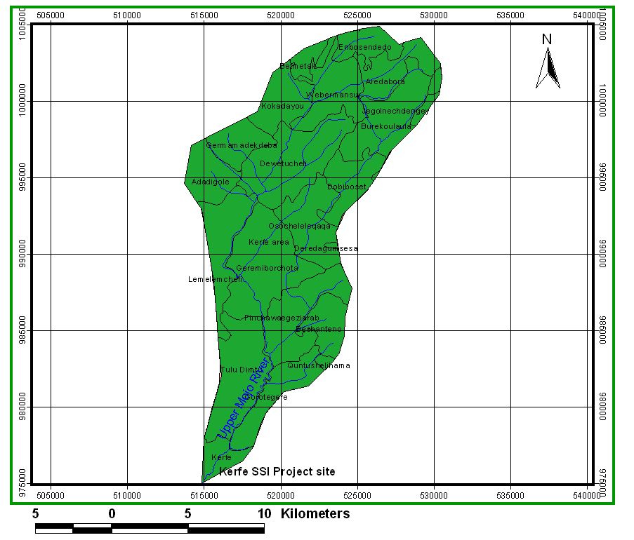
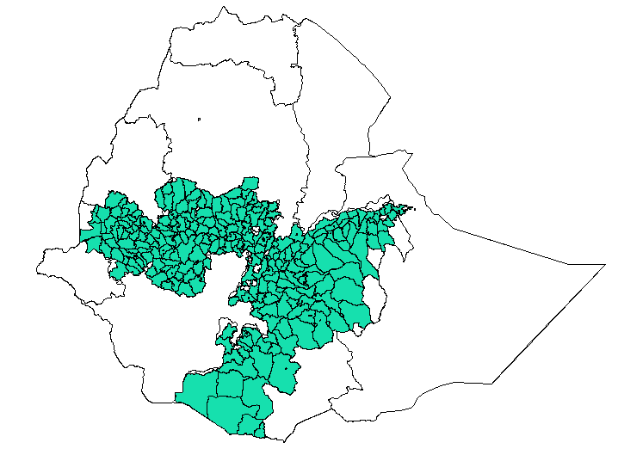
Figure 1.1. Location map of the project area

Brief Description of the project components
Kerfe irrigation project has net command area of 39 ha with water demand of 46l/s. The project is gravity diversion system on Mojo River. One-way (Right side) intake is suggested based on available suitable irrigable farm land with available discharge. Reasonable systematic layouts were adopted to minimize costs and to enable easier application of water and easy management of the project.

Population

According to MoFED (2007 projected for 2016) population data the total population of the kebele is 2311(1201 male and 1110 female) with 462 household and 387 housing units. However, according to kebele administrators the total population of the Karfekebele is 6,846 with 3154 male and 3692 female. The total household size is about 1083 with 977 male and 106 female heads. Similarly, in the project area the total HH size and total population are about 200 and 3445 with 1451 male and 1994 female.

Natural Features

Climate and Hydrology

Climate
The climate of the area comes under the influence of the Inter-Tropical Convergence Zone (ITCZ). The seasonal rainfall distribution within the study area results from the annual migration of the ITCZ. The study area experiences bi-modal type of rainfall (two rainy seasons). The main rainy season often extends from June through end of September and the small rainy season from middle of March to end of April, the rest of the months are generally dry. Along with the ITCZ the orography has significant effect for the formation of rain in the project area.
The mean annual rainfall distribution of the region shows considerable spatial variation, due to the great range in elevation across the Mojo River. The mean annual rainfall is ranges from 850mm to 950mm at the project area. Mean monthly maximum air temperature is about 26.9⁰c while the mean minimum monthly is about 8.8⁰c.
Seasonal variations, showing during rainy & dry seasons has different trend of rainfall distribution, but a great differences of values can be observed between these two seasons, depending on the actual chronological period covered by the historical record. Annual
The mean annual maximum temperature at the project area estimated to be about 26.3⁰c and the mean annual minimum temperature is 11.5⁰c.The mean annual temperature is about 18.9⁰c, which is analyzed from Bishoftu meteorological station which is nearest to the project area, approximately about 21kms far from headwork.

Hydrology
The project area is endowed with different sources of water. The major water source for the area is the Mojo River. There are also different seasonal streams and ground water resource.
The Mojo River watershed area site in an area where there is intensively arable agriculture, the main activity being Agriculturalist. The Mojo River is incised in a flat channel which, at the lower catchment was slightly dry. This drainage originated above Chefe Donsa town around mountainous area. It covers a total catchment area of 244 km² at proposed headwork site. Out of the total catchments area approximately 91.9% covered with cultivated land and the rest with open grass land.
Mojo River catchment is intensively cultivated land with rugged slope, while the lower part of the drainage area is flat and flows to Koka dam which is located in Awash River Basin. The length of drainage area is about 32.4 km and the overall slope is around 1.4% at proposed weir site.
The project is proposed to take water from Mojo River. Diversion intake site is proposed to be constructed across the river at geographic coordinate of 516108E longitude & 976729N latitude and an average altitude of about 2038m.a.s.l.
Mojo River is the source of water for irrigation. It is also used for domestic purposes in the rural areas. Nowadays there are traditional irrigation users at upstream and downstream. The hydrological data shows that mean monthly flow of Mojo River at Mojo town gauging station varies from 0.768m³/s to 68.2m³/s. The lowest mean flow usually occurs in November, December and January months while the highest flow occurs in August month.

Length of Growing Period
Bishoftu Meteorological station is considered to estimate length of growing period. Moist and humid periods of the station where the monthly rainfall was greater than half of the monthly Potential Evapotranspiration (PET) which indicates presence of relatively sufficient moisture in the soil to support plant growth ,i.e., Length of Growing Period (LGP) is shown in Table 2.1 below. With the exception of the years 2006, 2008 and 2010 the Length of Growing Period (LGP)s were shorter than 120 days. Scarcity of rainfall was faced in the command area, Bishoftu, in 2016 as explained by the community members during the agronomic survey.

Year | Jan | Feb | Mar | Apr | May | Jun | Jul | Aug | Sep | Oct | Nov | Dec
2003 | 38.3 | 55.4 | 64.4 | 100.3 | 21.1 | 81.4 | 277.9 | 285.5 | 120.0 | 6.0 | 3.6 | 35.4
PET | 103.7 | 108.4 | 131.9 | 131.2 | 134.2 | 111.1 | 101.4 | 99.4 | 101.2 | 121.3 | 116.6 | 109.6
0.5PET | 51.85 | 54.2 | 65.95 | 65.6 | 67.1 | 55.55 | 50.7 | 49.7 | 50.6 | 60.65 | 58.3 | 54.8
LGP | -13.6 | 1.2 | -1.6 | 34.7 | -46.0 | 25.9 | 227.2 | 235.8 | 69.4 | -54.7 | -54.7 | -19.4
2004 |  |  | 67.8 | 119.9 | 2.0 | 133.5 | 172.5 | 209.1 | 73.6 | 22.6 | 10.3 | 0.0
 |  |  | -1.8 | 54.3 | -65.1 | 78.0 | 121.8 | 159.4 | 23.0 | -38.1 | -48.0 | -54.8
2005 | 21.8 | 0.0 | 122.1 | 77.3 | 86.5 | 96.7 | 168.0 | 186.7 | 153.3 | 0.0 | 2.9 | 0.0
 | -30.1 | -54.2 | 56.2 | 11.7 | 19.4 | 41.2 | 117.3 | 137.0 | 102.7 | -60.7 | -55.4 | -54.8
2006 | 5.0 | 108.8 | 0.0 | 52.2 | 32.2 | 108.2 | 329.0 | 141.4 | 122.8 | 78.3 | 5.2 | 16.1
 | -46.9 | 54.6 |  | -13.4 | -34.9 | 52.7 | 278.3 | 91.7 | 72.2 | 17.7 | -53.1 | -38.7
2007 | 5.8 | 0.0 | 0.0 | 57.9 | 92.0 | 77.4 | 326.8 | 155.1 | 123.2 | 13.2
 | -46.1 | -54.2 | -66.0 | -7.7 | 24.9 | 21.9 | 276.1 | 105.4 | 72.6 | -47.5 | -58.3 | -54.8
2008 | 0.0 | 0.0 | 0.0 | 41.1 | 47.6 | 55.5 | 226.3 | 253.5 | 148.6 | 3.2 | 45.2 | 0.0
 |  |  |  | -24.5 | -19.5 | 0.0 | 175.6 | 203.8 | 98.0 | -57.5 | -13.1 | -54.8
2009 | 40.9 | 0.0 | 13.9 |  | 16.8 | 38.0 | 125.1 | 243.9 | 45.5 | 67.5 | 0.6 | 20.9
 | -11.0 | -54.2 | -52.1 | -65.6 | -50.3 | -17.6 | 74.4 | 194.2 | -5.1 | 6.9 | -57.7 | -33.9
2010 | 0.0 | 36.2 | 87.0 | 129.7 | 37.2 | 100.7 | 197.9 | 204.9 | 125.5 | 0.0 | 0.0 | 0.0
 |  | -18.0 | 21.1 | 64.1 | -29.9 | 45.2 | 147.2 | 155.2 | 74.9 | -60.7 | -58.3 | -54.8
2011 | 0.0 |  | 85.2 | 25.2 | 64.8 |  | 239.9 | 287.7 | 147.3 | 0.0 | 1.6 | 0.0
 |  |  | 19.3 | -40.4 | -2.3 | -55.6 | 189.2 | 238.0 | 96.7 | -60.7 | -56.7 | -54.8
2012 | 0.0 | 0.0 | 110.2 | 39.2 | 26.9 |  | 175.6 | 193.7 |  | 1.6 | 0.0
 |  |  | 44.3 | -26.4 | -40.2 | -55.6 | 124.9 | 144.0 | -50.6 | -59.1 | -58.3 | -54.8
2013 | 0.0 | 0.0 | 32.3 | 51.2 | 50.8 | 161.9
 |  |  | -33.7 | -14.4 | -16.3 | 106.4 | -50.7 | -49.7 | -50.6 | -60.7 | -58.3 | -54.8
Table 2.1. Length of Growing Period for making use of Bishoftu Meteorological Station

Physiography
The present physiographic setting of the catchment is the result of volcano-tectonic activity that forms the plateau and the rift in general. Later erosion and river dissection has contributed to the existing rugged landform. Figure 2.1 depicts, altitude distribution of the study area
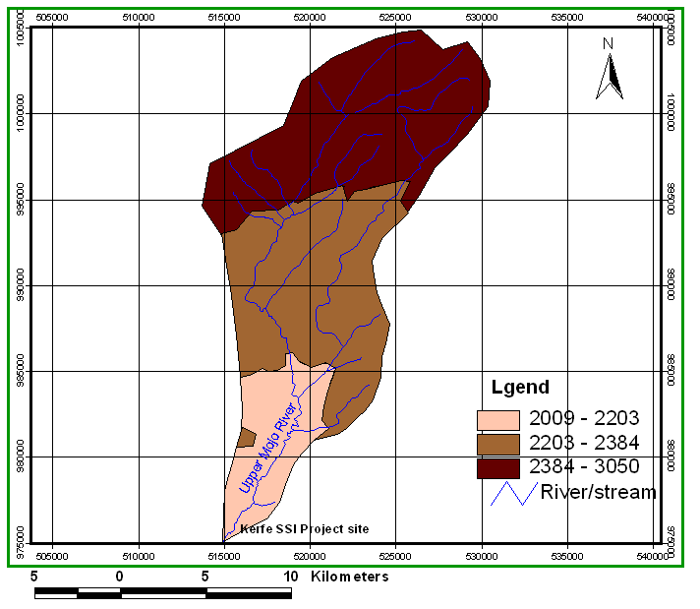
Figure 2. 1. Altitude distribution of Upper Mojo River catchment at Kerfe project area.

Drainage

Upper Modjo River with its tributaries forms Modjo River catchment that terminally joins Awash River.
Various factors affect the pattern and density of drainage in the study area. Among these are: rainfall, slope, vegetation, rock type and tectonics are important ones. Figure 2.2 depicts drainage density of the catchment.
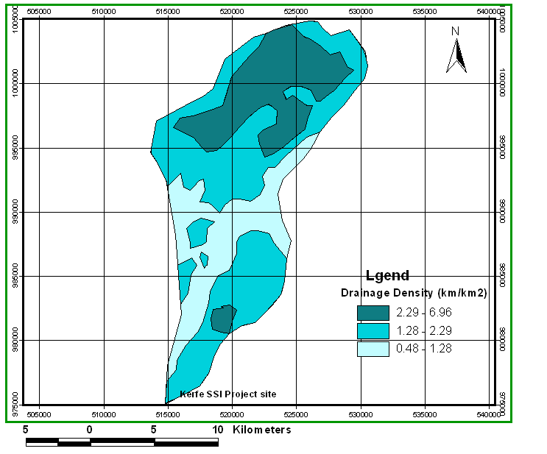
Figure 2. 2. Drainage density of Upper Mojo River at Kerfe village

Catchment Morphology
In general, the study area has four landform units consisting of level land, rolling plains and plateaus, hilly plains, high gradient mountains, high gradient escarpments.
Level lands and undulating lands: consists of level and undulating plateau plain lands having wide distribution in the in the study area. The area is almost flat to gently undulating having slope gradient less than 2%; and gently undulating to undulating lands of 2-8 % slopes.
Rolling plains& plateaus: This land unit includes, rolling plain and plateaus, transitional lands, and side slopes, a slope between 8-16 percent.
Hilly Plains: This land unit includes landforms as medium gradient hills and steep side slopes, a slope between 16-30 percent.
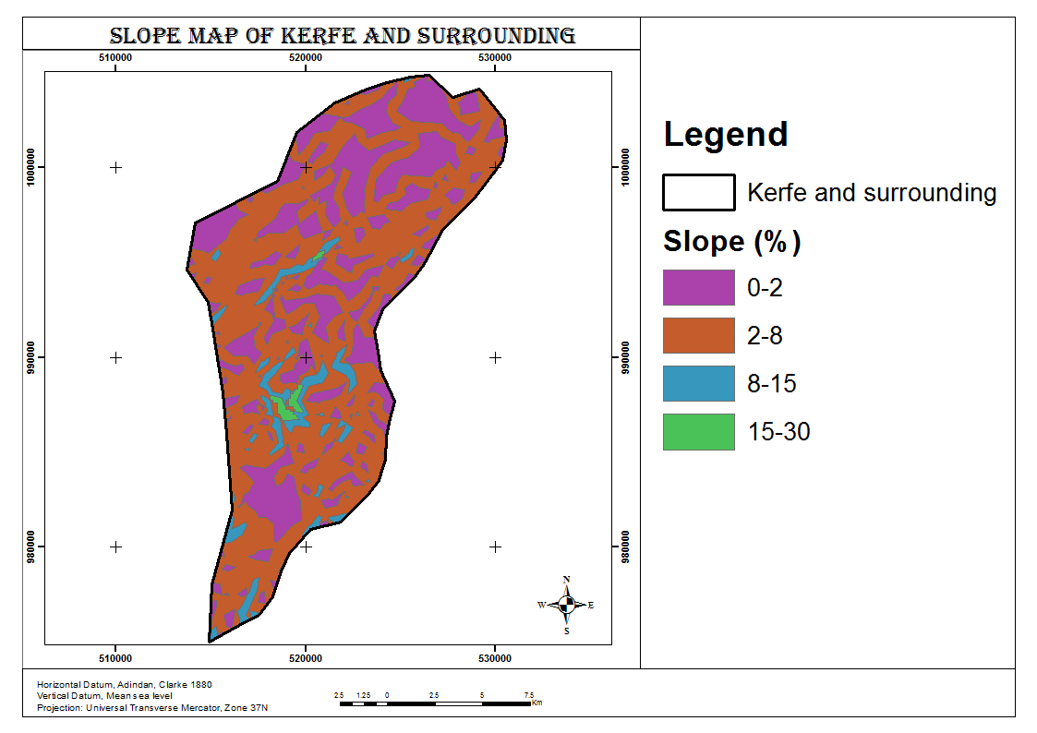
Figure 2. 3. Landform distribution of the study area

Geology
Geology of upper Awash catchment at small scale irrigation project consist of Tarmeber Magazaz Formation (Ntb), Nazret group (Nn) and Bishoftu volcanics (Qbb).

Tarmaber Magazaa Formation (Ntb): are typically alkaline basalts in nature (Kazmin, 1981). Usually individual flows are easily recognizable particularly in areas where plaeosols and scoraceous horizons developed in many places between flows (Kazmin, 1979). In general, the Tarmaber Basalts and their equivalents have much fresher appearance than the underlying stratoid basalts of Alage Formation (PNa).
Nazret Group (Nn): The Nazret group is widely present in the study area; and it is affected by the NE-SW trending lineaments. The unit consists of sequence of welded rhyolitic ignimbrites, with flow units. It also comprises of numerous rhyolitic and trachytic). The age of Nazret unit is between 9.5 and 3Ma (Kazmin and Berhe., 1978). This unit is a basal unit grouped under the intra rift complex and may constitute the upper part of Nazret Group of (Kazmin and Berhe., 1978) with respect to age constraints. Fresh ignimbrite along the banks and floor of the Modjo River is interbedded with lacustrine deposit. Each ignimbrite layer has an average thickness of about 2 meters. This unit includes various welded and often jointed columnar ignimbrites.
Bishoftu Volcanics (Qbb): It is found extensively in the central part of the study area forming a NNE trending belt in the rift axis complex. Bishoftu volcanics represent the most recent basic lava flow of the Debrezeit area (Tsegaye Abebe. et al., 1999), which was also reported as the younger volcanics by Grasparon et al (1993). In the Bishoftu volcanics there are two groups represented by spatter and cinder cones with associated tabular lavas and phreatomagmatic deposits, respectively. The latter, consisting mainly of pyroclastic surges and highly fragmented deposits associated with maars.
Figure 2. 4. Geological map of the study area (Adapted from Geological map of Ethiopia, 2006)
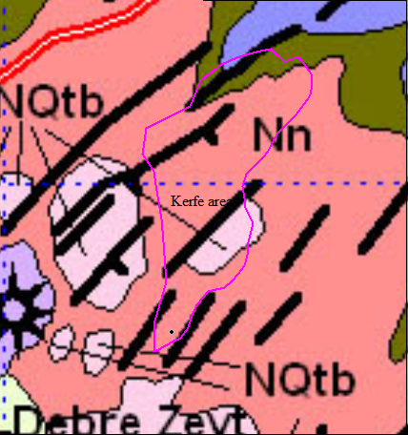
Legend
Ntb | Tarmaber Megezez Formation : Transitional and alkaline basalt.
NQtb | Bishoftu Formation : Alkaline basalt and trachyte.
Nn | Nazret Series : Ignimbrites,unwelded tuffs,ash flows, rhyolitic flows,domes and trachyte.

Soil
Climate, topography, parent material, maturity and biological activities are the major controlling factors that control soil formations.
The soil development in the study area is mostly due to the physical disintegration and chemical decomposition of volcanic rocks. The weathering products either remain in places and form residual soils or are transported and deposited to form alluvial deposits in low-lying areas. Meanwhile, the difference observed in the type and development of soils in the catchment mostly depends on the topography, parent materials and the degree of weathering.
In general, three soil types are observed in the study area. These are Cambisols, Vertisols and Liptosol.
Cambisols: combine soils with at least an incipient subsurface soil formation; and it covers more than 75% of the catchment. Transformation of parent material is evident from structure formation and mostly brownish discoloration, increasing clay percentage, and/or carbonate removal. They are soils with at least the beginnings of horizon differentiation in the subsoil evident from changes in structure, color, clay content or carbonate content. Cambisols are characterized by slight or moderate weathering of parent material and by the absence of appreciable quantities of illuviated clay, organic matter.
Vertisols: are churning, heavy clay soils with a high proportion of swelling clays that cover small areas (i.e. about 20% in southern part of the study area. These soils form deep wide cracks from the surface downward when they dry out. The heavy soil texture and domination of expanding clay minerals result in a narrow soil moisture range between moisture stress and water excess.
Leptosols: These soils cover limited areas in the catchment (less than 5%); and occur mainly on undulating & rolling volcanic plains and steep hill and mountain side slopes. The soils are generally young, which are limited by their topsoil horizon over an initial development of subsoil horizon or directly over an altered parent rocks from which they have developed. They are shallow with limited profile development.

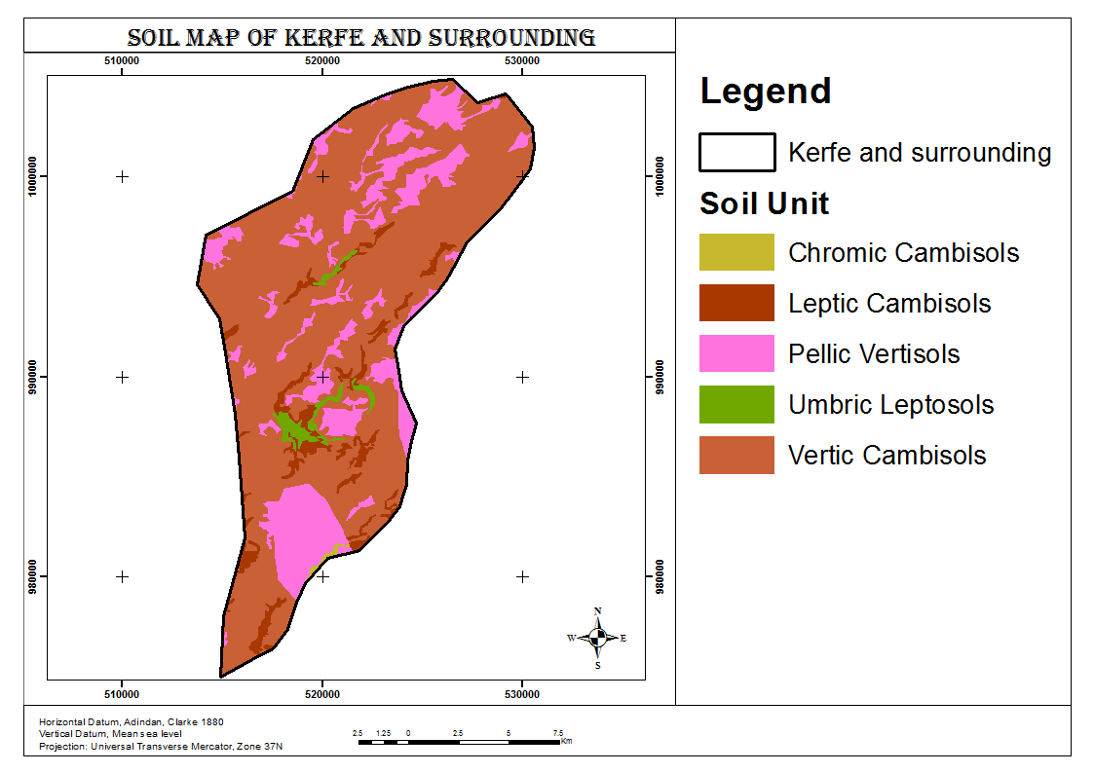
Figure 2. 5. Soil distribution in the study area (Adapted from Upper Awash Land use Study Project, Soil Survey).

Land use and land cover
Land can be put to different uses based on the suitability of its different physical land resources, demand, climate, location, etc.
In the catchment, the original vegetation is more preserved in the elevated areas than the flat areas, especially in the stream valleys and foot of elevated areas where there is seepage of water or shallow groundwater. This is due to the fact that people had made the natural forest to disappear on the flat lands in order to grow crops. Moreover, there are discouraging situations in which deforestation is still going on through improper utilization of the forest: clearing or cutting of the vegetation for trading and for new farmland, especially in the new resettlement areas. Accordingly, more than 90% of the land in the catchment is employed cultivation. The remaining 10% is covered by shrubs, grass, rocks, etc.

Socioeconomic Profile of the project area

General
The main economic sources and livelihoods of communities in the project area are agriculture. That is production of different crops and rearing of livestock. In addition to agriculture and livestock productions; the district in general and command areas in particular has potentials of different constructions stones.
During socioeconomic survey, different methodology were used to identify the economic and livelihoods of the communities in the project areas. As a result, the following economic conditions were identified.

Crop Productions and Agricultural Supporting Services
Productions of crops are dominant (primary) economic activities that are practiced in the project area. The major crops grown in the districts in general and command area that are fall in project area in particular include Teff, Barley, Wheat, Maize, Horse bean, and, fruits and vegetables.

Existing Irrigation Practices
The communities nearby/around the envisaged irrigation development site have experience of irrigations as they are producing fruits and vegetables nearby river Modjo by pump. Crops produced by traditional irrigation include cabbages, Tomato, red onion, etc.
According to Ada’a district Irrigation development Authority, there are enough water resources potential. Currently, a few rivers have been providing irrigational functions both under traditional and modern communal schemes. Irrigations have been practiced in the areas of Wedecha Modjo, Belbela, Fultino rivers and Hora Kilole.
The major problems related to crop production in the area are low productivity of agricultural lands, land degradations, vegetable and fruit disease, shortage of farm lands due to absence of land use planning, soil erosion and increased population size. Shortage of infrastructure, There shortage of transport and communication services are also serious problems. Shortage of rural market, very low prices of Agricultural outputs.

Extension Services
It is the services given to the farmers through developmental agents and other NGOs. The service includes how to use modern and new technologies such as training for farmers on technical practices. In the district in general and in the project area in particular the sole supplier of extension services for the community is government. There are one DAs that have different professions in the Karfe kebele of project area. According to the government policies and programs in each kebeles there must be three professionals that have different education background. However, the avialable DAs in the project area and in Adeadistrict of kebeles were less than that with very limited available facilities (living house, and other basic services) for them.

. Livestock Husbandry
Livestock have a great interdependence with the rural area and make a substantial contribution to the rural economy. Most rural farming, transport and source of income do directly or indirectly link with them.
The major livestock feeds in district include pasture, bushes, shrubs, crop residues as well as industrial by- products. Currently there is no formal pastureland. On the other hand the regular Extension service did not devote for expansion of modern pasture as needed in all farmer association.
Regarding livestock diseases the productivity of livestock in district is affected by prevalence of diseases. Because of these cumulative effects the production obtained from livestock are still remained low. In order to prevent the livestock diseases there are limited livestock clinics
- Black Leg
- Anthrax
- Foot and mouth disease.
- Bovine pastoralysis
- Ovine pastorolysis
- Lamp skin disease.
In the district there are only four animal health institutions with one “B” type and three of the “D” type.

Income and Expenditure of Households
Household income and expenditure are the most determinant factors of individual living standard in general and consumption in particular. Saving is also affected by these two economic parameters. The income and expenditure of sampled HH will be discussed as follows:
The household survey results of project area, indicated that most of the household members spend their income on household goods such as food, cloth; farm execute, health and other social expenditure. According to socioeconomic survey, for instance in the project area out of 20 HHs, 20 respondents said they spends more than 2500 birr per year.

Population Dynamics and Distribution
In addition to assessing economic activities of the community in the project area which is vital to know communities’ capacity to pay for social services and the projection and anticipation of future economic trend for planning and decision making; the demographic study is also equally crucial for decision makers to design different type of social service facilities (School, water, Health, etc) requirement because of the implementations of intended irrigation projects as it attracts peoples from different areas.
According to MoFED (2007 projected for 2016) population data the total population of the kebele is 2311(1201 male and 1110 female) with 462 household and 387 housing units. However, according to kebele administrators the total population of the Karfekebele is 6,846 with 3154 male and 3692 female. The total household size is about 1083 with 977 male and 106 female heads. Similarly, in the project area the total HH size and total population are about 200 and 3445 with 1451 male and 1994 female.
The first phase of this study tries to set out the overall demographic features of the project areas based on surveyed HHs. It will be assessed demography in terms of Household size and density, Ethnic and Religious compositions, Migration (influxes of temporary residences), and Population Projection.
Hence, the different perspectives of demographic study, which are vital for Karfesmall scale irrigation development project and other development intervention, will be discussed.

Family Size
Family size is one of the major aspects of demography. It shows the diverse nature of demographic linkages to other development programs. In any development planning, family size of a particular society has a determinant impact on the overall process. For instance, the more family size the more needs for social facilities such as water, health, education, etc.
Accordingly, based on the household survey from 20 respondents, 5 HH (25%) of them have 6 families, and 4 (20%) respondents said that they had 8 families. Nearly, on average based on the collected HH data, the average family size in the project areas is6 families.

Age Composition
The composition of age of a particular’s society is a very critical component of development planning. In other words, in addition to other demographic components, it will facilitate and enable to predict what will be the future demand and development activity. The more the young generation, as an example, the higher the future means of livelihoods and other social services’ demand will be. It is also important to identify the working forces and dependent peoples in the areas for future developmental plans. Hence, aiming to plan the irrigation development and other development activities pattern of the study area, the research tried to divide respondents’ age structure into seven different categories.

The household survey carried out in the command areas shows that the age ranges of respondents are high between 31 years of age and 55 in the project area which is 16 HH (80 %) and it shows that active labour forces.
Generally speaking, even though the ages do not explains the skilled and unskilled labours, there are sufficient working age labour supply in the project areas whenever the proposed project is implemented.

Religious and Ethnic Compositions
According to survey results all of peoples in the project area belong to and Orthodox Christians community which is 100% of Household surveyed, engaged mainly in mixed farming activity. However, according to the Kebele Admiration there are other few followers of Christians.
In addition to this, according to the survey conducted in the project areas, Oromo constitute great majority (i.e., 90%) followed by Amhara (2%), of the total HH.

Gender and Family Planning in the project area
Gender is the socially constructed roles and responsibilities assigned to women and men but not a biological factor in a given culture or location. The sex based division of labor prevails in our society from time immemorial. Women are mostly deals with caring the children and seek member of family. It is the duty of women to fetch water from source, to prepare food, cleaning and managing house, purchasing food items and collecting firewood. There is sex discrimination in the project areas.
Regarding HHs family planning conditions, the HH members surveyed have positive attitudes to the family planning programs. As a result, about 89.5% of them supported the programs and they practiced it. However, 10.5% of them favor of having many children. In addition to this the health service’s (health post) extension workers said as the community in the area have positive.

Existing Social Services and Infrastructures

Existing Water Supply
Regarding water supply Cirmo, Karfe, Tamme, and Hofu villages have three, two, two and three water points respectively. Thepotable water supply is part of Fantale-Gimbichu water supply projects. About 619 household heads was benefitted from it. There is one health posts with one extension worker and one livestock clinic in the area.

Education
According to the data obtained from the field areas and representatives of Karfe kebele, there are three government and one private school facilities.
Table 1. School distributions and enrolment
School name | Grades | Enrollment in the year 2007 E.C
 |  | Male | Female | Total
Hofu | (1_7) | 186 | 147 | 333
Xamae | (1_4) | 100 | 80 | 180
GaraGojo | (1_7) | 269 | 235 | 504
MalkaIrrecha | (1_4) | 108 | 103 | 211
Advent | (1_8) | 92 | 95 | 187
Total |  | 755 | 660 | 1,415

Health Services
The importance of analysing existing health facilities in the project area is to evaluate and identify changes in the human health, risks may arises as a result of change in socio-economic and psycho-social factors of the environment, to take mitigation measures and for the future development of health services in the project areas.

Prevailing Diseases in the Areas
According to the HH survey results, the most deadly prevailing diseases in the area are malaria, headache Diarrhea, and eye diseases, etc. As it is depicted in the following tables, malaria (75%), Typhoid fever(85%) and Ameba (45%), are major disease affecting the health of the communities in the project areas, respectively.

Table 2.2. The most common diseases prevail in the areas
Prevailing Diseases in the project area in %
Malaria | Gastric | TB | Diarrhea | Typhoid fever | Eye Diseases | Ameba
75 | 10 | 20 | 40 | 85 | 30 | 45
Source: socioeconomic survey
Current health data shows, the water born disease is high in the project area. Malaria and Typhoid feverare highly prevalent in the project area.

Major Health Related Problems
The problem starts with shortage of health institutions. There is one Health post in the kebele with one health extensions. In this regard, there is a need to expand and establish investment on health. The problem is also exacerbated by very low availability of health facilities, qualified manpower, medicine and medical equipment, high cost of medicine and treatment.
On the other hand, the HH members asked to whether they received health education on disease prevention and control or not and majority of them said that they have the information about it.

Infrastructures
Infrastructure and social services are refers to the fundamental facilities and system serving a country, city or areas including the service and amenities necessary for its economy to function. It typically characterizes technical structures such as roads, water supply, schools, health services, sewers, electrical grids, telecommunications, and it is the physical components of interrelated systems providing commodities and services to enable sustain or enhance societal living conditions.

Communications and Transportations
They play very important role in any development endeavors. It would be impossible to conceive of social and economic development in the absence of adequate transport, communication infrastructure and services. Transportation problems were analyzed from the house hold survey. About 98.2%, 69.3%, and 64.9% of HH said there are inconveniency of roads, high cost of transportation and shortage of transport vehicles, respectively. Access to overall telecommunications service is much lower than expected. There is a very limited availability of the service with very bad quality.
Mobile network service is showing improvement in the past years. Since its introduction in the country, this service is covering much of the area’s telecommunication coverage. However, the quality of the service is very low even at the national standard; due to unknown reasons.

Roads
The survey also analyzed about road transportation. That is about 8.3% of HH said there is no road, 69% said the cost is high, 98.2 % said the existing road is bad.

Means of Transports
The means of transportation to get social service and services (market, health, etc) are very essential particularly in the rural villages where the hardships are very strong. In many parts of the project areas people use to transport their sick person to health institutions for instance, carrying on shoulders, Horse Carts, pack animals and sometimes using vehicles. There are very few vehicles available for the communities to go to markets and health services. The problem is not only lack of vehicle transport but the underling cost of the transport services is unbearable to the majority of the people.

Marketing Facilities
The intend of the market situation overview is to identify and evaluate the market potential, market related problems, accessibilities and chain of markets in the project areas. Available data were collected from zone, district and village levels to analyses the current state of market and marketing facilities in the study areas.
The nearest potential markets Centers available in the project area include Jimata Livestock and crop markets, Ardaga and Hiddi among others. All three Market places that are found in the project areas have all items to be marketed including livestock and crops. According to the information from communities there is a high demand for crops and livestock from all villages in the district and even at zones and regional levels when the proposed project will implemented.
Regarding the accessibilities, as there are high demand for the crop production in the area, there are also a lot of problems prevail in the project areas such as high transportation prices, scarcity of means of transportations of products from village to village, from district to village and between district and zones and in general the major market and marketing facilities problems are infrastructure problems.

Financial Institutions
Banks, insurance corporations and micro-finance play substantial role in the economy. They facilitate and stimulate the economy and they are the engines for farm operation and management.
There are no financial institutions available in the karfe kebeles of project areas but there are two branches of commercial banks, and other private banks in Bishoftu town, capital town of the Adea district and 23Kms away from the project area. However, all the aforementioned banks did not incorporate provision of credit to the farmers as banks demands collateral for which the asset of the farmers would not suffice their requirement. This forced the regional government to establish micro-finance schemes that operates in the region to support vulnerable and poor households.
In general, small size of the loan and group collateral become hindrance to the member of the community to get maximum benefit out of the credit. To this effect farmers are not liable to sufficient credit to improve their farming, as the banks does not consider their assets as collateral. Some members of the community are forced to take loans from traditional money lenders at high interest rate as the repayment for loans are high. Thus, there is need for appropriate financial institutions as irrigation farm requires high capital to purchase different agricultural inputs.

Development Potentials, Constraints and Opportunities in the Project area
This section describes the developmental competences, challenges and suitable environments for the over -all economic and social advance of the area. It emphasizes on the existing irrigation, and other developmental potentials, existing problems and future opportunities in the project area.

Developmental Potentials and Opportunities
There are two main reasons why the developmental potential and opportunities of any intended area should be estimated. First, it provides a base for the formulation of strategies for any socioeconomic development, (specifically, irrigation development in our case); and second, it gives a benchmark for monitoring progress within a given sectors (irrigation sector). several factors needs to be considered when estimating developmental potential and opportunities (irrigation) that includes water resources, availability of suitable lands for irrigation, cropping patterns and irrigation technology to be used.
As there were identified during field survey, some of the irrigation and other developmental potentials, and opportunities but not limited to, includes:-
- Availability of fertile farm land and weather condition for agricultural activities such as growing cash and industrial crops and other natural resources.
- Perennial rivers flowing through the year that can be utilize for both traditional and modern irrigation such Modjo river.
- Availability of inexpensive labor in the area
- Willingness and interests of the community towards irrigation projects and other developmental programs

Challenges and constraints
- Despite the fact that the extension service on the use of different inputs and other methods of technological services has started long ago the level of utilization of this technology to the farmers is still very lower this is due to lack of budget and skilled human power.
- Very limited infrastructure development such as road network, lack of information due to inaccessibility of telecommunication, poor transportation services, and also occurrences of different crop diseases.
- Inadequate water supply and sanitation service in rural the project areas.
- Irregular rainfall distribution causes seasonal fluctuation both in quality and quantity of crop production.
- Very poor health facilities. For instance, Referral service is poor pregnancies often enter into every serious complication when usually end in the death of the mother or child or even both.
- Inadequate knowledge on improved and diversified irrigation agronomic practice
- Shortage of financial institution
- Shortage of basic technical know-how irrigation pumps, drip irrigation system, and surface and spate irrigation methods.
- Inadequate base line data and information on the development of water resources.

Socioeconomic Impacts of the Project
The proposed irrigation project will have substantial positive impacts (expected benefits of the project) on the socioeconomic development of the area. It will raise the living standards of the given community and advance their material well-being. The project may have also adverse effects on the community around area as well as the neighboring peoples. It may cause social disturbance and increase water borne diseases.

Positive Impacts
The positive impacts can be reflected both at national (regional) and households (individual) level. It will increase production and services in the economy through closing supply created gaps and make surplus for the markets. It will also increase economic capacity of the individual’s at the household levels and transferred skills or knowledge during implementations.
Specifically, the project is, therefore, expected to facilitate the growth and development in the area through:
- Improving the productivity and employment opportunity to the farmers and others from adjoining and different area of the country by reducing unemployment and underemployment.
- Enabling the beneficiaries to increase productivity but general stay with the same production base
- Encouraging intensive land and labor options
- Stimulating economy through generating employment opportunities and creating market interactions due to additional productions
- Enhancing household income and improve quality of live for members of the families in particular and the country in general.
- Augmenting development of the township by attracting commercial and investment activities.
- Increase requirement to pay for mitigation of social and environmental impacts.
- Development of social services and infrastructure. There should be the opportunity of development of social services and infrastructure corresponding with the proposed irrigation project in the area.
In general, the socioeconomic benefits (it can be direct or indirect benefits) of the project are wide and multi-faceted which cannot easily measured.

Negative Impacts
Any project planning has adverse or negative effects on the targeted community and environment when it is realized. And the study also identified the following negative effects that may ascend during project implementation. These may include:
- It creates prevalence of various diseases such as malaria and other water borne diseases and STDs due to population movement and increasing concentration of irrigation water.
- Increase income inequalities by benefiting disproportionate those members of society that are already wealthier. This is because smaller landowners are better able to afford additional agricultural inputs, machinery, chemicals, and labor that will be needed to benefit from extra water.
- It may create social disturbance during implementation of the project.

Problem Identification

Soil Erosion
The main type of land degradation, in the watershed is soil erosion. Soil degradation is decline of organic matter, depletion of nutrient, salinization and drying up of rivers and streams. However, the degree and intensity of erosion varies from place to place depending on the soil types and intensity of erosion agents. The increase in human and animal population number caused high deforestation of hilly areas contributes different types of erosion.

The common type of erosion is water erosion exhibited with all forms of erosion such as sheet and rills, gully, stream bank and land sliding on very steep slope areas.

Sheet Erosions: is the removal of thin layer of soil and. it is unnoticed because of the total amount of soil removed in any storm usually small. However, it has series determinately effect on soil fertility and productivity since it removes lighter soil particles and soluble nutrients. Sheet erosions the dominant form of erosion occurring in all parts of the basin. It is the most widely destructive erosion process. However, it is obvious that sheet erosion is more series where the surface cover is little.

Rill Erosion: Rill erosion is the next noticeable form of erosion. In all areas where sheet erosion occurs, we can observe the symptoms of rill erosion. The symptom of rill erosion is the occurrence of rills or small channels on different land units. Rill erosion occurs in all parts of the basin and considered as the second destructive form of erosion. The intensity of rills varies with in the basin; rills are observed frequently in areas of having relatively high slopes and frequent rain.

Gully Erosion: Alike sheet and rill erosion, gully erosion is a threat .With continues encroaching of gullies mostly towards cultivated and grazing land; gully erosion is also a problem in the watershed. Because of this negligence the gullies are regularly expanding. Cultivated and grazing lands are expanded up to the edge of the gully and even on gully sides.

Vegetation Degradation
Excess removal of forests is contributing to land degradation. Since harvested trees had not been sufficiently replaced by tree planting in the area, soils are exposed to high intensity of rainfall the major sources of energy for the rural households in the watershed include mainly firewood. The only sources of fuel wood therefore are some homestead plantations, crop residues and animal dung. The major sources of energy for the rural households in the watershed include mainly firewood residues. Most households get firewood from scrublands and private eucalyptus plantations around homesteads and along roads and footpaths.

Weed invasive
Weed invasive is common land degradation in the catchment, which is mainly observed in cultivated land. This type of degradation is a severe problem on agricultural production mainly on crop production through depletion of nutrients in the soil.

Improper Land Utilization System
The major cause for land structural deterioration of the watershed is believed to be long-term excessive tillage without any remedial measures. Cultivation for a long period, which is common feature for the area resulted in depletion of soil nutrients and organic matter that in turn enhanced crusting, aggressive runoff, accelerated erosion and ultimately low productivity. Soils low in organic matter due to long-term cultivation and high in silt contents are usually most prone to crusting that often occurs after heavy erosive storms. The removal of forest cover played a great role in the process of enhancing accelerated erosion. As a result of this process, the topsoil depth is reduced to a minimum uncultivable value are the most important factors in high runoff yield that results in more accelerated erosion.

Consequences of Land degradation in the catchment

Decline of Soil Fertility
Loss of soil fertility is severely affected by soil erosion and land degradation, use of dung and crop residues for household fuels and animal feeds and decline in fallow periods. Even though the farming system in the project area is mixed crop–livestock, the culture is based on the nutrient take way from the soil that the nutrient return to the soil is very minimal. The chemical fertilizer use is also limited because of its unaffordable price to the watershed area poor farmers. The soil fertility problem in the watershed is therefore one of the serious problems, which should be addressed in this watershed management plan.

Decline of Crop Production
The major problems of crop production are:
- Depletion of soil fertility
- Improper timing in cultivation
- Occurrence of disease and pests.
- Lack of production management extravagancy at harvesting seasons for weeding and other cultural ceremonies.
- Seasonal fluctuation.
- Lack of awareness of farmers.
- Lack of farm inputs or unable to purchase it

Decline of Livestock Production
The constraints encountered in livestock production are man induced.
The major problems are:
- lack of awareness of the farmers in performing the following basic livestock managements
- Vaccinating their animals with little charges and/free programs set by governmental institutions
- Early examining of sick animals
- Improving and cross breeding
- Technical practice in feeding and breeding

Land Capability Classification
Of many agricultural interpretations of soil maps the Land Capability Classification developed by the Soil Conservation Service of the United States department of Agriculture, USDA is widely used and soundly tested and is applicable worldwide (Klingebiel and Montgomery 1961).

USDA Land Capability Classification
It assesses land capability from known relationship between the growth and management of crops and physical factors of soil, site and climate. Land is graded according to its potentialities and the severity of its limitation for crop growth in to eight classes. Land suited to cultivation and other uses is included in classes1-4, and land not generally suited for cultivation and for only limited use for other purposes is included in classes, 4-8, (see Table 4.1). Class 1 land has a wide range of uses with few limitations, while the remaining seven classes suffer from increasingly severe limitations and are progressively less flexible

Land Capability Classification, Principles
  - The land classification is primarily meant for soil conservation purposes.
  - The land is classified mainly on the basis of limitations (those directly or indirectly related to water erosion).
  - The productivity assessment and the economic aspects are not considered in this classification but can easily be overlaid and provide guidance for more accurate and effective selection and design of SWC measures.
  - The soil and water conservation requirement classes are homogeneous only with respect to the degree of limitations in agricultural use. Each class may include different kinds of soil.
  - To assess the classes, the range of diagnostic characteristics for each land feature is adapted to the main physical conditions found in semi-arid areas.

Categories of the System
In the land classification, two categories are proposed. These are the Soil Conservation Requirement Class (SCRC) and the Land Class Unit (LCU). The SCRC represents the major category of the system. It is determined by the most limiting condition permitted in a range of characteristics for each land feature. There are eight SCRC which area class I, II, III, IV, V, VI, VII and VIII. The risk of soil erosion increases through classes I to IV and VI to VIII. Likewise, the requirements for soil conservation practices and management also increase similarly. Class V is a special case. In this classification class V is wetland, very poorly drained; it has major management problems but no erosion hazard, unless by salts.
The land class unit (LCU) is the lowest category of the system. The major limiting factor affecting the use of the land for agricultural purposes determines the land class unit. The limiting factors could be one or two of the following land features:
- Slope (L),
- Soil depth (D),
- Past erosion (E),
- Water logging (W),
- Infiltration (I),
- Texture (T), Stoniness & rockiness (S).
- Salinity (A) and
- Sodicity and pH or reaction (R)
Although important factors, are not considered as leading factors in this classification and their importance should be case specific and valued based upon local conditions.
Symbols for the land class units are represented as SCRC symbol + Major Limiting Factor. For example, land class units IIL means SCRC class two with a major limitation of slope (E).

Subclasses |  | e |  | w |  |  | s |  |  |  |  |  | c
Limitations |  | Slope | Wind or water erosion | Overflow | Drainage | Moisture holding capacity | depth | Stoniness | Structure and workability | Permeability of subsoil | Salinity and alkalinity | Fertility |  | Climate
Cultivated land | SCRC | No | No slight | No | No | No | No | [No] | No | No | No | No slight |  | No
Cultivated land | I
Cultivated land | II | Slight | Moderate | Slight | Slight moderate | Slight moderate | Slight | [Slight] | Slight | Slight | Slight moderate | Slight moderate |  | slight
Cultivated land | III | Moderate (mod. Steep slopes) | Severe | Moderate | Moderate (imperfectly drained) | Moderate severe | Moderate severe (shallow) | - | - | Moderate severe (very low) | Moderate | severe |  | moderate
Cultivated land | IV | Severe | Very severe | Severe | Severe (poorly) | Severe | severe | - | - | - | severe | severe |  | moderate
Non-cultivated land | V | No | (no) | Frequent | Ponded areas | - | - | Severe (stony) | - | - | - | Severe
Non-cultivated land | VI | Severe (very steep) | Severe | - | Severe (excessively drained) | severe | Severe (shallow) | -  strong | - | - | - | - |  | Severe
Non-cultivated land | VII | - | Very severe | - | Excessively drained | - | shallow | severe | - | - | - | - |  | Unfavorable climate
Non-cultivated land | VIII | Land not suitable for agriculture
Table 4.1: Degree of Limitation of the Characteristics for the Different Capability Classes

The land classification System for soil conservation also attempts to identify the most suitable land use for each Soil Conservation Requirement Class. 4.2.shows suitable land use group in the different soil conservation requirement classes.
SCRC | Suitable land use
I  II  III  IV | Land suitable for annual crops
V | Wet land - regularly waterlogged, may be suitable only for rice & temporary grazing
VI | Land suitable for perennial crops or grazing
VII | Land suitable for forestry
VIII | Land not suitable for agriculture
Table 4.2: Suitable land use for SCRC
Land capability classification for the whole watershed was made by assessing factors that are limiting capability of land for specified type of land use. Table 4.2 shows the area extent of land capability class for different land use systems verses current land use/land cover class. In line with this, table 4.3 shows extent of land capability classes in the watershed.
Current land use/land cover classes |  |  | Land capability class/SCRC
Current land use/land cover classes | I | IIL |  | IIIL | IVL | VW | VIL | VIIL | Total
Cultivated Land | 77 | 98 |  | 24 | 11 | - | - | - | 219
Open Wood Bush land | - | - |  | - | - | - | - | - | -
Open Wood Grass land | - | - |  | - | 5 | - | - | 6 | 11
Open Wood with Shrub and Bush land | - | - |  | - | 6 | - | 6 | 2 | 13
Total | 77 | 98 |  | 24 | 22 | - | 6 | 7 | 243
Table 4.3: Current land use/land cover vs land suitability with respect to SCRC

Soil and Water Conservation Experience
In 2010, the Ethiopian government launched a land restoration program that aimed to double agricultural productivity through improving the management of natural resources and agricultural lands. Since then, physical and biological Soil and Water Conservation (SWC) measures are observed to be implemented in many areas by local communities including its management.
To decrease the problem of SWC in the catchment, the development agents, and natural resource experts at zonal and woreda levels are providing advice to develop terraces and supporting them with other soil fertility and SWC measures such as use of compost, farmyard manure, improved fallows, and use of grass strips in areas that are intensively cultivated, with high population density and high levels of land fragmentation. The practiced structural soil and water conservations measure and soil fertility increment practiced in the catchment are briefly explained as follows:

Traditional Cut-off Drains: is the most important and widely practiced structural indigenous soil conservation measure in the study area. Accordingly, the structures are constructed across the traditional waterways, which are prepared on farm plots parallel to the slope during rainy season. The idea was to change the flow of powerful runoff coming from one known direction at the top of the farm plot. Because of this, farmers describe the structure as traditional cutoff drain or locally “boraatii bishaanii”. The structure was production-oriented as well as conservation-oriented.

Traditional waterways: are widely practiced form currently throughout the country to reduce soil loss by runoff on higher altitude. It is a common practice in the study area also to protect crop fields from being damaged by run-off that comes from certain direction. Accordingly, farmers practiced two-type waterway structures in the study area. These structures are stone waterway and grass/soil waterways. The stone paved waterways were used for a long period than the grass waterway, which was eroded by runoff. By doing so, they protect their farm plots from the damaging effect of runoff.

Soil bund: Soil bund is an embankment constructed from soil along the contour with water collection channel or basin at its upper side. It has been practiced by throwing soil dug from basin down slope. It used to control runoff and erosion from cultivation fields by reducing the slope length of the field, which ultimately reduces and stops velocity of runoff. Usually, it was constructed in fields that have slope greater than 10%. Development team in the watershed mainly advises the farmer to constructs this conservation structure but the farmers do not apply this method.
Compost: is also one of the modern soil fertility improvement measure is rarely practiced in the area because of low awareness of people on compost. The preparation of compost involves the use of ash, leaves, grasses, cow dung etc with two or three holes. This material firstly saved (collected) in one hole and transferred to the second hole after ten or twelve days and it transferred to the first hole after other ten days, this process continue at list for three months; after that, the compost was taken to the farmlands. In the basin, this measure has been introduced recently by the force of rural development agent extensions.
Stone terraces: Stone terraces have been practiced in the area where construction material like stone is available. It is the conservation measure of soil and water practiced highly over farmland of the basin. The construction of stone terracing is labor demanding. Therefore, farmers of the area construct the structure in groups mainly during the dry season.

Soil and Water Conservation Development Plan

General
For sound watershed management different interventions are proposed that will solve the stated problems when it is implemented properly. The development plan is designed considering social, economical, technical and ecological aspects of the area. Based on this, the watershed management plan covers physical, bio-physical and biological conservation measures.

Physical Soil and Water Conservation Measures
The soil erosion status of the area is classified as moderate to severe level. Both classes are hazardous and require strong measures of conservation, which is integrated in all agriculture activities because most physical soil conservation measures are applied in agricultural production areas. The main physical SWC measures recommended to be implemented in the command area are soil bunds, stone faced soil bunds, stone bunds, Cut off drain, waterway, check dams. These physical measures are applicable in a broad range of agro-ecological zones and land uses.
They should be integrated with:
- Bund stabilization using grasses, legume shrubs, trees, cash crops.
- Compost making.
- Control grazing-avoid animals to graze between bunds.

Stone-faced soil bunds: These structures are recommended on cultivated lands with some levels of stoniness.

Cut off drain: After assessing existence of enough out let facility, cut-off drain is effective to avoid the excess runoff from cultivated lands. Before designing the cut off drain the peak runoff rate should be known. Suitable at a foot of a steep hillside under which cultivated fields are exposed. Constructed above gully head to divert run off from active gullies to treated/stable ones

Micro-basins: Micro-basins are proposed to accommodate eroded soils and runoff water so as to create conducive microenvironment for any type of plantation activities. The shape of micro basins can be full or half moon type. For flat areas full moon type is recommended while half moon is for steep slopes.
- Applicable in steep and degraded hillsides and for community closures.
- Need to be combined with hillside terraces, trenches and other measures.
- Constructed using sods, in areas without stones, and stabilized with plants.

Hillside Terraces: Hillside terraces are recommended on steep slopes community closures. Need to be combined with other measures, like micro basins, trenches, etc.
Soil Fertility Management: Soils in the command area range from the very infertile, in steep slopes, to moderately fertile, in lower slopes. There is a close relationship between soils, and soil and water conservation. The aim of soil management is to maintain the fertility and structure of the soil. Highly fertile soil result in high crop yields, good plant cover resulting in conditions, which minimize the erosive effects of raindrops and runoff. The central theme in here is that soil fertility must be seen as a key to soil and water conservation.

Soil fertility can be maintained through addition of organic matter; typically composting and maturing, to increase the resistance of erodible soil and increase agricultural production. The system includes practices such as leaving dead plant material at the surface of the soil, after the crop is harvested, to keep moisture within the ground, and protect the soil from erosion. It also includes ploughing along contours to have plough ferrous that slowdown speed of surface runoff and increases soil-water infiltration.

Biological Soil and Water Conservation Measures
Grass strips: Grass strips are the most effective ones in arresting the sediment inflow. For this watershed there are different exotic and local grasses adapted in that area which therefore can be planted on soil and or stone-faced soil bunds. Grass strips can be done by direct sowing, planting the sods and by developing it from the un ploughed lands between the cultivated areas.

Green manuring, organic matter application, mulching and crop rotation: are considered as biological soil conservation measures. They are mainly concerned with keeping soil fertility and as a result develop good soil structure, which can resist erosion. Mulching and organic matter applications are much more effective than the other factors for they influence surface condition of the soil which in turn control infiltration rate.

Hedge row plantation: There are different bush species for hedge row plantation such as tree Lucerne, Susbania sesban and other that are being grown at the near vicinity of the project area. Plant, shrub and grass species to be planted should be with multipurpose quality and fast growing. The species must have high palatable bio-mass for livestock feed and forage; enriching ability of soil nutrients; high yield of food, fuel and construction wood; quality for soil and water conservation but not aggressively compete or suppress the field.

Area Closure: Area closure is a protection system and saving mechanism of land against any external influences including erosion. Slopes above 40% are recommended to be closed from day to day human activities and livestock grazing to give a way for natural trees and grass vegetation regeneration.

Main land use: Mostly degraded hillsides and large gully networks.
Main core measures: Guarding, hillside terraces, micro basins, trenches, multipurpose plantation, check dam, cut off drain and others.
River Bank Protection: Currently, Stream and river bank undercutting, soil sliding and deep gorges creation is one of the problems related to soil erosion and ecological degradation. Removal of soil from stream bank is mainly aggravated by the run-off falling over the banks of the river from the nearby areas without appropriate measures for soil conservation. This stream and river bank erosion causes several problems such as continuous destruction of adjoining productive cropped lands right up to the stream banks and sometimes badly damages the lands, during flood. Therefore, protecting of streams and riverbanks should be important part of the watershed management.
Cut and Carry: Cut and Carry is a system of utilizing forage for shade feeding. It is a conservation based management technique to preserve soil and vegetation. It helps to avoid damages that may be caused if animals are allowed to graze.

Implementation Strategy

Preparation for implementation
Different watershed teams will play a major role in maintaining a high level of participation during implementation. They will coordinate the efforts provided by the community and those of single individuals or target groups.

Institutional organization and terms of reference
General roles and responsibilities for participatory watershed development program (PWDP):
- Regional, zonal (if applicable), woreda experts and DAs are responsible to propose and arrange training for land users before and during implementation based on local conditions and specific needs. Therefore, training proposals should be developed and forwarded to wereda level, which will provide the technical support.
- DAs and woreda experts are responsible to follow-up trials and development of on-farm participatory technology for innovative measures to be tested in specific areas.
- DAs and woreda experts will play a major role in strengthening the communication between the various sector agencies operating in the area by involving their experts and using their resources whenever required; for instance, education and health experts, resources, NGOs and others.

Resource identification and mobilization
Self-help contributions and empowerment:
Work parties and solidarity efforts:
The community has a key role to play in the contribution of labor and support to the implementation of the plan.
Implementation and management of watershed plans:
- Identify farming system-specific menu of activities, which can be undertaken using self-help resources that would enhance household physical assets.
- Identify households on whose holdings NRM activities can be undertaken following watershed logic, can facilitate their organization into a number of groups, and can ensure timely accomplishment of the activity. Link the self-help activity to any other form of available support in different areas.
- Work towards requiring group members to contribute in kind to the task being carried out within their capacity and agreement.
- Identify eligible households where other assets are to be built using external support. Determine the quantity of the transfer that the group is eligible for and effect the payment on schedule.
- Facilitate the accomplishment of agricultural/NRM tasks in/around the homestead of disabled people following the spirit.

Group formation, community and social organization: Proper establishment and construction of quality measures help much on sustainability but they are only half the job. The other half is proper management of assets. Proper management is not only necessary to sustain and improve measures but also to initiate their replication and expansion. Development initiatives will not be sustained unless beneficiaries make some form of resource commitment to support those initiatives. Watershed development and management should be thought as a contract where self-help and external support efforts translate into commitments to manage, protect and eventually improve assets once established are considered part of the agreement.

Social organization built on traditional or new methods is also intended to promote initiatives and activities that enable improved social interactions between groups and people, highlight gender issues constructively as well as optimize sharing of benefits and enhance mutual mechanisms of solidarity

Group formation for social organization and income generation initiatives is, on the other hand, meant strengthen local capacities required to sustain community-focused development, to improve the living conditions and income of rural households, the poor and disadvantaged in particular.
A long-lasting, collective responsibility for natural resources requires the construction of a common vision rooted in the values of farmers who live on the watershed and experts in the woreda line agencies. This can lead to adoption of new social norms and a refusal to allow land degradation to continue. This is also linked to gradually building an increased capacity of the watershed communities and the broader watershed continuums to build enough resilience to sustain them and exit from external assistance.

The community watershed team will form the groups that will implement the plan, generate community income and manage community assets. It will decide on the number of group membership following local norms.

Large parts of Ethiopia have degraded and food-insecure areas. These require the implementation of multiple activities that pass the test of quality. Otherwise, the impact of a few activities would remain limited and not be able to catch up with the pace of overall problems.
As problems of households are multiple and interrelated, the solutions should be multiple and integrated. Therefore, a broad network of watershed plans and activities, properly selected and designed based on people’s problems, priorities allow the vulnerable areas, and to plan based on food gaps, number of vulnerable people and resources available.

Organizational arrangement at watershed/community level
Community labor based contracts and solidarity schemes. Based on the watershed plan prepared, the amount of labor requirements and type of materials are then estimated. Building on the traditional work parties, the labor component could be thought as a labor based community watershed “contract”. The resources provided or to be provided on self-help and/or other forms of assistance can be translated into person days.

The total cumulative person days can then be taken up as a credit that the able-bodied target group should “repay” back to themselves or to the community in a participatory manner, or to specific groups they themselves prioritize during a given year in terms of assets building for watershed development.

Watershed development should strive to ameliorate the position of women in general and female-headed households in particular. The case is also made for people unable to work to build significant assets but who are able to manage. Many women and the categories of people named retain considerable potential to manage assets with dedication and care.

On the other hand, the number of chronic, food-insecure women-headed households is considerable compared to the total number of food-insecure households. In addition, it is not likely to move into other areas for opportunities as men do. Women groups or the whole target group could be organized to this effect and assist those women in building their asset base. Women have a high sense of protection, saving and market-oriented attitudes that should be nurtured. They should be given support to increase their participation in watershed development and NR management, including productivity intensification measures at homestead level.

Linkages with land-use certification. The ongoing efforts on land-use certification in several regions is an excellent incentive to enable land users to value their land holding but also to encourage investments in degraded and marginal areas. The certification process should be closely linked with watershed development planning. The responsibilities of households in managing their land should be related to the management of the measures implemented in such landholdings following watershed development logic and interventions. Specific arrangements at woreda and regional levels are needed to ensure that land certification is integrated with watershed development and avoid that interventions undertaken on private or communal areas are disconnected and of poor quality.

Training and experience sharing
Building the capacity of local communities and extension workers is an important component in watershed management. Different people will have different roles and responsibilities in watershed projects implementation and there is a need to train people involved in the watershed development program/project at various levels-villagers, CBOs, extension staff, and others.

The purpose is to achieve sustainable village/community-based development with integrated watershed management serving as a tool.

Training can enhance knowledge, attitude (problem solving, behavior, and the like), skills (communication, technological, demonstrations, conceptual) and relationship (trust, respect, co-operation and teamwork)

How to assess training needs: The role that one is expected to play in watershed programs/ projects often determine training needs. We need to determine roles and responsibilities of the stakeholders (woreda team, DA, kebele, innovative farmers, and others).
Core aspects of training and experience sharing:
    - Extension staffs need to be trained and encouraged to develop their own training modules as per the needs of the watershed community;
    - Identification and use of trainers and resource persons both from within and outside the project area will strengthen the process of capacity building;
    - Exposure visits, interactive sessions and networking among stakeholders can play a major role in the capacity building of the grass root level workers;
    - Participatory training methodologies encourage innovation;
    - Accountability must be in-built within the capacity-building process;
    - Linkage with research institutions help in providing practical solutions to specific problems encountered.

Implementation Plan

General schedule
The plan of implementation of the proposed watershed management interventions discussed in this section includes time schedule for implementation of the measures for showing the sequence of activities; list of inputs required; strategic issues that should be considered for successful implementation and institutions that should be responsible for implementing the proposed development interventions, without disregarding the existing government structures. These all have been considered by looking into the actual situation of the country in general and the community and the Woredas in the watershed in particular.

Time schedule and phasing
Implementation of watershed management interventions requires sequencing of activities on the basis of priority and prerequisites. Planning for the implementation, thus, should take into consideration sequencing and phasing of interventions. For example, it is not wise to plan implementation of tree planting before seedling production is carried out. As a general rule, physical measures should be constructed where necessary before plantations. In soil and water conservation for watershed management the first year of the watershed management programme is devoted to capacity building (where required) and development of physical measures and nursery establishment for seedlings production. In subsequent years, it will be possible to take-up construction of physical measures simultaneously with seedling production and establishment of plantations.
Plan of implementation of watershed management intervention should also take into consideration the farming calendar of the farmers. As such, it should not interfere with the normal agricultural operations. Therefore, selection of appropriate season from the view point of technical aspects and farming systems should be one of the major considerations in planning implementations of interventions. The duration of implementation period will depend on the quantity of work involved to achieve each intervention which indirectly depends on the size of areas to be treated, availability of inputs, etc.
With the basic points discussed earlier, the plan of implementation of proposed activities for Kerfe Small scale irrigation project watershed has been prepared and presented in Table 8.1. Implementation of the proposed watershed development interventions has been planned to be carried-out in two phases, each phase having a period of two years. Thus, all the proposed measures would be in place at the end of fifth year.

Table 8.1. Implementation schedule and total labor requirement by phase and years
S/N | Target | Unit | Phase I |  | Phase II |  | Total planned work
S/N | Target | Unit | 1st year (2014) | 2nd year (2015) | 3rd year (2016) | 4th year (2017) | Total planned work
1 | Physical SWC Structural Measures
1.1 | Level stone bund | km | 10 | 20 | 20 |  | 50
1.2 | Fana juu | km | 150 | 250 | 250 | 100 | 750
1.3 | Soil bund | km | 350 | 400 | 400 | 350 | 1500
1.4 | Trench construction (5-50%) | No | 500 | 500 | 500 | 500 | 2500
1.5 | Cut off Drain | M³ | 200 | 200 | 200 | 200 | 800
1.6 | Sediment Storage and over flow dam in gullies | m³ | 0 | 200 | 200 |  | 400
1.7 | Stone check dam Construction | m³ | - | 2000 | 2000 |  | 4000
1.8 | Brushwood Check dam | m³ | - | 500 | 500 |  | 1000
2 | Biological SWC Measures
2.1 | Grass strips | Km | 200 | 200 | 200 | 200 | 1000
2.2 | Compost making (pit) | km | 200 | 200 | 200 | 200 | 1000
2.3 | Nursery establishment | No. | 5 |  |  |  | 5
2.4 | Nursery rehabilitation | No. | 5 |  |  |  | 5
2.5 | Seed collection |  |  | -
 | - Trees | Ql. | 2 | 2 | 2 | 2 | 8
 | - Legumes | Kg | 10 | 10 | 10 | 10 | 50
 | - Grasses | Kg | 10 | 10 | 10 | 10 | 50
 | - Fruit trees | Kg | 10 | 10 | 10 | 10 | 50

Inputs Requirement
Inputs are resources such as labour, equipment, planting materials, etc., which are required for implementation of the activities. Tables 8.2 show the list of inputs along with their quantity and time when these inputs are required. The period of time when these inputs are required should correspond with quantities of activities that require the inputs. Table 8.2 gives the detail of inputs required for implementing the activities.
Table 8.2. Inputs required for implementation of watershed development activities
Type of input | Unit | Quantity | Inputs required by period year
Type of input | Unit | Quantity | Phase I |  | Phase II
Type of input | Unit | Quantity | 1 | 2 | 3 | 4
Clinometers | No. | 12 | 12 | - | - | -
Water level | No. | 60 | 60 | - | - | -
Altimeter | No. | 15 | 15 | - | - | -
Compass | No. | 20 | 20 | - | - | -
Measuring tape(50m) | No. | 25 | 25 | - | - | -
Axe | No. | 150 | 150 | - | - | -
Hoe | No. | 250 | 250 | - | - | -
Rake | No. | 100 | 100 | - | - | -
Shovel | No. | 250 | 250 | - | - | -
Hand saw | No. | 20 | 20 | - | - | -
Watering can | No. | 50 | 50 | - | - | -
Wheel barrow | No. | 30 | 30 | - | - | -
Root pruning scissors | No. | 60 | 60 | - | - | -
Garden hose | m | 1800 | 1800 | - | - | -
Hammer | No. | 50 | 50 | - | - | -
Sickle | No. | 50 | 50 | - | - | -
Garden fork | No. | 50 | 50 | - | - | -
Spray (nap sack) | No. | 30 | 30 | - | - | -
Sharpening file | No. | 18 | 18 | - | - | -
Barbed wire | m | 1500 | 1500 | - | - | -
Polythene tube | Ql. | 1000 | 250 | 250 | 250 | 250
Fertilizer | Ql. | 50 | 15 | 10 | 15 | 10

Estimation of Cost for Watershed Development
The estimation of costs for the watershed management component has been made based on the standard work norms developed for soil and water conservation measures and later revised in 2000 by the then Ministry of Agriculture in cooperation with WFP. The watershed development will be undertaken not only for the benefit of Kerfe small scale project, but also for the entire Mojo river basin. Therefore, the cost estimate has to match with the basin, not Kerfe alone.
Table 9.1. Estimated costs
No. | Description | Cost ETB
1 | Watershed treatment activities | 1,500,000
2 | Inputs and materials | 70000
3 | Stationary and other items | 15000
4 | Salary, Per Diem and transportation | 450000
 | Total | 2,035,000.00
 | Contingency (5%) | 101,750.00
 | Grand total | 2,136,750.00

Monitoring and Evaluation
Monitoring and evaluation of performance of interventions implemented as watershed management programmes is an important tool to value the proper implementation and out puts and impacts thereafter. Therefore, it should be considered with serious attention. Through monitoring, raw data or information can be collected from the project area which at later time may be used for evaluating the success and impact of a project. Moreover, monitoring is a management tool which facilitates continued learning and provides quality information for evaluation, which is a process in which judgments on success and/or failures are made.
Monitoring and evaluation of the performance of the activities during implementation and afterwards should be participatory for ensuring effective watershed management programme. For the current project it is recommended to carry out continuous monitoring at various stages as the condition permits. Evaluation should be made at the end of every year or completion of the plan of work for the year. Moreover, the impacts of the interventions should be evaluated.
The following indicators are suggested for monitoring and evaluation:
- Amount of activities achieved against the plan
- Maintenance and improvement in the land productivity
- Improvement in livestock feed supply either in terms of quantity or quality
- Decrease in soil erosion and reduction in sedimentation
- Change in the livelihood of the community through a longer period
- Increase in vegetal cover on forest and grazing lands and decrease in deforestation of forest areas
- Change in awareness of the community towards the need for watershed management, and the number of farmers community who have adapted the interventions on their farm land where required

Conclusion and Recommendation
The mean annual rainfall is ranges from 850mm to 950mm at the project area. Mean monthly maximum air temperature is about 26.9⁰c while the mean minimum monthly is about 8.8⁰c.
The project area is endowed with different sources of water. The major water source for the area is upper Mojo River. Mojo River catchment is intensively cultivated land with rugged slope, while the lower part of the drainage area is flat and flows to Koka dam which is located in Awash River Basin. The length of drainage area is about 32.4 km and the overall slope is around 1.4% at proposed weir site.
The present physiographic setting of the catchment is the result of volcano-tectonic activity that forms the plateau and the rift in general. Later erosion and river dissection has contributed to the existing rugged landform. Accordingly, the catchment has altitude and drainage density variation of 2009 – 3050m.a.m.s.l and 0.48 – 6.96 km/km2. Catchment morphology of the area consists of level and undulated land, rolling plains and plateaus and hilly plains with overall slope ranges of 0-30%. Soil cover of the catchment consists of cambisol (75%), vertisol (20%) and liptosol (5%). More than 90% of the land in the catchment is employed cultivation. The remaining 10% is covered by shrubs, grass, rocks, etc.
Major observed problems in the catchment are: soil degradation, vegetation degradation, weed invasi ve, improper land utilization; and the resulting decline of soil fertility, crop production and livestock production.
Population in the catchment have soil and water conservation experiences consisting of making: Traditional cut-off drains, traditional water ways, soil bund, compost and stone terraces.
Soil and water conservation development plan consisting of physical measures (stone faced bunds, cutoff drains, micro basins, hillside terraces and soil fertility management); and biological measures (grass strips, green manuring, organic matter application, mulching, crop rotation, hedge row plantation, area closure, river bank protection, cut and carry etc.) have been proposed for the basin.
Implementation strategy incorporating: institutional organization and terms of reference; resource identification and mobilization; outstanding arrangement at watershed/community level; training and experience sharing have been devised for success of the project.
Finally, the consultant recommends all activities mentioned under implementation of the “Watershed Development” section on the basis of the discussed implementation plan, budget and M&E.

References
CSE, 1989. Conservation Strategies of Ethiopia, Transitional Government of Ethiopia, Addis Ababa.
Donals,B.T (1984) Soil and water Conservation in the Ethiopian Highlands-An Assessment of Requirements and Evaluation of Activities, Ethiopian Highlands reclamation Study, LUPRD, MoA, Addis Ababa,
Donals,B.T (1984) Strategy Proposals for soil and water conservation in the Ethiopian Highlands, Ethiopian Highlands reclamation Study, LUPRD, MoA, Addis Ababa,
EEPA (2003). State of Environment Report for Ethiopia, Ethiopian Environmental Protection Authority, Addis Ababa, Ethiopia.
Escobedo, J.U. (1988). Land classification for Use in soil Conservation, Community forests and soil conservation Department, MoA, Assistance to Soil and Water Conservation Programme phase II, Addis Ababa, Ethiopia.
Ethiopian Forestry Action Program (1994). Ministry of Natural Resources Development and Environmental Protection, Volume II and Volume III, Final Report, EFAP Secretariat, Addis Ababa.
Taffa Tulu (2011). Soil and Water Conservation for Sustainable Agriculture. Mega Publishing and Distribution P.L.C, Addis Ababa

