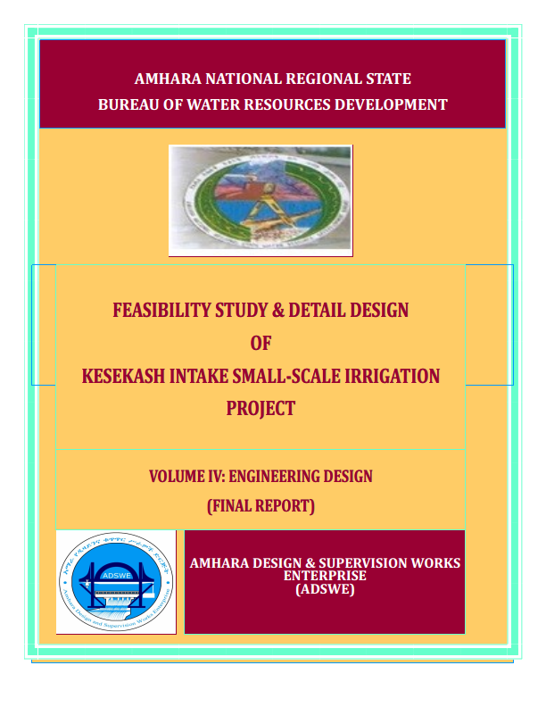
Amhara National Regional State
Water Resources Development Bureau
(BOWRD)

Feasibility Study and Detail Design
Of
Keskashi Intake Small-Scale Irrigation Project

Volume IV: Engineering Design Final Report
December, 2014(Revised 2016)

Bahir Dar
Client: Bureau of Water Resource Development
(BoWRD)
Address:
P. O. Box: 88
Telephone: 0528-198853/855
Fax: 251-08-20-65-68/204676/202040
Consultant: Amhara Design & Supervision Works Enterprise
(ADSWE)
Address:
P. O. Box: 1921
Telephone: +251-582-181023/ 180638/181198/181254
Fax: (058) 2180550/ (058) 2180560
E-mail: amhara design@yahoo.com
Bahir Dar, Ethiopia

FEASIBILITY STUDY & DETAIL DESIGN REPORT STRUCTURE
- Volume I: Watershed Management
- Volume II: Engineering Geology
- Volume III: Irrigation Agronomy
- Volume IV: Engineering Design
- Volume V: Socio Economy
- Volume VI: Environmental Impact Assessment
Table of Contents Page Nr
FEASIBILITY STUDY & DETAIL DESIGN REPORT STRUCTURE i
LIST OF TABLES iv
LIST OF FIGURES v
SAILENT FEATURE vii
1 INTRODUCTION 1
1.1 Background 1
1.1.1 Description of the Project Area 1
1.2 Objectives of the Study 3
1.2.1 Major Objective 3
1.2.2 Specific Objectives 3
1.3 Scope of the Study 4
1.4 Methodology 4
SECTION-I: HYDROLOGY 6
2 HYDROLOGY 7
2.1 Watershed Characteristics 7
2.2 Hydro-Metrological Data Availability 8
2.2.1 Climate 8
2.2.2 Rainfall Data 9
2.2.3 River flow data 9
2.2.4 Upstream & Downstream utilization 9
2.3 Design Flood Analysis 9
2.3.1 Design Rainfall computation 10
2.3.2 Outlier Test 10
2.3.3 Check for variance 10
2.3.4 Peak Discharge Determination 12
2.3.5 Tail Water Depth Computation 13
SECTION-II: HEADWORK DESIGN 18
3 HEADWORK STRUCTURES DESIGN 19
3.1 Headwork Site Selection 19
3.2 River Geomorphology 19
3.2.1 River Bed condition 19
3.2.2 River Bank condition 20
3.3 Sources of construction materials 21
3.3.1 Rock for Masonry and Crushed Coarse Aggregate 22
3.3.2 Fine Aggregates 22
3.3.3 Water 22
3.4 Headwork Type Selection 22
3.5 Hydraulic Design of Headwork Structure 23
3.5.1 Intake Sill Level Determination 23
3.5.2 Base flow of the River 23
3.5.3 Intake Dimensions 23
3.6 Bill of Quantity and Cost Estimation 27
SECTION-III: IRRIGATION AND DRAINAGE SYSTEMS INFRASTRUCTURE 30
4 IRRIGATION AND DRAINAGE SYSTEMS DESIGN 31
4.1 Irrigable Area Description 31
4.1.1 Topography 31
4.1.2 Climate 31
4.1.3 Soil characteristics 32
4.1.4 Existing Irrigation Practices in the Project Area 32
4.2 Irrigation Water Requirement 32
4.2.1 Crop Water Requirement (CWR) 32
4.2.2 Irrigation efficiency (Ep) 32
4.2.3 Irrigation duty 32
4.2.4 Irrigation methods 35
4.3 Irrigation and Drainage System Layout 35
4.3.1 Conveyance System 36
4.4 Design of the Canal System 36
4.4.1 Main Canal 36
4.4.2 Tertiary Canals (TC1, TC2, TC2-1 and TC2-2) 36
4.4.3 Tertiary canals 37
4.4.4 Field Canals 40
4.5 Canal Structures Design 40
4.5.1 Design of Division box 40
4.5.2 Design of a typical flume 45
4.5.3 Pier design 64
4.5.4 Abutment design 75
4.5.5 Chute Design 80
4.5.6 Super passage 83
4.5.7 DROP DESIGN 91
4.5.8 Road crossing structure 91
4.6 Irrigation Infrastructure Bill of Quantities and Cost Estimate 92
5 CONCLUSION AND RECOMMENDATION 99
6 OPERATION AND MAINTENANCE 100
6.1 General 100
6.2 Operation of the Head Works 100
6.3 Irrigation System Operation 100
6.4 Maintenance Requirement 101
REFERENCE 102

LIST OF TABLES

Table 1: Outlier test analysis 10
Table 2: Test for goodness to fit using D-index 11
Table 3: Stage discharge analysis 14
Table 4: River discharge computation at different stages of flow 16
Table 5 Stability analysis of masonry retaining wall 27
Table 6: Hydraulic Parameters of main canal 38
Table 7: Hydraulic Parameters of Tertiary canals Error! Bookmark not defined.
Table 8Hydraulic Parameters of tertiary canals 39
Table 9: Hydraulic Parameters of Flume Error! Bookmark not defined.
Table 10: Hydraulic parameters of Division Boxes 42

LIST OF FIGURES

Figure 1-1: Location map of the project area 2
Figure 2-1: Drainage map of Keskashi watershed 8
Figure 2-2: Rating Curve 15
Figure 2-3: River profile 16
Figure 3-1: River bed at the proposed intake site 20
Figure 3-2: River bed at the Right Bank 20
Figure 3-3: River bed at the Left Bank 21
Figure 3-4 Loading diagram of masonry retaining wall (wet condition) 27
Figure 4-1Typical Cross Section of Main and TC2 canals Error! Bookmark not defined.
Figure 4-2: Typical Cross Section of TC-1, TC-2-1 and TC2-2 canals 37
Figure 4-3: Typical Division Box plan 40

SAILENT FEATURE
- Project name: Keskashi Intake Irrigation Project
- Name of the stream: Keskashi river
- Location of the intake site using
- East: 573241
- North: 1098754
- Zone: North Shewa
- Wereda: Mojan Wodera
- Average Altitude: 2454.36 masl
- Hydrology
- Design rainfall: 198.38 mm
- Catchment area: 2.79 km²
- Time of concentration: 0.3 hr
- Design flood: 40. 73m3/sec
- Design base flow: 275 lit/se.

- Diversion Intake
- Depth of Bed bar: 2.5m
- Gross crest length: 57 m
- Intake crest level: 2452.54 m.a.s.l
- U/S HFL: 2452.94 m.a.s.l

- Outlet
- Sill level: 2452.54 m.a.s.l
- Opening dimension: 0.7m x 0.65 m
- Discharge capacity: 813.88 l/sec.
- Elevation difference between intake and command area
- Intake Sill level: 2452.54m a.ms.l
- Minimum command elevation 2254.14m a.m.s.l
- Elevation difference between intake and minimum command 2452.54- 2254.14 =198.4m
- Elevation difference between intake and end of TC 2452.54- 2290.70 =161.84m
- Irrigation and Drainage Systems Infrastructure
- Command area size: 198ha
- Silty clay with slightly dark brown nature
- Design discharge of the main canal = 172.2 l/sec.
- Irrigation system layout consists of one lined main canal, one lined tertiary Canal, and two earthen tertiary canals
- Main irrigation structures designed are;
- drainage crossing super passage structures
- Chute structures
- Flume
- Drainage culvert
- Ford structure
- Foot path road
- Division Box structures
- Off takes
- Project cost

INTRODUCTION

Background
In Ethiopia, under the prevalent rain-fed agricultural production system, the progressive degradation of the natural resource base, especially in highly vulnerable areas of the highlands coupled with climate variability have aggravated the incidence of poverty and food insecurity. The major source of growth for Ethiopia is still conceived to be the agriculture sector. Hence, this sector has to be insulated from drought shocks through enhanced utilization of the water resource potential of the country, (through development of small-scale irrigation, water harvesting, and on-farm diversification) coupled with strengthened linkages between agriculture and industry (agro-industry), thereby creating a demand for agricultural output. In line with the above, efforts have been made by the government to improve the situation in the country in areas of domestic water supply provision, irrigation, watershed management, etc. The Amhara Water Resources Development Bureau is playing its role in the development of small scale irrigation projects in the region. Accordingly, as part of the water sector development program, the office has initiated the study and design of a small scale irrigation scheme Keskashi River at Feres Megalebiya and Zub Amba Kebeles and signed an agreement with Amhara Design & Supervision Works Enterprise (ADSWE) for the study and design of the project.

Description of the Project Area

Location
This irrigation project is located mainly at Zub Amba Kebele, Mojana Wodera Wereda of North Shoa Zone in the Amhara Region. The proposed irrigation project is to be undertaken on Keskashi River and the headwork structures are specifically located at an altitude of about 2452.54m masl and geographical coordinates of 573241N (UTM) and 1098754E (UTM).

Figure 1-1: Location map of the project area

Accessibility
The project site is 20km from Sella Dingay. Out of this distance, 12km is all weather gravel road on the way from Sella Dingay to Molalie, the capital of Menz Mama Woreda, at URAP camp site and turning to the right side the 6km is accessible during dry weather till the headwork site. And this 6km needs paving a new temporary access road with machine. The last 2.5km seems inaccessible by vehicle due to steep hill. Previous Irrigation Practices

Previous Irrigation Practices
There is constant river flow at the proposed head work position. The discharge is estimated about 275l/s. during the time reconnaissance survey. The river bed seems mostly covered by boulders, cobbles and gravels. There is traditional intake on this river using different irrigation. The traditional irrigation practices are under taken by individual farmers that use the river flow to the extreme left side is with hardship. So, the farmers in the project area are very much interested to upgrading the traditional scheme to modern scheme.

Objectives of the Study

Major Objective
The project area faces variability of rainfall distribution though the overall rainfall generally suffices the rain-fed agriculture. Accordingly, the rain-fed agriculture needs means of supplementing during distribution failures and further full irrigation is required to maximize the use of the potential land and water resources.
Hence the objective of this project is to contribute a substantial share in the effort to reduce the risk of production decrease due to rainfall variability and increase the productivity of the resource in the project specific area. Specifically, the project is targeted for the following.
- To make sustainable the rain-fed crop production and make extra production in the dry season possible for 198.2 ha of land through irrigation.
- There is a general consensus that irrigation investments will achieve broader food security and poverty reduction impacts and if efforts are also geared towards up-grading existing traditional farming practices with support to enhance access to input supply, output marketing and extension to facilitate access to information and innovations.
- This objective is to be realized by constructing intake structures across the Kaskashi River and diverting the river flow.

Specific Objectives
Other benefits that can be expected to appear with the launching of the project are:
- Efficiency of water use improvement;
- Improved local nutrition/food security gains;
- Improved management of scarce natural resources (land and water);
- Resilience against drought risk;
- Rationale for erosion control and watershed management;
- Rationale for the intensification and modernization of small-holder agriculture and rural lifestyles.
The engineering study and design enables the realization of the project by the provision of engineering structures that will allow the appropriate abstraction of the river water for delivery in to the identified irrigation fields of the study area. Hence, this engineering design is specifically targeted to:
- Analyze hydrologic requirements of the project and engineering structures;
- The formulation of sound and stable structure, with necessary provisions that allow safe, easy and low-maintenance operation in the service life of the project;
- Develop working drawings;
- Estimation of construction costs.

Scope of the Study
- The irrigation design shall ensure reliability, equity and flexibility of water delivery to farmers. It will aim at reducing conflicts among water users and will lead to lower operation and maintenance costs.
- Updating the existing, if available, computation of the actual evapo-transpiration, crop water requirement, irrigation demand/duty using the existing and recent agronomic, climatologic and soil data using more appropriate methodologies.
- Establish design criteria for irrigations structures to be approved by the client and to be used in the final design stage,
- Design proper irrigation system compatible with local conditions and management capabilities,
- Establish flood protection measures for the command area and canal structures and design the respective drainage system accordingly,
- Planning and layout of the irrigation system, which include irrigation canals, drainage channels, inspection roads and alignments, canal spacing, canal length, location of structures, and water profiles along canal and drains at specified reaches, which is most economical easily manageable and aligned with topographic feature and geological investigation.
- Determination and estimation of water application conveyance and other losses and irrigation efficiencies and consideration of those parameters in design steps.
- Check and test hydraulic and structural designs of main canal considering total demand and the required capacity and the base flow availability,
- Prepare general plans and drawings for all irrigation infrastructure and irrigation systems designs,

Methodology
In the study and design procedure, Designers used the following steps.
- Specific Site identification:
  - Review of the reconnaissance survey conducted by the Client
  - 50,000 scale top map and GIS information
  - Local farmers interview and discussion
  - Wereda and Zone Agriculture section expertise
  - Previous studies
  - On foot travel along the river channel and farm areas.
- Topographic survey:
  - Surveying the headwork site and the Command area with sufficient radius, using Total station
- Flow estimation
  - Physical observation on flood mark indications and local information about high flood and critical flow condition of the river
  - Analyzing the recorded river flow data and use watershed inputs for further analysis.
  - Base flow estimated during the reconnaissance field visit by floating method.
- Irrigable area identification:
  - Using local information
  - 50,000 Topographic map, and GIS information, GPS to see elevation
The design report is organized in three sections. In Section I the Hydrology study is presented and in Sections II and III the Headwork and Irrigation and Drainage Systems designs are discussed respectively. In Section III, planning and design of the irrigation system after diverting the water using the intake will be dealt. The following are major areas of concern in this part.
- Study and design of the irrigation method to be adopted,
- Study and design of the irrigation system layout and associated structures,
- Design of the different conveyance canals,
- Planning and design of the different irrigation and drainage structures,
- Preparation of the longitudinal profiles of the different irrigation and drainage canals.

SECTION-I: HYDROLOGY

HYDROLOGY

Watershed Characteristics
The Watershed has marked topographic variation. All types of slopes are present. The dominant slope class is 15-30% which covers 49.01% % of the total area followed by by steep (30-50%) which is 29.35%. Sloping (8-15%), very steeply (>50%), gently sloping (3-8%) and flat or almost flat (0-3%) accounts 9.89%, 6.06%, 4.25% and 1.45% respectively. Table 1 of the watershed feasibility study report shows the slope classes and proportion of the watershed.
Certain physical properties of watersheds significantly affect the characteristics of the runoff and sediment yield and are of great interest in hydrologic analyses. The rate and volume of runoff, and sediment yield from the watershed have much to do with shape, size, slope and other parameters of the landscape. These suggest that there should be some important relations between basin form and hydrologic performance. If the basin and hydrologic characteristics are to be related, the basin form must also be represented by quantitative descriptors. These parameters can be measured from maps.
Table 1: Slope Class and Coverage
No | Slope |  | Area Coverage
No | Description | Class (%) | Hectare (ha) | Proportion (%)
1 | Flat or almost flat | 0-3% | 4.04 | 1.45
2 | Gently sloping | 3-8% | 11.86 | 4.25
3 | Sloping | 8-15% | 27.61 | 9.89
4 | Moderately steep | 15-30% | 136.87 | 49.01
5 | Steep | 30-50% | 81.96 | 29.35
6 | Very steeply | >50% | 16.92 | 6.06
Total |  |  | 279.26 | 100
The watershed characteristics are analyzed and presented the Watershed Feasibility Study Report of the same project. In summary:
- Catchment Area = 2.79km^2
- Stream Length = 2.73km
- CN(II) = 85.85
(Extracted from the Watershed Study Report of the same project)
At the selected reference point, the area of Keskashi catchment is 2.79km2 and consists of a network of tributaries as shown in Figure 2:1 below.
The drainage pattern has something to do with erosion hazard and sediment yield. The main river of the watershed found in a wereda and intersects different kebeles along its route. The drainage pattern of the watershed is ordered by this main river, to which all other drainage lines are tributaries. The tributaries of the main river are long; joining to the main river channel in much kilometers travel rise from different parts of the watershed and significantly affect the flood characteristics of the watershed. The drainage pattern of Keskash watershed is dendrite with total streams length of 9.20 km and longest flow of 2.73 km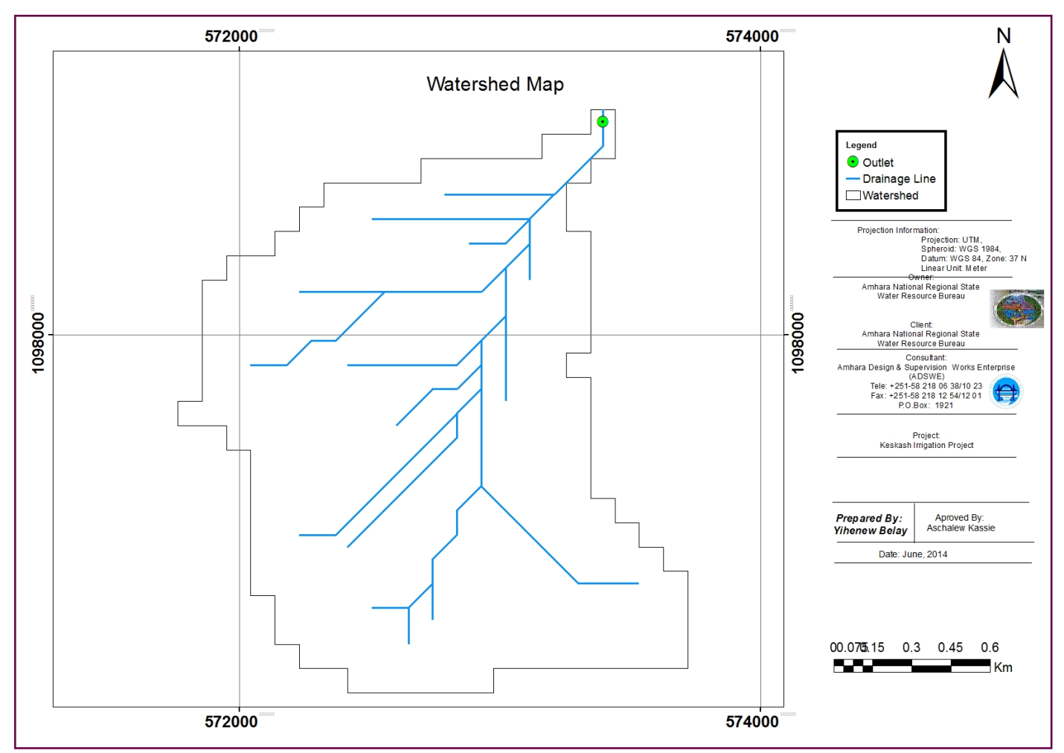
Figure 2-1: Drainage map of Keskashi watershed

Hydro-Metrological Data Availability

Climate
Small scale irrigation project designers and planners are faced with lack of good data on the hydrology of the stream/river system that will be their water source and on local weather and climate conditions. Stream gauging stations are virtually non-existent in remote rural areas of Ethiopia; meteorological stations are almost rare. Likewise, at Feres Megalebiya and Zum Amba Kebele and in the catchment area of this project, there is no meteorological station of any level. Moreover, there are no flow data for the river near the project. Therefore, data for the hydro-meteorological analysis is taken from the nearby station and similar areas. Rainfall & temperature data are considered from Debre Sina Meteorological station. In fact, this station is very close to the project area.
As per the data of the station, March – April are identified as high temperature periods whereas December–January are low temperature periods. The mean annual rainfall amount is more than 1198mm (1995 - 1986 data) and most of it occurs from June to August.

Rainfall Data
In order to compute the design flood for the intake structure, the daily maximum rainfall is collected from Debre Sina Metrological stations with a record of 11 years.

River flow data
The base flow which is measured on 275 l/s. Since this base flow is measured during the dry months of the year, this figure is adopted for design.

Upstream & Downstream utilization
Downstream of the proposed site, appreciable need for water is anticipated for locals and cattle provisions. Therefore, at least 40% of the minimum flow has to be released for downstream requirements.
For the sake of planning and design, however, the outlet for the intake is designed for a discharge of 163l/s for this project and the project is to be developed for 198 ha of land, which is most of the time achievable as the flow for most of the time is significant to support this size of command area. There is no irrigation projects both u/s and d/s of the intake site.

Design Flood Analysis
For the design and analysis of structures to be constructed on the river, estimation of flood magnitude is an important task. This can be done using different techniques depending on the data available. For this particular case, there are no river flow data and hence the flood estimation is done using the rainfall data and applying rational formula Method.

Design Rainfall computation
Based on the data of 24hr peak rainfall given in Table 1 the design rainfall, Rf is computed using Log Pearson Type III Method.

Outlier Test
Higher Limit, $Y_{H}=Ymean+Kn*Sy$, Kn = 2.134 for 12 Years of data.
Lower Limit, $Y_{H}=Ymean-Kn*Sy$, Kn = 2.134 for 12 Years of data.

Table 2-1: Outlier test analysis
Sr.No | Year | Heaviest rainfall(mm/day) | Descending order(x) | Y=Log(x)
1.00 | 1998.00 | 66.40 | 114.60 | 2.06  Higher Limit, YH = 2.0854  Lower Limit, YL = 1.724  Therefore,  Upper limit of rainfall = 10^2.085 = 121.723mm  Lower Limit of rainfall = 10^1.724 = 52.934mm  Conclusion: The rainfall values are within the limits.
2.00 | 1999.00 | 81.60 | 106.70 | 2.03
3.00 | 1980.00 | 106.70 | 100.30 | 2.00
4.00 | 1981.00 | 80.00 | 82.10 | 1.91
5.00 | 1982.00 | 64.20 | 81.60 | 1.91
6.00 | 1983.00 | 82.10 | 80.00 | 1.90
7.00 | 1984.00 | 75.60 | 75.60 | 1.88
8.00 | 1985.00 | 100.30 | 75.50 | 1.88
9.00 | 1986.00 | 114.60 | 68.20 | 1.83
10.00 | 1987.00 | 75.50 | 66.40 | 1.82
11.00 | 1988.00 | 68.20 | 65.60 | 1.82
12.00 | 1989.00 | 65.60 | 64.20 | 1.81

Check for variance
After checking the outliers, the data should be checked for variability. For variability the formula used is
$α=\left(\frac{δ_{∩-1}}{\sqrt{N}*Mean}\right)*100\%$
Where, δ_{n-1 =} Standard deviation =16.82
N = Nr of recorded data =12
M_{ean} = 81.73
$α$ = Standard error
$α=\left(\frac{16.82}{\sqrt{12}*81.73}\right)*100\%=$5.942$<10\%$ Acceptable
Therefore the data shows no variability.

D-Index test
After checking the consistency of the data for higher and lower outlier, the 12 years data is obtained as representative for the analysis using D-index. The D-Index test is believed to be the better goodness to fitness in many literatures. Hence in this study it was used to determine the best statistical distribution to estimate the peak rainfall. The D-index for the comparison of the fit of various distributions is summarized as follows.
$D_{-Index}=(\frac{1}{X_{m}})*\sum_{i=1}^{6}{Abs(Xi-{Xi}^{'})}$
Where Xi and Xi’ are the i^{th} highest observed and computed values for the distribution respectively
Table 2-2: Test for goodness to fit using D-index
Rank | XI | Normal | Gumbel EVI | Log Normal | Log person Type III
 |  | XI -'XI' | XI -'XI' | XI -'XI' | XI -'XI'
1 | 114.6 | 5.351 | 0.413 | 4.16 | 0.431
2 | 106.7 | 6.224 | 6.537 | 6.94 | 6.872
3 | 100.3 | 5.251 | 7.267 | 6.63 | 7.776
4 | 82.1 | 8.648 | 5.918 | 7.02 | 5.340
5 | 81.6 | 5.374 | 2.411 | 3.70 | 1.827
6 | 80.0 | 3.454 | 0.563 | 1.89 | 22.266
SUM |  | 34.301 | 23.108 | 30.332 | 22.266
D-index |  | 0.420 | 0.283 | 0.371 | 0.272

All the candidate distributions give almost identical correlation coefficients. However, the standard errors are significantly lower for the Log person Type III Method which is0.272. Accordingly, the design rain for this distribution has been selected as the best fit for this study

The design rainfall using Log person Type III Method is given as
Normal Variance (Z) =K_{T}+( K_{T} ^2-1)*(K/6)+1/3*( K_{T} ^3-6* K_{T})*( K /6)^2-( K_{T} ^2-1)*( K /6)^3+ K_{T} *( K /6)^4+1/6*( K /6)^5

= (LN ((1/B75^2)) ^0.5)
Where R_{f =} Design rainfall
K_{T} = Frequency factor
K= skewness coefficient
KT=6^0.5/3.14* (0.5772+LN (LN (T/T-1))
=6^0.5/3.14* (0.5772+LN (LN (50/50-1)) =2.054
K=Skew coeff. /6
T= Return period = 50 years

- Point Design Rainfall = 198.38 mm
The design rainfall at points for 50 years return period is 198.38mm and the areal design rainfall is calculated in the following section. = Peak Discharge Determination

Peak Discharge Determination

General
The River is not gauged river. The design flood is calculated by using rational method. Thus, it is preferred to base the flood analysis on rainfall data, which are better both in quantity and quality of data. In the hydrologic analysis for drainage structures, it must be recognized that there are many variable factors that affect floods. Some of the factors that need be recognized and considered on an individual site by site basis are; rainfall amount and storm distribution; catchment area, shape and orientation; ground cover; type of soil; slopes of terrain and stream(S); antecedent moisture condition; Storage potential (over bank, ponds, wetlands, reservoirs, channel, etc.)

Peak flood analysis by rational method
Design flood is calculated rational. This method is widely adopted and more reliable method for flood estimation of catchment area less than 5km². The approach considers, watershed parameters, like Area, Curve number, and time of concentration.

Run off Analysis
Input data:

Topography and Vegetation | Catchment area (km²) | Catchment percent (%) | Value of C | Weighted values of C
 | 1 | 2 | 3 | 2x3
Woodland
Hilly | 0.49 | 10 | 0.5 | 0.05
Cultivated
Rolling | 1 | 30 | 0.6 | 0.18
Hilly | 1.3 | 60 | 0.72 | 0.432
Total & Avg. | 2.79 | 100 |  | 0.77

- C : runoff coefficient= 0.77
- Catchment Area, A = 2.79 Km²
- i: rainfall intensity in mm/h for the design return period and for a equal to 50% of design rain point fall = 68.69mm
T_{p} = Time to peak (hr)
Q = Incremental run-off (mm)

Q=40.78m3/sec

Tail Water Depth Computation
Tail water depth of the river is equal to the flood depth and amount at the proposed intake site before construction of the intake. The river cross-section was surveyed.

S.No | northing | easting | elevation | partial distance | cumulative distance
1 | 1098727.55 | 573286.67 | 2454.34 | 0.00 | 0.00
2 | 1098727.79 | 573283.29 | 2453.97 | 3.39 | 3.39
3 | 1098729.72 | 573279.42 | 2453.74 | 4.32 | 7.71
4 | 1098731.17 | 573274.84 | 2453.46 | 4.81 | 12.52
5 | 1098732.37 | 573271.70 | 2453.27 | 3.36 | 15.88
6 | 1098733.82 | 573267.60 | 2453.08 | 4.35 | 20.22
7 | 1098736.47 | 573263.25 | 2452.83 | 5.09 | 25.32
8 | 1098738.40 | 573259.15 | 2452.72 | 4.54 | 29.85
9 | 1098741.54 | 573255.28 | 2452.64 | 4.97 | 34.83
10 | 1098745.39 | 573275.70 | 2452.54 | 5.99 | 40.82
11 | 1098748.28 | 573247.56 | 2452.75 | 4.27 | 45.09
12 | 1098751.90 | 573244.18 | 2453.41 | 4.95 | 50.04
13 | 1098754.07 | 573242.49 | 2454.01 | 2.75 | 52.79
14 | 1098756.48 | 573240.32 | 2454.86 | 3.25 | 56.03
15 | 1098758.41 | 573238.39 | 2455.88 | 2.73 | 58.76
16 | 1098760.34 | 573237.18 | 2457.24 | 2.28 | 61.04
17 | 1098762.51 | 573234.29 | 2459.59 | 3.62 | 64.66
Table 2-3: Stage discharge analysis
S.N | Elevation/m/ | water depth increrement /m/ | Width(m) | wetted Area /m^2 | perimeter /m/ | Hydraulic radius/R/ | slope | velocity /m/s | Discharge/m^3/s/
1 | 2452.54 | 0.00 | 0.00 | 0.00 | 0.00 | 0.00 | 0.03 | 0.00 | 0.00
2 | 2452.79 | 0.25 | 20.00 | 5.00 | 5.00 | 1.00 | 0.03 | 4.34 | 21.71
3 | 2453.04 | 0.50 | 27.00 | 13.50 | 13.50 | 1.00 | 0.03 | 4.34 | 58.61
4 | 2453.29 | 0.75 | 34.00 | 25.50 | 25.50 | 1.00 | 0.03 | 4.34 | 110.70
5 | 2453.54 | 1.00 | 39.00 | 39.00 | 39.00 | 1.00 | 0.03 | 4.34 | 169.31
6 | 2453.79 | 1.25 | 45.00 | 56.25 | 56.25 | 1.00 | 0.03 | 4.34 | 244.20
7 | 2454.04 | 1.50 | 50.00 | 75.00 | 75.00 | 1.00 | 0.03 | 4.34 | 325.60
8 | 2454.29 | 1.75 | 53.00 | 92.75 | 92.75 | 1.00 | 0.03 | 4.34 | 402.66
9 | 2454.54 | 2.00 | 55.00 | 110.00 | 110.00 | 1.00 | 0.03 | 4.34 | 477.55

Figure 2-2: Rating Curve
From the above stage discharge table and curve the maximum flood level corresponding to the computed design peak discharge is 40.78 (0.4 m from the river bed) and it is considered as the d/s high flood level i.e. expected at the intake axis before construction of the intake.
D/S HFL = 2452.94 masl.

- Average river bed slope
Average river bed slope of River is estimated by two different techniques. One is by end area method and the other is by using best fit line method. Designers have adopted the best fit line method output for further analysis.
The water level of the river is taken at different points along the river channel around the head work site. Surveying work done for 64m length. And then, average water surface slope is considered as the river bed slope. For comparison of the two procedures, refer the attached Excel file.

Figure 2-3: River profile
- Manning’s Roughness coefficient
The Manning’s roughness coefficient is taken from standard table based on the river nature. The river at the headwork site has got braded feature and curving nature. The river banks are defined and relatively smooth. Manning’s roughness coefficient (n = 0.04) is adopted.

- Discharge of the river
Input data:
- Manning's roughness coefficient, n = 0.04
- Average river bed slope, S = 0.0303
- , Where, R = Hydraulic radius = (Area/Perimeter)
- $Q=V*A$

Table 2-4: River discharge computation at different stages of flow

S.N | Elevation/m/ | water depth increrement /m/ | Width(m) | wetted Area /m^2 | perimeter /m/ | Hydraulic radius/R/ | slope | velocity /m/s | Discharge/m^3/s/
1 | 2452.54 | 0.00 | 0.00 | 0.00 | 0.00 | 0.00 | 0.03 | 0.00 | 0.00
2 | 2452.79 | 0.25 | 20.00 | 5.00 | 5.00 | 1.00 | 0.03 | 4.34 | 21.71
3 | 2453.04 | 0.50 | 27.00 | 13.50 | 13.50 | 1.00 | 0.03 | 4.34 | 58.61
4 | 2453.29 | 0.75 | 34.00 | 25.50 | 25.50 | 1.00 | 0.03 | 4.34 | 110.70
5 | 2453.54 | 1.00 | 39.00 | 39.00 | 39.00 | 1.00 | 0.03 | 4.34 | 169.31
6 | 2453.79 | 1.25 | 45.00 | 56.25 | 56.25 | 1.00 | 0.03 | 4.34 | 244.20
7 | 2454.04 | 1.50 | 50.00 | 75.00 | 75.00 | 1.00 | 0.03 | 4.34 | 325.60
8 | 2454.29 | 1.75 | 53.00 | 92.75 | 92.75 | 1.00 | 0.03 | 4.34 | 402.66
9 | 2454.54 | 2.00 | 55.00 | 110.00 | 110.00 | 1.00 | 0.03 | 4.34 | 477.55

SECTION-II: HEADWORK DESIGN

HEADWORK STRUCTURES DESIGN

Headwork Site Selection
The headwork site is selected in accordance with getting sufficient head for the proposed command area. The selected headwork site is ideal for intake structure to irrigate the command area found at the left banks. The headwork site is situated at 573241 m N, 1098754 m E and river bed elevation of 2452.54 m above sea level. At this site the river course is well defined, matured with fixed width and forms nearly a U-shaped valley. At this specific site, it is characterized or covered by 85% Oversize river lain deposit comprising pebble to big boulder. Loose sandy gravel has 15% proportion.
The river is flowing through a defined wide channel and its scouring effect on the river course is not significant high as its most u/s river stage and also covers by 15%loose sandy gravel. The different sections of the stream at the proposed headwork site are described separately below:-

River Geomorphology
It is a common fact that the river development tends to accommodate itself to the local geology that develops along the structurally weak zones like faults, joints, folds, etc. The drainage system of the study area is strongly influenced by geological structures and formations, and the nature of the vegetation cover. The nature of geological formations and structures has also strong influence on the development of the channel.
From permeability point of view the deposit is highly pervious. Bed rock is exposed at the downstream reaches. Hence by extrapolation from downstream exposure, it has been expected to encounter bedrock at an estimated depth of 2.5m at the proposed intake site. Hence the structure has to be founded on the bed rock. Keskash River is at the boulder stage. Therefore the intake structure has to be designed so as to resist the impact load of big boulders having maximum diameter 0.95m.

River Bed condition
The Left margin of the river, of which the proposed intake structure is supposed to rest, is characterized by 85% Oversize River laid deposit comprising pebble to big boulder. Loose sandy gravel has 15% proportion. From permeability point of view the deposit is highly pervious. Excavation of pit could not be successful to define the depth to bed rock, because of lack of dewatering equipment. However bed rock is exposed at the downstream reaches. Hence by extrapolation from downstream exposure, it has been expected to encounter bedrock at an estimated depth of 2.5m at the proposed intake site. Hence the structure has to be founded on the bed rock. Keskash River is at the boulder stage. Therefore the intake structure has to be designed so as to resist the impact load of big boulders having maximum diameter 0.95m.
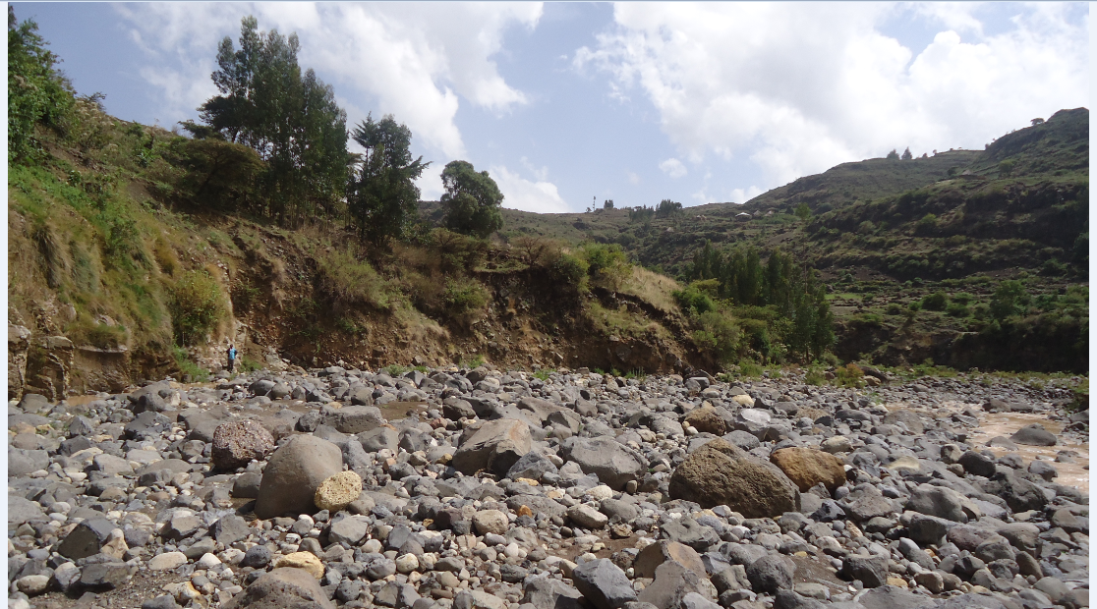
Proposed intake site
Figure 3-1: River bed at the proposed intake site

River Bank condition

Right Bank
The right bank has not well defined section. Active erosional landform is evident at this bank. The right bank is dominantly made up of well graded granular unconsolidated deposit comprising fine sand to coarse gravel. Oversize material has a proportion of 25% at this bank. Since the proposed structure is restricted at the margin of the left bank, the right bank has no influence on the performance of the intake structure.
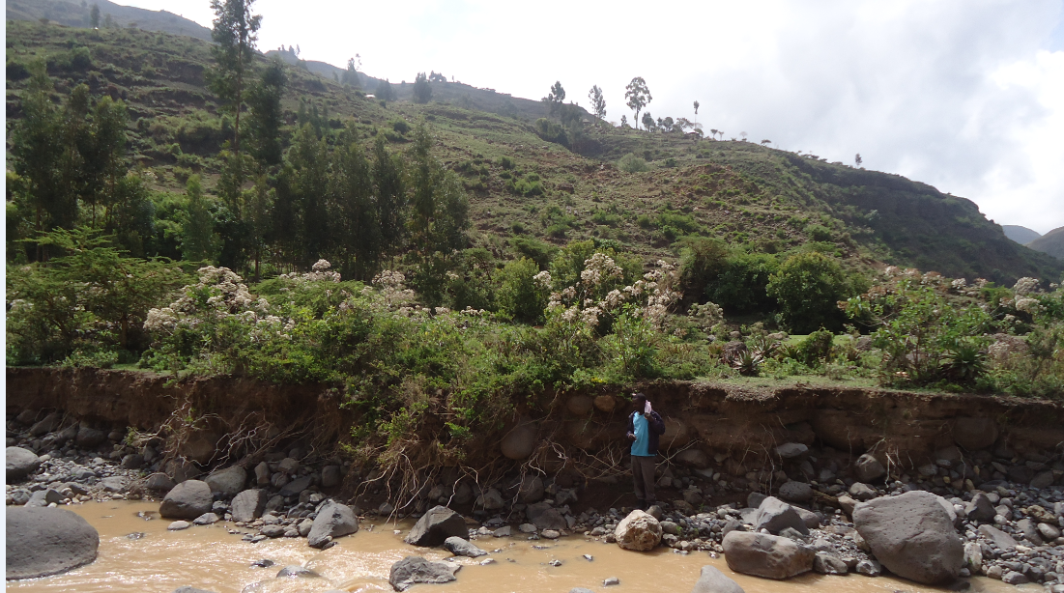
Figure 3-2: River bed at the Right Bank

Left Bank
The Left bank is characterized by steeply sloping topographic set up. The intake structure is supposed to be constructed at this bank. In the upstream reaches rhyolite is exposed. However in the downstream reaches, well graded granular loose deposit has been observed. 25% of the deposit is oversize comprising pebble to boulder size. The deposit is not expected to be continuous across the left bank. Because the presence of rhyolite at the upstream reaches of the river bank dictates its continuation in the downstream as well. The deposit is prone to sliding. The rhyolitic unit exposed in the left bank affected by three set of discontinuities. The joints are oriented NW-SE, SW-NE and N-S. NW-SE trending joint is the master joint. The extents of these joints fall in the range of 0.1-0.85m and the aperture lies between 1.5 and 5mm. Most of the joints are open. However few of them are filled with clay.
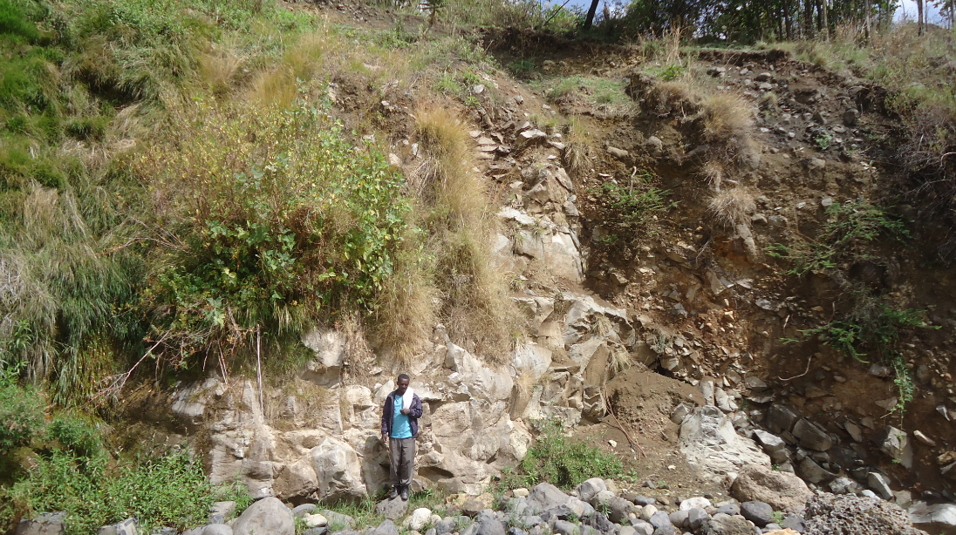
Figure 3-3: River bed at the Left Bank

Sources of construction materials
During site investigation, natural construction materials required for the construction of the various proposed engineering structures at the headwork and within the farmland have been assessed, and possible quarry sites and borrow areas have been identified within the vicinity of the study area as close to the project site as possible. The materials needed for the construction of the structures include rock for masonry stones, aggregates (both coarse and fine), and water.

Rock for Masonry and Crushed Coarse Aggregate
During site investigation rocks required for masonry works were identified. Basaltic Boulders which is rounded to semi-rounded in shape is available in Keskash River in sufficient quantity. Hence it can be used for masonry works by reshaping it in to angular form for proper bondage
Aggregates are inlet materials which when bound together by cement will form concrete. Generally, aggregates occupy 70 to 75% of concrete volume. Aggregates are classified as fine and coarse grained depending on their sizes. The size of fine aggregates shall not exceed 4.75mm. Aggregates of bigger size are called coarse aggregate. The type of the work to be built governs the maximum size of aggregate. For most of the common reinforced concrete works, a maximum of size of 20mm is generally suitable.

Coarse aggregate
Coarse aggregate for the construction of the project can be obtained by collecting fresh basaltic river boulders and crushing it to the desired size. Boulders deposited in the riverbed can satisfy the coarse aggregate demand of the project.

Fine Aggregates
Borrow areas for fine aggregate or natural sand have been assessed starting from the project stream itself. Natural deposits of such materials are not found within the beds of the stream in the project area; seeing to this nature of the River, other distant streams have been explored to identify source areas for fine aggregate or natural sand that can be used for this particular project. During this field work, one relatively distant stream was identified for possible source for sand. The stream is known as ‘Jewhuha (Sweur River). It is located at 84km from the project site. The source area can be reached on a dry weathered road.

Water
Water for construction purposes can be found from the project stream, Keskashi, itself. The stream is perennial throughout the year that there is sufficient amount of flow along its course. During this field time the stream flow was more than 275L/second.

Headwork Type Selection
The headwork type of the project is Intake which will be used to maintain the water level to divert the minimum river flow discharge for irrigation .The water to be diverted is taken through guiding canal to the irrigation gated intake. As it is:
- The elevation difference between the command and the intake site is 198m difference
- The was traditional intake system conveying practice
- The River has x-sectional length is 55m wide

Hydraulic Design of Headwork Structure

Intake Sill Level Determination

The outlet sill level is determined based on the minimum river bed elevation. Therefore, the minimum river bed level is taken as the outlet sill level of the outlet.

Base flow of the River

As it is mentioned in the Hydrology section above, the base flow of the river measured in January during the reconnaissance survey at the intake site is 275 l/s. Out of this 163 l/s will be required for the proposed scheme and the remaining will be released for downstream. The purpose of releasing the 87 l/s to downstream is for the sake of downstream users and the environmental requirement.

Intake Dimensions
The intake dimension is designed based on the command area size and the respective irrigation duty. The total area which needs to be irrigated is 198ha and the maximum irrigation duty is 1.21 l/s/ha. Accordingly, the total amount of water required to this command area is given by: Q = Max.Duty * Command area* Factor of safety
Where Max duty = 1.19 l/s Command area = 198ha
Therefore: Q = 1.21 l/s*198ha*1.5=245 l/s = 0.258m³/sec
The opening size is fixed using principle of rectangular notch given by

Where = Q discharge B = Width Cd = Coefficient of discharge H = Depth

Q | Cd | B | g | Fb | H | H_{T} | Opening size
0.245 | 0.6 | 0.6 | 9.81 | 0.3 | 0.13 | 0.43, take 0.5m | 0.6mX0.55m

Therefore the size of the intake structure:- by using rectangular notch formula Let assume b=0.6m, from this we get h = 0.55 m, fb = 0.3m since, there is surplus water released to d/s and there will be possibility of irrigating extra command using d/t technologies the dimension of the intake is 0.6X0.55m is taken

Flow over the intake crest
a. Crest Length
Lacey’s regime width, $L=4.75*\sqrt{Q},$ $=4.75*\sqrt{40.78}$ = 30.34m
- Actual river section width of the over flow section of the river is = 55m
b. Discharge over the intake section
- Design discharge, Q = 40.79 m³/s

River Bed Protection
- Scour depth determination: - The scour depth is determined using Lacey’s formula to determine the regime scour depth given by: -

Where; f = 1.75 *d1/2
Where R=scour depth measured below HFL
q= discharge intensity (m^3/s/m) = Q/L=40.78/23.49=1.74
f = laces silt factor, the weighted silt factor f becomes 9.33
R= 0.93m
Sour depth –D= 1.5*0.93 =1.39m
HFL = | 2452.54 (RBL) + 0.4 (TWD) = | 2452.94
RBL = 2452.54
SDL = | 2452.94- 1.5*0.93 = | 2451.55
Cutoff depth below river bed=0.99m , however, according to the geological investigation depth of cut off shall to be at rock foundation =2.5m

- Bed Stabilizer: Considering control of the scour of the river and to stabilize the river bed level a reinforced concrete bed bar is buried in to a depth of 2.5m. The reinforced concrete bed bar is more durable and water tight and it is also cost effective from the maintenance point of view.
- Bed Bar Design
- Foot level of Bed Bar =2452.54 – 2.5 = 2450.04m a.s.l
- Bed Bar Depth = 2.5m
- Free board = 0 m
- Total Height of Bed Bar =2.5m
- Bed bar Crest Level =2452.54 m a.s.l
- Bad bar channel foundation depth is monolithic up to 55m from the retaining structure

Gate Provisions and Analysis
The gate of the off take canal is to be sliding gate made with vertical sheet metal.
4 | OFF TAKE GATE ANALYSIS
4.1 | Gate provision
 | For slide gates b²*h*H>2m⁴ should be fulfilled
 | where H =is gate height, in m | 0.55
 | Groove allowance | 0.05
 | Actual gate height, H | 0.65
 | B=is gate span m | 0.60
 | Groove allowance | 0.05
 | Actual gate span, B | 0.70
 | h=head of water over the sill which is U/S HFL-skill level = | 0.40
 | B²*h*H = | 0.086
 | B²*h*H=0.086m⁴< 2m⁴, Therefore stiffening materials are needed
4.2 | Thickness and dimension
 | Description | off take Gate
 | Height of gate, H | 0.65
 | Width of gate, W | 0.70
 | Groove depth, gt | 0.05
 | Water/Silt Depth (maximum) | 0.60
 | Allowable stress, ton/m2 | 16500.00
 | Unit weight of Water, ton/m3 | 1.00
 | Unit weight of silt, ton/m3 | 0.35
 | Water Pressure, PW, (ton) | 0.18
 | Silt Pressure, (ton) | 0.06
 | Total Pressure, PT (ton) | 0.24
 | Length (W+2*gt) | 0.75
 | Moment Maximum, M=P*L2/8 | 0.02
 | Thickness, t, m | 0.003
 | Factor of safety, fs | 2.00
 | E | 2100000.00
 | Ta, Kg/cm2 | 1650.0
 | Friction coefficient b/n gate and groove(f) | 0.50
 | ﻻs | 7.85
 | Ps, mm | 10.00
 | Weight
 | (weight of gate), W1 (ton) | 0.01
 | Wt(W1+W2) (ton) | 0.01
 | Pw(water pressure on gate), (ton) | 0.12
 | Pw(Silt pressure on gate), (ton) | 0.04
 | Total Pressure, PT (ton) | 0.16
 | Uplift Pressure, Pu, (ton) | 0.00
 | Nd, ton | 0.08
 | Nu, ton | 0.08
 | I | 0.08
 | Di, mm | 6.71
 | Do, mm | 16.71
 | Ts, Kg/cm2 | 210.97 | Ts < Ta, safe!!!

Trash Rack
A trash rack screen is provided in front of the intake structure in order to prevent the entry boulders and tree trunk and clog the gates. Therefore the intake Trash rack up to the gate level is provided.0.8m m height and 0.9m width trash rack with 24mm diameter steel spaced at 50 mm horizontally and vertically is provided.

Design of off take beam and gate sliding column
The beam is made to have dimensions of 0.9m X 3m X 0.2m with C- 20 concrete and its reinforcement is as provided below. Provide Φ16 bars at 275 mm c/c spacing with minimum reinforcement cover of 25mm. Provide Φ8 stirrup 300 mm c/c. The column is made to have a dimension of 0.9m x 0.2m x 0.2m with C - 20 concrete and its reinforcement is 4Φ14 bars and Φ6 stirrup 300 mm c/c.

Stability Analysis of Retaining Wall
Stability analysis is carried out to see the already determined retaining wall section is safe against overturning, sliding, tension. The stability analysis is carried out considering the effect of the following forces.
- Weight of the retaining wall section
- Back fill of moist Soil pressure
The extreme load combination is the case of wet condition. Therefore we provide 3m masonry retaining structure at u/s and d/s of the intake location and. (For more detail see the drawing)
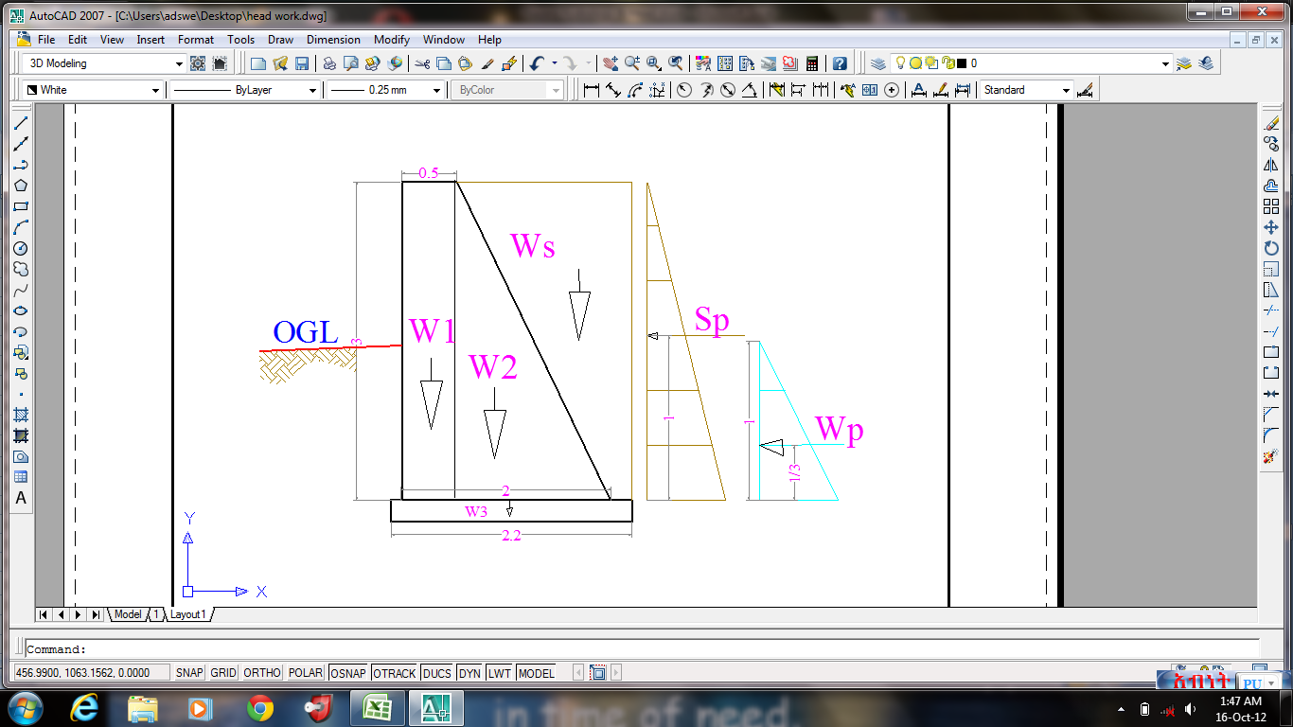
Figure 3-4 Loading diagram of masonry retaining wall (wet condition)
Table 3-1 Stability analysis of masonry retaining wall
Height of retaining wall | Top width | Hs (submerged) |  | Width of D/S retaining wall |  | BW concrete | Specific weight of Stone masonry KN/m3 |  | Specific weight of Soil KN/m3 |  | Active pressure coefficient(Ka) |  |  | Foundation depth
3.40 | 0.5 | 3.40 |  | 2 |  | 2.2 | 22.5 |  | 20 |  | 0.33 |  |  | 2.5
Stability Analysis
Code |  |  | Load |  |  |  | Lever Arm, R | Moment
 |  |  | Vertical |  | Horizontal |  |  | Positive |  | Negative
W1 |  |  | 38.3 |  |  |  | 0.25 | 9.6
W2 |  |  | 65.3 |  |  |  | 1.0 | 65.3
WS |  |  | 68.0 |  |  |  | 1.5 | 102.0
Pw |  |  |  |  | 4.0 |  | 0.30 |  |  | 1.2
SP |  |  |  |  | 38.6 |  | 1.1 |  |  | 43.7
SUM |  |  | 171.5 |  | 42.6 |  |  | 176.8 |  | 44.9
Over turning = (M+ve/M-ve) >1.5 |  |  |  |  |  |  |  | Fo |  | 3.94 |  | safe
Sliding = (µxFv/Fh),---µ=0.75 >1.5 |  |  |  |  |  |  |  | Fs |  | 3.02 |  | safe
Tension: X= (Net Moment/Sum Fv), e=x-B/2, e<B/6 |  |  |  |  |  |  |  | X |  | 0.77
 |  |  |  |  | B/6= |  | 0.37 | e |  | 0.33 |  | safe

Bill of Quantity and Cost Estimation
The quantities of the various items have been worked out as per the final design and final drawings prepared for the scheme. The unit rates analysis has been carried out based on the data available in the vicinity of the project area.
BILL No. 1. GENERAL

BILL No. 2. HEAD WORK

SECTION-III: IRRIGATION AND DRAINAGE SYSTEMS INFRASTRUCTURE

IRRIGATION AND DRAINAGE SYSTEMS DESIGN

Irrigable Area Description

Topography
Topography is an important factor for the planning of any irrigation project as it influences method of irrigation, drainage, erosion, mechanization, cost of land development, labour requirement and choice of crops.
The topographic feature of the far surroundings of the project area, especially in the North and south directions, is dominated by chains of mountainous escarpments. However, the topographic feature of the command ranges from gently sloping to strongly sloping and crossed by some big and small gullies. The slope gradient class is from 2% (gently sloping) to 15% (strongly sloping). The slope gradient indicates that the proposed command area is moderately to marginally suitable for surface irrigation. Hence, to use the proposed command area for irrigation development, it needs to make bench terraces along the contours of the command area.

Climate
As per the hydrological analysis and on the basis of the traditional Ethiopian Agro-Ecological Zones (MOA, 1981), the UGDWIP area is basically classified as Moist Woina Dega (sub-moist cool) agro-ecological zone, indicating better moisture condition in the area in wet seasons. There is belg rain season in the project area. Despite the fact that the Meher rains are considered adequate, there is notable variation in terms of onset, distribution and withdrawal from year to year affecting crop production in general and crop productivity in particular.
As the project site has no its own meteorological station, Sela Dingay (for rainfall) and Alem Ketema (for minimum and maximum temperature relative humidity, wind speed and sunshine hour) meteorological stations data were used for the project study as long as these stations are relatively near to the proposed command area. In general, the sources of meteorological data are the National Meteorology Service Agency (NMSA).

Soil characteristics
Soil properties (physical, chemical, etc.) greatly influence the growth and thereby yield of crops which is grown. The command area has predominantly clay textured soils which can be classified as moderately drained soil. Most of the study area soils are categorized as deep soil (1-1.5 meter depth). Soils of the command area are suitable for most of the selected crops to be grown (for further detail see the Agronomy Study of the same project.

Existing Irrigation Practices in the Project Area
The pressure of survival and the need for additional food supplies to meet the demands of the increasing population is necessitating a rapid expansion of irrigation schemes. Thus, irrigation is becoming a basic part of well developed agriculture wherever there is water and irrigable land potential. Accordingly, traditional irrigation practices are under taken by individual farmers that use the river flow to the left side is with laborious temporary diversions. So, the farmers in the project area are very much interested in the idea of upgrading the traditional scheme to modern scheme.

Irrigation Water Requirement

Crop Water Requirement (CWR)
The calculation of crop water requirement is a very important aspect for planning of any irrigation project. Several methods and procedures are available for this. The Food and Agriculture Organization (FAO) of the United Nations has also made available several publications on this subject and other issues related with this. The computer program available in FAO Irrigation and Drainage Paper No. 56 “CROPWAT” has been used for the calculation of Crop Water requirement. This program is based on Penman-Monteith approach and procedures for calculation of crop water requirements and irrigation requirements are mainly based on methodologies presented in FAO Irrigation and Drainage Paper No. 24 “Crop Water Requirements” and No. 33 “Yield Response to Water”.
The corresponding values of the crop water requirements of the proposed crops of the project are presented in the Agronomy Study of the same project.

Irrigation efficiency (Ep)
To complete the evaluation of the demand, the efficiency of the water distribution system and of application must be known.
The gross requirement of water for irrigation system is very much dependent on the overall efficiency of the irrigation system, which in turn is dependent on several factors: Method of irrigation, type of canal (Lined and/or Unlined), method of operations (simultaneously and continuous or Rotational water supply), and availability of structures (for controlling and distribution and measuring and monitoring).
On the basis of these factors, the project has planned to impose surface irrigation method (using furrows). The canal system is lined. Hence, the conveyance efficiency has estimated to be 95 % and field application efficiency 60%. As a result of these the overall irrigation efficiency has approximately estimated to be 48%. According to the soil Lab result, soils of the command area are predominantly characterized as clay soils.
The three steps as enumerated above will be able to give the crop water requirement during its cropping period. The losses in the irrigation system have to be incorporated to arrive at the water requirement at the head of the irrigation system.

Irrigation duty
Irrigation duty is the volume of water required per hectare for the full flange of the crops. Moreover, it helps in designing an efficient irrigation canal system. The area, which will be irrigated, can be calculated by knowing the total available water at the source and the overall duty for all crops required to be irrigated in different seasons of the years.
The proposed cropping pattern of Keskash Intake irrigation project has showed maximum net irrigation water requirement (NIWR) for all dry and wet seasons proposed crops are with the amounts of 3.78 and 3.2mm/day for 18 working/irrigation hours in the months of February and October, respectively.
For Keskash Intake Irrigation Project, it has estimated to adopt 60% field application efficiency (ea) and 95% conveyance efficiency (ec) as the soil is clay textured soils and the canal systems are estimated to be lined . Once the conveyance and field application efficiencies are determined or estimated, the scheme irrigation efficiency (e) for the selected surface irrigation method can be calculated using the following formula:
e = ec * ea*ed = 60/100 95/100*85/100= 48%
100
Where, e = scheme irrigation efficiency (%)
ec = conveyance efficiency (%)
ea = field application efficiency (%)
ed=distribution efficiency(%)
For the designing of the project, the GIWR is given as follows:
GIWR = NIWR/e = 3.78/0.48 = 7.87 [mm/day] for full irrigation
GIWR = NIWR/e = 3.29/0.48 = 6.85 [mm/day] for supplementary irrigation
The GIWR 7.87 & 6.85 mm/day) represents the daily quantity of water that is required to be applied for dry and wet season’s crops, respectively. This water quantity is also used for the determination of the canal discharge in consideration of the time of flow and is defined as the duty, expressed as l/s/ha.
The duty is calculated by:
Duty (D) = GIWR × 1000 × 10 / (t × 60×60)
Where; Duty – the duty [l/s/ha]
GIWR – Gross Irrigation Requirement [mm/day]
t – Daily irrigation or flow hours [hrs]
The duty for the GIWR of 7.87 & 6.85 mm/day for 18 hours of daily irrigation time (t = 18), is supported to be used with furrow irrigation method. Hence, duty for full and supplementary irrigations of 18 working hours (as the site is a little bit farer to farmers’ village) has computed as follows:
D = (7.87 x 10 x 1000) / (18 x 3600) = 1.21 l/s/h (for full irrigation)
D 6.85 x 10 x 1000) / (18 x 3600) = 1.057 l/s/h (for supplementary irrigation)

Irrigation methods
Among the different irrigation systems gravity irrigation surface irrigation system will be used for the project area; and the irrigation water will be obtained from Kaskashi River and by constructing diversion intake and convoying the water commonly through lined and earthen canals (MC, SC and TC) and then leading to field canals; and finally irrigation takes place mostly in furrows.
For this project, among the various irrigation methods, surface irrigation method has been selected. Of the surface irrigation methods furrow, border and basin irrigation methods can be used to supply irrigation water to the plants/crops. However, each method has its own advantages and disadvantages. Care should be taken when choosing the method which is best suited to the local circumstances, i.e., depending on slopes, soil types, selected crop types, amount of water available, etc. of the command area.
Based on the above factors surface irrigation method has been proposed for the proposed crops in this project. The method allows applying light irrigation and can be laid out in sloping fields along the contour. Furrow irrigation method is best suited for most of the proposed and row planted crops. In general, furrow irrigation method is simple, manageable and widely practiced irrigation method. This method is suitable for row crops that cannot stand in water for long periods. The only thing required to use this method is row planting of crops. Besides, basin and border irrigation method would be used for the non-row planted crops. Rotational flow water distribution is also recommended for the project area.

Irrigation and Drainage System Layout
The irrigation system layout for the project is prepared taking the following points into consideration besides other factors.
- A primary concern in the layout of the system is that it serves the purpose of conveying and distributing water to the command area.
- The excavation and earth fill volumes not be excessive, otherwise the construction costs can be tremendous.
- The selection of longitudinal bed slope is made taking into account the existing slopes of the terrain, so as to minimize deviations in canal routing.
- Curves in canals should not be too sharp.
The proposed irrigation system layout comprises one main/primary canal, and four tertiary canals as shown on the layout Drawings. The main canal runs for most of its length parallel to the contours, at one section cross the counter and fall as chute structure and several changes of direction are necessary to follow the topography. It crosses one main gully, one foot path. The main canal is masonry lined for a length of 2635 meters starting from the intake outlet.

Conveyance System
The conveyance system consists of Main canal to irrigate total command area of 198 ha. The main canal starts from Water abstraction site on left side and conveys water for a length of 2635m.
Main canal is aligned parallel to the contours and supplies to two tertiary canals.

Design of the Canal System
Flow Depth and Section Capacity
The earthen canals have been designed with a trapezoidal shape and the lined ones with rectangular x-section using Manning's Formula:
Where Q= discharge (m³/s)
R= Hydraulic radius (Flow area/wetted perimeter)
S= Hydraulic gradient
n= Manning's roughness coefficient, n=0.024 is adopted for the earth channels and n=0.018 for the masonry lined part of the main canal

Main Canal (Lined)
The main canal is designed for a discharge of 172l/s and depending on the site specific condition, appropriate slope is provided. Hydraulic parameters of the main canal are shown below.
From chainage of 0+379.51m to 0+508.76m (for MC1) and 0+0 to 0+5.13m (for MC2) there are chute structures and at chainage 0+183.88m to 0+188.08m, 0+564.42m to 0+592.46 and 0+ 1750.16m to 0+1794.34m there is super passage and there is one flume section a span of 156m long

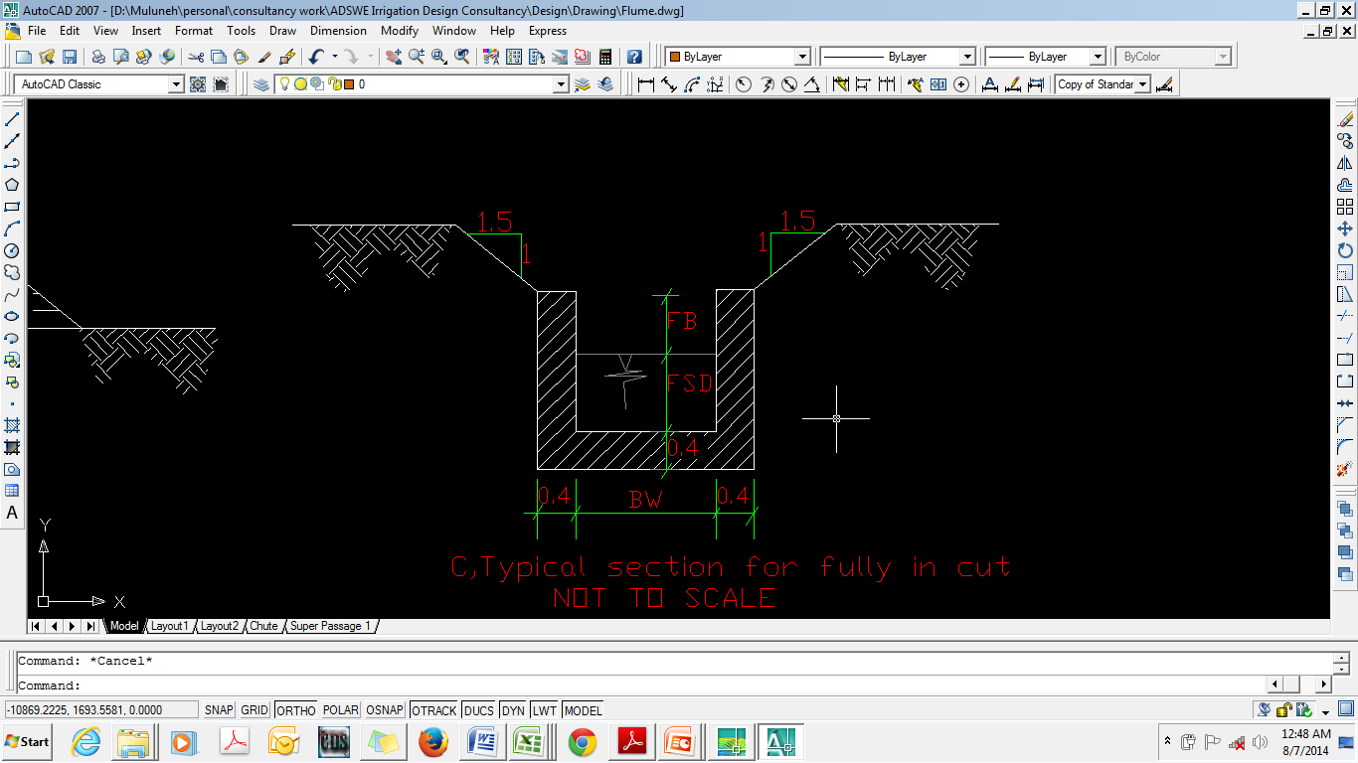
Figure 4-1Typical Cross Section of Main canals

Secondary Canals (SC1, SC2, SC2-1 AND SC2-2)
There are four unlined trapezoidal section secondary canals (SC). All of them are branched from the main canal. On the secondary canals there are a lot of chute structures due to long distance steepness of the slope. The designs of the secondary canal dimensions are determined by using Manning’s formula.
Q = , R=A/P
Where, Q = Design discharge, m³/s
R = Hydraulic radius of the canal, m
A = Wetted cross sectional area of canal, m²
P = Wetted Perimeter, m
n = Manning’s roughness coefficient
S = Bed slope of the canal
The shape of the canal cross section, A is trapezoidal shown below. The hydraulic parameters are presented in Table 4.2 below.

Tertiary canals
In the layout system there are four tertiary canals, the designed discharge is determined based on the duty of irrigation. The sections of the canals are determined by using manning’s formula, and most of them are trapezoidal section. The hydraulic characteristics is Presented in Table 5.3 below.
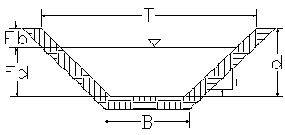
Figure 4-2: Typical Cross Section of SCs and TCs

Table 4-1: Hydraulic Parameters of main canal

 |  | Typical main Canal Section Hydraulic Parameters.
Canal name | Length (m) | Area(ha) | Duty(M^3/s/ha) | Q (m3/s) | B (m) | D (m) | Fb (m) | Area | Perimeter | R=A/P | S | N | V=1/N*R^(2/3)*S^0.5 | QD(m3/s)
M.C | 822 | 198.20 | 0.00121 | 0.172 | 0.60 | 0.55 | 0.30 | 0.33 | 1.70 | 0.19 | 0.001 | 0.018 | 0.56 | 0.185
MC2 | 1813.51 | 141.35 | 0.00121 | 0.171 | 0.60 | 0.55 | 0.30 | 0.33 | 1.70 | 0.19 | 0.001 | 0.018 | 0.59 | 0.194

Table 4-2: Hydraulic Parameters of Secondary canal
Secondary Canals Section.
Canal name | Length (m) | Comm. Area (ha) | DutyM^3/s/ha) | Q req (m3/sec) | m (H:V) | B (m) | D (m) | Fb (m) | A(m) | P(m) | R=A/P | S | N | V(m/s) | Qdes (m3/sec) | Remark
S.C.1 | 3159.99 | 50.00 | 0.00121 | 0.06 | 1.0 | 0.50 | 0.35 | 0.30 | 0.30 | 1.49 | 0.20 | 0.0010 | 0.035 | 0.31 | 0.091
S.C.2 | 139 | 74.69 | 0.00121 | 0.09 |  | 0.60 | 0.50 | 0.30 | 0.30 | 1.60 | 0.19 | 0.0011 | 0.035 | 0.31 | 0.093 | Chute
S.C.2-1 | 3608.23 | 59.40 | 0.00121 | 0.07 | 1.0 | 0.60 | 0.50 | 0.30 | 0.55 | 2.01 | 0.27 | 0.0011 | 0.035 | 0.40 | 0.220
S.C.2-2 | 458 | 6.79 | 0.00121 | 0.01 | 1.0 | 0.60 | 0.50 | 0.30 | 0.55 | 2.01 | 0.27 | 0.002 | 0.035 | 0.47 | 0.258

Table 4-3Hydraulic Parameters of tertiary canals
Tertiary Canal Section.
Canal name | Length (m) | Comm. Area (ha) | DutyM^3/s/ha) | Q req (m3/sec) | m (H:V) | B (m) | D (m) | Fb (m) | A(m) | P(m) | R=A/P | S | N | V(m/s) | Qdes (m3/sec) | Remark
T.C.1 | 144.58 | 0.85 | 0.00121 | 0.001 | 1.0 | 0.30 | 0.20 | 0.20 | 0.10 | 0.87 | 0.12 | 0.00 | 0.035 | 0.20 | 0.020
T.C.2 | 487.42 | 7.00 | 0.00121 | 0.008 | 1.0 | 0.30 | 0.20 | 0.20 | 0.10 | 0.87 | 0.12 | 0.00 | 0.035 | 0.20 | 0.020
T.C.3-0 | 1698.37 | 17.00 | 0.00121 | 0.021 | 1.0 | 0.40 | 0.30 | 0.20 | 0.21 | 1.25 | 0.17 | 0.001 | 0.035 | 0.31 | 0.064
T.C.3 | 187.61 | 31.80 | 0.00121 | 0.038 |  | 0.30 | 0.20 | 0.20 | 0.06 | 0.70 | 0.09 | 0.010 | 0.018 | 1.07 | 0.064 | Chut
T.C.3-1 | 678.98 | 22.00 | 0.00121 | 0.027 | 1.0 | 0.30 | 0.20 | 0.20 | 0.10 | 0.87 | 0.12 | 0.002 | 0.035 | 0.26 | 0.026
T.C.3-2 | 276.21 | 9.80 | 0.00121 | 0.012 |  | 0.30 | 0.20 | 0.20 | 0.06 | 0.70 | 0.09 | 0.0063 | 0.018 | 0.85 | 0.051 | Chut
T.C.3-2-1 | 332.27 | 3.01 | 0.00121 | 0.004 | 1.0 | 0.30 | 0.20 | 0.20 | 0.10 | 0.87 | 0.12 | 0.002 | 0.035 | 0.26 | 0.026
T.C.3-2-2 | 602.16 | 6.79 | 0.00121 | 0.008 | 1.0 | 0.30 | 0.20 | 0.20 | 0.10 | 0.87 | 0.12 | 0.0015 | 0.035 | 0.26 | 0.026
T.C.4 | 151.33 | 2.26 | 0.00121 | 0.003 |  | 0.30 | 0.20 | 0.20 | 0.06 | 0.70 | 0.09 | 0.001 | 0.018 | 0.36 | 0.021 | Chut
T.C.5 | 59.24 | 1.00 | 0.00121 | 0.001 | 1.0 | 0.30 | 0.20 | 0.20 | 0.10 | 0.87 | 0.12 | 0.001 | 0.035 | 0.22 | 0.022
T.C.6 | 98.53 | 2.26 | 0.00121 | 0.003 | 1.0 | 0.30 | 0.20 | 0.20 | 0.10 | 0.87 | 0.12 | 0.001 | 0.035 | 0.22 | 0.022
 | 43.49 | 7.24 | 0.00121 | 0.009 |  | 0.30 | 0.20 | 0.20 | 0.06 | 0.70 | 0.09 | 0.034 | 0.035 | 1.02 | 0.061 | Chut
  T.C.7
T.C.7-1 | 486.47 | 5.10 | 0.00121 | 0.006 | 1.0 | 0.30 | 0.20 | 0.20 | 0.10 | 0.87 | 0.12 | 0.001 | 0.035 | 0.22 | 0.022
T.C.7-2 | 82.83 | 1.71 | 0.00121 | 0.002 | 1.0 | 0.30 | 0.20 | 0.20 | 0.10 | 0.87 | 0.12 | 0.002 | 0.035 | 0.26 | 0.026
T.C.8 | 152.32 | 3.50 | 0.00121 | 0.004 |  | 0.30 | 0.20 | 0.20 | 0.06 | 0.70 | 0.09 | 0.027 | 0.018 | 1.76 | 0.106 | Chut
T.C.8-1 | 115.23 | 1.04 | 0.00121 | 0.001 | 1.0 | 0.30 | 0.20 | 0.20 | 0.10 | 0.87 | 0.12 | 0.002 | 0.035 | 0.26 | 0.026
T.C.8-2 | 185.27 | 1.28 | 0.00121 | 0.002 | 1.0 | 0.30 | 0.20 | 0.20 | 0.10 | 0.87 | 0.12 | 0.003 | 0.035 | 0.39 | 0.039
T.C.9 | 1009.26 | 9.56 | 0.00121 | 0.012 | 1.0 | 0.30 | 0.20 | 0.20 | 0.10 | 0.87 | 0.12 | 0.001 | 0.035 | 0.22 | 0.022
T.C.10 | 605.69 | 4.74 | 0.00121 | 0.006 | 1.0 | 0.30 | 0.20 | 0.20 | 0.10 | 0.87 | 0.12 | 0.001 | 0.035 | 0.22 | 0.022
T.C.11 | 174.63 | 3.68 | 0.00121 | 0.004 |  | 0.30 | 0.20 | 0.20 | 0.06 | 0.70 | 0.09 | 0.001 | 0.018 | 0.38 | 0.023 | Chut

BW= Canal bottom width QR= required discharge FSD= Full supply depth QD= Designed Discharge

FB= Free board
SS= Side slope
Vel= Velocity

Field Canals
As shown in the layout, field canals run across the contours and hence face steeper gradient. The discharge of most of the field canals is very small and this is taken as an advantage to cope up with the relatively steeper gradient. As can be seen from the layout, majority of the filed canals can be used to irrigate both sides of the command area depending on the condition of the individual plots of land owned by individual farmers.

Canal Structures Design

Design of Division box
At different points of the main and secondary canals division boxes are provided which divert the flow to the secondary canal and tertiary canals. Gate should be provided at the outlet of the boxes. For detail refer the drawing.
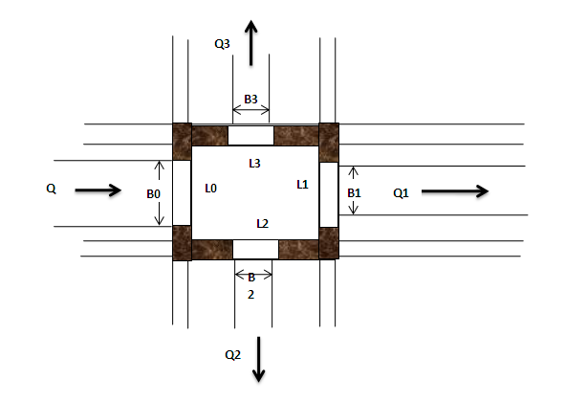
Figure 4-3: Typical Division Box plan
Using broad crested formula,
Q= CL (h) ^{3/2}
Where; Q= discharge over rectangular weir/intake (opening), m³/s
C = discharge coefficient, c= 1.7
L= effective length of crest form in m
h= over flow depth, m
Assuming equal discharge coefficient & sill height for two dividing canals, the proportion becomes.
Q₁/ Q₂= Q₂/ Q₃ =L₁/ L₂ = L₂/ L₃
Where Q₁= is flow in canal 1
Q₂ = is flow in canal 2
Q₃ = is flow in canal 3
L₁= is effective crest length of weir/intake sill across opening to canal 1
L₂= is effective crest length of weir/intake sill across opening to canal 2
L₃ = is effective crest length of weir/intake sill across opening to canal 3
Q₁= CL₁ (h)^{3/2},
L₁ = Q₁/Ch^{3/2}
L₂ = L₁*Q₂/ Q₁
L₃ = L₁*Q₃/ Q₁
The depth of (height of) the division box,
D = d + f_{b}
The width of the division box,
B = b + 2*m*D
Where b= base width of the incoming canal
D = total canal depth of the incoming canal

Table 4-4: Hydraulic parameters of Division Boxes

Dividing canal Name | Chainage | Q₀ (m³/sec) | Q₁ (m³/sec) | Q₂ (m³/sec) | B₀ (m) | D₀ (m) | H₀ (m) | D = D₀+FB) (m) | B (m) | L₀ | L₁ (m) | L₂ (m)
MC 2 & TC1 | 0 +5.13 | 0.172 | 0.170 | 0.015 | 0.60 | 0.55 | 0.30 | 0.85 | 1.20 | 0.61 | 0.60 | 0.30
MC 2 & SC1&SC2 | 0+1813.5 | 0.171 | 0.061 | 0.111 | 0.60 | 0.55 | 0.30 | 0.85 | 1.20 | 0.61 | 0.50 | 0.50
MC2 & TC11 | 0+1260 | 0.171 | 0.171 | 0.004 | 0.60 | 0.55 | 0.30 | 0.85 | 1.20 | 0.61 | 0.61 | 0.30
SC1&TC2 | 1+803.2 | 0.061 | 0.052 | 0.015 | 0.50 | 0.35 | 0.17 | 0.65 | 1.10 | 0.51 | 0.50 | 0.30
SC2&TC3-0 | 0+100 | 0.090 | 0.070 | 0.021 | 0.60 | 0.50 | 0.20 | 0.80 | 1.20 | 0.61 | 0.60 | 0.40
SC 2 & SC 2-1&SC2-2 | 0+138.36 | 0.07 | 0.02 | 0.053 | 0.60 | 0.50 | 0.17 | 0.80 | 1.20 | 0.61 | 0.30 | 0.46
SC2-1&TC3 | 0+928 | 0.09 | 0.07 | 0.021 | 0.60 | 0.00 | 0.20 | 0.30 | 1.20 | 0.61 | 0.47 | 0.40
SC2-1&TC4 | 2+114.97 | 0.09 | 0.07 | 0.023 | 0.60 | 0.00 | 0.20 | 0.30 | 1.20 | 0.61 | 0.45 | 0.30
SC2-1&TC5 | 2+498.72 | 0.09 | 0.06 | 0.026 | 0.60 | 0.00 | 0.20 | 0.30 | 1.20 | 0.61 | 0.43 | 0.30
SC2-1&TC6 | 2537.4 | 0.09 | 0.06 | 0.026 | 0.60 | 0.00 | 0.20 | 0.30 | 1.20 | 0.61 | 0.43 | 0.30
SC2-1&TC7 | 2+788.6 | 0.09 | 0.06 | 0.026 | 0.60 | 0.00 | 0.20 | 0.30 | 1.20 | 0.61 | 0.43 | 0.30
SC2-1&TC8 | 3+378.96 | 0.09 | 0.06 | 0.026 | 0.60 | 0.00 | 0.20 | 0.30 | 1.20 | 0.61 | 0.43 | 0.30
TC 3 & TC 3-1&TC3-2 | 0+187.6 | 0.04 | 0.03 | 0.015 | 0.30 | 0.20 | 0.18 | 0.50 | 0.90 | 0.30 | 0.30 | 0.30
TC 3-2 & TC 3-2-1&TC3-2-2 | 0+276.21 | 0.012 | 0.004 | 0.015 | 0.30 | 0.20 | 0.08 | 0.50 | 0.90 | 0.31 | 0.30 | 0.39
TC7 & TC 7-1&TC7-2 | 0+43.5 | 0.01 | 0.00 | 0.015 | 0.30 | 0.20 | 0.07 | 0.50 | 0.90 | 0.31 | 0.30 | 0.52
TC8 & TC 8-1&TC8-2 | 0+167.4 | 0.00 | 0.00 | 0.015 | 0.30 | 0.20 | 0.04 | 0.50 | 0.90 | 0.31 | 0.30 | 1.09
SC 2 -2& TC 9 &TC10 | 0+138.65 | 0.02 | 0.01 | 0.015 | 0.30 | 0.20 | 0.10 | 0.50 | 0.90 | 0.31 | 0.30 | 0.30
D₁ (m) | B₁ (m) | D₂ (m) | B₂ (m) | L_{p2} (m)
0.55 | 0.60 | 0.20 | 0.30 | 0.51
0.35 | 0.50 | 0.35 | 0.50 | 0.52
0.30 | 0.55 | 0.20 | 0.30 | 0.50
0.35 | 0.50 | 0.20 | 0.30 | 0.51
0.50 | 0.60 | 0.30 | 0.40 | 0.51
0.20 | 0.30 | 0.00 | 0.00 | 0.51
0.60 | 0.00 | 0.30 | 0.40 | 0.51
0.60 | 0.00 | 0.20 | 0.30 | 0.51
0.60 | 0.00 | 0.20 | 0.30 | 0.51
0.60 | 0.00 | 0.20 | 0.30 | 0.51
0.60 | 0.00 | 0.20 | 0.30 | 0.51
0.60 | 0.00 | 0.20 | 0.30 | 0.51
0.20 | 0.30 | 0.20 | 0.30 | 0.51
0.20 | 0.30 | 0.20 | 0.30 | 0.51
0.20 | 0.30 | 0.20 | 0.30 | 0.51
0.20 | 0.30 | 0.20 | 0.30 | 0.51
0.20 | 0.30 | 0.20 | 0.30 | 0.51

Where L=Length of throat
B=Width of Division Box | Qo= is flow in canal 1
D=Depth of Division Box | Q1 = is flow in canal 2
Bo=Width of the incoming canal | Q2 = is flow in canal 3
D0=Depth of the incoming canal | L0= is effective crest length of weir sill across opening to canal
Lo=Q0/(C*H03/2) | L1= is effective crest length of weir sill across opening to canal 2
L0/L1=Q0/Q1 | L2 = is effective crest length of weir sill across opening to canal 3
L1=L0*(Q1/Q0)
L2=L0*(Q2/Q0)
L3=L0*(Q3/Q0)
B=B0+(2*m*H1)
L1=L2= 1.2+3/2Q 1/2
H0=(Q0/(C*L0))^(2/3)
c =1.7

Design of a typical flume
There is one gully crossing flume which is 156m long that crosses Koso Woha River. Among many shorter alternative spans this route of the flume is selected along banks with rocky foundation to increase stability, suitable slope to carry the structure and also to increase the command area as much as possible. The detail analysis is annexed with excel and shown on the working drawing.
Canal Name | Flume ( MC-2)
length, m | 156
Area(ha) | 198
Duty(m^3/s/ha) | 0.00121
Qreq (m3/s) | 0.171
B (m) | 0.6
D (m) | 0.55
Fb (m) | 0.3
Area | 0.25
Perimeter | 1.69
R=A/P | 0.19
S | 0.002
n | 0.0180
$v=\frac{1}{n} xR^{2/3}S^{1/2}$^{/2} (m/s) | 0.75
Qdes (m³/s) | 0.184

Table 4-5: Flume hydraulic parameters
 | HYDRAULIC DESIGN
 | 1. Characteristics of the main canal
 | Discharge m³/s |  |  | Bed width b (m) |  |  | Water depth d1 (m) |  |  | Side slope (H:V) |  |  |  | Velocity v (m/s)
 | 0.184 |  |  | 0.60 |  |  | 0.55 |  |  | 0.0 |  |  |  | 0.56
 | Clear span length of the flume |  |  |  |  |  |  |  |  | 156.34
 | Shape of flume is rectangular
 | 2. Flume Section
 | Assume b/d= 1.5 to 2 |  |  |  |  |  |  |  |  | 1.11
 | Assume Velocity of flow in flume section, V |  |  |  |  |  |  |  |  | 0.75
 | Roughness coefficient, n |  |  |  |  |  |  |  |  | 18
 | Water area, A=Q/V |  |  |  |  |  |  |  |  | 0.25
 | Assume bed width, b |  |  |  |  |  |  |  |  | 0.60
 | Water depth, d2 |  |  |  |  |  |  |  |  | 0.55
 | Velocity |  |  |  |  |  |  |  |  | 0.75 |  |  |  | Ok
 | Froude number, Fr=V/sqrt(gd) |  |  |  |  |  |  |  |  | 1.69 |  |  |  | *It is ok**Stable subcritical flow*
 | Wetted perimeter, P= b +2d |  |  |  |  |  |  |  |  | 0.19
 | Hydraulic radius, R=A/P |  |  |  |  |  |  |  |  | 0.16
 | Friction head loss, hf
 |  |  |  |  |  |  |  |  |  |  |  |  |  |  | 5
 |  | 3. Water surface change at the u/s and d/s of the flume
 |  | i. Drop of water surface at the inlet of the flume
 |  |  |  |  |  |  |  |  |  |  |  |  |  |  | 0.019
 |  | 3. Water surface change at the u/s and d/s of the flume
 |  | i. Drop of water surface at the inlet of the flume
 |  |  |  |  |  |  |  |  |  |  |  |  |  |  | 0.019
  ii. Rise of water surface at the d/s of canal section
 |  |  |  |  |  |  |  |  |  |  |  |  |  |  | 0.004
 |  | 4. elevation
 |  | Invert elevation at u/s canal |  |  |  |  |  |  |  |  |  |  |  |  | 2439.08
 |  | Water surface elevation at u/s canal
 |  | =Invert elevation at u/s canal +d |  |  |  |  |  |  |  |  |  |  |  |  | 2439.63
 |  | Water surface at the flume inlet
 |  | =(Water surface elevation at u/s canal)-∆h1 |  |  |  |  |  |  |  |  |  |  |  |  | 2439.61
 |  | Invert elevation at the flume inlet
 |  | =(Water surface at the flume inlet) –d₂ |  |  |  |  |  |  |  |  |  |  |  |  | 2439.07
 |  | Invert elevation at the flume outlet
 |  | =(Invert elevation at the flume inlet) -hf |  |  |  |  |  |  |  |  |  |  |  |  | 2438.81
 |  | Water surface elevation at the flume outlet
 |  | =(Invert elevation at the flume outlet) + d2 |  |  |  |  |  |  |  |  |  |  |  |  | 2439.356
 |  | Water surface elevation at the d/s canal
 |  | =(Water surface elevation at the flume outlet)+∆h2 |  |  |  |  |  |  |  |  |  |  |  |  | 2439.359
 |  | Invert elevation at the d/s canal
 |  | =(Water surface elevation at the d/s canal) -d1 |  |  |  |  |  |  |  |  |  |  |  |  | 2438.809
 |  | 5. Total head loss
 |  |  |  |  |  |  |  |  |  |  |  |  |  |  | 0.271
 |  | Check water surface different between u/s and d/s canal.
 |  | =(wat. surf. Elev. at u/s canal) – (Wat. surf. Elev. d/s canal ) |  |  |  |  |  |  |  |  |  |  |  |  | 0.271
 |  | 6. Canal elevation at each section
Section |  |  | Location |  |  | Water depth (m) |  |  | Change in water level |  |  |  |  |  |  | Elevation of
 |  |  |  |  |  |  |  |  |  |  |  |  |  |  |  | Canal bed |  | Water surface
A |  |  | u/s canal |  |  | 0.55 |  |  | - |  | - |  |  |  |  | 2439.08 |  | 2439.63
B |  |  | Flume |  |  | 0.55 |  |  | drop |  | 0.019 |  |  |  |  | 2439.07 |  | 2439.61
C |  |  | Flume |  |  | 0.55 |  |  | drop |  | 0.255 |  |  |  |  | 2438.81 |  | 2439.36
D |  |  | d/s canal |  |  | 0.55 |  |  | rise |  | 0.004 |  |  |  |  | 2438.81 |  | 2439.36

6. Provision of cutoff depth at the beginnig and end of inlet and outlet transition respectively
Full supply depth of incoming canal |  |  | = | 0.55 | m
Bed width of the incoming canal |  |  | = | 0.60 | m
 |  | Q | = | 0.18 | m³/s
 |  | q | = | 0.31 | m³/s/m
Lacey's silt factor, |  | f | = | 0.60
Normal depth of scour: R=1.35(q2/f)1/3 |  |  | = | 0.73
Anticipated R |  |  | = | 1.09
Cutoff depth below canal bed |  |  | = | 0.54
 |  | Let's say | = | 1.00 | m

HYDRAULIC PARAMETERS OF CANAL
Full Supply Depth |  |  |  |  |  | FSD | = | 0.55 | m
Free Board |  |  |  |  |  | FB | = | 0.30 | m
Number of Spans |  |  |  |  |  | No_barrels | = | 22.00 | No.
Clear span |  |  |  |  |  | Width_bay | = | 7.11 | m
Width of Abutment |  |  |  |  |  | Width_abutment | = | 0.50 | m
Therefore C/C of supports |  |  |  |  |  |  | = | 7.61 | m
Internal Width of Concrete Barrel |  |  |  |  |  | Width_barrel | = | 0.50 | m
Width of Pier |  |  |  |  |  | Width_pier | = | 0.50 | m
DESIGN PARAMETERS
Grade of the cement concrete, |  |  |  | C 25 |  | f_{c'} | = | 25.00 | Mpa
Modulus of elasticity of concrete, Ec=0.043*γc^{1.5}*SQRT(fc') |  |  |  |  |  | Ec | = | 25278.73 | Mpa
Grade of the steel Reinforcement (for ∅>=20) |  |  |  |  |  | f_{y} | = | 400 | Mpa
Grade of the steel Reinforcement (for ∅<20) |  |  |  |  |  | f_{y} | = | 276 | Mpa
 |  |  |  |  |  | Es | = | 198000 | Mpa
Modular Ratio,n=Es/Ec |  |  |  |  |  | n | = | 7.91 | N/mm²
 |  |  |  |  |  | €
Unit weight of water |  |  |  |  |  | gc | = | 24.00 | KN/m²
Unit weight of concret |  |  |  |  |  | gw | = | 9.81 | KN/m²
Load and Resistance Factors
 |  |  |  |  |  | moment=φ | = | 0.90
 |  |  |  |  |  | shear=φ | = | 0.85
Dead Load limit state factor |  |  |  |  |  |  | = | 1.25
Live Load Limit state facctor |  |  |  |  |  |  | = | 1.75
Dead Load Service Limit State factor |  |  |  |  |  |  | = | 1.00
Live load service limit state factor |  |  |  |  |  |  | = | 1.30

SERVICE LIMIT DESIGN
1.0 Durability
Longitudinal Direction
Cover for main reinforcement steel for:-
 |  | slab cover |  | = | 50 | mm
 |  | η |  | = | 1
M=ηΣγQi=1.0(Mdc+1.0Mwa)
Mu | = | 100.38 | KNm
using Φ | = | 18.00 | mm bar
Trail Reinforcement, as |  | = | 254.47 | mm²
As=M/(jfsd)
Assume j | = | 0.875
fs = 0.6fy | = | 165.60 | Mpa
As | = | 905.24 | mm²/m
Spacing | = | 281.11 | mm
Use diam | 18.00 | mm bar c/c | 120.00 | mm for the bottom of the slab
As (Provided) |  | = | 2120.58 | mm²/m
2.0 Control of Crack
Structure components should be proportioned that the tensile stress in the reinforcement
steel fs should be less than fsa
 | fs<fsa, where fsa=z/(dcA)1/3<0.6fy
Z= crack width parameter(N/mm)=23000N/mm for serve exposure
dc= depth of concert from extreme fiber to centre of the bar located closest to there to.
dc=< 50mm
A= is area of concrete having the same centeroid as the principal tensile reinforcement and bounded by
the surfaces of the cross section and line parallel to the the neutral axis divided by the number of bars(mm2),
clear cover <=50mm
Check whether the section at service load has cracked or not against 0.8fr
fr=the rupture stress = 0.63√f'c = |  |  | 3.15 | Mpa
Mu |  | = | 100.38 | KNm
fctm=M/(1/6bh²) |  | = | 0.76 | Mpa
0.8fr |  | = | 2.52 | Mpa
the section hasn't cracked

s | = | 170 | mm
t | = | 170 | mm
D | = | 970 | mm
b | = | 500.00 | mm
B | = | 840.00 | mm
A | = | 244800 | mm²
Cx | = | 403.03 | mm
Ig | = | 64,490,914,062.53 | mm⁴
Determine x from the equilibrium of moment areas
 |  |  | n | = | 7.91
Steel Stress is then, fs/n=M(d/2)/I |  |  | = | 0.71 | Mpa
fs | = | 5.61 | Mpa
fsa=z/(dcA)1/3<0.6fy
Z = | 23000 | N/mm | dc = | 50 | mm
 |  |  | Ac=2dc*S= | 11980 | mm2
 |  |  |  | s = spacing
fsa= | 272.70 | Mpa | >0.6fy | = | 165.60 | Mpa
fs= | 5.61 | Mpa | < fsa OK
6.0 Deflection and camber
Total dead load of flume is considered in the design:
 | Flume U Section dead load |  |  | = | 9.96 | KN/m
 | Water load |  |  | = | 3.92 | KN/m
 |  | Total |  | = | 13.88 | KN/m
Mdl=W_{DL}L²/8= |  | 100.38 | KNm
Using the Ig,ΔDL=5*W_{DL}L⁴/384EcIg, for defelcetion at centre of a simply supported beam
Flume U Section, Ig |  | = | 64,490,914,062.53 | mm⁴
 | ΔDL=(5*W_{DL}L⁴/384EcIg) |  | = | 0.37 | mm
 | Long term deflection for As'=0, 3.0-As'/As=3.0
 | Long-term deflection is =3*Immediate= |  |  | 1.11 | mm
 | Provide a camber of |  | 0.00 | mm at the center, since the deflection is small
Check for crack width control
The limit of cracking is satisfied by insuring that the maximum calculated surface width of cracks
is not greater than the specified value, depending on the degree of exposure of the member for
The case under consideration equal to 0.2mm.
To check the surface crack width, the following procedure is necessary:
 | (a) Calculate the service bending moment.
 | (b) Calculate the depth of the neutral axis, lever arm and steel stress by elastic theory.
 | ( c) Calculate the surface strain allowing for the stiffening effect of the concrete
 | (d) Calculate the crack width
The maximum service bending moment is calculated using characteristics loads with
Load factor=1.

Figure-2-6: Assumed stress & strain diagram-cracked section-elastic design
The depth of neutral axis x is calculated using the usual assumptions for modular ratio design.

For the crack width formula to be valid, the compressive stress in the concrete and the steel
under service conditions must be less than the limiting values as follows:
Concrete



 | a_{cr} | is the distance b/n the point considered and the surface the
 |  | nearest longitudinal bar
 | c_{min} | The minimum cover over the tension steel
Check for crack width control ( Assumed crack width=0.2mm)
Description |  |  |  | Value | Unit
Ms(Service Bending Moment)) |  |  | = | 100.38 | KNm
Section Height (h) |  |  | = | 970 | mm
Section Width (w) |  |  | = | 840 | mm
Concrete Cover(c_{min}) |  |  | = | 50 | mm
effective depth(d) |  |  | = | 911 | mm
Bar Dia. |  |  | = | 18 | mm
Spacing |  |  | = | 120.00 | mm
A_{s} |  |  | = | 1780.38 | mm²
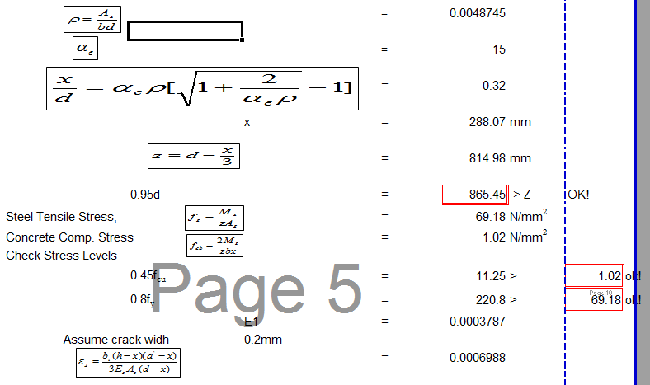
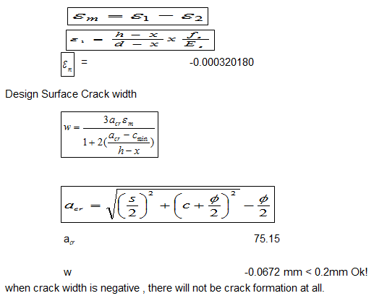

 | SERVICE LIMIT DESIGN
 | I. Longitudinal Direction
 |  | Channel Effective Span |  |  | = | 7.61 | m
 |  | Water Load |  |  | = | 3.92 | KN/m
 |  | Dead Load |  |  | = | 9.96 | KN/m
 | Load
 |  |  | V_{CD} = | 37.86 | KN
 |  |  | V_{WA} = | 14.92 | KN
 |  |  | M_{CD} = | 72.00 | KNm
 |  |  | M_{WA} = | 28.38 | KNm
 | Strength - I Design
 |  |  | V_{U} = | 73.20 | KN
 |  |  | M_{U} = | 139.19 | KNm
 | Reinforcement for Flexure
 | M u= | 139.19 | KNm/m
 | Bar Dia. | 18.00 | mm | fy | = | 276.00 | Mpa
 | Spacing | 120.00 | mm | fc' | = | 25.00 | Mpa
 | As = | 1,781.28 | mm²
 | b= | 340.00 | mm | Considering 2*t
 | c = | Asfy/(0.85fcbb) |  | = | 80.05 | mm
 | a= | 68.05 | mm
 | d'= | 911.00 | mm
 | d= | 111.00
 | c/d= | 0.09 | < 0.42 Ok! For ductility requirement
 | Maximum reinforcement is limited by ductility requirement, which is given by
 | a = | βc
 | c/d=< | 0.42 | a=<0.42βd | β= | 0.85 | for f'c<=28 Mpa
 |  |  |  |  |  | Art.5.7.2.2
 | Φ= | 0.90 | For Flexure
 | Reinforcement
 |  | ρ = | As/bd |  | = | 0.0058
 |  | ρ_{min}= | 0.03*(fck/fy) |  | = | 0.0027 | <ρ ok!
 | Moment Carrying Capacity of the section = Mn = |  |  |  | As*fy(d-a/2) | = | 431.15 | KNm
 | Factored Resistance |  | 0.9* | Mn | = | 388.04 | KNm
 |  |  |  | >Mu | = | 139.19 | KNm
 |  |  |  |  |  | <0.9*Mn, ok!
 | Distribution bar for slab
 | For longitudinal reinforced concrete construction |  |  |  | Art.5.14.4.1
 | % of transverse dist.reinf=1750/Sqrt(L)<=50%
 | % reinf. = | 20.07 | <50% | L= C/C Span Length(mm)
 | % reinf. = | 425.50 | mm²/m
 | Minimum Reinforcement for crack control of imature concrete |  |  |  |  | (None water side)
 | % reinf. = | 0.20% bd | 186.48
 | Use Dia. | 12.00 | Re-bar, as= | 113.10 | mm2
 | Spacing = | 265.80 | mm | (Taking the maximum of distribution and crack)
 | Use Φ | 12.00 | mm bar C/C | 275.00 | mm on bottom of slab as Distribution Bar
 | Temperature and shrinkage Reinforcement for slab ( water side)
 | Transverse reinforcement on the top of slab
 |  | As>=0.75Ag/fy= |  | 102.55 | mm²/m
 | As for each face |  |  | 51.28
 | Using | 12.00 | bar diam | As= | 113.10 | mm²
 |  | Spacing= | 2,205.61 | mm
 | Use diam | 10.00 | bars C/C | 275.00 | mm in long directions, crack control for
 | immature concrete requirement will govern
 | Flexural resistance Check at base slab during construction stage
 |  | Span | = | 7.61 | m
 |  | D | = | 198.00 | mm
 |  | b | = | 840.00 | mm
 |  | Assume Live Load |  | 1.00 | KN/m2
 |  | Dead Load |  | 4.03 | KN/m
 | Service Load |  |  | 5.03
 | Factored Load = 1.35*DL+1.5*LL |  |  | 6.94 | KNm/m
 |  | V |  | 19.14 | KN
 |  | M |  | 36.39 | KNm
 |  | Vu |  | 26.41 | KN/m
 |  | Mu |  | 50.21 | KNm/m
 | Reinforcement for Flexure
 | M u= | 50.21 | KNm/m
 | Bar Dia. | 18.00 | mm | fy = | 276.00 | Mpa
 | Spacing | 120.00 | mm | fc' = | 25.00 | Mpa
 | As = | 2,120.58 | mm2/m
 | b= | 1000.00 | mm
 | c = | Asfy/(0.85fcbb)= |  | 32.40 | mm
 | a= | 27.54 | mm
 | d= | 111.00 | mm
 | c/d= | 0.29 | < 0.42: Ok! For ductility requirement
 | Maximum reinforcement is limited by ductility requirement, which is given by
 | a = | βc
 | c/d=< | 0.42 a=<0.42βd |  | β= | 0.85 | for f'c<=28 Mpa
 |  |  |  |  |  | Art.5.7.2.2
 | Φ= | 0.90 | For Flexure
 | Reinforcement
 |  | ρ = | As/bd | 0.0191
 |  | ρ_{min}= | 0.03*(fck/fy) | 0.0027 | < ρ ok!
 | Moment Carrying Capacity of the section = Mn = |  |  |  | As*fy(d-a/2) | 56.91 | KNm
 | Factored Resistance |  | 0.9* | Mn |  | 51.22 | KNm
 |  |  |  |  | >Mu | 50.21 | KNm
 |  |  |  |  |  | <0.9*Mn, ok!
 | Shear Carrying Capacity of Section (Check for bottom slab during construction)
 | Vn |  | 166.00 | KN/m
 |  | 0.85Vn | 141.10 | KN/m
 |  | > Vu = | 26.41 | KN/m
 |  |  | Ok!
 | system design shall be improved to dia. 18 @ 120mm due considering the uncertainty during construction stage
 | such as partially demolishing of base slab formwork before completion of the total work,
 | Formwork support removal due to flooding is some of the possible uncertainties.
2 | Reinforcement for trough wall for water & wind lateral loads
 | Water Load
 | h (cantilever height) |  | = | 0.80 | m
 | Vu |  | = | 23.63 | KN/m
 | Mu |  | = | 15.75 | KNm/m
 | Wind Load
 | Wind Pressure on super structure |  |  | = | 2.40 | KN/m2
 | Vu |  |  | = | 9.07 | KN/m
 | Mu |  |  | = | 1.21 | KNm/m
 | Water pressure exceeds the wind pressure & shall be designed for water pressure
 | Reinforcement for Flexure
 | M u= | 15.75 | KNm/m
 | Bar Dia. | 12.00 | mm | fy | = | 276.00 | Mpa
 | Spacing | 150.00 | mm | fc' | = | 25.00 | Mpa
 | As = | 753.98 | mm2/m
 | b= | 800.00 | mm
 | c = | Asfy/(0.85fcbb) |  | = | 14.40 | mm
 | a= | 12.24 | mm
 | d= | 111.00 | mm
 | c/d= | 0.13 | < 0.42 Ok! For ductility requirement
 | Maximum reinforcement is limited by ductility requirement, which is given by
 | a = | βc
 | c/d=< | 0.42 | a=<0.42βd | β= | 0.85 | for f'c<=28 Mpa
 |  |  |  |  |  | Art.5.7.2.2
 | Φ= | 0.90 | For Flexure
 | Reinforcement
 |  | ρ = | As/bd | 0.0085
 |  | ρ_{min}= | 0.03*(fck/fy) | 0.0027 | <ρ ok!
 | Moment Carrying Capacity of the section = Mn = |  |  |  | As*fy(d-a/2) | 21.83 | KNm
 | Factored Resistance |  | 0.9* | Mn |  | 19.64 | KNm
 |  |  |  |  | >Mu | 15.75 | KNm
 |  |  |  |  |  | ok!
 | Φ= | 0.90 | For Flexure
 | Distribution bar for trough wall
 | For longitudinal reinforced concrete construction |  |  |  | Art.5.14.4.1
 | % of transverse dist.reinf=1750/Sqrt(L)<=50%
 | % reinf.= | 20.07 | <50% | L= C/C Span Length(mm)
 | % reinf. = | 151.29 | mm²
 | Minimum Reinforcement for crack control of immature concrete
 | % reinf. = | .20% bd | 177.60
 | Use Dia. | 10.00 | Re-bar, as= | 78.54 | mm2
 | Spacing= | 442.23 | mm
 | Use Φ | 10.00 | mm bar C/C | 300.00 | mm on water side of wall as Distribution Bar
 | Temperature and shrinkage Reinforcement for trough wall
 | Transverse reinforcement on the outer face of the wall (non-water side)
 |  | As>=0.75Ag/fy= |  | 241.30 | mm²/m
 | As for each face |  |  | 120.65
 | Using | 10.00 | bar diam | as= | 78.54 | mm²
 |  | Spacing= | 650.96 | mm
 | Use diam | 10.00 | bars C/C | 300.00 | mm in long directions, crack control for
 | immature concrete requirement will govern
 | Check for Shear (for U-section for loading in the longutidinal direction)
 | V_{n} = V_{c} + V_{s} ≤ 0.504 f′_{c} *b_{o} d_{v}
 | for which: V_{c} = 0.166 Sqrt(f′_{c} )*b_{o} d_{v} , and
 | V_{s} = A_{v} f_{y} d_{v} / s
 | fc' = | 25.00 | Mpa
 | bo = | 840.00 | mm | (channel width out to out )
 | bo' = | 500.00 | mm | (channel width in to in )
 | h = | 970.00 | mm | (channel height out to out)
 | h = | 800.00 | mm | (channel height in to in)
 | Bottom Slab
 |  | Vc = | 344.28 | KN
 | Vn = | 0.85Vc = | 292.64 | KN
 | > | Vu = | 73.20 | KN | Ok!
 | I. Transverse Direction |  |  | of course it is not much relevant
 | Reinforcement for Flexure in transverse Direction
 | a) For Bottom Slab
 | i. Support
 | M u(Support)= |  | = | 26.87 | KNm/m
 | Bar Dia. |  | = | 18.00 | mm | fy = | 276.00 | Mpa
 | Spacing |  | = | 120.00 | mm | fc' = | 25.00 | Mpa
 | As |  | = | 2120.58 | mm2/m
 | b |  | = | 1000.00 | mm
 | c |  | = | Asfy/(0.85fcbb) = |  | 32.40 | mm
 | a |  | = | 27.54 | mm
 | d |  | = | 111.00 | mm
 | c/d |  | = | 0.29 | < 0.42 Ok! For ductility requirement
 | Maximum reinforcement is limited by ductility requirement, which is given by
 | a = | βc
 | c/d=< | 0.42 | a=<0.42βd | β= | 0.85 | for f'c<=28 Mpa
 |  |  |  |  |  | Art.5.7.2.2
 | Φ= | 0.90 | For Flexure
 | Reinforcement
 |  | ρ = | As/bd = | 0.0191
 |  | ρ_{min}= | 0.03*(fck/fy) = | 0.0027 | <ρ ok!
 | Moment Carrying Capacity of the section = Mn = |  |  |  | As*fy(d-A/2) | 56.91 | KNm
 | Factored Resistance |  | 0.9* | Mn |  | 51.22 | KNm
 |  |  |  |  | >Mu | 26.87 | KNm
 |  |  |  |  |  | ok!
 | ii. Span
 | M u(Span)= | = | 5.85 | KNm/m
 | Bar Dia. | = | 18.00 | mm | fy = | 276.00 | Mpa
 | Spacing | = | 120.00 | mm | fc' = | 25.00 | Mpa
 | As | = | 2119.50 | mm2/m
 | b | = | 1000.00 | mm
 | c | = | Asfy/(0.85fcbb) = |  | 32.39 | mm
 | a | = | 27.53 | mm
 | d | = | 111.00 | mm
 | c/d | = | 0.29 | < 0.42 Ok! For ductility requirement
 | Maximum reinforcement is limited by ductility requirement, which is given by
 | a = | βc
 | c/d=< | 0.42 | a=<0.42βd | β= | 0.85 | for f'c<=28 Mpa
 | Φ= | 0.90 | For Flexure
 | Reinforcement
 |  | ρ = | As/bd | 0.0191
 |  | ρ_{min}= | 0.03*(fck/fy) | 0.0027 | <ρ ok!
 | Moment Carrying Capacity of the section = Mn = |  |  |  | As*fy(d-a/2) | 56.88 | KNm
 | Factored Resistance |  | 0.9* | Mn |  | 51.19 | KNm
 |  |  |  |  | >Mu | 5.85 | KNm
 |  |  |  |  |  | ok!
 | Check for Shear
 | V_{n} = V_{c} + V_{s} ≤ 0.504 f′_{c} *b_{o} d_{v}
 | for which: V_{c} = 0.166 Sqrt(f′_{c} )*b_{o} d_{v} , and
 | V_{s} = A_{v} f_{y} d_{v} / s
 | fc' | = | 25.00 | Mpa
 | bo | = | 1000.00 | mm
 | dv(B. Slab) | = | 111.00 |  |  | b-bottom

Pier design
 | Sub Structure Design
 | Pier Design
1 | Input Data
A | Super structure Slab
 |  |  |  | Span of Super structure
 |  |  |  | for both side of pier |  |  |  |  |  | 7.28 | m
 | Width in Transverse Direction
 |  |  |  | Flume width in the transverse direction |  |  |  |  |  | 1.01 | m
 |  |  |  | Flume Slab Thickness
 |  |  |  |  |  | Bottom Slab at mid &end span |  |  |  | 1.00 | m
 |  |  |  | Flume Wall
 |  |  |  |  |  | Height including bottom slab thickness |  |  |  | 1.00 | m
 |  |  |  |  |  | Wall thickness |  |  |  | 0.17 | m
B |  |  |  | Pier Cup
 |  |  |  | pier cup projection from end of side wall
 |  |  |  | Length in Transverse Dir. In each side = |  |  |  |  |  | 0
 |  |  |  |  |  | Height |  |  |  | 1 to 0.7
 |  |  |  |  |  | Length in Transverse Dir. |  |  |  | 1.01
 |  |  |  |  |  |  |  |  |  | 1.00
 |  |  |  |  |  | Width in Longitudinal Direction |  |  |  | 0.5 | m
C |  |  |  | Pier
 |  |  |  |  |  | Height |  |  |  | 10.06 | m
 |  |  |  |  |  | Pier Width=
 |  |  |  |  |  |  |  | At Top |  | 0.50 | m
 |  |  |  |  |  |  |  | At Bottom |  | 0.50 | m
 |  |  |  |  |  |  |  | Pier Batter |  | 0.05
 |  |  |  |  |  |  |  | Pier Thickness |  | 0.50 | m
D |  |  |  | Foundation Slab/Footing ( Dimensions to be revised latter)
 |  |  |  | Thickness |  |  |  |  |  | 0.5 | m
 |  |  |  | Width in Transverse Direction |  |  |  |  |  | 1.50 | m
 |  |  |  | Width in Longitudinal Direction |  |  |  |  |  | 1.5 | m
 |  |  |  | Foundation material = Rock
 |  |  |  | Allowable Bearing Pressure |  |  |  |  |  |  | KN/m2
 |  |  |  | Material Property
 |  |  |  | Concrete & Re-bars property shall be same as
 |  |  |  | super structure
2 |  | Loads From Super Structure
 |  |  | Dead Loads from one span
 |  |  | W_{DC} |  | Self Weight |  |  |  | 87.666 |  |  | KN
 |  |  | Wwater |  | Weight of water |  | WWA |  | 8.923 |  |  | KN
 |  |  | P_{DC} |  |  |  |  |  | 87.666 |  |  | KN
 |  |  | P_{water} |  |  |  |  |  | 8.923
 |  |  | Total |  |  |  | R_{DL} |  | 96.588 |  |  | KN
 |  |  | Pier & Footing Loads
 |  |  | Pier Cup Load |  |  |  |  |  | 8.400 |  |  | KN
 |  |  | W_{DC} |  | Pier Load |  |  |  | 60.360 |  |  | KN
 |  |  |  |  | Footing Pad |  |  |  | 27.00 |  |  | KN
 |  |  | Live Loads
 |  |  |  |  |  |  |  |  | 3.00 |  |  | KN/m2
 |  |  | Live Load
 |  |  |  |  | From one span (R_{LL}) |  |  |  | 5.325 |  |  | KN
 |  | Pier Design
 |  | i) | Stream Flow Pressure
k=0.35 for circular end
Assume Vmax = 2.5m/sec. |  |  |  |  | Has to be modified
p = |  | 1.74 |  |  | KN/m2
 |  | 0.87 |  |  | KN/m |  | for the pier width of 0.50m
LOAD COMBINATION FOR PIER & FOOTING DESIGN

LOAD SUMMARY
When two spans are all loaded with live load |  |  |  | dead Load in KN |  | Tran. Moment in KNm |  | Long. Moment in KNm
Dead Load | = DL |  |  | 288.9 |  | 0.0 |  | 0.0
Live Load | = LL = |  |  | 5.3 |  | 0.0 |  | 0.0
Wind Load on structure | = WS = |  |  | 0.0 |  | 0.0 |  | 0.0
Wind Load on Live Load) | = WL = |  |  | 0.0 |  | 0.0 |  | 0.0
Longitudinal Force | = LF = |  |  | 0.0 |  | 0.0 |  | 0.0
Stream Flow Pressure Load | = SF = |  |  | 0.9 |  | 0.3 |  | 0.0

Load & Resistance Factor Design (LRFD)
Factored Loads for Pier Design
 |  | Sum of factored loads
LOADING |  | Vertical compression (p_{u}) in KN | Moment in Tran. Dir.(KNm) | Moment in Long. Dir.(KNm)
Strength-I | = 1.25*DL+1.75*(LL+IM+LF)+1*SF | 370.49 | 0.3 | 0
Strength-III | = 1.25*DL+1*SF+1.4*WS | 361.17 | 0.3 | 0.00
Strength-V | =1.25*DL+1.35*(LL+IM+LF)+1*SF+.4WS+.4*WL | 368.36 | 0.3 | 0.00
 | Max. (Design Value) | 370.49 | 0.30 | 0.00
Service Loads for Pier Design
Service-I | = 1*DL+1*(LL+IM+LF)+1*SF+0.3WS+0.3WL | 294.26 | 0.305 | 0.00
Service-II | = 1*DL+1.3*(LL+IM+LF)+1*SF | 295.86 | 0.304590125 | 0.00
Service-III | = 1*DL+0.8*(LL+IM+LF)+1*SF | 293.20 | 0.304590125 | 0.00
 | Max. (Design Value) | 295.86 | 0.30 | 0.00

Pier Design
The pier is designed as rectangular section shown in the figure.
Gross area of pier section = | (8400*1000)*(0.6*1000) | 275000 | mm2
Since the column is very short and thick we can assume
minimum percentage of reinforcement = 1% =A_{s} |  | 2750 | mm2
 | As = As' ( 50% for each face) | 1275 | mm2
Using Dia. 20mm Re-bar, No. bars for one face |  | 3.98
Spacing |  | 2964.55
 |  | 125.60
Provide Dia. 20mm @ a spacing of 125mm c/c
Provide also stirrup @ a spacing of 125mm c/c
The Pier can be designed as unaxial member b/c the major axis of bending along
Transverse direction is dominant over the axis along the longitudinal.
Therefore , the Pier can be designed as unaxial member and detail of the analysis is
as here in below.
Parameters

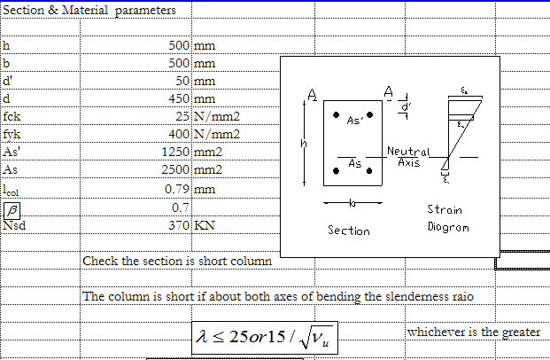

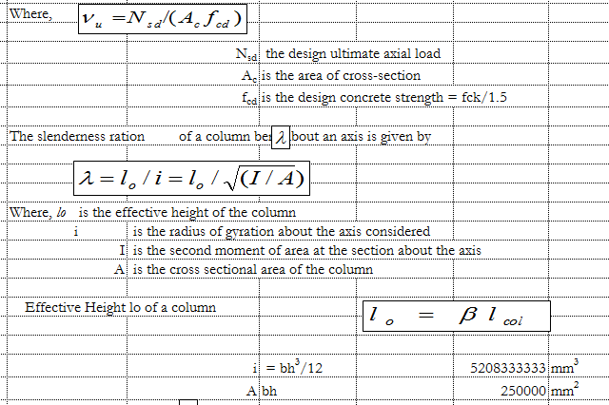
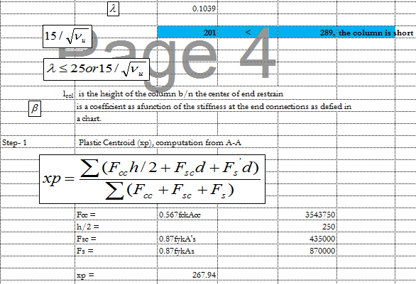
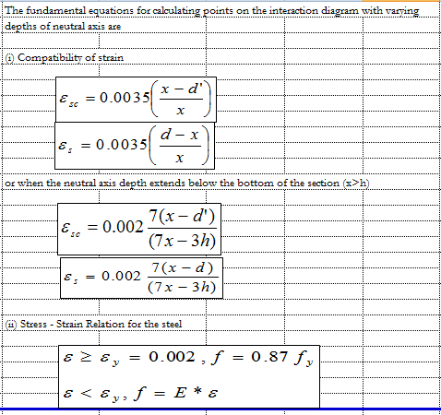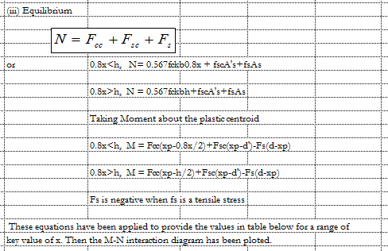

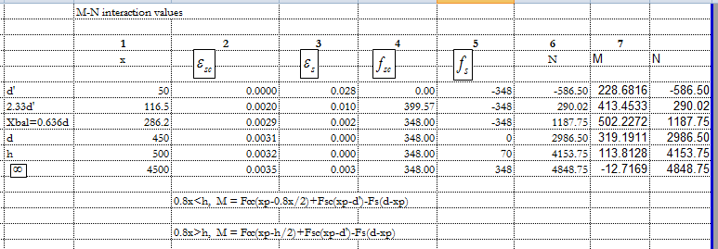
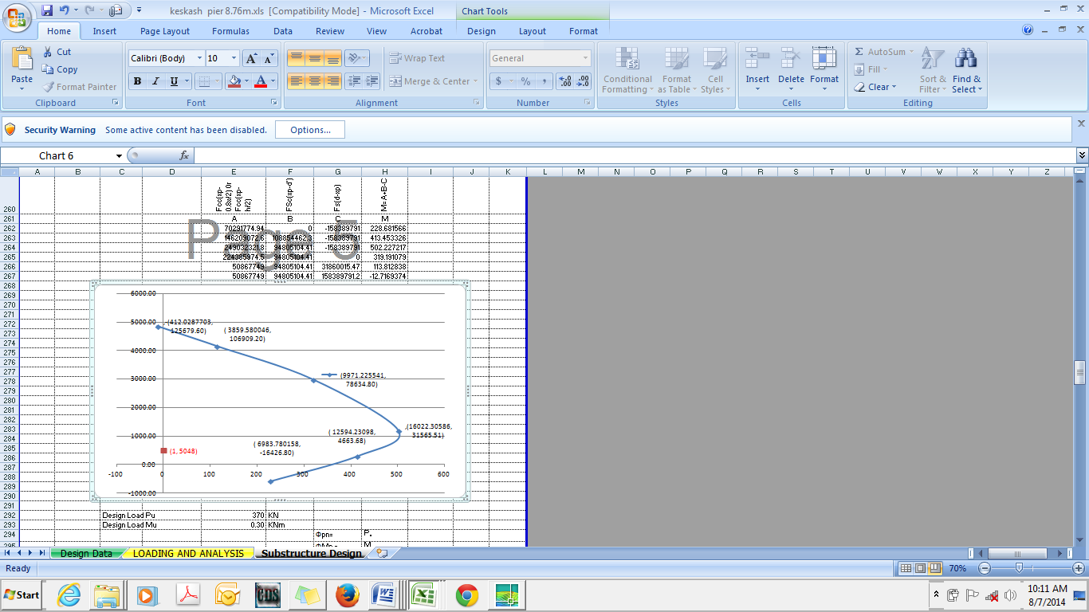

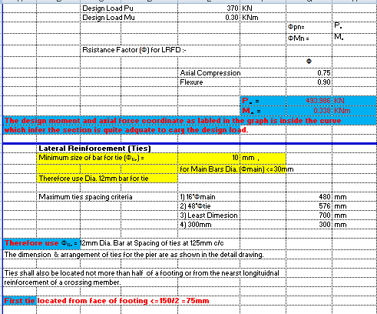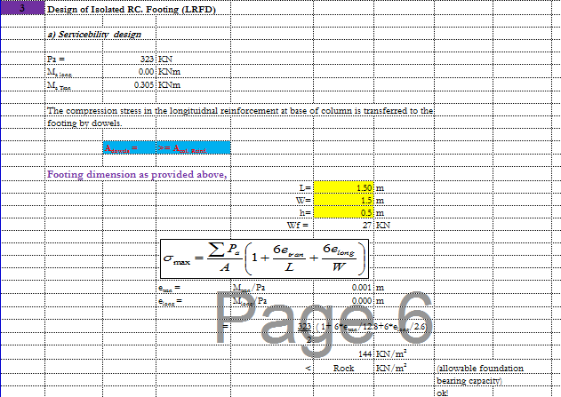

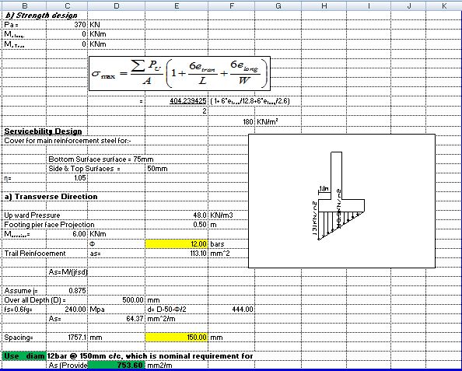
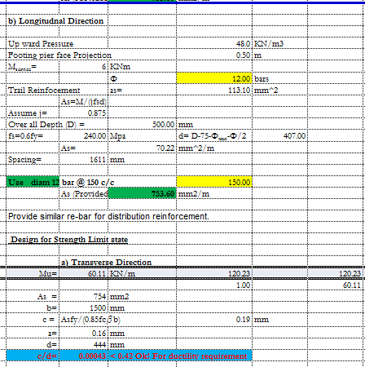
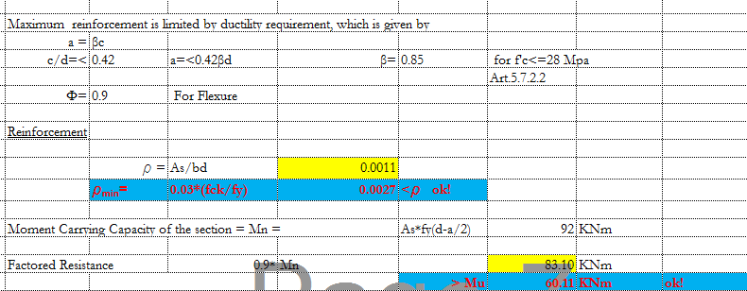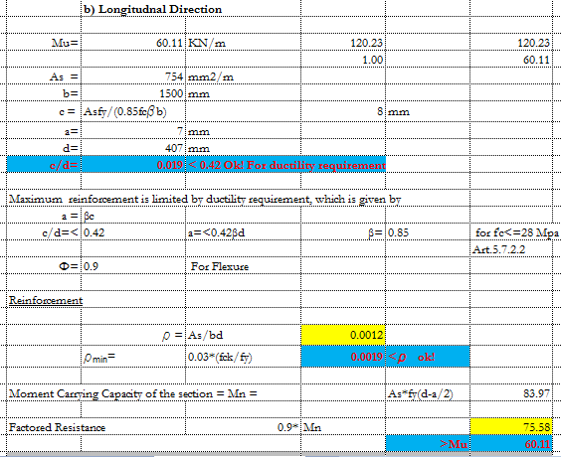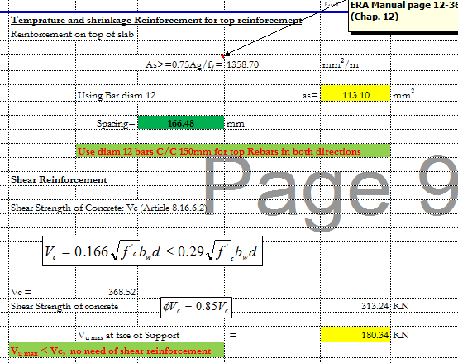

Abutment design
Design of Abutment
1.1. Hydraulics data
River bed level |  |  |  | = | 2438.84 | m
HFL |  |  |  | = | 2439.24 | m
Free board |  |  |  | = | 0.80 | m
Foundation depth, FD |  |  |  | = | 1.50 | m
Depth of saturated bottom soil, H_{satu.}= 2/3*H |  |  |  | = | 1.53 | m
Depth of moistened upper soil, H_{mois.} = H - H_{satu.} |  |  |  | = | 0.77 | m
Width b/n moist and saturated soil, W_{ms.} |  |  |  | = | 0.81 | m
1.2. Material data
Unit weight of masonry (g_{masn.}) |  |  |  | = | 24.00 | KN/m³
Unit weight of bedding concrete (g_{conc.}) |  |  |  | = | 23.00 | KN/m³
Moist unit weight of backfill (g_{mois.}) |  |  |  | = | 18.00 | KN/m³
Saturated unit weight of backfill (g_{sat.}) |  |  |  | = | 20.00 | KN/m³
Submerged unit weight of backfill (g_{sub.}) |  |  |  | = | 10.20 | KN/m³
Unit weight of water (g_{wat.}) |  |  |  | = | 9.80 | KN/m³
Angle of internal friction (∅) |  |  |  | = | 30.00 | Degree
Active internal friction coefficient (Ka) |  |  |  | = | 0.33
The friction angle b/n masonry & concrete |  |  |  | = | 33.00 | Degree
The friction angle b/n concrete & soil |  |  |  | = | 20.00 | Degree
Maximum allowable compressive strength in masonry |  |  |  | = | 1.00 | N/mm²
Maximum allowable tensile strength in masonry |  |  |  | = | 0.10 | N/mm²
Maximum allowable compressive strength in concrete |  |  |  | = | 20.00 | N/mm²
Maximum allowable tensile strength in concrete |  |  |  | = | 3.00 | N/mm²
Maximum soil bearing pressure |  |  |  | = | 150.00 | kN/m²
1.3.Required dimensions of the retaining wall for stability consideration
Masonry
Top width, b |  |  |  | = | 0.50 | m
Bottom width, C |  |  |  | = | 1.50 | m
Top section height, h |  |  |  | = | 0.40 | m
Total height, H=U/S HFL- River bed level + FB + FD-D |  |  |  | = | 4.69 | m
Concrete base
Thickness of concrete base, D=H/8 to H/6 |  |  |  | = | 0.40 | m
Width of left side concrete base, Bl=D/2 to D |  |  |  | = | 0.40 | m
Width of right side concrete base, Br=10 to 15 cm |  |  |  | = | 0.15 | m
Total width of concrete base, B=C+Bl+Br |  |  |  | = | 2.05 | m

2.0. Loading and satiability analysis
PS2

Br
Bl
D
W1
W2
W6
W3
W5
h
H
b
W7
C
B
Ground level
Water table
H_{satu.}
River bed
FD
U/s HFL

PW
PS1
H_{mois.}
W_{ms}
W4
W8
W9

Table 1: Load calculation
D/s supporting abutment Length |  | = |  | 2.00 |  | m
U/s supporting abutment Length |  | = |  | 2.00 |  | m
Total abutment Length= U/S+D/S + Canal External width= |  |  |  | 4.80 |  | m
No. | Code of load | Load Formula |  | Load (KN) |  | Moment arm formula |  |  | Moment arm (m) |  | Moment (KNm)
A | Dead load of flume |  |  | 4.98 |  | b/2 |  |  | 0.25 |  | 1.24
B | Water load of flume |  |  | 2.26 |  | b/2 |  |  | 0.25 |  | 0.57
1.0 | Self weight
1.1 | W1 | g_{masn}.bH |  | 28.14 |  | b/2 |  |  | 0.25 |  | 7.04
1.2 | W2 | 0.5g_{masn.}(C-b)(H-h) |  | 51.48 |  | b+((C-b)/3) |  |  | 0.83 |  | 42.90
2.0 | Soil (vertical)
2.1 | W3 | g_{mois.}h(C-b) |  | 7.20 |  | b+((C-b)/2) |  |  | 1.00 |  | 7.20
2.2 | W4 | 0.5g_{mois.}(C-b-W_{ms})(H_{mois.}-h) |  | 0.64 |  | b+(2/3)(C-b-Wms) |  |  | 0.63 |  | 0.40
2.3 | W5 | 0.5g_{mois.}W_{ms}(H_{mois.}-h) |  | 2.66 |  | (C-W_{ms})+(W_{ms}/2) |  |  | 1.10 |  | 2.92
2.4 | W6 | 0.5g_{satu.}W_{ms}H_{satu.} |  | 12.37 |  | (C-W_{ms})+((2/3)W_{ms}) |  |  | 1.23 |  | 15.23
3.0 | Soil (horizontal)
3.1 | PS1 | 0.5K_{a}g_{mois.}H_{mois.}² |  | 1.76 |  | H_{satu.}+(H_{mois.}/3) |  |  | 1.79 |  | 3.15
3.2 | PS2 | 0.5K_{a}g_{sub.}H_{satu.}² |  | 4.00 |  | H_{satu.}/3 |  |  | 0.51 |  | 2.04
4.0 | Water (horizontal)
4.1 | PW | 0.5g_{wat.}H_{satu.}² |  | 11.52 |  | H_{satu.}/3 |  |  | 0.51 |  | 5.89
5.0 | Uplift (masn/conc)
5.1 | PU1 | 0.15*0.5g_{wat.}H_{satu.}C |  | 1.69 |  | (2/3)C |  |  | 1.00 |  | 1.69
3.0. Stability analysis at the level of masonry/concrete base interface
1. Overturning
Sum of stabilizing moment = |  | (M1+M2+M3+M4+M5+M6) |  |  | = | 77.50 |  |  | KNm
Sum of destabilizing moment = |  | (MS1+MS2+MW+MU1) |  |  | = | 12.78 |  |  | KNm
Factor of Safety = |  |  |  |  | = | 6.07 |  |  | Safe
2. Sliding
Sum of vertical force = |  | (W1+W2+W3+W4+W5+W6-PU1) |  |  | = | 108.04 |  |  | KN
Horizontal sliding force = |  | (PS1+PS2+PW) |  |  | = | 17.28 |  |  | KN
Horizontal resisting force = |  | (R_{v}tan∅) |  |  | = | 70.16 |  |  | KN
Factor of Safety = |  |  |  |  | = | 4.06 |  |  | Safe
3. Tension
Net moment = |  | stab. Momnt+destab. momnt |  |  | = | 64.72 |  |  | KNm
Net vertical force = |  | Downward - upward |  |  | = | 108.04 |  |  | KNm
X = |  | Mr/Rv |  |  | = | 0.60 |  |  | m
e = |  | C/2 -x |  |  | = | 0.15 |  |  | m
C/6 = |  |  |  |  | = | 0.25 |  |  | Safe
4. Direct compressive/tensile stress at the concrete surface
Direct compressive stress (at the heal) base of concrete |  |  |  |  | = | 0.12 |  |  | N/mm²
 |  | which is |  |  | < Pallow=15N/mm^2 for C15 concrete
 |  | which is |  |  | < Pallow=1N/mm^2 for masonry
Direct compressive/tensile stress (at the toe) base of concrete |  |  |  |  | = |  | 0.03 |  |  | N/mm²
 |  |  |  |  | which is |  | +ve, therefore no tension
5. Bending stress at the concrete bottom surface
 | W=g_{mason.}H | = |  |  | 112.56 |  | KN/m
 | M | = |  |  | 59.13 |  | KNm
 | b | = |  |  | 1.00 |  | m
 | D | = |  |  | 0.40 |  | m
 | I=bD³/12 | = |  |  | 0.01 |  | m
 | y=D/2 | = |  |  | 0.20 |  | m
 | Z=I/y | = |  |  | 0.03 |  | m
 | σ = M/Z | = |  |  | 2217.34 |  | KN/m²
 |  | = |  |  | 2.22 |  | N/mm²
 |  | which is |  |  | < Pallow=3N/mm^2 for concrete
4.0. Stability analysis at the level of concrete/soil base interface
No. | Code of load | Load Formula | Load (KN) |  |  | Moment arm formula |  | Moment arm (m) |  |  | Moment (KNm)
A | Dead load of flume |  | 4.98 |  |  | b/2 |  | 0.25 |  |  | 1.24
B | Water load of flume |  | 2.26 |  |  | b/2 |  | 0.25 |  |  | 0.57
1.0 | Self weight
1.1 | W1 | g_{masn}.bH | 28.14 |  |  | Bl+b/2 |  | 0.65 |  |  | 18.29
1.2 | W2 | 0.5g_{masn.}(C-b)(H-h) | 51.48 |  |  | Bl+b+((C-b)/3) |  | 1.23 |  |  | 63.49
1.3 | W7 | g_{conc.}DB | 18.86 |  |  | B/2 |  | 1.03 |  |  | 19.33
2.0 | Soil (vertical)
2.1 | W3 | g_{mois.}h(C-b) | 7.20 |  |  | Bl+b+((C-b)/2) |  | 1.40 |  |  | 10.08
2.2 | W4 | 0.5g_{mois.}(C-b-W_{ms})(H_{mois.}-h) | 0.64 |  |  | Bl+b+(2/3)(C-b-Wms) |  | 1.03 |  |  | 0.66
2.3 | W5 | 0.5g_{mois.}W_{ms}(H_{mois.}-h) | 2.66 |  |  | Bl+(C-W_{ms})+(W_{ms}/2) |  | 1.50 |  |  | 3.99
2.4 | W6 | 0.5g_{satu.}W_{ms}H_{satu.} | 12.37 |  |  | Bl+(C-W_{ms})+((2/3)W_{ms}) |  | 1.63 |  |  | 20.18
2.5 | W8 | 0.5g_{mois.}Br*H_{mois.} | 1.04 |  |  | B-(Br/2) |  | 1.98 |  |  | 2.04
2.6 | W9 | 0.5g_{satu.}Br*H_{satu.} | 2.30 |  |  | B-(Br/2) |  | 1.98 |  |  | 4.54
3.0 | Soil (horizontal)
3.1 | PS1 | 0.5K_{a}g_{mois.}H_{mois.}² | 1.76 |  |  | D+Hsatu.+(Hmois./3) |  | 2.19 |  |  | 3.86
3.2 | PS2 | 0.5K_{a}g_{sub.}H_{satu.}² | 4.00 |  |  | D+(H_{satu.}/3) |  | 0.91 |  |  | 3.64
4.0 | Water (horizontal)
4.1 | PW | 0.5g_{wat.}H_{satu.}² | 11.52 |  |  | D+(H_{satu.}/3) |  | 0.91 |  |  | 10.50
5.0 | Uplift (conc/soil)
5.1 | PU2 | 0.5g_{wat.}(H_{satu.}+D)B | 19.42 |  |  | (2/3)B |  | 1.37 |  |  | 26.54
1. Overturning
Sum of stabilizing moment = |  | (M1+M2+M3+...M9) | = |  |  | 144.41 |  | KNm
Sum of destabilizing moment = |  | (MS1+MS2+MW+MU2) | = |  |  | 44.54 |  | KNm
Factor of Safety = |  |  | = |  |  | 3.24 |  | Safe
2. Sliding
Sum of vertical force = |  | (W1+W2+W3+...+W9-PU2) | = |  |  | 112.51 |  | KN
Horizontal sliding force = |  | (PS1+PS2+PW) | = |  |  | 17.28 |  | KN
Horizontal resisting force = |  | (R_{v}tan∅) | = |  |  | 40.95 |  | KN
Factor of Safety = |  |  | = |  |  | 2.37 |  | Safe
3. Tension
Net moment = |  | stab. Momnt+destab. momnt | = |  |  | 99.88 |  | KNm
Net vertical force = |  | Downward - upward | = |  |  | 112.51 |  | KNm
X = |  | Mr/Rv | = |  |  | 0.89 |  | m
e = |  | B/2 -x | = |  |  | 0.14 |  | m
B/6 = |  |  | = |  |  | 0.34 |  | Safe
4. Direct stress at the soil surface (bearing and tension)
Direct compressive stress (at the heal) base of soil |  |  | = |  |  | 76.94 |  | KN/m²
 |  |  | which is |  |  | < Pallow=150KN/m^2
Direct compressive/tensile stress (at the toe) base of concrete |  |  | = |  |  | 0.03 |  |  |  | N/m²
 |  |  | which is |  |  | +ve, therefore no tension

Chute Design
Taking sample Mc Chute Design
Design of Chute structure (Simplified method)
Chute on |  |  | MC2
From Chainaige |  |  | 0+825.67
To Chainaige |  |  | 0+828.52
canal bed level at A |  |  | EL.A | 2443.32 | m
canal bed level at B |  |  | EL.B | 2438.77 | m
Elevation d/c (Z) |  |  |  | 4.548 | m
Velocity at inlet |  |  |  | 0.66 | m/sec
 |  |  | Bo | 0.50 | m
depth full supply |  |  | D₀ | 0.50 | m
Velocity head, |  |  | h_{vo} | 0.022 | m

1. Critical flow hydraulics
 | Discharge, Q |  |  | Q= |  | 0.162 | m³/se c
 | Width of notch, |  |  | b_{c}= 0.734*Q/d₀ ^{3/2} |  | 0.34 | m
 | Unit discharge, m3/se c/m |  |  | q= Q/b_{c} |  | 0.48 | m³/se c/m
 | Critical depth, m |  |  | dc= (q²/g) ^{1/3} |  | 0.29 | m
 | Critical Velocity, m/sec |  |  | V_{c}=q/d_{c} |  | 1.68 | m/sec
 | Velocity head, m |  |  | h_{w}=V_{c}²/(2g) |  | 0.14 | m
 | Water area, m² |  |  | A_{c}=b_{c}*d_{c} |  | 0.10 | m²
 | Wetted Perimeter, m |  |  | P_{c}=b_{c}+2d_{c} |  | 0.91 | m
 | Hydraulic radius, m |  |  | R_{c}=A_{c}/P_{c} |  | 0.11 | m
 | Water surface slope, |  |  | I_{c}= (nV_{c}/R_{c}^{2/3})² |  | 0.02

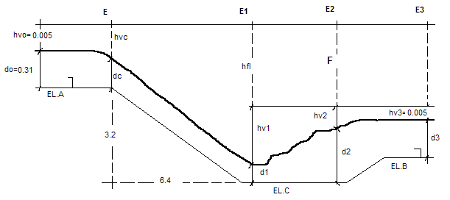
2. Energy at Section (C)
 | F=EL.A-EL.B | 4.548 | m
 | E_{C}=d_{C}+h_{vC}+Z | 4.979 | m

3. Energy at Section (1)

Designation | Results of the calculation
Trial number | 1 | 2 | 3
Assumed depth, d₁ | 0.100 | 0.101 | 0.090
b₁₌b_{c} | 0.336 | 0.336 | 0.336
A₁=b₁*d₁ | 0.034 | 0.03 | 0.030
V₁=Q/A₁ | 4.817 | 4.79 | 5.352
h_{v1}=V₁²/(2g) | 1.183 | 1.17 | 1.460
P₁=b₁+2d₁ | 0.536 | 0.54 | 0.516
R₁=A₁/P₁ | 0.063 | 0.06 | 0.059
I₁=(nV₁/R₁^{2/3})² | 0.302 | 0.30 | 0.407
I_{m}=(I_{c}+I₁)/2 | 0.159 | 0.16 | 0.212
h_{fl}=I_{m}*L | 3.433 | 3.39 | 4.660
E₁=d₁+h_{v1}+h_{fl} | 4.716 | 4.66 | 6.210
E₁=E_{c}=8.54 |  | o.k. | a little small

4. Conjugate depth after jump
 | Froude number, |  | Fr=V₁/(gd₁)^{0.5} |  |  | 4.827
 | Conjugate depth, |  | d₂=d₁/2((1+8F₁²)^{0.5}-1) |  |  | 0.638 | m
5. Stilling basin
 | a. Length, |  | L=4*d₂ |  |  | 2.551 | m
 | b. Width, |  | B = (18.46* Q^{0.5})/(9.91+Q) |  |  | 0.738 | m
 | c. Bottom elevation (EL.C)
 |  |  | V₂=q/d₂ |  |  | 0.755 | m/sec
 |  |  | h_{v2}=V₂²/(2g) |  |  | 0.029 | m
 |  |  | E₂=d₂+h_{v2} |  |  | 0.667 | m
 |  |  | E₃=d₃+h_{v3} |  |  | 0.522 | m
 |  |  | a=E₂-E₃ |  |  | 0.145 | m
 |  |  | EL.C = EL.B - a |  |  | 2438.625 | m

Super passage
Sample Supper passage at MC
HYDRAULIC DESIGN OF CROSS DARINAGE STRUCTURE ( CHINAGE 0+563)
 | Name of Project: |  | Keskashi SSIP
 | HYDRAULIC PARAMETERS OF CANAL
1 | Design Discharge of Canal |  |  |  |  |  | Q_{C} | = | 0.16 | m³/s
2 | Bed Width of Canal |  |  |  |  |  | BW | = | 0.55 | m
3 | Full Supply Depth |  |  |  |  |  | FSD | = | 0.55 | m
4 | Canal Bed level at U/S |  |  |  |  |  | CBL | = | 2444.406 | m
5 | Head loss due to u/s structures |  |  |  |  |  | hf | = | 0.08
6 | CBL including hf |  |  |  |  |  | CBL c | = | 2444.326
7 | Side Slope of Canal |  |  |  |  |  | SS | = | 0.00 | :1
8 | Manning's Coefficient |  |  |  |  |  | n | = | 0.0180
9 | Free Board |  |  |  |  |  | FB | = | 0.30 | m
 | HYDRAULIC PARAMETERS OF DRAIN
1 | Design Flood Discharge of Drain |  |  |  |  |  | Q_{D} | = | 2.24 | m³/s
2 | Original Ground Level |  |  |  |  |  | OGL | = | 2445.43 | m
3 | High Flood Level |  |  |  |  |  | HFL | = | 2445.63 | m
4 | Proposed Bed Level of Drain |  |  |  |  |  | DBL | = | 2445.430 | m
5 | Clear Water way available for Drain |  |  |  |  |  | CWW | = | 23.80 | m
6 | Angle of Skew |  |  |  |  |  | θ_ | = | 0 | Degree
7 | Name of the Drain/Stream/River |  |  |  |  |  |  |  | B_MC_Drain - 02
 | Type of structure proposed |  |  |  | Supper passage
 | HYDRAULIC DESIGN
Step 1 | DESIGN OF DRAINAGE WATER WAY
 | The Drainage Waterway as per Lacey's regime perimeter (P = 4.75√Q) |  |  |  |  |  |  | = | 7.11 | m
 | * If Drain is passing rocky stata Lacey's regime perimeter is not applicable.
 | Natural drainage water way |  |  |  |  |  |  | = | 23.80 | m
 | Number of Bays |  |  |  |  |  |  | = | 10 | Pieces of precast Slab
 | Thikness of peir |  |  |  |  |  |  | = | 8 | m
 | Width of each Bay |  |  |  |  |  |  | = | 1.58 | m
 | Total clear water way |  |  |  |  |  |  | = | 15.80 | m
 | Modified length of water way |  |  |  |  |  |  | = | 23.80 | m
Step 2 | DESIGN OF CANAL WATER WAY
 | Bed width of the canal |  |  |  |  |  |  | = | 0.55 | m
 | Number of Barrel Sections |  |  |  |  |  |  | = | 1
 | Width of Barrel Section |  |  |  |  |  |  | = | 0.55 | m
 | Compartment Wall Thickness |  |  |  |  |  |  | = | 0.40 | m
 | Width at flumed Section |  |  |  |  |  |  | = | 0.95 | m
 | Contraction Splay |  |  |  |  |  |  | = | 2 | :1
 | Expansion Splay |  |  |  |  |  |  | = | 3 | :1
 | Length of Contraction Transition |  |  |  |  |  | Lfc | = | -0.39 | m
 | Length of Expansion Transition |  |  |  |  |  | Lfe | = | -0.59 | m
 | length of flumed rectangular portion of the canal between abutments |  |  |  |  |  |  |  | 23.80 | m
 | In transitions the side slopes of the canal section will be warped in plan from original slop to vertical

SECTION 1-1
Area of the Section (U/S normal canal section) |  |  |  |  |  |  | = | 0.30 | m²
Velocity = Q/A |  |  |  |  |  |  | = | 0.54 | m/s
Velocity head = v²/2g |  |  |  |  |  |  | = | 0.01 | m
R.L of bed at 1-1 |  |  |  |  |  |  | = | 2444.33 | m
R.L of water surface at 1-1 |  |  |  |  |  |  | = | 2444.88 | m
R.L of T.E.L. at 1-1 |  |  |  |  |  |  | = | 2444.89 | m
SECTION 2-2
bed width |  |  |  |  |  |  | = | 0.55 | m
Area of the Section (Rectangular barrel section) |  |  |  |  |  |  | = | 0.30 | m²
Velocity = Q/A |  |  |  |  |  |  | = | 0.54 | m/s
Velocity head = v²/2g |  |  |  |  |  |  | = | 0.01 | m
Head loss at transition (0.3*(V₃²-V₄²)/2g) |  |  |  |  |  |  | = | 0.00 | m
R.L of bed at 2-2 |  |  |  |  |  |  | = | 2444.32 | m
R.L of water surface at2-2 |  |  |  |  |  |  | = | 2444.87 | m
R.L of T.E.L. at 2-2 |  |  |  |  |  |  | = | 2444.89 | m
SECTION 3-3
Area of the Section (Rectangular barrel section) |  |  |  |  |  |  | = | 0.30 | m²
Wetted perimeter |  |  |  |  |  |  | = | 1.65 | m
Hydraulic Radius |  |  |  |  |  |  | = | 0.18 | m
velocity in the trough |  |  |  |  |  |  | = | 0.54 | m/s
 | L |  |  |  |  |  | = | 23.80 | m
 | n |  |  |  |  |  | = | 0.02
 | HL=n2*V2*L/R4/3 |  |  |  |  |  | = | 0.02 | m
R.L. of bed at 3-3 |  |  |  |  |  |  | = | 2444.30 | m
R.L of water surface at 3-3 |  |  |  |  |  |  | = | 2444.85 | m
R.L of TEL at 3-3 |  |  |  |  |  |  | = | 2444.87 | m
Loss of head in expansion transition from 3-3 to 4-4 |  |  |  |  |  |  | = | 0.00 | m
R.L of bed at 4-4 |  |  |  |  |  |  | = | 2444.30 | m
R.L of water surface at 4-4 |  |  |  |  |  |  | = | 2444.85 | m
R.L of TEL at 4-4 |  |  |  |  |  |  | = | 2444.87 | m
DESIGN OF TRANSITIONS FOR DRAIN
Design of contraction and expansion transitions
Since the depth is constant, the transition can be designed on the basis of Mirtas's transition equation
 | Bx=(Bn*Bf*Lf)/(Lf*Bn-x(Bn-Bf))
X | Bx(cntrac.) | Bx(Expan.)
0.00 | 23.80 | 23.80
1.00 | -4.76 | -7.95
2.00 | -2.16 | -3.41
3.00 | -1.40 | -2.17
4.00 | -1.04 | -1.59
4.50 | -0.92 | -1.40 |  |  |  |  |  |  | 0.0173
5.00 |  | -1.25
6.00 |  | -1.04
6.75 |  | -0.92

Step 5 |  |  |  | DRAIN WATER DEPTH DETRMINATION
Type of Material (soil) |  |  |  |  | Amount |  |  | Av. Grain size(d_{mm}) |  |  |  | Lacey's Silt Factor "f"
fine sand |  |  |  |  | 30% |  |  | 0.32 |  |  |  | 0.99
Gravels |  |  |  |  | 35% |  |  | 7.28 |  |  |  | 4.72
Cobbles and boulders |  |  |  |  | 35% |  |  | 38.1 |  |  |  | 10.80
Average |  |  |  |  |  |  |  |  |  |  |  | 5.73
R= |  |  |  |  | 0.21 |  |  | m
Providing 0.84m depth of Bed bar
TOTALY=0.84m
Free board |  |  |  |  |  |  |  |  |  |  |  |  |  |  |  |  |  |  |  |  |  |  |  | = |  |  | 0.3 |  |  | m
The HFL & velocity of the drainage using iteration
Trail No. |  | trial flow depth |  |  | Area |  | Perimeter |  |  |  | R |  | R^(2/3) |  |  |  |  | SLOPE |  |  |  |  | N |  |  | Q m³ |  |  | VELOCITY
1 |  | 0.10 |  |  | 1.58 |  | 16.00 |  |  |  | 0.099 |  | 0.2136 |  |  |  |  | 0.34 |  |  |  |  | 0.04 |  |  | 4.92 |  |  | 3.11
2 |  | 0.06 |  |  | 0.98 |  | 15.92 |  |  |  | 0.062 |  | 0.1562 |  |  |  |  | 0.34 |  |  |  |  | 0.04 |  |  | 2.24 |  |  | 2.28
3 |  | 0.051 |  |  | 0.81 |  | 15.90 |  |  |  | 0.051 |  | 0.1369 |  |  |  |  | 0.34 |  |  |  |  | 0.04 |  |  | 1.61 |  |  | 2.00
4 |  | 0.08 |  |  | 1.26 |  | 15.96 |  |  |  | 0.079 |  | 0.1844 |  |  |  |  | 0.34 |  |  |  |  | 0.04 |  |  | 3.40 |  |  | 2.69
From the trail calculation the drainage discharge can flow in |  |  |  |  |  |  |  |  |  |  |  |  | 0.06 |  |  |  |  | m
Flow depth and1.16 m/s flow velocity through 15m length of barrel.
but flow depth advisable to take = |  |  |  |  |  |  |  |  |  | 0.197 |  |  | m
DESIGEN OF CUTOFFS AND PROTECTION WORKS FOR THE DRAINAGE FLOOR
For purly aluvial streams which are contracted beyond the lacey's perimeter ,
Lacey's scour depth (R') may be computed by using the formula
assume |  |  | f |  |  |  |  |  |  |  |  |  |  |  |  |  |  |  |  |  |  |  |  | = |  |  | 5.73
 |  |  | q |  |  |  |  |  |  |  |  |  |  |  |  |  |  |  |  |  |  |  |  | = |  |  | 0.14 |  |  | m³/m
 |  |  | R'= 1.35*(q^2/f)^1/3 |  |  |  |  |  |  |  |  |  |  |  |  |  |  |  |  |  |  |  |  | = |  |  | 0.21
Provide cutoff depth for scouring is 1.5R' on both sides, d/s & u/s
Depth of cutoff below H.F.L |  |  |  |  |  |  |  |  |  |  |  |  |  |  |  |  |  |  |  |  |  |  |  | = |  |  | 0.31
R.L of bottom cutoff |  |  |  |  |  |  |  |  |  |  |  |  |  |  |  |  |  |  |  |  |  |  |  | = |  |  | 2445.12
 | Structural Design of Super Passage at Chainage 0+563
1.0 | Design Data
 | General
 | Project- |  |  |  |  |  |  |  | Keskash SSI Project
 | Designed By- |  |  |  |  |  |  |  | Muluneh Bimrew
 | Case -Statical calculation
1.1 | Drainage Data
 | Clear Water Way Width of Drainage |  |  |  |  |  |  |  |  |  |  |  |  | 23.80 |  |  | m
 | Draiange Water Depth + FB |  |  |  |  |  |  |  |  |  |  |  |  | 0.50 |  |  | m
 | Drainage Wall thickness |  |  |  |  |  |  |  |  |  |  |  |  | 0.40 |  |  | m
 | Compacted Soil fill depth |  |  |  |  |  |  |  |  |  |  |  |  | 0.00 |  |  | m
 | Stone Pitching Depth |  |  |  |  |  |  |  |  |  |  |  |  | 0.00 |  |  | m
 | Drainage Wall Height |  |  |  |  |  |  |  |  |  |  |  |  | 0.50 |  |  | m
 | Skew Angle(Degree)- |  |  |  |  |  |  |  |  |  |  |  |  | 0
1.2 | Canal Data
 | No. of Bays |  |  |  |  |  |  |  |  |  |  |  |  | 1.00
 | Clear Width of Each Bay |  |  |  |  |  |  |  |  |  |  |  |  | 0.55 |  |  | m
 | Box Section Width (c/c of wall) |  |  |  |  |  |  |  |  |  |  |  |  | 0.95 |  |  | m
 | Elevation d/c b/n CBL and DBL |  |  |  |  |  |  |  |  |  |  |  |  | 1.10 |  |  | m
 | Top Slab Thickness |  |  |  |  |  |  |  |  |  |  |  |  | 0.20 |  |  | m
 | Bottom Slab Thickness |  |  |  |  |  |  |  |  |  |  |  |  | 0.00 |  |  | m
 | FSD + F.B |  |  |  |  |  |  |  |  |  |  |  |  | 0.85 |  |  | m
 | Box Wall thickness |  |  |  |  |  |  |  |  |  |  |  |  | 0.40 |  |  | m
 | Adjusted Clear Box Wall Height |  |  |  |  |  |  |  |  |  |  |  |  | 0.904 |  |  | m
 | Adjusted Box Wall Height(c/c) |  |  |  |  |  |  |  |  |  |  |  |  | 1.00 |  |  | m
 | Material Property
 | Concrete and water
 | Type Of Concrete: |  |  |  |  |  |  |  | C-25
 |  |  |  |  |  |  |  |  | f'c= |  |  |  |  | 25 |  |  | Mpa
 | Φbackfill = |  |  |  |  |  |  |  | 30 |  |  |  |  | ° = |  |  | 0.5236
 |  |  |  |  |  |  |  |  | 0.33
 | Density of Concrete |  |  |  |  |  |  |  | γc= |  |  |  |  | 24.00 |  |  | KN/m³
 | Density of Water |  |  |  |  |  |  |  | γc= |  |  |  |  | 9.81 |  |  | KN/m²
 | Density of Saturated Soil |  |  |  |  |  |  |  |  |  |  |  |  | 19.00 |  |  | KN/m³
 | Density of Stone Pitching |  |  |  |  |  |  |  |  |  |  |  |  | 27.00 |  |  | KN/m³
 |  |  |  |  |  |  |  |  | Ec=0.043*γc*SQRT(fc')
 |  |  |  |  |  |  |  |  | 25278.7341 |  |  |  |  | Mpa
 | Reinforcement:
 | Diam>=20mm |  |  |  |  |  |  |  | fy= |  |  |  |  | 400 |  |  | Mpa
 | Diam<20mm |  |  |  |  |  |  |  | fy= |  |  |  |  | 276 |  |  | Mpa
 | Es= |  |  |  |  |  |  |  | 198000 |  |  |  |  | Mpa
 | Modular Ratio,n=Es/Ec= |  |  |  |  |  |  |  |  |  |  |  |  | 7.91
 | Load and Resistance Factors
 | moment=φ |  |  |  |  |  |  |  |  |  |  |  |  | 0.9
 | shear=φ |  |  |  |  |  |  |  |  |  |  |  |  | 0.85
 | Dead Load limit state factor= |  |  |  |  |  |  |  |  |  |  |  |  | 1.35
 | Live Load Limit state facctor= |  |  |  |  |  |  |  |  |  |  |  |  | 1.50
 | Dead Load Service Limit State factor= |  |  |  |  |  |  |  |  |  |  |  |  | 1.00
 | Live load service limit state factor= |  |  |  |  |  |  |  |  |  |  |  |  | 1.00
 | Fatigue Live Load Factor= |  |  |  |  |  |  |  |  |  |  |  |  | 0.75
 | Dynamic impact allowance
 | Fatigue and Fracture |  |  |  |  |  |  |  |  |  |  |  |  | 15 |  |  | %
 | All other Limit state |  |  |  |  |  |  |  |  |  |  |  |  | 33 |  |  | %
Specification Used -ERA Bridge Design Manual 1982/AASHTO LRFD Bridge Design Spec.1998
Design Method : Load and Resistance Factor Method(LRFD)

Design of road crossing Slab
Design for Strength I Limit state
1. Design data
Table.1 Design data for Slab
 | Concrete - Grade C-20 |  |  | Code | Steel
 | Fck | 16,000 | kpa | [EBCS 2 Table 2.3] | Fyk | 300,000 | kpa
 | Fctk | 1,300 | kpa | [EBCS 2 Table 2.4] | PS | 1.15
 | PS Factor | 1.65 | CW-II | [EBCS 2 Table 3.1] | Fyd | 260,870 | kpa
 | Fcd | 8242.42 | kpa |  | Es | 198,000 | kpa
 | Fctd | 788 | Kpa |  | (min) | 0.002
 | G | 24 | KN/m³
 | Ecm | 27,000 | Kpa | [EBCS 2 Table 2.5] | (max) | 0.0165
2. Determination of Section for Slab
 | Width of support |  |  | 0.40 | m
 | Clear span length |  |  | 1.58 | m
 | Assumed thickness of slab |  |  | 0.20 | m
3. Effective span
 | C/C of Supports (Abutments) |  |  | 2.38 | m
 | Clear Span + Depth of Slab |  |  | 1.78 | m
 | Effective Span (Min. of the two), S |  |  | 1.8 | m
4. Load
 | Slab own weight, DL₁ |  |  | 4.56 | KN/m
 | Wall weight |  |  | 4.265
 | Live load, LL |  |  | 4.59 | KN/m
Design load, W |  | ,=1.3DL+1.6LL |  | 18.79 | KN/m
 | Mu = WS²/8 |  |  | 7.44 | KNm
 | Vu = WS/2 |  |  | 16.73 | KN
5. Main reinforcement
 | Cover |  | 50 | mm
 | Diameter of Reinf. Bar |  | 12 | mm
therefore effective ,d |  |  | 0.144 | m

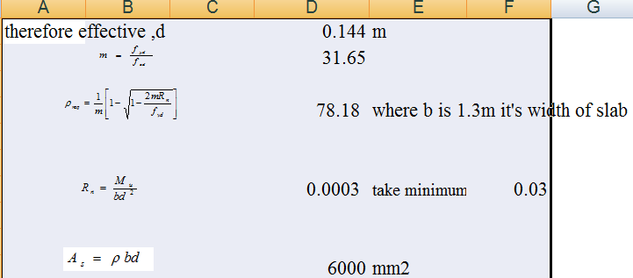

minimum reinforcement bar using dia 12mm
 |  | a_{s} | 113.04 | mm2
No of bars required = |  |  | 53.08
calculated spacing |  | 1000*a_{s}/As | 188.40 | mm using diam=12
provided spacing |  |  | 300 | mm using diam=12
Check capacity
 |  | a=As*fyd/fcd*b |  | 0.0190 | m
 |  |  |  | 210.53 | KNm | > Mu Ok!!
 |  | de | 1440
 |  | 3*de | 4320 | mm which is >4000mm ok!
Provide 12mm dia @275mm c/c in both directions with minimum reinforcement
cover of 50mm

DROP DESIGN
At TC1
Canal name | Chainage (m) | water depth,d1 (m) | Design discharge,Q (m3/sec) | Drop H,(m) | width of drop,bc >=0.3m | unit discharge,q=Q/bc (m3/s/m | Critical depth, dc=(q^2/g)^(1/3) (m | Lip height,a=dc/2,>0.15m | Basin length,L (m) | Basin width,w >=bc | LUm | LD(m) | Lw(m) | t | FB | top width B
TC1 | 0+77.74 | 0.198 | 0.001 | 0.5 | 0.30 | 0.003 | 0.011 | 0.15 | 0.18 | 0.30 | 1.2 | 1.2 | 0.5 | 0.3 | 0.32 | 0.198

Road crossing structure
6 road crossing structures are provided on the Mc, and tertiary canals canal, at the existing foot paths. The road crossing structures are rectangular reinforced concrete slab. The slab is reinforced with 12mm @150mmc/c the length of the slab is to be the same as the respective canal bed width, its width and thickness is 3m and 15mm respectively.

Irrigation Infrastructure Bill of Quantities and Cost Estimate
Sr. No. | Work Description |  | Unit |  | Qty | Unit Cost (ETH. Birr) | Total cost (ETH. Birr)
 | MAIN CANAL LINED
1 | Earth work & compaction
1.1 | 20 cm. Clearing on loose & dry soil. |  | m² |  | 3,835.00 | 14.33 | 54,955.55
1.2 | Excavation in loose soil |  | m³ |  | 3,321.68 | 98.97 | 328,746.67
1.3 | Excavation in soft rock |  | m³ |  | 100.00 | 355.28 | 35,528.00
1.4 | Compacted embank. fill |  | m³ |  | 580.66 | 67.34 | 39,101.64
1.5 | (10cm thick C-20, single reinforcement 8mm bar precast slab with area 1.4mx1.5m) |  | m³ |  | 7.56 | 2,778.97 | 21,009.01
1.6 | Masonry work with 1:3 cement sand ratio |  | m³ |  | 2,060.10 | 1,706.71 | 3,515,993.27
1.7 | Plastering |  | m² |  | 3,205.50 | 133.12 | 426,716.16
1.8 | Pointing |  | m² |  | 489.70 | 66.68 | 32,653.20
1.9 | Hard core |  | m² |  | 2,303.10 | 254.96 | 587,198.38
1.1 | 10cm Lean concrete |  | m² |  | 2,852.30 | 210.33 | 599,924.26
Sub Total-1 |  |  |  |  |  |  | 5,641,826.14
2 | Chute structure
2.1 | 20 cm. Clearing on loose & dry soil. |  |  | m² | 188.50 | 14.33 | 2,701.21
2.2 | Excavation in loose soil |  |  | m³ | 288.45 | 98.97 | 28,547.90
2.3 | Excavation in soft rock |  |  | m³ | 20.00 | 355.28 | 7,105.60
2.4 | Masonry work with 1:3 cement sand ratio |  |  | m³ | 123.50 | 1,706.71 | 210,778.69
2.5 | 25cm Cemented stone pitching/ hard core |  |  | m² | 168.90 | 326.33 | 55,117.14
2.6 | 10cm thick C-7 concrete bedding |  |  | m² | 170.40 | 168.26 | 28,671.50
2.7 | Plastering |  |  | m² | 238.80 | 133.12 | 31,789.06
2.8 | Pointing |  |  | m² | 131.20 | 66.68 | 8,748.42
2.9 | C-20 concrete cut off as per the drawing on each topographic undulation |  |  | m³ | 1.30 | 2,778.97 | 3,612.66
Sub Total-2 |  |  |  |  |  |  | 377,072.16
3 | Division Box
3.1 | Excavation in normal loose soil |  |  | m³ | 5.38 | 98.97 | 532.46
3.1 | Masonry work with 1:3 cement sand ratio |  |  | m³ | 4.68 | 1,706.71 | 7,987.40
3.2 | 25 cm hard core |  |  | m³ | 3.35 | 254.96 | 854.12
3.3 | 10cm thick C-7 concrete bedding |  |  | m² | 3.35 | 267.55 | 896.29
3.4 | Plastering |  |  | m² | 10.66 | 133.12 | 1,419.06
3.5 | Pointing |  |  | m² | 10.66 | 66.68 | 710.81
3.6 | Gate consists of |  |  | Pcs | 6.00 | 2,741.15 | 16,446.90
 | 4mm thick sheet metal (0.4*0.5m )
 | Stiffening angle iron (30x30x4)
 | Angle iron for groove (40x40x4)
 | 16mm reinforcement bar for handling
Sub Total-3 |  |  |  |  |  |  | 28,847.04
4 | Super passage for MC1 and MC2
5.1 | Slab concrete(C-20) |  |  | m³ | 39.36 | 2,778.97 | 109,393.74
5.2 | ф12mm bar |  |  | kg | 2,461.39 | 46.62 | 114,750.00
5.3 | Cut off |  |  | m³ | 10.19 | 2,896.84 | 29,529.09
5.4 | Masonry with 1:3 cement sand ratio |  |  | m³ | 26.28 | 1,706.71 | 44,852.34
5.5 | Plastering |  |  | m² | 43.80 | 133.12 | 5,830.66
5.6 | Back fill |  |  | m³ | 16.00 | 67.34 | 1,077.44
Sub Total-4 |  |  |  |  |  |  | 305,433.26
5 | Flume from 0+849 to 0+989
5.1 | Earth work & compaction |  |  | m³ | 80.40 | 217.00 | 17,446.80
5.2 | Weathered rock excavation |  |  | m³ | 2.75 | 269.37 | 740.77
5.3 | Masonry work with 1:3 cement sand ratio |  |  | m³ | 10.58 | 1,706.71 | 18,056.99
5.4 | Pointing |  |  | m² | 3.08 | 66.68 | 205.37
5.5 | Concert work C-25 |  |  | m³ | 116.21 | 3,057.70 | 355,335.32
5.6 | Bar 20 Diam |  |  | kg | 1,112.49 | 52.92 | 58,872.97
5.7 | Bar 18 Diam |  |  | kg | 4,003.50 | 46.62 | 186,643.17
5.8 | Bar 12 Diam |  |  | kg | 1,320.71 | 46.62 | 61,571.50
5.9 | Bar 10 Diam |  |  | kg | 3,553.66 | 46.62 | 165,671.63
5.10 | Form work for slab and wall |  |  | m² | 461.20 | 507.99 | 234,284.99
5.11 | Form work for footing and column |  |  | m² | 290.40 | 611.61 | 177,611.54
sub total 5 |  |  |  |  |  |  | 1,276,441.05
6 | Foot Path (agreed location with the communities)
6.1 | (10cm tick,C-20, single reinforcement precast slab with area 0.95mx1.5m) |  |  | m³ | 3.56 | 2,778.97 | 9,904.25
6.2 | RC bar, 8mm dia. |  |  | kg | 64.41 | 48.06 | 3,095.54
sub total 6 |  |  |  |  |  |  | 12,999.79
Total |  |  |  |  |  |  | 7,642,619.44
 | SECONDARY CANALS (SC1 )
1 | Earth work & compaction
1.1 | 20 cm. Clearing on loose & dry soil. |  |  | m² | 3,791.99 | 14.33 | 54,339.19
1.2 | Excavation in normal loose soil |  |  | m³ | 2,885.10 | 98.97 | 285,538.35
1.3 | excavation in soft rock |  |  | m³ | 234.00 | 355.28 | 83,135.52
1.4 | Fill and compaction with selected material |  |  | m² | 239.00 | 303.05 | 72,428.95
sub total 1 |  |  |  |  |  |  | 495,442.01
2 | Super passages
2.1 | Slab concrete(C-20) |  |  | m³ | 29.30 | 2,778.97 | 81,423.82
2.2 | ф12mm bar |  |  | kg | 1,819.30 | 46.62 | 84,815.95
2.3 | Cut off |  |  | m³ | 7.60 | 2,896.84 | 22,015.98
2.4 | Masonry with 1:3 cement sand ratio |  |  | m³ | 13.14 | 1,706.71 | 22,426.17
2.5 | Plastering |  |  | m² | 21.90 | 133.12 | 2,915.33
2.6 | Back fill and compaction with selected material |  |  | m³ | 8.00 | 303.05 | 2,424.40
sub total 2 |  |  |  |  |  |  | 216,021.65
3 | Division Box
3.1 | Excavation in normal loose soil |  | m³ |  | 1.46 | 98.97 | 144.50
3.2 | Masonry work with 1:3 cement sand ratio |  | m³ |  | 1.29 | 1,706.71 | 2,201.66
3.3 | 25cm hard core |  | m³ |  | 1.02 | 254.96 | 260.06
3.4 | 10cm thick C-7 concrete bedding |  | m² |  | 0.54 | 267.55 | 144.48
3.5 | Plastering |  | m² |  | 10.66 | 133.12 | 1,419.06
3.6 | Gate consists of |  | Pcs |  | 3.00 | 2,741.15 | 8,223.45
 | 4mm thick sheet metal (0.4*0.5m )
 | Stiffening angle iron (30x30x4)
 | Angle iron for groove (40x40x4)
 | 16mm reinforcement bar for handling
Sub Total 3 |  |  |  |  |  |  | 12,393.20
4 | foot path
4.1 | (10cm tick,C-20, single reinforcement precast slab with area 0.95mx1.5m) |  | m³ |  | 3.56 | 2,778.97 | 9,904.25
4.2 | RC bar ,8mm dia. |  | kg |  | 64.41 | 48.06 | 3,095.54
sub total 4 |  |  |  |  |  |  | 12,999.79
5 | Ford
 | C-20 concrete volume |  | m³ |  | 15.05 | 2,778.97 | 41,823.50
 | Riprap area |  | m² |  | 32.00 | 383.06 | 12,257.92
 | bar 8 |  | kg |  | 154.00 | 48.06 | 7,401.24
 | bar 6 |  | kg |  | 77.00 | 53.39 | 4,111.03
Sub Total-5 |  |  |  |  |  |  | 65,593.69
6 | Turn out for SC1
6.1 | Masonry work |  | m³ |  | 5.85 | 1,706.71 | 9,984.25
6.2 | Cemented stone pitching/ hard core |  | m³ |  | 19.72 | 1,631.64 | 32,175.94
6.3 | 10cm thick C-10 concrete bedding |  | m² |  | 14.39 | 210.33 | 3,026.65
6.4 | Plastering |  | m² |  | 31.59 | 133.12 | 4,205.26
6.5 | Gate supply, cutting ,welding and installation (0.4mx0.4m, 3mm thick sheet metal, 4m long angle iron for groove (30x30x3), 1m long, 12mm reinforcement.bar for handle) |  | Pcs |  | 6.00 | 2,504.41 | 15,026.46
sub Total 6 |  |  |  |  |  |  | 64,418.56
TOTAL |  |  |  |  |  |  | 853,869.11
 | SC2,SC2-1 AND SCS2-2
1 | Earth work & compaction
1.1 | 20 cm. Clearing on loose & dry soil. |  | m² |  | 5,045.26 | 14.33 | 72,298.62
1.2 | Excavation in normal loose soil |  | m³ |  | 4,810.60 | 98.97 | 476,105.08
1.3 | excavation in soft rock |  | m³ |  | 234.00 | 355.28 | 83,135.52
1.4 | Fill and compaction with selected material |  | m² |  | 64.70 | 303.05 | 19,607.34
sub total 1 |  |  |  |  |  |  | 651,146.56
2 | Flume SC2-1 from 1+860.27 to 1+880.1
2.1 | wall and slab concrete(C-25) |  | m³ |  | 61.70 | 3,057.70 | 188,660.09
2.2 | Reinforcement
a | ф12mm bar |  | kg |  | 608.72 | 46.62 | 28,378.53
b | ф20mm bar |  | kg |  | 305.99 | 52.92 | 16,192.99
c | ф20mm bar |  | kg |  | 253.46 | 52.92 | 13,413.10
2.3 | Masonry with 1:3 cement sand ratio |  | m³ |  | 10.58 | 1,706.71 | 18,056.99
2.4 | Plastering |  | m² |  | 6.90 | 133.12 | 918.53
2.5 | Back fill with Selected Material |  | m³ |  | 4.72 | 303.05 | 1,430.40
2.6 | Pointing |  | m² |  | 3.08 | 66.68 | 205.37
2.7 | Form Work
a | form work for slab and wall |  | m² |  | 25.65 | 507.99 | 13,029.94
b | form work for footing and column |  | m² |  | 102.60 | 611.61 | 62,751.19
sub total 2 |  |  |  |  |  |  | 343,037.13
3 | Division Box
3.1 | Excavation in normal loose soil |  | m³ |  | 10.19 | 98.97 | 1,008.50
3.2 | Masonry work with 1:3 cement sand ratio |  | m³ |  | 9.00 | 1,706.71 | 15,360.39
3.3 | 25 cm hard core |  | m³ |  | 2.91 | 254.96 | 741.93
3.4 | 10cm thick C-10 concrete bedding |  | m² |  | 3.81 | 267.55 | 1,019.37
3.5 | Plastering |  | m² |  | 74.62 | 133.12 | 9,933.41
3.6 | Gate consists of |  | Pcs |  | 21.00 | 2,741.15 | 57,564.15
 | 4mm thick sheet metal (0.4*0.5m )
 | Stiffening angle iron (30x30x4)
 | Angle iron for groove (40x40x4)
 | 16mm reinforcement bar for handling
Sub Total 3 |  |  |  |  |  |  | 85,627.76
4 | foot path
4.1 | (10cm tick,C-20, single reinforcement precast slab with area 0.95mx1.5m) | m³ |  |  | 3.56 | 2,778.97 | 9,904.25
4.2 | RC bar ,8mm dia. | kg |  |  | 64.41 | 48.06 | 3,095.54
sub total 4 |  |  |  |  |  |  | 12,999.79
5 | Chute structure at SC2,SC2-1 and SC2-2
5.1 | 20 cm. Clearing on loose & dry soil. | m² |  |  | 1,911.85 | 14.33 | 27,396.82
5.2 | Excavation in loose soil | m³ |  |  | 1,489.03 | 98.97 | 147,369.20
5.3 | Excavation in soft rock | m³ |  |  | 345.00 | 355.28 | 122,571.60
5.4 | Fill and compaction with selected material | m³ |  |  | 5.26 | 303.05 | 1,594.65
5.5 | Masonry work with 1:3 cement sand ratio | m³ |  |  | 993.60 | 1,706.71 | 1,695,787.06
5.6 | 25cm Cemented stone pitching/hard core | m² |  |  | 1,079.40 | 326.33 | 352,240.60
5.7 | 10cm thick C-7concrete bedding | m² |  |  | 1,466.90 | 168.26 | 246,820.59
5.8 | Plastering | m² |  |  | 2,159.50 | 133.12 | 287,472.64
5.9 | Pointing | m² |  |  | 4.80 | 66.68 | 320.06
6 | C-20 concrete cut off as per the drawing on each topographic undulation | m³ |  |  | 8.30 | 2,778.97 | 23,065.45
Sub Total-5 |  |  |  |  |  |  | 2,904,638.68
6 | Ford
 | C-20 concrete volume | m³ |  |  | 15.05 | 2,778.97 | 41,823.50
 | Riprap area | m² |  |  | 32.00 | 383.06 | 12,257.92
 | bar 8 | kg |  |  | 154.00 | 48.06 | 7,401.24
 | bar 6 | kg |  |  | 77.00 | 53.39 | 4,111.03
Sub Total-6 |  |  |  |  |  |  | 65,593.69
Total |  |  |  |  |  |  | 4,063,043.61
 | TERTIARY CANALS(TC1,2,3,4,5,6,7,8,11, TC7-1, TC7-2, TC8-1, TC8-2, TC3-1, TC3-2, TC3-2-1 and TC3-2-2)
1 | Earth work & compaction
1.1 | 20 cm. Clearing on loose & dry soil. | m² |  |  | 9,460.42 | 14.33 | 135,567.79
1.2 | N. excavation soil. | m³ |  |  | 1,935.22 | 98.97 | 191,528.72
1.3 | excavation in soft rock | m³ |  |  | 218.37 | 355.28 | 77,582.49
1.4 | fill and compaction with selected material approved by the engineer | m³ |  |  | 9.00 | 303.05 | 2,727.45
Sub Total-1 |  |  |  |  |  |  | 407,406.46
2 | Chute structures
2.1 | 20 cm. Clearing on loose & dry soil. |  |  | m² | 1,977.11 | 14.33 | 28,331.97
2.2 | Excavation in loose soil |  |  | m³ | 677.33 | 98.97 | 67,034.86
2.3 | Excavation in soft rock |  |  | m³ | 345.00 | 355.28 | 122,571.60
2.4 | Fill and compaction with selected material |  |  | m³ | 59.01 | 303.05 | 17,882.37
2.5 | Masonry work with 1:3 cement sand ratio |  |  | m³ | 412.10 | 1,706.71 | 703,335.19
2.6 | 25cm Cemented stone pitching/hard core |  |  | m² | 842.90 | 326.33 | 275,063.56
2.7 | 10cm thick C-7concrete bedding |  |  | m² | 1,308.00 | 168.26 | 220,084.08
2.8 | Plastering |  |  | m² | 1,209.00 | 133.12 | 160,942.08
2.9 | Pointing |  |  | m² | 6.10 | 66.68 | 406.75
2,10 | C-20 concrete cut off as per the drawing on each topographic undulation |  |  | m³ | 5.30 | 2,778.97 | 14,728.54
Sub Total-2 |  |  |  |  |  |  | 1,610,381.00
3 | Division Box
3.1 | Excavation in normal loose soil |  |  | m³ | 15.85 | 98.97 | 1,568.67
3.2 | Masonry work with 1:3 cement sand ratio |  |  | m³ | 13.84 | 1,706.71 | 23,620.87
3.3 | 25 cm hard core |  |  | m³ | 14.25 | 254.96 | 3,633.18
3.4 | 10cm thick C-7 concrete bedding |  |  | m² | 7.55 | 267.55 | 2,020.00
3.5 | Plastering |  |  | m² | 35.74 | 133.12 | 4,757.71
3.6 | Gate consists of |  |  | No | 31.00 | 2,741.15 | 84,975.65
 | 4mm thick sheet metal (0.4*0.5m )
 | Stiffening angle iron (30x30x4)
 | Angle iron for groove (40x40x4)
 | 16mm reinforcement bar for handling
Sub Total 3 |  |  |  |  |  |  | 120,576.08
4 | Foot Path
4.1 | (10cm tick,C-20, single reinforcement precast slab with area 0.95mx1.5m) |  |  | m³ | 11.88 | 2,778.97 | 33,014.16
4.2 | RC bar ,8mm dia. |  |  | kg | 64.41 | 48.06 | 3,095.54
sub total 4 |  |  |  |  |  |  | 36,109.71
5 | Turn out for TCs
5.1 | Masonry work |  |  | m³ | 117.00 | 1,706.71 | 199,685.07
5.2 | Cemented stone pitching/hard core |  |  | m³ | 394.38 | 1,631.64 | 643,486.18
5.3 | 10cm thick C-10 concrete bedding |  |  | m² | 287.76 | 210.33 | 60,524.56
5.4 | Plastering |  |  | m² | 631.80 | 133.12 | 84,105.22
5.5 | Gate supply, cutting ,welding and installation(0.4mx0.4m, 3mm thick sheet metal, 4m long angle iron for groove (30x30x3), 1m long, 12mm reinforcement.bar for handle) |  |  | Pcs | 60.00 | 2,504.41 | 150,264.60
sub total 5 |  |  |  |  |  |  | 1,138,065.63
Total |  |  |  |  |  |  | 3,312,538.88
 | Tertiary CANALS (TC3-0,TC9, and TC10)
1 | Earth work & compaction
1.1 | 20 cm. Clearing on loose & dry soil. |  |  | m² | 3,644.65 | 14.33 | 52,227.76
1.2 | N. excavation soil. |  |  | m³ | 2,580.18 | 98.97 | 255,360.41
1.3 | excavation in soft rock |  |  | m³ | 218.37 | 355.28 | 77,582.49
1.4 | fill and compaction with selected material approved by the engineer |  |  | m³ | 150.70 | 303.05 | 45,669.64
Sub Total-1 |  |  |  |  |  |  | 430,840.31
2 | Chute structures
2.1 | 20 cm. Clearing on loose & dry soil. |  |  | m² | 506.13 | 14.33 | 7,252.77
2.2 | Excavation in loose soil |  |  | m³ | 343.77 | 98.97 | 34,022.42
2.3 | Excavation in soft rock |  |  | m³ | 345.00 | 355.28 | 122,571.60
2.4 | Fill and compaction with selected material |  |  | m³ | 59.01 | 303.05 | 17,882.37
2.5 | Masonry work with 1:3 cement sand ratio |  |  | m³ | 251.30 | 1,706.71 | 428,896.22
2.6 | 25cm Cemented stone pitching/hard core |  |  | m² | 248.20 | 326.33 | 80,995.11
2.7 | 10cm thick C-7concrete bedding |  |  | m² | 389.10 | 168.26 | 65,469.97
2.8 | Plastering |  |  | m² | 325.10 | 133.12 | 43,277.31
2.9 | Pointing |  |  | m² | 6.10 | 66.68 | 406.75
2.10 | C-20 concrete cut off as per the drawing on each topographic undulation |  |  | m³ | 1.80 | 2,778.97 | 5,002.15
Sub Total-2 |  |  |  |  |  |  | 805,776.67
3 | Division Box
3.1 | Excavation in normal loose soil |  |  | m³ | 3.80 | 98.97 | 376.09
3.2 | Masonry work with 1:3 cement sand ratio |  |  | m³ | 3.36 | 1,706.71 | 5,734.55
3.3 | 25 cm hard core |  |  | m³ | 2.54 | 254.96 | 647.60
3.4 | 10cm thick C-7 concrete bedding |  |  | m² | 15.10 | 267.55 | 4,040.01
3.5 | Plastering |  |  | m² | 9.48 | 133.12 | 1,261.98
3.6 | Gate consists of |  |  | No | 9.00 | 2,741.15 | 24,670.35
 | 4mm thick sheet metal (0.4*0.5m )
 | Stiffening angle iron (30x30x4)
 | Angle iron for groove (40x40x4)
 | 16mm reinforcement bar for handling
Sub Total 3 |  |  |  |  |  |  | 36,730.56
4 | Foot Path
4.1 | (10cm tick,C-20, single reinforcement precast slab with area 0.95mx1.5m) |  |  | m³ | 5.94 | 2,778.97 | 16,507.08
4.2 | RC bar ,8mm dia. |  |  | kg | 322.05 | 48.06 | 15,477.72
sub total 4 |  |  |  |  |  |  | 31,984.80
5 | Turn out for TCs
5.1 | Masonry work |  |  | m³ | 76.05 | 1,706.71 | 129,795.30
5.2 | Cemented stone pitching/hard core |  |  | m³ | 256.35 | 1,631.64 | 418,270.91
5.3 | 10cm thick C-10 concrete bedding |  |  | m² | 187.04 | 210.33 | 39,340.12
5.4 | Plastering |  |  | m² | 410.67 | 133.12 | 54,668.39
5.5 | Gate supply, cutting ,welding and installation(0.4mx0.4m, 3mm thick sheet metal, 4m long angle iron for groove (30x30x3), 1m long, 12mm reinforcement.bar for handle) |  |  | Pcs | 39.00 | 2,504.41 | 97,671.99
sub total 5 |  |  |  |  |  |  | 739,746.71
Total |  |  |  |  |  |  | 2,045,079.06
TOTAL FOR INFRASTRUCTURE |  |  |  |  |  |  | 17,917,150.09

CONCLUSION AND RECOMMENDATION
- The infrastructure of this project area is designed to irrigate about 198 ha of land by taking its supply from the keskashi intake irrigation project. The maximum duty of the command area for 18 hours per day irrigation with overall project efficiency of 45%. The method of irrigation of the project area is furrow surface irrigation in which the main and tertiary canals are working continuously where as the field canals within a tertiary block are working rotational system.
- As the dominant soil type is clay soil, the main canal system is designed to be masonry.
- The reason why the main canal is to be lined up to the end is to avoid the siltation problem, time saving to reach at the tail part, reduce maintenance cost and reducing seepgae.
- On the Tertiary (TC2) unit of the irrigation systems, some are associated with chute. They are designed as far as possible to be cut. The layout is designed as far as possible to avoid cross-structures and high steeply slope area within them.
- The design of the canal dimensions of the irrigation canal is done by applying the manning’s uniform flow equation. The variable of the hydraulic parameters are calculated using iteration or flow master program.
- The design discharge of the drainage canals are determined using rational formula and log person III method.
- As soils of the command area are predominantly clay textured; and hence water and soil management measures should be undertaken; and optimum moisture content should be maintained to improve workability of the soil during land preparation and planting time.

The following recommendations are drown:
- For better performance and long service year of the project regular inspection and maintenance is highly required.
- Farmers training, how to operate and maintain the project structures as a whole and available and water resources has a paramount important.
- The irrigation hours per day and per week should be flexible based on base flow amount of each week or month.
- Close supervision of the construction should be made to modify (if need be) each Components of irrigation system based on specific site conditions.

OPERATION AND MAINTENANCE

General
The main objective of the operation and maintenance aspect of an irrigation scheme is to facilitate the timely delivery of the required irrigation water to farms and to keep the irrigation system in an optimum operating condition. This section therefore, discusses the main functions of the subject matter under consideration for the scheme.

Operation of the Head Works
Operation at the diversion weir mainly focuses on the diversion of a controlled flow of river water, timely cleaning of floating debris in front of intake and removal of sediment deposits in front of the weir and intake structures.

Irrigation System Operation
The operation of the irrigation system depends mainly on the method of water delivery at farm level. Surface irrigation method is the recommended type of water distribution and application method for Aderkayna diversion irrigation scheme.
The farmers would organize themselves and form groups in order to handle the water management. Since flow is low Rotational water distribution would be applied within the group. The rotational distribution is then to distribute water by turn to the whole scheme according to the timely need of crop water requirement. For better and efficient water management, crop diversification should be avoided within a group. This would reduce the complexity of water distribution system of the scheme during one irrigation season. At farmers’ level of operation, a constant flow and variable irrigation time is advisable.
The operation of the irrigation system is continuous for 14 hours per day in main, secondary and tertiary canals where as field canals within a tertiary block are operating in rotational system with each other for irrigation hours proportional to their size. Since the tertiary canal discharges are within the manageable range and the irrigation canal structures are accordingly designed for simple operation, the farmers can open and close easily whenever they required.

Maintenance Requirement
The canal system of the project is earthen canal except main canal and secondary canal, which is susceptible to siltation, erosion, growth of weeds and or breaching problems. Though the canal sections are designed for non- silting and non scouring conditions, the above mentioned problems are unavoidable and hence periodical and yearly inspection and maintenance of canals and structures are obligatory in order to fulfill the design objective of the project area.
The maintenance tasks are categorized into two types: - routine activities, and repairs. The routine maintenance activities that are carried out periodically include:-
- Regular cleaning of sediments and weeds from canals and drains;
- Inspection and lubrication of gates; and
- Maintenance of cracked lined canals, regulating and control structures.
Repair works include task carried out more frequently and quickly, and include those tasks that are generally unpredictable. They also include emergency works. The activities included in this category are:-
- Repairing overtopped or breached canals, drains, and flood protection dykes;
- Repairing jammed gates;
- Filling holes made by wild animals; and
- Reduced free board due to walking over by people and livestock.
Regular inspection of the irrigation facilities should be carried out as part of the maintenance activities. These tasks could be carried out immediately after the end of the main rains in September and during the rainy season. This could concentrate on the interceptor drains and the flood protection dykes, the main canal and the field drains. The inspection of the other works like the tertiary canals, field drains, and the water control and regulating structures could be carried out as part of routine operation activities.
- Beneficiaries of the project need to have operation and maintenance budget, For O&M cost incurring entity area:
- Purchase sing of gate lubricate (grease)
- Replacing and maintenance of Stolen and damaged gates
- Repair Damages on the cross drainage structures.
The expense for O&M should be collected from the beneficiaries. Of course, much of the task is done by the labor and skill of the community. For cost incurring activities beneficiaries have to collect money based on the proportion of the command area they owned.

REFERENCE
- FAO (1977) guidelines for predicting crop water requirements. No 24, Rome Italy
- Design of small Canal structures , USBR
- Soft copies of hydraulic structure publishing
- IDD manual
- ESRDF manual

