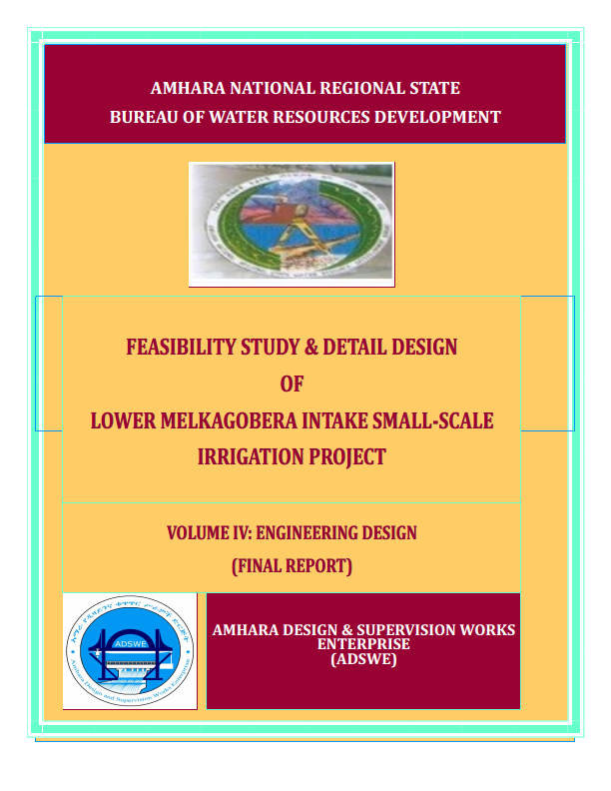
Amhara National Regional State
Water Resources Development Bureau (BOWRD)

Feasibility Study and Detail Design of
Lower Melka Gobera Intake Small-Scale Irrigation Project

Volume IV: Engineering Design Final Report

December, 2014(Revised 2016)
Bahir Dar
Client: Water Resource Development Bureau
(BoWRD)
Address:
P.O. Box: 88
Telephone: 0528-200853/855
Fax: 251-08-20-65-68/204676/202040
Consultant: Amhara Design & Supervision Works Enterprise
(ADSWE)
Address:
P.O. Box: 1921
Telephone: +251-582-181023/ 180638/181201/181254
Fax: (058) 2180550/ (058) 21805102
E-mail: amhara design@yahoo.com
Bahir Dar, Ethiopia

FEASIBILITY STUDY & DETAIL DESIGN REPORT STRUCTURE
- Volume I: Watershed Management
- Volume II: Engineering Geology
- Volume III: Irrigation Agronomy
- Volume IV: Engineering Design
- Volume V: Socio Economy
- Volume VI: Environmental Impact Assessment

Table of Contents Page
Contents
SAILENT FEATURE vii
1 INTRODUCTION 9
1.1 Background 9
1.2 Description of the Project Area 10
1.2.1 Location 10
1.2.2 Accessibility 10
1.3 Objectives of the study 10
1.3.1 Specific Objectives 10
1.4 Scope of the study 12
1.5 Methodology 12
SECTION-I: HYDROLOGY 14
2 Watershed characteristics 15
3 Hydro-metrological data availability 17
3.1 3.1 Hydro-meteorological data availability 17
3.1.1 Hydrometric data 17
3.1.2 Climate 17
3.1.3 Daily Heaviest Rainfall Data 18
4 Daily Heaviest Rainfall data availability and checking 18
4.1 Data Consistency Test 20
4.1.1 Checking Data Reliability 21
4.1.2 Data Outlier Test 21
5 Design Storm Computation 23
5.1 D-Index test 23
6 Design Flood Determination 25
6.1 Peak flood analysis by SCS method 25
6.1.1 Time of concentration (Tc) 25
6.1.2 Curve number (CN) 26
6.1.3 Areal Rainfall 27
6.1.4 Rainfall Profile 27
6.2 Flood mark Method 31
6.2.1 Tail Water Depth Computation 31
6.2.2 Average river bed slope 32
6.2.3 Manning’s Roughness coefficient for the river bed and banks (average) 32
6.2.4 Discharge of the river 32
6.3 Selected Design flood 34
7 Basin Base flow, Demand and Water balance 34
7.1 Basin Base flows 34
7.2 Existing water use and Irrigation Practices 36
7.3 Upstream & Downstream utilization 36
7.1 Conclusion 36
SECTION-II: HEADWORK DESIGN 38
8 Headwork site selection 39
9 River Geomorphology 40
9.1 Left Bank conditions 40
9.2 Stream Bed 42
9.3 Natural Construction Materials 42
9.4 Fine Aggregates 43
9.5 Canal Fill Material 43
9.6 Water 43
10 Headwork type selection 43
10.1 Hydraulic design of headwork structure 43
10.1.1 Design Base flow of the River 44
10.2 Design of intake 44
10.3 Hydraulic Gate Design 45
10.4 Trash Rack 46
10.5 Design of Retaining Wall 46
10.6 Upstream and downstream Retaining walls Design 46
11 Bill of Quantity and cost estimation 47
12 Conclusion and recommendation 50
SECTION-III: IRRIGATION AND DRAINAGE SYSTEMS INFRASTRUCTURE 51
13 Irrigation Infrastructure 52
13.1 Irrigable command area 52
13.1.1 Topography and soil 52
13.1.2 Irrigation/Farm Blocks 52
13.1.3 Irrigation Efficiency and irrigation duty 52
13.1.4 Irrigation Interval 54
13.2 Irrigation & Drainage system lay out 54
13.2.1 Canal layout 54
13.2.2 Drainage system 55
13.3 Selection of Canal Design Section 55
13.3.1 Main Canal 55
13.3.2 Tertiary canal 56
13.4 Design of Irrigation canals 58
13.4.1 Main canal 58
13.4.2 Tertiary Canal 59
13.4.3 Field Canals 102
13.5 Design of Drainage System 102
14 Irrigation Structures 61
14.1 Design of Division boxes and turnouts 61
14.2 Design of field canal turnouts 62
14.3 Design of Drops 63
14.4 Cross drainage 65
14.5 Design of Road Crossing Structures 66
14.6 Design of catch drain 67
14.7 Access Road 70
15 Bill of Quantity and cost estimation 70
16 CONCLUSION AND RECOMMENDATION 73
SECTION IV: OPERATION AND MAINTENANCE 74
17 OPERATION AND MAINTENANCE 74
17.1 General 74
17.2 Irrigation system operation 74
17.3 Maintenance 75
18 Recommendations 77
REFERENCE 77

LIST OF TABLES

Table 2-3: Parts of catchment area 15
Table 1: Data availability and adequacyKombolcha station 17
. Table 2: storm Analysis for Kombolcha Rainfall Station 18
Table 3: Test for goodness to fit using D-index 23
Table 4: Determination of Time of Concentration 25
Table 5: Design Rainfall Arrangement 27
Table 6: Direct Runoff analysis 28
Table 7: Hydrograph coordinates 30
Table 8: River discharge computation at different stages of flow, (down stream) 32
Table 11: upstream and Downstream Retaining wall stability analysis 47
Table 13: Bill No. 1- General Items 47
Table 14: Bill No. 2- Head Work Structure 48
Table 16: Canal features 58
Table 17: hydraulic characteristics of the main canal 59
Table 18 Hydraulic characteristics of the tertiary canal 102
Table 19 :Locations of field canal diversion/turnouts 61
Table 20 Hydraulic characteristics of the Division boxes 62
Table 21: Fixing the field canal capacity 63
Table 22 Hydraulic characteristics of drops 64
Table 23: Catch drain hydraulics 68
Table 24: Cost summary 69
Table 25: Bill No. 3- Engineering cost estimation for Infrastructure 70

LIST OF FIGURES
Figure 1: Location map of the project area 10
Figure 2: Drainage map of Dambushta watershed 16
Figure 6: Complex Hydrograph 31
Figure 7: the river cross-section for Gobera intake axis 31
Figure 8 STAGE DISCHARGE CURVE 33
Figure 9: Base flow of the river near traditional diversion ( Left) 35
Figure 10: photo showing proposed intake axis 39
Figure 11: Photo showing left bank 41
Figure 12: Right Bank 41
Figure 13: Geological x section along Gobera intake axis 42
Figure 23: lined canal section view 56
Figure 24 : tertiary canal section 57
Figure 28 : typical gully crossing plan 66
Figure 29: typical road crossing section 67
Figure 30: Typical catch drain 68

SAILENT FEATURE
- Project name: Gobera2 intake Irrigation Project
- Name of the stream: Gobera river
- Location of the locationof the intake site using
- North: 1205967.6 (UTM)
- East: 267575.57 (UTM)
- Zone: (S/wollo)
- Wereda: Argoba
- Kebeele: Argoba
- Accessibility from woreda town 6.5km
- Average Altitude: 1193.53 a.m.s.l
- Hydrology
- Design rainfall: 91.56
- Catchment area: 81.27km²
- Longest flow path length: 21.73Km
- Design flood: 673.66m³/sec
- Design base flow: 185.3 lit/s

- Head work
- type, intake
- Height: 0m
- Gross crest length: 50m
- intake crest level: 1180.27m.a.s.l
- U/S HFL: 1183.27m.a.s.l
- D/s HFL: 1183.27m.a.s.l
- Afflux: 0m

- Outlet
- Bed Sill level: 1179.77m.a.s.l
- Opening dimension:
    - Left canal outlet: 0.50m x 0.50m
- Discharge capacity:
      - Left : 146.26 l/sec.
Irrigation and drainage systems Infrastructure
- Command area size: 102ha
- Design discharge of the main canal:
146.26 l/s
- Canals
  - No of main canal: 1
  - No of Tertiary canal: 6
  - No of field canal : 20

Project cost (with VAT)

INTRODUCTION

Background
Development of Irrigation contributes a valuable share in the production of agricultural products which enhances the removal of food security problem & leads the economic growth of a country where there are sufficient water resources for this purpose.
Different study document shows, in our country, there are sufficient resources of water that can be utilized for various purposes. But only few percent of existing water resources is under utilization. On other side there are a number of chronically food insecure families. This may be due to lack of good attitude, skill & budget. Nowadays, the degrees of these problems are slightly in the stage of minimizing as per activities of past indicate because of attention given to irrigation practices by Ethiopian government & other concerned bodies.
Similarly, Gobera2 irrigation project study has been executed to increase the agricultural product, its operation managed by farmers of the project area. This document contains study & design of sheriff project. It is a small scale irrigation project. The project is located Amhara regional state in South Wollo zone, in argoba special woreda. The project covers only argoba kebele.
At the project area, agriculture is the main pillar of the economy, which depends on the annual crops. For the production of annual crops there is insufficient & non- uniform rainfall distribution for the production of annual crops at this project area. Therefore, the study found out that the existence of the promise of gathering additional agricultural product by irrigation. Again, supplementing yearly crops by irrigation can be undertaken. Hence, it is possible gather product twice & more per year. As per this study, executing the irrigation practices during dry & wet seasons, the livelihood of population of the project can be improved due to the registered economic growth as a result of agriculture product increment. On average Sheriff Irrigation project can give benefits on 102ha of command area.
This design document comprises of three sections. Section one contains Hydrology study Section two deals with head work structure design& section three infrastructures.

Description of the Project Area

Location
Gobera 2 Small-Scale Irrigation Project is found in Amhara National Regional state (ANRS), South Wollo Administrative Zone of Argoba Special Woreda about 37km far, to the East, from main Asphalt road (Dessie to Addis Ababa) passing via Harbu Town. It is also 57km far, to the south-east, from Kombolcha town. The proposed irrigation project is to be undertaken onGobera River and the headwork structures are specifically located at an altitude of about 1193.53 amsl and geographical coordinates of 12011026N(UTM )& 610895E (UTM).
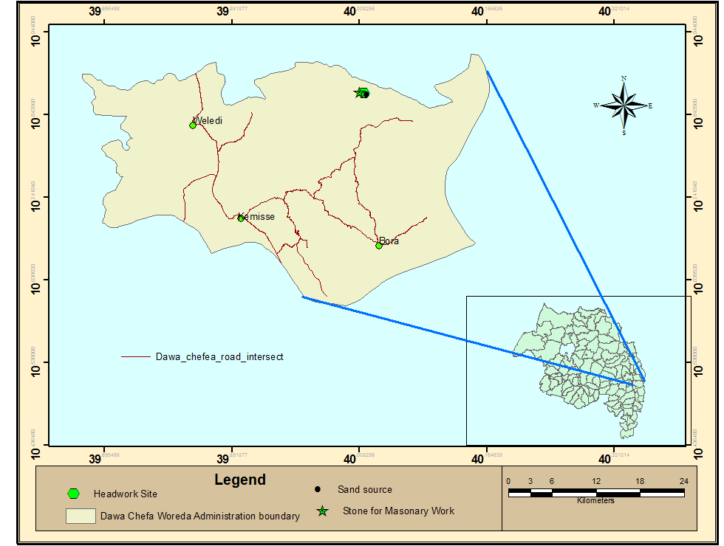
Figure 1: Location map of the project area

Accessibility
It can be accessed by Bahir Dar- Dessie- Haribu, 517km asphalted road, and 37km gravel road which links Haribu to Medina (the center of Arigoba Woreda). The project area is located 6.5km away from Medina town which can be accessed through gravel road. Walking along the river for about 800m is required to reach to the specific site.

Objectives of the study
The Enterprise is required to make a complete feasibility and or detail design study by conducting a complete assessment and investigation of all available water and land resources all along the gobera River. The service is also mainly focused in searching and selecting the best intervention /intake in this case/ technology and tries to locate it together with local users. All the process of the service is purely bounded by the terms of reference and other guidelines and formats as per the client’s interest.

Specific Objectives
a/ The objective of completing the hydrology component study is primarily to produce a comprehensive assessment and study about the agro meteorology, water demand and supply, the hydrology of the overall given watershed area in terms of spatial (U/s and D/s) aspect and temporal (wet and dry/critical) aspects so that the intervention is at least with minimum risk and does make environmental imbalance in the project at hand and in the u/s and d/s aspect.
- To identify, estimate and allocate, according to the water balance study, proportional irrigation water resource for the given diversion as well as for other competitive uses around the project area
- To appropriately estimate the design flood across the given cross section of the diversion and/or the surrounding area by using various acceptable hydrological methods and models, so that after construction of the structure any unmanaged/overtopping, over flooding, back flooding and scouring ,etc/ will be minimized and the structure will be safe throughout the intended life time.
- To estimate reasonably design storm and design flood using required return period to properly size the recommended hydraulic structures for the purpose.
- To properly investigate and recommend the current and the future uses of the water source and make a good water balance study that can enhance the equity of the resource; mitigate any anticipated risks that can probably happen due to the project.
B/ to produce a comprehensive study about the project area and find appropriate intervention for the purpose called diversion weir. Properly selected headwork and its appurtenant structures associated with its designs and drawings are expected to be delivered at the end. Proper lay out of the design on to the topographic map with the given scale is also the main objective.
c/ to produce a comprehensive study about the irrigation system layout, supply and drainage canal design and other infrastructure designs such as access road, cross drainage, cross road and other system facilities in sheriff irrigation project.
- To identify, and locate, the diversion intake which can command the proposed command area (102ha).
- Structural dimensioning and setting out of the specifications
- To appropriately estimate the engineering design bills and cost estimates for headwork structures.
- To properly design the engineering drawing based on the Terms of Reference.
- To identify the irrigable land topography and arrange the irrigation layout system and other mechanisms.
- To select practicable irrigation method for the project and use this selection for the overall design purpose,
- To assess and design the canal lining requirements and select appropriate canal section that fits the site conditions.
- To design all accessory irrigation infrastructures and justify all necessary reasons based on the site conditions.
- To make ground truthing and complete detail design thereby producing the working drawing.

Scope of the study
The study uses meteorological stations from kombolcha and kemise National Meteorological station due to various hydrological reasons, therefore meteorologically the study covers wider areas but hydro-logically the study is limited to data that are entirely in the gobera and adjacent watersheds which have basically an influence to the watershed of gobera. The study has intensively used topographic maps generated using AutoCAD civil 3D software at a larger scale of mapping (1 m contour intervals. The drawing outputs or deliverables will be as stated in the terms of reference. Headwork site plan and irrigation system sit plan shall be prepared at scales of 1:500 to 1: 1020 respectively. All other topographic data are obtained through visual observation and field investigation.

Methodology
The study has primarily focused to preparation & collection of the secondary data required to undertake the given assignment at required standards. Interdisciplinary team of experts has assessed and collected necessary data both at office and field survey/investigation.
After the team has moved to the field, detail field observation and investigation has been conducted to carefully select and decide which site will be hydraulically best and then various topographic; geotechnical, social and environment data had been collected.
The design of Sheriff Irrigation project follows the principles of participatory design criteria for which the site is selected because people are exercising irrigation over the proposed site. All other design criteria are that of clients TOR guidelines.
The following methods /procedures, but not the only one, have been used in the accomplishment of this service:
- Site identification:
- 50,000 scale top map and GIS information
- Local farmers interview and discussion
- Previous assessment studies
- Transect walk along the river longitudinal axis.
- Topographic survey:
- Surveying the head work ( as part of the whole topo map ) area with sufficient radius to u/s and d/s reaches, using Total station
- Flow estimation
- Physical observation on flood mark indications and local information about high flood and base flow condition of the river
Analysing the recorded rainfall data and use water shed inputs for further.

SECTION-I: HYDROLOGY

Watershed characteristics
In any small scale modern irrigation system, most of the headwork component structures are to be designed considering the magnitude of flood produced by a fifty years return period design rainfall. Once the rainfall is determined the next step is to investigate about the characteristics of the watershed.
Determination of catchment area, main stream length and the vertical elevation difference are the major and the primary activity for watershed runoff simulation using various accepted models. Gobera irrigation project has a total catchment area of 81.27km2 having the main stream length of 21.74km, the maximum watershed elevation being 2150m and the minimum elevation is 1150m. The watershed has an average main stream bed slope of 0.015.
57.291% of catchment area is poor cultivated land and 0.588% is exposed surface. The rest parts of the catchment are grass land, shrub and Bush land, & forest area as shown in the table below.
Table 2-3: Parts of catchment area
Category | Condition | area_km2 | percentage
Cultivated Land | Poor | 46.564 | 57.291
Grass Land | Poor | 22.676 | 27.9
Forest Land | Poor | 0.887 | 1.092
Shrub and Bush Land | Fair | 10.671 | 13.129
Exposed Surface | Poor | 0.478 | 0.588
 |  | 81.275 | 102
The major land use types in the watershed shows above the table. All the watershed parameters have been determined by using a topographic map at a scale 1:50000 and Digital Elevation Model of 30x30m resolution. By using SWAT GIS and field ground trusting or data collection, the average Curve Number in Antecedent Moisture Condition II is found to be 67.75 selected for the densely covered high canopy trees. Sheriff River is found in the upper part of sheriff and together drains in to a wash basin. All the details of the watershed characterization and development plan are shown in the watershed report.

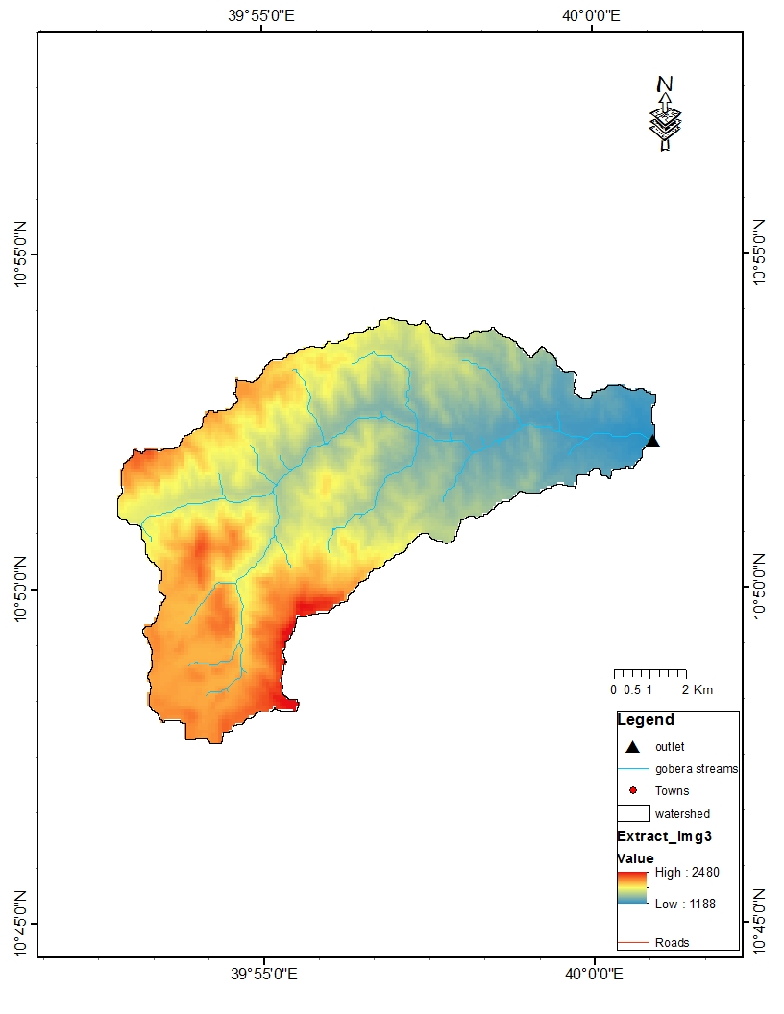
Figure 2: Drainage map of Gobera 2 watershed

Hydro-metrological data availability

3.1 Hydro-meteorological data availability

Hydrometric data
. Hydrologists and designers are faced with lack of good or non recorded hydrometric data on the target stream/river and on local weather and climate conditions. Stream gauging stations are non-existent in remote rural areas of the region and even meteorological stations are almost rare near small rivers in the region. Likewise, at the watershed of Sheriff River, there is neither gauged river nor meteorological station. Therefore investigating other stations near the project area is the primary step in hydrological analysis of the given Gobera watershed

Climate
There are many hydro-meteorological stations these are, Kombolcha, kemise and shewarobi. Kombolcha metrological stations are nearest to the watershed and it includes all components of the climate relative to the other stations. In this station there is only Rainfall data element recorded in kombolcha meteorological station. Therefore, rainfall and daily heaviest rainfall elements have been taken in this station. The completeness of the selected kombolcha station data is tabulated as shown in the following table
Table 1: Data availability and adequacyKombolcha station
climate data Elements | No. years | Range of Data Years | Missing Data | Adequacy | Remark
Minimum temperature | - | - | - | -
Maximum temperature | - | - | - | -
Daily heaviest Rainfall | 42 | 1953-1994 |  | Adequate
monthly rainfall | - | - | - | -
wind speed | - | - | - | -
sunshine hours | - | - | - | -
relative humidity | - | - | - | -

Daily Heaviest Rainfall Data
In order to compute the design flood for design of the diversion structure, the daily maximum rainfall is collected from Kombolcha Metrological stations with a record period of 43 years. This station is selected because it is the nearest one as compared to other stations (kemise and shewa robi). That means the watershed of our site is under this basin.

Daily Heaviest Rainfall data availability and checking
Rainfall and other related meteorological data availability is core for any projects that require hydrological analysis. However, sufficient availability of such data in the target position is a rarely phenomenon in developing countries.
At the proposed outlet point or diversion point, Gobera River has a catchment area of 81.27km². The nearest meteorological station for the watershed is that of Kombolcha

. Table 2: storm Analysis for Kombolcha Rainfall Station
S.No. | Year | Max. RF | Descending Order | Rank | Logarithmic Value/Yo/ | (Yo-Ym)² | (Yo-Ym)³
1 | 1953 | 55.3 | 94.5 | 1 | 1.9754 | 0.0617489 | 0.0153442
2 | 1954 | 54.6 | 82.8 | 2 | 1.9180 | 0.0365161 | 0.0069779
3 | 1955 | 59 | 76 | 3 | 1.8808 | 0.0236775 | 0.0036434
4 | 1956 | 41 | 74.8 | 4 | 1.8739 | 0.0215981 | 0.0031741
5 | 1957 | 61.9 | 67.9 | 5 | 1.8319 | 0.0110106 | 0.0011554
6 | 1958 | 53.6 | 65 | 6 | 1.8129 | 0.0073917 | 0.0006355
7 | 1959 | 63 | 63 | 7 | 1.7993 | 0.0052421 | 0.0003795
8 | 19102 | 41.2 | 62.4 | 8 | 1.7952 | 0.0046575 | 0.0003179
9 | 1961 | 54.5 | 62.3 | 9 | 1.7945 | 0.0045629 | 0.0003082
10 | 1962 | 51.4 | 61.9 | 10 | 1.7917 | 0.0041928 | 0.0002715
11 | 1963 | 51.2 | 102.7 | 11 | 1.7832 | 0.0031641 | 0.0001780
12 | 1964 | 76 | 59.5 | 12 | 1.7745 | 0.0022637 | 0.0001077
13 | 1965 | 34.2 | 59 | 13 | 1.7709 | 0.0019284 | 0.0000847
14 | 1966 | 41 | 59 | 13 | 1.7709 | 0.0019284 | 0.0000847
15 | 1967 | 65 | 58.5 | 15 | 1.7672 | 0.0016174 | 0.0000650
16 | 1968 | 53.5 | 58.1 | 16 | 1.7642 | 0.0013866 | 0.0000516
17 | 1969 | 47.6 | 58 | 17 | 1.7634 | 0.0013315 | 0.0000486
18 | 1970 | 59.5 | 56.4 | 18 | 1.7513 | 0.0005925 | 0.0000144
19 | 1971 | 45.1 | 55.3 | 19 | 1.7427 | 0.0002492 | 0.0000039
20 | 1972 | 43.4 | 54.6 | 20 | 1.7372 | 0.0001051 | 0.0000011
21 | 1973 | 15 | 54.5 | 21 | 1.7364 | 0.0000895 | 0.0000008
22 | 1974 | 58.1 | 53.6 | 22 | 1.7292 | 0.0000050 | 0.0000000
23 | 1975 | 94.5 | 53.5 | 23 | 1.7284 | 0.0000020 | 0.0000000
24 | 1976 | 39.5 | 52.4 | 24 | 1.7193 | 0.0000579 | -0.0000004
25 | 1977 | 102.7 | 51.4 | 25 | 1.7110 | 0.0002552 | -0.0000041
26 | 1978 | 48.9 | 51.2 | 26 | 1.7093 | 0.0003122 | -0.0000055
27 | 1979 | 56.4 | 50.7 | 27 | 1.7050 | 0.0004809 | -0.0000105
28 | 1980 | 38 | 50.5 | 28 | 1.7033 | 0.0005592 | -0.0000132
29 | 1981 | 62.3 | 49.6 | 29 | 1.6955 | 0.0009895 | -0.0000311
30 | 1982 | 58 | 48.9 | 30 | 1.6893 | 0.00141102 | -0.0000533
31 | 1983 | 82.8 | 47.6 | 31 | 1.6776 | 0.0024336 | -0.0001201
32 | 1984 | 49.6 | 45.1 | 32 | 1.6542 | 0.0052943 | -0.0003852
33 | 1985 | 62.4 | 43.4 | 33 | 1.6375 | 0.0080011 | -0.0007157
34 | 1986 | 42.8 | 42.8 | 34 | 1.6314 | 0.0091192 | -0.0008708
35 | 1987 | 50.5 | 42.2 | 35 | 1.6253 | 0.0103279 | -0.0010496
36 | 1988 | 67.9 | 41.2 | 36 | 1.6149 | 0.0125533 | -0.0014065
37 | 1989 | 74.8 | 41 | 37 | 1.6128 | 0.0130313 | -0.0014876
38 | 1990 | 59 | 41 | 38 | 1.6128 | 0.0130313 | -0.0014876
39 | 1991 | 42.2 | 39.5 | 39 | 1.5966 | 0.0169889 | -0.0022144
40 | 1992 | 52.4 | 38 | 40 | 1.5798 | 0.0216546 | -0.0031866
41 | 1993 | 50.7 | 34.2 | 41 | 1.5340 | 0.0372152 | -0.0071793
42 | 1994 | 58.5 | 33.8 | 42 | 1.5289 | 0.0392126 | -0.0077650
SUM |  |  | 2295.80 |  | 72.5314 | 0.3881958 | 0.0048618
MEAN |  |  | 54.66 |  | 1.7269 | 0.0092428 | 0.0001158
STANDARD DEVATION |  |  | 12.59 |  | 0.0973

Data Consistency Test
At first trial we have checked the 43 years of data for its outliers and one data set is outlier. After removing the lower outlier rainfall record (15mm) at the year of 1973, the data has been again checked for higher and lower outlier and 15mm record data is outlier. There for the computation of design rainfall is done by using 42 years of data. Rejecting this data and rechecking for its quality shows the following results.
42 years of daily heaviest rainfall records of Kombolcha meteorological station, from 1953 to 1994, were used for the estimation of point design rainfall. In spite of less number of rainfall data, the designer selected an event that recurs in every 50 years of return period to compute the design rainfall, which is common for small scale irrigation projects like Gobera intake Diversion. These data should be checked for their consistency or outlier test to assure the reliability of data for further design flood simulation.

Checking Data Reliability
Standard deviation of the data series from the mean value is an indicator of the variation of data series. Variation is the inverse function of the number of the data. The variation is also the reflection of the errors in the series. The data series could be considered reliable & adequate if the percent of errors is less than or equal to ten percent. Percent of errors is given by:-
αn-1, standared devation
$αn-1=√( \frac{Σ(X-µ)^2}{n-1})$, n=number of data & µ= mean of data series which it gives 12.59
αn stndared error of mean, αn-1/$\sqrt[2]{n}$ which is 1.94
Relative standard = standard error of mean/mean *102 which gives 3.55% it is less than 10% it is adequate and reliable.

Data Outlier Test
This is done to check whether the adopted data are within a limited range or not. Outliers are data points that depart significantly from the trend of the remaining data. The retention or deletion of these outliers can significantly affect the magnitude of statistical parameters as mean and standard deviation that are computed from the data, especially for small samples. Procedures for treating outliers require judgment involving both mathematical and hydrologic considerations. However, here simple mathematical approaches are practiced to sort out the data that seem reliable of the trend of the parent.
Input data:
Summation of the daily maximum rainfall data records of 43years,
Arithmetic mean of the data, X,
Summation of common logarithms of the data,
Mean value of common logarithms of the data,
Standard deviation of the common logarithms,
Skewness of the common logarithms of the daily maximum rainfall data, Cs
Tests for Outliers
Outliers are data points that depart from the trend of the remaining data especially at the two extreme ends. The deletion or retention of these outliers can significantly affect the magnitude. As shown from the above calculation the Station Skewers is less than +0.4 ; thus, test for higher
Outliers are not important. All the data population are in the same group however to complete the process and see the result,
Test for higher outlier
Where: = mean of data in common log unity
= From table for sample size N
From Table for data N=43,, and
Skewness coefficients = 0.1028
Higher outlier
The highest recorded value (99.4mm) is less than the higher outlier (110.64 mm). Therefore, there is no higher outlier data other than already removed (166mm for in the 2000). It is not included in the above table.
Test for lower outlier
Lower outlier
The lowest recorded value as shown from the table is 15 mm which is less than lower outlier (29.06 mm) and therefore this lowest recorded value is rejecting from the data serious.

Design Storm Computation
After checking consistency (reliability and outliers) test, the rainfall data are obtained as representative for the analysis. The magnitude of the design rainfall of 50 years of return period is estimated by the recommended distributions such as Gumble, EVI, Log Pearson and Lognormal distributions. The best fitting distribution to be used can be done by using D-index test as follows.

D-Index test
After checking the consistency of the data for higher and lower outlier, the 19 years data is obtained as representative for the analysis using D-index. The D-Index test is believed to show the better goodness or fitness of the data to frequency models. Hence in this study it was used to determine the best statistical distribution to estimate the peak rainfall. The D-index for the comparison of the fit of various distributions is summarized as follows.
$$D_{-Index}=(\frac{1}{X_{m}})*\sum_{i=1}^{6}{Abs(Xi-{Xi}^{'})}$$
Where Xi and Xi’ are the i^{th} highest observed and computed values for the distribution respectively
Table 3: Test for goodness to fit using D-index
 | Rank | XI | Normal | Log Pearson Type III | Log Normal | Pearson Type III | Gumbel EVI | Gumbel
 | Rank | XI | XI -'XI' | XI -'XI' | XI -'XI' | XI -'XI' | XI -'XI' | XI -'XI'
 | 1 | 94.50 | 14.762 | 10.297 | 11.192 | 14.161 | 8.689 | 12.102
 | 2 | 82.80 | 6.980 | 4.593 | 5.101 | 6.614 | 3.913 | 1.521
 | 3 | 76.00 | 2.727 | 1.431 | 1.743 | 2.491 | 1.214 | 9.767
 | 4 | 74.80 | 3.482 | 2.894 | 3.082 | 3.335 | 2.961 | 12.216
 | 5 | 67.90 | 1.798 | 1.881 | 1.781 | 1.879 | 1.622 | 20.265
 | 6 | 65.00 | 3.294 | 2.997 | 2.962 | 3.323 | 2.1024 | 24.265
 | Sum |  | 33.043 | 24.094 | 25.861 | 31.803 | 21.003 | 80.135
 | Sum/Mean |  | 0.1024 | 0.441 | 0.473 | 0.582 | 0.384 | 1.466
 | Point Rainfall |  | 80.53 | 85.86 | 84.49 | 81.44 | 87.31 | 91.56
 | Design Point Rainfal = |  |  | 87.31

Due to client interest and practically fit to our country probability test gumbel is used.
- Gumbel Powell method
In this study, design rainfall is to mean the amount of 24 hours rainfall that is computed from the available data series based on the given return periods recommended at the rain gauge point. Gumble Powell is the most widely used method for the prediction of annual extreme values like annual rain falls, flood flows and the like for the desired return period. This method is also adopted to estimate the design rainfall for this particular study. Its formula is given by:-
$XT=µ+KT*σn-1$ Where $KT=\frac{YT-Yn}{Sn}$
Yn = Reduced mean in Gumble’s extreme value distribution for N sample size from table;
Sn= Reduced standard deviation in Gamble’s extreme value distribution for N sample size from table;
T=Return period, for weir diversion of 50 years return periods;
$σn-1$ = Standard deviation of annual rain fall; and
µ = Mean of all values annual rain fall.
For sample size N=42, Yn =0.5448, and Sn =1.1458
YT=-(ln (ln$(\frac{T}{(T-1)}))$) =-(ln (ln ($\frac{50}{50-1})))$=3.9
$$KT=\frac{YT-Yn}{Sn}=\frac{3.9-0.5448}{1.1458}=2.93$$
$X50=µ+KT*σn-1=54.66+2.93*12.59=91.56mm$$X50=µ+KT*σn-1=54.77+2.87*10.98=86.27mm$
The design rain fall of 50 years return period is 91.56mm at the recording rain gage point

Design Flood Determination

Peak flood analysis by SCS method
The water shed of Gobera river has watershed of 81.27 km².rational formula cannot be used to estimate the design flood since the size of the catchment is greater than 5km².therefore,united states soil conservation services(SCS) method is used to simulate the design flood .
For ungaged rivers, the design flood can be simulated by using SCS unit hydrograph method. The computation is done using design rainfall or storm estimated earlier, In the hydrologic analysis of flood using SCS method, rainfall amount and storm distribution; catchment area, shape and orientation; ground cover; type of soil; slopes of terrain and stream(S); antecedent moisture condition; Storage potential (over bank, ponds, wetlands, reservoirs, channel, etc.) can be used and all such data shall be carefully determined before proceeding to SCS simulation

Time of concentration (Tc)
Time of concentration has been calculated by taking the stream profile of the longest streamline and dividing it in to different elevation ranges. Kirpich formula is adopted for computation.
Table 4: Determination of Time of Concentration
Partial | Elevation | Elevation Difference in m
Length,m | in m | Elevation Difference in m | Slope of river, Decimal
0 | 2150 | 0 | 0 | 0
2.78 | 19102 | 190 | 2710.84 | 0.41
4.31 | 1620 | 340 | 4264.39 | 0.54
4.69 | 1420 | 200 | 7888.63 | 0.73
9.96 | 1150 | 270 | 4339.70 | 3.24
21.74 |  | 1020
Total Tc,in hr |  |  |  | 3.24

Hence
- Tc= 3.24 hr Since it is >3 hr ., duration of excess rainfall difference, D =1 hr
- Time to peak,
$T_{p=}\frac{D}{2}+0.6*{1.2T}_{c}$= 2.444 hr
- Base time,
$T_{b}=2.67*T_{p}$ =6.53 hr
- Recession time,
$T_{r}=1.67*T_{p}$=3.91hr.

Curve number (CN)
. Curve number (CN) is achieved based on SCS method by watershed characterization in terms of land cover, treatment, hydrologic condition and soil group. From the watershed analysis curve number at condition II =65.75 for the good watershed cover and highly hard pan soil nature. Since peak rainfall is found at an antecedent moisture condition III state, this value has to be changed to antecedent moisture condition III.
- Conversion factor = 1.23
- CN Condition (III) = (Factor from Table x CN condition II) = 65.75*1.23 = 83.42

Areal Rainfall
As the area of the catchment gets larger, coincidence of all hydrological incidences becomes less and less. This can be optimized by changing the calculated point rainfall to aerial rainfall. The conversion factor is taken from standard table or curves that relate directly with the size of watershed area and type of the gauging station (IDD manual). But in this project a table was used.

Rainfall Profile
. Rainfall profile is the distribution of the proportion of design rainfall during every incremental time on the watershed area during the 24 hours duration. Well developed models are needed to determine such an event for the selected basin area. But there are no sufficient modeling studies in the vicinity and adaptation of standard curves has been taken as the only option. Designer of this project has adopted the standard curve from Design Guidelines for Small Scale Irrigation Projects in Ethiopia. With the aid of rainfall profile versus duration curve the percentages of design rainfall distribution on the catchment area are computed for the first most intensive storm duration

Table 5: Design Rainfall Arrangement
Duration (hr) | Design Rainfall | Rainfall Profile |  | Area to Point Ratio % | Areal Rainfall (mm) | Incremental Rainfall (mm) | Descending order | Rank
Duration (hr) |  | % | mm
1 | 91.84 | 45 | 41.3 | 68 | 21.5 | 21.47 | 21.47 | 1
2 |  | 58 | 53.3 | 78 | 36.9 | 15.47 | 15.47 | 2
3 |  | 67 | 61.5 | 80 | 45.5 | 8.52 | 8.52 | 3
4 |  | 72 | 66.1 | 82 | 50.9 | 5.45 | 5.45 | 4
5 |  | 75 | 68.9 | 83.5 | 57.1 | 6.20 | 6.20 | 5
6 |  | 79 | 72.6 | 85 | 59.9 | 2.81 | 2.81 | 6

Curve number at antecedent moisture condition III =83.42
Catchment Area, A = 81.27km²
Direct run-off,
$$Q=\frac{{(I-0.2*S)}^{2}}{(I+0.8*S)}$$

Where, I = Rearranged cumulative run-off depth (mm
S = Maximum run off potential difference,
$$S=\left(\frac{25400}{CN}\right)-254$$
Peak run-off for incremental;
$$Q_{p}=0.21*\frac{(A*Q)}{T_{p}}$$
Where, A=Catchment area (Km²⁾
T_{p}=Time to peak (hr)
Q = Incremental runoff (mm)
Table 6: Direct Runoff analysis
Rearraged order  No | Rearraged Incremental R.F  mm | Cumulative R.F  mm | Incremental rain fall  mm | Cumulative runoff(Q)  mm | Incremental runoff | Incremental discharge  m³/s | Time of incremental Hydrograph
 |  |  |  |  | mm | Incremental discharge  m³/s | Beginning | Peak | End
6 | 3.09 | 3.09 | 3.09 | 0.00 | 0.00 | 0.00 | 1.00 | 2.44 | 6.5
4 | 3.64 | 6.72 | 3.64 | 0.00 | 0.00 | 0.00 | 2.00 | 3.44 | 7.5
2 | 9.73 | 16.45 | 9.73 | 0.71 | 0.71 | 4.96 | 3.00 | 4.44 | 8.5
1 | 26.86 | 43.31 | 26.86 | 13.18 | 12.47 | 87.11 | 4.00 | 5.44 | 9.5
3 | 12.02 | 55.33 | 12.02 | 21.38 | 8.20 | 57.25 | 5.00 | 6.44 | 10.5
5 | 5.61 | 102.94 | 5.61 | 25.52 | 4.14 | 28.89 | 6.00 | 7.44 | 11.5
6

Table 7: Hydrograph coordinates
Time | H1 | H2 | H3 | H4 | H5 | H6 | SUM
0.00 | 0.00 |  |  |  |  |  | 0.00
1.00 | 0.00 | 0.00 |  |  |  |  | 0.00
2.00 | 0.00 | 0.00 | 0.00 |  |  |  | 0.00
2.44 | 0.00 | 0.00 | 0.90 | 0.00 |  | 0.00 | 0.90
3.00 | 0.00 | 0.00 | 2.03 | 34.95 | 0.00 | 0.00 | 36.98
3.44 | 0.00 | 0.00 | 2.93 | 44.42 | 0.00 | 0.58 | 47.93
4.00 | 0.00 | 0.00 | 4.06 | 56.29 | 0.00 | 4.51 | 64.86
4.44 | 0.00 | 0.00 | 4.96 | 65.76 | 10.40 | 7.66 | 88.78
5.00 | 0.00 | 0.00 | 4.29 | 77.63 | 23.43 | 11.59 | 116.93
5.44 | 0.00 | 0.00 | 3.75 | 87.11 | 33.83 | 14.73 | 139.41
6.44 | 0.00 | 0.00 | 2.53 | 65.76 | 57.25 | 21.81 | 147.36
6.53 | 0.00 | 0.00 | 2.43 | 64.02 | 56.11 | 22.39 | 144.95
7.44 |  | 0.00 | 1.31 | 44.42 | 43.22 | 28.89 | 117.85
7.53 |  | 0.00 | 1.22 | 42.68 | 42.08 | 28.31 | 114.29
8.53 |  |  | 0.00 | 21.34 | 28.05 | 21.24 | 70.63
9.53 |  |  |  | 0.00 | 14.03 | 14.16 | 28.18
10.53 |  |  |  |  | 0.00 | 7.08 | 7.08
11.53 |  |  |  |  |  | 0.00 | 0.00

From the analysis, the 50 years return period design flood is 147.36m ³/s. This implies that for this watershed the peak flood rate per km2 area of the watershed is about 1.81 m3/s/km2. This value ensures that high rainfall of the area can generated higher rate of runoff per km2 of the generating catchment in spite of its forest coverage. Graphical plot of all the 6 hr synthetic hydrographs are shown below.

Figure 6: Complex Hydrograph

Flood mark Method
During field assessment and topographic survey, the normal and maximum flood mark points has been selected by interviewing the local aged farmers and marked in cross section of selected river geometry. This is just to check the design flood what we have determined using rough simulation methods such as SCS for engaged catchments. That was the main purpose of taking flood marks during field assessment and that will be checked using the stage discharge analysis in the following section.

Tail Water Depth Computation
Tail water depth of the river is equal to the flood depth and amount at the proposed weir site before construction of the weir. It is used to crosscheck peak flood estimated by the SCS unit hydrograph method with flood mark method and to see the flood feature after the hydraulic jump. During field visit, the flood mark of the river at the proposed diversion site was marked based on dwellers information and physical indicative marks. The data required to do stage discharge analysis has been discussed in the following section.

Figure 7: the river cross-section for Gobera intake axis

Average river bed slope
Average river bed slope of River is estimated by using best fit method. The water level of the river is taken at different points along the river channel around the headwork site. Surveying work has been done for 102m length. And then, average water surface slope is considered as the river bed slope which is on Average, S = 0.015. The detail is arranged in spread sheet.

Manning’s Roughness coefficient for the river bed and banks (average)
The Manning’s roughness coefficient is taken from standard table based on the river nature. The river at the headwork site has got relatively U-shape feature and straight nature. The river banks have grasses and tree roots but on the river bed there are out cropped boulders whence Manning’s roughness coefficient (n = 0.035) is adopted.

Discharge of the river
Input data:
Manning's roughness coefficient, n = 0.035
Average river bed slope, S = 0.015
,
Where, R = Hydraulic radius = (Area/Perimeter)

$$Q=V*A$$

Table 8: River discharge computation at different stages of flow, (down stream)
Stage | Elevatioin | Area | perimetter | roughness | hydrualic raduis | Slope | velocity | Discharge
0 | 1180.27 | 0 | 0 | 0.035 | 0.00 | 0.015 | 0 | 0
0.5 | 1180.77 | 0.23 | 4.66 | 0.035 | 0.05 | 0.015 | 0.470839 | 0.108293
1 | 1181.27 | 24.56 | 38.28 | 0.035 | 0.64 | 0.015 | 2.1023046 | 63.93081
1.287279 | 1181.557279 | 35.6408 | 40.35202692 | 0.035 | 0.8893042 | 0.015 | 3.241087 | 147.36 | peak FLOOD
1.5 | 1181.77 | 44.49 | 41.89 | 0.035 | 1.06 | 0.015 | 3.6421027 | 162.0596
2 | 1182.27 | 66.16 | 45.51 | 0.035 | 1.45 | 0.015 | 4.49059 | 297.0974
2.5 | 1182.77 | 89.56 | 49.12 | 0.035 | 1.82 | 0.015 | 5.222536 | 467.7303
3 | 1183.27 | 114.71 | 52.76 | 0.035 | 2.17 | 0.015 | 5.872755 | 673.6638 | flood mark
3.5 | 1183.77 | 141.6 | 56.39 | 0.035 | 2.51 | 0.015 | 6.464749 | 915.4085
4 | 1184.27 | 170.24 | 102.03 | 0.035 | 2.84 | 0.015 | 7.010889 | 1193.534
4.5 | 1184.77 | 220.44 | 119.63 | 0.035 | 1.84 | 0.015 | 5.2595 | 1159.404
5 | 1185.27 | 284.9 | 140.21 | 0.035 | 2.03 | 0.015 | 5.613752 | 1599.358
5.5 | 1185.77 | 358.92 | 156.71 | 0.035 | 2.29 | 0.015 | 6.080112 | 2182.274
6 | 1186.27 | 439.97 | 169.94 | 0.035 | 2.59 | 0.015 | 6.59775 | 2902.812
6.5 | 1186.77 | 527 | 182.44 | 0.035 | 2.89 | 0.015 | 7.097487 | 3740.376
7 | 1187.27 | 620.96 | 194.75 | 0.035 | 3.19 | 0.015 | 7.580567 | 4707.229

As shown on table, by interpolation, the tail water depth that corresponds to peak flood, 147.34m³/s discharge is 1.29m from river bed. The water top level is at the elevation of 1181.56m a.s.l. The flood mark is 3m with elevation of 1183.27m.

Figure 8 STAGE DISCHARGE CURVE

Selected Design flood
Based on the stage analysis result of the flood mark elevation, the amount of flood computed in that elevation has been found to be 673.66m3/s which is higher than the computed flood amount using SCS method above. The overflow over the length becomes maximum and therefore for the case of designing the protection walls of a bank it is advisable to take the design flood obtained by using flood mark method ( higher value ) and hence design flood is taken as 673.66m3/s..
Based on the stage discharge analysis of the project at the intake section or design discharge capacity of the river channel before the construction or intervention, the downstream high (HFL) flood level can be fixed by the selected designed flood in the previous section.

Basin Base flow, Demand and Water balance

Basin Base flows
Today the question of water right becomes a nationwide burning issue. Crop cultivation based on modern or semi-modern irrigation schemes becomes the solely alternative for developing countries like Ethiopia to feed their rapidly growing population. Though it is the bare fact, downstream water rights and ecological securities should be preserved to make the project environmental friendly whereby resolving social conflicts too. Gobera River is perennial and on April 28/2006 E.C during site investigation period, the base flow had been measured by using floating method and the discharge was found to be 182.8 l/sat this time all traditional irrigation that mention above well be open (operate)and to release the water for downstream users . The elder inhabitants confirmed that the base flow decreases less than this figure. On the other hand the river flow increases more till the month of November. The figure indicates that the river has good potential to irrigate even more than the target area. Therefore, this project has been designed to exploit the water potential effectively and efficiently in environmentally friendly manner so as to ensure food security and to increase the income of the farmers living around the area.

Proposed axis
Figure 9: Base flow of the river near traditional diversion ( Left)
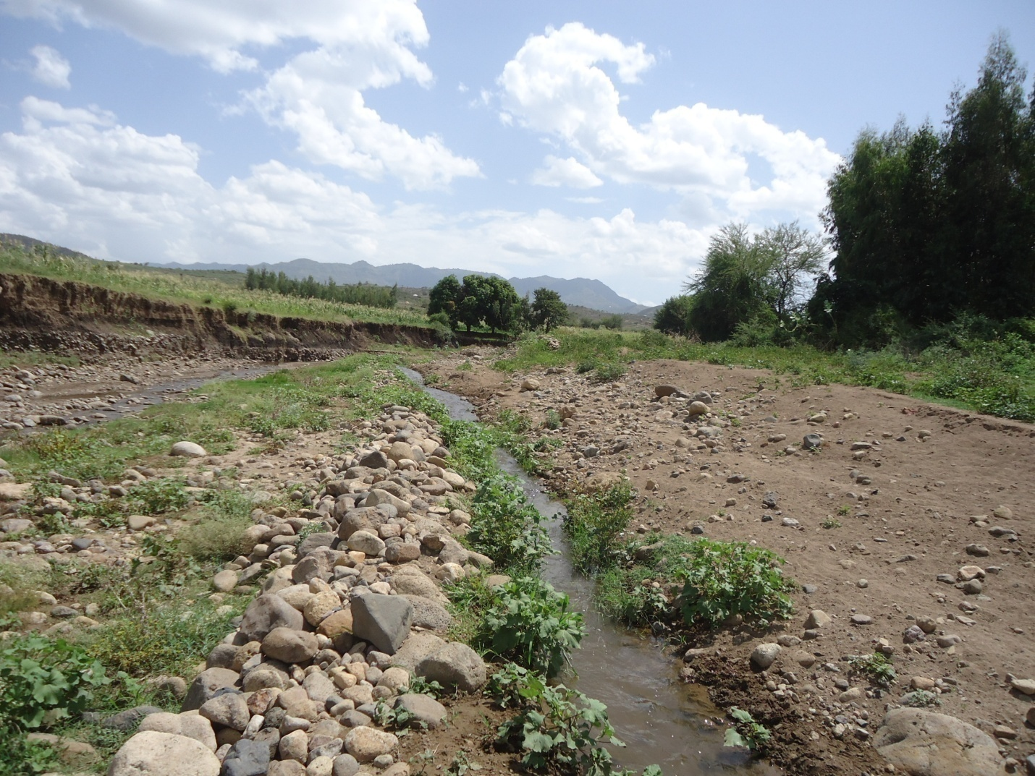
The location of another traditional scheme is 400m downstream of the current traditional project. This situation and the presence of wet lands are good evidences for the availability of potential ground water storage.
The farmers can be benefited from the excess flow of late winter season. The river has good base flows till the end of January without any conflict caused by water scarcity. Moreover the project area is a lowland area and many springs are seen developed along the river course .So, the proposed Gobera 2 Irrigation project will not cause any environmental disturbances resulting from shortage of water during the 1st irrigation period and the second irrigation period.
In addition to this, there is significant amount of effective rainfall in the month of May that can supplement the irrigation cultivation. This condition resolves the probable conflict for water and makes the project very ideal to be practiced. In addition to the presence of tributaries at downstream of the headwork site, at least 21% of the above base flow should be permanently released for downstream users for cattle and other demands. Again the tail water from the proposed command area joins the main GoberaRiver this also replenishes the available water resource.
Therefore, considering 39.04 l/s for downstream users and for environmental purpose as well a design flow 146.26 l/s has been used for canal sizing. Finally, the irrigation hours need to be increased to cultivate larger area keeping the diverted water volume constant. Longer irrigating period can be adopted exercised as the majority of the command area is found along residential areas.

Existing water use and Irrigation Practices
The watershed is currently covered with less populated trees and many springs along the banks of the rivers. The river water is also used for domestic water supply and irrigation uses downstream. People use the eyes of the springs along the stream bank for drinking purpose.
There is a traditional irrigation practice along the river, and especially on the proposed site, about 30 ha on the right is being irrigated. There exist traditional (near 400m) irrigation practices observed in the near downstream and 500m upstream parts of the river. Generally in the late season up to the end of month of January there is no shortage of water and afterwards water decrease. The water resource becomes minimum in the driest months of April and May as of the interviewed aged people saying.

Upstream & Downstream utilization
Gobera 2 irrigation project will not affect the downstream eco-system since there are small springs around/and just downstream of the newly proposed site that join the River. These springs produce reliable discharge throughout the year. In addition to that Gobera River joins to sheriff River after 1km distance travel and more of the downstream community is beneficiary of the irrigation scheme. So, there will not be conflict on downstream of the proposed site. Though the community around the proposed area, on the upstream side, showed their interest

Conclusion
Sheriff River has a81.27km2 watershed and Kombolcha station is the nearest Meteorological station. Data for Storm analysis has been selected in this station and for other water management purpose, data must be taken from kombolcha station which has all the five element recorded data.
The design storm computed by using gumbel has been selected .and it is found to be 91.56.
The design flood was found to be 673.66m3/s from flood mark method of analysis and its specific design flood was 8.29m3/s/km2. This is higher and is safe for design.
The base flow measured in April 2014 by using floating method was 182.8l/s and leaving 21% environmental flow for downstream water users, a design base flow of 146.26 l/s has been approved.

SECTION-II: HEADWORK DESIGN

Headwork site selection
. In selecting or comparing the best site, it was practically important to put criteria’s such as considering the flood the channel has to accommodate, the length of the river width, the topographically suitability, the relative economic considerations , the availability of enough command and other selection or comparison criteria’s.
During the period of field assessment, it was tried to critically observe all possibilities by moving 3-4kms u/s and d/s from the initial options. The 1st option, there is no enough command and the command nearest to the boarder of afar region this leads conflict b/n afar and harawi people. The second option, located u/s of the 1st option this maintaining the existing weir but the bank of the river at that axis will be worn out by flood. The third most option was traditionally diverted site where it is located at a high slope and a meandering section of the river. 3102m idle length to the left. This is the best option selected relative to the other options.
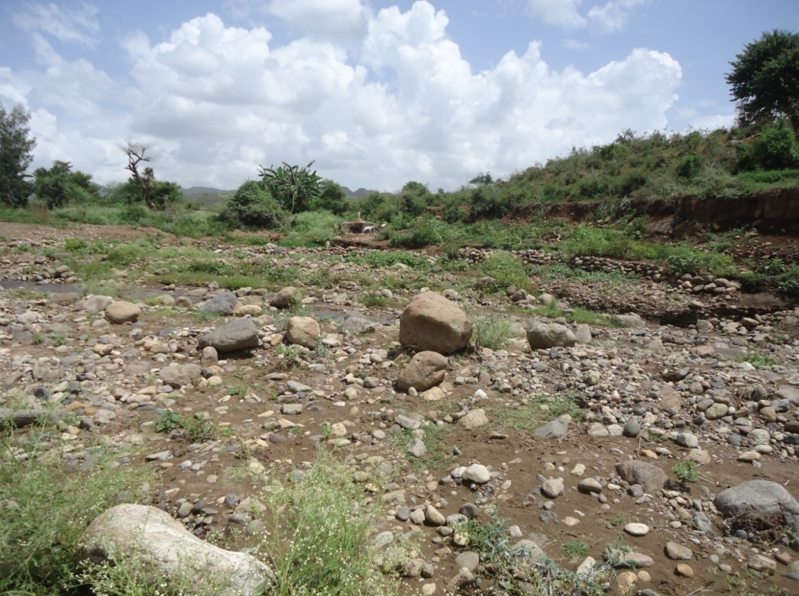
Figure 10: photo showing proposed intake axis
Therefore, the headwork site is situated at12011026N (UTM) & 610895 (UTM). And river bed elevation of 1180.27 (river bed) m above sea level. At this site the river course is well defined, stable and forms nearly a U-shaped cross section. The left side bank of headwork site 2m from the selected axis is nearest to the hill.
The headwork site geological surface and subsurface conditions have been investigated based on the nature of the proposed structure. At the site and immediate vicinity, the stream flows along gentle slope course and its bed is mainly covered with recently deposited sand with gravels and boulders.

River Geomorphology
The pattern of the drainage system of the study area is strongly influenced by geological structures and formations, the nature of the vegetation cover and climate. It is a common fact that the development of the river tends to accommodate itself to the local geology that develops along the fault zone. Geological formations and structures have strong influence on the channel development. The bank of Sherif river is subjected to active erosion and it is continuously changing the river course. The boulder in the river bed is semi rounded to angular. The angular boulder indicates it is transported short distance, possibly from northern and southern part of the study area. The semi-rounded boulders are possibly transported from a relatively long distance. Meandering effect is the most dominant phenomenon for Sheriff river. Tributaries which drain from north western and south western part of the study area merge with Sheriff river. It is commonly dry except during rainy season.

Left Bank conditions
The right bank is characterized by steeply sloping topographic set up. It is mainly composed of loose silty sand at the middle section of the left bank and sand with gravel mixed with big boulder having an average diameter of 0.35m in the lower reaches of the bank. 6m away from the top section of the left bank, exposure of highly weathered basalt has been observed. This unit is expected to have an extension in depth. The bank is subjected to active erosion. Therefore it has to be supported by retaining wall. The retaining wall has to be keyed with the basaltic unit.
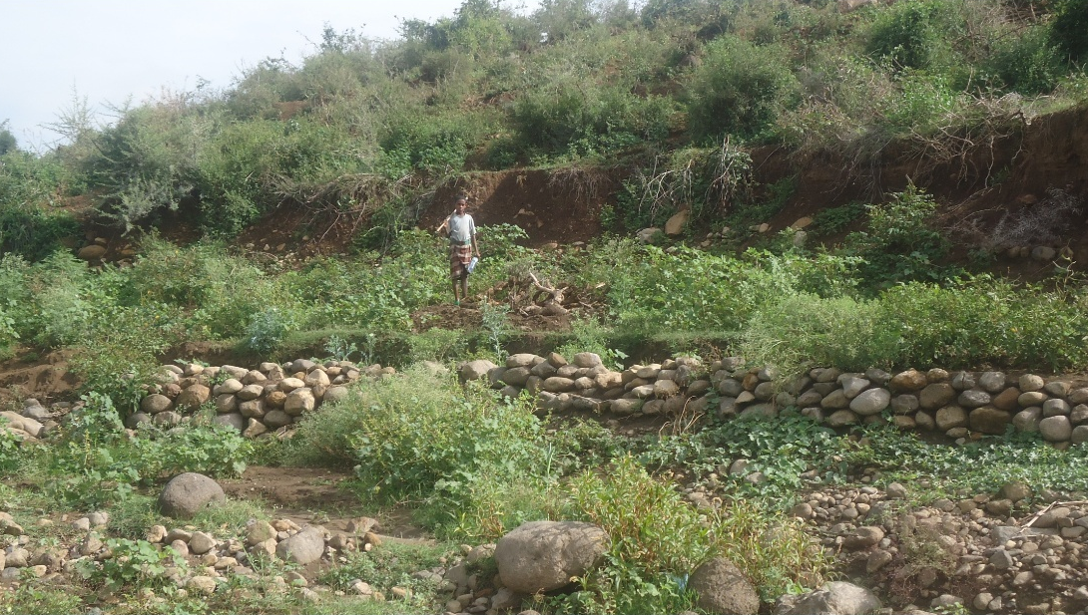

Figure 11: Photo showing left bank
The right bank has moderately slopping topographic set up. It is mainly made up of silty sand which is underlain by loose gravelly sand with silt. This bank is not stable; a continuous change in its morphology has been noted.
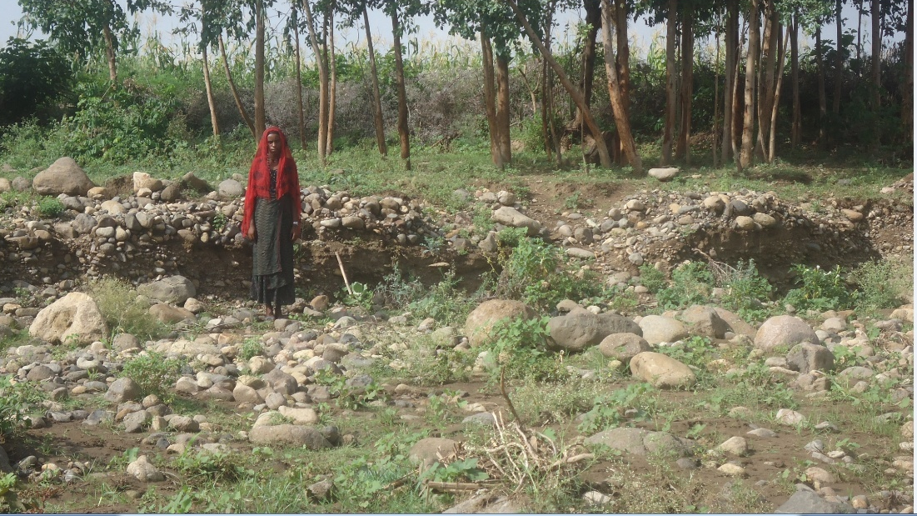
Right BANK
LeftBANK
Figure 12: Right Bank

To summarize the geological condition of the headwork, a geological X- section is prepared by combining the obtained and interpreted surface and subsurface data.
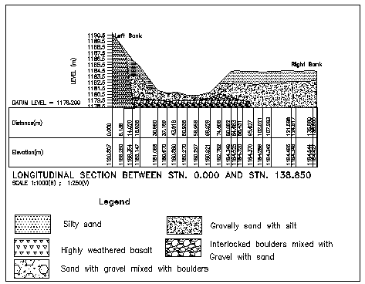
Head work axis
Figure 13: Geological x section along Gobera intake axis

Stream Bed
In general the central and the left margin of the river course are covered with loose sand with gravel mixed with boulder. A pit excavated in the stream bed confirms that the extent of this deposit is 0.8m. Interlocked boulder mixed with gravel with sand has been encountered beneath this depth. Bed rock is not expected at economical depth. Hence the structure has to be founded on this interlocked boulder with appropriate cutoff depth.

Natural Construction Materials
Apart from the geotechnical investigation carried out for the headwork and main canal, construction material investigation namely aggregates, masonry rocks and lining material has been identified. The location and brief description of the materials is presented as follows

Fine aggregates
Fine aggregates (sand), for the proposed project can be obtained from Sherif river at 272m downstream of the proposed intake site.

Coarse aggregates
Coarse aggregate for the construction of the project can be obtained by collecting fresh basaltic river boulders and crushing it to the desired size. Boulders deposited in the riverbed can satisfy

Fine Aggregates
Fine aggregates (sand), for the proposed project can be obtained from Sheriff river at 272m downstream of the proposed intake site.

Canal Fill Material
Clay for lining material is found at middle reaches of the command area. It is medium stiff dark brown in color, underlain by redish silty clay. The thickness of the dark brown clay is restricted to 0.6m and is supposed to be good for lining the pervious section of the main canal

Water
Water for construction purposes can be get from the project stream, Gobera, itself. The stream is perennial that throughout the year there is enough amount of water flow along its course. During this field time the stream flow was about 182.8L/second

Headwork type selection
After detail observation of the available water balance, the target command area and the cost of future idle canal length, it is decided to design an intake with zero elevation. The intake is to be constructed with mass concrete material with a 20cm thickness RCC capping.

Hydraulic design of headwork structure
The following major factors have been reasonably assessed during the field study and the final topographic map has been investigated whether the target area can be commanded at less weir height or not. By using necessary parameters, the weir crest elevation has been determined on both sides of the river as follows:
- Maximum command area elevation =1180.27(bed)
- Main canal idle Length (m) =1020
- Lowest Point of river center=1180.27
The intake height is zero means the top level of the intake and the river bed is equal

Design Base flow of the River
Based on the water balance analysis, the minimum flow of April measurements have been used. Therefore, considering 39.04 l/s for downstream users and for environmental purpose as well , a design flow of 146.26 l/s has been used for the purpose

Design of intake
- Sill Level Determination
The sill level of intake out let is based on the required amount of water availability that can be easily diverted throughout the dry season.
- Capacity determination
The capacity of the intake outlet is the function of discharge required for the irrigation based on crop water requirements. Gobera project is intended for full irrigation during driest season. But supplementary irrigation for annual crops is not required due to sufficiency of rainfall so, the capacity of the main canal is determined based on the peak duty of the project area for full irrigation water supply i.e., 1.45 l/s/ha for 12hrs.
As indicated in water balance subtitle of hydrology section, the required discharge,
Full irrigation, Q_{req}= command area*duty = 1.45*102=96.69 l/s = 0.097 m^³/s.
So, the canal & intake capacity has to be fixed based on the required discharge of 0.097m³/s.
The of take dimension is computed using rectangular notch formula given by:
Q = CLH ^{(3/2)}
Where: Q=diverted discharge= the required discharge, Q_{req} = 0.097m³/sec
Cd=Coefficient of discharge, C_{d}=0.62
B=Width of intake, 0.5 m
H=Height of the intake =flow depth above sill level
g=Acceleration due to gravity
Therefore for a width of 0.5 m,
H= (Q/ (CL)) ^{2/3}=0.2m. Providing 0.05m clearance on both sides, then, 0.5m width & 0.5m height has to be provided by considering maintenance.
- The river water way: As it is discussed under the river geology (2), the left bank is massive rock just below 0.5m depth. The off take position on the left side of the river. To minimize cut under rock, the river width is expanded to the right side and the off take is designed with in the river bed (at the toe of the left bank).

Hydraulic Gate Design
. The gate used for irrigation water control has to be water tight, with least leakage, straight, rigid, & capable of being raised or lowered by hoisting mechanism provided.
It is usually recommended to use slide gate for its simple, safe operation and less maintenance requirements. Generally the slide plate gate type consists of leaf (skin plate and seals), embedded part (sliding surface also called side guide, and sill beam, lintel, seal seats) and hoisting device.
Thickness & tensile strength determination: The gate skin has to have sufficient thickness and strength to resist hydraulic water pressure exerted by maximum highest flood. The minimum 6mm thickness of skin plate has to be considered including correction taken for corrosion. Based on this principle of designing, gate for this project is computed as follows.
Data required:
- Head of water above sill=3.11m
- Width of intake ,B=0.50m
- Height of leaf gate ,H=0.5m
The structural steel of 300N/mm² tensile yield strength with tension & bending moment at wet condition is selected for the gate design and installation.
The thickness of leaf/plate is given by;$t=√(\frac{K}{102}*\frac{P*H*B}{σ})$ where,$σ=bending stress in\frac{N}{mm^{2}}$
t=skin plate thickness in mm
K=coefficient factor based on H/B (from table)
H= longer dimension of leaf gate in mm
B= shorter dimension of intake in mm
P=Water pressure in N/mm² at the gate center.
Then, $aloowable stress,σ$=0.45*300N/mm²=135 N/mm²=13500 N/mm²
Head of 3.11m water exerts pressure at the bottom of the gate,
P_{b}=10KN/M^³*3.11m=31.1KN/m²
At the center of the gate, the pressure will be,
$$P=\frac{10KN}{m^{3}}*\left(3.11-\frac{0.2}{2}\right)=\frac{30.12KN}{m^{2}}=30.12*\frac{{10}^{-4}N}{mm^{2}}$$
For B/H= 1.6, K=51.54
The thickness of plate$,$
$$t=\sqrt{\frac{K}{102}*\frac{P*H*H}{σ}}=\sqrt{\frac{51.54}{102}*\frac{30.12*10^(-4)*40*40}{1.35*10^5}}=0.004mm$$
$S=\sqrt{\frac{K}{100}*\frac{P*H*B}{σ}}=\sqrt{\frac{28.7}{100}*\frac{2.8*47*47}{1.35*10^4}}=0.363cm≈4mm$But the computed value is below the minimum recommended value of 4mm; hence, 6mm gate leaf thickness is adopted.

Trash Rack
A trash rack screen is provided in front of the intake structure in order to prevent the entry of floating derbies, and logs into the off take. The trash rack has to cover the size of 0.50m*0.5m with 12mm diameter steel bar spaced at 102mm center to center horizontally and vertically.

Design of Retaining Wall
At the two ends of the diversion structure walls have been provided to safeguard the structure from scour of banks at the ends .The walls are basically provided to keep the highest flood flow within the cross section and to safeguard areas out of the river bank from scouring and cavity.

Upstream and downstream Retaining walls Design
Using stability analysis, wall dimensions are found for protection walls. a free board of 0.5m is selected for both u/s and d/s walls. The bed elevation near (3.5) the upstream& downstream bank is found to be 1180.77m. Therefore the height of the retaining wall is given by subtracting the bed elevation from the upstream HFL and then adding a nominal freeboard of 0.5m.
H _{wall= 1183.27} -1180.27+0.5=3. 5m
By checking all the factor of safeties using spread sheet analysis, the dimensions of the u/s protection wall are with top width of 0.50m and bottom width 3.5m. Stability is checked in submerged lateral earth pressure condition which is the critical case. The stability checks are tabulated below.

1 | Dimension
 | Height,H | Triangle ,B1 | Rectangle,B2 | Bed width, B
 | 3.50 | 3.00 | 0.50 | 3.50
2 | Stability analysis
 | Code | Load |  | Lever Arm, R | Moment (about toe)
 |  | Vertical | Horizontal |  | Posetive | Negative
 | W1 | 40.250 |  | 0.250 | 10.063
 | W2 | 120.750 |  | 1.500 | 181.125
 | Ps |  | -18.191 | 1.000 |  | -18.191
 | ph |  | -102.025 | 1.167 |  | -70.029
 | SUM | 161.000 | -78.216 | 3.917 | 191.188 | -88.220
3 | Factor of safety against,
 | overturing test |  | Fo | 2.167 | >1.5 | OK
 | Sliding test |  | Fs | 1.544 | >1.50 | OK
 | Tension test |  | X | 1.735
 | B/6= | 0.583 | e | 0.015 | <B/6 | OK

Table 11: upstream and Downstream Retaining wall stability analysis

Bill of Quantity and cost estimation

In this basic topic three major tasks have been conducted. The1st and the most important is the preparation of quantity take off sheet. The 2nd part of this topic shall be summarizing the take off sheet and preparing the Bill of quantities for each work items in the headwork. The last activities to be performed here is estimation of the unit rate specific to the project area.
Finally the engineering cost estimate for the head work shall be computed and summed up for procurement specification. Take off sheet will be annexed or given in softcopy.

Table 13: Bill No. 1- General Items

Table 14: Bill No. 2- Head Work Structure

Conclusion and recommendation
Gobera irrigation scheme is proposed for irrigating a traditionally developed irrigable land of area 102. The headwork site is located at an altitude of 1193.53m asl. The crest length of the intake is 30m.
The intake abstracts water and supply to the command area in the left side of the river with masonry lined main canals. The canal irrigates an area of 102ha and there are 6 tertiary canals. There are about 21 proposed field canals.

SECTION-III: IRRIGATION AND DRAINAGE SYSTEMS INFRASTRUCTURE

Irrigation Infrastructure

Irrigable command area

Topography and soil
Topography is an important factor for the planning of any irrigation project so long as it influences method of irrigation, drainage, erosion, costs of land development, mechanization, labor requirement and choice of crops. Topographically most of the cultivated lands of the project area are found between nearly levels to gently sloping lands. In general, the command area lies from almost flat to gently sloping (i.e., 0 to 5%) slopes. Nonetheless, the slope of the command area has identified to be suitable for surface irrigation. The command area is also found inclined west to east position from the head work site and the elevation range is 1,190m asl at the top and 1,167.5m asl at the bottom of the command area

Irrigation/Farm Blocks
The minimum proposed size of irrigation unit is determined by fixing the manageable discharge by the local communities. Considering the farmers experience the minimum proposed size of irrigation unit is set by the capacity of field canals. Basically depending on the topography of the Gobera 2 command, the proposed irrigation blocks are named after the commands that can be irrigated by Tertiary canals and hence the blocks are said to be tertiary blocks. There are 5 tertiary blocks in Gobera 2 irrigation project. The capacity and the size of each tertiary block are described in the following table. However the name of the block and the number of users in the given block shall be done at the detail and ground checking time.

Irrigation Efficiency and irrigation duty
Irrigation duty is the volume of water required per hectare for the full flange of the crops. Moreover, it helps in designing an efficient irrigation canal system. The area which will be irrigated can be calculated by knowing the total available water at the source and the overall duty for all crops required to be irrigated in different seasons of the years. The proposed cropping pattern of Sheriff Irrigation project has showed a maximum net irrigation water requirement (NIWR) in the month of February with the amount of 4.57 mm/day for maize.
For sheriff small-scale irrigation project, it has estimated to adopt 102% field application efficiency and 80% conveyance efficiency as the soil is clay texture. Therefore, the overall efficiency for the selected surface irrigation method is (102/102 × 80/102) which is 48%.
E = Ec × Ea/102 = 102 × 80/102 ≈ 50% Where, e = scheme irrigation efficiency (%) ec = conveyance efficiency (%) ea = field application efficiency (%)

The GIWR for the design of the project is given for the selected irrigation method (i.e., surface irrigation) as follows:
GIWR = NIWR/IE = 4.7/0.48 = 9.52 [mm/day]
The GIWR represents the daily quantity of water that is required to be applied. This water quantity is also used for determination of the canal discharge in consideration of the time of flow and is defined as the duty, expressed as l/s/ha. The duty is calculated by:
Duty (D) = GIWR x 1020 x 10 / (t x 102 x 102)
Where; Duty – the duty [l/s/ha]
GIWR – Gross Irrigation Requirement [mm/day]
t – Daily irrigation or flow hours [hrs]

The duty for the project area for GIWR of 9.52 mm/day and 18 hours of daily irrigation time (t = 18) is supported to be used with furrow irrigation method. Hence, Duty for 18 working hours is computed as follows:
D = 9.52 x 1020 x 10 / (18 x 31020) = 1.45 l/s/ha for full irrigation
The NIWR and GIWR can be expressed as the duty for the net water requirement and for the gross water requirement of the cropping pattern.
Since farmers are well aware of the irrigation technology in the project area, we have selected 6 days irrigation days per week and 14hrs of irrigation time per day. Using this time input data and the cowwat based maximum duty, the design duty has been calculated.
Based on this and the type of crops proposed for the project area, the design duty for Sheriff Irrigation project has been determined as 1.45 l/s/ha. For detail, please refer agronomist report.
The gross command area is large enough available all downstream of the proposed irrigation project. However, the surveyed irrigable land gross size is about 130ha and the net irrigable land for the project is 102. This amount may increase in the 1st period irrigation where water source is available enough for all uses.

Irrigation Interval
Correct timing of application has a great importance for a given crop. The following relationship is used to determine the irrigation interval and schedules of the proposed crops in the scheme which can be clearly set in the operation and maintenance document.
- Irrigation Interval: (I) = P x Sa x d
- Depth of Irrigation application (d) = P x Sa x D, Ea= 102%
Where Sa = Total available soil, mm/m soil depth
P = Fraction of available water
ETC= maximum crop evapotranspiration per day
Ea = Application efficiency, fraction
D= Root Depth
Since P, D, and ETC will vary over the growing season, the depth in mm and interval of irrigation in days will vary. Hence, if there is a need of irrigation application, the farmer may use hand touching and observation.
Though the canal is design to carry the critical base flow of 146.26 l/s, the canal has been given enough freeboard and can be used in excess flows in good season flows available.

Irrigation & Drainage system lay out

Canal layout
The irrigation scheme layout was prepared by considering the general topography of the land, the soil characteristics, minimizing crossing structure and slope of the canal. Several alternatives were considered for the conveyance and distribution system. The most promising and economical of these alternatives were recommended for more details. The irrigation system comprises three major components: the main canal, tertiary canal and field canal system.
The general layout system consists of one main canals namely left canal (MC) and (tertiary canals and field canals. In order to facilitate the drainage system the natural drains available across the command area has been used as a tertiary drain and field drains are provided based on the topography of the site. The layout system covers a net command area of 102ha.
Water is conveyed through the main canals from the diversion head work. The flow through the main canal is continuous type. And the flow through tertiary and field canals is on rotational base. For easy distribution, division boxes and turnouts are provided at the head of tertiary and filed canals respectively.
The conveyance system consists of one Main canal to irrigate total command area of 102 ha. Main canal (MC) has a length of 4.52km and Tertiary canals are designated as distribution system. The Layout process of the distribution system has involved several steps and the parameters Topographical, Field slope and its uniformity and Sizes of the canals are determined based on the requirement in the field unit.

Drainage system
The drainage system is provided for effective disposal of excess irrigation water and runoff from the irrigation field during rainy season. Field drains and catch drain collect from each field units and topo above the canals will be conveyed with drainage crossing structure and directly discharge into the river and natural Drainage system. All the drains are natural and except the protection of their nature, no artificial drain has been made.

Selection of Canal Design Section

Main Canal
From the head work report we have got the canal outlet capacity is fixed considering optimum design base flow. Therefore Outlet capacity of the main canals is sized based on the available command area. Therefore the command area available in the left side of the river is 102ha and the MC is designed with a Design base flow of 146.26 l/s.
Using weir discharge equation the outlet size has been determined as follows
Q= CLH³/₂
Where C= coeff.of discharge = 1.7
L= Length of water way (m)
H= head above crest level (m) = water depth in the canal = 0. 5m for MC
All of the command area is found in the left side. Geotechnical investigation of the canal route has been carried out in view of permeability, workability, seepage and instability. Accordingly, a number of traverses following the existing canal have been made to characterize the permeability nature of the soil in the area. The general geologic set up of the entire canal route is characterized by loose sandy silt soil cover. Therefore, from permeability point of view the rout is relatively pervious and there will be significant amount of seepage if the canal is unlined (earthen). And other canal systems other than the primary canal can also lined because the command is sloppy. At around a1.7 km and 4.2km away from the head work structure there is a gorge crossed by the main canal. As a result, a crossing structure is needed.
This design is made with the intension of lining the main canal considering the pervious nature of the soil. The lined canal will save the limited water source available there. The topography is increasingly dropping the whole length of the canal and therefore the main canal is designed with the ground surface slope with total in cut and zero fill. This design arrangement with the natural slope changes the canal design to run in chute section for variable ground slopes as shown in the above section. Both Main canal sections are designed by using Manning’s equation for masonry sections as shown below.

Q = , R = A/P

Q = , R = A/P
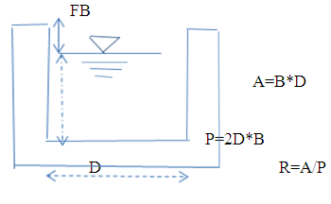
Where Q = Design discharge, m³/s
R = Hydraulic radius of the canal, m
A = Wetted cross sectional area of canal, m²
P = Wetted Perimeter, m
n = Manning’s roughness coefficient
S = Bed slope of the canal
Figure 23: lined canal section view

Tertiary canal
Considering the topography orientation and which is tapered and the command area small in size there is no secondary canal in this project. But instead tertiary canals take water from the Main canal and distribute to field canals.
There are 7 tertiary canals and their sections are proposed to be rectangular in shape which is lined. It designed by using Manning’s equation.
Q = , R=A/P
Where
Q = Design discharge, m³/s
R = Hydraulic radius of the canal, m
A = Wetted cross sectional area of canal, m²
P = Wetted Perimeter, m
n = Manning’s roughness coefficient
S = Bed slope of the canal

The hydraulic Parameters for each variable are calculated by Iteration method with MS-EXL program for main canal, & tertiary canals as shown in table below.
Figure 24 : tertiary canal section
The hydraulic Parameters for each variable are calculated by Iteration method with MS-EXL program for main canal & tertiary canals as shown in table below.

Table 16: Canal features
Canal Type | No of TC | Length of canal | net comand are (ha) | Design duty (l/s/ha) | Canal design capacity | adopted Q, l/s
MC-1 | 7 | 4520 | 56 | 1.45 | 81.2 | 81
TC-1-1 | 1 | 790 | 12 | 1.45 | 17.4 | 17
TC-1-2 | 1 | 680 | 5.9 | 1.45 | 8.555 | 9
TC-1-3 | 1 | 9102 | 14.4 | 1.45 | 20.88 | 21
TC -1-4 | 2 | 700 | 11 | 1.45 | 15.95 | 16
TC-1-5 | 1 | 650 | 5 | 1.45 | 7.25 | 7
TC-1-6 | 1 | 130 | 7.4 | 1.45 | 10.73 | 11

Design of Irrigation canals

Main canal

Canal Section
Considering the length of the main canals, the slope of the land, the seepage of water, the scarcity of water and the costs during operation and maintenance, the main canal is proposed to have masonry lining so as to maximize the efficiency of the irrigation. The detail is presented in the above table. The canal section is rectangular masonry lined and is designed using the manning’s formula.
Q = 1/n R2^{/3} S^{1/2} A
Using this formula for different design discharge, the canal section is determined and the result is shown below in the table. The canal design slope is probably the ground slope where there is zero fill principle. There are four major ground slopes as shown in the following table. However, based on the information from main canal profile the slopes may vary and the detail shall be shown in canal profile drawing.

Table 17: hydraulic characteristics of the main canal
Prameters | MR1 | MR2 | MR3 | MR4 | MR5 | MR6 | MR7 | MR8 | MR9 | MR10
Design discharge ,Q | 0.081 | 0.081 | 0.081 | 0.081 | 0.081 | 0.081 | 0.081 | 0.081 | 0.081 | 0.081
Bed width to depth ratio (b/d) | 1 | 1 | 1 | 1 | 1 | 1 | 1 | 1 | 1 | 1
Side slope ,Z | 0 | 0 | 0 | 0 | 0 | 0 | 0 | 0 | 0 | 0
Manning's roughness, n | 0.018 | 0.018 | 0.018 | 0.018 | 0.018 | 0.018 | 0.018 | 0.018 | 0.018 | 0.018
Average Longitudinal slope, S | 0.002 | 0.001 | 0.05882 | 0.02 | 0.07692 | 0.04167 | 0.04 | 0.004444 | 0.014286 | 0.004
water depth, d | 0.36 | 0.42 | 0.19 | 0.24 | 0.18 | 0.21 | 0.21 | 0.31 | 0.25 | 0.32
bed width, b | 0.36 | 0.42 | 0.19 | 0.24 | 0.18 | 0.21 | 0.21 | 0.31 | 0.25 | 0.32
Area | 0.13 | 0.17 | 0.04 | 0.06 | 0.03 | 0.04 | 0.04 | 0.10 | 0.06 | 0.10
Wetted perimeter | 1.09 | 1.25 | 0.58 | 0.71 | 0.55 | 0.62 | 0.62 | 0.94 | 0.76 | 0.96
Hydraulic radius | 0.12 | 0.14 | 0.06 | 0.08 | 0.06 | 0.07 | 0.07 | 0.10 | 0.08 | 0.11
Velocity, v | 0.61 | 0.47 | 2.17 | 1.45 | 2.40 | 1.90 | 1.87 | 0.82 | 1.27 | 0.79
Canal Discharge capacity | 0.08 | 0.08 | 0.08 | 0.08 | 0.08 | 0.08 | 0.08 | 0.08 | 0.08 | 0.08
Free board | 0.30 | 0.30 | 0.30 | 0.30 | 0.30 | 0.30 | 0.30 | 0.30 | 0.30 | 0.30
Total depth | 0.66 | 0.72 | 0.49 | 0.54 | 0.48 | 0.51 | 0.51 | 0.61 | 0.55 | 0.62
Adopted, depth, d | 0.7 | 0.7 | 0.5 | 0.5 | 0.5 | 0.5 | 0.5 | 0.6 | 0.6 | 0.6
Adopted, Bed width b | 0.45 | 0.45 | 0.30 | 0.22 | 0.21 | 0.19 | 0.20 | 0.18 | 0.20 | 0.23
FOR CLEAR | 0.5 | 0.5 | 0.5 | 0.5 | 0.5 | 0.5 | 0.5 | 0.5 | 0.5 | 0.5

Tertiary Canal
There are 6 tertiary canals running across the main canals and the length of the tertiary canal varies from place to place in the command area. Considering the capacity of an irrigator to handle the discharge and the existing natural land block, the design discharge of the tertiary’s vary and the minimum discharge set is limited to 7l/s. And based on such data the minimum canal section has been determined
All tertiary canals are lined and the section of the canals are determined using the manning’s formula. Considering the siltation problems of canals0.018 manning’s coefficient is adapted for masonry lined. Detail hydraulic characteristics of the tertiary canals are shown below. In the table the computed values are inserted but for practical case take the bed width for all tertiary as b=0.3m when it is below 0.30m.
Table 18 Hydraulic characteristics of the tertiary canal
Prameters | TC-1-1 | TC-1-2 | TC-1-3 | TC-1-4 | TC-1-5 |  | TC-1-6
Design discharge ,Q | 0.017 | 0.009 | 0.021 | 0.016 | 0.007 | 0.011
Bed width to depth ratio (b/d) | 1 | 1 | 1 | 1 | 1 | 1
Side slope ,Z | 0 | 0 | 0 | 0 | 0 | 0
Manning's roughness, n | 0.018 | 0.018 | 0.018 | 0.018 | 0.018 | 0.018
AverageLongitudinal slope, S | 0.0014 | 0.001 | 0.02 | 0.003 | 0.02 | 0.002
water depth, d | 0.22 | 0.18 | 0.14 | 0.18 | 0.09 | 0.17
bed width, b | 0.22 | 0.18 | 0.14 | 0.18 | 0.09 | 0.17
Area | 0.05 | 0.03 | 0.02 | 0.03 | 0.01 | 0.03
Wetted perimeter | 0.65 | 0.55 | 0.43 | 0.55 | 0.28 | 0.52
Hydraulic radius | 0.07 | 0.06 | 0.05 | 0.06 | 0.03 | 0.06
Velocity, v | 0.36 | 0.27 | 1.03 | 0.47 | 0.78 | 0.37
Canal Discharge capacity | 0.017 | 0.009 | 0.021 | 0.016 | 0.007 | 0.011
Free board | 0.3 | 0.3 | 0.3 | 0.3 | 0.3 | 0.3
Total depth | 0.52 | 0.48 | 0.44 | 0.48 | 0.39 | 0.47
Adopted, depth, d | 0.5 | 0.5 | 0.4 | 0.5 | 0.4 | 0.5
Adopted, Bed width b | 0.22 | 0.2 | 0.12 | 0.14 | 0.14 | 0.1
FOR CLEAR | 0.3 | 0.3 | 0.3 | 0.3 | 0.3 | 0.3

Field Canals
Field canals are supplied water from tertiary canals through turnout structures. The field canals will be constructed by the farmers and remove while they plough the irrigation field.
For the next irrigation, they can easily construct again. Field canals are constructed with the same sections of the respective tertiary canals. There are 20 field canals diverted from the 5 tertiary canals in the whole system. Field canals are designed based on the existing canal system and footpath system alignment and hence the length of field canals varies for ease of operation.
Table 19 : Locations of field canal diversion/turnouts
Branching parent canal name | Chain age (0+…….) | turnout dimensions
Branching parent canal name | Chain age (0+…….) | bed width | depth
TC- 1-1 | 102,220,340,500,6102 | Equal TC | Equal TC
TC- 1-2 | 10,1102,300,4102 | Equal TC | Equal TC
TC- 1-3 | 102,210,350,500,640,800,000 | Equal TC | Equal TC
TC- 1-4 | 20,1102,300,4102,680 | Equal TC | Equal TC
TC- 1-5 | 10,1102,300,4102,620 | Equal TC | Equal TC
TC- 1-6 | 5,130 | Equal TC | Equal TC

Design of Drainage System
The main purpose of the drainage system in the command area is to remove the flood during rain
Season and surplus irrigation water from the entire system. As discussed earlier, all the drains are natural ones. Collector drains takes from each field drains and empties to the natural waterways. The field drains will be constructed by the farmers and remove while they plough the irrigation field. For the next irrigation, they can easily construct again. Field canals are constructed with the same sections of the respective field canals.

Irrigation Structures

Design of Division boxes and turnouts
The proportional division of water among receiver canal and delivery canal is effected by providing division box. There are 6 tertiary division structures to be developed from the main canals. Since all the TC division structures /division boxes are one sided boxes, design of one sided division box is shown. Turnouts are recommended for diverting flows from TCs to FCs (field canals). The principle of designing of the division box an opening width is computed based on the rectangular notch weir formula as follow.
The proportionality of the division boxs is adjusted with the width of the outlet and the head over the sill which can be the same of main canals. At each division boxes, control gates are provided. When the computed division box crust width is too small, for simplicity for small design flows as gobera, basin width of the turnout is equal to the bed width of the main canal
⇒ Width of tertiary canal /outlet = ( Q_{TC} /Q_{O}) x b_{o}
Where Q_{TC} = Design discharge to tertiary canal
Q_{o} = Design ongoing discharge in the main canal
b_{o} = Main canal bed width for ongoing discharge
Using the above relations the hydraulic characteristics of the turnouts are determined as shown below in the table.
Table 20 Hydraulic characteristics of the Division boxes
Dividing Canal Name | Chainage | CBL | ON GOING, Q₀ (lit/sec) | OUTGOING, Q₁ (lit/sec) | TC FLOW, Q₂ (lit/sec) | parent canal bed width Bo | parent canal depth,Do | TCs bed width Bc | width of the basin ,B=Bo+0.40 | Length of the basin ,L=Bc+0.41 | depth of the basin ,D=Do
MC-1
TC-1-1 | 0+680 | 1178.53 | 81 | 64.0 | 17.00 | 0.50 | 0.50 | 0.30 | 0.90 | 0.70 | 0.50
TC-1-2 | 1+450 | 1178.09 | 64 | 55.0 | 9.00 | 0.50 | 0.50 | 0.30 | 0.90 | 0.70 | 0.50
TC-1-3 | 2+210 | 1175.93 | 55 | 34.0 | 21.00 | 0.50 | 0.50 | 0.30 | 0.90 | 0.70 | 0.50
TC-1-4 | 2+740 | 1149.37 | 34.00 | 18.00 | 16.00 | 0.50 | 0.50 | 0.30 | 0.90 | 0.70 | 0.50
TC-1-5 | 3+290 | 1127.49 | 18.00 | 11.00 | 7.00 | 0.50 | 0.50 | 0.30 | 0.90 | 0.70 | 0.50
TC-1-6 | 4+110 | 1124.25 | 11.00 | 0.00 | 11.00 | 0.50 | 0.50 | 0.30 | 0.90 | 0.70 | 0.50

Design of field canal turnouts
Turnouts are provided at the tertiary canals to divert or to release the flow into the field canals. The width of the turnouts has been decided to take as the same as the bed width of tertiary canal since the computed value for such small flows is minimum. On both side of the Tertiary and field canals control gates are provided.
Based on the system alignment and the nature of topography, a turnout can supply for two field canals.
Table 21: Fixing the field canal capacity
Canal Type | No of FC | Length of canal | net comand are (ha) | comand/FC ratio | adopted Q, l/s | Q/FC ratio | FC capacity selected
TC-1-1 | 5 | 790 | 12 | 2.40 | 17 | 3.4 | 6
TC-1-2 | 4 | 680 | 5.9 | 1.48 | 9 | 2.3 | 6
TC-1-3 | 6 | 9102 | 14.4 | 2.40 | 21 | 3.5 | 6
TC-1-4 | 4 | 700 | 11 | 2.75 | 16 | 4.0 | 6
TC-1-5 | 2 | 650 | 5 | 2.50 | 7 | 3.5 | 6
TC-1-6 | 2 | 150 | 7.4 | 3.70 | 11 | 5.5 | 6

Use 0.3m bed width and 0.30m height turnouts for all field canals

Design of Drops

Well, the design of drops may be necessary in steep slope commands like Gobera 2. The length of gobera 2 site, all the length the main canal is running without any drops in order to find an ideal command area which may save water and command. This was due to limited discharge available in the basin. Therefore, tertiary 1 (TC-1-1) and tertiary 5 (TC-1-5) requires drop structures but others has no drops. Critical flow hydraulics has been made in excel spread sheet analysis and the result is attached here in the following table.

Table 22 Hydraulic characteristics of drops
PARAMETERS | SYBOLS | UNITS | VALUES
CRITICAL FLOW HYDRAULICS |  |  | TC-1-1 | TC- 1-5
Design discharge | Q | m3/s | 0.017 | 0.009
incoming canal depth | d1 | m | 0.30 | 0.30
drop top eleveatoin | EL.A | m | -
drop bottom elevation excluding lip height | EL.B | m | -
drop height | h | m | 1.50 | 0.9
width of the drop | bc | m | 0.08 | 0.04
Unit discharge | q | m3/s/m | 0.22 | 0.22
Critical depth | dc | m | 0.17 | 0.17
STILLING BASIN
Lip height | a | m | 0.09 | 0.09
basin width | B | m | 0.102 | 0.30
Basin Length | L | m | 1.34 | 1.07
protection of upstream/d/s canal (pitch) | P | m | 1.40 | 1.34
NUMBER OF DROPS |  |  | 1.00 | 1.00

Cross drainage
There are 2 large gullies whose width various from10 to 20m. Only the two main s cross such gullies and therefore for sustainability purpose depending on the site condition, an RCC cross gully structure is designed.
Sample drawings are shown below. All the structures are checked against stability analysis. Each wall has a line concrete of C-5 of thickness 15cm at the bed of the walls.
The gully located in the main canal (MC) has been crossed with a design buried canal according to the site conditions.

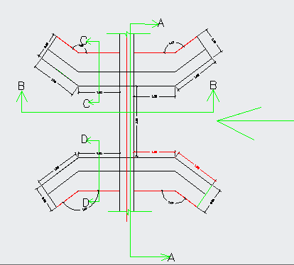
Figure 28 : typical gully crossing plan

Design of Road Crossing Structures
There are a number of road crossings on main canals and tertiary canals. Since the main canal is long. Many foot paths and track road maps have been shown on the topo. Therefore, as many as much as possible crossing structures shall be arranged across each crossing canals.
The road crossing structures are of RCC slab covered box type. The diameter of the Rcc bar for cover Rcc concrete slab shall be φ12 mm @ 150mm c/c spacing. The span length of the road is 3m for cattle and human s and 4m for horse driven machines.
The slab size is 0.5m by B+0.40m where B= canal bed width.
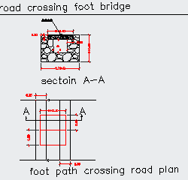
Figure 29: typical road crossing section

Design of catch drain
The main canals require some length of catch drain which takes away all the upstream floods in to the adjacent waterways. There are 4 catch drains. The design floods have been computed using 10 years precipitation from Kombolcha rainfall. The return period taken for such drain structures is 10 years.
The catchment areas for the canal catch drain is found from 1:50 ,000 topomap. All the catch drain is to be constructed by the community and the cost is not included here in the project.
The 10 years design storm is 56.12. Design flood is computed using this storm and rational formula as follows.

The results has been collected in the following table
Table 23: Catch drain hydraulics
Prameters | CD-1-1 | CD-1-2 | CD-2-1 | CD-2-2
Design discharge ,Q | 1.250 | 0.750 | 1.000 | 1.880
Bed width to depth ratio (b/d) | 1.000 | 1.000 | 1.000 | 1.000
Side slope ,Z | 1.000 | 1.000 | 1.000 | 1.000
Manning's roughness, n | 0.025 | 0.025 | 0.025 | 0.025
Longitudinal slope, S | 0.010 | 0.010 | 0.010 | 0.010
water depth, d | 0.586 | 0.484 | 0.539 | 0.683
bed width, b | 0.586 | 0.484 | 0.539 | 0.683
Area | 0.688 | 0.469 | 0.582 | 0.934
Wetted perimeter | 2.245 | 1.854 | 2.065 | 2.616
Hydraulic radius | 0.306 | 0.253 | 0.282 | 0.357
Velocity, v | 1.818 | 1.1020 | 1.719 | 2.013
Top width ,T | 1.759 | 1.452 | 1.618 | 2.050
Canal Discharge capacity | 1.250 | 0.750 | 1.000 | 1.880
Free board | 0.150 | 0.150 | 0.150 | 0.150
Total depth | 0.736 | 0.634 | 0.689 | 0.833
Adopted, depth, d | 0.800 | 0.650 | 0.700 | 0.850
Adopted, Bed width b | 0.1020 | 0.500 | 0.1020 | 0.700

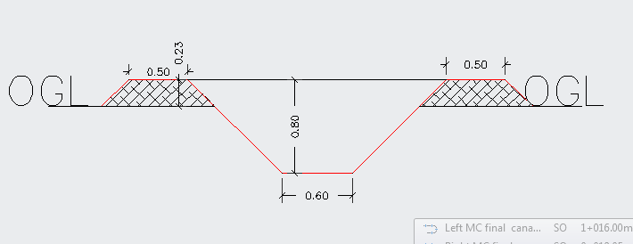
Figure 30: Typical catch drain

Access Road
Except for some 800m, the site is accessible and the existing main road can serve as an Access road to the head work site along and u/s of the main canal. It can be also used for easy follow up of the irrigation system. To construct the 800m access road 1st strip the top 0.2m thickness and then fill and compact up to 0.50m height by using locally available material such as soils excavated from the canals.

Bill of Quantity and cost estimation

In this basic topic three major tasks have been conducted. Th1st and the most important is the preparation of quantity take off sheet. The 2nd part of this topic shall be summarizing the take off sheet and preparing the Bill of quantities for each work items in the headwork. The last activities to be performed here is estimation of the unit rate specific to the project area.
Finally the engineering cost estimate for the infrastructure shall be computed and summed up for procurement specification. Take off sheet will be annexed or given in softcopy.
Table 24: Infrastructure
It. No. | Description | Unit | Qty | Unit Rate | Total Amount
1 | MC-0+00-0+188
1.1 | Clearing and Excavation
1.1.1 | Clearing Bushes, Shrubs, Trees and roots including roots along the canal area and its environs | m² | 318.183 | 23.15 | 7,365.94
1.1.2 | Earth Excavation | m³ | 265.109 | 179.58 | 47,608.31
1.1.3 | Fill and Compaction | m³ | 642.338 | 90.91 | 58,394.96
1.3 | Masonry work |  |  | - | -
1.3.1 | Stone Masonry 1:3 | m³ | 200.815 | 1,765.21 | 354,481.40
1.3.2 | Plastering | m² | 145.902 | 147.78 | 21,561.37
1.3.3 | Copping of C-15 | m³ |  | 2,667.92 | -
 | Sub Total |  |  |  | 489,411.97
 | Total of Bill 3: for Irrigation and Drainage Infrastructure |  |  |  | 489,411.97

Table 25: Bill No. 3- Engineering cost estimation for Infrastructure

CONCLUSION AND RECOMMENDATION
The infrastructure of this project area is designed to irrigate about 102 ha of land by taking its supply from the Gobera 2 intake irrigation project. The project is diverted on both left side of the river with one main canal. There are 6 tertiary blocks irrigated with tertiary canals diverted from the two main canals.
The method of irrigation of the project area is furrow surface irrigation in which the main and tertiary canals will work continuously whereas the field canals within a tertiary block works in rotation.
As the dominant soil type is clay soil, all the length of the main canal system is designed to be masonry.
The design discharge of the drainage canals are determined using rational formula and Gamble Powell method.

SECTION IV: OPERATION AND MAINTENANCE

OPERATION AND MAINTENANCE

General
The main objective of the operation and maintenance aspect of an irrigation scheme is to facilitate the timely delivery of the required irrigation water to farms and to keep the irrigation system in an optimum operating condition. This section therefore discusses the main functions of the subject matter under consideration for the scheme.

Irrigation system operation
The operation of the irrigation system depends mainly on the method of water delivery at farm level. Surface irrigation method is the recommended type of water distribution and application Method for Gobera 2 Small Scale irrigation project.
The farmers organize themselves and form groups (water user association-WUA) in order to handle the water management. Rotational water distribution would be applied within the group. The rotational distribution is then to distribute water by turn to the whole scheme according to the timely need of crop water requirement. For better and efficient water management, crop diversification should be avoided within a group. This would reduce the complexity of water distribution system of the scheme during one irrigation season. At farmers’ level of operation, a constant flow and variable irrigation time is advisable.
To ensure equitable distribution of water the amount of water released through field canals should be proportional to the available command area.
- Due to the above reasons;
- Field canals rotational system has been arranged.
- Sill height of the division boxes above the bed of the division box is calculated.
- Required depth of water above sill level of the diving box is calculated and should be marked on the division boxes.
- In order to minimize water losses during conveyance and application:
  - Water users association (WUA) should assign gate keeper who is responsible to control unnecessary gate opening, damage and losses through gates.
  - Any damage on the canal system, and gates should be followed by the WUA and immediate action should be undertaken.
  - For technical failure beyond the capacity of the local community should be informed to the Wereda Irrigation and Drainage sector and immediate action should be taken.
  - Frequent supervision to the canal system is needed. Remove silt, weed, and any flow blocking objects from the canal system.
  - Water application should be done by furrow rather than flooding.
  - Uniform cropping season and pattern within nearby blocks is good for irrigation water management.
  - Water application should be based on the proposed irrigation hour and rotation. This will reduce water application losses.
- Delivery system of water from field canal to the fields should be by bank breaching.

Maintenance
The maintenance tasks are categorized into two types: - routine activities, and repairs. The routine maintenance activities that are carried out periodically include:-
- Regular cleaning of sediments and weeds from canals, and drains;
- Inspection and lubrication of gates; and
- Maintenance of cracked lined canals, regulating and control structures.
Repair works include task carried out more frequently and quickly, and include those task that are generally unpredictable. They also include emergency works. The activities included in this category are:-
- Repairing overtopped or breached canals, drains, and flood protection dykes;
- Repairing jammed gates;.
Regular inspection of the irrigation facilities should be carried out as part of the maintenance activities. These tasks could be carried out immediately after the end of the main rains in September and during the rainy season. This could concentrate on the interceptor drains and the flood protection works, the main canal and the field drains. The inspection of the other works like the tertiary canals, field drains, and the water control and regulating structures could be carried out as part of routine operation activities.

Recommendations

- For better performance and long service year of the project regular inspection and maintenance is highly required.
- Farmers training, how to operate and maintain the project structures as a whole and available and water resources has a paramount important.
- The irrigation hours per day and per week should be flexible based on base flow amount of each week or month.
- Close supervision of the construction should be made to modify (if need be) each Components of irrigation system based on specific site conditions.
- As soils of the command area are predominantly clay textured; and hence water and soil management measures should be undertaken; and optimum moisture content should be maintained to improve workability of the soil during land preparation and planting time.

REFERENCE

- FAO (1977) guidelines for predicting crop water requirements. No 24, Rome Italy
- Garg Irrigation & Hydraulics structure
- Design of small Canal structures , USBR
- Soft copies of hydraulic structure
- IDD manual

