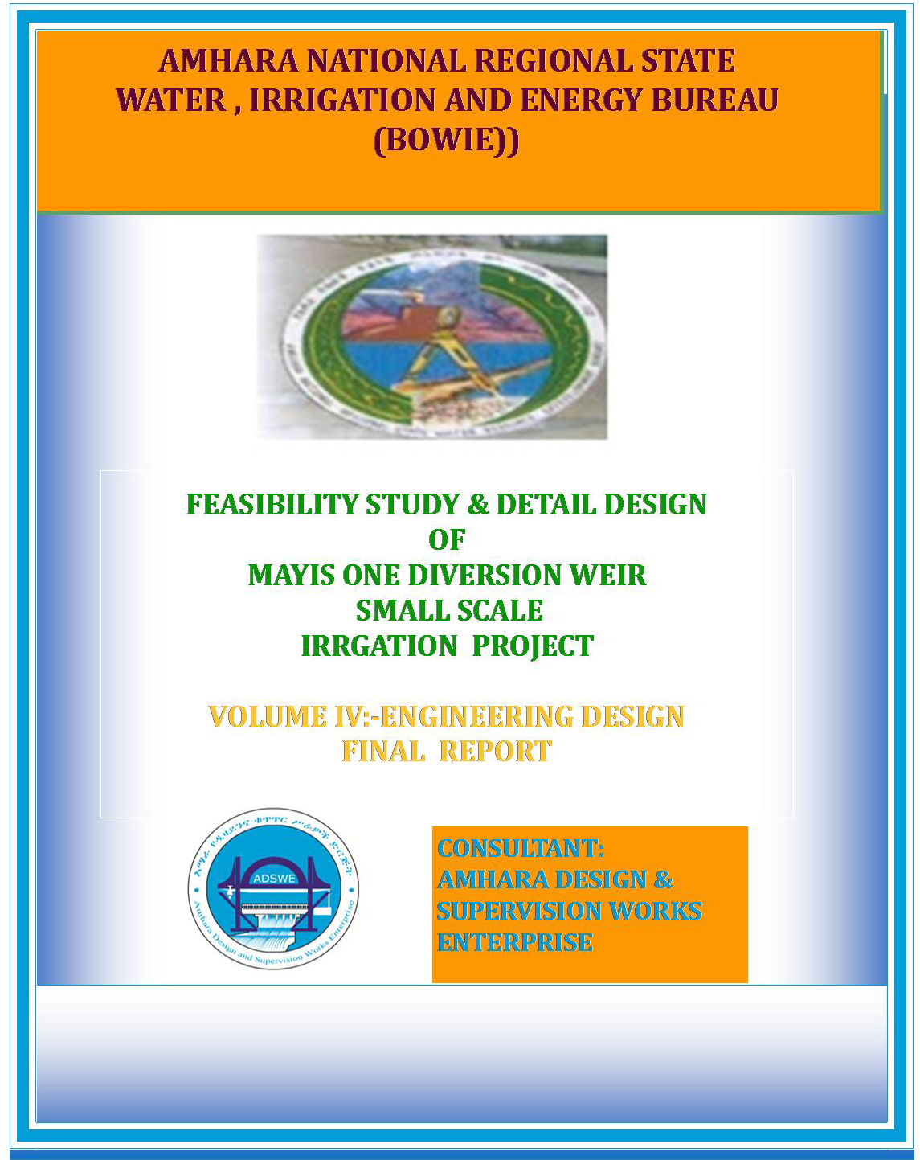

Amhara National Regional State
Water, Irrigation and Energy Development Bureau
(BOWIED)

Feasibility Study and Detail Design
Of
Mayis One Diversion weir small Scale Irrigation Project

Engineering Design Final Report
October, 2018
Dessie, Ethiopia
Client: Amhara National Regional State Water, Irrigation and Energy Development Bureau (ANRS WIEB)
Address:
P.O.Box: 88
Telephone: 0528-200853/855
Fax: 251-08-20-65-68/204676/202040
Bahirdar, Ethiopia
Consultant: Amhara Design & Supervision Works Enterprise Eastern Amhara Branch Office (E/ADSWE)
Address:
P.O.Box: 1921
Telephone: +251-333-124954
Fax: (033) 3124954
E-mail: amhara design@yahoo.com
Dessie, Ethiopia

Table of Content
Table of Contents
Table of Content i
List of Table v
List of Figure vi
SAILENT FEATURE vii
1 INTRODUCTION 1
1.1 Background 1
1.1.1 Description of the Project Area 1
1.1.1.1 Location 1
1.1.1.2 Accessibility 2
1.2 Objectives of the Study 2
1.2.1 Major Objective 2
1.2.2 Specific Objectives 3
1.3 Scope of the Study 4
1.4 Methodology 4
SECTION-I: HYDROLOGY 6
2 HYDROLOGY 7
2.1 Watershed Characteristics 7
2.2 Hydro-Metrological Data Availability 8
2.2.1 Climate 8
2.2.2 Rainfall Data 9
2.2.3 River flow data 9
2.2.4 Upstream & Downstream utilization 9
2.3 Design Flood Analysis 9
2.3.1 Outlier Test 10
2.3.2 Check for variance 10
2.3.3 D-Index test 11
2.3.4 Design Rainfall computation 12
2.4 Peak Discharge Determination 13
2.4.1 General 13
2.4.2 Peak flood analysis by SCS unit hydrograph method 13
2.4.2.1 Time of concentration (Tc) 13
2.4.2.2 Curve number (CN) 14
2.4.2.3 Area Rainfall 14
2.4.2.4 Run off Analysis 15
2.4.3 Tail Water Depth Computation 17
SECTION-II: HEAD WORK DESIG 20
3 HEADWORK STRUCTURES DESIGN 21
3.1 Headwork Site Selection 21
3.2 River Geomorphology 23
3.2.1 River Bed condition 23
3.2.2 River Bank condition 25
3.2.2.1 Right Bank 25
3.2.2.2 Left Bank 25
3.3 Sources of Construction Materials 26
3.3.1 Rock for Masonry and Crushed Coarse Aggregate 26
3.3.2 Fine Aggregates 27
3.3.3 Water 28
3.4 Headwork Type Selection 28
3.4.1 Hydraulic Design of Headwork Structure 28
3.4.1.1 Weir Height Determination 28
3.4.1.2 Weir Dimensions 29
3.4.2 U/S and D/S HFL Calculation & Determination 33
3.4.3 Hydraulic Jump Calculation 34
3.4.4 Impervious floor 35
3.4.4.1 D/s impervious floor (Ld) 35
3.4.4.2 U/S Impervious Floor Length, (Lu) 36
3.4.5 Floor thickness 36
3.4.5.1 Upstream floor thickness 36
3.4.5.2 Downstream floor thickness 36
3.4.6 Cut off Depth Calculation 37
3.4.6.1 U/s cut off 37
3.4.6.2 D/s cut off 37
3.4.7 Stability Analysis of weir 38
3.4.8 Design of Divide wall, Under Sluice, and Canal outlet 39
3.4.8.1 Wall height fixation of Divide Wall 40
3.4.8.2 Under sluice 41
3.4.8.3 Canal outlet level 42
3.4.8.4 Breast Wall and Operation Slab 43
3.4.8.5 Trash Rack 44
3.4.8.6 Retaining Walls 44
3.5 Bill of Quantity and Cost Estimation 47
SECTION-III: IRRIGATION AND DRAINAGE SYSTEMS 54
4 IRRIGATION AND DRAINAGE SYSTEMS DESIGN 55
4.1 Irrigable Area Description 55
4.1.1 Topography 55
4.1.2 Climate 55
4.1.3 Main Canal Route Geology 56
4.1.4 Soil characteristics 59
4.1.5 Existing Irrigation Practices in the Project Area 59
4.2 Irrigation Water Requirement 59
4.2.1 Crop Water Requirement (CWR) 59
4.2.2 Irrigation efficiency (Ep) 59
4.2.3 Irrigation duty 60
4.2.4 Irrigation methods 62
4.2.5 Irrigation schedule (IS) 62
4.3 Irrigation and Drainage System Layout 64
4.3.1 Conveyance System 64
4.4 Design of the Canal System 64
4.4.1 Main Canal 65
4.4.2 Pipe out lets 66
1.4.3 Secondary Canals 67
4.4.3 Tertiary canals 69
4.4.4 Field Canals 70
4.4.5 Chute structures at Canals 70
4.5 Drainage Canals 71
4.5.1 Drainage Canals 71
4.5.2 Field drainage canals 71
4.5.3 Escape canal 72
4.6 Canal Structures Design 72
4.6.1 Design of a typical flume 72
4.6.1.1 Hydrologic Characteristics of flume 73
4.6.1.2 Hydraulic Characteristics of flume 74
4.6.1.3 Structural Characteristics of flume 75
4.6.2 Design of slab cover 77
4.6.3 Design of Division box 78
4.6.4 Design of drop structure 80
4.6.5 Road crossing structure 81
4.6.6 Design of footpath structure 82
4.7 Irrigation Infrastructure Bill of Quantities and Cost Estimate 83
4.8 Summary of Bills 87
5 CONCLUSION AND RECOMMENDATION 88
6 OPERATION AND MAINTENANCE 89
6.1 General 89
6.2 Operation of the Head Works 89
6.3 Irrigation System Operation 89
6.4 Maintenance Requirement 90
REFERENCE 92

List of Table
Table 2-1 Slope class 7
Table 2-2 Watershed Feasibility Study Report 7
Table 2-3 Outlier Test Analysis 10
Table 2-4 Test for goodness to fit using D-index 11
Table 2-5 Determination of Time of Concentration 13
Table 2-6 Runoff analysis 15
Table 2-7 Hydrograph coordinates 16
Table 2-8: Weir Site River Cross section Coordinate Data 17
Table 2-9 Stage discharge analysis 18
Table 3-1Weir Height Determination 29
Table 3-2: D/S face profile Coordinates of (X, Y) 32
Table 3-3: U/S face profile coordinates(X,Y) 32
Table 3-4 Weir Stability Analysis 38
Table 3-5 Divide wall Stability Analysis 41
Table 3-6 Upstream retaining wall stability analysis 45
Table 3-7 Downstream retaining wall stability analysis 45
Table 3-8 General Items BOQ 47
Table 3-9 Head Work BOQ 48
Table 4-1:- Irrigation intervals for the dry season proposed crops 63
Table 4-2: Hydraulic Parameters of main canal 65
Table 4-3: hydraulic parameters of pipe out let at main canal 66
Table 4-4 Hydraulic parameters of secondary canals 68
Table 4-5 hydraulic parameter of tertiary canals 69
Table 4-6 hydraulic parameter of chutes structures 70
Table 4-7 hydraulic parameter of escape canals 72
Table 4-8 GIS output data for flume hydrology 73
Table 4-9 hydrologic parameter of gully crossing structures 74
Table 4-10: Hydraulic Parameters of Flume 74
Table 4-11: Hydraulic Parameters of cover slab 77
Table 4-12: Hydraulic parameters of Division Boxes 80
Table 4-13: Hydraulic parameters of drop 81
Table 4-14: Hydraulic parameters of drop 81
Table 4-15: Hydraulic parameters of drop 82
Table 4-16 Infrastructure bill of quantity 83
Table 4-17 summery of bills 87

List of Figure
Figure 1-1 Location map of the project area 2
Figure 2-1 Drainage map of Mayis One watershed 8
Figure 2-2 Complex Hydrograph 16
Figure 2-3 River Profile 18
Figure 2-4 Rating Curve 19
Figure 3-1 Head work axis options 22
Figure 3-2 River bed at the proposed weir site 24
Figure 3-3 Geological x-section of Mayis head work one 26
Figure 3-4 Rock Quarry Site 27
Figure 3-5 Weir Section 34
Figure 4-1: Typical Cross Section of pipe out lets at main canal 67
Figure 4-2:- typical cross section of secondary canals 68
Figure 4-3:- typical cross section of tertiary canals 69
Figure 4-4: Typical Field Canal X-section 70
Figure 4-5: Typical chute Canal X-section 71
Figure 4-6: Typical Escape Canal X-section 72
Figure 4-7 live load in the flume (water load) & Figure 4-8 service bending moment 76
Figure 4-9 shear strength & Figure 4-10 shear BM 76
Figure 4-11 peir cap cross section 77
Figure 4-12: Typical Division Box plan 78
Figure 4-13: Typical Division Box plan 80
Figure 4-14: Typical Division Box plan 82

SAILENT FEATURE
- Project name: Mayis One Diversion weir small scale Irrigation Project
- Name of the stream: Mayis river
- Location of the weir site using
- Head work
Northing- 1210345m
Easting-471870m
Altitude-2684m
- Zone: South Wollo
- Wereda: Mehal sayint Wereda
- Didin kebel
- Hydrology
- Design rainfall: 77.551 mm
- Catchment area: 18.42 Km²
- Longest flow path length: 9.01 Km
- Design flood: 59.54 m³/sec
- weir
- weir type: ogee shape cyclopean weir with RC capping
- Height: 2 m
- Gross crest length: 12 m
- Crest level:2686.1m.a.s.l, U/S HFL-1=2690.1m.a.s.l & D/S HFL=2688.59m.a.s.l
- Outlet
- Sill level: 2685.46 m.a.s.l
- Opening dimension: 0.7*0.6 m²
- Discharge capacity: 209.16lit/sec.

- Irrigation and drainage systems Infrastructure
- Command area size: 148.448 ha in left and 23ha in the right
- Type of soil of the command area is dominantly clay loam soil
- Design discharge of the main canal = 181.1 L/sec
- Irrigation system layout consists of 1 lined main canal and 8 lined secondary canal 32 lined tertiary canals
- Main irrigation structures designed are;
- Road crossing structures =1
- cattle crossing =11
- Flumes=8
- division box=24 & drop = 14
- supper passage=1
- Project cost

Mays-1 Irrigation Project Summary of Cost
Bill No | Description | Amount
Bill No 1 | General Items | 3,105,320.68
Bill No 2 | Head Work | 4,198,307.24
Bill No 3 | Infrastructure | 27,076,821.22
Total Before VAT |  | 34,380,449.15
VAT (15%) |  | 5,157,067.37
Total With VAT |  | 39,537,516.52
Command Area, ha |  | 171.45
Cost per ha |  | 200,527.55

INTRODUCTION

Background
In Ethiopia, under the prevalent rain-fed agricultural production system, the progressive degradation of the natural resource base, especially in highly vulnerable areas of the highlands coupled with climate variability have aggravated the incidence of poverty and food insecurity. The major source of growth for Ethiopia is still conceived to be the agriculture sector. Hence, this sector has to be insulated from drought shocks through enhanced utilization of the water resource potential of the country, (through development of small-scale irrigation, water harvesting, and on-farm diversification) coupled with strengthened linkages between agriculture and industry (agro-industry), thereby creating a demand for agricultural output. In line with the above, efforts have been made by the government to improve the situation in the country in areas of domestic water supply provision, irrigation, watershed management, etc. The Amhara Water Resources Development Bureau is playing its role in the development of small scale irrigation projects in the region. Accordingly, as part of the water sector development program, the office has initiated the study and design of a small scale irrigation scheme on Mayis River at Didin Kebele and signed an agreement with Amhara Design & Supervision Works Enterprise (ADSWE) for the study and design of the project.

Description of the Project Area

Location
This irrigation project is located mainly at Didin Kebele, Mehal Sayint Woreda of South wollo Zone in the Amhara Regional state. The proposed irrigation project is to be undertaken on Mayis River and the headwork structures are specifically located at the center of the weir axis.
The geographic coordinate of the weir site is:
Northing: 1210340.560m
Easting: 471864.620m
Altitude: 2684.09 m a.s.l
The graphical location of the project area has been described with the following figure

Figure 1-1 Location map of the project area

Accessibility
The project area is accessed through Dry Weather road 9Km from Mehal Sayint Woreda Town and 4Km needs access road up to the head work site.

Objectives of the Study

Major Objective
The project area faces variability of rainfall distribution though the overall rainfall generally suffices the rain-fed agriculture. Accordingly, the rain-fed agriculture needs means of supplementing during distribution failures and further full irrigation is required to maximize the use of the potential land and water resources.
Hence the objective of this project is to contribute a substantial share in the effort to reduce the risk of production decrease due to rainfall variability and increase the productivity of the resource in the project specific area. Specifically, the project is targeted for the following.
- To make sustainable the rain-fed crop production and make extra production in the Supplementary season possible for 148.448 ha and 27.3ha from the left and right side of land through irrigation.
- There is a general consensus that irrigation investments will achieve broader food security and poverty reduction impacts and if efforts are also geared towards up-grading existing traditional farming practices with support to enhance access to input supply, output marketing and extension to facilitate access to information and innovations.
- This objective is to be realized by constructing diversion Weir structures across the Mayis River and diverting the river flow.

Specific Objectives
Other benefits that can be expected to appear with the launching of the project are:
- Efficiency of water use improvement;
- Improved local nutrition/food security gains;
- Improved management of scarce natural resources (land and water);
- Resilience against drought risk;
- Rationale for erosion control and watershed management;
- Rationale for the intensification and modernization of small-holder agriculture and rural life styles.
The engineering study and design enables the realization of the project by the provision of engineering structures that will allow the appropriate abstraction of the river water for delivery in to the identified irrigation fields of the study area. Hence, this engineering design is specifically targeted to:
- Analyze hydrologic requirements of the project and engineering structures;
- The formulation of sound and stable structure, with necessary provisions that allow safe, easy and low-maintenance operation in the service life of the project;
- Develop working drawings;
- Estimation of construction costs.

Scope of the Study
- The irrigation design shall ensure reliability, equity and flexibility of water delivery to farmers. It will aim at reducing conflicts among water users and will lead to lower operation and maintenance costs.
- Updating the existing, if available, computation of the actual evapo-transpiration, crop water requirement, irrigation demand/duty using the existing and recent agronomic, climatologic and soil data using more appropriate methodologies.
- Establish design criteria for irrigations structures to be approved by the client and to be used in the final design stage,
- Design proper irrigation system compatible with local conditions and management capabilities,
- Establish flood protection measures for the command area and canal structures and design the respective drainage system accordingly,
- Planning and layout of the irrigation system, which include irrigation canals, drainage channels, inspection roads and alignments, canal spacing, canal length, location of structures, and water profiles along canal and drains at specified reaches, which is most economical easily manageable and aligned with topographic feature and geological investigation.
- Determination and estimation of water application conveyance and other losses and irrigation efficiencies and consideration of those parameters in design steps.
- Check and test hydraulic and structural designs of main canal considering total demand and the required capacity and the base flow availability,
- Prepare general plans and drawings for all irrigation infrastructure and irrigation systems designs,

Methodology
In the study and design procedure, Designers used the following steps.
- Specific Site identification:
  - Review of the reconnaissance survey conducted by the Client
  - 50,000 scale top map and GIS information
  - Local farmers interview and discussion
  - Woreda and Zone Agriculture section expertise
  - Previous studies
  - On foot travel along the river channel and farm areas.
- Topographic survey:
  - Surveying the headwork site and the Command area with sufficient radius, using Total station
- Flow estimation
  - Physical observation on flood mark indications and local information about high flood and critical flow condition of the river
  - Analyzing the recorded river flow data and use watershed inputs for further analysis.
  - Base flow estimated during the reconnaissance field visit by floating method.
- Irrigable area identification:
  - Using local information
  - 50,000 Topographic map, and GIS information, GPS to see elevation
The design report is organized in three sections. In Section I the Hydrology study is presented and in Sections II and III the Headwork and Irrigation and Drainage Systems designs are discussed respectively. In Section III, planning and design of the irrigation system after diverting the water using the weir will be dealt. The following are major areas of concern in this part.
- Study and design of the irrigation method to be adopted,
- Study and design of the irrigation system layout and associated structures,
- Design of the different conveyance canals,
- Planning and design of the different irrigation and drainage structures,
- Preparation of the longitudinal profiles of the different irrigation and drainage canals.

SECTION-I: HYDROLOGY

HYDROLOGY

Watershed Characteristics
The topographic feature of Mayis one Watershed encompasses all types of slop classes from flat to steep slope. The dominant slope classes are moderately steep (15-30%), slopping (8—15%) steep (30-50%) 50.12%, 23.19% and 17.20% of the total area of a watershed respectively. The rest gently slopes, flat and steep area sharing 6.63%, 2.32% and 0.56 % of the total area of the watershed respectively.
Table 2-1 Slope class
No | Slope  Slope Class (%) |  | Area Coverage
No | Description | Class (%) | Hectare (ha) | Proportion (%)
1 | Flat or almost flat | 0--35 | 10.24 | 0.56
2 | Gently sloping | 3--8% | 122.01 | 6.63
3 | Sloping | 8--15% | 426.8 | 23.19
4 | Moderately steep | 15--30% | 922.54 | 50.12
5 | Steep | 30--50% | 316.58 | 17.20
6 | Very steep | >50% | 42.77 | 2.32
Certain physical properties of watersheds significantly affect the characteristics of the runoff and sediment yield and are of great interest in hydrologic analyses. The rate and volume of runoff, and sediment yield from the watershed have much to do with shape, size, slope and other parameters of the landscape. These suggest that there should be some important relations between basin form and hydrologic performance. If the basin and hydrologic characteristics are to be related, the basin form must also be represented by quantitative descriptors. These parameters can be measured from maps.
Table 2-2 Watershed Feasibility Study Report
General information’s | Value
Watershed area (Km2) | 18.42
Longest flow path (LFP) km | 9.01
Time of concentration | 1.39
Average curve number value(II) | 74.52
At the selected reference point, the area of Mayis catchment is 18.42km² .Mayis River at the headwork site is characterized by well-defined channel system and considerable flows. It looks that the gradient of the stream is getting medium and hence there exists significant deposition of sediment mainly gravels with sand and boulders.
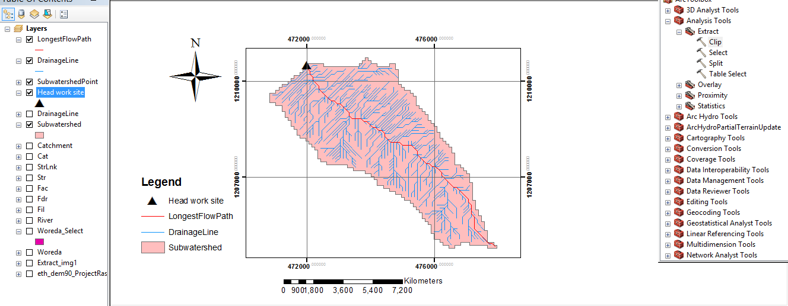
Figure 2-1 Drainage map of Mayis One watershed

Hydro-Metrological Data Availability

Climate
Small scale irrigation project designers and planners are faced with lack of good data on the hydrology of the river system that will be their water source and on local weather and climate conditions. Stream gauging stations are virtually non-existent in remote rural areas of Ethiopia; meteorological stations are almost rare. Likewise, at Didin Kebele and in the catchment area of this project there is no meteorological station of any level. Moreover, there are no flow data for the river near the project. Therefore, data for the hydro-meteorological analysis is taken from the nearby station and similar areas. Rainfall data are considered from Saint Ajibar Meteorological station. In fact, this station is very close to the project area. The mean annual rainfall amount is more than 22.6mm (1995 - 2011data) and most of it occurs from July to October.

Rainfall Data
In order to compute the design flood for the Weir structure, the daily maximum rainfall is collected from Saint Ajibar Metrological stations with a record of 16 years.

River flow data
The base flow at Weir site by Floating method measured is 73 l/s. Since this base flow is measured during the dry months of the year, this figure is adopted for design.

Upstream & Downstream utilization
Downstream of the proposed site, appreciable need for water is anticipated for locals and cattle provisions. Therefore, the flow has to be released for downstream by considering Mayis one and Mayis two water balance.
- Base flow =205 l/s
- Tributary (From Spring Sources) =base flow at mayis-2- base flow at mayis-1
=205-73 = 132 l/s
- Net command area=72.45ha
- Duty = 1.22 l/s/ha
- Design discharge = 72.45ha*1.22 l/s/ha=88.389l/s
- Remaining discharge at mayis-2
=132-88.39 = 43.611l/s
At head work one downstream release is not necessary because less than 1km there is spring water source. From head work two the remaining discharge is sufficient for downstream users.

Design Flood Analysis
For the design and analysis of structures to be constructed on the river, estimation of flood magnitude is an important task. This can be done using different techniques depending on the data available. For this particular case, there are no river flow data and hence the flood estimation is done using the rainfall data and applying SCS Curve Method.

Outlier Test
Higher Limit,$Y_{H}=Ymean+Kn*Sy$, Kn = 2.278 for 16 Years of data.
Lower Limit,$Y_{H}=Ymean-Kn*Sy$, Kn = 2.278 for 16 Years of data.
Table 2-3 Outlier Test Analysis
Year | Daily heaviest Rain Fall (mm) | Descending Order | Logarithmic Value/Yo/  Higher Limit, YH = 1.86  Lower Limit, YL = 1.29  Therefore,  Upper limit of rainfall = 10^1.86= 73.16mm  Lower Limit of rainfall = 10^ 1.29=19.34mm  Conclusion: The rainfall values are within the limits.
1996 | 40.5 | 67.2 | 1.83
1997 | 46 | 57 | 1.76
1998 | 30.3 | 52.3 | 1.72
1999 | 39.6 | 46 | 1.66
2000 | 27.6 | 41.7 | 1.62
2001 | 28.2 | 40.5 | 1.61
2002 | 22.6 | 39.6 | 1.60
2003 | 57 | 39.4 | 1.60
2004 | 39.4 | 38.1 | 1.58
2005 | 29.2 | 37 | 1.57
2006 | 37 | 30.3 | 1.48
2007 | 52.3 | 30.1 | 1.48
2008 | 67.2 | 29.2 | 1.47
2009 | 38.1 | 28.2 | 1.45
2010 | 30.1 | 27.6 | 1.44
2011 | 41.7 | 22.6 | 1.35
SUM |  | 626.80 | 25.21
MEAN |  | 39.18 | 1.58
STANDARD DEVATION |  | 11.91 | 0.13
SKEWNESS COEFICIENT |  | 0.92 | 0.28

Check for variance
After checking the outliers, the data should be checked for variability. For variability the formula used is $α=\left(\frac{δ_{∩-1}}{\sqrt{N}*Mean}\right)*100\%$
Where, δ_{n-1 =} Standard deviation =11.91
N = No of recorded data =16
M_{ean} = 39.18
$α$ = Standard error
$α=\left(\frac{11.91}{\sqrt{16}*39.18}\right)*100\%=7.59<10\%$ Acceptable
Therefore the data is adequate and consistence.

D-Index test
After checking the consistency of the data for higher and lower outlier, the 16 years data is obtained as representative for the analysis using D-index. The D-Index test is believed to be the better goodness to fitness in many literatures. Hence in this study it was used to determine the best statistical distribution to estimate the peak rainfall. The D-index for the comparison of the fit of various distributions is summarized as follows.
$D_{-Index}=(\frac{1}{X_{m}})*\sum_{i=1}^{6}{Abs(Xi-{Xi}^{'})}$
Where Xi and Xi’ are the i^{th} highest observed and computed values for the distribution respectively
Table 2-4 Test for goodness to fit using D-index
Rank | XI | Normal | Log Pearson Type III | Log Normal | Pearson Type III | Gumbel EVI | Gumbel
 |  | XI -'XI' | XI -'XI' | XI -'XI' | XI -'XI' | XI -'XI' | XI -'XI'
1 | 67.2 | 9.39 | 6.71 | 7.80 | 7.32 | 7.36 | 2.11
2 | 57 | 3.69 | 3.58 | 3.81 | 3.47 | 3.89 | 0.14
3 | 52.3 | 2.07 | 3.11 | 2.97 | 2.75 | 3.27 | 0.42
4 | 46 | 1.76 | 0.09 | 0.43 | 0.54 | 0.03 | 2.22
5 | 41.7 | 3.92 | 1.90 | 2.35 | 2.37 | 1.91 | 3.55
6 | 40.5 | 3.16 | 0.99 | 1.49 | 1.43 | 1.04 | 2.22
Sum |  | 23.994 | 16.382 | 18.845 | 17.872 | 17.499 | 10.661
D_index |  | 0.612 | 0.418 | 0.481 | 0.456 | 0.418 | 0.272
Point Rainfall |  | 63.63 | 71.48 | 68.52 | 65.36 | 70.04 | 77.55
Design Point Rainfall |  | 77.55

All the candidate distributions give almost identical correlation coefficients. However, the standard errors are significantly lower for the Gumbel’s Method which is 0.27. Accordingly, the design rain for this distribution has been selected as the best fit for this study.

Design Rainfall computation
Based on the data of 24hr peak rainfall given in Table 2-4 the design rainfall, RF is computed using Gumble’s Method.
The design rainfall using Gumbel Method is given as
Where R_{f} = Design rainfall
R_{mean} = average of all values of annual heaviest fall = 39.18mm
σ_{n-1} = standard deviation of the series = 11.91 mm
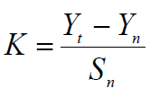
, T= Return period = 50 years
Yn, Sn = constant found from Gumble’s extreme value distribution table for N= 16 Years
- Yn = 0.52 and Sn = 1.05
- Point Design Rainfall = 77.55 mm
The design rainfall at points for 50 years return period is 77.55mm and the areal design rainfall is calculated in the following section.

Peak Discharge Determination

General
The River is not gauged river. The design flood is calculated by using SCS unit hydrograph method and flood mark method. Thus, it is preferred to base the flood analysis on rainfall data, which are better both in quantity and quality of data. In the hydrologic analysis for drainage structures, it must be recognized that there are many variable factors that affect floods. Some of the factors that need be recognized and considered on an individual site by site basis are; rainfall amount and storm distribution; catchment area, shape and orientation; ground cover; type of soil; slopes of terrain and stream(S); antecedent moisture condition; Storage potential (over bank, ponds, wetlands, reservoirs, channel, etc.)

Peak flood analysis by SCS unit hydrograph method
Design flood is calculated SCS (The United States Soil Conservation Service). This method is widely adopted and more reliable method for flood estimation. The approach considers, watershed parameters, like Area, Curve number, and time of concentration.

Time of concentration (Tc)
Time of concentration has been calculated by taking the stream profile of the longest streamline and dividing it in to different elevation. Kirpich formula is adopted for computation.
Table 2-5 Determination of Time of Concentration
Reach | Length(km) | Elevation | Eliv-difference | Slope | Tc
0 | 0 | 3430 | 0 | 0.000 | 0
1 | 1.26 | 3280 | 150 | 0.119 | 0.18
2 | 1.62 | 3060 | 220 | 0.136 | 0.21
3 | 2.5 | 2920 | 140 | 0.056 | 0.41
4 | 2.61 | 2740 | 180 | 0.069 | 0.39
5 | 1.02 | 2684 | 56 | 0.055 | 0.21
Total | 9.01 |  |  |  | 1.39

The formula is,
$Tc=\sum{0.948\left\{{\left(\frac{{L_{1}}^{3}}{H_{1}}\right)}^{0.385}+{\left(\frac{{L_{2}}^{3}}{H_{2}}\right)}^{0.385}+…+{\left(\frac{{L_{n}}^{3}}{H_{n}}\right)}^{0.385}\right\}}$
- Tc = 1.39 Since Tc < 3hr., duration of excess rainfall difference, D = 0.5.
- Time to peak,
$T_{p=}\frac{D}{2}+0.6*T_{c}$ = 1hr
- Base time,
$T_{b}=2.67*T_{p}$ = 3hr
- Recession time,
$T_{r}=1.67*T_{p}$ = 1.6hr.

Curve number (CN)
Curve number (CN) is achieved based on USSCS method by watershed characterization in terms of land cover, treatment, hydrologic condition and soil group. From the watershed analysis curve number at condition II =74.52. Since peak rainfall is found at an antecedent moisture condition III state, this value has to be changed to antecedent moisture condition III.
- Conversion factor = 1.190
- CN Condition (III) = (Factor from Table x CN condition II) =74.52*1.190 = 88.48. For detail analysis of the computation, Refer Excel file,

Area Rainfall
As the area of the catchment gets larger, coincidence of all hydrological incidences becomes less and less. This can be optimized by changing the calculated point rainfall to aerial rainfall. The conversion factor is taken from standard table that relate directly with the size of watershed area and type of the gauging station. (IDD manual)
For the case of Mayis irrigation project,
- Total watershed area = 18.42 Km²
- Type of gauging station = Daily rainfall (24 hr.)
- Areal Rainfall = (Point Rainfall) x (Conversion factor)

Run off Analysis
Input data:
Design Point Rainfall = 77.55mm
Curve number at antecedent moisture condition III = 88.48
Catchment Area, A = 18.42 Km²
Tc = 1.39hr, D = 0.5hr., Tp = 1 hr; Tb = 3hr; Tr = 1.6 hr.
Direct run-off,
$Q=\frac{{(I-0.2*S)}^{2}}{(I+0.8*S)}$
Where, I = Rearranged cumulative run-off depth (mm
S = Maximum run off potential difference,
$S=\left(\frac{25400}{CN}\right)-254$
Peak run-off for incremental;
$Q_{p}=0.21*\frac{(A*Q)}{T_{p}}$
Where, A = Catchment area = 18.42 Km²
T_{p} = Time to peak (hr)
Q = Incremental run-off (mm)

Table 2-6 Runoff analysis
Duration | cumulative RF | accumulative runoff | incremental runoff | runoff in | Beginning Time | peak Time | End Time
hr | mm | mm | mm | m3/s
0.50 | 3.38 | 0.00 | 0.00 | 0.00 | 0.00 | 1.00 | 3.00
1.00 | 7.16 | 0.01 | 0.01 | 0.03 | 0.50 | 1.50 | 3.50
1.50 | 19.22 | 3.47 | 3.46 | 13.38 | 1.00 | 2.00 | 4.00
2.00 | 35.73 | 13.61 | 10.14 | 39.22 | 1.50 | 2.50 | 4.50
2.50 | 41.96 | 18.23 | 4.62 | 17.89 | 2.00 | 3.00 | 5.00
3.00 | 45.41 | 20.91 | 2.68 | 10.38 | 2.50 | 3.50 | 5.50
Table 2-7 Hydrograph coordinates
Time | Hydrograph Coordinate
hr | H1 | H2 | H3 | H4 | H5 | H6 | BF | HT
0.00 | 0.00 |  |  |  |  |  | 0.28 | 0.28
0.50 | 0.00 | 0.00 |  |  |  |  | 0.28 | 0.28
1.00 | 0.00 | 0.02 | 0.00 |  |  |  | 0.28 | 0.30
1.50 | 0.00 | 0.03 | 6.69 | 0.00 |  |  | 0.28 | 7.00
2.00 | 0.00 | 0.03 | 13.38 | 19.61 | 0.00 | 0.00 | 0.28 | 33.32
2.50 | 0.00 | 0.02 | 10.04 | 39.22 | 8.94 | 0.00 | 0.28 | 58.55
3.00 | 0.00 | 0.01 | 6.69 | 29.42 | 17.89 | 5.19 | 0.28 | 59.54
3.50 |  | 0.00 | 3.35 | 19.61 | 13.42 | 10.38 | 0.28 | 47.12
4.00 |  |  | 0.00 | 9.81 | 8.94 | 7.78 | 0.28 | 26.81
4.50 |  |  |  | 0.00 | 4.47 | 5.19 | 0.28 | 9.94
5.00 |  |  |  |  | 0.00 | 2.59 | 0.28 | 2.87
5.50 |  |  |  |  |  | 0.00 | 0.28 | 0.28

Figure 2-2 Complex Hydrograph
From the analysis, the 50 year return period design run off is 59.54 m ³/s

Tail Water Depth Computation
Tail water depth of the river is equal to the flood depth and amount at the proposed weir site before construction of the weir. It is used to crosscheck peak flood estimated by the SCS unit hydrograph method with flood mark method and to see the flood feature after the hydraulic jump. During field visit, the flood mark of the river at the proposed diversion site was marked based on dwellers information and physical indicative marks. The river cross-section was surveyed.
Table 2-8: Weir Site River Cross section Coordinate Data
No | X-Coordinate | Y-Coordinate | Partial Distance | Cumulative Distance | Elevation
1 | 471880.95 | 1210353.77 | 0.0 | 0.0 | 2694.03
2 | 471877.56 | 1210351.02 | 4.4 | 4.4 | 2691.29
3 | 471876.45 | 1210350.12 | 1.4 | 5.8 | 2689.26
4 | 471874.33 | 1210348.41 | 2.7 | 8.5 | 2686.86
5 | 471872.34 | 1210346.80 | 2.6 | 11.1 | 2684.80
6 | 471870.66 | 1210345.43 | 2.2 | 13.2 | 2684.24
7 | 471868.27 | 1210343.59 | 3.0 | 16.3 | 2684.28
8 | 471866.74 | 1210342.31 | 2.0 | 18.3 | 2684.25
9 | 471864.62 | 1210340.56 | 2.8 | 21.0 | 2684.09
10 | 471862.73 | 1210339.04 | 2.4 | 23.4 | 2684.76
11 | 471861.50 | 1210338.02 | 1.6 | 25.0 | 2686.30
12 | 471859.74 | 1210336.57 | 2.3 | 27.3 | 2689.81
13 | 471858.37 | 1210335.48 | 1.7 | 29.1 | 2691.88
14 | 471854.87 | 1210332.68 | 4.5 | 33.5 | 2693.99
- Average river bed slope
Average river bed slope of River is estimated by two different techniques. One is by end area method and the other is by using best fit line method. Designers have adopted the end area method output for further analysis.
The water level of the river is taken at different points along the river channel around the head work site. Surveying work done for 100m length. And then, average water surface slope is considered as the river bed slope. For comparison of the two procedures, refer the attached Excel file.

Elevation (m)
Cumulative length (m)
Figure 2-3 River Profile
- Manning’s Roughness coefficient
The Manning’s roughness coefficient is taken from standard table based on the river nature. The river at the headwork site has boulder material and curving nature. The river banks are defined and relatively rough. Manning’s roughness coefficient (n = 0.045) is adopted.
- Discharge of the river
Input data:
- Manning's roughness coefficient, n = 0.045
- Average river bed slope, S = 0.0151
- , Where, R = Hydraulic radius = (Area/Perimeter)
- $Q=V*A$
Table 2-9 Stage discharge analysis
No | Elevation | Depth | Wet Area | Top Length | Wet Perimeter | Hydraulic radius | Velocity (m/sec.) | Discharge (m^3/sec.) | Remark
1 | 2684.09 | 0.0 | 0.00 | 0.00 | 0.00 | 0.0 | 0.0 | 0.0
2 | 2684.59 | 0.5 | 3.50 | 11.02 | 11.08 | 0.32 | 1.27 | 4.43
3 | 2685.09 | 1.0 | 9.71 | 12.93 | 13.40 | 0.72 | 2.20 | 21.37
4 | 2685.59 | 1.5 | 16.52 | 14.20 | 14.99 | 1.10 | 2.91 | 48.14
5 | 2685.75 | 1.66 | 18.90 | 14.55 | 15.47 | 1.21 | 3.10 | 59.54 | Peak Discharge
6 | 2686.09 | 2.0 | 23.91 | 15.30 | 16.50 | 1.45 | 3.50 | 83.59
7 | 2686.59 | 2.5 | 31.85 | 16.34 | 17.96 | 1.77 | 4.00 | 127.44
8 | 2686.67 | 2.58 | 33.27 | 16.52 | 18.19 | 1.83 | 4.08 | 136.19 | Flood Mark
9 | 2687.09 | 3.0 | 40.27 | 17.40 | 19.32 | 2.08 | 4.45 | 179.39
10 | 2687.59 | 3.5 | 49.14 | 18.32 | 20.68 | 2.38 | 4.86 | 238.94
12 | 2688.09 | 4.0 | 58.45 | 19.23 | 22.03 | 2.65 | 5.23 | 305.90

Figure 2-4 Rating Curve
From the above stage discharge table and curve the maximum flood level corresponding to the computed design peak discharge is 2685.75(1.66m from the river bed) and peak discharge at the flood mark is 2686.67 (2.58m from the river bed). So, use the design peak discharge 136.19m3/s from flood mark method. It is considered as the d/s high flood level i.e. expected at the weir axis before construction of the weir.
- D/S HFL = 2686.68 masl.

SECTION-II: HEAD WORK DESIG

HEADWORK STRUCTURES DESIGN

Headwork Site Selection
In this site two axes are selected optional, among these we select the best head work axis by considering the following options.
- Axis-1 is too narrow than axis-2 due to this high afflux will occur and it needs high retaining wall height and length.
- Axis-1 is very near to the curve in which hydraulically not recommended
- At downstream axis-1 there is pond created due to fall/scour, i.e it needs cut not less than one 1m depth and 4m length of bed rock which not economical and geotechnical recommended.
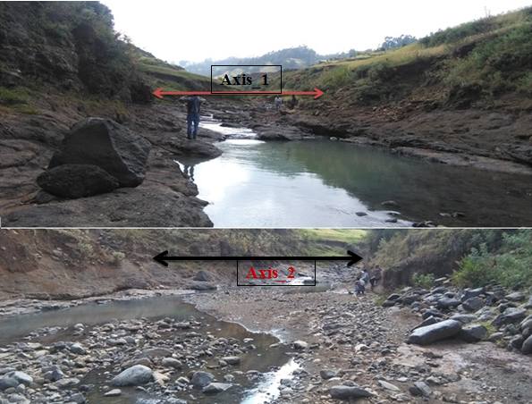
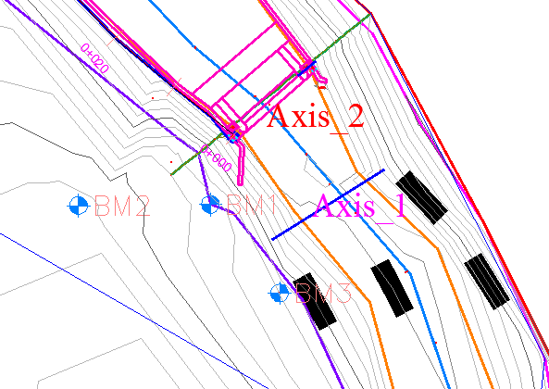
Figure 3-1 Head work axis options
- In addition to the above problems, there are gullies at both axes. But the gully at axis one is very large and untreatable comparing with axis two. From these justifications axis two is selected for design.
The headwork site is situated at1210345.43 m N, 471870.66 m E and river bed elevation of 2684.09m above sea level at the center of the weir axis. At this site the river course is well defined, matured with fixed width and forms nearly a U-shaped valley. The right bed and bank at weir site are made up agglomerates basalts (if the top 0.5m units are removed fresh rock will be expected) and also the active stream beds are covered bed rocks. On the other hand, the top 2m of left bank is covered with the flood plain deposit (low plastic clay soil With intermixed with gravel and cobble material) and lower units dominated by bedrocks (basalt). The detail geologic nature of the banks, and bed of the stream along the headwork axis and immediate vicinity are described and their potential geotechnical influence on the proposed structures also discerned/detected below.

River Geomorphology
It is a common fact that the river development tends to accommodate itself to the local geology that develops along the structurally weak zones like faults, joints, folds, etc. The drainage system of the study area is strongly influenced by geological structures and formations, the nature of the vegetation cover and climate. The nature of geological formations and structures has also strong influence on the development of the channel.
The present morphology of the Mayis River channel is a function of a number of processes and environmental conditions, including the composition of the bed and the banks (moderately weathered, fractured and jointed basalt along right side whereas loose silt clay soils and recent alluvial deposit at the left bank and bed); the size and composition of the sediment moving through the channel; the rate of sediment transport through the channel and deposition on the banks and beds; and the regional degradation due to erosion processes. The left bank forms steep slope topography, having about more than 3m height from stream bed. From surface observation, the bank is covered entirely with two type’s geological material such the top 2m of banks covered with low plastic clay material intermixed with gravel and boulders it is stiff, moist and dry while the lower section covered with agglomerate basalts. It is flood plain deposit having dark brown color. It has weak strength and deposited form rivers nearby ridges. But this loss material lies on the top parts of the bed rocks (basalts).

River Bed condition
The stream bed or course is well defined, nearly straight, and shows rough surface due to bed rocks (center and both left and right bed) and undulating appearance of bedrock outcrops at the weir axis. Along the weir axis, the bed is made up of two basically different geologic materials, as seen from surface observation. These are recently deposited alluvial coarse grained sediments, and underling bedrock.
The central, left and right areas of the bed are totally covered with the agglomerate basalt, which is a slightly weathered and jointed bed rock. The jointed rock units are not persistent and closed with soil. Some parts of the bedrock are covered with the recent sediments at the central and left areas of the stream bed. The alluvial sediment observed at the center and right beds are composed dominantly of Gravel with significant amount of boulders and cobbles. It is loose, dry (at the time of study) and easily workable .From surface geological understanding of the area, the thickness of this slightly weathered and jointed bed rocks range 0.5to 1.0m. If this top parts of the rock units remover fresh parts of rock will be expected and this bedrock extension that exposed at the right bed, left beds and bank. On the other hand, the bedrock found at head work axis is affected by slight degree of weathering and erratically oriented joints. The joints are not persistence that most of them penetrate to shallow depth or affecting the top 0.5 to 1.0m thickness of the rock. The foundation of the proposed weir structure; therefore, can be lie on the bedrock after removing the top 0.5m jointed portion of the bedrock at the both side of the bank. In addition to this, the foundation of weir along the axis should lie on the bedrock, after excavating the top parts covering the center, and left bed of the river.
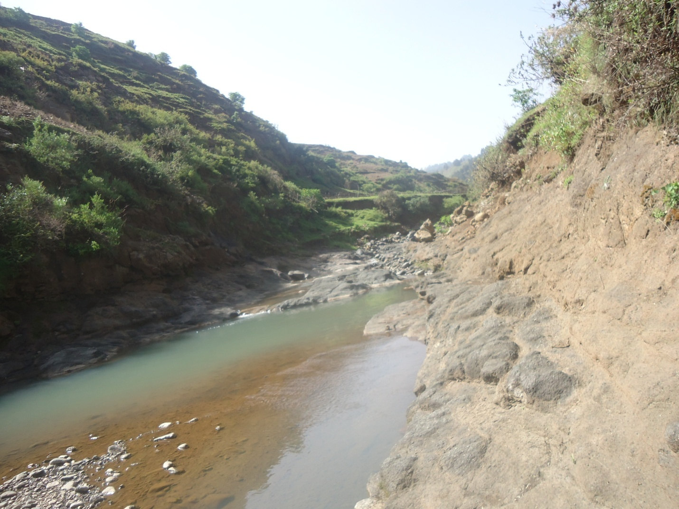
Weir Axis
River bed
Figure 3-2 River bed at the proposed weir site

River Bank condition

Right Bank
At the headwork site/axis, the right bank is characterized by relatively steep slope, having about more than 5m height from stream bed. It reveals nearly vertical section within this height. From visual observation of the natural exposure, there are one geologic unit (agglomerate) forming the bank section. And it is portion of the older bedrock at the project site. The rock is agglomerate, which is affected by slightly degree of weathering and joint (joint is not persistent). If the top 0.5m of the banks is fresh parts of rocks will be expected. It is resistant to flood erosion that there is no need to proposed bank protection works. But we construct retaining wall to protect right side outlet.

Left Bank
At the proposed headwork axis and immediate vicinities, the left bank forms steep slope topography, having about more than 3m height from stream bed. From surface observation, the bank is covered entirely with two type’s geological material such the top 2m of banks covered with low plastic clay material intermixed with gravel and boulders it is stiff, moist and dry while the lower section covered with agglomerate basalts. It is flood plain deposit having dark brown color. It has weak strength and deposited form rivers nearby ridges. But this loss material lies on the top parts of the bed rocks (basalts). The bank is now affected by flood erosion that active eroded surfaces are visible. So, it is necessary to provide some bank protection structures to prevent ongoing bank erosion.

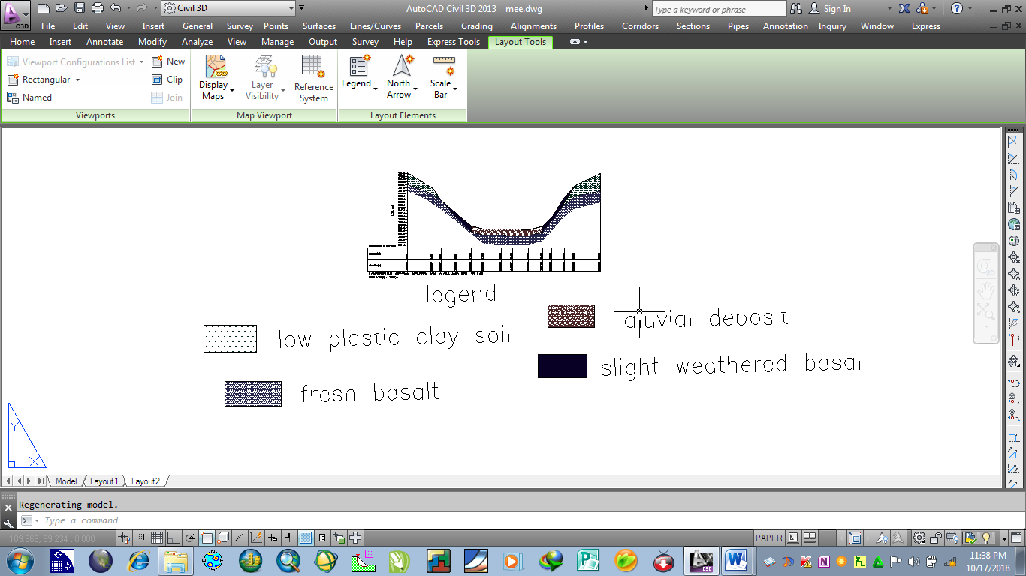
Figure 3-3 Geological x-section of Mayis head work one

Sources of Construction Materials
During the site investigation, natural construction materials required for the construction of the various proposed engineering structures at the headwork and within the farmland have been assessed, and possible quarry sites and borrow areas have been identified within the vicinity of the area as much as possible. In addition to the identification, the quality, quantity, accessibility condition and ownership of each proposed production sites have also been studied and described in this report; on separate sub-sections below. The natural materials required for the construction of the proposed hydraulic structures include rock for masonry stones, aggregates (both coarse and fine), impervious soil for fill and/or lining, backfill soil, and water.

Rock for Masonry and Crushed Coarse Aggregate
Quarry site that can be used for production of rock for masonry stone and crushed coarse aggregates has been assessed during the field work session within the vicinity of the project area at economic distance for hauling.
One possible quarry site has been identified along the left sides of Mayis Rivers following the main canal route at co-ordinates of about 468877mE and 1212745mN with elevation 2718m. Here slightly weathered basaltic rock exposed and forms a continuous ridge parallel to the main canal. It is believed that below this weathered rock, fresh portion of the rock is found and can be used for the intended purpose. This quarry site has good potential and an economic distance from the head work site. It has about 4km form the head site downstream direction and found nearby the small village Gimbaro (with continues ridge segments).
In this field study, another sources for rock also proposed. The second possible quarry site has been assessed in Mayis stream itself in upstream direction. It has good potential of rocks for an intended purpose.
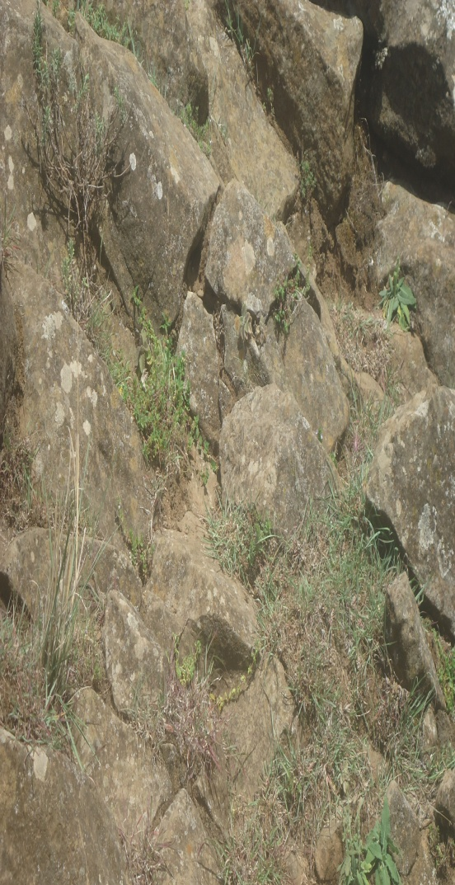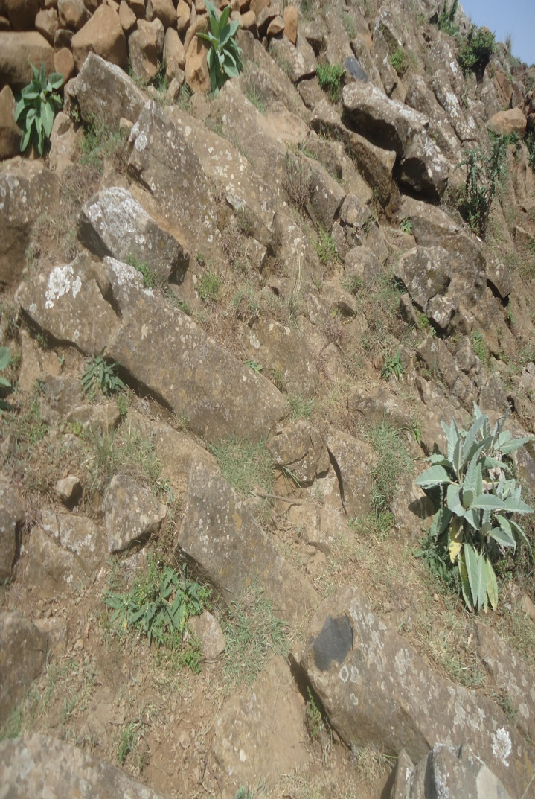
Figure 3-4 Rock Quarry Site

Fine Aggregates
Borrow areas for fine aggregate or natural sand have been assessed starting from the project stream itself. Natural deposits of such materials couldn’t be found when assessed within the beds of the stream in the project area; rather very coarser sediments and rock exposures are found covering almost the entire bed of the Mayis stream. Seeing to this nature of the stream, other distant streams have been explored to identify the best source areas for fine aggregate or natural sand that can be used for this particular project. During exploration of this natural sand, at a distant one stream was identified as a possible source of fine sand. The stream is known as ‘jara’. It has about 280km from the project site, within chefa Robit woreda. A potential source area within the jara stream bed is located co-ordinate about 603390Em, 1163001 within 1432 above sea level. Specifically this site is found the main asphaltic road which is goes to addis ababa, near to a small village of chefa Robit.

Water
Water for construction purposes can be getting from the project stream, Mayis itself. The stream is perennial that throughout the year there is some amount of water flow along its course. During this field study time the stream flow was about 73L/s base flow. The stream water originates from mainly fractured basaltic and Rhyolitic rock aquifer, which is portion of the Ethiopian western highland that is known to discharge good quality potable water.

Headwork Type Selection
Looking the availability of natural construction materials and considering the river features and expected flood amount, ogee type of weir is chosen. As it is:
- Most efficient and economical
- Weir section is expected only 35% of the peak flood while the remaining flood will pass over the overflow section of the river course.
- There is a significant bed load (boulder effect) in the river.

Hydraulic Design of Headwork Structure

Weir Height Determination
The following major factors have been seen in determining the weir crest level:
- Maximum command area elevation
- Deriving head of the intake structure
- Main canal slope
- Loss
- Lowest Point of river center

Table 3-1Weir Height Determination
Parameters | Units
Length of the canal (from outlet to first irrigation) | 400
Slope of the canal | 0.001
Maximum Command Area | 2685
Head Regulator Loss | 0.1
Head due to Turn out & bending | 0.1
Head Due to Canal Slope | 0.4
Canal total depth | 0.50
Canal Outlet Sill Level | 2685.46
Freeboard | 0.1
Weir Crest Level | 2686.1
Min. River Bed Level | 2684.09
Weir Height | 2.01

Weir Dimensions
- Crest Length
- Lackey’s regime width, $L=4.75*\sqrt{Q},$ $=4.75*\sqrt{136.19}$ = 55.43m.
- Actual river section width of the over flow section of the river is = 15m, used for design analysis effective length of the crest by deducting under sluice and divide wall is 12m.
- Discharge passing over the weir section
Ogee weir type has been selected for Mayis one project. The flood passing this weir type is given by:
Q=CLH_{e}^{3/2} where, Q= discharge in m³/s
C=coefficient of discharge
H_{e} =total head over the crest including velocity head in m.
L= effective length of crest in m
In this case, Q= 136.19m³/s, L=12m, C=2.2, but, it depends upon various factor, such approach depth, upstream slope of the weir and submergence effect. Since, the values of Q, L& C are known the value of He can be approximated, of which the correct value is calculated after the correction of coefficient of discharge.
The approximate, $He={\left(\frac{Q}{CL}\right)}^{\frac{2}{3}}={\left(\frac{136.19}{2.2*12}\right)}^{\frac{2}{3}}=2.99m$
Approach velocity, $Va=\frac{Q}{Hd+p}$ where, flow depth over weir, $Hd=He-\frac{Va^{2}}{2*g}$ and p=effective weir height that does not fill up with silt, P=2.0 in this case.
Then,$\frac{{Va}^{2}}{2g}=He-Hd=2.99-Hd$, but V_{a} = $\frac{Q}{L(Hd+P}$
Therefore, $\frac{{136.19}^{2}}{{(12*(Hd+2))}^{2}}*\frac{1}{2*9.81}=2.99-Hd$
The approximate value of H_{d} =2.69m by the iterating the above equation. But, variation of discharge coefficient has to be checked against the factors that affect it.
- Approach depth of water:-for the effective depth of approach of water, P is greater than 1.33 times the over flow depth, H_{d}, the velocity of approach has been found to have a negligible effect upon discharge and as such Hd becomes equal to He. In such case, the coefficient of discharge=2.2.however, for P to H_{d} ratio less than 1.33, the approach velocity has appreciable effect.
For Mayis one project ogee weir, P=2.0 and H_{d} =2.69, then P to Hd ratio is equal to 0.74, which is less than 1.33. So, approach velocity has significant effect. From developed curve of He/Hd versus C/Cd, the value of C/Cd=0.98 for a given P/Hd. Hence, corrected coefficient of discharge=Cd*0.98=2.156.
- Upstream slope of the weir: - the upstream slope of the weir is considered to be vertical in case of Mayis one head work weir structure. So., it doesn’t have any impact on the coefficient of discharge. Then, C= Cd.
- Submergence effect: - when the tail water level is at above of the weir level the weir can’t discharge freely. This effect is commonly expressed in the ratio of (He+weir height) to He. If this ratio is greater than 1.7. There is no effect of submergence. Weir height of the project=2 & He=2.99, then$, \frac{He+weir height}{He}=\frac{2.99+2}{2.99}=1.67<1.7$. So there is effect of submergence. From developed curve of (He+h)/He versus Ca/C, the value of Ca/C=0.99 for a given (He+h)/He. Hence, corrected coefficient of discharge=C*0.99=2.134
The adjusted or the corrected discharge coefficient, C=2.134. Now, corrected value of He and Ha can be calculated as follows.
$$He={\left(\frac{Q}{CL}\right)}^{\frac{2}{3}}={\left(\frac{136.19}{2.134*12}\right)}^{\frac{2}{3}}=3.05m$$
Then,$\frac{{Va}^{2}}{2g}=He-Hd=3.05-Hd$, but V_{a} = $\frac{Q}{L(Hd+P}$
Therefore, $\frac{{136.19}^{2}}{{(12*(Hd+2))}^{2}}*\frac{1}{2*9.81}=3.05-Hd$
The corrected value of discharge depth passing over the weir, Hd ₌2.76m by the iterating equation and approach velocity head,
The velocity head, h_{a} is computed from the approach velocity as shown below
Ha=He –Hd = 3.05-2.76 = 0.29m
- Downstream profile of the ogee weir
The downstream profile of the Ogee weir is represented by equation:
$X^{n}=K.{\left(Hd\right)}^{n-1}.Y$ Where,( X,Y) are the coordinates of points on the crest profile with origin at the highest point C of the crest called apex.
Hd is design head including velocity head in m.
K and n constant values depending up on the upstream slope
For this design case, the slope of the upstream face is vertical. For vertical upstream face value of K=2.0 & value of n =1.85 from standard table and calculated Hd= 3.05m. Then, substituting these values into the above equation, it becomes:-
$X^{1.85}=2.{\left(3.05\right)}^{1.85-1}.Y⇒X^{1.85}=2*{3.05}^{0.85}*Y$
$${⇒Y=X}^{1.85}/(2*{3.05}^{0.85})$$
Taking the origin of coordinate(X, Y) at C, the maximum value of Y= weir height, h- r/2, where $r= \frac{weir height}{4}=\frac{2.0}{4}=0.5m$ and maximum value of Y,$Ymax=2-\frac{0.5}{2}=2.25m$
Consider the value of X at 0.5m interval of increment, then values of Y is given below in the table.
Table 3-2: D/S face profile Coordinates of (X, Y)
x | 0.0 | 0.5 | 1.0 | 1.50 | 2.0 | 2.5 | 3.00 | 3.53
y | 0.00 | 0.05 | 0.19 | 0.41 | 0.70 | 1.06 | 1.48 | 2.00
Smooth gradual reverse curvature is provided at the bottom of the downstream face to turn the flow into the apron of a stilling basin. A radius of about one fourth of the weir height is considered to be satisfactory for this curvature.
Radius of the curve,$r= \frac{weir height}{4}=\frac{2}{4}=0.5m$
- Upstream profile of the Ogee weir
As per studies of U.S Army corporation the upstream curve of the Ogee weir having a vertical upstream face, is given by equation:-
$$Y=0.724*\frac{{\left(X+0.27Hd\right)}^{1.85}}{Hd^{0.85}}+0.126Hd-0.4315Hd^{0.375}*{\left(X+0.27Hd\right)}^{0.625}—(a)$$
And the upstream profile extends up to X=-0.27Hd.
The maximum value of X=-0.27*3.05=-0.82m. Then, the value of X and Y is given below with the above equation (a).
Table 3-3: U/S face profile coordinates(X,Y)
X | Y
0.00 | 0.00
-0.10 | 0.00
-0.20 | 0.01
-0.30 | 0.03
-0.40 | 0.06
-0.500 | 0.10
-0.600 | 0.15
-0.700 | 0.21
-0.82 | 0.384
- Top and bottom width

The top and bottom width of the ogee weir is determined using ogee spillway profile formula. As discussed above section downstream profile calculation at 2m weir height x=3.53m and upstream profile equation x=0.27Hd =0.82. So the bottom width of the weir calculated as the sum of upstream and downstream width.

B = 0.82+3.53 = 4.35m ~ 4.4m

U/S and D/S HFL Calculation & Determination
From the stage –discharge curve prepared (Section 2.4.3, in Hydrology Part) the high flood level before construction (i.e. D/s HFL) corresponding to the design flood is 2686.68m a.s.l.
D/s HFL = 2686.68m amsl ---------------------------- (a)
U/s HFL = U/s bed level + weir height + H_{d} -------- (b)
=2684.06+2+2.76= 2688.86m amsl
U/s TEL=U/s bed level+ weir height + He
U/s TEL = 2684.09 +2+3.05 =2689.14m amsl
- Afflux
⇒ Afflux = U/s HFL- D/s HFL = 2688.86m a.s.l – 2686.68m a.s.l = 2.18m.
From the flood level analysis, it is seen that the flood overtops the banks of the river u/s of the structure. This condition is allowed to take place as it does bring pronounced negative impacts on the structures, then constructing protective structures to protect.
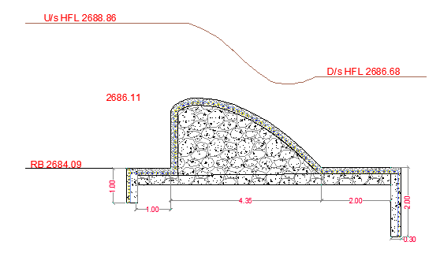
Figure 3-5 Weir Section

Hydraulic Jump Calculation
As discussed in the geologic report, the river bed is rock formation and hence stilling basin for energy dissipation is not required. Left side banks are not sound rock, a wing walls are required at u/s and D/s sides.
The length of wing walls is determined based on the length of Jump, and it is calculated as shown below.
• Weir crest length = 12m
• Weir height (h) = 2m
• Pre-jump depth = y₁
• Post -jump depth =y₂
h + H_{e} = y₁ + h_{a}
But, He = 3.05m
$q=\frac{Q}{l}=\frac{136.19m3/s}{12m}=11.35m$²$/s$
$$h_{a}=\frac{q2}{2*g*{y1}^{2}}=\frac{{11.35}^{2}}{2*g*{y_{1}}^{2}}$$
2m + 3.05m=y₁+13.6/y₁²
After iterations Y₁₌ 1.33m
V₁=q/y₁=11.35/1.33= 8.55m/s
$$F_{r}=\frac{V_{1}}{\sqrt{gy_{1}}}=\frac{8.55}{\sqrt{9.81*1.33}}=2.37$$
$$y_{2}=\frac{y_{1}}{2}\left(\sqrt{1+8*{F_{r}}^{2}}-1\right) y_{2}=\frac{1.33}{2}\left(\sqrt{1+8*{2.37}^{2}}-1\right) =3.833m$$
Hydraulic jump length (L) =5*(y₂-y₁) =5*(3.833-1.33) =12.3 take 12.5m

Impervious floor

D/s impervious floor (Ld)
For under seepage the worst condition would be when the water on the upstream side is at the level of the weir crest & there is no tail water. Seepage head loss at
- Pond level case:
Hs = crest level –bed level
= 2m
- Maximum flood case:
Hs = U/s HFL- D/s HFL
= 2688.86m-2686.68
= 2.18m
Therefore maximum seepage head occurs when water is stored up to the pond level and there is no water on the d/s.
= Bligh’s constant, C_{b} is depending on the type of the foundation.
$$L_{d}=2.2*C_{b}*\sqrt{\frac{H_{s}}{10}} L_{d}=2.2*9*\sqrt{\frac{2.18}{10}} =9.24$$
But the river bed foundation is rock the D/s impervious floor is taken to be 2m long nominal dimension is recommended.

U/S Impervious Floor Length, (Lu)
For this particular project take nominal u/s impervious floor length (L_{u}) = 1m due to rock foundation available.

Floor thickness
Hydraulic head (HL) =pond level (canal outlet)-bed level
= 2686.1m a.s.l-2684.09m a.s.l=2m
Total creep’s length = Lu + Ld +2d1 + 2d2 +B
= 1+3+2*0.6 +2*1+4.3=11.5m take 12m
Hydraulic gradient =d/Lt=2/12=0.181m

Upstream floor thickness
Creep length at heel=2*0.6+1=2.2m
Unbalanced load h1=HL-GE*L=2-0.181*2.2=1.6m
Floor thickness (t) =4/3h (G-1) =4/3*1.6(2.3-1) =2.73, but the foundation is hard rock impervious takes 0.5m nominal thickness.

Downstream floor thickness
Creep length (L2) =2.2+4.4+2*1 =8.5m
Unbalanced load h1=HL-GE*L=2.0-0.167*8.5=1.07m
Floor thickness (t) =4/3h (G-1) =4/3*1.07(2.3-1) =1.1 m, but the foundation is hard rock or impervious takes 0.5m nominal thickness. The floor is constructed by Cyclopean concrete.

Cut off Depth Calculation

U/s cut off
- Q = 136.19m³/sec
- q = 11.35 m³/s/m
- D50=72.5mm for medium boulder
- Silt factor, f =1.76*(d₅₀)^{0.50}
f= 14.99
- R =1.35*(q²/f)^{(1/3)}
R=1.35*(q²/f)^{(1/3)} = 2.77
Hence bottom level of u/s cut off = U/S HFL – 1.5R = 2688.86-1.5*2.77=2684.7amsl
U/s cut off depth = bed level- U/s cut off level = -0.6m the negative sign indicates no required of upstream cutoff, but take 0.5m nominal depth properly anchor hard rock.
      - D/s cut off
- Q =136.19m³/sec
- q =11.35m³/s/m
- D50=72.5mm for medium boulder
- Silt factor, f =1.76*(d₅₀)^{0.50}
f= 14.99
- R=1.35*(q²/f)^{(1/3)}
R=1.35*(q²/f)^{(1/3)} =2.77
Hence bottom level of d/s cut off = D/S HFL – 2*R= 2682.06amsl
D/s cut off depth = bed level– D/s cut off level
= 2684.09-2682.06= 2.03m, take 2m for rock foundation covered by 0.5-2m alluvial deposit to anchor hard rock properly.

Stability Analysis of weir
Stability analysis is carried out to see the already determined weir section is safe against overturning, sliding, tension. The stability analysis is carried out considering the effect of the following forces.
• Water pressure
• Weight of the over flow weir section
• Sediment load
The extreme load combination is the case where the head is at crest level of the weir and there is no flow over the weir (static case)
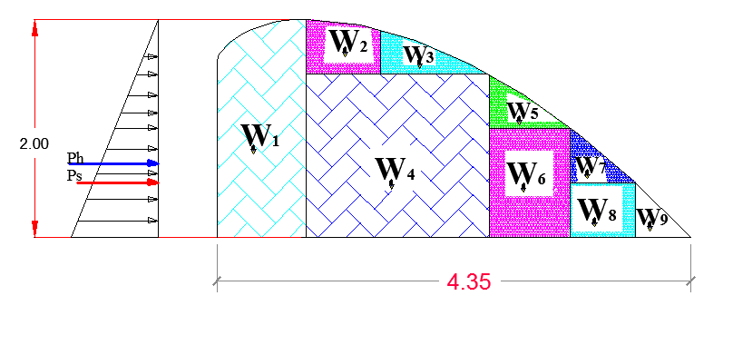
Table 3-4 Weir Stability Analysis
Load | Force |  |  | Lever Arm | Moment
Load | Formula | Vertical | Horizontal | Lever Arm | Positive | Negative
Self-weight of weir | W1 | 39.36 |  | 3.99 | 157.05
Self-weight of weir | W2 | 3.24 |  | 3.28 | 10.63
Self-weight of weir | W3 | 9.60 |  | 2.65 | 25.41
Self-weight of weir | W4 | 30.24 |  | 2.74 | 82.86
Self-weight of weir | W5 | 8.88 |  | 1.65 | 14.68
Self-weight of weir | W6 | 8.88 |  | 1.53 | 13.59
Self-weight of weir | W7 | 7.20 |  | 0.96 | 6.91
Self-weight of weir | W8 | 3.60 |  | 0.81 | 2.92
Self-weight of weir | W9 | 6.12 |  | 0.34 | 2.08
Water pressure | Ph |  | 19.62 | 0.67 |  | -13.08
Silt Load,Ps_{H} | ps |  | 24.00 | 0.67 |  | -16.00
Sum | SUM | 117.12 | 43.62 |  | 316.12 | -29.08

Where, W = weir self-weight Ph = water pressure
Ps = silt load Pu = uplift pressure
∑V = 117.12KN ∑M(+) = 316.12KN.m
∑H=43.62KN ∑M(-) = 29.08KN.m
- Factor of safety against overturning (FSO)
FSO = $\frac{\sum{M+}}{\sum{M-}}= \frac{316.12}{29.08}$ = 10.87>1.5, acceptable
- Factor of safety against sliding (FSS)
µ, µ=0.7
$Fss=\frac{0.7*117.12}{43.62}$ = 1.88> 1.5, acceptable
- Check for tension (i.e. whether the resultant lies within the middle third)
The location of the resultant force from the toe is given by
$X= \frac{\sum{M\left(+\right)-\sum{M(-)}}}{\sum{V}}=\frac{316.12-29.08}{117.12}$ = 2.45
The eccentricity, $e=X-\frac{B}{2}=2.45-\frac{4.4}{2}=0.27$
The eccentricity (e) should be less than$\frac{B}{6}=\frac{4.4}{6}=0.73$ .Hence the obtained e = 0.27m < 0.73m.
This implies that the resultant lies within the middle third. Hence, no tension

Design of Divide wall, Under Sluice, and Canal outlet
Divide wall is designed in order to create separation between outlet canal and natural river course. The divide wall allows safe and stable base flow to the canal outlet. Flow turbidity created by current flow impact over the weir body is reduced.

Wall height fixation of Divide Wall
The existing topographical condition at the weir axis and HFL are considered to be most governing parameters for fixing the wall height.
After construction of the weir (u/s HFL) = 2688.86m.a.s.l
Hence the level of divide wall and weir body foundation should be the same and is 2688.86m
U/s wall height = U/s HFL - foundation level + free board.
Adapt 0.7m free board for safety
U/s wall height = 2688.86m.a.s.l – 2684.09m + 0.7m =5.5m
⇒ Provide 5.5m wall height and the top level of the divide wall =2684.09m + 5.5m =2689.59amsl
D/s wall height = D/s HFL - Foundation level + free board
=2686.68m.a.s.l-2684.09m.a.s.l+0.7=3.3m
⇒ Provide 4.5m wall height and the top level of the divide wall =2684.09 +3.3=2687.39m.a.s.l
Hence including free board, take the critical height of the divide wall = 5.5m
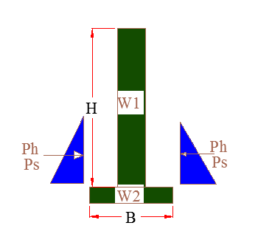

Table 3-5 Divide wall Stability Analysis
Height, H | Top width, B |  | Bottom Width, B |  | under sluice side silt and water depth |  | Weir side silt and water depth
5.50 | 0.50 |  | 1.50 |  | 0.7 |  | 2
Code | Load |  |  |  | Lever Arm, R |  | Moment
 | Vertical |  | Horizontal |  |  |  | Positive |  | Negative
W1 | 66.0 |  |  |  | 0.3 |  | 16.5
W2 | 18.0 |  |  |  | 0.8 |  | 13.5
Ps |  |  | -7.2 |  | 0.7 |  |  |  | 4.8
Pw |  |  | -19.6 |  | 0.7 |  |  |  | 13.1
Pw2 |  |  | 2.4 |  | 0.2 |  | 0.56
Ps2 |  |  | 0.9 |  | 0.2 |  | 0.2
Ww |  |  |  |  | 1.2 |  | 0.0
Ws |  |  |  |  | 0.8 |  | 0.0
Pu |  |  |  |  | 0.9 |  |  |  | 0.00
SUM | 84.0 |  | -23.5 |  |  |  | 30.8 |  | 17.9
Factor Of Safety Against
Over turning = (M_{+ve}/M_{-ve}) >1.5 |  |  |  | F_{o} |  | 1.72 |  | >1.5 |  | OK
Sliding = (µxFv/F_{h}),---µ=0.75 >1.5 |  |  |  | F_{s} |  | 2.68 |  | >1.5 |  | OK

Under sluice
The under sluice is mainly provided here to remove silt deposition at a result of barrier structure. Hence the sill level of the under sluice is fixed to facilitate this deposited silt to increase the efficiency of water abstracting to the main canal through the head regulator from the pocket. The sill level of this sluice is fixed to be 0.7m higher than the minimum bed level. Hence the sill level of the under sluice is 2684.79 amsl. Even if the position of the under sluice is on concave side that is on scouring side, there might be boulders that may come into the pocket of the under sluice due to the barrier structure. Hence in addition to the supply of water to the intake and the removal of silt, this acts to remove the boulder that comes to wards it. Considering this, the opening size of the gate is 1m*0.9m with spindle type operating from the operation slab. Considering rectangular notch profile of flow of water at the under sluice, the discharge passing is computed using the following formula.
- The capacity should be at least five times the canal discharge to ensure proper scouring.
- Capacity of passing about 10% to 20% of the maximum flood discharge at high floods.
- During construction, it should be able to pass the prevailing (at least base flow) discharge of the river.
But the practical application of those values is not sound so the discharging capacity of under sluice is determined by using orifice flow formula for maximum flood condition.
i.e. $Q=C_{d}*A*\sqrt{2gh}$,
Where, C_{d} = Discharge coefficient =0.80
A = under sluice opening area (m²)
g = 9.81m/s²
Width (b) = $\frac{Qd}{ Cd*H\sqrt{2g*h}}$ $\frac{1.35}{0.9*1\sqrt{2*9.81*0.45}}$= $=0.87m take 1m$
Hence the size of the under sluice is 0.9m$×1m$ (height *width)

Canal outlet level
The head regulator is provided on the left side .The sill level of this head regulator is fixed from different angle observations. The main conveyance system is 6.22km which passes more gullies and undulating alignment. Hence this level is fixed based on the optimum route alignment and the maximum irrigated command level including minor and major losses criteria. Based on this condition, the sill level is fixed to be 2685.46m.
• Outlet capacity
The minimum command area is determined by the minimum flow of the river. But the canal capacity should be determined for maximum command area and the corresponding discharge. In this case the outlet capacity is fixed considering maximum duty.
- Outlet capacity = Duty x command area
Where, maximum duty for 18 hr irrigation = 1.22L/s/ha
Left side Command area = 148.448ha.
Right side Command area = 23ha
- Outlet capacity for left side = 1.22 L/s/ha x 148.448ha = 181.11L/sec,
- Outlet capacity for right side = 1.22L/s/ha x 23ha = 28.06L/s
• Outlet size
From the weir discharge formula the outlet size is determined as follows
Q = CLHe^{3/2}
Where; C = coeff. Of discharge = 1.7
L = Length of water way (m)
He = head above sill level (neglecting the velocity head)
- From hydraulic analysis the outlet dimension for left side
Width (b) = 0.7m
Depth (d) = 0.6m, with free board 0.1
- From hydraulic analysis the outlet dimension for right side
Width (b) = 0.5m
Depth (d) = 0.4m, with free board
Hence, provide an outlet size of 0.7m x 0.6m (length x height) .The gate of the off take canal is to be vertical sheet metal of 7m x 0.6m for the closure of the opening space. Provide some extra dimensions for groove insertion. Gross area of sheet metals for the off take canal gate will be 0.8m x 0.65m (allowing 5cm insertion for grooves and above the weir crest level). The grooves are to be provided on the walls using angle iron frames at the two sides of the gate openings.
Trash racks of diameter 20mm with c/c spacing of 10cm has to be provided u/s of the gate to prevent entry of debris to the canal.

Breast Wall and Operation Slab
A vertical raised gate is designed for the head regulator and under sluice. These gates slide over the breast wall using spindle during opening and closing.
For easy operation of these gates, operation slab is provided. The size of the operation slab is fixed from the point of construction and free movement. The size of the operation slab is shown in the drawing for both head regulator and under sluice with thickness 0.2m.
The thickness of the breast wall is also the same as that of the operation slab. The nominal thickness is fixed from the point of construction rather than the imposed load. The thickness required for the imposed load is less than the nominal value and treated as cantilever retaining wall. For the breast wall, the minimum reinforcement area is taken as 15% along the respective direction.
Hence A_{steel} = 0.0085*1000*200=300
A_{steel} = 300mm²/m
Provide 12@C/c 200 mm
Considering concrete cover thickness of 50 mm, effective depth = 50 + 12/6 = 56
Hence spacing of reinforcement = 200mm < 282mm
A_{steel} = 565.5
Therefore the actual provided steel area per meter width is 565 mm²/m > 300 mm²/m. It is ok!
The actual arrangement of angle irons, spindles, shafts and operation slab including other components is shown on the design drawing.
For each arrangement and further information, refer to the design drawing.

Trash Rack
To avoid entrance of floating materials like leaf, debris, animal dung, water foam into the intake and to protect plate damage by water carried stone 0.80m*0.70m, 20mm daimeter bar mesh spaced at 10cm centre to centre and anchored to the wall trash rack is crucial.

Retaining Walls
At the left and right side of the diversion weir, walls have been provided to safeguard the structure from scour at the ends and also as a facility to the canal outlet operation and maintenance at the canal outlet portion. D/s retaining wall is provided 70m length in the left and 50m length in the right along the river bed to protect the canal from floods. Construction joint is recommended for the downstream retaining wall with 10m space differences.

Table 3-6 Upstream retaining wall stability analysis
Item Description |  | Forces(KN.m) |  |  |  | Lever arm | Moment about toe(KN.m)
 |  | Vertical |  | Horizontal |  | (m.) | Resisting | Overturning
 |  | +ve | -ve | +ve | -ve | (m.) | Resisting | Overturning
1. Vertical force
1.1. Self-weight(W1) |  | 50.60 |  |  |  | 0.2 | 10.12
1.2. Self-Weight(W2) |  | 183.43 |  |  |  | 1.37 | 250.68
1.4. Silt pressure(Ps2) |  | 135.58 |  |  |  | 2.33 | 316.34
2. Horizontal force
2.2. Active pressure (Ps1) |  |  |  |  | -85.7083333 | 1.83 |  | -157.13
TOTAL |  | 369.60 | 0.00 | 0.00 | -85.71 |  | 577.14 | -157.13
I) | Overturning Stability |  | F_{o}=∑M_{r}/∑M_{o} |  | 3.67 | Safe | 1.50
II) | Sliding Stability |  | F_{ss}=ɳΣFv/FH |  | 2.59 | Safe | 1.50
III) | Overstressing Stability |  | ΣM=Mr+Mo |  | 420.01
 | 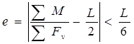 |  | ∑M/∑Fv |  | 1.1363922
 |  |  | L/2 |  | 1.65
 |  |  | e= |  | 0.5136<0.55 | safe | L/6 | 0.55
Table 3-7 Downstream retaining wall stability analysis
Item Description |  | Forces(KN) |  |  |  | Lever arm | Moment about heel(KN.m)
 |  | Vertical |  | Horizontal |  | (m.) | Resisting | Overturning
 |  | +ve | -ve | +ve | -ve | (m.) | Resisting | Overturning
1. Vertical force
1.1. Self-weight(W1) |  | 37.95 |  |  |  | 1.75 | 66.41
1.2. Self-Weight(W2) |  | 5.98 |  |  |  | 2.43 | 14.55
1.3. Self-weight(w3) |  | 59.34 |  |  |  | 0.75 | 44.51
1.4. Water pressure(Ph) |  |  |  |  | -33.8 | 0.87 |  | -29.29
2. Horizontal force
2.1 Active pressure (Phs) |  |  |  | 11.33 |  | 0.67 | 7.56
2.2. Active pressure (Pvs)
TOTAL |  | 103.27 | 0.00 | 11.33 | -33.80 |  | 133.02 | -29.29
I) | Overturning Stability |  | F_{o}=ΣM_{r}/ΣM_{o} |  | 4.54 | Safe | 1.50
II) | Sliding Stability |  | F_{ss}=ɳΣFv/FH |  | 3.22 | Safe | 1.50
IV) | Overstressing Stability |  |  | ΣM=Mr+Mo | 103.73
 |  |  |  | ΣM/ΣFv | 1.0044
 |  |  |  | L/2 | 1.00
 |  |  |  | e= | 0.0045 | safe | 0.33
At the toe
Item Description |  | Forces(KN) |  |  |  | Lever arm | Moment about toe(KN.m)
 |  | Vertical |  | Horizontal |  | (m.) | Resisting | Overturning
 |  | +ve | -ve | +ve | -ve | (m.) | Resisting | Overturning
1. Vertical force
1.1. Self-weight(W1) |  | 37.95 |  |  |  | 0.4 | 15.18
1.2. Self-Weight(W2) |  | 5.98 |  |  |  | 1.00 | 5.98
1.3. Self-weight(w3) |  | 59.34 |  |  |  | 1.65 | 97.91
1.4. Water pressure(Ph.) |  |  |  |  | 0 |  |  | 0.00
2. Horizontal force
2.1 Active pressure (Phs) |  |  |  |  | 11.33 | 0.67 |  | -7.56
2.2. Active pressure (Pvs)
TOTAL |  | 103.27 | 0.00 | 0.00 | 11.33 |  | 119.07 | -7.56
I) | Overturning Stability |  | F_{o}=ΣM_{r}/ΣM_{o} |  | 15.76 | Safe | 1.50
II) | Sliding Stability |  | F_{ss}=ɳΣFv/FH |  | 6.38 | Safe | 1.50
IV) | Overstressing Stability |  | ΣM=Mr+Mo |  | 111.52
 |  |  | ΣM/ΣFv |  | 1.08
 |  |  | L/2 |  | 1.00
 |  |  | e |  | 0.0798 | safe | 0.33

Bill of Quantity and Cost Estimation
The quantities of the various items have been worked out as per the final design and final drawings prepared for the scheme. The unit rates analysis has been carried out based on the data available in the vicinity of the project area.
Table 3-8 General Items BOQ
Item | Bill No. 1. General | Unit | Quantity | Rate (Birr) | Amount  ( Birr)
1.1 | Allow for mobilization | L.S | 1 | 209,646.67 | 209,646.67
1.2 | Allow for demobilization | L.S | 1 | 209,646.67 | 209,646.67
1.3 | Allow for contractor’s camping facilities 3*4m2, Living room for contractors key personnel, CIS and internally painted clip wood wall, Masonry floor cement screened and well ventilated room complete with doors and windows. | No | 4 | 59,214.99 | 236,859.96
1.3 | Allow for Consultant’s camping facilities 3*4m2, Living room for contractors key personnel, CIS and internally painted clip wood wall, Masonry floor cement screened and well ventilated room complete with doors and windows. | No | 2 | 59,214.99 | 118,429.98
1.3 | 5*5m2, Store and dining room constructed from CIS with doors and windows, Masonry floor cement screened | No | 1 | 65,982.6 | 65,982.57
1.3 | Barbed wire fence 60*40m and 1.5m high treated timber post complete with 3m wide gate and a CIS guard house (1.5*2m) | No | 1 | 65,551.49 | 65,551.49
1.4 | Allow for temporary access road (in km) to site including drainage culvert and ditches in the direction of the engineer. | km | 4 | 506,534.07 | 2,026,136.28
1.5 | Dewatering of open trenches and excavations, pumps | LS | 1 | 113,040.00 | 113,040.00
1.6 | Provide project indicator post starting from the construction time | LS | 1 | 7,807.68 | 7,807.68
1.7 | Provision of as built drawings for the project | LS | 1 | 52,219.39 | 52,219.39
 | Sub Total |  |  | 3,105,320.68

Table 3-9 Head Work BOQ
Item. No | Description | Unit | Quantity | Unit Price (Birr) | Total Cost (Birr)
2 | Head work structure
2.1 | Weir Body
2.1.1 | Site Clearing and Grubbing | m² | 152.00 | 19.16 | 2912.32
2.1.2 | Excavation of ordinary soil with (Machine) |  | 1.00 | 77.39 | 77.39
2.1.3 | Excavation of weathered rock by (Machine) | m³ | 178.80 | 246.91 | 44147.51
2.1.4 | Excavation of hard rock by (Machine) | m³ | 25.80 | 601.78 | 15525.92
2.1.5 | Concrete capping, C-25 (1:1.5:3) | m³ | 16.30 | 3289.27 | 53601.98
2.1.6 | Cyclopean concrete(60% C-20,40% graded stone) | m³ | 95.04 | 2158.41 | 205135.31
2.1.7 | Reinforcement bar, φ12 with 200mm spacing including (bending, cutting & placing) | Kg | 404.64 | 88.00 | 35608.14
2.1.8 | Reinforcement bar, φ12 with 200mm spacing including (bending, cutting & placing) | Kg | 368.08 | 88.00 | 32390.92
 | Sub Total |  |  |  | 389399.49
2.2 | Cut off
2.2.1 | U/S cut off
2.2.1.1 | Excavation of weathered rock by (Machine) | m³ | 5.25 | 316.54 | 1661.84
2.2.1.2 | Excavation of hard rock by (Machine) | m³ | 5.25 | 646.22 | 3392.64
2.2.1.3 | Concrete, C-25 (1:1.5:3) | m³ | 4.50 | 3289.27 | 14801.72
2.2.1.4 | Reinforcement bar, φ10 with 200mm spacing including (bending, cutting & placing) | Kg | 55.46 | 88.00 | 4880.50
2.2.1.5 | Reinforcement bar, φ12 with 200mm spacing including (bending, cutting & placing) | kg | 67.44 | 88.00 | 5934.69
2.2.2 | D/S cut off
2.2.2.1 | Excavation of ordinary soil including alluvial deposit & boulders with (Machine) | m3 | 24.00 | 77.39 | 1857.42
2.2.2.2 | Excavation of weathered rock by (Machine) | m³ | 5.60 | 316.54 | 1772.62
2.2.2.3 | Excavation of hard rock by (Machine) | m³ | 11.20 | 646.22 | 7237.63
2.2.2.4 | Concrete, C-25 (1:1.5:3) | m³ | 7.20 | 3289.27 | 23682.76
2.2.2.5 | Reinforcement bar, φ10 with 200mm spacing including (bending, cutting & placing) | Kg | 108.46 | 88.00 | 9544.09
2.2.2.6 | Reinforcement bar, φ12 with 200mm spacing including (bending, cutting & placing) | Kg | 143.75 | 88.00 | 12650.26
 | Sub Total |  |  |  | 87,416.18
2.3 | Apron
2.3.1 | U/s apron
2.3.1.1 | Excavation of weathered rock with (Machine) | m³ | 7.50 | 316.54 | 2374.05
2.3.1.2 | Excavation of hard rock with (Machine) | m³ | 3.00 | 646.22 | 1938.65
2.3.1.3 | Concrete capping, C-25 (1:1.5:3) | m³ | 3.00 | 3289.27 | 9867.82
2.3.1.4 | Cyclopean Concrete (60% C-20,40% graded stone) | m2 | 4.50 | 2158.41 | 9712.85
2.3.1.5 | Reinforcement bar, φ12 with 200mm spacing including (bending, cutting & placing) | Kg | 79.86 | 88.00 | 7027.92
2.3.1.6 | Reinforcement bar, φ10 with 200mm spacing including (bending, cutting & placing) | Kg | 46.83 | 88.00 | 4121.31
 | Sub Total |  |  |  | 35,042.600
2.3.2 | D/s apron
2.3.2.1 | Excavation of weathered rock by (Machine) | m³ | 16.00 | 316.54 | 5064.64
2.3.2.2 | Excavation of hard rock by (Machine) | m³ | 6.40 | 646.22 | 4135.79
2.3.2.3 | Concrete capping, C-25 (1:1.5:3) | m³ | 6.40 | 3289.27 | 21051.34
2.3.2.4 | Cyclopean Concrete (60% C-20,40% graded stone) | m2 | 9.60 | 1538.00 | 14764.79
2.3.2.5 | Reinforcement bar, φ12 with 200mm spacing including (bending, cutting & placing) | Kg | 156.18 | 88.00 | 13743.49
2.3.2.6 | Reinforcement bar, φ10 with 200mm spacing including (bending, cutting & placing) | Kg | 99.83 | 88.00 | 8784.90
 | Sub Total |  |  |  | 67,544.960
2.4 | Divide wall
2.4.1 | Excavation of weathered rock by (Machine) | m³ | 2.50 | 316.54 | 791.35
2.4.2 | Excavation of hard rock by (Machine) | m³ | 1.00 | 646.22 | 646.22
2.4.3 | Concrete work, C-25 | m³ | 23.63 | 3289.27 | 77725.50
2.4.4 | Reinforcement bar, φ14 with 200mm spacing including (bending, cutting & placing) | Kg | 619.36 | 88.00 | 54503.71
2.4.5 | Reinforcement bar, φ8 with 200mm spacing including (bending, cutting & placing) | Kg | 197.43 | 88.00 | 17373.72
 | Sub Total |  |  |  | 151,040.50
2.5 | Under Sluice
2.5.1 | Excavation weathered rock by (Machine) | m³ | 10.32 | 316.54 | 3266.69
2.5.2 | excavation of hard rock by (Machine) | m³ | 1.72 | 646.22 | 1111.49
2.5.3 | Cyclopean Concrete (60% C-20,40% graded stone) | m³ | 5.58 | 1538.00 | 8582.03
2.5.4 | Concrete capping, C-25 (1:1.5:3) |  | 1.96 | 3289.27 | 6446.97
2.5.5 | Reinforcement bar, φ12 with 200mm spacing including (bending, cutting & placing) | Kg | 46.14 | 88.00 | 4060.58
2.5.6 | Reinforcement bar, φ12 with 200mm spacing including (bending, cutting & placing) | Kg | 52.18 | 88.00 | 4591.58
 | Sub Total |  |  |  | 28,059.349
2.6 | operation slab
2.6.1 | concrete c-20 (1:2:3) | m3 | 1.12 | 2082.51 | 2332.41
2.6.2 | Reinforcement bar, φ12 with 150mm spacing including (bending, cutting & placing) | Kg | 34.78 | 88.00 | 3061.05
2.6.3 | Reinforcement bar, φ12 with 150mm spacing including (bending, cutting & placing) | Kg | 35.49 | 88.00 | 3123.52
 | Sub Total |  |  |  | 8,516.98
2.7 | Brest wall for offtake
2.7.1 | concrete c-20 (1:2:3) |  | 1.19 | 2082.51 | 2474.02
2.7.2 | Reinforcement bar, φ12 with 150mm spacing including (bending, cutting & placing) |  | 29.28 | 88.00 | 2576.91
2.7.3 | Reinforcement bar, φ12 with 150mm spacing including (bending, cutting & placing) |  | 27.15 | 88.00 | 2389.49
 | Sub Total |  |  |  | 7,440.42
2.8 | Brest wall for under sluice
2.8.1 | concrete c-20 (1:2:3) | m³ | 1.78 | 2082.51 | 3698.53
2.8.2 | Reinforcement bar, φ12 with 150mm spacing including (bending, cutting & placing) | Kg | 59.10 | 88.00 | 5200.66
2.8.3 | Reinforcement bar, φ12 with 150mm spacing including (bending, cutting & placing) | Kg | 53.24 | 88.00 | 4685.28
 | Sub Total |  |  |  | 13,584.48
2.9 | Retaining wall
2.9.1 | Upstream Guide Wall
2.9.1.1 | Excavation of ordinary soil by (Machine) | m³ | 150.00 | 77.39 | 11608.86
2.9.1.2 | excavation of weathered rock by (Machine) | m³ | 30.00 | 316.54 | 9496.20
2.9.1.3 | Back fill and compacted with excavation soil | m³ | 112.50 | 45.36 | 5103.49
2.9.1.4 | Masonry work (1:3) | m³ | 150.00 | 1436.00 | 215400.00
2.9.1.5 | Provide C-10 Lean concrete for masonry footing lining of thickness as per the drawing | m³ | 6.00 | 170.00 | 1020.00
2.9.1.6 | pointing (1:2 ratio) | m2 | 120.00 | 135.00 | 16200.00
 | Sub Total |  |  |  | 258,828.547
2.9.2 | D/S Guide Wall
2.9.2.1 | Excavation of ordinary soil by (Machine) | m³ | 1470.00 | 69.26 | 101812.20
2.9.2.2 | Excavation of weathered rock by (Machine) | m³ | 525.00 | 316.54 | 166183.50
2.9.2.3 | Back fill and compacted with excavation soil | m³ | 630.00 | 45.36 | 28579.56
2.9.2.4 | Masonry work (1:3) Including construction joint (water stop) with 10m space | m³ | 1031.80 | 1436.00 | 1481664.80
2.9.2.5 | Provide C-10 Lean concrete for masonry footing lining of thickness as per the drawing | m³ | 28.00 | 1610.26 | 45087.24
2.9.2.6 | pointing (1:2 ratio) | m2 | 630.00 | 135.00 | 85050.00
 | Sub Total |  |  |  | 1,908,377.29
2.9.3 | Loose back protection retaining wall at the left side
2.9.3.1 | Excavation of ordinary soil by (Machine) | m³ | 1980.00 | 69.26 | 137134.80
2.9.3.3 | Back fill and compacted with excavation soil | m³ | 1650.00 | 45.36 | 74851.22
2.9.3.4 | Gabion box supply according to the specification, filling with recommended stone size and installation | m³ | 862.50 | 1071.98 | 924585.18
 | Sub Total |  |  |  | 1,136,571.20
2.10 | Gates
2.10.1 | under sluice
 | Iron Sheets ,6mm thickness | Ls | 2 | 25000.00 | 50000
 | Stiffening angle iron (30*30*10)
 | Angle iron for groove(50*50*10) ,4.7m long
 | Spindle Ø40mm,5.9m long
 | Anchor bar , φ10mm
 | Sub Total |  |  |  | 50,000.00
2.10.2 | head regulator gate
 | Iron Sheets ,4mm thickness | Ls | 2 | 20000.00 | 40000
 | Stiffening angle iron (30*30*10)
 | Spindle Ø40mm
 | Angle iron for groove(40*40*10),0.7m long
 | Anchor bar , φ10mm
 | Trash rack reinforcement bar, φ20 with 50mm spacing | Kg | 187.33 | 88.00 | 16485.25
 | Sub Total |  |  |  | 56,485.25
 | TOTAL |  |  |  | 4,198,307.24

SECTION-III: IRRIGATION AND DRAINAGE SYSTEMS
INFRASTRUCTURE

IRRIGATION AND DRAINAGE SYSTEMS DESIGN

Irrigable Area Description

Topography
Topography is an important factor for the planning of any irrigation project as it influences method of irrigation, drainage, erosion, mechanization, and cost of land development, labor requirement and choice of crops.
The topographic feature of the project command area is mainly sloping type. Its elevation range is from 2683 to 2598 meters above sea level. The Federal Land Use Right Proclamation prohibits the cultivation of annual crops on land with greater than 60% slope, however the user can use steeper land if appropriate conservation measures are applied and/or perennial crops and forest trees are planted.
The project command area is situated at the left side of Mayis River (to the south west side of the river). The natural topographic feature of the command area has inclined from the North to the South direction.

Climate
As per the hydrological analysis and on the basis of the traditional Ethiopian Agro-Ecological Zones (MOA, 2001), the UGDWIP area is basically classified as Dega (sub-moist cool) agro-ecological zone, indicating better moisture condition in the area in wet seasons. The project area has Bimodal and uneven distribution pattern of rainfall. The main rain season, locally known as Keremt, occurs from end of June to end of August with about 58% share of annual rainfall; and about 42% of the annual rainfall occurs during the dry season from October to May. As the project site has no its own meteorological station, SAYNT AJBAR (for rainfall and minimum and maximum temperature) and SAYNT AJBAR (for relative humidity, wind speed and sunshine hour) meteorological stations data were used for the project study as long as these stations are relatively near to the proposed command area. In general, the sources of meteorological data are the National Meteorology Service Agency (NMSA).

Main Canal Route Geology
For this particular project, the main canal route has length of 6.22km and outlets in left side of the river. Within this length, the canal passes different geologic materials, which varies both surficial and to depth. The distribution of the geologic materials with respect to the canal route, and their characteristics, especially permeability, stability and workability have been investigated during the field work using only visual inspection of natural cuts and exposures as these features reveals mostly the depth to bedrock.
Based on the findings of the surface geological investigations and with reference to design chain ages and also natural existing features, the canal route ground conditions have been described in the succeeding sections.
- From outlet (0+000m) to about 0+110m (within the left bank slope), the canal passes a foot of a ridge, which is portion of the left bank of the river. The ground surface is covered with low plastic clay soil intermixed with some gravel and cobble rocks that is deposited by the flood. The thickness of this layer is in the range of 1 to 2m. It is stiff, dry, workable and pervious horizon. It is underlain by jointed basaltic and Rhyolite rocks. If the canal section lies in below the top soil (1 to 2m from surface) significant seepage is expected through the jointed and weathered rock units, and so lining is required. Along this particular reach there is collapse of left banks. So that within this reaches the canal route needs retaining wall that protected from floods. Within this sub-reach, one gully will be crossed by the main canal. Both banks of the gully are made up of similar geologic materials. The top about 2m is characterized by low plastic clay soil having stiff consistency. It is dry and impervious horizon. It is underlain by highly weathered Rhyolite rock. Both banks are now affected by active flood erosion that widening of banks is observed both up- and down-stream of the crossing site. It is; hence, necessary to design bank protection works.
- From about 0+120m to 0+410m the ground surface is covered with low plastic clay soil. It reddish in color. The thickness of this layer is in the range of 1 to 2m. It is stiff, dry, workable and pervious horizon. It is underlain by jointed Rhyolite rock. Within this reaches significant seepage is expected. So that lining is required. Along this particular reach there is no observed land instability. . Within this sub-reach, one gully will be crossed by the main canal. Both banks of the gully are made up of similar geologic materials. The top about 1m is characterized by low plastic clay soil having stiff consistency.
- From about0+440m to 600m. The route is covered by gravel clay soil having dark gray color. The thickness of this layer is in the range of 1 to 2m thick, stiff, easily workable and pervious. It is underlain by closely jointed and highly weathered Rhyolite bedrock. This lower unit is pervious, stable and workable at least some 1 to 2m thickness. Within this reaches highly weathered and jointed bed rocks easily visible at shallow depths. So that, significant seepage is expected through the jointed and weathered rock units, and so lining is required. Within this sub-reach, one gully will be crossed by the main canal. Both banks of the gully are made up of similar geologic materials. The top about 3m is characterized by low plastic clay soil having stiff consistency. It is underlain by highly weathered Rhyolites rock. Both banks are now affected by active flood erosion that widening of banks is observed both up- and down-stream of the crossing site. It is; hence, necessary to design bank protection works.
- From about 000+620 to 1070m the ground surface is covered by gravel clay soil having reddish color. The thickness of this layer is in the range of 1 to 1.5m thick, stiff, easily workable and impervious. It is underlain by closely jointed and highly weathered Rhyolite bedrock. This lower unit is pervious, stable and workable at least some 1 to 1.5m thickness. Within this reaches highly weathered and jointed bed rocks easily visible at shallow depth. So that significant seepage is expected through the jointed and weathered rock units, and so lining is required. Along this particular reach there is no observed land instability. Within this sub-reach, one gully will be crossed by the main canal. Both banks of the gully are made up of similar geologic materials. The top about 2m is characterized by low plastic clay soil having stiff consistency. It is dry and impervious horizon. It is underlain by highly weathered Rhyolites rock. Both banks are now affected by active flood erosion that widening of banks is observed both up- and down-stream of the crossing site. It is; hence, necessary to design bank protection works. On the other hand, the gully bed is covered with recent alluvial deposit transported by the gulley.
- From about 000+1080 to about 0+1418m the ground surface is covered by gravel clay soil having reddish color. The thickness of this layer is in the range of 0.5 to 1m thick, stiff, easily workable and impervious. It is underlain by closely jointed and highly weathered Rhyolite bedrock. This lower unit is pervious, stable and workable at least some 0.5to 1m thickness. Within this reaches highly weathered and jointed bed rocks easily visible at shallow depth. So that significant seepage is expected through the jointed and weathered rock units, and so lining is required. Within this sub-reach, one gully will be crossed by the main canal. Both banks of the gully are made up of similar geologic materials. The top about 2m is characterized by low plastic clay soil having stiff consistency. It is dry and impervious horizon. It is underlain by highly weathered Rhyolites rock. Both banks are not now affected by active flood erosion that is not need of banks protection. On the other hand, the gully bed is covered with bedrocks.
- From about 000+1450 to 000+ 4810m the route is covered by low plastic clay soil dark gray color. The thickness of this layer is in the range of 1 to 2m thick, stiff, easily workable and impervious. It is underlain by closely jointed and highly weathered Rhyolite bedrock. This lower unit is pervious, stable and workable at least some 1 to 2m thickness. Within this reaches highly weathered and jointed bed rocks easily visible at shallow depths. So that, significant seepage is expected through the jointed and weathered rock units, and so lining is required. Within this sub-reach, two gullies will be crossed by the main canal.. The top about 2m is characterized by low plastic clay soil having stiff consistency. It is dry and impervious horizon. It is underlain by highly weathered Rhyolites rock. Both banks are not now affected by active flood erosion that is not need of banks protection. On the other hand, the gully bed is covered with bedrocks. Both banks covered with the rock including the active gulley beds. Both banks are not now affected by active flood erosion that is not need of banks protection. Within this reach the main canal will be cross the road that used by local people.
- From about 000+4810 to the end the ground surface is covered medium plastic clay soil having dark color. The thickness of this layer is in the range of 1 to 2.5m thick, stiff, easily workable and impervious. If the canal section lies within the above range earthen canal will be proposed while underlain by closely jointed and highly weathered Rhyolites bedrock. This lower unit is pervious, stable and workable. Within this reaches highly weathered and jointed bed rocks easily visible after 2.5m depth. So that significant seepage is expected through the jointed and weathered rock units, and so lining is required.

Soil characteristics
Soil properties (physical, chemical, etc.) greatly influence the growth and thereby yield of crops which is grown. The command area has predominantly clay loam textured soils which can be classified as moderately drained soil. Most of the study area soils are categorized as deep soil (1-1.5 meter depth). Soils of the command area are suitable for most of the selected crops to be grown (for further detail see the Agronomy Study of the same project).

Existing Irrigation Practices in the Project Area
The pressure of survival and the need for additional food supplies to meet the demands of the increasing population is necessitating a rapid expansion of irrigation schemes. Thus, irrigation is becoming a basic part of well-developed agriculture wherever there is water and irrigable land potential. Accordingly,. There is no traditional irrigation practice at that project or left of maise one so, the farmers in the project area are very much interested in the idea of constructing modern irrigation scheme.

Irrigation Water Requirement

Crop Water Requirement (CWR)
The calculation of crop water requirement is a very important aspect for planning of any irrigation project. Several methods and procedures are available for this. The Food and Agriculture Organization (FAO) of the United Nations has also made available several publications on this subject and other issues related with this. The computer program available in FAO Irrigation and Drainage Paper No. 56 “CROPWAT” has been used for the calculation of Crop Water requirement. This program is based on Penman-Monteith approach and procedures for calculation of crop water requirements and irrigation requirements are mainly based on methodologies presented in FAO Irrigation and Drainage Paper No. 24 “Crop Water Requirements” and No. 33 “Yield Response to Water”.
The corresponding values of the crop water requirements of the proposed crops of the project are presented in the Agronomy Study of the same project.

Irrigation efficiency (Ep)
To complete the evaluation of the demand, efficiency of water distribution system and of efficiency field application must be known.
The gross requirement of water for irrigation system is very much dependent on the overall efficiency of the irrigation system, which in turn is dependent on several factors: Method of irrigation, type of canal (Lined and/or Unlined), method of operations (simultaneously and continuous or rotational water supply), and availability of structures (for controlling and distribution and measuring and monitoring).
On the basis of these factors it has been planned to apply surface (furrow, etc.) irrigation method. Concerning the irrigation canal systems of the projects have been designed to have lined main and sub main canals with earthen field canals. Therefore, conveyance efficiency has been estimated to be 80% (based on the engineering study report); while the field application efficiency 60% which is determined by soil texture. The command area is clay loam type (based on soil lab results). Hence, the overall/project efficiency is estimated 48% as it has seen from the calculation below.
e = ec * ea = 80*60 = 48%
100 100
Where, e = Scheme irrigation efficiency (%)
ec = Conveyance efficiency (%)
ea = Field application efficiency (%)
The aforementioned three steps will be able to give the crop water requirement during its cropping period. The losses in the irrigation system have to be incorporated to arrive at the water requirement at the head of the irrigation system.

Irrigation duty
Irrigation duty is the volume of water required per hectare for the full flange of the crops. It also helps in designing efficient irrigation canal systems. The irrigable area can be calculated by knowing the total available water at the source; and the overall duty for all crops required to be irrigated in the two seasons of the year.
For the designing of the irrigation water application and flows in the entire irrigation system it is advisable to take the average net irrigation requirement of scheme supply for the computation of irrigation duty. The average net irrigation requirement for the computation of dry season irrigation duty for 20 irrigation hours is 4.2mm/day in the month of February. For wet season crops the average net irrigation requirement is 2.7mm/day in the month of October.
For the designing of the project, the GIWR for dry season crops is given as follows:
GIWR = NIWR/e = 4.2/0.48 = 8.75 [mm/day]
The GIWR (8.75mm/day) represents the daily quantity of water that is required to be applied for dry season crops. This water quantity is also used for the determination of the system discharge in consideration of the time of flow and also defined as the duty, expressed in l/s/ha.
The duty is calculated by:
Duty (D) = GIWR × 1000 × 10 / (t × 60×60)
Where; Duty – the duty [l/s/ha]
GIWR – Gross Irrigation Requirement [mm/day]
t – Daily irrigation or flow hours [hrs.]
The duty for GIWR of 8.75mm/day for daily irrigation time 20 hours of dry season full irrigation is computed as:
D = (8.75x10x1000) / (20x3600) = 1.22l/s/ha
The GIWR for wet season crops is given as follows:
GIWR = NIWR/e = 2.7/0.48 = 5.6mm/day
The GIWR (5.6mm/day) represents the daily quantity of water that is required to be applied for wet season crops as supplementary irrigation.
Duty (D) = GIWR × 1000 × 10 / (t × 60×60)
Where; Duty – the duty (l/s/ha)
GIWR – Gross Irrigation Requirement (mm/day)
t – Daily irrigation or flow hours (hrs.)
The duty for GIWR of 5.6mm/day for daily irrigation time of 20 hours for supplementary irrigation has been computed as:
D = (5.6x10x1000) / (20x3600) = 0.78l/s/ha

Irrigation methods
Among the different irrigation systems rotational irrigation system will be used for the project area; and the irrigation water will be obtained from Mayis River and by constructing diversion weir and convoying the water commonly through lined canals (MC, SC, and TC) and then leading to field canals; and finally irrigation takes place mostly in furrows.
For this project, among the various irrigation methods, surface irrigation method has been selected. Of the surface irrigation methods furrow, border and basin irrigation methods can be used to supply irrigation water to the plants/crops. However, each method has its own advantages and disadvantages. Care should be taken when choosing the method which is best suited to the local circumstances, i.e., depending on slopes, soil types, selected crop types, amount of water available, etc. of the command area.
Based on the above factors surface irrigation method has been proposed for the proposed crops in this project. The method allows applying light irrigation and can be laid out in sloping fields along the contour. Furrow irrigation method is best suited for most of the proposed and row planted crops. In general, furrow irrigation method is simple, manageable and widely practiced irrigation method. This method is suitable for row crops that cannot stand in water for long periods. The only thing required to use this method is row planting of crops. Besides, basin and border irrigation method would be used for the non-row planted crops. Rotational flow water distribution is also recommended for the project area.

Irrigation schedule (IS)
Irrigation scheduling is one of the management activities that aim at effective and efficient utilization of water. Irrigation schedule is expressed in terms of frequency, rate and duration of how water is delivered to a farm unit. The number and timing of irrigation vary widely for different crops. It is the function of crops, soil and climate. In this irrigation project study, it has been tried to determine the irrigation schedules/intervals of the proposed crops for dry and/or wet seasons. Thus, the proposed crops 20 hours irrigation schedules or irrigation intervals, based on outputs of CropWat 8.0 software, is presented in Annex 5 & 6 for the clay loam texture dominated soils. Nonetheless, as 18 hours irrigation schedule has been selected for the real practicality of this project, the proposed crops irrigation interval is calculated using the following formula:
I = (P.Sa) D
ETc
Where; I = Irrigation interval (days)
(p.sa) = readily available soil water (mm/m)
Etc = Crop evapotranspiration (mm/day)
D = Rooting depth (m) of crops
P = depletion fraction of available water
Sa=Total available soil moisture
In general, the field irrigation scheduling is based on the field water balance and is expressed in depth (d, mm) and interval of irrigation (I) as it is presented in table 33.
Table 4-1:- Irrigation intervals for the dry season proposed crops
Crop | Sa(mm/m) | P | D(m) | PSaD (mm/m) | ETc (mm/day) | I (day) = (P*Sa*D)/ETc
Wheat | 180 | 0.55 | 1.0 | 99 | 4.50 | 22
Potato | 180 | 0.35 | 0.40 | 25.2 | 3.94 | 6
Garlic | 180 | 0.30 | 0.30 | 16.2 | 3.74 | 4
Note: Here, it is worked out to determine the irrigation intervals of the dry season proposed crops. For the wet season crops supplementary irrigation can be provided when required, and depending on the distribution of the rainfall.

Irrigation and Drainage System Layout
The irrigation system layout for the project is prepared taking the following points into consideration besides other factors.
- A primary concern in the layout of the system is that it serves the purpose of conveying and distributing water to the command area.
- The excavation and earth fill volumes not be excessive, otherwise the construction costs can be tremendous.
- The selection of longitudinal bed slope is made taking into account the existing slopes of the terrain, so as to minimize deviations in canal routing.
- Curves in canals should not be too sharp.
The proposed irrigation system layout comprises 1 main canal, 8 secondary canals and 32 tertiary canals as shown on the layout Drawings. The main canal runs for most of its length parallel to the contours and several changes of direction are necessary to follow the topography. It crosses 19 main gullies, 11 foot path and one URAP road. The main canal is masonry lined for a length of 6220 meters starting from the weir outlet to make maintenance easier since this part of the canal may be subjected to flooding during high flood flows.

Conveyance System
The conveyance system consists of one Main canal to irrigate total command area of 148.448 ha at left side of Maise river and out lets in the right side but the is no detailed infrastructure design because of there are more that11 major gullies which are uneconomical to design the main canal and this gully crossing and other related structures to irrigate 23 hectare of land at the right side of Maise river The left side main canal starts from Water abstraction site on left side and conveys water for a length of 6.22 Km.
Main canal is aligned along contours and supplies to eleven pipes out lets, eight secondary unit and thirty two tertiary canals.

Design of the Canal System
Flow Depth and Section Capacity
The lined canals have been designed with a rectangular shape using Manning's Formula:
Where Q= discharge (m³/s)
R= Hydraulic radius (Flow area/wetted perimeter)
S= Hydraulic gradient
n= Manning's roughness coefficient, n=0.018 is adopted for the lined for the masonry canals.

Main Canal
The main canal is designed for a discharge of 177 l/s and depending on the site specific condition, appropriate slope is provided. Main canal is aligned along contours and supplies to eleven pipes out lets, eight secondary unit and thirty two tertiary canals.Hydraulic parameters of the main canal are shown below. There are 8 Flume structures, 1 chute, 1 supper passage, 1 URAP road crossing and 3 footpaths.
Table 4-2: Hydraulic Parameters of main canal
reach | value of n | bed slope | BW(m) | FSD(m) | FB (m) | V (m/sec) | WP | QD | QR
0-1+510 | 0.18 | 0.001 | 0.7 | 0.43 | 0.2 | 0.59 | 1.56 | 0.177 | 0.175
1+510-2+220 | 0.18 | 0.001 | 0.7 | 0.41 | 0.2 | 0.58 | 1.52 | 0.166 | 0.162
2+220-2+460 | 0.18 | 0.001 | 0.7 | 0.4 | 0.2 | 0.57 | 1.5 | 0.161 | 0.158
2+460-2+940 | 0.18 | 0.001 | 0.69 | 0.38 | 0.2 | 0.56 | 1.45 | 0.147 | 0.144
2+940-3+430 | 0.18 | 0.001 | 0.67 | 0.37 | 0.2 | 0.55 | 1.41 | 0.137 | 0.137
3+430-3+960 | 0.18 | 0.001 | 0.67 | 0.37 | 0.2 | 0.55 | 1.41 | 0.137 | 0.094
3+960-4+000 | 0.18 | 0.25 | 0.17 | 0.12 | 0.2 | 4.51 | 0.41 | 0.092 | 0.094
4+000-4+710 | 0.18 | 0.001 | 0.6 | 0.32 | 0.2 | 0.51 | 1.24 | 0.097 | 0.094
4+710-5+400 | 0.18 | 0.001 | 0.5 | 0.35 | 0.2 | 0.49 | 1.2 | 0.085 | 0.078
5+400-6+220 | 0.18 | 0.001 | 0.5 | 0.25 | 0.2 | 0.44 | 1 | 0.055 | 0.048

BW= Canal bottom width QR= Required discharge
FSD= Full supply depth QD= Designed Discharge
FB= Free board
SS= Side slope
Vel= Velocity

Pipe out lets
In the layout system there are 11 pipes out lets, the designed discharge is determined based on the duty of irrigation and command area. The sections of the pips are circular section. The first supply location of the main canal is Field canal pipe turnout at about 0+490 meter chain age. This field canal operated rotationally within the next adjacent FC and the controlling mechanism for this out lets is using the vertical sheet metal gate. The hydraulic characteristics are presented in Table below.
Table 4-3: hydraulic parameters of pipe out let at main canal
pipe out let at main canal
sr.n | chain age | pipe length(m) | area (ha) | duty (l/s/ha) | out let capacity (l/s) | Q (m3/s) | v (m/s) | diameter (m) | diameter(mm) | adopt diameter(mm)
1 | 0+490 | 1.0 | 0.55 | 1.22 | 0.65 | 0.0006 | 1 | 0.029 | 28.8 | 110
2 | 0+570 | 1.0 | 0.06 | 1.22 | 0.07 | 0.0001 | 1 | 0.009 | 9.5 | 110
3 | 0+630 | 1.0 | 0.23 | 1.22 | 0.27 | 0.0003 | 1 | 0.019 | 18.6 | 110
4 | 0+720 | 1.0 | 0.388 | 1.22 | 0.46 | 0.0005 | 1 | 0.024 | 24.2 | 110
5 | 0+850 | 1.0 | 0.33 | 1.22 | 0.39 | 0.0004 | 1 | 0.022 | 22.3 | 110
6 | 0+990 | 1.0 | 0.42 | 1.22 | 0.50 | 0.0005 | 1 | 0.025 | 25.1 | 110
7 | 1+090 | 1.0 | 0.96 | 1.22 | 1.13 | 0.0011 | 1 | 0.038 | 38.0 | 110
8 | 1+200 | 1.0 | 0.71 | 1.22 | 0.84 | 0.0008 | 1 | 0.033 | 32.7 | 110
9 | 1+800 | 1.0 | 1.28 | 1.22 | 1.51 | 0.0015 | 1 | 0.044 | 43.9 | 110
10 | 1+980 | 1.0 | 1.28 | 1.22 | 1.51 | 0.0015 | 1 | 0.044 | 43.9 | 110
11 | 2+100 | 1.0 | 1.28 | 1.22 | 1.51 | 0.0015 | 1 | 0.044 | 43.9 | 110

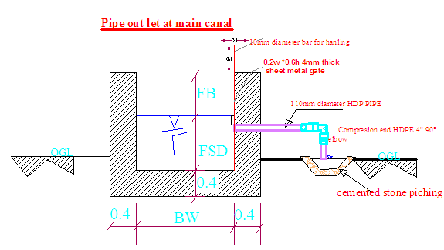
Figure 4-1: Typical Cross Section of pipe out lets at main canal

1.4.3 Secondary Canals
In the layout system there are 8 secondary canals, the designed discharge is determined based on the duty of irrigation. The number of secondary canals for development of 148.5ha net command area is eight in which the density of canal is based on the number of command between gullies is accounted and command topography accounted. The sections of the canals are determined by using manning’s formula, and they are rectangular section. The hydraulic characteristics for sc-1 &2 are presented in Table 4.2 below. Similarly the hydraulic characteristics for other secondary canals are analysis in excel.
Table 4-4 Hydraulic parameters of secondary canals
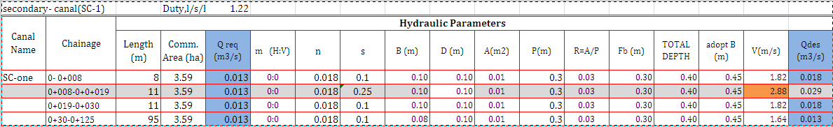

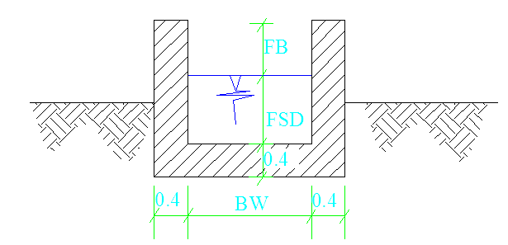
Figure 4-2:- typical cross section of secondary canals

Tertiary canals
In the layout system there are 32 tertiary canals, the designed discharge is determined based on the duty of irrigation and the command area which each tertiary canal can irrigate. The sections of the canals are determined by using manning’s formula, and they are rectangular section. Among the different irrigation systems rotational irrigation system will be used for the tertiary canals; and the irrigation water will be obtained from the secondary canals. It is impossible to attach all the hydraulic parameter for 32 tertiary canals. The sample hydraulic characteristics are Presented below for further excel analysis sees the attached excel.
Figure 4-3:- typical cross section of tertiary canals
Table 4-5 hydraulic parameter of tertiary canals
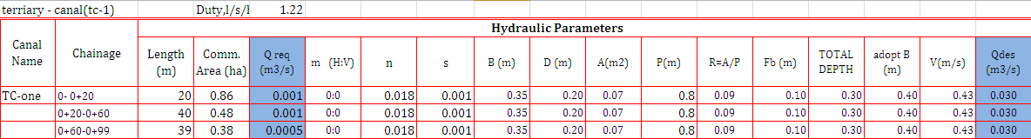

Field Canals
As shown in the layout, field canals run across the contours and hence face relatively steeper gradient. Field canals at secondary six are lined masonry rectangular shape canals. The discharge of most of the field canals is very small and this is taken as an advantage to cope up with the relatively steeper gradient. Figure 4.3 below shows a typical field canal x-section at secondary six but the other field canals are earthen trapezoidal canals. As much as possible field canals shall be made in fill in order to easily irrigate the adjacent command area. As can be seen from the layout, majority of the filed canals can be used to irrigate both sides of the command area depending on the condition of the individual plots of land owned by individual farmers.
Figure 4-4: Typical Field Canal X-section

Chute structures at Canals
Naturally the topography of the project are is undulating type so even thought for main canal and territory canal follows the contour at some chain age MC, SC and TC has chute structures. The hydraulic parameter of the chute structures are as follows.
Table 4-6 hydraulic parameter of chutes structures
chute on | Starting Chain age | design discharge Q (m3/s) | B (m) | D1 | FB | length L (m) | drop height ht (m) | g | a | f | B
MC-1 | 3+960 | 0.096 | 0.70 | 0.12 | 0.20 | 40 | 10 | 0.642 | 0.15 | 0.62 | 10
SC-1 | 0+008 | 0.012 | 0.45 | 0.10 | 0.3 | 11 | 3 | 0.063 | 0.15 | 0.17 | 10
SC-3 | 0+040 | 0.022 | 0.45 | 0.10 | 0.3 | 40 | 8 | 0.177 | 0.15 | 0.39 | 10
SC-4 | 0+016 | 0.014 | 0.45 | 0.10 | 0.3 | 50 | 13 | 0.081 | 0.15 | 0.42 | 10
SC-5 | 0+015 | 0.041 | 0.45 | 0.10 | 0.3 | 31 | 8 | 0.454 | 0.15 | 0.48 | 10
SC-6 | 0+003 | 0.025 | 0.45 | 0.10 | 0.3 | 41 | 11 | 0.223 | 0.15 | 0.42 | 10
SC-7 | 0+021 | 0.028 | 0.45 | 0.10 | 0.3 | 73 | 21 | 0.262 | 0.15 | 0.69 | 10
SC-6 TC-2 | 0+052 | 0.010 | 0.40 | 0.10 | 0.3 | 63 | 13 | 0.059 | 0.15 | 0.50 | 10
SC-6 TC-3 | 0+041 | 0.008 | 0.40 | 0.10 | 0.3 | 50 | 12 | 0.042 | 0.15 | 0.48 | 10

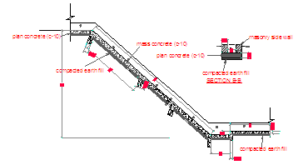
Figure 4-5: Typical chute Canal X-section

Drainage Canals

Drainage Canals
Catch drainage canals Drainage Canals aren't provided for the main canal, because there are nine escape canals which join excess water to the gullies along main canal and the drainage are entered to gullies through the escaping Canals. Hence to be economical no need of catch drains for main canal.

Field drainage canals
Field drainage Canals aren't provided for the Tertiary canals, because all of the tertiary canals are entered to gullies as a result the tertiary canals are used as field drainage during wet season.in addition It is assumed that there is no excess irrigation water during dry season. For the rainy season the water that comes through the tertiary canals directly entered to gullies.

Escape canal
For mais-1 irrigation project length of main canal is 6.22 km hence there are 9 escaping canals provide at main anal along the route. Hence the hydraulic parameter as follows below.
Table 4-7 hydraulic parameter of escape canals
escape canal at main canal
escape | chain age | internal width (B) | top width of canal(TW) | length(L) | canal total depth(D)
1 | 0+060 | 0.4 | 0.6 | 4 | 0.4
2 | 0+540 | 0.4 | 0.6 | 11 | 0.4
3 | 0+790 | 0.4 | 0.6 | 8 | 0.4
4 | 1+270 | 0.4 | 0.6 | 15 | 0.4
5 | 1+710 | 0.4 | 0.6 | 8 | 0.4
6 | 2+370 | 0.4 | 0.6 | 5 | 0.4
7 | 4+100 | 0.4 | 0.6 | 15 | 0.4
8 | 4+580 | 0.4 | 0.6 | 5 | 0.4
9 | 5+760 | 0.4 | 0.6 | 12 | 0.4

t
BW
FSD
FB
TW
1.5
1

Figure 4-6: Typical Escape Canal X-section

Canal Structures Design

Design of a typical flume
For Maise one project the rout of main canal follows counter along terrain topography as a result there are 19 gully crossing structures from here 8 are flume structures and the remaining are supper passage and dry river cover slab structures. For 8 flumes structures there hydrologic, hydraulic and structural analyses have been done.

Hydrologic Characteristics of flume
Hydrologic analysis have been done for large gullies which has relatively significant stream flow, catchment area and stream line at GIS delineation. Hence the contribution catchment area very small we used the rational method to compute the peak flood analysis of the gullies. GIS output of gullies for hydrological analysis.
Table 4-8 GIS output data for flume hydrology
maise1- flum-8
partial | Cumulative | Elevation | Elevation-diff | TC(hr) | slope | catchment area(ha)
length(km) | 0 | 2797 | 0 | 0
0.55 | 0.55 | 2750 | 47 | 0.107937
0.48 | 1.03 | 2720 | 30 | 0.109635 | 74.75728
1.03 |  |  |  | 0.217572 | 0.013377 | 12.55 ha
maise1- flum-6
partial | Cumulative | Elevation | Elevation-diff | TC(hr) | slope | catchment area(ha)
length(km) | 0 | 2991 | 0 | 0
0.68 | 0.68 | 2900 | 91 | 0.106936
0.853 | 1.533 | 2800 | 100 | 0.133984
0.406 | 1.939 | 2747 | 147 | 0.049005 | 125.8381
 |  |  |  | 0.289926 | 0.007947 | 77.22 ha
maise1- flum-5
partial | Cumulative | Elevation | Elevation-diff | TC(hr) | slope | catchment area(ha)
length(km) | 0 | 2971 | 0 | 0
0.419 | 0.419 | 2900 | 71 | 0.067256
0.765 | 1.184 | 2800 | 100 | 0.118151
0.295 | 1.479 | 2738 | 138 | 0.034722 | 157.5389
1.479 |  |  |  | 0.220129 | 0.006348 | 30.7 ha
maise1- flum-4
partial | Cumulative | Elevation | Elevation-diff | TC(hr) | slope | catchment area(ha)
length(km) | 0 | 2834 | 0 | 0
0.136 | 0.136 | 2800 | 34 | 0.024346
0.212 | 0.338 | 2744 | 144 | 0.023322 | 266.2722
0.338 |  |  |  | 0.047667 | 0.003756 | 1.395 ha
maise1- flum-3
partial | Cumulative | Elevation | Elevation-diff | TC(hr) | slope | catchment area(ha)
length(km) | 0 | 2848 | 0 | 0
0.185 | 0.185 | 2800 | 48 | 0.03042
0.148 | 0.333 | 2750 | 150 | 0.01516
0.064 | 0.397 | 2741 | 9 | 0.01700 | 269.5214
0.397 |  |  |  | 0.06258 | 0.00371 | 1.76 ha
The analysis is as follows in the table.
Table 4-9 hydrologic parameter of gully crossing structures
Chain age | Drainage name | Length(m) | Time of concentration(min) | Runoff coefficient( C ) | RF Intensity(I)mm/hr | Catchment area A(ha). | Q _{from} _{catch} (m³/s)
0+802 | flume-3 | 397.000 | 3.780 | 0.720 | 200 | 1.760 | 0.704
0+910 | flume-4 | 338.000 | 2.880 | 0.720 | 160 | 1.395 | 0.446
1+297 | flume-5 | 1479.000 | 13.212 | 0.720 | 195 | 30.700 | 11.973
1+718 | flume-6 | 1939.000 | 17.394 | 0.720 | 260 | 77.220 | 40.154
4+030 | flume-8 | 1030.000 | 13.050 | 0.720 | 260 | 12.550 | 6.526

Hydraulic Characteristics of flume
Hydraulic analysis has been done for all flume structures independently. Hydraulic characteristics of flume one as follows
Length of the flume: 10 m
Shape of the flume: rectangular, Roughness coefficient, n =0.014
From the canal longitudinal profiles, u/s canal bed level (CBL) = 2685.39m
D/s Canal bed level (CBL) =2685.359m
U/s full supply level (FSL) = 2686.04m
D/s Full Supply Level = 2686.009m
Total head loss between the inlet & Outlet =0.031m
Table 4-10: Hydraulic Parameters of Flume
Flume on | start Chain age | Q | V | L | h | t
Flume 1 | 70 | 0.177 | 0.61 | 10 | 0.6 | 0.15
Flume 2 | 553 | 0.177 | 0.59 | 14.78 | 0.6 | 0.15
Flume 3 | 802 | 0.177 | 0.59 | 12 | 0.6 | 0.15
Flume 4 | 910 | 0.177 | 0.59 | 13.3 | 0.6 | 0.15
Flume 5 | 1287 | 0.177 | 0.59 | 37.014 | 0.6 | 0.15
Flume 6 | 1718 | 0.166 | 0.58 | 15 | 0.6 | 0.15
Flume 7 | 1917 | 0.166 | 0.58 | 4.05 | 0.6 | 0.15
Flume 8 | 4010 | 0.0973 | 0.51 | 64 | 0.6 | 0.15

Structural Characteristics of flume
In case of Maise-one irrigation project there are 8 flume structures which has maximum pier depth of 9.9m and minimum depth of 1m so the structural analysis have done for pier height greater than 6m one sample using 10m pier height and another one sample for pier height less than 6m done one sample structural analysis using maximum pier height 5m. But the slab and the side wall analysis are the same for all flume structures. The detail analysis at the excel analysis.
Design of Flume for Maise Main Canal
Flume Cross Section
 |  | in side dimensions
 |  |  | h = | 0.7 | m
 |  |  | w= | 0.6 | m
 |  |  | t (Wall) | 0.2 | m
 |  |  | t(Bas S.) | 0.2 | m
 |  | Material Properties
 |  | Unit Wt. of Water |  | 10 | KN/m3
 |  | Unit Wt. of RC |  | 24 | KN/m3
 |  | fck |  | 25 | Mpas
 |  | fy |  | 400 | Mpa.
1 | Design of Flume Section
1.1 | Load Assement
 |  | Concrete load ( DL) |  | 11.52 | KN/m
 |  | Water Load |  | 4.2 | KN/m
1.2 | Load on Flume Section
 | at Bottom of Wall water Load |  |  | 8 | KN/m2
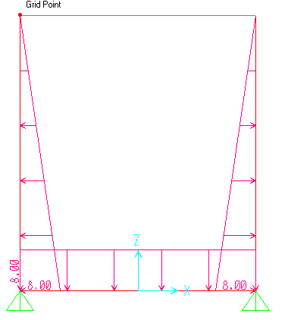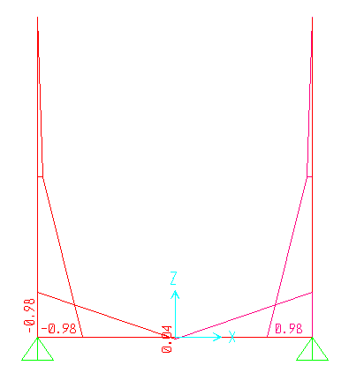

Figure 4-7 live load in the flume (water load) Figure 4-8 service bending moment

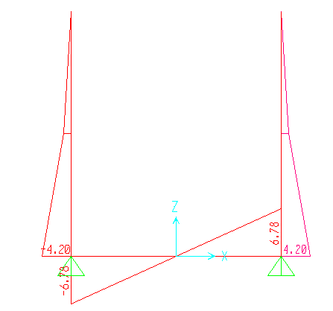
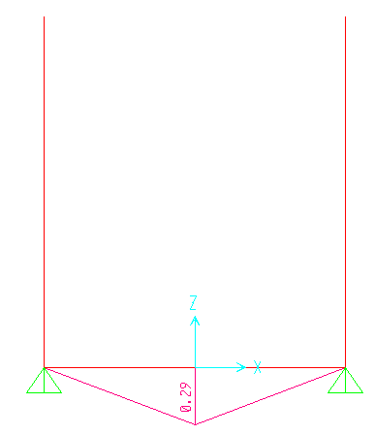
Figure 4-9 shear strength Figure 4-10 shear BM

3 | Bracket Design ( Pier Cup)
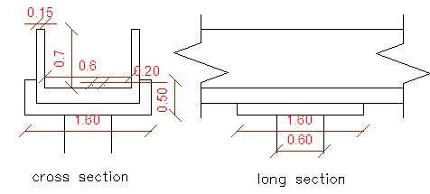

Figure 4-11 peir cap cross section

Design of slab cover
There are 10 covered slab structures at the main canal which the main canal top bank level less than 0.5m from drainage level profile the design is based on manning’s incorporated with hydrology, hydraulic and structural analysis and design. . Similarly the hydraulic characteristics for the cover slab are analysis in excel and shown below.
Table 4-11: Hydraulic Parameters of cover slab

Design of Division box
For Mayis irrigation project there are 24 division box provided at different points of the main and secondary canals division boxes are provided which divert the flow to the secondary canal and tertiary canals. Because the command area is inclined Standard division box plan and sections are for one way opening Gate should be provided at the outlet of the boxes. For detail refer the drawing.
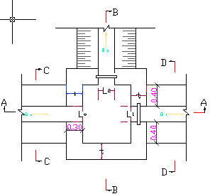
Figure 4-12: Typical Division Box plan
Using broad crested formula,
Q= CL (h)^{3/2}
Where; Q= discharge over rectangular weir/intake (opening), m³/s
C = discharge coefficient, c= 1.7
L= effective length of crest form in m
h= over flow depth, m
Assuming equal discharge coefficient & sill height for two or three dividing canals, the proportion becomes.
Q₀/ Q₁= Q₁/ Q₂ =L₀/ L₁ = L₁/ L₂
Where Q₀= is flow in canal 1
Q₁ = is flow in canal 2
Q₂ = is flow in canal 3
L₀= is effective crest length of weir/intake sill across opening to canal 1
L₁= is effective crest length of weir/intake sill across opening to canal 2
L₂ = is effective crest length of weir/intake sill across opening to canal 3
Q₁= CL₁ (h)^{3/2},
L₀ = Q₁/Ch^{3/2}
L₁ = L₁*Q₁/ Q₀
L₃2= L₀*Q₂/ Q₀
The depth of (height of) the division box,
D = d + f_{b}
The width of the division box,
B = b + 2*m*D
Where b= base width of the incoming canal
D = total canal depth of the incoming canal

Table 4-12: Hydraulic parameters of Division Boxes

Design of drop structure
For Mayis irrigation project there are 14 drop structures provided at different points of the main 2 drops and secondary canals 10 drops and field canals 2drops. Drops are provided to minimize the head and adjust the longitudinal canal slope. For detail refer the drawing.
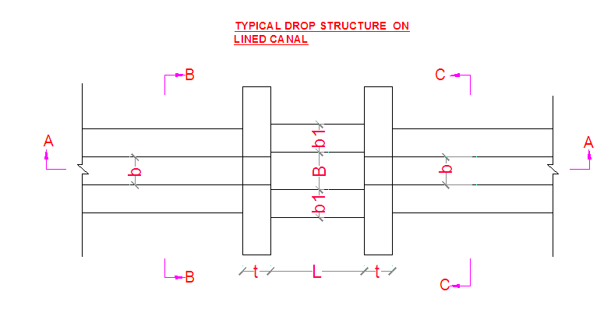
Figure 4-13: Typical Division Box plan
Table 4-13: Hydraulic parameters of drop

Road crossing structure
Four road crossing structures are provided on the one at main canal, one at secondary canal three and two at SC-3 TC-3 and TC-5 tertiary. The road crossing structures are rectangular reinforced concrete slab. The slab is reinforced with 12mm @150mmc/c the length of the slab is 0.9 m which is the same as the respective canal bed width, its width and thickness is 6 m and 15mm respectively.
Table 4-14: Hydraulic parameters of drop
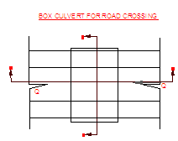
Figure 4-14: Typical Division Box plan

Design of footpath structure
There are 11 foot path structures at the main, secondary and tertiary canals which used to cattle and human access to the command. The hydraulic characteristics for the footpaths are analysis in excel and shown below.
Table 4-15: Hydraulic parameters of drop

Irrigation Infrastructure Bill of Quantities and Cost Estimate
Table 4-16 Infrastructure bill of quantity
S. no | Item of work | Unit | Quantity | Unit Price | Amount (ETB)
3 | infrastructure
3.1 | main canal
3.1.1 | excavation of ordinary soil including cart away | m³ | 10309.7 | 88.20 | 909311.13
3.1.2 | back fill with excavated material | m³ | 2021.5 | 102.31 | 206819.67
3.1.3 | Wreathed Rock excavation (by labor) | m3 | 856.448 | 532.6 | 456179.82
3.1.4 | masonry work(1:3 ratio) | m³ | 3856.4 | 1,436.00 | 5,537,790.40
3.1.5 | plastering work(1:3 ratio) | m² | 17727.0 | 109.42 | 1939703.07
3.1.6 | HDP pipe for outlet PN6 PE100 Dia 110mm | mt | 11.0 | 1,025.20 | 11277.20
3.1.5.1 | both side compression HDPE 4'' 900 elbow | pcs | 11.0 | 70.00 | 770.00
3.1.5.2 | 0.7m*0.6m gate 4mm thick sheet metal with 10mm dia with ring dia.15cm for handling | no | 20 | 6,500.00 | 130000.00
3.1.5.3 | 0.45m*0.4m gate 4mm thick sheet metal with 10mm dia with ring dia.15cm for handling | no | 11 | 6,500.00 | 71500.00
3.1.7 | cemented stone pitching | m³ | 9.9 | 1,240.43 | 12280.22
3.7 | concrete cover slab
3.7.1 | concrete work (c-20) including formwork | m³ | 141.1 | 3,117.00 | 439652.85
3.7.2 | reinforced bar including supply cutting & welding
3.7.2.1 | Ø12 mm bar | kg | 1629.8 | 88 | 143425.50
3.8 | escaping canal
3.8.1 | excavation of ordinary soil including cart away | m³ | 27.9 | 88.20 | 2460.78
3.8.2 | masonry work(1:3 ratio) | m³ | 6.5 | 1,436.00 | 9305.28
3.8.3 | back fill with excavated material | m³ | 3.2 | 102.31 | 331.48
3.8.4 | plane concrete (1:3 ratio) | m³ | 3.8 | 1,544.35 | 5837.64
3.8.5 | plastering work (1:3 ratio) | m² | 16.2 | 109.42 | 1772.62
3.8.6 | 0.45m*0.4m gate 4mm thick sheet metal with 10mm dia with ring dia.15cm for handling | no | 9.0 | 6500 | 58500.00
3.9 | gabion work
3.9.1 | excavation of ordinary soil including cart away | m³ | 13.5 | 88.20 | 1190.70
3.9.2 | stone field gabion work | m³ | 252.0 | 1,400.75 | 352988.62
3.9.3 | back fill with excavated material | m³ | 5.9 | 102.31 | 607.72
3.2 | secondary canals
3.2.1 | excavation of ordinary soil including cart away | m³ | 2252.8 | 88.20 | 198698.06
3.2.2 | back fill with excavated material | m³ | 500.6 | 102.31 | 51218.94
3.2.3 | masonry work(1:3 ratio) | m³ | 1251.6 | 1,436.00 | 1797243.75
3.2.4 | plastering work(1:3 ratio) | m² | 4783.8 | 109.42 | 523441.90
3.3 | tertiary canal
3.3.1 | excavation of ordinary soil including cart away | m³ | 4092.5 | 88.20 | 360956.74
3.3.2 | back fill with excavated material | m³ | 1461.6 | 102.31 | 149536.30
3.3.3 | masonry work(1:3 ratio) | m³ | 3248.0 | 1,436.00 | 4664128.00
3.3.4 | plastering work(1:3 ratio) | m² | 13966.4 | 109.42 | 1528215.09
3.4 | drop
3.4.1 | excavation of ordinary soil including cart away | m³ | 22.7 | 88.20 | 2000.38
3.4.2 | back fill with excavated material | m³ | 18.1 | 102.31 | 1856.31
3.4.3 | masonry work(1:3 ratio) | m³ | 33.3 | 1,436.00 | 47765.15
3.4.4 | plastering work(1:3 ratio) | m² | 97.0 | 109.42 | 10609.87
3.5 | division box
3.5.1 | excavation of ordinary soil including cart away | m³ | 11.2 | 88.20 | 984.31
3.5.2 | back fill with excavated material | m³ | 8.4 | 102.31 | 856.33
3.5.3 | masonry work(1:3 ratio) | m³ | 32.1 | 1,436.00 | 46033.41
3.5.4 | plastering work(1:3 ratio) | m² | 73.1 | 109.42 | 8000.85
3.5.6 | canal gate including supply, cutting, welding and installation consisting of
3.5.6.1 | 0.7m*0.6m gate 4mm thick sheet metal with 10mm dia with ring dia.15cm for handling | Pcs | 8.0 | 6,500.00 | 52000.00
3.5.6.2 | 0.45m*0.4m gate 4mm thick sheet metal with 10mm dia with ring dia.15cm for handling | Pcs | 30.0 | 6,500.00 | 195000.00
3.6 | foot path
3.6.1 | masonry work(1:3 ratio) | m³ | 96.1 | 1,436.00 | 138008.60
3.6.2 | plastering work(1:3 ratio) | m² | 11.0 | 109.42 | 1203.63
3.6.3 | concrete work (c-20) including formwork | m³ | 35.7 | 3,117.00 | 111276.90
3.6.4 | reinforced bar including supply cutting & welding
3.6.4.1 | Ø8mm | kg | 41.2 | 88 | 3622.08
3.7 | supper passage
3.7.1 | excavation of ordinary soil including cart away | m³ | 35.7 | 88.20 | 3148.74
3.7.2 | back fill with excavated material | m³ | 10.5 | 102.31 | 1074.26
3.7.3 | masonry work(1:3 ratio) | m³ | 41.2 | 1,436.00 | 59105.76
3.7.4 | pointing work(1:2 ratio) | m² | 39.2 | 53.03 | 2078.95
3.7.5 | concrete work (c-20) including formwork | m³ | 2.1 | 3,117.00 | 6522.32
3.7.6 | reinforced bar including supply, cutting & welding
3.7.6.1 | Ø10 mm | kg | 30.5 | 88 | 2684.00
3.7.6.2 | Ø 14 mm | kg | 40.5 | 88 | 3564.00
3.7.6.3 | Ø 20 mm | kg | 25.5 | 88 | 2244.00
3.8 | flume
3.8.1 | excavation of ordinary soil including cart away | m³ | 87.3 | 88.20 | 7699.86
3.8.2 | back fill with excavated material | m³ | 46.5 | 102.31 | 4757.42
3.8.3 | masonry work(1:3 ratio) | m³ | 2185.3 | 1,436.00 | 3138090.80
3.8.4 | pointing work (1:2 ratio) | m² | 696.2 | 53.03 | 36922.66
3.8.5 | concrete work (c-25) including formwork | m³ | 68.9 | 3,117.00 | 214820.07
3.8.6 | reinforced bar including supply, cutting & welding
3.8.6.1 | Ø10 mm | kg | 10498.3 | 88.00 | 923846.88
3.8.6.2 | Ø14 mm | kg | 1175.1 | 88.00 | 103407.92
3.8.6.3 | Ø16 mm | kg | 17381.7 | 88.00 | 1529590.48
3.9 | chute
3.9.1 | excavation of ordinary soil including cart away | m³ | 595 | 88.20 | 52479.00
3.9.2 | back fill with excavated material | m³ | 116.7 | 102.31 | 11939.58
3.9.3 | masonry work(1:3 ratio) | m³ | 303.4 | 1,436.00 | 435682.40
3.9.4 | plastering work(1:3 ratio) | m² | 466.7 | 109.42 | 51066.70
3.9.5 | plane concrete work (c-10) | m³ | 166.9 | 1,544.35 | 257752.08
3.10 | box culvert (URAP road crossing)
3.10.1 | excavation of ordinary soil including cart away | m³ | 4.8 | 88.20 | 423.36
3.10.2 | back fill with selected material | m³ | 2.9 | 102.31 | 294.65
3.10.3 | masonry work(1:3 ratio) | m³ | 4.8 | 1,436.00 | 6892.80
3.10.4 | plastering work(1:3 ratio) | m² | 4.8 | 109.42 | 525.22
3.10.5 | concrete work (c-20) including formwork | m³ | 10.8 | 3,117.00 | 33663.60
3.10.6 | reinforced bar including supply, cutting & welding
3.10.6.1 | Ø 12mm | kg | 24.8 | 88 | 2182.40
 | Infrastructure Cost total |  |  |  | 27,076,821.22
 | 15 % Vat |  |  |  | 4,061,523.18
 | Total infrastructure Cost With Vat |  |  |  | 31,138,344.40
 | cost per hectare without VAT |  |  |  | 182,399.37
 | cost per hectare with VAT |  |  |  | 209,759.27

Summary of Bills
Table 4-17 summery of bills
Mayis-1 Small Scale Irrigation Project
SUMMARY OF BILLS
Bill No. | Description | Amount (Birr)
1 | General Items | 3,105,320.68
2 | Head work | 4,198,307.24
3 | Infrastructure | 27,076,821.22
Total |  | 34,380,449.15
VAT (15%) |  | 5,157,067.37
Grand Total with VAT |  | 39,537,516.52

CONCLUSION AND RECOMMENDATION
- The infrastructure of this project area is designed to irrigate about 148.448 ha of land by taking its supply from the Mayis diversion weir irrigation project. The maximum duty of the command area for 20 hours per day irrigation with overall project efficiency of 48%. The method of irrigation of the project area is furrow surface irrigation in which the main, secondary and tertiary canals are working continuously whereas the field canals within a tertiary block are working rotational system.
- As the dominant soil type is clay soil, the main canal system is designed to be masonry.
- The reason why the main canal is to be lined up to the end is to avoid the siltation and scouring problems, time saving to reach at the tail part, reduce maintenance cost.
- On the secondary unit of the irrigation systems, some are associated with chute. They are designed as far as possible to be partially filled and cut. The layout is designed as far as possible to avoid cross-structures within them.
- The design of the canal dimensions of the irrigation canal is done by applying the manning’s uniform flow equation. The variable of the hydraulic parameters are calculated using iteration or flow master program.
- The design discharge of the drainage canals are determined using rational formula and Gamble Powell method.
- As soils of the command area are predominantly clay loam textured; and hence water and soil management measures should be undertaken; and optimum moisture content should be maintained to improve workability of the soil during land preparation and planting time.

The following recommendations are drown:
- For better performance and long service year of the project regular inspection and maintenance is highly required.
- Farmers training, how to operate and maintain the project structures as a whole and available and water resources has a paramount important.
- The irrigation hours per day and per week should be flexible based on base flow amount of each week or month.
- Close supervision of the construction should be made to modify (if need be) each Components of irrigation system based on specific site conditions.

OPERATION AND MAINTENANCE

General
The main objective of the operation and maintenance aspect of an irrigation scheme is to facilitate the timely delivery of the required irrigation water to farms and to keep the irrigation system in an optimum operating condition. This section therefore, discusses the main functions of the subject matter under consideration for the scheme.

Operation of the Head Works
Operation at the diversion weir mainly focuses on the diversion of a controlled flow of river water, timely cleaning of floating debris in front of intake and removal of sediment deposits in front of the weir and intake structures.

Irrigation System Operation
The operation of the irrigation system depends mainly on the method of water delivery at farm level. Surface irrigation method is the recommended type of water distribution and application method for Mayis-1 diversion irrigation scheme.
The farmers would organize themselves and form groups in order to handle the water management. Since flow is low Rotational water distribution would be applied within the group. The rotational distribution is then to distribute water by turn to the whole scheme according to the timely need of crop water requirement. For better and efficient water management, crop diversification should be avoided within a group. This would reduce the complexity of water distribution system of the scheme during one irrigation season. At farmers’ level of operation, a constant flow and variable irrigation time is advisable.
The operation of the irrigation system is continuous for 18 hours per day in main, secondary and tertiary canals whereas field canals within a tertiary block are operating in rotational system with each other for irrigation hours proportional to their size. Since the tertiary canal discharges are within the manageable range and the irrigation canal structures are accordingly designed for simple operation, the farmers can open and close easily whenever they required.

Maintenance Requirement
The canal system of the project is earthen canal except main canal and secondary canal, which is susceptible to siltation, erosion, growth of weeds and or breaching problems. Though the canal sections are designed for non- silting and non-scouring conditions, the above mentioned problems are unavoidable and hence periodical and yearly inspection and maintenance of canals and structures are obligatory in order to fulfill the design objective of the project area.
The maintenance tasks are categorized into two types: - routine activities, and repairs. The routine maintenance activities that are carried out periodically include:-
- Regular cleaning of sediments and weeds from canals and drains;
- Inspection and lubrication of gates; and
- Maintenance of cracked lined canals, regulating and control structures.
Repair works include task carried out more frequently and quickly, and include those tasks that are generally unpredictable. They also include emergency works. The activities included in this category are:-
- Repairing overtopped or breached canals, drains, and flood protection dykes;
- Repairing jammed gates;
- Filling holes made by wild animals; and
- Reduced free board due to walking over by people and livestock.
Regular inspection of the irrigation facilities should be carried out as part of the maintenance activities. These tasks could be carried out immediately after the end of the main rains in September and during the rainy season. This could concentrate on the interceptor drains and the flood protection dykes, the main canal and the field drains. The inspection of the other works like the tertiary canals, field drains, and the water control and regulating structures could be carried out as part of routine operation activities.
- Beneficiaries of the project need to have operation and maintenance budget, For O&M cost incurring entity area:
- Purchase sing of gate lubricate (grease)
- Replacing and maintenance of Stolen and damaged gates
- Repair Damages on the cross drainage structures.
The expense for O&M should be collected from the beneficiaries. Of course, much of the task is done by the labor and skill of the community. For cost incurring activities beneficiaries have to collect money based on the proportion of the command area they owned.

REFERENCE
- FAO (1977) guidelines for predicting crop water requirements. No 24, Rome Italy
- Design of small Canal structures , USBR
- Soft copies of hydraulic structure publishing
- IDD manual
- ESRDF manual

