oromia REGIONAL national states

THE NATIONAL REGIONAL STATE OF
OROMIA
OROMIA IRRIGATION DEVELOPMENT AUTHORITY


FEASIBILITY STUDY AND DETAIL DESIGN
OF
LOT 10 SSIPs [KELLAM WOLLEGA]

Meti SMALL SCALE IRRIGATION
PROJECT
SOCIO ECONOMY, ORGANIZATION AND MANAGEMENT, AND FINANCIAL ANALYSIS
FINAL REPORT2

Tel: 0920724075/0911963757
E-mail: letinsasc@gmail.com

March 2019
Addis Ababa, Ethiopia
oromia irrigation development authority

FEASIBILITY STUDY AND DETAIL DESIGN
OF

bale zone gurra dhamole woreda awuchache SMALL SCALE IRRIGATION PROJECT
SOCIO ECONMIC
FEASIBILITY STUDY REPORT



P.O.Box:2929/1250
Tel.: +251-920724075/0911963757
Addis Ababa, Ethiopia
E-mail: letinsasc@gmail.com
March 2015
Addis Ababa, Ethiopia

TABLE OF CONTENTS
TABLE OF CONTENTS 2
LIST OF TABLES 6
LISTOF FIGURES 6
ANNEXES 7
ACRONYMS 8
1 EXCUTIVE SUMMARY 9
2 INTRODUCTION AND BACKGROUND 12
2.1 INTRODUCTION 12
2.2 Rationale of the project 12
2.3 Review of policies and strategies 13
2.4 Objectives 14
2.4.1 General objective 14
2.4.2 Specific objective 14
2.5 Scope of the Study 15
2.6 limitation of the study 15
3 Methodology 16
4 SOCIO ECONoMiC Features 21
4.1 Location and access 21
4.2 Proposed Project Command area and Beneficiaries 21
4.3 Climate and topography 22
4.4 Water source 22
4.5 Project area and Settlement 23
5 Population And Demographic Characteristics 25
5.1 General 25
5.2 Population size of woreda 25
5.3 Urban and Rural Population of Sayyo woreda 25
5.4 Population Density and Spatial Distribution 26
5.5 Project Area Population Size and Demographic Features 26
5.5.1 Population 26
5.5.2 Family size 26
5.5.3 Sex composition 27
5.5.4 Age structure and labour availability 27
5.5.5 Labour Availability 27
5.5.6 Ethnic Groups 28
5.5.7 Religion 28
5.5.8 Population Growth Projection 29
5.5.9 Factors contributing population growth 30
6 Land Use and land holding 31
6.1 Land use 31
6.2 Land holding size and land access 31
7 Economic and poverty situation 33
7.1 Economic and livelihood source 33
7.2 Wealth status and income distribution 34
7.3 Food Security Situation 34
8 Economic activities and production 35
8.1 Agriculture and Crop production 35
8.2 Livestock 36
8.3 Other off farm activities 37
8.4 Agro Processing Industries and Urban Economic Prospect 37
9 Market and roots 38
9.1 Market Institutions and stakeholders 38
9.2 Market and Market prospect at project area 38
9.3 Market Centre 38
9.4 Product destination 39
9.5 Product Demand and Supply 40
9.6 Product Price 41
9.7 Market problems and constraints 42
10 Agricultural support service 44
10.1 Agricultural Extension Service 44
10.2 Credit and saving 45
10.3 Cooperative and water users associations 47
11 Gender 49
12 Basic Social Service 51
12.1 Health service and health infrastructures 51
12.2 Education 53
12.3 water supply 54
12.4 Source of Energy 54
12.5 Development Potentials and Opportunities 55
13 Projects Social impact and Threats 56
13.1 Human Displacement 56
13.2 Health and related social impacts 57
13.3 Land Loss and land redistribution issues 57
14 Project Benefit and Contribution 59
14.1 Direct beneficiaries 59
14.2 Other Indirect economic benefit 59
15 Community Participation 61
15.1 Cost Sharing 61
15.1 Camp site 62
15.2 Cost Recovery 63
15.3 Project Beneficiaries 64
16 Conclusion and Recommendation 66
16. Introduction and Background 69
16.1 Introduction 69
16.2 Objective 69
16.3 Policies and Legal framework 69
16.4 Role and responsibilities 70
17 Existing Organization and Management 72
17.1 Administration Status of the Project Area 72
17.2 Existing Community Organizations 72
17.3 Community Consultation and Participation 73
17.4 Local Administration Support to the Scheme 73
18 Proposed Organizational Structures 75
18.1 General 75
18.2 Proposed Organization arrangements 75
18.3 Water User Association (WUA) 75
18.4 Land issue and dispute settlement approach 77
18.5 Cost Recovery and Water Charge Approach 78
18.6 Training and capacity building 78
19 Monitoring and Evaluation 79
20 Conclusion 81
21 Introduction and Background 83
21.1 INTRODUCTION 83
21.2 OBJECTIVE 83
21.3 BASIC PRINCIPLES AND CONCEPTS 84
22 METHODOLOGY, ASSUMPTIONS AND CONCEPTUAL FRAMEWORK 85
22.1 General 85
22.2 Inputs and Outputs 85
22.3 Financial and Economic Viability Indicators and approach 86
22.4 Financial and Economic Viability Indicators and implications 87
22.5 THE PROJECT 88
22.5.1 TECHNOLOGY 88
22.5.2 COMMAND AREA AND BENEFICIARIES 88
22.6 PROJECT COST 88
22.6.1 General 88
22.6.2 Irrigation infrastructure and system Investment Cost 88
22.6.3 Other farm tools/implements investment cost 89
22.6.4 Replacement cost 90
22.6.5 Investment schedule 92
22.6.6 Operation & Maintenance Cost 92
22.6.7 Project Financing 92
23 FINANCIAL ANALYSIS 93
23.1 WITHOUT PROJECT 93
23.1.1 Cropping pattern and land allocation 93
23.1.2 Farm input and yield estimates 93
23.1.3 Farm cost and income 93
23.2 WITH THE PROJECT Situation 94
23.2.1 Cropping pattern 94
23.2.2 Land Development Plan 94
23.2.3 Input and farm cost 95
23.2.4 Yield build up 95
23.2.5 Price of input and output 95
23.2.6 Financial Analysis Results 95
23.2.7 Risk and Sensitivity Analysis 96
24 ECONOMIC ANALYSIS 98
24.1 ESSENCE AND ISSUES 98
24.2 BASIC PRINCIPLES AND APPROACH 98
24.2.1 Economic Evaluation 98
24.2.2 Conversion Factor used for economic analysis 98
24.3 ECONOMIC ANALYSIS RESULT 99
25 CONCLUSION AND RECOMMENDATION 100

LIST OF TABLES
Table 6-1 : Land use pattern of Sayyo woreda and Anno Mikael Kebele 31
Table 8-1: Shows major crops produced under rain fed in Sayyo Woreda 2009/2010 35
Table 8-2: Major crops under irrigation in Sayyo woreda 2009 35
Table 8-3: Major crops under rain fed in Anno Mikael 2009/2010 35
Table 8-4: Major crops under irrigation in Anno Mikael kebele 2009/2010 36
Table 8-5: Livestock types & quantities in Sayyo Woreda and Anno Mikael Kebele 36
Table 9-1: Market distance from the project kebele 38
Table 9-2: average prices of some products trend in Sayyo Woreda 41
Table 10-1: Agricultural input supply and distribution in Sayyo Woreda 44
Table 12-1: Ten top diseases of Sayyo Woreda report 52
Table 12-2: Health personnel of Sayyo woreda health office 53
Table 12-3: Sayyo Woreda Student enrolment 53
Table 12-4: School and enrollment of the Anno Mikael kebele 54
Table 19-1: Monitoring and Evaluation Framework 79
Table 22-1: Investment cost- Irrigation infrastructure and system development 89
Table 22-2: "With" the project other Investment costs and Overhead costs 91
Table 23-1: Without project/Existing cropping pattern (%) 93
Table 23-2: Cropping pattern with project 94
Table 23-3: Land development plan and cropping Pattern “with” the project 94
Table 23-4: Yield Build Up for "With" Project Situation 95
Table 23-5: Financial Analysis Result 96
   Table 23-6 Risk and sensitivity analysis 96
Table 24-1: Average Conversion Factor(ACF) of common items 99
Table 24-2: Economic analysis and sensitivity test result 99

LISTOF FIGURES

Figure 3-1: Discussion with woreda key stake holders 17
Figure 3-2: During house hold survey 18
Figure 3-3: Methodological framework, Procedure and workflow 20
Figure 4-1: Partial views of the study team 22
Figure 4-2: Shows Meti river 23
Figure 4-3: Shows settlement of the area 24
Figure 5-1: population growth trend of the Anno Mikael kebele 29
Figure 6-1: Command area of Meti SSIP 32
Figure 7-1: Economic and livelihood source of the kebele 33
Figure 9-1: Discussion with community during the visit 39
Figure 9-2: Market and Product destination flow 40
Figure 9-3: Population growth and Food demand projection of Anno Mikael kebele 40
Figure 10-1: livestock towards market 48
Figure 11-1 Discussion with woreda women and children office experts 50
Figure 12-1: Charcoal woods on production for sell 55
Figure 15-1: Committee elected by community 63
Figure 18-1: Proposed Organizational Structure for Irrigation Water User Cooperatives (WUC) 76

ANNEXES
ANNEX 1: Financial and Economic Analysis Tables 102
ANNEX 2: Reference 104
ANNEX 3: LIST OF CONTCATS IN SAYYO WOREDA 105
ANNEX 4 : Community petition 106
ANNEX 5: Questioners 112
ANNEX 6: Household Survey Questionnaires 122

ACRONYMS
BC: Benefit Cost
BOQ: Bill of Quantity
CF: Conversion Factors
CSA: Central Statistics Authority
DA: Developmental Agent
ECX: Ethiopian Commodity Exchange
FC: Farmers Cooperative
FDRE: Federal Democratic Republic of Ethiopia
FNPV: Financial Net present Value
GTP: Growth Transformation Plan
Ha: Hectare
IRR: Internal Rate of Return
IWMI: International Water Management Institute
IWUC: Irrigation Water User Cooperative
MDG: Millennium Development Goal
MOWE: Ministry of water, energy and irrigation bureau
O&M: Operation and Maintenance
OIDA: Oromia Irrigation Authority
PASDEP: Plan for Accelerated and Sustained to End Poverty
Ql: Quintal
SSIP: Small Scale Irrigation Projects
VCT: Voluntary Counseling and Test
WAO: Woreda Agriculture Office
WAO: Woreda agriculture office
WCPO: Woreda Cooperation Promotion Office
WCPO: Woreda cooperative promotion office
WDC: Water Distributer Committee
WDC: Water distributor committee
WMC: Water Management Committee
WMC: Water management committee
WUA: Water User Association

EXCUTIVE SUMMARY
In the Ethiopian government development policy, agriculture is leading sector of the economy and given prime attention and considered as source of growth and drawn agriculture growth progrmme (AGP) to stimulate production and productivity in agriculture and thereby to bring reinforced development in industry and other sector of the economy.
Accordingly, Oromia Irrigation Development Authority initiated for study of several small scale irrigation projects of which Meti irrigation project is one among those project identified for feasibility study. The study was undertaken by Letinsa Share Company. Part I of this report deals with socio economic study report and Part II is also organization and management aspect of the project.
Location: Meti Small-Scale Irrigation Project is located in Sayo Woreda and can be accessed along the asphalt road that runs from Addis Ababa to Dembi Dolo towns. The project is about 655km from Addis Ababa and just 9 km from the woreda and Zone Capital Dembi Dolo. From the indicated 9km, 6km is asphalt road and the rest 3km is URRAP constructed road. During project construction, it needs only 1km new access road.
Agro ecology and climate: Ecologically the woreda is distributed in 25 % low land, 45.83 % mid land and 29.17 % is high land.
Population: The total population of woreda is 126,615. From this 69,554 % are male and rests 57,061 % are female. . The Anno Mikael kebele has total households of 977 from this 585 are male headed 39 are female headed. Anno Mikael have a total population of 3598, from this Male is 1569 and Female is 2029.
Proposed project and beneficiaries: The command area is 107 ha and about 428 households will be expected to be a beneficiary with considering 0.25 ha of land for a household. Total cost of the project is 25,671,263.61 Birr including 15% VAT and community participation which is 7.01% or birr 1,682,238.
Community Participation: Community participation in planning, implementation and management is believed to ensure sustainable operation of development project. The community also expressed their interest and willing on meeting and application as they have good demand for the project.
Organization and Management: Functional community organization starts from clear understanding of the project area and existing community organization and administrative setup. The woreda agriculture office speaks as they have sufficient irrigation experts while the irrigation experts express as they need additional technical trainings and practical experiences on irrigation.
In general, proposed project is planned in potential and suitable agro ecology to produce diversified market based crops, but less experience in modern irrigation, and the project planned in consultation of community and community willing for participation and strong local responsiveness, suitable land and water resource available… etc. and socially feasible for implementation.

- PART I: SOCIO ECONOMY

INTRODUCTION AND BACKGROUND

INTRODUCTION
In line with government development strategic direction and policy focus for agriculture, Meti irrigation project was identified for feasibility and design study. The Meti SSIP project is located in Kellam Wollega zone Sayo Woreda in Anno Mika’el kebele. Feasibility study of the project included all sectorial studies and this socio-economic study conducted as one components of the feasibility study with aims to identify basic socio-economic features of the project area. The report preparation considered the requirements of the Terms of reference, field observation and, data collected at project sites and different stakeholder consultations to depict general socio-economic overview of the project area.

Rationale of the project
Agriculture is the dominant sector of the Ethiopian economy that contributes over 40% of GDP, 90% of export earnings and 85% of employment. However, the sector characterized largely rain fed dependent that cause severe damage in agriculture due to shortage of rainfall and others.
To overcome the effects of climate change and rainfall shortage, water centered development in agriculture is given prime importance more than ever in current agricultural development program with aims to improve the problem with food deficits in the country. Therefore, there is growing interest of government and other stakeholders towards promotion of water centered agricultural development.
The government policy support both private investment as well as small holders farm in agriculture development and small scale irrigation is believed to relief small holders rainfall dependence to increase agricultural production and one among the interventions options and one of the pillars in agriculture growth program ( AGP).
In a country like Ethiopia where over 85% of the population livelihood base is agriculture dependent, efficient and effective utilization of available land, water and labor is paramount important to bring sustained economic development. Irrigation Project believed to achieve increased livelihood bases, income improvement and generally to promotes socio economic development of the country. Thus technical support for development of the available water resources and irrigation is inevitable and necessary to bring sustainable food production and agricultural development.

Review of policies and strategies
The government of Ethiopia adopts development policies and strategies every five years. The Plan for Accelerated and Sustained Development to End Poverty (PASDEP) adopted for the period 2005/6-2009/10 has given prime importance for rural and agriculture development with aims for accelerated, sustained, and people-centered economic development to achieve the MDGs by 2015.
Following the PASDEP, Growth and Transformation Plan (GTP) adopted for the period (2009/10-2014/15) after that (AGP 2) is planned or the period of 2015/16-2019/20 and is directed to achieve an economy which has a modern and productive agricultural sector with enhanced technology and an industrial sector that plays a leading role in the economy; to sustain economic development and secure social justice; and, increase per capita income of citizens so that it reaches at the level of those in middle-income countries.”
In policy direction of GTP 2, smallholder farming will continue to be the major source of agricultural growth with shift into commercialization. To complement this development objective, concerted policy support for private investment in large commercial farms Fundamentals of the strategy include the shift to produce high value crops, a special focus on high-potential areas, facilitating the commercialization of agriculture, supporting the development of small and large-scale commercial agriculture where it is feasible. In general, agriculture will direct on placing major effort to support the intensification of marketable farm products by small and large farmers for domestic and export market.
During the GTP 2 period, it is planned to transform agriculture sector to high growth path in order to ensure the food security challenge of the country and to curb inflationary pressure as well as broadening the export base of the country. The sector also serves as a spring board to bring about structural transformation in the long run through contribution to industrial growth. To promote multiple cropping and better cope with climate variability and insure food security, the Growth and Transformation Plan (GTP) 2 has adopted agricultural development and focus strategies include;
- Scaling up production and productivity of land, labor and available natural resource use based on agro ecological suitability.
- Specialization, diversification and strengthening agricultural production and marketing system.
- Strengthen extension service for majorities of smallholders
- Provide support for the private large scale commercial farms.
- Promotes appropriate use of rain water and other water source,
- Improve water use efficiency through expanding of irrigation schemes with special attention to small scale irrigation schemes development.
- Strengthen public participation in the planning and implementation and take affirmative action’s to enhance women participation at Woreda and kebele level; engaging and mobilizing the public in the construction of local infrastructure development activities (road, schools, health stations, irrigation and others).
In general, the agricultural Transformation Plan has adopted range of interventions and public investments directed to basic infrastructure development mainly road, market infrastructures and others to support and scale-up of the success in economic growth of the country. For conducting the socio economic study other policies like water policy, land use policy etc was referred and used to explain the issues.
In line with the general development policy and strategic framework, several attempts underway in study and design of small scale irrigation project initiated by respective regions with vision towards water centered irrigated agriculture development for small holder benefit through efficient utilization of the existing water resource.

Objectives

General objective
The main objective of the socio economic study of the Meti irrigation project is to assess and identify the communities demand, social and health impact and the existing socio-economic opportunities and constraints of the project area.

Specific objective
The specific objective of the Meti SSIP is as the following
- The study is to reveal socio economic situation of existing conditions, economic activities, and income and livelihood source
- Identify socio economic constraints and priority problems and asses expected positive and adverse impacts as well as community attitude and social feasibility of the project.
- To assess the demographic features and characteristics of the community
- To assess the existing agricultural market practice, opportunities and challenges

Scope of the Study
The socio economic study of the Meti SSIP deals with all about socio economic and demographic features of the project area. These includes assessment of existing economic activities, economic and livelihood basis, existing basic social infrastructure and social services, and identifying major economic and social problems, development priorities of the project area. Furthermore, the study gathers data on positive and adverse social impacts of the project, and stipulate how to intensify the positive aspect and mitigate the possible adverse social impacts due to the project.
In general, the report tried to verify the underlying socio economic and demographic situations and the scope of task includes, but not limited to;
- Asses and identify existing socio economic problems, constraints and social mitigation measures
- Asses gender relations and gender disaggregated data with respect to land access, control over resource, capital and income.
- Assess the status of house hold economy
- Asses conflicting and or competing demand if any
- Asses social impacts of the projects
- Asses and evaluate farmers attitude toward the project and
- Asses existing social structures and recommend social structure for sustainable use and operation of the irrigation system.
- Assess extent of farmers interest in the project and its implications for project planning

limitation of the study
Some socio economic data was not available as expected. For example the market data was not included all the items can be produced by irrigation. The market share of the local product was also not available. Some data was also couldn’t be found specific to the project level.

Methodology
Both primary and secondary data gathered from relevant key informants, Sectoral offices, stakeholders and project beneficiaries and all directly or indirectly affected community groups. Moreover, woreda
Government offices, key informants, and other responsible partners at Woreda office and zone level contacted and discussed on the project under study. Relevant data and information required for the study was identified prior to field work and pre-prepared information checklist that used in gathering information and baseline data with respect to socioeconomic situation of the area and checked consistency of the data thorough discussion with farmers and development agents of the project kebele.
The general methodology approach used in data collection and descriptive analysis includes;
- Review of Reports and Secondary Data Source
Available secondary data and socio economic information were gathered in January 20- March, 24, 2018, at regional, zonal, Woreda, kebele and community level that expected to serve as input for the study. Pertinent documents on policy issues mainly land policy, irrigation policy of the region, and other national and regional development strategic policy direction accessible were also gathered and reviewed within the framework of the project objective.
- Key Informants and Discussion With Stakeholder institutions
Primary data required for this study were generated through field assessment and in office discussion in March, 2018. Site visits and discussion also held with different stakeholders and focal groups including interview with individual households. Representatives of sectoral office and other stakeholders and experts of these institutions have been contacted that includes;
- Woreda Administration representative
- Woreda irrigation development authority office
- Woreda water resource development office
- Woreda agriculture and rural development office ,
- Kebele office, Development agents and Beneficiaries/community representatives,
- Health office, Education office and Other sector offices in the project areas
- Worreda Women and children and youth office
- Discussion and consultation meeting was held with, Woreda cooperative promotion office, trade and market development office and other concerned sectoral office.
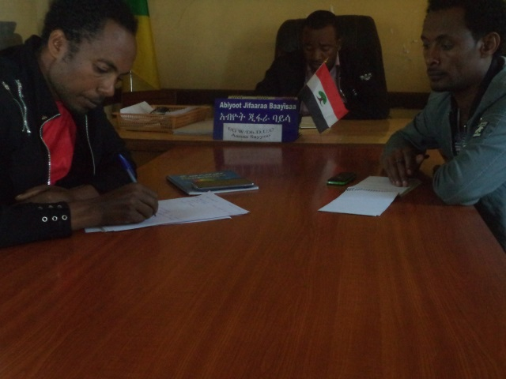
Figure 3-1: Discussion with woreda key stake holders
- Key informants Interview
Key informants interview was made with key responsible individuals mainly woreda agriculture development office and other sectoral offices. Discussion was held with relevant sectoral office and communicated to provide information on specific and selected issues related to irrigation development and other relevant socio-economic issues. The key informants expressed their interest and also raised their doubts especially the quality of the construction and how to make the road access.
- Public Consultation and Focal Group Discussion
In order to know attitudes, opinions and reactions of the community toward the proposed project, group discussion and consultative meeting was held with Kebele leaders, community representatives and different segments of the society. The public consultation was facilitated and pre-arranged by kebele leaders and participants were drawn from different groups of the society (opinion leaders & elders, Women, Youth, beneficiary farmers and Kebele councils) and where woreda administrator and other decision maker’s representatives attended the meeting on March, 24, 2018 on the project site.
Furthermore, transect walks were made in the project area to grasp an overview of the existing socio economic situation and in the process discussions held with communities to explore opinion and attitudes towards the project.
- Household Survey
Household survey was also undertaken in order to assess some basic data on household’s economy and demographic structures based on randomly selected sample population. In conducting the survey, enumerators were selected from the project sites, trained and assigned to conduct the household survey. The head site and command area is in Ano Mikael and Gambi kebele of Sayyo woreda and it covers about 428 ha. As observed from household survey and discussion with key stakeholders the population of the kebele and beneficiary of the command area are fully an Oromo indigenous Oromo. They are almost homogeneous mainly with respect to ethnicity but religion wise they are Muslims and Christian (Orthodox and protestant) culturally and socio economic characteristics of the society is almost similar. By Considering the homogeneous ethnic characteristics of the population using the purposive sampling method about 30 in number of the household’s population taken in household survey. Age composition of sample household ranges from 23 years to 70years.
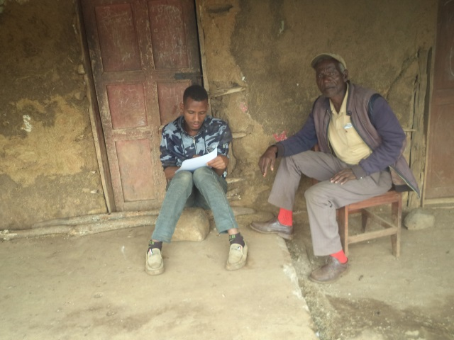
Figure 3-2: During house hold survey
- Data analysis
The socio economic report used descriptive and quantitative analysis approach. The report focuses on project area specific socio economic features, and also provides highlight on general overview of the region, zone and Woreda as required. Household survey analyzed using different software’s example Microsoft excels. The result found used as statistical description.
- Procedures and Process flow
The socio economic study followed the steps and procedure required in data collection and analysis. At the first glance to field work contact was made with Woreda administrative, woreda OIDA office and woreda rural and Agriculture development office. After preliminary discussion, with Woreda administrative Woreda OIDA person assigned to facilitate and guide the study team to project area and kebeles to link with kebele administrative and development agents/DA’s on the project kebele where discussion and data collection continued at kebele level from development agents office and provided available data mainly on command area and beneficiaries. After the discussion at development office, site visit made at project sites and command area and identified the command areas and nature and characteristics of the beneficiary population and determined the sample size for the household survey. After the enumerators trained and assigned for household survey, key informants discussion and community consultation and other data collection continued at kebele and Woreda level and successfully completed the data collection at field and analysis of the report at office. The general approach, process flow and sequence of work are depicted as follows.

Figure 3-3: Methodological framework, Procedure and workflow

Study team
Woreda admin /woreda OIDA
Support staff from the woreda Office
Kebele administrative/ Development agents
Discussion and data collection from Development agents
Site visits & field observation and identification of command area and beneficiary population
Household survey, farmer’s consultation, key informants discussion and data collection at kebele and woreda level.

SOCIO ECONoMiC Features

Location and access
Meti Small-Scale Irrigation Project is located in Sayo Woreda and can be accessed along the asphalt road that runs from Addis Ababa to Dembi Dolo towns. The project is about 655km from Addis Ababa and just 9km from the woreda and Zone Capital Dembi Dolo. From the indicated 9km, 6km is asphalt road and the rest 3km is URRAP constructed road. During project construction, it needs only 1km new access road.
Name of SSIP | Distance from from Woreda capital town | Distance from Dembi Dollo town | Distance from Addis Ababa
Meti | 6 km, 3 km gravel road 1 km foot path | 6 km, 3 km gravel road 1 km foot path | 634 km

Proposed Project Command area and Beneficiaries
The Meti SSIP head work bases in the boundary of Anno Mika’el and Gambi kebeles. The command area is also on the left side in Anno Mika’el kebeles. Communities had an experience of using traditional irrigation for many years by gravity. But at this time they couldn’t continue. Because the head site they used for diversion of water was deepen by erosion and they couldn’t divert it by their labor. The community express as they have an interest for irrigation and on exercising it. During our visit the command area of Anno Mika’el irrigation project have different crops however some areas are free of any crops. The proposed irrigation project is also using diversion irrigation system.
The command area is 107 minimum land division of 0.25ha for the households 428 of household will go to be beneficiary from the project. The command head site and command area in the same kebele so there is no problem in community that they have an experience of using together the water and they know each other because of they are from the same kebele.
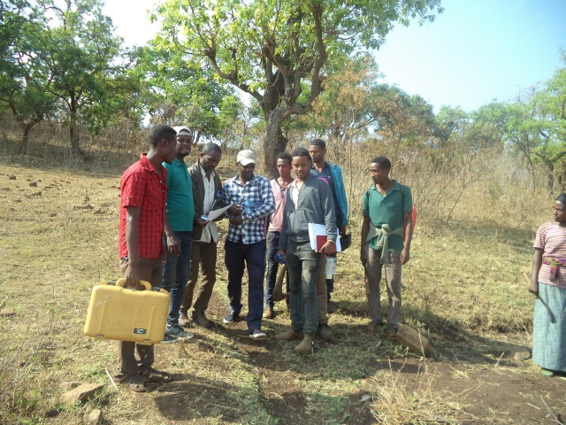
Figure 4-1: Partial views of the study team

Climate and topography
According to available data source, Sayyo woreda has an altitude range of 1100-2750 masl, an annual rainfall range of 1453-2074mm and rain distributed over April to ends in December and a range of temperatures 11⁰c-27^{O}c. Ecologically the woreda is distributed in 25 % low land, 45.83 % mid land and 29.17 % is high land. They use the Meher season rain for crop production.
The proposed project is characterized as low land where temperature, sunshine, winds… etc is very moderate. Thus hot climate is suitable for crop production in short time.

Water source
The water source for crop production at the project area majorly depends on rain fall and in community view producing only in rainfall is not adequate to produce enough crops only at one time rain fall. The water source is the Meti river which originates and flows from the same woreda and different kebeles. The origin of the Meti river is Sasi kebele then it crosses through different kebeles such as Alaku, Kusaye, Alaku Sanka, Alaku Sati Dorgome then Gambi and Anno Mika’el kebele. Different tributaries mixed to the river at different points. As it was observed during the field assessment and secondary data collected from the relevant sources, Meti River is Perennial which is not yet exploited by modern irrigation. The water flows throughout the year but no effective and efficient use because of it hadn’t constructed in modern way. The Meti river flows to Dabus river then flows to Nile river.
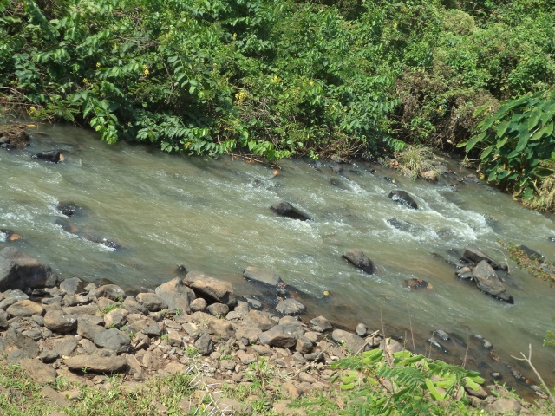
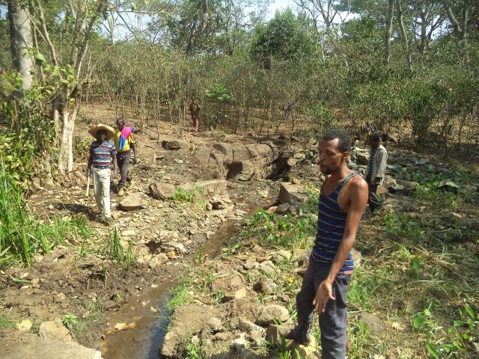
Figure 4-2: Shows Meti river

Project area and Settlement
The project area settlement pattern was assessed to understand the socio economic changes at the area and integrate expected changes with proposed project. The proposed project beneficiary of Meti SSIP settlement was near to the head site and to the command area. Most community settlement is at a near to the command area almost favorable to plough in fair distance. The village is settled in permanent way on the right side and their settlement is one area and settled as a village on scattered way. Their settlement is almost not in planned way, it is just in scattered and irregular way as they own the land. They use the river for different purposes in addition to irrigation such as drinking of livestock, cloth washing, bathing etc.
Most of community house structure was constructed from roof corrugated iron sheet and grass, the wall almost from wood and mud and the floor is from mud.
The society living in this area is fully an indigenous Kellam Wollega Oromo. The society was settled in permanent way in the area and their life depends on crop production and livestock breeding.

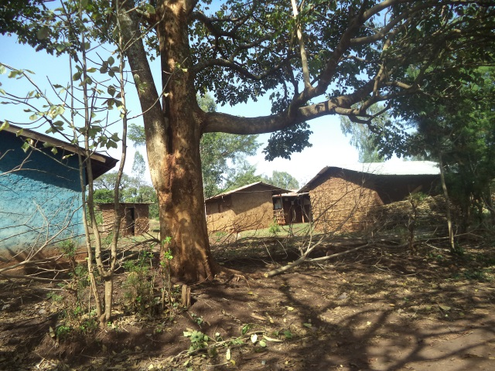
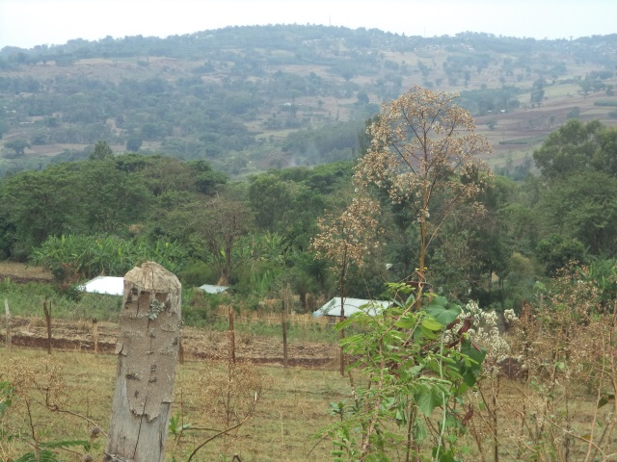
Figure 4-3: Shows settlement of the area

Population And Demographic Characteristics

General
Development project targets to see some gaps of existing population as well for future generation, for sustainable economic, social, and cultural development of the community in project area and expected added value and benefit to the society at large.
As a result development project planning needs to have data on existing population size and projected population growth, and understanding on social interaction and the overall situation in population characteristics like population density and land holding size, average family size/growth rate, age and sex composition, ethnicity and others including factors affecting production capacities like labor, age structures and availability, population movement/migration and spatial distribution are some of the issue discussed in this section of the report. In general, population and demographic data is relevant for market planning as well as other related issues and population data at regional, Woreda and kebele level indicted in section that follows for general overview of demographic features.

Population size of woreda
According to the data obtained from Woreda, Sayyo woreda has a total HHs of 13,630 and from this Male HHs are 12,213 Female heads are 1,417 and the total populations of woreda is 126,615. From this 69,554 % are male and rests 57,061 % are female. The Sayyo woreda is a surrounding rural population of Dambi Dollo town. Data from the woreda administrative also shows that ethnically Oromo is about 95 %, and the rest 5 % is estimated that Amhara. The total kebele of Sayyo woreda have 26 rural kebeles.

Urban and Rural Population of Sayyo woreda
100 % of Sayyo woreda population lives in rural woredas. The majority of rural living system depends on Agriculture which is crop production and livestock raring. Most rural produces coffee. The urban population income generating also depends on commercial and some also depends on agriculture. The Sayyo woreda office is located in Dambi Dollo town. The Meti society’s exposure and traveling to the big town is limited to the Dambi Dollo. Meti society or Ano Mikael and other adjacent kebeles are the communities who located in rural area of the Sayyo woreda and near to Dambi Dollo town.
The kebele and woreda have a mobile phone communication and have hydroelectric power. Meti SSIP is near to Dambi Dollo town where zone office is located. The road from Dambi Dollo to the adjacent region Gambella is also all weather gravel road. The road from the site to Dambi Dollo town is short and good. The transportation was relatively good. It is accessible for minibus and Bajaj Taxi.

Population Density and Spatial Distribution
Population density is one of the indicators for land holding size and other economic issues. Population density for Ethiopia is 110.7 people/km² and for Oromia region 95/km2 (250/sq mi) person /km2. Besides that the population density for Kellam Wollega Zone is 76/ km2 and for Sayyo woreda is also 76.4 person / km².
According to Woreda administrative and agriculture office, Population density is not that much high and the land holding size of the of the Anno Mikael kebele in average is 0.25 ha to 8 ha per household while some of the youths have no land except their family given them for which serves only for house construction.

Project Area Population Size and Demographic Features

Population
Sayyo woreda have a total Population of 126,615. From this 69,554 is male and 57,061 is also female. The project kebele, which the command area majorly lies, is Anno Mikael. The Anno Mikael kebele has total households of 977 from this 585 are male headed 39 are female headed. Ano Mikael have a total population of 3598, from this Male is 1569 and Female is 2029.

Family size
Based on the available data gathered at health office and the results of the household survey the average family size for the project area was estimated. The minimum and maximum family size for the project kebele ranges from 2 to the larger 10 members of family size and the averages family size at the command area estimated to be 6 family sizes which are greater to national average of 5 family sizes. According to the sample household survey result, household below and equal to 5 family member’s accounts 29% and Majority of the household have family members which are between 6-10 members and accounts about 60%.
Table 5-1: Family size range and % of household survey conducted in project kebele
Family size | Frequency | Percent
Below or equal to 5 |  | 29%
6-10 |  | 60 %
11 and above |  | 11 %
Total |  | 100 %
Source: Sample Household survey during the study

Sex composition
Sex composition of a population is important as it provides useful information like reproductive potential, gender mainstreaming, labor resource, education coverage, benefit share and participation by sex… etc. According to Woreda data male accounts 55 % and female accounts 45% the same to that at project kebele Anno Mikael male accounts 44 % female accounts 56 %.

Age structure and labour availability
Age is one of the basic demographic characteristics of a population and useful for demographic analysis, determine availability of productive age and other socio-economic developments planning. The age and sex structure of a population is usually the effects of past fertility, mortality and migration.
Though age data have many uses, it is usually found to be very difficult in obtaining reliable data on age. Effort was made in gathering secondary data from woreda health office and education office as well as computed the age structure from primary data source of household survey undertaken in project kebele. However, as majority of the respondent are farmer group and illiterate and lack knowledge and capacity of recording their children’s and their own age and therefore, the difficulty of obtaining reliable age information of a person in any surveys and censuses is a common phenomenon that encountered.
To mitigate this problem, enumerators are informed methods such as using list of historical events in order to assist primarily the respondents and then enumerators to estimate a person’s age.
According to CSA (2007), the proportion of young population in Ethiopia with age below 15 years indicated to be 46.3 % and the working age group (15-64) accounts to 51 % and population above 64 years age shares about 2.7 percent.
With regards to the project area the computed household survey analysis result indicates the broad base of population pyramid shows that significant proportions (32.9%)is less than 15 years and 65.8 % are between 15-64 years and (2.4%) of the population at project area are above 64 years.

Labour Availability
Availability of labor is important during construction and operation as irrigation is labor intensive project. With regards to Labor availability existing situation assessed in terms of disguised unemployment and competing demand for labor at the area. At current condition due to land shortage many of the young age groups are land less as disguised unemployment/dependent with families. The project is expected to contribute additional temporary work and intensive use of family labor during operation and create opportunity for land access due to extensive use labor in irrigation farm. The community speaks as they have an experience to work by share cropping for those have land. If somebody has a land the other body will cover all labor works and they share other expenses and benefits gained. In the project area labor employment for irrigation activity is not common but they have an experience of labor employment for coffee harvesting. The daily labor employment includes food and accommodation and additional cash. Currently the daily laborer costs 60 birr per-day but it increases to 80- 100 birr per day during the coffee harvesting pick time when it calculated with food and accommodation its cost is higher than this .
Regarding the working culture of the people, some key informants indicate that working as daily laborer for other farm is looked as inferiority. There is bad views working as daily labor for private farm, particularly working on individual farm of their own ethnic considered as shame which needs to bring attitudinal change. On the other hand the people well accept working as contract or daily worker in construction activities like road and similar activities undertaken by government or other private investment ventures.

Ethnic Groups
The ethnic composition of the Sayyo woreda is almost an indigenous Kellam Wollega Oromo which accounts about 95%, Amhara and other tribe’s accounts about 5 %. But the ethnic composition of Anno Mika’el kebele is estimated about 100 % is an indigenous Oromo with the religion composition of Muslims accounts about 10 % and Orthodox is 20 and protestant Christian estimated to be 70%.

Religion
Religion composition assessed at country level and with respect to project area context. According to census 2007, existing religion in the country were categorized into six. The three major religion groups include Orthodox (43.6%), Muslim (33.9%) and Protestants (18.6%) traditional 2.6%, catholic, 0.7%, others 0.7%).
In same data source, religion composition indicated by region and in Oromia Muslim shares 47.6%, Orthodox shares (30.7 %), and Protestant (17.7 %), traditional religion 3.3% and others shares (1 %).
Religion aspect Sayyo woreda Christian Orthodox accounts 20% and protestant accounts about 70 % and Muslim accounts about 10%. The same to that the project kebele in Anno Mikael, Orthodox Christian accounts about 20%, protestant accounts about 70 % and Muslims accounts about 10%.

Population Growth Projection
The data on population size of the country as obtained from the successive population and housing censuses shows steady increments of significant proportions. For instance, comparison of the population size counted in the latest census conducted in 2007 with the 1994 census count shows that the population of a country has increased by more than 20 million persons in 12 years period of census 1994 and 2007. Population and Housing Census results showed population of Ethiopia grew at an average annual rate of 2.6 percent during the period 1994-2007 and total population of the country estimated 73.9 million at the base year 2007. The pattern in population growth determines food demand and agricultural product supply planning and population growth trend of the country indicated in figure that follows.
According to the 2007 Population and Housing Census results, the highest annual growth rate for the period (1994-2007) is observed for Gambella Region (4.1%) followed by Benishangul-Gumuz (3.0%), South nations nationalities and peoples regional state and Oromia (2.9 %) and the national average of 2.6%.
Therefore, based on the annual growth rate for the Oromia region from 2018 to 2020 the growth rate is 2.9 %, from 2020 to 2025 the growth rate is 2%, from 2026 to 2030 the growth rate is 1.7% and from 2031 the population growth is 1.4%. Based on the above population growth the total population at project area will be projected to increase from the current total of 3598 to 5,585 at the end of project life in 25 Year’s period (2018 to 2043).

Figure 5-1: population growth trend of the Anno Mikael kebele

Factors contributing population growth
Population growth is accounted mainly due to fertility, mortality and population migration/ population movement and other factors. At existing condition family size at project area is generally high and land fragmentation continued for the young and many landless groups are created because of the land redistribution was not conducted after 1983 EC or 27 years.
In general, based on the discussion with community some contributing factors identified to cause high population include;
- Low educational status and high social value for children
- Using family planning is working against God
- Using family planning affects human health
- Low health extension in effective family planning and attitudinal change
However, with health extension support and other intervention measures, family size and population growth at project area anticipated to decline and recommend strengthening the health extension service. The health extension program have to focus on family planning education, it should be integrated with other programs like nutrition.

Land Use and land holding

Land use
The land use pattern is mainly composed of an extensive grazing, subsistence type of agriculture and scattered settlement, situated within different land forms. Crops such as maize, sorghum, Dagusa, Bean and other lowland crops like red peper are cultivated under traditional way of farming practices. The land use pattern in Sayyo woreda is largely arable land and about 63,028 ha.
Table 6-1 : Land use pattern of Sayyo woreda and Anno Mikael Kebele

S/n | Types of Land Use | (ha)
1 | Arable land | 63,028
2 | Grazing land | 8320
3 | Settlements and different social services | 52360
4 | Forest lands (including shrubs) | 8920
5 | Wet land
6 | Hilly & Rocky land | 3,492
 | Others
 | Total | 136,190
Source: Sayyo woreda agricultural and rural development office

S/n | Types of Land Use | (ha)
1 | Cultivated land | 2115
2 | forest land | 275
3 | Grazing land | 47.5
4 | Settlement& infrastructure | 175
5 | Wet land
6 | Hilly & rocky land
 | Total | 2613

The land use pattern at project area is mainly composed of extensive crop cultivation mainly maize, sorghum and teff scattered settlement, situated within different land forms. As the information obtained from development offices of kebele, about 2115 ha of the land in Anno Mikael kebele is arable land and land use pattern of the kebele is as the above table.

Land holding size and land access
Land redistribution was not done in Oromia regional state after Dergue regime fail in 1983 EC whereas the certification was provided in this government system. The average land holding size of the Sayyo woreda is 1.5 ha per house hold whereas according to the report from kebele DA office the range of land holding size for the project area is 0.5-8 ha. According to the woreda land administration department there was no land redistribution in the woreda as many of the land area occupied by households and investors. Even though the average land holding size shows as it is not bad the majority of the young family head has no land except they get small size of land for house construction from their family. In general, land holding size ranges from 0.5 ha to 8 ha.
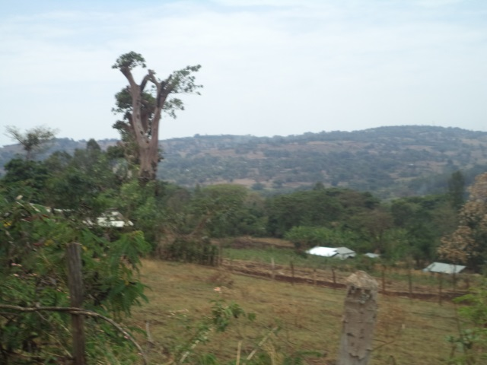
Figure 6-1: Command area of Meti SSIP

Economic and poverty situation

Economic and livelihood source
Sayyo Woreda is a rural agricultural community however they use mixed economy for house hold consumptions and income generating. Almost all households produces crop for their house hold consumption. The major Crops such as maize, sorghum, teff, and other lowland pulses are cultivated under traditional way of farming practices. As the information obtained from the farmers and physical observation made in the field, part of the command area was cultivated for traditional irrigation practices for maize during the assessment period. Even though some products produced in irrigation major production was using rain fed. In the area cereal crop used as traditional staple food. In Sayyo woreda as well as in project kebele maize and sorghum is the dominant crop in order of land coverage and cultural importance.
Livestock provides/contributes supplementary food and household income and also used to cultivate farm land and means of farm activities. Majority of the household in both rural and urban have livestock as supplementary economic resource.
Economic activities outside agriculture is limited and few young groups engaged in off farm activities like trading of coffee, cattle, crops and commodities, etc….
As estimate taken from the kebele DA office, crop production contributes about 80% of the household livelihood and income source and livestock supplement about 15% to household livelihood and others off farm like trading of cattle, crops and commodities which accounts about 5% which is less significant.

Figure 7-1: Economic and livelihood source of the kebele

Wealth status and income distribution
Wealth and poverty status is a relative term and depends on the communities’ resource base and definition of community given to poor and rich and depends on once view and many others. In the context of the project area, community wealth ranking and wealth status primarily related to land holding size, coffee planted, number of farm ox and cattle possession, house structure (corrugated/thatch roof) as well as access to some basic services like mobile cell phone….etc.
Based on the household survey result and focus group discussion ranking in command area, wealth status of the household indicated in terms of income classification and about 77.77% of the household annual income is less than or equal to birr 15,000 classified as poor household and 16.66 % of the household annual income ranges birr 15,000-35,000 categorized as middle income and 5.55 %of the household annual income above 35,000-40,000 considered as higher wealth group. Most of the community is not volunteer to express their income and resists during the discussion and interviews.
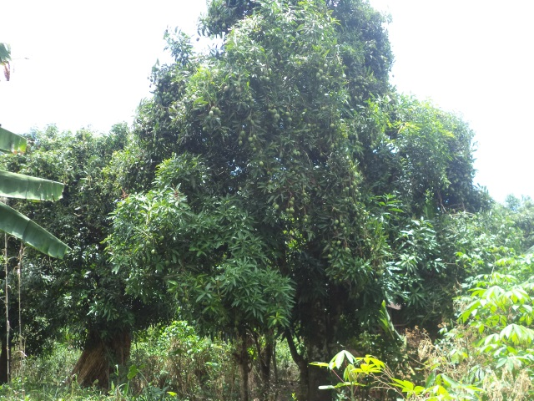
Figure 8: Fruit trees Meti river area

Food Security Situation
The midland and low land areas of Sayyo woreda is known by production of different cereals. Some of the cereal crops produced is maize, sorghum, bean, hari coat bean pean, salit etc… and coffee etc.
The Sayyo woreda are generally have sufficient rain and good climatic condition and can produce sufficient cereals for consumption and to supply for market.
The woreda have no safety net program because of the society is food secured.

Economic activities and production

Agriculture and Crop production
The area is known by rain fed cultivation of cereal crops. Because of the project area or Sayyo woreda is a mid and low land most of their production is maize and sorghum. Majority of their production is rain fed dependent. They use traditional ploughing using oxen. The traditional irrigation is started to practice in all rural kebeles while the production is not that much effective because of their agricultural input utilization and water using is in traditional way. The meher productions in the area have many problems. For example shortage of rain etc crop adoptable to grow in project area indicated in table that follows.
Table 8-1: Shows major crops produced under rain fed in Sayyo Woreda 2009/2010

S/n | Major crops of the Woreda (rain-fed) | Area in Ha | Total production | Remark
1 | Maize | 12576 | 578519
2 | Sorghum | 9607 | 307448
3 | H.Bean | 3351.25 | 70376.25
4 | Wheat | 4366 | 126614
5 | Millet | 1706 | 49000
6 | F. Bean | 584.16 | 19987
7 | Teff | 36565 | 34545
8 | Seasame | 230 | 8625
Source: woreda agriculture and rural development office
Table 8-2: Major crops under irrigation in Sayyo woreda 2009
S/n | Major crops of the Kebele (rain-fed) | Area Coverage  Ha | Average Yield  (qt/ha)
1 | Tomato | 371 | 30420
2 | Potato | 1638 | 172080
3 | Onion | 174 | 22310
4 | Garlic | 37 | 2989
5 | Cabbage | 630 | 108991
Table 8-3: Major crops under rain fed in Anno Mikael 2009/2010
S/n | Major crops of the Kebele (rain-fed) | 2010
S/n | Major crops of the Kebele (rain-fed) | Area Coverage  Ha | Average Yield  (qt/ha)
1 | Maize | 107 | 8025
2 | Teff | 60 | 300
3 | Sorghum | 86 | 2064
4 | Dagussa | 35 | 560
5 | Lojo | 26 | -

Table 8-4: Major crops under irrigation in Anno Mikael kebele 2009/2010
S/n | Major crops of the Kebele (rain-fed) | 2009 |  | 2010
S/n | Major crops of the Kebele (rain-fed) | Area Coverage  Ha | Average Yield  (qt/ha) | Area Coverage  Ha | Average Yield  (qt/ha)
1 | Tomato | 1.5 | 2 | 1.5 | 2
2 | Potato | 2.625 | 5.5 | 3.25 | 5.5
3 | Maize | 8 | 28 | 8.125 | 28
Source: kebele DA office
The project area has fertile land and high production potential, but because of low agriculture input utilization and traditional farming system agricultural production is low and possible to increase production much more than the current level with agriculture input utilization and minimum improvement in land and water management.

Livestock
Livestock and by product mainly milk and milk by product is used to supplement family food and income. Livestock generate income and supplement food source and used in farm activities mainly ox for farm plough.
Cattle dominates the livestock population in project Sayyo Woreda and kebele, as the data source from the area cattle population amounts about 122,988 in Sayyo woreda 2926 in Anno Mikael kebele.
Table 8-5: Livestock types & quantities in Sayyo Woreda and Anno Mikael Kebele
S/n | Sayyo Woreda |  | Anno Mikael Kebele | Diseases of the area
S/n | Type of livestock | Qty | Qty | Diseases of the area
1 | Cattle | 122,988 | 2926 | Trypanosmosis, Lumpy skin, diseases, B/pastorilais, FMD, NCD
2 | Sheep | 153,735 | 1014 | Trypanosmosis, Lumpy skin, diseases, B/pastorilais, FMD, NCD
3 | Goats | 112739 | 446 | Trypanosmosis, Lumpy skin, diseases, B/pastorilais, FMD, NCD
4 | Horses | 3,433 | - | Trypanosmosis, Lumpy skin, diseases, B/pastorilais, FMD, NCD
5 | Mule | 706 |  | Trypanosmosis, Lumpy skin, diseases, B/pastorilais, FMD, NCD
6 | Donkeys | 8,375 | 527 | Trypanosmosis, Lumpy skin, diseases, B/pastorilais, FMD, NCD
6 | Poultry | 174,233 | 3692 | Trypanosmosis, Lumpy skin, diseases, B/pastorilais, FMD, NCD
Source: Sayyo Woreda Livestock Health Clinic and kebele DA Office
Other activities like bee keeping and honey production is also a potential and contribute as an economic activities in the area. Modern type of behalves was not adopted in the kebele.
Veterinary clinic is available in the project kebele but the clinic has no doctor and the service is by Para medical professionals.

Other off farm activities
In the project area all activities are directly or indirectly related to agricultural activities and other off farm activities are very limited. However, there are few local household groups engaged in some off farm activities like poultry, agricultural product and livestock buying and selling. This sector also includes marketing of consumable industrial products which has potential to contributes household income and advisable to promote rural marketing as it contributes in supply and demand for product marketing at the area. In order to support agricultural marketing and micro enterprise development at the project area, it is important to strengthen credit and saving to such group of the community.

Agro Processing Industries and Urban Economic Prospect
Currently the command area and as well the woreda is free of any agro processing or industries while it is good if linkage created for the future because of it has an advantage for purchasing the local product. For example because of no processing in the area the farmers forced to sell maize in cheap price. The milk is also consumed by the community because of no processing and good market available in the area however some part sold as butter.

Market and roots

Market Institutions and stakeholders
The organizational structure for market management assessed and at woreda level, the task of market and cooperative activities were the job responsibility under agriculture office for long years. However, with organizational restructuring in Oromia region trade and market development office is established and on follows the market activity of the woreda.

Market and Market prospect at project area
Maize and Sorghum is the major dominant crops produced for home consumption in woreda and in project kebele as well. Some products like onion and tomato was also purchased for household consumption from other area.

Market Centre
Availability of primary, secondary and tertiary market centre and urban economic development tends to influence marketing of agricultural product. The project kebele have no market to sell their crop. But the live stocks market and the crop market is available at Dambi Dollo town. The irrigation project area or Anno Mikael has no market in its kebele but in better area from other rural kebeles.
Table 9-1: Market distance from the project kebele
s/n | Site of market | Distance Dambi Dollo and project SSIP | Remark
1 | Dulli | 15km
2 | Dorgome | 24 km
3 | Dambi Dollo | 6 km
4 | Esho | 23 km
Even though the market is not in long distance the market sites themselves were not accessible for transports both for public and loading. The community as criticize they have no transport vehicles even though the road is all weather gravel road. They requests high money, loads more than double on the vehicle. The community transports maize and other products by donkeys, mule and human force.
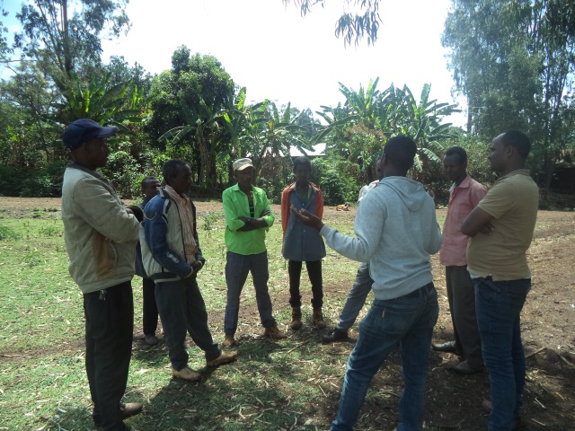
Figure 9-1: Discussion with community during the visit

Product destination
Product destination for agricultural product from the project area including food crops like teff is mainly for supply to local market for local consumption. The market destination for surplus production of agricultural product from the area especially market is sold to the ECX (Ethiopian commodity exchange). Maize consumed in the area and also transported to Gambella through merchants.
Coffee is transported to Dambi Dollo and sold to Addis Ababa through ECX. Goats and sheep also sold to Dambi Dollo and then transported to Gambella. Tomato produced in the area and consumed by local markets. Onion and potato also supplied from other areas like Shoa and west Wollega.
Other tertiary market root is open within the zone as well as neighbour regional town. The primary market is with low market price due to the public transportation problem and the local traders have no capacity to search the market when compared with the product. Private traders and even strong famers cooperative are not available in area.

Figure 9-2: Market and Product destination flow

Gambella & near town
Food crops
- Maize
- Sorghum
- Teff
- Tomato

Market Destination
Local
Food crops
- Maize
- Sorghum
Addis Ababa
Cash crops
- coffee
- Salit

Product Demand and Supply
Considering the huge development potential of the area population expected to grow rapidly and predicted high food demand in the project kebele and domestic market at large.Based on the population growth rate and assuming the standard wheat equivalent food per capita consumption set 240kg (UNICEF), the total food demand for the project kebele or Anno Mikael is expected to increase from the current 8635 quintal to 13,404 quintal in 25 years period of year 2043.

Figure 9-3: Population growth and Food demand projection of Anno Mikael kebele

Product Price
The project area major crops include maize, sorghum, wheat, teff and beans that produced for household food consumption as well as cash crops to generate income. The retail price of these crops assessed at Woreda town and the trade and market development office experts speaks as the price of the product has on increasing trend from year to year.
Table 9-2: average prices of some products trend in Sayyo Woreda
s/n | Agricultural product | Ql Price in Birr |  |  |  |  | Remark
s/n | Agricultural product | 2006 | 2007 | 2008 | 2009 | 2010 | Remark
1 | Wheat | 800 | 750 | 975 | 980 | 1050
2 | Teff | 1500 | 1800 | 2000 | 2200 | 2400
3 | Maize | 500 | 525 | 450 | 700 | 550
4 | Sorghum | 630 | 525 | 375 | 600 | 750
5 | Boloqe | - | - | 675 | 1700 | 750
6 | Barely | 450 | 675 | 675 | 650 | 850
7 | Bean | 1000 | 975 | 1350 | 1450 | 1450
8 | Pean | 1350 | 1500 | 1650 | 1950 | 2250
9 | Daguja | 750 | 950 | 1000 | 1200 | 1250
Source: Sayyo Woreda trade and market development office
Due to road and transportation problem and the demand for cash for different purposes farmers forced for excess supply to the market as soon as crops harvested and that cause price fall and unfavourable to trade.
As to farmers key informants and marketing experts said farmers have low awareness in producing market based crops and vegetable. They produce similar products at the same time for house hold consumption. That forced the farmers to lose their products in cheap price.
The problem emanates due to market, transportation and awareness problem, some farmers forced to sale on farm or farmer traders assemble the product at farmer’s door at cheap price and marketing at the cost of the farmers.
With regards to agricultural input price farmers also indicated unfavourable terms of trade between cost of fertilizer and price of agricultural output. As farmers indicates fertilizer price escalates from year to year.

Market problems and constraints
During the consultation with community and key stakeholders, major market related problems in the study area were identified, it that mainly includes;
- Lack of transportation
Due to lack of transport means market product transportation usually uses human labour and animal and marketing requires high energy and time for the producers.
Transportation and communication services are fundamental factors in determining development endeavours being undertaken in a given locality. Since they provide services to other sectors of the economy, it would be impossible to conceive of social and economic development in the absences of adequate transport and communication infrastructure and services.
Others Communication means with mobile network are also not working well around the project areas. The project woreda have electric supply. The project kebele on the way of town and near to kebele office have hydroelectric power and it didn’t covered all the kebele. Totally no hotels and rural based village and less urbanized to effect high demand for agricultural output even though the woreda capital is short distance.
- Market linkage and information is also a problem for farmers
The farmer produces what cost increased on a market in a time. All farmers production is almost similar and at the same time. Because of no market linkage the production will be excess on a local market for one time and a cost will decline at that time. According to trade and market office experts the market is not as expected for the farmers.
- Lack of saving awareness and exposure to crises
Banks and minimum rural financial institutions are required to meet farmer’s financial needs for agricultural input or others. Ethiopian commercial Bank, Awash Bank, Oromia International, Oromia cooperative banks and other commercial banks are available in Dambi Dollo town. Oromia credit and saving Share Company is also on serving in woreda which located at Dambi Dollo town. Community speaks as many households received loan without clear understanding and preparation which resulted in crises for the family. The community over utilizes and miss uses it as soon as they sold their product than saving it. Some persons from the project kebele have an experience of receiving loan from Oromia credit and saving share company (WALQO) however not for irrigation.

- Product quality problem
The farmers have an experience of mixing good and bad quality products by focusing on the quantity. Mixing bad quality discourages the customer from buying and results in poor cost. The agriculture extension professionals and marketing professionals have to work hard to improve the community’s attitude to focus on quality. The community have to be aware the good and bad things of adulterating quality.
- Budget shortage
The marketing and trade office experts have no enough budgets to search and link the local producers and whole sellers with other areas. In addition to that almost all experts are fresh and lack technical practice and skill to search the market. They don’t have transporting materials like motor bicycle and fuel budget.

Agricultural support service

Agricultural Extension Service
The agricultural extension service of the Woreda is supplied by agricultural and rural development office. The agricultural extension service includes agricultural input supply and utilization, supply and use of different chemicals like herb sides and insect side livestock breeding and protection etc. Even though the service is not as expected Woreda agricultural office and kebele DA office express as they are conducting many efforts.
Agricultural input mainly fertilizer and improved seed is provided to farmers by facilitations of different stakeholders. The agriculture and rural development office suggests and requests the item and amount of inputs needed. The cooperative promotion office supports the farmer’s primary cooperatives in different capacity building beginning from establishment to training on different activities like recording, auditing etc. The primary farmers integrated cooperatives and unions also directly supplies and or sells to farmers the input needed. In Woreda different variety of seeds such as maize and fertilizers such as NPS and Urea are on supplying every year.
As a farmer indicates low purchasing power and increasing input price trend was one of the constraints for limiting input application. Fertilizer and improved seeds distributed in last year is was as follow.
Table 10-1: Agricultural input supply and distribution in Sayyo Woreda

Agricultural input | Unit | Distributed in 2008/9 | Unit price | distribution 2009/10 | Unit Price
DAP | Ql | 2517 | 1754 | 1420 | 1704
NPS | Ql
UREA | Ql | 4197 | 1345 | 2648 | 1330
POTASIM(k) | Ql
Total | Ql
Improved seeds | Ql
Maize Limmu | Ql | 16 | 5465 | 18 | 5611.4
Maize Shone | Ql | 28 | 4716 | 27 | 4802.86
BH 661 | Ql | 16 | 2217 | 15 | 220.28
Total

Table: Inputs distributed in Anno Mikael kebele

Agricultural input | Unit | Distributed in 2008/9 | Unit price | distribution 2009/10 | Unit Price
DAP | Ql | 15 | 1840 | 118 | 1866
NPS | Ql
UREA | Ql | 158 | 1239 | 138 | 1385
POTASIM(k) | Ql |  |  |  | 0
Chemicals | Lit
Endo sulfine
Improved seeds
BH-661 | Ql | 1.5 |  | 2
BH-661 | Ql
Maize Limmu | Ql | 13 |  | 26
Maize Shone | Ql | 8 | 1113.7 | 5 | Not decided
Total
Source: Sayyo woreda cooperative promotion office and kebele DA office
As farmers and the agricultural office indicated some of the constraints in agricultural input supply and application includes;
- Shortage of improved seeds
- Late delivery and distribution of inputs
- Credit is not facilitated by government
- Farmer is not ready to buy by cash
- Fertilizer selling cost is increasing from time to time
- Supply and demand is not as required
- No research center available in nearby
- The improved seed as well as fertilizer is very expensive example 1 ql of maize Shone variety price is 4879 birr but the sell for local maize 1 ql is 600.
- Farmers have doubt on improved seeds

Credit and saving
Like any other business, rural farmer also in need of finance to meet immediate needs for agricultural inputs and others. Credit service providers are available in Woreda through three bank and one micro finances however the availability for irrigation/agriculture is through Oromia credit and saving Share Company / WALQO. Credit disbursement is to serve farmers in productive activities and majority used for livestock development, fattening agricultural inputs like improved seeds.
The Oromia credit and saving share company speak as there is an option to give a loan for farmers for irrigation users through group and individual wise however currently no farmers received for irrigation.
Oromia credit and saving share company have different types of giving credit for farmers. The system is individually and for group and also according to return system in instalment and in term.
The criteria to get credit from Oromia credit and saving Share Company/ WALQO is vary when it is group based, small business micro enterprises and individual
- Preparing business plan
- Recording owns property
- Kebele identification card and living in kebele
- Free from other loan
- Free from any criminal
- Free from any addiction
According to our analysis receiving credit from Oromia credit and saving share company/WALQO have many advantages than receiving from others micro finance.
Some of the advantages are
- No collateral needed for loan in team
- Credit is available for irrigation users
- Give priority for poor of poor and women
- The return uses declining system
- Monitors and train the clients every three month
- Uses less group member
- Oromia credit and saving Share Company uses less interest rate 13% - 18 % while others private micro finance uses 15% - 24 %.

Cooperative and water users associations
Farmer organized as cooperative in Woreda established on 3 categories. They have different activities and focus areas. Most cooperatives performance is not satisfactory.
Their categories are and members for Multi-Purpose Cooperative are shown in the following table below.
s/n | Type of cooperatives | Quantity | Members by sex |  |  | Amount of capital
s/n | Type of cooperatives | Quantity | M | F | T | Amount of capital
1 | Multipurpose cooperatives | 22 | 5579 | 517 | 6096
2 | Saving and credit cooperatives |  |  |  |  | They are new and not well organized
3 | Consumer cooperative cooperatives
 | Total

According to the woreda cooperative office the community awareness on cooperative is not satisfactory. Currently some cooperatives members like irrigation didn’t started service. Cooperatives established in the Woreda status and strength is varying from each other. According to woreda experts the farmers are volunteers to be established as cooperatives but they are not ready to contribute the needed capital.
Criteria to be established as a cooperative is
- Registration
- Committee establishment
- Feasibility study or analysis
- Forming general assembly
- Developing rules and regulations
- Pays their share
- Age minimum of 14 years and above
After that they will apply to Woreda cooperative office and certified as a cooperative. According to the Woreda cooperation promotion office irrigation users tried to be established as cooperatives however it didn’t yet finalized. This is because of the misunderstanding of cooperative promotion office that organizing only irrigation users may not be allowed.
The irrigation user’s associations currently focuses on water use management and conflict resolution, but in the future they expands and focuses on seed producing and input supply.
Establishing irrigation water users as cooperative before construction have many advantages even for facilitation of participation during construction.
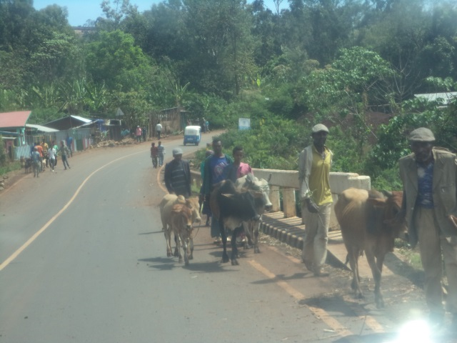
Figure 10-1: livestock towards market
The problems and constraints indicated at Woreda and project kebele includes
- Cooperatives not start activity as soon as established
- Cooperative member have a doubt to contribute cash
- Control committee not works well
- Some members not willing to sell their products to cooperatives instead they sell to privates traders
- Less capital for operation or running business
- Some committee misuses or corrupts it
- Some employed staff and the committee not works in integration
- Educated members are less in number
- Woreda promotion office have no enough budget and resource to give satisfactory monitoring

Gender
Like many rural area of Ethiopia, women involve in household chores, food preparation, child care, marketing and farm activities and work burden than male counterpart. In addition to child care women engage in farm activities and marketing to support family income and livelihood source for the family. Child labor use is also high and involve in food preparation and cooking, collecting fire woods, fetching water, livestock keeping and some other farm activities. The women participate in all agricultural activities.
Almost all in house and farm activity are women’s job, whereas the decision on different activity like resource cattle and camel selling and management is the husband’s duty.
Most male have a power and access to use on cash for alcohol drinking and even to enjoy with other ladies during travel to town for different purposes.
In general, women participation in agriculture and farming activity is very high while the major decision still made by the male counterpart.
Women at project area are economically male dependent and revolving fund and credit service highly recommended to reduce women economic vulnerability and alternative options identified to increase income for women for the benefit of the household. The proposed project also expected to support women through production of garden vegetables and as income source option.
According to women and children office irrigation improves family living standard and income and they will support by different activities if the project constructed in short period. The woreda women and children tried to organize women on irrigation and they on performing different activities.
According to our discussion with woreda key stakeholders and with community women’s have an involvement in all irrigation activities.
Some girls in the project area stops school on around 7 and 8 grades. In the area poly marriage is available. Even though women circumcision assumed as it is stopped the women also speaks as it improved by the cutting system and almost to (aggami) just touching to say she circumcised.
Female headed women’s gives their land sharing with youth’s have no land and but have labour. The female headed women also can get their share as male in the area no traditional influences to use irrigation land except difficulty of the work. Most of the female headed family gives their land for landless youths in crop sharing system. Even though many efforts are on-going on different stakeholders early marriage on women is not fully stopped.
Constraints on women and to perform women related activities in the Woreda can be stated;
- Lack of allocated budget to resolve women immediate needs
- Lack of training and empowering to address women problem
- No strong integration to address the women’s issue while all running individually
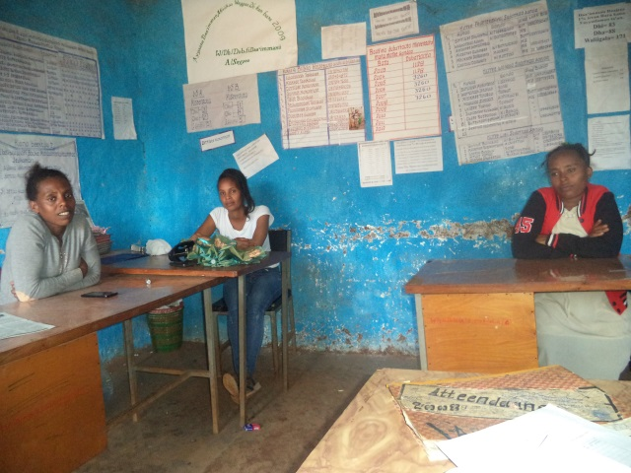
Figure 11-1 Discussion with woreda women and children office experts

Basic Social Service

Health service and health infrastructures
According to Sayyo Woreda health office health coverage in health centre and health post provision is 100%. Latrine coverage is also 80%. Latrine utilization of the society is not good and it needs hard working. Sayyo Woreda has different health institutions such as 5 health centre, 26 health posts.
According to the Woreda health office different activities are on conducting in different levels for prevention and treatment of diseases. For example the health posts fully works on prevention which included vaccination, family planning and family health services, health education on sanitation etc. The health centre also performs different activities like diagnoses of different diseases, VCT for HIV/AIDS, admission for not more than five days, and also other prevention activities like vaccine, family planning services, supporting and monitoring health extension workers assigned in health post.
Special discussion held with Sayyo woreda health office on the negative health impact may rise due to irrigation project. The woreda health office expressed as Sayyo woreda is one of the woreda which have Onchocerchiasis (Gu’a). Onchoceriasis breeds and transmits to human beings through mosquito which called Tsetsefliy. The mosquito which transmits Onchocerciasis breeds in the water which is following or travelling water. Even though Onchocerciasis is one of the expected negative health impact in the woreda the woreda health office head informed as they are doing many activities for prevention and treatment of Onchocerciasis diseases. The woredaa is on giving mass treatment 2 times in a year. The diagnosis by identifying laboratory and treatment can be done in woreda.
Sayyo woreda is one of the Kellam woredas who included and supported by non-governmental organization called lights for Woreda. The project is planned to give medication for prevention and treatment at list for 12 years.
Malaria is one of the expected can be due to irrigation water. The community have to mosquito net during sleeping and have to take early treatment if affected by malaria. The woreda have health education program throughout the woreda on health extension workers.

Table 12-1: Ten top diseases of Sayyo Woreda report
 | Sayyo woreda health office
s/n | Disease type | No of cases
1 | AFI | 1818
2 | D/M/S/S | 982
3 | Intestinal parasites | 11890
4 | AURI | 863
5 | Urinary Tract infection | 560
6 | Pneumonia | 860
7 | Single spontaneous delivery | 860
8 | Typhoid fever | 307
9 | Trauma (injury, racture) | 566
10 | Helmenitheisis | 357
Source: Sayyo warada health office

HIV/AIDS
At all health centre Voluntary council and test (VCT) and ART service is available. Woreda health office informed as HIV/AIDS is series in the area and now the case is on declining.
Sanitation and hygiene
Regarding sanitation and hygiene situation health extension assigned in each kebele and the health extension worker focus on it as their other health extension packages. Even though the report on latrine coverage indicates as 85 % status the real community practice on sanitation is not that much appreciable. The community assume as latrine is for those have no bush. No kebele is reported as open defecation free (ODF).
Health personnel
Sayyo Woreda has variety of health professionals which included health officer, nurses etc and with total health personnel excluding health extension workers is 73, health extension workers 62.

Table 12-2: Health personnel of Sayyo woreda health office

Sayyo woreda
Health personnel | Quantity
Drs | 0
Health officer | 7
BSC Nurses | 4
(Clinical nurse, midwifery, public) | 38
Laboratory technicians | 9
Pharmacy | 4
Sanitarian | 10
Health extension workers | 62
Supporting staff | 53
Total | 188
Health problems and constraints includes
- Inaccessibility and transport problem
- Budget shortage
- The topographic area of the Woreda
- Traditional beliefs to discourage delivery at health institutions

Education
Education level of the household determines the level of community awareness and technology adoptability and other socio economic development status of a given community.
In Sayyo Woreda there are different school facilities are on giving service at different levels. All the schools are government schools.
Table 12-3: Sayyo Woreda Student enrolment

Grade | Number of  schools | Student enrolment |  |  | Teachers
Grade | Number of  schools | M | F | T | M | F | T
1-4 |  | 9641 | 8496 | 18,137 | 186 | 211 | 397
5-8 |  | 6723 | 5585 | 12308 | 184 | 112 | 296
1-8 |  | 16364 | 14081 | 30448 | 370 | 323 | 693
9-10 |  | 1937 | 1623 | 3560 | 80 | 19 | 99
11-12 |  | 411 | 355 | 746 | 31 | 6 | 37
Total |  | 18762 | 16059 | 34771 | 111 | 25 | 136
In Anno Mikael kebele also there is 2 schools that teaches1-8. The school enrolment in Anno Mikael kebele male student accounts about 51 % and female student also accounts about 49 % of the entire students.

Grade | Number of  schools | Student enrolment
Grade | Number of  schools | M | F | T
1-4 |  | 393 | 360 | 753
5-8 |  | 235 | 254 | 489
Total 1-8 | 2 | 628 | 614 | 1242

Table 12-4: School and enrollment of the Anno Mikael kebele
Problems
- Traditional influences for girls education and work overload
- The school compound and construction is also not attractive for student
- Budget shortage for school supervision and material supply

water supply
Sayyo woreda has different types of water supply system which included protected springs, hand pumps, motorized springs and deep wells. Currently the safe water supply coverage of the woreda is 63.3%. The total schemes on giving the water supply in woreda is spring on spot 457, deep well 2, spring with gravity system 7, shallow wells with hand pumps 28. Some of the project keble uses from the Dambi Dollo town. The project area community have no safe water supply. The woreda started to construct the safe water supply for the project area communities before 3 years but they stopped. Community have a series complain for the failure of water supply projects after they damaged many peoples coffee and land without any advantage.

Source of Energy
The project woreda Sayyo capital Dambi Dollo town have an electric power. But the project area as majority of our country’s rural kebele has no electric supply and modern energy source. The area was known by its natural forest. The traditional practice of the society on conserving the natural society is very good. The community uses wood for energy source, fencing of crops to protect livestock from their crops. In general, energy and livelihood depends on natural resource with increasing agricultural expansion at the expense of wood and shrubs, deforestation and less practice for forestation; the direct consequence of this in the long run inevitably to impact and ends up adverse impact on agro ecology of the area and influence food security situation unless proper water, land and natural resource management is in place. The community in Anno Mikael kebele which is access able to transport started to sell fire wood.
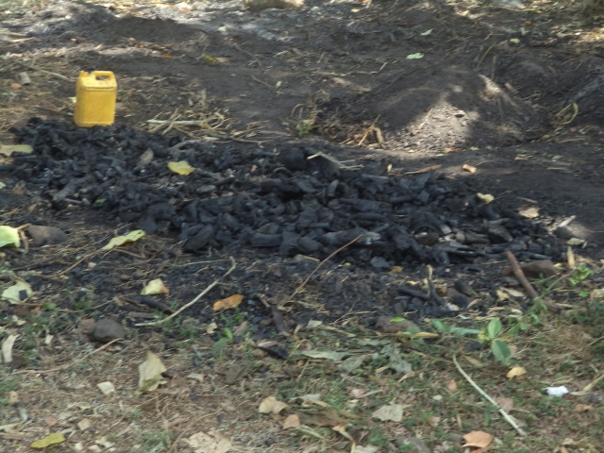
Figure 12-1: Charcoal woods on production for sell

Development Potentials and Opportunities
The project area has great agricultural potentials in terms of land slop, suitable agro ecology for production of diversified crops. The beginning of these irrigation projects will make an important contribution to the regional efforts to combat adequate marketable food and improved production and productivity of the project area and social infrastructure development. The main quantifiable opportunities will be the following.
- Existing institutional setup and government structure formed farmers in development zone and one to five farmer groups is good opportunity for community organization, labor mobilization, and formation of water users association and institutional arrangement of the project.
- The opening of the university may improves for the market linkage with project kebele
- The irrigation site on the way of Dambi Dollo may create an access for the market

Projects Social impact and Threats

Human Displacement
Expected displacement due to the project was assessed and analyzed at command area, upper and downstream. The proposed irrigation water source Meti river originates from the same woreda but different kebeles called Sasi. Then it crosses through different kebeles and reaches Anno Mikael. Before the head site there is no irrigation practice. The Meti river flows to downstream and many tributaries mixed to it at different sites. Before command area the irrigation practice is on limited land. On the head site area about 20 peoples are on practicing the traditional irrigation. In addition to them the woreda started to develop a nursery site on AGP2.
Upper and lower command area:
Meti river have no problem on the upper side because of the river discharge is high due to many tributaries is mixed to the river. The river freely flows to the area without shortage for irrigation and also other purposes. There are also different tributaries which added to the river on different sites after the weir and command area. For example the Meti river is one of them. Even though the community uses river water for different purposes such as livestock drinking, washing clothes, bathing and etc there are other options in the area.
So the upper side has no any problem if the river developed for the irrigation at assumed command area. Additional tributaries serve the community for different purposes like live stock and additional irrigation. The lower command areas also have sufficient water because of different tributaries mixed to the river at different places. Already they have adapted system to use together without conflict.
The adverse impact of the irrigation construction which will be expected to happen on upper and lower command area is assessed. As to the assessment study, proposed irrigation command area is near to the settlement and used under traditional irrigation and rain fed crop production. The technology option to use is diversion by gravity system. Some permanent plants may be in command area. The community was raised as that was not that much dangerous and the benefit from irrigation is better than the damage can happen due to irrigation construction. Those farmer groups whose land might be lost or damaged due to canal should be given awareness for willingness for the common benefit of the general community or compensated by equivalent farm land or other social system and conflict resolution committee, DAs and woreda stakeholders should take the lead role. As to the field observation and consultation with local communities, the proposed irrigation water source have sufficient capacity to serve all and less to anticipate other adverse social or people displacement due to the project.
Left and right side: The proposed irrigation project is right side canal. The traditional canal flows through the existing plants like coffee tree. The community already aware for the passing of the canals and they said we can solve if any problems can be damaged during the canal construction for any conflict can be happen. On both sides as we observed and discussed with community no adverse impacts can happen on social and environmental wise on human beings due to the Meti river irrigation construction.

Health and related social impacts
The Proposed irrigation use diversion on the high area and free flows to the command area. Project area is a hot and marshy area; malaria may be expected because of irrigation water. According to discussion with Woreda health office they are on working to prevent different communicable diseases. Currently the community awareness on malaria prevention is good community uses different methodologies to minimize malaria disease such as cleaning the environment and water area mosquito net use etc. so the irrigation water also not that much stored and creates favorable condition for breeding of mosquitoes. So we can minimize whatever causes can rise because of it. The expected health problem in the area is parasites and Amoebiases because of different vegetables and fruits eaten raw or without cooking.
According to health office the expected health impact from irrigation is less while the advantage by supplying additional income and improving nutrition is high. Woreda health office informed us that they have a health education program through health extension workers and also at health institutions by different staff, so therefore we can aware our community and control the expansion of such diseases.
The Onchocerciasis (Gu’a) is the other expected diseases due to Tsetse flies breeding in flowing water but as we discussed above already the woreda health office have a program for prevention and its treatment.

Land Loss and land redistribution issues
In Oromia region land distribution didn’t conducted after Dergue regime. Most land of the command area is occupied by house hold farmers. Some farmers farmland included in command area is vast whereas most active farmers have no piece of land from the command area. Huge amount of money/cash will be invested for construction of the irrigation system and the irrigation is also naturally labor and capital intensive. So therefore land redistribution by considering different point is mandatory. For example some farmers have relatively vast land even though it was not in the command area, for such farmers replacing farm land in the command area is possible. Most command area is not the communal land, it occupied by private farmers while in the woreda the land near to river is not given for farmers by land ownership certificate. For those farmers who have land on rain fed and exchanging the land with irrigation is the best option depending on the region land and water use policy.
The issue will have to be well recognized and according to the land proclamation, irrigation land shall be redistributed with minimum of 0.25ha to ensure effective and efficient and equitable utilization of irrigable command area and water resource potential.
In general, irrigation development project has to meet efficient and social equity and land distribution has to be planned with consent & agreement of the community without worsening the other and should aims to maximize the overall benefit for local, regional and national economic development.

Project Benefit and Contribution

Direct beneficiaries
- Food Security and increased income at household level
Majority of the households in the project kebele able to meet family food demand and introduction of modern irrigation in the area will enable farmers to produce surplus crops and ensure sustainable food supply for local and regional market and contribute food security of the country by maximizing household income.
- Promotes women Income Generating Schemes
Women lack source of income generating scheme which is one of the major problems for women in the project area and development of irrigation scheme will enable women to participate in irrigated farming and garden vegetable production and generate income from development of the irrigation schemes. Particularly, widow and women household will benefit in generating adequate income for their family.
- Job Opportunity
Irrigated crop production is labor intensive activity and the landless and underemployed social groups will get opportunity and access for land through employment by cash during farming, share cropping and other in small holder farm expected to increase. Temporary employment also will be generated during construction and operation phase, as the project requires considerable working force from the nearby areas and it is expected that the implementation of the proposed project will contribute employment.
- It saves labor and time
The community especially the women can get variety of vegetables at nearby without travelling to distance area. This can help them by accessing the variety of vegetables and also saves women labor and time from travelling long distance.

Other Indirect economic benefit
Urban Development: The commencement of this small scale irrigation projects will contributes development of urbanization and market expansion through travelling to town for product sell and or the urban merchant travels to the area for product buying.

Skill, knowledge and Socio- cultural Improvement: The skill- knowledge and cultural diffusion created and farming system and work culture of the households will be greatly improved gradually through social interactions and skill transfer.

Community Participation

Cost Sharing
Community participation in planning, implementation and management is believed to ensure sustainable operation of development project. There is a need to establish and implement norms and procedures for financial sustainability and viability of irrigated schemes. Water resource development policy stipulates small scale irrigation project to be implemented on cost sharing and towards stage by stage cost recovery transition. Whereas Medium and large scale irrigation development schemes are to operate on full cost recovery principle.
The idea was clearly shared with community and the assessed community view and expected contribution from the community estimated. The community have traditional irrigation practice and their interest and commitment was very attractive. They have clear experience how irrigation benefits society and government. They also express as they wastes many of their labour for diversion and excavating canals every year. They told us that a minimum of 100 labour per day participate for diversion of the river every year.
The community have series doubt that the government may receive their land for his purpose as before. The community have complaining for the woreda received their land for the nursery. The woreda government had received the nursery land by force without agreement of the community. They speak as they need the land and as they demand the irrigation land.
After extensive discussion on the government objective as to increase the farmers living standard and to minimize labor wastage then they accepted the idea. Discussion also continued with possible contribution and cost sharing of the community to realize the project. Finally consensus was reached by the community group to contribute the required input (labour, material, money, etc,) for implementation of the project. Generally community is ready to contribute at least 10 % of the capital through different types such as labour, material and in cash.
The community also discussed on the issue of compensation for the farmers their land and some fruit trees may be damaged by canal. The community promised to solve the compensation issues may raise due to canal and irrigation.
The woreda steering committee and community promised to solve the compensation issues by themselves. Actually no huge damage is not expected because of the irrigation have only the canal line. Even before some years there was a traditional canal line and community never expect the compensation.
The community also discussed on the importance of camp site. The woreda and beneficiary community also promised to facilitate the camp site during the construction with contractor.
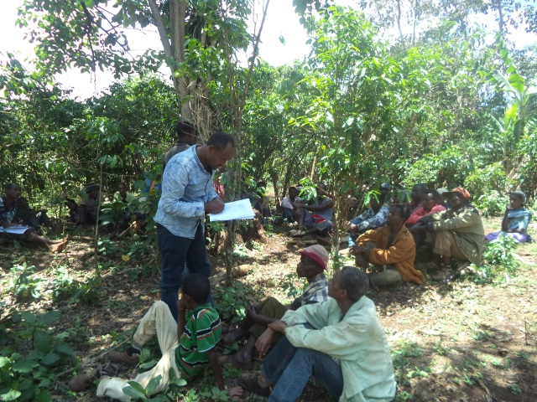
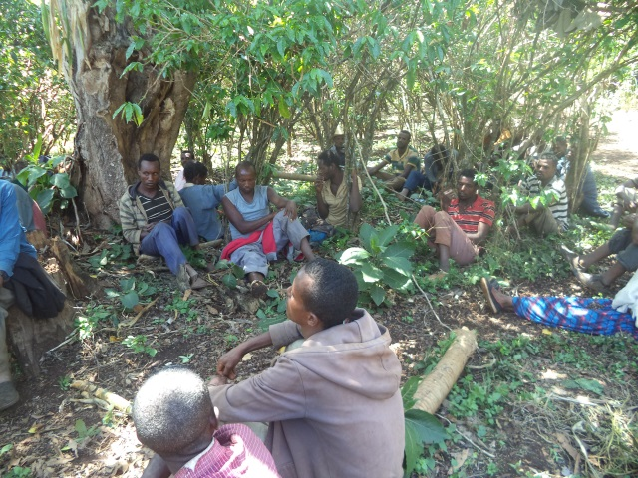
Development project without community participation is less sustainable and highly recommended to promote community participation at all level and the estimated labour cost amount should be excluded from the total project cost if contracting the project to outside source for implementation.

Camp site
The community also discussed on the importance of camp site during the construction and after construction. Finally they agreed and promised to allocate the camp site during the construction with contractor interest with their future advantage to use it as office and store.
At the end the community elected the entry committee which can serve to promote and facilitate the community during construction. The committee was elected from both kebele their name is as bellow.
Name of committee elected
- Assefa Ayana
- Ifa Tarresa
- Getachew Likasa
- Nebiyu Daniel
- Tefera Dingata
- Bulcha Tolessa
- Habib Bizu
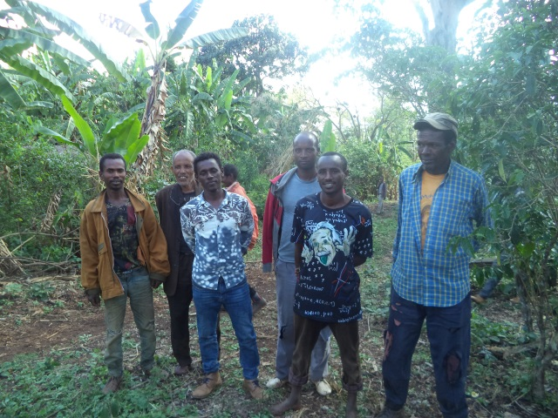
Figure 15-1: Committee elected by community
Conflict resolution
Communities have been asked what other support to provide for project implementation and expressed their full willingness to provide local materials like stones, sand and land for camping and other project use and tolerate land loss due to canal or other; and if any conflict arises due to the project, community have agreed to settle and arrange land exchange for farmers whose land submerged due to the main canal, secondary canal and camp site.

Cost Recovery
As available review indicates local experience in irrigation cost recovery have not much performed or properly realized cost recovery. In area where water user associations or irrigation cooperatives formed, simply collect membership fees and share contributions in the case of irrigation water cooperatives and only some schemes cooperatives collect some money for system administration and management purpose.
The beneficiary community at Meti irrigation project currently had traditional irrigation experience but not yet organized as water users associations (WUA) or Irrigation water user’s cooperatives (IWUC) but simply they established a committee which facilitates water use program. The existing committee is also just not formal but they says committee those volunteers who facilitates the water schedule and facilitates for water head diversion labour. But after intensive discussion with beneficiary community on the importance of the common committee as they are the beneficiary of one river they established the entry committee by making a representative for all the command areas. Totally seven (7) committee members elected and shared a duty.
As stated in water resource development policy and strategies, medium and large scale irrigation development schemes are to operate on full cost recovery principle; whereas small scale irrigation project to be implemented on cost sharing and towards stage by stage cost recovery transition. Conceptually, the purpose of cost recovery is to provide sustainable irrigation services that improve irrigation performance through:
- More efficient O & M of irrigation facilities,
- Promoting more efficient use of water by framers,
- Support public investment project and ensure equitable and sustainable financial capital allocation
- Sustain the functioning of irrigation systems through their regular O & M and gradual upgrading of the O & M capacities of the local beneficiaries.
With these general understanding the idea of the cost recovery was discussed with the communities/beneficiaries and explored the opinion of beneficiaries and created awareness to the community and consensus reached to adopt water fee collection for sustainable operation and maintenance of the proposed schemes. In general, O & M with responsibilities and duties indicated in proposed organizational arrangement part II of this report.

Project Beneficiaries
The proposed project type is modern irrigation system for the benefit of small holder farmer and management system to operate at small holders’ farmers’ level.
The proposed technology option of river diversion irrigation is to cover 107 ha of command area and to make the beneficiaries effective and efficient in irrigation water utilization.
The selected technology type considered existing experience, knowledge and skills in the area to manage the irrigation schemes and the capacity of the existing water discharge. The technology type suitable and adopted is diversion of river and using by gravity system from Meti river on both sides of the river. The irrigable land area is expected to be 107 ha and expected to serve total beneficiaries of 408 households assuming 0.25 ha of irrigated land area per household.

Conclusion and Recommendation
The proposed Meti SS irrigation project is a diversion from Meti river and majorly serve a community of Anno Mikael community. The design and planned irrigable command area is 107 ha and expected to serve a total of about 408 household beneficiaries. The project area has potential water source and suitable agro ecology for agriculture development. The command area is used under small holder farm and the project intended to develop for small holder’s farm and management with participation of the community.
The agricultural farming system use traditional system of ox pulled plough system and those who have no ox use share cropping and hand tools for farming and there is no effort for farm mechanization. Farmers at the area have no exposure to mechanized farm. The agro climate is almost mid land areas that characterised hot and have good rain. Maize and sorghum are the major crops and people at project area are food secured and can produce excess supply for market provided improved farming inputs, efficient land and water utilization.
Among the constraints at the project area includes the ever increasing and unprecedented population growth and growing farming population, intensively and expanding cultivation, not using agricultural inputs like fertilizers and improved seeds, degrading natural environment and resources through traditional forest burning in dry season, rain fed dependence and lack of traditional irrigation and dependence on unreliable rainfall. Sustainable development, on the other hand, could be achieved with simultaneous efforts on all aspects of the socio-economic spheres that signify poverty to be fought in many directions. Therefore, some of the conclusion and recommendation with social aspect of the project highlighted as follows;
16.1 Conclusions
- Good traditional irrigation experience and traditional farming practice of the local community in, positive attitude observed and consensus reached as it contributes livelihood improvement and positive for implementation of the project.
- Working towards the promotion of market linkage with traders which would have direct effect in strengthening the interaction between the urban and rural economy.
16.2: Recommendations
- Implementation and management of the project requires participatory approach where local people get job opportunity in the construction of the project and should not be limited to migrants from surrounding towns and distant places.
- Efforts should also be made to involve women in to the labor force and to be recruited in management committee,
- In consultant view, significant adverse social impact, people displacement or other adverse health impact is not expected and socially accepted and feasible for implementation.

- PART II: ORGANIZATION AND MANAGEMENT

16. Introduction and Background

Introduction
In addition to the social and other technical study, Institutional issues are equally important for success or failure of smallholder irrigation schemes. Therefore, required to assess existing institutional setup and with aims to rectify proposed organization and management arrangement in line with community managed irrigation scheme development, operation and management.
Furthermore, favorable legal framework for the enforcement of equitable water distribution and provision of efficient technical support for O & M and management of community organizations are among key factors for sustainable development of irrigation schemes to achieve the overall agricultural sector development objectives. As a result, the organization and management assessment included as main part of the feasibility study of the project.

Objective
The overall objective of the organization and management study is to depict existing institutional setup based on which to propose organization system and management options to overtake the responsibilities of sustainable operation and management of the irrigation Project and to assess the enabling environment, the policy and existing legal framework in the development of small scale irrigation projects.

Policies and Legal framework
Assessment of the enabling environment, the policy and existing legal framework is one of the significant issues to understand the mandates, roles and responsibilities of the various stakeholders and local decision makers involved in the development of small scale irrigation projects.
In the current institutional and organizational arrangement of the federal government of Ethiopia, Ministry of Water Irrigation and Energy is responsible for managing and administering of large scale irrigation infrastructures of dams, main canals & roads, dikes and main drains and other major irrigation infrastructure development.
On the other hand, the administration, operation, management and maintenance of small-scale irrigation structures including the traditional schemes are the responsibility of community and local governments and sector stakeholders.

To achieve the intended objective of agriculture development policy, strategies and legal framework adopted at national and regional level and some of the relevant and related documents reviewed includes;
- National Water Policy
- National Agricultural Development Policy
- Agricultural Growth Program (AGP)
- Cooperative Society Proclamation
- Rural Land Proclamation, Administration and Use Regulation (Proclamation No 456/2005) and Regulation no 135/2007 and 455/2005, the expropriation of land holding for public purpose and payment of compensation

Role and responsibilities
Organization and management responsibility of water sector changes from time to time at federal and regional level. Still water resource management and responsible stakeholders varies from region to region. As per the organizational structures of Oromia National Regional State Oromia Irrigation Development Authority is responsible to undertake study, design and construction of small scale irrigation projects undertaken by participation of the community, transfer completed irrigation schemes to beneficiaries, and provide support for maintenance works beyond community level. Organizing farmer cooperatives mandate is also given for the cooperative promotion office. The agricultural extension work and promotion is also an agricultural bureau mandate. The irrigation extension is under agricultural office at Woreda level.
At Woreda level, Woreda OIDA office is responsible for small scale irrigation management. The activity included small scale irrigation design, construction, and scheme management. In addition woreda agriculture and development office has given mandates for agronomic improvement and schemes effective utilization. The Woreda agriculture office, articulates as they have sufficient experts for Irrigation development while the experts speaks as they need different technical trainings on practical irrigation.
Based on the discussion with key informants some gaps and constraints observed in organization and management of small scale irrigation schemes includes;
- Farmers less awareness and resistance
- Less input use
- Less acceptance for technology
- Shortage of budget
- Less technical experience of woreda experts
- Transport problem
- Shortage of manpower especially woreda OIDA office

Existing Organization and Management

Administration Status of the Project Area
Functional community organization starts from clear understanding of the project area and existing community organization and administrative setup
The kebele are divided into three development zones and administrative councils have established at kebele representing the legislative and executive bodies that also represent extension workers and coordinated by kebele manager.
The command area beneficiaries of Meti SSIP are majorly the community from Anno Mikael and Gambi kebeles. The management of the scheme has to work with woreda administrative, kebele administrative, different stakeholders and with political administrative working in integration with community make the project more profitable and sustainable. This should be done from project planning, community mobilization, benefit sharing, community organization and institutional arrangement. The feeling of the community during community consultation was similar and attractive. Their initiative and doubt is similar. But after the discussion all the community agreed and decided to establish a common entry committee for facilitation of different activities in common and expressed as they can get more benefit if worked together.
However, the existing administrative structure is well organized and farmers formed into groups called (1 to 5) where one group leader of five members as small unit of administrative and development unit expected to contributes active community participation in implementation and management of the project. In addition to kebele administration the cooperation and support of Woreda stake holders like agriculture and cooperative promotion office is mandatory.

Existing Community Organizations
The project scheme command area is anticipated to serve the Anno Mikael kebele communities and irrigation infrastructure planned is diversion of the river irrigation system for the people living in the aforementioned kebeles.
The irrigation experience is not that much satisfactory and in modern and organized way. Even though the construction of one modern irrigation construction started in the woreda the woreda and community is not happy because of it delayed for more than 5 years on construction. There is a traditional irrigation schemes in Woreda and the woreda cooperative office registered as there is an irrigation beneficiary cooperative no cooperative started a job as cooperative or as an association. It needs intensive effort of concerned stakeholders to create awareness, capacity building towards irrigated farming practice and gradually establish strong irrigation management structure to operate & maintain irrigation system on sustainable basis.

Community Consultation and Participation
As the organization and management assessment prevails, the farmers in the project area have good knowledge and practice on the economic importance of irrigation. They informed us their awareness increment from time to time on irrigation use and know they are not only rain fall dependent for their livelihood source. But their productivity and income is not that much as expected. It requires continuous awareness creation and facilitation to bring in good attitude and productivity for improved benefit from irrigated agriculture. Consultation meeting and discussion was made as regards to importance of the project and implementation of the envisaged irrigation project as well as on their roles & responsibility during and after construction of the irrigation scheme.
During the consultation with farmers and community at project area major outstanding issues raised and discussed with conclusive remark given as follows;
- The beneficiaries are willing to fully participate in construction through cash, labor and material contribution at list 10% and to take responsibility of O & M of the scheme then after.
- They are willingly agreed to strengthen the established water users committee and promised to establish Water Users cooperatives to properly utilize the water and for sustainable operation and management of their irrigation scheme.
- The community highly recommended meeting with woreda concerned bodies before implementation and strong follow up during the implementation
- Moreover, they decided to carry out required maintenance of irrigation structures, main & secondary canals and any in-farm structures by themselves and cooperatively manage the scheme through their community association or cooperatives.
As observed and in opinion of the consultant, better experience on irrigation but less experience in adopting modern irrigation system and management so intensive effort required in irrigation extension work to the target people.

Local Administration Support to the Scheme
Consultation was made with woreda administration, woreda irrigation development authority, Woreda agriculture office, woreda water, energy, mines office, woreda cooperative promotion office, woreda health office, woreda trade and market development office, woreda education office, woreda women children and youth office. It was realized that the local decision makers and concerned stakeholders have positive attitude towards implementation of the project.
Finally, the local authorities indicated as it is a government and their interest and communities demand for irrigation development, even they had conducted different effort to increase irrigation use for food production and meet security at large and agreed to resolve any problems that will arise on land use, water distribution and management of command area throughout study, construction, operation and implementation of the project and planning for efficient and equitable land and water allocation.

Proposed Organizational Structures

General
The proposed institutional arrangement envisage irrigation project essentially is intended to be farmer-managed and the command area farmers are expected to be fully involved in the planning, design and construction of the scheme, after which they are to own and manage as well as operate and maintain the systems on sustainable manner. With this objective, the organizational structure based on water source, settlement pattern and irrigation system structures, explicitly to the intended user community based irrigation schemes proposed with available option as follows.

Proposed Organization arrangements
Water user association (WUA) and irrigation water user cooperatives (IWUC) are the two organizational options for consideration in this report. As the existing experience in the country shows, water users association (WUA) is much more community based and simple to establish, but its legal status not yet recognized and draft proclamation prepared to effect legal entity and proposed with expectation to get approval. Whereas, cooperative is already given legal entity and it is the higher stages of the farmers’ organizations below the union. Based on the management experience in the country, it is better to establish irrigation water user association (WUA) first and then promote to irrigation water user cooperatives (IWUCs).

Water User Association (WUA)
The expected project beneficiaries include smallholder farmers with very low traditional experience to manage the irrigation water and scheme management can start with simple Water Users Associations (WUAs) and gradually develop to IWUC. The organization setup of irrigation water user’s cooperatives and (IWUC) and water users associations (WUAs) are similar except legality and the function and role of credit and market committee under IWUC. The WUA is limited for the distribution of irrigation Water among the beneficiaries, cleaning of canals, collection of water fees and support in minor maintenance of the irrigation scheme and do not involve credit and market until given legal ground.
The structure and organizational setup of WUAs is follow farm blocks and groups of farm households for smooth flow of information and management of group activities. The control committees of WUAs are accountable to the General Assembly.
A general Assembly which is directly elected by all members will be the highest decision making body. The executive committee to be elected by the General Assembly will carry out routine activities of the Association. Major committee and subcommittee to be established under WUA and IWUC include;
- General Assembly
- Water Management Committee
- Control Committee
- Disputes and Conflict Resolutions Committee
- Credit & Marketing Promotion Committee
- Water Distribution Committee
- Group Leader
The general assembly of irrigation water user association and Woreda offices like woreda OIDA, agricultural and cooperative and promotion office have an advisory and capacity building relationship while the General assembly and others have direct managerial relationship.
Woreda OIDA

Woreda agriculture office
Woreda cooperation promotion office

Figure 18-1: Proposed Organizational Structure for Irrigation Water User Cooperatives (WUC)

Water distribution committee is responsible to enable fair& equitable distribution of water, irrigation scheduling and coordinate labor mobilization and water fee collection… etc. Functions shall be devised by the management committee and must get the approval of the General Assembly before implementation.
During organization and establishment of proposed irrigation water users cooperatives’ the support from Woreda OIDA, woreda Agricultural office and cooperative promotion office, Kebele Administration and DAs as well as community leaders is crucially important as front line stakeholders in the process of providing management support.

Land issue and dispute settlement approach
Within the context of Meti small scale irrigation project area, the irrigation land holding size of some farmer is high and above the minimum requirement and for efficient and equitable land use land redistribution could be effected with consent and agreement of the user community. Land redistribution to be conducted should follow the procedure and strategies of land proclamation.
Rural land administration proclamation has explicitly and transparently indicated that except the irrigation land, farmers holding land shall not be redistributed. With regards to redistribution of irrigation land, procedure to be followed indicated on article 14.4 of the proclamation and explicitly states;
- A maximum holdings size of irrigation land of farmers households shall not exceed 0.5 hectare
- The distribution and redistribution of irrigation land shall be applicable to both traditional and modern irrigation lands, but not applicable to irrigation land used by individual or group of farmers by developing springs water, diverting small rivers or water harvesting on their own effort.
- In land redistribution, land holders whose land lied in the command area shall be given priority and retain the maximum holding size of 0.5 ha and the remaining land shall be distributed with minimum 0.25ha for farmers in the vicinity.
- Farmers whose irrigable land holding redistributed to others, shall be compensated with a reasonable rain fed land by the user of the scheme and if that not possible the land holder shall have the right to get additional o.5ha from the irrigable land area.
- Distribution and redistribution of irrigation land shall be made with the participation and decision of the community.
The management of the irrigation water user association/ cooperation expected to work signed by all beneficiaries and in consultation with kebele of the project area and Woreda administration when it found appropriate.

Cost Recovery and Water Charge Approach
The irrigation water users association/ cooperative to be established not only to maintain fair & equitable water distribution and scheduling, but also creates awareness of cost recovery, plan and implement water charging mechanisms with consensus of the general assembly. Awareness rising should be made to water management committee and subcommittee members and each user group should clear on the purpose and use of water charge and approved by the general assembly.
The following major tasks are proposed to be undertaken as a preparation to implement organization and management and thereby to achieve cost recovery on proposed irrigation schemes;
- Conduct wide coverage awareness creation on irrigation cost recovery for the sector offices at all level, irrigation water users and other stakeholders;
- Strengthen the management capacity of the community organization / irrigation user’s associations/ cooperatives to enable them to implement the cost recovery.
- Promote Woreda and Kebele level support to irrigation water users on irrigation agronomy, water management and marketing of perishable products.

Training and capacity building
It is highly important to facilitate the transfer and adaptation of modern institutional arrangement and management of small scale irrigation schemes to attain sustainable operation of the system. In this regards training and capacity building required at different level including Woreda staffs, development agents and farmers group that aims to
- Conduct public consultation and awareness raising for the community
- Special training on leadership and organization for water management committee and sub committees, team leaders
- Strengthen technical and management capacity of the woreda and DAs to improve and upgrade organization and management efficiency of the project
- In order to meet cost recovery, special attention needs to be given to understanding water charging methods, collection system, and cash spending and management, record keeping and reporting.

Monitoring and Evaluation
In the context of proposed irrigation project, evaluations adopts and focus on progress towards realizing sustainable organization and management system that ensure sustainable operation and management of the schemes which is the prime objective and goal. Therefore, periodical evaluation should be undertaken by relevant stakeholders and responsible sectoral office mainly woreda OIDA, woreda cooperatives promotion office and woreda agriculture and rural development office and others as required. Evaluation team should be organized from this office and undertake ongoing evaluation/Midterm evaluation, terminal and ex post evaluation of the irrigation schemes management. Implementation of cost recovery as liquidity/cash management requires special follow up and control and periodical evaluation and auditing the cash collected and expense and this should be made transparent for the community to maintain trust of the community. Evaluation framework model developed with due attention that at existing level of farmer’s awareness, education and organizational status, evaluation system considered that;
- The system should be simple to operate, and designed as to meet the specific requirements of the objective.
- It should concentrate on key indicators that measure the variables.
With the context of the proposed irrigation, some major issues evaluation and logical framework presented which could be modified as appropriate on application.
Table 19-1: Monitoring and Evaluation Framework
Expected Result | Indicators | Means of verification | Data source | Responsible*
Farmers trained with full understanding and awareness in establishing organization and management system (WUA) | % of farmers trained and given awareness | Reports from development gents | Development agents and kebele manager data | WAO  WCPO  DAs  WMC
subcommittee organized and provided capacity building training | Numbers of subcommittee formed and trained | Report from Development agents | Development agents and kebele manager data | “
WUA Established | Meti WUA in place for schemes management | Organizational setup, subcommittee and membership segregated by sex | Development agents and kebele manager data | “
Awareness and consultation workshop on cost recovery | % of members attended the consultation | Final consensus report | Woreda agriculture office, cooperative promotion office and DAs, | “
Cost recovery system in place | Number of members registered | List of members on register book | Woreda agriculture and Das | “
Bill and water fee collected | Amount of water fee collected | Registered book account | WMC  WDC  Team leaders | DA/Kebele manager

Conclusion
From the experience of small scale irrigation project in Ethiopia, organization and management is one of the challenging areas for sustainable operation of schemes and equally important to give due attention for organization and management aspect that ensure sustainable operation of the system. In this report, project area specific features, experience, community attitude were discussed and proposed most viable organization and management arrangement.
The proposed Meti SSIP planned to use river diversion irrigation system and net irrigable command area is 107 ha and expected beneficiaries of about 408 households. Modern irrigation experience of the community has not developed and existing local institutional setup for irrigation management is at low stage.
Based on the experience in other areas and taking the proclamation on cooperative society organization simple and farmers’ level organization and management system proposed to establish water user association (WUA) first and then promote to Irrigation water users Cooperatives (IWUC). Water management committee, and other Subcommittee like water distributor committee is required to establish under the general umbrella of one water user system.
In general, water centered agricultural development approach is government policy direction and responsible stakeholders should have in their annual plan, not only for the irrigation physical infrastructure development, but also equally for organization and management of the scheme.
The development agents and Woreda sector office should have to focus organization and management issues in their annual plan and monitored and evaluated in accordance of the set indicators by their report. Reports will be compiled and analyzed monthly, quarterly and yearly in the planning period to indicate the effectiveness of the performance and draw lesson for corrective measures and the future plan of action.

- PART III. FINANCIAL ANALYSIS

Introduction and Background

INTRODUCTION
This report refers to financial and economic analysis and feasibility test for Meti small scale irrigation project. The financial analysis is intended to assess the financial impacts on project participants and the economic benefits to the national economy. The analysis will, thus, seek to assess the financial effects of the project on the farm households as private business entity. It shows the rate of return on capital investment in implementing the project, and indicated the degree of financial viability of the project. The analysis also indicates the net returns, which will accrue to the farmers and project owners.
In making this analysis, all the relevant cost and benefit items with and without the project is identified, evaluated with appropriate prices and come up with reasonable incremental net returns and the financial Viability indicators updated accordingly.
Financial cost outflow and income inflow of the project estimated based on crop budget, farm cost and net returns under without and with project situation and based on the unit farm model computed gross and net incremental return of the project.

OBJECTIVE
Financial and economic analysis study aims to indicate project viability to assist investment decision. The specific objective is to test whether the project meets the basic feasibility criteria in both financial and economic terms and justify whether the project is a worthwhile for investment resources.
To meet the stated objective, the scope of task includes comprehensive financial and economic analysis prepared for the project. The report contained basic data and provided;
- Cost structure of the project
- Estimate financial and economic annual net returns from the existing and proposed crops in the command area and farm budgets,
- Financial analysis data base that are indicative of resource use and levels of returns,
- Evaluated the project in terms of financial return
- Tested financial Viability of the project including calculations of NPV, IRR and B/C ,
- Indicated source of finance and share of investments
- Economic analysis and economic return evaluated and
- Sensitivity analysis tested by using the financial and economic criteria by changing for all of the major variable factors.

BASIC PRINCIPLES AND CONCEPTS
Financial Analysis: The financial analysis is concerned with the individual financial entities participate in the project. In financial analysis outflow/cost and inflow/benefit primarily use market price. The financial analysis is more concerned investment financial profitability to farm operators as a business entity.
Economic analysis: The purpose of economic analysis of the proposed project is to measure its real contribution to the national income. The essence in economic analysis is that market prices as used in the financial analysis do not often reflect such opportunity cost values and the prices used in the economic analysis have to be real reflecting the true scarcity value or opportunity cost value. Therefore, the economy analysis requires for the adjustments of the financial benefits and the costs in to their respective real values in order to reflect their opportunity cost values. The purpose and aims in economic analysis is to test optimum allocation of scarce capital resources, and measure the extent to which investment to the project contributes additional economic value to the national economy based on the appropriate parameters as conversion factors. These parameters have been used in valuing the cost and benefit items for this project where Economic Price= Market Price * CF. Conversion factors are used based on the documents prepared as National Economic Parameters for Ethiopia (1998).

METHODOLOGY, ASSUMPTIONS AND CONCEPTUAL FRAMEWORK

General
Accumulated experience on the preparation of similar projects and the guidelines of project analysis technique was used. The analysis considered “without” and “with” project situations and identified involved cost and benefits, crop and farm budgets per models per hectare and developed the project cost and income flow and computed the analysis.

Inputs and Outputs
Engineering cost estimate provided by the irrigation engineer for the weir and irrigation infrastructure. The agronomist report used for cropping patterns, unit requirement of seed rates, fertilizers, pesticides, and labor days required for a hectare of land. Input and output price data is collected at project site that used in cost and benefit/Value projections.
- Farm Budget
Farm budget was developed from farm models by giving the inflows and outflows monetary values. In order to know the gross and net benefit of the “with” and “without” project conditions details of gross, net and incremental net benefit, farm budget was prepared per hectare basis first and transformed to the whole area of the proposed project
- Comparison Between “With” And “Without” Project
All the relevant cost and benefit items with and without the projects are identified, valued with appropriate prices and incremental net returns with the project computed. Cost inflow and outflow, crop budget, farm cost and net returns computed for with and without the project situation based on the unit farm model and arrived at gross and net incremental return of the project. In making the analysis, incremental project costs were calculated by deducting costs of the “without” project from the “with” project condition. Similarly incremental benefits were determined by deducting the gross benefits of the “without” project situation from the gross benefits of the “with” project condition. The comparison of the financial situation "without” project and “with” the project situation clearly stated. Finally, net incremental benefits were calculated by deducting incremental costs from incremental benefits.
- Prices of Inputs and Outputs
Prices in the financial analysis for both cost and benefit streams are those, which are actually received and spent by the project at the farm site commonly called “farm-gate” prices. Prices information are one of the determinants in cost and benefit projection and used site specific as collected in and around the project area. Prices of output are that are actually received by farmers and are attributable to their crop production activities. Price information was collected for the existing and proposed crops and analyzed for appropriate price in the analysis.

Similarly input price information collected at project sites mainly cost of fertilizer, improved seeds, prices of tools, equipment and packing materials, wage for unskilled labour power cost assessed at the project area for consideration in the analysis.
- Project Period
One of the indicators for the length of the project period for which analysis has to be carried out is the technical life of the major capital assets. The project life of small scale irrigation with diversion estimated between 20-25 years. Therefore, project life is taken 25 years, which is acceptable determined by the technical life of the major capital items of the proposed project.
- Opportunity Cost Of Capital
The opportunity cost of capital is taken to be 10.23 %, which is recommended 10 % to 12 % by the Ministry of Finance and Economic Development of the Federal Democratic Republic of Ethiopia. In accordance with the findings of the study on Commercial Bank of Ethiopia this cut of discount rate is 10.23 % and this has been accepted for financial analysis of most projects.

Financial and Economic Viability Indicators and approach
Financial Net present value (FNPV), internal rate of return (IRR) and benefit cost (B-C) ratio are the parameters generally used to determine the financial viability of a project. In this study, the three measures of project viability were used to determine the viability of the project.
The three commonly used indicators of project viability were computed using the following formulae:
a. Net Present value
Where B_{t} = benefit in year t;
Ct = cost in year t;
t = 1, 2, 3, ...;
n = number of years;
i = interest (discount) rate
b. Benefit Cost Ratio
This indicator is equivalent to the ratio of the present value of benefits to the present value of costs. If there is no limitation of funds, the decision criterion is to accept any project having B/C ratio greater than 1.
c. Internal Rate of Return
Or
Where; LDR = lower discount rate at which its NPV is positive;
UDR = upper discount rate at which its NPV is negative;
NPV1 = Net Present value at the lower discount rate; and
NPV2 = Net Present value at the upper discount rate
The internal rate of return is a widely accepted criterion in project analysis and it is a very useful measure of project evaluation. The formal selection criterion for the internal rate of return measure of project worth is to accept all independent projects having an internal rate of return equal to or greater than the opportunity cost of capital (10.23%). The decision criterion in the Ethiopian context is to accept a project if it’s IRR is above the cutting edge of 10.23%, opportunity cost of capital.

Financial and Economic Viability Indicators and implications
Net present value (NPV), internal rate of return (IRR), and B/C ratio are used to determine the viability of the proposed project. Although, data base for the financial and economic viability test differs, the approach and implication of viability indicators are the same.
Net present value/NPV: The NPV measures the attractiveness of a project and the decision criteria is to accept all projects where NPV positive when discounted at the opportunity cost of capital. The NPV earns back all the capital and operating costs expended upon it and pay a given percent for the use of the money in the meantime.
Internal rate of return/IRR: The selection criterion with IRR is to accept where IRR result is greater than the opportunity cost of capital that justifies the project earns more than its opportunity cost and worth to implement.
Benefit -Cost ratio (B/C): It is defined as the ratio of the present worth of benefits to the present worth of costs. The selection criteria in financial B/C ratio are accepting all projects where the B/C ratio is greater than discounted at the opportunity cost of capital.

THE PROJECT

TECHNOLOGY
Depending on land topography and other considerations, project cost primarily depends on topographic nature of the area, system design and irrigation technology options (pumps, diversion, dam sprinkler, drip). Technology type is one factor determining for irrigation project cost and the project under study is diversion of the Meti river.

COMMAND AREA AND BENEFICIARIES
The benefits and cost flow depend on net irrigable land area and land development plan. The total potential irrigable area is over 107 ha, due to some natural hindrances and other limiting factors; the net irrigable area is limited to 107 ha to be effective under irrigation system. The project can support a maximum of 428 household beneficiaries under the existing land holding size of 0.25ha/household. However, irrigation is assumed labor intensive and recommended manageable land is 0.25ha/household and expected to serve total beneficiaries of about 428 households. Based on this basic ground, benefit and cost accruing estimated under “without” and “with” project.

PROJECT COST

General
Financial analysis requires data on capital cost of the project as well as the yearly ‘operation & maintenance cost’. The capital cost includes cost of construction of all engineering structures and developing infrastructure required for implementation of the project, including access road to project site from the main road.
Catchment development cost and others has not been loaded on the project for the purpose of financial analysis. Similarly, accruing benefits due to other economic effect have not been considered for financial analysis.

Irrigation infrastructure and system Investment Cost
The irrigation infrastructure and system development cost estimated to birr 22,322,838. The total investment cost including VAT (15%) and 7.01 community contribution is estimated to birr 25,671,263.61.

Table 22-1: Investment cost- Irrigation infrastructure and system development

S.No. | Description | Total Cost | AGP Share | Comm. Share
1 | Preparatory Work | 992,710 | 992,709.78
2 | Access Road construction | 550,000 | 550,000.00
3 | Head Work Structure | 3,480,641 | 3,480,640.54
4 | Construction of Flume structures on Right main canal | 332,638 | 332,637.76
5 | Division Box on Right Main Canal to Tertiary Canal | 51,035 | 51,035.43
6 | Turn Outs on Main & Tertiary canals | 308,640 | 308,640.14
7 | Foot Slab Bridge | 39,057 | 39,057.13
8 | Right Main Canal (MC-1) | 9,491,443 | 9,491,443.18
9 | Left Main Canal (MC-2) | 6,595,146 | 6,595,146.29
10 | Secondary Canal | 320,956 | 320,955.56
11 | Tertiary Canal | 70,572 | 70,572.12
12 | Drainage Canals | 1,209,320 |  | 1,209,320
13 | Field Canals (No =61) | 242,875 |  | 242,875
14 | Field Drainage Canals (No =57) | 230,042 |  | 230,042
15 | Sign Post for the project | 90,000 | 90,000.00
 | Total Engineering Cost Estimate of the project | 24,005,076 | 22,322,838 | 1,682,238
 | 15% VAT |  | 3,348,426
 | Total Cost |  | 25,671,263.61
 | Community Contribution (%) |  |  | 7.01
 | Net Command Area, ha | 107
 | Project Cost per Hectare | 239,918.35
Source: Engineering cost estimate/ BOQ

Other farm tools/implements investment cost
With development of the irrigation system, improved farm tools and implements required. Farm tools are estimated based on the area planned for development (sprayers -1/ha and others tools 2/ha and 1 motor cycle for management and supervision of the project in the period of project beginning of the project operation. Required list of farm tools and other investment cost estimated to birr 490510
in the first year and birr 51100 every year and birr 288980 every two years alternatively of the project period.
The motor cycle is for management supervision by woreda OIDA office and this cost expected to be covered by the office from annual budget. With regards to other cost, farmers used to purchase farm tools for farm activities and this cost are assumed to be covered and financed by household beneficiaries.

Replacement cost
Major irrigation structure and equipment replacement are included in maintenance cost whereas farm tools are considered as replacement cost. Farm tools are estimated in ANNEX 4 and assumed to be replaced every two years, and the other cost is part of operation and maintenance and expected to cover directly or indirectly by target beneficiaries.
Table 22-2: "With" the project other Investment costs and Overhead costs
Ser.No | Cost Item | Unit | Quantity by Project Years |  |  |  |  |  |  |  |  |  | Unit Price (Birr) | Total Costs by Project Years
Ser.No | Cost Item | Unit | 1 | 2 | 3 | 4 | 5 | 6 | 7 | 8 | 9 | 10 to 25 | Unit Price (Birr) | 1 | 2 | 3 | 4 | 5 | 6 | 7 | 8 | 9 | 10 to 25
 | A.Other Investmebnt costs
1 | Shovel | No | 214 |  | 214 |  | 214 |  | 214 |  | 214 |  | 120 | 25680 |  | 25680 |  | 25680 |  | 25680 |  | 25680
2 | Hoe | No | 214 |  | 214 |  | 214 |  | 214 |  | 214 |  | 100 | 21400 |  | 21400 |  | 21400 |  | 21400 |  | 21400
3 | Sickles | No | 214 |  | 214 |  | 214 |  | 214 |  | 214 |  | 100 | 21400 |  | 21400 |  | 21400 |  | 21400 |  | 21400
4 | Axe | No | 214 |  | 214 |  | 214 |  | 214 |  | 214 |  | 100 | 21400 |  | 21400 |  | 21400 |  | 21400 |  | 21400
5 | Gesso | No | 214 |  | 214 |  | 214 |  | 214 |  | 214 |  | 150 | 32100 |  | 32100 |  | 32100 |  | 32100 |  | 32100
6 | Wheel barrow | No | 214 |  | 214 |  | 214 |  | 214 |  | 214 |  | 200 | 42800 |  | 42800 |  | 42800 |  | 42800 |  | 42800
7 | Rake | No | 214 |  | 214 |  | 214 |  | 214 |  | 214 |  | 150 | 32100 |  | 32100 |  | 32100 |  | 32100 |  | 32100
8 | Spade | No | 214 |  | 214 |  | 214 |  | 214 |  | 214 |  | 150 | 32100 |  | 32100 |  | 32100 |  | 32100 |  | 32100
9 | Sprayer | No | 30 |  | 30 |  | 30 |  | 30 |  | 30 |  | 2000 | 60000 |  | 60000 |  | 60000 |  | 60000 |  | 60000
 | Sub Total |  |  |  |  |  |  |  |  |  |  |  |  | 288980 |  | 288980 |  | 288980 |  | 288980 |  | 288980
10 | Motor cycle | No | 1 |  |  |  |  |  |  |  |  |  | 150000 | 150000
 | B.Overhead Costs
1 | Perdiem | MD | 120 | 120 | 120 | 120 | 120 | 120 | 120 | 120 | 120 | 120 | 214 | 25680 | 25680 | 25680 | 25680 | 25680 | 25680 | 25680 | 25680 | 25680 | 25680
2 | Fuel | litre | 300 | 300 | 300 | 300 | 300 | 300 | 300 | 300 | 300 | 300 | 19.5 | 5850 | 5850 | 5850 | 5850 | 5850 | 5850 | 5850 | 5850 | 5850 | 5850
3 | Training/capacity building | round | 2 | 2 | 2 | 2 | 2 | 2 | 2 | 2 | 2 | 2 | 214 | 20,000 | 20,000 | 20,000 | 20,000 | 20,000 | 20,000 | 20,000 | 20,000 | 20,000 | 20,000
 | Sub Total |  |  |  |  |  |  |  |  |  |  |  | 214 | 51530 | 51530 | 51530 | 51530 | 51530 | 51530 | 51530 | 51530 | 51530 | 51530
 | Grand Total |  |  |  |  |  |  |  |  |  |  |  | 30 | 490510 | 51560 | 340510 | 51530 | 340510 | 51530 | 340510 | 51530 | 340510 | 51530

Investment schedule
In most case small scale irrigation project are planned to complete in one year period. Thus considering the land area of 107 ha planned for development, the project tends to small scale irrigation and taking the simplicity of the project structures we assumed to complete it in one year and investment cost assumed to be 100% utilized in zero year of the financial analysis.

Operation & Maintenance Cost
Irrigation project expected to wear and tear out and maintenance required ensuring sustainable operation of the system. This includes replacement cost for purchase and changing major irrigation equipment. Operation cost is the other cost intended for operation and running project as stipulated in project plan and this cost includes farmers and experts/staffs training as capacity building and other running cost. Training cost is assumed for the first two years as capacity building. Maintenance cost in most project analysis assumes 2-10% of investment cost and this project considered 2% of investment cost of irrigation infrastructure as maintenance cost. These costs are expected to incur annually and assumed to be financed by woreda OIDA office and community in the form of labor and financial contribution that requires establishing strong water users association for mobilization of financial and labor contribution for smooth and sustainable service of the business. Handing over of the project requires training/capacity building for woreda OIDA and concerned technical staffs of the woredas like agriculture offices and beneficiary community on roles and responsibility to administer the system of the irrigation scheme.

Project Financing
Farm tools and other replacement cost as well as operation and maintenance cost is to be covered from beneficiaries’ communities. In addition to this, the project investment is expected to be financed with participation of communities that willing to contribute labor and other local materials with total estimated amount to birr 1 1,682,238 or about 7.01 % of the total irrigation system investment cost in terms of labour by excavating tertiary canals, field and drainage canals. The remaining project and investment costs expected to be covered and financed either from government source or other external sources.

FINANCIAL ANALYSIS
The analysis considered two scenarios, with and without project. The financial analysis computed by considering cropping pattern, benefit and cost flow under the two scenarios.

WITHOUT PROJECT

Cropping pattern and land allocation
The existing cropping pattern dominates by maize and Sorghum which are the major cash and food crops growing in both agricultural production seasons.
The without project of existing cropping patterns as indicated by maize taking lion share of the cultivated land that accounts about 35% of the total irrigable land and wheat20%, Teff 15%, H.Bean 10% Chick pea10% and potato 10%. Crop production is rainfall dependent and there is no cropping in dry season and the most common cropping pattern at the project area is adopted for the financial analysis indicated in table below.
Table 23-1: Without project/Existing cropping pattern (%)
Appendix 3 "Without" the project Cropping Pattern and Land Development

Ser.No | Crop Type | Cropping Pattern | Land Development by Project Years
Ser.No | Crop Type | % | 1 | 2 | 3 | 4 |  | 9 | 10 to 25
1 | Maize | 34.3 | 36.7 | 36.7 | 36.7 | 36.7 |  | 36.7 | 36.7
2 | Sugar cane | 21.4 | 22.8 | 22.8 | 22.8 | 22.8 |  | 22.8 | 22.8
3 | Cabbage | 7.1 | 7.5 | 7.5 | 7.5 | 7.5 |  | 7.5 | 7.5
4 | Sesame | 8.6 | 9 | 9 | 9 | 9 |  | 9 | 9
5 | H.Bean | 28.6 | 31 | 31 | 31 | 31 |  | 31 | 31
 | Total | 100 | 107 | 107 | 107 | 107 |  | 107 | 107
Source: Agronomy report

Farm input and yield estimates
At existing condition farmers at the project area use local seeds for all types crops under cultivation maize, Teff, wheat and H.bean and Chickpea, but apply commercial fertilizer and chemicals which are included in input cost. Farming system and technology is traditional hand tools and oxen-plough commonly and labor is used for land preparation.

Farm cost and income
In order to estimate the incremental income which will be obtained because of the project, it is necessary to estimate the benefit of the “without” project situations. Five crops dominate the cropping pattern in wet season and no crops in dry season. Without project production estimated and the total annual farm cost estimated to be birr 1172225 and total farm income of birr 2,261,725 and the annual net return amounts to birr 1089500 constantly to the end of the project period.

WITH THE PROJECT Situation

Cropping pattern
Wet and dry season production considered and there are diversified crops proposed in addition to the existing crop under with project development.
Table 23-2: Cropping pattern with project

Sel.No | Crop Type | Cropping Pattern %
A Dry Season |  | 100
1 | Maize | 41.4
2 | Tomato | 20
3 | Pepper | 17.1
4 | Sugar cane | 21.4
B.Wet Season |  | 100
1 | Maize | 34.3
2 | Sugar cane | 21.4
3 | Cabbage | 7.1
4 | sesame | 8.6
5 | H.Bean | 28.6
Total |  | 200
Source: Agronomy report

Land Development Plan
The project as small scale project is possible to complete construction in one year period. It is to be assumed that all construction activities are to be completed in the zero year of investment, because the structures are not as such huge and farm structures are also not complex, so that land use plan is to reach full capacity utilization in the 1styear’s period 100%. Based on this understanding, land area to be under irrigation will be expected fully 107 ha.
Table 23-3: Land development plan and cropping Pattern “with” the project
Sel.No | Crop Type |  | Cropping Pattern % | Land Development by Project Years
Sel.No |  |  | Cropping Pattern % | 1 | 2 | 3 | 4 | 5 | 6 | 7 | 8 | 9 | 10 to 25
A Dry Season |  |  | 100 | 107.00 | 107.00 | 107.00 | 107.00 | 107.00 | 107.00 | 107.00 | 107.00 | 107.00 | 107.00
1 | Maize |  | 41.4 | 44.30 | 44.30 | 44.30 | 44.30 | 44.30 | 44.30 | 44.30 | 44.30 | 44.30 | 44.30
2 | Tomato |  | 20 | 21.40 | 21.40 | 21.40 | 21.40 | 21.40 | 21.40 | 21.40 | 21.40 | 21.40 | 21.40
3 | Pepper |  | 17.1 | 114.49 | 114.49 | 114.49 | 114.49 | 114.49 | 114.49 | 114.49 | 114.49 | 114.49 | 114.49
4 | Sugar cane |  | 21.4 | 22.90 | 22.90 | 22.90 | 22.90 | 22.90 | 22.90 | 22.90 | 22.90 | 22.90 | 22.90
B.Wet Season |  |  | 100 | 107.00 | 107.00 | 107.00 | 107.00 | 107.00 | 107.00 | 107.00 | 107.00 | 107.00 | 107.00
1 | Maize |  | 34.3 | 36.701 | 36.701 | 36.701 | 36.701 | 36.701 | 36.701 | 36.701 | 36.7 | 36.701 | 36.701
2 | Sugar cane |  | 21.4 | 22.898 | 22.898 | 22.898 | 22.898 | 22.898 | 22.898 | 22.898 | 22.9 | 22.898 | 22.898
3 | Cabbage |  | 7.1 | 7.597 | 7.597 | 7.597 | 7.597 | 7.597 | 7.597 | 7.597 | 7.597 | 7.597 | 7.597
4 | sesame |  | 8.6 | 9.202 | 9.202 | 9.202 | 9.202 | 9.202 | 9.202 | 9.202 | 9.202 | 9.202 | 9.202
5 | H.Bean |  | 28.6 | 30.602 | 30.602 | 30.602 | 30.602 | 30.602 | 30.602 | 30.602 | 30.6 | 30.602 | 30.602
Total |  |  | 200 | 214 | 214 | 214 | 214 | 214 | 214 | 214 | 214 | 214 | 214
Source: computed based on cropping pattern proposed and land development plan in Agronomy

Input and farm cost
Development of the irrigation project expected to increase yield and productivity with optimum application of agricultural input. Farm input and cost as well as expected gross and net return under “with the project” situation computed.

Yield build up
Crop yield is mainly estimated based on the level of crop management, required practices, availability of agricultural inputs, proper extension activities, and existing climatic situations for crop production and other considerations like observation of existing yield condition, anticipated research out puts…etc. Considering these parameters, the following yield projection is given by the agronomist as shown in table below.
Table 23-4: Yield Build Up for "With" Project Situation
Sel.No | Crop Type | Yield With Project Condition (qt/ha)
Sel.No | Crop Type | 1 | 2 | 3 | 4 | 5 | 6 | 7 | 8 | 9 | 10 to 25
A Dry Season
1 | Tomato | 200 | 200 | 200 | 200 | 200 | 200 | 200 | 200 | 200 | 200
2 | Pepper | 180 | 180 | 180 | 180 | 180 | 180 | 180 | 180 | 180 | 180
3 | Cabbage | 220 | 220 | 220 | 220 | 220 | 220 | 220 | 220 | 220 | 220
4 | Maize | 60 | 60 | 60 | 60 | 60 | 60 | 60 | 60 | 60 | 60
5 | Sesame | 10 | 10 | 10 | 10 | 10 | 10 | 10 | 10 | 10 | 10
B.Wet Season
1 | Maize | 200 | 200 | 200 | 200 | 200 | 200 | 200 | 200 | 200 | 200
2 | Pepper | 180 | 180 | 180 | 180 | 180 | 180 | 180 | 180 | 180 | 180
3 | Cabbage | 220 | 220 | 220 | 220 | 220 | 220 | 220 | 220 | 220 | 220
4 | Sesame | 10 | 10 | 10 | 10 | 10 | 10 | 10 | 10 | 10 | 10
5 | H.Bean | 24 | 24 | 24 | 24 | 24 | 24 | 24 | 24 | 24 | 24
Total

Price of input and output
Price used in the analysis is farm gate price that farmers receive as farm income and hence price of output used the farm gate price collected at project area. Sometimes price collected tends to reflect the retail price and in such case retail price changed to producer price by deducting 10% as market cost from the retail price.

Financial Analysis Results
The financial analysis was carried out after developing all the project cost and benefit flow and gross and net returns accruing to the farmers and/or project owners. Summary of the financial analysis results is shown in table below and the detail data table in Annex IV. The Net Present value is Birr $78,730,814.92 which is highly positive and based on the IRR criteria; the IRR results indicate 44 % which is more than the opportunity cost of capital (2.3), indicating the viability of the project. Based on the B/C ratio criterion, it result 2.3 which is much above one and meet the viability criteria in all yardstick indicators.
Table 23-5: Financial Analysis Result
viability indicators | Results
NPV | $78,730,814.92
IRR | 44%
B/C | 2.3
Looking the overall performance of the viability criteria, the project is highly Variable and worth for implementation.

Risk and Sensitivity Analysis
Risk and sensitivity analysis involves identifying the Variables that most influence a project’s net benefits and quantifying the extent of their influence, and assessing the probable effects of the result of uncertainties and risks associated with the project. The sensitivity analysis was thus carried out under the following major Variables, using financial values;-
- Increasing Investment cost by 10% maintaining other factors constant
- Decreasing Benefit of the project by 10% maintaining other factors constant
- Simultaneous increase of Investment cost by 10% and Benefit decreases by 10% maintaining other factors constant
The results show the project is still vale under all the sensitivity test scenarios and meet viability requirement as the summary of sensitivity test result indicated in Table below.
   Table 23-6 Risk and sensitivity analysis

No | Scenarios | NPV | IRR | B/C
1 | Base case | $78,730,814.92 | 44% | 2.3
2 | Increasing investment cost by 10 % maintaining other factors constant | $ 71,633,005.82 | 40% | 2.2
3 | Decreasing benefit of the by 10 % and other variables constant | $64,294,397.91 | 39% | 2.24
4 | Simultaneous increase of investment and decrease of benefit by 10 % respectively maintaining other factors constant | $61,634,762.49 | 36% | 2.13

Comparison of the “without” and “With the Project” Situation Analysis of the project
The two production scenarios are made to compute the financial and economic benefits of the project investment. Accordingly 25years project period is assumed as to the technical recommendation and life year of the irrigation infrastructure for which the new investment is made. With two investment scenarios two cases are analyzed in terms of cost and return. The first case indicates that with very low investment capital and low water efficiency very low income (Revenues) has been attained, whereas in the second case “with the project” case the project analysis result shows that high investment cost, modern project infrastructure and high water use efficiency shall bring extreme high productivity of labour, material and high value of financial benefit for the community and high value of economic benefit for the nation. The figurative summary of the analysis result shown as follows: Therefore, according to the analysis made to compare and contrast the two scenarios the proposed project investment is much more beneficial to the beneficiary community in the project area and to the nation as whole.

ECONOMIC ANALYSIS

ESSENCE AND ISSUES
Irrigation project has a nature of public good as public investment capital expends with expectation return for the society and national income. The economic analysis therefore, aims to measure the real contribution of the project to the society/ national economy. Investment capital is also scarce and need efficient allocation and the economic analysis is to measure and evaluate the extent of project contribution to the national income justify worthiness to invest into the project from national economy point of view.

BASIC PRINCIPLES AND APPROACH
The essence in economic analysis is that, market prices as used in financial analysis sometimes do not often reflect the real cost/ values because of various imperfections may due to market distortion, policy intervention like fixed price of output and input or other factors. Such prices may not reflect true values and recommend price adjustment on cost and benefit streams to arrive the real value of each component. Accordingly, all the financial accounts on costs and benefits which have been estimated for making financial analysis have been adjusted to reflect the opportunity cost values by conversion factors given as standard, which are more or less described in table bellow.

Economic Evaluation
Economic costs and the economic returns determined by converting its financial costs and returns into economic terms through appropriate prices and conversion factors. The financial costs and returns converted into economic costs and evaluated to reflect real economic cost and return from the project.

Conversion Factor used for economic analysis
Conversion factors based on National Economic Parameters prepared for Ethiopia’ (1998) used in changing market price into economic price. I.e. Economic Price= Market Price * CF.
Table 24-1: Average Conversion Factor(ACF) of common items
No | Item | Average Conversion Factor(ACF)
1 | Unskilled Labour | 0.33
2 | Wheat | 1.28
3 | Fertilizer -Urea | 0.81
4 | Pulses | 1.17
5 | Construction: Irrigation & drainage | 0.623
6 | Operation & maintenance | 0.90
7 | Crop | Depends on type of crops
8 | Spices | 1.06
9 | Discount rate | 10.23%
10 | Standard conversion factor | 0.90

ECONOMIC ANALYSIS RESULT
Financial and economic project’s viability measures/indicators are similar but differ in data input. Economic Internal rate of return (EIRR), net present value (ENPV), and economic benefit cost (EB-C) ratio are generally used to determine the economic viability of projects. The computed economic analysis result indicates viability of the project under all the viability indicators with positive economic net present value of birr $106,915,888.07, internal rate of return 84% which is much above the cut point rate and economic benefit-cost ratio 1.77.
Table 24-2: Economic analysis and sensitivity test result
No | Scenarios | NPV | IRR | B/C
1 | Base case | $106,915,888.07 | 84% | 1.77
2 | Increasing Investment cost by 10% and Other things remaining constant | $105,340,675.21 | 77% | 1.75
3 | Gross return decreased by 10% | $80,443,141.36 | 66% | 1.58
4 | Increasing Investment cost and decreased gross return by 10% | $78,786,188.49 | 60% | 1.56

CONCLUSION AND RECOMMENDATION
Meti Irrigation project use diversion system from Meti river source and expected to develop irrigable command area of 107 hectare. The irrigation infrastructure and system development cost estimated to birr 8,704,748 including (Vat) 15% and community participation.
With and without project return and cost analysis computed and the results of financial the financial viability test result indicated Net Present value/NPV of birr $ The Net Present value is Birr $161,980,814.41and IRR is 472% and B/C ratio is 6.09 which is above one to bring added value for investment capital and under the financial viability indicators worth for implementation. The project is still viable assuming increase in investment cost by 10% and decrease in benefit by 10%. The project is still viable even assuming simultaneous adverse change in both Variables and advisable to implement in line with proposed development plan.
Economic viability also tested and the result much greater than the financial return. It also anticipated contributing other social and economical development for the area and implementing the proposed irrigation development project is tested worth full from financial and economic point of view.
With and without project return and cost analysis computed and the results of financial and economic analyses show viability of the project from financial & economic aspect and recommend for investment.
However, considering low level of traditional irrigation practice, low farmers organization in WUA, under developed market system of the area, even though the financial and economic analysis is done for full project command area, and the project infrastructure is relatively simple and it is possibly complete in one year to come to production at the beginning of next to the construction year. Since the command area is small as compared to the beneficiaries voluntarily use the whole command area at once in the first year of project operation.
Therefore, it is recommendable to design for the whole 107 ha to develop at one phase and establish the farmers WUA as immediately as possible to manage the scheme. In order to realize the anticipated outcome from the project, all the extension services (such as provision of inputs on time, technical support, provision of training and forming and strengthening (WUA) have to be undertaken to achieve the predicted benefits of the project.
Based on the findings in other report, this report ends with general conclusion and recommendation for decision makers. As discussed in different sectoral reports of feasibility study, the project is technically feasible, financial and economic return viable, but social awareness, farmers organization, road and market infrastructure at low stage and requires continued effort in basic infrastructure development to operate at small holder level. The national policy favors the establishment of such projects as a strategy to alleviate food shortage at local and national level and all round effort should be made to realize implementation and sustainable operation of the scheme.

ANNEXES

ANNEX 1: Financial and Economic Analysis Tables
Finanacial Analysis

X-Without project and W-With project
ANNEX 5.2: Economic Analysis Result
X-Without project
W-With project

ANNEX 2: Reference

- Best practice and technologies for small scale agricultural water management in Ethiopia, International Water Management Institute (IWMI), , Proceedings of MOARD/MoWRD/USAID/ symposium and exhibition , Addis Ababa, Published Colombo, Sri Lanka, March 2006
- Central statistics Agency (CSA), Annual Statistical Abstract, 2011
- Central statistics Agency (CSA), Household Income and Expenditure Survey, 1996
- Ministry of Water Resource Development, Environment and social management framework and resettlement policy framework, Final Report, MoWRD, 2008
- Ethiopia Sustainable Development and poverty Reduction Program, Ministry of Finance and Economic Development (MoFED 2002, Addis Ababa , Ethiopia.
- Guide line for study of small scale irrigation projects in Ethiopia, Environment and social impact assessment, Continental consultant and Concert engineering (2002), August 2002.
- Guide to social analysis for Developing countries, ODA (1995), HMSO, London.
- Guideline for the preparation of public sector projects, Federal Democratic Republic of Ethiopia (FDRE 2006), Addis Ababa, Ethiopia.
- Participation and social assessment : Tools and techniques , Rietbergen-Mccracken, J. and Narayan D. World bank, Washington, (1998),
- Project Planning, Implementation, Monitoring And Evaluation, Training Materials And Manuals, Management Institute of Ethiopia (2002),
- Report on Ethiopian economy, Ethiopian Economic Association ( 20010/11), Addis Ababa.
- Other unpublished secondary data from Sayyo Woreda sectoral office, kebele and development agent office
- Proclamations on land and rural administration and others
ANNEX 3: LIST OF CONTCATS IN SAYYO WOREDA
No | Name | Organization/position | Contact address
1 | Abiyot Jifara
2 | Chalo Kebebew | Woreda OIDA head | 0917847432
3 | Birtukan getachew | Women affairs association | 0942413102
4 | Olyad kumera | Cooperative inputs expert head | 09176650
5 | Mesay Regassa | Health office MCH | 0917840160
6 | Gezehagn mekonnin | Trade and market information expert | 0917815393
7 | Fitsum kongo | Kebele manager | 0917350501
8
9
10

ANNEX 4 : Community petition
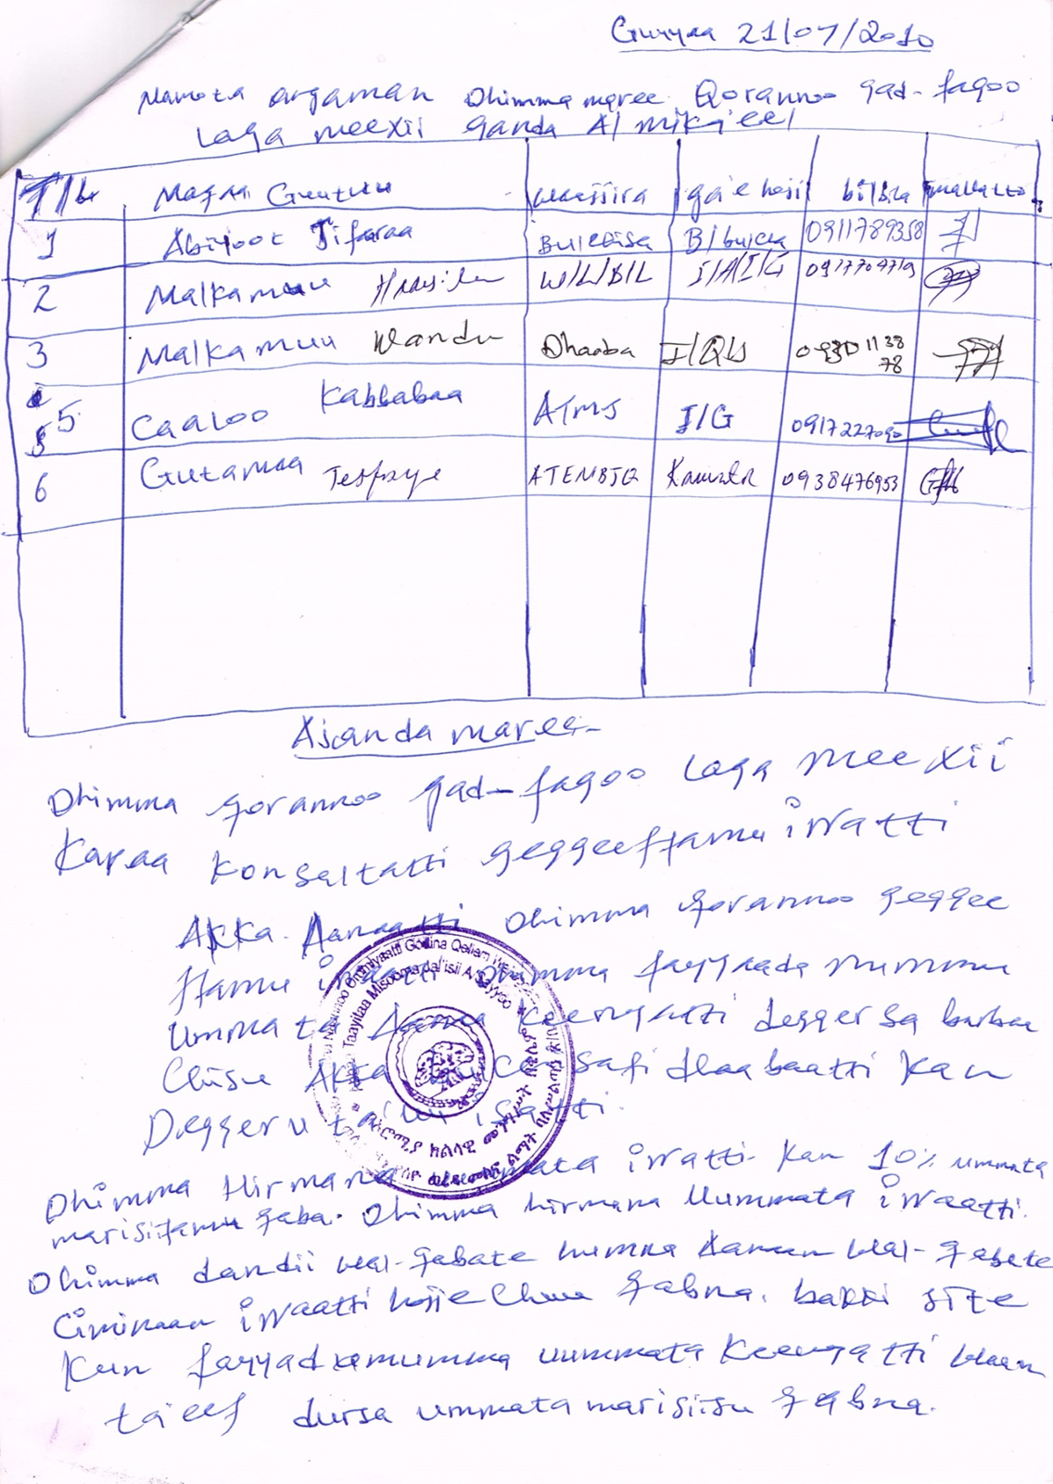
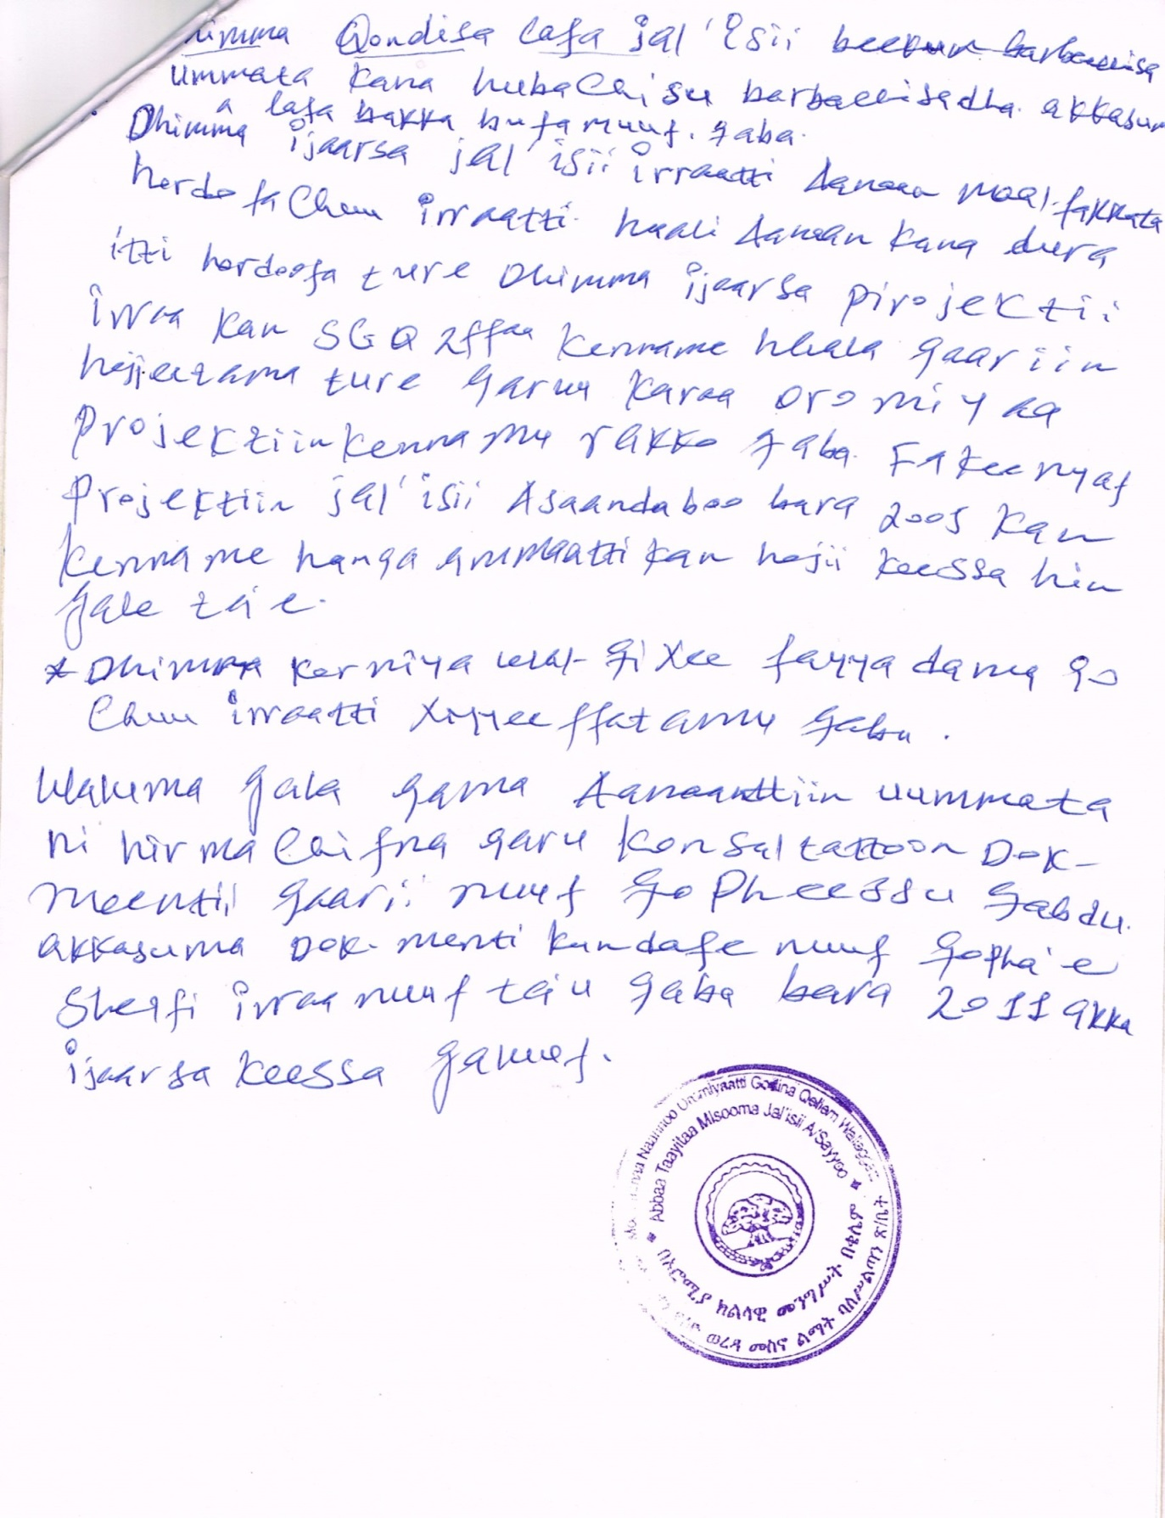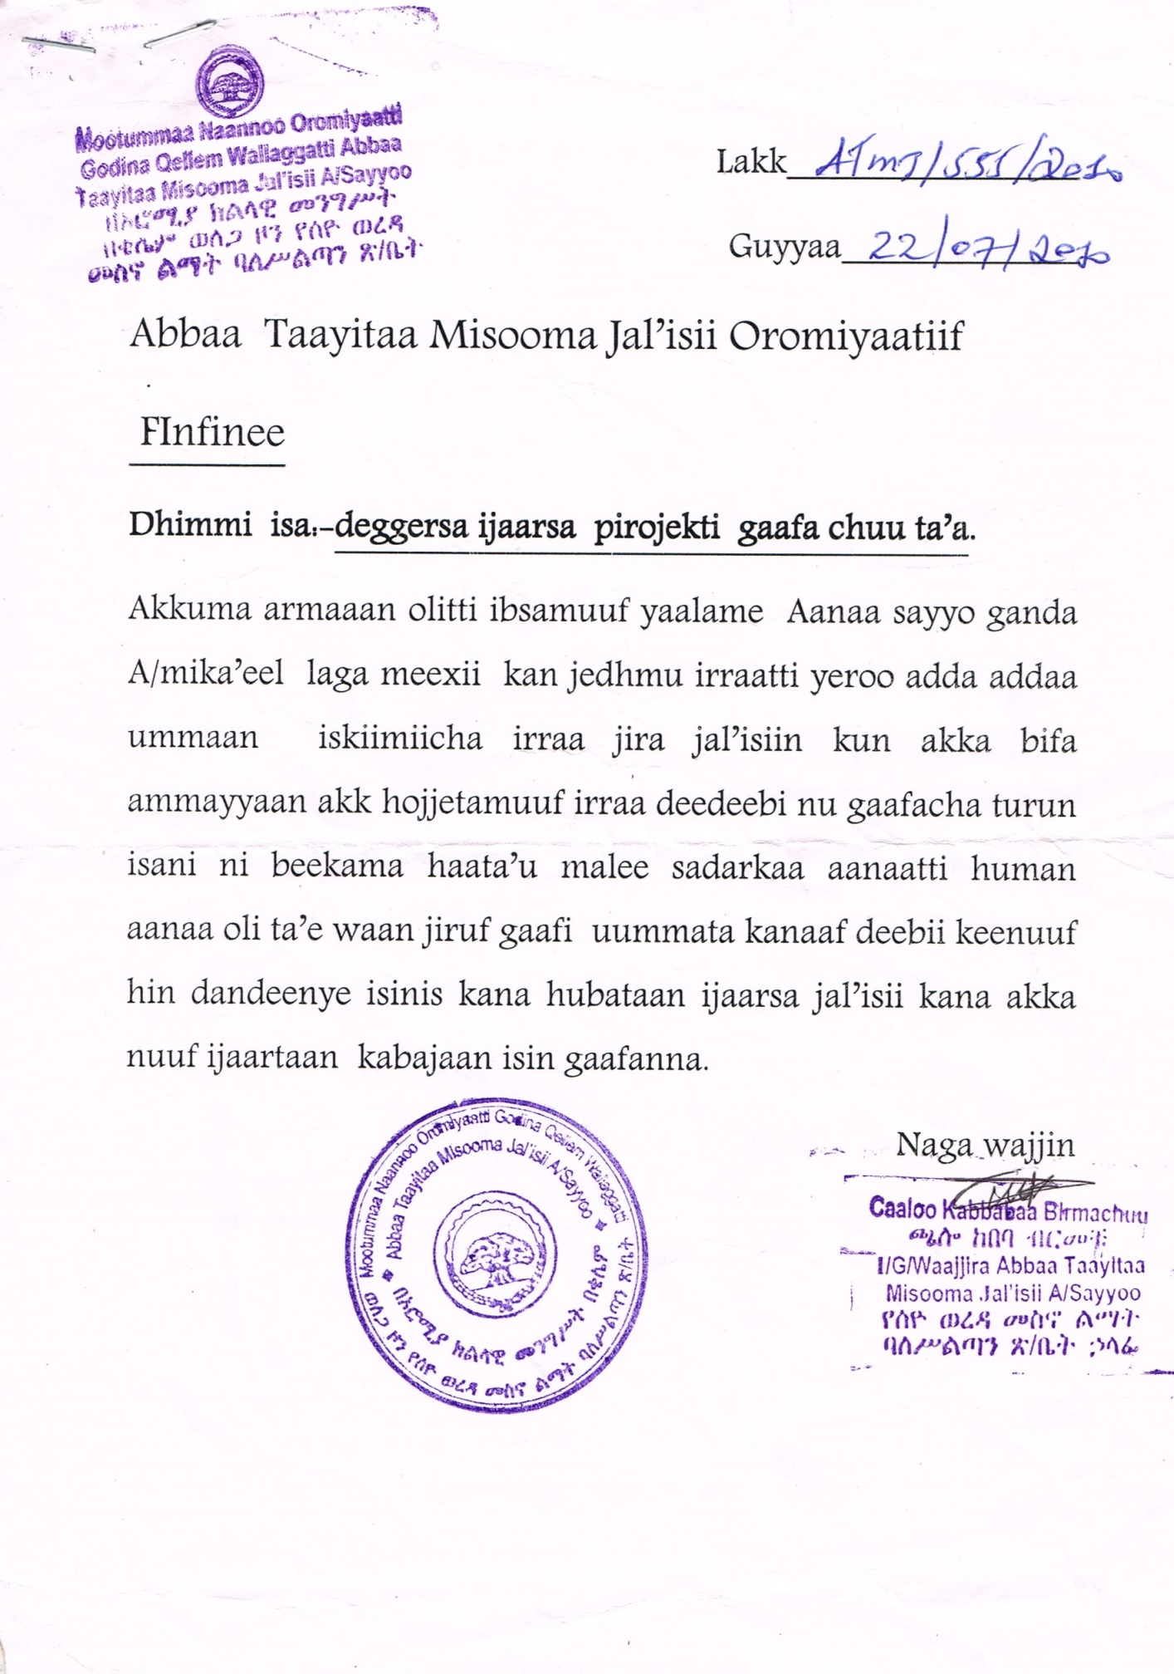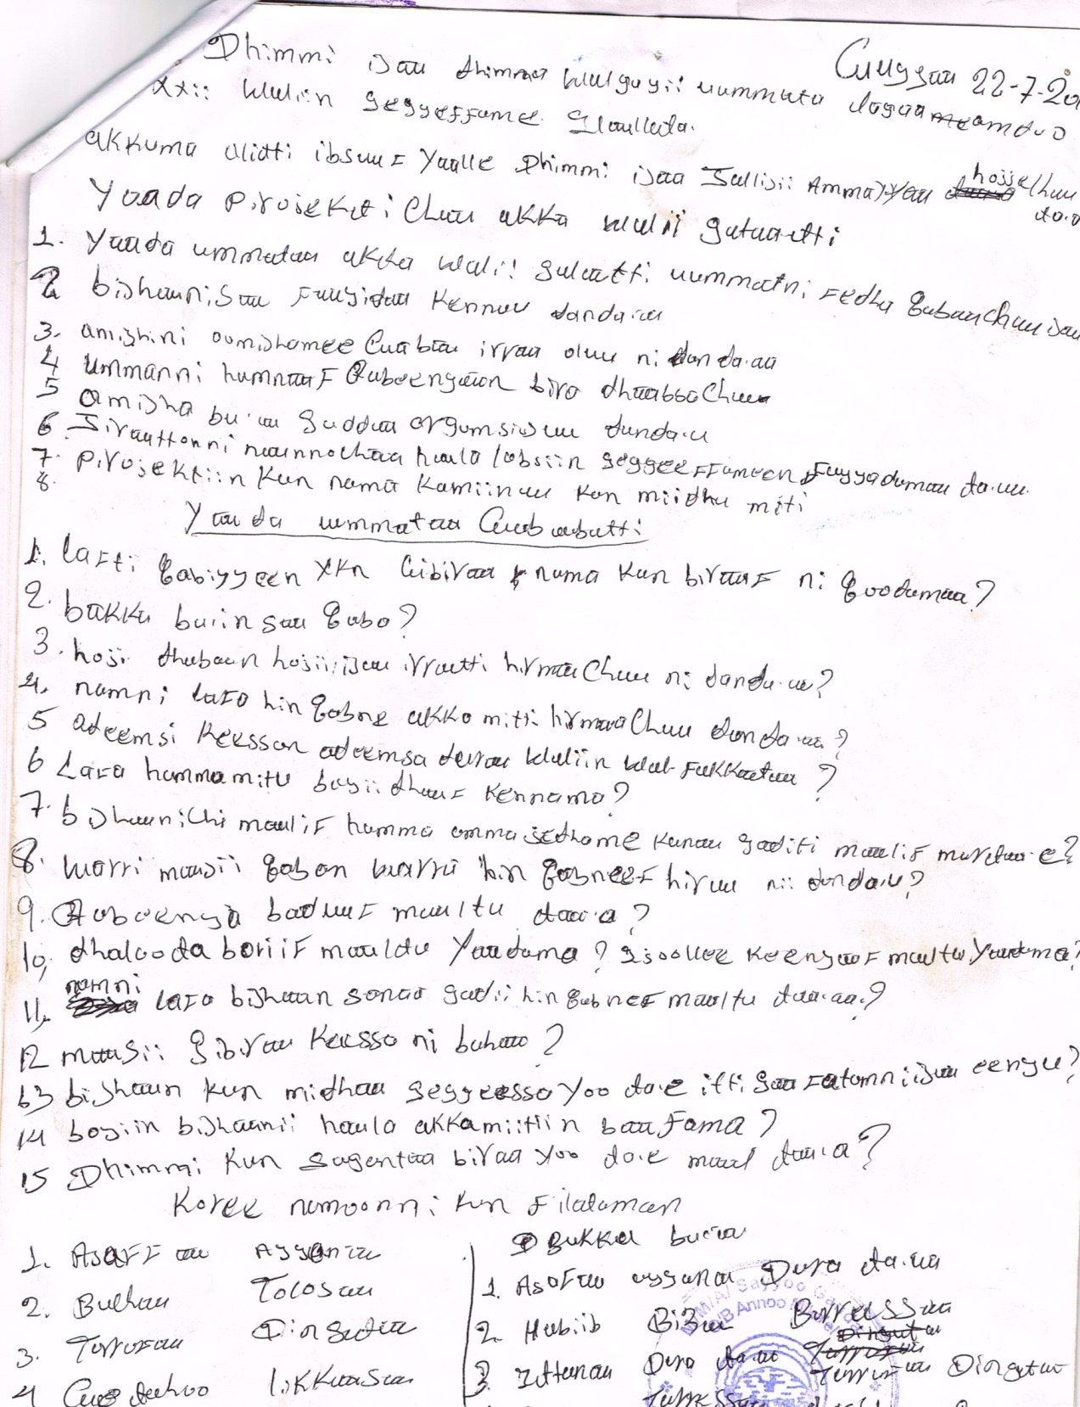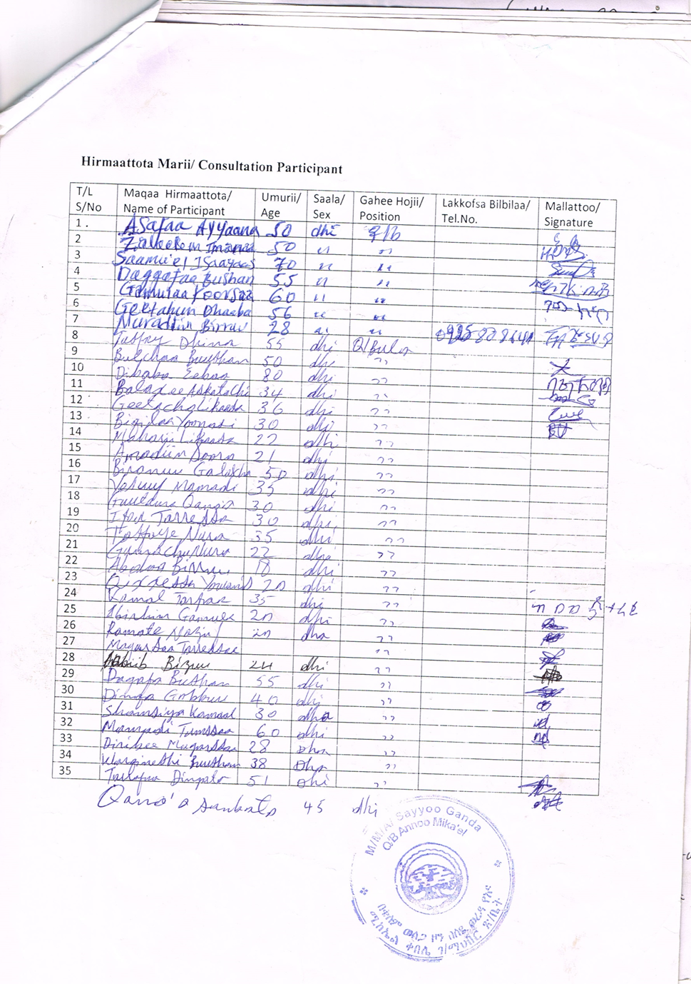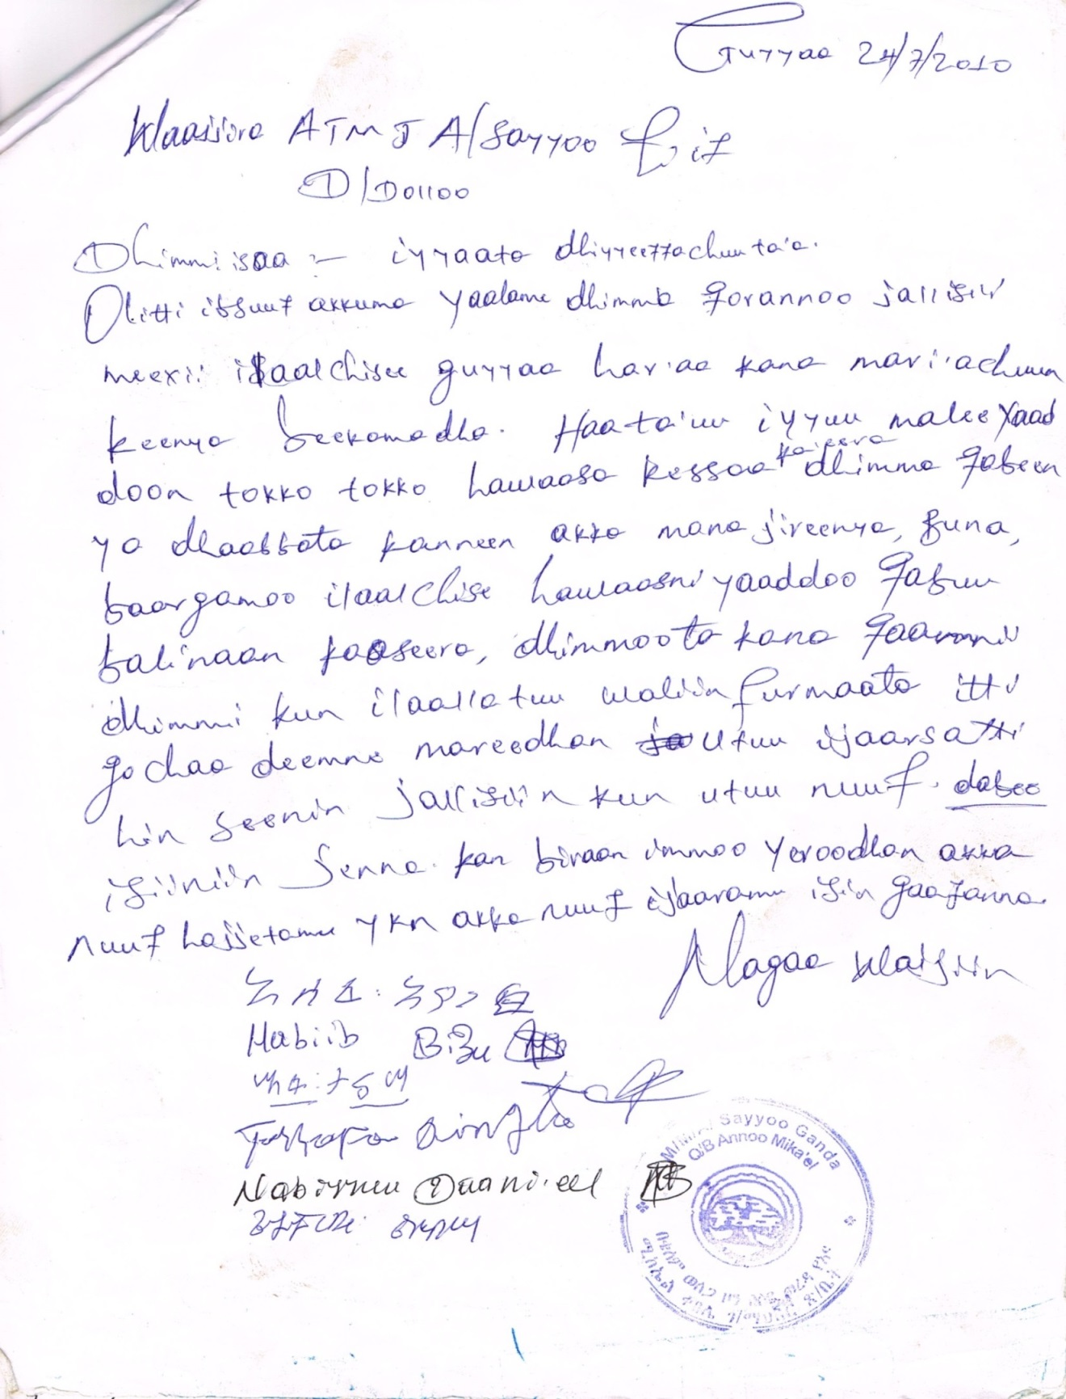

ANNEX 5: Questioners
Woreda and Kebele Level Socio Economic Data Assessment
- Project Name _________________________________________________
- Location: Region ____________________Zone _________________Woreda ________________ Kebele________________
  - Name of towns and distance : Zone town _____________/____km; Woreda town _____/__KM; Rural village_________/____/km
  - Agro climates of the project kebele
Average altitude
Average rainfall
Average temperature
Rainfall seasons | Meher: From ________________ to _________________  Belg : From ________________to __________________
  - Agro-climate classification
%
High land
Mid high land
Low land
  - Land area, land use and land cover of the kebele
- Total land area: _____________ha;
Land Use | Area in ha. | % Share
Cultivated
Cultivable
Natural Forest
Waste land
Grazing and others
Total
  - Land holding size
Land Use | % Share
Landless
Below 0.5ha
0.5-1ha
1-2ha
2-3ha
3-5ha
>5ha
  - Population by kebele and sub village

Average family size:_____________
Number of kebeles ; Rural__________ Urban________ Total ______________

No | Kebele | Land area (ha) | HH | Population |  |  | Population Density
 |  |  |  | Male | Female | Total
  - Economic and livelihood base of the kebele
Sectors | % share contribution | Major crops and livestock type
Crop prod
Livestock
Mixed agriculture
Industry
Trade & commercial

  - What are major crops currently produced and potential to grow?
Major crops currently produced | Crops potential to grow | How is the crop use in terms of food and cash crops

  - Is the rainfall adequate for crop production? ___________
Does the community practice irrigation? ______________

  - Crop production and supply in the woreda
- Rain fed crop production
Crop type | 2003 | 2004
- Irrigated crop production
Crop type | 2003 | 2004

  - Irrigation experience
Is there traditional/modern irrigation practice? If yes give background information?
When constructed?
Who constructed?
What benefit?
Is there an organized water users association (WUA) in the kebele?

  - If yes, number of existing irrigation schemes in the woreda??
Name of irrigation schemes | kebele | Kebele | Command area (ha) | Remark (Traditional/Modern)

Water users associations (WUA) and membership
Name of irrigation water users associations | Number of members |  | Total
Name of irrigation water users associations | Male | Female | Total

  - Livestock
What are the major livestock: ________________ _____________________
What is the use value of holding livestock: _______________________________

Livestock type | Number of livestock | Average holding /household

What are the major livestock diseases? _____________________ _____________________
Where do livestock get fodder/feeding source? ________________ _____________________
Is there animal health clinic; ______________________________
What are the problems and constraints with livestock’s?
- _______________________________________________________
- _______________________________________________________
- _______________________________________________________
  - Food demand and Food security situation
- Is the kebele in food shortage/deficit?

- How is the overall food security situation?

- What copping mechanism in place to meet food security of the kebele/kebele?

- If there exist safety net as strategy indicate number kebele covered under safety net in the kebele ?

Number of households served safety net or other support?
Kebele | Indirect/food for work support  No of households |  | Total | Direct support |  |  | Remark
Kebele | Male | Female | Total | Male | Female | Total
  - What do you think are the factors that contributes food deficits in the kebele
- _______________________________________________________
- _______________________________________________________
- _______________________________________________________
- _______________________________________________________
  - Marketing
Major market place and distance from the project area within the kebele or neighbor kebele that serve as market outlet

Market place | Kebele | Distance from the project (KM)

Price trend (2000-2004) and current price
Crop type | Price trend by year |  |  |  | 2005  Current price
Crop type | 2000 | 2002 | 2003 | 2004 | 2005  Current price

- What are the product in excess of local market
- What product is in short supply for the local market?
- Can local market absorb increased production?
- Major market roots and product flow in the kebele as well as domestic and boarder trade if any. What product flow where and their market destinations?

  - Cooperative
- Existing agricultural cooperatives and Unions in the kebele
- Cooperative Membership by sex
Name of cooperatives /unions | Number of members |  | Total
Name of cooperatives /unions | Male | Female | Total
What are the constraints/problems in cooperatives management and weak performance?
- ______________________________________________________________________
- ______________________________________________________________________
- ______________________________________________________________________

  - Agricultural Extension and input supply
Name of kebele | Total number farmers households (both sex) | Number of farmers supported in extension service | Number of assigned development agents | No of health extension workers | FTC | No Nursery sites
- Give sex disaggregated data on farmers training and skill development in the last three years if any.

Distribution of input by kebele (2003 & 2004)
 | Unit | 2003 | 2004 | Remark
Fertilizer
DAP
UREA
Chemicals
-
-
Improved seeds
-

What do you think are the constraints in input supply
- ______________________________________________________________
- _____________________________________________________________
- _____________________________________________________________

  - Rural agricultural financing
How is the community attitude for credit & saving? Where do you get finance when in need?
Is there rural financing schemes (credit & saving) institutions in the kebele?
Who are the stakeholders providing credit & saving in the kebele?

For What purpose do the credit used ? | - ___________________________________  - ___________________________________  - ___________________________________
Credit beneficiaries and disbursement
 | Total |  |  | Amount of credit
Year | Male | Female | Total | Amount of credit
2001
2002
2003
  - Gender issues
What are the problems of women at the area mainly in ?
- Education
- Health
- Water supply
- Grinding mill
- Fuel

What are the traditional or cultural constraints hindering women equal decision making power

Availability of women organization in the project area
Do women participate in agricultural activities other development project work like daily work as off farm income?
What are the benefit this irrigation project for women?
Do you think any adverse/negative impacts?
Are women conceived equal to men counter parts? Who is the decision maker

Describe task assigned for men and women
No | Women | Men

  - Impact analysis Upper & lower stream users
Describe canal lay out (one side/two side) __________________________________________________________________
Are there beneficiaries on the other side of the canal, if yes describe estimated no of HH ______________________________

 | Estimated No of HH | Social impact | Environmental impact | Remark
Upper stream
Other side of the canal
- Dam, Diversion & wear structure
- Road and canal structure area
Command area
Down stream

  - Human Health and health service
What health service is available in the kebele: ____________ ___________________
Where do you served for other health care
Facilities | Location | Distance from project area
Hospital
Health center
Health post
No of health extension worker in the kebele
What are the three major health diseases?
- ____________________________
- ____________________________
- ___________________________
Ten top disease Year _______
No | Item | %
1
2
3
4
5
6
7
8
9
10
Ten top under five
No | Item | %
1
2
3
4
5
6
7
8
9
10

Health problems and constraints at project area/kebele
- _____________________________
- ___________________________
- _____________________________
  - Education
School & student enrolment
School | Number of schools in the kebele | School enrolment |  | Total | DROPOUT BY MALE & FEMALE
School | Number of schools in the kebele | Male | Female
1-4
4-8
1-8
8-10

Problems & constraints in education and school dropout
- _____________________________________________________________
- ____________________________________________________________
- _______________________________________________________________
  - Availability of other infrastructures and priority problem in basic social service
Road
Electricity
Telecommunications
Market
-
-
  - General issues
- Labour cost
- Labor availability
- community contribution
- Ethnic composition
- Attitude of the community towards the project
- Religion composition of the people and job culture
Marriage & cultural practice
Family size
Farming system and cultural practice
Irrigation practice
Existing cropping pattern
Proposed cropping pattern
Constraints to agricultural crop production | -
Attitude toward the projects | -

ANNEX 6: Household Survey Questionnaires
Gaaffin kun kan qophaahee jallisiiwan xixiqqaa hawaasaaf ijaramuuf qoratamaniif waan ta’eef isiiniins gaaffii kanarratti raga ykn odeefaanoo sirri ta’ee keennudhaan gumaacha akkataasiftan isin gaafanna
- Gaaffiwan bu’uraa
  - Ganda ----------------------------------------------------------
  - Maqaa abbaa maatii ------------------------------------ saala------------------ umurii-------------
  - Saba -------------------------------------
  - Sadarkaa barumsaa abbaa maatii -------------------------------------
  - Baayina maatii -------------------------------------
  - Baayina maatii umurii fi saalaan

Umurii | Dhira | Dubartii | Ida’ama
Waggaa 15 gadii
Waggaa 15- 64
Waggaa 64 ol

  - Barumsa karoora maatii argattanii beektuu?
a, eeyyanii --------------------- b, miti ---------------------------
  - karoora maatii isin nifayyadamtuu?
a, eeyyanii --------------------- b, miti ---------------------------
- Qabeenya Lafaa fi Haala Mala Qonnaa
  - Lafa qonnaa qbaduu?
a, eeyyanii --------------------- b, miti ---------------------------
  - Waligalatti lafti qonnaa keesan heektara hagam ta’a? ----------------
  - Lafa bishaanin misoomu qabduu? a, eeyyanii --------------------- b, miti --------------------
  - Eeyanii yoo ta’e lafa hagamtuu misoomaa jira? --------------------------------
  - Qotiyyoo qonnaa meeqa qabduu? -------------------------------------
  - Qonnaaf maal fayyadamtuu? a, qootiyyoo ------------------- b, farad ----------------- ------c, harree----------------------- d, sa’a -------------------------- e, gaangee ---------------------
- Sirna Koorniyaa fi Haala Qonnaa
  - Dubarttoonnii abbaa warraa ta’an qixxee dhiiraa lafa argatuu?
a, eeyyanii --------------------- b, miti ---------------------------
  - Naannoo kanatti hojii korniyaaf qoodamee dhiiraa fi dubartiin qoodamee jira?
a, eeyyanii --------------------- b, miti ---------------------------
  - Eyyanii hota’ee hojii dubartoonnii irratti hinhirmaannee kamfa’i?
- qonna qootuu 2, eeruu ykn maasaa qopheessuu 3, kotokotuu/ shuqunuu 4, bishaan jallisii obaasuu 5, aramaa buqqisuu 6, haamuu guuruu 7, gabaa fi gurguruu 8, kan biraa ---------------------------------------------------------------------------------------------------------------------------------------------------------------------------------------------------------------------------
  - Dubartoonni abbaa warraa ta’an baasii suphaa jallisiif ooluu dhira wajjin kaffaluu danda’uu jettaniti yaadduu?a , eeyyanii --------------------- b, miti ---------------------------
- Itti Fayyadama Bishaan Jallisi fi Oomishaa
  - Jallisiin fayyadamuu muxannoo qabduu? a, eeyyanii ----------------- b, miti ---------------
  - Jallisii oomishuu erga calabdanii waggaa meeqa ta’e?-------------------------
  - Waggaatti si’a meeqa oomishituu? ---------------------------------------------
  - Yeroo ammaa kana oomishini gurguddoon sadan isin omiishtan maalfa’i?
1,----------------------------------------
2,------------------------------------------
3,-----------------------------------------
  - Ijaarsi jaallisii kun xumuramee tajaajila yoo keenuu calqabee kan isin dursaan omishuu barbaadan maal fa’i? tarreen kaahii.
1.-------------------------------------------------
2,--------------------------------------------------
3,--------------------------------------------------
4.6 Omisha jallisiitiif humni maatii qoftii gahaa jeettuu?
a, eeyyanii ----------------- b, miti ---------------------
4.7 Qonnaa fi suphaa jallissiitiif meeshaa gahaa qabna jettuu?
a, eeyyanii ----------------- b, miti ---------------------
4.8 Hojjata dirree misoomaa irraa haala mala qonnaa fi kanfafakkaatan barumsaa fi deegarsa gara garaa yeroo yerootti argattu? a, eeyyanii ----------------- b, miti ---------------------
4.9 Waajjira qonnaa irraa deegrsi gara garaa isiniii taasifamee beekaa? a, eeyyanii ---- b, miti ----
5. Oomisha Roobaa fi Oomishituummaa Isaa
5.1 Waggaa keessatti rooba kan argattan ji’a meeqaaf?--------------- hagami haga yoomii?----------
5.2 Oomishitoota yeroo roobaa omishtan sadan ibsaa
1.------------------------------------------2,-----------------------------------------3,------------------------------------
6. Dhiiheessa Calla Guddiftuu fi Bittaa
6.1 Xaa’oo fi callaa gudiftuu biraa nifayyadamtuu? a, eeyyanii ------- b, miti ---------
6.2 Bara darbee calla guddiftuu hagaam fayyadamtanirtuu?
Gosa calla guddiftuu | Safartuu | Baayyana
Xaa’oo
Daappii
Uriyaa
Dikee/ kompostii
Farra aramaa
Farra ilbisootaa
Sanyii

6.3 Calla guddiftuu gabaadhuma naannoodhumaa argattuu? a, eeyyanii ---- b, miti -----
6.4 Deebinsaanii miti yoo ta’ee eessaa argattuu?
1, Waajjira qonnaa irraa 2, waldaa qonnaan bultootaa irraa 3, daldaaltootaa dhunfaa irraa 4, iddoo biroo ---------------------------------------
6.5 Gatiin calla guddiftuu madaalaamaadha jeettuu? a, eeyyanii ---- b, miti -----
-----------------------------------------------------------------------------------------------------------------------------------------------------------------------------------------------------------------------------------------------------------
7. Haala Liqii fi Qusannaa
7.1 Dhaabbatni liqiii fi qusannaa naannoo keessan jiruu beektuu? a, eeyyanii ---- b, miti -----
7.2 Eeyyanii yoo ta’ee liqii fudhattanii beektuu? a, eeyyanii ---- b, miti -----
7.3 Liqii fdhattan maal ittin hojjatanii? 1, loon horsiisuu ykn gabbisuuf 2, calla guddiftuu bituuf 3, daldaalaaf 4, dhimmaa biraaf
7.4 Hanqinnii maallaqaa/ qarshii ji’a kam keessa?-----------------------------------------------
8. Haala Gabaa
8.1 Oomisha keessan eessatti eenyuuf gurgurtuu? 1, waldaa qotee bultootaaf 2, daldaala dhunfaaf eruurratti 3, gabaa/ magaalaa naannooti 4, warshaaf 5, kan biraa yoo ta’ee ibsaa ------------------------------------------------------------------------------------------
8.2 Gabaan/ iddoon omisha keessan itti gurgurtan gidduu galeessaan sa’aati meeqa isiin deemsisa? -----------------------------------------
8.3 Oomisha keessan gabaatti kan geessitan geejjiba maaliin? 1, harree 2, farad/gaangee 3, konkolaataa 4, gaarii 5, human namaa baatee 6, kan biraa yoo ta’ee ibsaa -------------------------------------------------------------------------------------------------------------------------------------------
8.4 Waggaa sadii asitti hojii jallisii, calla guddiftuu akkasumas gabaan walqabatee rakkoo gurguddoon isin qunnamee isiin qunnamee kamidha? Tarreen kaahaa .
.Gatii taa’oo dabaluu . Gatii omishaa xiqqaachuu
. Rakkoo geejjibaa . Rakkoo karaa
. Gabaa naannoodha dhabamuu .qulqullina dhabuu oomishaa
. Kan biraa ----------------------------------------
-----------------------------------------------------------
--------------------------------------------------- ------
-------------------------------------------------------------
------------------------------------------------------------
-------------------------------------------------------- --
------------------------------------------------------------
-----------------------------------------------------------
----------------------------------------------------------
9. Haala Qabeenya Maatii Galii Fi Bahii
9.1 Maddii galii matii keessani guddoon maalirraahi?
1. qonnaa midhaanii 2. Loon horsiisuu 3.Meeshaalee harkaan hojjataman 4.Daldaalaa xixxiqqaa 5.Hojii humnaa guyyaan 6. Kan biro -----------------------------------------------------------------------------------------------------------------------------------------------------------------------------
9.2 Maddii galii matii keessani lammaffaan maalirraahi?
1. qonnaa midhaanii 2. Loon horsiisuu 3.Meeshaalee harkaan hojjataman 4.Daldaalaa xixxiqqaa 5.Hojii humnaa guyyaan 6. Kan biro -----------------------------------------------------------------------------------------------------------------------------------------------------------------------------
9.3 Bara darbee kana galiin maatii keessan walii galaa qarshii meeqa ta’a? -----------------------------------------------------------------------------------------------------------------------------------------------------------
9.4 Bara darbee kana baasiin maatii keessan walii galaa qarshii meeqa ta’a? --------------------------------------------------------------------------------------------------------------------------------------------------------
10. Hubannoo Kafaltii Tajaajilaa
10.1 Tajaajila jallisii kana itti fufinsaa amansiisaa taasisuuf gatii suphaa eenyuu haadanda’uu jettaniti amantuu?
1. Itti fayyadamtoota 2. Mootummaa 3.Miti mootummaa 4. Kan biroo yoo ta’ee ibsaa --------------------------------------------------------------------------------------------------------------------------------
10.2 Qaamnii haa kaffaluu jedhan sun maaliif haakaffaluu jedhan laataa?--------------------------------------------------------------------------------------------------------------------------------------------------------------------------------------------------------------------------------------------------------------------------------------------
11. Caasaa fi Bulchinsa Pirojeektii
11.1 Waldaan itti fayyadamtoota bishaan jallisii naannoo keessan jiraa? a, eeyyanii ---- b, miti ---
11.2 Miseensa waldaa itti fayyadamtoota jaallisiitii? a, eeyyanii ---- b, miti -----
11.3 Miseensa waldaa itti fayyadamtoota jallisii yoo ta’uu baattan maalii fi?
1. Miseensa waldaa ta’uu waan hinbarbaadneef 2. Waldichi cimaa waan hintaaneef
3. Qaamni qiindeessuu waan hinjirree fi waldichiis siirrii waan hin taaneef 4. Kan biro -----------------------------------------------------------------------------------------------------------------------------------
11.4 Fulduraaf miseensa waldaa ta’uf fedhii qabduu? a, eeyyanii ---- b, miti -----
12. Jallisii qoratamaa jiruu kanaan walqabatee wanti jeettan yoo jiraatee? -------------------------------------------------------------------------------------------------------------------------------------------------------------------------------------------------------------------------------------------------------------------------------------------Galatoomaa!!!!!!!

