Oromia National Regional State Irrigation
Development Authority (OIDA)

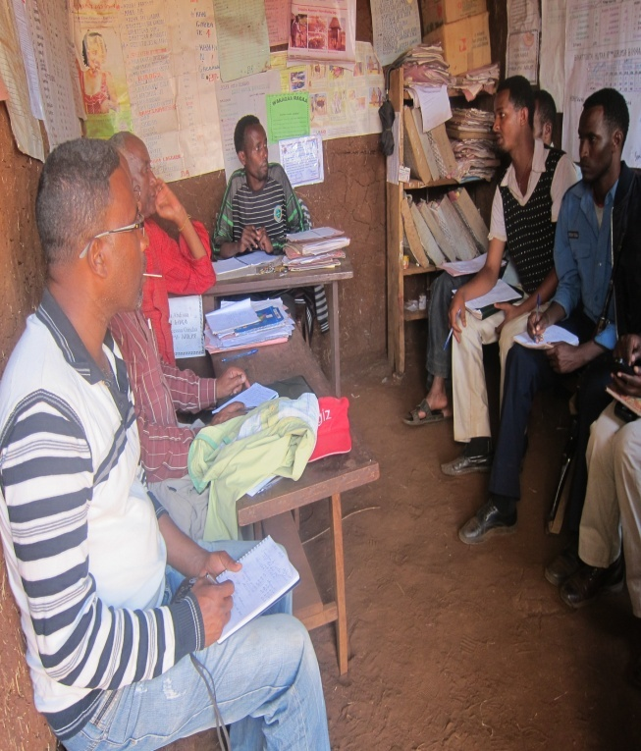

Organization and Management Study Report of Ukke Small Scale Irrigation Project -Lot 1 of Nine SSIPs ( Final Draft)

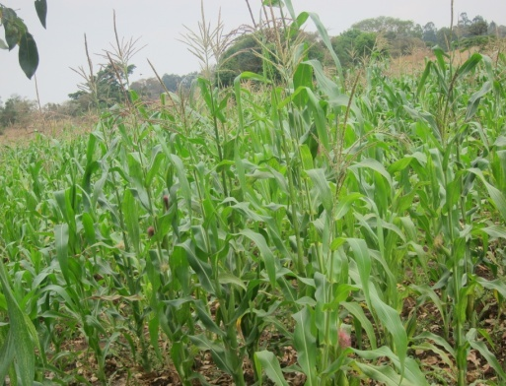

Consultant: Boneya PLC
Reviewed By OIDA-AGP Team

October, 2016
Batu

Table of Content
List of Tables iii
List of Figures iii
1. Introduction 1
1.1 General objective 1
1.1.1 Specific objectives 1
1.2 Methodology 2
2. Implementing bodies/Agents 2
2.1 Oromia Irrigation Development Authority (OIDA) 2
2.2 District Administration 3
2.3 District Health Office 3
2.4 District Environmental protection, Land administration and land use office 3
2.5 District Agricultural Development office 3
2.6 Kebele Administration 4
2.7 Beneficiary Community 5
3. Proposed Organization and Management Structure 9
3.1 Water User Association (WUA) 10
3.1.1 Establishment, Functions and Service Period 12
3.1.2 Rights and Obligations of the Beneficiary Community 12
3.1.3 Committee Composition and Members 13
3.1.4 The Duties and Responsibilities of WUC 13
3.1.5 Rights and Obligations Water User Committee 14
3.1.6 Duties and Responsibilities of the Committee Members 14
4. Cost Coverage 17
4.1 AREA-BASED PRICING 18
4.2 VOLUMETRIC PRICING 18
4.3 Block pricing 19
5. Monitoring and Evaluation 20
6. Reporting Requirements and mechanisms 23
7. Training needs proposed for irrigation Water Users Association/WUA/ 23

List of Tables

Table: 1.1 Name and address of some of the contacted persons around the project ………..7
Table 1.2: Key Monitoring Areas/performance indicators proposed .....................................21
Table 1.3: Water Users Association performance evaluation format ....................................22
Table 1.4: Training needs proposed for irrigation WUA ……………………………………...24
Table 1.5: Estimated cost/budget requirement proposed for irrigation WUA ………………25

List of Figures

Fig. 3.1 Proposed Organizational Structure of WUA ………………………………………….11

1. Introduction
Functional and purposeful organization and management system has a horizontal and a vertical dimension. The horizontal dimension is concerned with the way in which the various activities essential to the achievement of an organization's objectives can best be differentiated (in accordance with the specialist skills required for each activity) and then coordinated in order to produce the necessary unity of effort among the resulting specialist units. The vertical dimension is concerned with the way in which responsibilities are distributed among members working at different levels of the organization and its component units, from the project to the small group level.
As an indispensable element to help sustain the proposed Ukke small scale irrigation project, the relevant and applicable organizational and management system is proposed by the consultant as follows;

Project Rationale

The study of the project was conducted based on demand of the community of project area and if the implementation of this project is considered, it boosts income of the community, improves living standard of community and generally alleviate poverty.

General objective

The general objective of carrying out the organization and management study is to pinpoint the existing organizational and managerial aspect of the managing bodies of the community and propose relevant, clear and functional organizational structure and management system of the intended project and also suggest the roles, duties and responsibilities of the various committee members assigned in the implementation of the project.

Specific objectives

- To identify the rights and obligations of the committee members and the project beneficiaries
- To study and analyze the roles, duties and responsibilities of the committee members and the beneficiaries
- To sustainably operate the irrigation project
- To enhance active/ full participation of the beneficiaries
- To analyze the attitude of the beneficiaries in managing and administering the project
- To identify the managerial capacity gaps of the committee and the project beneficiaries and recommend relevant and applicable capacity building/training requirements
- To identify existing organizational bottlenecks and recommend appropriate organizational structure for the proposed project.

Methodology

The relevant methodologies employed to study the organizational and management conditions of the proposed project are suggested as under:
- Interview and round table discussions with the users’ representative
- Focused group discussion
- Stakeholders interest assessment
- Review of study documents and various reports conducted on organization and management conditions of the project area (both primary and secondary data were collected from primary and secondary data sources).

Implementing bodies/Agents

The findings of the institutional frame work analysis covering:
- The identification of agencies responsible for project implementation;
- Assessment of the institutional capacity of such agencies; and
- Any steps that are proposed to enhance the institutional capacity of agencies responsible for the small scale irrigation implementation.

2.1 Oromia Irrigation Development Authority (OIDA)

The appropriate implementing body that is responsible for coordination and implementation of small scale irrigation project is the Oromia Irrigation Development Authority (OIDA). The Authority has played an important coordination role in the small scale irrigation implementation.
Oromia Irrigation Development Authority (OIDA) is supported by its already existing structures in the implementation of project activities. At Zonal level, the East Wollega Zone Administration is involved in the proposed project through its respective staffs operating under the Zonal Administration, and through co-ordination of activities with project-related structures. The administration has indicated that they intend to:
- Facilitate a preparatory workshop with government representatives from Regional, Zonal and District levels, in the District, inviting for example, women, the youth, religious leaders and elders of the affected communities, to introduce the objectives and plans of the government about the Project;
- Under the supervision of the District, for Zonal and District officials to hold a one- or two-day meeting with the project Kebele, as a formal meeting for public awareness;

At District level, representatives from District Offices are required to form District Project Implementation Teams (WPITs) comprising: Team Leaders of Extension, Water Resources, Cooperative Promotion, Inputs and Credit team, and Environmental Protection and land administration and land use; representative from District Finance; and representatives of Kebele community associations and water user association.

2.2 District Administration
The District Steering Committee, chaired by the respective District Administrator or his deputy, has representation from the District Administration and all the District Offices. The Committee advises on the implementation of Projects at a local level, and in particular discusses sector-wide issues (such as land, agricultural activities, women’s issues, and health) to ensure an effective and integrated approach. The Committee meets frequently to assess progress of the Irrigation Project’s implementation, and when/if issues arise for discussion.

2.3 District Health Office

District Health Office will be faced with an increase in the prevalence of diseases given potential impacts of the Project. Although assisted by a number of governmental and non-governmental organizations, particularly for sexual transmitted diseases and HIV/AIDS, other diseases may require additional support. The Health Office, however, is faced with problems, including:
- Medical supplies and drugs delivered to health facilities in the District do not cover the potential demand for the period. The problem becomes serious when epidemics, such as for malaria, prevail. Most Health Centers, except in district have administrative problems in using and managing funds allocated for medical supplies and drugs.
- District does not have an adequate number of vehicles to provide efficient and equitable medical services to the communities. Most Health Centers are located in towns, which are far away from rural communities. As a result of lack of transport, medical staff of the Health Centers cannot assist Health Posts in the project area. However, one ambulance from the project district sometimes available to serve especially the pregnant women.

2.4 District Environmental protection, Land administration and land use office
The District Environmental protection and land use office has two departments: a) Environmental Protection process team, and b) Rural Land Administration. Problems experienced, or anticipated, by the Office, as headed by the Office Head, include the following:

- Project implementation may also be delayed when the District Administration assigns the concerned staffs to other ‘urgent’ assignments.
- Shortage of skilled employees/man power and insufficient facilities;
- There is capacity limitation relating to skilled workers, transport, and budget.

2.5 District Agricultural Development office
Agriculture and rural development office of the district has a wide range of responsibilities in development activities of the rural areas of the District, accomplished through the following departments: Extension; Natural Resources Development; Early Warning; Input Supply and Follow-up and Marketing; and Cooperatives promotion.

The role of the office in Project implementation involves the following responsibilities:

- Provision of relevant information and contribution of the staff to assess community mobilization at kebele level
- Administering agricultural activities in the project area during and after project implementation;
- Organizing farmers into water user association, to effectively use the resource with minimum conflict of interest among water users;
- Continuing agricultural extension activities, with a greater emphasis on irrigation development; and
- Acting as a major stakeholder in the land redistribution process, this will be carried out under the responsibility of the district’s office.

At present, at the project Kebele level and the project area there are three development workers/agents assigned and comprises; crop development agent, irrigation development and natural resources agent, livestock development and cooperative promoter agent. The development agents’ activities are organized and controlled by supervisors assigned by the project district, having a higher educational and experience level than the development agents.

The current agricultural development support services will change in content and magnitude due to the introduction of new modern irrigation development. For example:
- Farmers will need to be organized into water user association
- The irrigation scheme requires/demands a wider range of professional support;
- Input use of the farmers will increase substantially, placing greater demand on the input supply and follow-up and marketing team;
- Introduction of new technology and mechanization, which will need to be accepted by farmers; and if the size and quality of the staff is not improved, the workload for existing staff will be significant.
The concerned office has proposed the following support to build capacity to carry out implementation of the project:
- Training of both the district, kebele staff and users’ representative in irrigation and drainage, agronomy, protection, post harvest handling, livestock production, etc.;
- Strengthening the credit facility system;
- Experience sharing with similar projects,
- Provision of a sufficient budget
- Provision of equipment and other facilities, such as office and transport with a maintenance facility;
- Support to farmer training; and
- Consultant support in specialized fields.

2.6 Kebele Administration
During the survey the consultant observed that the Kebele leaders have been actively involved in the project, assisting in the identification of people who will be affected by the project infrastructure, and participating in the valuation of affected properties through accompanying the Asset Valuation team in the valuation exercise, confirming the rightful landholder of properties, and being witness to results.

They will continue to be involved in the project, through acting as the first point of reference on the ground around the project, as the local liaison government agency, and through representation of the Kebele on project structures.
Hence, particularly the Kebele administration is responsible for;
- Land administration; as per the existing and functional regulations and procedures
- Organizing public consultation meetings in villages to help inform the communities about the project and make meaningful involvement.
- Closely follow up the project by acting as the kebele representative body (liaison officers) and find a solution in case of any problems encountered during the project implementation.

2.7 Beneficiary Community
The beneficiary community is the nucleus element in the planning and implementation of the intended project and still there is a need to create awareness on the small scale irrigation development, assess their opinion and views toward the planned project, to identify their level of participation. Accordingly, thorough discussions were made with the beneficiary communities at the intended project site on 14/05/2105 and 08/09/15 on very important agendas. On the meeting held, the beneficiaries represented/assigned the scheme user committee comprising of three to five subcommittee members. In this report document petitions, minutes and other important agreement reached with the indicated signatures of the participants are attached.

During discussions with the beneficiary community, the following issues were raised:

- As implementing capacity of the employees found in the Kebele office is limited and not equipped”; we require/need technical support from the upper administrative body to help provide appropriate support for the issues that are becoming more complex in their nature, For instance:”The land use plan of the beneficiary community
- Concerned body should look for the solution to the sky rocketing input cost
- Also, many questions were raised and got answer by the consultant, district and kebele representative the participated in the general meeting held.
Number of beneficiaries participated in the general meeting
- Male : 201
- Female: 23
- Total: 224

Main Agenda of the Discussion
1) Awareness creation on the intended modern small scale irrigation development plan
2) The benefit of modern small scale irrigation development
3) The roles/duties and responsibilities of the beneficiary community
4) The rights and obligations of the project committee & the beneficiaries

5) Discussing on the community participation in the project cycle
- During study and design phase
- During Implementation phase
- During scheme operation and Maintenance phase
6) Discussing on modes of community participation, project cost share (ways of maximizing public participation) confirmed in the form of;
- Labor contribution
- Money contribution
- Material contribution ( sand, stone, . . . )
7) The necessity of compensation payment, or replacement of properties due to construction of the project (access road, main canal, camp site, Weir site, Night storage, etc) and different options for compensation mechanisms
8) Land Reallocation and land distribution within the context of the New Scheme
9) On the issue of cost recovery and water tariff payment
10) The existence, expected and the effect of displacement due to the intended project, if any
11) Establishment of Water User Association (WUA) as per the basic principles of Oromia Cooperative Promotion Agency in accordance with proclamation number 147/98.
Committee Composition and Member
Composition:
Among the committee members at least three of them should be women and should play key managerial role. This is due to the fact that the women bear the maximum burden of food security related activities.
The executive committee shall have the following members:
- Chairperson
- Secretary
- Cashier/treasurer
- Store keeper
- Purchaser
- Auditor
- Scheme Caretaker/Operator

12) Discuss on the By Law of WUA of the scheme which is ratified by the beneficiaries

Participants attending the general meeting have actively and openly discussed on the above mentioned agendas one by one and showed their interest and have good attitude towards the implementation of the project. They also agreed and accepted to use commonly the irrigable farm land. As most of the communities around the project have been using the River by diverting traditionally on the command area, they developed ample experience to also use the intended modern irrigation project efficiently.
Besides, the general meeting attendee showed their agreement to participate in any work the project demands in any form for their support and they have come to a common decision to:
- Participate in project implementation
- Use commonly the irrigable command area
- Share land as per by law and/ or the existing social norm
- Participate in soil and water conservation
- Contribute 10% of the project cost i.e. by digging the line of water canal (labour force)
Moreover, some people from the community who participated in the general meeting but have no farm land in the command area and raise their opinion and personal view that the intended project has no negative impact.

In the same way, the administration officials, the peasant association leaders and the project beneficiaries have positive attitude towards the proposed project.

Table: 1.1 Name and address of some of the contacted persons around the project

No | Name | District/Zone | Current position | Cell phone
No | Name | District | Current position | Cell phone
1 | Emanuel Haile | ,, | Head, OIDA | 0917817525
2 | Yonas Liman | ,, | Engineer | 0910283904
3 | Kedir Husen | ,, | Process owner, extension team | 0934441625
4 | Gemechis Bekele | ,, | Sociologist | 0920405423
5 | Abraham Hordofa | ,, | Agronomist | 091703308
6 | Takele | ,, | Extension expert | 0917842146
 |  | Zone
1 | Kelil Shifa | ,, | Head, OIDA | 0920408585
2 | Milkessa Workineh | ,, | Vice head, OIDA | 0917071268

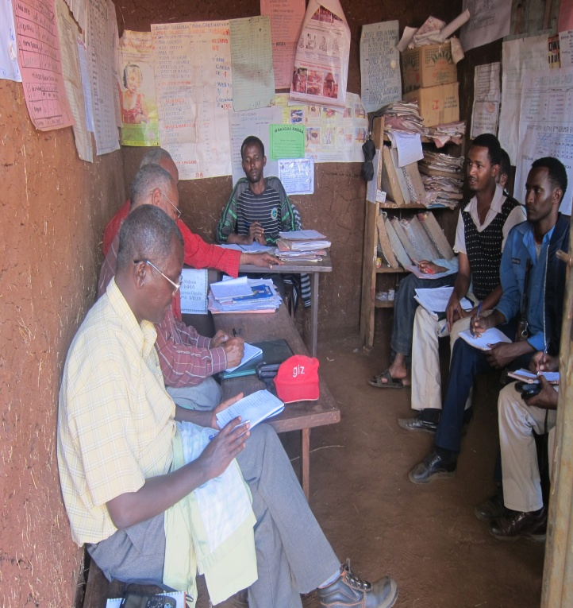
Photo: 2.1 Discussion held with concerned project Kebele ( Jarso Tolera PA Cabinet members & beneficiaries)
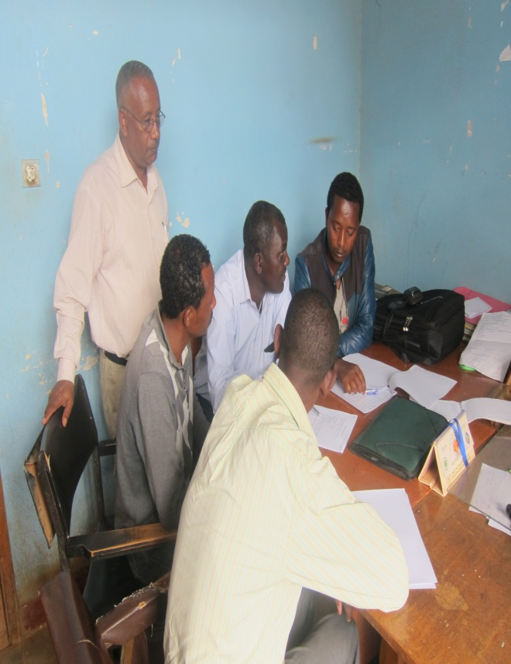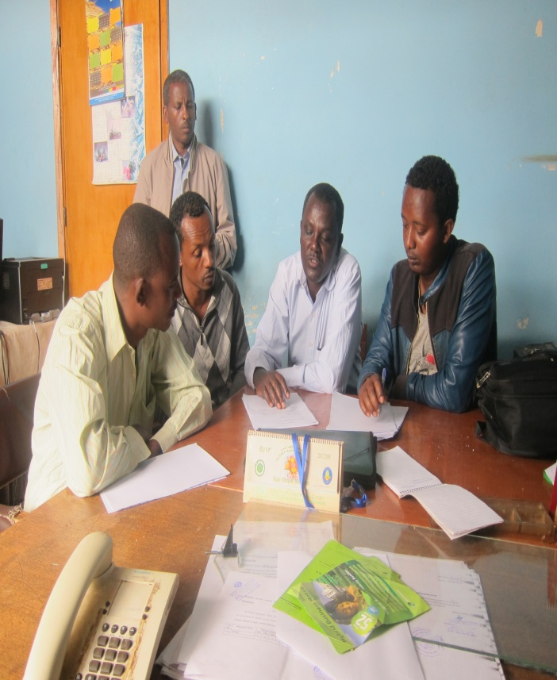
Photo: 2.2 Discussion held with project district ( Guto Gidda) OIDA staff

3. Proposed Organization and Management Structure
Organization and management structure would include water distribution and system maintenance, collection of water charges or similar fees and taxes and support, marketing and input supply and extension to farmers on water management at the local level. Management services such as finance, personnel, planning and monitoring - are also provided including input supply and marketing services. The provision of adequate marketing facilities is likely to be particularly needed, because the introduction of irrigation will create a potential for cultivating crops which have previously been unknown in the area; if farmers lack reliable marketing outlets for these crops they will not be prepared to take the risks of adopting them.
The main criterion chosen to classify the organizations is whether the organizational structure covers all the development activities (water management, agricultural extension, supply of inputs, credit, marketing and basic infrastructure and social services), or a few of these activities, or only those related to water management. The irrigation scheme management and administration characterized by an integrated organizational structure where all development activities are undertaken by specialized units which are all connected by a clear line of command and finally responsible to a single person (chair person) or water user committee.
  - It should be assumed that in the coming reasonable time of future development program will be the responsibility and authority of the benefiting community. Hence, the proposal of the institutional set-up assumes that the prevailing laws, policies directives regulations, consistency of work, etc. with certain changes or amendments are believed to continue.
  - Due care should be taken to avoid the tendency of creating a big institution which can become expensive and it has to be as simple as possible and clearly relate to the project's goals, missions, visions, values and objectives.
  - The proposal has to be in a position to necessitate efficiency and effectiveness.
  - The proper arrangement or assignment of jobs and/or posts into logical sub-groups or appropriate categories is accorded due attention. In the process, the main or organic functions of the project are given the prominence they deserve.
  - The activities that need to be undertaken by the project at top, middle and lower levels of management and shop floor are properly identified and constituted into clear and precise organizational units.
  - Efforts should be made to logically group and systematically synchronize functions and activities so as to constitute an integrated organization structure that will enable achievement of unity of management and the attainment of the goals and objectives for which the project is established.
  - The organizational structure is based upon a fair amount of delegation and decentralization of authority and appropriate span of control for managerial and supervisory personnel. In addition the relationship of stakeholders with project office is clearly seen and demarcated.

Consequently, the organizational and management structure of Irrigation project has been developed/ adapted by the consultant. The Consultant hereby forwards the Scheme Organization and Management under one most possible option that is Participatory Irrigation Management organization structure that gives ways for benefiting community to have voice and choice. Therefore, the proposed organizational Structure and management would allow;
- The project to adapt a structure that is more suitable for enhancing sustainability.
- Strengthen the management team.
- Improve overall effectiveness by removing areas of duplication and redundancy.
- Provide better support for user community to maximize positive impacts of the project and enhance sustainability.
- Strengthen accountability involvement of the benefiting community that pave way to enhance sustainability.

3.1 Water User Association (WUA)
Functional and sustainable community Management for Irrigation Scheme Operation and Maintenance is indispensable and without this it is quite difficult to realize and have sustainable management system in place. In fact it is very natural for a given community to participate in different activities that could generate benefit for them. But many experiences depict that because of different reasons particularly lack of clearly stated rules and regulation for community-based management in most of the Irrigation Schemes those lacks sustainability.

In this respect, this regulation is believed to enable the beneficiary community to manage the Irrigation Scheme and obtain the benefit under sustainable condition. In general, with a due consideration to the sustainable issue the study describe:
- The right and obligation of the beneficiary community.
- The duties and responsibilities of the water user committee and
- Decision area and the point of punishment up on the regulation violated by the community.
With this frame of mind, the consultant has included/adapted the organizational chart that comprises; rights and obligations and duties and responsibility of the project committee and members of water users committee for the proper administration and management of Irrigation Scheme as indicated hereunder.

Proposed Organizational Structure
Regional Irrigation Development Authority (OIDA)

Zone OIDA

District OIDA

Users’ Community/General Assembly

Water User Committee

Chairman

Storekeeper

Purchaser

Accountant

Caretakers

Auditor

Members
Cashier

Fig. 3.1 Proposed Organizational Structure of WUA

3.1.1 Establishment, Functions and Service Period
- The Water User Association members shall elect the committee members.
- The service period/terms for the committee members shall be three years but re-election of members is possible for a period of two terms.
- The committee members shall consist of seven members out of which at least women shall be incorporated. Legal binding decisions may only be taken if the chairperson in accordance with the law has invited the committee members and if more than half of the members are present.

3.1.2 Rights and Obligations of the Beneficiary Community
Rights
The beneficiary community has the right:
- To get the service without any discrimination.
- To be elected for or elect the Irrigation Scheme WUA committee.
- To elect caretaker for the scheme and fix the salary.
- To decide on the type of tariff rate and the amount to cover running and maintenance cost and the like.
- To decide upon the expansion and choice of technology.
- To decide upon the type and amount of contribution whenever the need arises.
- To fix the amount of allowance for the WUA committee members if any.
- To attend the general meeting.
- To decide on free services provision of water for individuals who are not capable to pay for the service.
- To decide the type and the amount of incentive that shall be given for the committee members.

Obligation
The beneficiary community has the obligation:
- To use the irrigation water properly.
- To safe guard the scheme from damage or abuse.
- To be involved actively in every activity that shall be significant and required for the scheme, e.g. construction of access road, clearing the surrounding areas of water source and irrigation structures.
- To attend the general meeting that shall be arranged by the committee.
- To pay on time users fee that shall be decided on the general meeting.
- To report on time any break down or unusual conditions of the scheme to the concerned body.
- To safe guard the water source from pollution and keep the scheme under good sanitation condition.
- To co-operate with the Irrigation Scheme WUA committee and caretakers.
- To perform every activity but only significant for the scheme that shall be assigned by the committee chairperson, for instance conveying message to the concerned bodies.
- To adhere to the regulation set to manage the scheme.

Recognition of WUA
- The Project Office shall recognize the WUA as the legal representative of the Communities, which get benefit from the irrigation scheme, and as the agent of the regional office as lay down in the letter of recognition.
- The recognition shall be made public.

3.1.3 Committee Composition and Members
Composition:
Among the committee members at least three of them should be women and should play key managerial role. This is due to the fact that the woman bear the maximum burden of food security related activities.
Member
The committee shall have the following members:
      - Chairperson
      - Secretary
      - Cashier/treasurer
      - Store keeper,
      - Purchaser
      - Auditor
      - Scheme Caretaker/Operator

3.1.4 The Duties and Responsibilities of WUC
The committee shall have the following duties and responsibilities:
- To manage the Irrigation scheme operation, monitor and evaluate the general status.
- To prepare quarter and annual reports on the performance and financial situation of the scheme and submit to the Project Office and report to the general meeting of the beneficiary community.
- To effect O&M expenditure properly.
- To motivate the beneficiary community towards utilization of improved Irrigation Scheme and modern farming practice
- To take full responsibility of the overall scheme administration and management.
- To open and operate bank accounts in the name of the scheme.
- To mobilize the community for community participation.
- To adopt a simple but efficient book keeping system.
- To report major breakdown that are beyond the capacity of the committee to the Project Office.
- To resolve conflict that may arise between the beneficiary households.
- To decide on the opening and closing time of the irrigation water in consultation with the community.
- To develop links with and get support from concerned stakeholders for operation and maintenance work.
- To collect and manage revenues as per the tariff rate.
- To propose tariffs /contributions.
- To manage procurements (service, works and good).
- To decide upon modifications and extension of Irrigation Scheme system in cooperation with the District OIDA office.

3.1.5 Rights and Obligations Water User Committee
The WUC shall take full responsibility for scheme administration and management. It is authorized to manage and control all transactions concerning revenue and properties of the irrigation schemes. It is responsible for the operation and maintenance of the scheme.
Rights:
- To use the irrigation scheme to the benefit of the community.
- To collect revenue as per the agreement within the community.
- To propose water tariff for the community decision.
- To manage water related expenditure
- To open and operate bank accounts.
- To manage and monitor employment contracts with support staff required for the scheme operation & maintenance.
- To decide upon modifications and extension of irrigation schemes in cooperation with project office and or other stakeholders.
- To manage and control procurements of services, works and goods.
Obligation:
- To properly administer and manage the scheme.
- To assure the provision of reliable and adequate/equitable water for the benefiting community.
- To organize timely repair of the irrigation scheme.
- To prepare and submit quarterly report to Project Office.
- To use the revenue collected for irrigation scheme related expenditure only.
- To keep surplus revenues in the bank account of the WUA.
- To implement water tariff, approved by the benefiting community.
- To keep proper records of all income and expenditure
- To encourage the communities to properly utilize the all agricultural input and improved practices to maximize benefits of irrigation scheme.

3.1.6 Duties and Responsibilities of the Committee Members
Chairperson
- Is accountable to the beneficiary community and the Project Office.
- Inspects the administration and proper usage of the finance, materials and other properties.
- Approves the purchase of the required materials, and equipment.
- Calls and leads meeting of the community and the committee
- Facilitates the discussion during meeting.
- Follow-up the implementation of the committee decision.

Secretary
- Writes and records the minutes of the executive and general meeting of the beneficiary community.
- Co-ordinate and chairs the meetings in the absence of the chairperson.
- Registers the beneficiary households and their family size for documentation purpose.
- Keeps record of meeting decision.
- Records the scheme incomes and expenses.

Cashier/Treasurer
- Collects cash with the prepared cash collecting receipts.
- When the chairperson orders and/or approves and prepares cash collecting and payment bills, the cashier performs accordingly.
- Deposits the collected cash in the nearest bank or similar institutes that gives same service within 24 hours to one week.
- Presents the cash receipt of the bank to the secretary. Keeps safely receipt.
- Presents the receipts and cash in hand for recording, inspection and auditing purpose.
- Effect payments when approved by chairperson and/or the secretary.

Purchaser
- Purchases water related goods when authorized by the Chairperson.
- Collect specification from the technician
- Collect purchase order
- Collect at least three price quotations for comparison purpose,
- Withdraw cash for the purchase upon approval of the chairperson,
- Assure the quality of item to be purchase in line with the specification.
- Collect the necessary receipt for the purchased items
- Deliver the purchased items upon approval of its quality by technician to the storekeeper.
- Settle the advance taken for the purchase

Storekeeper

- Keep the record and property of the Irrigation Scheme
- Register purchased items upon delivery by the purchaser.
- Prepare purchase request for goods before they out of stock,
- Receive item purchased taking all the necessary precautions,
- Keep necessary record of items in orderly manner,
- Provide the necessary documents for inventory,

The Auditor
- Inspects the proper implementation of financial forms and utilization materials and or equipment.
- Inspects the cost and expenses of the purchased materials.
- Follows up and monitors the collected cash, assures the cash deposit in the bank as well as the proper handling and utilization of cash.
- Prepares auditing report every six months to the WUA committee, Project Office and address to general meeting of the beneficiary community.
Scheme Caretaker/Operator
The scheme shall have a caretaker that should be elected by the beneficiary community. The number of caretakers shall depend on the scheme type and complexity. The caretaker/s shall be trained to operate and maintain the scheme components. The caretaker shall be paid for the service from the scheme revenue based on the agreed payment.
The caretaker shall be accountable to the committee and have the following responsibilities:
- To undertake routine and minor maintenance of the water scheme.
- To prepare operational and maintenance report of the scheme and submit the report to the committee and Project Office.
- To keep the equipment operation follow-up card at the proper place and avail on request to the body that needs the information.
- To report any break down or damage on time to the concerned body.
- To operate the water points on time for proper utilization.
- To keep and utilize the maintenance toolkits.
- To keep operational and maintenance record of the scheme.
- To show the beneficiary how to use the scheme properly.

4. Cost Coverage

Water pricing and recovery of the costs of irrigation investment, operation and maintenance have been contentious issues for many decades. The low charges for irrigation water are questioned, as well as, the small percentage of farmers who actually pay the charges. This creates serious problems both for irrigation agencies and, in the long run, for farmers. If the fees collected do not cover the costs of Operation and Maintenance of an irrigation project, its sustainability, without continued government subsidies, may be at risk. Water fees are collected from beneficiary farmers for two main reasons. The first is to cover the O&M cost so that the project is financially sustainable. In many cases, fees will also need to include a charge for the cost of capital required to construct the project. This charge for capital is important for future irrigation investments. The second objective involves pricing to encourage beneficiary farmers to use water economically per unit of output or produce greater net economic returns per unit of water, or both.

Cost coverage means that income from operations equals (or exceeds) all cost incurred by the Irrigation Scheme in a given period. Such cost can be broken down into three categories:
- Running cost,
- Maintenance and repairs,
- Replacement reserve (depreciation of fixed assets).

As maintenance and repair cost may not occur in every quarter and the value of Irrigation Scheme installations may not be known by the WUA, it will provide quarterly figures on the amount of this cost. A maintenance and repair reserve per annum amounting to 1% of the total installation/ replacement cost should be used unless a better way of estimating this cost category is known. The replacement reserves will be calculated on the basis of the cost of replacement of each Irrigation Scheme at today’s prices (or actual cost of installations not older than two years).

In order to determine whether cost coverage has been achieved, the following calculation is applied based on the quarterly cash accounting records:
Assume:
IR = Income from Revenue collection
RC = Running Cost (excluding expenses for maintenance/repair)
S = Surplus/Deficit
MR = Maintenance & Repair Reserve
RR = Replacement Reserve
IR - RC = S₁
S1 - MR = S₂
S2 – RR = S₃

If surplus/ deficit (S₃) is zero or positive for two consecutive three-month periods cost coverage has been achieved. Thus, to achieve the two primary goals of cost recovery and reduced water use per unit of output in Irrigation water management, two key issues must be addressed: first, to design an effective pricing mechanism based on local conditions and, second, to develop a strategy for obtaining high rates of collection. In this section, we focus on the three major methods for pricing water: area-based pricing, volumetric pricing, and market equilibrium pricing. Emphasis is placed on the first two categories, including extensions, modifications, and combinations of the two.

4.1 AREA-BASED PRICING
Area-based water charges are fixed charges, based on the area irrigated or “supposed” to be irrigated. They are often calculated by dividing the total area irrigated into the O&M costs of providing irrigation water, which basically follows the average cost pricing principle. Defining O&M costs is important because the water supply entity may have an incentive to inflate the costs charged to farmers. In addition, the use of irrigated area varies from year to year and season to season. For example, the area irrigated during the wet season is usually much larger than during the dry season. In addition, the project area is usually larger than the area actually irrigated.

Therefore, irrigation officials will need to estimate the area actually irrigated each season. The disadvantage of this pricing method is that, once the irrigated area decision is made, the water charge will have no effect on farmers’ water consumption, because the marginal cost of applying additional quantities of water per hectare is zero. Thus, the demand for water is usually higher than it would be under a price or charge that varied by the quantity of water used, and it is likely to lead to overuse of water by farmers near the head of the canal. The advantage is that it is simple to calculate, easy for farmers to understand, and the implementation costs are lower than for volumetric pricing because water deliveries do not have to be measured. Although it gives farmers no incentive to reduce water use per hectare, it is still used in Irrigation Project and due to the simplicity of its implementation.

4.2 VOLUMETRIC PRICING
With volumetric water pricing, the charge is based on the amount of water delivered. The economic optimal pricing rule requires that price should be set equal to the marginal cost of providing the water, and it requires accurate measurement of water through meters. The advantage of this pricing method is that it encourages farmers to limit their water use. Also, it is easy to understand in the sense that you pay for the quantity of water delivered to the farm. However, it has several disadvantages. First, the implementation costs can be high because meters are required, and they have to be honestly read and reported.

Second, marginal cost pricing does not allow full cost recovery in the case of decreasing average costs (e.g., large canal systems). Once the infrastructure is in place, the marginal project costs will be lower than average costs, thus pricing based on the marginal cost will not achieve full cost recovery. In contrast, for the case of pump irrigation using groundwater, the marginal project costs are likely to be higher than average project costs, particularly when marginal costs include the marginal user cost. Thus, for some groundwater projects, marginal cost pricing could result in over collection as well as high water charges relative to farm income. To address the concerns about the impacts of water charges on farm income, two different modified versions of volumetric pricing can be used.

4.3 Block pricing
Block pricing involves varying the water price when water use for a set time period exceeds a set volume (e.g. 5,000 m³ per hectare per season). If high water charges are a concern, an increasing block charge can be used. The price of the first block can be set below O&M costs. The second and later blocks are raised to higher rates that cover O&M costs and reflect the marginal cost of operations. The amount of the first block is often considered the basic amount of water needed to support a farm family, so this method also attempts to address equity issues. Farmers pay a low rate for the first block but a much higher price for any water used that exceeds the first block. This pricing method operates similarly to a quota.

In fact, a quota is an extreme case of increasing block pricing. Even when an official quota exists, farmers can still obtain additional water by paying irrigation officials or private sources a high enough price. If the price difference between blocks is large enough, farmers will try not to use more than the first block of water. The will be benefiting community members expressed their willingness to contribute and participate in operation and maintenance of irrigation scheme and they demand for more time of operation of irrigation project to payee fees that include replacement cost.

To conclude, for the project under study, it is suitable to adopt area -based tariff to augment sustainability at someplace where the farmers begin to contribute money for operation and maintenance even if it has some disadvantages on efficient and economic use of water for irrigation.

5. Monitoring and Evaluation

Monitoring is an ongoing process that plays an essential role in implementing successfully the proposed irrigation project. As it is most basic, monitoring should determine whether or not communities/users have access to the scheme and also aim to assess management, operational, maintenance and overall performances for which measurable indicators must be set.
Ongoing management control can be made to keep and sustain the project before they tend to go out of control by employing the most appropriate methods. Post performance management control and monitoring is recommended because the results are usually obtained from reports or observations. Thus, effective project management requires:
- designing a proper relevant monitoring system,
- develop/adopt various performance indicators
- prompting stakeholders with pictures and a way to assess implementation and
- coordinated management methods to keep the system sustainable
As the same time, all responsible agencies should monitor the work of their affiliates so that the irrigation project will be carried out in accordance with the implementation schedule proposed in the feasibility study and design report by respective bureaus found at all levels.
Moreover the impact of the project should be evaluated periodically by applying applicable evaluation techniques (PERT, Propensity Score Matching and the likes) and the best lesson drown is documented after some years of the completing of the project. Therefore, Oromia Irrigation Development Authority (OIDA), zone and District irrigation development offices and other concerned government offices, respective agricultural development offices, cooperative promotion offices, administrative offices are responsible to monitor and evaluate the implementation of the project. To conclude, it is advisable to device means of continuous information flow of the overall project status/activity on monthly bases that enables to take corrective measures timely.

The following are assumed to be key monitoring areas/performance indicators for the proposed irrigation project which deserve due attention:

Table 1.2: Key Monitoring Areas/performance indicators proposed
No | Monitoring areas | Activities to be accomplished | Responsible bodies
1 | Irrigation Water supply | Checking water production to ensure sufficient supply of water to the beneficiaries | District irrigation dev’t, WUA, beneficiaries
2 | Water distribution | Checking daily water supply services | District irrigation dev’t, WUA, beneficiaries
3 | Billing & Cash Collection for O &M | Checking whether the O & M collection/billing efficiency is maintained to acceptable level | District irrigation dev’t, WUA, beneficiaries
4 | Record keeping | Ensure that appropriate and timely records are maintained consistently | District irrigation dev’t, WUA, beneficiaries
5 | Reporting | Ensure that records are summarized, reports prepared and presented to appropriate bodies | WUA, committees, book keeper, operators beneficiaries
6 | Repair and Maintenance | Making sure that system is maintained at the right time and in an acceptable quality | District irrigation dev’t, operators, WUA, beneficiaries
7 | Water loss control | Checking whether water loss is at an acceptable level and minimal | District irrigation dev’t, operators, WUA, beneficiaries
8 | Resource Management | Ensure that the scheme’s resources are properly managed and free from any risk of embezzlement | District irrigation dev’t, WUA, store keeper, beneficiaries
9 | Maintain appropriate capacity | Assess that whether adequate capacity is available all the time to manage the scheme effectively | Region, Zone District irrigation dev’t agri.devt, cooperative agency, WUA, beneficiaries ,stakeholders
10 | Overall efficiencies | Monitoring whether the irrigation activities are operating at an optimal efficiency | Region, Zone District irrigation dev’t agri.devt, cooperative agency, WUA, beneficiaries ,stakeholders

Table 1.3: Water Users Association & beneficiaries’ performance evaluation format
S/N | Type of indicator | Beneficiaries/operators report |  |  | WUA
S/N | Type of indicator | Plan | Achievement | % | Weight | % of weight
1 | Service Coverage of the scheme |  |  | 15 |  | 17
1.1 | Quality of the major and other structures
1.2 | Timely operation and maintenance
1.3 | Quality organization & management system
1.4 | Responses to beneficiary requests
2 | Water consumptions |  |  | 15 |  | 15
2.1 | The total amount of water supplied and used
2.2 | Area based water consumption
3 | Water loss control |  |  | 10 |  | 8
3.1 | The supplied & used water control
4 | Billing system |  |  | 10 |  | 10
4.1 | Payment made for water tariff
5 | Cost of Operation & Maintenance |  |  | 20 |  | 15
5.1 | Unit operational cost
5.2 | Maintenance cost
6 | Investments |  |  | 10 |  | 10
6.1 | The capital works carried out and the investment involved for the project
7 | Financial Performance |  |  | 10 |  | 15
7.1 | Revenue collection efficiency (%)
7.2 | Cost recovery (Revenue -cost ratio)
8 | Human resources development performance |  |  | 10 |  | 10
8.1 | The approved organizational structure are occupied by WUA committee members
8.2 | WUA committee members capacity building/training
 | Total |  |  |  |  | 100

6. Reporting Requirements and mechanisms

Based on the evaluated reports made the key performance indicators of the project organization and management condition shall also be reported to the concerned government offices/sectors found at different levels on periodic basis as part of mandatory reporting requirements along with project reports so as to monitor the project’s implementation.

7. Training needs proposed for irrigation Water Users Association/WUA/

The capacity building work is not a onetime phenomenon; rather it is a continuous process that requires attention of the irrigation scheme management body and stakeholders. The training program envisaged for irrigation WUA, but not limited to, should cover:
- Training on recording transactions, summarizing and reporting
- Cash collections system and beneficiaries’ contribution
- Resources management
- Repair and maintenance of scheme and facilities
- Water loss control
- System improvement or development
- Monitoring and evaluation of the overall irrigation activities

To help organize and manage the irrigation project efficiently and effectively the consultant has proposed applicable training program and other budget requirements for irrigation WUA. Accordingly, the following training needs, monitoring and evaluation systems with the total budget requirement is proposed to capacitate the concerned executive committee members and beneficiaries as detailed in the table below;

Table 1.4: Training needs proposed for irrigation WUA
Item  No | Course Title | Program Emphasis on | Target Group | Type of training | Duration
1 | Purpose, objective & benefits of the Project | - Role and responsibility  - Rights & Obligations  - Irrigation scheme O& M  - Monitoring & Evaluation  - WUA-District/kebele reporting relationship | Committee Members, beneficiaries | Short-term | One Week
2 | Organization & Management | - Principles of organization & management of WUA  - Scheme administration & control techniques  - Coordination & motivation | Various Committee members | Short-term | One Week
3 | Book keeping, accounts recording, property handling | - Single entry accounting system  - Budgeting  - Financial reporting | Book keeper, purchaser, WUA chair person, secretary, cashier, store keeper | Short-term | One Week
4 | Technical ( Scheme Operation & Maintenance) | - Operating records  - Maintenance records  - Trouble shooting  - O & M reporting  - Billing System | Operators , some committee members | Periodically/ Once in three months | One Week

No. | Trainees | Number of trainees | Training Subject/topics | Training durations | venue | Total estimated  Cost | Remark
1 | Executive committee members | 7 | - project planning, implementation, procurement, administration monitoring and evaluation | One week | Gute ( project district town) | 17,600.00 | Perdiem & Transp., other related costs
2 | Book keeper/cashier/Auditor | 2 | - Book keeping, recording | One week | Gute ( project district town) | 11,200.00 | ,,
3 | Store keepers | 2 | - Materials & property procurement & management | One week | ,, | 9,800.00 | ,,
4 | Operator/care takers | 4 | - Scheme operation & maintenance, technical management of the scheme | One week/ within three months | ,, | 16,650.00 | ,,
 | Total | 15 |  |  |  | 55,250.00
Table 1.5: Estimated cost/budget requirement proposed for irrigation WUA

