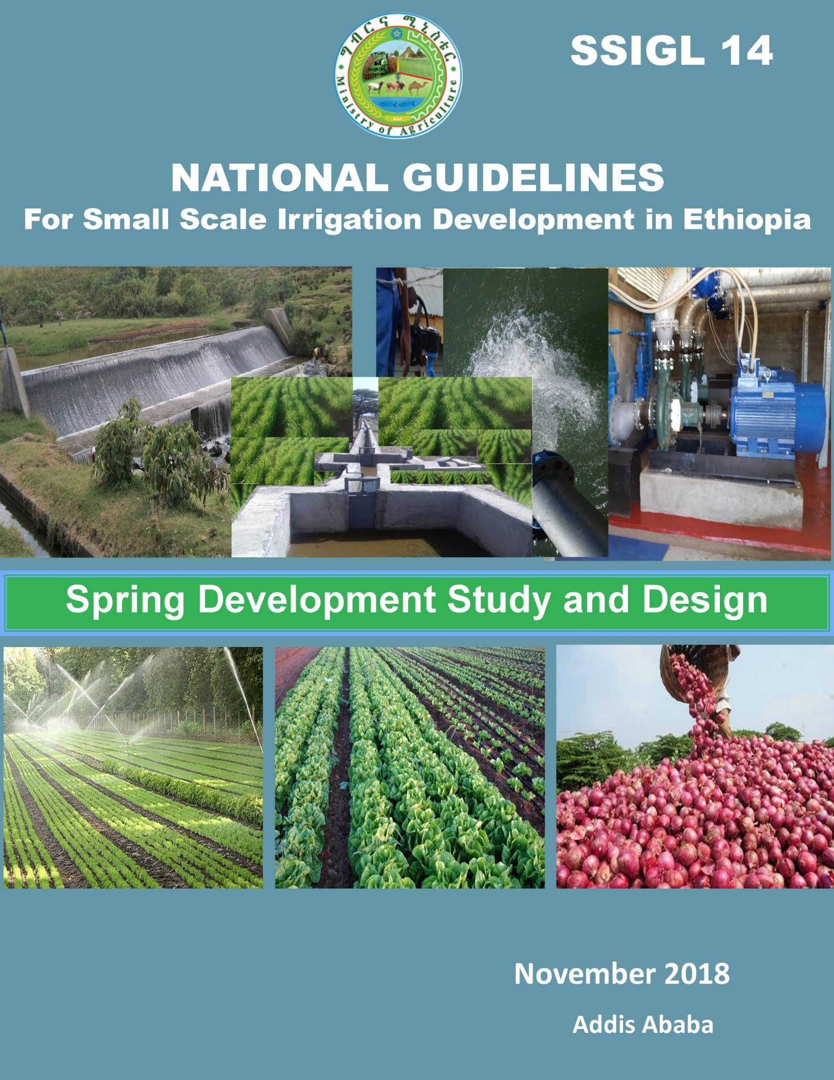

***MINISTRY OF AGRICULTURE***

***National Guidelines for Small Scale Irrigation Development in Ethiopia***

**SSIGL 14: Spring Development Study and Design**

**November 2018 Addis Ababa**

**National Guidelines for Small Scale Irrigation Development in Ethiopia**

**First Edition 2018**

© MOA 2018

Ministry of Agriculture

Small-Scale Irrigation Development Directorate

P. O. Box 62347

Tel: +251-1-6462355

Fax: +251-1-6462355

Email: [SSIDdirectorate@moa.gov.et](mailto:SSIDdirectorate@moa.gov.et)

[SSIDdirectorate@gmail.com](mailto:SSIDdirectorate@gmail.com)

eDMS (intranet): MoA SSID DMS (<http://172.28.1.188:8080/DMS/login.jsp>)

Website: [www.moa.gov.et](http://www.moa.gov.et)

***Financed by Agricultural Growth Program (AGP)***

***DISCLAIMER***

*Ministry of Agriculture through the Consultant and core reviewers from all relevant stakeholders included the information to provide the contemporary approach about the subject matter. The information contained in the guidelines is obtained from sources believed tested and reliable and are augmented based on practical experiences. While it is believed that the guideline is enriched with professional advice, for it to be successful, needs services of competent professionals from all respective disciplines. It is believed, the guidelines presented herein are sound and to the expected standard. However, we hereby disclaim any liability, loss or risk taken by individuals, groups, or organization who does not act on the information contained herein as appropriate to the specific SSI site condition.*

# FORWARD

Ministry of Agriculture, based on the national strategic directions is striving to meet its commitments in which modernizing agriculture is on top of its highest priorities to sustain the rapid, broad-based and fair economic growth and development of the country.  To date, major efforts have been made to remodel several important strategies and national guidelines by its major programs and projects.

While efforts have been made to create access to irrigation water and promoting sustainable irrigation development, several barriers are still hindering the implementation process and the performance of the schemes. The major technical constrains starts from poor planning and identification, study, design, construction, operation, and maintenance. One of the main reasons behind this outstanding challenge, in addition to the capacity limitations, is that SSIPs have been studied and designed using many ad-hoc procedures and technical guidelines developed by various local and international institutions.

Despite having several guidelines and manuals developed by different entities such as MoA (IDD)-1986, ESRDF-1997, MoWIE-2002 and JICA/OIDA-2014, still the irrigation professionals follow their own public sources and expertise to fill some important gaps. A number of disparities, constraints and outstanding issues in the study and design procedures, criteria and assumptions have been causing huge variations in all vital aspects of SSI study, design and implementation from region to region and among professionals within the same region and institutions due mainly to the lack of agreed standard technical guidelines. Hence, the SSI Directorate with AGP financial support, led by Generation consultant (GIRDC) and with active involvement of national and regional stakeholders and international development partners, these new and comprehensive national guidelines have been developed.

The SSID guidelines have been developed by addressing all key features in a comprehensive and participatory manner at all levels. The guidelines are believed to be responsive to the prevalent study and design contentious issues; and efforts have been made to make the guidelines simple, flexible and adaptable to almost all regional contexts including concerned partner institution interests. The outlines of the guidelines cover all aspects of irrigation development including project initiation, planning, organizations, site identification and prioritization, feasibility studies and detail designs, contract administration and management, scheme operation, maintenance and management.

Enforceability, standardization, social and environmental safeguard mechanisms are well mainstreamed in the guidelines, hence they shall be used as a guiding framework for engineers and other experts engaged in all SSI development phases. The views and actual procedures of all relevant diverse government bodies, research and higher learning institutions, private companies and development partners has been immensely and thoroughly considered to ensure that all stakeholders are aligned and can work together towards a common goal. Appropriately, the guidelines will be familiarized to the entire stakeholders working in the irrigation development. Besides, significant number of experts in the corresponding subject matter will be effectively trained nationwide; and the guidelines will be tested practically on actual new and developing projects for due consideration of possible improvement. Hence, hereinafter, all involved stakeholders including government & non-governmental organizations, development partners, enterprises, institutions, consultants and individuals in Ethiopia have to adhere to these comprehensive national guidelines in all cases and at all level whilst if any overlooked components are found, it should be documented and communicated to MOA to bring them up-to-date.

Therefore, I congratulate all parties involved in the success of this effort, and urge partners and stakeholders to show a similar level of engagement in the implementation and stick to the guidelines over the coming years.



H.E. Dr. Kaba Urgessa

State Minister, Ministry of Agriculture

***SMALL SCALE IRRIGATION DEVELOPMENT VISION***

*Transforming agricultural production from its dependence on rain-fed practices by creating reliable irrigation system in which smallholder farmers have access to at least one option of water source to increase production and productivity as well as enhance resilience to climate change and thereby ensure food security, maintain increasing income and sustain economic growth.*

# ACKNOWLEDGEMENTS

The preparation of SSIGLs required extensive inputs from all stakeholders and development partners. Accordingly many professionals from government and development partners have contributed to the realization of the guidelines. To this end MOA would like to extend sincere acknowledgement to all institutions and individuals who have been involved in the review of these SSIGLs for their comprehensive participation, invaluable inputs and encouragement to the completion of the guidelines. There are just too many collaborators involved to name exhaustively and congratulate individually, as many experts from Federal, regional states and development partners have been involved in one way or another in the preparation of the guidelines. The contribution of all of them who actively involved in the development of these SSIGLs is gratefully acknowledged. The Ministry believes that their contributions will be truly appreciated by the users for many years to come.

The Ministry would like to extend its appreciation and gratitude to the following contributors:

* Agriculture Growth Program (AGP) of the MoA for financing the development and publication of the guidelines.
* The National Agriculture Water Management Platform (NAWMP) for overseeing, guidance and playing key supervisory and quality control roles in the overall preparation process and for the devotion of its members in reviewing and providing invaluable technical inputs to enrich the guidelines.
* Federal Government and Regional States organizations and their staff for their untiring effort in reviewing the guidelines and providing constructive suggestions, recommendations and comments.
* National and international development partners for their unreserved efforts in reviewing the guidelines and providing constructive comments which invaluably improved the quality of the guidelines.
* Small-scale and Micro Irrigation Support Project (SMIS) and its team for making all efforts to have quality GLs developed as envisioned by the Ministry.

The MOA would also like to extend its high gratitude and sincere thanks to AGP’s multi development partners including the International Development Association (IDA)/World Bank, the Canada Department of Foreign Affairs, Trade and Development (DFATD), the United States Agency for International Development (USAID), the Netherlands, the European Commission (EC), the Spanish Agency for International Development (AECID), the Global Agriculture and Food Security Program (GAFSP), the Italy International Development Cooperation, the Food and Agriculture Organization (FAO) and the United Nations Development Program (UNDP).

Moreover, the Ministry would like to express its gratitude to Generation Integrated Rural Development Consultant (GIRDC) and its staff whose determined efforts to the development of these SSIGLs have been invaluable. GIRDC and its team drafted and finalized all the contents of the SSIGLs as per stakeholder suggestions, recommendations and concerns. The MoA recognizes the patience, diligence, tireless, extensive and selfless dedication of the GIRDC and its staff who made this assignment possible.

Finally, we owe courtesy to all national and International source materials cited and referred but unintentionally not cited.

Ministry of Agriculture

***DEDICATIONS***

*The National Guidelines for Small Scale Irrigation Development are dedicated to Ethiopian smallholder farmers, agro-pastoralists, pastoralists, to equip them with appropriate irrigation technology as we envision them empowered and transformed.*

# List of Guidelines

**Part I. SSIGL 1: Project Initiation, Planning and Organization**

**Part II: SSIGL 2: Site Identification and Prioritization**

**Part III: Feasibility Study and Detail Design**

**SSIGL 3: Hydrology and Water Resources Planning**

**SSIGL 4: Topographic and Irrigation Infrastructures Surveying**

**SSIGL 5: Soil Survey and Land Suitability Evaluation**

**SSIGL 6: Geology and Engineering Geology Study**

**SSIGL 7: Groundwater Study and Design**

**SSIGL 8: Irrigation Agronomy and Agricultural Development Plan**

**SSIGL 9: Socio-economy and Community Participation**

**SSIGL 10: Diversion Weir Study and Design**

**SSIGL 11: Free River Side Intake Study and Design**

**SSIGL 12: Small Embankment Dam Study and Design**

**SSIGL 13: Irrigation Pump Facilities Study and Design**

**SSIGL 14: Spring Development Study and Design**

**SSIGL 15: Surface Irrigation System Planning and Design**

**SSIGL 16: Canals Related Structures Design**

**SSIGL 17: Sprinkler Irrigation System Study and Design**

**SSIGL 18: Drip Irrigation System Study and Design**

**SSIGL 19: Spate Irrigation System Study and Design**

**SSIGL 20: Quantity Surveying**

**SSIGL 21: Selected Application Software’s**

**SSIGL 22: Technical Drawings**

**SSIGL 23: Tender Document Preparation**

**SSIGL 24: Technical Specifications Preparation**

**SSIGL 25: Environmental & Social Impact Assessment**

**SSIGL 26: Financial and Economic Analysis**

**Part IV: Contract Administration & Construction Management**

**SSIGL 27: Contract Administration**

**SSIGL 28: Construction Supervision**

**SSIGL 29: Construction of Irrigation Infrastructures**

**Part V: SSI Scheme Operation, Maintenance and Management**

**SSIGL 30: Scheme Operation, Maintenance and Management**

**SSIGL 31: A Procedural Guideline for Small Scale Irrigation Schemes Revitalization**

**SSIGL 32: Monitoring and Evaluation**

**Ancillary Tools for National Guidelines of Small Scale Irrigation Development**

**SSIGL 33: Participatory Irrigation Development and Management (PIDM)**

**SSIGL 34: Quality Assurance and Control for Engineering Sector Study and Design**

**TABLE OF CONTENTS**

FORWARD i

ACKNOWLEDGEMENTS iii

List of Guidelines v

Acronyms x

PREFACE xi

UPDATING AND REVISIONS OF GUIDELINES xiii

1 OVERVIEW 1

1.1 general 1

1.2 objectives of this part of the guideline 1

1.2.1 General objectives 1

1.2.2 Specific objectives 1

1.3 definitions of technical terms 2

1.4 origin and formation 2

1.5 factors affecting spring water quality and quantity 3

1.6 classifications of springs 3

1.6.1 Classifications of springs based on geologic structure 3

1.6.2 Classifications of springs based on their distribution 5

2 MEASUREMENT 7

2.1 general measurement procedures 7

2.2 measurement of springs in low areas 8

3 SPRING DEVELOPMENT AND PROTECTION WORKS 9

3.1 general 9

3.2 spring site assessment and preparation 9

3.2.1 Assessment of potential spring site 9

3.2.2 Yield estimation 10

3.2.3 Analysis of demand of spring water 10

3.2.4 Spring reliability & quality 12

3.3 spring development procedures 12

3.3.1 Conditions for spring development 12

3.3.2 Procedures for developing a seepage spring 12

3.3.3 Procedures for developing a concentrated spring 13

3.3.4 Concentrated springs in lowland areas 13

3.4 design considerations of protection works 14

3.4.1 General design considerations 14

3.4.2 Specific considerations 14

3.5 arrangement of spring boxes 16

3.5.1 General 16

3.5.2 Spring box for artesian springs 17

3.5.3 Spring box for gravity springs 17

3.5.4 Spring Box for seepage springs 18

3.6 water extraction methods 19

4 COLLECTION CHAMBER 21

4.1 general 21

4.2 types of collection chamber 21

4.3 design of collection chamber 21

4.3.1 Required data 21

4.3.2 Sizing of collection chamber 21

4.4 fence 27

5 CONSTRUCTION WORKS around springs 29

5.1 site preparation 29

5.2 general construction steps 29

5.2.1 Concrete construction steps 30

5.2.2 Installing a spring box 31

6 SOCIAL INFRASTRUCTURES 33

6.1 general 33

6.2 community water supply points 33

6.3 cattle trough 33

6.4 washing basin 34

7 Spring OPERATION AND MAINTENANCE 35

7.1 general 35

7.2 check-up at the protection zone 35

7.3 check-up at the spring chamber 35

7.4 maintenance of spring boxes & its appurtenances 35

7.5 frequencies & requirements for maintenance 36

REFERENCES 37

**LIST OF TABLES**

Table 3‑1: Indicative Daily Water Consumption Rate for Livestock, in lit/day 10

Table 3‑2: Indicative daily water consumption rate for base year in l/c/d 11

Table 3‑3: Computed Water Demand at Every Five Years Interval 11

Table 4‑1: Summary of agronomy data given for worked examples 23

Table 4‑2: Computation of Storage Capacity of Collection Chamber/Tank (m3) 24

Table 4‑3: Sizing of Collection Chamber for the Peak Storage Capacity 24

Table 4‑4: Analysis of Monthly Water Availability for Irrigation and Water balance 26

**LIST OF FIGURES**

Figure 1‑1: Depression spring (a) contact spring (b) & spring in jointed sandstone (c) 4

Figure 1‑2: Artesian Spring Occurring at Outcrop of Aquifer (L) & along a Fault (R) 5

Figure 2‑1: Measuring spring water by bowl hillside springs 7

Figure 3‑1: Alternative collecting system and cross sectional view of concentrated spring 13

Figure 3‑2: Cross Section through a typical spring protection box 15

Figure 3‑3: Spring box for artesian springs 17

Figure 3‑4: Typical Arrangement of Spring Box with Side Entrance for Water 17

Figure 3‑5: Typical layout plan of a storage box for seepage springs 18

Figure 3‑6: Typical spring protection works & Its surrounding as seen overcrowded 19

Figure 3‑7: Summary of procedure for spring study, design & implementation 20

Figure 4‑1: Typical plan and cross section of a storage tank 23

Figure 4‑2: Typical reinforced concrete post & barbed wire arrangement 27

Figure 6‑1: Typical section through consumer water point, FAO & UNICEF, 2012 33

Figure 6‑2: Typical view of livestock watering trough 33

Figure 6‑3: Typical plan and cross section of washing basin 34

# Acronyms

|  |  |
| --- | --- |
| A | Area |
| AGP | Agricultural Growth Program |
| ANRS | Amhara National Regional State |
| CoD | Construct a cut-off drain |
| CSA | Central Statistics Agency |
| CU | Coordinating Unit |
| EGL | Energy grade Line |
| FAO | Food and Agriculture Organization |
| GIRDC | Generation Integrated Rural Development Consultant |
| H:V | Horizontal to Vertical |
| ha | Hectare |
| HGL | Hydraulic Grade Line |
| IFAD | International Fund for Agriculture Development |
| L | Left |
| l/c/d | liters per capita per day |
| l/s | Liter per second |
| m | meter or side slope |
| m3/d | meter cube per day |
| Mm3 | Million meter cube |
| MoANR | Ministry of Agriculture and Natural Resources |
| MOWIE | Ministry of Water, Irrigation and Electricity |
| Nr | Number |
| NRCS | Natural Resources Conservation Service |
| ONRS | Oromia National Regional State |
| P | Perimeter |
| q | Unit discharge per meter |
| Q | Discharge |
| R | Right |
| SSID | Small Scale Irrigation Development |
| SSIGL | Small Scale Irrigation Guideline |
| SSIP | Small Scale Irrigation Project |
| SSIS | Small Scale Irrigation Scheme |
| SWC | Soil and Water Conservation |
| SWHISA | Sustainable Water Harvesting & Institutional Strengthening In Amhara |
| UNICEF | United Nations Children's Education Fund |
| USDA | United States Department of Agriculture |
| V | Velocity/Volume |
| WL | Water Level |
| WT | Water Table |

# PREFACE

While irrigation development is at the top of the government’s priority agendas as it is key to boost production and improve food security as well as to provide inputs for industrial development. Accordingly, irrigated land in different scales has been aggressively expanding from time to time. To this end, to enhance quality delivery of small-scale irrigation development planning, implementation and management, it has been decided to develop standard SSI guidelines that must be nationally applied. In September 2017 the Ministry of Agriculture (MoA) had entrusted Generation Integrated Rural Development Consultant (GIRDC) to prepare the National Small-scale Irrigation Development Guidelines (SSIGLs).

Preparation of the SSIGLs for enhancing development of irrigated agriculture is recognized as one of the many core initiatives of the MoA to improve its delivery system and achieve the targets in irrigated agriculture and fulfill its mission for improving agricultural productivity and production. The core objective of developing SSIGLs is to summarize present thinking, knowledge and practices to enable irrigation practitioners to properly plan, implement and manage community managed SSI schemes to develop the full irrigation potential in a sustainable manner.

As the SSIGLs are prepared based on national and international knowledge, experiences and practices, and describe current and recommended practice and set out the national standard guides and procedures for SSI development, they serve as a source of information and provide guidance. Hence, it is believed that the SSIGLs will contribute to ensuring the quality and timely delivery, operation and maintenance of SSI schemes in the country. The SSIGLs attempt to explain and illustrate the important concepts, considerations and procedures in SSI planning, implementation and management; and shall be used as a guiding framework for professionals engaged in SSI development. Illustrative examples from within the country have been added to enable the users understand the contents, methodologies presented in the SSIGLs.

The intended audiences of the SSIGLs are government organizations, NGOs, CSOs and the private sector involved in SSI development. Professionally, the SSIGLs will be beneficial for experienced and junior planners, experts, contractors, consultants, suppliers, investors, operators and managers of SSI schemes. The SSIGLs will also serve as a useful reference for academia and researchers involved and interested in SSI development. The SSIGLs will guide to ensure that; planning, implementation and management of SSI projects is formalized and set procedures and processes to be followed. As the SSIGLs provide information and guides they must be always fully considered and applied by adapting them to the local specific requirements.

In cognizance with the need for quality SSIGLs, the MoA has duly considered quality assurance and control during preparation of the guidelines. Accordingly, the outlines, contents and scope of the SSIGLs were thoroughly discussed, reviewed and modified by NAWMP members (senior professionals from public, national and international stakeholder) with key stakeholders in many consultative meetings and workshops. Moreover, at each milestone of SSIGL preparation, resource persons from all stakeholders reviewed and confirmed that SSIGLs have met the demands and expectations of users.

Moreover, the Ministry has mobilized resource persons from key Federal, National Regional States level stakeholders and international development partners for review, validation and endorsement of the SSIGLs.

Several hundreds of experienced professionals (who are very qualified experts in their respective fields) from government institutions, relevant private sector and international development partners have significantly contributed to the preparation of the SSIGLs. They have been involved in all aspects of the development of SSIGLs throughout the preparation process. The preparation process included a number of consultation meetings and workshops: (i) workshop to review inception report, (ii) workshop on findings of review of existing guidelines/manuals and proposed contents of the SSIGLs, (iii) meetings to review zero draft SSI GLs, (iv) review workshop on draft SSI GLs, (v) small group review meetings on thematic areas, (vi) small group consultation meetings on its final presentation of contents and layout, (vii) consultation mini-workshops in the National States on semi-final versions of the SSIGLs, and (viii) final write-shop for the appraisal and approval of the final versions of SSIGLs.

The deliberations, concerns, suggestions and comments received from professionals have been duly considered and incorporated by the GIRD Consultant in the final SSIGLs.

There are 34 separate guidelines which are categorized into the following five parts concurrent to SSI development phases:

Part-I. Project Initiation, Planning and Organization Guideline which deals with key considerations and procedures on planning and organization of SSI development projects.

Part-II. Site Identification and Prioritization Guideline which treats physical potential identification and prioritization of investment projects. It presents SSI site selection process and prioritization criteria.

Part-III. Feasibility Study and Detail Design Guidelines for SSID dealing with feasibility study and design concepts, approaches, considerations, requirements and procedures in the study and design of SSI systems.

Part-IV. Contract Administration and Construction Management Guidelines for SSI development presents the considerations, requirements, and procedures involved in construction of works, construction supervision and contract administration.

Part-V. SSI Scheme Management, Operation and Maintenance Guidelines which covers SSI Scheme management and operation.

Moreover, Tools for Small Scale Irrigation development are also prepared as part of SSIGLs.

It is strongly believed and expected that; the SSIGLs will be quickly applied by all stakeholders involved in SSI development and others as appropriate following the dissemination and familiarization process of the guidelines in order to ensure efficient, productive and sustainable irrigation development.

The SSIGLs are envisioned to be updated by incorporating new technologies and experiences including research findings. Therefore, any suggestions, concerns, recommendations and comments on the SSIGLs are highly appreciated and welcome for future updates as per the attached format below. Furthermore, despite efforts in making all types of editorial works, there may still errors, which similarly shall be handled in future undated versions.

# UPDATING AND REVISIONS OF GUIDELINES

The GLs are intended as an up-to-date or a live document enabling revisions, to be updated periodically to incorporate improvements, when and where necessary; may be due to evolving demands, technological changes and changing policies, and regulatory frameworks. Planning, study and design of SSI development interventions is a dynamic process. Advancements in these aspects are necessary to cope up with the changing environment and advancing techniques. Also, based on observation feedbacks and experiences gained during application and implementation of the guidelines, there might be a need to update the requirements, provisions and procedures, as appropriate. Besides, day-by-day, water is becoming more and more valuable. Hence, for efficient water development, utilization and management will have to be designed, planned and constructed with a new set up of mind to keep pace with the changing needs of the time. It may, therefore, be necessary to take up the work of further revision of these GLs.

This current version of the GLs has particular reference to the prevailing conditions in Ethiopia and reflects the experience gained through activities within the sub-sector during subsequent years. This is the first version of the SSI development GLs. This version shall be used as a starting point for future update, revision and improvement. Future updating and revisions to the GLs are anticipated as part of the process of strengthening the standards for planning, study, design, construction, operation and management SSI development in the country.

Completion of the review and updating of the GLs shall be undertaken in close consultation with the federal and regional irrigation institutions and other stakeholders in the irrigation sub-sector including the contracting and consulting industry.

In summary, significant changes to criteria, procedures or any other relevant issues related to technological changes, new policies or revised laws should be incorporated into the GLs from their date of effectiveness. Other minor changes that will not significantly affect the whole nature of the GLs may be accumulated and made periodically. When changes are made and approved, new page(s) incorporating the revision, together with the revision date, will be issued and inserted into the relevant GL section.

All suggestions to improve the GLs should be made in accordance with the following procedures:

1. Users of the GLs must register on the MOA website: Website: [www.moa.gov.et](http://www.moa.gov.et)
2. Proposed changes should be outlined on the GLs Change Form and forwarded with a covering letter or email of its need and purpose to the Ministry.
3. Agreed changes will be approved by the Ministry on recommendation from the Small-scale Irrigation Directorate and/or other responsible government body.
4. The release date of the new version will be notified to all registered users and authorities.

Users are kindly requested to present their concerns, suggestions, recommendations and comments for future updates including any omissions and/or obvious errors by completing the following revisions form and submitting it to the Ministry. The Ministry shall appraise such requests for revision and will determine if an update to the guide is justified and necessary; and when such updates will be published. Revisions may take the form of replacement or additional pages. Upon receipt, revision pages are to be incorporated in the GLs and all superseded pages removed.

**Suggested Revisions Request Form (Official Letter or Email)**

To: ---------------------------------------------------------------

From: -----------------------------------------------------------

Date: -----------------------------------------------------------

**Description of suggested updates/changes:** Include GL code and title, section title and # (heading/subheading #), and page #.

|  |  |  |  |  |
| --- | --- | --- | --- | --- |
| **GL Code and Title** | **Date** | **Sections/** **Heading/Subheading/** **Pages/Table/Figure** | **Explanation** | **Comments (proposed change)** |
|  |  |  |  |  |
|  |  |  |  |  |

Note that be specific and include suggested language if possible and include additional sheets for comments, reference materials, charts or graphics.

**GLs Change Action**

|  |  |  |  |
| --- | --- | --- | --- |
| **Suggested Change** | **Recommended Action** | **Authorized by** | **Date** |
|  |  |  |  |
|  |  |  |  |
|  |  |  |  |

Director for SSI Directorate**: _______________________Date: ________________**

The following table helps to track initial issuance of the guidelines and subsequent Updates/Versions and Revisions (Registration of Amendments/Updates).

**Revision Register**

|  |  |  |  |  |
| --- | --- | --- | --- | --- |
| **Version/Issue/Revision No** | **Reference/Revised Sections/Pages/topics** | **Description of revision (Comments)** | **Authorized by** | **Date** |
|  |  |  |  |  |
|  |  |  |  |  |
|  |  |  |  |  |

# OVERVIEW

## general

Spring water is a natural flow of water from the ground at a single point and/or several points within a restricted area, usually along hillsides, at the base of slopes, or in low areas/valley bottoms, etc. Thus, they may emerge at different points on dry land or in the beds of streams, ponds, or lakes. Spring water can also be defined as a groundwater emerging naturally through a weak surface of the earth as outcrops of groundwater that often appear as small water holes or wet-spots at the foot of hills or along river banks.

When a spring has no visible current, it is called a seep. Springs may emerge at different points on dry land or in the beds of streams, ponds, or lakes. The water that flows from springs is usually safe from contaminants, due to the fact that groundwater is naturally filtered as it flows through the earth. Therefore, once the spring is developed it can be used for irrigation and domestic consumption, requiring little to no treatment. This makes springs relatively inexpensive yet safe as water sources and used for multipurpose.

Water source of most springs is rainfall that seeps/infiltrates into the ground uphill from the spring outlet. To obtain satisfactory water, it is necessary to find the source, properly develop it, eliminate surface water intrusion and prevent animals from gaining access to the spring to prevent contamination.

Springs are usually used for different purposes including source of water supply and irrigation. They are also not capped naturally. Consequently, they are exposed for contamination and wastage and thus it needs a protection headwork which also supplies irrigation water on one side or both in left and right sides, even more, in some cases. On such headwork, it needs to include other subsidiary structures among which protection work, outlet structure, cattle trough, and bath and washing basins can be mentioned.

## objectives of this part of the guideline

### General objectives

The general objective of this part of the guideline is to enable implementers of water projects develop a spring so as to make potential groundwater available for use which has been unused, under used, or wasted otherwise.

### Specific objectives

Specific objectives of this guideline is to prepare procedures and tools and related infrastructures for developing and protecting springs for use in small scale irrigation project development. Such project is implemented where yield or potential yield greatly exceeds the needs and conservation of the supply may not be a critical consideration in the development. However, where the yield or potential yield is low, proper development should emphasize the optimum utilization of the available water, using such structures like storage tanks.

The guideline is prepared with the scope that regional and wereda level water experts and contractors can use and draw on during the spring development, construction and supervision processes. It covers the main aspects of planning, design and technology options as well as construction and supervision processes for Spring Development and protection. Whilst every effort has been made to cover the important aspects of Spring Development, Construction and Supervision, it should be noted that this guideline is by no means complete, thus users are encouraged to refer to other similar documents as well.

## definitions of technical terms

**Artesian**: Is a situation where ground water is forced to the surface without pumping by natural high pressure imposed by impermeable strata.

**Collection chamber**: Is a hydraulic structure situated downstream of a spring box and designed for storing water during non-irrigation times.

**Demand**: is any type of water need from the spring such as community water supply, washing taking bath, irrigation requirement, livestock and wild animals’ requirement.

**Energy grade Line/EGL:** is the summation of elevation head (H) of the pipe, pressure head (Hp) and velocity head (Hv) with reference to a fixed datum. Also to be considered is the head loss (hL) or friction/energy lost in conveying the water from one point to another.

**Headwork**: is any hydraulic structure located across the stream or on the lake, reservoir and/or ground water to collect reserve or divert water for irrigating crops and/or hydropower use. Thus it includes Diversion Headwork/Weir, Free Intake structure, Pump, Spring Protection or Development, Dam and Ground water extraction. In a storage system, such structure is called a 'Storage dam' and the main body of the structure is mostly 'Earth-dam' where-as for a diversion system, it is called a 'Weir', and the water pool is called a 'Pond'.

**Hydraulic Grade Line (HGL):** The Hydraulic Grade Line/HGL: is an imaginary line that connects the points on which the water would rise in a piezometer tube if inserted in any place along the pipe as indicated in the figure above. It is the measure of the pressure head available plus elevation of the pipe at various points.

**Spring**: spring is a place where a natural outflow of groundwater occurs. Thus, it is any natural situation where water flows from an aquifer to the earth's surface.

**Spring Box**:Is a hydraulic structure built on the spring eye to develop it for use in the downstream environment.

**Yield**: is the quantity of water a spring produces.

## origin and formation

Spring water originates normally from part of rainwater which infiltrates into the soil and seeps through the permeable layer. The water seeps down until it meets with an impervious layer of material like clay or rock that prevents it from flowing deeper downwards into the ground. At those places where the impervious layer reaches the surface, the groundwater flow is forced to the surface and forms a spring. The outflow may be at one spot only such as at a rock fissure or along the length of a layer such as a gravel bed. The spring water flows freely under gravity i.e. gravity type, or under pressure from below i.e. artesian type. The yield of different springs varies, from the gentle dripping at a small spring to the strong flow of large quantities of water at a bigger spring.

A spring is generated when natural pressure forces groundwater above the land surface through a weak point or surface. This means it can occur at a distinct point or over a large seepage area.

The springs located on hillsides often have sufficient slope to deliver water by gravity to the location where it is used. This configuration can result in significant savings, as there are no additional energy requirements like electricity or pump costs. Springs developed in low areas on the other hand, generally require a source of power like a pump to lift the water to its point of use.

A slow hillside seep or trickle where no visible water flow is observed should not be considered a true spring. Thus, a spring should have water flow year-round and have at least a sizeable/sustainable flow rate to be considered worthwhile for development.

In general, springs need to be developed properly so as to improve its yield and then protected from contamination by sanitary spring box to supply quality water.

## factors affecting spring water quality and quantity

Spring water quality and quantity depends on the following factors:

* Annual rainfall pattern: The more distributed and regular annual rainfall pattern yields more spring water,
* Size and geological formation of the intake area: The wider and loose the geological formation of an area gives good yield than restricted aquifer,
* Nature and slope of the surface onto which the rainwater falls: If rain falls on steep surface, water cannot get enough time to seep down and form spring water. But flatter and forest covered land on its top and longer sloping surface down hillside gives good yield,
* Thickness and nature of the covering stratum: The thicker the stratum covering water bearing aquifer, the more productive it is,
* Thickness and nature of the water bearing layer: This also affects the yield in a similar manner as above factor,
* May be mineralized if water-bearing material is soluble, is hard if it contains CaC03 i.e. if spring issues from or percolates through limestone,
* Key signs of a good spring is that the water maintains a constant temperature throughout the day which is just below the average air temperature,
* The water should also be colourless.

## classifications of springs

### Classifications of springs based on geologic structure

Springs are usually classified in to two based on the geologic structure and forces bringing the water to the surface. These categories of springs are:

* Gravity and
* Artesian springs.

These main types of springs occur in nature, and varies with the location and source of water.

Gravity springs are also subdivided in to: Depression springs, Contact springs and Fracture/Joint/ tubular springs. Similarly, artesian springs are subdivided in to two: Artesian flow springs or Aquifer outcrop springs and Artesian fissure springs or Fault springs. Gravity springs occur in unconfined aquifers. Where the ground surface dips below WT, any such depression will be filled with water. Gravity depression springs usually have a small yield and a further reduction occurs during the dry season or when nearby groundwater withdrawals result in the lowering of the groundwater table.

There are also magmatic springs which usually yield highly mineralized hot water that is associated with deep-seated magmas. Consequently, most of these springs are not of good quality for irrigation. The numerous springs in the rift valley basin of Ethiopia are examples of such type. Thus, these springs are not dealt here.

#### Gravity springs

These are springs formed when downward movement of underground water is restricted by an impervious underground layer and the water is forced to the surface.

(a) 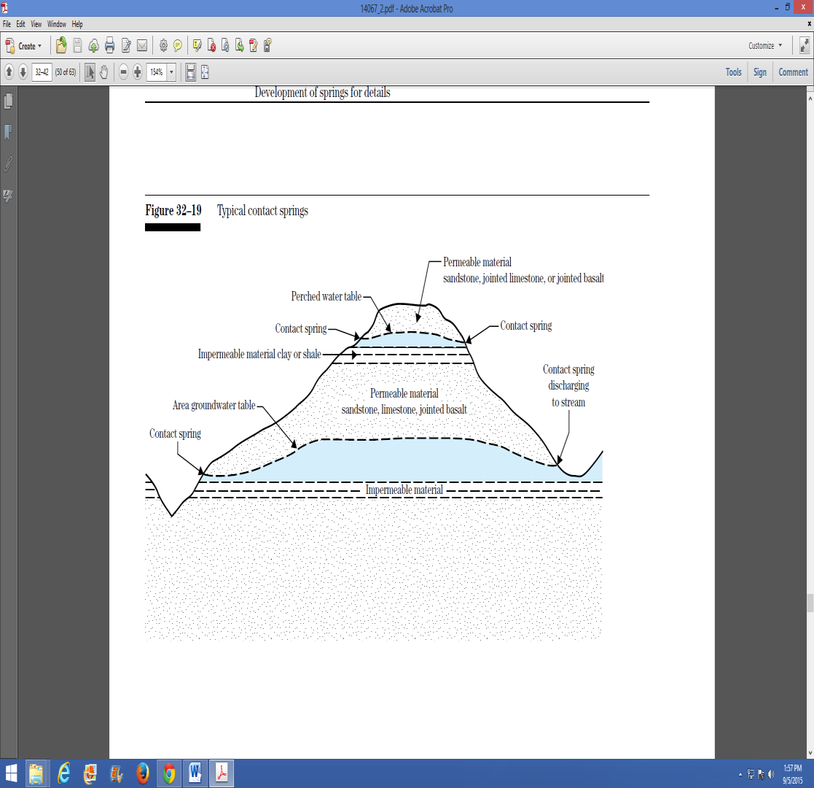 (b)

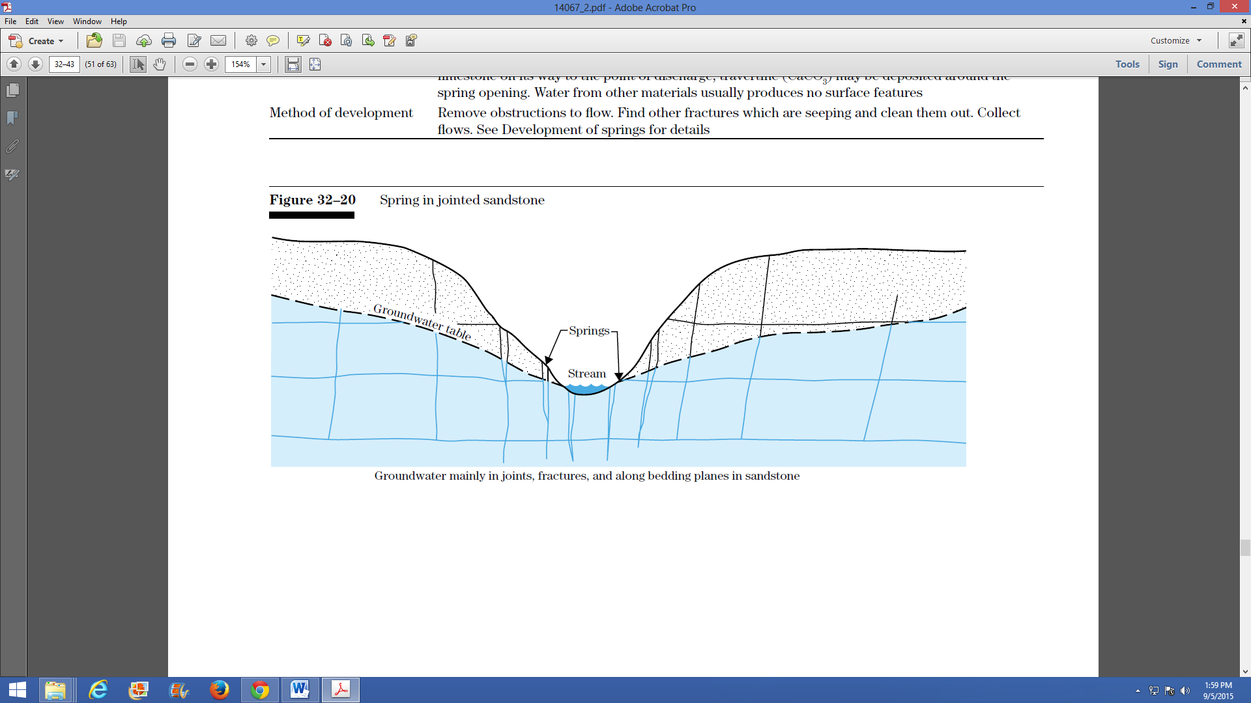(c)

Source: Springs, as compiled by marco Bruni, 2001

Figure ‑: Depression spring (a) contact spring (b) & spring in jointed sandstone (c)

These type of springs rest on a single impervious layer, and can be thought of as an underground river. The unconfined aquifer will add many “tributaries” or input from local water and rain that seeps into the ground. Any contaminated water that flows into the ground will only have the short flow distance before reaching the spring, giving the input water much less time to be filtered naturally. Thus, Gravity depression springs usually have a small yield and a further reduction is likely when dry season conditions or nearby groundwater withdrawals result in a lowering of the groundwater table.

#### Artesian springs

These types of springs occur where groundwater is pressurized between two impermeable layers. In artesian type springs, water reaches the surface because it is pushed under pressure through cracks or joints in the upper impermeable layer. In this type of spring, piezometric surface is above the ground surface.

The discharge from these springs is higher, spilling-over and there is less fluctuation. Two types of artesian springs are there: aquifer outcrop springs and fault springs.

Such are confined by two layers of impervious material. The water from artesian springs is likely to have been sufficiently filtered naturally through the ground, and typically has little to no chance of being contaminated with surface water that may infiltrate into the spring.

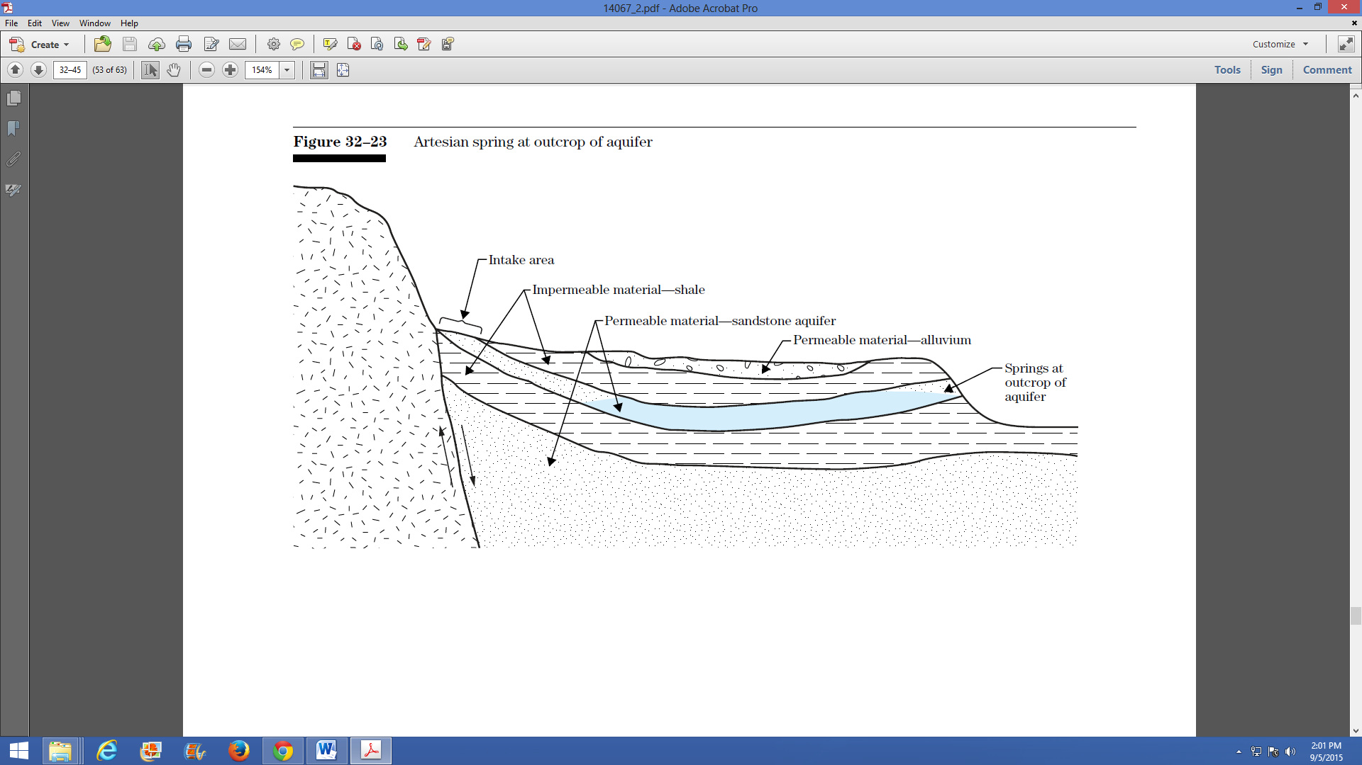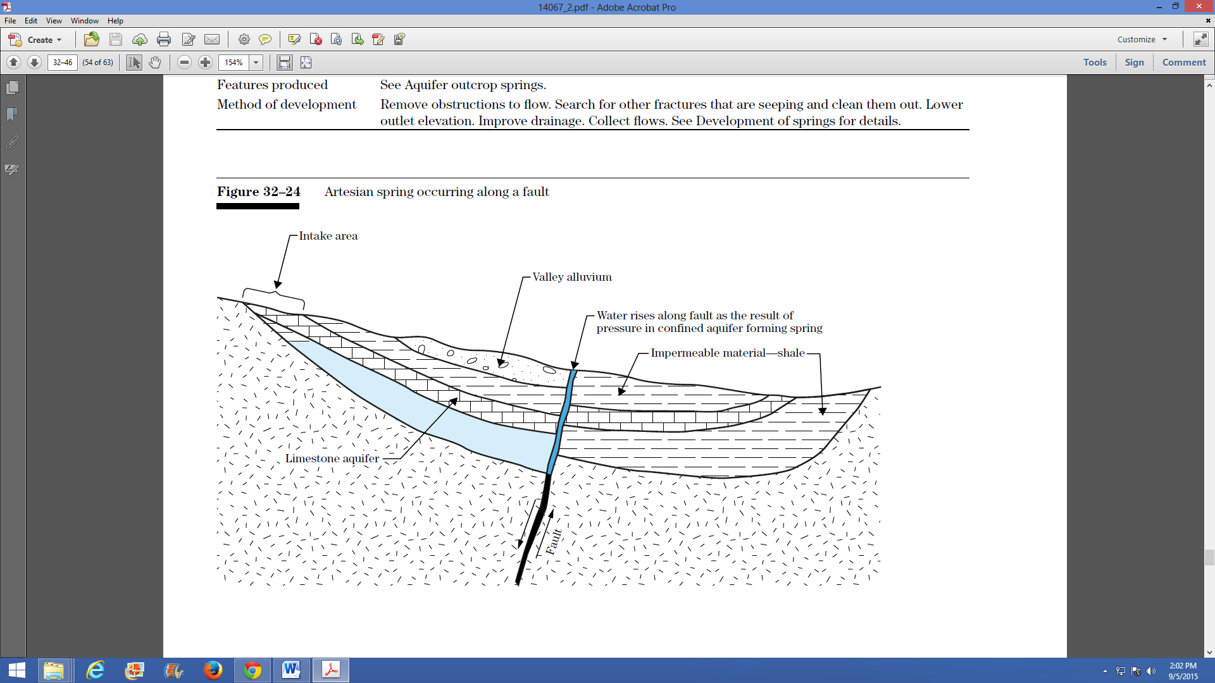

Figure ‑: Artesian Spring Occurring at Outcrop of Aquifer (L) & along a Fault (R)

### Classifications of springs based on their distribution

Based on their distribution, springs are classified as:

* Seepage springs and
* Concentrated springs.

#### Concentrated springs

Concentrated springs are springs typically occurring when groundwater emerges from one defined discharge in the earth’s surface. Concentrated springs are visible and are often found along hillsides where groundwater is forced through openings in fractured bedrock. This type of spring is relatively easy to develop and is usually less contaminated than other types of springs.

#### Seepage springs

As a contrast to concentrated springs, there are springs which occur in distributed pattern, which we call seepage springs. Seepage springs occur when shallow groundwater oozes or “seeps” from the ground over a large area and has no defined discharge point. This type of spring usually occurs when a layer of impervious soil redirects groundwater to the surface.

Such springs occur where water simply seeps out of sand, gravel, and other porous material. Opposed to artesian and gravity springs where flow is directed to one point, seepage springs result from a somewhat unconfined aquifer, where an underground reservoir simply leaches out in different places. This gives seepage springs the highest susceptibility to contamination. Therefore seepage springs need periodic disinfection if it is planned for domestic water supply.

# MEASUREMENT

## general measurement procedures

Spring water measurement can be carried out based on typical procedures shown below.

Because of seasonal variations in output flow, springs intended to feed irrigation water supply must be measured monthly for at least a period of one year before the final design is started. Furthermore, if annual rainfall data are available covering a number of years, the year of investigation should be compared with previous years to get an idea about the minimal yield that can be expected. The longer the measuring period, the more reliable the result is - and consequently the more reliable the water supply is.

There is a time interval between minimum/maximum rainfall and minimum/maximum yield of a spring. This means that the lowest yield should not occur at the end of the dry period but some weeks or even months later. This time interval shows that the spring water originates from a water-bearing layer and is not surface water penetrating from above the catchment area.

Spring water can be measured either by floating or bowl or bucket as shown below:

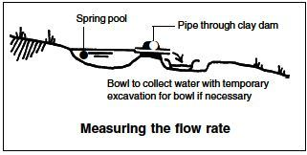

Figure ‑: Measuring spring water by bowl hillside springs

Flow of the spring should be intercepted below the ground surface either by a cut-off wall or cut-off trench to either block, or intercept the spring flow as it moves down the slope;

This cut-off wall is usually made of concrete;

If sufficient elevation exists, water can be supplied by gravity through a buried pipe to its point of use.

**Procedures:**

* Arrange one container with known volume, say 50 liters size;
* Fill the container and record the starting and finishing time, say 5 seconds;
* Repeat this measurement 3 to 5 times to improve accuracy;
* Calculate flow of the spring in liters/second for each measurement repeatedly, say 75, 80, 78, 82 liters/second and 80 liter/ second)
* Finally, take the average flow rate of repeated readings i.e. (75+80+78+82+80)/5= 79 liter/ second.

## measurement of springs in low areas

For springs in low areas, the only option is to pump water to where it is needed;

In both cases, collection chamber is required if:

* There is no night time irrigation,
* Spring flow is small & needs to store & use it.

Since each spring has different headwork configuration it needs to approach accordingly and thus all designs need adapting to suit the type of spring and the topography.

Use of the design with higher flow rates is possible in some instances, but more than one delivery pipe and a larger concreted sump behind the headwall are recommended for such flows.

For detailed analysis of spring flow, refer “GL 3: Hydrology and Water Resources Planning Guideline for SSID”.

# SPRING DEVELOPMENT AND PROTECTION WORKS

## general

The quantity of water from a spring can be substantially increased by digging out the area around the spring down to an impervious layer, to remove silt, decomposed rock and other rock fragments, and mineral matter sometimes deposited by the emerging groundwater. However, in doing this, particular care should be taken, especially in fissured limestone areas, to avoid disturbing underground formations to the extent that the spring is deflected in another direction or into other fissures. Such process of improving yield of springs is known as spring development. Thus, springs need to be collected and developed before they are protected. There are three techniques of spring development for using it as water sources:

* Spring boxes;
* Horizontal wells; and
* Seep development.

Case study: “*There was a spring locally named as “Burka Birbisa” in eastern part of Oromia National Regional State, Ethiopia. In 1995 GC, a small scale irrigation project which was supported by IFAD was built to develop a 40ha gross command area to serve 100 household beneficiaries on this spring eye. However, after some years of service, the protection works of the project headwork was collapsed and dismantled due to piping effects. Consequently, maintenance was required to reestablish it. However, the spring was totally disappeared as a result of disturbance in local water bearing geology while excavating around the spring eye, and finally the project stopped functioning.*”

## spring site assessment and preparation

### Assessment of potential spring site

First of all, we need to inspect the geologic conditions around the potential spring site. If the geologic formation around it is found rocky, it indicates that it can have a high infiltration rate through fractures, and contaminants may not be filtered out. If this geologic formation is mostly sand, the water will infiltrate, but will be filtered to some degree depending on the depth of the aquifer. If this geologic formation contains a high degree of clay, contaminated water will have a difficult time infiltrating the aquifer and the spring can be said it is relatively safe for our purpose.

Then after it needs to decide if this spring is able to meet farmers’ demand and is accessible for irrigating the proposed command area. This requires to answer the questions: “how easy will it be to transport construction materials and tools to the site?” As a consequence, we need to think at this stage, about the conveyance system of irrigation water as well. How the construction and maintenance can be done and who will cover the cost? Can the community afford the project and will they able to maintain the spring? The development of spring should be demand based, and needs discussion with the beneficiaries and needs confirmation of their commitments.

### Yield estimation

An assessment of yield of a spring and its seasonal variation of flow are indispensable. The yield and the reliability of a spring flow can be influenced by the construction of the spring water collection works. Information about the yield is crucial in the decision-making process for the tapping of a spring. Yield is studied in terms of flow rate and consistency. Variation in the yield of a spring during the dry season and the rainy season is an important criterion to determine whether the spring is a suitable source. If the ratio between the highest yield in the rainy season and the yield in the dry season is below 20, then the spring has an acceptable consistency and can be regarded as a reliable source in both wet and dry seasons.

### Analysis of demand of spring water

Demand of spring water in general need to determine the amount of water required for irrigation, drinking water, livestock and domestics and losses. Based on the monthly potential evapotranspiration determined in Hydrology and estimated monthly crop water requirement in Agronomy part we need to compute monthly water balance in consideration of the above consumption rates.

Domestic and livestock water requirements can be estimated using the expression:

Vd = N*q*t ……………………………………………………………………...………… (3-1)

Where, Vd = Volume of water required for domestic purposes (liters or m3)

N = Number of people and livestock (Number)

q = Daily water consumption (lpcd)

t = Number of days for water consumption (days)

Usually, twenty percent of the above estimated water demand is considered as various losses, consequently,

Total water demand = Gross Irrigation req’t + Total domestic water req’t + 20% for loss … (3-2)

To estimate projected population after base year, Po:

 ……………………………………………………………………… (3-3)

Where, P0 = Initial or base year population (Nr)

Pn= Projected population after n decades (Nr)

r = Growth rate (%)

n = Number of years

Table ‑: Indicative Daily Water Consumption Rate for Livestock, in lit/day

|  |  |  |  |  |  |
| --- | --- | --- | --- | --- | --- |
| **SN** | **Livestock type** | **Weight (kg)** | **Mean (lit)** | **Maximum (lit)** | **For planning purposes (lit)** |
| 1 | Cattle | 350 | 16.4 | 56.1 | 25 |
| 2 | Sheep | 35 | 1.9 | 5.2 | 5 |
| 3 | Goats | 30 | 2 | 5.4 | 5 |
| 4 | Equines |  |  |  | 12 |
|  |  |  |  | Avg. | 11.8 |

Source: National Water Sector strategy, MoWR, 2001

Table ‑: Indicative daily water consumption rate for base year in l/c/d

|  |  |  |  |  |  |
| --- | --- | --- | --- | --- | --- |
| **SN** | **Demand** | **Per Capita Demand, l/c/d** | | | **Remark** |
| **Rural** | **Town** | **City (e.g. AA)** |
| 1 | Domestic demand | 15-25 | 65-80 | 120 | National Water Sector strategy |
| 2 | Institutional Demand | 15% of Domestic | - | - |  |
| 3 | Public Demand | 3% of Domestic | - | - |  |
| 4 | Livestock Demand | 12 | - | - | Taken avg. from above table |
| 5 | D/s Release | 10% of (1+2+3+4) | - | - |  |

Source: National Water Sector strategy, MoWR, 2001

***Box-3-1:***

***Worked Example-1****: Consider a Spring Development SSI Project called Bereda Lencha in ONRS, East Hararge Zone,* Gola Oda *Woreda. Other related given data: Water demand is proportional to population growth;* Base year population which were using this spring water in 2012 is 5,544 Livestock Population is 5,000; *rural population Growth Rate from CSA is 2.5% per annum for* domestic *and 2.0% for Livestock Population. Design Period is 20 years; Institutional Demand is 15% of Domestic demand; Public Demand is 3% of Domestic demand; Demand is assumed to be 20 l/s/d for the 1st ten years, 23 l/s/d for next 10yrs & 25l/s/d for last years; Measured discharge is assumed available for all the days of a year, i.e. 198 l/s can be obtained every day Rural Population. Assuming peak hour factors of 1.9, 1.9, 1.7, 1.7 and 1.7 every five years respectively, compute overall peak hourly demand.*

***Solution****:*

Table ‑: Computed Water Demand at Every Five Years Interval

| **SN** | **Description** | **Unit** | **2012** | **2017** | **2022** | **2027** | **2032** |
| --- | --- | --- | --- | --- | --- | --- | --- |
| 1 | **Population to be served** |  |  |  |  |  |  |
| 1.1 | Rural Population | Nr | 5,544 | 6,273 | 7,097 | 8,029 | 9,084 |
| 1.2 | Livestock Population | Nr | 5,000 | 5,520 | 6,095 | 6,729 | 7,430 |
|  | Sub Total |  | 10,544 | 11,793 | 13,192 | 14,759 | 16,514 |
| 2 | **Demand** |  |  |  |  |  |  |
| 2.1 | Rural Domestic demand | m3/d | 111 | 125 | 163 | 185 | 227 |
| 2.2 | Institutional water demand | m3/d | 17 | 19 | 24 | 28 | 34 |
| 2.3 | Public Demand | m3/d | 3 | 4 | 5 | 6 | 7 |
| 2.4 | Livestock Demand | m3/d | 60 | 66 | 73 | 81 | 89 |
|  | ***Sub Total of daily demand*** | m3/d | 191 | 214 | 266 | 299 | 357 |
| 2.5 | Unexpected d/s release | m3/d | 19 | 21 | 27 | 30 | 36 |
|  | ***Total average daily demand*** | m3/d | 210 | 236 | 292 | 329 | 393 |
|  |  | l/s | ***2.4*** | ***2.7*** | ***3.4*** | ***3.8*** | ***4.5*** |
| 2.7 | Average per capita demand | l/c/d | 20 | 20 | 22 | 22 | 24 |
| 2.8 | Maximum daily factor |  | 1.25 | 1.25 | 1.2 | 1.2 | 1.2 |
| 2.9 | Maximum daily demand | m3/d | 262 | 295 | 351 | 394 | 471 |
| 2.10 | ***Maximum daily flow*** | ***l/s*** | ***3.0*** | ***3.4*** | ***4.1*** | ***4.6*** | ***5.5*** |
| 2.11 | Peak hour factor |  | 1.9 | 1.9 | 1.7 | 1.7 | 1.7 |
| 2.12 | ***Overall Peak Hour Demand*** | ***l/s*** | ***5.8*** | ***6.5*** | ***6.9*** | ***7.8*** | ***9.3*** |

Note: Institutional includes e.g. schools, clinic, etc.; Public includes taking bath & washing around the spring eye. Source of this Population data is CSA, 2007.

*Thus, take overall peak hourly design demands 9.3 l/s.*

### Spring reliability & quality

It is necessary to determine the reliability, quality and the average/minimum flow of the spring for the whole season of irrigation. Basically, we need to ask the local residents for the history of the spring then decide if the spring is seasonal or if it is fairly constant all year round from the assessed historical backgrounds.

Following this, it needs to check the quality of the spring water if it is also required for drinking (as such water resource need to be developed for multipurpose scheme). If we have no equipment to do this, look at the turbidity and check how the water smells. If there is a strong odor, or the water is very turbid (has a lot of suspended sediment), it will probably need additional treatment than the standard spring water. This could include settling, filtering, and disinfecting.

If we can see nothing wrong from observation, make a judgment based on the survey of the area. If the conditions/use of the land is suspect, it may still be necessary to at least disinfect the water before consumption from findings expected from the collected samples for physical and chemical analysis in the laboratory.

Finally, determine the flow of the spring in dry season using the above mentioned methods. This can be done by constructing a temporary dike to retain the spring flow. Then insert a pipe through the clay dike, and read the time for how long it takes to fill a container with a known volume. It will be the best to perform this test for several times, and at least once during the dry season. The objective is to determine average and minimum flows in order to predict if the spring will be sufficient for the needs of the community or to fix the size of irrigable land.

## spring development procedures

### Conditions for spring development

Spring development procedure depends on type and nature of springs. The following sections show procedures to develop springs based on their nature.

Seepage springs are difficult to develop. They are also highly susceptible to contamination from surface sources and they need to be monitored before development to ensure that they will provide a dependable source of water during the entire year. Flow is often lower from such springs, making them less dependable.

### Procedures for developing a seepage spring

* Dig test holes upslope from the seep until you locate the point where the impervious layer is 90cm underground.
* Create a trench approximately 45 to 60 cm wide across the slope. Trench should be extended 15 cm into the impervious layer (below the water-bearing layer) and should extend 120 to 180cm beyond the seepage area. Install 120cm of collection tile and surround the tile with gravel.
* Installation of a collecting wall will help prevent water from escaping the collection tile. This collecting wall should be constructed of 10 to 15 cm thick of concrete.
* Collection tile should be connected to a pipe that leads to the spring box. Box inlet must be below the elevation of the collector tile.
* Remove potential sources of contamination and divert surface water away from spring box or collection area.

### Procedures for developing a concentrated spring

Major steps required for developing a concentrated spring are:

Excavate the land upslope from the spring discharge until 90 cm of water is flowing.

* Install a rock bed to form an interception reservoir.
* Build a collecting wall of concrete or plastic down slope from the spring discharge.
* Install a pipe low in the collecting wall to direct the water from the interception reservoir to a concrete or plastic spring box. (Note*: problems with spring flow can occur if water is permitted to back up behind the wall, such as disappearance of spring eye.)*
* Remove potential sources of contamination and divert surface water away from the spring box or collection area by trench/dyke depending on degree of expected flood from the upstream side.
* Alternative types of interception reservoirs and collecting walls can be constructed as shown in figure below.



Figure ‑: Alternative collecting system and cross sectional view of concentrated spring

### Concentrated springs in lowland areas

Some concentrated springs emerge in valleys or lowland areas. A spring that forms in a low area may be very difficult to safeguard from bacterial contamination since surface water in general tends to flow toward these valleys. For this reason, it is critical that water collected from these areas is regularly tested and, if necessary, receives disinfection treatment.

To develop a lowland spring, follow the steps described above for the development of a concentrated spring, but a collecting wall may not be needed.

## design considerations of protection works

### General design considerations

The ever increasing demands due to both increase of population and increases in per capita due to standard of living needs to be considered in addition to the reductions expected in outputs of existing springs.

Design of all types of spring boxes is basically the same and includes the following features:

* Water-tight collection box constructed of concrete, brick, clay pipe or other material.
* A heavy removable cover that prevents contamination and provides seepage for cleaning.
* An overflow pipe,
* A drainage pipe underneath and
* A connection to a storage tank or directly to a distribution system.

When considering a spring as our source of irrigation/water supply, it is important to ensure that the rate of flow is reliable throughout all seasons of the year or within the crop water requirement duration.

Spring flow that fluctuates greatly throughout a year is an indication that the source is unreliable as well as may have the potential for contamination since they are fed by shallow groundwater, which usually flows through the ground for only a short period of time and may interact with surface water. The engineer or hydrologist should be able to learn about historical flow of the spring from the previous owner or a neighbor to deduce trend of that spring flow.

### Specific considerations

The following points specify considerations which need to be taken care of while designing spring protection works:

* Protection headwork is intended not for storage on its eye but guiding flow to the designed intakes or collection chamber and hence the right and/or left main canals by capping structure i.e. spring box works.
* Water from such spring flows in different directions or limited outlet. Spring water which previously flows out randomly in almost all directions needs to be collected and directed to the intended outlets by a protection structure.
* Spring development must be undertaken with great care as any form of ‘back-pressure’ on the water could cause it to change its route and the eye of the spring to move or disappear at-all because spring water follows a path of least resistance.
* Proper spring development should involve protecting both the spring and its water quality from environmental damage and contamination, as well as improving access (e.g. taps, troughs, bathing area, close washing area.) to the water for all its intended uses.
* Check from local elders that spring water flows year-round and its variation in rate.
* Elevation of the spring eye with respect to the surrounding area and also the location to where the water is to be supplied
* Flow rate of the spring and the amount of water required i.e. supply Vs. demand;
* Two basic types of designs are used for spring developments: for low areas and for hillsides
* A temporary drainage channel should be constructed to ensure that the water can continue flowing during construction and to prevent puddling/ponding.
* The area immediately beneath the point of discharge (or seepage area) should be excavated until either the horizontal water layer or firm rocks are reached.
* Excavation should proceed into the slope until a height of earth above the discharge point is a minimum of 1m to prevent backwater pressure. A spring from a rock face requires minimal excavation, but a spring with widespread seepage may require an excavation of several cubic meters.
* For artesian springs, the excavation is likely to be vertical into the ground, and this poses additional problems for preventing back-pressure. The two recommended strategies are thus:
* construct a trench around the area and locate the intake several meters away from the eye of the spring, and
* Sink large concrete rings around the eye of the spring as the excavation continues to prevent the surrounding soil from falling back in to the excavation hole. The spring may have to be left relatively exposed and hence a manhole cover may be required. The outlet should also be as low as possible to prevent back-pressure, but as high as existing level to maintain intake to the designed main canals.
* Place loose stones and gravel over the area of the eye of the spring for some temporary protection;
* After excavation, the spring area should be left for 24-48 hours to enable it stabilize or regenerate, before additional construction work continue;

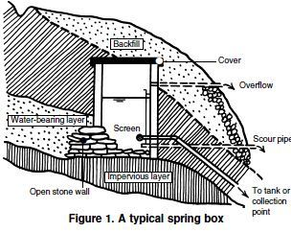

Figure ‑: Cross Section through a typical spring protection box

* All structures have to be located at least few centimetres away from, and below, the eyes of the spring eye,
* A drainage pipe with gate valve should be provided so that cleaning and maintenance of the spring capping and the collection box would be possible the pipe should preferably place at 0.15m above the bottom of the floor of the spring,
* Other aspects specific to the particular spring site should also be taken into consideration including flood protection, reforestation, catchments area protection, etc.
* The design should consider the use of local material to the extent possible,
* Stability of wing walls section need to be checked for effects of lateral water pressure and piping under the structure, such that there is no tension under the base of the structure; and the maximum toe and heel pressures on foundations should not exceed safe limits.

## arrangement of spring boxes

### General

A spring box is a water-tight structure built around spring to isolate it from contaminated surface runoff. It is critical that this box be built properly to ensure that surface water, insects, or small animals cannot enter the structure. If designed properly, it can provide reserve storage during a situation when the spring flow rate is below normal. It is important to keep surface water away from the spring box, and animals should be fenced out of the spring’s drainage area. All activities should be kept to at least 30 m from the spring box.

There are two basic types of intakes for spring development and collecting water from springs and seeps. The first, and easiest to install, is the spring box.

A small area is dug out around the spring and lined with gravel. A concrete box with a removable cover is placed over the spring to collect and store the water. The cover prevents contamination and should be heavy enough to keep people from removing it to dip buckets and cups into the collection box. A tap and an overflow to prevent a back-up in the aquifer should be installed.

For springs that flow from one spot on level ground, an open-bottomed spring box should be placed over the opening to capture all available flow.

For spring development on a hillside, a box with an open back should be placed against the hillside and the water should be channeled into the collection box.

Intakes for seeps and some springs can be perforated plastic or concrete pipe placed in trenches or collection ditches. The trenches are deep enough so that the saturated ground above them acts as a storage reservoir during times of dry weather.

Generally, the trenches should be 1 meter below the water level. Collection pipes are placed in the trenches which are lined with gravel and fine sand so that sediment is filtered out of the water as it flows into the pipes.

There are several possible designs for spring boxes but, their basic principles are similar. Spring box serves as collector for spring water if its yield is large and a small number of people are being served and the source is located near the users. When larger numbers of people are served, the water collected in the spring box flows to larger storage tanks. The two basic types of spring boxes are a box with one pervious side for collection of water from a hillside, and a box with a pervious bottom for collection of spring water flowing from a single opening on level ground. To determine which design to use dig out around the area until an impervious layer is reached, locate the source of the spring flow, and design to fit the situation.

In general, both the type of spring and its location determine the type of spring box to be built. There are three basic design types, related to the three types of springs as described in following section.

### Spring box for artesian springs

If the spring is naturally occurring on relatively flat ground, it is likely to be an artesian spring. Water flows vertically out of the ground due to the pressure that is accumulated within a confined aquifer. For this type of spring, a spring box with an open bottom is used, as illustrated below.



Figure ‑: **Spring box for artesian springs**

### Spring box for gravity springs

If the spring occurs at the base of a slope or hillside, the flow is likely to be gravity driven. Unlike an artesian spring, a gravity spring will most likely have just one impermeable layer (on the bottom). In this case, much less pressure will exist in the system.

Due to the nature of the horizontal flow, and low water pressure, a gravity spring in a hillside will require a spring box with a side entrance for the water, as shown in figure below.



Figure ‑: Typical Arrangement of Spring Box with Side Entrance for Water

### Spring Box for seepage springs

In the case of a seepage spring, water will likely be flowing from more than one point. Similar to gravity springs, the flow will result from the force of gravity, and therefore exist almost always at hillsides or the bottom of a slope. Seepage springs have the highest susceptibility for contamination; thus appropriate protection against contamination should be constructed if it is required for safe supply.

A spring box for a seepage spring can be constructed in two ways, depending on the spring characteristics. The ideal design is to dig far enough back into the hill to reach the single source of all of the spring flow. In this case, the seepage spring would simply be a gravity spring covered by a small amount of porous media.

If a single line of water flow cannot be found, it may still be possible to dig far enough back to ensure all of the water flows into the side opening of the spring box. However, if the lines of spring flow are too separated and cannot be channeled into one spring box structure, then a different approach is needed. Rather than a spring box, one should construct what is known as a Seep Collection System. An example of such a system is shown below.

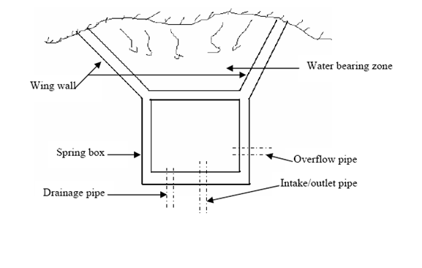

Figure 3‑5: Typical layout plan of a storage box for seepage springs

## water extraction methods

There are several types of systems that can be built to extract water from a spring. The most common is however to build a spring box. Of-course a lower cost and simpler in design alternative is the protection of a spring with no box provided that its yield is enough to develop the intended irrigable command area. But spring boxes are more useful to prevent contamination, and providing the spring with an easy way to flow into a pipe. So as to improve yield of a spring, it has to be developed and protected as protective structure increases the volume of water that can be diverted from the spring and protects the site from contamination by runoff or animals.

For the case of spring box design, there are again two basic design alternatives. These are a box with one pervious side for collection of water from a hillside and a box with a pervious bottom for collection of spring water flowing from a single opening on level ground.

To determine which design to use, dig out around the area until an impervious layer is reached, locate the source of the spring flow, and design to fit the situation. Following successive figures present typical drawings of spring development arrangements.

A spring can be developed into a drinking/irrigation water supply by collecting the discharged water using tile or pipe and running the water into some type of storage tank situated at downstream. Protecting the spring from surface contamination is essential during all phases of spring development. Springs can be developed in two different ways and the method we choose will depend on whether it is a concentrated spring or a seepage spring.

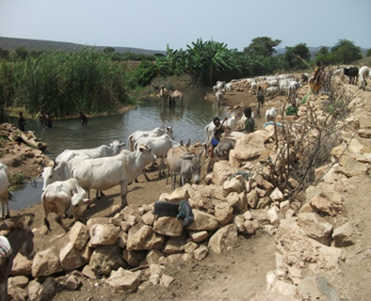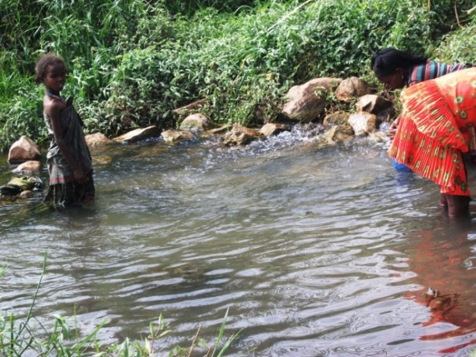

Traditional protection work

Traditional trench work

Source: Bereda Lencha Springs, GIRDC, 2010

Figure ‑: Typical spring protection works & Its surrounding as seen overcrowded

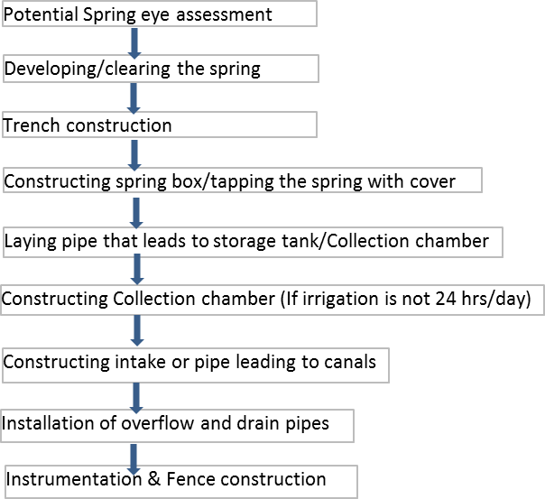

Figure ‑: Summary of procedure for spring study, design & implementation

# COLLECTION CHAMBER

## general

The impression of the collection chamber also called storage tank is that, it collects and stores water coming from the spring box when there is no irrigation (which could be during the night time or during non-irrigation hours) so that in the morning when beneficiaries mobilize for irrigation, there is sufficient amount of water that can irrigate the crop land, which otherwise have wasted.

Therefore, a storage tank is required to collect night time spring flow to balance the daily water demand of the community/crop need. In these circumstances, the storage tank should be designed to store a maximum of flow in non-irrigation times from the spring, depending on the yield of the spring and the daily water demand of the community/crop need.

## types of collection chamber

Collection chamber can be classified based material of construction as Concrete, Masonry plastered with mortar, or Earthen plastered with geo-membrane. It can also be classified based on shape/geometry of the chamber as trapezoidal, rectangular, square or circular.

Selection of either type of these collection chambers is dependent on availability of construction material as well as skilled labor in the vicinity of the project area.

## design of collection chamber

### Required data

Major data required for design of collection chamber are:

* Flow rate or yield of the spring,
* Duration of flow of demand,
* Topographic map of the site together with the command area (or if they are far away by strip topographic map),
* Geologic conditions of the storage site/area,
* Community/land owner’s agreement

### Sizing of collection chamber

Size of storage capacity of a collection chamber can vary depending on topographic features of each site. However this capacity can be determined based on the following principles:

To determine how big the storage reservoir should be, calculate how much water will flow into the reservoir during the night or non-irrigation hours.

V = Q*t …………………………………………….………………………………………... (4-1)

Where, V is volume of water required to be stored in the tank (m3)

Q is flow rate of the spring (l/s or m3/s)

t is duration of flow to the storage (s)

It is generally assumed to have some extra capacity in the chamber/tank some 20% to account for dead storage (excluding free board, which is usually provided to account for avoiding overtopping due to waves or unexpected inflow), so multiply the volume calculated by 1.2 so as to account for losses such as seepage or leakage, wave, evaporation, etc.

Storage Reservoir Volume (Mm3) = Volume (m3) x 1.2/1,000,000 …………………..………. (4-2)

Once we know the volume of storage from this equation, we can calculate storage tank dimensions using the formula

Volume = Width x Length x height …………………………………………………………...…... (4-3)

But this equation holds true for the case of uniform height only. Consequently, the following trapezium equation is used instead.

 ………………………………………………………………...…... (4-4)

Where, V = Total storage capacity including free board, m3

d = Water storage depth at height, d, m

H = Total tank depth = d+Fb, m …………………………………………….…... (4-5)

At = Top surface area of storage = L🞨 W, m2 ……………..………….………. (4-6)

Ab = Base area of storage = l🞨w, m2 …………………………………………... (4-7)

For the case of water storage area, L& W are replaced by b & B respectively. Thus:

At = Top surface area of stored water = b🞨 B, m2 and H=d ……….………… (4-8)

Usually, shape, dimensions, slopes and other factors of storage area should be fixed based on the actual site condition. Then depending on the construction method and site condition, we select the shape of the chamber either trapezoidal, or square, or circular or rectangular.

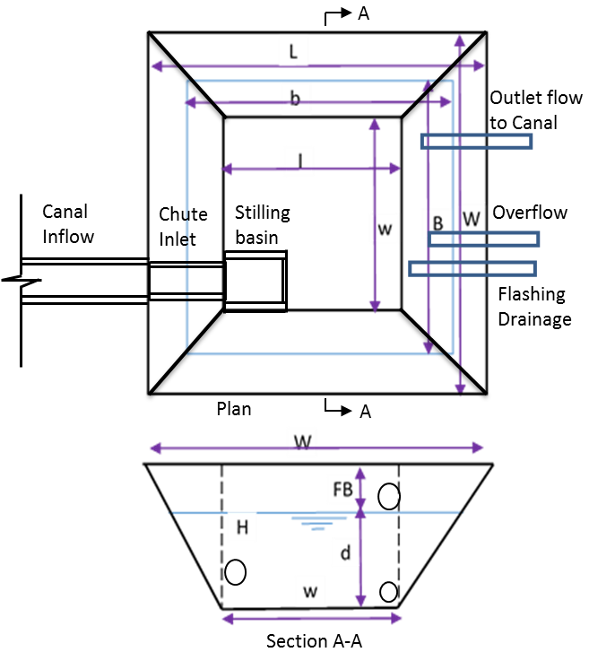

Figure ‑: Typical plan and cross section of a storage tank

Note: Storage Tanks may not surround the whole directions of spring eye, rather depends on topographic conditions of each site.

***Box 4-1:***

***Worked Example-2****: Consider worked example-1 above. If the intended irrigation hour per day is 12hours to irrigate a net area of 202ha, compute a peak storage capacity of the storage tank (m3) and appropriate dimensions based on the following monthly water duties, percent area to be irrigated. Use internal side slope of the storage, (H:V) to be 1.5-2.0 & external one to be 2.0-3.0 depending on its height.*

Table ‑: Summary of agronomy data given for worked examples

|  |  |  |  |  |  |  |  |  |  |  |  |  |
| --- | --- | --- | --- | --- | --- | --- | --- | --- | --- | --- | --- | --- |
| **Description** | **Jan** | **Feb** | **Mar** | **Apr** | **May** | **Jun** | **Jul** | **Aug** | **Sep** | **Oct** | **Nov** | **Dec** |
| Duty (l/s/ha for 24hr) | 0.57 | 0.65 | 0.31 | 0.03 | 0.02 | 0.10 | 0.30 | 0.42 | 0.23 | 0.04 | 0.10 | 0.32 |
| %Area to be irrigated | 100 | 100 | 100 | 7 | 7 | 100 | 100 | 100 | 100 | 87 | 100 | 100 |

***Solution****: We need to estimate percentage area to be irrigated in to actual area to be irrigated (ha). Then compute Q=q*A and then storage requirement for 12hr (m3) and finally select peak storage to fix the expected capacity of the tank including 20% for dead storage. Since topographic features of the selected reservoir area may not suit to deepening it for more than 2.5m, take this as upper limit of depth of the reservoir.*

Table ‑: Computation of Storage Capacity of Collection Chamber/Tank (m3)

| **Description** | **Jan** | **Feb** | **Mar** | **Apr** | **May** | **Jun** | **Jul** | **Aug** | **Sep** | **Oct** | **Nov** | **Dec** |
| --- | --- | --- | --- | --- | --- | --- | --- | --- | --- | --- | --- | --- |
| Nr. of Days in a Month | 31 | 28 | 31 | 30 | 31 | 30 | 31 | 31 | 30 | 31 | 30 | 31 |
| Duty, q (l/s/ha for 24hr) | 0.57 | 0.65 | 0.31 | 0.03 | 0.02 | 0.10 | 0.30 | 0.42 | 0.23 | 0.04 | 0.10 | 0.32 |
| %Area to be irrigated | 100 | 100 | 100 | 7 | 7 | 100 | 100 | 100 | 100 | 87 | 100 | 100 |
| Actual Area to be irrigated, A (ha) | 202 | 202 | 202 | 14 | 14 | 202 | 202 | 202 | 202 | 176 | 202 | 202 |
| Required irr. flow to be stored, Q (l/s) | 115.10 | 131.46 | 62.60 | 0.42 | 0.28 | 20.19 | 60.58 | 84.81 | 46.45 | 7.03 | 20.19 | 64.62 |
| Storage Requirement for 12hr, V (m3) | 4,972 | 5,679 | 2,704 | 18 | 12 | 872 | 2,617 | 3,664 | 2,006 | 304 | 872 | 2,792 |
| Thus, design value for determining 12hr storage per day i.e. peak capacity, (m3) = | | | | | | | | | | | 5,679 | |
| And including allowances for dead storage of 20% gives peak storage capacity, (m3) = | | | | | | | | | | | **6,815** | |

Note: Actual Area to be irrigated (ha) = %Area to be irrigated* net area of 202ha; Q=q*A; V=Q/1000*12*3600.

*Now let’s estimate size of the reservoir base on the above capacity. Usually, it is preferred if the size is of square shape though it is governed by prevailing topographic features. For the time being, consider trapezoidal shape (as it is easy to construct and increase ranges of surface area) and then compute the size as follow.*

Table ‑: Sizing of Collection Chamber for the Peak Storage Capacity

| **Description** | **Value** | **Remark** |
| --- | --- | --- |
| Peak live storage Capacity, Vlive (m3) = Q*t | 5679 m3 | Peak capacities from previous table |
| Minimum storage capacity including 20% for dead storage, Vreq (m3) = | 6815 m3 |
| Allowed dead storage, Vd=Vreq - Vlive | 1136 m3 |  |
| Depth of water to be stored for irrigation/live storage, d-d' | 2.1 |  |
| Depth of dead storage, d' | 0.2 |  |
| Freeboard, FB | 0.8 | Assumed |
| Therefore, total height of storage structure, H | 3.1 | Maximum height |
| Assume a square inverted frustum shape |  |  |
| Internal side slope of Storage, m (H: V ) | 2 |  |
| External side slope of Storage, m (H: V ) | 3 |  |
| **Proposed length and width of Storage** |  |  |
| Bottom width of Storage, w | 57 | Assumed such that it satisfies following cond. |
| Bottom length of Storage, l | 60 |
| Storage width to Top of pond level, W=w+2mH i.e. Crest width | 69.4 |  |
| Storage length to Top of pond level, L=l+2mH i.e. Crest length | 72.4 |  |
| Storage width to Top of stored water surface level, B | 66 |  |
| Storage length to Top of stored water surface level, b | 69 |  |
| **Designed capacity of the storage** |  |  |
| Pond size is computed from, Vcal=H/3*(At+Ab+SQRT(At+Ab)) |  |  |
| Where, V=Volume of the pond,m3 |  |  |
| At= Pond top Area = L x W,m2 | 5,025 |  |
| Ab=Pond bottom area = l x w, m2 | 3,420 |  |
| Vcal= H/3 * (At+Ab+SQRT(At+Ab)) | 8,821 |  |
| Check that Vcal > Vreq | OK | This needs to be "Ok" |
| Top width of crest of the storage, Cb | 3 | Assumed |
| Thus, provide a pond with 57x60m bottom and corresponding crest size of 67x70m for storing 12 hour flow in the night | | |
| Top width of Water surface, B=w+2md | 66.2 |  |
| Top length of Water surface, b=l+2md | 69.2 |  |
| Water surface Area, Aw=b*B | 4,581 |  |
| Volume of stored water, Vw=d/3 * (Aw+Ab+SQRT(Aw+Ab)) | 6,203 | Including dead storage |
| Top width of dead storage, B'=w+2md' | 57.8 |  |
| Top length of dead storage, b'=l+2md' | 60.8 |  |
| Water surface Area, Ad=b'*B' | 3,514 |  |
| Volume of dead storage, Vd=d'/3 * (Ad+Ab+SQRT(Ad+Ab)) | 468 |  |
| Thus, computed volume of live storage Vcs=Vw - Vd | 5,735 |  |
| Check that Vcs  Vlive | OK | This needs to be "Ok" |

Note: The two requirements indicated in the table, i.e. Vcal > Vreq and Vcs  Vlive must be fulfilled so as to accept the assumed dimensions.

***Box 4-2:***

***Worked Example-3****:* Assuming that the *measured discharge of the spring under consideration is to be available throughout the year, compute monthly water available for irrigation and analyze corresponding water balance (Mm3) for the case when the preceding peak demand is thought required the whole months of the year (Assume, losses are insignificant).*

***Solution****: Water balance is computed based on annual condition. Consequently, the required questions are computed and summarized in table below.*

Table ‑: Analysis of Monthly Water Availability for Irrigation and Water balance

| **Demand & Supply** | **Jan** | **Feb** | **Mar** | **Apr** | **May** | **Jun** | **Jul** | **Aug** | **Sep** | **Oct** | **Nov** | **Dec** | **Avg** | **Annual** |
| --- | --- | --- | --- | --- | --- | --- | --- | --- | --- | --- | --- | --- | --- | --- |
| Nr. of Days in a Month | 31 | 28 | 31 | 30 | 31 | 30 | 31 | 31 | 30 | 31 | 30 | 31 |  |  |
| Domestic |  |  |  |  |  |  |  |  |  |  |  |  |  |  |
| Institutional |  |  |  |  |  |  |  |  |  |  |  |  |  |  |
| Public |  |  |  |  |  |  |  |  |  |  |  |  |  |  |
| Livestock |  |  |  |  |  |  |  |  |  |  |  |  |  |  |
| D/s release |  |  |  |  |  |  |  |  |  |  |  |  |  |  |
| Subtotal of Peak demand other than irr. (Mm3) | 0.025 | 0.022 | 0.025 | 0.024 | 0.025 | 0.024 | 0.025 | 0.025 | 0.024 | 0.025 | 0.024 | 0.025 | 0.024 | 0.29 |
| Spring supply (base flow, Mm3) | 0.53 | 0.479 | 0.53 | 0.513 | 0.53 | 0.513 | 0.53 | 0.53 | 0.513 | 0.53 | 0.513 | 0.53 | 0.52 | 6.24 |
| Water available for irr. (Mm3) | 0.505 | 0.457 | 0.505 | 0.489 | 0.505 | 0.489 | 0.505 | 0.505 | 0.489 | 0.505 | 0.489 | 0.505 | 0.496 | 5.95 |
| ****  Taking 75% for irrigation | 0.379 | 0.342 | 0.379 | 0.367 | 0.379 | 0.367 | 0.379 | 0.379 | 0.367 | 0.379 | 0.367 | 0.379 | 0.372 | 4.46 |
| or in (l/s) | 141.5 | 127.8 | 141.5 | 137 | 141.5 | 137 | 141.5 | 141.5 | 137 | 141.5 | 137 | 141.5 | 138.9 | 0.142 |
| Duty (l/s/ha for 24hr) | 0.57 | 0.651 | 0.31 | 0.03 | 0.02 | 0.1 | 0.3 | 0.42 | 0.23 | 0.04 | 0.1 | 0.32 |  |  |
| %Area to be irrigated | 100 | 100 | 100 | 7 | 7 | 100 | 100 | 100 | 100 | 87 | 100 | 100 |  |  |
| Actual Area (ha) | 202 | 202 | 202 | 14 | 14 | 202 | 202 | 202 | 202 | 176 | 202 | 202 |  |  |
| Irr. Demand, Q (m3/s) | 0.12 | 0.13 | 0.06 | 0.0004 | 0.0003 | 0.02 | 0.06 | 0.08 | 0.05 | 0.01 | 0.02 | 0.06 |  |  |
| Total Demand (Mm3) | 0.33 | 0.34 | 0.19 | 0.03 | 0.03 | 0.08 | 0.19 | 0.25 | 0.14 | 0.04 | 0.08 | 0.2 |  | 1.89 |
| Water Balance (Mm3) | 0.046 | 0.002 | 0.187 | 0.342 | 0.354 | 0.29 | 0.192 | 0.127 | 0.222 | 0.335 | 0.29 | 0.181 |  | 2.569 |

## fence

Fence is a protective structure required around the perimeter of spring site high and sturdy enough to prevent access by livestock, wild animals and children from entering the pan area and contaminating the water. Construction of such fence may take place before the construction of the spring box; however a sufficient opening should be left so that the materials can be easily delivered to the site. People will also need adequate space to maneuver during the placement of the spring box (if it is constructed away from the spring).

Although it is strongly recommended that the fence be built before construction of the spring box begins, if this does not happen, then the fence should definitely be in place before the community starts to use the water.

The fence should be a minimum of 9 meter radius from the spring, and generally no more than 30 meter radius. Of-course the catchment topography to a large extent dictates the dimensions of the fencing area. It is usually built from a 10cm thick reinforced concrete poles placed at every 1m interval and knotted by barbed wire at every 10cm interval all along its height.

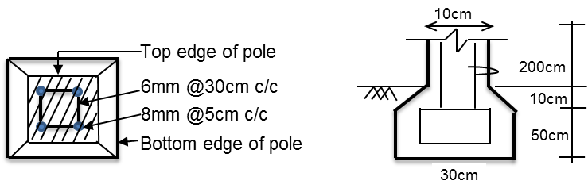

Figure ‑: Typical reinforced concrete post & barbed wire arrangement

For structural design aspects refer GL-10 Diversion Weir Study and Design.

# CONSTRUCTION WORKS around springs

## site preparation

The site needs to be properly prepared before excavation and construction work begin. If you prepare the site well and have a good layout for tools, materials and other construction equipment, the process of developing the spring will go smoothly and easily. The major steps required for site preparation are clearing the site, fencing the site, plan the site layout, and construction materials & equipment and storage facilities.

Any potential sources of contamination upstream of the spring eye should be identified and addressed if its purpose is for water supply and irrigation. A working area roughly 15 m radius from the spring or depending on existing terrain and land coverage should be cleared of all vegetation, loose stones, dead wood, etc. and planted only with grass after construction.

Once we have completed these steps, we are ready to begin excavation and subsequent construction.

Developing a spring or seep requires some understanding of ground water flow and preparation of a thorough construction plan. The construction plan should include:

* A map of the area identifying the location of the spring, the locations of water use, distances from source to use outlet points, and surveyed changes in elevations;
* A complete list of all labor, materials, and tools needed; and
* A spring box design with diagrams of the top, side, and front views, and the dimensions of a cover.

## general construction steps

The followings are some general steps which need to be followed for constructing protection works around spring eyes:

* Conducting Setting out,
* Align the main flow path/s,
* Protect the source,
* Indicate position of the headwall,
* Excavating for and constructing the headwall, wing walls and access
* Divert the water,
* Build the headwall and wing walls,
* Build the apron slab and steps, if any,
* Construct the surface water diversion ditch and fence
* Train the community on Operation, management & Maintenance aspects

Similarly, subsequent procedures can also be followed:

* Step 1: Layout and construction of Soil and water conservation (SWC) structures around the spring catchment, if any.
* Step 2: Collect water from the spring for analysis.
* Step 3: Develop the spring eye by excavation at the pint of emergence.
* Step 4: Excavate a trench at the lower end of the spring eye, fill with clay soil or concrete and provide polythene sheet lining to prevent seepage
* Step 5: Construct water draw off point, first by making a foundation followed by wall. Provide two outlets, the lower one as the draw off point and the upper one as the draw off point and the upper one as a breather. Provide a discharge channel on the slab floor and incorporate stairs/ steps for steep slopes of more than 30%
* Step 6: Fill excavated spring eye with hard core, starting with large ones and finishing with small ones. Cover with polythene sheet, then soil and plant grass.
* Step 7: Construct a cut-off drain (CoD) or diversion ditch above the spring eye to divert runoff water. Then fence off the area around the spring and plant indigenous trees.

In general, the followings are general steps appropriate for spring protection construction steps for either design choice:

* Locate the spring site and mark out the area with measuring tape, cord, and wooden stakes or pointed sticks.
* Clean out the area around the spring to ensure a good flow. If the spring flows from a hillside, dig into the hill far enough to determine the origin of the flow. Where water is flowing from more than one opening, dig back far enough to ensure that all the water flows into the collecting area. If the flow cannot be channeled to the collection area because openings are too diffuse, drains will have to be installed. Flow from several sources may be diverted to one opening by digging farther back into the hill. Always try to dig down deep enough to reach an impervious layer. An impervious layer makes a good foundation for the spring box, and provides a better surface for a seal against underflow.
* Pile loose stones and gravel against the spring before putting in the spring box. The stones serve as a foundation for the spring box and help support the ground near the spring opening to prevent dirty materials from washing in.
* Approximately 8 meters above the spring site (and depending on topography), dig a trench for diverting surface runoff. Use large stones, if available, to line the diversion trench and prevent erosion.
* Mark off an area about 9 meters by 9 meters for a fence (or as required). Place the fence posts 2 meters apart and string the fence.
* Note: Heavy vehicle traffic over the uphill water bearing layer should be avoided to prevent compaction that may reduce water flow.

### Concrete construction steps

In order to have a strong structure, concrete must be cured for at least 7 days. Strength increases with curing time. Be sure that all tools and materials needed to build the forms and mix the concrete are at the site.

* Build wooden forms. Once the dimensions of the box have been drawn, cut wood to the appropriate sizes and set up the forms on a level surface. The outside dimensions of the forms should be 0.1 meter larger than the inside dimensions. An open bottom or back should be planned, depending on the spring source location. The size of the opening in the form depends on the area that must be covered to collect the maximum water. When building forms for a box with a bottom, be sure to set the inside forms 0.1 meter above the bottom for the floor. This is done by nailing the inside form to the outside form so that it hangs 0.1 meter above the floor. Make holes in the forms for the outflow and overflow pipes. Place small pieces of pipe in them so that correctly sized holes are left in the box as the concrete sets. Build a form for the box cover. Build all forms at the site.
* Set the forms in place. Forms must be well secured and braced before pouring the concrete. The braces can be tied together with wire. Use a stick to tighten the wire and force the forms together. If the forms are set and concrete is poured at the permanent site, water must be diverted from the area to allow the concrete to cure. If diversion is not possible, pour the concrete near the permanent site, and plan to have 6-8 people available to help move the box later after the concrete has cured.
* Oil the forms. This prevents the concrete from sticking.
* Prepare the reinforcing rods (rebar) in a grid pattern for placement in the forms for the spring box cover. Make sure there is 0.15 meters between the parallel bars and that the rods are securely tied together with wire. Then position the reinforcing rods in the form. Four bars tied together to form a square should be placed in the forms.
* Mix the concrete in a proportion of 1 part cement, 2 parts sand, and 3 parts gravel. Add just enough water to form a thick paste. More gravel can be used to conserve cement.
* Pour the concrete into the forms. Tamp the concrete to avoid pockets or voids. Smooth all surfaces. Make the middle of the cover a little higher than the sides to encourage drainage away from the spring box.
* Cover the concrete with canvas, burlap, empty cement bags, plastic, straw or some other protective material to prevent it from losing moisture. The covering should be kept wet so water from the concrete is not absorbed. If concrete days, it no longer hardens, its strength is lost, and it begins to crack. Keep the cover on for as long as the concrete is curing.
* Let the concrete structures set for at least 7 days, wetting the concrete daily. After 7 days, the forms can be removed and the box installed based on the following steps.

### Installing a spring box

The spring box must be properly installed to ensure that it fits on a solid, impervious base, and that a seal with the ground is created to prevent water seeping under the structure.

* Place the spring box in position to capture the maximum flow. Place gravel around the box or in the basin so that water flows through it before entering the box.
* Seal the area where the spring box makes contact with the ground. Use concrete or puddled clay to form a seal.
* Be sure that the area where the spring flows from the ground is well lined with gravel, and then backfill the dugout area with gravel. The gravel fill should reach as high as the inlet opening in the spring box so that the water flowing into the structure passes through gravel. For spring boxes on level ground, gravel backfill is unnecessary.
* Place the pipes in the box. Use concrete to seal around the pipes and prevent leaks. Place screening over the pipe openings and secure with wire.
* Disinfect the inside of the box with a chlorine solution. Before the spring box is closed, wash its walls with a light solution of chlorine.
* Place the cover on the box.

# SOCIAL INFRASTRUCTURES

## general

There are social infrastructures related to spring development and protection works. These structures include but not limited to the following: watering points for human being, watering points for livestock and washing basins. Brief of these infrastructures are presents as follow.

## community water supply points

These are structures which are directly connected to the spring box and is situated on its downstream side. Its typical cross section looks like the following figure.



Figure ‑: Typical section through consumer water point, FAO & UNICEF, 2012

## cattle trough

Cattle troughs or animal water points are structures to be considered for watering livestock away from the spring eye so that they may not disturb or interfere with irrigation operation. Its typical view looks like the following figure. Its size depends on demand of livestock population.



Figure ‑: Typical view of livestock watering trough

## washing basin

In order to protect quality of irrigation water from being contaminated by polluted water from washed clothes, provision of facilities for this purpose beside collection chamber is essential. Washing basins of size as indicated on figure are presented to minimize interference with flow of the canals.

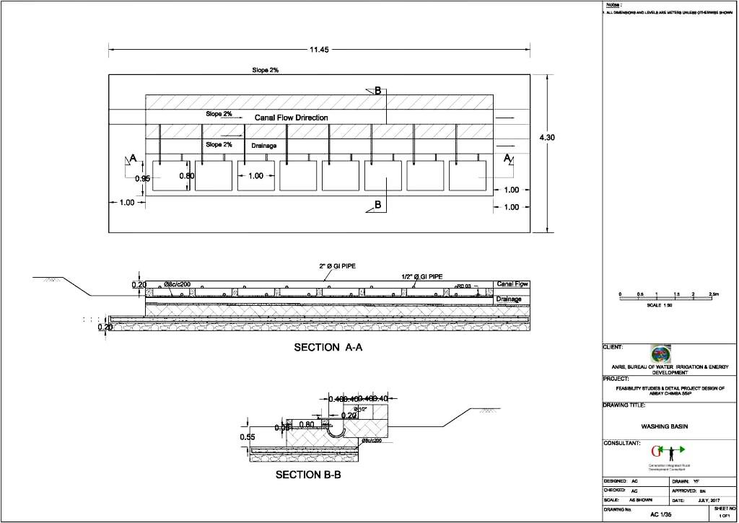

Figure ‑: Typical plan and cross section of washing basin

# Spring OPERATION AND MAINTENANCE

## general

Spring catchments, as per Meuli & Wehrli, 2001, need very little operation and a lot less maintenance than other catchment systems. A simple design combined with high-quality construction for all structures in the catchment area will keep maintenance requirements to a minimum. Nevertheless, all spring catchments need a periodic check-up. To ensure water quality and to avoid operational problems at the catchment, a monthly control is vital. Minor jobs like basic repairs or monitoring activities can be planned and carried out by the caretaker. In case of major repairs (e.g. wet spots around the catchment, leaks at the spring chamber, etc.), the responsible service should be consulted. The following sections show aspects that have to be checked during regular visits to spring catchment area.

## check-up at the protection zone

* The fence of the protection area,
* The diversion drainage above the catchment,
* Wet spots indicating a leakage from the catchment,
* Trespass such as prohibited farming in the intake area.

## check-up at the spring chamber

* Leakage at the chamber,
* The manhole cover,
* Blockage at the supply line - water comes through the reserve (overflow) pipe,
* The ventilation,
* The water quality and quantity (tested without equipment),
* Sedimentation in the chamber,
* If possible measure the yield of the spring and compare it with data of previous years.

## maintenance of spring boxes & its appurtenances

If properly installed, spring boxes require very little maintenance, however, it is recommended that the water quality be checked before being put into use, as well as on a yearly basis or as needed. It is also a good idea to check that the uphill diversion ditch is adequately diverting surface runoff away from the spring box and is not eroding. One maintenance item that is frequently overlooked is to ensure that the animal fence is in good repair.

Although some grazing area may be lost, the loss in grazing area is preferable to a contaminated water source or compacted soil that could lead to decreased flow rates. For hillside collection boxes, it is important to check that the uphill wall is not eroding and is maintaining structural integrity.

The cover should be checked frequently to ensure that it is in place and appears to be watertight. Make sure that water isn't seeping out from the sides or from underneath the spring box, and check that the screening is in place on the overflow pipe.

Check also that:

* The gate valves are properly operating and require greasing,
* Check for stagnant water around water point and clear/open drain to soak away,
* Clear bush and keep compound around water point clean and free of rubbish and animal or human waste,
* If the pipe is working properly and repair leaking or damaged parts,
* The fence requires to be kept in good condition and the entrance gate should be safely secured,
* The capacity of a collection chamber is enough to hold the required volume of water at every beginning of irrigation season.

## frequencies & requirements for maintenance

Once a year, disinfect the system and remove sediment from the spring box. To do so, open the valve on the outlet pipe, allowing the spring box to drain. Remove any accumulated sediment from the box and wash the interior walls with a chlorine solution (If it is in use for water supply).

As springs are supposed to serve for multipurpose, the spring box need to be treated with chlorine as required. As per Michigan Technological University, the solution for this washing should be mixed in a ratio of 10 lit water with 0.2 lit chlorine bleach. After washing the interior of the spring box, chlorine should be added directly to the water in the spring box in a ratio of 100 parts chlorine per million parts water, and allowed to sit for 24 hours. If it isn't possible to allow the chlorine to sit for 24 hours, two consecutive applications twelve hours apart should provide for adequate disinfection. If possible, water samples should be analyzed periodically for contamination.

It should be noted that chlorine and chlorine compounds might irritate eyes and skin; proper protective equipment such as gloves, safety glasses, and protective clothing should be worn if available when dealing with chlorine.

# REFERENCES

* Classification of springs, Journal of geology, by Bryan, K. 1919,
* Ethiopian Water Sector Development Program, 2001;
* Guideline for Spring Development: Site Selection, Design and Construction SWHISA, ANRS, 2010;
* Spring Box Design, Construction and Maintenance, Michigan Technological University, 2003;
* Spring Development and Protection, WATER FACTS 4 Publication, By Penn State College of Agricultural Sciences, 2016;
* Trainer’s Manual for Community Managed Water Supplies, Kenya, FAO & UNICEF, 2012,
* Well Design and Spring Development, USDA, NRCS, 2010;

