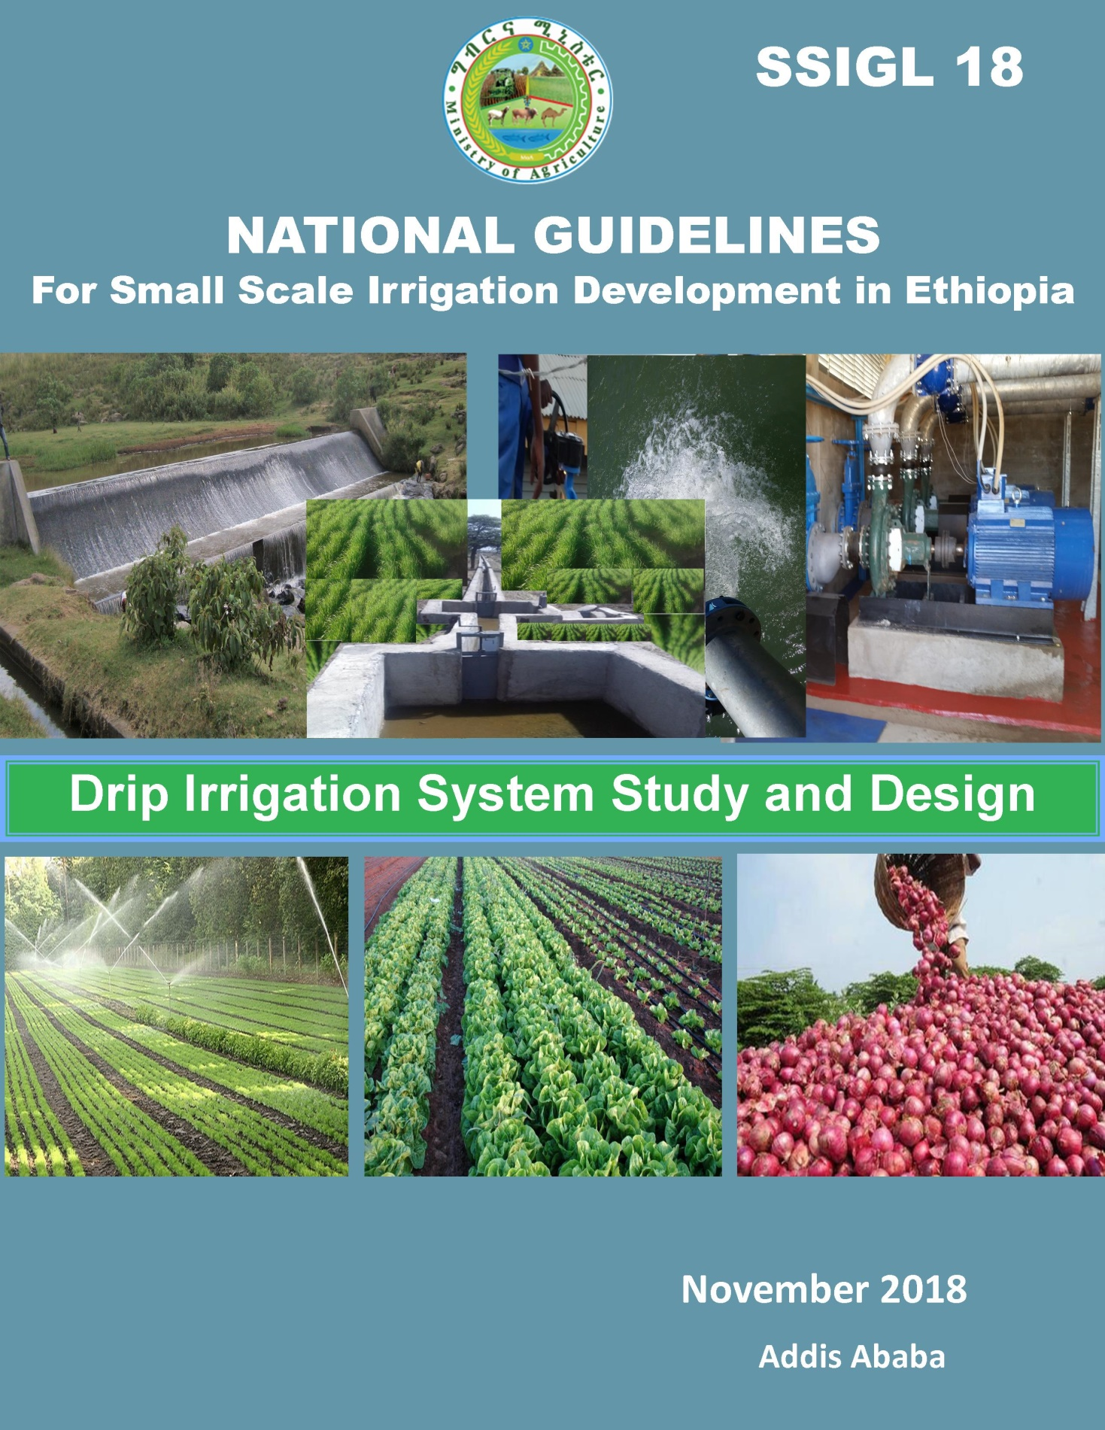

***MINISTRY OF AGRICULTURE***

***National Guidelines for Small Scale Irrigation Development in Ethiopia***

**SSIGL 18: Drip Irrigation System Study and Design**

**November 2018 Addis Ababa**

**National Guidelines for Small Scale Irrigation Development in Ethiopia**

**First Edition 2018**

© MOA 2018

Ministry of Agriculture

Small-Scale Irrigation Development Directorate

P. O. Box 62347

Tel: +251-1-6462355

Fax: +251-1-6462355

Email: [SSIDdirectorate@moa.gov.et](mailto:SSIDdirectorate@moa.gov.et)

[SSIDdirectorate@gmail.com](mailto:SSIDdirectorate@gmail.com)

eDMS (intranet): MoA SSID DMS (<http://172.28.1.188:8080/DMS/login.jsp>)

Website: [www.moa.gov.et](http://www.moa.gov.et)

***Financed by Agricultural Growth Program (AGP)***

***DISCLAIMER***

*Ministry of Agriculture through the Consultant and core reviewers from all relevant stakeholders included the information to provide the contemporary approach about the subject matter. The information contained in the guidelines is obtained from sources believed tested and reliable and are augmented based on practical experiences. While it is believed that the guideline is enriched with professional advice, for it to be successful, needs services of competent professionals from all respective disciplines. It is believed, the guidelines presented herein are sound and to the expected standard. However, we hereby disclaim any liability, loss or risk taken by individuals, groups, or organization who does not act on the information contained herein as appropriate to the specific SSI site condition.*

# FORWARD

Ministry of Agriculture, based on the national strategic directions is striving to meet its commitments in which modernizing agriculture is on top of its highest priorities to sustain the rapid, broad-based and fair economic growth and development of the country.  To date, major efforts have been made to remodel several important strategies and national guidelines by its major programs and projects.

While efforts have been made to create access to irrigation water and promoting sustainable irrigation development, several barriers are still hindering the implementation process and the performance of the schemes. The major technical constrains starts from poor planning and identification, study, design, construction, operation, and maintenance. One of the main reasons behind this outstanding challenge, in addition to the capacity limitations, is that SSIPs have been studied and designed using many ad-hoc procedures and technical guidelines developed by various local and international institutions.

Despite having several guidelines and manuals developed by different entities such as MoA (IDD)-1986, ESRDF-1997, MoWIE-2002 and JICA/OIDA-2014, still the irrigation professionals follow their own public sources and expertise to fill some important gaps. A number of disparities, constraints and outstanding issues in the study and design procedures, criteria and assumptions have been causing huge variations in all vital aspects of SSI study, design and implementation from region to region and among professionals within the same region and institutions due mainly to the lack of agreed standard technical guidelines. Hence, the SSI Directorate with AGP financial support, led by Generation consultant (GIRDC) and with active involvement of national and regional stakeholders and international development partners, these new and comprehensive national guidelines have been developed.

The SSID guidelines have been developed by addressing all key features in a comprehensive and participatory manner at all levels. The guidelines are believed to be responsive to the prevalent study and design contentious issues; and efforts have been made to make the guidelines simple, flexible and adaptable to almost all regional contexts including concerned partner institution interests. The outlines of the guidelines cover all aspects of irrigation development including project initiation, planning, organizations, site identification and prioritization, feasibility studies and detail designs, contract administration and management, scheme operation, maintenance and management.

Enforceability, standardization, social and environmental safeguard mechanisms are well mainstreamed in the guidelines, hence they shall be used as a guiding framework for engineers and other experts engaged in all SSI development phases. The views and actual procedures of all relevant diverse government bodies, research and higher learning institutions, private companies and development partners has been immensely and thoroughly considered to ensure that all stakeholders are aligned and can work together towards a common goal. Appropriately, the guidelines will be familiarized to the entire stakeholders working in the irrigation development. Besides, significant number of experts in the corresponding subject matter will be effectively trained nationwide; and the guidelines will be tested practically on actual new and developing projects for due consideration of possible improvement. Hence, hereinafter, all involved stakeholders including government & non-governmental organizations, development partners, enterprises, institutions, consultants and individuals in Ethiopia have to adhere to these comprehensive national guidelines in all cases and at all level whilst if any overlooked components are found, it should be documented and communicated to MOA to bring them up-to-date.

Therefore, I congratulate all parties involved in the success of this effort, and urge partners and stakeholders to show a similar level of engagement in the implementation and stick to the guidelines over the coming years.

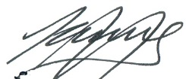

H.E. Dr. Kaba Urgessa

State Minister, Ministry of Agriculture

***SMALL SCALE IRRIGATION DEVELOPMENT VISION***

*Transforming agricultural production from its dependence on rain-fed practices by creating reliable irrigation system in which smallholder farmers have access to at least one option of water source to increase production and productivity as well as enhance resilience to climate change and thereby ensure food security, maintain increasing income and sustain economic growth.*

# ACKNOWLEDGEMENTS

The preparation of SSIGLs required extensive inputs from all stakeholders and development partners. Accordingly many professionals from government and development partners have contributed to the realization of the guidelines. To this end MOA would like to extend sincere acknowledgement to all institutions and individuals who have been involved in the review of these SSIGLs for their comprehensive participation, invaluable inputs and encouragement to the completion of the guidelines. There are just too many collaborators involved to name exhaustively and congratulate individually, as many experts from Federal, regional states and development partners have been involved in one way or another in the preparation of the guidelines. The contribution of all of them who actively involved in the development of these SSIGLs is gratefully acknowledged. The Ministry believes that their contributions will be truly appreciated by the users for many years to come.

The Ministry would like to extend its appreciation and gratitude to the following contributors:

* Agriculture Growth Program (AGP) of the MoA for financing the development and publication of the guidelines.
* The National Agriculture Water Management Platform (NAWMP) for overseeing, guidance and playing key supervisory and quality control roles in the overall preparation process and for the devotion of its members in reviewing and providing invaluable technical inputs to enrich the guidelines.
* Federal Government and Regional States organizations and their staff for their untiring effort in reviewing the guidelines and providing constructive suggestions, recommendations and comments.
* National and international development partners for their unreserved efforts in reviewing the guidelines and providing constructive comments which invaluably improved the quality of the guidelines.
* Small-scale and Micro Irrigation Support Project (SMIS) and its team for making all efforts to have quality GLs developed as envisioned by the Ministry.

The MOA would also like to extend its high gratitude and sincere thanks to AGP’s multi development partners including the International Development Association (IDA)/World Bank, the Canada Department of Foreign Affairs, Trade and Development (DFATD), the United States Agency for International Development (USAID), the Netherlands, the European Commission (EC), the Spanish Agency for International Development (AECID), the Global Agriculture and Food Security Program (GAFSP), the Italy International Development Cooperation, the Food and Agriculture Organization (FAO) and the United Nations Development Program (UNDP).

Moreover, the Ministry would like to express its gratitude to Generation Integrated Rural Development Consultant (GIRDC) and its staff whose determined efforts to the development of these SSIGLs have been invaluable. GIRDC and its team drafted and finalized all the contents of the SSIGLs as per stakeholder suggestions, recommendations and concerns. The MoA recognizes the patience, diligence, tireless, extensive and selfless dedication of the GIRDC and its staff who made this assignment possible.

Finally, we owe courtesy to all national and International source materials cited and referred but unintentionally not cited.

Ministry of Agriculture

***DEDICATIONS***

*The National Guidelines for Small Scale Irrigation Development are dedicated to Ethiopian smallholder farmers, agro-pastoralists, pastoralists, to equip them with appropriate irrigation technology as we envision them empowered and transformed.*

# List of Guidelines

**Part I. SSIGL 1: Project Initiation, Planning and Organization**

**Part II: SSIGL 2: Site Identification and Prioritization**

**Part III: Feasibility Study and Detail Design**

**SSIGL 3: Hydrology and Water Resources Planning**

**SSIGL 4: Topographic and Irrigation Infrastructures Surveying**

**SSIGL 5: Soil Survey and Land Suitability Evaluation**

**SSIGL 6: Geology and Engineering Geology Study**

**SSIGL 7: Groundwater Study and Design**

**SSIGL 8: Irrigation Agronomy and Agricultural Development Plan**

**SSIGL 9: Socio-economy and Community Participation**

**SSIGL 10: Diversion Weir Study and Design**

**SSIGL 11: Free River Side Intake Study and Design**

**SSIGL 12: Small Embankment Dam Study and Design**

**SSIGL 13: Irrigation Pump Facilities Study and Design**

**SSIGL 14: Spring Development Study and Design**

**SSIGL 15: Surface Irrigation System Planning and Design**

**SSIGL 16: Canals Related Structures Design**

**SSIGL 17: Sprinkler Irrigation System Study and Design**

**SSIGL 18: Drip Irrigation System Study and Design**

**SSIGL 19: Spate Irrigation System Study and Design**

**SSIGL 20: Quantity Surveying**

**SSIGL 21: Selected Application Software’s**

**SSIGL 22: Technical Drawings**

**SSIGL 23: Tender Document Preparation**

**SSIGL 24: Technical Specifications Preparation**

**SSIGL 25: Environmental & Social Impact Assessment**

**SSIGL 26: Financial and Economic Analysis**

**Part IV: Contract Administration & Construction Management**

**SSIGL 27: Contract Administration**

**SSIGL 28: Construction Supervision**

**SSIGL 29: Construction of Irrigation Infrastructures**

**Part V: SSI Scheme Operation, Maintenance and Management**

**SSIGL 30: Scheme Operation, Maintenance and Management**

**SSIGL 31: A Procedural Guideline for Small Scale Irrigation Schemes Revitalization**

**SSIGL 32: Monitoring and Evaluation**

**Ancillary Tools for National Guidelines of Small Scale Irrigation Development**

**SSIGL 33: Participatory Irrigation Development and Management (PIDM)**

**SSIGL 34: Quality Assurance and Control for Engineering Sector Study and Design**

**TABLE OF CONTNTS**

FORWARD i

ACKNOWLEDGEMENTS iii

List of Guidelines v

Acronyms xi

PREFACE xiii

UPDATING AND REVISIONS OF GUIDELINES xv

1 Basics on DRIP Irrigation System 1

1.1 definition 1

1.2 Objective and Presentation structures of the guideline 1

1.3 principles of operation 1

1.4 benefits and limitations of drip system 1

1.4.1 Benefits 1

1.4.2 Limitations 3

1.5 the current status of drip system and its prospects in ethiopia 3

1.5.1 Current status 3

1.5.2 Future prospects 3

1.6 adaptability of dripsystem 4

1.7 types of drip system 4

1.8 components of drip irrigation system 7

1.9 filteration in drip irrigation system 12

1.9.1 General 12

1.9.2 Pre-filteration 12

1.9.3 Filters 13

1.10 fertilizer and chemicalapplicators 15

2 Design of Drip System 17

2.1 the design process 17

2.1.1 Preliminary design of drip system 18

2.1.2 Detail Design of Drip System 24

3 EQUIPMENT SPECIFICATION, BILL OF QUANTITITES & TENDER 57

3.1 general 57

3.2 equipment standards 57

3.3 specification of the different parts of drip system 57

3.4 bill of quantities 59

3.5 tenders 60

4 INSTALLATION AND TESTING OF DRIP SYSTEM 61

4.1 recieving and handling of pipes and fittings 61

4.1.1 Receiving, unloading and handling guide 61

4.1.2 Storage of received materials 61

4.2 installation of pipe lines and fittings 61

4.2.1 Installation of mains and submain pipes 61

4.2.2 Manifolds, laterals and drippers installation 67

4.3 testing of the system 67

5 OPERATION AND MAINTAINANCE 69

5.1 operation 69

5.1.1 When and how long to irrigate 69

5.1.2 Starting and stopping the system 69

5.2 maintainance 69

REFERENCES 73

APPENDICES 75

INDEXES OF KEY WORDS: 97

**LIST OF APPENDICES**

APPENDIX I: Unit Conversion 77

APPENDIX II:Common symbols used in pressurized system 77

APPENDIX III: Drip irrigation system design data collection form 78

APPENDIX IV: Drip irrigation system uniformity of application form 79

APPENDIX V: (a) LDPE pipes inner diameter and wall thickness 79

APPENDIX VI: (b) HDPE pipes inner diameter and wall thickness 80

APPENDIX VII: (c) PVC pipes inner diameter and wall thickness 80

APPENDIX VIIII: Minor head loss coefficients 81

APPENDIX IX: Slide rule for calculation of head losses by hazen-williams 82

APPENDIX X: (a)–Nomograph for calculation of Head Losses in HDPE pipes of different classes 83

APPENDIX XI: (b)–Nomograph for calculation of Head Losses in PVC pipes of different classes 84

APPENDIX XII: (a)–Head loss charts for PVC pipes 85

APPENDIX XIII: (b)–Head loss charts for PE pipes 91

APPENDIX XIV:Excel template for design of drip irrigation system (Interface) 95

**LIST OF TABLES**

Table 1‑1: Selection criteria for filters in drip system as per the causes of clogging 15

Table 1‑2: Recommended type of filters as per the source of water 15

Table 2‑1 : Diameter of coverage of emitter on different soil types 21

Table 2‑2: Correction Factor, F for friction losses in plastic pipes with multiple outlets (Source: keller and blisener, 1990) 30

Table 3‑1: Sample Equipment specification (based on Table 3.2 below) 58

Table 3‑2: Sample Bill of Quantity for the complete design example 1 case 59

**LIST OF FIGURES**

Figure 1‑1: Surface drip system 5

Figure 1‑2: Typical family/gravity drip system 5

Figure 1‑3: Subsurface drip system 6

Figure 1‑4: Bubbler irrigation 6

Figure 1‑5: A typical drip irrigation system control head components 7

Figure1‑6: Different types of PE fittings 11

Figure 1‑7: A typical drip system layout with various of its components 11

Figure1‑8: Emitter clogging 12

Figure 1‑9: Hydrocyclone filter 13

Figure1‑10: Sand/media filter 14

Figure 1‑11: Secondary filters 14

Figure 1‑12: Fertigation equipment 15

Figure 2‑1: Design porcess for a small scale drip system 17

Figure 2‑2: Empirical relationship between wetting diameter and emitter discharge 19

Figure 2‑3: Wetting pattern under different soil types 21

Figure 2‑4: Layout of drip system for cluster of small holding farmers (with lateral length of 50m) 26

Figure 2‑5: :Layout of drip system for cluster of small holding farmers(with lateral length of 100m) 27

Figure 2‑6: Tapered submain pipe 36

Figure 2‑7: Typical surface pump arrangment 41

Figure 2‑8:Topographic map of the area (scale: 1:2500) 43

Figure 2‑9: Layout of the system (scale: 1:2500) 51

Figure 2‑10: Drip system layout for a 4.04ha orchard 52

Figure 4‑1: Thrust blocking for PVC pipes 65

Figure 4‑2: Example of control head installation 65

Figure 4‑3: Example of end line of submain pipe installation 65

# Acronyms

|  |  |
| --- | --- |
| A | Total Area to be irrigated |
| AGP | Agricultural Growth Program |
| b | Flow exponent of the flow equation |
| BS | British Standard |
| C | Friction coefficient |
| CU | Consumptive Use |
| Cu | Coefficient of Uniformity |
| CUp | Peak Consumptive Use |
| D | Internal diameter of pipe |
| DN | Nominal Diameter |
| Ea | Application Efficiency |
| ECe | Electrical conductivity of the soil saturation extract |
| ECW | Electrical conductivity of the irrigation water |
| Em | Efficiency of the motor driving the pump |
| EP | Efficiency of a pump |
| ETc | Maximum daily water consumption of the Crop |
| ETt | Gross depth of irrigation application |
| F | Chritansen correction factor |
| g | Accleration due to gravity |
| GIRDC | Generation Integrated Rural Development Consultant |
| HDPE | High density polyethylene |
| hfL | Frictional head loss in the lateral line |
| hfm | Frictional head loss in the main line |
| hfma | Frictional head loss in the manifold |
| hfsm | Frictional head loss in the submian |
| hl | Local head loss |
| HL | Inlet pressure head of lateral |
| Hm | Inlet pressure head of main |
| Hma | Inlet pressure head of manifold |
| Ho | Operating pressure head of dripper |
| HP | Horse power |
| Hsm | Inlet pressure head of submain |
| HzL | Elevation head difference along the lateral |
| Hzm | Elevation head difference along the main line |
| Hzma | Elevation head difference along the manifold |
| Hzsm | Elevation head difference along the subman |
| ID | Internal diameter |
| IDE | International Development Enterprise |
| ISO | International standard organization |
| J | Head loss gradient |
| L | Length of pipe |
| LDPE | Low density polyethylene |
| Lph | Liter per hour |
| LR | Leaching Requirement |
| MOANR | Ministry of Agriculture and Natural Resource |
| MOWIE | Ministry of Water, Irrigation and Electricity |
| N | number of shifts per day |
| nc | Number of emitters per crop |
| nd | Number of drippers per lateral |
| NGOs | Non-Governmental Organizations |
| nl | Number of laterals per manifold |
| nma | Number of manifold per submain |
| NP | Number of emitters per tree |
| nsm | Number of submain on main line |
| OD | Outer Diameter |
| P | Percentage of the total area shaded by a mature crop |
| PE | Polyethylene |
| PN | Nominal Pressure |
| PVC | Polyvinyl Chloride |
| PW | Percentage of wetted area |
| Q | System discharge |
| q | Emitter discharge |
| Q | Operating pressure of dripper |
| qL | Inlet discharge of lateral |
| qm | Inlet discharge of main |
| qma | Inlet discharge of manifold |
| qsm | Inlet discharge of submain |
| SDI | Subsurface Drip Irrigation |
| Se | Spacing between emitters on a lateral |
| SL | Spacing between laterals on a manifold |
| Sl | Spacing between rows |
| Sr | Spacing between crops in a row |
| SSID | Small Scale Irrigation Development |
| SSIGL | Small Scale Irrigation Guideline |
| SSIP | Small Scale Irrigation Project |
| SSIS | Small Scale Irrigation Scheme |
| Ta | Time of application |
| uPVC | Unplasticised Polyvinyl Chloride |
| UV | Ultraviolet light |
| V | Velocity of water flow |
| W | Width of the wetted area |
| WD | Wetting diameter |

# PREFACE

While irrigation development is at the top of the government’s priority agendas as it is key to boost production and improve food security as well as to provide inputs for industrial development. Accordingly, irrigated land in different scales has been aggressively expanding from time to time. To this end, to enhance quality delivery of small-scale irrigation development planning, implementation and management, it has been decided to develop standard SSI guidelines that must be nationally applied. In September 2017 the Ministry of Agriculture (MoA) had entrusted Generation Integrated Rural Development Consultant (GIRDC) to prepare the National Small-scale Irrigation Development Guidelines (SSIGLs).

Preparation of the SSIGLs for enhancing development of irrigated agriculture is recognized as one of the many core initiatives of the MoA to improve its delivery system and achieve the targets in irrigated agriculture and fulfill its mission for improving agricultural productivity and production. The core objective of developing SSIGLs is to summarize present thinking, knowledge and practices to enable irrigation practitioners to properly plan, implement and manage community managed SSI schemes to develop the full irrigation potential in a sustainable manner.

As the SSIGLs are prepared based on national and international knowledge, experiences and practices, and describe current and recommended practice and set out the national standard guides and procedures for SSI development, they serve as a source of information and provide guidance. Hence, it is believed that the SSIGLs will contribute to ensuring the quality and timely delivery, operation and maintenance of SSI schemes in the country. The SSIGLs attempt to explain and illustrate the important concepts, considerations and procedures in SSI planning, implementation and management; and shall be used as a guiding framework for professionals engaged in SSI development. Illustrative examples from within the country have been added to enable the users understand the contents, methodologies presented in the SSIGLs.

The intended audiences of the SSIGLs are government organizations, NGOs, CSOs and the private sector involved in SSI development. Professionally, the SSIGLs will be beneficial for experienced and junior planners, experts, contractors, consultants, suppliers, investors, operators and managers of SSI schemes. The SSIGLs will also serve as a useful reference for academia and researchers involved and interested in SSI development. The SSIGLs will guide to ensure that; planning, implementation and management of SSI projects is formalized and set procedures and processes to be followed. As the SSIGLs provide information and guides they must be always fully considered and applied by adapting them to the local specific requirements.

In cognizance with the need for quality SSIGLs, the MoA has duly considered quality assurance and control during preparation of the guidelines. Accordingly, the outlines, contents and scope of the SSIGLs were thoroughly discussed, reviewed and modified by NAWMP members (senior professionals from public, national and international stakeholder) with key stakeholders in many consultative meetings and workshops. Moreover, at each milestone of SSIGL preparation, resource persons from all stakeholders reviewed and confirmed that SSIGLs have met the demands and expectations of users.

Moreover, the Ministry has mobilized resource persons from key Federal, National Regional States level stakeholders and international development partners for review, validation and endorsement of the SSIGLs.

Several hundreds of experienced professionals (who are very qualified experts in their respective fields) from government institutions, relevant private sector and international development partners have significantly contributed to the preparation of the SSIGLs. They have been involved in all aspects of the development of SSIGLs throughout the preparation process. The preparation process included a number of consultation meetings and workshops: (i) workshop to review inception report, (ii) workshop on findings of review of existing guidelines/manuals and proposed contents of the SSIGLs, (iii) meetings to review zero draft SSI GLs, (iv) review workshop on draft SSI GLs, (v) small group review meetings on thematic areas, (vi) small group consultation meetings on its final presentation of contents and layout, (vii) consultation mini-workshops in the National States on semi-final versions of the SSIGLs, and (viii) final write-shop for the appraisal and approval of the final versions of SSIGLs.

The deliberations, concerns, suggestions and comments received from professionals have been duly considered and incorporated by the GIRD Consultant in the final SSIGLs.

There are 34 separate guidelines which are categorized into the following five parts concurrent to SSI development phases:

Part-I. Project Initiation, Planning and Organization Guideline which deals with key considerations and procedures on planning and organization of SSI development projects.

Part-II. Site Identification and Prioritization Guideline which treats physical potential identification and prioritization of investment projects. It presents SSI site selection process and prioritization criteria.

Part-III. Feasibility Study and Detail Design Guidelines for SSID dealing with feasibility study and design concepts, approaches, considerations, requirements and procedures in the study and design of SSI systems.

Part-IV. Contract Administration and Construction Management Guidelines for SSI development presents the considerations, requirements, and procedures involved in construction of works, construction supervision and contract administration.

Part-V. SSI Scheme Management, Operation and Maintenance Guidelines which covers SSI Scheme management and operation.

Moreover, Tools for Small Scale Irrigation development are also prepared as part of SSIGLs.

It is strongly believed and expected that; the SSIGLs will be quickly applied by all stakeholders involved in SSI development and others as appropriate following the dissemination and familiarization process of the guidelines in order to ensure efficient, productive and sustainable irrigation development.

The SSIGLs are envisioned to be updated by incorporating new technologies and experiences including research findings. Therefore, any suggestions, concerns, recommendations and comments on the SSIGLs are highly appreciated and welcome for future updates as per the attached format below. Furthermore, despite efforts in making all types of editorial works, there may still errors, which similarly shall be handled in future undated versions.

# UPDATING AND REVISIONS OF GUIDELINES

The GLs are intended as an up-to-date or a live document enabling revisions, to be updated periodically to incorporate improvements, when and where necessary; may be due to evolving demands, technological changes and changing policies, and regulatory frameworks. Planning, study and design of SSI development interventions is a dynamic process. Advancements in these aspects are necessary to cope up with the changing environment and advancing techniques. Also, based on observation feedbacks and experiences gained during application and implementation of the guidelines, there might be a need to update the requirements, provisions and procedures, as appropriate. Besides, day-by-day, water is becoming more and more valuable. Hence, for efficient water development, utilization and management will have to be designed, planned and constructed with a new set up of mind to keep pace with the changing needs of the time. It may, therefore, be necessary to take up the work of further revision of these GLs.

This current version of the GLs has particular reference to the prevailing conditions in Ethiopia and reflects the experience gained through activities within the sub-sector during subsequent years. This is the first version of the SSI development GLs. This version shall be used as a starting point for future update, revision and improvement. Future updating and revisions to the GLs are anticipated as part of the process of strengthening the standards for planning, study, design, construction, operation and management SSI development in the country.

Completion of the review and updating of the GLs shall be undertaken in close consultation with the federal and regional irrigation institutions and other stakeholders in the irrigation sub-sector including the contracting and consulting industry.

In summary, significant changes to criteria, procedures or any other relevant issues related to technological changes, new policies or revised laws should be incorporated into the GLs from their date of effectiveness. Other minor changes that will not significantly affect the whole nature of the GLs may be accumulated and made periodically. When changes are made and approved, new page(s) incorporating the revision, together with the revision date, will be issued and inserted into the relevant GL section.

All suggestions to improve the GLs should be made in accordance with the following procedures:

1. Users of the GLs must register on the MOA website: Website: [www.moa.gov.et](http://www.moa.gov.et)
2. Proposed changes should be outlined on the GLs Change Form and forwarded with a covering letter or email of its need and purpose to the Ministry.
3. Agreed changes will be approved by the Ministry on recommendation from the Small-scale Irrigation Directorate and/or other responsible government body.
4. The release date of the new version will be notified to all registered users and authorities.

Users are kindly requested to present their concerns, suggestions, recommendations and comments for future updates including any omissions and/or obvious errors by completing the following revisions form and submitting it to the Ministry. The Ministry shall appraise such requests for revision and will determine if an update to the guide is justified and necessary; and when such updates will be published. Revisions may take the form of replacement or additional pages. Upon receipt, revision pages are to be incorporated in the GLs and all superseded pages removed.

**Suggested Revisions Request Form (Official Letter or Email)**

To: ---------------------------------------------------------------

From: -----------------------------------------------------------

Date: -----------------------------------------------------------

**Description of suggested updates/changes:** Include GL code and title, section title and # (heading/subheading #), and page #.

|  |  |  |  |  |
| --- | --- | --- | --- | --- |
| **GL Code and Title** | **Date** | **Sections/** **Heading/Subheading/** **Pages/Table/Figure** | **Explanation** | **Comments (proposed change)** |
|  |  |  |  |  |
|  |  |  |  |  |

Note that be specific and include suggested language if possible and include additional sheets for comments, reference materials, charts or graphics.

**GLs Change Action**

|  |  |  |  |
| --- | --- | --- | --- |
| **Suggested Change** | **Recommended Action** | **Authorized by** | **Date** |
|  |  |  |  |
|  |  |  |  |
|  |  |  |  |

Director for SSI Directorate**: _______________________Date: ________________**

The following table helps to track initial issuance of the guidelines and subsequent Updates/Versions and Revisions (Registration of Amendments/Updates).

**Revision Register**

|  |  |  |  |  |
| --- | --- | --- | --- | --- |
| **Version/Issue/Revision No** | **Reference/Revised Sections/Pages/topics** | **Description of revision (Comments)** | **Authorized by** | **Date** |
|  |  |  |  |  |
|  |  |  |  |  |
|  |  |  |  |  |

# Basics on DRIP Irrigation System

## definition

Drip irrigation system is one of the broad classes of pressurized irrigation systems. It is a method of watering plants at the plant location, frequently and at a volume of water approaching the consumptive use of the plant. It is the most efficient of all methods of irrigation in terms of water use and application. “Trickle” and “Drip” are terms exchangeably used to describe such system.

## Objective and Presentation structures of the guideline

This guideline is a guide for planning, design, operation and maintenance of *drip irrigation system*. The main target of the guide is to have standard drip irrigation system design for small holdings. The material is prepared with emphasis given to the practical aspects of drip irrigation system. It starts with definition, system components and a briefing on the concept of pipe line hydraulics. Then, it deals with the detail planning and design. The design procedures are more illustrated by practical examples. To make the material comprehensive, the equipment specification, installation and the operation and maintenance aspects of the system are included.

## principles of operation

In drip irrigation system, water is carried by a pipe distribution network under low pressure (usually less than 30m head). A pump or sufficient head (gravity) is required to create this pressure. The pipes in the system are different in their sizes. In order of their sizes from large to small, they are called as main, sub-main, manifold and lateral pipes. The main line is connected to the pump through short supply pipe. It takes water from the source and delivers it to the submain pipes. Each submain pipe then deliverto manifolds, and each manifold pipe to laterals.The water application to soil at the plant location is finally made at very low rate by small devices called as ‘emitters’ or ‘drippers’ which are placed on the lateral pipes at selected spacings. The pressure distribution along drip irrigation pipes is controlled by the energy drop through friction and the energy gain or loss due to slopes.

## benefits and limitations of drip system

### Benefits

The use of drip irrigation systemhas many benefits which include:

* It substantially saves water, fertilizer, operating cost (labor and energy)and reduces weed infestation due to wetting of lesser soil volume.
* It is most suitable in areas where water is scarce, crop value is very high, or topographical and other conditions might preclude the successful use of other types of irrigation systems.
* As water application is at the root zone and frequent, it maintains an optimum moisture level in the soil at all times resulting in less water lost to evaporation and wind.
* As the soil volume is always in near optimum conditions, drip irrigation enhances plant growth and yield.
* The system is also ideally suited for applying fertilizers and chemicals through the water applied.
* With proper design and operation, drip system can also be applied on highly slopy lands.
* The system can even function with pressure compensating emitters on upto 60% slope and rough terrains.
* As only water is applied at localized places, it is a suitable system for irrigating leafy vegetables which are susceptible to leaf diseases.
* As the application is at or near to the plant location, there is more control of water by the system and enables uniform application;
* The system also enables to apply saline water because of frequent (daily) irrigation.

### Limitations

Drip system has also some limitations:

* The installation cost per hectare is relatively higher than suface irrigation system.
* Owing to the smallest openings, the emitters are prone to clogging unless the water is filtered before it gets into the system.
* The lateral pipes are prone to mechanical and rodents damages.
* The system has lack of influence on micro climate unlike sprinkler system.
* if the number of drippers in the system is large, there will be difficulty of visual control of all drippers.
* As the application is more frequent, if irrigation is interrupted for some reason, crop damage is more likelyand there will be accumulation of salts around the root zone.
* Planning and design of the system requires good technical know-how and its operation needs great attention.
* As the soil moisture is kept at optimum condition near the root zone, it restricts the development of root growth just at shallow depth and this might have poor plant anchorage to the soil.

## the current status of drip system and its prospects in ethiopia

### Current status

In Ethiopia, drip irrigation system is widely practiced in flouriculture farms in the Amhara and Oromia regions. For small land holders, drip system is employed on 7000ha in Kobo-Girana, and the development of 18000ha with sprinkler and drip irrigation alternative system using ground water as a source is underway inRaya Valley at Alamata and Mohoni. Feasibility level study has also been conducted for development of over13000 ha with drip irrigation at Adda Becho, Eastern Oromia. Recently, a project is also underway for the development of 7000ha of sugarcane using subsurface drip irrigation system through a cooperation agreement between the government of Ethiopia and Netafim drip manufacturing company of Israel.

Further, a family drip system has become preferred system by the small farmers in arid and semi-arid regions of the country. It is low cost system and works by gravity. The system can be installed for small parcel of land (up to 1000m2) to enable for the production of small market based crops such as vegetables in their backyards. It was introduced by a non-profit NGO called International Development Enterprise (IDE-Ethiopia) and by companies like Plastro and Netafim. This system is particularly an advantage for women as a means of income because they are the one who are taking care of the house.

### Future prospects

Although drip irrigation is a recent introduction, it isa much preferred system for a country like Ethiopia. Few of the conditions which favour the development of the system in Ethiopiainclude the undulating and steep topography of wide arable areas; the marginal soils of peripheral regions;andshallow soils with low water holding capacity in the arid and semi-arid regions of the country, which prevent for effective use of surface irrigation methods. The irrigation streams are also too small to distribute water efficiently by surface methods in this part of the nation.Further, one of the major hurdles to irrigation development in the country is the underperformance of existing surface irrigation schemes. The growing increase in hydropower production coupled with the above reasons enables to opt for other effiecnt method of irrigation such as drip system as the application of this system produces a drastic change in irrigation management practices at farm level.

In addition, thermoplastic pipes and fittings, made of uPVC, LDPE and HDPE which are now manufactured in Ethiopia in many sizes and classes, and even the production of emitters in local companies like Bruh Tesfa Irrigation and Water Technology PLC has significantly reduced the cost of the system and opens the opportunity for expansion of drip irrigation. The expansion of flouriculture industries in the country has also attracted reknown Israeli companies like Plastro and Netafim to open their offices in Ethiopia which enable to easily access system components. International NGOs such as IDE-Ethiopia has also enabled small farmers to get access to the system through the intrduction of low cost, gravity drip irrigation which are commonly known as family drip system.

## adaptability of dripsystem

For optimum crop growth, drip irrigation is suitable under the following conditions.

**Suitable crops.** Drip irrigation is suited for vegetables, and most row and tree crops.

**Suitable slopes.**Drip irrigation is adaptable to any farmable slope, whether uniform or undulating.

**Suitable soils.**Drip system is best suited to sandy soils with high infiltration rates although itis adaptable to most soils due to possibility of a more frequent application of water at small flow rate than surface and sprinkler systems.

**Suitable irrigation water.** A good clean supply of water, free of suspended sediments, is required to avoid cloggig of drippers.

**Other uses of drip irrigation.**Drip system has several agronomical and agro-technical advantages. Due to partial wetting of soil, it suppresses weed growth and reduces compaction of the soil. The system can be operated with less energy and operating cost. The system enables application of liquid fertilier and pesticides with water.

## types of drip system

Drip irrigation systemsaregenerally classified into surface system, subsurface system, overhead system and bubbler system based on the method of water application.

**Surface drip system** is a system in which laterals are laid on the soil surface. The commonly used drippers in this system are online drippers (pressure compensating or non-compensating), in-line drippers and microtubes. The choice of these drippers depends on the type of crop, topography, availablity of labour, and soil type.In-line drippers are preferred for low value row crops such as vegatables. On-line drippers are generally preferred for high value crops such as flowers and tree crops. On steep and uneven topography, pressure compensating drippers are preferred to control pressure variations among drip line. Microtubes are used as drippers in an area where labour is abundent and cheap. Surface drip system with standard in-line and online drippers is most poular and design of such system is discussed in this guide.

To help use of drip system by the small farmers, a surface system that is low-cost, low-tech, low-pressure (gravity) drip systems are introduced by NGOs like IDE in developing countries in Africa and Asia. They are family drip systems that come with a complete kit for irrigating areas up to 1000m2(30mx34m). A kind of drippers used in such system are either microtubes or on-line drippers. A pump is not required for the system. The water source is elevated (1 to 2m) water tank (reservoir) which serves as a pressure regulator and fertilizer injection point.

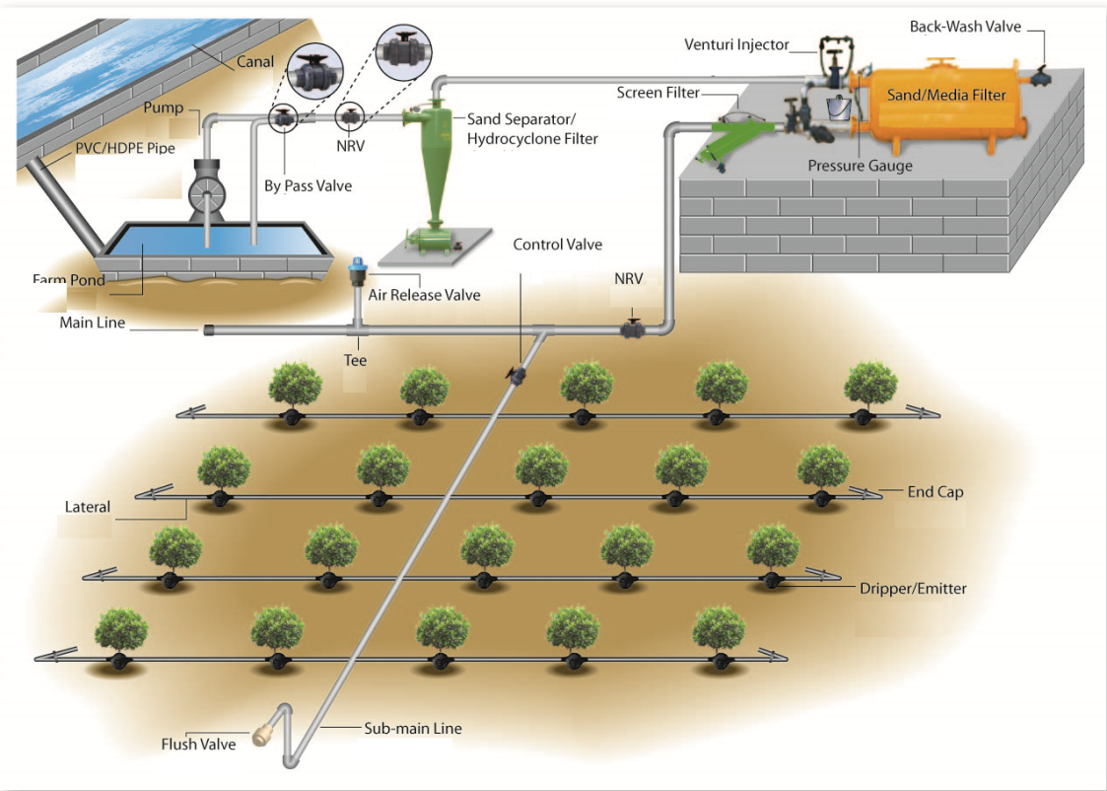

Figure 1‑1: Surface drip system

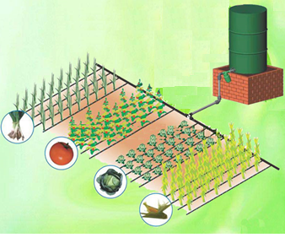

Figure 1‑2: Typical family/gravity drip system

**Subsurface Drip Irrigation (SDI)** is the irrigation of crops through buried lateral pipes containing embedded emitters located at regular spacings. There are a wide variety of configurations and equipment used, however drip tubes are typically located 15 to 25 cm below the soil surface. SDI is most widely used for the irrigation of both annual row crops, and field crops in the USA and for permanent crops in Israel. Due to the high initial cost and intensive management requirement, its adoption has, however, proceeded slowly. Despite this, the system is being introduced in Ethiopia for production of sugarcane for the new sugarcane factories.

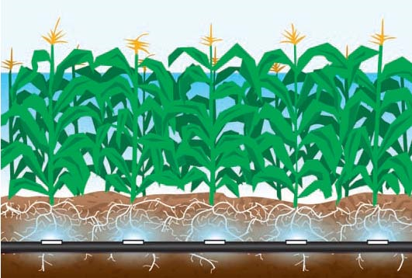

Figure 1‑3: Subsurface drip system

**Bubbler system**is a system ofwater application to the soil surface using a small stream or fountain through a device called bubbler. It is relatively high volume irrigation. Bubblers are available in adjustable flow type and pressure compensating type.  Pressure compensating emitters are available in 2-, 4-, 6-, and 8-lpm flow rates. Adjustable flow bubblers are adjusted for flows between 0- and 8-lpm. They are more durable than drip emitters and are less likely to plug.The system is suitable for controlled irrigation of trees having high water requirement. This system is not however popular.

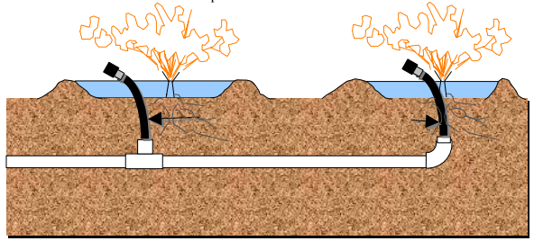

Figure 1‑4: Bubbler irrigation

## components of drip irrigation system

Components that are usually required for drip irrigation systems include the pumping unit, control head, distribution lines (main, submain manifold and lateral pipes), emitters, valves, fittings, and other necessary appurtnances.

1. **Pumping unit:** Pump is required to create sufficient head in the drip system. Centerfuigal pumps are generally used in drip system for surface water sources and shallow wells.
2. **Control head.**The function of control head is to control, filter, and regulate flow and pressure within the system. It can be operated manually or automatic. The control unitincludes valves (gate valve, non-return valve, and air release valve), pressure regulators, pressure guage, water meter, filter and fertilizer injection equipment. The filters and fertilizer applicators are separately discussed in sections 1.8 and 1.9, respectively. The other components are briefly described below.

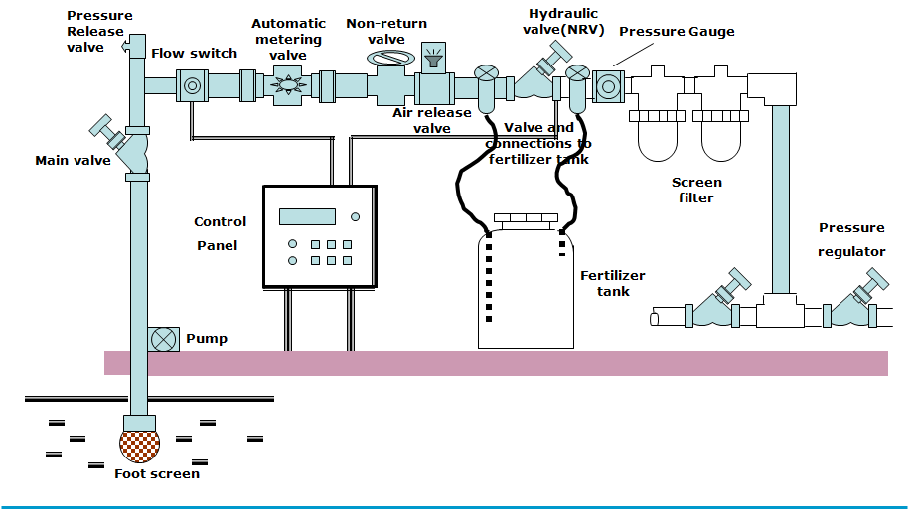

Figure 1‑5: A typical drip irrigation system control head components

1. **Valves:** The valves used at the control unit include:

* **Main valve or gate valve:** It is used to open and shut off the system.
* **Non-return valve:** This valve, at times of water cutoff, is essential for preventing the backward flow of water, that may contain fertilizer solution, into main supply system.
* **Air release valve:** This valve is located at the highest point of the system and is used to release air accumulating in the pipe system, which otherwise damages the pipes.

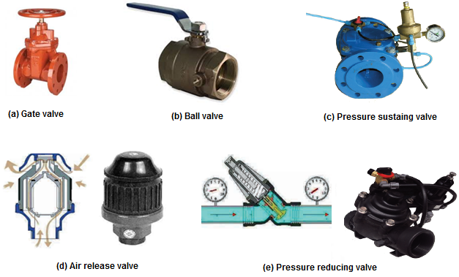

Figure 1‑6: Different types of valves used in drip system

1. **Pressure regulators:** They are used to regulate the pressure in the system to the required level. Regulators are usually required for a large scale system. In a small system, a simple bypass valve can be used for water pressure control in the pipe lines.
2. **Pressure gauge:**It is used to measure and monitor the pressure under which drip system is working in order to deliver the water uniformly. The most common pressure gauge used is the Bourdon gauge.

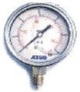

Figure 1‑7: A Bourdon type pressure gauge

1. **Water meter:**It is used to measure the volume of water delivered. The common flow meter consists of a casing containing a horizontal or vertical impeller. The impeller is rotated by the flowing water and transmits its rotational motion to a measuring scale mounted on top of the casing.

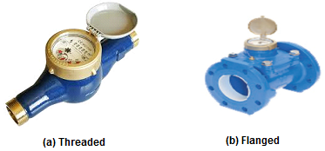

Figure 1‑8: A water meter

1. **Distribution lines:**This comprises of pipes of diffrent sizes starting with a single large main line followed by smaller diameter pipes as submain, manifold and lateral lines.
2. **Main and submain pipes:**They are usually rigid PVC or HDPE pipes to minimize corroision and clogging. PVC pipes are made with class 4 to 16 and come with sizes ranging from 32 to 400mm (Fig 1-9a,b).. HDPE pipes are mades with class 4 and 6, and come with sizes ranging from 25 to 110mm. Class refers to the maximum pressure that the pipe can resisit without failure. For example, class 4 means, the pipe can operate upto a working pressure of 40m.This variation is due to the thickness of the pipes (see Appendix III and IV). They are permanent and are generally laid 45 to 65cm below the ground. Both main and submain pipes are provided with flush valves at the outlets to occasionaly flush the pipes to remove the sediment deposits.
3. **Manifolds**: They are black HDPE pipes with class4or 6and are usually with commercially available diameter of 32, 40, 50, 63 and 75mm (Fig 1-9b). This pipe may be absent in small system like the family drip as the laterals are directly connected to the submain pipes.
4. **Lateral lines**:They are made of soft black LDPE with nominal pressure (PN) of1.0-4.0bars (i.e. 10m to 40m head) but ususally come with PN of 2.5 and 4 (Fig 1-9c). They are commercially available with diameters of 12mm, 16mm and 20mm. Laterals are fitted to the manifolds with small connector fittings at fixed positions and laid on the surface along the plant rows. They are equipped with closely spaced dripper emitters or emission outlets. The lateral pipes are purposively made black to discourage growth of algae and other organic contaminants (don’t allow light to enter the tubing). They are also made to have ultraviolet light (UV) protection to prevent rapid deterioration from exposure to sunlight. Each lateral line is connected either the submain line or the manifold.

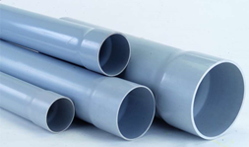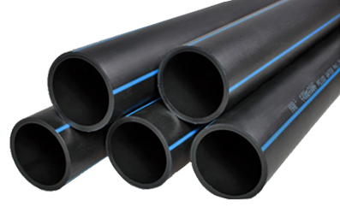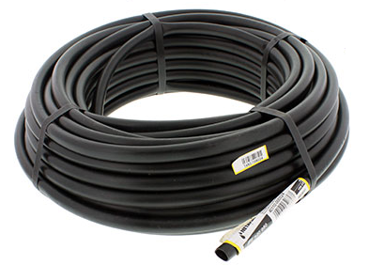

**a)uPVC pipe (b) HDPE pipe (c) Lateral pipe coil**

Figure 1‑9: Pipes used in drip irrigation

1. **Emitters/drippers:**they are water applicators or emission devices which are placed at regular or desired spacing on the laterals.The basic purpose of water applicators in drip irrigation systems is to dissipate energy. This is because lateral pressures must be high enough to provide adequate uniformity, yet emitters must yield small flow rates. Drippers of various discharge capacitities are available on the market but commonly availble capacities are 2lph, 4 lph, 8 lph and 16 lph. Drippers could be online (point source) which are affixed at desired spacing (Fig 1-10a)., or inline (line source) which are extruded at desired spacing during production of lateral pipes(Fig 1-10b). The online drippers are widely used for fruit crops. The inline drippers are primarily used on vegetables and other closely spaced crops. Some emitters have flushing, or continuous flushing features to help prevent clogging while still having small flow rates. Some other emitters have pressure compensating features to provide a more constant flow rate over a range of operating pressures. These emitters are particularlyused when the lateral pipes are laid on very slopy lands.

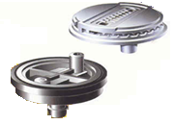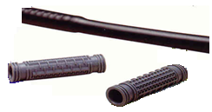

1. **Online dripper (b) Inline dripper**

Figure 1‑10: Types of drippers according to their connection to lateral

1. **Valves, fittings and other accessories**. Apart from those on the control unit, there are small valves that are provided on divisions of several irrigation plots to control the flow water. These valves can be manually operated or automated. Valves for flushing at ends of manifolds and laterals are often manually operated. Additionally, air release valves are also used at the higher points of the system to avoid water hammer. Connectors which are appropriate to connect pipelines to regulating and control devices, and pipe of the same or different diameters are used ((Fig 1-11). Accessories such as end cap and hole plug are also used. Fittings such as take off to connect lateral with submain; joiner to connect same size lateral pipes.

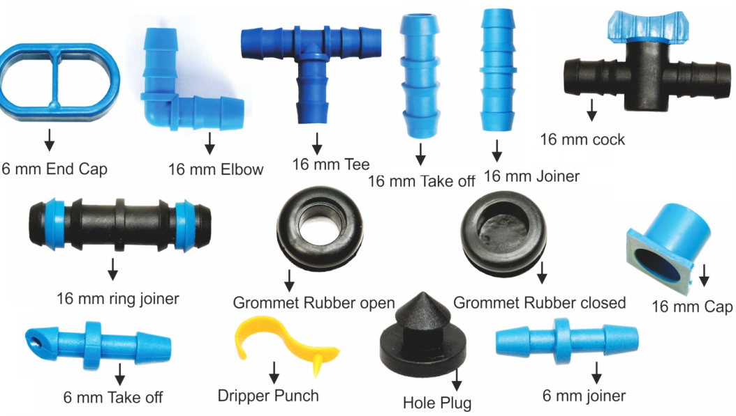

Figure 1‑11: Connectors and accessories used in drip system

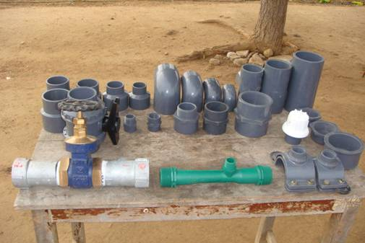

Figure 1‑12: Drip irrigation valves and differentPVC fittings

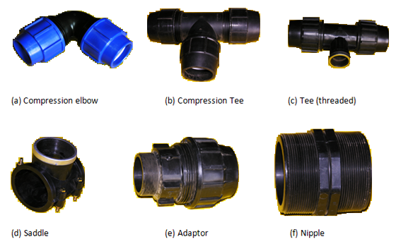

Figure1‑6: Different types of PE fittings

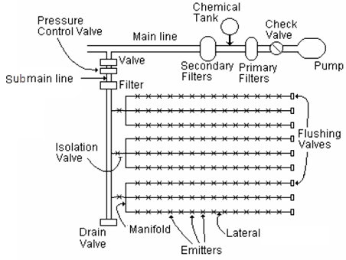

Figure 1‑7: A typical drip system layout with various of its components

***Key Note:*** *Not all drip systems have all of the above components. The types of components suitable for a given system depend to a certain degree upon the type of system being considered. There are also different arrangement in the layout of drip system depending upon the scale of use. Thus,*

*- Some systems may be gravity-fed and require no pumping.*

*- Simple systems like family drip systems may not have submains and manifolds; laterals*

*are directly connected to the main pipe.*

*- Some systems may not have pressure regulators or other types of safety valves.*

*- Systems with relatively dirty water may have multiple levels of filtration while others*

*may have only minimal screening.*

## filteration in drip irrigation system

### General

Water for drip irrigation systems may come from open reservoirs, canals, rivers, groundwater, municipal systems, and other sources. These sources may have some form of solid contaminants. Solid contaminants can include both organic and inorganic matter. Examples of inorganic matter are sand, silt and clay (soil particles), and trash floating in the water. Examples of organic matter are bacteria, algae, weeds & weed seeds, insect larvae, snails, and others.

Solid contaminants need to be removed from drip irrigation systems because theycause clogging of emitters, which can lead to serious water deficits and non-uniformity of the applied water. They may also cause wear on pump impellers, emitter outlets, and other hardware. In some cases they can provide nutrients which support the growth of bacteria in the pipes.Groundwater usually requires less filtration than surface water, but even groundwater should be filtered. The maximum allowable particle size in drip irrigation water is usually between 0.075 mm and0.2 mm, so the water must be quite clean.

Filtration is almost always complemented by the injection of various chemicals into the water to help prevent clogging due to bacterial growth and precipitation of solids from the water. Solid particles smaller than emitter outlets can cause clogging when they bridge at the opening (see Fig. 1.8). It is recommended to remove all particles larger than 1/10 of the minimum outlet diameter for drip emitters.

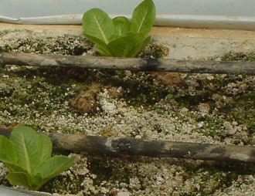

Figure1‑8: Emitter clogging

### Pre-filteration

**i) Use of reservoirs**

In addition to buffering differences in supply and demand rates, reservoirs are often used in drip system:

1. To allow for settling of some of the suspended particles. In this case, the reservoir serves as a “settling basin”. Precipitated sediment can be periodically removed from the reservoir with equipment or manual labor.
2. To aerate water pumped from wells, thereby oxidizing and precipitating manganese and iron out of the water (some groundwater has manganese and iron, and these can cause plugging of emitters).
3. To allow for air to escape when the water comes from a “cascading” well, in which air becomes entrained into the water. Air in pipelines can dampen the effects of water hammer, but also causes surges and blockages of flow.
4. To allow oils to collect on the water surface. Oils can cause rapid clogging of most types of filters, requiring special cleaning with solvents and possible replacement of sand media. When pumping from a reservoir the inlet is below the water, and oil does not enter.

**ii) Pre-screening devices**

Screens are provided at the suction pipe of a pump to prevent fish, large debris and trash from entering the pipe system, upstream of the other filtration devices. Screening devices often have “self-cleaning” features, otherwise they can clog up rapidly.

### Filters

Filter is an essential component of the drip system. Filter is used to minimize or prevent inflow of possible suspended material in the water to the pipe line and drippers. The type of filter needed depends on the water quality and the operating pressure of the drip system. There are four common types of filters used in drip system, namely sand filter, screen filter, hydrocyclone filter and disk filter.

**a) Sand separators/hydrocyclone filters:** They are used to remove sand (but not organic matter) from the water. Most work by spinning the water in an enclosed column (or cone) to remove sand through a centrifuge-type action. The centrifugal forces cause the sand to move to the outside edge of the cylinder and then collect at the bottom of the tank. It can remove 70 to 95% of dense particles that are heavier than water. But sand separators cannot remove all of the sand, and may pass large amounts when the system is starting or stopping. Thus, screen filters should be installed downstream.

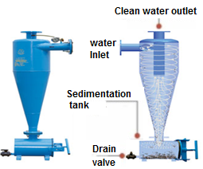

Figure 1‑9: Hydrocyclone filter

**b) Sand /media filters:** These types of filters are tanks filled with sand, or some other particles such as crushed granite.These filters are very good for removing relatively large amounts of organic and inorganic matter. Some silt and clay particles can also be removed by sand media filters, but not by most screen-type filters. However, much silt and clay can pass through a media filter too.

Back-flushing is required to clean the tanks. Back-flushing can be performed manually orautomatically, based on elapsed time and/or on a pressure differential limit across thetanks. Automatic back-flushing is recommendable, because labor is not always reliable.

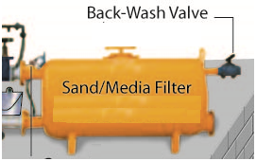

Figure1‑10: Sand/media filter

**c) Screen filters:**These are conventional type of filters, with two-dimensional surfaces and little capacity to accumulate debris. There are many different kinds and variations of these filters. They are primarily used as backup (safety) filters downstream of the primary filters (media and hydro-cyclone filters). Screen filters are very common and usually the least expensive type of filter. If the screen becomes dirty and is not cleaned, the pressure differential can become great enough to burst the screen. Or, the screen may stretch until the openings expand enough to pass some of the debris (which is not desirable). Flow through the filter is usually from inside to outside (debris is trapped on the inside surface during operation) to prevent collapse of the screens. Thus, the screens need to be regularly cleaned. Screen filters can be washed by hand or automatically flushed with water. Manually-cleaned filters can have slow or quick release cover latches.

**d) Disc filters:** They are similar to screen filters, but they use tightly packed plastic disks for the filter media, with a deeper filter area. It holds more contaminants than a regular screen filter without clogging. They are often installed in banks (several filters in parallel). They often have automatic back-flushing features. The disks can also easily be cleaned by unshackling them and washing by hand. These filters are not designed to remove sand from the water (sand gets stuck in the grooves). They can efficiently remove organic matter but they can have clogging problems with some kinds of stringy algae.

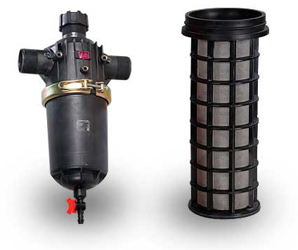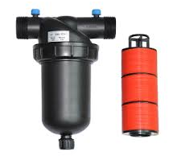

(a ) screen filter (b) Disc filter

Figure 1‑11: Secondary filters

Table 1‑1: Selection criteria for filters in drip system as per the causes of clogging

| **Causes of Clogging** | **Contamination of water** | **Criterion for selection** | **Type of Filters\*** | | | |
| --- | --- | --- | --- | --- | --- | --- |
| **Hydrocyclone** | **Sand** | **disc** | **Screen** |
| Soil Particle size | Low | ≥0.2mm | A | B |  | C |
|  | High | <0.2mm | A | B |  | C |
| Suspended solids | Low | ≤50mg/l |  | A | B | C |
|  | High | >50mg/l |  | A | B |  |
| Algae, organic material | Low |  |  | B | A | C |
|  | High |  |  | B | A | C |
| Iron and Manganese | Low | ≤0.5mg/l |  | B | A | A |
|  | High | >0.5mg/l |  | A | B | B |

* A = the recommended alternative; B = the second choice; C = the third choice

Table 1‑2: Recommended type of filters as per the source of water

|  |  |
| --- | --- |
| **Source of water** | **Contamination of water** |
|
| Municipal Water System | Screen Filter, Hydrocyclone Filter, or Disk Filter |
| Shallow well | Screen Filter, Hydrocyclone Filter, or Disk Filter |
| River | Disk Filter, Media Filter and Screen Filter, Hydrocyclone and Media Filter |
| Pond or lake | Disk Filter, Media Filter and Screen Filter, Hydrocyclone and Media Filter |
| Spring or artesian well | Screen Filter, Hydrocyclone Filter, or Disk Filter |
| Organic material in water | Disk Filter, Media Filter and Screen Filter, Hydrocyclone and Media Filter |
| Sand in water | Screen Filter, Hydrocyclone Filter, or Disk Filter |

## fertilizer and chemicalapplicators

Drip irrigation system allows simultaneous application of liquid fertilizers and chemicals to be applied with irrigation water. These applications are technically termed as fertigation and chemigation, respectively. Fertilizer application through the system requires an additional device in the system. Generally, fertilizers are injected into the system by using any of the three prinicpal devices namely, (1) the venturi pump; (2)the injection pump; and (3)fertilizer tank (the by-pass system). With the same system, chemical tanks are used to inject systemic insecticides, and algaecides into the irrigation water. Fertilizer and Chemical injection devices are installed upstream of filters to prevent system clogging. The tanks and valves are often plastic to avoid corrosion and freeze-up.However, for small land holdings, the fertilizer injector is not always needed, as many farmers prefer to apply granular fertilizer manually.

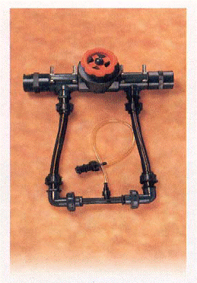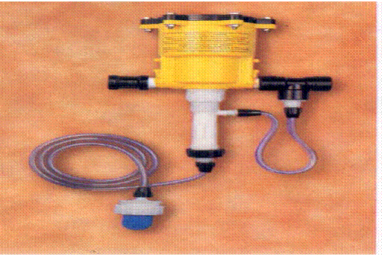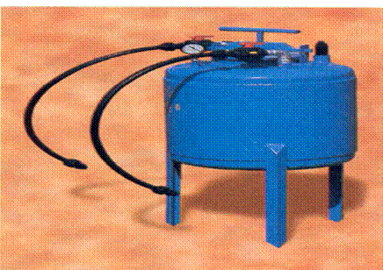

**a) Venturi pump b) Fertilizer pump c) Fertilizer tank**

Figure 1‑12: Fertigation equipment

# Design of Drip System

Water requirement of the plant per day is an important element in drip irrigation. To apply this required amount of water uniformly to all the plants in the field, it is essential to properly plan and design the system. Particularly, the focus of drip system design is toapply water to meet peak crop water requirement, maintain application and uniformity efficiencies at a desired level, get energy and water efficient system to keep initial capital and operation cost as low as possible, and make the system simple in operation and maintenance so that farmers can use the system without extensive training

## the design process

The design of drip system require the following two stage process:

* Preliminary design
* Detail design

The step-by-step design procedure for the system at the two stages is enumerated below. Further, design calculator is prepared in Spreadsheet which can be found in the accompanied CD.

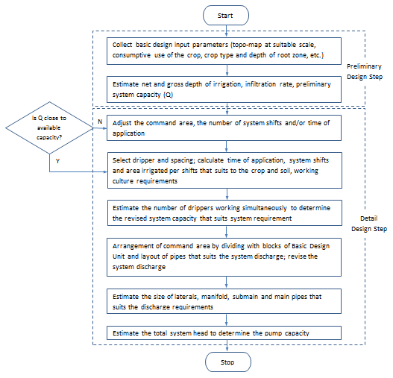

Figure 2‑1: Design porcess for a small scale drip system

### Preliminary design of drip system

It is an important step for system design. It is the stage of field data collection, and determination of basic design parameters that will be needed as inputs in the detail design stage.

#### Field data collection

The first step in the design of drip system is to make the resource inventory and operating conditions of the area and collect basic information for design. This includes:

1. Topographic map of the area at a scale (usually 1:1000 to 1:2500 with 1m or 0.5m contour-line intervals) that shows all physical features including the locations of the water sources, existing infrastructures, drainage outlets, marshy areas, existing irrigation schemes, settlements, land holdings (private/ cooperatives), other development activities and the like.
2. The basic climatic data such as temperature, humidity, wind speed, daily sunshine hours and rainfall are required to decide the evapotranspiration demand in the area. This may alternatively be obtained from agronomic data.
3. Water source (location, quantity, quality, period of availability). The available head, maximum available flow rate at the supply points and supply hours have to be defined. The quality of water shall be suitable for irrigation. Particularily, the level of salinity has to be defined to decide on the requirement for leaching of salts accumulated in the root zone of the soil.
4. The major crops to be grown and their characterstics such as effective root zone, peak consumptive use rate and its occurrence and the allowable moisture deficit.
5. Soil type and its charactrestics such as infiltration rate and water holding capacity.

**Note:** Data may be collected using the data collection form shown in Appendix III

#### Determination of basic design parameters

Once the basic data are at hand, the following basic parameters to suit to the detail drip system design and operation will be determined.

* Percentage of wetted area
* Depth of irrigation
* Emitter spacing
* Emitter discharge
* Emitter selection
* Preliminary system discharge

**I. Perecentage of wetted area, Pw:** drip irrigation system normally wets only a portion of the horizontal and the cross sectional area of a soil. The percentage of wetted area, Pw compared with the entire cropped area depends on the volume and rate of the discharge at each emission point, the spacing of the emission points and the type of the soil which is irrigated. It is an important factor to determine the spacing and discharge of emitters.

Pw of a lateral is the ratio of the width of the wetted area measured at a depth of 30cm beneath the emitters to the spacing between laterals. Pw ranges from 33% to 100%. For crops like vegetables, the perecentage of wetted area may be taken as 100%. But for fruit trees like orchards, since they are planted at wider spacing, Pw is normally 33% to 67%and is claculated by:

 ---- (2.1)

Where,

|  |  |
| --- | --- |
| PW = | Percentage of wetted area |
| Np = | Number of emitters per tree |
| W = | width of the wetted area |
| SL = | Spacing between laterals |

Further, for known emitter discharge, the empirical relationship shown in Figure 2-2 may be used to find the wetting diameter for different textured soils. From this value, the Pw may alternatively be found by the relationship:

 ---- (2.2)

Where,

|  |  |
| --- | --- |
| PW = | Percentage of wetted area |
| SL= | Spacing between laterals, m |
| Se = | Spacing between emitters, m |
| WD = | Wetting diameter, m |

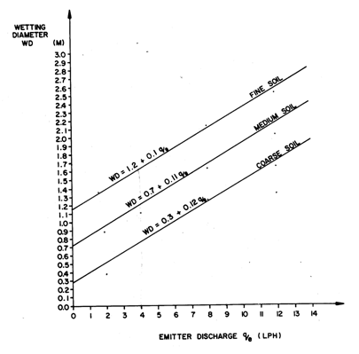

Figure 2‑2: Empirical relationship between wetting diameter and emitter discharge

**ii. Depth of Irrigation** - Daily application is recommended in drip irrigation. Thus, the depth of irrigation is taken equal to the daily consumptive use of the crop. As a result, the gross depth of application for crops in drip irrigation is determined by:

 ---- (2.3)

Where,

|  |  |
| --- | --- |
| ETt = | Gross depth of application, mm/day |
| ETc = | Maximum daily consumption of the crop, mm/day |
| PW = | Percentage of wetted area, % |
| Ea = | Application efficiency, % (usually 90%) |

In the absence of information on the percentage of wetted area, ETt can be alternatively calculated from estimated perecntage of the total area shaded by a mature crop, P as:

 ---- (2.4)

Leaching is necessary if the irrigation water and/or the saturation extract of the soil contains excess salts. However, in drip irrigation, extra leaching with increased quantities of water at every application during the irrigation season is not recommended unless salt accumulation reaches hazardous levels. Leaching should take place after the crop harvest, between irrigation seasons, where the salt content is excessive and the rainfall is not sufficient. It is done either by flooding the area or by low precipitation sprinklers. However, if desired, the leaching requirement, LR under drip irrigation is determined by:

 ---- (2.5)

Where,

|  |  |
| --- | --- |
| LR = | The Leaching requirment, fraction |
| ECw = | the electrical conductivity of the irrigationwater |
| (ECe)min = | the 100% yield threshold value for salinity of the soil extract. |

For further on leaching and leaching requirment , the reader may refer section 8 of GL5 on Soil survey and land suitability.

The leaching ratio increases the depth to apply by 1/(1-LR). That is, salinity of the soil extract, ECe, is measured by taking a soil sample to the laboratory, adding pure water until the soil is saturated, then measuring the electrical conductivity. (ECe)min is for 100% yield.

Thus, the gross depth of irrigation water, ETt is calculated by:

For LR≤0.1, ---- (2.6a)

For LR≥0.1,  ---- (2.6b)

Where,

|  |  |
| --- | --- |
| d = | Gross depth of irrigation, mm/day |
| Ea = | Application efficiency, % |

**Worked Example 1:**Determine the gross depth of irrigation for drip system with the following data:

* Location: Raya
* Water Source: Borehole (ground water)and good quality
* Crop: vegetables
* Maximum daily water requirement: 5.4mm/day
* Soil: Deep clay and moderately drained
* Application Efficency: 90%

**Solution:**

Since the crops to be irrigated are vegetables, Pw can be taken as 100%. As the water quality is good for irrigation, leaching is not required. Thus, the gross depth of irrigation is:



**iii. Emitter Spacing -** the spacing between emitters in a row and between rows depends on crop spacing, soil type and infiltration data, and also incorporating other practical experiences. Generally, closer spacing is provided on sandy soil and wider spacing on clay soil as the soil texture affects the lateral soil water movement (Fig. 2.3). In close growing vegetable crops like onion, 30 to 40cm dripper spacing is generally recommended. But in wider spacing crops, the dripper spacing along rows is kept equal to the plant spacing. In tree crops, the dripper spacing is kept with the plant spacing but the number of drippers to be provided per plant may be more than one depending upon the water requirment of the crop.Table 2.1may be used as guide in the absence of any information or experience on spacing of emitters.

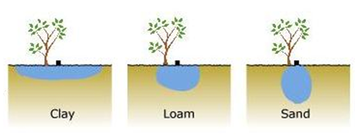

Figure 2‑3: Wetting pattern under different soil types

Table 2‑1 : Diameter of coverage of emitter on different soil types

|  |  |  |  |  |
| --- | --- | --- | --- | --- |
| **Soil Type** | | **Sand** | **Loam** | **Clay** |
| Emitter Distribution | |  |  |  |
| Infiltration Rate | mm/hr | 19 – 32 | 6 – 19 | 4 – 6 |
| Diameter of coverage | m | 0.30–0.91 | 0.60–1.20 | 1.0–1.80 |
| Available Water | mm/m | 0.11 | 0.16 | 0.20 |

**iv. Discharge of Emitter -** the discharge of an emitter for a given spacing of the crops in a row and between rows is determined by:

 ---- (2.7)

Where,

|  |  |
| --- | --- |
| q = | discharge, lit/hr |
| Sr = | Spacing between crops in a row, m |
| Sl = | Spacing between rows, m |
| nc = | Number of emitters per crop, m |
| Ta = | Time of application, hours |

The command area may be required to irrigate in shifts. The time of application per shift, Ta in this case will then be calculated from the available maximum working hours per day (see Worked Example 2).

**Worked Example 2:** Determine discharge of an emitter in a drip system with the following data:

* Crop: vegetables
* Irrigation Area: 30ha
* Gross depth of irrigation: 6mm/day
* Spacing between emitters: 0.5m
* Spacing between laterals: 1m
* Maximum working hours per day: 16hrs
* Area irrigated at a time: 6ha
* Time of irrigation application: 4hrs
* Number of emitters per crop: 1

**Solution:**

Since the area irrigated per shift is 6ha, the number of shifts per day is worked out to be:



Then, the time of irrigation application per shift is:



Now, the emitter discharge can be calculated using eqn. 2.7 as:



Since the minimum commercially available emitter discharge is 2lit/hr, time of application is adjusted accordingly,



**v. Emitter Selection -** the selection of an appropriate emitter requires a combination of objective and subjective judgments. To select a specific emitter, the soil type, required discharge according to the system, plant spacing and other planning factors such as the number of emitters used per crop will be considered. For discharge of an emitter known from equation 2.7, selection is made from the manufacture’s catalog. The discharge of commercially available emitters are expressed in terms of operating pressure head by the power curve equation of the form:

 ---- (2.8)

|  |  |
| --- | --- |
| q = | discharge of selected emitter, lit/hr |
| h = | Operating pressure head of the emitter, m |
| k = | Discharge coefficient, constant |
| x = | Exponent, constant |

Therefore, the operating pressure of the selected emitter for required discharge can be obtained from the above equation.

Commercially, emitters with discharges of 2, 4, 8, and 16 lph are available. Emitters among these are selected with consideration of the infiltration rate of the soil. If discharge of the selected emitter is different from the calculated discharge in equation 2.7, then adjustment will be made on the time of application.

**Worked Example 3:** From manufacturer’s catalogue, a medium long-path emitter with k = 0.00131 and x = 0.63 is selected. For emitter discharge of 2 lit/hr(= 0.0056 lit/s), determine the average operating pressure head of the emitter.

**Solution:**

Substituting the values of q, k and x in equation q = khx, the average operating pressure of the emitter can be found. To solve , the characterstic equation will first be transformed into logarthimic form as:





The average operating pressure head, h is then found as 10m

***Key Note:***

*- The emitter is so selected that application rate equals to or less than the absorption rate of*

*soil.*

*- Sometimes, a loop with 3 to 4 emitters is placed around each plant to provide the required*

*wetted area. This should be away from the plant stem.*

*- If single emitter is provided, it must be placed 15-30cm from the base of the plant.*

**vi. Prelimnary Capacity of Drip System** – the system capacity of a drip system is preliminary estimated based on the depth of irrigation, the area desired to be irrigated and the time of application as:

 ---- (2.9)

Or, for known system discharge the net area that can be irrigated per day is:

 ---- (2.10)

Where,

|  |  |
| --- | --- |
| Q = | System discharge, lit/sec |
| ETt= | Gross depth of irrigation, mm |
| A = | Cultivated area, ha |
| Ta= | Application time, hr |

**Worked Example 4:** Given the following information.

* Crop: vegetables
* Gross depth of irrigation, ETt: 6mm/day
* Time of irrigation application: 1.5hrs

a) Determine the discharge required to run the system if the area of irrigation unit is 6ha

b) What is the maximum area that can be irrigated with a system discharge of 108m3/hr?

**Solution**:

1. From the given data, the system capacity can be calculated using eqn. 2.9 as:

b) Using the same equation for A with Q=108m3/hr or 30 lit/sec



### Detail Design of Drip System

After the basic design parameters are determined, the detail design of drip system will take place. The detail design refers to the layout and engineering estimation of the sizes of the distribution system including the power requirement to run the system. For detail design, the following terminologies need to be clear first.

#### Important Terminologies in Drip Irrigation System Design

***Pressure:***a force required to push water through a given cross-section of pipe, expressed in units of kg/cm2, bar or atmosphere.

***Water head:*** the pressure at the base of a water column, expressed in meter units. A head of 10m is equivalent to a pressure of 1 atm.or 1 bar.

***Water discharge (flow rate):*** the amount of water that flows through a certain cross-section per unit time. The common units of discharge in metric units is m3/hr or lit/sec.

***Dripper spacing:*** the spacing between the drippers along the laterals.

***Lateral spacing:*** the spacing between the laterals.

***Nominal pipe diameter:*** the diameter of plastic pipes which is expressed as the external diameter, in units of mm.

***Percentage of Wetted Area:*** the ratio of the width of the wetted area measured at a depth of 30cm beneath the soil surface to the spacing between laterals.

#### Detail Design Procedures

The detail design of drip system that suits small land holdings requires:

* Layout of the system
* Determination of length of pipes
* Determination of capacity of pipe lines and system capacity
* Sizing of pipes
* Determination of pump capacity

**i. Layout of The System**

Layout of drip system refers to deciding on the arrangement of main, submain, manifolds and lateral lines to connect water source with the planned crop in the area. Appropriate layout of drip system is important to attain adequate and uniform distribution of water. The field layout shall be developed on the detailed map according to topographic nature of the area, and location of water sources.

The general rule in layout of the system is that laterals are laid along the general contour line as far as possible to minimize pressure variation. Manifolds are laid orthagonal to the laterals and preferably to downslope. Submains are laid along the contour line to supply water for irrigation blocks. And, in most cases the main pipes are laid across the contour lines starting from the source.

In small landholdings, for economic reasons, the layout of the field is made in such a way that each farmer or cluster of farmers will have responsibility for their equipments and overall management of the system. That is, valves are provided at inlet point of the manifold to control their farms. Thus, layout is made to have equal sized blocks of command area, which can get water from the same point on the submain called basic design Unit (BDU). The block will further be sub-divided into equal sized small operation-unit or plot units called subunit. The subunit will be determined based on the minimum land-holding size or based on the future manageable size arrangement, and the regional irrigation landholding policy. In many regions in Ethiopia, the smallest land holding size is taken as 0.5ha. In the layout, the spacings between the blocks along which the main and submain lines are running is taken as 6m and 4m for farm road, respectively. A spacing of 2m is kept between the pair of blocks. The spacing between the subunits is taken as 1m so that inspection of fields is possible.

Thus, the arrangement of the manifolds with the laterals is dictated by the topography and layout of the field. Figure2.4and Figure 2.5 are typicals of the layout of a drip system for small land hoIdings with four cluster of farmers each managing 0.5ha.

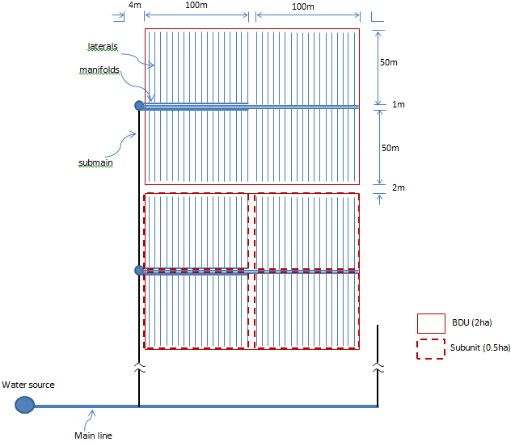

Figure 2‑4: Layout of drip system for cluster of small holding farmers (with lateral length of 50m)

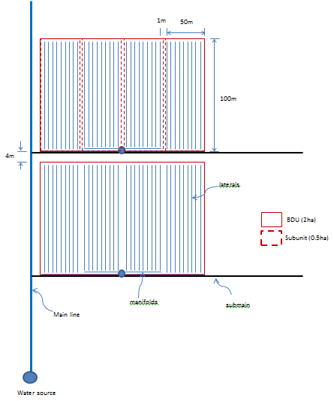

Figure 2‑5: :Layout of drip system for cluster of small holding farmers(with lateral length of 100m)

***Key Note:*** *An individual system can be installed for a farmer who has his own water source and large size farms. In this case, the size of blocks may be increased as desired and only one control valve will be installed at the connection point of the manifold in stead of four. Further, laterals can be connected to both sides of the manifold (see complete design sample 2.)*

**ii. Length of main line, submains, manifolds and laterals**

The length of main line is decided based on the location of the water source from the location of the first submain, and the spacings between the submains. Whereas, the submains, manifolds and laterals are decided based on the length and width of BDUs.

For example, for the layout shown in Fig. 2.4:

Length of submain line = (Ne-0.5)* W+ Ne*Wa,

where, Ne, and W are number and width of BDU, respectively, and Wa is width of access road between BDU

Length of short manifold = length of subunit

Length of long manifold = length of BDU+access road b/n subunits

Length of lateral line = width of subunit

**iii. Capacity of Main Line, Submain Lines, Manifolds and Laterals**

The inlet discharge of lateral is determined by multiplying the selected dripper discharge to the number of drippers installed on a lateral.

 ---- (2.11)

The inlet discharge of manifold is determined by multiplying the inlet discharge of lateral to number of laterals per manifold.

 ---- (2.12)

The inlet discharge of submainis determined by multiplying the inlet discharge of manifold to number of manifolds per submain.

 ---- (2.13)

The inlet discharge of main is also the system discharge which is determined by multiplying the inlet discharge of submain to number of sumains on the main line. This is true if the submain have the same number of blocks or BDUs. Otherwise, the system capacity will be the summation of inlet discharges of the submains. i.e.

 (if the submain have the same number of blocks) ---- (2.14a)

 (otherwise) ---- (2.14b)

Where,

|  |  |
| --- | --- |
| q = | Dripper discharge, lit/hr |
| nd = | Number of dripper on a lateral line |
| Ll= | Length of lateral, m |
| Sd= | Spacing between drippers |
| ql = | Flow carried by each lateral line, lit/hr |
| qma = | Flow carried by each manifold line, lit/hr |
| qsm = | Flow carried by each submain line, lit/hr |
| Q = | System discharge, lit/hr |
| nd= | Number of drippers per lateral line |
| nl = | Number of laterals per manifold |
| nma = | Number of manifold per submain |
| nsm = | Number of submain pipes on main line |

**iV. Sizing of Main Line, Submain Lines, Manifolds and Laterals**

An ideal drip irrigation system is one in which all drippers deliver uniform discharge. From practical point of view, it is almost impossible to achieve 100 percent uniformity due to the dripper flow variations caused by pressure variation along the lateral lines, manifolds, submains and main line. However, the flow variation can be reduced by proper hydraulic design. This requires first a good understanding of the hydraulics in multioutlet pipes like the case in drip system, which is briefly discussed below. After this briefing, the procedures for sizing of the drip pipes is presented.

**a. Concept of Pipe Hydraulics in Pressurized Irrigation System**

When water is flowing in pipes, it loses energy from friction of water with pipe walls and other components of the irrigation system such as fittings. These frictional losses are classfied into two categories. Losses which occur due to the friction of the water with the pipe walls is called as **major losses** (pipe friction or longitudinal friction loss), whereas losses which occur due to the turbulence of flow by other components of the system is referred as**minor losses**(local losses). The local losses are relatively smallbut should be taken into account in design

The frictional head losses in pipes are commonly found by Hazen-William’s equation or Darcy-Weisbach equation.

1. **Hazen-William’s Equation:**

 ---- (2.15)

1. Darcy-Weisbach Equation:

 (for small pipe, D<125mm) ---- (2.16a)

 (for large pipe, D>125mm) ---- (2.16b)

Where,

|  |  |
| --- | --- |
| J = | The head loss gradient, m per 100m length of pipe |
| L = | Length of pipe, m |
| Q = | Flow rate in the pipe, m3/hr |
| D = | Internal diameter of pipe, mm |
| K = | Conversion constant = 1.131x1011 |
| C = | Friction coeffiecient, which is a function of pipe material characterstics |
| K1 = | Conversion constant = 8.38x106 |
| K2 = | Conversion constant = 9.19x106 |

The Hazen-Williams equation was originally developed for pipes larger than 75mm in diameter. The user can employ Hazen-Williams equation for such size of pipes. But Darcy-Weisbach equation estimates better the head loss for all of pipes. Thus theuser is advised to use equation 2.16a for plastic pipes less than 125mm in diameter and equation 2.16b for larger plastic pipes where the diameter is wider than 125mm. In this guide, the Darcy-Weisbach equation is used.

Use of the above head loss equations might be tedious work unless a computer is used. Alternatively, the reader may use slide rules, nomographs or head loss charts which are presented inAppendices VII, VIII and IX, respectively.

Now, the reader needs to understand that flow of water through a closed /blind pipeline of a given diameter and length like the case in water supply system causes more friction loss than does flow through a pipeline with a number of equally spaced outlets which is the case in drip irrigation system. The reason for this reduction in friction loss is that the volume of flow decreases each time an outlet is passed.

Therefore, for computing head losses in multioutlet pipes, the friction head loss is done in two steps as follows.

* First, the head loss is calculated by assuming that the pipe is plain (without considering the outlets) using either equation 2.15 or equation 2.16.
* Then, it is multiplied by a factor called Christansen correction factor, F whose value can be read from table 2.2 for given number of outlets or can be calculated using equation 2.18.

Or simply, the head loss *hf* in a pipe with uniform spaced outlets is given by:

 ---- (2.17)

***Key Note:*** *For the number of outlets greater than 30, F value of 0.36 may practically be adopted.*

Alternative to Table 2.2, the first dripper is being located at a distance equal to the dripper spacing from the lateral inlet, the Christansen correction factor, F based on the number of outlets in the pipe, N can also be calculated from:

 ---- (2.18a)

Where,

|  |  |
| --- | --- |
| F = | Chritansen correction factor |
| b = | Flow exponent of the flow equation, for example b=1.852 in Hazen-William’s equation |
| N = | Number of outlets in a pipe |

Table 2‑2: Correction Factor, F for friction losses in plastic pipes with multiple outlets (Source: keller and blisener, 1990)

|  |  |  |  |
| --- | --- | --- | --- |
| Number  of outlets | F1 | F2 | F3 |
| 5 | 0.469 | 0.337 | 0.410 |
| 10 | 0.415 | 0.350 | 0.384 |
| 12 | 0.406 | 0.352 | 0.381 |
| 15 | 0.398 | 0.355 | 0.377 |
| 20 | 0.389 | 0.357 | 0.373 |
| 25 | 0.384 | 0.358 | 0.371 |
| 30 | 0.381 | 0.359 | 0.370 |
| 40 | 0.376 | 0.360 | 0.368 |
| 50 | 0.374 | 0.361 | 0.367 |
| 100 | 0.369 | 0.362 | 0.366 |
| F1 to be used when the distance from the lateral inlet to the first outlet is the regular outlet spacing S meters  F2 to be used when the first outlet is just by the lateral inlet  F3 to be used when the distance from the lateral inlet to the first outlet is S/2 meters | | | |

If the first dripper is located a distance of less than or equal to the dripper spacing, Se from the lateral inlet, the Christansen correction factor, F based on the number of outlets in the pipe, N can also be calculated from:

 ---- (2.18b)

Where, 

Drip system usually has the first dripper at a distance of ½Se from the lateral inlet (= 0.5). Under such condition, the Christansen correction factor, F based on the number of outlets in the pipe, N can be derived as:

 ----(2.18c)

**Worked Example5:** Compute the friction head loss in a drip lateral diameter of 16mm (Inner dia. =12.8mm)and length of 50m using Hazen Williams equation (C=150). Drippers with discharge of 4lit/hr are spaced at 0.50m and the first dripper is at regular spacing of drippers.

**Solution:**

The inlet discharge of the lateral is calculated by multiplying the number of drippers with the discharge of each dripper, q. The number of drippers is a function of the length of lateral, L and spacing between drippers, S.



First, the hydraulic gradient J for 100m length pipe is determined usng eqn. 2.16:



Then, for N=100 from table 2.2, F = 0.369. Thus, for L=50m lateral, the friction head loss hf using eqn. 2.17 is:



In addition to the frictional head losses in a pipe, there are local head losses due to a local disturbance in water flow. This disturbance in water flow happens anywhere equipment is attached to the system, such as a valve, filter, and pressure regulator and also in elbow and connection junction. The local head loss is proportional to the velocity of flow and is calculated as follows:

 ---- (2.19)

Where,

|  |  |
| --- | --- |
| hl = | Local head loss, m |
| K = | a constant provided by the manufacturer |
| V = | Velocity of water flow, m/s |
| g = | Accleration due to gravity, m/s2 |

K is a constant and its value depends on the way the equipment is made of. The reader need to see this value from the manufacturers’ catalogues. In the absence of any information, the values for K indicated in Appendix V for some common types of equipment may be used. It is usually taken in design as 0.2 percent of the operating pressure head of the emitter.Sometimes, however, the fittings may be expressed in equivalent length of pipes and the head loss for the length is calculated by the appropriate friction head loss equation.

**Worked Example 6:** What is the head loss occurring in a 250mm equal tee with the flow in the main pipeline at a flow velocity of 2 m/s?

**Solution**:

Here *K* = 0.40 for Tee fitting (see Appendix VIII); *V* = 2 m/s; *g* = 9.81 m/s



If the total system contains 15 tees under the same conditions, then the total head loss in the fittings is 15 x 0.08 = 1.2 metres

**b. Selection of size of pipelines**

Next, the sizes of the pipes in the system are decided in such a way that a satisfactory discharge uniformity between all the emitters in a system are achieved. The sizes of main line, submain lines, manifolds and lateral lines are selected as per the discharges carried through them and the friction head loss corresponding to these discharges.

1. **aterals and manifolds**

In drip system design, certain variation of emitter outflow along a lateral line is allowed. The design criterion is generally based on the emitter flow variation of less than 10% (20% pressure variation).However, for minimum variation, the criterion is applied to all the emitters connected in a subunit. In this case, 55% of the allowable head loss is allocated to the lateral and 45% to the manifold.

The sizing of the laterals, and manifolds are therefore decided based on these design criteria. Selection is normally done starting from the smallest commercially available sizes and going towards the successively larger size pipes until the criteria is met.

The step-by-step procedure for selection of lateral and manifold size is given below.

**Step 1.** Select a given commercially available size of lateral pipe (for LDPE class 4 pipe see Appendix V(a)).

**Step 2.** Assume the flow in the pipe through the entire length without dripper and determine the friction head loss.

**Step 3.** Multiply the friction head loss calculated in step 2 above by the correction factor obtained corresponding to the number of drippers on the lateral line.

**Step 4.** To step 3 above, add the elevation difference if the lateral goes uphill or subtract if it goes downhill.

**Step 5.** Check whether the head loss computed in step 4 is within the allowable limit of 55% of the 20% of the operating head of drippers. If it is within the limit, the size of the pipe diameter selected in step 1 above is acceptable. Otherwise, another value for the diameter of the pipe is selected and the steps 1 through 5 are repeated. When the value of head loss as obtained in step 4 is far less than the allowable value, then the next smaller size of pipe, from among the commercially available sizes, is considered. Otherwise, the next larger size is adopted and repeat the procedure until the condition is satisfied.

**Step 6.**Similarily, select a given commercially available size of manifold (for HDPE class 4 pipe see Appendix V(b)).

**Step 7.** Assume the flow in the pipe through the entire length without laterals and determine the friction head loss.

**Step 8.** Multiply the friction head loss calculated in step 7 above by the correction factor obtained corresponding to the number of laterals on the manfiold.

**Step 9.** To step 8 above, add the elevation difference if the manifold goes uphill or subtract if it goes downhill.

**Step 10.** Check whether the head loss computed in step 9 is within the remaining allowable head loss from the 20% operating head of drippers (If all the 55% were consumed by the lateral, it shall not be greater than 45%). If it is within the limit, the size of the pipe diameter selected in step 6 above is acceptable. Otherwise, another value for the diameter of the pipe is selected and the steps 6 through 10 are repeated. When the value of head loss as obtained in step 9 is far less than the allowable value, then the next smaller size of pipe, from among the commercially available sizes, is considered. Otherwise, the next larger size is adopted and repeat the procedure until the condition is satisfied.

Then, the inlet pressure heads of lateral and manifold pipe are determined by:

The pressure head at inlet of lateral:

 --- (2.20)

Where,

|  |  |
| --- | --- |
| HL = | Required pressure head at inlet of lateral, m |
| Ho = | Operating pressure head of emitter, m |
| hfL= | Frictional head loss in the lateral line, m |
| HzL= | Elevation head difference along the lateral (use + for upslope and – for down slopel), m |

The pressure head at manifold inlet is:

 --- (2.21)

Where,

|  |  |
| --- | --- |
| Hma = | Required pressure head at inlet of manifold, m |
| HL = | pressure at inlet of lateral, m |
| hfma = | Frictional head loss in the manifold, m |
| Hzma= | Elevation head difference along the manifold (use + for upslope and – for down slopel), m |

***Key Note:*** *Sincea drip irrigation system is made by a combination of different sizes of plastic pipes, which are considered as smooth pipes, the friction loss for the pipe lines is better computed from Darcy-Weisbach equation.*

**Worked Example7:**Low density polyethylene pipe (LDPE)lateral pipes arelaid on a level ground and are connected to HDPE manifold at a spacing of 1m. Each lateral hasa discharge of 0.2m3/hrand a length of 50m. It has drippers at spacing of 0.5m which has an operating pressure of 10m. What are the suitable sizes of the laterals and the manifold?

**Solution:**

As per the design criteria, the discharge variation of drippers shall be kept within 10% (or, pressure variation of 20%). Thus, the maximum allowable head loss is20% of the operating pressure head of emitters.i.e0.20*10m= 2m

This head loss is distributed b/n the lateral and manifold. 55% of it (=1.10m) is required to be in the lateral and the rest 45% (=0.90m) is desired to be in the manifold.

The number of drippers on the lateral is:



For N=100, the correction factor F from table 2.2 is 0.369

First, select the smallest commercially available diameter, i.eclass 4 and 12mm (ID= 9.4mm) and compute hf.

Using Darcy-Weisbach equation for small plastic pipes,



Then, the head loss hf for L=50m and F=0.369 is:



The head loss is greater than the allowable pressure head. Thus, increase the diameter to the next available size, i.e 16mm (ID=12.8mm).

Now, J for selected size of pipe is:



Thus, the head loss hf for L=50m and F=0.369 is:



This value is well below the allowable head loss. Thus, 16mm diameter of lateral is selected as suitable.

And, the remaining allowable head loss in the manifold is 1.49m (=2-0.51).

Now, the inlet pressure head of each lateral is:



1. **For manifold sizing,**

The number of laterals on the manifold is:



For N=100, the correction factor F from table 1.5 is 0.369

Discharge of manifold,



First, select the smallest commercially available diameter, i.e 50mm (ID= 45.6mm) and compute hf.

Using Darcy-Weisbach equation for small plastic pipes,



Then, the head loss hf for L=100m and F=0.369 is:



The head loss is well above the allowable head, 50mm is not suited.

Thus, thenext larger size is 63mm (ID=57.6mm) and compute hf



Then, the head loss hf for L=100m and F=0.369 is:



The head loss is still above the allowable head. Thus, 63mm is not suited.Thus, the next larger size is 75mm (ID=68.6mm) and compute hf



Then, the head loss hf for L=100m and F=0.369 is:



Now the head loss is below the allowable head and thus, manifold size of 75mm is selected.

Now, the inlet pressure head of the manifold is:



1. **Sizing of Submain and main**

The main and submain pipes are sized based on the flow velocity rather than the friction loss. However, considerations shall be given to economic size. That is, the friction loss shall not be too high to increase the energy costs. Larger size pipe might be desired to select without much reduction of the velocity.

Thus, the submain size is determined on the assumption that the flow in the pipe should not exceed 1.5-2m/sec to prevent pipe failure due to water hammer. Upon this criteria, the diameter of submain line can be fixed from the relation;

 ---- (2.22)

Where,

|  |  |
| --- | --- |
| qsm = | discharge of submain line, m3/s |
| V = | Allowable velocity of flow (1.5-2m/s), m/s |
| D = | Diameter of submain line, m |

Submain pipes can be designed to have 2 to 4 pipe diameters, tapered (telescoping) down toward the downstream end. For tapered submains, the smallest of the pipe diameters (at the downstream end) should be greater than about ½ the largest diameter (at the upstream end) to help avoid clogging during flushing of the submain. The maximum average flow velocity in each pipe segment shall be maintained less than 2 m/s.



Figure 2‑6: Tapered submain pipe

The step-by-step procedure for selection of submain size is given below.

**Step 1.** Select a given commercially available size for a given length of pipe (for PVC or HDPE pipe class 6 see Appendix V).

**Step 2.** From discharge capacity of the pipe calculate the velocity using equation 2.22.

**Step 3.** Check whether the velocity is within the allowable limit. If it is within the limit, the size of the pipe diameter selected in step 1 above is acceptable. Otherwise, another value for the diameter of the pipe is selected and the steps 1 through 5 are repeated. When the velocity as obtained in step 3 is far less than the allowable value, then the next smaller size of pipe, from among the commercially available sizes, is considered. Otherewise, the next larger size is adopted and repeat the procedure until the condition is satisfied.

**Step 4.** Calculate the frictional head loss using equation 2.15 or 2.16.

**Step 5.** If the frictional head loss is judged to be too high, the size selected in step 3 will be changed to the next larger size

**Step 6** Compute the velocity for the new size of pipe. If the velocity is found too low from the allowable lowest range, reject the size. Otherwise, accept and calculate the new friction head loss.

Then, the inlet pressure of the submain is then computed as:

 ---- (2.23)

Where,

|  |  |
| --- | --- |
| Hsm = | inlet pressure of the submain, m |
| Hma = | inlet pressure of the manifold, m |
| ∑hfsm = | total of the friction head loss in each segment of the submain pipe, m |
| Hzsm = | elevation difference between the two ends of the submain (+ for upslope and – for downslope. |
| Hrsm = | Height of riser pipe which connects submain with manifold, m |

**Worked Example8:** Two manifolds of 100m length are connected to a PVC submain at 102m apart. Each manifold has an inlet discharge of 20m3/hr and inlet pressure head of 11.21m. The submain is buried at 0.60m below the ground and connected with the manifold by a riser pipe. What is the suitable size of the submain if the two manifolds are operating simultanously? What is the pressure head required at the inlet of the submain?

102m

submain

Manifold 1

Manifold 2

20m3/hr

40m3/hr

100m

**Solution**:

The size of the submain can be computed using velocity method. As per the criteria, the velocity of flow in the pipe should be b/n 1.5 to 2m/s. Thus,

starting from the end of the pipe, for the 102m length, the discharge of the pipe is 20m3/hr.

If class 6 PVC pipe of 75mm (ID=70.4mm) is selected, the cross-sectional area of the pipe is:



Now, the velocity is:



Since the velocity is within the desired limit, the size may be taken as suitable for this segment of the pipe.

The next segment of the submain carries the discharge required by both the manifolds. Thus, its discharge is 40m3/hr. The length of this part of the submain is 100m.

Now, select class 6 PVC pipe of 90mm (ID=84.4mm). The cross-sectional area of the pipe for this size is:



Now, the velocity is:



Now, the velocity is within the allowable range. Thus, 90mm is a suitable size for the second segment.

To find the inlet pressure of the submain, the head losses in the two segments of the submain have to be worked out. Thus, using Darcy-Weisbach equation for small plastic pipes,

For 102m segment, Q = 20m3/hr and D=70.4mm



For L=102m,



Similarily, for 100m segment, Q = 40m3/hr and D=84.4mm



For L= 100m,



Thus, the total friction head loss in the submain is 2.71+3.77 = 6.48m

Thus, the inlet pressure head of the submain considering the riser height which connects the submain with the manifolds, and assuming that it is laid on level ground is:



Finally, the main line size is determined based on the total discharge required in the system, and velcoity of flow as in the case of submain line design (that is, follow same procedures like above) . But the discharge of the main pipe will be determined considering the block area of the system operating at a time. The velocity of flow in the main pipe is recommended to be within the range of 1.5-2.5m/sec. The main line can also have different size of pipes.

After the size is selected, the inlet pressure of the main line is computed as:

 ---- (2.24)

Where,

|  |  |
| --- | --- |
| Hm = | inlet pressure of the main line, m |
| Hsm = | inlet pressure of the submain, m |
| ∑hfm = | total of the friction head loss in each segment of the main pipe, m |
| Hzm = | elevation difference between the two ends of the main (+ for upslope and – for downslope. |
|  |  |

**Worked Example9:** Two submains of each carrying a discharge of 40m3/hr and inlet pressure of 18.29m are connected to a main line at 205m apart. The water source from the inlet point of the first submain is 200m. What are the suitable size and inlet pressure head of the main line if the two submains work simultaneously?

submain 1

submain 2

Main pipe

200m

205m

80m3/hr

40m3/hr

**Solution**:

The size of the main can be computed using velocity method. As per the criteria, the velocity of flow in the pipe should be b/n 1.5 to 2.5m/s.

Thus, starting from the end of the pipe, for the 205m length, the discharge of the pipe is 40m3/hr.

If class 6 PVC pipe of 90mm (ID=84.4mm) is selected, the cross-sectional area of the pipe is:



Now, the velocity is:



The velocity is within the allowable range. Thus, 90mm is a suitable size.

For the next 200m length, the discharge of the pipe is 80m3/hr.

If class 6 PVC pipe of 110mm (ID=103.2mm) is selected, the cross-sectional area of the pipe is:



Now, the velocity is:



This velocity is greater than the allowable range.

Now select the next bigger size, 140mm (ID=131.4),



Now, the velocity is:



The velocity is within the allowable range. Thus, 140mm is a suitable size.

To find the inlet pressure of the main line, the head losses in the two segments of the submain have to be worked out. Thus, using Darcy-Weisbach equation for small plastic pipes,

For the first 205m segment, Q = 40m3/hr and D=84.4mm



For L=205m,



For the next 200m segment, Q = 80m3/hr and D=131.4mm, the Darcy-Weisbach equation for larger plastic pipe (D>125mm) will be adopted. Thus,



For L=200m,



Thus, the total friction head loss in the main is 7.73+3.3 = 11.03m

Thus, the inlet pressure head of the main assuming that it is laid on level ground is:



1. **Determination of pump capacity**

Drip system requires energy to move water through the pipe distribution network. To create this energy, a pump is needed unless the system works by gravity like the family drip system. If the source of water is surface water or shallow well, a centerfuigal pump is used as it cheap, easy to install, operate and maintain.

After sizing of the pipe lines, the capacity of the pump that would be enough to deliver the required discharge of water at the desired pressure head will be determined by:

 ---- (2.25)

Where,

|  |  |
| --- | --- |
| HP= | the required pump capacity, hp |
| Q = | discharge required for the system, lit/s |
| H= | Total pumping head = Hm+Hs+hfs+hl+hc, in which Hma is the inlet pressure of main line; Hs is total static head; hfs isfriction head loss in suction pipe; hlfriction head loss in pipe fittings; andhc is local head losses in control head. |
| Ep = | efficiency of the pump, usually 75% |
| Em = | efficiency of the motor driving the pump, usually 80% |

The maximum system capacity, Q would have already been determined in the preceding design steps, based on the number of subunits (laterals and manifolds together) irrigated at a time, their sizes, emitter discharge and spacing, and number of emitters per plant.

The pumping head or the total dynamic head, H is the sum of static lift, pipe line losses (elevation and friction), control head pressure losses, losses to the critical subunit plus inlet pressure. The reader may refer guides on pumps and pump selection.

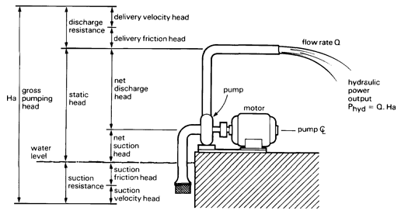

Figure 2‑7: Typical surface pump arrangment

***Key Note:*** *In the absence of any information, the friction head losses in fittings may be considered as 2% of the operating head of emitter, and the losses in the control head may be taken as 5-10m.*

**Solution:**

**Worked Exampleb10:** Determine the pump capacity for drip system with the following information.

* The water source: Ground water well
* Discharge, Q : 80m3/hror 22.22 lit/sec
* Total Static Head, Hs: 10m
* Inlet pressure of main pipe, Hma: 29.32m
* Head loss in control unit, hc: 5m
* Take 2% of the operating pressure head of emitter for local losses in fittings

From the given data, thepumping head is calculated as:



Now, the pump capacity from eqn. 2.13:



**A complete Design Example 1 (for cluster of smallholding farmers):**

Design a drip irrigation system for small farmers. The average land holding size of each farmer is 0.5ha. The system is to irrigate vegetable crops. The topographic map of the area (scale 1:2500 and countour interval of 0.5m) is shown below. The basic data collected from the field are the following.

* Location: Raya Valley, Tigray Regional State
* Water source: Ground Water (deep Well)labelled as WF0/BH5
* Safe Yield of the Well: 108m3/hr (or, 30 lit/s)
* Water quality: good for irrigation
* Irrigable area: 30ha
* Average maximum daily requirement of the common crops grown in the area: 5.4mm/day
* Soil: dominantly deep clay and moderately drained (Available water: 150mm/m)
* Maximum working hours per day: 17hrs
* Main and submain pipes are to be installed at 0.6m below the ground.

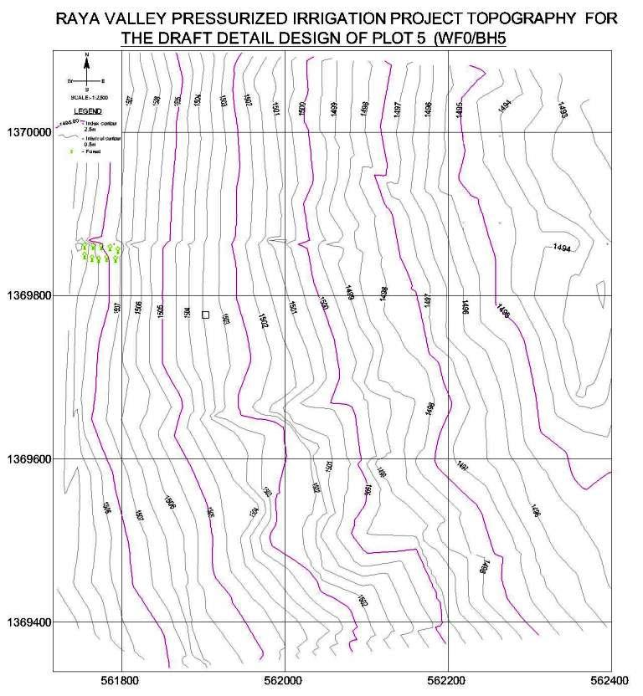

Figure 2‑8:Topographic map of the area (scale: 1:2500)

**Solution:**

**I. Preliminary Design:**

The first step for design is determination of the basic design parameters based on the given information.

1. ***Gross depth of irrigation:***Since the crops to be irrigated are vegetables, the percentage wetted area, Pw can be taken as 100%. The application efficiency for drip irrigation is usually considered as 90%. Further, as the water quality is good for irrigation, leaching is not required. Thus, the gross depth of irrigation is:



1. ***Emitter and lateral spacings:*** They are decided based on the row and plant spacing of the selected crops. For vegetable or close growing row crops, the usual recommendation 30 to 50cm between plants and 0.9 to 1m between rows. Thus, an emitter spacing of 0.50m and lateral spacing of 1m is taken for design.
2. **Emitter selection:** Since the soil is clay and moderately drained, it has relatively low infiltration rate. Thus, a dripper with 2lit/hr may be selected to suit with the infiltration rate of the soil. Accordingly, the time of application is:



1. From manufacturer’s catalogue, let us assume that such emitter is operated at 10m pressure head.

(Note: commercial emitters are usually manufactured to operate at a standard pressure head of 10m for the specified discharge)

1. The net area that can be irrigated per day with a safe yield of the well 30lit/sec is:



1. No. of shifts per day = Working hours per day/time of application per irrigation = 17/1.5=11.33, say 12shifts
2. Area irrigated simultaneously = total area irrigated per day/No. of shifts = 30/12 = 2.5ha.Therefore, 5 subunits are irrigated at the same time for 1.5hrs.

**II. Detail Design:**

The next step is the layout of the field and the distribution system to suit to the irrigation operation, and sizing of the pipe lines.

1. The first step for detail design is to layout the arrangement of the field and the pipe lines on the map depending upon the topography and the location of water source with exclusion of non-irrigable features such as villages and other existing facilities. Thus, the layout on the map with consideration of the following is laid out as shown in Fig. 2.8:

* The smallest irrigation unit of the system which is the manageable size of pressurized irrigation system by each farmer is fixed to 0.5ha. A 100m x 50m is adopted to fit the size.
* The BDU is taken as 2ha. So, with a sub unit of 0.5 ha, four operations selected for the system application.i.e Four farmers are clustered in a BDU but they can manage their own plots.
* The layout is based on the assumption that the irrigable area will be reallocated to farmers as per the manageable size and the beneficieries will be organized at Tabia level accordingly.
* The direction of the laterals are laid along the contour and the direction of the manifolds areorthogonal to the laterals and are laid downslope to minimize pressure variation.
* Five submains, each supplying to 3BDUS (3X4 subunits) are connected to the main line. This is to suit the irrigation supply to a subunit per shift by each submain.

1. The next step is sizing of pipe lines.

* Each lateral discharge = Number of dripper per lateral* emitter discharge

= (Length of lateral/spacing between emitters)* dripper discharge

= (50/0.5)*2=0.2m3/hr

* Each manifold discharge = Number of laterals*each lateral discharge

= Length of manifold/spacing between laterals*lateral discharge

=(100/1)*2=20m3/hr.

This discharge is also the discharge carried by each submain.

(Note: the first emitter on a lateral and the first lateral on a manifold is connected at a regular spacing of emitters and laterals, respectively).

**Selection of lateral size ,**

As per the criteria for design, Pressure variations within a subunit (100m x 50m), are to be limited to 20%. Since the selected pressure head at emitters is 10m, pressure variation within a subunit is to be limited to 2.0m. Actually, a maximum of 55% of this variation is expected to be between emitters in a lateral and the rest 45% in the submain.

Thus, first, select the smallest commercially available diameter, i.e 12mm (ID= 9.4mm) and compute hf.

Using Darcy-Weisbach equation for small plastic pipes,



Then, the head loss hf for L=50m and F=0.369 is:



The head loss is greater than 55% of the allowable pressure variation (=1.1m). Thus, increase the diameter to the next available size, i.e 16mm (ID=12.8mm).

Now, J for selected size of pipe is:



Thus, the head loss hf for L=50m and F=0.369 is:



The lateral is going 0.5m upslope. Adding this value to head loss, it becomes 1.01m. This value is below the allowable head loss. Thus, 16mm diameter of lateral is selected as suitable.

Now, the inlet pressure head of each lateral is:



(Note: The average elevation of the lateral is 0.5m upslope as observed from the map)

Selection of manifold size,

There are two manifolds used in the layout - short (100m) and long (200m)

* The number of laterals on the manifold is 100
* For N=100, the correction factor F from table 1.5 is 0.369
* Discharge of manifold,



First, select the smallest commercially available diameter, i.e 50mm (ID= 45.6mm) and compute hf.

Using Darcy-Weisbach equation for small plastic pipes,

* 

Then, the head loss hf for L=100m and F=0.369 is:



The shorter manifold has an average elevation advantage of 2.5m. Therefore, the net head loss is 7.71m-2.5m = 5.21m.

The net head loss is much greater than the allowable head loss. Thus, try with the next bigger size,

The next bigger size is 63mm (ID= 57.6mm) and compute hf.



Then, the head loss hf for L=100m and F=0.369 is:



Now, the net head loss is: 2.54m-2.5m = 0.04m.

Now, the head loss is less than the remaining allowable head (i.e = 2-1.01= 0.99m). Thus, a manifold size of 63mm is selected for shorter manifold.

For longer manifold, L=200m

If the size is 63mm, the friction in the first 100m blind pipe is 6.89m as calculated above and the next 100m is 2.54m. Thus, the total friction loss is 9.43. Since the manifold has an elevation (downslope) advantage of 4m, which reults in the net head loss of 5.43. It is well above the allowable head.

The next bigger size is 75mm (ID= 68.6mm) and compute hf.



Then, the head loss hf for L=100m and F=0.369 is:



Thus, the total head loss is: 3+1.11= 4.11m and the net head loss is 0.11m. This is below the allowable head loss in the manifold. Therefore, 75mm is selected for longer manifold.

Now, the inlet pressure head of the shorter manifold is:



(Note: The average elevation difference of manifold is 2.5m downslope as observed from the map)

Now, the inlet pressure head of the longer manifold is:



Thus, the inlet pressure is governed by the longer manifold. Flow or pressure regulation is required for shorter manifold.

Selection of submain size:

The submain size is determined on the assumption that the flow in the pipe should not exceed 1.5-2m/sec.

Since each of the five submains is carrying the same discharge 20m3/hr,if class 6 PVC pipe of 75mm (ID=70.4mm) is selected, the cross-sectional area of the pipe is:



Now, the velocity is:



This velocity is a bit smaller than the recommended lower range but it is better to keep this size to avoid high head loss by using smaller size. Thus, 75mm is selected for size of submain.

The inet pressure of each submain at block 3 and 5:

To find the inlet pressure of the submain, the head losses in the submain for the farthest manifold connection shall be worked out as:

Q = 20m3/hr and D=70.4mm



For L=263m (250m+6m access road along mainline+2x2m accesss road b/n BDU + 3X1m acesss road b/n subunits),



Since the submain is to be installed at 0.60m blelow the ground, a riser pipe is required to connect the submain with the manifold. Thus, the inlet pressure head of the submainconsidering this head is:



(Note: Average elevation difference = 1.5m upslope as observed from the map)

The inlet pressure of the submain at block 1:

For Approx. L=384m (263+121):





Sizing of main:

For the first 206m, Q= 2*20 = 40m3/hr:

If class 6 PVC pipe of 90mm (ID=84.4mm) is selected, the cross-sectional area of the pipe is:



Now, the velocity is:



Since the velocity is within the recommended limit, 90mm is selected as suitable.

Friction head loss in this segment (Q=40m3/hr, D=84.4 and L=206m) is:





Inlet pressure at this pipe (which is also the inlet pressure at submains for block 2 and 4) is:



This pressure is the governing pressure. Thus, it is the inlet pressure of submains supplying for block 2 and 4.

(Note: elevation is 4.5 downslope as observed from the map)

For the next segment (L=85m), Q= 80m3/hr:

If class 6 PVC pipe of 110mm (ID=103.2mm) is selected, the cross-sectional area of the pipe is:



Now, the velocity is:



Since the velocity is a bit above the recommended limit, it may be taken as a suitable size.

Friction head loss in this segment (Q=80m3/hr, D=103.4 and L=85m) is:





Inlet pressure at this pipe is:



(Note: elevation is 1.5 downslope as read from the map)

This segment has common inlet point with the submain supplying to block1. As the inlet pressure of this segment is a bit less than but practically the same as the inlet pressure at inlet of submain to block1 (=27.01m), no adjustment on the size of the pipes on the segment is needed. Thus, the head at inlet of submain 1 will be taken as the governing pressure for both the pipes.

For the last segment (L=83m), Q= 100m3/hr:

If class 6 PVC pipe of 140mm (ID=131.4mm) is selected, the cross-sectional area of the pipe is:



Now, the velocity is:



Since the velocity is now within the recommended limit,140mm is a suitable size for this segment, too

Friction head loss in this segment (Q=100m3/hr, D=131.4 and L=83m) is:





Inlet pressure at this pipe is:



Note: the last segment is laid on zero slope.

Pump capacity:

If the head loss in the control head is assumed to be 5m, the suction head of the pump is 20m, and the local losses in fittings to be 2% of the operating pressure head of the emitters, theopertating pressure head of the pump is:



Again, if the pump and motor efficiencies are assumed to be 70%, the pump capacity for Q=100m3/hr is:



Thus, the salient features of the drip system are:

1. Depth of irrigation : 6mm

2. Irrigation interval : 1 day

3. Number of emittres working simultaneously: 600,000

4. Operating head of emitter : 10m

5. Discharge of dripper : 2 lph

6. Number of drippers per plant : 1

7. Emitter Spacing on the lateral : 0.5m

8. Lateral Spacing on the manifold : 1m

9. Number of system shifts per day : 12 shifts

10. Total command area : 30ha

11. Number of Irrigation blocks : 5 blocks of each 6ha

12. Area of BDU : 2ha (100mx200m)

13. Number of subunits per BDU : 4 subunits of each 0.5ha(50mx100m)

14. Size of lateral : 16mm (class 4LDPE.)

15. Size of manifold: : 63mm and 75mm (class 6 HDPE)

16. Size of submain pipe : 75mm (class 6 PVC)

17. Size of main pipe : tellescopic(class 6 PVC 90 and 140mm)

18. Length of each lateral : 50m

19. Length of each manifold : 100m of 63mm and 200m of 75mm

20. Length of each submain : 4x263m and 1x384m

21. Total length of laterals : 300,000m

22. Total length of manifold : 3000m of 63mm and 6000m of 75mm

23. Total Length of submain line : 1435m

24. Length of main line : 206m of 90mm, 168m of 140mm

25. System Discharge : 100m3/hr

26. Total head : 58.81m

27. HP of the pump : 45hp

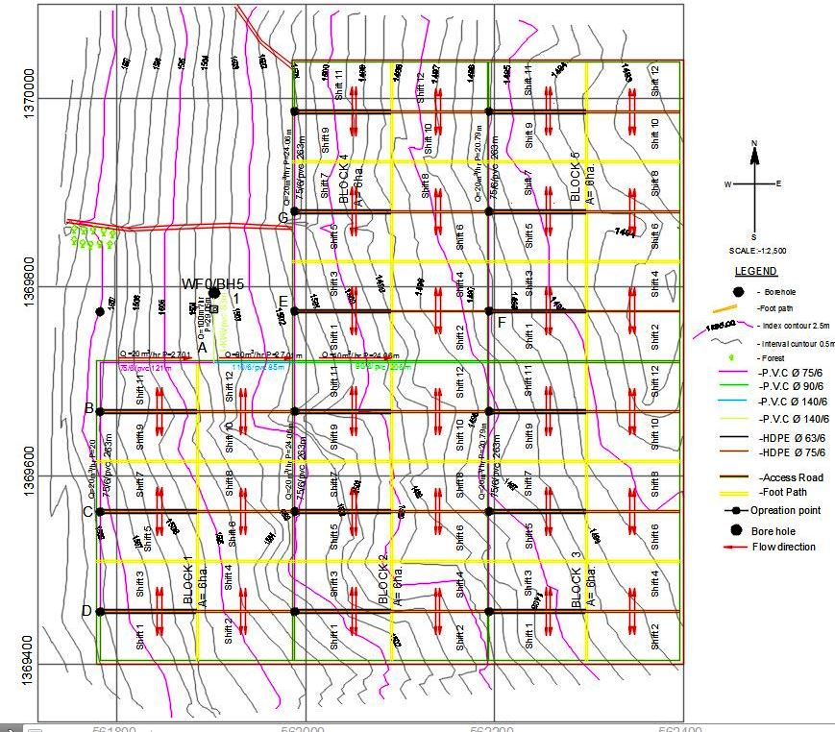

Figure 2‑9: Layout of the system (scale: 1:2500)

**A complete Design Example 2 (for commercial use by a Model farmer having 1 to 4ha):**

Design a drip irrigation system for a fully matured orchard on a field of 4ha owned by model farmer(s) with the following information.

* The field topography: levelled
* Maximum time for irrigation: 20 hours per day
* Allowable pressure variation in the emitters:15%*,*
* Water source: Open Well
* Maximum suction lift at the well = 10m
* Peak ET rate : 6.8mm/day
* The matured orchard shades 70% of the area;
* Drip irrigation efficiency is 90%.
* Each tree is to be supplied by 8 emitters.
* Spacing between plants x Spacing between laterals = 4m x 7m
* System layout is given (see figure below) and number of irrigation units is 4 and unit 1 and 2 are to be irrigated at the same time and alternated with units 3 and 4.

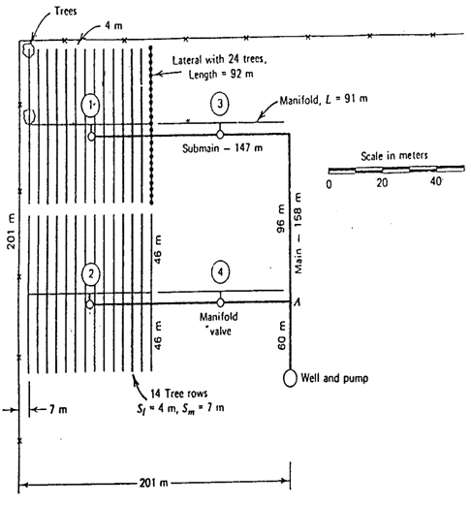

Figure 2‑10: Drip system layout for a 4.04ha orchard

**Solution:**

The system is laid out in such a way that the command area has four operations blocks/irrigation units. Two units are desired to be irrigated at a time. Therefore,

The gross depth of irrigation per day, ETt



Irrigation time per shift, Ta = maximum Irrigation time per day/number of shifts per day = 20/2 = 10hrs

Discharge per emitter with a spacing of 4 m x 7 m and with 4 emitters per tree

or 0.0012lit/s

Selection of emitter:

From manufacturer’s catalogue, if a medium long-path emitter with k = 0.000303 and x = 0.63 is selected. Substituting in equation q = khx, with an average discharge of 0.0012 lit/s, the average operating pressure of the emitter can be found by first transforming the characteristic equation into logarithmic form and solving for h:





h is then found as 8.9 m. This is the average operating pressure head, Ha.

Sizing of pipe lines:

1. **Discharge of pipe lines as per the layout**

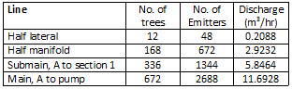

As the laterals are connected on both sides of the manifold, only half the length of the lateral was considered for design. Similarly, as the submain end is connected at the mid-point of the manifold, half the length of the manifold was considered for design. In such cases, depending upon the topography, inlet pressures of lateral and manifold on both sides are compared. If the two are found different, the lateral or manifold shifted to the downslope side little by little until the inlet pressures on both sides nearly become equal. That is called the best position of the laterals or manifolds. On level ground, however, the conncection is made at mid-point of the pipes.

1. **Selection of pipe diameters:**

The total allowable pressure loss (15 % of Ha) in both the lateral and manifold is

= 8.9 x 0.15 =1.3 m.

Of which, 0.55 x 1.3 = 0.7m is allowed for lateral and 0.45 x 1.3 = 0.6m is allowed for the manifold.

Now, the friction head loss in each of the lines is determined by Darcy-Weisbach equation by selecting a diameter to keep the loss within the allowable limits of 0.7m and 0.6m.i.e.

For lateral sizing:

If the size of lateral is 16mm (ID=12.8mm),

* 

Thus, the head loss hf for L=46m and F=0.369 (for N=12 outlets from the table) is:



This value is below the allowable head loss. Thus, 16mm diameter of lateral is selected as suitable.

For manifold sizing,

If the size of manifold is 32mm (ID=28.8mm),

* 

Thus, the head loss hf for L=46m and F=0.401 (for N=12 outlets from the table) is:



This value is greater than the allowable head loss. Thus, try with the next bigger size.

The next bigger size is 40mm (ID=36.6mm),

* 

Thus, the head loss hf for L=46m and F=0.401 (for N=12 outlets from the table) is:



This value is less than the allowable head loss. Thus, 40mm is selected as the size of the manifold.

For Submain sizing,

Select 40mm (ID=36.6mm) HDPE/4 pipe. For Q=5.8464m3/hr, the cross-sectional area of the pipe is:

* 

Now, the velocity is:



Now, the friction head loss is,



Then, the head loss hf for L=243m and F=0.401 is:



The velocity was in the desired limit but the head loss is too high. To save energy of operation, it is better to increase the size to the next bigger size with some reduction of velocity of flow.

Select 50mm (ID=45.6mm) HDPE/4 pipe. For Q=5.8464m3/hr, the cross-sectional area of the pipe is:



Now, the velocity is:



Now, the friction head loss is,



Then, the head loss hf for L=243m and F=1 is:



For main sizing,

Select 50mm (ID=45.6mm) HDPE/4 pipe. For Q=5.8464m3/hr, the cross-sectional area of the pipe is:

* 

Now, the velocity is:



Now, the friction head loss is,



Then, the head loss hf for L=60m and F=1 is:



To save energy of operation, it is also better to increase the main line size to the next bigger size with some reduction of velocity of flow. Thus, for 63mm (ID=57.6mm) HDPE/4, for Q=5.8464m3/hr, the cross-sectional area of the pipe is:



Now, the velocity is:



Now, the friction head loss is,



Then, the head loss hf for L=60m and F=1 is:



The selected pipe sizes for the pipe lines and the corresponding head losses are presented below.

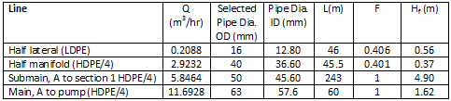

The pressure head at inlet of lateral:

 

The pressure head at inlet of manifold:



1. **Size of pump:**

Total head for pump, H is the sum of manifold pressure (9.60m), friction loss at sub-main (4.9m), friction loss at main (1.62m), suction lift (10m), height of riser pipe that connects submain with manifold be 0.60m, local losses at fittings 2% of operating pressure head of emitter and friction head loss at control head (5m).

H = 9.60 + 4.9 + 1.62 + 10 + 0.6m+0.02*8.9+5 = 31.9m

System discharge, Q is the sum of all emitters operating at a time. i.e. 11.6928m3/h. Therefore, the pump capacity is:



Thus, the salient features of the drip system are:

1. Depth of irrigation : 6.22mm

2. Irrigation interval : 1 day

3. Number of emittres working simultaneously: 2688

4. Operating head of emitter : 8.9m

5. Discharge of dripper : 4.35 lph

6. Number of drippers per plant : 4

7. Emitter Spacing on the lateral : 4m

8. Lateral Spacing on the manifold : 7m

9. Number of system shifts per day : 2 shifts

10. Total command area : 4ha

11. Number of Irrigation blocks : 4 blocks of each 1ha

12. Area of BDU : 1ha (100mx100m)

13. Number of subunits per BDU : 2 subunits of each 0.5ha

14. Size of lateral : 16mm (class 4 LDPE.)

15. Size of manifold: : 40mm (class 4 HDPE)

16. Size of submain pipe : 50mm (class 4 HDPE)

17. Size of main pipe : 63mm (class 4 HDPE)

18. Length of each lateral : 46m

19. Length of each manifold : 91m

20. Length of each submain : 1x243m and 1x147m

21. Total length of laterals : 300,000m

22. Total length of manifold : 364m

23. Total Length of submain line : 390m

24. Length of main line : 60m

25. System Discharge : 11.69m3/hr

26. Total pumping head : 31.9m

27. HP of the pump : 3hp

# EQUIPMENT SPECIFICATION, BILL OF QUANTITITES & TENDER

## general

With the completion of the design, a detailed list of all the equipment needed (pipes, pipe fittings, etc.) for the installation of the system must be prepared with full descriptions, standards and specifications for every item. In addition to the quantities, it is imperative to determine and specify:

* size and name (2-in ball valve, 50-mm pipe, etc.);
* kind of material (brass, uPVC, etc.);
* pressure rating or class (PN 4 bars, 6 bars, etc.);
* type of joints (screw, solvent welded, etc.);
* standards complied with (ISO 161, 3606, BS 21, ISO 7, etc.).

## equipment standards

All pipes, pipe fittings and other irrigation equipment are manufactured according to various standards applied in the countries of origin. These standards, although equivalent to each other, vary in terms of the dimensioning, the class rating, the safety factor and the nomenclature.

Therefore, it is advisable to specify the type of equipment required strictly to follow the International Standards Organization (ISO) standards because all other local and national standards are in broad conformity with these standards. And, the description of the equipment should be as clear and simple as possible. An example with the minimum specifications required shall be specified as follows.

Item 1: Black HDPE pipe, PN 4.0 bars, to a standard in compliance with ISO standards, supplied in coils of 200 m:

a. 40 mm DN, 1800 m;

b. 50 mm DN, 3200 m.

Item 2: Polypropylene connector fittings manufactured to ISO metric dimensions. Quick release, compression type and/or threaded (screw-type) ends male or female, for use with the above HDPE pipes:

a. 63 mm x 2 in (male) adaptor, 7 pieces;

b. 63 mm x 2 in (female) clamp saddle, 2 pieces;

c. 50 mm x 2 in (male) adaptor, 2 pieces.

Should the equipment not comply with any standard, due to many reasons, a full technical description should be given of the material it is made of, the working pressure and the use. The latter is important because the fittings should be made of material recommended for use with the particular pipe.

## specification of the different parts of drip system

Drip irrigation systems are commonly built with plastic pipe, of which there are various types and specifications. Some of the most common types are uPVC, HDPE and LDPE pipes.uPVC pipes are usually white, LDPE and HDPE are usually black. All of these pipe materials are called “thermoplastic” because the material can be repeatedly softened by increasing the temperature, and hardened by a decrease in temperature.It is important to understand how the technical specifications affect design decisions (pipe sizing).

The following must be considered in specifying pipe materials and fittings required for drip system.

Main and submain line: The considerations are:

* drip system installation consists of uPVC pipes of different pressure requirments for main and submain lines. A pipe working pressure of 4.0 bars seems to meet the requirements of the system. However, although the low to medium pressure systems are not subjected to the very high pressures created by water hammer, it is advisable to use 6.0-bar pipes or more for the main line and 4.0 bars or more for the submain line.
* about 5 percent should be added to the design total length of pipelines required.
* the right quantities of pipe connector, fittings and their types (bends, tees, end plugs, reducers, etc.)
* the number of shut-off and air valves on the distribution network.The air valves are fitted on riser pipes connected with clamp saddleson the mains;
* the right quantities of the riser pipes for the hydrants, if the mains are buried,and of the shut-off valves or the special hydrant valves.

Manifolds and Laterals: The considerations are:

* HDPE pipes are used as manifolds and soft LDPE pipes are used as laterals in drip systems. It is advisable to use Class 4.0 pipes for the manifold and lateral lines.
* total length of pipes required;
* quantities of adaptors, tees, bends, end plugs and line filters;
* pipe connectors and fittings,

***Head control:*** The considerations are:

* All the components of the head control of the system must be determined, i.e. shut-off valves, check valve, air valve, fertilizer injector, filters, pressure regulators, etc.
* In addition, all the auxiliary fittings must be included, such as the pipe pieces, hoses and fittings needed to assemble the unit, and the pressure gauges and other small devices required.

***Pumping Unit:***The considerations are:

* A full and detailed description of the pumping unit must be given, including the kind of pump and the capacity and output of the pumping unit, i.e. the water delivery versus the dynamic head.

Table 3‑1: Sample Equipment specification (based on Table 3.2 below)

| **Item No.** | **Equipment specification** |
| --- | --- |
| 1.1 to 1.3 | White PVC pipes, PN 6bars in compliance with ISO standard. Supplied in 6 and 12m lengths |
| 2.1 to 2.2 | Black HDPE pipes, PN 4.0 bars in compliance with ISO standard. Supplied in 100m rolls |
| 2.3 | Black LDPE pipes, PN 4 bars in compliance with ISO standard. Supplied in 200m rolls |
| 3.2 to 3.6 | PE connector fittings for use with PE pipes and to ISO dimensions |
| 4.4 | Ball valves quarter turn, on-off operation, made of brass, PN 16bars and to ISO standards |
| 4.11 | Filter (strainer), screen type, or grooved disks, 120 mesh/130 micron, epoxy coated metal body or other quality material, PN 10 bars and to ISO standards |
| 3.1 | On-line dripper, turbulent flow, made of high quality plastic material, 2lit/hr discharge at 1bar operating pressure, coefficient of manufacturer’s variation less than 7%, filterationrequirments 120mesh/130micron. |
| 5 | The trench should be as uniform and level as possible, free of large stones and any other sharp edged materials. Where required it must be filled with embediment material to a depth of 10cm. Trench dimesnsions should be 60cm minimum depth for 75mm pipe and above |

## bill of quantities

Bill of quantity for each and every item in the design will be prepared. The price will be fixed with +10% of the prevailing average unit rate of the international and local price quotations. The installation cost will be estimated based on the previous experiences in the area with +10% to absorb possible cost variations. An example of bill of quanttities is shown in table 3.2 below.

Table 3‑2: Sample Bill of Quantity for the complete design example 1 case

| **No.** | **Description of items** | **Unit** | **Quantity** | **Unit Cost** | **Total cost (birr)** |
| --- | --- | --- | --- | --- | --- |
| 1 | Main and submain pipes |  |  |  |  |
| 1.1 | * ∅140 class 6 PVC pipe | m | 168 |  |  |
| 1.2 | * ∅90 class 6 PVC pipe | m | 206 |  |  |
| 1.3 | * ∅75 class 6 PVC pipe | m | 1,436 |  |  |
|  | Sub total 1 |  |  |  |  |
| 2 | Manifold and laterals pipes |  |  |  |  |
| 2.1 | * ∅63 class 4 HDPE pipe | m | 3,000 |  |  |
| 2.2 | * ∅75 class 4 HDPE pipe | m | 6,000 |  |  |
| 2.3 | * ∅ 16/4 ( 16mm class 4 LDPE) | m | 300,000 |  |  |
|  | Sub Total 2 |  |  |  |  |
| 3 | Fittings and Accessories |  |  |  |  |
| 3.1 | Drippers/emitters, 2 lit/hr | No. | 600,000 |  |  |
| 3.2 | Barbed Head Connector/ takeoff (∅16x16) | No. | 600 |  |  |
| 3.3 | Grommet (∅16x16) | No. | 600 |  |  |
| 3.4 | Endline Clamp,16mm | No. | 600 |  |  |
| 3.5 | Plastic End Cap 63mm | No. | 30 |  |  |
| 3.6 | Plastic End Cap 75mm | No. | 30 |  |  |
| 4 | Control heads |  |  |  |  |
| 4.1 | Compression Adaptor or connector(f75-f63') | No. | 4 |  |  |
| 4.2 | Adaptor (f75-f75') | No. | 4 |  |  |
| 4.3 | Solvent weld 90oelbow (75mm) | No. | 9 |  |  |
| 4.4 | Ball Gate valve, 1.5″ (F/M) | No. | 5 |  |  |
| 4.5 | S.W.Tee (63x63x63) | No. | 3 |  |  |
| 4.6 | Nipple (1.5'') | No. | 1 |  |  |
| 4.7 | Saddle (63 x 3/4'') | No. | 3 |  |  |
| 4.8 | Air Release Valve 3/4″ | No. | 1 |  |  |
| 4.9 | Union(1.5″ ) | No. | 1 |  |  |
| 4.10 | Pressure Regulator 1.5″ | No. | 1 |  |  |
| 4.11 | Plastic Screen Filter 3/4″(120 -mesh) | No. | 1 |  |  |
| 4.12 | Fertilizer tank(60litre) & accessories | No. | 1 |  |  |
|  | Sub Total 3 |  |  |  |  |
| **5** | **Pumps and generator** |  |  |  |  |
|  | Submersible pump with 45hp | No. | 1 |  |  |
|  | Standby generator | No. | 1 |  |  |
|  | Sub Total 5 |  |  |  |  |
| 6 | **Earthwork and Installation cost** |  |  |  |  |
|  | Excavation cost | ha | 30 |  |  |
|  | System installation cost | ha | 30 |  |  |
|  | Sub Total 5 |  |  |  |  |
|  | Total cost (birr) |  |  |  |  |
|  | Administration Cost, and Contingency (10%) |  |  |  |  |
|  | Grand total (birr) |  |  |  |  |

.

## tenders

The purchasing of irrigation equipment or execution of services, such as the installation, operation and maintenance of irrigation networks and/ or pumps, should be effected as per the national procurement rules and regulations. As per Ethiopian Procurement regulation, for equipment and services up to a value of Birr 200,000, the purchase can be effected through ‘quotations’, i.e. written quotations may be asked from a representative number (at least 3) of suppliers. Where the value of the equipment exceeds birr 200,000, their purchase should be effected through public tender. This is done in accordance with the procurement rules and regulations.

Wide publicity should be given to every ‘notice inviting tenders’ (invitation for tenders). This must include the name of the buyer, a brief description of the items for which tenders are invited, the address for delivery of equipment, and the closing date and time of the tenders. Moreover, it should include a statement that the buyer is not bound to accept the lowest or any other tender, and also state to whom the bidders must apply for full particulars.

In the case of ‘local tenders’ for the purchase of relatively limited quantities, the tender document that must be available and given to prospective bidders on request should include only the general conditions of the tender and the technical specifications of goods. It is important that allrequired conditions be clearly stated in detail in the tender document, including the time and method of delivery, method of payment, i.e. letter of credit, cash against documents, payment on delivery, etc.; and other related information.

In the case of ‘international bids’, the contract documents must include, in detail, the following:

* invitation for bids;
* instructions to bidders(source of funds, eligible bidders, goods and services,cost,content of bidding documents, preparation and submission of bids, opening and evaluation, award of contract, etc.);
* general conditions of contract (definitions, country of origin and standards, performance, security, inspection and tests, insurance, transportation, warranty, payment, amendments, delays, force majeure, etc.);
* special conditions; technical specifications(general, materials and workmanship ,schedules of requirements/bill of quantities, and particular technical requirements/ specifications);
* bid form and price schedules;
* contract form, bid security and performance security.

# INSTALLATION AND TESTING OF DRIP SYSTEM

## recieving and handling of pipes and fittings

### Receiving, unloading and handling guide

Pipes and fittings are delivered to aproject site in rolls or pieces depending on the type of product. When a load of pipes and fittings arrives at the site, it is the responsibility of the engineer to check it thoroughly. If possible, it is required to inspect each piece for damage. It is quite necessary to check quantities against the delivering list. Note missing or damaged items on bill of loading; set aside any damaged items and notify the supplier.

In order to avoid any damage to pipes and fittings, the person in charge of the site must adhere to the following recommendations.

* The storage surface must be flat, stable, and free of stones and debris.
* Unload the truck, being careful to avoid any movement, which could cause injury to the personnel or damage to the product and make note if any missing products in the delivery lot.
* Unload layer by layer, ensuring they do not fall to the ground.
* Do not discard damaged materials; rather identify them carefully for later inspection and notify to the supplier on time.
* Do not return damaged product before the authorization of the supplier.

### Storage of received materials

Pipes and fittings delivered in rolls or pieces must be stored appropriately as described below.

* Deposit the products on a clear, flat surface, and far away from any source of fire hazard.
* Specially fittings must be stored inside shelter and take care not to be lost.
* The maximum pipe storage height is preferable not to exceed 1.5m.
* Use chocks to prevent the pile of pipes from falling down which could result in damage to the pipes, or worse still, cause injury to a person.
* If the pipes are stockpiled along the trench, they should be as close as possible to the trench, on the opposite side from the backfill, to minimize loading, unloading and transportation.

## installation of pipe lines and fittings

### Installation of mains and submain pipes

Mains and submain pipes in drip irrigation are buried. For installation of main and submain pipes, first make sure that the pipes, fittings and valves are free from defects impairing strength and durability and be of the best commercial quality for the purposes specified. All pipes, valves and pipe fittings shall conform to the relevant standards. As the pipes are usually buried, to protect them from farming operations and traffic hazards, the following guide may be used in their installation.

#### Trench excavation

Proper layout, demarcation and pegging that guides the excavation line has to be carried out before commencing excavation works. According to the volume of earth work, labor availability and accessibility the excavation works can be carried out by labor or excavator. During the excavation works, the excavated material should not block sidewalks, utility outlets and back falling of excavated material to the trench. The excavation of trenches for pipelines shall at any one time be limited to lengths approved by the design engineer.

The width of the trench varies based on pipe size, soil type and other site specific conditions. The minimum clear width of the trench measured at the center line of the pipe is generally specified at least 300mm greater than the outside diameter of the pipe to enable backfill material to be installed in the pocket area. For pipes with outside diameter of 200mm up to 400mm commonly 500mm width is recommended to allow free movement of human being shoulder during excavation and installation.

The pipes should be buried at depth of 350mm-400mm below the deepest recorded penetration of plough depth. Therefore, the commonly used depth of excavation is 500mm plus the pipe outside diameter.

Adequate dewatering system to lower the existing ground water table below the level of the trench bottom and to keep the trench dry until pipes are assembled and back filled. If during the progress of the work the trench in part or in whole becomes flooded, the contractor shall immediately stop all relevant work until the trench is dry.

#### Installation

After excavation of the trench, installation follows. Installation of pipelines includes construction of beddings and foundation, laying and jointing of pipes and fittings, manholes and other structures in the line, testing, and backfilling of trenches, surface restoration and commissioning.

**i) Pipe laying, jointing and cutting**

For laying the pipes, first granular bedding of sand for pipes shall be placed by spreading and compacting granular bedding material over the complete width of the pipe trench. Where pipes are jointed, bell holes of ample dimensions shall be formed in the bedding to ensure that each pipe is uniformly supported throughout the length of its barrel and to enable the joint to be made and inspected during testing. After pipe laying, additional material shall be placed and compacted by hand rammer in 150mm layers equally on each side of the pipe as side support for the pipe.

Where pipes are laid on granular beds in ground with high groundwater level, puddled clay stanks shall be constructed at 25m intervals at the mid-point of an individual pipe. The stanks shall be 0.5m long and shall be recessed 300mm into the sides and base of the trench, and shall extend by a minimum of 150mm above the top level of the granular material.

Hydrants must be installed out of the way and must be painted with a bright-coloured paint to prevent them from being run over. All mainlines and submains must be flushed after installation to get rid of dirt that may have entered the pipes during installation. Pressure measuring points must be installed after each control valve at a block or hydrant so that the design operating pressure of the system can be set at those points.

While laying pipes, all joints shall be flexible joints and comply with the relevant provisions of the appropriate standards and shall be made to the manufacturer's recommendations.

Flanged joints shall be properly aligned before any bolts are tightened. Gaskets for flanged joints shall be of the inside-bolt-circle type. Gaskets may be secured temporarily to one flange face by a minimum quantity of clear rubber solution. Unless specified otherwise joints having exposed mild steel components shall be cleaned and all loose rust shall be removed. The internal lining in a gap which has been left for the joint to be made shall be completed in accordance with the recommendations issued by the manufacturer unless specified otherwise. The external protection shall comprise bitumen applied to a thickness of not less than one millimeter onto the external surface of the joint, followed where appropriate by a spiral wrap of heavy duty glass fiber tape bonded with hot bitumen.

For closing lengths, it may be necessary to cut pipes of various materials. Pipes shall be cut by a method which provides a clean square profile without splitting or fracturing the pipe wall, and which causes minimum damage to any protective coating. Where necessary, the cut ends of pipes shall be formed to the tapers and chamfers suitable for the type of joint to be used and any protective coatings shall be made good.

In general during pipe laying and joining works the following guides shall be adopted:

* When pipes are supplied in rolls properly transport the roll to installation trench, unroll and stretch straight off side of the trench length.
* Immediately before being laid and jointed, each pipe and fitting shall be carefully examined for flaws, cracks, or any other damage and all dust, dirt and foreign matter must be removed from the pipe. Therefore, sufficient care shall be taken to ensure that each pipe and fitting remains clean during the laying.
* If the Engineer deems the defective pipe as being suitable for use, the defective pipe shall be cut back at least 150mm beyond any visible flaw and prepared for jointing.
* All pipe lining and jointing shall be carried out by experienced pipe layers, well skilled in their work, to the grades, levels and lines shown on the drawing
* Joint the HDPE pipes using welding machines or compression fittings off side of the trench.
* Before pipe laying to the trench clean all stone, soil and other debris that might have fallen to the trench.
* Drag the pipes carefully section by section to the trench and laid on a natural bed over the trench formation when there is no rocky or stony ground exists.
* HDPE pipes with small diameter pipes may be laid to curves, not exceeding 1.3 times the minimum diameter.
* For the installation of valves and other fittings where required, pipes shall be cut and prepared using proper tools.
* Additional care should be taken during the laying of pipes by using suitable caps or plugs to cover open ends in the event of a prolonged interruption on completion of the work.

**ii). Installation of fittings**

As presented in section 1.6, there are several types of PVC and PE fittings. The most common fittings used in PVC pipes are Solvent Weld and threaded fittings. There are, however, different options of connecting HDPE pipe with fittings and the most commonly used are described below.

1. **Flanged fittings**

Flanged fittings are used mostly in large sizes exceeding 90mm size and when there is a need to use flanged fittings and pipes. All flanged connections are face to face dimension by using backing rings, bolts, nuts and gaskets.

1. **Butt weld fittings**

All pipes are going to be joined face to face by welding or by using weldable fittings such as reducer, tee, elbow and etc. Also there is an option of using electro fusion fittings mostly during maintenance work and some special cases like welding that to be carried above ground level on roof and other raised areas. All weldable fittings are carried by using standard welding machines.

1. **Compression fittings (Sleeve connection)**

These types of fitting connections represents for joining of PE pipes and all of the compression fittings and shall be consist the following parts:

* Body and lock nut- with great rigidity and low moisture absorbency
* Grip/splits ring- strong, hard, highly crystalline and is known as plastic engineering.
* Thrust ring/Bushing – with a characteristic of chemical resistance to solvents, acids and alkaline, toughness and flexibility.
* ‘O’ rings – made of rubber.

During installation of these types of fittings the following guide points shall be adopted:

* Level the end of the pipe to be inserted in to the fitting.
* Disconnect the lock nut from the body by rotating anti clock wise and remove the grip ring.
* During installation clean the pipe surface that to be inserted in to the fitting and the internal surface of the compression fitting.
* Insert the nut and the grip to the pipe which is ready for connection.
* Insert and push the pipe end to the bushing ring.
* After ensuring proper insertion of the pipe to the bushing ring push back the grip until it connects to the bushing ring and then locks the nut to the body by rotating clock wise.

1. **Threaded fittings**

This can be referring to any types threaded fittings.

* Use adequate teflon on external threaded part of the fitting during connection thread to thread.
* Connect at right position of the fitting thread to ensure tight connection.
* Be care full not to damage the peach of the thread.

**iii) Curves and Bends**

The pipes shall be laid in straight lines where possible. Curves of long radius shall be obtained by deflection at the joints. The deflection of the joints for this purpose shall not be more than 50% of the maximum deflection as specified by the pipe manufacturer for the relevant type of joint. Concrete thrust blocks shall be provided where ordered by the engineer. Concrete for thrust blocks shall be placed carefully against undisturbed earth or rock and shall in no case give less than 150mm of cover to the pipe. Concrete shall be grade C25. When casting thrust blocks, no couplings or joints shall be covered, and where timber shuttering has been used such timber shall be removed before backfilling.

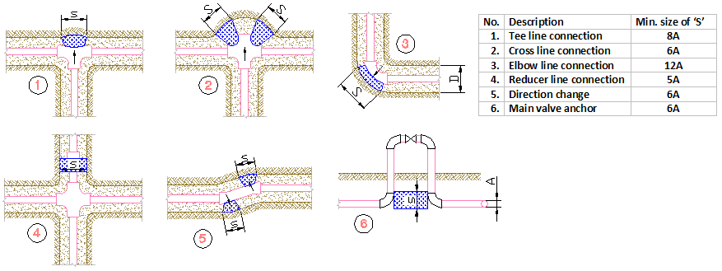

Figure 4‑1: Thrust blocking for PVC pipes

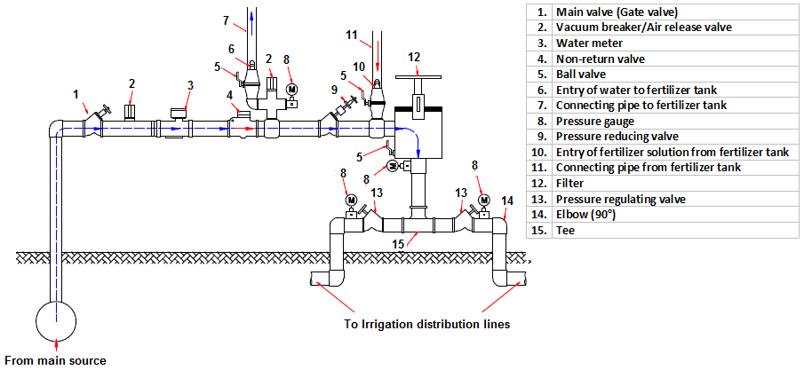

Figure 4‑2: Example of control head installation

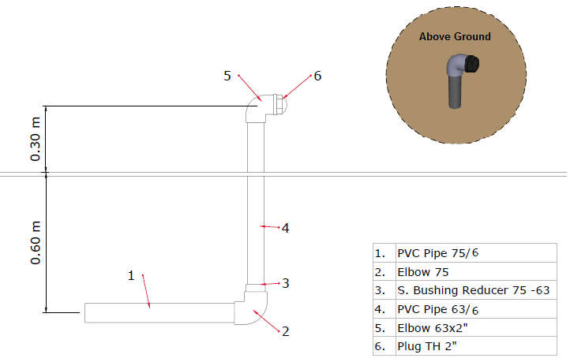

Figure 4‑3: Example of end line of submain pipe installation

**iv)****Testing of main and submain pipes and fittings**

As soon as pipes have been placed on their bedding and before backfilling they shall be tested for leakage. Before any testing, the contractor shall ensure that the pipeline is anchored adequately and that thrusts from bends, branch outlets or from the pipeline ends are transmitted to solid ground or to a suitable temporary anchorage. Open ends shall be stopped with plugs, caps or blank flanges properly jointed.

The Contractor shall not cover up any pipe except uPVC pipe until it has been inspected, tested and approved. uPVC may be covered to a depth of 150mm to reduce thermal movement if immediate inspection and testing is not practicable.

Before testing, valves shall be checked and sealed, the sections of main filled with water and the air released. After having been filled, pipelines shall be left under operating pressure for the period of not less than three (3) hours, so as to achieve conditions as stable as possible for testing.

The pressure shall then be raised until the test pressure being 125 % times the maximum working pressure, is reached in the lowest part of the tested section, and the pressure shall be maintained at this level, by pumping if necessary, for a period of one hour. The pump shall then be disconnected, and no further water shall be permitted to enter the pipeline for a further period of one hour. At the end of this period the original pressure shall be restored by pumping and the loss measured by drawing off water from the pipeline until the pressure at the end of test is reached again.

**v) Filling and Protection**

After testing, the pipe must be surrounded by fill for proper protection. Back filling can be done by using selected soil from the excavated native material in the trench provided, which is free from large stones, and free of debris or other organic materials up to 500mm height over the crown of the pipe in which it is up to the maximum depth of the plough. The purpose of the backfill is to protect the pipe from damage and floating over during water filling condition. It is not necessary to compact the backfill directly over the top of the pipe for the sake of the pipe’s structural strength. However, it may be necessary for the sake of roadway integrity.

The pipe shall be protected with concrete encasement from live traffic loads at road crossings.

Filling and protection to pipes shall extend fully to the sides of the excavation. The Contractor shall provide and maintain an adequate support system for upholding the ground actually encountered, and the safety of adjacent structures or utilities shall not be affected.

All support systems shall be properly maintained until the permanent work is sufficiently advanced to permit it to be removed. No gaps or voids are permitted as a result of the removal of the support system. Gaps and voids that may be created upon removal of the support system shall be properly filled with an approved granular material or Sand or other approved means.

The trench above the so finished pipe surround shall be filled with fill and shall be compacted flush with ground level.

### Manifolds, laterals and drippers installation

After installation of main and submain pipes, the manifolds and lateral pipes are installed as per the design and arrangement of the fields. The manifolds are HDPE pipes which should be carefully connected to the submain pipes at riser points. Each laterals connected on a manifold in a given block/BDU shall carefully be laid along the crop rows or between rows depending upon the arrangement decided during design. The inlet end shall be connected to the manifold with suitable size of connectors and the other end of the laterals shall be closed by end plugs. For inline emitters, it is important to assure that each emitter positions are at exact locations of the crops. For online emitters, carefully place the emitters at desired spacing. Be careful that the first emitter is placed on the lateral at designed spacing.

## testing of the system

The purpose of a drip system is to distribute water uniformly. Right after installation and successful testing of pipes and fittings, the uniformity of the emitter discharges in the system shall be tested. Mostly non-uniformity in drip irrigation systems is caused by: (1) emitter plugging, wear, and manufacturing variations; and, (2) non-uniform pressure distribution in pipes and hoses. Emitters of the same type have variations in discharge (at the same operating pressure) due to small differences from manufacturing tolerances. Manufactures normally specify the coeffiecient of variation (CV) of their products.

In practice, the degree of uniformity of emitters discharges can be computed from field observations of the depths of water collected in open cans placed at sampled emitters in a subunit. The operating time used for testing is for at least 30minutes. The common index for indication of application uniformity in drip irrigation is distribution uniformity, DU which is given by:

 ---- (4.1)

Where,

|  |  |
| --- | --- |
| DU = | coefficient of uniformity |
| Q25% = | the average flow rate of 25% of the emitters with the lowest flow rate |
| Qn = | the average flow rate of all the sampled emitters. |

To calculate DU, the flow rate of a representative sample (40 to 100 emitters in the subunit) is measured. DU values above 90% is a very good uniformity; 75 to 90% is good uniformity and below 75% is unacceptable.

# OPERATION AND MAINTAINANCE

Appropriate operation and maintenance of drip system components is as important as proper design. Because the success or failure of any properly designed and installed system are determined by the way both the irrigation system as a whole and its component parts are operated and maintained.

Technical guidelines and manual on the requirements of operation and maintenance of equipments and systems will be provided by the manufacturers and/or equipment suppliers. But further the followingis the general instruction for the farmers, and system operators with regard to the operation and maintenance (O&M)of a drip irrigation system.

## operation

### When and how long to irrigate

The application of the exact amount of water required by the crops at the right time is the main achievement of the irrigation installation. Farmers shall strictly follow the main elements of irrigation programming, such as discharge, operating hours and irrigation frequency for equity of water allocation as well as to achieve high water use efficiency.

### Starting and stopping the system

Starting and shutting down the system needs to be done very carefully in order to prevent surges and water hammer and to avoid air pockets in the pipelines. The opening and closing of the valves at the head of the system, the main and sub-main pipelines, should always be done slowly.

Farmers shall strictly follow the pumping operation schedules. The starting and stopping times for the pump unit shall be scheduled to match to the desired irrigation hours. There may be a need to readjust the pumping period when there would be adverse weather condition in terms of rainfall amount, distribution and intensity of solar radiation. The readjustment should be done either based on actual records or predictions of weather condition (rainfall or solar radiation) in the command areas and the surrounding environment. The farmers have to be informed and trained about the readjustment process in the irrigation system. If the measured rainfall is, for example, more than half of the daily deficit, farmers needs to be instructed to stop the pumping operation. Otherwise, in the absence of recorded rainfall data, personal judgment will govern to operate or not to operate the pump. However, to operate the pump at the delivery point, the supplier’s instructions should be followed.

## maintainance

The long-term operation of the irrigation installation depends upon simple maintenance carried out by the farmer and the periodic servicing and the repair of special devices (filters, injector, etc.) carried out by trained maintenance and repair personnel. Spare parts of commonly needed items should be kept on hand for emergencies. Periodic inspection of supply pipes, mechanical equipment (such as pumps, emitters and filters) and distribution systems should be made throughout the irrigation season.

The following parameters are particularly important to be evaluated to determine the level of operation and that can be readjusted where not satisfactory.

**Operating pressures:** With the system in operation, pressure measurements are taken at various points on the piping network, preferably at the beginning and at the far end of the main and the submain pipelines. The operating pressures of the first and last emitters on a number of laterals are also measured. All pressures should be within the designed range. The difference in the emitter pressure should not differ from the recommended average pressure by more than 20 percent. Any change should be investigated immediately.

**Flow rates/water discharge:** The emitter flows in drip system are considered to be affected both by hydraulic and manufacturer’s variation. The flow rates (discharge) of emitters are determined in the field by recording the time required to fill up a graduated can with water. The degree of variation of emitter outflows is then determined using equation 4.1. The difference between discharges of any two emitters in the system should be less than 10 percent or the uniformity coefficient should be more than 90%.

**Uniformity of application and depth of wetting:** This may be checked by probing the soil at various locations using a probe, shovel or soil auger. The examination can be made 12-24h after irrigation depending on the type of soil. Water should penetrate a few centimeters below the root depth. Areas taking less or more water shall be identified for further investigation. Visual observations for evaluation purposes of any type should be avoided as they might lead to misjudgments.

**Check, air and pressure control valves:**In drip system, the main pipe and sub-main pipes are controlled by butterfly valves at all main junctions. At high points in the system and at the points where the venting is required during filling, the air valves will be provided to expel the trapped air. At the points on long and steep pipelines where the pressure exceeds, the desirable pressure control valves will be provided to regulate the pressure. All these valves shall be protected preferably by a concrete chamber.

In addition to the above simple evaluations, the following checks, on-site modifications, re-arrangements and preventive maintenance are necessary:

* Check for any leakage in piping or through valves.
* Check for any clogged emitters.
* Flush the system network at least once every four irrigation cycle. An approximate flushing time of 2-3min for each line will prevent sedimentation on the inner pipes walls.
* Clean the filters of the system thoroughly before every irrigation.
* During operation, check for the minimum difference in pressure between the inlet and the outlet of the main filter.
* Check the air and check valves periodically for proper functioning.
* Inspect plastic equipment, valves and devices for cracks and other physical damage.
* Flush fertilizer injectors after each use. Inspect hoses and valves.
* Conduct systematic checks to spot malfunctioning equipment affected by physical deterioration and other possible damage by machinery, animals, etc.
* Make frequent visual checks of the system to ensure that it is in good condition and operating efficiently.

Maintenance shall also be carried out during a period of non-use to prepare the system: a) for the off-season shut-down; and b) for use before the next season. All spare equipments and pipes shall be carefully handled and stored.

Troubleshooting in Drip Irrigation

No drip irrigation system is immune to malfunctions due to normal wear and tear or exceeding the systems limitations. Here are corrective measures to common problems that will help to run the system efficiently.

|  |  |
| --- | --- |
| **Problem** | **Solution** |
| Valve does not open or close | Check rubber o-rings and replace as needed. Re-tighten connections by hand only. |
| Uneven or no flow at drippers; clogged drippers | Check all filters and clean as needed. Make sure that you did not exceed the system's total maximum flow capacity and run length for the selected lateral size. Check for adequate water flow and water pressure available at the water source. Clean or replace pressure regulator if needed. While the water is on, hold your finger over the dripper outlet for a few seconds. This "back flushing" will often work to reset inconsistent emitters. Clean dripper (cleanable models) and/or replace dripper if necessary. |
| Drippers or fittings popping out of tubing | Check water pressure past pressure regulator Check for and remove any clogs in drippers or fittings. Remove dripper if necessary, plug hole with a goof plug, then reinstall dripper into a cleanly punched hole in the tubing. |
| Leaks along tubing; damaged tubing | Cut out leaking or damaged section and reattach sections of tubing with a coupler. If tubing damage is caused by rodents, consider additional solutions to repel rodents. |
| Fitting separating from tubing; fittings do not fit tubing | Push tubing further into or onto compression or barbed fitting. Ensure other types of fittings are properly attached and secured. Ensure outside diameter (OD) and inside diameter (ID) tubing size is compatible with fitting size. |
| Plants appear stressed | Check water flow at drippers near plants. Clean, repair or replace all associated components, including tubing and connectors as needed. Adjust dripper flow rates and add more drippers if needed. Adjust watering schedule as needed. |

# REFERENCES

* Asfaw, K.K and G.H. Gebremedhin. 2015. Irrigation in Ethiopia: A Review. Academia Journal of Agricultural Research 3(10): 264-269.
* Awulachew, S.B., T. Erkossa and R.E. Namara. 2010. Irrigation potential in Ethiopia:  
  Constraints and opportunities for enhancing the system. IWMI.
* Azenkot A. 2001. Irrigation Systems. Irrigation and Soil Field Service. Mashav and Cinadco. Israel. MASHAV and CINADCO. Israel.
* FAO. 2002. Localized Irrigation Systems: Planning, Design, Operation and Maintainance. Planning, Development, Monitoring and Evaluation of Irrigated Agriculture with Farmer Participation. Volume IV, Module 9. Harare.
* FAO. 2001. Planning, Design, Operation and Maintainance. Planning, Development, Monitoring and Evaluation of Irrigated Agriculture with Farmer Participation. Volume V, Module 10-14. Harare.
* Nathan, R. 2002. Fertilization Combined with Irrigation (Fertigation). Department of Soil and Irrigation. MASHAV and CINADCO. Israel.
* Phocaides, T. 2000. Technical Handbook on Pressurized Irrigation Techniques. FAO, Rome.
* Sapir, E. and M. Sne. 2001. Sprinkler Irrigation. Irrigation and Soil Field Service. MASHAV and CINADCO. Israel.
* WWDSE. 2008. Raya Valley Pressurized Irrigation Project – Final Detail Engineering Design Document.

# APPENDICES

APPENDIX I: Unit Conversion

|  |  |
| --- | --- |
| Length: |  |
| 1m | 100cm |
| 1cm | 10mm |
| 1km | 1000m |
| Area: |  |
| 1ha | 10000m2 |
| 1km2 | 100ha |
| Volume: |  |
| 1m3 | 1000 lit |
| 1gallon | 3.78 lit |
| Pressure: |  |
| 1 atm | 1 bar |
| 1atm | 1kg/cm2 |
| 1atm | 10m head |

APPENDIX II:Common symbols used in pressurized system

|  |  |
| --- | --- |
| Well |  |
| Pump |  |
| Head control |  |
| Water meter |  |
| Filter |  |
| Valve |  |
| Hydraulic valve |  |
| Hydraulic valve with a pilot |  |
| Air release valve |  |
| Flow rate(m3/s) |  |
| Head loss(m) |  |
| Pressure (m) |  |

APPENDIX III: Drip irrigation system design data collection form

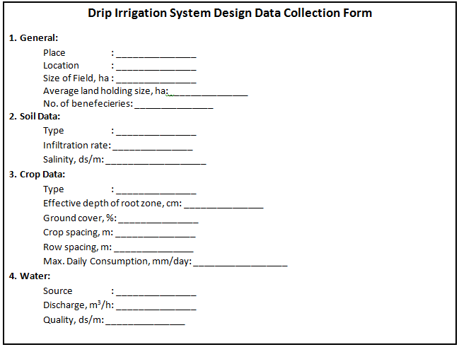

APPENDIX IV: Drip irrigation system uniformity of application form



APPENDIX V: (a) LDPE pipes inner diameter and wall thickness

|  |  |  |  |  |  |  |  |  |  |  |
| --- | --- | --- | --- | --- | --- | --- | --- | --- | --- | --- |
| **OD (mm)** | **Class** | | | | | | | | | |
| **2.5** | | **4** | | **6** | | **8** | | **10** | |
| **ID (mm)** | **Wall  thickness** | **ID (mm)** | **Wall  thickness** | **ID (mm)** | **Wall  thickness** | **ID (mm)** | **Wall  thickness** | **ID (mm)** | **Wall  thickness** |
| 12 | 9.8 | 1.1 | 9.6 | 1.2 | 9.2 | 1.4 | 8.6 | 1.7 | 8.0 | 2.0 |
| 16 | 13.2 | 1.4 | 12.8 | 1.6 | 12.4 | 1.8 | 11.6 | 2.2 | 10.6 | 2.7 |
| 20 | 17.0 | 1.5 | 16.6 | 1.7 | 15.4 | 2.3 | 14.4 | 2.8 | 13.2 | 3.4 |
| 25 | 21.8 | 1.6 | 21.2 | 1.9 | 19.4 | 2.8 | 18.0 | 3.5 | 16.6 | 4.2 |
| 32 | 28.8 | 1.6 | 27.2 | 2.4 | 24.8 | 3.6 | 23.2 | 4.4 | 21.2 | 5.4 |

OD=Outer Diameter; ID=Inner Diameter

Source: Moshe, 2011

APPENDIX VI: (b) HDPE pipes inner diameter and wall thickness

|  |  |  |  |  |  |  |  |  |  |  |
| --- | --- | --- | --- | --- | --- | --- | --- | --- | --- | --- |
| **OD (mm)** | **Class** | | | | | | | | | |
| **2.5** | | **4** | | **6** | | **8** | | **10** | |
| **ID (mm)** | **Wall  thickness** | **ID (mm)** | **Wall  thickness** | **ID (mm)** | **Wall  thickness** | **ID (mm)** | **Wall  thickness** | **ID (mm)** | **Wall  thickness** |
| 16 |  |  |  |  |  |  |  |  | 12.8 | 1.6 |
| 20 |  |  |  |  |  |  | 16.8 | 1.6 | 16.2 | 1.9 |
| 25 |  |  |  |  | 21.8 | 1.6 | 21.1 | 2.0 | 20.4 | 2.3 |
| 32 |  |  | 28.8 | 1.6 | 28.2 | 1.9 | 27.2 | 2.4 | 26.2 | 2.9 |
| 40 |  |  | 36.8 | 1.6 | 35.2 | 2.4 | 34.0 | 3.0 | 32.6 | 3.7 |
| 50 | 46.8 | 1.6 | 46.0 | 2.0 | 44.0 | 3.0 | 42.6 | 3.7 | 40.8 | 4.6 |
| 63 | 59.8 | 1.6 | 58.2 | 2.4 | 55.4 | 3.8 | 53.6 | 4.7 | 51.4 | 5.8 |
| 75 | 71.2 | 1.9 | 69.2 | 2.9 | 66.0 | 4.5 | 64.0 | 5.5 | 61.4 | 6.8 |
| 90 | 85.6 | 2.2 | 83.0 | 3.5 | 79.2 | 5.4 | 76.8 | 6.6 | 73.6 | 8.2 |
| 110 | 104.6 | 2.7 | 101.6 | 4.2 | 96.8 | 6.6 | 93.8 | 8.1 | 90.0 | 10.0 |
| 125 | 118.8 | 3.1 | 115.4 | 4.8 | 110.2 | 7.4 | 106.6 | 9.2 | 102.2 | 11.4 |
| 140 | 133.0 | 3.5 | 129.2 | 5.4 | 123.4 | 8.3 | 119.4 | 10.3 | 114.6 | 12.7 |
| 160 | 152.0 | 4.0 | 147.6 | 6.2 | 141.0 | 9.5 | 136.4 | 11.8 | 130.8 | 14.6 |
| 180 | 171.2 | 4.4 | 166.2 | 6.9 | 158.6 | 10.7 | 153.4 | 13.3 | 147.2 | 16.4 |

Source: Moshe, 2011

APPENDIX VII: (c) PVC pipes inner diameter and wall thickness

|  |  |  |  |  |  |  |  |  |
| --- | --- | --- | --- | --- | --- | --- | --- | --- |
| **OD (mm)** | **Class** | | | | | | | |
| **4** | | **6** | | **8** | | **10** | |
| **ID (mm)** | **Wall  thickness** | **ID (mm)** | **Wall  thickness** | **ID (mm)** | **Wall  thickness** | **ID (mm)** | **Wall  thickness** |
| 63 | 59.4 | 1.8 | 59.0 | 2.0 | 58.2 | 2.4 | 57.0 | 3.0 |
| 75 | 71.4 | 1.8 | 70.4 | 2.3 | 69.2 | 2.9 | 67.8 | 3.6 |
| 90 | 86.4 | 1.8 | 84.4 | 2.8 | 83.0 | 3.5 | 81.4 | 4.3 |
| 110 | 105.6 | 2.2 | 103.2 | 3.4 | 101.6 | 4.2 | 99.4 | 5.3 |
| 140 | 134.4 | 2.8 | 131.4 | 4.3 | 129.2 | 5.4 | 126.6 | 6.7 |
| 160 | 153.6 | 3.2 | 150.2 | 4.9 | 147.6 | 6.2 | 144.6 | 7.7 |
| 225 | 216.2 | 4.4 | 211.2 | 6.9 | 207.8 | 8.6 | 203.4 | 10.8 |
| 280 | 269.0 | 5.5 | 262.8 | 8.6 | 258.6 | 10.7 | 253.2 | 13.4 |
| 315 | 302.6 | 6.2 | 295.6 | 9.7 | 290.8 | 12.1 | 285.0 | 15.0 |

Source: Moshe, 2011

APPENDIX VIIII: Minor head loss coefficients

|  |  |  |  |
| --- | --- | --- | --- |
| **Fitting, valve** | **Loss coefficient, K** | **Fitting, Valve** | **Loss Coefficient, K** |
| 45o standard elbow | 0.35 | Gate valve | 0.20 |
| 90o standard elbow | 0.75 | Three-fourths open | 0.90 |
| Coupling or union | 0.04 | On-half open | 4.50 |
| Tee, along run | 0.40 | One-fourth open | 24.00 |
| Branching flow | 1.00 | Globe valve, open | 6.40 |
| Ball check valve, open | 70.00 | Globe valve, half open | 9.50 |

APPENDIX IX: Slide rule for calculation of head losses by hazen-williams

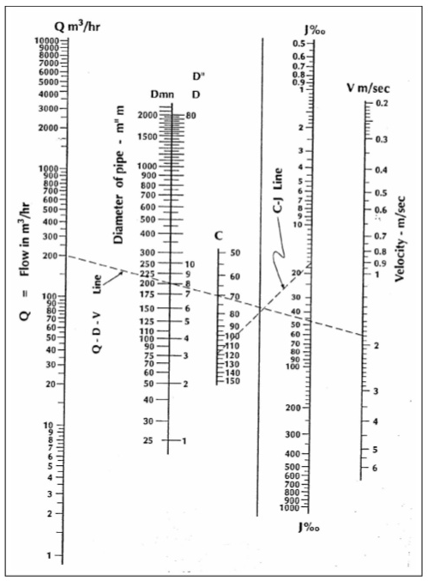

APPENDIX X: (a)–Nomograph for calculation of Head Losses in HDPE pipes of different classes

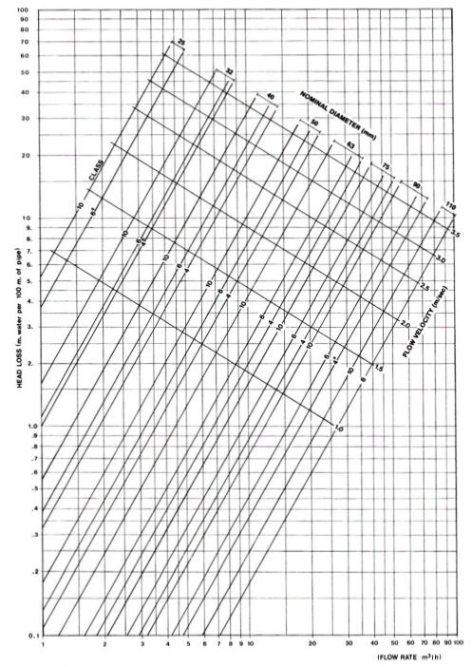

APPENDIX XI: (b)–Nomograph for calculation of Head Losses in PVC pipes of different classes

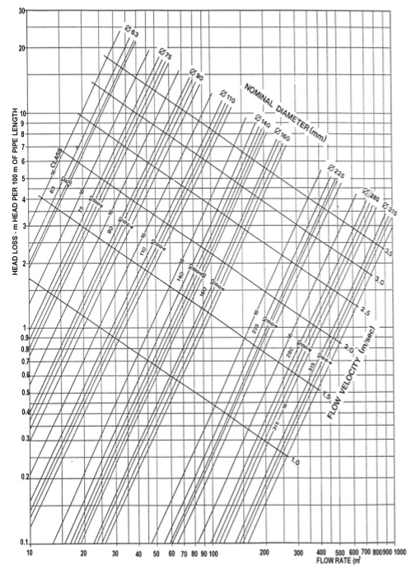

APPENDIX XII: (a)–Head loss charts for PVC pipes

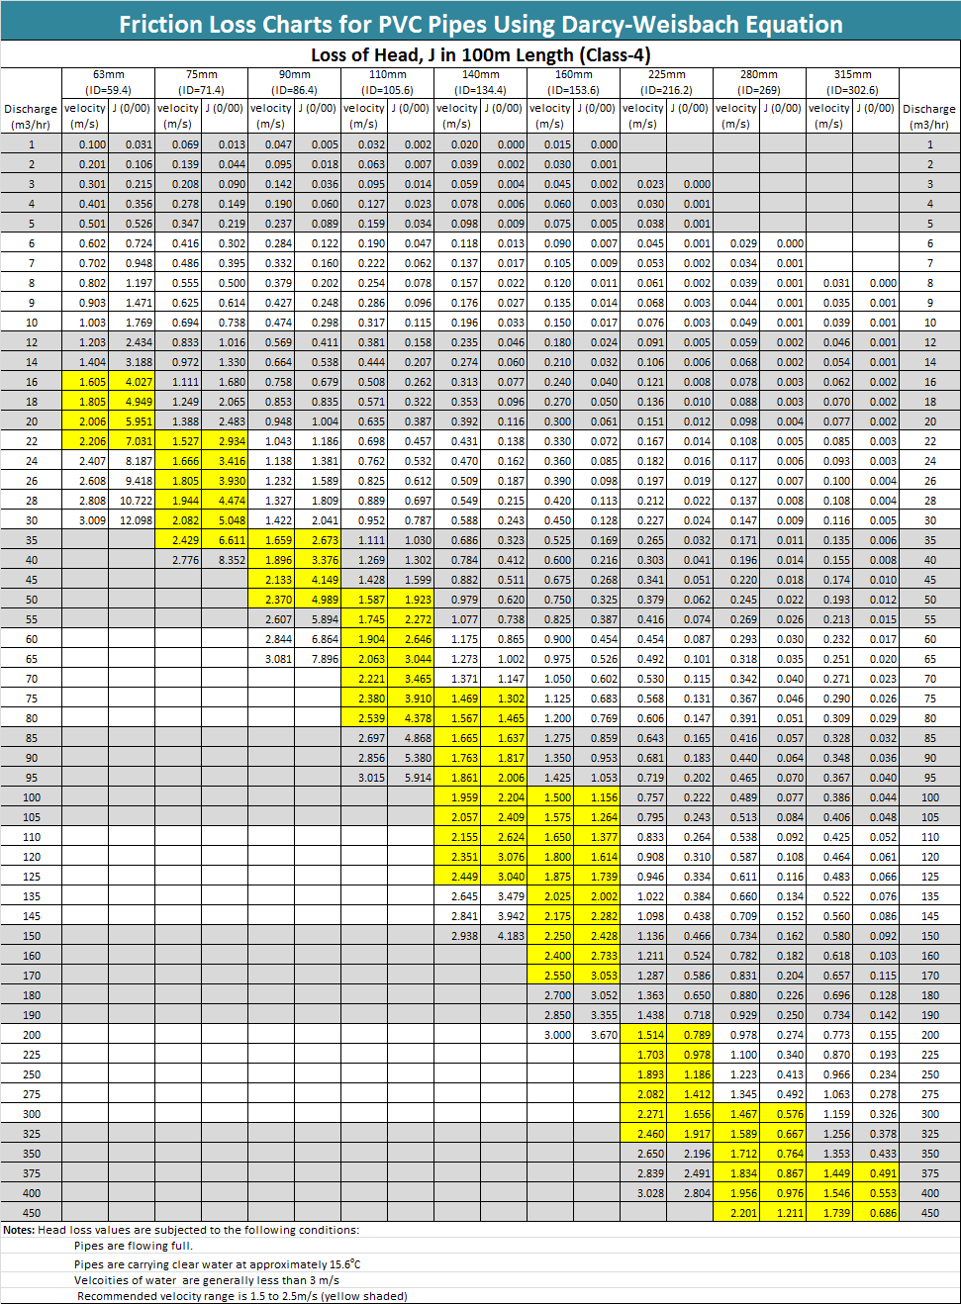

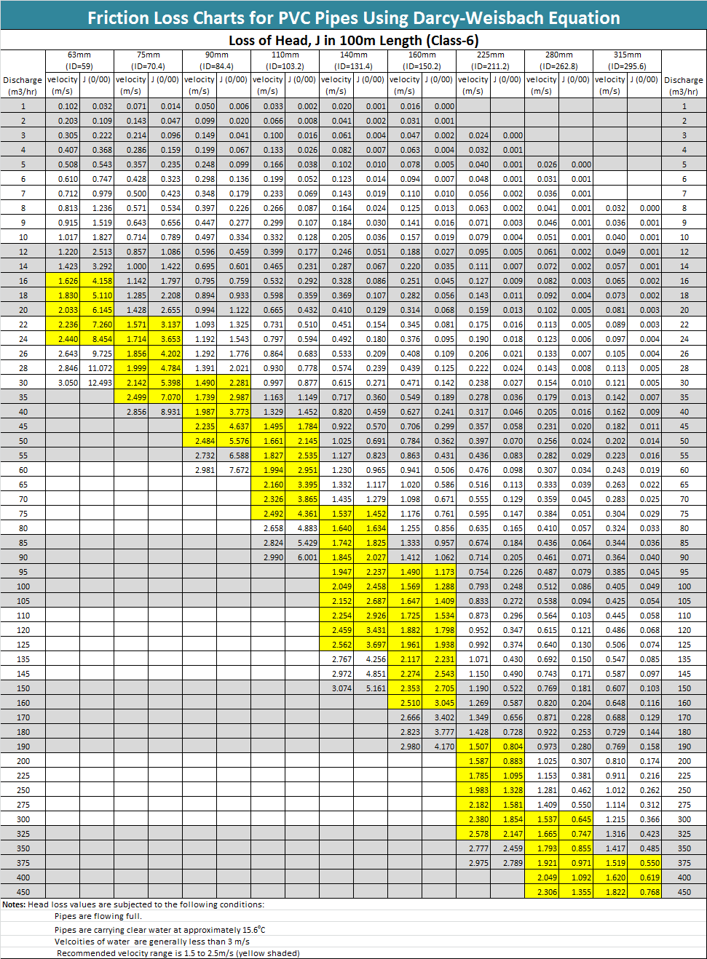

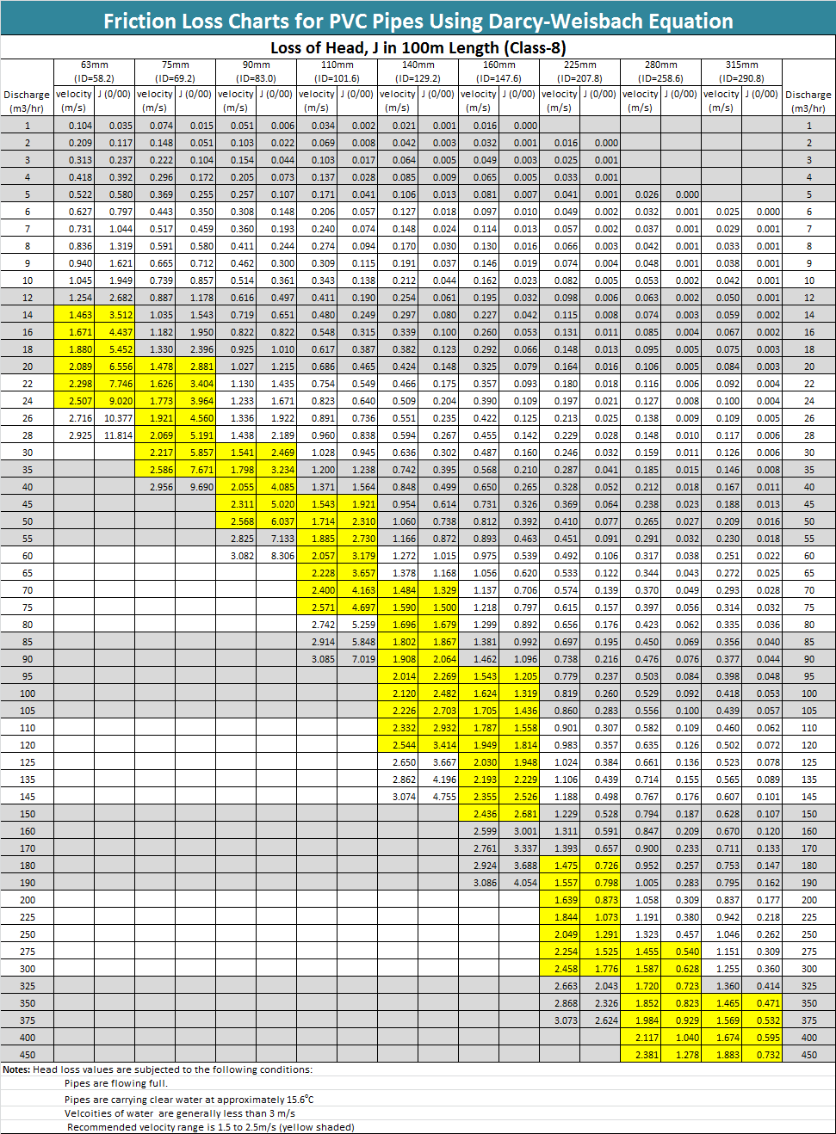

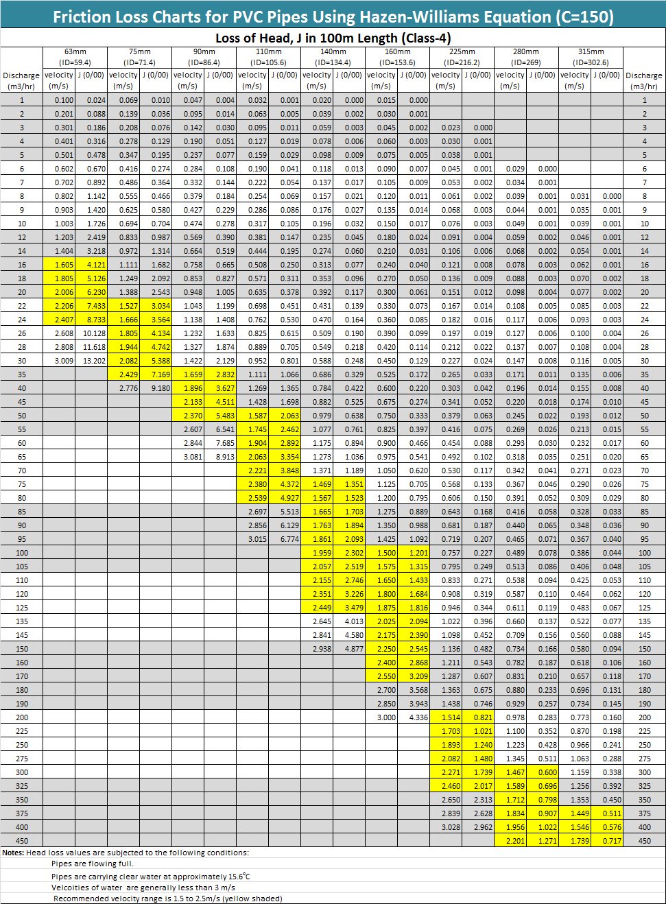

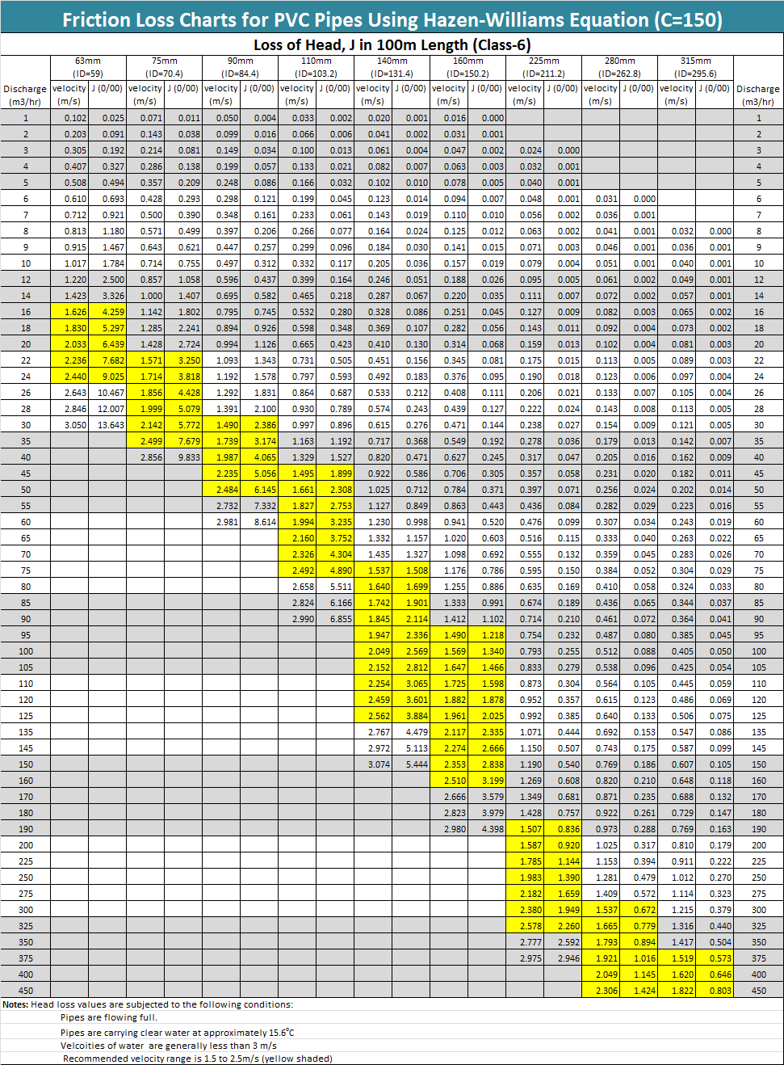

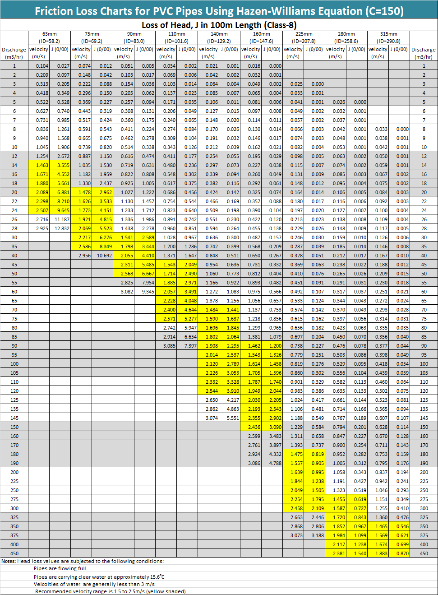

APPENDIX XIII: (b)–Head loss charts for PE pipes

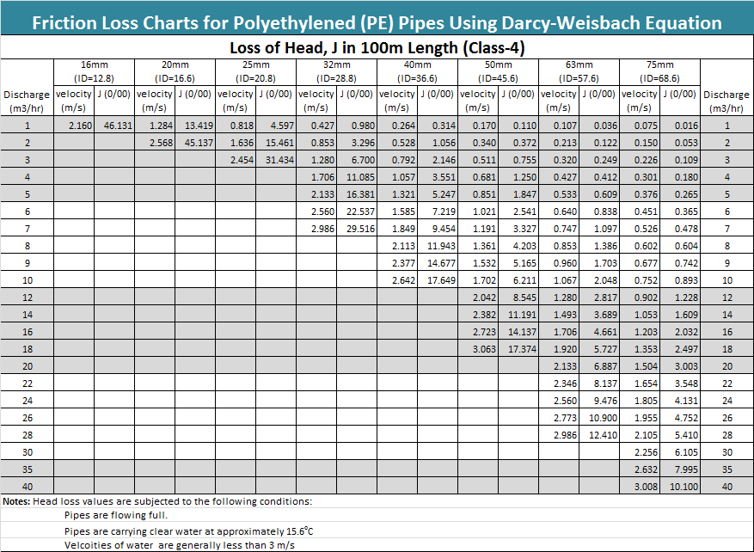

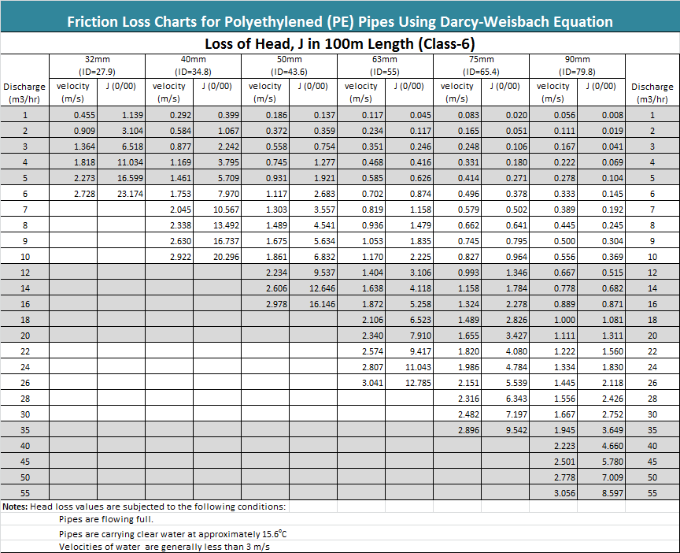

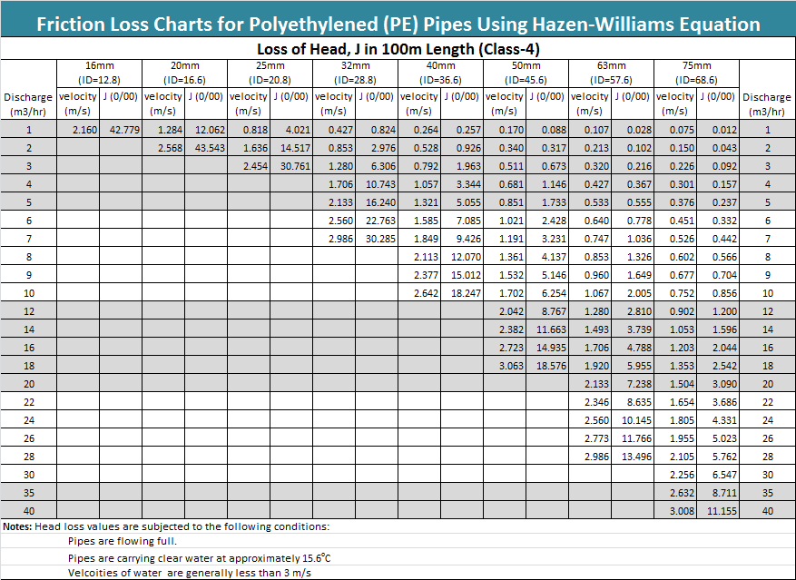

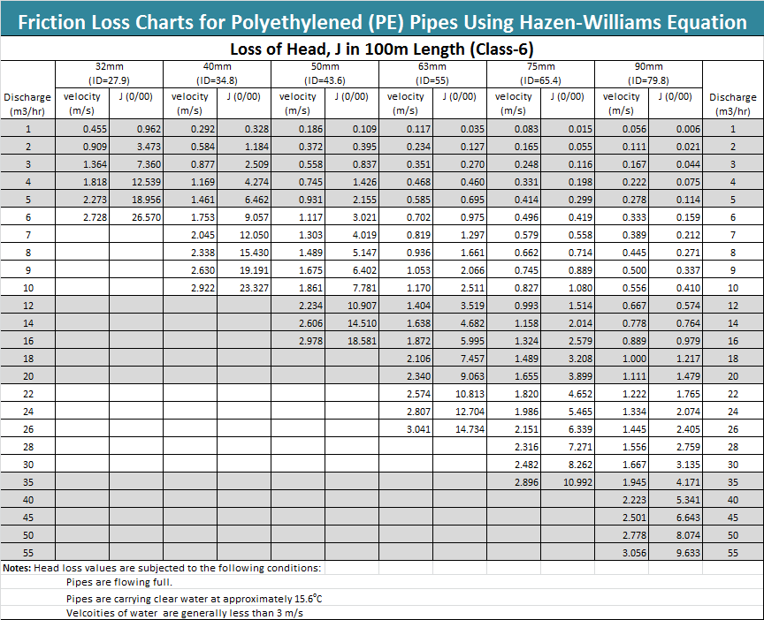

APPENDIX XIV:Excel template for design of drip irrigation system (Interface)

See the accompanied CD

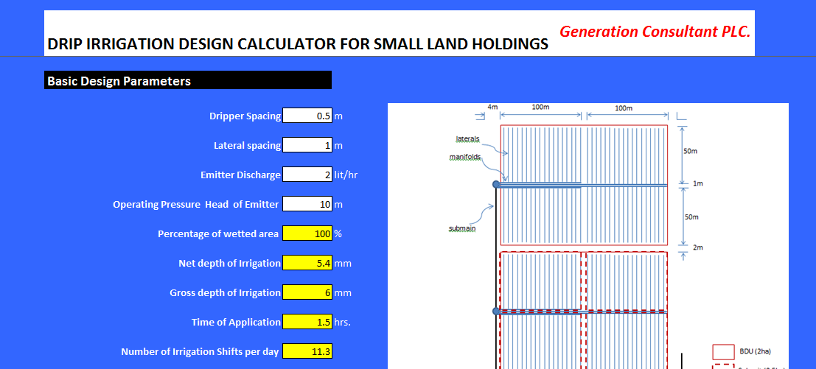

# INDEXES OF KEY WORDS:

* **Application efficiency –** it refers to the depth of water stored in the root zone per unit depth water applied usually expressed in percentage.
* **Accessories –** they refer to the minor components of the sprinkler system such as risers, couplers, valves, water meter, pressure guage, bends, plugs, fittings, etc.
* **Application rate –** the depth of irrigation water applied per unit time usually expressed by mm/hr.
* **Basic design unit –** it refers to a small block of command area, which can get water from submain.
* Clogging –
* **Connectors –** they refer to devices used to provide connection between two pipes and between pipes and fittings.
* **Consumptive use –** it refers to the evapotranspiration need of the crop, which depends on the crop type and climate of the project area.
* **Control head –** it refers to the system regulation point which consists of majorly valves, water meter, pressure gauges, fertilizer connections and water filter.
* **Correction factor –** it refers to a ratio of the frictional head loss in multi-outlet pipe to that in blind pipe.
* **Design of drip system –** refers to determination of the proper sizes of the pipe networks and pump capacity to obtain a system that provides satisfactorily uniform application of water with a minimum annual operation and maintainance cost.
* **Discharge (flow rate) –** it refers to the amount of water that flows through a certain cross-section of pipe per unit time usually expresssed in m3/hr or lit/hr.
* **Drip system –** it refers to one of the broad classes of pressurized irrigation methods; in which water is applied at or near the plant location, frequently, and at rate equal to the consumptive use of the crops.
* **Drippers (emitters) –** they refer to water applicators or emission devices which are placed at regular or desired spacing on the laterals.
* **Emitter spacing –** it refers to the regular spacing of emitters on a lateral pipe.
* **Filters –** they refer to devices which are used to reduce or remove impurities in water before entering to the pipe network.
* **Filtration –** it refers to the process of reducing or removing impurities in water by using filters.
* **Fittings –** they refer to devices which are used to facilitate proper connections of pipes. Fittings include flanges, adapter and nipples.
* **Friction head loss –** it refers to the loss of the pressure head due to the friction of the water with the pipe walls or due to the turbulence of flow by other components of the system.
* **Head loss gradient, J (0/00) –** it refers to the frictional head loss per 100m length of pipe.
* **HDPE pipe –** it refers to a flexible pipe which is made of high density polyethylene material.
* **Irrigated area –** it refers to the size of arable land which is commanded by the irrigation system.
* **Inner diameter –** it refers to the internal diameter of a pipe which is expressed in inches for aluminum and steel pipe and in mm for plastic pipes.
* **Intake rate –** it refers to the rate at which water infiltrate into the soil usually expressed in mm/hr.
* **Irrigation cycle, f –** it refers to the period in days required to complete irrigating the design command area.
* **Irrigation interval, F –** it refers to the time period in days between two successive irrigation applications.
* **Lateral pipes –** it refers to the smallest size pipes in a sprinkler system onto which sprinkler heads are connected at regular spacing through a riser pipe.
* **Lateral spacing –** it refers to the regular spacing between two consecutive laterals which are connected on a main pipe.
* **Leaching requirement, LR –** it refers to the water applied onto the soil in excess of the required depth of irrigation to flush out salts from the root zone of the plant.
* **LDPE pipe –** it refers to a flexible plastic pipe which is made of low density polytheleyne pipe.
* **Main line –** it refers to a single largest size pipe line in the sprinkler pipe network.
* **Manifolds –** they are black HDPE pipes onto which lateral pipes are connected at regular interval.
* **Net depth of irrigation, dn –** it refers to the depth of water to be applied to the soil thatis readily available for the crop to absorb.
* ***Nominal pipe diameter* –** it refers tothe diameter of steel pipes up to 10inch, which is expressed as the internal diameter, measured in inches. Wider diameters, as well as the diameter of aluminium,and plastic pipes are expressed as the external diameter, measured in inches in aluminium pipes and in mm in plastic pipes.
* **Outer diameter –** it refers to the external diameter of a pipe.
* **Percentage of Wetted area, Pw –** it refers to the ratio of the width of the wetted area measured at a depth of 30cm beneath the emitters to the spacing between laterals.
* **Pipe network –** it refers to the three major pipes in the sprinkler system, namely main, submain and laterals.
* **Pressure –** it refers to a force required to push water in a given size of pipe, expressed in units of kg/cm2, bar or atmosphere.
* **Pressure head –** it refers tothe pressure of water which is expressed in depth of water column. The common unit of pressure head is meter. A head of 10m is equivalent to 1 atm.or 1 bar.
* **Pressurized system –** It refers to the type of irrigation system which uses pipe networks as means of water conveyance and the water flows in the pipes under pressure.
* **Pump –** it refers to a device which is used to provide sufficient head for the water to move in the sprinkler pipe networks under presssure.
* **PVC pipe –** it refers to a pipe which is made of polyvinyl chloride material
* **Riser pipe –** it refers to short vertical pipe which is connecting buried submain with manifolds.
* **Static head –** it refers to the head from the pump center line to the level of water surface at the source.
* **Submain line –** it refers to the second largest pipe in a sprinkler system onto which lateral pipes are connected at regular spacing.
* **Subunit –** the smallest irrigation operation unit or the manageable size of pressurized irrigation system by each farmer.
* **Supply line –** it refers to a short pipe directly connected to the source or pump, and delivers water to the system via. main pipe.
* **System capacity –** it refers to the flow rate or the volume of water flow per unit time required by the system usually expressed in m3/hr or liter per hr.
* **System layout –** it refers to the arrangement of the field and the pipe lines on the map depending upon the topography and the location of water source with the consideration of non-irrigable features such as villages and other existing facilities.
* **Uniformity coefficient, Cu –** it refers to an index used to measure the degree of uniformity of sprinklers application rate for given set of conditions in the field.
* **uPVC pipe –** it refers to pipe which is a rigid, chemically resistant form of PVC and is made of unplasticized poly vinyl chloride material.
* **Valves –** they refer to devices which are used to control the flow of the water in irrgiation systems.

