AMHARA NATIONAL REGIONAL STATE
DEWA CHEFA WEREDA IRRIGATION AND LOWLAND AREA OFFICE
FEASIBILITY STUDY AND DETAIL DESIGN
OF
SEMIRA DIVERSION/ INTAKE-WEIR SMALL SCALE IRRIGATION PROJECT
ENGINEERING DESIGN FINAL REPORT

October, 2024
kemissie, Ethiopia

Table of Contents Page Nr
LIST OF TABLES iv
LIST OF FIGURES v
SAILENT FEATURE vi
1 INTRODUCTION 1
1.1 Background 1
1.1.1 Description of the Project Area 1
1.2 Objectives of the Study 3
1.2.1 Major Objective 3
1.2.2 Specific Objectives 3
1.3 Scope of the Study 4
1.4 Methodology 5
SECTION-I: HYDROLOGY 7
2 HYDROLOGY 8
2.1 Watershed Characteristics 8
2.2 Hydro-Metrological Data Availability 9
2.2.1 Climate 9
2.2.2 Rainfall Data 10
2.2.3 River flow data 10
2.2.4 Upstream & Downstream utilization 10
2.3 Design Flood Analysis 10
2.3.1 Design Rainfall computation 10
2.3.2 Outlier Test 11
2.3.3 Check for variance 12
2.3.4 Peak Discharge Determination 14
2.3.5 Tail Water Depth Computation 18
SECTION-II: HEADWORK DESIGN 23
3 HEADWORK STRUCTURES DESIGN 24
3.1 Headwork Site Selection 24
3.2 River Geomorphology 24
3.2.1 River Bed condition 25
3.2.2 River Bank condition 26
3.3 Sources of construction materials 28
3.3.1 Rock for Masonry and Crushed Coarse Aggregate 28
3.3.2 Fine Aggregates 28
3.3.3 Water 29
3.4 Headwork Type Selection 29
3.4.1 Hydraulic Design of Headwork Structure 30
3.4.2 U/S and D/S HFL Calculation & Determination 31
3.4.3 Hydraulic Jump Calculation 32
3.4.4 Impervious floor 33
3.4.5 Cut off Depth Calculation 35
3.4.6 Stability Analysis of weir 37
3.5 Bill of Quantity and Cost Estimation 43
SECTION-III: IRRIGATION AND DRAINAGE SYSTEMS INFRASTRUCTURE 49
4 IRRIGATION AND DRAINAGE SYSTEMS DESIGN 50
4.1 Irrigable Area Description 50
4.1.1 Topography 50
4.1.2 Climate 50
4.1.3 Soil characteristics 51
4.1.4 Existing Irrigation Practices in the Project Area 51
4.2 Irrigation Water Requirement 52
4.2.1 Crop Water Requirement (CWR) 52
4.2.2 Irrigation efficiency (Ep) 52
4.2.3 Irrigation duty 53
4.2.4 Irrigation methods 54
4.3 Irrigation and Drainage System Layout 55
4.3.1 Conveyance System 56
4.4 Design of the Canal System 56
4.4.1 Main Canal 56
4.4.2 Primary HDPE Pipe 57
4.4.3 Field Canals 58
4.5 Canal Structures Design 59
4.5.1 Design of a typical flume 59
4.5.2 Design of Division boxes 59
4.5.3 Design of field canal turnout 61
4.5.4 Road crossing structure 62
4.6 Irrigation Infrastructure Bill of Quantities and Cost Estimate 64
5 CONCLUSION AND RECOMMENDATION 70
6 OPERATION AND MAINTENANCE 71
6.1 General 71
6.2 Operation of the Head Works 71
6.3 Irrigation System Operation 71
6.4 Maintenance Requirement 72
REFERENCE 73

LIST OF TABLES

Table 2-1: Outlier test analysis 11
Table 2-2: Test for goodness to fit using D-index 13
Table 2-3: Determination of Time of Concentration 14
Table 2-4: Runoff analysis 16
Table 2-5: Hydrograph coordinates 17
Table 2-6: Weir Diversion Site River Cross section Coordinate Data 18
Table 2-7: Stage discharge analysis 19
Table 2-8: River discharge computation at different stages of flow 22
Table 4-1: Hydraulic Parameters of main canal 56
Table 4-2: Hydraulic Parameters of primary HDPE pipe 58
Table 4-4: Hydraulic Parameters of Flume 59
Table 4-5: Hydraulic parameters of Division Boxes 61

LIST OF FIGURES

Figure 1-1: Location map of the project area 2
Figure 2-1: Drainage Map of Workie watershed 9
Figure 2-2: Complex Hydrograph 18
Figure 2-3: Discharge-depth Rating Curve 20
Figure 2-4: River profile 21
Figure 3-1: River bed at the proposed Weir Diversion site 26
Figure 3-2: River bed geological x-section 27
FIGURE 3-3 : Weir section
Figure 3-4 :Weir stability 38
Figure 3-5: Typical design of masonry retaining wall 42
Figure 4-1: Typical Field Canal X-section 58
Figure 4-2: Typical Division Box section 60
Figure 4-3: turnouts from masonry lined 62
Figure 4-4: typical road crossing section 63

SAILENT FEATURE
- Project name: Semira Diversion/Intake Weir Small scale Irrigation Project
- Name of the stream: Workie river
- Location of the Weir Diversion site using
- North: 1190420.739 m
- East: 599789.9684 m
- Average Altitude: 1807.757 masl
- Zone: Kemissie Oromia zone
- Woreda: Dewa Chefa
- Kebele:- Goda kebele
- Hydrology
- Design rainfall: 104.48 mm
- Catchment area: 6.33 Km²
- Longest flow path length: 3.89 Km
- Design flood: 32.76 m³/se by flood mark
- Base flow: 80 lit/s, release 20 l/s to d/s users
- Design base flow: 60 lit/se.
- Metrological data
a) Kemise metrological station
b) Number of data used 22 years
- Weir Diversion
- Weir type: Intake Weir with Concrete
- Height: 0.7m
- Gross crest length: 6 m
- Weir crest level: 1807.7m.a.s.l
- U/S HFL: 1809.648m.a.s.l
- U/S TEL: 1809.546 m.a.s.l
- D/s TEL: 1811.022 m.a.s.l.
- D/s HFL: 1809.549 m.a.s.l
- Afflux: 0.10 m

Irrigation and drainage systems Infrastructure
- Command area size: 100 ha
- Type of soil of the command area is dominantly clay loam soil
- Design discharge of the main canal = 60 l/sec
- Irrigation system layout consists of Masonry Lined and HDPE Pipe main canal network system
- Main irrigation structures designed are;
- Gully crossing structures, such as, Flume& Supper passage structure
- Road crossing structure
- division box, and turn out
Project cost
SEMIRA IRRIGATION PROJECT
SUMMARY OF BILLS
Bill No. | Description | Amount (Birr)
1 | General Items | 345,000.00
2 | Head work | 2,390,489.77
3 | Infrastructure | 19,265,118.20
Total |  | 22,000,607.97
Contingency 10%) |  | 2,200,060.80
Grand Total |  | 24,200,668.76
VAT (15%) |  | 3,630,100.31
Grand Total with VAT |  | 27,830,769.08
Command Area(ha) |  | 100
Per hactare Cost without VAT |  | 242,006.69
Per hactare Cost with VAT |  | 278,307.69

INTRODUCTION

Background
In Ethiopia, under the prevalent rain-fed agricultural production system, the progressive degradation of the natural resource base, especially in highly vulnerable areas of the highlands coupled with climate variability have aggravated the incidence of poverty and food insecurity. The major source of growth for Ethiopia is still conceived to be the agriculture sector. Hence, this sector has to be insulated from drought shocks through enhanced utilization of the water resource potential of the country, (through development of small-scale irrigation, water harvesting, and on-farm diversification) coupled with strengthened linkages between agriculture and industry (agro-industry), thereby creating a demand for agricultural output. In line with the above, efforts have been made by the government to improve the situation in the country in areas of domestic water supply provision, irrigation, watershed management; etc. The Amhara Irrigation and Lowland Area Development Bureau is playing its role in the development of small scale irrigation projects in the region. Accordingly, as part of the water sector development program, the office ( Dewa chefa Irrigation & Lowland ) has initiated the study and design of a Small small scale irrigation scheme on Workie River at Goda Kebele for the study and design of the project.

Description of the Project Area

Location
This irrigation project is located mainly at Goda Kebele, Dewa Chefa Wereda of Oromia Zone in the Amhara Region. The proposed irrigation project is to be undertaken on Workie River and the headwork structures are specifically located at an altitude of about 1807.757 masl and geographical coordinates of 1190420.739 N (UTM) and 599789.9684 E (UTM).

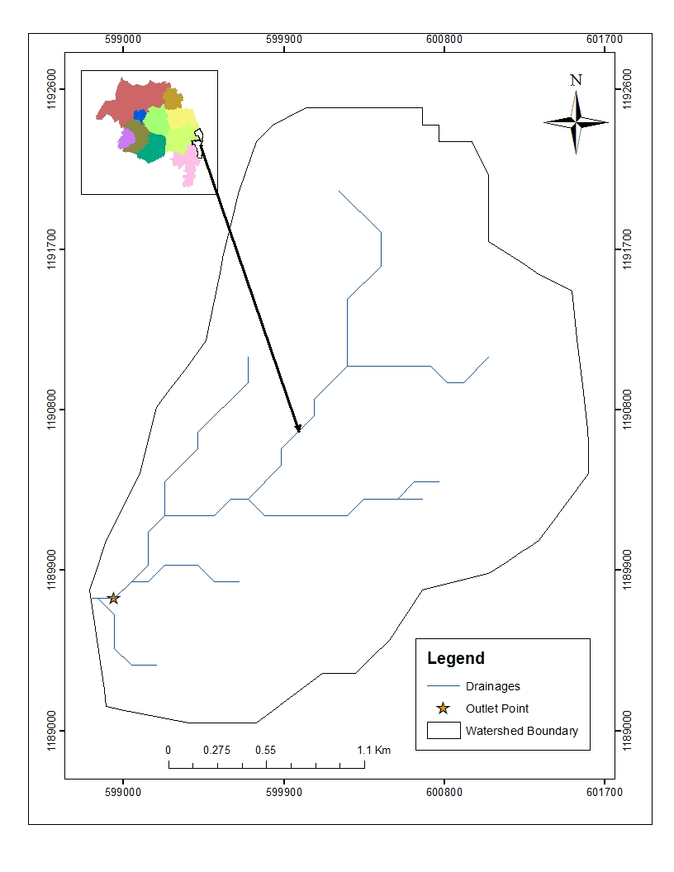
Figure 1-1: Location map of the project area

Accessibility
The Workie Irrigation project headwork site is located in the National State of the Amhara Region, Oromia zone, Dewa Chefa Woreda, in Goda kebele. The geographic co-ordinates of the site are defined by the UTM location of 1190420m N, 599789m E and river bed elevation of 1807m above mean sea level.
The Head work project site is 15 km from Kemissie to north-East. Out of this distance, 12km is all weather gravel road and turning to the right side the 3km is in accessible till the headwork site. There for, the access road it needs Construct temporary access road to site which includes Cut the hilly terrain, fill the Gorgy area, boulder excavation, hard rock Excavation and highly Site clearing. UN less the work methodology is difficult.

Previous Irrigation Practices
There are traditional diversions on the upstream/downstream of this river using different irrigation practices but as the hydrology and Hydrogeology study and respondent farmers indicated, the river has capacity of recharging as it stretches down from the source area of the river. As a result there will not be a marked reduction or fluctuation of water flows both for the already existing and the newly proposed irrigation schemes. The traditional irrigation practices (if any) are under taken by individual farmers that use the river flow to the extreme Left side is with hardship. So, the farmers in the project area are very much interested to upgrading the traditional scheme to modern scheme.

Objectives of the Study

Major Objective
The project area faces variability of rainfall distribution though the overall rainfall generally suffices the rain-fed agriculture. Accordingly, the rain-fed agriculture needs means of supplementing during distribution failures and further full irrigation is required to maximize the use of the potential land and water resources.
Hence the objective of this project is to contribute a substantial share in the effort to reduce the risk of production decrease due to rainfall variability and increase the productivity of the resource in the project specific area. Specifically, the project is targeted for the following.
- To make sustainable the rain-fed crop production and make extra production in the dry season possible for 100 ha of land through irrigation.
- There is a general consensus that irrigation investments will achieve broader food security and poverty reduction impacts and if efforts are also geared towards up-grading existing traditional farming practices with support to enhance access to input supply, output marketing and extension to facilitate access to information and innovations.
- This objective is to be realized by constructing Intake-Weir Diversion structures across the Workie River and diverting the river flow.

Specific Objectives
Other benefits that can be expected to appear with the launching of the project are:
- Efficiency of water use improvement;
- Improved local nutrition/food security gains;
- Improved management of scarce natural resources (land and water);
- Resilience against drought risk;
- Rationale for erosion control and watershed management;
- Rationale for the intensification and modernization of small-holder agriculture and rural lifestyles.
The engineering study and design enables the realization of the project by the provision of engineering structures that will allow the appropriate abstraction of the river water for delivery in to the identified irrigation fields of the study area. Hence, this engineering design is specifically targeted to:
- Analyze hydrologic requirements of the project and engineering structures;
- The formulation of sound and stable structure, with necessary provisions that allow safe, easy and low-maintenance operation in the service life of the project;
- Develop working drawings;
- Estimation of construction costs.

Scope of the Study
- The irrigation design shall ensure reliability, equity and flexibility of water delivery to farmers. It will aim at reducing conflicts among water users and will lead to lower operation and maintenance costs.
- Updating the existing, if available, computation of the actual evapo-transpiration, crop water requirement, irrigation demand/duty using the existing and recent agronomic, climatologic and soil data using more appropriate methodologies.
- Establish design criteria for irrigations structures to be approved by the client and to be used in the final design stage,
- Design proper irrigation system compatible with local conditions and management capabilities,
- Establish flood protection measures for the command area and canal structures and design the respective drainage system accordingly,
- Planning and layout of the irrigation system, which include irrigation canals, drainage channels, inspection roads and alignments, canal spacing, canal length, location of structures, and water profiles along canal and drains at specified reaches, which is most economical easily manageable and aligned with topographic feature and geological investigation.
- Determination and estimation of water application conveyance and other losses and irrigation efficiencies and consideration of those parameters in design steps.
- Check and test hydraulic and structural designs of main canal considering total demand and the required capacity and the base flow availability,
- Prepare general plans and drawings for all irrigation infrastructure and irrigation systems designs,

Methodology
In the study and design procedure, Designers used the following steps.
- Specific Site identification:
  - Review of the reconnaissance survey conducted by the Client
  - 50,000 scale top map and GIS information
  - Local farmers interview and discussion
  - Wereda and kebele Agriculture section expertise
  - Previous studies
  - On foot travel along the river channel and farm areas.
- Topographic survey:
  - Surveying the headwork site and the Command area with sufficient radius, using Total station
- Flow estimation
  - Physical observation on flood mark indications and local information about high flood and critical flow condition of the river
  - Analyzing the recorded river flow data and use watershed inputs for further analysis.
  - Base flow estimated during the reconnaissance field visit by floating method.
- Irrigable area identification:
  - Using local information
  - 50,000 Topographic map, and GIS information, GPS to see elevation
The design report is organized in three sections. In Section I the Hydrology study is presented and in Sections II and III the Headwork and Irrigation and Drainage Systems designs are discussed respectively. In Section III, planning and design of the irrigation system after diverting the water using the Weir Diversion will be dealt. The following are major areas of concern in this part.
- Study and design of the irrigation method to be adopted,
- Study and design of the irrigation system layout and associated structures,
- Design of the different conveyance canals,
- Planning and design of the different irrigation and drainage structures,
- Preparation of the longitudinal profiles of the different irrigation and drainage canals.

SECTION-I: HYDROLOGY

HYDROLOGY

Watershed Characteristics
The watershed is found within 1698 to 2240 meters above sea level altitudinal range. The watershed has marked topographic variation. The dominant slope class is moderately steep (15-30%) which covers 46.24% of the total area followed by steep slope (30-50%), which is 32.51%.Sloping (8-15%), very Steep (>50%) and gently sloping (3-8%) which accounts 10.19%, 8.94% and 2.12% respectively. Table 1 of the watershed feasibility study report shows the slope classes and proportion of the watershed.
Certain physical properties of watersheds significantly affect the characteristics of the runoff and sediment yield and are of great interest in hydrologic analyses. The rate and volume of runoff, and sediment yield from the watershed have much to do with shape, size, slope and other parameters of the landscape. These suggest that there should be some important relations between basin form and hydrologic performance. If the basin and hydrologic characteristics are to be related, the basin form must also be represented by quantitative descriptors. These parameters can be measured from maps.
The watershed characteristics are analyzed and presented in Table 2 of the Watershed Feasibility Study Report of the same project. In summary:
- Catchment Area = 6.33km²
- Stream Length = 3.89Km
- CN(II) = 88.41
(Extracted from the Watershed Study Report of the same project)
At the selected reference point, the area of Workie catchment is 6.33km² and consists of a network of tributaries as shown in Figure 1 below.
Workie River at the headwork site is characterized by well-defined channel system and considerable flows. It looks that the gradient of the river/stream is getting low and hence there exists significant deposition of sediment mainly cobbles and boulders.
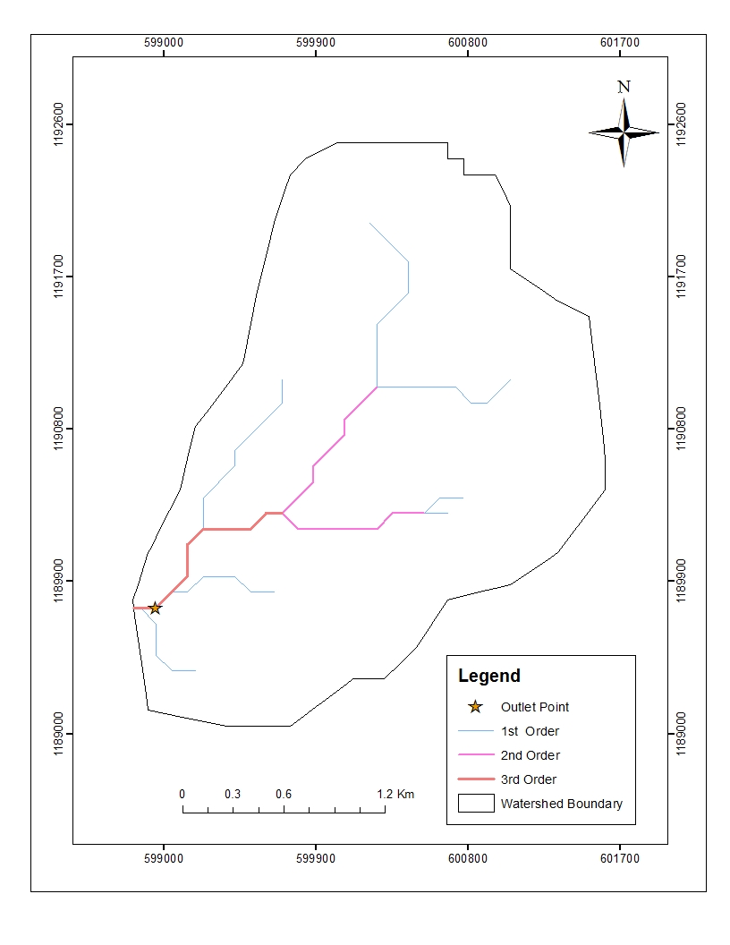

Figure 2-1: Drainage Map of Workie watershed

Hydro-Metrological Data Availability

Climate
Small scale irrigation project designers and planners are faced with lack of good data on the hydrology of the river system that will be their water source and on local weather and climate conditions. Stream gauging stations are virtually non-existent in remote rural areas of Ethiopia; meteorological stations are almost rare. Likewise, at Goda Kebele (Project area location) and in the catchment area of this project, there is no meteorological station of any level. Moreover, there are no flow data for the river near the project. Therefore, data for the hydro-meteorological analysis is taken from the nearby station and similar areas. Rainfall & temperature data are considered from Kemissie Meteorological station. In fact, this station is very close to the project area.
The average of annual rainfall of the area is calculated based on 20 years record of the station and is equal to 921.585mm/yr. The annual average minimum and maximum temperature is about observed 16.54ºc and 28.16ºc respectively. The mean annual temperature of the watershed is about 20.25⁰c.

Rainfall Data
In order to compute the design flood for the Intake- Weir Diversion structure, the daily maximum rainfall is collected from Kemissie Metrological stations with a record of 22 years.

River flow data
The base flow which is measured on May 2023/24 is 80 l/s. Since this base flow is measured during the dry months of the year, this figure is adopted for design.

Upstream & Downstream utilization
The water distribution of Workie River is for both existing irrigation system at proposed site itself and downstream of the proposed site in left side of river there is irrigated command area which is constructed by World vision and in right side of the river is irrigated command area which is constructed ifad and the method of irrigation is rotational scheme irrigation system is used hence, from the previous Experience Semira Intake-Weir Diversion Irrigation project is design rotational scheme irrigation system.
For the sake of planning and design, however, the outlet for the Weir Diversion is designed for a discharge of 60 l/s for this project and the project is to be developed for 100 ha of land, which is most of the time achievable as the flow for most of the time is significant to support this size of command area.

Design Flood Analysis
For the design and analysis of structures to be constructed on the river, estimation of flood magnitude is an important task. This can be done using different techniques depending on the data available. For this particular case, there is no river flow data and hence the flood estimation is done using the rainfall data and applying SCS Curve Method.

Design Rainfall computation
Based on the data of 24 hr peak rainfall given in Table 1 the design rainfall, Rf is computed using Gumble’s Extreme Value Method.

Outlier Test
Checking data Quality
Let Y=log X
Lowest Data RL=10^YL
Highest Data RH=10^YH, Where, Higher and lower limit YL=Ymean -Kn*syn-1 & YH=Ymean +Kn*syn-1
Ymean =1.763
Syn-1=logarithmic standard deviation= 0.109, Kn =2.429 for 22 record data
YL=1.498 & YH=2.028
Therefore, RL=31.5mm <3 5.5mm is Ok and RH=106.715mm > 84.2mm is Ok
As we observed from the above result the data is within the higher and lower outliers is safe
Table 2-1: Outlier test analysis
Kemissie max daily rainfall
No | year | Max rain fall of year(X) | Descending order (x) | Y=logx | cumulative rainfall
1 | 1990 | 38 | 84.2 | 1.925 | 38
2 | 1991 | 36 | 81.9 | 1.913 | 73.5
3 | 1992 | 42 | 81 | 1.908 | 115.5
4 | 1993 | 50 | 72.6 | 1.861 | 165.2
5 | 1994 | 67 | 72.5 | 1.860 | 232.2
6 | 1995 | 66 | 69.8 | 1.844 | 298.2
7 | 1996 | 84 | 67 | 1.826 | 382.4
8 | 1997 | 60 | 66 | 1.820 | 441.9
9 | 1998 | 70 | 63.9 | 1.806 | 511.7
10 | 1999 | 60 | 62 | 1.792 | 571.4
11 | 2000 | 81 | 60.4 | 1.781 | 652.4
12 | 2001 | 73 | 59.7 | 1.776 | 724.9
13 | 2002 | 64 | 59.5 | 1.775 | 788.8
14 | 2003 | 58 | 58 | 1.763 | 846.8
15 | 2004 | 73 | 53.9 | 1.732 | 919.4
16 | 2005 | 62 | 50 | 1.699 | 981.4
17 | 2006 | 54 | 49.7 | 1.696 | 1035.3
18 | 2007 | 45 | 44.6 | 1.649 | 1079.9
19 | 2008 | 82 | 42 | 1.623 | 1161.8
20 | 2009 | 50 | 40.9 | 1.612 | 1211.8
21 | 2010 | 60 | 38 | 1.580 | 1272.2
22 | 2011 | 41 | 35.5 | 1.550 | 1313.1
sum |  | 1313.1 |  | 38.79191314
mean/µ/ |  | 59.686 |  | 1.763
stdv/αn-1/ |  | 14.272 |  | 0.109
skew/g/ |  | -0.012 |  | -0.426

Check for variance
After checking the outliers, the data should be checked for variability. For variability the formula used is $α=\left(\frac{δ_{∩-1}}{\sqrt{N}*Mean}\right)*100\%$
Where, δ_{n-1 =} Standard deviation =14.27
N = Nr of recorded data =22
M_{ean} = 59.686 and $α$ = Standard error
$α=\left(\frac{14.272}{22*59.686}\right)*100\%=5.10<10\%$ Acceptable, Therefore the data shows no variability.

D-Index test
After checking the consistency of the data for higher and lower outlier, the 22 years data is obtained as representative for the analysis using D-index. The D-Index test is believed to be the better goodness to fitness in many literatures. Hence in this study it was used to determine the best statistical distribution to estimate the peak rainfall. The D-index for the comparison of the fit of various distributions is summarized as follows.
$D_{-Index}=(\frac{1}{X_{m}})*\sum_{i=1}^{6}{Abs(Xi-{Xi}^{'})}$
Where Xi and Xi’ are the i^{th} highest observed and computed values for the distribution respectively
Table 2-2: Test for goodness to fit using D-index
Rank | XI' | Normal | GUMBLE EVI | Log normal | Log person Type III
Rank | XI' | XI-'XI' | XI-'XI' | XI-'XI' | XI-'XI'
1 | 84.200 | 0.079 | 9.813 | 4.930 | 1.739
2 | 81.900 | 2.803 | 2.609 | 2.614 | 1.724
3 | 81.000 | 5.265 | 2.190 | 5.001 | 4.632
4 | 72.600 | 0.485 | 2.061 | 0.795 | 0.801
5 | 72.500 | 1.669 | 1.146 | 1.959 | 1.595
6 | 69.800 | 0.973 | 1.227 | 1.705 | 1.092
Sum |  | 37.14 | 55.729 | 55.141 | 41.173
D-index=sum/mean |  | 0.622 | 0.934 | 0.924 | 0.690
All the candidate distributions give almost identical correlation coefficients. However, the standard errors are significantly lower for the Normal Distribution Method which is 0.622. Accordingly, the design rain for this distribution has been selected as the best fit for this study
- But, Gumbell Peak RF is taken for further analysis because it gives as maximum RF hence to minimize Risk and also the method is widely used method and structurally safe

The design rainfall using Gumbell Method is given as
Where R_{F =} Design rainfall
R_{mean} = average of all values of annual heaviest fall = 59.686 mm
σ_{n-1} = standard deviation of the series = 14.272 mm
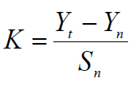
, T= Return period = 50 years
Yn, Sn = constant found from Gumble’s extreme value distribution table for N= 22Years
- Yn = 0.5268 and Sn = 1.0754
- Point Design Rainfall = 104.478 mm
The design rainfall at points for 50 years return period is 104.48 mm and the areal design rainfall is calculated in the following section.

Peak Discharge Determination

General
The River is not gauged river. The design flood is calculated by using SCS unit hydrograph method. Thus, it is preferred to base the flood analysis on rainfall data, which are better both in quantity and quality of data. In the hydrologic analysis for drainage structures, it must be recognized that there are many variable factors that affect floods. Some of the factors that need be recognized and considered on an individual site by site basis are; rainfall amount and storm distribution; catchment area, shape and orientation; ground cover; type of soil; slopes of terrain and stream(S); antecedent moisture condition; Storage potential (over bank, ponds, wetlands, reservoirs, channel, etc.)

Peak flood analysis by SCS unit hydrograph method
Design flood is calculated SCS (The United States Soil Conservation Service). This method is widely adopted and more reliable method for flood estimation. The approach considers, watershed parameters, like Area, Curve number, and time of concentration.

Time of concentration (Tc)
Time of concentration has been calculated by taking the stream profile of the longest streamline and dividing it in to different elevation. Kirpich formula is adopted for computation.
Table 2-3: Determination of Time of Concentration
Partial Distance/km/ | cumulative distance/km/ | Elevation/m/ | Elevation diff./meter | TC/hr
0 | 0 | 2240 | 0
0.41 | 0.41 | 2100 | 140 | 0.05
1.00 | 1.41 | 1960 | 140 | 0.15
1.58 | 2.99 | 1760 | 200 | 0.22
0.90 | 3.89 | 1698 | 62 | 0.18
 |  |  | TC | 0.59

The formula is,
$Tc=\sum{0.948\left\{{\left(\frac{{L_{1}}^{3}}{H_{1}}\right)}^{0.385}+{\left(\frac{{L_{2}}^{3}}{H_{2}}\right)}^{0.385}+…+{\left(\frac{{L_{n}}^{3}}{H_{n}}\right)}^{0.385}\right\}}$
- Tc = 0.59 Since Tc <3hr., duration of excess rainfall difference, D = 0.1hr.
- Time to peak,
$T_{p=}\frac{D}{2}+0.6*T_{c}$ = 0.41hr
- Base time,
$T_{b}=2.67*T_{p}$ = 1.08hr
- Recession time,
$T_{r}=1.67*T_{p}$ = 0.68hr.

Curve number (CN)
Curve number (CN) is achieved based on USSCS method by watershed characterization in terms of land cover, treatment, hydrologic condition and soil group. From the watershed analysis curve number at condition II =75.56. Since peak rainfall is found at an antecedent moisture condition III state, this value has to be changed to antecedent moisture condition III.
- Conversion factor = 1.17
- CN Condition (III) = (Factor from Table x CN condition II) =75.56*1.170 = 88.41. For detail analysis of the computation, Refer Excel file, attached here with.

Area Rainfall
As the area of the catchment gets larger, coincidence of all hydrological incidences becomes less and less. This can be optimized by changing the calculated point rainfall to aerial rainfall. The conversion factor is taken from standard table that relate directly with the size of watershed area and type of the gauging station. (IDD manual)
For the case of Semira irrigation project,
- Total watershed area = 6.33 Km²
- Type of gauging station = Daily rainfall (24 hr.)
- Aerial Rainfall = (Point Rainfall) x (Conversion factor)

Run off Analysis
Input data:
- Design Point Rainfall = 104.478mm
- Curve number at antecedent moisture condition III = 88.41
- Catchment Area, A = 6.33 Km²
- Tc = 0.59hr, D = 0.1hr., Tp = 0.41 hr; Tb = 1.08 hr; Tr = 0.68 hr.
- Direct run-off,
$Q=\frac{{(I-0.2*S)}^{2}}{(I+0.8*S)}$
Where, I = Rearranged cumulative run-off depth (mm
- S = Maximum run off potential difference,
$S=\left(\frac{25400}{CN}\right)-254$
- Peak run-off for incremental;
$Q_{p}=0.21*\frac{(A*Q)}{T_{p}}$
Where, A = Catchment area = 6.33 Km²
T_{p} = Time to peak (hr)
Q = Incremental run-off (mm)
Table 2-4: Runoff analysis
Rainfall Duration(D) | Direct runoff increment, Ri(mm) | qp for 1mm runoff /m3/s/mm | qp for incremental run off m3/s/ | begin time, hour | peak time, hour | end time, hour | remarks
0-0.1 | 0.00 | 3.27 | 0.00 | 0 | 0.41 | 1.09 | h1
0.1-0.2 | 0.03 | 3.27 | 0.10 | 0.1 | 0.51 | 1.19 | h2
0.2-0.3 | 0.94 | 3.27 | 3.1 | 0.2 | 0.61 | 1.29 | h3
0.3-0.4 | 3.64 | 3.27 | 11.9 | 0.3 | 0.71 | 1.39 | h4
0.4-0.5 | 3.04 | 3.27 | 9.9 | 0.4 | 0.81 | 1.49 | h5
0.5-0.6 | 2.19 | 3.27 | 7.18 | 0.5 | 0.91 | 1.59 | h6
Table 2-5: Hydrograph coordinates
Time | Q1 | Q2 | Q3 | Q4 | Q5 | Q6 | Base flow(m^3/se) | Qtotal(m^3/se)
0.0 | 0.00 |  |  |  |  |  | 0.06 | 0.06
0.1 | 0.00 | 0.00 |  |  |  |  | 0.06 | 0.06
0.2 | 0.00 | 0.02 | 0.00 |  |  |  | 0.06 | 0.08
0.3 | 0.00 | 0.04 | 0.51 | 0.00 |  |  | 0.06 | 0.61
0.4 | 0.00 | 0.06 | 1.02 | 1.68 | 0.00 |  | 0.06 | 2.82
0.41 | 0.00 | 0.06 | 1.05 | 1.79 | 0.08 |  | 0.06 | 3.05
0.50 | 0.00 | 0.08 | 1.53 | 3.37 | 1.23 | 0.00 | 0.06 | 6.27
0.51 | 0.00 | 0.10 | 1.56 | 3.48 | 1.31 | 0.05 | 0.06 | 6.56
0.61 | 0.00 | 0.00 | 3.11 | 5.16 | 2.54 | 0.84 | 0.06 | 11.71
0.71 | 0.00 | 0.00 | 1.77 | 11.95 | 3.77 | 1.63 | 0.06 | 19.18
0.81 | 0.00 | 0.00 | 1.46 | 5.83 | 9.95 | 2.42 | 0.06 | 19.73
0.91 | 0.00 | 0.00 | 1.16 | 4.83 | 4.26 | 7.19 | 0.06 | 17.49
1.09 | 0.00 | 0.00 | 0.61 | 3.02 | 2.94 | 2.36 | 0.06 | 9.00
1.19 |  | 0.00 | 0.31 | 2.02 | 2.21 | 1.89 | 0.06 | 6.48
1.29 |  |  | 0.00 | 1.01 | 1.47 | 1.42 | 0.06 | 3.96
1.39 |  |  |  | 0.00 | 0.74 | 0.95 | 0.06 | 1.74
1.49 |  |  |  |  | 0.00 | 0.47 | 0.06 | 0.53
1.59 |  |  |  |  |  | 0.00 | 0.06 | 0.06

Figure 2-2: Complex Hydrograph
From the analysis, the 50 year return period design run off is 19.88 m ³/s

Tail Water Depth Computation
Tail water depth of the river is equal to the flood depth and amount at the proposed Weir Diversion site before construction of the Weir Diversion. It is used to crosscheck peak flood estimated by the SCS unit hydrograph method with flood mark method and to see the flood feature after the hydraulic jump. During field visit, the flood mark of the river at the proposed diversion Weir Diversion site was marked based on dwellers information and physical indicative marks. The river cross-section was surveyed.
Table 2-6: Weir Diversion Site River Cross section Coordinate Data
Easting | Northing | Elevation | remark | Partial Distance | Chain age
599791.704 | 1190421.663 | 1809.6493 | River center | 0.00 | 0.00
599789.9684 | 1190420.739 | 1807.7571 | River center | 1.97 | 1.97
599788.1576 | 1190419.908 | 1807.0493 | River center | 1.99 | 3.96
599786.9785 | 1190418.907 | 1807.0572 | River center | 1.55 | 5.51
599780.2814 | 1190425.964 | 1808.4018 | River center | 9.73 | 15.23
599781.9721 | 1190426.642 | 1807.7718 | River center | 1.82 | 17.06
599784.6217 | 1190428.522 | 1807.9967 | River center | 3.25 | 20.30
599786.9232 | 1190430.092 | 1809.6213 | River center | 2.79 | 23.09
599785.9397 | 1190436.594 | 1809.632 | River center | 6.58 | 29.67
599783.2918 | 1190437.259 | 1809.0629 | River center | 2.73 | 32.40
599780.3824 | 1190437.098 | 1809.581 | River center | 2.91 | 35.31

Table 2-7: Stage discharge analysis
S.Nr | Elevation/m/ | Water depth /m/ | Wetted Area (A), m^2 | Perimeter /m/ | Hydraulics radius/R/ | Velocity /m/s/ | Discharge /m^3/s/ | Remark
1 | 1807.05 | 0 | 0 | 0 | 0 | 0 | 0 | RBL elevation from topo
2 | 1807.35 | 0.3 | 0.09 | 0.81 | 0.11 | 1.347 | 0.11
3 | 1807.65 | 0.6 | 0.34 | 1.684 | 0.20 | 2.077 | 0.71
4 | 1807.95 | 0.9 | 0.77 | 2.51 | 0.31 | 2.743 | 2.11
5 | 1808.25 | 1.2 | 1.37 | 3.36 | 0.41 | 3.319 | 4.55
6 | 1808.55 | 1.5 | 2.14 | 4.19 | 0.51 | 3.854 | 8.23
7 | 1808.85 | 1.8 | 3.08 | 5.08 | 0.61 | 4.325 | 13.33
8 | 1809.05 | 2.00 | 4.25 | 6.29 | 0.68 | 4.648 | 19.75 | Peak Discharge
9 | 1809.15 | 2.10 | 4.23 | 5.99 | 0.71 | 4.785 | 20.25
10 | 1809.55 | 2.50 | 6.09 | 7.25 | 0.84 | 5.38 | 32.76 | Flood mark

Figure 2-3: Discharge-depth Rating Curve
From the above stage discharge curve the maximum flood level corresponding to the computed design peak discharge is 1809.05 (2.0 m from the river bed) and it is considered as the d/s high flood level i.e. expected at the Weir Diversion axis before construction of the Intake-Weir Diversion.
D/S HFL = 1809.55m.a.s.l. All hydraulics analysis is computed by flood mark because of the tail water depth of peak flood is very small; hence to protect overtopping flood tail water depth by flood mark elevation is safe for design
D/S HFL = 1809.55masl,
- Average river bed slope
Average river bed slope of River is estimated by two different techniques. One is by end area method(s=0.008) and the other is by using best fit line method (0.045). Since, it is to better to design best fit line method because of it is more accurate to actual the ground .The water level of the river is taken at different points along the river channel around the head work site. Surveying work done for 122.02m length. And the, average water surface slope is considered as the river bed slope. For comparison of the two procedures, refer the attached Excel file.

Figure 2-4: River profile
- Manning’s Roughness coefficient
  - The Manning’s roughness coefficient is taken from standard table based on the river nature. The river at the headwork site has got the River bed shows highly Boulder river feature and curving nature. The river banks covered dominantly transported boulders and gravels within the silt deposit
. Manning’s roughness coefficient (n = 0.035) is adopted.

- Discharge of the river
Input data:
- Manning's roughness coefficient, n = 0.035
- Average river bed slope, S = 0.008
- , Where, R = Hydraulic radius = (Area/Perimeter)
- $Q=V*A$
Table 2-8: River discharge computation at different stages of flow
S.Nr | Elevation/m/ | Water depth /m/ | Wetted Area (A), m^2 | Perimeter /m/ | Hydraulics radius/R/ | Velocity /m/s/ | Discharge /m^3/s/ | Remark
1 | 1807.05 | 0 | 0 | 0 | 0 | 0 | 0 | RBL elevation from topo
2 | 1807.35 | 0.3 | 0.09 | 0.81 | 0.11 | 1.347 | 0.11
3 | 1807.65 | 0.6 | 0.34 | 1.684 | 0.20 | 2.077 | 0.71
4 | 1807.95 | 0.9 | 0.77 | 2.51 | 0.31 | 2.743 | 2.11
5 | 1808.25 | 1.2 | 1.37 | 3.36 | 0.41 | 3.319 | 4.55
6 | 1808.55 | 1.5 | 2.14 | 4.19 | 0.51 | 3.854 | 8.23
7 | 1808.85 | 1.8 | 3.08 | 5.08 | 0.61 | 4.325 | 13.33
8 | 1809.05 | 2.00 | 4.25 | 6.29 | 0.68 | 4.648 | 19.75 | Peak Discharge
9 | 1809.15 | 2.10 | 4.23 | 5.99 | 0.71 | 4.785 | 20.25
10 | 1809.55 | 2.50 | 6.09 | 7.25 | 0.84 | 5.38 | 32.76 | Flood mark

SECTION-II: HEADWORK DESIGN

HEADWORK STRUCTURES DESIGN

Headwork Site Selection 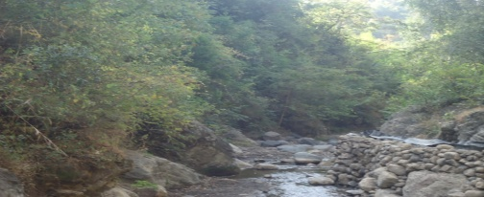
The headwork site is situated at 1190420.739 m N, 599789.9684 m E and river bed elevation of 1807.757 m above sea level. The headwork site geological surface and subsurface conditions have been investigated based on the nature of the proposed structure. At the site and immediate vicinity, the stream flows along moderate to steep slope course. The right bed and bank at Weir Diversion site are made up of bedrock (the Rhyolite), on the contrary, the central and right bed are covered with the bed rocks. On the other hand, left bank is covered with the flood plain deposit dominated by bedrocks (Rhyolite). The detail geologic nature of the banks, and bed of the stream along the headwork axis and immediate vicinity are described and their potential geotechnical influence on the proposed structures also discerned/detected below, with remedial measures. The different sections of the stream at the proposed headwork site are described separately below:-

River Geomorphology
It is a common fact that the river development tends to accommodate itself to the local geology that develops along the structurally weak zones like faults, joints, folds, etc. The drainage system of the study area is strongly influenced by geological structures and formations, the nature of the vegetation cover and climate. The nature of geological formations and structures has also strong influence on the development of the channel.
The present morphology of the Workie River channel is a function of a number of processes and environmental conditions, including the composition of the bed and the banks are made up of bedrock (the Rhyolite), on the contrary, the central and right bed are covered with the bed rocks. On the other hand, right bank is covered with the flood plain deposit dominated by bedrocks (Rhyolite). The size and composition of the sediment moving through the channel rate of sediment transport through the channel and deposition on the banks and beds and the regional degradation due to erosion processes. The bank is covered entirely with soil. The soil is dominated by SILT having low to Small plasticity the left bank composed of loose silt clay soil and coarser alluvial sediment as the result the stream shows highly meandering nature both up and downstream from the proposed site but at the particular Weir Diversion site it shows nearly straight river channel. The river has narrower section in upstream direction whereas to downstream side the river section becomes wider.

River Bed condition
At the proposed headwork site the stream bed or course is well defined, nearly straight, and shows rough surface due to recent sediment (center and right bed) accumulations and undulating appearance of bedrock outcrops (at left bed). Along the Weir Diversion axis, the bed is made up of two basically different geologic materials, as seen from surface observation. These are recently deposited alluvial coarse grained sediments, and underling bedrock.
The central and left areas of the bed are totally covered with the alluvial deposits, while the rigt bed is made up of Rhyolite bedrock. The bedrock is totally covered with the sediments at the central and left areas of the stream bed. The alluvial sediment observed at the center and left beds are composed dominantly of Gravel with significant amount of boulders and cobbles. It is loose, dry (at the time of study) and not easily workable (to dig test pit). From surface geological understanding of the area, the thickness of this sediment is expected in the range 1.5 to 2m. This coarser sediment is believed to be underlain by the bedrock extension that exposed at the right bed and bank. On the other hand, the bedrock found at right bed is affected by slight degree of weathering and erratically oriented joints. The joints are not persistence that most of them penetrate to shallow depth or affecting the top 0.5 to 1m thickness of the rock. The foundation of the proposed Weir Diversion structure; therefore, can be lie on the bedrock after removing the top 0.5 to 1m jointed portion of the bedrock at the left side. In addition to this, the foundation of the bed bar (if proposed), along the axis should lie on the bedrock, after excavating the top alluvial deposit covering the center, and right bed of the river.
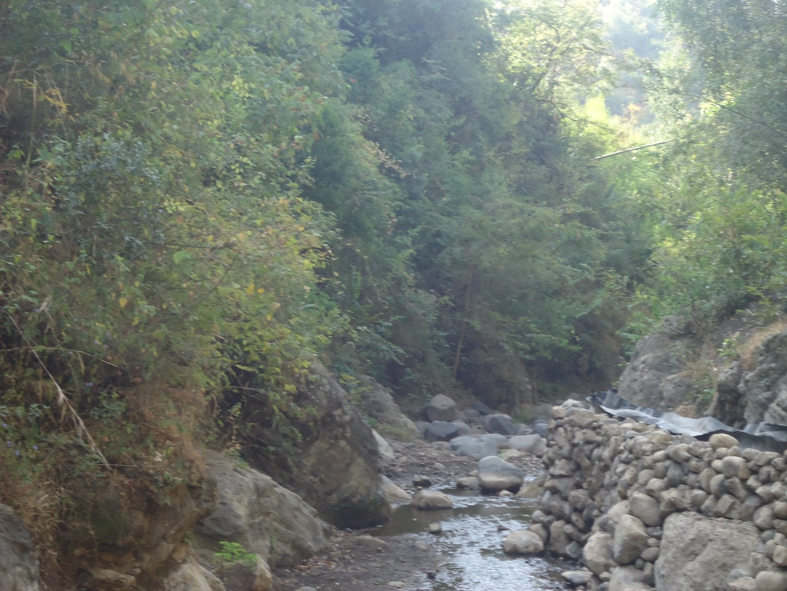
Weir axis
Left side
Right side
Figure 3-1: River bed at the proposed Weir Diversion site

River Bank condition

Right Bank
At the headwork sit axis, the left bank is characterized by relatively steep slope, having about more than 2.5m height from stream bed. It reveals nearly vertical section within this height. From visual observation of the natural exposure, there are two geologic units (Rhyolitic rocks and loss material at the top. And it is portion of the older bedrock at the project site. The rock is Rhyolite, which is affected by shallow depth of jointing (0.5 to1m) and slight degree of weathering. It is resistant to flood erosion that there is no need to proposed bank protection works.

Left Bank
At the proposed headwork axis and immediate vicinities, the left bank forms relatively moderate to steep slope topography. From surface observation, the bank is covered entirely with soil. The soil is dominated by SILT having low to Small plasticity. There are few disseminated transported boulders and gravels within the silt deposit. It has 2 to 4m exposed thickness. It is flood plain deposit having dark brown color. It has stiff consistency and dry moisture content but this loss material lies on the top parts of the bed rocks (Rhyolite). The bank is not now affected by flood erosion that active eroded surfaces are visible. So, it is not necessary to provide some bank protection structures to prevent ongoing bank erosion.
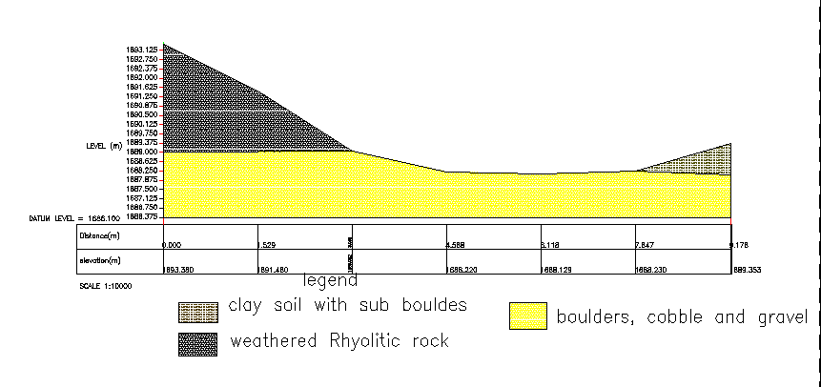
Figure 3-2: River bed geological x-section

Sources of construction materials
During the site investigation, natural construction materials required for the construction of the various proposed engineering structures at the headwork and within the farmland have been assessed, and possible quarry sites and borrow areas have been identified within the vicinity of the area as much as possible. In addition to the identification, the quality, quantity, accessibility condition and ownership of each proposed production sites have also been studied and described in this report; on separate sub-sections below. The natural materials required for the construction of the proposed hydraulic structures include rock for masonry stones, aggregates (both coarse and fine), impervious soil for fill and/or lining, backfill soil, and water.

Rock for Masonry and Crushed Coarse Aggregate
During site investigation rocks required for masonry works were identified along the right side the Quarry site that can be used for production of rock for masonry stone and crushed coarse aggregates has been assessed during the field work session within the vicinity of the project area at economic distance for hauling.
Here moderately weathered Rhyolite rock exposed and forms a continuous ridge parallel to the main canal. It is believed that below this weathered rock, fresh portion of the rock is found and can be used for the intended purpose.
In this field study, another sources for rock also proposed. The first one is near small village which is called Wedeso at co-ordinates of about 598240mE and 1190225mN with elevation 1735m above sea level.
The other relatively distant source for rock is located at about 4 to 5km from the headwork to the direction of main canal (to the direction of the end of the main canal). Here, this quarry site good potential for all our needs.

Fine Aggregates
Borrow areas for fine aggregate or natural sand have been assessed starting from the project stream itself. Natural deposits of such materials couldn’t be found when assessed within the beds of the stream in the project area; rather very coarser sediments and rock exposures are found covering almost the entire bed of the workie stream. Seeing to this nature of the stream, other distant streams have been explored to identify the best source areas for fine aggregate or natural sand that can be used for this particular project. During exploration of this natural sand, at a distant one stream was identified as a possible source of fine sand. The stream is known as ‘jara’. It is located at about 40km from the project site, within chefa Robit woreda. A potential source area within the jara stream bed is located alongside the main kemise Robit-Ataye Asphalt road, near to a small village of chefa Robit. Here, there are local legalized sand miners associations, and the sand is acquired from them through negotiation and agreement.
The samples have been analyzed at Amhara Design and Supervision material testing laboratory to characterize the gradation of the sand deposit. According to these laboratory test results (See Annexture-2), the sand deposits from various portion of the jara stream have grading as indicated in Figure 4.3 (Annexture-1 from Geology report). As the sand will be used as fine aggregate in the construction of concrete and as mortar ingredient for masonry works, its quality has been evaluated based on ASTM C33 specification, especially its grading.

Water
Water for construction purposes can be found from the project stream, Workie River itself. The stream is perennial throughout the year that there is some amount of flow along its course. During this field time the stream flow was more than 60L/second.

Headwork Type Selection
Looking the availability of natural construction materials and considering the river features and expected flood amount, Intake-Weir Diversion is chosen. As it is:
- Simple for construction
- Stability of resisting score depth since the foundation is more safe up 2m
- At proposed head work it’s have Economical section
- availability of local material for cyclopean work

Hydraulic Design of Headwork Structure

Weir Diversion Height Determination
The following major factors have been seen in determining the weir/Weir Diversion crest level:
- Maximum command area elevation
- Deriving head of the Weir Diversion structure
- Main canal slope Sill level of off take canal
- Main canal idle Length
- Loss
- Lowest Point of river center (River bed elevation)

Base flow of the River
The study team has assessed that the stream is used for irrigation along its entire course at the proposed diversion site since the farmers are using the stream for traditional SSI (Irrigation Infrastructure Report). Study team has calculated flow of the river at the Weir Diversion site as 80 l/s. Out of this 60 l/s will be required for the proposed scheme and the rest will be released for downstream. The purpose of releasing the 25% l/s to downstream is for the sake of downstream users.

Weir Diversion Dimensions

Flow over the Weir Diversion crest
a. Crest Length
- Lacey’s regime width, $L=4.75*\sqrt{Q},$ $=4.75*\sqrt{32.76.}$ = 27.187 m.
- Actual river section width of the over flow section of the river is = 6m
b. Discharge over the weir section
- Design discharge, Q = 32.76 m³/s by flood mark

Bottom width
Bottom width of ogee weir is the summation of downstream profile length and upstream profile length.
Bottom width=upstream profile length + downstream profile length
Upstream profile length=0.27Hd whereas design head (Hd) =1.935m
=0.27*1.94=0.52m
Downstream profile length =X^{n}=K*Hd^{n-1}*Y
Whereas k & n are constant for vertical ogee slope take, 2&1.85 respectively.
Height weir (Y) =2.1m & HD=1.935m
X^{1.85}=2*Hd^{1.85-1}*2.1
X=2.9m
Bottom width=0.52+2.9=3.46m
≈ 3.5m
Provide 6m bottom width respectively, which will be tested for adequacy during stability analysis.

U/S and D/S HFL Calculation & Determination
From the stage –discharge curve prepared the high flood level before construction (i.e. D/s HFL) corresponding to the design flood is 1809.549m a.s.l.
D/s HFL = 1809.549m amsl ------------------------------------- (a)
U/s HFL = U/s bed level + weir height + H_{d} -------- (b)
H_{d} is the depth of water over the weir crest. This is calculated by assuming ogee weir formula.
$Q=C*L*{H_{e}}^{\frac{3}{2}}$ Whereas Q=32.76m³/s, L=5m & c=2.2
$H_{e}={\left(\frac{Q}{C*L}\right)}^{\frac{2}{3}}$=2.07

Schematic Diagram of weir Section
The velocity head, h_{a} is computed from the approach velocity as shown below
Where g: acceleration due to gravity = 9.81m/sec²
Va is Approach velocity determined by
L is Weir crest length = 6 m,
h_{d} is flow depth over the weir and also,
By trial and error method, h_{d} is found to be 1.94 m

h_{a} = H_{e}-h_{d} = 2.07m-1.94m = 0.13m

- Velocity head, h_{a} = 0.13m

U/s HFL =U/s TEL –velocity head =1809.546m a.s.l – 0.13m = 1809.416m a.s.l
- Afflux
⇒ Afflux = U/s HFL- D/s HFL = 1809.648m a.s.l –1809.549 m a.s.l = 0.1m.
From the flood level analysis, it is seen that the flood overtops the banks of the river u/s of the structure. This condition is allowed to take place as it doesn’t bring pronounced negative impacts on the structures, rather than constructing bulky structures to confine it.

Hydraulic Jump Calculation
As discussed in the geologic report, the river bed is alluvial deposit and hence stilling basin for energy dissipation is required. Both left and right side banks are bed rock, a wing walls are required at u/s and D/s sides for the right side of the river, so as to protect flood entering to the canal in high flood cases.
The length of wing walls is determined based on the length of Jump, and it is calculated as shown below.
• Weir crest length =6m
• Intake-Weir height = z = 0.7m
• Pre-jump depth = y₁
• Post -jump depth =y₂

Neglecting losses between point A and B and considering similar datum
z + H_{e} = y₁ + h_{a}
But, He = 2.07m,
$q=\frac{Q}{l}=\frac{32.76m3/s}{5m}=6.552m$²$/s$
$$h_{a}=\frac{q2}{2*g*y^{2}}=\frac{{10.71}^{2}}{2*g*{y_{1}}^{2}}$$
2.1m + 2.07m=y₁+2.89/y₁²
After iterations Y₁ = 0.81 m
V₁=q/y₁=6.552/0.81=8.08m/se
$$F_{r}=\frac{V_{1}}{\sqrt{gy_{1}}}=\frac{8.08}{\sqrt{9.81*0.81}}=2.89$$
$$y_{2}=\frac{y_{1}}{2}\left(\sqrt{1+8*{F_{r}}^{2}}-1\right) y_{2}=\frac{0.81}{2}\left(\sqrt{1+8*{2.82}^{2}}-1\right) =2.916m$$
Hydraulic jump length (L) for Fr=2.89from the graph L=5*(y_{2-y1)} =5*(2.916-0.81) = 10.53~11m

Impervious floor

D/s impervious floor (Ld)
For under seepage the worst condition would be when the water on the upstream side is at the level of the weir crest & there is no tail water. Seepage head loss at
- Pond level case:
Hs = crest level –bed level
= 2.1m
- Maximum flood case:
Hs = U/s HFL- D/s HFL
= 1809.648m a.s.l –1809.549 m a.s.l
= 0.1m.

Therefore maximum seepage head occurs when water is stored up to the pond level and there is no water on the d/s.
= Bligh’s constant, C_{b} is depending on the type of the foundation.
$$L_{d}=2.2*C_{b}*\sqrt{\frac{H_{s}}{10}} L_{d}=2.2*9*\sqrt{\frac{2.1}{10}} =9.07 m$$
The jump length is 11m, Therefore D/s impervious floor is taken to be 11m long, the maximum.

U/S Impervious Floor Length, (Lu)
The u/s impervious floor, (L_{u}) = LT- (Ld +2*d1+2*d2+B) = -3.09m take nominal distance=1m Therefore total length of the u/s impervious floor is taken 1m long.
Whereas, LT=Hs*C =2.1*9=18.9m, C, based on river characteristics material
Ld =length of D/S Impervious Floor Length=5.1m
D1=U/S cut off=1.5m
D2=d/s cut off=2.5m
B=bottom width of weir=3.5m

Floor thickness (t) by khosla’s & Bligh’s theory

Creep length (b) =2*1.5+1+3.5+5.1+2*2.5= 17.6m
Hydraulic head (d) =pond level -bed level
= 1807.7m a.s.l-1807.05m a.s.l
=0.7m
Hydraulic gradient (GE) =d/b=0.7/17.6=0.0398
Floor thickness at heel
Creep length up to point (L)
=2*d1+L2=2*1.5+1=4m
Up lift pressure (head) at heel (h) =HS-GE*L
h=2.1-0.0398*4=1.941m
Thickness (t)=4/3*h/(G-1)
t=4/3*1.941/(2.4-1) =1.848m
Take 1m b/c there is counterbalance water load
Floor thickness at Toe
Creep length up to point (L)
=2*d1+L2+B=2*1.5+1+3.5=7.5m
Up lift pressure (head) at heel (h) =HS-GE*L
h=2.1-0.0398*7.5=1.80m
Thickness (t) =4/3*h/ (G-1)
t=4/3*1.8/ (2.4-1) =1.715m
Take 1.4m calculated by Bligh’s theory
Floor thickness at 4m from Toe
Creep length up to point (L)
=2*d1+L2+B+4=2*1.5+1+3.5+4=11.5m
Up lift pressure (head) at heel (h) =HS-GE*L
h=2.1-0.0398*11.5=1.64m
Thickness (t) =4/3*h/ (G-1)
t=4/3*1.64/(2.4-1) =1.56m
Take 1m calculated by Bligh’s theory
Floor thickness at 8m from Toe
Creep length up to point (L)
=2*d1+L2+B+8=2*1.5+1+3.5+8=15.5m
Up lift pressure (head) at heel (h) =HS-GE*L
h=2.1-0.0398*15.5=1.48m
Thickness (t) =4/3*h/ (G-1)
t=4/3*1.48/ (2.4-1) =1.4m
Take 1.4m calculated by Bligh’s theory
Floor thickness at 15m from Toe
Creep length up to point (L)
=2*d1+L2+B+15=2*1.5+1+3.5+11=18.5m
Up lift pressure (head) at heel (h) =HS-GE*L
h=2.1-0.0398*18.5=1.36m
Thickness (t) =4/3*h/ (G-1)
t=4/3*1.36/ (2.4-1) =1.2m
Take 1.2m calculated by Bligh’s theory
The floor is constructed with cyclopean C-20 concrete with well graded stone
- For detail analysis of the computation, Refer Excel file.

Cut off Depth Calculation

U/s cut off
- Q = 32.76 m³/sec
- q = 6.552 m³/s/m
Silt factor, f =1.76*(d₅₀)^{0.50}
f= 3.78
- D₅₀=4.66mm for fine gravel & boulder
- R =1.35*(q²/f)^{(1/3)}
R=1.35*(q²/f) ^{(1/3)} = 3.04m take R = 3.04 m
Hence bottom level of u/s cut off = U/S HFL – 1.25*R
=1809.648.-1.25*3.04=1805.848m
Take the bottom level of the u/s cut off as 1805.848 considering the floor thickness
U/S Cut off depth=river bed level- bottom level of u/s cut off
=1807.05 -1805.848 =1.2 take 1.2m, therefore, bottom level of U/s cut off =1807.05 -1.2=1805.848 m

D/s cut off
- Q =32.76m³/sec
- q =6.522 m³/s/m
- Silt factor, f =1.76*(d₅₀)^{0.50}, f= 3.78 take f=3.78
- D₅₀=4.66mm for fine gravel & boulder
- R=1.35*(q²/f)^{(1/3)}, R=1.35*(q²/f)^{(1/3)} =3.04 take
Hence bottom level of u/s cut off = D/S HFL – 1.5*R
=1809.549-1.5*3.04=1804.989m
Take the bottom level of the u/s cut off as 1804.989m considering the floor thickness
D/S Cut off depth=river bed level- bottom level of d/s cut off
=1807.049 -1804.989=2.06 take 2.5m from excel report.
For each arrangement and further information, refer to the design drawing.

Figure 3 3: weir section

Stability Analysis of weir
Stability analysis is carried out to see the already determined weir section is safe against overturning, sliding, tension. The stability analysis is carried out considering the effect of the following forces.
• Water pressure
• Weight of the over flow weir section
• Sediment load
The extreme load combination is the case where the head is at crest level of the weir and there is no flow over the weir (static case)
Figure 3-4: Weir stability

Name of forces | Symbol | Area(m²) | Magnitude of forces (KN) |  | Lever arm in m | Moment at "o"(KN.M)
Name of forces | Symbol | Area(m²) | Vertical | Horizontal | Lever arm in m | Resisting | Disturbing
Weight Of Weir Body | W-1 | 0.05 | 1.02 |  | 3.2 | 3.27
 | W-2 | 0.67 | 15.12 |  | 3.3 | 49.90
 | W-3 | 0.56 | 12.49 |  | 2.54 | 31.72
 | W-4 | 0.37 | 8.33 |  | 1.71 | 14.21
 | W-5 | 0.60 | 13.50 |  | 1.54 | 20.79
 | W-6 | 0.62 | 14.04 |  | 1.71 | 23.96
 | W-7 | 0.29 | 6.53 |  | 2.71 | 17.66
1. Water pressure(U/S) | Pwh | 0.22 |  | -8.46 | 0.2 |  | -1.871
2. Silt pressure | Psilt | 0.829 |  | -0.57 | 0.22 |  | -0.127
5. Uplift pressure | U1 | 1.150 | -11.285 |  | 2.31 |  | -26.088
sum |  |  | 59.73 | -2.733 |  | 161.506 | -26.693

∑V = 59.73KN ∑M (+) = 161.506KN.m
∑H=-2.733KN ∑M (-) = 26.693KN.m
i) Factor of safety against overturning (Fo)
>1.5 Safe!
ii) Factor of safety against sliding (FS)

,
<0.75 Safe!
iii) Check for tension (i.e. whether the resultant lies within the middle third)
The location of the resultant force from the toe is given by
The eccentricity (e) = X – 3.5/2, B = 3.5m
Hence, e = 2.25-3.5/2 = 0.5m
The eccentricity (e) should be less than B/6 =, Hence the obtained e = 0.5m < 0.583m.
⇒The resultant lays within the middle third no tension

Wall height fixation of wing wall
The existing topographical condition at the weir axis and HFL are considered to be most governing parameters for fixing the wall height.
After construction of the weir (u/s HFL) = 1809.65m.a.s.l
U/s wall height = U/s HFL - foundation level + free board.
Take 0.2m free board
U/s wall height = 1809.65m.a.s.l – 1807.05m+ 0.2m =2.8 m
⇒ Provide 2.8m wall height and the top level of the U/s retaining wall =1807.05m + 2.8m =1809.85m.a.s.l
D/s wall height = D/s HFL - foundation level + free board
=1809.549m.a.s.l – 1807.05m+ 0.2m =2.7 m
Hence including free board, take the critical height of the D/s retaining wall = 2.7m
U/s Retaining wall Stability Analysis

Under sluice/silt Excluder/
Silt Excluder is designed in order to safely release sediment that incoming in to canal out let. The stream is small crest length to carry very large sediment load having silts, sands, cobles, and boulder. Besides, the weir height is so medium. Therefore, the sediment load is mostly dissolved clay, silts, and fine grained sand, easily disposed by farmers manually. Hence, under sluice opening having 70x70cm internal opening, which can be installed and detached by hand, is provided

Design of the canal head sluice
In order to allow, the water to the main canal a canal head sluice of opening 70cmx45cm is adopted. This gate is controlled by the manually maneuvered gear driven gate, which is operated at the top of the left retaining wall. And the head regulator is provided on the Right side .The sill level of this head regulator is fixed from different angle observations. The main conveyance system is more than 3.12km which passes more gullies and undulating alignment. Hence this level is fixed based on the optimum route alignment and the maximum irrigated command level including minor and major losses criteria. Based on this condition, the sill level is fixed to be 1807.7m.
• Outlet capacity
The minimum command area is determined by the minimum flow of the river. But the canal capacity should be determined for maximum command area and the corresponding discharge. In this case the outlet capacity is fixed considering maximum duty and command area and 1.25 correction factors are considered to account the variation of duty.
- Outlet capacity = Duty x command area x correction factor
Where, maximum duty for 16 hr irrigation = 1.04 L/s/ha
Command area = 100 ha.
- Outlet capacity = 1 x 1.04 L/s/ha x 100 ha = 104 L/sec, Say 104 L/s.
• Outlet size
From the Weir Diversion discharge formula the outlet size is determined as follows
Q= 2/3*Cd*(2g) ^ (1/2)*B*H^ (2/3
Where: Q=diverted discharge,
B=Width of Weir Diversion,
H=Height of the Weir Diversion
g=Acceleration due to gravity
Hence, provide an outlet size of 0.7m x 0.45m (length x height) at the entrance .The gate of the off take canal is to be vertical sheet metal of 0.7m x 0.45m for the closure of the opening space. Provide some extra dimensions for groove insertion. Gross area of sheet metals for the off take canal gate will be 0.8m x 0.550m (allowing 5cm insertion for grooves and above the Intake/Weir Diversion crest level). The grooves are to be provided on the walls using angle iron frames at the two sides of the gate openings.
Trash racks of diameter 12mm with c/c spacing of 10cm has to be provided u/s of the gate to prevent entry of debris to the canal.

Retaining Walls
In the right side the retaining wall is designed by cyclopean concrete to be safe structurally and to minimize the area to be cover by masonry wall hence, the river width is very small.
Stability analysis is carried out to see the already determined retaining wall section is safe against overturning, sliding, tension. The stability analysis is carried out considering the effect of the following forces.
- Weight of the retaining wall section
- Back fill of moist Soil pressure
The extreme load combination is the case of wet condition. Therefore we provide 2.8m masonry retaining structure d/s of the Weir Diversion location and. (For more detail sees the drawing& exell file)

Ps1

W1
W2
Ps2

W3

Figure 3-5: Typical design of masonry retaining wall

Bill of Quantity and Cost Estimation
The quantities of the various items have been worked out as per the final design and final drawings prepared for the scheme. The unit rates analysis has been carried out based on the data available in the vicinity of the project area.
Bill No. 1- General Items
S.N | BILL No. 1 General Items | UNITE | QUANTITY (M^3) | UNITE PRICE | AMOUNT (ETH. BIRR)
 | 1. General Items
1.1 | Allow for Mobilization | L.S | 1 | 15,000.00 | 15000.00
1.2 | Allow for Demobilization | L.S | 1 | 15,000.00 | 15000.00
1.3 | 4*5m2, permanent Store constructed from CIS with doors and Windows, Masonry floor cement screed | NO | 1 | 100,000.00 | 100000.00
1.4 | Construct temporary access road to site the access road needs Cut and hilly terrain, fill the Gorgy area, boulder excavation, hard rock Excavation and highly Site clearing. | L.S | 3.3 | 50,000.00 | 165000.00
1.5 | Dewatering of open trenches and excavations and pumps | L.S | 1 | 50,000.00 | 50000.00
 | Sub Total |  |  |  | 345,000.00

BILL No. 2 HEAD WORK
 | BILL No. 2 HEAD WORK | UNITE | QUANTITY (M^3) | UNITE PRICE | AMOUNT (ETH. BIRR)
 | 2. Head Work Structure, Intake structure
2.1 | 20 cm. Clearing on loose & dry soil. | m2 | 50.000 | 74.620 | 3,731.000
2.2 | Excavation river deposit (sand, gravel , pebble and highly boulder) | m³ | 56.00 | 534.00 | 29,904.00
2.3 | Hard rock Excavation | m³ | 15.00 | 2,906.00 | 43,590.00
2.4 | Weathered Rock Excavation | m³ | 13.30 | 2,305.00 | 30,656.50
2.5 | Back fill and Compaction with Excavated material | m³ | 10.40 | 585.00 | 6,084.00
2.6 | 15cm thick C-15 bedding lean concrete(1:2:4) | m³ | 10.65 | 2,628.00 | 27,988.20
2.7 | Reinforced Concrete work ( C-20 ) including form work | m³ | 28.00 | 9,500.00 | 266,000.00
 | Sub Total |  |  |  | 404,222.70
 | 3. Apron
3.1 | D/S Apron
3.1.1 | Excavation river deposit (sand, gravel , pebble and highly boulder) | m³ | 75 | 534.00 | 40,050.000
3.1.2 | Weathered rock excavation | m³ | 6.3 | 2,305.00 | 14,521.500
3.1.3 | Hard rock Excavation | m³ | 14.7 | 2,906.00 | 42,718.200
3.1.4 | Cyclopean concrete(60% C-20,40% graded stone) including Form work | m³ | 60.4 | 9,500.00 | 573,800.000
 | Sub Total |  |  |  | 671,089.70
4 | Protection work
4.1 | U/s retaining wall
4.1.1 | Excavation river diposite (sand,gravel , pebble and boulder) | m³ | 58.5 | 534.00 | 31,239.00
4.1.2 | Weathered rock excavation | m³ | 9.75 | 2,305.00 | 22,473.75
4.1.3 | Hard rock Excavation | m³ | 16.25 | 2,906.00 | 47,222.50
4.1.4 | Masonry work with 1:3 cement sand ratio | m3 | 20.00 | 7,500.00 | 150,000.00
4.1.5 | 10cm thick C-10 lean concrete(1:3:6) | m³ | 2 | 2,628.00 | 5,256.00
4.1.6 | Pointing (1:2) | m2 | 21.50 | 450.00 | 9,675.00
4.1.7 | Back fill and Compact with excavated material | m³ | 19 | 585.00 | 11,115.00
 | Sub Total |  |  |  | 276,981.25
4.2 | D/s retaining wall
4.2.1 | Excavation river deposit (sand, gravel , pebble and highly boulder) | m³ | 97.50 | 534.00 | 52,065.00
4.2.2 | Weathered rock excavation | m³ | 39.30 | 2,305.00 | 90,586.50
4.2.3 | Hard rock Excavation | m³ | 42.70 | 2,906.00 | 124,086.20
4.2.4 | Masonry work with 1:3 cement sand ratio | m3 | 50.00 | 7,500.00 | 375,000.00
4.2.5 | 10cm thick C-10 lean concrete(1:3:6) | m³ | 12.40 | 2,628.00 | 32,587.20
4.2.6 | Pointing (1:2) | m2 | 100.00 | 450.00 | 45,000.00
4.2.7 | Back fill and Compact with excavated material | m³ | 95.75 | 585.00 | 56,013.75
 | Sub Total |  |  |  | 775,338.65
5 | Gates
5.1 | Off take Canal gate
5.1.1 | Off take Canal gate supply and installation consist of:- | No | 1 | 30,321.47 | 30,321.47
5.1.1 | (0.7mx0.45m, 6mm thick sheet metal,
5.1.1 | ø40mm spindle 2.92m long, with all accessories
5.1.1 | ø10mm bar for anchorage, Angle iron with the masonry wall 2.0Kg
5.1.2 | Trash rack Ф12mm bar | Kg | 63.297 | 222.46 | 14,080.97
5.1.3 | Concrete C-25(1:2:3) | m³ | 0.396 | 9,500.00 | 3,762.00
5.1.4 | Slab Ф12mm bar | Kg | 41.547 | 222.46 | 9,242.45
 | Sub Total |  |  |  | 57,406.89
6 | Escape canal and Gate
6.1 | Escape Canal
6.1.1 | Excavation river deposit (sand, gravel , pebble and highly boulder) | m³ | 10.73 | 534.000 | 5,729.82
6.1.2 | Masonry work with 1:3 cement sand ratio | m³ | 3.19 | 7,500.000 | 23,925.00
6.1.3 | Plastering (1:2) | m² | 7.98 | 450.000 | 3,591.00
6.1.4 | Cyclopean 60% C-20 & 40% Boulder including form work | m³ | 1.13 | 9,500.000 | 10,687.50
6.1.5 | Concrete C-25(1:2:3) | m³ | 1.09 | 9,500.000 | 10,355.00
6.1.6 | 10cm thick C-10 lean concrete(1:3:6) | m³ | 2.37 | 2,628.000 | 6,228.36
 | Sub Total |  |  |  | 60,516.68
6.2. | Escape simple Hand shatter gate
6.2.1 | Escape canal gate consists installation, the gate consists the following parts | No | 2 | 7,500.00 | 15,000.00
 | 6mm thick sheet metal. 0.7m x 0.7m, (50x50x10mm) angel iron 1m length. Handel 12mm Ø
 | Sub Total |  |  |  | 15,000.00
7 | Under sluice
7.1 | Under sluice take gate consists Installation, the gate consists the following parts | No | 1 | 15,000.00 | 15,000.00
7.1.2 | Excavation (Loose river bed formation) | m³ | 24.21 | 534.00 | 12,928.14
7.1.3 | Cyclopean concrete (60% C-20,40% GRADED STONE) with (1:2:3 ratio) | m³ | 7.91 | 9,500.00 | 75,145.00
7.1.4 | Concrete C-20 | m3 | 1.05 | 9,500.00 | 9,975.00
7.1.5 | Reinforcement φ12 | Kg | 62.91 | 222.46 | 13,994.96
7.1.6 | Lean Concrete, C-10 (for bedding) | m³ | 1.1 | 2,628.00 | 2,890.80
 | Sub Total |  |  |  | 129,933.90
 | Total |  |  |  | 2,390,489.77
 | Total cost |  |  |  | 2,735,489.77
 | VAT (15%) |  |  |  | 410,323.47
 | Grand total |  |  |  | 3,145,813.23

SECTION-III: IRRIGATION AND DRAINAGE SYSTEMS INFRASTRUCTURE

IRRIGATION AND DRAINAGE SYSTEMS DESIGN

Irrigable Area Description

Topography
Topography is an important factor for the planning of any irrigation project as it influences method of irrigation, drainage, erosion, mechanization, and cost of land development, lab our requirement and choice of crops.
The topographic feature of the project command area is mainly sloping type. Its elevation range is from 1807 to 1789 meters above sea level. The slope gradient also ranges from steeply sloping (3%) to strongly sloping (25%). However, it has identified to be suitable for surface irrigation. Nevertheless, it requires soil and water conservation measures or structures (i.e. constructing bunds, bio-physicals, check dams, artificial water ways, etc).
The project command area is situated at the Left side of Workie River. The natural topographic feature of the command area has inclined to the South-East direction.

Climate
As per the hydrological analysis and on the basis of the traditional Ethiopian Agro-Ecological Zones (MOA, 2001), the UGDWIP area is basically classified as under Woina Dega agro-ecology which is conducive to the production of tropical highland crops. There is no belg rain season in the project area. Climate has an important influence on the nature of the natural vegetation, the characteristics of the soil, the crops that can be grown and the types of farming that can be practiced in any region. The climate of an area is highly correlated with its vegetation and, by extension, the types of crops that can be cultivated. The project area has Bimodal and uneven distribution pattern of rainfall. The main rain season, locally known as Keremt, occurs from end of June to end of August with about 80% share of annual rainfall; and about 20% of the annual rainfall occurs during the dry season from October to May.
In the project area the main bottle neck for the successful crop production is uneven distribution of rainfall, especially in the months of August and September. The highest rainfall occurs in the months of July and August with a better intensity and spatial distribution. Had it been the annual rainfall sufficient enough and evenly distributed throughout the year, crop production of the area would have been remarkably high.
As the project site has no its own meteorological station, Kemissie (for rainfall and minimum and maximum temperature) and Kemissie (for relative humidity, wind speed and sunshine hour) meteorological stations data were used for the project study as long as these stations are relatively near to the proposed command area. In general, the sources of meteorological data are the National Meteorology Service Agency (NMSA). Kemissie rainfall data was used for the computation (using CropWat 8.0 software) and analyses of irrigation water requirements. The amount of average annual rainfall at Kemissie meteorological station is about 1049mm. (for further detail see the Agronomy Study of the same project

Soil characteristics
Soil properties (physical, chemical, etc.) greatly influence the growth and thereby yield of crops which is grown. The command area has predominantly clay textured soils which can be classified as moderately drained soil. Most of the study areas soils are categorized as deep soil (1-1.5 meter depth) .Soils of the command area are suitable for most of the selected crops to be grown (for further detail see the Agronomy Study of the same project.

Existing Irrigation Practices in the Project Area
The pressure of survival and the need for additional food supplies to meet the demands of the increasing population is necessitating a rapid expansion of irrigation schemes. Thus, irrigation is becoming a basic part of well-developed agriculture wherever there is water and irrigable land potential. Accordingly, traditional irrigation practices are under taken by individual farmers that use the river flow to the Left side is with laborious temporary diversions and also it is traditionally irrigation practice by HDPE pipe. So, the farmers in the project area are very much interested in the idea of upgrading the traditional scheme to modern scheme.

Irrigation Water Requirement

Crop Water Requirement (CWR)
The calculation of crop water requirement is a very important aspect for planning of any irrigation project. Several methods and procedures are available for this. The Food and Agriculture Organization (FAO) of the United Nations has also made available several publications on this subject and other issues related with this. The computer program available in FAO Irrigation and Drainage Paper No. 56 “CROPWAT” has been used for the calculation of Crop Water requirement. This program is based on Penman-Monteith approach and procedures for calculation of crop water requirements and irrigation requirements are mainly based on methodologies presented in FAO Irrigation and Drainage Paper No. 24 “Crop Water Requirements” and No. 33 “Yield Response to Water”.
The corresponding values of the crop water requirements of the proposed crops of the project are presented in the Agronomy Study of the same project.

Irrigation efficiency (Ep)
To complete the evaluation of the demand, the efficiency of the water distribution system and of application must be known.
The gross requirement of water for irrigation system is very much dependent on the overall efficiency of the irrigation system, which in turn is dependent on several factors: Method of irrigation, type of canal (Lined or Unlined), method of operations (simultaneously and continuous or Rotational water supply), and availability of structures (for controlling and distribution and measuring and monitoring).
On the basis of these factors, the project has planned to impose surface irrigation method (using furrows). The canal system is Designed lined for main and Secondary canal, Earthen for tertiary and field canal. Hence, the conveyance efficiency has been estimated to be 95%, distribution efficiency 80%, and field application efficiency 60%. As a result of these the overall irrigation efficiency has been estimated to be 55%. According to soil Lab result, soils of the command area are predominantly characterized as clay loam soils.

Irrigation duty
Irrigation duty is the volume of water required per hectare for the full flange of the crops. Moreover, it helps in designing an efficient irrigation canal system.
The area, which will be irrigated, can be calculated by knowing the total available water at the source and the overall duty for all crops required to be irrigated in different seasons of the years.
The proposed cropping pattern of Semira Intake Diversion irrigation project has showed a maximum net irrigation water requirement (NIWR) in the month of April with the amount of 3.3mm/day for 16 working hours (for overall proposed crops).
However, for the designing of the irrigation water application and the flows in the entire canal systems, from the overall proposed crops the one that has maximum NIWR was used for irrigation duty calculation. Accordingly; and hence taken for the irrigation project duty calculation as indicated here below:
For Semira Intake Diversion Irrigation Project, it decided to adopt 60% field application efficiency, 80% distribution efficiency, and 95% conveyance efficiency as the soil is clay loam textured and the canal systems are estimated to be lined for main canal near head work. Hence, the overall/project efficiency for the selected surface irrigation method has been estimated to be 55% (60/100*95/100*80/100) which is rounded to 55%.
For the designing of the project, the GIWR is given as follows:
GIWR = NIWR/e = 3.3/0.55 = 6.00 [mm/day]
The GIWR, 6 mm/day, represents the daily quantity of water that is required to be applied. This water quantity is also used for the determination of the canal discharge in consideration of the time of flow and is defined as the duty, expressed as l/s/ha.
The duty is calculated by:
Duty (D) = GIWR × 1000 × 10 / (t × 60×60)
Where; Duty – the duty [l/s/ha]
GIWR – Gross Irrigation Requirement [mm/day]
t – Daily irrigation or flow hours [hrs]
The duty for the GIWR of 6mm/day and 16 hours of daily irrigation time (t = 16), is supported to be used with furrow irrigation method. Hence, Duty for 16 working hours, as the site is nearer to farmers’ village and local farmers have experiences in irrigation, is computed as follows:
The duty for GIWR of 6.00mm/day for daily irrigation time 16 hours of dry season full irrigation is computed as:
D = (6.00x10x1000) / (16x3600) = 1.04l/s/ha
The GIWR for wet season crops is given as follows:
GIWR = NIWR/e = 1.3/0.55 = 2.36 [mm/day]
The GIWR (2.36mm/day) represents the daily quantity of water that is required to be applied for wet season crops as supplementary irrigation.
Duty (D) = GIWR × 1000 × 10 / (t × 60×60)
Where; Duty – the duty [l/s/ha]
GIWR – Gross Irrigation Requirement [mm/day]
t – Daily irrigation or flow hours [hrs.]
The duty for GIWR of 2.36mm/day for daily irrigation time of 12 hours for supplementary irrigation has been computed as:
D = (2.36x10x1000) / (12x3600) = 0.55 l/s/ha

Irrigation methods
Among the different irrigation systems Semira irrigation system will be used for the project area; and the irrigation water will be obtained from Workie River and by constructing diversion weir/Semira Diversion and convoying the water commonly through earthen canals (TC, and FC) and then leading to field canals; and finally irrigation takes place mostly in furrows.
For this project, among the various irrigation methods, surface irrigation method has been selected. Of the surface irrigation methods furrow, border and basin irrigation methods can be used to supply irrigation water to the plants/crops. However, each method has its own advantages and disadvantages. Care should be taken when choosing the method which is best suited to the local circumstances, i.e., depending on slopes, soil types, selected crop types, amount of water available, etc. of the command area.
Based on the above factors surface irrigation method has been proposed for the proposed crops in this project. The method allows applying light irrigation and can be laid out in sloping fields along the contour. Furrow irrigation method is best suited for most of the proposed and row planted crops. In general, furrow irrigation method is simple, manageable and widely practiced irrigation method. This method is suitable for row crops that cannot stand in water for long periods. The only thing required to use this method is row planting of crops. Besides, basin and border irrigation method would be used for the non-row planted crops. Rotational flow water distribution is also recommended for the project area.

Irrigation and Drainage System Layout
The irrigation system layout for the project is prepared taking the following points into consideration besides other factors.
- A primary concern in the layout of the system is that it serves the purpose of conveying and distributing water to the command area.
- The excavation and earth fill volumes not be excessive, otherwise the construction costs can be tremendous.
- The selection of longitudinal bed slope is made taking into account the existing slopes of the terrain, so as to minimize deviations in canal routing.
- Curves in canals should not be too sharp.
The proposed irrigation system layout comprises 1 (Nr) Masonry main canal, HDPE pipe network systems further information Refer on the layout Drawings. The main canal runs for most of its length parallel to the contours and several changes of direction are necessary to follow the topography. It crosses four main gullies. The main canal is Masonry lined for a length of 50 meters starting from the Intake Diversion outlet. The main canal route passes through a narrow terraces supported by dry masonry at some places and there is no working space, in most places, as the right and left sides are covered by chat plantations or else surrounded by upper and lower terrace for easier for construction there for to minimize challenge of working space and work methodology it propose rectangular Masonry canal with 0.3m thickness for bottom and side walls.

Conveyance System
The conveyance system consists of 1 (Nr) Main canal to irrigate total command area of 100 ha. The main canal starts from Water abstraction site on Left side and conveys water for a length of 3.113 Km.
Main canal is aligned along contours and supplies to Masonry lined canal and HDPE pipe flow pipe network systems.

Design of the Canal System
Flow Depth and Section Capacity
The earthen canals have been designed with a trapezoidal shape and the lined ones with rectangular x-section using Manning's Formula:
Where Q= discharge (m³/s)
R= Hydraulic radius (Flow area/wetted perimeter)
S= Hydraulic gradient
n= Manning's roughness coefficient, n=0.025 is adopted for the earth channels and n=0.018 for the masonry lined part of the main canal

Main Canal
The main canal is designed for a discharge of 130l/s and depending on the site specific condition, appropriate slope is provided. Hydraulic parameters of the main canal are shown below.
At a chain age of 0+176-0+191, 0+598-0+606, 1+504-1+544 and 2+482-2+491 there are Flume structures.
Table 4-1: Hydraulic Parameters of main canal

 |  | Hydraulic Parameters
Canal name | Chainage | Area(ha) | Duty  (l/s/ha) | Q (m3/s) | B (m) | D (m) | Fb (m) | Area | Perimeter | R=A/P | S | N | Total depth |  | V=1/N*R^(2/3)*S^0.5 | Q req. (m3/s)
M.CC | (0+00-0+50.28) | 125 | 1.39 | 0.1738 | 0.40 | 0.16 | 0.24 | 0.063 | 0.72 | 0.09 | 0.010 | 0.018 | 0.4 |  | 1.10 | 0.0696

B= Canal bottom width QR= required discharge d= Full supply depth
S= Longitudinal slop V= Velocity
QD= Designed Discharge

Primary HDPE Pipe
Lay out of all primary canals are across the steep slope, which has steep canal bed slope. The bottom and the sides of the masonry works for these canals cannot withstand the scouring effect of the flows in this canal. It is also more technically acceptable all network system is HDPE pipes of the required diameter. The economic viability feasible rather than concrete and masonry works. Mane hole at each junction and energy dissipater at each field valve is provided properly.
The hydraulic characteristics is Presented in below. For detail analysis show excel

Table 4-2: Hydraulic Parameters of primary HDPE pipe

Field Canals
As shown in the layout, field canals run across the contours and hence face relatively steeper gradient. The discharge of most of the field canals is very small and this is taken as an advantage to cope up with the relatively steeper gradient. Figure 15 below shows a typical field canal x-section. As much as possible field canals shall be made in fill in order to easily irrigate the adjacent command area. As can be seen from the layout, majority of the filed canals can be used to irrigate both sides of the command area depending on the condition of the individual plots of land owned by individual farmers.
Figure 4-1: Typical Field Canal X-section

Canal Structures Design

Design of a typical flume
Hydraulic Characteristics of the canal for flume-1 on MC pipe
Length of the flume: 8m
Shape of the flume: Rectangular Roughness coefficient, n =0.014
From the canal longitudinal profiles, u/s canal bed level (CBL) = 1808.9399m
D/s Canal bed level (CBL) = 1808.635
U/s full supply level (FSL) = 1809.18m
D/s Full Supply Level = 1808.885m
Total head loss between the inlet & Outlet =0.41m
Table 4-4: Hydraulic Parameters of Flume
Flume location | Chain age | Q(m^3/se) | V(m/s) | L(m) | Width canal(m) | Depth canal(m)
MC | 0+176-0+191 | 0.028 | 0.91 | 14 | 0.4 | 0.4
MC | 0+598-0+606 | 0.0236 | 0.75 | 8 | 0.4 | 0.4
MC | 1+504-1+544 | 0.047 | 1.5 | 40 | 0.4 | 0.4

Design of Division boxes
At different points of the main canals division boxes are provided which divert the flow to the secondary canal and tertiary canals. Turnout is also recommended in the main canal to directly to the field canal is. Gate should be provided at the outlet of the boxes. For detail refer the drawing.

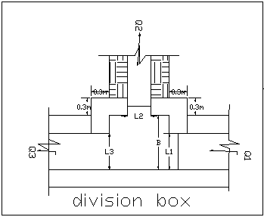
Figure 4-2: Typical Division Box section
Using broad crested formula,
Q= CL (h) ^{3/2}
Where; Q= discharge over rectangular weir/Weir Diversion (opening), m³/s
C = discharge coefficient, c= 1.7
L= effective length of crest form in m
h= over flow depth, m
Assuming equal discharge coefficient & sill height for two or three dividing canals, the proportion becomes.
Q₁/ Q₂= Q₂/ Q₃ =L₁/ L₂ = L₂/ L₃
Where Q₁= is flow in canal 1
Q₂ = is flow in canal 2
Q₃ = is flow in canal 3
L₁= is effective crest length of weir/Weir Diversion sill across opening to canal 1
L₂= is effective crest length of weir/Weir Diversion sill across opening to canal 2
L₃ = is effective crest length of weir/Weir Diversion sill across opening to canal 3
Q₁= CL₁ (h) ^{3/2},
L₁ = Q₁/Ch^{3/2}
L₂ = L₁*Q₂/ Q₁
L₃ = L₁*Q₃/ Q₁
The depth of (height of) the division box,
D = d + f_{b}
The width of the division box,
B = b + 2*m*D
Where b= base width of the incoming canal
D = total canal depth of the incoming canal
Table 4-5: Hydraulic parameters of Division Boxes

Design of field canal turnout
Turnouts are provided at the tertiary canals to divert or to release the flow into the field canals. The width of the turnouts has been decided to take as the same as the bed width of tertiary canal since the computed value for such small flows is minimum.
Based on the system alignment and the nature of topography, a turnout can supply for only one field canal. Considering the managing capacity of the farmers, the detail is shown in the drawing.
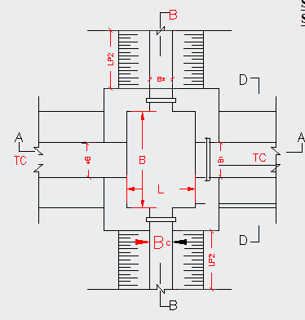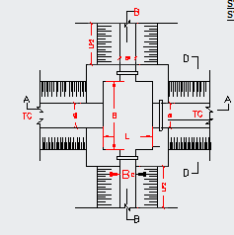
Figure 4-3: turnouts from masonry lined

Road crossing structure
1 (Nr) road crossing structures are provided on the Main canal, at the community road crossing. The road crossing structures are rectangular reinforced concrete slab. The slab is reinforced with 12mm @150mmc/c the length of the slab is 1.5m which is the same as the respective canal bed width, its width varies is and thickness is 20mm . The slab size is 1.5m by B+0.40m where B= canal bed width. For further information see Drawing of Road Crossing
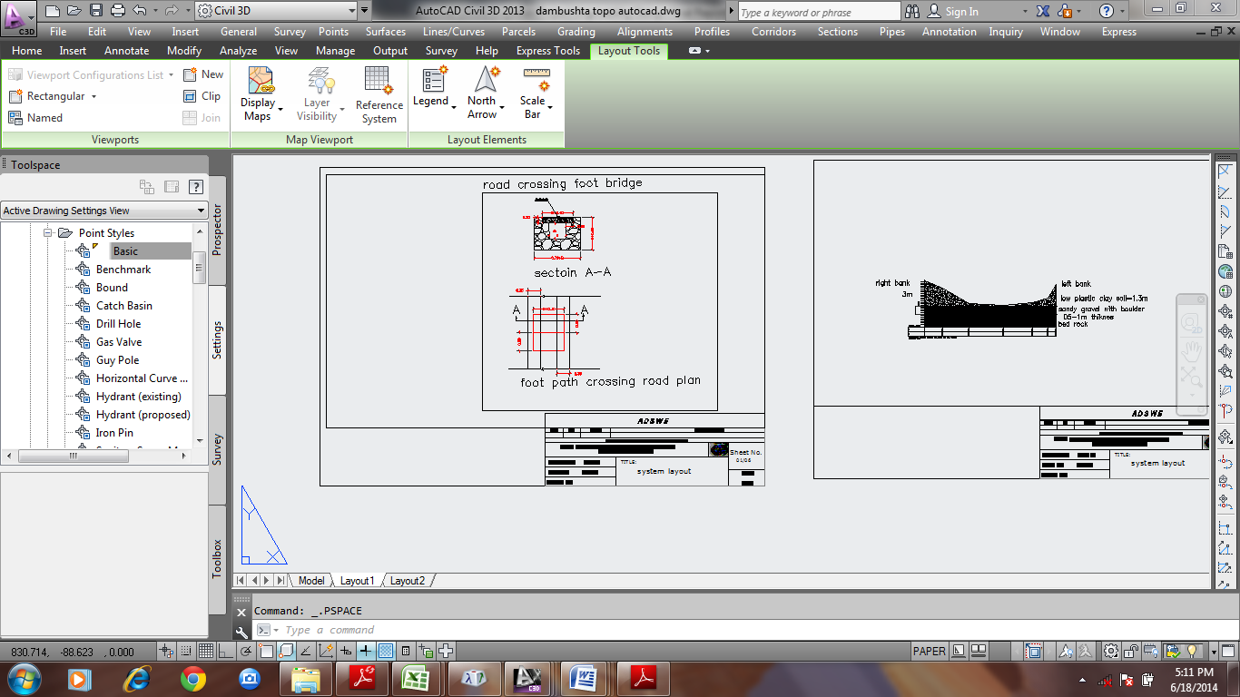
Figure 4-4: typical road crossing section

Irrigation Infrastructure Bill of Quantities and Cost Estimate
 | BILL No. 3. INFRASTRUCTURE | UNITE | QUANTITY | UNITE PRICE | AMOUNT (ETH. BIRR)
 | Main canal masonry Work
1 | Earth work & compaction
1.1 | 20 cm. Clearing on loose & dry soil. | m2 | 60.000 | 74.620 | 4,477.200
1.2 | Excavation of loose soil | m3 | 72.000 | 534.000 | 38,448.000
1.3 | Excavation soft rock | m3 | 36.000 | 2,305.000 | 82,980.000
1.4 | Excavation Hard rock | m3 | 18.000 | 2,906.000 | 52,308.000
1.6 | Back fill with Excavated material | m3 | 24.000 | 585.000 | 14,040.000
2 | Masonry Work
2.1 | Construction of masonry canal wall 0.4m height, 0.3m thickness both sides with basaltic or equivalent stone bedded in cement sand mortar 1:3 mix ratio | m3 | 24.000 | 7,500.000 | 180,000.000
2.2 | 15 cm selected material filling on excavated canal bed level | m3 | 9.375 | 445.510 | 4,176.656
3 | Concrete Work
3.1 | 10 cm thick lean concrete above selected material filling on excavated canal bed level with 1:3:6 mix ratio | m² | 50.000 | 2,628.000 | 131,400.000
4 | Finishing Work
4.1 | Apply three coats of plastering all exposed canal and other infrastructure | m² | 90.000 | 450.000 | 40,500.000
4.2 | Pointing | m² | 20.000 | 450.000 | 9,000.000
 | SUB-TOTAL |  |  |  | 557,329.856
5 | Gully crossing structure(Flume)
5.1 | Excavation
5.1.1 | Ordinary earth excavation | m3 | 14.535 | 534.000 | 7,761.690
5.1.2 | Excavation soft rock | m3 | 7.268 | 2,305.000 | 16,751.588
5.1.3 | Excavation Hard rock | m3 | 7.268 | 2,906.000 | 21,119.355
5.1.4 | Back fill with Excavated material | m3 | 29.070 | 585.000 | 17,005.950
5.2 | Concrete work |  |  |  | -
5.2.1 | C-20 concrete work | m3 | 17.688 | 9,500.000 | 168,036.000
5.2.2 | Form work | m2 | 53.376 | 1,050.000 | 56,044.800
5.3 | Stone work
5.3.1 | Masonry (abutment walls) | m3 | 20.000 | 7,500.000 | 150,000.000
5.3.2 | Gabion work | m3 | 14.500 | 4,875.000 | 70,687.500
5.3.3 | Plastering | m2 | 40.500 | 450.000 | 18,225.000
5.3.4 | lean concrete | m2 | 12.000 | 2,628.000 | 31,536.000
5.4 | Reinforcements |  |  |  | -
5.4.1 | ø8 | kg | 129.956 | 222.460 | 28,909.976
5.4.2 | ø12 | kg | 158.561 | 222.460 | 35,273.542
5.4.3 | ø14 | kg | 101.045 | 222.460 | 22,478.367
 | SUB-TOTAL |  |  |  | 643,829.768
6 | Division Box |  |  |  | -
6.1 | Excavation |  |  |  | -
6.1.1 | Excavation normal loose soil | m3 | 32.400 | 534.000 | 17,301.600
6.1.2 | Excavation soft rock | m3 | 16.200 | 2,305.000 | 37,341.000
6.1.3 | Excavation Hard rock | m3 | 16.200 | 2,906.000 | 47,077.200
6.1.4 | Back fill with Excavated material | m3 | 77.760 | 585.000 | 45,489.600
6.2 | Stone work
6.2.1 | Masonry work | m3 | 8.000 | 7,500.000 | 60,000.000
6.2.2 | stone pitching | m3 | 10.000 | 1,988.500 | 19,885.000
6.2.3 | Plastering | m2 | 12.000 | 450.000 | 5,400.000
6.3 | Gate | No | 20.000 | 2,761.538 | 55,230.770
6.3.1 | 3mm thick sheet metal w*d(30*40) | m2 | 1.920 | 492.750 | 946.080
6.3.2 | Stiffening angle iron (30*30*4) | m | 40.000 | 275.000 | 11,000.000
6.3.3 | Angle iron for groove(40*40*4) | m | 80.000 | 225.000 | 18,000.000
6.3.4 | 12mm reinforcement bar for handling | Kg | 9.472 | 222.460 | 2,107.141
6.4 | Trash rack |  |  |  | -
6.4.1 | 8mm reinforcement bar | Kg | 138.923 | 222.460 | 30,904.736
6.4.2 | Trash rack Ф12mm bar | Kg | 15.984 | 222.460 | 3,555.801
 | SUB-TOTAL |  |  |  | 354,238.928
7 | Drop Structure
7.1 | Excavation
7.1.1 | Excavation normal loose soil | m3 | 3.072 | 534.000 | 1,640.448
7.1.2 | Excavation soft rock | m3 | 1.536 | 2,305.000 | 3,540.480
7.1.3 | Excavation Hard rock | m3 | 1.536 | 2,906.000 | 4,463.616
7.1.4 | Backfill and Compaction with excavated material | m3 | 6.144 | 585.000 | 3,594.240
7.2 | Masonry | m3 | 3.600 | 7,500.000 | 27,000.000
7.2.1 | Plastering | m2 | 5.000 | 450.000 | 2,250.000
7.2.2 | Stone Pitching | m3 | 2.800 | 1,988.500 | 5,567.800
7.2.3 | 5cm lean Concrete C-10 | m2 | 3.000 | 2,628.000 | 7,884.000
 | SUB-TOTAL |  |  |  | 55,940.584
8 | Main pipe works
8.1 | EARTH WORK & EXCAVATION FOR MAIN PIPE WORK |  |  |  | -
8.1.1 | Site Clearing to a depth of 20cm | m2 | 3,064.000 | 74.620 | 228,635.680
8.1.2 | Trench Excavation of loose soil | m3 | 1,103.040 | 534.000 | 589,023.360
8.1.3 | Excavation soft rock | m3 | 551.520 | 2,305.000 | 1,271,253.600
8.1.4 | Excavation Hard rock | m3 | 551.520 | 2,906.000 | 1,602,717.120
8.1.5 | Back fill with Excavated material | m3 | 22.680 | 585.000 | 13,267.800
9.0 | SUPPLY AND INSTALLATION OF PIPES INCLUDING WELDING |  |  |  | -
9.1 | Main Pipe Line Works |  |  |  | -
9.1.1 | HDPE, PE100 Pipe 255mm PN 10 | m | 3,064.000 | 4,500.000 | 13,788,000.000
 | SUB-TOTAL |  |  |  | 17,492,897.560
10 | Anchor
10.1 | Earth
10.1.1 | Trench Excavation of loose soil | m3 | 10.000 | 534.000 | 5,340.000
10.1.2 | Excavation soft rock | m3 | 5.000 | 2,305.000 | 11,525.000
10.1.3 | Excavation Hard rock | m3 | 5.000 | 2,906.000 | 14,530.000
10.1.4 | Back fill with Excavated material | m3 | 20.000 | 585.000 | 11,700.000
10.2 | Concrete work |  |  |  | -
10.2.1 | C-20 concrete work | m3 | 1.170 | 9,500.000 | 11,115.000
10.2.2 | Form work | m2 | 12.000 | 1,050.000 | 12,600.000
10.3 | Reinforcements |  |  |  | -
10.3.1 | ø8 | kg | 15.866 | 222.460 | 3,529.461
10.3.2 | ø10 | kg | 18.500 | 222.460 | 4,115.510
 | SUB-TOTAL |  |  |  | 74,454.971
11 | Casing
11.1 | Precast concrete work
11.1.1 | C-20 concrete work | m3 | 2.880 | 9,500.000 | 27,360.000
11.1.2 | Form work | m2 |  |  | 40,320.000
 |  |  | 38.400 | 1,050.000
11.2 | Reinforcements |  |  |  | -
11.2.1 | ø8 | kg | 32.963 | 222.460 | 7,332.851
11.2.2 | ø10 | kg | 51.307 | 222.460 | 11,413.681
 | SUB-TOTAL |  |  |  | 86,426.532
 | Total |  |  |  | 19,265,118.200
 | Total cost |  |  |  | 19,265,118.200
 | Vat (15%) |  |  |  | 2,889,767.730
 | Grand cost |  |  |  | 22,154,885.929

CONCLUSION AND RECOMMENDATION
- The infrastructure of this project area is designed to irrigate about 100 ha of land by taking its supply from the Semira intake Diversion irrigation project. The maximum duty of the command area for 16 hours per day irrigation with overall project efficiency of 55%. The method of irrigation of the project area is furrow surface irrigation in which the main masonry lined and primary HDPE canal are working continuously whereas the canals are working rotational system.
- As the dominant soil type is clay loam soil, the main canal system is designed to be masonry.
- The reason why the main canal is to be lined up to the end is to avoid the siltation problem, time saving to reach at the tail part, reduce maintenance cost.
- On the primary unit of the irrigation systems, some are associated with HDPE Pipe.
- The design of the canal dimensions of the irrigation canal is done by applying the manning’s uniform flow equation. The variable of the hydraulic parameters are calculated using iteration or flow master program.
- The design discharge of the drainage canals are determined using rational formula and Gamble Powell method.
- As soils of the command area are predominantly clay loam textured; and hence water and soil management measures should be undertaken; and optimum moisture content should be maintained to improve workability of the soil during land preparation and planting time.

The following recommendations are drown:
- For better performance and long service year of the project regular inspection and maintenance is highly required.
- Farmers training, how to operate and maintain the project structures as a whole and available and water resources has a paramount important.
- The irrigation hours per day and per week should be flexible based on base flow amount of each week or month.
- Close supervision of the construction should be made to modify (if need be) each Components of irrigation system based on specific site conditions.

OPERATION AND MAINTENANCE

General
The main objective of the operation and maintenance aspect of an irrigation scheme is to facilitate the timely delivery of the required irrigation water to farms and to keep the irrigation system in an optimum operating condition. This section therefore, discusses the main functions of the subject matter under consideration for the scheme.

Operation of the Head Works
Operation at the diversion intake mainly focuses on the diversion of a controlled flow of river water, timely cleaning of floating debris in front of intake Diversion and removal of sediment deposits in front of the intake and intake Diversion structures.

Irrigation System Operation
The operation of the irrigation system depends mainly on the method of water delivery at farm level. Surface irrigation method is the recommended type of water distribution and application method for semira diversion irrigation scheme.
The farmers would organize themselves and form groups in order to handle the water management. Since flow is low Rotational water distribution would be applied within the group. The rotational distribution is then to distribute water by turn to the whole scheme according to the timely need of crop water requirement. For better and efficient water management, crop diversification should be avoided within a group. This would reduce the complexity of water distribution system of the scheme during one irrigation season. At farmers’ level of operation, a constant flow and variable irrigation time is advisable.
The operation of the irrigation system is continuous for 16 hours per day in main canals whereas field canals are operating in rotational system with each other for irrigation hours proportional to their size. Since the primary canal discharges are within the manageable range and the irrigation canal structures are accordingly designed for simple operation, the farmers can open and close easily whenever they required.

Maintenance Requirement
The canal system of the project is Pipe HDPE canal and masonry main canal, which is susceptible to clogging by sediment or siltation, problems. Though the canal sections are designed for non- silting and non-scouring conditions, the above mentioned problems are for to protect siltation problem at each entrance of pipe it’s provided trash rack and at each junction wash out valve.
The maintenance tasks are categorized into two types: - routine activities, and repairs. The routine maintenance activities that are carried out periodically include:-
- Regular cleaning of sediments and weeds from canals and drains;
- Inspection and lubrication of gates; and
- Maintenance of cracked lined canals, regulating and control structures.
Repair works include task carried out more frequently and quickly, and include those tasks that are generally unpredictable. They also include emergency works. The activities included in this category are:-
- Repairing overtopped or breached canals, drains, and flood protection dykes;
- Repairing jammed gates;
- Filling holes made by wild animals; and
- Reduced free board due to walking over by people and livestock.
Regular inspection of the irrigation facilities should be carried out as part of the maintenance activities. These tasks could be carried out immediately after the end of the main rains in September and during the rainy season. This could concentrate on the interceptor drains and the flood protection dykes, the main canal and the field drains. The inspection of the other works like the tertiary canals, field drains, and the water control and regulating structures could be carried out as part of routine operation activities.
- Beneficiaries of the project need to have operation and maintenance budget, For O&M cost incurring entity area:
- Purchase sing of gate lubricate (grease)
- Replacing and maintenance of Stolen and damaged gates
- Repair Damages on the cross drainage structures.
The expense for O&M should be collected from the beneficiaries. Of course, much of the task is done by the labor and skill of the community. For cost incurring activities beneficiaries have to collect money based on the proportion of the command area they owned.

REFERENCE
- FAO (1977) guidelines for predicting crop water requirements. No 24, Rome Italy
- Design of small Canal structures , USBR
- Soft copies of hydraulic structure publishing
- IDD manual
- ESRDF manual
- Ministry of water resources
- Hydraulic structural design guide line for small scale irrigation project in Amhara region
- Ethiopian Ministry of irrigation department manual(IDD)
- Irrigation Engineering And Hydraulic Structure (Garge)
- Flood frequency analysis by A.Ramachandra Rao, Khaled H.hamed
- Applied Hydrology by Ven Te chow,David R.Maidment,Larry W.Mays

