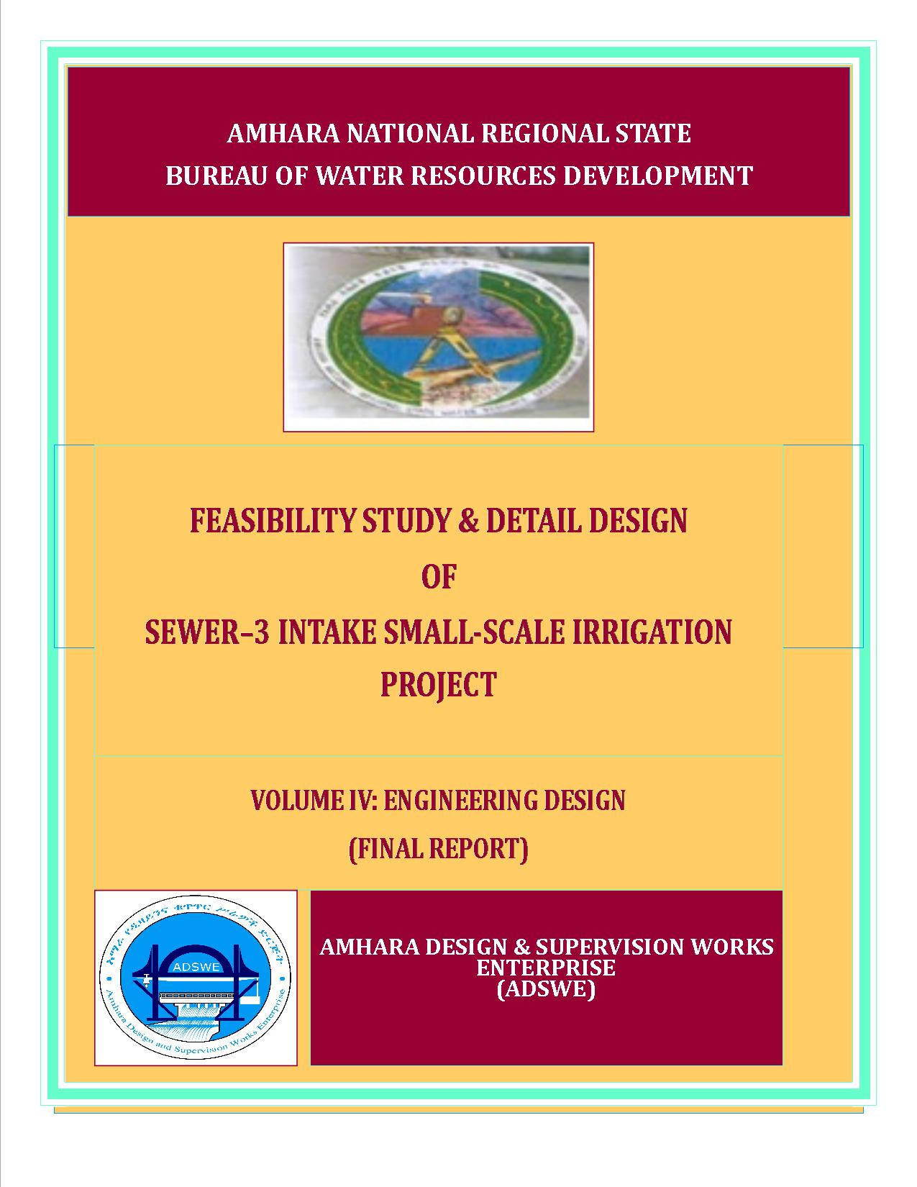

Amhara National Regional State
Water Resources Development Bureau
(BOWRD)

Feasibility Study and Detail Design
Of
(Sewer-3) Intake Small-Scale Irrigation Project

Volume IV: Engineering Design Final Report
December, 2014(Revised 2016)
Bahir Dar
Client: Bureau of Water Resource Development
(BoWRD)
Address:
P. O. Box: 88
Telephone: 0528-200853/855
Fax: 251-08-20-65-68/204676/202040
Consultant: Amhara Design & Supervision Works Enterprise
(ADSWE)
Address:
P. O. Box: 1921
Telephone: +251-582-181023/ 197638/181201/181254
Fax: (058) 2197550/ (058) 2197560
E-mail: amhara design@yahoo.com
Bahir Dar, Ethiopia

FEASIBILITY STUDY & DETAIL DESIGN REPORT STRUCTURE
- Volume I: Watershed Management
- Volume II: Engineering Geology
- Volume III: Irrigation Agronomy
- Volume IV: Engineering Design
- Volume V: Socio Economy
- Volume VI: Environmental Impact Assessment
Table Of Contents Page No .
LIST OF TABLES iv
LIST OF FIGURES v
SAILENT FEATURE vii
1 INTRODUCTION 1
1.1 Background 1
1.1.1 Description of the Project Area 1
1.2 Objectives of the Study 3
1.2.1 Major Objective 3
1.2.2 Specific Objectives 4
1.3 Scope of the Study 4
1.4 Methodology 5
SECTION I: HYDROLOGY 7
1.5 Watershed Characteristics 8
1.6 Hydro-Metrological Data Availability 9
1.6.1 Climate 9
1.6.2 Rainfall Data 10
1.6.3 River flow data 10
1.6.4 Upstream & Downstream utilization 10
1.7 Design Flood Analysis 10
1.7.1 Design Rainfall computation 11
1.7.2 Outlier Test 11
1.7.3 Check for variance 12
1.7.4 Peak Discharge Determination 13
1.7.5 Tail Water Depth Computation 17
SECTION II: HEADWORK DESIGN 21
1.8 Headwork Site Selection 22
1.9 River Geomorphology 22
1.9.1 River Bed condition 23
1.9.2 River Bank condition 24
1.10 Sources of construction materials 26
1.10.1 Rock for Masonry and Crushed Coarse Aggregate 26
1.10.2 Fine Aggregates 27
1.10.3 Water 27
1.11 Headwork Type Selection 27
1.11.1 Hydraulic Design of Headwork Structure 27
1.11.2 U/S and D/S HFL Calculation & Determination 29
1.11.3 Hydraulic Jump Calculation 29
1.11.4 Impervious floor 29
1.11.5 Cut off Depth Calculation 30
1.11.6 Stability Analysis of Intake Retaining wall 30
1.11.7 Design of Canal outlet, Breast wall and Oppresion slab 33
2.8 Bill of Quantity and Cost Estimation 35
SECTION III:- IRRIGATION AND DRAINAGE
SYSTEM INFRASTRUCTURE 38
1.12 Irrigable Area Description 39
1.12.1 Topography 39
1.12.2 Climate 39
1.12.3 Soil characteristics 40
1.12.4 Existing Irrigation Practices in the Project Area 40
1.13 Irrigation Water Requirement 40
1.13.1 Crop Water Requirement (CWR) 40
1.13.2 Irrigation efficiency (Ep) 41
1.13.3 Irrigation duty 41
1.13.4 Irrigation methods 42
1.14 Irrigation and Drainage System Layout 43
1.14.1 Conveyance System 44
1.15 Design of the Canal System 44
1.15.1 Main Canal 44
1.15.2 Secondary Canals 45
1.15.3 Tertiary canals 45
1.15.4 Field Canals 46
1.16 Drainage Canals 47
1.16.1 Catch drainage canals 47
1.16.2 Tertiary canal drainage canals 48
1.16.3 Design of Division box 48
1.16.4 Road crossing and supper passage structure 51
1.17 Irrigation Infrastructure Bill of Quantities and Cost Estimate 52
2 CONCLUSION AND RECOMMENDATION 55
3 OPERATION AND MAINTENANCE 56
3.1 General 56
3.2 Operation of the Head Works 56
3.3 Irrigation System Operation 56
3.4 Maintenance Requirement 57
REFERENCE 58

LIST OF TABLES
Table 2-1: Outlier Test Analysis 11
Table 2-3: Determination Of Time Of Concentration 14
Table 2-4: Runoff Analysis 16
Table 2-5: Hydrograph Coordinates 16
Table 2-6: Intake Site River Cross Section Coordinate Data 18
Table 2-7: Stage Discharge Analysis 18
Table 2-8: River Discharge Computation At Different Stages Of Flow 20
Table 3.1 Retaining wall stability analysis....................................................................................31
Table 3.2 General Items and Headwork BOQ..............................................................................35
Table 4-1: Hydraulic Parameters Of Main Canal 44
Table 4-2: Hydraulic Parameters Of Secondary Canals 45
Table 4-3: Hydraulic Parameters Of Tertiary Canals 46
Table 4-4: Hydraulic Parameters Of Catch Drains 48
Table 4-5: Hydraulic Parameters Of Division Boxes 50
Table 4.6 Irrigation Infrastructure Bill of Quantities and Cost Estimate.......................................52

LIST OF FIGURES
Figure 1-1: Location Map Of The Project Area 2
Figure 2-1: Drainage Map Of (Name Of Project) Watershed 9
Figure 2-2: Complex Hydrograph 17
Figure 2-3: Rating Curve 19
Figure 2-4: River Profile 19
Figure 3-1: River Bed At The Proposed Intake Site 23
Figure 3.2 Right side of the bank along Canal..............................................................................25
Figure 3.3 Retaining wall stability................................................................................................31
Figure 4-1: Typical Cross Section Of Secondary Canals 45
Figure 4-2: Typical Cross Section Of Tertiary Canals 46
Figure 4-3: Typical Field Canal X-Section 47
Figure 4-4: Typical Cross Section Of Catch Drain Canals 47
Figure 4-5: Typical Division Box Plan 49
Figure 4.6. On SC2 Road Crossing................................................................................................51
Figure 4.7 On SC1 Supper Passage...............................................................................................51

SAILENT FEATURE
- Project name: Sewer3 diversion Intake Irrigation Project
- Name of the stream: Sewer river
- Location of the intake site using UTM
- North: 1115537.45
- East: 604729.41
- Average Altitude: 1139 masl
- Kebele:- Balchi
- Zone:- Oromia
- Wereda:- Jillie Timuga
- Hydrology
- Design rainfall: 135.65 mm
- Catchment area: 205.67 Km²
- Longest flow path length: 29.9 Km
- Design flood: 496.45 m³/sec
- Design base flow: 180 lit/se.

- Diversion Intake:
- Intake type: Rectangular filled by Cyclopean concrete
- Depth of bed bar: 3 m
- Gross crest length: 110 m
- Intake crest level: 1139 m.a.s.l
- U/S HFL: 1141 m.a.s.l
- D/s HFL: 1141 m.a.s.l

- Outlet
- Sill level: 1139 m.a.s.l
- Opening dimension: 0.6*0.5 m²
- Discharge capacity: 132 lit/sec.
Irrigation and drainage systems Infrastructure
- Command area size:97 ha
- Type of soil of the command area is dominantly black cotten soil
- Design discharge of the main canal = 132 l/sec
- Irrigation system layout consists of one lined main canal, 2 secondary lined canals and 11 tertiary canals and many FC.
- Main irrigation structures designed are;
- One Gully crossing structures with one foot path
- One Foot path
- One supper passage
Summary of Project cost
Bill No. | Descrption | Amount (Birr) | Remark
1 | General item | 1,390,133.35
2 | Head Work | 6,319,869.87
3 | Main, Secondary, Tertiary Canal and Catch Drain | 3,626,004.34
Total |  | 11,336,007.56
VAT 15% |  | -
Grand Total |  | 11,336,007.56

INTRODUCTION

Background
In Ethiopia, under the prevalent rain-fed agricultural production system, the progressive degradation of the natural resource base, especially in highly vulnerable areas of the highlands coupled with climate variability have aggravated the incidence of poverty and food insecurity. The major source of growth for Ethiopia is still conceived to be the agriculture sector. Hence, this sector has to be insulated from drought shocks through enhanced utilization of the water resource potential of the country, (through development of small-scale irrigation, water harvesting, and on-farm diversification) coupled with strengthened linkages between agriculture and industry (agro-industry), thereby creating a demand for agricultural output. In line with the above, efforts have been made by the government to improve the situation in the country in areas of domestic water supply provision, irrigation, watershed management, etc. The Amhara Water Resources Development Bureau is playing its role in the development of small scale irrigation projects in the region. Accordingly, as part of the water sector development program, the office has initiated the study and design of a small scale irrigation scheme on Sewer River at Balchi Kebele and signed an agreement with Amhara Design & Supervision Works Enterprise (ADSWE) for the study and design of the project.

Description of the Project Area

Location
This irrigation project is located mainly at Balchi Kebele, Jillie Timuga Wereda of Oromia Zone in the Amhara Region. The proposed irrigation project is to be undertaken on Sewer River and the headwork structures are specifically located at an altitude of about 1139 masl and geographical coordinates of 1115537.45N (UTM) and 604729.41 E (UTM).
Figure 0-1: Location map of the project area

Accessibility
The project area is accessed through Sewer3 project is around 25km from Jillie Timuga wereda and 3km from Jawaha town to the Southern and western direction respectively. along to the u/s river direction or via Balchi kebele to the North west direction.
Head work site is 3km from asphalt road along Sewer river to the upstream. During dry season by making small maintenance the road will be accessible.

Previous Irrigation Practices
There are modern diversions on the upstream of this river using different irrigation practices but as the hydrology and Hydrogeology study and respondent farmers indicated, the river has capacity of recharging as it stretches down from the source area of the river. As a result there will not be a marked reduction or fluctuation of water flows both for the already existing and the newly proposed irrigation schemes. The traditional irrigation practices (if any) are under taken by individual farmers that use the river flow to the extreme left side is with hardship. So, the farmers in the project area are very much interested to upgrading the traditional scheme to modern scheme.
At the time of study, At the upstream of the new proposed project there are two Weir construction project by Seral around before many years ago, those are called Sewe1 and Sewer2 they feed the society by modern Irrigation system. Sewer1 and Sewer2 projects are 2500m and 1800m far respectively from the new or Sewer3 Intake Irrigation project. While we observed the Sewer2 project at dry season there are many discharges are flow over the crest level of the weir and also there are many springs are collected and made a good flow in the river.
Really this river can have a good discharge capacity by its nature. special, many continues and never dry springs are located at the downstream of the Sewer3 projects this indicated that the downstream users are used the river without any problem. and totally this rivers are filled with natural multi spring water and makes just as spoon-feed for downstream and everywhere without any discharge scarcity.

Objectives of the Study

Major Objective
The project area faces variability of rainfall distribution though the overall rainfall generally suffices the rain-fed agriculture. Accordingly, the rain-fed agriculture needs means of supplementing during distribution failures and further full irrigation is required to maximize the use of the potential land and water resources.
Hence the objective of this project is to contribute a substantial share in the effort to reduce the risk of production decrease due to rainfall variability and increase the productivity of the resource in the project specific area. Specifically, the project is targeted for the following.
- To make sustainable the rain-fed crop production and make extra production in the dry season possible for 97ha of land through irrigation.
- There is a general consensus that irrigation investments will achieve broader food security and poverty reduction impacts and if efforts are also geared towards up-grading existing traditional farming practices with support to enhance access to input supply, output marketing and extension to facilitate access to information and innovations.
- This objective is to be realized by constructing intake structures across the Sawor River and diverting the stream flow.

Specific Objectives
Other benefits that can be expected to appear with the launching of the project are:
- Efficiency of water use improvement;
- Improved local nutrition/food security gains;
- Improved management of scarce natural resources (land and water);
- Resilience against drought risk;
- Rationale for erosion control and watershed management;
- Rationale for the intensification and modernization of small-holder agriculture and rural lifestyles.
The engineering study and design enables the realization of the project by the provision of engineering structures that will allow the appropriate abstraction of the river water for delivery in to the identified irrigation fields of the study area. Hence, this engineering design is specifically targeted to:
- Analyze hydrologic requirements of the project and engineering structures;
- The formulation of sound and stable structure, with necessary provisions that allow safe, easy and low-maintenance operation in the service life of the project;
- Develop working drawings;
- Estimation of construction costs.

Scope of the Study
- The irrigation design shall ensure reliability, equity and flexibility of water delivery to farmers. It will aim at reducing conflicts among water users and will lead to lower operation and maintenance costs.
- Updating the existing, if available, computation of the actual Evapo-transpiration, crop water requirement, irrigation demand/duty using the existing and recent agronomic, climatologic and soil data using more appropriate methodologies.
- Establish design criteria for irrigations structures to be approved by the client and to be used in the final design stage,
- Design proper irrigation system compatible with local conditions and management capabilities,
- Establish flood protection measures for the command area and canal structures and design the respective drainage system accordingly,
- Planning and layout of the irrigation system, which include irrigation canals, drainage channels, inspection roads and alignments, canal spacing, canal length, location of structures, and water profiles along canal and drains at specified reaches, which is most economical easily manageable and aligned with topographic feature and geological investigation.
- Determination and estimation of water application conveyance and other losses and irrigation efficiencies and consideration of those parameters in design steps.
- Check and test hydraulic and structural designs of main canal considering total demand and the required capacity and the base flow availability,
- Prepare general plans and drawings for all irrigation infrastructure and irrigation systems designs,

Methodology
In the study and design procedure, Designers used the following steps.
- Specific Site identification:
  - Review of the reconnaissance survey conducted by the Client
  - 50,000 scale top map and GIS information
  - Local farmers interview and discussion
  - Wereda and Zone Agriculture section expertise
  - Previous studies
  - On foot travel along the river channel and farm areas.
- Topographic survey:
  - Surveying the headwork site and the Command area with sufficient radius, using Total station
- Flow estimation
  - Physical observation on flood mark indications and local information about high flood and critical flow condition of the river
  - Analyzing the recorded river flow data and use watershed inputs for further analysis.
  - Base flow estimated during the reconnaissance field visit by floating method.
- Irrigable area identification:
  - Using local information
  - 50,000 Topographic map, and GIS information, GPS to see elevation
The design report is organized in three sections. In Section I the Hydrology study is presented and in Sections II and III the Headwork and Irrigation and Drainage Systems designs are discussed respectively. In Section III, planning and design of the irrigation system after diverting the water using the Intake will be dealt. The following are major areas of concern in this part.
- Study and design of the irrigation method to be adopted,
- Study and design of the irrigation system layout and associated structures,
- Design of the different conveyance canals,
- Planning and design of the different irrigation and drainage structures,
- Preparation of the longitudinal profiles of the different irrigation and drainage canals.

SECTION I: HYDROLOGY

HYDROLOGY

Watershed Characteristics
The Watershed has marked topographic variation. The dominant land cover types are Cultivated land which covers 68.76% of the total area followed 100%. Shrub and bushland are 15.92%. From the mild to steepest slope are covered the watershed area.
Table 1 watershed feasibility study report.
Land Cover Type | Area (km2) | A(ha) | Percent(%)
Cultivated Land | 141.41 | 14141.28 | 68.76
Forestland | 11.54 | 1154.15 | 5.61
Grassland | 13.74 | 1373.95 | 6.68
Shrub and bushland | 32.73 | 3273.04 | 15.92
Woodland | 2.31 | 231.16 | 1.12
Built Up Area | 0.70 | 70.34 | 0.34
Marsh | 0.16 | 15.78 | 0.08
Expossed Surface | 3.05 | 305.16 | 1.48
Total | 205.65 | 20564.87 | 100.00
Certain physical properties of watersheds significantly affect the characteristics of the runoff and sediment yield and are of great interest in hydrologic analyses. The rate and volume of runoff, and sediment yield from the watershed have much to do with shape, size, slope and other parameters of the landscape. These suggest that there should be some important relations between basin form and hydrologic performance. If the basin and hydrologic characteristics are to be related, the basin form must also be represented by quantitative descriptors. These parameters can be measured from maps.
Table 2 of the Watershed Feasibility Study Report
General informations | Value
Watershed area (Km2) | 205.65
watershed perimeter (km) | 94.68
Max.stream flow(LFP) km | 29.9
Time of concentration | 4.4
Average curve number value | 69.2

At the selected reference point, the area of Sewer catchment is 205.65km² and consists of a network of tributaries as shown in Figure 2.1 below.
Sewer River at the headwork site is characterized by well-defined channel system and considerable flows. It looks that the gradient of the stream is getting medium and hence there exists significant deposition of sediment mainly gravels with sand and small quantity boulders.
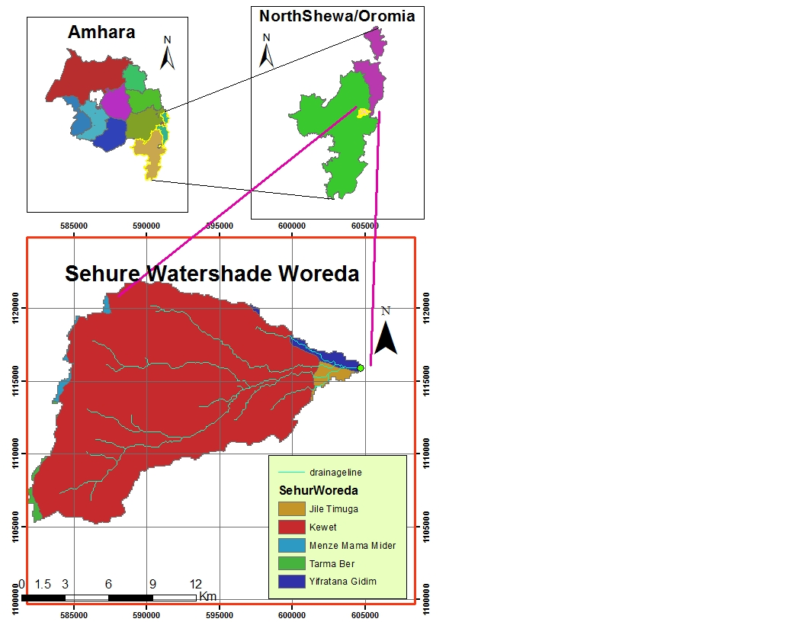
Figure 0-1: Drainage map of Sewer3 watershed

Hydro-Metrological Data Availability

Climate
Small scale irrigation project designers and planners are faced with lack of good data on the hydrology of the stream/river system that will be their water source and on local weather and climate conditions. Stream gauging stations are virtually non-existent in remote rural areas of Ethiopia; meteorological stations are almost rare. Likewise, at Balchi Kebele (Project area location) and in the catchment area of this project, there is no meteorological station of any level. Moreover, there are no flow data for the stream near the project. Therefore, data for the hydro-meteorological analysis is taken from the nearby station and similar areas. Rainfall & temperature data are considered from Debresena Meteorological station. In fact, this station is very close to the project area.
As per the data of the station, March – June are identified as high temperature periods whereas December–January are low temperature periods. The mean annual rainfall amount is more than 115.5mm (1974 - 2009 data) and most of it occurs from July to September.

Rainfall Data
In order to compute the design flood for the Intake structure, the daily maximum rainfall is collected from Debresena Metrological stations with a record of 36 years.

River flow data
The base flow at Intake site by Floating method measured on 12/09/ 2014 is 180l/s. Since this base flow is measured during the dry months of the year, this figure is adopted for design.

Upstream & Downstream utilization
Downstream of the proposed site, appreciable need for water is anticipated for locals and cattle provisions. Therefore, at least 27% of the minimum flow has to be released for downstream (Affar Camels and goats) requirements with addition of spring which located everywhere of the river .There is no any structure upstream of the proposed intake site and no intake downstream of the intake.
For the sake of planning and design, however, the outlet for the i1ntake is designed for a discharge of132l/sec for this project and the project is to be developed for 97ha of land, which is most of the time achievable as the flow for most of the time is significant to support this size of command area.

Design Flood Analysis
For the design and analysis of structures to be constructed on the river, estimation of flood magnitude is an important task. This can be done using different techniques depending on the data available. For this particular case, there are no Sewer river flow data and hence the flood estimation is done using the rainfall data and applying SCS Curve Method.

Design Rainfall computation
Based on the data of 24hr peak rainfall given in Table 1 the design rainfall, Rain fall is computed using Gumble’s Extreme Value Method.

Outlier Test
Higher Limit, $Y_{H}=Ymean+Kn*Sy$, Kn = 2.639 for 36Years of data.
Lower Limit, $Y_{H}=Ymean-Kn*Sy$, Kn = 2.639 for 36Years of data.
Higher Limit, YH = 2.149
Lower Limit, YL = 1.645
Therefore,
Upper limit of rainfall = 10^2.149 = 140.839mm/day
Lower Limit of rainfall = 10^1.645= 44.197mm/day
Conclusion: The rainfall values are within the limits. So no data rejection.

Table 0-1: Outlier test analysis
S.NO. | year | Daily max. RF of year(X) | Descending Order(X) | Rank (M) | probability,P(%) =M/(N+1) | Return period, T=(N+1)/M | Y=log X | Cummalative rainfall
1 | 1974 | 66.4 | 115.5 | 1 | 2.700 | 37.00 | 2.06 | 66.40
2 | 1975 | 55.9 | 114.6 | 2 | 5.410 | 18.50 | 2.06 | 122.30
3 | 1976 | 72.9 | 113.2 | 3 | 8.110 | 12.33 | 2.05 | 195.20
4 | 1977 | 91.5 | 111.7 | 4 | 10.810 | 9.25 | 2.05 | 286.70
5 | 1978 | 64.4 | 106.7 | 5 | 13.510 | 7.40 | 2.03 | 351.10
6 | 1979 | 86.3 | 100.3 | 6 | 16.220 | 6.17 | 2.00 | 437.40
7 | 1997 | 79.3 | 99.8 | 7 | 18.920 | 5.29 | 2.00 | 516.70
8 | 1981 | 115.5 | 98.1 | 8 | 21.620 | 4.63 | 1.99 | 632.20
9 | 1982 | 64.5 | 91.5 | 9 | 24.320 | 4.11 | 1.96 | 696.70
10 | 1983 | 77.3 | 86.3 | 10 | 27.030 | 3.70 | 1.94 | 774.00
11 | 1984 | 67.9 | 85.1 | 11 | 29.730 | 3.36 | 1.93 | 841.90
12 | 1985 | 99.8 | 82.1 | 12 | 32.430 | 3.08 | 1.91 | 941.70
13 | 1986 | 97.9 | 81.6 | 13 | 35.140 | 2.85 | 1.91 | 1022.60
14 | 1987 | 72.4 | 97.9 | 14 | 37.840 | 2.64 | 1.91 | 1095.00
15 | 1988 | 113.2 | 97.3 | 15 | 40.540 | 2.47 | 1.90 | 1208.20
17 | 1990 | 75.5 | 97 | 17 | 45.950 | 2.18 | 1.90 | 1283.70
18 | 1991 | 44.8 | 79.3 | 18 | 48.650 | 2.06 | 1.90 | 1328.50
19 | 1992 | 98.1 | 77.3 | 19 | 51.350 | 1.95 | 1.89 | 1426.60
21 | 1994 | 111.7 | 75.6 | 21 | 56.760 | 1.76 | 1.88 | 1538.30
22 | 1995 | 63.3 | 75.5 | 22 | 59.460 | 1.68 | 1.88 | 1601.60
23 | 1996 | 85.1 | 75.5 | 23 | 62.160 | 1.61 | 1.88 | 1686.70
24 | 1997 | 97.3 | 72.4 | 24 | 64.860 | 1.54 | 1.86 | 1767.00
25 | 1998 | 66.4 | 72.4 | 25 | 67.570 | 1.48 | 1.86 | 1833.40
26 | 1999 | 81.6 | 68.2 | 26 | 70.270 | 1.42 | 1.83 | 1915.00
27 | 2000 | 106.7 | 67.9 | 27 | 72.970 | 1.37 | 1.83 | 2021.70
28 | 2001 | 97 | 66.4 | 28 | 75.697 | 1.32 | 1.82 | 2101.70
29 | 2002 | 64.2 | 66.4 | 29 | 78.397 | 1.28 | 1.82 | 2165.90
30 | 2003 | 82.1 | 65.6 | 30 | 81.097 | 1.23 | 1.82 | 2248.00
31 | 2004 | 75.6 | 64.5 | 31 | 83.797 | 1.19 | 1.81 | 2323.60
32 | 2005 | 100.3 | 64.4 | 32 | 86.490 | 1.16 | 1.81 | 2423.90
33 | 2006 | 114.6 | 64.2 | 33 | 89.190 | 1.12 | 1.81 | 2538.50
34 | 2007 | 75.5 | 63.3 | 34 | 91.890 | 1.09 | 1.97 | 2614.00
35 | 2008 | 68.2 | 55.9 | 35 | 94.590 | 1.06 | 1.75 | 2682.20
36 | 2009 | 65.6 | 44.8 | 36 | 97.300 | 1.03 | 1.65 | 2747.97
sum |  |  | 2123.9 |  |  |  | 64.50
mean/µ/ |  |  | 97.97 |  |  |  | 1.90
stdv/αn-1/ |  |  | 17.81 |  |  |  | 0.095363
skew/g/ |  |  | 0.490 |  |  |  | -0.06442

Check for variance
After checking the outliers, the data should be checked for variability. For variability the formula used is
$α=\left(\frac{δ_{∩-1}}{\sqrt{N}*Mean}\right)*100\%$
Where, δ_{n-1 =} Standard deviation =17.81
N = Nr of recorded data =36
M_{ean} = 97.97
$α$ = Standard error
$α=\left(\frac{17.81}{\sqrt{36}*97.97}\right)*100\%=3.67<10\%$ Acceptable
Therefore the data shows no variability.

Point Design Rainfall
In this study, design rainfall is to mean the amount of 24 hours rainfall that is computed from the available data series based on the given return periods recommended at the rain gauge point. Gumble Puwell distribution method is the most widely used method for the prediction of annual extreme values like annual rain falls, flood flows and the like for the desired return period. This method is also adopted to estimate the design rainfall for this particular study. Its formula is given by:-
$XT=µ+KT*σn-1$ Where $KT=\frac{YT-Yn}{Sn}$
Yn = Reduced mean in Gumble’s extreme value distribution for N sample size from table;
Sn= Reduced standard deviation in Gamble’s extreme value distribution for N sample size from table;
T=Return period, for weir diversion of 50 years return periods;
$σn-1$ = Standard deviation of annual rain fall; and
µ = Mean of all values annual rain fall.
For sample size N=36, Yn =0.532, and Sn = 1.0961 from standard table.
YT=-(ln (ln$(\frac{T}{(T-1)}))$) =-(ln (ln ($\frac{50}{50-1})))$=3.9
$KT=\frac{YT-Yn}{Sn}=\frac{3.9-0.532}{1.0961}=3.07$ $X50=µ+KT*σn-1=97.8+3.07*17.81=135.57mm$$X50=µ+KT*σn-1=54.77+2.87*10.98=86.27mm$$X50=µ+KT*σn-1=54.77+2.87*10.98=86.27mm$
- The design rain fall of 50 years return period is 135.57mm at the recording rain gage point.

Peak Discharge Determination

General
The stream is not gauged river. The design flood is calculated by using SCS unit hydrograph method. Thus, it is preferred to base the flood analysis on rainfall data, which are better both in quantity and quality of data. In the hydrologic analysis for drainage structures, it must be recognized that there are many variable factors that affect floods. Some of the factors that need be recognized and considered on an individual site by site basis are; rainfall amount and storm distribution; catchment area, shape and orientation; ground cover; type of soil; slopes of terrain and stream(S); antecedent moisture condition; Storage potential (over bank, ponds, wetlands, reservoirs, channel, etc.)

Peak flood analysis by SCS unit hydrograph method
Design flood is calculated SCS (The United States Soil Conservation Service). This method is widely adopted and more reliable method for flood estimation. The approach considers, watershed parameters, like Area, Curve number, and time of concentration.

Time of concentration (Tc)
Time of concentration has been calculated by taking the stream profile of the longest streamline and dividing it in to different elevation. Kirpich formula is adopted for computation.
Table 0-2: Determination of Time of Concentration
Time of concentration( TC)
Kirpich formula was used by dividing the water course into 4 parts.
Where Tc= 0.948(L³/H)^{0.385},L is in km²
H is elevation difference b/n two cosecutive points in metre.
S.N. | partial distance(km) | commulative distance(km) | Elevation | Elevation differnce(m) | Slope | TC in hrs
0 | 0 | 0 | 3060 | 0 | 0 | 0
1 | 15 | 15 | 2500 | 560 | 37.333 | 1.89
2 | 2.1 | 17.1 | 2200 | 300 | 17.544 | 0.25
3 | 0.8 | 17.9 | 1340 | 860 | 48.045 | 0.05
4 | 12 | 29.9 | 1180 | 190 | 6.355 | 2.22
Time of concetration in hrs(Tc) |  |  |  |  |  | 4.4

The formula is,
$Tc=\sum{0.948\left\{{\left(\frac{{L_{1}}^{3}}{H_{1}}\right)}^{0.385}+{\left(\frac{{L_{2}}^{3}}{H_{2}}\right)}^{0.385}+…+{\left(\frac{{L_{n}}^{3}}{H_{n}}\right)}^{0.385}\right\}}$
- Tc = 4.4hr Since Tc > 3hr., duration of excess rainfall difference, D = 1hr.
- Time to peak,
$T_{p=}\frac{D}{2}+0.6*T_{c}$ = 3.15hr
- Base time,
$T_{b}=2.67*T_{p}$ = 8.4hr
- Recession time,
$T_{r}=1.67*T_{p}$ = 5.26hr.

Curve number (CN)
Curve number (CN) is achieved based on USSCS method by watershed characterization in terms of land cover, treatment, hydrologic condition and soil group. From the watershed analysis curve number at condition II =69.2. Since peak rainfall is found at an antecedent moisture condition III state, this value has to be changed to antecedent moisture condition III.
- Conversion factor = 1.190
- CN Condition (III) = (Factor from Table x CN condition II) =69.2*1.190 = 82.35

Area Rainfall
As the area of the catchment gets larger, coincidence of all hydrological incidences becomes less and less. This can be optimized by changing the calculated point rainfall to aerial rainfall. The conversion factor is taken from standard table that relate directly with the size of watershed area and type of the gauging station. (IDD manual)
For the case of Sewer3 irrigation project,
- Total watershed area = 205.65 Km²
- Type of gauging station = Daily rainfall (24 hr.)
- Aerial Rainfall = (Point Rainfall) x (Conversion factor)

Run off Analysis
Input data:
- Design Point Rainfall = 135.67mm
- Curve number at antecedent moisture condition III = 82.35
- Catchment Area, A = 205.65Km²
- Tc = 4.4hr, D = 1hr., Tp = 3.15hr; Tb = 8.4hr; Tr = 5.26hr.
- Direct run-off,
$Q=\frac{{(I-0.2*S)}^{2}}{(I+0.8*S)}$
Where, I = Rearranged cumulative run-off depth (mm
- S = Maximum run off potential difference,
$S=\left(\frac{25400}{CN}\right)-254$
- Peak run-off for incremental;
$Q_{p}=0.21*\frac{(A*Q)}{T_{p}}$
Where, A = Catchment area = 205.65 Km²
T_{p} = Time to peak (hr)
Q = Incremental run-off (mm)
Table 0-3: Runoff analysis
RF Duration (D) | DR increment | Qp for 1mm runoff (m3/s) | Qp for incremental run off (m3/s) | begin time | peak time | end time
0-1 | 0.70813 | 13.72 | 9.7 | 0 | 3.15 | 8.40
1--2 | 0.120 | 13.72 | 1.6 | 1 | 4.15 | 9.40
2--3 | 3.124 | 13.72 | 42.9 | 2 | 5.15 | 10.40
3--4 | 21.485 | 13.72 | 294.8 | 3 | 6.15 | 11.40
4--5 | 13.224 | 13.72 | 181.4 | 4 | 7.15 | 12.40
5--6 | 5.021 | 13.72 | 68.9 | 5 | 8.15 | 13.40

Table 0-4: Hydrograph coordinates
Time | Q1 | Q2 | Q3 | Q4 | Q5 | Q6 | Base flow | Qtotal
0 | 0.00 |  |  |  |  |  | 0.15 | 0.15
1 | 3.09 | 0.00 |  |  |  |  | 0.15 | 3.24
2 | 6.17 | 0.52 | 0.00 |  |  |  | 0.15 | 6.85
3.15 | 9.72 | 1.12 | 15.66 | 0.00 |  |  | 0.15 | 26.65
4.15 | 7.85 | 1.65 | 29.28 | 107.69 | 0.00 |  | 0.15 | 146.61
5.15 | 6.01 | 1.33 | 42.87 | 201.33 | 66.282305 | 0.00 | 0.15 | 317.96
6.15 | 4.16 | 1.02 | 34.66 | 294.76 | 123.91909 | 25.169709 | 0.15 | 483.83
7.15 | 2.31 | 0.70 | 26.50 | 238.30 | 181.43 | 47.053234 | 0.15 | 496.45
8.15 | 0.46 | 0.39 | 18.35 | 182.23 | 146.68 | 68.890312 | 0.15 | 417.15
8.4 | 0.00 | 0.31 | 16.31 | 168.21 | 138.05 | 65.525 | 0.15 | 388.56
9.4 |  | 0.00 | 8.15 | 112.14 | 103.54 | 52.420 | 0.15 | 276.41
10.4 |  |  | 0.00 | 56.07 | 69.03 | 39.315 | 0.15 | 164.56
11.4 |  |  |  | 0.00 | 34.51 | 26.210 | 0.15 | 60.87
12.4 |  |  |  |  | 0.00 | 13.105 | 0.15 | 13.25
13.4 |  |  |  |  |  | 0.000 | 0.15 | 0.15

Figure 0-2: Complex Hydrograph
From the analysis, the 50 year return period design run off is 496.45 m ³/s

Tail Water Depth Computation
Tail water depth of the river is equal to the flood depth and amount at the proposed Intake site before construction of the Intake. It is used to crosscheck peak flood estimated by the SCS unit hydrograph method with flood mark method and to see the flood feature after the hydraulic jump. During field visit, the flood mark of the river at the proposed Intake site was marked based on dwellers information and physical indicative marks. The river cross-section was surveyed.

Table 0-5: Intake Site River Cross section Coordinate Data
Northing | Easting | ELEVATION | Partial dis.(m) | Com. Dis.(m) | Elev. Diff(m) | AREA(m2)
1115689.65 | 604774.06 | 1142.91 | 0 | 0 | 3.08 | 0
1115697.06 | 604771.25 | 1142.81 | 10.00 | 10.00 | 3.18 | 31.3
1115670.46 | 604768.43 | 1140.5 | 10.00 | 20.00 | 5.49 | 43.35
1115660.86 | 604765.62 | 1139.17 | 10.00 | 30.00 | 6.82 | 61.55
1115651.27 | 604762.8 | 1139 | 10.00 | 40.00 | 6.99 | 69.05
1115641.67 | 604759.99 | 1139.13 | 10.00 | 50.00 | 6.86 | 69.25
1115632.08 | 604757.17 | 1139.21 | 10.00 | 60.00 | 6.78 | 68.2
1115622.48 | 604754.36 | 1139.35 | 10.00 | 70.00 | 6.64 | 67.1
1115612.89 | 604751.54 | 1139.51 | 10.00 | 97.00 | 6.48 | 65.6
1115603.29 | 604748.73 | 1139.64 | 10.00 | 90.00 | 6.35 | 64.15
1115593.7 | 604745.91 | 1139.63 | 10.00 | 100.00 | 6.36 | 63.55
1115584.1 | 604743.1 | 1139.72 | 10.00 | 110.00 | 6.27 | 63.15
1115574.5 | 604740.28 | 1139.87 | 10.00 | 120.00 | 6.12 | 61.95
1115564.91 | 604737.47 | 1140.21 | 10.00 | 130.00 | 5.78 | 59.5
1115555.31 | 604734.65 | 1143.76 | 10.00 | 140.00 | 2.23 | 40.05
1115545.72 | 604731.84 | 1144.33 | 10.00 | 180.00 | 1.66 | 19.45
1115536.12 | 604729.02 | 1144.9 | 10.00 | 160.00 | 1.09 | 13.75
1115526.53 | 604726.21 | 1145.49 | 10.00 | 170.00 | 0.5 | 7.95
1115517.36 | 604723.52 | 1145.99 | 9.56 | 179.56 | 0 | 2.39
Total |  |  | L total | 179.56 | A total | 871.29

Table 0-6: Stage discharge analysis
S.N | Elevation(m) | water depth (m) | wetted Area (m^2) | wetted perimeter (m) | Hydrualic radius(R)=A/P | slope | velocity (m/s) | Discharge Q=V/A (m^3/s)
1 | 1139 | 0 | 0 | 0 | 0 | 0.010 | 0 | 0
2 | 1139.5 | 0.5 | 12.03 | 47.29 | 0.25 | 0.010 | 1.14 | 13.73
3 | 1140 | 1 | 50.04 | 100.40 | 0.50 | 0.010 | 1.79 | 89.42
4 | 1140.5 | 1.5 | 103.83 | 110.37 | 0.94 | 0.010 | 2.73 | 283.39
5 | 1140.87 | 1.87 | 145.02 | 112.13 | 1.29 | 0.010 | 3.37 | 496.45
6 | 1141 | 2 | 159.39 | 112.74 | 1.41 | 0.010 | 3.58 | 570.78

Figure 0-3: Rating Curve
From the above stage discharge table and curve the maximum flood level corresponding to the computed design peak discharge is 1140.62 (1.62 m from the river bed) and it is considered as the d/s high flood level i.e. expected at the Intake axis before construction of the Intake.
D/S HFL and U/S HFL = 1139 masl.
- Average river bed slope
Average river bed slope of River is estimated by two different techniques. One is by end area method and the other is by using best fit line method. Designers have adopted the end area method output for further analysis.
The water level of the river is taken at different points along the river channel around the head work site. Surveying work done for 320m length. And then, average water surface slope is considered as the river bed slope. For comparison of the two procedures, refer the attached Excel file.

Figure 0-4: River profile
- Manning’s Roughness coefficient
The Manning’s roughness coefficient is taken from standard table based on the river nature. The river at the headwork site has got braded feature and curving nature. The river banks are defined and relatively smooth. Manning’s roughness coefficient (n = 0.04) is adopted.

- Discharge of the river
Input data:
- Manning's roughness coefficient, n = 0.04
- Average river bed slope, S = 0.0099
- , Where, R = Hydraulic radius = (Area/Perimeter)
- $Q=V*A$

Table 0-7: River discharge computation at different stages of flow
S.N | Elevation(m) | water depth (m) | wetted Area (m^2) | wetted perimeter (m) | Hydrualic radius(R)=A/P | slope | velocity (m/s) | Discharge Q=V/A (m^3/s)
1 | 1139 | 0 | 0 | 0 | 0 | 0.010 | 0 | 0
2 | 1139.5 | 0.5 | 12.03 | 47.29 | 0.25 | 0.010 | 1.14 | 13.73
3 | 1140 | 1 | 50.04 | 100.40 | 0.50 | 0.010 | 1.79 | 89.42
4 | 1140.5 | 1.5 | 103.83 | 110.37 | 0.94 | 0.010 | 2.73 | 283.39
5 | 1140.87 | 1.87 | 145.02 | 112.13 | 1.29 | 0.010 | 3.37 | 496.45
6 | 1141 | 2 | 159.39 | 112.74 | 1.41 | 0.010 | 3.58 | 570.78
 |  | H=1.87m |  |  |  |  |  | Q=496.45m3/s

SECTION II: HEADWORK DESIGN

HEADWORK STRUCTURES DESIGN

Headwork Site Selection
The headwork site is situated at 1115537.45m N, 604729.41m E and river bed elevation of1139.m a.s.l. above sea level. At this site the river course is well defined, matured with fixed width and forms nearly a U-shaped valley and at right side it depressed by small amount depth. At this specific site, covered by recent alluvial deposit sediment at the river bed whereas the left bank is also made from silt clay soil but the right bank is covered by silt clay soil at the top for few centimeter thickness below this soil there is Stiff clay soil which extend in upstream direction and the d/s right river bank. The river is flowing through a defined channel and its scouring effect on the river course is significant as its bed covered by loose, alluvial deposit which is easily erodible and transported by running water. The different sections of the stream at the proposed headwork site are described separately below:-

River Geomorphology
It is a common fact that the river development tends to accommodate itself to the local geology that develops along the structurally weak zones like faults, joints, folds, etc. The drainage system of the study area is strongly influenced by geological structures and formations, the nature of the vegetation cover and climate. The nature of geological formations and structures has also strong influence on the development of the channel.
The present morphology of the Sewer River channel is a function of a number of processes and environmental conditions, including the composition of the bed and the banks (deposit of gravel along right side whereas loose silt clay soils and recent coarser deposit at the left bank and bed); the size and composition of the sediment moving through the channel; the rate of sediment transport through the channel and deposition on the banks and beds; and the regional degradation due to erosion processes. Both left bank and the bed are composed of loose silt clay soil and coarser alluvial sediment as the result the stream shows highly meandering nature both up and downstream from the proposed site but at the particular Intake site it shows nearly straight river channel. The river has wider section in upstream direction whereas to downstream side the river section become narrower.

River Bed condition
The stream bed or course at the proposed headwork site is nearly straight, well defined, and shows almost uniform surface. But at the u/s and d/s of the proposed project the both directions of river banks are become extend and wide from one bank to another bank. It is made up of loose, recent, alluvial deposit sediment (dominated by sand and gravel sediment with small amounts of boulders compare to other coarser sediment).This sediment extend in both up and downstream direction from the proposed Intake site. This sediment has thicker deposit at the proposed Intake site as observed from test pit dug at the bed, downstream observation and geological setting of the study area. It is loose, dry to moist as increase the depth due to subsurface water encountered. Using visual method, The river bed shows very rough surface due to recent sediment accumulations, which is predominantly loose gravel with sand mixed with 30% oversize material comprising pebble and small boulder. The boulders in the stream bed are semi rounded and rounded in shape suggesting that relatively short and long distance transportation respectively. Effort were made to dug a pit in the stream bed, however it could not be manageable to continue beneath 0.35m depth due to excessive flow of water. Visual classification of the deposit at this depth shows an estimation of 30% oversize, 45% gravel size(4.75-76.2mm), 20% sand size(0.075-4.75mm) and 5 % fines(<0.075mm). The average grain size of the deposit is estimated to be 4.75mm. The main sediments (especially the gravels) are sub-rounded to round; indicating long distance of transportation by the river action and boulders not much in stream bed hence impact of boulders for proposed Intake structure is insignificant.
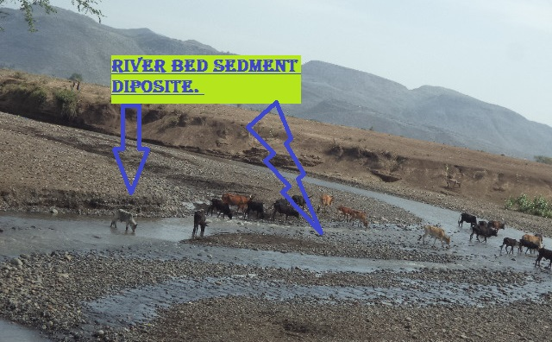
Figure 0-5: River bed at the proposed Intake site

River Bank condition

Right Bank
The right bank is assigned facing downstream. It is characterized by a relatively moderate to gentle slope, having 5m heights from stream bed. It reveals nearly vertical section for the first 0.8m bank height and gets gentler traversing away from the steeply sloping section. From visual observation of the natural cuts at the bank, there are two distinct geological materials forming the bank section namely slightly moist, medium stiff silty clay which covers the upper most part of the bank and loose gravelly silt which is predominantly observed in the lower reaches of the bank. Pit excavated at the right bank shows 1m thick slightly moist soft silty clay underlain by 0.8m thick light gray, moist, stiff clay with gravel. Excessive subsurface water has been encountered at 1.5m depth. From stability point of view, the right bank is subjected to active erosion. Therefore it has to be supported by gabion wall to prevent possible expansion of the river section at this bank.
The top surface of the bank is covered with grasses and farm land, whereas the slope and its bottom are bare and liable or prone to bank erosion that some part of it is actively affected during flood times, for only down-stream of the headwork axis. During the field work, the bank soil has been classified according to the Unified Soil Classification System (USCS) based on visual method. The soil shows loose dry strength, low dilatancy, low toughness and low plasticity and easily eroded. From these field test results, the soil horizon is classified as low Plastic CLAY (CL) soil group. It is stiff, dry to moist, moderately to low plastic, and impermeable.
Furthermore, for this project bank protection with the same times of canal supporting works are necessary in down-stream directions for about 300m length constructed by masonry and by continued gabion must be extend for 100m length. for the sec of river bank protection and canal supporting by anchoring with hard rock if it is possible to get hard rock within shallow depth, to prevent further widening of the stream course at the headwork site due to the stream flood and construction of the proposed diversion structure (Intake).
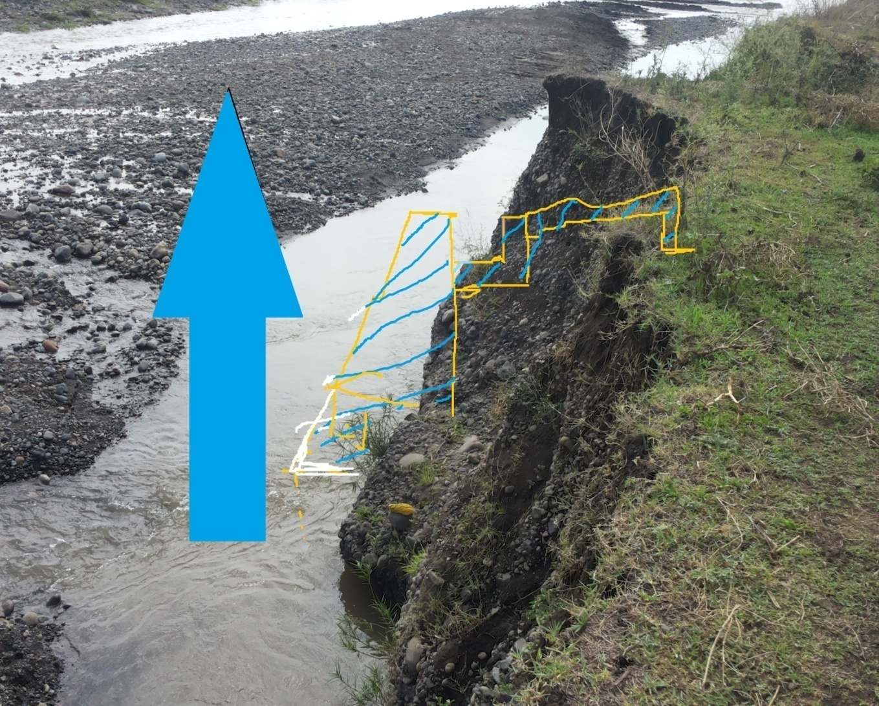
Figure 3.2 Right side of the bank along Canal

Left Bank
The left bank of the river is covered by loose, black silt clay soil with some sand and gravel sediment layer near the bottom of the bank. The left bank is assigned facing downstream. It has steep topographic set up. It is made up of 3.5m thick loose sand with gravel. The deposit at this bank is recent. The loose unconsolidated deposit of this bank can easily be eroded by flood. The width of the river is very wide. Furthermore the intake structure is supposed to be constructed at the right margin. Therefore the effect of the prevailing engineering geological units at this bank on the performance the headwork structure is negligible. since at the left side of the river there are no farmers farm land.

Sources of construction materials
During site investigation, natural construction materials required for the construction of the various proposed engineering structures at the headwork and within the farmland have been assessed, and possible quarry sites and borrow areas have been identified within the vicinity of the study area as close to the project site as possible. In addition to identifying the quality, quantity and accessibility conditions of the construction materials, ownerships of each proposed production sites have also been studied and described in this report, on separate sub-sections below. The materials needed for the construction of the structures include rock for masonry stones, aggregates (both coarse and fine), and water.

Rock for Masonry and Crushed Coarse Aggregate
Slightly weathered ignimbrite has been identified for masonry works of the project at 11.5km distance away from the headwork site. It is located in Jillie Timuga woreda, Mutifecha kebelle in a locality called Fugnan Bete ridge. It has 0.35 to nil overburden. Vertical joints developed on this unit are favorable for quarrying activity. It is found in sufficient quantity for the construction of the project under consideration. Geographic location of the quarry site is Easting 604466, Northing - 1119545 and Elevation 1198.
Aggregates are inlet materials which when bound together by cement will form concrete. Generally, aggregates occupy 70 to 75% of concrete volume. Aggregates are classified as fine and coarse grained depending on their sizes. The size of fine aggregates shall not exceed 4.75mm.
Aggregates of bigger size are called coarse aggregate. The type of the work to be built governs the maximum size of aggregate. For most of the common reinforced concrete works, a maximum of size of 20mm is generally suitable.
Coarse aggregate for the construction of the project can be obtained by collecting fresh basaltic river boulders and crushing it to the desired size. Boulders deposited in the riverbed can satisfy the coarse aggregate demand of the project.

Fine Aggregates
Borrow areas for fine aggregate or natural sand have been assessed starting from the project stream itself.

Water
Water for construction purposes can be found from the project stream, Sewer river itself. The stream is perennial throughout the year that there is some amount of flow along its course. During this field time the stream flow was more than 180L/second.

Headwork Type Selection
Looking the availability of natural construction materials and considering the river features and expected flood amount, Intake is chosen. As it is:
- Simple for construction
- Intake section is expected only 0.030% of the peak flood while the remaining flood will pass over the overflow section of the river course.
- There is no significant bed load (boulder effect) in the river.

Hydraulic Design of Headwork Structure

Intake Height Determination
The following major factors have been seen in determining the Intake crest level:
- Maximum command area elevation
- Deriving head of the intake structure
- Main canal slope
- Loss
- Lowest Point of River center

Base flow of the River
The study team has assessed that there are no irrigation project at u/s. but the water can be execs and flow over the existing weir. Also there are many spring at d/s of the existing project. Similarly by nature the river can have good recharge of water. According to study team has calculated flow of the river during dry season of the local at the Intake site by using the floating method 180l/s. Out of this 132 l/s will be required for the proposed scheme and the rest will be released for downstream. The purpose of releasing the 48l/s with river everywhere spring to downstream is for the sake of downstream users.

Intake Dimensions

Flow over the Intake crest
a. Crest Length
- Lacey’s regime width, $L=4.75*\sqrt{Q},$ $=4.75*\sqrt{496.45}$ = 105.83 m.
- Actual river section width of the over flow section of the river is = 110m
b. Discharge over the Intake section
- Design discharge, Q = 496.45 m³/s

Top and bottom width
According to the Beligh’s formula, top and bottom width of the Intake body is determined as follows
- Input Data:
P: Height of Intake bed bar (m) = 3m
He: specific energy head (over flow depth + approaching velocity head (m))
: Specific weight of bed bar body (2.3 for cyclopean concrete)
Top width, 1.6m ----take 0..8m is enough.
Bottom width, 1.6m......take 0..8m is enough.
Provide the width of bed bar as rectangular 0.8m and 0.8m top and bottom width respectively, which will be tested for adequacy during stability analysis of bed bar.

U/S and D/S HFL Calculation & Determination
From the stage –discharge curve calculation the high flood level before construction (i.e. D/s HFL) corresponding to the design flood is 1140.87m a.s.l.
D/s HFL = 1140.87masl ------------------------------------- (a)
U/s HFL = U/s bed level + Intake bed bar above OGL height + H_{e} ---- (b)
H_{e} is the depth of water over the Intake bed bar crest. This is calculated by assuming broad crested weir/intake formula.
$Q=C*L*{H_{e}}^{\frac{3}{2}}$
$H_{e}={\left(\frac{Q}{C*L}\right)}^{\frac{2}{3}}$= $(\frac{496.45}{\left(0.65*110\right)})^(3/2)$= 1.96, take as 2m

Hydraulic Jump Calculation
As discussed in the geologic report, the river bed is alluvial deposit and hence stilling basin for energy dissipation is required. Both left and right side banks are not sound rock, a wing walls are required at u/s and D/s of river right sides and the gabion constructions are provided for the left side of U/s river side. so as to protect the scouring of the bank due to the formation of flow tabulation and fluctuation, and not to flow the river out of river bank in high flood cases.
Instead of Intake construction there is no Jump formation at the head work site since no structures are present above minimum river center. so He=Y1=Y2=2m and Afflux=0 no d/s scouring.

Impervious floor

D/s impervious floor (Ld)
For under seepage the worst condition would be when the water on the upstream side is at the level of the weir/intake crest & there is no tail water. Seepage head loss at
- Pond level case:
Hs = crest level –bed level
= 1139m-1139m=0m
- Maximum flood case:
Hs = U/s HFL- D/s HFL
= 1141m-1141m
= 0m (Afflux)
Therefore no water pond and there is no water jump over the structure to the d/s level Also there is no water on the d/s.

Cut off Depth Calculation
- Q = 496.45 m³/sec
- q = 4.51 m³/s/m
- Silt factor, f =1.76*(d₅₀)^{0.50}
f= 3.8358 take f=3.84
- D₅₀=4.75mm for medium sandy soil
- R =1.35*(q²/f)^{(1/3)}
R=1.35*(q²/f)^{(1/3)} = 2.355 take R = 2.36 m
L, calculated=105.83m gives scour depth 2.8m and
L, measured=110m gives scour depth 2.71m.
So, like geologist I adopted 3m.

Stability Analysis of Intake Retaining wall
Stability analysis is carried out to see the already determined Intake section is safe against overturning, sliding, tension. The stability analysis is carried out considering the effect of the following forces.
• Water pressure
• Weight of it self
• Sediment (soil) load
The structural stability is analyzed taking the worst case combination of forces.
Unit weight of selected material
Unit weight of masonry
Angle of repose=30⁰Density of masonry
Density of concrete

 |  |  |  | 0.4
 |  |  |  |  | 2
 |  |  |  |  |  | OGL
 | 0.3 |  |  |  | 3
 |  | 1
0.6
 |  |  |  | 0.1
 |  |  | 2

Figure 3.3 Retaining wall stability

Table 3.1 Retaining wall stability analysis
DESCRIPTION | horzontal forces (KN/M3) | vertical forces (KN/M3) | lever arm(m) | restoring moment(M+) | Disturbing moment (M-)
W1= weight of wall |  | 45.097 | 1.016666667 | 45.83
W2= weight of wall |  | 47.040 | 1.7 | 79.97
W3= weight of wall |  | 22.400 | 1 | 22.40
W4= weight of Canal |  | 4.497 | 3.2 | 14.34
ps1= pressure of soil | 7.92 |  | 0.666666667 | 5.28
ps2= pressure of soil |  | 1.485 | 0.125 | 0.19
ps3= pressure of soil | -7.92 |  | 0.666666667 |  | -5.28
ps4= pressure of water |  | 14.715 | 0.9 | 13.24
ps5= pressure of water | 19.620 |  | 2.166666667 |  | 42.51
summation | 19.62 | 135.2 |  | 181.2445 | 37.23
safety against;-
Overturing(FSO) = | 4.868 | >1.5 | so,it is save!
Sliding( FSS) = | 0.145 | <0.75 | save!
Existance of tension | X= | 1.065
 | e= | -0.065 | <B/6=0.33 | no tension at everywhere.

∑V = 135.2KN ∑M(+) = 181.2445KN.m
∑H= 19.62KN ∑M(-) = 37.23KN.m

i) Factor of safety against overturning (Fo)
> 1.5 Safe!
ii) Factor of safety against sliding (FS)
,
> 0.75 Safe! where
iii) Check for tension (i.e. whether the resultant lies within the middle third)
The location of the resultant force from the toe is given by
The eccentricity (e) = X – B/2, B = 2m
Hence, e = 1.065-2/2 = 0.065m
The eccentricity (e) should be less than B/6 =, Hence the obtained e = 0.065m < 0.33m.
⇒The resultant lies within the middle third no tension
Conclusion: From stability analysis, the designed weir/intake section is over safe. To be economical and structural safe Provide 0.6m top width and 2m bottom width.

Design of Canal outlet, Breast wall and Operation slab
Divide wall for weir construction is designed in order to create separation between outlet canal and natural river course. for the time being we didn't use this structure.

Canal Outlet Level
The head regulator is provided on the Right side .The sill level of this head regulator is fixed from different angle observations. The main conveyance system is almost 1km which passes through the right side of the river bank with retaining wall. Hence this level is fixed based on the optimum route alignment and the maximum irrigated command level including minor and major losses criteria. Based on this condition, the sill level is fixed to be 1139m.
• Outlet Capacity
The minimum command area is determined by the minimum flow of the river. But the canal capacity should be determined for maximum command area and the corresponding discharge. In this case the outlet capacity is fixed considering maximum duty and command area and 1.5 correction factors are considered to account the variation of duty.
- Outlet capacity = Duty x command area x correction factor
Where, maximum duty for 18 hr irrigation = 1.64 L/s/ha
Command area = 97ha.
- Outlet capacity = 1.64 L/s/ha x 97ha = 131.2 L/sec, Say 132 L/s.

• Outlet Size
From the weir/intake discharge formula the outlet size is determined as follows
Q = CLHe^{3/2}
Where; C = coeff. of discharge = 1.7
L = Length of water way (m)
He = head above sill level (neglecting the velocity head) = 2m
⇒Adopt water way length = 0.6m Also by using the Rectangular Notch formula get the same value.
Hence, provide an outlet size of 0.6m x 0.5m (length/width x height).The gate of the off take canal is to be vertical sheet metal of 0.6m x 0.50m for the closure of the opening space. Provide some extra dimensions for groove insertion. Gross area of sheet metals for the off take canal gate will be 0.7m x 0.60m (allowing 5cm insertion for grooves and above the Intake crest level). The grooves are to be provided on the walls using angle iron frames at the two sides of the gate openings.
Trash racks of diameter 16mm with c/c spacing of 10cm has to be provided u/s of the gate to prevent entry of debris to the canal.

Breast Wall and Operation Slab
A vertical raised gate is designed for the head regulator and under sluice. These gates slides over the breast wall using spindle during opening and closing.
For easy operation of these gates, operation slab is provided. The size of the operation slab is fixed from the point of construction and free movement. The size of the operation slab is shown in the drawing for both head regulator with thickness 0.15m.
The thickness of the breast wall is also the same as that of the operation slab. The nominal thickness is fixed from the point of construction rather than the imposed load. The thickness required for the imposed load is less than the nominal value and treated as cantilever retaining wall. For the breast wall, the minimum reinforcement area is taken as 15% along the respective direction.
Hence A_{steel} = 0.0015*1000*200=300
A_{steel} = 300mm²/m
Provide 12@C/c 200 mm
Considering cover thickness of 50 mm, effective depth = 50 + 12/6 = 56
Hence spacing of reinforcement = 200mm < 432mm
A_{steel} = 565.2
Therefore the actual provided steel area per meter width is 565 mm²/m > 300 mm²/m. It is ok!
The actual arrangement of angle irons, spindles, shafts and operation slab including other components is shown on the design drawing.
For each arrangement and further information, refer to the design drawing.
Trash Rack
To avoid entrance of floating materials like leaf, debris, animal dung, water foam into the intake and to protect plate damage by water carried stone 0.8m*0.8m, 18mm bar mesh spaced at 100mm and anchored to the wall trash rack is crucial.
2.8 Bill of Quantity and Cost Estimation
The quantities of the various items have been worked out as per the final design and final drawings prepared for the scheme. The unit rates analysis has been carried out based on the data available in the vicinity of the project area.

Table 3.2 - General Items and Headwork BOQ
It. No. | Description | Unit | Qty | Unit Rate | Total Amount
1.1 | Allow for mobilization | L.S | 1 | 78,145.38 | 78,145.38
1.2 | Allow for demobilization | L.S | 1 | 74,238.11 | 74,238.11
1.3 | Allow for contraction camp and facilities, Living room and office for construction key personnel, CIS and Internally painted chip wood wall, Masonry floor cement screened and well ventilated room complete with doors and windows. | No | 1 | 545,394.59 | 545,394.59
1.3 | Store and dining room constructed from CIS with doors and windows, Masonry floor cement screened | No | 1 | 205,139.64 | 205,139.64
1.3 | Barbed wire fence 40*30m and 1.5m high treated timber post complete with 3m wide gate and a CIS guard house (1.5*2m) | No | 1 | 62,546.25 | 62,546.25
1.4 | Dewatering of open trenches and excavations, pumps | LS | 1 | 366,341.97 | 366,341.97
1.5 | Provide project indicator post starting from the construction time | LS | 1 | 7,728.02 | 7,728.02
1.6 | Access Road | km | - | 450,425.30 | -
1.7 | Provision of as built drawings for the project | LS | 1 | 50,599.39 | 50,599.39
Grand Total |  |  |  |  | 1,390,133.35

Headwork BOQ
It. No. | Description | Unit | Qty | Unit Rate | Total Amount
I | Head Work Structure
1 | Bed Bar
1.1 | Excavation river deposited and bolder | m³ | 1,293.60 | 110.10 | 142,425.36
1.2 | Back fill and Compact with excavated material | m³ | 462.00 | 60.59 | 27,992.58
1.3 | Cyclopean 60% C-20 & 40% Boulder | m³ | 351.12 | 1,960.58 | 688,398.85
1.4 | Lean concrete(C-10)10cm thick(1;3;6) | m³ | 11.62 | 1,880.35 | 21,849.67
2 | Desilting basin/Escape canal
2.1 | Masonry (1:3) | m³ | 23.10 | 1,593.10 | 36,800.61
2.2 | Plastering(1:3) | m² | 24.42 | 107.28 | 2,619.78
2.3 | Stone pitching | m³ | 11.00 | 252.53 | 2,777.83
2.4 | Concrete C-20(1:2:3) for slabs | m³ | 0.55 | 2,548.97 | 1,401.93
2.5 | 10cm thick C-10 lean concrete(1:3:6) | m³ | 4.95 | 1,880.35 | 9,307.73
2.6 | Dia.12mm reinforcement bar | kg | 11.98 | 45.80 | 548.68
2.7 | Tying wire | kg | 1.32 | 60.00 | 79.20
2.8 | Escape Canal Main Canal Gates
2.8.1 | Scape canal gate consists Installation, the gate consists the following parts for detail refer the design | No. | 1.00 | 22,308.87 | 22,308.87
 | 6mm thick sheet metal, 0.6m X 0.9m
 | 50X50X10mm angle iron, 0.7m length
 | 12mm bar for anchorage, 2.0Kg
 | Spindle 40Ø,2m long
 | Handle32Ø,Washer 180Ø,16Ø stiffeningAngel Iron
2.8.2 | Simple Shater Gate in Main Canal
 | Maincanal gate consists installation, the gate consists the following parts | No. | 1.00 | 3,765.40 | 3,765.40
 | 4mm thick sheet metal. 0.7m x 0.6m, 50x50x10mm angel iron 0.5m length. Handle ø12mm
2.9 | Stair
2.9.1 | Masonary | m³ | 6.98 | 1,593.10 | 11,121.42
2.9.2 | Plastering(1:3) | m² | 11.38 | 107.28 | 1,220.74
Sub Total |  |  |  |  | 972,618.65
3 | Retaining wall
3.1 | Excavation river deposit and bolder | m³ | 2,062.50 | 110.10 | 227,081.25
3.2 | Back fill and Compact with Selected material | m³ | 825.00 | 285.05 | 235,166.25
3.3 | Cart away (by labor) Distance 51 - 100m | m³ | 825.00 | 49.48 | 40,821.00
3.4 | Masonry (1:3) | m³ | 1,823.58 | 1,593.10 | 2,905,145.30
3.5 | Cyclopean 60% C-20 & 40% Boulder | m³ | 82.50 | 1,960.58 | 161,747.85
3.6 | 10cm thick C-10 lean concrete(1:3:6) | m² | 110.00 | 188.04 | 20,684.40
3.7 | Pointing(1:2) | m² | 660.00 | 124.78 | 82,354.80
4 | Right side Bank protection
4.1 | Excavation river deposited and bolder | m³ | 495.00 | 110.10 | 54,499.50
4.2 | Back fill and Compact with excavated material | m³ | 199.98 | 60.59 | 12,116.79
4.3 | Masonry (1:3) | m³ | 308.55 | 1,593.10 | 491,551.01
4.4 | Pointing (1:2) | m² | 1,320.00 | 69.56 | 91,819.20
4.5 | Gabion mattress | m³ | 575.85 | 1,351.70 | 778,376.45
4.6 | 10cm thick C-10 lean concrete(1:3:6) | m² | 54.45 | 188.04 | 10,238.78
5 | Trash rack 18ø bar
5.1 | Dia.18mm reinforcement bar | kg | 33.00 | 76.93 | 2,538.69
6 | Intake, breast wall and operation slab
6.1 | Earth excavation river deposited | m³ | 132.00 | 110.10 | 14,533.20
6.2 | Concrete C-20(1:2:3) | m³ | 1.65 | 2,548.97 | 4,205.80
6.3 | Masonry (1:3) | m³ | 112.20 | 1,593.10 | 178,745.82
6.4 | Pointing(1:2) | m² | 64.90 | 69.56 | 4,514.44
6.5 | 10cm thick C-10 lean concrete(1:3:6) | m² | 4.84 | 188.04 | 910.11
6.7 | Dia.12mm reinforcement bar | kg | 33.00 | 45.80 | 1,511.40
6.8 | Tying wire | kg | 3.96 | 60.00 | 237.60
Sub Total |  |  |  |  | 5,318,799.63
7 | Gates
7.1 | Off take canal gate consists Installation, the gate consists the following parts 6mm thick sheet metal 0.7x0.6m, 50x50x10mm angle iron, 4.6 m length 12mm bar for anchorage 2.0Kg. Spindle 40ø, 3m long Handle32ø,Washer 180ø,16ø stiffening bar,1.7m long. | No | 1.00 | 28,451.59 | 28,451.59
Sub Total |  |  |  |  | 28,451.59
Total |  |  |  |  | 6,319,869.87

SECTION III:- IRRIGATION AND DRAINAGE

SYSTEM INFRASTRUCTURE

IRRIGATION AND DRAINAGE SYSTEMS DESIGN

Irrigable Area Description

Topography
Topography is an important factor for the planning of any irrigation project as it influences method of irrigation, drainage, erosion, mechanization, and cost of land development, labour requirement and choice of crops.
The topographic feature of the project command area lies between flat to gently sloping (i.e., 0 to 2%) slopes. Its elevation range is from 1139m to 1125 meters above sea level. However, it has identified to be suitable for surface irrigation. Nevertheless, it requires soil and water conservation measures or structures (i.e. constructing bunds, bio-physicals, check dams, artificial water ways, etc).
The project command area is situated at the right side of Sewer River (to the South side of the river). The natural topographic feature of the command area has inclined from the North-South, from West - East south to North direction.

Climate
As per the hydrological analysis and on the basis of the traditional Ethiopian Agro-Ecological Zones (MOA, 2001), the UGDWIP area is basically classified as moist warm (sub-moist cool) agro-ecological zone, indicating better moisture condition in the area in wet seasons. There is no belg rain season in the project area. Despite the fact that the Meher rains are considered adequate, there is notable variation in terms of onset, distribution and withdrawal from year to year affecting crop production in general and crop productivity in particular.
As the project site has no its own meteorological station, Senbete(for rainfall and minimum and maximum temperature) and Senbete(for relative humidity, wind speed and sunshine hour) meteorological stations data were used for the project study as long as these stations are relatively near to the proposed command area. In general, the sources of meteorological data are the National Meteorology Service Agency (NMSA).

Soil characteristics
Soil properties (physical, chemical, etc.) greatly influence the growth and thereby yield of crops which is grown. The command area have black clay soils, and deep soil characteristics Soil properties (physical, chemical, etc.) greatly influence the growth and thereby yield of crops which is grown. The command area has heavy clay textured soils. Which is a workable soil depth for crop production; and have nil to slight erosion hazards?
(for further detail see the Agronomy Study of the same project.)

Existing Irrigation Practices in the Project Area
The pressure of survival and the need for additional food supplies to meet the demands of the increasing population is necessitating a rapid expansion of irrigation schemes. Thus, irrigation is becoming a basic part of well-developed agriculture wherever there is water and irrigable land potential. Accordingly, Pump and small irrigation practices are under taken by individual farmers that use the river flow to the Right side is with laborious very small temporary diversions not greater than 1ha. So, the farmers in the project area are very much interested in the idea of upgrading the Pump scheme and sample traditional to modern scheme.

Irrigation Water Requirement

Crop Water Requirement (CWR)
The calculation of crop water requirement is a very important aspect for planning of any irrigation project. Several methods and procedures are available for this. The Food and Agriculture Organization (FAO) of the United Nations has also made available several publications on this subject and other issues related with this. The computer program available in FAO Irrigation and Drainage Paper No. 56 “CROPWAT” has been used for the calculation of Crop Water requirement. This program is based on Penman-Monteith approach and procedures for calculation of crop water requirements and irrigation requirements are mainly based on methodologies presented in FAO Irrigation and Drainage Paper No. 24 “Crop Water Requirements” and No. 33 “Yield Response to Water”.
The corresponding values of the crop water requirements of the proposed crops of the project are presented in the Agronomy Study of the same project.

Irrigation efficiency (Ep)
To complete the evaluation of the demand, the efficiency of the water distribution system and of application must be known.
The gross requirement of water for irrigation system is very much dependent on the overall efficiency of the irrigation system, which in turn is dependent on several factors: Method of irrigation, type of canal (Lined and/or Unlined), method of operations (simultaneously and continuous or Rotational water supply), and availability of structures (for controlling and distribution and measuring and monitoring).
On the basis of these factors, the project has planned to impose surface irrigation method (using furrows). The canal system is lined other than unlined canal near the head work. Hence, the conveyance efficiency has been estimated to be 85%, distribution efficiency 75%, and field application efficiency 60%. As a result of these the overall irrigation efficiency has been estimated to be 51%. According to soil Lab result, soils of the command area are predominantly characterized as clayey soils.

Irrigation duty
Irrigation duty is the volume of water required per hectare for the full flange of the crops. Moreover, it helps in designing an efficient irrigation canal system.
The area, which will be irrigated, can be calculated by knowing the total available water at the source and the overall duty for all crops required to be irrigated in different seasons of the years.
The proposed cropping pattern of Sewer Intake irrigation project has showed a maximum net irrigation water requirement (NIWR) in the month of March with the amount of 5.38 mm/day for 24 working hours (for overall proposed crops).
However, for the designing of the irrigation water application and the flows in the entire canal systems, from the overall proposed crops the one that has maximum NIWR was used for irrigation duty calculation. Accordingly, Maize has showed the maximum NIWR (i.e. 4.4 mm/day); and hence taken for the irrigation project duty calculation as indicated here below:
For Sewer River Intake Irrigation Project, it decided to adopt 60% field application efficiency, 75% distribution efficiency, and 85% conveyance efficiency as the soil is clay textured and the canal systems are estimated to be lined of the main canal can be provided. Hence, the overall/project efficiency for the selected surface irrigation method has been estimated to be 51% (60/100*85/100*75/100) which is rounded to 51%.
For the designing of the project, the GIWR is given as follows:
GIWR = 5.38/0.51 = 10.55 [mm/day]
The GIWR, 10.55 mm/day, represents the daily quantity of water that is required to be applied. This water quantity is also used for the determination of the canal discharge in consideration of the time of flow and is defined as the duty, expressed as l/s/ha.
The duty is calculated by:
Duty (D) = GIWR × 1000 × 10 / (t × 60×60)
Where; Duty – the duty [l/s/ha]
GIWR – Gross Irrigation Requirement [mm/day]
t – Daily irrigation or flow hours [hrs]
The duty for the GIWR of 10.55mm/day and 18 hours of daily irrigation time (t = 18), is supported to be used with furrow irrigation method. Hence, Duty for 18 working hours, as the site is nearer to farmers’ village and local farmers have experiences in irrigation, is computed as follows:
D = (10.55 x 1000 x 10) / (18 x 3600)=1.64l/s/ha

Irrigation methods
Among the different irrigation systems Sewer irrigation system will be used for the project area; and the irrigation water will be obtained from Sewer River and by constructing diversion weir/intake and conveying the water commonly through earthen canals (SC, SC, and TC) and then leading to field canals; and finally irrigation takes place mostly in furrows.
For this project, among the various irrigation methods, surface irrigation method has been selected. Of the surface irrigation methods furrow, border and basin irrigation methods can be used to supply irrigation water to the plants/crops. However, each method has its own advantages and disadvantages. Care should be taken when choosing the method which is best suited to the local circumstances, i.e., depending on slopes, soil types, selected crop types, amount of water available, etc. of the command area.
Based on the above factors surface irrigation method has been proposed for the proposed crops in this project. The method allows applying light irrigation and can be laid out in sloping fields along the contour. Furrow irrigation method is best suited for most of the proposed and row planted crops. In general, furrow irrigation method is simple, manageable and widely practiced irrigation method. This method is suitable for row crops that cannot stand in water for long periods. The only thing required to use this method is row planting of crops. Besides, basin and border irrigation method would be used for the non-row planted crops. Rotational flow water distribution is also recommended for the project area.

Irrigation and Drainage System Layout
The irrigation system layout for the project is prepared taking the following points into consideration besides other factors.
- A primary concern in the layout of the system is that it serves the purpose of conveying and distributing water to the command area.
- The excavation and earth fill volumes not be excessive, otherwise the construction costs can be tremendous.
- The selection of longitudinal bed slope is made taking into account the existing slopes of the terrain, so as to minimize deviations in canal routing.
- Curves in canals should not be too sharp.
The proposed irrigation system layout comprises 1 (One) main canal, Two (2) secondary canals and 11(Eleven) tertiary canals as shown on the layout Drawings. The main canal runs within the right side of the river bank with up to 300m and continue going parallel to the contours up to reach SC1 and SC2 and several changes of direction are necessary to follow the topography. The main canal is masonry lined for a length of 965meters starting from the Intake outlet to reach the first division box. Also the partial Sc1(300m) and SC2(400m) are lined for water usage properly and the seck of loose soil type to prevent seepage and infiltration of water.

Conveyance System
The conveyance system consists of One (1) Main canal to irrigate total command area of 97 ha. The main canal starts from Water abstraction site on right side and conveys water for a length of 1 Km.
Main canal is aligned along contours and supplies to two secondary unit and one tertiary canals also both SC supplies for 10 TC and finally they distributed to the many field canal.

Design of the Canal System
Flow Depth and Section Capacity
The earthen canals have been designed with a trapezoidal shape and the lined ones with rectangular x-section using Manning's Formula:
Where Q= discharge (m³/s)
R= Hydraulic radius (Flow area/wetted perimeter)
S= Hydraulic gradient
n= Manning's roughness coefficient, n=0.024 is adopted for the earth channels and n=0.018 for the masonry lined part of the main canal

Main Canal
The main canal is designed for a discharge of 132l/s and depending on the site specific condition, appropriate slope is provided. Hydraulic parameters of the main canal are shown below.
Table 0-8: Hydraulic Parameters of main canal
Canal Name | Area(ha) | Chainage | Length | Q req | B | D | A | P | Fb | R | Z | S | n | V | Qdes | remark
MC-1 | 97 | 0+300 | 300 | 0.131 | 0.6 | 0.48 | 0.288 | 1.56 | 0.3 | 0.184615 |  | 0.00067 | 0.018 | 0.47 | 0.135 | Lined
 |  | 0+740 | 440 | 0.131 | 0.6 | 0.41 | 0.246 | 1.42 | 0.3 | 0.173239 |  | 0.001 | 0.018 | 0.55 | 0.135 | Lined
 | 72 | 0+965 | 215 | 0.118 | 0.55 | 0.41 | 0.2255 | 1.37 | 0.3 | 0.164599 |  | 0.001 | 0.018 | 0.53 | 0.12 | Lined

BW= Canal bottom width QR= Required discharge
FSD= Full supply depth QD= Designed Discharge
FB= Free board
SS= Side slope
Vel= Velocity

Secondary Canals
Table 0-9: Hydraulic Parameters of secondary canals
Name | Reach | Value of n | Bed Slope | BW (m) | FSD (m) | FB (m) | V (m/sec) | WP (m) | SS | QR | QD | remark
Sc-1 | 0 - 600m | 0.018 | 500 | 0.4 | 0.3 | 0.15 | 0.6 | 0 |  | 0.069 | 0.07 | lined
 | 600-100 | 0.24 | 500 | 0.2 | 0.3 | 0.1 | 0.5 |  | 1:1 | 0.05 | 0.06 | earth
Sc-2 | 0 -400m | 0.018 | 1000 | 0.4 | 0.3 | 0.15 | 0.55 | 0 |  | 0.069 | 0.07 | Lined
 | 400-1700 | 0.24 | 1000 | 0.2 | 0.3 | 0.1 | 0.45 |  | 1:1 | 0.05 | 0.06 | earth

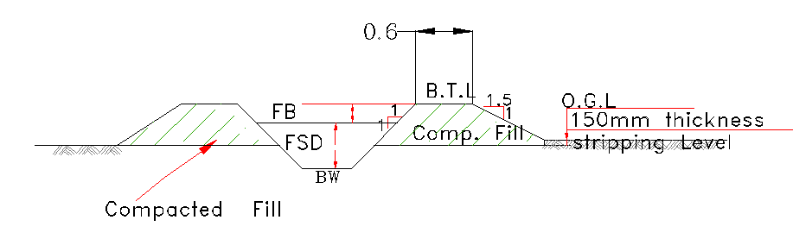
Figure 0-6: Typical Cross Section of secondary canals

Tertiary canals
In the layout system there are Eleven (11) tertiary canals, the designed discharge is determined based on the duty of irrigation. The sections of the canals are determined by using manning’s formula, and they are trapezoidal section. The hydraulic characteristics is Presented in Table 5.3 below.
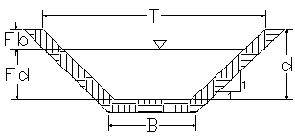
Figure 0-7: Typical Cross Section of tertiary canals
Table 0-10: Hydraulic Parameters of tertiary canals
Type of  canal | Command  area(ha) | Design  discharge  Q(m3/s) | Bed width (m) | Flow  depth  (m) | velocity  (m/s) | Free board  (m) | Total canal depth  (m) | Top width  (m) | Canal  length  (m)
TC1--1 | 8 | 0.013 | 0.2 | 0.3 | 0.64 | 0.1 | 0.4 | 0.90 | 312
TC1-1-1 | 5 | 0.008 | 0.2 | 0.2 | 0.65 | 0.1 | 0.3 | 0.8 | 256
TC1-1-2 | 4 | 0.007 | 0.2 | 0.2 | 0.64 | 0.1 | 0.3 | 0.97 | 220
TC1-1-3 | 4 | 0.007 | 0.2 | 0.2 | 0.88 | 0.1 | 0.3 | 0.97 | 312
TC1-1-4 | 3.4 | 0.006 | 0.2 | 0.2 | 0.3 | 0.1 | 0.3 | 0.97 | 215
TC1-1-5 | 6.2 | 0.01 | 0.2 | 0.2 | 0.91 | 0.1 | 0.3 | 0.97 | 163
TC1-1-6 | 4.6 | 0.008 | 0.2 | 0.2 | 0.51 | 0.1 | 0.3 | 0.97 | 224
TC1-1-7 | 7.5 | 0.012 | 0.2 | 0.2 | 0.33 | 0.1 | 0.3 | 0.97 | 165
TC1-2-1 | 4 | 0.007 | 0.2 | 0.2 | 0.42 | 0.1 | 0.3 | 0.97 | 385
TC1-2-2 | 3.9 | 0.006 | 0.2 | 0.2 | 0.36 | 0.1 | 0.3 | 0.97 | 125
TC1-2-3 | 3.8 | 0.006 | 0.2 | 0.2 | 0.36 | 0.1 | 0.3 | 0.97 | 160

Field Canals
As shown in the layout, field canals run across the contours and hence face relatively steeper gradient. The discharge of most of the field canals is very small and this is taken as an advantage to cope up with the relatively steeper gradient. Figure 15 below shows a typical field canal x-section. As much as possible field canals shall be made in fill in order to easily irrigate the adjacent command area. As can be seen from the layout, majority of the filed canals can be used to irrigate both sides of the command area depending on the condition of the individual plots of land owned by individual farmers.
Figure 0-8: Typical Field Canal X-section

Drainage Canals

Catch drainage canals
In the layout system there are seven (7) Catch drain canals, the designed discharge is determined based on the Catchment area, run off coefficient and rain fall intensity (Rational formula). The sections of the canals are determined by using manning’s formula, and they are trapezoidal section.
Figure 0-9: Typical Cross Section of Catch drain canals

Table 0-11: Hydraulic Parameters of Catch drains
Drain Canal name | Chainage | Length (m) | Comm. Area (ha) | Q req (m3/s) | m (H:V) | N | S | B (m) | D (m) | A(m) | P(m) | R=A/P | Fb (m) | V(m/s) | Qdes (m3/s)
TD1-1 | 0+00-0+589 | 200 | 5.00 | 0.19 | 1:1 | 0.025 | 0.001 | 0.4 | 0.4 | 0.39 | 1.70 | 0.23 | 0.3 | 0.5 | 0.18
TD1-2 | 0+00-0+766 | 250 | 4.00 | 0.15 | 1:1 | 0.025 | 0.001 | 0.4 | 0.4 | 0.33 | 1.56 | 0.21 | 0.3 | 0.5 | 0.15
TD1-3 | 0+00-0+956 | 225 | 4.10 | 0.15 | 1:1 | 0.025 | 0.001 | 0.4 | 0.4 | 0.34 | 1.58 | 0.22 | 0.3 | 0.5 | 0.15
TD1-4 | 0+00-0+839 | 225 | 3.90 | 0.15 | 1:1 | 0.025 | 0.001 | 0.4 | 0.4 | 0.33 | 1.55 | 0.21 | 0.3 | 0.4 | 0.14
CTD C1-1 | 0+00-0+839 | 450 | 17.00 | 0.64 | 1:1 | 0.025 | 0.001 | 0.7 | 0.7 | 0.99 | 2.69 | 0.37 | 0.3 | 0.6 | 0.64
MD1 | 0+00-0+1085 | 665 | 25.00 | 0.94 | 1:1 | 0.025 | 0.001 | 0.8 | 0.8 | 1.32 | 3.11 | 0.42 | 0.3 | 0.7 | 0.94
MD2 | 0+00-0+764 | 1970 | 48.50 | 1.83 | 1:1 | 0.025 | 0.001 | 1.0 | 1.0 | 2.17 | 3.99 | 0.54 | 0.3 | 0.8 | 1.82

Tertiary canal drainage canals
Drainage Canals aren't provided for the Tertiary canals, because all of the tertiary canals are entered to gullies and also there is shortage of irrigation water. It is assumed that there is no excess irrigation water during dry season. For the rainy season the water that comes through the tertiary canals directly entered to gullies. So, Gully protection is necessary at the tertiary canal out fall. For the protection gabion is recommended.

Design of Division box
At different points of the main and secondary canals division boxes are provided which divert the flow to the secondary canal and tertiary canals. Gate should be provided at the outlet of the boxes. For detail refer the drawing.
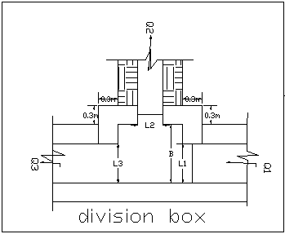
Figure 0-10: Typical Division Box plan
Using broad crested formula,
Q= CL (h)^{3/2}
Where; Q= discharge over rectangular weir/intake (opening), m³/s
C = discharge coefficient, c= 1.7
L= effective length of crest form in m
h= over flow depth, m
Assuming equal discharge coefficient & sill height for two or three dividing canals, the proportion becomes.
Q₁/ Q₂= Q₂/ Q₃ =L₁/ L₂ = L₂/ L₃
Where Q₁= is flow in canal 1
Q₂ = is flow in canal 2
Q₃ = is flow in canal 3
L₁= is effective crest length of weir/intake sill across opening to canal 1
L₂= is effective crest length of weir/intake sill across opening to canal 2
L₃ = is effective crest length of weir/intake sill across opening to canal 3
Q₁= CL₁ (h)^{3/2},
L₁ = Q₁/Ch^{3/2}
L₂ = L₁*Q₂/ Q₁
L₃ = L₁*Q₃/ Q₁
The depth of (height of) the division box,
D = d + f_{b}
The width of the division box,
B = b + 2*m*D
Where b= base width of the incoming canal
D = total canal depth of the incoming canal
Table 0-5: Hydraulic parameters of Division Boxes
DESCRIPTION | CHAINAGE | Q1(l/s) | Q2(l/s) | Q3(l/s) | L1 | L2 | TAKE L2(d) | L3 | Take L3 (B) | BOX LENGTH | D1 | D2 | D3 | Ldp | Lup | LW | H1 | H2 | H3
MC-1 & TC1-1 | 0+740 | 131 | 13 | 118 | 0.6 | 0.060 | 0.1 | 0.54 | 0.55 | 1.6 | 0.48 | 0.42 | 0.41 | 2.73 | 2.34 | 0.6 | 0.025 | 0.025 | 0.025
MC-1 ,SC1-1,SC1-2 | 0+957 | 118 | 49 | 69 | 0.55 | 0.228 | 0.3 | 0.32 | 0.4 | 1.4 | 0.4 | 0.36 | 0.3 | 2.36 | 2.025 | 0.58 | 0.025 | 0.025 | 0.025
SC1-1
SC1-1&TC1-1-1 | 0+197 | 69 | 8 | 61 | 0.4 | 0.046 | 0.09 | 0.35 | 0.36 | 1.6 | 0.6 | 0.39 | 0.6 | 2.8 | 2.4 | 0.62 | 0.022 | 0.022 | 0.022
SC1-1&TC1-1-2 | 0+310 | 61 | 7 | 54 | 0.36 | 0.041 | 0.08 | 0.32 | 0.36 | 1.6 | 0.6 | 0.38 | 0.6 | 2.73 | 2.34 | 0.62 | 0.021 | 0.021 | 0.021
SC1-1&TC1-1-3 | 0+400 | 54 | 7 | 48 | 0.35 | 0.045 | 0.08 | 0.31 | 0.35 | 1.6 | 0.6 | 0.38 | 0.55 | 2.71 | 2.325 | 0.62 | 0.02 | 0.02 | 0.02
SC1-1&TC1-1-4 | 0+450 | 48 | 6 | 42 | 0.35 | 0.044 | 0.04 | 0.31 | 0.35 | 1.5 | 0.55 | 0.37 | 0.3 | 2.54 | 2.175 | 0.61 | 0.019 | 0.019 | 0.019
SC1-1&TC1-1-5 | 0+640 | 42 | 10 | 32 | 0.25 | 0.060 | 0.06 | 0.19 | 0.25 | 1.3 | 0.5 | 0.39 | 0.64 | 2.19 | 1.875 | 0.6 | 0.021 | 0.021 | 0.021
SC1-1&TC1-1-6 | 0+650 | 32 | 8 | 24 | 0.25 | 0.063 | 0.06 | 0.19 | 0.25 | 1.3 | 0.5 | 0.39 | 0.6 | 2.19 | 1.875 | 0.6 | 0.018 | 0.018 | 0.018
SC1-1&TC1-1-7 | 0+970 | 24 | 12 | 12 | 0.2 | 0.100 | 0.1 | 0.1 | 0.2 | 1.1 | 0.46 | 0.4 | 0.57 | 1.96 | 1.68 | 0.59 | 0.017 | 0.017 | 0.017
SC1-2
SC1-2&TC1-2-1 | 0+200 | 49 | 7 | 42 | 0.45 | 0.064 | 0.2 | 0.39 | 0.42 | 1.7 | 0.64 | 0.4 | 0.6 | 3.03 | 2.595 | 0.63 | 0.016 | 0.016 | 0.016
SC1-2&TC1-2-2 | 0+460 | 42 | 6 | 36 | 0.42 | 0.060 | 0.08 | 0.36 | 0.35 | 1.6 | 0.6 | 0.38 | 0.57 | 2.84 | 2.43 | 0.62 | 0.015 | 0.015 | 0.015
SC1-2&TC1-2-3 | 0+550 | 36 | 6 | 30 | 0.35 | 0.058 | 0.1 | 0.29 | 0.23 | 1.5 | 0.57 | 0.4 | 0.48 | 2.61 | 2.235 | 0.61 | 0.015 | 0.015 | 0.015

Road crossing and supper passage structure
There are one road crossing with gully crossing structures on SC1, one foot path and one supper passage are provided on SC2, The road crossing structures are rectangular reinforced concrete slab. The slab is reinforced with 12mm @180mmc/c the length of the slab is 3m which is the same as the respective canal bed width, its width and thickness is 1m and 20mm respectively.
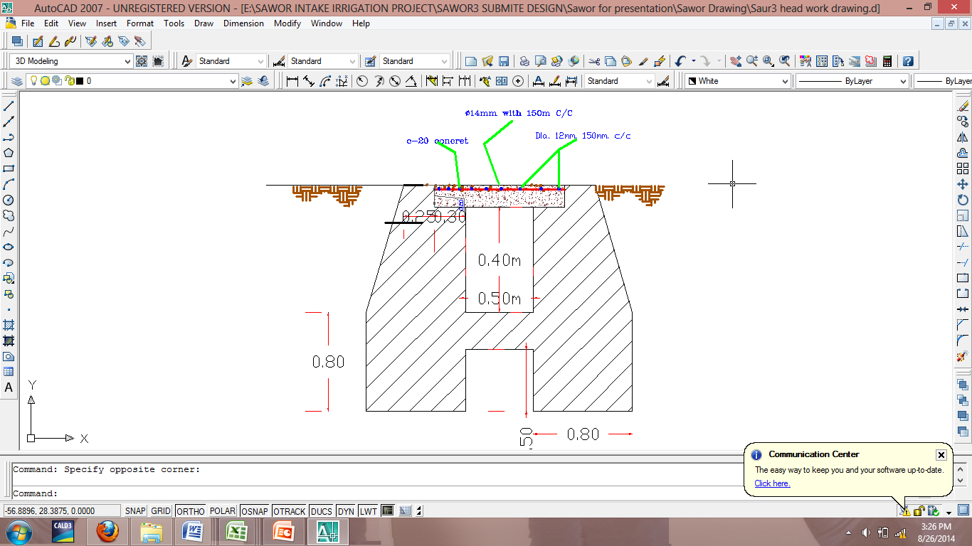
Figure 4.6. On SC2 road crossing
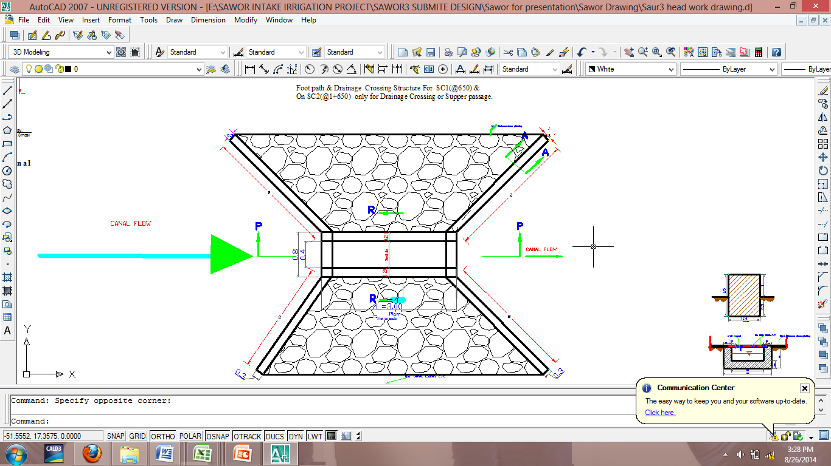
Figure 4.7 On SC1 supper passage.

Table 4.6 Irrigation Infrastructure Bill of Quantities and Cost Estimate
Bill No. | Description | Amount (Birr) | Remark
1 | General item | 1,390,133.35
2 | Head Work | 6,319,869.87
3 | Main, Secondary, Tertiary Canal and Catch Drain | 3,626,004.34
Total |  | 11,336,007.56
VAT 15% |  | -
Grand Total |  | 11,336,007.56

It. No. | Description | Unit | Qty | Unit Rate | Total Amount
1 | Main canal
1.1 | Site Clearing and Grubbing | m² | 106.15 | 12.12 | 1,286.54
1.2 | Excavation ordinary soil | m³ | 2,016.85 | 88.08 | 177,644.15
1.3 | Back fill | m³ | 636.90 | 60.59 | 38,589.77
1.4 | Masonry work(1:3) | m³ | 841.50 | 1,555.94 | 1,309,323.51
1.5 | Plastering (1:2) | m² | 2,547.60 | 124.78 | 317,889.53
1.6 | Culvert (0n MC and DC)
1.6.1 | Masonry work | m³ | 16.50 | 1,555.94 | 25,673.01
1.6.2 | 14ø bar | kg | 38.50 | 45.80 | 1,763.30
1.6.3 | Anchor bar | kg | 55.00 | 78.69 | 4,327.95
1.6.4 | 16ø bar | kg | 55.00 | 45.80 | 2,519.00
1.6.6 | Concrete C-20(1:2:3) | m³ | 11.22 | 2,548.97 | 28,599.44
1.7 | Gates | No. | 3.00 | 2,433.20 | 7,299.60
1.7.1 | 4mm thick sheet metal | m²
1.7.2 | Angle iron for groove(40*40*4) | Pcs
1.7.3 | 16mmø reinforcement bar | Kg
1.7.4 | Stiffening angle iron(30*30*4) | Pcs
1.7.5 | 10cm thick C-10 lean concrete(1:3:6) | m³ | 0.22 | 1,880.35 | 413.68
1.8 | Division box
1.8.1 | Masonry work(1:3) | m³ | 14.44 | 1,555.94 | 22,463.88
1.8.2 | 10cm thick C-10 lean concrete(1:3:6) | m² | 0.33 | 188.04 | 62.05
1.8.3 | Plastering(1:2) | m² | 33.00 | 124.78 | 4,117.74
Sub Total |  |  |  |  | 1,941,973.15
2 | SC 1-1
2.1 | Clearing and grubbing | m² | 233.20 | 12.12 | 2,826.38
2.2 | Excavation(soil) | m³ | 650.67 | 88.08 | 57,311.19
2.3 | Masonry work(1:3) | m³ | 316.80 | 1,555.94 | 492,921.79
2.4 | Plastering (1:2) | m² | 1,056.00 | 124.78 | 131,767.68
2.4.1 | Back fill | m³ | 275.00 | 60.59 | 16,662.25
2.5 | Cemented stone pitching | m³ | 2.75 | 1,555.00 | 4,276.25
2.6 | Division box
2.6.1 | Masonry work(1:3) | m³ | 27.50 | 1,555.94 | 42,788.35
2.6.2 | Cemented stone pitching | m³ | 13.20 | 1,555.00 | 20,526.00
2.6.3 | 10cm thick C-10 lean concrete(1:3:6) | m² | 0.98 | 188.04 | 184.09
2.6.4 | Plastering(1:2) | m² | 31.90 | 124.78 | 3,980.48
2.7 | Gates | Pcs | 10.00 | 2,403.14 | 24,031.40
2.7.1 | 4mm thick sheet metal
2.7.2 | Agle iron for groove(40*40*4)
2.7.3 | Dia.16mm reinforcement bar
2.7.4 | 10cm thick C-10 lean concrete(1:3:6) | m³ | 3.41 | 1,880.35 | 6,411.99
2.8 | Road Crossing and Supper passage
2.8.1 | Excavation ordinary soil | m³ | 27.50 | 88.08 | 2,422.20
2.8.2 | Back fill | m³ | 13.20 | 60.59 | 799.79
2.8.3 | Masonry(1:3) | m³ | 13.20 | 1,555.94 | 20,538.41
2.8.4 | Concrete C-20(1:2:3) | m³ | 6.05 | 2,548.97 | 15,421.27
2.8.5 | 14ø bar | kg | 110.00 | 45.80 | 5,038.00
2.8.6 | Plastering(1:2) | m² | 13.20 | 124.78 | 1,647.10
2.8.7 | Cemented stone pitching | m³ | 3.85 | 1,555.00 | 5,986.75
3 | SC 1-2
3.1 | Clearing and grubbing | m² | 572.00 | 12.12 | 6,932.64
3.2 | Excavation(soil) | m³ | 2,288.00 | 88.08 | 201,527.04
3.3 | Masonry work(1:3) | m³ | 211.20 | 1,555.94 | 328,614.53
3.4 | Plastering (1:2) | m² | 704.00 | 124.78 | 87,845.12
3.5 | Back fill | m³ | 220.00 | 60.59 | 13,329.80
3.6 | Division box
3.6.1 | Masonry work(1:3) | m³ | 16.50 | 1,555.94 | 25,673.01
3.6.2 | Cemented stone pitching | m³ | 2.75 | 1,555.00 | 4,276.25
3.6.3 | 10cm thick C-10 lean concrete(1:3:6) | m² | 0.39 | 188.04 | 72.40
3.6.4 | Plastering(1:2) | m² | 23.10 | 124.78 | 2,882.42
3.7 | Gates | Pcs | 6.00 | 2,403.14 | 14,418.84
3.7.1 | 4mm thick sheet metal | m²
3.7.2 | Angle iron for groove(40*40*4) | Pcs
3.7.3 | Dia.16mm reinforcement bar | Kg
3.8 | Foot path
3.8.1 | Excavation(soil) | m³ | 28.60 | 88.08 | 2,519.09
3.8.2 | Back fill | m³ | 52.80 | 60.59 | 3,199.15
3.8.3 | Masonry work(1:3) | m³ | 16.50 | 1,555.94 | 25,673.01
3.8.4 | Plastering(1:2) | m² | 27.50 | 124.78 | 3,431.45
3.8.5 | Concrete C-20 | m³ | 2.20 | 2,548.97 | 5,607.73
3.8.6 | Ø 12 mm R.bar | kg | 44.00 | 45.80 | 2,015.20
3.9 | Supper passage
3.9.1 | Excavation(soil) | m³ | 28.60 | 88.08 | 2,519.09
3.9.2 | Back fill | m³ | 52.80 | 60.59 | 3,199.15
3.9.3 | Masonry work(1:3) | m³ | 16.50 | 1,555.94 | 25,673.01
3.9.4 | Plastering(1:2) | m² | 27.50 | 124.78 | 3,431.45
3.9.5 | Concrete C-20 | m³ | 2.09 | 2,548.97 | 5,327.35
3.9.6 | Ø 12 mm R.bar | kg | 44.00 | 45.80 | 2,015.20
3.9.7 | Cemented stone pitching | m³ | 3.52 | 1,555.00 | 5,473.60
Sub Total |  |  |  |  | 1,631,197.90
4 | TC 1-1
4.1 | Clearing and grubbing | m² | 173.80 | 12.12 | 2,106.46
4.2 | Excavation(soil) | m³ | 41.18 | 88.08 | 3,627.49
4 | TC 1-1-1
4.1 | Clearing and grubbing | m² | 185.90 | 12.12 | 2,253.11
4.2 | Excavation(soil) | m³ | 56.23 | 88.08 | 4,952.91
5 | TC1-1-2
5.1 | Clearing and grubbing | m² | 81.40 | 12.12 | 986.57
5.2 | Excavation(soil) | m³ | 9.77 | 88.08 | 860.37
6 | TC1-1-3
6.1 | Clearing and grubbing | m² | 231.00 | 12.12 | 2,799.72
6.2 | Excavation(soil) | m³ | 40.13 | 88.08 | 3,534.47
7 | TC1-1-4
7.1 | Clearing and grubbing | m² | 130.90 | 12.12 | 1,586.51
7.2 | Excavation(soil) | m³ | 15.71 | 88.08 | 1,383.56
8 | TC1-1-5
8.1 | Clearing and grubbing | m² | 179.30 | 12.12 | 2,173.12
8.2 | Excavation(soil) | m³ | 21.52 | 88.08 | 1,895.13
9 | TC1-1-6
9.1 | Clearing and grubbing | m² | 137.50 | 12.12 | 1,666.50
9.2 | Excavation(soil) | m³ | 29.44 | 88.08 | 2,592.72
10 | TC1-1-7
10.1 | Clearing and grubbing | m² | 135.30 | 12.12 | 1,639.84
10.2 | Excavation(soil) | m³ | 21.78 | 88.08 | 1,918.38
11 | TC1-2-1
11.1 | Clearing and grubbing | m² | 364.10 | 12.12 | 4,412.89
11.2 | Excavation(soil) | m³ | 43.69 | 88.08 | 3,848.39
12 | TC1-2-2
12.1 | Clearing and grubbing | m² | 27.50 | 12.12 | 333.30
12.2 | Excavation(soil) | m³ | 42.37 | 88.08 | 3,732.13
13 | TC1-2-3
13.1 | Clearing and grubbing | m² | 132.00 | 12.12 | 1,599.84
13.2 | Excavation(soil) | m³ | 33.26 | 88.08 | 2,929.89
Sub Total |  |  |  |  | 52,833.29
Grand Total |  |  |  |  | 3,626,004.34

CONCLUSION AND RECOMMENDATION
- The infrastructure of this project area is designed to irrigate about 97ha of land by taking its supply from the Sewer Intake irrigation project. The maximum duty of the command area for 18 hours per day irrigation with overall project efficiency of 51%. The method of irrigation of the project area is furrow surface irrigation in which the Main and Secondary canals are working continuously where as the field canals within a tertiary block are working rotational system.
- As the dominant soil type is black cotten soil, the main canal system is designed to be masonry.
- The reason why the main canal is to be lined up to the end is to avoid the siltation problem, time saving to reach at the tail part, reduce maintenance cost and use water properly.
- On the secondary unit of the irrigation systems, some are associated with far as possible to be very small filled and almost total cut.
- The design of the canal dimensions of the irrigation canal is done by applying the manning’s uniform flow equation. The variable of the hydraulic parameters are calculated using iteration or flow master program.
- The design discharge of the drainage canals are determined using Rational formula and Gamble Powell method.
- As soils of the command area are predominantly black cotten(clay) textured; and hence water and soil management measures should be undertaken; and optimum moisture content should be maintained to improve workability of the soil during land preparation and planting time.

The following recommendations are drown:
- For better performance and long service year of the project regular inspection and maintenance is highly required.
- Farmers training, how to operate and maintain the project structures as a whole and available and water resources has a paramount important.
- The irrigation hours per day and per week should be flexible based on base flow amount of each week or month.
- Close supervision of the construction should be made to modify (if need be) each Components of irrigation system based on specific site conditions.

OPERATION AND MAINTENANCE

General
The main objective of the operation and maintenance aspect of an irrigation scheme is to facilitate the timely delivery of the required irrigation water to farms and to keep the irrigation system in an optimum operating condition. This section therefore, discusses the main functions of the subject matter under consideration for the scheme.

Operation of the Head Works
Operation at the diversion weir mainly focuses on the diversion of a controlled flow of river water, timely cleaning of floating debris in front of intake and removal of sediment deposits in front of the weir and intake structures.

Irrigation System Operation
The operation of the irrigation system depends mainly on the method of water delivery at farm level. Surface irrigation method is the recommended type of water distribution and application method for Aderkayna diversion irrigation scheme.
The farmers would organize themselves and form groups in order to handle the water management. Since flow is low Rotational water distribution would be applied within the group. The rotational distribution is then to distribute water by turn to the whole scheme according to the timely need of crop water requirement. For better and efficient water management, crop diversification should be avoided within a group. This would reduce the complexity of water distribution system of the scheme during one irrigation season. At farmers’ level of operation, a constant flow and variable irrigation time is advisable.
The operation of the irrigation system is continuous for 14 hours per day in main, secondary and tertiary canals where as field canals within a tertiary block are operating in rotational system with each other for irrigation hours proportional to their size. Since the tertiary canal discharges are within the manageable range and the irrigation canal structures are accordingly designed for simple operation, the farmers can open and close easily whenever they required.

Maintenance Requirement
The canal system of the project is earthen canal except main canal and secondary canal, which is susceptible to siltation, erosion, growth of weeds and or breaching problems. Though the canal sections are designed for non- silting and non scouring conditions, the above mentioned problems are unavoidable and hence periodical and yearly inspection and maintenance of canals and structures are obligatory in order to fulfill the design objective of the project area.
The maintenance tasks are categorized into two types: - routine activities, and repairs. The routine maintenance activities that are carried out periodically include:-
- Regular cleaning of sediments and weeds from canals and drains;
- Inspection and lubrication of gates; and
- Maintenance of cracked lined canals, regulating and control structures.
Repair works include task carried out more frequently and quickly, and include those tasks that are generally unpredictable. They also include emergency works. The activities included in this category are:-
- Repairing overtopped or breached canals, drains, and flood protection dykes;
- Repairing jammed gates;
- Filling holes made by wild animals; and
- Reduced free board due to walking over by people and livestock.
Regular inspection of the irrigation facilities should be carried out as part of the maintenance activities. These tasks could be carried out immediately after the end of the main rains in September and during the rainy season. This could concentrate on the interceptor drains and the flood protection dykes, the main canal and the field drains. The inspection of the other works like the tertiary canals, field drains, and the water control and regulating structures could be carried out as part of routine operation activities.
- Beneficiaries of the project need to have operation and maintenance budget, For O&M cost incurring entity area:
- Purchase sing of gate lubricate (grease)
- Replacing and maintenance of Stolen and damaged gates
- Repair Damages on the cross drainage structures.
The expense for O&M should be collected from the beneficiaries. Of course, much of the task is done by the labor and skill of the community. For cost incurring activities beneficiaries have to collect money based on the proportion of the command area they owned.

REFERENCE
- ARORA, K.R., Irrigation Water Power and Water Resources Engineering, Professor of Civil Engineering, Engineering College, Kota (Raj.)
- Design of small Canal structures , USBR
- Ethiopian Ministry of irrigation department manual(IDD).
- Hydraulic structural design guide line for small scale irrigation project.
- Irrigation Engineering And Hydraulic Structure (Garge)
- PART 1-3F design guide lines on diversion structure
- Soft copies of hydraulic structure publishing FAO (1977) guidelines for predicting crop water requirements. No 24, Rome Italy

