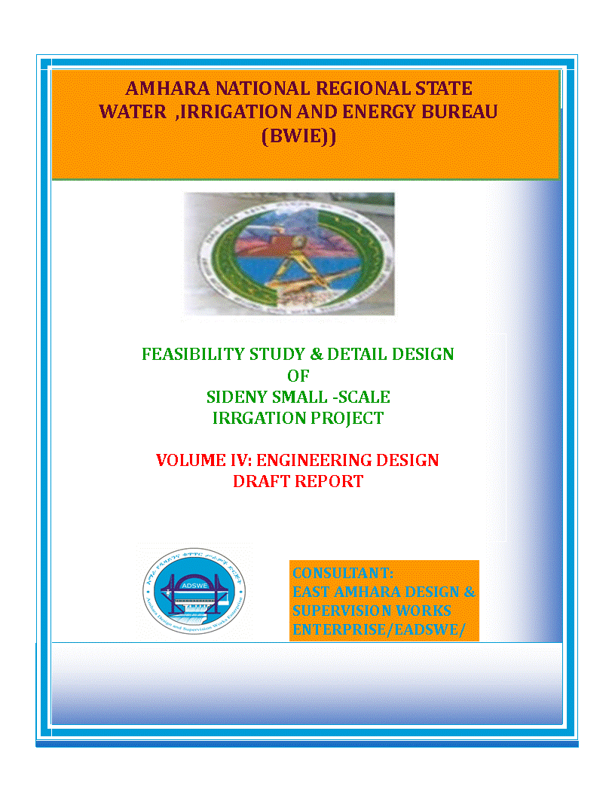

Amhara National Regional State
Water Resources Development Bureau
(BOWRD)

Detail Design
Of
Diversion Small-Scale Irrigation Project

Volume IV: Engineering Design Final Report
September, 2009
Bahir Dar
Client: Bureau of Water Resource Development
(BoWRD)
Address:
P. O. Box: 88
Telephone: 0528-200853/855
Fax: 251-08-20-65-68/204676/202040
Consultant: Amhara Design & Supervision Works Enterprise
(ADSWE)
Address:
P. O. Box: 1921
Telephone: +251-582-181023/ 180638/181201/181254
Fax: (058) 2180550/ (058) 2180560
E-mail: amhara design@yahoo.com
Bahir Dar, Ethiopia

FEASIBILITY STUDY & DETAIL DESIGN REPORT STRUCTURE
- Volume I: Watershed Management
- Volume II: Engineering Geology
- Volume III: Irrigation Agronomy
- Volume IV: Engineering Final Draft Design
- Volume V: Socio Economy
- Volume VI: Environmental Impact Assessment
Table of Contents Page Nr
FEASIBILITY STUDY & DETAIL DESIGN REPORT STRUCTURE i
LIST OF FIGURES v
SAILENT FEATURE vi
1 INTRODUCTION 1
1.1 Background 1
1.1.1 Description of the Project Area 1
1.2 Objectives of the Study 3
1.2.1 Major Objective 3
1.2.2 Specific Objectives 4
1.3 Scope of the Study 4
1.4 Methodology 5
SECTION-I: HYDROLOGY 7
2 HYDROLOGY 8
2.1 Watershed Characteristics 8
2.2 Hydro-Metrological Data Availability 9
2.2.1 Climate 9
2.2.2 Rainfall Data 10
2.2.3 River flow data 10
2.2.4 Upstream & Downstream utilization 10
2.3 Design Flood Analysis 10
2.3.1 Design Rainfall computation 11
2.3.2 Outlier Test 11
2.3.3 Check for variance 13
2.3.4 Peak Discharge Determination 15
2.3.5 Tail Water Depth Computation 19
SECTION-II: HEADWORK DESIGN 24
3 HEADWORK STRUCTURES DESIGN 25
3.1 Headwork Site Selection 25
3.1.1 River Bed condition 25
3.1.2 River Bank condition 27
3.2 Main Canal Route 28
3.3 Sources of construction materials 30
3.3.1 Rock for Masonry and Crushed Coarse Aggregate 30
3.3.2 Fine Aggregates 31
3.3.3 Water 31
3.4 Headwork Type Selection 32
3.4.1 Hydraulic Design of Headwork Structure 32
3.5 Bill of Quantity and Cost Estimation 40
SECTION-III: IRRIGATION AND DRAINAGE SYSTEMS INFRASTRUCTUR 44
4 IRRIGATION AND DRAINAGE SYSTEMS DESIGN 45
4.1 Irrigable Area Description 45
4.1.1 Topography 45
4.1.2 Climate 45
4.1.3 Soil characteristics 46
4.1.4 Existing Irrigation Practices in the Project Area 46
4.2 Irrigation Water Requirement 46
4.2.1 Crop Water Requirement (CWR) 46
4.2.2 Irrigation efficiency (Ep) 47
4.2.3 Irrigation duty 49
4.2.4 Irrigation methods 52
4.3 Irrigation and Drainage System Layout 52
4.3.1 Conveyance System 53
4.4 Design of the Canal System 53
4.4.1 Main Canal 54
4.4.2 Tertiary canals 56
4.4.3 Field Canals 58
4.5 Drainage system design 58
4.6 Canal Structures Design 60
4.6.1 Design of Division box 60
4.6.2 Design of Turnout 62
4.6.3 Design of Drop Structure 62
4.6.4 Road crossing structure 64
5 CONCLUSION AND RECOMMENDATION 68
6 OPERATION AND MAINTENANCE 70
6.1 General 70
6.2 Operation of the Head Works 70
6.3 Irrigation System Operation 70
6.4 Maintenance Requirement 71
7 REFERENCE 73

LIST OF TABLES

Table 1: Outlier test analysis 11
Table 2: Test for goodness to fit using D-index 14
Table 3: Determination of Time of Concentration 15
Table 4: Runoff analysis 18
Table 5: Hydrograph coordinates 19
Table 6: intake Site River Cross section Coordinate Data 20
Table 7: Stage discharge analysis 21
Table 8: typical design of masonry retaining wall 37
Table 9: Bill of quantity and cost estimation for Head work 40
Table 10: Bill of quantity and cost estimation for Head work 41
Table 11 Irrigation Scheme for Wet Season 51
Table 12: irrigation Scheme for Dry Season 51
Table 13: Hydraulic Parameters of main canal 55
Table 14: Hydraulic Parameters of tertiary canals 57
Table 15: Hydraulic parameters of Division Boxes 61
Table 16: Hydraulic Parameters of Drop Structure 63
Table 17: Bill of Quantity for Infrastructure 64

LIST OF FIGURES

Figure 1: Location map of the project area 2
Figure 2: Drainage map of watershed 9
Figure 3: Complex Hydrograph 19
Figure 4: River cross section 20
Figure 5: Rating Curve 21
Figure 6: River profile 22
Figure 7: Plate Stream Bed 26
Figure 8: Engineering Geological Cross- Sections along Proposed Bed Bar 26
Figure 9: Stream Bed Geologic Formations and Left Bank 27
Figure 10: Right Bank and Stream Bed ends 28
Figure 11: The First 0 + 100m Main Canal Route 29
Figure 12: Between the First 0+100m to about 0+ 300m of Main Canal 29
Figure 13: Coarse Aggregates 31
Figure 16: Typical Cross Section of tertiary canals 56
Figure 17: Typical Field Canal X-section 58
Figure 18: Typical Division Box plan 60
Figure 19: Typical Cross Section of Vertical Drop Structure 63

SAILENT FEATURE

- Project name: Sidney Intake Irrigation Project
- Name of the stream: Sidney river
- Location of the intake site using
- South: 576283.2m
- North: 1279436 m
- Zone: North Wollo
- Wereda: Habru
- Average elevation 1439.195masl
- Hydrology
- Design rainfall: 82.03mm
- Catchment area:84.8848 Km²
- Longest flow path length: 17.76 Km
- Design flood: 250.14m³/sec
- Design base flow: 260 lit/se.

- Diversion Intake structure
- Intake type: Bed bar structure with Cyclopean concrete
- Height: 2 m
- Gross crest length: 195 m
- Intake crest level: 1458.66 m.a.s.l
- U/S HFL: 1460.353 m.a.s.l
- D/s HFL: 1460.353 m.a.s.l
- Afflux: 0 m

- Under sluice
- Sill level: 1458.28m.a.s.l
- Dimension: 0.7*0.6.m²
- Discharge amount: 1.31 m³/sec

- Outlet
- Sill level: 1458.28 m.a.s.l
- Opening dimension: 0.5*0.7 m²
- Discharge capacity: 219.45 lit/sec.
- Irrigation and drainage systems Infrastructure
- Command area size: 65 ha u/s of the existing weir 12.4 ha d/s of the existing weir & 76.6 ha By rehabilitation of the existing system ie lining the existing earthen main canal to increase conveyance
- Type of soil of the command area is dominantly clay loam
- Design discharge of the main canal = 219.45 l/sec
- Irrigation system layout consists of one lined main canal & 18 tertiary canals
- Main irrigation structures designed are;
- Foot path

- Project cost
SIDENY IRRIGATION PROJECT
SUMMARY OF BILLS
Bill No. | Description | Amount (Birr)
1 | General Items | 1,534,608.13
2 | Head work | 3,094,018.21
3 | Infrastructure | 6,768,708.70
 | Total | 11,397,335.04
 | VAT (15%) | 1,709,600.26
 | Grand Total with VAT | 13,106,935.29
 | Command Area(ha) | 154
 | Per hectare Cost without VAT | 74,008.67
 | Per hectare Cost with VAT | 85,109.97

INTRODUCTION

Background
In Ethiopia, under the prevalent rain-fed agricultural production system, the progressive degradation of the natural resource base, especially in highly vulnerable areas of the highlands coupled with climate variability have aggravated the incidence of poverty and food insecurity. The major source of growth for Ethiopia is still conceived to be the agriculture sector. Hence, this sector has to be insulated from drought shocks through enhanced utilization of the water resource potential of the country, (through development of small-scale irrigation, water harvesting, and on-farm diversification) coupled with strengthened linkages between agriculture and industry (agro-industry), thereby creating a demand for agricultural output. In line with the above, efforts have been made by the government to improve the situation in the country in areas of domestic water supply provision, irrigation, watershed management, etc. The Amhara Water Resources Development Bureau is playing its role in the development of small scale irrigation projects in the region. Accordingly, as part of the water sector development program, the office has initiated the study and design of a small scale irrigation scheme on River at Girana Kebele and signed an agreement with Amhara Design & Supervision Works Enterprise (ADSWE) for the study and design of the project.

Description of the Project Area

Location
This irrigation project is located mainly at Girana Kebele, Habru Wereda of North Wollo Zone in the Amhara Region. The proposed irrigation project is to be undertaken on River/Stream and the headwork structures are specifically located at an altitude of about 1439.195 m.a.s.l and geographical coordinates of 1279436 m N (UTM) and 576283.2m E (UTM).

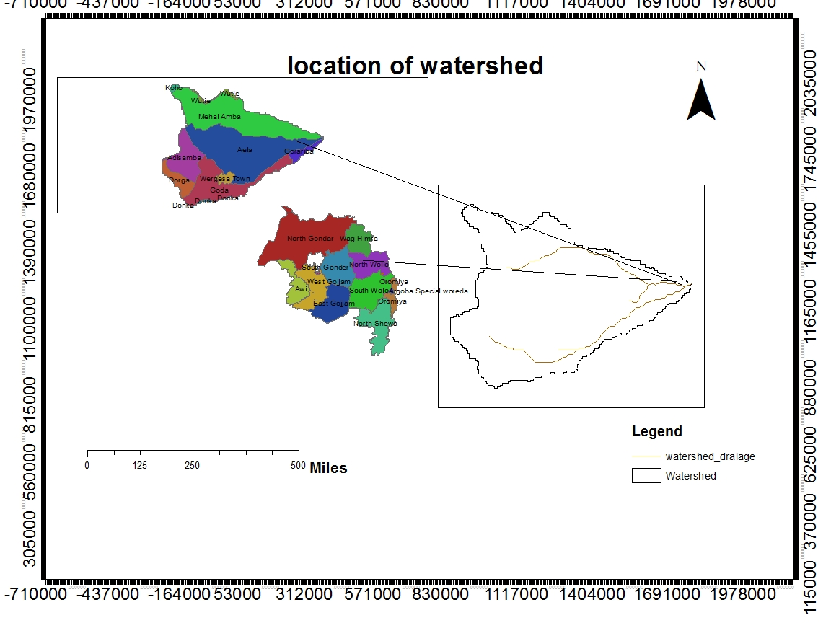

Figure 1: Location map of the project area

Accessibility
The project area is accessed through Asphalted Dry Weather road 15Km from Merssa to Girana, and 2.5Km accesses road must be constructed from girana to the Project area.
Previous Irrigation Practices
There are modern and traditional diversions on the upstream/downstream of this river using different irrigation practices but as the hydrology and Hydrogeology study and respondent farmers indicated, the river has capacity of recharging as it stretches down from the source area of the river. As a result there will not be a marked reduction or fluctuation of water flows both for the already existing and the newly proposed irrigation schemes. The traditional irrigation practices are under taken by individual farmers that use the river flow to the extreme left side is with hardship. So, the farmers in the project area are very much interested to upgrading the traditional scheme to modern scheme.
But The existing weir is only 0.98 km D/S of our head work & It is not efficiently working therefore we need to maintain the existing main canal to reduce the water loss .we decide to do the rehabilitation of existing system to solve water balance problems and to enable the water to rich d/s of the existing weir i.e. our system irrigates 12.4 ha of land d/s of the existing weir that is not afforded by the existing system.

Objectives of the Study

Major Objective
The project area faces variability of rainfall distribution though the overall rainfall generally suffices the rain-fed agriculture. Accordingly, the rain-fed agriculture needs means of supplementing during distribution failures and further full irrigation is required to maximize the use of the potential land and water resources.
Hence the objective of this project is to contribute a substantial share in the effort to reduce the risk of production decrease due to rainfall variability and increase the productivity of the resource in the project specific area. Specifically, the project is targeted for the following.
- To make sustainable the rain-fed crop production and make extra production in the dry season possible for77.4 ha with the new system &76.6 with rehabilitation of existing system of land through irrigation.
- There is a general consensus that irrigation investments will achieve broader food security and poverty reduction impacts and if efforts are also geared towards up-grading existing traditional farming practices with support to enhance access to input supply, output marketing and extension to facilitate access to information and innovations.
- This objective is to be realized by constructing diversion/intake structures across the River/Stream and diverting the river/stream flow.

Specific Objectives
Other benefits that can be expected to appear with the launching of the project are:
- Efficiency of water use improvement;
- Improved local nutrition/food security gains;
- Improved management of scarce natural resources (land and water);
- Resilience against drought risk;
- Rationale for erosion control and watershed management;
- Rationale for the intensification and modernization of small-holder agriculture and rural lifestyles.
The engineering study and design enables the realization of the project by the provision of engineering structures that will allow the appropriate abstraction of the river/stream water for delivery in to the identified irrigation fields of the study area. Hence, this engineering design is specifically targeted to:
- Analyze hydrologic requirements of the project and engineering structures;
- The formulation of sound and stable structure, with necessary provisions that allow safe, easy and low-maintenance operation in the service life of the project;
- Develop working drawings;
- Estimation of construction costs.

Scope of the Study
- The irrigation design shall ensure reliability, equity and flexibility of water delivery to farmers. It will aim at reducing conflicts among water users and will lead to lower operation and maintenance costs.
- Updating the existing, if available, computation of the actual evapo-transpiration, crop water requirement, irrigation demand/duty using the existing and recent agronomic, climatologic and soil data using more appropriate methodologies.
- Establish design criteria for irrigations structures to be approved by the client and to be used in the final design stage,
- Design proper irrigation system compatible with local conditions and management capabilities,
- Establish flood protection measures for the command area and canal structures and design the respective drainage system accordingly,
- Planning and layout of the irrigation system, which include irrigation canals, drainage channels, inspection roads and alignments, canal spacing, canal length, location of structures, and water profiles along canal and drains at specified reaches, which is most economical easily manageable and aligned with topographic feature and geological investigation.
- Determination and estimation of water application conveyance and other losses and irrigation efficiencies and consideration of those parameters in design steps.
- Check and test hydraulic and structural designs of main canal considering total demand and the required capacity and the base flow availability,
- Prepare general plans and drawings for all irrigation infrastructure and irrigation systems designs,

Methodology
In the study and design procedure, Designers used the following steps.
- Specific Site identification:
  - Review of the reconnaissance survey conducted by the Client
  - 50,000 scale top map and GIS information
  - Local farmers interview and discussion
  - Wereda and Zone Agriculture section expertise
  - Previous studies
  - On foot travel along the river channel and farm areas.
- Topographic survey:
  - Surveying the headwork site and the Command area with sufficient radius, using Total station
- Flow estimation
  - Physical observation on flood mark indications and local information about high flood and critical flow condition of the river
  - Analyzing the recorded river flow data and use watershed inputs for further analysis.
  - Base flow estimated during the reconnaissance field visit by floating method.
- Irrigable area identification:
  - Using local information
  - 50,000 Topographic map, and GIS information, GPS to see elevation
The design report is organized in three sections. In Section I the Hydrology study is presented and in Sections II and III the Headwork and Irrigation and Drainage Systems designs are discussed respectively. In Section III, planning and design of the irrigation system after diverting the water using the intake will be dealt. The following are major areas of concern in this part.
- Study and design of the irrigation method to be adopted,
- Study and design of the irrigation system layout and associated structures,
- Design of the different conveyance canals,
- Planning and design of the different irrigation and drainage structures,
- Preparation of the longitudinal profiles of the different irrigation and drainage canals.

SECTION-I: HYDROLOGY

HYDROLOGY

Watershed Characteristics
The Watershed has marked topographic variation. All types of slopes are present. The dominant slope class is 30-50% which covers 23.39% of the total area followed by 3-8% which is 22.34%. Mountain & Rolling Plain and Undulating Plain, Hill & Flat Plain accounts 10.84, 20.62 and 3.62 percent respectively. Table 2 of the watershed feasibility study report shows the slope classes and proportion of the watershed.
Certain physical properties of watersheds significantly affect the characteristics of the runoff and sediment yield and are of great interest in hydrologic analyses. The rate and volume of runoff, and sediment yield from the watershed have much to do with shape, size, slope and other parameters of the landscape. These suggest that there should be some important relations between basin form and hydrologic performance. If the basin and hydrologic characteristics are to be related, the basin form must also be represented by quantitative descriptors. These parameters can be measured from maps.
The watershed characteristics are analyzed and presented in Table 3 of the Watershed Feasibility Study Report of the same project. In summary:
- Catchment Area = 84.88
- Stream Length = 17.76Km
- CN(II) = 91
(Extracted from the Watershed Study Report of the same project)
At the selected reference point, the area of catchment is 84.88 km² and consists of a network of tributaries as shown in Figure 2-1 below.
River/stream at the headwork site is characterized by well-defined channel system and considerable flows. It looks that the gradient of the river/stream is getting high and hence there exists significant sediment load that is why we provide settling basin.

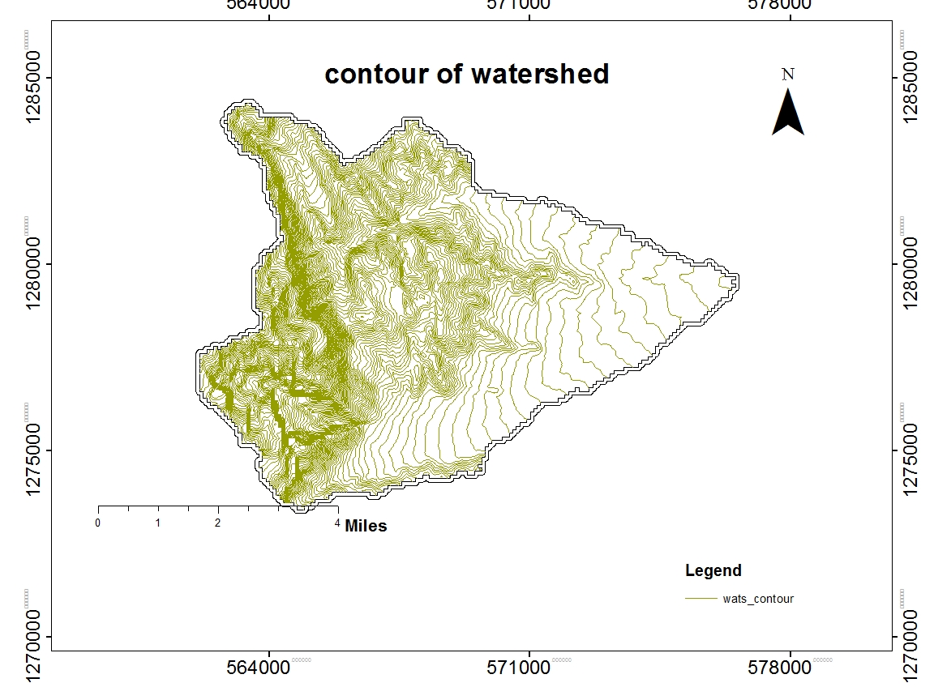
Figure 2: Drainage map of watershed

Hydro-Metrological Data Availability

Climate
Small scale irrigation project designers and planners are faced with lack of good data on the hydrology of the stream/river system that will be their water source and on local weather and climate conditions. Stream gauging stations are virtually non-existent in remote rural areas of Ethiopia; meteorological stations are almost rare. Likewise, at Girana Kebele 018 and in the catchment area of this project, there is no meteorological station of any level. Moreover, there are no flow data for the river/stream near the project. Therefore, data for the hydro-meteorological analysis is taken from the nearby station and similar areas. Rainfall & temperature data are considered from Merssa Meteorological station. In fact, this station is very close to the project area.
As per the data of the station, March – April are identified as high temperature periods whereas December–January are low temperature periods. The mean annual rainfall amount is less than 1060mm (1961 - 1989data) and most of it occurs from June to August.

Rainfall Data
In order to compute the design flood for the Diversion/intake structure, the daily maximum rainfall is collected from Merssa Metrological stations with a record of 25years.

River flow data
The base flow which is measured on May 2008 is 260 l/s. Since this base flow is measured during the dry months of the year, this figure is adopted for design.

Upstream & Downstream utilization
0.98 km Downstream of the proposed site, there exist modern diversion weir therefore we need to consider the water balance conditions and solve the existing water balance problems between U/s & D/s water users. Therefore, we will take the following measures
Even if base flow of river is surplus there is shortage of water as we observe this problem happened due to in efficient system of the existing weir i.e. we recommend to make the existing main canal lined & include with our main canal alignment b/c we have additional command area D/s of the existing weir.
For the sake of planning and design, however, the outlet for the diversion/intake is designed for a discharge of 219.45 l/s for this project and the project is to be developed for a total of 154 ha of land, which is most of the time achievable as the flow for most of the time is significant to support this size of command area.

Design Flood Analysis
For the design and analysis of structures to be constructed on the river/stream, estimation of flood magnitude is an important task. This can be done using different techniques depending on the data available. For this particular case, there are no river flow data and hence the flood estimation is done using the rainfall data and applying SCS Curve Method.

Design Rainfall computation
Based on the data of 24hr peak rainfall given in Table 1 the design rainfall, Rainfall is computed using Gumble’s Extreme Value Method.

Outlier Test
Higher Limit, $Y_{H}=Ymean+Kn*Sy$, Kn = 2.448 for 23Years of data.
Lower Limit, $Y_{H}=Ymean-Kn*Sy$, Kn = 2.448 for 23Years of data.

Table 1: Outlier test analysis

S.NO. | year | Daily max. RF of year(X) | Descending Order(X) | Y=log X | Cumulative rainfall
1 | 1981 | 66 | 70.6 | 1.82 | 66
2 | 1982 | 67.1 | 68.2 | 1.83 | 133.1
3 | 1983 | 50.1 | 67.1 | 1.7 | 183.2
4 | 1984 | 42.8 | 66 | 1.63 | 226
5 | 1985 | 55.7 | 63.9 | 1.75 | 281.7
6 | 1986 | 54.3 | 62.7 | 1.73 | 336
7 | 1987 | 70.6 | 62.6 | 1.85 | 406.6
8 | 1988 | 55.9 | 60.9 | 1.75 | 462.5
9 | 1989 | 54.6 | 60 | 1.74 | 517.1
10 | 1992 | 54.5 | 56.7 | 1.74 | 571.6
11 | 1993 | 62.6 | 55.9 | 1.8 | 634.2
12 | 1994 | 56.7 | 55.7 | 1.75 | 690.9
13 | 1996 | 53.9 | 55 | 1.73 | 744.8
14 | 1997 | 68.2 | 54.6 | 1.83 | 813
15 | 1998 | 60.9 | 54.5 | 1.78 | 873.9
16 | 1999 | 42.2 | 54.3 | 1.63 | 916.1
17 | 2000 | 42.5 | 53.9 | 1.63 | 958.6
18 | 2001 | 60 | 50.1 | 1.78 | 1018.6
19 | 2002 | 46.7 | 50 | 1.67 | 1065.3
20 | 2003 | 62.7 | 46.7 | 1.8 | 1128
21 | 2004 | 63.9 | 42.8 | 1.81 | 1191.9
22 | 2005 | 50 | 42.5 | 1.7 | 1241.9
23 | 2006 | 55 | 42.2 | 1.74 | 1296.9
sum |  | 1296.9 |  | 40.19
mean/µ/ |  | 56.386957 |  | 1.7473913
stdv/αn-1/ |  | 8.2295645 |  | 0.06524202
skew/g/ |  | 0.1614534 |  | -0.42033578

Higher Limit, YH = 1.907
Lower Limit, YL = 1.587
Therefore,
Upper limit of rainfall = 10^1.907 = 70.6 mm
Lower Limit of rainfall = 10^1.587 = 42.8 mm
Conclusion: The rainfall values are within the limits.

Check for variance
After checking the outliers, the data should be checked for variability. For variability the formula used is
$α=\left(\frac{δ_{∩-1}}{\sqrt{N}*Mean}\right)*100\%$
Where, δ_{n-1 =} Standard deviation =8.22
N = Nr of recorded data =23
M_{ean} = 56.38
$α$ = Standard error
$α=\left(\frac{8.22}{\sqrt{23}*56.38}\right)*100\%=1.96<10\%$ Acceptable
Therefore the data shows no variability.

D-Index test
After checking the consistency of the data for higher and lower outlier, the 23 years data is obtained as representative for the analysis using D-index. The D-Index test is believed to be the better goodness to fitness in many literatures. Hence in this study it was used to determine the best statistical distribution to estimate the peak rainfall. The D-index for the comparison of the fit of various distributions is summarized as follows.
$D_{-Index}=(\frac{1}{X_{m}})*\sum_{i=1}^{6}{Abs(Xi-{Xi}^{'})}$
Where Xi and Xi’ are the i^{th} highest observed and computed values for the distribution respectively

Table 2: Test for goodness to fit using D-index
Rank | XI | Normal | Log person type III | Log Normal | person Type III | Gumbel EVI | Gumbel
Rank | XI | XI -'XI' | XI -'XI' | XI -'XI' | XI -'XI' | XI -'XI' | XI -'XI'
1 | 70.6 | 10.963 | 14.175 | 12.099 | 12.499 | 14.843 | 5.803
2 | 68.2 | 8.516 | 9.083 | 8.277 | 9.166 | 9.496 | 12.099
3 | 67.1 | 6.381 | 5.694 | 5.487 | 6.558 | 5.956 | 10.713
4 | 66 | 4.937 | 3.522 | 3.667 | 4.808 | 3.682 | 9.613
5 | 63.9 | 4.879 | 3.010 | 3.382 | 4.535 | 3.096 | 7.513
6 | 62.7 | 4.164 | 2.010 | 2.534 | 3.663 | 2.041 | 6.313
Sum |  | 39.840 | 37.494 | 35.446 | 41.229 | 39.113 | 52.054
Sum/Mean |  | 0.693 | 0.652 | 0.616 | 0.717 | 0.680 | 0.905
Point Rain fall |  | 73.292 | 78.2 | 76.1 | 74.801 | 77.72 | 82.032

All the candidate distributions give almost identical correlation coefficients. However, the standard errors are significantly lower for the Log normal Method which is 0.616. Accordingly, the design rain for this distribution has been selected as the best fit for this study. but from experience Gamble method fits to our regional precipitation

The design rainfall using Gumbel Method is given as
Where R_{f} = Design rainfall
R_{mean} = average of all values of annual heaviest fall = 56.38 mm
σ_{n-1} = standard deviation of the series = 8.229 mm
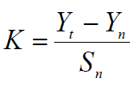
, T= Return period = 50 years
Yn, Sn = constant found from Gamble’s extreme value distribution table for N= 23 Years
- Yn = 0.528and Sn = 1.0811
- Point Design Rainfall = 82.03 mm
The design rainfall at points for 50 years return period is 82.03 mm and the areal design rainfall is calculated in the following section.

Peak Discharge Determination

General
The River is not gauged river. The design flood is calculated by using SCS unit hydrograph method. Thus, it is preferred to base the flood analysis on rainfall data, which are better both in quantity and quality of data. In the hydrologic analysis for drainage structures, it must be recognized that there are many variable factors that affect floods. Some of the factors that need be recognized and considered on an individual site by site basis are; rainfall amount and storm distribution; catchment area, shape and orientation; ground cover; type of soil; slopes of terrain and stream(S); antecedent moisture condition; Storage potential (over bank, ponds, wetlands, reservoirs, channel, etc.)

Peak flood analysis by SCS unit hydrograph method
Design flood is calculated SCS (The United States Soil Conservation Service). This method is widely adopted and more reliable method for flood estimation. The approach considers, watershed parameters, like Area, Curve number, and time of concentration.

Time of concentration (Tc)
Time of concentration has been calculated by taking the stream profile of the longest streamline and dividing it in to different elevation. Kirpich formula is adopted for computation

Table 3: Determination of Time of Concentration
N | Longest Flow | Elevation (m) |  |  | TC (hr)
N | (km) | Minimum | Maximum | Difference | TC (hr)
1 | 7.977767 | 1470 | 1673 | 203 | 1.34926
2 | 3.75845 | 1673 | 1862 | 189 | 0.58144
3 | 1.63555 | 1862 | 2056 | 194 | 0.22018
4 | 1.631372 | 2056 | 2247 | 191 | 0.22086
5 | 1.337184 | 2247 | 2458 | 211 | 0.16893
6 | 0.846873 | 2458 | 2703 | 245 | 0.0941
7 | 0.573579 | 2703 | 2936 | 233 | 0.06117
 |  |  | Time of concentration |  | 2.69595
 |  |  | AREA OF WATERSHED | 84.8848KM2
 |  |  | longest flow path | 17.76km

The formula is,
$Tc=\sum{0.948\left\{{\left(\frac{{L_{1}}^{3}}{H_{1}}\right)}^{0.385}+{\left(\frac{{L_{2}}^{3}}{H_{2}}\right)}^{0.385}+…+{\left(\frac{{L_{n}}^{3}}{H_{n}}\right)}^{0.385}\right\}}$
- Tc = 2.6959 Since Tc < 3hr., duration of excess rainfall difference, D = 0.5hr.
- Time to peak, $T_{p=}\frac{D}{2}+0.6*T_{c}$ = 1.9 hr
- Base time,$T_{b}=2.67*T_{p}$ = 4.9 hr
- Recession time,$T_{r}=1.67*T_{p}$ = 3.1 hr.

Curve number (CN)
Curve number (CN) is achieved based on USSCS method by watershed characterization in terms of land cover, treatment, hydrologic condition and soil group. From the watershed analysis curve number at condition II =78.88. Since peak rainfall is found at an antecedent moisture condition III state, this value has to be changed to antecedent moisture condition III.

- Conversion factor = 1.155
- CN Condition (III) = (Factor from Table x CN condition II) =78.88*1.155 = 91.03. For detail analysis of the computation, Refer Excel file, attached here with.

Area Rainfall
As the area of the catchment gets larger, coincidence of all hydrological incidences becomes less and less. This can be optimized by changing the calculated point rainfall to aerial rainfall. The conversion factor is taken from standard table that relate directly with the size of watershed area and type of the gauging station. (IDD manual)
For the case of irrigation project,
- Total watershed area = 84.88 Km²
- Type of gauging station = Daily rainfall (24 hr.)
- Aerial Rainfall = (Point Rainfall) x (Conversion factor)
- Aerial Rainfall =1- 0.044 x 84.88=0.85

Run off Analysis
Input data:
- Design Point Rainfall = 82.03mm
- Curve number at antecedent moisture condition III = 91
- Catchment Area, A = 84.88 Km²
- Tc = 2.69hr, D = 0.5hr., Tp = 1.9 hr; Tb = 4.9 hr; Tr = 3.1 hr.
- Direct run-off,
$Q=\frac{{(I-0.2*S)}^{2}}{(I+0.8*S)}$
Where, I = Rearranged cumulative run-off depth (mm
- S = Maximum run off potential difference,
$S=\left(\frac{25400}{CN}\right)-254$
- Peak run-off for incremental;
$Q_{p}=0.21*\frac{(A*Q)}{T_{p}}$
Where, A = Catchment area = 84.88 Km²
T_{p} = Time to peak (hr)
Q = Incremental run-off (mm)
Table 4: Runoff analysis
Time increment | 0.0-0.5 | 0.5-1 | 1-1.5 | 1.5-2 | 2-2.5 | 2.5-3 | 3.0-6.0 | 6-12.0 | 12.0-24.0
RF. Profile, (%) | 25.0% | 45.0% | 52.0% | 58.0% | 63.0% | 67.0% | 78.0% | 87.0% | 100.0%
Area to point ratio, (%) | 69.7% | 69.7% | 69.7% | 69.7% | 69.7% | 69.7% | 69.7% | 69.7% | 69.7%
RF. Profile, (mm) | 14.30 | 25.74 | 29.75 | 33.18 | 36.04 | 38.33 | 44.62 | 49.77 | 57.21
Incremental RF, (mm) | 14.3 | 11.4 | 4.0 | 3.4 | 2.9 | 2.3 | 6.3 | 5.1 | 7.4
Descending order | 1.0 | 2.0 | 3.0 | 4.0 | 5.0 | 6.0
Rearranged order | 6.0 | 4.0 | 3.0 | 1.0 | 2.0 | 5.0
RF in rearranged incr. | 2.3 | 3.4 | 4.0 | 14.3 | 11.4 | 2.9
Cumulative RF. I, (mm) | 2.3 | 5.7 | 9.7 | 24.0 | 35.5 | 38.3
Cumulative runoff, (mm) | 0.0 | 0.0 | 0.7 | 8.2 | 16.7 | 19.0
Incremental runoff, (mm) | 0.0 | 0.0 | 0.7 | 7.4 | 8.5 | 2.3
Peak run-off for incr.(qp ) | 0.0 | 0.2 | 7.0 | 71.6 | 81.8 | 22.2
Time to begin , (hr) | 0.00 | 0.50 | 1.00 | 1.50 | 2.00 | 2.50
Time to peak | 1.85 | 2.35 | 2.85 | 3.35 | 3.85 | 4.35
Time to end. | 4.94 | 5.44 | 5.94 | 6.44 | 6.94 | 7.44

Table 5: Hydrograph coordinates

Figure 3: Complex Hydrograph
From the analysis of SCS unit hydrograph, the 50 year return period design run off is 163.1 m ³/s

Tail Water Depth Computation
Tail water depth of the river is equal to the flood depth and amount at the proposed intake site before construction of the intake. It is used to crosscheck peak flood estimated by the SCS unit hydrograph method with flood mark method and to see the flood feature after the hydraulic jump. During field visit, the flood mark of the river at the proposed intake site was marked based on dwellers information and physical indicative marks. The river cross-section was surveyed.

Table 6: intake Site River Cross section Coordinate Data
RIVER CROSS SECTION
Northing | Easting | Elevation | Partial Distance | Cumulative Dis
1279370.762 | 576315.4272 | 1461.1 | 0 | 0
1279381.094 | 576315.17 | 1458.7 | 10.33 | 10.33
1279391.43 | 576314.9129 | 1459 | 10.33 | 20.67
1279401.76 | 576314.6558 | 1459.1 | 10.33 | 31.00
1279412.09 | 576314.3986 | 1459.2 | 10.33 | 41.34
1279422.42 | 576314.1415 | 1459.2 | 10.33 | 51.67
1279432.752 | 576313.8844 | 1459.4 | 10.33 | 62.01
1279443.083 | 576313.6272 | 1459.7 | 10.33 | 72.34
1279453.415 | 576313.3701 | 1460.1 | 10.33 | 82.68
1279463.747 | 576313.113 | 1460 | 10.33 | 93.01
1279474.078 | 576312.8558 | 1460 | 10.33 | 103.35
1279484.41 | 576312.5987 | 1459.9 | 10.33 | 113.68
1279494.741 | 576312.3416 | 1459.6 | 10.33 | 124.02
1279505.073 | 576312.0844 | 1459.3 | 10.33 | 134.35
1279515.405 | 576311.8273 | 1459 | 10.33 | 144.69
1279525.736 | 576311.5702 | 1458.9 | 10.33 | 155.02
1279536.068 | 576311.313 | 1458.9 | 10.33 | 165.36
1279546.399 | 576311.0559 | 1459 | 10.33 | 175.69
1279556.731 | 576310.7988 | 1459 | 10.33 | 186.03
1279567.063 | 576310.5416 | 1459 | 10.33 | 196.36
1279577.394 | 576310.2845 | 1459.7 | 10.33 | 206.70

Figure 4: River cross section

Table 7: Stage discharge analysis
X-Area | Elevation | Depth | A1 m2 | W.P1 m | R1 m | V1 m/s | Q1 m3/s | A2 m2 | W.P2 m | R2 m | V2 m/s | Q2 m3/s | Q total | Remarks
A0 | 1458.61 | 0.00 | 0.00 | 0.00 | 0.00 | 0.00 | 0.00 | 0.00 | 0.00 | 0.00 | 0.00 | 0.00 | 0.00 | River bed
A1 | 1458.86 | 0.25 | 1.11 | 9.00 | 0.12 | 1.50 | 1.67 | 0.00 | 0.00 | 0.00 | 0.00 | 0.00 | 1.67
A2 | 1458.88 | 0.27 | 1.33 | 9.78 | 0.14 | 1.60 | 2.12 | 0.00 | 0.00 | 0.00 | 0.00 | 0.00 | 2.12
A3 | 1459.11 | 0.50 | 5.60 | 31.06 | 0.18 | 1.94 | 10.86 | 10.95 | 58.80 | 0.19 | 1.89 | 20.74 | 31.60
A4 | 1459.36 | 0.75 | 16.87 | 54.34 | 0.31 | 2.78 | 46.93 | 27.15 | 70.84 | 0.38 | 3.07 | 83.23 | 130.16
A5 | 1459.41 | 0.80 | 19.71 | 56.93 | 0.35 | 2.99 | 58.93 | 30.67 | 73.18 | 0.42 | 3.25 | 99.77 | 158.70
A6 | 1459.42 | 0.81 | 20.276 | 57.625 | 0.35 | 3.02 | 61.30 | 31.17 | 73.963 | 0.42 | 3.27 | 101.80 | 163.10 | SCS Peak
A7 | 1459.61 | 1.00 | 31.92 | 66.06 | 0.48 | 3.74 | 119.20 | 46.36 | 82.91 | 0.56 | 3.94 | 182.81 | 302.01
A8 | 1459.86 | 1.25 | 49.39 | 73.95 | 0.67 | 4.64 | 228.95 | 68.71 | 95.29 | 0.72 | 4.67 | 321.04 | 549.99
A9 | 1459.90 | 1.29 | 52.45 | 75.229 | 0.70 | 4.77 | 250.14 | 72.33 | 98.09 | 0.74 | 4.74 | 343.06 | 593.20
A10 | 1460.11 | 1.50 | 68.73 | 79.37 | 0.87 | 5.51 | 378.73 | 96.71 | 124.93 | 0.77 | 4.90 | 473.70 | 852.43

Figure 5: Rating Curve
From the above stage discharge table and curve the maximum flood level corresponding to the computed design peak discharge is 1459.9 (1.29 m from the river bed) and it is considered as the d/s high flood level i.e. expected at the intake axis before construction of the intake.
D/S & U/S HFL = 1459.9 masl.
From the rating curve by SCS estimation, the maximum flood,163.1 m3/sec is corresponding to the tail water depth of 0.8 hence the D/s & U/s high flood level=1459.41 m.a.s.l and This discharge is limited to the crest length of 150 m b/c b/n the two rivers there is an island so the clear water way is reduced :: But In the Sideny River that is in our intake side the flood mark that we have taken during ground truth at the intake cross section (1459.9) shows the design discharge is 250.14 m3/s so to be safe we use this flood and the corresponding river width ie 70 to fix discharge intensity and intern calculate bed bar depth
- Average river bed slope
Average river bed slope of River is estimated by two different techniques. One is by end area method and the other is by using best fit line method. Designers have adopted the end area method output for further analysis.
The water level of the river is taken at different points along the river channel around the head work site. Surveying work done for 150 m U/S & D/S of head work site length. And then, average water surface slope is considered as the river bed slope.

Figure 6: River profile
- Manning’s Roughness coefficient
The Manning’s roughness coefficient is taken from standard table based on the river nature. The river at the headwork site has got braded feature and curving nature. The river banks are defined and relatively smooth. Manning’s roughness coefficient (n = 0.025) is adopted.

- Discharge of the river
Input data since we have two rivers so we need to calculate the discharge of each rivers separately and design the peak flood in the worst scenario
- Manning's roughness coefficient, n = 0.025
- Average river bed slope, S1 = 0.023
- Average river bed slope, S1 = 0.021
- , Where, R = Hydraulic radius = (Area/Perimeter)
- $Q1=V*A$
- $Q2=V*A$
- $Qt=Q1+Q2$

SECTION-II: HEADWORK DESIGN

HEADWORK STRUCTURES DESIGN

Headwork Site Selection
Headwork site of intake irrigation project is located at 576321E, 1279427N and 1460m River bed elevation GPS reading.
For this project a simple river bed level intake bed bar structure has been proposed for diverting the water to the main canal. The headwork site surface and subsurface geological conditions have been investigated based on the nature of the proposed structure. At the site and immediate vicinity, the stream flows along gentle slope course and its bed is mainly covered with recently deposited alluvial sediments. These deposits are dominated with gravely sand sediment. At both stream bed ends, there is top losing and underling compacted silty clay soil exposure that extends from the bank foot as observed near the headwork axis. The river banks are created from silt clay soil. The detail geologic nature of the banks, and bed of the stream along the headwork axis and immediate vicinity are described and their potential geotechnical influence on the proposed structures also discerned/detected below, with remedial measures.

River Bed condition
The river is depositional river due to slow speed, because the river gradient is very gentle. So the surface exposure of the river is dominantly river transported gravely sand sediment deposit. From test pit that is taken at 576321E, 1279427N and 1460m river bed elevation GPS reading. From the test pit log, the stream bed composed of gravely sand of river deposit up to a depth of 1m where the water strike depth is. Because of water interruption excavation could not exceeding more to depth. However; the stream bed expected to be contains of compacted clay to the depth. This soil horizon could be found at about 2 to 3m depth underlying river deposit.
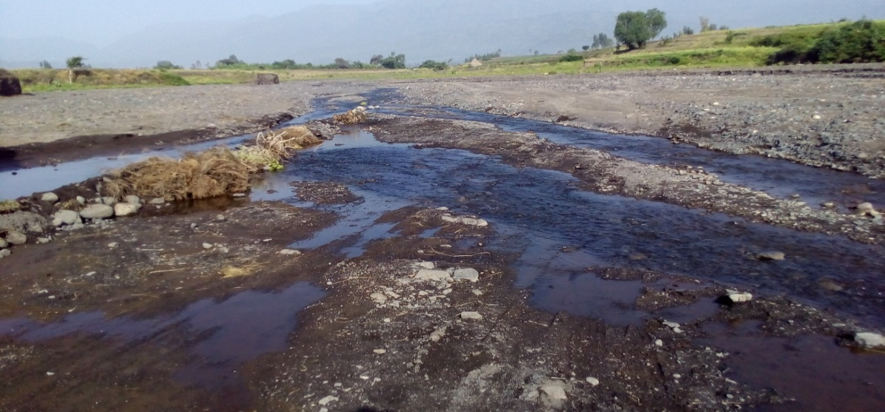
Figure 7: Plate Stream Bed

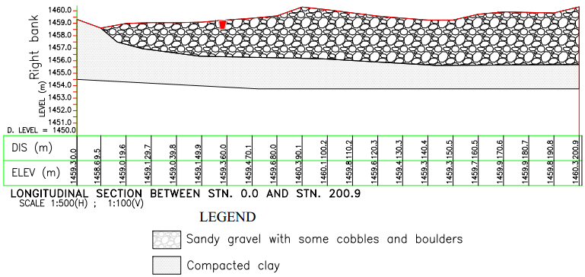
Figure 8: Engineering Geological Cross- Sections along Proposed Bed Bar
As described above, the foundation area of the headwork site is characterized by non-uniform geologic materials at the stream bed. The top is loose and pervious, while the compacted clay soil is very stiff and impervious. It is therefore better to incorporate a positive cut-off masonry wall at the central portion of the bed that attach after intercepting the 2 to 3m thickness sediment layer. This will help for seepage barrier.

River Bank condition

Left Bank
At the proposed headwork axis and immediate vicinities, the left bank forms vertical slope. From surface observation, the bank is formed from easily erodible silt clay soil. It is likely to widen the width of the river. This vertical soil exposure and has 2.5m thickness, See plate below. The exposure both along the downstream and upstream of the river channel. Since it is easily erodible, protection structure is necessary to provide stability and protection of the bank.
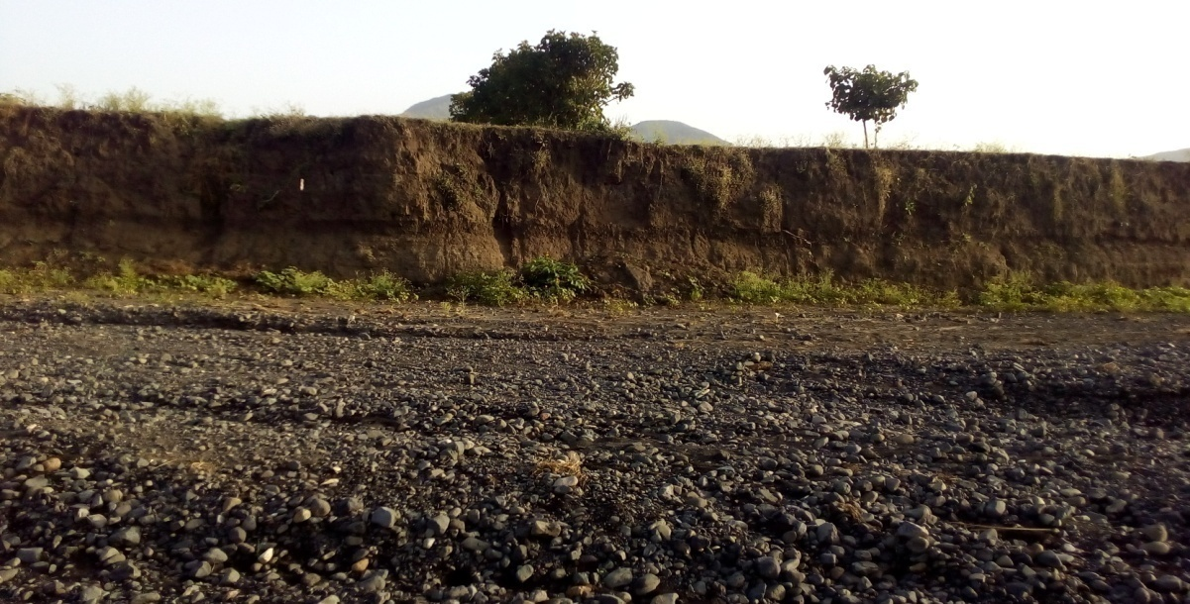

Figure 9: Stream Bed Geologic Formations and Left Bank

Right Bank
This side of the river is the main part of the project site proposed for which the main canal is constructed. The right bank of the river cut exposure has 4m thick loose clay exposure. This soil is low dry strength, brown color, no organic odder soft bearing capacity/ good workability property. At the headwork site/axis, the right bank is characterized by relatively moderate to gentle slope, having about 1m height from stream bed. From visual observation of the natural cuts at the bank, there are two distinct geological materials forming the bank section (see plate below).
From top to bottom, these are:-
- Loose silt clay
- Compacted silt clay
These two units have variable thickness/depth at the area. Just at the intake axis, the top exposed silt clay bank portion is loose soil, whereas the underlying is relatively compacted silt clay soil horizon. This bank section created soil materials have been affected by erosion/ flood under cutting which is widening the bank.

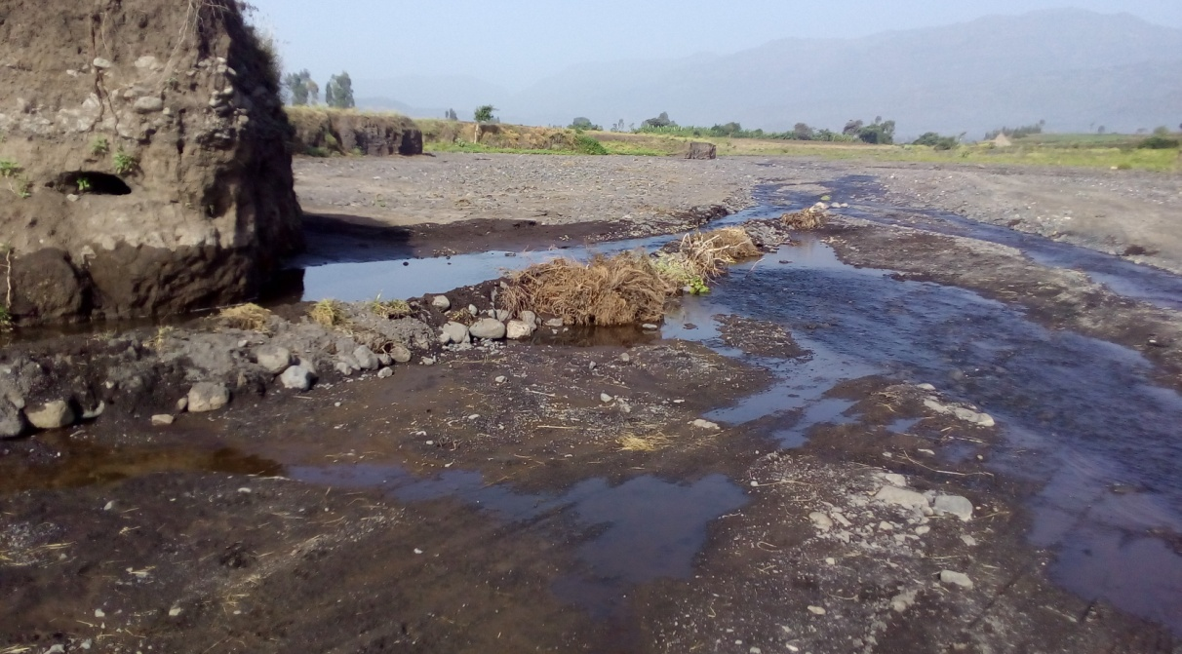
Figure 10: Right Bank and Stream Bed ends

Main Canal Route
For this particular project, the main canal is Right sided canal. The canal is traditionally used by some villagers/only upstream users.

Newly proposed canal has about 3.2km length. Within this length, the canal passes different geologic materials. The distribution of the geologic materials with respect to the canal route, and their characteristics, especially permeability, stability and workability have been investigated during the field work using visual inspection along route to investigate canal subsurface profile and at places where there is geologic variation and surface natural exposures/cuts are found.
Based on the findings of the surface and subsurface geological investigations and with reference to design chainages and also natural existing features, the canal route ground conditions have been described in the succeeding sections.
- From 0+000m to about 0+100m (within the Right bank slope), the proposed canal route passes along instable ground that could be easily erode by river flood, see plate below. So that retaining well construction is needed based on the evidence of traditionally canal.
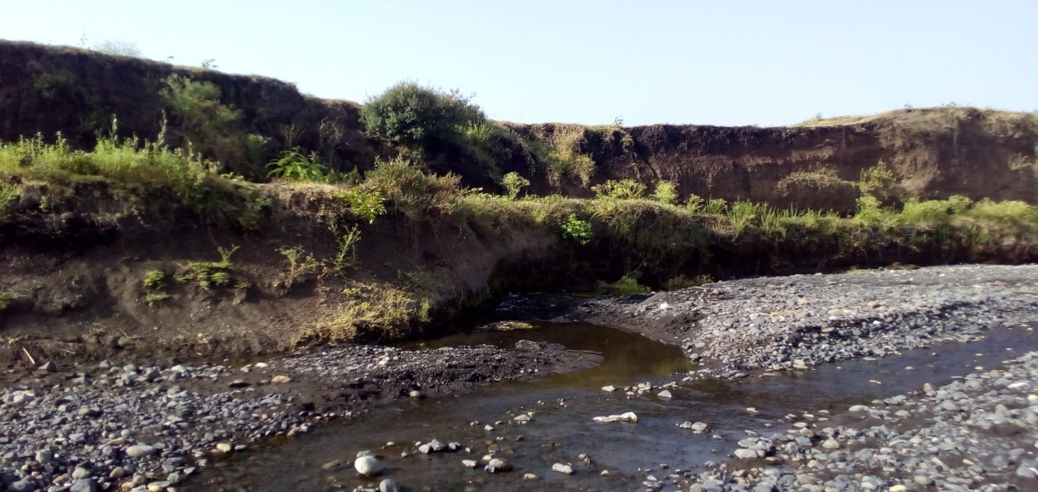
Retaining well thickness

Figure 11: The First 0 + 100m Main Canal Route
- From 0+100m to about 3+200m Main Canal Route, the canal route passes along gentle slope ground which is made up of silt clay soil.
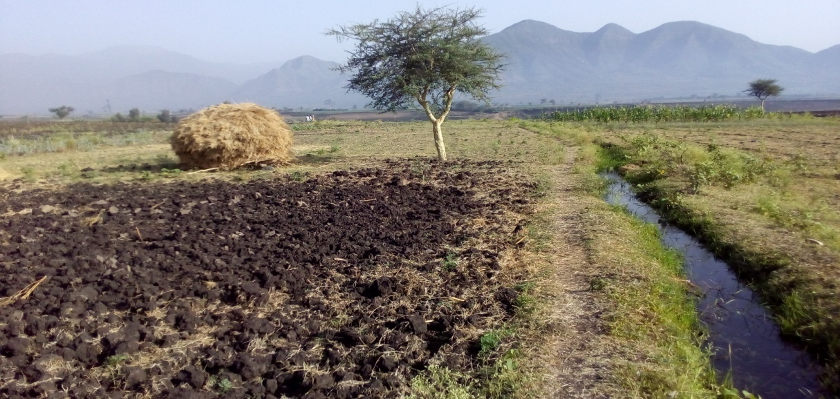
Figure 12: Between the First 0+100m to about 0+ 300m of Main Canal

Sources of construction materials
During the site investigation, natural construction materials required for the construction of the various proposed engineering structures at the headwork and within the farmland have been assessed, and possible quarry sites and borrow areas have been identified within the vicinity of the area as much as possible. In addition to the identification, the quality, quantity, accessibility condition and ownership of each proposed production sites have also been studied and described in this report; on separate sub-sections below. The natural materials required for the construction of the proposed hydraulic structures include rock for masonry stones, aggregates (both coarse and fine), impervious soil for fill and/or lining, backfill soil, and water.

Rock for Masonry and Crushed Coarse Aggregate
Quarry site that can be used for production of rock for masonry stone has been assessed during the field work session within the vicinity of the project area at economic distance for hauling. At the proposed quarry site there is sufficient fresh basalt which is river transported good quality rock that could be used as source area for masonry works. The quarry site is locally known as Menta Weha River, which is at upstream of the river near Mersa Town at about 25km to the North direction of the headwork site. Within this quarry site there is sufficient fresh basaltic rock.

The quarry site has good quality rock. At the quarry site, fresh rocks are found in large quantity that suffices the requirement of the project. From this site, rock of different sizes can be produced; ranging from cobble size to large boulders.
Coarse aggregate is required for concrete construction during masonry channel construction and head work site construction work. There is excess gravel and cobble size rock fragments within the river so by only crushing and gridding it in to required size and required amount coarse aggregate to use them. Its source is the river so there is no owner ship and deficiency problem as well as transportation cost.
From this site, rock of different sizes can be produced; ranging from coarse gravels to cobble size rock fragments that coarse aggregate can be produced easily.

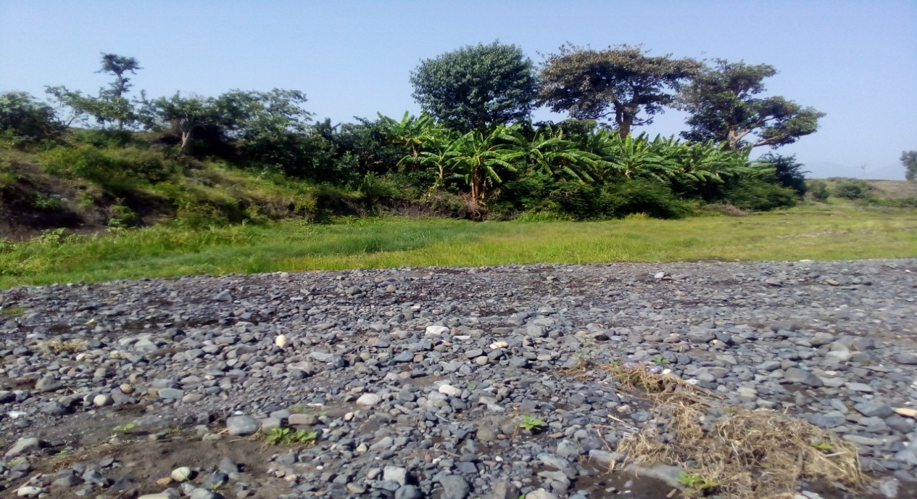
Figure 13: Coarse Aggregates

Fine Aggregates
Borrow areas of fine aggregate or natural sand have been assessed starting from the project stream itself. A natural deposit of such materials is found when assessed within the beds of the stream in the project area; source of these materials are available within the project stream. In the stream good quantity, which suffices the need of this project, is available. The deposit dominated by sand sized transported alluvial sediments both downstream and upstream, though some amount of fines and over sizes are also observed. The individual grains of sand are mainly originated from basalt rock and reveals high crushing resistant that the sand has good quality in this respect. The sand has good strength as it mainly develops from basalt rock and experiences long stream transportation, which normally removes any weak zones of the grains, See the Plate below. The river sand is taken to Amhara Design & supervision laboratory section as much as possible the result will be expected.

Water
Water for construction purposes can be getting from the project stream River itself. Water for construction purposes can be getting from the project perennial river that flows throughout the year used for local irrigation purpose. During this field time the stream flow was about 260L/s.

Headwork Type Selection
Looking the availability of natural construction materials and considering the river features and expected flood amount, cyclopean concrete intake is chosen.

Hydraulic Design of Headwork Structure

Intake Height Determination
The following major factors have been seen in determining the intake crest level:
- Maximum command area elevation
- Deriving head of the intake structure
- Main canal slope
- Loss
- Lowest Point of river center
Intake sill level Determination calculation
  - Intake sill level = Maximum command area elevation (m) + main canal length* Main canal slope (m) + different head losses (m)
- Maximum command area = 1457.421
- Main canal length from inlet to this maximum command position = 313
- Head lose = k*v^2/(2GD) = 0.2*(H12)^2/(2*9.81) + 0.1*(I12)^2/(2*9.81)
          - = 0.078
- Intake sill level = 1457.421 +18*0.015+228*0.002+88*0.005 + 0.078
= 1458.66

Base flow of the River
The study team has assessed that the stream is used for irrigation along its entire course except at the proposed diversion site where farmers are using the stream for traditional SSI (Irrigation Infrastructure Report). Study team has calculated flow of the river at the intake site as 260l/s. Out of this 219.45 l/s will be required for the proposed scheme and the rest will be released for downstream. The purpose of releasing the 39.5 l/s to downstream is for the sake of downstream users.

Intake Dimensions

Under sluice
The under sluice is mainly provided here to remove silt deposition at a result of barrier structure. Hence the sill level of the under sluice is fixed to facilitate this deposited silt to increase the efficiency of water abstracting to the main canal through the head regulator from the pocket. The sill level of this sluice is fixed to be 0.5m higher than the minimum bed level. Hence the sill level of the under sluice = 1458.58+0.7=1459.28 ie the under sluice is 0.2 m lower than the outlet canal bed level even if the position of the under sluice is on concave side that is on scouring side, there might be boulders that may come into the pocket of the under sluice due to the barrier structure. Hence in addition to the supply of water to the intake and the removal of silt, this acts to remove the boulder that comes to wards it. Considering this, the opening size of the gate is 0.6m*0.7m with spindle type operating from the operation slab. Considering rectangular notch profile of flow of water at the under sluice, the discharge passing is computed using the following formula.
- The capacity should be at least five times the canal discharge to ensure proper scouring.
- Capacity of passing about 10% to 20% of the maximum flood discharge at high floods.
- During construction, it should be able to pass the prevailing (at least base flow) discharge of the river.
But the practical application of those values is not sound so the discharging capacity of under sluice is determined by using orifice flow formula for maximum flood condition.
i.e. $Q=C_{d}*A*\sqrt{2gh}$,
Where, C_{d} = Discharge coefficient =0.6
A = under sluice opening area (m²)
g = 9.81m/s²
Width (b) = $\frac{Qd}{ Cd*\sqrt{2gh}}$ $\frac{1.31}{0.6\sqrt{2*9.81*0.7}}$ $=0.59m$ adopt 0.6
Hence the size of the under sluice is 0.6m$×0.7m$ (height *width)

Canal outlet level
The head regulator is provided on in front of the inlet .The sill level of this head regulator is fixed from different angle observations. The main conveyance system is more than 3km which passes undulating alignment. Hence this level is fixed based on the optimum route alignment and the maximum irrigated command level including minor and major losses criteria. Based on this condition, the sill level is fixed to be 1458.23m.
• Outlet capacity
The minimum command area is determined by the minimum flow of the river. But the canal capacity should be determined for maximum command area and the corresponding discharge. In this case the outlet capacity is fixed considering maximum duty and command area and 1.25 correction factors are considered to account the variation of duty.
- Outlet capacity = Duty x command area x correction factor
Where, maximum duty for 16hr irrigation = 1.14 L/s/ha
Command area = 154ha.
- Outlet capacity = 1.14 L/s/ha x 154ha = 219.45 L/sec.

• Outlet size
From the weir/intake discharge formula the outlet size is determined as follows
Q = CLHe^{3/2}
Where; C = coefficient of discharge = 1.7
L = Length of water way (m)
He = head above sill level (neglecting the velocity head) = 0.35m
⇒Adopt water way length = 0.7m
Hence, provide an outlet size of 0.5m x 0.7m (height x length) .The gate of the off take canal is to be vertical sheet metal of 0.5m x 07 for the closure of the opening space. Provide some extra dimensions for groove insertion. Gross area of sheet metals for the off take canal gate will be 0.6m x 0.80m (allowing 5cm insertion for grooves and above the intake crest level). The grooves are to be provided on the walls using angle iron frames at the two sides of the gate openings.
Trash racks of diameter 14mm with c/c spacing of 20cm has to be provided u/s of the gate to prevent entry of debris to the canal.

Breast Wall and Operation Slab
A vertical raised gate is designed for the head regulator and under sluice. These gates slide over the breast wall using spindle during opening and closing.
For easy operation of these gates, operation slab is provided. The size of the operation slab is fixed from the point of construction and free movement. The size of the operation slab is shown in the drawing for both head regulator and under sluice with thickness 0.15m.
The thickness of the breast wall is also the same as that of the operation slab. The nominal thickness is fixed from the point of construction rather than the imposed load. The thickness required for the imposed load is less than the nominal value and treated as cantilever retaining wall. For the breast wall, the minimum reinforcement area is taken as 15% along the respective direction.
Hence A_{steel} = 0.0015*1000*200=300
A_{steel} = 300mm²/m
Provide 12@C/c 200 mm
Considering cover thickness of 50 mm, effective depth = 50 + 12/6 = 56
Hence spacing of reinforcement = 200mm < 432mm
A_{steel} = 565.2
Therefore the actual provided steel area per meter width is 565 mm²/m > 300 mm²/m. It is ok!
The actual arrangement of angle irons, spindles, shafts and operation slab including other components is shown on the design drawing. For each arrangement and further information, refer to the design drawing.

Retaining Walls
At the two ends of the diversion intake, walls have been provided to safeguard the structure from scour at the ends and also as a facility to the canal outlet operation and maintenance at the canal
The height of the retaining wall is designed based on the following procedures
- Step 1 calculate the peak discharge of the river by using different methods like SCS curve number method & Rational methods according to the catchment size and available data
- Step 2 calculate the peak discharge of the river by using the available flood mark to cross check the SCS peak with the actual flood mark peak
- Step 3 collecting serving data of the river cross section at the intake axis and draw the cross section of the river at that axis in AutoCAD civil 3D
- Step 4 peak the minimum bed level of that section that is the bed bar level and draw the horizontal line that extends from the right bank to the left bank with in the desired vertical intervals
- Step 5 take the area and waited perimeter at different elevations
- Step 6 calculate the hydraulic radius and velocity of river flow by using manning or chezy equations
- Step 7 calculate the discharge of the river at different stages until we gate our design discharge
- Step 8 select the elevation that gives our design discharge
- Step 9 finally add free board and calculate the top and bottom width of the retaining wall by considering stability against different forces as shown below in table 8.
Table 8: typical design of masonry retaining wall
Design of U/s Retaining Wall | value | remark
Height of retaining wall | 1.50
Width of retaining wall | 0.98
Top width | 0.40
Specific weight of Stone masonry KN/m3 | 23
Specific weight of Soil KN/m3 | 19
Active pressure coefficient(Ka) | 0.33
Foundation depth | 1

Ka=(1 -sin Φ /1+sin Φ )
Φ= for dry condition | 30
Ka= | 0.33
HEIGHT | 1.5 | Forces(KN) |  |  | Lever arm (m.) | Moment about toe (kNM)
WIDTH | 0.98 | Vertical | Horizontal |  |  | Stabilizing | Disturbing
self-weight(W1) |  | 13.8 |  |  | 0.2 | 2.76
self-weight(W2) |  | 9.91 |  |  | 0.59 | 5.9
earth load on wall W3 |  | 3.8 |  |  | 0.50 | 1.9
earth load on wall W4 |  | 11.4 |  |  | 1.17 | 13.3
lateral earth pressure(Pa) |  |  | 7.13 |  | 0.50 | 0.0 | 3.57
Total |  | 38.91 | 7.13 |  |  | 23.8 | 3.57

Factor of safety against, | factors | values | limitations | remark
Over turning = (M+ve/M-ve) >1.5 | Fo | 6.68 | >1.5 | Safe
Sliding = (µxFv/Fh),---µ=0.75 >1.5 | Fs | 3.82 | >1.5 | Safe
Tension: X= (Net Moment/Sum Fv), e=x-B/2, e<B/6 | X | 0.52
B/6=0.16 | e | 0.03 | <B/6 | Safe

Design of D/s Retaining Wall | value | remark
Height of retaining wall | 1.70
Width of retaining wall | 1.11
Top width | 0.40
Specific weight of Stone masonry KN/m3 | 23
Specific weight of Soil KN/m3 | 19
Active pressure coefficient(Ka) | 0.33
Foundation depth | 0.5

Ka=(1 -sin Φ /1+sin Φ ) | Vertical Forces (KN) | Horizontal | Lever arm (m.) | Stabilizing | Disturbing | remark
Φ= for dry condition | 30
Ka= | 0.33
HEIGHT 1.7
WIDTH 1.11
self-weight(W1) | 15.64 |  |  | 0.2 | 3.128
self-weight(W2) | 13.78 |  |  | 0.64 | 8.8
earth load on wall W3 | 3.8 |  |  | 0.50 | 1.9
earth load on wall W4 | 11.4 |  |  | 1.17 | 13.3
Lateral earth pressure(Pa) |  |  | 9.16 | 0.57 | 0.0 | 5.19
Total | 44.62 |  | 9.16 |  | 27.1 | 5.19

Factor of safety against, | factors | values | limitations | remark
Over turning = (M+ve/M-ve) >1.5 | Fo | 5.21 | >1.5 | Safe
Sliding = (µxFv/Fh),---µ=0.75 >1.5 | Fs | 3.41 | >1.5 | Safe
Tension: X= (Net Moment/Sum Fv), e=x-B/2, e<B/6 | X | 0.49
B/6=0.18 | e | 0.06 | <B/6 | Safe
Remark in the above retaining wall analysis the downstream retaining wall height is greater than the upstream retaining wall by 20 cm but the top bank level for both retaining walls follow the river bed profile, Due to the allowance of 20 cm head at the approach canal the D/S retaining wall is constructed 20 cm below the Original Ground Level so for the analysis the D/s retaining wall height is considered as 1.70 m above the bed level of the approach canal::

Figure 14: Typical Design of Gabion Retaining Wall

Design of Gabion Retaining Wall | Value
Height of retaining wall | 2.50
Width of retaining wall | 1.75
Top width | 0.50
Specific weight of dray Stone KN/m3 | 14.00
Specific weight of Soil KN/m3 | 19.00
Active pressure coefficient(Ka) | 0.33
Foundation depth | 1.00

Ka=(1 -sin Φ /1+sin Φ )
Φ= for dry condition | 30
Ka= | 0.33
HEIGHT | Forces(KN) |  | Lever arm (m.) | Moment about toe (KN.m)
2.5 | Vertical | Horizontal | Lever arm (m.) | Stabilizing | Disturbing
WIDTH
1.75
self-weight(W1) | 17.5 |  | 0.25 | 4.375
self-weight(W2) | 21.875 |  | 0.92 | 20.1
lateral earth pressure(Pa) |  | 19.82 | 0.83 | 0.0 | 16.52
earth load on wall (Ps) | 29.6875 |  | 1.33 | 39.6
Total | 69.0625 | 19.82 |  | 64.0 | 16.52

Factor of safety against, |  |  |  |  | Remark
Over turning = (M+ve/M-ve) >1.5 |  | Fo | 3.88 | >1.5 | safe
Sliding = (µxFv/Fh),---µ=0.75 >1.5 |  | Fs | 2.61 | >1.5 | safe
Tension: X= (Net Moment/Sum Fv), e=x-B/2, e<B/6 |  | X | 0.69
B/6= | 0.29 | e | 0.19 | <B/6 | safe

Bill of Quantity and Cost Estimation
The quantities of the various items have been worked out as per the final design and final drawings prepared for the scheme. The unit rates analysis has been carried out based on the data available in the vicinity of the project area.
Table 9: Bill of quantity and cost estimation for General Items
Sidny small Scale Irrigation Project
Bill No One General Item
Item | Description | Unit | Qty | Unit Cost (Eth .Birr) | Amount (Eth. Birr)
1.1 | Allow for mobilization | L.S | 1 | 262,450.92 | 262,450.92
1.2 | Allow for demobilization | L.S | 1 | 86,587.34 | 86,587.34
1.3 | Allow for contractor’s camping facilities 3*4m2, Living room for contractors key personnel, CIS and internally painted clip wood wall, Masonry floor cement screened and well ventilated room complete with doors and windows. | No | 4 | 48,670.03 | 194,680.10
1.3 | Allow for Consultant’s camping facilities 3*4m2, Living room for contractors key personnel, CIS and internally painted clip wood wall, Masonry floor cement screened and well ventilated room complete with doors and windows. | No | 2 | 48,670.03 | 97,340.05
1.3 | 5*5m2, Store constructed from CIS with doors and windows, Masonry floor cement screened | No | 1 | 83,285.95 | 83,285.95
1.3 | Barbed wire fence 40*30m and 1.5m high treated timber post complete with 3m wide gate and a CIS guard house (1.5*2m) | No | 1 | 65,551.49 | 65,551.49
1.4 | Allow for temporary access road (in km) to site | km | 1 | 352,017.27 | 352,017.27
1.5 | Dewatering of open trenches and excavations, pumps | LS | 1 | 332,667.93 | 332,667.93
1.6 | Provide project indicator post starting from the construction time | LS | 1 | 7,807.68 | 7,807.68
1.7 | Provision of as built drawings for the project | LS | 1 | 52,219.39 | 52,219.39
 | Sub Total |  |  |  | 1,534,608.13

Table 10: Bill of quantity and cost estimation for Head work
Bill No Two Head Work Structure
Sidny small Scale Irrigation Project
Bill No Two Head Work Structure
Item | Description | Unit | Quantity | Unit Cost (Eth .Birr) | Amount (Eth. Birr)
I | Head Work Structure
1 | Bed Bar
1.1 | Ordinary soil excavation (by Mechanical) | m³ | 1295.74 | 123.71 | 160,296.00
1.2 | Weathered Rock Excavation by mechanical | m3 | 2.50 | 420.00 | 1,050.00
1.3 | Hard rock Excavation by mechanical | m³ | 1.00 | 646.22 | 646.22
1.4 | Back fill and Compact with Selected material (by Labour) | m³ | 496.90 | 57.46 | 28,549.97
1.5 | Cyclopean 60% C-25 & 40% Boulder | m³ | 118.7 | 1935.04 | 229,689.53
1.6 | C-20 concrete work for delivery canal and bed bar caping with (1:11/2:3) ratio | m3 | 43.23 | 2711.06 | 117,199.12
1.7 | Reinforcement bar, φ12 for delivery canal and bed bar caping | kg | 2103 | 52.00 | 109,356.00
2.7 | Reinforcement bar, φ14 for delivery canal and bed bar caping | kg | 43.87 | 52.00 | 2,281.24
 | Sub Total |  |  |  | 649,068.08
4 | APPROCH CANAL
4.1 | Ordinary soil excavation (by Mechanical) | m³ | 496.10 | 123.71 | 61,372.53
4.2 | Hard rock Excavation | m³ | 0.05 | 646.22 | 32.31
4.3 | Weathered Rock Excavation | m³ | 0.01 | 420.00 | 4.20
4.4 | Back fill and Compact with Selected material (by Labour) | m³ | 53.82 | 57.46 | 3,092.29
4.5 | Masonry work with 1:3 cement sand ratio | m³ | 542.90 | 1631.40 | 885,685.76
4.6 | Cyclopean 60% C-25 & 40% boulder (U/S for retaining wall) | m³ | 117.00 | 1935.04 | 226,399.68
4.7 | Pointing 1:2 ratio | m² | 270.60 | 53.48 | 14,471.69
4.8 | plastering(1:2) ferst & seccond coat | m2 | 620.10 | 131.63 | 81,625.03
 | Sub Total |  |  |  | 1,272,683.50
3 | Retaining wall (For U/S &D/S)
3.1 | Ordinary soil excavation (by Mechanical) | m³ | 93.55 | 123.71 | 11,573.07
3.2 | Hard rock Excavation | m³ | 0.00 | 1564.06 | -
3.3 | Weathered Rock Excavation | m³ | 0.00 | 668.49 | -
3.4 | Back fill and Compaction with Excavated material | m³ | 0.45 | 47.96 | 21.58
3.5 | Masonry work with 1:3 cement sand ratio | m³ | 31.00 | 1631.40 | 50,573.33
3.7 | Lean concrete(C-10)10cm thick(1;3;6) | m³ | 1.01 | 1928.26 | 1,947.54
3.8 | Pointing 1:2 ratio | m² | 40.32 | 53.48 | 2,156.31
 | Sub Total |  |  |  | 66,271.83
2 | Operation Slab & column For oftake & Under sluice
2.1 | C-25 (1:11/2:3) concrete work For Slab | m³ | 1.13 | 2711.06 | 3,063.50
2.2 | C-25 (1:11/2:3) concrete work For column | m³ | 0.63 | 2711.06 | 1,707.97
2.3 | Reinforcement bar, φ12 for Slab | kg | 47.56 | 52.00 | 2,473.12
2.4 | Reinforcement bar, φ12 for column | kg | 46.17 | 52.00 | 2,400.84
2.5 | Tai bar bar, φ6 | kg | 1.56 | 52.00 | 81.12
2.6 | Trash track φ24 | kg | 63.30 | 52.00 | 3,291.43
 | Sub Total |  |  |  | 13,017.97
5 | Under sluice & Escap canal
5.1 | Ordinary soil excavation (by Mechanical) | m³ | 42.24 | 123.71 | 5,225.51
5.2 | Masonry work with 1:3 cement sand ratio | m³ | 17.50 | 1631.39 | 28,549.33
5.3 | plastering(1:2) ferst & seccond coat | m² | 12.30 | 131.63 | 1,619.05
5.4 | Stone pitching | m³ | 5.04 | 1141.05 | 5,750.89
5.5 | Cyclopean 60% C-20 & 40% Boulder | m³ | 2.64 | 2711.06 | 7,157.20
5.6 | 10cm thick C-10 lean concrete(1:3:6) | m³ | 2.73 | 1593.94 | 4,351.46
 | Sub Total |  |  |  | 52,653.43
6.1 | Inttake gate fabrication, Supply and Installation as per the drawing | No | 1 | 28,321.47 | 28,321.47
6..2 | Under Sluice gate fabrication, Supply and Installation as per the drawing | No | 1 | 28,321.47 | 28,321.47
6..3 | Escape Gate Fabrication, Supply and Installation as per the drawing | No | 1 | 2800.47 | 2,800.47
 | Sub Total |  |  |  | 59,443.41
7 | Gabion work
7.1 | Ordinary soil excavation (by Mechanical) | m³ | 196.33 | 123.71 | 24,287.98
7.2 | Right U/s bank Gabion protection wall including gabion box | m³ | 134.05 | 1,400.00 | 187,670.00
7.3 | Left bank Gabion protection wall including gabion box | m³ | 459 | 1,400.00 | 642,600.00
7.4 | Gabion at D/s of the bed bar to protect scoring | m³ | 90.23 | 1,400.00 | 126,322.00
 | Sub Total |  |  |  | 980,879.98
 | Total carried to Head Work |  |  |  | 3,094,018.21

SECTION-III: IRRIGATION AND DRAINAGE SYSTEMS INFRASTRUCTUR

IRRIGATION AND DRAINAGE SYSTEMS DESIGN

Irrigable Area Description

Topography
Topography is an important factor for the planning of any irrigation project as it influences method of irrigation, drainage, erosion, mechanization, and cost of land development, labor requirement and choice of crops.
The topographic feature of the project command area is mainly sloping type. Its elevation range is from 1404 to1466 meters above sea level. The slope gradient also ranges from gently sloping (3%) to strongly sloping (12%). However, it has identified to be suitable for surface irrigation. Nevertheless, it requires soil and water conservation measures or structures (i.e. constructing bunds, bio-physicals, check dams, artificial water ways, etc).
Based on data obtained from Kebele 018 Girana Agricultural Development Office (where about 60% of the command area is found in 018kebele), where the project is located, the topography of the Kebele is 75% plain, 10% rugged, 15% mountainous, 0% valley and 0% others
The project command area is situated at the right side of River (to the west side of the river). The natural topographic feature of the command area has inclined from the North-west to the South-West direction.

Climate
According to the traditional Ethiopian agro-ecological zones classification (MOA, 2001) the proposed irrigation project area is basically categorized under Kola agro-ecology which is conducive to the production of tropical lowland crops. The elevation of the project command area ranges from 1404-1566 meter above sea level (masl).There is no belg rain season in the project area. Despite the fact that the Meher rains are considered adequate, there is notable variation in terms of onset, distribution and withdrawal from year to year affecting crop production in general and crop productivity in particular.
As the project site has no its own meteorological station, Merssa (for rainfall and minimum and maximum temperature) and Merssa (for relative humidity, wind speed and sunshine hour) meteorological stations data were used for the project study as long as these stations are relatively near to the proposed command area. In general, the sources of meteorological data are the National Meteorology Service Agency (NMSA).

Soil characteristics
Soil properties (physical, chemical, etc.) greatly influence the growth and thereby yield of crops which is grown. Based on field observation and soil laboratory results, in which soil samples were collected from the command area and submitted to ADSWE soil lab, the command area has predominantly clay textured (black cotton) soil which can be classified as imperfectely drained soils.
Based on FAO soil depth categorization, the effective soil depth of the command area is moderately deep to deep (70 - 120cm). Soils of the command area are suitable for most of the selected crops to be grown (for further detail see the Agronomy Study of the same project.

Existing Irrigation Practices in the Project Area
The pressure of survival and the need for additional food supplies to meet the demands of the increasing population is necessitating a rapid expansion of irrigation schemes. Thus, irrigation is becoming a basic part of well-developed agriculture wherever there is water and irrigable land potential. Accordingly, traditional irrigation practices are under taken by individual farmers that use the river flow to the right side is with laborious temporary diversions. So, the farmers in the project area are very much interested in the idea of upgrading the traditional scheme to modern scheme.

Irrigation Water Requirement

Crop Water Requirement (CWR)
The calculation of crop water requirement is a very important aspect for planning of any irrigation project. Several methods and procedures are available for this. The Food and Agriculture Organization (FAO) of the United Nations has also made available several publications on this subject and other issues related with this. The computer program available in FAO Irrigation and Drainage Paper No. 56 “CROPWAT” has been used for the calculation of Crop Water requirement. This program is based on Penman-Monteith approach and procedures for calculation of crop water requirements and irrigation requirements are mainly based on methodologies presented in FAO Irrigation and Drainage Paper No. 24 “Crop Water Requirements” and No. 33 “Yield Response to Water”.
The corresponding values of the crop water requirements of the proposed crops of the project are presented in the Agronomy Study of the same project.

Irrigation efficiency (Ep)
To complete the evaluation of the demand, the efficiency of the water distribution system and of application must be known.
The gross requirement of water for irrigation system is very much dependent on the overall efficiency of the irrigation system, which in turn is dependent on several factors: Method of irrigation, type of canal (Lined and/or Unlined), method of operations (simultaneously and continuous or Rotational water supply), and availability of structures (for controlling and distribution and measuring and monitoring).
- Water application efficiency (Ea.)
The purpose of irrigation is to replenish the available moisture in the root zone depleted by evapotranspiration. The application of the least amount of water required to bring the root zone moisture content up to field capacity is considered as efficient irrigation. If on the other hand, the amount of water applied grossly exceeds that actually needed for replenishment; the irrigator application efficiency is very low.
$$Ea=\frac{Water required to bring soil to FC levelw}{ Water received at field inlet}*100$$
- Primary factors for low application efficiency are:
- Improper Irrigation system design, construction.
- Poor maintenance of system.
- Inadequate farmers knowledge on crop water requirement
Field application efficiency varies with type of soil and method of irrigation. Some observed efficiencies are given below:
- Light soil 55%
- Medium soil 70%
- Heavy soil 60%
- Graded border irrigation 53%
- Basin irrigation 58%
- Furrow irrigation 57%
- Sprinkler irrigation 67%
- Drip irrigation 80%
- For rice cultivation, the efficiency is 32%
- Conveyance efficiency (Ec)
$$Ec=\frac{water received at inlet to a block of fields}{ Water released at project head works}*100$$
Primary factors affecting conveyance losses are management aspects which cause fluctuations in the supply as well as physical factors such as seepage losses through canal banks and canal outlets. Some of the observed conveyance efficiencies are:
- Continuous supply with no substantial change in flow – 90 %
- Rotational supply with no substantial change in rotation – 80 % areas of 70–300 ha
- Rotational Supply in projects more than 7,000 ha and less than 10,000 ha without effective management and communication – 65%–70% network
- Project efficiency (Ep)

$$Ep=\frac{water made directly available to yhe crop }{Water released at head works}*100$$
The overall project efficiency represents the efficiency of the entire operation between diversion of source of flow and the crop zone. Water delivery system improvements and farm irrigation improvements would significantly improve the ability of the farmer to apply more uniform and efficient irrigation.
The Project Efficiency can be increased through
  - Lining of canals in areas of high seepage losses, proper alignment and sectioning of field canals.
  - Maintenance of canals and drains, including an emphasis on farm drains. Inducing scarcity of water by limiting available water per unit area.
  - Ensuring reliability of supply system down to farmer’s level. Farmers need to know when they can count on water and how much water much they can count on.
  - Design farm systems so that release flow can be handled efficiently by the farmer.
  - Install proper structures at outlets to maintain the flow constant.
  - Encourage efficient design and construction of such system as level basins, contour borders and contour furrows and general land levelling and shaping.
On the basis of these factors, the project has planned to impose surface irrigation method (using furrows). The canal system is lined other than tertiary canals. Hence, the conveyance efficiency has been estimated to be 80%, distribution efficiency 80%, and field application efficiency 65%. As a result of these the overall irrigation efficiency has been estimated to be 52%. According to soil Lab result, soils of the command area are predominantly characterized as clay textured (black cotton) soils.

Irrigation duty
Irrigation duty is the volume of water required per hectare for the full flange of the crops. Moreover, it helps in designing an efficient irrigation canal system.
The area, which will be irrigated, can be calculated by knowing the total available water at the source and the overall duty for all crops required to be irrigated in different seasons of the years.
The proposed cropping pattern of intake irrigation project has showed a maximum net irrigation water requirement (NIWR) in the month of February with the amount of 6.54mm/day for 24 working hours (for overall proposed crops).
However, for the designing of the irrigation water application and the flows in the entire canal systems, from the overall proposed crops the one that has maximum NIWR was used for irrigation duty calculation. Accordingly, a dray season crop has showed the maximum NIWR (i.e. 6.5 mm/day); and hence taken for the irrigation project duty calculation as indicated here below:
For River Intake Irrigation Project, it decided to adopt 65% field application efficiency, 80% distribution efficiency, and 80% (Refer a textbook of agronomy) conveyance efficiency as the soil is clay textured and the canal systems are estimated to be lined except tertiary canals. Hence, the overall/project efficiency for the selected surface irrigation method has been estimated to be 52%.
For the designing of the project, the GIWR is given as follows:
GIWR = 3.4/0.52 = 6.52 [mm/day]
The GIWR, 6.52 mm/day, represents the daily quantity of water that is required to be applied. This water quantity is also used for the determination of the canal discharge in consideration of the time of flow and is defined as the duty, expressed as l/s/ha.
The duty is calculated by:
Duty (D) = GIWR × 1000 × 10 / (t × 60×60)
Where; Duty – the duty [l/s/ha]
GIWR – Gross Irrigation Requirement [mm/day]
t – Daily irrigation or flow hours [hrs]
The duty for the GIWR of 6.52mm/day and 16hours of daily irrigation time (t = 16), is supported to be used with furrow irrigation method. Hence, Duty for 16 working hours, as the site is nearer to farmers’ village and local farmers have experiences in irrigation, is computed as follows:
D = (6.52 x 1000 x 10) / (16 x 3600) = 1.14
Remark the irrigation hours is fixed to be 16 hours by considering the actual working conditions of the community if the farmers can irrigate 18-20 hours per day the designed canal dimension can be minimized but it is not practical in our countries situation.

Table 11 Irrigation Scheme for Wet Season
 | Jan | Feb | Mar | Apr | May | Jun | Jul | Aug | Sep | Oct | Nov | Dec
Precipitation deficit
1. Teff | 0 | 0 | 0 | 0 | 0 | 0 | 0 | 0 | 72.1 | 79.8 | 10.3 | 0
2. Sorghum | 0 | 0 | 0 | 0 | 0 | 58.6 | 0 | 0 | 78.4 | 73 | 0 | 0
3. Sesame | 0 | 0 | 0 | 0 | 0 | 11.5 | 0 | 0 | 73.7 | 0.7 | 0 | 0
4. Chick pea | 0 | 0 | 0 | 0 | 0 | 0 | 0 | 0 | 70.6 | 95.7 | 37.3 | 0
Net scheme irr.req.
in mm/day | 0 | 0 | 0 | 0 | 0 | 0.6 | 0 | 0 | 2.5 | 2 | 0.4 | 0
in mm/month | 0 | 0 | 0 | 0 | 0 | 17.5 | 0 | 0 | 73.7 | 61.5 | 10.6 | 0
in l/s/h | 0 | 0 | 0 | 0 | 0 | 0.07 | 0 | 0 | 0.28 | 0.23 | 0.04 | 0
Irrigated area | 0 | 0 | 0 | 0 | 0 | 50 | 0 | 0 | 100 | 100 | 50 | 0
(% of total area)
Irr.req. for actual area | 0 | 0 | 0 | 0 | 0 | 0.14 | 0 | 0 | 0.28 | 0.23 | 0.08 | 0
GIWR | 0 | 0 | 0 | 0 | 0 | 1.15 | 0 | 0 | 4.81 | 3.85 | 0.77 | 0
Monthly Duty in l/s/h | 0.00 | 0.00 | 0.00 | 0.00 | 0.00 | 0.27 | 0.00 | 0.00 | 1.11 | 0.89 | 0.18 | 0.00

Table 12: irrigation Scheme for Dry Season
Precipitation deficit | Jan | Feb | Mar | Apr | May | Jun | Jul | Aug | Sep | Oct | Nov | Dec
1. Onion | 60.3 | 88.8 | 89.7 | 44.1 | 0 | 0 | 0 | 0 | 0 | 0 | 0 | 20
2. Tomato | 61.6 | 113.7 | 84.4 | 0 | 0 | 0 | 0 | 0 | 0 | 0 | 0 | 16.8
3. Pepper | 28.2 | 87.1 | 91.5 | 59.8 | 0 | 0 | 0 | 0 | 0 | 0 | 0 | 5.5
4. Maize | 60.7 | 103.8 | 111.3 | 97.2 | 38.8 | 0 | 0 | 0 | 0 | 0 | 0 | 12.2
Net scheme irr.req.
in mm/day | 1.6 | 3.4 | 3 | 1.7 | 0.2 | 0 | 0 | 0 | 0 | 0 | 0 | 0.5
in mm/month | 50.9 | 94.3 | 92.7 | 50.1 | 5.8 | 0 | 0 | 0 | 0 | 0 | 0 | 14
in l/s/h | 0.19 | 0.39 | 0.35 | 0.19 | 0.02 | 0 | 0 | 0 | 0 | 0 | 0 | 0.05
Irrigated area | 100 | 100 | 100 | 85 | 15 | 0 | 0 | 0 | 0 | 0 | 0 | 100
(% of total area)
Irr.req. for actual area | 0.19 | 0.39 | 0.35 | 0.23 | 0.14 | 0 | 0 | 0 | 0 | 0 | 0 | 0.05
GIWR | 3.08 | 6.54 | 5.77 | 3.27 | 0.38 | 0.00 | 0 | 0 | 0.00 | 0.00 | 0.00 | 0.96
Monthly Duty in l/s/h | 0.53 | 1.14 | 1.00 | 0.57 | 0.07 | 0.00 | 0.00 | 0.00 | 0.00 | 0.00 | 0.00 | 0.17

Remark the irrigation schedule is based on the above irrigation duty as it is clearly shown in the above table with yellow levelled colour there is high demand flection therefore to overcome this we must extend the irrigation hours from 16 up to 24 hours in February and march.

Irrigation methods
Among the different irrigation systems furrow irrigation system will be used for the project area; and the irrigation water will be obtained from river and by constructing diversion intake and convoying the water commonly through lined & earthen canals (PC, SC, and TC) and then leading to field canals; and finally irrigation takes place mostly in furrows.
For this project, among the various irrigation methods, surface irrigation method has been selected. Of the surface irrigation methods furrow, border and basin irrigation methods can be used to supply irrigation water to the plants/crops. However, each method has its own advantages and disadvantages. Care should be taken when choosing the method which is best suited to the local circumstances, i.e., depending on slopes, soil types, selected crop types, amount of water available, etc. of the command area.
Based on the above factors surface irrigation method has been proposed for the proposed crops in this project. The method allows applying light irrigation and can be laid out in sloping fields along the contour. Furrow irrigation method is best suited for most of the proposed and row planted crops. In general, furrow irrigation method is simple, manageable and widely practiced irrigation method. This method is suitable for row crops that cannot stand in water for long periods. The only thing required to use this method is row planting of crops. Besides, basin and border irrigation method would be used for the non-row planted crops. Rotational flow water distribution is also recommended for the project area.

Irrigation and Drainage System Layout
The irrigation system layout for the project is prepared taking the following points into consideration besides other factors.
- A primary concern in the layout of the system is that it serves the purpose of conveying and distributing water to the command area.
- The excavation and earth fill volumes not be excessive, otherwise the construction costs can be tremendous.
- The selection of longitudinal bed slope is made taking into account the existing slopes of the terrain, so as to minimize deviations in canal routing.
- Curves in canals should not be too sharp.
The proposed irrigation system layout comprises 1 main canal and 18 tertiary canals as shown on the layout Drawings. The main canal runs for most of its length perpendicular to the contours. It crosses one foot path. The main canal is masonry lined for the entire length starting from the intake outlet to make maintenance easier since this part of the canal may be subjected to flooding during high flood flows.

Conveyance System
The conveyance system consists of 1 Main canal to irrigate total command area of 154 ha. The main canal starts from Water abstraction site on right side and conveys water for a length of 3258 Km.
Main canal is aligned across contours and supplies to 18 tertiary unit.

Design of the Canal System
Flow Depth and Section Capacity
The earthen canals have been designed with a trapezoidal shape and the lined ones with rectangular x-section using Manning's Formula:
Where Q= discharge (m³/s)
R= Hydraulic radius (Flow area/wetted perimeter)
S= Hydraulic gradient
n= Manning's roughness coefficient, n=0.025 is adopted for the earth channels and n=0.018 for the masonry lined part of the main canal

Main Canal
The main canal route is aligned along the counters to afford the maximum command elevation and after it riches the maximum command elevation it passes across the contours in the middle ridge to irrigate both sides of the command area with reference to the main canal alignment in addition to this the main canal up to chainage 0+80 m it follows the river bank so we construct the main canal with retaining wall
The main canal is designed for a discharge 219.45/s and depending on the site specific condition, appropriate slope is provided. Hydraulic parameters of the main canal are shown below.

Canal Name | Chainage | Hydraulic Parameters
Description |  | Length (m) | Comm. Area (ha) | Q req (m3/s) | n | s | B (m) | D (m) | R=A/P | Fb (m) | V(m/s) | Qdes (m3/s) | Total canal depth
MC | 0 +00 - 0+40 | 40 | 154.00 | 0.2195 | 0.018 | 0.0150 | 0.7 | 0.35 | 0.175 | 0.15 | 2.13 | 0.522 | 0.50
MC | 0+40- 0+245 | 205 | 154.00 | 0.2195 | 0.018 | 0.0020 | 0.7 | 0.39 | 0.184 | 0.11 | 0.81 | 0.220 | 0.50
MC | 0+245 - 0+323 | 293 | 154.00 | 0.2195 | 0.018 | 0.0050 | 0.6 | 0.35 | 0.162 | 0.15 | 1.17 | 0.245 | 0.50
MC | 0+323-0+508 | 191 | 154.00 | 0.2195 | 0.018 | 0.0050 | 0.6 | 0.35 | 0.162 | 0.15 | 1.17 | 0.245 | 0.50
MC | 0+508-0+538 | 24 | 154.00 | 0.2195 | 0.018 | 0.0050 | 0.6 | 0.35 | 0.162 | 0.15 | 1.17 | 0.245 | 0.50
MC | 0+538 - 0+708 | 72 | 144.00 | 0.2052 | 0.018 | 0.0100 | 0.5 | 0.30 | 0.136 | 0.10 | 1.47 | 0.221 | 0.40
MC | 0+708 - 0+827 | 191 | 134.00 | 0.1910 | 0.018 | 0.0200 | 0.5 | 0.25 | 0.125 | 0.15 | 1.96 | 0.246 | 0.40
MC | 0+827-0+930 | 24 | 123.30 | 0.1757 | 0.018 | 0.0120 | 0.5 | 0.25 | 0.125 | 0.15 | 1.52 | 0.190 | 0.40
MC | 0+930-1+110 | 16 | 115.30 | 0.1643 | 0.018 | 0.0130 | 0.5 | 0.25 | 0.125 | 0.15 | 1.58 | 0.198 | 0.40
MC | 1+110-1+230 | 120 | 105.53 | 0.1504 | 0.018 | 0.0130 | 0.4 | 0.27 | 0.115 | 0.13 | 1.50 | 0.162 | 0.40
MC | 1+230-1+400 | 170 | 96.53 | 0.1376 | 0.018 | 0.0130 | 0.4 | 0.25 | 0.111 | 0.15 | 1.46 | 0.146 | 0.40
MC | 1+400-1+517 | 117 | 89.53 | 0.1276 | 0.018 | 0.0130 | 0.4 | 0.25 | 0.111 | 0.15 | 1.46 | 0.146 | 0.40
 | 1+517-1+529 | 18 | 89.00 | 0.1268 | 0.018 | 0.0200 | 0.4 | 0.25 | 0.111 | 0.15 | 1.82 | 0.182 | 0.40
 | 1+529-1+561 | 18 | 89.00 | 0.1268 | 0.018 | 0.1200 | 0.4 | 0.25 | 0.111 | 0.15 | 4.45 | 0.445 | 0.40
 | 1+561-1+588 | 56 | 89.00 | 0.1268 | 0.018 | 0.0200 | 0.4 | 0.25 | 0.111 | 0.15 | 1.82 | 0.182 | 0.40
 | 1+588-2+785 | 1193 | 43.00 | 0.0613 | 0.018 | 0.0020 | 0.4 | 0.28 | 0.117 | 0.12 | 0.59 | 0.066 | 0.40
 | 2+785-3+259 | 489 | 46.00 | 0.0656 | 0.018 | 0.0020 | 0.4 | 0.28 | 0.117 | 0.12 | 0.59 | 0.066 | 0.40

Table 13: Hydraulic Parameters of main canal

BW= Canal bottom width QR= Required discharge
FSD= Full supply depth QD= Designed Discharge
FB= Free board
SS= Side slope
Vel= Velocity

Tertiary canals
In the layout system there are 18 tertiary canals, the designed discharge is determined based on the duty of irrigation. The sections of the canals are determined by using manning’s formula, and they are trapezoidal section. The hydraulic characteristics is Presented in Table 4.3 below.
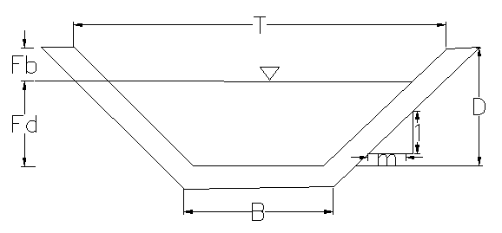

Figure 16: Typical Cross Section of tertiary canals

Canal name | Anet (ha) | Q_{reqd} (m3/s) | n | s | b | m | d | A(m2) | P(m) | R(m) | V(m/s) | Q_{calcu} | fb(m) | D(m) | T(m)
Tc-1 | 1.45 | 0.002 | 0.025 | 0.012 | 0.30 | 0.50 | 0.08 | 0.03 | 0.47 | 0.05 | 0.63 | 0.016 | 0.22 | 0.30 | 0.60
Tc-1 | 1.45 | 0.002 | 0.025 | 0.002 | 0.30 | 0.50 | 0.14 | 0.05 | 0.61 | 0.08 | 0.30 | 0.015 | 0.16 | 0.30 | 0.60
Tc-2 | 2.40 | 0.003 | 0.025 | 0.012 | 0.30 | 0.50 | 0.08 | 0.03 | 0.48 | 0.06 | 0.65 | 0.018 | 0.22 | 0.30 | 0.60
Tc-3 | 5.81 | 0.007 | 0.025 | 0.003 | 0.30 | 0.50 | 0.16 | 0.06 | 0.66 | 0.09 | 0.41 | 0.025 | 0.15 | 0.31 | 0.61
Tc-4 | 4.86 | 0.006 | 0.025 | 0.003 | 0.30 | 0.50 | 0.15 | 0.06 | 0.64 | 0.09 | 0.40 | 0.023 | 0.15 | 0.30 | 0.60
Tc-5 | 4.88 | 0.006 | 0.025 | 0.003 | 0.30 | 0.50 | 0.15 | 0.06 | 0.64 | 0.09 | 0.40 | 0.023 | 0.15 | 0.30 | 0.60
Tc-6 | 5.64 | 0.006 | 0.025 | 0.003 | 0.30 | 0.50 | 0.16 | 0.06 | 0.66 | 0.09 | 0.41 | 0.026 | 0.15 | 0.31 | 0.61
Tc-7 | 3.22 | 0.004 | 0.025 | 0.003 | 0.30 | 0.50 | 0.10 | 0.04 | 0.52 | 0.07 | 0.33 | 0.012 | 0.15 | 0.25 | 0.55
Tc-8 | 5.00 | 0.006 | 0.025 | 0.003 | 0.30 | 0.50 | 0.10 | 0.04 | 0.52 | 0.07 | 0.33 | 0.012 | 0.15 | 0.25 | 0.55
TC-9 | 5.10 | 0.006 | 0.025 | 0.003 | 0.30 | 0.50 | 0.10 | 0.04 | 0.52 | 0.07 | 0.33 | 0.012 | 0.18 | 0.28 | 0.58
Tc-10 | 3.86 | 0.004 | 0.025 | 0.003 | 0.30 | 0.50 | 0.10 | 0.04 | 0.52 | 0.07 | 0.33 | 0.012 | 0.15 | 0.25 | 0.55
Tc-11 | 5.00 | 0.006 | 0.025 | 0.003 | 0.30 | 0.50 | 0.10 | 0.04 | 0.52 | 0.07 | 0.33 | 0.012 | 0.15 | 0.25 | 0.55
Tc-12 | 3.00 | 0.003 | 0.025 | 0.003 | 0.30 | 0.50 | 0.10 | 0.04 | 0.52 | 0.07 | 0.36 | 0.013 | 0.15 | 0.25 | 0.55
Tc-13 | 3.00 | 0.003 | 0.025 | 0.003 | 0.30 | 0.50 | 0.10 | 0.04 | 0.52 | 0.07 | 0.33 | 0.012 | 0.15 | 0.25 | 0.55
Tc-14 | 3.24 | 0.004 | 0.025 | 0.003 | 0.30 | 0.50 | 0.10 | 0.04 | 0.52 | 0.07 | 0.36 | 0.013 | 0.15 | 0.25 | 0.55
Tc-15 | 2.21 | 0.003 | 0.025 | 0.003 | 0.30 | 0.50 | 0.10 | 0.04 | 0.52 | 0.07 | 0.36 | 0.013 | 0.15 | 0.25 | 0.55
Tc-16 | 3.50 | 0.004 | 0.025 | 0.003 | 0.30 | 0.50 | 0.10 | 0.04 | 0.52 | 0.07 | 0.36 | 0.013 | 0.15 | 0.25 | 0.55
Tc-17 | 3.28 | 0.004 | 0.025 | 0.002 | 0.30 | 0.50 | 0.10 | 0.04 | 0.52 | 0.07 | 0.29 | 0.010 | 0.15 | 0.25 | 0.55
Tc-18 | 8.88 | 0.010 | 0.025 | 0.002 | 0.30 | 0.50 | 0.10 | 0.04 | 0.52 | 0.07 | 0.29 | 0.01 | 0.15 | 0.25 | 0.55
Table 14: Hydraulic Parameters of tertiary canals

Field Canals
As shown in the layout, field canals run across the contours and hence face relatively steeper gradient. The discharge of most of the field canals is very small and this is taken as an advantage to cope up with the relatively steeper gradient. Figure 15 below shows a typical field canal x-section. As much as possible field canals shall be made in fill in order to easily irrigate the adjacent command area. As can be seen from the layout, majority of the filed canals can be used to irrigate both sides of the command area depending on the condition of the individual plots of land owned by individual farmers.
Figure 17: Typical Field Canal X-section

Drainage system design
Surface and subsurface drainage of irrigated soils, whether it is accomplished naturally or by provision of drainage facilities, is essential and complementary to irrigation of any soil or farm. In Amhara Region surface drainage is commonly adopted in design of small scale irrigation project. This method is used to surplus irrigation water or excessive runoff during rainy season. If designed properly it prevents water lodging/ ponding problem. The provision of irrigation systems with adequate capability to accurately control well managed water applications may significantly reduce the requirements for drainage facilities. However, the need for design of drainage system in Amhara region is important for a simple reason that rainy season runoff is an influencing factor.
In general drainage canals are aligned in depression.
Drainage canal capacity (Design discharge)
Source of drainage water is either excess irrigation water or rainy season runoff. Excess irrigation water for the drain canals, the supply canal design discharge is considered as the maximum drain design discharge. However this discharge should be compared to the rainy season runoff. .
Irrigation and drainage canals may be constructed in earth, be lined or unlined, or be constructed as flumes. For steady uniform flow conditions or if the flow can be considered as such manning flow formula is widely used for the computation of the discharge in such canals. The canal section can be rectangular or trapezoidal type.
Where Q= discharge (m³/s)
R= Hydraulic radius (Flow area/wetted perimeter)
S= Hydraulic gradient
n= Manning's roughness coefficient, n=0.025 is adopted for the earth channels and n=0.018 for the masonry lined
But in sideny irrigation project the command area at the left of the river is drain in to the sideny river and the right side of the river drainage is mixed with Giran town drainage system So we design field and tertiary drains
All the field and tertiary drains are constructed with earthen materials.

Canal Structures Design

Design of Division box
At different points of the main and secondary canals division boxes are provided which divert the flow to the secondary canal and tertiary canals. Gate should be provided at the outlet of the boxes. For detail refer the drawing.
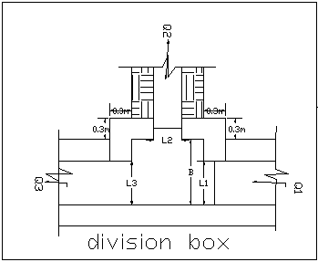
Figure 18: Typical Division Box plan

Using broad crested formula,
Q= CL (h)^{3/2}
Where; Q= discharge over rectangular weir/intake (opening), m³/s
C = discharge coefficient, c= 1.7
L= effective length of crest form in m
h= over flow depth, m
Assuming equal discharge coefficient & sill height for two or three dividing canals, the proportion becomes.
Q₁/ Q₂= Q₂/ Q₃ =L₁/ L₂ = L₂/ L₃
Where Q₁= is flow in canal 1
Q₂ = is flow in canal 2
Q₃ = is flow in canal 3
L₁= is effective crest length of weir/intake sill across opening to canal 1
L₂= is effective crest length of weir/intake sill across opening to canal 2
L₃ = is effective crest length of weir/intake sill across opening to canal 3
Q₁= CL₁ (h)^{3/2},
L₁ = Q₁/Ch^{3/2}
L₂ = L₁*Q₂/ Q₁
L₃ = L₁*Q₃/ Q₁
The depth of (height of) the division box,
D = d + f_{b}
The width of the division box,
B = b + 2*m*D
Where b= base width of the incoming canal
D = total canal depth of the incoming canal
Table 15: Hydraulic parameters of Division Boxes
Division  box  No. | Incoming  flow (m3/s) | Design  Discharge to first TC  (m3/s) | Design  Discharge to Second TC  (m3/s) | Ongoing  discharge  (m3/s) | MC bed width for ongoing discharge  (m) | TC outlet width  (m) | Top width of  division  box  (m) | Depth of  division box (m)
DV-1(TC-2 & 3) | 219 | 2 | 6.4 | 211 | 0.6 | 0.1 | 1.2 | 0.5
DV-2(TC-4 & 5) | 219 | 5 | 5.1 | 201 | 0.5 | 0.1 | 1.1 | 0.5
DV-3(TC-6 & 7) | 215 | 6 | 3.1 | 192 | 0.5 | 0.1 | 1.1 | 0.5
DV-4(TC-8 & 9) | 208 | 6 | 5.8 | 180 | 0.5 | 0.2 | 1.1 | 0.4
DV-5(Tc-10 & 11) | 109 | 0 | 5.7 | 103 | 0.5 | 0.2 | 1.1 | 0.4
DV-6(TC-12 & 13) | 109 | 3 | 3.4 | 96 | 0.4 | 0.1 | 1.0 | 0.4
DV-7(TC-14 & 15) | 110 | 4 | 2.5 | 89.5 | 0.4 | 0.1 | 1.0 | 0.4
DV-8(TC-17& 18) | 18 | 6.4 | 11.6 | 0 | 0.4 | 0.1 | 1.0 | 0.4

Design of Turnout
At different points of the main turnouts are provided which divert the flow from main canal to field canals. Gate should be provided at the outlet of the turnouts and the main canal.

Design of Drop Structure
For irrigation canals vertical drop structure of U.S.B R type standard is selected to convey water from higher to lower elevation of the ground. In the existing irrigation canal system they provide vertical type of drop structure so we provide vertical drop structures. The design procedures are shown below.
a. Critical hydraulic
- Design discharge, Q (m³/s)
- Height of drop, h (m)
- Width of drop, b_{c} =
Where d = water depth of the canal, m
- Critical discharge, q = Q/bc
- Critical depth, d_{c} =
- Lip height, a = dc/2, a ≥ 0.15

b. Stilling basin
- Basin width, B =
- Basin length, L =
All the hydraulic parameters computed using the above procedures with the type of
- L1=U/S protection
- L2= D/s protection
- b1=top width of drop wall =0.4m
- t=Thickness of the stilling basin=0.3m
Table 16: Hydraulic Parameters of Drop Structure
Drop On | Chain age | Q(m3/s) | V(m/s) | Bed Width, B | Depth, D | Drop ,H
MC | 1+232 | 0.146 | 1.46 | 0.30 | 0.30 | 0.7
MC | 1+336 | 0.146 | 1.46 | 0.30 | 0.30 | 0.7
MC | 1+495 | 0.146 | 1.46 | 0.30 | 0.30 | 1
MC | 1+535 | 0.182 | 1.46 | 0.30 | 0.30 | 0.7
(Note; Generally, the detail drawing and hydraulic parameters of the infrastructure are described in the drawing part.)

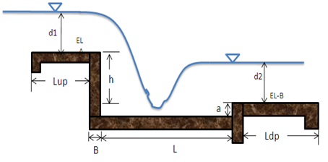
Figure 19: Typical Cross Section of Vertical Drop Structure

Road crossing structure
Two road crossing structures are provided on the main canal, at the existing foot paths. The road crossing structures are rectangular reinforced concrete slab. The slab is reinforced with 12mm @150mmc/c the length of the slab is 1.2m which is the same as the respective canal bed
Width, its width and thickness is 1.5m and 15mm respectively.
Table 17: Bill of Quantity for Infrastructure
Bill No Three Infrastructure
Sidny small Scale Irrigation Project
Bill No Three InfraStructure
Item | Description | Unit | Quantity | Unit Cost (Eth .Birr) | Amount (Eth. Birr)
1 | Main canal
1.1 | Ordinary soil excavation (by Mechanical) | m³ | 4,610.29 | 78.09 | 360,001.74
1.2 | Excavated material back fill and compaction | m3 | 727.95 | 85.00 | 61,875.75
1.3 | Hard rock Excavation | m3 | 0.50 | 646.22 | 323.11
1.4 | Excavation in Wethered rock | m3 | 0.50 | 420.00 | 210.00
1.5 | Masonry work with 1:3 cement sand ratio | m³ | 2973.15 | 1,631.40 | 4,850,389.81
1.6 | Plastering(1:2) ferst & second coat | m² | 7076.92 | 131.63 | 931,549.49
 | Sub Total |  |  |  | 6,204,349.90
2 | Turn out for MC
2.1 | Masonry work | m3 | 0.95 | 1,631.40 | 1,541.67
2.2 | Cemented stone pitching | m3 | 2.41 | 1,141.05 | 2,753.93
2.3 | Plastering(1:2) ratio first & second coat | m2 | 5.03 | 131.63 | 662.44
2.4 | Gate supply, cutting ,welding and installation(0.4mx0.4m, 4mm thick sheet metal, 1m long angle iron for groove (30x30x3), 1.2 m long, 12mm reinforcement.bar for handle) | Pcs | 4.00 | 2,090.08 | 8,360.32
 | sub Total |  |  |  | 13,318.36
3 | Division box for MC
3.1 | Masonry work with 1:3 cement sand ratio | m3 | 5.96 | 1,631.40 | 9,723.46
3.2 | 30cm Cemented stone pitching/hard core | m3 | 4.74 | 1,141.05 | 5,408.09
3.3 | Plastering(1:2) ratio ferst & second coat | m2 | 15.52 | 131.63 | 2,042.93
3.5 | Gate supply, cutting ,welding and installation(0.4mx0.4m, 4mm thick sheet metal, 1m long angle iron for groove (30x30x3), 1.2 m long, 12mm reinforcement.bar for handle) | Pcs | 48.00 | 2,090.08 | 100,323.84
 | sub total |  |  |  | 117,498.32
4 | Drop Structur
4.1 | Ordinary soil excavation (by Mechanical) | m3 | 16.20 | 78.09 | 1,265.00
4.2 | Excavation in Wethered rock | m3 | 1.62 | 420.00 | 680.40
4.3 | Back fill with Excavated material | m3 | 12.00 | 47.97 | 575.61
4.4 | Masonry work with 1:3 cement sand ratio | m3 | 15.14 | 1,631.40 | 24,691.20
4.5 | 30cm Cemented stone pitching/hard core | m3 | 3.40 | 1,141.05 | 3,881.52
4.6 | 10cm thick C-15concrete (1.2.4) raio | m2 | 10.63 | 2,447.75 | 26,024.07
4.7 | Plastering(1:2) ratio ferst & second coat | m3 | 32.13 | 131.63 | 4,228.89
 | sub total |  |  |  | 61,346.71
5 | Foot path for MC
5.1 | C-20 Re inforced concrete 1.2.3 ratio | m³ | 0.45 | 2,526.58 | 1136.962
5.2 | Reinforcement bar, φ12 | kg | 33.30 | 52.00 | 1731.600
 | sub total |  |  |  | 2,868.56
 | TOTAL for MC
6 | chute Structure
6.1 | Ordinary soil excavation (by Mechanical) | m3 | 32.00 | 78.09 | 2,498.77
6.2 | Excavation in Wethered rock | m3 | 0.00 | 420.00 | 0.00
6.3 | Back fill with Excavated material | m3 | 21.00 | 47.97 | 1,007.32
6.4 | Masonry work with 1:3 cement sand ratio | m3 | 22.00 | 1,631.40 | 35,890.75
6.5 | 30cm Cemented stone pitching/hard core | m3 | 17.80 | 1,141.05 | 20,310.76
6.6 | 10cm thick C-15concrete (1.2.4) raio | m2 | 3.20 | 2,447.75 | 7,832.81
6.7 | Plastering(1:2) ratio ferst & second coat | m3 | 35.20 | 131.63 | 4,633.45
 | sub total |  |  |  | 72,173.86
7 | EARTHEN TERITARY CANAL
7.1 | Tertiary canal Tc-1
7.1.1 | Ordinary soil excavation (by Mechanical) | m³ | 196.75 | 78.09 | 15,363.53
7.1.2 | Back fill with Excavated material | m³ | 28.00 | 47.97 | 1,343.10
 | sub total |  |  |  | 16,706.63
7.2 | Tertiary canal Tc -2
7.2.1 | Ordinary soil excavation (by Mechanical) | m³ | 148.00 | 78.09 | 11,556.81
 | sub totaln |  |  |  | 11,556.81
7.3 | Tertiary canal Tc-3
7.3.1 | Ordinary soil excavation (by Mechanical) | m³ | 132.90 | 78.09 | 10,377.71
 | sub total |  |  |  | 10,377.71
7.4 | Tertiary canal Tc-4
7.4.1 | Ordinary soil excavation (by Mechanical) | m³ | 131.21 | 78.09 | 10,245.78
 | Sub total |  |  |  | 10,245.78
7.5 | Tertiary canal Tc-5
7.5.1 | Ordinary soil excavation (by Mechanical) | m³ | 57.20 | 78.09 | 4,466.47
 | Sub total |  |  |  | 4,466.47
7.6 | Tertiary canal Tc-6
7.6.1 | Ordinary soil excavation (by Mechanical) | m³ | 22.59 | 78.09 | 1,764.02
 | Sub total |  |  |  | 1,764.02
7.7 | Tertiary canal Tc-7
7.7.1 | Ordinary soil excavation (by Mechanical) | m³ | 48.64 | 78.09 | 3,797.91
 | Sub total |  |  |  | 3,797.91
7.8 | Tertiary canal Tc-8
7.8.1 | Ordinary soil excavation (by Mechanical) | m³ | 77.55 | 78.09 | 6,055.84
 | Sub total |  |  |  | 6,055.84
7.9 | Tertiary canal Tc-9
7.9.1 | Ordinary soil excavation (by Mechanical) | m³ | 51.87 | 78.09 | 4,050.48
 |  |  |  |  | 4,050.48
 | Sub total
7.1 | Tertiary canal Tc-10
7.10.1 | Ordinary soil excavation (by Mechanical) | m³ | 58.24 | 78.09 | 4,547.66
 | Sub total |  |  |  | 4,547.66
7.11 | Tertiary canal Tc-11
7.11.1 | Ordinary soil excavation (by Mechanical) | m³ | 41.41 | 78.09 | 3,233.52
7.11.2 | Back fill with Excavated material | m³ | 0.11 | 47.97 | 5.08
 | Sub total |  |  |  | 3,238.60
7.12 | Tertiary canal Tc-12
7.12.1 | Ordinary soil excavation (by Mechanical) | m³ | 15.71 | 78.09 | 1,226.74
 | Sub total |  |  |  | 1,226.74
7.13 | Tertiary canal Tc-13
7.13.1 | Ordinary soil excavation (by Mechanical) | m³ | 100.74 | 78.09 | 7,866.35
 | Sub total |  |  |  | 7,866.35
7.14 | Tertiary canal Tc-14
7.14.1 | Ordinary soil excavation (by Mechanical) | m³ | 74.73 | 78.09 | 5,835.25
 | Sub total |  |  |  | 5,835.25
7.15 | Tertiary canal Tc-15
7.15.1 | Ordinary soil excavation (by Mechanical) | m³ | 35.69 | 78.09 | 2,786.57
 | Sub total |  |  |  | 2,786.57
7.16 | Tertiary canal Tc-16
7.16.1 | Ordinary soil excavation (by Mechanical) | m³ | 74.61 | 78.09 | 5,826.10
 | Sub total |  |  |  | 5,826.10
7.17 | Tertiary canal Tc-17
7.17.1 | Ordinary soil excavation (by Mechanical) | m³ | 93.453 | 78.09 | 7,297.41
 | Sub total |  |  |  | 7,297.41
7.18 | Tertiary canal Tc-18
7.18.1 | Ordinary soil excavation (by Mechanical) | m³ | 34.38871 | 78.09 | 2,685.30
 | Sub total |  |  |  | 2,685.30
8 | EARTHEN DRAINAGE CANAL
8.1 | Filed dran canals
8.1.1 | Ordinary soil excavation (by Mechanical) | m³ | 358.92 | 78.09 | 28,026.83
8.1.2 | Back fill with Excavated material | m³ | 152.00 | 47.97 | 7,291.11
8.2 | Tertiary dran canals
8.2.1 | Ordinary soil excavation (by Mechanical) | m³ | 1,782.94 | 78.09 | 139,223.67
8.2.2 | Back fill with Excavated material | m³ | 256.00 | 47.97 | 12,279.76
 | sub total |  |  |  | 186,821.37
 | TOTAL |  |  |  | 6,768,708.70

SIDENY IRRIGATION PROJECT
SUMMARY OF BILLS
Bill No. | Description | Amount (Birr)
1 | General Items | 1,534,608.13
2 | Head work | 3,094,018.21
3 | Infrastructure | 6,768,708.70
 | Total | 11,397,335.04
 | VAT(15%) | 1,709,600.26
 | Grand Total with VAT | 13,106,935.29
 | Command Area(ha) | 154
 | Per hactare Cost with out VAT | 74,008.67
 | Per hactare Cost with VAT | 85,109.97

CONCLUSION AND RECOMMENDATION
CONCLUSION
- The infrastructure of this project area is designed to irrigate about a total of 154 ha of land from which 76.6 ha by rehabilitation of the existing canal and the rest is by newly constructed system. The maximum duty of the command area for 16 hours per day irrigation with overall project efficiency of 52%. The method of irrigation of the project area is furrow surface irrigation in which the main and tertiary canals are working continuously whereas the field canals within a tertiary block are working rotational system.
- As the dominant soil type is clay loam black cotton soil, the main canal system is designed to be masonry.
- The reason why the main canal is to be lined up to the end is to avoid the siltation problem, time saving to reach at the tail part, reduce maintenance cost.
- The design of the canal dimensions of the irrigation canal is done by applying the manning’s uniform flow equation. The variable of the hydraulic parameters are calculated using iteration or flow master program.
- The design discharge of the drainage canals are determined using rational formula and Gamble Powell method.
- As soils of the command area are predominantly clay textured; and hence water and soil management measures should be undertaken; and optimum moisture content should be maintained to improve workability of the soil during land preparation and planting time.

RECOMMENDATION
- On traditional way the farmers use the two rivers by digging a canal on curved foot of dividing plane between two rivers but construction of bed bar on the traditional root creates weak zone at convex part of the bed bar so we need to construct the bed bar by digging through the plan and channelized the two base flows
- For better performance and long service year of the project regular inspection and maintenance is highly required.
- Farmers training, how to operate and maintain the project structures as a whole and available and water resources has a paramount important.
- The irrigation hours per day and per week should be flexible based on base flow amount of each week or month.
- The irrigation schedule must be operated according to the given scheme duty of table 11 and table 12 for dry and wet seasons respectively.
- Close supervision of the construction should be made to modify (if need be) each Components of irrigation system based on specific site conditions.

OPERATION AND MAINTENANCE

General
The main objective of the operation and maintenance aspect of an irrigation scheme is to facilitate the timely delivery of the required irrigation water to farms and to keep the irrigation system in an optimum operating condition. This section therefore, discusses the main functions of the subject matter under consideration for the scheme.

Operation of the Head Works
Operation at the diversion weir mainly focuses on the diversion of a controlled flow of river water, timely cleaning of floating debris in front of intake and removal of sediment deposits in front of the weir and intake structures.

Irrigation System Operation
The operation of the irrigation system depends mainly on the method of water delivery at farm level. Surface irrigation method is the recommended type of water distribution and application method for Sideny diversion irrigation scheme.
The farmers would organize themselves and form groups in order to handle the water management. Since flow is low Rotational water distribution would be applied within the group. The rotational distribution is then to distribute water by turn to the whole scheme according to the timely need of crop water requirement. For better and efficient water management, crop diversification should be avoided within a group. This would reduce the complexity of water distribution system of the scheme during one irrigation season. At farmers’ level of operation, a constant flow and variable irrigation time is advisable.
The operation of the irrigation system is continuous for 14 hours per day in main, secondary and tertiary canals whereas field canals within a tertiary block are operating in rotational system with each other for irrigation hours proportional to their size. Since the tertiary canal discharges are within the manageable range and the irrigation canal structures are accordingly designed for simple operation, the farmers can open and close easily whenever they required.

Maintenance Requirement
The canal system of the project is earthen canal except main canal and secondary canal, which is susceptible to siltation, erosion, growth of weeds and or breaching problems. Though the canal sections are designed for non- silting and non-scouring conditions, the above mentioned problems are unavoidable and hence periodical and yearly inspection and maintenance of canals and structures are obligatory in order to fulfill the design objective of the project area.
The maintenance tasks are categorized into two types: - routine activities, and repairs. The routine maintenance activities that are carried out periodically include:-
- Regular cleaning of sediments and weeds from canals and drains;
- Inspection and lubrication of gates; and
- Maintenance of cracked lined canals, regulating and control structures.
Repair works include task carried out more frequently and quickly, and include those tasks that are generally unpredictable. They also include emergency works. The activities included in this category are:-
- Repairing overtopped or breached canals, drains, and flood protection dykes;
- Repairing jammed gates;
- Filling holes made by wild animals; and
- Reduced free board due to walking over by people and livestock.
Regular inspection of the irrigation facilities should be carried out as part of the maintenance activities. These tasks could be carried out immediately after the end of the main rains in September and during the rainy season. This could concentrate on the interceptor drains and the flood protection dykes, the main canal and the field drains. The inspection of the other works like the tertiary canals, field drains, and the water control and regulating structures could be carried out as part of routine operation activities.
- Beneficiaries of the project need to have operation and maintenance budget, For O&M cost incurring entity area:
- Purchase sing of gate lubricate (grease)
- Replacing and maintenance of Stolen and damaged gates
- Repair Damages on the cross drainage structures.
The expense for O&M should be collected from the beneficiaries. Of course, much of the task is done by the labor and skill of the community. For cost incurring activities beneficiaries have to collect money based on the proportion of the command area they owned.

REFERENCE
- FAO (1977) guidelines for predicting crop water requirements. No 24, Rome Italy
- Design of small Canal structures , USBR
- Soft copies of hydraulic structure publishing
- IDD manual
- ESRDF manual

