OROMIA IRRIGATION DEVELOPMENT AUTHORITY
(OIDA)

FEASIBILITY STUDY AND DETAIL DESIGN
OF
Temket Bahair, Gurra-2 & Gewuso SSI PROJECTS
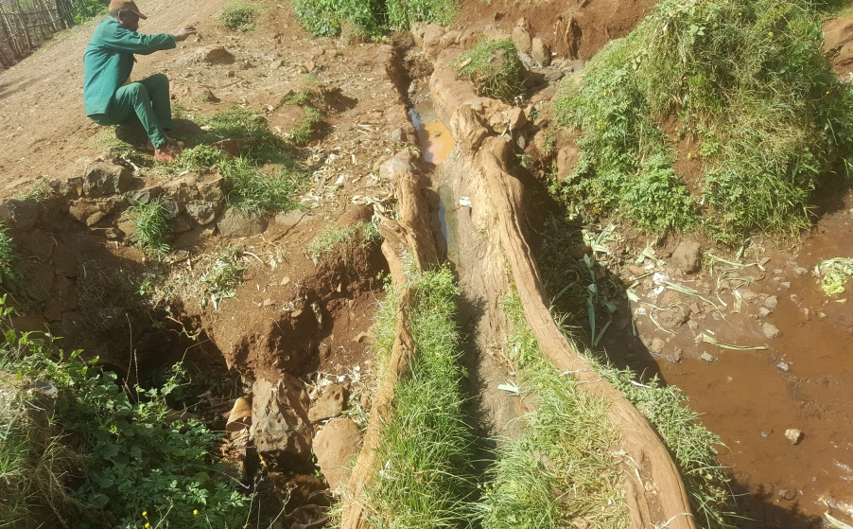 | 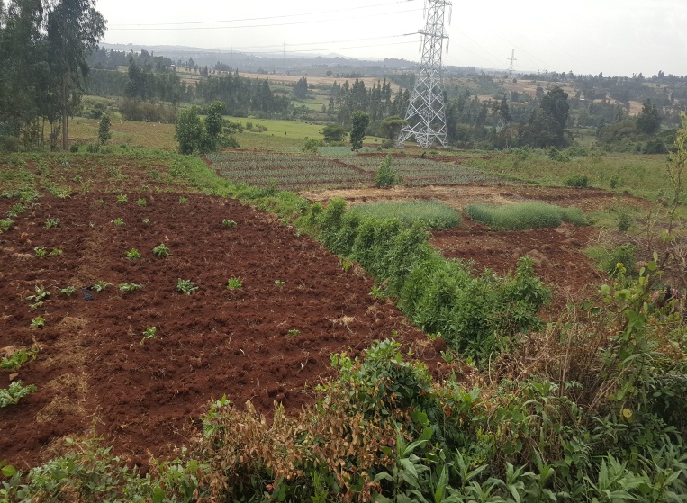
FEASIBILITY STUDY AND DETAIL DESIGN
OF
TIMKET BAHIR PROJECT

ENGINEERING REPORT
JUNE 2016
TABLE OF CONTENTS
1 INTRODUCTION 1
1.1 GENERAL 1
1.2 Project Location & Accessibility 2
1.3 Project objectives and scope 3
1.3.1 Objectives 3
1.3.2 Scope of Services 3
2 HEADWORK DESIGN 4
2.1 GENERAL 4
2.2 HEADWORK 4
2.2.1 Weir Site Selection 4
2.2.2 Weir Type & Shape 6
2.2.3 Hydraulic design 8
2.2.3.1 Weir Height 8
2.2.3.2 Crest Length 9
2.2.3.3 Head of Water over the Crest 9
2.2.3.4 Dimensions of the Weir Section 10
2.2.3.5 Downstream Flow Condition 10
2.2.3.6 Determination of Cutoff Depth and It’s Thickness 12
2.2.3.7 Length & Thickness of Apron 13
2.2.3.8 Riprap protection 15
2.2.3.9 Wing Wall Design 16
2.2.3.10 Design of Head Regulator 17
2.2.3.11 Design of Scouring Sluice 18
2.3 STRUCTURAL DESIGN 20
2.3.1 Stability analysis of the weir 20
2.3.1.1 Stability analysis for Pond Level/no flow Condition 21
2.3.1.2 Stability analysis for high flood level condition 23
2.3.2 Retaining Wall and Flood Protection Embankment 24
2.3.2.1 Stability Analysis for U/s Retaining (Wing) Walls 24
3 DETAIL DESIGN OF IRRIGATION SYSTEM 29
3.1 GENERAL 29
3.2 METHODOLOGY 29
3.3 Irrigation Experience of Users 30
3.4 AVAILABILITY OF WATER 31
3.5 CROP WATER REQUIREMENT 32
3.6 IRRIGATION SYSTEM LAYOUT 32
3.6.1 General 32
3.6.2 Main Canal 32
3.6.3 Secondary canals 32
3.6.4 Tertiary canals 33
3.6.5 Field Canals and Furrows 33
3.6.6 Command Area 33
3.7 HYDRAULIC DESIGN OF CANALS 35
3.7.1 Canal Features 35
3.7.2 Canals Design 35
3.7.2.1 Design of Lined Canals 35
3.7.2.2 Designed of Earthen Canals 36
3.8 DESIGN OF IRRIGATION STRUCTURES 39
3.8.1 General 39
3.8.2 Design of Division box Structures 39
3.8.3 Design of Offtake Structures 41
3.8.4 Conveyance structures 42
3.8.4.1 Design of Drop Structures 42
3.8.5 Design of Chute Structures 43
3.8.6 Design of Culvert Structures 43
3.8.7 Design of Foot Bridge 43
3.9 DRAINAGE SYSTEM 43
3.9.1 GENERAL 43
3.9.2 Design of Drains 44
4 BILL OF QUANTITIES AND COST ESTIMATE 45
4.1 UNIT RATE ANALYSIS 45
4.2 BILL OF QUANTITIES AND COST ESTIMATE 45
5 IMPLEMENTATION SCHEDULE BY MAJOR ACTIVITIES 53
6 CONCLUSION AND RECOMMENDATION 54
REFERENCES 55

LIST OF TABLES

Table 1-1: Location of Project Areas 2
Table 2-1: Fixing Weir Height 8
Table 2-2: Stability analysis for no flow condition 22
Table 2-3: Stability analysis for high flood condition 23
Table 2-4: calculation of forces and moments of the u/s wing walls 26
Table 2-5: calculation of forces and moments of the d/s wing walls 27
Table 3-1: identified Command Area 33
Table 3-2: Adopted Roughness co-efficient 35
Table 3-3: Hydraulic Design of Main, Secondary and tertiary Canals 38
Table 4-1: Summary of BOQ and Estimated Cost of Irrigation and related Works 45
Table 5-1: Indicative Implementation Schedule of the Project by Major Activities 53

LIST OF FIGURES
Figure 1-1 : Location Map of the Project 2
Figure 2-1: Headwork Axis 1 5
Figure 2-2: Headwork Axis 2 5
Figure 2-3: Headwork Axis 3 6
Figure 2-4: Type & Direction of Forces act on Weir in no flow condtion 21
Figure 2-5: Type & Direction of Forces act on Weir in high flood level condtion 23
Figure 2-6: Forces acting on U/S & D/s Wing walls under critical condition 25
Figure 3-1: Existing Traditional flume on left Side 30
Figure 3-2: Existing Traditional flume on right Side 30
Figure 3-3: Traditional Headwork site for left Side 31

ACRONYM
a.s.l. Above sea level
avg. Average
b Canal Bed Width
BOQ Bill of Quantities
CA Command Area
CA_{x} Canal Cross-sectional Area
CBL Canal Bed Level
CD Collector Drain
Ctd. Continued
CWR Crop Water Requirement
D Canal depth including flow depth & FB
d Flow depth
DBL Design Bed Level
DEM Digital Elevation Model
DS Design Standard
ETB Ethiopian Birr
F Furrow
FAO Food and Agriculture Organization of the United Nations
FB Free Board
FC Field Canal
FD Field Drain
FSD Feasibility Study and Detail design
FSL Full Supply Level
GOV Government
ha hectare
hA Hectare
hr hour
Km Kilometers
Km² Kilometer Square
LB Left Bank
l/s Liter per second
l/s/ha Liter per second per hectare
IWR Irrigation Water Requirement
LS Livestock
LUT Land Utilization Type
m³/s meter cube per second
m Canal side slope
MC Main Canal
MD Main Drain
Min. Minimum
Max. Maximum
MFL Maximum Flood Level
n Manning’s roughness coefficient
OGL Original Ground Level
OIDA Oromia Irrigation Development Authority
O&M Operation and Maintenance
OP Option
P Wetted perimeter
Qd Design Discharge
Qty. Quantity
R Hydraulic radius
RB Right Bank
RBL River Bed Level
RCC Reinforced Concrete
S Canal bed longitudinal slope
SC Secondary Canal
SSIP Small Scale Irrigation and Drainage Project
T Canal top width
TC Tertiary Canal
TD Tertiary Drain
TOR Terms of Reference
V Flow velocity
Vs. Versus
WUA Water Users Association
WL Water Level
WR Water Requirement

INTRODUCTION

GENERAL
Ethiopia is endowed with vast water resources potential. The annual surface water flow potential from the eight major river basins is estimated at about 123 Bm³ and the irrigable area potential of the land is estimated to be more than 3.5Mha. However, the level of utilization made from these resources for the socioeconomic development of the country so far is negligible, which make the agriculture, which is the dominant economic base and almost a sole means of living for the majority of the rural people in the country highly subsistent, unproductive and backward in its production system and cultural practice involved.
As it improves agricultural production and productivity by mitigating the problem of water shortage caused due to the unpredictable rainfall occurrences and distribution, Irrigation projects have been increasingly recognized as one of the strategies to enhance food-self-sufficiency and ensure food security at the household level. Irrigation is also a means of increasing income of the people, creating job opportunity, and generally, irrigation promotes economic development of the country. An irrigation system is designed to use the available water as efficient as possible by minimizing the losses in conveyance, distribution and application.
With regard to this and in the light of the problem, irrigation development (dry and wet season) in the areas where the potential resources are available is a not an option. These days, concerted efforts are being made at federal and regional level to transform the prevailing subsistence production system to high value and market oriented production system and to bring those people who solely relay on rain based agriculture to use modern agricultural irrigation by developing water resources exhaustively so as to play its own share in the GTP program. One of such efforts exerted in this line embarks on the judicious use of the available surface water sources particularly rivers for the small scale irrigation development in the region.
Oromia Irrigation Development Authority (OIDA) has awarded the assignment to LETINSA SHARE COMPANY Consultant to carry out Feasibility Study and Detail Design of three small-scale irrigation projects West Shawa Zone which included Timket Bahir Project in Welmera Woreda. This report addresses the engineering design:

Project Location & Accessibility
The administrative location and accessibility with respect to kebele, woreda, zone and region of the proposed Temket Bahair SSI project is presented in the following table:
Table 1-1: Location of Project Areas
- Administrative and geographical
Scheme | Administrative Location |  |  | Geographical location (meters)
Scheme | Zone | Woreda | Kebele/”got” | Easting | Northing
Temket Bahair | W/Shawa | Welmara | Berifeta Lemefa | 450454 | 999287
- Accessibility
Scheme | Region capital | Zone Town | Woreda
Temket Bahair | 125 | 97 | 19

Timket Bahir site is safely accessible using gravel road of 7Km from Menagesha Town which is at 25 Km from Addis Ababa.
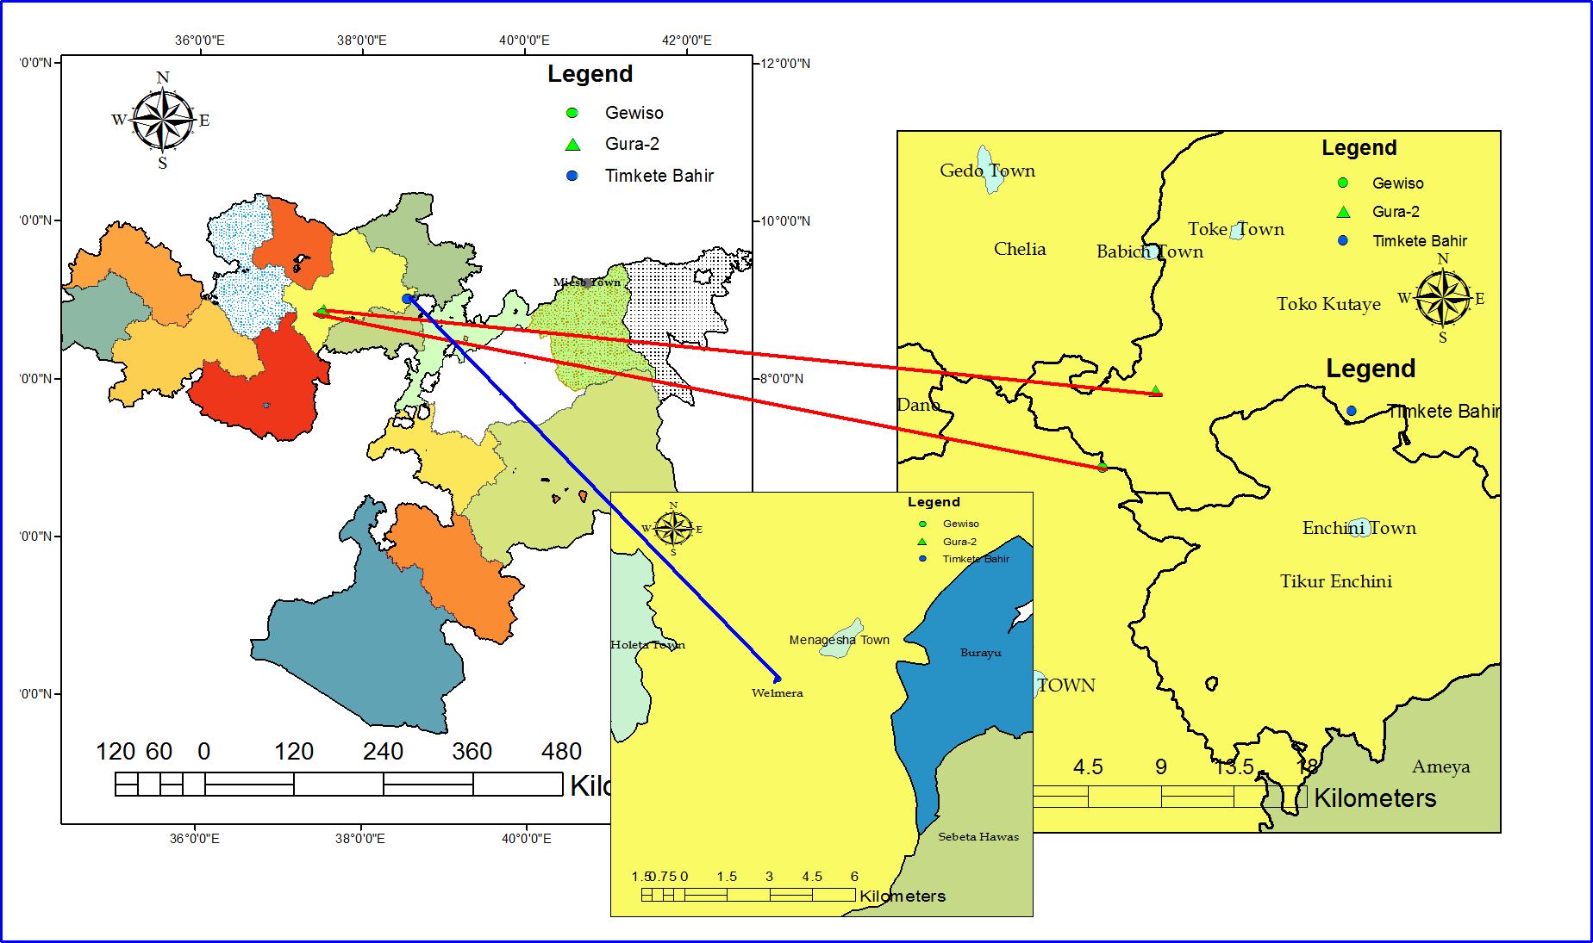
Figure 1-1 : Location Map of the Project

Project objectives and scope

Objectives
The main objective of the project is to develop irrigation system that enhance full benefit of farmers through a more efficient use of water resource, thereby ensuring sustainable food security, crop and income diversification that contributes for local, regional and national economic development endeavors which is planned to be achieved through irrigating 25ha of land to benefit the users in project area.
The specific objectives of the Engineering Design study are indicated below:
- To carry out a complete and detailed engineering design of the headwork and field structures for the irrigation schemes which will seek to establish an implementing plan for the sustainable development of irrigated agriculture, which will optimally exploit the land and water resources of the project for the benefits of its inhabitants;
- To prepare detail-working drawings, BOQ, specification and tender document for execution of construction works;
- To prepare operation and maintenance manuals;

Scope of Services
As stated in the TOR, the scope of study includes, but not limited to.
- Carrying out detail design, for the headwork components and its pertinent structures;
- Carrying out detail design of canal, drainage and road system
- Carrying out detail design of hydraulic structures
- Preparing Engineering Bill of Quantities, Cost estimates including break down of unit prices;
- Conducting socio-economic study and prepare the project development plan through the involvement of the beneficiaries to ensure that the project designs are in favor of the desired social
- Also to ensure that the project is economically and technically feasible and environmentally sustainable, and
- Preparing Detail Design Reports, Tender Documents and Catchment Management Plan.

To achieve the above objectives to the required scope, engineering design of Timket Bahir Project have been conducted and the results are presented using 6 Chapters: following this introductory chapter ,chapter 1, Chapter 2 describes Headwork Design, chapter 3 present Design of system; while, Chapter 4 address Bill of Quantity and Project Cost; chapter 5 is about the construction schedule, and the last chapter, chapter 6 present conclusion and recommendation. Also the reports contain Appendix.

HEADWORK DESIGN

GENERAL
Irrigation water for Timket Bahir irrigation project will be diverted from Timket Bahir River by means of a diversion weir constructed across the river at the selected site when water is demanded in command area. The weir is the structure anticipated to serve such purposes as raising the water level in the river, regulating the intake for allowing entrance of water into the canal, controlling the entry of silt into the canal, storing water for short periods of time so that the water will attain the required water level in the canal and reducing fluctuations in the level of supply in river.

In designing the headwork, every basic measures and parameters insuring the safety of the structures were taken in to account. Since weirs are constructed from expensive materials, withstand large flood events and last a reasonably long time, robust designs are necessary. To achieve these purposes, the hydraulic structures and structural works design will deal principally with application of universally accepted methodologies for evaluation of hydraulic forces acting on a structure and determination of the configuration of best functional efficiency. The general arrangement of the proposed weir and its main dimension was determined based on the results of hydraulic analysis and then checked for the structural.

HEADWORK

Weir Site Selection
Depending on availability/readiness of limiting resources such as land, water and beneficiaries as a primary criterion, diversion weir site should be selected by considering a combination of all or part of the following perspectives:
- Should be located far below the confluence of two rivers to avoid influence resulting from their erosive actions.
- The weir crest should be set to allow a safely passage of maximum flood discharge within designed weir crest length.
- Straight channel reach as the problem arises of concentration of flow on one side and island formation due to heavy silting within the guide bank on the other side when the angle between the headwork axis and the river axis exceeds 10°. If the river axis is to the right of headwork axis, the concentration of flow is generally on the left side with consequent tendency to form an island on the right side and vice versa. Thus weir axis should be laid such that it will be perpendicular to the river/flow axis but if in case found difficult it shall be laid at an angle which should not exceed 10°.
- The crest level should be set at desired height or level to be able to obtain the required driving head to safely deliver the designed discharge to main canal area without excessive digging
- Proximity & easiness of accessibility of the site by the main road,
- Availability of materials of construction like stone, sand and gravel in the nearby area,
- And, the main canal at the head reach should not be too deep in order to avoid large excavation work, to minimize construction cost and to reduce maintenance and side slopes stability problems
Based on the mentioned perspective we identified three headwork sites during field survey:
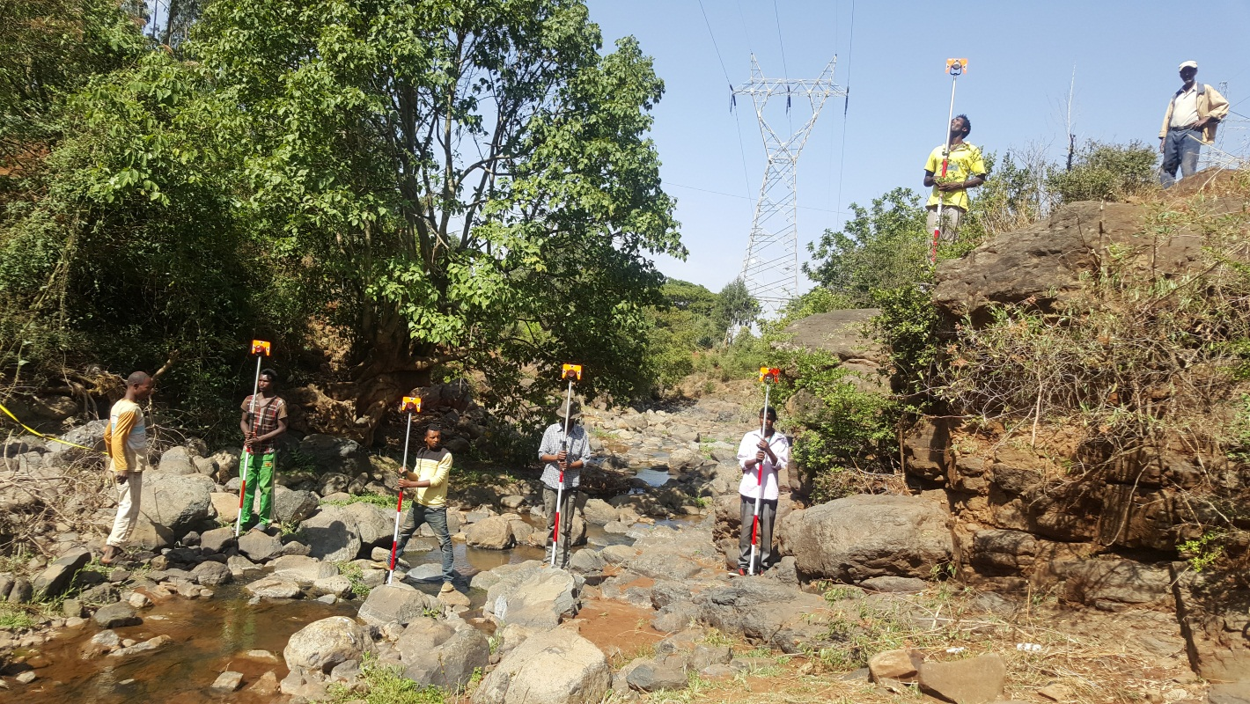

Figure 2-1: Headwork Axis 1
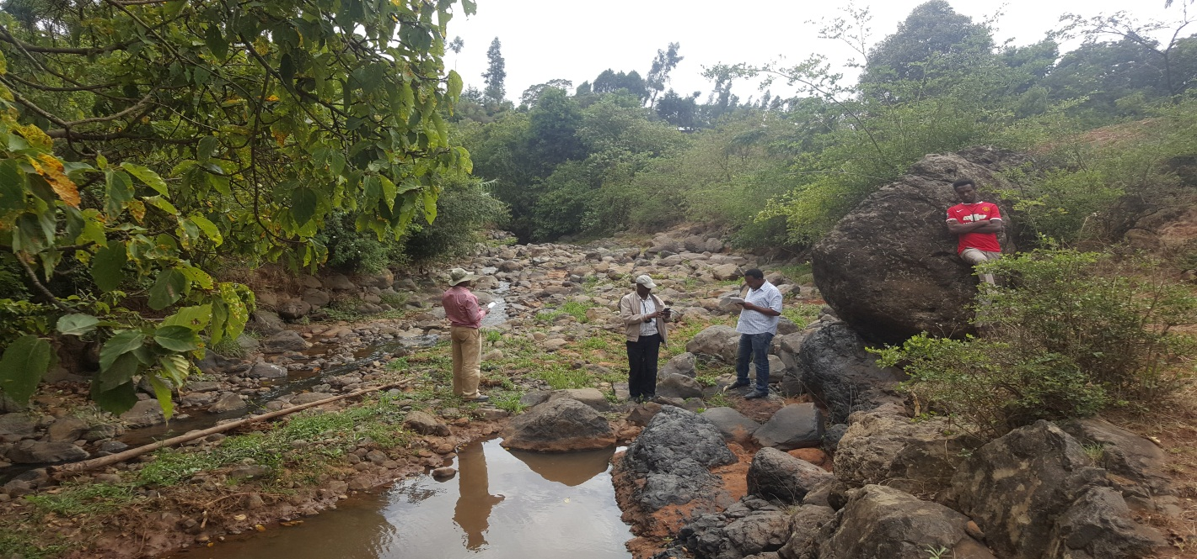

Figure 2-2: Headwork Axis 2

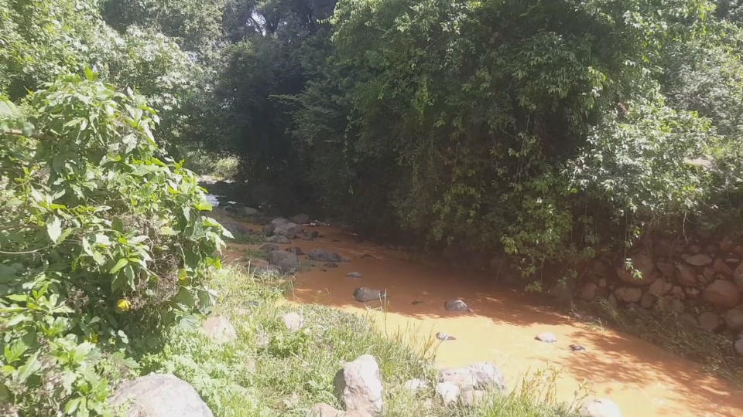
Figure 2-3: Headwork Axis 3

Since going up ward beyond the client’s Headwork Site (traditional Headwork site for left side) result in high hard rock excavation, and the head available at the traditional Headwork site for left side is large enough to irrigate the targeted area with small height weir, and since this site is very near to the command area, we confirmed and recommend it as the final Headwork site of the project.

Weir Type & Shape
Diversion Weirs with pertinent structures can be constructed using deferent materials i.e. stone masonry, Mass concrete, reinforced concrete and gabions. For selecting construction materials, among others the following factors are considered.
- Type of construction materials available at or near by construction site.
- The hydrological characteristics of the river: the type and size of bed materials transported by the river during its high flood.
- The foundation condition of the weir site.
- Availability of skilled and unskilled labour.
Weirs are also differ in shape, but designed and constructed to serve the same purposes. Four commonly usually adopted shapes are:
- An Ogee crested weir: the Ogee shaped weir has a higher coefficient of discharge than other weir shapes and that the coefficient is more predictable than of other weirs. The main disadvantage of-course is the difficulty in constructing it accurately and soundly.
- Vertical drop weir: the vertical drop weir appears simple to construct and easy and economical to design. In truth, if all structural checks are undertaken and adequate factors of safety are applied at maximum levels of flow, it will be found that for all weirs apart from those with very small flows per unit width, the wall section becomes very thick to resist overturning and shear forces
- Steep glacis weir: the steep glacis weir with upstream and downstream faces sloping at 1:1 or 1:1.5, does not suffer the construction difficulties of the ogee weir nor the instability of the vertical drop. It is the preferred type for weirs not subject to high velocity flows carrying large stones. The problem with this weir and the ones above subjected to high velocity flood flows carrying large boulders is that the boulders are first thrown against the steep upstream wall and damage it and are then thrown off the top of the weir to smash down on the stilling basin floor with similar effect.
- Shallow glacis weir: On rivers subject to high velocity flows carrying boulders it is recommended that the weir be made as low as possible and that a shallow glacis weir be used, with upstream and downstream slopes of the order of 1:2 or 1:3 (Weir Design Manual, by HALCROW-ULG, Sept. 1988).
The following points are considered to determine shape of the weir suited to this specific site.
- A weir with a shape that cannot easily be constructed by local manpower should not be considered.
- The availability of the skilled manpower for construction of weir
- The skill of the local builders, to perform it as per design and specification.
- Availability and Suitability of the local materials
Based on the mentioned points and our past related experience, as it is can be easily constructed by local manpower from the local builders as per design and specification, broad crested Weir Shape with 1:1 slope of downstream face is selected. And after considering the type of construction materials available at or near the site (refer engineering geology report); the hydrological characteristics of the river(carries larger boulders): the type and size of bed materials transported by the river during its high flood; and the foundation condition of the weir site, stone masonry weir is selected.
Therefore, masonry broad crested stone with 1:1 slope of downstream face type and shape is finally selected for Timket Bahir headwork site to divert silty free water to main canals.

Hydraulic design

Weir Height
The weir crest elevation is fixed with reference of river bed elevation considering the following factors.
- The crest level should be set at desired height or level to be able to obtain the required driving head to safely deliver the designed discharge to main canal.
- The weir crest should be set to allow a safely passage of maximum flood discharge within designed weir crest length.
- The bed level of the under sluice should be below sill level of canal head regulator.
- The main canals at the head reach should not be too deep in order to avoid large excavation work, to minimize construction cost and to reduce maintenance and side slopes stability problems.
Weir height should be selected by considering a combination of all or part of the above mentioned criteria.
At the location of the selected weir site, the river bed is equal to 2357.637m above mean sea level. By considering required driving head to safely deliver the designed discharge to main canal; a safely passage of maximum flood discharge within designed weir crest length, the bed level of the under sluice; excavation work that avoid deep cut, and the highest elevated point in command area, a weir height of 2.0m is fixed as shown in the following table:
Table 2-1: Fixing Weir Height
No | Description | Unit | Qty
1 | Fixing Weir Height
1.1 | Highest elevated point in the command area | m | 2358.80
1.2 | Water depth required for the elevated command area | m | 0.15
1.3 | Head Loss:
 | Head loss across head regulator | m | 0.10
 | Length, L of MC from head regulator to the Heighst Elveted Point | m | 300.00
 | Bed slope of the main canal, S |  | 0.00100
 | Head loss along the main canal = S*L | m | 0.30
 | Head loss at turnout | m | 0.10
 | Entrance, friction and exit loss | m | 0.08
 | Total head loss | m | 0.58
1.4 | Average riverbed elevation at selected weir axis | m | 2357.637
1.5 | Weir crest level | m | 2359.530
 | Crest height, h | m | 1.89
 | Adopt Weir Height of | m | 2
1.6 | Therefore, weir crested head is equal to | m | 2359.637

Crest Length
The length of the weir crest is determined based on the physical characteristics of the selected weir site and the width of the existing waterway. A weir with a long crest gives a small discharge per unit length and hence, the required energy dissipater per meter of the crest width is smaller than what is needed for a shorter crest length. A weir crests longer than maximum wetted river width causes formation of islands at upstream side of the weir. The formation of island upstream of the weir reduces the effective length of the crest (part of the weir less effective in passing the flood. As a general rule the crest length of the weir including scouring sluice, should be taken as the average wetted width during the flood. If possible the flow per unit width should not exceed 15m3/s/m; this will avoid a relative costly energy dissipation arrangement. Increasing the length of the weir crest to 1.2 times the river width is allowable.
To reduce costs, the width of the weir should be as small as possible. However, the narrower the weir, the greater the flow intensity and depth of flow over the weir. Safe energy dissipation downstream of the weir may therefore be quite expensive. Also, high flow velocities during floods will transport riverbed material, particularly if comprising gravel and boulders, which will increase wear and tear on the weir.

The length of the weir crest is determined based on the physical characteristics of the selected weir site and the width of the existing waterway. For optimum width, Lacey's Equation related to wetted perimeter to discharge in case of shallow channel is almost equal to the bed width of the channel.
Lacey’s Regime Perimeter (P) = 4.75*√Q
From Hydrology Report, Q _{50 year} = 108.2m³/s
Therefore, Lacey’s Regime Perimeter (P) =49.40m
During the physical field observations the weir crest length, the perpendicular distance between the left and right banks of the river which in turn perpendicular to the river flow, is measured and equal to 15m, this length include the length of unconsolidated deposit that will be removed and the length of the weir to the banks. Since the peak flood is relatively high, we adopt 16.0m.

Head of Water over the Crest
The depth water on of the Broad crest weir is computed using: Q = CL_{o}H_{e}^{3/2},

H_{e}= {Q / (C.L)} ^{2/3}
Where: -
Q = Peak Discharge (m³/sec) =108.2m3/s
C = Discharge Coefficient (C = 1.7)
L = Crest Length of Weir (m) = 16m
H_{e} = Total Energy Head (m)
H_{e} = 2.50m
Velocity of approach, V a = Q/A
= {Q/[L ((h-P)+H d)]},
where P = Silt height, take silt height 25 % of weir Height
= 0.5m
Therefore, h v = Va²/2g
hv =1/2g*{Q/[L ((h-P)+H d)]}2 ------------------------------------- (i)
But H e = H d + h v
h v = H e – H d --------------------------------- (ii)
The value of Hd is determined by Goal seek program using equation of (i) & (ii),
{Q / (C.L)} 2/3 – H d- 1/2g*{Q/[L ((h-P)+H d)]}2= 0
H d = 2.34 m, & h v = 0.160 m.

Dimensions of the Weir Section
Width of Weir
According to the Blight’s formula, the basic section of the weir body can be determined as follows:

Bottom width
B_{b} = (h+ H e)/√ (G-1) =3.95m
Where: - h – Height of the weir above the riverbed (m).
He – Maximum Depth of water over the crest (m).
G – Specific gravity of the Masonry material is (2.3).
To be economical, let fix Bb = 3.5m, and check the stability
Top width
B_{t} = He/√ (G-1) =2.11m, for similar reason adopt 1.5m

U/s & D/s Slopes
Vertical u/s side and 1:1 H: V downstream slope is recommended .

Downstream Flow Condition
Usually just downstream of the weir, the flow condition is turbulent and aggressive capable of damaging the riverbed surface unless preventive measures are taken to culminate this danger where eminent. In order to see the flow condition of the downstream from the incoming flood, the position of jump has to be determined.
Pre-jump, d₁
By equalizing the energy between upstream and downstream of the weir, the pre jump depth is determined using Bernoulli’s equitation as follows:

By trial and error, d₁ = 0.793m
And the critical depth dc is equal to:

d1 < dc, implies that the flow takes place from super critical to sub critical flow
The post /Sequent jump. d₂

The past jump depth or conjugated depth, d₂, is calculated from:
d₂ = 3.03m >d₃ = 2.7m:
The difference between d₂ and d₃ must be zero for best hydraulic condition. In this case d2 is greater than d3, implies need to depress a little the bed of the downstream apron. Thus, we recommended to depress the downstream apron bed by 0.5m.

Type of Flow
The ratio H2/H1 determine the type flow, the flow is free (modular) or Submerged (non-modular).If the ratio H2/H1< 0.75, where H1 and H2 are the u/s and d/s head above the weir crest, the flow is modular, i.e. not affected by submergence. Otherwise (H2/H1>0.75), the flow is Submerged (non-modular).
Upstream High Flood Level =Z₀ +h + H_{d} = 2361.980m
Upstream Total Energy Level = U/s HFL + h_{V} = 2362.138m
Downstream High Flood Level =Z₀ +T.W.D = 2360.340m
Downstream Total Energy Level = D/s HFL +hv= 2360.390m
H1, the u/s head above the weir crest = 2.501m
H2, the d/s head above the weir crest = 0.75m
Therefore, the ratio H2/H1 = 0.302 < 0.75, the flow over the weir is modular, not affected by the tail water level and the assumed discharge coefficient (C=1.7) is acceptable.
Position of the Jump
The position of the Jump is estimated using blench curve method i.e. Ef2 is read from the curve for knowing q & HL.
Downstream tail water energy level (d/s TEL) = 2360.342m
Head loss, HL = (u/s TEL) - (d/s TEL) = 1.75m
Discharge per meter width, q = Q/L = 6.76m³/s/m
From known values of q and HL, the corresponding values of Ef2 (d/s specific energy), can be read from blench curves. For q = 6.76 m³/s/m and HL =1.75m, Ef2 = 3.2m

Subtracting Ef2 from (d/s TEL), the level at which the jump will form can be determined, i.e. (d/s TEL) - Ef2 = 2357.14m, which implies the jump location is after at the toe of the weir, inside stilling basin

Determination of Cutoff Depth and It’s Thickness
Properly designed stilling basin dissipates the great majority of the turbulent energy in the flow. At the outflow from the basin there remains a certain proportion of energy in the flow that scours the downstream of the basin. The scour holes so formed may progress towards the structure and results in structural failure. Such failures can be prevented by providing piles or cut-off at u/s and d/s ends of the impervious floor, much below the calculated scour level.

The depth of scour can be calculated using Lacey’s equation.
Hydraulic mean depth(R), $R=1.35×{\left(\frac{q^{2}}{f}\right)}^{1/3}$
Where: R = hydraulic mean depth
q = discharge per meter length = 6.67m³/s
f = Lacey’s silt factor, 7 for Loose well rounded loose unconsolidated Boulder, cobble, gravel soil materials (see Engineering Geology and Geotechnical Report)
Upstream cutoff depth
River bed level =2357.637m
Required depth of scour below HFL at upstream = 1.5 R
Upstream cutoff level = U/S UFL- (1.5 × R) =2358.194m
U/S depth of Cutoff = 1.5R-(h +Hd) = -0.557m (the negative sign indicate that upstream cut off level is above river bed, no need of cutoff), For Safety purpose adopt 1.0m height and 0.5m thickness.
Downstream cutoff depth
Highest flood level at the Downstream = 2360.342m
River bed level =2357.637m
Required depth of scour below HFL at upstream = 1.75 R
Downstream cutoff level = U/S UFL- (1.75 × R) =2357.5640m
D/S depth of Cutoff = 1.75R-TWD = 1.712m
As described in Engineering Geology and Geotechnical Report the formation material up to 1.0 to 1.5m is to remove the boulders and weather rock, based on this recommendation we adopt 1.5m.

Length & Thickness of Apron

Length of Apron

Seepage force is the force acting on soil particles by the flow of water through the soil. If seepage force is too large at the exit of the flow line, it may remove soil particles in the region. Unless adequate percolation length is provided, this progressive action may cause foundation failure.

Since Bligh’s theory is commonly used in the design over the Lane’s method, the apron length is fixed by Blight’s method and checked for Lane’s method. The total length of apron fixed by Bligh’s Creep Methods .According to this method, the total creep length is given must exceed the sum of vertical creep lengths and horizontal creep distance.
L> CH
Where, L = total percolation distance (m), = Horizontal+ vertical
C= percolation co-efficient = 8, i.e. C for headwork foundation materials
h = max head (m),
For Dynamic case:
h = U/s HFL-D/S HFL =1.64m
For Static case,
h = weir crest level minus -river bed =2.0m
h = 2.0m is the maximum head
Thus, Lt > 8*2.0 =16.0m
Length of Downstream Impervious Floor (Ld/s) is obtained from:
Ld/s= 2.21C= 7.90m, adopt 8.0m.
And length of Upstream Impervious Floor (Lu/s):
Lu/s = L_{t} –L_{d}/_{s} –(Bb +2*d_{u/s} + 2*d_{d/s}) = -0.5m, the negative sign indicate no need to provide upstream apron, but for safety we adopt the nominal length, 3.0m.

- Check Safety against Piping/Undermining
Of course for such foundation no need to afraid piping problem, but if the construction is not well done the constructed materials has opportunity to confront piping problem. Owing to that we like to check for piping problem

Total Horizontal length provided = Length of upstream Apron + Bottom Width of the Weir+ Length of Downstream Apron = 16.5m
Total Vertical length provided = 2*d_{u/s} + 2*d_{d/s} = 5.0m

According to this Bligh’s method, the total creep length provided which is equal to sum of total vertical creep length and total horizontal creep distance should be greater than CH,16.0m m :
16.5+5= 21.5m > 16m, safe against Piping

According to Lane’s method, the total creep length provided which is equal to sum of total vertical creep lengths and one third of horizontal creep distance must be greater than CH, 7.15m;C=3, H=2.38 : = 1/3*14.5+5 = 9.8 > 6.0m, safe against Piping
- Exit gradient
For the standard form of structure with a floor length b, vertical cut-off depth d, the exit gradient at its downstream end is given by the equation below
Where, b is the horizontal length of the structure=19.5mm and
d is the downstream cutoff depth below the d/s protection apron=1.5m., which implies α=13.0
The exit gradient is below the critical value given for the foundation material: Boulder, cobble, gravel with soil material, is in between 0.2 to 0.17. So the provided downstream cutoff depth (1.5m) provides safe for materials against piping

Thickness of Apron
Hydraulic grade lines (HGL) of the sub-surface flow were computed using two methods, Bligh’s & Lane’s, for two conditions (i.e. for high flood and no over flow /pond level conditions) to determine the thickness of the apron to be provided. The downstream thickness depends on the larger value obtained by different scholars approach for the cases of static and dynamic flow conditions. The thickness at any point is given by,
Where:
t_{A}= the thickness of apron floor at a required point
H_{max} = Head differential b/n u/s & d/s water level (in dynamic & static case)
L_{A}= weighted creep length at a required point
Lc= Total weighted creep length
= LH+ Lv (for Bligh's method)
= 1/3*LH+ Lv (for Lane’s method)
Note*: The minimum thickness of the impervious aprons is 0.5m, and the maximum is 1.0m which is at the toe (refer geology report)

Riprap protection
Protective work is required the downstream of the solid apron to prevent the channel bed from being eroded by the current that leaves solid apron by dumped riprap.
Length of dumped riprap = 2.5d = 6.76m, adopt 7.0m
Minimum stone size is calculated by the following formula
V = 4.915D1/2 (R.S. Varshney page 33)

Where,
D = mean diameter of stone in m
V = average velocity of the flow in m/s
, to be in safe side 400mm is taken
The thickness of the riprap is taken as twice the size of stone proposed for dumped riprap and hence, the thickness becomes 400*2 = 800m or 0.80m. Stone with almost cubical in shape with minimum size of 400mm are proposed for the downstream apron.

Wing Wall Design
Sufficient freeboard should be provided for u/s and d/s wing walls in order to protect the walls and embankments from being overtopped by surges, splash and spray, and wave action setup by the turbulence of hydraulic jump, and not to allow high flood water to bypass the diversion weir. The common practice in the design of wall is adopted for this project, assign tentative dimensions and then check for the overall stability of the structures:

- Dimension of the u/s Wing Wall
- U/s Height of wing wall= h+He+ Fb
Where: h is height of weir, = 2.0m
He is Total flow head over the crest of the weir, = 2.5m
Fb is freeboard,
Therefore, U/s Height of wing wall = 5.0m
- Top Width = 0.5m
- Bottom width = 1.83
- Foundation depth = 1.0m
- Dimension of the d/s Wall
- D/s Wing Wall Height = TWD+ hv + Fb
Where: TWD is Tail Water depth
Hv – is Velocity Head
Fb is freeboard
Therefore, D/s Height of wing wall= 3.5m
- Top Width = 0.5m
- Bottom width = 1.50m
- Foundation depth = 1.0m

Design of Head Regulator
The command area lies on both side of river banks and hence, head regulators were designed for both sides. The axis of canal outlet is proposed to take off at an angle of 90º with diversion weir axis. Rectangular section conduits with 20cm reinforced concrete slab of 0.40m width by 0.50m height opening size were proposed for left side and 0.25m width by 0.4m height for right side. The amount of flow is controlled by the gate opening height.
Sample Designed: Left Side Regulator
The flow through the canal head regulators is supposed to be orifice flow and it’s design is carried out using Orifice formula given by:
Q=CA
Where
Q- Is the discharge through the intake =0.0235m3/s
,
C- Discharge coefficient for square rounded box culvert
A Cross sectional area of the gate opening;
h- Working head
Thus, by proposing intake section (h & b), A, P & R were calculated and then C. Then using Orifice formula, h related to main canal discharge (Q=Net Irrigable Area* Duty) and proposed intake section was estimated as follows:
The following dimensions of intake were proposed:
h = 0.5m
b = 0.4m
A=0.05m2
P = 0.80m
R = 0.25
L =10m
Therefore, using the above formula, C = 0.84
Working Head = Driving Head + Head Loss in the Regular
Driving Head (hd): is computed using orifice formula as follows:
Q=CA
V=C
V=1.44
h = 0.01
Head Loss in Regular = Inlet Loss + Outlet Loss + Friction Loss
- Inlet Loss hi is equal to
Where: Ke = 0.505 for square edged entrance
V = velocity through the culvert opening (m/s)
hi = 0.053m
Outlet Loss h_{o} :
h_{o} = 0.105m
Friction Loss h_{f} :
hf = 0.016m
Head Loss in Regular = 0.175m
Working Head = Driving Head + Head Loss in the Regular
= 0.03m, use 0.20m
FSL = Pond Level - Working Head
= 2359.44m
CBL = FSL-flow depth
= 2359.25m

Design of Scouring Sluice
The function of the weir sluice is to prevent high sediment loads entering the canal Off-takes. The under sluice dimension/capacity have fixed to pass the maximum of 5% to 10% of high flood discharge & 5 times main canal capacity.
=5.4m3/s
The maximum is Qs = 5.4m³/s

Identical under sluice gates are provided on both sides. Sample design of one is presented as follows:
The width of the water ways is proposed to be 1m. The under sluices are provide with opening of 1m width by 1.2m height.

Discharge and velocity through scouring sluice for Pond Level condition
Discharge through under-sluice for the condition when the upstream water level is at crest level and no water flow on downstream has been calculated. Under this condition the openings of under-sluice is working as free orifice.

The deposited materials behind scouring sluice are considered gravel, sand and silt with maximum 0.10m diameter. Required velocity for flushing out the above materials is computed as follows.
The discharge through each free orifice,
=
Where,
Q = discharge through under-sluice
Leff = effective length of under-sluice opening =1.0m
d = width of opening =1.00
Cd = coefficient of discharge = 0.620 (approx.)
h = head above center of opening orifice = 0.60m
=
The calculated velocity is greater than required critical velocity and the given dimensions fulfill the requirement for silt flush.
Discharge and velocity through scouring sluice for High Flood Level condition
During highest flood level occurrence, since the driving head is high, the bottom of gate is not submerged. Therefore, still the scouring sluice is working as free orifice and the same formula is used for computing the discharge and velocity through orifice.
Where,
Q = Discharge through under-sluices
Cd = coefficient of discharge = 0.62
Left= effective leaner water way =1.00
h = head above center of opening orifice = 3.1m
d = width of under-sluices opening = 1.00
=
Q = 5.80m³/s > Qs = 5.40m³/s, fulfilled
, fulfilled.
Since the deigned peak discharge is relatively high compare to the width of the river, sliding type of gates are preferred over spindle for under sluice gates. It is proposed to provide vertical sliding steel gate of rectangular shape supported by guiding systems.

STRUCTURAL DESIGN

Stability analysis of the weir
For the structure to be remained stable the following conditions must be fulfilled.
- The structure must safe against sliding, overturning and resultant force must lie within middle third.
- There should not be tension under the base
- The maximum toe and heel pressures on foundations should not exceed the prescribed safe limits.
The weir have to be checked against externals forces to decide whether the dimensions adopted from design based on hydraulic criteria is sufficient from structural stability point of view or not. The stability of the weir was checked for two conditions i.e. for of high flood level and pond Level conditions.

The weir wall constructed of stone masonry bedded in 1:3 ratio cement &sand mortar was designed. As described in the above sub section, Apron length and thickness, the impervious apron was checked for piping. All the forces and moments that act on weir are calculated separately for both conditions and tabulated in the following Tables. The external forces considered on stability of the weir body analysis are:
- The hydrostatic pressure up stream of weir,
- Uplift water pressure
- Tail water pressure,
- Self weight of the weir,
- The weight of water wedges and
- The silt pressure.
For the analysis of stability the following parameters value and symbols are adopted:
- Unit Weight of masonry, γ_{m} = 2.3 t/m³ (for weir body and u/s & d/s cut off walls)
- Unit Weight of water,γ_{w} = 1.0t/m³
- Unit Weight of bed material (fine sand submerged), γ_{s} = 1.9t/m³

Stability analysis for Pond Level/no flow Condition
Type and direction of forces act on Weir part during pond level condition is shown using the following figure :
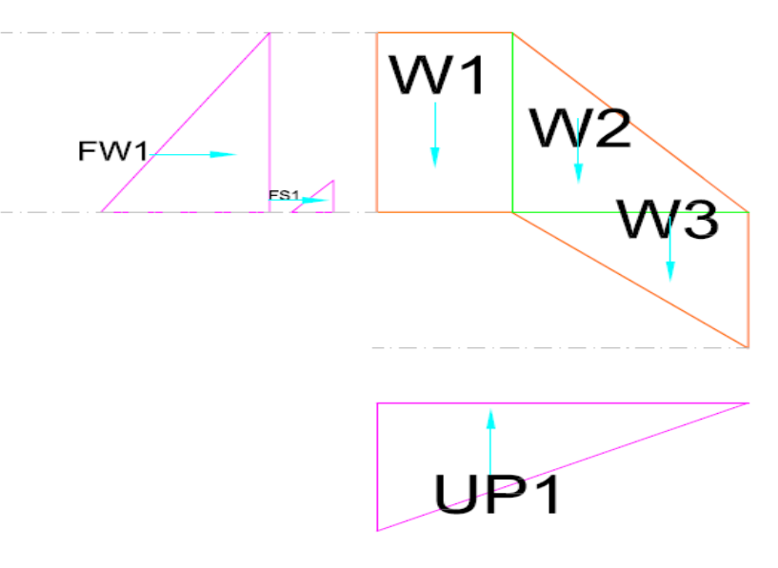
Figure 2-4: Type & Direction of Forces act on Weir in no flow condtion

Table 2-2: Stability analysis for no flow condition
Symbol of Forces | Direction & Magnitude of Force (KN) |  | Arm Length(m) |  | Moment about Toe (KN-m)
Symbol of Forces | Vertical | Horizontal | Vertical | Horizontal | MR (+) | MO (-)
W1 | 86.25 |  |  | 2.75 | 237.19 | -
W2 | 71.9 |  |  | 1.33 | 95.83 | -
W3 | 14.375 |  |  | 0.83 | 11.98 | -
U/s Water Force : Fw1 |  | 20 | 0.67 |  |  | 13.33
Silt pressure -F_{SP} |  | 2.38 | 0.17 |  |  | 0.40
Up lift pressure -UP1 | 35 |  |  | 2.33 |  | 81.67
∑ | 137.50 | 22.38 |  |  | 345.00 | 95.40
Note: We consider the uplift force in such foundation only to analyses the risk will be happened if the structure will not implemented as monolithic to the foundation rock for uncertainty reasons.

- Stability against overturning:
Factor of safety against overturning
= 3.6 > 1.5, safe against overturning!
- Check for Sliding
Factor of safety against sliding
= 0.16 < 0.65, safe against sliding!
- Check for Overstress/Tension
Factor of safety against over stress F.S, e = |B_{b}/2 -X average | < B/6
X average=∑Mnet/∑V =1.82
e = |B_{b}/2 -X average | = 0.07
B/6 = 0.58
e = 0.07 < B/6 = 0.58, safe against over stress!
- Factor of Safety against Contact Pressure
The contact pressure (Stress) on the foundation at the toe or heel of the weir body should be less than the allowable bearing capacity of the foundation material. Maximum and minimum compressive stress developed at toe of the weir is given by:
Both &< the stress allowable limit described in Geological report. So tension will not develop at the toe.

Stability analysis for high flood level condition
Type and direction of forces direction on Weir part are shown using the following figure :
Figure 2-5: Type & Direction of Forces act on Weir in high flood level condtion
Table 2-3: Stability analysis for high flood condition
No. | Symbol of Forces | Direction & Magnitude of Force (KN) |  | Arm Length(m) |  | Moment about Toe (KN-m)
No. | Symbol of Forces | Vertical | Horizontal | Vertical | Horizontal | MR (+) | MO (-)
1 | W1 | 86.25 |  |  | 2.75 | 237.19 | -
2 | W2 | 71.9 |  |  | 1.33 | 95.83 | -
3 | W3 | 14.375 |  |  | 0.83 | 11.98 | -
4 | V1 | 18.75 |  |  | 3.25 | 60.94
5 | U/s Water Force : Fw1 |  | 20 | 0.67 |  |  | 13.33
6 | U/s Water Force : Fw2 | 50 |  |  | 1.00 | 50.00
7 | U/s Water Force : Fw3 | 3.128405 |  |  | 0.26 | 0.82
8 | Silt pressure -F_{SP} |  | 2.38 | 0.17 |  |  | 0.40
9 | Up lift pressure -UP1 | 64.9075 |  |  | 2.33 |  | 151.45
10 | Up lift pressure -UP2 | 16.52 |  |  | 1.75 |  | 28.91
 | ∑ | 162.95 | 22.38 |  |  | 456.76 | 194.09

- Stability against overturning:
Factor of safety against overturning
= 2.35> 1.5, safe against overturning!
- Check for Sliding
Factor of safety against sliding
= 0.14 < 0.65, safe against sliding!
- Check for Overstress/Tension
Factor of safety against over stress F.S, e = |B_{b}/2 -X average | < B/6
X average=∑Mnet/∑V =1.61
e = |B_{b}/2 -X average | = 0.14
B/6 = 0.58
e = 0.14 < B/6 = 0.58, safe against over stress!
- Factor of Safety against Contact Pressure
The contact pressure (Stress) on the foundation at the toe or heel of the weir body should be less than the allowable bearing capacity of the foundation material. Maximum and minimum compressive stress developed at toe of the weir is given by:
Both &< the stress allowable limit described in Geological report. So tension will not develop at the toe. Therefore, the weir stable against sliding, overturning, over stress and against contact pressure in high flood level condition.

Retaining Wall and Flood Protection Embankment

Stability Analysis for U/s Retaining (Wing) Walls
The heights of upstream and downstream wing walls were determined in the hydraulic design work. Based on availability of material in site gravity stone masonry wall are proposed to be constructed.

The critical condition for u/s & d/s wing walls is no flow condition, because during high flood condition the structures are on safer side since soil pressure and water pressure balance each other. But in no flow condition wing walls are subjected to critical side soil pressure. This type of condition may occur during maintenance when under sluice gate is open & the coming flow of the river passes through under sluice. For the structures to be safe:
- the masonry section of the retaining (wing) walls must have enough weight to resist the thrust due to earth pressure from its rear without overturning
- The resultant force of entire weight of the wall and the external forces acting on it are required to cut the base within middle third
When these conditions are satisfied, the nature of the stress acting on the masonry wall at its base will be compression only. Thus stability is checked under these critical conditions based on the following assumption:

Unit weight of the masonry ………………………………………= 2.3t/m³
Unit weight of the saturated soil …………………………….. = 1.90t/m³
Angle of repose (Ø) in all conditions…………………………….. = 27º
Allowable soil bearing pressure ………………………….. = 30t/m²
Figure 2-6: Forces acting on U/S & D/s Wing walls under critical condition
- Stability Analysis for Upstream of the wing walls
The u/s wing walls are used for guiding the river water to confine it within river width, protect u/s river banks not to be over topped. Gravity type wing walls are proposed to be constructed with stone masonry embedded in to cement sand mortar and designed as a gravity walls. The stability analysis of the upstream wing walls are carried for critical section described above as follows:

Coefficient (k_{a}) of earth pressure using Rankine formula:
, and lateral earth pressure,

Table 2-4: calculation of forces and moments of the u/s wing walls
No. | Symbol of Forces | Direction & Magnitude of Force (KN) |  | Arm Length(m) |  | Moment about Toe (KN-m)
No. | Symbol of Forces | Vertical | Horizontal | Vertical | Horizontal | MR (+) | MO (-)
1 | W1 | 57.5 |  |  | 0.25 | 14.38 | -
2 | W2 | 61.33 |  |  | 1.83 | 112.44 | -
3 | W3 | 46.00 |  |  | 0.92 | 42.17 | -
4 | PaH | 69.00 |  |  | 1.83 | 126.50
5 | Active pressure -F_{SP1} |  | 25.944 | 1.50 |  |  | 38.92
 | ∑ | 233.83 | 25.94 |  |  | 295.49 | 38.92
- Stability against overturning:
Factor of safety against overturning
=7.59 > 1.5, safe against overturning!
- Check for Sliding
Factor of safety against sliding
= 0.11 < 0.65, safe against sliding!
- Check for Overstress/Tension
Factor of safety against over stress F.S, e = |B_{b}/2 -X average | < B/6
X average=∑Mnet/∑V =1.1
e = |B_{b}/2 -X average | = 0.10
B/6 = 0.33
e = 0.10 < B/6 = 0.33, safe against over stress!
- Factor of Safety against Contact Pressure
The contact pressure (Stress) on the foundation should be less than the allowable bearing capacity of the foundation material. Maximum and minimum compressive stress developed at toe of the weir is given by:
Both & < the stress allowable limit, implies safe against Contact Pressure.
- Stability Analysis for Downstream of the wing walls
The stability analysis of the downstream wing walls are carried out based on the following assumptions and data.

Angle of repose (Ø) in all conditions………………………… = 27º
Coefficient (k_{a}) of earth pressure using Rankine formula:
, and lateral earth pressure,
Table 2-5: calculation of forces and moments of the d/s wing walls
No. | Symbol of Forces | Direction & Magnitude of Force (KN) |  | Arm Length(m) |  | Moment about Toe (KN-m)
No. | Symbol of Forces | Vertical | Horizontal | Vertical | Horizontal | MR (+) | MO (-)
1 | W1 | 40.25 |  |  | 0.25 | 10.06 | -
2 | W2 | 28.75 |  |  | 0.78 | 22.36 | -
3 | W3 | 26.83333 |  |  | 0.67 | 17.89 | -
4 | PaH | 33.54167 |  |  | 1.33 | 44.72
10 | Active pressure -F_{SP1} |  | 27.025 | 1.33 |  |  | 36.03
 | ∑ | 129.38 | 27.03 |  |  | 95.03 | 36.03

- Stability against overturning:
Factor of safety against overturning
= 2.64 > 1.5, safe against overturning!
- Check for Sliding
Factor of safety against sliding
= 0.21 < 0.65, safe against sliding!
- Check for Overstress/Tension
Factor of safety against over stress F.S, e = |B_{b}/2 -X average | < B/6
X average=∑Mnet/∑V =0.46
e = |B_{b}/2 -X average | = 0.21
B/6 = 0.19
e = 0.21 < B/6 = 0.22, safe against over stress!
- Factor of Safety against Contact Pressure
The contact pressure (Stress) on the foundation should be less than the allowable bearing capacity of the foundation material. Maximum and minimum compressive stress developed at toe of the weir is given by:
Both & < the stress allowable limit, implies safe against Contact Pressure.T his tension is within the limits that the masonry can take. Hence, the structure is safe. The stability analyses of gates structures will be presented in detail design phase.

DETAIL DESIGN OF IRRIGATION SYSTEM

GENERAL
The objective of this project development is to make the farmers of the command area beneficiaries of irrigation water to irrigate 25ha net irrigable area. This is intended to be developed by diverting water from Timket Bahir River. For this purpose, a network of canal system, related infrastructures layout system and irrigation farm structures, comprising various components starting from main conveyance to field canals has been designed. The following parameters are very relevant in designing of the infrastructure system:
- The layout of canal system
- Crop water requirement
- Efficiencies of different components of canal system
It is, therefore, very essential that the different components of the canal system should be able to carry adequate discharge which may be able to meet the needs of proposed crops under the command of individual components. And since design of small scale irrigation scheme intended to be handed to farmers after completion, calls for careful consideration of the operation needs and management skills of the beneficiaries. The aim has been to provide simple, strong and sustainable irrigation and drainage systems that are easy to understand and operate. Accordingly, the project has been provided with simple water control and regulating structures that fulfill these requirements.

METHODOLOGY
The methodology followed to plan and designs the Timket Bahir project involves the following steps:
- Preparation of Top Map: more than 55ha of land was surveyed and the top map was produced using 1:1000 horizontal and 1:100 vertical scale and 0.5m contour interval to develop the layout of the system. 39ha of land is identified as net irrigable area
- Preparation of Layout: The components of the irrigation system should be aligned on the ridges and that of drainage in the valleys. Between two components of irrigation system, there should be one component of drainage system. The system should comprise from main canals to field canals.
- Discharge Capacity: It is also required to fix the discharge capacities of different components such that they are able to carry adequate irrigation water to serve properly, the areas under their respective commands.
- Fixation of F.S.L: It is required to fix the full supply level (FSL) of each component such that it facilitates reaching of irrigation water to every corner of the command area by gravity flow.
- Hydraulic Design: Once the design discharge is fixed, it is required to complete the hydraulic design of the different components.
- Structures: Canal structures on different components are essential parts of the system; they are required for regulating, monitoring, and controlling the irrigation supplies. It is, therefore, also required to decide about the type, location, size, and number etc of structures and prepare their detailed designs.

Irrigation Experience of Users
The users experienced using water for irrigation for long period of time, very long. Currently there using water on both sides of the rivers by developing different complex traditional structures as shown in the following figure:, almost all of the land on left side under main canal is currently irrigated by traditional irrigation and most of the land on right side is under rain fed cultivation.
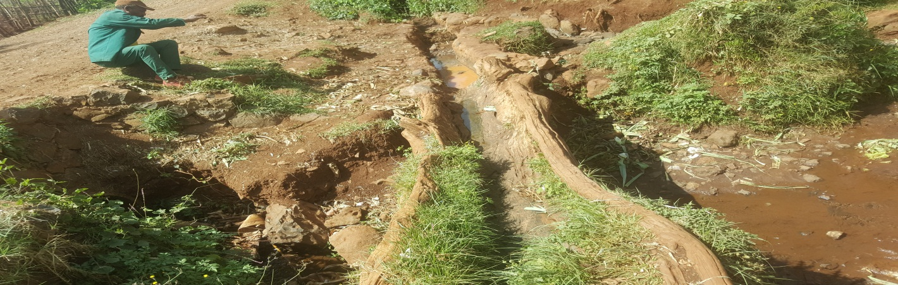

Figure 3-1: Existing Traditional flume on left Side
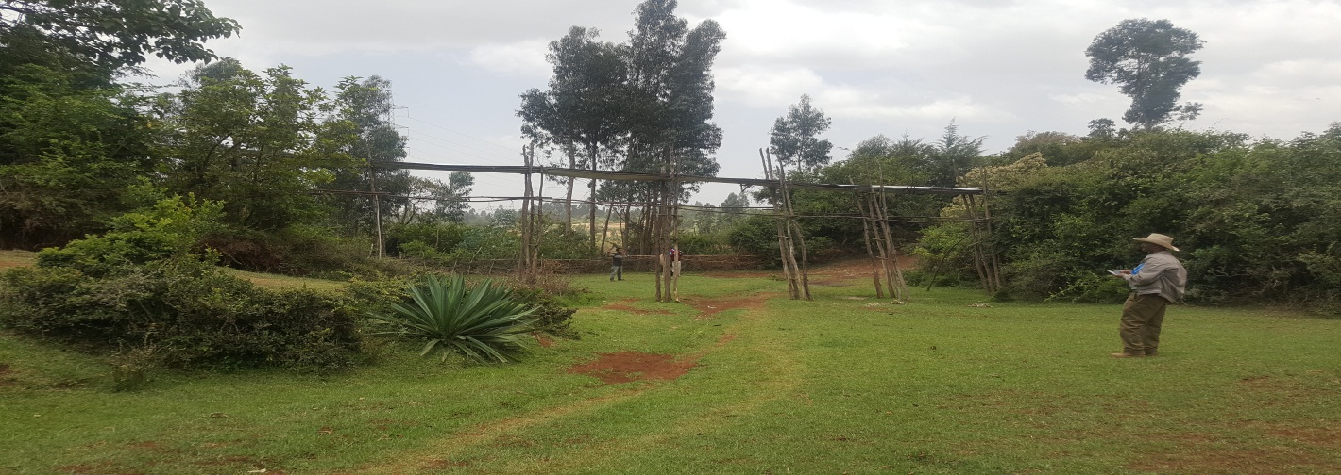

Figure 3-2: Existing Traditional flume on right Side

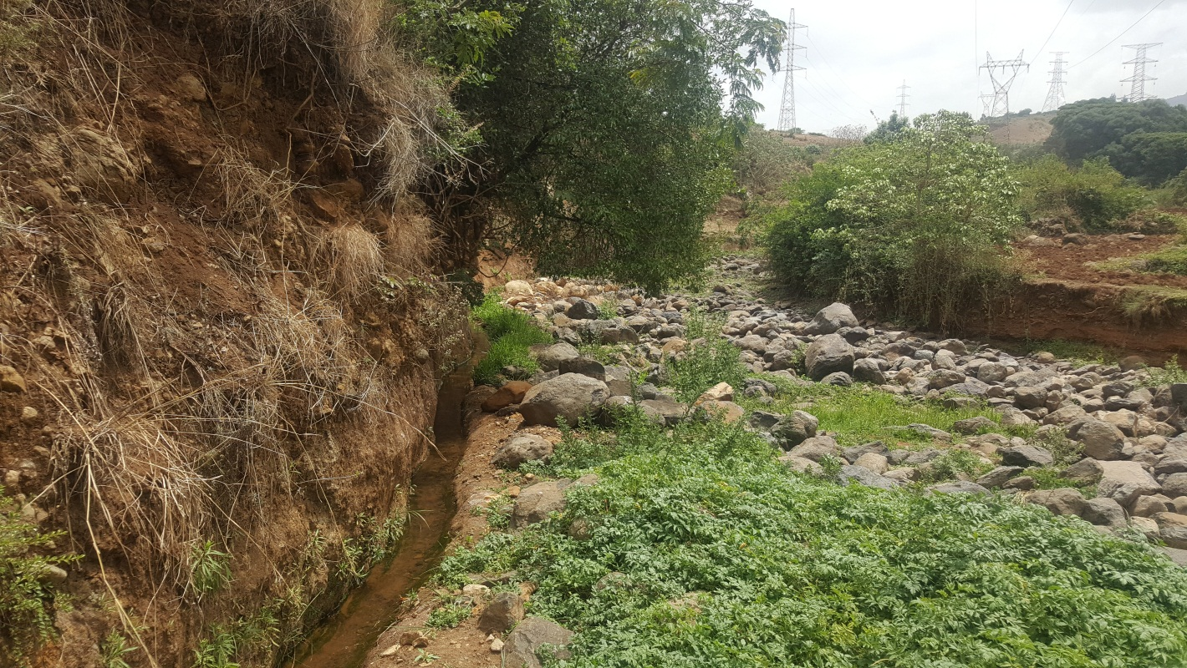
Figure 3-3: Traditional Headwork site for left Side

AVAILABILITY OF WATER
Based on the hydrological analysis as described in hydrologic study report of feasibility level, the reliability of the discharge available at the river during the dry seasons was computed using Floating Method: at March 25, 2016 the River was measured using floating method before start of rain and is equal to 28l/s.

As per information we got from the community for the past more than 40years more than 90% base flow was diverted to the targeted command area by the considering the spring from the banks of the river at downstream of the headwork site, the tributaries that comes from both sides at the end of our command area (chancho from right side and Qaresa from the left side) and join the river, flow from swampy area and from the drainage itself as the river itself is used as the main drain for downstream ecosystem.

But for this design we target to divert 85% the base flow and to leave 15% of the flow for downstream ecosystem in addition to water from swamy area, springs from banks, different tributaries and water from our drainage system. Thus, only we planned to divert 24l/s which can irrigate the proposed cropping pattern on 31ha of lands during dry time.

CROP WATER REQUIREMENT
The actual water requirement for the proposed cropping pattern is indicated in Agronomy Report. To arrive at actual monthly requirement and the rate of water flow at the head of main canal, 24 hrs operation times is fixed by considering the experience of users. The highest irrigation requirement for actual area was estimated and equal to 0.78l/s/ha for 24hrs, for more information concerning proposed cropping calendar and pattern, refer agronomic report.

IRRIGATION SYSTEM LAYOUT

General
The Irrigation System layout for the Command is being planned and designed keeping in view of;
- It fits best into the existing topography
- It serves the requirement of proposed crop
- Irrigation water is able to reach every part of command area by gravity flow.
- The cost of construction and operation is minimum.
- It operates efficiently free from trouble.
And the irrigation system proposed comprises the canal network having two main canals that distribute water among secondary, tertiary, and field canals. The distribution system consists of a network of secondary, tertiary and field canals for left side and secondary & field canals for right side

Main Canal
The layout of main canal is the most important and vital component of the entire planning work, that call for most careful consideration of all the factors governing the alignment: topography, natural drainage pattern etc. The main canal is aligned nearly along the contour lines to minimize loose of head. The total length of the canal is 433m & 712m for the left and right side respectively. The left side main canal is the existing canal.

Secondary canals
There are three of secondary canals in the system, two on the left and one on the right side. All secondary canals aligned across contour. The secondary canals are either distributed water among tertiary canals or directly feed the field canals and run across contour.

Tertiary canals
Some Block of command area are planned to be irrigated using the tertiary canals that off take directly from the secondary canals and supplies irrigation water to field canals.

Field Canals and Furrows
The command area under each tertiary canal is further sub-divided into several segments by field canals, which supply water to the furrows. These canals are aligned across the contour. By considering the proposed crops, furrow method of irrigation has been adopted. Accordingly, irrigation water will be applied to the farm through furrows. The average length of furrows is 100 meters. Irrigation water will be supplied to several furrows at a time, depending on the size of field canal that apply irrigation water.

Command Area
The topography of the area is characterized by moderate slope. The available Topographical maps of 1:50,000 scale for entire catchment and command area of the project are not adequate for planning and design of irrigation system. The topographical surveys have been conducted with the help of Total Station Method and results have been fed into computer from which topographical maps have been generated with 0.5m contour interval, 1:1,000 horizontal and 1:100 vertical scales.

The final size of the command area of the project is determined based on the result of the topographic survey, hydrological study, and soil survey and land evaluation study results. Accordingly, the survey has been conducted for entire command area measuring more than 55ha. After deducting non suitable area 39 net irrigable area is identified for final planning and design of the irrigation system. The following table describes the net area under each tertiary, secondary and main canal:

Table 3-1: identified Command Area
NO | Canal name | NIA(ha) | Remark
1 | LMC | 30.18
1.1 | LFC 0-0-1 | 0.85
1.2 | LSC 1 | 8.67
1.2.1 | LTC 1-1 | 3.20
1.2.1.1 | LFC 1-1-1 | 1.83
1.2.1.2 | LFC 1-1-2 | 1.37
1.2.2 | LTC 1-2 | 2.58
1.2.2.1 | LFC 1-2-1 | 1.10
1.2.2.2 | LFC 1-2-2 | 1.48
1.2.3 | LTC 1-3 | 2.89
1.2.3.1 | LFC 1-3-1 | 1.22
1.2.3.2 | LFC 1-3-2 | 1.67
1.3 | LSC 2 | 20.66
1.3.1 | LTC 2-1 | 2.40
1.3.1.1 | LFC 2-1-1 | 1.10
1.3.1.2 | LFC 2-1-2 | 1.30
1.3.2 | LTC 2-2 | 1.74
1.3.2.1 | LFC 2-2-1 | 0.89
1.3.2.2 | LFC 2-2-2 | 0.85
1.3.3 | LTC 2-3 | 2.94
1.3.3.1 | LFC 2-3-1 | 1.51
1.3.3.2 | LFC 2-3-2 | 1.43
1.3.4 | LTC 2-4 | 3.23
1.3.4.1 | LFC 2-4-1 | 1.95
1.3.4.2 | LFC 2-4-2 | 1.28
1.3.5 | LTC 2-5 | 1.80
1.3.5.1 | LFC 2-5-1 | 1.80
1.3.6 | LTC 2-6 | 3.55
1.3.6.1 | LFC 2-6-1 | 1.00
1.3.6.2 | LFC 2-6-2 | 0.98
1.3.6.3 | LFC 2-6-3 | 0.96
1.3.6.4 | LFC 2-6-4 | 0.61
1.3.7 | LTC 2-7 | 5.00
1.3.7.1 | LFC 2-7-1 | 1.83
1.3.7.2 | LFC 2-7-2 | 1.06
1.3.7.3 | LFC 2-7-3 | 1.17
1.3.7.4 | LFC 2-7-4 | 0.94
2 | RMC | 8.90
2.1 | RFC 0-0-1 | 0.54
2.2 | RFC 0-0-2 | 1.35
2.3 | RSC 1 | 7.01
2.3.1 | RFC 1-0-1 | 1.50
2.3.2 | RFC 1-0-2 | 0.81
2.3.3 | RFC 1-0-3 | 0.90
2.3.4 | RFC 1-0-4 | 1.00
2.3.5 | RFC 1-0-5 | 2.80
 | TOTAL NIA | 39.08

HYDRAULIC DESIGN OF CANALS

Canal Features
Roughness co-efficient-‘N’
Coefficient of rugosity largely depends on the type of surface. Different values are taken for different surface types. Based on the recommended N for ‘Criteria for design of lined canals and guidance for selection of Type of Lining’ the following values of ‘N’ have been adopted:
Table 3-2: Adopted Roughness co-efficient
Type of Surface | Canal component | Value of ‘N’
Masonry lining | Lined Part | 0.018
Concrete Lining | Lined Part | 0.014
Earthen Canal | Earthen Part | 0.025
Earthen Drain | Earthen Part | 0.03

Canal side Slopes
All earthen canals were proposed to be designed as trapezoidal section. By considering the soil type and slope of the land 1:1.5(V: H) side slope is adopted for tertiary canals.
Free Board
Free board between 0.35m to 0.25m are recommended for main canals, Secondary & tertiary canals.

Canals Design
Canals lining are adopted as per described in geology report for the main cannel routes. All lined canals reach are designed as rectangular masonry canals. And all earthen canals are designed as trapezoidal earthen canal. All tertiary canals run nearly parallel to the contour and proposed to be earthen canals.

Design of Lined Canals
All lined canals are designed as rectangular canals; the construction materials proposed for the canals are totally depending on the velocity of the flow. All lined main canals are designed as rectangular masonry canals. . For masonry surface Roughness co-efficient of n = 0.018. And the longitudinal slope vary from canal to canal based on the slope of topographic were the alignments of canals pass.

Sample Design: LMC (0- end)

The whole length is designed as lined rectangular canal using the above Manning formula and continuity equation as follows:
A = bh
p =b + 2h
R = A/p
Where:
 | Q | is | Design Discharge (m³/sec)
 | A | is | cross-sectional area in (m²)
 | V | is | mean velocity (m/sec)
 | p | is | Wetted Perimeter(m)
 | R | is | Hydraulic mean depth (m)
 | S | is | Slope of canal, and
Using the above formula the hydraulic parameters of the main canal are fixed as follows;
Bed width , b (m) | 0.40
Full Supply Depth, h (m) | 0.17
n | 0.018
Slope , S | 0.001
M(H:V) | 0:1
Cross Sectional flow Area, A (m²) | 0.067
Wetted perimeter, P (m) | 0.737
Mean Hydraulic Radius, R(m) | 0.091
Velocity, V (m/sec) | 0.36
Required Discharge, Q | 0.024m3/sec
Design Discharge, Q | 0.024m3/sec
A free board, F | 0.33
The hydraulic parameters for others lined main & secondary canals are fixed in similar way and tabulated in the following table, table 3.3:

Designed of Earthen Canals
All earthen canals are designed as trapezoidal section. For earthen/soil surface Roughness co-efficient of n = 0.025 is adopted, but the longitudinal slope vary from canal to canal based on the slope of topographic were the alignments of canals pass.

Sample Design: LSC2(0-230m)
This reach of the canal is designed as earthen trapezoidal canal using the Manning formula and continuity equation.
A = h(b +mh)
p =b + 2h(m²+1)^{0.5}
R = A/p

Where:
 | Q | is | Design Discharge (m³/sec)
 | A | is | cross-sectional area in (m²)
 | V | is | mean velocity (m/sec)
 | p | is | Wetted Perimeter(m)
 | R | is | Hydraulic mean depth (m)
 | S | is | Slope of canal, and
Using the above formula the hydraulic parameters of the main canal are fixed as follows;

Bed width , b (m) | 0.30
Full Supply Depth, h (m) | 0.16
n | 0.025
Slope , S | 0.001
M(H:V) | 1.5:1
Cross Sectional flow Area, A (m²) | 0.088
Wetted perimeter, P (m) | 0.885
Mean Hydraulic Radius, R(m) | 0.100
Velocity, V (m/sec) | 0.27
Design Discharge, Q | 0.024m3/sec
A free board, F | 0.34
The hydraulic parameters for others earthen secondary canal reach and tertiary canal were fixed in similar way and tabulated in the following table, table 3.3:

Table 3-3: Hydraulic Design of Main, Secondary and tertiary Canals

No | Canal Name | Chainage(m) |  | Types Of Canal | b | y | Fb | D | S | m1 | b/d | TW | A | P | R | n | V | Q - Design
No | Canal Name | From | To | Types Of Canal | (m) | (m) | (m) | m | S | (H:V) | m | m | m2 | m | m | n | m/s | l/s
1 | LMC | 0.000 | 433 | Lined rectangular | 0.40 | 0.17 | 0.33 | 0.50 | 0.00100 | 0.000 | 2.38 | 0.400 | 0.067 | 0.737 | 0.091 | 0.018 | 0.36 | 24.00
2 | LSC 1 | 0 | 247 | Lined rectangular | 0.20 | 0.09 | 0.31 | 0.40 | 0.02000 | 0.000 | 2.21 | 0.200 | 0.018 | 0.381 | 0.048 | 0.014 | 1.33 | 24.00
3.1 | LSC 2 | 0 | 230 | Earthen Trapezoidal | 0.30 | 0.16 | 0.34 | 0.50 | 0.00100 | 1.500 | 1.8 | 1.800 | 0.088 | 0.885 | 0.100 | 0.025 | 0.27 | 24.00
3.2 | LSC 2 | 230 | 410 | Lined rectangular | 0.20 | 0.07 | 0.33 | 0.40 | 0.04000 | 0.000 | 2.84 | 0.200 | 0.014 | 0.341 | 0.041 | 0.014 | 1.71 | 24.00
3.3 | LSC 2 | 410 | 680 | Earthen Trapezoidal | 0.30 | 0.16 | 0.34 | 0.50 | 0.00100 | 1.500 | 1.8 | 1.800 | 0.088 | 0.885 | 0.100 | 0.025 | 0.27 | 24.00
3.4 | LSC 1 | 680 | 1060 | Lined rectangular | 0.20 | 0.09 | 0.31 | 0.40 | 0.02000 | 0.000 | 2.21 | 0.200 | 0.018 | 0.381 | 0.048 | 0.014 | 1.33 | 24.00
4 | RMC | 0 | 711 | Lined rectangular | 0.25 | 0.11 | 0.29 | 0.40 | 0.00100 | 0.000 | 2.34 | 0.250 | 0.027 | 0.464 | 0.058 | 0.018 | 0.26 | 7.0
5 | RSC 1 | 0 | 238 | Lined rectangular | 0.25 | 0.11 | 0.29 | 0.40 | 0.00100 | 0.000 | 2.34 | 0.250 | 0.027 | 0.464 | 0.058 | 0.018 | 0.26 | 7.0
6 | LTC 1-1 | 0 | 253.981 | Earthen Trapezoidal | 0.30 | 0.15 | 0.35 | 0.50 | 0.00143 | 1.500 | 2.0 | 1.800 | 0.077 | 0.835 | 0.093 | 0.025 | 0.31 | 24.00
7 | LDC 1-1 | 0 | 267.4319 | Earthen Trapezoidal | 0.30 | 0.17 | 0.33 | 0.50 | 0.00200 | 1.500 | 1.7 | 1.800 | 0.098 | 0.928 | 0.105 | 0.025 | 0.40 | 39.04

DESIGN OF IRRIGATION STRUCTURES

General
Type and number of different structures required for the scheme have been determined based on the scheme layout. The structures to be designed should be designed as per standard criteria and local situation so that it’s hydraulically and structurally safe. To achieve this, we focus on many parameters that describe foundation condition, topographic situation, type & availability of construction materials, purpose/function of structures, selection type of structures, construction materials selection, fixing design criteria, selection of construction method being adopted….etc so that economical and structurally safe structures that will perform efficiently and competently with minimum head/amount loss, easy operation, less maintains cost, easily accessible…etc. will be implemented. There are different hydraulic structures proposed and designed for Timket Bahir system including:
- Regulating Structures: Division Box & Off take
- Conveyance structures: Drop
- Protective Structures: pipe Culvert & foot bridge
The design of typical structures were done using standard procedures and presented in the following sections and using drawing in drawing album

Design of Division box Structures
A diversion structure regulates the flow from one canal to the second canal system. It normally consists of a box with vertical walls in which controllable openings are provided. The minimum dimensions of the structure depend on its performance in the fully open position. The width of the outlet is usually proportional to the division of water flow to be made. These structures are constructed of stone masonry. This type of structures incorporated in this project to divide the flow from main canals to secondary canals and from secondary to tertiary canals.
A total of 9 division box structures are proposed in the system and tits sample design is presented as follows:

Since the flow in all canals are open channel, the division boxes are designed using broad crest flow formula by assuming the same equal discharge coefficient & sill height for all direction.

Design of Division Box: 1 (Sample design)
Station: From LMC to LSC 1 & LSC 2
Using broad crested formula, Q= CL(h)3/2
Where Q= discharge over rectangular weir (opening), m³/s
c= discharge coefficient, c= 1.7
L= effective length of crest form in m
h= over flow depth, m
Assuming equal discharge coefficient & sill height for the two dividing canals, the proportion becomes.
Q1= CL1 (h) 3/2
L1 = Q1/(Ch3/2)
Q1/ Q2 =L1/ L2
L2 = L1*Q2/Q1
Where: Q1= is flow in incoming parent canal, LMC
Q2 = is flow toward outgoing, LSC1
Q3 = is flow to ward LSC 2
L1= is effective crest length of weir sill across opening to LMC
L2= is effective crest length of weir sill across opening to LSC 1
L3= crest length of opening a cross the 3rd canal, LSC 2
The height of the division box,
D= D+fb
The width of the division box, B= b+2*m*D
Where: b= base width of the incoming canal
m= side slope of the incoming canal
D= total canal depth of the incoming canal
In Case of DB1
Q₁= 0.024m³/s
Q₂=0.024m³/s
Q₃=0.024m³/s
h = 0.168m
b =0.40
L₁= Q₁ / Ch ^{3/2} = 0.204, adopt 0.3m opening size.
L₂= L₁Q₂/ Q1= 0.3m
L₃= L₂Q₃/ Q₂ = 0.30m
Depth of Division Box, H = D of parent canal +some free board = 0.60m
Top width of Division Box = b of parent canal +2 *m*D = 1.0m. The division box is square, 1.0m*1.0m dimensions. The design of the other division boxes will be done in similar method and presented in detail design report.

Design of Offtake Structures
Box off take structures are provided on tertiary canals to distribute water among field canals. The of of the box off take structure is totally the same with the design of division box , weir formula is used for the same assumption(assuming the same equal discharge coefficient & sill height for all direction). 11 box structures are incorporated in the system to regulate flow in tertiary canals and its sample design is presented as follows:

Design of Box offtake1: (Sample design)
Station: From LTC 1-1 to LFC 1-1-1
Using broad crested formula, Q= CL(h)3/2
Where Q= discharge over rectangular weir (opening), m³/s
c= discharge coefficient, c= 1.7
L= effective length of crest form in m
h= over flow depth, m
Assuming equal discharge coefficient & sill height for the two dividing canals, the proportion becomes.
Q1= CL1 (h) 3/2
L1 = Q1/(Ch3/2)
Q1/ Q2 =L1/ L2
L2 = L1*Q2/Q1
Where: Q1= is flow in incoming parent canal, LTC 1-1
Q2 = is flow toward outgoing, LTC 1-1
Q3 = is flow to ward LFC 1-1-1
L1= is effective crest length of weir sill across opening to LTC 1-1
L2= is effective crest length of weir sill across opening to LTC 1-1
L3= crest length of opening a cross the 3rd canal, LFC 1-1-1
The height of the division box,
D= D+fb
The width of the division box, B= b+2*m*D
Where: b= base width of the incoming canal
m= side slope of the incoming canal
D= total canal depth of the incoming canal
In Case of DB1
Q₁= 0.024m³/s
Q₂=0.012m³/s
Q₃=0.012m³/s
h = 0.15m
b =0.30
L₁= Q₁ / Ch ^{3/2} = 0.20, adopt 0.25m opening size.
L₂= L₁Q₂/ Q1= 0.125m
L₃= L₂Q₃/ Q₂ = 0.125m
Depth of Box, H = D of parent canal +some free board = 0.60m
Top width of Division Box = b of parent canal +2 *m*D = 1.3m. The division box is square, 1.3m*1.3m dimensions. The design of the other boxes will be done in similar method and presented in detail design report.

Conveyance structures

Design of Drop Structures
Whenever the available natural ground slope is steeper than the designed bed slope of the channel, the difference is adjusted by constructing vertical 'falls' or 'drops' in the canal bed at suitable intervals. The function of drop structures is to convey water from a higher to a lower elevation and to dissipate excess energy resulting from this drop, which may otherwise scour the bed and banks of the canal. The common types of vertical drops are adopted.
Sample Design: LMC1 @ 1+250m, Hr = 1.2m
Q= 0.024m³/s, V= 0.36m/s, b= 0.4m, d=0.17m, CBL (Before) = 2358.996 m & 2357.796 m (after fall)
He= d+v²/2g = 0.17m
Stilling basin, L= 3 (H_{e}*h)^{1/2},
= 1.38m, adopt 1.50m
Width, W = 18.46* (Q)^{1/2}/ (9.91+Q)
= 0.29m. adopt 0.5m
Sill height, X = 0.25 (H_{e}xh)^{2/3} = 0.09m, adopt 0.15m

For more information refer drawing album

Design of Chute Structures
7 chute structures, 2 on LSC1, 3 on LSC2 & 2 on RSC1 are provided to convey water. The sample design of the chutes are presented in annex 1..

Design of Culvert Structures
2 pipe culvert structures are provided on the right main canals where the canals cross the very small gullies. The hydraulic design of the sample structure is presented in annex 2 & drawing album. The detail design of all culverts will be presented in detail design report.

Design of Foot Bridge
A foot path is provided on canals to join access road to the farm road so that the command area is easily accessible. The structures are proposed at three places. A typical design is presented in drawing album.

DRAINAGE SYSTEM

GENERAL
When irrigation or rainfall water cannot fully infiltrate into the soil or ground water it rises over a certain period of time or cannot move freely over the soil surface to an outlet, then ponding or water logging occurs. Smoothening the land surface or establishing series of drainage network so as to remove low-lying areas in which water can settle partly solve this problem. In Timket Bahir irrigation project the main drain outlet is in the nearby location which is Timket Bahir River itself, thus excess water can be collected and discharged through collector drains to the river.

Poor drainage and water logging can cause several adverse effects like lack of aeration of roots, reduction in soil temperature, delays in timely cultivation operations, inhibited activities of soil bacteria, creation of Stalinization, and damp climate lack of aeration of roots, reduction in soil temperature, delays in timely cultivation operations, inhibited activities of soil bacteria, creation of Stalinization, and damp climate are an issue in Timket Bahir like project where Swamy areas area currently observed with in the command area and the infilteration of the soil is very small, 6mm/hr.

Consequently, four types of drains are provided for this project: field drains run across the contour parallel to field canal to collect excess water from field unit and pass to tertiary drains, which run nearly parallel to contour to collect water from field drains and finally join collector drains, which run across contour and ended in Timket Bahir River and the main drains, the river itself. The main and some of the collective drains in this project are natural drainage, which have well defined water courses. But some of collective drainage, tertiary and field drains, are new internal drainage introduced to the system.

Design of Drains
The designs of tertiary drains are included in the project, but the construction of tertiary and field drains totally left for users. The amount of water in the field drain can be estimated in difference methods and set as drainage module/ coefficient. For this project 12.2l/s/ha for 24hrs drainage module is estimated, see the hydrology report.

Manning and continuity equations were used to design the dimension of drains. All drains design as trapezoidal earthen open ditch, using roughness of coefficient 0.03. The typical design of the drain, sample design of LTD 1-1 is included in this report:
A = h(b +mh)
Wp =b + 2h(m²+1)^{0.5}
R = A/W_{p}
Where:
 | Q | = | Design Discharge (m³/sec)
 | A | = | cross-sectional area in (m²)
 | V | = | mean velocity (m/sec)
 | W_{p} |  | Wetted Perimeter(m)
 | R | = | Hydraulic mean depth (m)
 | S | = | Slope of drains, and
With the above mentioned assumption, the hydraulic parameters of the LTD 1-1 are as follows;
Bed width , b (m) | 0.3
Maximum Water Depth, h (m) | 0.17
N | 0.03
Slope , S | 0.002
Cross Sectional flow Area, A (m2) | 0.098
Wetted perimeter, Wp (m) | 0.928
Mean Hydraulic Radius, R(m) | 0.105
Velocity, V (m/sec) | 0.40
Required Discharge, Q | 0.039m3/sec
Design Discharge, Q | 0.039m3/sec
A free board, F | 0.33

The design of other tertiary drains will be presented in detail design report.

BILL OF QUANTITIES AND COST ESTIMATE

UNIT RATE ANALYSIS
Before estimating bill of quantities of each item, rate build up is made for all bill items of the project in consideration of cost of current construction materials and approximating future inflation of input construction items (as contingencies). Based on these costs, the estimated investment cost and annual operation and maintenance costs are derived for budgetary purposes and financial viability evaluation.

BILL OF QUANTITIES AND COST ESTIMATE
Estimated costs of the project construction, which are considered as the engineers estimate, are prepared based on three particulars: namely, the established design criteria of this project and bill of quantities and estimated current rate for construction and procurements of items. In arriving at this estimate of this bill of quantities of each item, summarized here:

Table 4-1: Summary of BOQ and Estimated Cost of Irrigation and related Works
S/No | Description of Activities | Total cost(Br) | Community Share
1 | Preparatory Work | 256,500.00 | -
2 | Access Road Construction | 21,600.00 | -
3 | Head Work Construction | 1,036,356.55 | -
4 | Canals and Drainage System | 1,953,385.05 | 237,545.57
5 | Structures on Canals | 220,074.27 | -
 | Sub Total | 3,487,915.9 | 237,545.6
 | Community Share (%)
 | Management & Construction Supervision (5%) | 174,395.8 | 11,877.3
 | Total | 3,662,311.7 | 249,422.8
 | Physical Contingency (10%) | 366,231.2 | 24,942.3
 | S.Total | 4,028,542.8 | 274,365.1
 | VAT (15%) | 604,281.4 | 41,154.8
 | Grand Total | 4,632,824.3 | 315,519.9
 | Community Share (%) |  | 6.8%

4.2 Detail Bill of Quantities
TIMKET BAHIR SMALL SCALE IRRIGATION SCHEME
BILL OF QUANTITIES AND COST
SN | Description | Unit | Qty | Unit cost(Br) |  | Total cost(Br) | Community Share
1 | Preparatory Work
1.1 | Mobilization and Demobilization | LS | 1.00 | 10,000 |  | 10,000.00
 | Sub total 1-1 |  |  |  |  | 10,000.00
1.2 | Engineering surveying andPreparation of as-built drawings and site plan including operation and maintenace manual | LS | 1.00 | 20,000.00 |  | 20,000.00
 | Sub total 1-2 |  |  |  |  | 20,000.00
1.3 | Camping
1.3.1 | Construction of consultant's residence and/or office of size 4.4m*4.4m from CIS (G-32) for roof & external wall from CI sheet (G-32), internally painted chip wood wall,and founded on a 25cm thick hardcore , 8cm C10(1:3:6) lean concrete and 2cm screed floor. The room should be well ventilated thus equipped with window and door of same material as wall, will be done as per drawing | Ls | 1.00 | 35,000.00 |  | 35,000.00
1.3.2 | Construction of contractor's residence and/or office of size 9.65m*3m from CIS(G-32) for roof & external wall(G-32) and internally painted chip wood wall & founded on a 25cm thick hardcore , 8cm C10(1:3:6) lean concrete and 2cm screed floor. Two rooms each has size of 3m*3m and are well ventilated equipping them with windows and doors of same material as wall as per drawing. | Ls | 1.00 | 45,000.00 |  | 45,000.00
1.3.3 | Construction of 5m*5m store for Contractor which is constructed from CIS(G-32) wall and roof(G-32) with door and window, founded on a 25cm thick hardcore , 8cm C10(1:3:6) lean concrete and 2cm screed floor as per drawing | Ls | 1.00 | 40,000.00 |  | 40,000.00
1.3.4 | Construction of Caferia and kitchen facility size 6m*4m, constructed from CIS(G-32) wall and roof(G-32) with door and window, founded on a 25cm thick hardcore, 8cm C10(1:3:6) lean concrete and 2cm screed floor as per drawing | Ls | 1.00 | 48,000.00 |  | 48,000.00
1.3.5 | Construction of shower and toilet rooms of total size 4m*2m, constructed from CIS(G-32) wall and roof(G-32); ventilated separate with door and window, founded on a 10cm thick hardcore , 5cm C10(1:3:6) lean concrete as per drawing | Ls | 1.00 | 20,000.00 |  | 20,000.00
1.3.6 | Construction of guard house facility of size 2m*2m, constructed from CIS wall and roof with door and window, founded on a 25cm thick hardcore, 8cm C10(1:3:6) lean concrete and 2cm screed floor as per drawing | Ls | 1.00 | 12,000.00 |  | 12,000.00
1.3.7 | Fence works all around the campof area 50m*30m, 2.0m height and 15cm diamter treated timber post/eucluptus poles with barbed wire at 20cm vertical interval & posted in a minimum of 0.6m depth backfilled with lean concrtete, C10(1:3:6) | Ls | 1.00 | 6,500.00 |  | 6,500.00
1.3.8 | Sign Post at Junction and Camp Office, with Dimension of 1.0m*1.5m of 3mm thick with 0.3m*0.3m of 2.5m angle Iron pole, 0.4m*0.4m founded on C10(1:3:6) mass concrete of 0.5m minimum depth | LS | 2.00 | 10,000.00 |  | 20,000.00
 | Sub total 1-3 |  |  |  |  | 226,500.00
 | Total for 1 |  |  |  |  | 256,500.00
2 | Access Road Construction
2.1 | Access Road Maintenance cutting to an average depth of 0.3 m, with 6m width as per Drawing | km | 0.72 | 30,000 |  | 21,600.00
 | Total for 2 |  |  |  |  | 21,600.00
3 | Head Work Construction
3.1 | Earth Works
3.1.1 | Site clearing to an average depth of 20 cm | m² | 300 | 7.00 |  | 2,100.00
3.1.2 | Ordinary soil Excavation for Coffer dam | m³ | 92 | 50.00 |  | 4,600.00
3.1.3 | Ordinary soil Excavation for bed | m³ | 589 | 50.00 |  | 29,461.45
3.1.4 | Soft rock excavation | m³ | 183 | 185.00 |  | 33,776.93
3.1.5 | Hard Rock excavation | m³ | 58 | 440.00 |  | 25,560.92
 | Sub total 3-1 |  |  |  |  | 95,499.30
3.2 | Stone(Masonry & Concrete) Works
3.2.1 | Weir Body
 | Stone masonry work above OGL with mortar mix 1:3 | m³ | 75.0 | 1350 |  | 101,250
 | Stone masonry work below OGL with mortar mix 1:3 | m³ | 51.2 | 1320 |  | 67,584
 | Plastering all the exposed surfaces 2cm thick first coat with mortar of 1:3 mixing ratio and the second coat with 2cm thick 1:2 mixing ratio | m² | 113.6 | 80 |  | 9,088
 | Lean concrete, C-10(1:3:6) 10cm thick for bedding | m³ | 6.7 | 2150 |  | 14,448
 | Sub total |  |  |  |  | 192,370.00
3.2.2 | Apron
3.2.2.1 | U/s Apron
 | Stone masonry work below OGL with mortar mix 1:3 | m³ | 20.0 | 1320.0 |  | 26400.0
 | Plastering all the exposed surfaces 2cm thick first coat with mortar of 1:3 mixing ratio and the second coat with 2cm thick 1:2 mixing ratio | m² | 40.0 | 80.0 |  | 3200.0
 | Lean concrete, C-10(1:3:6) 10cm thick for bedding | m³ | 4.0 | 2150.0 |  | 8600.0
 | Sub Total |  |  |  |  | 38,200 | -
3.2.2.2 | D/s Apron
 | Stone masonry work below OGL with mortar mix 1:3 | m³ | 100.0 | 1320 |  | 132,000
 | Plastering all the exposed surfaces 2cm thick first coat with mortar of 1:3 mixing ratio and the second coat with 2cm thick 1:2 mixing ratio | m² | 128.0 | 80 |  | 10,240
 | Lean concrete, C-10(1:3:6) 10cm thick for bedding | m³ | 12.8 | 2150 |  | 27,520
 | Sub Total |  |  |  |  | 169,760
3.2.3 | Cut off
3.2.3.1 | U/s Cut Off
 | Stone masonry work below OGL with mortar mix 1:3 | m³ | 8.0 | 1320 |  | 10,560
 | Plastering all the exposed surfaces 2cm thick first coat with mortar of 1:3 mixing ratio and the second coat with 2cm thick 1:2 mixing ratio | m² | 8.0 | 80 |  | 640
 | Lean concrete, C-10(1:3:6) 10cm thick for bedding | m³ | 0.8 | 2150 |  | 1,720
 | Sub Total |  |  |  |  | 12,920
3.2.3.2 | D/s Cut Off
 | Stone masonry work below OGL with mortar mix 1:3 | m³ | 12.0 | 1320 |  | 15,840
 | Plastering all the exposed surfaces 2cm thick first coat with mortar of 1:3 mixing ratio and the second coat with 2cm thick 1:2 mixing ratio | m² | 8.0 | 80 |  | 640
 | Lean concrete, C-10(1:3:6) 10cm thick for bedding | m³ | 0.8 | 2150 |  | 1,720
 | Sub Total |  |  |  |  | 18,200 | -
3.2.5 | Under sluice
 | Stone masonry work below OGL with mortar mix 1:3 | m³ | 5.6 | 1320 |  | 7,392
 | Plastering all the exposed surfaces 2cm thick first coat with mortar of 1:3 mixing ratio and the second coat with 2cm thick 1:2 mixing ratio | m² | 5.1 | 80 |  | 405
 | Lean concrete, C-10(1:3:6) 10cm thick for bedding | m³ | 0.5 | 2150 |  | 993
 | Sub Total |  |  |  |  | 8,790 | -
3.2.6 | Retaining Wall
3.2.6.1 | U/s Retaining Wall
 | Stone masonry work above OGL with mortar mix 1:3 | m³ | 142.3 | 1350 |  | 192,092
 | Stone masonry work below OGL with mortar mix 1:3 | m³ | 49.4 | 1320 |  | 65,208
 | Plastering all the exposed surfaces 2cm thick first coat with mortar of 1:3 mixing ratio and the second coat with 2cm thick 1:2 mixing ratio | m² | 121.5 | 80 |  | 9,720
 | Lean concrete, C-10(1:3:6) 10cm thick for bedding | m³ | 4.9 | 2150 |  | 10,623
 | Sub Total |  |  |  |  | 277,643 | -
3.2.6.2 | D/s Retaining Wall
 | Stone masonry work above OGL with mortar mix 1:3 | m³ | 84.5 | 1350 |  | 114,075
 | Stone masonry work below OGL with mortar mix 1:3 | m³ | 39.0 | 1320
 | Plastering all the exposed surfaces 2cm thick first coat with mortar of 1:3 mixing ratio and the second coat with 2cm thick 1:2 mixing ratio | m² | 117.0 | 80 |  | 9,360
 | Lean concrete, C-10(1:3:6) 10cm thick for bedding | m³ | 3.9 | 2150 |  | 8,385
 | Sub Total |  |  |  |  | 131,820 | -
3.2.7 | Intake
 | Concrete, C25(1:2:4) | m³ | 11.97 | 2850 |  | 34,115
 | Sub Total |  |  |  |  | 34,115 | -
3.3 | Gates Implementation
3.3.1 | Undersluice gate installation, as per drawing
 | 7mm thick sheet metal,1.1m x1.3m;14mm dia of stiffening bar; 12mm dia bar for anchorage & Dia.20mm for handling | No | 2 | 15000 |  | 30,000
3.3.3 | Offtake gate installation, as per drawing
 | 4mm thick sheet metal,0.5m x0.50m; 12mm dia of stiffening bar; 16mm dia bar for anchorage | No | 2 | 9000 |  | 18,000
3.4 | Ladder for undersluice Gates Operation
 | RHS 80*40*3.5 | m | 16 | 280 |  | 4,480
 | RHS 40*40*3.0 | m | 19 | 240 |  | 4,560
 | Sub total |  |  |  |  | 57,040 | -
 | Total of Headwork |  |  |  |  | 1,036,356.55
3 | Canals and Drainage System
3.1 | Main canal (MC), LMC & RMC with total Length =1144m
3.1.1 | clearing up to 15m cm depth soil(only 45% is considered) | m² | 1,467 |  | 7.00 | 10,269.00 | 10,269.00
3.1.2 | Ordinary soil Excavation | m³ | 1,091 |  | 50.00 | 54,566.23 | 54,566.23
3.1.3 | Soft rock excavation | m³ | 85 |  | 185.00 | 15,702.95
3.1.4 | Hard Rock excavation | m³ | 24 |  | 440.00 | 10,670.73
3.1.5 | Masonry work with 1:3 mortar work | m³ | 353 |  | 1320 | 465,577.77
3.1.6 | Plastering with 1:3 mix ,3 coats | m² | 1,176 |  | 80 | 94,056.11
3.1.7 | Fill and Compaction of Normal Soil | m³ | 96 |  | 72.00 | 6,912.00
 | Sub Total 3-1 |  |  |  |  | 657,754.79 | 64,835.23
3.2 | Secondery canals, 3 on in Numbe,( Total Length= 1546m )
3.2.1 | clearing up to 15m cm depth soil(only 45% is considered) | m² | 1148 |  | 7.00 | 8,036.00 | 8,036.00
3.2.2 | Ordinary soil Excavation | m³ | 1204 |  | 50.00 | 60,242.11 | 60,242.11
3.2.3 | C25 Concrete(1:2:4) | m³ | 385.00 |  | 2,850 | 1,097,250.00
3.2.4 | Fill and Compaction of Normal Soil | m³ | 111.00 |  | 72.00 | 7,992.00
 | Sub Total 3-2 |  |  |  |  | 1,173,520.11 | 68,278.11
3.4 | Tertiary canals (10 in No), L=2480
3.4.1 | clearing up to 15m cm depth soil | m² | 1,522 |  | 8.00 | 12,179.07 | 12,179.07
3.4.2 | Excavation Normal Soil | m³ | 518 |  | 44.00 | 22,806.69 | 22,806.69
3.4.3 | Fill and Compaction of Normal Soil | m³ | 236 |  | 72.00 | 16,973.77
 | Sub Total 3-4 |  |  |  |  | 51,959.53 | 34,985.76
3.5 | Tertiary Drains (7 in No), L=1820m
3.5.1 | clearing up to 15m cm depth soil | m² | 2111.5 |  | 8.00 | 16,891.98 | 16,891.98
3.5.2 | Excavation Normal Soil | m³ | 1,194 |  | 44.00 | 52,554.48 | 52,554.48
3.5.3 | Fill and Compaction of Normal Soil | m³ | 10 |  | 72.00 | 704.16
 | Sub Total 3-5 |  |  |  |  | 70,150.62 | 69,446.46
3.6 | Collective Drain
3.5.1 | clearing up to 15m cm depth soil | m² | 786.13 |  | 8.00 | 6,289.02 | 6,289.02
3.5.2 | Excavation Normal Soil | m³ | 438 |  | 44.00 | 19,259.20 | 19,259.20
3.5.3 | Fill and Compaction of Normal Soil | m³ | 4 |  | 72.00 | 255.66
 | Sub Total 3-5 |  |  |  |  | 25,803.87 | 25,548.21
 | Total of 3 |  |  |  |  | 1,953,385.05 | 237,545.57
4 | Structures on Canals
4.1 | Divition Boxes(9 in No)
4.1.1 | clearing up to 15m cm depth soil | m2 | 27.0 |  | 7.00 | 189.00
4.1.2 | Excavation of Normal Soil | m3 | 23.3 |  | 50.00 | 1,163.25
4.1.3 | Masonry work with 1:3 mortar | m3 | 25.7 |  | 1320 | 33,976.80
4.1.4 | Plastering with 1:3 mix ,3 coats | m2 | 67.3 |  | 80 | 5,385.60
4.1.5 | Cemented Stone Pitching (1:3 ratio) | m3 | 6.4 |  | 600.00 | 3,861.00
4.1.6 | C10(1:3:6), Lean Concrete | m3 | 2.5 |  | 2,150 | 5,321.25
4.1.7 | 5mm thick double framed with angle iron Gate works supply & Installation, as per drawing | No | 9.0 |  | 480.00 | 4,320.00
4.1.8 | Back fill and compaction | m3 | 14.9 |  | 72.00 | 1,069.20
 | Sub Total 4-1 |  |  |  |  | 55,286.10 | -
4.2 | Box Offtake(12 in No)
4.2.1 | clearing up to 15m cm depth soil | m² | 49.00 |  | 7.00 | 342.97
4.2.2 | Excavation of Normal Soil | m3 | 36.71 |  | 50.00 | 1,835.71
4.2.3 | Masonry work with 1:3 mortar | m3 | 25.52 |  | 1,320 | 33,685.96
4.2.4 | Plastering with 1:3 mix ,3 coats | m² | 104.57 |  | 80.00 | 8,365.83
4.2.5 | Cemented Stone Pitching (1:3 ratio) | m³ | 8.95 |  | 600.00 | 5,370.70
4.2.6 | C10(1:3:6), Lean Concrete | m³ | 4.90 |  | 2,150 | 10,533.95
4.2.7 | 5mm thick double framed with angle iron Gate works supply & Installation, as per drawing | No | 11.00 |  | 480.00 | 5,280.00
4.2.8 | Back fill and compaction | m3 | 15.19 |  | 72.00 | 1,093.43
 | Sub Total 4-2 |  |  |  |  | 66,508.55 | -
4.3 | Vertical Drops on canal & collective Drain |  |  |  |  | -
4.3.1 | clearing up to 15m cm depth soil | m² | 20.04 |  | 7.00 | 140.31
4.3.2 | Foundation Excavation | m³ | 30.04 |  | 50.00 | 1,501.86
4.3.3 | Masonry Work with 1:3 Morter | m³ | 22.52 |  | 1,320 | 29,732.14
4.3.4 | Plastering with 1:3mix, 3coat | m² | 41.70 |  | 80.00 | 3,335.65
4.3.5 | C10(1:3:6), Lean Concrete | m³ | 1.15 |  | 2,150 | 2,473.41
4.3.6 | Cemented Stone Pitching (1:3 ratio) | m³ | 1.26 |  | 600.00 | 757.35
4.3.7 | Back fill and compaction | m³ | 17.64 |  | 72.00 | 1,269.78
 | Sub Total 4-3 |  |  |  |  | 39,210.51
4.4 | Pipe Culvert Cross Drainage Structure
4.4.1 | clearing up to 15m cm depth soil(only 45% is considered) | m² | 11.57 |  | 7.00 | 80.99
4.4.2 | Ordinary soil Excavation | m³ | 36.00 |  | 50.00 | 1,800.00
4.4.5 | Masonry work with 1:3 mortar work | m³ | 6.04 |  | 1,320 | 7,968.40
4.4.6 | Plastering with 1:3 mix ,3 coats | m² | 2.43 |  | 80.00 | 194.34
4.4.7 | RCC C- 25(1:2:4) concrete | m³ | 2.49 |  | 2,850 | 7,102
4.4.8 | Reinforcment Bar, as per drawing | Kg | 228 |  | 45.00 | 10,253
4.4.9 | Bedding concrete, C10 (1:3:6) | m³ | 0.90 |  | 2,150 | 1,929
4.4.10 | Back fill and compaction | m³ | 8.54 |  | 72.00 | 615
4.4.11 | Stone pitching at base of abutemnt ondarin side | m³ | 8.54 |  | 600.00 | 5,126
 | Sub Total 4-4 |  |  |  |  | 35,069.11
4.5 | Social Structures
4.5.1 | Foot Briedge structures (3 in number as per drawing) | LS | 2.00 |  | 12,000 | 24,000.00
 | Sub Total 4-5 |  |  |  |  | 24,000.00
 | Total 4 |  |  |  |  | 220,074.27
 | Total Cost |  |  |  |  | 3,487,915.87 | 237,545.57

IMPLEMENTATION SCHEDULE BY MAJOR ACTIVITIES
As any project is time limited task, its implementation should have timetable so that necessary inputs be arranged accordingly. In view of that, this project is expected to be completed in half year/ six months under predicted supply conditions of material, financial availability and manpower arrangement.

The following table shows such schedule designed and presented for major activities of this project.
Table 5-1: Indicative Implementation Schedule of the Project by Major Activities
Bill  No | Activity | One Fiscal Year
Bill  No | Activity | Quarter-1 |  |  |  | Quarter-2 |  |  | Quarter-3 |  |  | Quarter-4
Bill  No | Activity | July | Aug | Sept |  | Oct | Nov | Dec | Jan | Feb | Mar | Apr | May | Jun
1 | Mobilization, Demobilization & Access Road Construction,
2 | Engineering surveys and preparation of as built drawings
3 | Camp (Warehouse, Construction staff residence & Toilet) construction
4 | Headwork Construction
5 | Construction of Main Canals
6 | Construction of Secondary Canals
7 | Construction of Tertiary and Field Canals
8 | Construction of On-Farm Structures
9 | Construction of Cross Drainage Structures
10 | Construction of Drains
Note: An indicated schedule does not show scope of works but timetable at which each activity should be considered be in parallel or separate.

CONCLUSION AND RECOMMENDATION
For Timket Bahir project the constraint is not land but water. 55ha of land is surveyed, 39ha of land is identified as net irrigable area, but after considering the downstream ecosystem and the proposed cropping pattern, the minimum flow of the river can only irrigate 31ha of lands. Thus, 39ha of land is irrigated during supplementary Irrigation. Since the users experienced irrigation for long period of time, we mainly focus on improving the system performance for left side command area. To optimize the net irrigable area during dry time we make all the main and secondary canals lined.

The engineering cost estimate of the project with 10% contingency, 10% supervision and 15% VAT is birr 4.6Mil Br. Unto cost of 0.32Mil birr is expected to be cover during construction by users, which is 6.8% of the investment cost.

Though our finding of analysis and design shows that the project is technically feasible in all engineering aspect, environmentally friendship and socially acceptable we strongly recommend working on watershed activities that enhance the base flow during dry time and try to improve countinousely the efficiency of the water distribution mechanisms by providing technical support for users.

REFERENCES
Design Examples for Headwork, Canal and Related Structure, by Overseas Department of Agricultural Development Corporation Republic of Korea, 2001;
ESRDF, Irrigation and Drainage Projects Operation and Maintenance Manual – 1998;
IrrigationSystems: Design, Planning, andConstruction, byLaycock,FSC (Forest Stewardship Council) 1996;
MoWR, Guideline, Manuals, and Standard Design of Small and Medium Scale Irrigation Projects: Part I-A: Design Guideline on Irrigation Systems, 2002;

