OROMIA NATIONAL REGIONAL
STATE
OROMIA IRRIGATION DEVELOPMENT AUTHORITY

Ukke Soil Survey and Land Evaluation for Irrigation Development Feasibility Study FINAL Report
PREPARED BY BONEYA CONSULTING PLC

Reviewed by OIDA-AGP Team

October, 2016
Batu

TABLE OF CONTENTS

Table of Contents……………………………………………………………………….I
List of Tables……………………………………………………...…………………….I
DEVELOPMENT 1
1.1 Introduction 1
1.2 General information on the site 1
1.3 Methodologies used for the study 2
1.4 Study Results 3
1.5 Interpretation of analytical data 6
1.6. Soil profile description and other associated studies 6
1.7 Interpretation of soil survey information for land capability and 8
Irrigability classification 8
1.8 Recommendations 9
1.9 conclusions 10
PHASE 1.1 11
PHASE 1.2 12
PHASE 1.3 13
PHASE 1.4 14

LIST OF TABLES

Table 1: summary of land and soil characteristic of the command area 3
Table 2: Physical and chemical analytical results of the soil samples 3
Table 3: Soil Test Lab Results 4
Table 4: SOIL PROFILE DESCRIPION SHEET 11

SOIL SURVEY AND LAND EVALUATION FOR IRRIGATION

DEVELOPMENT

1.1 Introduction

Soil is an essential component of the terrestrial ecosystems of the earth and is a media for plant growth. It provides the necessary primary and secondary nutrients for plant. Hence, the management and conservation of soil is unquestionable for maximum utilization of this essential component of natural resource.

Soil related problems such as acidification, nutrient depletion and accumulation of salts each of which is capable of being reversed. But the most serious problem is erosion because of that it cannot be reversed. These problems are the main reason for the decline of agricultural production of our county. The local subsistent farmers have almost no scientific information about their soil fertility and productivity conditions. They mostly use their traditional knowledge and a very small scientific assistance given to them by the concerned bodies to evaluate their soil fertility and productivity. However, soils need continues follow up for the management, for sustainable production for this the field and laboratory studies of agricultural soils are very crucial.

It is based on the above facts that soil studies of this irrigation project have been conducted both in the field and laboratory. It is hoped that the studies result will remarkably help for the good soil management practices of the irrigation project for sustainable and maximum production.

1.2 General information on the site

Uke commands area has undulating landform of slope 5-8% for soil mapping unit 1 and gently undulating landform of 2-5%. Its surrounding is sloping which is bare cultivated land and exposed to sever erosion problem. The command area has elevation range of 1425-1397 m above sea level and gets average annual rainfall of 1617.17mm and mean annual temperature of 22.87ºc. It is classified under moist kola of agro-climatic zone.

The soil formation of the command area of soil mapping unit 1 is Fluvisol and that of oil mapping unit 2 is the result of alluvial deposition of transported soil materials. The parent material of the area is the basic volcanic rock, which is quartz field spastic nice.

Methodologies used for the study

General field visit and reconnaissance had been made and auger observation had been taken to find the soil variation existing and to classify the command area in to different soil mapping units. Based on the texture, soil depth, slope and land use point of view the entire command area was divided in to two soil units, which are soil unit 1 and soil unit 2.

Diagonal sampling technique was used to collect the composite samples for the chemical and physical laboratory studies of the soils. A number of samples were collected from the soil units and mixed together to form the composite samples from the desired depth. Soil profile descriptions and other associated studies were made using representative test pits, General Field visit and farmers interviews.

The soil units are described as follows:-

Soil Unit 1:- This soil unit 1 of the command area has got:- sandy clay loam to sandy loam surface texture and sandy loam composition of sub-surface texture ; Very deep effective soil depth (>150cm), undulating micro topography of slope 5-8% very deep ground water table of >2m, somewhat excessive drainage of class V. The soil reaction of the command area lies in a range of moderately acidic soil reaction of PH 5.4 very high organic matter content and very high total nitrogen content of 9.73% and 0.50% respectively; And medium available phosphorus of 14.60ppm. It is Fluvisol type of soil.

Soil unit 2:- This unit is the area near the border of uke river embankment it is gently undulating topography of slope 2-5%, sandy loam to loam surface texture, very deep effective soil depth(>150cm), most parts of this soil unit has seasonally deep (1-2m) ground water table. Some part of this unit near the river exposed to flooding exceptionally when river fills up and move out of the embankment. It has got moderately well drainage class (IV) during rainy season and well drainage class (V) during dry season. The soil reaction of the command area lies in a range of moderately acidic soil reaction of PH 5.93, very high organic matter content and very high total nitrogen content of 6.93% and 0.35% respectively and also has medium available phosphorus of 15.75 PPM. It is alluvial type of soil.

Table 1: summary of land and soil characteristic of the command area

Mapping  Unit | Soil unit  (FAO) | Slope rang (%) | Eff. Soil depth(cm) | Drainage class | CEC  Meq/100 | O.M%  (TopSoil) | T.N(%)  Topsoil | PH  (Top soil) | Texture  (top soil) | Area
 |  |  |  |  |  |  |  |  |  | Ha | %
1 | Fluvisol | 5-8 | >150 | Somewhat excessive | 37.04 | 9.73 | 0.50 | 5.4 | Sandy clay loam to sandy loam | 130 | 65
2 | Alluvial | 2-5 | >150 | Well | 29.40 | 6.93 | 0.35 | 5.93 | sandy loam | 70 | 35

Study Results

Table 2: Physical and chemical analytical results of the soil samples

Soil unit | Sample No | Depth  (cm) | PH  H₂o  1:5 | E.C | CEC  Meq/100g | O.C  % | O.M  % | T.N  % | Av.p  Ppm | Clay % | Silt% | Sand  % | Texture
1 | 1 | 0-25 | 5.24 | 0.102 | 39.225 | 4.677 | 8.063 | 0.403 | 27.051 | 30 | 31 | 39 | Sandy clay loam
1 | 1 | 25-50 | 5.54 | 0.023 | 30.961 | 4.572 | 7882 | 0.394 | 0.000 | 18 | 23 | 59 | Sandy loam
1 | 2 | 0-25 | 5.55 | 0.115 | 34.854 | 6.610 | 11.96 | 0.570 | 2.151 | 16 | 27 | 57 | Sandy loam
1 | 2 | 25-50 | 5.56 | 0.035 | 33.455 | 5.755 | 9.922 | 0.496 | 0.000 | 16 | 21 | 63 | Sandy loam
2 | 1 | 0-25 | 5.87 | 0.086 | 29.385 | 3.562 | 6.142 | 0.307 | 11.302 | 16 | 31 | 53 | Sandy loam
2 | 1 | 25-50 | 5.92 | 0.033 | 29.946 | 3.036 | 5.234 | 0.262 | 12.273 | 26 | 1 | 75 | Sandy clay loam
2 | 2 | 0-25 | 5.99 | 0.105 | 29.412 | 4.479 | 7.722 | 0.386 | 20.207 | 16 | 37 | 47 | Loam
2 | 2 | 25-50 | 5.87 | 0.051 | 35.797 | 4.637 | 7.995 | 0.400 | 9.298 | 16 | 29 | 55 | Sandy loam

Table 3: Soil Test Lab Results

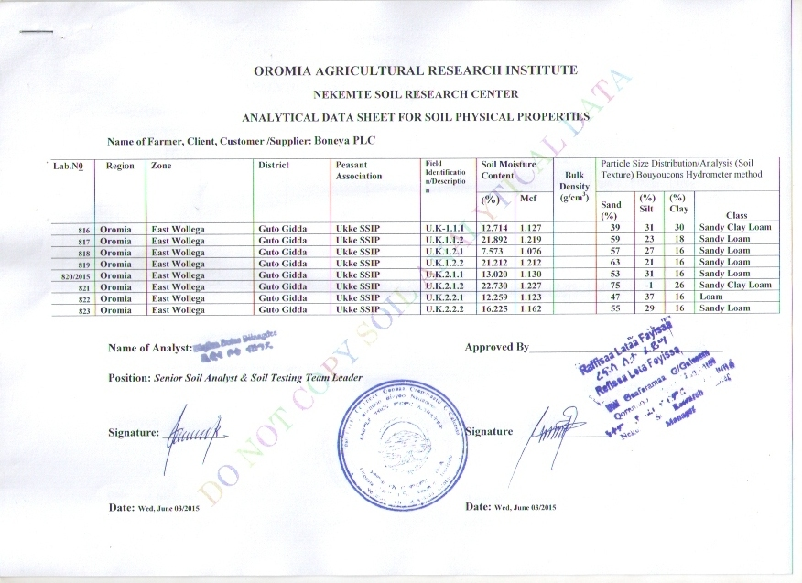

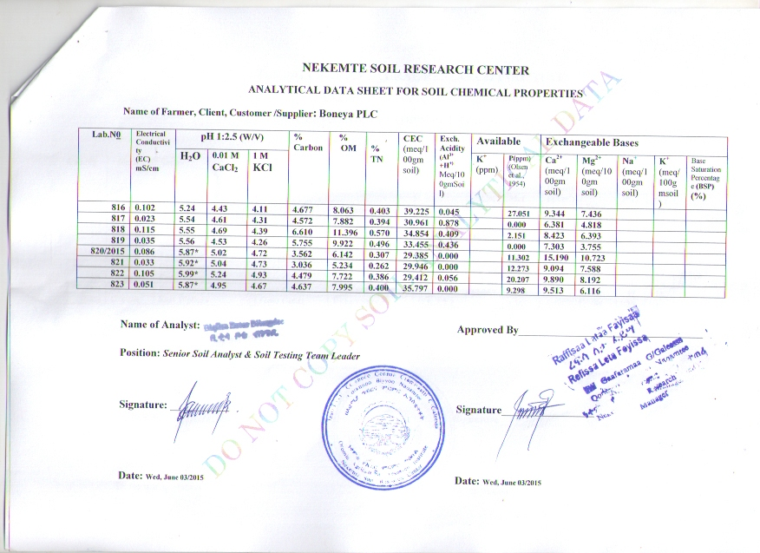

Interpretation of analytical data

a, Soil reaction (PH):- soil unit 1 has got moderately acidic soil reaction of PH 5.4. Soil unit 2 has got moderately acidic soil reaction of PH 5.93.

b, Total Nitrogen:- soil unit 1 has very high total nitrogen content which is 0.5% and also soil unit 2 has very high total nitrogen content 0.35%.

c, Available phosphorus:- soil unit 1 has medium available phosphorus (14.601ppm) in its top soil and low available phosphorus in its sub-soil (Neal) in its sub soil. Soil unit 2 has got high available phosphorus (15.755ppm) in its top soil and also medium available phosphorus in its sub-soil which is 10.785ppm.

d, Organic matter content:- Soil unit 1 has got very high organic matter content which is 9.73% and that of soil unit 2 also has got very high organic matter content which is 6.93%.

e, Texture:- soil unit 1 has got sandy clay loam to sandy loam textural composition and that of soil unit 2 has got sandy loam textural composition.

1.6. Soil profile description and other associated studies

1. Landform: - The land form of soil unit 1 has got undulating micro topography of slope 5-8% and that of soil mapping unit 2 has is mainly gently undulating of slope 2-5%.

2. Altitude range: - The altitude of the two soil-mapping units and/or the entire command area is lies in b/n 1425-1697m above sea level.

3. Micro-relief: - No dominant micro-relief is observed in both the soil-mapping units.

4. Slope shape: - The slope of soil unit 1 is almost convex and that of soil unit 2 is even.

5. Permeability: - The permeability of soil unit 1 is moderately slow and that of soil units 2 is slow.

6. Run off: - As the Topography of soil unit 1 is undulating top graph of slope 5-8% the bare part of soil unit 1 is exposed to runoff during heavy rain season. But due to gently undulating topography of slope 2-5% of soil unit 2 it is free from runoff.

7. Flooding: - Soil unit 1 has no problem of flooding. But, some part of soil unit 2 nearer to Uke river is exposed to flooding exceptionally when river fills up and move out of the embankment.

8. Ground water table: - The ground water table of soil unit 1 is very deep in all seasons. And Most parts of soil unit 2 is seasonally deep (1-2m) ground water table during dry season.

9. Ponding (accumulation of water): - Both soil unit 1 and 2 have no problem of ponding.

10. Erosion status: - Soil unit 1 has got moderate erosion at site and soil unit 2 has no problem of erosion.

11. Rockiness: - There is no rockiness in both the soil unit

12. Vegetation: - very few part of left side soil unit 2 is covered by scattered perennial crops such as banana and Mango.

13. Effective soil depth: - Both units have got very deep effective soil depth

14. Drainage class: - Soil unit 1 has got excessive drainage (class VI) in all seasons. But soil unit 2 has got moderately well (IV) drainage class during rainy season and well drainage (class V) during dry season.

15. Color:- Soil unit 1 has got dusky red (2.5YR3/3) when dry and soil unit 2 has got dominant surface color of Dark grayish brown (10YR4/2) and dark reddish gray (5YR4/2) at some place when dry.

16. Structure: - Soil unit 1 has medium structure and that of soil unit 2 is fine structure.

17. Consistence: - Soil unit 1 has hard, friable slightly sticky and none plastic when dry, moist and wet respectively and it is none cemented. But soil unit 2 has loose, very friable, slightly sticky and none plastic consistence of surface soil when dry, moist and wet respectively and none cemented.

18. Cracks: - The two soil units have no cracks

19. Pores: - Soil unit 1 has got medium sized pores, which are many in number. But soil unit 2 has got fine sized pores.

20. Roots: - The two soil units have few roots of medium size

21. Parent material: - the parent material of the command area is quartz field spastic nice.

1.7 Interpretation of soil survey information for land capability and

Irrigability classification

Based on the combined field and laboratory studies made, soil unit 1 has been classified under capability class III and irrigability class II with the following characteristic.

Sandy clay loam to sandy loam surface texture
Very deep effective soil depth (>2m)
Medium structure
Excessive drainage in all seasons
Moderate to severe erosion status which accelerates the formation of gully in some parts of this soil unit 1 command area
Undulating micro topography of slope 5-8%
Moderately acidic soil reaction of ph 5.4
Very high total nitrogen content of 0.50%
Medium available phosphorus of 14.601ppm
There is moderate to severe erosion problem.

The limitation of soil unit 1 is erosion.
Based on the field and laboratory studies of the soils made soil unit 2 has been classified under capability class I and irrigability class II with the following characteristics.

Sandy Loam surface texture
Very deep effective soil depth (>150cm)
Fine structure
Moderately well drainage class during rainy season and well drainage
Class during dry season
Gently sloping micro topography
Moderately acidic soil reaction of ph 5.93
Very high Organic matter content and total nitrogen content of 9.73% and
6.93% respectively
High available phosphorus of 15.755ppm
Exposed to flooding exceptionally when river fills up and move out of
the embankment

The limitation of this unit is the exceptionally flooding during rainy season.

1.8 Recommendations

As it was verified above soil unit 1 has got undulating micro topography of slope 5-8% it is exposed to moderate to severe erosion besides its bare land of annual crops and no modern conservation activities are observed and erosion is the problem of this soil unit. Therefore to use this soil unit of land for surface irrigation, the necessary integrated soil and water conservation measure should be incorporated to the irrigation project development. Based on this graded soil bunds with water ways have been recommended for this soil unit.

The construction of conservation measures both biologically and physically should be made during the irrigation project construction. The conservation measures which will be constructed should be planted with a type of grass called vet vary grass to stabilize the structures and to prevent gully formation.

The conservation structures are expected to control the erosion problems which will happen during the irrigation water application and the erosion caused by rain water. The structures will also facilitate the infiltration rate of the irrigation water and rain water for plant growth.
The design and specification of the conservation measures should be made included in the design of the irrigation project. As much as possible agro forestry activities should be practiced to the left side of the command area from top to down view.

Soil unit 1 has got very high organic matter content and total nitrogen, medium available phosphorus. Therefore to make the available phosphorus high the half rate of phosphate fertilizer such as Triple super phosphate (ca(H₂po₄)₂) , mono ammonium phosphate ((NH₄)H₂ po₄) and /or Diammonium phosphate ((NH₄)₂H₂po₄) which is commonly used in our country; Each of those mentioned phosphorus fertilizers has phosphorous content of 20%, 26%, and 23% respectively; must be applied.

Note that soil unit 1 has very high total nitrogen thus no need of nitrogenous fertilizers application.

In general together with recommended conservation measures, this unit is suitable for irrigation. Thus, those horticultural and cereal crops which can give good yield in this soil with sandy clay loam to sandy loam texture, moderately acidic soil reaction of PH 5.4 very deep effective soil depth, medium structure and other favorable factors can be selected and recommended for this unit.

As discussed above soil unit 2 of command area has good fertility potential of very high organic matter content and total nitrogen, very deep effective soil depth good workable soil texture which is sandy loam surface texture. Has high available phosphorus and moderately acidic soil reaction. Here from the above mentioned good fertility and productivity status of the soil. It is possible to recommend that the soils are suitable for most horticultural crops. Thus those irrigation crops; which can give good yield on this type of soils can be selected and recommended by an agronomist. As of the top soil of soil unit 2 has high available phosphorous, this soil unit does not need an application of fertilizers.

1.9 conclusions

As described above soil unit 1 is suitable for surface irrigation with the recommended treatments, soil and water management and conservation measures. Soil unit 2 is also suitable for irrigation with almost no limitation.

Based on the studied and described properties of the soil, the necessary irrigation soil and water management should be made for maximum and sustainable production.

Table 4: SOIL PROFILE DESCRIPION SHEET
LOCATION Uke |  | MAPSHEET |  |  |  |  |  |  | Filed No 1
 | MAPPING UNIT 2 |  |  |  |  |  |  | GRIDREF
SUTORCS) |  |  | DATE 20/08/2007 |  |  |  |  | COORDINATES
SOIL CLASSIFCATION(FAO) Alluvial  ST |  |  |  |  |  |  |  | PHASE 1.1
SURROUNDING LAND FORM sloping |  |  |  |  | Rock out crops None
PHYSIOGRAPHIC POSITION SLOPE 8-30% |  |  |  |  |  |  | ELEVATION
MICROTOPOGRAPY gently undulating |  |  |  |  |  | Slope 2-5%
VEGETATION /LAND USE annual field cropping
PARENT MATERIAL Basalt
FLOODING Exceptional |  |  |  | Pounding None |  |  |  |  |  | SEEPAG None
PERMEABLTY Slow DRAINAGE CLASSL IV MOIS COND Moist
SURFACESTNINESS/GRAVEL None
EROSION A, AT SITE None B. SURROUNDING Severe
CRACK A, DEPTH - B, WIDTH – C, FUEQUENCY

HORIZONE DESCRIPTION

HORIZON SYMBOL | 1 | 2 | 3
DEPTHC CM | 0-25 | 25-70 | 70->150
COLOR MOIST  DRY | V. Dark gray (10YR3/1) | Dusky reddish  Gray (10R3/1) | Strong brown (7.5YR5/6)  Reddish yellow (7.5YR6/6)
MOTL/NG | Common | - | None
TEXTURE | Loam | Loam | Clay loam
STRUCTURE/CRACKS | V. Fine | Medium | Fine
CONSIS TENCE  DRY  MOIST  WET | Loose  V. Friable  Slightly sticky & none plastic | Hard slightly  Friable  V. Sticky & plastic | Friable  V. Sticky & V. plastic
CLTAMS/SUKEN SLDES | Common | - | Common
CEMENTATION | None cemented | Cemented | S. Cemented
PORES/BURROWS | Fine | Common | Medium
ROCK FBAGMENT | None | None | None
MINERAL NODULES | - | - | -
CAC0₃ | - | - | -
BOUNDARY | - | - | -
PH(FLELD) | - | - | -
D/AGNOSIC HORIZONES A, SURFACE B, SUBSURFACE
D/AGNOSTIC PROPERTIES DEPH (PABALITIC CONTACT)

Table 5: SOIL PROFILE DESCRIPION SHEET
LOCATION Uke |  | MAPSHEET |  |  |  |  |  | Filed No 2
 | MAPPING UNIT 2 |  |  |  |  | GRIDREF
SUTORCS) |  |  | DATE 21/08/2007 |  |  | COORDINATES
SOIL CLASSIFCATION(FAO) Alluvial  ST |  |  |  |  |  | PHASE 1.2
SURROUNDING LAND FORM sloping |  |  |  |  | Rock out crops None
PHYSIOGRAPHIC POSITION SLOPE 8-30% |  |  |  |  |  |  | ELEVATION
MICROTOPOGRAPY gently undulating |  |  |  |  |  | Slope 2-5%
VEGETATION /LAND USE annual field cropping
PARENT MATERIAL Basalt
FLOODING Exceptional |  |  |  | Pounding None |  |  |  |  | SEEPAG None
PERMEABLTY Slow DRAINAGE CLASSL IV MOIS COND Moist
SURFACESTNINESS/GRAVEL None
EROSION A, AT SITE None B. SURROUNDING Severe
CRACK A, DEPTH - B, WIDTH – C, FUEQUENCY

HORIZONE DESCRIPTION
HORIZON SYMBOL | 1 | 2 | 3
DEPTHC CM | 0-25 | 25-65 | 65->150
COLOR MOIST  DRY | Dark brown  (7.5YR3/3) | Black  (2.5Y 2.5/1) | Reddish fray  (2.5YR7/1)
MOTL/NG | Common | None | None
TEXTURE | Clay | Heavy Clay | -
STRUCTURE/CRACKS | Medium | Medium | Fine
CONSIS TENCE  DRY  MOIST  WET | -  Friable  Slightly sticky & plastic | -  Friable  V. Sticky &  V. Plastic | -  Firm  V. Sticky & V. plastic
CLTAMS/SUKEN SLDES | - | - | -
CEMENTATION | W. cemented | S. Cemented | V.S. Cemented
PORES/BURROWS | Medium | Fine | Medium
ROCK FBAGMENT | None | None | None
MINERAL NODULES | - | - | -
CAC0₃ | - | - | -
BOUNDARY | - | - | -
PH(FLELD) | - | - | -
D/AGNOSIC HORIZONES A, SURFACE B, SUBSURFACE
D/AGNOSTIC PROPERTIES DEPH (PABALITIC CONTACT)
Table 6: SOIL PROFILE DESCRIPION SHEET

LOCATION Uke |  | MAPSHEET |  |  |  |  |  | Filed No 3
 | MAPPING UNIT 2 |  |  |  |  | GRIDREF
SUTORCS) |  |  | DATE21/08/2007 |  |  | COORDINATES
SOIL CLASSIFCATION(FAO) Alluvial  ST |  |  |  |  |  | PHASE 1.3
SURROUNDING LAND FORM sloping |  |  |  |  | Rock out crops None
PHYSIOGRAPHIC POSITION SLOPE 8-30% |  |  |  |  |  |  | ELEVATION
MICROTOPOGRAPY gently undulating |  |  |  |  |  | Slope 2-5%
VEGETATION /LAND USE annual field cropping
PARENT MATERIAL Basalt
FLOODING Exceptional |  |  |  | Pounding None |  |  |  |  | SEEPAG None
PERMEABLTY Slow DRAINAGE CLASSL IV MOIS COND Moist
SURFACESTNINESS/GRAVEL None
EROSION A, AT SITE None B. SURROUNDING Severe
CRACK A, DEPTH - B, WIDTH – C, FUEQUENCY

HORIZONE DESCRIPTION

HORIZON SYMBOL | 1 | 2 | 3
DEPTHC CM | 0-25 | 25-90 | 90->150
COLOR MOIST  DRY | V. Dark gray (5YR3/1)  Dark reddish gray (5YR4/2) | Reddish black  (10R2.5/1) | Strong brown (7.5YR5/6)
MOTL/NG | Common | - | -
TEXTURE | Loam | Loam | Clay loam
STRUCTURE/CRACKS | V. Fine | V. Fine | Fine
CONSIS TENCE  DRY  MOIST  WET | Loose  V. Friable  Slightly sticky & none plastic | loose  Loose  Slightly Sticky & plastic | Friable  V. Sticky & V. plastic
CLTAMS/SUKEN SLDES | - | - | -
CEMENTATION | None cemented | W. Cemented | S. Cemented
PORES/BURROWS | Fine | Fine | Medium
ROCK FBAGMENT | None | None | None
MINERAL NODULES | - | - | -
CAC0₃ | - | - | -
BOUNDARY | - | - | -
PH(FLELD) | - | - | -
D/AGNOSIC HORIZONES A, SURFACE B, SUBSURFACE
D/AGNOSTIC PROPERTIES DEPH (PABALITIC CONTACT)

Table 7: SOIL PROFILE DESCRIPION SHEET
LOCATION Uke |  | MAPSHEET |  |  |  |  |  | Filed No 1
 | MAPPING UNIT 1 |  |  |  |  | GRIDREF
SUTORCS) |  |  | DATE18/08/2007 |  |  | COORDINATES
SOIL CLASSIFCATION(FAO) Fluvisol  ST |  |  |  |  |  | PHASE 1.4
SURROUNDING LAND FORM sloping |  |  |  |  | Rock out crops None
PHYSIOGRAPHIC POSITION slope 8-30% |  |  |  |  |  |  | ELEVATION
MICROTOPOGRAPY undulating |  |  |  |  |  | Slope 5-8%
VEGETATION /LAND USE annual & perennial cropping
PARENT MATERIAL Basalt
FLOODING None |  |  |  | Pounding None |  |  |  |  | SEEPAG None
PERMEABLTY Med. Slow DRAINAGE CLASSL VI MOIS COND dry
SURFACESTNINESS/GRAVEL None
EROSION A, AT SITE Moderate B. SURROUNDING Severe
CRACK A, DEPTH - B, WIDTH – C, FUEQUENCY

HORIZONE DESCRIPTION

HORIZON SYMBOL | 1 | 2
DEPTHC CM | 0-20 | 20->150
COLOR MOIST  DRY | Dusky red (2.5YR3/2) | Dark red  (2.5YR3/6)
MOTL/NG | Common | None
TEXTURE | Loam | Loam
STRUCTURE/CRACKS | Fine | Medium
CONSIS TENCE DRY  MOIST WET | Hard Friable  Slightly sticky & none plastic | V. Hard Firm  Slightly sticky & none plastic
CLTAMS/SUKEN SLDES | - | -
CEMENTATION | None cemented | W. Cemented
PORES/BURROWS | Medium | Very fine
ROCK FBAGMENT | None | None
MINERAL NODULES | - | -
CAC0₃ | - | -
BOUNDARY | - | -
PH(FLELD) | - | -
D/AGNOSIC HORIZONES A, SURFACE B, SUBSURFACE
D/AGNOSTIC PROPERTIES DEPH (PABALITIC CONTACT)

