

THE NATIONAL REGIONAL STATE OF OROMIA

OROMIA IRRIGATION DEVELOPMENT AUTHORITY

AGRICULTURAL GROWTH PROGRAM (AGP II)
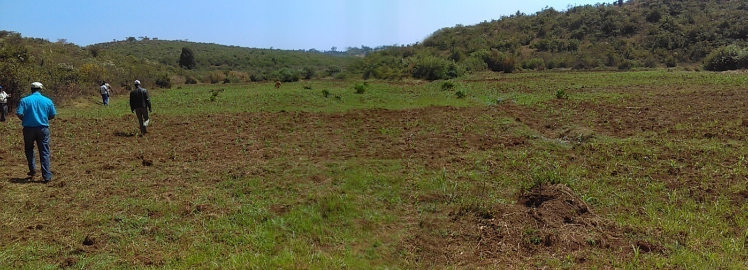
Lot Nine of Eighty Small Scale Irrigation Projects Feasibility Study and Detail Design
Volume I & II: Socio-Economic; Financial & Economic Analysis; and
Community Organization & Management Studies of Birbirsa Small Scale Irrigation Project
March 2019
Final
Finfinne
 AYJEF Water Woks and P.O.Box: 43329 Tele: +251 911 304019
Business Service PLC E-mail: ayconsult1@gmail.com

Table of Contents

Table of Contents Page

1. INTRODUCTION 1
1.1. General Background of the Study 1
1.2. The Study Frameworks 2
1.3. Major Tasks of the Study 2
1.4. Organization of the Report 2
PART ONE 3
2. THE SOCIO-ECONOMIC STUDY 3
2.1. Objectives of the Study 3
2.2. Project Rationale 3
2.3. Scope of the Study 4
2.4. Limitation of the Study 4
2.5. Methodology of the Study 4
2.5.1. Data Collection Methods 5
2.5.1.1. Primary Data Collection Methods 5
2.5.1.1.1. Sample Household Survey 6
2.5.1.1.2. Key-informant Interview (KII) 6
2.5.1.1.3. Focus-group Discussion (FGD) 7
2.5.1.1.4. Formal Discussion 7
2.5.1.1.5. Observation 7
2.5.1.2. Secondary Data Collection Methods 7
2.5.2. Data Processing and Analysis 8
2.5.2.1. Quantitative Analysis 8
2.5.2.2. Qualitative Analysis 8
2.6. Review of Existing Policies and Legal Frameworks 8
2.6.1. The Water Sector Policies and Strategies 9
2.6.2. The Agriculture Sector Policies and Strategies 9
2.6.3. Implementation Capacity Building 10
2.6.4. Gender Policy 11
2.6.5. Population Policy 11
2.7. Description of Project Area and Location 12
2.7.1. Guutoo-Giddaa District 12
2.7.2. The Project Command Area 13
2.8. Population of the Project Area 14
2.8.1. Demographic Characteristics 14
2.8.1.1. Current Population 14
2.8.1.1.1. Age Group of the Population 15
2.8.1.1.2. Settlement and Migration 16
2.8.1.2. Projected Population 16
2.9. Economic Bases of the Project Area 18
2.9.1. Agriculture 18
2.9.1.1. Crop Production 19
2.9.1.2. Livestock 21
2.9.1.3. Off-farm Activities 22
2.10. Food Security Situation in the Project Area 22
2.11. Land Use Pattern and Landholding Size 22
2.11.1. Land Use Pattern 22
2.11.2. Landholding Size of Households 23
2.11.3. Possession of Oxen by Households 23
2.12. Marketing Conditions of Agricultural Inputs & Outputs 24
2.12.1. Marketing of Project Inputs 24
2.12.2. Marketing of Project Outputs 25
2.13. Agribusiness Opportunity and Potential 26
2.14. Gender Analysis 26
2.15. Availability of Construction Materials 27
2.16. Infrastructure & Social Services 27
2.16.1. Social Services 27
2.16.2. Electricity Services 28
2.16.3. Communication Services 28
2.16.4. Road Infrastructure 28
2.16.5. Financial and Credit Institutions 28
2.17. Development Opportunity & Constraints 29
2.17.1. Constraints 29
2.17.2. Potentialities 29
2.18. Project Benefits 30
2.18.1. Direct Economic Benefits 30
2.18.2. Indirect Economic Benefits 30
2.19. Social Impacts & Mitigation Measures 30
2.20. The Household Survey Result 31
2.20.1. The Beneficiary Community 31
2.20.2. Agriculture-based Activities 32
2.20.2.1. Crop Production 33
2.20.2.2. Animal Husbandry 33
2.20.3. Household Income & Expenditure in the Project Area 38
2.20.3.1. Household Income in the Project Area 38
2.20.3.2. Household Expenditure in the Project Area 39
2.20.4. Social Services in the Project Area 40
2.20.4.1. Education Services in the Project Area 40
2.20.4.2. Health Services in the Project Area 41
2.20.4.3. Water Supply and Sanitation Services in the Project Area 43
2.20.5. Transportation, Communication & Financial Services in the Project Area 44
2.20.6. Socio-cultural Issues in the Project Area 44
2.20.7. Informal & Formal Community Organizations 45
2.20.8. Community Attitude towards the Project 45
2.20.9. Gender Issues 45
2.20.10. Claim for Compensation 46
2.20.11. Problem of Food Insecurity 46
2.20.12. Occurrence of Conflicts & Resolution Mechanisms 46
2.21. Summary of Socio-economic Study 50
PART TWO 52
1. COMMUNITY ORGANIZATION AND MANAGEMENT STUDY 52
1.1. Introduction 52
1.1.1. Objective 52
1.1.2. Scope 52
1.1.3. Approach and Methodology 53
1.2. Review of Literatures 53
1.3. Existing Irrigation Scheme Management Structures 55
1.4. Community Participation & Attitude towards the Project 56
1.5. Scheme Management & Stakeholders Involvement 57
1.5.1. Community Contribution and Scheme Management 57
1.5.2. Stakeholders Involvement 58
1.5.2.1. The Need for Agricultural Extension Services 58
1.5.2.1.1. Irrigation Practices Improvement 59
1.5.2.1.2. On-farm Development (Land Preparation) 59
1.5.2.1.3. Actual Conditions of Agricultural Extension Services 60
1.6. Irrigation Land Distribution and Re-distribution 60
1.7. Monitoring and Evaluation (M & E) 61
1.8. Summary of Irrigation Scheme Organization and Management Study 61
PART THREE 63
1. FINANCIAL AND ECONOMIC ANALYSIS 63
1.1. The “Without-project” Situation 63
1.1.1. The Existing Cropping Patterns and Yield 63
1.1.2. Cost of Production of the Proposed Cropping System 63
1.1.3. Returns from the Proposed Crops without the Project 64
1.2. The With-project Situation 65
1.2.1. Actual & Projected for the Proposed Crops 65
1.2.2. Development of Irrigation Agriculture 66
1.2.3. Land Allocation & Crop Pattern and Intensity 66
1.2.4. Cost Estimation 68
1.2.5. Returns from the Proposed Crops 69
1.3. Result of the Cost-Benefit Analysis 70
1.4. Sensitivity Analysis 71
4. CONCLUSION AND RECOMMENDATION 74
Annexes Error! Bookmark not defined.
Annex 1. Minutes of Community Meeting and Petition Error! Bookmark not defined.
Annex 2. Sample Command Areas and Community Consultation 84
Annex 3. HH Survey Questionnaire 85
Annex 4. Focus Group Discussions Checklists 94
Annex 5. Checklists for Key-informants Discussion 94
Annex 6. Project Implementation Schedule 98

List of Tables
Table 1. Crop productivity level to be attained by the end of GTP-II 10
Table 2: Comparison of population for district, Kebele & project area 15
Table 3: Age group of the population of the district by areas of residence 15
Table 4. Urban Population Growth Rates by Region 16
Table 5. Rural Population Growth Rates by Region 17
Table 6: Projected population at the medium growth rate variant 17
Table 7: Trend of land cultivated and crop yield under rain-fed and irrigation production methods (2005-20010 E.C) 20
Table 8: Existing cropping pattern and yield of irrigated crops at Nagassa Kebele, 2009/10 E.C 21
Table 9: Livestock population of the district 22
Table 1: Land Resource by Use 22
Table 11: Possession of oxen by households 24
Table 12: Trend of input utilization in the district 24
Table 13: Input utilization rate (2009/10 E.C) 25
Table 14: Estimate of population size of Naqamtee city by sources 25
Table 15: Number of schools in the district and Kebele 27
Table 16: Number of health institutions in the district and Kebele 28
Table 17. Household characteristics 31
Table 18. Agriculture based activities of the community 35
Table 19. Household income of the community 38
Table 20. Estimated Annual Income of HH from Different Sources 39
Table 21 Estimated Annual Expenditure of HH by Items 39
Table 1. The state of education service in the project area 40
Table 23. Health service evaluation of the project area 42
Table 24. Water supply evaluation of the project area 43
Table 25. Transportation activities of the project area 44
Table 26. Evaluation of community attitude towards the project 48
Table 27. Monitoring and evaluation plan of the project area 61
Table 28: Average Yield and Market Price of the Proposed Crops Against Cost of Production Per Hectare 63
Table 29: Average Variable Costs of Production Per Hectare for Proposed Crops 64
Table 30: Benefit from the Proposed Crops Without the Project (WOP) 65
Table 31: Actual and Projected Yield for Proposed Crops 65
Table 32: Proposed Crop Pattern and Intensity 67
Table 33: Estimated Cost of Crop Production 68
Table 34: Estimated Investment and Other Costs 68
Table 35: Projected Returns from the Proposed Crops 69
Table 36: Projected Production Costs and Returns for the Proposed Crops 69
Table 37: Cost-Benefit Analysis of the Proposed Project 70
Table 38: A 5% increase in the cost stream and no change in the benefit stream 71
Table 39: A 5% decline in the benefit stream and no change in the cost steam 72
Table 40: A 5% decline in the benefits and a 5% increase in cost 73

List of Figures
Figure 2: Research Approach and Tools 5
Figure 3: Partial view of Lake Sorga, Nekemte February 2018. Figure 4: A snapshot of Loko River 29
Figure 5: Model Irrigation Scheme Management Structure 56

Acronyms
AGP Agricultural growth program
AYJEF AYJEF PLC
BCR Benefit-cost ratio
Br Birr (Ethiopian Birr)
CIS Corrugated iron sheet
CSA Central Statistical Agency
DA Development agent(s)
E.C Ethiopian calendar
EFY Ethiopian fiscal year
ESP Environmental Support Project
FA Farmers’ Association
FGD Focal-group discussion
FTC Farmers’ Training Center
GA General Assembly
GTP-I Growth & Transformation Plan One
GTP-II Growth & Transformation Plan Two
Ha (ha) Hectare
HH Household
HIV/AIDS Human immune virus/acquired immune deficiency syndrome
IWUA Irrigation water users’ association
KG Kindergarten
KII Key-informants’ interview
km kilo meter
M & E Monitoring and evaluation
NGOs Non-governmental organization(s)
NPV Net present value
OIDA Oromia Irrigation Development Authority
PIDM Participatory irrigation development management
Qt (qt) Quintal
SDG Sustainable development goal
SPSS Statistical package for social scientists
SSIP Small-scale irrigation project
STD Sexually-transmitted diseases
TB Tuberculosis
T & V Training and visit
UNDP United Nations development program
USAID United States Agency for International Development
WIDA Woreda Irrigation Development Authority
ZIDA Zone Irrigation Development Authority

Executive Summary
Birbirsa small-scale irrigation development project has been envisaged to be implemented in East-Wollagga Zone, Guutoo-Giddaa District, Nagaasaa Kebele on Laga-Birbirsa River by OIDA, the owner of the project, with AGP fund. The objective of the project is to introduce modern irrigation practice at the smallholder farm level and to enable the smallholder farmers to produce more food crops thereby to meet household food security and bring additional income. The implementation approach is through PIDM with direct participation and management by the user community. As identified in the feasibility study and detail design of the project, a net command area of 51 hectare of land to be developed and to serve 85 smallholder farmer households (79 male-headed and 6 female-headed households).

As part of the feasibility study and detail design of the project, the socio-economic study, institutional setup study or organizational management arrangement for the irrigation scheme economic and financial analyses have been conducted. These studies have been done through discussion: with the would-be user community; the implementing irrigation development authority at all levels, administration offices, sector offices and stakeholders; direct observation to the project areas by the study team; and sample household survey.

The livelihood of the community is predominantly based on mixed economic activities: crop production and livestock rearing. Other means of making a living in the area includes forest, apiculture, and very intermittent daily labor.

The community has an age-long experience of producing crops under rain-fed and “Bonee” method. They produce crops only once year using rain water except that some farmers use Bonee or traditional furrow irrigation method to produce a limited range of crops in a small amount. They also keep few livestock for milk, meat, egg, plowing, transport, sale, etc. The per capita land size and its fertility status/carrying capacity or productivity is on a declining trend. Here, the irrigation project is necessary to enable the user community to produce a wider range of crops, to grow forage for animals when rain is scarce, and to make efficient utilization of slack or idle labor during the dry season of the year.

The potential opportunity for the operations of farming industry and businesses is minimal for these types of small-scale irrigation farms. Rather agri-business, the opportunity can be seen from other angles such as agro forestry, apiculture, access roads construction to the project sites whose lack is currently a bottle neck constraint for the community to deliver its agricultural products to the local market for sell and transport farm inputs to their villages.

The irrigation project is very important to the user community in particular and consumers in general in contributing to bringing about improved nutritional status and food security. Thus, it is likely to result in more financial income for the beneficiary households, and better efficiency in the utilization of scarce economic resources.

The project is viable by all criteria of evaluation: financial, economic, technical and institutional. The NPV is positive and The BCR is greater than 1 (one).

The community is eager to adopt and use the irrigation project and willing to cover operation and maintenance cost. The existing management structure is very weak although the community has certain experience of using Bonee or traditional furrow irrigation. Thus, they need to be more organized and supported (institutional, technical, legal) like land allocation, water use, credit arrangement, farm input supply, agronomic practice, etc.

Introduction

General Background of the Study
Oromia has 63 river systems and 688 tributary streams, which annually discharge 58 billion cubic meters of surface water, the equivalent of half the nation’s surface water resources. Despite the large water resources potential, Oromia’s agricultural sector is almost entirely dependent on rain-fed farming. Irrigated agriculture constitutes just less than 5 percent of the potential and about 2.14 percent of the total cultivated land. The implication of these figures is that irrigated agriculture has to go a long way before it can make a significant contribution towards regional food security. In Oromia Region, it is said that out of the estimated 1.7 million ha of potential irrigable land, only about 5% of the potential or 85,400 ha has been developed so far. The modern irrigation practice in many places has been introduced as late as mid 1980’s when there was a country-wide drought affecting huge number of population (OIDA Website).
The Oromia National Regional State had established the Oromia Irrigation Development Authority (OIDA), an independent public body, for undertaking the study, design and construction of irrigation projects in suitable areas and operating the schemes to contribute towards hastening the socio-economic development of the rural community through participatory irrigation development management (PIDM) approach, which helps the community take part in all stages of a project. To overcome food insecurity problems in the region, OIDA is closely working with international financiers under the Agriculture Growth Program (AGP). The main funders of this program are UNDP, the World Bank Group, USAID, the Netherlands Government, etc., through a pooled-funding mechanism. The program has three components: Agricultural Production and Commercialization; Small-scale Rural Infrastructure Development and Management; and Project Management, Monitoring and Evaluation as well. The main intervention areas of the AGP are increasing agricultural productivity, commercialization of smallholder farmers and contributing to nutritional diversity and consumption at household (HH) level thereby to secure better livelihood for the rural poor through expanding the pace of irrigated-agriculture development.
In its five-year plan, OIDA has incorporated 105-120 projects in Oromia under AGP-II. In 2010 EFY, about 80 SSIP comprising 6,286.53 ha of lands and 13,279 user households were planned and awarded for studies, and design. As part of this plan, an agreement was signed between OIDA (the Client) and AYJEF Water Works and Business PLC (the Consultant) for feasibility study and detail design of Lot-9 (Lega-Birbirsa, Gora’a, Kolasa, Beseka, Chirecha-Bora, and Dosa) small-scale irrigation development projects. Later, up on site visit by the study team and project owners (zone and district), Gora’a and Dosa have been replaced by other sites: Madda-Jalela or Ukkee (Zone-3) and Maqa sites, respectively.

The Study Frameworks
The major tasks of the feasibility study and detail design AGP-II SSIP include physical (land topography, soil texture, consistency, structure, profile and depth, salinity and drainage; water resources accessibility, quantity and quality; climate and crop top or root watering crops, shallow-rooted crops, etc., capital and labor availability and cost) conditions, and socio-economic and institutional aspects, environmental situations, etc.

Major Tasks of the Study
As part of the feasibility study and detail design AGP-II SSIP, the focus of this particular section is devoted to the study of the socio-economic aspects of the project area, institutional arrangement for the irrigation scheme, and financial and economic analyses. Commonly, the study of the socio-economic aspects includes the project background, location descriptions, and scopes of the assessment, existing conditions, project suitability and its impact on human life, settlement, occupations and other issues. The institutional setup study is undertaken to put a management or organizational arrangement for the irrigation scheme to be managed by the user community. The economic and financial analyses are also conducted to know the returns and benefits generated by the project during its life time.

Organization of the Report
This draft report presents the study of socioeconomic aspects of the project area, institutional setup for irrigation scheme management in two consecutive parts followed by the financial and economic analysis part prepared based up on the detail feasibility and engineering report of the study. Finally, conclusion and annexes of other materials have been included.

PART ONE

The Socio-economic Study

Fundamentally, the study of the socio-economic study begins and ends with participatory irrigation development management (PIDM) approach where more involvement and decision-making of the user community is to be exercised. These aspects are the roots of the objectives and methodologies of the study. The project suitability, institutional viability, environmental sustainability, economic and financial soundness are all a function of user community participation and knowledge.

Objectives of the Study
The general objective of the study is to investigate the current socio-economic aspects, and organizational setup in line with the development project intended to be launched in the area, and come up with sound conclusion and recommendations to facilitate the smooth implementation of the project. The specific objective of the study to:
- Investigate the social, economic, institutional, cultural and attitudinal issues in relation to the development project,
- Identify the positive and negative impacts of the project on the population in the project area and recommend mitigation measures for smooth implementation of the project
- Forward possible solutions to minimize the problems related to displacement and relocation of the people, if any, in the project area.

Project Rationale
The rationale for the project is to advance socio-economic progress and enhancement of food security, employment creation, income generation and improvement in the nutritional status of the community and reduction in extreme poverty through accelerated irrigation and drainage development; and utilization of limited resources efficiently in the project area.

Scope of the Study
The scope of this study covers review of issues and aspects related to the project, among other things, policy and legal issues; existing situations: demographic characteristics in the command area; identifying major economic activities` (livelihood forms); the settlement pattern and housing condition; social service availability and accessibility; assessment of the situation of public utilities in the area and economic infrastructures and institutions; exploring the socio-cultural aspects including gender and related issues; investigating the possible economic, social and other related impacts of the project on the community in the area and their mitigation measures. Moreover, the scope of this study covers the review of previous studies and conducting additional study on the remaining issues project to update the data based on the ToR. The scope of this study also covers confirmation of the previous identification or reconnaissance survey or pre-feasibility study conducted by OIDA and feasibility study and detail design for construction of the project.

Limitation of the Study
As specified in the TOR, the pre-feasibility study conducted by OIDA was not found or inadequate where available. Finding basic data from sectors was also difficult because most of the stakeholders including officials and experts were largely pre-occupied with handling security issues during the study; and consequently, restricted movements to the project site or within the zone in general contributed to difficulty in data collection. Therefore, previously-recorded data and computed results as well as repetitive field re-visits have been used to fill the gaps.

Methodology of the Study
The methodology and procedures adopted for this study to achieve the stated objectives include sampling design; determination of sample size, sources of data, and methods of data collection employed in the main survey and data-processing tools. The major issues and study variables on which data/information were collected had been identified based on the Terms of Reference provided by the client. Key Information required on each of the variables from different sources had also been identified. Data collection was done through field observation, consultation and discussion with various concerned groups, and sample households survey.
Accordingly, both primary and secondary data were collected from relevant and/or available sources. The sources of primary data are households, community members, experts in the field, key informants, officials in government offices and other relevant entities in the project area. On the other hand, secondary data were collected from different sources such as performance reports, previous studies, etc. The methodologies applied in collecting the data required from the different sources, data management, data analysis and reporting are outlined below.

Data Collection Methods

Primary Data Collection Methods
Two distinct methods: quantitative and qualitative approaches were employed in primary data collection for the study of this particular irrigation development project. A quantitative approach relies on numbers, figures, and other empirical statistical figures whereas a qualitative approach entirely focuses on the subjective occurrence of a given entity; like, peoples’ attitudes, feelings, comments, local social organization and their appearances.
Thus, in quantitative data collection sample household survey was undertaken using structured questionnaires (annexed to this document). In qualitative data collection focus-group discussion, key-informants interview and direct-field observation were employed as the figure below shows.

Figure 1: Research Approach and Tools

Sample Household Survey
Sample household survey was conducted to collect data from farm households in the project command area – direct beneficiary. This involves the identification of the total number of the would-be user households (male-headed and female-headed), the determination and selection of sample of the households both from the male-headed and female-headed households to be included in the survey, developing data-gathering tools, determining methods of acquiring information from the sample households, identifying and selecting enumerators.
The method of probability sampling was used in selecting the sample households in the survey. Accordingly, the method of stratified simple random sampling was used. For this, the sample households were listed and stratified into male-headed and female-headed based their gender patterns. Then the lottery method was employed independently for the male-headed and female-headed households for random selection of at least 10% of them to be given an equal chance.
A structured household survey questionnaire was used as data-gathering tool for the survey based on the issues, the study variables and data requirements identified such as socio-cultural, language and livelihood of the command area community.
Information or data were collected from the sample households using the personal interview method. For this, enumerators were recruited. The enumerators were development agents (DA) working in the Kebele or district community participation promotion experts. Accordingly, one-day training was provided to the enumerators on the data collection tools and approach, and finally, coding, encoding and the cleaning the data.

Key-informant Interview (KII)
The second method of primary data collection designed is the Key-informant Interview (KII). In each Kebele, at least 2 KII were conducted. The Key informants were selected from the resident households, Kebele leaders, DA, and/or relevant government employees residing in the Kebele as required. They were identified through gathering pre-hand information on who among the residents of the Kebele have full information about the situations. Semi-structured questionnaires were employed in gathering information from the key informants.

Focus-group Discussion (FGD)
One focus-group discussion was held in each Kebele/Woreda on pre-identified issues and variables using checklists as data-gathering tools. Focus-group discussion participants were selected from different social groups including elders, women, youth, etc. The Kebele officials had assisted in organizing the focus-group discussions. The focus-group discussants were made discuss on the issues openly, and, important notes were taken from the discussions.

The theme of discussion points revolve around the main source of livelihood of the community; bottleneck economic, social and environmental problems in the area; availability of social services and infrastructures; development potential, opportunity and constraints, prevalence of conflicts on the use of common resources and resolution mechanisms; and the wider attitude of the whole community and beneficiaries toward the project as well as possible fate of the project.

Formal Discussion
Formal discussions were conducted with Kebele leaders, DAs, health-extension workers, school leaders, and with relevant officials and experts in the district offices. Checklists were also developed for leading discussions to be held.

Observation
Personal observations were made to collect information on different issues identified. These were done through conducting visits to different localities in the command area, diversion weir site; down-and-upper stream users’ areas, and the right and left banks of the rivers by taking pictures and taking field notes.

Secondary Data Collection Methods
Different relevant and available data sources such as study documents, reports, the Internet and other documents were reviewed to substantiate and enrich the socio-economic study carried out the target the project areas. In this regard, different socio-economic, financial and institutional arrangements reports pertaining to this study were reviewed. In addition, checklists were used to collect recorded/existing data from respective sector offices of the districts or where the irrigation project sites located. Accordingly, at least ten sectors offices were selected and secondary data from were collected there from.

Data Processing and Analysis
Both quantitative and qualitative methods of data analysis were employed. The quantitative analysis was used in examining the sample survey data and numerical data collected from secondary sources. The qualitative analysis, on the other hand, was used to assess and explain the information collected through focus-group discussions, key-informant interviews, personal observations and formal discussions held.

Quantitative Analysis
The survey data collected were coded and encoded into SPSS software and analyzed based on the objective set out. That is, the data were analyzed using descriptive, frequencies and ratio (percentage) methods. The data analysis results were displayed in tables, charts and graphs; and then exported to Microsoft Excel Spreadsheet for display. Moreover, numerical secondary data obtained from different sources were analyzed using descriptive methods of analysis. The results of the analysis will be presented in tables and graphs and charts, etc.

Qualitative Analysis
Data collected through FGDs, KIIs, formal discussions and personal observations were qualitatively analyzed. This was done through organizing the information gathered from different sources on each variable and by triangulating the information from different sources and consolidating the central idea/concept that these data commonly contain.

Review of Existing Policies and Legal Frameworks
To provide basis for the overall study of the project, reviews of existing policies, strategies and regulations as well as legal frameworks pertinent to the subject have been undertaken. In this regard, the provisions of the second Growth and Transformation Plan GTP-II, May 2016) policies and strategies have been incorporated into this document. As a vehicle towards the realization of Ethiopia’s national vision of becoming a lower-middle-income country by 2025, the GTP-II (2015/16-2019/20) transformation agenda is built on sector policies, strategies and programs, and the post-2015 global sustainable development goals (SDG) as well.

The Water Sector Policies and Strategies
The development policies and strategies of the water sector put a firm emphasis on efficient utilization and development of water resources, flood and drought control and mitigation efforts as priorities. An integrated water resource development and utilization focuses on the parallel usage of water supply, irrigation development, watershed management and water infrastructure development activities. In addition, water resources management will be geared into complementary sectors such as agriculture, health, mining, energy, etc., cross-cutting sectors like capacity building, environment, gender, etc.

The Agriculture Sector Policies and Strategies
One of the 10 (ten) strategic policy frameworks of the GTP-II that are directly linked to this project and to be pursued and given utmost emphasis and priority is that agriculture will remain the main driver of the economic growth and development. Thus, the strategic directions to be pursued for Agriculture and Rural Transformation:
- Development of smallholder crop and pastoral agriculture as the main source of growth and rural transformation;
- All-rounded support to educated youth to enable them organize and engage in agriculture investment;
- Provision of the necessary support to domestic and selected foreign investors to participate in transformative agriculture sub sectors;
- Implementation of the scaling-up strategy as suitable to the various agro-ecological development zones; and
- Holistic measures aimed at addressing constraints and challenges related to supply of agricultural inputs and utilization of agricultural technologies.
The strategic directions to be pursued generally render ensuring sustainable agriculture coupled with expansion of irrigation development, natural resource conservation and management, efforts to improve benefits to the community through strengthening biodiversity conservation, enhancing the income of farming households through progressive transition from producing subsistence crops into high-value crops, putting in place more effective and efficient agricultural marketing system thereby to assess and ensure that the marketing system integrates farmers and cooperatives, and enabling the youth and women in rural areas.
Thus, the underlying principles of the GTP-II for agricultural development are maintaining environmental sustainability, promoting climate change adaptation and mitigation, broad-based and inclusive growth, with a particular focus on engaging women, youth and poor households. The GTP-II was formulated around three high-level objectives for the agriculture sector:
- bring about accelerated and sustained growth of agriculture within the framework of the “Climate Resilient Green Economy Strategy”;
- bring about a significant shift in agricultural productivity, build productive capacity and thereby enhance the contribution of the sector to the economy;
- Enable women, youth and other stakeholders to participate and contribute their part and benefit from the development outcomes.

To achieve these objectives major targets within the crop farming and pastoral development sub-sectors of agriculture are:
- Increased crop productivity and production: to raise the productivity level of the majority of smallholder farmers to the productivity level attained by model farmers (as shown in the table 1 below) augmented by enhanced cooperative capacity and efficiency, and reduced pre-and-post-harvest losses.
Table 1. Crop productivity level to be attained by the end of GTP-II
Table 2.1:
No. | Type of Crops | Average Productivity (qt/ha) |  | Incremental Change (%)
No. | Type of Crops | Base (2014/15) | Target (2019/20) | Incremental Change (%)
1 | Stalk cereals | 29.00 | 42.64 | 47.03
2 | Non-stalk cereals | 21.10 | 31.00 | 46.92
3 | Pulse crops | 17.20 | 23.00 | 33.72
4 | Oilseed crops | 9.00 | 12.70 | 41.11
5 | Coffee | 7.48 | 11.00 | 47.06
- Increased livestock production and productivity: the central elements here are promoting the adoption of improved livestock husbandry practices/technologies, feed production technologies, and livestock health system.
- Reduced degradation and improved productivity of natural resources: Watershed development, irrigation development, forestry development (or agro-forestry) and bio-diversity conservation.
- Enhanced food security at national and household level: enhanced food security, strengthening disaster prevention and response ability as well as ensuring adequate and timely transfers and promoting resilience among chronically food insecure households; and nutrition.

Implementation Capacity Building

The implementation capacity building activities during the GTP-II period is that systems will be established for plant protection, animal health and quality control, agricultural input supply and credit services, coffee development extension, urban agriculture, rural youth employment generation, out-growers schemes, contract agriculture, and agricultural product marketing. There should also be proper management and administration of development projects with enhanced project planning and management capacity in place.

Gender Policy
Women and youth account for the majority of the entire population in Ethiopia. Hence their participation and influence has to be commensurate with their size. However, the organizational and leadership capability of women and youth has not yet reached the desired level. Besides, there is also difference in the strength and participation of women and youth organizations from place to place and sector to sector. GTP-II has accorded organized participation of women and youth groups at the grassroots level in rural areas to enable them to play a leading role, for instance, in promoting participatory-agricultural development and equity in their respective villages. There is also a well-documented effect of participation of women groups in promoting maternal and child health, enhancing the quality and equity of primary health care delivery, as well as strengthening accountability in the health sector throughout the country.
Three strategic directions for women and youth empowerment during the GTP-II: (i) Strengthening women and youth organizations; (ii) Ensuring the active participation of these organizations in the development and governance programs, and ascertaining equity in benefiting women and youth from the resultant outcomes; (iii) Establish coordination of these organizations with other concerned bodies working in women and youth affairs at all levels.

Population Policy

The main goal of population policy of Ethiopia is to balance the rate of population growth with economic growth and to maximize the welfare of the population over time. The main objectives of the sector are to maintain the declining trends of fertility; to create balancing situation between demographic variables and social, economic and environmental goals; to make population and development data more accessible for preparation of reliable development plans and subsequent monitoring and evaluation at all levels; and to strengthen the participation of NGOs and civil societies in development activities. To realize the objectives stated in the policy, the major strategic directions are integration of population activities into sector development plans, coordinating its implementation and enhancing access and utilization of population data, strengthening family planning services and women’s participation.

Description of Project Area and Location

Laga-Birbirsa small-scale irrigation project (SSIP) is intended to be constructed on Laga-Birbirsa River in Nagaasaa Kebele of Guutoo-Giddaa District.

Guutoo-Giddaa District

Guutoo-Giddaa District is one of those 17 districts in East-Wallagga Zone and its capital is Naqamte City, which is also the capital of the zone. The district is divided into 20 rural Kebeles and 3 urban centers. Guutoo-Giddaa District is bounded by Gidda Ayyana and Gudayya-Bila districts in the north; Digga, Limmu and Sasigga districts in the west; Laqa-Dullacha and Wayyu-Tuqa district in the south; and Gudayya-Bila, Sibu-Sire and Wayyu-Tuqa district in the east. Guto-Gidda District has a total area of 105,750 hectares and is located between 8057'40"- 9030'55"N latitudes, and 36026'25" - 36044'20"E longitudes, extending for about thirty-three minutes (33') north to south or vice versa and about eighteen minutes (18') east to west or vice versa. Guutoo-Giddaa is divided into three distinct agro-climatic zones; namely, highland 0.26 percent, the midland 46.74 percent and lowland 53.00 percent.

The land is characterized by ups and downs like the other districts bordering it with the exception of Ukke and Loko areas. Dalo and Arruu mountains have altitude of 2,270 meters and 2,200 meters above sea level, respectively. There are other hills: Loko 2,160 meters, Ongorcha 2,200 meters and Mootee 2,200 meters above sea level. The dominant climatic condition is a sub-tropical type. As a result, the area experiences a mean annual temperature of slightly greater than 160C and mean annual rainfall of 580 to 2,200mm per annum.

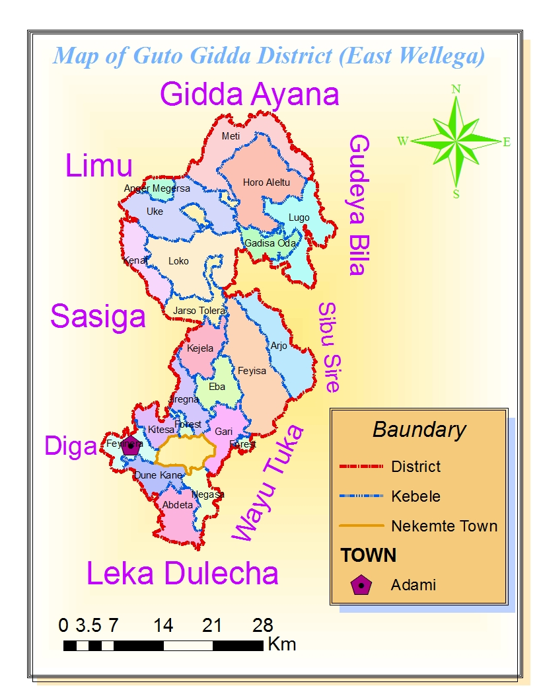
Source: Regional Statistics and Information Directorate

The Project Command Area

Laga-Birbirsa small-scale irrigation project (SSIP) is intended to be constructed on Laga-Birbirsa (or Hanquu) River. The project command area is located in Nagaasaa Kebele on the left bank of Lega-Birbirsaa (Hanquu, as it is locally known) River. It is found at a distance of about 4 km from Naqamte City in the south direction, through a dry-weather access road. As per the engineering study depicts, the project will use water by gravity irrigation technique from Hanqu River and the command area of about 51 hectares to be developed for irrigation agriculture. The assessment of the area revealed that the future irrigation infrastructure would include the existing Bonee-traditional irrigation area.
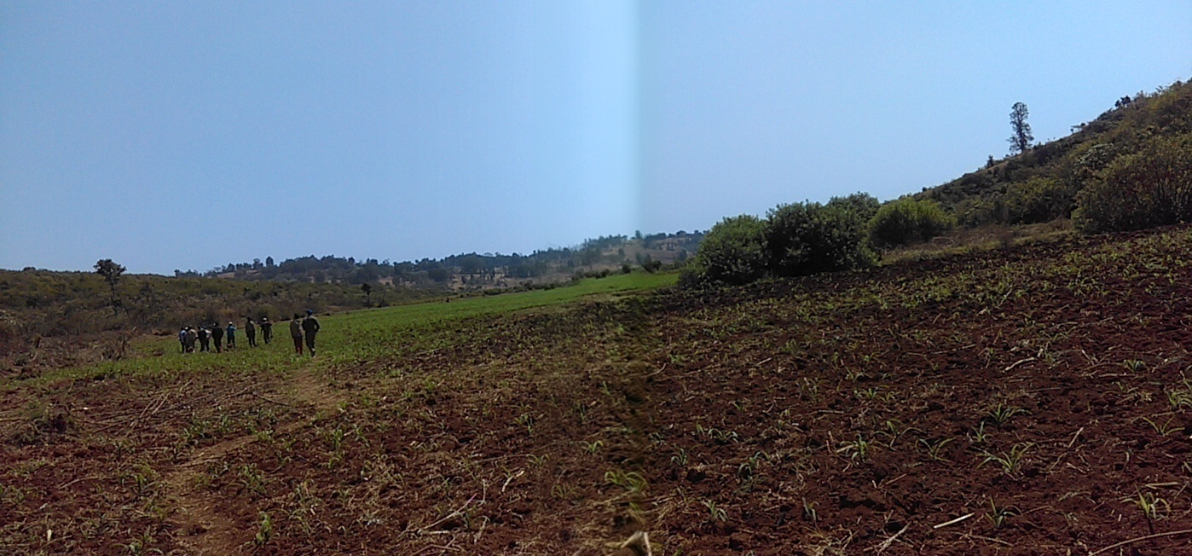
Figure 2: Partial view of the existing Lega-Birbirsa Boonee Area in February 2018.

Population of the Project Area

Demographic study is a crucial factor and requirement for decision makers to design different projects and social service facilities (school, water supply, healthcare, etc.) because of the implementations of such projects and facilities including irrigation projects has impacts as it attracts peoples’ attention from different arenas. Thus, it is necessary to have the estimate of current and future population of the project area in general and command area in particular.

Demographic Characteristics
Demographic characteristics consists of population size, sex, age structure, family size, migration and place of residence, number of households (male-headed or female-headed); life expectancy; population growth rate; population projection; and occupation or employment characteristics of the population.

Current Population
The people of the area predominantly belong to the Oromoo ethnic group, and are largely followers of the Christian religion (Protestant and Orthodox). According to the population and housing census report of the Ethiopian Central Statistical Agency (CSA, 2007), the total population of Guutoo-Giddaa District was 89,906 (45,810 male and 44,096 female) with 18,996 households while that of Nagaasaa Kebele was 3,056 (1,453 male and 1,603 female) with 604 households. However, according to the Kebele’s record, the total population of the Kebele is 3,950 (2,133 male and 1,817 female) with households of 689 (560 male-headed and 129 female-headed).

Table 2: Comparison of population for district, Kebele & project area
Descriptions of Population by Locations | Population Size |  |  | Number of Household
Descriptions of Population by Locations | Male | Female | Total | Male | Female | Total
District (CSA, 2007 ) | 45,810 | 44,096 | 89,906 | - | - | 18,996
Nagasa Kebele (CSA, 2007) | 1,453 | 1,603 | 3,065 | - | - | 604
Nagasa Kebele (projected from CSA, 2007) | 1,891 | 2,086 | 3,977 | - | - | -
Nagasa Kebele record (2010 E.C) | 2,133 | 1,817 | 3,950 | 560 | 129 | 689
Project Area (2010 E.C) | 232 | 252 | 484 | 79 | 6 | 85
District (2010 E.C based on CSA, 2007 ) | 59,615 | 57,385 | 117,000 | - | - | 15,859
Source: CSA (2007), Kebele Record and Computation, 2018.

Age Group of the Population
With regard to the age structure of the population of the district, as stated in the physical and socio-economic profile, more than 53.20% of the total population of the district falls within the economically-active age group. Thus, although there is no recorded information on the age group of the residents of the Kebele, it can be deduced from this fact that the age structure of the population of the Kebele could be similar to that of the district. The age structure of the population of the district for both areas of residence (rural and urban) is given as in the following table.
Table 3: Age group of the population of the district by areas of residence
 | Rural |  |  | Urban |  |  | Total
Age group | Male | Female | Total | Male | Female | Total | Male | Female | Total
0-14 | 25,435 | 24,344 | 49,779 | 1,466 | 1,785 | 3,251 | 26,901 | 26,129 | 53,030
% | 44.22 | 43.95 | 44.09 | 34.13 | 41.67 | 37.89 | 43.52 | 43.78 | 43.65
15-64 | 30,362 | 29,729 | 60,091 | 2,427 | 2,119 | 4,546 | 32,789 | 31,848 | 64,637
% | 52.79 | 53.67 | 53.22 | 56.51 | 49.46 | 52.99 | 53.05 | 53.36 | 53.20
> 65 | 1,718 | 1,323 | 3,041 | 402 | 380 | 782 | 2,120 | 1,703 | 3,823
% | 2.99 | 2.39 | 2.69 | 9.36 | 8.87 | 9.12 | 3.43 | 2.85 | 3.15
Total | 57,515 | 55,396 | 112,911 | 4,295 | 4,284 | 8,579 | 61,810 | 59,680 | 121,490
Source: G/Giddaa District Planning & Economic Development, June 2017.

Settlement and Migration
The population in the project area is a sedentary agricultural society and the settlement pattern of the same is a scattered type but grouped into small clusters of villages. The houses in the rural areas are mostly a sort of mix of thatch-roofed traditional ones and some are made wooden walls with corrugated-iron sheets (CIS). Those houses in the urban areas are hollow block walls and roofed with CIS. As learned from the officials there are no observable and significant demographic events that result in abrupt increment or reduction in the number of population, pattern of settlement, the movement of people or migration to and fro the area in the recent years in the intention of making permanent settlement.

Projected Population
The population projection can be computed using the low, medium and high population growth rate variants, established in the CSA Analytical Report (1994), and adapted by the Ministry of Water Resources as Environmental-Support Project (ESP) Component 3 Planning Model, in 2001 for urban and rural population projection scenarios during stratified intervals of time (starting from 2000 and onwards), as shown in the tables below.
The High variant: assumes that the government makes some attempts to reduce the current high level of fertility by introducing different alternative approaches of the national population program to the population of the area.
The Medium variant: it is assumed that the different approaches of the national population program will be moderately effective and the current growth rate will decrease at a faster pace than the high variant.
The low variant: an optimistic assumption is made by expecting that the current high level of fertility will be going to decrease at accelerated pace thereafter until it reach the final value. Here it is expected that the government will be successful in the implementation of the different population programs to attain its goal.
Table 4. Urban Population Growth Rates by Region
Region | Urban Population Growth Rate (%) for the Period 2000-2030
Region | 2000 | 2005 | 2010 | 2015 | 2020 | 2025 | 2030
Addis Ababa | 2.95 | 2.96 | 2.88 | 2.64 | 2.29 | 1.90 | 1.75
AFFAR | 3.84 | 4.27 | 3.94 | 3.99 | 3.62 | 3.63 | 3.48
AMHARA | 5.09 | 4.53 | 4.67 | 4.41 | 4.25 | 4.05 | 3.85
B/GUMUZ | 4.34 | 4.65 | 4.35 | 4.51 | 4.05 | 3.99 | 3.59
DIRE DAWA | 4.93 | 4.40 | 4.15 | 3.78 | 3.51 | 3.27 | 3.12
GAMBELLA | 5.15 | 4.56 | 4.10 | 4.64 | 4.01 | 4.16 | 3.78
HARARI | 4.19 | 4.00 | 3.63 | 3.44 | 3.25 | 2.98 | 2.99
OROMIYA | 5.29 | 4.88 | 4.74 | 4.53 | 4.32 | 4.08 | 3.84
SNNPRS | 5.50 | 4.94 | 4.70 | 4.46 | 4.25 | 4.02 | 3.77
SOMALI | 4.61 | 4.65 | 4.52 | 4.39 | 4.16 | 3.90 | 3.68
TIGRAY | 5.06 | 4.63 | 4.56 | 4.41 | 4.22 | 4.04 | 3.81
(Source: ESP Component 3 Urban Planning Model, December 2001)
Table 5. Rural Population Growth Rates by Region
Region | Rural Population Growth Rate (%) for the Period 2000-2030
Region | 2000 | 2005 | 2010 | 2015 | 2020 | 2025 | 2030
Addis Ababa | 2.95 | 0.00 | 0.00 | 0.00 | 0.00 | 0.00 | 0.00
AFFAR | 3.84 | 2.06 | 1.94 | 1.72 | 1.58 | 1.39 | 1.22
AMHARA | 5.09 | 2.49 | 2.33 | 2.17 | 1.98 | 1.76 | 1.52
B/GUMUZ | 4.34 | 2.37 | 2.26 | 2.06 | 1.95 | 1.67 | 1.50
DIRE DAWA | 4.93 | 2.36 | 1.92 | 1.41 | 1.00 | 0.64 | 0.31
GAMBELLA | 5.15 | 2.19 | 2.07 | 1.79 | 1.64 | 1.37 | 1.28
HARARI | 4.19 | 2.71 | 2.38 | 2.13 | 1.92 | 1.57 | 1.63
OROMIYA | 5.29 | 2.65 | 2.48 | 2.24 | 2.00 | 1.72 | 1.43
SNNPRS | 5.50 | 2.80 | 2.57 | 2.31 | 2.08 | 1.82 | 1.56
SOMALI | 4.61 | 2.30 | 2.21 | 1.98 | 1.69 | 1.39 | 1.10
TIGRAY | 5.06 | 2.31 | 2.14 | 1.94 | 1.71 | 1.43 | 1.14
(Source: Ministry of Water Resources, ESP Component 3 Rural Planning Model, January 2001).
Therefore, for this particular purpose, the projected population at the medium variant rate from the 2007 CSA figures and Kebele administration records in 2018 has been taken as a baseline population. The projected population of the district and Kebele in 2018 is about 117,000 and 3,977, respectively. The average of the population size from the two sources in 2018 and 2038 is 3,963 and 5,336 respectively. The projected population is as shown in table 6 below.
Table 6: Projected population at the medium growth rate variant
No. | Locality | Base Population & Growth Rate (%) | Growth rate (%) and projected population (2019-2038)
No. | Locality | Base Population & Growth Rate (%) | 2.24 | 2.00 |  | 1.72 |  | 1.43
No. | Locality | 2018 | 2019 | 2020 | 2024 | 2025 | 2029 | 2030 | 2038
1 | Nagasa Kebele (CSA, 2007) | 3,977 | 4,066 | 4,147 | 4,230 | 4,566 | 4,889 | 4,959 | 5,555
2 | Nagasa Kebele record (2010 E.C) | 3,950 | 4,038 | 4,119 | 4,459 | 4,535 | 4,856 | 4,925 | 5,518
AVERAGE (of 1 & 2) |  | 3,963 | 4,052 | 4,133 | 4,474 | 4,551 | 4,872 | 4,942 | 5,536
3 | Project area | 484 | 495 | 505 | 546 | 556 | 595 | 603 | 676
3.1 | - male | 232 | 237 | 242 | 262 | 266 | 285 | 289 | 324
3.2 | - female | 252 | 258 | 263 | 284 | 289 | 310 | 314 | 352
4 | G/Gidda District | 117,000 | 119,621 | 122,013 | 132,071 | 134,343 | 143,827 | 145,883 | 163,432
Source: CSA and Kebele Administration, 2018.
Based on the Kebele’s record, the total number of beneficiary population of the command area of the project in the year 2018, base year, is 484 (232 male and 252 female). This current population of the project area is expected to reach 676 in the next 20 years (2038). Similarly, the total number of the would-be user or beneficiary households of the command area of the project is 85.
Given the widespread joblessness phenomena in urban areas and the population growth trend from the projection, it is believed that adequate labor would be available from the project area for the tasks required to be carried out during the operation of the project. As seen by observation and heard from group discussions, the settlement pattern in the project area is a sedentary agriculture and population movement or migration from one place to another for any reason is very minimal thereabouts.

Economic Bases of the Project Area
The major economic basis of the people in the district and project area is agriculture. It is a generally-accepted fact that agriculture remains the prime sector and potential income-generating activity to the rural community. Trade and government employment are the main sources of livelihood to those people in urban areas.

Agriculture
The main economic activities and source of livelihood of the resident community in the project area is agriculture, i.e., a complementary system of production of crops and rearing of livestock, which is a mixed-farming system.

Crop Production
Different crops are produced in Guutoo-Giddaa District (Woreda) and the intended project the area (Kebele and the command area). The major crops produced in the district are cereals (teff, maize and millet), oil crops (Niger seed), and vegetables (potato and carrot). Crop production is carried out under both rain-fed, irrigation and Bonee methods in the district in general. Crop production in the proposed irrigation project command area is done under rain-fed and Bonee traditional production methods. Crops produced under rain-fed method in the district and Kebele or project area include Teff, maize, millet and potato while maize, potato and carrot are produced using Bonee method. Generally, crop production in the project area is merely at household-subsistence levels; and a little or only some part of it is taken to local markets, as residents tell.

Table 7: Trend of land cultivated and crop yield under rain-fed and irrigation production methods (2005-20010 E.C)
Type of Crop |  | Trend of land cultivated and crop yield under rain-fed production method (2006-2010 E.C)
 |  | 2006 |  |  |  |  |  | 2007 |  |  |  |  |  | 2008 |  |  |  |  |  | 2009 |  |  |  |  | 2010
 |  | Area (ha) |  |  | % | Yield (qt/ha) |  | Area (ha) |  |  | % | Yield (qt/ha) |  | Area (ha) |  | % |  | Yield (qt/ha) |  | Area (ha) |  | % |  | Yield (qt/ha) | Area (ha) |  |  | % |  | Yield (qt/ha)
Maize |  | 8478 |  |  | 28.3 | 104 |  | 13470 |  |  | 45.0 | 59 |  | 14493.5 |  | 54.3 |  | 49.5 |  | 16443.5 |  | 55.6 |  | 47 | 18343 |  |  | 62.0 |  | 52.5
Sorghum |  | 6322 |  |  | 21.1 | 26 |  | 4171 |  |  | 13.9 | 27 |  | 1995 |  | 7.5 |  | 19 |  | 2651 |  | 9.0 |  | 22.5 | 2740 |  |  | 9.3 |  | 25
Teff |  | 3720 |  |  | 12.4 | 10 |  | 4075 |  |  | 13.6 | 7 |  | 3563 |  | 13.4 |  | 4.5 |  | 3854 |  | 13.0 |  | 8 | 3407 |  |  | 11.5 |  | 6.5
Wheat |  | 195 |  |  | 0.7 | 19.5 |  | 195 |  |  | 0.7 | 17 |  | 195 |  | 0.7 |  | 16 |  | 175 |  | 0.6 |  | 16 | 573 |  |  | 1.9 |  | 6
Barley |  | 169.25 |  |  | 0.6 | 13 |  | 165 |  |  | 0.6 | 15 |  | 165 |  | 0.6 |  | 14 |  | 148 |  | 0.5 |  | 12 | 508 |  |  | 1.7 |  | 6.7
millet |  | 2399 |  |  | 8.0 | 13 |  | 1732 |  |  | 5.8 | 12 |  | 1103.5 |  | 4.1 |  | 7.5 |  | 1508 |  | 5.1 |  | 11 | 529 |  |  | 1.8 |  | 6.8
Rice |  | 60 |  |  | 0.2 | 31.6 |  | 60 |  |  | 0.2 | 33 |  | 60 |  | 0.2 |  | 34 |  | 53.5 |  | 0.2 |  | 30 | 167.5 |  |  | 0.6 |  | 32
Faba bean |  | 118 |  |  | 0.4 | 10 |  | 118 |  |  | 0.4 | 10 |  | 118 |  | 0.4 |  | 8 |  | 106 |  | 0.4 |  | 5.5 | 98 |  |  | 0.3 |  | 6.5
Field pea |  | 35 |  |  | 0.1 | 10 |  | 35 |  |  | 0.1 | 10 |  | 35 |  | 0.1 |  | 9 |  | 25 |  | 0.1 |  | 7 | 20 |  |  | 0.1 |  | 5
Haricot bean |  | 1220.5 |  |  | 4.1 | 10 |  | 1197 |  |  | 4.0 | 6 |  | 1380 |  | 5.2 |  | 7.5 |  | 575 |  | 1.9 |  | 7..5 | 953 |  |  | 3.2 |  | 8.4
common bean |  | 188.5 |  |  | 0.6 | 10.8 |  | 165 |  |  | 0.6 | 4 |  | 165 |  | 0.6 |  | 11 |  | 148 |  | 0.5 |  | 17 | 120 |  |  | 0.4 |  | 13
Niger seed |  | 2237 |  |  | 7.5 | 4.5 |  | 1270 |  |  | 4.2 | 3.8 |  | 105 |  | 0.4 |  | 3.5 |  | 1236 |  | 4.2 |  | 4.6 | 400 |  |  | 1.4 |  | 5.2
Sesame |  | 3117 |  |  | 10.4 | 5 |  | 1558 |  |  | 5.2 | 3.3 |  | 1558 |  | 5.8 |  | 4.6 |  | 1091.5 |  | 3.7 |  | 4.12 | 804 |  |  | 2.7 |  | 4
Ground nut |  | 1735 |  |  | 5.8 | 11.6 |  | 1735 |  |  | 5.8 | 12 |  | 1735 |  | 6.5 |  | 11.6 |  | 1559 |  | 5.3 |  | 9 | 900 |  |  | 3.0 |  | 10.6
Total |  | 29994.25 |  |  | 100.0 |  |  | 29946 |  |  | 100.0 |  |  | 26671 |  | 100.0 |  |  |  | 29573.5 |  | 100.0 |  |  | 29562.5 |  |  | 100.0 |  | -
Type of crop | Trend of land cultivated and crop yield under irrigated production method (2005-2009 E.C)
Type of crop | 2005 |  |  |  |  |  | 2006 |  |  |  |  |  | 2007 |  |  |  |  |  | 2008 |  |  |  |  |  |  | 2009
Type of crop | Area (ha) |  | % | Yield (qt/ha) |  |  | Area (ha) |  | % | Yield (qt/ha) |  |  | Area (ha) |  | % |  | Yield (qt/ha) |  | Area (ha) |  | % |  | Yield (qt/ha) |  |  | Area (ha) | % |  | Yield (qt/ha)
Tomato | 365 |  | 9.125 | 107.4 |  |  | 538 |  | 8.7 | 138.5 |  |  | 724 |  | 9.4 |  | 174.4 |  | 1587 |  | 20.0 |  | 150.6 |  |  | 1321 | 16.6 |  | 238.9
Potato | 1209 |  | 30.225 | 98.9 |  |  | 1180 |  | 19.1 | 281.5 |  |  | 1964 |  | 25.5 |  | 18.9 |  | 2144 |  | 27.0 |  | 142.1 |  |  | 2306 | 29.0 |  | 146.2
onion | 576 |  | 14.4 | 92.4 |  |  | 776 |  | 12.6 | 124.4 |  |  | 1070 |  | 13.9 |  | 173.8 |  | 1755 |  | 22.1 |  | 140 |  |  | 1700 | 21.4 |  | 147.6
Garlic | 5 |  | 0.125 | 90.6 |  |  | 17 |  | 0.3 | 118.1 |  |  | 17 |  | 0.2 |  | 117.8 |  | 4.5 |  | 0.1 |  | 141.3 |  |  | 6 | 0.1 |  | 138.3
Cabbage | 99 |  | 2.475 | 92.1 |  |  | 160 |  | 2.6 | 142.4 |  |  | 159 |  | 2.1 |  | 119.5 |  | 238 |  | 3.0 |  | 137.4 |  |  | 295 | 3.7 |  | 179.4
pepper |  |  | 0 |  |  |  | 204 |  | 3.3 | 118.1 |  |  | 184 |  | 2.4 |  | 98.9 |  | 412 |  | 5.2 |  | 124.2 |  |  | 815 | 10.3 |  | 99.3
Maize | 1746 |  | 43.65 | 98.0 |  |  | 3287 |  | 53.3 | 8.4 |  |  | 3599 |  | 46.6 |  | 7.8 |  | 1798 |  | 22.6 |  | 74.7 |  |  | 1500 | 18.9 |  | 109.5
Total | 4000 |  | 100 | - |  |  | 6162 |  | 100.0 | - |  |  | 7717 |  | 100.0 |  | - |  | 7938.5 |  | 100 |  | - |  |  | 7943 | 100 |  | -

The trend of the area of land cultivated for the production of major crops by smallholder farmers, and the amount of yield per unit of land cultivated for each crop under rain-fed and irrigation production methods during the period of 2005-20010 E.C in the district is as depicted in the table 2.7 above (source: District Agricultural & Natural Resources Development Office, 2010 E.C). Chemical fertilizer is applied to the soil to keep soil fertility and raise crop yield for rain-fed produced crops. However, in Boonee farming method, no fertilizer is used as it requires water to be dissolved in the soil for proper utilization by the crop.

As seen from the above table, the size of land under irrigated production of crops increased from 4,000 ha in 2005 E.C to 7,943 ha in 2009 E.C. About 4,983 ha land has been put under furrow traditional irrigation and 2,960 ha under modern (pump) irrigation in the district. But under furrow traditional irrigation, about 11.75 ha land was covered with different crops in the Nagaasaa Kebele in 2009/10 EFY.
Table 8: Existing cropping pattern and yield of irrigated crops at Nagassa Kebele, 2009/10 E.C
Type of Crop | Area (ha) | Share of Land (%) | Yield (qt/ha)
Maize | 2 | 17.0 | 35
Beet root | 0.5 | 4.3 | 110
Onion | 0.25 | 2.1 | 120
Tomato | 0.5 | 4.3 | 130
Potato | 7 | 59.6 | 140
Sweet potato | 0.75 | 6.4 | 130
Local cabbage | 0.75 | 6.4 | 120
Total | 11.75 | 100.0 | -
Source: Agronomic Study Report, 2018.

Livestock
As indicated earlier the economic activity in the project area is a mixed-farming system. Next to crop production, livestock and livestock products are the other source of livelihood of the community in the form of food and means of transport in the area. The main types of livestock in the area include cattle, sheep, goat, donkey, mule, horse, and poultry. Apiculture is also traditionally practiced by few households to a limited extent. The population of livestock in the district is given below.

Table 9: Livestock population of the district
Year | Cattle | Sheep | Goats | Mules | Horses | Donkey
2008 | 93,863 | 12,600 | 13,000 | 3,700 | 1,200 | 5,000
2009 | 96,161 | 12,300 | 15,922 | 4.,200 | 1,700 | 5,300
Source: District Livestock Development, Health, and Marketing Office.

Off-farm Activities
There are very limited job opportunities and other off-farm activities other than crop production and rearing livestock that generate a significant income to the households in the project area except some income from forest products (charcoal, firewood, timber, etc.); and occasional daily earning through sale of family labor. Apiculture is practiced on a very small scale by few people in the area.

Food Security Situation in the Project Area
The project area is generally not prone to famine and the living condition of the community is at subsistence level. There are no operations of food-for-work or safety net programs in the area unlike other parts of the country. But people are still unaware of the concept of food security in terms of access to food in time and place, purchasing power, quantity and quality (nutritional ingredient) of food, etc.

Land Use Pattern and Landholding Size
The situation of land use pattern and landholding size by a household in the district (Woreda) and Kebele or project area is as follows.

Land Use Pattern
The district has a total area of 105,750 hectares and the current land use pattern of the district is mostly under cultivation. As the data obtained from the district and Kebele shows, the land use pattern of the district and Kebele is indicated by hectare as follows.
Table 10: Land Resource by Use
 | Types of land resource use in the district | Approximate area coverage (in hectare) | Location in Kebele (hectare)
1 | Land for crop cultivation | 39,510.00 | 1,667.00
 | - For annual crop production | 29,543.00 | 1,577.00
 | - For perennial crop production | 9,967.00 | 90.00
2 | Arable land | 46,671.00 | 354.00
3 | Pasture land/Grazing Land | 6,353.00 | 21.00
4 | Degraded /barren area | 2,347.50 | 14.00
5 | Forests | 7,669.50 | 18.50
6 | Bush land and shrub land | 634.50 | 35.00
7 | Infrastructure and settlement | 2,564.50 | 22.50
 | Total (1+2+3+4+5+6+7) | 105,750.00 | 2,132.00
Source: Physical & Socio-economic Profile of Guto-Gidda District (June 2017) & Kebele, Feb 2018.
The land has been exploited over a very long period of time and soil fertility has highly been deteriorated. There are different and common methods of maintaining soil fertility in the district.
- Traditional methods such as using cattle dung (manure), crop rotation, green manure, fallowing, composting, and intercropping. Biological soil conservation practices like planting trees, strip planting and other agro-forestry practices. Physical soil conservation methods such as terrace, and cut-off drain;
- Applying chemical fertilizer, this has widely been in use over the last 2-3 decades.

Landholding Size of Households
Household farmland holding size is the most determinant factors of crop production. The household per capita landholding size in the district (Woreda) and Kebele or project area is almost the same. About one-third of the rural households in the district have farmland less than 0.5 ha, which is under rain fed agriculture, and at the current yield levels, cannot produce enough food to meet household food requirement. The average farmland holding size per household was 3.59 ha (2007-2008 EFY) with the majority of the households proportionally holding 2 ha. The households in the highland areas have smaller landholding size than those in the lowland areas do have.
Regarding land tenure, the rights of the household to hold and use the land in the district, many households have certificate of the right to hold land. The District Rural Use & Administration Office has the mandate of issuing, verifying or revoking the certificate within its jurisdiction at any time. During the discussion held with the community, all households had demonstrated their readiness and commitment to fully utilize their landholding to achieve maximum efficiency.

Possession of Oxen by Households
Crop production is totally done with frequent land tillage (usually 2-3 times) using ox-driven power plowing. About 13% of the total 15,859 farm households in the district in 2009 EFY has no oxen at all and 18% has only one half or a single ox. The majority of the households in the district, which is nearly 37%, have a pair of oxen and 13% has more than three pairs of oxen. Similarly, about 15.90% of the 689 farm households of the Kebele have no oxen at all and 30.33% has only one-half or a single ox. The majority of the households in the Kebele, which is 38.17%, have one pair of oxen. Only a small section, 4.93%, of the households of the Kebele has more than three pairs of oxen. The detail is as shown in the table below.
Table 11: Possession of oxen by households
Description |  | Number of pair of oxen owned by a farm household |  |  |  |  | Total
Location | Number of pair of oxen owned by a farm household | 0 | ½ | 1 | 2 | ≥3 | Total
District | Number of farm household | 2,062 | 2,854 | 5,868 | 3,013 | 2,062 | 15,859
District | Proportion of farm household (%) | 13.00 | 18.00 | 37.00 | 19.00 | 13.00 | 100.00
Kebele | Number of farm household | 104 | 209 | 263 | 79 | 34 | 689
Kebele | Proportion of farm household (%) | 15.09 | 30.33 | 38.17 | 11.47 | 4.93 | 100.00
Source: Physical & Socio-economic Profile of Guto-Gidda District (June 2017) & Kebele, Feb 2018.

Marketing Conditions of Agricultural Inputs & Outputs
Marketing conditions agricultural inputs and outputs basically indicate those aspects of market for project input supply and demand for outputs of the project. Supply of the project inputs is roughly there and demand for project outputs seems consistent in the area.

Marketing of Project Inputs
The area has a long experience of using agricultural inputs to boost crop production and productivity. However, the trend of supply these inputs is fluctuating, partly, because of its escalating price and, partly, as a result of the rising demand due to the ever-increasing number of users, severity of pests and weeds, and highly-deteriorating soil fertility conditions to a level where feeding a family would be impossible without applying chemical fertilizer. Other inputs like DAP and pesticides seem that they are disappearing from market basket.
Table 12: Trend of input utilization in the district
Type of Inputs | Production Year (EFY)
Type of Inputs | unit | 2005/6 | 2006/7 | 2007/8 | 2008/9 | 2009/10
DAP | qt | 9,464.00 | 889.50 | 4.50 | - | -
Urea | qt | 11,488.00 | 12,793.50 | 10,306.00 | 17,689.00 | 20,329.00
Other fertilizer (blended) | qt | - | 12,247.00 | 6,874.50 | 10,460.00 | 15,152.50
Herbicide | lit | 2,000.00 | 6,061.00 | 2,651.50 | 5,112.00 | 6,842.00
Insecticide | lit | 523.00 | 525.00 | 338.00 | 189.00 | 136.00
Pesticide | lit | - | 5,113.00 | 517.00 | 32.00 | -
Improved seed | qt | 1,643.00 | 3,108.25 | 2,954.00 | 3,594.00 | 37,504.00

Source: District Cooperative Promotion Office, February 2018.

Input rate and prices are among the determinants of agricultural production. Based on the recent information collected from the district, input utilization rate and unit prices of last production year are given below.
Table 13: Input utilization rate (2009/10 E.C)
Type of crop | Seed rate (kg/ha) | Fertilizer rate (kg/ha) |  |  | Insecticide (Liter/ha) |  |  |  | Unit Price in Birr (for seeds only)
Type of crop | Seed rate (kg/ha) | UREA | DAP | NPS, NPSB, NPSBZn | Malathion | Durisban | Dimethoate | 2.4-D | Unit Price in Birr (for seeds only)
Maize | 25 | 200 |  | 100 | 1 | 1 | 1 | 1 | 3,500.00- 4,500.00
Sorghum | 30 | 100 |  | 100 | - | - | - | -
Teff | 25 | - |  | - | - | - | - | 1
Millet | 20 | - |  | - | - | - | - | -
Soybean | 60-90 | - |  | 100 | - | - | - | -
Ground nut | 120-160 | - |  | 100 | - | - | - | -
Haricot bean | 75 | - |  | 100 | - | - | - | -
Unit Price in Birr (for items other than seeds) |  | 965 | 1,206 | 1,206 |  |  |  | 200.

Marketing of Project Outputs
In reference to market availability and accessibility to the project area the nearby Naqamtee City is experiencing an accelerated-population growth and spatial expansion continued at an even-greater speed due to combined effects of various forces. The city has a population of about 125,000 as different sources indicate.
Table 14: Estimate of population size of Naqamtee city by sources
Year | 2007 | 2018 | 2019 | 2020 | 2024 | 2025 | 2029 | 2030 | 2038
Growth rate (urban) | 4.88 |  |  | 4.32 |  | 4.08 |  | 3.84
Municipal estimate (based on CSA, 2007) | - | 125,545 | 131,496 | 137,729 | 165,759 | 173,616 | 208,949 | 218,853 | 316,995
CSA 2007, population projected the above rate | 75,219 | 124,520 | 130,161 | 135,784 | 160,812 | 167,373 | 196,406 | 203,948 | 275,700
Average | - | 125,033 | 130,829 | 136,757 | 163,285 | 170,494 | 202,677 | 211,400 | 296,348

Now Naqamtee city houses Wollagggaa University and other several colleges, trading companies, financial institutions (banks, insurance and micro credits and savings companies), numerous health institutions and large contingent of new business establishments with the corresponding large number of employees and services recipients. All these institutions and companies house a significant number of consumers. Nekemte is also serving as a convergent-point and gate way for the Bahir-Dar route in the Amhara regional state, Benishangul-Gumuz regional state, Gambella regional state as well as Metu and Jimma towns. All these factors play their role in triggering supply of different set of commodities and production inputs in response to the implied demand for such goods and services.

Agribusiness Opportunity and Potential
This small-scale irrigation development project is primarily intended for production of food crops for domestic consumption by smallholder farm households and supply to the local markets on a retail scale to bring additional income whenever the produce is in excess of this consumption. Thus, opportunity and potential of agribusiness is minimal for such a small-scale production.

Gender Analysis
“If it looks like a duck, walks like a duck, quacks like a duck, it’s a social construct of a duck.” …, fashionable claims about “the social construction of gender” are no less bizarre. Men and women look unalike, walk unalike, talk unalike. They differ in who is more competitive, single-minded and risk-taking; who is more likely to jump a long/high, drive too fast, commit a murder, or win a game; in what triggers their jealousy and status envy. Differences such as these are universal, transcending culture, class, ethnicity, religion, education, and politics. They manifest themselves in all societies, across the modern world, and in every known record back through time. – [emphasis added].

Gender difference, which is revealed in the socially-constructed roles of men and women, exists in the project area or beyond, and manifests itself in the type of tasks assigned in the community as a role or responsibility of men or women. The tasks could be domestic (cooking, house dressing, washing, etc.) or related to everyday life outside a household (farmland preparation, religious service, conflict resolution and arbitration, etc.). These roles may be expressed in other situations like the length of time spent by each person on every task, the willingness, tendency and desire to do or not to do something; in the degree of participation or refrain. These are also influenced by the degree of their acceptance or rejection by the public.
Obviously, there is no a clear-cut demarcation or prohibition as to what is the responsibility of men or women in the wider area in general and the project command area in particular. For instance, all members of a household participate in fetching water for domestic use, house construction, and road maintenance and land preparation in most cases. The difference may be expressed in terms of the frequency of doing a given task, the length of time spent on each specific task and the intensity of labor embodied in the task by each category gender. As an age-long habit, women spend more time on cooking and childcare than men do; conversely, men spend more time on farmland preparation than women spend.
In general, there is no significant difference between women and men in access to and control household resources as well deciding on the same in the area. There are no noticeable harmful traditional practices that negatively affect the female sects of the community, for forbidding from joining school. The major issues of gender variability, if any, in the project area have been treated in detail under the household survey sub-section of this document.

Availability of Construction Materials
Regarding the availaity of construction materials in the project area, on the yearly average production of stone in Guutoo-Giddaa District is 65,000 ton. Other construction materials such as sand and gravel are produced in sufficient quantities in the neighboring districts, especially Diggaa District some 30km from the project area along the asphalt pavement leading to Gimbii.

Infrastructure & Social Services
As the project area has relative proximity to the district/zone capital, there are better availability of communication infrastructure facilities and social services thereon.

Social Services
The most common social services available in the project area and/or around comprise schools, health institutions (health station and health posts), farmers’ training centers (FTC), cooperative unions, credit and saving services, etc.
Table 15: Number of schools in the district and Kebele
S.№ | Description of School Variables | Number of schools by their level (2009/10 EFY)
S.№ | Description of School Variables | KG | Primary School (1-8) | Senior secondary (9-10) | Preparatory (11-12) | Technical/vocational | Total
1 | District
1 | Number of school | 37 | 34 | 2 | 1 | 0 | 74
2 | Ganda/Kebele
2 | Number of school | 0 | 1 | 0 | 0 | 0 | 1

There are 74 schools of different levels in the district as shown in the table. In the Kebele, there is one first cycle school (1-4), and there are also one human health post, one animal health post, and one FTC.
Table 16: Number of health institutions in the district and Kebele
S.№ | Description of School Variables | Number of by their type (2009/10 EFY)
S.№ | Description of School Variables | Hospital | Health | Clinic | Health post | Total
1 | District
1 | Number of institutions | 0 | 3 | 12 | 17 | 32
2 | Ganda/Kebele
2 | Number of institutions | 0 | 0 | 0 | 1 | 1

Electricity Services
In the project area, there are no electric light or energy services; households use firewood, crop residues, charcoal, animal dung and/or candle for domestic services instead.

Communication Services
There is no ground telephone service in the project area. But the people in use cell phone for business and everyday life with partners and relatives elsewhere. Postal service is available in the zone capital

Road Infrastructure
According to data obtained from Guto-Gidda District Road Authority, as of 2009 E.C, there was 186.11km (18km dry-weather, 167.11km gravel and 1km asphalt) road in the district. The asphalt pavement highway from Finfinnee to the western parts of the country (Gambella-Mattu-Baddelleand/or Gambella-Dembi-dollo-Gimbi and Asosa-Gimbi-Naqamte) passes through Naqamte. The Naqamte-Bure highway, which passes through Ukkee, is being upgraded to asphalt pavement. The construction of an air port has also been started around Ukkee, which is a promising opportunity for future development of the region including the project area.
The project area or site is only accessible via dry-weather road, which poses difficulty for motorized transport during the wet or rainy seasons.

Financial and Credit Institutions
Financial institutions like bank, insurance, credit and savings services are available in Naqamtee City in the nearby the command area. The question is rather as to the affordability of the people to repay even when credits are available at the capital cost.

Development Opportunity & Constraints
As elsewhere in the zone, the district including the project area has its own development opportunities that contribute in fostering its growth potential; and constraints that hinder its future progress. Some of the opportunities and constraints area presented as follows.

Constraints
The major limiting factors to the development of Guutoo-Giddaa District are broadly categorized into economic, social, and environmental influences. The existing economic constraints include issues like shortage of farmland, grazing land, shortage of agricultural input supply (both in terms of price and time), and lack of proper agricultural extension service. Social factors include issues like lack of transportation or limited access roads, prevalence of disease, unemployment, and lack of education service. Environmental constraints include factors like deforestation, soil erosion, decline and variability in soil fertility, amount and uneven distribution of rainfall affecting agricultural productivity. The situation of the project area and Kebele is likewise equally affected by the combination of all these factors.

Potentialities
Guutoo-Giddaa District has immense natural potential for development. Among the different natural resource endowment and potentialities of the district regardless of their variability in space, the most vivid ones are:
- Agricultural resources like cultivable land, fertile soil, livestock rearing, mining, fishing,
- Available human power,
- Natural resource like water, minerals and forest,
- Natural, cultural, and historical tourist attraction sites: mountains like Komto, Arjo, Bolo, Dugadungule; Dalo highland and man-made reservoir Lake Sorga.

Major rivers like Angar, Hare, Loko, Lugo, Tinfa, and Ebicha are also found in the district to be used for tourist purposes and investment activities.
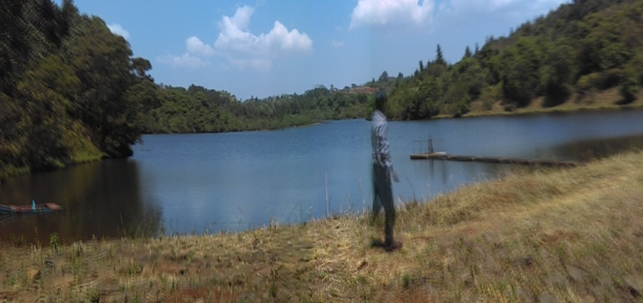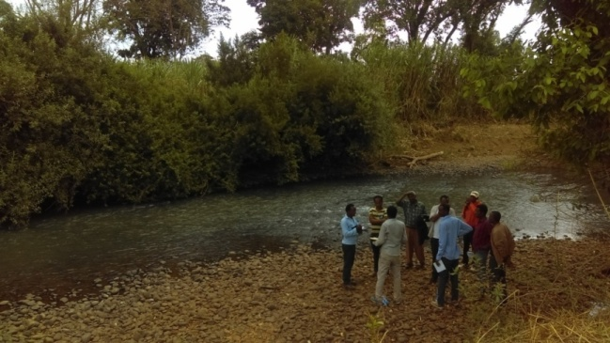
Figure 2: Partial view of Lake Sorga, Nekemte February 2018. Figure 3: A snapshot of Loko River

Project Benefits
This small-scale irrigation development project is likely to yield several sets of tangible and intangible benefits that accrue to the community particularly because of the availability of water during the dry seasons of the year in more quantity. Among such benefits, economic benefits are the ones that are expected to bring the most immediate impacts on the lives of the community. These expected economic benefits could be either or indirect in the light of their possible effects.

Direct Economic Benefits
The expected direct economic benefits of the project could be many. The most likely direct benefits of the project are: rise in the number of crop production cycles in the course of the year from the existing rain-dependent single cycle in a year; introduction of new crops, or expansion of the scale of production of the existing ones; addition to the nutritional status and diversity of the community; augmentation to the existing income level of the households; possibility for producing forge and crop residues for livestock during long-dry seasons of the year, and so on.

Indirect Economic Benefits
Likewise, the expected indirect economic benefits of the project could be many. The most likely indirect benefits of the project are: creating more job opportunity to the people in the command area and urban centers around reducing slack-time labor in a year as well as inducing new working seasons in the area; creation of opportunity for practicing fattening activities; addition to food supply and diversity to the local markets; promoting environment-friendly practices like inter-cropping activities with spice crops (ginger, kororima and hot pepper) in the command area, and so on.

Social Impacts & Mitigation Measures
Like any other development projects, this small-scale irrigation development project is likely to have both positive and negative social impacts on the community either during construction or later. The anticipated or possible impacts of the project that could happen to the community can have either direct or indirect relation to the project. Regarding these issues discussions and consultations held with the concerned stakeholders, it was learned that there will be no destruction and damage made to private properties and assets, crop and grazing land, settlement site, forestland, other sites of social values up or down stream due to the project. The community and Kebele administration assured with verbal minutes that they would provide communally-held land for the purposes of construction of irrigation project structures like headwork, main canal, camp site, etc. there would be no displacement, already held land re-allocation except allocation of communally-held land, compensation claim for land and other properties,,
Among the possible negative social impacts of the project, if any:
- Mosquito breeding along the canal and the resultant malaria infestation; and
- Lose of a portion of landholding by few households because of construction material damp on site and the canal route.
Mitigation measures for these possible negative impacts are provision of communally-held land by the community and Kebele administration as evidenced during consultation with these groups. The project is rather expected by the community to impart more positive social impacts, among the major possible positive social impacts are:
- Creation of additional job opportunity and income to members of the community during construction of the irrigation structures; and reduction in idle time during non-production seasons.

In general, there would be less probability that property or assets of individual beneficiaries be damaged due to the implementation of the project. The beneficiaries have promised not to claim for compensation in case damage occurs as confirmed during consultation with the user community. However, if any asset to be affected, the compensation mechanism will be:
- either in the form of land exchange from other farmers who have no irrigable land but likely to have irrigation land in the future
- or in the form of giving priority to those who may lose land or asset in providing job opportunity that will be created because of the implementation of the project.

The Household Survey Result

The Beneficiary Community
The project-beneficiary community consists of 85 total farm households, of which heads of 10 households (five female-headed and five male headed) or 11% have been taken as sample interviewed. According to the household survey result, all of them were born in the Kebele, belong to the Oromo ethnic group, and 60& and 40% of them follow the Protestant and Orthodox Christianity. Based on the survey, the major characteristics of the households are as shown in the table below.
Table 17. Household characteristics
Characteristics |  | Proportion of characteristics (%)
Age of HH head in year | Response | 18-35 | 36-64 | >64 | - | - | - | - | Total
Age of HH head in year | % | 60 | 40 | 0 | - | - | - | - | 100
Ethnicity of HH head | Response | Oromo | Amhara | Somali | Tigray | Other | - | - | -
Ethnicity of HH head | % | 100 | 0 | 0 | 0 | 0 | 0 | 0 | 100
Religion of HH head | Response | Orthodox | Protestant | Catholic | Islam | Other | - | - | -
Religion of HH head | % | 40 | 60 | 0 | 0 | 0 | 0 | 0 | 100
Family members’ age group | Response | < 15 | 15-64 | >64 | - | - | - | - | -
Family members’ age group | % | 30.36 | 69.64 | 0 | 0 | 0 | 0 |  | 100
Highest level of education attained by the HH head | Response | Illiterate | Read-and-write | 1-4 grade | 5-8 grade | 9-10 grade | 11-12 grade | >12 grade | -
Highest level of education attained by the HH head | % | 0 | 30 | 20 | 40 | 0 | 10 | 0 | 100
Marital status of HH head | Response | Married | Unmarried | Divorce | Widow | Monogamy | Polygamy | Other | -
Marital status of HH head | % | 100 | 0 | 0 | 0 | 100 | 0 | 0 | 100

Regarding the age group of family members, the larger proportion, 69.64%, of the section of the community falls within the economically active-age bracket, which signifies the availability of adequate labor force in the project area. The interviewees have responded that they married and practice of being married to a person at a time almost a polygamy type.
In reference to the education level attained by the head of the sample household, 30%, 20%, 40% and 10% “can read-and-write”, have attained grade 1-4, 5-8, 11-12, respectively. This indicates that the households and/or their members have the chance of being able to moderately receive and understand any training or technical support provided to them in the future.

Agriculture-based Activities
As the project area is an integral part of the district, agriculture is the foundation of the economy of the command area, too. Based on the sample household survey, mixed-farming system, i.e., crop production and animal husbandry is practiced by almost all the farmers in the command area as the prime source of their livelihood. Both production crop and rearing livestock are longstanding practices in the areas. The sample household survey result reveals that about 60% of the households derive 25%-50% of their livelihood from crop production; while 30% of them derive 50%-75% of their livelihood from livestock and live stock products. Details of the results are shown in the tables below.
Regardless of the size of the land plot each household possesses, all the respondents have landholdings being used for one or more of such activities as crop production, grazing for livestock, or as backyard. About 23.53%, 35.29%, 23.53% and 17.65% of the households have landholding less than 0.5ha, between 0.5ha and 1ha, 1ha and 1.5ha, more than 2ha, respectively. The proportion of households is 41.18%, 52.94% and 5.88%by land allocation pattern for grazing, crop cultivation and backyard, respectively. Neither to rent land out to others nor to rent land from others in return for regular payments exists in the project area as a general practice.

Crop Production
Out of the cultivated landholding by households in the command area, none has been irrigated except Boonee traditional production method, i.e., crop production is carried out only under rain-fed method.
- Under the rain-fed method of production, yield is on the decreasing trend (77.78%) as described by the respondents while 22.22% say there no change has been observed during the recent production years. This is substantiated by the respondents in the proportion that home-produced crop can sustain the household for the period of 3-6 months (30%), 6-9 months (40%) and 9-12 months (30%) per year without external injection in any form, and at the same time 40% of the respondents claim that the home-produced crop is insufficient to support the household for the whole year.
- The reason for the insufficiency of the home-produced crops is attributed to shortage of farmland (22.22%), shortage of farm inputs (66.67%) implied by high and ever-increasing price, and bad weather (11.11%). The coping mechanisms to compensate for the insufficiency gap are family labor (33.33%), sales of livestock-and-livestock products (11.11%), and sales of forest-and-forest products (55.56%).
- All of the households have the desire to change the rain-fed crop production method to irrigation-based production method as evidenced by the survey.

Animal Husbandry
On the other hand, regardless of the type and number of livestock each household possesses, all the respondents have livestock used for one or more of such activities as draft power, milk, meat or pack animal and as source of cash income when sold.
- About 91.30% and 8.70% of the households have livestock numbers of less than 5, and between 5 and 10 animals of all kinds, respectively.
- Of the sample households, 77.78% have oxen. However, about 90% of the households have either a single ox or a pair of oxen. In other words, of the households: 20% of has no oxen, 40% has a single ox, 30% has a pair of oxen and 10% has two pairs of oxen.
- Problems related to livestock rearing stand in the order of: shortage of feed and grazing land combined (40%); lack of capital to purchase more animals (30%); and prevalence of animal diseases (30%).
The community has demonstrated a desire to have improved animal husbandry practice like introduction of dairy and fattening breeds and stock size reduction with intensive and improvement feeding, healthcare, etc.

Table

Table 18. Agriculture based activities of the community
Characteristics |  | Proportion of characteristics (%)
Whether the household has landholding | Response | Yes | No | - | - | - | - | Total
Whether the household has landholding | % | 100 | 0 | - | - | - | - | 100
Size of land held by household | Response | < 0.5 ha | 0.5-1 ha | 1-1.5 ha | 1.5-2 ha | > 2 ha | - | -
Size of land held by household | % | 23.53 | 35.29 | 0 | 23.53 | 17.65 | - | 100
Purposes for which the land is allocated or being used | Response | Grazing | Crop cultivation | Backyard | Forest | - | - | -
Purposes for which the land is allocated or being used | % | 41.18 | 52.94 | 5.88 | 0 | - | - | 100
Share of land irrigated out the cultivated land | Response | 0% | < 25% | 25-33 | 33-50 | 50-75 | >75 | -
Share of land irrigated out the cultivated land | % | 100 | 0 | 0 | 0 | 0 | 0 | 100
Trend of crop production in the last five years | Response | Increasing | Decreasing | No change | - | - | - | -
Trend of crop production in the last five years | % | 0 | 77.78 | 22.22 | - | - | - | 100
Number of months the household relies on home-produced crops per year | Response | < 3 months | 3-6 Months | 6-9 months | 9-12 Months | - | - | -
 | % | 0 | 30.00 | 40.00 | 30.00 | - | - | 100
Food crops of all type required by the household per year in quintals | Response | < 2.5 qt | 22.5-5 qt | 5-7.5 qts | 7.5-10qts | > 10 qts | -
 | % | 0 | 60.00 | 20.00 | 10.00 | 10.00 | - | 100
Sufficiency of last year crop produced for household consumption | Response | Yes | No | - | - | - | - | -
 | % | 60 | 40 | - | - | - | - | 100
Reason for insufficiency of last year crop produced for household consumption | Response | Shortage of farmland | Shortage of inputs (seed, fertilizers, oxen etc.) | Bad weather (drought, excess rain, frost, hail, wind storm etc.) | Other | - | - | -
 | % | 22.22 | 66.67 | 11.11 | 0 | - | - | 100
Coping mechanism for crop insufficiency | Response | Sale of family members’ labor | Sale of livestock | Remittance | Aid from Govt. and/or NGO | Borrowing | Sale of forest products (timber, firewood) | -
Coping mechanism for crop insufficiency | % | 33.33 | 11.11 | 0 | 0 | 0 | 55.56 | 100
Share of crops in annual income of household | Response | 0% | < 25 % | 25-50% | 50-75% | > 75 % | - | -
Share of crops in annual income of household | % | 20 | 20 | 60 | 0 | 0 | - | 100
Whether using irrigation for crop production | Response | Yes | No | - | - | - | - | -
Whether using irrigation for crop production | % | 0 | 100 | - | - | - | - | 100
If “Yes”, for how long? | Response | < 5 yrs | 5-10 yrs | 10-15 yrs | > 15 yrs | - | - | -
If “Yes”, for how long? | % | - | - | - | - | - | - | -
If using irrigation, change witnessed since then | Response | Deteriorated | No change | Improved | - | - | - | -
If using irrigation, change witnessed since then | % | - | - | - | - | - | - | -
Whether crop produced without using irrigation is enough to support household need | Response | Yes | No | - | - | - | - | -
 | % | 12.50 | 87.50 | - | - | - | - | 100
Whether the household likes to continue using irrigation | Response | Yes | No | - | - | - | - | -
Whether the household likes to continue using irrigation | % | - | - | - | - | - | - | -
Whether the household has desire to change from rain-fed to irrigation | Response | Yes | No | - | - | - | - | -
 | % | 100 | 0 | - | - | - | - | 100
Livestock
Whether the household has livestock | Response | Yes | No | - | - | - | - | Total
Whether the household has livestock | % | 90 | 10 | - | - | - | - | 100
Proportion of households by type of livestock owned | Response | Cattle | Equine | Sheep/goat | Poultry | Beehives | - | -
Proportion of households by type of livestock owned | % | 34.78 | 34.78 | 21.74 | 8.70 | 0 | - | 100
Number of livestock the household owns | Response | 0 | < 5 | 5-10 | 10-15 | 15-20 | > 20 | -
Number of livestock the household owns | % | 0 | 91.30 | 8.70 | 0 | 0 | 0 | 100
Number of oxen the household owns | Response | 0 | 1 | 2 | 3 | 4 | 5 | -
Number of oxen the household owns | % | 20.00 | 40.00 | 30.00 | 0 | 10.00 | 0 | 100
Share of livestock in annual income of household | Response | 0% | < 25 % | 25-50% | 50-75% | > 75 % | - | -
Share of livestock in annual income of household | % | 20 | 30 | 20 | 30 | 0 | - | 100
Major problem in keeping livestock by the household | Response | Shortage of feed | Shortage of capital to buy animals | Livestock diseases | Shortage of grazing land | - | - | -
Major problem in keeping livestock by the household | % | 30.00 | 30.00 | 30.00 | 10.00 | - | - | 100
Source of feed for livestock | Response | Grazing | Crop residue | Grazing and Crop residue | Others | - | - | -
Source of feed for livestock | % | 33.33 | 0 | 66.67 | 0 | - | - | 100
Source of drinking water for livestock | Response | River | Traditional well | Pond | Springs | Other | - | -
Source of drinking water for livestock | % | 100 | 0 | 0 | 0 | 0 | - | 100
Occurrence of livestock feed shortage during g recent years | Response | Yes | No | - | - | - | - | -
Occurrence of livestock feed shortage during g recent years | % | 55.56 | 44.44 | - | - | - | - | 100
Measures taken (first and second) in response to feed shortage | Response | Increase sale of livestock | Buy feed from other places | Collect pods & leaves | Borrowing & sharing with others | Aid from government and NGOs | - | -
 | % | 33.33 | 0 | 66.67 | 0 | 0 | - | 100
 | % | 75.00 | 0 | 25.00 | 0 | 0 | - | 100
Livestock health treatment centers | Response | Community animal health workers | Local veterinary service | Private | Black market | Traditional healer | - | -
Livestock health treatment centers | % | 22.22 | 55.56 | 22.22 | 0 | 0 | - | 100
Whether households pay for livestock health treatment | Response | Yes | No | - | - | - | - | -
Whether households pay for livestock health treatment | % | 77.78 | 22.22 | - | - | - | - | 100
Amount of payment for livestock health treatment yearly | Response | < 20 Birr | 20-50 Birr | 60-80 Birr | 80-100 Birr | > 100 Birr | - | -
Amount of payment for livestock health treatment yearly | % | 14.29 | 57.14 | 28.57 | 0 | 0 | - | 100
Whether households have received extension services, credit & training | Response | Yes | No | - | - | - | - | -
 | % | 10 | 90 | - | - | - | - | 100

Household Income & Expenditure in the Project Area
The sample household survey result reveals that the major sources of household income in the project area are crop production and livestock rearing. Most of the households derive their livelihood from these two sources. In addition, some households earn their living from the sales of forest products, and few households make living out of off-farm activities and other sources. On the other hand, household expenditure is made on a classified set of consumer items like food, clothing, edible oil, soap, etc.
The share of crops in the annual income of households falls in nil, less than 25%, and the range of 25-50% in the proportion of 20%, 60%, and 20% of the households, respectively. Apart from being used as the prime staple food for the household, crops also play a significant role in providing feed to the livestock. The share of livestock in the annual income of households is nil, less than 25%, in the range of 25-50% and 50-75% in the proportion of 20%, 30%, 20%, and 30% of the households, respectively.

Household Income in the Project Area
Of the sample households interviewed, each 50% responded that crop production and livestock and livestock products, respectively, constitute their primary sources of income. Similarly, 20%, 10%, 30%, 30% and 10% of the sample households responded that crop production, livestock and livestock products, forest and forest products, off-farm activities and others, respectively, constitute their secondary sources of income.
Table 19. Household income of the community
Income Source & Sequence | Crop Production | Livestock & Livestock Products | Forest & forest products | Petty Trade | Off-farm Employment | Others | Total
Primary (%) | 50 | 50 | 0 | 0 | 0 | 0 | 100
Secondary (%) | 20 | 10 | 30 | 0 | 30 | 10 | 100

In terms of the items of source of income, of the sample households interviewed, 21.62%, 27.03%, 21.62%, 18.92% and 10.81% responded that crop production, livestock and livestock products, forest and forest products, off-farm activities and others, respectively, constitute their annual income. Similarly, in monetary terms: 10.81%, 5.41%, 5.41%, 2.70%, 8.11%, 35.14%, 8.11%, and 24.32% of the sample households responded that their annual incomes fall in the range of Birr less than 500.00, Birr 500.00-1,000.00, Birr 1,000.00-1,500.00, Birr 1,500.00-2,000.00, Birr 2,000.00-2,500.00, Birr 3,000.00-3,500.00, Birr 3,500.00-4,000.00 and Birr greater than 4,000.00, respectively.
Table 20. Estimated Annual Income of HH from Different Sources
Source of Income | Number & Share of HH by Range of Annual Income (Birr) |  |  |  |  |  |  |  | Total | % of HH by source Income
Source of Income | < 500 | 500-1,000 | 1,000-1,500 | 1,500-2,000 | 2,000-2,500 | 3,000-3,500 | 3,500-4,000 | > 4,000 | Total | % of HH by source Income
Crop | - | - | 1 | - | - | 3 | 3 | 1 | 8 | 21.62
Livestock & Livestock products | 2 | - | - | - | - | 1 | - | 7 | 10 | 27.03
Forest & forest products | - | - | - | - | 2 | 5 | - | 1 | 8 | 21.62
Off-farm | - | 2 | 1 | - | - | 4 | - | - | 7 | 18.92
Remittance | - | - | - | - | - | - | - | - | 0 | -
Other | 2 | - | - | 1 | 1 | - | - | - | 4 | 10.81
Total | 4 | 2 | 2 | 1 | 3 | 13 | 3 | 9 | 37 | 100.00
% | 10.81 | 5.41 | 5.41 | 2.70 | 8.11 | 35.14 | 8.11 | 24.32 | 100.00 | -

Household Expenditure in the Project Area
In terms of consumer items, of the sample households interviewed, 12.2%, 12.2%, 12.2%, 12.2%, 10.98%, 12.2%, 10.98%, 9.76%, and 7.32% responded that food; clothing; salt, sugar and edible oil; fuel; soap and sanitary materials; medical treatment; education; farm inputs and others, respectively, constitute their annual expenditure. Similarly, in monetary terms: 37.8%, 12.2%, 15.85%, 3.66%, 9.76%, 8.54%, 1.22%, and 10.98% of the sample households responded that their annual expenditures fall in the range of Birr less than 500.00, Birr 500.00-1,000.00, Birr 1,000.00-1,500.00, Birr 1,500.00-2,000.00, Birr 2,000.00-2,500.00, Birr 3,000.00-3,500.00, Birr 3,500.00-4,000.00 and Birr greater than 4,000.00, respectively.
Table 21 Estimated Annual Expenditure of HH by Items
Items of Expenditure | Number & Share of HHs by Range of Annual Expenditure (Birr) |  |  |  |  |  |  |  | Total | % of HH by Items of Expenditure
Items of Expenditure | < 500 | 500-1000 | 1000-1500 | 1500-2000 | 2000-2500 | 3000-3500 | 3500-4000 | > 4000 | Total | % of HH by Items of Expenditure
Food | - | - | - | - | - | 4 | 1 | 5 | 10 | 12.20
Clothing | - | 3 | 2 | - | 4 | 1 | - | - | 10 | 12.20
Salt, sugar, oil | 9 | 1 | - | - | - | - | - | - | 10 | 12.20
fuel | 9 | 1 | - | - | - | - | - | - | 10 | 12.20
Soap & sanitation | 8 | 1 | - | - | - | - | - | - | 9 | 10.98
Treatment | 4 | 2 | 3 | 1 | - | - | - | - | 10 | 12.20
Education | 1 | 2 | 3 | 2 | 1 | - | - | - | 9 | 10.98
Farm inputs | - | - | 2 |  | 2 | 1 | - | 3 | 8 | 9.76
Other | - | - | 3 |  | 1 | 1 | - | 1 | 6 | 7.32
Total | 31 | 10 | 13 | 3 | 8 | 7 | 1 | 9 | 82 | 100.00
% | 37.80 | 12.20 | 15.85 | 3.66 | 9.76 | 8.54 | 1.22 | 10.98 | 100.00 | -

Households usually sell some portion of their produces at local markets to cover the cost of financing non-home-made consumer goods and services such as clothing, medication, sugar, salt, farm inputs, oil, education, etc.

Social Services in the Project Area
There are certain social services or institutions provided by government agencies for the welfare of the community in the project area. As per the sample household survey conducted, the situation of social services such as education, healthcare, water supply, etc., in the project area is as described below.

Education Services in the Project Area
There is only one elementary school (1-4 grade) in the project area. All the respondents prefer formal education type for their children. The share of family members currently attending formal education is divided between 59% male and 41% female.
Table 22. The state of education service in the project area
Description |  | Proportion of characteristics (%) |  |  |  |  |  | %
The education HH head prefers for children | Response | Formal | Non-formal | Religious | - | - | Total | -
The education HH head prefers for children | % | 100 | 0 | 0 | - | - | 100 | -
Number or share of family members attending school by sex | Response | Male | Female | - | - | - | - | -
Number or share of family members attending school by sex | % | 59 | 41 | - | - | - | 100 | -
Proportion of households by average distance (in km) of schools by levels from home | Response (no. & %) | 1-4 grade | 1-8 (5-8) grade | 9-10 grade | 11-12 grade | > 12 grade | - | -
 | < 5km | 8 | 3 |  |  |  | 11 | 22.92
 | 5-10km | 2 | 7 | 8 | 10 | 10 | 37 | 77.08
 | 10-20km | - | - | - | - | - | - | -
 | 20-30km | - | - | - | - | - | - | -
 | >30km | - | - | - | - | - | - | -
 | Total | 10 | 10 | 8 | 10 | 10 | 48 | 100
 | % | 20.83 | 20.83 | 16.67 | 20.83 | 20.83 | 100
Major problems faced by the community in relation to education service | Response | Absence of the school in the nearby | HH demand of children labor | Unable to cover school expenses | Other | - | -
 | % | 0 | 90 | 10 | - | - | 100

The proportion of households by school accessibility is: 23% for grade 1-8 within 5km; and 77% for all grade levels within 5-10km.
The major problems in education services have forward-and-backward integrations and are attributed mainly to household demand for child labor (90%), and inability to cover school expenses with the meager household income (10%).

Health Services in the Project Area
There is only one health post in the project area. The state of healthcare services in the project area is as shown in the table below.
The respondents say that the first most-common diseases in the project area are malaria (30%), TB (10%), eye diseases (10%), headache (10%) and typhoid (40%). The second most-common diseases in the project area are intestinal parasites (10%), headache (60%) and typhoid (30%). When get sick, the people receive medical treatment at the nearby hospital (55.56%) and private clinic (44.44%).
The respondents say that the first most-common constraints in getting health services in the project area are attributed to absence of health service facilities in the nearby (60%), shortage of medicine (20%) and high cost of treatment and medication (20%). The second most-common constraints in getting health services are attributed to high cost of treatment and medication (40%), and shortage of medicine (20%), and lack of accessibility to health services (40%).
The share of household heads as to their agreement at the use of family planning is 90%, and their practice to use family planning is about 89% as well as their inclination to have more children stands only at 30%. Regarding the knowledge the usefulness of immunization of children and the mode of transmission of HIV/AIDS and protection from the same is 100%. This extent of awareness is largely owed to the continuous health-education effort made by health-extension workers at the community level.

Table 23. Health service evaluation of the project area
Characteristics |  | Proportion of characteristics (%)
The most (first and second) common disease in the area | Response | Malaria | Diarrhea | TB | Intestinal parasite | Eye diseases | STD | Headache | Typhoid | Total
The most (first and second) common disease in the area | % | 30 | 0 | 10 | 0 | 10 | 0 | 10 | 40 | 100
The most (first and second) common disease in the area | % | 0 | 0 | 0 | 10 | 0 | 0 | 60 | 30 | 100
Common medical treatment center | Response | Hospital | Health center | Private Clinic | Health post | Traditional healer | Self-treatment | Stay at home | Other | -
Common medical treatment center | % | 55.56 | 0 | 44.44 | 0 | 0 | 0 | 0 | 0 | 100
The most (first and second) common health constraint in the area | Response | Absence of health service in the near by | Shortage of medicine | Lack of health personnel | High cost of treatment and medication | Reluctance of the health personnel | Lack of accessibility to reach the health services | Other |  | -
 | % | 60 | 20 | 0 | 20 | 0 | 0 | 0 | - | 100
 | % | 0 | 20 | 0 | 40 | 0 | 40 | 0 | - | 100
Agreement at and use of family planning | Response | Yes | No | - | - | - | - | - | - | -
Agreement at and use of family planning | % | 90 | 10 | - | - | - | - | - | - | 100
Agreement at and use of family planning | % | 89 | 11 | - | - | - | - | - | - | 100
Tendency to have more children | Response | Yes | No | - | - | - | - | - | - | -
Tendency to have more children | % | 30 | 70 | - | - | - | - | - | - | 100
Knowledge of mode of transmission of & protection from HIV/AIDS |  | Yes | No | - | - | - | - | - | - | -
 | % | 100 | 0 | - | - | - | - | - | - | 100
Health education received in disease prevention and control; and immunization as well |  | Yes | No | - | - | - | - | - | - | -
 | % | 90 | 10 | - | - | - | - | - | - | 100

Water Supply and Sanitation Services in the Project Area
The major sources of water supply for domestic use in the project area are springs. The state of water supply services in the project area is as shown in the table below.
Table 24. Water supply evaluation of the project area
Characteristics |  |  | Proportion of characteristics (%)
Sources of water supply | Response | River | Pond | Lake | Hand-dug Well | Protected spring | Unprotected spring | Piped Water | Total
Sources of water supply | % | 0 | 0 | 0 | 0 | 40.00 | 60.00 | 0 | 100
Time taken to fetch water from source | Response | < 15 minute | 15-30 minute | > 30 minute | - | - | - | - | -
Time taken to fetch water from source | % | 20.00 | 60.00 | 20.00 | - | - | - | - | 100
Member of the family mainly fetching water | Response | Wife | Female children | Male children | Husband | All members | - | - | -
Member of the family mainly fetching water | % | 40.00 | 30.00 | 0 | 0 | 30.00 | - | - | 100
Whether the HH pays for the use of water supply | Response | Yes | No | - | - | - | - | - | -
Whether the HH pays for the use of water supply | % | 100 | 0 | - | - | - | - | - | 100
Whether the HH has or use toilet | Response | Yes | No | - | - | - | - | - | -
Whether the HH has or use toilet | % | 0 | 100 | - | - | - | - | - | 100
Where to dispose wastes | Response | Everywhere | In the nearby farming plots | In pits | In the nearby natural depression | Burning in the fire | Open dumping | Other | -
Where to dispose wastes | % | 0 | 0 | 20.00 | 30.00 | 0 | 30.00 | 20.00 | 100

The share of household heads by water supply sources stands at 60% and 40% from unprotected springs and protected springs, respectively. The burden of collecting water for household or domestic use mainly rests on the shoulder of women, where they share 70% of the task, although all members of the household take part in the task. The time spent in collecting water for domestic use is fairly moderate as 60% of the respondents say that they travel for 15 to 30 minutes to fetch water from the sources. There is no payment for the use of water supply services in the project area as water is directly obtained from springs.
All respondents confirm that they have no or make use of toilet services of any kind in their area. The practice of disposing wastes, especially solid wastes, is in pits (20%), in the nearby natural depression (30%), open defecation/field (20%), and other places (20%).

Transportation, Communication & Financial Services in the Project Area
In the project area people use cell phone to communicate with relatives and business partners anywhere. Postal service is available within less than 10km in Naqamte city. Despite the project area is located within 5km distance from the city; it is accessible by car only during the dry season as the access road is in a very poor condition. The interviewed sample households tell that there is problem of transportation in the project area despite the proximity of the area to the district and zone capital, especially for transporting goods during rainy seasons. The problem is entirely attributed to the bad condition of the access road.
The response of the interviewed households also confirms (100%) the poor condition of the road as the manifestation of the real problem of transportation in the project area as depicted in the table below.
Table 25. Transportation activities of the project area
Characteristics |  |  | Proportion of characteristics (%)
Whether there is problem of transportation in the project area | Response | Yes | No | - | - | - | Total
 | % | 100 | 0 | - | - | - | 100
Manifestation of the problem of transportation in the area | Response | There is no road at all | The fare is high | The road is not good | The road is too far | Other problem | -
Manifestation of the problem of transportation in the area | % | 0 | 0 | 100 | 0 | 0 | 100

As learned from the discussion held with different stakeholders, the community in the project area uses banking services in Naqmte city as needed. There are also micro-financing and credit institutions in the towns. However, the communities of the project area tell that they do not prefer to receive financial credit for the purchase of initial assets and to begin the operation of a new business or to purchase farm inputs because the interest rate on the principal fund is high.

Socio-cultural Issues in the Project Area
The socio-cultural issues comprise several social and cultural factors of which informal and formal community organizations, community participation and attitudes toward the proposed project, gender issues, occurrence of conflicts and ways of conflict resolution, claim for compensation as a result of damage to properties due to the project, and existence of food insecurity are the most common ones.

Informal & Formal Community Organizations
The communities of the project area have age-long customs of getting together to discuss and deliberate on the issues of common concerns. There are various means of coming together among which formal community organization (20%); informal social organization (30%), religious leaders (40%) and esteemed elders (20%) play key roles. The most important forms of informal social groupings, through which members of the community help one another in the project area, are Iddir (40%), Daboo (30%) and other (30%).

Community Attitude towards the Project
Apart from the repetitive request filed by the community for assistance by the government in the irrigation development project in the previous years, almost all of the sample household heads responded that they had not heard of the new project until the arrival of the study team. But they are happy to accept the proposed project and express their willingness to provide whatsoever support they can afford to do so for the successful implementation of the project. As they explained, the reason for their acceptance of the project is in expectation of complete and sustainable change by way of the project. The proportion of expectation is largely attributed to sustainable production method and better income from the existing plot of land (54.55%), creation of new job opportunity at least during construction (36.36%), and other advantages like feed production for their livestock during shortage of rain or dry seasons (9.09%). However, 25% of the respondents have expressed their own negative perception toward the project: 67% due to fear of loss of part of their relatively larger landholdings and 33% ascribed to reduction in income from livestock for grazing land gets to be irrigated.
The members of community demonstrate their willingness to participate in the implementation of the project. The forms of contribution or participation are expressed as the provision of labor (54.55%), labor and material (9.09%), and idea generation (36.36%).

Gender Issues
With reference to expressing gender issues in the project area, the members of the community exhibit their own personal perception and that of the community as a whole. All of the household heads interviewed to express their feelings or perceptions of the existence of gender discrimination in the area responded “Yes”. As to whether who decides on the assets of the households, the response is in the proportion of both husband and wife only (80%) and all members of the household (20%).
Of the household heads interviewed to express their feelings or perceptions of the estimated daily average working hours for women and men in the project area, the response is in the proportion of: less than 8 hours (10%) and between 8 and 12 hours (90%) for men; and between12 and 15 hours (40%) and more than 15 hours (60%) for women. With respect to the participation of men in household tasks, the response of the household heads interviewed is 100% “Yes”. Of course this frequency of response does not indicate the degree of participation by each man in proportion to the length of time men spend on domestic tasks. With respect to the participation of women in the decision-making process of community affairs in the project area, the response of the household heads interviewed is 100% “Yes”. Of course this frequency of response still does not indicate the degree of participation by each woman in process. However, this participation may be demonstrated through the existence of formal organizations like the women’s association and informal groupings such as Iddir in the area.
There are also some impeding factors to the extent of participation of women in most of the community affairs. As the response of the household heads interviewed indicates, among such impeding factors and time demanding tasks on the shoulders of women as well as the most pressing ones are lack of grinding mills (20%), limited maternal and child healthcare services (70%), and shortage of credit and saving services (10%).

Claim for Compensation
In reference to the claim for compensation as a result of damage of property or asset due to the project, the response of the household heads interviewed is 100% “No”. This is not because they place less value on their assets; it is rather for the sole reason that they have expectation of better benefits from the project in the future.

Problem of Food Insecurity
As to the existence of food insecurity problem in the project area, the response of the household heads interviewed is 100% “No”. This, however, does imply the real essence of food security like the quality of nutrition and access to food (place, time, quantity, quality, etc).

Occurrence of Conflicts & Resolution Mechanisms
As to the occurrences of conflict on the use of resources (land, water, etc.) among people and existence of the corresponding conflict-resolution mechanisms in the project area, the response of the household heads interviewed is in the proportion of 88.89% “Yes”, and 11.11% “No”. The process of conflict resolution takes either formal or informal manifestations. The task of resolving conflicts when they occur is usually done through mediation by elders and religious leaders as well as through formal community organizations by demarcation of land plots and certification of landholdings, etc. If the conflict is not resolved in this way, the case will be lodged to the court (Oromia Rural Land Use and Administration Proclamation No. 130/2007, Article 16).

Table 26. Evaluation of community attitude towards the project
Characteristics |  | Proportion of characteristics (%)
Ways of getting together to discuss and deliberate of the issues of common concerns | Response | Formal community organization | Informal social organization | Religious leaders | Esteemed elders | Other | - | Total
 | % | 20 | 30 | 40 | 10 | 0 | - | 100
Informal social organizations | Response | Iddir | Daboo | Wonfal | Guuzaa | Mahbar | other | -
Informal social organizations | % | 40 | 30 | 0 | 0 | 0 | 30.00 | 100
Fields of participation by the HH head in community development programs | Response | A forestation | Soil and water conservation (terracing, soil bund, etc) | Social services (water supply, education, health etc.) | Road construction | Others | - | -
 | % | 41.67 | 16.67 | 33.33 | 8.33 | 41.67 | - | 100
Forms of contribution by the HH head | Response | Labor contribution | Material provision | Money contribution | Idea generation | All | - | -
Forms of contribution by the HH head | % | 81.82 | 18.18 | 0 | 0 | 0 |  | 100
Expectation from the project | Response | Sustainable production and then better income | Job opportunity will be created | Better infrastructure & social services | Other advantages | - | - | -
Expectation from the project | % | 54.55 | 36.36 | - | 9.09 | - | - | 100
Any possible negative perception toward the project | Response | Yes | No | - | - | - | - | -
Any possible negative perception toward the project | % | 25 | 75 | - | - | - | - | 100
Reasons for the negative perceptions | Response | Fear of losing land | Fear of losing house | Fear of losing trees | Reduction of income from crop production | Reduction of income from livestock | Fear of social disruption | -
Reasons for the negative perceptions | % | 67 | 0 | 0 | 0 | 33 | 0 | 100
Forms or ways of contribution or participation in the project | Response | Labor | Material | Money | Labor & material | Material & money | Idea provision | -
 | % | 54.55 | 0 | 0 | 9.09 | 0 | 36.36 | 100
Existence of gender discrimination in the area or community | Response | Yes | No | - | - | - | - | -
Existence of gender discrimination in the area or community | % | 100 | 0 | - | - | - | - | 100
Decision making by members of the HH on assets | Response | Husband only | Wife only | Both husbanded and wife | All house hold members | - | - | -
Decision making by members of the HH on assets | % | 0 | 0 | 80 | 20 | - | - | 100
Average working hours for men and women in the project area | Response | < 8 hrs | 8-12 hrs | 12-15 hrs | > 15 hrs | - | - | -
Average working hours for men and women in the project area | % (for men) | 10 | 90 | 0 | 0 | - | - | 100
Average working hours for men and women in the project area | % (for women) | 0 | 0 | 40.00 | 60.00 | - | - | 100
Participation of men in household tasks | Response | Yes | No | - | - | - | - | -
Participation of men in household tasks | % | 100 | 0 | - | - | - | - | 100
Whether women participate in decision-making of the community affairs | Response | Yes | No | - | - | - | - | -
 | % | 100 | 0 | - | - | - | - | 100
Existence of women’s association in the project area | Response | Yes | No | - | - | - | - | -
Existence of women’s association in the project area | % | 100 | 0 | - | - | - | - | 100
Most pressing needs of women in the project area | Response | Grinding mills | Safe water supply | Maternal and child health care services | Credit and saving schemes | - | - | -
Most pressing needs of women in the project area | % | 20 | 0 | 70 | 10 | - | - | 100
Claim for compensation as a result of damage of property or asset due to the project | Response | Yes | No | - | - | - | - | -
 | % | 0 | 100 | - | - | - | - | 100
Existence of food insecurity problem in the project area | Response | Yes | No | - | - | - | - | -
Existence of food insecurity problem in the project area | % | 0 | 100 | - | - | - | - | 100
Occurrence of conflict on the use of resources and existence of resolution mechanism in the project area | Response | Yes | No | - | - | - | - | -
 | % | 88.89 | 11.11 | - | - | - | - | 100

Summary of Socio-economic Study
This section presents the analysis of results of secondary data, field observation and discussion with various groups, and sample household survey. The community in the project area is almost a homogenous one whose ancestors settled in the area since time immemorial and practicing a mixed-farming system with certain degree of experience of Bonee traditional irrigation. The level of production under this traditional method hardly goes beyond domestic consumption. With the Bonee method they have been unable to drastically change the level of production. For years, they have been appealing to the government for assistance in shifting the Bonee method to modern irrigation method of production.
There is sizeable land and water potential for irrigation development as identified by the study. This is likely to bring about increase in the level of production by growing varieties of crops with the new project, which is intended to cover household consumption and partly to go to local markets to fetch additional income to the households. The by-products of the crops may also be used as feed for livestock and would enhance household income and welfare. As a result of the availability of irrigation water in the future, there could occur secondary benefits to the community such as full employment of household labor especially during those seasons, which were previously considered slack time. The current assessment reveals that there is adequate labor force in the project area given the age structure of the community, the size of farmland at one’s disposal and seasonality of farm operations. Even in case there is a need for more local labor force, there is a possibility that voluntary labor would easily be mobilized to the project area from the nearby towns.
On the other hand, it is believed that the irrigation scheme can help in rehabilitating or maintaining the environment by enabling the farmers to get more production than before from a relatively small land plot as a result of increased production cycles in the course of a given year. The target community has a good prospect of the project to result in better and improved level of living conditions. Thus, the community is eagerly waiting for the project to be a reality and ready to provide whatsoever support is needed with resources at its disposal. Beyond the entheiasism of the community and all the expected benefits, some adverse impacts may occur to the environment. Malaria infestation may cause health problem to the community. Use of chemical inputs (pesticides) may also pose a sort of challenge to the community by harming bees (as honey is one of income sources) and other creatures.

The supports of stakeholders in various fields are obviously needed to materialize the objective of the project and maintain its sustainable operation. The major areas of supports by stakeholders are extension service, market arrangement for timely input supply and output distribution, access road construction, credit service, adverse impacts mitigation of mosquito breeding along the canals, etc.
Generally, there are immense local market potential and good physical infrastructures in the project area to foster the marketing process. However, access road is lacking near or within the project site to farm-gate activities. Thus, the concerned sector needs to pay attention to access road construction.
Regarding gender issues it seems that there exists a fair access to or control over household resources, and participation in decision making by women as men. Similarly, there are no harmful practices that significantly hinder girls’ access to education and participation in common matters.
It is believed that traditionally sacred places, ritual sites, cemeteries, forest reserves, and other perennials trees or fixed properties will not be damaged due to this irrigation project; and no displacement of people or destruction of houses. On the bases of these realities, there will be no possibility of resistance to provide land or claim for assets and properties due to damage by the project, too. As explained during community consultation and correlated by the results of the household survey, claim for compensation for damaged property or asset due to the project is almost nil. This is not because they place less value on their assets; it is rather for the sole reason that they have expectation of better benefits from the project in the future.
There are seldom occurrences of conflict on the use of resources (land, water, etc.) among the people in the project area; and, the process of conflict resolution takes either formal or informal manifestations. The task of resolving conflicts when they occur is usually through mediation by elders and religious leaders as well as through formal community organizations by demarcation of land plots and certification of landholdings, etc.
The community in the broader areas in general and those in the project area in particular has demonstrated its desire for the project to be implemented, certain levels of willingness and experience of participation in various development activities like forestation, soil and water conservation, construction of social service infrastructures, road construction, etc. the forms of participation include provision of land, labor, material, idea generation and so on. The user community has also reaffirmed its readiness to continue participation and provide support for the project in all ways possible including its agreement to own and operate the project.

PART TWO

Community Organization and Management Study

Introduction
As experiences show most irrigation development projects generally meet their objectives when they are designed, constructed sand managed with more and direct participation of the user community and pertinent stakeholders. Although the participation of the user community at all stages of a project cycle is indispensable, the irrigation scheme operation and management phase is the most critical one for maintaining its sustainability. This requires the study and designing of an appropriate organization and management of the irrigation schemes. The organization and management study focuses on how the operation of the irrigation schemes should be organized and managed for sustainable, efficient, and effective and fair use of the irrigation water. Moreover, the stakeholders to be involved at different levels in the operation and management of the scheme, their roles and responsibilities, and the forum that would be established at Kebele and cluster levels so as to ensure the efficient and effective provision of irrigation services will be assessed.

Objective
The objective of the organizational and management study is to design an appropriate organizational structure where the user community and relevant stakeholders are included at different levels of the administrative hierarchies together with their respective roles.

Scope
The scope of organization and management study includes the identification of major issues:
- the existing formal irrigation scheme management structure through administrative hierarchical levels;
- those potential conflicts and other factors to be addressed in the management of the irrigation scheme and the use of water for irrigation;
- interrelated activities involved in addressing each of the issues and the levels at which the activities are carried out; and;
- Stakeholders involved at different levels, their possible roles and relationships; and
- The way the management of the scheme and water use should be organized.
Generally, in the irrigation scheme management study several factors are consider and treated among which the key ones are: the existing organization and management system; community participation and attitude towards the project; potential conflicts on the use of the irrigation structures and water; activities involved in addressing each of these issues and organizational levels at which they are carried out; and the stakeholders involved, their possible roles and interrelations; and the establishment of Irrigation Water users’ Associations (IWUAs).

Approach and Methodology
The approach and methodology of the study of community organization and management is based on review of existing small-scale irrigation scheme management practices in the area; opinion and judgment of some key informants, zone and district sector officials, Kebele leaders and development agents, etc. Moreover, review of theoretical and empirical literatures regarding the roles of institutions; the management of irrigation water in other countries and in Ethiopia has been assessed. Based on these, qualitative analysis and interpretation of information gathered has been conducted to match with the real situation on the ground.

Review of Literatures
Literatures on the institutions and management of irrigation schemes in Ethiopia and other parts of the world have been reviewed. A brief extract of them is as presented below:
- According to North (1990), institutions are the rules of the game in society; they are the humanly devised constraints that shape human interaction. As a result, they structure incentives in human exchange, whether political, social, or economic. They include any form of constraint that influences the action of individuals. Institutions can be formal or informal: formal constraints are rules that human beings devise and informal constraints are conventions and codes of behavior. Institutional constraints include both what individuals are prohibited from doing and under what conditions some individuals are permitted to undertake certain activities.
- Institutions change through time ranges from conventions, codes of conduct, and norms of behavior to state law, common law and contracts between individuals (Ostrom V., 1971).
- Irrigation institutions are defined as the collective arrangements at scheme level for water control and use, which include water distribution, construction of infrastructure, maintenance and rehabilitation irrespective of the sources of water that could be from streams, scheme, river diversion or groundwater (Von Benda -Beckmann and Von Bendci-Beckmam 2000).
- Identification of factors that facilitate the establishment and effectiveness of collective action for irrigation development would help identify … where concerted effort is needed…. Understanding the evolution, development and functioning of traditional water uses … gives important insights … to organize and develop modern irrigation associations. Developing local-leadership skills for irrigation management also appears to be a key factor for successful collective irrigation management (Gebremedhin and Peden, 2003).
- Checkol and Alamirew (2007) conducted a study on technical and institutional evaluation of Geray irrigation scheme in west Gojjam zone, Amhara region, Ethiopia. The technical evaluation was made taking selected performance indicators like conveyance efficiency, application efficiency, water delivery performance and maintenance indicators. The result of the study showed that the main and tertiary canals conveyance efficiencies were 92% and 82%, respectively. Many of the secondary and tertiary canals were poorly maintained and the structures were dysfunctional. Moreover, application efficiency monitored on three farmers’ plots located at different ends of a given secondary canal ranged 44 % up to 57%. Water delivery performance was only 71% implying a very substantial reduction from design of the canal capacity. Besides, maintenance indicator evaluated in terms of water level charge (31.9%) and effectiveness of infrastructures (67%) shows that the scheme management was very poor. The result also depicts that [only] 47% of the land initially planned was under irrigation while there was no change in the water supply indicating doubt in the sustainability of the scheme. The scheme had been managed by Water Users Association for four years; despite it was constructed 27 years ago. Moreover, the study shows very poor overall performance OR management the scheme by the Water Users Association, minimal support services rendered to the beneficiaries, very few indicators that production was market-oriented. Conflict resolution remains the duty of the Kebele Council and Water Users Association witout legal authority to enforce its by-laws.
- A study by Shimelis (2006) evaluated the institutional and management practices of small-scale irrigation systems in Ethiopia, taking the case of two small-scale irrigation schmes in eastern Oromia: Gibe Lemu and Gambela Terra. 65 sample households were selected from total of 216 households. Interview and discussion was held with key informants, and Water Users’ Association. The result shows poor managed of the irrigation systems in terms of water allocation and distribution, conflict management and system maintenance, because of lack of well-established organizations and institutions. The water user associations were ill-organized and weak to run the irrigation systems. Clearly defined and well-enforced land and water rights did not exist at the operational level.
- Zeleke (2006) employed qualitative approach, to examine water rights and the process of negotiations among irrigators along Indris modern scheme in Tokke-Kuttaye district, West Shoa Zone, Oromia Regional State, Ethiopia. The findings depicted that water rights and processes of negotiations were found to be at their immature ground. Multiple water right rules emanating both from the customary and formal water acts have co-existed to direct the actions of users. In this regards, the theoretical orientations of pluralism in water right paradigms proved to coincide with the programmatic context of water uses.
- Furthermore, the main reasons for conflict occurrence in connection to irrigation water use and rights are decline in the volume of water resource, institutional failures to address the causes adequately, weak observance on governing water right rules and increasing demands of users. As a result, negotiation process to settle disputes was repeatedly initiated either by users, committee members (elder) or courts.
International experiences with farmer irrigation management also show that successful community management of irrigation schemes and economic and financial costs of sustainable self–management with a small proportion of improved income, low transaction cost of the organization and improvement in livelihoods of a significant number of members.

Existing Irrigation Scheme Management Structures
The existing formal irrigation scheme management structure extends from at regional level to the lower administrative echelon, which is Ganda (Qabale or Kebele). The stretch of hierarchy begins from Oromia Irrigation Development Authority (OIDA), Zone Irrigation Development Authority (ZIDA), Woreda or Aanaa Irrigation Development Authority (WIDA) to community-level managed Irrigation Water Users’ Association (IWUA) or as the case may be, a design committee.
There are also stakeholders at parallel level pegging in the arrangement. These latter groups provide support to the irrigation sector development in their respective fields of duty-bound. The community-level managed Irrigation Water Users’ Association (IWUA), as established by law, has operational directive. The IWUA is accountable the General Assembly (GA), which consists of all its members, and three committees that are in turn accountable to the GA: executive committee; audit committee and Shengo or Falmii committee. All committee members are elected by the user community in a democratic manner at the GA. The executive committee has at least 7 members. The audit committee and Shengo or Falmii committee have 3-5 and a maximum of 5 members respectively. The following figure presents sketch of this relationship.

Figure 4: Model Irrigation Scheme Management Structure
Currently, according to the WIDA, the IWUA is available at the project site. But the IWUA has not been legalized by the competent authorities. For the purpose of conducting this study, a design or study committee had been organized by the study team.

Community Participation & Attitude towards the Project
The community of the Kebele around the project area is a permanently-settled or sedentary-agricultural society engaged in a mixed-farming system: crop production and raising livestock. The community has a long-and-tremendous experience of producing food crops, cash crops, rearing livestock and apiculture. Crops are produced both under rain-fed, Bonee and/or furrow-irrigation methods. The area is generally food self-sufficient and almost alien to famine except the memory of the 1977 E.C country-wide famine that Ethiopia underwent. The beneficiary community of the project is part and parcel of the larger community and shares the same or similar life experience.
The expected beneficiary of the project consists of about 85 households with 484 family members. They tell that they have attempted to divert the Laga-Birbirsa River by digging ditch to bring water to their plots through the ditch thereby to be used for irrigation, but they failed to succeed in doing so, i.e., to draw the water away from its deep course. They also tell that they have been filing their request to the government for assistance in developing the irrigation project and are now eagerly awaiting the upcoming irrigation project to realize their long-waited ambition and desire. They are fully committed and willing to exert all efforts and avail resources at their disposal for the project to come into reality and operate sustainably. The beneficiaries expect that they would be able to produce more with modern irrigation if they will have the opportunity of using it.
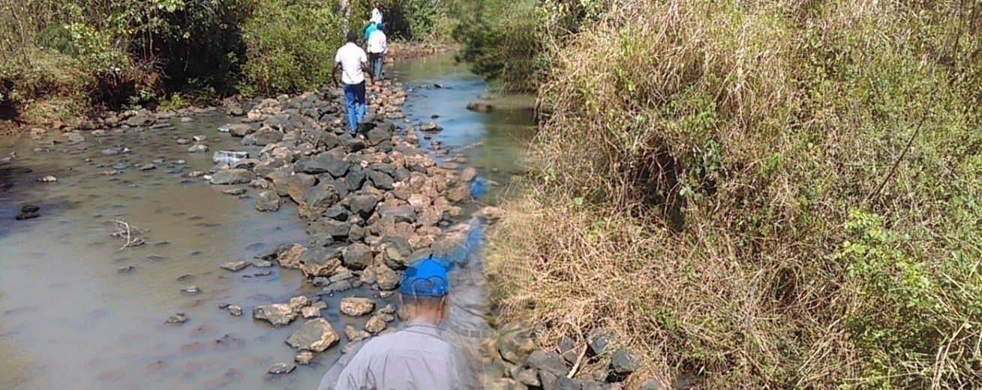

Scheme Management & Stakeholders Involvement
Water works management activities are the core operations of irrigation schemes and organizations, which include management of water user associations, operation and maintenance as well as collection and use of water charges and fees in a well-coordinated manner. Thus, the management of the scheme and use of water should be organized at different levels with differentiated roles of stakeholders at each level organization and clear relationships. Therefore, in order to come up with appropriate institutional arrangement and to design proper structures, these tasks are duly stated as follows.

Community Contribution and Scheme Management
According to the Ethiopian Water Resources Management Policy, water structures like dams, main canals, road accessibilities, dikes and drainage systems ought to be designed with the consideration of the affordability conditions of the beneficiary farmers and the type of crops to be grown thereto. Hence, the irrigation scheme is expected to be managed and costs must be covered by the money collected from user farmers which also should be maintained by an autonomous institution which should logically be representative of the water sector.
The beneficiary community will cover 10% of the investment cost of the project, which is Birr 7,906,352.51. This contribution is provided in the form of excavation of soft soil during construction and other materials or inputs at estimated value of Birr 790,635.25. This contribution by the user community is to promote sense of ownership of the project or scheme by the community thereby to ensure its sustainability.
It is believed that there is opportunity for collective action by water users for the operation and maintenance of irrigation system, i.e., it not is difficult to organize them because: (a) there is no excess water shortage to be wasted (b) the difference in water supply is not large between upstream and downstream farmers (c) the users’ association is relatively small in terms of service area and the number of farmer beneficiaries within its territory, (d) the local community has strong and high social bond and interactions (e) the farm households have less options of exit from farm to non-farm economic activities. But, on the other hand, where farmers who have had traditionally-practiced more rain-fed farming options might tend to show reluctance in managing communal-irrigation systems.
As estimated by the engineering feasibility study, the project is to be completed in one fiscal year under ideal conditions of financing, material availability and manpower allocation as in shown in annex.

Stakeholders Involvement
In addition to the water scheme management issues, the fulfillment of other tasks such as agricultural extension service, research support, input supplies, credit facilities, marketing, land allocation and administration, handling of legal cases and other related activities are inevitable in achieving the irrigation development project objectives. In this regard, full support of the respective government bodies and others is necessary.

The Need for Agricultural Extension Services
Agricultural extension and related services are among the most required tasks at the farm level. The most common agricultural extension and related services include the following:
- Irrigation practices improvement: advice to the farmers on how to improve their irrigation practices and to establish irrigated-crops patterns;
- On-farm development: assistance to the farmers in improving the farm layout;
- Quaternary canal system improvement: Encouraging the farmers to organize themselves into groups for the operation and maintenance of the quaternary canal systems and their improvement when needed. The detail is presented hereunder, as follows.

Irrigation Practices Improvement
Of the three most important activities of irrigation management - water distribution, system maintenance and irrigation extension activities are likely to assume the greatest relative importance in the early stages of a project. Thus, adequate extension service is should be in place and properly respond to the need of the farmers. Sufficient number of extension workers, qualified in all aspects of irrigation, agronomy, marketing and cooperatives ought to be assigned to irrigation schemes.

On-farm Development (Land Preparation)
On-farm development work is frequently left to the farmers' initiative and his own responsibility. However, on-farm development work is not attractive to the farmers because, it is usually an expensive task that requires special technical and financial leverage. Therefore, in order to make this operation attractive to farmers, it is imperative that some sizeable assistances and incentives should be offered; if not, the result is often that farms are poorly prepared to apply the irrigation water, which leads to severe water wastage and low-crop production.
Ultimately, the Irrigation Support Organization must stimulate the farmers to carry out the necessary improvements on their farm by providing the required technical assistances and trainings. In general, on-farm development activities entail the followings:
- intensive preliminary promotion to encourage the farmers to do their work as planned;
- strong technical supports by stakeholders as indicated and;
- Considerable amount of supervision during the operation.

Hence, to provide the required supports efficiently, there should be sufficient number of trained technicians and strong coordination of input supply facilitators, land allocation bodies and legal enforcement makers.

Actual Conditions of Agricultural Extension Services
Extension services by the Agricultural Development Office in irrigation practices, natural resources, general agronomy and animal husbandry is an already known responsibility. The DAs are trained and working only in the generic agriculture sub-sector. Accordingly, a large number of low-level professional staffs are being trained and assigned to each farmer’s association. However, the number of extension agents appears to be insufficient because the number of the extension agents assigned per a Farmers’ Association (FAs) is not more than two or three. Thus, agricultural extension agents working at project area are overloaded with rain-fed agricultural extension service works. Moreover, they have not received suitable training in irrigation techniques and practices. Most of them have a general training in agriculture, which is appropriate for the variety of duties they have to perform in rain-fed farming. The Regional Agricultural Development Bureau and its subordinate offices have also limited financial resources for extension services in irrigation.
Furthermore, the extension programs, like the Training and Visit (T & V) system, are not well placed to demonstrate the advantages of improved water management practices or proper irrigation practices and management; because, when the irrigation staff moves away from the areas, farmers might revert to the previous experience or malpractices. In making a close dialogue as and when required by the project, the extension workers should always be present in the project sites. However, it is obvious that delivering adequate assistance in irrigation practices to the farmers through the existing traditional extension services (Woreda Agricultural Development Office) would be inadequate.
The actual conditions of agricultural extensions services in the district and project area reveal that the fields of services and number of personnel engaged in providing the services are limited. The working extension system deploys three or four DAs to each Kebele: trained in the fields of plant science, animal production and animal health with the responsibility for crop production, livestock production and animal health, natural resource management, and cooperative promotions. The single farmers’ training center (FTC) in each Kebele is not well equipped with the required teaching materials and logistics. Currently, the ratio of DA to farmers in Nagaasaa Kebele is 1:238. Similarly, the average ratio in the district is 1 DA to 209 farmers or 76 DA to 15,877 farmers in 2009 EFY.

Irrigation Land Distribution and Re-distribution
It is expected that the irrigated land will be allocated equally (0.5 hectare) to each of the target households as per the Oromia Rural Land Use and Administration Proclamation No. 130/2007, Article 14, Sub-article 4 (a). However, land allocation in this manner is done where land is scarce. Regarding this particular project, land scarcity is not a serious problem at present and land distribution or re-distribution may be made as appropriate depending on the trend of newly-formed smallholder farm households

Monitoring and Evaluation (M & E)
The construction of the irrigation infrastructures alone is not an end by itself to meet the desired objective of the project. Therefore, M & E is necessary for regular follow-up of the day-to-day operation and progress of the scheme; and mid-term or terminal assessment of the impacts happen. M is continuously done to ensure that activities are being implemented as planned focusing on inputs used and outputs obtained. E is periodically carried out to judge the effectiveness of the process and the efficiency of resources used. The following table depicts the M & Evaluation Plan for implementation.
Table 27. Monitoring and evaluation plan of the project area
S.n | Activities to be monitored | Concerned body | Performance indicators
1. | Extent to which farmers participate in the project implementation | Kebele administration, DA, IWUA | Amount of birr/materials contributed by the beneficiaries
2. | Readiness to accept extension services | Extensions worker, IWUA | Number or per cent of users who receive extension trainings
3. | Water distribution (adequacy, equity and reliability) | IWUA | Degree of satisfaction of members
4. | Land preparation | Extension worker, IWUA | Per cent of land prepared for cultivation
5. | Proper cultivation | Peasants, extension worker | Timely cultivation of crops
6. | Harvesting | Peasants, extension worker | Timely harvesting of products
7. | Market linkage | Cooperatives and WUA | Market outlet created during harvest
8. | Income statement | Accountants | Revenue generated from irrigation

Summary of Irrigation Scheme Organization and Management Study
Irrigated agriculture requires a special training, considerable attention and close and frequent supervision by the development agents, especially during the initial years of the irrigation scheme operation, since most of the farmers have little or no experience with irrigated crops. The introduction of suitable irrigation methods is an important step that is intimately related to the need for appropriate land development work (usually land grading or preparation).
As to the occurrences of conflict on the use of resources (land, water, etc.) among people and existence of the corresponding conflict-resolution mechanisms in the project area, there are cases conflict confirmed during focus-group discussion, key-informants interview and response of the household survey interview. The process of conflict resolution takes either formal or informal manifestations. The task of resolving conflicts when they occur is usually done through mediation by elders and religious leaders as well as through formal community organizations by demarcation of land plots or through certification of landholdings by the government sector institution usually the District Rural Land Use and Administration Office. If the conflict is not resolved in this way, the case will be lodged to the regular court (Oromia Rural Land Use and Administration Proclamation No. 130/2007, Article 16).
The community has significant traditional knowledge, skill and experience of crop production with Boonee method. However, the community has a limited capacity and needs the supports of stakeholders in extension service, input supply, access road construction, credit service provision or facilitation, scheme management organization, land allocation and certification, watershed management and chemical fertilizer hazard mitigation, etc., to materialize the project and maintain its sustainability. Thus, capacity building activities for the community; and coordinated stakeholders support and operation is required. This would eventually yield into sustainable operation of the irrigation scheme and bring about improvement in the overall living condition of the beneficiary community.
As seen from experience, in order to utilize the full design capacity of the irrigation scheme, user households need to have sufficient skills in water management, operation and maintenance of the irrigation scheme, agronomic practice, marketing arrangement for farm inputs and outputs, etc. For the irrigation system to function at full capacity or optimum employment level, all concerned sector institutions and volunteers ought to be coordinated in a manner capable of delivering the necessary skills and other complementary supports. Here, the major challenges to sustainable operation of irrigation schemes are weak institutional functions and conflict on water use. To avoid such shortcomings, it would be imperative to put a mechanism in place:
- for maintaining schemes on regular bases to keep normal and equitable flow of water across the system,
- to strengthen institutional capacity for governing irrigation water use and rights based on the demands of users; and
- For dispute settlements among water users.

PART THREE

Financial and Economic Analysis
For this analysis, based on the agronomic study, only those crops that have actual and projected yield, direct and quantifiable costs of production, and known farm-gate or market prices have been taken and the computation has been done accordingly.

The “Without-project” Situation
Crop productivity, i.e., yield per ha determines the volume of total agricultural crop production. It is the most commonly used impact indicator to determine the performance of the agricultural production. However, crop yield is inevitably affected by many factors such as weather, input price, changes in farming practices, amounts of fertilizer used, quality of seed varieties, etc. Those benefits that accrue to the users in the without-project situation, the opportunity cost of the current, has been estimated based on the existing cropping pattern and yield, cost of production and farm-gate prices of each crop.

The Existing Cropping Patterns and Yield
Based on the agronomic assessment results, the pattern and yield of major food crops are produced under both rain-fed and traditional furrow irrigation method in and around the project area. The cropping pattern with actual and potential yields for a “model farm” of one hectare in and around the command areas for the specific or proposed crops is considered and shown in Table 28 below. The potential crop yield is assumed to be attained under intense agronomic practice and stakeholder support.
Table 28: Average Yield and Market Price of the Proposed Crops Against Cost of Production Per Hectare
No. | Crops | Actual Yield (qt/ha) | Price of Crop (Br/qt) | Gross Return (Br/ha) | Cost of Production (Br/ha)
1 | Pepper | 12.5 | 1,500.00 | 18,750.00 | 12,894.00
2 | Onion | 120 | 1,500.00 | 180,000.00 | 15,790.00
3 | Tomato | 130 | 1,200.00 | 156,000.00 | 14,604.00
4 | Maize | 35 | 470.00 | 16,450.00 | 15,257.50
5 | Cabbage | 120 | 1,000.00 | 120,000.00 | 11,615.00
6 | Banana | 150 | 1,000.00 | 150,000.00 | 23,960.00
7 | Potato | 140 | 800.00 | 112,000.00 | 42,752.25

Cost of Production of the Proposed Cropping System

The variable costs of cultivation and inputs of the cropping pattern obtained from the agronomic study report for a hectare of land is presented in Table 29 below.

 | Table 29: Average Variable Costs of Production Per Hectare for Proposed Crops
No. | Crops | Seed | Urea | Blended Fertilizer | Pesticide/Fung...herbicides | Labor | Pair of Oxen | Set of Farm Tools | Total Variable Cost (Birr)
1 | Pepper | 304.00 | 965.00 | 1,205.00 | 700.00 | 5,280.00 | 1,280.00 | 3,160.00 | 12,894.00
2 | Onion | 3,000.00 | 965.00 | 1,205.00 | 500.00 | 5,040.00 | 1,920.00 | 3,160.00 | 15,790.00
3 | Tomato | 272.00 | 965.00 | 1,807.00 | 800.00 | 6,320.00 | 1,280.00 | 3,160.00 | 14,604.00
4 | Maize | 962.50 | 1,930.00 | 1,205.00 | 800.00 | 5,280.00 | 1,920.00 | 3,160.00 | 15,257.50
5 | Cabbage | 375.00 | - | - | 400.00 | 6,400.00 | 1,280.00 | 3,160.00 | 11,615.00
6 | Banana | 16,000.00 | - | - | - | 3,520.00 | 1,280.00 | 3,160.00 | 23,960.00
7 | Potato | 30,000.00 | 1,592.25 | - | 700.00 | 5,380.00 | 1,920.00 | 3,160.00 | 42,752.25

Returns from the Proposed Crops without the Project
The size of land allocated for each crop, costs of production, actual yield levels and current farm gate prices of crops have been adapted to estimate the gross and net returns from the proposed crops. The annual net return from the crop patterning under the without-project situation is about Br 678,688.50 as shown in Table 30 below.

Table 30: Benefit from the Proposed Crops Without the Project (WOP)
 |  | Land Allocated to Each Crop (ha) | Actual Yield (qt/ha) | Land Use Tax (Br70.00/ha/annum) | Price of Crop (Br/qt) | Gross Return (Br/ha) | Cost of Production (Br/ha) | Net Return (Br/ha)
1 | Pepper | - | - | - | 2,500.00 | - | - | -
2 | Onion | 0.25 | 120 | 17.50 | 1,500.00 | 45,000.00 | 3,965.00 | 41,017.50
3 | Tomato | 0.50 | 130 | 35.00 | 1,200.00 | 78,000.00 | 7,337.00 | 70,628.00
4 | Maize | 2.00 | 35 | 140.00 | 470.00 | 32,900.00 | 30,655.00 | 2,105.00
5 | Cabbage | 0.75 | 120 | 52.50 | 1,000.00 | 90,000.00 | 8,763.75 | 81,183.75
6 | Banana | - | - | - | - | - | - | -
7 | Potato | 7.00 | 140 | 490.00 | 800.00 | 784,000.00 | 299,755.75 | 483,754.25
Total |  | 10.50 | - | 735.00 | - | 1,029,900.00 | 350,476.50 | 678,688.50

The With-project Situation

The size of land allocated for each crop, costs of production, actual yield levels and current farm gate prices of crops have been adapted to estimate the gross and net returns from the proposed crops under the situation of the project in the future. The type of crop proposed, size of land allocated for each crop, and the actual yield and projected yield of the same crops under the with-project situation are as follows.

Actual & Projected for the Proposed Crops

The type of crop proposed, and the actual yield and projected yield of the same crops under the with-project situation are as shown in Table 31 below.
Table 31: Actual and Projected Yield for Proposed Crops
No. | Crops | Actual & Potential/Projected Crop Yield (qt/ha) by Years
No. | Crops | Actual | Y-1 | Y-2 | Y-3 | Y-4 | Y-5
1 | Pepper | 12.50 | 15.00 | 20.00 | 22.00 | 24.00 | 25
2 | Onion | 120.00 | 130.00 | 180.00 | 220.00 | 280.00 | 350
3 | Tomato | 130.00 | 140.00 | 200.00 | 280.00 | 350.00 | 400
4 | Maize | 35.00 | 50.00 | 70.00 | 80.00 | 85.00 | 90
5 | Cabbage | 120.00 | 150.00 | 250.00 | 300.00 | 350.00 | 450
6 | Banana | 150.00 | - | 120.00 | 160.00 | 280.00 | 480
7 | Potato | 140.00 | 160.00 | 250.00 | 320.00 | 380.00 | 448.00

Development of Irrigation Agriculture
The first two years is planned for pre-investment and the implementation activities of the project such as camping, irrigation head works, canal development, etc, before the start of production. At the end 1st year of production, all of the command area will be covered with crops at its full capacity and the subsequent years are supposed to be the time of intensifying the irrigation technology to its full development.

Land Allocation & Crop Pattern and Intensity
Crops proposed for the’ with project’ case are based on the suitability conditions of the areas and currently existing demands for the product both at household level and local markets and production practices. Land is proportionally allocated to each crop for 5 years and cropping pattern and intensity together with the expected output of the respective crop is as in table 32 below.

Table 32: Proposed Crop Pattern and Intensity
No. | Type of crops | Year 1 |  |  |  | Year 2 |  |  |  | Year 3 |  |  |  | Year 4 |  |  |  | Year 5+
No. | Type of crops | Dry season |  |  |  | Dry season |  |  |  | Dry season |  |  |  | Dry season |  |  |  | Dry season
No. | Type of crops | ha | % | Yield (qt/ha) | Total Output (qt) | ha | % | Yield (qt/ha) | Total Output (qt) | ha | % | Yield (qt/ha) | Total Output (qt) | ha | % | Yield (qt/ha) | Total Output (qt) | ha | % | Yield (qt/ha) | Total Output (qt)
1 | Pepper | 5 | 10 | 15 | 75 | 5 | 10 | 20 | 100 | 5 | 10 | 22 | 110 | 5 | 10 | 24 | 120 | 5 | 10 | 25 | 125
2 | Onion | 3 | 6 | 130 | 390 | 2 | 4 | 180 | 360 | 2 | 4 | 220 | 440 | 2 | 4 | 280 | 560 | 2 | 4 | 350 | 700
3 | Tomato | 2 | 4 | 140 | 280 | 2 | 4 | 200 | 400 | 1 | 2 | 280 | 280 | 1 | 2 | 350 | 350 | 1 | 2 | 400 | 400
4 | Maize | 20 | 39 | 50 | 1,000 | 18 | 37 | 70 | 1,260 | 21 | 43 | 80 | 1,680 | 21 | 43 | 85 | 1,785 | 19 | 39 | 90 | 1,710
5 | Cabbage | 3 | 6 | 150 | 450 | 2 | 4 | 250 | 500 | 2 | 4 | 300 | 600 | 2 | 4 | 350 | 700 | 2 | 4 | 450 | 900
6 | Banana | 2 | 4 | - | - | - | - | 120 | 240 | - | - | 160 | 320 | - | - | 280 | 560 | - | - | 480 | 960
7 | Potato | 16 | 31 | 160 | 2,560 | 20 | 41 | 250 | 5,000 | 18 | 37 | 320 | 5,760 | 18 | 37 | 380 | 6,840 | 20 | 41 | 448 | 8,960
Total |  | 51 | 100 | - | - | 49 | 100 | - | - | 49 | 100 | - | - | 49 | 100 | - | - | 49 | 100 | - | -

Cost Estimation
The total financial requirements for the project are just the sum of the three cost elements: investment costs, operation and maintenance cost (O & M), and production cost, as shown in the following tables (33 and 34) for the implementation of the project.
Table 33: Estimated Cost of Crop Production
 | Project Year | Y-1 | Y-2 | Y-3 | Y-4 | Y-5⁺
No. | Type of Crop | Cost (Br) | Cost (Br) | Cost (Br) | Cost (Br) | Cost (Br)
1 | Pepper | 64,470.00 | 64,470.00 | 64,470.00 | 64,470.00 | 64,470.00
2 | Onion | 47,370.00 | 31,580.00 | 31,580.00 | 31,580.00 | 31,580.00
3 | Tomato | 29,208.00 | 29,208.00 | 14,604.00 | 14,604.00 | 14,604.00
4 | Maize | 305,150.00 | 274,635.00 | 320,407.50 | 320,407.50 | 289,892.50
5 | Cabbage | 34,845.00 | 23,230.00 | 23,230.00 | 23,230.00 | 23,230.00
6 | Banana | 47,920.00 | 4,160.00 | 4,160.00 | 4,160.00 | 4,160.00
7 | Potato | 684,036.00 | 855,045.00 | 769,540.50 | 769,540.50 | 855,045.00
Total |  | 1,212,999.00 | 1,282,328.00 | 1,227,992.00 | 1,227,992.00 | 1,282,981.50

The total investment cost of the project including 15% VAT is about Birr 7,906,352.51.
Table 34: Estimated Investment and Other Costs
No. | Cost Type | Unit | Quantity | Unit Cost (Br) | Total Cost (Br)
1 | Initial Investment + VAT (Br) | Br | - | - | 7,906,352.51
2 | Maintenance Cost (2% of investment - VAT) | Br | - | - | 137,501.78
3 | Environmental management cost (2% of investment - VAT) | Br | - | - | 137,501.78
4 | Local land tax (Br 70/ha/annum) | Br | 51.00 | 70.00 | 3,570.00
5 | Irrigation water charge (Br 45/HH/annum) | Br | 85.00 | 45.00 | 3,825.00
Total |  | - | - | - | 8,188,751.08

Returns from the Proposed Crops
The annual net return from the crop patterning under the with-project situation is about Br 4,001,500.00 in the first year and will reach Br 11,549,200.00 in the fifth year and beyond as shown in Table 35 below.
Table 35: Projected Returns from the Proposed Crops
 | Project Year | Y-1 | Y-2 | Y-3 | Y-4 | Y-5⁺
No. | Type Crop | Gross Return (Br) | Gross Return (Br) | Gross Return (Br) | Gross Return (Br) | Gross Return (Br)
1 | Pepper | 112,500.00 | 150,000.00 | 165,000.00 | 180,000.00 | 187,500.00
2 | Onion | 585,000.00 | 540,000.00 | 660,000.00 | 840,000.00 | 1,050,000.00
3 | Tomato | 336,000.00 | 480,000.00 | 336,000.00 | 420,000.00 | 480,000.00
4 | Maize | 470,000.00 | 592,200.00 | 789,600.00 | 838,950.00 | 803,700.00
5 | Cabbage | 450,000.00 | 500,000.00 | 600,000.00 | 700,000.00 | 900,000.00
6 | Banana | - | 240,000.00 | 320,000.00 | 560,000.00 | 960,000.00
7 | Potato | 2,048,000.00 | 4,000,000.00 | 4,608,000.00 | 5,472,000.00 | 7,168,000.00
Total |  | 4,001,500.00 | 6,502,200.00 | 7,478,600.00 | 9,010,950.00 | 11,549,200.00

The annual revenues of the proposed products have been estimated using the production costs, the irrigation design costs, operation and maintenance costs, etc. This analysis has been developed for 20 years based on the current market prices. . Accordingly, the estimate of the annual net return from the whole command areas is as shown below.
Table 36: Projected Production Costs and Returns for the Proposed Crops
Year | Y-1 | Y-2 | Y-3 | Y-4 | Y-5+
Gross Return (Br) | 4,001,500.00 | 6,502,200.00 | 7,478,600.00 | 9,010,950.00 | 11,549,200.00
Cost (Br) | 1,212,999.00 | 1,282,328.00 | 1,227,992.00 | 1,227,992.00 | 1,282,981.50
Net Return (Br) | 2,788,501.00 | 5,219,872.00 | 6,250,608.00 | 7,782,958.00 | 10,266,218.50

Result of the Cost-Benefit Analysis
Therefore, a constant farm-gate price of the year 2017/18 for both inputs and outputs estimation has been used in order to reflect the income and expenses of the farm at project level; assuming a conversion rate of 11%. The NPV of the incremental benefits of the project at 11% discounting factor is estimated to be about Br 9.63 million; and the BCR was found to be 1.55. The payback period is found to be the 4th year. The results indicate that the project is financially and economically viable; which is presented as shown in Table 37 below.
Table 37: Cost-Benefit Analysis of the Proposed Project
Description of Components |  | Year
 |  | 0 | 1 | 2 | 3 | 4 | 5+
Pre-investment costs |  | 369,437.50 | - | - | - | - | -
Investment costs |  | 7,906,352.51 | - | - | - | - | -
Fixed cost (M cost, environmental management cost, land tax & water charge) |  | - | 282,398.57 | 282,398.57 | 282,398.57 | 282,398.57 | 282,398.57
Variable Operating Costs |  | - | 1,212,999.00 | 1,282,328.00 | 1,227,992.00 | 1,227,992.00 | 1,282,981.50
Management & Supervision cost (5%) |  | 395,317.63 | - | - | - | - | -
Total Cost |  | 8,671,107.64 | 1,495,397.57 | 1,564,726.57 | 1,510,390.57 | 1,510,390.57 | 1,565,380.07
WOP Benefits |  | 678,688.50 | 678,688.50 | 678,688.50 | 678,688.50 | 678,688.50 | 678,688.50
WP Benefits |  | - | 4,001,500.00 | 6,502,200.00 | 7,478,600.00 | 9,010,950.00 | 11,549,200.00
Incremental benefits |  | (9,349,796.14) | 1,827,413.93 | 4,258,784.93 | 5,289,520.93 | 6,821,870.93 | 9,305,131.43
Discounted Benefits @11% |  | - | 3,604,955.35 | 5,277,328.57 | 5,468,285.01 | 5,935,792.10 | 6,853,884.29
Discounted Cost @11% |  | 9,349,796.14 | 1,958,636.31 | 1,820,805.02 | 1,600,634.91 | 1,442,014.24 | 1,331,744.73
NPV |  | (9,349,796.14) | 1,646,319.04 | 3,456,523.55 | 3,867,650.10 | 4,493,777.86 | 5,522,139.55
BCR = |  | Benefits | = 27,140,245.33 = |  | 1.550549413
 |  | Costs | 17,503,631.36
Payback period = 4 years

- Benefit-Cost Ratio = 1.55;
- Total NPV at 11% = + 9,636,613.97; and
- IRR = 37.83%.

Sensitivity Analysis
There is a possibility that the results of the financial and economic cost-benefit analysis are subjected to a range of risk and uncertainties. Thus, sensitivity test is required in order to understand more about the degree of confidence with which the outputs of the analysis is conducted. The project is expected to use new irrigation technologies in relation to the existing culture of the communities. So that, it is useful to use a range of different planning horizons in line with the reliability and appreciation of the dynamic nature of the project environments, rather than expecting immediate financial earnings in a short period of time.
To this effect, assessment is made to know the extent to which the proposed investment implies risk for the country and for the project. Risks should have to be identified and their possible impacts on the financial and economic viability of the investment and its sustainability have to be examined. Accordingly, three possible scenarios have been considered here for the sensitivity test: These are;
- A 5% increase in the cost stream and no change in the benefit stream;
- A 5% decline in the benefit stream and no change in the cost steam; and
- A 5% decline in the benefits and a 5% increase in cost.
Table 38: A 5% increase in the cost stream and no change in the benefit stream
Description of Components |  | Year
 |  | 0 | 1 | 2 | 3 | 4 | 5+
Pre-investment costs |  | 387,909.38 | - | - | - | - | -
Investment costs |  | 8,301,670.14 | - | - | - | - | -
Fixed cost (M cost, environmental management cost, land tax & water charge) |  | - | 296,518.49 | 296,518.49 | 296,518.49 | 296,518.49 | 296,518.49
Variable Operating Costs |  | - | 1,273,648.95 | 1,346,444.40 | 1,289,391.60 | 1,289,391.60 | 1,347,130.58
Management & Supervision cost (5%) |  | 415,083.51 | - | - | - | - | -
Total Cost |  | 9,104,663.02 | 1,570,167.44 | 1,642,962.89 | 1,585,910.09 | 1,585,910.09 | 1,643,649.07
WOP Benefits |  | 712,622.93 | 712,622.93 | 712,622.93 | 712,622.93 | 712,622.93 | 712,622.93
WP Benefits |  | - | 4,001,500.00 | 6,502,200.00 | 7,478,600.00 | 9,010,950.00 | 11,549,200.00
Incremental benefits |  | (9,817,285.94) | 1,718,709.63 | 4,146,614.18 | 5,180,066.98 | 6,712,416.98 | 9,192,928.01
Discounted Benefits @11% |  | - | 3,604,955.35 | 5,277,328.57 | 5,468,285.01 | 5,935,792.10 | 6,853,884.29
Discounted Cost @11% |  | 9,817,285.94 | 2,056,568.13 | 1,911,845.27 | 1,680,666.66 | 1,514,114.95 | 1,398,331.97
NPV |  | (9,817,285.94) | 1,548,387.23 | 3,365,483.29 | 3,787,618.36 | 4,421,677.15 | 5,455,552.32
Total NPV of |  | Benefits | 27,140,245.33 |  | BCR = | 1.476713727
 |  | Costs | 18,378,812.92
 |  | NPV | 8,761,432.40

Table 39: A 5% decline in the benefit stream and no change in the cost steam
Description of Components |  | Year
 |  | 0 | 1 | 2 | 3 | 4 | 5+
Pre-investment costs |  | 369,437.50 | - | - | - | - | -
Investment costs |  | 7,906,352.51 | - | - | - | - | -
Fixed cost (M cost, environmental management cost, land tax & water charge) |  | - | 282,398.57 | 282,398.57 | 282,398.57 | 282,398.57 | 282,398.57
Variable Operating Costs |  | - | 1,212,999.00 | 1,282,328.00 | 1,227,992.00 | 1,227,992.00 | 1,282,981.50
Management & Supervision cost (5%) |  | 395,317.63 | - | - | - | - | -
Total Cost |  | 8,671,107.64 | 1,495,397.57 | 1,564,726.57 | 1,510,390.57 | 1,510,390.57 | 1,565,380.07
WOP Benefits |  | 678,688.50 | 678,688.50 | 678,688.50 | 678,688.50 | 678,688.50 | 678,688.50
WP Benefits |  | - | 3,801,425.00 | 6,177,090.00 | 7,104,670.00 | 8,560,402.50 | 10,971,740.00
Incremental benefits |  | (9,349,796.14) | 1,627,338.93 | 3,933,674.93 | 4,915,590.93 | 6,371,323.43 | 8,727,671.43
Discounted Benefits @11% |  | - | 3,424,707.58 | 5,013,462.14 | 5,194,870.76 | 5,639,002.50 | 6,511,190.07
Discounted Cost @11% |  | 9,349,796.14 | 1,958,636.31 | 1,820,805.02 | 1,600,634.91 | 1,442,014.24 | 1,331,744.73
NPV |  | (9,349,796.14) | 1,466,071.27 | 3,192,657.12 | 3,594,235.85 | 4,196,988.26 | 5,179,445.34
Total NPV of |  | Benefits | 25,783,233.06 |  | BCR= | 1.473021942
 |  | Costs | 17,503,631.36
 |  | NPV | 8,279,601.70

Table 40: A 5% decline in the benefits and a 5% increase in cost
Description of Components |  | Year
 |  | 0 | 1 | 2 | 3 | 4 | 5+
Pre-investment costs |  | 387,909.38 | - | - | - | - | -
Investment costs |  | 8,301,670.14 | - | - | - | - | -
Fixed cost (M cost, environmental management cost, land tax & water charge) |  | - | 296,518.49 | 296,518.49 | 296,518.49 | 296,518.49 | 296,518.49
Variable Operating Costs |  | - | 1,273,648.95 | 1,346,444.40 | 1,289,391.60 | 1,289,391.60 | 1,347,130.58
Management & Supervision cost (5%) |  | 415,083.51 | - | - | - | - | -
Total Cost |  | 9,104,663.02 | 1,570,167.44 | 1,642,962.89 | 1,585,910.09 | 1,585,910.09 | 1,643,649.07
WOP Benefits |  | 712,622.93 | 712,622.93 | 712,622.93 | 712,622.93 | 712,622.93 | 712,622.93
WP Benefits |  | - | 3,801,425.00 | 6,177,090.00 | 7,104,670.00 | 8,560,402.50 | 10,971,740.00
Incremental benefits |  | (9,817,285.94) | 1,518,634.63 | 3,821,504.18 | 4,806,136.98 | 6,261,869.48 | 8,615,468.01
Discounted Benefits @11% |  | - | 3,424,707.58 | 5,013,462.14 | 5,194,870.76 | 5,639,002.50 | 6,511,190.07
Discounted Cost @11% |  | 9,817,285.94 | 2,056,568.13 | 1,911,845.27 | 1,680,666.66 | 1,514,114.95 | 1,398,331.97
NPV |  | (9,817,285.94) | 1,368,139.46 | 3,101,616.87 | 3,514,204.11 | 4,124,887.55 | 5,112,858.10
Total NPV of |  | Benefits | 25,783,233.06 |  | BCR= | 1.40287804
 |  | Costs | 18,378,812.92
 |  | NPV | 7,404,420.14

The results in all the three scenarios are feasible and sustainable in changing circumstances. The NPVs are positive; and the benefit-cost ratios are greater than one in all cases.

CONCLUSION AND RECOMMENDATION
There available land and water potential for irrigation development is likely to bring about increased production and crop varieties, increased household consumption, feed for livestock and additional income with the new project. The availability of irrigation water in the future could produce secondary benefits to the community such as increase in the seasons of farm operations, additional job opportunity, and new skills of production. Given the age structure of the community, adequate local labor force can easily be made available for the farm operations and voluntarily mobilize to the project area from the nearby urban centers. On the other hand, it is believed that the irrigation scheme can help in rehabilitating or maintaining the environment by enabling more production than before from a relatively small land plot.
With direct beneficiary community participation in the whole stages of the irrigation project and the necessary support from all stakeholders those development constraints could turn into opportunity thereby achieve the goal and objectives set out. The beneficiary community has a good of prospect of the project for improving their living conditions and is eagerly waiting for the project to be a reality and ready to provide support with resources at its disposal. Beyond this entheiasism of the community, the supports of stakeholders (extension service, timely input supply, access road construction, credit service provision, mitigation of mosquito breeding, chemical input hazards, etc.) are needed to materialize the objective of the project and maintain its sustainability. To maintain the benefits that accrue to the community, stakeholders ought to strive to minimize adverse impacts to the environment. This would eventually yield into sustainable operation of the irrigation scheme and bring improvement in the lives of the community.
The local market potential and physical infrastructures in the project area are generally in a good condition.
The introduction of irrigation methods needs to be tailored to the real situations of the beneficiaries. Development agents (DA) ought to have a special training in irrigated agriculture so that they could make close and frequent supervision during the initial years of the irrigation scheme operation, since most of the farmers have little or no experience with irrigated crops.
.

Annexes

Annex 1 Minutes of Community Meeting and petition

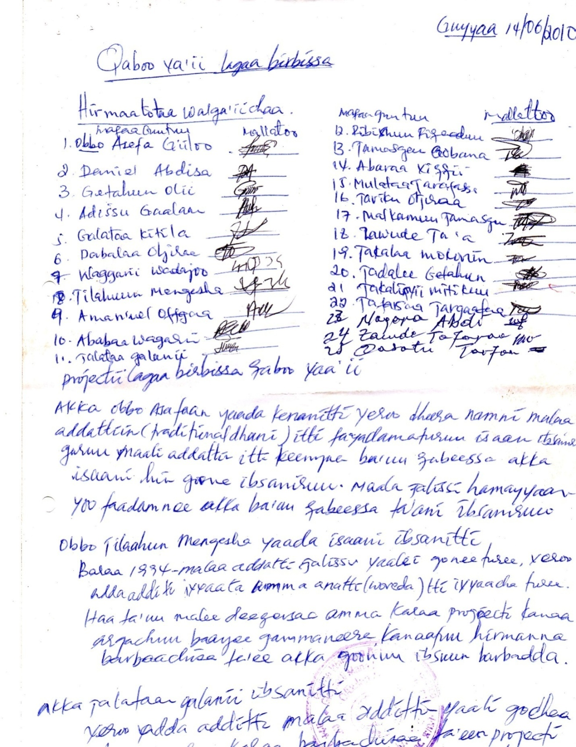

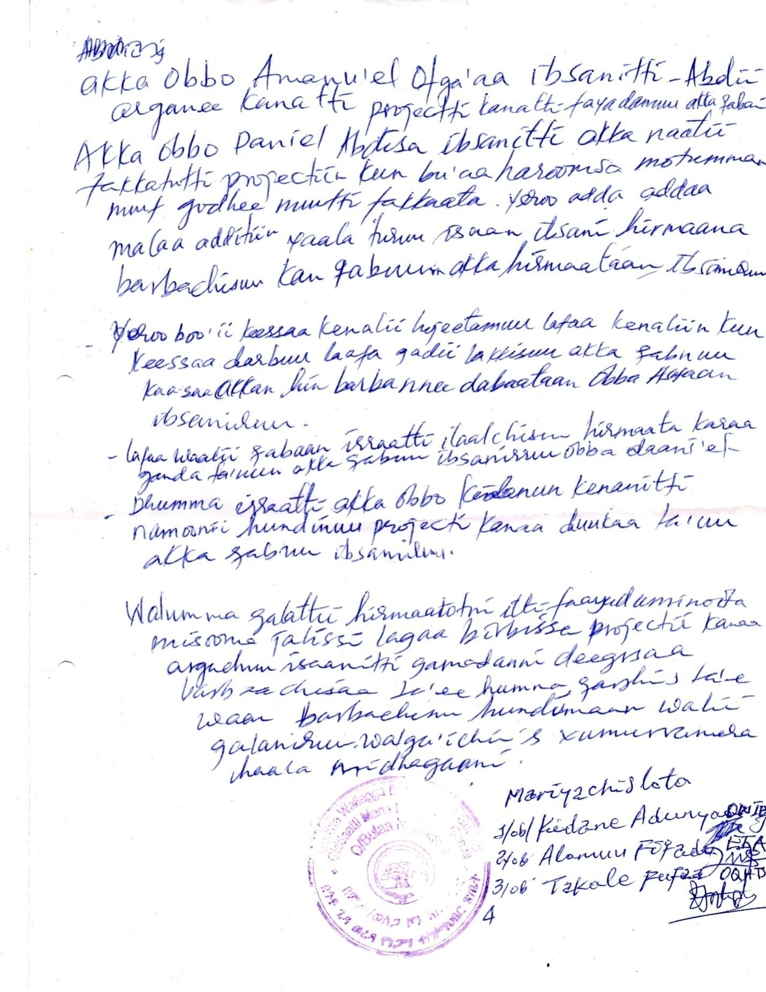
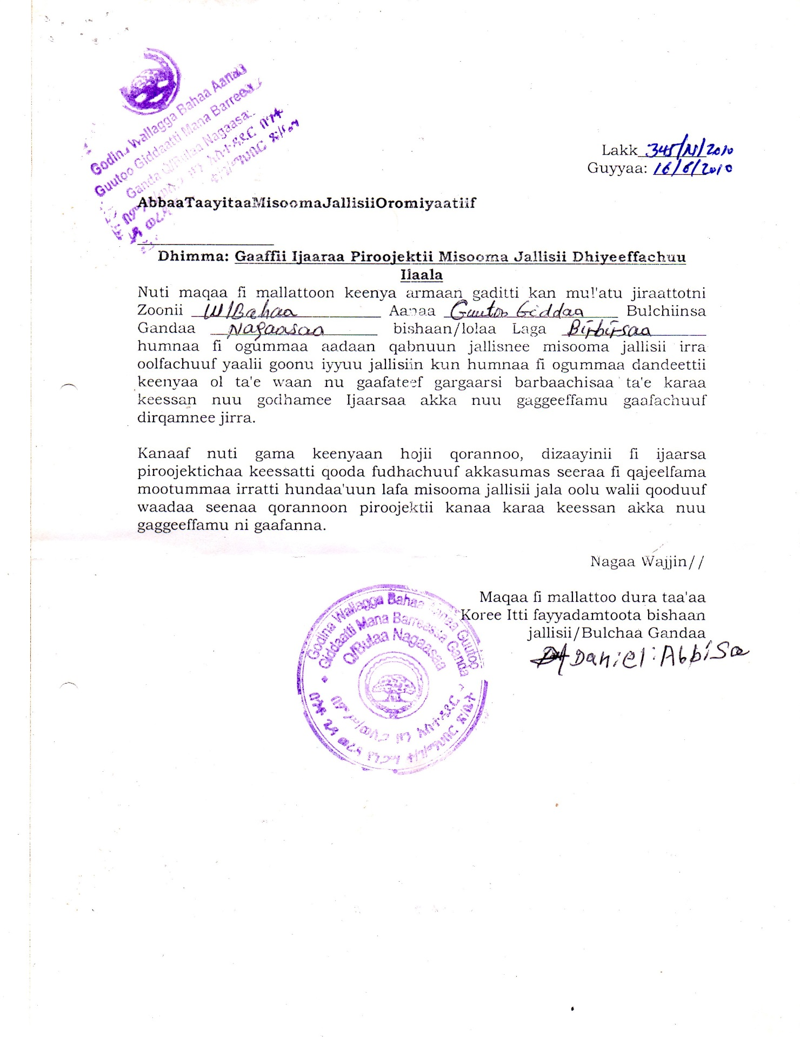
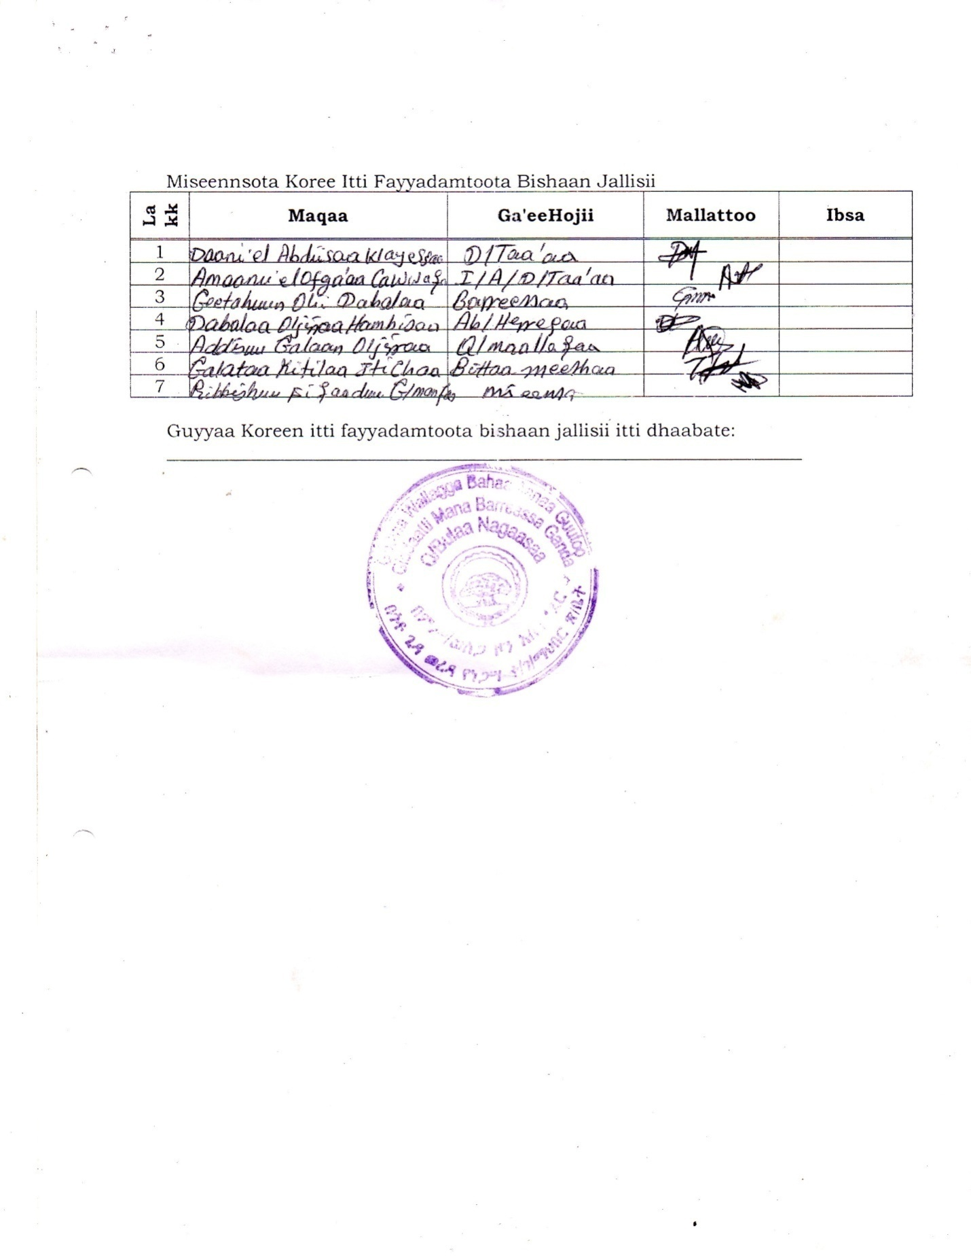

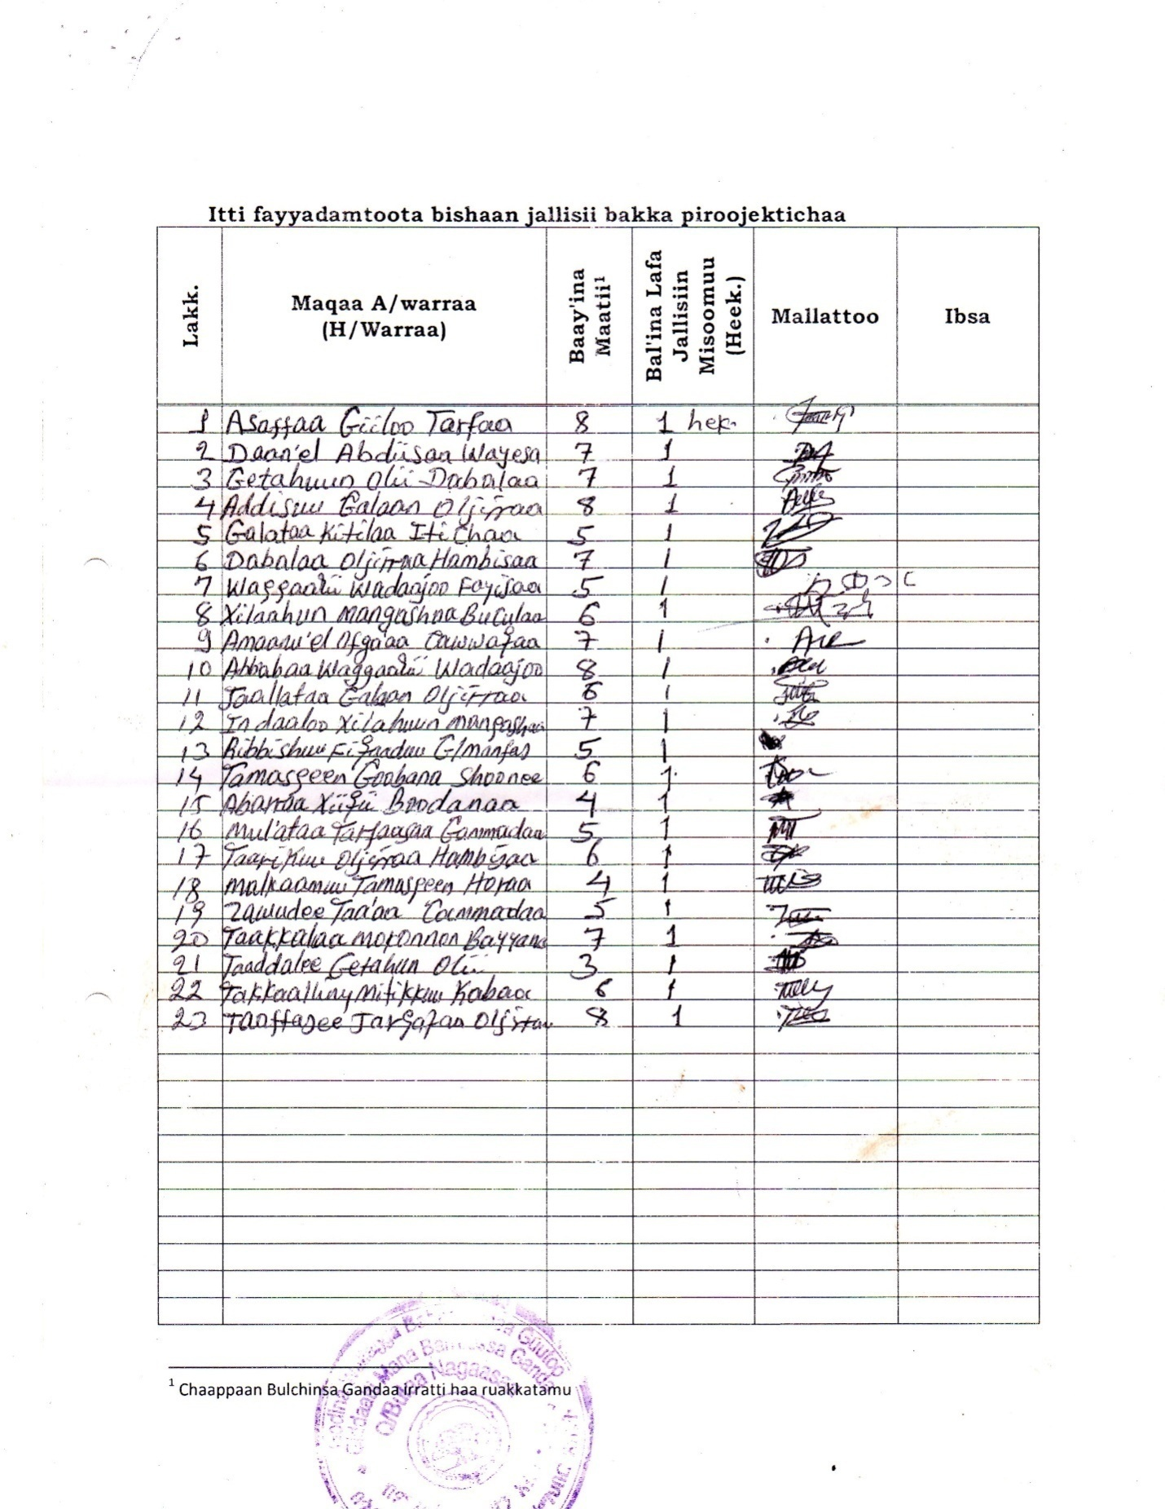

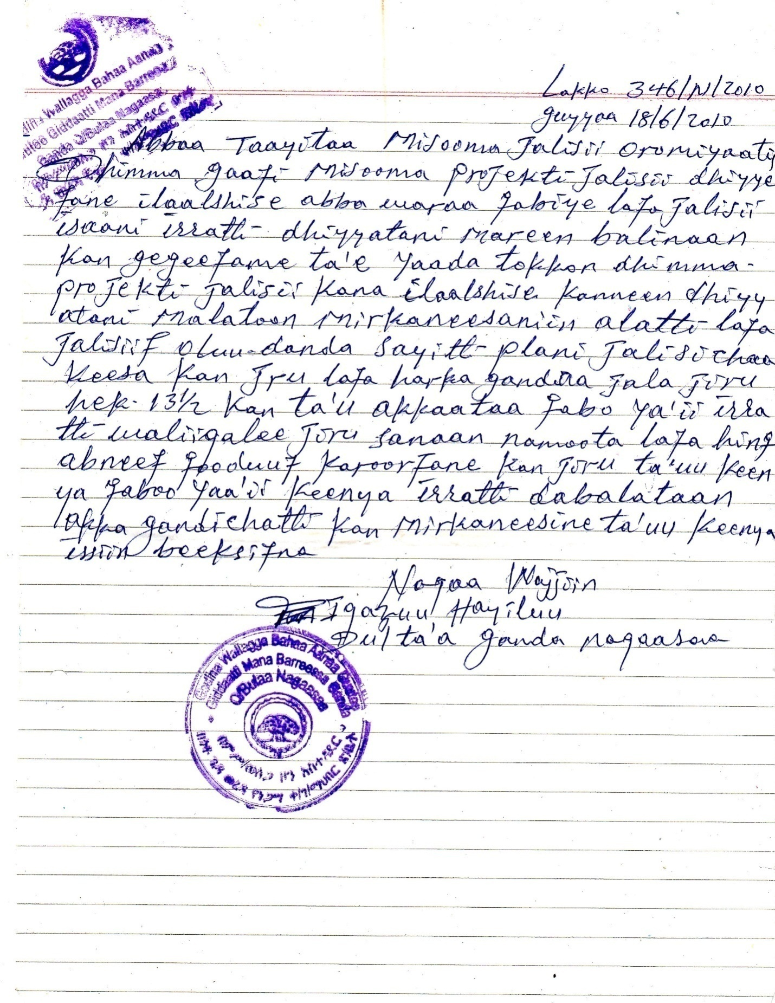

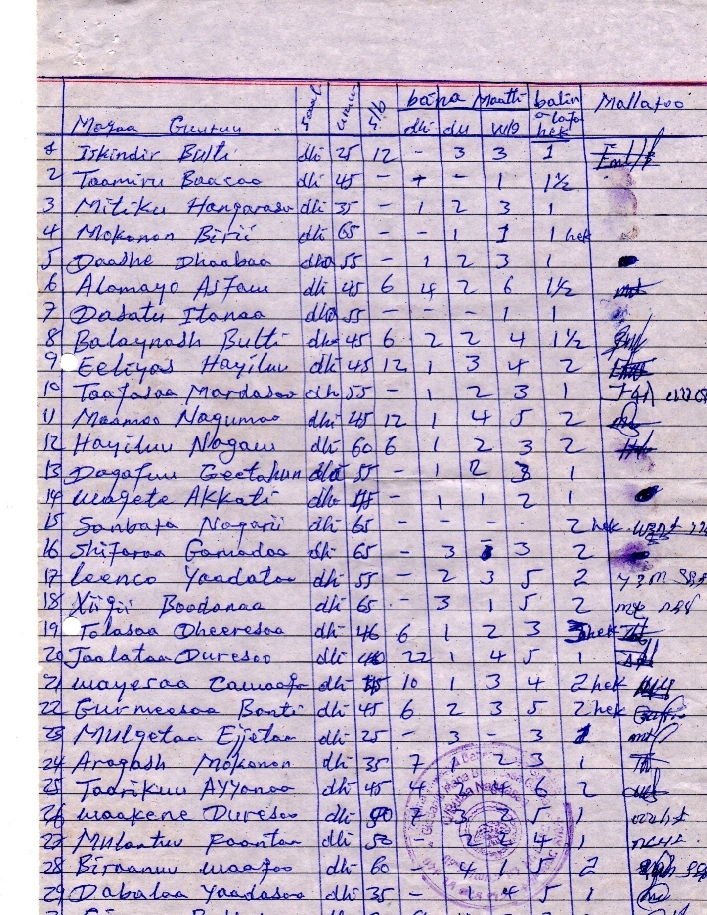
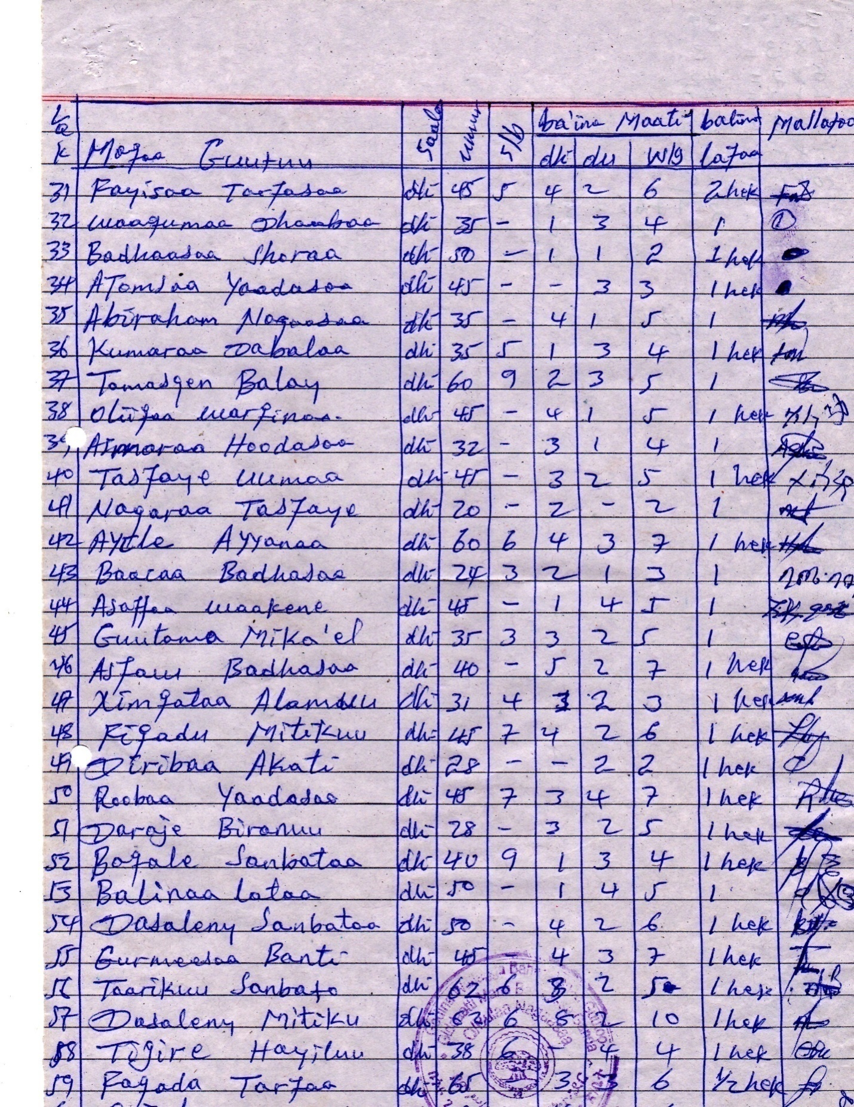

Annex 2. Sample Command Areas and Community Consultation
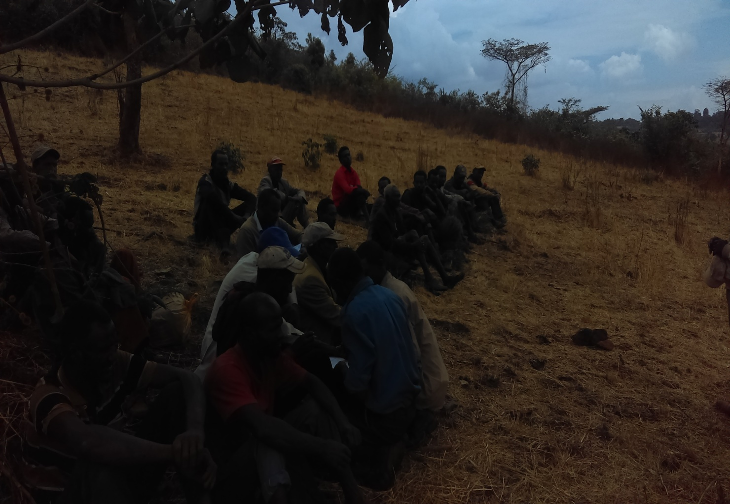

Annex 3. HH Survey Questionnaire
Socio-economic Study: Questionnaire for Household Survey for Small-scale Irrigation Projects

Interview Date_________

Project Title: ________________________________

Location: Region ________________ Zone ______________Woreda______________

Kebele Administration:
- HOUSHOLD CHARACTERSTICS
  - Name of the household’s head
  - Sex: 1. Male 2. Female
  - Age
  - Religion
  - Marital Status
1. Single 2. Married 3. Divorced 4. Widowed
  - Family size
Male Female Total
  - Family member’s age in number
1. Less than 15yrs ----------- 2. 15-64 yrs Above 64 yrs ____ 4. Total
  - Ethnic Group ___________________
  - Educational Level
1. Illiterate 2. Read & write 3. Grade 1-8 4. Grade 9-12 5. Above Grade 12
  - What is the primary source of income (means of livelihood) of the HH

1. Crop production 2. Livestock Production 3. Equally from crop & livestock Production
4. Forest production 5. Petty trade 6. Others
  - What is the secondary source of income (means of livelihood)
1. Crop production 2. Livestock products 3. Forest products 4. Petty trade
5. Off-farming employment 6. Others if any
1.12. Estimates of annual income of the HH from different sources
S.No | Income Sources | Annual income in Birr | Remark
1 | Crop production
2 | Sale of livestock
3 | Sale of livestock products (Milk, butter, cheese, egg, skin, honey, etc)
4 | Sale of vegetables and fruits
5 | Sale of forest products
6 | Off farm activities
7 | Remittance
8 | Others
Total

1.13. Estimates of annual expenditure of the HH for different purposes
S.No | Type of Expenditure | Annual Expenditure in Birr | Remark
1 | Food
2 | Clothing
3 | Fuel
4 | Salt, sugar, oil etc
5 | Soap and other sanitation purposes
6 | Treatment
7 | Education
8 | Farm inputs
9 | Others
Total

1.14. Were you born here? 1. Yes 2. No
1.15. If no, for how long have you lived in this area?
1. Less than 10 Yrs, 2. 10 - 20 years, 3. More than 20 years

2. Social Services

2.1 Education

2.1.1 What type of education do you prefer for your children?
1. Formal education 2. Non-formal education 3. Religious education

2.1.2 How far is the nearby formal education institution for the household? In km.
1. 1st cycle, 1-4 2. 2nd cycle 1-8 (5-8) 3. High School (9-10)
4. Preparatory 11-12 5. Higher education

2.1.3 Number of family members attending formal education.
1. Male 2. Female 3. Total

2.1.4 What are the major problems of education in your community?
1. Absence of the school in the nearby 2. Unable to cover school expenses
3. HH demand of children labor
2.2 Health
2.2.1. What is the most common disease prevailing in your area?
1. Malaria 2. Diarrhea 3. TB 4. Intestinal parasite 5. Eye diseases
6. STD 7. Headache 8. Typhoid 9. Others (Specify) ------------------------------------------------
2.2.2 What is the second most common disease prevailing in your area?
1. Malaria 2. Diarrhea 3. TB 4. Intestinal parasite 5. Eye diseases
6. STD 7. Headache 8. Typhoid 9. Others (Specify) ------------------------------------------------
2.2.3 Where do you go for treatment when one of your family members gets sick?
1. Hospital 2. Health center 3. Private Clinic 4. Health post
5. Traditional healer 6. Self-treatment 7. Stay at home
2.2.4. What is the major constraint in health services?
1. Absence of health service in the near by 2. Shortage of medicine 3. Lack of health personnel
4. High treatment and medicine cost 5. Reluctance of the health personnel
6. Lack of accessibility to reach the health services 7. Other
What is the second major constraint in health services?
1. Absence of health service in the nearby 2. Shortage of medicine 3. Lack of health personnel
4. High treatment &Medicine cost 5. Reluctance of the health personnel
- Lack of accessibility to reach the health services 7. Other
2.2.6. Have you ever received health education on diseases prevention and control? 1. Yes 2. No
    - Do you agree that immunization for children and women are useful? 1. Yes 2. No
2.2.8 Do you agree that family planning is useful? 1. Yes 2. No
    - Do you and/or your spouse (husband or wife) use family planning service? 1. Yes 2. No
    - Do you favor to have many children? 1. Yes 2. No
    - Do you know the mode of transmission of HIV/AIDS from person to person? 1. Yes 2. No
    - Do you know what you should do to protect yourself and your family from being infected with HIV/ AIDS?

1. Yes 2. No
  - Drinking Water Supply
    - Main sources of water used for drinking and food cooking?
1. River 2. Pond 3. Lake 4. Hand-dug Well 5. Protected spring
6. Not protected spring 7. Piped Water 8. Others
    - How far (distance) do you travel to fetch water from the major Supply source?
Round trip distance: KM OR Minute
    - Do you pay for water? 1. Yes 2. No
    - If Yes How much per month in birr
    - Who mainly collects water for the family?
1. Wife 2. Female children 3. Male children 4. Husband 5. All HH members

2.4. Sanitation Facilities
2.4.1. Do you have Toilet? 1. Yes 2. No
    - Where are you disposing your domestic dry waste?
1. Everywhere 2. In the nearby farming plots 3. In pits 4. In the nearby natural depression 5. Burning in the fire 6. Open dumping 7. Other
  - Transports and Communication
    - Do you have transportation problems in this area? 1. Yes 2. No
    - If yes, what is the main problem?
1. There is no Road at all 2. The fare is high 3. The road is not good 4. The road is too far 5. Other problem (Specify)
    - How far is the nearest postal service from you area? in KM
    - How far is the nearest telephone service from your area? in KM
    - How far is the nearest Bank service from your area? in KM
- AGRICULTURE AND FOOD SUPPLY
3.1. Land Tenure
    - Do you have your own landholding? 1. Yes 2. No
    - If yes, how much in hectare (ha)?

Grazing
Cultivated
Backyard
Forestland ____________

Total

    - Of the cultivated land in ha: Rain fed ha Irrigated ha
    - Do you have rented your own land to others? 1. Yes 2. No
    - Do you have rented land from others? 1. Yes 2. No

  - Crop Production
3.2.1 How is the trend of your crop production for the last 5 years?
1. Increasing 2. Decreasing 3. No change
3.2.2 Is your last year's production sufficient for your family? 1. Yes 2. No
3.2.3 If no, what is the reason?
1. Shortage of farmland 2. Shortage of inputs (seed, fertilizers, farm power etc.)
3. Bad weather (drought, excess rain, frost, hail, wind storm, etc.) 4. Other reasons
3.2.4 How do you manage to fill the crop failure/insufficiency gap?
1) Family members’ labor 2) Sale of livestock 3) Remittance from relative abroad (foreign country)
4) Aid from Govt. and or NGO 5) Borrowing 6) Sale of forest products (timber, firewood, etc.)
3.2.5 For how many months of the year your households rely only on the yearly produced crops without external
support or buying grain from market?
1) < 3 months 2) 3-6 Months 3) 6-9 months 4) 9-12 Months
3.2.6 How many quintals of all types of food crops does your family require for 12 Months? qt
3.2.7 Do you use any labor from outside other than your family for producing crops? 1. Yes 2. No
3.2.8 What is the share/contribution of crop production in your annual income?
Estimate the percentage %
3.2.9 Do you use irrigation for crop production? 1. Yes 2. No
3.2.10 If “No”, is your produce enough to support your family? 1. Yes 2. No
3.2.11 If you are using irrigation, for how long? 1. For < 5 years 2. For 5-10 years 3. For > 10 years
3.2.12 How is your life changed since use of irrigation? 1. Deteriorated 2. No change 3. Improved
3.2.13 Would like to continue using irrigation? 1. Yes 2. No
3.2.14 Do you want to change from rain -fed crop production to irrigated farming? 1. Yes 2. No
3.3 Livestock Production
3.3.1 Do you own livestock? 1. Yes 2. No
3.3.2 If yes, specify their type and number?
No | Type | Number
1 | Cattle
2 | Oxen
3 | Equines (horses, donkeys, mule, camel)
4 | Shoats (goats & Sheep)
5 | Poultry
6 | Bee hives

3.3.3 What are the main problems of livestock keeping?
1. Shortage of feed 2) Shortage of capital to buy animals 3) Livestock diseases
3.3.4 Do you have enough oxen for ploughing/plowing? 1. Yes 2. No
3.3.5 What is the share of livestock contribution of your annual income?
Estimate the percentage %
3.3.6 What is the source of feed for livestock?
1. Grazing 2. Crop residue 3. Grazing and Crop residue 4. Others (specify)
3.3.7 Source of water for livestock
1. River 2. Traditional well 3. Pond 4. Springs 5. Other
3.3.8 Did you provide your livestock any supplemental feed materials during the dry season or during the wet season? 1. Yes 2. No
3.3.9 Do you conserve feed for dry season and wet season (rooba/kiremt)? 1. Yes 2. No
3.3.10 If yes, state the type of feed you mostly conserve (only one)
1. Standing hay 2. Cut hay 3. Crop residues 4. Browse (pods, leaves, etc) 5. Other (name)
3.3.11 was there shortage of animal feed in the recent years? 1. Yes 2. No
3.3.12 what is the first measure you take during feed shortage?
1. Increase sale of livestock 2. Buy feed from other places 3. Collect pods & leaves
4. Borrowing and sharing with others 5. Aid from government and NGOs
3.3.13 what is the second measure you take during feed shortage?
1. Increase sale of livestock 2. Buy feed from other places 3. Collect pods & leaves 4. Borrowing and sharing with others 5. Aid from government and NGOs 6. Off-farm employment
7. Others (specify)
3.3.14 Is the frequency of feed shortage increasing? 1. Yes 2. No
3.3.15 Do you practice apiculture? 1. Yes 2. No
3.3.16 If yes, what number of beehives do you have? 1. Modern 2. Traditional
3.3.17 who treat your animals?
1. Community Animal Health Workers 2. Local veterinary service
3. Private 4. Black Market 5. Traditional healer
3.3.18 Do you pay for their service? 1. Yes 2. No
3.3.19 How much did you pay in the last 1-year?
1. Below 20 Birr 2. 20-50Birr 3. 60-80Birr 4. 80-100Birr 5. above 100 Birr
3.3.20 you may be advised to reduce the number of livestock, but keep only productive ones under improved management and
better feeding. Do you agree to destock (reduce) the number of your livestock? 1. Yes 2. No
3.3.21 Are you willing to conserve livestock feed if you are provided with the necessary training and material? 1. Yes 2. No
3.3.22 Do you like to carry out fattening and or dairy programs? 1. Yes 2. No
3.3.23 If yes, which one do you like most?
1. Fattening & dairy 2. Fattening 3. Dairy programs
3.3.24 Do you like to receive improved breeds? 1. Yes 2. No
3.3.25 If yes, which types of livestock do you like most?
1. Dairy Cattle 2. Beef Cattle 3. Goat 4. Sheep 5. Poultry
3.3.26 Have you ever received any extension service, credit, and training for livestock production? 1. Yes 2. No
4. SOCIO CULTURAL ISSUES
4.1 In Formal Social organizations
4.1.1 How do people get together to discuss issues of community concerns?
1) Through formal community organization 2) Through Iddir and/or other related informal social organization
3) Through religious leaders 4) Through esteemed (kabajamoo)elders 5) Others
4.1.2 Do you organize or participate in the informal organizations such as Iddir, Debo, Wonfel, Guuzaa, Mahber and other
similar informal social organizations? 1. Yes 2. No
4.1.3 If yes, state the name of the most important one of the informal associations you organize or participate?

4.2 Community Participation
4.2.1 Have you taken part in any of the following community development programs?
1. Afforestation: 1. Yes 2. No
2. Soil and water conservation (terracing, soil bund, etc): 1. Yes 2. No
3. Social services (water supply, education, health etc.): 1. Yes 2. No
4. Road construction: 1. Yes 2. No
4.2.2 In what form do you participate?
1. Labor contribution 2. Material provision 3. Money contribution 4. Idea generation
4.3 Community's attitude on the proposed irrigation development project
4.3.1 Have you herd of the proposed irrigation development project ever before? 1. Yes 2. No
4.3.2 If yes, from whom?
4.3.3 Do you accept the proposed development plan? 1. Yes 2. No
4.3.4 If yes, what do you expected from it?
1. Sustainable production and then better income 2. Job opportunity will be created
3. Better infrastructure & social services 4. Other advantages
4.3.5 In what way do you like to contribute or participate for the project in the future?
1. Labor 2. Material 3. Money 4. Labor & material 5. Material & money
6. Idea provision 7. Other
4.3.6 If your perception is negative towards the project, specify your reason:
1. Fear of losing land 2. Fear of losing house 3. Fear of losing trees 4. Reduction of income from crop production 5. Reduction of income from livestock 6. Fear of social disruption

4.4 Gender Issues
4.4.1 Is there sex discrimination in this area? 1. Yes 2. No
4.4.2 Who is the decision maker on the household assets (land, livestock) in your house hold?
1. Husband only 2. Wife 3. Both husbanded and wife 4. All house hold members
    - Estimate the average working hours for men and women per day: --------------------------------------------------------------
4.4.4 Do men/husbands participate in the house tasks? 1. Yes 2. No
4.4.5 Do women participate in the decision making of community affairs and development activities?
1. Yes 2. No
4.4.6 Is there Women association in your area? 1. Yes 2. No
4.4.7 What are the most pressing needs of women in this area?
1. Grinding mills
2. Safe water supply
3. Maternal and child health care services
4. Credit and saving schemes
5. Compensation claim: -----------------------------------------------------------------------------------------------------------------------------------------------------------------------------------------------------------------------------------
6. Food security situation: --------------------------------------------------------------------------------------------------------------------------------------------------------------------------------------------------------------------------------
7. Conflict occurrence and resolution mechanism: ------------------------------------------------------------------------------------------------------------------------------------------------------------------------------------------------

Name of the Enumerator _________________________________________________
Date __________________________________________________
Address __________________________________________________

Annex 4. Focus Group Discussions Checklists
- What are the types of livestock reared in your area? And your preferences?
- What are the main problems regarding livestock production in your area? What are the possible solutions? (Problem tree analysis)
- Who plays decisive role in making decisions regarding land use in your area?
- What are the types of crops grow in your area? And your crop preference?
- What are the major problems regarding crop production in your area? What are the possible solutions?
- What is the wealth category of your area?(Wealth ranking)
- What are the major social problems (education, health, water supply and sanitation etc.) in your area?
- What are the major problems regarding access to infrastructure (road, market, grinding mill, telephone, electricity and other utilities)?
- Have you heard of the proposed irrigation development?
- Do you accept the proposed development plan?
- In what way do you like to contribute or participate for the project in the future?(at least 10%)
- How do women participate in the decision making of community affairs and development activities?
- What are the most pressing needs of women in this area?
- Compensation claim in relation to the irrigation scheme establishment?
- Food security situation of your area?
- Is there land use conflict in your area? If yes, what are the main causes of the land use conflict?
- Are there any conflict resolving mechanisms in for land use conflict in your area? And how do you apply these mechanisms?
- What are the main development problems? What are the possible solutions? What are the general development opportunities and potentials in your area?

Annex 5. Checklists for Key-informants Discussion

Review of the socio-cultural aspects in the study area;
- Ethnic and religious composition of the population;
- Social, ethnographic, economic, cultural and even political factors that might help or hinder the integration process in the area;
- Assess the attitude of the local community towards the development project;
- Assess probable reactions towards the development project by the local community and other stakeholders;
- Presenting proposals to be made concerning appropriate steps to be taken to promote positive factors that minimize negative aspects with regard to the irrigation process;

Review of the settlement pattern and housing condition;

Review of Social services and their accessibility and availability levels:-
- Education service;
- Size and structure of the educational system; Schools by cycle and level; and distribution of schools and coverage of education in project area ;
- Student drop out; major reasons for drop out;
- Major problems/constraints in relation to education;
- Health Service;
- Type and number of health institutions in the project area, distribution institutions and coverage of health service;
- Family planning service in the areas:
- Major problems/constraints that hinder health service provision in the project area ;
- Prevalence of diseases and the situation of HIV/AIDS
- The impact of the development project on the health of the population in the area (in relation to water-born and related disease, such as malaria);
- Mitigation measures to control possible health hazards which may appear as a result of the development project in the area ;
- Water Supply and Sanitation;
- Major sources of water in the area in general for various purposes; availability and access to potable water supply and coverage;;
- Major problems/constraints related to water and potable water supply in the project area;
Possible economic, social and other related impacts of the project on the community in the area and their social impact mitigation measures;
- Site inundated and health impacts on the community
- Employment opportunities to be created for the local community will be assessed;
- Social and cultural values, which might have influence (either positive or negative);

Assess the Situation of Public Utilities in the area
- Electricity, telephone and postal services; cultural and recreational facilities and sites
- Ritual and religious sites, traditionally sacred, ceremonial, cemeteries and grave yards;

Assessing Economic Infrastructures and Institutions
- Market services including product, input, credit facilities;
- Transportation system; road network and type;
- Government institutions functioning in the area; NGOs; CBOs; traditional institutions;
- Availability of financial institutions (Banks and Insurance); Cooperative societies.

Identifying Major Economic (livelihood forms) Activities
- Crop cultivation
- Major crops grown in the area- rain-fed and irrigated agriculture
- Size of farmland holding;
- Yield per hectare per year/or per harvesting period (for perennial crops);
- Estimated cost of production per hectare;
- Average income obtained from crop cultivation annually in the project area;
- Major problems/constraints related to crop production in the area;
- Possible problems that can be encountered as a result of the implementation of the project in the area; and possible mitigation measures to be recommended.
- All inputs and outputs demand and supply conditions
- Livestock rearing
- livestock number, type; form of grazing, source of feed; size of grazing land;
- Average income obtained from livestock production by a household annually;
- Possible problems that may be encountered due to the development of the project; and indicate their mitigation measures.
- Off-farm activities in the area
- Number of people engaged in off-farm activities; significance of off-farm activities;
- Constraints and possible opportunities of off-farm activities in the area( as a result of the development project);
- Average income obtained from off-farm activities annually;
- Assess the future development strategy by mainstreaming the rural community in the area;
- Major stakeholders in the project area (to be identified and assessed in relation to their threats and possible opportunities) ;
- Assess the issue of handling the rehabilitation of the local community (if there is displaced from the command area).

Gender and Related Issues
- The situation of women in relation to access to resources, control over resources and the condition of decision making of women will be assessed;
- The situation of girls’ access to education will be assessed;
- The situation of harmful traditional practices that mainly affect the female in the area will be examined;
- The condition and status of strategic and practical gender needs in the area will be investigated duly;

Organization Setup Situations
- The role of each level organization and their relationships will be identified.

Annex 6. Project Implementation Schedule
Bill No | Activity | FISCAL YEAR
Bill No | Activity | QUARTER-1 |  |  | QUARTER-2 |  |  |  | QUARTER-3 |  |  |  | QUARTER-4
1 | Access, Mob & Demob
2 | Camping
3 | Headwork
4 | Cross drainage structures
5 | Main canal
6 | Turnouts

Bonee is a traditional furrow irrigation production practice, which is carried out immediately after the most recent regular heavy rain season while the soil still remains moist.

