TABLE OF CONTENTS

1. HEAD WORK………………………………………………………………………………………………….4
1.1. General 4
1.1.1. Methodology 4
1.1.2. Irrigable area 4
1.1.3. Water Availability 4
1.1.4. Major Components of the project 4
1.1.5. Selection of Headwork site 5
1.1.6. Geology of weir site 5
1.2. Design of Headwork (weir) 6
1.2.1. Intake Design 6
1.2.2. Capacity of sluiceway 7
1.2.3. Water depth on the crest for broad crested weir 7
1.2.4. The approach Velocity 8
1.3. Stilling basin 8
1.3.1. Energy Method 8
1.3.2. Hydraulic Jump 8
1.3.3. Bed level of stilling basin: 8
1.3.4. Bernoulli’s energy equation between upstream & downstream of wire body 9
1.3.5. Froude number 9
1.3.6. Conjugate Depth 9
1.3.7. Tail water depth (d₃) 10
1.3.8. Length of the stilling 10
1.3.9. Conventional method 11
1.4. Determination of Detailed parts 11
1.4.1. Bottom width 11
1.4.2. Top width 11
1.5. Thickness of the floor 12
1.5.1. Foundation material: 12
1.5.2. Length of percolation: 12
1.5.3. Blight's method 12
1.5.4. Lane method 12
1.5.5. Maximum head on the structure 15
1.5.6. Exit gradient 15
1.6. Stability Analysis of weir 16
1.6.1. Dynamic Case 16
1.6.2. Foundation Reaction 17
1.6.3. Safety factors 17
1.6.4. Static case 17
1.6.5. Safety factors 18
1.7. Design of Wing walls 19
1.7.1. Safety against overturning 19
1.7.2. Safety against sliding 19
1.7.3. Location of resultant (middle-third- rule) 19
1.8. Backwater effect 20
1.9. Intake Gate 20
1.10. Silt Gate 20
2. Irrigation and Drainage…………………………………………………………………………………..21
2.1. Design Criteria 21
2.2. Irrigation System Design 21
2.2.1. Design of Main Canal system 22
2.2.2. Design of Earthen Tertiary canals 23
2.2.3. Design of field channels 24
2.2.4. Design of furrow irrigation methods 24

2.3. Drainage Modulus 25
2.3.1. Rational method of flood determination 25
2.4. Design of Storage pond 26
2.4.1. Overall stability 27
2.4.2. Overall stability 29
2.4.3. Stability of d/s slope 29
2.4.4. Factor of safety against maximum shear 29
It occurs at 0.4 bd = 1.98m 29
2.4.5. Stability of u/s slope 30
2.4.6. Pond Inlet and Spillway 30
2.4.7. Critical Flow Hydraulics 31
2.4.8. Energy at Section-C 32
2.4.9. Conjugate depth after jump 32
2.4.10. Stilling Basin 32
2.4.11. Pond outlet 32
2.5. Design of Pipe Culverts 33
2.6. Design of Aqueducts 34
2.7. Design of turnout and Field off takes 34
2.8. Design of Vertical Drop (U.S.B.R.Type) 35

List of Tables
Table 1-1: Hydraulic Calculations of Sluice Capacity for 50 year flood 7
Table 1-2: Blign’s Coefficient and Lane’s Creep Ration 13
Table 1-3: Summery of downstream apron floor thickness 14
Table 1-4: Safe exit gradient against soil type 15
Table 2-1: Summary of canal dimension 24
Table 2-2: Energy calculation at Section C 32
Table 2-3: Summary of pipe culvert design 33
Table 2-4: Summary of Aqueduct 34
Table 2-5: Summary of turnout 34
Table 2-6: Summary of vertical drop calculation 35

List of Figures
Figure 1-1: Intake level of weir body 6
Figure 1-2: Water depth of broad crested weir 7
Figure 1-3: Discharge Vs Depth Curve of tail water depth 10
Figure 1-4: Energy profile of the weir 10
Figure 1-5: Weir section 13
Figure 1-6: Detail section of weir body 14
Figure 1-7: Details of guide wall 19
Figure 1-8: Section of intake and silt gates 20
Figure 2-1: Lined and Earthen canal section 23
Figure 2-2: Main drain section 26
Figure 2-3: Section of pipe culverts 33
Figure 2-4: Section of vertical drop design 35

List of Annex
Annex 1: Bill of Quantity, Specification and Cost Estimate 37
Annex 2: Detail Measurement and Quantity of Camping 42
Annex 3: Detail Measurement and Quantity of Head Work 43
Annex 4: Detail Measurement and Quantity of Head Work 45
Annex 5: Detail Measurement and Quantity of Pond 46

EXECUTUVE SUMMARY
Engineering aspects related to project study and design is addressed under this section. All influential factors that determine project sustainability are accounted to come up with reasonable results of study. In so doing, idea from different disciplines was given due attention to make the scheme smart. The project is gravity diversion system on Yora River that delineates Gechi districts. One-way intake is suggested to serve the district. Manageable systematic layouts were adopted to minimize costs and to enable easier application of water. A total of 120 ha of land were surveyed and net irrigable area of 100 ha of land was planned for development.

Water availability could have been good if monthly flow data were available but at this level of study it was not possible to have reliable data. Hence dry season flow was estimated and reasonably safe flow was taken as lean flow available for design. The lean flow as reported under hydrology section is 94 l/s.

Pits at left and right banks of the Yora River and along the weir axis underwater excavation methods are adapted in order to determine the various sub-surface sequences of earth materials. Based on lithological logging of the pits and trench workings alluvial deposits and tuff lithology is encountered.

The irrigation design project needs to be simple so that users can understand and participate in the operation and maintenance. Complex designs are avoided as much as possible. Designing cost effective structures is taken as one of the approaches in this study and design work. The irrigation system and structures are designed to use the water as efficient as possible by minimizing the losses in conveyance, distribution and application system.

The canal system design is to provide water, adequate in quantity and command to all farms within the area serviced. The system should be convenient to operate and should blend with the pattern of farming. Canals are normally designed to properly distribute water to a system that will make irrigation easy and efficient. The conveyance and distribution systems include the main and tertiary canals that distribute water to the field canals. The main and tertiary canals will have a constant volume of water in each reach.

The total project cost estimate is based on current unit rate from on-going project that has been made for the different elements of irrigation schemes. Accordingly, the required total investment cost is estimated to be about Birr 9,669,378.45 including VAT.

HEAD WORK

General
Engineering aspects related to project study and design is addressed under this section. All influential factors that determine project sustainability are accounted to come up with reasonable results of study. In so doing, idea from different disciplines was given due attention to make the scheme smart. The project is gravity diversion system on Yora River that delineates Gechi districts. One-way intake is suggested to serve the district. Manageable systematic layouts were adopted to minimize costs and to enable easier application of water. A total of 120 ha of land were surveyed and net irrigable area of 100 ha of land was planned for development.

Methodology
The methodologies adopted are:
- Existing localities and community experiences and information.
- Using 1:50,000 contour maps
- Site survey and investigations
- Secondary data from concerned areas
- Hydro-meteorological data, crop data, soil data etc. collecting and organizing for this study.
- Using guidelines manuals and other reference materials

Irrigable area
The irrigable area is moderately flat with slope ranging between 1-5% towards Yora River. The soil of the area is silt clay soil and thick in depth. The radish clay soil is good for structures. The proposed crops under irrigation have duty of 1.61l/s/ha. And the net irrigable area is 100 ha.

Water Availability
It could have been good if monthly flow data were available; but at this level of study it was not possible to have reliable data. Hence dry season flow was estimated and reasonably safer flow was taken as lean flow available for design. The lean flow as reported under hydrology section is 94 l/s.

Major Components of the project
1. Diversion Head work (Broad crested weir), temporary cofferdam and Flood protection dyke.
2. Lined main conveyance canal on one sides of the river 1980m long and Earthen MC is 400m, Secondary supply canals (910m), Tertiary canals (3457) and Canal water escape on main canals (1 in No).
3. Aqueducts-2(No)
4. Culvers-2(No)
5. Turnouts and Field off take (No)
6. Cut off drain along MC 3380 m and Other Drainage canals 1180m long
7. Access road clearance 3km and Camping
8. Storage pond and appurtenant structures (3300m³)
9. Drops (No)

Selection of Headwork site
The headwork site was selected under the following factors:
- Possibility to command the anticipated area.
- Geological formation of the site.
- Relative cost of weir.
- Possibility to protect flooding of off taking canal
- Relatively area convenient for construction and less flood heights & effects.
- Access to the site
- Area simpler for temporary diversion during construction.

Geology of weir site

Pits at left and right banks of the Yora River and along the weir axis underwater excavation methods are adapted in order to determine the various sub-surface sequences of earth materials. Based on lithological logging of both pits and trench workings alluvial deposits and tuff lithologies are encountered.

Pit1, P1, has a diameter of 0.90cm and dug up to 0.90cm depth at the right bank of the river. Lithological logging of Pit1 shows 0.50cm thick sandy silt with some gravel, while the remaining depth, 0.40cm, thickness is constituted from alluvial deposits of gravel, cobbles, pebbles and boulders. Boulders are the dominant grain sizes of rounded, spherical and platy in shape of the alluvial deposit.

Pit2, P2, has a diameter of 0.90cm and dug up to 0.50cm depth at the left bank of the river. The whole depth of the pit is constituted from alluvial deposits similar to the Pit1 lithological log.

Challenges for further digging of pits are encountered during hand dug excavations. This is due to bigger size of alluvial deposits encountered, which is difficult to dig and remove out. Therefore, progressive digging of pits is inhibited due to geological ease encountered.

Yora River along its flow course at its upstream and downstream is mainly overlain by alluvial deposits forming river terraces. The deposits have spherical to rounded in shape. Blocks of basaltic boulders are also found around weir axis. The size of the blocks is as long as from 1.40m-2.60m and 0.50m-2.10m high. These blocks have governed the river flow to localize between them. The blocks shows poorly developed tight columnar jointing.

Downstream of the weir axis at 5.70m long from the underwater trenching site, there is pond as deep as 1.80m.This may indicate ancient local fall that has undergone under scoring erosion at river floor.

Trenching along the weir site for 3.8m long, with 0.80m wide and 0.70m depth is accomplished under/within the river water course. The finding of this trenching show from top of water course 0.16m thick clear water thickness, 0.54m thick alluvial deposits and top of tuff litho logy is at 0.70m depth is encountered. Further investigation of this tuff is challenged due to under water excavation, which is difficult to progress without diverting the river. An exposure at downstream from the weir site shows the tuff has an exposure thickness of about 0.35m up to 2.75m at left banks of the river.

Left and right banks of the river are dominated by alluvial deposits forming beds and blocks of basaltic rocks.

Design of Headwork (weir)
Weir type: Broad crested masonry weir
Length or span of the weir overflow was taken 22m from the existing situation of the river section.
1) Determination of crest level
- Average level of the highest field = 1952.82m
- Water depth required = 0.45m
- Head loss across the field = 0.00m
- Head loss at turnout = 0.05m
- Slope of canal x distance from weir =(0.002x250) = 0.5m
- Head loss across head regulator = 0.10m
- Crest level of the weir = 1953.92m
- Upstream river bed level =1953.00
i.e. Crest height = crest level - upstream river bed level
= 1953.92-1953.00 = 0.92m ~1.00m

Intake Design
Given: Q=94l/s
Formula adopted: Orifice (free outflow)
Q=C_{d} A√(2gh) ……………………………………………….………………….Eq 1.1
where h=y-(D/2) and A=πD²/4
C_{d}=0.62 for free out flow condition
=0.8 for submerge out flow
Thus φ50cm concrete pipe was adopted. Regulate by gate.
Intake level= 2609.508m
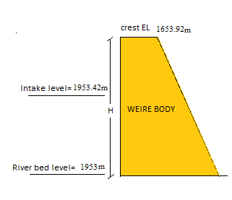
Figure 1-1: Intake level of weir body

Capacity of sluiceway
The capacity of the sluice decided based on the maximum of the values of discharge obtained by twice the intake capacity or the 20% of the design discharge.
- Intake capacity:0.094 m³/s→ Sluiceway capacity: 2 x 0.5 = 1 m³/s
- 50 year design flood: 157.7 →Sluiceway capacity: 0.2 x 157.7 = 31.54 m³/s

Thus the minimum sluiceway capacity has to be 31.57m³/s.

Table 1-1: Hydraulic Calculations of Sluice Capacity for 50 year flood
Feature | Data | Formula | Calculation | Result
Width of sluiceway | 0.5 m
Flood discharge | 157.7 m³/s
Capacity of sluice |  | Section 1.3 | 0.2 x 157.7 | 31.54 m³/s
Crest elevation of sluiceway | 1865.6
Using the formula for a broad crested weir |  | Q = 1.7LH^{1.5} | 1.7x 0.5 x (2.2 + 3.27)^{1.5} | 10.87 m³/s

Water depth on the crest for broad crested weir
Q = 1.7LH^{3/2}…………………………………………………………………..Eq 1.2
Q = Design flood = 157.7m³/s (from Hydrology report)
L = Weir span = 22m
H = Total Head over crest = water ht + velocity head
Hence 157.7 = 1.7x22xH^{3/2}

H=2.61m
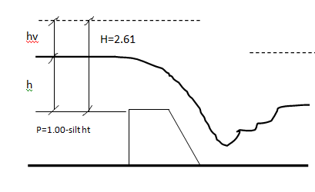
Figure 1-2: Water depth of broad crested weir

The approach Velocity
$Va=\frac{Q}{L(h+P)}$ ……………………………………………………………….Eq 1.3

P was taken 0.50m after silt up
Where $h=\frac{Va^{2}}{2g}$
$\frac{Va^{2}}{2g}=H-h=2.61-h$
$But Va=\frac{Q}{L(h+P)}=\frac{157.7}{22(h+0.5)}$
$$\frac{{157.7}^{2}}{(22{\left(h+0.5\right))}^{2}}*\frac{1}{19.62}=2.61-h$$
$$\frac{2.62}{(h+{0.5)}^{2}}=2.61-h$$
By trial & error h = 2.27m

Stilling basin

Energy Method
Velocity head in approach channel
h_{va} = H-h ……………………………………………………………………Eq 1.4
= 2.61- 2.27 = 0.34m

Hydraulic Jump
For soft removable foundation:
River bed elevation = 1953.00m
Downstream water level (d₃) = 1953.00-3=1950m
Weir crest level = 1953.92
Height of crest, p= 0.50m (silt height assumed)

Bed level of stilling basin:
First find the jump height, D₂ or sequent depth.

First Trial:
Assuming the floor level is 0.90m lower than river bed,
Assumed EL1 = EL3-0.90 = 1953.00-0.90 = 1952.10m
H = E_{o} = E₁
Z = EL0- Assumed EL1 ……………………………………..………Eq 5
= (+ 1954)-(+1952.10) = 1.9m
E0 = h+ hvo+Z…………………………………………………………Eq 6
= H_{e}+Z = 2.61+1.9 = 4.51m
q = Q/L……………………………………………………….………...Eq 7
= 157.7/22 = 7.17m³/s/m

Bernoulli’s energy equation between upstream & downstream of wire body
Z₀+ weir ht + h + h_{v}= Z₁+d₁+V₁²/2g…………………………..………………Eq 8
0.90+1.00+2.27+0.34 = d₁+V₁²/2g
4.51 = d₁+ v₁²/2g -----------------1
V₁= q/d₁ = 7.17/d₁----------------2………………………………….………….Eq 9
Substituting 2 in 1:
4.51= 7.17/ V₁+V₁²/19.62
By trial & Error V₁= 8.48m/s
Hence d₁ = 0.85m

Froude number
Fr = ………………………………………………………….……….Eq 10
Where:
Fr= Froude number
V₁ = mean velocity of flow (m/s)
g = acceleration of gravity (m/s²)
d₁ = depth of flow (m)

Conjugate Depth

d₂ = …………………………………….………..Eq 11
Where:
d₂ = conjugate depth (m)
d₁ = upstream depth (m)
Fr = Froude number

Tail water depth (d₃)

Figure 1-3: Discharge Vs Depth Curve of tail water depth

The tail water depth d₃=3.00m is less than the sequent depth, d₂ and thus the jump recedes downstream for downstream floor level 0.90m lower than upstream apron level. Hence the bottom level of stilling basin will be EL.1 = 1952.10m.

Length of the stilling
L = 4d₂ …………………………………………………………….……………..Eq 12
= 4x3.033 = 12.132 say 12.20m
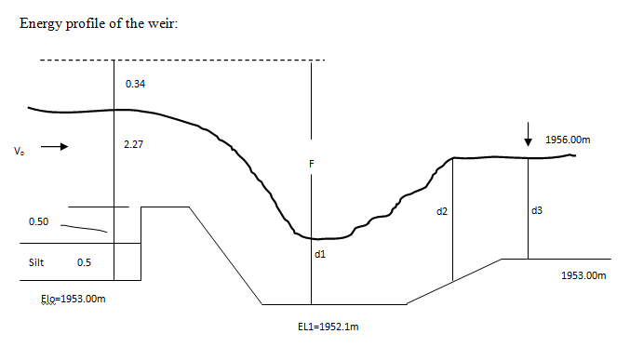
Figure 1-4: Energy profile of the weir

Conventional method
Experimental formula to determine the length and depth of stilling basin

Length of stilling basin
L = …………………………………………………………………………..Eq 13

Depth of stilling basin
d = ≥d ≥ F/3…………………………………………………….Eq 14
Where:
L = Length of basin (Horizontal length of weir glacis + length of downstream apron floor in m)
d = depth of basin (m)
h = over flow depth (m)
F = (upstream water level + velocity head) - (downstream water level)
h = 2.27m
F = (1956.27+0.34)-(1956.00) = 0.61m
L = L¹ =
d = = 0.59m use 0.30m to keep the criteria F/2 ≥d ≥ F/3.
Here the tail water depth is higher than the sequent depth and thus the flow gets submerged. Hence the stilling basin is so designed as to be equipped with the floor length of L = 4.00m and the depth of d= 0.40 m and the transition length of L¹= 4.00m.
From economic point of view this conventional method is selected in determining the length and depth of stilling basin. The detail design of the weir body and apron is as follows:

Determination of Detailed parts
According to Bligh’s formula, the basic section of weir body for the un submerged condition is determined as follows.

Bottom width
L = …………………………………………………………..Eq 15

Top width
B = ……………………………………………………………..Eq 16
Where:
H = height of weir = 1.00m
He = Specific energy head = 2.61m
ρ = Specific weight of weir body = 2.3
L = m
B =
L = 2.38m use L = 3.80 for the weir sloping surface (glacis) are 1V:1H.

Thickness of the floor
- Upstream apron thickness for leakage proof can be taken 0.50m.
- Downstream apron thickness can be determined for static & dynamic hydraulic condition. The larger thickness will be selected.
The thickness at any point (A) is calculated from:
t_{A} = {H_{max}[1- (La/ L_{c}) ]+ (TwL-wL_{A})}x (safety factor /(γ_{m}-1))……………….……….Eq 17
Where:
t_{A =} Thickness of apron at the point A (m)
f = factor of safety = 1.30
H_{max} = upstream & downstream head differential (m)
L_{A} = Weighted creep length at the point A (m)
L_{c} = Weighted creep length total (m)
TwL = tail water level (m)
WLA = Water level at point A (m)
γ_{m}= Specific gravity of masonry (2.3)
Notes: - At the toe of weir the term (TWL-WLA) should be reduced by 50% for dynamic case.

Foundation material:
Foundation material is 0.54m thick alluvial deposits and top of tuff litho logy is at 0.70m depth is encountered. For the sake of this design fine sand formation was taken.

Length of percolation:
Cut off walls of upstream & downstream besides the apron floor shall be installed with good anchorage with weir body to prevent piping & limit intensity of uplift pressure.

Blight's method
L> CH ………………………………………………………………………Eq 18
where L = total percolation distance (m) = Horizontal+ vertical
h = max head (m)
C= percolation co-efficient = 15

Lane method
L>CH………………………………………………………………………..Eq 19
Where L = percolation distance = V+H/3
-For sloping surface > 45⁰ taken as vertical otherwise horizontal.
C = Percolation co-efficient = 7
H = max head (m)
* Adopt Lane's methods

Table 1-2: Blign’s Coefficient and Lane’s Creep Ration
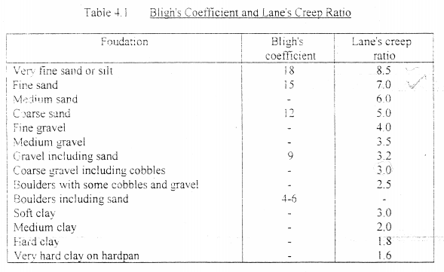
For stilling basin level fixed 0.90m lower than the riverbed level then the weir section will be:
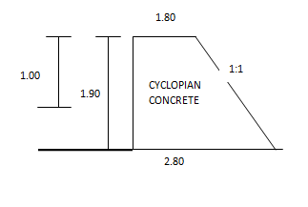
Figure 1-5: Weir section

Table 1-3: Summery of downstream apron floor thickness
Point | Weighted creep length |  |  | H_{max} [1-La/Lc] | TWL-WLA | t*(1.3)/(2.3-1) | Remark
Point | H | V | L
Dynamic Case- H_{max}= 0.27 |  |  |  |  |  |  | Take reduced value of 1.60m instead of 3.14.
A | 8.2 | 6.5 | 9.233 | 0.09 | 3.05 | 3.14 | Take reduced value of 1.60m instead of 3.14.
B | 11.5 | 6.5 | 10.33 | 0.07 | 0 | 0.07 | Take reduced value of 1.60m instead of 3.14.
C | 13.5 | 6.5 | 11 | 0.05 | 0 | 0.05 | Take reduced value of 1.60m instead of 3.14.
Static case-H_{max} = 1.00 |  |  |  |  |  |  | Take reduced value of 1.60m instead of 3.14.
A | 8.2 | 6.5 | 9.233 | 0.33 | 0.5 | 0.83 | Take reduced value of 1.60m instead of 3.14.
B | 11.5 | 6.5 | 10.33 | 0.25 | 0.5 | 0.75 | Take reduced value of 1.60m instead of 3.14.
C | 13.5 | 6.5 | 11 | 0.20 | 0.5 | 0.70 | Take reduced value of 1.60m instead of 3.14.

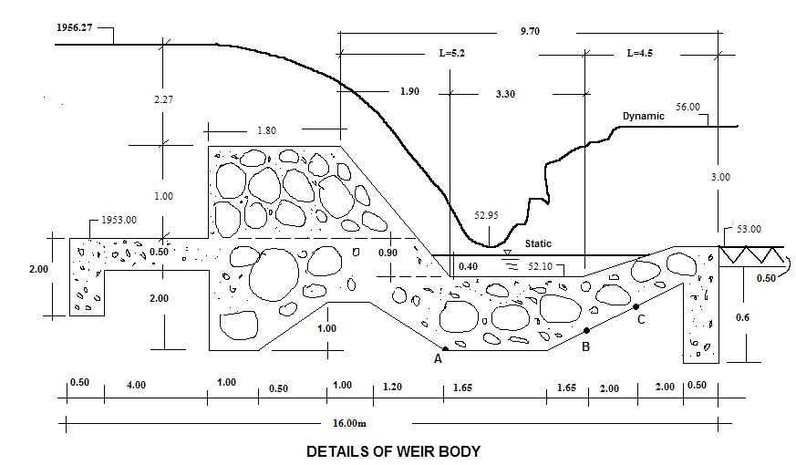Figure 1-6: Detail section of weir body

Maximum head on the structure
* Dynamic case= Head water- tail water = 3.27-3.00 = 0.27m
* Static case = weir crest -river bed =1.00m
L_{c}= Σlv + 1/3 Σlh…………………………………………………………………………………………………………………..……..Eq 20
L_{C} = (2+1.5 + 2.0+1.0+0.6) + 1/3 (16.00) = 7.1 + 5.33 = 12.43m
Hence thickness of each point will be:
Point A 1.70> 1.60 (Dynamic case)

Point B 0.80>0.75 (static case)

Point C 0.72 > 0.70 (static case)

Weighted creep ratio = L_{c} / Head on structure = 12.43/1.00 = 12.43

According to Lane's recommended ratios, this structure would be safe from piping on either clay or on fine sand. The base material of the river consists of fine sand. Therefore the length of the apron is sufficient to prevent the piping,
Lane recommends; C = 7
L > CH → 7x1 = 7.00m
14.5 > 7 Safe!

Exit gradient
The final exit up ward thrust should not exceed certain value for the foundation material to avoid piping; safe exit gradient for course silt is 0.17-0.14.
Khosla formula to determine exit gradient at downstream side for structure with floor length (b) and vertical cut off (d)
G_{E} = H/d* …………………………………………………………..Eq 21
Where 1= =1/2+ α=b/d
GE must be less than 0.17 to 0.14 for this case
Table 1-4: Safe exit gradient against soil type
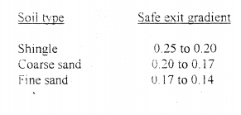
α = b/d = 16.00/0.6 = 26.67………………………………………..………..Eq 22
λ= 1+ ……………………………..….…….Eq 23
G_{E}= ………………………….…..…Eq 24

Recommended G_{E} is 0.17 to 0.14 and 0.116 is less than the critical values stated by Khosla thus it is safe to use 1.10m cutoffs at downstream!
Note: - Use weep holes for guide walls, pressure relief holes for downstream apron and expansion joint for long masonry work
»Use free board for guide wall of 0.50m and thus total height of wall is 1.00+ 2.27+0.50 = 3.77m at upstream. For downstream wall 3.00+0.50 = 3.50m, take 3.77m for typical stability analysis.

Stability Analysis of weir

Dynamic Case
Conditions:
- Up lift pressure was considered for the General weir section; p_{u} = _{gw}h_{t}²/2
- Downstream water pressure was considered; p_{d} = g_{w}h²/2
- Water wedge weight was considered for weir crest only; W_{w} = g _{w}A
- Upstream water pressure was considered; P_{u2} = g_{wh}²/2
- Dead weight also considered; W1 ₌ g_{c}A
Where:
g w-Unit Wt of water which is 10kN/m³ and
g c- unit Wt of cyclopedia concrete work that is 24kN/m³
Area in m²
h- Height that the pressure apply on it, in m
Moment is taken about the toe per meter width.

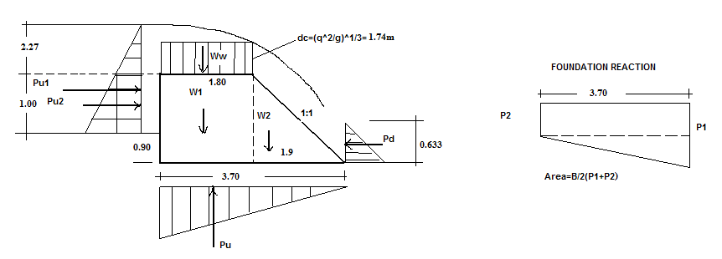

No | Item | Force  (KN) | Arm  (m) | Moment  (KN.m) | Sum  (KN.m)
1 | P_{u1} =(g_{w}(2.27²/2) x 1.00 | 25.76 | 1.27 | -32.72 | -153.59
2 | P_{u2} = g_{w}h²/2 | 5.00 | 1.4 | -7.00 | -153.59
3 | p_{u} = g_{w}h_{t}²/2 | 53.46 | 2.13 | -113.87 | -153.59
4 | p_{d} = g_{w}h²/2 | 2.00 | 0.211 | 0.42 | 372.96
5 | W_{w} ⁼ g _{w}A | 31.32 | 2.8 | 87.70 | 372.96
6 | W1 ₌ g_{c}A | 82.08 | 2.8 | 229.82 | 372.96
7 | W₂ = g_{c}A | 43.32 | 1.27 | 55.02 | 372.96
8 | Foundation reaction | 1.85(P₁₊p₂) |  | B²(p₁+2p₂)/6 2.282(p1+2p2)

Foundation Reaction
1) 1.85(p₁+p₂)= ΣV = 103.26………………………………………………………...Eq 25
2) 2.282(p₁+2p₂) = ΣM = 220.22……………………………………………………Eq 26
p₁+p₂ = 55.81 p₁ = 15.12 KN
p₁+2p₂ = 96.50 p₂ =40.69KN
Allowable bearing capacity of foundation material was taken 10 ton/m² for silt formation is (100KN/m2) and thus it is safe.

Safety factors

Over turning satiability
S0 = Σm+/Σm- ……………………………………………………………..Eq 27
= 372.96/152.74 = 2.44 > 1.5 ok.

Sliding safety factor:
Ss = ΣH/ ΣV<f ………………………………………………………….….Eq 28
where f = 0.65 for this case
S_{s} = 28.76/103.26 < f
S_{s} = 0.28 < 0.65 ok!

Check for tension:
x = Σm/ΣV ………………………………………………………………….Eq 29
= 220.22/103.26 = 2.13m and eccentricity for no tension
e ≤ B/6,……………………………………………………………………...Eq 30
e = ⎢(B/2)-x⎢ ≤ B/6 that is =⎢1.85-2.13⎢ ≤ 3.7/6
= 0.28≤0.62 ok no tension!

Static case
Here p_{u1} = 5.00KN @ 1.23m, -6.15KNm
Pu=5.00KN @2.13m, -10.65KNm
W1=82.08KN @ 2.80m, +229.82KNm
W2=43.32KN @ 1.27m, +55.02KNm

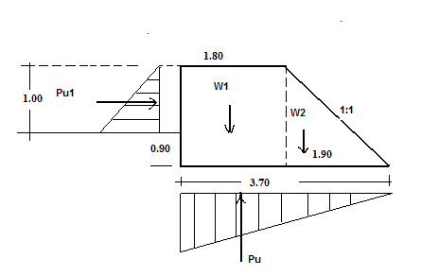

Safety factors

Over turning satiability
So = Σm+/Σm-…………………………………………………………….Eq 31
= 284.84/16.8 = 16.95>1.5 ok!

Sliding safety factor:
Ss = ΣH/ΣV < f…………………………………………………………...Eq 32
= 6.15/114.75 = 0.05<0.65

Check for tension:
X = ΣM/ΣV………………………………………………………………..Eq 33
=268.04/114.75 = 2.34
e = 0.48 < 0.62 ok no tension upstream.

Design of Wing walls
Considerations:
- Analysis per meter span and moment about heel.
- Earth pressure at rest was considered.
- Drained silty clay back fill was considered.
- γ_{m} = 23 KN/m³, γ_{w} = 10KN/m³, γ_{soil} = 18kN/m³
- Drained angle of internal friction was taken 30⁰
- p_{s}= ½ k_{o}γ_{s} H² where K₀= 1-sinϕ and hence p_{s} = 64.98 k/m say 65KN/m

Force (KN) | Sum of forces |  | Arm (m) | Sum of moments | Moment (KNm)
P_{s =} | 65 | 65= H | 1.27 | -82.55 | -82.33
Ws₁₌ | 45.36 | 225.12 = V | 1.61 | 73.03 | 299.26
WS₂₌ | 25.2 | 225.12 = V | 2.55 | 64.26 | 299.26
WM₁₌ | 32.2 | 225.12 = V | 0.25 | 8.05 | 299.26
WM₂₌ | 57.96 | 225.12 = V | 1.10 | 63.76 | 299.26
WM₃₌ | 64.4 | 225.12 = V | 1.40 | 90.16 | 299.26

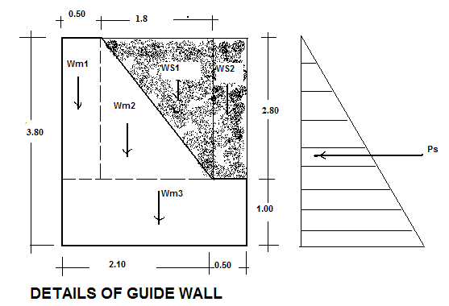Figure 1-7: Details of guide wall

Safety against overturning
299.26/82.33 = 3.63 > 1.5 ok

Safety against sliding
65/225.12 = 0.29 < 0.65 OK

Location of resultant (middle-third- rule)
X = ΣM/ΣV = 216.93/225.12 = 0.964
e = ⏐(B/2)-X⏐ = ⏐1.4-0.964⏐ = 0.436
e ≤ B/6 = 0.467m →0.436 < 0.467 Ok!

Backwater effect
Due to the new barrier it is obvious that the raise in flood height will cover extra banks and this was considered in the design to protect effects by flood protection dyke and keep flood height of 2.27m above crest not to result any upstream damages. The river morphology is more of valley and thus no side flooding is expected.

Intake Gate
The intake level is fixed to 1953.50. Opening diameter by general Orifice formula for free outflow is 50 cm concrete pipe. Here the head required above center of pipe to create flow of 94l/s is 0.03m. It is to be operated by spindle gate. One-way intake was proposed.

Silt Gate
The silt gates are located adjacent to each intake gate. There is one flushing gates on intake side. They are 0.20m lower than the intake level i.e. 1953.20. It is 0.50m wide. Hence depth below crest level is 0.70m; this gate is to be operated (lifted) manually during the rainy season. The plate thickness shall be 5mm thick.
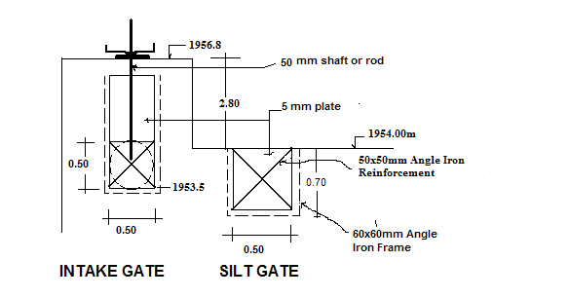
Figure 1-8: Section of intake and silt gates

Irrigation and Drainage

Design Criteria
The irrigation design project needs to be simple so that users can understand and participate in the operation and maintenance. Complex designs are avoided as much as possible. Designing cost effective structures is taken as one of the approaches in this study and design work. The irrigation system and structures are designed to use the water as efficient as possible by minimizing the losses in conveyance, distribution and application system. In this context, the criteria proposed to be adapted for the planning and design of Yora small scale irrigation project is discussed below under various heads/sub heads.

Irrigation System Design
The planning and layout of an irrigation system design is dictated by the area to be irrigated and the source of water supply. The data considered for designing irrigation system are:
- The water resources to be used, including source of water, flow rates/ availability and water quality
- Topography of the land surface
- The physical and chemical characteristics of the soil, including infiltration rates, soil moisture holding capacities, salinity
- Expected cropping pattern
- Economic and marketing situation in the area and the availability of services, including the availability of labor (family labor), maintenance services by the farmers themselves

Before commencement of design of entire irrigation structure, the detailed irrigation and drainage system layout were prepared. This layout contains information on field configuration, canal networks, natural drainage channels network, field drains, access roads and service roads, etc. Key dimensions for all layout components and irrigation and drainage infrastructure are determined.

Ground level profiles of canal systems are also taken and analyzed in accordance with the acceptable field layout. The detail levels are then used for the longitudinal and cross section of the canals and drains and to determine the levels of canal control and regulating structures.

Yora main canal that carries water directly from the diversion weir is divided into 6 tertiary canals directly off taking from the main canal and 2 secondary canals. The design of the canal is concerned with the determination of the cross sectional dimension of the canal to convey the required discharge needed to meet the peak requirement of crops grown in the entire command area. The whole section of the canal is designed for adequate capacity, to provide sufficient capacity.

All conveyance and distribution systems are designed as unlined section, based on the criteria such that the canal is non-silting when conveying sediment-laden water, and non-scouring when conveying silt-free water. The canal flows were classified as steady and uniform and were designed using the Manning’s equation for open canals.

$Q = A * V$………………………………………………………Eq 34
Where: Q = Discharge (m³/s)
A = Average of cross-section (m²)
V = Average velocity (m/s)

The velocity of flow was computed using Manning Formula as follows.
$V=\frac{1}{n}*R^{2/3}*S^{\frac{1}{2}}$ …………………………………………………….Eq 35

Where: V = Average velocity (m/s)
n=Rugosity coefficient, depends on canal material roughness
R = Hydraulic mean radius (m)
S = Bed slope of canal

Design of Main Canal system
The purpose of canal system design is to provide water, adequate in quantity and command to all farms within the area serviced. The system should be convenient to operate and should blend with the pattern of farming. Canals are normally designed to properly distribute water to a system that will make irrigation easy and efficient.

The conveyance and distribution systems include the main and tertiary canals that distribute water to the field canals. The main and tertiary canals will have a constant volume of water in each reach. Flows in the field canals are distributed among farmers according to the size of land holding on a time sharing basis i.e. a farmer will take the full field flow for a scheduled period of time. This allocation is managed by the farmers themselves, through their Water Users’ Association.

It is designed to supply the irrigation water from the diversion weir. The detail hydraulic computation is shown in Table 2-1. The longitudinal profile and cross section of the main canal is shown on Figure 2-1. The values of the design parameters of the typical main canal are shown in Table 2-1.

Flow = 94 l/s
Bed slope of canal = 0.002
Velocity in earth canal for clayey soil = 0.60-0.70m/s,

Q = A/n R ^{3/2} s ½…………………………………………………..……….Eq 36 n = 0.025 for earth
n = 0.014 for lined section

- Economical lined Rectangular section criteria;
B = 2y………………………………………………………………………….Eq 37 R = y/2………………………………………………………………………..Eq 38
Where
B = bed width of canal
y = water depth
R = Hydraulic radius
y = 0.25m B= 0.45m V = 0.95m/s F = 0.25m D = 0.50m
- Economical Earthen Trapezoidal section criteria:
B = 0.6y, m=1.5 for canal inner side slope
R = y/2
$A= y(b+my)$ ……………………………………………………………..Eq 39
$P=b+2y\sqrt{m^{2}+1}$ …………………………………………….……………Eq 40
y=0.26 B=0.20 V = 0.64m/s F = 0.25 D = 0.51 w = 0.50m

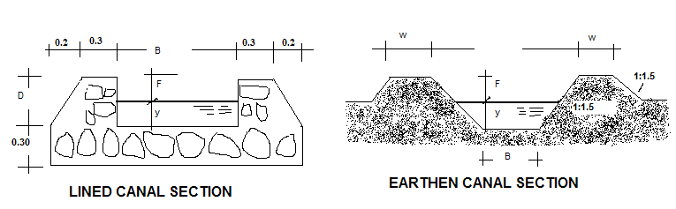Figure 2-1: Lined and Earthen canal section

Design of Earthen Tertiary canals
The water budget for the condition that continuous flow in main, secondary and tertiary canal and rotated flow in field canals for duty of 1.61 l/s/ha it could be seen that the flow that is required for each area when multiplied by the duty is less than the stream size required to irrigate 1ha of land per day in 10 hr irrigation. Unit flow or stream size q:
qt =DA ……………………………………………..……………………….Eq 41
Where q= unit flow (m3/s)
t= irrigation time per day (10 hr)
D= depth of application (120mm or 0.12m for this case)
A= Area to be irrigated (1ha)
Hence q=0.12m*(100mx100m)/(14*60*60)=0.024m3/s=24l/s

It is this stream size that was used to design each tertiary canal as Duty times Area is less than 24l/s for each tertiary canal in the system layout plan.
Q=24l/s n = 0.025 m=1.5
The condition B = 0.6y provides non practical Bed width & thus use B = 0.20 and determine y:
For slope 0.007 v=0.58m/s B=0.20m y=0.11m F=0.25 D=0.36m w=0.40m
For slope 0.005 v=0.55m/s B=0.20m y=0.13m F=0.25 D=0.38m w=0.40m
Here though the flow velocity is slightly smaller, it was accepted & silt clearance may be frequent.

Table 2-1: Summary of canal dimension
Canals | Q  (m³/s) | V  (m/s) | B  (m) | Y  (m) | F | D  (m) | m | Slop | W  (m)
Lined MC | 0.094 | 0.95 | 0.45 | 0.25 | 0.25 | 0.5 |  | 0.002
Earthen MC | 0.094 | 0.64 | 0.2 | 0.26 | 0.25 | 0.51 | 1.5 | 0.002 | 0.5
SC-1 | 45.08 | 0.59 | 0.2 | 0.13 | 0.25 | 0.38 | 1.5 | 0.002 | 0.4
SC-2 | 26.1 | 0.58 | 0.2 | 0.12 | 0.25 | 0.37 | 1.5 | 0.002 | 0.4
TC-1 | 8.4 | 0.35 | 0.15 | 0.1 | 0.25 | 0.35 | 1.5 | 0.002 | 0.4
TC-2 | 18.5 | 0.45 | 0.18 | 0.1 | 0.25 | 0.35 | 1.5 | 0.002 | 0.4
TC-3 | 14.3 | 0.43 | 0.16 | 0.1 | 0.25 | 0.35 | 1.5 | 0.002 | 0.4
TC-4 | 24.3 | 0.57 | 0.2 | 0.1 | 0.25 | 0.35 | 1.5 | 0.002 | 0.4
TC-5 | 13.2 | 0.42 | 0.15 | 0.1 | 0.25 | 0.35 | 1.5 | 0.002 | 0.4
TC-6 | 19 | 0.46 | 0.19 | 0.1 | 0.25 | 0.35 | 1.5 | 0.002 | 0.4

Design of field channels

Field channel is designed as an open channel aligned along the natural slope. The bed width, water depth and side slopes of 1:5 Vertical: Horizontal of the field channel designed is to be used for distributing the required discharge is varied. The channel is designed using Manning’s equation. The Typical longitudinal section is shown on drawing.

Design of furrow irrigation methods

2.2.4.1 Selection of irrigation methods
The selection of irrigation method/system is largely influenced by the topographic nature of the command area, soil and crop type that is planned to be grown. Farmers experience and level of technology being used in plough system are also other important factors, which have got considerable impact on the selection of irrigation methods.

The morphological feature of the area is characterized by undulating valley bottom flanked by valley slopes 2 to 6% slopes and it is suitable for contour furrow.
Furrow method of application is quite suitable for row crops like maize, potatoes, and vegetables and adaptable to most soils of different textures.

The actual irrigation operation will be carried out according to irrigation schedule to be worked out on the basis of the stage of crop development, prevailing climatic data and water management practices to be adopted during operation of the system.

In this project, with the help of development agents supported with necessary trainings, the farmers are supposed to construct the contour furrow on their own farm lands.

Drainage Modulus

Rational method of flood determination
Q = 2.78 CiA……………………………………………………………..Eq 42
Where
C = 0.3, Constant that depend on catchment character,
i = Intensity of rainfall for time of concentration, in cm/hr
A = Area of catchment in km² = 10ha=0.10km²

Time of Concentration t_{c}
t_{c} = 1/3000 ………………………………………………..Eq 43
Where
L= Length of remotes point in watercourse: 1500m
S= Slope of the water course for well managed irrigation farm = 0.0016
t_{c} = 1.1089hr

Intensity of rainfall, i for time of concentration t_{c} is then,
i = R₅₀/t_{c} …………………………………………………………………Eq 44
= 107mm/1.1089 hr = 96.49mm/hr = 9.65cm/hr
Q = 2.78CiA
Q = 2.78x0.30x9.65x0.10
Q = 0.8048m3/s for 10ha area and thus 80.48l/s/ha for 1 ha area.

As stated earlier the run off expected from design storm results in 80.48l/s/ha. For the major cut off drain along the main canal maximum area draining towards the conveyance canal is 5ha between outlet points, which result in 402.4l/s flow to be intercepted at various points on the canal route and natural drains. Thus it was designed for this flow manning roughness co-efficient of 0.03 was adopted. And as per the IDD manual in design of drainage canals the following standard bed widths are to be adopted for the corresponding flows:
B=0.40m for Q<100l/s
B=0.50m for 100<Q<150l/s
B=0.60m for 150<Q<200l/s
B=0,80m for Q>200l/s

Hence for the main drain or cutoff drain the design parameters are as follows:
Q = 0.4024m³/s m =1.5 S = 0.002 n = 0.03 B = 0.80m
Q = A/n R ^{2/3} S ^{1/2} …………………………………………………………….………Eq 45
Thus for B = 0.80 y = 0.60m V = 0.70m/s
Using F = 0.20m Total Depth D of canal = 0.65m

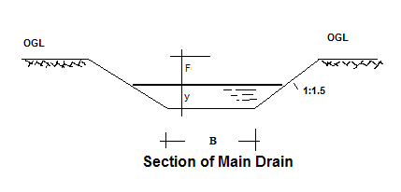
Figure 2-2: Main drain section

Majority of the area drain to natural drainage routes and thus it was not essential to consider flow hydraulics of these natural water courses, but it is obvious that the local community has take care of these drainage courses not to develop gullies.

Design of Storage pond
- 94 l/s flow is to be stored for 10hr and thus volume of storage is 3384m³
- For 2.00m useful storage in 1V: 2H inner slope pond, 0.65m dead storage and 0.65m free board, 35m at bottom and 48.2m at top square pond is enough to store 3300m³
- Top Bank width 4m, inner slope 1V: 2H and outer slope 1v: 1.5H was adopted and analyzed for stability under homogenous clay fill.
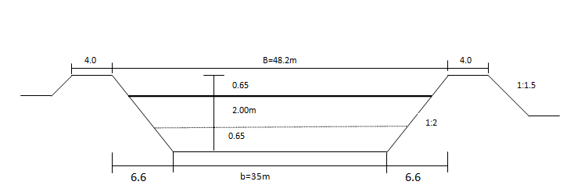

Approximate method of homogeneous embankment stability analysis was adapted- For maximum banking of 4.00m
Note: - Homogeneous pond of clayey fill material.
- Overall stability of embankment
- Stability of u/s slope.
- Stability of d/s slope.

Overall stability
Resisting force is taken as shear resistance developed at the base of embankment

F_{s} = Resisting force/sliding force = W tanφ…………………………….Eq 46
Where
W = effective unit wt of the entire embankment per unit length.
φ = angle of internal friction of the fill (bank) material.
To compute effective wt of the embankment, the phreatic line is first located and then the average unit wt is considered taking soil above the phreatic line as moist and that below as submerged.
W = Average unit wt x cross sectional area of the dam embankment……………Eq 47
Sliding force is the lateral water pressure =
P_{H =} γ_{w}h²/2……………………………………………………………..…….Eq 48
γ_{w} = 10kN/m³
h = max water depth (m)

$$Factor of safety=\frac{W tan }{{wh}^{2}/2} this shall be greater than 2$$
Determination of phreatic line:
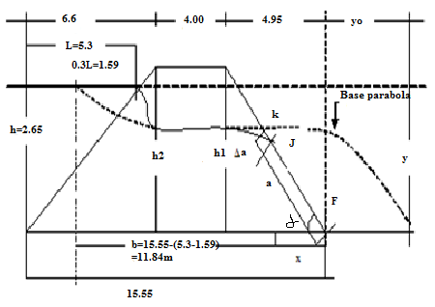

∝ = tan ⁻¹ 3.3/4.95 = 33.69⁰
For ∝ = 33.69⁰ Δa/ ( a+Δa),
C = exit correction = 0.355 (From table)
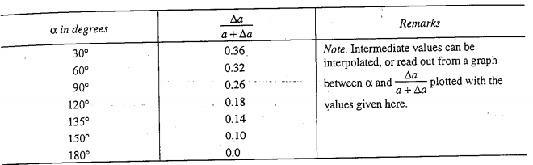
a+Δa = y_{o}/(1-cos ∝) …………………………………………………….………Eq 49
where y_{o} = - b = 12.13-11.84=0.29
a+Δa = 0.29/1-cos (33.690) = 1.73m
C= Δa/(a+Δa) = 0.355 = Δa/1.73 → Δa = 0.61m
a+ Δa = 1.73m
Δa = 0.61 a = 1.12m

Thus J is the corrected exit point:
The portion JF is the discharge face that remains always wet.
Sin ∝ = y/a ⇒ 0.555= y/1.12 → y = 0.62m
Cos ∝= x/a ⇒ 0.832 = x/1.12 → x = 0.93m

The co-ordinate of various points of the base parabola is given by:
Y = …………………………………………….…..Eq 50
y₁= h₁ at x = 4.95m y₂ = h₂ at x = 8.95m
$h1=\sqrt{0.58*4.95+0.084}$ = 1.72m
$h2=\sqrt{0.58*8.95+0.084}$ =2.30m
Weighted unit, wt of soil is given by γ_{s} = {γ₁h₁+ γ₂(H-h₁)}/H……………..Eq 51

Where: - γ₁ = Submerged unit wt of soil below phreatic line = 14KN/m³ for clay fill
γ₂ = moist unit wt of soil above phreatic line = 20 KN/m³
H=Total ht of pond Embankment = 3.30m
h₁=distance from phreatic line to base of the pond embankment = h₁ = 1.99m
γ_{s} = 14x1.72+20 (3.30 - 1.72) = 16.87 KN/m³
3.30

Overall stability
Resisting force = W tan φ………………………………………………………………………Eq 52
φ = Angle of internal friction= 28⁰ for clay material.
= 289.35 KN/m
Water pressure = γ_{w}h²/2 = 10x2.65²/2 ⁼ 35.11KN/m
Available factor of safety = 289.35/35.11= 8.24>2 ok!

Stability of d/s slope
Max. Shear appears at 0.4b _{d}= 0.4x4.95 = 1.98m
Total horizontal force= H_{d} = γ_{sH}²/2 tan ²(45⁰-φ/2)+(γ_{w} h₁2)/2……………………………Eq 53
H_{d} = (16.87x3.3² tan ² 31⁰)/2+(10x1.72²)/2
H_{d} = 33.16+14.79 = 47.95KN

Resisting force due to internal friction and Cohesion:
R_{d} = W_{d} tan φ + cbd………………………………………………………………………………………………………….……..Eq 54
b_{d} = 5.63m C = 50 KN/m² for clay fill material
Rd = (1/2 x3.3x4.95) x 16.87 tan φ + 50x4.95
R_{d} = 73.26+247.50 = 320.76KN

Available factor of safety = 320.76/47.95 = 6.69 >2 ok!

Factor of safety against maximum shear

It occurs at 0.4 bd = 1.98m
According to the theory of max elasticity, Shear (τ_{max}) is twice the average shear (τ_{av}).
τ_{max} = 2 τ_{av} = 2 ( H_{d}/b_{d})……………………………………………………………………..…Eq 55
= 2( 47.95)/4.95 = 19.37KN

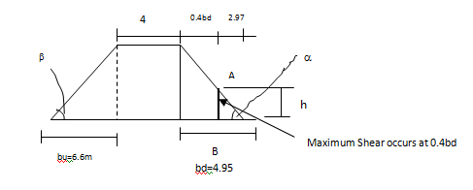

Factor of safety at point of maximum shear, F'_{s}
Shear strength by Mohr-Coulomb shear equation at shear plane AB:
S = γ tanφ+C……………………………………………………………………………………Eq 56
S= (γ_{s}h) tanφ+C, tan ∝= h /2.97 → h = 2.97*tan 33.69⁰ = h = 1.98

F'_{s}= Shear strength at point of max shear…………………………………………..….Eq 57
Maximum shear stress
F'_{s} = γ_{s}h tan φ + C = 16.87x1.98 tan 28⁰ + 50
τ_{max} 19.37
F'_{s} = 3.50>1.5 Ok!

Stability of u/s slope
Horizontal force acting on u/s portion of embankment is given by:
H_{u} = (γ_{s}H² /2) tan ²(45⁰-φ/2) + (γ_{w}h₂²)/2 ………………………………………………………………..………….Eq 58
γ_{s} Shall be taken as saturated unit wt = 14 KN/m³
H_{u} = (14/2) x2.65²tan² (31⁰) + (10/2) x 2.3²
H_{u} = 17.75+26.45 = 44.20 KN
Average shear = τ_{av} = H_{u} / b_{u} = 44.2/6.6 = 6.70KN

Max: Shear stress occurs at 0.4b_{u} and is equal to twice the average shear.
ie. τ_{max} = 2 τ_{av} = 13.40KN
Resisting force against horizontal shear force is given by:
R_{u} = W_{u} tan φ + C bu………………………………………………………………………………………………………………………..Eq 59
W_{u} = total efficient wt of u/s portion of the embankment.
W_{u =} γ_{s} x (Area) per meter length.
R_{u} = 14 (1/2 x6.6x 3.3) tan 28⁰ + 50x6.6 = 411.06KN
Factor of safety of u/s slope = F_{s} = Ru/H_{u} = 411.06/44.2= 9.30>2 ok!
Factor of safety against maximum shear,
F_{s}’ = S_{max} / τmax……………………………………………………………………………………………………………………………………Eq 60
tan β = h/3.3→ h=0.5(3.3) h = 1.65m
S_{max} = γ _{s}h tanφ+ C = 14x1.65 tan 28 + 50 = 62.28KN
τ_{max} = 2τ_{av} = 13.40 KN
F_{s} = 62.2/13.4 = 4.65 > 1.5 ok!

Hence the adopted embankment section is safe with regard to total stability and slope stability. Good quality of work (Compaction and material selection) is essential.

Pond Inlet and Spillway
Using the simplified method of chute hydraulics:

Critical Flow Hydraulics
Discharge, Q=0.094m³/s
Width of notch=bc=0.734Q/do^{3/2} = 0.4m.
This is not practically convenient and thus uses 0.30m.
Unit discharge =q = Q/bc = 0.094/0.40=0.24m3/s/m
Critical depth =dc=(q²/g)^{1/3}=0.18m
Critical velocity, vc=q/dc=0.25/0.185=0.99m/s
Critical velocity head=hvc=vc²/2g=0.05m
Water area at critical flow=Ac=bcxdc=0.072m²
Wetted perimeter=Pc=bc+2dc=0.76m
Hydraulic radius=Rc=0.095m
If n=0.014
Water surface slope at critical flow =Ic=⎨(nVc)/(Rc^{2/3})⎬² = 0.0044 ……………..Eq 61

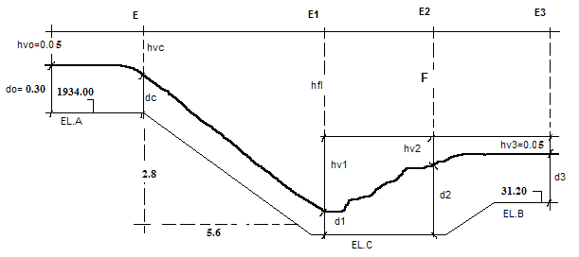

Energy at Section-C
F=EL.A-EL.B=2.8m…………………………………………………………………..Eq 62
Ec = dc + hvc + Z……………………………………………………………………..Eq 63
= 0.18+0.05+2.8=3.03m

Table 2-2: Energy calculation at Section C
Designation | Result of calculation
Trail No | 1 | 2 | 3 | 4
Assumed d1 | 0.035 | 0.043 | 0.044 | 0.045
b1=bc | 0.400 | 0.400 | 0.400 | 0.400
A1=b1xd1 | 0.014 | 0.017 | 0.018 | 0.018
V1=Q/A1 | 6.714 | 5.529 | 5.341 | 5.222
hv1=v²/2g | 2.298 | 1.558 | 1.454 | 1.390
P1=b1+2d1 | 0.470 | 0.485 | 0.488 | 0.490
R1=A1/P1 | 0.030 | 0.035 | 0.036 | 0.037
I1=(nv1/R^{2/3})² | 0.957 | 0.522 | 0.469 | 0.438
Im=(Ic+I1)/2 | 0.482 | 0.265 | 0.238 | 0.222
hfl=Im.L | 2.699 | 1.482 | 1.333 | 1.245
E1=d1+hv1+hfl | 5.032 | 3.083 | 2.831 | 2.680
E1=Ec= 3.03 | Too large | Accepted | Small | Too small

Conjugate depth after jump
Froude no, Fr=V1/√gd1=8.51…………………………………………………………..Eq 64
Conjugate depth d2 = d1/2(√(1+8Fr2)-1) = 0.51m………………………………...Eq 65

Stilling Basin
- Length, L=4d2=4x0.51=2.04m say 2.10m
- Width, B=18.46√Q/(Q+9.91)=0.564 say 0.60m
- Bottom elevation EL.C
V2=q/d2=0.461m/s and hv2=V2²/2g= 0.11
E2=d2+hv2=0.62m
E3=d3+hv3 = (0.3+0.05) = 0.35m
a=E2-E3=0.62-0.35=0.27m
EL.C=EL3-a=30.93m

Pond outlet
Here the orifice formula for free outflow through concrete pipe was adopted. It is obvious that flow varies with gate opening level and this is to be controlled manually by the user, for sake of calculation head above centerline of 0.10 was considered to determine the pipe size.
Q=CdA√(2gh) ………………………………………………………………….Eq 66
Where
h=0.10m, Cd=0.62 and Q= 0.12m3/s A=0.138m²
Diameter=0.4195m take 0.50m concrete pipe

Outlet pipe of size 50cm diameter shall be used. It is to be controlled manually by spindle gate. The plate thickness shall be 50mm and shaft diameter 50mm.

Design of Pipe Culverts
Adopt velocity in pipe greater than 1m/s design under partial flow condition each culvert is designed to pass supply flow designed for each canal.

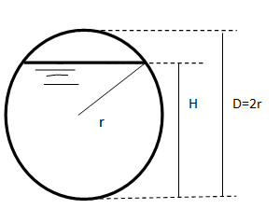

Figure 2-3: Section of pipe culverts

H= 0.8D
For table for H/r = 1.60 ∝ = A/r² = 2.694 p/r = 4.428 β= R/r = 0.608
For D = 0.10 → A = 0.006735 P = 0.2214 R = 0.0304
For D = 0.20 → A = 0.02694 P= 0.4428 R = 0.0608
For D = 0.25 → A = 0.0420 P = 0.5535 R = 0.0759
For D = 0.30 → A = 0.0606 P = 0.6642 R = 0.0912
For D = 0.40 → A = 0.1078 P = 0.8856 R = 0.1216
For D = 0.50 → A = 0.1684 P =1.107 R = 0.1520
For D = 0.60 → A = 0.2425 P = 1.328 R = 0.1824
For D = 0.80 → A = 0.4310 P = 1.1771 R = 0.2432
For D = 1.00 → A = 0.6735 P = 2.214 R = 0.3040

Downstream water level = u/s canal water level-Hydraulic losses
Hydraulic loss=1.2 (V₂²-V₁²)/2g + friction loss………………………………………..Eq 67
Friction loss for canal bed slope, I =IL………………………………………………….Eq 68

Table 2-3: Summary of pipe culvert design
Item | Flow (l/s) | Pipe Diameter (m) | Flow Area (m²) | V₂ (m/s) | V₁ (m/S) | Span, L | I | 1.2(V₂²-V₁²)/2g | IxL | Total Hydraulic loss | Level difference adopted (m)
Culvert (Typical) | 0.094 | 0.45 | 0.136 | 0.7 | 0.64 | 6 | 0.002 | 0.0040 | 0.01 | 0.016 | 0.1
Culvert (Typical) | 0.024 | 0.25 | 0.042 | 0.6 | 0.55 | 6 | 0.005 | 0.0014 | 0.03 | 0.031 | 0.1

Design of Aqueducts
Here since the pipe length is too short, total hydraulic loss is negligible, and hence it was designed to pass, the maximum drainage based on the drainage module previously stated.

The orifices formula governs the flow through the pipe under.

Q=CA√(2gh) ………………………………………………………………….Eq 69
where C={1.1+0.026L/(D) ^{1.2} }^{-0.50} for concrete pipe of beveled lip entrance
h= level difference between upstream and downstream water surface.
A=0.1964 for diameter=0.50m
A=0.2827 for diameter=0.60m
A=0.5027 for diameter=0.80m

Table 2-4: Summary of Aqueduct
Particular | Canal Above | Canal below | Drainage flow (m³/s) | Pipe size(d) | Maximum length L (m) | C | Minimum h (m) | Area (m²) | Flow for head h | Remark
Aqueduct (Typical) | MC | MD | 0.22 | 0.5 | 1.1 | 0.926 | 0.15 | 0.196 | 312 l/s | Canal above is trapezoidal

Design of turnout and Field off takes
The flow in turnouts and field off takes is governed by the orifice formula. It basically depends on the pipe size and head creating flow.
Q=C_{d} A√(2gh) …………………………………………………………………Eq 70

where h=y-(D/2), Creating flow in meter
A=πD²/4, area of pipe
C_{d -} Coefficient of discharge,
0.80 - submerged out flow and
0.62 - free out flow,
g- Acceleration due to gravity 9.81 m/s
Each turn out is to be controlled with simple shutters with chain to lift to required level:
Table 2-5: Summary of turnout
Turnout | On canal | Q (m³/s) | Y (m) | (4Q/C)²/  19.62 | Trial value of D (m) | D⁴  (y - 0.5D) | Diameter Adopted (m)
TO (Typical) | MC | 0.094 | 0.26 | 0.00190 | 0.3765 | 0.001442 | 0.35 controlled
FOT(Typical) | TC | 0.024 | 0.13 | 0.00012 | 0.15 | 0.000028 | 0.15 controlled

Design of Vertical Drop (U.S.B.R.Type)
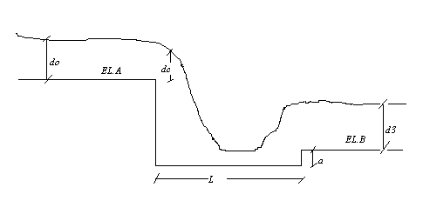
Figure 2-4: Section of vertical drop design

Input Parameters:

- Discharge - Q
- Upstream water depth - h₁
- Upstream water velocity - v₁
- Downstream water depth - h₂
- Downstream water velocity - v₂
- Drop - ht z

Drop width: bc=0.734 Q/(h1)1.5

Unit discharge=q=Q/bc

Critical depth: hc =(q2/g)1/3

Stilling basin:

Basin width: B=18.46(Q)½/(Q+9.91)

Basin length: L=[2.5+1.1(hc/z)+(hc/z)3](z*hc)0.5

Lip height: a =hc/2

U/s Transition Length: L = B + 3/2Q1/2
Dimensions that are not convenient during construction were changed reasonably.

Table 2-6: Summary of vertical drop calculation
Drop on Canal | Q | Drop ht | Drop width(bc) | Basin width(B) | q | dc | Basin length(L) | Lip ht | U/s Transition
MC | 0.094 | 1.00 | 0.52 | 0.57 | 0.18 | 0.15 | 1.03 | 0.07 | 1.03
 |  | 0.80 | 0.52 | 0.57 | 0.18 | 0.15 | 0.94 | 0.07 | 1.03
 |  | 0.60 | 0.52 | 0.57 | 0.18 | 0.15 | 0.83 | 0.07 | 1.03
 |  | 0.50 | 0.52 | 0.57 | 0.18 | 0.15 | 0.78 | 0.07 | 1.03
 |  | 0.50 | 0.52 | 0.57 | 0.18 | 0.15 | 0.78 | 0.07 | 1.03
TC | 0.024 | 1.00 | 0.13 | 0.29 | 0.18 | 0.15 | 1.03 | 0.07 | 0.52
 |  | 0.80 | 0.13 | 0.29 | 0.18 | 0.15 | 0.94 | 0.07 | 0.52
 |  | 0.60 | 0.13 | 0.29 | 0.18 | 0.15 | 0.83 | 0.07 | 0.52
 |  | 0.50 | 0.13 | 0.29 | 0.18 | 0.15 | 0.78 | 0.07 | 0.52
 |  | 0.50 | 0.13 | 0.29 | 0.18 | 0.15 | 0.78 | 0.07 | 0.52

ANNEX
BILL OF QUANTITIY, SPECIFICATION
AND COST ESIMATE

Annex 1: Bill of Quantity, Specification and Cost Estimate
No | Item | Unit | Qty | Unit Rate | Total Cost
1 | Access road clearance of ordinary soil | Km | 3.00 | 6,000.00 | 18,000.00
2 | Mobilization and Demobilization | Ls | 1.00 | 7,000.00 | 7,000.00
Total Carried to Summary (1 & 2) |  |  |  |  | 25,000.00
3 | Camping
 | A. Living rooms 4(3mx3m)
 | B. Store 1(5mx5m)
 | C.Kitchen1 (3mx3m)
 | D. Guard house1 (2.5x 2m)
 | E. Toilet house1 (2.5x 2m)
 | F. Office1 (3x3)
 | G. Fencing
3.1 | Site clearance | m² | 132.72 | 35.10 | 4,658.47
3.2 | Trench and other excavations | m³ | 38.00 | 128.70 | 4,890.60
3.3 | Cart away surplus excavations | m³ | 38.00 | 58.50 | 2,223.00
3.4 | Stone masonry | m³ | 32.28 | 1,814.18 | 58,561.59
3.5 | 20 cm hard core | m³ | 49.05 | 1,486.21 | 72,902.11
3.6 | 10 cm lean concrete | m³ | 24.53 | 2,474.15 | 60,681.52
3.7 | CIS walling (G-32) | m² | 249.20 | 324.00 | 80,740.80
3.8 | CIS roofing (G-32) | m² | 146.40 | 324.00 | 47,433.60
3.9 | Fencing | m | 160.00 | 80.00 | 12,800.00
Total Carried to Summary - 3 |  |  |  |  | 344,891.70
4 | Headwork (22m span Masonry Broad Crested Weir)
4.1 | Site clearance | m² | 672.00 | 35.10 | 23,587.20
4.2 | Coffer dam for temporary flow diversion with sand filled bags(dry time flow is estimated to 94 l/s and river span about 20m | m³ | 48.00 | 156.00 | 7,488.00
4.3 | Excavation for temporary diversion channel
4.3.1 | Soft soil formation | m³ | 12.50 | 128.70 | 1,608.75
4.3.2 | Rocky soil (Soil with cobbles) | m³ | 12.50 | 255.00 | 3,187.50
4.4 | Excavation for foundations |  |  |  | -
4.4.1 | Soft soil formation | m³ | 306.00 | 128.70 | 39,382.20
4.4.2 | Rocky soil (Soil with cobbles) | m³ | 2.23 | 255.00 | 568.65

No | Item | Unit | Qty | Unit Rate | Total Cost
4.5 | Compacted rock fragments on loose foundation to avoid differential settlements | m³ | 52.80 | 117.00 | 6,177.60
4.6 | Lean concrete works for foundation (1:2:6 mix) | m³ | 525.27 | 1,959.64 | 1,029,343.08
4.7 | Brest wall and Gate operating slab (1:2:4) mix | m³ | 16.39 | 2,474.15 | 40,556.20
4.8 | Cyclopean concrete | m³ | 60.50 | 888.83 | 53,774.25
4.9 | Masonry bedded in 1:3 mortar | m³ | 253.80 | 1,814.18 | 460,437.80
4.1 | Plastering in 1:3 mortar | m² | 355.56 | 130.85 | 46,526.31
4.11 | Ripe rap | m² | 132.00 | 270.21 | 35,667.40
4.12 | Manually lifted silt gate of size 60x50cm and 5mm thick plate in 60x60 mm angle iron slot well reinforced as per drawing, fixed in position | Pcs | 1 | 2,000.00 | 2,000.00
4.13 | Intake gate operated by spindle and shaft with square thread, plate size is 600x500x5mm as per drawing and specifications, fixed in position | Ls | 1 | 3,500.00 | 3,500.00
4.14 | Dia 40 cm concrete pipe supply and fix in position | Pcs | 6 | 450.00 | 2,700.00
4.15 | Fill and compactions with red clay | m³ | 68.6 | 156.00
Total Carried to Summary - 4 |  |  |  |  | 1,756,504.94
5 | Lined Conveyance Canal(MC)-1680m long
5.1 | Excavations
5.1.1 | Soil excavation | m³ | 2553.60 | 128.70 | 328,648.32
5.1.2 | Rock excavation | m³ | 38 | 255.00 | 9,690.00
5.2 | Hard core well blinded with 1:3 mortar | m³ | 705.6 | 1,486.21 | 1,048,666.86
5.3 | Masonry bedded in 1:3 mortar | m³ | 1740.48 | 1,814.18 | 3,157,536.58
5.4 | Plastering in 1:3 mortar | m² | 1680 | 130.85 | 219,834.08
5.5 | Fill and compactions with red clay | m³ | 712.32 | 156.00 | 111,121.92
Total Carried to Summary - 5 |  |  |  |  | 4,875,497.75
6 | Secondary Canal(2510m)
6.1 | Soil Excavation | m³ | 734.426 | 128.70 | 94,520.63
6.2 | Fill and compaction | m³ | 200.8 | 156.00 | 31,324.80
Total Carried to Summary - 6 |  |  |  |  | 125,845.43
7 | Tertiary canals (2908m)
7.1 | Soil Excavation | m³ | 717.549 | 128.70 | 92,348.56
7.2 | Fill and compaction | m³ | 232.64 | 156.00 | 36,291.84
Total Carried to Summary - 7 |  |  |  |  | 128,640.40

No | Item | Unit | Qty | Unit Rate | Total Cost
8 | Drainage canals
8.1 | Main Drain (cutoff drain) excavation | m³ | 196.5 | 128.70 | 25,289.55
8.2 | Tertiary drain excavation | m³ | 609.5 | 128.70 | 78,442.65
8.3 | Fill and compaction with red clay | m³ | 183 | 156.00 | 28,548.00
Total Carried to Summary - 8 |  |  |  |  | 132,280.20
9 | Drop structure(49No)
9.1 | Excavation on ordinary soil | m³ | 459.62 | 128.70 | 59,153.09
9.2 | Hard core well blinded with 1:3 mortar | m³ | 137.20 | 1,486.21 | 203,907.44
9.3 | Masonry bedded in 1:3mortar | m³ | 117.60 | 1,814.18 | 213,347.07
9.4 | Plastering in 1:3 mortar | m² | 392.00 | 130.85 | 51,294.62
9.5 | Lean concrete works(1:2:4 mix) | m³ | 1.18 | 2,474.15 | 183.92
9.6 | Fill and compaction with red clay | m³ | 10.78 | 156.00 | 1,681.11
Total Carried to Summary - 9 |  |  |  |  | 529,567.24
10 | Turnout (6No)
10.1 | Excavation on ordinary soil | m³ | 25.20 | 128.70 | 3,243.24
10.2 | Hard core well blinded with 1:3 mortar | m³ | 16.84 | 1,486.21 | 25,020.71
10.3 | Masonry bedded in 1:3 mortar | m³ | 16.38 | 1,814.18 | 29,709.80
10.4 | Plastering in 1:3 mortar | m² | 46.16 | 130.85 | 6,040.82
10.5 | Dia 15 cm concrete pipe supply and fix in position | Pcs | 6.00 | 2,000.00 | 12,000.00
10.6 | Gates of size 450x300x3mm in 40x40 mm angle iron slot(frame) and 1m long chain to control flow rates as per drawing | Pcs | 6.00 | 2,500.00 | 15,000.00
10.7 | Red clay fill and compaction | m³ | 17.96 | 156.00 | 2,802.49
Total Carried to Summary - 10 |  |  |  |  | 93,817.06
11 | Field off takes (22in No)
11.1 | Soil Excavation | m³ | 39.41 | 128.70 | 5,072.42
11.2 | Hard core well blinded with 1:3 mortar | m³ | 19.75 | 1,486.21 | 29,357.31
11.3 | Masonry bedded in 1:3mortar | m³ | 15.24 | 1,814.18 | 27,641.09
11.4 | Plastering in 1:3 mix | m² | 60.19 | 130.85 | 7,876.22
11.5 | Supply and install Dia 15 cm concrete pipes | Pcs | 22.00 | 2,000.00 | 44,000.00
11.6 | Steel Shutters(gates) as per drawing | Ls | 22.00 | 1,800.00 | 39,600.00
11.7 | Red clay Fill and compaction | m³ | 10.02 | 156.00 | 1,562.66
Total Carried to Summary - 11 |  |  |  |  | 155,109.70

No | Item | Unit | Qty | Unit Rate | Total Cost
12 | Aquiducts (2No)
12.1 | Excavation on ordinary soil | m³ | 29.21 | 128.70 | 3,759.39
12.2 | Hard core well blinded with 1:3 mortar | m³ | 11.47 | 1,486.21 | 17,053.04
12.3 | Masonry bedded in 1:3 mortar | m³ | 15.56 | 1,814.18 | 28,226.66
12.4 | Plastering in 1:3 mortar | m² | 40.11 | 1,814.18 | 72,758.00
12.5 | Concrete pipe of 50 cm diameter supply and install as per drawing | Pcs | 2.00 | 500.00 | 1,000.00
12.6 | Red clay fill and compaction | m³ | 8.76 | 156.00 | 1,367.30
Total Carried to Summary - 12 |  |  |  |  | 124,164.39
13 | Pipe Culverts (2No)
13.1 | Excavation on ordinary soil | m³ | 28.32 | 128.70 | 3,644.78
13.2 | Hard core well blinded with 1:3 mortar | m³ | 11.43 | 1,486.21 | 16,985.21
13.3 | Lean concrete works(1:2:4 mix) | m³ | 0.50 | 2,474.15 | 1,237.07
13.4 | Masonry bedded in 1:3 mortar | m³ | 9.80 | 1,814.18 | 17,778.92
13.5 | Plastering in 1:3 mortar | m² | 38.64 | 1,814.18 | 70,099.75
13.6 | Concrete pipe of 25 cm diameter supply and install | Pcs | 3.43 | 250.00 | 857.14
13.7 | Concrete pipe of 50 cm diameter supply and install | Pcs | 8.57 | 500.00 | 4,285.71
13.8 | Selected fill and compaction | m³ | 12.49 | 156.00 | 1,947.77
Total Carried to Summary - 13 |  |  |  |  | 116,836.37
14 | Pond and related structures
14.1 | Excavation of ordinary soil(medium) | m³ | 3870.40 | 128.70 | 498,120.48
14.2 | Fill and compaction with red clay | m³ | 3172.40 | 156.00 | 494,894.40
14.3 | Pond inlet |  |  |  | -
14.3.1 | Excavation on ordinary soil | m³ | 24.13 | 128.70 | 3,105.07
14.3.2 | Hard core blinded with 1:3 mortar | m³ | 9.05 | 1,486.21 | 13,446.30
14.3.3 | Masonry bedded in 1:3 mortar | m³ | 5.31 | 1,814.18 | 9,634.18
14.3.4 | Plastering in 1:3 mortar | m² | 41.70 | 1,814.18 | 75,651.13
14.3.5 | Clay back fill and compaction | m³ | 8.43 | 156.00 | 1,314.53
14.4 | Pond spillway |  |  |  | -
14.4.1 | Excavation on ordinary soil | m³ | 20.36 | 128.70 | 2,620.23
14.4.2 | Hard core blinded with 1:3 mortar | m³ | 7.38 | 1,486.21 | 10,967.75
14.4.3 | Masonry bedded in 1:3 mortar | m³ | 4.14 | 1,814.18 | 7,505.70
14.4.4 | Plastering in 1:3 mortar | m² | 27.61 | 1,814.18 | 50,083.95
14.4.5 | Clay back fill and compaction | m³ | 7.11 | 156.00 | 1,109.28

No | Item | Unit | Qty | Unit Rate | Total Cost
14.5 | Pond outlet |  |  |  | -
14.5.1 | Excavation on ordinary soil | m³ | 38.04 | 128.70 | 4,896.37
14.5.2 | Hard core blinded with 1:3 mortar | m³ | 9.42 | 1,486.21 | 14,007.19
14.5.3 | Masonry bedded in 1:3 mortar | m³ | 41.04 | 1,814.18 | 74,453.77
14.5.4 | RCC in 1:2:4 mix as per reinforcement detail of drawing | m³ | 0.20 | 4,820.48 | 978.37
14.5.5 | Supply and fix 50 cm diameter concrete pipe | Ls | 8.00 | 2,000.00 | 16,000.00
14.5.6 | Gate of size 3000x50x5mm operated with spindle and 50mm square threaded shaft as per drawing and specifications | Ls | 1.00 |  | -
14.5.7 | Plastering in 1:3 mortar | m² | 27.61 | 1,814.18 | 50,083.95
14.5.8 | Red clay back fill and compaction | m³ | 7.11 | 156.00 | 1,109.28
Total Carried to Summary - 14 |  |  |  |  | 1,329,981.93
TOTAL PROJECT COST |  |  |  |  | 8,408,155.17
VAT (15%) |  |  |  |  | 1,261,223.28
GRAND TOTAL |  |  |  |  | 9,669,378.45

Annex 2: Detail Measurement and Quantity of Camping
Bill No | Times | L (m) | W (m) | H (m) | Unit | Particular of item and detail of work | Explanation
1 |  | 3 |  |  |  | Access road clearance ordinary soil
 |  |  |  | 3 | km
2 |  |  |  |  |  | Mobilization and Demobilization
3 |  |  |  |  |  | Camping
3.1 | 15.60 | 3.60 |  |  |  | Site clearance
3.1 | 5.60 | 5.60
3.1 | 6.20 | 5.20
3.1 | 3.6 | 3.60
3.1 |  |  |  | 132.7
3.2 |  |  |  |  |  | Trench and other excavations
3.2 | 2 | 15.00 | 0.70 | 0.50
3.2 | 4 | 3.00 | 0.70 | 0.50
3.2 | 4 | 5.00 | 0.70 | 0.50
3.2 | 4 | 2.50 | 0.70 | 0.50
3.2 | 4 | 2.00 | 0.70 | 0.50
3.2 | 1 | 2.00 | 2.50 | 2.00
3.2 |  |  |  | 38.00 | m³
3.3 |  |  |  |  |  | Cart away surplus excavations
3.3 |  |  |  | 38.00 | m³
3.4 |  |  |  |  |  | Stone masonry
3.4 |  | 98.00 | 0.30 | 0.30
3.4 |  | 86.00 | 0.30 | 0.50
3.4 |  | 86.00 | 0.30 | 0.20
3.4 |  | 9.00 | 0.30 | 2.00
3.4 |  |  |  | 32.28 | m³
3.5 | 1 | 14.55 | 14.55 | 0.20 |  | 20 cm hard core
3.5 | 1 | 2.55 | 2.55 | 0.20
3.5 | 1 | 4.55 | 4.55 | 0.20
3.5 | 2 | 2.05 | 1.55 | 0.20
3.5 |  |  |  | 49.05 | m³
3.6 | 1 | 14.55 | 14.55 | 0.10 |  | 10 cm lean concrete
3.6 | 1 | 2.55 | 2.55 | 0.10
3.6 | 1 | 4.55 | 4.55 | 0.10
3.6 | 2 | 2.05 | 1.55 | 0.10
3.6 |  |  |  | 24.53 | m³
3.7 |  | 20 |  | 2.8 |  | CIS walling (G-32)
3.7 |  | 36 |  | 2.8
3.7 |  | 12 |  | 2.8
3.7 |  | 9 |  | 2.8
3.7 |  | 12 |  | 2.8
3.7 |  |  |  | 249.2 | m²
3.8 |  | 6 | 6.8 |  |  | CIS roofing (G-32)
3.8 |  | 13 | 4.5
3.8 | 2 | 4 | 4.4
3.8 |  | 3.5 | 3.4
3.8 |  |  |  | 146.4 | m²
3.9 |  |  |  |  |  | Fencing(40mx40m)
3.9 | 2 | 40 | 40
3.9 |  |  |  | 160 | m

Annex 3: Detail Measurement and Quantity of Head Work
No | Times | L (m) | W (m) | H (m) | Unit | Particular of item and detail of work | Explanation
1 |  |  |  |  |  | Headwork (22m span Masonry Broad Crested Weir)
1.1 |  | 24 | 28.00 |  |  | Site clearance
1.1 |  |  |  | 672.00 | m²
1.2 |  | 2 | 20.00 | 1.20 |  | Coffer dam for temporary flow diversion with sand filled bags(dry time flow is estimated to 94l/s and river span about 20m
1.2 |  |  |  | 48.00 | m³
1.3 |  |  |  |  |  | Excavation for temporary diversion channel
1.3 |  | 50 | 0.50 | 0.50 |  | a. Soft soil formation
1.3 |  |  |  | 12.50
1.3 |  | 50 | 0.50 | 0.50 |  | b. Rocky soil (Soil with cobbles)
1.3 |  |  |  | 12.50
1.4 |  |  |  |  |  | Excavation for foundations
1.4 | 2 | 17 | 3.00 | 3.00 |  | a. Soft soil formation
1.4 |  |  |  | 306.00 | m³
1.4 |  | 11.8 | 22.00 | 0.50 |  | b. Rocky soil (Soil with cobbles)
1.4 |  | 5.65 | 22.00 | 1.07
1.4 |  | 5.35 | 22.00 | 2.23 | m³
1.4 |  |  |  | 525.27
1.5 |  | 16 | 22.00 | 0.15 |  | Compacted rock fragments on loose foundation to avoid differential settlements
1.5 |  |  |  | 52.80 | m³
1.6 |  | 11.8 | 22.00 | 0.50 |  | Lean concrete works(1:2:6 mix)
1.6 |  | 5.65 | 22.00 | 1.07
1.6 |  | 5.35 | 22.00 | 2.23
1.6 |  |  |  | 525.27 | m³
1.6 |  | 6 | 0.70 | 3.80 |  | Brest wall and Gate operating slab (1:2:4) mix
1.6 |  | 1.8 | 1.20 | 0.20
1.6 |  |  |  | 16.39 | m³
1.6 |  | 22 | 1.80 | 1.00 |  | Cyclopean concrete
1.6 | 0.5 | 22 | 1.90 | 1.00
1.6 |  |  |  | 60.50 | m³

No | Times | L (m) | W (m) | H (m) | Unit | Particular of item and detail of work | Explanation
1.7 | 2 | 8.3 | 0.50 | 4.00 |  | Masonry(1:3 mix)
1.7 | 1 | 8.3 | 2.00 | 3.00 |  | Gide wall
1.7 | 2 | 8.3 | 2.00 | 1.00 |  | Gide wall
1.7 | 2 | 13.7 | 0.50 | 3.20 |  | Gide wall
1.7 | 1.00 | 13.7 | 2.00 | 2.00 |  | Gide wall
1.7 | 1.00 | 1.9 | 0.5 | 0.8 |  | Gide wall
1.7 | 2.00 | 13.7 | 2.00 | 1.00 |  | Gide wall
1.7 |  |  |  | 253.80 | m³ | Gide wall
1.8 |  |  | 22.00 | 1.00 |  | Plastering in 1:3 mortar
1.8 |  | 1.8 | 22.00
1.8 |  |  | 22.00 | 2.20
1.8 | 2 | 22 |  | 3.40
1.8 | 2 | 22 |  | 1.00
1.8 | 2 | 6 |  | 3.80
1.8 | 1 | 6 | 0.70
1.8 |  | 1.8 | 1.20
1.8 |  |  |  | 355.56 | m³
1.9 |  |  |  |  |  | Manually lifted silt gate of size 60x50cm and 5mm thick plate in 60x60 mm angle iron slot well reinforced as per drawing, fixed in position
2.10 |  |  |  |  |  | Intake gate operated by spindle and shaft with square thread, plate size is 600x500x5mm as per drawing and specifications, fixed in position
2.11 |  |  |  |  |  | Dia 50 cm concrete pipe supply and fix in position
2.12 |  |  |  |  |  | Weep hole over the guide wall with 2 inch PVC pipe in bedded in masonry walls at 2m vertical and 1.5m horizontal c/c
2.13 |  |  |  |  |  | Expansion joint with 2mm sheet metal imbedded @10 m interval as per drawing
2.14 | 2 | 16 | 0.50 | 3.60 |  | Fill and compactions with red clay
2.14 | 2 | 16 | 2 | 2.6
2.14 | 2 | 0.25 | 22 | 2
2.14 | 2 | 0.25 | 22.00 | 1.90
2.14 | 2 |  |  | 68.6 | m³
2.14 | 2 | 6 | 22 |  |  | Ripe rap
2.14 | 2 |  |  | 132 | m²

Annex 4: Detail Measurement and Quantity of Head Work
No | Times | L (m) | W (m) | H(m) | Unit | Particular of item and detail of work | Explanation
1 |  |  |  |  |  | Main canal
1 |  | 1680 | 1.9 | 0.8 |  | Soft soil excavations
1 |  |  |  | 2554 | m³
1 |  | 100 | 1.9 | 0.2 |  | Rock excavations
1 |  |  |  | 38 | m³
1 |  | 1680 | 1.4 | 0.3 |  | Hard core well blinded with 1:3 mortar
1 |  |  |  | 706 | m³
1 | 2 | 1680 | 0.4 | 0.37 |  | Masonry bedded in 1:3 mortar
1 | 2 | 1680 | 1 | 0.37
1 |  |  |  | 1740 | m³
1 | 2 | 1680 | 0.3 |  |  | Plastering in 1:3 mortar
1 |  | 1680 | 0.4
1 |  |  |  | 1680 | m²
1 | 2 | 1680 | 0.25 | 0.7 |  | Fill and compactions with red clay
1 |  | 1680 | 0.2 | 0.37
1 |  |  |  | 712 | m³
2 |  |  |  |  |  | Secondary Canal
2 |  | 2510 | 0.2 | 0.38 |  | Soil excavation
2 |  | 2510 | 0.57 | 0.38
2 |  |  |  | 734 | m³
2 | 2 | 2510 | 0.4 | 0.1 |  | Fill and compaction with red clay
2 |  |  |  | 201 | m³
3 |  |  |  |  |  | Tertiary Canal
3 |  | 2908 | 0.18 | 0.35 |  | Soil excavation
3 |  | 2908 | 0.525 | 0.35
3 |  |  |  | 718 | m³
3 | 2 | 2908 | 0.4 | 0.1 |  | Fill and compaction with red clay
3 |  |  |  | 233 | m³

Annex 5: Detail Measurement and Quantity of Pond
No | Times | L (m) | W (m) | H (m) | Unit | Particular of item and detail of work | Explanation
1 |  |  |  |  |  | Pond and related structures
1.1 |  | 40 | 7.2 | 2.05 |  | Excavation of ordinary soil(medium)
1.1 |  | 40 | 40 | 2.05
1.1 |  |  |  | 3870.4 | m³
1.1 | 0.5 | 40 | 7.2 | 3.6 |  | Fill and compaction with red clay
1.1 |  | 40 | 4 | 3.6
1.1 | 0.5 | 40 | 5.4 | 3.6
1.1 |  | 40 | 7.2 | 2.05
1.1 | 2 | 40 | 4 | 2.05
1.1 |  | 40 | 5.4 | 2.05
1.1 |  |  |  | 3172.4 | m³
1.2 |  |  |  |  |  | Pond inlet
1.2 |  | 17.74 | 1.70 | 0.80 |  | Excavation on ordinary soil
1.2 |  |  |  | 24.13 | m²
1.3 |  | 17.74 | 0.30 | 1.70 |  | Hard core blinded with 1:3 mortar
1.3 |  |  |  | 9.05 | m³
1.4 |  | 0.5 | 16.34 | 0.50 |  | Masonry bedded in 1:3 mortar
1.4 | 0.5 | 0.5 | 0.30 | 16.34
1.4 |  |  |  | 5.31
1.4 | 2 | 14.44 | 0.50 |  |  | Plastering
1.4 | 2 | 14.44 | 0.50
1.4 |  | 14.44 | 0.50
1.4 | 2 |  | 0.50 | 2.80
1.4 |  |  | 0.40 | 2.80
1.4 | 2 |  | 0.30 | 2.80
1.4 |  |  |  | 41.70
1.5 |  |  |  |  |  | Clay back fill and compaction
1.5 | 2 | 17.74 | 0.25 | 0.80
1.5 | 0.5 | 17.74 | 0.50 | 0.30
1.5 |  |  |  | 8.43 | m³
1.5 |  |  |  |  |  | Pond spill way
1.5 |  | 14.97 | 1.70 | 0.80 |  | Excavation on ordinary soil; average length
1.5 |  |  |  | 20.36 | m³
1.6 |  | 14.47 | 0.30 | 1.70 |  | Hard core blinded with 1:3 mortar
1.6 |  |  |  | 7.38 | m³

No | Times | L (m) | W (m) | H (m) | Unit | Particular of item and detail of work | Explanation
1.7 |  | 12.23 | 0.50 | 0.50 |  | Masonry bedded in 1:3 mortar
1.7 | 0.5 | 12.23 | 0.50 | 0.30
1.7 |  | 0.25 | 1.00 | 0.50
1.7 | 0.5 | 0.25 | 0.30 | 1.00
1.7 |  |  |  | 4.14 | m³
1.7 |  | 14.47 | 0.50 |  |  | Plastering
1.7 | 2 | 12.23 |  | 0.50
1.7 | 2 | 13.57 | 0.30
1.7 |  |  |  | 27.61 | m³
1.7 | 2 | 14.97 | 0.25 | 0.80 |  | Clay back fill and compaction
1.7 | 0.5 | 14.97 | 0.30 | 0.50
1.7 |  |  |  | 7.11 | m³
1.7 |  |  |  |  |  | Pond outlet
1.7 |  | 26.18 | 1.20 | 0.30 |  | Excavation on ordinary soil
 |  | 15.9 | 1.20 | 1.50
 |  |  |  | 38.04 | m³
1.8 |  | 26.18 | 0.30 | 1.20 |  | Hard core blinded with 1:3 mortar
1.8 |  |  |  | 9.42 | m³
1.9 |  | 7.2 | 1.20 | 3.60 |  | Masonry bedded in 1:3 mortar
1.9 | 2 | 0.3 | 1.20 | 3.60
1.9 |  | 1.7 | 1.20 | 3.60
1.9 |  |  |  | 41.04 | m³
1.9 | 2 | 14.97 | 0.25 | 0.80 |  | Clay back fill and compaction
1.9 | 0.5 | 14.97 | 0.30 | 0.50
1.9 |  |  |  | 7.11 | m³

