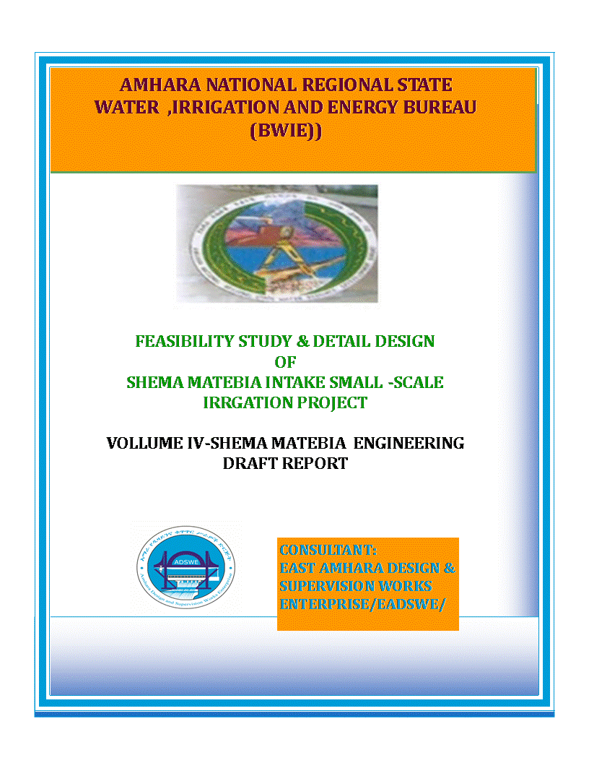
Amhara National Regional State
Water Resources Development Bureau
(BOWRD)
Detail Design
Of
Shema Matebia Diversion Intake Small-Scale Irrigation Project
Volume IV: Engineering Design Final Report
October, 2011EC
Dessie, Ethiopia
Client: Bureau of Water Resource Development
(BoWRD)
Address:
P. O. Box: 88
Telephone: 0528-200853/855
Fax: 251-08-20-65-68/204676/202040
Consultant: Amhara Design & Supervision Works Enterprise
(E/ADSWE)
Address:
P. O. Box: 1921
Telephone: +251-033 312 49 60
Fax: (058) 2180550/ (058) 2180560
E-mail: amhara design@yahoo.com
Dessie, Ethiopia

FEASIBILITY STUDY & DETAIL DESIGN REPORT STRUCTURE
- Volume I: Watershed Management
- Volume II: Engineering Geology
- Volume III: Irrigation Agronomy
- Volume IV: Engineering Design
- Volume V: Socio Economy
- Volume VI: Environmental Impact Assessment
Table of Contents Page Nr
FEASIBILITY STUDY & DETAIL DESIGN REPORT STRUCTURE i
LIST OF TABLES iv
LIST OF FIGURES iv
SAILENT FEATURE vi
1 INTRODUCTION 1
1.1 Background 1
1.1.1 Description of the Project Area 1
1.2 Objectives of the Study 3
1.2.1 Major Objective 3
1.2.2 Specific Objectives 3
1.3 Scope of the Study 4
1.4 Methodology 4
SECTION-I: HYDROLOGY 6
2 HYDROLOGY 7
2.1 Watershed Characteristics 7
2.2 Hydro-Metrological Data Availability 8
2.2.1 Climate 8
2.2.2 Rainfall Data 9
2.2.3 River flow data 9
2.2.4 Upstream & Downstream utilization 9
2.3 Design Flood Analysis 9
2.3.1 Design Rainfall computation 10
2.3.2 Outlier Test 10
Check for variance 12
2.3.3 Peak Discharge Determination 14
2.3.4 Tail Water Depth Computation 19
2.3.5 Peak discharge analysis of flume 24
SECTION-II: HEADWORK DESIGN 28
3 HEADWORK STRUCTURES DESIGN 29
3.1 Headwork Site Selection 29
3.2 River Geomorphology 29
3.2.1 River Bed condition 29
3.2.2 River Bank condition 31
3.3 Sources of construction materials 32
3.3.1 Rock for Masonry and Crushed Coarse Aggregate 32
3.3.2Fine Aggregates. 33
3.3.2 Water 33
3.4 Headwork Type Selection 33
3.4.1 Hydraulic Design of Headwork Structure 34
3.4.2 Base flow of the River 34
3.5 Bill of Quantity and Cost Estimation 38
SECTION-III: IRRIGATION 44
SYSTEMS INFRASTRUCTURE 44
4 IRRIGATION AND DRAINAGE SYSTEMS DESIGN 45
4.1 Irrigable Area Description 45
4.1.1 Topography 45
4.1.2 Soil characteristics 45
4.1.3 Existing Irrigation Practices in the Project Area 46
4.2 Irrigation Water Requirement 46
4.2.1 Crop Water Requirement (CWR) 46
4.2.2 Irrigation duty 47
4.2.3 Irrigation methods 48
4.3 Irrigation and Drainage System Layout 49
4.3.1 Conveyance System 49
4.4 Design of the Canal System 49
4.4.1 Main Canal 50
4.4.2 Secondary Canals 51
4.4.3 Tertiary canals 52
4.4.4 Field Canals 54
4.4.5 Design of a typical flume 54
4.4.6 Design of Division box 55
4.4.7 Chute structure 58
4.4.8 Drop structure 60
4.4.9 Escape canal 60
4.4.10 Road crossing and foot path structure 61
4.5 .Irrigation Infrastructure Bill of Quantities and Cost Estimate 64
5. CONCLUSION AND RECOMMENDATION 98
5 OPERATION AND MAINTENANCE 99
5.1 General 99
5.2 Operation of the Head Works 99
5.3 Irrigation System Operation 99
5.4 Maintenance Requirement 100
REFERENCE 101

LIST OF TABLES

Table 2-1: Outlier test analysis 10
Table 2-2: Test for goodness to fit using D-index 12
Table 2-3: Determination of Time of Concentration 15
Table 2-4: Runoff analysis 18
Table 2-5: Hydrograph coordinates 18
Table 2-6: intake Site River Cross section Coordinate Data 19
Table 2-7: Stage discharge analysis 21
Table 2-8: River discharge computation at different stages of flow 24
Table 3-1: Typical design of masonry retaining wall 36
Table 4-1: Hydraulic Parameters of main canal 50
Table 4-2: Hydraulic Parameters of secondary canals 51
Table 4-3: Hydraulic Parameters of tertiary canals 53
Table 4-4: Hydraulic Parameters of Flume 54
Table 4-5: Hydraulic parameters of Division Boxes 57

LIST OF FIGURES

Figure 2-1Drainage map of Shema Matebia watershed 8
Figure 2-2 Complex Hydrograph 19
Figure 2-3Stage discharge Curve 22
Figure 2-4River profile 23
Figure 3-1River bed at the proposed intake site 30
Figure 3-2Geological Cross Section along Head Work Axis 31
Figure 3-3Bed bar section 34
Figure 4-1Typical Cross Section of secondary canals 52
Figure 4-2Typical Cross Section of tertiary canals 52
Figure 4-3Typical Field Canal X-section 54
Figure 4-4Typical Division Box plan 55
Figure 4-5chute structure 59
Figure 4-6drop structure 60
Figure 4-7road crossing and foot path structure 64

SAILENT FEATURE

- Project name: Shema Matebia diversion Intake Irrigation Project
- Name of the stream: Shema Matebia river
- Location of the intake site using
- North:1301071.807m
- South:465875.548m
- Zone: North Wollo
- Wereda: Meket
- Average Altitude: 2094.544
- Hydrology
- Design rainfall: 76.13mm
- Catchment area: 37.38Km²
- Longest flow path length: 9.8 Km
- Design flood: 324m³/sec
- Design base flow: 97 lit/se.

Irrigation and drainage systems Infrastructure
- Command area size:102 ha
- Type of soil of the command area is dominantly clay loam soil
- Design discharge of the main canal = 97 l/sec
- Irrigation system layout consists of primary canal, 2 lined main canal, 3 lined secondary canals and 9tertiary canals & 25field canal and three escape canal
- Main irrigation structures designed are;
- Gully crossing structures
- Foot path
- Road crossing
- Super passage
- Drop, division box, chute ,turnout and three escape canals

Project cost

SHEMA MATEBIA IRRIGATION PROJECT
SUMMARY OF BILLS
Bill No. | Description | Amount (Birr)
1 | General Items | 947,546.67
2 | Head work structures | 4,035,772.51
3 | Infrastructures | 13,362,402.50
Total |  | 18,345,721.68
Contingency (10%) |  | 1,834,572.17
Grand Total |  | 20,180,293.84
VAT (15%) |  | 3,027,044.08
Grand Total with VAT |  | 23,207,337.92
Command Area(ha) |  | 102.00
Per hectare Cost without VAT |  | 197,846.02
Per hectare Cost with VAT |  | 227,522.92

INTRODUCTION

Background
In Ethiopia, under the prevalent rain-fed agricultural production system, the progressive degradation of the natural resource base, especially in highly vulnerable areas of the highlands coupled with climate variability have aggravated the incidence of poverty and food insecurity. The major source of growth for Ethiopia is still conceived to be the agriculture sector. Hence, this sector has to be insulated from drought shocks through enhanced utilization of the water resource potential of the country, (through development of small-scale irrigation, water harvesting, and on-farm diversification) coupled with strengthened linkages between agriculture and industry (agro-industry), thereby creating a demand for agricultural output. In line with the above, efforts have been made by the government to improve the situation in the country in areas of domestic water supply provision, irrigation, watershed management, etc. The Amhara Water Resources Development Bureau is playing its role in the development of small scale irrigation projects in the region. Accordingly, as part of the water sector development program, the office has initiated the study and design of a small scale irrigation scheme on Shema River/Stream at Maserot Kebele and signed an agreement with Amhara Design & Supervision Works Enterprise (ADSWE) for the study and design of the project.

Description of the Project Area

Location
This irrigation project is located mainly at Maserot Kebele, Meket Wereda of North Wollo Zone in the Amhara Region. The proposed irrigation project is to be undertaken on Shema Matebia River/Stream and the headwork structures are specifically located at an altitude of about 2094.544masl and geographical coordinates of 1301071.807 N (UTM) and 465875.548 E (UTM).

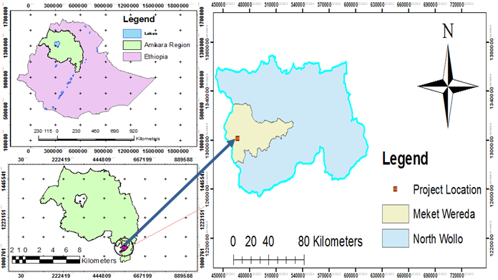

figure2.1 1: Location map of the project area

Accessibility
Shema matebia River Intake Irrigation Project is found in Amhara National Regional State, North Wollo Administrative Zone of Meket Woreda The project area is accessed through 11km distance from Meket Town to Masero kebel.It is Gravel surface road and it required road crossing structures, ford, box culvert .cut and fill, 4km temporary access road in the command area up to the head work it needs cut and fill.

Previous Irrigation Practices
The existing low productivity and production capacity of rain-fed crops, due to uneven distribution of rainfall and heavy hail damage, has enforced farmers to develop traditional irrigation practices. Therefore, irrigated agriculture has gradually developing following rainfall abnormalities and scarcity of land. In the project area irrigated crop production has been practicing using water from Shema Matebia River by constructing traditional intake structures. Furthermore, farmers in the project area have constructed small water wells to use as a source of water for irrigation. Thus, the project area is trying to practice two seasons’ crop productions. The first is rain-fed crop production which is the main income base and constitutes more than 92% of the annual cultivated land; and the second is irrigated crop production (traditional& modern) that accounts about 8% of the whole cultivated land area.

Objectives of the Study

Major Objective
The project area faces variability of rainfall distribution though the overall rainfall generally suffices the rain-fed agriculture. Accordingly, the rain-fed agriculture needs means of supplementing during distribution failures and further full irrigation is required to maximize the use of the potential land and water resources.
Hence the objective of this project is to contribute a substantial share in the effort to reduce the risk of production decrease due to rainfall variability and increase the productivity of the resource in the project specific area. Specifically, the project is targeted for the following.
- To make sustainable the rain-fed crop production and make extra production in the dry season possible for 102 ha of land through irrigation.
- There is a general consensus that irrigation investments will achieve broader food security and poverty reduction impacts and if efforts are also geared towards up-grading existing traditional farming practices with support to enhance access to input supply, output marketing and extension to facilitate access to information and innovations.
- This objective is to be realized by constructing diversion/intake structures across the Shema Matebia River/Stream and diverting the river/stream flow.

Specific Objectives
Other benefits that can be expected to appear with the launching of the project are:
- Efficiency of water use improvement;
- Improved local nutrition/food security gains;
- Improved management of scarce natural resources (land and water);
- Resilience against drought risk;
- Rationale for erosion control and watershed management;
- Rationale for the intensification and modernization of small-holder agriculture and rural lifestyles.
The engineering study and design enables the realization of the project by the provision of engineering structures that will allow the appropriate abstraction of the river/stream water for delivery in to the identified irrigation fields of the study area. Hence, this engineering design is specifically targeted to:
- Analyze hydrologic requirements of the project and engineering structures;
- The formulation of sound and stable structure, with necessary provisions that allow safe, easy and low-maintenance operation in the service life of the project;
- Develop working drawings;
- Estimation of construction costs.

Scope of the Study
- The irrigation design shall ensure reliability, equity and flexibility of water delivery to farmers. It will aim at reducing conflicts among water users and will lead to lower operation and maintenance costs.
- Updating the existing, if available, computation of the actual evapo-transpiration, crop water requirement, irrigation demand/duty using the existing and recent agronomic, climatologic and soil data using more appropriate methodologies.
- Establish design criteria for irrigations structures to be approved by the client and to be used in the final design stage,
- Design proper irrigation system compatible with local conditions and management capabilities,
- Establish flood protection measures for the command area and canal structures and design the respective drainage system accordingly,
- Planning and layout of the irrigation system, which include irrigation canals, drainage channels, inspection roads and alignments, canal spacing, canal length, location of structures, and water profiles along canal and drains at specified reaches, which is most economical easily manageable and aligned with topographic feature and geological investigation.
- Determination and estimation of water application conveyance and other losses and irrigation efficiencies and consideration of those parameters in design steps.
- Check and test hydraulic and structural designs of main canal considering total demand and the required capacity and the base flow availability,
- Prepare general plans and drawings for all irrigation infrastructure and irrigation systems designs,

Methodology
In the study and design procedure, Designers used the following steps.
- Specific Site identification:
  - Review of the reconnaissance survey conducted by the Client
  - 50,000 scale top map and GIS information
  - Local farmers interview and discussion
  - Wereda and Zone Agriculture section expertise
  - Previous studies
  - On foot travel along the river channel and farm areas.
- Topographic survey:
  - Surveying the headwork site and the Command area with sufficient radius, using Total station
- Flow estimation
  - Physical observation on flood mark indications and local information about high flood and critical flow condition of the river
  - Analyzing the recorded river flow data and use watershed inputs for further analysis.
  - Base flow estimated during the reconnaissance field visit by floating method.
- Irrigable area identification:
  - Using local information
  - 50,000 Topographic map, and GIS information, GPS to see elevation
The design report is organized in three sections. In Section I the Hydrology study is presented and in Sections II and III the Headwork and Irrigation and Drainage Systems designs are discussed respectively. In Section III, planning and design of the irrigation system after diverting the water using the intake will be dealt. The following are major areas of concern in this part.
- Study and design of the irrigation method to be adopted,
- Study and design of the irrigation system layout and associated structures,
- Design of the different conveyance canals,
- Planning and design of the different irrigation and drainage structures,
- Preparation of the longitudinal profiles of the different irrigation and drainage canals.

SECTION-I: HYDROLOGY

HYDROLOGY

Watershed Characteristics
The watershed is found within 2078 to 2960 meters above sea level altitudinal range. The watershed has marked topographic variation. All types of slopes are present in watershed. The dominant slope class is Steep Slope (30-50%), which covers 25.76% of the total area followed by gently sloping (3-8%), very steep slope (>50%), moderately steep (15-30%), flat (0-3%) and sloping (8-15%) and which accounts 22.05 %,20.53 %, 14.54%, 10.73% and 6.39% respectively. The table shows the slope classes and proportion of the watershed.. Table 1 of the watershed feasibility study report shows the slope classes and proportion of the watershed.
Certain physical properties of watersheds significantly affect the characteristics of the runoff and sediment yield and are of great interest in hydrologic analyses. The rate and volume of runoff, and sediment yield from the watershed have much to do with shape, size, slope and other parameters of the landscape. These suggest that there should be some important relations between basin form and hydrologic performance. If the basin and hydrologic characteristics are to be related, the basin form must also be represented by quantitative descriptors. These parameters can be measured from maps.
The watershed characteristics are analyzed and presented in Table 2 of the Watershed Feasibility Study Report of the same project. In summary:
- Catchment Area = 37.38km²
- Stream Length = 9.81Km
- CN(II) =93.03
(Extracted from the Watershed Study Report of the same project)
At the selected reference point, the area of the catchment is 31.8km² and consists of a network of tributaries as shown in Figure 2 below.
Shema River/stream at the headwork site is characterized by well-defined channel system and considerable flows. It looks that the gradient of the river/stream is getting low and hence there exists significant deposition of sediment mainly cobbles and boulders.

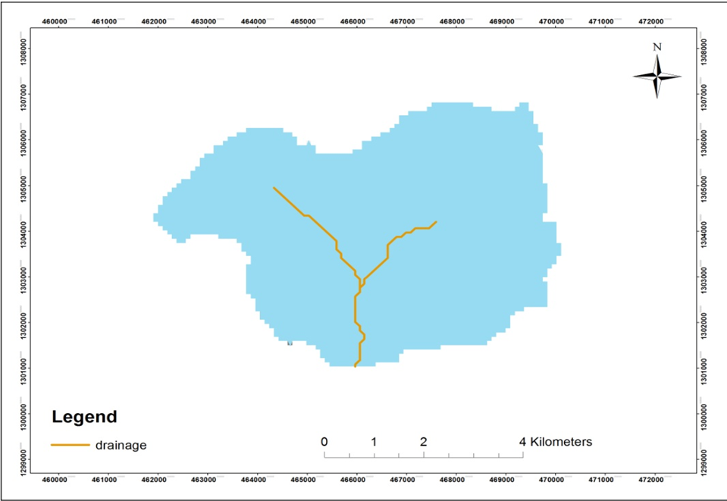
Figure 2-1Drainage map of Shema Matebia watershed

Hydro-Metrological Data Availability

Climate
Small scale irrigation project designers and planners are faced with lack of good data on the hydrology of the stream/river system that will be their water source and on local weather and climate conditions. Stream gauging stations are virtually non-existent in remote rural areas of Ethiopia; meteorological stations are almost rare. Likewise, at Maserot Kebele (Project area location) and in the catchment area of this project, there is no meteorological station of any level. Moreover, there are no flow data for the river/stream near the project. Therefore, data for the hydro-meteorological analysis is taken from the nearby station and similar areas. Rainfall & temperature data are considered from Nfasmewucha Meteorological station. In fact, this station is very close to the project area.
As per the data of the station, March – April are identified as high temperature periods whereas December–January are low temperature periods. Irrigation water requirements. The amount of average annual rainfall at Lalibela meteorological station is about 740mm

Rainfall Data
In order to compute the design flood for the Diversion/intake structure, the daily maximum rainfall is collected from Nfasmewucha Metrological stations with a record of 21years.

River flow data
The base flow which is measured in May 2008EC is 132 l/s. Since this base flow is measured during the dry months of the year, this figure is adopted for design.

Upstream & Downstream utilization
Downstream of the proposed site, appreciable need for water is anticipated for locals and cattle provisions. Therefore, at least 30% of the minimum flow has to be released for downstream requirements from head work 100m distance in the left &right side of the river there are two springs &they flow into downstream of the river.
For the sake of planning and design, however, the outlet for the diversion/intake is designed for a discharge of 97l/s for this project and the project is to be developed for 102 ha of land, which is most of the time achievable as the flow for most of the time is significant to support this size of command area by supplementary irrigation.

Design Flood Analysis
For the design and analysis of structures to be constructed on the Shema river/stream, estimation of flood magnitude is an important task. This can be done using different depending on the data available. For this particular case, there are no river flow data and hence the flood estimation is done using the rainfall data and applying SCS Curve Method.

Design Rainfall computation
Based on the data of 24hr peak rainfall given in Table 1 the design rainfall, Rf is computed using Gumble’s Extreme Value Method.

Outlier Test
Higher Limit, $Y_{H}=Ymean+Kn*Sy$, Kn = 2.408 for 21years of data.
Lower Limit, $Y_{H}=Ymean-Kn*Sy$, Kn = 2.408 for 21 Years of data.

Table 2-1: Outlier test analysis
Daily maximum RF
S.NO. | year | Daily max. RF of year(X) | Descending Order(X) | Y=log X | Cumulative rainfall
1 | 1986 | 53.6 | 58.5 | 1.73 | 53.6
2 | 1987 | 53.7 | 54.5 | 1.73 | 107.3
3 | 1988 | 58.5 | 53.7 | 1.77 | 165.8
4 | 1989 | 37.7 | 53.6 | 1.58 | 203.5
5 | 1992 | 41.1 | 51.2 | 1.61 | 244.6
6 | 1993 | 48 | 48 | 1.68 | 292.6
7 | 1994 | 33 | 46.5 | 1.52 | 325.6
8 | 1995 | 51.2 | 45.9 | 1.71 | 376.8
9 | 1996 | 37.9 | 45.6 | 1.58 | 414.7
10 | 1997 | 42.5 | 44.9 | 1.63 | 457.2
11 | 1998 | 54.5 | 44.5 | 1.74 | 511.7
12 | 1999 | 35.2 | 44.4 | 1.55 | 546.9
13 | 2000 | 46.5 | 44.3 | 1.67 | 593.4
14 | 2001 | 44.4 | 44.2 | 1.65 | 637.8
15 | 2002 | 44.3 | 42.5 | 1.65 | 682.1
16 | 2003 | 45.6 | 41.1 | 1.66 | 727.7
17 | 2004 | 35.3 | 37.9 | 1.55 | 763
18 | 2005 | 45.9 | 37.7 | 1.66 | 808.9
19 | 2006 | 44.2 | 35.3 | 1.65 | 853.1
20 | 2007 | 44.5 | 35.2 | 1.65 | 897.6
21 | 2008 | 44.9 | 33 | 1.65 | 942.5
sum |  | 942.5 |  | 34.62
mean/µ/ |  | 44.88 |  | 1.65
stdv/αn-1/ |  | 6.83 |  | 0.07
skew/g/ |  | 0.14 |  | -0.16
 |  | YH=ỳ+Kn*Syn-1
 |  |  |  | ỳ= Logarithmic mean= |  | 1.650
 |  |  |  | Syn-1= logarhimic standard division = |  |  |  | 0.070
 |  |  |  | kn = | 2.408
 |  | YL= |  | 1.481
 |  | YH= |  | 1.819
Then, | RL= | 30.300 |  | <33 | OK!
 | RH= | 65.851 |  | >58.5 | OK!
 | There is no highest outlier value. Because, data value recorded in 1988, 58.5mm/day, is not greater than highest calculated values, 65.851mm/day, Hence, it is no outer lier value and has not rejected data series. No lower outlier value.

Check for variance
After checking the outliers, the data should be checked for variability. For variability the formula used is
$α=\left(\frac{δ_{∩-1}}{\sqrt{N}*Mean}\right)*100\%$
Where, δ_{n-1 =} Standard deviation =6.8
N = Nr of recorded data =21
M_{ean} = 44.88
$α$ = Standard error
$α=\left(\frac{6.8}{\sqrt{21}*44.88}\right)*100\%=3.32<10\%$ Acceptable
Therefore the data shows no variability.

D-Index test
After checking the consistency of the data for higher and lower outlier, the 21 years data is obtained as representative for the analysis using D-index. The D-Index test is believed to be the better goodness to fitness in many literatures. Hence in this study it was used to determine the best statistical distribution to estimate the peak rainfall. The D-index for the comparison of the fit of various distributions is summarized as follows.
$D_{-Index}=(\frac{1}{X_{m}})*\sum_{i=1}^{6}{Abs(Xi-{Xi}^{'})}$
Where Xi and Xi’ are the i^{th} highest observed and computed values for the distribution respectively

Table 2-2: Test for goodness to fit using D-index
 |  | Normal | GUMBLE EVI | Lognormal | Log person Type III
Rank(m) | XI | XI-'XI' | XI-'XI' | XI-'XI' | XI-'XI'
1 | 58.5 | 2.07 | 2.62 | 0.16
2 | 54.5 | 0.50 | 2.04 | 0.90 | 0.70
3 | 53.7 | 1.33 | 0.09 | 0.39 | 0.45
4 | 53.6 | 2.52 | 1.82 | 1.89 | 1.86
5 | 51.2 | 1.21 | 1.02 | 0.81 | 0.72
6 | 48 | 1.01 | 0.83 | 1.24 | 1.37
7 | 46.5 | 1.61 | 1.15 | 1.70 | 1.86
8 | 45.9 | 1.36 | 0.70 | 1.35 | 1.52
9 | 45.6 | 0.85 | 0.03 | 0.75 | 0.94
10 | 44.9 | 0.76 | 0.18 | 0.60 | 0.79
11 | 44.5 | 0.38 | 0.63 | 0.17 | 0.36
12 | 44.4 | 0.30 | 1.36 | 0.54 | 0.36
13 | 44.3 | 0.98 | 2.06 | 1.25 | 1.07
14 | 44.2 | 1.69 | 2.75 | 1.96 | 1.80
15 | 42.5 | 0.82 | 1.84 | 1.08 | 0.94
16 | 41.1 | 0.31 | 1.25 | 0.54 | 0.42
17 | 37.9 | 1.94 | 1.12 | 1.76 | 1.84
18 | 37.7 | 1.08 | 0.42 | 0.98 | 1.02
19 | 35.3 | 2.27 | 1.82 | 2.29 | 2.27
20 | 35.2 | 0.88 | 0.74 | 1.09 | 0.99
21 | 33 | 1.00 | 1.32 | 1.55 | 1.33
Sum |  | 24.85 | 25.77 | 23.00 | 22.92
D-index |  | 0.55 | 0.57 | 0.51 | 0.51
Design Rainfall |  | 58.9 | 66.4 | 62.2 | 62.9
The fittest distribution method has the smallest D-index value, hence Log Pearson Type III is the fittest
All the candidate distributions give almost identical correlation coefficients. However, the standard errors are significantly lower for the Log Pearson type III Method which is 0.51. Accordingly, the design rain for this distribution has been selected as the best fit for this study but, for avoiding the risk the GUMBLE method is the best method.

The design rainfall Gumble Method is given as
Where R_{f =} Design rainfall
R_{mean} = average of all values of annual heaviest fall =44.88 mm
σ_{n-1} = standard deviation of the series = 6.83 mm
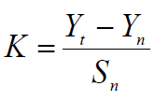
, T= Return period = 50 years
Yn, Sn = constant found from Gumble’s extreme value distribution table for N=21Years
- Yn =0.5252 and Sn =1.0696
- Point Design Rainfall = 66.44 mm
The design rainfall at points for 50 years return period is 66.44 mm and the areal design rainfall is calculated in the following section.

Peak Discharge Determination

General
The Shema Matebia River/stream is not gauged river. The design flood is calculated by using SCS unit hydrograph method. Thus, it is preferred to base the flood analysis on rainfall data, which are better both in quantity and quality of data. In the hydrologic analysis for drainage structures, it must be recognized that there are many variable factors that affect floods. Some of the factors that need be recognized and considered on an individual site by site basis are; rainfall amount and storm distribution; catchment area, shape and orientation; ground cover; type of soil; slopes of terrain and stream(S); antecedent moisture condition; Storage potential (over bank, ponds, wetlands, reservoirs, channel, etc.)

Peak flood analysis by SCS unit hydrograph method
Design flood is calculated SCS (The United States Soil Conservation Service). This method is widely adopted and more reliable method for flood estimation. The approach considers, watershed parameters, like Area, Curve number, and time of concentration.

Time of concentration (Tc)
Time of concentration has been calculated by taking the stream profile of the longest streamline and dividing it in to different elevation. Kirpich formula is adopted for computation.
Table 2-3: Determination of Time of Concentration

No | LFP | Z_Min | Z_Max | Z_Mean | E/D | TC
1 | 2.40704 | 2890.001 | 2983 | 2915.8 | 92.9965 | 0.45663
2 | 1.576 | 2031.002 | 2101.5 | 2069.25 | 70.4981 | 0.31149
3 | 1.57347 | 2089.002 | 2145 | 2111.35 | 55.9985 | 0.33973
4 | 2.11708 | 2139.886 | 2328.38 | 2215 | 188.497 | 0.29994
5 | 2.14774 | 2328.383 | 2893.05 | 2626.87 | 564.666 | 0.1999
 |  |  |  |  |  | 1.60768

The formula is,
$Tc=\sum{0.948\left\{{\left(\frac{{L_{1}}^{3}}{H_{1}}\right)}^{0.385}+{\left(\frac{{L_{2}}^{3}}{H_{2}}\right)}^{0.385}+…+{\left(\frac{{L_{n}}^{3}}{H_{n}}\right)}^{0.385}\right\}}$
- Tc = 1.60768 Since Tc <3hr., duration of excess rainfall difference, D = Tc/6hr=0.2679hr.
- Time to peak,
$T_{p=}\frac{D}{2}+0.6*T_{c}$ = 1.0985hr
- Base time,
$T_{b}=2.67*T_{p}$ = 2.933
- Recession time,
$T_{r}=1.67*T_{p}$ = 1.83hr.

Curve number (CN)
NO. | soil type | Land use | Shape_Area | hydro -condition | soil Group | CN | A*CN
1 | Eutric Cambisols | Grassland | 164.5 | poor | B | 80 | 13160
2 | Eutric Cambisols | Shrubland | 30.41 | poor | B | 79 | 2402.39
3 | Eutric Cambisols | Cultivatedland | 522.61 | poor | B | 85 | 44421.85
4 | Eutric Nitosols | Grassland | 35.84 | poor | B | 80 | 2867.2
5 | Eutric Nitosols | Shrubland | 233.29 | poor | B | 79 | 18429.91
6 | Eutric Nitosols | Cultivatedland | 502.46 | poor | B | 85 | 42709.1
7 | Lithosols | Grassland | 6.46 | poor | D | 89 | 574.94
8 | Lithosols | Shrubland | 14.07 | poor | D | 86 | 1210.02
9 | Lithosols | Cultivatedland | 163.44 | poor | D | 90 | 14709.6
10 | Pellic Vertisols | Grassland | 23.04 | poor | D | 89 | 2050.56
11 | Pellic Vertisols | Shrubland | 1003.1 | poor | D | 86 | 86264.88
12 | Pellic Vertisols | Cultivatedland | 511.31 | poor | D | 90 | 46017.9
13 | rock surface | Grassland | 31 | poor | A | 68 | 2108
14 | rock surface | Shrubland | 12.66 | poor | A | 45 | 569.7
15 | rock surface | Cultivatedland | 484.65 | poor | A | 74 | 35864.1
 |  |  | 3738.9 |  |  |  | 313360.15
 |  |  |  |  |  |  | 83.810787
 |  |  |  |  |  | corraction factor | 1.11
 |  |  |  |  |  | condition -3 | 93.03
 |  |  |  |  |  | LFP | 9.81 | KM
 |  |  |  |  |  | AREA | 37.38 | km2

Curve number (CN) is achieved based on USSCS method by watershed characterization in terms of land cover, treatment, hydrologic condition and soil group. From the watershed analysis curve number at condition II =80.2. Since peak rainfall is found at an antecedent moisture condition III state, this value has to be changed to antecedent moisture condition III.

- Conversion factor = 1.11
- CN Condition (III) = 93.03

Area Rainfall
As the area of the catchment gets larger, coincidence of all hydrological incidences becomes less and less. This can be optimized by changing the calculated point rainfall to aerial rainfall. The conversion factor is taken from standard table that relate directly with the size of watershed area and type of the gauging station. (IDD manual)
For the case of Shema Matebia irrigation project,
- Total watershed area = 37.38 Km²
- Type of gauging station = Daily rainfall (24 hr.)
- Aerial Rainfall = (Point Rainfall) x (Conversion factor)

Run off Analysis
Input data:
- Design Point Rainfall = 66.44mm
- Curve number at antecedent moisture condition III = 93.03
- Catchment Area, A = 37.38Km2
- Tc = 1.6hr, D = 0.205hr., Tp = 0.943hr; Tb = 2.52 hrs; Tr = 1.75hr.
Direct run-off,
$Q=\frac{{(I-0.2*S)}^{2}}{(I+0.8*S)}$
Where, I = Rearranged cumulative run-off depth (mm
- S = Maximum run off potential difference,
$S=\left(\frac{25400}{CN}\right)-254$
- Peak run-off for incremental;
$Q_{p}=0.21*\frac{(A*Q)}{T_{p}}$
Where, A = Catchment area =37.38Km²
T_{p} = Time to peak (hr.)
Q = Incremental run-off (mm)

Table 2-4: Runoff analysis

Table 2-5: Hydrograph coordinates

Figure 2-2 Complex Hydrograph

From the analysis, the 50 year return period design run off is 76.13 m ³/s

Tail Water Depth Computation
Tail water depth of the river is equal to the flood depth and amount at the proposed intake site before construction of the intake and river training structure of retaining wall in d/s and u/s of out let. It is used to crosscheck peak flood estimated by the SCS unit hydrograph method with flood mark method. During field visit, the flood mark of the river at the proposed diversion/intake site was marked based on dwellers information and physical indicative marks. The river cross-section was surveyed.
Table 2-6: intake Site River Cross section Coordinate Data
point No | Code | North | East | X- distance | Y-distance | Partial distance | Commutative distance | elevation
1 | river center | 1301318.47 | 465892.27 | 0 | 0 | 0 | 0 | 2092.32
2 | river center | 1301310.244 | 465886.08 | -8 | -6 | 2 | 2 | 2091.94
3 | river center | 1301301.854 | 465880.12 | -8 | -6 | 3 | 5 | 2091.57
4 | river center | 1301293.13 | 465874.68 | -9 | -5 | 4 | 9 | 2091.20
5 | river center | 1301283.427 | 465871.29 | -10 | -3 | 7 | 16 | 2091.02
6 | river center | 1301273.548 | 465868.39 | -10 | -3 | 9 | 26 | 2090.85
7 | river center | 1301263.669 | 465865.5 | -10 | -3 | 10 | 36 | 2090.67
8 | river center | 1301253.79 | 465862.6 | -10 | -3 | 10 | 46 | 2090.50
9 | river center | 1301243.911 | 465859.7 | -10 | -3 | 10 | 55 | 2090.33
12 | river center | 1301233.999 | 465856.93 | -10 | -3 | 10 | 65 | 2089.74
13 | river center | 1301223.995 | 465854.5 | -10 | -2 | 10 | 76 | 2088.92
14 | river center | 1301213.991 | 465852.07 | -10 | -2 | 11 | 87 | 2088.42
15 | river center | 1301203.986 | 465849.64 | -10 | -2 | 11 | 97 | 2087.91
16 | river center | 1301193.982 | 465847.21 | -10 | -2 | 11 | 108 | 2087.40
17 | river center | 1301184.196 | 465844.08 | -10 | -3 | 10 | 118 | 2086.94
18 | river center | 1301174.868 | 465839.72 | -9 | -4 | 8 | 126 | 2086.7011
19 | river center | 1301165.539 | 465835.37 | -9 | -4 | 7 | 133 | 2086.4676
20 | river center | 1301156.02 | 465831 | -10 | -4 | 7 | 141 | 2086.3063
21 | river center | 1301146.324 | 465828 | -10 | -3 | 8 | 149 | 2085.9787
22 | river center | 1301136.239 | 465826 | -10 | -2 | 10 | 159 | 2085.2421
23 | river center | 1301126.035 | 465825 | -10 | -1 | 12 | 171 | 2084.7113
24 | river center | 1301115.785 | 465824 | -10 | -1 | 13 | 184 | 2084.3556
25 | river center | 1301105.535 | 465823 | -10 | -1 | 13 | 197 | 2084.0404
26 | river center | 1301095.286 | 465822 | -10 | -1 | 13 | 211 | 2083.7252
27 | river center | 1301085.244 | 465823 | -10 | 1 | 15 | 225 | 2083.3574
28 | river center | 1301075.741 | 465827 | -10 | 4 | 18 | 243 | 2082.7093
29 | river center | 1301066.05 | 465830 | -10 | 3 | 19 | 262 | 2082.0749
30 | river center | 1301056.359 | 465834 | -10 | 3 | 19 | 280 | 2081.5859
31 | river center | 1301046.668 | 465837 | -10 | 3 | 19 | 299 | 2081.2034
32 | river center | 1301036.977 | 465841 | -10 | 3 | 19 | 317 | 2080.8217

Table 2-7: Stage discharge analysis
S.N | Elevation/m/ | water depth /m/ | wetted Area /m^2 | perimeter /m/ | Hydraulic radius/R/ | slope | velocity /m/s | Discharge/m^3/s/
1 | 2086.187 | 0.000 | 0.000 | 0.000 | 0.000 | 0.037 | 0.000 | 0.000
2 | 2086.687 | 0.500 | 18.459 | 51.920 | 0.356 | 0.006 | 0.940 | 17.343
3 | 2087.187 | 1.000 | 46.940 | 61.372 | 0.765 | 0.006 | 1.566 | 73.495
4 | 2087.237 | 1.050 | 49.990 | 62.280 | 0.803 | 0.006 | 1.617 | 80.830
5 | 2087.687 | 1.500 | 79.765 | 70.451 | 1.132 | 0.006 | 2.034 | 162.216
6 | 2088.187 | 2.000 | 117.100 | 79.536 | 1.472 | 0.006 | 2.423 | 283.717
7 | 2088.687 | 2.500 | 158.885 | 88.620 | 1.793 | 0.006 | 2.763 | 438.983
8 | 2088.790 | 2.603 | 168.072 | 90.575 | 1.856 | 0.006 | 2.827 | 475.136
9 | 2089.29 | 3.103 | 215.342 | 98.743 | 2.18 | 0.006 | 3.148 | 677.966

Figure 2-3Stage discharge Curve
From the above stage discharge table and curve the maximum flood level corresponding to the computed design peak discharge is 2088.79 (2.603 m from the river bed) and it is considered as the d/s high flood level i.e. expected at the intake axis before construction of the intake.
D/S HFL = 2088.79 masl.
- Average river bed slope
Average river bed slope of River is estimated by two different techniques. One is by end area method and the other is by using best fit line method. Designers have adopted the end area method output for further analysis.
The water level of the river is taken at different points along the river channel around the head work site. Surveying work done for 317m length. And then, average water surface slope is considered as the river bed slope. For comparison of the two procedures, refer the attached Excel file.

Figure 2-4River profile
- Manning’s Roughness coefficient
The Manning’s roughness coefficient is taken from standard table based on the river nature. The river at the headwork site has got braded feature and curving nature. The river banks are defined and relatively smooth. Manning’s roughness coefficient (n = 0.04) is adopted.

- Discharge of the river
Input data:
- Manning's roughness coefficient, n = 0.04
- Average river bed slope, S = ^{0.003}
- , Where, R = Hydraulic radius = (Area/Perimeter)
- $Q=V*A$

Table 2-8: River discharge computation at different stages of flow
Tail water-Discharge Computation at axis of bed bar
S.N | Elevation/m/ | water depth /m/ | wetted Area /m^2 | perimeter /m/ | Hydraulic radius/R/ | slope | velocity /m/s | Discharge/m^3/s/
1 | 2086.187 | 0.000 | 0.000 | 0.000 | 0.000 | 0.003 | 0.000 | 0.000
2 | 2086.687 | 0.500 | 18.459 | 51.920 | 0.356 | 0.003 | 0.642 | 11.842
3 | 2087.187 | 1.000 | 46.940 | 61.372 | 0.765 | 0.003 | 1.069 | 50.182
4 | 2087.237 | 1.050 | 49.990 | 62.280 | 0.803 | 0.003 | 1.104 | 55.190
5 | 2087.687 | 1.500 | 79.765 | 70.451 | 1.132 | 0.003 | 1.389 | 110.760
6 | 2088.187 | 2.000 | 117.100 | 79.536 | 1.472 | 0.003 | 1.654 | 193.720
7 | 2088.687 | 2.500 | 158.885 | 88.620 | 1.793 | 0.003 | 1.886 | 299.735
8 | 2088.790 | 2.603 | 168.072 | 90.575 | 1.856 | 0.003 | 1.930 | 324.420
9 | 2089.29 | 3.103 | 215.34 | 98.743 | 2.18 | 0.003 | 2.150 | 462.912

Peak discharge analysis of flume
The catchment area is less than 5km^2 should be use rational method for calculating peak discharge
Flume -1-1
Hydrology raw data
Table 2-9: River discharge computation at different stages of flow

Z_Min |  | Z_Max |  |  | Z_Mean |  |  | SLength |  |  | e/d |  | tc
2117.721 |  | 2203.8249 |  |  | 2155.912 |  |  | 284.9049 |  |  | 86.10358 |  | 0.0376466
2379.342 |  | 2527 |  |  | 2464.687 |  |  | 353.3656 |  |  | 147.6584 |  | 0.0366006
2302.136 |  | 2379.3416 |  |  | 2336.263 |  |  | 206.5661 |  |  | 77.20602 |  | 0.0261081
2247 |  | 2302.1356 |  |  | 2271.028 |  |  | 251.7535 |  |  | 55.13556 |  | 0.039746
2203 |  | 2247.431 |  |  | 2219.828 |  |  | 346.9138 |  |  | 44.43098 |  | 0.0636559
2096 |  | 2117.7213 |  |  | 2108.254 |  |  | 204.5227 |  |  | 21.72129 |  | 0.0458595
 |  |  |  |  |  |  |  |  |  |  |  |  | 0.2496168
FID | Shape * |  |  | OID_ |  |  | Shape_Leng |  |  | Shape_Area(ha) |  |  |  | HydroID | Name
0 | Polygon |  |  | 0 |  |  | 4697.276 |  |  | 75.452147 |  |  |  | 17921 | flume_1
Hydrology analysis |  |  | Tc= |  |  | 0.249617 |  |  | hr
design rainfall= |  |  |  |  |  | 74.94 |  |  | mm
runoff coefficient, C |  |  |  |  |  | 0.4566
catchment area,= |  |  |  |  |  | 0.754521 |  |  | km^2
 |  |  | Q=CIA |  |  | 0.717151 |  |  | m^3/S

Flume -1-2
Hydrology raw data
Table 2-10: River discharge computation at different stages of flow

No | LFP | Z_Min | Z_Max | Z_Mean | E/D | TC
1 | 0.54894 | 2174.9 | 2384.6 | 2286.8 | 209.7 | 0.06056
2 | 0.29472 | 2075 | 2098.1 | 2084.9 | 23.09 | 0.06903
3 | 0.33885 | 2098.1 | 2152.1 | 2111.9 | 54.06 | 0.05846
4 | 0.11638 | 2152.1 | 2174.9 | 2163.5 | 22.75 | 0.02374
5 | 0.11765 | 2384.6 | 2415 | 2397.5 | 30.43 | 0.02149
 |  |  |  |  |  | 0.23328

FID | Shape * | Shape_Leng |  |  | Area(ha) |  | HydroID |  | Name
0 | Polygon | 3904.23 |  |  | 37.0283 |  | 17929 |  | flume_1-2
Hydrology analysis |  |  | Tc= | 0.2333 |  | hr
design rainfall= |  |  |  | 74.94 |  | mm
runoff coefficient= |  |  |  | 0.439
catchment area,= |  |  |  | 0.3703 |  | km^2
 |  |  | Q=CIA | 0.1523 |  | m^3/S

Flume -1-3
Hydrology raw data
Table 2-11: River discharge computation at different stages of flow
No | LFP |  | Z_Min |  |  | Z_Max |  |  |  | Z_Mean |  |  | E/D |  | TC
1 | 0.706 |  | 2465.73251 |  |  | 2744 |  |  |  | 2587.81 |  |  | 278.27 |  | 0.073
2 | 0.346 |  | 2079 |  |  | 2149.4 |  |  |  | 2111.8 |  |  | 70.393 |  | 0.054
3 | 0.603 |  | 2149.39343 |  |  | 2228.7 |  |  |  | 2186.06 |  |  | 79.287 |  | 0.098
4 | 0.316 |  | 2228.6808 |  |  | 2266.7 |  |  |  | 2247.52 |  |  | 38.004 |  | 0.062
5 | 0.606 |  | 2266.68497 |  |  | 2410.6 |  |  |  | 2326.21 |  |  | 143.88 |  | 0.078
6 | 0.242 |  | 2410.56539 |  |  | 2465.7 |  |  |  | 2440.95 |  |  | 55.167 |  | 0.039
 |  |  |  |  |  |  |  |  |  |  |  |  |  |  | 0.405
No |  | Shape_Leng |  |  | Shape_Area(ha) |  |  | HydroID |  |  |  | Name |  | AREA
1 |  | 6954.5 |  |  | 141.32381 |  |  | 17925 |  |  |  | flume_3 |  | 141.32
Hydrology analysis |  |  |  | Tc= |  |  | 0.4045 |  | hr
design rainfall= |  |  |  |  |  |  | 74.94 |  | mm
runoff coefficient= |  |  |  |  |  |  | 0.448
catchment area,= |  |  |  |  |  |  | 1.4132 |  | km^2
 |  |  |  | Q=CIA |  |  | 0.5931 |  | m^3/S
Note: The flood cannot reach the flume section because the gully depth up to canal it is high.so it does not need stage discharge analysis in this case.

SECTION-II: HEADWORK DESIGN

HEADWORK STRUCTURES DESIGN

Headwork Site Selection
The headwork site is situated at 1301071.807m m N, 465875.548m E and river bed elevation of 2094.544 m above sea level. At this specific site, covered by recent alluvial deposit sediment at the river bed whereas the left bank is also made from silt clay soil but the right bank is covered by silt clay soil at the top for few centimeter thickness below this soil there is highly to moderately weathered aphanitic rock exposure which extend in upstream direction. The river is flowing through a defined channel and its scouring effect on the river course is significant as its bed covered by loose, alluvial deposit which is easily erodible and transported by running water. The different sections of the stream at the proposed headwork site are described separately below:-

River Geomorphology
It is a common fact that the river development tends to accommodate itself to the local geology that develops along the structurally weak zones like faults, joints, folds, etc. The nature of geological formations and structures has also strong influence on the development of the channel.
The present morphology of the River/Stream channel is a function of a number of processes and environmental conditions, including the composition of the bed and the banks (moderately weathered, fractured and jointed basalt along right side whereas Low Plastic Clay (CL), with some silt and alluvial sediment deposit and recent coarser deposit at the left bank and bed); the size and composition of the sediment moving through the channel; the rate of sediment transport through the channel and deposition on the banks and beds; and the regional degradation due to erosion processes. Both left bank and the bed are composed of loose silt clay soil and coarser alluvial sediment as the result the stream shows highly meandering nature both up and downstream from the proposed site but at the particular intake site it shows nearly straight river channel. The river has wider section in upstream direction whereas to downstream side the river section become narrower.

River Bed condition
For this project a simple river bed level Intake structure has been proposed for diverting the water to the main canal route by gravity. The headwork site geological surface and subsurface conditions have been investigated based on the nature of the proposed structure. At the site and immediate vicinity, the stream flows along moderate slope course and its bed is mainly covered with recently deposited alluvial sediments. These sediments are dominated by boulder, sand, gravel with some fine sand at the top and gravel with sand and cobble/boulder fragments to depth. At some portions of the stream bed, especially at both left and right ends, there are outcrops of the bedrock (aphanitic Basalt). On the other hand, the banks of the stream at the headwork site are made up of similar geologic materials; most part of the left bank is made up of Basalt rock. The right bank, on the contrary, is made up of massive loose collapse soil deposit and highly weathered rhyolite rock. The detail geologic nature of the banks, and bed of the stream along the headwork axis and immediate vicinity are described and their potential geotechnical influence on the proposed structures also discerned/detected below, with remedial measures.
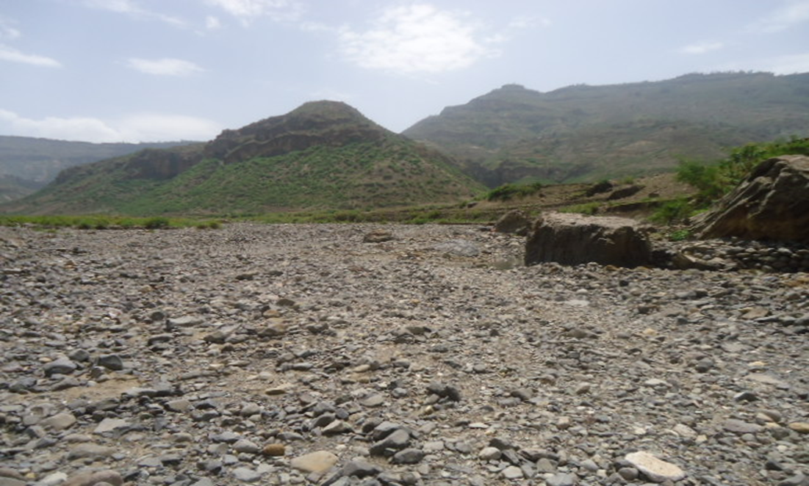
Figure 3-1River bed at the proposed intake site
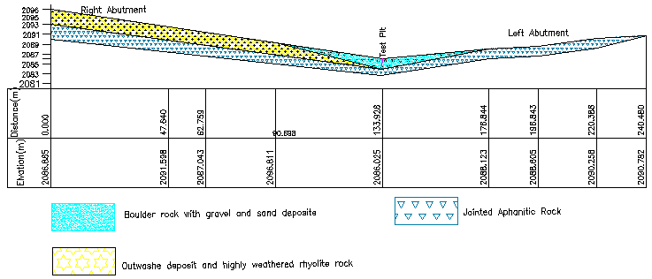

Figure 3-2Geological Cross Section along Head Work Axis

River Bank condition

Right Bank
At the headwork site/axis, the right bank is characterized by relatively moderate to gentle slope, having about 3m height from stream bed. It reveals nearly horizontal section within this height. From visual observation of the natural cuts at the bank, there are two distinct geological materials forming the bank section. From top to bottom, these are:-
(i) Low Plastic Clay (CL), with some silt and alluvial sediment deposit
(ii) Slightly Weathered basalt bedrock
These two units have variable thickness/depth at the area. Just at the Intake axis, the top clay soil has about less than a meter, gets decreasing towards upstream. The underlying bedrock is observed at the bank foot. These overburden soil materials have been affected by erosion/ flood under cutting which is widening the bank by forming nearly gentle slope. However, such steep slope configuration observed at upstream and downstream bank part forms instability or collapse and easily erodible because of its loose material.

Left Bank
At the proposed headwork axis and immediate vicinities, the left bank forms relatively steep slope topography. From surface observation, the bank is made up of outcrops of basalt geological units. This rock unit, for geotechnical purpose, shows two distinct layers at the bank. These are top jointed portion of the rock, and underlain massive basalt rock. The slope and peak areas of the bank are covered by low plastic clay soil with intercalated aphanitic basalt rock unit. This top unit has thickness ranges of less than a meter, decreasing towards the bank foot. Underlying this low plastic clay soil is massive bedrock. This bedrock exposed on the surface at the left bank foot (See plate4.1 and Annexture-2). Similar rock formation exposes along the downstream part of the bank, till about 20m, after which the bank is made up of erodible alluvial sediment deposit. However, it is necessary to provide some bank protection structures to prevent the initial bed bar portion near to the bank or cut slope by slope or berm because of their rock falling.

Sources of construction materials
During the site investigation, natural construction materials required for the construction of the various proposed engineering structures at the headwork and within the farmland have been assessed, and possible quarry sites and aggregate (fine and coarse) areas have been identified within the vicinity of the area as much as possible. In addition to the identification, the quality, quantity, accessibility condition and ownership of each proposed production sites have also been studied and described in this report; on separate sub-sections below. The natural materials required for the construction of the proposed hydraulic structures include rock for masonry stones, aggregates (both coarse and fine), impervious soil for fill and/or lining, backfill soil, and water.

Rock for Masonry and Crushed Coarse Aggregate
Quarry site can be used for the production rock for masonry stone and crushed coarse aggregate has been assessed during the field work within near to the proposed project area at reasonable economical distance hauling. The possible quarry site has been identified within right side/bank of the headwork to about 2.2km and 2.3km at downstream following a continuous ridge bordering the right side of Shema Matebia stream. The possible quarry site has been identified within right side/bank of the headwork to about 2.0-3.0km at downstream following a continuous ridge bordering the right side of Shema Matebia stream at geographical location of 466123mE, 1298945mN and 465393mE, 1298872mN of there is natural rock and used the stock by flooding which is deposit at stream bed. This select quarry site is common land and farmland in same part. At this quarry site, the available rock type is aphanitic basalt which is magmatic in origin and occurs in the form of angular fragments of suitable sizes (See plate4.4). It is dark gray and fine texture volcanic rock. Naturally, this rock is strong as it is generally slightly-fresh very thin cover of top weathered zones observed during the site investigation, which needs to be removed during rock dressing and before crushing but it is less than a meter thick. At the quarry site, fresh basalt rock units are found in large quantity that sufficient the requirement of the project. From this site, rock of different sizes can be produced during construction time.

3.3.2Fine Aggregates.
Borrow Areas for fine aggregate or natural sand have been assessed starting from the project stream itself. Natural deposits of such materials could not be found when assessed within the beds of the stream in the project area. The main source of the sand materials as filter media and concrete work is available at about 70km from the construction site towards Northern wollo from the Woreda town called Mekite. This sand is found along Tekezie River in lalibela town. The quality of this sand filter material shall be used according to the filter design criteria identified in the geological report.
Other possible sand source site is found between Delanta and Wadila Woreda with the river is called Zhita which is a good potential for the intended purpose. It has 80km for the construction site.

Water
During site investigation Shema Matebia stream base flow is estimated as 97L/s so water for construction purposes can be getting from the project stream itself. The stream is perennial that throughout the year there is some amount of water flow along its course according to the local people information. The stream water originates from mainly fractured basaltic rock aquifer, which is portion of the Ethiopian western highland that is known to discharge good quality potable water.

Headwork Type Selection
Looking the availability of natural construction materials and considering the river features and expected flood amount, intake is chosen. As it is:
- The river is alluvial deposit morphology so; it needs bed bar structure for preventing the water passing through it.
- The river does not need head regulator structure because the head work river minimum elevation is greater than maximum command area elevation.
- The head work type selection based on maximum command elevation.
- The bed bar cutoff depth from geological report 3.5m up to 4.5m the we take average depth 4.5m cutoff from minimum river bed elevation
- The river minimum elevation 2086.03m.a.sl and cutoff elevation 2082.03m.a.sl
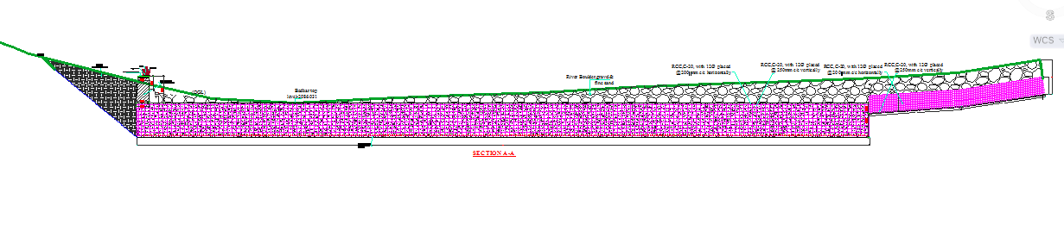

Figure 3-3Bed bar section

Hydraulic Design of Headwork Structure

Base flow of the River
The study team has assessed that the stream is not used for irrigation along its entire course except at the proposed diversion site where farmers are using the stream for traditional SSI (Irrigation Infrastructure Report). Study team has calculated flow of the river/stream at the intake site as 132l/s.

3.4.2.1. Wall height fixation of Divide Wall
The existing topographical condition at the weir/intake axis and HFL are considered to be most governing parameters for fixing the wall height.
After construction of the intake (u/s HFL) = 2088.79m.a.s.l
Hence the level of divide wall and weir/intake body foundation should be the same and is 2088.79m
U/s wall height = U/s HFL - foundation level + free board.
Adapt 0.5m free board
U/s wall height = 2088.79m.a.s.l – 2086.031m + 0.5m =3.1 m
⇒ Provide 3.1 m wall height and the top level of the divide wall =2088.79m + 3. 1m =2089.13.

3.4.2.2. Breast Wall and Operation Slab
A vertical raised gate is designed for the head regulator. These gates slide over the breast wall using spindle during opening and closing.
For easy operation of these gates, operation slab is provided. The size of the operation slab is fixed from the point of construction and free movement. The size of the operation slab is shown in the drawing 0.2m thickness.
The thickness of the breast wall is 25cm. The nominal thickness is fixed from the point of construction rather than the imposed load. The thickness required for the imposed load is less than the nominal value and treated as cantilever retaining wall. For the breast wall, the minimum reinforcement area is taken as 15% along the respective direction.
Hence A_{steel} = 0.0015*1000*200=300
A_{steel} = 300mm²/m
Provide 12@C/c 200 mm
Considering cover thickness of 50 mm, effective depth = 50 + 12/6 = 56
Hence spacing of reinforcement = 200mm < 432mm
A_{steel} = 500mm^2
Therefore the actual provided steel area per meter width is 565 mm²/m > 300 mm²/m. It is ok!
The actual arrangement of angle irons, spindles, shafts and operation slab including other components is shown on the design drawing.
For each arrangement and further information, refer to the design drawing.

3.4.2.3. Retaining Walls stability analysis
At the two ends of the diversion intake, walls have been provided to safeguard the structure from scour at the ends and also as a facility to the canal outlet operation and maintenance at the canal outlet portion.
Table 3-1: Typical design of masonry retaining wall
Upstream retaining wall analysis
SN | `rd(KN/M^3) | r(masonry)Kn/m^3 |  | rw(KN/m^3) | rsa(KN/m^3)
SN | 18.5 | 21 |  | 10 | 21.5
 | DESCRIPTION | horizontal forces (KN/m) | vertical forces (KN/m) | lever arm(m) | restoring moment(M+) | Disturbing moment (M-)
1 | W1= 3.1*0.5*23 |  | 33 | 0.25 | 8
2 | W2=3.1*1.2*23*0.5 |  | 46 | 1.0 | 44
3 | Ws=(1.8-0.5)3.1*17 |  | 40 | 1.4 | 58
4 | Ps1=(1/3)*17*3.1*(1/3)*3.1*0.3 | 3 |  | 2.4 |  | 8
5 | ps2= (1/3)*17*2.1 | 7 |  | 1.0 |  | 7
6 | psa3= (12-10)*2.1*0.5*2.1*0.33 | 5 |  | 0.7 |  | 3
7 | pw= 10*2.1*2.1*0.5 | 21 |  | 0.5 |  | 10
 | summation | 36 | 118 |  | 110 | 28
 | safety against;-
 | Overturning(FSO) =MR(+)/MR(-) | 3.869 | >1.5 | safe
 | Sliding( FSS) =RV/RH | 3.275 | >1.5 | safe
 | Safety against tension
 | Existence of tension | X=MR/V | 0.688
B/6= | 0.317 | e= | 0.262 | safe

Downstream retaining wall analysis
SN | DESCRIPTION | horizontal forces (KN/m) | vertical forces (KN/m) | lever arm(m) | restoring moment(M+) | Disturbing moment (M-)
1 | W1= 3.1*0.5*21 |  | 33 | 1.15 | 37
2 | W2=3.1*1.3*21*0.5 |  | 46 | 2.3 | 106
3 | PW=10*2.6*2.6*0.5 | 33.8 |  | 0.9 |  | 29.3
4 | Wcanal=0.9*0.4*21 |  | 6 | 0.5 | 3
5 | Wcanal= 0.7*0.4*21 |  | 4 | 0.4 | 2
6 | W3=2*1.8*21 |  | 80 | 1.0 | 76
7 | pw= 10*2.1*2.1*0.5 | 11 |  | 0.9
 | summation | 45 | 168 |  | 224 | 29
 | safety against;-
 | Overturning(FSO) =MR(+)/MR`(-) | 7.635 | >(1.5-2) | safe
 | Sliding( FSS) =RV/RH | 3.728 | >1.5-2) | safe
 | Safety against tension
 | Existence of tension | X=MR/V | 1.157
b/6 | 0.32 | e | 0.21 | safe

Bill of Quantity and Cost Estimation
The quantities of the various items have been worked out as per the final design and final drawings prepared for the scheme. The unit rates analysis has been carried out based on the data available in
the vicinity of the project area.

BILL No. 1General Items
Item No | Description | Unit | Quantity | Rate Birr | Amount Birr
1.1 | Allow for mobilization with jacamer mounted excavater | L.S | 1 | 103,273.33 | 103,273.33
1.2 | Allow for demobilization | L.S | 1 | 103,273.33 | 103,273.33
1.3 | Allow for consultant's camp and facilities =4*5m2 , Living rooms & offices for supervision key personnel, CIS and Interminally painted chipwood wall, Masonry floor cement screened and well ventilated room complet with doors and windows. | L.S | 2 | 50,000.00 | 100,000.00
1.4 | Allow for contrator's camp and facilities =4*5m² , Living rooms & offices for constraction key personnel, CIS and Interminally painted chipwood wall, Masonry floor cement screened and well ventilated room complet with doors and windows. | No | 4 | 50,000.00 | 200,000.00
1.5 | 5*5m2, Store constructed from CIS with doors and windows, Masonry floor cenmet screened | No | 1 | 50,000.00 | 50,000.00
1.6 | Barbed wire fence 60*20m and 1.5m high treated timber post complet with 3m wide gate and a CIS grard house (1.5*2m) | LS | 1 | 16,000.00 | 16,000.00
1.7 | 3km temporary access in the command area with cut &fill | km | 3 | 100,000.00 | 300,000.00
1.8 | Dewatering of open trenches and excavations, pumps | LS | 1 | 50,000.00 | 50,000.00
1.9 | Provide project indicator post starting from the construction time | LS | 1 | 10,000 | 10,000.00
1.10 | Provision of as built drawings for the project | LS | 1 | 15,000 | 15,000.00
Total for general Items |  |  |  |  | 947,546.67

Bill No.2 Head Work structures
Item no | Description | Unit |  | Quantity | Unit Price | Amount (ETB)
2.1 | INTAKE BODY(BED BAR)
2.1.1 | Alluvial deposit boulder ,gravel with fine sand excavation | m3 | m³ | 4080 | 150.00 | 612,000.00
2.1.2 | Back fill and compaction with the river excavated material | m3 | m³ | 3912.4 | 66.17 | 258,894.08
2.1.3 | C-20 concrete(1:2:3) ratio | m³ | m³ | 167.6 | 2,995.00 | 501,962.00
2.1.4 | ф12mm Reinforcement bar Supply, Cutting, Bending, and placing | kg | Kg | 4090.00 | 80.00 | 327,200.00
Sub total |  |  |  |  |  | 1,700,056.08
2.2 | Operational slab,breast wall , dividewall& spindle gate
2.2.1 | spindle gate | no | no | 1 | 30000 | 30000
 | 4mm thickness sheet metal, 0.608m X 0.508m
 | 40x40x4mm angle iron, 3.72m length double frame of spindl gate
 | N12mm bar for anchorage, 1.50Kg
 | N12mm bar for anchorage, Angle iron with the masonry wall 2.0Kg
 | spidle of 40mm dia steel, 4.40m length
2.2.2 | offtake Trash rack made of φ16mm bar and the cost includes supply, cutting, welding and fixing in position |  | Kg | 47.20 | 80.00
2.2.3 | C-20 concrete(1:2:3) of operation slab,breast wall,divided wall | m³ | m³ | 7 | 2,995.00 | 20,965.00
2.2.4 | ,breast wall Ф12mm Reinforcement bar | kg | Kg | 63.45 | 80.00 | 5,076.04
2.2.5 | operation slab Ф12mm Reinforcement bar | kg | Kg | 16.21 | 80.00 | 1,296.48
Sub total |  |  |  |  |  | 57,337.52
2.3 | Upstream River retaining wall
2.3.1 | Excavation of soil mixed with gravel | m3 | m³ | 210.7 | 250.00 | 52,675.00
2.3.2 | Back fill and compact with the excavated material. | m3 | m³ | 91.91 | 66.17 | 6,081.93
2.3.3 | Masonry Lining and wall construction using 1:3 mortars for canals of any height. .The thickness of masonry wall will be as indicated in the drawing. | m3 | m³ | 365.3 | 1,622.27 | 592,613.43
2.3.4 | 10cm thick C-10 (1:3:6)lean concrete | m3 | m³ | 2.47 | 1,612.71 | 3,983.40
2.3.5 | Plastering ( two coats ) with 1:2 cement mortar ratio of 25mm thickness the internal sides , top canal & bottom the canal | m2 | m² | 19.5 | 53.00 | 1,033.50
Sub total |  |  |  |  |  | 656,387.26
2.4 | Downstream of river retaining wall
2.4.1 | Excavation of soil mixed with gravel. | m³ | m³ | 1527.82 | 250.00 | 381,955.00
2.4.2 | weared rock excavation |  | m³ | 654.78 | 790.76
2.4.3 | Back fill and compact with the excavated material. | m³ | m³ | 795.4 | 66.17 | 52,633.77
2.4.4 | Masonry (1:3) Ratio | m³ | m³ | 700 | 1,622.27 | 1,135,585.54
2.4.5 | 10cm thick C-10(1:3:6) lean concrete | m3 | m³ | 15.46 | 1,612.71 | 24,932.53
2.4.6 | pointing (1:2) Ratio | m2 | m² | 224.90 | 53.00 | 11,919.70
2.4.7 | Plastering ( two coats ) with 1:2 cement mortar ratio of 25mm thickness | m2 | m² | 170.2 | 87.93 | 14,965.11
Sub total |  |  |  |  |  | 1,621,991.65
Sub total |  |  |  |  |  | 4,035,772.51
 | Head work structures |  |  |  |  | 4,035,772.51

SECTION-III: IRRIGATION

SYSTEMS INFRASTRUCTURE

IRRIGATION AND DRAINAGE SYSTEMS DESIGN

Irrigable Area Description

Topography
The nature of topography can influence soils of an area in many ways. In irrigated agriculture, topography influences the choice of irrigation method, the irrigation efficiency, the labor requirement, cost of land development, the problems of drainage, the hazards of erosion, the range of possible crops that can be grown and the size/shape of fields to put under cultivation. The suitable soils occur on a range of slopes up to 12%; while the slope of land greater than 12% is considered permanently unsuitable for irrigation for all land use types (LUTs).
Based on data obtained from Maserot (013) Kebele Agricultural Development Office, where the project is located, the topography of the kebele is 45% plain, 35% rugged, 10% mountainous and 10% valley.
4.1.1 Climate
As per the hydrological analysis and on the basis of the traditional Ethiopian Agro-Ecological Zones (MOA, 2001), the UGDWIP area is basically classified as Moist Woina Dega (sub-moist cool) agro-ecological zone, indicating better moisture condition in the area in wet seasons. There is belg rain season in the project area. Despite the fact that the Meher rains are considered adequate, there is notable variation in terms of onset, distribution and withdrawal from year to year affecting crop production in general and crop productivity in particular.
As the project site has no its own meteorological station, Nfasmewuch(for rainfall and minimum and maximum temperature) and Nfasmewuch(for relative humidity, wind speed and sunshine hour) meteorological stations data were used for the project study as long as these stations are relatively near to the proposed command area. In general, the sources of meteorological data are the National Meteorology Service Agency (NMSA).

Soil characteristics
Soil properties (physical, chemical, etc.) greatly influence the growth and thereby yield of crops which is grown. The command area has predominantly loam clay textured soils which can be classified as moderately drained soil. Most of the study area soils are categorized as deep soil (0.3-0.6 meter depth). Soils of the command area are suitable for most of the selected crops to be grown (for further detail see the Agronomy Study of the same project.

Existing Irrigation Practices in the Project Area
The pressure of survival and the need for additional food supplies to meet the demands of the increasing population is necessitating a rapid expansion of irrigation schemes. Thus, irrigation is becoming a basic part of well-developed agriculture wherever there is water and irrigable land potential. Accordingly, Irrigated agricultural production is practicing on small plots mainly by using water from traditionally developed springs and fetching water from rivers.

Irrigation Water Requirement

Crop Water Requirement (CWR)
To complete the evaluation of the demand, the efficiency of the water distribution system and of application must be known.
The gross requirement of water for irrigation system is very much dependent on the overall efficiency of the irrigation system, which in turn is dependent on several factors: Method of irrigation, type of canal (Lined and/or Unlined), method of operations (simultaneously and continuous or rotational water supply), and availability of structures (for controlling and distribution and measuring and monitoring).
On the basis of these factors it has planned to impose surface (furrow, etc.) irrigation method. Concerning the irrigation canal systems of the project it has designed to have one main canal and multi secondary canals which are lined and multi territory and field canal (earthen type); and hence the conveyance efficiency has estimated to be 90% (based on the engineering study report); while the field application efficiency has estimated to be 65% seeing that the soil texture of the command area is heavy clay type (based on soil Lab results). Hence, the overall/project efficiency has estimated to be 58% as it has seen from the calculation below.
e = ec* ea = 90*65 = 58.5= 58%
100 100
Where, e = Scheme irrigation efficiency (%)
ec = Conveyance efficiency (%)
ea = Field application efficiency (%)
The aforementioned three steps will be able to give the crop water requirement during its cropping period. The losses in the irrigation system have to be incorporated to arrive at the water requirement at the head of the irrigation system.

Irrigation duty
Irrigation duty is the volume of water required per hectare for the full flange of the crops. It also helps in designing an efficient irrigation canal system. The irrigable area can be calculated by knowing the total available water at the source; and the overall duty for all crops required to be irrigated in the two seasons of the year.
The proposed cropping pattern of Shema Matebiya river intake irrigation project has showed maximum net irrigation water requirement (NIWR) of 4.7 mm/day for overall dry season recommended crops in the month of March and 3.2mm/day for overall wet season recommended crops in the month of October. For the designing of the irrigation water application and flows in the entire canal system out of the proposed/selected crops the average maximum NIWR has been taken. Therefore, the maximum NIWR which is 4.7mm/day in the month of March for dry season crops and taken for the irrigation project duty calculation for 20 irrigation hours and 3.2mm/day in the month of October for wet season crops and taken for the irrigation project duty calculation for 20 irrigation hours (see the calculation below).
For the designing of the project, the GIWR is given as follows:
GIWR = NIWR/e = 4.7/0.58 = 8.1[mm/day] for full irrigation
GIWR = NIWR/e = 3.2/0.58= 5.5 [mm/day] for supplementary irrigation
The GIWR (8.1 and 5.5 mm/day) represents the daily quantity of water that is required to be applied for dry and wet season crops, respectively. This water quantity is also used for the determination of the canal discharge in consideration of the time of flow and also defined as the duty, expressed as l/s/ha.
The duty is calculated by: Duty (D) = GIWR × 1000 × 10 / (t × 60×60)
Where; Duty – the duty [l/s/ha]
GIWR – Gross Irrigation Requirement [mm/day]
t – Daily irrigation or flow hours [hrs.]
The duty for GIWR of 8.1 mm/day (dry seasons) for daily irrigation time (t = 20 hrs.) and 5.5 mm/day (wet season) for daily irrigation time (204 hrs.). Thus, duty for irrigation hours of dry and wet seasons’ full and supplementary irrigation has computed as follows, respectively:
D = (8.1x10x1000) / (20x3600) = (81000/72000) =1.1l/s/h (for full irrigation during dry season)
D = (5.5x10x1000) / (20x3600) = (55000/72000) =0.76l/s/h (for supplementary irrigation during wet season)

Irrigation methods
Slope and the changes in slope of the irrigated area, especially undulating or variable multidirectional sloped fields, have a major influence over selection of the method of irrigation. Among the different irrigation systems perennial irrigation system will be used for the project area. The irrigation water will be obtained from Shema Matebiya river water source by diverting and carrying the water through main, secondary and tertiary canals and then leading to field canals and finally turning to irrigation furrows.
Among the various irrigation methods surface irrigation method with the combination of bench terraces at hillside sites has selected for this project. Thus, furrow, border and basin irrigation methods can be used to supply irrigation water to the selected crops. However, each method has its own advantages and disadvantages. Care should be taken when choosing the method which is best suited to the local circumstances, i.e., depending on slopes, soil types, selected crops type, amount of water available, etc. of the command area.
Based on the above factors surface irrigation method with the combination of bench terraces has proposed for the selected crops in this project. The method allows applying light irrigation and can be used on a variety of fields (sloping fields) along the contour. Furrow irrigation method is best suited for most of the proposed and row planted crops. In general, furrow irrigation method is simple, manageable and widely practiced irrigation method. This method is suitable for row crops that cannot stand in water for long periods. The only thing required to use this method is row planting of crops. Besides, basin and border irrigation method would be used for the non-row planted crops. Rotational flow water distribution is also recommended for the project area

Irrigation and Drainage System Layout
The irrigation system layout for the project is prepared taking the following points into consideration besides other factors.
- A primary concern in the layout of the system is that it serves the purpose of conveying and distributing water to the command area.
- The excavation and earth fill volumes not be excessive, otherwise the construction costs can be tremendous.
- The selection of longitudinal bed slope is made taking into account the existing slopes of the terrain, so as to minimize deviations in canal routing.
- Curves in canals should not be too sharp.
The proposed irrigation system layout comprises 2 main canal, 3masonry lined secondary canals and 9 earthen tertiary canals as shown on the layout Drawings. The main canal runs for most of its length parallel to the contours and several changes of direction are necessary to follow the topography. There are seven gullies crossing structure, two foot path and two road crossing. There are 194m masonry primary canal and main canal is masonry lined for a length of 2988m main canal-1 and 1553m main canal-2 starting from masonry lined primary canal.

Conveyance System
The conveyance structure or system designed by supplementary irrigation system using the duty of 0.761L/s/ha
The conveyance system consists of canal to irrigate total command area of 102ha. The main canal starts from Main canal is aligned along contours and supplies to three secondary unit and 9 tertiary canals.

Design of the Canal System
Flow Depth and Section Capacity
The earthen canals have been designed with a trapezoidal shape and the lined ones with rectangular x-section using Manning's Formula:
Where Q= discharge (m³/s)
R= Hydraulic radius (Flow area/wetted perimeter)
S= Hydraulic gradient
n= Manning's roughness coefficient, n=0.024 is adopted for the earth channels and n=0.018 for the masonry lined part of the main canal

Main Canal
The main canal is designed for a discharge of 97l/s and depending on the site specific condition, appropriate slope is provided. Hydraulic parameters of the main canal are shown below.
Table 4-1: Hydraulic Parameters of main canal

canal | Length (m) | Comm. Area (ha) | s | B (m) | D (m) | Fb (m) | V(m/s) | Q req (m3/s) | Qdes (m3/s) | total depth canal
primary canal | 194 | 90 | 0.0020 | 0.5 | 0.36 | 0.24 | 0.68 | 0.124 | 0.124 | 0.6
MC-1 | 701 | 71 | 0.0020 | 0.5 | 0.30 | 0.22 | 0.65 | 0.098 | 0.098 | 0.5
MC-1 | 886 | 71 | 0.0010 | 0.5 | 0.37 | 0.10 | 0.50 | 0.098 | 0.098 | 0.5
MC-1 | 282 | 41.5 | 0.0010 | 0.4 | 0.38 | 0.10 | 0.42 | 0.057 | 0.057 | 0.5
MC-1 | 874 | 40.5 | 0.0020 | 0.3 | 0.29 | 0.10 | 0.55 | 0.056 | 0.053 | 0.4
MC-2 | 416 | 20 | 0.0020 | 0.3 | 0.20 | 0.24 | 0.47 | 0.028 | 0.026 | 0.4
MC-2 | 724 | 20 | 0.0014 | 0.3 | 0.21 | 0.16 | 0.42 | 0.028 | 0.027 | 0.4
MC-2 | 476 | 12.87 | 0.0014 | 0.3 | 0.15 | 0.23 | 0.38 | 0.018 | 0.017 | 0.4

B= Canal bottom width QR= Required discharge
D= Full supply depth QD= Designed Discharge
FB= Free board
S= Side slope
V= Velocity

Secondary Canals
Table 4-2: Hydraulic Parameters of secondary canals
sc-1-1 | Length (m) | Comm. Area (ha) | s | B (m) | D (m) | Fb (m) | V(m/s) | Qdes (m3/s) | Q req (m3/s) | total depth
sc-1-1 | 20 | 27 | 0.2000 | 0.30 | 0.05 | 0.4 | 2.6 | 0.04 | 0.04 | 0.4
sc-1-1 | 100.5 | 27 | 0.0769 | 0.30 | 0.07 | 0.3 | 2.0 | 0.04 | 0.04 | 0.4
sc-1-1 | 20.1 | 16 | 0.0235 | 0.30 | 0.10 | 0.3 | 1.3 | 0.04 | 0.04 | 0.4
sc-1-1 | 21 | 16 | 0.0400 | 0.30 | 0.08 | 0.3 | 1.5 | 0.04 | 0.04 | 0.4
sc-1-1 | 20 | 16 | 0.0339 | 0.30 | 0.08 | 0.3 | 1.5 | 0.04 | 0.04 | 0.4
sc-1-1 | 20 | 14 | 0.0769 | 0.30 | 0.04 | 0.4 | 1.5 | 0.02 | 0.02 | 0.4
sc-1-1 | 40.2 | 13 | 0.1000 | 0.30 | 0.03 | 0.4 | 1.6 | 0.02 | 0.02 | 0.4
sc-1-2 | 20.0 | 31.0 | 0.222 | 0.3 | 0.04 | 0.4 | 2.7 | 0.04 | 0.04 | 0.4
sc-1-2 | 100.2 | 31.0 | 0.065 | 0.3 | 0.07 | 0.3 | 1.8 | 0.04 | 0.04 | 0.4
sc-1-2 | 120.0 | 28.0 | 0.049 | 0.3 | 0.07 | 0.3 | 1.6 | 0.04 | 0.04 | 0.4
sc-1-2 | 60.0 | 24.0 | 0.033 | 0.3 | 0.08 | 0.3 | 1.4 | 0.04 | 0.03 | 0.4
sc-1-2 | 80.2 | 23.0 | 0.045 | 0.3 | 0.06 | 0.3 | 1.5 | 0.03 | 0.03 | 0.4
sc-1-3 | 37.6 | 4.0 | 0.080 | 0.30 | 0.04 | 0.30 | 1.66 | 0.022 | 0.022 | 0.3
sc-1-3 | 73.3 | 4.0 | 0.067 | 0.30 | 0.05 | 0.27 | 1.54 | 0.021 | 0.022 | 0.3
sc-1-3 | 37.5 | 4.0 | 0.071 | 0.30 | 0.05 | 0.25 | 1.58 | 0.022 | 0.022 | 0.3
sc-1-3 | 42.1 | 4.0 | 0.091 | 0.30 | 0.04 | 0.24 | 1.72 | 0.022 | 0.022 | 0.3

Figure 4-1Typical Cross Section of secondary canals

Tertiary canals
In the layout system there are 9 tertiary canals, the designed discharge is determined based on the duty of irrigation. The sections of the canals are determined by using manning’s formula, and they are trapezoidal section. The hydraulic characteristics is Presented in Table 4.3 below.
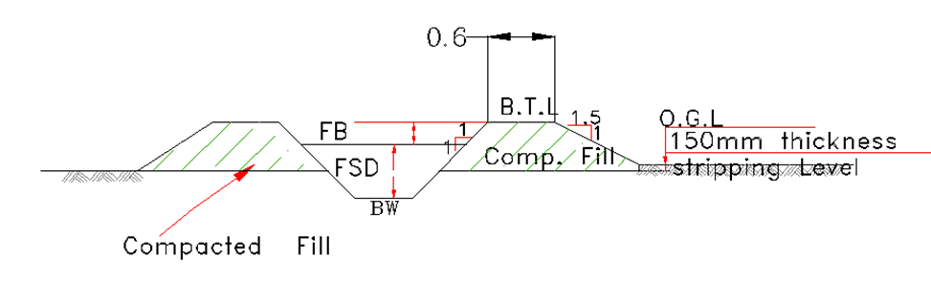
Figure 4-2Typical Cross Section of tertiary canals

Table 4-3: Hydraulic Parameters of tertiary canals
Canal name | Length (m) | Comm. Area (ha) | Q req (m3/s) | s | B (m) | D (m) | Fb (m) | V(m/s) | Qdes (m3/s)
TC-1-1-1 | 154 | 6 | 0.008 | 0.0022 | 0.35 | 0.073 | 0.230 | 0.273 | 0.008
TC-1-1-2 | 203.2 | 6.3 | 0.009 | 0.0020 | 0.35 | 0.078 | 0.222 | 0.269 | 0.009
TC-1-1-3 | 248 | 3.1 | 0.004 | 0.0022 | 0.35 | 0.049 | 0.240 | 0.222 | 0.004
TC-1-1-4 | 144.9 | 6.3 | 0.009 | 0.0020 | 0.35 | 0.077 | 0.223 | 0.268 | 0.009
TC-1-2-1 | 197.34 | 7.4 | 0.010 | 0.0020 | 0.3 | 0.056 | 0.244 | 0.222 | 0.004
TC-1-2-2 | 301.85 | 3.6 | 0.00495 | 0.0020 | 0.3 | 0.059 | 0.241 | 0.227 | 0.005
TC-1-2-3 | 152.24 | 4 | 0.0054 | 0.0020 | 0.35 | 0.075 | 0.225 | 0.264 | 0.008
TC-1-2-4 | 370.53 | 8.2 | 0.01107 | 0.0020 | 0.3 | 0.056 | 0.244 | 0.221 | 0.004
TC-1-2-5 | 265.6 | 3.14 | 0.004239 | 0.0020 | 0.3 | 0.089 | 0.211 | 0.283 | 0.010

Field Canals
As shown in the layout, field canals run across the contours and hence face relatively gentle gradient. The discharge of most of the field canals is very small and this is taken as an advantage to cope up with the relatively steeper gradient. Figure 4.3 below shows a typical field canal x-section. As much as possible field canals shall be made in fill in order to easily irrigate the adjacent command area. As can be seen from the layout, majority of the filed canals can be used to irrigate both sides of the command area depending on the condition of the individual plots of land owned by individual farmers.
Figure 4-3Typical Field Canal X-section

Design of a typical flume
Hydraulic of the canal
Length of the flume: 7m
Shape of the flume: Rectangular reinforcement, Roughness coefficient, n =0.013
Table 4-4: Hydraulic Parameters of Flume

canal |  | Comm. Area (ha) | Q req (m3/s) | n | B (m) | D (m) | B/D | Fb (m) | total depth canal
MC-1 | flume-1-1 | 83 | 0.078954 | 0.013 | 0.4 | 0.3 | 1.1 | 0.2 | 0.5
MC-1 | flume-1-2 | 83 | 0.078954 | 0.013 | 0.4 | 0.3 | 1.5 | 0.2 | 0.5
MC-1 | flume-1-3 | 83 | 0.078954 | 0.013 | 0.3 | 0.3 | 1.1 | 0.2 | 0.5
MC-2 | flume-2-1 | 20 | 0.019025 | 0.013 | 0.3 | 0.2 | 1.5 | 0.2 | 0.4
MC-2 | flume-2-2 | 20 | 0.019025 | 0.013 | 0.3 | 0.2 | 2.0 | 0.2 | 0.4
MC-2 | flume-2-3 | 20 | 0.019025 | 0.013 | 0.3 | 0.2 | 2.0 | 0.2 | 0.4

Design of Division box
At different points of the main and secondary canals division boxes are provided which divert the flow to the secondary canal and tertiary canals. Gate should be provided at the outlet of the boxes. For detail refer the drawing.

Figure 4-4Typical Division Box plan
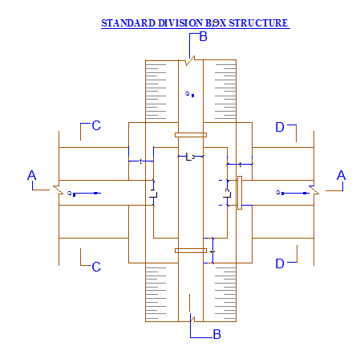

Using broad crested formula,
Q= CL (h)^{3/2}
Where; Q= discharge over rectangular weir/intake (opening), m³/s
C = discharge coefficient, c= 1.7
L= effective length of crest form in m
h= over flow depth, m
Assuming equal discharge coefficient & sill height for two or three dividing canals, the proportion becomes.
Q₁/ Q₂= Q₂/ Q₃ =L₁/ L₂ = L₂/ L₃
Where Q₁= is flow in canal 1
Q₂ = is flow in canal 2
Q₃ = is flow in canal 3
L₁= is effective crest length of weir/intake sill across opening to canal 1
L₂= is effective crest length of weir/intake sill across opening to canal 2
L₃ = is effective crest length of weir/intake sill across opening to canal 3
Q₁= CL₁ (h)^{3/2},
L₁ = Q₁/Ch^{3/2}
L₂ = L₁*Q₂/ Q₁
L₃ = L₁*Q₃/ Q₁
The depth of (height of) the division box,
D = d + f_{b}
The width of the division box,
B = b + 2*m*D
Where b= base width of the incoming canal
D = total canal depth of the incoming canal
Table 4-5: Hydraulic parameters of Division Boxes

Dividing canal Name | Chainage | Q₀ (lit/sec) | Q₁ (lit/sec) | Q₂ (lit/sec) | Q₃ (lit/sec) | B₀ (m) | D₀ (m) | H₀ (m) | D (D₀+FB) (m)
Primary canal ,MC-1&MC-2 | 0+187 | 123.75 | 97.625 | 27.5 | 0 | 0.5 | 0.30 | 0.28 | 0.54
MC-1 & SC-1-1 | 1+320 | 97.625 | 98 | 37 | 0.0 | 0.52 | 0.3 | 0.23 | 0.5
MC-1 & SC-1-2 | 2+160 | 98 | 57 | 43 | 0.0 | 0.48 | 0.3 | 0.24 | 0.4
SC -1-1 &(TC-1-1-1) | 0+0-0+20 | 37 | 29 | 8 | 8.5 | 0.30 | 0.05 | 0.17 | 0.40
SC -1-1 &(TC-1-1-2) | 0+0-0+21 | 37 | 29 | 9 | 8.5 | 0.30 | 0.05 | 0.17 | 0.40
SC -1-1 &TC-1-1-3 | 0+167 | 37 | 33 | 4 | 0.0 | 0.30 | 0.05 | 0.17 | 0.40
SC- 1-1 &(TC-1-1-4) | 0+304 | 37 | 29 | 9 | 0.0 | 0.30 | 0.05 | 0.17 | 0.40
SC- 1-2 &TC-1-2-1 | 0+165 | 43 | 43 | 0 | 0.0 | 0.30 | 0.04 | 0.19 | 0.40
SC -1-2&(TC-1-2-2) | 0+300 | 43 | 26 | 16 | 0.0 | 0.30 | 0.04 | 0.19 | 0.40
SC -1-2&(TC-1-2-3) | 0+300 | 43 | 32 | 11 | 0.0 |  | 0.04 | 0.19 | 0.40
SC -1-2&(TC-1-2-4) | 0+465 | 43 | 38 | 4 | 11.1 | 0.30 | 0.0 | 0.19 | 0.40
SC -1-2&(TC-1-2-5) | 0+465 | 42.625 | 32.6215 | 10.0035 | 11.1 | 0.30 | 0.04 | 0.19 | 0.40

Chute structure
The is no any alternative for avoiding the chute structure and the chute structure in secondary canal-1-1 and 1-2
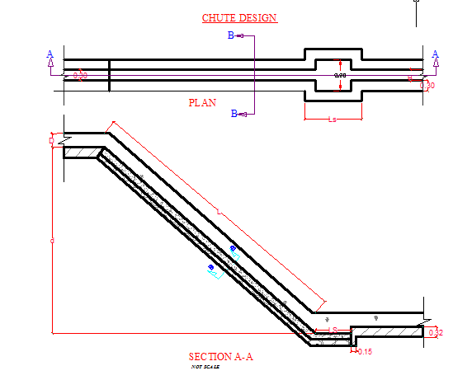

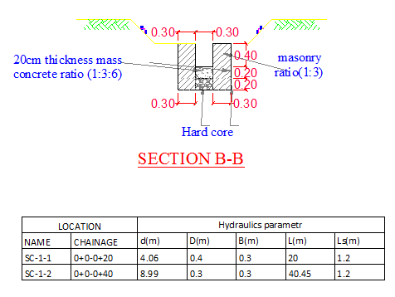
Figure 4-5chute structure

Drop structure
The drop structure in secondary canal-1-1, secondary canal-1-2, secondary canal 1-3 and in escape canal
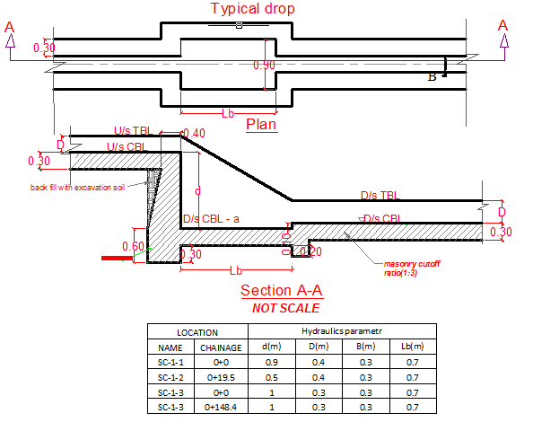

Figure 4-6drop structure

Escape canal
Three escape canal in main canal 1 and in main canal 2, 31m, 28m and 22m respectively
The escape canal lined bed width 0.3m and depth=0.4m
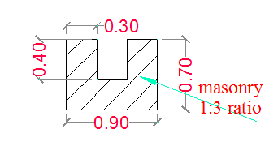

Road crossing and foot path structure
Two road crossing structures are provided at main canal -1 &secondary canal -1-2. The road crossing structures are rectangular reinforced concrete slab. The slab is double reinforced with 12mm @200mm c/c the length of the slab is 1.1m and 1.2m which is the same as the respective canal bed width, its width and thickness is 6m and the reinforcement with 12mm@200mm c/c.
Two foot path structures are provided at secondary canal-1 -1 &secondary canal -1-2. The foot path structures are rectangular reinforced concrete slab. The slab is single reinforced with 10mm @200mmc/c the length of the slab is 2.6m which is the same as the respective canal bed width, its width and thickness is 1.1m and 1.2m and the reinforcement with 10mm@200mm c/c.

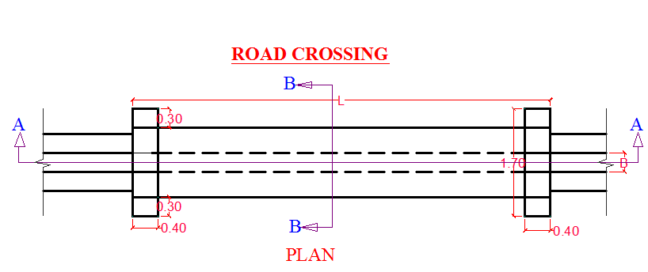
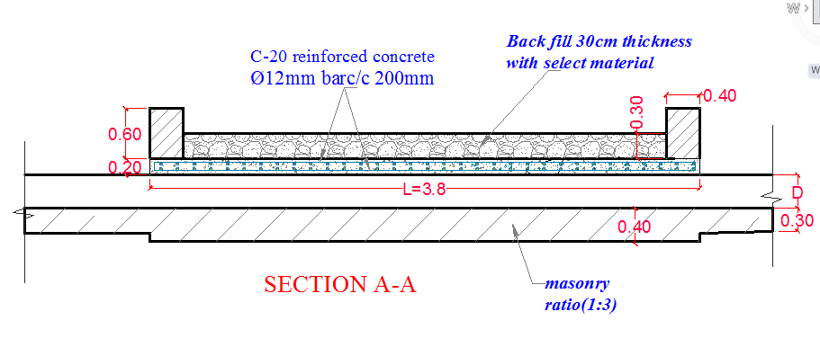

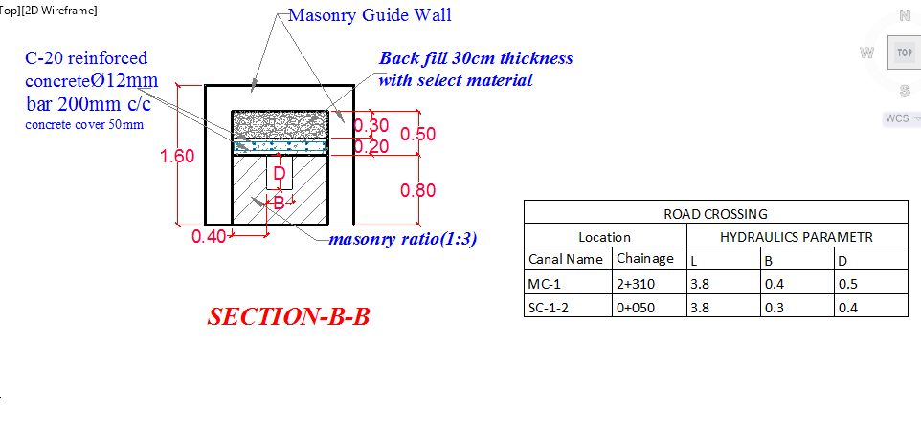

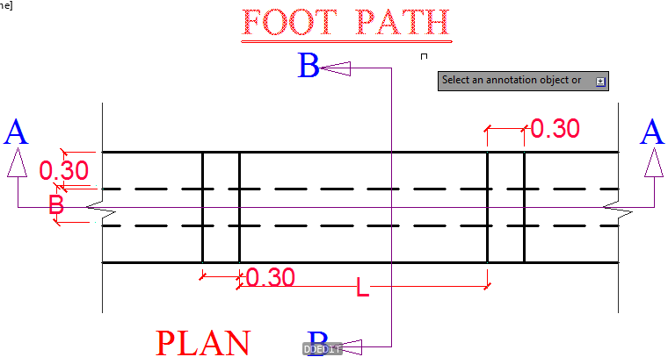
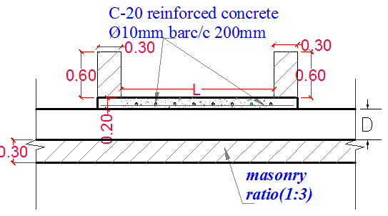

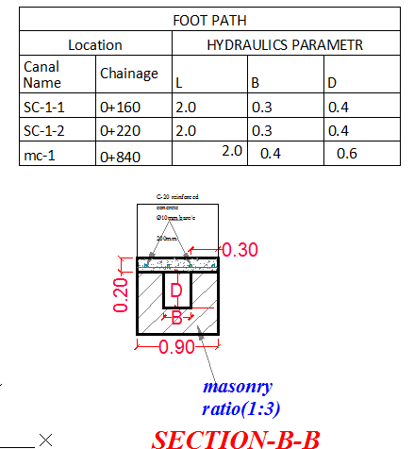
Figure 4-7road crossing and foot path structure

.Irrigation Infrastructure Bill of Quantities and Cost Estimate
The quantities of the various items have been worked out as per the final design and final drawings prepared for the scheme. The unit rates analysis has been carried out based.
Infrastructures
Item no | Description |  | UNITE | QUANTITY | UNITE PRICE |  | AMOUNT (ETH. BIRR)
1 | PRIMARY CANAL
1.1 | Top soil Clearing and grubbing to a maximum depth of 20cm as per the design and to the satisfaction of the Engineer. |  | m² | 232.7 |  | 15.92 |  | 3,703.82
1.2 | Bulk excavation in Ordinary soil(excavation includes cart away) |  | m³ | 328.65 |  | 114.90 |  | 37,761.12
1.3 | weathered rock excavation |  | m³ | 320.00 |  | 790.76 |  | 253,042.93
1.4 | Back fill and compacted in 20cm layers with hand compactor (on site) with the excavated material. |  | m³ | 77.80 |  | 66.17 |  | 5,148.05
1.5 | Masonry Lining and wall construction using 1:3 mortar for canals of any height .The thickness of masonry wall will be as indicated in the drawing. |  | m³ | 192.15 |  | 1,436.00 |  | 275,932.97
1.6 | Plastering ( two coats ) with 1:2 cement mortar ratio of 25mm thickness the internal sides , top canal & bottom the canal |  | m² | 457.36 |  | 240.00 |  | 109,767.29
Subtotal |  |  |  |  |  |  |  | 685,356.18
I | DIVISSION BOX @chainage 0+0179
1 | Masonry Lining and wall construction using 1:3 mortar for canals of any height .The thickness of masonry wall will be as indicated in the drawing. |  | m³ | 4.24 |  | 1,436.00 |  | 6,095.26
2 | Plastering ( two coats ) with 1:2 cement mortar ratio of 25mm thickness the internal sides , top canal & bottom the canal |  | m² | 4.73 |  | 240.00 |  | 1,135.09
3 | Gate supply,cutting,welding& installation |  | no | 2.00 |  | 875.00 |  | 1,750.00
 | 2mm thick sheet metal(0.506mx0.506m)
 | stiffening angle iron (30*30*4) with locking
Subtotal |  |  |  |  |  |  |  | 8,980.35
2 | MAIN CANAL-1 (MC-1)
2.1 | Top soil Clearing and grubbing to a maximum depth of 20cm as per the design and to the satisfaction of the Engineer. |  | m³ | 3510 |  | 15.92 |  | 55,867.67
2.2 | Bulk excavation in Ordinary soil(excavation includes cart away) |  | m³ | 2,219.88 |  | 114.90 |  | 255,056.51
2.3 | excavation weathered rock |  | m³ | 951.38 |  | 790.76 |  | 752,309.53
2.4 | Back fill and compacted in 20cm layers with hand compactor (on site) with the excavated material. |  | m³ | 1,203.41 |  | 66.17 |  | 79,632.57
2.5 | Masonry Lining and wall construction using 1:3 mortar for canals of any height .The thickness of masonry wall will be as indicated in the drawing. |  | m³ | 2,294.49 |  | 1,436.00 |  | 3,294,880.73
2.6 | Plastering ( two coats ) with 1:2 cement mortar ratio of 25mm thickness the internal sides , top canal & bottom the canal |  | m² | 5,180.40 |  | 240.00 |  | 1,243,295.09
 | Subtotal |  |  |  |  |  |  | 5,681,042.11
II | DIVISSION BOX
A | DIVISSION BOX MC1 & SC-1-1 @chainage 1+320
1 | Masonry Lining and wall construction using 1:3 mortar for canals of any height .The thickness of masonry wall will be as indicated in the drawing. |  | m³ | 3.24 |  | 1,436.00 |  | 4,647.78
2 | Plastering ( two coats ) with 1:2 cement mortar ratio of 25mm thickness the internal sides , top canal & bottom the canal |  | m2 | 2.75 |  | 240.00 |  | 661.04
3 | Gate supply,cutting,welding& installation |  | no | 2.00 |  | 875.00 |  | 1,750.00
 | 2mm thick sheet metal(0.506mx0.606m)
 | stiffening angle iron (30*30*4) with locking
 | Subtotal |  |  |  |  |  |  | 7,058.82
B | DIVISSION BOX MC1 & SC-1-2 @chainage 2+160
1 | Masonry Lining and wall construction using 1:3 mortar for canals of any height .The thickness of masonry wall will be as indicated in the drawing. |  | m³ | 2.98 |  | 1,436.00 |  | 4,274.91
2 | Plastering ( two coats ) with 1:2 cement mortar ratio of 25mm thickness the internal sides , top canal & bottom the canal |  | m² | 2.75 |  | 240.00 |  | 661.04
3 | Gate supply,cutting,welding& installation |  | no | 2.00 |  | 875.00 |  | 1,750.00
 | 2mm thick sheet metal(0.506mx0.406m)
 | stiffening angle iron (30*30*4) with locking
 | Subtotal |  |  |  |  |  |  | 6,685.95
III | TURNOUT
A | Turnout MC-1@chainage-0+420
1 | Masonry Lining and wall construction using 1:3 mortar for canals of any height .The thickness of masonry wall will be as indicated in the drawing. |  | m³ | 3.21 |  | 1,436.00 |  | 4,611.01
2 | Plastering ( two coats ) with 1:2 cement mortar ratio of 25mm thickness the internal sides , top canal & bottom the canal |  | m2 | 2.69 |  | 240.00 |  | 645.49
3 | cemented stone pitching |  | m³ | 1.67 |  | 979.78 |  | 1,640.63
4 | Gate supply,cutting,welding& installation |  | no | 2.00 |  | 875.00 |  | 1,750.00
 | 2mm thick sheet metal for the flow direction(0.506mx0.606m) and for turnout direction (0.306mx0.606m
 | stiffening angle iron (30*30*4) with locking
 | Subtotal |  |  |  |  |  |  | 8,647.13
B | Turnout MC-1@chainage-0+580
1 | Masonry Lining and wall construction using 1:3 mortar for canals of any height .The thickness of masonry wall will be as indicated in the drawing. |  | m³ | 6.00 |  | 1,436.00 |  | 8,616.00
2 | Plastering ( two coats ) with 1:2 cement mortar ratio of 25mm thickness the internal sides , top canal & bottom the canal |  | m² | 2.69 |  | 240.00 |  | 645.49
3 | cemented stone pitching |  |  | 1.20 |  | 979.78 |  | 1,175.74
4 | Gate supply,cutting,welding& installation |  | no | 2.00 |  | 875.00 |  | 1,750.00
 | 2mm thick sheet metal for the flow direction(0.506mx0.606m) and for turnout direction (0.306mx0.606m
 | stiffening angle iron (30*30*4) with locking
 | Subtotal |  |  |  |  |  |  | 12,187.22
C | Turnout MC-1@chainage-0+872
1 | Masonry Lining and wall construction using 1:3 mortar for canals of any height .The thickness of masonry wall will be as indicated in the drawing. |  | m³ | 2.50 |  | 1,436.00 |  | 3,590.00
2 | Plastering ( two coats ) with 1:2 cement mortar ratio of 25mm thickness the internal sides , top canal & bottom the canal |  | m² | 2.65 |  | 240.00 |  | 637.11
3 | cemented stone pitching |  | m^2 | 2.00 |  | 979.78 |  | 1,959.56
4 | Gate supply,cutting,welding& installation |  | no | 2.00 |  | 875.00 |  | 1,750.00
 | 2mm thick sheet metal for the flow direction(0.506mx0.606m) and for turnout direction (0.306mx0.606m
 | stiffening angle iron (30*30*4) with locking
 | Subtotal |  |  |  |  |  |  | 7,936.66
D | Turnout MC-1@chainage-1+820
1 | Masonry Lining and wall construction using 1:3 mortar for canals of any height .The thickness of masonry wall will be as indicated in the drawing. |  | m³ | 6.00 |  | 1,436.00 |  | 8,616.00
2 | Plastering ( two coats ) with 1:2 cement mortar ratio of 25mm thickness the internal sides , top canal & bottom the canal |  | m² | 2.69 |  | 240.00 |  | 645.49
3 | cemented stone pitching |  |  | 1.25 |  | 979.78 |  | 1,224.72
4 | Gate supply,cutting,welding& installation |  | no | 2.00 |  | 875.00 |  | 1,750.00
 | 2mm thick sheet metal for the flow direction(0.506mx0.406m) and for turnout direction (0.306mx0.406m
 | stiffening angle iron (30*30*4) with locking
 | Subtotal |  |  |  |  |  |  | 12,236.21
E | Turnout MC-1@chainage-2+020
1 | Masonry Lining and wall construction using 1:3 mortar for canals of any height .The thickness of masonry wall will be as indicated in the drawing. |  | m³ | 6.00 |  | 1,436.00 |  | 8,616.00
2 | Plastering ( two coats ) with 1:2 cement mortar ratio of 25mm thickness the internal sides , top canal & bottom the canal |  | m2 | 2.65 |  | 240.00 |  | 637.11
3 | cemented stone pitching |  |  | 1.05 |  | 979.78 |  | 1,028.77
4 | Gate supply,cutting,welding& installation |  | no | 2.00 |  | 875.00 |  | 1,750.00
 | 2mm thick sheet metal for the flow direction(0.506mx0.406m) and for turnout direction (0.306mx0.406m
 | stiffening angle iron (30*30*4) with locking
 | Subtotal |  |  |  |  |  |  | 12,031.87
F | Turnout MC-1@chainage-2+820
1 | Masonry Lining and wall construction using 1:3 mortar for canals of any height .The thickness of masonry wall will be as indicated in the drawing. |  | m³ | 6.00 |  | 1,436.00 |  | 8,616.00
2 | Plastering ( two coats ) with 1:2 cement mortar ratio of 25mm thickness the internal sides , top canal & bottom the canal |  | m² | 2.18 |  | 240.00 |  | 522.58
3 | cemented stone pitching |  |  | 1.25 |  | 979.78 |  | 1,224.72
4 | Gate supply,cutting,welding& installation |  | no | 2.00 |  | 875.00 |  | 1,750.00
 | 2mm thick sheet metal for the flow direction(0.506mx0.406m) and for turnout direction (0.306mx0.406m
 | stiffening angle iron (30*30*4) with locking
 | Subtotal |  |  |  |  |  |  | 12,113.30
IV | Gully crossing Flume
A | Gully crossing Flume MC-1@ chainage 0+0290
1 | Ordinary soil excavation |  | m³ | 205.89 |  | 71.06 |  | 14,630.19
2 | boulder excavation |  | m³ | 81.00 |  | 150.00 |  | 12,150.00
3 | Back fill and compacted in 20cm layers with hand compactor (on site) with the excavated material. |  | m³ | 33.90 |  | 66.17 |  | 2,243.25
4 | Masonry Lining and wall construction using 1:3 mortar for canals of any height .The thickness of masonry wall will be as indicated in the drawing. |  | m³ | 99.08 |  | 1,436.00 |  | 142,272.56
5 | lean concrete C-10(1:3:6) |  | m³ | 5.00 |  | 1,612.71 |  | 8,063.56
6 | pointing (1:2) Ratio |  | m² | 44.93 |  | 68.50 |  | 3,077.63
7 | φ8mm Reinforced bar |  | kg | 134.02 |  | 80.00 |  | 10,721.42
8 | φ10mm Reinforced bar |  | kg | 511.71 |  | 80.00 |  | 40,936.80
9 | φ14mm Reinforced bar |  | kg | 354.91 |  | 80.00 |  | 28,393.09
10 | φ16mm Reinforced bar |  | kg | 92 |  | 80.00 |  | 7,338.20
11 | C-20 Reinforced concrete |  | m³ | 25.00 |  | 2,995.00 |  | 74,875.00
12 | construction joint with water stopping |  | m2 | 3.00 |  | 300.00 |  | 900.00
 | Subtotal |  |  |  |  |  |  | 345,601.70
B | Gully crossing Flume MC-1@ chainage 0+800
1 | Ordinary soil excavation |  | m³ | 17.16 |  | 71.06 |  | 1,219.39
3 | Back fill and compacted in 20cm layers with hand compactor (on site) with the excavated material. |  | m³ | 5.00 |  | 9.43 |  | 47.17
4 | Masonry Lining and wall construction using 1:3 mortar for canals of any height .The thickness of masonry wall will be as indicated in the drawing. |  | m³ | 37.47 |  | 1,436.00 |  | 53,800.60
8 | φ10mm Reinforced bar |  | kg | 123.83 |  | 80.00 |  | 9,906.13
10 | φ12mm Reinforced bar |  | kg | 501 |  | 80.00 |  | 40,115.12
11 | C-20 Reinforced concrete |  | 3.6 | 25.00 |  | 2,995.00 |  | 74,875.00
 | Subtotal |  |  |  |  |  |  | 179,963.42
C | Gully crossing Flume MC-1 @ chainage 1+890
1 | Bulk excavation in Ordinary soil(excavation includes cart away) |  | m³ | 205.00 |  | 71.06 |  | 14,567.30
2 | gravel, boulder,& rock fragment excavation |  | m³ | 50.00 |  | 389.44 |  | 19,472.22
3 | Back fill and compacted in 20cm layers with hand compactor (on site) with the excavated material. |  | m³ | 67.04 |  | 66.17 |  | 4,435.89
4 | Masonry Lining and wall construction using 1:3 mortar for canals of any height .The thickness of masonry wall will be as indicated in the drawing. |  | m³ | 104.08 |  | 1,436.00 |  | 149,452.56
5 | lean concrete C-15 ratio (1:3:6) |  | m3 | 3.42 |  | 1,612.71 |  | 5,520.31
6 | pointing (1:2) Ratio |  | m2 | 44.93 |  | 135.00 |  | 6,065.28
7 | φ8mm Reinforced bar |  | kg | 32.03 |  | 80.00 |  | 2,562.18
8 | φ10mm Reinforced bar |  | kg | 448.039 |  | 80.00 |  | 35,843.13
9 | φ14mm Reinforced bar |  | kg | 19.04 |  | 80.00 |  | 1,522.92
10 | φ16mm Reinforced bar |  | kg | 450 |  | 80.00
11 | C-20 Reinforced concrete |  | m³ | 26.45 |  | 2,995.00 |  | 79,215.35
12 | construction joint with water stopping |  | m2 | 6.27 |  | 300.00 |  | 1,881.00
 | Subtotal |  |  |  |  |  |  | 320,538.15
V | ROAD CROSSING@ MC-1
1 | φ12mm Reinforced bar |  | kg | 118.97 |  | 54.38 |  | 6,469.17
2 | C-20 Reinforced concrete |  | m³ | 1.84 |  | 2,995.00 |  | 5,516.79
3 | Masonry Lining and wall construction using 1:3 mortar for canals of any height .The thickness of masonry wall will be as indicated in the drawing. |  | m³ | 6.12 |  | 1,621.39 |  | 9,922.92
 | Subtotal |  |  |  |  |  |  | 21,908.88
vi | Escap canal @ MC-1 chainge 0+800
1 | Bulk excavation in Ordinary soil(excavation includes cart away) |  | m^3 | 14.04 |  | 71.06 |  | 997.79
2 | Back fill and compacted in 20cm layers with hand compactor (on site) with the excavated material. |  | m^3 | 14.19 |  | 66.17 |  | 939.27
3 | Masonry Lining and wall construction using 1:3 mortar for canals of any height .The thickness of masonry wall will be as indicated in the drawing. |  | m^3 | 12.08 |  | 1,436.00 |  | 17,343.58
4 | Plastering ( two coats ) with 1:2 cement mortar ratio of 25mm thickness the internal sides , top canal & bottom the canal |  | m^2 | 48.23 |  | 240.00 |  | 11,574.07
5 | Gate supply,cutting,welding& installation |  | no | 2.00 |  | 875.00
 | 2mm thick sheet metal for the flow direction(0.506mx0.406m) and for escape direction (0.306mx0.606m
 | stiffening angle iron (30*30*4) with locking
 | Subtotal |  |  |  |  |  |  | 30,854.70
vii | Escape canal @ MC-1 chainge 1+980
1 | Bulk excavation in Ordinary soil(excavation includes cart away) |  | m^3 | 21.06 |  |  |  | -
2 | Back fill and compacted in 20cm layers with hand compactor (on site) with the excavated material. |  | m^3 | 11.26 |  |  |  | -
3 | Masonry Lining and wall construction using 1:3 mortar for canals of any height .The thickness of masonry wall will be as indicated in the drawing. |  | m^3 | 20.33 |  | 1,436.00 |  | 29,190.63
4 | Plastering ( two coats ) with 1:2 cement mortar ratio of 25mm thickness the internal sides , top canal & bottom the canal |  | m^2 | 53.16 |  | 240.00 |  | 12,759.56
5 | Gate supply,cutting,welding& installation |  | no | 2.00 |  | 875.00
 | 2mm thick sheet metal for the flow direction(0.506mx0.406m) and for escape direction (0.306mx0.406m
 | stiffening angle iron (30*30*4) with locking
 | Subtotal |  |  |  |  |  |  | 41,950.19
2 | MAIN CANAL-2 (MC-2)
2.1 | Top soil Clearing and grubbing to a maximum depth of 20cm as per the design and to the satisfaction of the Engineer. |  | m³ | 2,018.90 |  | 15.92 |  | 32,134.26
2.2 | Bulk excavation in Ordinary soil(excavation includes cart away) |  | m³ | 1,367.54 |  | 71.06 |  | 97,177.52
2.3 | weathered rock excavation |  | m³ | 341.89 |  | 790.76 |  | 270,349.05
2.4 | Back fill and compacted in 20cm layers with hand compactor (on site) with the excavated material. |  | m³ | 466.39 |  | 66.17 |  | 30,862.60
2.5 | Masonry Lining and wall construction using 1:3 mortar for canals of any height .The thickness of masonry wall will be as indicated in the drawing. |  | m³ | 1,237.10 |  | 1,436.00 |  | 1,776,470.11
2.6 | Plastering ( two coats ) with 1:2 cement mortar ratio of 25mm thickness the internal sides , top canal & bottom the canal |  | m² | 2,768.95 |  | 240.00 |  | 664,548.27
 | Subtotal |  |  |  |  |  |  | 2,871,541.82
I | TURNOUT
A | Turnout MC-2@Chainaige0+170
1 | Masonry Lining and wall construction using 1:3 mortar for canals of any height .The thickness of masonry wall will be as indicated in the drawing. |  | m³ | 3.22 |  | 1,436.00 |  | 4,620.09
2 | Plastering ( two coats ) with 1:2 cement mortar ratio of 25mm thickness the internal sides , top canal & bottom the canal |  | m² | 1.84 |  | 240.00 |  | 440.47
3 | cemented stone pitching |  |  | 1.02 |  | 979.78 |  | 999.37
4 | Gate supply,cutting,welding& installation |  | no | 2 |  | 875.00 |  | 1,750.00
 | 2mm thick sheet metal for the flow direction(0.406mx0.406m) and for turnout direction (0.306mx0.403m
 | stiffening angle iron (30*30*4) with locking
 | Subtotal |  |  |  |  |  |  | 7,809.93
B | Turnout MC-2@Chainaige0+450
1 | Masonry Lining and wall construction using 1:3 mortars for canals of any height. .The thickness of masonry wall will be as indicated in the drawing. |  | m³ | 2.76 |  | 1,436.00 |  | 3,970.32
2 | Plastering ( two coats ) with 1:2 cement mortar ratio of 25mm thickness the internal sides , top canal & bottom the canal |  | m² | 1.96 |  | 240.00 |  | 470.68
3 | cemented stone pitching |  |  | 1.11 |  | 979.78 |  | 1,087.55
4 | Gate supply,cutting,welding& installation |  | no | 2 |  | 875.00 |  | 1,750.00
 | 2mm thick sheet metal for the flow direction(0.406mx0.406m) and for turnout direction (0.306mx0.403m
 | stiffening angle iron (30*30*4) with locking
 | Subtotal |  |  |  |  |  |  | 7,278.55
C | Turnout MC-2@Chainaige0+760
1 | Masonry Lining and wall construction using 1:3 mortar for canals of any height .The thickness of masonry wall will be as indicated in the drawing. |  | m³ | 2.82 |  | 1,436.00 |  | 4,048.74
2 | Plastering ( two coats ) with 1:2 cement mortar ratio of 25mm thickness the internal sides , top canal & bottom the canal |  | m² | 1.92 |  | 240.00 |  | 460.89
3 | cemented stone pitching |  |  | 1.32 |  | 979.78 |  | 1,293.31
4 | Gate supply,cutting,welding& installation |  | no | 2 |  | 875.00 |  | 1,750.00
 | 2mm thick sheet metal for the flow direction(0.406mx0.406m) and for turnout direction (0.306mx0.403m
 | stiffening angle iron (30*30*4) with locking
 | Subtotal |  |  |  |  |  |  | 7,552.94
D | Turnout MC-2@Chainaige0+980
1 | Masonry Lining and wall construction using 1:3 mortars for canals of any height. .The thickness of masonry wall will be as indicated in the drawing. |  | m³ | 2.82 |  | 1,436.00 |  | 4,050.82
2 | Plastering ( two coats ) with 1:2 cement mortar ratio of 25mm thickness the internal sides , top canal & bottom the canal |  | m² | 1.92 |  | 240.00 |  | 461.18
3 | cemented stone pitching |  |  | 1.01 |  | 979.78 |  | 989.58
4 | Gate supply,cutting,welding& installation |  | no | 2 |  | 875.00 |  | 1,750.00
 | 2mm thick sheet metal for the flow direction(0.406mx0.406m) and for turnout direction (0.306mx0.403m
 | stiffening angle iron (30*30*4) with locking
 | Subtotal |  |  |  |  |  |  | 7,251.58
E | Turnout MC-2@Chainaige1+285
1 | Masonry Lining and wall construction using 1:3 mortars for canals of any height. .The thickness of masonry wall will be as indicated in the drawing. |  | m³ | 2.82 |  | 1,436.00 |  | 4,052.51
2 | Plastering ( two coats ) with 1:2 cement mortar ratio of 25mm thickness the internal sides , top canal & bottom the canal |  | m² | 1.92 |  | 240.00 |  | 461.42
3 | cemented stone pitching |  |  | 1.01 |  | 979.78 |  | 989.58
4 | Gate supply,cutting,welding& installation |  | no | 2 |  | 875.00 |  | 1,750.00
 | 2mm thick sheet metal for the flow direction(0.406mx0.406m) and for turnout direction (0.306mx0.403m
 | stiffening angle iron (30*30*4) with locking
 | Subtotal |  |  |  |  |  |  | 7,253.51
F | Turnout MC-2@Chainaige1+553
1 | Masonry Lining and wall construction using 1:3 mortars for canals of any height. .The thickness of masonry wall will be as indicated in the drawing. |  | m3 | 2.82 |  | 1,436.00 |  | 4,052.51
2 | Plastering ( two coats ) with 1:2 cement mortar ratio of 25mm thickness the internal sides , top canal & bottom the canal |  | m² | 1.92 |  | 240.00 |  | 461.42
3 | cemented stone pitching |  |  | 1.32 |  | 979.78 |  | 1,293.31
4 | Gate supply,cutting,welding& installation |  | no | 2 |  | 875.00 |  | 1,750.00
 | 2mm thick sheet metal for the flow direction(0.406mx0.406m) and for turnout direction (0.306mx0.403m
 | Stiffening angle iron (40*40*4) with locking
 | Subtotal |  |  |  |  |  |  | 7,557.24
II | Canal cover slab/super passage
A | Canal cover slab/super passeg@Chainage1+97
1 | C-20 concrete(pre-cast) |  | m³ | 3.11 |  | 2,995.00 |  | 9,299.48
2 | RCC bar 10mm diam. |  | Kg | 97.20 |  | 80.00 |  | 7,775.92
3 | Masonry Lining and wall construction using 1:3 mortars for canals of any height. .The thickness of masonry wall will be as indicated in the drawing. |  | m³ | 19.11 |  | 1,436.00 |  | 27,441.96
4 | Plastering ( two coats ) with 1:2 cement mortar ratio of 25mm thickness |  | m2 | 53.10 |  | 240.00 |  | 12,744.00
5 | Gabion |  | m³ | 30.00 |  | 1,072.21 |  | 32,166.28
Subtotal |  |  |  |  |  |  |  | 89,427.64
B | Canal cover slab/super passege@Chainage1+430
1 | C-20 concrete(pre-cast) |  | m³ | 2.03 |  | 2,995.00 |  | 6,064.88
2 | RCC bar 10mm diam. |  | Kg | 88.81 |  | 80.00 |  | 7,104.99
3 | Masonry Lining and wall construction using 1:3 mortar for canals of any height. .The thickness of masonry wall will be as indicated in the drawing. |  | m² | 15.03 |  | 1,436.00 |  | 21,583.08
4 | Plastering ( two coats ) with 1:2 cement mortar ratio of 25mm thickness |  | m2 | 39.50 |  | 240.00 |  | 9,480.00
5 | Gabion |  | m³ | 30.00 |  | 1,072.21 |  | 32,166.28
Subtotal |  |  |  |  |  |  |  | 76,399.22
III | Gully crossing Flume
A | Gully crossing Flume MC-2@ 0+20
1 | Bulk excavation in Ordinary soil(excavation includes cart away) |  | m³ | 139.44 |  | 71.06 |  | 9,908.61
2 | weathed rock excavation |  | m³ | 12.69 |  | 790.76 |  | 10,032.76
3 | Alluvial deposit boulder ,gravel with fine sand excavation |  | m³ | 25.38 |  | 150.00 |  | 3,806.25
4 | Back fill and compacted in 20cm layers with hand compactor (on site) with the excavated material. |  | m³ | 69.72 |  | 66.17 |  | 4,613.56
5 | c-10 lean concrete(1:3:6) |  | m³ | 3.00 |  | 1,612.71 |  | 4,838.14
6 | Masonry Lining and wall construction using 1:3 mortar for canals of any height. .The thickness of masonry wall will be as indicated in the drawing. |  | m³ | 92.87 |  | 1,436.00 |  | 133,361.32
7 | pointing (1:2) Ratio |  | m² | 25.59 |  | 135.00 |  | 3,454.65
8 | φ8mm Reinforced bar |  | kg | 84.70 |  | 80.00 |  | 6,775.93
9 | φ10mm Reinforced bar |  | kg | 84.699 |  | 80.00 |  | 6,775.93
10 | φ14mm Reinforced bar |  | kg | 25.382 |  | 80.00 |  | 2,030.56
11 | φ16mm Reinforced bar |  | kg | 487.4923 |  | 80.00 |  | 38,999.38
12 | C-20 Reinforced concrete |  | m³ | 36.12 |  | 2,995.00 |  | 108,166.09
13 | construction joint with water stopping |  | m² | 3.00 |  | 300.00 |  | 900.00
 | Subtotal |  |  |  |  |  |  | 333,663.18
B | Gully crossing Flume MC-2@chainage 0+320
1 | Bulk excavation in Ordinary soil(excavation includes cart away) |  | m3 | 363.20 |  | 71.06 |  | 25,808.99
2 | Back fill and compacted in 20cm layers with hand compactor (on site) with the excavated material. |  | m³ | 55.80 |  | 66.17 |  | 3,692.44
3 | c-10 lean concrete (1:3:6)at pier footing pad &abutment |  | m³ | 9.96 |  | 1,613 |  | 16,062.61
4 | Masonry Lining and wall construction using 1:3 mortars for canals of any height. .The thickness of masonry wall will be as indicated in the drawing. |  | m³ | 387.24 |  | 1,436.00 |  | 556,071.61
5 | pointing (1:2) Ratio |  | m² | 50.80 |  | 135.00 |  | 6,858.00
6 | φ8mm Reinforced bar |  | kg | 233.55 |  | 80.00 |  | 18,684.38
7 | φ10mm Reinforced bar |  | kg | 705.86 |  | 80.00 |  | 56,468.41
8 | φ14mm Reinforced bar |  | kg | 31.73 |  | 80.00 |  | 2,538.20
9 | φ16mm Reinforced bar |  | kg | 676.50 |  | 80.00 |  | 54,119.85
10 | C-20 Reinforced concrete |  | m³ | 36.49 |  | 2,995.00 |  | 109,299.64
11 | construction joint with water stopping |  | m² | 1.50 |  | 300.00 |  | 450.00
 | Subtotal |  |  |  |  |  |  | 850,054.13
C | Gully crossing Flume MC-2@ chainage 1+320
1 | Bulk excavation in Ordinary soil(excavation includes cart away) |  | m³ | 100.00 |  | 71.06 |  | 7,106.00
2 | back fill with excavate soil |  | m³ | 50.00 |  | 53.83 |  | 2,691.67
3 | c-10 (1:3:6)lean concrete at pier footing pad &abutment |  | m³ | 10.77 |  | 1,613 |  | 17,365.68
4 | Masonry Lining and wall construction using 1:3 mortar for canals of any height .The thickness of masonry wall will be as indicated in the drawing. |  | m³ | 30.00 |  | 1,436.00 |  | 43,080.00
5 | pointing (1:2) Ratio |  | m² | 15.00 |  | 135.00 |  | 2,025.00
6 | φ8mm Reinforced bar |  | kg | 8 |  | 80.00 |  | 663.04
8 | φ10mm Reinforced bar |  | kg | 145.2404 |  | 80.00 |  | 11,619.23
9 | φ14mm Reinforced bar |  | kg | 6.6477 |  | 80.00 |  | 531.81
10 | φ16mm Reinforced bar |  | kg | 27.7845 |  | 80.00 |  | 2,222.76
11 | C-20 Reinforced concrete |  | m³ | 6.51 |  | 2,995.00 |  | 19,503.44
12 | construction joint with water stopping |  | m2 | 1.10 |  | 300.00 |  | 330.00
Subtotal |  |  |  |  |  |  |  | 107,138.64
E |  | Escap canal @ MC-2 chainge 1+200
1 |  | Bulk excavation in Ordinary soil(excavation includes cart away) | m^3 | 26.7420035 |  | 81.06 |  | 2,167.71
2 |  | Back fill and compacted in 20cm layers with hand compactor (on site) with the excavated material. | m^3 | 9.71138861 |  | 53.83 |  | 522.80
3 |  | Masonry Lining and wall construction using 1:3 mortars for canals of any height. .The thickness of masonry wall will be as indicated in the drawing. | m^3 | 19.5470225 |  | 1,436.00 |  | 28,069.52
4 |  | Plastering ( two coats ) with 1:2 cement mortar ratio of 25mm thickness the internal sides , top canal & bottom the canal | m^2 | 38.57 |  | 240.00 |  | 9,256.81
5 |  | Gate supply,cutting,welding& installation | no | 2
 |  | 3mm thick sheet metal(0.403mx0.406m)
 |  | 3mm thick sheet metal(0.403*0.306m)
 |  | Stiffening angle iron (40*40*4) with locking
 |  | Subtotal |  |  |  |  |  | 40,016.84
3. 1.SECONDARY CANAL(SC1-1)
3.1 |  | Bulk excavation in Ordinary soil(excavation includes cart away) | m³ | 432.05 |  | 71.06 |  | 30,701.46
3.2 |  | Back fill and compacted in 20cm layers with hand compactor (on site) with the excavated material. | m³ | 146.46 |  | 66.17 |  | 9,691.36
3.4 |  | Masonry Lining and wall construction using 1:3 mortars for canals of any height. .The thickness of masonry wall will be as indicated in the drawing. | m³ | 235.48 |  | 1,436.00 |  | 338,150.33
3.5 |  | Plastering ( two coats ) with 1:2 cement mortar ratio of 25mm thickness the internal sides , top canal & bottom the canal | m² | 784.94 |  | 240.00 |  | 188,384.59
 |  | Subtotal |  |  |  |  |  | 566,927.73
I |  | DIVISSION BOX SC 1-1
A.DIVISSION BOX SC-1-1&(TC-1-&TC-1-1-2@chainage 0+020
1 |  | Masonry Lining and wall construction using 1:3 mortars for canals of any height. .The thickness of masonry wall will be as indicated in the drawing. | m³ | 2.81 |  | 1,436.00 |  | 4,038.16
2 |  | Plastering ( two coats ) with 1:2 cement mortar ratio of 25mm thickness the internal sides , top canal & bottom the canal | m² | 1.91 |  | 240.00 |  | 459.42
3 |  | cemented stone pitching | m³ | 1.20 |  | 979.78 |  | 1,175.74
4 |  | Gate supply,cutting,welding& installation | no | 3.00 |  | 875.00 |  | 2,625.00
 |  | 2mm thick sheet metal(0.306mx0.403m)
 |  | stiffening angle iron (30*30*4) with locking
 |  | Subtotal |  |  |  |  |  | 8,298.31
B.DIVISSION BOX SC-1-1&TC-1-1-3 @chainage 0+0165
1 |  | Masonry Lining and wall construction using 1:3 mortars for canals of any height. .The thickness of masonry wall will be as indicated in the drawing. | m³ | 2.81 |  | 1,436.00 |  | 4,038.16
2 |  | Plastering ( two coats ) with 1:2 cement mortar ratio of 25mm thickness the internal sides , top canal & bottom the canal | m² | 0.81 |  | 240.00 |  | 194.90
2 |  | cemented stone pitching | m³ | 1.91 |  | 979.78 |  | 1,875.53
3 |  | Gate supply,cutting,welding& installation | no | 2.00 |  | 875.00 |  | 1,750.00
 |  | 2mm thick sheet metal(0.35mx0.45m)
 |  | stiffening angle iron (30*30*4) with locking
 |  | Subtotal |  |  |  |  |  | 7,858.60
C. |  | DIVISSION BOX SC 1-1 &(TC1-1-4)@ chainage 0+0304
1 |  | Masonry Lining and wall construction using 1:3 mortars for canals of any height. .The thickness of masonry wall will be as indicated in the drawing. | m³ | 0.81 |  | 1,436.00 |  | 1,166.16
2 |  | Plastering ( two coats ) with 1:2 cement mortar ratio of 25mm thickness the internal sides , top canal & bottom the canal | m² | 1.91 |  | 240.00 |  | 459.42
3 |  | Gate supply,cutting,welding& installation | no | 3.00 |  | 875.00 |  | 2,625.00
4 |  | 2mm thick sheet metal(0.306mx0.403m)
 |  | stiffening angle iron (30*30*4) with locking
Subtotal |  |  |  |  |  |  |  | 4,250.58
II | Drop structure@ SC-1-1 chaianage 0+0
1 | Masonry Lining and wall construction using 1:3 mortars for canals of any height. .The thickness of masonry wall will be as indicated in the drawing. |  | m³ | 4.19 |  | 1,436.00 |  | 6,009.66
2 | Plastering ( two coats ) with 1:2 cement mortar ratio of 25mm thickness the internal sides , top canal & bottom the canal |  | m² | 7.30 |  | 240.00 |  | 1,750.80
Subtotal |  |  |  |  |  |  |  | 7,760.46
III | FOOTPATH@SC-1-1
1 | φ12mm Reinforced bar |  | kg | 25.74 |  | 80.00 |  | 2,059.39
2 | C-20 Reinforced concrete |  | m³ | 1.77 |  | 2,360.34 |  | 4,177.81
3 | Masonry Lining and wall construction using 1:3 mortars for canals of any height. .The thickness of masonry wall will be as indicated in the drawing. |  | m³ | 1.29 |  | 1,436.00 |  | 1,852.44
5 | Plastering ( two coats ) with 1:2 cement mortar ratio of 25mm thickness the internal sides , top canal & bottom the canal |  | m² | 2.2 |  | 240.00 |  | 528.00
Subtotal |  |  |  |  |  |  |  | 8,617.63
IV | chute @SC-1-1
1 | Masonry Lining and wall construction using 1:3 mortars for canals of any height. .The thickness of masonry wall will be as indicated in the drawing. |  | m³ | 9.668 |  | 1,436.00 |  | 13,883.25
2 | hard core(dry masonry) |  | m³ | 3.86 |  | 407.45 |  | 1,572.75
3 | plain Concrete C-10 (1:3:6) |  | m³ | 1.278 |  | 1,612.71 |  | 2,061.05
4 | Plastering ( two coats ) with 1:2 cement mortar ratio of 25mm thickness the internal sides , top canal & bottom the canal |  | m² | 29.54 |  | 240.00 |  | 7,089.60
 | Subtotal |  |  |  |  |  |  | 24,606.65
1 | TC-1-1-1
1.1 | Ordinary soil excavation |  | m³ | 161.60 |  | 71.06 |  | community
1.2 | Back fill and compact with the excavated material. |  | m³ | 46.87 |  | 875.00 |  | community
Subtotal |  |  |  |  |  |  |  | -
1 | TC-1-1-2
1.1 | Ordinary soil excavation |  | m³ | 159.40 |  | 71.06 |  | community
1.2 | Back fill and compact with the excavated material. |  | m³ | 46.87 |  | 71.06 |  | community
Subtotal |  |  |  |  |  |  |  | community
1 | TC-1-1-3
1.1 | Ordinary soil excavation |  | m³ | 158.23 |  | 71.06 |  | community
1.2 | Back fill and compact with the excavated material. |  | m³ | 46.87 |  | 46.87 |  | community
Subtotal |  |  |  |  |  |  |  | community
1 | TC-1-1-4
1.1 | Ordinary soil excavation |  | m³ | 92.95 |  | 71.06 |  | community
1.2 | Back fill and compact with the excavated material. |  | m³ | 46.87 |  | 240.00 |  | community
Subtotal |  |  |  |  |  |  |  | community
1 | TC-1-1-5
1.1 | Ordinary soil excavation |  | m³ | 62.72 |  | 71.06 |  | community
1.2 | Back fill and compact with the excavated material. |  | m³ | 46.87 |  | 1,436.00 |  | community
Subtotal |  |  |  |  |  |  |  | community
4 | SECONDARY CANAL(SC 1-2)
4.1 | Bulk excavation in Ordinary soil(excavation includes cart away) |  | m³ | 179.40 |  | 71.06 |  | 12,748.13
4.2 | Back fill and compacted in 20cm layers with hand compactor (on site) with the excavated material. |  | m³ | 179.40 |  | 66.17 |  | 11,871.35
4.3 | Masonry Lining and wall construction using 1:3 mortar for canals of any height. .The thickness of masonry wall will be as indicated in the drawing. |  | m³ | 255.38 |  | 1,436.00 |  | 366,730.81
4.4 | Plastering ( two coats ) with 1:2 cement mortar ratio of 25mm thickness the internal sides , top canal & bottom the canal |  | m² | 851.28 |  | 240.00 |  | 204,306.86
 | Subtotal |  |  |  |  |  |  | 595,657.15
I | DIVISSION BOX @SC 1-2
A | DIVISSION BOX SC 1-2 &TC-1-2-1@chainage0+0165
1 | Masonry Lining and wall construction using 1:3 mortars for canals of any height. .The thickness of masonry wall will be as indicated in the drawing. |  | m³ | 2.82 |  | 1,436.00 |  | 4,056.21
2 | Plastering ( two coats ) with 1:2 cement mortar ratio of 25mm thickness the internal sides , top canal & bottom the canal |  | m² | 1.91 |  | 240.00 |  | 459.42
3 | cemented stone pitching |  | m³ | 1.45 |  | 979.78 |  | 1,420.68
4 | Gate supply,cutting,welding& installation |  | no | 3.00 |  | 875.00 |  | 2,625.00
 | 2mm thick sheet metal(0.306mx0.403m)
 | stiffening angle iron (30*30*4) with locking
 | Subtotal |  |  |  |  |  |  | 8,561.31
B | DIVISSION BOX SC -1-2&(TC-1-2-2&TC1-2-3)@chainage0+0300
1 | Masonry Lining and wall construction using 1:3 mortars for canals of any height. .The thickness of masonry wall will be as indicated in the drawing. |  | m³ | 2.82 |  | 1,436.00 |  | 4,056.21
2 | Plastering ( two coats ) with 1:2 cement mortar ratio of 25mm thickness the internal sides , top canal & bottom the canal |  | m² | 1.92 |  | 240.00 |  | 461.93
3 | cemented stone pitching |  | m³ | 1.36 |  | 979.78 |  | 1,332.50
4 | Gate supply,cutting,welding& installation |  | no | 3.00 |  | 875.00 |  | 2,625.00
 | 2mm thick sheet metal(0.306mx0.403m)
 | stiffening angle iron (30*30*4) with locking
 | Subtotal |  |  |  |  |  |  | 8,475.65
C | DIVISSION BOX SC -1-2 &(TC1-2-4&TC-1-2-5)@chainage0+0465
1 | Masonry Lining and wall construction using 1:3 mortars for canals of any height. .The thickness of masonry wall will be as indicated in the drawing. |  | m³ | 2.82 |  | 1,436.00 |  | 4,046.84
2 | Plastering ( two coats ) with 1:2 cement mortar ratio of 25mm thickness the internal sides , top canal & bottom the canal |  | m² | 1.92 |  | 240.00 |  | 461.93
3 | cemented stone pitching |  | m³ | 1.12 |  | 979.78 |  | 1,098.62
4 | Gate supply,cutting,welding& installation |  | no | 3.00 |  | 875.00 |  | 2,625.00
 | 2mm thick sheet metal(0.306mx0.403m)
 | stiffening angle iron (30*30*4) with locking
Subtotal |  |  |  |  |  |  |  | 8,232.40
II | Drop structure SC1-2@ chainage 0+0
1 | Masonry Lining and wall construction using 1:3 mortars for canals of any height. .The thickness of masonry wall will be as indicated in the drawing. |  | m³ | 4.48 |  | 1,436.00 |  | 6,426.10
2 | Plastering ( two coats ) with 1:2 cement mortar ratio of 25mm thickness the internal sides , top canal & bottom the canal |  | m² | 7.36 |  | 240.00 |  | 1,766.16
Subtotal |  |  |  |  |  |  |  | 8,192.26
III | ROAD CROSSING @SC1-2
1 | φ12mm Reinforced bar |  | kg | 97.18 |  | 80.00 |  | 7,774.62
2 | C-20 Reinforced concrete |  | m³ | 1.452 |  | 2,995.00 |  | 4,348.74
2 | Masonry Lining and wall construction using 1:3 mortars for canals of any height. .The thickness of masonry wall will be as indicated in the drawing. |  | m³ | 5.94 |  | 1,436.00 |  | 8,529.84
4 | Plastering ( two coats ) with 1:2 cement mortar ratio of 25mm thickness the internal sides , top canal & bottom the canal |  | m² | 7.26 |  | 240.00 |  | 1,742.40
5 | Back fill and compacted in 20cm layers with hand compactor (on site) with the excavated material. |  | m³ | 20 |  | 60.48 |  | 1,209.58
 | Subtotal |  |  |  |  |  |  | 23,605.18
IV | FOOTPATH -@SC-1-2
1 | φ12mm Reinforced bar |  | kg | 10.74 |  | 80.00 |  | 859.39
2 | C-20 Reinforced concrete |  | m³ | 1.27 |  | 2,360.34 |  | 2,997.64
3 | Masonry Lining and wall construction using 1:3 mortars for canals of any height. .The thickness of masonry wall will be as indicated in the drawing. |  | m³ | 1.29 |  | 1,436.00 |  | 1,852.44
4 | Plastering ( two coats ) with 1:2 cement mortar ratio of 25mm thickness the internal sides , top canal & bottom the canal |  | m² | 2.2 |  | 240.00 |  | 528.00
 | Subtotal |  |  |  |  |  |  | 6,237.46
V | chute @SC-1-2
1 | Masonry Lining and wall construction using 1:3 mortars for canals of any height. .The thickness of masonry wall will be as indicated in the drawing. |  | m³ | 9.668 |  | 1,436.00 |  | 13,883.25
2 | hard core(dry masonry) |  | m³ | 5.36 |  | 407.45 |  | 2,183.93
3 | plain Concrete C-10 (1:3:6) |  | m³ | 2.778 |  | 1,612.71 |  | 4,480.11
4 | Plastering ( two coats ) with 1:2 cement mortar ratio of 25mm thickness the internal sides , top canal & bottom the canal |  | m² | 29.54 |  | 240.00 |  | 7,089.60
 | Subtotal |  |  |  |  |  |  | 27,636.89
5 | SECONDARY CANAL(SC 1-3)
5.1 | Ordinary soil excavation (by labor)Depth not exceeding 1.5m |  | m³ | 58.14 |  | 71.06 |  | 4,131.51
5.2 | Back fill and compacted in 20cm layers with hand compactor (on site) with the excavated material. |  | m³ | 46.87 |  | 66.17 |  | 3,101.74
5.3 | Masonry Lining and wall construction using 1:3 mortars for canals of any height. .The thickness of masonry wall will be as indicated in the drawing. |  | m³ | 92.16 |  | 1,436.00 |  | 132,344.54
5.4 | Plastering ( two coats ) with 1:2 cement mortar ratio of 25mm thickness the internal sides , top canal & bottom the canal |  | m² | 335.40 |  | 240.00 |  | 80,496.44
 | Subtotal |  |  |  |  |  |  | 220,074.24
I | TURNOUT
A | Turnout SC-1-3@Chainage0+080
2 | Masonry Lining and wall construction using 1:3 mortars for canals of any height. .The thickness of masonry wall will be as indicated in the drawing. |  | m³ | 0.83 |  | 1,436.00 |  | 1,196.47
3 | Plastering ( two coats ) with 1:2 cement mortar ratio of 25mm thickness the internal sides , top canal & bottom the canal |  | m² | 1.99 |  | 240.00 |  | 477.07
4 | cemented stone pitching |  | m³ | 1.36 |  | 979.78 |  | 1,332.50
5 | Gate supply,cutting,welding& installation |  | no | 2.00 |  | 875.00 |  | 1,750.00
 | 2mm thick sheet metal(0.306mx0.403m)
 | stiffening angle iron (30*30*4) with locking
Subtotal |  |  |  |  |  |  |  | 4,756.04
II | Drop structure@SC-1-3
A | Drop structure@chainage 0+0
1 | Masonry Lining and wall construction using 1:3 mortars for canals of any height. .The thickness of masonry wall will be as indicated in the drawing. |  | m³ | 3.92 |  | 1,436.00 |  | 5,621.94
2 | Plastering ( two coats ) with 1:2 cement mortar ratio of 25mm thickness the internal sides , top canal & bottom the canal |  | m² | 7.03 |  | 240.00 |  | 1,686.00
Subtotal |  |  |  |  |  |  |  | 7,307.94
B | Drop structure@SC 1-3 chainage 0+148.4
1 | Masonry Lining and wall construction using 1:3 mortars for canals of any height. .The thickness of masonry wall will be as indicated in the drawing. |  | m³ | 3.92 |  | 1,436.00 |  | 5,621.94
2 | Plastering ( two coats ) with 1:2 cement mortar ratio of 25mm thickness the internal sides , top canal & bottom the canal |  | m² | 7.03 |  | 240.00 |  | 1,686.00
Subtotal |  |  |  |  |  |  |  | 7,307.94
1 | TC-1-2-1
1.1 | Ordinary soil excavation |  | m³ | 141.43 |  | 71.06 |  | community
1.2 | Back fill and compact with the excavated material. |  | m³ | 13.70 |  | 66.17 |  | community
Subtotal
1 | TC-1-2-2
1.1 | Ordinary soil excavation |  | m³ | 105.67 |  | 71.06 |  | community
1.2 | Back fill and compact with the excavated material. |  | m³ | 19.07 |  | 46.87 |  | community
Subtotal
1 | TC-1-2-3
1.1 | Ordinary soil excavation |  | m³ | 167.68 |  | 71.06 |  | community
1.2 | Back fill and compact with the excavated material. |  | m³ | 0.83 |  | 875.00 |  | community
Subtotal
1 | TC-1-1-4
1.1 | Ordinary soil excavation |  | m³ | 118.48 |  | 71.06 |  | community
1.2 | Back fill and compact with the excavated material. |  | m³ | 44.17 |  | 46.87 |  | community
Subtotal
1 | TC-1-2-5
1.1 | Ordinary soil excavation |  | m³ | 124.48 |  | 71.06 |  | community
1.2 | Back fill and compact with the excavated material. |  | m³ | 21.58 |  | 46.87 |  | community
Subtotal
1 | TC-1-2-6
1.1 | Ordinary soil excavation |  | m³ | 103.85 |  | 71.06 |  | community
1.2 | Back fill and compact with the excavated material. |  | m³ | 40.93 |  | 46.87 |  | community
Subtotal |  |  |  |  |  |  |  | 13,362,402.50
Total of Bill 3: for Infrastructure Structure
oject area.

5. CONCLUSION AND RECOMMENDATION
- The infrastructure of this project area is designed to irrigate about 102 ha of land by taking its supply from the Shema Material diversion intake irrigation project. The maximum duty of the command area for 20 hours per day irrigation with overall project efficiency of 58%. The method of irrigation of the project area is furrow surface irrigation in which the main and tertiary canals are working continuously whereas the field canals within a tertiary block are working rotational system.
- As the dominant soil type is clay loam soil, the main canal, secondary canal system is designed to be masonry.
- The reason why the main canal is to be lined up to the end is to avoid the siltation problem, time saving to reach at the tail part, reduce maintenance cost.
- On the secondary unit of the irrigation systems, some are associated with chute. They are designed as far as possible to be partially filled and cut. The layout is designed as far as possible to avoid cross-structures within them.
- The design of the canal dimensions of the irrigation canal is done by applying the manning’s uniform flow equation. The variable of the hydraulic parameters are calculated using iteration or flow master program.
- As soils of the command area are predominantly clay loam textured; and hence water and soil management measures should be undertaken; and optimum moisture content should be maintained to improve workability of the soil during land preparation and planting time.

The following recommendations are drown:
- For better performance and long service year of the project regular inspection and maintenance is highly required.
- Farmers training, how to operate and maintain the project structures as a whole and available and water resources has a paramount important.
- The irrigation hours per day and per week should be flexible based on base flow amount of each week or month.
- Close supervision of the construction should be made to modify (if need be) each Components of irrigation system based on specific site conditions.

OPERATION AND MAINTENANCE

General
The main objective of the operation and maintenance aspect of an irrigation scheme is to facilitate the timely delivery of the required irrigation water to farms and to keep the irrigation system in an optimum operating condition. This section therefore, discusses the main functions of the subject matter under consideration for the scheme.

Operation of the Head Works
Operation at the diversion intake mainly focuses on the diversion of a controlled flow of river water, timely cleaning of floating debris in front of intake and removal of sediment deposits in front of the intake structures.

Irrigation System Operation
The operation of the irrigation system depends mainly on the method of water delivery at farm level. Surface irrigation method is the recommended type of water distribution and application method for Shema Matebia diversion irrigation scheme.
The farmers would organize themselves and form groups in order to handle the water management. Since flow is low Rotational water distribution would be applied within the group. The rotational distribution is then to distribute water by turn to the whole scheme according to the timely need of crop water requirement. For better and efficient water management, crop diversification should be avoided within a group. This would reduce the complexity of water distribution system of the scheme during one irrigation season. At farmers’ level of operation, a constant flow and variable irrigation time is advisable.
The operation of the irrigation system is continuous for 14 hours per day in main, secondary and tertiary canals whereas field canals within a tertiary block are operating in rotational system with each other for irrigation hours proportional to their size. Since the tertiary canal discharges are within the manageable range and the irrigation canal structures are accordingly designed for simple operation, the farmers can open and close easily whenever they required.

Maintenance Requirement
The canal system of the project is earthen canal except main canal and secondary canal, which is susceptible to siltation, erosion, growth of weeds and or breaching problems. Though the canal sections are designed for non- silting and non-scouring conditions, the above mentioned problems are unavoidable and hence periodical and yearly inspection and maintenance of canals and structures are obligatory in order to fulfill the design objective of the project area.
The maintenance tasks are categorized into two types: - routine activities, and repairs. The routine maintenance activities that are carried out periodically include:-
- Regular cleaning of sediments and weeds from canals and drains;
- Inspection and lubrication of gates; and
- Maintenance of cracked lined canals, regulating and control structures.
Repair works include task carried out more frequently and quickly, and include those tasks that are generally unpredictable. They also include emergency works. The activities included in this category are:-
- Repairing overtopped or breached canals, drains, and flood protection dykes;
- Repairing jammed gates;
- Filling holes made by wild animals; and
- Reduced free board due to walking over by people and livestock.
Regular inspection of the irrigation facilities should be carried out as part of the maintenance activities. These tasks could be carried out immediately after the end of the main rains in September and during the rainy season. This could concentrate on the interceptor drains and the flood protection dykes, the main canal and the field drains. The inspection of the other works like the tertiary canals, field drains, and the water control and regulating structures could be carried out as part of routine operation activities.
- Beneficiaries of the project need to have operation and maintenance budget, For O&M cost incurring entity area:
- Purchase sing of gate lubricate (grease)
- Replacing and maintenance of Stolen and damaged gates
- Repair Damages on the cross drainage structures.
The expense for O&M should be collected from the beneficiaries. Of course, much of the task is done by the labor and skill of the community. For cost incurring activities beneficiaries have to collect money based on the proportion of the command area they owned.

REFERENCE
- FAO (1977) guidelines for predicting crop water requirements. No 24, Rome Italy
- Design of small Canal structures , USBR
- Soft copies of hydraulic structure publishing
- IDD manual
- ESRDF manual

